REGISTRATION FORM FOR THE STAKEHOLDER SEMINAR OF EUSDR PILLAR 2

R.S.V.P.

________________________________________________________________________________

Annual Stakeholder Seminar of the
Priority Area 4 „To restore and maintain the quality of waters” and the
Priority Area 5 „Environmental Risk”
Priority Area 6 „ Biodiversity, landscapes, air and soil quality”
of the EU Strategy for the Danube Region

Budapest, 6 November 2012

Name: ……………………………………………………………….

Organisation: ………………………………………………………..

Post: …………………………………………………………………

Phone: ……………………………………………………………….

E-mail: ……………………………………………………………… (check spelling, please)

Primary PA: (Please mark the boxes accordingly)

PA4 (Water Quality)
PA5 (Environmental Risks)
PA6 (Biodiversity, landscapes, air and soil quality)

Lunch: (Please mark the boxes accordingly)

 | vegetarian |  | not vegetarian

Accommodation at Danubius Hotel Helia (venue of the Stakeholder Seminarium)
(just for information purposes, more information about the hotel and booking is at Practical Information below)

 | yes |  | no

Please return this registration form according to your primary PA to the following e-mail addresses before 26 October 2012:

PA4 | toth.gyorgy@vkki.hu and  david.szilvia@vkki.hu
PA5 | bakonyi.peter@vituki.hu and  olimpia.negru@mmediu.ro
PA6 | florian.ballnus@stmug.bayern.de and  ana.kobaslic@mzoip.hr and  ivna.vuksic@mzoip.hr

Please register only to one of the PAs!

For further information see Practical Details!

PRACTICAL INFORMATION

Annual Stakeholder Seminar of the Priority Area 4
– To restore and maintain the quality of waters –
and of the Priority area 5
– Environmental Risk –
of the EU Strategy for the Danube Region

Budapest, 6 November 2012

- Working language

The official language of the meeting is English.

- Transport

If you arrive at Liszt Ferenc International Airport

By public transport

Passengers are taken by a direct bus service, called Bus No. 200E, from the Liszt Ferenc International Airport, to Kőbánya-Kispest metro terminal (blue line). By the blue metro line (3) you can reach “Dózsa György út” stop in about 30 minutes. From here the venue of the meeting can be reached by foot, walking along Dráva utca, see detailed map. The tickets in Budapest are only valid for one ride, so if you change from bus to Metro you need to punch another ticket. A one-way ticket costs HUF 320 (400 HUF when buying on the bus from the driver).

By taxi

The official taxi company is Főtaxi. It can transfer the passengers to any part of Budapest. All cars are equipped with POS terminal, therefore passengers can pay with credit card as well. Reservations can be made in person at Főtaxi booths located at the airport. At the taxi rank in front of the stands taxis are parking continuously waiting for passengers, in case of a special request there is only a few minutes to wait for the taxi arriving from the nearby parking.
Districts | Prices HUF | Prices EUR
Pest | ∼5500 HUF | ∼22 EUR
Buda | ∼6500 HUF | ∼24 EUR

By minibus

The AirportShuttle-Minibus provides a door-to-door transfer between the Airport and any point of Budapest and its fleet operates 24 hours a day. The transfer operates as a shared-ride service, which means that passengers travelling to /from the same/ closely situated address are taken in the same vehicle.
The service provides the transfer with a boarding capacity of 8 to 10, and 30 to 50 passengers. The AirportShuttle-Minibus Desks are to be found in the terminal. All Minibuses arrive to and depart from the Terminals’ Main Entrance.
Reservations can be made in person at the AirportShuttle-Minibus Desks or 24 hours before your flight departure via online reservation system www.airportshuttle.hu, through travel agencies or by calling the Call Center by dialling the number (+36-1) 296-8555.

If you arrive by train

There are three main train terminals at Budapest: Keleti pályaudvar (Eastern), Déli pályaudvar (Southern) and Nyugati pályudvar (Western). All the three terminals have their Metro stops. The first two (Keleti and Déli) are located at the stops of the red line. You have to go to “Deák tér”, where you can change for the blue line. The third train terminal has a Metro stop on the blue line. By the blue line (3) you can reach “Dózsa György út” metro stop. From here the venue of the meeting can be reached by foot, walking along Dráva utca, see detailed map. The tickets in Budapest are only valid for one ride, so if you change from bus to Metro you need to punch another ticket. A one-way ticket costs HUF 320.

If you arrive by car

The recommended hotel has its own parking facility for cars (approx. 1.2 EUR/hour; for hotel guests at a price of 10 EUR/day). The streets outside of the Hotel are pay parking zones. The traffic is rather hectic within Budapest, to reach the Hotel from the border of Budapest takes minimum 45 minutes.

- Recommended accommodation

Danubius Hotel Helia (venue of the Stakeholder Seminarium)
homepage: http://www.danubiushotels.com/en/our_hotels/hungary/budapest/danubius_health_spa_resort_helia
Special services:
http://www.danubiushotels.com/en/our_hotels/hungary/budapest/danubius_health_spa_resort_helia/spa_and_wellness

Address: 62-64. Kárpát utca, 1133 Budapest, Hungary GPS coordinates: N 47°31'47" E 19°3'19"
Phone: +36-1-889-5800 , Fax: +36-1-889-5801

Using the following link rooms can be booked at a special rate (EUR 70) for 4 to 7 November period:
https://book.danubiushotels.com/OWSC/en/book/hotel.DSHU02/block.KUL061112/ms.1/
Normal reservation by phone: +36-1-889-5823, by fax: +36-1-889-5801,
by E-mail: helia.reservation@danubiushotels.com,

- About Hungary and Budapest

Currency
Hungarian Forint (HUF)

Time Zone
Central European Time Zone

Important phone numbers
Country code for Hungary: +36
European Emergency number: 112

Useful links

You can find more information about Hungary on www.hungary.com

You can find more information about Budapest on www.budapestinfo.hu

For further details or in case of any question, please contact:

Szilvia DÁVID  National Institute for Environment  Secretary for PAC4  david.szilvia@vkki.hu | György István TÓTH  National Institute for Environment  Assistant for PAC4  toth.gyorgy@vkki.hu

Maps to the seminar, overview map

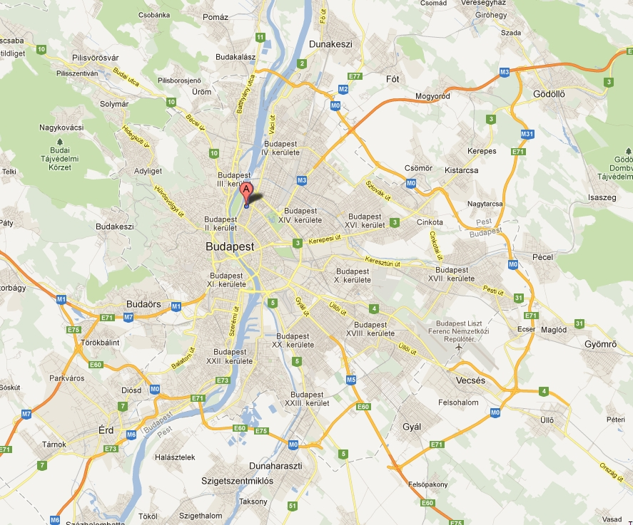

Detailed map



