「RF-Sputter Coater Machine」 User Manual
CANON ANELBA ENGINEERING E-200S
December 22, 2009

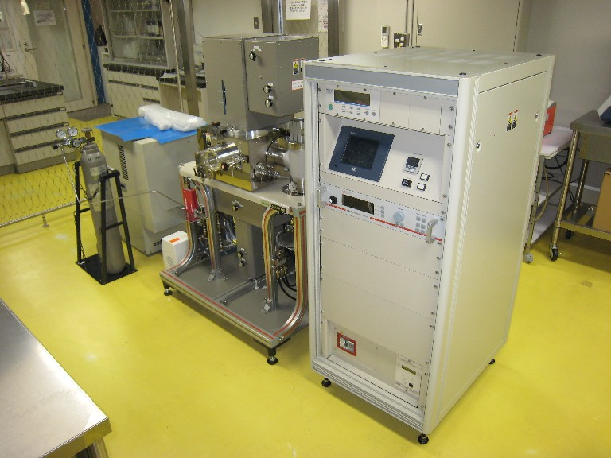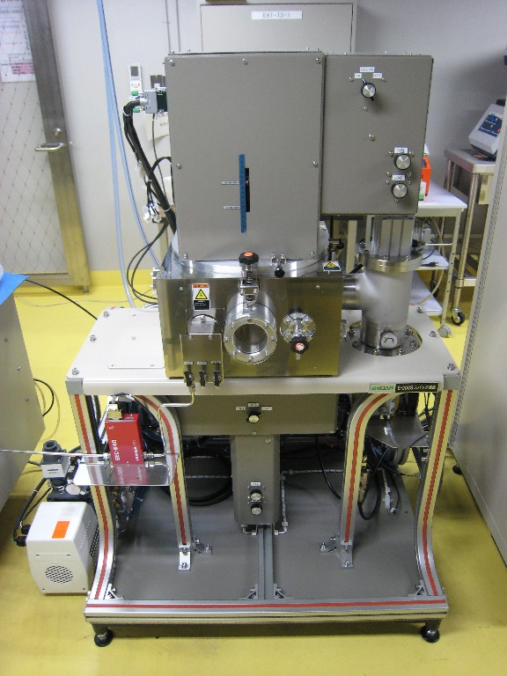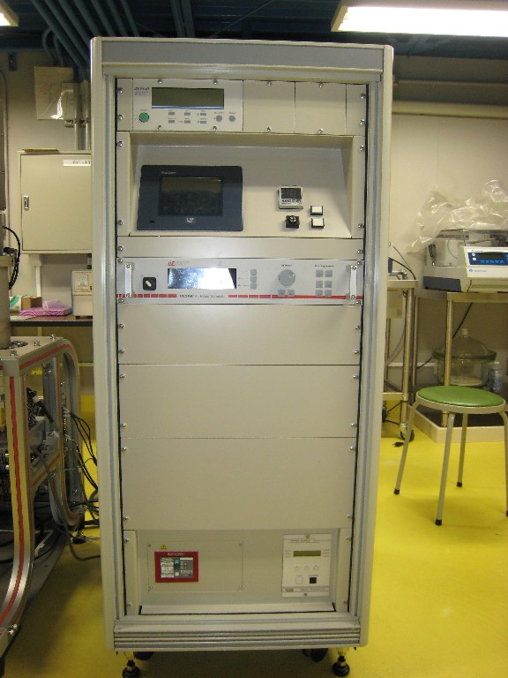
Control Panel
Main Unit
Argon gas
Compressor
Switch Panel
Main Power Supply
ＲＦ Power Supply
Touch Panel
Pressure gage
Coating chamber
Rotary Pump
Cooling water
Compressed air
Overall View Main Unit Control Panel

１．Utility Operation
- Turn on the breaker of the switch panel (3 phase, 200V).
- Turn on the compressor and confirm that the air pressure is 0.5 - 0.8 MPa.
- Open the container valve for Argon gas Ar and set the secondary pressure to 0.1 MPa. Note: Opening the container valve by 1/4 rotation is more than enough.
- Fully open the valve of the cooling water.
- Open the two red valves on the left side of the main unit. The cooling water will be supplied to the target and the substrate.
- For the red valves, horizontal position = CLOSE, vertical position = OPEN.
- The green valves are use to bypass the cooling water. These valves are normally CLOSE.
- In order to heat the substrate, set the right red valve to CLOSE position. At the same time, OPEN the right green valve. After that, the recessed water inside the pipe will be blown out by the compress air (~3 minutes).
- Turn ON the main power supply.
- The ALARM will be turned on. Please press the RESET button to cancel the ALARM.

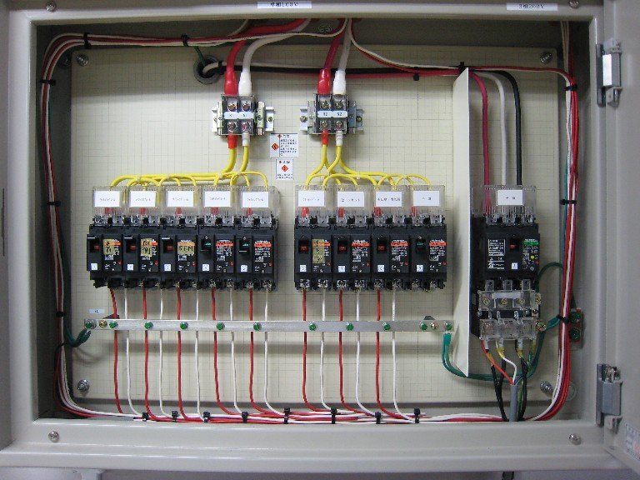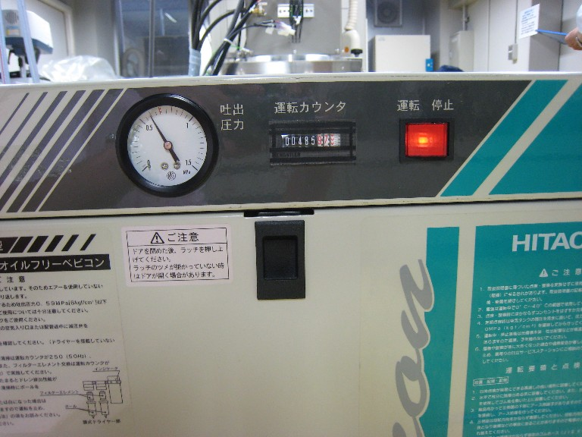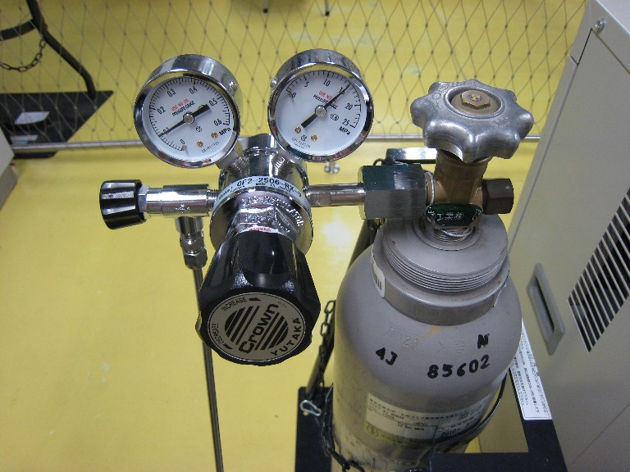
Electrical Switch
Pressure Control Valve
Container valve
Mass Flow Valve
Secondary pressure
Breaker
Pressure gage
Switch Panel Compressor Argon Gas Regulator
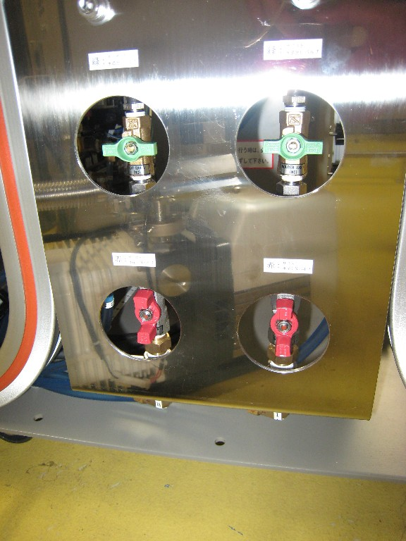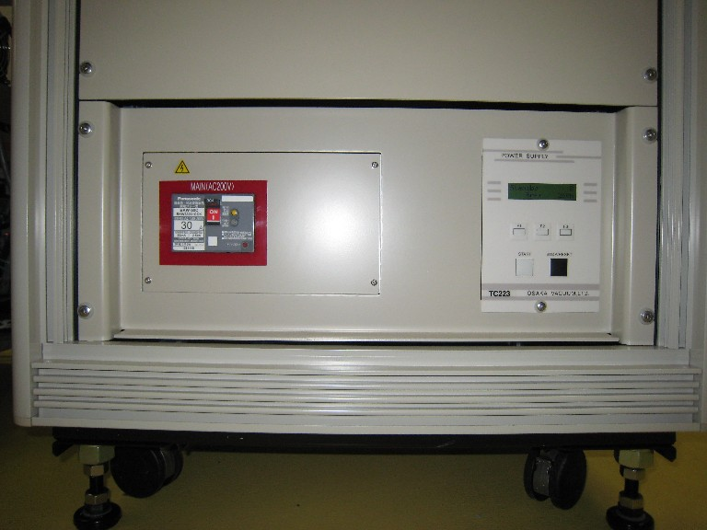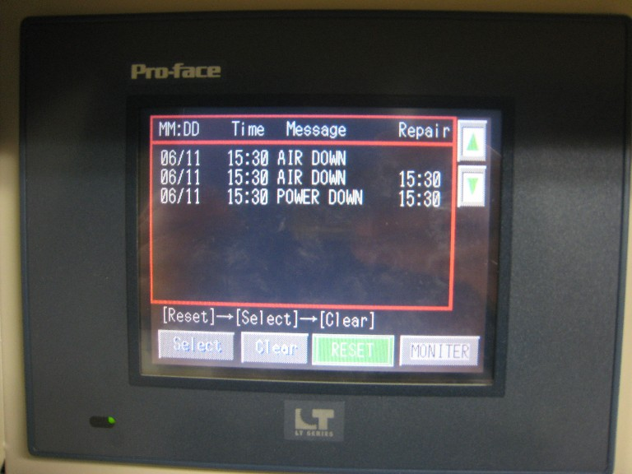
RESET
Target
Substrate
Cooling Water
Compressed Air
Red: Cooling water (OPEN)
Green: Compressed air (CLOSE)
Left: Target; Right: Substrate

Touch Panel

２．Operation of Vacuum Pump
- Turn ON the power switch located at the upper part of the control panel. There are two vacuum level sensors, one for low vacuum level and another one for high vacuum level.
- Please confirm that the manual orifice of the coating chamber and Turbo Molecular Pump (TMP) is CLOSED. Rotate the manual orifice to the CLOSE direction lightly during confirmation. DO NOT tighten the manual orifice strongly.
- Press “MONITER” on the touch panel (Don’t ask me why they put “MONITER” instead of “MONITOR”), Then press “Menu” to show the “SELECTION” display.
- Press “PUMP” on the “SELECTION” display to show “PUMPING” display.
- Press “TMP” on the “PUMPING” display to turn ON (green) the exhaust system.
- The exhaust system is operated automatically. First, it operates the Rotary Pump (RP), and then it operates the TMP.
- When TMP is operational, you can hear the “KEEN…” sound.
- At this point, the coating chamber has not reached the vacuum condition yet.

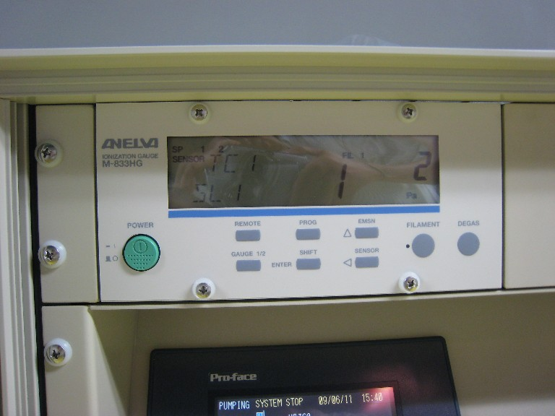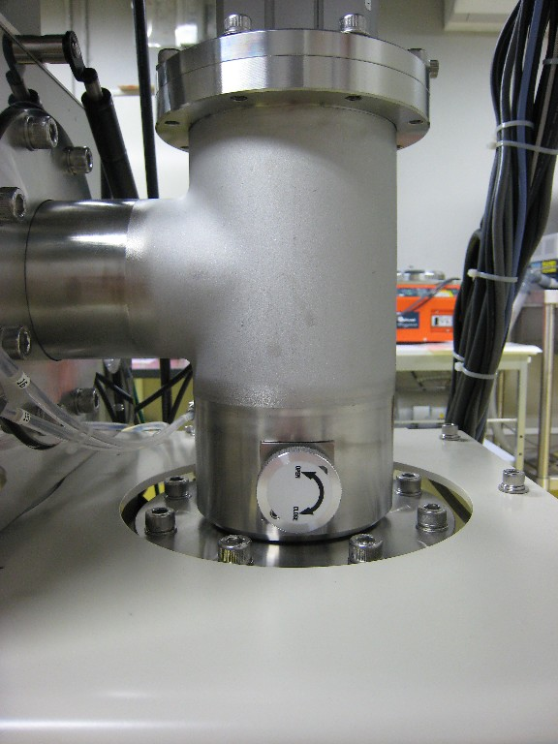
MONITOR
Power switch
Vacuum gage Manual orifice (CLOSE) Touch panel
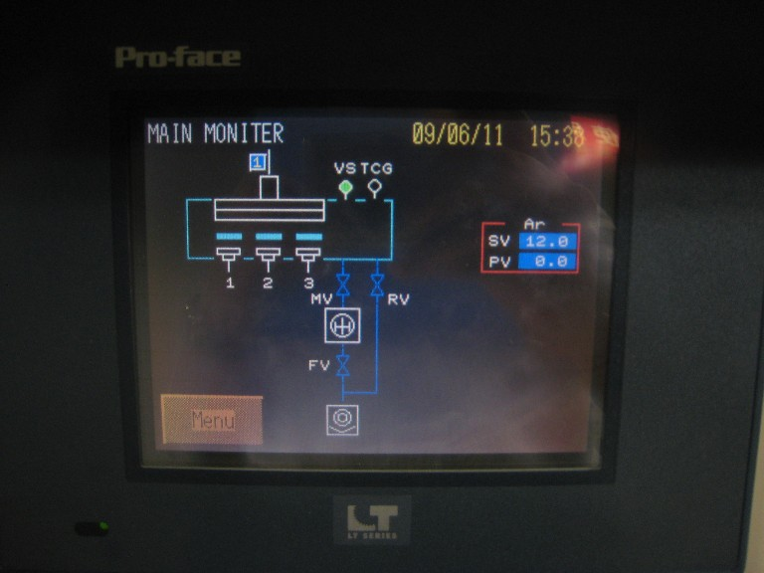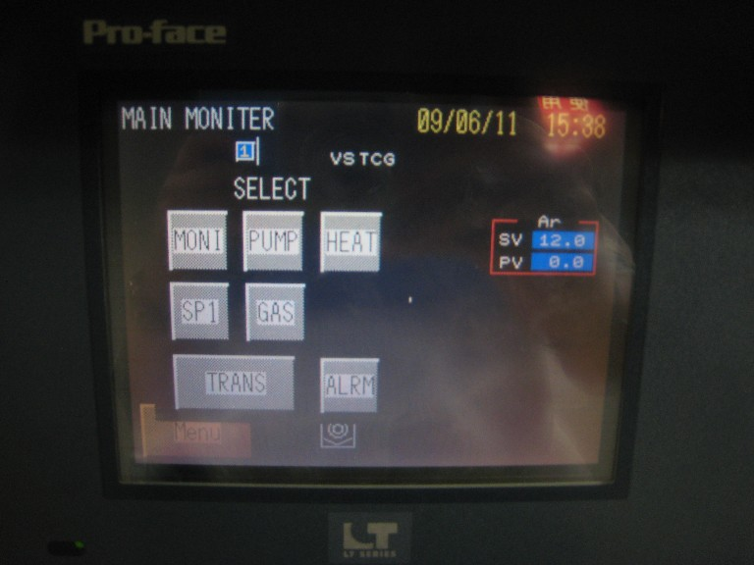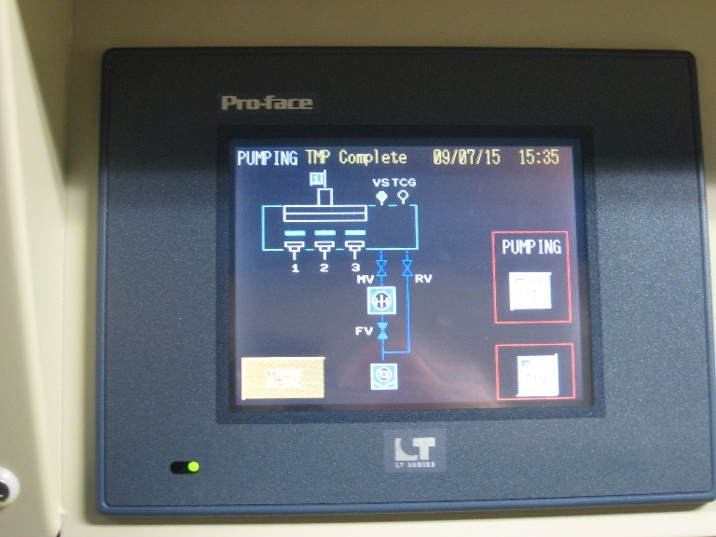
Menu
PUMP
TMP
MONITER display SELECTION display PUMPING display ３．Setting Up the Substrate
- Press “Menu” on the touch panel. At the “SELECTION” display, press “TRANS”.
- At the “T/S & ROT CONTROL” display, confirm that PV=1 at “SUBST ROT” and PV=100.0 (mm) at “TS POS”.
- Press “Menu” on the touch panel. At the “SELECTION” display, press “PUMP”. Confirm that “MV” and “RV” is CLOSED. Then, confirm that “SP” is OFF (white).
- TMP will be damaged by the exposure to the air during operation. Therefore, this confirmation is very important.
- Open the VENT valve (Leak valve) “VV” of the coating chamber. The air will flow into the coating chamber.
- After the coating chamber is filled with air (atmospheric pressure), open the lock by rotating the clamp. Then, lift the hatch slowly by holding its support pole.
- Confirm the type of materials in target 1, target 2 (magnetic), and target 3.
- Target 1 and 3 are for non-magnetic materials while target 2 is for magnetic material.
- Mount the specimen on the specimen holder.
- If you want to coat the materials while rotating the stage, place your specimen close to the middle part of the stage.
- Confirm that no dust/dirt/particles are adhered on the O-ring of the flange.
- If there are dust/dirt/particles, clean it using ethanol.
- Close the coating chamber slowly.
- Close the coating chamber using both hands. Be careful not to hurt your hands.
- Close the VENT valve.
- Close the VENT valve slowly.
- Close and lock the hatch’s lock.
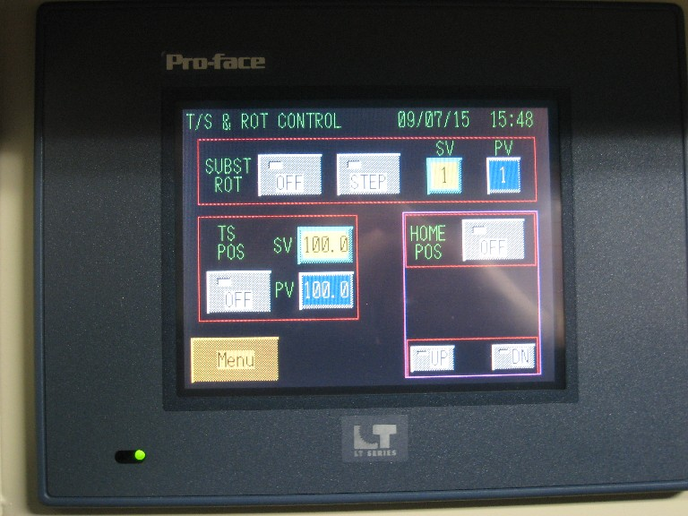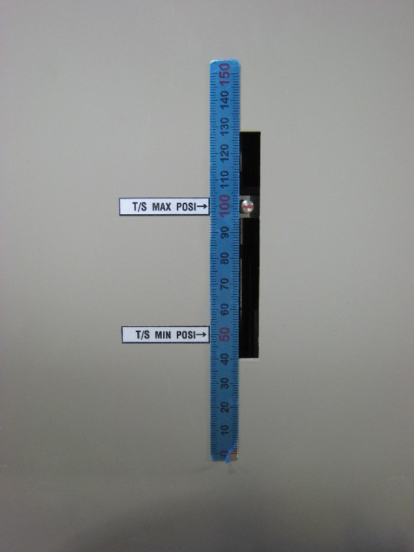
TRANS
100.0
PV
Holder position
SELECTION display T/S & ROT display Height of the substrate holder
（TS POS = 100 mm）
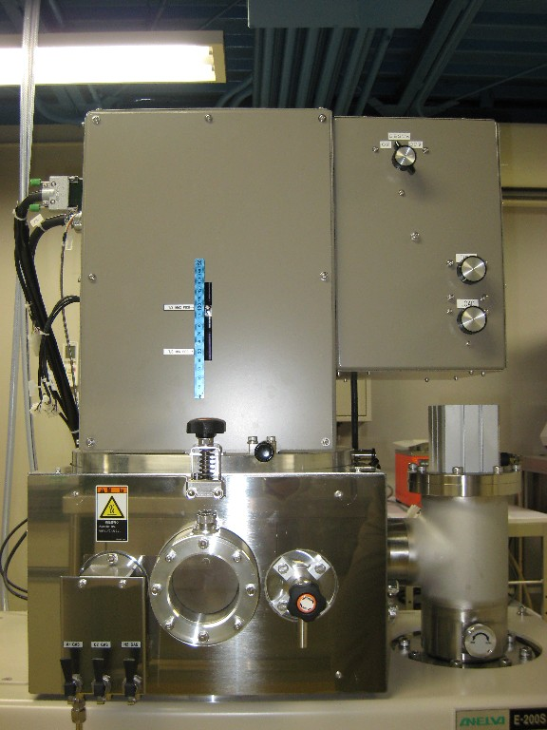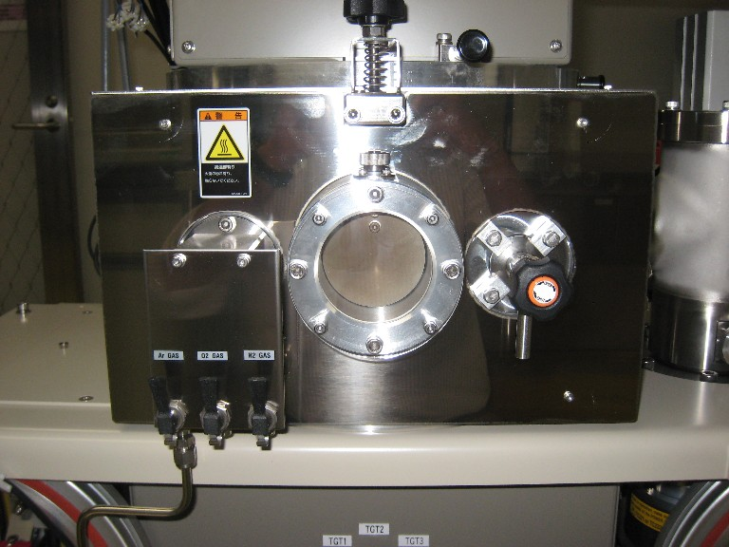
SP
Hatch’s lock
VENT valve
Support pole
PUMPING display Main Body: front Hatch’s lock, support pole,
＜Valve＞ void：CLOSE，Filled：OPEN and VENT valve
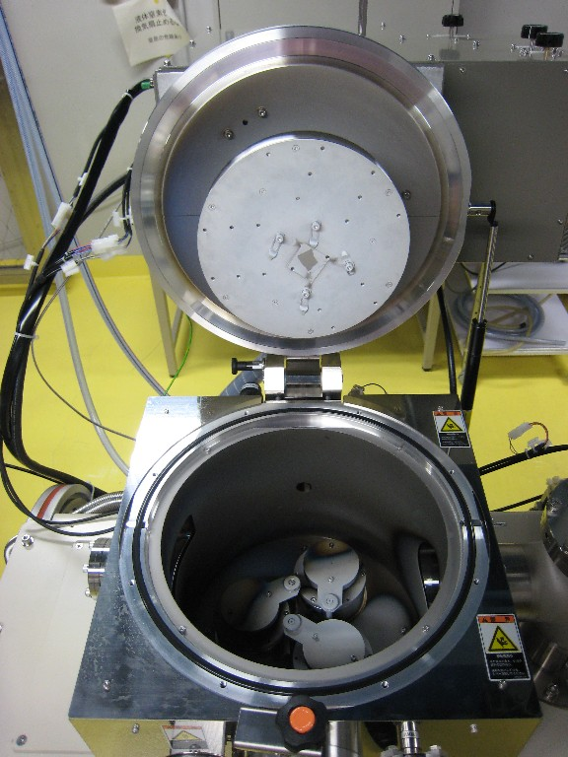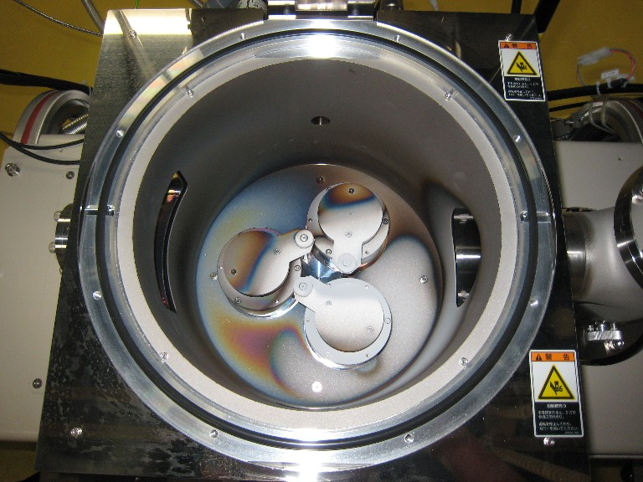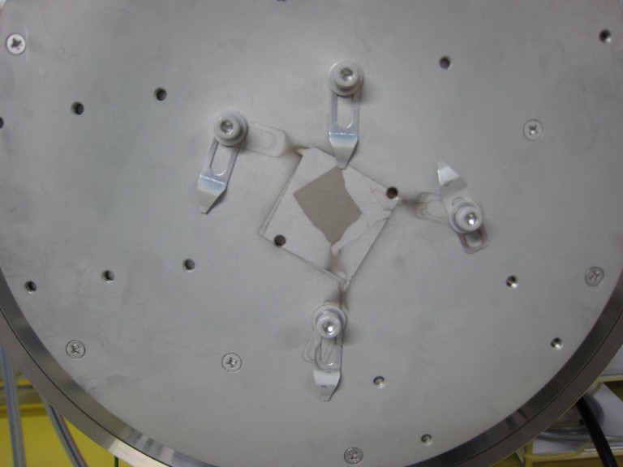
Specimen holder
Target 1
Target 3
Target 2
(magnetic)
Shutter
Target 1-3
Specimen holder
Coating chamber OPEN Target Specimen holder

４．Evacuation of coating chamber
- Press “MENU” on the touch panel. At the “SELECT” display, press “PUMP”.
- At the "PUMPING" display, confirm that the “TMP” is on, and then turn on the “SP”. The evacuation of coating chamber will be started.
- At first, the sound of the rotary pump will become louder and then gradually decreased.
- Open the manual orifice, then wait until the pressure of the coating chamber become 10⁻⁴ Pa. (Approximately 30 minutes).
- Please open the manual ORIFICE slowly.
- During evacuation, when the pressure does not reach 10 Pa due to air leakage, the error message will be shown after 3 minutes.
- In this case, open the coating chamber and check the O-ring. Then, close the chamber again and restart the evacuation process.
PUMP

SP

TMP

Menu

MONITER display SELECT display PUMPING display

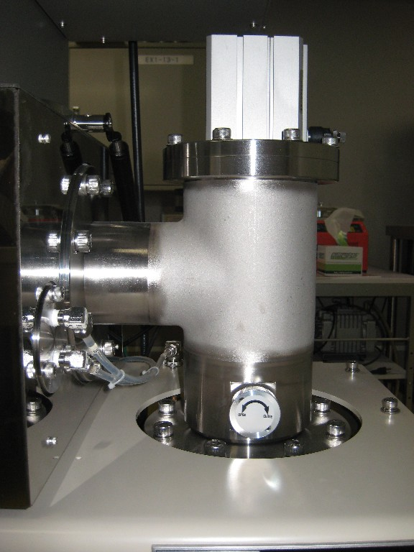
Pressure inside the coating chamber

Manual ORIFICE（open） Vacuum gage
５．Injection of gas(Argon)
  - Turn off the “FILAMENT” on the vacuum gage.
    - If the filament is left on when the gas is injected into the coating chamber, the filament might be damaged.
  - Confirm that the Argon gas pressure on the secondary pressure is 0.1 MPa. Adjust the amount of pressure using the mass flow valve.
  - Open the stop valve “CV”.
  - Press “MENU” on the touch panel. At the “SELECT” display, press “GAS”. At the “GAS CONTROL” display, define the required SV value（Ar: Min 0.2―Max 30sccm.）.
  - After closing the manual ORIFICE, turn on “MFC” then the gas will be injected into the coating chamber.
  - Confirm that the coating chamber pressure is 10 Pa.
  - In addition, it is better to turn on “SP LINK”.
    - During injection, it is possible to change the SV value.
    - If the “SP LINK” is left to be ON, the gas will be automatically stopped after coating process.
  - By adjusting the manual ORIFICE, the pressure inside the coating chamber can be controlled.
    - (If the conditions for coating with Al are [SV: 30 sccm (8Pa), target distance: 80cm, RF power: 150 Watt, coating time: 1 hour], the coating thickness will be 100-120 nm).

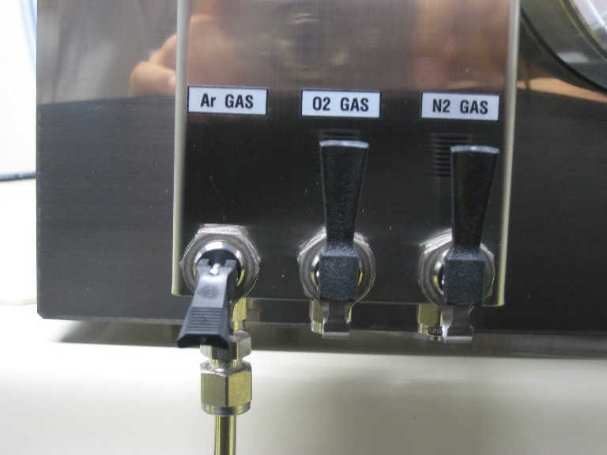
FILAMENT OFF

Mass flow valve

Stop valve CV

Pressure of the coating chamber

Pressure gage Argon gas regulator Ar stop valve CV

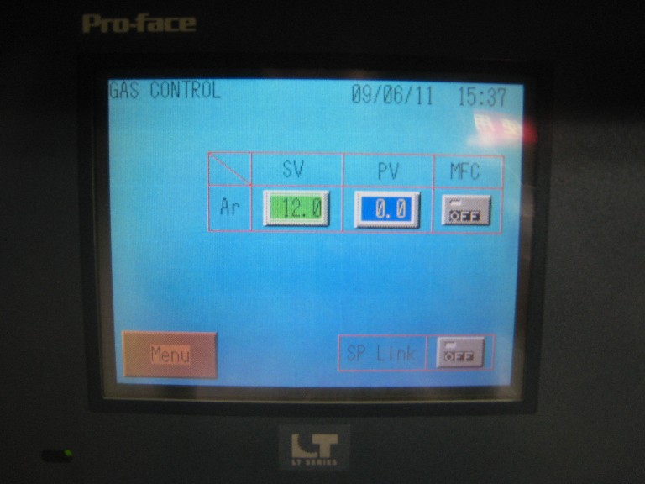
GAS

MFC

CLOSE

SP Link

ＳＶ

SELECT display GAS CONTROL display Manual ORIFICE (close)

６．Plasma generation and coating control
- At “TRANS CONTROL” display, turn on the “HOME POS” switch.
Set the distance between the target to the substrate as 100 mm.
Afterwards, change the distance to the required position → Please refer to the “Rotation and vertical operation method of the specimen holder” on the attached paper.
To rotate the specimen holder, press “STEP” to change it into “CONTINUE”. Then, press”OFF” to change it into “ON”.
To stop the rotation, press “CONTINUE” to change it into “STEP”. The specimen holder will be automatically stopped. Please note that the distance between the target and the specimen can not be changed while rotating.
- Use the knob under the main body to select the target for coating.
- Rotate the knob to “TGT 1”,”TGT 2”, or “TGT 3” to select the target.
- Turn on the “RF Power Generator”.
- Turn the knob on the “RF Power” panel counter clockwise and set the power input to 0 (zero).
- Turn on the “RF Power” knob. Then, when the knob is set to “0” W, the left side display will show “000Wf”. Then, set the knob to “10Wf”.
If the argon gas and the cooling water is not flowing during this step, the error message will be shown. The process will be intercepted by the “interlock”.
- Set the reflected wave “Wf” at the right side display to zero “0” by tuning the “LOAD” (rough adjustment) and “TUNE” (fine adjustment) knobs at the lower part of the main body.
- Slowly increase the power input while tuning the reflected wave to zero “0”. Please be careful not to exceed 10 percent of the RF power input (i.e. if the Wf is 100 Wf, then the Wr should be less than 10Wr). Repeat this step until the required power input is achieved.
- Confirm the generation of plasma from the window at the main body.
(Warning: do not look into the plasma more than a few seconds. Then, do not forget to close the window).
- At the “SP CONTROL” display, set the target opening time ”□h□m□s” prior to the coating process.
- From”TGT1”,”TGT2”,and ”TGT3”; select the required target and then turn it on.
- Turn on the “TIMER” on the touch panel.
(The target shutter will be open, and then the coating process is started. Leave the machine until the coating process is finished. Drink some coffee or something at 7 eleven!!!! DO NOT GO HOME!!!!).

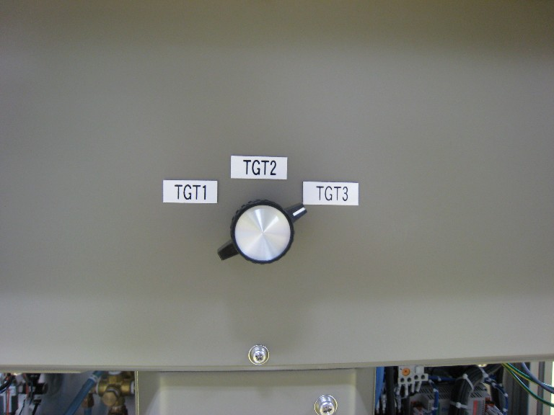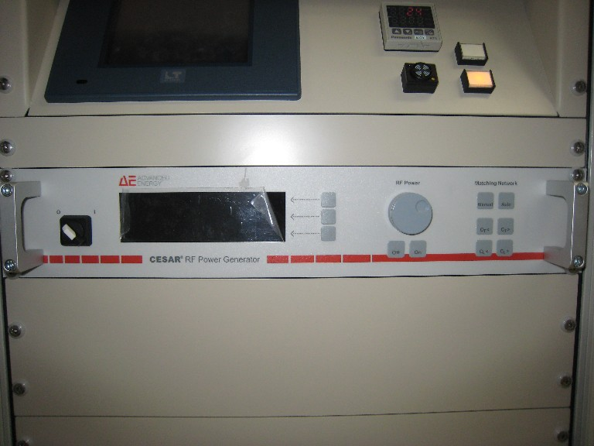
HOMEPOS
Target selection

Power

RFknob

T/S & ROT display Knob for target selection RF adjustment

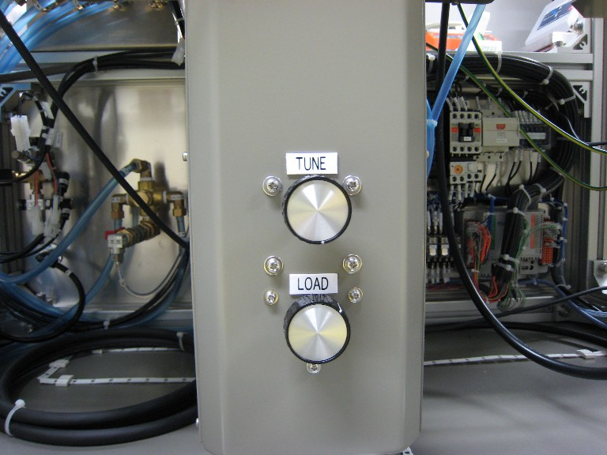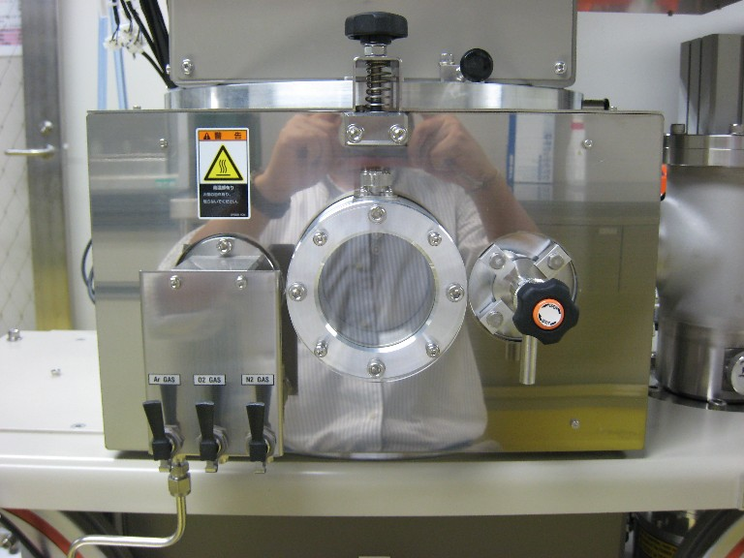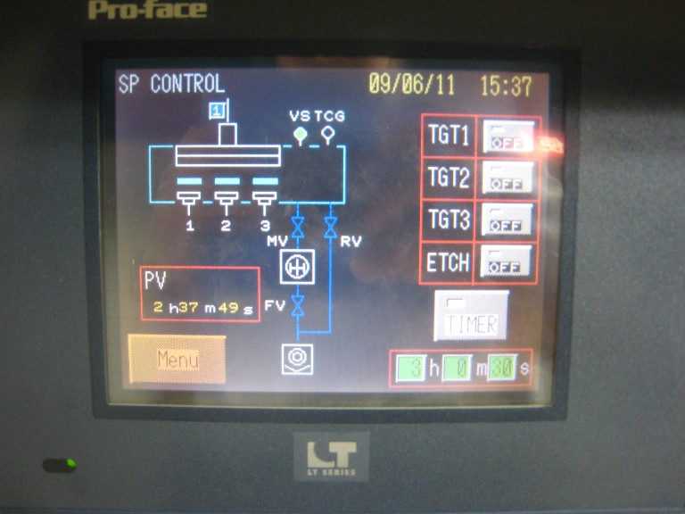
TUNE
LOAD
Target selection
Up: TIMER;
below: opening time
Reflected wave adjustment peeking window SP CONTROL display

７．Taking the substrate
- Normally, the argon gas will be stopped after the coating process. If, the argon gas is still flowing, turn off the “MFC” at the “GAS CONTROL” display. After that, close the stop valve CV.
- Open the manual ORIFICE. The coating chamber will be promptly ventilated. Then, close the manual ORIFICE again.
- Turn off the filament of the pressure gage. After that, turn off the “SP” switch at the “PUMPING” display.
- In case of coating with rotation, make sure to stop the rotation at the “T/S & ROT CONTROL” display. Return the specimen holder to the standard position (100 mm).
- Open the VENT valve to ventilate the coating chamber. Open the hatch’s lock and then open the coating chamber by holding its support pole.
- Takes the substrate carefully.
(Warning: when high temperature is used, be careful not to burn your hand).
- Close the coating chamber.
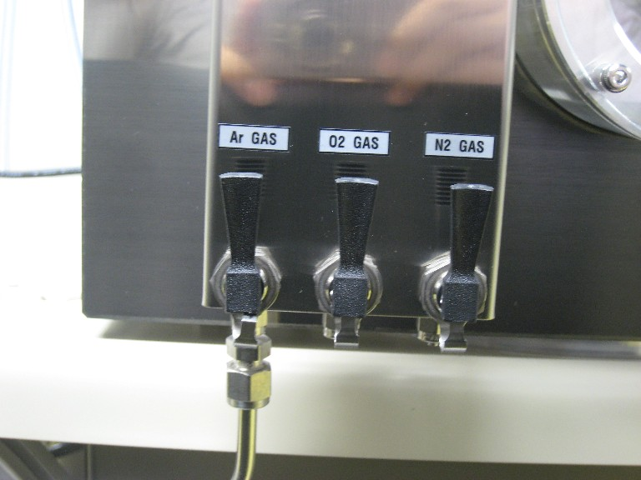
OFF
CV（CLOSE）
OPEN→CLOSE

GAS CONTROL display stop valve CV manual ORIFICE

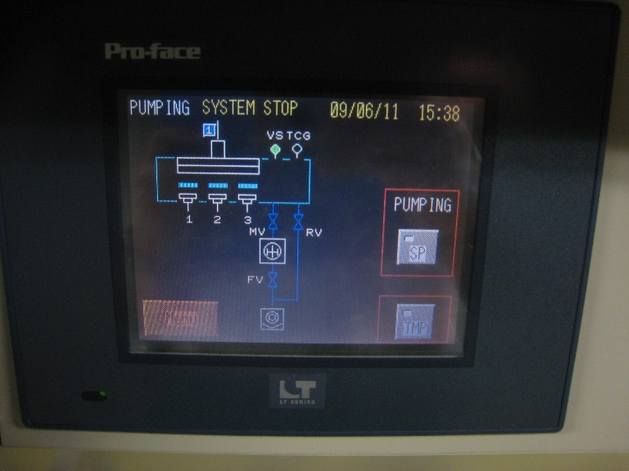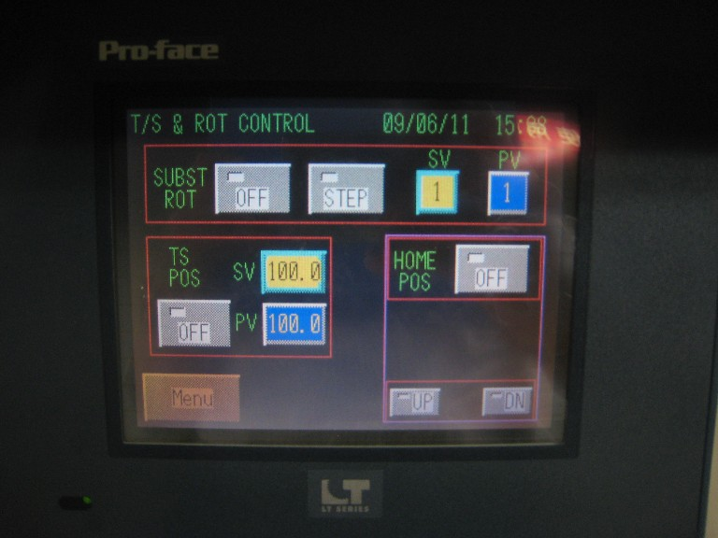 Pressure gage PUMPING display T/S & ROT display
FILAMENT OFF

SP OFF

OFF

SUBST ROT OFF

OFF

HOMEPOS ON

OFF

Hatch’s lock

VENT valve

Support pole

Specimen holder

Coating chamber (front view) coating chamber (OPEN)

８．Shutting down the equipment
- At the “PUMPING” display, turn on the “SP” switch.
- After turning to TMP, wait for 1-2 minutes in order to make the coating chamber in vacuum condition.
- At the “PUMPING” display, turn off the “SP” switch.
- Turn off the “TMP” switch at the “PUMPING” display (below the “SP” switch).
- Wait for approximately 4 minutes (until the rotary pump and the turbo molecular pump (TMP) are stopped). After that, turn off the pressure gage. Then, turn off the main controller.
- Close the argon gas valve then turn off the compressor. Then, turn off the cooling water. Finally, turn of the breaker of the main switch panel.
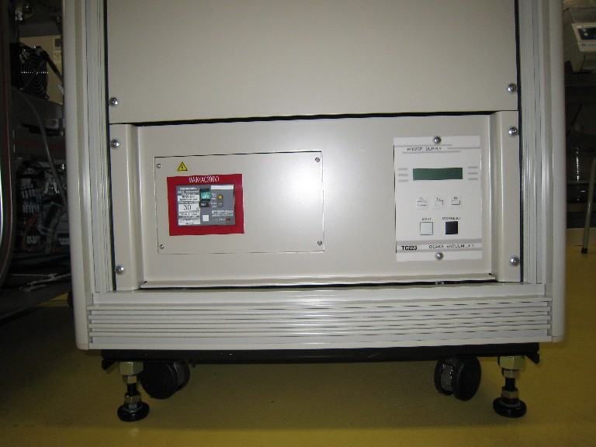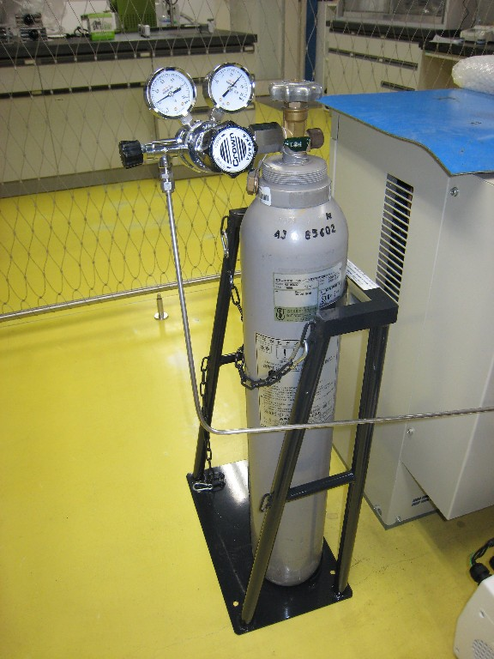
SP

TMP

Power（OFF）
Power（OFF）

PUMPING display pressure gage main controller argon gas regulator
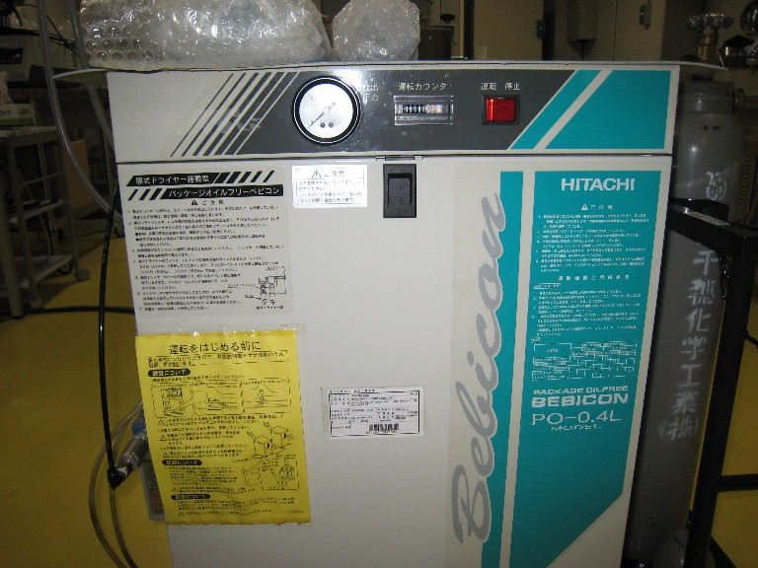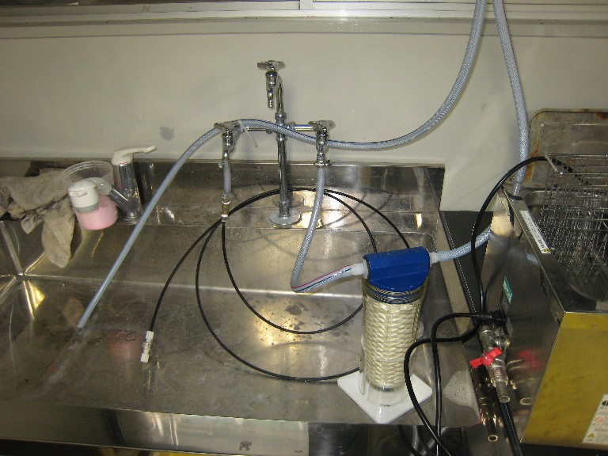
POWER

Breaker

Compressor Cooling water Switch panel

Translators:
    - Willy Kurnia
    - Namatame Yoshiyuki
    - Osawa Hiroki

ANELBA’s contact person:
森本 潤 （もりもと じゅん）/Morimoto Jun

401-0397 山梨県南都留郡鳴沢村8532-28
TEL: 0555-20-5573（直通）
FAX: 0555-85-3057
E-mail: morimoto.jun@canon-anelvaeng.co.jp
（2009.6.10）

