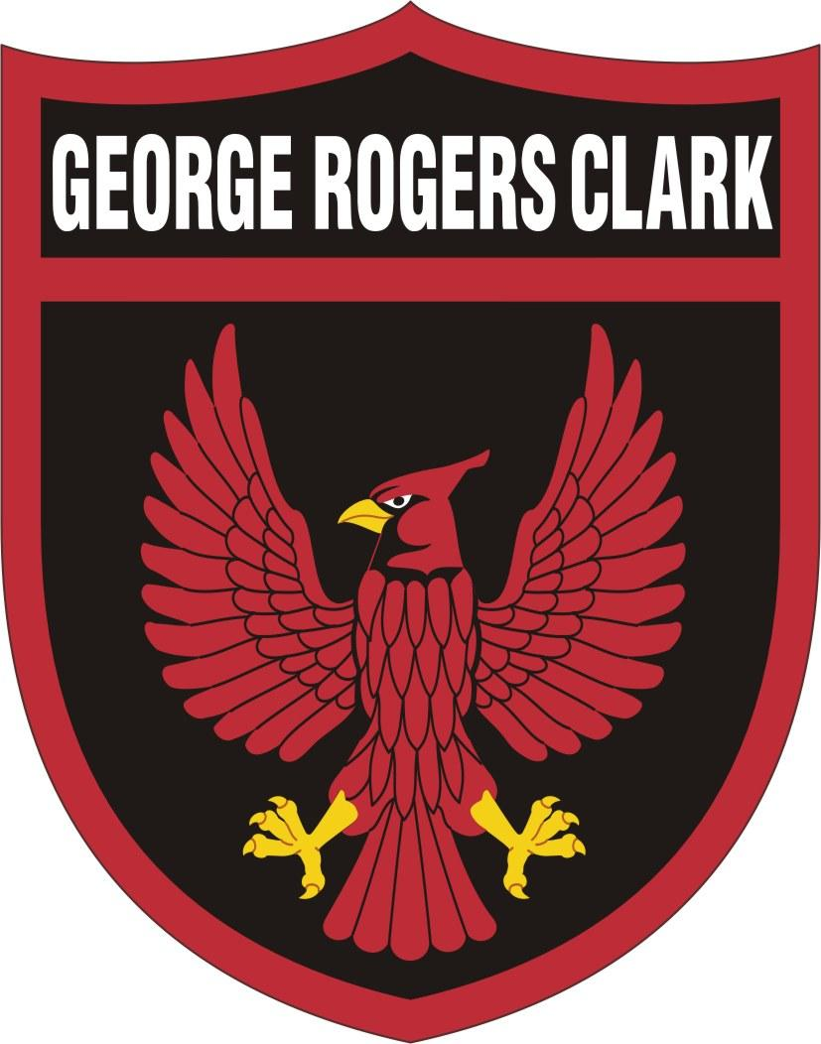
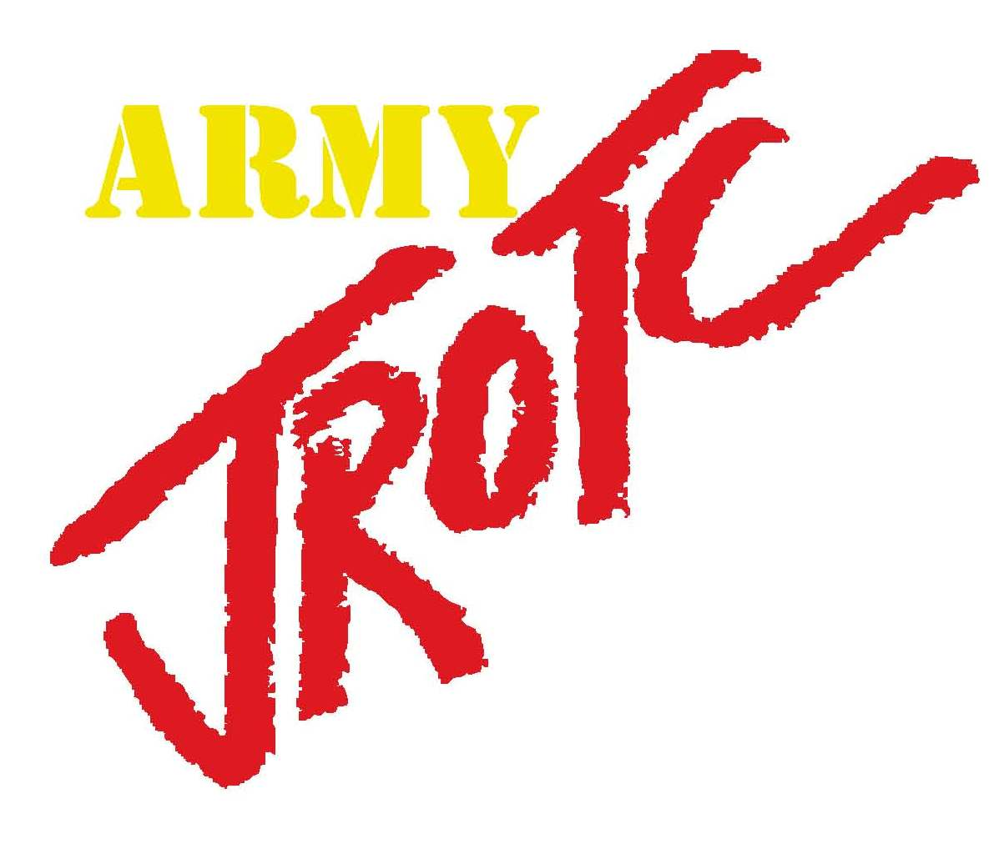

REGIMENTAL
STANDARD OPERATING PROCEDURES
(SOP)
George Rogers Clark High School
Junior ROTC

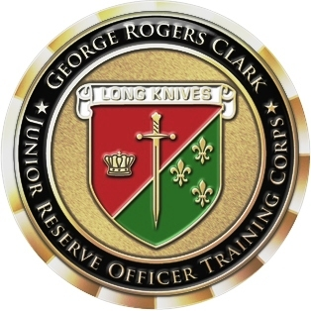

Regimental SOP
School Year (SY) 2018-2019
(LAST REVISED 25 July 2018)
INDEX / TABLE OF CONTENTS

CHAPTER DESCRIPTION PAGE

1 GENERAL PROVISIONS (SAI & AI DUTIES) 3

2 CADET ENROLLMENT / DISENROLLMENT 6

3 ACADEMIC CREDIT & GRADING 7

4 CADET CONDUCT (CUSTOMS & COURTESIES) 8

5 MERITS & DEMERITS 12

6 ORGANIZATION OF THE REGIMENT 14
A. Cadet Battalion (Regiment) & Company Headquarters positions 14
B. Selections, Appointments, & Promotions 15

7 CADET OFFICERS & NCO’S 18

8 CADET DUTY POSITION DESCRIPTIONS 19
A. Duties & Responsibilities of the Regimental Staff (LET-4) 19
B. Duties & Responsibilities of Company-Level (LET-3) Staff 24
C. Duties & Responsibilities of Drill/Color Guard/Raider Team 27

9 UNIFORMS & CADET RANK 29
A. Uniform Issue & Description 29
B. Proper Wearing of the Uniform 30
C. Cadet Grooming Standards 31
D. Wearing of Cadet Rank 32
E. Wearing of Cadet Headgear 33
F. Placement of ROTC Lapel Insignia 34
G. & H. Placement Star, Academic Wreath, & Unit Crest 35
I. & J. Placement of Name Plate & Placement of Ribbons 36
K. & L. Marksmanship Badges & Wearing of Shoulder Cords 37
M. Wearing of Arc Tabs 38
N. Wearing of ACU 39

10 RECOGNITION (AWARDS & RIBBONS) 41
A & B. General & Types of Awards & Ribbons 41-44
C & D. JROTC Ribbons (N-1, N-2, N-3, N-4) & Criteria 45-48
E. JCLC (Summer Camp) Awards 49
Order of Precedence Chart (Ribbons) 50
F. Arc Tabs (Medal) 51
G. SAI Awards (Marksmanship, Academic Wreath, Raider Tab) 52
H. Order of the Long Knife Requirements & points chart 53-55
I. Regimental Jacket 56
J. Regimental Coin 57

11 WEAPONS & SECURITY (Arms Room/S-2) 58
12 SUPPLY (Supply Room/S-4) 60
CHAPTER 1
GENERAL PROVISIONS (SAI & AI DUTIES)

A. AUTHORITY: The Junior Reserve Officers Training Corps (JROTC) is organized under authority of Section 40 to 47c, of the National Defense Act of 1916. Statutory provisions are contained in Title 10, United States Code, Section 2031. The program operates under the guidelines Army Regulation (AR) 145-2 and Cadet Command Regulation 145-2.

B. MISSION: The mission of JROTC is “To Motivate Young People to be Better Citizens.”

C. OBJECTIVES: The objectives of the Army JROTC program are:

- Develop leadership and patriotism.
- Develop informed and responsible citizens.
- Strengthen character.
- Develop self-discipline, responsibility, and a positive response to constituted authority.
- Develop the ability to logically arrange thoughts and communicate effectively both orally and in writing.
- Develop an appreciation of the values of physical and mental fitness.
- Develop the basic skills necessary to work effectively as a team member.
- Provide the motivation and the life skills necessary to graduate from High School.
- Acquaint students with educational and vocational career opportunities and technical requirements of the modern age.
- Promote a historical understanding of the role of the citizen soldier and familiarize students with the history, purpose and structure of the military service.
- Encourage qualified cadets to apply for scholarships, and encourage those who are capable of college level academics to continue their education.

D. DEFINITIONS/JOB DESCRIPTIONS

1. Senior Army Instructor (SAI) Responsibilities:
a. General: Directs, coordinates, and supervises the overall Army JROTC program, and teaches select classes in accordance with appropriate Army, State and School District regulations, directives and policies.
b. References: Current Army and School District regulations and policies.
c. Responsibilities:
(1) Department head of the JROTC department. Responsible for the success or failure of the JROTC program.
(2) Update designated lesson plans, student handouts and examinations for the JROTC program.
(3) Serves as counselor for the noncommissioned officer(s) assigned.
(4) Oversees training requirements and submission of requisitions for materials.
(5) Performs duties as official judge and/or board president/member in all cadet competitions.
(6) Principal classroom instructor for upper level cadets.
(7) Encourages and assists cadets in applying for scholarships.
(8) Establishes and maintains a public affairs program for the JROTC unit.
(9) Coordinates cadet activities with the principal, designated staff coordinator, and other department heads as appropriate.
(10) Responsible for implementation of the JROTC POI and appropriate Army regulations and directives. Works to obtain graduation credit for JROTC curriculum instruction.

2. Army Instructor (AI) Responsibilities:
a. General: The noncommissioned officer in charge (NCOIC) Army Instructor (AI) is responsible to the Senior Army Instructor (SAI) and the institutional head for the accomplishment of the instructional, operational, and administrative mission of the school’s Army JROTC Program.
b. References: Current Army and School District regulations and policies.
c. Responsibilities:
(1) On a daily basis, responsible for assisting the SAI with the overall Army Junior ROTC Training Program.
(2) Prepare and maintain all records required by Army and School District.
(3) Performs as the primary instructor for LET 1 and LET 2 classes.
(4) Serve as the designated primary hand receipt holder and Military Property Specialist (MPS) and IMPACT Card Custodian.
(5) Faculty advisor for extracurricular activities.
(6) Represents the SAI in his absence as JROTC department head and act as JROTC advisor to the principal and his staff.
(7) Performs other duties as directed by the principal or SAI.

3. Shared/Overlapping Responsibilities for the SAI & AI (s):
a. General: In addition to teaching different topics during the school year as required by the JROTC program of instruction (POI), the duties and responsibilities of all JROTC instructors encompass a variety of activities which extend beyond the classroom.
b. References: Current Army and School District regulations and policies.
c. Shared/Overlapping Responsibilities:
(1) Adhere/comply with policies, procedures, rules, and regulations of the school principal, the School District, and US Army Cadet Command.
(2) Establish and maintain cadet organization and rank structures, which, coupled with an awards and decorations program, provide incentives to promote acceptable performance of leadership responsibilities.
(3) Plan and coordinate with supporting agencies, train cadets to conduct extracurricular activities to include community service.
(4) Prepare a master training schedule and weekly training schedules.
(5) Prepare cadets to attend summer camp (JCLC) IAW CCR 145-2.
(6) Plan, coordinate, prepare for, and conduct a summer camp preparatory training session for cadets as needed.
(7) Organize, train, and supervise multiple Color Guard teams to support school and community functions.
(8) Organize, train and supervise cadet competitive teams to foster teamwork and the desire of cadets to excel.
(9) Procure, maintain, safeguard, account for, and replace cadet uniforms, uniform accessories and accoutrements, training aids (to include drill rifles), air rifles, other equipment and office supplies required to fully support and sustain an efficient JROTC unit.
(10) Create, maintain, and file for each JROTC student a cadet record which includes JROTC test/performance grades, promotions and reductions in rank, awards, and decorations, merits and demerits, and emergency data.
(11) Maintain various files and reports required by regulations.
(12) Routinely and frequently attend and participate fully in School District meetings and JROTC projects.
(13) Prepare for and participate in formal inspections conducted by the School District and Cadet Command.

4. Supply Activities and Tasks (See GRC JROTC Supply SOP).

CHAPTER 2
CADET ENROLLMENT / DISENROLLMENT

A. CONDITIONS FOR ENROLLMENT:

1. Become at least 14 years of age during their Leadership, Education and Training (LET) 1 term/year.
2. Physically qualified under standards prescribed by CCR 145-2.
3. Acceptable to the high school principal and SAI.
4. Be a regularly enrolled student in 9th, 10th, 11th, or 12th grade. No student will be enrolled simultaneously in two (2) LET levels unless authorized by the SAI.
5. Morally qualified. Applicants for enrollment, who have a record of conviction by any military or civilian court, for other than minor traffic violations, are not eligible unless the Region Commander grants a waiver.
6. Eligibility for enrollment in LET 2-4 will be determined by the SAI.
a. Cadets MUST obtain a passing final grade (D or better) in order to advance to the next LET-level.
b. The SAI/AI have the right to not allow a Cadet to return to the program for reasons listed below (Disenrollment).

B. DISENROLLMENT: Normally cadets can be dis-enrolled or excluded from attendance, as appropriate, as determined by the SAI and the school counselors and principal.

1. In all cases a student can be dis-enrolled when he/she:
a. Withdraws from school.
b. Shows inaptitude for leadership training indicated by lack of general adaptability, or desire to learn.
c. Fails to maintain acceptable standards of academic achievement, conduct, participation (such as failure to wear the uniform) or attendance.
d. Shows undesirable character traits such as
(1) Cheating.
(2) Stealing.
(3) Use of or possession of drugs and/or alcohol.
(4) Lying.
(5) Frequent incidents of a discreditable nature with civil or school authorities.
e. Shows indifference to and lack of interest in leadership training as shown by:
(1) Frequent absence from class.
(2) Large accumulations of demerits.
(3) An established pattern of shirking or similar acts.
(4) Disrespect towards the instructors or sponsors.

2. Students dis-enrolled from JROTC may not be readmitted without permission of the SAI.

CHAPTER 3
ACADEMIC CREDIT & GRADING

A. ACADEMIC CREDIT; JROTC Leadership Education & Training (LET). Credit towards graduation is awarded as follows at GRC HS:

1. LET-1 1 elective credit (LET 1.1 & LET 1.2)
2. LET-2 1 elective credit (LET 2.0)
3. LET-3 1 elective credit (LET 3.0)
4. LET-4 2 elective credits (LET 4.0)

B. GRADING:

1. The grading criteria for all LET-levels will vary depending on the instructor syllabus and curriculum and the prescribed JROTC Program of Instruction (POI) for each LET-level. However, the basic grading criteria will be broken down as follows (50% - 25% - 25%):

a. Uniform Inspections & General Cadet Knowledge (50%). Each Uniform Inspection is worth a total of 100 points. Specified points are deducted for uniform violations and failure to demonstrate general cadet knowledge.
(1) Uniform Inspections (see Chapter 9; Uniforms & Cadet Rank) are conducted during class periods on Fridays. Cadets are expected to wear their uniform to school and remain in uniform for the entire day (unless approved by SAI/AI to change into civilian clothes).
(2) Cadets who FAIL to wear their uniform on inspection day or are ABSENT on uniform inspection day will be awarded ZERO (0) points for that inspection. They will be permitted to MAKE-UP this inspection the following week prior to close-of-business (COB) the following Thursday and potentially receive full credit. The instructor (SAI/AI) will deal with any extended absences on a case-by-case basis.
(3) Failure to wear the uniform all day (even on a make-up day) will result in a ZERO (0) for that day’s Uniform Inspection and possible De-Merits (see Chapter 5).
(4) If a Cadet misses three (3) Uniform Inspections per 9-Week Grading Period, they will be demoted one (1) Cadet rank.
(5) If a Cadet misses six (6) Uniform Inspections during any point during a School-Year, they will also be demoted one (1) Cadet rank and be considered for disenrollment.

b. Exams, quizzes, tests, practical exercises, projects, presentations, etc (25%).

c. Overall Class Participation (25%). Class participation is defined as classroom participation (asking/answering questions, discussion, etc) and may include mandatory participation in a community support or JROTC event (such as the Winchester Christmas Parade or Ft. Boonesborough Raider Invitational) or submission of mandatory projects or assignments.

2. Extra credit may be made available to students, as determined by the classroom instructor.
3. Any Cadet who is failing JROTC (below 60%) will NOT be permitted to compete as a member of a competitive team (Raider, Drill/Color Guard).
CHAPTER 4
CADET CONDUCT (CUSTOMS & COURTESIES)

A. Cadets will conduct themselves at all times in a manner to reflect credit upon themselves, the school, the Regiment, the U.S. Army, and the community.

B. All JROTC instruction will be conducted in a military manner. Cadets will be considered to be in formation upon entry into the classroom or onto the drill field, will “fall in” as is appropriate to the occasion, and will come under the command and control of their cadet chain of command until released to the SAI/AI.

C. Horseplay and acts of irresponsibility will not be tolerated. At no time will public displays of affection be tolerated when in uniform or during field trips.

D. Punctuality is mandatory for all formations.

E. Serious infractions of discipline and/or cadet regulations will be referred to the SAI/AI. Actions will be referred to the appropriate school officials when necessary.

F. Cadets involving themselves in improper actions such as fighting, disrespect to staff or faculty, etc. while in or out of uniform are subject to demotion, demerits, and potential dismissal from the program (see Chapter V; Merits and Demerits).

G. Military Courtesies: Courtesy is visible evidence of respect for designated authority and consideration of others. Courtesy among members of the Armed Forces is indispensable to discipline and unit cohesion. All JROTC cadets must consider this concept as an obligation being in the program. These military courtesies must be adhered to and should be rendered to all current (Active Duty, National Guard, or Reserve) and former (Retired or otherwise) members of our Armed Forces. Cadet Officers and NCOs will be recognized and their rank respected when in uniform or otherwise during school or at JROTC-supported functions/events.

1. Saluting (Officers): Saluting, more than any other courtesy, is the trademark of the military profession. It is both a greeting and an expression of MUTUAL respect. Rendering a salute does not mean that you are inferior or subservient. Instead, it reflects great pride in your profession and respect for those who are senior to you in rank or position and experience. NOTE: Only OFFICERS receive a salute. Enlisted Cadets, to include NCO’s, do not salute each other.

a. Procedures: While in uniform (at all times), when meeting or walking past an officer outdoors (other than any designated Non-Salute area), all Cadets will render a salute to ANY higher ranking officer (Cadet or otherwise). The Salute should be rendered when approaching and within 6 paces and eye contact is made (it is not necessary to stop; continue to walk, if walking). The subordinate will initiate the salute and will sound off with “Long Knife Pride,” the superior will return the salute with “Never Dies.” Do not drop your salute until the superior officer returns the salute and drops their salute.

b. DO NOT render the hand salute when:
(1) Indoors (unless reporting-in for a board, such as Cadet of the Month Board).
(2) When NOT in uniform. However, cadets should acknowledge the higher-ranking or senior person by saying, “Good Morning, Sir”, or “Good Afternoon, Ma’am”.
(3) As a member of a formation or group; the senior member or commander of that formation only needs to salute, after calling the formation or group to the position of attention.
(4) Carrying articles in both hands, or otherwise occupied as to make saluting impractical. However, cadets should acknowledge the higher-ranking or senior person by saying, “Good Morning, Sir”, or “Good Afternoon, Ma’am”.
(5) While driving a vehicle.
(6) While inside a designated “no-salute” area.

c. Avoiding eye contact or moving away from an officer to purposely avoid rendering a salute is a sign of disrespect and will not be tolerated. Carry items in your LEFT hand so that you always have your RIGHT hand free so that you may render a salute.

2. Officers:

a. Addressing an Officer by Name: The most common courtesy is use of the words “Sir” and “Ma’am.” These terms are used when addressing a superior, either officer or cadet officer. When addressing an officer, the individual’s rank should precede his name. Example: when addressing Captain Jones, the proper address is “Captain Jones”. Lieutenants are referred to as Lieutenant, not First Lieutenant or Second Lieutenant when speaking in conversations. Likewise, Colonels and Lieutenant Colonels may be called Colonel. FOR CADETS: Full rank preceded by the word “cadet” is usually used when making introductions, such as: “May I introduce to you Cadet First Lieutenant Jones.

b. Talking to an Superior Officer: Standing, when talking to or being addressed by an officer, is another common courtesy. Proper courtesy dictates that the subordinate will stand at the position of ATTENTION while talking to an Officer.

(1) Conversation with an Officer (outdoors): When approaching an officer for a conversation outdoors, halt approximately two (2) steps in front of the officer. Salute and state “Sir/Ma’am, Cadet ___________ , may I speak to you?” Wait for the salute to be returned and you are asked to state your business.

(2) Conversation with an Officer (indoors): When approaching an officer indoors do not salute. Come to the position of Attention, and then ask your question.

(3) Reporting to an Officer (SAI): Follow the following steps when reporting to a senior officer indoors:
(a) Knock on the door of the office and wait to be told to enter.
(b) Move to a position directly in front of the officer, assumes the position of attention and salute. State your rank, name, and purpose. Example: “Sir, Cadet Private Jones, Reporting as Ordered.” Hold your salute until it is returned. If you are told to sit down, be seated. When business is completed, the cadet rises, stands at the position of attention, salutes, executes a facing movement and departs.
c. Saluting an Officer: When in uniform outdoors, cadets will render the hand salute to higher ranking Officers and will show proper respect when speaking to a cadet officer or NCO, no matter what LET-level they are. When NOT in uniform, a hand salute is not expected, but higher ranking cadets will be properly recognized.

3. Non-Commissioned Officers (NCO):

a. Addressing an NCO by Name: When a cadet addresses an NCO, the individual’s rank should precede his/her last name. Example: when addressing Sergeant First Class (SFC) Williams, the proper address is “Sergeant Williams.” Sergeants, Staff Sergeants, Sergeants First Class, and Master Sergeants are referred to as Sergeant. First Sergeants (1SG) are always referred to as First Sergeant. Likewise, Sergeant Majors and Command Sergeant Majors are always addressed as Sergeant Major. When responding to a question from an NCO, the reply should include the NCOs rank, e.g. “Yes, Sergeant” or “No, Sergeant Major”. FOR CADETS: Full rank preceded by the word “cadet” is usually used when making introductions, such as: “May I introduce to you Cadet First Sergeant Williams.”

b. Talking to or reporting to an NCO: Standing, when talking to or being addressed by an NCO, is another common courtesy. Proper courtesy dictates that the subordinate will stand at the position of PARADE REST while talking to an NCO.

c. Saluting an NCO: Enlisted do NOT salute other enlisted, to include NCOs. However it is still proper courtesy to acknowledge another superior NCO when passing.

4. Approaching a Higher Ranking Cadet: When a higher ranking/superior officer or NCO is in conversation with someone else, approach the Officer/NCO but remain 6 paces away at the position of Parade Rest. When the Officer/NCO is no longer busy, step forward, come to the position of Attention (Officer) or Parade Rest (NCO) and state your business.

5. Senior Officer or NCO (SAI/AI) Entering the Regimental/Battalion Area: It is common military courtesy to recognize the entrance and/or departure of any senior Officer(s) and/or NCO(s) into the unit area.

a. SAI:
(1) When the SAI enters the JROTC area (for the first time) at the beginning of the day, the first Cadet to recognize (see) him will call the Battalion to “Attention.” All present will stand at the position of “Attention” until told to “Carry On” by the SAI.
(2) When the SAI is departing for the day (indoors), a Cadet will call the Battalion to “Attention,” and all present will stand at the position of “Attention” until told to “Carry On” by the SAI.
(3) When the SAI is departing the building (outdoors) for the day/evening, and Cadets are sitting/standing around the main entrance to the school (outdoors), the first Cadet who sees the SAI will call all Cadets present to the position of “Attention. Then all Cadets present will “Present Arms (salute)” and sound-off with “Long Knife Pride, Sir.” Once the SAI returns the salute, he/she will command “Carry-On” and the Cadets may return to normal operations.

b. AI (If the SAI is not present): When the AI enters the JROTC area at the beginning of the day, the first Cadet to recognize him when call the Battalion to “At Ease.” All present will stand at the position of “Parade Rest” until told to “Carry On” by the AI. If the SAI is not present when the AI announces he is departing for the day, a Cadet will call the Battalion to “At Ease,” and all present will stand at the position of “Parade Rest” until told to “carry on” by the AI.

c. Other Military in Uniform: Additionally, when a superior of the SAI/AI (typically an announced visit from the Cadet Command) enters the room, the same courtesies will be rendered.

H. Honors to the National Flag and National Anthem.

1. The daily ceremonies of Reveille and Retreat constitute a dignified homage to the American flag at the beginning of the day (when it is raised) and at the end of the day (when it is lowered). The flag is hoisted at the sound of the first note of Reveille. At the last note of Retreat, a gun will be fired at which time the band or field music will play the National Anthem or sound TO THE COLORS and the flag will be lowered. All personnel within sight or sound will assume the position of attention, face the colors, and render a salute.

2. When passing or being passed by uncased national color, military personnel render honors by executing a salute appropriate to their dress and formation. If indoors and not in formation, personnel assume the position of attention, but do not salute. When saying the Pledge of Allegiance cadets in uniform will stand at attention, but will NOT render a salute nor place their hand across their chest.

3. Whenever and wherever the National Anthem, “To The Colors,” or “Hail to the Chief” is played:
(1) In uniform. At the first note all dismounted personnel in uniform and not in formation, within saluting distance to the flag, will face the flag, or music, (if the flag is not in view) salute, and maintain the salute until the last note is sounded.
(2) Not in uniform. When wearing civilian headgear, remove headgear with the right hand and hold it at the left shoulder with the right hand over the heart. When in athletic uniform stand at attention and remove headgear, if any. When no headgear is worn, render honors by placing the right hand over the heart.

4. The National Flag when not flown from a staff or mast, should always be hung flat, whether indoors or out. Under no circumstances should the flag be draped over chairs of benches, nor should any object or emblem of any kind be placed above or on it, nor should it be hung where it can be easily contaminated or soiled. When carried with other flags, the national colors should always be on the right (as the color bearers are facing) or in the front.
CHAPTER 5
MERITS & DEMERITS

NOTE: This is a Cadet-led program! Cadets must be proactive about submitting these.

A. MERITS: Cadets who exceed expected behavior may be submitted or recommended by another Cadet for the following Merits (final determination made by SAI/AI):

Miscellaneous; submitted by another Cadet (approved by the SAI/AI ) | 3
Cadet of the Month Board (CoMB) Nominee | 5

B. DEMERITS: Cadets who fail to meet expected behavior in the following areas may receive the following Demerits (final determination made by SAI/AI):
* PDA is defined per the GRC Student Guide/Handbook
Public Display of Affection (PDA) while in Uniform * | 2
Detention (Reported Poor Behavior) | 2
Disrespectful Behavior (reported by another Cadet or Teacher) | 2
Failure to Follow Instructions (FtFI) | 2
Horseplay while in Uniform | 2
Dereliction of Duty (failure to attempt to accomplish assigned mission) | 3
Use of foul or inappropriate Language | 2
Smoking (or Dipping) on Campus | 3
Uniform Infractions (out-of-uniform at GRC or improper wear off campus) | 3
Partial P-ISAP (typically one (1) class period) | 2
All-Day ISAP or PASS | 4
Improper/Poor Weapons Discipline (on an air rifle range) | 4
Suspension from School (OSS) | 5
Bus; Loss of riding privileges/suspension | 3
Fighting while in Uniform | 5
Abuse of Authority | 10
Miscellaneous (as determined by the SAI/AI) | 3

C. PROCEDURES (STEPS/SEQUENCE):

1. Any Cadet NCO (Corporal or above) may recommend any cadet for merits or demerits. When a Cadet NCO or Officer observes another cadet exceeding expected standards of behavior (merits) or failing to meet expected standards of behavior (demerits) they will fill-out a Merit/Demerit Card. NOTE: The Cadet NCO/Officer submitting the Merit/Demerit Card must specify what behavior or category has been met on the Merit/Demerit Card. Select the most appropriate category per the table above – other behavior or categories can be mentioned to the SAI/AI for consideration. The Merit/Demerit Card must be completely filled out and should include the names of witnesses. Demerits can also come from the school administration for ISAP and/or PASS, or be from a teacher who contacts the SAI/AI.

2. The Cadet NCO or Officer will give the Merit/Demerit Card(s) to the AI (or SAI) as soon as possible after observing or reporting the behavior.

3. The AI (or SAI) will then investigate the circumstances surrounding the behavior/event. The AI/SAI may require other Cadets (or teachers) who observed the behavior (witnesses) to discuss it with them and may also include a discussion with the accused Cadet’s chain of command.

4. The AI (or SAI) will confer about the circumstances and make a final determination whether or not the merits or demerits will “stick” or be “dismissed.”

5. Once a determination has been made by the AI/SAI, the Merit or Demerit Card will be given to the appropriate Company 1SG or Regimental SGM (RSGM) for entry into the Merit/Demerit Log (maintained by the RSGM). For LET 2 Cadets, the Card will be given to the RSGM to enter into the Log. The AI/SAI will also refer any PASS/ISAP or OSS demerits (obtained via email) to the appropriate Company 1SG or RSGM for entry into the Log.

6. Once a Merit/Demerit has been approved, the Company 1SG or RSGM will give the Merit/Demerit Card(s) and a copy of the Merit-Demerit Log to the Regimental S-1 for recording in the JUMS database.

7. The Merit/Demerit Log should be reviewed every Friday (after uniform inspection) by the respective Company 1SG’s and RSGM.

8. Merits and demerits will be maintained separately and a total count maintained (in both the Merit/Demerit Log Spreadsheet and JUMS) for a cadet’s tenure in JROTC. Demerits (cumulative) will also be included on the Order of the Long Knife standings.

9. Cadets who earn zero (0) demerits for a whole school year will earn the Good Conduct Ribbon (N-3-10).

D. ADDITIONAL CONSEQUENCES (DEMERITS): Cadets will receive the following additional consequences for failing to meet expected behavior:

1. Cadets who reach the 10 Demerit level during a Semester (1/2-year) will be ineligible to compete as a member of a competitive team for the rest of that Semester.

2. Cadets who reach the 20 Demerit level during a School Year (SY) will be reduced in rank by one grade or denied promotion.

3. Cadets who reach the 30 Demerit level at any point (cumulative) will be ineligible to receive the Order of the Long Knife, or if they have been inducted, will be removed from The Order.

NOTE: This system will only work if the Corps of Cadets uses it !

CHAPTER 6
ORGANIZATION OF THE REGIMENT

A. The Regiment (Cadet Battalion) is authorized up to the following positions:

REGIMENTAL (Cadet Battalion) Headquarters:
POSITION | CADET RANK
Regimental Commander (RCO) | MAJ / LTC
Regimental Executive Officer (RXO) | CPT / MAJ
Regimental Sergeant Major (SGM/CSM) | SGM / CSM
S-1 (Personnel & Administration) Officer | 1LT / CPT
Assistant S-1 Officer | 2LT / 1LT
S-1 NCO In-Charge (NCOIC) | SSG / SFC / MSG
S-2 (Security & Special Projects) Officer | 1LT / CPT
Assistant S-2 Officer | 2LT / 1LT
S-2 NCO In-Charge (NCOIC) | SSG / SFC / MSG
S-3 (Operations & Training) Officer | CPT / MAJ
Assistant S-3 Officer | 1LT / CPT
S-3 NCO In-Charge (NCOIC) | SFC / MSG
S-4 (Logistics & Supply) Officer | 1LT / CPT
Assistant S-4 Officer | 2LT / 1LT
S-4 NCO In-Charge (NCOIC) | SSG / SFC / MSG
S-5 (Public Affairs & Recruiting) Officer | 1LT / CPT
Assistant S-5 Officer | 2LT / 1LT
S-5 NCO In-Charge (NCOIC) | SSG / SFC / MSG
S-6 (Automation) Officer | 1LT / CPT
Assistant S-6 Officer | 2LT / 1LT
S-6 NCO In-Charge (NCOIC) | SSG / SFC / MSG

Company Headquarters:
POSITION | CADET RANK
Company Commander | 1LT / CPT
Company Executive Officer (XO) | 2LT / 1LT
Company First Sergeant (1SG) | MSG / 1SG
Supply NCO (& Assistant Supply NCO) | SGT / SSG / SFC
Admin NCO (& Assistant Admin NCO) | SGT / SSG / SFC
Physical Fitness (PT) NCO | CPL / SGT / SSG
Guidon Bearer (LET-1 Only) | PFC / CPL

Platoon Headquarters:
POSITION | CADET RANK
Platoon Leader | SFC / 2LT
Platoon Sergeant | SSG / SFC
Squad Leader & Team Leader | LET 1 & LET 2

NOTES: LET 3 (Junior) and LET 4 (Senior) Cadets will begin the Fall Semester at a RANK and in a DUTY POSITION as dictated by the SAI/AI (using an Order of Merit (OML) ranking; see below). They will be designated to a rank commiserate with their duty position, but typically one-below the typical rank found in typical Army units. This allows for a possible follow-on promotion in the Spring Semester. Cadets can be promoted above the authorized duty position, but only at the discretion of the SAI/AI. Some LET 3 (Junior) cadets (which are also taking LET-4) may be selected and appointed to staff positions on the Cadet Battalion Staff (when they are enrolled as a LET-3/4). However, they will be the same rank as both a LET-3 and LET-4.

B. Selections, Appointments, and Promotions:

1. General Guidelines.

(a) Selection for promotion to any rank will be made on a “best qualified" basis. Consideration will be given to leadership ability, military proficiency in multiple disciplines (supply, admin, drill, etc.), appearance and bearing, and high character qualifications. Scholastic grades (both overall GPA & JROTC GPA), extracurricular activities (including Order of the Long Knife points), and other requisites will also be considered. See Race-to-PFC (under LET 1 paragraph below) for details on promotion to cadet PFC.
(b) Final determination and all appointments/promotions will be approved by the SAI/AI and promotion orders published (JUMS). This includes making duty position changes.
(c) Reductions in rank or change in duty position may result at any time for inefficiency, improper conduct, or other justifying causes when properly supported and with the approval of the SAI/AI. Reductions will also be made by written order in JUMS.
(d) Rank by LET level will not exceed the following except by approval from SAI:
(1) LET 1 – SGT.
(2) LET 2 – SFC.
(3) LET 3 – CPT.
(4) LET 4 – LTC.

2. LET 4 (Senior-year) Selections/Appointments/Promotions:

(a) During the Spring (final) Semester of the LET 3 (Junior) year, all LET 3 cadets will fill out a questionnaire that provides them an opportunity to rank-order what positions they desire to have during their LET 4 (Senior) year (on the Cadet Battalion/Regimental Staff).
(b) At the end of the LET 3 (Junior) year (during the Summer), the SAI and AI will determine and select which new LET 4 cadets would be best suited (“best qualified”) to hold leadership and staff positions on the Cadet Battalion (Regimental) Staff, using an Order of Merit List (OML). The OML will assist the SAI/AI in determining what cadets are best qualified for each Regimental Staff position. See OML Criteria below.
(c) At the beginning of the Fall Semester (new SY), LET 4/Senior year Cadets will be promoted into their new positions (some may even go from NCO to Officer rank) on the Cadet Battalion Staff (at one rank less than the typical rank for the position).
(d) Just prior to the end of the Fall Semester (December), all LET-4 Cadets will be assessed using the “Blue Card” Leadership Card (by the SAI) and recommended for final promotion to the appropriate/typical rank for the position of which they hold. These promotions will take place at the beginning of the Spring (final) Semester (January time-frame).

3. LET 3 (Junior-year) Selections/Appointments/Promotions:

(a) During the Spring (final) Semester of the LET 2 (Sophomore) year, all LET 2 cadets will fill out a questionnaire that provides them an opportunity to rank-order what positions they desire to have during their LET 3 (Junior) year (on a Company-level staff).
(b) At the end of the LET 2 (Sophomore) year (during the Summer), the SAI and AI will determine and select which LET 3 cadets would be best suited (“best qualified”) to hold leadership and staff positions on the Cadet Company-level staffs. The OML will assist the SAI/AI in determining what cadets are best qualified for each Company-level duty position. See OML Criteria below.
(c) At the beginning of the Fall Semester (LET 3/Junior year), Cadets will be promoted into their new positions (some may even go from NCO to Officer rank) within their respective Company (Bowman or Worthington Company) at one rank less than the typical rank for the position.
(d) Just prior to the end of the Fall Semester (December), all LET-3 Cadets will be assessed using the “Blue Card” Leadership Card (by the SAI) and recommended for final promotion to the appropriate/typical rank for the position of which they hold. These promotions will take place at the beginning of the Spring (final) Semester (January time-frame).

4. LET 2 (Sophomore-year) Selections/Appointments/Promotions:

(a) At the end of the Spring Semester of the LET 1 (Freshman) year (during the summer), the SAI and AI will determine which LET 1 cadets are worthy of promotion for the next school year. This promotion will be announced at the beginning of the LET-2 year.
(b) Additionally, any LET 1 cadet who attends JROTC Cadet Leadership Camp (JCLC) or “Summer Camp” will be considered for immediate promotion to the next higher rank. These promotions will typically take place immediately upon return from JCLC.
(c) Just prior to the end of the Fall Semester (December), all LET-2 Cadets will be assessed by the AI and SAI and identified for promotion. These promotions will take place at the beginning of the Spring (final) Semester (January time-frame).

5. LET 1 (Freshman-year) Selections/Appointments/Promotions: “The Race to PFC”

(a) The “Race to PFC” begins immediately after the New Cadet (LET 1) Ceremony in the Fall (October time-frame) and ends at the end of the second nine-week grading period (prior to Christmas Break).
(b) The “Race to PFC” includes LET 1 cadets having to locate and interview select LET 4 (Senior) cadets and ask them to challenge the cadet with answering a total of 25 select questions (selected and approved by the SAI/AI).
(c) The general guidelines of this section and the Demerit system still apply and can cause a LET 1 cadet to either not get promoted to PFC or cause them to lose their rank.
(d) After the “Race-to-PFC,” all LET-1 cadets may be considered for additional promotions. This includes additional promotions to PFC or above (no higher than SGT). These promotions typically occur at the beginning of the Spring (final) Semester (January time-frame) and may continue throughout the remainder of the school year.

6. Order of Merit List (OML) Criteria. The OML for both PROMOTIONS and JCLC attendance will be based upon the cumulative rankings of the following:

(a) Cumulative GPA (all years in HS).
(b) JROTC GPA (cumulative; all years in JROTC).
(c) Final APFT Score (taken during the Spring Semester).
(d) Order of the Long Knife (OoLK) total points (end of SY).
(e) De-Merit points (lower is best).
(f) Leadership evaluation by SAI.
(g) Leadership evaluation by AI.
CHAPTER 7
CADET OFFICERS & NCO’S

A. Authority to exercise command and control at each unit level is vested in the cadet officers and NCO’s who are solely responsible for establishing and upholding the standards of performance in their respective units. Duties and responsibilities for each duty position are outlined in Chapter 8. These policies and guidelines apply during any organized and/or recognized JROTC events.

1. Cadet Officers:
a. Cadet officers will be cadets who have clearly demonstrated their competence and leadership ability. In addition to command and staff abilities, they must be qualified to assist the SAI/AI and to act as instructors in any military duty or class activity. Promotion to cadet officer will not be given solely as a reward for longevity.
b. Cadets of lower rank are required to receive and obey all lawful orders from cadet officers and noncommissioned officers.
c. Cadet officers who fail to comply with cadet regulations or this SOP, or who passively allow other cadets to violate rules and regulations, may be demoted in rank and/or reassigned.
d. Cadets who have received excess demerits during their time in JROTC may not be eligible for promotion to officer status. The level of excess demerits is determined by the SAI/AI.

2. Cadet Noncommissioned Officers (NCOs):
a. Cadet NCOs are assistants to the cadet officers and the SAI/AI. In this capacity, cadets of lower rank will obey all lawful orders of NCOs.
b. Cadet NCO’s who fail to discharge their duties and responsibilities may be demoted and/or reassigned.

B. Normally the responsibilities of cadet officers and NCO’s cease upon termination of the school day. However, these responsibilities are extended, and these individuals are encouraged to inspire other cadets to follow regulations and to wear the uniform properly on campus, when in public, or on specified uniform days and during extracurricular activities on and off campus. This responsibility will NOT be abused by any cadet of any rank.

C. Cadet Officers and NCO’s are responsible to the SAI/AI for the appearance, discipline, efficiency, and welfare of their units during prescribed class periods. The entire Cadet Chain of Command is responsible for enforcing uniform standard at ALL times. Members of a cadet’s chain of command will be held accountable for the performance of their subordinates in this regard, to include demerits for dereliction of duty.

D. Cadets of any rank are NOT PERMITTED to use Push-Ups (or other exercise) as a form of punishment without the prior approval and consent of the SAI or AI.

E. Cadets serving on the Regimental Staff positions (LET-4) are authorized to wear the White Shoulder Staff Cord on their left shoulder. The Staff Cord will be issued at the assumption of command ceremony.
CHAPTER 8
CADET DUTY POSITION DESCRIPTIONS

A. DUTIES and RESPONSIBILITIES OF REGIMENTAL (Cadet Battalion) LEADERSHIP and STAFF (LET 4):

1. Regimental (Battalion) Commander (RCO):

a. Reports directly to the SAI/AI and is responsible for advance coordination with the SAI/AI on all matters pertaining to training, operations, and policies and procedures for the Cadet Regiment, focusing on future operations and training.
b. Responsible for the overall training, administration, logistical support, discipline, morale, esprit-de-corps, and performance of the cadet Regiment (Battalion). In essence, the Regimental Commander is responsible for what the unit does, or does not (fails to) do.
c. Set the example for the Regiment in appearance, attitude, conduct, bearing, tact, discipline, and performance. Lead by example at all times. Be involved in all aspects of JROTC operations, training, and community/school support.
d. Command the Regiment through proper use of the cadet chain of command and within the policy and guidelines set by the SAI/AI, this SOP, and Cadet Command Regulations (CCR).
e. Be fully knowledgeable of all matters regarding the Regiment (Cadet Battalion).
f. Make recommendations for the promotion/reduction of cadets.
g. Mentor all members of the Staff (LET-4) and Company-Level (LET-3) leadership.
h. Direct and supervise any staff work conducted.
i. Prepare and/or approve briefings as directed.
j. Delegate authority to the Regimental Executive Officer (RXO) when absent.

2. Regimental Executive Officer (RXO):

a. Directly supervise (as the Chief of Staff) the Regimental (cadet battalion) Staff and be responsible to the RCO and the SAI/AI for the daily coordination of all staff actions related to all staff functions; administrative & personnel actions (S1), security & special projects (S2), operations and training (S3), logistics & supply (S4), public relations/affairs & recruiting operations (S5), and automation operations (S6). Be thoroughly knowledgeable of all staff duties, responsibilities, and actions. Check and verify staff actions are being accomplished.
b. The RXO is a key advisor to the RCO. Therefore, the RXO must keep the RCO informed of all ongoing staff actions, future operations, and problem areas within the unit. The RXO is responsible to make recommendations with respect to such areas.
c. Act in the absence of the Regimental Commander (RCO). Therefore, the RXO must be totally familiar with the duties and responsibilities of the RCO.
d. Take notes during all Regimental Command and Staff/Training Meetings.
e. Direct and supervise any staff work conducted. Conduct a daily out-brief of any staff work conducted (or not conducted).
f. Conduct daily classroom attendance and report to SAI.
g. Perform other duties as the RCO, SAI, or AI directs.

3. Regimental Sergeant Major (RSGM):

a. Serve as the most senior cadet Non-Commissioned Officer (NCO) of the Cadet Regiment and is the RCO’s key advisor concerning enlisted and noncommissioned cadets. Advise the RCO on all NCO matters and provide guidance.
b. Make recommendations concerning promotions/reductions/awards and/or problem areas encountered. Makes input to RCO and S-3 for the annual Race-to-PFC MOI.
c. Responsible to the RCO and S-1 for consolidation of attendance rosters at any formations or functions/events (obtained from 1SGs).
d. Closely monitor the training, conduct, and inspection of any drill and ceremonies (especially Color Guards, Saber Guards, and Honor Guards), both during and after school.
e. Manage and monitor the Merit/Demerit system and all problems/issued related to cadet conduct. Maintain the Merit/Demerit LOG in coordination with the SAI/AI. Coordinate with S-1 to document Merits/Demerits into JUMS (monthly basis).
f. Responsible for planning, coordinating, and executing the monthly Cadet of the Month Board. Publish the annual Cadet of the Month Board MOI.
g. Overall responsible for the police-call (tidiness and cleanliness) of the JROTC classrooms and any designated outside areas.
h. Monitor the Flag Detail Tracking Log and ensure data gets entered into JUMS (Flag Detail Ribbon).
i. Mentor all other NCO’s, especially the Regimental Staff NCO’s and Company 1SG’s.
j. Perform other duties as assigned by the RCO, SAI or AI.

4. Regimental Personnel Officer (S-1):

a. The S-1 is the principal staff officer responsible to the to the RCO and SAI/AI for all matters relating to personnel and administration (awards and promotions).
b. Responsible to input and maintain cadet personnel and administrative data in JUMS. Be fully knowledgeable in entering JUMS data and creating reports. Maintain a binder that includes all printed (hard-copy) award and promotion orders.
c. Track the turn-in of all required forms (beginning of school-year). Update daily.
d. Maintain accountability of all awards and rank located in the awards cabinet.
e. Ensure that cadet ribbons and awards are ready for issue (awarding) each Friday (Uniform Inspection). Ensure cadets receive the correct award and orders are posted to binder.
f. Responsible to ensure that rosters (Required Forms and Regimental Roster) remain current and accurate (update weekly).
g. Responsible to input Merit/Demerit information into JUMS (monthly).
h. Overall responsible for the planning and execution of the New Cadet (LET-1) Induction Ceremony.
i. Overall responsible for the planning and execution of the end-of-the-year Annual Cadet Awards Ceremony.
j. Assist in the preparation of any invitations, mailings, seating arrangements, and protocol, including the annual Military Ball.
k. Assist the SAI/AI in the annual LET-4/Senior Awards Program/Banquet.
l. Supervise the Assistant S-1 and S-1 NCOIC in execution of duties of the S-1 shop.
m. Perform other duties as the RC or RXO directs.

5. Regimental Security and Special Projects Officer (S-2):

a. The S-2 is the principal staff officer responsible to the RCO and SAI/AI on all matters related to the physical security and accountability of sensitive equipment (weapons and sabers).
(1) Responsible for the appearance and cleanliness of the Arms Room.
(2) Supervise the issue and/or return of weapons or sabers from the Arms Room.
(3) Conduct monthly weapons inventory (includes all Color Guard equipment). See Chapter 11 of this SOP.
(4) Issue color guard equipment (and any other equipment stored in the Arms Room) to cadets and maintain accountability and serviceability of equipment.
(5) Assist the SAI/AI in the set-up and preparation of marksmanship training.
b. Serve as the Special Project Officer that encompasses duties or operations that do not normally fall under the duties and responsibilities of other principal staff, such as: open houses, informal parents inspections, community service events, etc. Also may be required to assist in the planning and execution of the Military Ball or Awards Ceremony or other events.
c. Supervise the Assistant S-2 or NCOIC in execution of duties of the S-2 shop.
d. Perform other duties as assigned by the RC or RXO.

6. Regimental Operations and Training Officer (S-3):

a. The S-3 is the principal staff officer to the RCO and SAI/AI in matters pertaining to cadet operations and training. The S-3 also advises, assists, and coordinates with other staff officers in the operational aspects of their particular duties and activities.
b. Plan and coordinate all Regimental training activities and community support events to include ceremonies, fund-raising events, service learning projects, programs, parades, and extra-curricular activities (JROTC, school, community support). Responsible for preparing and disseminating Memorandums of Instruction (MOI), Letters of Instruction (LOI), and Operation Orders (OPORDS). Prepare briefings based upon MOI/LOI/OPORD. Coordinate all MOI, LOI, and OPORD with all other Staff sections. The S-3 should review any previous AAR’s prior to publishing a new MOI/LOI/OPORD.
c. Responsible for training schedules/calendars.
(1) Post (and sign) all weekly training schedules as directed by the SAI/AI and coordinate training with the Companies.
(2) Review the Training Schedules and Semester Calendar with the Regimental Staff every week. The S-3 is the expert on the Semester Calendar.
d. Assist and support the Regimental Club in preparation for competitive events (Raider Team, Color Guard Team, Drill Teams, Rifle Team, etc). Prepare Permission Slips.
e. Responsible to insure that any classroom and/or outdoor training areas are properly are coordinated and ready prior to training.
f. Ensure After Action Reviews (AARs) are conducted after each and every cadet event. Every AAR must be documented (written-up) and placed on the network computer drive.
g. Serve as the RXO in their absence. In the absence of the RCO and RXO the S-3 assumes command of the Regiment.
h. Supervise the Assistant S-3 and S-3 NCOIC in execution of duties of the S-3 shop.
i. Perform other duties as directed by the RCO or RXO.

7. Regimental Logistics & Supply Officer (S-4):

a. The S-4 is the principal staff officer to the RCO and SAI/AI in matters pertaining to the provision of supply, maintenance, transportation, and miscellaneous logistic support.
b. Advise other staff officers and assist them in logistical matters respective to their areas of responsibility. Responsible for planning and coordinating the logistical support of all JROTC cadet events and competitions.
c. Supervise and ensure the cleanliness and tidiness of the Supply Room in coordination with Company Supply NCOs. The Supply Room should never be left unattended.
d. Responsible for the storage and maintenance of accurate supply records (inside a file cabinet), to include cadet clothing records, hand receipts, up-to-date inventories, and other such supply actions as directed by the SAI/AI.
e. Responsible for the proper storage, maintenance, issue, and turn-in of all supplies and equipment material as directed by the SAI/AI. Must READ and understand the Supply SOP.
f. Be thoroughly familiar with supply procedures, requisitions, turn-in, laundry/dry cleaning/alterations, pick-up, and inventory of equipment. Conduct a monthly inventory of all major clothing items.
g. Responsible for the assisting in the investigation of losses of issued property, under the guidance of the SAI/AI.
h. Supervise the Assistant S-4 and S-4 NCOIC in execution of duties of the S-4 shop.
i. Perform other duties as assigned by the RCO or RXO.

8. Regimental Public Affairs Officer/ Recruiting Officer (S-5):

a. Public Affairs: The S-5 is the principal staff officer to the RCO and SAI/AI on public information and public relations matters between the Army/JROTC program, and the school, the parents of students/cadets, and the community.
(1) Establish contacts with the news media within the high school (“Smoke Signals” school newspaper and GRC High School Newsletter) and Clark County (Winchester Sun) and submit articles and photos to school and local newspapers, and any other news media deemed appropriate:
(a) Provide input and prepare the JROTC section to the GRC High School Newsletter. Coordinate with Regimental Staff and SAI/AI.
(b) Arrange with reporters, photographers, television media, and other public relations organizations for coverage of Regimental activities and events that are newsworthy.
(c) Prepare and submits press releases with information about unit, team, or individual accomplishments, community activities, and service learning projects.
(2) Serves as the Regimental photographer and ensures that all events are covered by a photographer (responsible to train on how to use camera & ensure fresh batteries are always loaded). Downloads photos and maintains an organized digital database (files) of all photos.
(3) Assist the S-6 in creating any digital Regimental MS-PowerPoint slide shows (with music) for special events such as the New Cadet (LET-1) Induction Ceremony, Regimental Military Ball, and Annual Awards Ceremony.
(4) Responsible for collecting articles and photos for inclusion in the Regimental Scrapbook (published at the end of the school year, but maintained throughout the year).

b. Recruiting: Overall responsible for all Recruiting events and opportunities.
(1) Advise the SAI/AI on ways and means to improve the awareness and acceptance of Army JROTC on campus and in the community and be fully knowledgeable of the mission of the Army JROTC.
(2) Responsible to review and publish any Recruiting pamphlets or programs.
(3) Responsible for the JROTC Trophy Case.
c. Supervises the Assistant S-5 or NCOIC in execution of duties of the S-5 shop.
d. Perform other duties as directed by the RCO/RXO or SAI/AI.

9. Regimental Automation Officer (S-6):

a. The S-6 is the principal staff officer to the RC and SAI/AI responsible for maintaining automation (computers) and communications (radios) equipment.
b. Automation (Computers):
(1) Responsible for updating the GRC JROTC Regimental Facebook page in coordination with the S-5 and the SAI/AI.
(2) Assists the SAI/AI in the maintenance of automation/computer systems and other technology equipment. Keep all classroom computers updated and operational.
(3) In coordination with the S-5, responsible for creating any digital Regimental MS-PowerPoint slide shows (with music) for special events such as the New Cadet (LET-1) Induction Ceremony, Regimental Military Ball, and Annual Awards Ceremony.
c. Communications (radios): Responsible for maintaining accountability, maintenance, and operational capabilities of all walkie-talkie radios and other technology equipment (PA system, AV projectors, etc).
d. Overall responsible for planning, coordinating, and executing all Fundraising for the corps of cadets. Responsible for advertising and tracking all fundraising activities.
e. Supervise the Assistant S-6 or NCOIC in execution of duties of the S-6 shop.
f. Perform other duties as directed by the RCO/RXO or SAI/AI.

10. Assistant Staff Officers and NCOIC’s:

a. Responsible to their respective staff officer in the efficient execution of staff functions.
b. Assume the duties of the primary staff officer in his/her absence.
c. Coordinate all staff actions with other members of the Regimental Staff and Company leadership.
d. Insure all data entered into the JUMS database is 100% accurate.

B. DUTIES and RESPONSIBILITIES OF COMPANY-LEVEL (LET-3) LEADERSHIP:

1. Company Commander:

a. Responsible for the effective training, discipline, morale, esprit-de-corps, appearance and performance of the Company. In essence, the Company Commanders are responsible for what their Company does, or does not (fails to) do.
b. Set the example in appearance, attitude, conduct, bearing, tact, discipline, and performance at all times.
c. Be familiar with the duties and responsibilities of all the members of the Company Headquarters (LET-3) and make continuous evaluation of subordinates with regard to performance, effectiveness, and military bearing and appearance. Make recommendations for promotions, reductions, and awards.
d. Mentor, guide, & directly supervise Platoon Leaders.
e. Command the company through proper use of the cadet chain of command and within the policy and guidelines set by the SAI/AI, this SOP, and Cadet Command Regulations (CCR).
f. Supervise any inspections (uniform or otherwise).
g. Be familiar with the duties of the Cadet Regimental Staff and the RCO.
h. Perform other duties as the RCO or SAI/AI may direct.

2. Company Executive Officer (XO):

a. Responsible for being familiar with the duties, responsibilities, and policies of the Company Commander (see above) and always be prepared to assume command of the Company in the absence of the Company Commander.
b. Assist the Company Commander to mentor and guide the Platoon Leaders.
c. Assist and coordinate with the Cadet Regimental Staff as needed.
d. Perform other duties as directed by the Company Commander.
e. Report classroom attendance to the SAI on a daily basis.

3. First Sergeant (1SG):

a. Serve as the senior cadet Non-Commissioned Officer (NCO) of the Company and is the Company Commander’s key advisor concerning enlisted and other NCO cadets. Advise the Company Commander of any problem areas concerning enlisted cadets in the company and makes any necessary recommendations with regard to specific problems or issues.
b. Set the example for the NCOs and enlisted cadets of the Company in appearance, conduct, bearing, tact, discipline, and performance. Mentor and guide other NCO’s, especially Platoon Sergeants.
c. Make recommendations concerning promotions/reductions/awards and/or problem areas encountered. Monitor and track LET-1 progress during the annual Race-to-PFC.
d. Responsible for consolidation and correctness of attendance rosters at any formations or functions/events.
e. Closely monitor the training, conduct, and inspection of any drill and ceremonies (especially Color Guards, Saber Guards, and Honor Guards), both during and after school.
f. Responsible for coordinating LET-1 attendance at the monthly Cadet of the Month Board.
g. Track and review the Merit/Demerit LOG for the Company.
h. Responsible for the police-call (tidiness and cleanliness) of the JROTC classrooms, locker rooms, and any designated outside areas.
i. Supervise the Admin NCO and Supply NCO and ensure they coordination their actions and duties with the Regimental S-1 and S-4.
j. Maintain a current and accurate roster of all LET-1 cadets in the company.
k. Supervise preparation and conduct of any uniform inspections.
l. Make recommendations for promotions and/or reductions in rank when appropriate.
m. Utilize NCO’s to monitor and enforce cadet appearance standards on uniform day (Friday) throughout the high school (from arrival to departure).
n. Perform other duties as directed by the Company Commander.
o. Appoint a Company Guidon Bearer and insure the guidon is present at all company functions. Train and supervise.

4. Platoon Leader (PL):

a. Responsible for the effective training, discipline, morale, esprit-de-corps of subordinates with regard to performance of the platoon. In essence, Platoon Leaders are responsible for what their platoon does, or does not (fails to) do.
b. Set the example in appearance, attitude, conduct, bearing, tact, discipline, and performance at all times.
c. Be familiar with all members of the Platoon (LET-3 & LET-1) and make continuous evaluation of members of the platoon with regard to performance, effectiveness, and appearance in order to make recommendations for promotions, reductions, awards, and changes of assignment.
d. Exercise command of the platoon through proper use of cadet chain of command and within the policy and guidelines established by the Company Commander and this SOP.
e. Conduct Uniform Inspections (on Fridays), as directed.
f. Be familiar with the duties of the Company Commander and Company XO as well as all the members of the platoon. Serve as the Company XO in his/her absence.
g. Perform any other duties as the Company Commander may direct.

5. Platoon Sergeant (PLTSGT):

a. Be familiar with the duties of the Platoon Leader (PL) and take charge of the platoon in their absence.
b. Advise the PL of any problem areas concerning personnel in the platoon and make recommendations concerning specific problems or promotion recommendations.
c. Assist the PL in the maintenance of discipline, esprit-de-corps, morale, appearance, and training of the cadets in the platoon.
d. Maintain a current roster of cadets in the platoon. Know the names of every Cadet in the platoon.
e. Prepare cadets for any inspections and prepare cadets for the Cadet of the Month Board.
f. Monitor the Merit/Demerit system and assist with resolving issues.
g. Monitor and make recommendations as appropriate for promotions/reductions and awards. Ensure cadets receive timely recognition of both promotion and awards.
h. Set the example for the NCOs and enlisted cadets of the platoon.
i. Assist the 1SG in monitoring and enforcing cadet appearance standards throughout the day on uniform day (Friday). Serve as the Company 1SG in their absence.
j. Perform other duties as directed by the PL or 1SG.

6. Supply NCO and Assistant:

a. Serve as the company’s principal point of contact with the Regimental (Battalion) S-4 on all supply and equipment issues.
b. Assist the Battalion S-4 in maintaining accurate records and conducting supply actions for company personnel to include cadet clothing records, hand receipts, inventories, and other such supply actions.
c. Serve as the company Arms Room NCO. Assist the Regimental S-2 in issuing and accounting for all weapons and arms room equipment.
d. Responsible for the storage, maintenance, issue, and turn-in of all supplies, uniforms, and reference material as directed by the Company 1SG, SAI or AI. Assist in sizing and issuing uniforms to LET-1 Cadets.
e. Assist the Battalion S-4 in the cleanliness and tidiness of the Supply Room.
f. Perform other duties as directed by the Company Commander/1SG, SAI or AI.

7. Admin NCO and Assistant:

a. Serve as the company’s principal point of contact with the Regimental (Battalion) S-1 on all personnel and administrative issues.
b. Assist the Company 1SG and Battalion S-1 in tracking the turn-in of all required forms (beginning of school-year).
c. Assist the Company 1SG and Battalion S-1 in monitoring cadet awards program to insure timely recognition of cadet achievements. Assist the SAI in the conduct of weekly awards or promotion ceremonies.
d. Insure all personnel and administrative data provided is 100% accurate.
e. Perform other duties as directed by the Company Commander/1SG, SAI or AI.
f. Assist the SAI/AI in maintaining Cadet record filing system.

8. Physical Fitness (PT) NCO:

a. Responsible for coordinating support with the SAI/AI and unit regarding all physical fitness (Army Physical Fitness Test (APFT), Cadet Challenge, and other) events and training.
b. Responsible for recording and documenting the results of any physical fitness event.
c. Perform other duties as directed by the Company 1SG, SAI or AI.

9. Company Guidon Bearer (LET-1):

a. Serve as the bearer of the Company guidon. Be responsible for insuring the guidon is present at all company functions.
b. Assist the 1SG in training of any potential Guidon Bearers.
c. Perform other duties as directed by the Company chain of command.

C. DUTIES and RESPONSIBILITIES OF OTHER (Color Guard, Drill Team, and Raider Team) LEADERSHIP: Commanders (or Captains) of any Color Guard, Drill Team, or Raider Team will be hand-selected by the SAI/AI in order to provide leadership opportunities for deserving cadets in order to develop their leadership skills and abilities and provide them with an opportunity to acquire additional Order of the Long Knife points.

1. Color Guard Commander (assigned by the SAI/AI for a specific competition or event; required to earn additional OoLK (+20) points):

a. In coordination with the SAI/AI, determine the membership and specific duties of the Color Guard (team); who are the Rifle Bearers and who carries the Kentucky flag.
b. Responsible for supervising the effective training, discipline, morale, and esprit-de-corps of the assigned the Color Guard (team).
c. Insure each member of the Color Guard is properly briefed on the assignment or event to include the date, time, and location of the event, the uniform required, and type of color guard equipment required. Track the turn-in of Permission Slips (if required), and ensure all necessary equipment is ready and on-hand prior to the event.
d. Insure proper credit is recorded in JUMS database (for awards and ribbons).
e. Set the example in terms of appearance, attitude, conduct, bearing, tact, discipline, and performance.
f. Coordinate with the SAI/AI or Regimental Staff for support requirements.

2. Drill Team Commander (assigned by the SAI/AI for a specific competition or event; required to earn additional OoLK (+20) points):

a. In coordination with the SAI/AI, determine the membership and specific duties of the Drill Team; identify the squad leaders.
b. Responsible for supervising the effective training, discipline, morale, and esprit-de-corps of the assigned members of the Drill Team.
c. Insure each member of the Drill Team is properly briefed on the competition event to include the date, time, and location of the event, the uniform required, and the type of Drill Team equipment required (i.e. M-1903 drill rifle). Track the turn-in of Permission Slips (if required), and ensure all necessary equipment is ready and on-hand prior to the event.
d. Insure proper credit is recorded in JUMS database (for awards and ribbons).
e. Set the example in terms of appearance, attitude, conduct, bearing, tact, discipline, and performance.
f. Coordinate with the SAI/AI or Regimental Staff for support requirements.

3. Raider Team Commander (required to EARN the Raider Team Shoulder Tab):

a. In coordination with the SAI/AI, determine the membership and specific duties of the Raider Team.
b. Responsible for supervising the effective training, discipline, morale, and esprit-de-corps of the assigned the Raider Team.
c. Insure each member of the Raider Team is properly briefed on the competition event to include the date, time, and location of the event, the uniform required, and type of Raider Team equipment required (i.e. 1-Rope Bridge, running shoes, etc). Track the turn-in of Permission Slips (if required), and ensure all necessary equipment is ready and on-hand prior to the event.
d. Insure proper credit is recorded in JUMS database (for awards and ribbons).
e. Set the example in terms of appearance, attitude, conduct, bearing, tact, discipline, and performance.
f. Coordinate with the SAI/AI or Regimental Staff for support requirements.
g. Serving as a Raider Team Captain (OIC) is a prerequisite for achieving the Raider Shoulder Tab. See Chapter IX.

4. Rifle Team Commander: See the Marksmanship and Rifle Team SOP.
CHAPTER 9
UNIFORMS & CADET RANK

A. UNIFORM ISSUE:

1. The uniform of the United States Army is more than a mere suit of clothes. It is a symbol of honor, tradition, and achievement. It is worn by those who are willing to sacrifice their lives for our liberty and freedom. It must always be worn with dignity and respect. A cadet will not wear or allow other Cadets to wear the uniform in a disrespectful manner.

2. Cadets will be issued JROTC uniforms and associated uniform items on a hand receipt. The requirements and standards for the issuing and wearing of uniforms are contained in the subsequent paragraphs in this chapter and Chapter 12; SUPPLY (Supply Room/S-4).

3. Uniform Inspections (Fridays): Uniform Inspections are conducted once a week (normally on Fridays), or as directed by SAI/AI. All Cadets are required to wear their designated Class A or Class B uniform to and from school on this day. The uniform will be worn ALL day during school, except during PE/PT or lab/shop classes that would risk damage to or spills on the uniform. Cadets will discuss and request to change out-of and back-into uniform with their respective PE or Lab/Shop teacher (or SAI/AI). Failure to wear the uniform all day will result in a ZERO (0) for that day’s Uniform Inspection and possible De-Merits (see Chapter 5). Additionally, Cadets who are out of uniform three (3) times or more during a 9-week grading period may be required to turn-in their uniform and will receive failing inspection results (zero) for the remainder of the semester.

4. New (LET-1) Cadets: New (LET-1) will not be issued a uniform until they have demonstrated mastery of the skills listed below (normally awarded at the New (LET-1) Cadet Induction Ceremony near the end of the first 9-week grading period). New Cadets must achieve these skills by the end of their first 9 weeks of enrollment (if enrolled later in the school year). Cadets who do not achieve these standards by the first 9-weeks of enrollment will not be issued a uniform and therefore will receive a non-passing grade (Zero (0)) for each Uniform Inspection.
a. Memorized the Cadet Creed.
b. Memorized the ranks of the U.S. Army and JROTC Cadet ranks.
c. Effectively demonstrated saluting, individual positions, and facing movements.
d. Achieved appropriate grooming standards as specified in CC Regulation 145-2.

5. No Wear Rules: Cadets will NOT wear their uniforms when participating in the following:
a. After school jobs.
b. Non-JROTC fundraising activities.
c. Non-JROTC events, unless participating as a member of a color guard or team or representing the Cadet Regiment.
d. In connection with the furtherance of any political or commercial interests.
e. When participating in public speeches, interviews, picket lines, marches, rallies, or public demonstrations, except when authorized by the Commander, USACC.
f. When attending any meeting or event that is a function of, or is sponsored by, an extremist organization.
g. When wearing the uniform will bring discredit upon the Army.
h. When specifically prohibited by Army regulations.
i. The mix of civilian attire with the Army uniform, such as school jacket, sweater, etc, is not authorized. The wearing of partial uniforms is NOT authorized.

B. PROPER WEARING OF THE UNIFORM:

1. Uniform Description/Definition: Army JROTC uniforms will be worn only at times and places specified by the SAI/AI. Uniforms will be worn in accordance with Army Regulation (AR) 670-1, AR 145-2, and Cadet Command (CC) Regulation 145-2. In accordance with CCR 145-2 (Chapter 11), the Class A or B uniform is the standard for the classroom and campus. Types of uniforms and description to be worn as follows:

a. Class A/B (dress) Uniform (Army Service Uniform or ASU): The standard dress (Class A/B) uniform consists of black shoes, black socks, trousers/slacks or skirt, belt with belt buckle, short-sleeve dress shirt (grey) with white t-shirt, coat/jacket (black), necktie or neck tab, and headgear (beret). Also included are additional pin-on items such as nametag, rank, unit crest (DUI), JROTC torch of knowledge insignia, and all authorized ribbons, awards, decorations, and tabs.
(1) Class A Uniform (with Coat/Jacket): includes the wear of the dress coat/jacket (green or black) with all authorized awards, ribbons, badges (arc tabs), nametag, pin-on rank, JROTC torch of knowledge insignia, unit crest, star, and any other issued items. This uniform is typically worn during the winter months and during ceremonies and competitions, or as directed.
(2) Class B Uniform (NO Jacket) with Brass: This version of the dress uniform is without the Class A coat/jacket. The Short-sleeve shirt (grey) is worn without necktie; the neck tab is optional for female cadets. If a LONG-sleeve shirt is worn, the Cadet MUST wear a necktie/neck tab. Either shirt is worn WITH all ribbons, awards, and badges (taken off coat/jacket and placed on the shirt) and must include nametag and unit crest and star. This uniform is typically worn during the warmer months.
(3) Class B Uniform (without brass): This version of the dress uniform is only worn during times the Class A uniform is prescribed, but authorization to temporarily remove the Class A jacket has been approved (during class periods or work details). If the Class A coat/jacket is taken off, cadets must still wear rank and nameplate on short sleeve shirt.

b. Army Combat Uniform (ACUs): The ACU consists of tan combat boots, socks, trousers, belt, coat/blouse, tan t-shirt, pin-on or Velcro rank, nametapes (GRC, JROTC or Cadet last name), patches (GRC and JROTC), and headgear (beret). The ACU is to be worn only on an exceptional basis for adventure (Raider Team) training, JCLC, or special team activities, but NOT on campus during the school day. Therefore, the ACU will only be issued to deserving cadets and will ONLY be worn when directed.

NOTE: The Class A or Class B w/ Brass are the STANDARD uniforms for Uniform Inspections (Fridays) as directed by SAI/AI (seasonally dependent).

2. Uniform Appearance: Uniforms must present a neat and clean appearance. Loose strings will be cut from the uniform. No jewelry, watch chain, combs, checkbooks, pens, pencils or similar items will appear exposed on uniforms. The Army uniform will not be mixed with civilian clothing. Bulky items in pockets distract from the uniform. While in uniform, Cadets will not place their hands in their pockets except momentarily to place or retrieve items. Under no circumstances will shirt-tails be worn outside the trousers.

3. ACU Proper Wear: When authorized, the ACU top may be removed in hot weather, provided that the issued t-shirt or Raider t-shirt is worn. Removal of the ACU top will only be authorized by the senior instructor present. On all other occasions the ACU uniform must be worn with proper boots, headgear, insignia, and with all buttons fastened. ACUs boots ARE NOT to be worn as personal everyday footwear unless authorized by SAI/AI.

4. Black Jackets: The issued black windbreaker jackets with liner may be worn during cold weather on uniform days or over civilian clothes. The Regimental Jacket (black fleece) may be worn in lieu of the JROTC black jacket. A non-hooded sweatshirt or field jacket liner may be worn underneath the jacket for additional warmth. No civilian coat, sweatshirt, etc. may be worn over the issued black jacket, Regimental Jacket or Class A coat.

5. Headgear/Cover: Headgear/cover will be worn at all times when outdoors. Headgear is never worn indoors except while under arms (with weapon) or during appropriate ceremonies, inspections, or parades. Cadets will uncover (take headgear off) when indoors. This applies to civilian and military headgear alike.

C. CADET GROOMING STANDARDS:

1. Grooming: The following grooming standards apply to all cadets WHILE IN UNIFORM:

a. Hairstyles. Many hairstyles are acceptable, as long as they are neat and conservative. Hair will be neatly groomed. The length and bulk of hair will not be excessive or present a ragged, unkempt, or extreme appearance. Hair will not fall over the eyebrows or extend below the bottom edge of the collar. Lines or designs will not be cut into the hair or scalp. If dyes, tints, or bleaches are used, colors used must be natural to human hair and not present an extreme appearance. Applied hair colors that are prohibited include, but are not limited to, purple, blue, pink, green, orange, bright (fire-engine) red, and fluorescent or neon colors. It is the responsibility of instructors to use good judgment in determining if applied colors are acceptable, based upon the overall effect on cadets’ appearance.

(1) Males. Sideburns will be neatly trimmed. The base will not be flared and will be a clean-shaven, horizontal line. Sideburns will not extend below the lowest part of the exterior ear opening. The face will be clean-shaven, except for permitted mustaches. Males are not authorized to wear braids, cornrows, or dreadlocks (unkempt, twisted, matted, individual parts of hair) while in uniform. Hair that is clipped closely or shaved to the scalp is authorized.

(2) Females. Hairstyles will not interfere will proper wearing of military headgear. Hair holding ornaments (barrettes, pins, clips), if used, must be transparent or similar in color to hair, and will be inconspicuously paced. Beads or similar ornamental items are not authorized. Females may wear braids and cornrows as long as the braided style is conservative and the braids and cornrows lie snugly on the head. Hair will not fall over the eyebrows or extend below the bottom edge of the collar at any time during normal activity or when standing in formation. Long hair that falls naturally below the bottom edge of the collar, to include braids, will be neatly and inconspicuously fastened or pinned, so no free-hanging hair is visible.

b. Fingernails. Cadets will keep fingernails clean and neatly trimmed so as not to interfere with performance of duty. Females may wear polish that is not exaggerated, faddish, or of extreme coloring, such as purple, gold, blue or white while in uniform.

c. Hygiene and Tattoos. Cadets are expected to maintain good hygiene. Tattoos are authorized except in areas of the body (i.e., face, legs) that would cause the tattoo to be exposed while in Class A uniform. Tattoos or brands that are extremist, indecent, sexist, or racist are prohibited, regardless of location on the body, as they are prejudicial to good order and discipline within the unit, the school, and the community.

2. Cadets will not be allowed to participate in public events such as school or community support activities unless they meet the published standards and represent the Army and the JROTC program in an appropriate manner. Cadets may be required to depart the premises or take off their uniform if they fail to meet these standards.

D. WEARING OF CADET RANK:

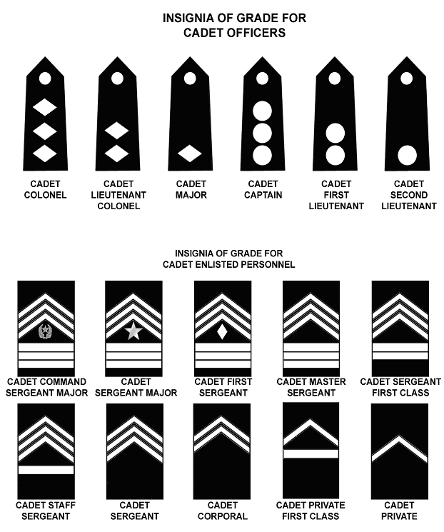

1. Class A/ASU Jacket: Cadet pin-on rank (‘shiny”) will be centered between the bottom of the button hole and the top of the shoulder seam of the Class A/ASU jacket for all ranks.

2. Class B (green or grey) Shirt: Cadets will wear the Shoulder Boards (cloth) Insignia on both shoulders of the Class “B” Shirt.

3. ACU: All cadets will wear the subdued pin-on or Velcro rank insignia (purchased by cadet) on the ACU top/blouse. Multiple-disc grades (1LT, CPT, and LTC) are won vertically on the ACU coat, but horizontally on the ACU cap (see headgear below).

E. WEARING OF CADET HEADGEAR:

1. Beret (grey):

a. Cadet Officers will wear the non-subdued (“shiny”) pin-on Rank Insignia (Pips or Diamonds) on their Berets. Cadet Officer Rank will be centered on the Flash and worn horizontally (straight across).

b. Cadet NCO’s (CPL – CSM) do not wear a rank on Beret flash. Cadet NCO’s will wear the non-subdued, pin-on ROTC wreath on the Beret flash.

c. Cadet PFC. Cadets who reach the rank of PFC will be authorized to wear non-subdues (“shiny”) PFC rank on the beret flash, but only while on GRC campus (this provision in our SOP is not iaw CCR 145-2).

d. Cadet Enlisted (PVT) do not wear anything on the Beret.
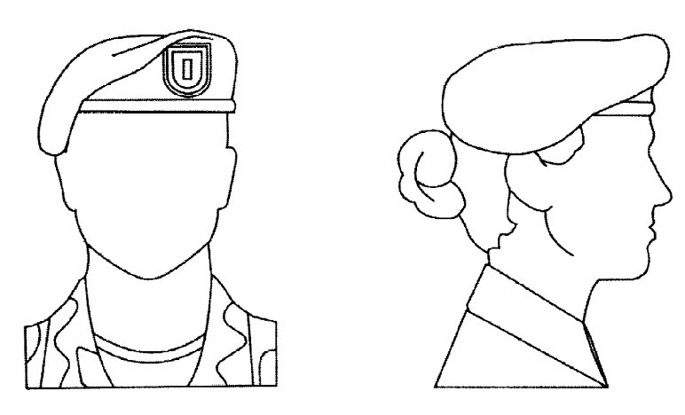
Wear of the Beret, male and female
(centered over LEFT eye; level all around – not tilted)

2. ACU Field Cap: The ACU patrol/field cap is the standard headgear with the ACU uniform, unless specified or directed by the SAI/AI (see Red and Tan beret below):

a. All cadet Officer’s will wear non-subdued, silver (“shiny) pin-on rank on their ACU patrol cap, centered on the cap.

b. All Enlisted cadets will wear subdued pin-on rank on their ACU patrol cap, centered on the cap.

c. Cadets may wear their personal name tape (velcro) or GRC (G.R.C. HS) on the back of their patrol/field cap (this provision in our SOP is not iaw CCR 145-2).

3. Drill/Color Guard (RED) and Raider (TAN) Berets: Cadets who earn the Drill Team Arc Tab, Color Guard Arc Tab, and/or the Raider Arc Tab are authorized to be issued and wear either the RED (Drill/Color Guard) or TAN (Raider) Beret with both the Class A/ASU or ACU uniform, unless otherwise directed. The Red/Green flash will also be worn on the beret.

F. PLACEMENT OF ROTC LAPEL INSIGNIA:

1. Cadet Officer (Class A uniform):

a. Male Cadet officer. The ROTC insignia (R.O.T.C. letters) will be worn 5/8 inch above the notch on both collars with the center line of the insignia bisecting the notch and parallel to the inside edge of the lapel. The Corps insignia (torch of knowledge disc) should be positioned so that the center line of the insignia bisects the center line of the ROTC insignia and is parallel to the inside edge of the lapel.

b. Female Cadet officer. The ROTC insignia (R.O.T.C. letters) will be worn centered on both collars 5/8 inch up from the collar and lapel seam with the centered line of the insignia parallel to the inside edge of the lapel. The Corps insignia (R.O.T.C. letters) will be worn on both lapels 1 ¼ inches below the ROTC insignia, with the insignia bisecting the ROTC insignia and parallel to the inside edge of the lapel.

2. Cadet Enlisted (Class A uniform): The Corps insignia (torch of knowledge disc) are worn centered on both lapels of the coat, parallel to the inside edge of each lapel, and placed so the bottom angle is 1 inch above the notch on the male and 5/8 inch above female lapel.

3. ACU: No Corps collar insignia of either type is worn on the ACU.

PLACEMENT OF ROTC LAPEL INSIGNIA (Officer & Enlisted)



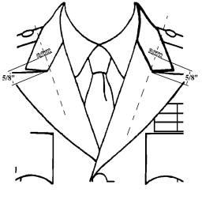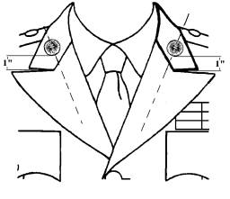
Officer: - JROTC Insignia (5/8”) Enlisted: JROTC Torch Insignia (1”)
- JROTC Torch Insignia (1 ¼”)

G. PLACEMENT OF FORMAL INSPECTION STAR and ACADEMIC WREATH:

1. Formation Inspection (MU/HU/HUD) STAR: The Merit Unit (WHITE Star), Honor Unit (BLUE Star), or Honor Unit (GOLD Star) with Distinction is worn centered 1/4 inch above the right breast pocket on the male Class A jacket/coat and 1/4 inch above the nameplate on the female Army Class A jacket/coat. One point of the star is up on the coat or on the shirt when it is worn as an outer garment.

1/4 inch above right breast pocket (or nameplate for female)

2. Academic Achievement Wreath: Cadets with at least a B average in all subjects and an A average in JROTC are authorized to wear the Academic Achievement Wreath and receive the Academic Achievement, (N-1-3) ribbon.

a. The Academic Wreath is worn centered immediately above the right breast pocket on the Class A jacket/coat or Class A shirt when worn as an outer garment.

b. If the Formal Inspection Star (MU/HU/HUD) insignia is worn, the wreath will be pinned so that the star will be worn inside the wreath.

c. Subsequent awards (Academic Wreath). Receipts of subsequent awards are indicated by the appropriate color felt backing placed behind the Academic Wreath. See Order of Precedence Chart.

Academic Wreath w/ Honor Unit Insignia (Star)
Centered 1/4 inch above the right breast pocket, with point of star facing up

H. PLACEMENT OF UNIT CREST (Distinctive Unit Insignia/DUI): If the Formal Inspection Star (or academic wreath with star) is worn, the Unit Crest (DUI) will be worn 1/8 inch above the Star/Wreath. If the Formal Inspection star is not worn (or authorized/awarded) the DUI is worn 1/4 inch above the coat pocket on the male uniform and 1/4 inch above the nameplate on the female uniform.


GRC JROTC Unit Crest (DUI) is 1/8 inch above Star/Academic Wreath
I. PLACEMENT OF NAME PLATE (Class A): The pocket area on the class B uniform shirt is the same as the pocket area on the Class A uniform.

1. Male: The male name plate will be worn on the flap of the right breast pocket. The name plate will be vertically centered between the top of the button and the top of the pocket. Center the name plate horizontally above the button.

2. Female: The nameplate should be placed 1 to 2 inches above the top button of the coat and centered horizontally on the wearer’s right side. The nameplate will be worn in comparable position on the Class B uniform. Female personnel may adjust the placement of the nameplate to adjust to body configuration (in line with top button).

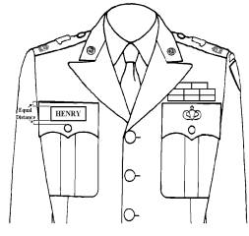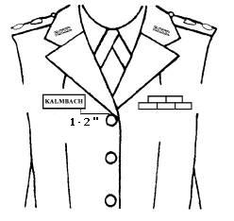
CLASS “A” NAMEPLATE – MALE CLASS “A” NAMEPLATE – FEMALE

J. PLACEMENT OF RIBBONS:

1. Male Cadets:

a. ASU Coat: Male Cadets wear ribbons placed 1/8” from the top of the pocket. Medals of any kind are to be worn centered on the pocket flap 1/8” from the top of the pocket seam (See Chapter 10).

b. Grey Short-Sleeve Shirt: Male Cadets wear ribbons placed 1/8” from the top of the pocket. Medals of any kind are to be worn centered on the pocket flap 1/8” from the top of the pocket seam (See Chapter 10).

2. Female Cadets: Female Cadets wear ribbons centered on the left side, with the bottom row positioned parallel to the bottom edge of the nameplate.

a. ASU Coat: Female Cadets wear ribbons 1” – 2” above the TOP button of the coat, adjusted to conform to individual body-shape differences.

b. Grey Short-Sleeve Shirt: Female Cadets wear ribbons 1” – 2” above the third (3d) button from the top, adjusted to confirm to individual body-shape differences.
K. PLACEMENT OF MARKSMANSHIP BADGES & FRATERNAL MEDALS (Class A Coat):

MALE FEMALE
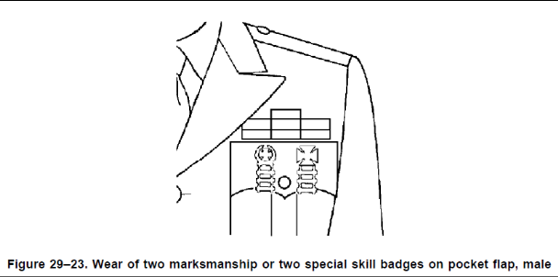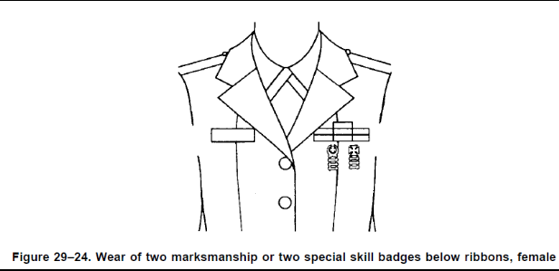

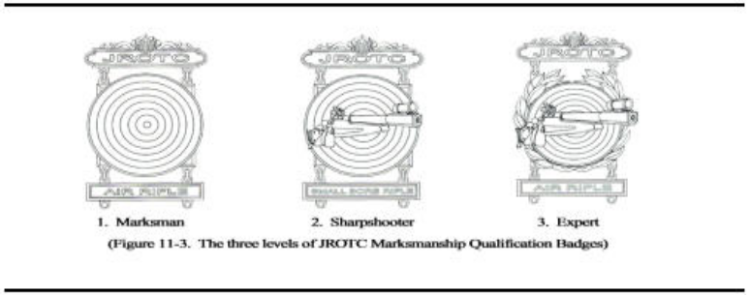

L. WEARING of SHOULDER CORDS (Class A): There are two (2) shoulder cords authorized for wear in the Regiment:

a. Scarlet (Red) Cord – Order of the Long Knife - worn on right shoulder.

b. White Cord – Current Regimental Staff – worn on left shoulder.

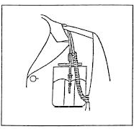
Wear of Shoulder Cord
Staff (LET-4) Cord (White) = LEFT shoulder
OoLK Cord (Red) = RIGHT shoulder

M. WEARING of ARC TABS (Class A):

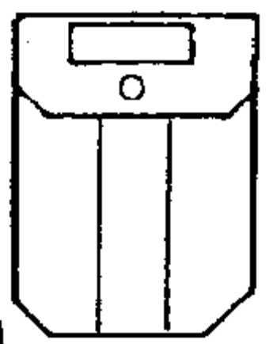

Wear of the Metal ARC TABS
Males - centered on right breast pocket - 1/8 inch apart from each
Females – centered below nametag – 2-4” below – 1/8 inch apart from each
Females may adjust placement of badges to conform to individual body-shape differences.

Maximum number is six (6)
(Wear in order of precedence – See Chapter 10)

N. Wearing of ACU:

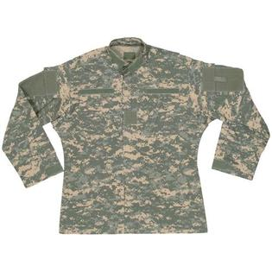
Individual NAME
or
G.R.C. HS Tape
JROTC Tape (velcro)
GRC
Shoulder Patch
JROTC
Shoulder Patch

NOTE: Leadership Position Patches (Velcro) are worn on the LEFT SHOULDER (above patch)

O. RESPONSIBILITY AND MAINTENANCE OF UNIFORMS:

1. Before a student can be enrolled in JROTC, his/her parent/guardian must assume financial responsibility for loss or damage of government items issued.

a. Parents or guardian will sign a JROTC Form “Uniform Agreement of Responsibility."

b. During uniform issue, each cadet must insure that he/she receives the clothing or equipment for which they are signing for (Cadet Hand-Receipt and JUMS Clothing Record). Each and every time a Cadet turns-in or receives any additional uniform items, they must update their Hand-Receipt.

c. The cadet and parent must sign the initial issue hand receipt verifying that the cadet has been issued everything on the hand receipt.

2. Costs of laundry, cleaning, and normal maintenance of uniforms is the responsibility of each cadet. Inspections will be conducted on the uniform day of each week to insure that high standards of personal appearance are being maintained, and to enable the SAI/AI to observe the condition of clothing and equipment.

3. Upon leaving the JROTC program, all government uniforms and equipment must be returned to the JROTC department. Failure to return uniforms and equipment may result in a debit being placed on the cadet’s student account. Failure to return uniforms and equipment constitutes theft of U.S. Government property and will be reported to court authorities for enforcement.

CHAPTER 10
RECOGNITION (AWARDS & RIBBONS)

A. GENERAL: Cadet awards, ribbons, badges, tabs, and cords are presented to cadets in recognition of outstanding performance and/or achievement. Some of these are awarded as soon as practical after earning the award/ribbon and some are only awarded at the Annual Awards Ceremony.

B. TYPES OF AWARDS: The following are the various types of awards and ribbons that Cadets may earn:

1. Department of the Army:
a. Medal for Heroism.
b. Superior Cadet Award (Regimental Selection). See paragraph H (SAI Awards) for selection criteria.
c. Legion of Valor Bronze Cross (Region Selection).

2. JROTC Individual Awards/Ribbons (paragraph C of this section):
a. N-1 (Academic).
b. N-2 (Athletic).
c. N-3 (Military).
d. N-4 (Service).

3. Fraternal and Association (external to GRC JROTC) Awards such as:
a. Sons of Confederate Veterans (SCV) – LET-1 Only.
b. Bluegrass Daughters of the American Colonists – Any Cadet (LET-1).
c. Military Order of the World Wars (MOWW) – NO LONGER USED.
d. Kentucky National Guard Recruiting Command (KYNG) – Any Cadet (LET-2).
c. Sons of the Union Veterans of the Civil War (SUVCW) – Any Cadet (LET-2).
d. Association of the United States Army (AUSA) – Any Cadet (LET-2).
e. Marine Corps League (MCL) – Any Cadet (LET-2).
f. Veterans of Foreign Wars (VFW) – LET-2 only.
g. Military Order of the Purple Heart (MOPH) – NO LONGER USED.
h. National Sojourners – LET-2 or LET-3 only.
i. American Veterans (AMVETS) – LET-3 only.
j. Military Officers Association of America (MOAA) – NO LONGER USED.
k. Reserve Officers Association (ROA) – LET-3 only.
l. Scottish Rite – LET-3 only.
m. U.S. Army Recruiting Command (USAREC) – LET-3 only.
n. Sons of the American Revolution (SAR) – LET-3 only.
o. American Legion; General Military Excellence Award – LET-3 only.
p. American Legion; Scholastic Excellence Award - LET-3 only.
q. Daughters of 1812 – LET-3 or LET-4 only.
r. Daughters of the American Revolution (DAR) – LET-4 only.
s. EKU Deans Award – LET-4 only.
NOTE: These awards should be worn in the above listed order of precedence.

ORGANIZATION | WHO  (LET-level) can receive? | WHAT do they receive? | CRITERIA
Sons of Confederate Veterans (SCV) | LET-1 (LET-2) | Medal, ribbon, & certificate | The award should go to a rising 2nd year cadet who has demonstrated the qualities of Honor, Courage & in particular commitment to his/her unit throughout the school year.
Bluegrass Daughters of the American Colonists | Any Cadet (LET-1) | Medal, ribbon, & certificate | For proficiency in academic subjects, JROTC activities, & good citizenship
Kentucky National Guard | Any Cadet  (LET-2) |  | Any deserving cadet who excels at JROTC and may potentially join the Army National Guard
Sons of the Union Veterans of the Civil War (SUVCW) | Any Cadet  (LET-2) | Medallion, ribbon, & certificate | Cadet that “shows a high degree of patriotism to his/her Nation and has demonstrated a high degree of academic performance and leadership.”
Association of the US Army (AUSA) | Any Cadet  (LET-2) | medal | The SAI & the local AUSA chapter will establish the criteria selection for the award. Presented to Cadets who are recognized for outstanding leadership & academic achievement.
Marine Corps League (MCL) | ANY Cadet  (LET-2) | ribbon | Leadership of service project/activity, top 25% of class in all subjects (including JROTC)
Veterans of Foreign Wars (VFW) | Cadets in 10th (LET-2) grade or above who are actively engaged in JROTC activities are eligible for the award. | medal pendant with matching ribbon bar | (1) Positive attitude toward the JROTC.  (2) Outstanding military bearing & conduct in & out of uniform.  (3) Personal attributes (self-confidence, initiative, flexibility, & judgment).  (4) Patriotism (commander or member of color guard, drill team with or without arms, flag protocol instruction team & actively promote Americanism).  (5) Courtesy (dependability, punctuality, human relations, respect, cooperation).  (6) Growth potential (capable of assuming high leadership responsibilities in the unit with additional training and experience).
National Sojourners | Be in the 2nd (LET-2) or 3rd (LET-3) year of JROTC | ribbon with medal pendant | (1) Be in the top 25% of his or her academic class.  (2) Have encouraged & demonstrated the ideals of Americanism by deed &/or conduct.  (3) Have demonstrated a potential for outstanding leadership.  (4) Not have previously received the award.
AMVETS | Be in the 3rd year (LET-3) of a 4-year program. | medal &/or certificate | (1) Be in good academic standing.  (2) Demonstrate a high degree of military bearing both in & out of the military uniform.  (3) Not have previously received this award.
Reserve Officers Association (ROA) | Be in the 3rd (LET-3) year of a 4-year program. | Gold medal, ribbon & certificate. | (1) Be in good academic standing.  (2) Demonstrate a high degree of loyalty to the units, school, community, & country.  (3) Demonstrate exceptional potential in leadership.  (4) Not have previously received this award.
Scottish Rite | Be in the 3rd (LET-3) year of a 4-year program. | bronze metal pendent, a ribbon, & a certificate | (1) Have contributed the most among Cadets on campus to encourage & demonstrate Americanism, by deeds or conduct during participation in integrated-curricular activities or community projects.  (2) Have demonstrated academic excellence by being in the top 25% of his or her academic class.  (3) Have demonstrated a potential for outstanding leadership by exhibiting qualities of dependability, good citizenship, & patriotism.  (4) Be in the second year of a three-year option or in the third year of a four-year program.  (5) Not have previously received this award.
U.S. Army Recruiting Command (USAREC) | Be in the 3rd (LET-3) year of a 4-year program. | bronze medal & ribbon bar | (1) Be in the top 25% of his or her academic class.  (2) Have demonstrated outstanding leadership traits & possess the potential for assuming positions of increased responsibility.  (3) Participate in integrated-curricular activities that foster both scholastic & military excellence.  (4) Demonstrate qualities of dependability & good character, respect military discipline & standards, & possess a fundamental & patriotic understanding of the importance of JROTC training.  (5) Not have previously received the award.
Sons of the American Revolution (SAR) | 3rd-year  (LET-3) cadets |  | High degree of merit in leadership, military bearing, & general excellence.  Top 10% of their JROTC class.  Top 25% of their overall class.
American Legion | During the junior (LET-3) year, a Cadet in a class HS JROTC unit will receive the bronze medal | bronze medal & ribbon bar | (1) General Military Excellence Award. The Cadet must—  (a) Be in the top 25% of his/ her class in JROTC & non-JROTC subjects.  (b) Have demonstrated outstanding qualities in military leadership, discipline, character, & citizenship.  (2) Scholastic Excellence Award. The Cadet must—  (a) Be in the top 10% of his/her class in non-JROTC subjects.  (b) Be in the top 25% of his/her class in JROTC.  (c) Have demonstrated qualities of leadership.  (d) Have actively participated in related student activities such as student organizations, constructive activities, or sports.
Daughters of 1812 | Junior (LET-3) or Senior  (LET-4) | Bronze medal & certificate | Demonstrated qualities of academic excellence, leadership, military discipline, dependability, patriotism, & character.
Daughters of the American Revolution (DAR) | Be a member of the graduating class (LET-4). | bronze medal & ribbon bar, | (1) Be in the top 25% of the Cadets in JROTC & academic subjects.  (2) Have demonstrated qualities of dependability & good character, adherence to military discipline, leadership
EKU Deans Award (College of Business & Technology) | Senior (LET-4) | certificate | Outstanding Senior cadet.

4. Metal Arc Tabs: See paragraph E of this Chapter.

5. Senior Army Instructor (SAI) Awards: See paragraph H of this Chapter.

5. Order of the Long Knife: See paragraph I of this Chapter.

C. RIBBONS (JROTC): The following ribbons may be earned by cadets as prescribed below and must be worn in accordance with prescribed hierarchy. Awards noted as being presented “annually” will only be awarded at the Annual Awards Ceremony. School Year=1 July-30 June.

1. SUPERIOR CADET Ribbon:

# | TITLE of RIBBON | Awarded By: | Criteria
 | Superior Cadet Ribbon | SAI | Awarded annually to one (1) Cadet in each LET-level for outstanding academic achievement & leadership.

2. ACADEMIC RIBBONS (Series 1):

# | TITLE of RIBBON | Awarded By: | Criteria
N-1-1 | Distinguished Cadet Award for Scholastic Excellence | Superintendent  or designated representative | Awarded annually to a Senior cadet who exhibits the highest cumulative GPA.
N-1-2 | Academic Excellence Award Ribbon | Principal | Awarded annually to 1 cadet per LET- level for maintaining the highest academic GPA.
N-1-3 | Academic Achievement Ribbon | SAI | Awarded annually to all cadets who maintain a cumulative GPA 4.0 (in all academic subjects) for the academic year (may not also receive the N-1-7).
N-1-4 | Perfect Attendance Ribbon | SAI | Awarded annually to cadets with zero unexcused absences during the SY prior to the annual award ceremony (1x per year).
N-1-5 | Student Government Ribbon | Principal | Awarded annually to cadets elected to any student held office.
N-1-6 | Leadership Development Ribbon | Principal | Awarded annually to cadets who successfully complete (pass) their LET-level training.
N-1-7 | Academic Performance Ribbon | SAI | Awarded annually to cadets who maintain a cumulative GPA 3.0 (“B” average) or higher.
N-1-8 | National Honor Society Ribbon | SAI | Awarded annually in accordance with criteria established by the School.
N-1-9 | Academic or Leadership (JLAB) Team Member | SAI | Awarded annually to cadets who compete as a member of the JLAB Academic or Leadership Team at one competition (1x per year).
3. ATHLETIC RIBBONS (Series 2):

# | TITLE of RIBBON | Awarded By: | Criteria
N-2-1 | Varsity Athletic Ribbon | Principal | Awarded annually to cadets that participate (“Letter”) in a varsity sport.
N-2-2 | Physical Fitness Excellence Ribbon | SAI | Awarded 1x annually (in the fall semester) to cadets who maintain excellent physical fitness by achieving an 85% or better in all five (5) Cadet Challenge events. Cadets earning this ribbon will not wear the N-2-3 ribbon, even if previously earned.
N-2-3 | ROTC Athletic Ribbon | SAI | Awarded 1x annually (in the fall semester) to cadets who achieve a 50% rating or better in all five (5) Cadet Challenge events.
N-2-4 | APFT Excellence Ribbon | SAI | Awarded to cadets who excel on the APFT by scoring at least 75 points on each event and 225+ points overall on the FULL Army Physical Fitness Test (FM 21-20). Must be graded by SAI/AI. See also Raider Arc Tab.
N-2-5 | APFT Performance Ribbon | SAI | Awarded to cadets who attain the minimum Army standard of 60 points on each event and 180+ points overall on the FULL Army Physical Fitness Test (FM 21-20). Must be graded by SAI/AI.

4. MILITARY RIBBONS (Series 3):

# | TITLE of RIBBON | Awarded By: | Criteria
N-3-1 | Senior Army Instructor (SAI) Leadership Ribbon | SAI | Awarded annually to one (1) cadet per LET level who displays the highest degree of leadership, as determined by the SAI and AI.
N-3-2 | Personal Appearance Ribbon | SAI | Awarded annually to cadets who consistently present an outstanding appearance (85% or better average for uniform inspections for the school year).
N-3-3 | Proficiency Ribbon | SAI | Awarded annually to those cadets who have demonstrated an exceptionally high degree of leadership, academic achievement, & performance of duty.
N-3-4 | Drill Team Ribbon | SAI | Awarded to drill team members who have competed in at least 1 competition (1x per school year). See also Drill Team Arc Tab (Arc Medal).

# | TITLE of RIBBON |  | Awarded By: | Criteria
N-3-5 | Orienteering Ribbon |  | SAI | Awarded to cadets who have competed in an orienteering event as an individual or team competition (1x per school year). See also Orienteering Arc Tab (Arc Medal).
N-3-6 | Color Guard Ribbon |  | SAI | Awarded to color guard members who have performed 3 or more times (community service/  school/competition) with a Color Guard (1x per school year). See also Color Guard Arc Tab (Arc Medal).
N-3-7 | Marksmanship Team Ribbon |  | SAI | Awarded to cadets who participate in a competitive air-rifle marksmanship competition or postal match (1x per school year). See also Rifle Team Arc Tab & Marksmanship Qualification Badge.
N-3-8 | Adventure Training Ribbon |  | SAI | Awarded to cadets who have competed as a member of the Raider team or participate in a qualifying Adventure Training event (1x per school year).
N-3-9 | Commendation Ribbon |  | SAI | Awarded to cadets whose performance of duty exceptionally exceeds that expected of a cadet in his/her grade and experience. See Cadet of the Month.
N-3-10 |  | Good Conduct Ribbon | SAI | Awarded annually to the cadets who have demonstrated outstanding conduct throughout the school year by receiving zero (0) demerits.
N-3-11 |  | JCLC Summer Camp Ribbon | SAI | Awarded to cadets for who complete all training requirements of the JROTC Summer Camp. Also see JCLC (Summer Camp) Metal Arc Tab.
N-3-12 |  | Honor / Saber Guard Ribbon | SAI | Awarded to cadets selected to serve two (2) times in an Honor Guard, Saber Guard, or as a Service Flag Bearer. Also see Honor/Saber Guard Arc Tab (Arc Medal).
N-3-13 |  | Flag Detail Ribbon | SAI | Awarded to cadets who participate in both one (1) Flag Retirement Ceremony and one (1) Flag Placement Ceremony. Also see Flag Detail Arc Tab (Arc Medal).
N-3-14 |  | Regimental Club Ribbon | SAI | Awarded annually to cadets who have accumulated 75% or better attendance during Regimental Club (including Air Rifle Team & JLAB) for the school year.
N-3-15 |  | Rappelling Ribbon | SAI | Awarded to those cadets who successfully rappel during a JROTC sanctioned training event. NOTE: Often awarded after J.C.L.C.

5. MISCELLANEOUS RIBBONS (Series 4):

 | TITLE of RIBBON | Awarded By: | Criteria
N-4-1 | Parade Ribbon | SAI | Awarded to cadets who have participated in local community parades: i.e., Veterans Day Parade, Memorial Day Parade, Christmas Parade, etc.
N-4-2 | Recruiting Ribbon | SAI | Awarded to the cadets who recruit students into the JROTC program.
N-4-3 | School/Community Service Ribbon | SAI | Awarded to cadets who participate in 2 or more JROTC-sponsored school or community service projects.
N-4-4 | Fund Raising Ribbon | SAI | Awarded to cadets who participate in 2 or more fund raising activities.
N-4-5 | Humanitarian Ribbon | SAI | Awarded to cadets who participate in donating blood or other charitable projects outside of JROTC where participation can be documented.
N-4-6 | Service Learning Ribbon | SAI | Awarded to Cadets who participate in at least one Service Learning Project (SLP) during the school year (1x per year). Cadet must participate in the entire project, not just the exploratory project.
N-4-7 | Excellence Staff Performance Ribbon | SAI | Awarded annually to those LET-4 cadet staff members who perform their duties in an efficient and supportive manner.

D. Multiple Awards (Ribbons):

1. Multiple awards of any ribbon or medal will be designated with a lamp device affixed to the ribbon as follows:
a. 2nd award - Bronze lamp.
b. 3rd award - Sliver lamp (replace Bronze lamp).
c. 4th award - Gold lamp (replace Silver lamp).
d. 5th award - Gold and Bronze lamp.
e. 6th award – Gold and Silver lamp.
f. 7th award - 2 Gold lamps, etc.

2. Maximum Ribbons: Cadets will be limited to wearing six (6) rows of ribbons (with the exception of the Superior Cadet award which may be worn centered above the 6 rows). If a cadet earns more than the 6-row limitation, they may then wear medal “dangly” awards (see below) or must remove the lowest ribbon on the order of precedence.

3. Wearing of Medals (Fraternal and Marksmanship Awards): Cadet can wear a maximum of three (3) “dangly” medals (including marksmanship medals).

(a) Any Marksmanship Medal will be worn closest to the heart (inside) which signifies that it is higher in the order of precedence above any Fraternal Awards/Medals.

(b) Fraternal Medals that also have ribbons (awarded both) will not be worn as medals until cadets have reached the maximum 6-row criteria stated above (once a cadet has reached the 6-row maximum, fraternal medal awards may be worn). Fraternal awards (ribbons) are subordinate to JROTC ribbons (N-1, N-2, N-3, or N-4) and must be worn BELOW other JROTC awards.

(c) The Superior Cadet Award will NOT be worn as a medal; it will always be worn as the top ribbon in the order of precedence (iaw CCR 145-2, para 12-1d).

SEE NEXT PAGE FOR ORDER OF PRECEDENCE & PICTURE OF RIBBONS

E. JROTC Cadet Leadership Challenge (JCLC) Summer Camp Awards (Silver Musket):

1. Cadets who successfully complete JCLC will be awarded the Silver Musket (Basic) upon completion of summer camp (awarded on-site upon graduation).

2. Cadets who also score 240-269 on the APFT at JCLC will be awarded the Silver Musket with one (1) Star. NOTE: Bluegrass JCLC typically only runs a 1-mile run; doubles points.

3. Cadets who also score 270-300 on the APFT at JCLC will be awarded the Silver Musket with two (2) Stars. NOTE: Bluegrass JCLC typically only runs a 1-mile run; doubles points.

BASIC Silver Musket | Successfully completing JCLC
MUSKET with ONE (1) Star | Scoring 240-269 on APFT | 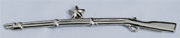
MUSKET with TWO (2) Stars | Scoring 270-300 on APFT | 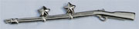
NOTE: GRC is the only JROTC program that awards 1 or 2 Stars based upon the APFT.

4. Cadets who successfully complete the Rappelling training also get credit for the Rappelling Ribbon (N-3-15). NOTE: Orienteering is NO longer conducted at JCLC (2017).

5. The JCLC Summer Camp Ribbon (N-3-11) and Summer Camp Arc Tab (+50 Order of the Long Knife points) is also awarded.
GRC JROTC Ribbon Order of Precedence Chart

Medal for Heroism |  | Superior Cadet | Distinguished Cadet  (N-1-1) | Academic Excellence  (N-1-2)
Academic Achievement  (N-1-3) |  | Perfect Attendance  (N-1-4) | Student Government  (N-1-5) | Leadership Development  (N-1-6)
Academic Performance  (N-1-7) |  | National Honor Society  (N-1-8) | Academic (JLAB) Team  (N-1-9) | Optional (N-1-10)  NOT USED
SAI Leadership  (N-3-1) |  | Personal Appearance  (N-3-2) | Proficiency  (N-3-3) | Drill Team  (N-3-4)
Orienteering  (N-3-5) |  | Color Guard  (N-3-6) | Marksmanship Team  (N-3-7) | Adventure Training  (N-3-8)
Commendation  (N-3-9) |  | Good Conduct  (N-3-10) | JCLC  (N-3-11) | Honor/Saber Guard  (N-3-12)
Flag Detail  (N-3-13) |  | Regimental Club  (N-3-14) | Rappelling  (N-3-15) | Varsity Athletics  (N-2-1)
JROTC Physical Fitness (85%)  (N-2-2) |  | JROTC Athletics (50%)  (N-2-3) | APFT Excellence (75%)  (N-2-4) | APFT Performance (60%)  (N-2-5)
Parade  (N-4-1) |  | Recruiting  (N-4-2) | School/Community Service  (N-4-3) | Fundraising  (N-4-4)
Humanitarian Service  (N-4-5) |  | Service Learning  (N-4-6) | Excellent Staff Performance  (N-4-7) | All “other” ribbons or awards such as Fraternal awards  (per CCR 145-2)
 | Meritorious Unit Insignia: Each member of a unit designated as a Meritorious Unit is awarded the WHITE Star.
 | Honor Unit Insignia: Each member of a unit designated as an Honor Unit is awarded the BLUE Star.
 | Honor Unit With Distinction Insignia: Each member of a unit designated as a Honor Unit With Distinction Unit is awarded the GOLD Star.
 | Academic Achievement Wreath: Awarded to cadets who attain an overall B average in all subjects and an A average in JROTC. This award may only be worn in the semester following receipt. Consecutive receipt of the awards will be recognized by the placement of a colored felt pad behind the wreath:  2nd Award = RED 3rd Award = SILVER 4th Award = GOLD

F. MEDAL ARC TABS: The following ARC TABS (medals) may be earned by cadets as described below. Only the below listed Arc Tabs/Pins are authorized and worn in the order listed. See Chapter IX (Uniforms and Rank) for a diagram for proper wear.

ORDER of PRECEDENCE | TITLE of ARC TAB | Presented To (WHO) | Criteria (FOR)
1 | Raider Arc Tab  (Arc Medal)   | Any Cadet | Cadets who earn the N-2-4 (APFT Excellence Ribbon; 75%) AND the N-3-8 (Adventure Team Ribbon) earns the Raider Arc Tab. Also see Raider Shoulder Tab.
2 | Color Guard Arc Tab  (Arc Medal)   | Any Cadet | Cadets who earn the N-3-6 (Color Guard Ribbon) twice (2x) AND have competed as a member of a Color Guard during a competition earn this Arc Tab. Cannot earn in 1-year.
3 | Honor Guard Arc Tab  (Arc Medal)   | Any Cadet | Cadets who earn the N-3-12 (Honor/  Saber Guard Ribbon) twice (2x); once (1x) as a member of an Honor Guard & once (1x) as a member of a Saber Guard earn this Arc Tab.
4 | Drill Team Arc Tab  (Arc Medal)   | Any Cadet | Cadets who earn the N-3-4 (Drill Team Ribbon) twice (2x) AND have competed as a member of a Drill Team during a competition earn this Arc Tab. Cannot earn in 1-year.
5 | JCLC Arc Tab  (Summer Camp)   | Any Cadet | Awarded to cadets for who complete all training requirements of the JROTC Summer Camp (also N-3-11 ribbon).
6 | Cadet of the Month / Year Arc Tab (Arc Medal)   | LET-1 only | As selected by a Board comprised of officers & NCOs from the Regimental Staff. Cadet of the Month also receives the Commendation Ribbon (N-3-9). The Cadet of the Year Arc Tab will be worn above the Cadet of the Month.
7 | Rifle Team Arc Tab (Arc Medal)   | Any Cadet | Cadets who earn the N-3-7 (Marksmanship Team Ribbon) twice (2x) earn this Arc Tab. Also see Marksmanship & Rifle Team SOP. Cannot earn in 1-year.
8 | JLAB Arc Tab  (Arc Medal)   | Any Cadet | Formerly Leadership Arc Tab. Cadets who make the JROTC Leadership or Academic Bowl (JLAB) teams that make it to the 2nd round of the competition (alternates must have competed during 1st Round).
9 | Flag Detail Arc Tab  (Arc Medal)   | Any Cadet | Cadets who earn the N-3-13 (Flag Detail Ribbon) twice (2x) earn this Arc Tab.
10 | Orienteering Arc Tab  (Arc Medal)   | Any Cadet | Cadets who earn the N-3-5 (Orienteering Ribbon) twice (2x) AND have competed as an individual or member of a Orienteering Team during a competition earn this Arc Tab. Cannot earn in 1-year.

G. SAI AWARDS: The following AWARDS are attainable by conspicuous achievement as indicated and awarded by the Senior Army Instructor (SAI):

TITLE of AWARD | Presented To (WHO) | Criteria (FOR)
General George Rogers Clark “Master of the Long Knife” Award  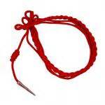 | Awarded annually to the cadet who achieves the highest point total of the current years Order of the Long Knife all the inductees for that school year. | All Order Inductees will have their names added to the Order of the Long Knife plaque. The cadet (non-Senior) achieving the highest points total by the date of the Annual Awards Ceremony will receive a double RED cord indicating his/her selection as the “Master of the Long Knife” award recipient.
Superior Cadet Award (Medal, Certificate & Ribbon) | LET-1  LET-2  LET-3  LET-4 | The outstanding cadet in each LET-level. Top 10% of JROTC class & the top 50% of class in overall academic standing. Includes the highest degree of leadership, involvement, participation, discipline, character, & potential.
Marksmanship Qualifications (Badge)  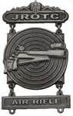 | Cadets who achieve the marksmanship standards as prescribed in CCR 145-2 & Marksmanship SOP | Successfully completing prescribed course of fire (based on firing the AR-1 (10 Bull)) target with minimum established score.  The scores for the different badges are:  230-300 is Expert  130-200 is Sharp Shooter  110-129 is Marksman
Academic Achievement Wreath   | LET-1  LET-2  LET-3  LET-4 | Awarded to cadets who attain an overall B average in all subjects & an A average in JROTC. The award may only be worn in the semester following receipt. Consecutive receipt of the awards will be recognized by the placement of a colored felt pad behind the wreath in the following colors: 2nd award (red), 3rd award (silver), 4th + award (gold).
Honor Unit With Distinction Insignia  (Gold Star)  Honor Unit Insignia  (Blue Star)  Merit Unit Insignia  (White Star) | ALL Cadets | Attainment of Merit Unit, Honor Unit or Honor Unit With Distinction rating during HQCC Formal Inspections. The insignia is worn 1/8” above the right coat/shirt pocket. When wearing the Academic Achievement Wreath, the star device is worn inside the wreath’s laurels.
Raider Shoulder Tab  (Class A/B & ACU)  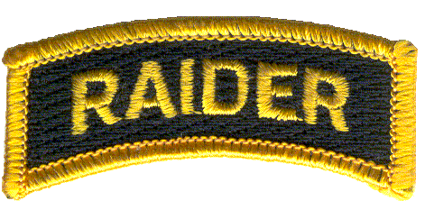 | Any Cadet | Cadets who have earned the Raider Arc Tab (N-2-4 & N-3-8) AND have served as a Captain of or commanded a Raider Team at a competitive event. WORN on RIGHT shoulder. See Raider Arc Tab (Arc Medal).
H. George Rogers Clark Order of the Long Knife:

Order of the Long Knife
Of all the cadet awards the most coveted is the Order of the Long Knife (OoLK) cord. The Order of the Long Knife is named for General George Rogers Clark whose name among the Indian tribes of the Northwest Territory was Long Knife. The scarlet cord symbolizes the Red Belt of War General Clark presented to Indians during treaty negotiations. The Order of the Long Knife is the most prestigious award because it requires the cadet to demonstrate self-discipline, competency, dedication, and success in all aspects of cadet life. Only the most devoted cadets will achieve the Order of the Long Knife. It is anticipated that cadets will not achieve this status before the end of their sophomore year at the earliest. Each year cadets who achieve 700 points including all mandatory requirements will be inducted into the order and will have his or her name added to the Order of the Long Knife plaque.
a. The awarding of the Order of the Long Knife (OoLK) typically occurs twice (2x) per school year. The first opportunity to be awarded the OoLK is during the annual Military Ball. The second opportunity to be awarded the OoLK is during the Annual Awards Ceremony. If necessary, the OoLK may be awarded at the very end of the school year, but will have to be awarded during classroom time and not in an official ceremony in front of the entire Regiment.
b. In any of the cases stated above, the following criteria MUST be met:
(1) The 14 x MANDATORY requirements MUST be accomplished/achieved in order to qualify for the Order of the Long Knife. There are 340+ possible “1st attempt” points that can be earned from the Mandatory requirements.
(2) The ADDITIONAL POINTS in 27 areas make up the difference (to obtain the minimum 700 points). There are an additional or possible 870 points that can be earned from the Additional Points list.
(3) DEMERITS are also included (subtracted) from the total OoLK points total.
NOTE: Cadets who earn DEMRITS will have points deducted from the Order of the Long Knife total equaling the number of demerits accumulated at the time of determination for induction. Cadets who receive more than 50 demerits become ineligible. Cadets who accumulate 50 demerits after being inducted into the order must relinquish their cord and will be removed from the Order’s roles.

c. The MASTER of the Order of the Long Knife is awarded to the Cadet (who is not a graduating Senior) who achieves the HIGHEST point total for the school year by the date of the Annual Awards Ceremony. It is presented by the previous year’s recipient and the SAI at the Annual Awards Ceremony.

The points system or criteria for the Order of the Long Knife are explained on the next page of this section.
Order of the Long Knife MANDATORY Requirements

MANDATORY REQUIREMENTS | POINTS AVAILABLE | POINTS AWARDED
1. JROTC Cadet Creed  * must score 100%  * zero (0) after 3rd attempt | 1st Attempt = 30 points  2nd Attempt = 20 points  3rd Attempt = 10 points
2. U.S. Army Ranks  * must score 100%  * zero (0) after 3rd attempt | 1st Attempt = 30 points  2nd Attempt = 20 points  3rd Attempt = 10 points
3. JROTC Cadet Ranks  * must score 100%  * zero (0) after 3rd attempt | 1st Attempt = 30 points  2nd Attempt = 20 points  3rd Attempt = 10 points
4. George Rogers Clark Knowledge Test  * 50 questions – 1 point per question | Must score at least 15 out of 50 on the test. Re-takes are authorized.
5. National Chain of Command  * must score 100%  * zero (0) after 3rd attempt | 1st Attempt = 30 points  2nd Attempt = 20 points  3rd Attempt = 10 points
6. Command Squad Drill (Box)  * must score 90% or better  * zero (0) after 3rd attempt | 1st Attempt = 25 points  2nd Attempt = 15 points  3rd Attempt = 5 points
7. Drill Team Ribbon (N-3-4) | 30 points – 1x award
8. Color Guard Ribbon (N-3-6) | 10 points – 1x award
9. Adventure Team Ribbon (N-3-8) | 20 points – 1x award
10. Flag Detail Ribbon (N-3-13)  * Flag Placement & Flag Retirement | 20 points – 1x award
11. Parade Ribbon (N-4-1)  *only 1st Award is Mandatory  * 2nd Award is considered Additional Points | 1st Award = 20 points  *2nd Award = 10 points
12. Community Service Ribbon (N-4-3) *only 1st Award is Mandatory  * 2nd Award is considered Additional Points | 1st Award = 20 points  *2nd Award = 10 points
13. Fund Raising Ribbon (N-4-4)  *only 1st Award is Mandatory  * 2nd Award is considered Additional Points | 1st Award = 30 points  *2nd Award = 15 points
14. Service Learning Ribbon (N-4-6)  * 2nd Award is considered Additional Points | 1st Award = 30 points  *2nd Award = 15 points
340 1st Attempt points
(*not including 2nd)
Order of the Long Knife Additional Points

ADDITIONAL POINTS | POINTS AVAILABLE | POINTS AWARDED
1. Cadet Challenge Awards/Ribbon(s)  (Certificate, N-2-2, & N-2-3)  * highest award counts | N-2-2 (85%) = 40 points  N-2-3 (50%) = 30 points  Certificate = 0 points
2. Academic Wreath (max of 4 awards) | 30 points each award
3. JCLC Arc Tab (Summer Camp)  & JCLC Ribbon (N-3-11) | 50 points – 1x award
4. Cadet of the Month (Metal Arc Tab)  Cadet of the Year (Metal Arc Tab) | 25 points – 1x award  15 bonus points
5. Honor Guard Arc Tab (Metal Arc) | 30 points – 1x award
6. Flag Detail Arc Tab (Metal Arc) | 30 points – 1x award
7. Color Guard Arc Tab (Metal Arc)  Command @ Competition  Command @ School Event | 30 points – 1x award  30 points – 1x award  10 points – 1x award
8. Drill Team Arc Tab (Metal Arc)  Commanded @ Competition | 30 points – 1x award  20 points – 1x award
9. Orienteering Arc Tab (Metal Arc) | 30 points – 1x award
10. Rifle Team Arc Tab | 30 points – 1x award
11. Good Conduct Ribbon (N-3-10) | 30 points – 1x award
12. Regimental Club Attendance (75%) Ribbon (N-3-14) | 25 points – each award
13. Recruiting Ribbon (N-4-2) | 25 points – 1x award
14. Humanitarian Ribbon (N-4-5) | 30 points – 1x award
15. Raider Arc Tab (Metal Arc)  Command @ Competition (Patch) | 50 points – 1x award  30 points – 1x award
16. JLAB Arc Tab (Metal Arc)  (make it to 2nd Round of JLAB competition) | 25 points – 1x award
17. APFT Performance Ribbon (N-2-5)  (PASSING score/60% all events)  Includes any Varsity Letter | 20 points each award  20 points per Letter
18. Marksmanship Qualification Badge  * highest award counts | Expert = 30 points  Sharpshooter = 20 points  Marksman = 10 points
19. Personal Appearance Ribbon (N-3-2) | 25 points – each award
Up to 870
additional points
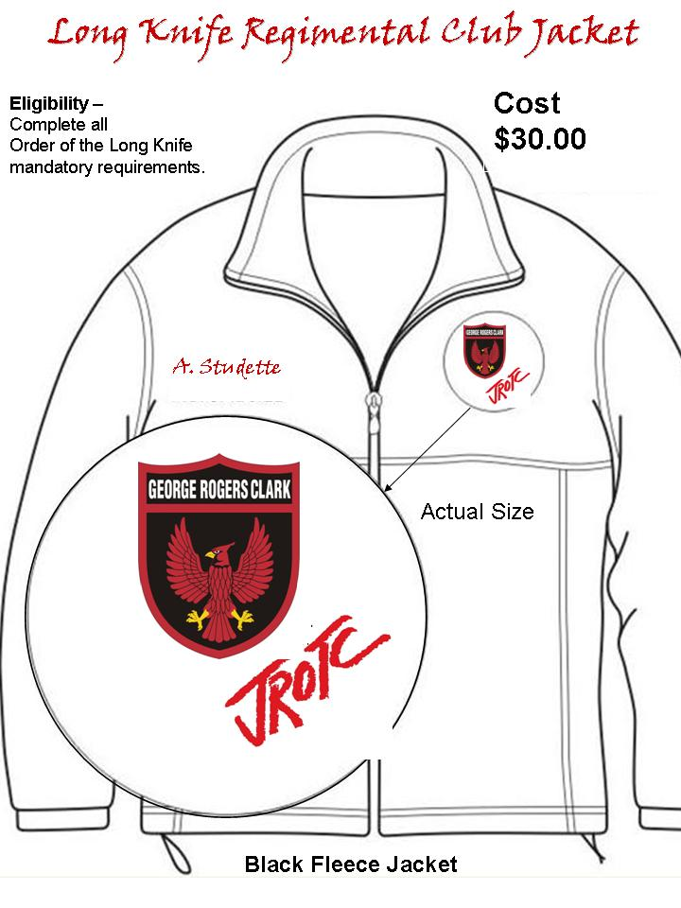
Cadet must purchase Jacket and have name embroidered on the jacket.
CADETS who have been AWARDED the Regimental Jacket (completed ALL mandatory requirements) are the ONLY person AUTHORIZED to wear it (NO girl/boy-friends).
J. Alumni Challenge Coin: The GRC Alumni Challenge Coin is presented to Seniors (LET-4) who upon graduation meet all the following criteria:

a. Be an active JROTC cadet upon graduation from George Rogers Clark High School.
b. Have completed the 15 mandatory requirements for the Order of the Long Knife.
c. Have maintained an average of 85% percent rating on uniform appearance inspections for the school year during their Senior year (earned the Personal Appearance Ribbon; N-3-2).
d. Graduate with a “B” (3.0) average in JROTC.
e. Incur NO MORE than 8 Demerits during their Senior-year or a determination by both the SAI and AI that the cadet has brought discredit to the program.
f. Additionally, cadets must NOT have accumulated over 30 DEMERITS during the cadet’s tenure in JROTC.
f. Coins will be presented at the Annual Awards ceremony to eligible seniors.
g. The SAI and AI reserve the right to issue or deny any Cadet their Alumni Challenge Coin.
h. The LET-4 Senior Class may elect to vote to award an Alumni Challenge Coin to any other graduating Senior (not LET-4) who is deserving. The criteria for this vote is determined by the LET-4 class with approval by the SAI.
i. The Coins are numbered. The SAI/AI maintains a log of which coins are presented. Unnumbered coins are presented to VIPs and supporters of the program as special recognition.

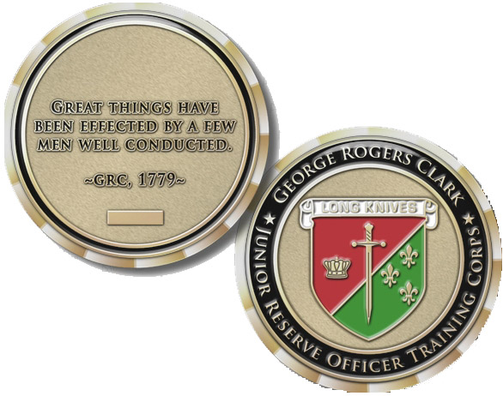

GRC Alumni Challenge Coin
CHAPTER 11
WEAPONS & SECURITY (Arms Room/S-2)

NOTE: This Chapter is only an extract taken from the GRC JROTC Supply SOP that includes all standard operating procedures and regulatory guidance regarding weapons and security.

A. PURPOSE: The purpose of this Chapter is to highlight for Cadets the applicable established policies and procedures for securing weapons (Drill & Air Rifles), ammunition, and other sensitive (pilferable) items.

B. RESPONSIBILITIES:

1. Arms Room (weapon) security is the responsibility of the SAI/AI or MPS/MPC, designated cadet supply and security personnel (Regimental S-4 or S-2 Staff or Company-level Supply Sergeants), and all cadets in the possession of Government property. All will ensure that all sensitive containers in the Arms Room and doors permitting access into the Arms Room are secured daily prior to close of business.
2. The SAI/AI will ensure all members and participants in JROTC adhere to the provisions outlined in applicable regulations and guidance contained in the GRC JROTC Supply SOP and other regulatory guidance concerning the security of arms and ammunition.
3. All JROTC Cadets will handle weapons, ammunition, and other sensitive items in a safe and secure manner.

C. TYPES OF WEAPONS: The GRC HS JROTC currently has the following types of weapons on-hand and authorized:

1. Rifle, Air (LIN: 60002N), NSN: 100501C051181 (by serial number).
2. Rifle, Dummy Drill, (LIN: R44655), NSN: 100501D811400 (by serial number).
3. Rifle, Drill, Facsimile (LIN: XA101G), NSN: 6910015194121 (by serial number).

D. ARMS ROOM ACCESS & SECURITY:

1. UNESCORTED Access: A memorandum will be posted on the Arms Room door listing the personnel that have authorized UNESCORTED access. Normally this access will be limited to the Regimental S-2 and S-4 Staff(s).
2. ESCORTED Access: A memorandum will be posted on the Arms Room door listing the personnel that have authorized ESCORTED (escort must be a JROTC Cadre/Instructor) access.
3. No individual will be in the Supply or Arms Room unless accompanied by SAI/AI or designated cadet supply and security personnel (Regimental S-4 or S-2 Staff or Company-level Supply Sergeants).
4. Key access to any supply storage area will be limited to the SAI/AI or MPS/MPC or designated cadet supply and security personnel (Regimental S-4 or S-2 Staff or Company-level Supply Sergeants).
5. Loss or Theft: Dummy drill rifles and air rifles are pilferable items; therefore, GRC HS JROTC will ensure the storage of dummy drill rifles and air rifles IAW regulatory security requirements. Any loss or theft of weapons (dummy drill or air rifle) will be reported immediately to the SAI/AI. Loss of accountability of weapons constitutes a serious incident and requires special reports and procedures (per AR 190-11 and AR 190-40).
6. Ammunition Storage: Air Rifle pellets will be stored and secured separately from the Air Rifles (not in the Arms Room).

E. ISSUE/TURN-IN PROCEDURES:

1. In a classroom or training environment, there is no need for students/cadets to sign a control sheet when continuous surveillance/supervision exists by cadre personnel.
a. In this instance, the instructor (SAI/AI) signs the control sheet for the total number of weapons issued.
b. If training rifles are used during the course of a day, at the end of each class period or at the end of each training period, a physical count of the rifles will be made prior to the release of the class or team.
2. The GRC JROTC Weapons Control Log may be used to issue weapons, as necessary.
3. Under no circumstances will a cadet be allowed to take a training drill rifle or air rifle home or transport such weapon in a POV; with the exception of non-military (white plastic) replica drill rifles.

F. WEAPONS (DRILL & AIR RIFLE) INVENTORY: Drill and Air Rifles will be physically inventoried by serial number monthly.
1. Serial numbers will be verified quarterly with those recorded the IPBO Hand Receipt and the informal property book (JUMS) by the MPS/MPC.
2. Consecutive inventories will not be conducted by the same individual (iaw AR 190-50).
3. The Cadet S-2 is authorized to conduct the monthly inventory; verified by the MPS/MPC.
4. The Cadet S-2 (or MPS/MPC) will use JUMS to print-out a serial number listing (reports) of all dummy drill rifles and air rifles to inventory (Log onto JUMS, then go to Reports tab):
(a) Use Rifle Tracking Report (found under Property tab) to print-out a report of all Government-issued air and dummy drill rifles.
(b) Use M1903 Drill Rifles (School) Report (found under Ad Hoc Reports) to print-out a report of all School-issued drill rifles (x4).
(c) Use Daisy 853 Air Rifles (School)/Government) Report (found under Ad Hoc Reports) to print-out a report of all School-issued air rifles (x4).
(d) Sign and Date the Rifle Tracking Report (on the last page) and attach the M1903 Drill Rifles and Daisy 853 Air Rifles (School/Government) Reports and then file accordingly.

CHAPTER 12
SUPPLY (Supply Room/S-4)

NOTE: This Chapter is only an extract taken from the GRC JROTC Supply SOP that includes all standard operating procedures and regulatory guidance regarding supply activities and actions.

A. PURPOSE: The purpose of this Chapter is to highlight for Cadets the applicable established policies and procedures and regulatory guidance regarding supply activities and actions.

B. RESPONSIBILITIES: The SAI and AI are responsible for proper supervision to ensure that property accountability is maintained in accordance with all Department of Defense (DoD), U.S. Army, TRADOC, Cadet Command, and Fort Knox regulations and other applicable directives.

1. The SAI or the AI will be appointed (in writing) by the GRC HS Principal as the Military Property Custodian (MPC)/Military Property Specialist (MPS) to perform logistics tasks, to be responsible and accountable for government property, and to manage it in accordance with Army policy and procedures. Normally, the MPC/MPS will be the AI.
2. The Cadet S-4 and his/her staff section will supervise all cadet supply activities and actions, as directed by the Cadet Battalion Commander and SAI/AI. Refer to Chapter 8 (Cadet Duty Position Descriptions) for additional details.

C. STORAGE of CLOTHING/UNIFORM ITEMS, SUPPLIES & EQUIPMENT: Supply Room security is the responsibility of the SAI/AI or MPS/MPC, designated cadet supply personnel (Regimental S-4 Staff or Company-level Supply Sergeants), and all cadets in the possession of Government or school property. All will ensure that all sensitive containers in the Supply Room and doors permitting access into the Supply Room are secured daily prior to close of business. All Supply representatives (SAI/AI, MPS/MPC, and all authorized Cadet supply personnel) will use the following guidance to ensure proper storage of clothing/uniform items, equipment and supplies:

1. Ensure security of all government property. Ensure the doors to the Supply and Arms Room are locked after use.
2. Ensure all items stored in the Supply Room and Arms Room are properly stored in designated locations at all times and are kept clean and serviceable.
3. Ensure all government property and school property are properly marked and stored separately.

D. CADET CLOTHING/UNIFORM ISSUE & TURN-IN:

1. Cadet Clothing/Uniform Issue:
(a) Cadets and parents/guardians are required to sign and have on-file a copy of the GRC JROTC Uniform Agreement Form (GRC JROTC Form 1) prior to issue of any uniform or clothing items.
(b) For the initial (first) issue (Fall semester or new student) of uniform Class A (old green or new ASU) items, a JUMS Hand Receipt will be printed and the Cadet AND Parent/Guardian will sign for all items issued.
(1) The Cadet will be provided a copy of the signed JUMS Hand Receipt.
(2) The original signed copy will be filed in the filing cabinet (by name).
(3) If there are any changes to the initial issue, only the Cadet must sign the new JUMS Hand Receipt.
(c) For the Army Combat Uniform (ACU), the GRC HS JROTC Form 3645-1 (ACU) may be used to temporarily document issue of ACU; otherwise and eventually, use a printed JUMS hand-receipt.
(d) For Cadets attending JCLC (Summer Camp), the GRC HS JROTC Form 3645-1 (JCLC) will be used to temporarily issue and document the issue of ACU and other associated military/government-issued equipment (OCIE).
(e) Cleaning, alteration, and renovation of cadet uniforms will be accomplished prior to issuing uniforms to cadets, whenever possible. Once issued to cadets, the cost of cleaning and normal maintenance of uniforms is a cadet (parent/guardian) responsibility.

2. Cadet Clothing/Uniform Turn-In:
(a) Cadets will turn-in all or specified clothing/uniform items upon:
(1) Disenrollment or Graduation.
(2) End of School Year (SY) or as directed by SAI/AI or MPS/MPC.
(b) Once clothing/uniform and/or equipment issued to cadets is returned, it will quickly be documented in JUMS and returned to the Supply Room. A copy of the cadet’s new JUMS Hand Receipt will be provided to the cadet, as necessary.
(c) Clothing worn out through fair wear and tear will be replaced at no cost to the student.

E. HAND RECEIPTS: JUMS Hand Receipts will be maintained in the file cabinet managed by the Cadet S-4 and the MPS/MPC. The Company-level Supply Sergeants will assist in maintaining clothing records/hand-receipts on all Cadets.

