

Document name: | Registration Authority Smartcard Issuance and Usage Policy and Procedures (Trust-wide policy)
Document type: | Policy
What does this policy replace? | Existing Registration Authority Policy
Staff group to whom it applies: | All staff within the Trust issued with Smartcards
Distribution: | The whole of the Trust
How to access: | Intranet
Issue date: | May 2017
Next review: | May 2019 or subject to major change to RA Systems and Services
Approved by: | Executive Management Team/Trust Board and date
Developed by: | Registration Authority Manager - IM&T
Director leads: | Director of Finance and Resources
Contact for advice: | Head of IT Services & Systems Development



CONTENTS

 |  |  | PAGE
1. | INTRODUCTION |  | 3
2. | PURPOSE |  | 4
3. | THE RISKS OF NOT HAVING THIS POLICY AND PROCEDURES IN PLACE |  | 5
4. | DEFINITIONS |  | 5
5. | PRINCIPLES |  | 7
6. | ROLES AND RESPONSIBILITIES |  | 10
7. | MANAGEMENT & USE OF RA EQUIPMENT |  | 18
8. | PROCEDURES |  | 18
9. | COMMENTS & ENQUIRIES REGARDING THIS POLICY AND PROCEDURES |  | 20
10. | MONITORING THE COMPLIANCE AND EFFECTIVENESS OF THIS POLICY AND PROCEDURES |  | 20
11. | REFERENCES |  | 21
12. | REVIEW OF THIS POLICY AND PROCEDURES |  | 22
 | Appendices
 | Appendix A | RA Procedures | 23
 | Appendix B | Directly Employed New User Registration Flowchart | 31
 | Appendix C | Non-Directly Employed New User Registration Flowchart | 32
 | Appendix D | Smartcard Access Role Change Flowchart | 33
 | Appendix E | Smartcard Incident Reporting Flowchart | 34
 | Appendix F | Resetting Smartcard Password Flowchart | 35
 | Appendix G | Leavers & Revocation Flowchart | 36
 | Appendix H | Guidance for the approval of RA Sponsors & Approval Form | 37
 | Appendix I | Smartcard Stock Control Audit Procedure | 38
 | Appendix J | Equality Impact Assessment Tool | 41
 | Appendix K | Checklist for the Review and Approval of Procedural Document | 43
 | Appendix L | Version Control Sheet | 46
REGISTRATION AUTHORITY POLICY

1. | INTRODUCTION
 | 1.1 | With the introduction of the NHS Care Records Service (NHS CRS) compliant applications, it is of paramount importance that NHS patients are confident their medical records are kept secure and confidential in line with the NHS Care Records Guarantee, NHS Constitution and local arrangements as described in the South West Yorkshire Partnership NHS Foundation Trust (SWYPFT) IM&T Security Policy and Confidentiality Policy.
 | 1.2 | To achieve this, all employees (as described in section 1.5 and 4.1) requiring access to NHS CRS compliant applications must be registered with a smartcard and have appropriate access profiles. The registration process for NHS CRS compliant applications must meet current Government e-GIF Level 3 authentication requirements to ensure the identity of the individual applying for registration and access. All the NHS CRS compliant applications use a common security and confidentiality approach. This is based upon care setting, areas of work and business functions.
 | 1.3 | The primary method by which users will access an NHS CRS compliant application is via a smartcard issued during the formal registration process. Once an applicant has been successfully registered they will have a User ID, pass-code and a smartcard issued to them, which will permit their individual access to the appropriate application(s) and information. The registration process is operated at a local level by an authorised Registration Authority (RA) that is required to be carried out in accordance with and conform to the National Registration Authority Policy standards (NHS Digital). The operation of the Registration Authority has been integrated, where possible, with Trust functions covering the Human Resources administration of staff starters/leavers processes and network access requests to non NHS CRS Compliant systems.
 | 1.4 | In Public Key Infrastructure (PKI) terms there is a single Registration Authority (NHS Digital - formerly Health and Social Care Information Centre). All organisations that run a local Registration Authority do so on a delegated authority basis from NHS Digital. As NHS Digital is the single Registration Authority it needs to assure itself that organisations are operating appropriately and discharging their duties in an effective and consistent fashion. This paper sets out the policy and procedures under which all aspects of the RA function will be processed, managed and monitored locally to ensure compliance with national guidance and organisational responsibilities.
 | 1.5 | This policy applies to all staff of SWYPFT including contracted third parties (including agency staff – where appropriate), students/trainees, people on secondment and other staff on placement with SWYPFT, and staff of partner organisations with approved access covered by contracted Service Level Agreements (SLAs).
 | 1.6 | Specifically where arrangements are in place between SWYPFT and other partner organisations (e.g. local authorities) for Registration Authority services, this policy applies to all services and locations where SWYPFT is the lead organisation.
2. | PURPOSE
 | 2.1 | The policy aims to provide the framework for the continuing development of robust Registration Authority management practices established and to summarise the procedures for the operation of the Registration Authority within SWYPFT. The operation of the Registration Authority has been integrated, where possible, with Trust functions covering the Human Resources administration of staff starters/leavers processes and network access requests to non NHS CRS compliant systems.
 | 2.2 | This document has been developed to ensure that the Registration Authority arrangements within SWYPFT adhere to National Guidance and Standards, through: -
 |  | 2.2.1 |  | Systems in place to provide a robust structure for Registration Authority management within SWYPFT.
 |  | 2.2.2 |  | Increased staff awareness of their responsibilities with regards to Registration Authority compliance.
 |  | 2.2.3 |  | Staff being fully aware of their responsibilities with regards to usage of smartcards and general good practice.
 |  | 2.2.4 |  | Compliance with legal obligations and national requirements.
 | 2.3 | The policy and its procedures aim to provide guidance to all NHS CRS compliant application users on the processes to be followed.
 | 2.4 | The policy is intended to provide assurance to the SWYPFT Executive Management Team (EMT) and Trust Board that appropriate arrangements are in place for the safe operation, management and monitoring of Registration Authority responsibilities.
 | 2.5 | This policy document has been updated to incorporate: -
 |  | 2.5.1 |  | Changes in functionality due to the Spine 2 Care Identity Service.
 |  | 2.5.2 |  | Identity management guidelines and the verification of identity checks as part of the introduction of Care Identity Service (CIS) which is designed to streamline the process for employee identity management and control access to electronic systems. Integrated Identity Management aims to improve information security whilst reducing the administrative costs associated with managing employee identity in the NHS.
 |  | 2.5.3 |  | Registration Authority restrictions
 |  | 2.5.4 |  | Position Based Access Controls (PBAC)
 |  | 2.5.5 |  | Registration Authority reporting
 | 2.6 | This policy replaces all previous versions.
3. | THE RISKS OF NOT HAVING THIS POLICY AND PROCEDURES IN PLACE
 | 3.1 | Failure to comply with this policy and procedures may result in the following risks arising: -
 |  | 3.1.1 |  | SWYPFT may not meet it’s obligations in ensuring adherence to national Registration Authority guidance and audit requirements.
 |  | 3.1.2 |  | SWYPFT Registration Authority processes and actions may be deemed to be unfair and inconsistent if not undertaken in accordance with this policy and procedures.
 |  | 3.1.3  3.1.4 |  | All staff using NHS CRS compliant applications may not be fully aware of the standards of conduct expected of them and consequences of non-compliance with this policy and procedures.  SWYPFT may not meet its obligations in ensuring adherence to NHS IG Toolkit standards and requirements.
4. | DEFINITIONS
 | 4.1 | The use of the word staff in this document means people who are directly employed by, contracted to provide services to, or are part of a contractual agreement with SWYPFT. SWYPFT will operate the Registration Authority on behalf of the following organisations and groups of staff that operate within the geographic boundaries of Trust. This applies to: -  - Staff directly employed by SWYPFT  - Any other clinical or non-clinical person who is contracted by SWYPFT who requires access to NHS CRS compliant applications in order to perform the duties for which they are employed  - All staff who require access to NHS CRS compliant applications and who are not directly employed by SWYPFT but where SWYPFT is responsible for the provision of Registration Authority services across geographical responsible areas.
 | 4.2 | Glossary of Terms
 |  | CRS |  |  | (National) Care Records Service aims to create the integrated electronic care record
 |  | eReferral |  |  | Electronic Referral Service (formerly Choose & Book)
 |  | EPS |  |  | Electronic Prescription Service
 |  | ESR |  |  | Electronic Staff Record
 |  | HR  NHS Digital |  |  | Human Resources Department within SWYPFT  National body that the Trust is accountable to in respect of Registration Authority services (formerly Health & Social Care Information Centre)
 |  | CIS |  |  | Care Identity Services combines the currently separate processes within Registration Authority and Human Resources for capturing and managing employee identity
 |  | IR1 |  |  | Incident Reporting Form
 |  | IM&T |  |  | Information Management & Technology Department within SWYPFT
 |  | ISTC |  |  | Independent Sector Treatment Centre
 |  | IT |  |  | Information Technology
 |  | LPC |  |  | Local Pharmaceutical Committee
 |  | RA |  |  | Registration Authority
 |  | RBAC |  |  | Role Based Access Controls are the nationally defined set of business functions that make up system roles that users can be assigned to
 |  | Role Profile |  |  | Term used to define system access levels for individual users of NPfIT Systems
 |  | SLA |  |  | Service Level Agreement
 |  | Smartcard |  |  | Photo ID Card issued to individual NPfIT system users that holds information relating to levels of system access assigned.
 |  | SUD |  |  | (National) Spine User Directory is where user registration details are held. When users access systems with their smartcard, the details on the SUD are authenticated against their smartcard as part of the login process
 |  | CIS |  |  | The Care Identity Service paperless system where user registrations are processed electronically in order to enable smartcards to be issued.
 |  | UUID |  |  | The User’s Unique Identifier which is a number allocated to the user’s CIS account and which is printed on the individual’s smartcard along with their photograph.
5. | PRINCIPLES
 | 5.1 | Registration Authority Organisation
 |  | 5.1.1 |  | The organisation needs a Registration Authority function to administer the registration process; to manage the distribution and use of Smartcards, and individual NHS CRS compliant applications system access rights.
 |  | 5.1.2 |  | At this time there are no plans for the NHS CRS compliant smartcard to become the SWYPFT staff identification card. However, this may be subject to change in line with any associated National Guidance.
 |  | 5.1.3 |  | All staff as detailed in 4.1 will be required to complete the registration process and be issued with a smartcard.
 |  | 5.1.4 |  | Staff who do not require access to ESR or NHS CRS compliant applications will NOT be issued with a Smartcard. However, staff who are nominated to the role of RA Sponsor will be registered on the National SPINE following normal registration procedures and will be issued with a smartcard for the sole purpose of carrying out this role.
 |  | 5.1.5 |  | SWYPFT will comply fully with the latest published National RA Guidance, Policies and Procedures available from the NHS Digital Website. Depending on the extent of the changes that revised NHS Digital guidance introduces, this may result in further review of this policy.
 |  | 5.1.6 |  | The procedures covered in this document are the local support procedures necessary to adhere to the National Policies and Procedures covering: -  - Identification and Appointment of Registration Authority staff  - Registration of Strategic Registration Authority Manager (Strategic RA Manager)  - Registration of Registration Authority Manager (RA Manager)  - Registration of Registration Authority Agents (RA Agents) and IT Servicedesk Registration Authority Agents (IT Servicedesk RA Agents)  - Registration of Registration Authority Sponsors (RA Sponsors)  - Registration of NHS CRS compliant Application Users  - Management of NHS CRS compliant Application Users  - Management of Registration Authority/User Smartcards  - Management of Registration Authority/User PIN/Pass-codes  - Management of Registration Authority/User Profiles (Determines the level of access for system users)
 |  | 5.1.7 |  | The intended audience for this document and its awareness/use are the following: -  - Board Members  - Directors  - Senior Management  - Heads of Service  - Service Managers  - Improving Clinical Information Group (ICIG)  - All users/customers of the Registration Authority Services provided by SWYPFT  - Human Resources personnel  - IM&T personnel  - Confidentiality Specialists including Caldicott Guardian(s)  - IT Support Services or Help Desk personnel  - NHS Digital staff
 |  | 5.1.8 |  | SWYPFT Registration Authority is made up of the following personnel: -  - SIRO (Executive)  - Caldicott Guardian (Executive)  - Deputy Director of IM&T  - Strategic Registration Authority Manager  - Registration Authority Manager  - Registration Authority Sponsors  - Registration Authority Agents  - IT Service Desk Registration Authority Agents
 |  | 5.1.9 |  | Those identified in 5.1.8 will ensure tight control over the issue and maintenance of electronic Smartcards, whilst providing an efficient and responsive service that meets the needs of the users.
 |  | 5.1.10 |  | The Registration Authority needs to have at the heart of its thinking protecting patients’ interest and the obligations placed on staff through the NHS Care Record Guarantee. Consideration also needs to be given to how the patient perspective is incorporated into this governance framework. The individuals/teams providing this governance need to be familiar with this document and the obligations it contains.
 |  | 5.1.11 |  | Registration Authority Sponsors are appointed and entrusted to determine who should have what access and maintaining the appropriateness of that access. Please refer to Appendix H.
 |  | 5.1.12 |  | Currently Registration Authority Sponsors are selected from:  - Line Managers (Department & Service Managers/Team Leaders)  - Service Management Lead for SLA Management within 3rd Party organisations (e.g. ISTCs, Hospice)  - Key administrative staff
 |  | 5.1.13 |  | The Registration Authority needs to ensure that:  The national registration processes are adhered to in full as identified in document “Registration Authorities: Governance Arrangements for NHS Organisations”  https://digital.nhs.uk/article/311/Registration-Authorities-and-Smartcards  RA personnel are familiar with and understand “Registration Policy and Practices for Level 3 Authentications and Registration Authorities Operational Process and Guidance” https://digital.nhs.uk/article/311/Registration-Authorities-and-Smartcards  There are sufficient Smartcards and Smartcard issuing and maintenance equipment for the organisation http://systems.digital.nhs.uk/rasmartcards/cis/requests  The process identified by NHS Digital, formerly CfH, for enabling locum, agency and bank staff access to NHS CRS compliant applications will be strictly followed, where applicable. Refer to ”Registration Authorities: Arrangements for Temporary Access to NHS CRS Applications v1.0”  All above referenced documentation is available at https://digital.nhs.uk/article/311/Registration-Authorities-and-Smartcards  PLEASE NOTE THAT THE NHS DIGITAL WEBSITE IS CURRENTLY UNDER RE-DEVELOPMENT AND THE ABOVE FOUR HYPERLINKS AND THE ONE ON THE PAGE BELOW ARE ONLY TO THE REGISTRATION AUTHORITY HOME PAGE.  An indexed and secure audit trail is maintained of applicants’ registration information and profile changes for previous paper based registrations  All historic completed paper registration authority application forms (RA Forms) and associated documents are stored securely in an area where only the RA personnel have access, in line with the Records Management Code of Practice for Health and Social Care 2016 (available via NHS Digital).  Notification of the creation and revocation of RA managers (including their e-mail address) is sent by e-mail to ramanager_agents@nhs.net  Compliance with the NHS Care Records Guarantee is observed https://digital.nhs.uk/Registration-Authorities-and-Smartcards  SWYPFT Information Governance policies are duly observed.
 |  | 5.1.14 |  | An annual review will be conducted to risk assess and review all NHS CRS compliant applications such as the Electronic Staff Record (ESR), TPP SystmOne and RiO; that may operate outside of the stated core hours and manage any associated risks through the SWYPFT risk assessment process. The outcomes could include extending core hours, implementing on call services or other measures enabling emergency access, and enabling more limited sub sets of the available core Registration Authority services.
 |  | 5.1.15 |  | All duties in relation to the Registration Authority function, this Registration Authority policy and procedures, incorporating the issuance of smartcards will be conducted in adherence with the SWYPFT Equal Opportunities and Equality Schemes.
 |  | 5.1.16 |  | Where services are contracted or part of an agreement, then adequate provision for the necessary compliance with Registration Authority requirements needs to be made in the contract/agreement.
6. | ROLES AND RESPONSIBILITIES
 | 6.1 | All NHS organisations are responsible for the registration of NHS CRS compliant application users whether their own staff or those of independent contractors, independent providers, voluntary organisations or other public bodies appropriate to that NHS organisation. The following responsibilities have been identified from recommended national policy.
 | 6.2 | SWYPFT Executive Management Team  The SWYPFT Executive Management Team is responsible for: -
 |  | 6.2.1 |  | Ensuring that the Registration Authority functions are embedded in the Information Governance Framework of the Trust to ensure the best interests of patients are reflected in the registration procedures.
 |  | 6.2.2 |  | Nominating an Executive member to provide leadership at Board level for registration.
 |  | 6.2.3 |  | Receiving periodic reports from the Information Governance Lead
 | 6.3 | Caldicott Guardian
 |  | 6.3.1 | Responsible for protecting the confidentiality of patient and service-user information and enabling appropriate information-sharing. The Caldicott Guardian also has a strategic role, which involves representing and championing Information Governance requirements and issues at Board and/or Executive Management Team level and, where appropriate, at a range of levels within the organisation's overall governance framework.
 |  | 6.3.2 | To provide organisational and clinical assurances that the Registration Authority arrangements within the Trust comply with statutory requirements.
 | 6.4 | Deputy Director of IM&T
 |  | 6.4.1 |  | Appointing a Strategic Registration Authority Manager and a Registration Authority Manager for SWYPFT and to act as the Senior Responsible Officer (SRO) for the organisation’s Registration Authority governance arrangements.
 |  | 6.4.2 |  | Ensure the nomination and revocation of Registration Authority Manager(s) is submitted to the Health & Social Care Information Centre.
 |  | 6.4.3 |  | Agreeing RA Audits with internal and/or external agencies.
 | 6.5 | SWYPFT Improving Clinical Information Group (SWYPFT ICIG)  The (SWYPFT ICIG) is responsible for: -
 |  | 6.5.1 |  | Ensuring Registration Authority Manager(s) and Registration Authority Sponsors work within the Information Governance and Performance Management framework within the organisation.
 |  | 6.5.2 |  | Reviewing and approving, where appropriate, inter-organisational agreements, fallback smartcard distribution and usage policy, the use of fallback smartcards for testing during commissioning and any other local processes proposed by the Registration Authority Manager.
 |  | 6.5.3 |  | Receiving the RA Annual Report from the Strategic RA Manager.
 | 6.6 | Strategic Registration Authority Manager (Strategic RA Manager)  The Strategic RA Manager is responsible for: -
 |  | 6.6.1 |  | Identifying how RA services are to be delivered by the organisation (e.g. partner with other organisations to provide Registration Authority services, etc.) and the nature of service delivery (which sites, what hours, etc.). This will include the provision of Registration Authority services to non-NHS organisations where appropriate.
 |  | 6.6.2 |  | Submission to the Provider Contracts Group for approval of any proposed agreement with other organisation to provide Registration Authority services (this includes other NHS and non-NHS organisations).
 |  | 6.6.3 |  | Identifying the appropriate number of organisational Registration Authority Sponsors, and defining the process by which suitable Registration Authority Sponsor candidates will be identified for approval.
 |  | 6.6.4 |  | Ensuring that the necessary support functions (Information Services Training, Information Services (IS) and Information Technology (IT), Human Resources (HR) and Registration Authority support) are in place and are aligned with the needs of Registration Authority (i.e. out of hours arrangements, etc.). This incorporates identifying areas where the organisation’s business processes need integrating to minimise risk and duplication of effort.
 |  | 6.6.5 |  | Taking account of national policies, procedures and guidance when developing the local RA governance framework i.e. Registration policy and practices for level 3 authentication, registration authority operational process and guidance, where relevant to SWYPFT.
 |  | 6.6.6 |  | Ensuring that there are inter-organisational agreements, and that the organisations are able to meet their Registration Authority responsibilities.
 |  | 6.6.7 |  | Ensuring a regular review of policies and procedures e.g. HR starters and leavers is undertaken in conjunction with the HR directorate and updates made, where necessary, to align them with the Registration Authority requirements
 |  | 6.6.8 |  | Ensuring that local Registration Authority operations are aligned with the SWYPFT Risk/Incident Management Process
 |  | 6.6.9 |  | Ensuring that there is sufficient capacity in the RA function to meet the operational and clinical needs of SWYPFT.
 |  | 6.6.10 |  | Ensuring that annual reviews and risk assessments of all Registration Authority related NHS CRS compliant application services is performed, thus providing the organisation with the necessary levels of assurance.
 |  | 6.6.11 |  | The Strategic RA Manager will ensure that a routine reporting process is established in place so as to provide the Information Governance Committee with the assurance that effective management and monitoring arrangements are in place in respect of the organisation’s Registration Authority services and responsibilities.
 |  | 6.6.12 |  | Ensuring that the Trust complies with it’s responsibilities in relation to the National Information Governance Toolkit (IGT) requirements, achieved through IGT reporting mechanisms.
 | 6.7 | Registration Authority Manager (RA Manager)  The RA Manager is responsible for: -
 |  | 6.7.1 |  | Ensuring that all identified organisational Registration Authority Sponsors are assigned to the role of RA Sponsor and are aware of their associated responsibilities.
 |  | 6.7.2 |  | Ensuring adherence to national policies, procedures and guidance and when implementing locally, establishing RA governance frameworks i.e. Registration policy and practices for level 3 authentication, registration authority operational process and guidance, as deemed relevant to SWYPFT.
 |  | 6.7.3 |  | Ensuring users have only one NHS CRS smartcard issued to them showing their User’s Unique Identifier (UUID) and photograph, and that users are aware of their security and confidentiality responsibilities relating to smartcard use. The issue of more than one NHS CRS smartcard to a user is not permitted.
 |  | 6.7.4 |  | Ensuring compliance with procedures for identifying which temporary staff require access to NHS CRS compliant applications and their registration needs, where considered appropriate and necessary.
 |  | 6.7.5 |  | Ensuring compliance with procedures for lost, stolen, forgotten and damaged smartcards requiring urgent replacement.
 |  | 6.7.6 |  | Sending notification of the creation and revocation of Registration Authority staff (and their email address and contact telephone number to ramanagers_agents@nhs.net to ensure the mailing list is kept up to date, permitting timely communication of policy and guidance.
 |  | 6.7.7 |  | Management of the day to day operation of the local Registration Authority agents and services
 |  | 6.7.8 |  | Ensuring that the Registration Authority agents are sufficiently responsible and trained to operate the national Registration Authority processes, equipment and applications.
 |  | 6.7.9 |  | Ensuring that the national Registration Authority processes for smartcard issue/revocation and profile modification are adhered to within SWYPFT.
 |  | 6.7.10 |  | Informing the Strategic Health Authority of any process, hardware and application problems associated with the Registration Authority function.
 |  | 6.7.11 |  | Providing management support to the organisation’s Registration Authority Agents and Registration Authority Sponsors on process, hardware and application problems.
 |  | 6.7.12 |  | Ensuring that all Registration Authority procedures and any other material which supports the issue/revocation of a smartcard and the position/role profiles associated with the smartcard are retained in accordance with the national Registration Authority processes.
 |  | 6.7.13 |  | Ensuring that all contractors who need to use the NHS CRS compliant applications are aware of SWYPFT Information Governance.
 |  | 6.7.14 |  | Conducting annual reviews and risk assessments of all Registration Authority related NHS CRS compliant application services, providing documentary evidence to support assurance requirements.
 |  | 6.7.15 |  | Producing ad-hoc Registration Authority reports to help manage the quality of Registration Authority Services.
 |  | 6.7.16 |  | Identifying and maintaining methods of allocating user access to defined profiles, whilst indicating any process synergies, efficiency gains, and information governance risks during implementation phases.
 |  | 6.7.17 |  | Where an organisation is merging or closing, identifying where the Registration Authority records will reside and gain approval from the SWYPFT ICIG.  Typical scenarios are: -  If an organisation is being merged into a new organisation, the records should be transferred to the new organisation.  If an organisation is being merged with more than one organisation, the records should be distributed accordingly between the organisations.  If an entire organisation is being closed, the records should be transferred to a senior Registration Authority organisation.
 |  | 6.7.18 |  | Liaising with local IT Services in ensuring compliance with up to date versions of Registration Authority related software across all of the local IT estate, as necessary.
 |  | 6.7.19 |  | Representing the Trust at Registration Authority Leads forums both nationally and regionally as required.
 |  | 6.7.20 |  | The RA Manager will provide the routine reports to the ICIG as an assurance that effective processes and monitoring arrangements are being adhered to regarding the provision of Registration Authority Services.
 | 6.8 | Registration Authority Sponsors (RA Sponsors)  Registration Authority Sponsors are responsible for: -
 |  | 6.8.1 |  | Approving user registrations as defined by the organisation or via an inter-organisational agreement that has been approved by the Trust.
 |  | 6.8.2 |  | Working with RA Agents to maintain access to NHS CRS compliant applications within their area of responsibility that is consistent with the SWYPFT IM&T Security Policy. This includes access profiles change and removal, and the revocation of smartcards and smartcard certificates.
 |  | 6.8.3 |  | Identifying the levels of access (position/role profile) to information for staff who are required to use NHS CRS compliant applications as part of their job role and who are under direct line management responsibilities and ‘known’ to the Registration Authority Sponsor.
 |  | 6.8.4 |  | Initiating requests to Registration Authority personnel through the CIS system for staff registrations and position/role assignments.
 |  | 6.8.5 |  | Vouching for the identification of a user, ensuring proof of ID (National Insurance Number) and occupation has been confirmed at the time of initiating the smartcard registration request when using the create user function of the CIS system.
 |  | 6.8.6 |  | Renewal of a user’s smartcard certificate (where applicable), unlocking a user’s smartcard and resetting pass codes – only where confident of the user’s identity.
 |  | 6.8.7 |  | Ensuring they are familiar with the extent of the functionality and information access a position/role profile they may highlight actually grants to a user.
 |  | 6.8.8 |  | Ensuring that the position/role profile associated with a user is appropriate.
 |  | 6.8.9 |  | Informing the RA Manager of problems associated with user access levels.
 |  | 6.8.10 |  | Completing the appropriate stages of the Registration Authority registration process (via the CIS system)
 |  | 6.8.11 |  | Ensuring that the Trust Incident Report (IR1, IR2) Process is fully complied with for all instances where smartcards have either been lost, misplaced or stolen.
 |  | 6.8.12 |  | Assuring the RA Manager of the accuracy of the information recorded within the CIS system and on the paper Registration Authority forms, where used/retained. A list of all Registration Authority Sponsors will be maintained accordingly.
 |  | 6.8.13 |  | Reviewing and confirming that all staff remain in employment with the organisation, are performing the same duties and have appropriate access levels assigned for their job role(s).
 | 6.9 | Registration Authority Agent (RA Agent)  The RA Agent is responsible for: -
 |  | 6.9.1 |  | Ensuring that the national and local operational processes are adhered to and for the collection/recording of accurate information from the registration process onto the CIS System.
 |  | 6.9.2 |  | Confirms that users have only one NHS CRS smartcard issued to them showing their User’s Unique Identifier (UUID) and photograph, and that users are aware of their responsibilities relating to Information Governance and smartcard use. The issue of more than one NHS CRS smartcard to a user is not permitted.
 |  | 6.9.3 |  | Ensuring that all inter-SWYPFT agreements are followed and adhered to and reporting all incidents, misuses, anomalies and problems to the RA Manager.
 |  | 6.9.4 |  | Day to day support of the local Registration Authority operational processes adhering to national standards.
 |  | 6.9.5 |  | Issuing smartcards to users who have been sponsored and who have suitably proven identities in accordance with the national process.
 |  | 6.9.6 |  | Ensuring that access profiles specified and agreed by sponsors follow the process and procedures developed and endorsed by the organisation. This covers the creation, maintenance and updating of individual user smartcard profiles in accordance with the RA Sponsor’s requirements.
 |  | 6.9.7 |  | Renewal of a user’s smartcard certificates if confident of the user’s identity, where applicable. Where possible encouraging users to self renew their smartcard certificates via the Self Service Portal.
 |  | 6.9.8 |  | Unlocking a user’s smartcard and resetting logon passwords, where applicable.
 |  | 6.9.9 |  | Cancelling and updating user details and their smartcard access in accordance with the RA Sponsor’s requirements.
 |  | 6.9.10 |  | Reporting incidents of misuse, anomalies, or problems to the RA Manager and initiating local risk management procedures.
 |  | 6.9.11 |  | Escalating process, hardware and application problems to the RA Manager/Health & Social Care Information Centre.
 |  | 6.9.12 |  | Providing support to RA Sponsors on process, hardware and application problems.
 |  | 6.9.13 |  | Ensuring that all Registration Authority requirements are followed accordingly and that any other materials which support the issue/revocation of a smartcard and position/role profiles associated with the smartcard are retained in accordance with the national Registration Authority processes.
 |  | 6.9.14 |  | Completing the annual review of RA Sponsors and users to ensure that all staff are assessed to ensure they are confirmed to remain in employment with the organisation, are performing the same duties and have appropriate access levels assigned for their job role(s).
 |  | 6.9.15 |  | Adhering to the RA Audit requirements and ensuring that all Registration Authority RA Forms and associated information is maintained and securely stored according to national RA guidelines.
 |  | 6.9.16 |  | Ensuring that unallocated smartcards are subject to tight management controls and stock checks are performed on a regular basis to provide organisational assurances.
 |  | 6.9.17 |  | Ensuring that contact details for RA Agents including email address and telephone numbers are recorded in the Spine User Directory.
 | 6.10 | IT Servicedesk Registration Authority Agent (IT Servicedesk RA Agent)  The IT Servicedesk RA Agent is responsible for: -
 |  | 6.10.1 |  | Renewal of a user’s smartcard certificates if confident of the user’s identity, where applicable. Where possible encouraging users to self renew their smartcard certificates via the Self Service Portal.
 |  | 6.10.2 |  | Unlocking a user’s smartcard and resetting logon passwords, where applicable.
 |  | 6.10.3 |  | Reporting incidents of misuse, anomalies, or problems to the RA Manager and initiating local risk management procedures.
 |  | 6.10.4 |  | Providing support to RA Sponsors on process, hardware and application problems.
 | 6.11 | Staff (Users issued with Smartcards)  Are responsible for ensuring the safety and security of smartcards and that PIN codes and pass codes are kept confidential, thus safeguarding smartcard usage, ensuring that no one else uses/has access and in reporting any loss, theft, suspected misuse to the issuing Registration Authority function and their line manager/RA Sponsor.
7. | MANAGEMENT & USE OF REGISTRATION AUTHORITY EQUIPMENT
 | 7.1 | The RA Manager, on behalf of SWYPFT will be responsible for ensuring that adequate numbers of smartcards are available, in maintaining the smartcards throughout their useful life and operational maintenance of specialised RA IT Equipment.  The Head of IT Services & Systems Development in collaboration with the Deputy Director of IM&T will ensure that there is sufficient computer equipment to support all users of NHS CRS compliant applications (including those for registration). All Registration Authority equipment will be subject to policies and procedures governing the management and control of SWYPFT Assets.

8 | PROCEDURES
 | 8.1 | This Policy is supported by the Registration Authority Procedures set out in Appendix A and associated flowcharts contained in Appendices B-F.
 | 8.2 | Local Support Processes for NHS CRS Compliant Applications Users
 |  | 8.2.1 | NHS CRS compliant application users who need support should contact the IT Servicedesk on: -  Tel: 01226 644040 (ext 4040 internally).  Email: Servicedesk@swyt.nhs.uk
 | 8.3 | Local Audit
 |  | 8.3.1 | The management and use of smartcards will be subject to internal and external audit by the RA Manager and Internal Audit respectively to ensure that national policy and local procedures are being followed. Specifically, Auditors will look to confirm that: -  - Smartcards are handled securely by users  - Historic RA documents are stored securely as appropriate  - Access to NHS CRS compliant applications and records is controlled appropriately  - Blank and enabled but unallocated Smartcards are stored safely and appropriate records are kept  - Position Based Access Controls/role allocation and de-allocation is performed appropriately  - Random checking of PBAC roles with those requested by the RA Sponsor  - An annual audit of RA Sponsors and users will be performed to ensure appropriate levels of access are maintained  - Bi-annual stock checks of all smartcards and the associated stock levels
 |  | 8.3.2 | To aid audit the following records will be maintained: -  - the number of Smartcards held  - details of Smartcards issued  - the number of smartcards that are faulty or damaged
9 | COMMENTS & ENQUIRIES REGARDING THIS POLICY AND PROCEDURES
 | 9.1 | All comments and enquiries in relation to this policy and/or procedures should be directed to: -  Paul Foster  Head of IT Services & Systems Development  (Strategic RA Manager)  IM&T  Oaks Building  Kendray Hospital  Doncaster Road  Barnsley  South Yorkshire  S70 3RD  Tel: 07770 282121  Email: Paul.Foster@swyt.nhs.uk
10. | MONITORING THE COMPLIANCE AND EFFECTIVENESS OF THIS POLICY AND PROCEDURES
 | 10.1 | Consultation and Communication with Stakeholders
 |  | 10.1.1 | The process for consultation, negotiation and ratification will be via : -  - SWYPFT Executive Management Team  - SWYPFT Improving Clinical Information Group (ICIG).  A news item will be placed on the Intranet asking for comments as part of the consultation. A link to this news story will be sent in an email to all staff.
 | 10.2 | Approval of procedural documentation
 |  | 10.2.1 | Procedural documentation will be considered and approved by the SWYPFT Improving Clinical Information Group, for ratification by the SWYPFT Executive Management Team and will be communicated through the Systems Development Team within IM&T who are responsible for the Trust’s Registration Authority function.
 | 10.3 | Monitoring effectiveness
 |  | 10.3.1 | The Deputy Chief Executive/Director of Finance requires the Deputy Director of IM&T to ensure that a process is in place to monitor the compliance and effectiveness of this policy and procedure. This will include: -
 |  |  | - ICIG will receive monthly reports summarising all RA activities for the reporting
 |  |  | - ICIG will consider any trends and issues that arise from incidents and address actions both through feedback to Service Managers and staff, the IT Programme Management Team and through amendment as required to the policy and procedures.
 |  |  | - The results of the six-monthly smartcard stock control audit (refer to Appendix I) will be summarised in a report for ICIG consideration.
- The Strategic RA Manager will complete an annual report on Registration Authority for the ICIG. This report will include confirmation that: -

- The smartcard stock control audits have been completed

- Assurance that actions from any audits are being addressed

- Assurance of RA compliance with national guidance and standards

- RA personnel are in post

 |  |  | - If significant risks or issues arise between reports these will be escalated to the ICIG and onto the corporate risk register if required.
11. | REFERENCES
 | 11.1 | RA Website Reference Documents  All referenced documentation, unless specifically stated, is available at http://nww.hscic.gov.uk/rasmartcards
 |  | 11.1.1 | Registration Authorities Setup and Operation
 |  | 11.1.2 | Registration Policy and Practices for Level 3 Authentications
 |  | 11.1.3 | We abide by the local confidentiality policy and code of practice (based on the national code)
 |  | 11.1.4 | NHS CRS Acceptable Use Policy, Terms and Conditions
 |  | 11.1.5 | NHS Care Records Guarantee http://www.nigb.nhs.uk/guarantee
 |  | 11.1.6 | NHS Codes of Practice and Legal Obligations http://www.connectingforhealth.nhs.uk/systemsandservices/infogov/codes
 |  | 11.1.7 | NHS Applications – NHS Spine Authentication Portal  https://portal.national.ncrs.nhs.uk/portal/dt
12. | REVIEW OF THIS POLICY AND PROCEDURES
 | 12.1 | This policy and procedures will be reviewed 2 years from the date of approval or sooner if there is a requirement to meet legal, statutory or good practice standards.
APPENDIX A

8 | PROCEDURES  As part of Registration Authority induction processes new starters and existing staff who require access to NHS CRS compliant systems will be required to comply with the following processes: -
 | 8.1 | RA Sponsor Registrations
 |  | 8.1.1 | Following the appointment of the RA Sponsors they must undertake awareness training in the role in order to understand the requirements of the role and the allocation of position based access controls (PBAC). Please refer to Appendix H within this document.
 |  | 8.1.2 | Designated RA Sponsors must arrange an appointment with an RA Agent, ideally via a scheduled appointment (either attendance in person to IM&T Department or with the RA Agent visiting the nominated RA Sponsor’s base site.
 |  | 8.1.3 | For all existing staff who are to be designated as an RA Sponsor, they are required to provide documentary evidence to prove their identity. Their sponsor must have generated a new user request via the CIS system in order to complete the RA Sponsor registration process.
 |  | 8.1.4 | The RA Agent will keep signed evidence to confirm that the proposed RA Sponsor has fully understood the responsibilities of the sponsor role.
 |  | 8.1.5 | Request for newly proposed RA Sponsors will be granted by the RA Agent on behalf of the appropriate organisation in accordance with instructions given by the relevant Executive. RA Sponsors will be staff with sufficient seniority to understand staff job functions, system access levels and accept the responsibility required. All RA Sponsors must be registered themselves before they can sponsor users.
 |  | 8.1.6 | Where appropriate, RA Sponsors may be granted functionality in the CIS in order to enable them to unlock cards. All staff that are granted and approved to perform RA Sponsor activities in CIS will be allocated specific RA Sponsor roles that are distinct from any other system related roles that they may be assigned.
 | 8.2 | Directly Employed User Registrations
 |  | 8.2.1 | All new staff that are directly employed by the Trust will have completed the relevant identity and security checks and their details will be available to the RA function for the purpose of completing the Registration Authority process. Please refer to Appendix B of this document. This will enable the digital photograph taken for the issue of Trust ID badge to be made available for the creation of the individual’s smartcard.
 |  | 8.2.2 | Once the ESR Interface to the CIS system has been enabled, the appropriate details to support the registration process for smartcard issuance will be automatically obtained negating the need for the user to attend in person.
 |  | 8.2.3 | For all users attending scheduled NHS CRS compliant application training sessions, the Registration Agents will have provided smartcards to the Systems Training Team to issue to the appropriate individual during training after verifying that the physical appearance matches the smartcard photograph. Please refer to Appendix B of this document.
 | 8.3 | Non-Directly Employed User Registrations
 |  | 8.3.1 | All staff that are required to complete the registration process must arrange a mutually agreed scheduled appointment with an RA Agent. Please refer to Appendix C of this document. Depending on the nature of the request, smartcard registration and issue may be performed in the following ways: -  - User attends in person at IT Programme Management Team offices by prior arrangement  - User presents at a scheduled clinic run by the RA Agent at the user’s place of work  - The RA Agent visits the user at their place of work  Where necessary, the RA Agent will arrange a mutually convenient date/time at a suitable location to complete the registration and smart card issue process.
 |  | 8.3.2 | Specifically for third party organisations, where RA services are provided through a formal SLA, the primary named person will contact the IT Servicedesk to arrange a mutually convenient appointment for the RA Agent to complete the registration process for staff as required.
 |  | 8.3.3 | RA Sponsors are responsible for making sure that NHS CRS compliant application users are given the minimum appropriate level of access needed to perform their job.
 |  | 8.3.4 | Proof of identity needs to be provided by the user when attending to complete the registration. The user must bring with them at least one item from each group as listed in Appendix A Section 8.4
 |  | 8.3.5 | System access levels will be allocated to the user’s smartcard at the end of the appropriate NHS CRS compliant system training by the RA Team following confirmation from the Systems Training Team.
 | 8.4 | Personal Identity Documents
 |  | 8.4.1 | All documentary evidence should:-  - be issued by a trustworthy and reliable source  - ideally be difficult to forge  - if dated be valid and current (see lists for further details)  - contain the applicant’s full name, photograph and signature  - have required some form of identity check before issued to the individual.
 |  | 8.4.2 | Acceptable Personal Identity Documents: -  - Full signed passport  - UK Biometric Residence Permit (BRP) card  - UK full or provisional photocard driving licence  - EU/other nationalities photocard driving licence (valid up to 12 months up to the date of when the individual entered the country)  - HM Armed Forces Identity card (UK)  - Identity cards carrying the PASS accreditation logo
 |  | 8.4.3 | Acceptable Proof documents: -  - Utility bill *  - Local authority tax statement **  - Current UK driver’s license (if not already used for personal ID)  - UK full or provisional photocard driving licence (if not already used for personal ID)  - Full old-style paper driving licences  - HM Revenue & Customs tax notification (HMRC)  - A financial statement such as bank, building society or credit card statement **  - Credit union statement (UK) *  - Mortgage statement from a recognised lender **  - Local council rent card or tenancy agreement *  - Evidence of entitlement to Department for Work and Pension Benefits **  - Confirmation from an electoral register that a person of that name lives at the claimed address **  * All documents must be dated within 6 months  ** All documents must be dated within 12 months
 | 8.5 | Changes to existing user access levels
 |  | 8.5.1 | What a user is able to access is based on the information in the profile. Whenever there is a temporary or permanent change in the way a person works, a review of their NHS CRS compliant application access must be carried out. If there are significant changes to the staff member’s role the relevant Role Profile on the NHS CRS compliant Spine User Database must be requested via a RA Sponsor. Some examples are listed below: -  - Changes to Job Title  - Changes to Access requirements  - Changes to Department  - Changes to Site(s) or base location  Please refer to the flowchart in Appendix D contained within this document.
 |  | 8.5.2 | Where new roles are being added or roles are being changed the RA Sponsor of the relevant work area will follow the appropriate process within the CIS system to request the changes.
 |  | 8.5.3 | Once the changes have been approved by the RA Sponsor, the RA Agent will grant the requested RA changes within the CIS system.
 |  | 8.5.4 | When a particular role comes to an end the profile must be updated by deactivating the role as soon as is practical after the role has ceased. Where the user is leaving the NHS please refer to Appendix A Section 8.7 Leavers & Revocation.
 | 8.6 | Temporary Staff: Locums, Agency, Students and Bank Personnel
 |  | 8.6.1 | Temporary staff may need access to NHS CRS compliant applications as part of their role. The following points should be considered: -  - Staff working as part of a team may not need a smartcard to fulfil the role  - Some temporary staff could already possess a smartcard and will only require a role profile to be added  - Temporary staff smartcard holders may not have sufficient training in the use of the particular NHS CRS compliant application needed to be accessed.  - Temporary staff employed on a short-term contractual basis will not be eligible for system access so will not undertake the registration and smartcard issuance process.
 | 8.7 | Leavers & Revocation
 |  | 8.7.1 | When staff are leaving, the following points must be considered: -  - All position role profiles in the CIS system pertaining to the employee must be deactivated as soon as practicable.  - If the User is transferring to another NHS organisation e.g. Acute Trust etc. and they can provide details/proof then they may be allowed to retain the Smartcard but their SWYPFT position profile must be removed.  - Staff permanently leaving the NHS should have their certificates revoked and the smartcard issued to them should be destroyed (Examples of permanently leaving would include retirement, leaving for employment in a non-NHS job or taking up full-time education, etc.)  - The RA Agent must be notified by the users Line Manager completing and returning a Systems Access Form to the Service Desk, giving as much notice as possible to action the request in a timely and efficient manner. The required actions must be performed at the end of the last working day of employment with the Trust or as soon after the staff member leaves as possible.
 |  | 8.7.2 | There are occasions when it is necessary to deactivate a Smartcard by revoking the Smartcard certificate. Reasons for this include: -  - The Smartcard is lost or stolen  - There has been some other security breach associated with the Smartcard or Smartcard certificate
 |  | 8.7.3 | Revocation tasks can only be actioned by RA Agents and RA Managers following requests from RA Sponsors. Please refer to Appendix G of this document.
 |  | 8.7.4 | Where the revocation has been requested by HR because of security related events, HR will need to raise a revocation request via the relevant RA Sponsor through the Service Desk as stated in Appendix A sub-section 8.7.1.
 |  | 8.7.5 | Revocation renders the Smartcard useless. Revocation can only be carried out by RA Agents and RA Managers in conjunction with the relevant RA Sponsor on written request of HR.
 | 8.8 | Incident Reporting
 |  | 8.8.1 | Incidents may be reported by any member of staff where they feel that there is a risk to patient health, confidentiality or organisational reputation. Incidents should be reported, following the SWYPFT Incident Reporting Procedure and to the RA Manager as detailed in Appendix E of this document. Examples of incidents are: -  - Smartcard or application misuse.  - Smartcard theft.  - Smartcard loss  - Smartcard damage  - Non-compliance of local or National Registration Authority policy and procedures  - Any unauthorised access of NHS CRS compliant applications.  - Any unauthorised alteration of patient data.
 |  | 8.8.2 | All incidents MUST be reported to the RA Manager who will consider all incidents reported to them. In addition to this, the member of staff reporting the incident MUST complete an IR1 form with their Line Manager.
 |  | 8.8.3 | Any incidents considered significant will be escalated to the Strategic RA Manager, SWYPFT Information Governance Committee, HR and/or the Caldicott Guardian depending on the nature of the incident. A major breach of security will also be reported by the Strategic RA Manager to the NHS Digital System Suppliers (if appropriate) to ensure any risks resulting from the event can be taken into account and mitigated against.
 |  | 8.8.4 | A significant incident is an isolated incident or a series of less significant incidents that could lead to a serious degradation of healthcare or information security. The SWYPFT ICIG and Caldicott Guardian will consider incidents reported to them and decide whether systems or working practices should be reviewed as a result.
 |  | 8.8.5 | The reporting of NHS CRS compliant applications failure or unavailability should be directed to the IT Service Desk in the first instance. The IT Servicedesk will be responsible for logging the incident with the National Service Desk. In such instances, operational services, departments and/or teams must revert to manual contingencies procedures.
 | 8.9 | Lost, Stolen or Damaged Smartcards
 |  | 8.9.1 | Smartcards should be treated with care and protected to prevent loss or damage.
 |  | 8.9.2 | Lost or damaged Smartcards should be reported to the IT Servicedesk as soon as practicable. Please refer to the flowchart detailed in Appendix E of this document.
 |  | 8.9.3 | Once notified that a Smartcard has been lost or damaged, the IT Servicedesk will inform the RA Agent(s) to have the lost/damaged Smartcard revoked and replaced (see below) as soon as possible. In the case of loss or theft the RA Agent must be informed immediately so that checks may be made to ensure that the Smartcard has not been misused. Any recorded misuse during the intervening period must be escalated to the RA Manager.
 |  | 8.9.4 | When an issued smartcard becomes unusable or it is lost or stolen the smartcard certificate must be revoked, see Appendix A Section 8.7 Leavers and Revocation. Revocation renders the Smartcard useless.
 |  | 8.9.5 | The staff member will need to physically attend a designated Trust site where RA services are provided for a new smartcard to be issued. The RA Agents will verify that the physical appearance of the individual presenting matches the smartcard photograph. Receipt of the new smartcard must be confirmed by both parties.
 |  | 8.9.6 | As soon as a staff member realises that their smartcard has been lost or stolen they must contact the IT Servicedesk on one of the following numbers: externally 01226 644040 or internally 4040 during working hours (Monday to Friday 8.00am to 6.00pm).  Out of hours notifications are to be submitted via email to: -  Email: Servicedesk@swyt.nhs.uk
 |  | 8.9.7 | In line with this, you will be required to inform your line manager and complete a Datix Incident Form. Submission of the completed Datix Incident Form will follow normal Trust procedures.
 |  | 8.9.8 | If an individually frequently requires replacement cards, further action may be taken.
 | 8.10 | PIN/Passcode Unlocking/Changing/Password Resets
 |  | 8.10.1 | Users who have forgotten their PIN/Pass-code or suspect that it may be known by another or who have been locked out of NHS CRS compliant applications because of three failed login attempts, should report the problem to their RA Sponsor in the first instance or to the IT Servicedesk as soon as practicable. Please refer to the flowchart detailed in Appendix F of this document.
 |  | 8.10.2 | If notified to the IT Servicedesk a call will be logged on the helpdesk system, a job assigned and number allocated for appropriate action. The smartcard holder will be provided the job number which must be referenced in all subsequent correspondence. The staff member will have to physically visit Kendray for the PIN/Pass-code to be changed. This task must be carried out by a member of staff within Information Services who has the appropriate RA roles (either RA Agent or IT Servicedesk RA Agent) as defined in Section 6 of this document.
 | 8.11 | Smartcard Misuse
 |  | 8.11.1 | A staff member must report suspected smartcard misuse in line with the SWYPFT Incident Reporting Policy and Procedures. Depending on the severity of the allegation an investigation may be required. If it is suspected that a Smartcard is being misused then it should be reported to HR who may request that the certificate associated with the Smartcard should be suspended or revoked as appropriate.
 |  | 8.11.2 | If Smartcard misuse by a staff member is discovered to have been malicious or intentional, the appropriate disciplinary measures must be taken. The RA Manager will consult with HR and the matter must proceed following SWYPFT Disciplinary Processes.

APPENDIX B
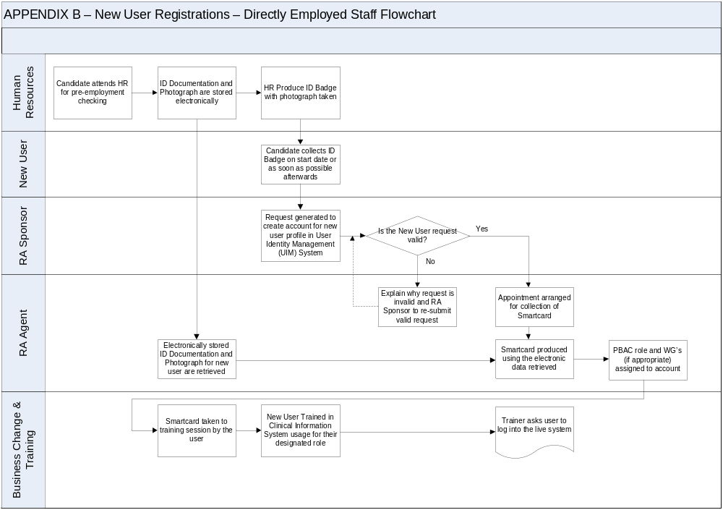
APPENDIX C
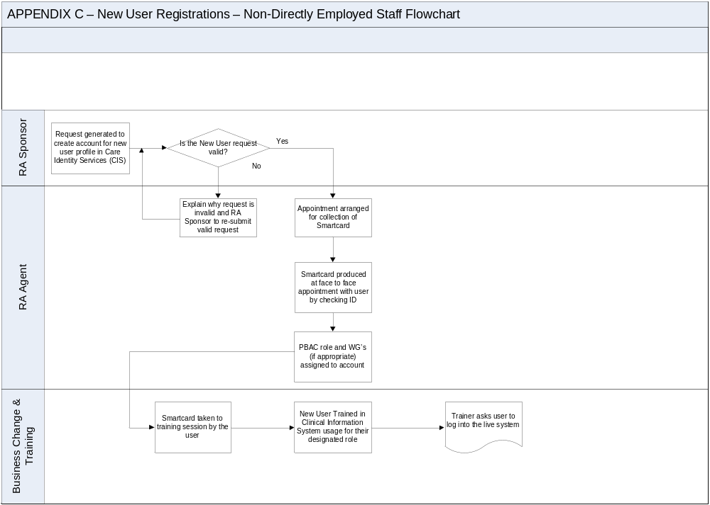
APPENDIX D
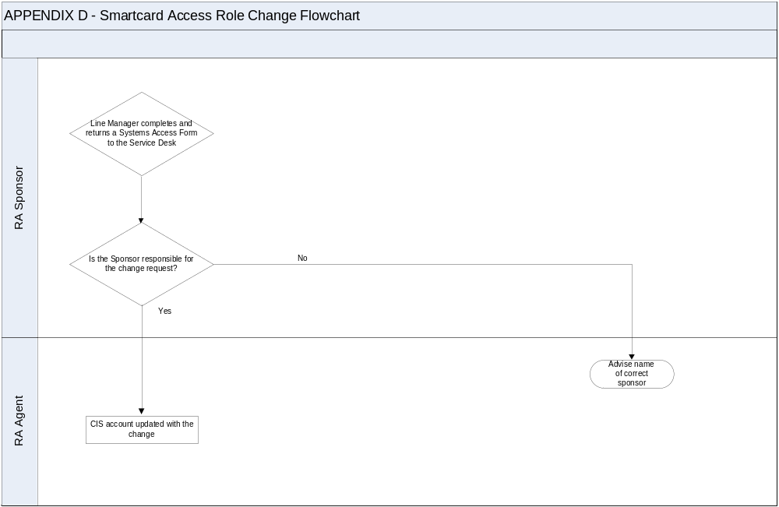
APPENDIX E
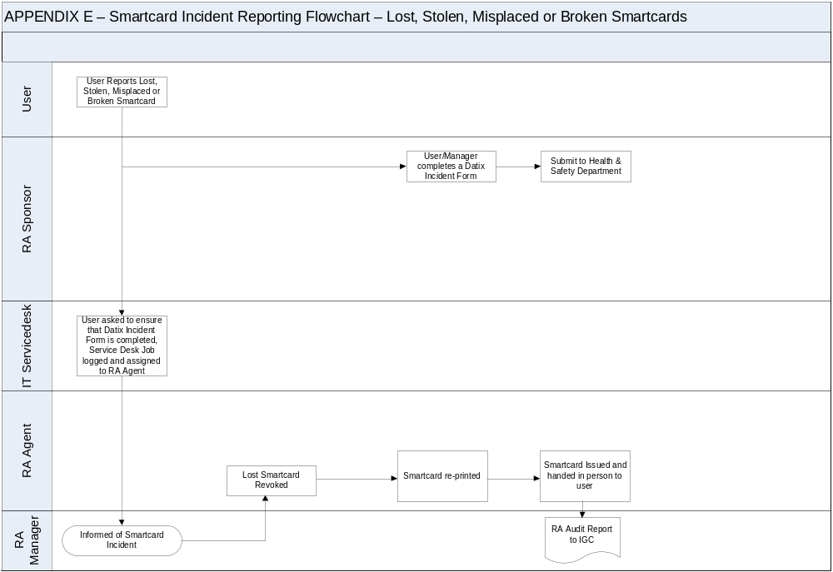
APPENDIX F

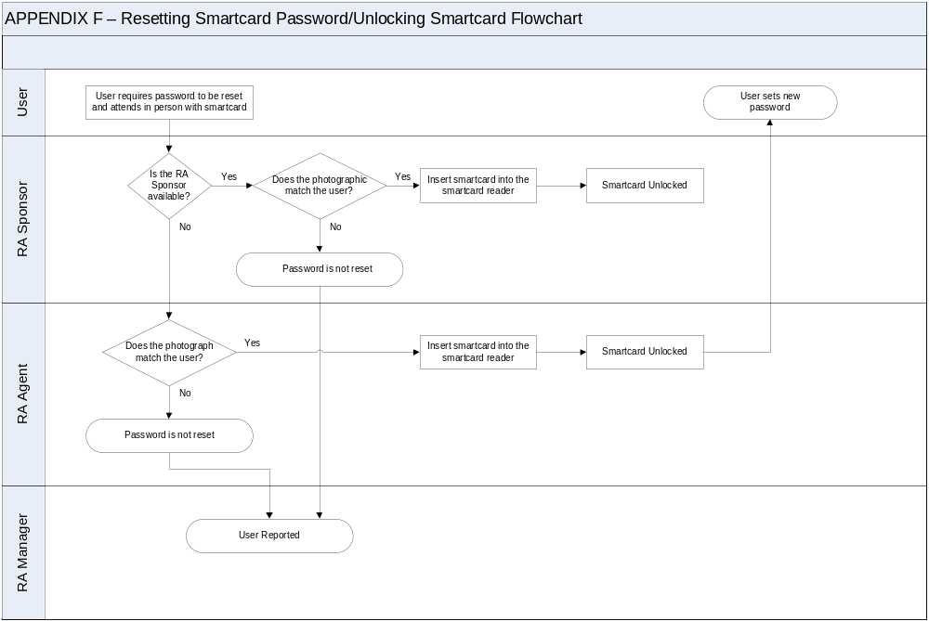
APPENDIX G
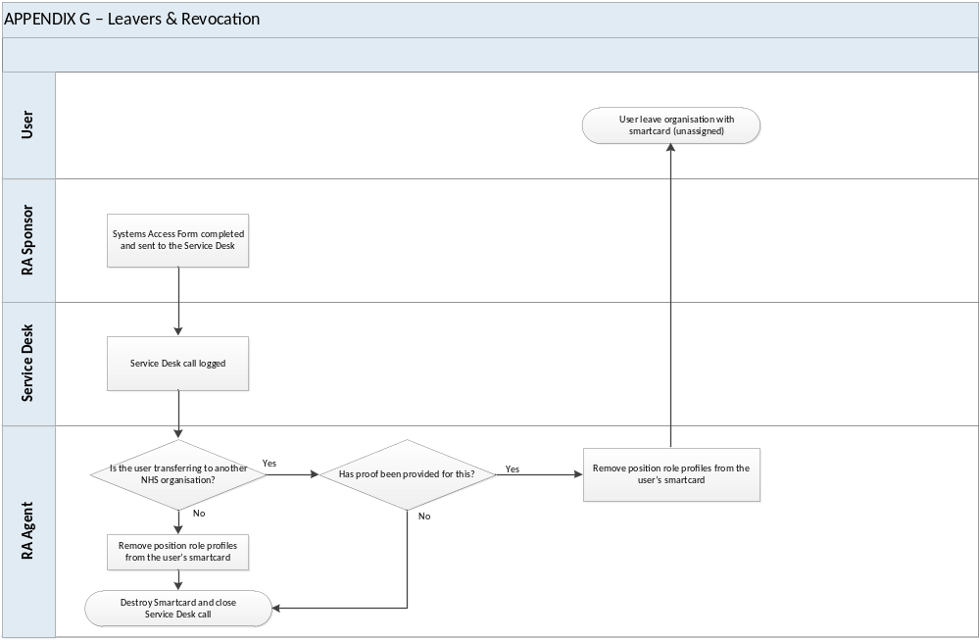

APPENDIX H

Guidance for the Approval of RA Sponsors & Approval Form

Requirement for RA Sponsors

In order to use an NHS CRS compliant application, users need to be set up appropriately in the CIS system. This is performed via the Registration Authority (RA/Smartcard) Process.

In order to proceed with the Registration Authority Process it is necessary to appoint ‘RA Sponsors’. RA Sponsors are usually Service Team Leaders, Heads of Department or Line Managers within the organisation.

RA Sponsors have the following responsibilities with regards to their involvement in a user’s Registration:

- Identify the user’s use and access to information of an NHS CRS compliant application – the organisation they belong to and their Role Profile.

- To manage certificate renewals and PIN re-sets of employees’ smartcards.

The following RA sponsor approval form should be completed to nominate and confirm individuals who are considered to be appropriate to perform the role of RA Sponsor within the Directorate/Department.

APPENDIX I

Title: | REGISTRATION AUTHORITY  Smartcard Stock Control Audit Procedure

INTRODUCTION

For Healthcare Professionals to access NHS CRS compliant applications they must have completed the registration process. The registration process for NHS CRS compliant applications has to adhere to current Government requirements and will be applied nationally. All the NHS CRS compliant applications use a common security and confidentiality approach.

The primary method by which system users will access an NHS CRS compliant application is via a smartcard issued during the registration process. Once an applicant has been successfully registered they will have a User ID, pass-code and smartcard, which will permit their access to the appropriate application(s) and information. The registration process is operated at a local level by an authorised Registration Authority that are required to conform to the National Registration Policy and Practices.

This document describes procedures for the stock management of unissued blank smartcards and the recording of smartcards issues so as to ensure that all smartcards obtained from the SHA can be accounted for.

Provision of Smartcards
Blank smartcards are provided to the Trust via the NHS Digital. Smartcards are obtained through the NHS Digital by the Trust submitting orders for additional smartcards. Smartcards are provided in boxes of 200. Each box is sealed and has a label stating the range of serial numbers which are contained in the box. Each smartcard has its own individual serial number printed upon it.

All blank unissued smartcards are stored securely by the Registration Authority function within the Trust. Smartcards are stored in a locked filing cabinet in the Registration Authority Office that is only accessible to the Registration Authority Staff.

Smartcard Issuance
During the registration and smartcard issuance process for staff, the serial number of the smartcard that is to be issued to each individual member of staff is recorded within the Registration Authority & Training Database (historically, the serial number was recorded at the top of the completed RA paper form) at the time of issue by the Registration Authority Agent & Systems Officer.

Smartcard Stock Checks
On a six-monthly basis, stock checks of both issued and unissued blank smartcards are reconciled to ensure that all smartcards allocated to the Trust can be accounted for.

The Registration Authority & Training Database is used primarily for the purpose of checking the smartcard stock levels, reconciling blank cards and issued cards to ensure all are accounted for. This function is performed by the Registration Authority Manager.

The stock of blank smartcards is reconciled against those issued, this includes any blank unissued smartcards that the Registration Authority Agent & Systems Officers have for issuance purposes.

Occasionally, faulty smartcards are encountered during the issuance process. These faulty smartcards are retained by the Systems Management & Registration Authority Team for the sole purpose of stock control checking. These smartcards are stored securely in the same location as the blank unissued smartcards but placed in a separate box designated specifically for faulty smartcards.

Outcomes of Smartcard Stock Control Audit
The outcomes of the smartcard stock control checks are summarised into a report and presented to the ICIG as part of the RA reporting mechanisms.

Appendix J - Equality Impact Assessment Tool
To be completed and attached to any policy document when submitted to the Executive Management Team for consideration and approval.

Date of Assessment: _________06/01/2017_____________

 | Equality Impact Assessment Questions: |  | Evidence based Answers & Actions:
1 | Name of the document that you are Equality Impact Assessing |  | Trustwide Registration Authority Policy
2 | Describe the overall aim of your document and context?  Who will benefit from this policy/procedure/strategy? |  | The overall aim of the policy is to describe the Trust’s approach to the Registration Authority policies and procedures.  All staff
3 | Who is the overall lead for this assessment? |  | Head of IT Services & Systems Development
4 | Who else was involved in conducting this assessment? |  | IT Services Manager
5 | Have you involved and consulted service users, carers, and staff in developing this policy/procedure/strategy?  What did you find out and how have you used this information? |  | The Executive Management Team was consulted on the original development of the policy. Feedback from the Registration Authority manager and IM&T staff has also been considered in developing the policy.  N/A
6 | What equality data have you used to inform this equality impact assessment? |  | N/A
7 | What does this data say? |  | N/A
8 | Taking into account the information gathered above, could this policy /procedure/strategy affect any of the following equality group unfavourably: | Yes/No | Evidence based Answers & Actions. Where Negative impact has been identified please explain what action you will take to remove or mitigate this impact.
8.1 | Race | No | N/A
8.2 | Disability | No | N/A
8.3 | Gender | No | N/A
8.4 | Age | No | N/A
8.5 | Sexual Orientation | No | N/A
8.6 | Religion or Belief | No | N/A
8.7 | Transgender | No | N/A
8.8 | Maternity/Pregnancy | No | N/A
8.9 | Marriage & Civil partnerships | No | N/A
8.10 | Carers*Our Trust requirement* | No | N/A
9 | What monitoring arrangements are you implementing or already have in place to ensure that this policy/procedure/strategy:- |  | This policy aims to standardise the approach to the Smartcard process and will be monitored regularly.
9a | Promotes equality of opportunity for people who share the above protected characteristics;
9b | Eliminates discrimination, harassment and bullying for people who share the above protected characteristics;
9c | Promotes good relations between different equality groups;
9d | Public Sector Equality Duty – “Due Regard”
10 | Have you developed an Action Plan arising from this assessment? |  | No
11 | Assessment/Action Plan approved by
Signed: Date:

Title:

12 | Once approved, you must forward a copy of this Assessment/Action Plan to the Equality and Inclusion Team:  inclusion@swyt.nhs.uk  Please note that the EIA is a public document and will be published on the web.  Failing to complete an EIA could expose the Trust to future legal challenge.

If you have identified a potential discriminatory impact of this policy, please refer it to the Director of Corporate Development or Head of Involvement and Inclusion together with any suggestions as to the action required to avoid/reduce this impact.

For advice in respect of answering the above questions, please contact the Director of Corporate Development or Head of Involvement and Inclusion.

Appendix K - Checklist for the Review and Approval of Procedural Document
To be completed and attached to any policy document when submitted to EMT for consideration and approval.
 | Title of document being reviewed: | Yes/No/  Unsure | Comments
1. | Title
 | Is the title clear and unambiguous? | YES
 | Is it clear whether the document is a guideline, policy, protocol or standard? | YES
 | Is it clear in the introduction whether this document replaces or supersedes a previous document? | NO
2. | Rationale
 | Are reasons for development of the document stated? | YES
3. | Development Process
 | Is the method described in brief? | YES
 | Are people involved in the development identified? | YES
 | Do you feel a reasonable attempt has been made to ensure relevant expertise has been used? | YES
 | Is there evidence of consultation with stakeholders and users? | EMT
4. | Content
 | Is the objective of the document clear? | YES
 | Is the target population clear and unambiguous? | YES
 | Are the intended outcomes described? | YES
 | Are the statements clear and unambiguous? | YES
5. | Evidence Base
 | Is the type of evidence to support the document identified explicitly? | YES
 | Are key references cited? | YES
 | Are the references cited in full? | YES
 | Are supporting documents referenced? | YES
6. | Approval
 | Does the document identify which committee/group will approve it? | YES
 | If appropriate have the joint Human Resources/staff side committee (or equivalent) approved the document? | N/A
7. | Dissemination and Implementation
 | Is there an outline/plan to identify how this will be done? | YES
 | Does the plan include the necessary training/support to ensure compliance? | N/A
8. | Document Control
 | Does the document identify where it will be held? | YES
 | Have archiving arrangements for superseded documents been addressed? | YES
9. | Process to Monitor Compliance and Effectiveness
 | Are there measurable standards or KPIs to support the monitoring of compliance with and effectiveness of the document? | YES
 | Is there a plan to review or audit compliance with the document? | YES
10. | Review Date
 | Is the review date identified? | YES
 | Is the frequency of review identified? If so is it acceptable? | YES
11. | Overall Responsibility for the Document
 | Is it clear who will be responsible implementation and review of the document? | YES

Appendix L - Version Control Sheet

This sheet should provide a history of previous versions of the policy and changes made
Version | Date | Author | Status | Comment / changes
1 | November 2016 | Business Change & IT Training Support Officer | Draft | Draft version updated from original.
1 | December 2016 | RA Manager | Final Draft | Guidance from IG Manager.
2 | December 2016 | IT Services Manager | Final Draft | Changes made following review and subsequent recommendations from IG Manager
3 | January 2017 | Head of IT Services & Systems Development | Final | Inclusion of Equality Impact Assessment.
4 | January 2017 | IG Manager | Final | Circulation to ICIG group for comment prior to submission to EMT for final approval
5 | February 2017 | Head of IT Services & Systems Development | Final | Submission to EMT

