

Research Project Management with Agresso

Table of Contents

Introduction 3
Logging on to Agresso on the Web 3
General Navigation 4

Running a Report 8
Select and Launch a Report 8
Select Parameter Options 10
Selecting Parameters 11
Run the Report 14
Viewing a Report 14
Drilling into Lower Level Data 15
Filters 17
Exporting to Excel 18
Other Features 19
Creating A Shortcut 19
Customising Existing Reports 20
Useful Links 20
Appendix I Useful Reports 21
Appendix II Agresso Period Convention 23

Introduction

Agresso is a web based application that allows you to view and manage your research project.

Users must have a valid login ID and Password to access Agresso.

Access permissions per account are granted by the Information Solutions & Services Department via a service desk ticket. Email authorisation will be required from the budget holder of the account outlining what permissions are to be granted.

This training manual details how to:

- Log On
- Navigate Around the Web Based Application
- Find, Run and View a Report
- Drill into the Data to lower level information
- Export to Excel

Logging on to Agresso on the Web

Agresso enables users to access their financial information via the Internet.
The address for the login page is: https://agresso.nuigalway.ie

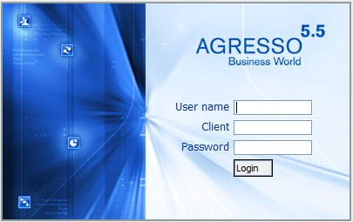

The login screen requires users to input the following:

- Login name (your 6 digit staff id number)
- Client (this is always U1)
- Password (you will be assigned a password, which you must not share with any other user)

Once you have keyed in this information, click the button.

General Navigation

Once you have logged on to Agresso, you will be automatically directed to the welcome page.

This is subdivided into 3 areas:

Sub Menu Main Window

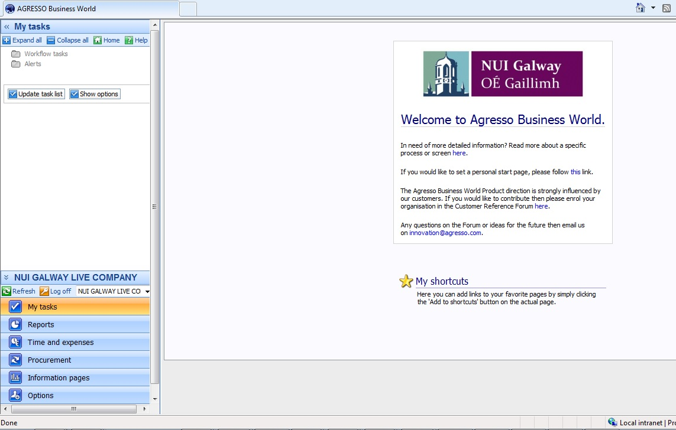

Navigation Bars

- Sub Menu – This area shows the sub menu options available within the main Navigation Bar Currently Selected (see navigation bars)

- Main Window – This is the main window in which reporting can be viewed

- Navigation Bars – These navigation bars allow you to view the different functions available to you.

Note: Whilst users can have several options under this particular window, This document reviews only the reporting element.

To navigate to a specific report you must first select the Reports option from the Navigation Bars. This will bring you to the Global Reporting Menu.

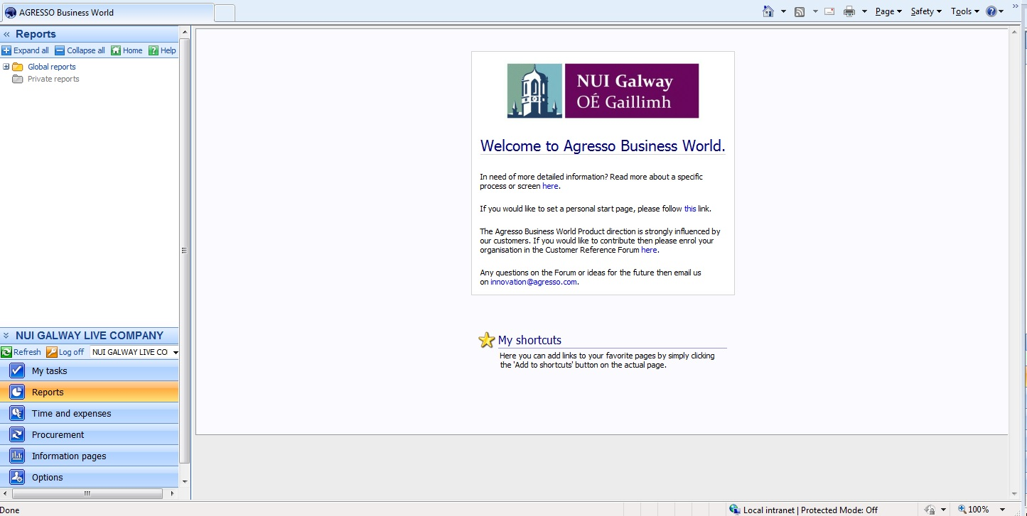

Note: The main reporting menu is structured in the same way as the usual Windows navigation, using Folders and Sub-Folders.

To navigate into the subfolders, simply click once on the name of the folder. Alternatively, click on the ‘plus sign’ next to the folder. Both options will expand the folder to the next level.

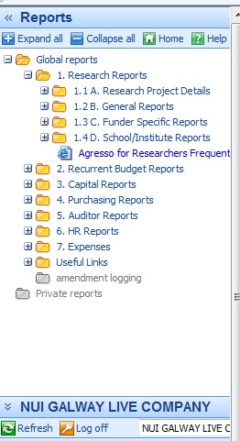
The Reports menu in Agresso has been structured in such a way that users can navigate to the desired report much more easily.

It should be clear from the top level reporting options, which submenu you should select next.

Under 1. Research Reports, You can view the reports you can use to access and view your Research Account details. These are explained more fully in Appendix I

Running a Report

The methodology for running a report is the same for every report in Agresso, so simply understanding how to use one report, will allow you to use the rest.

There may be some small differences on the parameter selection page, but essentially, running a report follows the same simple steps.

- Select and Launch a Report
- Select Parameter Options
- Run the Report
Select and Launch a Report

In order to find the report you require, you must expand the subfolder to its lowest level to reveal the entire list of reports in that subfolder.

To assist users in finding the most appropriate report for any given purpose, the reports have been named intuitively. To help you find the Report you require, please refer to Appendix I below. Alternatively, you can visit the Agresso help pages on the Research Accounting Website.

Essentially, Agresso Research Reports have been structured under the following main headings:

- 1.1A. Research Project Details: This report gives details of what type of account this is and its attributes.

- 1.2B. General Reports: This lists available reports for general use by all users.

- 1.3C Funder Specific Reports: This lists shows available reports per funder that shows the financial activity on the account

- 1.4D School / Institute Reports: This lists reports for use to determine financial activity by groups (e.g. College, Colleges Institutes).

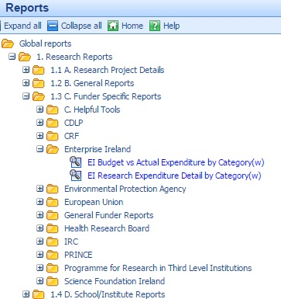
For example, the most common view is the report which compares your Research Budget with the Actual Expenditure. These are located under 1.3 Funder Specific Reports.

Select your funder and expand the folder. Once you have located your report, simply click on its name to launch. Here you see the report for Enterprise Ireland.

If your funder is not listed, select General Funders Reports.

Select Parameter Options

When you launch a report, a new window will open, in which you are asked to select certain parameters and run the report. The new window has a number of fields:
1
2
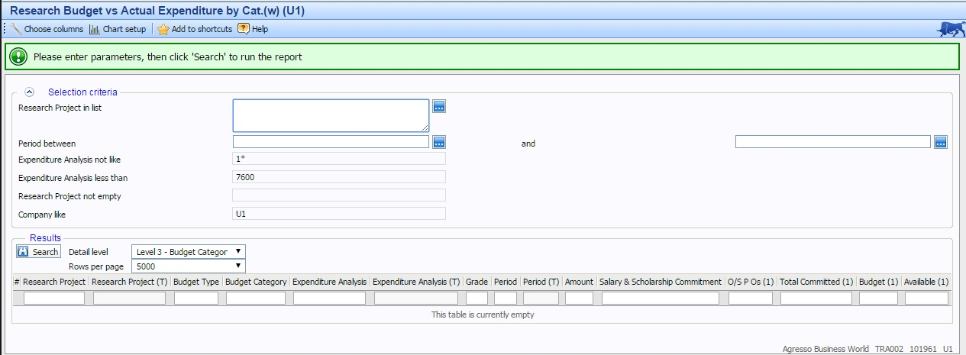
3

- Prompt Bar :this green field gives a general instruction as to what you need to do next

- Parameter Field Users can define the parameters under which the report is run.

- Results Field Once the parameter field have been populated, the user can hit and the result will be shown in this area.

Selecting Parameters

There are a number of way in which the parameter fields may be populated. This is determined by the type of operator is used in the parameter.

Note: An “operator” is command which determines what individual or range of values should be taken. For example:
- Equal to =
- Greater Than >
- In List
- Between

Where the operator allows the choice of more than one value e.g. “In List”, a blue button appears next to the parameter field e.g.

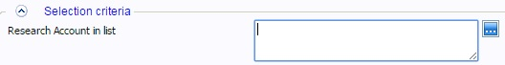

If you know the Sub-Account, you may simply type it in the empty field like so

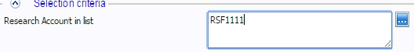

If however you don’t know the Sub-Account or want to run the report for several Sub-Accounts, click on the blue button. This brings up a new window, which allows you to search for your required Cost Code.

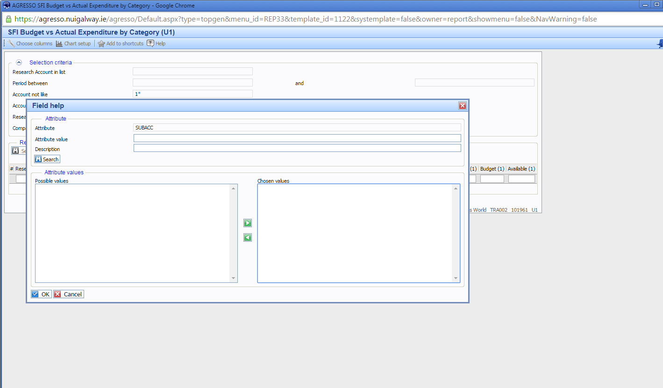

If you now click on this will bring back all Sub-Accounts you have access to.

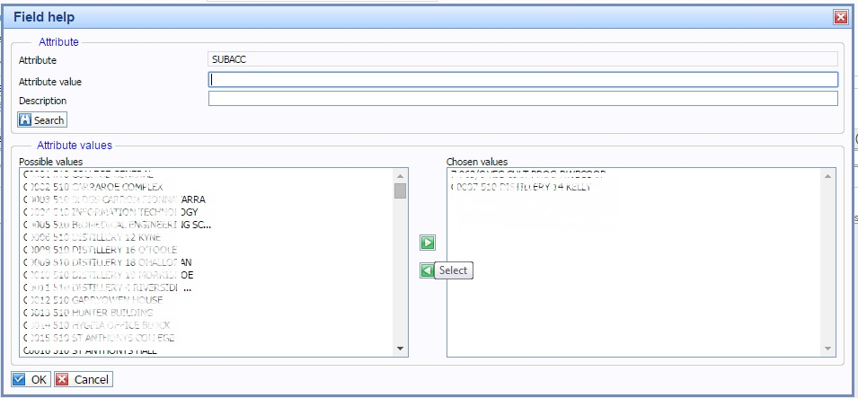

Tip – if you have access to many accounts and you want to limit the accounts that are returned in this view, you can use the Attribute Value field at the top plus the wild card * to bring back subsets.

For example, if you know your desired Sub-Account begins with RCS… but cannot remember the last digits, type RCS* in the Attribute Value Field and hit

This will only return Sub-Accounts beginning with RCS…

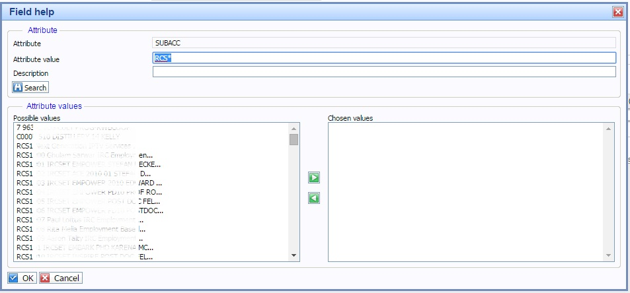

To now select parameters for the report, highlight the desired values and, using the arrow keys, move them over to the right hand box, Chosen Values

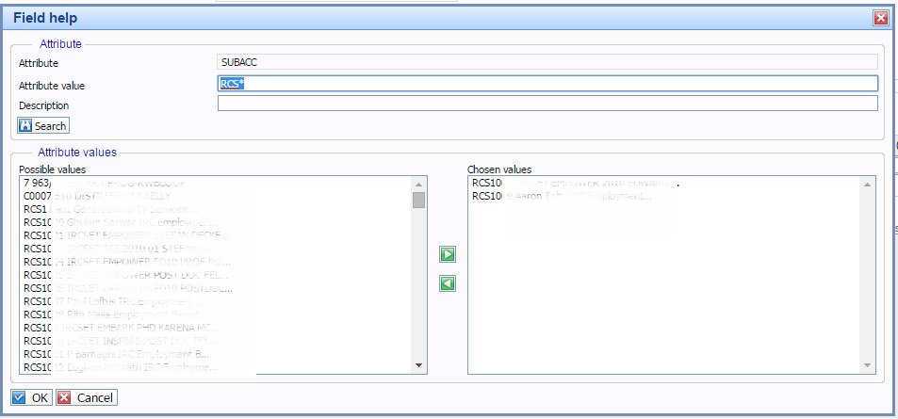

Tip – Ranges of values can be chosen by selecting one value and holding the shift key and then selecting the next value.

Tip – more than one individual value can be chosen by holding down the CTRL key while selecting values.

Once all desired values have been chosen, hit , which will bring you back to the parameter input field.

Fill in the other parameter fields in the same way. Please note that not all parameter fields may be edited. Certain fields are fixed (greyed out) to allow the report to pull back specific data from the set. These items may be ignored.

Note: Agresso Period Parameter

By default, every Research Budget Report has been set up with the period equal to the current financial period i.e. 201400 through to 201412 for the current financial period.

These period ranges are not fixed however, and may be overwritten. For example, if you wished to see the expenditure for…

- the first quarter, the ranges should be: between 201400 and 201403
- a single month, say February 2014, then :between 201405 and 201405

For more information on Agresso period convention, please refer to Appendix 1 at the end of this document.

Run the Report

Once all the parameter fields have been filled, to run the report, hit

Viewing a Report

Once a report is run, it will populate the Results Section of the open window.

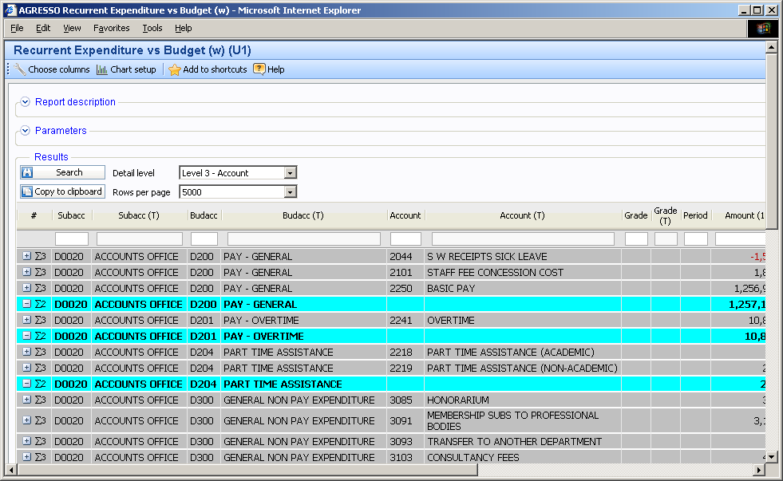

The Results Section will show a summary level of information for the parameters selected in the parameter section.

It is possible to scroll around the report using the scroll bars at the side of the window.

Drilling into Lower Level Data

There are a number of ways to drill down to the lower level data within each report.

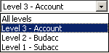
Drill 1 - The first way, is to expand the existing view using the “Detail Level” drop down menu at the top of the results section. Clicking on the drop down menu, you will be presented with 4 options, each defining the level at which the report can be run, with “All Levels” being the lowest level of detail.

Try clicking on each of these to see what happens.

Drill 2 - The second option allows you to drill into a single row at a time. To do this click on the button to the left of the row you wish to drill into. This expands that particular row to the lowest level.

Drill 3 - The third drill option allows you to drill down to the detail BEHIND the lowest level of data i.e. the transaction level data. This can only be accessed when the current report has been expanded to its lowest level (see Drill 1 and 2 above).

For example, if you wish to see the individual transactions which make up and amount on the Stationery Line, expand that line to the lowest level, thus:

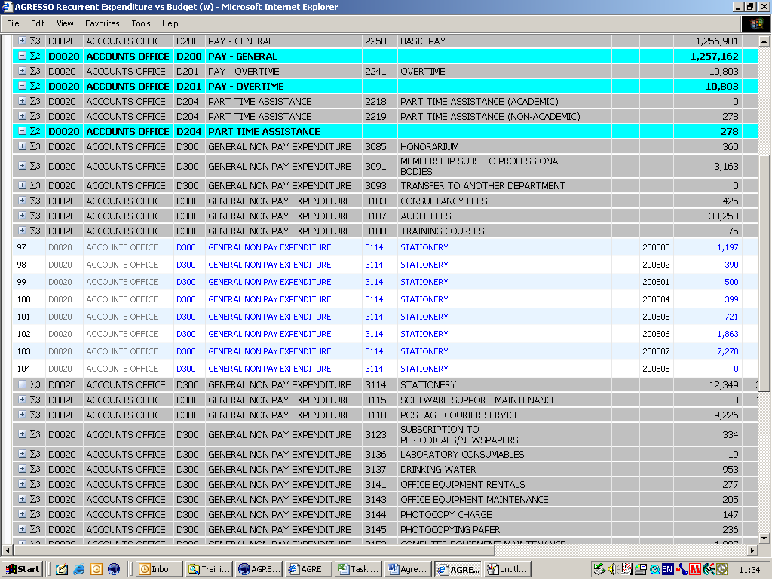

You will notice that each of the values are coloured in blue and have a hyperlink attached. Clicking on the number you wish to drill into, launches a new report window. Clicking on the button, will produce a detailed transaction report for that amount.

Drill 4 - The last drill method utilises the “Link to Reports” functionality to the right of the expended row.

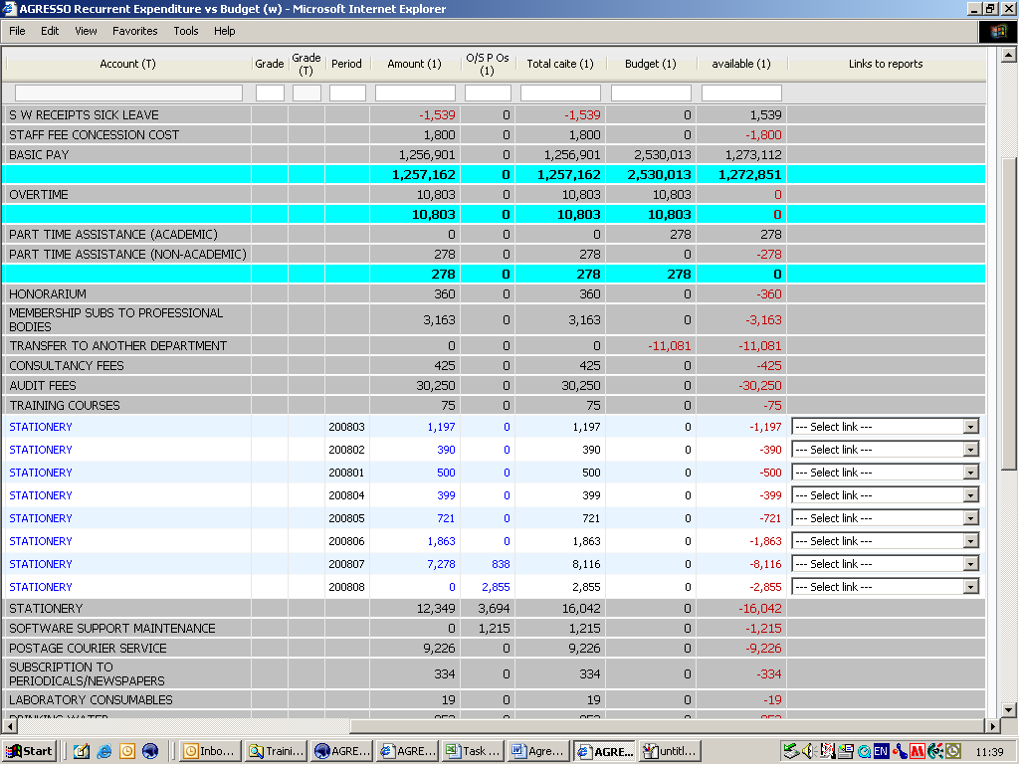

You will notice a drop down menu option to the right of the expanded row. This drop down menu allows you to run a more detailed report on information in that row.

Selecting the desired report from the drop down menu launches a new report window.

Simply click on to run the detailed report. You will notice that the total adds up to the amount on the previous report.

Filters

Once you have run a report, you may wish to limit the information you see in your results set to a smaller group of data. For example, you may only wish to look at the data on a single account.

To do this you can use the Filter Function, which appears at the top of the Results Section, just below the column description.

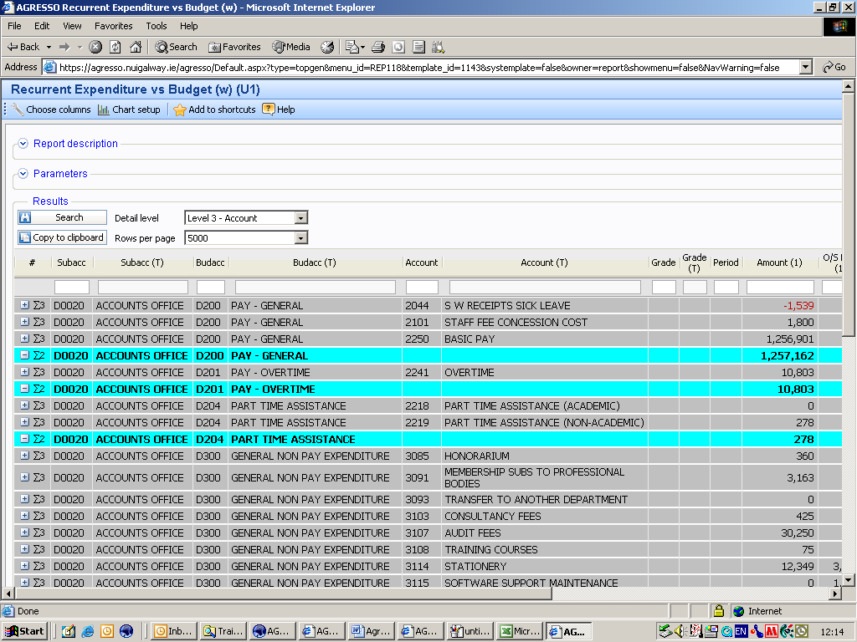

Keying in the value of the attribute that you wish to filter on in the blank cell and hitting , will run the report for you, filtering on that value.

For example, let us assume we were only interested in looking at account 3114 – Stationery, we could type 3114 in the blank filter cell in the Account Column, run the report.

This brings back the following result:

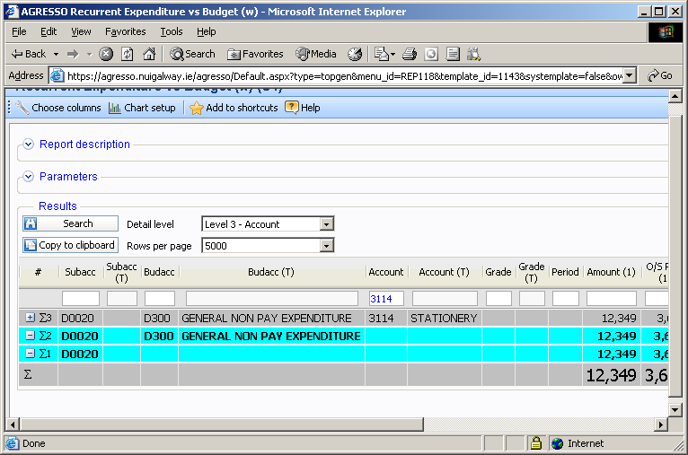

Tip using the Wild Card * allows you to return groups of data. This is especially useful when running Detailed Reports and using the filter function on description fields to search for a particular entry e.g. Supplier Name

Exporting to Excel

Now that you are able to run, view and drill into the reports, you may wish to export these reports to excel to perform additional analysis

To do this, you can use the button at the top of the Result section.

Once you have copied the information to clipboard, you can then paste this into and Excel Spreadsheet.

Note: function copies the data exactly as it appears in the results pane, so if you want the low level information to appear in your spreadsheet, you must expand the detail first in the Web application.

Other Features

There are a number of other features on Agresso which will allow you to navigate yourself around the system more easily
Creating A Shortcut

If you realise that you use a report frequently, you may wish to add this to your Shortcuts Menu, which appears on the Welcome page when you login.

This avoids the need to navigate through Global Reports menu after you have logged in.

To add a report to the shortcut menu, you must be in the report itself, where you will notice a button at the top of the screen.

Click on this button, and that report will be moved to the Welcome Page as follows (you will need to click on the button first).

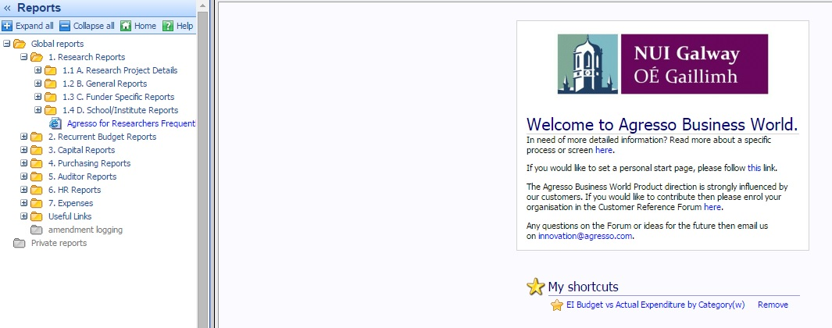

Clicking on the shortcut hyperlink, will bring you directly to your report.

Customising Existing Reports

If you wish to exclude specific columns for your report, you can use the option at the top of the screen.

Clicking on this button allows you to deselect columns which might not be of interest to you.

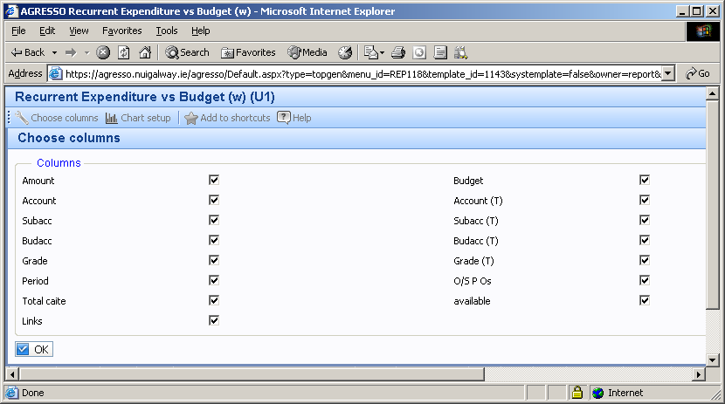

Simply tick the boxes relating to the columns you wish to see and click okay. This will then only show those columns which have been selected
Useful Links

As well as running reports from Agresso, the system provides links to useful web pages. For example, the Research Accounting Home Page, which has useful information about Agresso, including a copy of this training document.

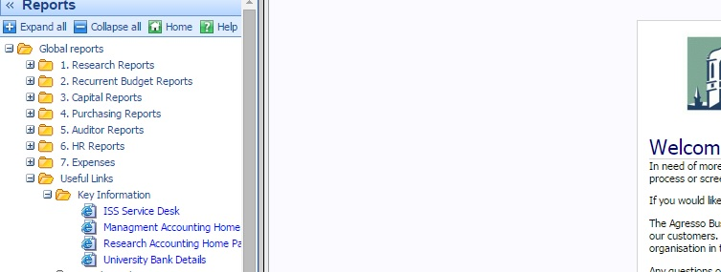

Appendix I Useful Reports

In order to assist you in finding the most appropriate report for your requirements, a quick reference guide has been produced for you here.

I want to see what details are configured on my Research Account

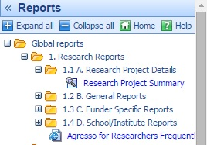
This report lists:
- Principal Investigator
- Description of the Account
- Start and End date
- Budget Holder
- Personnel Administrator (This is the person who receives a monthly report on this project)
- RAO Contact (This is your support contact person in the Research Accounting Office)
- Funder
- Funders Program
- Vatable Status
- Overheads applied to this account

I want to view my available balance against my expenditure.

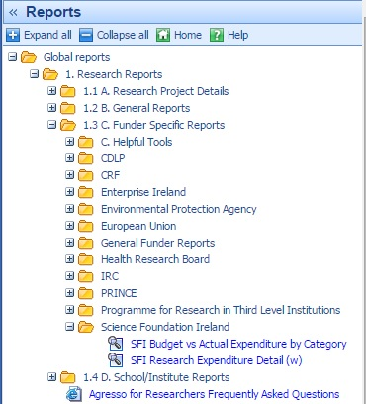
For a Research Budget Account , search for your funder’s Research Vs Actual Report under 1.3 Funder Specific Reports. Below you can see the Research vs Actual Expenditure Report for SFI (Science Foundation Ireland) funded accounts.

If your funder is not listed you may use the General Research vs Actual Expenditure Report located under General Funder Reports

For a Research Non Budget Account, you can use the Research Non-Budget Balance Table report located in 1.2B General Reports

I want to see transaction level information e.g. to check to see is a particular payment has been made.

For a Research Budget Account , search for your funder’s Research Expenditure Details report under 1.3 Funder Specific Reports. Below you can see the Research Expenditure Detail Report for SFI (Science Foundation Ireland) funded accounts.

If your funder is not listed you may use the General Research Expenditure Detail Report located under General Funder Reports

For a Research Non Budget Account, you can use the Research Non-Pay Detailed Transactions report located in 1.2B General Reports

I want to see the actual income received from the funder and any payments to partners

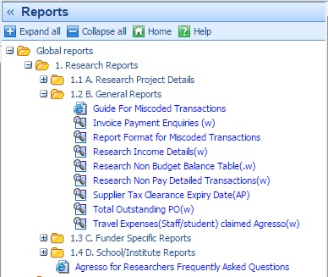
Run the Research Income Details report located under 1.2B General Reports

I want to see outstanding purchase orders (POs)

Run the Total Outstanding PO report located under 1.2B General Reports

Appendix II Agresso Period Convention

NUI Galway’s Financial Period matches the Academic year i.e. From 1st October though to 30th September the following year.’

Agresso, being a Financial System, has it’s period set up to match to the Financial Period, and is subdivided into Calendar months, October being the first period in the Financial Year.

The way this is reflected in Agresso is with a 6 digit figure YYYYPP, where

YYYY is the Financial year and
PP is the period in that Financial year.

So the Financial(Academic) Year 2014/15 would be 2014 in Agresso

Similarly, October, being the first period in the financial year is represented 01

Therefore the period October 2014 is shown as 201401 in Agresso.

Extending this we have:

October 2014 | 201401
November 2014 | 201402
December 2014 | 201403
January 2015 | 201404
February 2015 | 201405
March 2015 | 201406
April 2015 | 201407
May 2015 | 201408
June 2015 | 201409
July 2015 | 201410
August 2015 | 201411
September 2015 | 201412

The period 201500 is reserved for the Budget loaded before the start of the financial period, hence the ‘00’ convention. Note that this period should always be included I views where there budget is reported.

