 | 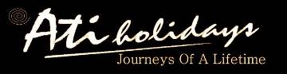 |  | 
  Personalised itinerary for: Rivendell - Special Self-Drive Itinerary
Traveller/s
Travel Dates | 1 February 2016 to 11 February 2016

Your Namibia holiday of a lifetime!
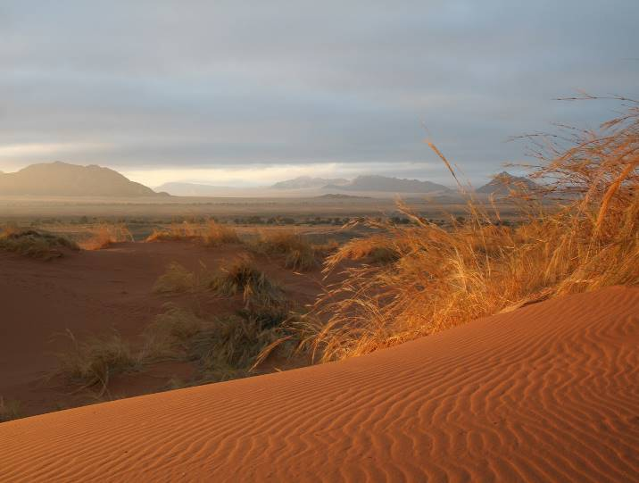

Monday
Monday
  1st February 2016

Rivendell Guest House
www.rivendellnamibia.com

Windhoek
Windhoek, the capital of Namibia, is located in a basin between the Khomas Hochland, Auas and Eros Mountains. It is 1,680m above sea level, 650km north of the Orange River and 360km from the Atlantic seaboard. The city is situated in what is almost the country’s geographical centre. This location has obvious benefits when it comes to governing a country the size of Namibia, and also makes it the ideal place to begin your Namibian holiday. Windhoek is home to approximately three hundred and fifty thousand people, an extremely small capital by global standards. This number is growing rapidly at present mostly due to a lack of employment in rural areas.
The city centre is characterised by a proliferation of German style buildings, a lasting reminder of Namibia's early colonial history. Early buildings such as the Alte Feste (old fort), Christuskirche and Tintenpalast (the parliament buildings) are of particular historical interest. Other notable buildings in Windhoek include St Mary's Cathedral and the Turnhalle Building.
Windhoek has had several names over the years, many inspired by the hot water springs found in the area, the earliest of which were the Damara /Ais //Gams (/ indicates a click in Nama spelling) which means firewater, and the Herero Otjimuise or place of steam. Several opinions are offered for the origin of the present name; the most popular of these is that sometime before 1840 Jonker Afrikaner, a Nama leader, named the area Winterhoek, after the farm in South Africa where he was born. Windhoek, or windy corner, is a corruption of this name. During the day the city centre has a European cafe culture, German cuisine dominates, but Namibian influence can be found in the quantity and quality of meat on offer, (vegetarians be warned, Namibia is carnivorous country!) Saying that, the streets are choc-a-bloc with people of all ages and cultures, all bearing a wonderful sense of pride, hope and ambition.

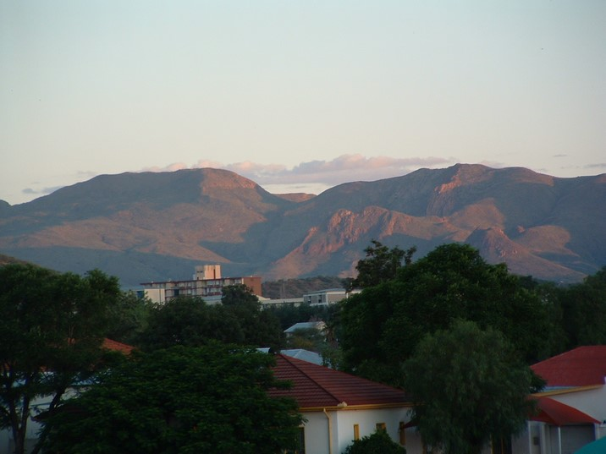

  ATI Holidays
  ATI Airport Transfer from HKIA

Today you will be met at the airport by our transfer driver, he will wait for you in arrivals with a name board. There is an ATM and a money exchange booth at the airport so you should be able to change or withdraw money if you need to. They are not always open/ working but there are other options in the centre of town. The drive into Windhoek takes around 45 minutes, so you can relax in air-conditioned luxury and enjoy the scenery on the way to your first destination!

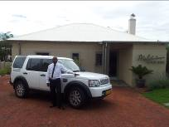

Rivendell Guest House
40 Beethoven Street, Windhoek | +264 (0)61 250006
Located in a quiet suburb of Namibia’s capital city Windhoek, Rivendell caters for guests who enjoy homely, comfortable accommodation at a reasonable price. Rivendell is for many, “the last homely house before the wilds”! The emphasis is on friendly hospitality and helpfulness, whether it be reserving a table at the best restaurant in town, organising a day trip, finding a rental car, booking a safari or planning a full self-drive itinerary. Families are welcome and a cot with bedding can be provided on request.
Relax around the swimming pool or lounge area, and maybe take some time to explore the shops and restaurants of the city. Accommodation consists of five en-suite rooms, five rooms with shared bathroom facilities, and two self-catering flats. Facilities include satellite TV lounge, large swimming pool, gardens, self-catering kitchen, honesty bar, free of charge WiFi internet, guest computer for people travelling without laptops, guest phone and safe off-road parking.

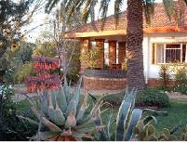

1 x En-Suite Room, Accommodation Only
All of the en-suite rooms have a tea and coffee tray with kettle, a fan and comfortable double or twin beds. Some of the rooms are large enough to add one or two extra beds. There are five en-suite rooms.

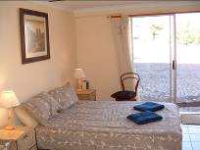

  Europcar
  Group W - Toyota Double Cab 4x4 or similar

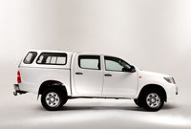
  • Pick-up  • Drop-off  • Hire period | 1st February  11th February  10 days
  The car will be delivered to your first overnight stay, or you will collect it at the Europcar Airport desk. We have requested the car with Classic Plus Super Cover Insurance which is the best insurance you can get in Namibia. Please note that the driver and any authorized co-driver must produce a valid unendorsed driver's license and passport at the time of rental. The driving license needs to be in English. If not, an International driver's license will be required.

Toyota 4x4 Double Cab or similar. CD player, manual, air-conditioning, power steering.
Here are some rough guidelines on Europcar rentals:
Direct payments - on collecting your car you will be asked to give a credit card, please note that debit cards are not accepted. This is to cover the fuel deposit (refundable on returning the car full of fuel), document administration fee, additional driver fees + any other services or fees such as baby seats, claim handling fee etc. Further details on the inclusions and outlines are listed below. Please note that these are GUIDELINES ONLY and you must refer to your Europcar contract for specific details.
Your car hire includes super collision damage and theft loss waivers (SCDW & STLW), unlimited kilometres, VAT, stamp duty, airport surcharge, contract fee, national and regional maps, personal accident insurance (PAI), windscreen damage, tyre, rim & hubcap damage, sandblasting damage. Two spare tyres are included as standard.
You will not be covered for any damage due to negligence, or water/ under-carriage damage. Negligence includes, but is not limited to, driving over the speed limit, driving after dark outside of towns or cities, driving under the influence of alcohol or drugs, failing to check oil and water levels, reckless driving. The majority of Europcar’s vehicles now have tracking devices which will record speed and also alert Europcar to any erratic driving.
Your car hire excludes a refundable fuel deposit of Rand/N$1500, refundable deposit in case of damage due to negligence of Rand/N$2904, additional driver fee of Rand/N$303 per driver, young driver surcharge of Rand/N$242 per day per driver (age 18-20 with a full licence for at least 2 years), Rand/N$363 per rental for a baby seat, Rand/N$230 traffic fine handling fee, Rand/N$726 claim handling fee, Rand/N$605 assessors fee in case damage is greater than N$5000.
Please take care to examine your vehicle and all tyres, including the spares, before signing it off on arrival. It is also ESSENTIAL that you read the Europcar Contract extremely carefully. Be aware of all the inclusions and exclusions in your contract.
Vehicle: Toyota 4X4 Double Cab or Similar Seats: 5 (3 along the back row, back middle seat only has a lap strap seatbelt)
Luggage: 2 large, 2 med, 2 small Doors: 4
Airconditioning: Y Radio/Tape/CD: Y
ABS Brakes: N Airbags: N
Power Steering: Y Manual/Automatic: M
Power Output: 110 KW Estimated Range* (Km): 550
Fuel Capacity: 80 Litres

Tuesday
Tuesday
  2nd February 2016

  Dinner
  Desert Homestead Lodge
  www.deserthomestead-namibia.com

Road Directions from Windhoek to Desert Homestead Lodge
Approximately 318km/ 5 hours excluding stops. This is measured from the centre of Windhoek to Desert Homestead Lodge, so please allow for the extra km that you will drive from specific lodge to lodge. Set off this morning for your drive south. Travelling from Windhoek drive south on the B1 to Rehoboth. Approximately 5km south of Rehoboth turn west onto the C24, and follow this road all the way to Nauchas. From here take the D1275 via the amazing Spreetshoogte Pass, taking the drive very easy on the way down. Turn south onto the C14 and drive to Solitaire. At Solitaire, where coffee, apple cake and petrol are all available, you will then turn onto the C19 and drive further south. Approximately 26km south of the C27 turnoff towards Sesriem you will see the entrance to Desert Homestead Lodge on your right hand side.
If you do not want to take the steep Spreetshoogte Pass, you can continue on the C24 from Nauchas via the Remhoogte Pass and then take the D1273 to meet up with the C19 south of Solitaire. Or you could leave the C24 and take the M47 and D1206 via Kobos, Klein Aub & Rietoog to Bullsport. Here you would take the D854 to join the C19, just north of this junction you will find the entrance to Desert Homestead Lodge on your left hand side.

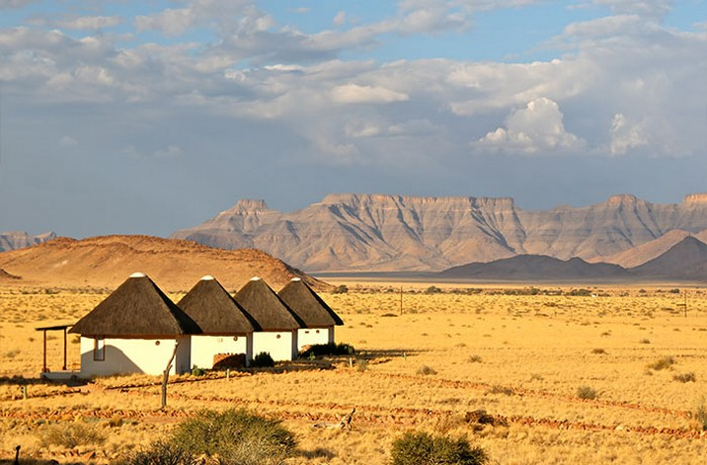

Desert Homestead Lodge
Sesriem | +264 (0)61 240020
Desert Homestead is a beautifully decorated and friendly establishment with a bar, restaurant and pool. Being only thirty kilometres from Sesriem, the entrance to the world famous Namib Naukluft Park, means that the lodge is ideally situated for exploring the five million year old dunes, or hiking in the Namib Naukluft Mountains. Optional horse riding or nature drives within this spectacular area can be arranged.
The main lodge building has an open plan V-shape design, and houses a lounge, small library, bar and dining room with a fireplace. The building opens up onto a wrap around verandah built carefully into the rocks of the koppie on which the lodge is situated. The views over the plains to the dunes and mountains in the distance are especially soothing during the last hours of daylight, when the barking geckos for which the Namib is famous create an eerie cacophony. The swimming pool and rustic latte shaded deck area are situated below the level of the verandah and are a great location to while away the afternoon hours, when the desert heat is at its most fierce.
The warm hospitality that the name Desert Homestead is synonymous with, will ensure you a welcome respite from the desert extremes. Relax and unwind on the verandah, soak up the spectacular vistas and savour home-grown farm cuisine, before moving on to explore further afield.

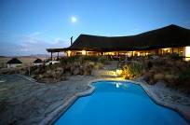

1 x Double Room, Dinner & Breakfast Included
The thatched chalets offer a soothing respite from the desert extremes. The cream linens and colonial style dark wood furniture lend an old world charm to the interiors, whilst ceiling fans help to take the edge off the heat. Mosquito nets are provided in each room.

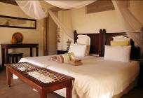

Wednesday
Wednesday
  3rd February 2016

  Breakfast, Dinner
  Desert Homestead Lodge

Sesriem & Sossusvlei
The Namib-Naukluft Park is one of the least populated areas in the country, and visitors can experience an intense feeling of vastness and isolation. Here the magical and awe-inspiring beauty of the night skies can be enjoyed like few places on earth. The nearby NamibRand Nature Reserve was designated as a Gold standard Dark Sky Reserve in 2012 which means that the full array of visible sky phenomena can be viewed in this amazing area; aurora, airglow, Milky Way, zodiacal light, and faint meteors.
Sossusvlei, with its monumental dunes, up to 325m when measured from their base, is one of the top destinations in Namibia. The star-shaped dunes are a sought after topic for artists and photographers. Formed by strong multi-directional winds, they are at their highest and most spectacular where the west-flowing Tsauchab River empties itself into the vlei. The warm tints of the sand, ranging from apricot to orange, red and maroon, contrast vividly with the dazzling white surfaces of the large deflationary clay pans at their bases. One of these, referred to as Dead Vlei, is a large ghostly expanse of dried white clay, punctuated by skeletons of ancient camel-thorn trees, carbon-dated as being between 500 and 600 years old. When it has rained sufficiently in the interior for the Tsauchab River to come down and fill the main pan, flamingoes and other aquatic birds are drawn to the area.
If you are self-driving into this magical area, you can wake early and drive to the Sesriem gate and onwards towards Sossusvlei, around 70km from the Park entrance. The entrance opens at sunrise and this is the best time of day to see the dunes. You will need to pay National Park entry fees of N$80 per person and N$10 per vehicle per day. The last section of the road into Sossusvlei is 4x4 area only and you can either leave your vehicle at the car park and proceed either on foot (a beautiful walk), or take the shuttle which usually runs between here and Sossusvlei which is 5km away. The shuttle costs N$100 per person return. The desert can be extremely hot in the middle of the day, so please remember plenty of water, a hat, high factor sunblock and sturdy, closed walking shoes! Enjoy the amazing scenery of the desert and then return to Sesriem and perhaps take a look at Sesriem Canyon.

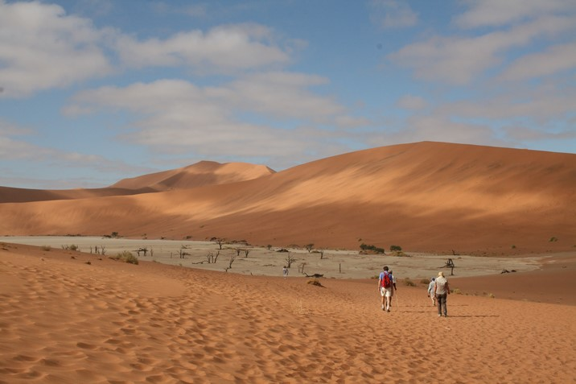

Day at Leisure on dinner, bed & breakfast basis
Enjoy a full day of relaxing around the lodge, enjoying the scenery and maybe taking part in one or two of the optional activities to make the most of the surrounding environment and your unique destination.

Thursday
Thursday
  4th February 2016

  Breakfast
  Cornerstone Guesthouse
  www.cornerstoneguesthouse.com

Road Directions from Sesriem to Swakopmund
Approximately 344km/5.5 hours excluding stops. This is measured from Sesriem to the centre of Swakopmund, so please allow for the extra km that you will drive from specific lodge to lodge. Drive to the coast this morning, travelling along the C19 & C14 roads, via Solitaire. These roads are all gravel until you reach Walvis Bay, and the mountain passes are quite steep so please drive very carefully! There are sometimes road works on this stretch of road, so please slow right down if you see any work being done. Solitaire is a good place to stop to refuel both your vehicle and yourself, and to stretch your legs a little. This mystic little 'town' does justice to its name in more than one way. Home baked bread and apple pie is available at the service station, and you can enjoy the desolate desert scenery from a place of comfort. Before reaching Swakopmund, you may like to stop at Walvis Bay to see the famous lagoon, a wetland of international importance and home to many bird species including the greater flamingo. If you do park at the lagoon, please don't leave your car as there have been some incidences of theft from this car park. Likewise, please don't stop to climb any dunes along the Walvis Bay to Swakopmund road as some cars have also been broken into in this area.

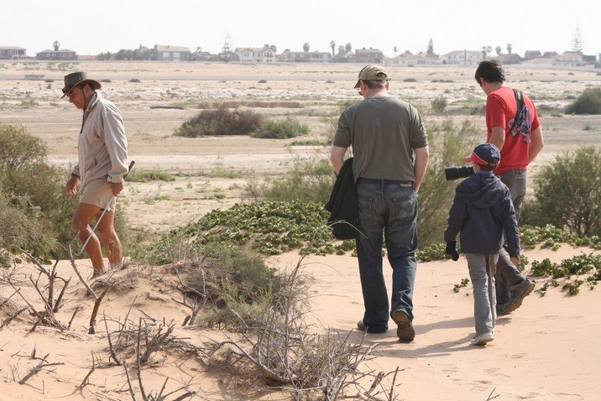

Cornerstone Guesthouse
40 Hendrik Witbooi Street, Swakopmund | +264 (0)64 462468
Cornerstone is located on the corner of Rhode Allee and Hendrik Witbooi, at number 40 Hendrik Witbooi Street.
Cornerstone Guesthouse is a small, private and peaceful bed and breakfast situated within easy walking distance of the ocean and the town centre of Swakopmund. Occupying a quiet corner of Swakopmund’s old town, near the aquarium and the old brewery, Cornerstone offers the charm and intimacy of a family-run B&B combined with the modern amenities of a luxury hotel. Within a few minutes from the guest house you can walk to beaches, cafés, restaurants, lively pubs, Swakopmund tourist attractions and a variety of interesting shops and markets. All the rooms have en-suite bathrooms with large solar-assisted showers and modern fittings.
Peter and his team offer an inclusive breakfast with a fresh selection of fruits, juices, yoghurts, breads, preserves and eggs and bacon cooked to order. Wash that all down with your choice of either freshly brewed coffee or tea, and you'll be ready to explore the attractions of Swakopmund and the Skeleton Coast.

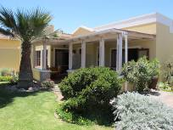

1 x Cornerstone Double Room, Breakfast Included
Cornerstone provides bed and breakfast accommodation in seven rooms; five are double/twin rooms and two are family rooms which can sleep four people each. The rooms all have private entrances and patios with a table and chairs; inside, the rooms are light, spacious and neat with tile and wooden floors, beach house colours and your choice of double or twin beds. All rooms have en suite bathrooms with large solar-assisted showers and modern fittings.

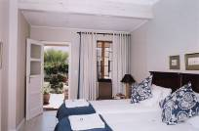

Friday
Friday
  5th February 2016

  Breakfast
  Cornerstone Guesthouse

Swakopmund
Swakopmund is a fascinating and intriguing resort town, complete with German architecture, monuments, historic buildings, well-maintained gardens, palm tree lined avenues, coffee bars and great seafood restaurants. Temperatures rarely drop below 15C and rainfall is practically zero, however, the town is subjected to 9 months of morning fog each year. These damp and grey conditions often result in cool temperatures persisting for the whole day, but this mist band, stretching up to 30km inland, gives water and life to the desert plants & animals and sustains 80 types of lichen, as well as the unique Welwitschia plants. The many ingenious adaptations to water collection, like the Tok-Tokkie beetle which condenses vapour on its' raised back, make for fascinating walks and drives in the ‘Moon Landscape’ or ‘Welwitschia Drive’, located close to the town. Please ask us for advice on restaurants, the more popular ones should be booked in advance and we are happy to do this for you.

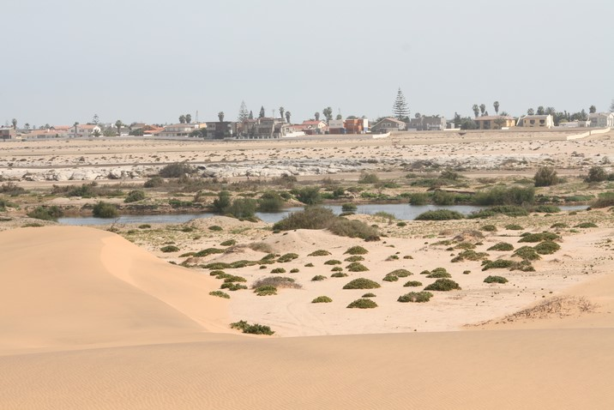

Day at Leisure on B&B basis
Enjoy relaxing and exploring your surroundings today, making the most of your destination. Maybe take part in one or two optional activities, or visit some local sites of interest.

Saturday
Saturday
  6th February 2016

  Breakfast, Dinner
  Grootberg Lodge
  www.grootberg.com

Road Directions from Swakopmund via Uis to Grootberg Lodge
Approximately 430km/6.5 hours excluding stops. This is measured from the centre of Swakopmund to Grootberg Lodge, so please allow for the extra km that you will drive from specific lodge to lodge. From Swakopmund take the C34 coastal road north towards Henties Bay. Perhaps, if you leave town early enough, take a detour to visit the fur seal colony of Cape Cross which opens each day at 10am. You will then turn inland just north of Henties Bay where petrol is available, and follow the C35 before turning onto the D2612. The scenery changes slowly today from wide, open gravel plains to the mountainous region of Damaraland. You will drive past the Brandberg, Namibia’s highest mountain, and onwards to the dry Huab River. Look out for the rare desert elephant along your drive. Follow the D2612 all the way to the junction with the C39 where you will turn left. Follow the C39 for approximately 43km, and then turn onto the C43 and drive to Palmwag. Palmwag should have fuel, but they sometimes have problems with supply so please fill your tanks before you leave Swakopmund, and maybe top up in Uis to be on the safe side. From Palmwag turn eastwards onto the C40 road all the way to the Grootberg Pass. You can park at the bottom of this steep pass and the security guard here will radio up to the lodge so that they can come and fetch you in their 4x4, or you can drive yourselves up if you have a head for heights! It is a good idea to take a lunch pack with you from Swakopmund as you will not have much opportunity to stop en-route today.

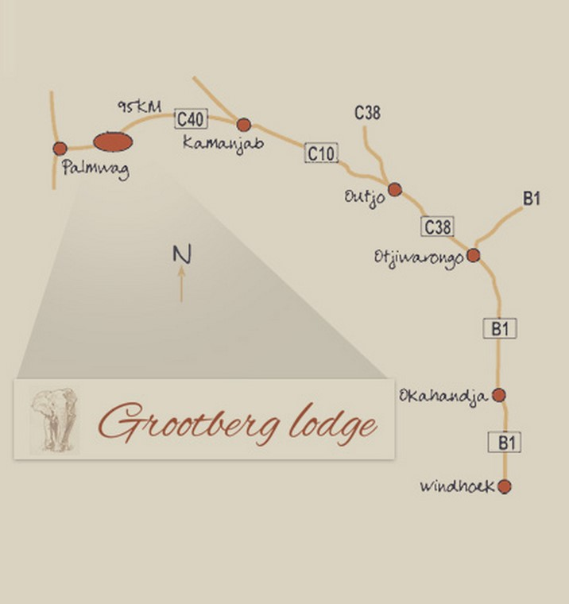

Grootberg Lodge
Grootberg | +264 (0)61 228 104
Perched on the lip of the Grootberg Plateau, with an infinite view down the Klip River Valley, lies Grootberg Lodge. This benchmark project in mainstream tourism draws the local #Khoadi// Hoas community into the many benefits of the tourism industry. The community owns the lodge which was built using EU funding, and the management and staff training has been subcontracted out to a private lodge management company while the community becomes self-sustainable.
The lodge consists of 16 thatched en-suite chalets, with hardwood verandas that project one into the impossible view. Gorgeous feather duvets, polished concrete floors, delicious rooibos and honey soaps, home-grown salads and vegetables and endless, endless views.
The 12 000 hectare exclusive use area that the lodge encompasses boasts a myriad of Damaraland flora and fauna, with Desert elephant, Black rhino and even lion occasionally ghosting an appearance. For travellers making their way between Swakopmund and Etosha, the lodge provides the ideal midway stopover, whilst allowing guests to experience the true wilderness that is Damaraland.

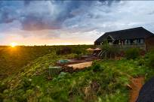

1 x Double Room, Dinner & Breakfast Included
Grootberg offers 14 twin and 2 family rock and thatch chalets which gaze out over the Klip River Valley where Black Eagles are a regular sight — hunting just below your private deck. Additionally, two family units provide enough space for parents and two children to share comfortably. Each room has a shower, toilet and washbasin complimented with the necessary amenities. The rooms each have a writing desk, bedside lamps and a small deck in front of the unit. A small coffee and tea station is provided with hot water flasks (refillable at the lodge's main area).

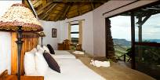

Sunday
Sunday
  7th February 2016

  Breakfast, Dinner
  Hobatere Lodge
  www.hobatere-lodge.com

Road Directions from Twyfelfontein to Hobatere Lodge
Approximately 290km/4.5 hours excluding stops. This is measured from the Twyfelfontein site to Hobatere Lodge, so please allow for the extra km that you will drive from specific lodge to lodge. From Twyfelfontein take the D2612 all the way to the junction with the C39 where you will turn right towards Khorixas. Follow the C39 through Khorixas, and just after this town turn northwards (left) onto the C35 to Kamanjab. Continue on the C35 once you have passed through Kamanjab, Hobatere Lodge is located approximately 65km north of Kamanjab, close to the Galton Gate into Etosha.

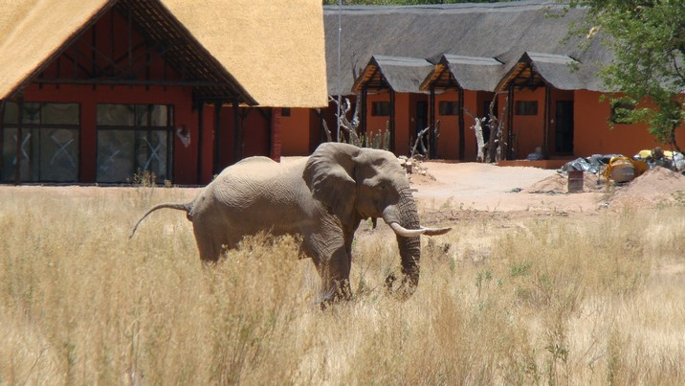

Hobatere Lodge
Hobatere | +264 (0)61 228 104
Hobatere Lodge is strategically located 65km north of Kamanjab on the western border of the Etosha National Park. The lodge has an airstrip and is situated in a concession area of 8,808 ha which is home to a varied selection of wildlife, including elephant, giraffe, eland, and Hartmann's zebra. The lodge offers visitors the opportunity to experience game drives in open vehicles, and nature walks with experienced and knowledgeable rangers.
Early morning and night drives are also part of the activities on offer. Many nocturnal animals, such as aardvark, cape fox, bat-eared fox, aardwolf, genet and many more can be encountered. Activities also include drives into the Etosha National Park.
The lodge belongs to the #Khoadi //Hoas Conservancy. One of the primary objectives of the lodge is to increase the benefits to the local community, reducing human wildlife conflict and also conservation of the area. Guests can look forward to great hosting from the local community, a warm welcome, personalised service, excellent food, and inviting chalets with comfortable beds in the middle of the wilderness. There is a swimming pool next to the main area with sun loungers for relaxing under the Namibian sun. A spacious restaurant is complimented by a lounge, bar area and an outside veranda with seating allowing for excellent views of the waterhole. A small curio shop is also available.

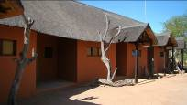

1 x Double Room, Dinner & Breakfast Included
There are six twin rooms, six double rooms and two single rooms at Hobatere. Each room has a shower, toilet and washbasin complimented with the necessary guest amenities. There is also a writing desk, bedside lamp and a small deck in front of each room for relaxing and perhaps sipping a sundown drink whilst admiring the view. A small coffee and tea station with a hot water flask (refillable at reception) is also provided.

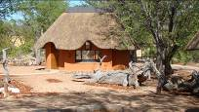

Monday
Monday
  8th February 2016

  Breakfast, Dinner
  Mushara Outpost
  www.mushara-lodge.com

Mushara Outpost
Namutoni | +264 (0)61 24 00 20
The Mushara Collection, which includes the Mushara Lodge, Mushara Bush Camp, The Mushara Outpost and the Mushara Villa, is ideally situated a mere 8 km from the eastern entrance of the world famous Etosha National Park. It offers a variety of accommodation options – from the family friendly Mushara Bush Camp to the privacy of the exquisite Mushara Villas.
The Mushara Collection represents the only family run properties in Eastern Etosha. Everything that Marc and Mariza have achieved is infused with their passion for an excellent guest experience and the very highest standards of service.



1 x Mushara Outpost Chalets, Dinner & Breakfast Included
Mushara Outpost is another addition to the Mushara Collection of exquisite accommodation establishments, situated just 10 km from the Von Lindequist Gate of world-famous Etosha National Park. Mushara Outpost accommodates 16 guests in custom-made tent-like wood and canvas structures which are nestled on the banks of an ancient dry riverbed, known as ”omuramba” in the Herero language. Mushara Outpost is all about old-fashioned hospitality with warm, friendly and personalized service on the doorstep to the wonders of Etosha National Park. The lodge’s main house is styled like an old farm house with high walls, corrugated iron roof and a large wrap-around veranda facing northeast to take advantage of shade. The ambiance is similar to that of a well lived-in house: friendly and extremely comfortable with a light feel to it.
Each tent is mounted on a wooden deck, 1.5 m above the ground, providing a different perspective of the bush. A large glass sliding door leads into the tent, all windows and doors are covered with fly-screen. Large glass windows from floor to ceiling allow for plenty of air circulation during the night. Air conditioning adds an extra level of comfort on very warm afternoons. The open plan bathroom sports a ceiling, two large windows and a separate, enclosed toilet. The shower cubicle is glass from top to bottom. Unzip the external canvas cover as far as you are comfortable with and your time in the shower takes on a new dimension.
The furnishing of the tent is minimal, comfortable and has a light feel to it. A mini-bar, coffee station, safe deposit box, telephone, mosquito net, sockets for charging storage batteries, hair drier and air conditioning are standard. Whether you enjoy the privacy of your veranda or the comfort of your tent, the tranquility of the bush is guaranteed.

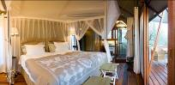

Road Directions from Dolomite Camp to Etosha, Namutoni side
Approximately 303km/6.5 hours excluding stops, or a full day's game drive. This is measured from Dolomite Camp to Namutoni, so please allow for the extra km that you will drive from specific lodge to lodge. Take the main C38 road through the Park towards the east, or divert and do some game viewing on the smaller roads along the way. The speed limit inside the park is 60 km/h so please keep this in mind when planning your day driving through the Park!

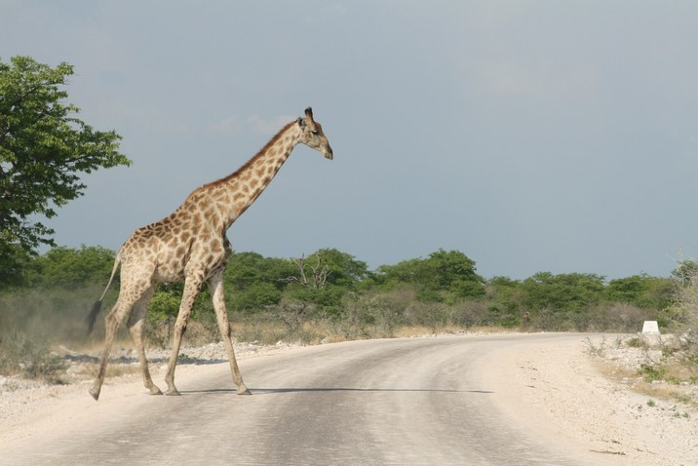

Tuesday
Tuesday
  9th February 2016

  Breakfast, Dinner
  Mushara Outpost

Etosha
Etosha, meaning "Great White Place", is dominated by a massive mineral pan. The pan is part of the Kalahari Basin, the floor of which was formed around 1000 million years ago. The Etosha Pan covers around 25% of the National Park. This pan was originally a lake fed by the Kunene River, however the course of the river changed thousands of years ago and the lake dried up. The +/- 4,590km² pan now is a large dusty depression of salt and clay which fills only in heavy rain, and even then only holds water for a short time. This temporary water in the Etosha Pan attracts thousands of wading birds including impressive flocks of flamingos. The perennial springs along the edges of the Etosha Pan draw large concentrations of wildlife and birds.
To enter Etosha you will need to pay park entry fees of N$80 per person per day and N$10 per vehicle (children under 16 are free of charge). The fees are charged per 24 hour period and unfortunately cannot be paid in advance. Okaukuejo, Halali & Namutoni rest camps can be visited for lunch, a swim or simply a quick break, each camp having a restaurant, small shop & petrol station. If you are staying inside the Park, care should be taken to be back in the rest camp before sunset when the Park gates close.
There is a key deposit of N$500 for accommodation within the Park. You will be refunded when you check out. Please just make sure that you include an addition +/-20min for this process as they will check on your room before they refund you.
The Etosha National Park opens its gates at sunrise and closes them at sunset. At the entrance gates there are huge clocks indicating the opening & closing times which change with the seasons. The speed limit inside the park is 60km/h so please keep this in mind when planning your day driving through the Park. Many of the roads have a steep camber so take care at all times, it is easier than it seems to overturn a vehicle if you are not concentrating fully on the road! There is so much to see here, just resting by one of the waterholes and waiting for the animals to come to you, or by driving slowly through the Park and watching the sides of the roads carefully. Every season in Etosha has something different to offer.

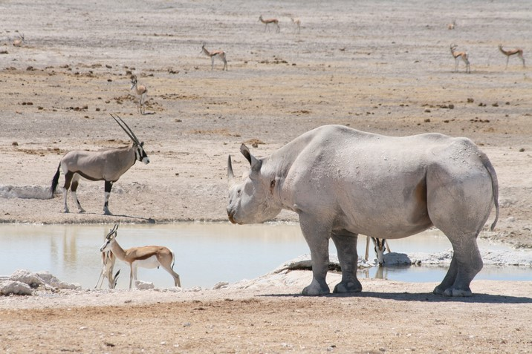

  www.mushara-lodge.com
  Mushara Outpost
  Game Drive

On the Mushara game drives guests experience fascinating perspectives of wildlife in Etosha. The lodge vehicles, designed for any weather conditions, are spacious and comfortable and offer 360 degree unobstructed views from elevated seats. The lodge guides receive up-to-date information on game movement and therefore have a high success rate at spotting game.

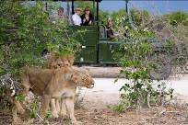

Wednesday
Wednesday
  10th February 2016

  Breakfast, Dinner
  Okonjima Plains Camp
  www.okonjima.com

Okonjima
Situated halfway between the capital Windhoek and the Etosha National Park, the 55,000 acre Okonjima Game Reserve has some of the best accommodation in Namibia, but the highlight has to be the cheetah and leopard safaris. Namibian safaris are truly wonderful and as The AfriCat Foundation rehabilitates cheetahs, wild dogs, hyenas and leopards, there are opportunities to see these beautiful carnivores in their natural environment.

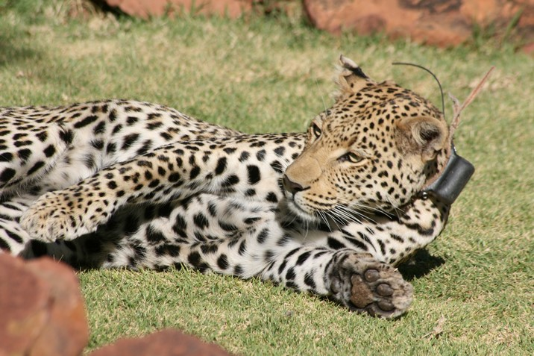

Road Directions from Etosha, Namutoni side to Okonjima
Approximately 365km/4.5 hours excluding stops. This is measured from Namutoni to Okonjima, so please allow for the extra km that you will drive from specific lodge to lodge. Departing from Namutoni you will take the C38 road exiting the park through the Von Lindequist gate until, after 36km, you connect with the B1. Turn right here and drive via Tsumeb and Otavi to Otjiwarongo. Otjiwarongo is a good town at which to stop for a break, fuel and maybe some shopping for snacks and drinks in the big Spa supermarket here. There is also a Wimpy restaurant next to the Spa. Make sure you keep your car locked, and that no valuables are on display. From Otjiwarongo, travel south on the B1 in the direction of Okahandja. After approximately 48km on this road, take the gravel turn-off to the right, just after the sign "Okahandja 130km". There is a big cheetah sign on the road.

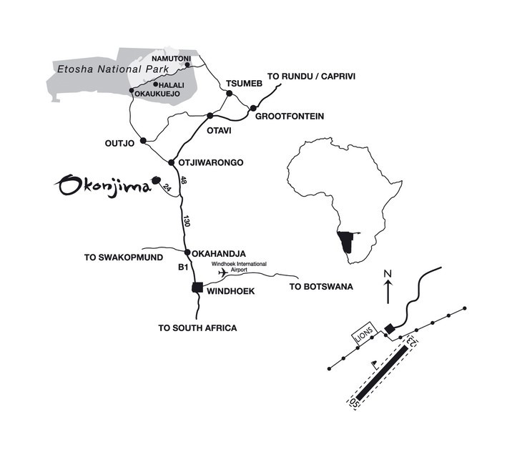

Okonjima Plains Camp
Otjiwarongo | +264 (0)67 687032 / 3/ 4
West of the Waterberg Plateau, the vast plains are occasionally broken by the remnants of ancient Sandstone outcrops, which once covered large areas of Northern Namibia. Nestled among the Omboroko Mountains lies Okonjima – a Herero name meaning Place of the Baboons. This is much more than just a lodge. Okonjima is also home to The Africat Foundation.
The Africat Foundation, works with farmers and the public to conserve the big cat species of Namibia. The project is there to educate the local communities on how to work with big cat species rather than capturing them and removing them from arable land, and includes a local school. The hopes are to extend their environmental education efforts to high school and even university undergraduates in the future.

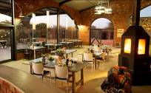

1 x Plains Camp Standard Room, Dinner & Breakfast Included
The Plains Camp design honours the Okonjima cattle-farming history. In the early 1920’s, Okonjima became a cattle farm and was bought by Val (VJ) & Rose Hanssen in 1970. They were well-established Brahman breeders and continued to farm cattle until the need for solutions to increasing livestock losses became pertinent and post-independence interest in Namibia as a tourist destination, escalated. In 1993, the herds of Brahman and Jersey cattle were sold, changing the face of Okonjima as well as that of Carnivore Conservation!
The Barn/ Entertainment area - AKA 'The Lapa', meaning 'Gathering Place', - includes, the dining and lounge area, the pool and the curio-shop; and hosts the 3-tier accommodation facility. Plains Camp is family & wheel-chair friendly!
The open, grass-plains were 'recovered' by removing and burning invasive Acacia-bush during 2012 and 2013, creating the plains-view, ensuring a great sunset most evenings.
Each of the 14 Standard Rooms enjoy a view across the Okonjima grass plains. Four of the rooms form two large, double rooms/family-units. All rooms are set 15m -20m apart, some distance from 'The Barn' or main entertainment area.

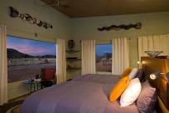

Thursday
Thursday
  11th February 2016

Breakfast

Fly out of Windhoek International Airport
You will continue your drive, out to the airport to drop your hire car off in time to connect with your onward flight. The drive to the airport from town takes around 45 minutes and you should arrive no later than 2 hours before your flight departs in order to drop your car off and check in.
There is one petrol station at the airport, as you approach the airport you will see a sign to the petrol station which is located on the left hand side of the main road, just after the turnoff to the airport. After filling up, you can drive from the petrol station to the airport parking without having to come back onto the main road, just follow the signs. Please remember that after you drop your car off, Europcar will charge your credit card for any other extras such as an additional driver. When you drive from the petrol station to the airport, you will come to a small roundabout. Follow signs to the hire car drop offs; Europcar have a parking area and there will be a representative there to take the car from you before you go to the departure hall and check in.

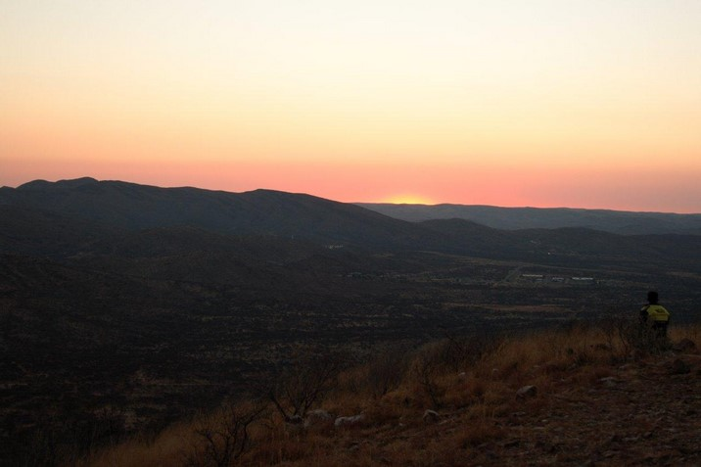

Pricing
Total Cost  Per Person | N$41,900.00  N$29,950.00

A non-refundable 20% deposit payment of N$8,552.95 is due upon in order to confirm your bookings.

The 80% balance payment of N$34,211.80 is due 6 weeks before arrival, by 21st December 2015.

Terms and Conditions
All bookings are subject to our standard Terms & Conditions as they appear on our Booking Form. The Booking Form must please be signed, initialled where indicated, and then returned to us before we can confirm your travel plans.
Included
  ATI Holidays
  Cell Phone

Your cell phone will be a simple Nokia or Samsung. Your ATI representative will show you how to use phone. Turn the phone on by holding down the off button. Enter the four digit PIN number which is written on the back of the phone. The phone number is also written on the back, if you want to give this to friends or family back home. The phone numbers for ATI, Europcar, any relevant air charter company, and all the lodges you will be staying in, are pre-programmed into the Contacts section of your phone. Please keep the phone switched on all the time so that we can reach you in case of emergency, or any unscheduled changes to your itinerary. We will also provide a charger so that you can plug it in each evening.
We will also give you a cool box with ice bricks if you are self-driving, you can re-freeze the ice bricks at your overnight stops, and we ask you to please return this to us at the end of your stay along with the cell phone. In addition we will lend you a simple First Aid kit including treatments for cuts, bruises, small burns and other injuries. We ask you to please only use this if you really need to, and to try to return it to us intact so that we can lend it to other guests in the future.

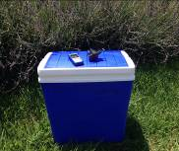

  ATI Holidays
  MediVac Insurance

ATI Holidays offers an inclusive emergency accident & serious illness evacuation and treatment insurance plan for all our clients in Namibia. This was organised as a result of several recent cases throughout the country where even clients whose personal policies did include Medi-Vac cover experienced delays of up to four hours before international insurers authorised the launch of a Medi-rescue vehicle, plane or helicopter. As a result ATI Holidays negotiated a new 'Life Saver' insurance policy that is now included in all our Namibian holidays. This guarantees an instant, no questions emergency launch of private medical rescue and evacuation services. Additionally we have included N$25,000 of emergency treatment cover at Namibia's private trauma centres, ensuring that no delay in urgent treatment is experienced. Our insurance company would then liaise with your insurance company after the event to finalise payment.

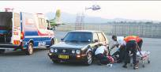

After hours vehicle delivery in Windhoek.

Excluded
Fuel for the self-drive rental vehicle if applicable
Fuel deposit, additional driver charge & negligence deposit for the rental vehicle if applicable
Entrance fees to all National Parks/ sightseeing attractions not included as guided activities in your itinerary
Gratuities
International flights and airport taxes
Travel insurance for cancellation, curtailment and medical emergencies/ treatment – this is mandatory when making a booking with us
Visas if applicable – all visas are the full responsibility of the client
All other expenses of a personal nature

