
EMBASSY OF ROMANIA
Trade and Economic Promotion Office
Amman
Hashemite Kingdom of Jordan

 |  | 
Monthly News Bulletin

"To support the Jordanian business community in their efforts towards
enhancing the trade relations and economic cooperation with Romania"

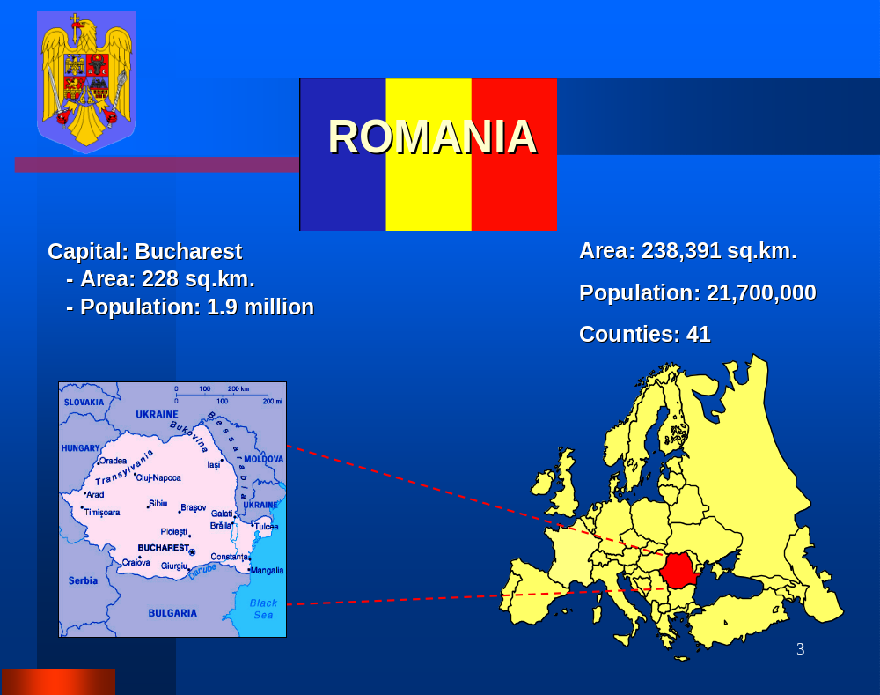

No. 1 – January 2013

INSIDE

- Macroeconomic View 3-6

- Market and Companies News 6-8

- Company Profile, Offers
& Business Proposals 9-15

- Useful Links & Resources 16

MACROECONOMIC VIEW

Romanian government approves framework of Financial Supervision Authority
The government approved through an ordinance the creation of the Financial Supervision Authority (FSA), which should oversee the insurance, stock exchange and private pension markets.The authority follows the model of other EU member states that unified the non-banking supervision authorities.
The government hopes the new authority will cut some of the bureaucratic practices in supervision and should become an anchor of stability. Following this move, Romania will have two institutions that manage the financial sector. The National Bank of Romania (NBR), which oversees the banking sector and the FSA.
The FSA will have 15 members and a smaller combined budget compared to the three existing authorities CNVM – stock exchange, CSA – insurance, CSSPP – private pensions.
“Romania needs to adapt its institutions, to make them more flexible and efficient in supervising the non-banking financial markets,” the Prime Minister Victor Ponta has said.

EBRD: Advancing privatization, key priority for the Romanian economy in 2013
Romania continues to be highly exposed to negative developments in the eurozone, and the recent political crisis also had a negative impact on the economy. European Bank for Reconstruction and Development (EBRD) said in a press release that in the energy sector state-owned enterprises still dominate electricity generation and competition is limited. Several important privatizations in this sector have been delayed. Improving the investment climate, advancing privatization in key sectors and the quality of the transport network needs significant improvements, are the key priorities for the Romanian economy in 2013 identified by EBRD. According to the financial institution, further progress on this issue would be helpful in attracting much-needed investment to the sector. “Heightened efforts are needed to remove red tape and licensing problems, where are cited as problems by enterprises in business climate surveys”, said EBRD. Also, the new Romanian government has expressed its commitment to proceed with the sale of important assets, but implementation has been slow and should be accelerated if sales are to be achieved next year. Now that the appropriate legislation for private sector involvement is in place, the authorities should set up efforts to attract private investment and know-how to key transport projects, EBRD analysts think. The banking sector survived the negative fallout from the financial crisis and is reasonably well capitalized. However, financing for small and medium-sized enterprises (SMEs) is limited outside of the main urban areas and capital markets are underdeveloped

Romanian economy to expand by 1.1 percent of GDP in 2013, says Erste Bank
The Romanian economy is set to grow by 1.1 percent of GDP in 2013, helped by the renegotiation of an IMF agreement and a potential hike in EU funds absorption, according to a report of Erste Group on CEE markets and stocks. The Erste analysts said the country has improved its fiscal balance since 2010, and estimates a budget deficit of 2.7 percent of GDP on ESA 95 for 2013.
“The Romanian economy will still be trailing behind its potential in 2013, with economic growth due to pick up slightly to 1.1 percent, highly sensitive to developments in the Euro zone, which absorbs around 55 percent of Romania’s exports,” said the report.
Authorities need to strengthen administrative capabilities of EU funds absorption. The country has drawn less than EUR 2 billion from the EUR 19 billion made available through to 2013. The country also has to improve the efficiency of domestic capital spending, according to analysts.

Romgaz listing makes the BSE emerging market
The lack of drivers for economic growth is making the Romanian equity market less attractive for foreign investors, although a handful of stocks performed well last year.
Erste analysts listed among the favorite stocks the Property Fund (FP), oil & gas company Petrom, lender Banca Transilvania, pharma producer Biofarm and the grid operator Transelectrica.
The government pledged to sell minority takes in several energy firms under an agreement with the IMF, but the privatization schedule has been delayed, either due to changes in the government configuration or bad market conditions.
The secondary public offering of the Transelectrica was the only notable event on the BSE last year. Erste considers that the listing of the state-owned gas producer Romgaz could bring the domestic stock exchange in the emerging market category.
The initial public offerings in Hidroelectrica, the insolvent hydropower producer and in Nuclearelectrica, the nuclear producers, should take place in 2015. Analysts said the success of these listings relies on increased profitability and the liberalization of the power market. Furthermore, al leas 60 percent of the output of these power producers needs to be sold on the wholesale market OPCOM to make them attractive for investors.

The new government’s to-do list on communications
Under the governing program for 2013-2016, the Romanian executive pointed out the targets it has in mind, in alignment with the European Digital Agenda. These include expanding broadband to rural areas, e-Governing, inter-operability, cloud computing, R&D and social media.
The government’s agenda stipulates the implementation of cloud services at the level of public institutions by creating a centralized, scalable and dynamic platform that should offer quality IT services at low prices and at European security standards.
The executive also intends to promote modern mechanisms of e-commerce, m-commerce, m-wallet and near-field-communication (NFC) in alignment with European regulations, and the encouragement of merchants to use these channels.
Initiating R&D programs in IT&C, based on the needs of the industry and stimulating private investments in R&D is also a target.
As far as broadband is concerned, the executive proposes to improve the access to broadband of the population and firms in the rural areas, in order to close the digital divide. This includes setting up a law package that should encourage the development of broadband infrastructure as well as modernizing the broadband NGA-FTTH networks.
Shaping digital competences among the population, with an emphasis on certain disadvantaged categories such as the elderly or those with disabilities, is also listed as priority.

Romanian National Bank BNR) ends 2012 with a EUR 2 billions decrease of its foreign exchange reserves
Foreign exchange reserves of the National Bank of Romania (BNR) ended last year at EUR 31.2 billions, EUR 2 billions less than at the end of 2011, but slightly up from November 2012, when they stood at EUR 31.16 billions. At the end of 2011, BNR’s foreign exchange reserves amounted to EUR 33.2 billions. In December last year, the Central Bank posted cash inflows worth EUR 2.132 billions, reads a press release issued by BNR. Outflows stood at EUR 2.093 billions, representing changes in the foreign exchange reserve requirements of the credit institutions, interest and principal payments on foreign currency public debt, including the amount of EUR equivalent 252.05 M representing the payment of the third principal installment and interest on Romania’s loan from the International Monetary Fund. The gold stock held steady at 103.7 tones. However, following the change in the international price of gold, its value amounted to EUR 4.207 billions. The international reserves of Romania (foreign currencies and gold) on December 31, 2012 stood at EUR 35.413 billions, compared to EUR 35.594 billions on November 29, 2012. During the month of January 2013 the payments due on public and publicly guaranteed foreign currency denominated debt amount to EUR 135.07 millions

Investments in economy advanced by 16 percent in Q3 2012
The investments made in the Romanian economy increased during the third quarter of lat year and in the interval January 1 – September 30, against the similar periods of 2011, by 16 percent and 17.9 percent respectively, according to preliminary data released by the National Statistics Institute (INS). In Q3 2012, compared to the similar interval of 2011, net investments in the national economy advanced by 16.0 percent, to RON 20.28 billion (6 billions Euros) (at current prices), with the increase being registered in all structure elements: machines (transport means included) by 29.5 percent, new construction works by 6.0 percent and other expenses by 5.7 percent. Compared to the third quarter of 2011, 2012 brought a 4.1 percent increase of the share held by machinery (transport means included) in the total investments. During the first nine months of 2012, investments advanced by 17.9 percent to RON 48.995 billions (9 billions Euros) (at current prices).

Romania’s annual inflation rate drops to 4.56 percent in November
After Romania’s annual inflation rate hit a high of 5.33 percent in September 2012, fueled by price increases for food products, in November it dropped to 4.56 percent, according to data released by the National Institute of Statistics (INS).
In November 2012 compared to the previous month, prices for food products went up by 0.3 percent and decreased by 0.1 percent for non-food products and services.
In the food products category, eggs reported the highest price increase of 8.07 percent while the highest decrease – 1.6 percent – was reported for fresh and canned fruit. In the non-food category, fuel prices dropped by 1.5 percent while rents, airfares and phone and TV subscription dropped each by less than one percentage point.
Romania’s central bank has previously increased last year’s inflation target from 3.2 percent to 5.1 percent by year end. The target for 2013 has also been revised upwards, from an initial 3 percent to 3.5 percent.

Romania, among 10 most attractive countries for green energy
Romania climbed for the first time in top 10 most attractive countries in the world for investments in wind energy at the beginning of 2012, according to Ernst &Young report ‘Renewable energy country attractiveness index. Its evolution throughout the last year, although slightly fluctuant, has confirmed that Romania offers one of the most attractive markets for clean energy investments. Romania has therefore successfully held on to its position, finishing the year 2012 in the top 10 regarding wind energy, and on the 13th place regarding the aggregate indices for all forms of renewables.

Construction works volume up by 2.1 percent in first ten months of 2012
The construction works’ volume has risen in the first ten months of 2012 both as gross series and as series adjusted to the number of workdays and seasonality by 2.1 percent and 3.4 percent respectively, year-on-year, the National Statistics Institute (INS) data shows. Construction works dropped by 12.2 percent in the case of residential buildings and 3.3 percent in the case of non-residential buildings. The volume of construction works grew by 8.6 percent in the case of engineering constructions. In October, the volume of construction works grew month-on-month by 5.5 percent as gross series and by 0.7 percent as adjusted series. Compared to October 2011 the drops stood at 5.1 percent (gross series) and 6 percent (adjusted series).

MARKET & COMPANIES NEWS

Mobile broadband leads the way in internet growth
The total number of broadband mobile internet reached 6.9 million, up 63.8 percent compared to the end of 2011 and nearly double compared to the number registered in half 2011, according to telecom watchdog ANCOM. The report was made based on data reported by internet providers between January 1- June 30, 2012.
In fact, mobile broadband posted the highest growth in all internet connections.
“Within a year, the number of active mobile broadband internet connections has nearly doubled,” said Catalin Marinescu, president of ANCOM.
Thus, there were 5.6 million mobile broadband internet connections via mobile phones and 1.3 million via modems/cards/USB devices.
At June 30, 2012, there were approximately 7.4 million SIM cards that allowed access to mobile internet via technologies such as 3G, 3G+, EV-DO or 4G.
Fixed broadband internet connections also increased, albeit at a slower pace, reaching more than 3.4 million in the first half of this year, reaching a 4.1 percent growth compared to the previous semester and 9.1 percent growth compared to the similar period last year.
Half of the fixed internet connections used by residential clients were at least 30 Mbps.
From the total number, 88.9 percent use the FTTx technology which uses optic fiber to a location close to the final user, which makes possible to offer high internet speeds.
The penetration rate of fixed broadband internet has reached 18 percent of the population and 44 percent of the households.
In the first half of 2012, there was an 11.7 percent growth on the previous semester in the number of connections in the rural environment up to 0.8 million.

ANCOM: Romanian telecom market reached EUR 1.6billions in first half of 2012
Revenues on the Romanian telecommunications market summed up RON 7.48 billion (EUR 1.6 billion) in the first half of 2012, which represented a 3.5 percent growth compared to the same period in 2011.
Fixed telephony and rented lines services saw an 11 percent drop compared to the first half of 2011, reaching values of RON 745 million and RON 133 million.
With the exception of the two above-mentioned services, internet access services hiked by approximately 16 percent, up to RON 1.1 billion.
Mobile telephony services also posted a slight increase of 0.1 percent up to RON 2.7 billion.
The services provided by re-broadcasters to the final user increased by 2.6 percent up to RON 796 million.
The revenues from inter-connection to mobile and fixed points posted 1.4 percent annual growth to the value of RON 999 million, and 14.6 percent respectively, to RON 341 million.
The penetration rate of fixed telephony has maintained at 24.6 percent of the population.
The traffic in public fixed telephony lines continued to drop in H1, 2012, compared to H1, 2011 by 8.7 percent, reaching 2.8 billion minutes.
The monthly average time that was spent on the mobile phone was 1 hour and 41 minutes, which is 10 minutes less compared to the same period last year. The length of one call was on average 3 minutes and 16 seconds.
In mid-2012, in Romania there were 5.5 million users who had electronic communication bundles, 68.8 percent more compared to the same period last year.
Of these, 3.77 million use 2-play packages, which represents 105.5% growth compared to the same period last year, and 1.73 million users of 3-play services.

Total assets of private pension schemes reach 1.58pct of GDP as of end-October 2012

The total assets managed by all of Romania's private pension schemes were standing at RON 9.63 billion (2.12 billion euros) as of end-October 2012, up 40.40 percent from December 2011 and 49.16 percent from October 2011; when stated in euro, the rise was 33.71 percent and 42.21 percent, respectively, according to a recent bulletin released by the Private Pension System Supervisory Board (CSSPP).
Compared with September 2012, the rise in total assets was 3.25 percent. As of October 31, 2012, the total assets of the private pension schemes were making up 1.58 percent of the country's Gross Domestic Product (GDP), compared with 1.19 percent on December 31, 2011.
The rise in the total assets of the private pension schemes (Pillar II) outpaced the rise in the assets of the optional pension schemes (Pillar III). Thus, Pillar II assets advanced 41.04 percent from December 2011, while Pillar III assets increased by just 30.92 percent.
Compared with the similar month of the year before, Pillar II assets were up 49.94 percent, while Pillar III assets were up 37.90 percent, according to the CSSPP bulletin released on Thursday at an international seminar held by the CSSPP and the Chilean Embassy in Bucharest.

Pirelli to invest EUR 105 million in Romania between 2013 and 2017

Pirelli company announced it is going to invest 105 million euros in Romania over the next five years (2013-2017), according to the investment plan of the company.

The investment of Pirelli company, supported by the Romanian government with 35 million euros, is meant to increase the capacity of their plant in Slatina from 10 million tires in late 2013 to 13 million tires in 2017.The new investment adds to the investment plan of Pirelli company between 2005-2014, in amount of 450 million euros.
The investment announced on Tuesday is meant to increase the surface of the tyre plant from 180,000 square metres to 200,000 in 2017, and to the development of their production capacity. The Slatina-based plant has now a production capacity of 8.5 million tires and will reach 10 million tires in late 2013.
The new investment plan will also create 500 jobs by 2017, as the company will reach a number of 3,500 employees.
The Slatina-based tyre plant is one of the most modern production units for cars belonging to Pirelli group and manufactures Premium range tires.

COMPANY PROFILE, OFFERS & BUSINESS PROPOSAL

SIVECO ROMANIA SA

Address: | Calea Bucuresti-Ploiesti nr. 73-81
City: | Bucuresti
Phone: | 0040 21 3023300
Fax: | 0040 21 3023391
E-mail: | office@siveco.ro
Web site: | www.siveco.ro
Contact person: | Florian Ciolacu
Year of establishment: | 1992
Type of activity: | Manufacturer
Quality Standards, Licenses/Certifications: | ISO 9000/2009
Field of activity: | - Computer programming, consultancy and related activities
Short description: | Our organization gets constantly involved in major IT projects, providing non-discriminatory access to eLearning, eHealth, eAgriculture, eCustoms, eBusiness solutions.  The company's mission is to be the main supplier and integrator of ERP solutions, eBusiness, eLearning, eGovernment, eHealth, eAgriculture and eCustoms solutions in Romania and to become a European leader in software.
Export offer: | - SIVECO Applications -ERP  - eLearning  - eHealth  - eBanking  - Credit Bureau
Main export markets: | Syria, Egypt

GEROCOSSEN SRL

Address: | Bd. Dimitrie Pompei nr. 9, Sector 2
City: | Bucuresti
Phone: | 0040 21 2420271
Fax: | 0040 21 2420867
E-mail: | gerocossen@gerocossen.ro
Web site: | www.gerocossen.ro
Contact person: | Sava Carmencita - R&D Manager
Year of establishment: | 1991
Quality Standards, Licenses/Certifications: | ISO 9001:2000, certified from 2004 and ISO 14001:2004 from 2006
Type of activity: | Manufacturer; Exporter
Field of activity: | - Manufacture of perfumes and toilet preparations
Short description: | GEROCOSSEN is a Romanian cosmetic producer founded in 1990 by 3 specialists with extensive experience in the field of cosmetic products, who also form the managing team.  In the present GEROCOSSEN has more than 100 products in its portfolio. Promoted under the slogan "Essential for beauty !" the company produces creams, body lotions, sun care products, shampoo and hair dyes.  GEROCOSSEN cosmetics are developed based on the research made by the company's specialists and are formulated based on natural active principles extracted from plants, flowers and cereals associated with modern cosmetic ingredients.
Export offer: | - Skin care products  - Shampoo  - Hair lotions  - Hair color cream, hair balm  - After Shave  - Shaving foam
Main export markets: | Kuwait, Italy, Morocco, Switzerland

CAMEXIP SA | 

City: | Baicoi
Phone: | 0040 244 260132, 260347, 260137
E-mail: | camexip@camexipsa.ro; office@camexip.ro
Web site: | www.camexipsa.ro
Contact person: | George State - General Manager
Year of establishment: | 1978
Quality Standards, Licenses/Certifications: | S.R. EN ISO 9002/95 Certificat ABS Q.E. Inc - Huston S.U.A.
Type of activity: | Manufacturer - mainly exporter
Field of activity: | Manufacture of other special purpose machinery
Export offer: | - Heat exchange units: boards for heat exchangers  - Other machine-tools for working wood, cork, bone, hard rubber :spare parts and accessories for machines used for wood processing  - Parts of machinery: spare parts and accessories for equipment used in rubber and plastics processing  - Parts of machinery used for industrial preparation or manufacture of food or drink: spare parts and accessories for equipment used in food industry
COMELF SA

City: | Bistrita
Phone: | 0040 263 234462
Fax: | 0040 263 238092
E-mail: | comelf@comelf.ro
Web site: | www.comelf.ro
Contact person: | Murar Ioan – Head of Marketing Dept.
Year of establishment: | 1991
Quality Standards, Licenses/Certifications: | ISO 9001:2000  ISO 14001:2004
Type of activity: | Manufacturer
Field of activity: | - Manufacture of machinery for mining, quarrying and construction  - Power Generation Equipment - Manufacture of engines and turbines, except aircraft, vehicle and cycle engines  - Refractory Machinery - Manufacture of other special-purpose machinery
Short description: | COMELF SA Bistrita was established in 1991, basically founded on old “Utilaj Tehnologic” Company (established year 1971) transforming this in joint stock company.  Starting 1999, COMELF SA is a private company, main shares owned by UZINSIDER SA Bucharest and COMELF SA is a part of UZINSIDER GROUP Bucharest.  1. Activities: COMELF SA produces:  1.1. Gas dedusting equipments  1.2. Equipments for treating and cleaning waters  1.3. Parts for Co-generative Power Plants with Gas Turbines  1.4. Boilers and Boiler Parts  1.5. Storage tanks  1.6. Welded Steel Constructions  1.7. Earth moving machinery and machinery parts  1.8. Construction equipments + others  In 2007 our company has implemented the environment-friendly management system and has been awarded, by TÜV MANAGEMENT SERVICE Germany, the certification according to ISO 14001:2004 for the following domains: projecting, manufacturing, assembling and service for: gas-dedusting, water treatment and purification, gas turbine power plants, energetic, metallurgical and chemical industry, earth-moving machinery, lifting equipments, welded metallic constructions in carbon and stainless steel and pressure tanks.  SLV München - Germany attest for manufacturing of welded steel constructions according to DIN 18 800 and DIN 15 018.  TÜV Bayern - Germany authorization for manufacturing tanks under pressure according to technical prescriptions AD - Merkblatt HP O, TRD 201and EN 729 – 2.
Main export markets: | Netherlands, Italy, Germany, France, Belgium, Norway, Austria

ROMCARBON SA

City: | Buzau
Phone: | 0040 238 711155
Fax: | 0040 238 710722
E-mail: | office@romcarbon.com
Web site: | www.romcarbon.com
Contact person: | Banucu Ileana - General Manager
Year of establishment: | 1952
Quality Standards, Licenses/Certifications: | ISO 9001:2000, OHSAS 18001:2007, ISO 14001:2004
Type of activity: | Manufacturer
Field of activity: | - Manufacture of plastic plates, sheets, tubes and profiles
Short description: | Main activities include the design of blocks, foils, tubes, plastic profiles, plastic packaging, plastic items for constructions and for cars’ parts, accessories and engines.
Export offer: | - EPS trays  - pp bags  - pe foil  - pp band
Main export markets: | Moldova Republic, Serbia, Ukraine, Albania, Bulgaria, Hungary

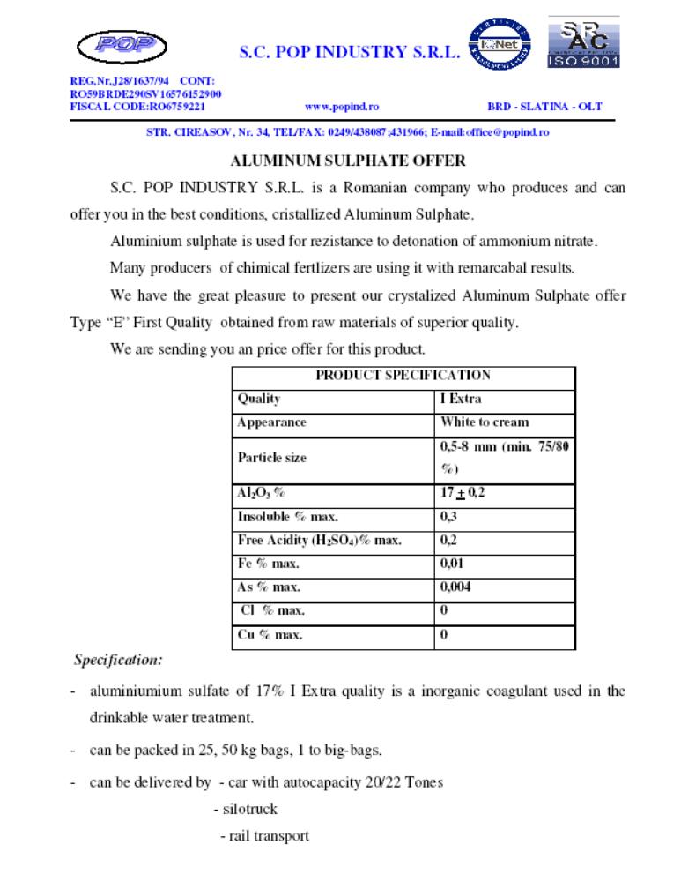

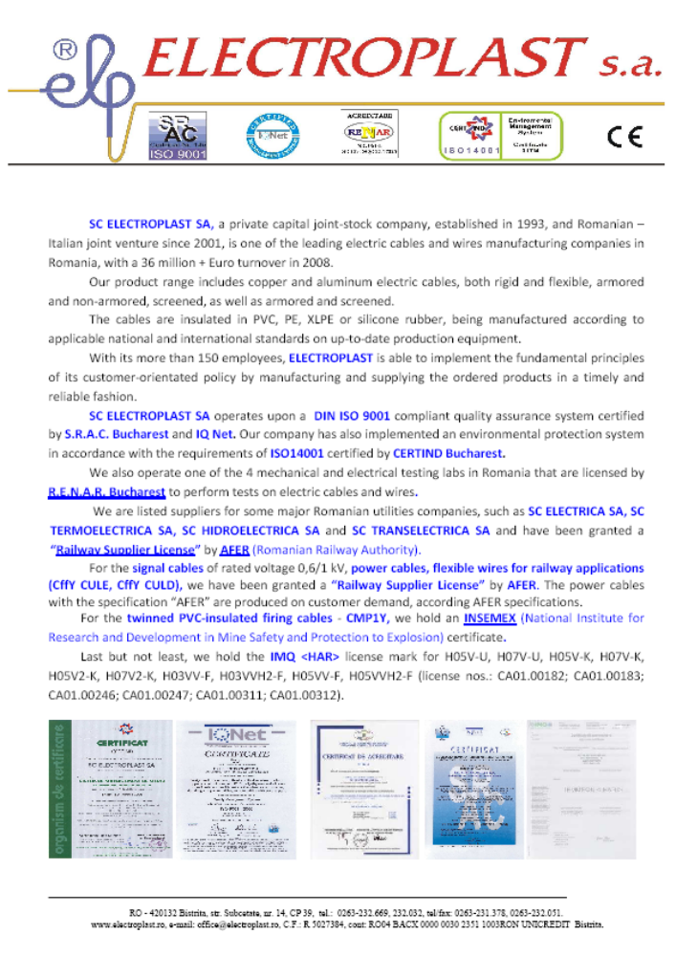

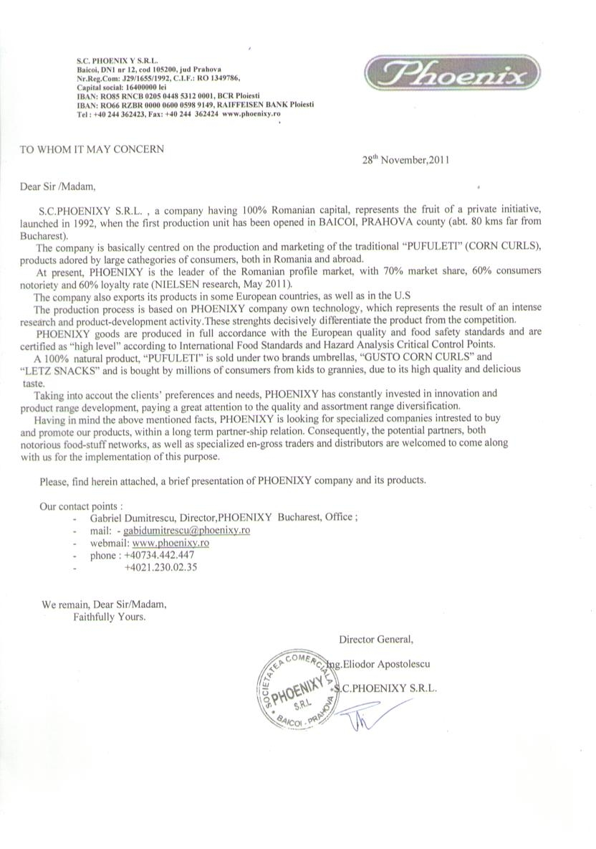
Useful Links & Resources

Ministry OF ECONOMY, COMMERCE and business environment
www.minind.ro

DEPARTMENT FOR FOREIGN TRADE
www.dce.gov.ro

THE AUTHORITY FOR STATE ASSETS RECOVERY
www.avas.ro

THE CHAMBER OF COMMERCE AND INDUSTRY OF ROMANIA
www.ccir.ro

THE CHAMBER OF COMMERCE AND INDUSTRY OF BUCHAREST
www.ccib.ro

ROMANIAN CENTRE FOR TRADE & FOREIGN INVESTMENT PROMOTION
www.traderom.ro

NATIONAL INSTITUTE OF STATISTICS
www.insse.ro

ROMANIAN CUSTOM OFFICE
www.custom.ro

ROMANIAN NATIONAL BANK
www.bnro.ro

