CAMECA SIMS
5f, 6f & 5fE7 Laboratory, Sample and Mount Preparation Notes

David R. Nelson
d.r.nelson@icloud.com

Contents

1. Introduction 3
a) Background to this document 3
b) Capabilities of a CAMECA 5FE7 Secondary Ion Mass Spectrometer 3
c) The SIMS Laboratory: essential facilities and support instrumentation 3
d) Notes on keeping a SIMS facility operational 4
e) Routine SIMS Laboratory Operational Costs 5
2. Sample and Mount Preparation 8
a) Sample preparation for SIMS analysis 8
b) Preparing an Epoxy Mount (for SIMS analysis of mineral grains or irregular shaped samples) 9
c) Mount Polishing 10
d) Sample Cleaning 10
e) Conductive Coating 10
f) Use of Leica EM SCD005 Sputter Coater Unit for Gold Coating 12
g) Use of Leica EM SCD005 Sputter Coater Unit for Carbon Coating 12
h) Use of Edwards Scancoat Six Sputter Coater Unit (GFZ Potsdam) 13
i) Mounting Samples into CAMECA Holders 14
3. Sample Introduction into Instrument 16
a) 5f Removal of sample holder from Sample Stage and Instrument 16
b) 5fE7 Using Navigator Stage software 17
c) 5fE7 To prepare a Holder map using the Navigator Stage software 17
d) 5fE7 To Set the scale-bar in the Camera Image using the Camera software 18
e) 5fE7 To adjust the position of the light source so that it is centred on the Camera Image 18
f) 5fE7 Sample Change 18
g) 5fE7 Sample Change and resetting the unload/load stage positions 18

1. Introduction

Background to this document
These draft laboratory and sample preparation notes record key steps in operation of a CAMECA SIMS instrument. The notes were prepared from March 2010 by D.R Nelson based on his own experience with the CAMECA 5f at University of Western Sydney but supplemented also by procedures learned from Dr M. Wiedenbeck (GFZ Potsdam) during a visit to the CAMECA 6f SIMS laboratory at GFZ Potsdam. In August 2010, the UWS CAMECA 5f was upgraded to a CAMECA 5fE7. These notes have been amended to include documentation of procedures learned during the training received from Mathias Carrachioli, Joel Bonnet, Thierry Wilhem and Cedric Julien, CAMECA Engineers, as part of the upgrade process.

Capabilities of a CAMECA 5FE7 Secondary Ion Mass Spectrometer
The main characteristics and capabilities of a CAMECA 5fE7 SIMS are:
- Oxygen (O⁺, O₂⁺, O⁻ and O₂⁻) and Cesium (Cs⁺) primary ion sources, operable at impact energies up to 15 kV (although duo will operate more stably at <12 kV)
- element and isotope depth profiling with typical sputtering rates of c. 1 µm /hour, enabling concentration profiles with <5 nm depth resolution
- charge compensation via electron gun for non-conducting samples
- qualitative isotope ratio or element concentration imaging with field of view up to 500 µm² and c. 2 µm spatial resolution
- In-situ isotope (e.g. H/D, Li, B, C, N, O, S, Cl) and trace element ratio analysis
- for semi-conductor dopant and impurity depth profiling, diffusion rate investigations, thin film characterisation, corrosion studies, stable isotope analysis and other applications in the Earth, Environmental and Materials Sciences

The SIMS Laboratory: essential facilities and support instrumentation
The following support facilities are essential to fully utilise a CAMECA 5fE7 SIMS:
- Sputter Coater; a Leica EM SCD005 Sputter Coater Unit is adequate
- Profilometer; a KLA Tencor Alpha-Step IQ Surface Profilometer is useful for measurement of analysis pits and surface roughness to 0.04 µm resolution. In the profilometer text files, the first column in the text file is the X axis (i.e. traverse length) and the second column contains the depth at the traverse position. The units are microns x 10⁻³.

Notes on keeping a SIMS facility operational
Tasks required in order to keep a SIMS facility operational are:

- Ordering of replacement instrument components (via employee’s Purchase Order system)
- Cooling Water system filters- must be ordered and replaced every 12 months
- Sample holders- require regular cleaning, are easily damaged and must be repaired using a specialised spot-welder (requires trip to Emu Plains)
- Ar, N₂ and O₂ gas bottles- gas usage must be monitored and new gas bottles ordered as required
- Gold coater unit- requires regular maintenance, including of rotary pump, ordering and replacement of consumables including Au sources etc.
- Profilometer- requires routine re-calibration and regular servicing
- Laboratory reagents and consumables- Galden, Acetone, Alcohol, etc. including wash bottles etc. for sample preparation, foil, gloves, etc. must be ordered as depleted
- UPS power supply – requires regular servicing
- Vacuum gaskets must be replaced with new ones (to be ordered) whenever the instrument is vented and opened
- Cs Ion source- must be dismantled and cleaned regularly, depleted Cs reservoirs must be replaced as required
- Duoplasmatron Oxygen ion source- must be dismantled, cleaned and reassembled following c. 2 weeks of use
- Routine maintenance of instrument vacuum system fore-line traps and rotary backing pumps- require regular oil changes, trap replacement etc.
- Primary column apertures and slits- must be replaced after every few months of use
- Secondary system apertures and slits- require regular monitoring and replacement
- Electron multiplier, CCD and Faraday Cup detectors- require voltage adjustment, dead-time determination and depending on use, replacement every 12 to 24 months
- Thermocouple, ionisation and cold cathode vacuum gauges- have a limited lifetime and must be replaced regularly
- Electron gun filaments- must be replaced regularly to maintain electron source
- Stage motors- require regular adjustment and servicing
- Illuminator- regular realignment, bulbs require regular replacement
- Clients – dealing with queries, loading samples, mailing samples, preparing talks, organising visits to the facility, OH&S induction and training whilst here, packaging results, responding to questions regarding the analytical results obtained etc. takes up probably more than 40% of the technicians time
- General administration, including OH&S, risk assessments, laboratory maintenance, liaising with and responding to other colleagues, meetings etc., reviewing SIMS access proposals etc. probably takes up more than 25% of the facility managers time

Routine SIMS Laboratory Operational Costs

Routine (ongoing) Operation Costs include:

Gasses:
- N₂, for instrument venting lines: 1 x N₂ bottle/annum, cylinder rental $467/annum
- Ar for gold coater; 1 Ar bottle/annum, cylinder rental $467/annum
- O₂, 99.999% for duo; 1 O₂ bottle/annum,cylinder rental $90/annum

Vacuum Gaskets; 5/annum @ €100 ea. Must be purchased from CAMECA.
Cs ionizer assembly - €1851: 1/annum required, new Cs ion reservoir fitted to instrument on 16th February 2012. Must be purchased from CAMECA
Electron gun filament - €325: 1/annum required, new filament fitted to instrument on 9th November 2011. Must be purchased from CAMECA
Apertures and Slits:
Primary column: 100, 50, 20, 10 microns @ €150 ea/annum.
Secondary Column: Contrast and Field Aperture sets, Source, Energy and Exit Slits require replacement every few years. All must be purchased from CAMECA
Pump oils etc; 1 x 1l bottle/annum @ $100/l
Galden PFPE coolant; 1 x 5kg drum/annum @ US$750. Must be purchased from Italy.
Gold (99.999% Au) diaphragms, carbon supplies for coater unit; 1/annum. Must be purchased from Leica.
Misc reagents: acetone, ethyl alcohol, specialized detergents, inc. wash bottles etc
Disposable lab gloves, kimwipes, foil, scalpels, misc tools, piping etc.
Aluminium foil; 1 large roll/annum

Contingency for major breakdowns (perhaps 1 every one or two years?)
There are 6 turbo-pumps, two ion pumps, a sublimation pump and two rotary pumps (one on the gold coater, plus two spares) @ $10,000 to $20,000 each, that each might last another 10 years or might break down tomorrow.
Sample imaging camera, UPS, stage motors, air compressor, computer, ceramic parts etc, might cost on average $5,000 to replace.

Itemised costs for the period’s remainder of 2012, and for full year 2013, are given in the Table below:

Table 1. SIMS laboratory- running cost estimates (in Australian dollars) for the periods remainder of 2012 and full year 2013
Laboratory Consumables | To 31 Dec 2012* |  | 2013
Ar, N and O gas bottles @ $45/month | $270 |  | $520
Cooling Water filters (5 filters, replaced annually @ $50 ea) | $100 |  | $250
Laboratory consumables (gloves, reagents, foil, kimwipes etc.) | $750 |  | $2,500
Galden SV90 cooling fluid 5 kg @ USD150/kg (quotation of 10 August 2010) | - |  | $750
Repair of damaged sample holders @ $200 | $200 |  | -
sub-total | $1,070 |  | $4,020
CAMECA Instrument Consumables**
1 x Cs ionizer assembly - P/N 0045630470 - unit ex work price : 1851 € | $2,238 |  | $2,250
1 x E-gun filament - P/N 0039249381 - unit ex work price 329 € | $396 |  | $400
1 x 20 micron primary column Mo aperture - unit ex work price : 134 € | $161 |  | $175
1 x 10 micron primary column Mo aperture - unit ex work price : 134 € | $161 |  | $175
Parts for conversion of single cooling circuit to dual circuit system : Est. 800 € | Est. $963 |  | -
CAMECA-sourced instrument gaskets | - |  | $1,000
CAMECA-sourced instrument consumables : sub-total | $3,919 |  | $4,000
total: | $4,989 |  | $8,020
*Cost of the recently ordered Frame Grabber and hard drive not included.
** Replacement of spare parts installed during 2011-12. Currency conversion 1.00 € (EUR) = 1.20397 AUD.
In order to avoid the 20% impost imposed by Australian Customs to import these items via international courier, I have arranged for the CAMECA engineer to bring these replacement parts with him on his next visit (July 2012).

Table 2. SIMS laboratory- contingency cost estimates (in Australian dollars) for the periods remainder of 2012 and full year 2013
CAMECA Instrument Contingency for parts failure***
 | lifetime (years) | Exchange cost | contingency/year
turbo-pump V81M Nav.pump ISO 63 | 2 | $2,251 | $2251/2 = $1125
turbo-pump V301M Navigator ISO 100 | 4 | $3,728 | $3728/4 = $932
Gauge head IMG-100 Assy, NW25 | 4 | $587 | $587/4 = $147
Gauge head MBA-100 Assy, NW25 | 4 | $397 | $397/4 = $100
UHV-24 Ion Gauge replacement kit | 4 | $236 | $236/4 = $59
Gauge head 531 thermocouple | 4 | $87 | $87/4 = $22
Total contingency for breakdowns |  |  | $2,385/annum
*** Prices of replacement parts based on Dynapumps quotation 040812RBN of 23 August 2012. Part lifetimes based on estimates provided by the CAMECA Engineer and Dynapumps.

2. Sample and Mount Preparation

Sample preparation for SIMS analysis
Preparation of geological samples (rocks, meteorites and minerals) and of biogenic samples (for example, shells, corals, bone and osteoderms) for SIMS analysis requires access to the following equipment:
- fine diamond saw
- set of saw sample holders and diamond saw blades for geological samples
- 25 mm (1 inch) diameter moulds, 2 inch wide double-sided tape
- large rectangular glass thin section blanks (granite size, 7.5 cm x 5 cm x 3 mm)
- epoxy resin (such as EPIREZ EPIMOUNT, a two part epoxy)
- ultrasonic bath
- binocular microscope
- transmitted and reflected l microscope with digital camera, for preparation of photographic maps of the sample surface and to identify and plot analysis site locations
- mechanical grinding/polishing machine
- 50 mm x 50 mm x 5 mm thick glass sheet (for hand polishing/finishing)
- wet grinding papers (various grades)
- polishing cloths, polishing grits and diamond pastes
- millipore ultra-clean water supply
- petroleum ether, iso-propanol, soap solution for mount cleaning
- Sputter Coater Unit for conductive (Au or C) sample surface coating

The SIMS instrument uses sample holders that accept slightly less than 1" (c. 23 mm) diameter and will accommodate samples up to 7 mm in thickness.
It is essential that the prepared sample is flat as the primary ion beam strikes the sample surface at a high angle (between 20 and 60 degrees, depending on the primary ion source accelerating voltage and sample HV gradient) and thus, any topography will displace the intersection of the ion beam from the secondary ion extraction system. Furthermore, the sample surface is part of the secondary extraction system and the sample is held at up to 15,000 volts. Hence, any undulations or blemishes will perturb the potential field. For this reason, the finished mount should have no pits, bubbles, scratches or protrusions. Other problems that are often associated with a poor mount are charge build up, which decreases sensitivity and in some instances prevents data collection, and arcing or current discharge between the sample surface and the secondary ion extraction surface located c. 1 mm away from the mount surface.
As the pressure within the source chamber is typically <10⁻¹⁰ tor, samples must also be highly stable within very high vacuum conditions. Labels or bubbles within the epoxy resin must be avoided as they act as virtual leaks within the ion microprobe and can cause an electrical discharge.
Engrave sample identification on the back of the section. Magic markers should not be used as we may use ethanol to clean your sample before they will be coated. For measurement of high precision isotope ratios, relief must be at an absolute minimum. It is not always possible to judge relief by microscope and samples may require scanning by Profilometer or similar instrument with sub-micron resolution. For isotope ratio analysis, a working standard should be mounted in each sample. Standards should be homogeneous, have known isotopic compositions, and match the mineralogy and major element composition.
Samples should have photographic, diagrammatic or other appropriate documentation for location of analysis spots. At minimum, reflected light microscopy is recommended at low and high magnification. The UWS SIMS reflected light microscope field of view is 1500 μm². Other types of imaging or scales of examination depend on the details of each sample and may include SEM, BSE, CL, EBSD, EPMA, or laser con-focal microscope.

Preparing an Epoxy Mount (for SIMS analysis of mineral grains or irregular shaped samples)
For mounting mineral grains and geological samples such as shells and bone, the best epoxy to use is EPIREZ EPIMOUNT, a two-part epoxy, or a similar hard two part epoxy. Also required for mount preparation are 1 inch diameter moulds, 2 inch wide double sided tape, and some large rectangular glass thin section blanks (granite size, 7.5 cm x 5 cm x 3 mm) or some 5 mm thick glass sheet. If mounting samples within 25 mm diameter epoxy disks, samples should be located within 5 mm of the centre of the disk and must not show significant (< μm) surface relief or tilting.
Grains, shells or samples can be arranged on double-sided tape (Selleys is the brand we use as the layer of glue is thinner than most tapes), which is stuck down on a sheet of glass, and then the mould place around them. Specimens or different populations should be well separated, but centrally located. All grains should be within a central 1.7 mm diameter region to prevent grains being too close to the surface of the surrounding sample holder. Standard chips should be located close to the unknowns. Do not press the grains into the double-sided tape as this can increase the number of grains plucked from the surface during polishing. The exception to this statement is the standard. If they are large chips then push then down gently to ensure a large surface exposure. Make sure there is no hair or dirt on the double-sided tape. Don't mark the tape with a pen as the ink will be incorporated into the epoxy. Use the mould to make a slight impression so you can locate your grains. The mould should be very lightly greased on the inner surface prior to pressing onto the double-sided tape. A very light smearing that is difficult to detect is about the correct amount.
Care must be taken to guarantee success with EPIREZ. Weigh out the mix on a balance as this is superior to making a mix by volume. There must be no air bubbles in the mount. These can be eliminated by very gently stirring (folding) the epoxy mix for five minutes with a spatula until the two components are completely mixed (e.g. there is no apparent streaking due to variation of refractive index). The EPIREZ mixture should be ultrasoned for a few minutes before casting. Use a fine needle to break bubbles and to ensure bubbles adjacent to the mounted grains are removed. Stir the epoxy very carefully to prevent moving samples or mineral grains in the mount. This is an easy way to cross contaminate mineral samples, so it is preferable to mount each samples mineral population in separate mounts. If you do decide to put more than one mineral population on a mount, use a disposable pipette the epoxy onto the centre of the mount as this allows the epoxy to flow outwards to the rim as this reduces the possibility of cross-contamination. Curing should be done in an oven for >24 hrs at 20 to 60 degrees Celsius, with the mould covered with Al foil to prevent dust entering. After setting, carefully remove the mould and leave the disk attached to the double-sided tape.

Mount Polishing
Grinding and polishing of the sample is done in the normal fashion used for thin sections. I prefer to use a suction attachment on a thin section grinding wheel to hold the large thin section slide. In this way, it is easy to obtain a parallel back surface. Once the back surface is flat and the disk is the correct thickness it can be removed from the slide. Usually this can be done by peeling up the tape and tugging on it. If the disk doesn't come off easily then gently heat the slide and the glue should soften. Do not apply force as it should not be required. If you did a good job with the earlier parts, the disk should have a good flat surface to start and grinding can be reduced to a minimum. Use a 5 or 10 micron lap or 1200 grit to grind down until you are about 1/3 through the minerals. This can be checked by comparing the observed size of the grains in both reflected and transmitted light. Then clean up the surface with 5 um grit. If polished, a final grit of 1 micron diamond is recommended.
Some useful hints with grinding and polishing: 1) let the powder do the cutting, so don't push down too hard, or use excessive weights. 2) Use a figure 8 pattern for manual work. 3) Use lots of lubricant, and don't let things dry out, as this will prevent friction, which is the major cause of plucking. 4) Keep everything clean. Ultrasonic the sample and wash your hands between each stage, as cross contamination is common. The final polish must be perfect at <1 microns and the surface flat.
If there is a problem with the mount, it is possible to recover specimens by dissolving the epoxy. Epoxy can be dissolved in di-chloro-methane. Care should be taken as this chemical is highly carcinogenic. If there are more specimens that can be used as replacements, then just throw away the mount and start again.

Sample Cleaning
For pre-cleaning prior to coating, samples are placed in a small clean Perspex beaker and cleaned in ethanol and distilled ethanol in an ultrasonic bath for 15 minutes. To minimise surface contamination, the sample may be cleaned prior to coating by ultrasonic washing for a few minutes in (1) Pet Ether, (2) iso-propanol, (3) dilute soap solution (such as Decon), and (4) three rinses of millipore water. The sample is then dried for coating.

Conductive Coating
Non-conductive samples will be either Au- or C-coated with thickness of ~30 nm. The Au coat should be thin as possible as this reduces contaminants in the surface during analysis and reduces the raster time required for imaging, but must have a centre to edge resistivity of 10-20 ohms. An Au coat can be removed with methanol or KI solution.
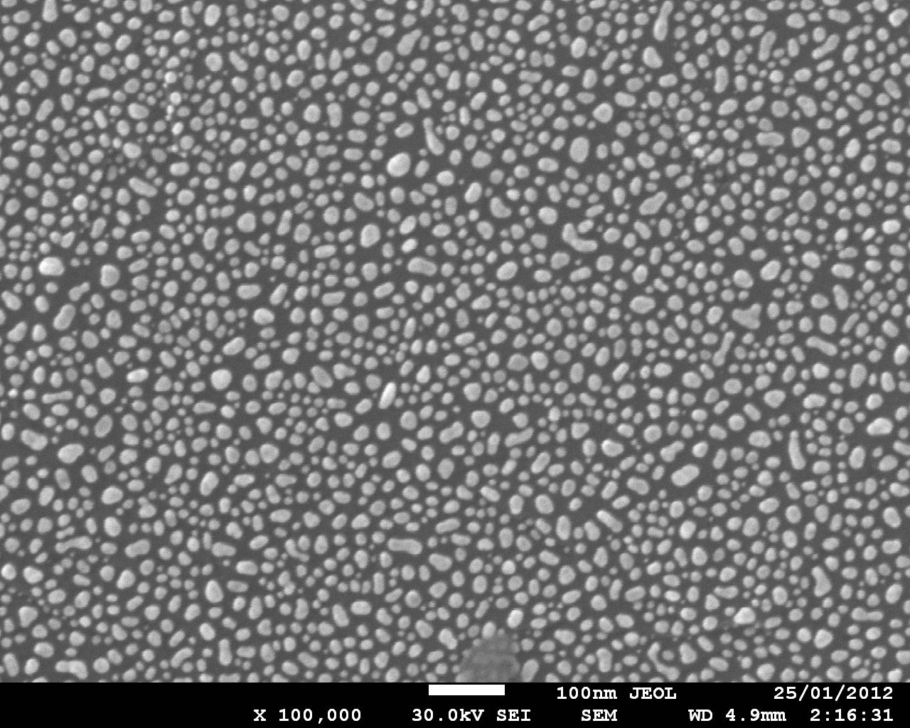

Sputtered Au on graphite, Leica EM SCD005 Sputter Coater Unit using 10 sec deposition time.

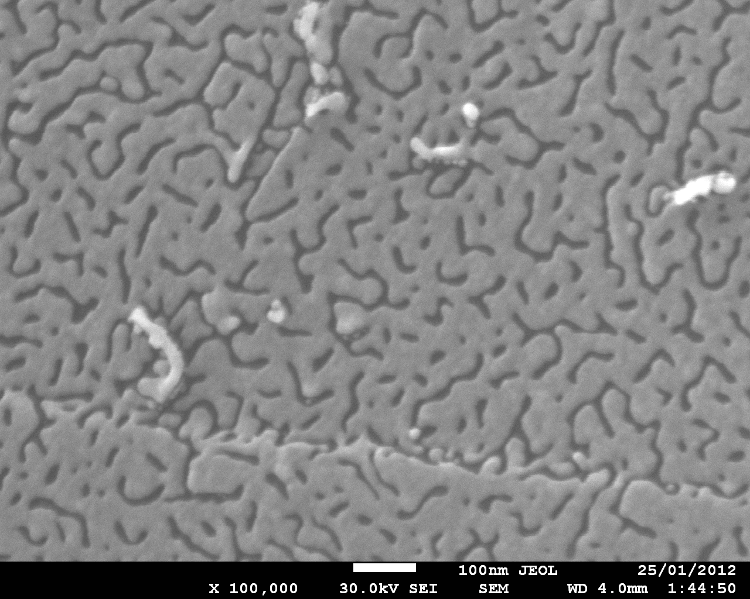

Au
Graphite

Sputtered Au on graphite, Leica EM SCD005 Sputter Coater Unit using 40 sec deposition time.

Use of Leica EM SCD005 Sputter Coater Unit for Gold Coating
A sputter coat thickness of 35 nm of gold is required for non-conductive samples.
- Check oil level in rotary pump; fill (using oil in chemical cupboard opposite and either port on pump) if required
- Check status of gold disk located in top of lid of vacuum jar; replace disk if necessary
- Put cleaned samples (max of 4) on metal floor in glass container, spread evenly around coater surface may put thin samples on Al foil so that they can be extracted from unit more easily
- Open Ar line rear butterfly valve on wall (behind regulator); do not adjust the Ar regulator, which has been set to 0.5 x Atmospheric Ar
- Switch power to unit on at wall switches
- Close door and seat and seal top and bottom of glass seals well
- Turn green “Power” switch on front of coater unit on
- Vent coater chamber with Ar momentarily, to remove air from unit and replace it with Ar, by momentarily pressing the “Flush” switch; allow pump to draw down to <10⁻² tor (green zone)
- Repeat Step 8 twice (vent 3 times)
- Pump down to <10⁻¹ mbar
- Ensure black “Timer” meter on front of unit reads 90 (sec)
- Switch on “Start” to start coating process; current reading will take a few seconds to show; adjust current knob to 60 mA and Ar dial to keep vacuum reading within the range 10⁻¹ to 10⁻² tor during coating process
- Close down coater unit by switching off the green “Power” rocker switch, power switches on wall and by closing the Ar line butterfly valve on wall

Use of Leica EM SCD005 Sputter Coater Unit for Carbon Coating
Ar is not required for carbon coating but a good vacuum of <10⁻¹ mbar is required.
- Check oil level in rotary pump; fill (using oil in chemical cupboard opposite and either port on pump) if required
- Remove Gold Coater Lid, plastic safety shield and vacuum jar
- Adjust height of stage to select desired Carbon Coat thickness (usually 6 cm height as shown on larger vacuum jar cylinder)
- Cut 4 cm length of carbon thread (usually kept in drawer with rest of Carbon Coating parts) and (for single thread) attach each end to the electrodes of the Carbon Coating lid; add slight tension to carbon thread; single thread is usually sufficient but can use 2 threads across electrodes
- Replace with larger vacuum jar cylinder, safety shield and Carbon Coating lid; close shutter
- Put cleaned samples (max of 4) on metal floor in glass container, spread evenly around coater surface may put thin samples on Al foil so that they can be extracted from unit more easily
- Switch power to unit on at wall switches
- Attach power leads from Carbon Coater Power Supply to top of lid; polarity doesn’t matter
- Seat and seal top and bottom of glass seals well
- Turn green “Power” switch on front of coater unit and Carbon Coater Power Supply to on
- Pump down to <10⁻¹ mbar
- Firstly, degas thread: with shutter closed, press “Up” button on Carbon Coater Power Supply until two green LED dots are lit for 1 carbon thread, or three green LED dots are lit for 2 carbon threads across electrodes; leave power on and thread glowing for 15 sec, then press “Reset” to stop the degassing process
- To start coating process; open shutter and press “Flash” button; carbon thread will flash brightly and then coating process is complete
- Close down coater unit by switching off the green “Power” rocker switch, power switches on wall
- Exchange Carbon Coating vacuum jar cylinder, safety shield and lid for Gold Coating parts and retrieve samples

Use of Edwards Scancoat Six Sputter Coater Unit (GFZ Potsdam)
- Turn “Power” switch on front of coater unit on, switch power to backing pump and open Ar line (left hand blue valve on wall) to 0.25 Atmosphere
- Put cleaned samples (max of 4) on metal floor in glass container, spread evenly around coater wire; may put thin samples on Al foil so that they can be extracted from unit more easily
- Close door and seat and seal top and bottom of glass seals well
- Open backing line valve (black valve on bench top near coater unit) and pump down to 10⁻¹ tor
- Vent coater chamber momentarily with “Vent” switch, to remove air from unit and replace it with Ar
- Repeat last 2 steps twice (vent 3 times)
- Pump down to <10⁻¹ tor
- Turn on HT switch
- Switch on “Start” to start coating process; wait until Edwards digital reading (not the “Process Timer digital reading but the “FTM6” box on top of the coater unit) reaches “35.0” (nanometres); takes approximately 5 minutes
- Press small button (not clearly labelled) on lower left hand side of small “Process Timer” digital meter on front of Edwards Scancoat Six unit to stop coating process
- Switch HT off
- Close backing line valve and press ”Vent” rocker switch to vent coater and remove samples
- Close down coater unit by switching off “Power” rocker switch, backing pump and closing the Ar line valve on wall

Mounting Samples into CAMECA Holders
The CAMECA sample holders consist of stainless steel bodies onto which a 0.1 mm thick tungsten mask has been spot-welded. The masks have square, rectangular or circular apertures through which the sample surface can be accessed.
The sample surface to be analysed must be flat and level with the back of the Ta holder, with little or no pressure on the Ta mask (which can warp up and therefore sample cannot be analysed if too much pressure is applied to sample in the holder). Samples should be carefully inserted into the holder and held against Ta mask firmly but lightly, to ensure both good conductivity and also that the holder Ta mask remains flat and does not warp or lift up at all.
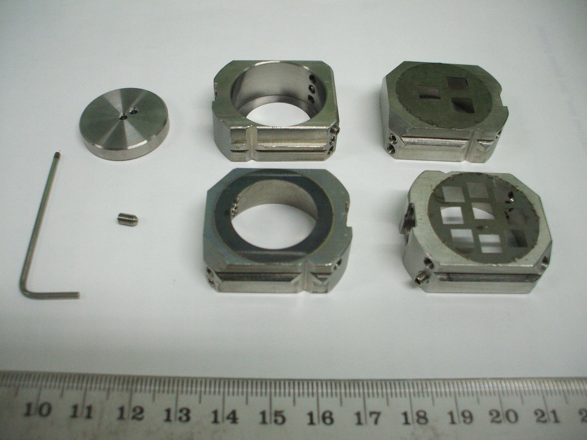
CAMECA sample holders
Remove all “grub screws” in holders that aren’t used (as loose screws can fall into the air lock, sample chamber or other parts of the vacuum system) and check and re-tighten all others in the holder before putting the holder into instrument’s vacuum system. Purchase a laboratory “gripper” and keep in laboratory in advance, for “fishing” out fallen parts.
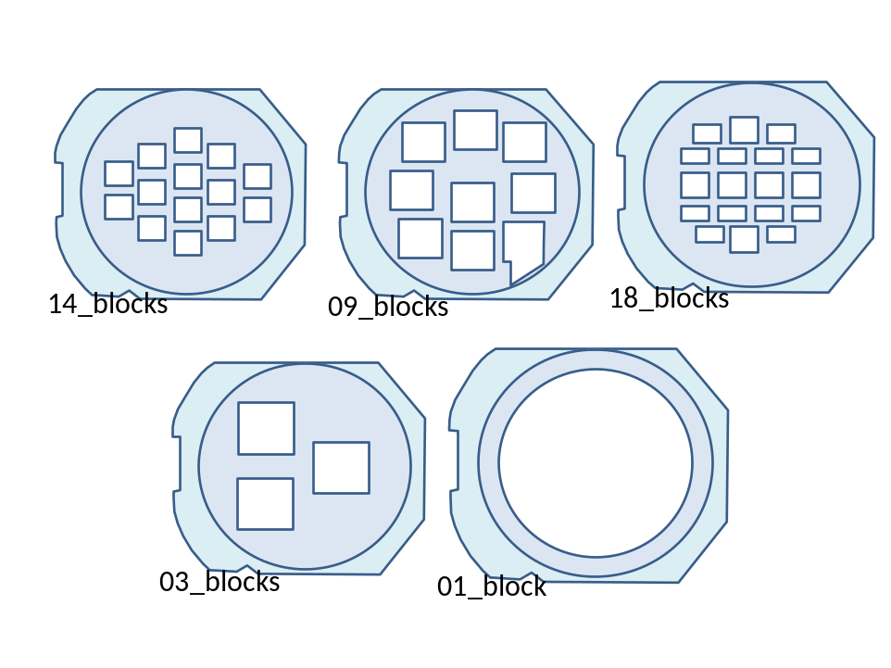
For ensuring good conductivity with the W mask, apply silver (rather than carbon) dag (Acheson G 3691 Silver Dag 915 mit Pinsel. 25 g, Plano GmbH, D35578 Wetzlar; this is vacuum stable, can be put into instrument sample lock almost immediately after application and gives good vacuum in 15 minutes); shake bottle and use a wire pointer rather than the brush supplied with bottle to apply dag to sample surface and mask. Plano GmbH can also supply a vacuum-stable double-sided adhesive Carbon tape, used extensively for SEM/EMPA, and that is also ideal for conductively attaching samples to the backing plates of mount holders. Use a Pilot Supercolor Marker Ultrafine <permanent type> pen rather than a xylene marker pen, to label holders with sample names and numbers.

3. Sample Introduction into Instrument

5f Removal of sample holder from Sample Stage and Instrument
- Open “Holder” software
- Select “Unld” (lower right) button to move stage to unload position; stage should move to unload position
- Check sample stage coordinates are 0.0, 0.0 mm on D1
- Open Airlock: adjust wire coming from end of Sample Exchange Rod until green “Open” led of Airlock (valve 2) is lit; whilst lit, select “Open” (up) with toggle switch to open valve (should hear hissing followed by a clunk)
- Using magnet, move Sample Change Rod in so that its end is clearly visible and align its end horizontally so that it will fit into sample holder slot when inserted fully
- Insert Sample Change Rod smoothly using a single smooth, slow and continuous action, watching end of rod so that the inner rod remains correctly aligned and so that the pin tracks into the slot visible in the port near the sample stage, until rod hits the end stop (the sample holder in the stage)
- Rotate the magnet and Sample Change Rod 90 degrees, turning the top of the magnet towards the Duoplasmatron; sample holder should then be locked into the Sample Change Rod
- Press and hold light switch on top of Sample Chamber to turn light on; withdraw Sample Change Rod smoothly and completely using a single smooth, slow and continuous action, watching end of rod through the port and on the TV screen to ensure that Holder is correctly attached to rod
- With Sample Change Rod completely withdrawn, adjust wire coming from end of Sample Exchange Rod until red “Closed” led of Airlock (valve 2) is lit; whilst lit, select “Close” (down) with toggle switch to close valve (should hear hissing followed by a clunk)
- Open Fore-lock (valve 1): select “Open” (up) with toggle switch to open valve (should hear hissing followed by a clunk)
- Wind Fore-lock holder into lock so that it is aligned with the Sample Holder on end of Sample Change Rod
- Using magnet, move Sample Change Rod in to the lock so that the Sample Holder on end of Sample Change Rod fits into the Fore-lock holder
- Rotate the magnet and Sample Change Rod, turning the top of the magnet away from the Duoplasmatron, through 90 degrees; Sample Change Rod should then unlock from the Sample Holder
- Withdraw Sample Change Rod smoothly and completely using a single smooth, slow and continuous action
- Wind Fore-lock holder back into Fore-lock
- Close Fore-lock (valve 1): select “Closed” (down) with toggle switch to close valve (should hear hissing followed by a clunk)
- Press light green “SAS Pump Vent” button (second from left) on D1 to stop Fore-lock turbo-pump and vent Fore-lock; should hear turbo-pump wind down
- Unclip door to open Fore-lock
- Rotate stage knob to move sample holder out of lock and remove sample from airlock stage

5fE7 Using Navigator Stage software
Notes: There are many features in Navigator that are very useful but not obvious from the Navigator dialog. There are two views of Stage that are selectable using the buttons “front”, which shows the holder from the front or top view, and back (i.e. mirror image of front) which is how the stage and instrument sees the stage orientation. The “front” orientation (holder as viewed from the front) is generally more useful once the holder is loaded into the instrument and during analysis. Select Holder type, showing analysis areas on mask and can then name analysis areas by using mouse left-click, which turns these areas from grey to pink. Using mouse right-click turns these areas blue. Analysis Area name is written to analysis file. Icon showing square within square will centre in middle of the analysis area. Can name point locations and save within a Holder Configuration file.
Holder position offset; can locate corner of Holder Analysis Area in Navigator Image and put offset in if required.
Beam is switched off whenever stage is moved in Navigator unless “Beam On” option is checked.
For Chained Analyses, stage positions must be saved. “Snap” allows current position to be saved, name of position to be edited, then by using “Add”, its location can be added as a named position to Preset file using “Save As”. Config file relates to Holder type.
Software will not allow the sample stage to be viewed with camera during analysis. Can use old CCD camera but must have raster turned off to avoid flickering of image.
When changing to a new mount, it is possible to change the relative X and Y coordinates of positions of all saved positions at once, using “Beam Pos” button.
Can save Optical Image (as jpg, tiff or bitmap) of the sample surface using a pull-down menu accessed in the Image Window.
A new stage unloading position of X = 99715, Y = 5000 has been determined and set, following fixing of the stage motor problem on 4 August 2012.

5fE7 To prepare a Holder map using the Navigator Stage software
Use “Modify” to select a pre-existing map to modify and save as a new one. Cannot modify the current holder so will have to “unload” if modifying the current holder. Then, use Rectangle and circle buttons and specify the size and position of these using the 4 text-boxes. Adjust location and size of the boxes until the map looks correct. Will then need to put the holder in the instrument and drive stage to corners of boxes, then re-size and re-position the boxes so that they are in the correct position and have the correct size.

5fE7 To Set the scale-bar in the Camera Image using the Camera software
Select “calibrate field of view”: two green crosses will appear in different positions on the screen. Position one green cross on a feature in image, click “ok”, then move stage to position the other green cross on the same feature as the first cross and click “ok” again. Scale bar will indicate correct size.
Should be able to double-click on spot on image and stage will drive to that position. However, if the field of view is changed and the Camera software is closed using the red cross rather than the minimize box on the top left of the dialog, the double-click stage-positioning stops working properly and the stage drives to the incorrect position only half way to the double-click position, as the parameters X step and Y step in “Software”, “Video” the “cur” file are incorrectly reset to 1 rather than the correct value of 2. Can change these back to 2 in the current settings file manually.
Holder offset X and Y parameters in navigator position the cross on the Navigator Holder image. It wqill then be possible to change these X and Y offset values to position the cross in the correct position on the holder image shown on the Navigator stage diagram.

5fE7 To adjust the position of the light source so that it is centred on the Camera Image
There are two adjustment knobs located underneath the source chamber housing that are used to direct the position of the light source, which is located underneath the source chamber and between it and the airlock. One adjustment is reached from the airlock side whereas the other is reached from the other side of the source chamber.

5fE7 Sample Change
LEDS:
- RED LED: never touch the sample air lock valve when the LED is red
- GREEN LED: ok to change sample
When on red line, the airlock valve MUST be closed. When on green line, the airlock valve MUST be open.

5fE7 Sample Change and resetting the unload/load stage positions
May need to re-align the sample unload position with the rod position, due to changing main chamber door gasket or gasket in sample change rod. Unload/load positions are saved in “Set-up” on Board in “Other” tab of main board
Procedure is described below:
- In “Set-up”, select load/open file icon, then follow path: D/CAMECAIMS Data/Set-up, load the file “cvr_stpv3.set”; this file contains all stage parameters
- Then in column showing “Set-up”, double-click on “Set-up”, navigate to Software/Holder
- Will see: “Unload pos X abscissa 10400”; Unload pos Y ordinate 250” etc; these are /10 of values indicated on Navigator screen
- With cursor in the value box, use right mouse button to show dialog to enable the value to be changed. Change value, then click ok, no need to Save.
- Can then use Navigator to drive stage to new unload position; may need to load a holder in Navigator beforehand

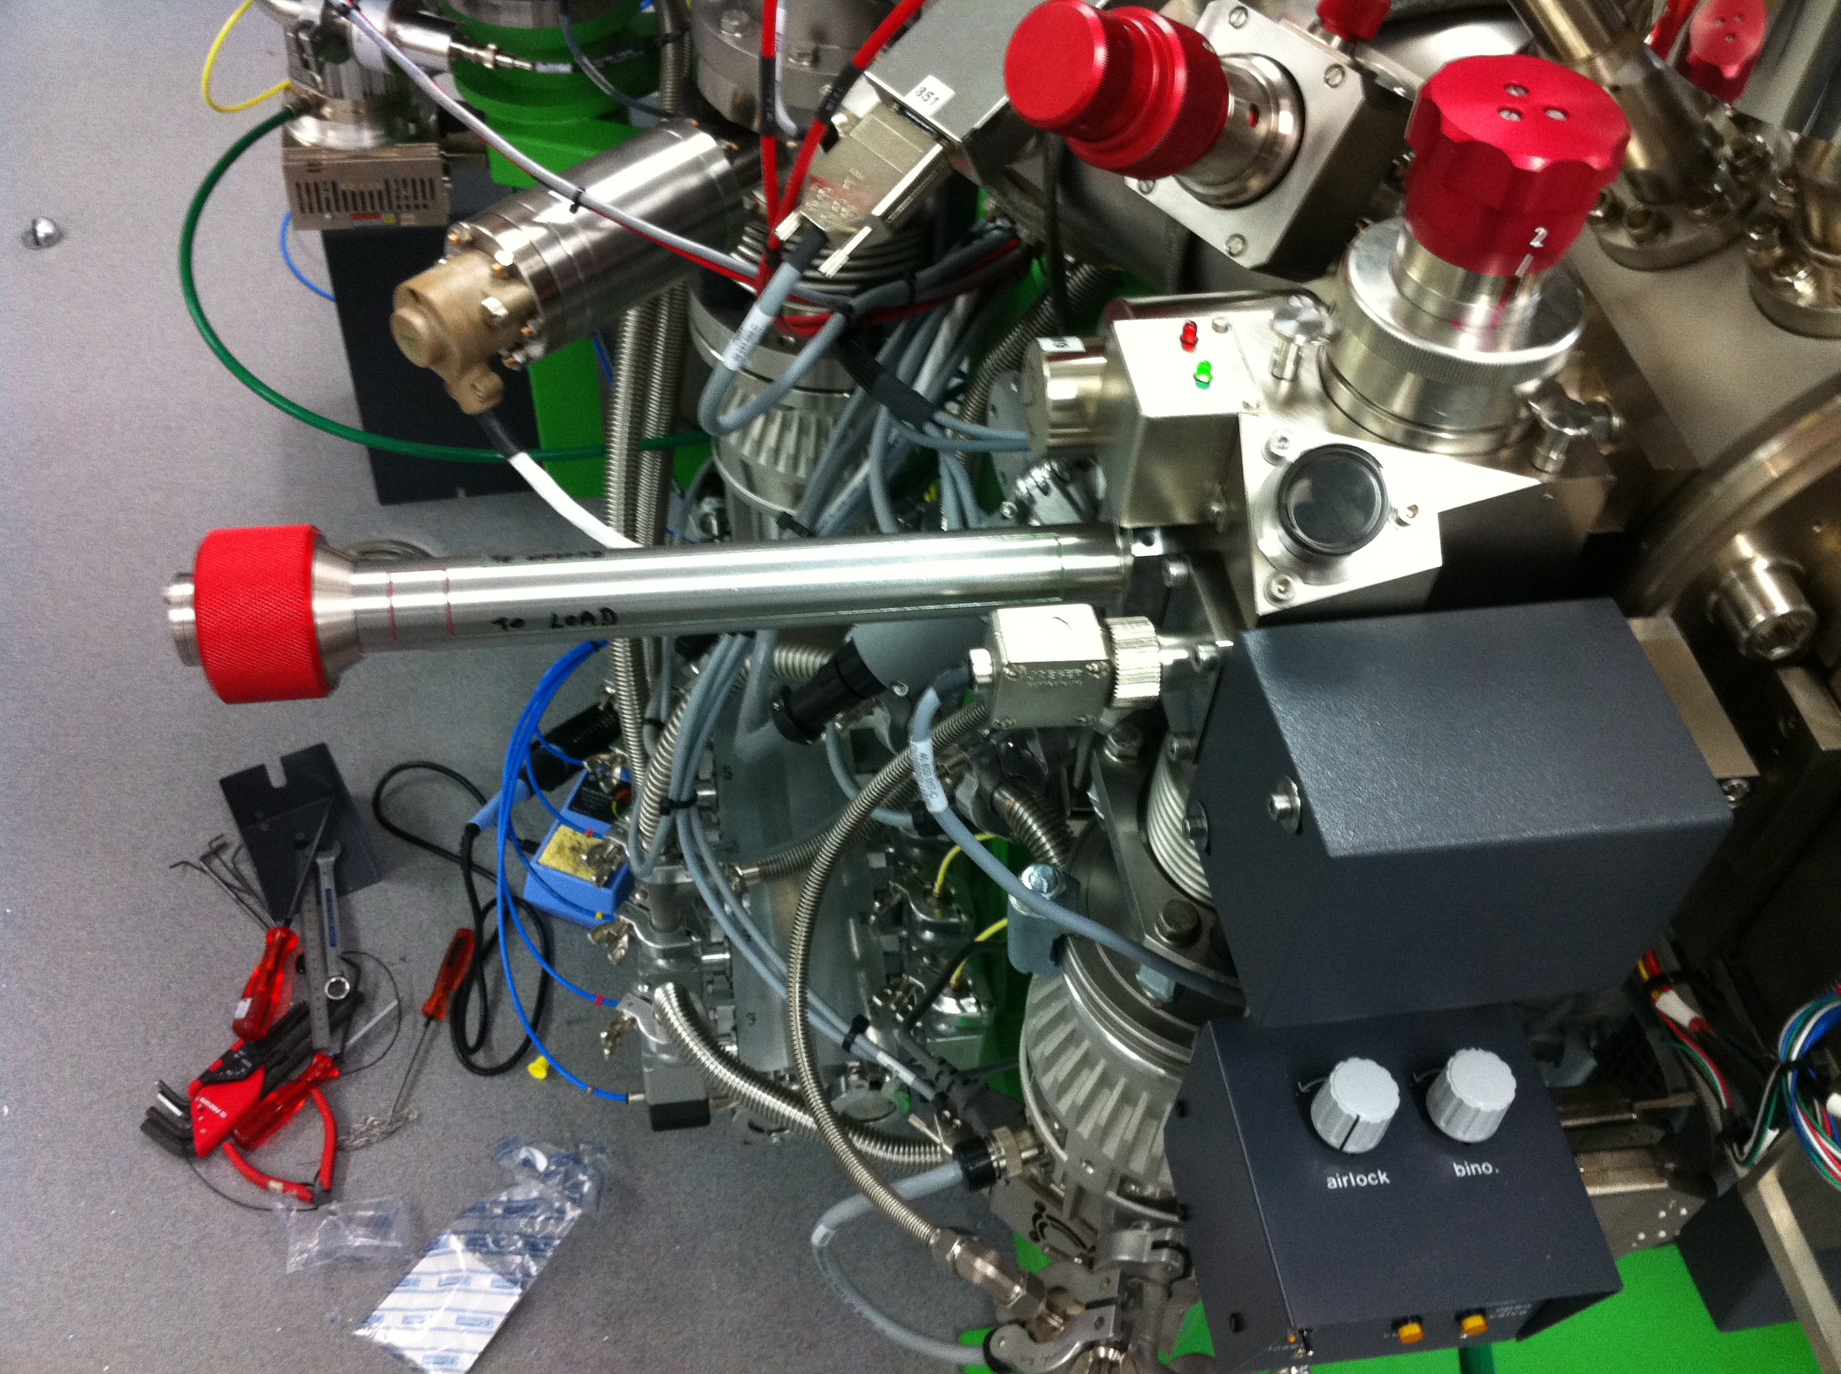

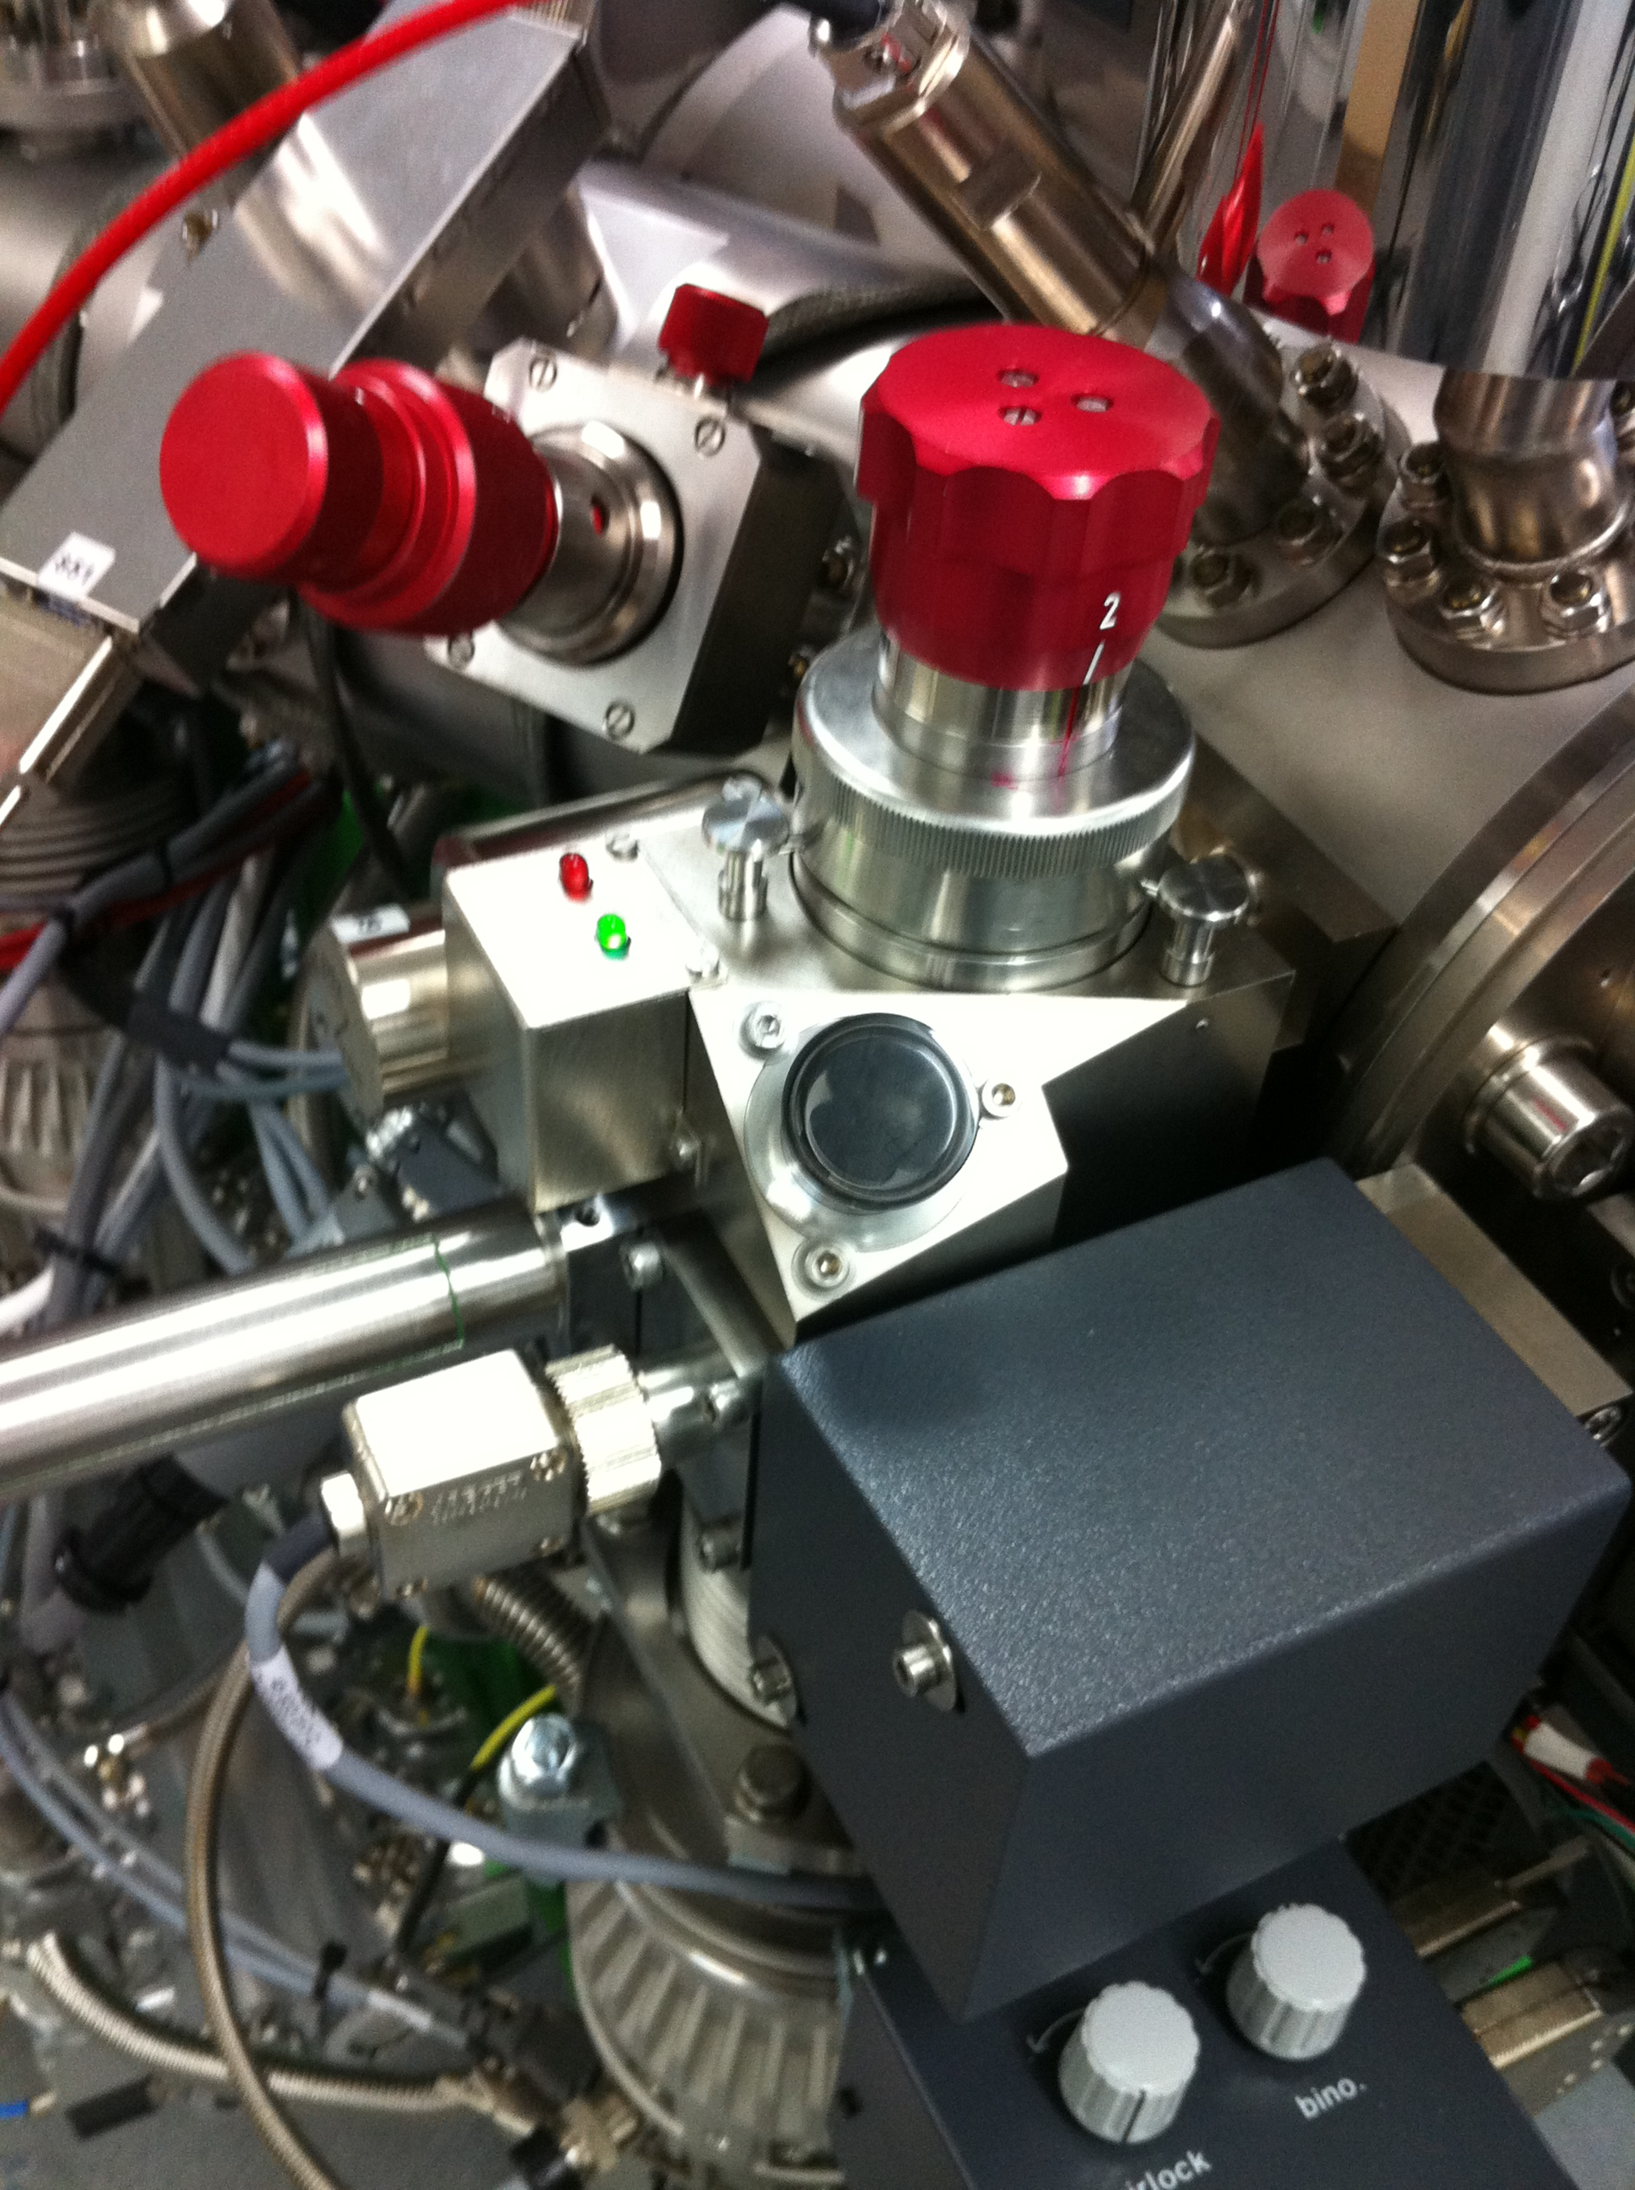
Airlock sample mechanism may be rotated in airlock only there is only one other sample holder in the mechanism and there is no sample in the sample chamber (i.e. only when the pin that extends into holder mechanism position 1 when empty allows; this pin stops the mechanism from being rotated; cannot have two samples in a row; sample chamber and position 1 from which sample chamber is loaded). If there are 2 samples in the mechanism, then it will not be possible to rotate the mechanism. Change samples from Airlock into Sample Chamber only when the Airlock pressure is <10⁻⁷ tor.
To reconnect the motors after coils have been stopped, use
IMS5fE7> motor connect
Overall travel for both X and Y motors should be around or slightly less than 200,000 steps:
Date: 4 August 2012:
Travel X = 199429 steps
Travel Y = 199398 steps.

