UV Laser Microdissection – User Manual:
1 Security advice 3
1.1 Laser security 3
1.2 General security 3
2 UV Laser Microdissection 4
2.1 System set up 4
2.2 Principle of operation 5
3 Installation of the system 5
4 Preparation of the slides 6
5 Operation of UV Laser Microdissection 6
5.1 Overview of functions 6
5.2 Camera settings 8
5.3 Movement of the table 9
5.3.1 Slide overview for navigation 11
5.4 Documentation of samples 11
5.5 Measurements in the video image 11
5.6 Selecting areas for dissection 11
5.6.1 Fluorescence 11
5.6.2 Group cutting 12
5.6.3 Drawing the cutting contour 13
5.6.4 Statistics 13
5.6.5 Storage of marked cutting paths and groups 13
5.7 Cutting 14
5.8 Single Step Collection 15
5.9 Calibration 16
5.9.1 Table control 16
5.9.2 Laser position 16
5.9.3 Range of focus and power 17
6 Maintenance 17
7 Trouble shooting 17
7.1 View 17
7.2 Movement 18
7.3 Drawing 18
7.4 Cutting 18
7.5 Collection 18
8 Warranty 19
9 Customer support 19
10 Consumables 19
11 System data overview 19
12 Annex 21

Security advice
The system should only be used for microdissection as described in the manual. Do not use the system for any other purpose. Damage due to unauthorised use is not subject to warranties. The system should only be used by trained persons.
Please read the Security Advice and the Manual before operation.

Laser security
This system contains a laser for cutting. There are security devices in the system to prevent laser interference with the user. The beam path is protected by a box. If the laser comes out from the objective lens then the divergence of the laser is high so that the radiation is harmless. If the illumination arm is bend backwards the laser activity is blocked due to an electrical interlock. There is a blocking laser absorption filter inside the microscope which prevents the laser radiation coming trough the oculares.
The laser itselfs complies with Laser Class IIIb according to the EN60825-1.
To ensure full security of the system please follow the rules below:
- Turn off the Laser with the key switch to prevent unauthorised operation of the system.
- Do not remove any objective lens while the laser is operating.
- Never operate the sytem without the objective lens.
- Never stare into the lens revolver while the laser is operating.
- Use only the provided lenses for the laser cutting.
- Do not place any reflecting objects in the beam path above the microscope objective.
- The laser source and the optical equipment are protected by the blue boxes. Never open these boxes to avoid electrical shock or laser beam contact. The dangerous laser radiation is limited to the beam path.

General security
Do not disassemble the system. The installation of the system is provided by SL Microtest. Repairs, removal or exchange of components beyond the operations described in this manual may only by carried out by SL Microtest or persons expressly authorised by SL Microtest to do so. If you have any problems with the equipment, contact SL Microtest.
The power supply is installed by SL Microtest. SL Microtest makes sure that the system is provided with the appropriate voltage. Do not change the power cords.
Avoid wet or dusty conditions near the system. If liquid gets inside the system, do not attempt to use it. Contact SL Microtest.
Unplug all electrical supply before cleaning the system. Do not use cleaning fluids or sprays but only smooth and dry cloth.
As long as the table control is not calibrated, table movements can be sudden and fast. Make sure that the place around the table is free.
Read the manual of your microscope for specific microscope security advises. If you do not have the manual contact your microscope provider or SL Microtest.

UV Laser Microdissection
The UV Laser Microdissection is a method to isolate under microscopic view small areas or single cells from histological section for further microbiological analysis. Only the cell(s) wanted for further investigation are cut out. DNA, RNA as well as proteins from undisturbed, pure samples can be investigated. No mechanical contact is necessary for the cutting out of the samples. Thus the method avoids contamination of the samples. |  |  |  |  |  | Isolation of cells
UV Laser Microdissection allows comfortable working with high precision and a large throughput without contamination. |  |  |  |  |  | Advantages of the system
Several areas of interest can be cut out in one automated operation and collected in one reaction tube. One reaction tube used for Single Step Collection can collect several dissectates, even from different slides. |  |  |  |  |  | Several dissectates collected in one reaction tube
Review of the sample and selection of areas to cut has not be followed directly by the cutting operation. The automated cutting can be carried out later and by another person. |  |  |  |  |  | Scan and cutting –  time displaced operation possible

System set up
The UV Laser Microdissection system consists of a high performance research microscope with motorised scanning stage, a maintenance free laser, optical equipment and a high-end pentium computer with Windows 9x and the sophisticated control software UV Cut. |  |  |  |  |  | Components
All usual microscope features are available. The UV Cut software controls the laser and scanning stage actions without blocking any other microscope action.
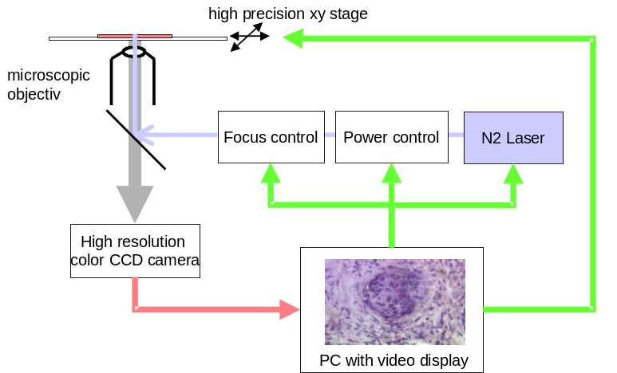

Principle of operation
Microdissection for isolation of cells is only useful if you can remove the parts of the tissue you are interested in from the slide. The single step collection makes sampling of one or several isolated areas easy and contamination free. |  |  |  |  |  | Separation of cells from the slide
The Single Step Collection uses a protective membrane and a reaction tube with a special adherent lid. |  |  |  |  |  | Single Step  Collection
The purpose of the protective membrane is:  to avoid contamination of the sample  to facilitate easy removing and collection of the cut area |  |  |  |  |  | Protective  membrane
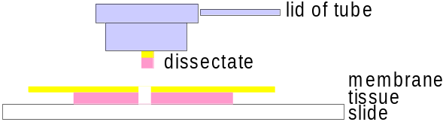

The laser cuts through the tissue and the membrane. The separated tissue and membrane are collected with the lid of the reaction tube.
The laser cuts around the cells to be isolated. For the collection no radiation is used. |  |  |  |  |  | No radiation  directly on  dissectates
The membrane and the adhesive lid have no influence on further molecular biological processing. The membrane material is polyester. The membrane is transparent and does not affect the light beam.
The lid of the reaction tube also contains a diffusor unit. The lid improves the image quality remarkably and can be placed directly on top of tissue and membrane during all operations. |  |  |  |  |  | Image quality

Installation of the system
The system is installed by SL Microtest in the laboratory of the customer. After the installation SL Microtest will provide a basic introduction to the operation of the system. The customer doesn’t need to change the installation of the equipment (see security advice). |  |  |  |  |  | Installation by  SL Microtest

Preparation of the slides
The Single Step Collection of the dissectates requires special slides. The slides are provided with a 2μ thick, clear membrane. |  |  |  |  |  | Protective  membrane
Intermediate slide  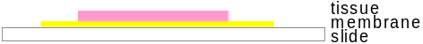  Dissection slide  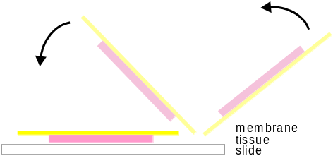 |  |  |  | The tissue is mounted on the membrane as on an ordinary slide.  Paraffin sections, cryo sections or smears can be used.  After the usual processing (deparaffinase, staining, etc) the membrane with the tissue is flipped over to a new slide and fixed.  Thus the tissue is now under the membrane and protected against contamination

Operation of UV Laser Microdissection

Overview of functions
The UV Laser Microdissection system provides all necessary tools for
- scanning the sample
- document the sample through screenshots
- marking the path for the laser cutting around single cells or cell clusters
- marking several areas to be cut in one operation
- storing the marked cutting paths (for later cutting)
- dissectating the marked sample areas automatically
- collection of the dissectated areas without radiation or contamination
The operation of UV Laser Microdissection is controlled by the comfortable and easy to use UV Cut software. |  |  |  |  |  | UV Cut Software
UV Cut offers you two skins. You can switch between the skins with key F12. One skin offers you all tools directly accessible through buttons. The other skin offers the larger video image. The most used tools are placed as buttons, the others are accessible through drop down menus. All functions are available in both skins. |  |  |  |  |  | Two skins for  different user  demands
Extended tool area:  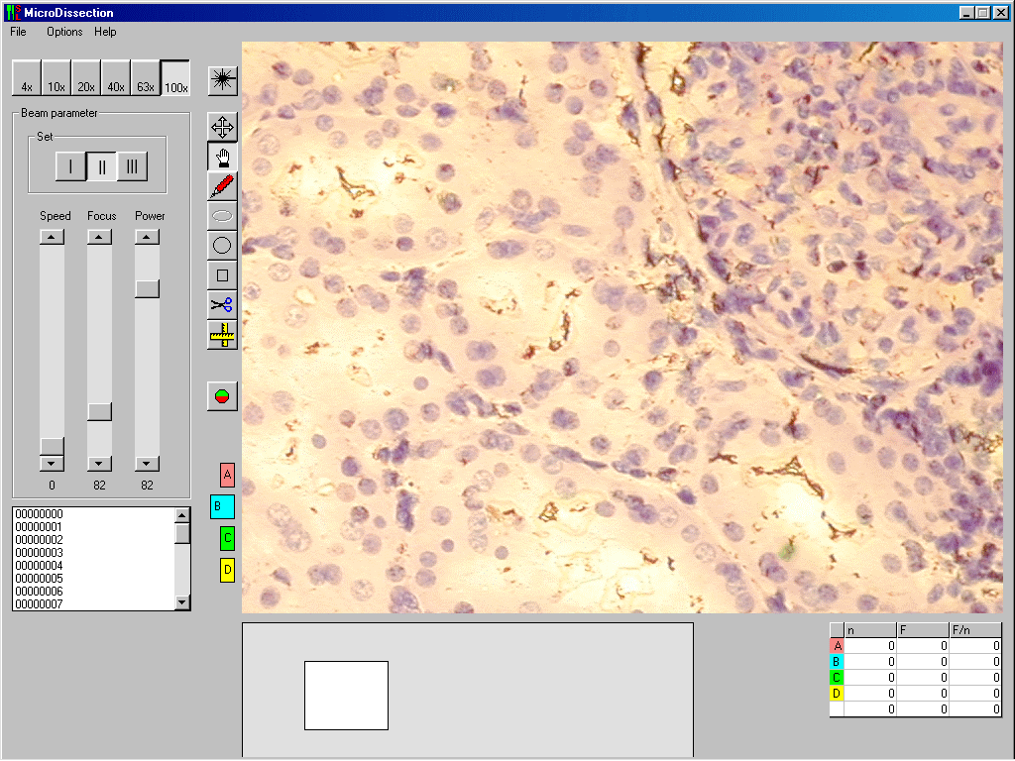 |  |  |  |  |  | Extended tool area
Extended video screen:  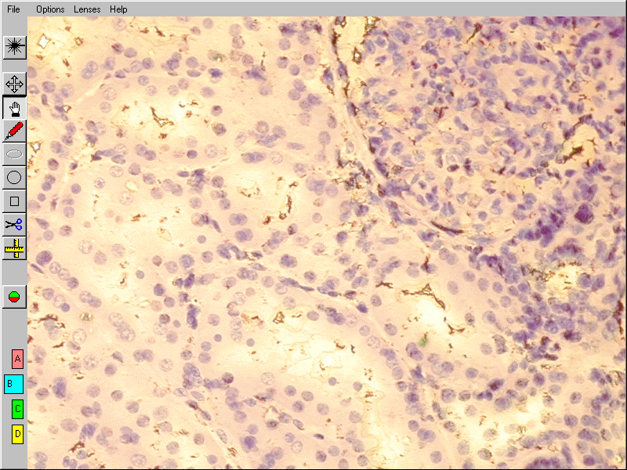 |  |  |  |  |  | Extended video screen
The ccd camera mounted on the microscope allows real-time view of the sample on the computer monitor. The visible area of the sample depends on the magnification and the chosen skin of UV Cut. For scanning a low magnification provides a quick overview. Isolating the cells is done easier in high magnification. |  |  |  |  |  | Monitor view
The lid of the reaction tube for the Single Step Collection contains a diffusor unit. Place the lid over the area of tissue you want to review and dissectate during all operations. For scanning a larger area than covered by the lid of the tube use the diffusor disk. |  |  |  |  |  | Image improvement
The movement of the stage is controlled by the UV Cut software. Different modes allow fast scanning for overview or slow scanning for details. |  |  |  |  |  | Moving the stage
UV Cut offers you an easy documentation of your samples. You can make shots from the area of your sample you see on the monitor. The images are stored in a database allowing sample names and keywords (fast and focused search of images) |  |  |  |  |  | Documentation
Several drawing tool are available for marking the cutting path around the interesting cells. You can use freehand drawing or circles and rectangles. |  |  |  |  |  | Marking the  cutting line
Areas to be cut out can be added to four different groups. You can choose to cut out one single area, one group of areas or all areas. |  |  |  |  |  | Grouping areas  to be cut out  in one operation
The marked cutting paths can be stored for time displaced cutting. As long as the slide is not removed from the motorised stage, the cutting path will be exactly as marked before. |  |  |  |  |  | Storage of cutting contours
The cutting along the marked contour is executed automatically at a mouse click. It can be repeated for the same contour several times. |  |  |  |  |  | Cutting
The special reaction tube with the adhesive lid collects the dissectates. It can collect single or several dissectates. |  |  |  |  |  | Single Step Collection

Camera settings
The UV Laser Microdissection can easily be combined with fluorescence. |  |  |  |  |  | Fluorescence
For fluorescence images the ccd camera needs a different set up as for standard light. The camera settings can be changed in the menu Options.
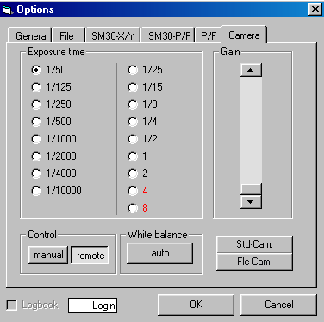
For standard light choose an exposure time from 1/50 to 1/10000 according to light conditions, sample and chosen lens (left column). The video screen shows you immediately the effects of the camera setting. For fine tuning use the scrollbar Gain. Confirm the chosen exposure time with the button Std-Cam. This setting is used until you change it again. |  |  |  |  |  | Standard light
For fluorescence choose an exposure from 1/25 up to 8 according to light conditions, sample and chosen lens (right column). For fine tuning use the scrollbar Gain. Confirm the exposure time with the button Flc-Cam. This setting is used until you change it again. |  |  |  |  |  | Fluorescence
As standard the camera control is set on remote. In this mode UV Cut can switch the exposure time between standard and fluorescence. Other camera set up is part of the installation of the system. If you want to change camera settings not accessible through the camera menu of UV Cut choose manual. The recommended (and installed) settings for the ccd camera are listed in the annex of this manual. |  |  |  |  |  | Camera control
If you change the illumination devices of your microscope you should run the automatic white balance. |  |  |  |  |  | White balance

Movement of the table
The motorised xy-table is controlled through the UV Cut software. You can control the table in four different modes. During cutting the table is moved automatically. |  |  |  |  |  | Four table movement modes
The distance between two points in the visible sample area depends of the magnification. Therefore the program needs information on the chosen magnification for the table control. Click the corresponding button in the top line of the tool area, if you are in the detailed skin. If you use the larger video image skin, open the drop down menu “lenses” and click on the chosen magnification. |  |  |  |  |  | Choose and confirm magnification
Choose or open the context menu by pressing the right mouse button with the cursor in the video window and choose Move with a left mouse click. By pressing the left mouse button the table follows directly the mouse movement. |  |  |  |  |  | Direct mouse control
Choose the cross arrow button in the tool area or open the context menu by pressing the right mouse button with the cursor in the video window and choose Joystick with a left mouse click. A cross cursor appears. Use the mouse like a joystick. The direction of the table movement follows the mouse. The table speed increases with the distance of the cursor from the screen centre. A left mouse click stops the table movement, a right mouse click return to the standard mode. This mode is useful for fast scanning for targeted areas. |  |  |  |  |  | Joystick mode
With the keyboard cursor keys the table can be moved slowly and continuous to the four directions. |  |  |  |  |  | Keyboard control
The arrow keys in the number block move the sample step by step with a small overlap from one viewing area to the next. This allows to search for a particular location in the sample without missing any part of the sample. |  |  |  |  |  | Keyboard control:  step by step movement

Slide overview for navigation
In the UV Cut skin with detailed tool window you will find a window representing the slide under the video window. After calibration and selection of the area of interest this window shows you the position of the detail of the large video image on the slide as red frame.
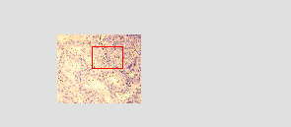
The program needs information of the position of the slide on the motorised table. As this can be different for each slide you have to calibrate the slide position. |  |  |  |  |  | Calibration
Move the left upper corner of the slide (you see the black border of the table and the glass border of the slide) to the upper left corner of the large video window. Then place the mouse in the slide window and press the right mouse button. Choose SetZero with a left mouse button click from the context menu.
The navigation window can show a video image of the sample. Click on the right mouse button and choose SetAOI with a left mouse button click. A cross cursor appears. Place it in the upper left corner of the area where you sample is on the slide. Press the left mouse button and open a rectangle representing the size of your sample. |  |  |  |  |  | Area of interest
Click the right mouse button and choose AutoScan with a click on the left button. The area of interest is scanned automatically. You can see now a small video image of your area of interest. |  |  |  |  |  | Scan area of  interest
A red rectangle represents the position of the detail visible in the large video window. You can move this red frame with the left mouse button. The motorised table moves automatically to the chosen detail. With this navigation you have always an overview of the position of your detail and the large image of the detail in the large video window. |  |  |  |  |  | Navigation

Documentation of samples
Slide images can be taken in every magnification. Open the drop down menu File. Choose Save image and the usual Windows Save as menu appears. |  |  |  |  |  | Save images
The software used for the documentation allows keywords for easy sorting and tracking of your documentation database. All image processing tools are available. |  |  |  |  |  | Image database

Measurements in the video image
Click  or open context menu with a right mouse click and choose Measurement with a left mouse click. The cursor appears as a ruler. Press the left mouse button and move the mouse.

Selecting areas for dissection

Fluorescence
Set the ccd camera on fluorescence exposure time by clicking the fluorescence button . Start the fluorescence illumination.
To avoid damages by the excitation, UV Cut offers you a frozen image to draw the cutting path. Click the right mouse button with the cursor over the video screen. Choose freeze from the context menu. Stop the fluorescence illumination. |  |  |  |  |  | Frozen image
In the frozen image all drawing and grouping functions as described below are available. When you start cutting the program swifts automatically from frozen image to real time video and standard camera setting.

Group cutting
 | UV Cut can cut several areas in one operation. The cutting group of an area has to be chosen before drawing the cutting contour. You can choose between four groups. |  |  |  |  | Several dissectates in one  operation
 | At the left bottom corner of the video window are four coloured buttons named A, B, C and D. The activated button is larger. |  |  |  |  | Cutting groups
All areas belonging to one group are marked with the same contour colour.
You can adjust the colour and thickness of the drawing lines of the cutting groups and the current drawing in the menu General under the menu Options. |  |  |  |  |  | Contour colour and thickness
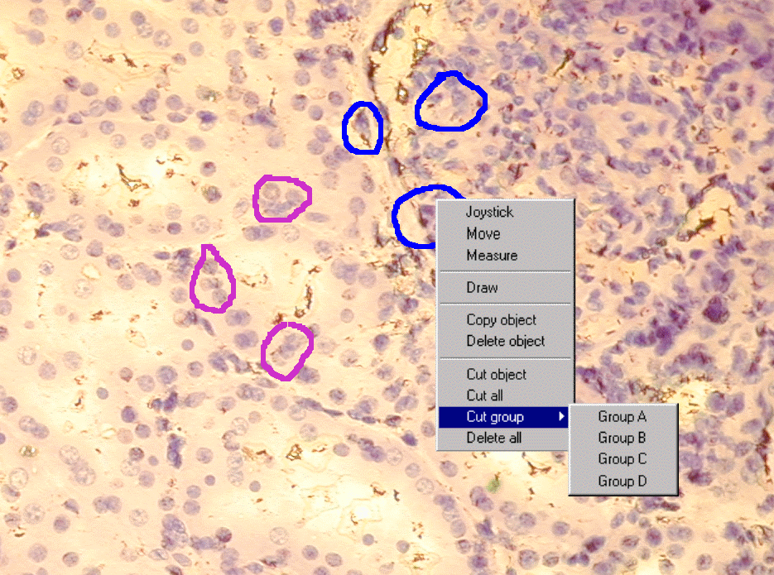

Drawing the cutting contour
The laser cuts along the contour you draw around the interesting area you want to dissectate.
You can choose between freehand drawing and pre set forms like circle, ellipse and rectangle. |  |  |  |  |  | Drawing modes
To activate the freehand drawing mode press . The cursor appears as pencil. Press the left mouse button to draw the contour around the area you are interested in. The program can close the contour automatically when the cursor is near enough to the starting point. The cursor indicates the automatic closing by changing the form. |  |  |  |  |  | Freehand drawing
Choose or . The cursor appears as pencil with the symbol of the chosen form. Move the mouse with pressed left button over the length of the area you want to mark. Move then with the still pressed left button to the right to expand your form. |  |  |  |  |  | Pre set form  contours
The drawing mode can be activated through the context menu. Press the left mouse button (cursor in the video window) and choose Draw with a right mouse click. The last used drawing mode is activated. |  |  |  |  |  | Context menu
With the context menu you can also delete one or several contours. |  |  |  |  |  | Delete contours

Statistics
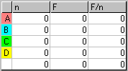 |  |  | The table under the video window shows for each group the number of marked areas, the total surface of the marked areas and the average surface of the marked areas. The last row show the added values for all groups.

Storage of marked cutting paths and groups
The storage of marked cutting paths allows a separated review of the slide and time displaced processing of the cutting. With this feature you can also easily prepare cutting for more than four groups of areas.
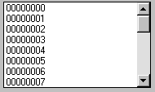 |  |  | To save a slide ID open File and New slide. Enter a slide number. Then save the marked cutting path under File and Save contours. Enter a cutting contour number. If you use the UV Cut skin with detailed tool view, you find a list in the left bottom of the screen showing the names of all saved contours.
Open the stored cutting contours with the File and Open contours or double click on the name in the list on the screen.
As long as you not move the slide from the stage, you can proceed with the cutting even after restarting the program.
If you have moved the slide, calibrate the slide position. If the marked contours are not fitting exactly around the areas to dissectate press the Alt key and move the table in the mouse mode.
You can select your preferred file for saving the cutting paths. Open Options and File and choose your preferred folder. |  |  |  |  |  | Saving path  preference

Cutting
The automated cutting along the contours you marked makes your work easier and faster. You can decide if you want to cut out one area, one group of areas or all areas. |  |  |  |  |  | Automated  cutting
For most applications the best cutting results are observed with 20x and 40x lenses. Always confirm a change of magnification. Click the appropriate of these buttons 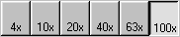, if you are in the detailed skin. If you use the larger video image skin, open the drop down menu Lenses and click on the chosen magnification. |  |  |  |  |  | Magnification
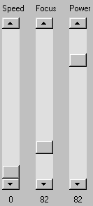 |  | The laser set up includes the parameters speed, focus and power. In the skin with large video window the laser parameters are found in the context menu (right mouse click) |  |  |  | Laser set up
 |  | Before dissectating the tissue you are interested in, test the laser per-formance in another area of the sample. Draw a line or circle and start cutting for this figure. Change the parameters during cutting to observe the effects of the parameter settings. The best results can be reached with power as low as possible, slow speed and exact focus. |  |  |  | Test of cutting
To adjust these parameters start with high values for power. The focus can be found quite easy with this power. Make several cuts with different focus values and compare the results. With reduced power the focus is in a more defined area. Go down step by step with the power and repeat focusing until the cutting line will be fine and clear without tissue bridges.
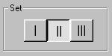 |  | You can store three laser parameter settings for each magnification. If you are working in the detailed tool skin, you find the buttons for the settings above the scrollbars for parameter setting. In the skin with large video window the setting are found under Lenses. |  |  |  | Laser parameter  settings
Cutting can be started with or through the context menu (right mouse click). Select single contour cutting, group cutting or cutting of all areas. |  |  |  |  |  | Start cutting

Single Step Collection
The lid of the reaction tube can be placed over the tissue during all operations of UV Laser Microdissection. The lid contains a diffusor and improves the image quality considerably. The lid should be placed over the tissue before cutting. |  |  |  |  |  | Reaction tube as collection tool and image improver
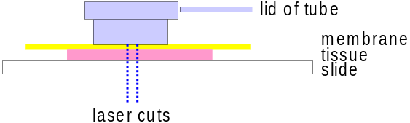

The laser cuts from below through the tissue and the membrane. It does not warm up the sample or the adhesive lid.
The adhesive lid of the reaction tube easily collects the dissectates. The collection of several dissectates in one reaction tube is a major improvement for fast working. |  |  |  |  |  | Several dissectates in one  reaction tube
After cutting all areas to be collected in this tube just lift the lid. The adhesion isolates the dissectates from the sample.
Remove the tube holder from the microscope and take the tube from the holder. Add a solution to the tube, close the lid and shake. The dissectates are ready for further processing.

Calibration

Table control
The UV Cut system is calibrated through SL Microtest as part of the installation in your laboratory. When you exchange lenses you have to repeat the calibration as described below.
When you insert new lenses to your microscope the table control through mouse and keyboard has to be calibrated for each magnification separate. After some time of operation it may be necessary to recalibrate the control, when contour and cutting line are no longer fitting exactly. |  |  |  |  |  | Calibration for new lenses
Fix a slide with sample. Choose your objective and click the corresponding to inform the program on the chosen magnification. |  |  |  |  |  | Confirm objective
Open Options and than Calibrate in the top line menu.
For calibration you will find two marked areas in the right top and left bottom of the screen (calibration areas). Mark one small and remarkable point of the sample in one of the calibration areas with a right mouse button click. Move this point to the opposite calibration area (pressed left mouse button) and mark this point again with a right button click. Confirm calibration and continue with the next objective (set the program to the chosen magnification)

Laser position
After some time of use the laser position can be slightly out of focus. If the cutting fits no longer to the marked cutting line or the laser pointer you should adjust and confirm the laser position. It has to be done for each magnification separate. |  |  |  |  |  | Laser position
Fix a slide with sample. Choose your objective and click the corresponding box in the top line to inform the program on the chosen magnification. |  |  |  |  |  | Confirm objective
Cut a hole in the sample with . Click once to start the laser and a second time to stop it. The button is red when the laser is on. If necessary adjust the laser focus and power.
Open the Options menu and choose Laser position. Move the cursor cross to the hole you cut and confirm this position with a right mouse button click. Continue with the next objective.

Range of focus and power
Laser focus and power are calibrated at the installation of the UV Laser Microdissection. In case of a computer crash the UV Cut software cannot be closed correctly. The calibration of the laser focus and power are lost. To recalibrate open Options and P/F and press the range focus and range power buttons.

Maintenance
The system works maintenance-free.
The laser plasma cartridge has to be replaced approximately after 300 hours of cutting. The replacement will be at the cost of the customer. SL Microtest will provide the plasma cartridge.
Time of laser use is counted automatically. You can find this information under the menu Options in General.  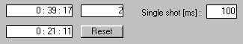  The upper left figure shows the total laser time, the bottom left figure the laser time of the actual laser and the upper right figure the number of lasers already used in the system. |  |  |  |  |  | Laser time counter

Trouble shooting
This chapter provides help for problems which can occur working with UV Cut. Most of the problems can be easily solved. Please read through the trouble description and the trouble shooting tips.

View
Image not clear, image too dark, too bright, no image on monitor  - Please check the camera set up and compare with the camera manual.  - Another cause for insufficient images can be the illumination.  - Use the diffusor disk or the lid of the tube for better images with uncovered samples. |  |  |  |  | View

Movement
The movement is not exact and not repeatable, the stored positions can not be found again.  - Check if the sample is fixed correctly on the stage and cannot move. |  |  |  |  | Movement

Drawing
The line is nearly not visible.  - Please choose dark line colours for bright samples and bright line colours for dark samples. Rise the thickness of the line. |  |  |  |  | Drawing

Cutting
No cutting can be observed.  - The laser has not been switched on (key switch).  - The magnification is not corresponding with the objective lens.  - The laser power is too low.  - The laser focus is not well adjusted.  - The cutting is not perfect, bridges remain in the cutting path.  - The cutting speed is too high, or the laser power too low.  - The cutting path is not corresponding with the drawn contour.  - The laser position has to be adjusted. Perhaps the magnification is not properly chosen.  - The camera is tilt and so the x axis of the camera is not corresponding to the x axis of the scanning table. Please turn the camera until the movement of the image is exactly horizontal when you move the table with the left or right arrow key.  - The calibration has changed, please calibrate the system. |  |  |  |  | Cutting

Collection
The dissectates are not collected  - Make sure that the lid is placed directly over the treated area and lowered down to the membrane.  - Check the cutting. If the speed is to high, the beam not focused or the power to low the cutting can be imperfect. |  |  |  |  | Collection

Warranty
The optical system and the control software are warranted against defects in materials and workmanship for a period of one (1) year from date of installement. This warranty is limited to the repair or replacement of system components returned to SL Microtest within the one (1) year period. Unauthorised repairs, replacements and modification will delete all warranties. |  |  |  |  | software  optical system
The laser plasma cartridge is warranted for 250 hours of continuous laser cutting. |  |  |  |  | laser cartridge
The microscope is not included in the warranty given by SL Microtest. The warranty depends on the manufacturer of the microscope. |  |  |  |  | microscope

Customer support
For all questions on the UV Laser Microdissection:
(technical, consumables, warranties) please contact:

MMI AG
Flughofstrasse 37
8152 Glattbrugg
Switzerland
Tel ++41 1 809 10 10
Fax ++41 1 809 11 11

Consumables
The system is delivered with tubes for Single Step Collection and membrane slides for about 80 samples.
Further Single Step Collection tubes and membranes can be ordered from MMI AG or local representative.

System data overview
Required minimum workspace:
The table for the microscope, laser, optical equipment, computer monitor and keyboard requires a minimum dimension of 1,20m x 0,90m
The computer has to be positioned under or near the table. The camera computer connection cable is only 2m to ensure reliable data transfer.

 | Components:
 | Name | Description | Specifications
 | microscope | research microscope,  Zeiss; Nikon; Olympus; Leica | (inverted) with fluorescence port
 | xy scanning table | scanning table with stepper motors | scanning area : (100x100)mm²  accuracy : < 1µm
 | laser system |  | wavelength : 337nm;  pulse energy : >300µJ;  line voltage : 200-240 VAC  or 100-110 VAC,  50-60 Hz, 1,0A
 | optical and electronical coupling unit | Laser control unit  SL Microtest
 | ccd camera with power supply | DXC-950P Power HAD  SONY | 3CCD Colour Video Camera;  CCD-Chip : ½-inch 3-Chip with Power HAD technology  horizontal resolution : 750 TV lines;  Sensitivity : 2000 lux at F8,5;  single to noise ratio : 58 dB
 | computer | Pentium PC with Win 98 | With RGB frame grabber
 | control software | UV-Cut SL Microtest | 32 bit Software

Annex
Camera settings:


