MSC report for the STAC - November 2006

Mirror Suspension Control is a working group whose mission is to ensure adequate performance of the overall system designed to control the suspended optical elements of Virgo. “Adequate” means that MSC main task is related to both the performance during critical commissioning phases and the target sensitivity of Virgo.

The suspension of Virgo test masses is a sophisticated system that makes use of position and acceleration sensors, placed at the top of the inverted pendulum, whose signals are suitably pre-filtered, combined, and sent to electromagnetic actuators acting at the top level. At the bottom of the suspension chain (at the so-called F7 level) a further ground-based control system is available. Below such a level, the steering stages (“payload” or “last stages”) allow to control the position of the mirrors by acting through the last suspension stage (from F7): they make use of ground based auxiliary signals or global signals, namely those worked out from ITF operation.

During Virgo Commissioning the overall performance of the suspension system was consistently improved to enhance its reliability in relation to the locking. This task is quite interlaced with the performance of the mirror sensing and control. As the commissioning advanced, the fulfillment of MSC tasks became more and more related to the ITF operation, while standalone performance measurements, based upon single-suspension signals, became closer to maintenance checkup tests.

Present main efforts of MSC, in three directions, are described below, sorted with increasing priority. They are meant to exploit the ITF performance, i.e. its duty-cycle and its sensitivity in the medium-term, without major hardware changes.

I) Completion of all the suspension control implementations available. This essentially means controls at the F7 level. Actually, the damping of the suspension with respect to the ground, at the end of the SA chain is applied only at the terminal towers (NE,WE), where the locking force is re-allocated to the marionette. Expectedly, in order to face a variety of control strategies and to effectively operate under any whether condition, all the ITF suspensions should have all the possible control handles available. This work started in October 2007 and is almost completed.

II) Specific improvement of external disturbance rejection performance, namely, improvement of MSC reliability under windy whether conditions (winter 2007). Suspension control operates through a critical blending of inertial sensing (accelerometer-based), affected by tilt due to the wind at f < 70 mHz, and position-sensing (LVDT) re-injection of microseism disturbance in the 200-600 mHz range, which degrades the sensitivity (see figure below). A compromise crossover frequency at 50 mHz has been worked out to limit position-sensing disturbance, coupled to microseism, but, still, large correction at the payload level uses sometimes to occur, causing failures of science-mode lock acquisition and unlock events. This matter is presently being approached globally, i.e. by testing the GIPC (Global Inverted Pendulum Control). GIPC consists in pre-filtering, re-allocating at the IP level the mirror correction signal (usually applied at the payload level, reaction-mass and marionette), and leaving LVDT out-of-loop. In such a way the crossover between position and acceleration signals can be set at higher frequency (70-80 mHz) and the overall effect of the wind is then compensated. Also, microseism re-injection in the ITF should be reduced since the crossover frequency can be set at 30 mHz, enhancing microseism rejection through LVDTs, in the two remaining suspension where the GIPC is applied (no locking force). GIPC strategy has been partially and successfully tested, however, the completion of the feasibility and performance study has to be done in science-mode and its actual effectiveness must be checked under critically windy condition.

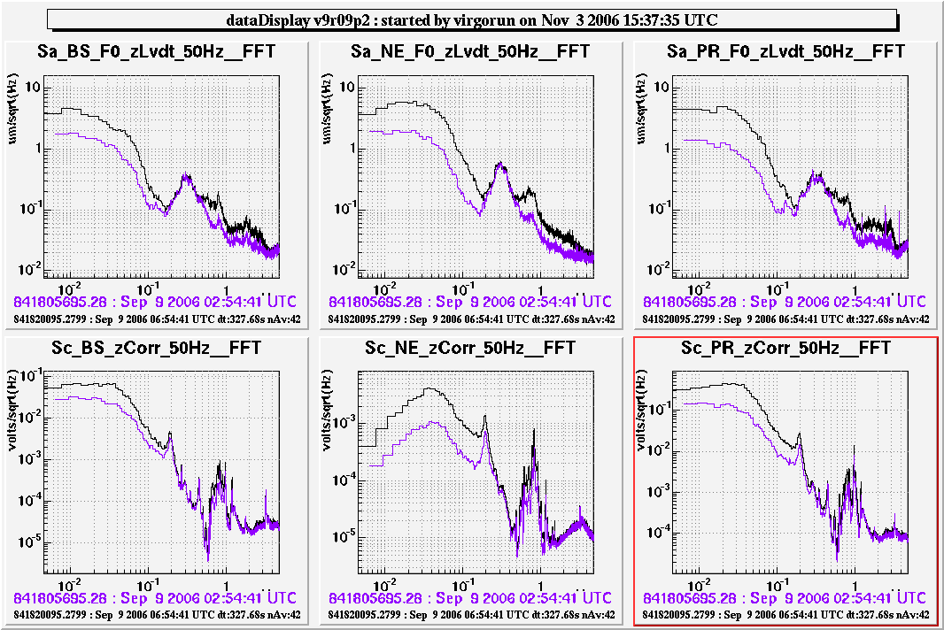
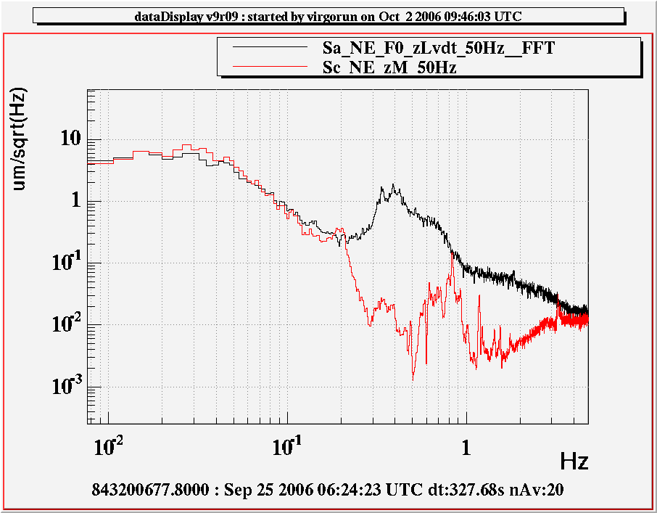
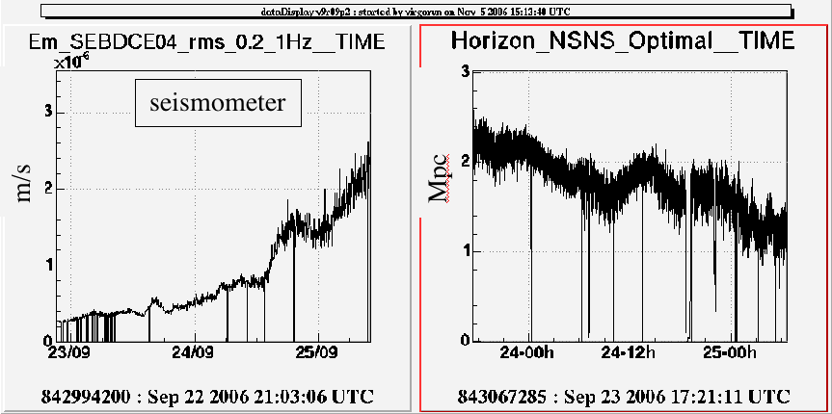
Up: comparison of LVDT and mirror correction signals during two periods of WSR1, in different whether conditions (wind and μseismic sea activity), It is clear that a large component of correction on the mirror is coherent with the tilt introduced by standard IP control. Down left: during WSR2 μseism strongly correlated with the ITF sensitivity, worsening the observed horizon. This process has to be investigated. Down right: LVDT signal compared to mirror correction (expectedly cleaner from μseism, due to the SA filtering), this is the signal used in GIPC scheme.

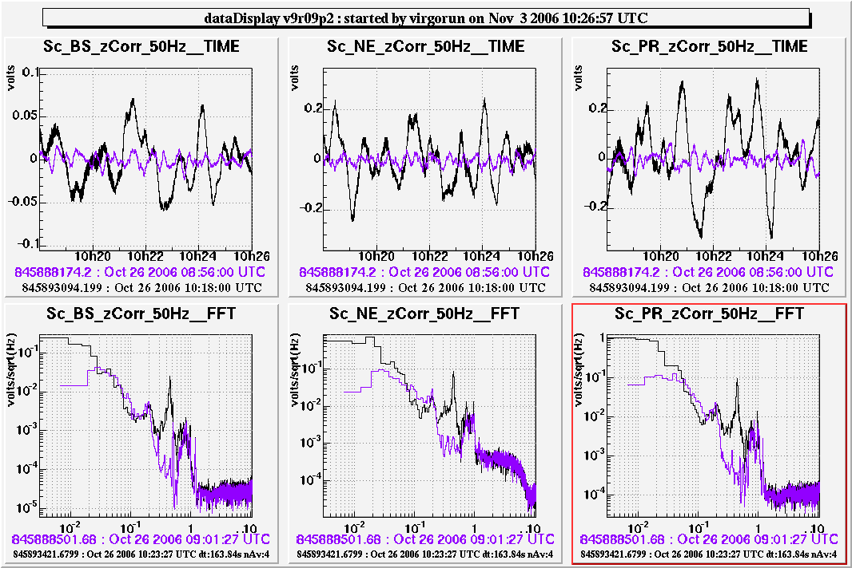
Up: A test with three suspensions under GIPC, engaged at step 4 (grey fringe, no autoalignment). Here the blending position vs acceleration is at 70 mHz and the reduction of disturbance re-injection by LVDT is more evident, in the actual scheme (without GIPC) the crossover is at 50 mHz and GIPC should be mainly effective against the wind.

III) Control noise affecting Virgo sensitivity is locking workgroup concern, but also a MSC concern with high priority. A campaign of DAC noise reduction, through the study of dedicated noise projections, has been extensively performed by suspension electronics crew in order to improve DAC noise at f < 150 Hz. The result is that by means of low-noise electronic patches in the control chain resulting in an overall actuation-noise budget reduction by a factor ~10, allowing to approach Virgo target sensitivity at 150 Hz. Installation of new coil drivers, under detector coordination, will be performed in the next months to gain the further actuation noise reduction deeded to reach the sensitivity in the low frequency range. At the same time, angular control noise, injected by alignment correction onto the ITF signal through the beam mis-centered position on mirrors is under improvement by means of correction signal roll-off tuning (partially done) and beam-centering utilities (recent achievements). This latter activity is performed through a strict collaboration among Alignment, Locking and MSC workgroups.

MSC report for the STAC - June 2007

Mirror Suspension Control is a work-group whose mission is to ensure suitable control performance of the overall Virgo suspension system. MSC task is then strictly connected to those of longitudinal control (locking), angular automatic control and Detector Operation.

Suspension Top-stages
Microseismic activity in the 0.2- 0.6 Hz range, usually peaked at 0.3 Hz, affects the mirror motion and consequently ITF sentivity. Its contribution is mainly due to position sensors (LVDT) driving suspension top-stages. Low frequency disturbance, below 70 mHz are due to local disturbance, mainly to the wind, causing tilt and re-injected by accelerometers at the suspension top-stage. Position-vs-Acceleration blending and strategic optimization, considering the overall system (6 long + 3 short suspensions), were the key items of the latest MSC improvement. Below the main sections of this work:
- Error-signal blending. Only most flexible choices, among a family of prefiltering features tested for the Pos/Acc sensing are in-line for VSR1 (40-70 mHz crossover). Long-term operation will help to exploit further implementations.
- Global Inverted Pendulum Control, meant to reallocate mirror position signal to the top-stages of four (i.e. the four ITF d.o.f.) replacing the local position sensing (LVDT). By merging such a strategy with a suitable sensor blending, it helps to strongly reject local tilt-disturbance (e.g. wind). GIPC implemenation for VSR1 is enabled only for terminal suspensions (NE,WE), since they are more subject to such disturbances.
- Vertical damping. It has been implemented in 6 long +1 short (OB) suspensions. The net improvement in DF stabillity was evident as it was running in all long suspensions. As the need of V-damp at OB level was clear, it was implemented also there. For technical reasons it was not possible to implement V-damp for IB and MC.

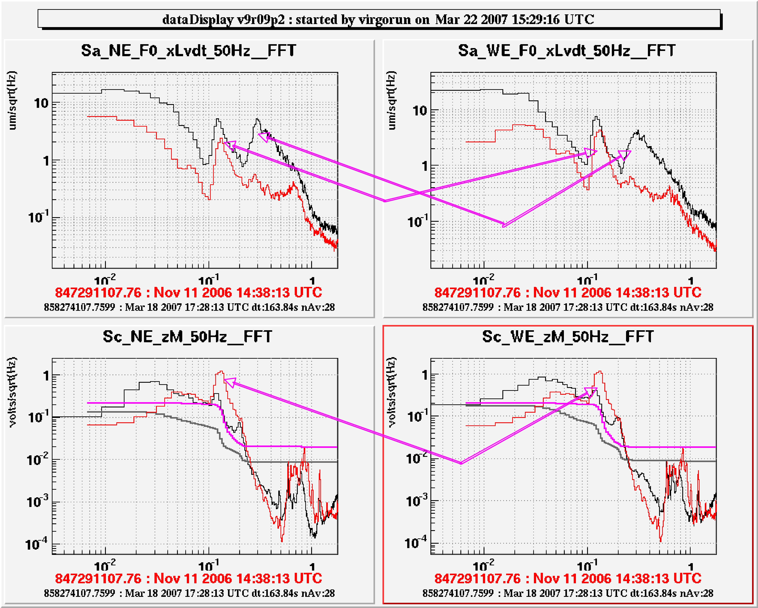Fig. 1 In spite of the larger microseism at the top-stage and a critical peak at 130 mHz (top) we have now a smaller correction on the marionette (bottom).
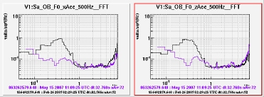
Fig. 2 Output bench susp. improvement

Suspension Bottom-stages
Top-stage suspension improvements must be accomplished at the Bottom-stage level. This was the second key feature of the latest and very crucial MSC improvements. The latest MSC engagement involved the following items:
- Compensation of non-linear yaw recoil on both SuperAttenuator and Payload, due to large lock correction applied, under windy conditions, from SA-bottom (F7) to the Marionette at the terminal mirrors (NE,WE).
- Four-marionette reallocation. Such a configuration had been implemented before the compensation of the non-linear (quadratic) effect mentioned above. Sharing each arm correction between two marionettes reduces by a fator 4 the impact wind disturbance on the ITF alignment. However the neeed of this feature, in-line for VSR1, is significantly reduced after the compensation of quadratic driving terms.
- Equalization/Operation/Further Stab improvement. A continuous effort was spent to update and mantain MSC performance and to improve its operation. Before VSR1 angular Local Control noise roll-off have been equalized and made less aggressive to improve stability without worsening control noise re-injection impact on the sensitivity.
- Driver noise projection and further reduction. After the DAC noise reduction by a factor 10, reported in November, the sensitivity in the 50-100 Hz range improved and, again, model projections showed that actuator noise was likely to be a limiting noise source. Hence, it was proposed to install another emphasis/de-emphasis filter (20-100 Hz), at the output of reaction mass actuators, to reduce both DAC and Coil Driver noise contributions without spoiling the dynamics of the actuators. This solution was implemented successfully at the BS before VSR1.

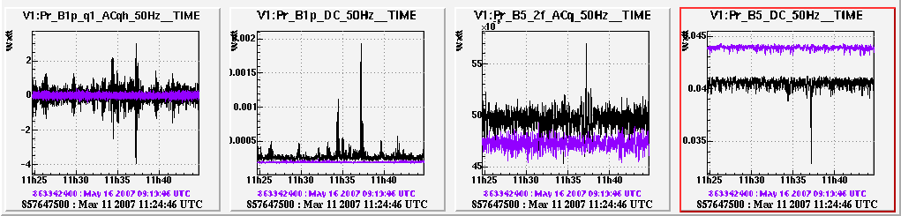
Fig. 3: stability improvement in global ITF signals achieved using quadratic compensa-tion during periods under similar LF disturbance.

Overall impact of MSC on duty cycle and sensitivity

In Fig 4 the empirical correlation between optimal inspiral NS-NS detection horizon, μseism and wind is reported. Only during a short period (red), as IP rms (0.22-1Hz) displacement exceedes ~1 μm, the phenomenological relation can be reconstructed as:

Mpc
The fitted parameters show a clear improvement since November (see Table below).
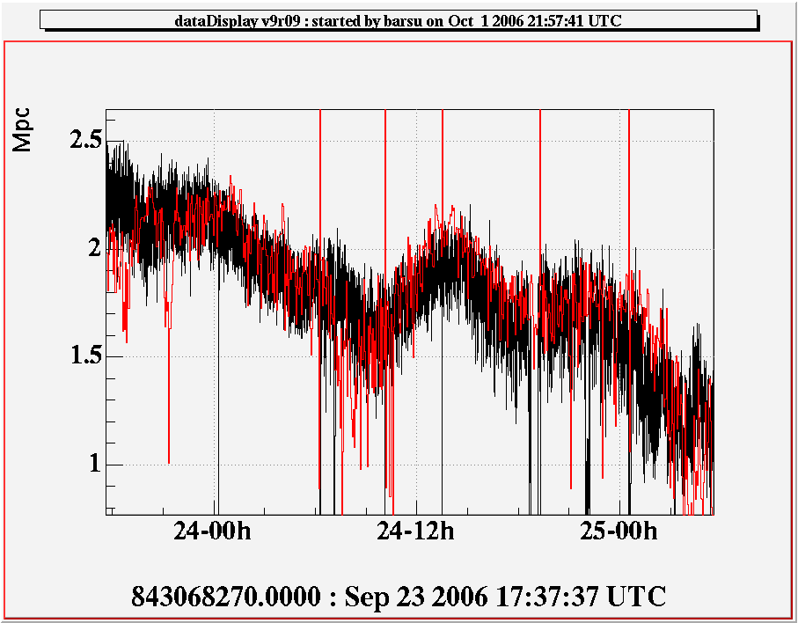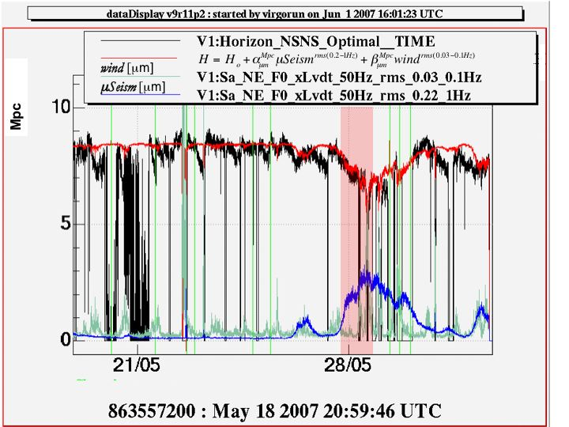
Fig. 4: Left: the empirical relation reported in the last STAC report. Right: VSR1 data display a remarkably smaller coupling between horizon and environmental disturbance.

Table: the wind impact is hardly seen and the μseism effect is 5.2 times smaller than it used to be.
Oct 06 | 2.7 | -1 | -1
May 07 | 8.5 | -0.6 | -0.3

Possible improvements during VSR1 commissioning breaks.
Only “light” improvements can be performed during the science run. Their relevance will be outlined throgh the continuous operation of the interferometer. They are the following:
Stability
- The GIPC behaviour under coherent ground excitation (earthquakes) should be improved. A possible solution, to be implemented after VSR1, is to use differential acceleration signals for the suspensions under GIPC. During VSR1 suitable alarms to disable GIPC, by checking the coherent response of IP LVDT local sensors or by means of Earthquake worldwide servers could be enough to prevent some unlocks. The impact of Eartquake events on the duty cycle is being estimated. First indication, from the data, is that even during the summer anti-wind configuration (and hence GIPC) is reccommended.
- Specific actuation and read-out couplings, given the VSR1 configuration, suggest to set input towers under autoalignment over the full control BW or to remove locking force from input mirror marionettes. Alignment group will study the former solution, while the latter, technically very simple, has to be checked versus the efficiency of quadratic recoil subtraction.
- Alter VSR1 MC and IB suspension control will be revised to pursue consistently MSC improvement. In the case of MC suspension this activity will imply hardware interventions while in the case of IB it will be crucial to to perform an adequate study to merge and optimize top-stage and last-stage control strategies.
Control Noise
It was foreseen to implement the same emphasis/de-emphasis filters installed at the ouput of BS Coil Drivers also at NE and WE reaction mass controls, but for lack of time this installation was not performed. Reasonably it might be done during a VSR1 commissioning break. However, even considering the these noise reduction, we will not be compliant with Virgo design requirements below 50 Hz, The use of a 2nd order emphasis/de-emphasis filter will be the only way to reduce it, but we have to wait the new coil drivers for this purpose.

MSC report for the STAC - October 2007

The main issues concerning MSC are repoerted in the STAC report June-07. Several preparatory improvements had been implemented before VSR1. Due to the commissioning rush approaching the science run start-up, these implementations were meant to be flexible, namely they were tunable with negligible impact on the ITF sensitivity performance, and aimed to enhance operation robustness and, hence, increased duty cycle.preventing external disturbance. Remarkably, VSR1 provided a unique opportunity to study the detector under stable and stadardized conditions. Indeed the short commissioning breaks were exploited to perform relevant improvements. They will be briefly commented below.

At the beginning of VSR1 the essentials of MSC configuration were the following:

- Global Inverted Pendulum Control (GIPC): concerning only position, and not, also, the acceleration; implemented terminal suspensions (NE,WE) control.
- Tunable choice of environmentally featured blending Pos/Acc signals for central area suspension control.
- Quadratic actuation recoil compensation on both Marionette and Superattenuator chain (F7);
- Four-Marionette locking force re-allocation;
- LC Roll-Off attenuated to improve stability (NI,WI,BSty).

All these items, but the last, were meant to improve accelerometer disturbance rejection during windy days and to minimize μseism reinjection through position sensors (LVDT). For instance, using GIPC means to use a cleaner signal, derived from global ITF control thus allowing an increase of the Pos/Acc crossover (70 mHz).
During VSR1 it was possible to perform the following improvements:

- Anti-Wind (Jun 5) . After few days it was clear that lock acquisition (and hence the ITF duty cycle) would have been more roboust by using accelerometer prefiltering optimized to reduce wind noise re-injection in all the suspension of the central area.

- Locking force re-allocation using end mirror marionettes only (Jun 6). The compensation of non-linear recoil on both marionette and Superattenuator had been implemented before VSR1. Hence we simplified the scheme, allowing a clearer reconstruction of ITF lengths, by re-allocating the lock correction on NE and WE marionettes only, with no risk of consequent misalignment during windy days.

- BS LC (Jul 4). A further tuning of BS angular Local control was needed in order to prevent the presence of low frequency non-stationarity detected in the sensitivity (~100 mHz).

- PR μSFR (Jul 6). In most cases of earthquakes the locking force used to saturate Power Recycling mirror actuators. Hence we decided refer PR top stage motion to North-Input mirror (along BS transmission). We tested off line this configuraiton and calibrated its parameters. We called such a configuration μSeism-Free-Reconstruction (μSFR) meaning that since μSeismic disturbance (sea), is common among LVDT suspension top-stages in the central area, its contribution to the differential sensor reconstructed is cancelled and allows to increase LVDT/ACC cross-over frequency to avoid low frequency misfunctioning of accelerometers causing actuator saturation.

- EQG (Jul mid). The duty cycle of Virgo is affected by re-lock recovery times rather long (30-40 min). At VSR1 beginning far earthquake events from Mag 5.6-5.8 used to cause operation unlocks. The shake due to a far earthquake waves is quite coherent over a 3-km baseline The GIPC strategy, applied at end towers to make top-stage control more roboust against the wind, it was applied only partially since it was based upon a blending of a differential position signal (cavity length variation, derived from the locking force) with a local top-stage acceleration. In case of coherent disturbance, over the FP arm baseline, the control unstable. We studied a Guardian (EQG) an automated process based upon the behavior of suspension signals and environmental vetoes designed to disable the GIPC in case of earthquakes. EQG ability to consistently react to earthquakes was tuned and allowed to reduce saturation occurrence causing unlocks to a rate comparable with other main unlock sources (~1/week).

- Beam Centring (Jul mid). Since the angular control roll-off had been released in order to improve the stability, it was needed to refine the centring of the mirrors along the beam axis. This improved the sensitivity in the range 10-15 Hz.

- Complete GIPC and μSFR with EQG removal (Sep 15) Finally we managed to send through optical links the signal of input mirror top-stage accelerometers to the end towers allowing hence the true reconstruction of end tower top stage with respect to input tower ones. Having the full reconstruction (position and acceleration instead of position only) the GIPC was no longer unstable during earthquakes. And we could remove EQG operation. At the same time we linked the input tower top-satge signals to the BS allowing the μSeism Free Reconstruction also for it, in order to make also BS control more roboust against actuator saturation.
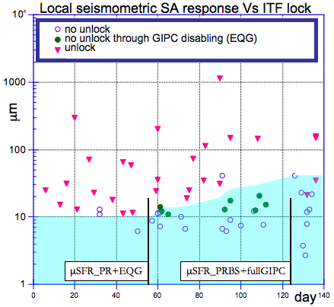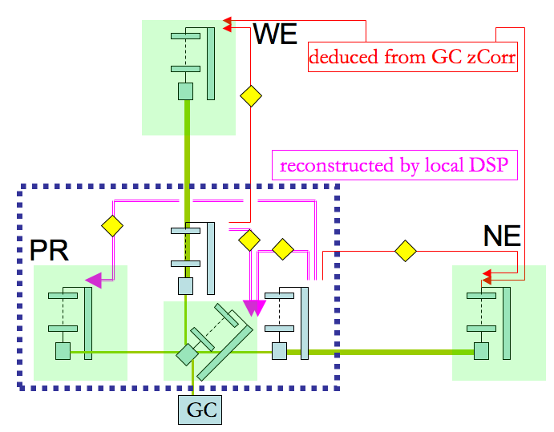
Fig.1 (left): In the mid July Earthquake Guardian and μSFR for PR wer implemented thus saturation unlocks in case of earthquakes was reduced by 40 %. Finally μSFR and GIPC were fully implemented with a further overall roboustness improvement.
Fig.2 (right): Top-stage control strategy adopted in the final VSR1 phases. Diamonds show interconnections between suspension top-stages enabled during the run. A differential error signal network referred to input mirror has been built up. In such a way the EQG patch became unnecessary.

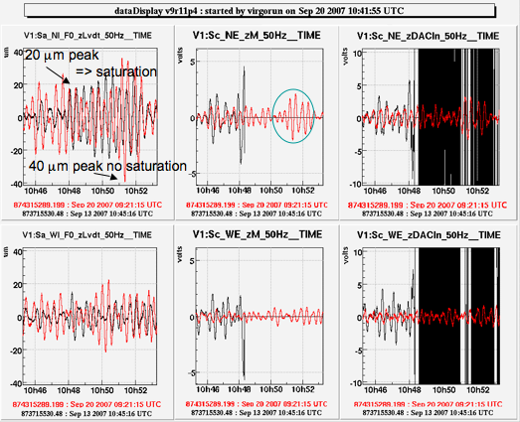
Fig.3 6.8 M earthquake in Indonesia few days after full GIPC implementation. A previous event (smaller, Sept 12) unlocked the ITF due to actuator saturation. Instead, thanks to the new GIPC setup the system stands (no guardian action is needed) and the actuator dynamics more than doubled. The biggest correction applied to the marionette (green) corresponds to 7 μm.

Improvements after VSR1
Noise sources involved in mirrror suspension control did not limit the sensitivity performance during VSR1. However, the system showed to be still sensitive to environmental noise especially during days with high μseism activity (sea). In such cases drops in NSNS horizon up to 30% were observed. Thus a campaign of system characterization has been performed by means of One-By-One injections at suspension top-stages during stable and environmentally quiet performance. The aim of these measurements is to assess the major disturbance entry–point and to clarify the mechanism of coupling with the dark fringe signal.

Once the actual envirnmental noise impact will be complete, the optimization of short suspensions (IB,MC,OB), mainly related to the reparation of HW components (MC,Accelerometer), IP tuning (MC) and vertical damping implementation will be performed. In this context new coil driver tests will be carried out to estimate the possibility to approach the eddy current noise budget projection before starting the update dof the detector toward Virgo+.

MSC report for the STAC - June 2008

Mirror suspension control strategy underwent to a significant improvement during VSR1. Just after the run MSC work-group tasks were mainly aimed to the stabilization of the suspension system disturbance rejection strategy and focused the efforts to the attempt of further improving Virgo sensitivity before the shutdown for Virgo+ upgrade. Even though the motivation of the action done was did not produce a direct improvement of the sensitivity, such activity was strongly reccommended in order to test and ensure a suitable operation of Virgo+.

1.1 Tuning and deeper understanding of suspension control strategy.
- Micro-seismic activity in the 0.2- 0.6 Hz range, usually peaked at 0.3 Hz, affects the mirror motion and consequently ITF sentivity. Following the path described in the last report, it is possible to exploit μseismic-free signals by exchanging the signals among the suspensions. In the central area this allowed to increase the crossover frequency of hybrid error signals used for BS and PR for top-stage control up to 100 mHz, while for end towers (NE,WE), where the result is obtained through GIPC (reallocation of ITF lock force to top stage), the crossover was kept at 70 mHz. The overall result is that the noise induced by the ground through LVDT on accelerometers is below or close to that would affect a standalone suspension by means of 30 mHz crossover, but without spoiling the top stage control with the tilt noise due to accelerometers in case of wind.

- In the same framework we performed a study to infer any entry point of external disturbance or control noise that could be responsible of noise up-conversion in the critical region of Virgo best sensitivity, due to generic unknown coupling process.
The analysis was not exaustive but the only clear effect delineated was related to the noise reinjected by the angular control of NI and WI mirrors in the bandwidth 1-3 Hz. Hence it was needed an improvement of NI and WI local control performance in order to reduce the gain demand to the automatic alignemnt of NE and WE.

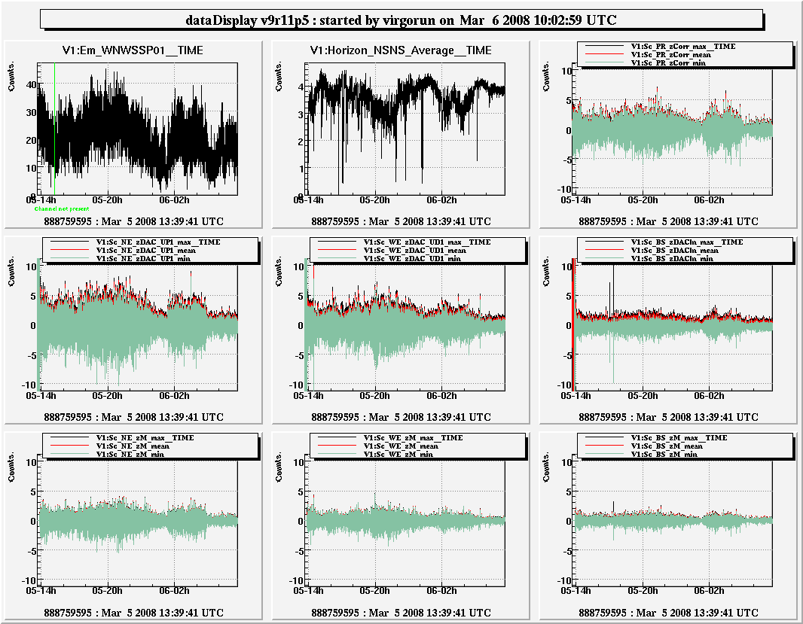
- March 06/08: the suspension control robusteness was successfully tested and provided precious data for designing reduced dynamical range practial requierements during a 18-hour-long lock under stormy conditions (among the worse observed at the site).

1.2 Sensitivity at low-frequency.
The work concerning the low frequency sensitivity improvement scheduled for the post-VSR1 concerned MSC about the following items:
A - Local angular control
B - Hierarchical control
C - New coil drivers
Remarkably, at this level, any strategy improvement involved a cycle of actions on other systems or activities, as suspension, alignment and locking performance.

A) Local angular control
- Angular control of power recycling mirror is very critical for the ITF locking. Before VSR1 we implemented a multiple control to this payload. From the marionette (AA,from wavefront sensing) and from the mirror (local control, by means of a high-gain filter, noisy). Moreover, during VSR1 the BS ty (yaw) was partially set under local control). Even though PR angular control noise had no effect on VSR1 sensitivity, in order to accomplish the use AA also for BS, it was necessary to reshape PR marionette local control.

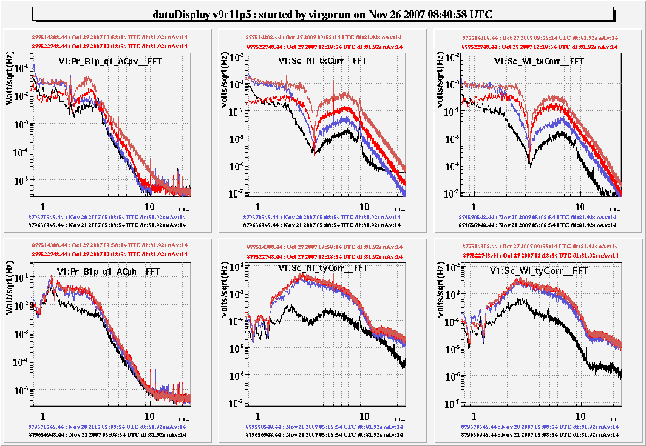
- Angular local control of input mirrors remained driven by ITF signals (5 mHz BW) but underwent to crucial improvements (partially mentioned Sec 1.1), meant also to achieve higher sensitivity at low frequency.

___VSR1 data;
___Low gain investigation mentioned in Sec. 1.1 to cancel noise re-injection on AA signals;
___New pitch filter;
___New PSD amplifiers with dual dynamical range (G_{std}, G_{stdx10}) and new yaw filter (here only for NI).

By means of these improvements any residual angular-to-longitudinal noise coupling (around 10 Hz) compensated by the actual capability of automatic and manual beam centring techniques developed by the alignemnt workgroup.

- In the framework of suspended output bench (OB) noise hunting, local control filters of have been also upgraded, even if not motivated by clear evidence of noise re-injection on Virgo sensitivity.

- Finally, a significant effort was done for the preventive electromagnetic cleaning-up of the environment around the suspensions-by removing the power supply of local controls from suspension tower ovens.

B) Hierarchical control
- The cleaning of payload resonances (e.g. 16.7,46.7 Hz) seen in the sensitivity curve, due to the suspension where marionette reallocation is implemented was addressed by reshaping the reallocation filter.

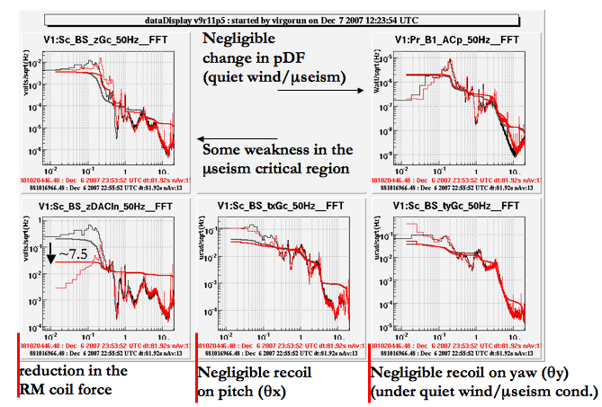
- BS lock-force reallocation to the marionette, motivated by the scheduled overall actuator noise reduction leading to new coil driver installation for the FP arm suspensions. The rms of locking force applied from the reaction-mass was reduced by a factor 7.5 through BS-specialized and equalized hierarchical filtering wth crossover at 0.5 Hz.

- The first resonance of the superattenuator chain (200 mHz) used to slightly contribute to the rms of locking force the correction where the GIPC is applied (NE,WE). Hence a fourth hierarchical control point, the last filter of the chain, using GC signal and actuating with respect to the ground, can be used to damp this peak. The control bandwidth (~1 Hz) and the gain were designed not to reinject the μseism noise during strong sea activity.

C) New Coil drivers.
The issue of new coil-driver implementation was motivated by low-frequency sensitivity achievement, but also, and strongly, by the preparation of Virgo+ operation. Moreover, this activity was strictly interlaced with environmental noise investigations and with Eddy-current noise projections whose related action consisted in reducing the actuator magnet induction by a factor 5.
(below AG)
Actuation noise in Virgo is dominated by DAC noise over the whole frequency range.
At the beginning of February 2008, new coil drivers were installed at NE and WE Up/Down coils. In following plots, green line is the DAC reference noise while the blue line includes an over estimation of DAC excess noise when driven by low frequency high amplitude signals.

The actuation noise budget after magnets replacement at terminal mirror is shown below. To be noticed that the gain respect with previous picture is only due to the different whitening filter since smaller forces due to smaller magnets were compensated driving a higher current into the coils reducing the series resistor value.

Actuator noise budget after magnet replacement (reduction 1/5)

Marionettte actuators are, at present, dominant in respect with reference mass actuators noise. The following plot shows noise budget for Marionette actuators with a first order whitening filter (1-10Hz). Further reduction of the noise would be possible implementing high power – low noise modes on these actuators.

MSC report for the STAC - November 2008

During the long shut-down of the interferometer MSC main activity was suspended and redirected to follow the steps of the detector recovery. The NE payload equipped with the new mirror was installed on Oct 9th/08. Few changes of MSC concern had changed with respect to the previous one.
- Removal and weight compensation of side actuators, according to VSR1 experience and to the need of setting the lock operation to the low-noise mode, leaving connected only longitudinal actuators. Transversal pendulm oscillation at 0.6 Hz can the detected through the coupling with marionette angular signal and damped by using a suitable combination of longitudinal actuators from the Reaction-Mass.

- New markers for coarse Local Control, have been silicate bonded to the mirror. They are built with similar technique as the previous one but are much cheaper and have only three spots. This configuration works but since the distance of the spots is half times the previous, given the camera CCD resolution, the coarse signal is noisier. However, according to the commissioning experience Coarse signals are used only in case of very large yaw oscillations (4 mrad < |ty| < 50), then the control is hierarchically passed to the optical levers.

- Different HeNe reflectivity of the rear mirror face. The mirror optical lever had been set onto the rear face of the mirror and the amplification optimized. Hence it was decided to reduce by 30 % the laser diode power in order not to saturate the PSDs amplifiers.

- Internal misalignment of the payload. In order to facilitate the alignment and to properly set the local control range zero a check was performed by the optics group by means of an autocollimation apparatus assembled on the NE external bench. The mirror turned out to be pitch tilted by 12 mrad± 1 mrad (limited by a conservative estimate of the external bench gravity) as the marionette/reaction-mass were aligned to the gravity line. Hence it was needed to compensate mirror versus marionette/reaction-mass alignment through motor balance.
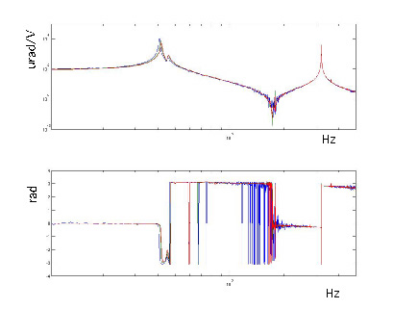
In the figure the transfer function of NE pitch (tx, marionette readout), measured in three different tx positions is shown (b = mirror misaligned payload inclined by 13 mrad, g = mirror roughly aligned with payload tilted 12 mrad, r = mirror misaligned through a further marionette misalignment by 16 mrad). Provided that ty transfer funcion is the same as in the past, beside some change in tx coupling with longitudinal d.o.f (z), involving marionette suspension wire, no dramatic effects as mechanical friction or pivoting within the payload are present.

MSC performance is expected to fulfill Virgo+ requirements. The overall architecture of both suspension control and last stage angular control, reported in the last STAC report (Jun 2008), will remain the same. However, performance mantenance concerns and special issues arising from commissioning steps towards VSR2 are far from being considered with low priority.

With lower priority, in view of Vadv, the overall control strategy will evolve in the direction of increasing GIPC crossover up to 100 mHz for the end mirrors (to improve tilt noise re-injection) and toward a differential driving meant not to make the overall control limited by the top-stage control of input mirror suspensions (where actually the crossover is around 50 mHz). By means of these two solutions the low-noise duty cycle of the detector, at the nominal V+ sensitivity, would not be limited even by the worst weather conditions.

As new digital electronics will be available, a relevant effort will be required first a) to re-adapt the existent strategy to the new system and then b) to exploit new funcionalities, as digital recombination of suspension motion signals among all the suspension sites and higher /more-complex RT computational capability.

