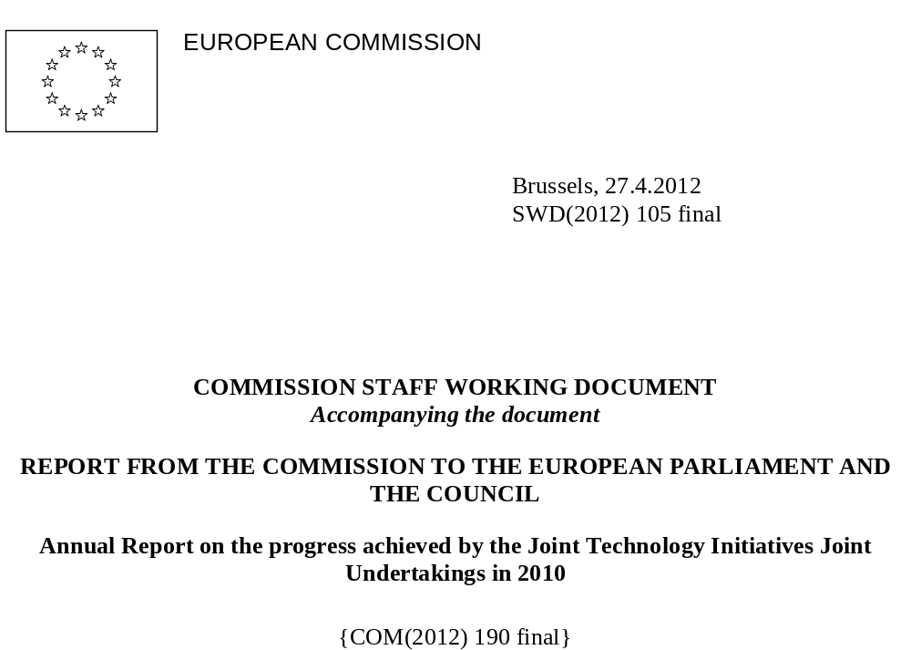
TABLE OF CONTENTS
TABLE OF ABBREVIATIONS 5
1. Introduction 7
2. Progress achieved by the Clean Sky JU 8
2.1. About the CS JU 8
2.2. Main activities of the CS JU in 2010 9
2.3. Calls for proposals 12
2.3.1. Submission and evaluation process 12
2.3.2. Calls launched in 2009 and 2010 14
2.4. Call 2 SP1-JTI-CS-2009-02 16
2.4.1. Summary information 16
2.4.2. Analysis of proposals submitted 19
2.4.3. Evaluation results 19
2.4.4. Grant agreements signed 20
2.5. Call 3 SP1-JTI-CS-2010-01 23
2.5.1. Summary information 23
2.5.2. Analysis of proposals submitted 27
2.5.3. Evaluation results 27
2.5.4. Grant agreements signed 28
2.6. Call 4 SP1-JTI-CS-2010-02 33
2.6.1. Summary information 33
2.6.2. Analysis of proposals submitted 34
2.6.3. Evaluation results 34
2.6.4. Grant agreements signed 34
2.7. Call 5 SP1-JTI-CS-2010-03 36
2.7.1. Summary information 36
2.7.2. Analysis of proposals submitted 39
2.7.3. Evaluation results 39
2.7.4. Grant agreements signed 40
2.8. Call 6 SP1-JTI-CS-2010-04 45
2.8.1. Summary information 45
2.8.2. Analysis of proposals submitted 48
2.8.3. Evaluation results 48
2.8.4. Grant agreements signed 49
2.9. Call 7 SP1-JTI-CS-2010-05 53
2.9.1. Summary information 53
2.9.2. Analysis of proposals submitted 56
2.9.3. Evaluation results 56
3. Progress achieved by the Innovative Medicines Initiative (IMI) JU 57
3.1. About the IMI JU 57
3.2. Main activities of the IMI JU in 2010 58
3.3. Call 2 IMI_Call_2009_2 62
3.3.1. Summary information 62
3.3.2. Analysis of proposals submitted 63
3.3.3. Evaluation procedure 65
3.3.4. Evaluation results 68
3.3.5. Grant agreements signed 70
3.4. Call 3 IMI_Call_2010_3 72
3.4.1. Summary information 72
4. Progress achieved by the Fuel Cells and Hydrogen (FCH) JU 74
4.1. About the FCH JU 74
4.2. Main activities of the FCH JU in 2010 75
4.3. Call 2 FCH-JU-2009-1 79
4.3.1. Summary information 79
4.3.2. Analysis of proposals submitted 80
4.3.3. Evaluation procedure 80
4.3.4. Evaluation results 81
4.3.5. Grant agreements signed 82
4.4. Call 3 FCH-JU-2010-1 87
4.4.1. Summary information 87
4.4.2. Analysis of proposals submitted 88
4.4.3. Evaluation procedure 90
4.4.4. Evaluation results 90
4.4.5. Grant agreements signed 91
5. Progress achieved by the ARTEMIS JU 96
5.1. About the ARTEMIS JU 96
5.2. Main activities of the ARTEMIS JU in 2010 96
5.3. Call 3 ARTEMIS-2010-1 99
5.3.1. Summary information 99
5.3.2. Analysis of proposals submitted 101
5.3.3. Evaluation procedure 106
5.3.4. Evaluation results 107
5.3.5. Grant agreements signed 109
6. Progress achieved by the ENIAC JU 112
6.1. About the ENIAC JU 112
6.2. Main activities of the ENIAC JU in 2010 112
6.3. Call 3 ENIAC-2010-1 115
6.3.1. Summary information 115
6.3.2. Analysis of proposals submitted 116
6.3.3. Evaluation procedure 116
6.3.4. Evaluation results 117
6.3.5. Grant agreements signed 120
7. Conclusion 122
8. References 123

TABLE OF ABBREVIATIONS
AA | Application Area
ABAC | Accrual Based Accounting System
ACARE | Advisory Council for Aeronautics Research in Europe
AENEAS | Association for European Nanoelectronics Activities
ARTEMIS-IA | ARTEMIS Industrial Association
ASP | ARTEMIS Sub-Programme
CATRENE | Cluster for Application and Technology Research in Europe on Nanoelectronics
CHP | Combined Heat & Power
CMOS | Complementary Metal Oxide Semiconductor
CP | Collaborative Project
CS | Clean Sky
DG | Directorate-General
DG INFSO | Directorate-General for Information Society and Media
DG RTD | Directorate-General for Research and Innovation
EC | European Commission
ED | Eco-Design
EFPIA | European Federation of Pharmaceutical Industries Association
EFTA | European Free Trade Association
EoI | Expression of Interest
EPSS | Electronic Proposal Submission Service
ETP | European Technology Platform
EU | European Union
FCH | Fuel Cells and Hydrogen
FP7 | Seventh Framework Programme of the European Community for research, technological development and demonstration activities (2007-2013)
FPP | Full Project Proposal
GA | Grant Agreement
GAM | Grant Agreement for Members
GAP | Grant Agreement for Partners
GRA | Green Regional Aircraft
GRC | Green Rotorcraft
IAS | Internal Audit Service
ICAS | International Council of the Aeronautical Sciences
ICT | Information and Communications Technologies
IMI | Innovative Medicines Initiative
IP | Intellectual property
IRC | Industry and Research Committee
IT | Information Technologies
ITD | Integrated Technology Demonstrator
JTI | Joint Technology Initiative
JU | Joint Undertaking
NEF | Negotiation Form Facility
NEW-IG | New Energy World Industry Grouping
NGA | National Grant Agreement
NGO | Non-Governmental Organisation
NSRG | National States Representatives Group
OJ | Official Journal of the European Union
PAB | Public Authorities Board
PO | Project Outline
PPP | Public-private partnership
PRO | Public Research Organisations
R&D | Research & Development
RTD | Research, Technological Development and Demonstration
S&T | Scientific & Technological Excellence
SA | Coordination and Support Action
SAGE | Sustainable and Green Engines
SET-Plan | European Strategic Energy Technology Plan
SFWA | Smart Fixed Wing Aircraft
SGO | Systems for Green Operations
SME | Small and Medium-Sized Enterprise
STAB | Scientific and Technological Advisory Board
TE | Technology Evaluator
UK | United Kingdom
USA | United States of America

1. Introduction
The present Commission Staff Working Document accompanies the Report from the Commission to the European Parliament and to the Council on the progress achieved by the Joint Technology Initiatives Joint Undertakings in 2010. In compliance with Article 11 (1) of each Council Regulation establishing the Joint Technology Initiatives Joint Undertakings (hereinafter referred to as "JTI JUs") it shall provide details on the implementation of their research activities, i.e. number of proposals submitted, number of proposals selected for funding, type of participants, including SMEs, and country statistics. The document shall also "include assessment results of the Technology Evaluator referred to in Article 8(1) of the Statutes [of the Clean Sky JU], as appropriate" pursuant to Article 11(1) of Council Regulation (EC) 71/2008 setting up the Clean Sky Joint Undertaking.
The data contained in this document is gathered through a specifically designed template, filled in by each JTI JU under the guidance of the European Commission. It is divided into five main sections, one per Joint Undertaking. Each section contains the following three sub-sections providing information on the JTI JUs' activities in 2010 in a structured and uniform way: 1) About the JTI JU, 2) Main activities in 2010, and 3) Calls for proposals.
The description of the progress of each Joint Undertaking throughout the year starts with a short introduction of the JTI JU, outlining its legal basis, main objectives, research priorities, funding and governing structure. The second sub-section highlights the key achievements of the entity in 2010, both from operational and administrative perspective. The submission and evaluation process of the individual JTI JUs used in the calls is also schematically explained.
The last sub-section is dedicated to the calls for proposals launched by the Joint Undertakings in 2010. In case the entity has launched multiple calls during the year, each call is described in a separate sub-section. The call's presentation starts with a brief summary listing the call topics, eligible beneficiaries, timeline and indicative budget. This is followed by detailed statistics on the submitted proposals by types of participants and by country. A special attention is given to the number of SMEs, whose participation in the call is presented separately.
The evaluation procedure is also described, giving information on the evaluation criteria, scoring and weighting of the proposals, composition of the evaluation committees and the evaluation steps that have been followed. Detailed statistics on the selected proposals by types of participants and by country are provided, which can serve for a comparative analysis of the participants at the different steps of the call. The sub-section ends with a table giving information on the grant agreements signed in the respective call.
Among the five JTI JUs, only the presentation of the Clean Sky's calls for proposals follows a slightly different structure to avoid repeating of information, because the Joint Undertaking publishes several calls per year following the same steps for submission and evaluation of proposals.

2. Progress achieved by the Clean Sky JU

2.1. About the CS JU
The Clean Sky Joint Undertaking (hereinafter referred to as "CS JU") has been established by Council Regulation (EC) 71/2008 of 20 December 2007 as a public-private partnership between the aeronautic industry, represented by the leaders of the Integrated Technology Demonstrators (ITDs) and their associates, and the European Union, represented by the European Commission.
The ITD leaders are twelve industrial organisations that jointly committed to perform, complete and exploit the Clean Sky programme. Each of them leads or co-leads a specific Integrated Technology Demonstrator. The associate members are seventy-four private or public organisations representing industry, academia, SMEs and research centres, selected through a transparent and fair process as permanent members of the Clean Sky JU. They committed to perform and complete certain essential work packages in one or more ITDs for the duration of Clean Sky.
The CS JU has been set up for a period up to 31 December 2017 with the main objective to develop environmental technologies impacting all flying segments of commercial aviation in order to contribute to the ACARE targets for reduction of emissions and noise in air transport in Europe, thus contributing to improving the air transport system worldwide.
The objective of the Clean Sky JU is achieved through coordination of research activities that pool resources from the public and private sectors, and that are carried out by the main aeronautical stakeholders (ITD leaders and associates) directly and by partners selected through open and competitive calls for proposals.
The CS JU is built upon six different technical areas called Integrated Technology Demonstrators, which develop innovative technologies covering all segments of commercial aviation. Each ITD is led by two founding members and operates through a matrix structure. The ITDs are listed below:
- Smart Fixed Wing Aircraft (SFWA) led by Airbus and SAAB – focused on active wing technologies that sense the airflow and adapt their shape as required, as well as on new aircraft configurations to optimally incorporate these novel wing concepts;
- Green Regional Aircraft (GRA) led by Alenia Aeronautica and EADS-CASA – dealing with low-weight configurations and technologies using smart structures, low-noise configurations;
- Green Rotorcraft (GRC) led by Agusta-Westland and Eurocopter – focused on innovative rotor blades and engine installation for noise reduction, lower airframe drag, diesel engine and electrical systems for fuel consumption reduction and environment-friendly flight paths;
- Sustainable and Green Engines (SAGE) led by Rolls-Royce and Safran – integrating technologies for low noise and lightweight low pressure systems, high efficiency, low nitrous oxides and low weight core;
- Systems for Green Operations (SGO) led by Thales Avionics and Liebherr Aerospace – coping with all-electric aircraft equipment and systems architectures, thermal management, capabilities for green trajectories and improved ground operations;
- Eco-Design (ED) led by Dassault Aviation and Fraunhofer Gesellschaft – addressing the full lifecycle of materials and components, focusing on issues such as optimal use of raw materials, decreasing the use of non-renewable materials, natural resources, energy, the emission of noxious effluents and recycling.
Multiple links for coherence and data exchange is ensured between the different ITDs.
Complementing these six ITDs, the Technology Evaluator (TE) is a dedicated evaluation platform cross-positioned within the CS project structure. The TE is co-led by DLR and Thales and includes major European aeronautical research organisations as members. Its objective is to assess the environmental impact of the technologies developed by the ITDs and to assess the result of the overall Clean Sky's project output.
The total budget of the CS JU is equally divided between the EU and its private members and is set to a maximum of € 1.6 billion. The EU contribution of € 800 million is paid from the budget appropriation allocated to theme "Transport" of the Specific Programme "Cooperation" under the Seventh Framework Programme (FP7) of the European Union (2007-2013).
The CS JU governance is composed of three bodies: the Governing Board, the Executive Director and the ITD Steering Committees. It is also supported by three advisory groups: the Scientific and Technological Advisory Board (STAB), the National States Representatives Group (NSRG) and the General Forum.

2.2. Main activities of the CS JU in 2010
After its establishment, Clean Sky gradually developed an operational capacity, and on 16 November 2009 has been granted administrative and operational autonomy from the European Commission. Thus, 2010 was the first full year of independent functioning of the Joint Undertaking.
Key milestones
- Publication and evaluation of the five CS JU's calls for proposals in 2010 as planned;
- Amendment to the model Grant Agreement for Partners (GAP) and the model Grant Agreement for Members (GAM);
- Internal processes definition and mapping;
- Set-up of a Scientific and Technological Advisory Board in the Clean Sky's governance structure;
- Establishment of Internal Audit Plan and Ex-Post Audit Strategy;
- Adoption of a Communication and Dissemination Strategy.
In 2010 the CS JU achieved progress in both increasing its operational capacity and in running the Clean Sky operations. 10 additional staff members were recruited, growing to 20 by the end of the year. An Internal Auditor was appointed to establish the internal control function and, in particular, to deal with the risk management activities. A first internal audit started in November 2010, still in progress at the turn of the year. Also, the main settings of the CS JU were established: a Quality Manual, a Manual of Financial Procedures, and a Management Manual. A Development Plan was elaborated and had to be submitted for adoption by the Governing Board in 2011.
In addition, in December 2010 Clean Sky finalised the procurement procedure on its new permanent premises. The call for tender has been organised jointly with the other four JUs, which were temporarily housed at the Covent Garden building in Brussels, and in close collaboration with the European Commission. The CS JU moved successfully to the White Atrium building in Brussels in January 2011.
As aircraft fuel economy is influenced by flight trajectory management strategy, Clean Sky maintained close links with the SESAR Joint Undertaking, which investigates air traffic management technologies in line with the Single European Sky initiative.
Technology Evaluator
The TE has been created in 2008 with the objective to assess the environmental impacts and benefits of the overall Clean Sky's project output. The general TE requirements were defined in 2009. In 2010, they had to be reviewed and detailed, paying particular attention to the first assessment cycle and to the needs of the trade-off studies. Among the main tasks for the year was to create a TE system mock-up based on the GRC (helicopter) case study. This has been expected to help the design and development of the TE system for the first mid-term assessment planned for the end of 2011. Each year until the final assessment in 2015, more accurate assessments are planned to be performed with the updated sets of models resulting from the ITDs' progress.
Governance
The CS JU Governing Board held four meetings in 2010.
On its meeting of 18 March 2010 the Governing Board re-elected for a second and last mandate its chair and vice-chair, followed by election of new chair and vice-chair for 2011 on its next meetings on 14 October and 17 December. The Governing Board approved inter alia the CS JU General Strategy, the CS JU Communication and Dissemination Strategy, modifications to the model grant agreements, the CS JU Staff Policy Plan 2011-2013, the CS JU Annual Implementation Plan 2010, etc.
The Steering Committees responsible for technical decisions taken within each ITD and the TE met regularly in the course of 2010.
The Scientific and Technological Advisory Board (STAB) was set up in June 2010 as an advisory body to the CS JU. It was composed of 11 high-level scientists and engineers, all independent from the Clean Sky's stakeholders. The first meetings of the Board took place in July and November. They were dedicated on the general presentation of the Clean Sky JU and on some specific issues. The first item which the STAB started work on was the completion of the Joint Undertaking's Development Plan.
On 18 June 2010, the CS JU's stakeholders gathered for the first General Forum. It was designed to take place at least once a year with the purpose to provide information to the participants in the initiative about its activities and the progress of the Clean Sky JU, and to get recommendations from them on managerial and operational items. This event gathered more than 300 representatives from the aviation industry, the scientific and research community, national public authorities, and non-governmental organisations.
Communication activities
Among the considerable achievements during the year was the adoption of a Communication and Dissemination Strategy by the Clean Sky's Governing Board in June 2010. The activities undertaken during the year were in compliance with the strategy. A CS communication network was settled to gather all its members on communication issues. The first meeting took place on 21 October 2010.
In order to inform widely potential candidates about its calls for proposals, Clean Sky held a number of information sessions in Madrid, Vienna, Bologna, Turin, The Hague and London. On 18 June 2010 the Joint Undertaking organised a public conference "The aviation industry goes green" within the framework of the first General Forum on the latest developments of the Clean Sky programme. An exhibition featuring the activities of the six ITDs and the TE was accessible throughout the day.
Furthermore, the Clean Sky initiative was promoted through different external industrial events – aerospace trade shows, fairs and exhibitions, such as the ILA Berlin Air Show in Germany, "Flyg med Framtid" in Stockholm (Sweden), the International Council of the Aeronautical Sciences (ICAS) Conference in Nice (France), the Farnborough International Airshow in the UK, Helitech in Portugal, the AeroWeek in Brussels (Belgium), the AeroSpace and Defence Industries Association of Europe (ASD) Convention in Montreux (Switzerland), the Imperial College's Green Aviation Forum in London (UK).
In 2010, Clean Sky changed its visual identity. A tagline "Innovating together, flying greener" was adopted and the logo was simplified. Promotional materials such as roll-ups, press kits, ITD fact sheets were produced. Following a call for tender, the Clean Sky's website (http://www.cleansky.eu) was renewed and has been regularly updated with up-to-date information on calls for proposals and latest news. A quarterly newsletter called "Skyline" has been launched.

2.3. Calls for proposals

2.3.1. Submission and evaluation process
Grant agreements with members
The majority of the work inside the Clean Sky JU is carried out by its industrial members under the form of grant agreements with named beneficiaries. According to Article 13 (2) (a) of Council Regulation (EC) 71/2008 setting up the Joint Undertaking an amount of up to € 400 million shall be allocated to the ITD leaders and up to € 200 million – to the associate members. In turn, the ITD leaders and associates engage to contribute resources at least matching the EU contribution.
The Clean Sky JU signed the first seven grant agreements with its members (referred to as "GAM") in 2008: one for each of the six ITDs, and a supplementary one for the activities of the Technology Evaluator. These grant agreements will remain in force for the whole duration of Clean Sky, until 31 December 2017. Each year, an amendment is signed in order to update the annual description of work with the corresponding JU financial contribution. The commitments amounted to € 17 million in 2008, € 70.6 million in 2009 and € 75.7 million in 2010. No new named beneficiaries joined the CS JU in 2010.
Grant agreements with partners
According to Article 13 (2) (b) of the same regulation, the remaining 25% of the EU funding to the Clean Sky JU (amounting to at least € 200 million) are allocated to partners selected via open and competitive calls for proposals. They serve the dual purpose of widening the participation in Clean Sky to other organisations and to identify R&D performers to take part in the mainstream activities of Clean Sky. Partners selected via calls for proposals are funded in compliance with the upper funding limits set in the FP7 Rules for Participation.
According to the Clean Sky's Rules for Participation and Rules for Submission of Proposals and the Related Evaluation, Selection and Award procedures any legal entity established in an EU Member State or in a country associated to the FP7 may participate in a CS project. A proposal may involve one or several participants. Examples of potential participants are research institutes, universities, industry, including SMEs, and end-users.
The call topics are proposed by each ITD Steering Committee and reviewed by the CS JU Executive Office and the European Commission. The calls are broadly published by all suitable channels, including on the Clean Sky's website. According to the requirements of the ITD and the work package, a single stage submission and evaluation process is followed. After a proposal is submitted, eligibility check and independent evaluations took place.
The evaluation of proposals is performed on the basis of the following principles:
- Excellence of projects selected;
- Transparency of decisions;
- Fairness and impartiality of evaluations;
- Confidentiality of all information;
- Efficiency and speed of evaluation;
- Compliance with ethical and security principles.
The evaluation of proposals is carried out by a panel of experts comprising two internal experts from the ITD responsible for the call and two external experts in an open and transparent competitive procedure. Topic managers representing the ITD leaders, as well as Clean Sky staff members also take part in the evaluation process. The presence of independent observers aims to verify and guarantee that the above-mentioned rules and principles are followed.
The evaluations are performed against six pre-determined evaluation criteria: 1) Technical excellence, 2) Innovative character, 3) Compliance with the call for proposals specification and timetable (relevance), 4) Adequacy and quality of respondent's resources, management and implementation capabilities and track record, 5) Appropriateness and efficient allocation of the resources to be committed (budget, staff, equipment), and 6) Contribution to European competitiveness.
For each criterion, a score is given on a scale from 0 (proposal fails to address the criterion) to 5 (proposal addresses all aspects of the criterion). All factors have equal weight. For a proposal to be considered for funding, it needs to pass the following thresholds: a minimum 3/5 for each of the 6 criteria and a minimum 20/30 total score.
The evaluation process consists of several steps:
- Briefings of the experts to explain the process and the rules for evaluation;
- Eligibility Review Committee to ensure a coherent legal interpretation of all cases and equal treatment of participants;
- Individual remote evaluation, the results of which are included in an individual evaluation report;
- Consensus meeting for each proposal, the results of which are included in a consensus evaluation report;
- Topic meeting to examine and compare the various consensus reports, the results of which are included in an evaluation summary report. A topic report is also established with a list of ranked proposals above thresholds, a list of proposals failing one or more thresholds and a list of ineligible proposals, if any.
If the proposal passes the thresholds and is selected for funding, it enters into the next phase – the negotiation. The process is concluded by the signature of a contract, called Grant Agreement with Partners (referred to as "GAP").
It is important to note that the calls for proposals launched by the Clean Sky JU differ from collaborative research calls launched by the other JTI JUs. The content of the activities is much more focused, i.e. there are topics, rather than research themes, with a limited duration and specific targeted results expected at higher technology readiness levels.
The calls supplement the technical competences of the Clean Sky's members by performing highly specific activities, which, on the other hand, have to "slot in" with the overall technical work plan of the CS JU. For this reason, only one contract is awarded for each of the topics that are published, and compliance with the technical description is imperative. However, due to the very specific nature, it is possible to participate in a call as a single entity and not in a consortium, as allowed by the Clean Sky's Rules for Submission of Proposals.
Another difference from collaborative research calls is that the budget is defined by the topic value, and not by the maximum funding, which allows a wider participation from all types of entities, independently from the actual eligibility for funding.

2.3.2. Calls launched in 2009 and 2010
Since its establishment and by the end of 2010, Clean Sky launched a total of seven calls for proposals – two in 2009 and five in 2010. As a result, 73 projects are currently underway working towards the development of environmental technologies with impact on all flying segments of commercial aviation.
Clean Sky published its first call for proposals on 15 June 2009. It attracted 216 proposals requesting a total contribution of € 59 million. 45% of the applicants declared an SME status. After the evaluation and negotiation processes, 57 grant agreements have been signed. The Commission's Annual Report on the progress achieved by the JTI JUs in 2009 provides detailed information on that call.
The second call for proposals was open from 25 November 2009 till 23 February 2010. Since the submission and evaluation of the proposals took place in 2010, the results of the call were not included in the Commission's Annual Report on the progress achieved by the JTI JUs in 2009 and will be reviewed in the present Commission Staff Working Paper.
In 2010, the CS JU launched 5 calls which covered 150 topics, resulting in a total of 325 partners from 22 countries selected after call 6. The present document shall provide detailed information on four of those five calls (calls 3 to 6). Since the last for the year call for proposals (call 7) was launched on 24 September 2010 and the evaluation of the received proposals took place in January 2011, the Commission shall present the results of the call in its next year's report.
The table below gives an overview of the calls for proposals launched by the Clean Sky JU in 2009/2010 that will be reviewed in the present document:
Call № | Reference | Publication date | Deadline for submission | Evaluation | Nr of topics | Nr of GAPs | Indicative budget (M€) | Outcome of the call (M€)
2 | SP1-JTI-CS-2009-02 | 25-11-2009 | 23-02-2010 | Mar 2010 | 24 | 20 | 11.2 | 8.3
3 | SP1-JTI-CS-2010-01 | 29-01-2010 | 27-04-2010 | May 2010 | 45 | 41 | 17.0 | 17.0
4 | SP1-JTI-CS-2010-02 | 30-03-2010 | 30-06-2010 | Jul 2010 | 4 | 4 | 5.9 | 5.9
5 | SP1-JTI-CS-2010-03 | 30-04-2010 | 20-07-2010 | Sep 2010 | 34 | 27 | 26.0 | 11.3
6 | SP1-JTI-CS-2010-04 | 27-07-2010 | 12-10-2010 | Nov 2010 | 29 | 24 | 18.8 | 16.7
7 | SP1-JTI-CS-2010-05 | 24-09-2010 | 09-12-2010 | Jan 2011 | 38 | 29 | 30.6 | 30.6
Table 1. Overview of the CS JU calls for proposals launched in 2010
The average response to the CS JU calls in 2010 was about 2.5 proposals per topic, i.e. more than 350 proposals in total. The average failure rate of the topics was 15%, due either to a lack of proposals submitted in a certain topic, or to negative evaluation results of the proposals in a topic.
With respect to the first two calls in 2009, when the call fiches contained incorrect indicative budget under some topics, a significant improvement has occurred in 2010 on the eligibility aspects of proposals. After call 3 – the first call of 2010 – less than 1-2 proposals per call were declared ineligible due to a requested funding above the threshold defined in the call fiches.
Still limited to call 6 (SP1-JTI-CS-2010-04), but referring to all calls launched by the Clean Sky JU (including results from the two calls launched in 2009), Figure 1 provides statistics per country in terms of presence in winning proposals:
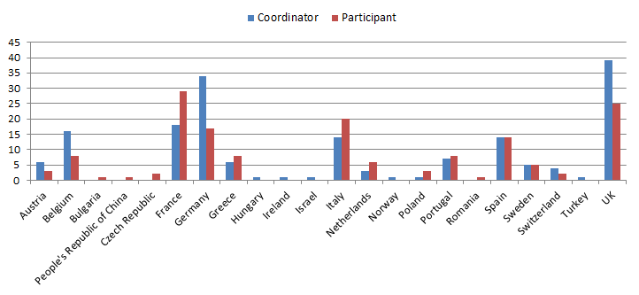
Figure 1. CS JU – calls 1 to 6 (2009 and 2010). Geographic distribution of winning proposals
For all calls for proposals (up to call 6), 42% of the winners selected for funding by the Clean Sky JU were SMEs. The figure below shows the presence of SMEs among the winning entities; it provides in particular the number of SMEs in winning consortia per ITD.
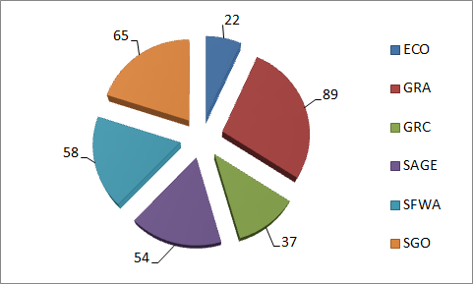
Figure 2. CS JU – calls 1 to 6 (2009 and 2010). Number of winning SMEs
The calls for proposals process led to an increased number of grant agreements to be negotiated in 2010. In total, 81 GAPs were processed at the total amount of € 18.5 million. Of this, € 11 million were paid for pre-financing of GAPs.
The negotiation of the projects selected for funding in the third and fourth call for proposals (SP1-JTI-CS-2010-01 and SP1-JTI-CS-2010-02) started before summer 2010 and by the time of drafting the report was still in progress, whereas the negotiations of the projects in call 5 (SP1-JTI-CS-2010-03) were launched at the end of the year. The last two calls launched by Clean Sky in 2010 were expected to be negotiated in 2011.

2.4. Call 2 SP1-JTI-CS-2009-02

2.4.1. Summary information
The Clean Sky JU published its second call for proposals on 25 November 2009. The call was open for 24 topics covering activities within all ITDs except for Smart Fixed Wing Aircraft (SFWA) and Technology Evaluator (TE). The 24 open topics were grouped in 11 areas, further re-grouped under the ITDs as shown in the table below:
Identification | ITD-Area-Topic | Nr of topics | Indicative budget (K€) | Maximum funding (K€)
JTI-CS-ECO | Clean Sky – Eco-Design | 5 | 990 | 742.5
JTI-CS-ECO-01 | Area-01 – EDA (Eco-Design for Airframe) | 2 | 650
JTI-CS-2009-2-ECO-01-001 | Life cycle assessment databases improvement |  | 150
JTI-CS-2009-2-ECO-01-002 | Development of anaphoretic paint capable to protect pickled aluminium alloy surface against corrosive |  | 500
JTI-CS-ECO-02 | Area-02 – EDS (Eco-Design for Systems) | 3 | 340
JTI-CS-2009-2-ECO-02-001 | Sensor for Convective and/or Radiative Heat Loss |  | 60
JTI-CS-2009-2-ECO-02-002 | Thermo physical Properties Library for Relevant Fluids |  | 80
JTI-CS-2009-2-ECO-02-003 | Methods & Tools – Electrical Network Analysis |  | 200
JTI-CS-GRA | Clean Sky – Green Regional Aircraft | 3 | 380 | 285
JTI-CS-GRA-01 | Area-01 – Low weight configurations | 1 | 100
JTI-CS-2009-2-GRA-01-025 | Fatigue test of sensor integrated CFRP aircraft panels with stiffeners |  | 100
JTI-CS-GRA-02 | Area-02 – Low noise configurations | 2 | 280
JTI-CS-2009-2-GRA-02-005 | 3D design of flap side edge active flow control |  | 80
JTI-CS-2009-2-GRA-02-006 | Instrumentation-electronic (Optical assembly & Thermal and mechanical strain measurement) |  | 200
JTI-CS-GRC | Clean Sky – Green Rotorcraft | 8 | 5,040 | 3,780
JTI-CS-GRC-01 | Area-01 – Innovative Rotor Blades | 2 | 355
JTI-CS-2009-2-GRC-01 -002 | Development and provision of a numerical model to solve laminar turbulent boundary layer transition and boundary layer velocity profiles for unsteady flow conditions |  | 130
JTI-CS-2009-2-GRC-01-003 | Actuation mechanism development and supply for 2D wind tunnel and specimen bench testing |  | 225
JTI-CS-GRC-02 | Area-02 – Reduced drag of rotorcraft | 3 | 1,335
JTI-CS-2009-2-GRC-02-001 | Contribution to the study of the air intake and exhaust integration into a tiltrotor nacelle |  | 395
JTI-CS-2009-2-GRC-02-002 | Contribution to analysis of rotor hub drag reduction |  | 500
JTI-CS-2009-2-GRC-02-003 | Contribution to optimisation of heavy helicopter engine installation design |  | 440
JTI-CS-GRC-03 | Area-03 – Integration of innovative electrical systems | 2 | 2,750
JTI-CS-2009-2-GRC-03-001 | Electric Tail Drive – Modelling, Simulation and Rig Prototype Development |  | 2,500
JTI-CS-2009-2-GRC-03-002 | Innovative energy recovery for electrical use |  | 250
JTI-CS-GRC-05 | Area-05 – Environmentally friendly flight paths | 1 | 600
JTI-CS-2009-2-GRC-05-003 | Emission analysis – Tools required to perform the emissions analysis and evaluation methodology, experimental support |  | 600
JTI-CS-SAGE | Clean Sky – Sustainable and Green Engines | 6 | 1,760 | 1,320
JTI-CS-SAGE-02 | Area-02 – Direct Drive Open Rotor | 3 | 1,300
JTI-CS-2009-2-SAGE-02-003 | Design, computation and drawing of lubrication system equipment |  | 660
JTI-CS-2009-2-SAGE-02-004 | Performance and qualification tests of lubrication system equipment |  | 240
JTI·CS-2009-2-SAGE-02-005 | Design & Make of a test bench for Heat Exchanger |  | 400
JTI-CS-SAGE-05 | Area-05 – Turboshaft | 3 | 460
JTI-CS-2009-2-SAGE-05-007 | High temperature material |  | 230
JTI-CS-2009-2-SAGE-05-008 | Oil tank in composite |  | 115
JTI-CS-2009-2-SAGE-05-009 | Casing in composite |  | 115
JTI-CS-SGO | Clean Sky – Systems for Green Operations | 2 | 3,000 | 2,250
JTI -CS-SGO-04 | Area-04 – Aircraft Demonstrators | 2 | 3,000
JTI-CS-2009-2-SGO-04-001 | Design and manufacture of an aircraft tractor compliant with specifications for Smart Operations on ground |  | 2,000
JTI-CS-2009-2-SGO-04-002 | Provision of electrical equipments to complement the PROVEN tests rig |  | 1,000
TOTAL |  | 24 | 11,170 | 8,377.5
Table 2. CS JU call 2 (SP1-JTI-CS-2009-02). Topics overview
The full call process has been managed by the autonomous Clean Sky JU, according to the same principles of excellence, transparency, fairness and impartiality, confidentiality, efficiency, speed and ethical considerations applied by the European Commission in the first call.
The timing for the call is given on Figure 3 below:
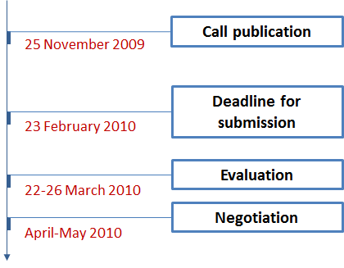
Figure 3. Timeline of the CS JU call 2 (SP1-JTI-CS-2009-02)
The total budget for the second call included initially a financial contribution from the EU to the Clean Sky JU of a maximum of € 16 million. This call was entirely financed from the 2009 budget. The final published value was for a total scope of work of € 11,170,000 with a maximum EU funding of € 8,377,500 (50-75% of the topic maximum budget indicated).
The difference between the originally forecasted value and the finally allocated amount (equal to € 16 million) was due to the fact that the calls formed an integral part of the overall work programme of Clean Sky, and were launched to bring in skills and contributions that needed to harmonise with the activities of the named beneficiaries. Some of the originally foreseen topics were finally not launched, due to reasons of relevance or quality of the topic descriptions. The unspent budget remained to be re-allocated to other topics (including re-launches of unanswered ones), keeping in mind that the Clean Sky JU has the obligation to allocate at least € 200 million via calls for proposals across its entire duration.

2.4.2. Analysis of proposals submitted
The call was published on 25 November 2009 and applicants were invited to submit their proposals by 23 February 2010. In total, 60 proposals were submitted in response to the 24 open topics addressed by the present call, involving applicants from 16 countries. 2 were found to be ineligible and the remaining 58 eligible proposals were evaluated by 74 independent experts.

2.4.3. Evaluation results
The on-site evaluation of the proposals took place in Brussels between 22 and 26 March 2010 following the methodology described in Section 2.3.1. It was preceded by individual remote evaluations. Out of the 58 eligible proposals, 35 passed the thresholds, while 23 failed one or more thresholds.
In terms of covered technological areas, all 5 topics in Eco-Design and 3 in GRA were successful. On the contrary, 2 out of 8 of the GRC topics failed (GRC-01-003 and GRC-02-003), because in both cases the two proposals received were evaluated below threshold. In SAGE, topic SGE-05-009 failed because the only proposal submitted was also assessed below threshold. In SGO, topic SGO-04-001 failed due to the fact that it did not attract any proposals in its domain.
Thus, after the evaluation, 20 projects could be finalised covering 20 of the originally published 24 topics. To sum up, the 4 topics remaining vacant were the following:
- ITD: Green Rotorcraft; Area-01: Innovative rotor blades; Topic: Actuation mechanism development and supply for 2D wind tunnel and specimen bench testing;
- ITD: Green Rotorcraft; Area-02: Reduced drag of rotorcraft; Topic: Contribution to optimisation of heavy helicopter engine installation design;
- ITD: Sustainable and Green Engines; Area-05: Turboshaft; Topic: Casing in composite;
- ITD: Systems for Green Operations; Area-04: Aircraft Demonstrators; Topic: Design and manufacture of an aircraft tractor compliant with specifications for Smart Operations on ground.
The 20 proposals proposed for funding accounted for 32 participations from 10 European countries. Of those, 10 (31.3%) participants came from academia and 5 (15.6%) were research institutions. The SME participation was 34.4% (11 companies), requesting a total funding of € 2,428,881 (29.3% of the total requested funding).
The geographical distribution of the proposals selected for funding is shown in the graph below, the UK and Italy being on the lead with 4 winning proposals each, followed closely by Belgium (3 proposals), Germany and France (2 proposals):
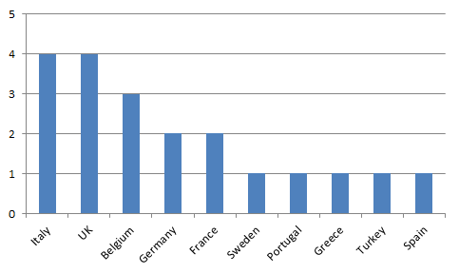
Figure 4. CS JU call 2 (SP1-JTI-CS-2009-02). Proposals selected for funding per country

2.4.4. Grant agreements signed
The negotiations of the 20 proposals proposed for funding in CS JU call 2 started in April-May 2010. It is important to note that by the time of writing of the present document some of the projects were still under negotiation. In Table 3 below these projects are shown on positions 16-20 in italic.
The total budget requested by the selected 20 proposals amounted to € 8,279,484.40, of which € 5,712,247.55 was the EU contribution. The total contribution under the GAPs signed by October 2011 – 15 contracts in total – equalled to € 6,040,060.40, of which the EU funding was € 4,385,730.80 and the in-kind contribution from industry amounting to € 1,654,329.60.
№ | Project number | Project acronym | Project title | CS JU contribution | In-kind contribution | Total contributions
1. | 267496 | LCA DATIM | Life cycle assessment database improvement | 112,500.00 | 37,500.00 | 150,000.00
2. | 267678 | CORA | Sensor for Convective and Radiative Heat Loss | 44,550.00 | 14,850.00 | 59,400.00
3. | 267614 | AEROTHERMOPROP | Modelica library of thermodynamic and transport properties | 60,000.00 | 20,000.00 | 80,000.00
4. | 267608 | SMART | Saber Model Automatic tRanslation Tool, a software for Saber models conversion to multi-systems simulation platforms | 149,310.00 | 49,770.00 | 199,080.00
5. | 267522 | FATIGUETEST | Fatigue Test | 74,805.00 | 24,936.00 | 99,741.00
6. | 267487 | 3DFSE | 3D Design of Flap Side Edge Flow Control | 59,957.00 | 19,986.00 | 79,943.00
7. | 267679 | SMYLE | LE coupon based technology | 148,360.00 | 49,455.00 | 197,815.00
8. | 267567 | LAMBLADE | Development and provision of a numerical model to solve laminar-turbulent boundary-layer transition and boundary-layer velocity profiles for unsteady flow conditions | 92,400.00 | 30,840.00 | 123,240.00
9. | 267309 | TILTOP | Efficient Shape Optimization of Intake and Exhaust of a Tiltrotor Nacelle | 286,200.00 | 95,400.00 | 381,600.00
10. | 267571 | CARD | Contribution to Analysis of Rotor Hub Drag Reduction | 374,997.00 | 125,001.20 | 499,998.20
11. | 267322 | ELETAD | Electrical Tail Drive – Modelling, Simulation and Rig Prototype Development | 1,858,825.80 | 619,608.60 | 2,478,434.40
12. | 267643 | RECYCLE | theRmal Energy reCoverY eleCtricaL systEms | 187,500.00 | 62,500.00 | 250,000.00
13. | 267492 | MAEM-RO | Methodologies and applications of emission measurements on rotorcraft | 288,500.00 | 288,500.00 | 577,000.00
14. | 267617 | GILD | Green & Innovative Lubrication Devices | 468,186.00 | 156,062.00 | 624,248.00
15. | 267651 | LUBEST | Performance and qualification tests of lubrication system equipment | 179,640.00 | 59,920.80 | 239,560.80
Sub-Total (signed GAPs) |  |  |  | € 4,385,730 | € 1,654,330 | € 6,040,060
16. | 267285 | CR FREE EPAINT | Development of a non chromated, Reach’s compliant anodic electropaint, with very low volatile organic compounds, for high protection against electrochemical corrosion of pickled aluminium alloys used | 283,687.00 | 234,188.00 | 517,875.00
17. | 267676 | TB-ACOC | Design and manufacture of a bench test to measure the thermal performance and pressure drop of the coolers Air Cooled Oil Cooler | 288,747.00 | 93,883.00 | 382,630.00
18. | 267525 | TIALBLADE | (Blades Into) High Temperature Material | 172,476.75 | 60,628.25 | 233,105.00
19. | 267611 | COMP-OIL-TANK | Feasibility, design, manufacture and characterization of an oil tank made of composite material | 86,096.00 | 28,698.00 | 114,794.00
20. | 267210 | ELPOC | Electrical Power Control – More Electric Aircraft | 495,510.00 | 495,510.00 | 991,020.00
Sub-Total (Proposals in negotiation) |  |  |  | € 1,326,518 | € 912,907 | € 2,239,424
TOTAL |  |  |  | € 5,712,248 | € 2,567,237 | € 8,279,484
Table 3. Signed GAPs and proposals in negotiations in the CS JU call 2 (SP1-JTI-CS-2009-02)

2.5. Call 3 SP1-JTI-CS-2010-01

2.5.1. Summary information
The Clean Sky JU published its third call for proposals on 29 January 2010. The call was open for 45 topics covering activities within all ITDs without the Technology Evaluator (TE). The 45 open topics were grouped in 13 areas, further re-grouped under the six ITDs as shown in the table below:
Identification | ITD-Area-Topic | Nr of topics | Indicative budget (K€) | Maximum funding (K€)
JTI-CS-ECO | Clean Sky – Eco-Design | 2 | 1,046 | 784.5
JTI-CS-ECO-01 | Area-01 – EDA (Eco-Design for Airframe) | 1 | 400
JTI-CS-2010-1-ECO-01-003 | Development of Chromium free dense and thin micro-arc coatings for corrosion protection of light alloys (Al and Mg) |  | 400
JTI-CS-ECO-02 | Area-02 – EDS (Eco-Design for Systems) | 1 | 646
JТI-СS-2010-1-ЕСО-02-004 | Electrical test bench drive systems: mechanical interfaces |  | 646
JTI-CS-GRA | Clean Sky – Green Regional Aircraft | 12 | 2,025 | 1,518.75
JTI-CS-GRA-01 | Area-01 – Low weight configurations | 8 | 1,075
JTI-CS-2010-1-GRA-01-026 | Reliability Oriented Optimisation of Structural Replacement Strategies |  | 150
JTI-CS-2010-1-GRA-01-027 | Design and manufacturing of smart composite panels for wing applications and development of structural health monitoring techniques |  | 120
JTI-CS-2010-1-GRA-01-028 | Nano Modification of CFRP Resin |  | 80
JTI-CS-2010-1-GRA-01-029 | Definition of requirements and tests of practicability |  | 75
JTI-CS-2010-1-GRA-01-030 | Advanced Lightning tests on a few material types for aviation |  | 150
JTI-CS-2010-1-GRA-01-031 | Functional laminates development Components compatibility and feasibility assessment Industrialization |  | 200
JTI-CS-2010-1-GRA-01-032 | Resin Laminate and Industrial Nanoparticles Concept and Application Industrialization |  | 180
JTI-CS-2010-1-GRA-01-033 | Trade-off study for the ranking of new technologies best fitting wing |  | 120
JTI-CS-GRA-02 | Area-02 – Low noise configurations | 3 | 800
JTI-CS-2010-1-GRA-02-007 | Wing/pylon/nacelle/HLD for advanced regional TF A/C configuration by multidisciplinary design with aero-elastic constrains |  | 450
JTI-CS-2010-1-GRA-02-008 | Efficient CFD multiphysics programming research |  | 150
JTI-CS-2010-1-GRA-02-009 | Adaptive wing structure concept for load matching |  | 200
JTI-CS-GRA-04 | Area-04 – Mission and trajectory Management | 1 | 150
JTI-CS-2010-1-GRA-04-002 | ATM operational requirements (collection of information regarding ATM operational requirements, available regulation, safety requirements and future expected features) |  | 150
JTI-CS-GRC | Clean Sky – Green Rotorcraft | 4 | 2,622 | 1,966.5
JTI-CS-GRC-01 | Area-01 – Innovative Rotor Blades | 1 | 400
JTI-CS-2010-1-GRC-01 -004 | Performance/benefit assessment of advanced rotor configurations including active and passive blades |  | 400
JTI-CS-GRC-02 | Area-02 – Reduced drag of rotorcraft | 2 | 1,725
JTI-CS-2010-1-GRC-02-004 | Contribution to design optimisation of tiltrotor for drag (fuselage/wing junction, nose, landing gear, empennage) |  | 898
JTI-CS-2010-1-GRC-02-005 | Contribution to the aerodynamic design optimisation of a helicopter fuselage including its rotating rotor head |  | 827
JTI-CS-GRC-04 | Area-04 – Installation of diesel engines on light helicopters | 1 | 497
JTI-CS-2010-1-GRC-04-002 | Participation to the definition of optimal helicopter architecture for diesel engine |  | 497
JTI-CS-SAGE | Clean Sky – Sustainable and Green Engines | 1 | 1,000 | 750
JTI-CS-SAGE-03 | Area-03 – Large 3-shaft turbofan | 1 | 1,000
JTI-CS-2010-1-SAGE-03-001 | Fan annulus filler development |  | 1,000
JTI-CS-SFWA | Clean Sky – Smart Fixed Wing Aircraft | 18 | 6,350 | 4,762.5
JTI-CS-SFWA-01 | Area-01 – Smart Wing Technology | 17 | 5,850
JTI-CS-2010-1-SFWA-01-004 | Support of icing-tests (runback-ice behaviour of surfaces) and icing mechanisms |  | 230
JTI-CS-2010-1-SFWA-01-005 | Support of development of riblet-application device |  | 260
JTI-CS-2010-1-SFWA-01-006 | Concept for automated riblet-application (robot-concept) |  | 260
JТ1-С8-2010-1-SFWA-01-007 | In field surface inspection tool (for bonded repair) |  | 150
JTI-CS-2010-1-SFWA-01-008 | Construction and assembly of a prototype surface pre-treatment tool for in-field use |  | 150
JTI-CS-2010-1-SFWA-01-009 | Prototype of curing tool |  | 150
JTI-CS-2010-1-SFWA-01-010 | Phased array ultrasound and NDT measurements |  | 150
JTI-CS-2010-1-SFWA-01-011 | Prefabricated CFRP Parts |  | 150
JTI-CS-2010-1-SFWA-01-012 | Concept study: Cleaning device for wing leading edge |  | 40
JTI-CS-2010-1-SFWA-01-013 | Active Flow Control (AFC) techniques on trailing edge shroud for improved high lift configurations – design, manufacture and tests |  | 460
JTI-CS-2010-1-SFWA-01-014 | Manufacturing of the test set up for gust load alleviation in the Onera S3Ch WT facility |  | 400
JTI-CS-2010-1-SFWA-01-015 | Development and test of a fluidic actuator prototype (MEMS type) on aircraft level |  | 190
JTI-CS-2010-1-SFWA-01-016 | Ultra low power autonomous wireless stain gauge data acquisition unit |  | 800
JTI-CS-2010-1-SFWA-01-017 | Fluidic sensor for separation detection in flight – development, design, C&M, and tests |  | 610
JTI-CS-2010-1-SFWA-01-018 | Development and test of subsystem of active flow control actuator based on pneumatic principles |  | 290
JTI-CS-2010-1-SFWA-01-019 | Flown Control Actuator System development, manufacture and demonstration for high lift |  | 620
JTI-CS-2010-1-SFWA-01-020 | Structural designs and tests for integration of active flow control concepts on trailing edge high lift device |  | 940
JTI-CS-SFWA-02 | Area-02 – New Configuration | 1 | 500
JTI-CS-2010-1-SFWA-02-006 | Design and manufacture of a ground-based structural/systems demonstrator |  | 500
JTI-CS-SGO | Clean Sky – Systems for Green Operations | 8 | 3,545 | 2,658.75
JTI-CS-SGO-02 | Area-02 – Management of Aircraft Energy | 7 | 3,245
JTI-CS-2010-1-SGO-02-012 | Saber Electrical Benchmark |  | 200
JTI-CS-2010-1-SGO-02-013 | Test Bench for global cooling solutions validation |  | 500
JTI-CS-2010-1-SGO-02-014 | Construction of evaluation Power Modules (10) to a given design |  | 175
JTI-CS-2010-1-SGO-02-015 | Current return simulation (methodology & tool) |  | 300
JTI-CS-2010-1-SGO-02-016 | Thermal exchange, modelling and power optimization |  | 500
JTI-CS-2010-1-SGO-02-017 | Integration study of Electro-thermal and Electro-mechanical Ice Protection devices in an A320 slat |  | 370
JTI-CS-2010-1-SGO-02-018 | Design, manufacturing, integration and validation of AFD function |  | 1,200
JTI-CS-SGO-03 | Area-03 – Management of Trajectory and Mission | 1 | 300
JTI-CS-2010-1-SGO-03-007 | Parametric optimisation techniques for on-board trajectory shaping under constraints |  | 300
TOTAL |  | 45 | 16,588 | 12,441
Table 4. CS JU call 3 (SP1-JTI-CS-2010-01). Topics overview
The call process was managed by the Clean Sky JU, according to the principles of excellence, transparency, fairness and impartiality, confidentiality, efficiency, speed and ethical considerations.
The timing for the call is given on Figure 5 below:
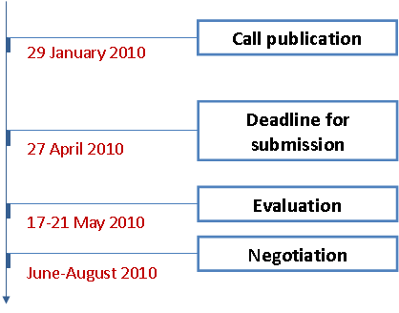
Figure 5. Timeline of the CS JU call 3 (SP1-JTI-CS-2010-01)
The total indicative budget of the call was set to € 16,588,000, of which the EU contribution could be up to € 12,441,000 (50-75% of the topic maximum budget indicated).

2.5.2. Analysis of proposals submitted
The call was published on 29 January 2010 and applicants were invited to submit their proposals by 27 April 2010. In total, 113 proposals were submitted in response to the 45 open topics addressed by the present call, involving applicants from 18 countries. 6 were found to be ineligible and the remaining 107 eligible proposals were evaluated by 95 independent experts.

2.5.3. Evaluation results
The on-site evaluation of the proposals took place in Brussels between 17 and 21 May 2010 following the methodology described in Section 2.3.1. It was preceded by individual remote evaluations. To ensure high degree of transparency, the CS JU invited one independent observer to verify if the evaluations have been done according to the set evaluation guidelines and rules. Out of the 107 eligible proposals, 70 passed the thresholds, while 37 failed one or more thresholds.
In terms of covered technological areas, similarly to the previous call launched by Clean Sky in 2009, the 2 topics in Eco-Design and all 12 topics in GRA were successful. The same applied to the only topic published in SAGE. As to GRC, 3 out of the 4 topics in this demonstrator resulted in a winning proposal. Topic GRC-04-002 failed, because all proposals were evaluated below threshold. Regarding SFWA and SGO, topics SFWA-01-007, SFWA-01-014 and SGO-05-015 did not attract any proposals in their domains, while the proposals submitted in SFWA-01-013 and SGO-02-014 could not pass the required thresholds.
Thus, after the evaluation, 40 projects could be finalised. To sum up, the 6 topics remaining vacant were the following:
- ITD: Green Rotorcraft; Area-04: Installation of diesel engines on light helicopters; Topic: Participation to the definition of optimal helicopter architecture for diesel engine;
- ITD: Smart Fixed Wing Aircraft; Area-01: Smart Wing Technology; Topic: In field surface inspection tool (for bonded repair);
- ITD: Smart Fixed Wing Aircraft; Area-01: Smart Wing Technology; Topic: Active Flow Control (AFC) techniques on trailing edge shroud for improved high lift configurations – design, manufacture and tests;
- ITD: Smart Fixed Wing Aircraft; Area-01: Smart Wing Technology; Topic: Manufacturing of the test set up for gust load alleviation in the Onera S3Ch WT facility;
- ITD: Systems for Green Operations; Area-02: Management of Aircraft Energy; Topic: Construction of evaluation Power Modules (10) to a given design;
- ITD: Systems for Green Operations; Area-02: Management of Aircraft Energy; Topic: Current return simulation (methodology & tool).
The 40 proposals proposed for funding accounted for 63 participations from 10 European countries. Of those, 23 (36.5%) came from academia and 10 (15.9%) were research institutions. The SME participation was 27% (17 companies were SMEs), requesting a total funding of € 3,235,968 (24% of the total requested funding).
The geographical distribution of the proposals selected for funding is shown in the graph below, Germany taking firmly the leading position with 13 proposals, followed by the UK, France and Italy:
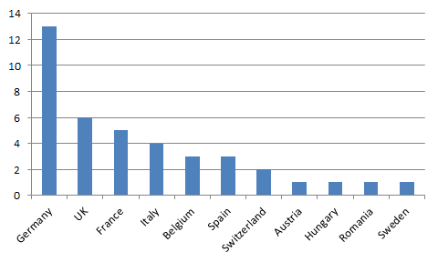
Figure 6. CS JU call 3 (SP1-JTI-CS-2010-01). Proposals selected for funding per country

2.5.4. Grant agreements signed
The negotiations of the 40 proposals proposed for funding in CS JU call 3 started in June-August 2010. Considering that the average time-to-grant for Clean Sky’s projects with partners in 2010 was on average 8.21 months, by the time of writing of the present document some of the projects were still under negotiation. In Table 5 below these projects are shown on positions 25-40 in italic.
As seen in the table, the total budget requested by the 40 proposals amounted to € 13,535,240.72, of which € 9,091,926.55 was the EU contribution. The total contribution under the GAPs signed by October 2011 – 24 contracts in total – equalled to € 8,283,319.72, of which the EU funding was € 5,526,556.00 and the in-kind contribution from industry amounting to € 2,756,763.72.
№ | Project number | Project acronym | Project title | CS JU contribution | In-kind contribution | Total contributions
1. | 270589 | CO-PROCLAM | COrrosion PROtective Coating on Light Alloys by Micro-arc oxidation | 291,675.00 | 107,545.00 | 399,220.00
2. | 270625 | MACOTECH | Design and manufacturing of smart composite panels  for wing applications and development of structural  health monitoring techniques | 89,955.00 | 29,985.00 | 119,940.00
3. | 268170 | RESMOD | Modification of Resin | 55,080.00 | 18,360.00 | 73,440.00
4. | 270586 | WINGTECH_EVALUATION | Wing box technology evaluation – trade-off study for the ranking of new technologies best fitting wing | 89,765.00 | 29.922.00 | 119,687.00
5. | 270593 | AWAHL | Advanced Wing And High-Lift Design | 319,544.00 | 130,456.00 | 450,000.00
6. | 270612 | E-CFD-GPU | Efficient CFD Multi-physics programming research | 112,500.00 | 37,500.00 | 150,000.00
7. | 270641 | DARGOS | Definition of ATM Requirements for GRA Operations and Simulations | 112,065.00 | 37,355.00 | 149,420.00
8. | 270629 | MORALI | Multi-Objective Robust Assessment of heLicopter Improvements | 275,880.00 | 123,960.00 | 399,840.00
9. | 270609 | CODE-TILT | Contribution to design optimization of tiltrotor components for drag reduction | 670,500.00 | 223,500.00 | 894,000.00
10. | 270563 | ADHERO | Aerodynamic Design Optimisation of a Helicopter Fuselage including a Rotating Rotor Head | 618,750.00 | 206,250.00 | 825,000.00
11. | 270571 | MISPA | Proposal for the Development of an Applicator for Microstructured Paint Coatings Resulting in Significant Drag Reduction of Treated Surfaces | 182,608.00 | 70,265.72 | 252,873.72
12. | 270535 | CLEANCOMPFIELD | Construction and Assembly of a Prototype Surface Pre-treatment Tool for In-filed use | 112,500.00 | 37,500.00 | 150,000.00
13. | 270669 | COMPARE | COMPArative evaluation of NDT techniques for high-quality bonded composite REpairs | 112,497.00 | 37,503.00 | 150,000.00
14. | 270539 | EASYPATCH | Prefabricated CFRP Parts | 112,050.00 | 37,350.00 | 149,400.00
15. | 270644 | CLEANLE | Concept Study of a cleaning device for wing leading edges | 29,955.00 | 9,985.00 | 39,940.00
16. | 270577 | MEMFAC | A Microfabricated Actuator for Active Flow Control on Aircraft | 94,988.00 | 94,988.00 | 189,976.00
17. | 270658 | STRAINWISE | Hardware & Software Development of Wireless Sensor Network Nodes for Measurement of Strain in Airborne Environment | 552,048.00 | 243,345.00 | 795,393.00
18. | 270597 | FLOWSENSYS | Flow sensor system for the separation detection at low speed in view of flight | 76,500.00 | 25,500.00 | 102,000.00
19. | 270526 | DT-FA-AFC | Development and Test of Fluidic Actuators for Active Flow Control Applications | 194,595.00 | 65,165.00 | 259,760.00
20. | 270588 | AFCIN | Structural designs and tests for integration of active flow control concepts on a trailing edge high lift device | 321,599.00 | 108,401.00 | 430,000.00
21. | 270601 | GBSSD(2) | Design & Manufacture of a ground based structural/systems demonstrator (Phase 2) | 249,807.00 | 249,808.00 | 499,615.00
22. | 270666 | ESCRITP | Electrical Simulation Criteria & Tool Performances | 100,000.00 | 100,000.00 | 200,000.00
23. | 270598 | ARCANGEL-ALPHA | Arcing and next generation electrical airplane power hazard abatement | 593,407.00 | 593,409.00 | 1,186,816.00
24. | 270624 | POTRA | Parametric optimisation software package for trajectory shaping under constraints | 158,288.00 | 138,711.00 | 296,999.00
Sub-Total (signed GAPs) |  |  |  | € 5,526,556 | € 2,756,764 | € 8,283,320
25. | 270583 | VEDISYS | Versatile and Eco-efficient Direct Drive Systems for Testing the Starters/Generators of Aircraft Engines | 484,363.00 | 161,457.00 | 645,820.00
26. | 270584 | ELTESTSYS | Electrical test bench drive systems: mechanical interfaces | 453,900.00 | 169,500.00 | 623,400.00
27. | 270590 | ROSA | Reliability Oriented Optimisation of Structural Replacement Strategies for Aircraft Structures | 112,470.00 | 37,490.00 | 149,960.00
28. | 270573 | EXPECT | Examination of Practical Aspects of Innovative Bonded Composite Repair Techniques | 56,250.00 | 18,750.00 | 75,000.00
29. | 270622 | CLEAN SKY FOUDRE | Advanced Lightning tests on a few material types for aviation | 56,500.00 | 56,500.00 | 113,000.00
30. | 270616 | COMPASS | Functional laminates development. Components compatibility and feasibility assessment. Industrialization | 149,997.00 | 50,000.00 | 199,997.00
31. | 270599 | BME CLEAN SKY 032 | Resin. Laminate and Industrial Nanoparticles Concept and Application. Industrialization | 134,999.00 | 45,001.00 | 180,000.00
32. | 270640 | MAWS | Modelling of Adaptive Wing Structures | 149,999.55 | 49,999.85 | 199,999.40
33. | 270596 | ORCA | Development of an optimized large scale engine CFRP annulus filler | 573,132.00 | 423,365.00 | 996,397.00
34. | 270647 | ICE-TRACK | Support of Icing Tests (Runback-Ice behaviour of surfaces) and Icing Mechanisms | 172,100.00 | 57,367.60 | 229,467.60
35. | 270587 | RIBLET ROBOTICS | Concept for automated riblet application (robot-concept) | 130,000.00 | 130,000.00 | 260,000.00
36. | 270574 | INDUCTOR | Induction based Curing Tool for Optimized heating of composite Repairs | 112,500.00 | 37,500.00 | 150,000.00
37. | 270531 | FLOCOSYS | Efficient System for Flow Control Actuation | 45,450.00 | 15,150.00 | 60,600.00
38. | 270660 | BANCHYDRO | Design and modify test bench to allow liquid-liquid heat exchanger engineering. Qualification and certification tests. Measure the thermal performance and pressure drop. | 373,875.00 | 124,625.00 | 498,500.00
39. | 270561 | TEMPO | Thermal Exchange Modelling and Power Optimization | 374,835.00 | 124,945.00 | 499,780.00
40. | 270591 | SIEDIT | Development of a Slat with Integrated Electrical Deicers for Icing Wind Tunnel Tests | 185,000.00 | 185,000.00 | 370,000.00
Sub-Total (Proposals in negotiation) |  |  |  | € 3,565,371 | € 1,686,550 | € 5,251,921
TOTAL |  |  |  | € 9,091,927 | € 4,443,314 | € 13,535,241
Table 5. Signed GAPs and proposals in negotiations in the CS JU call 3 (SP1-JTI-CS-2010-01)

2.6. Call 4 SP1-JTI-CS-2010-02

2.6.1. Summary information
The Clean Sky JU published its fourth call for proposals on 30 March 2010. The call was open for 4 topics grouped in two areas under one ITD – Smart Fixed Wing Aircraft (SFWA) as shown in the table below:
Identification | ITD-Area-Topic | Nr of topics | Indicative budget (K€) | Maximum funding (K€)
JTI-CS-SFWA | Clean Sky – Smart Fixed Wing Aircraft | 4 | 5,900 | 4,425
JTI-CS-SFWA-01 | Area01 – Smart Wing Technology | 2 | 1,400
JTI-CS-2010-2-SFWA-021 | MEMS accelerometer for wing behaviour measurement |  | 600
JTI-CS-2010-2-SFWA-022 | MEMS gyrometer for wing behaviour measurement |  | 800
JTI-CS-SFWA-03 | Area03 – Flight Demonstrators | 2 | 4,500
JTI-CS-2010-2-SFWA-03-002 | Starboard leading edge and upper cover design and manufacturing |  | 3,700
JTI-CS-2010-2-SFWA-03-003 | Krueger Flaps Design and Manufacture |  | 800
TOTAL |  | 4 | 5,900 | 4,425
Table 6. CS JU call 4 (SP1-JTI-CS-2010-02). Topics overview
The call process was managed by the Clean Sky JU, according to the principles of excellence, transparency, fairness and impartiality, confidentiality, efficiency, speed and ethical considerations.
The timing for the call is given on Figure 7 below:
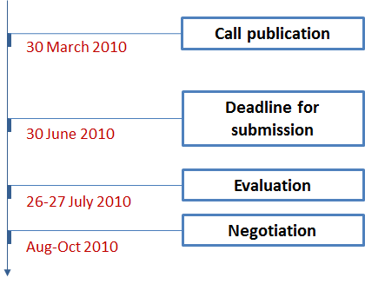
Figure 7. Timeline of the CS JU call 4 (SP1-JTI-CS-2010-02)
The total indicative budget of the call was set to € 5,900,000, of which the EU contribution could be up to € 4,425,000 (50-75% of the topic maximum budget indicated).

2.6.2. Analysis of proposals submitted
The call was published on 30 March 2010 and applicants were invited to submit their proposals by 30 June 2010. In total, 9 proposals were submitted in response to the 4 open topics addressed by the present call, involving applicants from 6 countries. None of them was found to be ineligible, and all 9 eligible proposals were evaluated by 8 independent experts.

2.6.3. Evaluation results
The individual remote evaluations of the proposals were carried out between 12 and 25 July 2010, followed by consensus meetings on the CS site in Brussels on 26-27 July 2010. To ensure high degree of transparency, the CS JU invited the same independent observer as in the previous call to verify if the evaluations have been done according to the set evaluation guidelines and rules. Out of the 9 eligible proposals, 7 passed the thresholds, while 2 failed one or more thresholds. After the evaluation, proposals were selected for negotiation covering all 4 topics.
The 4 proposals proposed for funding accounted for 4 participations from 4 different European countries – the UK, Belgium, Norway and Switzerland. Of those, all were private industrial companies – there were no participants coming from academia or research centres. The SME participation was 50%, requesting a total funding of € 1,400,000 (23.9% of the total requested funding).

2.6.4. Grant agreements signed
The negotiations of the 4 proposals proposed for funding in CS JU call 4 started in August-October 2010. Currently, all contracts are signed and one of the projects – "Wing Dynamics Acceleration Sensor" is already running.
As seen in Table 7 below, the total budget requested by the selected proposals amounted to € 5,859,840, of which € 3,279,920 was the EU contribution:
№ | Project nr | Project acronym | Project title | CS JU contribution | In-kind contribution | Total contributions
1. | 271492 | WINGACCS | Wing Dynamics Acceleration Sensor | 450,000.00 | 150,000.00 | 600,000.00
2. | 271494 | CS-GYRO | MEMS gyrometer for wing behaviour measurement | 600,000.00 | 200,000.00 | 800,000.00
3. | 271496 | DEAMAK | Design And Manufacture of Krueger Flaps | 379,920.00 | 379,920.00 | 759,840.00
4. | 271498 | NLFFD | NLF Starboard Leading Edge & Top cover design & manufacture | 1,850,000.00 | 1,850,000.00 | 3,700,000.00
TOTAL |  |  |  | € 3,279,920 | € 2,579,920 | € 5,859,840
Table 7. Signed GAPs in the CS JU call 4 (SP1-JTI-CS-2010-02)

2.7. Call 5 SP1-JTI-CS-2010-03

2.7.1. Summary information
The Clean Sky JU published its fifth call for proposals on 30 April 2010. The call was open for 34 topics covering activities within all ITDs without the Technology Evaluator (TE). The 34 open topics were grouped in 11 areas, further re-grouped under the six ITDs as shown in the table below:
Identification | ITD-Area-Topic | Nr of topics | Indicative budget (K€) | Maximum funding (K€)
JTI-CS-ECO | Clean Sky – Eco-Design | 4 | 740 | 555
JTI-CS-ECO-01 | Area-01 – EDA (Eco-Design for Airframe) | 4 | 740
JTI-CS-2010-3-ECO-01-004 | Development and implementation of Magnesium sheets in A/C |  | 70
JTI-CS-2010-3-ECO-01-005 | Integration development of a wireless strain monitoring system with a simulation tool |  | 250
JTI-CS-2010-3-ECO-01-006 | Enhanced local heating device capable of high and homogeneous temperature for the repair of large composite damages |  | 220
JTI-CS-2010-3-ECO-01-007 | Accelerated fatigue testing methodology for fibre reinforced laminates for aircraft structures |  | 200
JTI-CS-GRA | Clean Sky – Green Regional Aircraft | 4 | 840 | 630
JTI-CS-GRA-02 | Area-02 – Low noise configurations | 3 | 510
JTI-CS-2010-3-GRA-02-010 | Advanced concepts for trailing edge morphing wings: design and manufacturing of test rig and test samples and lest execution |  | 210
JTI-CS-2010-3-GRA-02-011 | LE based technology structure realisation |  | 150
JTI-CS-2010-3-GRA-02-012 | Aero-acoustic design and assessment of a low-noise configuration for a regional aircraft nose landing gear (NLG) |  | 150
JTI-CS-GRA-04 | Area-04 – Mission and Trajectory Management | 1 | 330
JTI-CS-2010-3-GRA-04-003 | Advanced avionics equipment simulation |  | 330
JTI-CS-GRC | Clean Sky – Green Rotorcraft | 1 | 430 | 322.5
JTI-CS-GRC-03 | Area-03 – Integration of innovative electrical systems | 1 | 430
JTI-CS-2010-3-GRC-03-003 | Piezo power supply module |  | 430
JTI-CS-SAGE | Clean Sky – Sustainable and Green Engines | 4 | 12,500 | 9,375
JTI-CS-SAGE-03 | Area-03 – Large 3-shaft turbofan | 1 | 10,000
JTI-CS-2010-3-SAGE-03-002 | Aeroengine intake technology development |  | 10,000
JTI-CS-SAGE-05 | Area-05 – Turboshaft | 3 | 2,500
JTI-CS-2010-3-SAGE-05-010 | Development of a Wasted Heat Regeneration System (WHRS) |  | 1,200
JTI-CS-2010-3-SAGE-05-011 | Development of exhaust noise attenuation technologies |  | 1,100
JTI-СЗ-2010-3-SАGЕ-05-012 | Development of an advanced system for pollutant measurement |  | 200
JTI-CS-SFWA | Clean Sky – Smart Fixed Wing Aircraft | 8 | 4,040 | 3,030
JTI-CS-SFWA-01 | Area-01 – Smart Wing Technology | 5 | 2,140
JTI-CS-2010-3-SFWA-01-023 | Design of Robust Shock-Control-Bumps for Transport Aircraft with Laminar-Flow Wings |  | 350
JTI-CS-2010-3-SFWA-01-024 | Flight-tests with multi-functional coatings |  | 150
JTI-CS-2010-3-SFWA-01-025 | Development of a closed loop flow control algorithm for wing trailing edge flow control including experimental validation |  | 560
JTI-CS-2010-3-SFWA-01-026 | Power module using Silicon Carbide technology for DC/DC converter application |  | 480
JTI-CS-2010-3-SFWA-01-027 | Deflection and structural health monitoring of composite wing movables driven by smart actuators |  | 600
JTI-CS-SFWA-02 | Area-02 – New Configuration | 3 | 1,900
JTI-CS-2010-3-SFWA-02-007 | Wind Tunnel Model Design for Low Speed Test with Active Flow Control |  | 250
JTI-CS-2010-3-SFWA-02-008 | Numerical and experimental aero-acoustic assessment of installed Counter Rotating Open Rotors (CROR) power plant |  | 200
JTI-CS-2010-3-SFWA-02-009 | Model design & manufacturing of the turbofan configuration for low speed aerodynamic and acoustic tests |  | 1,450
JTI-CS-SGO | Clean Sky – Systems for Green Operations | 13 | 7,250 | 5,437.5
JTI-CS-SGO-02 | Агеа-02 – Management of Aircraft Energy | 11 | 4,500
JTI-CS-2010-3-SGO-02-019 | Sample PEM construction for testing, characterisation and manufacturability assessment. |  | 500
JTI-CS-2010-3-SGO-02-020 | Development of key technology components for high performance electric motors |  | 250
JTI-CS-2010-3-SGO-02-021 | Development of key technology components for high power-density power converters for rotorcraft swashplate |  | 250
JTI-CS-2010-3-SGO-02-022 | Fan noise reduction: study and realisation of a sub-assembly dedicated to new generation of Starter / Generator |  | 200
JTI-CS-2010-3-SGO-02-023 | Development of current and voltage sensors suitable with aircraft environment |  | 600
JTI-CS-2010-3-SGO-02-024 | Test bench for endurance test and reliability of avionics power electronic modules |  | 800
JTI-CS-2010-3-SGO-02-025 | Definition and realisation of a field bus suitable for a multi-PEM (power electronic modules) resource |  | 500
JTI-CS-2010-3-SGO-02-026 | Modelica Model Library Development Part I |  | 300
JTI-CS-2010-3-SGO-02-027 | Simulation and Analysis Tool Development Part I |  | 400
JTI-CS-2010-3-SGO-02-028 | Support to design and test of cooling technologies |  | 350
JTI-CS-2010-3-SGO-02-029 | Tests of advanced lubrication equipment |  | 350
JTI-CS-SGO-03 | Area-03 – Management of Trajectory and Mission | 1 | 750
JTI-CS-2010-3-SGO-03-008 | Modelling of weather phenomena to support Advanced Weather Radar development |  | 750
JTI-CS-SGO-04 | Aгеа-04 – Aircraft Demonstrators | 1 | 2,000
JTI-CS-2010-3-SGO-04-001 | Design and manufacture of an aircraft tractor compliant with specifications for Smart Operations on ground |  | 2,000
TOTAL |  | 34 | 25,800 | 19,350
Table 8. CS JU call 5 (SP1-JTI-CS-2010-03). Topics overview
The call process was managed by the Clean Sky JU, according to the principles of excellence, transparency, fairness and impartiality, confidentiality, efficiency, speed and ethical considerations.
The timing for the call is given on Figure 8 below:
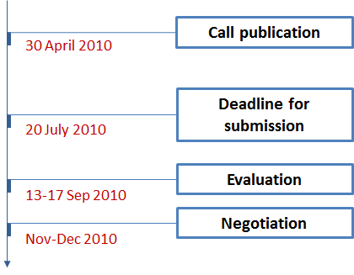
Figure 8. Timeline of the CS JU call 5 (SP1-JTI-CS-2010-03)
The total indicative budget of the call was set to € 25,800,000, of which the EU contribution could be up to € 19,350,000 (50-75% of the topic maximum budget indicated).

2.7.2. Analysis of proposals submitted
The call was published on 30 April 2010 and applicants were invited to submit their proposals by 20 July 2010. In total, 91 proposals were submitted in response to the 34 open topics addressed by the present call, involving applicants from 14 countries. 10 were found to be ineligible and the remaining 81 eligible proposals were evaluated by 89 independent experts.

2.7.3. Evaluation results
The on-site evaluation of the proposals took place in Brussels between 13 and 17 September 2010 following the methodology described in Section 2.3.1. It was preceded by individual remote evaluations. To ensure high degree of transparency, the CS JU invited one independent observer to verify if the evaluations have been done according to the set evaluation guidelines and rules. The 81 eligible proposals have been evaluated by a total of 89 technical independent experts, of which 33 external and 56 internal experts, representing 18 different nations. 48 proposals passed the thresholds, while 33 failed one or more thresholds.
In terms of covered technological areas, the 4 topics in Eco-Design and the only topic in GRC were successful. As to GRA, 3 out of the 4 topics in this demonstrator resulted in a winning proposal. Topic GRA-02-010 failed, because all proposals were evaluated below threshold. Regarding SAGE and SGO, topics SAGE-03-002, SGO-02-027 and SGO-04-001 did not attract any proposals in their domains, while the proposals submitted in SAGE-05-011, SGO SGO-02-026 and SGO-02-028 could not pass the required thresholds.
Thus, after the evaluation, 26 projects could be finalised. To sum up, the 7 topics remaining vacant were the following:
- ITD: Green Regional Aircraft; Area-02: Low noise configurations; Topic: Advanced concepts for trailing edge morphing wings: design and manufacturing of test rig and test samples and lest execution;
- ITD: Sustainable and Green Engines; Area-03: Large 3-shaft turbofan; Topic: Aeroengine intake technology development;
- ITD: Sustainable and Green Engines; Area-05: Turboshaft; Topic: Development of exhaust noise attenuation technologies;
- ITD: Systems for Green Operations; Area-02: Management of Aircraft Energy; Topic: Development of key technology components for high power-density power converters for rotorcraft swashplate;
- ITD: Systems for Green Operations; Area-02: Management of Aircraft Energy; Topic: Modelica Model Library Development Part I;
- ITD: Systems for Green Operations; Area-02: Management of Aircraft Energy; Topic: Simulation and Analysis Tool Development Part I;
- ITD: Systems for Green Operations; Area-02: Management of Aircraft Energy; Topic: Support to design and test of cooling technologies;
- ITD: Systems for Green Operations; Area-04: Aircraft Demonstrators; Topic: Design and manufacture of an aircraft tractor compliant with specifications for Smart Operations on ground.
The 26 proposals proposed for funding accounted for 48 participations from 11 countries. Of those, 23 (36.5%) came from academia and 10 (15.9%) were research institutions. The SME participation was 47.9% (23 companies were SMEs), requesting a total funding of € 5,611,076 (51.4% of the total requested funding).
The geographical distribution of the proposals selected for funding is shown in the graph below, the UK taking on the lead with 5 winning proposals, followed by France (4 proposals), Belgium and Germany (3 proposals each):
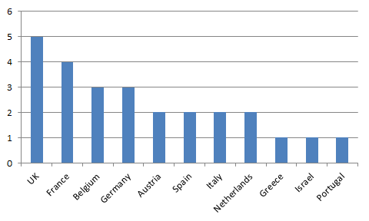
Figure 9. CS JU call 5 (SP1-JTI-CS-2010-03). Proposals selected for funding per country

2.7.4. Grant agreements signed
The negotiations of the 26 proposals proposed for funding in CS JU call 5 started in November-December 2010. Considering that the average time-to-grant for Clean Sky’s projects with partners in 2010 was on average 8.21 months, by the time of writing of the present document some of the projects were still under negotiation. In Table 9 below these projects are shown on positions 14-26 in italic.
As seen in the table, the total budget requested by the 26 proposals amounted to € 10,907,844.60, of which € 7,570,509.65 was the EU contribution. The total contribution under the GAPs signed by October 2011 – 13 contracts in total – equalled to € 5,559,856.60, of which the EU funding was € 3,939,931.65 and the in-kind contribution from industry amounting to € 1,619,924.95.
№ | Project number | Project acronym | Project title | CS JU contribution | In-kind contribution | Total contributions
1. | 271858 | DIMAG | Development and Implementation of Magnesium sheets in A/C | 52,500.00 | 17,500.00 | 70,000.00
2. | 271874 | WISMOS | Wireless/Integrated Strain Monitoring and Simulation System | 183,125.00 | 66,835.00 | 249,960.00
3. | 271691 | ADVANCED | Advanced heating system and control mode for homogeneous high temperature curing of large composite repairs | 165,000.00 | 55,000.00 | 220,000.00
4. | 271882 | FATIMA | Fatigue testing of CFRP materials | 149,995.00 | 49,999.00 | 199,994.00
5. | 271881 | ADAVES | Advanced avionics equipment simulation | 185,000.00 | 145,120.40 | 330,120.40
6. | 271880 | WHEXPERS | Study and manufacturing of a Wasted Heat Exchanger and a hot air Piston Engine Recuperation System | 899,985.75 | 299,995.25 | 1,199,981.00
7. | 271829 | NURMSYS | Original design & manufacturing of a New Upstream Rotating Measurement System for gas turbine exhaust gases studies | 144,210.00 | 58,070.00 | 202,280.00
8. | 271843 | NEXTWING | Numerical and EXperimental shock conTrol on laminar Wing | 262,274.40 | 87,424.80 | 349,699.20
9. | 271838 | LH-LHT-RFT | Flight-tests with multi-functional coatings | 58,350.00 | 58,350.00 | 116,700.00
10. | 271753 | VOCAL-FAN | Virtual optimization CFD platform allowing fan noise reduction | 149,335.00 | 49,780.00 | 199,115.00
11. | 271875 | AERTECVTI | Test bench for endurance test and reliability prediction of avionics power electronic modules | 564,900.00 | 188,300.00 | 753,200.00
12. | 271813 | SAFEPEM | SAfe Fieldbus dEvelopment for Power Electronic Module | 357,100.00 | 140,000.00 | 497,100.00
13. | 271847 | CLEOPATRA | CLEaner OPerations Attained Through Radars' Advance | 447,644.00 | 296,713.00 | 744,357.00
Sub-Total (signed GAPs) |  |  |  | € 3,619,419 | € 1,513,087 | € 5,132,507
14. | 271861 | LEATOP | Leading Edge Actuation Topology Design and Demonstration | 106,676.00 | 43,059.00 | 149,735.00
15. | 271886 | NOISETTE | Landing Gear Noise Attenuation | 114,643.00 | 34,907.00 | 149,550.00
16. | 271872 | PPSMPAB | Piezo Power Supply Module for Piezo Actuator Bench | 320,512.50 | 106,837.50 | 427,350.00
17. | 271866 | CLFCWTE | Development of a Closed Loop Flow Control Algorithm for Wing Trailing Edge Flow Control Including Experimental Validation in Two Low Speed Wind Tunnel Tests | 411,218.00 | 137,073.00 | 548,291.00
18. | 271855 | ROSIC | Robust Silicon-Carbide Technology for Aerospace DC-DC Conversion | 303,426.00 | 175,883.00 | 479,309.00
19. | 271853 | FOS3D | Fibre Optic System for Deflection and Damage Detection | 448,670.00 | 149,556.00 | 598,226.00
20. | 271784 | DEAFCON | Wind Tunnel Model Design with Active Flow Control, for Low Speed Test | 164,250.00 | 54,750.00 | 219,000.00
21. | 271765 | NAA-CROR | Numerical aero-acoustic assessment of installed Counter Rotating Open Rotor (CROR) power plant | 150,000.00 | 50,000.00 | 200,000.00
22. | 271815 | LOSPA | Model Design and Manufacturing of the Turbofan Configuration for Low Speed Aerodynamic and Acoustic Testing | 978,754.00 | 326,252.00 | 1,305,006.00
23. | 271788 | PEMREL | Sample power electronic module construction for testing, characterisation and manufacturability assessment | 337,141.00 | 162,430.00 | 499,571.00
24. | 271850 | HPEM | Development of key technology components for high performance electric  motors | 187,050.00 | 62,350.00 | 249,400.00
25. | 271816 | NEELEFFECT INTHESKY | Magnetic Sensors with No Remanence for Aircraft Application | 428,750.00 | 171,250.00 | 600,000.00
26. | 271867 | LUBSEP | Test of advanced lubrication equipment | --- | --- | 349,900.00
Sub-Total (Proposals in negotiation) |  |  |  | € 3,951,091 | € 1,474,348 | € 5,775,338
TOTAL |  |  |  | € 7,570,510 | € 2,987,435 | € 10,907,845
Table 9. Signed GAPs and proposals in negotiations in the CS JU call 5 (SP1-JTI-CS-2010-03)

2.8. Call 6 SP1-JTI-CS-2010-04

2.8.1. Summary information
The Clean Sky JU published its sixth call for proposals on 27 July 2010. The call was open for 29 topics covering activities within all ITDs without the Technology Evaluator (TE). The 29 open topics were grouped in 13 areas, further re-grouped under the six ITDs as shown in the table below:
Identification | ITD-Area-Topic | Nr of topics | Indicative budget (K€) | Maximum funding (K€)
JTI-CS-ECO | Clean Sky – Eco-Design | 3 | 2,200 | 1,650
JTI-CS-ECO-01 | Аrеa-01 – EDA (Eco-Design for Airframe) | 2 | 500
JTI-CS-2010-4-ECO-01-008 | Development of thermoplastic polymer blend with low melting point and properties close to PEEK ones |  | 200
JTI-CS-2010-4-ECO-01-009 | Moisture aging of composites – Time-Temperature – Moisture superposition principle – Hydric fatigue |  | 300
JTI-СS-EСО-02 | Area-02 – EDS (Eco-Design for Systems) | 1 | 1,700
JTI-CS-2010-4-ECO-02-005 | Development, Construction and Integration of Systems for Ground Thermal Test Bench |  | 1,700
JTI-CS-GRA | Clean Sky – Green Regional Aircraft | 4 | 2,650 | 1,987.5
JTI-CS-GRA-02 | Area-02 – Low noise configurations | 1 | 150
JTI-CS-2010-4-GRΑ-02-013 | Novel nose wheel evolution for noise reduction |  | 150
JTI-CS-GRA-03 | Аrеа-03 – All electric aircraft | 2 | 500
JTI-CS-2010-4-GRA-03-002 | Energy Management – Electrical motors power control. Analytical studies and modelling |  | 350
JTI-CS-2010-4-GRA-03-003 | Development of Numerical Models of Aircraft Systems to be used within the JTI/GRA Shared Simulation Environment |  | 150
JTI-CS-GRA-05 | Area-05 – New configurations | 1 | 2,000
JTI-CS-2010-4-GRA-05-005 | Aero-acoustic noise emissions measure for advanced Regional Open Rotor A/C configuration |  | 2,000
JTI-CS-GRC | Clean Sky – Green Rotorcraft | 3 | 1,165 | 873.75
JTI-CS-GRC-01 | Area-01 – Innovative Rotor Blades | 1 | 575
JTI-CS-2010-4-GRC-01-005 | Gurney flap actuator and mechanism for a full scale helicopter rotor blade |  | 575
JTI-CS-GRC-02 | Area-02 – Reduced drag of rotorcraft | 2 | 590
JTI-CS-2010-4-GRC-02-003 | Contribution to optimisation of heavy helicopter engine installation design |  | 440
JTI-CS-2010-4-GRC-02-006 | Helicopter hub and fuselage drag investigation by means of hybrid URANS/LES methods |  | 150
JTI-CS-SAGE | Clean Sky – Sustainable and Green Engines | 10 | 7,950 | 5,962.5
JTI-CS-SAGE-03 | Area-03 – Large 3-shaft turbofan | 4 | 3,800
JTI-CS-2010-4-SAGE-03-003 | High Efficiency Fuel Pumping |  | 1,500
JTI-CS-2010-4-SAGE-03-004 | Fuel Control System Sensors and Effectors |  | 1,300
JTI-CS-2010-4-SAGE-03-005 | High Temperature Electronics |  | 1,500
JTI-CS-2010-4-SAGE-03-006 | Ring Rolling of IN718 |  | 1,000
JTI-CS-SAGE-04 | Area-04 – Geared Turbofan | 6 | 4,150
JTI-CS-2010-4-SAGE-04-001 | Development of low cost near conventional hot die forging process for gamma-TiAl low pressure turbine blades |  | 650
JTI-CS-2010-4-SAGE-04-002 | Development of near net shape isothermal forging process for gamma-TiAl low pressure turbine blades |  | 600
JTI-CS-2010-4-SAGE-04-003 | Development and validation of an integrated methodology to establish future production concepts |  | 1,000
JTI-CS-2010-4-SAGE-04-004 | Development of low cost casting process for gamma-TiAl billets |  | 550
JTI-CS-2010-4-SAGE-04-005 | Development & Manufacture of High Temperature Carbon Fibre Reinforced Plastic (CFRP) Aero engine Parts for Continuous Use at Temperatures above 350 ºC |  | 850
JTI-CS-2010-4-SAGE-04-006 | Machining of highly stressed components; Development of Precise Electrochemical Machining (PECM) Simulation |  | 500
JTI-CS-SFWA | Clean Sky – Smart Fixed Wing Aircraft | 5 | 2,105 | 1,578.75
JTI-CS-SFWA-01 | Area-01 – Smart Wing Technology | 3 | 1,455
JTI-CS-2010-4-SFWA-01-013 | Active Flow Control (AFC) techniques on trailing edge shroud for improved high lift configurations – design, manufacture and tests |  | 460
JTI-CS-2010-4-SFWA-01-028 | Structural tests on smart droop nose device with regards to aircraft level |  | 745
JTI·CS-2010-4-SFWA-01-029 | Development, design and manufacture and test of AFC actuator controller with industrial purposes and certification issues |  | 250
JTI-CS-SFWA-02 | Area-02 – New Configuration | 2 | 650
JTI-CS-2010-4-SFWA-02-010 | Innovative shield design and manufacturing |  | 250
JTI-CS-2010-4-SFWA-02-011 | Impact test campaign |  | 400
JTI-CS-SGO | Clean Sky – Systems for Green Operations | 4 | 2,750 | 2,062.5
JTI-CS-SGO-02 | Area-02 – Management of Aircraft Energy | 2 | 2,250
JTI-C3-2010-4-SGO-02-014 | Construction of evaluation Power Modules (10) to a given design |  | 250
JTI-CS-2010-4-SGO-02-030 | Test rig for endurance and reliability trials applied on TRL growth of high power Starter / Generators |  | 2,000
JTI-CS-SGO-03 | Area-03 – Management of Trajectory and Mission | 2 | 500
JTI-CS-2010-4-SGO-03-009 | Propfan equipped aircraft noise model |  | 350
JTI-CS-2010-4-SGO-03-010 | High speed numerical integration techniques for precise prediction |  | 150
TOTAL |  | 29 | 18,820 | 14,115
Table 10. CS JU call 6 (SP1-JTI-CS-2010-04). Topics overview
The call process was managed by the Clean Sky JU, according to the principles of excellence, transparency, fairness and impartiality, confidentiality, efficiency, speed and ethical considerations.
The timing for the call is given on Figure 10 below:
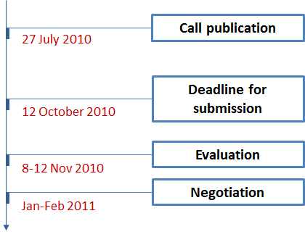
Figure 10. Timeline of the CS JU call 6 (SP1-JTI-CS-2010-04)
The total indicative budget of the call was set to € 18,820,000, of which the EU contribution could be up to € 14,115,000 (50-75% of the topic maximum budget indicated).

2.8.2. Analysis of proposals submitted
The call was published on 27 July 2010 and applicants were invited to submit their proposals by 12 October 2010. In total, 68 proposals involving applicants from 12 countries were received. Out of those 68 proposals, 64 were considered eligible for evaluation.

2.8.3. Evaluation results
The on-site evaluation of the proposals took place in Brussels between 8 and 12 November 2010 following the methodology described in Section 2.3.1. It was preceded by individual remote evaluations. To ensure high degree of transparency, the CS JU invited the same independent observer as in the fifth call to verify if the evaluations have been done according to the set evaluation guidelines and rules. Out of the 64 proposals, 40 passed the thresholds, while 24 failed one or more thresholds.
In terms of covered technological areas, the 3 topics in GRC and all 10 topics in SAGE were successful. As to Eco-Design, 2 out of the 3 topics in this demonstrator resulted in a winning proposal. Topic ECO-02-005 failed, because the only proposal received was evaluated below threshold. Regarding GRA, SFWA and SGO, topics GRA-02-013, SFWA-01-028 and SFWA-02-010 did not attract any proposals in their domains, while the proposals submitted in SGO-02-014 could not pass the set thresholds.
Thus, after the evaluation, 24 projects could be finalised. To sum up, the 5 topics remaining vacant were the following:
- ITD: Eco-Design; Area-02: EDS (Eco-Design for Systems); Topic: Development, Construction and Integration of Systems for Ground Thermal Test Bench;
- ITD: Green Regional Aircraft; Area-02: Low noise configurations; Topic: Novel nose wheel evolution for noise reduction;
- ITD: Smart Fixed Wing Aircraft; Area-01: Smart Wing Technology; Topic: Structural tests on smart droop nose device with regards to aircraft level;
- ITD: Smart Fixed Wing Aircraft; Area-02: New Configuration; Topic: Innovative shield design and manufacturing;
- ITD: Systems for Green Operations; Area-02: Management of Aircraft Energy; Topic: Construction of evaluation Power Modules (10) to a given design.
The 24 proposals proposed for funding accounted for 54 participations from 9 European countries. Of those, 15 (27.8%) participants came from academia and 9 (16.7%) were research institutions. The SME participation was 25.9% (14 companies), requesting a total funding of € 3,637,485 (21.8% of the total requested funding).
The geographical distribution of the proposals selected for funding is shown in the graph below, the UK and Germany being on the lead with 8 and 7 winning proposals respectively, followed by Spain (3 proposals):
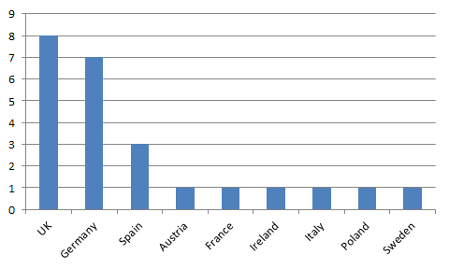
Figure 11. CS JU call 6 (SP1-JTI-CS-2010-04). Proposals selected for funding per country

2.8.4. Grant agreements signed
The negotiations of the 24 proposals proposed for funding in CS JU call 6 started in January-February 2011. Considering that the average time-to-grant for Clean Sky’s projects with partners in 2010 was on average 8.21 months, by the time of writing of the present document the majority of the projects were still under negotiation. In Table 11 below these projects are shown on positions 8-24 in italic.
As seen in the table, the total budget requested by the 24 proposals amounted to € 16,710,420.40, of which € 10,712,291.30 was the EU contribution. The total contribution under the GAPs signed by October 2011 – 7 contracts in total – equalled to € 4,509,931.60, of which the EU funding was € 3,168,047.30 and the in-kind contribution from industry amounting to € 1,341,884.30.
№ | Project number | Project acronym | Project title | CS JU contribution | In-kind contribution | Total contributions
1. | 278144 | SUPERBLEND | Development of Thermoplastic Polymer blend with Low Melting Point and with Similar Properties than PEEK | 149,628.00 | 49,876.00 | 199,504.00
2. | 277796 | E-BIRD | Development of numerical models of aircraft systems to be used within the JTI/GRA Shared Simulation Environment | 112,500.00 | 37,500.00 | 150,000.00
3. | 278419 | WENEMOR | Wind tunnel tests for the evaluation of the installation effects of noise emissions of an open rotor advanced regional aircraft | 1,374,993.00 | 578,334.20 | 1,953,327.20
4. | 278393 | PT656 | Gurney flap actuator and mechanism for a full scale helicopter rotor blade | 371,063.00 | 289,553.00 | 660,616.00
5. | 278416 | HEAVYCOPTER | Contribution to optimisation of heavy helicopter engine installation design | 329,400.00 | 109,800.00 | 439,200.00
6. | 278415 | HELIDES | Helicopter Drag Prediction using Detached-Eddy Simulation | 110,463.30 | 36,821.10 | 147,284.40
7. | 277927 | IMAPC | Development and validation of an integrated methodology in order to establish adapted production concepts for efficient turbofan engines | 720,000.00 | 240,000.00 | 960,000.00
Sub-Total (signed GAPs) |  |  |  | € 3,168,047 | € 1,341,884 | € 4,509,931
8. | 278156 | CF-THREAD | Composites under Fatigue: Temperature and Humidity Related Environmental Ageing Damage | 224,749.00 | 74,914.00 | 299,663.00
9. | 278407 | SIMEAD | Suite of integrated models for electrical aircraft drives | 261,453.00 | 87,150.00 | 348,603.00
10. | 278228 | ADEPT | High Efficiency Fuel Pumping | 711,608.00 | 711,607.00 | 1,423,215.00
11. | 278366 | CASE | Fuel Control System Sensors and Effectors | 655,991.00 | 579,189.00 | 1,235,180.00
12. | 278365 | HITME | High Temperature Electronics | 901,200.00 | 584,890.40 | 1,486,090.40
13. | 278288 | CORR | Introduction of contoured ring rolled parts for critical rotative aero engine applications | 520,013.00 | 423,903.00 | 943,916.00
14. | 278084 | DAFNE | Development of gamma-TiAl forgings in a low-cost near conventional hot-die process and process evaluation | 326,250.00 | 313,650.00 | 639,900.00
15. | 278438 | HI-POTENTIAL | Highly Innovative Isothermal Forging of Gamma-TiAl Alloy for LPT blades | 284,408.00 | 284,409.00 | 568,817.00
16. | 277741 | DATACAST | Development of a low cost Advanced gamma Titanium Aluminide Casting Technology | 323,000.00 | 227,000.00 | 550,000.00
17. | 278483 | HICOMP | Development and Manufacture of High Temperature Composite Aero Engine Parts | 376,555.00 | 376,557.00 | 753,112.00
18. | 278302 | SUPREME | Simulation tool for precise electrochemical machining of aircraft engine components | 361,817.00 | 120,605.00 | 482,422.00
19. | 277975 | ATTESI | Active Flow Control Technique on Trailing Edge Shroud for Improved High Lift Configurations | 344,834.00 | 114,946.60 | 459,780.60
20. | 278268 | ESTERA | Multi-level Embedded Closed-Loop Control System for Fluidic Active Flow Control Actuation Applied in High-Lift and High-Speed Aircraft Operations | 187,470.00 | 62,490.00 | 249,960.00
21. | 278368 | IMPTEST | Impact test campaign | 285,467.00 | 95,155.00 | 380,622.00
22. | 277861 | VEGETEBLE | Test rig for endurance and reliability trials applied on TRL growth of high power Starter / Generators | 1,419,935.00 | 479,945.00 | 1,899,880.00
23. | 277580 | FLIGHT-NOISE-II | Turboprop and Propfan-Equipped Aircraft Noise Emission Model | 247,179.00 | 82,393.00 | 329,572.00
24. | 278170 | NEURAL | Neural network computation for fast trajectory prediction | 112,316.00 | 37,439.00 | 149,755.00
Sub-Total (Proposals in negotiation) |  |  |  | € 7,544,244 | € 4,656,245 | € 12,200,489
TOTAL |  |  |  | € 10,712,291 | € 5,998,129 | € 16,710,420
Table 11. Signed GAPs and proposals in negotiations in the CS JU call 6 (SP1-JTI-CS-2010-04)

2.9. Call 7 SP1-JTI-CS-2010-05

2.9.1. Summary information
The Clean Sky JU published its seventh call for proposals on 24 September 2010. The call was open for 38 topics covering activities within all ITDs without the Technology Evaluator (TE). The 38 open topics were grouped in 15 areas, further re-grouped under the six ITDs as shown in the table below:
Identification | ITD-Area-Topic | Nr of topics | Indicative budget (K€) | Maximum funding (K€)
JTI-CS-ECO | Clean Sky – Eco-Design | 11 | 5,230 | 3,922.5
JTI-CS-ECO-01 | Area-01 – EDA (Eco-Design for Airframe) | 9 | 3,030
JTI-CS-2010-5-ECO-01-010 | Study of cyanate ester based composites in a high service temperature environment |  | 400
JTI-CS-2010-5-ECO-01-011 | Bicarbonate media blasting for paint-varnish removal and dry surface treatment |  | 300
JTI-CS-2010-5-ECO-01-012 | Development of more eco-efficient aluminium alloys for aircraft structures |  | 500
JTI-CS-2010-5-ECO-01-013 | Development and implementation of conductive coating for Magnesium sheets in A/C |  | 160
JTI-CS-2010-5-ECO-01-014 | Infusion system development for primary structure |  | 200
JTI-CS-2010-5-ECO-01-015 | Development of advanced preforms for LCM technologies |  | 250
JTI-CS-2010-5-ECO-01-016 | Surface mapping to improve reliability of dry treatment on metallic and organic surfaces |  | 250
JTI-CS-2010-5-ECO-01-017 | Production of yarns and fabrics based on recycled carbon fibres (CFs) |  | 250
JTI-CS-2010-5-ECO-01-018 | Environmental Data Models and Interface development |  | 720
JTI-CS-ECO-02 | Area-02 – EDS (Eco-Design for Systems) | 2 | 2,200
JTI-CS-2010-5-ECO-02-006 | Electrical Test Bench Power Center |  | 700
JTI-CS-2010-5-ECO-02-007 | Electrical Test Bench Control System, Instrumentation and Cabling |  | 1,500
JTI-CS-GRA | Clean Sky – Green Regional Aircraft | 2 | 620 | 465
JTI-CS-GRA-01 | Area-01 – Low weight configurations | 1 | 170
JTI-CS-2010-5-GRA-01-034 | Design, manufacturing and impact test on selected panels with advanced composite material |  | 170
JTI-CS-GRA-02 | Area-02 – Low noise configurations | 1 | 450
JTI-CS-2010-5-GRA-02-014 | Wing loads control/alleviation system design for advanced regional Turbo-Fan A/C configuration |  | 450
JTI-CS-GRC | Clean Sky - Green Rotorcraft | 7 | 11,580 | 8,685
JTI-CS-GRC-03 | Area-03 – Integration of innovative electrical systems | 2 | 930
JTI-CS-2010-5-GRC-03-004 | Innovative management of energy recovery for reduction of electrical power consumption on fuel consumption |  | 500
JTI-CS-2010-5-GRC-03-005 | Adaptation kit design & manufacturing: APU Driving System |  | 430
JTI-CS-GRC-04 | Area-04 – Installation of diesel engines on light helicopters | 2 | 9,950
JTI-CS-2010-5-GRC-04-003 | Optimised Diesel engine design matching a new light helicopter architecture |  | 650
JTI-CS-2010-5-GRC-04-004 | Diesel Power-pack Integration on a light helicopter demonstrator |  | 9,300
JTI-CS-GRC-05 | Area-05 – Environmentally friendly flight paths | 1 | 300
JTI-CS-2010-5-GRC-05-004 | Tuning of simplified rotorcraft noise models, preliminary acoustic measurement test campaign |  | 300
JTI-CS-GRC-06 | Area-06 – Eco-Design for Rotorcraft | 2 | 400
JTI-CS-2010-5-GRC-06-001 | Manufacturing of a Thermoplastic Composite Feasibility Article for a Helicopter Door |  | 200
JTI-CS-2010-5-GRC-06-002 | Manufacturing of thermoplastic structural demonstrators |  | 200
JTI-CS-SAGE | Clean Sky – Sustainable and Green Engines | 4 | 5,400 | 4,050
JTI-CS-SAGE-03 | Area-03 – Large 3-shaft turbofan | 2 | 2,600
JTI-CS-2010-5-SAGE-03-007 | Large 3-shaft Demonstrator – Core Turbomachinery – High Temperature Flexible PCB |  | 600
JTI-CS-2010-5-SAGE-03-008 | Large 3-shaft Demonstrator – Structural Surface Cooler development |  | 2,000
JTI-CS-SAGE-04 | Area-04 – Geared Turbofan | 2 | 2,800
JTI-CS-2010-5-SAGE-04-002 | Development of Innovative SLM-Machinery for High Temperature Aero Engine Applications |  | 1,800
JTI-CS-2010-5-SAGE-04-007 | Development of Selective Laser Melting (SLM) Simulation tool for Aero Engine applications |  | 1,000
JTI-CS-SFWA | Clean Sky - Smart Fixed Wing Aircraft | 8 | 3,999 | 2,999.25
JTI-CS-SFWA-01 | Area-01 – Smart Wing Technology | 6 | 1,842
JTI-CS-2010-5-SFWA-01-007 | In field surface inspection tool for contamination detection before bonded composite repair |  | 250
JTI-CS-2010-5-SFWA-01-014 | Final design and manufacturing of a test set up for the investigation of gust load alleviation |  | 400
JTI-CS-2010-5-SFWA-01-030 | Quantification of the degradation of microstructured coatings |  | 200
JTI-CS-2010-5-SFWA-01-031 | Assessment of the interaction of a passive and an active load alleviation scheme for a transport aircraft |  | 200
JTI-CS-2010-5-SFWA-01-032 | Technology evaluation and manufacturing of microtechnology-based Active Flow Control actuators |  | 300
JTI-CS-2010-5-SFWA-01-033 | Numerical Simulation of the Assembly Tolerances for NLF Wings |  | 492
JTI-CS-SFWA-03 | Area-03 – Flight Demonstrators | 2 | 2,157
JTI-CS-2010-5-SFWA-03-004 | A340 Outer Wing Metrology |  | 1,457
JTI-CS-2010-5-SFWA-03-005 | Surface quality measurement in flight |  | 700
JTI-CS-SGO | Clean Sky – Systems for Green Operations | 6 | 3,700 | 2,775
JTI-CS-SGO-02 | Area-02 – Management of Aircraft Energy | 2 | 550
JTI-CS-2010-5-SGO-02-027 | Simulation and Analysis Tool Development Part I |  | 400
JTI-CS-2010-5-SGO-02-031 | Qualification of insulation materials to engine oils |  | 150
JTI-CS-SGO-03 | Area-03 – Management of Trajectory and Mission | 3 | 1,150
JTI-CS-2010-5-SGO-03-011 | Recruitment of qualified flight crew (test, airline) and expenses for tests |  | 250
JTI-CS-2010-5-SGO-03-012 | SOG Wheel Actuator development for existing aircraft |  | 650
JTI-CS-2010-5-SGO-03-013 | Economic analysis according to business jets operators profile |  | 250
JTI-CS-SGO-04 | Area-04 – Aircraft Demonstrators | 1 | 2,000
JTI-CS-2010-5-SGO-04-001 | Design and manufacture of an aircraft tractor compliant with specifications for Smart Operations on ground |  | 2,000
TOTAL |  | 38 | 30,529 | 22,897
Table 12. CS JU call 7 (SP1-JTI-CS-2010-05). Topics overview
The call process was managed by the Clean Sky JU, according to the principles of excellence, transparency, fairness and impartiality, confidentiality, efficiency, speed and ethical considerations.
The timing for the call is given on Figure 12 below:
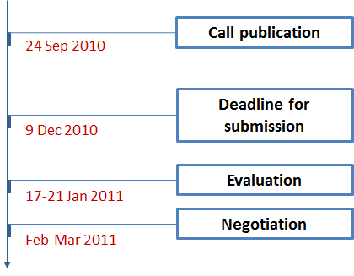
Figure 12. Timeline of the CS JU call 7 (SP1-JTI-CS-2010-05)
The total indicative budget of the call was set to € 30,529,000, of which the EU contribution could be up to € 22,896,750 (50-75% of the topic maximum budget indicated).

2.9.2. Analysis of proposals submitted
The call was published on 24 September 2010 and applicants were invited to submit their proposals by 9 December 2010. In total, 71 proposals involving applicants from 17 countries were received. Out of those 71 proposals, 67 were considered eligible for evaluation.

2.9.3. Evaluation results
The on-site evaluation of the proposals took place in Brussels between 17 and 21 January 2011 following the methodology described in Section 2.3.1. It was preceded by individual remote evaluations. To ensure high degree of transparency, the CS JU invited one independent observer to verify if the evaluations have been done according to the set evaluation guidelines and rules. Clean Sky started the negotiation of the successful projects in February-March 2011. The grant agreements signature of the selected 29 proposals and the payment of pre-financing were expected to be concluded by the first quarter of 2012.
Taking into consideration this timeline, the Commission shall present the results of the Clean Sky JU's seventh call for proposals in its next year's report on the progress achieved by the JTI JUs.

3. Progress achieved by the Innovative Medicines Initiative (IMI) JU

3.1. About the IMI JU
The Innovative Medicines Initiative Joint Undertaking (hereinafter referred to as "IMI JU") has been established by Council Regulation (EC) 73/2008 of 20 December 2007 as a public-private partnership between the pharmaceutical industry, represented by the European Federation of Pharmaceutical Industries and Associations (EFPIA), and the European Union, represented by the European Commission.
The IMI JU has been set up for a period up to 31 December 2017 with the main objectives to build a collaborative eco-system for pharmaceutical R&D in Europe and to speed up the development of more effective and safer medicines for patients. In achieving this, IMI creates large-scale networks of innovation in pharmaceutical research. Joining forces in the IMI research and training projects, large pharmaceutical companies and SMEs, academia, regulatory agencies and patients' organisations cooperate with each other to tackle the major challenges in drug development and to act towards improving people's health.
The objectives of the IMI JU are achieved through coordination of research activities that pool resources from public and private sectors. These activities are carried out by the members of the EFPIA directly and by partners selected through open and competitive calls for proposals.
To perform its goals, IMI has identified four priority areas ("pillars"), in which joint research projects of industry and research institutions can get financial support:
- Improving the Predictivity of Safety Evaluation (Pillar I): addressing predictive toxicology and risk assessment;
- Improving the Predictivity of Efficacy Evaluation (Pillar II): addressing predictive pharmacology, biomarkers identification and validation, patient recruitment and risk assessment;
- Knowledge Management (Pillar III): leveraging the potential of new technologies to analyse a huge amount of information in an integrative and predictive way;
- Education and Training (Pillar IV): addressing gaps in expertise needed to change and support the biopharmaceutical research and development process.
The maximum total budget of the IMI JU is set to € 2 billion, of which the EU contribution of € 1 billion should be at least matched with an in-kind contribution by the members of the EFPIA. The EU contribution is paid from the appropriations in the general budget of the European Union allocated to theme "Health" of Specific Programme "Cooperation" under the Seventh Framework Programme of the European Union (2007-2013).
The governance structure of IMI consists of three bodies: the Governing Board, the Executive Director and the Scientific Committee. Furthermore, the IMI JU is supported by two external advisory bodies: the States Representatives Group and the Stakeholder Forum.

3.2. Main activities of the IMI JU in 2010
After its establishment, IMI gradually developed an operational capacity, and on 16 November 2009 has been granted administrative and operational autonomy from the European Commission. Thus, 2010 was the first full year of independent functioning of the Joint Undertaking.
Key milestones
In line with the major objectives set in the IMI Annual Implementation Plan 2010, the IMI's most significant achievements during the year were:
- Kick-off of the research projects from the 2008 call for proposals, following conclusion of the respective grant agreements;
- Evaluation, selection and negotiation of the research projects submitted in the 2009 call for proposals;
- Launch of the 2010 call for proposals;
- Establishment of Overheads Policy;
- Publication of a guidance note on how to apply the IMI Intellectual Property Policy;
- Launch of the new IMI website including an electronic partner search tool;
- Setting-up of an internal audit function within the IMI's operational structure.
In parallel, several actions have been taken during the year in preparation for the key objectives set for 2011. These included:
- Further amendment of the model IMI JU grant agreement and completion of the IMI Financial Guidelines;
- Revision of the IMI Scientific Research Agenda and definition of the topics for future calls;
- Enhancement of communication activities on the basis of the first results achieved in the research projects;
- Organisation of ex-post audit activities.
After IMI became autonomous in November 2009, the number of IMI staff members increased to 22. In accordance with the adopted Staff Policy Plan 2010-2012, this aimed to ensure the full operational capacity of the IMI Executive Office to the limit given by the then temporary housing at the Covent Garden building in Brussels. The organised recruitment filled in also the position of the new internal auditor.
In addition, the procedure for procuring a permanent IMI location was concluded in close collaboration with the European Commission jointly with the other JTI JUs. IMI moved successfully into its new premises in the White Atrium building in Brussels in January 2011. The procedure for procuring the IT infrastructure for the new offices was also completed in 2010.
In 2010, IMI started defining its internal processes related to the adopted Internal Control Standards, and established its own internal audit capability. In September – November 2010, IMI conducted its first risk assessment exercise. The conclusions of the IMI's management on its first year of independent functioning was that the progress made in establishment and development of key internal control systems has been satisfactory and in line with the expectations.
Governance
The IMI Governing Board held three meetings in 2010.
At the 7th Governing Board meeting on 16 March 2010 a new chair and a deputy-chair were appointed. The Annual Activity Report 2009 and Annual Implementation Plan 2010 were adopted. The Governing Board approved the ranked list of Expressions of Interest of the first stage of the call for proposals launched in 2009. It also started a first round of amendments to the model grant agreement.
The 8th Governing Board meeting, which took place on 20 July 2010, was concluded with a decision to produce a statement on the Board's position on the future of the IMI JU beyond 2014.
The last for the year 9th Governing Board meeting on 14 December 2010 initiated discussions on intellectual property issues, financial questions related to the costs methodology for overheads and in-kind contributions, as well as a debate on the IMI Scientific Research Agenda and the topics for the fourth call for proposals planned for 2011.
The Scientific Committee and the States Representatives Group each met twice in 2010, providing advice on the revision of the IMI Scientific Research Agenda and the scientific priorities annexed to the Annual Implementation Plan 2011.
The first Stakeholder Forum, acting as an external advisory body to IMI, took place on 14-15 June 2010 in Brussels. The meeting gathered together more than 200 high-level industry representatives, regulators, policy makers, scientific experts, patient representatives and science leaders. The event featured presentations and discussions on the ongoing IMI projects, the IMI Scientific Research Agenda, the research topics in the planned third call for proposals launched in October 2010 and the IMI Intellectual Property Policy.
Communications activities
The IMI communication activities in 2010 were focused on maintaining and upgrading the established relations with its stakeholders. This was achieved through a number of communication events held in Brussels during the year. The most significant were the Stakeholder Forum on 14-15 June and the Open Info/Thematic Day on the 2010 call for proposals. During this day, organised on the date of the publication of the call – 22 October 2010, academic teams and representatives of patient organisations, regulators, SMEs, hospitals and other interested parties received information on the call topics and practical details on the participation in IMI projects.
Furthermore, several press releases related to the IMI's activities and published calls, and articles/features on important topics have been published throughout the year. In addition, members of the IMI Executive Office held presentations on the Initiative's mission during scientific conferences, symposia and specialists gatherings. The latter were an important opportunity for IMI to promote its corporate image and raise awareness and visibility of its activities in accordance with its communication strategy.
In 2010, IMI launched its new website (http://www.imi.europa.eu) with changed vision and improved navigation, aiming to present timely and up-to-date information on its activities, calls for proposals and ongoing research projects. A special online partner tool was created to facilitate the search for potential partners to prepare EoIs in response to IMI's calls for proposals. In September, IMI published the first issue of its electronic newsletter.
Calls for proposals
The IMI JU selects projects through open and competitive calls for proposals following a two-stage submission and evaluation process. Calls for proposals are published annually.
Each call for proposal provides a number of topics based on the scientific priorities set in the IMI Annual Implementation Plan, which in turn is based on the four identified priority areas ("pillars") described in Section 2.1. The call topics are defined by a group of pharmaceutical companies – members of the EFPIA, specialists in the respective field. These companies form the EFPIA consortia and are "leading" each topic. The EFPIA member companies are not beneficiaries, but provide an in-kind contribution to the projects.
In the first stage of IMI's calls (referred to also as "Stage 1") the call for proposals is announced. Interested parties from academia, SMEs, patient organisations, regulatory agencies and large non-EFPIA companies are invited to form applicant consortia and to submit their Expressions of Interest (EoIs) in response to the call. A first peer review is then performed, resulting in a shortlist of top-ranked consortia. The applicant consortia of the best ranked EoIs and the EFPIA consortium already associated to the topic are invited to form a full project consortium. They prepare together a Full Project Proposal (FPP) containing a draft project agreement, which shall be concluded by the members of the consortium governing their relationship.
In the second stage of IMI's calls (referred to as "Stage 2"), FPPs are evaluated through a second peer review based on the consistency with the original EoI, scientific excellence, quality of the implementation plan and potential impact. Ethical issues are also considered at this stage. Only FPPs that have been favourably reviewed in Stage 2 of the call can be selected for funding. The selected full project consortia are invited then to conclude a grant agreement governing their relationship with the IMI JU.
The last step before signing the grant agreement is the negotiation of the contract managed by the IMI Executive Office. The objective is to agree on the technical details of the project and to collect financial and legal information needed for preparing the grant agreement.
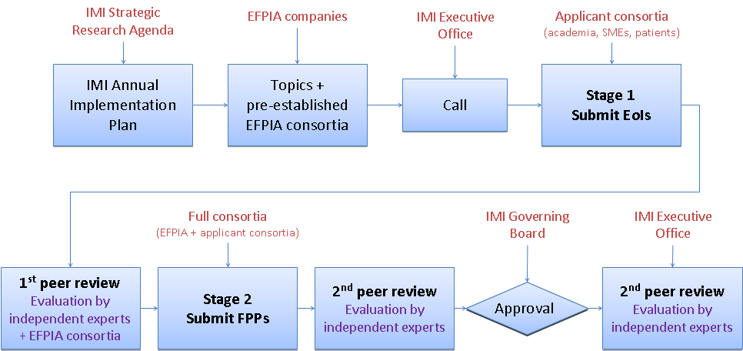
Figure 13. IMI JU calls for proposals. Submission and evaluation process
As a result of the calls, the IMI JU launches a new set of collaborative research and/or training projects every year. In line with the identified four priority areas ("pillars"), many IMI projects cope with socially significant diseases such as cancer, brain disorders and inflammatory, metabolic and infectious diseases. Other projects focus on knowledge management and on improving predictions of safety of new medicines. An additional focus for IMI is education and training to narrow the gaps in expertise in biomedical R&D knowledge and skills.
Already a total of 23 projects from the first two waves of the calls for proposals launched in 2008 and 2009 are underway. They are studying areas such as schizophrenia, rheumatoid arthritis, asthma, chronic pain, electronic health records, safety in qualifying biomarkers and standards for modelling and simulation tools. The third wave was planned to include projects on autism, tuberculosis, diabetes and the safety of drugs and vaccines.
The present Commission Staff Working Document shall review the submission and evaluation results of the IMI's second call for proposals published in November 2009, which – due to their timeline – were not included in the Commission's Annual Report on the progress achieved by the JTI JUs in 2009. It shall give also an overview on the IMI's third call for proposals launched in October 2010, the detailed results of which will be presented in the next year's Commission report.

3.3. Call 2 IMI_Call_2009_2

3.3.1. Summary information
IMI published its second call for proposals on 27 November 2009. Any company, university, research organisation, or other entity carrying out activities relevant to the objectives of the IMI JU in the EU Member States or countries associated with the FP7 could participate in the call by submitting an Expression of Interest through engaging in applicant consortia.
The following legal entities were eligible for funding by the IMI JU: SMEs, non-profit public bodies, non-profit research organisations, intergovernmental organisations, legal entities established under Community law, secondary and higher education establishments and non-profit patients' organisations. Any other legal entities were supposed to bear their own costs for participating in an IMI project.
The 2009 call for proposals included nine topics. They were based on the scientific priorities annexed to the IMI Annual Implementation Plan 2009 and were formulated by the relevant EFPIA consortia under two strategic areas for intervention – Pillar II: Improving the Predictivity of Efficacy Evaluation and Pillar III: Knowledge Management. The call topics are listed in the table below:
№ | Topic
Pillar II: Improving the Predictivity of Efficacy Evaluation
1. | Imaging biomarkers for anticancer drug development
2. | New tools for target validation to improve drug efficacy
3. | Molecular biomarkers: accelerating cancer therapy development and refining patient care
4. | Identification and development of rapid point-of-care diagnostic tests for bacterial diagnosis to facilitate conduct of clinical trials and clinical practice
5. | Understanding aberrant adaptive immunity mechanisms
6. | Translational research in chronic immune-mediated disease: bridging between animal models and humans
Pillar III: Knowledge Management
7. | Drug/disease modelling: library & framework
8. | Open pharmacological space
9. | Electronic health records
Table 13. Topics of the IMI JU 2009 call for proposals
The areas of cancer, infectious diseases and inflammation were set as priorities in Pillar II in 2009, while the focus in Pillar III was put on the standardisation, free access, interoperability and exchange of data relevant for drug discovery and development, including databases for drug/disease models and small molecules, and on the establishment of a frame for access and exchange of clinical/healthcare data.
The timeline of the IMI's 2009 call for proposals is shown on Figure 14 below:
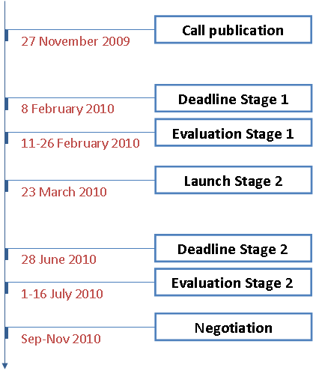
Figure 14. Timeline of the IMI JU 2009 call for proposals
The call process, managed by the IMI Executive Office, was conducted following the principles of excellence, transparency, fairness and impartiality, confidentiality, efficiency, speed and ethical considerations. It has been performed according to the IMI Rules for submission, evaluation and selection of Expressions of Interests and Full Project Proposals. The projects have been implemented under the IMI JU model grant agreement.
The total indicative budget of the call included a maximum EU financial contribution of € 76.8 million and in-kind contributions from the research-based companies members of the EFPIA estimated at € 79.5 million.

3.3.2. Analysis of proposals submitted
The call was published on 27 November 2009 and the applicants were invited to submit their Expressions of Interest in two months' time, by 8 February 2010. The EoIs had to be submitted by the applicant consortia electronically via a web-based service specifically designed by the IMI JU for that purpose.
In total, 124 Expressions of Interest involving 1,188 applicants from 39 different countries were received. Out of those 124 EoIs, 6 were ineligible due to incomplete application forms or applications submitted under a wrong topic. 118 EoIs were eligible for evaluation.
Of the total 1,188 applicants, 77.2% came from academia, 17.9% were SMEs and 4.9% represented other type of legal entities, such as patient organisations, agencies/regulatory organisations, other industry associations or non-EFPIA companies larger than SMEs. The participation of the different types of applicants in the submitted EoIs is displayed in the table below:
 | Non-EFPIA
 | Academia | SMEs | Others
Participants | 917 | 213 | 58 |  | 1,188
Total | 1,188 |  |  |  | 1,188
% | 77.2% | 17.9% |  | 4.9% | 100%
Table 14. IMI JU 2009 call for proposals – Stage 1. Typology of participants
Comparing to the number and type of participants in the IMI's first call for proposals, the picture for this call followed the same pattern. There was a slight increase of 0.9% in the number of participating SMEs against the other type of legal entities. Although not significant, this increase was in line with one of the main objectives of the IMI JU – to promote the involvement of SMEs in its activities.
In this second call, there were applicants from the following FP7 associated countries: Albania, Bosnia and Herzegovina, Israel, Norway, Serbia, Switzerland, Turkey, and also applicants from FP7 third countries: Canada, People's Republic of China, Republic of Korea, Russian Federation, Senegal, Ukraine and the USA. The figure below provides information on the submitted EoIs in the first stage of the call per country:
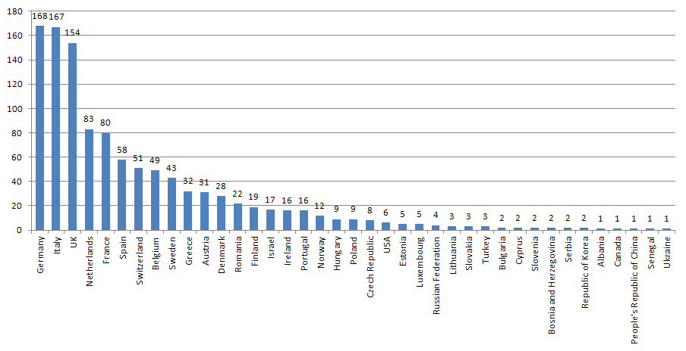
Figure 15. IMI JU 2009 call for proposals – Stage 1. Participation in the submitted EoIs per country
About 77% of all EoIs (90 in total) were submitted under Pillar II: Improving the Predictivity of Efficacy Evaluation. The remaining about ¼ of the EoIs (28 in total) was submitted under Pillar III: Knowledge Management.
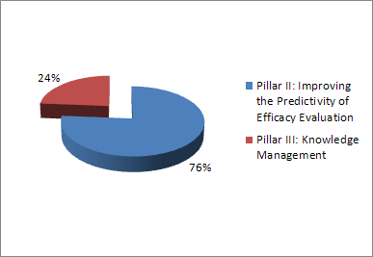
Figure 16. IMI JU 2009 call for proposals – Stage 1. Submitted EoIs per pillar
Similarly to the first call for proposals launched by IMI in 2008, the biggest number of EoIs was in Pillar II: Improving the Predictivity of Efficacy Evaluation.

3.3.3. Evaluation procedure
Stage 1 – EoIs
The evaluation of the EoIs (also referred to as "first peer review") took place between 11 and 26 February 2010. It was done in two consecutive steps – remotely and through consensus panel meetings.
The EoIs were evaluated against the following four criteria: 1) Scientific and/or technological excellence, 2) Excellence of partnership, 3) Quality and soundness of the work plan, including the budget, and 4) Potential ethical issues.
For each evaluation criterion, a score has been given on a scale from 0 (EoI fails to address the criterion) to 5 (EoI addresses all aspects of the criterion). Weighting and thresholds were set for the first two criteria, while the fourth criterion at this stage was only assessing the existence of potential ethical issues to be reviewed in the next stage of the call.
The table below gives an overview on the evaluation criteria, scoring, weighting and applicable thresholds in Stage 1 of the call:
№ | Evaluation criterion | Score | Weight | Threshold
1. | Scientific and/or technological excellence | 0 to 5 | 4 | 15/20
2. | Excellence of partnership | 0 to 5 | 3 | 10/15
3. | Work plan outline | 0 to 5 | --- | ---
4. | Ethical issues | Yes/No | --- | ---
Table 15. IMI JU 2009 call for proposals – Stage 1. Scoring, weighting and thresholds
As a first step, the EoIs were reviewed remotely by a total of 58 independent experts and representatives of the topic-generating EFPIA consortia. The latter could consult the EFPIA consortium on EoIs submitted in their own call topic. At this point, each expert worked on the EoIs individually. In the end, scores and comments on each evaluation criterion were included in individual evaluation reports used later in the consensus panel meetings.
After the individual assessments were completed, the first peer review moved to the next step – the consensus panel evaluations. The independent experts, along with the representatives of each topic-generating EFPIA consortium were brought together to finalise the first stage of the evaluation process. A series of consensus panel meetings were held from 23-26 February 2010 in the IMI premises in Brussels. The conclusions of these meetings were included in consensus evaluation reports based on which the IMI JU established a ranked list of the submitted EoIs for each of the nine call topics. It should be noted that the EFPIA representatives, while fully participating in the discussions, were not involved in the ranking of the submitted EoIs.
To ensure transparency, the IMI Executive Office invited three independent observers to the two stages of the evaluation process. The role of the observers was to verify if the peer reviews have been done according to the IMI Rules for submission, evaluation and selection of EoIs and FPPs. Their conclusions were reflected in an independent observers' report made publicly available on the IMI's website after the evaluation stages.
In general, the observers found that the first peer review was conducted in a professional and fair manner according to the rules. They also gave some recommendations to IMI on how to improve the Stage 1 submission and evaluation process in future calls.
The final ranking of the EoIs proposed by the evaluators was approved by the IMI Governing Board on 16 March 2010. After that, the applicant consortia of the top-ranked EoIs for each of the nine call topics were invited to discuss with the corresponding EFPIA consortium the feasibility of jointly developing Full Project Proposals for Stage 2 of the call.
Details on the selected EoIs in the first stage of the call can be found in Section 3.3.4.
Stage 2 – FPPs
The second stage of the call was launched on 23 March 2010. At this stage, the applicant consortia with the top-ranked EoIs submitted in each of the nine topics of the call were invited to join together with the pre-established EFPIA consortia associated with the respective topic and to submit Full Project Proposals. The deadline for FPPs submission was 28 June 2010.
At this stage, the coordinators of the applicant consortia and the EFPIA consortia held a number of meetings to foster interaction between the partners, as well as to facilitate the establishment of full project consortia and prepare their FPPs. The IMI Executive Office participated in each of these meetings providing assistance and acting as a facilitator on scientific, administrative, financial and legal issues. Similarly to Stage 1, the FPPs had to be submitted through the IMI electronic submission tool.
The evaluation of the FPPs (also referred to as "second peer review") took place between 1 and 16 July 2010. As in the first peer review, it has been done in two consecutive steps – remotely and through consensus panel meetings.
The FPPs were evaluated against the following four criteria: 1) Scientific and/or technological excellence, including an appropriate response to any ethical issues, 2) Excellence of the project implementation plan, 3) Consistency with the call topic and the project objectives set in the EoI at Stage 1 of the call, and 4) Potential impact and foreseen dissemination of the project results.
As in Stage 1 of the call, a score has been given on a scale from 0 (FPP fails to address the criterion) to 5 (FPP addresses all aspects of the criterion) for each evaluation criterion. In contrast to the previous stage, however, the criteria were not weighted. A threshold (3 points out of 5) has been set only for the criterion on scientific and/or technological excellence of the proposal, including also a response to any ethical issues the project might raise.
Table 16 gives an overview on the evaluation criteria, scoring and thresholds in Stage 2 of the call:
№ | Evaluation criterion | Score | Threshold
1. | Scientific and/or technological excellence | 0 to 5 | 3/5
2. | Excellence of the project implementation plan | 0 to 5 | ---
3. | Consistency with the call topic and the EoI | 0 to 5 | ---
4. | Potential impact of project results | 0 to 5 | ---
Table 16. IMI JU 2009 call for proposals – Stage 2. Scoring and thresholds
In contrast to the first peer review, the evaluation of the nine top-ranked FPPs was conducted by independent external experts only, without participation of members of the EFPIA consortia. A total of 58 experts participated in the second peer review of the call, including 8 ethical experts. The evaluation of the FPPs was, where feasible, performed by the same experts as the evaluation of the EoIs.
The proposals were assessed first remotely (1-7 July) and then in consensus panel meetings held in the IMI premises in Brussels (13-16 July). In addition, an ethical review was carried out for each FPP.
The results of the second peer review for each of the nine FPPs were included in two documents: valuation consensus form and ethical review report. After Stage 2 of the call, these documents have been communicated to the applicants.
The independent experts found out that the FPPs constructively evolved from the EoIs submitted in Stage 1 of the call, managed to address most of the questions raised during the first peer review and met the objectives of the call topics. They agreed, however, that some modifications may be required during the negotiation process.
As in the first stage of the evaluation, the IMI Executive Office invited the three independent observers to verify if the second peer reviews have been done according to the set evaluation guidelines and rules. Their conclusions have been reflected in a second independent observers' report. An Action Plan based on the recommendations of the report was drafted by the IMI JU with the objective to implement the prescribed actions in its 2010 call for proposals.

3.3.4. Evaluation results
Stage 1 – EoIs
Out of the 118 eligible EoIs , 51 (43.2%) were favourably evaluated in the first peer review of the call, i.e. above the defined thresholds. They were included in ranked lists under each of the nine call topics. The remaining 67 EoIs (56.8%) failed at least one threshold.
Table 17 shows that 45.6% (or 41) of the eligible EoIs passed the thresholds in Pillar II: Improving the Predictivity of Efficacy Evaluation, and 35.7% (or 10) – in Pillar III: Knowledge Management:
Pillar | Topic number | Eligible EoIs | EoIs above threshold |  | Selected EoIs  for Stage 2
Pillar II: Improving the Predictivity of Efficacy Evaluation | 1 | 26 | 7 | 26.9% | 1 | 14.3%
Pillar II: Improving the Predictivity of Efficacy Evaluation | 2 | 27 | 13 | 48.1% | 1 | 7.7%
Pillar II: Improving the Predictivity of Efficacy Evaluation | 3 | 10 | 3 | 30.0% | 1 | 33.3%
Pillar II: Improving the Predictivity of Efficacy Evaluation | 4 | 17 | 11 | 64.7% | 1 | 9.1%
Pillar II: Improving the Predictivity of Efficacy Evaluation | 5 | 7 | 6 | 85.7% | 1 | 16.7%
Pillar II: Improving the Predictivity of Efficacy Evaluation | 6 | 3 | 1 | 33.3% | 1 | 100.0%
Pillar II: Improving the Predictivity of Efficacy Evaluation | Sub-total | 90 | 41 | 45.6% | 6 | 14.6%
Pillar III: Knowledge Management | 7 | 4 | 1 | 25.0% | 1 | 100.0%
Pillar III: Knowledge Management | 8 | 6 | 3 | 50.0% | 1 | 33.3%
Pillar III: Knowledge Management | 9 | 18 | 6 | 33.3% | 1 | 16.7%
Pillar III: Knowledge Management | Sub-total | 28 | 10 | 35.7% | 3 | 30.0%
TOTAL |  | 118 | 51 | 43.2% | 9 | 17.6%
Table 17. IMI JU 2009 call for proposals – Stage 2. Scoring and success rate of the submitted EoIs
It can be observed that the overall success rate of the EoIs in this call was 17.6%. It was higher than in the previous IMI's call, when 13.4% of the eligible EoIs were selected to continue in Stage 2.
With regard to the call topics, the success rate under Pillar II was significantly lower than in Pillar III – 14.6% against 30%. This is partly due to the fact that the number of the submitted EoIs under the second pillar was much higher, but at the same time its scope was more specific.
Stage 2 – FPPs
All 9 FPPs were eligible and passed the threshold applicable to evaluation criterion 1 "Scientific and/or technological excellence".
Following a recommendation of the independent experts after the second peer review that the FPPs from Topic 5 "Understanding aberrant adaptive immunity mechanisms" and Topic 6 "Translational research in chronic immune-mediated disease: bridging between animal models and humans" should be merged due to their commonalities and complementarities, finally 8 FPPs were selected for negotiation.
In total, 193 applicants participated in the full project consortia that submitted the 8 FPPs proposed for funding. Of them, 22 EFPIA member companies representing one third of the total number of successful applicants accounted for 65 participations. 128 were the non-EFPIA participants, of which 36.3% came from academia, 11.9% were SMEs and 18.1% – other types of legal entities, such as patient organisations, agencies/regulatory organisations, other industry associations or non-EFPIA companies larger than SMEs. This distribution is shown in the table below:
 | EFPIA | Non-EFPIA
 | EFPIA | Academia | SMEs | Others
Participants | 65 | 70 | 23 | 35 |  | 193
Total | 65 | 128 |  |  |  | 193
% | 33.7% | 36.3% | 11.9% |  | 18.1% | 100%
Table 18. IMI JU 2009 call for proposals – Stage 2. Typology of participants
In comparison to the final stage of the IMI first call for proposals launched in 2008, there was a relative increase in the participation of SMEs against academia and other type of legal entities (6.1% in 2008, while 11.9% in 2009). However, the number of SME partners in the FPPs proposed for funding in this call remained at the same level as before (24 in 2008, 23 in 2009).
The non-EFPIA participants in the successful full project consortia originated from 20 countries – 17 EU Member States, Switzerland, Norway and Israel. The UK, as in the previous call, had the highest participation rate – 31 participants, followed by Germany and the Netherlands, respectively with 26 and 16 participants. Figure 17 illustrates in detail the participations per country in the end of that stage of the call:
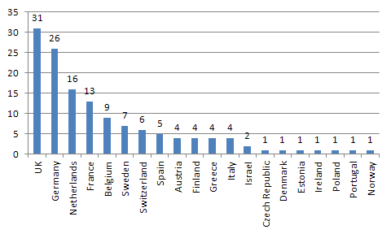
Figure 17. IMI JU 2009 call for proposals – Stage 2.
Participation in the FPPs proposed for funding per country
The total IMI JU financial contribution requested by the non-EFPIA participants in the FPPs selected for funding amounted to € 80,740,072. The funding requested by the SME partners was € 15,455,411, which represented 19.1% of the total IMI JU contribution in the call.

3.3.5. Grant agreements signed
The grant agreements of the IMI JU 2009 call for proposals were negotiated from September until November 2010. There were no changes in the approved list of the FPPs proposed for funding compared to the grant agreements signed.
The eight grant agreements were signed in 2011. Their total budget was € 171,707,565, of which the EU contribution formed the biggest part – € 80,740,072. The in-kind contribution from the EFPIA members amounted to € 65,872,527, and € 25,094,966 were added from the participants' own funds.
The amount committed by the European Commission for the second call for proposals in 2009 was € 78,643,200, of which the EFTA contribution was € 1,843,200. In 2010, IMI committed additionally € 2,096,872 for this call on the carried over amount from 2008 (€ 16,039,097).
Table 19 below provides information on the signed grant agreements in the IMI's 2009 call for proposals, detailing the financial contribution in the awarded proposals.
№ | GA number | Project acronym | Project title | IMI JU contribution | In-kind contribution from EFPIA members | Additional own resources | Total contributions
1. | 115188 | PREDECT | New models for preclinical evaluation of drug efficacy in common solid tumours | 8,100,509 | 7,066,607 | 2,532,789 | 17,699,905
2. | 115234 | OncoTrack | Methods for systematic next generation oncology biomarker development | 16,050,282 | 9,726,557 | 4,915,508 | 30,692,347
3. | 115151 | QuIC-ConCePT | Quantitative imaging in cancer: connecting cellular processes with therapy | 7,000,000 | 8,053,206 | 2,062,174 | 17,115,380
4. | 115153 | RAPP-ID | Development of rapid point-of-care test platforms for infectious diseases | 6,828,438 | 5,848,470 | 1,771,853 | 14,448,761
5. | 115139 | BTCure | Be the cure | 16,137,872 | 14,172,302 | 7,807,923 | 38,118,097
6. | 115156 | DDMoRe | Drug disease model resources | 9,615,058 | 9,820,120 | 1,729,883 | 21,165,061
7. | 115191 | Open PHACTS | The open pharmacological concepts triple store | 9,988,867 | 4,142,649 | 2,265,938 | 16,397,454
8. | 115189 | EHR4CR | Electronic health record systems for clinical research | 7,019,046 | 7,042,616 | 2,008,898 | 16,070,560
TOTAL |  |  |  | € 80,740,072 | € 65,872,527 | € 25,094,966 | € 171,707,565
Table 19. Grant agreements signed in the IMI JU 2009 call for proposals

3.4. Call 3 IMI_Call_2010_3

3.4.1. Summary information
IMI launched its third call for proposals on 22 October 2010. A two-stage submission and evaluation process, as in the previous calls, has been followed. According to the planning, the call process and the negotiations of the projects selected for funding had to be finalised in 2011.
Any company, university, research organisation, or other entity carrying out activities relevant to the objectives of the IMI JU in the EU Member States or countries associated with the FP7 could participate in the call by submitting an Expression of Interest.
Based on the scientific priorities outlined in the IMI Annual Implementation Plan 2010, the third call included seven topics. They were addressing the three following strategic pillars: Pillar I Improving the Predictivity of Safety Evaluation, Pillar II: Improving the Predictivity of Efficacy Evaluation and Pillar IV: Education and Training. Each topic was formulated and associated with a pre-established consortium of pharmaceutical companies – members of the EFPIA.
The topics in the IMI 2010 call are listed in the table below:
№ |  | Topic
Pillar I: Improving the Predictivity of Safety Evaluation
1. | Improving the early prediction of drug induced liver injury in man
2. | Immunogenicity: assessing the clinical relevance and risk minimization of antibodies to biopharmaceuticals
3. | Immunosafety of vaccines – new biomarkers associated with adverse events (early inflammation, autoimmune diseases and allergy)
Pillar II: Improving the Predictivity of Efficacy Evaluation
4. | Improving the preclinical models and tools for tuberculosis medicines research
5. | Translational endpoints in autism
6. | Development of personalized medicine approaches in diabetes
Pillar IV: Education and Training
7. | Fostering patient awareness on pharmaceutical innovation
Table 20. Topics of the IMI JU 2010 call for proposals
The timeline of the IMI's 2010 call for proposals has been planned as follows:
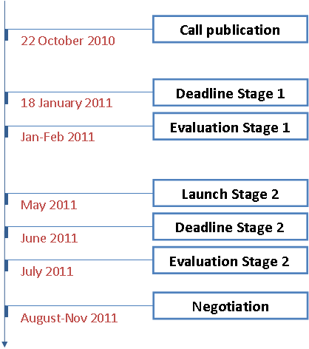
Figure 18. Indicative timeline of the IMI JU 2010 call for proposals
The total indicative budget of the call included a maximum EU financial contribution of € 114 million, matched with an in-kind contribution from the research-based companies, members of the EFPIA.
The amount committed by the European Commission for this call in 2010 was € 98,644,744, of which the EFTA contribution was € 2,424,744. The foreseen amount after Stage 2 of this call is € 111,816,312, which was planned to be committed by IMI in 2011.
The deadline for submitting Expressions of Interest was 18 January 2011. As before, EoIs had to be submitted online via the electronic tool on the IMI's website. The evaluations followed and Stage 1 of the call was completed by the end of February. IMI launched Stage 2 of the call in May as planned, followed by evaluation, selection and negotiation of the successful projects. The grant agreements signature and the payment of pre-financing were expected to be concluded by the first quarter of 2012.
Taking into consideration this timeline, the Commission shall present the results of the IMI's 2010 call for proposals in its next year's report on the progress achieved by the JTI JUs.

4. Progress achieved by the Fuel Cells and Hydrogen (FCH) JU

4.1. About the FCH JU
The Fuel Cells and Hydrogen Joint Undertaking (hereinafter referred to as "FCH JU") has been established by Council Regulation (EC) 521/2008 of 30 May 2008 as an industry-led public-private partnership supporting research, technological development and demonstration (RTD) activities in fuel cell and hydrogen energy technologies in Europe. The FCH JU members are the New Energy World Industry Grouping (NEW-IG), representing the fuel cell and hydrogen industries, the N.ERGHY Research Grouping, representing the research community, and the European Union, represented by the European Commission.
The FCH JU has been set up for a period up to 31 December 2017 with the main objective to significantly accelerate the market introduction of fuel cell and hydrogen technologies, realising their potential as an instrument in achieving a carbon-clean energy system. The broader use of fuel cells, as an efficient power conversion technology, and hydrogen, as an environment-friendly energy carrier, can contribute to reduce greenhouse gas emissions, and lower the dependence on hydrocarbons, and to stimulate the economic growth. The aim of the FCH JU is to bring these benefits to Europeans through a concentrated effort from all sectors pooling together public and private resources.
In order to achieve this aim, as well as manage and implement its programme of RTD activities in an efficient manner, the FCH JU has identified four main application areas (AA) outlined in the Multi-Annual Implementation Plan 2008-2013:
- Transport & Refuelling Infrastructure – dealing with next generation fuel cell hybrid vehicles, including cars and buses;
- Hydrogen Production and Storage – referring to sustainable hydrogen production, storage and distribution processes, for example production of hydrogen from biomass or solar energy;
- Stationary Power Production & Combined Heat and Power – aiming to meet the technical and economic requirements needed to compete with the existing energy conversion technologies;
- Early Markets – focused on the development of fuel cell-based products capable to enter the market in the short term and to turn into commercial success stories.
Cross-cutting activities have been established as a fifth area to provide programme level coordination. These include drafting of regulations and formulation of codes and standards, pre-normative and socio-economic research, technology and life cycle assessments, market support (particularly for SMEs), public awareness and education.
The maximum EU contribution to the FCH JU is € 470 million, covering running costs (€ 20 million) and operational costs (€ 450 million). The EU contribution is paid from the appropriations in the general budget of the European Union allocated to themes "Energy", "Nanosciences, Nanotechnologies, Materials and New Production Technologies", "Environment" and "Transport" of Specific Programme "Cooperation" under the FP7. For operational costs, the in-kind contributions from the members of the NEW Industry Grouping at least match the EU contribution to all type of beneficiaries participating in the FCH JU activities.
For coordinating the inputs of all the members and managing its activities, the Joint Undertaking's governance structure comprises two executive bodies – the Governing Board and the Executive Director assisted by the Programme Office, and three advisory bodies – the Scientific Committee, the States Representatives Group and the Stakeholders' General Assembly.

4.2. Main activities of the FCH JU in 2010
The main operational objectives of the FCH JU in 2010 focused on the management of its first and second calls for proposals. An overview of the 2009 call and details on the outcome of the negotiation process are provided in Section 4.3. Section 4.4 gives information on the 2010 call, providing analysis of the submitted proposals, describing the evaluation procedure and the evaluation results.
As to the administrative activities of the Joint Undertaking, the focus in 2010 was put on completing the legal and financial framework for the autonomy of the JTI JU. After meeting all "autonomy criteria", on 15 November 2010, the Joint Undertaking has been granted administrative and operational autonomy from the European Commission.
Key milestones
- Negotiation, signature of the grant agreements with selected beneficiaries and kick-off of the projects from the 2009 call for proposals;
- Launch of the 2010 calls of proposals, evaluation of the eligible proposals and establishment of a reserve list;
- Adoption of management and internal control systems;
- Configuration of the IT-assisted accounting system ABAC.
In terms of staffing, 12 new temporary agent positions have been filled in by the end of 2010. Thereby, 14 temporary agents had been recruited out of the 18 temporary agents authorised by the Joint Undertaking's 2010 Staff Policy Plan. In addition, following a public procurement procedure in 2010 jointly with the other JTI JUs, FCH moved into its new premises in the White Atrium building in Brussels in January 2011.
FCH experienced some IT problems during the year, such as delays in the configuration of the project management tools and increased response time of ABAC and the various FP7 applications used by FCH, which were identified in the Annual Activity Report 2010 as a critical risk for the operational performance of the Joint Undertaking. A number of actions have been taken to mitigate the risk – a root-cause analysis of the problems, a close follow-up of the concluded Service Level Agreements, monitoring and timely reporting of the occurred IT issues.
In preparation of its autonomy, in 2010 the FCH JU completed the establishment of its own internal control system. A set of 16 Internal Control Standards have been adopted and an action plan on their progressive elaboration has been established.
It is also worth mentioning that the Joint Research Centre (JRC) of the European Commission continued to collaborate together with the FCH JU under the Framework Agreement concluded in 2009.
Governance
The FCH Governing Board held three meetings in 2010.
The 5th Governing Board meeting was held on 29 January 2010, when the FCH JU's budget for 2010 was adopted and the Terms and Conditions for internal investigations in relation to the prevention of fraud, corruption and any illegal activity detrimental to the EU's interests were approved.
At the 6th Governing Board meeting on 15 June 2010 the then chair of the Joint Undertaking was re-elected and a new deputy-chair was elected. The Board nominated also Bert De Colvenaer as an Executive Director who officially took up his duties on 1 September. During this meeting the Governing Board adopted a number of important documents: the Annual Management Report 2009, the Annual Implementation Plan (AIP) 2010 and the amendment of the model FCH JU grant agreement. The FCH JU's Internal Control Standards were also formally approved.
The Board formally requested the Commission to initiate a process of amendment of the relevant articles in the Statutes of the FCH JU in order to improve the funding levels in the future calls for proposals. This has been done following the results of the readiness assessment exercise performed in preparation of the JU's autonomy. Among the identified critical risks was the impact that the requirement for the industry to match the EU financial contribution to projects had on the attractiveness of the FCH JU's programme. To solve the problem, the Board suggested keeping the 50/50 co-funding principle intact and recognising the shareholder role of the research community.
In the meantime, the ranked list of proposals selected for funding in the FCH JU's 2009 call was adopted in April 2010 and the negotiations have started. By October-December 2010 the negotiations of all projects were completed and the Board approved the lists of proposals for funding followed by signature of the grant agreements.
The last for the year 7th Governing Board meeting which took place on 10 November 2010 was concluded with appointment of the Commission Internal Audit Service (IAS) as the FCH JU's Internal Auditor.
The Scientific Committee met once during the year and the States Representatives Group held two meetings in 2010. In their advisory role, the members of the Scientific Committee provided input on the scientific priorities for the future Annual Implementation Plan and discussed the revision of the R&D agenda set out in the Multi-Annual Implementation Plan. The States Representatives Group was consulted on the topics for the 2010 and 2011 call for proposals, the possible amendments of the Council Regulation (EC) 521/2008 to improve the FCH JU funding limits and also discussed the revision of the Multi-Annual Implementation Plan.
The Stakeholders' General Assembly is an annual event aiming to inform the interested parties about the activities of the FCH JU and to receive feedback for the future planning of the programme. It provides a space for stakeholders across sectors from around the world to get together and discuss the state of affairs of the fuel cell and hydrogen industry, exchange ideas and make contacts. The 3rd Stakeholders' General Assembly took place in Brussels on 9-10 November 2010 and has been attended by more than 350 participants.
Communication activities
The main objectives in 2010 concerning communication activities were to efficiently disseminate the information on the opportunities offered by the calls for proposals and to raise political awareness on the technologies' readiness and commercialisation prospects.
Two Info Days were organised to promote the FCH JU 2010 call for proposals to potential participants and other stakeholders – on 17 May in Essen (Germany) and on 8 July 2010 in Brussels (Belgium). In addition, the FCH JU presented its programme and activities during 27 external events and conferences in 7 different EU Member States and one associated country, as well as on events in two non-European countries.
The Stakeholders' General Assembly, as mentioned above, was organised in Brussels on 9-10 November 2010 and represented a major communication event open to all public and private stakeholders. It gathered more than 350 participants from all over Europe, with some 70 speakers from Europe, Japan, Korea and the USA representing industry, research organisations, governmental and other public bodies, and NGOs.
Furthermore, the FCH JU published three press releases and launched a competitive market procedure for a new visual identity, the outcome of which was expected in 2011. Regarding its internet presence, the Joint Undertaking developed a new website (http://www.fch-ju.eu) aiming to inform the interested parties about project funding and ongoing RTD projects, as well as to provide general information to the public about the latest developments in fuel cell and hydrogen technologies.
Calls for proposals
The FCH JU launches open and competitive calls for proposals annually on the basis of which funding is granted for research, technological development and demonstration projects. The topics stem from the FCH JU Annual Implementation Plan and are consistent with the five Application Areas described above and the RTD priorities and key objectives for the respective year.
Two types of funding schemes are used to implement projects in the FCH JU: 1) collaborative projects, and 2) coordination and support actions. The schemes used in the different calls are announced in the call fiche. Collaborative projects are objective-driven research projects aiming at developing new knowledge, technology or product. Participants must form a consortium by at least three legal entities established in different EU Member States or FP7 associated countries, of which at least one should be a member of the Industry Grouping or the Research Grouping. Collaborative projects typically last two to five years.
The funding scheme allows also for two other types of actions to be financed: coordination (networking) actions coordinating research activities and policies and support actions contributing to the Annual Implementation Plan and the preparation of future EU research and technological development policy. Coordination actions are normally completed in two to four years, while support actions have a shorter duration.
FCH JU's projects are selected through calls for proposals following a single stage submission and evaluation process. Applications must be submitted using a special web-based service (since 2010, this is the FP7 tool EPSS – Electronic Proposal Submission Service) before a strictly-enforced deadline. The notifications for calls for proposals are published in the Official Journal of the European Union and broadly announced through various communication channels, including on the FCH JU website, indicating call topics, indicative budget, funding scheme, deadlines for submission and links to the submission tool EPSS. The whole call process is managed by the FCH according to the principles of excellence, transparency, fairness and impartiality, confidentiality, efficiency, speed and ethical and security considerations and following the FCH JU Rules for submission of proposals and the related evaluation, selection and award procedures.
As a next step, the FCH JU performs an eligibility check to see whether the applicants meet the announced eligibility criteria. Then FCH appoints independent experts to assist with the evaluation of proposals and identify those of best quality for possible funding. All eligible proposals are evaluated with respect to the evaluation criteria and the associated weight and thresholds set for the call. Evaluations are done in three steps: remotely, through on-site consensus meetings and panel reviews. During the remote evaluation, proposals are assessed individually by a minimum of three experts and the results are included in an individual evaluation report. Once the experts complete their individual assessments, the evaluation proceeds to a consensus assessment, the objective of which is to exchange common views on the evaluated proposals. The results of the consensus meetings are included in consensus evaluation reports. The final step in the evaluation process is the panel reviews. The outcome of those reviews is the evaluation summary report including a list of ranked proposals above thresholds, a list of proposals failing one or more thresholds and a list of ineligible proposals, if any. The presence of independent observers during the different evaluation stages verifies and guarantees that the above-mentioned rules and principles are followed.
After completing the evaluation and establishing ranked lists with proposals for funding, the Joint Undertaking enters into a negotiation with the coordinators of the proposals which have successfully passed the evaluation stage and until there is a budget available. If negotiations are successfully concluded, the project is selected and a grant agreement providing for a FCH JU financial contribution is signed.
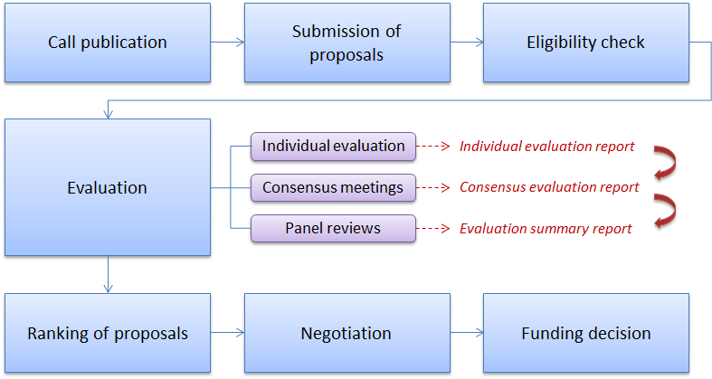
Figure 19. FCH JU calls for proposals. Submission and evaluation process
The Commission Staff Working Document accompanying the Annual Report on the progress achieved by the JTI JUs in 2009 provided detailed information on the FCH JU's first and second calls for proposals launched in 2008 and 2009. However, since the negotiations with the selected participants and the grant agreements in the second call were signed in 2010, the results of this call will be briefly presented in the present document.
The document will also describe the FCH JU third call published in June 2010, presenting the call topics, timeline and budget, analysing the proposals submitted in the call and the evaluation results. Since the ranked list of proposals selected for funding had to be approved by the Joint Undertaking's Governing Board in 2011, the definitive list of successful proposals and information on the signed grant agreements will be presented in the next year's Commission's report.

4.3. Call 2 FCH-JU-2009-1

4.3.1. Summary information
The FCH JU second call for proposals was published on 2 July 2009 with a deadline for submission 15 October 2009.
The call was open to legal entities established in the EU Member States or FP7 associated countries, as well as for international organisations. Legal entities from third countries could also participate, but they were only eligible for FCH JU funding provided that the Governing Board considered their participation to be of a particular benefit to the project. In general, the rules for participation and the eligibility criteria were similar to those in FP7 with the main difference that in the proposals funded through FCH calls at least one legal entity should be a member of the FCH JU Industry Grouping or the Research Grouping.
The 29 topics of the call covered all five FCH Application Areas, including 22 collaborative projects and 7 projects for coordination and support actions. The total indicative contribution from the FCH JU was set to € 73 million (including the EFTA contribution of € 1.7 million), which had to be at least matched by in-kind contributions from the industry participants in the projects. The topics and their corresponding indicative budget were exhaustively presented in the previous year's Commission's report.
The timeline of the call is shown on Figure 20 below:
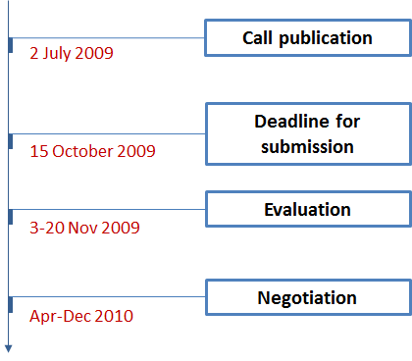
Figure 20. Timeline of the FCH JU 2009 call for proposals

4.3.2. Analysis of proposals submitted
The submission of proposals was done in a single stage. A total of 50 proposals were submitted in this call, of which 49 were eligible. They accounted for 400 participants from 25 countries, including 103 SMEs (25.8%). Detailed statistics on the types of participants, number of applicant SMEs and participation per country at this phase of the call can be found in the Commission's report on the JTI JUs' activities in 2009.

4.3.3. Evaluation procedure
The evaluation of the submitted proposals was carried out from 3 to 20 November 2009 by 31 independent experts in line with the FCH JU Rules for submission of proposals, and the related evaluation, selection and award procedures.
The evaluation criteria for collaborative projects and support actions were similar to those in FP7: 1) Scientific and/or technological excellence relevant to the topics addressed by the call, 2) Quality and efficiency of the implementation and the management, and 3) Potential impact through the development, dissemination and use of project results.
Each criterion was scored out of 5 (0 if the proposal fails to address the criterion and 5 if it addresses all aspects of the criterion); no weightings were applied. Individual and overall thresholds were applied to the scores. The threshold for individual criteria was 3/5, while the overall threshold, applying to the sum of the three individual scores, was 10/15.
In addition, a chairperson oversaw the consensus phase and one independent observer was invited to monitor that the evaluation procedure was carried out in a fair, impartial and confidential manner. The individual remote evaluations took place from 3 to 13 November 2009, followed by consensus meetings on 16-18 November and a final panel meeting on 19-20 November 2009.

4.3.4. Evaluation results
Out of the 49 eligible proposals, 31 were assessed above thresholds. They accounted for 395 participations, of which 88 were the SMEs (22%). Regarding the typology of participants, 112 (28.4%) were representatives of the research community and 73 (18.5%) of the participants came from academia.
In the light of the available budget, on 16 April 2010 the Governing Board of the FCH JU approved a list of 26 proposals for funding with additional 4 on the reserve list, ranked in priority order according to the evaluation results. This underwent a slight change and finally, it was decided that 28 proposals should be funded.
A total of 250 participants from were involved in the final 28 proposals to be funded. The table below gives a comparative overview on the number of participants and requested funding per AA of the eligible proposals and those proposed for funding:
Application Area |  | Transport & Refuelling Infrastructure | Hydrogen Production and Storage | Stationary Power Production & Combined Heat and Power | Early Markets | Cross-cutting activities | TOTAL
Number of proposals | Eligible | 7 | 7 | 20 | 7 | 8 | 49
Number of proposals | To be funded | 4 | 2 | 13 | 4 | 5 | 28
Number of proposals | Success rate | 57.1% | 28.6% | 65% | 57.1% | 62.5% | 57.1%
Number of participants | Eligible | 83 | 53 | 146 | 66 | 47 | 395
Number of participants | To be funded | 59 | 23 | 92 | 46 | 30 | 250
Number of participants | Success rate | 71.1% | 43.4% | 63% | 69.7% | 63.8% | 63.3%
Total costs (M€) | Eligible | 96.2 | 20.9 | 78.4 | 38.3 | 5.2 | 239
Total costs (M€) | To be funded | 81.4 | 7.4 | 54.1 | 25.6 | 2.5 | 170.9
FCH JU requested contribution (M€) | Eligible | 43.9 | 13.5 | 45.9 | 21.3 | 4.9 | 129.6
FCH JU requested contribution (M€) | To be funded | 34.2 | 4.8 | 30.1 | 14.3 | 2.4 | 85.7
Table 21. FCH JU 2009 call for proposals. Number of participants and requested funding per AA
The representatives of the research community kept their participation rate in the proposals proposed for funding of 28.4% (71 participations), while the number of higher or secondary education establishments slightly decreased to 14% (35 participants) against the private companies and public bodies. The overall success rate in the proposals for funding was 63%, of which 62% in collaborative projects and 70% in coordination and support actions. The requested EU contribution was € 85.74 million.
The participants in the successful projects originated from 20 countries – 14 EU Member States, Switzerland, Norway, Croatia, Turkey, the Russian Federation and Canada. Germany had the highest participation rate – 49 participants, followed by Italy and France, respectively with 39 and 32 participants. Figure 21 illustrates in detail the participations per country in the end of that stage of the call:
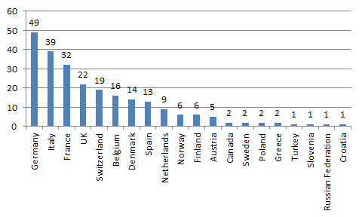
Figure 21. FCH JU 2009 call for proposals. Participations in the successful proposals per country

4.3.5. Grant agreements signed
The negotiation phase started on 19 April and was concluded by the end of 2010. The negotiation process took longer than expected due primarily to the fact that the IT tools (mainly NEF) were not adapted to the FCH JU rules until end of September 2010. The first payments to beneficiaries were made to all project consortia with the exception of one before the year end.
Table 22 below provides details on the projects for which grant agreements were signed with information about the EU contribution and the in-kind contribution from industry and research communities.
№ | Project acronym | Project title | FCH JU contribution | In-kind contribution from industry* | In-kind contribution from research* | Total contributions
1. | CHIC | Clean Hydrogen in European Cities | 25,878,334 | 55,633,502 | 412,455 | 81,924,291
2. | HyGuide | HyGuide | 366,318 | 123,932 | 25,848 | 516,098
3. | HyQ | Hydrogen fuel Quality requirements for transportation and other energy applications | 1,385,219 | 1,045,189 | 919,432 | 3,349,840
4. | PEMICAN | PEM with Innovative low cost Core for Automotive applicatioN | 1,861,352 | 866,404 | 1,207,463 | 3,935,219
5. | ADEL | Advanced Electrolyser for Hydrogen Production with Renewable Energy Sources | 2,043,518 | 761,254 | 1,164,328 | 3,969,100
5. | SSH2S | Fuel Cell Coupled Solid State Hydrogen Storage Tank | 1,613,878 | 211,886 | 1,615,225 | 3,440,989
7. | Premium Act | Predictive Modelling for Innovative Unit Management and Accelerated Testing Procedures of PEFC | 2,513,251 | 813,936 | 1,838,233 | 5,165,420
8. | Maestro | MembrAnEs for STationary application with RObust mechanical properties | 1,040,049 | 842,939 | 381,776 | 2,264,764
9. | HyComp | Enhanced Design Requirements and Testing Procedures for Composite Cylinders intended for the Safe Storage of Hydrogen | 1,380,728 | 1,291,900 | 878,676 | 3,551,304
10. | Ramses | Robust Advanced Materials for metal Supported SOFC | 2,140,334 | 972,726 | 1,583,284 | 4,696,344
11. | Hyprofessionals | Development of educational programmes and training initiatives related to hydrogen technologies and fuel cells in Europe. | 373,537 | 29,971 | 7,586 | 411,094
12. | STAYERS | STAYERS  Stationary PEM fuel cells with lifetimes beyond five years | 1,938,497 | 1,778,502 | 464,463 | 4,181,462
13. | FC-EuroGrid | Evaluating the Performance of Fuel Cells in European Energy Supply Grids | 588,982 | 60,070 | 185,603 | 834,655
14. | Asterix3 | ASsessment of SOFC CHP Systems build on the TEchnology of htceRamIX 3 | 1,361,894 | 1,499,042 | 235,955 | 3,096,891
15. | D-CODE | DC/DC COnverter-based Diagnostics for PEM systems | 1,173,818 | 568,921 | 473,028 | 2,215,767
16. | SCOTAS-SOFC | Sulphur, Carbon, and re-Oxidation Tolerant Anodes and Anode Supports for Solid Oxide Fuel Cells | 1,701,770 | 772,555 | 1,894,254 | 4,368,579
17. | NH34PWR | Ammonia based, fuel cell power for off-grid cell phone towers | 3,054,515 | 4,954,568 | 195,245 | 8,204,328
18. | LOTUS | Low Temperature Solid Oxide Fuel Cells for micro-CHP applications | 1,632,601 | 985,634 | 206,451 | 2,824,686
19. | CATION | Cathode Subsystem Development and Optimisation | 2,625,833 | 4,021,607 | 547,240 | 7,194,680
20. | SOFC-Life | Solid Oxide Fuel Cells – Integrating Degradation Effects into Lifetime Prediction Models | 2,418,620 | 789,830 | 2,441,404 | 5,649,854
21. | DESIGN | DEGRADATION SIGNATURES IDENTIFICATION FOR STACK OPERATION DIAGNOSTICS | 1,745,752 | 325,632 | 1,194,794 | 3,266,178
22. | H2FC-LCA | Development of Guidance Manual for LCA application to Fuel cells and Hydrogen technologies | 311,957 | 0 | 74,905 | 386,862
23. | TrainHy-Prof | Building Training Programmes for Young Professionals in the Hydrogen and Fuel Cell Field | 269,105 | 9,776 | 66,841 | 345,722
24. | FITUP | Fuel cell field test demonstration of economic and environmental viability for portable generators, backup and UPS power system applications | 2,475,978 | 1,761,001 | 766,478 | 5,003,457
25. | SHEL | Sustainable Hydrogen Evaluation in Logistics | 2,443,095 | 792,994 | 1,290,588 | 4,526,677
26. | HyLIFT-DEMO | European demonstration of hydrogen powered fuel cell forklifts | 2,881,245 | 3,416,038 | 464,815 | 6,762,098
27. | Moby Post | Mobility with Hydrogen for Postal Delivery | 4,262,057 | 2,640,159 | 884,405 | 7,786,621
28. | HyFacts | Identification, Preparation and Dissemination of Hydrogen Safety Facts to Regulators and Public Safety Officials | 1,044,406 | 272,463 | 83,759 | 1,400,628
TOTAL |  |  | € 72,526,643 | € 87,242,431 | € 21,504,534 | € 181,273,608
* Indicative budget figures.
Table 22. Grant agreements signed in the IMI JU 2009 call for proposals

4.4. Call 3 FCH-JU-2010-1

4.4.1. Summary information
The FCH JU third call for proposals was published on 18 June 2010 with a deadline for submission 13 October 2010. The rules for participation and eligibility criteria were similar to those of the call launched in 2009. See Section 4.3.1 above.
The call comprised of 25 topics based on the FCH RTD priorities in 2010 and covering all five Application Areas included in the FCH Annual Implementation Plan 2010. The estimated FCH JU financial contribution to the call was € 91.4 million (including the EFTA contribution of € 2.3 million), which had to be at least matched by in-kind contributions from the industry participants in the projects.
Table 23 provides a list of all the topics open in this call, as well as the indicative FCH JU funding per AA:
Application Area | Indicative FCH JU funding (M€)
Area SP1-JTI-FCH.1 "Transportation & Refuelling Infrastructure" | 31.6
SP1-JTI-FCH.2010.1.1 Large-scale demonstration of road vehicles and refuelling infrastructure III
SP1-JTI-FCH.2010.1.2 Next generation European MEAs for transportation applications
SP1-JTI-FCH.2010.1.3 Investigation of degradation phenomena
SP1-JTI-FCH.2010.1.4 Bipolar Plates
SP1-JTI-FCH.2010.1.5 Auxiliary Power Units for Transportation Applications
Area SP1-JTI-FCH.2 "Hydrogen Production & Distribution" | 11.0
SP1-JTI-FCH.2010.2.1 Efficient alkaline electrolysers
SP1-JTI-FCH.2010.2.2 Development of fuel processing catalyst, modules and systems
SP1-JTI-FCH.2010.2.3 Development of gas purification technologies
SP1-JTI-FCH.2010.2.4 Low temperature H₂ production processes
SP1-JTI-FCH.2010.2.5 Preparation of demonstration of efficient large-scale hydrogen liquefaction
SP1-JTI-FCH.2010.2.6 Feasibility of >400bar CGH2 distribution
Area SP1-JTI-FCH.3 "Stationary Power Generation & CHP" | 33.0
SP1-JTI-FCH.2010.3.1 Materials development for cells, stacks and balance of plant (BoP)
SP1-JTI-FCH.2010.3.2 Next generation cell and stack designs
SP1-JTI-FCH.2010.3.3 Component improvement for stationary power applications
SP1-JTI-FCH.2010.3.4 Proof-of-concept and validation of integrated fuel cell systems
SP1-JTI-FCH.2010.3.5 Field demonstration of stationary fuel cell systems
SP1-JTI-FCH.2010.3.6 Pre-normative research on power grid integration and management of fuel cells for residential CHP, commercial and industrial applications
Area SP1-JTI-FCH.4 "Early Markets" | 11.5
SP1-JTI-FCH.2010.4.1 Demonstration of fuel cell-powered materials handling vehicles including infrastructure II
SP1-JTI-FCH.2010.4.2 Demonstration of industrial application readiness of fuel cell generators for power supply to off-grid stations, including the hydrogen supply solution
SP1-JTI-FCH.2010.4.3 Fuel supply concepts for portable and micro fuel cells
SP1-JTI-FCH.2010.4.4 Components with advanced durability for Direct Methanol Fuel Cells
SP1-JTI-FCH.2010.4.5 Research and development on new portable and micro Fuel Cell solutions
SP1-JTI-FCH.2010.4.6 Pre-normative research on the indoor use of hydrogen and fuel cells
Area SP1-JTI-FCH.5 "Cross-cutting Issues" | 2.0
SP1-JTI-FCH.2010.5.1 Development of a Framework for Technology Monitoring and Assessments (TMA)
SP1-JTI-FCH.2010.5.2 Study of advanced hydrogen economy financing options
TOTAL (M€) | 89.1
Table 23. Topics of the FCH JU 2010 call for proposals and indicative EU funding
The timeline of the FCH JU's 2010 call for proposals is shown on Figure 22 below:
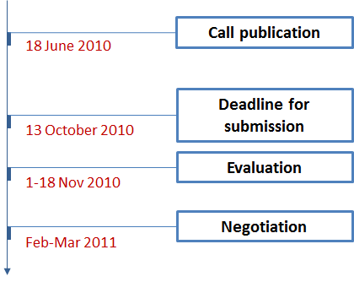
Figure 22. Timeline of the FCH JU 2010 call for proposals

4.4.2. Analysis of proposals submitted
The submission of proposals was done in a single stage. A total of 71 proposals were submitted by the deadline, of which 69 were eligible. They accounted for 559 participants from 32 countries, including 140 SMEs (25%). Regarding the typology of participants, 36% were representatives of the research community and 8% of the participants came from academia.
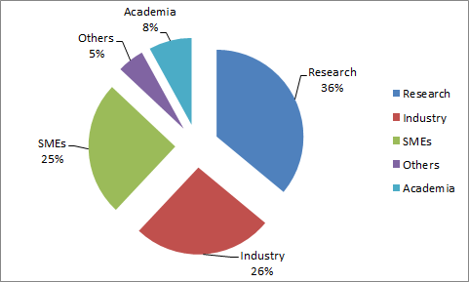
Figure 23. FCH JU 2010 call for proposals. Typology of applicants in submitted proposals
In this third call, Germany participated with the biggest number of partners – 88, followed by Italy (70), UK (59) and France (57). There were applicants from the following FP7 associated countries: Croatia, Bosnia and Herzegovina, Israel, Serbia, Switzerland, Turkey, and also applicants from FP7 third countries: the Russian Federation, Japan, People's Republic of China and the USA. The figure below gives an overview on the participations per country:
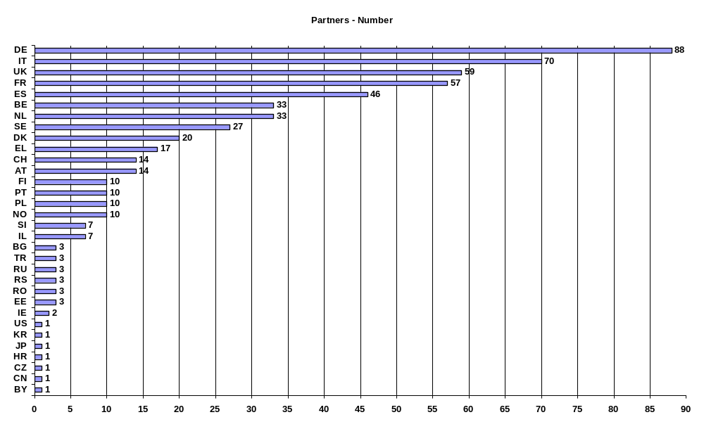
Figure 23. FCH JU 2010 call for proposals. Participation in the submitted proposals per country
The requested funding in all project proposals submitted by the deadline before evaluations amounted to € 230.6 million, 24% of which requested by SME partners. The requested funding per participating country can be found in the table below:
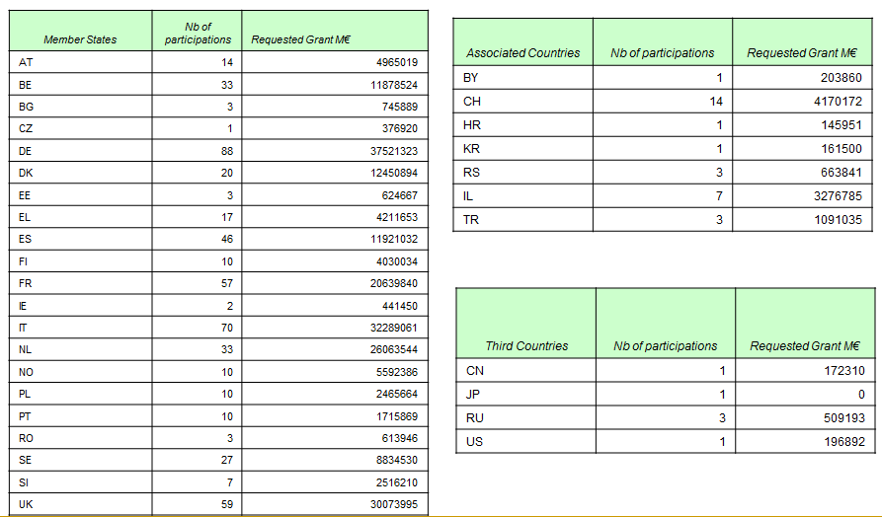
Table 24. IMI JU 2010 call for proposals. Requested funding per country

4.4.3. Evaluation procedure
As in the previous call, the submission of proposals was done in a single stage. The evaluation was carried out by 32 independent experts and a chairperson who oversaw the whole consensus phase. In addition, two independent observers monitored that the evaluation procedure was carried out in a fair, impartial and confidential manner. The individual remote evaluations took place from 1 to 13 November 2010 and the consensus meetings – from 16 to 18 November 2010.

4.4.4. Evaluation results
Out of the 69 eligible proposals, 43 were assessed above thresholds, requesting FCH JU contribution of € 147.76 million.
Table 25 below presents the overall picture of the evaluation with a breakdown of the proposals submitted in each Application Area, indicating the number of those which were above and below thresholds, as well as the requested FCH JU contribution:
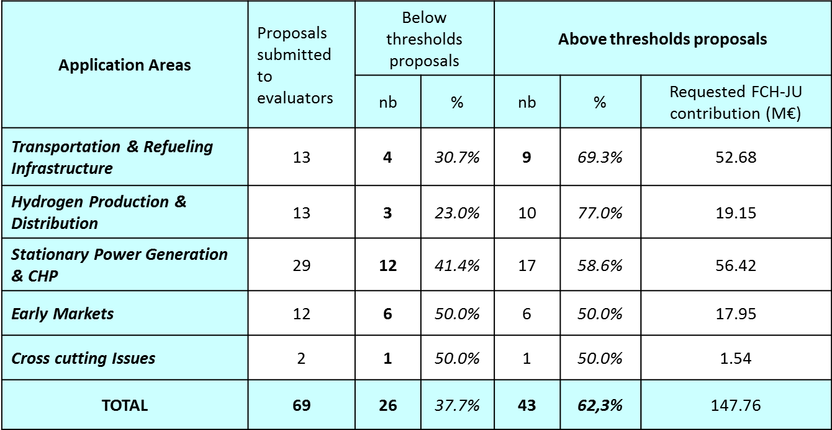
Table 25. FCH JU 2010 call for proposals. Evaluation results by AA

4.4.5. Grant agreements signed
No agreements were signed in 2010. In light of the available budget a list of 27 proposals (25 for collaborative projects and 2 for coordination and support actions) with additional 16 on the reserve list, ranked in priority order according to the evaluation results, was established by the end of 2010. The lists had to be submitted for approval of the FCH JU Governing Board at their first meeting in 2011. It was foreseen that the grant agreement negotiations for the short-listed proposals remain open by February-March 2011.
The Commission shall therefore present the definite list of grant agreements signed in the FCH JU third call for proposals in its next year's report.
Data on the provisional ranked list is provided in Table 26 below.
FCH JU rank | Final score | Coordinator |  | Proposal
FCH JU rank | Final score | Organisation | Nationality | Number | Funding scheme | Duration (months) | Acronym | Title
1 | 14 | DEUTSCHES ZENTRUM FUER LUFT – UND RAUMFAHRT EV | DE | 278138 | CP | 36 | NEMESIS2+ | New Method for Superior Integrated Hydrogen Generation System 2+
2 | 14 | SHELL GLOBAL SOLUTIONS INTERNATIONAL B.V. | NL | 278177 | CP | 24 | IDEALHY | Integrated Design for Efficient Advanced Liquefaction of Hydrogen
3 | 14 | NEDSTACK FUEL CELL TECHNOLOGY BV | NL | 278548 | CP | 36 | DEMCOPEM | Demonstration of a combined heat and power PEM fuel cell unit integrated into a chlor-alkali plant
4 | 14 | DIVERSEENERGY Ltd | UK | 279190 | SA | 24 | TOWERPOWER | Demonstration of FC-Based integrated generator systems to power off-grid cell phone towers, using ammonia fuel
5 | 13.5 | AVL LIST GMBH | AT | 278899 | CP | 36 | DESTA | Demonstration of 1st European SOFC Truck APU
6 | 13.5 | Rolls-Royce Fuel Cell Systems Ltd | UK | 278195 | CP | 36 | C3SOFC | Cost Competitive Component integration for StatiOnary Fuel Cell power
7 | 13.5 | AFC Energy plc | UK | 278674 | CP | 36 | LASER-CELL | Innovative cell and stack design for stationary industrial applications using novel laser processing techniques
8 | 13.5 | FORSCHUNGSZENTRUM JUELICH GMBH | DE | 278525 | CP | 30 | MMLRC=SOFC | Working towards Mass Manufactured, Low Cost and Robust SOFC stacks
9 | 13 | VAN HOOL N.V. | BE | 278192 | CP | 36 | High V.LO-City | Cities speeding up the integration of hydrogen buses in public fleets
10 | 13 | FUNDACION PARA EL DESARROLLO DE LAS NUEVAS TECNOLOGIAS DEL HIDROGENO EN ARAGON | ES | 278824 | CP | 36 | ELYGRID | Improvements to Integrate High Pressure Alkaline Electrolysers for Electricity/H2 production from Renewable Energies to Balance the Grid.
11 | 13 | HyGear Fuel Cell Systems B.V. | NL | 278629 | CP | 36 | SUAV | Microtubular Solid Oxide Fuel Cell Power System developement and integration into a Mini-UAV
12 | 12.5 | VOLVO TECHNOLOGY AB | SE | 277844 | CP | 36 | FCGEN | Fuel Cell Based On-board Power Generation
13 | 12.5 | AGENZIA NAZIONALE PER LE NUOVE TECNOLOGIE,L'ENERGIA E LO SVILUPPO ECONOMICO SOSTENIBILE | IT | 279075 | CP | 36 | CoMETHy | Compact Multifuel-Energy To Hydrogen converter
14 | 12.5 | FUNDACION INASMET | ES | 277916 | CP | 36 | METPROCELL | Innovative fabrication routes and materials for METal and anode supported PROton conducting fuel CELLs
15 | 12.5 | E.ON New Build & Technology Limited | UK | 278804 | CP | 36 | SOFT-PACT | Solid Oxide Fuel Cell micro-CHP Field Trials
16 | 12.5 | ERICSSON TELECOMUNICAZIONI | IT | 278921 | CP | 36 | FCpoweredRBS | Demonstration Project for Power Supply to Telecom Stations through FC technology
17 | 12 | AIR PRODUCTS PLC | UK | 278727 | CP | 40 | HyTEC | Hydrogen Transport in European Cities
18 | 12 | FOUNDATION FOR RESEARCH AND TECHNOLOGY HELLAS | EL | 278538 | CP | 24 | Hy2Seps_2 | Hybrid Membrane – Pressure Swing Adsorption (PSA) Hydrogen Purification Systems
19 | 12 | DEUTSCHES ZENTRUM FUER LUFT - UND RAUMFAHRT EV | DE | 278732 | CP | 36 | RESelyser | Hydrogen from RES: pressurised alkaline electrolyser with high efficiency and wide operating range
20 | 12 | TOPSOE FUEL CELL A/S | DK | 278257 | CP | 36 | METSAPP | Metal supported SOFC technology for stationary and mobile applications
21 | 12 | FUNDACION INASMET | ES | 278997 | CP | 36 | ReforCELL | Advanced Multi-Fuel Reformer for Fuel Cell CHP Systems
22 | 12 | CONSIGLIO NAZIONALE DELLE RICERCHE | IT | 278054 | CP | 36 | DURAMET | Improved Durability and Cost-effective Components for New Generation Solid Polymer Electrolyte Direct Methanol Fuel Cells
23 | 12 | Claassen Industrie Management Trading GmbH | AT | 278862 | SA | 24 | Temonas | TEchnology MONitoring and ASsessment
24 | 11.5 | POLITECNICO DI TORINO | IT | 278798 | CP | 36 | SOFCOM | SOFC CCHP with poly-fuel: operation and maintenance
25 | 11.5 | L'AIR LIQUIDE S.A A DIRECTOIRE ET CONSEIL DE SURVEILLANCE | FR | 278534 | CP | 36 | HyIndoor | Pre-normative research on safe indoor use of fuel cells and hydrogen systems
26 | 11 | STICHTING DIENST LANDBOUWKUNDIG ONDERZOEK | NL | 278855 | CP | 36 | HyTime | Low temperature hydrogen production from second generation biomass
27 | 11 | L'AIR LIQUIDE S.A A DIRECTOIRE ET CONSEIL DE SURVEILLANCE | FR | 278382 | CP | 36 | FCLIFT | FCLIFT: demonstration of substitution of battery electric forklifts by hydrogen fuel cell forklifts in a logistics warehouse
Table 26. FCH JU 2010 call for proposals. Ranked list of proposals selected for funding

5. Progress achieved by the ARTEMIS JU

5.1. About the ARTEMIS JU
Growing out of the ARTEMIS European Technology Platform (ETP), the ARTEMIS Joint Undertaking (hereinafter referred to as "ARTEMIS JU") was established by Council Regulation (EC) 74/2008 of 20 December 2007 as a public-private partnership between the European Commission, the participating Member and Associated States (by now 22 countries), and ARTEMIS-IA, a non-profit industrial association of R&D actors in the field of embedded computer systems.
The ARTEMIS JU has been set up for a period up to 31 December 2017 with the main objective to tackle the research and structural challenges in embedded systems faced by the industrial sector. The goal is to define and implement a Research Agenda for Embedded Computing Systems. ARTEMIS JU aims to help European industry consolidate and reinforce its world leadership in embedded computing technologies.
The maximum EU contribution to the ARTEMIS Joint Undertaking is set to € 420 million paid from the appropriations in the general budget of the European Union allocated to the theme "Information and Communication Technologies" of the Specific Programme "Cooperation" under the FP7. The research activities of the entity are supported also through financial contributions from the ARTEMIS Member States amounting to at least 1.8 times the EU contribution (€ 756 million) and through in-kind contributions by research and development organisations participating in projects, which at least match the contribution of the public authorities.
The ARTEMIS Joint Undertaking is managed by an Executive Director. Its governance structure comprises a Governing Board, a Public Authorities Board (PAB) and an Industry and Research Committee (IRC).

5.2. Main activities of the ARTEMIS JU in 2010
After its establishment, ARTEMIS gradually developed operational capacity, and on 26 October 2009 it has been granted administrative and operational autonomy from the Commission. Thus, 2010 was the first full year of independent functioning of the Joint Undertaking.
Key milestones
- Launch of the ARTEMIS third call for proposals;
- Grant agreements signature and kick-off of the selected proposals in the 2009 call;
- Monitoring and review of the ongoing 2008 calls for proposals;
- Adoption of an Internal Control Framework;
- Decision to delegate the Internal Audit function to the European Commission.
In 2010, ARTEMIS JU staff increased slightly – by two administrative assistants and the Undertaking ended up the year with 11 employees. Together with the other JTI JUs, the JU moved officially into its new premises in the White Atrium building in Brussels in January 2011.
Governance
The running of the Governing Board and the PAB run smoothly in 2010. The Governing Board held 3 meetings in 2010, while the PAB met 5 times. The IRC organised one official meeting.
The main decisions taken by the Governing Board during the year were related to the following topics:
- Internal Audit Service Charter and Ex-post Audit Strategy;
- Annual Implementation Plan and Budget Plan 2011;
- Multi-Annual Strategic Plan and Research Agenda, 2011 edition;
- Internal Control Framework and Internal Control Standards;
- Annual Accounts and Annual Activity Report for the year 2009;
- Management probationary report of the Executive Director;
- Multi-Annual Staff Policy Plan 2011-2013;
- Amendment to the model ARTEMIS JU grant agreement;
- Adoption of the JU's Annual Implementation Plan 2010 and Annual Budget Plan 2010.
Communication activities
One of the significant communication activities throughout the year was the participation of ARTEMIS at the ICT4EE event on 23-24 February 2010 in Brussels. Energy Efficiency is one of the key applications of embedded systems so ARTEMIS JU and ARTEMISIA organised a presence at this important conference and exhibition. This second edition of the high-level event on ICT for Energy Efficiency was organised by the European Commission's DG INFSO, in cooperation with the Spanish Presidency. It gathered policy makers and experts on the ICT for Energy Efficiency field through conferences, a Projects' exhibition and the "Best ICT4EE Project" Award Ceremony.
On 9-10 June 2010 ARTEMIS JU took part in the ARTEMISIA Summer Camp – a high-level strategic meeting defining the R&D agenda in embedded systems in Europe.
The peak of the events was the ARTEMIS-ITEA2 Co-Summit in Gent on 26-27 October 2010. This was an annual event during which ARTEMIS presented its role and objectives, and participated in an exhibition space with all its 25 presently running projects. A "student day" was also held, exposing the real world of embedded systems to students to encourage their career choice in the field. In addition, a workshop for the project coordinators was organised to discuss progress on the industrial priorities of the ARTEMIS-SRA and to evaluate the non-R&D activities, such as SME involvement, community building, etc. The Co-summit was an all-time record event in size; more than 600 people from 22 countries participated in the event and 90 stands at exhibition represented all running projects of ITEA and ARTEMIS and partnering organisations.
During the year, ARTEMIS published also several information brochures on the ongoing and the future calls for proposals, and three numbers of the quarterly ARTEMIS Magazine. The Undertaking improved it visual identity too, by re-designing its logo.
An overview of the ARTEMIS projects was produced in the ARTEMIS Book of Projects, Volume 1. This publication of almost 100 pages contains the 25 running ARTEMIS projects and articles that were published in the ARTEMIS Magazine. The ARTEMIS book was designed as a corporate identity gift of the ARTEMIS Joint Undertaking, as well as being a brochure. It has been distributed to high-level authorities, ARTEMIS Governing Board and PAB, member representatives of the ARTEMIS Industry Association, Directors of the ETPs and newly established PPPs, ARTEMIS project leaders, etc.
Interaction with the press occurred mainly via press releases and arranged interviews on different topics – briefings on the Co-Summit and on the ARTEMIS Brokerage event, an informative release on the submitted proposals in the 2010 call, etc.
Besides, the web site (http://www.artemis-ju.eu) has been an important tool for the ARTEMIS JU for publishing its objectives and announcements on the calls, but also for providing up-to-date information to the stakeholders. In the first quarter of 2010, the site has been significantly upgraded visually, much of the antiquated text replaced, information about the ARTEMIS JU office and its staff was added, and the appearance tidied up.
Calls for proposals
The ARTEMIS JU supports R&D activities through open and competitive calls for proposals published on a yearly basis, to attract the best European research ideas and capacities in the field of embedded computing systems. The ARTEMIS JU manages and coordinates research activities through a 10-year, € 2.5 billion research programme on embedded computing systems. The programme is open to organisations in the EU Member States and Associated Countries. Selected projects are co-financed by the Joint Undertaking and the Member States that have joined ARTEMIS. The ARTEMIS JU implements significant parts of the ARTEMIS–ETP Strategic Research Agenda co-funded by industry, research organisations, Member States and the Commission's own ICT programme.
ARTEMIS applies a two-stage procedure: proposers must first submit Project Outlines (POs), followed by the submission of Full Project Proposals (FPPs). The submission of an eligible PO is mandatory for the submission of a FPP. This is a detailed version of the PO and takes into account the feedback from the experts. Projects are selected for funding based on the quality of this document. The evaluation criteria and sub-criteria, including weights and thresholds, and the selection and award criteria are set out in the ARTEMIS Annual Work Programme 2010.
Proposals submitted to ARTEMIS JU calls undergo a technical evaluation and selections process carried out with the assistance of independent experts. This process ensures that allocation of the ARTEMIS Joint Undertaking's public funding follows the principles of equal treatment, excellence and competition.
Funding for ARTEMIS projects follows a unique tripartite model. Much of the funding is provided to the partners by their own government or regional agency, with whom a grant agreement is set up. The ARTEMIS Joint Undertaking also provides funding directly to the partners to the amount of 16.7% of their eligible costs. This funding model has been working well in the first years of the Joint Undertaking, but with certain limitations – mainly due to the strongly reduced level of commitments from the Member States in the context of the economic and financial crisis.
Concerning the first (2008) and second call (2009), the Annual Report on the progress achieved by the JTI JUs in 2009 prepared by the Commission gives detailed information on these calls.
The ARTEMIS JU has managed its third call for proposals in 2010 as planned. It was launched on 26 February 2010 and in the end of November 2010 the negotiations have started. Since the outcome of the negotiations was planned for January 2011, the Commission shall present the definitive list of the grant agreements signed under this call in its next year's report on the progress achieved by the JTI JUs.

5.3. Call 3 ARTEMIS-2010-1

5.3.1. Summary information
ARTEMIS published its third call for proposals on 26 February 2010.
The results arising from projects following the 2010 call were expected to demonstrate their contribution to the ARTEMIS JU high-level objectives set out below. ARTEMIS set an over-arching objective to close the design productivity gap between potential and capability, as a necessary pre-requisite to advancing Europe's competitive position on the world market:
- Reduce the cost of the system design from 2005 levels by 15% by 2013;
- Achieve 15% reduction in development cycles, especially in sectors requiring qualification or certification – by 2013;
- Manage a complexity increase of 25% with 10% effort reduction by 2013;
- Reduce the effort and time required for re-validation and recertification after change by 15% by 2013;
- Achieve cross-sectoral reusability of embedded systems devices developed using the ARTEMIS JU results.
The 2010 ARTEMIS calls for proposals had to address the design, development and deployment of ubiquitous, interoperable and cost-effective, powerful, safe and secure electronics and software systems. It should deliver on three industrial priorities: 1) Reference designs and architectures, 2) Seamless connectivity and middleware, and 3) Design methods and tools.
In addition to the industrial priorities, ARTEMIS JU proposals had to fit into one of the 8 specific ARTEMIS Sub-Programme (ASP) priorities for 2010, which were determined in the ARTEMIS Annual Work Programme for 2010 as follows:
- ASP1. Methods and processes for safety-relevant embedded systems;
- ASP2. Person-centric health management;
- ASP3. Smart environments and scalable digital services;
- ASP4. Efficient manufacturing and logistics;
- ASP5. Computing environments for embedded systems;
- ASP6. Security, privacy and dependability in Embedded Systems for applications, networks and services;
- ASP7. Embedded technology for sustainable urban life;
- ASP8. Human-centric design of embedded systems.
The timeline of the call is shown on Figure 24 below:
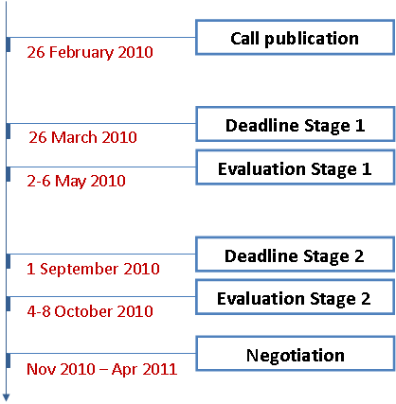
Figure 24. Timeline of the ARTEMIS JU 2010 call for proposals
The total budget for the call included an indicative ARTEMIS JU contribution of € 33.1 million and contributions from the Member States estimated at € 60.2 million. The exact commitment by Member State is shown in the table below:
ARTEMIS JU Member States (M€)
Austria | 5 | Hungary | 0.6
Belgium | 2 | Ireland | 1
Cyprus | 0 | Italy | 8
Czech Republic | 0.8 | Latvia | 0.22
Germany | 8 | Netherlands | 6
Denmark | 2 | Norway | 1.5
Estonia | 0.3 | Portugal | 0.8
Spain | 4 | Romania | 0
Finland | 6 | Sweden | 3
France | 4 | Slovenia | 1
Greece | 2 | United Kingdom | 4
Table 27. ARTEMIS JU 2010 call for proposals. Funding by Member States

5.3.2. Analysis of proposals submitted
The 2010 call was published on 26 February 2010 with a two-step procedure: deadline for submission of Project Outlines (POs) on 26 March 2010 and of Full Project Proposals (FPPs) on 1 September 2010. Submission of a PO was mandatory, although not gating. In both phases, the proposals had to be submitted electronically to the ARTEMIS JU via the FP7 Electronic Proposal Submission System (EPSS).
The 2010 call for proposals was the second ARTEMIS call to operate in a two-phase process call after the one launched in 2009. The call published in 2008 was one-stage.
The PO phase yielded 73 proposals, 1 of which was ineligible. The remaining 72 eligible proposals were reviewed and feedback was given to the applicants. For the FPP phase, 47 proposals were received by 1 September 2010 and the evaluations were completed in October 2010.
Stage 1 – Project Outlines (POs)
In total, 72 eligible POs have been submitted for evaluation involving 1,028 participants from 29 countries. Regarding the topic distribution, as seen from the graph below, the most attractive was ASP3 "Smart environments and scalable digital services", which gathered 18% of the submitted proposals at that stage.
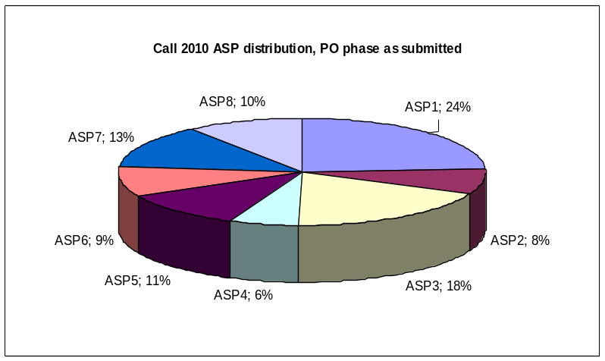
Figure 25. ARTEMIS JU 2010 call for proposals – Stage 1. ASP distribution as submitted
The total individual participations (each partner participating in multiple proposals was only counted once) were 745, of which 278 declared as SMEs (38%). 30% of the participants belonged to public and research organisations. The data for the proposals eligible for evaluation of the PO phase are detailed in the following chart:
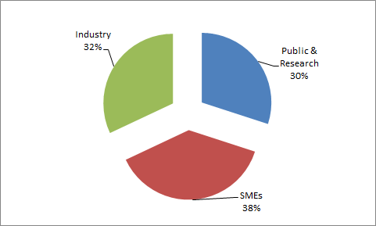
Figure 26. ARTEMIS JU 2010 call for proposals – Stage 1. Typology of applicants in POs
With regard to geographical distribution of the POs, a total of 29 countries took part at the first stage of the call. Spain accounted the biggest number of participants, followed by Germany, Italy and Finland.
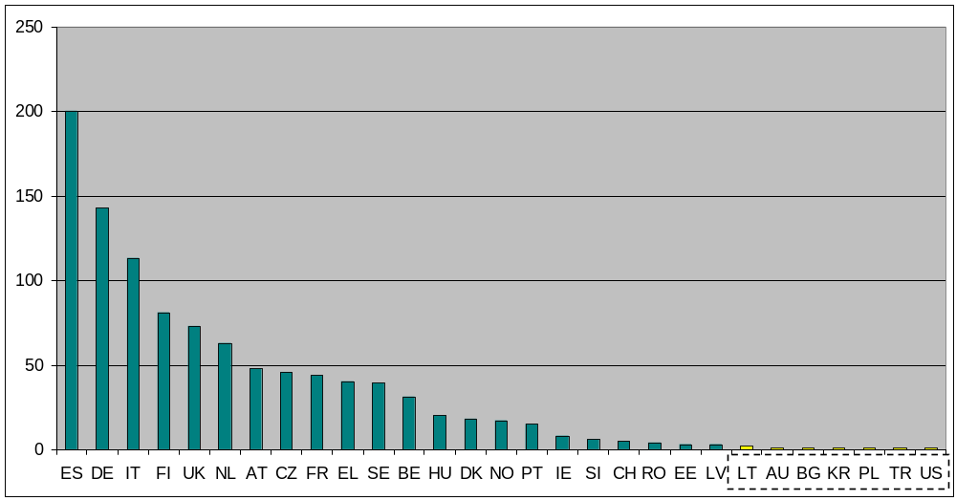
Figure 27. ARTEMIS JU 2010 call for proposals – Stage 1. Applicants by country
They requested a total funding of € 704 million. The total requested funding was split as follows: The total requested national funding was € 259 million and the total requested ARTEMIS JU funding was € 377 million, of which € 118 million EU funding. This is graphically presented by country on Figure 28 below. The total requested funding by SME partners was € 90 million (24%).
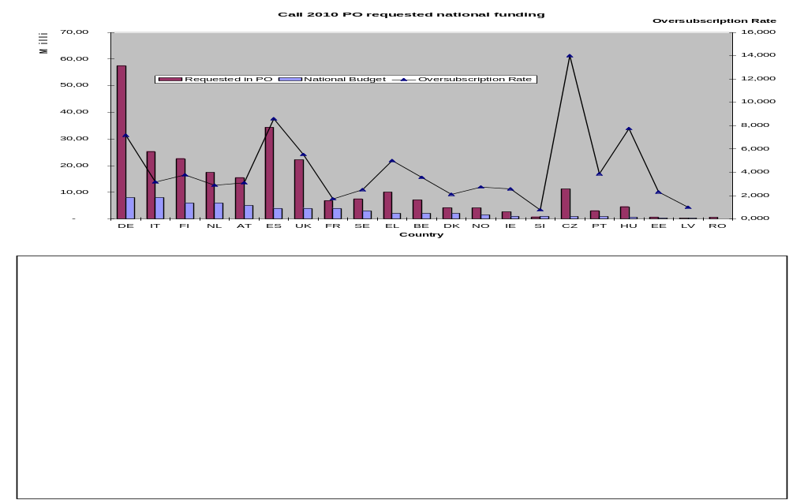
Figure 28. ARTEMIS JU 2010 call for proposals – Stage 1. Requested national funding by POs
As a tool to aid the participating ARTEMIS Member States in preparing their budget allocations, and also to provide valuable feedback for monitoring the programme, the Executive Director asked the assessors to judge the relative maturity of each project outline, classifying them on a scale of 1 ("very mature") to 4 ("below average"): MI=3 is regarded as "average" while MI=2 is "mature"). This Maturity Index information was given only to the PAB members, and not distributed to the proposers or otherwise outside the JU.
 | ASP1 | ASP2 | ASP3 | ASP4 | ASP5 | ASP6 | ASP7 | ASP8 | Total
MI=1 | 2 | 1 | 0 | 0 | 1 | 0 | 0 | 0 | 4
MI=2 | 4 | 1 | 3 | 1 | 2 | 2 | 4 | 3 | 20
MI=3 | 9 | 1 | 6 | 3 | 2 | 3 | 1 | 5 | 30
MI=4 | 1 | 5 | 5 | 1 | 1 | 1 | 2 | 1 | 17
Total | 16 | 8 | 14 | 5 | 6 | 6 | 7 | 9 | 71*
* For one proposal, the experts didn't find any relation with any of the 8 ASPs.
Table 28. ARTEMIS JU 2010 call for proposals – Stage 1. Maturity indexes by ASP
Over all proposals, the peak of 42% is in MI=3 (average), which had to be expected. The value in MI=2 is also relatively high, while the number in category MI=1 is quite small (6%). This may indicate a more severe rating by the experts for the highest maturity category, but the distribution is otherwise reasonable. The 24% of proposals in MI=4 represent some proposals that are often very incomplete. In future calls, this "number reservation strategy" will be discouraged and accurate instructions will allow all PO's not matching minimum requirements to be declared "ineligible".
Stage 2 – Full Project Proposals (FPPs)
Out of the 72 POs, 47 FPPs were successfully submitted by the deadline of 1 September 2010. As anticipated, all four of the most mature outline proposals were finalised and submitted as full project proposals. A small number of MI=2 proposals were not re-submitted, and about half of the coordinators of the least mature proposals decided not to re-submit. A little more than half of the MI=3 proposals were not re-submitted.
The total number of participations was 840, with 633 individual participants of which 34% – SMEs. Regarding the topic distribution, as seen from the graph below, the most attractive this time was ASP1 "Methods and processes for safety-relevant embedded systems", which gathered 25% of the submitted proposals at that stage.
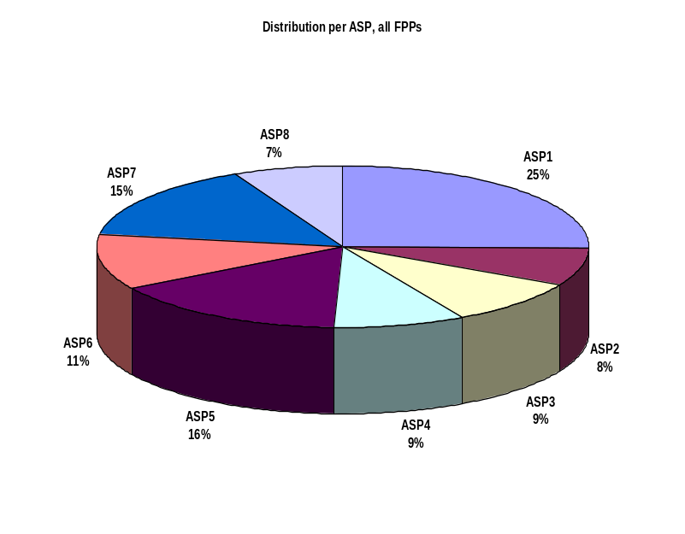
Figure 29. ARTEMIS JU 2010 call for proposals – Stage 2. ASP distribution as submitted
The initial analysis, based on the declarations of partners, showed that total individual participations (each partner participating in multiple proposals was only counted once) were 663, of which 226 declared as SMEs (34%). 25% of the participants belonged to public and research organisations. The data for proposals eligible for evaluation of the FPP phase of the call are detailed in the following chart:
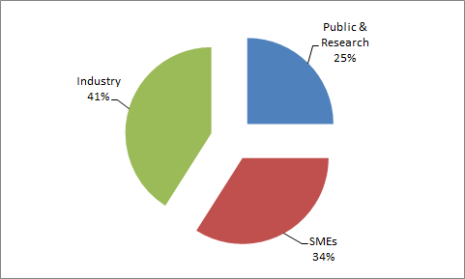
Figure 30. ARTEMIS JU 2010 call for proposals – Stage 2. Typology of applicants in FPPs
The average partners per project at the FPP stage equalled to 17.87. The proposals in the 2010 call showed a substantial number of large pan-European initiatives being undertaken by the constituency. There was also the requisite number of more targeted proposals.
With regard to geographical distribution of the FPP, 28 countries continued at the second stage of the call. The average number of participating countries in a proposal was 6.74 – the largest number being 13 and the smallest being 4 (one more than the strict minimum for eligibility).
Figure 31 shows a strong Spanish participation in the programme, particularly through the large number of SMEs, which have actively subscribed since the outset. Italy was also strongly represented at this stage of the call, followed by Germany, Finland and the Netherlands.
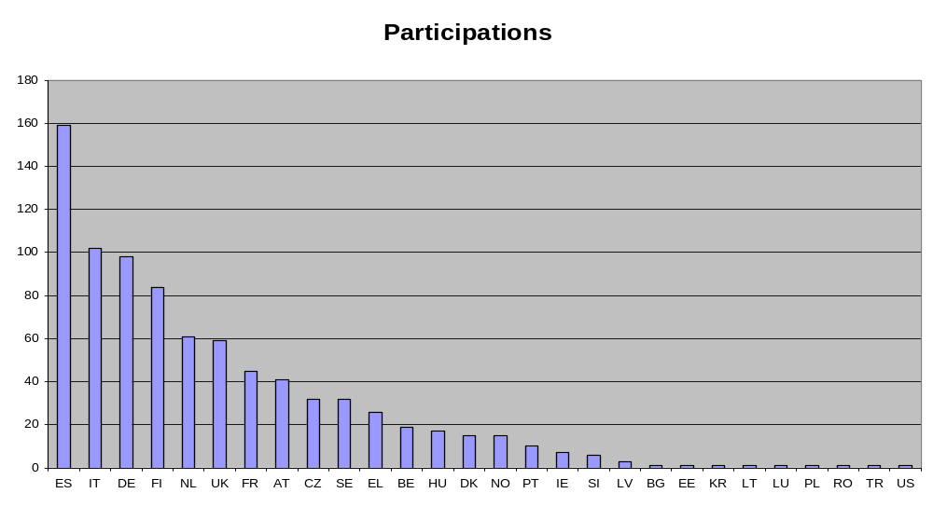
Figure 31. ARTEMIS JU 2010 call for proposals – Stage 2. Applicants by country
The total requested funding by the 47 FPPs was € 589 million. The total requested national funding reached € 215 million and the total requested ARTEMIS JU funding amounted to € 313 million, of which € 98 million EU funding. This is graphically presented by country on Figure 32 below.
In terms of EFTA contribution, it represented € 1,356,163 for the operational credits allocated to the call 2010.
The total requested funding by SME partners was € 156 million (27%).
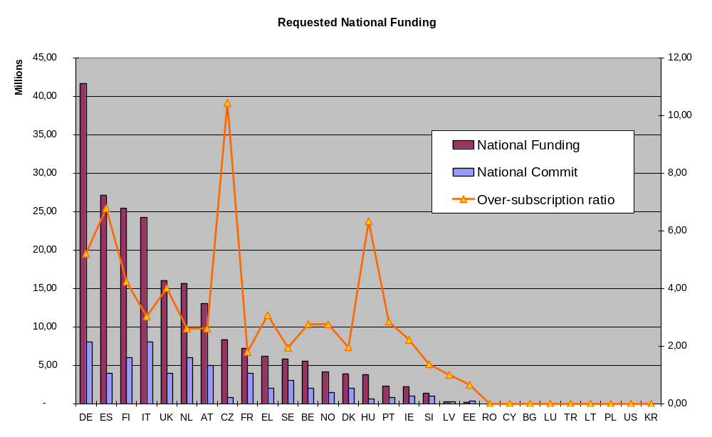
Figure 32. ARTEMIS JU 2010 call for proposals – Stage 2. Requested national funding by FPPs

5.3.3. Evaluation procedure
Stage 1 – POs
73 POs for research projects were submitted in response to first phase of this call, of which 72 satisfied the eligibility criteria.
The RiVET software was used to support and to track both off-site reading by experts and the progress of the panel meeting. The latter was held in Brussels on 2-6 May 2010. Each PO was assessed by two independent experts selected from the lists provided by the PAB and by ARTEMIS-IA. The individual assessment reports were summarised by a third expert, acting as rapporteur.
For the first time, a tool facilitating further analysis was used at the first phase of the call to judge the subjective quality of the POs and to observe the level of maturity of the response of the ARTEMIS community to the work programme. To that end, POs were classified into 4 Maturity Index levels – from "Below average" to "Very mature proposal". This information was not communicated externally, but did provide the ARTEMIS JU with an insight on the activities of the R&D community. The obtained results were also used by the PAB members in refining their budget allocations, where possible.
The evaluation results of this first phase were communicated to participants on 18 May 2010. They were notified on the level of satisfying the assessment criteria specified in the call, but were also informed by the national authorities on the fulfilment of the eligibility criteria for national funding. The submission of an eligible PO was mandatory for submission of the subsequent full project proposal.
Stage 2 – FPPs
47 FPPs were submitted in this phase, all eligibility criteria. The evaluation was conducted according to the rules described in the ARTEMIS Joint Undertaking selection and evaluation procedures related to calls for proposals.
Each proposal was initially evaluated remotely by four individual experts. This was followed by a panel meeting of external experts under the chairmanship of the ARTEMIS JU Executive Director. The panel produced the final evaluation result for each proposal after an in-depth discussion on the basis of the four individual reports from the experts.
The 5 evaluation criteria were:
- Relevance and contributions to the objectives of the call;
- R&D innovation and technical excellence;
- S&T approach and work plan;
- Market innovation and market impact;
- Quality of consortium and management.
Remote evaluation was done by in total 67 experts. Synthesis was done by one rapporteur per project. Consolidation and calibration of evaluation scores were performed by 15 experts, meeting in Brussels from 4 to 8 October 2010. Consolidation of the evaluation summary reports was achieved through three sub-panels, chaired by one EC person plus one JU person. Calibration of final scores in the evaluation summary reports was done in the final panel discussion chaired by the Executive Director.

5.3.4. Evaluation results
The applicants were informed of the evaluation results on 25 October 2010. At this stage, 28 proposals (60% of the total FPPs) were evaluated above threshold (40 points minimum on a maximum of 60) and 19 were evaluated below this selection threshold. Out of the 28, 11 projects were retained for negotiation, 6 were placed in a reserve list, and 11 projects were deemed not feasible financially though above the minimum score threshold. 19 projects (40% of the FPPs) were rejected as they were below the selection threshold.
A total of 10 projects successfully completed the negotiation phase. One project negotiation was cancelled by the Executive Director due to the changing market situation for the operating system Symbian.
The 10 selected proposals covered the priority objectives of the call (safety-relevant embedded systems for transportation and automation, smart environments and digital services and embedded computing platforms) in a satisfactory manner. About 33% of investment concerned projects related to safety critical systems (typically for transport applications), 4% – to smart environments and digital services, and 14% were earmarked for computing architectures projects. Additional 18% were spent energy reduction in urban areas, and another 12% – on human-centric design. One project in topic "Health", with 8% of the funding, was retained. 12% of the total contribution was spent on secure digital services. Unfortunately, no project addressing industrial efficiency (manufacturing and logistics) was retained.
In terms of the number of participants, the projects selected for funding comprise a total of 227 participations, of which 103 were large enterprises, 66 – SMEs (29%), and 58 represented public research organisations, such as universities and institutes. The following graph shows their relative distribution:
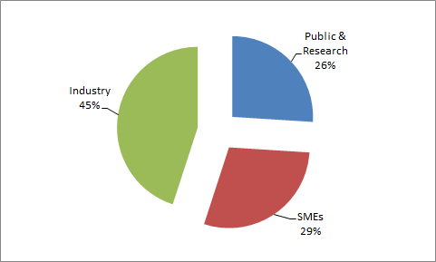
Figure 33. ARTEMIS JU 2010 call for proposals. Typology of applicants in the proposals for funding
With regard to geographical distribution of the proposals selected for funding, a total of 21 countries have been presented. Spain gave way to Italy (42), reaching the same number of applicants as Germany (27). The following chart shows a breakdown of participant type per country, taken into account all participations:
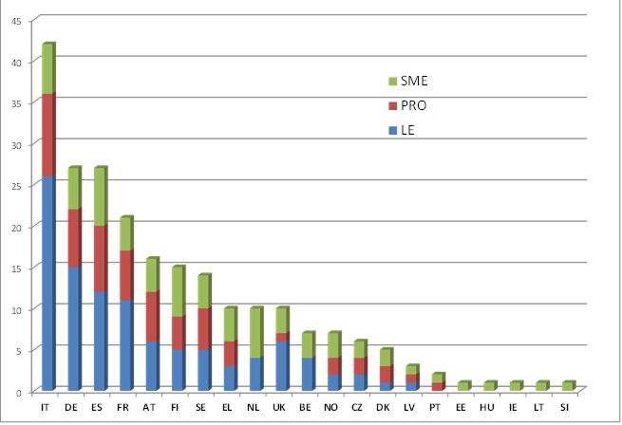
Figure 34. ARTEMIS JU 2010 call for proposals. Participant type per country
in the proposals selected for funding
In terms of the number of countries involved in each project, they varied from 10 to 4. No project has the strict minimum of 3 participating countries, and the average of 6.4 countries per project is significantly higher than has been historically the case. This is evidence that the ARTEMIS programme started attracting not only larger initiatives, but also various international partners in its projects, calling on expertise from a broader base of participants.
Overall, the Public Authorities Board allocated € 82.9 million of public funds from the ARTEMIS Member States and the European Union to those 10 projects amounting to a total funding of € 167.5 million. The € 28 million EU funding resulted in a leverage effect of 6 to 1. National budgets published in the call, subsequently increased by some countries to permit strategically important projects to be funded, were allocated at the rate of 91.2% and the EU budget – at the rate of 84.5%.
The projects ranged in size from € 45 million to € 3.3 million, with 3 projects of over € 15 million, representing 58% of the total funding. This was in line with the ARTEMIS "Think Big" approach, where larger projects are supported by smaller, more targeted initiatives in addressing the goals of the Annual Work Programme.
 | Industry | Public & Research  Organisations | SMEs | TOTAL (€)
Total Eligible Costs | 106,114,720.60 | 31,068,725.22 | 30,280,204.89 | 167,463,650.71
National Funding Requested | 27,682,748.66 | 16,903,600.96 | 10,313,050.43 | 54,899,400.04
EU Funding | 17,721,158.34 | 5,188,477.11 | 5,056,794.22 | 27,966,429.67
Total Eligible Costs | 63% | 19% | 18% | ---
National Funding Requested | 50% | 31% | 19% | ---
National Funding Rate | 26% | 54% | 34% | 33%
Total Funding Rate | 43% | 71% | 51% | 49%
* The ARTEMIS JU contribution was fixed at 16.7% of the total eligible costs
Table 29. ARTEMIS JU 2010 call for proposals. Funding breakdown per partner type

5.3.5. Grant agreements signed
On 20 October 2010, the ARTEMIS JU Executive Director received a mandate to enter into negotiations with 8 of the 11 highest ranked projects and to investigate possible reconfiguration of the remaining three. This mandate was extended in November to embrace the negotiation of the 3 FPPs, with the mandate ending in mid-April 2011.
During this period it became clear that the negotiations of one of the original 8 proposals would be irrevocably unsuccessful due to changes in the corporate strategy of the coordinator. In order to allow the national funding that became available due to the closure of this project to be re-allocated, the process of signing of the Joint Undertaking grant agreements was temporarily put on hold until a decision was taken on the re-allocation. The grant agreement preparation work was subsequently re-started, though by June 2011 no contract had yet been signed. The expected signature dates indicated in the table below are dependent on the ARTEMIS JU receiving signed NGA (National Grant Agreement) declarations from the coordinators' Member States: to date only two such certificates have been received.
The signature of the JU grant agreements in itself is not critical for allowing the projects to start, and two projects planned to kick off in March, three in April, two in May, two in June and one in July 2011. For two projects, however, a combination of internal delays and delay in securing a NGA led to a request to move their official starting date to the October- November 2011 timeframe.
№ | Project number | Project acronym | Project title | Total national funding | ARTEMIS JU contribution | Additional own resources | Total costs | Signature date (expected)
1. | 269334 | ASTUTE | Pro-active decision support for data-intensive environments | 5,362,482.07 | 2,301,932.48 | 6,119,612.30 | 13,784,026.85 | Q4 2011
2. | 269336 | D3CoS | Designing Dynamic Distributed Cooperative Human-Machine Systems | 5,193,398.75 | 2,429,633.51 | 6,925,671.39 | 14,548,703.65 | Q3 2011
3. | 269354 | ENCOURAGE | Embedded Intelligent Controls for Buildings with Renewable Generation and Storage | 1,756,412.94 | 1,063,579.18 | 3,548,745.48 | 6,368,737.60 | Q4 2011
4. | 269356 | HIGH PROFILE | High-throughput Production of FunctIonal 3D images of the brain | 5,017,647.04 | 2,825,739.87 | 9,077,211.09 | 16,920,598.00 | Q4 2011
5. | 269374 | IoE | Internet of Energy for Electric Mobility | 14,370,762.28 | 7,587,182.26 | 23,474,284.57 | 45,432,229.11 | Q4 2011
6. | 269335 | MBAT | Combined Model-based Analysis and Testing of Embedded Systems | 11,398,412.00 | 5,761,237.31 | 17,338,777.69 | 34,498,427.00 | Q3 2011
7. | 269317 | nSHIELD | New embedded Systems arcHItecturE for multi-Layer Dependable solutions | 5,091,894.30 | 2,249,372.43 | 6,128,029.77 | 13,469,296.50 | Q4 2011
8. | 269362 | PRESTO | ImProvements of industrial Real Time Embedded SysTems devel0pment process | 2,540,068.00 | 1,446,709.98 | 4,676,156.02 | 8,662,934.00 | Q4 2011
9. | 269265 | pSAFECER | Safety Certification of Software-intensive Systems with Reusable Components | 2,599,302.68 | 1,739,991.20 | 6,079,815.12 | 10,419,109.00 | Q4 2011
10. | 269389 | WSN DPCM | WSN Development, Planning and Commissioning & Maintenance ToolSet | 1,607,670.00 | 559,063.40 | 1,180,951.60 | 3,347,685.00 | Q4 2011
TOTAL |  |  |  | € 54,938,050 | € 27,964,442 | € 84,549,255 | € 167,451,747 | ---
Table 30. ARTEMIS JU 2010 call for proposals. List of proposals selected for funding

6. Progress achieved by the ENIAC JU

6.1. About the ENIAC JU
Growing out of the ENIAC European Technology Platform (ETP), the ENIAC Joint Undertaking (hereinafter referred to as "ENIAC JU") was established by Council Regulation (EC) 72/2008 of 20 December 2007as a public-private partnership between the European Commission, the participating Member and Associated States (by now 21 countries) and AENEAS, a non-profit industrial association of R&D actors in the field of semiconductors.
The ENIAC JU has been set up for a period up to 31 December 2017 with the main objective to tackle the research and innovation in nanoelectronic technologies and smart components and their integration in smart systems faced by the industrial sector. The goal is to define and implement a Research Agenda for Nanoelectronics-Based Systems. ENIAC JU aims to help European industry consolidate and reinforce its world leadership in nanoelectronics technologies and systems.
The maximum EU contribution to the ENIAC Joint Undertaking covering running costs and R&D activities is set to € 450 million paid from the appropriations in the general budget of the European Union allocated to the theme "Information and Communication Technologies" of the Specific Programme "Cooperation" under the FP7. The research activities of the entity are supported also through financial contributions from the ENIAC Member States amounting to at least 1.8 times the EU contribution (€ 810 million) and through in-kind contributions by research and development organisations participating in projects, which at least match the contribution of the public authorities.
Similarly to ARTEMIS, the ENIAC Joint Undertaking is managed by an Executive Director. Its governance structure comprises a Governing Board, a Public Authorities Board (PAB) and an Industry and Research Committee (IRC).

6.2. Main activities of the ENIAC JU in 2010
After its establishment, ENIAC gradually developed operational capacity, and on 3 May 2010 it has been granted administrative and operational autonomy from the Commission.
Key milestones
- Launch of the third call for proposals;
- Preparation of the fourth call for proposals;
- Updating the ENIAC Research Agenda in cooperation with CATRENE (Cluster for Application and Technology Research in Europe on Nanoelectronics);
- Implemented the Internal Control Framework;
- New staff recruited and prepared the move to the new premises.
Governance
The running of the Governing Board and the PAB run smoothly in 2010. The Governing Board held 2 meetings in 2010, while the PAB met 5 times. The IRC organised one official meeting.
The main decisions taken by the Governing Board during the year were related to the following:
- Implementing rules of the Staff Regulations for the appraisal of the Executive Director;
- Annual Implementation Plan and Annual Budget Plan 2011;
- Revision of the ENIAC JU grant agreement to take into account the changes introduced by the Lisbon Treaty;
- Multi-annual Strategic Plan and Research Agenda 2011;
- Internal Control Framework and Internal Control Standards;
- Ex-post audit strategy and Internal Audit Plans;
- Nomination of the reporting officers in charge of the appraisal of the Executive Director.
Communication activities
The ENIAC JU intensified its communications and dissemination activities in 2010 (brochure, project profiles, flyers, etc.), updated its web site, co-organised the European Nanoelectronics Forum, and actively participated in dedicated events and international conferences.
The ENIAC JU concluded in 2010 a Service Level Agreement with its member AENEAS to provide communication and public relations support. The ENIAC JU defined and executed in 2010 a Communication Plan. It established communication goals for its 5 constituencies:
- Internal to Executive Director / Secretariat
- ENIAC JU Bodies (Governing Board, PAB, Executive Director and IRC)
- Contributed to the Annual Activity Report 2009;
- Issued Quarterly reports to the Governing Board showing progress versus plan: achievements, issues, actions planned, in form of an Executive Summary and a Narrative;
- Organised a National Funding Authorities day;
- Had face-to-face meetings with public authorities (Austria, France, Germany, Italy, Netherlands, Romania, Spain);
- European Union Bodies (European Commission, Council and Parliament / Budget Authority, European Court of Auditors)
- Presented to the Commissioners for Research and for Digital Agenda, presented the real estate procedure to the Budgetary Committee of the Parliament and of the Council;
- Contributed to the Interim Evaluation of the JTIs;
- R&D Actors
- Published an updated version of the call for proposal including the Guide for Participants;
- Executed a communication day for the Project Coordinators;
- Public at large
- Issued 2 press releases;
- Printed and distributed the ENIAC JU brochure and Project Profiles for calls 1 and 2;
- Renewed the web site (http://www.eniac.eu);
- Co-organised the European Nanoelectronic Forum in Madrid (Spain);
- Organized a session and "Building Bridges" event at the conference ICT2010 in Brussels (Belgium);
- Participated in several events in Germany, Austria, Italy, Romania, sponsored events in Belgium, France and Germany;
- Presented an invited paper at the Sematech Litho Workshop and presented the "LENS" project at the Litho Symposium enhancing the international visibility.
Although progress has been made, the presence of the ENIAC JU in the media and in the public space is still to be improved, inter alia by making all public documents and project information readily available on the ENIAC JU web site.
Calls for proposals
The ENIAC JU supports R&D activities through open and competitive calls for proposals published on a yearly basis, to attract the best European research ideas and capacities in the field of nanoelectronics. The ENIAC JU manages and coordinates research activities through a 10-year, € 3 billion research programme on nanoelectronics. The programme is open to organisations in the EU Member States and Associated Countries. Selected projects are co-financed by the Joint Undertaking and the Member States that have joined ENIAC. The ENIAC JU implements significant parts of the ENIAC–ETP Strategic Research Agenda.
Funding decisions under the ENIAC JU Annual Work Programme are made on the basis of proposals submitted upon a call. Proposals describe planned research activities and give information on the applicants and the costs. The ENIAC JU evaluates all eligible proposals using independent experts in order to rank the proposals on the basis of the evaluation criteria.
Following the evaluation, the Public Authorities Board of the ENIAC JU decides on the selection of proposals and the allocation of funding (ENIAC JU and national funding). The ENIAC JU then negotiates with selected proposals taking into account the maximum public funding allocated and the potential recommendations for changes.
If negotiations are successfully concluded grant agreements are signed with ENIAC JU. Participants from ENIAC Member States also conclude national grant agreements with their own national funding authorities as they normally also receive a national financial contribution.
Concerning the first (2008) and second call (2009), the Annual Report on the progress achieved by the JTI JUs in 2009 prepared by the Commission gives detailed information on these calls.
The ENIAC JU has launched its third call for proposals in 2010 as scheduled. It was published at the same date as the ARTEMIS JU' call – on 26 February 2010. In the end of November 2010 the negotiations have already started. Since the outcome of the negotiations was planned for January 2011, the Commission shall present the grant agreements signed under this call in its next year's report on the progress achieved by the JTI JUs.

6.3. Call 3 ENIAC-2010-1

6.3.1. Summary information
ENIAC published its third call for proposals on 26 February 2010.
The results arising from projects following the 2010 call were expected to demonstrate their contribution to the ENIAC-JU high-level objectives described in the Multi-Annual Strategic Plan and in the Annual Work Programme 2010. The selected topics covered the priorities of the stakeholders, including those of the Member States.
The topics and proposals are grouped in four major areas:
- Advances in electric mobility;
- Applications driving advances in n and n+1 Complementary Metal Oxide Semiconductor (CMOS) technology nodes and their derivatives, related packaging and design technologies;
- Energy efficient, ecologically benign future manufacturing technologies;
- Alternative energies value chain and efficient power grid.
The timeline of the call is shown on Figure 35 below:
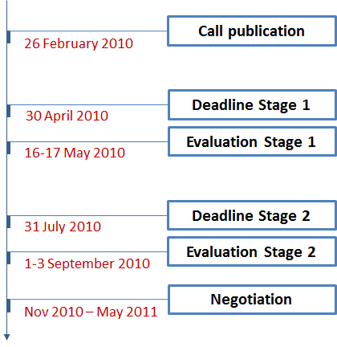
Figure 35. Timeline of the ENIAC JU 2010 call for proposals
The total budget for the call included an indicative ENIAC JU contribution of € 30.1 million and contributions from the Member States estimated at € 54.8 million. The exact commitment by Member State is shown in the table below:
ENIAC JU Member States (M€)
Austria | 3.0 | Italy | 10
Belgium | 2.0 | Netherlands | 8.0
Czech Republic | 0.4 | Norway | 1.5
Estonia | 0.0 | Poland | 0.8
Finland | 1.5 | Portugal | 0.5
France | 7.0 | Romania | 0.5
Germany | 12.0 | Slovak Rep. | 0.5
Greece | 1.5 | Spain | 1.5
Hungary | 0.6 | Sweden | 1
Ireland | 1.0 | United Kingdom | 1.5
Table 31. ENIAC JU 2010 call for proposals. Funding by Member States

6.3.2. Analysis of proposals submitted
The ENIAC JU 2010 call was published on 26 February 2010 and operated in a two-phase mode. The Project Outline (PO) phase yielded 34 proposals for review before the set deadline – 30 April 2010. This represented an increase of 26% in comparison to the year before. Submission of a PO was mandatory, although not gating. In both phases, the proposals had to be submitted electronically to the ENIAC JU via the FP7 Electronic Proposal Submission System (EPSS).
The submitted POs requested a total funding of € 707.8 million. This funding was split as follows: the requested national funding was € 234.8 million and the requested ENIAC JU funding was € 118.3 million.
In the Full Project Proposal (FPP) phase, 24 proposals were received by the deadline – 31 July 2010. The total requested funding by the 24 FPPs was € 482.8 million. The requested national funding reached € 159.8 million and the requested ENIAC JU funding amounted to € 80.7 million.

6.3.3. Evaluation procedure
24 POs for research projects were submitted in response to first phase of this call, all of which satisfied the eligibility criteria.
Each FPP was initially evaluated by four individual experts. This was followed by a panel meeting of external experts under the chairmanship of the interim Executive Director. The panel produced the final evaluation result for each proposal after an in-depth discussion on the basis of the 4 individual reports from the experts.
The 5 evaluation criteria were:
- Relevance and contributions to the objectives of the call;
- R&D innovation and technical excellence;
- S&T approach and work plan;
- Market innovation and market impact;
- Quality of consortium and management.

6.3.4. Evaluation results
The applicants were informed of the evaluation results in October 2010. At this stage, 21 FPPs were evaluated above threshold and 3 were evaluated below the selection threshold. Out of the 21, 10 projects were retained for negotiation; no projects were placed on a reserve list.
The total number of participants in the 21 proposals proposed for funding was 212. These 212 participants were supported financially by 17 ENIAC Member States. An overview of the number of proposals in the different stages of the three calls launched so far by ENIAC (2008-2010) can be found in the graph below:
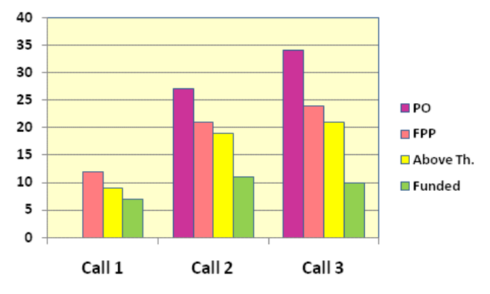
Figure 36. Number of proposals in the different stages of the ENIAC JU 2008-2010 calls
The trend of a strong SME participation continued in 2010. In the FPPs selected for funding in the 2010 call there were 212 participants coming from 145 organisations, among which there were 48 SMEs representing 33.1% of the participating entities. The situation is illustrated on the figure below:
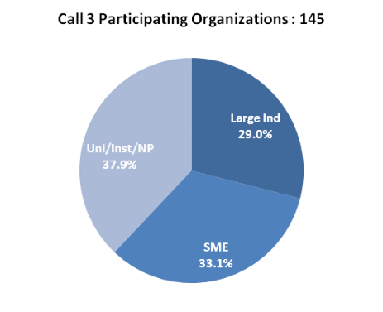
Figure 37. ENIAC JU 2010 call for proposals. Typology of applicants in the proposals for funding
The SMEs contributed € 33.0 million (16.4%) of the total eligible costs, and received € 13.3 million (15.2%) of the total public funding (14.8% of the national funding and 15.7% of the ENIAC JU funding). The funding distribution is graphically shown on Figure 38:
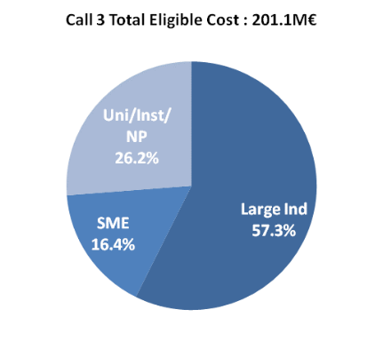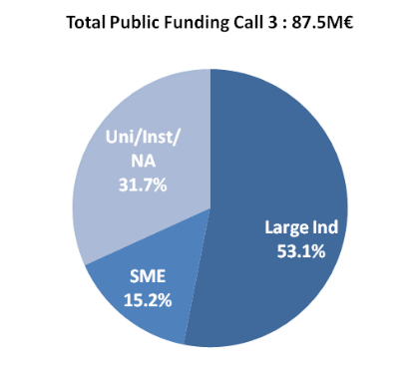
Figure 38. ENIAC JU 2010 call for proposals. Requested funding per type of participant
For reference, the statistics since the inception of the programme indicate that in the period 2008-2010 the ENIAC JU projects accounted for 627 participants from 336 organisations, out of which 140 (41.7%) – SMEs. In conclusion, SMEs represent 41.7% of the participating organisations and received 16.3% of the ENIAC JU grants awarded.
The total requested funding for the 21 proposals evaluated above threshold the second stage was € 482.8 million. The requested national funding amounted to € 159.8 million and the requested ENIAC JU funding was € 80.7 million. The total requested funding by SME partners was € 33 million (16.4 %).
All 10 projects have successfully completed the negotiation phase. The success rate was 41.7%. In terms of geographical distribution, the projects in the 2010 call had between 3 and 12 participating countries:
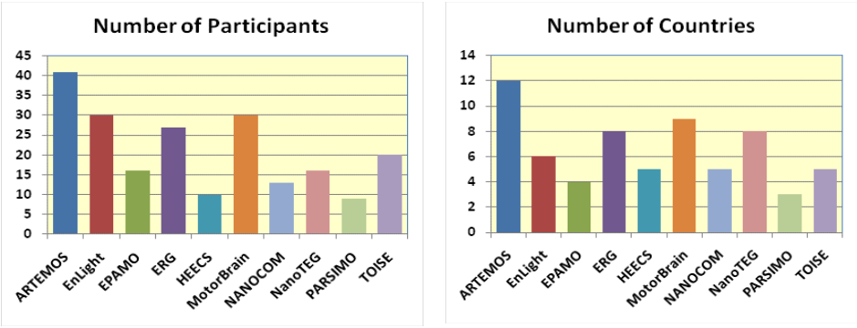
Figure 39. ENIAC JU 2010 call for proposals.
Number of participants and countries in the calls selected for funding
For reference, in all 28 projects selected for funding since the ENIAC programme start, all ENIAC Member States except Estonia and Latvia have been present in at least one project, while Denmark and Switzerland participated without becoming an ENIAC Member. The number of actually participating countries is 21.
Overall, € 87.6 million of public funds were allocated to the 10 proposals selected for funding with a total requested contributions amounting to € 201.1 million. The € 33.6 million EU funding resulted in a leverage effect of 6 to 1. National budgets published in the call were increased by some countries to permit strategically important projects to be funded. The EU indicative budget was went up by 12% following this increase.
The funding situation in the call is summarised in Table 32 below. It shows that the average oversubscription rate at the PO stage is about 4 times, and almost 3 times in the FPP evaluated above thresholds.
 | Available budget | POs | FPPs above threshold | Granted funding
Total requested funding | Min 180.5 | 707.8 | 482.8 | 201.1
National funding | 54.8 | 234.8 | 159.8 | 54.0
ENIAC JU funding | 30.1 | 118.3 | 80.7 | 33.6
Table 32. ENIAC JU 2010 call for proposals. Requested funding in the different stages of the call
The distribution of total eligible costs, national funding and JU grants per area of research in the projects arising from the 2010 and in the projects selected for funding since the inception of the programme (2008-2010) is shown in the next graph:
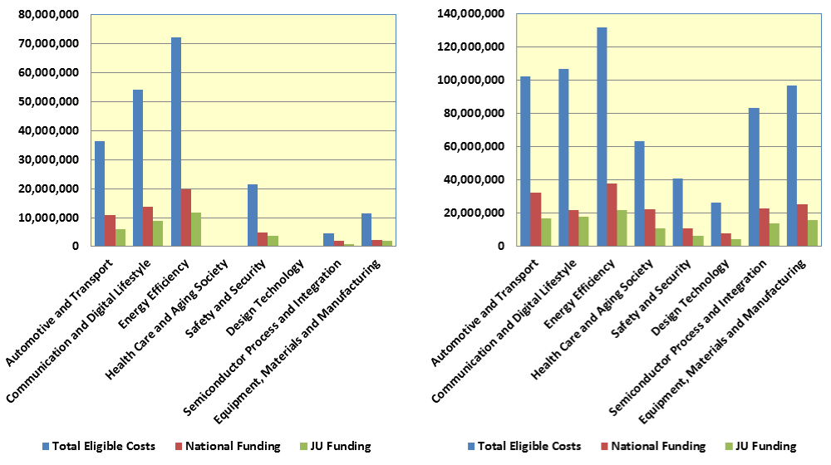
Figure 40. Total costs per research area in the ENIAC JU 2010 call and in all projects (2008-2010)

6.3.5. Grant agreements signed
All 10 consortia were invited to negotiations on 2 November 2010 for conclusion of grant agreements. The projects kick-off was planned for in 2011.
Nonetheless, delays have been experienced by some participants in the establishment of National Grant Agreements (NGA) which consequently slowed down the signature of the ENIAC JU grant agreements. Consortia have also experienced difficulties in entering into a Project Consortium Agreements. Although this was a legal requirement, it appeared to be very difficult to finalise it in less than one year.
№ | Project acronym | Project title | Total national funding | ENIAC JU contribution | Additional own resources | Total costs | Signature date (expected)
1. | ARTEMOS | Agile RF Transceivers and Front-Ends for Future Smart Multi-Standard Communications Applications | 8,543,956 | 6,836,061 | 25,554,478 | 40,934,495 | 8/2011
2. | EnLight | Energy Efficient and Intelligent Lighting Systems | 10,833,438 | 6,899,794 | 23,582,899 | 41,316,131 | 8/2011
3. | EPAMO | Energy-efficient piezo-MEMS tunable RF front-end antenna systems for mobile devices | 5,269,609 | 2,224,524 | 5,826,370 | 13,320,503 | 18/3/2011
4. | ERG | Energy for a green society | 8,138,528 | 4,293,851 | 13,279,305 | 25,711,684 | 2012 (Italian coordinator)
5. | HEECS | High Efficiency Electronics Cooking Systems | 899,690 | 833,894 | 4,009,515 | 4,933,378 | 5/4/2011
6. | MotorBrain | Nanoelectronics for Electric Vehicle Intelligent Failsafe Drive Train | 11,021,728 | 6,112,613 | 19,468,130 | 36,602,471 | 5/4/2011
7. | NANOCOM | Reconfigurable Microsystem Based on Miniaturized and Nanostructured RF-MEMS | 1,221,550 | 930,285 | 3,418,736 | 5,570,571 | 30/3/2011
8. | NanoTEG | Nanostructured ThermoElectric Systems for Green Transport Applications | 1,140,869 | 1,016,910 | 3,931,502 | 6,089,281 | 7/2011
9. | PARSIMO | Partitioning and Modeling of SiP | 1,847,175 | 814,244 | 2,214,294 | 4,875,713 | 7/2011
10. | TOISE | Trusted Computing for European Embedded Systems | 5,048,449 | 3,617,522 | 12,995,835 | 21,661,806 | 7/2011
TOTAL |  |  | € 53,155,271 | € 33,579,698 | € 114,281,064 | € 201,016,033 | ---
Table 33. ENIAC JU 2010 call for proposals. List of proposals selected for funding

7. Conclusion
2010 was the first year of autonomous functioning for most of the Joint Technology Initiatives Joint Undertakings after they developed operational capacity to implement their own budget. Despite the fact that the JTI JUs' internal structures were not yet working optimally and they have still to recover from the initial operational delays, the results achieved by the five JTI JUs reviewed in this document prove that they are on the right way towards achieving the set objectives.
Taking into account that together they represent a total investment of €10 billion and have the concrete capacity to accelerate the generation of new knowledge and innovation in their industries through organisation of successful calls for proposals, encouraging cooperation and involving a variety of stakeholders, especially SMEs, the JTI instruments might play an important role for the EU economy in the future. The lessons learned and the information gained from the first ongoing projects should be skilfully used to continue at this competitive pace.

8. References
- ARTEMIS JU Annual Activity Report 2010
- ARTEMIS JU Annual Work Programme 2010
- Clean Sky JU Annual Activity Report 2010
- Clean Sky JU Annual Implementation Plan 2010
- Commission Recommendation 2003/361/EC of 6 May 2003 concerning the definition of micro, small and medium-sized enterprises, OJ L 124, 20.05.2003, p. 36
- Commission Staff Working Document "Joint Technology Initiatives: Background, State-of-Play and Main Features", SEC(2007) 692, Brussels, 15.05.2007Designing together the "ideal house" for public-private partnerships in European research, JTI Sherpas’ Group, Final Report, January 2010
- Commission Staff Working Document accompanying the Communication from the Commission to the European Parliament, the Council, the European Economic and Social Committee and the Committee of the Regions "Partnering in Research and Innovation", SEC(2011) 1072 final, Brussels, 21.09.2011
- Council Regulation (EC) 521/2008 of 30 May 2008 setting up the Fuel Cells and Hydrogen Joint Undertaking, OJ L 153, 12.06.2008, p. 1
- Council Regulation (EC) 71/2008 of 20 December 2007 setting up the Clean Sky Joint Undertaking, OJ L 30, 04.02.2008, p. 1
- Council Regulation (EC) 72/2008 of 20 December 2007 setting up the ENIAC Joint Undertaking, OJ L 30, 04.02.2008, p. 21
- Council Regulation (EC) 73/2008 of 20 December 2007 setting up the Joint Undertaking for the implementation of the Joint Technology Initiative on Innovative Medicines, OJ L 30, 04.02.2008, p. 38
- Council Regulation (EC) 74/2008 of 20 December 2007 on the establishment of the ARTEMIS Joint Undertaking to implement a Joint Technology Initiative in Embedded Computing Systems, OJ L 30, 04.02.2008, p. 52
- Council Regulation (EC, Euratom) 1605/2002 of 25 June 2002 on the Financial Regulation applicable to the general budget of the European Communities, OJ L 248, 16.09.2002, p. 1
- Decision 1982/2006/EC of the European Parliament and of the Council of 18 December 2006 concerning the Seventh Framework Programme of the EC for research, technological development and demonstration activities (2007-2013), OJ L 412, 30.12.2006, p. 1
- ENIAC JU Annual Activity Report 2010
- ENIAC JU Annual Work Programme 2010
- FCH JU Annual Activity Report 2010
- FCH JU Annual Implementation Plan 2010
- FCH JU Multi-Annual Implementation Plan 2008-2013
- First Interim Evaluation of the ARTEMIS and ENIAC Joint Technology Initiatives, Panel Report, 30 July 2010
- First Interim Evaluation of the Clean Sky Joint Undertaking, Panel Report, 15 December 2010
- First Interim Evaluation of the Fuel Cells and Hydrogen Joint Undertaking, Expert Group Report, 13 April 2011
- First Interim Evaluation of the Innovative Medicines Initiative Joint Undertaking, Panel Report, 20 December 2010
- IMI JU Annual Activity Report 2010
- IMI JU Annual Implementation Plan 2010
- IMI JU Scientific Research Agenda 2008
- Joint Technology Initiatives: Public-Private Partnerships in EU research, brochure, 2007, European Commission, Directorate-General for Research and Innovation, ISBN: 978-92-79-06176-9
- Report from the Commission to the European Parliament, the Council, the European Economic and Social Committee and the Committee of the Regions "First Interim Evaluation of the ARTEMIS and ENIAC Joint Technology Initiatives", COM(2010) 752 final, Brussels, 16.12.2010

According to Article 1 of the Clean Sky's Statutes, the Integrated Technology Demonstrators (ITDs) refer to the six technological areas covered by the Clean Sky Joint Undertaking.
The founding ITD leaders of the Clean Sky JU are: Agusta-Westland, Airbus, Alenia, Dassault Aviation, EADS-CASA, Eurocopter, Fraunhofer Gesellschaft, Liebherr, Rolls-Royce, SAAB, Safran and Thales.
In 2001, the Advisory Council for Aeronautical Research in Europe (ACARE) set the following targets for the aeronautics industry by 2020: 50% reductions of the fuel consumption and the carbon dioxide emissions, 80% reduction of the nitrous oxides emissions, 50% reduction of the perceived external noise and improvement of the environmental impact of the lifecycle of aircraft and related products.
Europe in this context refers to the EU Member States and the countries associated to the Seventh Framework Programme of the European Union (2007-2013), i.e. Switzerland, Israel, Norway, Iceland, Liechtenstein, Turkey, Croatia, the Former Yugoslav Republic of Macedonia, Serbia, Albania, Montenegro, Bosnia and Herzegovina and Faroe Islands (December 2010).
Decision 1982/2006/EC of the European Parliament and of the Council of 18 December 2006 concerning the Seventh Framework Programme of the European Community for research, technological development and demonstration activities (2007-2013), OJ L 412, 30.12.2006, p. 1.
Pursuant to Art. 16 (1) of Council Regulation (EC) 73/2008, the Commission was responsible for the establishment and initial operation of the IMI JU until it gained the operational capacity to implement its own budget.
In system engineering, a trade-off study is a simultaneous consideration of multiple alternatives at a point in the design process where a decision needs to be made.
The start of project 271867 – LUBSEP has been postponed by two years following an agreement between the Partner and the Topic Manager; the project was monitored by the CS JU and finally cancelled in 2011.
EFPIA's mission is to promote pharmaceutical research and development in Europe and to create a favourable economic, regulatory and political environment, enabling the research-based pharmaceutical industry to meet the growing healthcare needs and expectations of patients. In 2010, the members of the EFPIA comprise of 31 European national pharmaceutical associations and 38 companies undertaking research, development and manufacturing of medicinal products for human use.
The EU Member States and the countries associated to the FP7.
The four pillars are defined in the original IMI Scientific Research Agenda (2008) and address the principal causes of delay in the biomedical R&D process.
Pursuant to Art. 16 (1) of Council Regulation (EC) 73/2008, the Commission was responsible for the establishment and initial operation of the IMI JU until it gained operational capacity to implement its own budget.
The Annual Implementation Plan describes the activities of the IMI JU planned for the following year and the corresponding expenditure estimates. It is subject to approval by the Governing Board.
Compliant with the provisions set in Art. 15 of Council Regulation (EC) 73/2008 stating that distinct rules on IP should be adopted to ensure that the intellectual property generated in the performed research activities is protected and results are used and properly disseminated.
The IMI Scientific Research Agenda is a multiannual research plan, setting out the research priorities of IMI. The priorities for each year are detailed in the IMI Annual Implementation Plan.
The objective of the ethical review is to ensure that the IMI JU supports research activities which are compliant with the fundamental ethical principles referred to in Art. 6 of Decision 1982/2006/EC on the Seventh Framework Programme of the European Community for research, technological development and demonstration activities (2007-2013).
A funding scheme broadly used in the FP7 designating research projects carried out by consortia with participants from different countries, aiming at developing new knowledge, technology, products, demonstration activities or common resources for research.
Within the meaning of Commission Recommendation 2003/361/EC of 6 May 2003 concerning the definition of micro, small- and medium-sized enterprises.
The amount shown is the indicative IMI financial contribution as it was published with the call. However, the final IMI financial contribution to the second call projects after negotiation was € 80.7 million (see Section 3.3.5). The EFTA contribution of € 1.843 million and a transfer of € 2.097 million from running costs to operational costs were used to enable IMI to engage this total contribution to the second call projects.
The New Energy World Industry Grouping "Fuel Cell and Hydrogen for Sustainability" (NEW-IG) is a non-profit association open to industrial companies dealing with fuel cell and hydrogen R&D activities in Europe, including the EU Member States, the countries in the European Economic Area and the EU associate and candidate countries. By the end of 2010, the Industry Grouping had 56 members. They varied from micro to large enterprises and were developing products for application in transportation, stationary, hydrogen production, components and portable fuel cell fields.
The N.ERGHY Research Grouping is a non-profit association representing the research community in Europe. The objective of N.ERGHY is to promote, support and accelerate the research and deployment process of fuel cell and hydrogen technology in Europe from the point of view of the research community. Currently the organisation has over 60 research institutes and universities as members.
The European Strategic Energy Technology (SET) Plan has identified fuel cells and hydrogen among the technologies needed for Europe to achieve the 2020 Energy and Climate Change goals – 20% reduction in greenhouse gas emissions, 20% share of renewable energy sources in the energy mix and 20% reduction in primary energy use, as well as to achieve the long-term vision for 2050 towards decarbonisation [Communication from the Commission of 22 November 2007, COM (2007) 723 final].
Pursuant to Art. 16 (1) of Council Regulation (EC) 521/2008, the Commission was responsible for the establishment and initial operation of the FCH JU until it gained operational capacity to implement its own budget.
Annexed to the Council Regulation (EC) 521/2008 setting up the FCH JU.
As explained in the Annual Activity Report 2010 of the FCH JU, "a large number of participants in the projects are research centres and other non-industry participants whose contribution to projects is currently not considered in the matching requirement. Therefore, the industry contribution alone has shown not to be sufficient to fulfil the matching requirement while maintaining funding rates that are in line with the nominal rates set at a level corresponding to the FP7 funding rates".
IT tool used in the negotiation process.
At the request of the project coordinator, for accounting reasons and due to the late start date of the project, the payment was delayed to January 2011.
The funding includes the FCH JU's own budget only. The amount corresponding to European Free Trade Area (EFTA) contribution was used to reinforce the different sub-budgets.
Austria, Belgium, Cyprus, Czech Republic, Germany, Denmark, Estonia, Spain, Finland, France, Greece, Hungary, Ireland, Italy, Latvia, Netherlands, Norway, Portugal, Romania, Sweden, Slovenia and the United Kingdom.
The ARTEMIS Industrial Association (ARTEMIS-IA) was established in January 2007 in the Netherlands by five companies: Philips, ST Microelectronics, Thales, Nokia and DaimlerChrysler. It represents the interests of the industry and the research community within the ARTEMIS Joint Undertaking.
Source: SINCOM data from budget appropriation BGUE-B2010-09.040102-C1-CE that corresponds to the operational credits for the ARTEMIS JU for 2010.
Software used for the evaluation of proposals.
Austria, Belgium, Czech Republic, Estonia, Finland, France, Germany, Greece, Hungary, Ireland, Italy, Latvia, Netherlands, Norway, Poland, Portugal, Romania, Slovak Republic, Spain, Sweden and the United Kingdom.
The Association for European Nanoelectronics Activities (AENEAS) is a non-profit industrial association established on 30 November 2006 to represent the R&D performers in the ENIAC Joint Undertaking.
CATRENE is an industry-driven 4-year EUREKA programme, starting on 1 January 2008, extendable to eight years. In the CATRENE programme, 260 partners (as of December 2011) from 18 European countries work on the most advanced research challenges in micro/nanoelectronics.
Estonia, Hungary, Latvia and Norway do not participate in this call.

