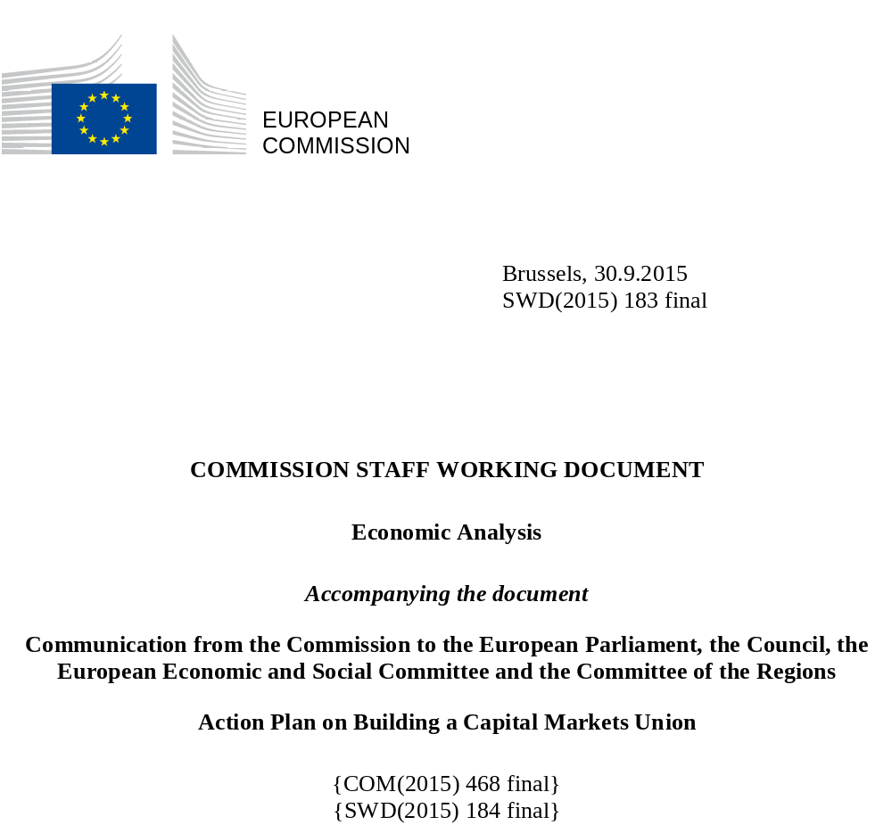
Contents
EXECUTIVE SUMMMARY 6
Chapter 1 THE IMPORTANCE OF THE CAPITAL MARKETS UNION 8
1.1 Overreliance on banking as an impediment for growth 8
1.2 The growth weakness became entrenched through the fragmentation of the EU financial sector 11
1.3 Objectives of the CMU 12
Chapter 2 TAKING STOCK OF EU CAPITAL MARKETS 16
2.1 Bank-based versus market-based financial systems 17
Optimal financial structure is dependent on the stage of development of the economy 17
Relative advantages of bank-based and market-based funding systems 20
Competition or complementary? 22
2.2. Historical, legal and economic structures as barriers for capital markets development 24
2.3 Financial stability and macro-prudential policy oversight for a stronger CMU 27
Chapter 3 FINANCING NEEDS BY THE EUROPEAN CORPORATE SECTOR AND INFRASTRUCTURE 31
3.1 Theory on businesses' access to funding 31
3.2 Do European SMEs lack funding? 33
3.4 Do European companies face barriers to going public? 44
3.5 Debt versus equity financing and the tax-induced debt bias 51
3.6 Barriers to access infrastructure finance 53
Chapter 4 THE PROVISION OF FUNDING THROUGH CAPITAL MARKET INSTRUMENTS 57
4.1 Identifying and understanding the investor base 58
4.2 Promoting saving and investment by households through capital markets 62
4.3 Promoting capital market investments by institutional investors 65
Chapter 5 REAPING OPPORTUNITIES TO PROMOTE CROSS-BORDER MARKET FUNDING 70
5.1 Benefits and determinants of cross-border investments 70
5.2 Insolvency rules and procedures and company law 72
5.3 Withholding tax and other tax barriers to cross-border investments 77
5.4 Financial market infrastructures 80
5.5 Supervisory and regulatory convergence 82
Chapter 6 A COUNTRY PERSPECTIVE ON THE CMU 84
6.1 Financing needs 85
6.2 Financing sources 92
6.3 Intermediation: linking financing sources with financing needs 96
6.4 How can the CMU benefit EU Member States with different levels of capital market development? 102
REFERENCES 106

List of Abbreviations

CCP | Central Clearing Counterparty
CSD | Central Securities Depository
CMU | Capital Markets Union
EBRD | European Bank for Reconstruction and Development
ECB | European Central Bank
EFSI | European Fund for Strategic Investments
EIB | European Investment Bank
EIOPA | European Insurance and Occupational Pensions Authority
ELTIF | European Long Term Investment Fund
ESG | Environmental, Social and Governance
ESMA | European Securities and Markets Authority
EU | European Union
EUR | Euro
FDI | Foerign Direct Investment
FSAP | Financial Services Action Plan
GDP | Gross Domestic Product
IFC | International Finance Corporation
IMF | International Monetary Fund
IPO | Initial Public Offering
MiFID | Markets in Financial Instruments Directive
MiFIR | Markets in Financial Instruments Regulation
MTF | Multilateral Trading Facility
NFC | Non-Financial Corporation
OECD | Organisation for Economic Co-operation and Development
OJ | Official Journal of the European Union
PP | Private Placement
PPP | Public Private Partnership
PRIPs | Packaged Retail Investment Products (Directive)
R&D | Research and Development
SME | Small and Medium Enterprise
SWD | Staff Working Document
TFEU | Treaty on the Functioning of the European Union
UCITS | Undertakings for the Collective Investment in Transferable Securities
USD | Dollar of the United States of America

EXECUTIVE SUMMMARY
This Commission Staff Working Document (SWD) accompanies the Action Plan on the Capital Markets Union (CMU). By providing an economic analysis of the functioning of financial markets in Europe, it substantiates the rationale for the objectives of the CMU and provides the context for the Action Plan. In particular, the SWD analyses the evolution and the current state of financial markets in the EU, the financing needs of the economy, the role of investors and how the two meet, and the obstacles to cross border investments in Europe.
The SWD provides a general context for identifying weaknesses and market failures in the functioning of European capital markets, some of which may be suitable candidates for action for the CMU Action Plan. However, some structural problems or market failures cannot be addressed effectively by policy action at EU level or our understanding of the nature of the market failure does not yet allow us to frame corrective policy action. Other problems may be better addressed through intervention at Member States' level or in other ways. It is nevertheless important to analyse these issues in the SWD to understand the context in which EU level initiatives can be usefully deployed through the CMU. This SWD builds on the SWD that accompanied the Green Paper on the Capital Markets Union, which provided initial reflections on the obstacles to the development of deep and integrated EU capital markets, and the 2015 European Financial Stability and Integration Review (EFSIR) that provides an extensive statistical overview of the EU financial system, including capital markets.
Chapter one explains how reducing the reliance on the banking sector and strengthening the integration of EU financial markets can support growth in Europe, and introduces the concept and objectives of the CMU in this context. Chapter two describes how the banking sector and capital markets have been developing in the EU and explores their respective roles and relative advantages in different stages of development of an economy. It demonstrates that banks and capital markets are two vital components of the financial system, not competing but complementing each other and co-evolving. It also explains why banks have a dominant role in the European financial structure and what complementing this structure with more market-based funding means for financial stability. Chapter three analyses how enterprises, and in particular SMEs, could benefit from a larger share of financing made available through capital markets. It describes the various funding sources of European non-financial corporations and explores their comparative advantages. After analysing how the financing needs of a company evolve over its life cycle, it explains why specific capital markets instruments that would be most appropriate to support the development of a firm remain under-developed in Europe. For non-financial corporations to have access to more market funding, as argued in chapter three, investors' savings through market instruments have to increase. This is what chapter four analyses. It first describes the EU investor base, distinguishing between retail investors, non-financial corporations and institutional investors. While households and non-financial corporations are the largest ultimate suppliers of funds, the intermediation role of institutional investors is crucial. The chapter then discusses how correcting information asymmetries, tackling barriers to cross-border investment by European funds and exploring the development of personal pension funds could promote households' investments in capital markets. It then analyses various obstacles to more investment by institutional investors in capital markets instruments. Chapter five provides a thorough insight into the barriers and obstacles to cross-border capital market transactions. After describing the economic benefits stemming from cross-border capital flows, it provides more detail on those aspects of capital markets' organisation that appear the most relevant in a cross-border context, in particular insolvency procedures, tax barriers, financial market infrastructures, as well as supervisory and regulatory practices at Member State level. Chapter six documents similarities and differences between Member States as regards their financing needs, their funding sources, and the structure and level of development of their financial markets. This diversity means that, while all Member States will benefit from the CMU, gains will materialise in various forms, depending on the specificity of each Member State.

Chapter 1 THE IMPORTANCE OF THE CAPITAL MARKETS UNION
Through the CMU, the European Commission strives to increase the benefits that capital markets and non-bank financial intermediaries can provide to the economy. Building a CMU is a key initiative in the work programme of the European Commission. It is also one of the elements for completing the Economic and Monetary Union, as set out in the recently published Five Presidents' Report. It would ensure a greater diversification in the funding of the economy and reduce the cost of raising capital, particularly for SMEs. The motivation for the CMU also stems from the shortcomings of the European Union (EU) financial system revealed by the financial crisis that are impeding economic growth and are holding back recovery. While there are a variety of funding sources available to finance the EU economy, it seems to overly rely on financing intermediated through banks. At the same time, market-based financial instruments could be more extensively used, at least in some countries. This document makes the case that if the EU financial system was more diversified and had a larger share of funding channelled through capital markets, this should ultimately lead to a wider choice of financial instruments for the benefit of both enterprises and investors and a lower cost of raising capital, notably for SMEs, and increase the attractiveness of Europe as a place to invest. The EU economy could move towards a higher growth path and be more resilient to economic shocks.

1.1 Overreliance on banking as an impediment for growth
The financial and sovereign debt crisis has taken a heavy toll on EU growth performance. Significant GDP loss occurred in many developed countries and became permanent. Support programmes for banks entailed non-recovered fiscal costs of about 5% of GDP or more in Belgium, Greece, Ireland, Luxembourg, the Netherlands, Austria and the UK. The unemployment rate increased from a pre-crisis low of 7.5% in 2007 to 11.6% in 2014 in the euro area, and from 7.2% to 10.2% in the EU. Compared with 2007, 6.5 million more people are now unemployed in the EU. In addition, European economies are not only suffering from permanent and significant losses of GDP, but in addition a reduced potential real GDP growth rate (see Charts 1 and 2).
Chart 1: Actual and potential GDP in the EU-28  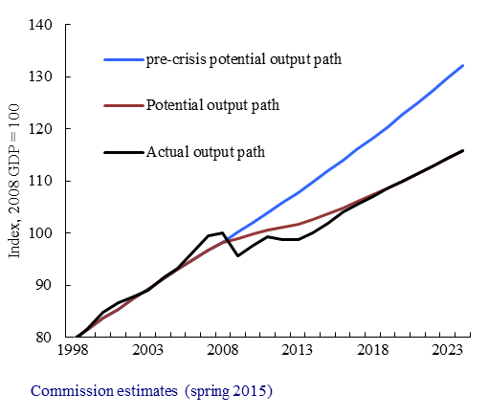 | Chart 2: Actual and potential GDP in the USA  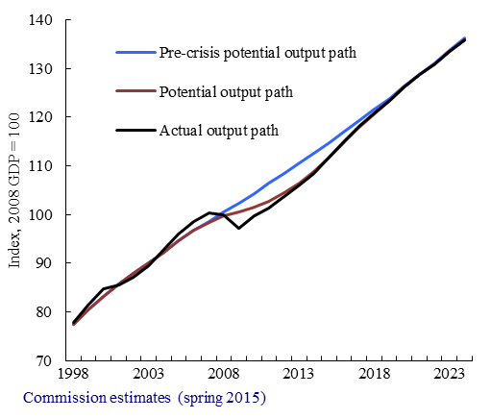
An investment gap opened in the EU and poses risks to achieving competitiveness and sustainable growth. The level of investment (gross fixed capital formation) in the EU has dropped by about 10% (EUR 300 billion in 2010 prices) since its peak in 2007 as a consequence of the economic and financial crisis. Capital inflows from abroad into the EU have also come down considerably, suggesting that weaker growth prospects have made the EU a less attractive place for financial investment. This investment gap poses a threat to reaching the targets set by the Europe 2020 Strategy and needs to be closed to achieve the overarching European policy goals of smart, inclusive and sustainable growth. The European Commission's new Investment Plan, including the European Fund for Strategic Investments (EFSI), was adopted to unlock investment to fill the gap. The Regulation setting up the EFSI explicitly requires that EU projects are consistent with EU policy priorities, such as the 2030 climate and energy package to achieve a low carbon economy. The EU's international investment policy is focused on providing EU investors and investments with market access and with legal certainty and a stable, predictable, fair and properly regulated environment in which to conduct their business.
The relatively large reliance on banks weighs on growth and recovery. In the run-up to the financial crisis, banks' balance sheets and off-balance sheet exposure grew fast, and credit provided in the form of bank loans outpaced GDP growth. The financial crisis imposed significant restructuring and deleveraging needs on the sector. Subsequently, the EU banking sector has become considerably less supportive to economic activity than in past upturns. Factors causing this include the following: (i) pre-crisis bank lending contributed to the accumulation of debt among private households and firms, part of which became unsustainable with the economic downturn; (ii) economic recessions tend to be more severe when accompanied by financial crises and especially banking crises; and (iii) EU banks reduced their coss-border activities (fragmentation). Banks' asset quality eroded amid weakening economic activity, particularly in EU Member States heavily exposed to stress on sovereign bond markets. As a result, the share of non-performing loans on banks' balance sheets increased. This has been identified as a crucial factor that has held back credit provision to the economy.
High bank dependency means that enterprises, and particularly SMEs, have difficulties accessing alternative funding sources when they cannot get credit from banks. For many companies, particularly in vulnerable Member States, access to finance has become markedly more difficult with the financial crisis. Difficulty in accessing finance is one of the obstacles that prevent SMEs from launching new products, broadening their activities and markets, strengthening their infrastructure and taking on more employees. This situation is equally true for well-established SMEs and those innovating ones that are small and rapidly expanding. Financing conditions remain tight in countries whose economies have been hit most severely by the crisis and especially for start-ups, SMEs and/or innovative companies.
From a systemic point of view, higher dependence on bank lending makes the economy more vulnerable when bank lending tightens, as happened in the recent crisis. In times of economic downturns coinciding with financial crises, capital markets have the ability to act as more effective shock-absorbers (see Section 2.1). The shock-absorbing capacity of capital markets is particularly high when borrowers can switch between funding sources and when funding is provided in the form of equity. Thus, diversification of funding sources and a higher share of equity funding make the financial system more stable. The diversification benefits apply equally to investors, who enjoy an increased set of investment opportunities in deeper and more liquid capital markets.

1.2 The growth weakness became entrenched through the fragmentation of the EU financial sector
The combination of the global financial crisis and euro-area sovereign debt crisis has halted the process of integration in EU banking and triggered a process of financial fragmentation. By 2007, European banks were significantly more internationalised than banks in the USA, Japan or China. This resulted primarily from their cross-border expansion within Europe. However, the crisis revealed that financial integration in the EU was hitherto shaped by cross-border inter-bank flows, which fuelled local credit bubbles and emerged as pro-cyclical and prone to sudden reversal. From 2008, cross-border lending in the euro area and the EU declined in absolute and relative terms. At the same time, banking activities, assets and risks migrated increasingly back to home jurisdictions. In parallel, banks invested increasingly in domestic sovereign bonds, thereby exhibiting home bias in most Member States. In Member States that experienced acute sovereign funding stress, banks' access to cross-border funding became particularly difficult and bank funding costs widened in both absolute and relative terms. Shortfalls in private funding in these banks have been partially compensated by higher borrowing from the Eurosystem.
Financial fragmentation has a significant effect on the possibility to share economic risks across borders. Economic literature identified capital markets and bank credit markets as having a potentially important role in cushioning the impact of economic shocks. By giving access to foreign assets, the capital markets channel provides stable revenues to investors when domestic income sources decay. The bank credit market channel assumes that banks provide stable funding to the economy even when the economic activity weakens and credit risks increase. The literature on risk sharing in the euro area found that it is underdeveloped and that it was not effective during the financial crisis. Indeed, the credit market played a small role because the severity and persistence of the economic downturn weakened the banking system, and because the fragmentation it entailed annihilated the cushioning effect of diversification. The reasons for the capital market channel to have had a limited cushioning effect during the crisis were seen in the limited size of capital markets in the EU. Economic theory has long conjectured a link between financial integration, risk sharing and higher economic growth through a "risk-amelioration" channel.
The macroeconomic consequences of a limited risk sharing became evident with the weak bank lending in vulnerable Member States that resulted from the crisis. An important element of cross-border risk-sharing was unavailable when needed most, leaving corporates in vulnerable Member States reliant on domestic banks that encountered funding problems either because they had to repair balance sheets themselves or were exposed to a weak sovereign. In other Member States, weak domestic demand for credit coupled with the unwinding of interbank lending resulted in excess liquidity in the banking system. Since SMEs are particularly dependent on funding from domestic banks, the fragmentation of banking markets aggravated financial constraints in the SME sector. EU cross-border banks did not compensate for the decline in credit supply by domestic banks. Difficulties to tap foreign sources were also observed for other funding instruments. Cross-border corporate bond holdings declined substantially during the financial crisis. The home bias in equity fell during the financial crisis, but remains significant, with 64% of EU equity holdings and 61% of euro area equity holdings being of domestic origin.
Chart 3: EU banks' total foreign assets and liabilities, trillion USD  - 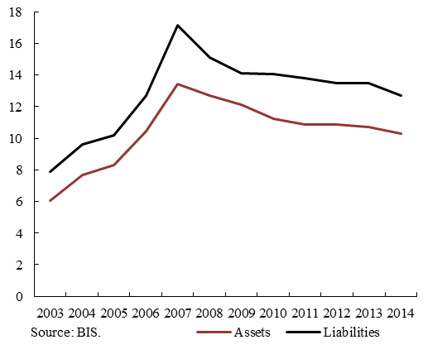 | Chart 4: Central bank funding of banks, in % of total liabilities  - 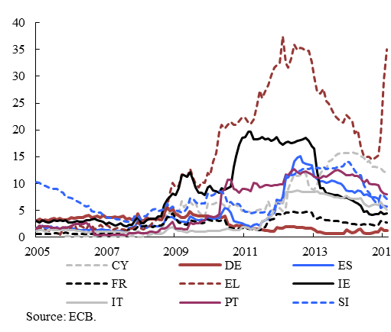

1.3 Objectives of the CMU
The CMU complements the regulatory financial reforms of recent years and the Banking Union. The aim of the financial reform agenda has been to strengthen regulation and supervision of the financial sector after the financial crisis, in order to restore and safeguard financial stability. The Banking Union, partly in response to the sovereign debt crisis, addresses supervision and resolution of banks, thereby targeting the nexus between banks and the sovereign risks in participating countries. With the overarching objective of maximising the benefits of capital markets and non-bank financial institutions for the real economy, the CMU provides additional value to those reforms.

The CMU has three main objectives:
  - The CMU will broaden the sources of financing in Europe towards non-bank financing by giving a stronger role to capital markets. It will offer to borrowers and investors a broader set of financial instruments to meet their respective needs.
  - The CMU will help deepen the single market for financial services. Capital markets will benefit from the size effects of the single market and become deeper, more liquid and more competitive, for the benefit of both borrowers and investors.
  - The CMU will help promote growth and financial stability. By facilitating companies' access to finance, in particular SMEs, the CMU will support growth and jobs' creation. At the same time, by promoting more diversified funding channels to the economy, it will help address possible risks stemming from the over-reliance on bank lending and intermediation in the financial system. By diversifying the risks, it will make the whole system more stable and help financial intermediaries granting more funding to the economy.
Capital markets enlarge the set of potential financing instruments and are complementary to bank financing. Non-bank financing does not merely substitute for investment that was previously funded by banks, but it enables additional investment that banks would not be ready to fund. As further detailed in Section 2.1, market financing is usually regarded to being better at dealing with uncertain environments and therefore better suited to fund riskier investment projects (with a higher required rate of return). The creation of the CMU not only complements banking activity, but also boosts it as banks provide important services to participants in many capital market segments and receive from it considerable revenues, notably in the form of fees. Besides, by providing a larger pool of financial assets which could be potentialy included in open market operations conducted by central banks, deeper capital markets could also strenghten the transmission of monetary policy impulses.
Deep, liquid and efficient capital markets bring advantages to borrowers and investors. They have three main advantages for companies seeking finance: (i) improve their access to funds; (ii) reduce their capital costs by creating competition among investors; and (iii) reduce the risk of disruption in financing by diversifying their funding sources (see Chapter 3). On the investors' side, by increasing the investment opportunities, efficient capital markets offer investors a broader set of financial products to (i) meet their investment objectives, (ii) diversify and manage their risks, and (iii) optimise their risk-return profile, while respecting their investment constraints – whether in terms of risk, duration, or other assets' characteristics (see Chapter 4). Overall, capital markets (especially equity markets) facilitate entrepreneurial and other risk-taking activities, which have a positive effect on economic growth.
Large and well-integrated capital markets can contribute to jobs and growth through a number of channels. They can contribute to allocative efficiency by opening up investment and diversification opportunities for investors across Europe, improving access to risk capital for borrowers, and allowing greater competition (unleashing corresponding benefits such as productivity gains, lower costs, greater choice, financial innovation, etc.). Unobstructed capital flows within the single market should allow financial resources to reach the most profitable investments. Portfolio diversification possibilities should also be enhanced because the larger financial markets are and the better integrated across borders, the more opportunities they allow to share risks among actors and economies. Cross-border integration increases the size of the relevant market, which allows for scale effects originating from lower costs to run market infrastructures, better capitalisation on search costs (see Section 5.1), and higher market liquidity.

Figure 1: A stylised view of the economic benefits of integrated and well-functioning capital markets
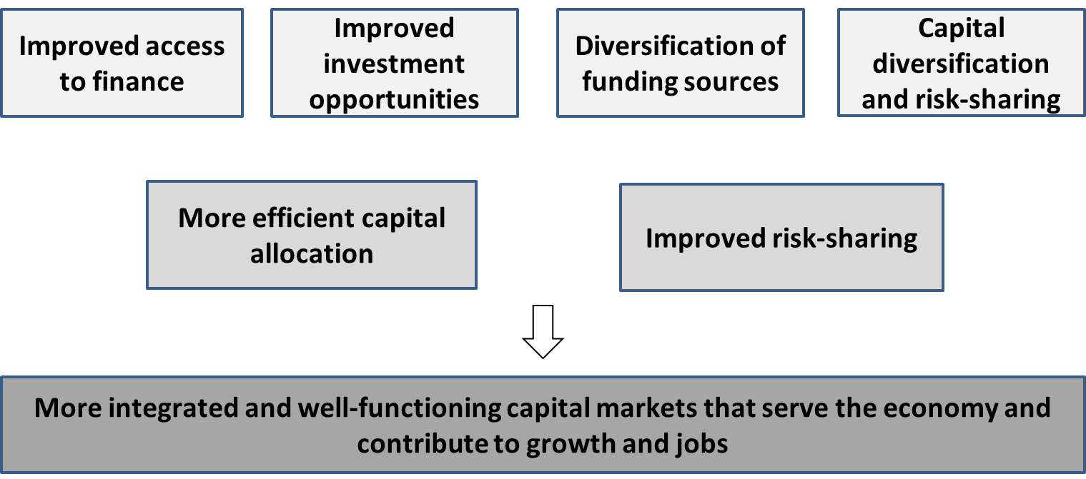

The CMU goes beyond previous initiatives to foster the single market for financial services. The CMU shares some economic objectives with the Financial Services Action Plan (FSAP), which led to the adoption of 42 regulatory measures, including 24 legislative measures, between 1999 and 2004. The FSAP also aimed at reducing obstacles to cross-border financial investment, thereby increasing efficiency gains through higher competition and realisation of scale effects and allowing a better diversification of risks on integrated financial markets. The CMU continues to build on this, focusing on the obstacles to cross-border investment, strengthening the contribution of capital markets to the EU financial system and funding households and companies. At the same time, the role of stronger supervisory convergence and enhanced financial stability feature more prominently than in the FSAP.
Figure 2: Financing of the economy: size of institutional sectors, 2014, EU 28, EUR billion
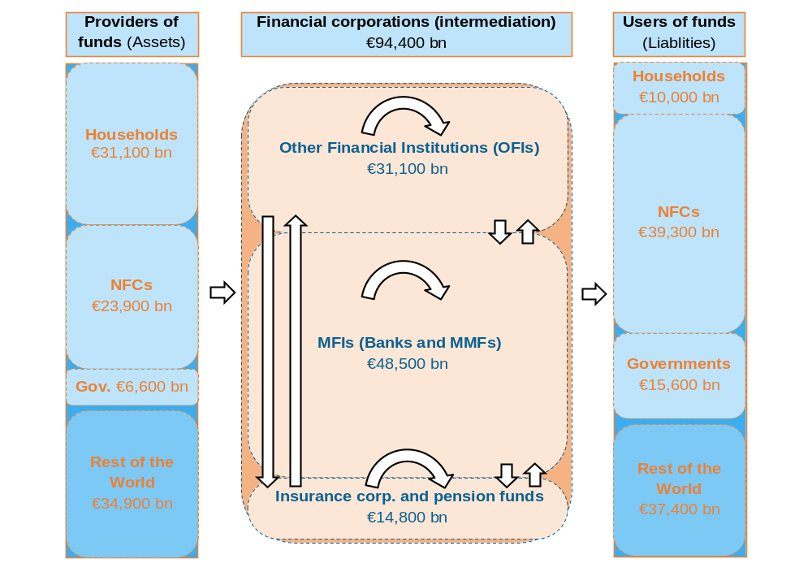
Notes: The height of each box is proportional to the actual size of the sector. Assets and liabilities of the real economy and RoW include funds channelled both through intermediation and direct financing.
Source: ECB, Eurostat and own calculations.

Chapter 2 TAKING STOCK OF EU CAPITAL MARKETS
Non-bank finance is small in the EU, though the situation differs from one Member State to another… The size of capital markets is conventionally measured by the ratio of outstanding financial assets relative to economic activity. International Monetary Fund (IMF) standard indicators of capital market size reveal that the EU has a particularly large capital market when financial assets held by banks are included. Should these assets be excluded and the size of capital markets be measured as the volume of outstanding bonds and shares, financial markets in the USA and Japan would be considerably larger. By the same token, several EU Member States (LU, IE, NL and DK) have relatively larger capital markets than the USA, suggesting that conditions in the EU can be supportive to the development of large capital markets.
Chart 5: Size of capital markets in % of GDP, 2013
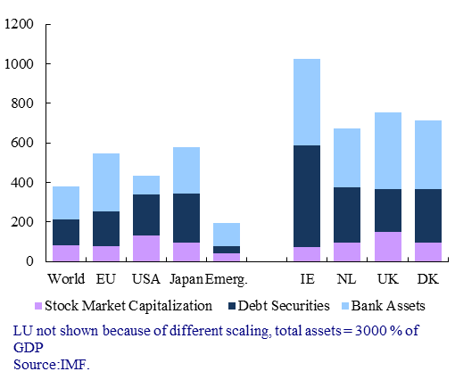
… and enterprises make little use of market financing sources. A large share of bank loans on the funding side of European enterprises witnesses the important role banks play. Bank loans respectively represent 14% and 3% of the total liabilities of European and US companies, respectively. Conversely, corporate bonds are more used as a source of funding by US companies, representing 11% of their total liabilities, to compare with 4 % in EU firms. As a result, corporate bonds amount to a third of bank credit in the EU whereas they are a more important funding tool than bank loans for US corporates. The dominance of market over non-market funding sources in the US is also evident when equity is looked at. While the share of equity on firms' balance sheets is broadly comparable in the US and the EU, slightly more than half of this equity is in the form of listed shares in the US, to compare with about one third in the EU. If not listed, shares are more difficult to trade and therefore less liquid, which entails a higher illiquidity premium that investors require as compensation for their longer-term engagement. Stock market capitalisation is markedly larger in the USA than in all EU Member States except Luxembourg and the UK. More detailed comparisons suggest that access to financial instruments that enterprises may want to use in special situations is easier in the USA. Examples would be when they are young and small and cannot provide collateral, when their investments are particularly risky or large compared to firm size, when their corporate or financing structure needs to be restructured etc. In such situations, these companies may want to tap non-standard markets such as high-yield bonds, leveraged loans, securitisation, or private equity markets, which are underdeveloped in many EU Member States.
Chart 6: Liabilities of the EU corporate sector, EU-28 non-financial corporations, 2013  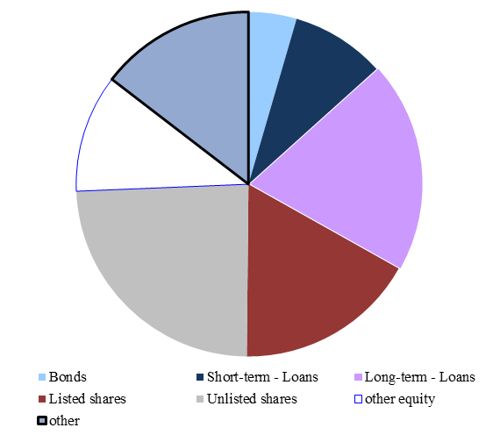 | Chart 7: Liabilities of the US corporate sector, non-financial corporations, 2013  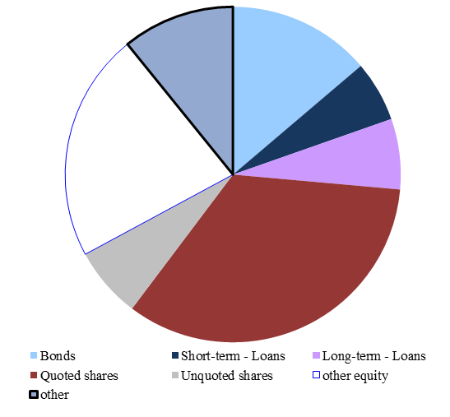
Source: Eurostat. | Source: OECD.

This chapter discusses three caveats often mentioned with respect to the development of capital markets in the EU. First, the advantages of a more market-based financial system would need to be balanced against the advantages that bank financing provides (Section 2.1). Second, the development of a stronger capital market would be a break with historical, legal and economic structures that led to a mainly bank-based system (Section 2.2). Third, the benefits and risks of a stronger capital market for financial stability (Section 2.3).

2.1 Bank-based versus market-based financial systems

Optimal financial structure is dependent on the stage of development of the economy
Available research fails to provide a general rule determining which financial structures are optimal with respect to their contribution to economic growth. As regards the causality between long-term growth performance and the size or structure of the financial system, the ultimate jury is still out. However, empirical studies suggest that very high credit relative to GDP may lower economic growth. A similar threshold has not been identified for market financing, especially equity financing (see Table 1). Some research even suggests that larger stock markets could be particularly supportive to economic growth. Depending on criteria and circumstances, studies highlight advantages of both bank-based and market-based financial systems. Analogously to firm-level choices where the optimal financial structure depends on the firm's characteristics, the optimal financial structure for a country depends on country-specific factors (see Chapter 6). In addition, studies show that economies at different stages of economic development require different mixtures of financial services to operate effectively. For example, as economies develop, the marginal gain in economic activity associated with an increase in bank intermediation becomes smaller, while the marginal impact associated with a further development of capital markets increases.
When it comes to moderating business cycle fluctuations, the influence of bank lending and capital markets differs considerably. In downturns that are not accompanied by financial tensions, healthy banks are the key element to help cushion shocks. But when recessions coincide with financial crises, bank-oriented economies tend to suffer more than market-oriented ones. Some studies show that market-based economies recover faster than bank-based economies even after controlling for the origin of the recession, the policy response, and the degree of economic flexibility. Accordingly, heavy leaning towards banks constraints the pace of economic rebound, making a diversified system indispensable to cushion economic shocks.
The optimal financial structure shifts towards capital markets along with higher levels of economic development. Banks are particularly well-placed to serve economies at an early stage of development because foreign bank entry allows for a swift growth of the banking system, hence providing a broader access to financing. They also have an uncontested role in certain market segments, for example to provide funding to firms that are too small to tap market sources. Capital markets take longer to develop because they require extensive technical and legal infrastructures (e.g. clearing, settlement, information provision). Services provided by financial markets become comparatively more important for high-income countries because, when economic and institutional systems mature, demand for a broader set of risk management and capital-raising tools increases beyond what banks can typically supply.
Table 1: Selected empirical estimates of the impact of financial development on economic growth
Study | Method and data | Findings
King and Levine (1993a, 1993b) | Economic growth rates are related to measures of lagged financial development in 80 countries. | Indicators of economic performance are positively associated with the size of the financial sector at the beginning of the sample period.
Rousseau and Wachtel (2011) | Cross sectional and panel data on financial and macroeconomic  indicators for 84 countries over the period 1960-2004. | Positive correlation of financial  size with economic growth disappears when concentrating on the period since 1990. In order to have positive effects on growth, financial deepening needs to be accompanied by appropriate financial sector policies.
Pagano and Pica (2012) | Growth regressions by Rajan-Zingales (1998) are re-estimated using UNIDO data for annual value added for 28 industries and 63 countries from 1970 to 2003. | Financial development increases employment, labour productivity and wages. The impact is stronger at low levels of financial development. Beyond a certain point, financial development does not contribute significantly to real economic activity.
Arcand, Berkes and Panizza (2012) | Analysis according to the set-up described in Beck and Levine (2004). Data covers the period 1960-2010 | The relationship between credit to the private sector and growth is concave and non-monotone. Finance starts having a negative effect on growth when credit to the private sector reaches 100% of GDP.
Cecchetti and Kharroubi (2012) | Panel regressions on a sample of 50 advanced and emerging countries over the period 1980–2009. | The level of financial development is good only up to a point, after which it becomes a drag on growth. For private credit extended by banks, the turning point is closer to 90% of GDP, lower than for market-based credit.
Demirgüç-Kunt and Levine (2011) | Quantile regressions are used to  assess the sensitivity of economic activity to both bank and securities market development. Data on 72 countries, over the period 1980-2008. | The sensitivity of economic development to changes in bank development decreases with economic development. The sensitivity of economic development to changes in securities market increases as countries grow. The demand for the services provided by securities markets increases relative to the demand for services provided by banks as economies develop.
Langfield and Pagano (2015) | Panel regressions with fixed effects and year dummies. Dataset contains 748 observations for 45 countries between 1988 and 2011. | Bank bias is negatively correlated with GDP growth, such that an increase in the size of the banking sector relative to stock and bond market capitalization is associated with lower GDP growth.
Cournède and Denk (2015) | Growth regressions on data for OECD and G20 countries between 1961 and 2011. | The composition of finance matters for growth. Credit expansion to the private sector slows growth in most OECD countries, but greater stock market capitalisation exhibits a highly significant link with stronger GDP growth.

Box 1: CMU, transaction costs and the theory of the firm
A number of theoretical approaches discussed the role of banks versus markets in the intermediation of savings to investments. The debate roots in a wider theory about the role of firms and markets in economics with the key initial contribution by Coase (1937). He recognised that the use of markets is not costless and in some cases transaction costs are lower if exchange is organised within firms. These transaction costs include search and information costs, bargaining and decision costs, and monitoring and enforcement costs. New institutional economics, for example Williamson (1985) used the concept of transaction costs to explain the existence of institutions.
Transaction costs are particularly important for credit contracts beause the lender needs to be sure that the borrower pays back, but the former has an information disadvantage with respect to the choices the borrower may take, opening scope for moral hazard of the latter. Banks can ease the impact of information asymmetries and thus help reduce transaction costs in financial exchanges. For example, Leland and Pyle (1977) formally show that a bank can communicate information to investors about potential borrowers at a lower cost than individual borrowers. In their model, intermediaries can solve moral hazard problems by monitoring the actions of firms. Diamond (1984) shows that the costs of monitoring and enforcing debt contracts issued directly to investors is the reason why raising funds through an intermediary, acting as a delegated monitor, can be superior.
Overall, the theory postulates that financial intermediaries play an important role in reducing information and transaction costs arising from information asymmetries, even if their existence does not replicate the credit market outcomes that would occur under a full information environment. A further optimisation of information structures and determinants of information costs and other transaction costs will further help overcome credit frictions.

Relative advantages of bank-based and market-based funding systems
Those arguing for the superiority of bank-based financial systems emphasise the advantages of banks in information gathering and relationship formation, as well as in financing standardized, lower-risk and well-collateralised projects. Given the economies of scale and scope in information gathering and processing, banks are in a better position than capital markets to address the inherent agency problems between debtors and creditors. A large literature has been devoted to understanding the special role played by banks in acquiring information about borrowers and in mitigating asymmetric information problems. The long-term relationship with a bank allows a firm to develop a reputation for good creditworthiness and ultimately to access finance at a lower cost (the "certification effect"). Even if other agents (such as credit rating agencies) may assume a similar function, it is argued that banks have an advantage in this regard due to the special knowledge they acquire from performing complementary functions on a large scale (e.g. account keeping of borrowers, provision of payment instruments). Market-based systems are more transparent as they reveal information publicly, thereby reducing incentives for investors to seek and acquire information. As a result, information asymmetries related to the debtor-creditor relationship are more accentuated in market-based than in bank-based structures.
Proponents of market-based systems point to the strength of capital markets in providing services to finance novel, longer-duration and high-risk projects. It is also often pointed out that non-bank finance is generally more flexible than bank finance (e.g. as regards repayment schedules or providing finance based on expected future earnings). Therefore, by not merely substituting for investment that was previously funded by banks, but enabling additional investment that banks would not be ready to fund, capital markets enlarge the potential investor base. This is possible because capital markets treat risk differently from banks. While banks do not only intermediate between depositors and borrowers but also typically take up themselves a major part of the risk, capital markets bring investors and those in need of funding directly together, transferring a higher share of the risk to investors. Dividing investment opportunities into numerous small-denomination securities allows capital markets to create a diverse menu of investment options at higher or lower risk, short-term or long-term, and allocate those according to investor type. Consequently, even risky projects get matched with appropriate investor types and so find the needed funding. The described process facilitates direct financial interactions between households, corporations, banks and governments, thereby filling in gaps where banks are constrained to lend.
Banks and capital markets have a differential impact on incentive formation through various channels. First, as they are decentralised and more diversified by nature, market-based systems are considered less susceptible to the development of monopoly and oligopoly powers. In such a scenario of collusion between a bank and firm managers against other creditors, high-collateral and low-productivity projects may be fostered, crowding out productive resources from the economy. In such a situation, the development of capital markets could provide additional disciplining forces to credit decisions and thereby increase the efficiency of asset allocation. Second, economic theory postulates that well-functioning capital markets can act as a disciplining device on managers and thereby enhance corporate governance. In banking, corporate governance is complicated by the existence of deposit guarantee schemes, lender of last resort facilities, and potential state implicit subsidies. The introduction of the Bank Recovery and Resolution Directive and the Banking Union package should reduce perceived implicit and explicit public guarantees for banks. Studies examining the role of market takeovers as corporate control devices also conclude in favour of market-based financial systems. The threat of an acquisition, which is easier to realise with well-developed stock markets, helps align managerial incentives with those of the owners.

Competition or complementary?
The conventional “bank versus market” dichotomy suggests that the two components are in clear competition. If true, the development of the two would be a zero-sum game and each segment would develop at the expense of the other. But more recent studies propose an integrated theoretical framework, where banks and capital markets not only compete for servicing a limited pool of investment projects, but also co-evolve. Complementarities between banks and capital markets are becoming more and more apparent, broadening the set of financing sources the ultimate borrower can choose from. Bank and market funding offer different mechanisms to overcome information problems such as adverse selection and moral hazard. The banks' capacity to select and monitor credit risk can also be separated from the provision of funding. Such complementarities are easy to notice in scenarios where a firm is contemplating either bonds issuance or bank credit. No matter which financial instrument is chosen, both banking and non-banking financial institutions may get directly or indirectly involved in the transaction, i.e. banks manage the issuance of bonds on behalf of the firm, or if they provide funding in form of a loan resell it on the market as part of a securitised product.
Box 2: Information frictions and incentives for long-term investments
In microeconomic analysis, financial issues are predominantly driven by information frictions, such as asymmetric information (see also Box 4) between creditor and debtor before agreeing on a contract or incentives to exploit leeway left open in the contractual terms to their advantage later on (moral hazard). Banks and markets offer means to deal with different information frictions. Markets help to deal with diverse opinions. They imply interaction among many actors, who may have very different views, and the price can be seen as a mechanism to aggregate diverse information. The interaction also allows suppliers of exotic goods to find buyers. The economic function of competition on capital markets among buyers and sellers is hence not limited to the discovery of market clearing prices for financial assets, but also to detect innovative firms and products. Conversely, involvement of banks has advantages over market funding in the unearthing of information if the evaluation of the credit risk is complex and requires the creditor to build up special expertise. Moreover, getting financial support from a bank often means building a long-term customer relationship, which can be useful in case of information frictions and when one needs to monitor and control the borrower.
While financial support from a bank to a debtor may facilitate the establishment of a long-term financing relationship, market financing must not necessarily be more short-term. A number of institutional investors, such as insurance companies and pension funds, have long-term liabilities and should therefore be natural long-term investors. The Kay Review (2012) demonstrated that short-termism is an issue in the asset management industry. Behind this are governance and information problems that are more related to how capital markets are organised in practice than with the principle of market transactions.
The relationship between ultimate savers and institutional investors is subject to principle-agent problems that can give rise to a myopic behaviour of the latter. For example, if the ultimate holders of investments use short-term performance indicators to monitor asset managers or formulate short-term targets in investment mandates, then asset managers have an incentive to favor short-term profits over long-term profitability. This effect will be augmented if part of the managers' remuneration depends on short-term performance indicators. The Kay Review recommended discouraging the use of measures and models that rely on short-term volatility of returns and deviations from indexes when deciding on the remuneration of asset managers. A better alignment of long-term interests between institutional investors and asset managers would contribute to a longer-term focus in investment strategies, notably taking into consideration risks and opportunities associated with challenges related to the environment, climate change and the energy sector. It could also lead to more investment into equity, as "perpetual" equity is considered to better support the financing of long-term investment.
Myopic investment horizons may also be the result of information limitations. While there is a wealth of data available to support investment decisions, its translation into relevant information is often not straightforward. Using price signals or other investors' decisions as proxies for own information gathering efforts bears the risk of herd behaviour and procyclicality on capital markets. The Kay Review recommended that the regulatory framework enables "companies, savers and intermediaries to adopt investment approaches which achieve long-term returns by supporting and challenging corporate decisions in pursuit of long-term value." Long-term investment is subject to long-term risks, for example climate change could significanty erode the value of some financial assets. Therefore, decision-making would also benefit from the disclosure and reporting of environmental and climate, social and governance (ESG) risk exposures. Integration of ESG issues in investment strategies, besides supporting climate friendly and sustainable investment opportunities, can contribute to investors' protection against long-term risks, in line with asset managers' fiduciary duties.
There are many areas where markets and banks offer complementary information and funding services, among them: (i) issuance of bonds, where banks provide a number of advisory and administrative services for the issuer; (ii) securitisation, where banks focus on credit analysis and markets focus on financing; and (iii) bank capital, where capital markets reduce the financing friction by lowering banks’ cost of equity, and enable banks to raise additional equity to expand their lending scope. At the same time, banks' expansion and improvement in credit analysis tend to boost investors' confidence, encourage investor participation in capital markets and spur capital markets evolution. Both the banking and capital markets' channels lead to feedback loops where each of the two components of the financial system benefits from the development of the other.
The shift of banks from their traditional relationship-oriented business model towards a more transaction-oriented business model over the last decades underscores the strong links between banks and capital markets. Until 1980, banking was predominantly based on long-term relationships with bank customers: loans were granted to households and firms for a long term and were kept on the balance sheet for their entire duration. The interests of the bank and the customer were thus clearly aligned as bank performance was closely related to the performance of its customers. The return on equity in this period was relatively modest but stable and balance sheets grew moderately with respect to the growth of the economy. As of 1980, however, and even more so as of 2000 in the run-up to the crisis, transaction-oriented banking became prominent, putting a larger focus on the short term. Banks' balance sheets expanded rapidly following innovations such as securitisation and returns on equity increased, leading to a lengthening of the intermediation chain (in which banks start to play different and increasingly important roles).
In conclusion, the recent economic theory emphasises the desirability of well-developed capital markets but pays less attention to the respective importance of capital market and bank funding. The distinction between bank-based and market-based financial systems seems to be fading while greater emphasis is put on their complementarity. Quite simply, it turns out that banks and capital markets are two vital components of the financial system, not competing but complementing each other and co-evolving.

2.2. Historical, legal and economic structures as barriers for capital markets development
Financial structures do not evolve independently from historical, legal and economic structures. This section investigates factors that seem to have led to a bank-dominated financial system in the EU. The comparison with the more market-based system in the US suggests that some of these factors are exogenous at first sight: different historical starting conditions, as well as differences in legal system and type of pension systems, for instance. In the EU, they shape firms' preferences for bank loans as they are more used to relationship based services as to transaction based services. And they give reason to households' incentive to save in bank deposits, which are considered safe as protected by public guarantees, most apparent in deposit guarantee schemes. While these factors limit the scope for the EU financial structure to converge to the US financial structure, they must not mean that the contribution of capital markets to economic activity has no potential to develop, especially when legal determinants are made more supportive to market funding. In the end, legal, economic and financial structures are mutually dependent on each other.
Differences in legal systems have been an important factor in the development of financial systems. Using various indicators of legal differences across countries, studies found that legal origin (US-English common law, French-Latin civil law, German, Scandinavian) and especially variables that cover investor protection are having a significant influence on the size and structure of financial systems. Capital markets are more developed in countries with a common law tradition and/or where rules that protect borrowers from expropriation by creditors and controlling owners and enforcement of legal rules are stronger. The World Bank's Doing Business Report provides indicators of business regulations in 189 economies including almost all EU Member States. The report shows that the scoring of Member States is very different. National performances widely differ in terms of business information disclosure, conflicts of interests, corporate transparency, minority investor protection, tax rates, recovery rates, contract enforcement costs, strength of insolvency frameworks, length of resolving insolvency, etc. Interestingly, some new Member States with still small capital markets are well placed with respect to some of the legal determinants that are favourable to capital market developments: Bulgaria, Cyprus and Slovenia are in the global top 20 with respect to the World Bank's protecting minority investors index, as are Lithuania and Latvia with respect to the enforcing contracts index. Over time, internationalisation of financial markets and convergence of legal rules that govern financial activity at an international and EU levels should lead differences in national financial systems to dissipate.
Chart 8: Member States' position in World Banks' indicators of legal determinants
(lower rank means better performance)
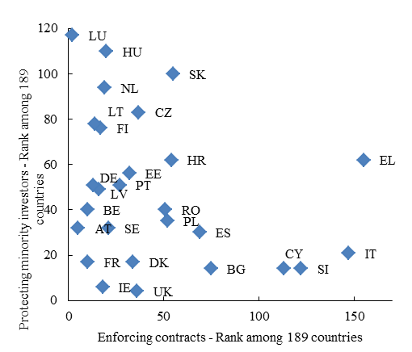
Source: World Bank.

Starting conditions have shaped differences in financial structures and may explain why capital markets took different sizes. Economic research on the role of historical factors in explaining economic institutions stipulates that starting conditions can be essential and may determine the path of economic development over long time. Since institutions change slowly, there is scope for inertia, i.e. economic structures reflect historical conditions, but may no longer be ideal with a view to current ones. A number of observations are consistent with the hypothesis that structural differences in the EU and the US financial system could be caused by different starting positions: prior to industrialisation, merchant banks had an important role in financing cross-border trade in Europe and were established financial institutions. Since the late 18th century, savings banks have popularised bank accounts as means for ordinary household to store financial wealth. The significant role of banks may have reduced the need and interest to develop capital markets in many European countries. In the US, banks came into existence only at the end of the 18th century. The need to attract foreign investors to fund high US public debt in the early 19th century seems to have fostered the development of securities markets in the US early on.
Historical disasters deepened differences in financial developments in the 20th century. While starting conditions for the development of the financial structures have been different in Europe and the US, there were also a number of events in the 20th century that are often quoted to explain why capital markets are more developed in the US. Thriving economic growth fuelled demand for market funding from the late 19th century in the US, and the Great Depression led the country to initiate a package of financial reforms that seemed to have discouraged banking activity, possibly to the advantage of capital markets. For example, the Glass-Steagall Act separated investment and commercial banking in 1931. The Bank Holding Company Act of 1956 impeded inter-state banking. Meanwhile, in Europe, the accumulation of financial capital was interrupted by World War I and hyperinflation in some countries. Private financial wealth evaporated in many European countries and substantially reduced the stock of capital available to be allocated on capital markets. After World War II, many European countries rebuilt their pension system by establishing a pay-as-you-go system, whereas pension funds became an important provider of funds on the US capital market. This led to significant differences in the amount of savings made available for investment in financial securities. Still nowadays, countries with an important pension funds sector tend to have larger capital markets.
Several major policy initiatives have paved the way to greater financial integration in the EU. The Treaty of Rome enshrined the freedom of movement of capital and freedom of cross-border services in 1957. However, decisive steps towards the integration of EU financial markets were taken only by the mid-1980s with the adoption of a White Paper on the completion of the internal market. The launch of the euro and the Financial Services Action Plan were major milestones in this integration process in 1999. They aimed at tackling obstacles to integration stemming from currency and regulatory segmentation. Following the EMU and the FSAP, conditions were in place for a greater consolidation and internationalisation of the EU banking sector. Mergers and acquisitions activity intensified, first among domestic institutions and then across borders. Western European banks notably acquired market share in most of the Central and Eastern European Member States. As a result of their expansion within Europe, European banks were, by 2007, significantly more internationalised than US, Japanese or Chinese banks. Meanwhile, capital market infrastructures remained geographically more fragmented. They provide the technical habitat for trading, clearing and settlement operations (see Section 5.4). Transparency, liquidity, price formation, information disclosure and data collection capabilities crucially depend on the existing market infrastructures. In the EU, different trading systems and platforms without interconnections have formed an obstacle to more efficient price formation mechanisms and to the availability of standardised data, notably in debt markets.
The economic effect of global financial integration materialised across EU Member States in different forms. Most visible has been the rise of financial centres in some, mainly larger Member States with more developed capital markets. Member States with a less developed financial system had large scope to catch up, but this materialised less in the form of strong growth of the country's financial industry. Instead, companies benefitted from remote access to capital markets in other Member States, for example through corporates issuing stocks on foreign stock exchanges. Convergence of framework conditions also allowed foreign investors to access smaller capital markets, for example foreign venture capital funds to invest in small firms in small Member States with less developed domestic capital markets. However, this effect has been of lesser importance for reasons set out at different places in this document.
In conclusion, underdeveloped capital markets may have been the cause of reigning legal structures and historical development, and also reflect institutional inertia. Since banks were dominant providers of finance, the need to develop legal conditions supportive to capital markets as a complement was less pressing. Hence, strengthening the rights of investors or minority shareholders was a lower priority because capital market instruments were underused. There is likely a self-reinforcing process between economic and financial structures: industries that are better served by bank funding, such as established firms with capital-intensive production and collateral tend to flourish more in bank-dominated financial systems, which results in a bias in industrial structures towards bank-dependent firms and more demand for bank services than for market funding.

2.3 Financial stability and macro-prudential policy oversight for a stronger CMU
Financial stability is a pre-requisite for delivering sustainable growth and jobs in the EU. Episodes of financial instability have historically been associated with considerable economic costs, and the global financial crisis revealed that a stable financial system is necessary for delivering sustainable growth. To this end, the EU's legal and institutional framework of financial regulation has been extensively recalibrated in recent years so as to ensure that the financial system is more resilient to shocks. Important financial reforms introduced enhanced prudential regulation of capital and liquidity requirements for banks, reflecting the need for stronger oversight of deposit-taking institutions and systemic banks.
The CMU should help to enhance financial stability in the EU by promoting more diversified funding channels to the wider economy. In doing so, it will help address possible future risks stemming from a strong reliance on bank lending and intermediation in the financial system. Given the central role of banks in the financial system including for market-based finance – as originators of risk, facilitators/intermediaries, as well as investors – the already undertaken financial reforms will have important positive effects for financial stability under the CMU. Additional macro-financial stabilising effects are expected to materialise as a consequence of the availability of broader sources of funding for productive investment in the EU, helping to avoid constraints to the supply of credit to the economy similar to those that emerged during the crisis amid strong bank deleveraging pressures. This highlights the complementarity of direct and indirect credit intermediation under the CMU, with positive effects stemming from the availability of more diversified sources of debt and equity finance for borrowers in the EU, greater risk-sharing and a more sustainable and smoother credit supply through the cycle.
At the same time, it is important to ensure that the further development of capital markets does not allow other systemic vulnerabilities to accumulate unchecked. While the banking business is, due to maturity transformation and its role in the money creation process and in the payment system, subject to potential systemic risks, non-bank financial institutions can also be vulnerable to runs, which may lead to considerable financial losses for their shareholders, debtors or other counterparts. A more market-based financial system, involving increased direct investor exposures to risk, could be more vulnerable to episodes of volatility. In the event of a sudden re-pricing of risk, contagion can propagate across markets and financial institutions through balance sheet and collateral channels. A higher exposure of financial market participants to volatility in market prices, for example, can feed into higher risk premia and thus lead to increases in the cost of capital for companies and financial losses for households. Thus, financial instability can adversely affect economic activity even when it does not result in systemic shocks.
Two sources of potential systemic vulnerability can be identified in a more market-based financial system: possibly greater interconnectedness and growing intermediation by entities outside the regulatory perimeter. First, while well-functioning markets support risk-sharing in the economy, the price discovery process also entails externalities for other holders of the same type of asset. Greater interconnectedness can lead to higher asset price correlations, which can reduce portfolio diversification benefits for investors. These effects can create a vicious cycle in times of broad-based sell-offs in markets with potential systemic implications. A second potential source of vulnerability is that activities gradually shift from more closely supervised and/or strongly regulated areas to less supervised and regulated ones. This could be conducive to a situation in which the ultimate risk-takers are taking more risks than they can eventually bear. Against this background, concerns have been voiced that the CMU project might lead to a further risk transfer from the more heavily regulated banking sector to less regulated areas, commonly referred to by the terms 'shadow banking', and more recently, market-based finance.
The European Commission approach to market-based finance is to deliver transparent and resilient market-based financing while tackling major financial risks. The financial reforms already put in place, such as the introduction of an EU regulatory framework for alternative investment funds, including hedge funds and private equity in the Alternative Investment Fund Managers Directive, are important in this respect. Furthermore, and in line with the FSB's 2013 recommendation to address the risks inherent to securities lending and repurchase agreements, the recently agreed Securities Financing Transactions regulation will ensure that the necessary information on these transactions is reported to trade repositories and investors in collective investment undertakings.
The development of the CMU should be accompanied by appropriate oversight for the financial system as a whole. In recent years substantial efforts have been undertaken at European and global levels to define, monitor and regulate market-based finance activities and the entities engaged in them. As the CMU takes shape, analysis will be undertaken to determine the continued appropriateness of measures and instruments available to address possible macro-prudential risks stemming from more market-based finance. In that regard, work is already ongoing internally in the European Commission and within the European Systemic Risk Board to assess issues concerning market liquidity and interconnectedness within the financial system, and certain intermediation activities undertaken by non-banks. Given the strong inter-linkages within financial markets and across sectors, micro-prudential supervision seems not sufficient. The main objective of the essential complementary macro-prudential oversight is to identify potential weaknesses in the structure and/or the cyclical dynamic of the system, and address them through well-targeted instruments and policy actions where necessary and justified.
In addition to strong micro- and macro-prudential supervision and oversight, a well-functioning CMU requires appropriate consumer and investor protection rules. A more market-based financial system relies on greater participation by both institutional and retail investors and necessitates that the ultimate risk-bearers are well equipped to independently evaluate and price risk. While this is equally relevant for individual and institutional investors, retail investors face particular difficulties in assessing risks and making informed investment decisions, given the associated cost in assessing some partly opaque and complex financial products. An important cause behind this are information asymmetries in favour of originators and distributors, rendering the full utility or return from these products difficult for consumers to ascertain until their final maturity (so-called 'credence goods'). Thus, appropriate investor protection is needed for enhancing and sustaining consumer and investor confidence. The European Securities and Markets Authority (ESMA) and the European Insurance and Occupational Pensions Authority (EIOPA) have already been given increased powers on investor protection through MiFID II, PRIIPS, the Short selling Regulation and other legislative acts.

Chapter 3 FINANCING NEEDS BY THE EUROPEAN CORPORATE SECTOR AND INFRASTRUCTURE
This chapter analyses the financing needs of European firms and infrastructures. Section 3.1 describes ways in which these needs can be filled and lists the company's characteristics that determine its access to funding. Section 3.2 focuses on the particularities of SMEs, which are important for the European economy but face considerable funding restrictions. Section 3.3 explains the consequences stemming from the lack of verifiable information about SMEs and from the limited financial knowledge by SMEs. Barriers preventing companies from going public, such as high costs and insufficient investment research coverage, are discussed in Section 3.4. Private placements are shown as a useful supplement and gateway towards public corporate bond issuance. Section 3.5 analyses various corporate liability structures and explains risks stemming from excessive company indebtedness. The specificity of infrastructure investment and related funding problems are described in Section 3.6.

3.1 Theory on businesses' access to funding
In order to develop their business and grow, companies get finance through internal or external funding. The latter term is used to describe funds that firms obtain from outside of the firm, such as debt or equity issues, contrary to internal financing which consists mainly of initial own resources and profits retained by the firm for investment. The pioneering work by Modigliani and Miller (1958) suggests that the capital structure of a company has no impact on its value when markets are perfect and frictionless. However, many capital markets are characterised by information asymmetries, and studies show that capital market imperfections make financing decisions relevant. For a given level of risk, external financing is typically more costly than internal financing due to the additional transaction costs and a premium, which compensates outside investors for the lack of knowledge of a company’s true creditworthiness or prospects. In consequence, firms financing decisions are strongly determined by information problems. In corporate finance, the pecking order theory highlights the role of asymmetric information in determining the cost of financing.
As depicted in the funding escalator model of corporate finance, a company's financing needs depend on various factors. In particular, variables such as its stage of development, growth objectives, innovativeness, sector of operation, and attitudes towards risk determine its financing needs. In the start-up phase, a company needs money to develop its business idea. Given the typical absence of retained earnings at this stage, the firm primarily sources funding externally, often from friends and family members for small companies. Although retained earnings increase when a company is successful and grows, a firm's external financing stays typically high in the growth stage with the main sources being bank funding, peer-to-business lending and/or private equity (especially in the form of venture capital). Once the firm enters the mature stage, financing structures adjust to the pace of earnings, a firm's growth and the collateral at disposal. At a certain point, the company may decide to go public, offering its stock to the general public on a security exchange as a means of equity financing and/or issuing bonds. Finally, in a declining phase, once new projects become scarce, funding needs become lower. If a firm cannot or does not want to put all retained earnings to profitable productive use, it may decide to buy back its debt or equity. While the exact funding needs differ across a company's lifecycle, external funding features prominently in all stages of a firm's development either for basic maintenance or for investment and growth.
Figure 3: The funding escalator of corporate finance
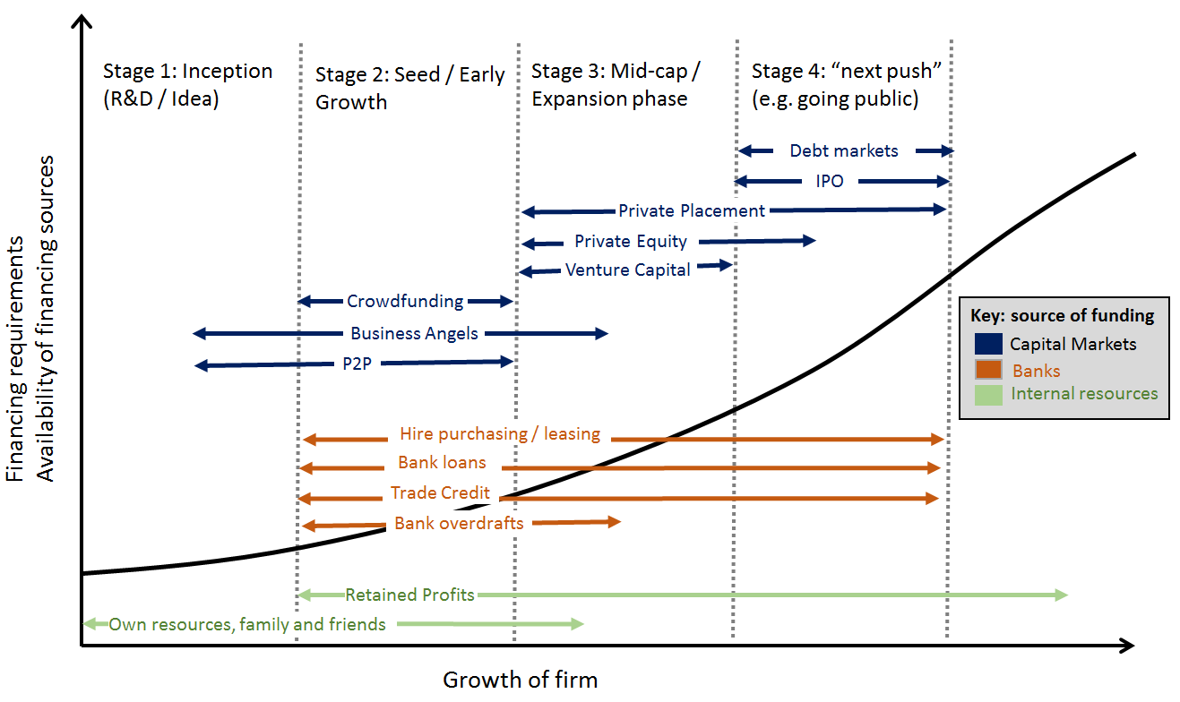
Source: European Commission.
Chart 9:Sources of funding used by NFCs (financial liabilities), EU 28, 2014, EUR billion
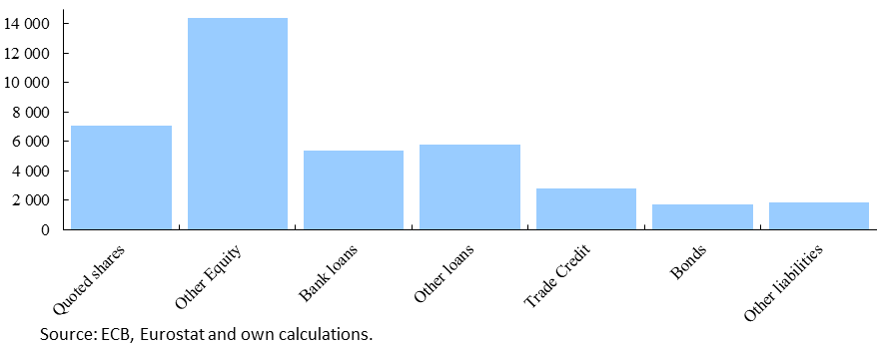

Companies face financing constraints. These constraints affect firms' investment decisions and growth prospects, and need to be addressed by appropriate policy action. Among other factors, the weak macroeconomic environment has caused corrections in financial markets and restricted the availability of external funding. The global financial crisis, followed by the euro area sovereign debt crisis, affected European businesses via multiple economic and financial channels and led to a global recession. But the negative effects have been uneven across countries, sectors and companies.
Both a company's characteristics and external factors are important determinants of its access to financing. The funding escalator model already highlighted the importance of the company’s stage of development. It is also harder to access finance for firms operating in countries whose regulatory environment is considered risky, burdensome or overly expensive due to extensive bureaucracy. Access to financing is also easier for firms that are able to resort to foreign capital markets, such as firms that are part of a multinational group.
More available company data allows the development of better measures for the presence of financing constraints. Empirical evidence suggests that financing constraints are widespread and particularly affect smaller, younger, or single-unit firms. Their business prospects are more difficult to evaluate for investors, they are perceived as riskier because they are less diversified, and they are often not in the possession of collateral.
Since the onset of the financial crisis, European companies and in particular SMEs have been facing a more difficult access to funding, reflected by both quantity and price restrictions. Some of the reasons have been cyclical, such as the deep recession, leading to higher credit risk and lower profitability. Other reasons have been firm-specific, such as poor credit standing, insufficient profitability, lack of viable business plans or operating in industries in need of restructuring. At the same time, some supply frictions have also weighed on the amount of financing granted: the financial crisis has aggravated funding conditions because sources of short and long-term financing have been affected by liquidity problems and increased risk aversion in the banking sector. Moreover, rising sovereign risk premia led to higher interest rates on lending to the private sector in crisis-ridden countries. Rising late payments by the public sector to its suppliers have further weighed on the funding situation of SMEs in vulnerable countries. Consequently, SMEs operating in some Member States have become disadvantaged in relation to their peers in the rest of the EU.

3.2 Do European SMEs lack funding?
Despite some stabilisation of the SME sector in Europe following the global financial and euro area sovereign debt crises, funding constraints remain a concern. The 2014 survey on the access to finance of enterprises in the euro area (SAFE) shows that small businesses are getting increasingly optimistic about their growth prospects, but it also shows that many profitable and solvent SMEs remain concerned about their access to finance. More than a third of SMEs surveyed did not manage to get the full bank loan financing they applied for, with particular problems reported by micro enterprises. Perceptions also differed across countries. 34% of the SMEs in Greece, 15% in Ireland and 15% in the Netherlands named access to finance as their most important problem, compared with only 7% in Germany and Austria. According to the Organisation for Economic Co-operation and Development (OECD), many SMEs in Europe could use additional funds productively, but cannot obtain these from the financial system. In a previous edition of the report, the OECD noted that securing suitable financing constitutes a problem especially for innovative SMEs whose technology and business models are not supported by many traditional financial institutions. The results of the European Commission's Innobarometer survey confirm that access to funding is a key obstacle for spurring R&D and the commercialisation of innovative products or services. Market analysis reveals that Europe has a smaller pool of non-bank funding available for investment by SMEs than the US, though the size of both economies is similar.
Barriers to funding faced by small and innovative companies have notable economic implications. More than 99% of all European businesses in the non-financial sector are SMEs. Combined, they provide two thirds of private-sector jobs, contribute to more than half of the total value added created by business activity in Europe, and are crucial for income and growth in the EU. At the same time, economic research considers innovation a crucial driver of long-term productivity and economic growth. Countries which are able to generate innovation and to adopt new technologies grow faster. At the current juncture, where many companies need to restructure following the protracted recession, there is a particular need to support innovative, growth-enhancing, while risky, investment.
Smaller firms are more constrained in receiving external funding because of their high sensitivity to economic cycles and shocks, which is in turn due to greater sectoral and geographical specialization. This disadvantage is reflected in higher interest rates on small loans when compared to large loans as well as in other forms of credit constraints. A comparison of the average cost of loans in Europe (see chart) shows a significant gap between lending to SMEs and to large firms. In addition, unlike large corporations, small companies have limited access to capital markets and thus remain disproportionally reliant on banks. The smaller a firm, the more restricted the spectrum of potential non-bank funding options (see table) . Alternative sources of financing are shown to be accessible only to larger firms, firms having high credit ratings, and firms located in countries with better developed financial markets.

Chart 10: Yields of and spread between small and large loans, euro area
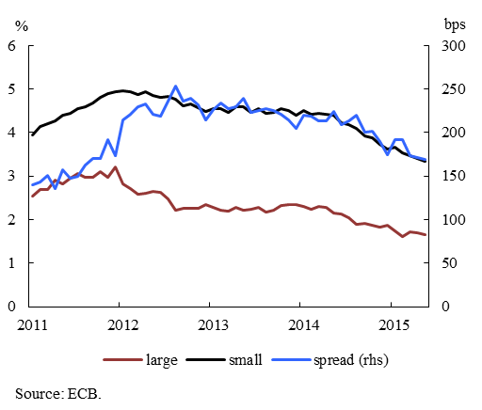

Table 2: Use of financing instruments by non-financial corporations
(percentage averages out of total sample over 2009-2014)
 | Micro | Small | Medium | Large
Retained earnings | 24 | 30 | 38 | 46
Grants/subsidised loans | 12 | 16 | 20 | 22
Bank overdrafts | 38 | 43 | 40 | 42
Bank loans | 28 | 39 | 43 | 48
Trade credit | 26 | 30 | 35 | 38
Other loans | 9 | 12 | 19 | 28
Leasing | 19 | 40 | 50 | 56
Debt securities | 1 | 1 | 1 | 4
Mezzanine | 1 | 2 | 4 | 6
Equity | 4 | 6 | 8 | 9
Sources: ECB and European Commission Survey on the access to finance of enterprises.
SMEs' dependence on bank lending is often rooted in long-standing client relationship. The comparative advantage of banks in acquiring information, as discussed earlier, is particularly relevant for SME financing. A study conducted in the UK finds that over half of the SMEs seeking finance and eligible for bank funding go to their main bank. More than two-thirds of SMEs approach only one bank and do not shop around for better offers if financing is granted. This is possibly because SMEs, once a workable relationship with a bank has been developed, see little value in devoting too much resources into financial enquiry, an activity that they usually do not consider their core business.
Investments in novel, longer-term projects, such as in the area of research and development, carry higher credit risk. Innovative companies often lack collateral that could be used to obtain credit, as investments in research and development typically mostly translate into intangibles assets, which are difficult to value. At the same time, banks need to comply with risk-based capital requirements and thus can allocate only a limited share of credit to riskier projects. As a consequence, some innovative, but risky, investment opportunities may remain unfunded in financial systems relying exclusively on banks. The SME credit gap was estimated at USD 1.5 trillion globally in 2011 – a third of it being in high-income OECD countries.
SME funding can be increased by supplementing banks with non-bank finance providers that have expertise in identifying risky projects. While banks intermediate between depositors and borrowers and at the same time take part of the risk themselves, capital markets directly link savers and investees. The inherent diversity of views and risk preferences present on capital markets makes it possible even for risky projects to get matched with appropriate investors. Hence, the more diverse nature of capital market funding is suitable not only for well-defined and predictable business projects, but also for risky and innovative endeavours.
There are various ways in which funding is provided beyond bank lending (see Chart 11). Leasing, factoring and various forms of trade and supply chain finance are capable of easing corporate financial problems, but are usually more expensive than bank loans. Loans by non-banks, including crowdfunding and peer-to-business platforms, are other potential sources of finance but are underdeveloped to date, even if they often carry lower borrowing costs than bank loans. Still another source of alternative finance, particularly suited for fast-growing firms, is private equity. Depending on the size of the investment and the stage of a company's growth, equity can be raised through family and friends, crowdfunding, business angels, venture capital, and, when a company matures, listing on a stock exchange.
Chart 11: Alternative sources of funding, outstanding volumes in EUR billion, EU-28, 2014
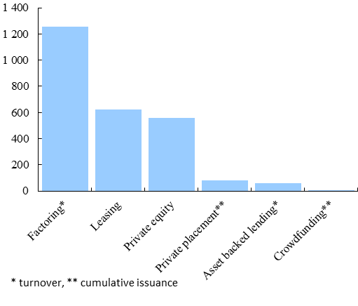
Note. When outstanding volumes were not available, turnover or cumulative issuance was issued as a proxy.
Source: Factors Chain International, EVCA, Leaseurope, Massolution, IKB Deutsche Industriebank, C/M/S Bureau Francis Lefebvre and own calculations.
So far, external equity funding for SMEs is rather limited in Europe. Private equity, a key source of funding for companies in a growing phase was significantly hit by the financial crisis, with funds raised dropping from over EUR 100 billion in 2006 to less than EUR 20 billion in 2009 (see Chart 12). Business volumes recovered in recent years, and fundraising by European private equity investors reached EUR 45 billion in 2014. Yet, net funds raised were only EUR 6 billion in 2014.
Chart 12: Private equity activity, gross annual flows, Europe, EUR billion
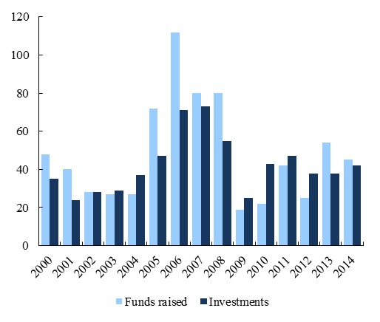
Notes: Data include venture capital. Funds raised: gross increases of liabilities. Investments: use of liquidity to purchase equity.
Source: EVCA 2014 European Private Equity Activity.
Business angel investment, which refers to private individuals offering financial support and other operational counsel to start-ups, also faced difficulties during the crisis. While banks have been unable or unwilling to provide loans to young and innovative start-ups, angel investors, acting either individually or through groups, syndicates or networks, have also become more risk adverse and have focused on later stage investments. Available figures suggest that the amounts invested by business angels in the EU remain small and highly concentrated. The statistics by the European Trade Association for Business Angels, Seed Funds and Early Stage Market Players (EBAN) show that business angels' outstanding investment in the EU amounted to EUR 5.5 billion in 2013, of which a large part is undertaken in the invisible market. More than half of the annual investment by business angels was estimated to be directed to the UK, Spain or France.
Venture capital, which can be a key funding source for growing companies, is usually invested through funds, often provided by institutional investors. With a market volume of EUR 3.6 billion in 2014, venture capital is particularly important for financing innovative companies. It can in particular play a determining role in stimulating entrepreneurship, supporting young companies and replacing or complementing traditional bank finance. Start-up stage investment represents the major part of venture capital activity. Companies active in growing business sectors such as life sciences, communications and electronics attract the majority of the available funds.
Academic literature argues that venture capital spurs innovation by relaxing financing constraints that innovative firms face due to asymmetric information and moral hazard problems. Business experience and research confirm that companies backed by venture capital are more likely to create patents, have high productivity and are competitive. The impact of venture capital investment on productivity growth has also been studied and shows that enterprises backed by venture capital are more competitive than others, feature higher individuality of their products and have better technologies. Overall, economic analysis shows that venture capital investment enhances productivity growth.
Despite positive effects on economic growth, venture capital constitutes a small part of total SME external financing. For most world economies, venture capital represents a negligible percentage of GDP, i.e. often less than 0.03%. Its presence is greater in Israel and the United States, where the venture capital industry is more mature. It represented in 2012 around 0.4% and 0.17% of GDP respectively. By contrast, venture capital investments expressed as a percentage of GDP did not exceed 0.1%. in any EU country. In 2013, venture capital firms invested only EUR 5 billion in Europe, an amount significantly lower than the EUR 26 billion invested in the US.
The financial crisis has severely affected the venture capital industry worldwide. In 2012, the level of venture capital investments was around 60% of 2007 levels in most developed countries. In spite of signs of recovery, total venture capital investments in Europe remain at around half their pre-crisis peak whereas in the US venture investments surpassed their pre-crisis peak in 2013. This means that the recovery in Europe is progressing sluggishly, with venture capital investment growing by only 6% in 2014 compared to 2013. This slow growth dynamics highlights the limited potential for a more radical expansion without policy intervention. Moreover, the number of companies backed by venture capital is similar to the level registered in 2007, indicating that the average size of the investment in individual companies in Europe has lowered over the last years. Currently, approximately 3200 European companies are venture-backed. Other estimates show that the venture capital market is only 12% of what it would be if it were as deep as in the US. If only half of the mentioned gap was closed, an additional EUR 25 billion could be raised every year to finance investment.
The main obstacles to the development of venture capital investment are market fragmentation and constraints on the supply side of the market. European venture capital investors have difficulties with reaching critical size and sufficient diversification in their portfolios. Three quarters of venture capital funds were in 2014 smaller than EUR 82 million and only 20% of funds had raised more than EUR 100 million over the last six years. Moreover, the activity is concentrated in a few Member States, such as the UK and France. Larger venture capital funds would be able to realise scale economies, specialize and thus possibly attract additional capital commitments for individual companies. However, the high degree of fragmentation along national lines limits the growth of the market and prevents economies of scale from materializing, which implies relatively high transaction costs.

On the supply side of the market, private institutional investors such as pension funds, funds of funds, banks and insurance companies have traditionally been important sources of funds for venture capital investment. However, regulatory or self-imposed constraints on their asset allocation may prevent institutional investors from scaling up their investments in this asset class. The small size and fragmentation of European venture capital funds represent additional barriers to investment by institutional investors. Moreover, since venture capital funds use equity issuance to exit from their investment, the declining liquidity on equity markets is an important deterrent to venture capital investment.
National business growth funds and related private- or public-led consortia can help pool funding resources and thus unlock the potential of fast-growing businesses. By pooling funds, large-scale investment projects could more easily be funded. In particular, allocating public financial resources to a pan-European Fund-of-Funds programme could help attract more private capital back to venture capital, particularly from non-EU sources. A Fund of Funds could act as a useful intermediary bridging the gap between large institutional investors and smaller venture capital funds. Thereby, it could provide access to larger pools of international capital and enable more SMEs to be financed and for longer periods of time.
Box 3: Case studies of business growth funds
A. France – BPI scheme (public-private co-financing): The French Banque Publique d'Investissement (Bpifrance) was created in 2012 In partnership with banking and finance establishments, Bpifrance funds SMEs along different stages of the funding escalator. It provides cash to cover R&D expenses and equity seed capital to strengthen a company’s financial structure and thus prepare it for initial fundraising. It also provides industrialisation loans to fund downstream expenditure for R&D projects; participatory development contracts to strengthen the equity capital base to implement development projects, innovation loans to finance the launch of innovations; and reindustrialisation assistance to fund investment expenditure. Through innovation development contracts the fund helps to fund non-tangible investment and working capital requirements associated with an innovation.
B. Fondo Italiano D'Investimento: The Fondo Italiano d'Investimento SGR manages three closed-end investment funds for qualified investors, for a total amount exceeding EUR 1.5 billion, one active in the private equity sector investing in companies with a turnover ranging from EUR 10 to 250 million and in other funds and investment companies; another active as venture capital fund of funds and another as private debt fund of funds.
C. UK - Business Growth Fund (private led): Launched by five major UK banks as a large-scale investment vehicle to invest in SME equity, this fund pools money to make large scale investments in growing companies. Investments between EUR 3 million and EUR 15 million are made in established, profitable companies with a turnover of up to EUR 150 million . Investment is provided as equity capital, alongside loans and trade finance. The Fund focuses on growth capital, not buy-outs, taking stakes of less than 40%. Scale effects drive down portfolio costs, making SME equity investments more attractive. In addition, investment in the fund is treated as a risk-weighted asset (rather than requiring a deduction from capital) and the banks are able to benefit from the capital treatment within CRD IV which covers risk-weighting for Collective Investment Undertakings. In 2013, the fund invested GBP 1.47 billion through a total of 652 deals.
D. Danish Growth Fund (public-private co-financing): Re-launched in 2001 as a strategy to develop venture capital markets in Denmark, this government-backed investment fund co-finances high-risk and knowledge-based SMEs. The fund has USD 2 billion capital under management and annually co-finances 500-800 SMEs. It uses both equity and loan instruments to leverage private investors and focuses on profitable growth companies. Facing a lack of sufficiently experienced venture capital management teams, the fund decided to build capacity to invest directly in companies alongside the support of existing venture capital funds. The initiative resulted in dynamic growth of the Danish venture capital market and a significant increase in the Danish venture capital funds' returns. The market has also consolidated, leading to fewer and bigger venture capital funds
E. Spain - Fond-ICO Global (public): This public venture capital fund of funds is a financing facility of the state-owned bank Instituto de Crédito Oficial. With a total of USD 1.2 billion of funds available, the fund seeks to promote privately managed venture capital funds. Its action is directed by the following principles: collaboration with private venture capital and private equity investment; forming private-public partnerships without interfering in the market; simplicity (recurrent schemes) and transparency (public tenders). Until end-2014, ICO helped to create 23 new venture capital and private equity funds, committing EUR 631 million. It aims at creating about 40 new venture capital funds mobilising an amount of around EUR 4 billion to be invested in Spain.
SMEs can obtain non-bank funding not only via private equity but also through peer-to-peer investment and borrowing. However, despite their rapid expansion, securities-based crowdfunding and peer-to-business lending still represent a small share of SMEs' funding. Today, there are approximately 400 crowdfunding platforms in Europe, and the funds raised through crowdfunding have grown from EUR 487 million in 2012 to EUR 2 957 million in 2014, at an average yearly growth rate of 146%, almost reaching the size of the venture capital market. The number of start-ups and SMEs in Europe financed through crowdfunding has grown from 1084 in 2012 to 5801 in 2014.

Greater awareness of securities-based crowdfunding and peer-to-business lending among investors and businesses is expected to result in an accelerated growth of the market. Moreover, more crowdfunding and peer-to-business lending could have a positive signalling effect for SMEs towards other sources of finance. At the same time, perceived uncertainty on the laws applicable to crowdfunding platforms is an obstacle to further development. Due to the lack of a precise definition of crowdfunding and the absence of applicable EU legislation, localised platforms that want to operate cross-border have to comply with several – and often divergent - national rules. Although, at present, the crowdfunding market remains localised, significant potential exists in this area in the future thanks to digitalisation and technological progress. An important fact explaining differences between the UK and the rest of Europe is that investing in early stage companies is incentivised via targeted regulation in the UK.
Insufficient clarity about the rights of investors participating in crowdfunding platforms weighs on their popularity. Only some EU countries, e.g. Germany, Spain, France, Italy, Austria and the UK, have introduced specific legislation on crowdfunding, which includes for example: registration of platforms, organisational requirements, capital requirements, professional requirements, liability. In a similar context, Belgium and Austria amended their prospectus rules to better fit the crowdfunding business model while Germany, Austria, Finland are considering legislative changes in the near future. Still, rules on the operation of crowdfunding platforms and related investor protection mechanisms are still absent in many EU countries.
The anonymous nature of the peer-to-peer market and the lack of comparable credit information about borrowers seeking funding on the platforms constitute further obstacles. Gathering and processing credit information is a resource-intensive activity that might not be undertaken if the associated costs are too high. Consequently, the potential of crowdfunding that could complement traditional sources of finance and contribute to helping start-ups move up the "funding escalator" remains underused.
The lack of verifiable information about SMEs restricts access not only to crowdfunding but also to other funding sources (see more details in Box 4). Investors and lenders need verifiable information about a company before supporting it financially. Financial statements and a firm's credit history and payment behaviour are essential to assess the repayment capacity of an SME. In addition, companies themselves use credit information services to assess the creditworthiness of clients or suppliers. Those SMEs about which information is missing may be rejected as a potential investment target already during the pre-screening process. Usually the bank that has built up a long-term relationship with an SME and knows well its financial situation, indebtedness and payment behaviour is the best placed to assess its true creditworthiness. But the sharing by banks of data with other market participants (such as business registers, credit bureaus and business information and scoring firms) is limited and varies from one Member State to another. Positive credit data coverage, while important because it provides information about the credit quality and behaviour of borrowers, also differs considerably between Member States. The lack of standardised, verifiable and accessible credit information about SMEs represents a significant barrier for alternative finance providers to invest into European SMEs. Therefore, tackling this shortcoming is a prerequisite to broaden SMEs' possible funding avenues.
Information problems prevent the securitisation of SME loans from taking off. The assessment of the creditworthiness of an SME loan is much more difficult than a mortgage loan. The monitoring effort is significant due to the heterogeneity of the businesses and information limitations. This makes the securitisation of SME loans more complex and difficult than the securitisation of a pool of mortgages. As a consequence, addressing information challenges is key to stimulate growth in the SME loans' securitisation market.
Box 4: Credit market failure due to asymmetric information
When lenders cannot adequately assess the credit quality of borrowers, they typically respond to such information asymmetry by raising interest rates on loans. This behaviour is at the root of the adverse selection problem: higher interest rates drive low-risk borrowers out of the market, while more high-risk borrowers step in. Moreover, borrowers may be incentivised to invest in riskier projects to compensate for the higher interest rates (an instance of moral hazard). In addition, some borrowers may not repay their debts, as in the absence of information about their creditworthiness they could still obtain loans from other lenders (another example of moral hazard). The presence of asymmetric information can ultimately lead to credit restrictions, even in competitive markets, and to dysfunctional or missing markets.
Insufficient financial education is another obstacle restricting SMEs' access to external funding. SMEs tend to lack knowledge on alternative sources of finance as well as on which information to submit to potential investors or lenders and how. Another problem is the lack of awareness about credit reports and credit history. Many SMEs are not able to get their own credit history and use it to obtain alternative financing. The lack of transparency on banks’ feedback to SMEs about their creditworthiness makes it even harder for SMEs to build their financial knowledge. Banks' feedback to borrowers varies in quality in Europe and only about half of SMEs find the feedback received by banks useful as regards obtaining future funding.
Lack of financial knowledge by SMEs considerably narrows their financing options. According to the SAFE survey, one SME out of three is not confident about talking with banks and only 20% are comfortable in negotiating with equity investors and venture capital firms. The smaller the firm size, the more limited its confidence in its own financial competence. Another report shows that only a quarter of those responsible for making finance decisions in SMEs possess financial qualifications, and for SMEs as a whole only a minority have a financially trained person. Alongside the lack of in-house expertise, SMEs also experience problems with using external advice. Only 9% of SMEs asked for advice when seeking an overdraft and only 16% when seeking a bank loan. The resulting knowledge gap and the lack of a recognised source of business finance advice for SMEs, able to guide them through the complexities of bank and non-bank finance and help them secure access to the most appropriate form of finance, hampers the use of financing options by SMEs.
Finally, limited research on SMEs impedes their visibility and further contributes to SME funding shortages. Despite the importance of SMEs for the European economy, little is known in a detailed and systematic manner about these specific companies, their activities and business profiles. For instance, 50% of SMEs listed on Euronext Amsterdam, Brussels, Paris and Lisbon do not benefit from any financial research and 16% are followed by only one analyst while NASDAQ OMX estimated in 2013 that only 10% of listed companies were covered by financial analysis. An empirical study confirms the significant impact of analyst coverage on corporate investment and financing costs. A decrease in analyst coverage increases information asymmetry and thus raises the cost of capital.

3.4 Do European companies face barriers to going public?
The larger a firm, the broader the spectrum of available external financing options... Corporate finance theory and business firm evidence suggest that larger firms can more easily meet their funding needs than smaller firms, as mentioned at the beginning of this chapter. In addition to bank loans, larger firms can finance their needs using existing purchase orders or accounts receivable factoring. They can also use their assets to obtain a secured business loan or line of credit. Lastly, they may acquire financing through issuing debt and/or equity. Fixed transaction costs, minimum denominations, lack of business histories, lack of brand and insufficient collateral impede smaller firms from accessing external finance.
… but certain market segments are accessible only to the largest firms. Issuing debt or equity is the start of a new phase for a company. Besides the need to prove to investors that its business has competitive strengths and an acceptable risk profile, a company that goes public has to change in many respects. Among other things, its management and corporate governance structure needs to be adapted, its accounting and reporting systems have to be enhanced, its capacity to communicate information with different stakeholders must be stepped up. For all these reasons, and also because raising capital on equity and debt markets involves high average transaction costs and heavy listing or issuance regulatory requirements, going public remains largely the domain of large firms. In 2015, of the 23 million SMEs in Europe, only 11 370 (less than 0.05%) are admitted to trading on a regulated market or a multilateral trading facility.
The corporate bond market in the EU has grown recently but is still relatively illiquid and heterogeneous. Aided by historically low interest rates, total issuance by non-financial corporations of euro-area denominated corporate bonds nearly doubled between 2008 and 2014 to EUR 340 billion. Despite high primary issuance from large mulitnationals in recent periods, liquidity in the secondary markets has decreased. A wide diversity of issuances, in terms of maturity and coupon structures, results in limited standardisation. Much of the corporate bond market is tailor-made and 'buy to hold'. Nevertheless, low secondary market liquidity impacts on bond prices and market volatility, and can be detrimental for primary issuance. Higher liquidity premiums lead to higher costs of funding for corporations. Market-makers play a crucial role in providing liquidity. A withdrawal of these activities and a reduction in dealer banks' inventories, post the financial crisis, may be contributing to the lower secondary market liquidity. A number of factors, both cyclical and structural, can be cited as potentially impacting market liquidity. There is also a view that the important steps taken to strengthen the bank balance sheets and improve their resilience, may have also unintendedly increased market-makers' costs, and possibly reduced their willingness to act as liquidity-providers. Studies show that a more integrated and liquid European market for corporate bonds would give European firms a broader choice of financing. There are market initiatives in the US addressing this concern, e.g. by agreeing to gather and sift more timely data about dealer inventories, as well as by establishing “all-to-all” trading platforms that involve both buy-side and sell-side traders.
Corporate bond issuance is commonly used by large firms which can obtain more easily credit ratings and issue bonds in large denominations, typically purchased by financial institutions. While there are national initiatives for retail bond markets, mainly selling mid-cap bonds, such markets are usually small and have a limited reach. Initiatives to pool small-cap bonds or bundle them with other instruments such as securitisation have had limited impact so far. However, of higher impact have been public and private-led initiatives to promote bonds meeting specific environmental, social and governance criteria.
Box 5: The emerging market of Green Bonds
The brand new market of green bonds, financial instruments which are aimed at financing projects generating an environmental, social or governance (ESG) benefit, has emerged over the last couple of years.
Initially, green bonds were mostly issued by public entities aiming at alleviating the market failure that the specific beneficiary projects (yielding positive externalities for society as a whole) were not adequately funded from the society's point of view. The European Investment Bank (EIB) pioneered it in 2007 by issuing the first green bond, which was linked to climate action investments. Historically, supra-national development banks, such as the EIB, the World Bank, the European Bank for Reconstruction and Development (EBRD) and the International Finance Corporation (IFC) have been the most prolific issuers. Together with national development banks, they continue to be the prime issuers, representing 44% of the green bond issuance in 2014. However, issuance of ESG bonds by the corporate sector increased sharply in 2014 and represented one third of the market, primarily in the energy, utilities, consumer goods and real estate sectors. This reflects the increasing appetite of investors for this type of instruments. The third group of issuers, regional/municipal entities, represented 13% of the volume of green bonds issued in 2014. Notably thanks to the arrival of new issuers such as national development banks, companies and local public entities, the market size tripled in 2014 over 2013, with a total of EUR 36.6 billion of green bonds issued by 73 issuers. According to Standard & Poor's estimates, the global market for green bonds could reach USD 100 billion in 2015.
The increased appetite for ESG bonds is explained by the fact that labelling a bond as ESG helps investors select investment projects that hedge the risks associated with poor environmental management, deteriorated employee relations and weak governance. However, despite this recently strong growth, the green bond market remains marginal, representing less than 0.1% of the global outstanding debt securities market.
To provide for some standardisation of this emerging market, market participants have been developing voluntary guidelines known as "Green Bond Principles". These Green Bonds principles, which were last updated in March 2015, are intended to (i) provide issuers guidance on the key components involved in launching a credible Green Bond, (ii) aid investors by ensuring the availability of information necessary to evaluate the environmental impact of their Green Bond investments, and (iii) assist underwriters by moving the market towards standard disclosures which will facilitate transactions. Green Bond Principles include guidelines on (i) the use of proceeds (e.g renewable energy, energy efficiency, sustainable waste management, sustainable land use, bio-diversity conservation, clean transport, sustainable water management, climate change adaptation), (ii) the process for project evaluation and selection, (iii) the management of proceeds, and (iv) reporting. While the Green Bond Principles are perceived as an important first step towards product standardisation, significant work remains to clearly establish which projects or assets qualify as green. There is also an increasing demand for a third party verification of key aspects regarding the "green"/sustainable nature of the projects financed with the proceeds of green bonds and the information provided. A lack of transparency and harmonisation in processes and reporting also have to be addressed to ensure the integrity and accuracy of the information provided to investors and improve the credibility of the sector.
Private Placements (PPs) offer a useful supplement to public corporate bond issuance. They constitute a well-established distribution channel for qualified investors around the world. The US private placement market is globally the most mature with annual issuance fluctuating around USD 35 billion. In Europe, despite constant expansion, the market is significantly smaller with about EUR 17 billion of deals in 2014, as opposed to nearly three times as much in the US. The growth of existing European markets and the intensifying cross-border issuance, reflected mainly by increased tapping of the US market by overseas investors, indicate a growing global demand for these products.
Box 6: What are private placements and why are they beneficial for issuers and investors?
In contrast to public offerings, where instruments are offered to the general public, private placements (PPs) are issued directly to appropriately qualified market participants. On the sell-side, these are usually authorised financial intermediaries, including placement agents, banks or investment funds/firms, while on the buy-side entities usually comprise authorised financial institutions, including pension funds and life insurance companies, and may also involve mezzanine funds, stock funds and trusts, high net worth individuals, and certain corporate investors. Financial instruments issued are mostly debt instruments (in a loan or a bond format) but can also include equity and hybrid products.
The key potential benefit of private placements for SMEs is the diversification of their funding without the need to secure formal credit ratings required for publicly traded debt issuance. With no minimum size limit, privately placed bonds can cater also to the needs of smaller companies. Private placements are flexible because they start from the premise that eligible market participants can arrange investment transactions between themselves without needing the normal protection designed for retail investors. Instead, fund managers negotiate terms with involved parties and tailor investment proposals to meet individual requirements. The otherwise regulatory safeguards for retail investor protection that are waived in a private placement include mandatory disclosure requirements; procedures for product registration or approval by supervisory authorities; promotion, distribution and marketing; and conduct of business rules. Participants in a transaction rely on private contract law to establish their rights and obligations during a private placement's lifetime.
Thanks to their flexible nature, private placements have lower regulatory and administrative costs than public offerings. Private placements also allow parties to maintain a higher level of privacy over their financing arrangements and to achieve a higher degree of flexibility in the amount of financing required. For investors, private placements are an important mode to meet particular investment requirements and objectives, and to obtain a stake in a company which they would not be able to achieve in case of public issuance.
Besides having an insufficient size, European private placement markets remain fragmented. Private placement activity in the EU is concentrated in a few Member States. The German Schuldscheine have historically played an important role in the long-term financing of German companies. With EUR 9 billion of deals in 2013, the German PP market accounts for 50% of the EU total. The French PP market, known as "Euro-PP", represents approximately a quarter of the EU total, with EUR 4 billion of activity in 2013. In the UK, a number of significant institutional investors provide UK-style PP to UK companies, but there is no well-established PP market so far.
Several factors cause the European PP market to lack size and depth. On the issuer side, one potential reason is the insufficient size of European firms (e.g., in terms of number of employees). Despite a similar number of SMEs operating in the US and EU economies, the average SME size is significantly greater in the US than in Europe. The analysis of firm dynamics confirms that the United States has a high proportion of industries with an above-average firm size relative to the rest of the world, while European countries tend to have smaller firms in most industries.
Chart 13: Schuldschein, annual gross issuance, EUR billion  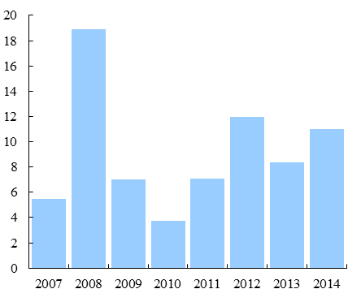  Note: 2014: expected issuance  Source: IKB Deutsche Industriebank (German Market Outlook 2014) and own estimates. | Chart 14: Euro PP, annual gross issuance, EUR billion  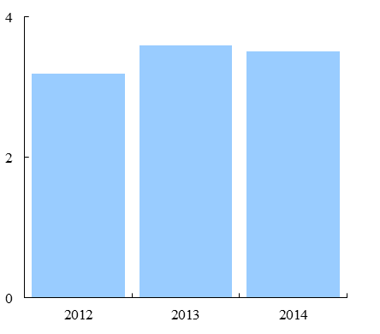  Note: 2014 expected issuance  Source: C/M/S Bureau Francis Lefebvre.
Another important barrier relates to the lack of standardised documentation. PP contracts are governed by national law and there is currently no single set of legal arrangements supporting private placement between local buy-side and sell-side participants. While the flexibility of terms of contract has economic benefits, it creates additional legal and advisory fees resulting from the need for individual agreements to be drafted for each transaction. Differences between EU private placement regimes make it impossible to extend private offerings across EU Member States without adjusting the marketing material or even the offer itself. Meanwhile, documentation standardisation is widely considered as one of the key enablers in the US PP market.
Another aspect hindering private placement activity in Europe are high costs related to regulatory requirements. Studies show that the cost of financial due diligence for investors only starts to pay for itself at the issue size of around EUR 20 million. One argument in favour of easing disclosure requirements for sales to institutional or high net worth investors is that these investors are supposed to be in a position to either conduct their own credit analysis or access supporting professional advice. Therefore they are less in need of the protection afforded by the disclosures required by the registration process.
A further difficulty is insufficient information on the creditworthiness of issuers. The absence of a framework in Europe facilitating the assessment of PP risks limits the growth of the market. In the US, a large part of the success of the US PP market was attributed to the role of the National Association of Insurance Commissioners (NAIC), where US PPs receive credit scores by the NAIC and investors are provided with regulatory guidance on capital weighting. Reliable credit analysis is considered as a key component of a functioning PP market but it is unclear whether such initiatives should be led by the public or the private sector.
As companies mature and grow, public equity markets provide an increasingly relevant funding option. Accessing additional equity capital, reducing the overall cost of capital, raising public awareness, and spreading the risk of ownership among a larger group of shareholders are the main drivers for issuing public equity. The possibility to spread ownership is especially important for original shareholders who want to redeem some of their profits while still keeping a stake in the company. For example, venture capitalists use in particular initial public offerings (IPOs) as an exit strategy allowing them to cash in on successful companies that they helped to start-up, even if many exits are done via trade sales rather than IPOs. A big advantage of IPOs versus exiting via trade sales is its positive effect for company employees in the form of stock options. Another advantage is an increased public awareness of the company because going public often generates brand recognition. In addition, the listing on public markets provides an immediate valuation of a company’s performance and value. This greater transparency enhances the discipline of a company’s management and improves internal governance. Finally, evidence shows that taking a company public reduces the overall cost of capital and gives the company a more solid standing when negotiating interest rates on existing or future debt. Empirical evidence might confirm the described benefits, even if the direction of causality is unclear and selection bias must be assumed to exist. For example, companies listed on the AIM, a submarket of the London Stock Exchange for smaller companies, show on average a turnover growth of 37% and employment growth of 20% in the year after their IPO. Another study finds that an IPO often leads to a relatively large rise of the size of a firm.
Corporate financing via equity markets is currently very small in Europe. Of the 23 million SMEs in the EU, only about 11.000 are listed on a stock exchange or traded on exchanges or Multilateral Trading Facilities (MTFs). Moreover, the share of listed SMEs has gone down in recent years, driven by a low number of entrants and even more by the decision of listed companies to de-list and go private. Although 2014 was the most successful year since 2007 in terms of IPO activity in Europe, the market dynamics remain weaker than before the financial crisis.
Chart 15: European IPO activity
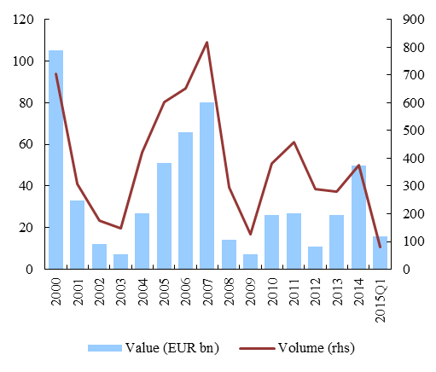
Source: PwC, IPO Watch Europe Q1 2015.
The limited activity on European equity markets may be affected by high costs incurred by companies when going public. In the case of a listing, such costs typically include the generation of financial reporting documents, payment of audit fees and creation of investor relation departments. While information disclosure is crucial to broaden the pool of capital funding while ensuring an appropriate level of investor protection, it may impact negatively the cost of raising capital. Data shows that compliance costs and disclosure requirements related to an IPO are particularly high for smaller firms. A study estimates that listing costs can account for 10 to 15% of proceeds for IPOs of less than EUR 6 million and only 3 to 8% for IPOs above EUR 50 million. For many firms, initial and on-going listing costs outweigh the benefits of listing.
A variety of other factors effectively serve as a deterrent to access to equity markets by enterprises. These obstacles include the lack of harmonisation of company and insolvency law, as further elaborated in Chapter 5. Other obstacles include insufficient investment research coverage and lack of comparable information on companies (as explained for the case of SMEs in the previous section). Also, cultural barriers impede the development of cross-border equity markets for mid-caps. Many firms work in their local language and lack visibility across borders so need to be funded locally. In addition, many mid-caps are family-run, and the founding family and management may be reluctant to shift control of the companies to other parties, in particular of foreign origin. Finally, a low level of liquidity characterizes the mid-cap segment. Medium-sized companies are intrinsically of a smaller scale than blue-chips, which reduces their attractiveness to institutional investors. Furthermore, recent market developments like high-frequency trading have tended to reinforce the attractiveness of large caps, at the expense of stocks of smaller companies. Although more than 90% of listed companies are below the top capitalisation (EUR 1 billion), these companies benefit from less than 10% of market activity, in terms of either market capitalisation, the number of trades or turnover Liquidity considerations have recently become particularly important in investor decisions.
The creation of dedicated equity platforms for medium-sized companies has proven effective in reaping the economic benefits of listing on a stock exchange without incurring high administrative and regulatory costs. In most markets, such platforms act as a second-tier listing alternative to the main stock exchange and are characterized by lower listing requirements and costs than the main board. At the same time, they provide medium-sized companies with the opportunity to IPO once they have become well-established. Several platforms of this kind operate successfully around the world. In Europe, access to public equity markets is supported by a dedicated sub-category (“SME Growth Market”) under the Multilateral Trading Facility category.

3.5 Debt versus equity financing and the tax-induced debt bias
From the perspective of an owner of a company in need of financing, equity and debt instruments each have specific advantages and disadvantages. The first advantage of equity is that it does not have to be repaid, meaning that the cash flows generated by the company can be used to further grow the company or diversify it in other areas. Another main advantage is that, by lowering the debt-to-equity ratio, it strengthens the financial structure of the company, which puts it into a more comfortable situation, notably in case of an adverse economic shock. One main disadvantage of equity versus debt is that the main shareholder partially gives up ownership of the company and therefore some control over the conduct of its business. Also, if the profits generated by the firm are sizable, the necessity to distribute part of them to other owners is likely to make the cost of equity capital higher than the cost of debt.
Debt financing is often a straightforward way to finance the acquisition of assets or operating expenses to grow one's business before the necessary funds are earned. On the one hand, debt financing is particularly adapted for firms pursuing an aggressive growth strategy. Closely related is the advantage of paying off debt in instalments over a period of time. Relative to equity financing, an owner would also benefit by not relinquishing any ownership or control of the business. On the other hand, the most obvious disadvantage of debt financing is that the company has to repay the loan, plus interest. Failure to do so exposes the company's assets to repossession by the lenders, and ultimately the company to a potential bankruptcy. As debt financing is borrowing against future earnings, meaning that future profits will be used to pay back debt instead of for example growing the company, a high leverage can severely limit future cash flow and stifle growth.
Tax considerations are also important for owners of a company in need of financial support. One tax aspect that has particular significance is the asymmetry in the tax treatment of debt and equity, the so-called "debt-equity bias". In most EU countries, corporate tax systems favour debt over equity by allowing the deductibility of interest expenses, while the return on equity financing usually does not receive any form of tax relief - and is in fact often subject to significant taxation both in terms of dividend payments and capital gains. On average, at the EU level in 2014, the cost of capital for equity has been estimated to be 45% higher than the cost of capital for debt because of taxation. Although the estimate is surrounded by a large uncertainty, the amount of the debt subsidy appears considerable. In 2007, it would have been equal to 4.9%, 2.4% and 3.5% of the GDPs in the US, Euro area and UK, respectively. In the current environment of low interest rates, the foregone tax revenues are lower, but they are likely to come back again to the pre-crisis levels when interest rates go up.
By favouring debt over equity, the tax system tilts the structure of the financial market towards debt instruments. Ultimately, it may affect the efficiency of the market in terms of asset allocation. Furthermore, the debt-equity bias, together with differences in the tax treatment of debt and equity across Member States and in the legal definition of debt and equity result in market fragmentation.
A higher leverage makes companies more fragile and economies more prone to crises. Companies with a large amount of debt and a low level of equity are more likely to go bankrupt in economic downturns. Also, manipulating the location of group debt for tax optimisation reasons may increase bankruptcy risks of the entities where the debt is located if there is no full sharing within the group. More specifically, empirical evidence confirms that the corporate debt bias leads to an excessive leverage in the corporate sector. For example, De Mooij (2011) estimated that a one percentage point higher corporate income tax rate increases the debt-asset ratio by between 0.17 and 0.28 percentage points. This also applies to the financial sector, in which excessive leverage increases the risk of a financial system crisis. In particular, De Mooij et al. (2013) find that a reduced tax bias is associated with a lower aggregate bank leverage, and the complete elimination of the tax bias would on average decrease the leverage ratio of banks by between 2.2 and 4.2 percentage points. This in turn would result into a lower probability of banking crisis. Removing the debt bias would also reduce substantially the costs in terms of public resources that are mobilised in case of a crisis in the range of 30 to 70%, even when using the most conservative estimates for the impact of taxation on indebtedness.
The debt bias may also have a negative impact on growth. Cournède et al. (2015) conclude from a study over a 50-year period that in most OECD countries more debt is typically associated with slower growth while more stock market financing generates a positive growth effect.
Other tax incentives may be used to support investment in specific financial instruments, economic sectors or actors in some instances. Tax incentives to support investment in smaller companies and start-ups are not uncommon. In particular, an increasing number of Member States are encouraging business angel and venture capital investment through tax incentives as a means of increasing the supply of early stage venture capital. Some Member States have introduced tax schemes to support specific beneficiaries (e.g. social enterprise), instruments (e.g. mini-bonds) or platforms (e.g. crowdfunding or private placements). Schemes to support employee ownership also usually benefit from tax incentives to attract a stable funding source as well as to stimulate retails investors' investment in equity or bonds products. However, taxation being a national prerogative, tax incentives vary widely from one Member State to another.

3.6 Barriers to access infrastructure finance
The EU has identified a lack of infrastructure investment as a key constraint on future growth. The high debt overhang and subdued investor sentiment limit demand for investment funding. At the same time, public investment has been on a secular declining trend in Europe since the 1970s from about 5% to about 2.5% of GDP in the 2000s. The most recent estimates for EU (national and cross-border) infrastructure investment needs for the period until 2020 arrive at a figure of around EUR 1 trillion, notably in Trans-European Networks (TENs) in the area of transport, energy and telecommunication. Taking into account other areas of 'classic' infrastructure such as water, sewage treatment or waste management, total infrastructure investment needs in the EU could reach EUR 2 trillion for the period up to 2020. Besides, in order to contribute to key objectives of the Energy Union and in particular the transition to a low carbon and climate resilient economy, the EU would need to mobilise significant investments in Europe in power grids, generation as well as energy efficiency and innovation. Investments in these sectors are general of smaller size than traditional Public Private Partnerships (PPPs) and therefore struggle to get access to finance. They also require assistance in project preparation as they are not as sophisticated as large PPPs. The investment needs related to both the achievement of the 2030 climate and energy targets and the modernisation and transformation of the energy system in EU Member States are estimated to amount to over EUR 200 billion on average per year through 2030.
Infrastructure investment faced funding constraints after the financial crisis. On the supply side, several major banks retreated from this business field or have become more selective. The decline of the monoline insurers reduced the availability of credit insurance, which had a crucial role in enhancing credit quality of infrastructure investment and thereby pulled in investors that sought limited exposure to risks. Whilst there has been some market recovery and liquidity has returned to some sectors of some markets, many projects, perceived as carrying higher risk (e.g. risk associated with greenfield projects, the predictability of demand, the very long-term development period, or the cross-border element of the project), are still unable to secure adequate funding. On the demand side, the generation of a strong pipeline of projects structured in a suitable way to attract private investors has been identified as a crucial element of the Investment Plan for Europe to improve and increase the number of projects for investors to invest in. While low interest rates motivate institutional investors such as insurance corporations and pension funds to search for new long-term investment opportunities that match their long-term liability structure, actual private investment in infrastructure has not yet picked up. It falls short of the high needs identified for infrastructure investments.
Long-term finance is provided by different types of investors. Private capital for infrastructure investment is provided in two main forms, corporate finance and project finance. A wide range of financing instruments and investment vehicles is used to finance infrastructure investments, including listed infrastructure equity (corporate equity), listed and unlisted infrastructure funds (mainly equity), corporate bonds of infrastructure companies, project bonds, project finance and finance through Public-Private-Partnerships (PPPs). Bank lending has been the main source of funds for infrastructure projects. However, the share of bond financing has been increasing recently, representing 23% of European project finance debt issuance by value (EUR 15.1 billion) in 2014, compared with just 3% in 2008. In 2014, European PPP transactions represented an aggregate value of EUR 18.7 billion across 82 transactions. Regarding the use of financing instruments and vehicles, the landscape is very diverse across EU Members States. The UK accounts for 35% of all infrastructure investments made through PPPs while in a number of EU Member States, PPPs do not play any role at all. The project bond market (debt issuance by project finance companies for investment by institutional investors or other financial institutions) in the EU is rather small and underdeveloped (with the exception of the UK before the financial crisis). Furthermore, public funds can be leveraged to activate private investment in infrastructures. In this regard, the European Fund for Strategic Investments (EFSI), established in the context of the European Commission's Investment Plan, aims at mobilising up to EUR 315 billion in additional investment in infrastructure, education, research, innovation and SMEs. The Investment Plan will also help provide greater regulatory predictability and remove barriers to investment, making Europe more attractive for investment. Public sector finance, either directly at central, regional and local level, or indirectly through national promotional banks or financial institutions, contributes about 1/3 to infrastructure investment in the EU.
The choice of the most efficient financing by the sponsor or procurement authority depends on a variety of factors. Such factors are: the size of the transaction, its complexity, the type of transaction, bank and capital market conditions at the relevant time, issuance and swap costs, the need for special terms such as non-standard covenants, the time available for marketing and the preparation of the financial documentation, strategic considerations such as investor diversification and public visibility.
Institutional investors could become a larger and more important source of long-term finance for infrastructure investment in the EU. Large pension funds or insurers are able to raise and commit sufficient capital by virtue of their own resources. The balance sheets of most institutional investors are dominated by long-term liabilities. Hence, that long-term investment improves their maturity structure. Long-term investment also carries typically an "illiquidity premium", i.e. higher interest rates, and reduces asset management costs due to lower average turnover. Moreover, many smaller investors could also diversify their investments in these kinds of assets, if they would not be restricted from doing so due to their size and the absence of readily available pooling mechanisms. Local pension plans, municipalities, pension schemes run by the liberal professions or corporate pension plans would benefit from investing through the newly established European Long Term Investment Funds (ELTIFs).
There are numerous obstacles to long-term finance for infrastructure, in particular for greenfield projects, some of which go beyond the scope of the CMU Action Plan. The key feature that characterises infrastructure investment is its inherent significant uncertainty due to the technical complexity of the projects, the long-term investment horizons, the importance of the macroeconomic environment, regulatory stability, and political commitment. Many large-scale investments that only pay off over the long term are concentrated in highly regulated sectors, e.g. energy, digital infrastructure or transport. Predictability regarding the future course of regulation would unlock projects that are typically affected by uncertainty. Despite some improvement recently, investors' attitude towards risky projects remains lukewarm, particularly during the construction phase of larger projects and for projects involving innovative technologies. Fair value accounting principles may also be detrimental to the long-term financing horizon of institutional investors. Lack of data on the financial performance of infrastructure investments has also been identified as a major challenge. A larger supply of appropriate investment pooling vehicles could broaden the investor base and diversify project and risk exposure of investors.
Box 7: Uncertainties in long-term project finance
There are four main sources of uncertainty for investors to overcome when deciding whether to invest in long-term infrastructure projects. First, there are the uncertainties inherent to the project itself given that its long-term nature entails specific risks, for example linked to potentially changing contractors or process innovations during the project period. Assumptions must be made about expected progress that may turn out to be too optimistic or pessimistic. Second, there is the problem of timescales – most will require investments with a long maturation process. Time matters as it is directly related to investors having to lock up their liabilities with corresponding expectations over future rates of return. The problem is that infrastructure projects often take time before bearing fruits (in terms of market rewards). On top of this, investments are sometimes subject to dead ends, detours, and demanding changes that can be both costly and time-consuming. Third, there are uncertainties in the economic environment. Predicting the rules of the game for investment and the level and volatility of long-term interest rates depends directly on the propensity of investors to take risks and allocate long-term capital to specific projects. Prevailing economic conditions, especially long-term macroeconomic stability, are a key driver of risk appetite. Volatility in real interest and exchange rates makes the net present value calculations of projects, particularly cross-border ones, much harder to predict. Fourth, the life of political commitments and decisions may differ from the life of the project. With the strain and tight scrutiny on many public sector budgets following the crisis, many investors need clear long-term assurance to overcome renegotiation concerns.

Chapter 4 THE PROVISION OF FUNDING THROUGH CAPITAL MARKET INSTRUMENTS
This chapter describes the EU investor base and how capital markets investments by retail and institutional investors can be promoted. For non-financial corporations to have access to more market funding, as argued in the previous chapter, investors' savings through market instruments have to increase. The first section describes the EU investor base, distinguishing between retail investors, non-financial corporations and institutional investors. Both have in common that they have strong links with banks. They differ in their capacity to deal with information frictions. The second section focuses on households' investment choices and discusses how correcting information asymmetries, providing financial advice and/or education, tackling barriers to cross-border investment by European funds and exploring the development of personal pension fund could promote households' investments in capital markets. The third section argues that, for institutional investors' investments to take off, barriers such as limited market size, access to transparent and comparable information, investment restrictions on specific asset classes and prudential requirements on certain investments would need to be tackled.
Economic theory postulates that lack of market size and depth may inhibit investors' interest in capital market instruments. Even the largest national markets in the EU could lack critical size, leading to an unduly small investor base and limited financial instruments to choose from. If capital markets are not sufficiently liquid, issuers face a small investor base on primary markets, investors face low liquidity on secondary markets, and traders on secondary markets have few instruments to choose from and few counterparts to deal with. Increased market size may encourage market entry and vice versa. This "chicken-and-egg" problem is comparable to a coordination failure or a market failure since each group would be better off and a more intensive user of capital markets if the other groups were more active users. Issuers, investors and also traders face underlying trade-offs resulting from obstacles to the flow of information: issuers are reluctant to unveil information about their business to everybody, as business competitors may exploit it to the disadvantage of the issuer. Investors on primary markets would benefit from liquid secondary markets, but possible buyers are discouraged from trading with them because they face an information disadvantage with respect to the position of the issuer.
Chart 16: Overview of the provision and use of funding by non-financial sectors, financial intermediation and markets, EU 28, 2014, EUR billion
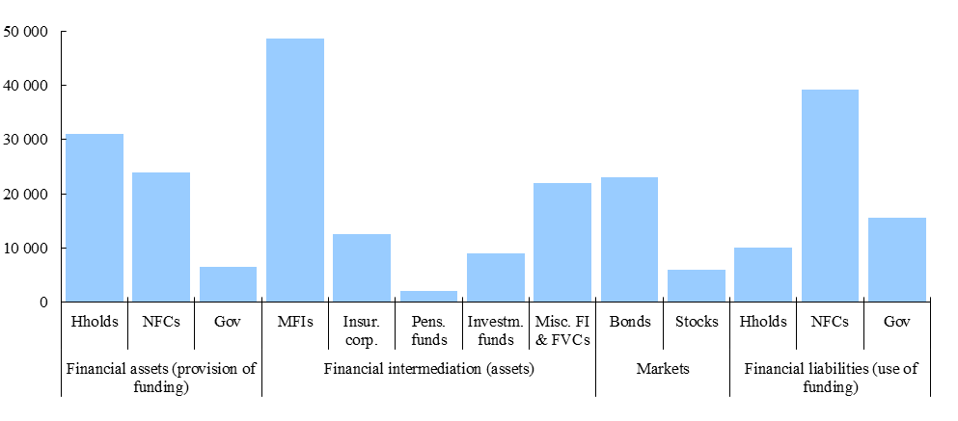
Note: MFIs include central banks.
Source: ECB, Eurostat and own calculations.
Chart 17: Breakdown of markets and bank asses by sector, EU-28, 2014, EUR billion
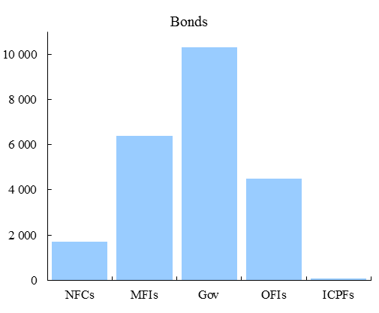 | 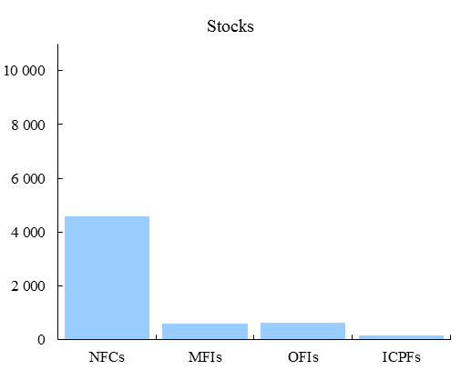 | 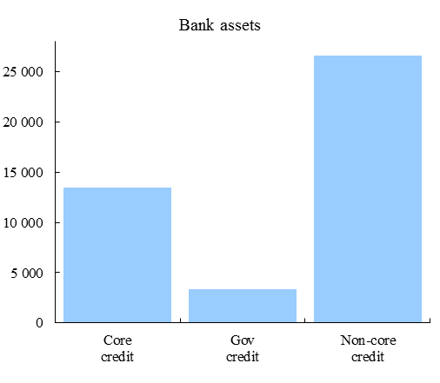
Notes: NFCs: non-financial corporations, MFIs: monetary and financial institutions (banks), Gov: governmnets, OFIs: other financial institutions, ICPFs: insurance corporations and pension funds. Core credit: credit to households and non-financial corporations, Gov credit: credit to governments, Non-core credit: other credit including wholesale funding provided, interfinancial credit and others. Credit can be provided through loans or by buying bonds and equity. For MFIs, central banks are not included
Source: ECB and own calculations.

4.1 Identifying and understanding the investor base
Households are the traditional ultimate supplier of funds in the economy, mainly through financial intermediaries. The EU households' total financial assets are worth almost 220% of GDP. Only a small share is currently held in direct market instruments, i.e. financial securities: listed shares and bonds each represented 4% of households' financial assets at end-2013. Investments in funds represent 6% of households' financial assets. The largest parts of their financial assets are in the form of bank deposits (30%), pension entitlements (20%), and claims against life-insurance companies (16%). When considering the potential total supply of funds that households can provide to the economy, considering real estate property is important, because this is the single most important and illiquid household asset. For those countries, where data is available, property in real estate constitutes about 40% of total household assets.
Chart 18: Households' composition of financial assets, 2013, EU-28  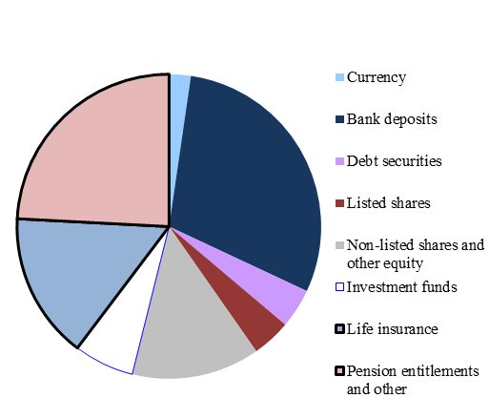 | Chart 19:Acquisition of net financial assets by sector, EU-28, % of GDP  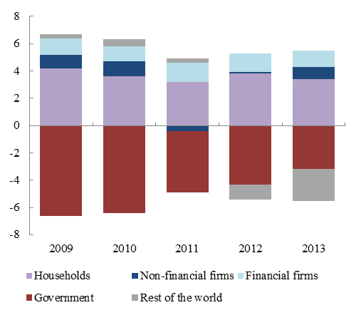
Source: Eurostat. |  | Source: Eurostat.

Non-financial corporations have recently also become significant ultimate suppliers of funds. Non-financial corporations (NFCs) have on aggregate turned from a user (net borrower) to a supplier of funds (net lender) in the EU and several of its Member States over the last years. NFCs supply about half of the amount of funds that households supply, i.e. EUR 142 billion relative to EUR 273 billion in the EU-28 per annum in 2014. Many firms hold large amounts of financial assets. According to 2013 data, these were in the EU-28 almost EUR 15 trillion or 106% of GDP, again broadly half of the stock held by households. Very few are held in market instruments or via financial intermediaries. Financial assets of the NFC sector are predominantly non-listed equity (40% of GDP), loans (13% of GDP), both reflecting linkages within the corporate sector, and deposits (19% of GDP). The financial sector also provides net funds to the economy, originating from the profits generated in the sector. Foreign investors have not been a net lender to the EU over the last years. Mirroring the EU's current account surplus, more than EUR 100 billion each year was invested or lent abroad in net terms in 2012-2014 and, given ageing populations in the EU, the direction of international capital flows is expected to remain the same. Still, sovereign wealth funds have become relevant institutional investors as they allocate sizeable portfolios on global capital markets.
Chart 20: Investment funds, asset allocation, euro area, 20014
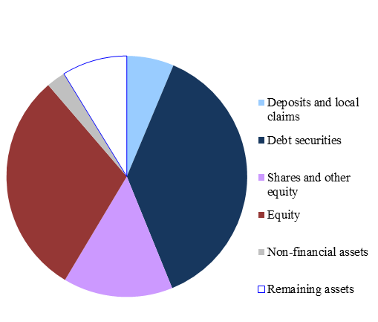
Source: ECB.
The large share of savings channeled through the financial system signals an important role of institutional investors. The financial claims of households against banks and various non-bank financial intermediaries, encompassing life-insurance corporations, pension funds and other investment funds, are further channeled into the economy. In the euro area, insurance companies and pension funds each hold assets that amount to approximately 85% of GDP. Debt securities and investment funds 'shares represent the largest share of securities held by insurance corporations and pension funds, respectively. Investment funds' asset allocation consists of broadly a third in debt securities, equity and other financial instruments.
The mirror image to more market instruments for the financing of firm activity is more ultimate savings invested through or in the form of market instruments. For example, households in the USA, UK and Sweden keep a proportionately small share of financial wealth in bank deposits, reflecting the smaller role of banks in funding the economy than in the EU-28. Chart 21 illustrates the relative weights of non-bank financial institutions in terms of financial assets, showing the important role of investment funds and insurance companies. These non-bank financial intermediaries provide significant funding to banks. Aggregate data for the EU suggests that 8% of insurance companies' and pension funds' financial assets are in form of deposits. This figure comes down to around 6% for investment funds. However, institutional investors channel an even larger part of the funding that they receive to banks, as they also hold equity and bonds issued by other financial institutions. Approximately 12% of debt securities held by non-bank financial intermediaries, and 5% of equity, are claims against banks.
Chart 21: Financial assets held by non-bank financial corporations, euro area, EUR billion  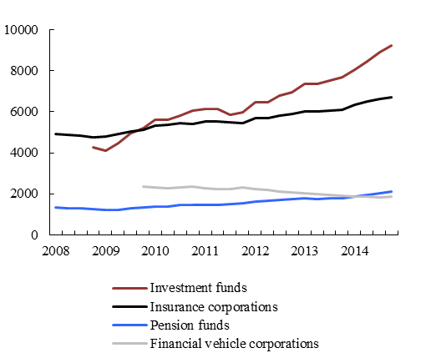  Source: ECB. | Chart 22: Financial assets held by investment funds broken down by investment policy, euro area, EUR billion  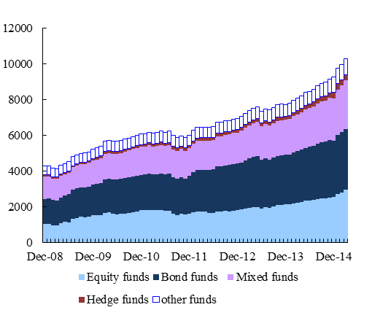  Source: ECB.

The difference in exposure to tradable financial securities between households and institutional investors reflects corresponding differences in their ability to address the underlying information problems. Actual households' portfolio choices seem aligned with their limited means to assess the credit risk and business prospects of borrowers. The high share of financial assets held in the form of bank deposits is indicative of households’ legitimate interest in holding assets that are liquid, have a stable nominal value, and represent claim against a trusted financial institution. Claims against non-bank financial intermediaries facilitate diversification of risks and allow access to the intermediaries' risk management capacity, which are both more difficult to achieve via direct holdings of securities if the amount of wealth at disposal is small. Conversely, institutional investors' portfolio choices are often explicitly determined by risk-return considerations. Hence, the share of funding that they direct to the banking sector primarily reflects the returns and risks that investments in banks offer relative to investments in other parts of the economy. If institutional investors decided to provide direct credit to non-banks, they would need to build up capacity to assess and manage credit risks. By investing in banks, they get indirect exposure to credit risk without the need to build this capacity. Beyond that, limitations due to investor mandates or regulation and ownership linkages with banks may be factors that drive the share of funding directed to banks higher.
Investors' desire to re-allocate portfolios towards more market-based instruments, a larger equity component or more cross-border exposure should mainly be driven by risk-return preferences. Standard economic theory suggests that actual portfolio allocations reveal investors' genuine preferences under the assumptions that these investors can freely choose the assets to invest in and that competition will equalise risk and liquidity adjusted returns among asset classes. However, under pre-defined risk-return preferences, asset allocation may not be optimal as influenced by different factors. For example, lack of access and high transaction costs can be deterrents to investment in some assets. Distorted prices resulting for example from differences in the tax treatment of financial assets, incomplete information and ineffective regulation will be another factor influencing investment choices.

4.2 Promoting saving and investment by households through capital markets
The actual composition of households' financial portfolio seems to be mainly driven by economic factors. Households' limited interest in tradable securities such as bonds and listed shares could be well driven by high transactions and information costs relative to expected returns from such assets. The better legal protection that bank deposits enjoy compared to other financial assets is another factor influencing investment choices. Shares provide some shelter from inflation, but create exposure to the business cycle and vice versa for bonds. However, most households save mainly in the form of house ownership, which also offers protection from inflation, but is highly illiquid. Saving in the form of financial wealth and particularly holdings of risky financial assets are concentrated among wealthier households. The wealthier the household, the more diversified its asset portfolio, and the more educated the household, the higher the share of risky assets. Theory provides support to this behaviour: equity holdings offer limited diversification gains if households' non-financial income is closely correlated to the business cycle. The rising share of bank deposits over the last years and the fact that it increased particularly in vulnerable Member States suggest that households attribute an important role to safety and predictability. Losses from investments in capital markets may also have a durable effect on portfolio choices. For example, the fall in equity valuations after 2000 led households in most EU Member States to disinvest from quoted shares. In most of the larger EU Member States, this trend only reversed after 2005. Trust is a fundamental element of capital markets and it has been shattered by the financial crisis. In 2013, only 35% of retail investors trusted investment services providers to respect consumer protection rules. Consumer protection rules are seen as instrumental in restoring retail investors' trust in capital markets.
While correcting information asymmetries can partly mitigate the risks stemming from uninformed financial investing, aspects of investor behaviour can still lead to poor investment decisions. The behavioural economics literature has illustrated that investor decisions are influenced by cognitive capacity and financial literacy, but also by biases reflecting personal circumstances and psychological factors. Despite these limitations, empirical research finds that most households deal well with the information restrictions they face in their allocation of financial wealth. Some households, however, make mistakes, mainly pertaining to inadequate diversification in financial asset allocation and paying excess fees to intermediaries and advisors. .
Financial education and better access to financial advice could help address high information costs that discourage households' investment in capital market instruments. It is not yet evident that policy measures aiming at improving financial literacy are efficient. While many countries started financial education programmes, there is still little empirical support to their effectiveness and particularly cost-effectiveness. Since most measures are recent, long-term changes to behaviour are not yet measureable. It is also questioned whether policies that exploit behavioural economics to "nudge" behaviour contributes to improved financial literacy. It might therefore be more effective if households could obtain professional financial advice on affordable terms. In the majority of Member States, consumers have limited access to independent consultation on investment, insurance or saving decisions on terms that they are willing to pay. Advisers employed by financial institutions often receive commission-based pay and have therefore an incentive to narrow their counsel to products provided by their employer. Independent financial advisers are mostly used by the wealthiest households, which can afford the cost of financial advice. For many households, tax advice seems more relevant than financial advice, and many consumers are reluctant to pay upfront fees for financial advice. While financial advice could help overcome information problems, a number of factors hold back the development of a market for financial advice. For example, typical retail investment portflios are normally small and may not cover the fixed cost of a full and independent financial advisory service.
Transaction costs may discourage a more widespread investment by households in investment funds, whose development cross-border is also withheld by different factors. For households, investment in funds, for example Undertakings for the Collective Investment in Transferable Securities (UCITS), offer several advantages, in particular diversification gains, limited information costs and targeted exposures to risks. Investment funds are important investors in debt securities and in equity and have become an increasingly important holder of corporate bonds over the last years, thereby helping larger firms to reduce bank dependency. They have proven instrumental in fostering cross-border risk sharing. For example, while euro area banks reduced international exposures and re-focused activity on domestic markets after the crisis, investment funds increased their share of foreign debt and equity holdings during the financial crisis. Direct ownership by private households of UCITS is relatively low in Europe. Transaction costs, which include fees and charges of acquiring or holding funds' shares vary significantly across Member States. They tend to be lower in Member States in which capital markets have a larger role in funding the economy, such as the UK, the Netherlands and Sweden. Market fragmentation and a small fund size result in proportionally higher costs in running funds and prevent the EU fund industry to realise scale effect to the same extent as their US counterparts do. A number of factors seem to hold back cross-border competition and cross-border mergers, which would via consolidation pressure lead to larger funds. Among them are local marketing and disclosure requirements, as UCITS are currently subject to different requirements in many of the countries in which they are sold. This means that several host regulators impose differing standards as to the content of the marketing material, prior approval of documentation, price of units and information publication in newspapers. Other factors limiting the take-up of cross-border funds in Europe are diverging national tax treatment and reporting requirements, fees to be paid for cross-border notifications and the obligation to appoint a local paying agent. As a result, Europe has a multitude of funds, including bonds, equity, money markets, mixed and specialised funds, distributed by many different providers, which often also sell their own funds. At end-2014, there were 36 148 individual UCITS in the EU, which is four times more than the number of US mutual funds. The average European UCITS fund is valued at EUR 200 million, which is one-seventh the size of typical US mutual funds which holds on average EUR 1.6 billion in assets.
Capital markets are not yet offering a wide choice of products to households because of fragmentation. Cross-country comparisons suggest that countries with a sizeable pension fund sector also tend to have deeper capital markets, for example the USA, the Netherlands and the UK. For many households, housing and life insurance are important means to save for the long term, while personal pension products are hardly used. For instance, the personal pension product market is very limited in some Central and Eastern EU Members, such as Poland, Romania, or Hungary. In addition, where they are somehow developed, personal pension products are developed to a very diverse extent: the volumes are significantly higher in Denmark than in Spain and France. Given the ageing of the European population and the increasing need for citizens to save in order to be able to maintain their living standards in their old days, there could be demand for these products. A number of reasons may explain why this market has not developed. Since personal pension products typically operate on a voluntary basis and involve implicit and explicit contracts over several decades, trust and understanding are particularly important. Governance through national rules resulted in cross-border market fragmentation: personal pension products are subject to various rules at EU level or to no EU legislation at all.. This prevented personal pension providers to maximise scale economies and risk diversification, thereby reducing choice and increasing cost. Households would benefit from more choices of personal pensions products that would offer capital and inflation protection, and in particular from simple, cost-effective, transparent and trustworthy methods of personalised savings for retirement. Growing private pension provisions would increase investment flows into capital markets. This, in turn, would support the diversity of participants in capital markets, particularly given the propensity of pension funds to allocate capital to a range of investment strategies and exploit the scale effects the single market for financial services offers. A developing market for personal pension products would stimulate competition and innovation and drive down costs. In this context, in line with the mandate given by the European Commission, EIOPA is currently conducting a consultation to further explore the potential and possible characteristics of a standardised personal pension product, for example through a pan-European or "29th" regime.

4.3 Promoting capital market investments by institutional investors
Institutional investors need meaningful information ensuring transparency and comparability across investment products irrespective of the channel of distribution. Although institutional investors are better equipped than households to deal with information problems, they need sufficiently clear information on the possible investment options to compare them and to make an informed decision. Disclosure of investment product features, associated costs, returns, risks and benefits, can be a powerful way of allowing investors to make informed choices about where and how to invest. Consistent disclosures and conduct rules across similar investment products are crucial for investors not to be nervous about investing in certain products/markets because of concerns that transparency and investor protection may not be as robust for some investment product or in certain European countries they are investing in. European institutions have made significant progress in improving the disclosure requirements over the last years.
Box 8: Information problems are less severe on larger markets

The possibility to free-ride on information gathered by other people creates the risk of underinvestment in information collection in the first place. Economic research elaborated on various channels through which more participants on a capital market would reduce information problems. For example, information gathering is generally costly and will only be undertaken if one expects to be able to pay it off by trading profitably on its basis. Agents can capitalise on costly information gathering activity only if other agents cannot free-ride on it, for example by imitating their trading strategy. The possibility for these agents to disguise their trading strategy in a largely populated market gives them therefore more incentives to undertake costly information gathering activity. A second argument that the impact of dominant market positions that are due to asymmetries in information or resource endowment are in general less severe on markets with many participants. The reason is that better informed players have a smaller impact on the market price if there are many other participants, unless the latter tend to imitation strategies and herd behaviour.
A variety of investment restrictions may explain the rather limited portfolio exposure of institutional investors in specific asset classes. Banks have reduced their investment in a number of asset classes over the last years, such as long-term infrastructure projects and SME lending. Rising participation of institutional investors in these areas in particular would help fill the funding gaps caused by the retreat of banks. However, institutional investors have little exposure to these less liquid assets. This limited exposure may sometimes create asset-liability mismatches. For instance, as pension funds face long-term liabilities, it would seem reasonable for them to invest predominantly in longer-term assets. Also, institutional investors are generally less exposed to funding risks than banks and are generally investing more in equity. Barriers to investment on capital markets could be due to various market or regulatory failures. They include insufficient liquidity and fragmented financial information, as well as structural factors, the importance of which varies for different types of investors. Asset managers are generally most concerned about liquidity, legal frameworks and difficulties in terms of information access and costs associated with necessary due diligence and risk assessment on certain types of capital markets transactions. Investors such as insurers and pension funds are arguably less worried about secondary-market liquidity given the long-term nature of their liabilities, but are often constrained by industry benchmarks and investment mandates, as well as in the case of pension funds by regulatory requirements. While those are important for governance of the financial intermediary with respect to ultimate holders and for prudential reasons, they limit the scope for investment in certain assets and cross-border.
Asset allocation in insurance and pension funds,
total assets 2014 in %
 | Total  billion, national currency | Currency and deposits | Loans | Bonds | Shares and other equity | Investment funds |  | other
Insurance corporations
FR | 2418 | 1.4 | 1.5 | 59.8 | 10.6 | 20.7 |  | 6.0
DE | 1884 | 19.3 | 14.1 | 17.4 | 11.5 | 28.8 |  | 8.9
IT | 679 | 4.2 | 1.4 | 65.2 | 10.3 | 16.9 |  | 1.9
NL | 511 | 2.9 | 16.8 | 39.7 | 4.7 | 19.5 |  | 16.4
other EA | 1350 | 7.7 | 3.5 | 47.8 | 8.6 | 20.1 |  | 12.2
UK (2013) | 1516 | 5.3 | 2.4 | 25.7 | 24.8 | NA |  | 41.8
USA (2013) | 7511 | 1.0 | 0.0 | 51.6 | 29.1 | NA |  | 18.2
Pension funds
NL | 1256 | 1.1 | 2.9 | 23.9 | 12.3 | 49.2 | 10.6
DE | 543 | 29.2 | 5.1 | 10.7 | 2.7 | 44.0 | 8.3
ES | 124 | 12.6 | 0.0 | 58.4 | 10.5 | 10.3 | 8.2
other EA | 241 | 5.8 | 0.7 | 36.1 | 29.2 | 25.5 | 2.7
UK (2013) | 1673 | 2.6 | 32.0 | 23.6 | 16.7 | NA | 25.1
USA (2013) | 16892 | 0.6 | 0.2 | 21.1 | 50.7 | NA | 27.4
Source: ECB and OECD (for UK and USA).
Lowering barriers to investment will alter asset allocations. Current prudential regulation may impact on the possibility or appetite to invest into specific assets through the calibration of capital charges and the qualitative and quantitative investment limits. Market practitioners state that financial regulation is, on the one side, dissuading investment in assets such as in infrastructure, (private) (non-listed) equity and (unrated) debt for securitized assets and, on the other side, creating comparative advantages to other asset classes. Occupational pension funds are said to be exposed to national restrictions on their investment opportunities. The removal or recalibration of these restrictions will need to be carefully assessed against prudential objectives and principles of consumer protection.

Chart 23: Securitisation in Europe, total in EUR billion  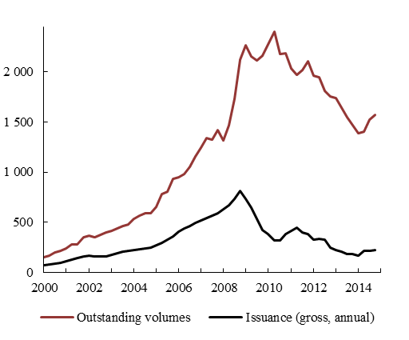 | Chart 24: Securitisation, outstanding amounts breakdown by collateral 2014  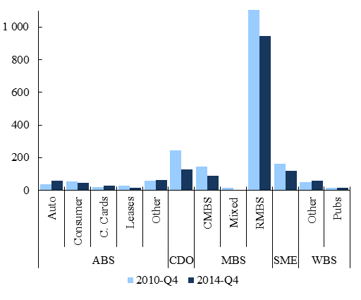
Notes: ABS: asset-backed securities; CDO: collaterised debt obligations; MBS: mortgage-backed securities; CMBS: commercial mortgage-backed securities; RMBS: residential mortgage-backed securities; SME: small and medium-sized enterprises; WBS: whole business securitisation. RMBS in 2010-Q4 = EUR 1.350 billion.
Source: AFME, SIFMA, ECB and own calculations.
Though EU securitisations performed far better than their US counterparts during the crisis, until now market issuance did not pick up again. Since the beginning of the financial crisis, European securitisation markets have remained very subdued in terms of new issuance volumes. Low demand for securitisation products reflects a problem of negative perceptions, caused by the role played by securitisation markets in the US subprime crisis. This negative perception is reflected in low investor confidence in securitised products and relatively onerous capital charges on such products under prudential regulation. Yet, this has little to do with the actual performance of EU securitisation during and after the financial crisis itself. Looking at AAA-rated securities, products backed by US residential mortgages (RMBS) reached default rates of 16% (subprime) and 3% (prime). By contrast, default rates of AAA EU RMBS never rose above 0.1%. The divergence is even bigger for BBB-rated products where US RMBS' default rates peaked at 62% and 46% (subprime and prime, respectively) while EU products' default rates peaked at 0.2%. Set in the wake of the US securitisation markets crash, capital requirements for exposures to securitisation have been calibrated on such markets' performance, leading to "an unduly conservative treatment of relatively less risky securitisations". Moreover, securitisation may receive unbalanced regulatory treatment, for example versus covered bonds. Since a bank can choose in favour of either funding option, covered bonds may currently appear more attractive.

Chapter 5 REAPING OPPORTUNITIES TO PROMOTE CROSS-BORDER MARKET FUNDING
This Chapter provides a more thorough insight into the barriers and obstacles that relate, in particular, to cross-border capital market transactions. It starts with a brief overview of the economic benefits stemming from cross-border capital flows, before dwelling in more detail on those aspects of capital markets organisation that appear to be the most relevant in a cross-border context. These cover insolvency procedures, company law, tax barriers, financial market infrastructures, as well as supervisory and regulatory practices at Member State level.

5.1 Benefits and determinants of cross-border investments
There is a broad consensus in the literature that cross-border investment is beneficial to both the investing and the recipient economies. The main benefits of cross-border financial integration are: greater efficiency of the economy and of the financial system, and better capacity to smooth the business cycle. Although these economic benefits of financial integration are undeniable, cross-border capital flows can also pose policy challenges and imply significant risks, especially if they are large and debt-based. Large and rapid increase of foreign debt, in particular of short maturity, can generate macroeconomic imbalances, unless properly channelled into an efficient use of the recipient economy. Possible negative effects include asset price inflation and rapid credit growth, raising the risk of sudden reversals and the need for adjustments in the real economy associated with boom and bust cycles. Foreign direct investment (FDI) and equity portfolio investment are found to be more conducive to efficient cross-border risk sharing than bond portfolio investment or credit flows, which tends to bring stability to the economy.
Cross-border market integration helps creating larger capital markets. Lifting national barriers brings more market participants, hence enhancing liquidity. As markets grow larger, agents have greater incentives to spend resources in information gathering (see Box 8). The larger the market, the better can risks be allocated, i.e. transferred from risk-averse to risk-loving agents. The postulated economic effect assumes that, on average, if agents can reduce or hedge their exposure to risks, they are comfortable with taking on more risk. A large investor base also allows to segment markets into more specialised financial assets to be traded with a sufficient number of traders.
The quality of host country institutions is one of the key determinants for cross-border investment a country attracts. Empirical research confirms that legal and institutional characteristics have a significant impact on the type and amount of capital received from abroad. These include information disclosure, accounting standards, costs of legal disputes. World Bank indicators reveal enormous differences in issues such as getting credit, protecting minority investors, paying taxes, enforcing contracts, resolving insolvency across the EU Member States (see Section 2.2). The roots of these differences are in different informal norms and enforcement practices developed historically in the Member States. At the same time, cross-border comparisons found that the quality of institutions is a decisive determinant of an economy's income especially those that protect property rights and help enforce contracts. The fragmentation of financial markets will subsist without genuine convergence of the functioning of institutional framework conditions to the best practice in the EU.
The availability of information about the host country is another important driver for cross-border investment. Cross-border investment implies higher information costs and often higher transaction costs, which prevents private households from investing abroad and so contributes to the home bias. In a 2012 Eurobarometer poll, 94% of the respondents said that they "have never purchased a financial product or service from another Member State". 20% did not consider doing so, arguing that they neither "see the benefit or the need". Therefore, cross-border asset holding is concentrated among institutional investors, whose rising market share has been shown to have significantly contributed to the internationalisation of capital markets. Investment funds are internationally diversified because they employ specialised analysts to understand the many relevant dimensions of foreign investment: familiarity with the foreign issuer, its business fields, accounting practices, property rights, insolvency law, etc. Yet, certain transaction costs are high and difficult to reduce even for institutional investors, for example in the case of risky investment. When the borrower is unlikely to pay back, a number of legal issues occur, which are more difficult to assess in a cross-border context, such as company law, securities law, insolvency procedures, access to collateral etc. differ across countries.
The aforementioned frictions constitute barriers to the free movement of capital in the EU. The principle of free movement of capital (Art. 63 TFEU) prohibits all restrictions on the movement of capital and on payments within the EU as well as between Member States and third countries. Recent major legislative steps by the EU are facilitating the movement of capital in Europe by providing full harmonisation in specific areas, in particular the banking sector (Capital Requirements Regulation, Banking Union) and the insurance sector (Solvency II ). However, the absence of full harmonization in several other financial markets' areas can open the door for national legislative ('gold plating) or administrative rules that may go beyond EU legislation and de facto restrict capital flows.
Quality of regulation and enforcement are central to attract investment from outside the EU. Investors from abroad may have even more difficulties overcoming information frictions in view of their larger geographical distance and possibly different legal and cultural background. Trust in the quality of legal framework conditions and in particular of their enforcement has been identified as crucial for an economy to attract foreign financial investment. Since unfamiliarity with foreign legal conditions means investors have to carry extra costs when investing in foreign jurisdictions, similarity between rules across jurisdictions would spur cross-border investment. This factor explains the importance law makers attach to regulatory convergence and international cooperation when developing regulation. Along similar lines, the role of international associations in developing standards on behalf of the private investors' community can hardly been underestimated as a factor crucial for cross-border investment.

5.2 Insolvency rules and procedures and company law
Insolvency rules have a key role in addressing the debt overhang and high level of non-performing loans, which hurt the European economy. First, lenders are unable or unwilling to provide funding to firms having non-performing loans or they charge prohibitive rates. This results in less credit being available to the economy. Second, as highly indebted companies use their profit to repay their debts, lagging debt restructuring leads to lower investments. Third, excessively leveraged banks and firms are more vulnerable to economic or financial shocks
In many EU Member States, insolvency procedures fail to maximise the prospects for asset recovery. About half of all newly created companies do not survive their first five years of activity. In order to survive, these companies require access to a restructuring procedure with creditors as well as emergency fresh financing, likely requiring special legal protection. The possibility to restructure debt would help those that are viable avoid entering into liquidation procedures. An insolvency regime that encourages more debt restructuring can improve the creditworthiness of viable companies by facilitating their deleveraging.
Chart 25: Strength of insolvency framework and non-performing loans
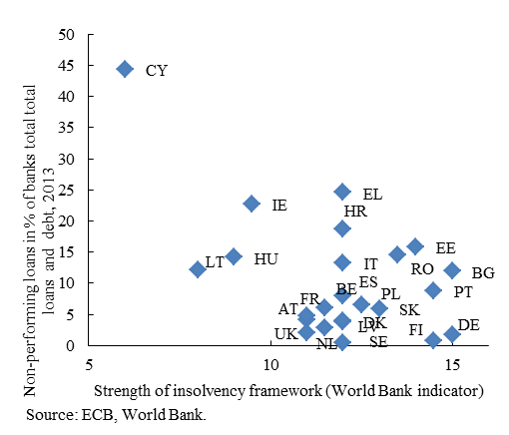
Many European insolvency and restructuring frameworks seem unclear, inflexible and costly. The effectiveness of insolvency laws can be measured by their ability to lead to predictable outcomes at the end of procedures which are short, cost-effective and offering less recourse. For example, the debt discharge period takes between five to seven years in most EU countries, compared to less than one year in the US. This shorter discharge periods allowed US households to recover more quickly from the financial crisis and is deemed to be one factor behind the swifter economic recovery in the US compared to the EU. Moreover, less recourse insolvency laws have positive microeconomic effects: if debtors are not required to hand-over income, the incentive to work increases. In the US those debtors not required to hand over income earned in the following year on average over USD 6 000 more income than those debtors required to hand-over income, and were 23% less likely to default on primary home loans. In contrast, most EU Member States require handing-over assets and income and are therefore full-recourse. The current recourse regime, with limited risk-sharing between financial investors and firms, may disincentivise small companies from taking risks and growing. Easily accessible restructuring procedures could improve the predictability of the outcome of insolvency proceedings and reduce the transaction costs generated by the insolvency administration.
Ineffective and divergent insolvency regimes represent an investment deterrent. Disparate insolvency regimes in the EU generates unpredictability for EU cross-border investments. This was confirmed by the responses to the Green Paper on the Capital Markets Union. When making investment decisions, investors look at their rights and expected losses in the event of financial difficulties. If before making an investment it is not possible to predict clearly what will happen with the investment throughout its lifecycle, it is also not possible to identify, quantify and manage risks which can affect this investment. This will impact the readiness of investors to invest in particular markets. The insufficient clarity and predictability in case of insolvency deter, in particular, corporate higher-risk segments (such as mezzanine and high-yield debt).
Differences in insolvency frameworks particularly impede the flow of capital across the EU. In the context of 28 divergent insolvency regimes in the EU, investors are facing high costs in assessing the risks associated with the potential bankruptcy of the company in which they invest. Companies in financial difficulty which do not have effective early restructuring possibilities in their home country have an incentive to relocate to Member States with more effective systems. At the same time, relocation triggered by differences in insolvency regimes might lead to the application of a different insolvency regime than originally expected by creditors. This adversely affects minority creditors even though the restructuring itself could be beneficial to the body of creditors and the company as a whole. Additional costs for creditors after the relocation, i.e. costs of legal advice and costs related to a shift in the centre of main interests, may be a barrier for creditors to properly manage their interests in recovering the debt, especially when the debt is relatively low.
Despite ongoing efforts to improve European insolvency and restructuring procedures, important differences persist across Member States. World Bank indicators suggest that resolving an insolvency can take between less than one year in Ireland, Belgium and Finland and more than three years in Bulgaria, Romania, Greece and the Slovak Republic (Chart 26). The recovery rate varies between 30% in Croatia and Romania and 90% in Belgium and Finland (Chart 27). A study commissioned by the European Parliament had shown that disparities between national insolvency laws can create obstacles, competitive disadvantages and difficulties for companies with cross-border activities or ownership within the EU. Unlike the US where bankruptcy is regulated at the federal level, in the EU insolvency proceedings are regulated at national level. In the absence of EU action, the discrepancies between the Member States'' insolvency legislations are likely to continue to create costs for cross-border creditors, incentives for forum-shopping and obstacles to the re-organisation of cross-border groups of companies.
Chart 26: Number of years required to enforce a contract or resolve an insolvency
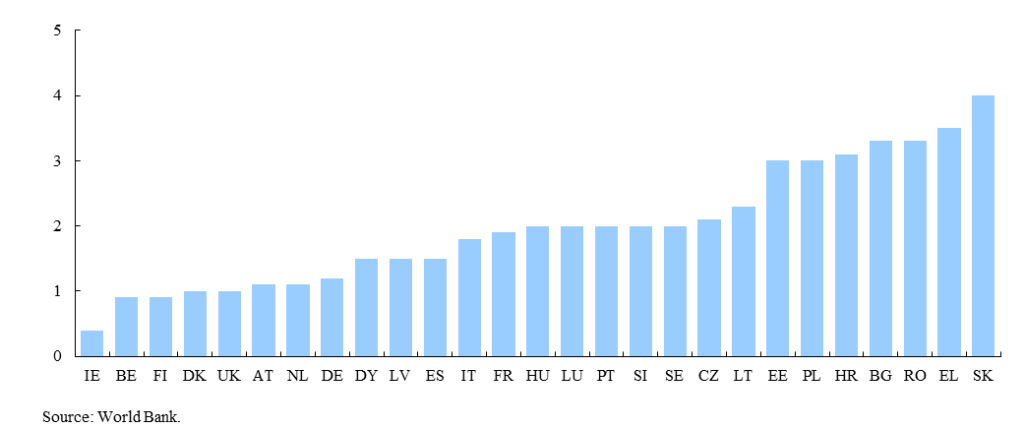

Chart 27: Recovery rate in enforcing a contract or resolving an insolvency

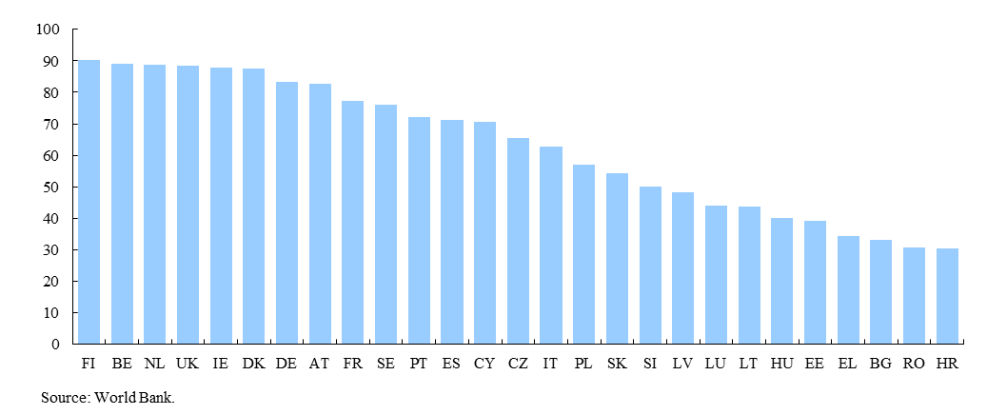

Box 9: European Commission recommendation on a new approach to business failure and insolvency
The European Commission has addressed a Recommendation to the Member States to encourage them to put in place minimum standards on early restructuring procedures and second chance for natural persons. The Recommendation has been partially taken up by some Member States, especially by those receiving insolvency recommendations in the context of the European Semester exercise addresing macro-economic imbalances. Even those Member States which have taken up the European Commission Insolvency Recommendation did so in a selective manner, meaning that differences remain.
The Recommendation and the subsequent evaluation of its implementation notably focused on preventive restructuring procedures, as enterprises do not have the same opportunities to deal with their financial difficulties everywhere in the EU. Several conditions contribute to the efficiency of restructuring procedures, but six in particular seem to stand out:
(i) The possiblity to file early with the objective of avoiding insolvency: The later a business initiates restructuring proceedings, the higher the costs of restructuring and the lower the management powers and success rate.
(ii) The position of the debtor: In order to encourage debtors to address their financial difficulties at an early stage, they should be left in principle in control of the day-to-day operation of their business. This would also ensure that the least disruption to the activity of the enterprise.
(iii) The possibility of a stay on individual enforcement actions: During negotiations on a restructuring plan, the debtor should be able to apply to a court for suspension of individual enforcement actions which could otherwise jeopardise the success of the restructuring process.
(iv) Adoption of the restructuring plans by creditors: Restructuring plans should be adopted by creditors representing the majority stipulated under national law.
(v) The protection for new finance granted in restructuring procedures: Encouraging new financing is necessary to ensure the success of a restructuring plan.
(vi) The involvement of courts when third party rights could be affected: While the Recommendation encourages some limits to the extent of court involvement, certain steps in a restructuring process require court involvement, notably when the rights of dissenting creditors are affected.
The Recommendation also focused on second chance provisions, urging Member States to provide for a reasonable discharge period of maximum three years from the opening of liquidation of assets proceedings or, in cases where a repayment plan has been approved, from the moment the plan is put into application.
While the Recommendation has provided useful focus for those Member States undertaking reforms in the area of insolvency, it has not succeeded in having the desired impact in facilitating the rescue of businesses in financial difficulty and in giving a second chance to entrepreneurs because of its only partial implementation in a significant number of Member States, including those having launched reforms. These differences in the implementation of the European Commission Recommendation mean continuing legal uncertainty and additional costs for investors in assessing their risks and persisting barriers to the efficient restructuring of viable companies in the EU, including cross-border enterprise groups.
Inefficient and divergent insolvency proceedings in the EU prevent speedier debt restructuring. Instrumental in this context was also the larger market for distressed debt in the USA compared to the EU. The US high-yield and distressed debt market has a well-diversified investor base, including more traditional distressed/alternative investors (e.g. private equity and hedge funds), as well as pension funds, insurers, and investment funds. In contrast, the investor base is much smaller in Europe, with US investors currently dominating both high yield bond and loan markets in the EU. The comparison with the US demonstrates that the problem of non-performing loans is more difficult to resolve without effective restructuring and insolvency tools.
Another area where important institutional differences are observed is company law. World Bank indicators provide a good illustration for diversity in approaches across EU Member States in this area. For example, despite harmonisation achieved through the existing shareholder rights directive, cross-border exercise of shareholder rights is still difficult. The length and complexity of equity holding chains together with diverging national rules and inadequate market practices make cross-border voting difficult and sometimes impossible. Efficient minority protection is particularly relevant in companies with controlling or dominant shareholders, which is the prevailing model in continental Europe. These different national models are often rooted in national traditions and aim at responding to the specific needs of local markets. However, these divergences make cross-border investment more difficult and costlier as investors are faced with a great variety of rules and models of functioning. The disadvantage, relative to domestic insiders, becomes particularly severe in case of investments that face a non-negligible probability of defaulting.

5.3 Withholding tax and other tax barriers to cross-border investments
A further barrier to cross-border investment in Europe is the diversity in the application of withholding taxes. While many Member States require companies paying dividends, interest and/or other securities' income to deduct a withholding tax and remit it to the local tax authorities, the tax treatment applied to different types of investors and the investment products varies widely. Withholding taxe rates, exemptions and relief procedures are subject to different domestic rules.
The diversity and complexity of procedures to claim tax treaty benefits on investment income poses further obstacles. Rates of withholding tax on securities income can often be reduced or even eliminated under double taxation treaties between countries or under domestic law. However, the procedures for claiming the reductions/exemptions are often demanding, resource-intensive and costly for investors, and are therefore a deterrent to cross-border investments, as pointed out in several reports of expert groups tasked by the European Commission. Some countries require individual investors to make claims for relief themselves rather than allowing financial institutions to do so on their behalf even though this is a nearly impossible task for the investors in question because they lack the expertise to make these claims. An investor may need to make claims in several Member States, because the financial institution acting on his behalf may have invested in several countries. The forms for making the claims may differ radically, change periodically, and be in languages that the investor does not understand. It is estimated that approximately 56 different tax reclaim forms exist within the EU. A further complication is that, in today's globalised world, there is often a chain of financial institutions between an investor and the Member State of the source of income. Alternatively, Member States may allow financial institutions to make claims for relief on behalf of investors but in that case they may insist that the claims are made by local financial institutions, denying foreign financial institutions the opportunity of doing so. Finally, the length of time that a Member State takes to pay out refunds of withholding tax under tax treaties or domestic law can vary from a few weeks to several years.
The economic impact of the complexity of reclaim procedures for withholding tax is significant. The European Commission estimated three types of costs associated with an inefficient withholding tax system: (i) the opportunity cost to investors due to delayed claims and payments of tax refunds estimated at EUR 1.84 billion per year; (ii) the foregone tax relief associated with investors not claiming the tax to which they are entitled because of the complexity and duration of the procedures estimated at EUR 5.47 billion per year; and (iii) the actual amount of costs for tax administrations related to the reclaim procedures (paperwork, etc) estimated at EUR 1.09 billion per year.
Despite the initiatives that have been taken in this area, difficulties in claiming withholding tax relief remain a major barrier to cross-border investment. The European Commission adopted in October 2009 a Recommendation on Withholding Tax Relief Procedures, which aimed at facilitating cross-border claims for withholding tax relief on investment income. The OECD also worked in the same field, developing with its members, including EU Member States and the European Commission, a package of documents and procedures that was designed as a single system for use throughout the world by financial institutions to claim withholding tax relief on behalf of investors, while reporting regularly to tax administrations so as to ensure investor compliance. But there have been few improvements to Member States' withholding tax relief procedures, and there are no substantial moves in the direction of the single, streamlined relief system that most of the financial industry claims is necessary.
A related problem is the discriminatory tax treatment of some investors. For instance, in the European Commission's White Paper on Pensions, a study on discriminatory taxation of cross-border investments by pension funds and life insurance companies was announced. EU pension funds have assets under management of around EUR 2.5 trillion, insurance companies around EUR 7 trillion. They may have invested considerable parts of their assets in other Member States. If taxes on these cross-border investments are levied contrary to EU law, the amounts unduly levied would be considerable and would negatively influence investment decisions.
Finally, taxation should not be a deterrent to cross-border investment activities by venture capital funds. A 2008 European Commission's Experts' Group report on removing tax obstacles to cross-border venture capital investments pointed to mismatches between Member States as regards the tax treatment of the five major components to a venture capital fund and its investments (the investors, the venture capital fund itself, the venture capital management company, the portfolio company and the advisory companies). This can lead to double or triple taxation and result in the tendency for venture capital to be restricted to domestic national markets rather than extending across the larger EU and international markets. However, the above mismatches can also be used to avoid taxes in one or more jurisdictions. In addition to cross-border dimension, an increasing number of Member States are encouraging business angel and venture capital investment through tax incentives schemes to support investment in SMEs and the supply of early stage venture capital.

5.4 Financial market infrastructures
Fragmented market infrastructures act as barriers to the free movement of capital. Financial market infrastructures provide essential services, such as trading order execution, confirmation and registration of trades, clearing and settlement, custodian services and collateral management. They also collect, record and disseminate data about trading volumes and prices throughout the financial system. Financial market infrastructures include stock exchanges, trade repositories, clearing houses and central counterparties (CCPs), central securities depositories (CSDs) and custodians. There are also different types of trade execution channels: direct trading, voice broker and electronic trading (e-trading). Numerous market infrastructure providers offer their services in the EU: ESMA lists 104 regulated markets and 153 multilateral trading facilities; it authorised 16 central counterparties and 6 trade repositories; the CSD factbook lists 30 CSDs in the EU of which 20 in the euro area including two international CSDs.
There is evidence that cross-border trades are on average still more expensive than domestic trades. For example, some fund management firms may incur up to ten times higher costs on identical services simply due to securities being registered and held with intermediaries domiciled in different Member States. The difference in costs for post-trading services between domestic and cross-border transactions may have even grown in the period 2006-2009, due to the fact that the decrease in domestic costs has been more rapid than the decrease in cross-border costs. Such cost differences may stem from a number of factors: (i) cross-border barriers such as divergent securities holdings laws; (ii) economies of scale and the ensuing variation in costs across jurisdictions; and (iii) variation in the exact type of service provided. As the financial crisis incited a shift towards collateralised transactions, infrastructures that foster cross-border collateral management have become particularly relevant.
Trading and post-trading systems condition the level of transparency and the way information is processed in markets. Dissemination of information, efficient price formation and homogeneous data availability can be hampered by fragmented architecture, aggravating the lack of liquidity. This is particularly true for debt markets: corporate bonds are still overwhelmingly traded over-the-counter via telephone and recorded manually. As a result, transaction prices for traded bonds have not been publicly available. The low level of electronic trading reflects a number of factors, such as the heterogeneity of securities, correlated trading and low turnover. The associated lack of data on trades mean that aggregate market information/data are also scarce and that quality of data is low. Heterogeneous data formats provided by different sources make it difficult to aggregate data on market activity and the distribution of prices. This situation involves significant information costs, and hampers market activity and liquidity. In response to the observed shortcomings, a new common EU legal framework for financial markets and trading venues has been created, imposing a set of transparency requirements throughout the trading cycle. As of January 2017, enhanced transparency regime with regard to both pre- and post-trade transparency will apply as part of the MiFID II/MiFIR framework, which also contains provisions on consolidated tape. This should improve the price formation process and contribute to an increased use of electronic platforms.
Different trading systems and platforms without interconnections are still an obstacle to EU market efficiency. The Giovannini reports in 2001 and 2003 already singled out the need to improve connectivity networks to common system platforms; interoperability between markets/systems through common standards and common technical protocols; open access to infrastructures, convergence of market rules and practices; and transparent pricing procedures. Interconnection can be achieved through compatible and/or shared trading platforms, eliminating the need for redundant investment in different trading systems and benefiting brokers that engage in cross-border transactions. Concentrated order flows would lead to more precise price discovery. On the other hand, efficiency is currently still impeded by cross-country legal and regulatory differences, high information costs, home-country bias and the fragmentation of the EU clearing and settlement systems. Different exchanges, clearing houses and CSDs operate in each country, whilst a major part of the EU level activity is anyway concentrated in a few of them. Recent regulation, particularly the European Markets Infrastructure Regulation (EMIR) and Central Securities Depositories Regulation (CSDR), will enhance cross-border access and interoperability between CCPs and CSDs and is also expected to foster competition in clearing and settlement services and raise consolidation pressure helping to increase efficiency in EU market infrastructures.
In mid-2015, the ECB launched the TARGET2-Securities platform (T2S) to address the fragmented infrastructure for transferring financial assets for trading and collateral operations. It provides settlement services for securities transactions in central bank money and it is built as a multicurrency system. T2S will be fully deployed by February 2017, covering almost all securities transactions in euro, and it is expected to bring numerous benefits, including: (i) lower processing costs for cross-border transactions; (ii) direct securities settlement in central bank money; and (iii) economies of scale without the need to merge securities depositories. T2S will facilitate cross-border collateral management by incentivising the EU post-trade industry to harmonise market practice, rules and standards. The CSDR complements the operational integration provided by T2S and gives further momentum to the post-trade harmonisation efforts.

5.5 Supervisory and regulatory convergence
Implementation, application and enforcement of EU rules on capital makets may be characterised by a number of inconsistencies related to supervisory and regulatory aspects, due to diverging national approaches and practices. Some of these divergences are warranted to accommodate national specificities, while others are rather due to different interpretations of the underlying principles, leading to situations where rules overlap or contain inconsistent legal requirements. This, in turn, creates legal uncertainty, opportunities for regulatory arbitrage, and disincentives to cross-border investments. On the other side, supervisory convergence aims at promoting a more uniform supervisory culture across the EU, preventing regulatory arbitrage and ensuring a consistent supervision of market participants. A consistent and effective application of the EU legislation can help to ensure a level playing field for market players across the EU and legal certainty. This is in particular achieved by eliminating possible undue barriers to investment arising from divergent interpretation of EU rules or from differences in national supervisory practices, while allowing for a degree of national discretion in certain cases. Legal certainty and a level-playing field in EU capital markets create a robust 'ecosystem' for investors to supply more capital and funding across borders.
Supervisory convergence is needed to give teeth to the EU consumer and investor protection rules. The 2014 European Commission consumer scoreboard found that the markets for investment products, private pensions and securities rank lowest in terms of trust in providers, comparability of offers, overall satisfaction and the incidence of complaints and problems. An important cause behind this are information asymmetries in favour of originators and distributors, rendering the full utility or return from these products difficult for consumers to ascertain until their final maturity. While this is relevant for both individual and institutional investors, retail investors face particular difficulties in assessing risks and making informed investment decisions, given the relative opacity and complexity of some financial products. Since information frictions are even more salient in the context of cross-border investments, transparency on costs and risks of investment products is even more relevant for trust of investors than on domestic capital markets. Consumer and investor protection rules that equip the ultimate risk-bearers in a more market-based financial system to independently evaluate and price risk seem to be a precondition for greater participation by both institutional and retail investors.
Regulatory convergence could reduce the multiplicity of reporting obligations, which act as a drag on investment. Enhanced transparency implies various reporting and disclosure obligations, which entail an administrative and financial burden for market participants. This is even truer for cross-border investments, where market participants are faced with divergent interpretation of EU rules and different requirements from one jurisdiction to another. On the other hand, more transparency should lead to lower search and monitoring costs for intermediaries and investors (i.e. more transparent price formation), as well as better investor protection. Recent EU rules, such as MiFID II, are expected to enhance the comprehensiveness and comparability of information on costs and charges related to various financial products. MiFID II/MiFIR also includes a transparency regime that has been extended to equity instruments other than shares as well as non-equity instruments. The standardisation of disclosure requirements should help enhance transparency, investors' trust and market efficiency.

Chapter 6 A COUNTRY PERSPECTIVE ON THE CMU
EU Member States differ significantly with regard to their economic and financial structures. This chapter documents differences across EU Member States as regards the financing sources used by companies to fund their activity (Section 1) and the ways households save (Section 2). Both constituencies represent the ultimate users of financial markets' intermediation. Savings are channelled to investments via various financial intermediaries and markets, which also differ by size, degree of maturity and the composition of assets (Section 3). This diversity means that, while all Member States will benefit from the CMU, gains will materialise in various forms, depending on the specificity of each Member State (Section 4).
CMU is not meant to trigger a convergence of financial structures to a single, uniform template because there is no universal financial structure optimal for each Member State. Most differences in financial structures across countries stem from legal and historical determinants and also from the interdependency between economic and financial structures themselves. A number of these economic determinants are well-established. For example, in economies characterised by a large number of small firms, the optimal financial structure may exhibit greater bank dependence. On the other side, for economies where large firms dominate, stronger reliance on market-based finance may be suitable. Stronger specialisation in high-tech firms, in turn, goes hand in hand with a larger market share of private equity and venture capital; likewise, a stronger presence of start-ups in new business areas may generate opportunities for crowdfunding. Finally, some countries have large financial sectors exporting financial services, which implies that the country's financial structure is determined by both domestic and foreign factors .
The economic literature identified a number of relevant factors that determine both economic and financial structures. Alongwith legal frameworks on the enforceability of ownership rights and the ease of property transfer, GDP per capita has proven significant in cross-country estimates of the determinants of financial structures. For instance, richer economies typically are endowed with a more developed financial structure, with the causality potentially running both ways: a more developed financial system also supports innovation and thus economic growth. Although this empirical result was derived based on samples comprising countries from various regions of the world, differences in both GDP per capita and the size of the financial system are also notable in the EU, suggesting that this factor is relevant in a more specific, European context. Differences in demographic profiles also matter, in particular as regards the amounts of funds made available to the economy. A large population offers scope for scale effects, which are particularly beneficial for financial market activity, and the ageing profile of the population has an impact on households' savings behaviour. But the share of savings that will ultimately be made available to firms also depends on other economic variables, such as: households' investment in housing, the population's age structure, the magnitude of public debt and the countries' current account position. All of these considerations vary considerably across the EU.
Different starting conditions imply different potential benefits from the CMU and different policy priorities at national level to draw the maximum benefit. The interdependency of financial and economic structures suggests that outliers in financial statistics are not necessarily to be interpreted in terms of over or under-performance, but need to be considered in the context of underlying explanatory factors. Yet, comparison with peers can be indicative of structural changes that are more or less promising to realise. A further important factor is the fact that the openness of EU economies allows firms to tap funding from foreign financial systems. A number of financial centres have developed as regional hubs to cater for some of the neighbouring economies' financial needs. As a consequence, access to foreign financial markets can be as important as the development of stronger local capital markets to cater for a country's financial needs.

6.1 Financing needs
Since national corporate sectors differ by their level of development, level of investment and liability structure, financing needs and the degree to which they can be satisfied also differ across EU Member States. The crisis has revealed and magnified important asymmetries across Member States in this area. The proportion of bank loan acceptances has fallen significantly along with declining enterprise investment. The sharpest falls were observed in countries most affected by the crisis. The situation has improved recently and some convergence in terms of credit availability has taken place, but substantial cross-country disparities remain, as evidenced by the ECB's Bank Lending Survey. For example, the cost of credit remains higher and access to credit is more constrained in Portugal, Spain and Italy as compared to Germany and France (Chart 28).
Chart 28: Interest rates on loans to non-financial corporations, selected Member States
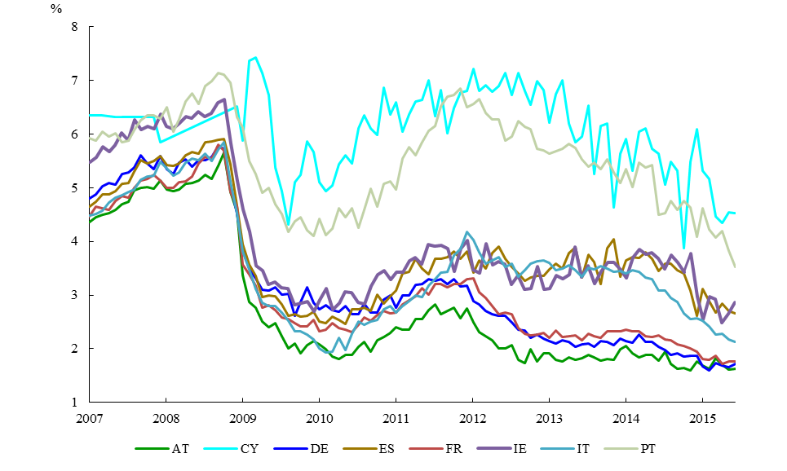
Source: ECB.
Financing needs in Europe are substantial. The share of corporate investment relative to GDP exceeds 10% in most countries and is highest in the rapidly growing economies of Central and Eastern Europe. This is contributing to the narrowing of the income gap (Chart 29). While important progress and convergence have been achieved in the area of productivity, discrepancies remain in the development of infrastructures and institutions. The level of corporate capitalisation and integration into European and global networks also lags behind their counterparts in Western Europe. In these "catching-up" economies, a large share of the capital required for investment comes from abroad in the form of foreign direct investments. In other countries, such as Greece or Cyprus, the low investment rate reflects the financial and sovereign debt crisis. In fact, concerns about the government's ability to service its debt increased the credit risk of companies operating in these countries, weighing on investment. Besides, in anticipation of increased taxation, domestic and foreign-led investment reduced further. The fall in investment has not been an exclusive feature of crisis-stricken euro Member States, but also of euro area core and non-euro area countries. The investment plan and establishment of EFSI is a consequence of the identification of an investment gap. Finally, in some countries, such as Luxembourg, the subdued level of investment could be due to the move towards a more service-oriented economy at high income levels. Luxembourg is an outlier, given the high dependence of the economy on the financial sector, which contributes 27% to the country's income. For comparison, in the EU as a whole the financial sector's contribution to income is 5.4%.
Chart 29: Corporate investment and expenditure on research and development, % of GDP, 2014 or 2013
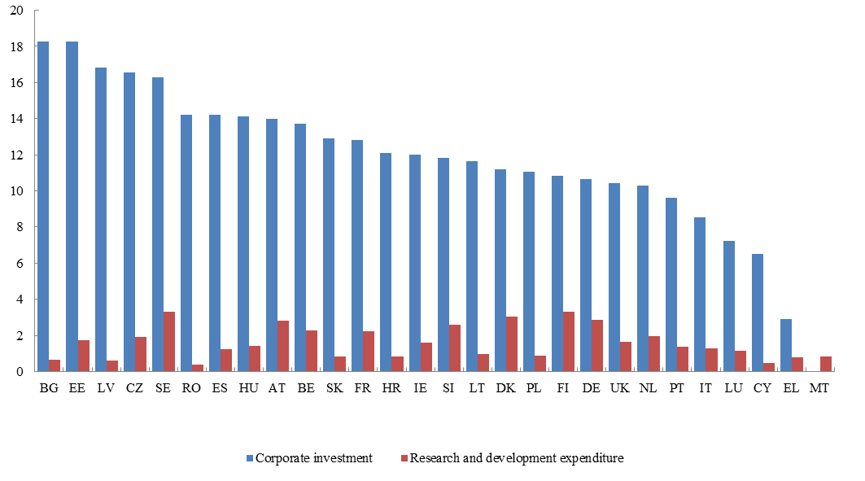
Source: Eurostat.

A number of factors affect corporate financing needs and the prospect of satisfying them. Credit conditions differ significantly among Member States due to them being in different phases of the economic cycle, varying levels of competition in the financial system and differences as regards the soundness and efficiency of financial institutions. The industrial structure is another important determinant, as sectors such as production of energy, real estate and also agriculture are particularly capital-intensive. When comparing EU Member States, the energy sector represents a significant share of investment in Bulgaria and Slovakia, the real estate sector in Germany and Austria and the agricultural sector in Bulgaria and Latvia. Since manufacturing is also disproportionately investment-intensive, a large manufacturing sector and especially a large share of manufacturing of computers, motor vehicles, coke and petroleum refinement implies higher capital needs. Company size also matters in explaining differences in accessing funding. For larger companies, concerns with their capacity to finance their investment needs are smaller because their spectrum of potential funding sources is broader and includes stock or bond issuance. In the EU, the share of large companies in overall corporate turnover is relatively homogeneous, ranging between 50% and 70%. Still, the proportion of large companies is higher in Germany, UK and Ireland while Malta, Greece, Estonia and Latvia have corporate sectors where smaller companies play a larger role (Chart 30). The larger an economy, the larger the relative weight of big companies tends to be, possibly because companies expand more easily if home markets are large.
Chart 30: The importance of large companies in an economy, Turnover of corporations with more than 50 employees as % of total, 2012 or 2011
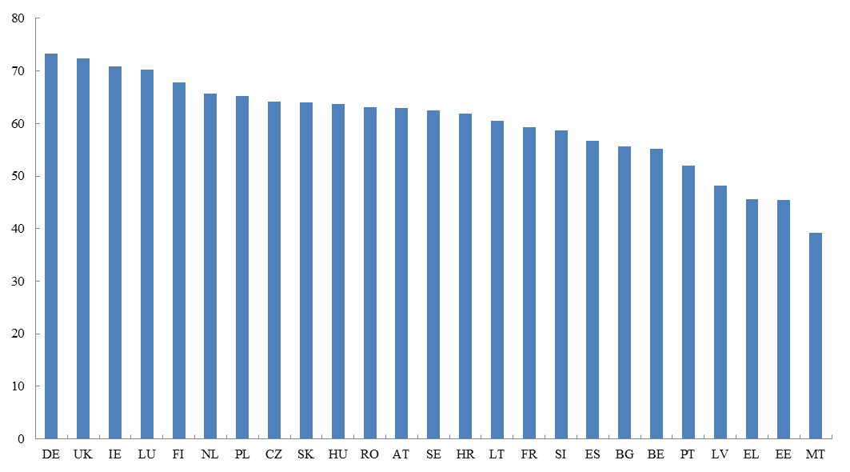
Source: Eurostat.

As described in Chapter 3, SMEs are particularly vulnerable to adverse economic conditions and constraints in credit supply. Statistical analysis confirms these trends, showing a correlation between company size and borrowing costs. As much as 45% of SMEs surveyed in Cyprus, 32% in Greece and 29% in Slovenia stated that insufficient access to finance was among the most pressing problems they were facing. More than 15% of small companies in Lithuania, Portugal, Croatia, Spain and Ireland answered in the same way. The European Commission's access to debt finance index summarises information about problems that SMEs encounter when they request bank loans (Chart 31). Relatively low scores for countries such as Romania, Cyprus and Greece confirm difficulties experienced by local SMEs in obtaining access to bank loans compared the EU average.
Chart 31: SMEs' access to debt finance, 2013, index
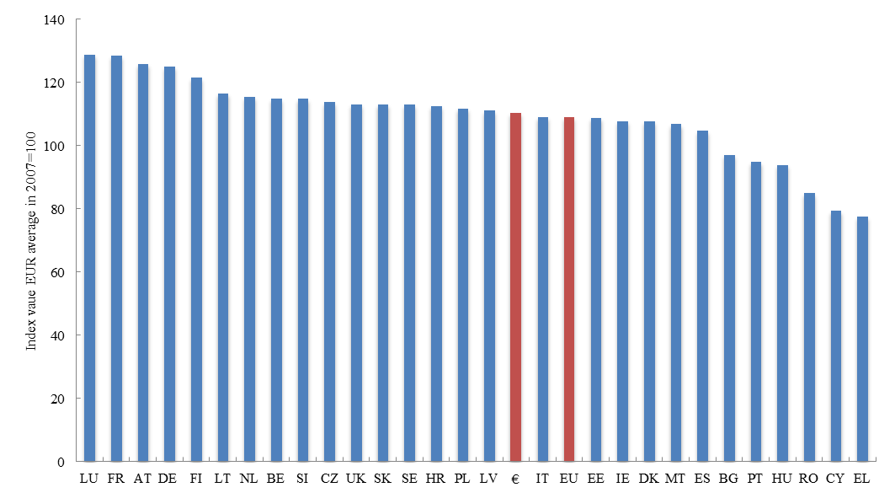
Source: European Commission.

Another key factor explaining differences in the availability of credit is the accumulated corporate debt level. On the one hand, a high level of debt has an impact on a company’s creditworthiness and reduces its repayment capacity. On the other hand, high corporate indebtedness limits the capacity of financial institutions to grant credit, or makes it more expensive in terms of capital requirements. The highest corporate indebtedness ratios, measured by outstanding bank loans to GDP, are observed in Cyprus (136%), Malta (65%) and the Netherlands (62%). Denmark, Greece, Spain, Italy and Portugal have corporate debt to GDP ratios above 50% while corporate sectors in Central and Eastern Europe are the least indebted.
In several countries, high corporate debt coincides with high interest rates charged on corporate loans, which further hampers investment. Currently, the interest rates on corporate bank loans are the highest in Cyprus (4.5%), Greece (5.6%), Portugal (3.5%) and Ireland (2.9%), as well as in Slovenia (3%) and Latvia (2.7%). All these countries experienced issues in the banking sector during the financial crisis. In Bulgaria (6.5%), Romania (6.1%) and Croatia (6%) currency risk may play a role, in addition to credit risk.
As highlighted in Chapter 3, Research and Development (R&D) is essential to enhance competitiveness, innovation and growth. R&D expenses are typically highest in more advanced economies: they represent more than 2% of GDP in Sweden, Denmark, Germany, Austria, Belgium, France, Netherlands (Chart 29). They are lower in countries where the economic activity is still suffering from the consequences of the crisis (Greece, Cyprus, Malta, and to a lower extent Spain and Italy), and in most countries of Central and Eastern Europe (with the exception of Slovenia). As R&D projects are capital-intensive and risky, they require appropriate financing. The state may provide part of the needed funding, but investment from private sources is indispensable. The use of capital markets, in particular venture capital, for corporate funding correlates with national investment in R&D. The Nordic countries as well as Germany and France are characterised by both relatively high R&D expenditures and a more intensive use of venture capital, while Slovakia, Romania, Latvia, Cyprus and Bulgaria are endowed with less developed capital markets in combination with a low level of investment in R&D.
Venture capital activity varies greatly across Europe. The Commission's access to equity finance index summarises information about the use of venture capital and business angel funding across EU Member States (Chart 32). It shows favourable financing environments in Ireland, Estonia, Denmark, Netherlands and Finland, whereas these equity instruments are least used in Luxembourg, Greece and Spain. Low utilisation of both private equity and venture capital are observed for Southern European Member States and those in Central and Eastern Europe.
Chart 32: SMEs' access to equity finance, 2013, index
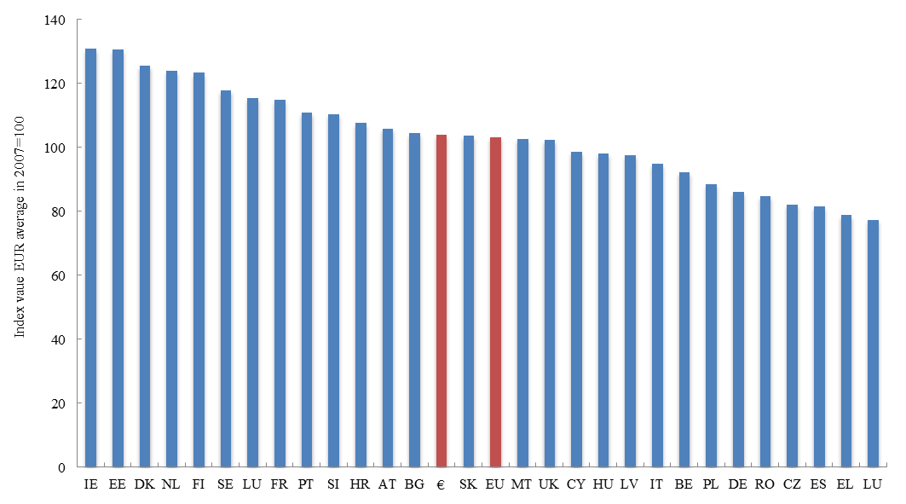Source: European Commission.

As mentioned in Chapter 3, corporate financing needs can be covered by own resources or external funding. The latter may be provided from domestic or foreign sources and it may be channelled via the financial sector (banks, capital markets) or intra-group, by parent or associated companies. In the EU, bank loans constitute the main source of external funding for corporations (Chart 33) and bank loans represent between 30% and 50% of the balance sheet. Cypriot and Greek companies are most reliant on bank loans, which account for more than half of their total liabilities. In both countries, securities markets play a minor role in corporate funding. In contrast, three groups of countries can be distinguished as relying to a lower extent on bank financing: (i) the first group includes the UK, France and Germany - as explained earlier, firms grow more easily in larger economies, so their average size is bigger, which supports the development of stock and bond markets; (ii) in Nordic countries, public equity is also an important source of funding for NFCs, exceeding on average 20% of the balance sheet; (iii) the third group of countries with lower dependence on bank credit includes Slovakia, Lithuania, Estonia, Czech Republic and Poland - this is partly explained by the fact that, in the relatively smaller and less developed markets of Central and Eastern Europe, companies rely to a bigger extent on own resources (e.g. retained profits), which are part of their equity.
Chart 33: Funding of companies: banks vs stock exchange, Loans and listed shares as % of total liabilities of non-financial corporations, 2014 or 2013
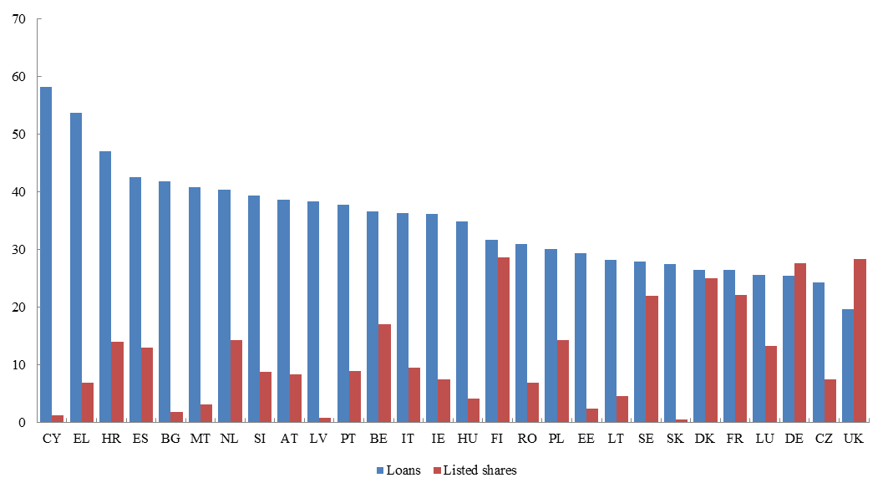
Source: Eurostat.

Debt securities markets play an increasing, but still relatively minor, role in providing funding for European corporations. France stands out with a 10% share of bonds on the corporate balance sheet, followed by the UK, Portugal, Austria and Finland (Table 3). But corporate bonds are still quasi-inexistent in some other European countries (e.g. Greece, Romania, Lithuania and Cyprus). Over recent years, debt securities have become a considerably more important source of funding, accounting for a third of new funding in the EU on average between 2010 and 2014. Use of corporate bond issuance has increased in those countries where bond issuance was already high before the crisis. In Belgium, Portugal and Italy, issuance of corporate bond has increased much more than expected given their starting position before the financial crisis. As regards other funding sources, the role of trade credit remains important in some countries, in particular in Central and Eastern European. It accounts for almost 20 % of corporate sector liabilities in Malta and Slovakia and is also high in Lithuania, Latvia, Czech Republic and Slovenia.

Table 3: Liability structure of non-financial corporations
(% of total, 2014 or 2013) 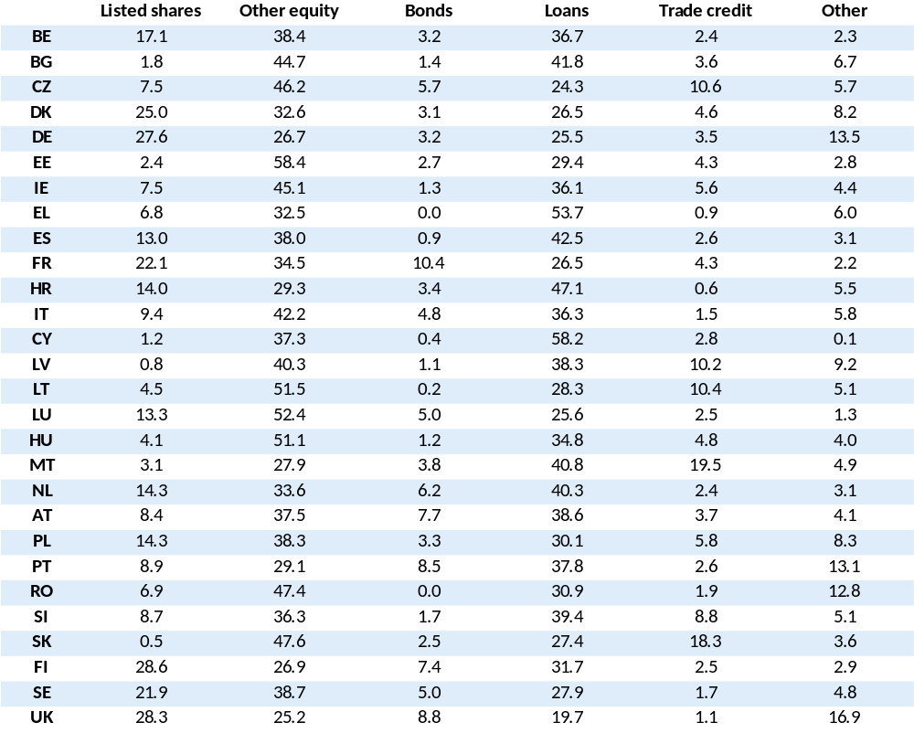
Source: Eurostat.

6.2 Financing sources
Households across Member States have different propensities to save, saving traditions and investment preferences. Income levels and population structures are also dissimilar. Despite these differences, it is remarkable that most households in the EU hold most of their disposable financial assets in the form of currency and bank deposits. Broadly speaking, with the exception of Luxembourg, the higher the income level in an economy, the smaller the percentage of financial assets held by households in the form of currency and deposits. It is in the Netherlands, Denmark and Sweden that the share of households' holdings in the form of currency and deposits is the lowest, and in Greece, Slovakia, Croatia and Cyprus that it is the highest. Also, households in Germany and Austria keep much more financial assets in this form than their peers with comparable income levels.
The second largest investment class is insurance and pension products, with a higher propensity for households to invest in these products in countries with a high income level (Chart 34). Households in the Netherlands, UK, Ireland, Denmark, Sweden and France hold a larger share of their financial assets in insurance products and pension funds than in bank savings and cash holdings. In Germany, the share of assets invested in insurance products and pension funds is roughly equal to the share of assets kept in the form of bank savings and cash holdings. The share of households' holdings in insurance products and pension funds is much lower in Member States with a lower GDP per capita. For example, households' investment in insurance products and pension funds is smallest in Bulgaria and Romania. But when compared to peers with a comparable income level, the share of financial assets in insurance and pension products is relatively low in Austria, Belgium and Finland and it is relatively high in Poland, Croatia, Slovakia and Portugal.
Chart 34: Assets of households: bank deposits versus insurance and pension fund products, (% of total, 2014 or 2013)
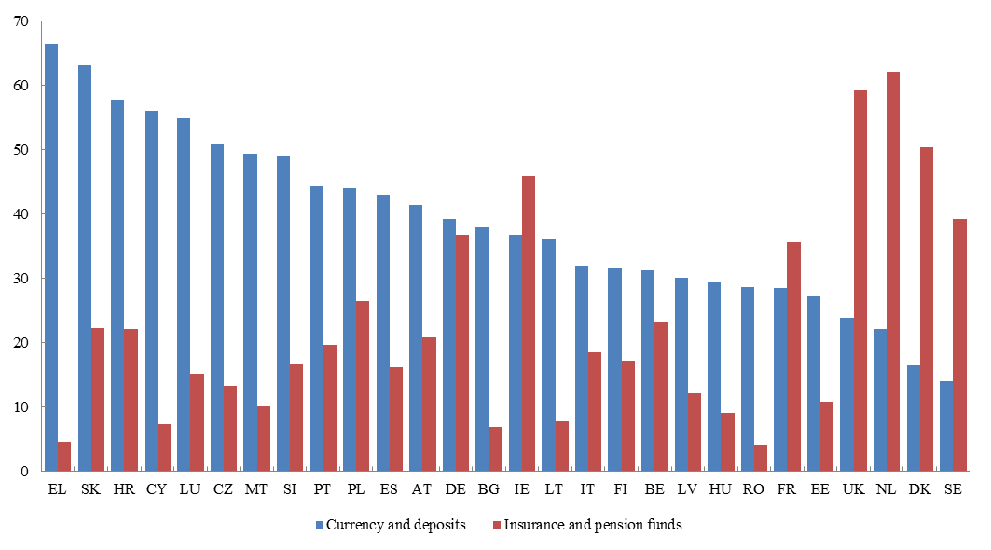
Source: Eurostat.

European households still invest only a limited percentage of their financial wealth directly in listed shares, bonds and investment funds (Chart 35). In 22 of the 28 EU Member States, less than 5% of households' financial assets are held in the form of either bonds or listed shares. More sizable investments in listed shares are reported in Finland, Spain and Sweden, and in bonds in Italy, Malta and Hungary. A commonly used alternative to direct investment in capital markets is investment funds. In many countries, assets entrusted to investment funds correspond roughly to the sum of assets invested directly in listed shares and debt securities. In approximately half of the EU Member States, households hold less than 5% of their financial assets in the form of investment funds. Households' investments in listed securities are larger in Belgium, Spain and Hungary (more than 10% of total financial assets). In all Member States except Germany, Hungary, Austria and Romania, households hold more unlisted shares and other equity than listed shares (Table 4), which reflects the importance of family business.
Chart 35: Assets of households: direct holding of securities versus investment funds, % of total, 2014 or 2013
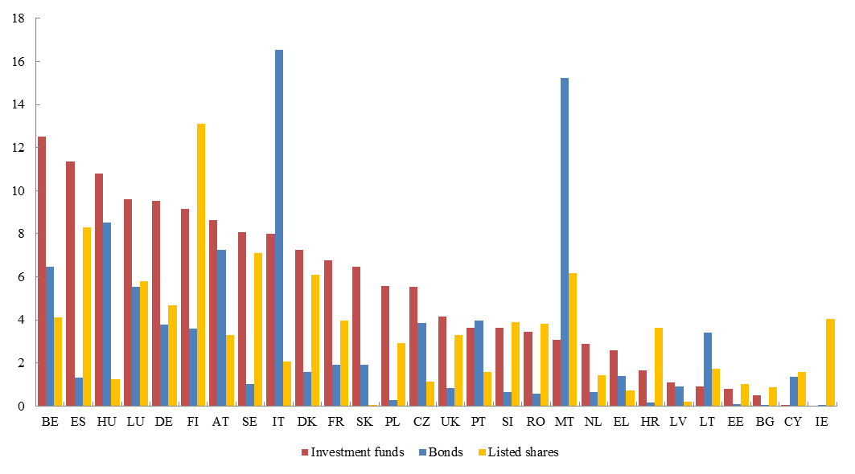Source: Eurostat.

Marketable financial assets seem to be a substitute for insurance and pension products as household assets, particularly in Member States with higher income levels. Household holdings of marketable financial securities, i.e. listed stocks, bonds and investment funds are also higher as a share of their total financial assets in Member States with high income. However, the cross-country correlation between the share of households' financial assets held in marketable securities and the income level is less clearcut than for other asset classes. The largest proportion of assets held in marketable financial securities is found in Italy, Finland, Malta and Belgium. While a traditional high supply of government bonds may motivate high holdings of bonds in Belgium and Italy, it offers little explanatory power for Finland and Malta. Market instruments seem to be particularly strong substitutes to claims against insurance and pension funds in those EU Member States with higher income levels. For example, Finland, Italy, Belgium and Malta match their high ranking in market instruments with a small share in insurance and pension products and vice versa for the UK and the Netherlands, Ireland and Denmark.
Rising income levels in European countries where the economy is catching up with the rest of the EU may lead to higher household demand for non-bank savings products in the future. Households' interest in allocating their savings to non-banks increases as they get richer. Member States with still low income levels may therefore expect rising demand for non-bank products in tandem with 'catch-up' growth. Whether these households will move towards insurers and pension funds or direct capital market instruments will depend on country-specific factors, notably such as tax incentives or the cost of financial intermediation.
In many EU Member States, NFCs have also become an important source of savings for the economy. Although traditionally a net borrower, the corporate sector has actually become a cumulative net lender in all Member States except Belgium, the Czech Republic, France, Italy, Croatia, Portugal and Sweden. A net lending position means that NFCs acquire net financial assets. In other words, their surpluses invested in various financial instruments may be accessed by companies with funding needs or by other sectors, for example governments or foreign firms. This change towards an atypical net lender position started in Europe in 2009.
The proportion of NFCs' financial assets held in the form of deposits is typically higher in Member States with lower per capita income. In comparison with households, NFCs hold a lower portion of their financial assets in the form of deposits. Still, this proportion is higher than 5% of their total assets in all Member States. The role of deposits for firms is also different. Most firms use currency and bank deposits not as a saving instrument, but rather to ensure their liquidity. Even though holding bank deposits is necessary for transaction purposes, the fact that these represent more than 40% of firms' total assets in some Member States (Bulgaria, Czech Republic, Greece, Croatia, Lithuania, Romania) suggests a strong bias in these countries in favour of holding financial assets with banks. When comparing the importance of currency and deposits in the balance sheet of European NFCs, it appears that it is higher in Member States with lower per capita income.
Corporations invest less than households in insurance, pension products, investment funds and listed shares while they hold more unlisted shares, other equity and other types of financial assets. Unlisted shares account for more than 30% of financial assets of NFCs in France, Sweden, Finland as well as Ireland and Luxembourg (Table 4). Other assets include mainly loans, trade credit and receivables / payables.
Table 4: Financial assets: households and non-financial corporations
(% of total, 2014 or 2013)
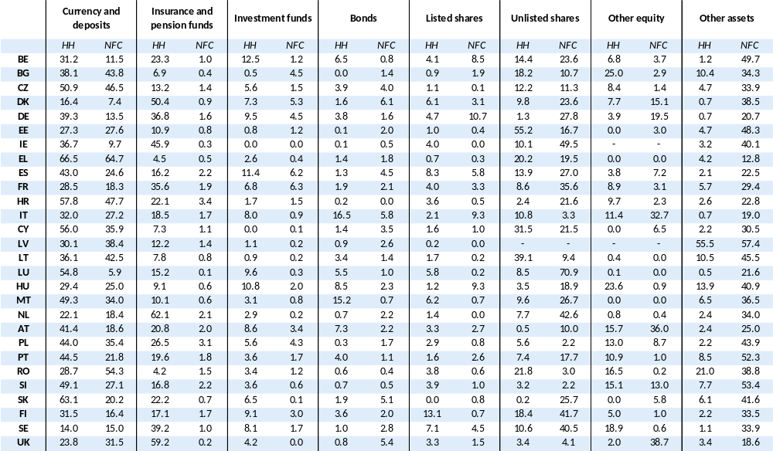
Source: Eurostat.

6.3 Intermediation: linking financing sources with financing needs
Even though banks are by far the largest financial intermediaries in all Member States, their importance varies significantly from one country to another. In most EU countries, total assets of the banking sector represent twice to four times national GDP (Table 5). However, this ratio is much higher in Malta, Ireland and Cyprus, which underlies the importance of the export of financial services in these countries. Luxembourg is an outlier, with total bank assets exceeding GDP up to twenty times reflecting the country's role as financial hub that provides financial services to other economies. On the other hand, in the still converging financial markets of Central and Eastern Europe, total assets of the banking sector typically are about the same size as national GDP, the lowest level of banking penetration being recorded in Romania (60% of GDP), Lithuania (70%) and Slovakia (78%).
While loans typically represent the bulk of the banking assets in the EU, most banks also invest in capital markets. Except for Luxembourg and Ireland which both have a large financial sector and hold the largest share of their assets in bonds, loans represent by far the most important asset on banks' balance sheets, i.e. 57.6% of total banking assets on average (Table 6). Except for Luxembourg and Ireland again, bonds are the second most important asset class on EU banks' balance sheets, accounting on average for 17.9% of total assets, of which the largest part is government bonds. Holdings in equity securities are much more limited, the average equity portfolio represents only 3% of banks' assets. On average, investments in unlisted shares is higher than investments in listed shares, representing 1.8% of banks' assets and being particularly high as a percentage of assets in Spain, Italy, Hungary and Austria.
While banks transform households’ deposits mainly into loans, insurance companies and pension funds are the key institutional investors intermediating funds from households to capital markets. The importance and balance sheet structure of insurance companies and pension funds varies greatly from one Member State to another (Table 5). Luxembourg stands out with assets of insurance companies representing 300% of its GDP. Other countries with a sizable insurance sector are Malta (132% of GDP), Denmark (109%), France and Sweden (97%), and Belgium (78%). On the other hand, countries in Central and Eastern Europe typically have small insurance sectors. Regarding pension funds, the Netherlands stands out with total assets amounting to 154% of GDP. Except for Denmark where pension funds' assets represent 75% of GDP, this ratio typically does not exceed 20% in other Member States.
The structure of the asset portfolio of insurance companies and pension funds also varies significantly from one Member State to another (Table 7). Typically, bonds constitute the largest asset class (45% of total assets on average), followed by investment funds (25%). However, in eight Member States, the proportion of bonds exceeds 60% (going up to 70% in the Czech Republic), while in nine others it is below 30% (e.g. 17% in Germany). Investment funds represent almost half of the institutional investors’ assets in Finland and Lithuania, but almost nothing in Malta. Shares, both listed and unlisted, account for nearly 10% of the portfolio of EU insurers and pension funds on average. Still, differences in equity holdings between one country and another remain significant. For example, while Polish and Irish insurance companies and pension funds hold about a quarter of their assets in listed shares, Danish institutions stand out as the largest investors in unlisted shares, as they represent 17% of their asset portfolio.
Diversity across Member States is also a key characteristic of the European investment fund sector. Luxembourg and Ireland, which are the two main EU hubs for fund registration and management, are outliers in the EU investment funds sector – assets held by investment funds represent 53 and 6.4 times national GDP, respectively (Table 5). In other EU Member States, the size of the asset portfolio held by investment funds ranges between 20% and 100% of GDP in countries with significantly developed capital markets, while it is below 15% of GDP in all Central and Eastern Europe countries. The investment funds sector is particularly underdeveloped in Lithuania, Latvia, Croatia Greece, Czech Republic, and Bulgaria, where investment funds' assets represent less than 3.5% of GDP.
Table 5(a): Financial intermediation in Member States via institutions
(% of GDP, 2013, 2014 or 2015)
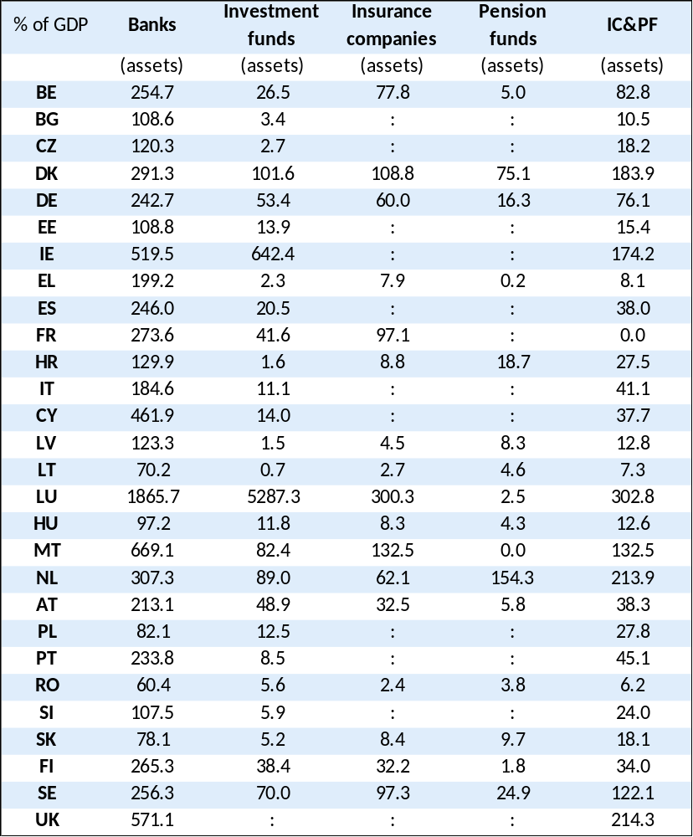
Source: Eurostat, ECB.

Table 5(b): Financial intermediation in Member States via markets
(% of GDP, 2013, 2014 or 2015)
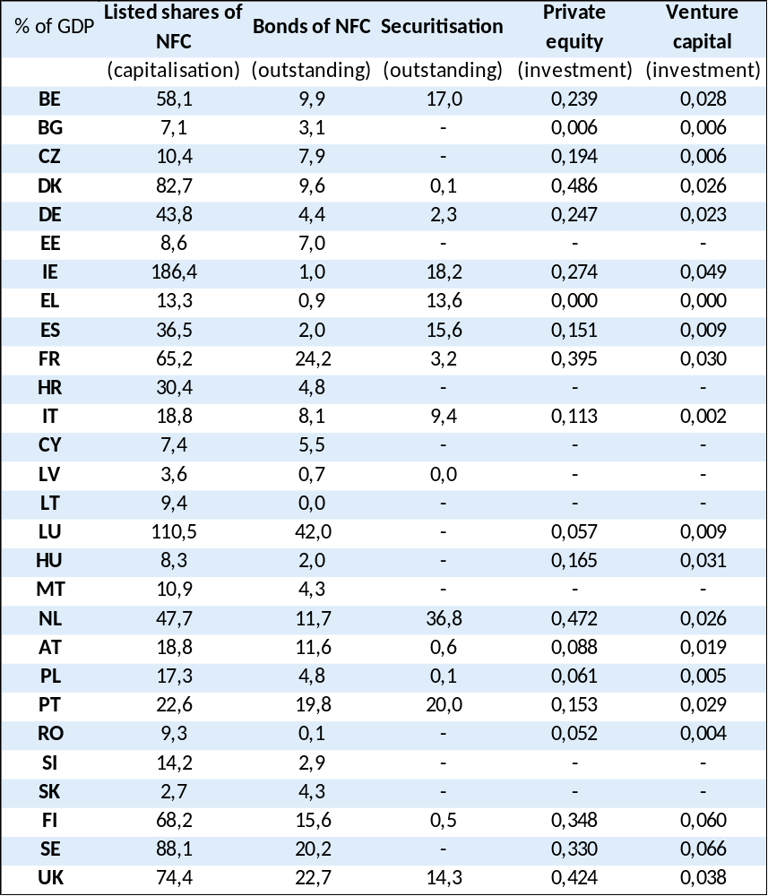
Source: Eurostat, ECB, Securities Industry and Financial Markets Association (SIFMA), European Private Equity and Venture Capital Association (EVCA).

The size of the stock market also varies greatly from one Member State to another. The capitalisation of publicly-listed NFCs relative to GDP (of the country where the NFC is registered) is highest in Ireland (190%) and Luxembourg (110%), where the financial sector is particularly developed (Table 5). Public equity markets are also large in the UK (where the capitalisation of listed NFCs represent 74% of GDP), Nordic European countries (88% in Sweden and 68% in Finland) and some older Member States (65% in France, 58% in Belgium and 44% in Germany). In all Central and Eastern Europe countries except Poland and the Czech Republic, public equity shares of NFCs represent less than 10% of GDP.
In all EU Member States, corporate bond markets are smaller than stock markets (Table 5). However, national differences exist. Relative to size, Luxembourg has the most developed bond market, with the value of outstanding bonds reaching 42% of GDP. The size of the national bond capital market exceeds 15% of GDP in France, UK, Sweden, Portugal and Finland. On the other side of the spectrum, several Member States feature very small corporate bond markets, in particular Romania, Latvia and Lithuania (below 1%), Ireland and Greece (1%), Estonia, Hungary and Spain (2%).
The level of development of securitisation indicates the degree to which financial intermediaries (primarily banks) use capital markets to fund their portfolios. It also varies greatly between Member States. Although securitisation is predominantly used for mortgage and consumer products, some corporate loans and bonds are also used as underlying assets. The Netherlands has the largest securitisation market (37% of GDP), with the bulk of the collateral being mortgage loans (Table 5). Some countries also have relatively developed securitisation markets, with stocks of securitised assets representing between 15% and 20% of GDP (Portugal, Ireland, Spain, UK). In some other large European countries, even though the amount of securitised assets outstanding is relatively low as a percentage of GDP, the securitisation market is also sizable in absolute numbers (France, Germany, Italy). In most other countries, the value of the outstanding securitised assets relative to the size of the economy is very small.
Private equity and venture capital, even if limited in all EU Member States, are important sources of funding, especially for higher risk and innovative projects. They can still be regarded as niche solutions compared to traditional financing venues. Taking all types of private equity investment into consideration, private equity activity is highest in the most developed capital markets (the large Member States, Benelux, the Nordic countries), but even in these countries it remains below 0.5% of GDP (Table 5). Venture capital, used for start-ups and more risky undertakings, constitutes a small fraction of private equity. This type of financing is most developed in Finland (0.07% of GDP), Sweden, Ireland and the UK.
Table 6: Structure of assets of banking sectors in EU Member States
(% of total, 2014 or 2013)
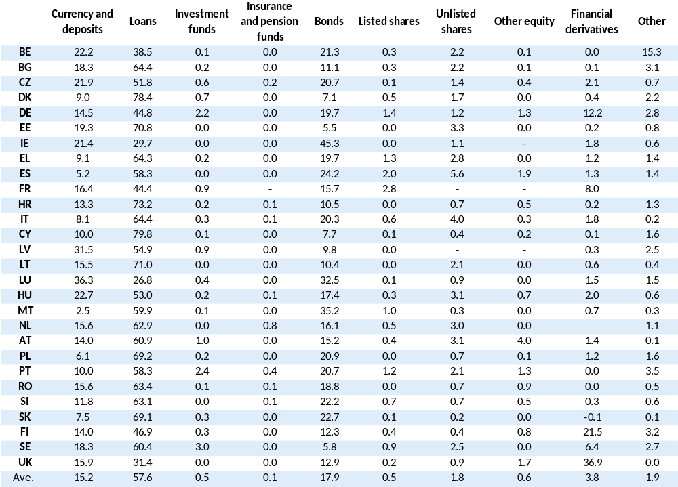
Source: Eurostat.

Table 7: Structure of assets of insurance companies and pension funds in EU Member States
(% of total, 2014 or 2013)

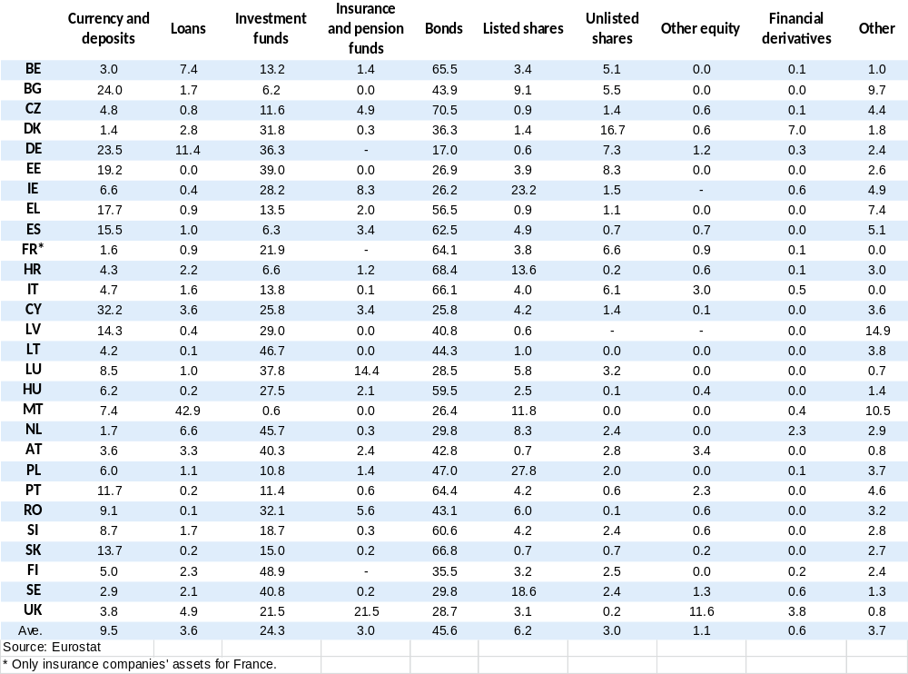

6.4 How can the CMU benefit EU Member States with different levels of capital market development?
All EU Member States are expected to benefit from more developed and better integrated capital markets. The key gains for local companies are the broader availability of financing instruments and a larger pool of investors from which funding can be obtained. In particular, start-ups looking for seed money will be able to get funds from business angels and/or private equity and venture capital funds operating in the region or in another EU Member State. This additional funding will first enable new companies to come into existence and then allow them to grow, with will directly benefit the local economy. At a later stage, the development of the CMU will make it easier for companies to get funding by issuing listed securities (bonds and/or equity).
On the investor side, retail and institutional investors will have access to a broader range of investment products. As financial products from national and other European suppliers become available, investors' ability to diversify portfolios (whether geographically, sectorally, from a maturity or asset class perspective, or otherwise) should increase. This should therefore result in a more efficient capital allocation. In addition, increased competition, also from foreign suppliers, to capture retail investors' savings will bring benefits in terms of maximisation of returns, limitation of costs and diversification of risks, therefore enabling an optimisation of their portfolios' risk-return profile.
As highlighted in earlier sections of this Staff Working Document, EU economies will become less dependent on bank funding and their financing flows will become more sustainable and stable. In countries where banks are dominant, borrowers able to attract other funding sources will be less dependent on banks. A more diverse financial system that includes capital markets alongside banking markets tends to be better able to absorb shocks and less vulnerable to financial crises. This also holds true at national level.
For EU Member States where capital markets are already well-developed, the CMU will generate more business for already well-established exchanges but also other capital markets stakeholders – such as banks, investment funds, institutional investors, market operators and intermediaries, etc. Such new business can take various forms: arrangement of the issuance of securities, auxiliary services linked to issuing and trading, development of existing or new investment products, etc. Some of these services require economies of scale to be profitable, thus are best delivered in large financial centres, but also in smaller financial centres that serve as regional hubs to neighbouring Member States. Scale economies and increased openness should stir competition in and among financial centres, leading to lower costs and the development of more tailor-made financial products. This should benefit domestic as well as foreign customers. Growth in financial services could also stimulate technical progress in other parts of the economy.
The CMU may encourage renewed cross-border financial activity by banks and other financial intermediaries to the benefit of those Member States which particularly suffered from sovereign debt crisis. The financial crisis left a legacy of high debt levels in the public and the financial sectors in several Member States. Even though financial support programmes and the Banking Union reduced the nexus between sovereign borrowers and banks, credit conditions are assessed as still relatively difficult in some Member States. Potential borrowers would benefit if they were less reliant on funding from domestic sources and could turn to foreign lenders. Foreign banks have so far shown little appetite to increase retail lending in Member States with a weaker banking system or to acquire banks under adjustment pressure in these countries. The CMU may contribute to the defragmentation of lending markets in the EU.
Significant benefits are also expected in Member States where capital markets are still structurally under-developed. In several EU countries with a still relatively low per capita income and a less developed financial sector, there is a strong need for investment, in particular in infrastructure. As regards Central and Eastern Europe, although the privatisation process of state-owned enterprises that started in the 1990s is well advanced, it is not yet complete. Besides, further capital inflows and foreign direct investment (FDI) are necessary to continue the reform process and support productivity improvement and growth in per capita income. For example, analysts believe that further growth in Central and Eastern Europe requires critical “enablers” such as investments in infrastructure, education and innovation as well as regulatory and institutional reforms.
Better developed local capital markets are essential to finance these investments, with the help of both domestic and foreign funding sources. Local capital markets, when open to foreign investment, can attract foreign capital. As a consequence, local firms get greater market access and credit constraints get relieved. In addition, the cost of capital for local firms and households decreases thanks to competition, and the risk sharing across countries improves. As foreign investors need to evaluate and monitor their investments, their rising information activity may also raise local standards in terms of quantity and quality of the information provided. The standardisation of the information requirements should in turn attract additional foreign investors. Foreign investment is also likely to put pressure on the receiving country to improve its business and regulatory environment. This, in turn, favours the creation and development of companies, creating a "virtuous cycle". Finally, local companies may also benefit from the intensified screening activity by investors and the discovery process this entails, which may encourage innovative activity.
Studies show that the development of local capital markets significantly improves the availability of long-term financing for local investment projects. More developed local capital markets allow firms to better manage the maturity and interest rate risks associated with long-term investments (such as investments in equipment, buildings, R&D or intangible assets) by allowing a better match between the duration of assets and financial liabilities. The development of a local bond market and to some extent the derivatives market that supports it could in particular bring this benefit. A larger local equity market can also improve local firms’ access to long-term capital.
Funding costs for borrowers can be lowered thanks to competition. For example, bond finance provides a source of competition to bank loans and may offer relatively cheap financing to large, reputable firms that have the scale and credentials to tap capital markets. In addition, as mentioned in Section 2.1, market discipline can improve the quality of the information disclosed by firms, which has a positive impact on their cost of funding. This facilitates the expansion of well-performing national companies, both domestically and across borders. All in all, broadening funding sources and reducing borrowing costs should benefit European corporations and stimulate the economy and therefore growth and jobs at a national level.
The optimal balance between local capital market development and integration in global capital markets will depend on country factors such as economic size and stage of development. While, as explained earlier, the development of local capital markets can bring several advantages to the local economy, the size of the borrowers and investors' pools also has to be taken into consideration. For some investment products, in particular those held over the long term, the existence of a deep and liquid market is not a pre-requisite. Still, for some financial products that typically thrive in a fully-fledged physical capital market, limited pools of potential borrowers and investors may constitute an important obstacle.
In this context, and as more and more national companies get funding on international capital markets, regional capital markets are increasingly developing. The CMU is expected to further foster the emergence of new or the growth of existing local financial centres, such as for example the Warsaw Stock Exchange and the restructured NewConnect, Warsaw's alternative trading market. Such new financial centres may build up expertise in specialised niches for corporates and investors with specific funding and investment needs.
To conclude, while all EU countries are expected to benefit from the CMU, national specificities may represent challenges in some instances but more importantly opportunities for a broad range of national stakeholders. Also, realisation of the full benefits of CMU will depend crucially on the commitment and rigor of its implementation at national level.

REFERENCES
Acemoglu, D. and Zilibotti, F. (1997a), Agency costs in the process of development, Seminar Papers 607, Stockholm University, Institute for International Economic Studies.
Acemoglu, D. and Zilibotti, F. (1997b), Was Prometheus Unbound by Chance? Risk, Diversification, and Growth, Journal of Political Economy, Vol. 105, No. 4, pp. 709-751.
Adrian, T. and Shin, H.S. (2008), Financial Intermediaries, Financial Stability, and Monetary Policy, Federal Reserve Bank of New York Staff Report No. 346.
Adrian, T. and Shin, H.S. (2010), The Changing Nature of Financial Intermediation, Federal Reserve Bank of New York Staff Report No. 439.
AFME (2014), An agenda for capital markets union, November 2014.
AFME (2015), Bridging the growth gap, Investor views on European and US capital markets and how they drive investment and economic growth, February 2015.
AFME-ICMA (2015), Guide to Infrastructure Financing: Bank loans, debt private placements and public bonds – smoothing the pathway for effective funding
Aghion P., Akcigit U., Howitt P. (2013), What Do We Learn From Schumpeterian Growth Theory? NBER Working Paper No. 18824
Akerlof G. A. (1970), "The Market for Lemons": Quality Uncertainty and the Market Mechanism, The Quarterly Journal of Economics, Vol. 84, No. 3. (Aug., 1970), pp. 488-500.
Al-Eyd, A. and Pelin Berkmen, S. (2013), Fragmentation and Monetary Policy in the Euro Area, IMF Working Paper No. 13/208.
Allard, J. and Blavy, R. (2011), Market Phoenixes and Banking Ducks, Are Recoveries Faster in Market-Based Financial Systems?. IMF Working Paper No. 11/213.
Allen, F. and Gale, D. (1997), Financial Markets, Intermediaries, and Intertemporal Smoothing, Journal of Political Economy, Vol. 105, No. 3, pp. 523-46.
Allen, F. and Gale, D. (1999), Corporate Governance and Competition, Center for Financial Institutions Working Papers 99-28, Wharton School Center for Financial Institutions, University of Pennsylvania.
Allen, F. and Gale, D. (2000), Asset Price Bubbles and Monetary Policy, Center for Financial Institutions Working Papers 01-26, Wharton School Center for Financial Institutions, University of Pennsylvania.
Almarzoqi, R.M., Ben Naceur, S. and Kotak, A. (2015), "What Matters for Financial Development and Stability?", IMF Working Paper No. 15/173.
Anderson, N, Brooke, M, Hume, M. and Kürtösiová, M. (2015), A European Capital Markets Union: implications for growth and stability, Bank of England Financial Stability Paper No. 33.
Arcand, J. L., Berkes, E. and Panizza, U. (2012), Too much finance? IMF Working Paper No. 12/161.
Arrondel, L., et al. (2014), How do households allocate their assets? Stylised facts from the Eurosystem household finance and consumption survey, ECB Working Paper No. 1722.
Baldi, G. et al. (2014), Weak investment dampens Europe's Growth, DIW Economic Bulletin 2014, No. 7.
Balduzzi, P., Brancati, E. and Schiantarelli, F. (2013), Financial Markets, Banks' Cost of Funding, and Firms' Decisions: Lessons from Two Crises, IZA Dicussion Paper No. 7872.
Bank of England and ECB (2014), The case for a better functioning securitisation market in the European Union, A discussion paper, May 2014.
Barkbu, B. et al. (2015) Investment in the euro area, why has it been weak? IMF Working Paper No. 15/32.
Bartelsman, E., Haltiwanger, J. and Scarpetta, S. (2009), Measuring and analyzing cross-country differences in firm dynamics, in: Dunne, T., Bradford Jensen, J. and Roberts, M.J. (eds.), Producer Dynamics: New Evidence from Micro Data, University of Chicago Press.
Battistini, N., Pagano, M. and Simonelli, S. (2013), Systemic Risk and Home Bias in the Euro Area, DG ECFIN Economic Papers No. 494.
Beck, T., Demirguc-Kunt, A., Levine, R. and Maksimovic, V. (2000), Financial structure and economic development - firm, industry, and country evidence, Policy Research Working Paper Series 2423, World Bank.
Beck, T., Demirgüg-Kunt, A. and Maksimovic, V. (2008), Financing patterns around the world: Are small firms different? Journal of Financial Economics Vol. 89, No. 3, pp. 467-87.
Beck, R., G. Georgiadis and R. Straub (2014), “The Finance and Growth Nexus Revisited”, Economics Letters, Vol. 124, No. 3, pp. 382-385.
Beck, T. and Levine, R. (2001), Stock markets, banks, and growth: correlation or causality?, Policy Research Working Paper Series 2670, World Bank.
Beck, T. and Levine, R. (2002), Industry Growth and Capital Allocation: Does Having a Market- or Bank-Based System Matter?, NBER Working Papers 8982, National Bureau of Economic Research.
Beck, T. and Levine, R. (2004), Legal Institutions and Financial Development, NBER Working Papers 10417, National Bureau of Economic Research, Inc.
Beck, T., Levine, R., and Loayza, N. (2000), Finance and the sources of growth, Journal of Financial Economics, 58(1-2), 261–300.
Beck, T., Demirguc-Kunt, A. and Martiez Piera, S. (2008), "Banking services for everyone? Barriers to Bank Access and Use around the World", World Bank Economic Review Vol. 22, pp. 397-430.
Berkes, E., Panizza, U. and Arcand, J.-L. (2012), Too Much Finance?, IMF Working Papers 12/161.
Beyer, A. et al. (2010), The financial reporting environment, Review of the recent literature, Journal of Accounting and Economics, 50, pp. 296-343.
Bhide, A. (1993), The hidden costs of stock market liquidity, Journal of Financial Economics, 34, 1, pp. 31-51.
BMG (2013) SME journey towards raising finance, Research Report.
Boot, A. and Thakor, A. (1991), Off-balance sheet liabilities, deposit insurance and capital regulation, Journal of Banking and Finance, 15, 4-5, pp. 825-846.
Boot, A. and Thakor, A. (1997), Can Relationship Banking Survive Competition?, CEPR Discussion Paper 1592.
Borensztein, E., Eichengreen, B. and Panizza, U. (2006), Building Bond Markets in Latin America.
Boyd, J.H.and Prescott, E.C. (1986), Financial intermediary-coalitions, Journal of Economic Theory, Vol. 38, pp. 211-232.
Brunnermeier, K, De Gregorio, J., Lane, P., Rey, H. and Shin, H.S. (2012) Banks and cross-border capital flows: policy challenges and regulatory responses, VOX column, 7 October 2012.
Calomiris, C. and Haber, S. (2014) Fragile by Design: The Political Origins of Banking Crises and Scarce Credit, Princeton University Press.
Calvet, L., Campbell, J. and Sodini, P. (2009), Measuring the Financial Sophistication of Households, NBER.
Campbell, J. Y. (2006), Household Finance, Journal of Finance, Vol. 61, Issue 4, pp. 1553–1604, August 2006.
Caprio, G. and Honohan, P. (2008), Banking Crises, Department of Economics Working Papers 2008-07, Department of Economics, Williams College.
Carvajal, A. and J. Elliott (2006), The Challenge of Enforcement in Securities Markets: Mission Impossible?, IMF Working Paper No. 168.
Caudoux, A. and Geffroy, J., Financing solutions to sustain the growth of SMEs and MTEs and lay the foundation for future competitiveness, Banque de France, Financial Stability review, No°19, 2015, p. 44
Cecchetti, S. and Kharroubi, E. (2012), Reassessing the impact of finance on growth, BIS Working Papers 381, Bank for International Settlements.
Çelik, S. and Isaksson, M. (2014), Institutional investors and ownership engagement, OECD Journal: Financial Market Trends, Vol. 2013/2
Centre for Strategy and Evaluation Services (2014) Market Practices and Policies on SME Rating, Report Commissioned by the European Commission
Chater, N., Huck, S. and Inderst, R. (2010), Consumer Decision-Making in Retail Investment Services: A Behavioural Economics Perspective, Final Report for the European Commission, DG SANCO, November 2010.
Čihák, M., Muñoz, S., Sharifuddin, S. T. and Tintchev, K. (2012), "Financial Stability Reports: What Are They Good For?", IMF Working Paper No 12/1.
City of London (2011), Insurance companies and pension funds as institutional investors: global investment patterns, Special Interest paper September 2011.
Coase, R. (1937), The Nature of the Firm, Economica, Vol. 4, No. 16, pp. 386–405.
Constâncio, V. (2015), European Financial Integration and Stability, speech 27 April 2015.
Cournède B., Denk, O., Hoeller P. (2015) OECD Economic Policy Paper, Finance and Inclusive Growth, OECD Economics Department Working Papers, No. 14, June 2015 OECD Publishing, Paris.
Cournède, B. and Denk, O. (2015), Finance and economic growth in OECD and G20 countries, OECD Economics Department Working Papers, No. 1223, OECD Publishing, Paris.
CRA (2009), Assessing the Effectiveness of Enforcement and Regulation, Study commissioned by the City of London Corporation, LIBA, ICMA, SIFMA and FOA.
CSES (2012), Evaluation of Market Practices and Policies on SME Rating, Centre for Strategy and Evaluation Services, Report commissioned by the European Commission.
Cunliffe, J. (2015), Financial stability, the Single Market and Capital Markets Union, speech at City of London Corporation and Open Europe conference, 20 January 2015.
Daude, C. and Fratzscher, M. (2008), The pecking order of cross-border investment, Journal of International Economics, Vol. 74, No. 1, 2008, pp. 94-119.
Davydenko et al (2008), Do Bankruptcy Codes Matter? A Study of Defaults in France, Germany and the UK, LXIII The Journal of Finance Vol. 565, pp. 603 – 604.
De la Torre, A., Gozzi, J.C. and Schmukler, S.L. (2006), Financial Development in Latin America: Big emerging issues, limited policy answers. World Bank Policy Research Working Paper No. 3963.
De Manuel, M. and Lannoo, K. (2012), Rethinking Asset Management: From Financial Stability to Investor Protection and Economic Growth, CEPS, April.
De Meza, D., Irlenbusch, B. and Reyniers, D. (2008), Financial Capability: A Behavioural Economics Perspective, Financial Services Authority, Consumer Research 69.
De Mooij, R. (2011), The Tax Elasticity of Corporate Debt: A Synthesis of Size and Variations, IMF Working Paper No. 11/95.
De Mooij, R., Keen, M. and Orihara, M. (2013), Taxation, Bank Leverage, and Financial Crises, IMF Working Paper No. 13/48
Demarigny Report, An EU-listing small business act, March 2010.
Demirguc-Kunt, A. and Levine, R. (1996), Stock Market Development and Financial Intermediaries: Stylized Facts, World Bank Economic Review, World Bank Group, 10, 2, pp. 291-321.
Demirguc-Kunt, A., and Levine, R. (2001), Financial Structures and Economic Growth: A Cross-Country Comparison of Banks, Markets, and Development. Cambridge, MA: MIT Press.
Demirgüç-Kunt, A. and Levine, R. (2009), Finance and Inequality: Theory and Evidence, Annual Review of Financial Economics, Annual Reviews, 1, 1, pp. 287-318.
Demirguc-Kunt A., Feyen, E., Levine, R. (2011), The Evolving Importance of Banks and Securities Markets, World Bank, Policy Research Working Paper WPS5805.
Demyanyk, Y., Ostergaard, C. and Sørensen, B.E. (2008), Risk sharing and portfolio allocation in EMU, DG ECFIN Economic Paper No. 334.
Derrien F. and Kecske A. (2013) The Real Effects of Financial Shocks: Evidence from Exogenous Changes in Analyst Coverage, Journal of Finance.
Dewatripont, M. and Maskin, M. (1995), Credit and Efficiency in Centralized and Decentralized Economies, Review of Economic Studies, 62, 4, pp. 541-55.
Diamond, D. W. (1984), Financial intermediation and delegated monitoring, Review of Economic Studies, 51, pp. 393-414.
Diamond, D. W (1991), Monitoring and Reputation: The Choice between Bank Loans and Directly Placed Debt, Journal of Political Economy, 99, 4, pp. 689-721.
Diamond, D. W and Verrecchia, R. E. (1982), Optimal Managerial Contracts and Equilibrium Security Prices, Journal of Finance, 37, 2, pp. 275-87.
Dixon, H. (2004), Unlocking Europe’s capital markets union, Centre for European Reform
Edmans, A., Heinle, M. and Huang Ch. (2013), The real costs of disclosure, CEPR Discussion Paper No. 9637.
ECSDA (2014), CSD Factbook, European Central Securities Depositories Association.
ECSIP (2013), Improving the Market Performance of Business Information Services regarding SMEs, ECSIP consortium, Report for the European Commission.
EGMI (2011), Expert Group on Market Infrastructures Report, 10 October 2011.
EIB (2013), Private Infrastructure Finance and Investment in Europe, European Investment Bank, Working Papers 2013/02, Georg Inderst.
EIB (2014), Unlocking Lending in Europe, European Investment Bank.
EIOPA (2014), Database of pension plans and products in the EEA: Statistical Summary, December 2014.
EIOPA (2015), Consultation paper on the creation of a pan-European personal pension product (PEPP), EIOPA CP 15/006.
Engel, D. and Keilbach, M. (2007), Firm Level Implications of Early Stage Venture Capital Investment - An Empirical Investigation, Journal of Empirical Finance 14(2), 150-167.
ESMA, Report on helping small and medium sized companies access funding, 2012.
ESRB (2014), Is Europe overbanked?, European Systemic Risk Board, ASC Report No. 4.
ESRB (2015), ESRB report on the regulatory treatment of sovereign exposures, European Systemic Risk Board, March 2015.
EU IPO Task Force (2015), Rebuilding IPOs in Europe. Creating jobs and growth in European capital markets, EuropeanIssuers, the European Private Equity and Venture Capital Association and the Federation of European Securities Exchanges, 23 March 2015.
European Banking Authority (2014), EBA Report on qualifying securitisation – respone to the Commission's call for advice on January 2014 on long-term financing.
European Central Bank (2012), Euro area cross-border financial flows, Article in Monthly Bulletin, February 2012.
European Central Bank (2014), Financial Integration in Europe, European Central Bank 2014 report.
European Central Bank (2015a), Financial Stability Report, European Central Bank, May 2015.
European Central Bank (2015b), Financial Integration in Europe, European Central Bank 2015 report.
European Central Bank (2015c), Non-bank financing for euro area NFCs during the crisis, Box 6 in Economic Bulletin, Issue 4.
European Commission (2008a), EMU@10: Successes and challenges after ten years of Economic and Monetary Union, European Economy 2/2008.
European Commission (2008b), Impact Assessment report on private placement, Staff Working Document SEC(2008)2340.
European Commission (2009a), Report of Expert Group on removing tax obstacles to cross-border Venture Capital Investments.
European Commission (2009b), The Economic Impact of the Commission Recommendation on Withholding Tax Relief Procedures and the FISCO Proposals, Staff working document C(2009)7924.
European Commission (2010), Towards a comprehensive European international investment policy, Communication COM(2010)343 final.
European Commission (2013), Ex ante assessment of the EU SME Initiative, Staff Working Document SWD(2013)517.
European Commission (2014a), Unleashing the potential of crowdfunding in the European Union, Communication COM(2014)172 final.
European Commission (2014b), Recommendation on a new approach to business failure and insolvency, Communication C(2014)1500 final.
European Commission (2014c), Impact Assessment accompanying the document "A policy framework for climate and energy in the period from 2020 up to 2030", Staff Working Document SWD(2014)15 final.
European Commission (2014d), Drivers and implications of the weakness of investment in the EU, box in European Commission DG ECFIN autumn 2014 forecast.
European Commission (2015a), Initial reflections on the obstacles to the development of deep and integrated EU capital markets Accompanying the document Green Paper Building a Capital Markets Union, Staff Working Document SWD(2015)13.
European Commission (2015b), European Financial Stability and Integration, Staff Working Document SWD(2015)98, 2015.
European Commission (2015c), Evaluation of the implementation of the Insolvency Recommendation, Communication C(2014)1500 final.
EVCA (2015), Venture Capital in Europe: A missed opportunity? European Venture Capital Association, 25 March 2015.
EVCA (2013), European Private Equity Activity, Statistics on Fundraising, Investments and Divestments, European Venture Capital Association.
EVCA (2015), 2014 European Private Equity Activity, European Venture Capital Association.
Ferrando, A., Popov, A. and Udell, G.F. (2015), Sovereign Stress, Unconventional Monetary Policy, and SME Access to Finance, ECB Working Paper No. 1820.
FESE (2015) A Blueprint for European Capital Markets, Federation of European Security Exchanges, October, www.fese.eu.
Fratzscher, M. and M.Rieth (2015), Monetary policy, bank bailouts and the sovereign-bank risk nexus in the euro area, ECFIN Economic Paper, forthcoming.
Gale, W. G. and Levine, R. (2010), Financial Literacy: What Works? How Could It Be More Effective? Brookings Institution
Gilchrist, S. and Mojon, B. (2014), Credit Risk in the Euro Area, NBER Working Paper No. 20041.
Giovannini Group (2001), Cross-Border Clearing and Settlement Arrangements in the European Union.
Giovannini Group (2003), Second Report on EU Clearing and Settlement Arrangements.
Goldsmith, R.W. (1969), Financial Structure and Development, Yale University Press, New Haven, CT.
Greenwood, R. and Scharfstein, D. (2013), The Growth of Finance, Journal of Economic Perspectives, Vol. 27, No. 2 (Spring), pp. 3–28.
Grjebine, T., Szczerbowicz, U. and Tripier, F. (2014), Corporate debt structures and economic recoveries, CEPII Working Paper No. 19.
Gros, D. (2014), The Transatlantic Growth Gap, CEPS Commentary, August.
Grossman, S.J. and Hart, O.D. (1979), A Theory of Competitive Equilibrium in Stock Market Economies, Econometrica, 47, 2, pp. 293-329.
Guiso, L., Jappelli, T. and Terlizzese, D. (1996), Income Risk, Borrowing Constraints, and Portfolio Choice, American Economic Review 86(1), 158-172.
HLEG (2013), Finance for Growth, Report of the high level expert group on SME and infrastructure financing.
HM Treasury (2012), Report on boosting finance options for business, Department for Business, Innovation and Skills, Industry-led working group on alternative debt markets March 2012.
HM Treasury (2013), SME journey towards raising finance, BMG Research Report (2013) Department for Business, Innovation and Skills, October 2013.
Hoffmann, M. and Sørensen, B. E. (2015), Small firms and domestic bank dependence in Europe's Great Recession, ECFIN Economic paper, forthcoming.
Holmström, B. and Tirole, J. (1994), Financial Intermediation, Loanable Funds and the Real Sector, IDEI Working Papers 40, Institut d'Économie Industrielle (IDEI), Toulouse.
IMF (2011), Long-Term Investors and Their Asset Allocation: Where Are They Now?, Chapter 2 in Global Financial Stability Report, September 2011.
IMF (2014), Global Financial Stability Report, April 2014.
IMF (2015a), Global Financial Stability Report, April 2015.
IMF (2015b), World Economic Outlook, Uneven Growth Short- and Long-Term Factors, April 2015.
INSOL (2010), Europe, Harmonisation of Insolvency Law at EU level, PE 419.633.
Inter-University Center (2014), The promotion of employee ownership and participation.
Iyer, R. et al (2014), Interbank liquidity crunch and the firm credit crunch: Evidence from the 2007-2009 crisis. Review of Financial Studies, Vol. 27, No. 1, pp. 347-372.
Jacklin, C. (1987), Demand deposits, trading restrictions, and risk sharing.
Jakab, Z. and Kumhof, M. (2015), Banks are not intermediaries of loanable funds — and why this matters, Bank of England Working Paper No. 529.
Jenkinson, T. and Ljungqvist, A. (2001), Going Public: The Theory and Evidence on how Companies Raise Equity Finance.
Jensen, M. C. and Murphy, K. J. (1990), Performance Pay and Top Management Incentives, Journal of Political Economy, 98, pp. 225-264.
Jensen, M. C. and Meckling, W. H. (1976), Theory of the Firm: Managerial Behavior, Agency Costs and Ownership Structure.
Jochem, A. and Volz, U. (2011), Portfolio holdings in the euro area – home bias and the role of international, domestic and sector-specific factors, Bundesbank Discussion Paper, Series 1: Economic Studies, No. 07/2011.
Jones (1995), R&D-Based Models of Economic Growth, The Journal of Political Economy, Vol. 103, Issue 4 (Aug., 1995), 759-784.
Eleni A. Kaditi, E. (2010), Foreign Investments and Institutional Convergence in Southeastern Europe, KU Leuven Discussion Paper No. 260.
Kaserer, C. and Rapp, M.S. (2014), Capital Markets and Economic Growth – Long-Term Trends and Policy Challenge, Research Report, March 2014.
Kay Review (2012), The Kay Review of UK Equity Markets and Long-term Decision Making, BIS/12/917.
Khan, M. S., Senhadji Semlali, A. and Smith, B.D. (2001), Inflation and Financial Depth, IMF Working Papers 01/44, International Monetary Fund.
Kick, T., Onali, E., Ruprecht, B. and Schaeck, K. (2014), Wealth shocks, credit-supply shocks, and asset allocation - Evidence from household and firm portfolios, ECB Working Paper No. 1662.
King, R. G. and Levine, R. (1993a), Finance and growth: Schumpeter might be right, Quarterly Journal of Economics, 108(3), 717-737.
King, R. G. and Levine, R. (1993b), Finance, entrepreneurship and growth, Journal of Monetary Economics, 32(3), pp 513-542.
Kortum, S. and Lerner, J. (2000), Assessing the impact of venture capital on innovation Rand Journal of Economics Vol. 31, 4, pp. 674-692.
Law, S. H. and Singh, N. (2014), Does too much finance harm economic growth? Journal of Banking and Finance: Vol. 41(C), pp. 36-44.
Laeven, L. and Valencia, F. (2012), Systemic Banking Crises Database: An Update, IMF Working Paper No. 12/163.
Laeven, L. (2014), The Development of Local Capital Markets: Rationale and Challenges, IMF Working Paper 14/234.
Langedijk S., Nicodème G., Pagano A. and Rossi A. (2014), Debt Bias in Corporate Taxation and the Costs of Banking Crises in the EU, Taxation Papers, No. 50.
Langfield S., Pagana M. (2015), Bank bias in Europe: Effects on systemic risk and growth, ECB Working Paper Series No. 1797, May 2015.
Lanoo, K., Pollack, A. and Stæhr, O. (2015), Keep Capital Markets Union simple, CEPS EMCI commentary No. 38, July.
La Porta, R., Lopez-De-Silanes, F., Shleifer, A. and Vishny, R. W. (1997), Legal Determinants of External Finance, Journal of Finance (1997), pp. 1131-1150.
Leland, H. E. and Pyle, D.H. (1977), Informational Asymmetries, Financial Structure, and Financial Intermediation, Journal of Finance, 32, 2, pp. 371-87.
Levine, R. (1997), Financial development and economic growth: views and agenda, Journal of Economic Literature, 35, pp. 688-726.
Levine, R. (2002), Bank-Based or Market-Based Financial Systems: Which Is Better?, Journal of Financial Intermediation, 11, 4, pp. 398-428.
Levine, R., Loayza, N. and Beck, T. (2000), Financial intermediation and growth: Causality and causes, Journal of Monetary Economics Vp. 46,No. 1, pp. 31-77.
Levine, R. and Zervos, S. (1998), Stock markets, banks, and economic growth, American Economic Review, 88, pp. 537-558.
Lewis, S. and Messy, F.-A. (2012), Financial Education, Savings and Investments: An Overview, OECD Working Papers on Finance, Insurance and Private Pensions, No. 22.
Lewis, V. L. and Churchill, N.C. (1983), The Five Stages of Small Business Growth. Harvard Business Review, Vol. 61, Issue 3, p. 30-50.
Liu, Y. and Rosenberg, Ch.B. (2013), Dealing with Private Debt Distress in the Wake of the European Financial Crisis, IMF Working Paper No. 13/44.
Lucas, R. E. (1988), On the mechanics of economic development, Journal of Monetary Economics, 22, pp. 3-42.
McCarthy, D. (2004), Household Portfolio Allocation: A Review of the Literature, Prepared for presentation at the International Forum organized by the ESRI, Tokyo, Japan, February 2004.
McKinnon, R. I. (1973), Money and Capital in Economic Development. Brookings Institution, Washington, DC.
McKinsey Global Insistute (2013), "A new dawn: Reigniting growth in Central and Eastern Europe"
Meng, C. and Pfau, W.D. (2010), The Role of Pension Funds in Capital Market Development
MiFID II/MiFIR, Regulation (EU) No. 646/2012 of the European Parliament and the Council of 4 July 2012 on OTC derivatives , central counterparties and trade repositories (EMIR), Directive 2014/65/EU (MiFID II) and the accompanying Regulation (MiFIR) of the European Parliament and of Council of 15 May 2014 on markets in financial instruments.
Milgrom, P. and Stokey, N. (1982), Information, trade and common knowledge, Journal of Economic Theory, 26, pp. 17–27.
Modigliani, F. and Miller, M. H. (1958). The Cost of Capital, Corporate Finance and the Theory of Investment. American Economic Review, 48, 261-97.
Myers, S. C. and Majluf, N.S. (1984), Corporate financing and investment decisions when firms have information that investors do not have. Journal of Financial Economics 13 (2): 187–221.
North, D. (1990), Institutions, Institutional Change and Economic Performance, Cambridge University Press.
Obstfeld, M. (1994), Risk-taking, global diversification, and growth, American Economic Review, 84, 5, pp. 1310-1329.
OECD (2011), Financing High-Growth Firms: The Role of Angel Investors, OECD Publishing, Paris.
OECD (2013), Entrepreneurship at a Glance, July 2013.
OECD (2014), Venture capital, in Entrepreneurship at a Glance 2014, OECD Publishing, Paris.
OCED (2015), How does the concentration of household wealth compare across countries? Chapter 6 in In it together: why less inequality benefits all, Paris 2015.
OECD (2009), Top Barriers and Drivers to SME Internationalisation, Report by the OECD Working Party on SMEs and Entrepreneurship, OECD.
OECD (2014), Annual Survey of Investment Regulations of Pension Funds,
OECD (2015a), Finance and Inclusive Growth, OECD Economic Policy Paper No. 14.
OECD (2015b), Financing SMEs and Entrepreneurs - An OECD Scoreboard, April 2015.
Oliver Wyman (2014), Towards better capital markets solutions for SME financing.
Oxera (2011), Monitoring prices, costs and volumes of trading and post-trading services, Oxera, May 2011.
Pagano, M. (1993), Financial Markets and growth, an overview, European Economic Review, 37, pp. 613-622.
Pagano, M. and Pica, G. (2012), Finance and employment, Economic Policy, 27(69), 5-55.
Picketty, T. (2014), Capital in the Twenty-First Century, Cambridge, MA: Belknap Press.
Polkovnichenko, V. (2005), Household Portfolio Diversification: A Case for Rank-Dependent Preferences, Review of Financial Studies, Vol. 18, Issue 4, pp. 1467-1502.
Portes, R. and Rey, H. (2005), The determinants of cross-border equity flows, Journal of International Economics Vol. 65, No. 2, pp. 269-296.
Rajan, R. G. (1992), Insiders and Outsiders: The Choice between Informed and Arm's-Length Debt, Journal of Finance, 47, 4, pp. 1367-400.
Rajan, R. and Zingales, L. (1998), Financial dependence and growth, American Economic Review, 88(3), 559-586.
Reinhart, C.M. and Reinhart, V.R. (2010), After the Fall, NBER Working Paper No. 16334.
Reinhart, C. M. and Rogoff, K.S. (2009), The Aftermath of Financial Crises. American Economic Review Vol. 99, No. 2, pp. 466-72.
Reinhart, C. M. and Rogoff, K.S. (2010), Growth in a Time of Debt. American Economic Review Vol. 100, No. 2, pp. 573–78.
Robinson, J. (1952), The generalization of the general theory in: The Rate of Interest and Other Essays. MacMillan, London.
Rocholl, J. and Niggemann, T. (2010), Pension Funding and Capital Market Development,
Rodrik, D., Subramanian, A. and Trebi, F. (2002), The primacy of institutions over geography and integration in economic development, NBER Working Paper No. 9305
Romain, A. and van Pottelsberghe, B. (2004), The Economic Impact of Venture Capital, Deutsche Bundesbank.
Romer, P. M. (1986), Increasing Returns and Long-Run Growth, The Journal of Political Economy, Vol. 94, No. 5. (Oct., 1986), pp. 1002-1037
Romer, P. M. (1990), Endogenous Technological Change, The Journal of Political Economy, Vol. 98, Issue 5, p. S71-S10.
Rousseau, P. L. and Wachtel, P.(2011), What is happening to the impact of financial deepening on economic growth? Economic Inquiry, 49, 276–288.
S&P (2015), Annual League Table for private placement deals in Europe.
Scharfstein, D. and Stein, J.C. (1988), Herd behavior and investment, Working papers WP 2062-88, Massachusetts Institute of Technology (MIT), Sloan School of Management.
Schoenmaker, D. (2013), Post-Crisis Reversal in Banking and Insurance Integration: An Empirical Survey, DG ECFIN Economic Papers No. 496.
Schoenmaker, D. (2014), New Evidence on the Home Bias in European Investment, DSF POLICY BRIEFS No. 34/ September 2014.
Schoenmaker, D. and.Bosch, T. (2008), Is the home bias in equities and bonds declining in Europe?, Investment Management and Financial Innovations, Vol. 5, Issue 4, 2008.
Segoviano, M. et al.. (2015), Securitization: The Road Ahead, IMF Discussion Note SDN 15/01.
Senhadji S. A. and Khan, M.S. (2000), Threshold Effects in the Relationship Between Inflation and Growth, IMF Working Papers 00/110, International Monetary Fund.
Singh, A. (1997), Growth: its sources and consequences, MPRA Paper 54978, University Library of Munich, Germany.
Solow (1956), A Contribution to the Theory of Economic Growth - The Quarterly Journal of Economics, Vol. 70, No. 1. (Feb., 1956), pp. 65-94.
Song, F. and Thakor, A.V., (2010), Financial System Architecture and the Co-evolution of Banks and Capital Markets, Economic Journal, 120, 547, pp. 1021-1055.
Stiglitz, J. E. (1981), Credit Rationing in Markets with Imperfect Information, American Economic Review, 1981, vol. 71, issue 3, pages 393-410.
Stiglitz, J. E. (1985), Economics of Information and the Theory of Economic Development, NBER Working Papers 1566, National Bureau of Economic Research, Inc.
Stiglitz, J. E. (2002), Globalization and its discontents. New York: W.W. Norton.
Szerb, L. (2009), The opportunities of Hungarian SME’s in venture capital investments.) In: Ulbert, J. (ed.) Az iskolateremtő. Pécsi Tudományegyetem, Közgazdaságtudományi Kar, pp. 247-258.
Tang, M. C., and Chyi, Y.-L. (2008), Legal Environments, Venture Capital, and Total Factor Productivity, Contemporary Economic Policy 26, 468-481.
The Economist (2015), The size of the subsidy: Finance's Bermuda triangle, 16 May 2015
Thiel, M. (2014), Fragmentation of wholesale funding markets – an empirical approach to measure country-specific risk premia in banks' bond spreads, ECFIN Economic Brief, Issue 32.
UNEP (2015), Fiduciary duty in the 21st century, United Nations Environment Programme Finance Initiative, Report, Sept 2015.
U.S. Department of the Treasury, IPO Task Force (2011), Rebuilding the IPO On-Ramp Putting Emerging Companies and the Job Market Back on the Road to Growth.
Välilä, T., Kozluk, T. and Mehrotra, A. (2005), Roads on a downhuill? Trends in EU infrastructure investment, EIB Papers, 10, 1, pp. 19-38.
Van Nieuwerburgh, S. and Veldkamp, L. (2005), Information Immobility and the Home Bias Puzzle, NYU Working Paper. FIN-04-026.
Vernon, N. and Wolff, G. (2015), Capital Markets Union: A Long-Term Vision, prepared for the informal ECOFIN meeting in Riga on April 25, Bruegel Policy Contribution 2015/5.
Vissing-Jorgensen, A. (2002), Towards an explanation of household portfolio choice heterogeneity: Non-financial income and participation cost structures, NBER Working Paper No. 884.
Wachtel, P. and Rousseau, P.L. (2000), Inflation, Financial Development and Growth, Working Papers 00-10, New York University, Leonard N. Stern School of Business, Department of Economics.
Walker, B., Carpenter, S., Anderies, J., Abel, N., Cumming, G. S., Janssen, M., Lebel, L., Norberg, J., Peterson, G. D., and Pritchard., R. (2002), Resilience management in social-ecological systems: a working hypothesis for a participatory approach. Conservation Ecology 6(1): 14.
Weinstein D. E. and Yafeh, Y. (1998), On the Costs of a Bank-Centered Financial System: Evidence from the Changing Main Bank Relations in Japan, Journal of Finance, 53, 2, pp. 635-672.
Wenger, E. and Kaserer, C. (1997), The German System of Corporate Governance - A Model Which Should Not Be Imitated, Papers 14, American Institute for Contemporary German Studies.
Williamsons, O.E. (1985), The Economic Institutions of Capitalism: Firms, Markets, Relational Contracting, New York: Free Press.
Wilson, K. E. and Silva, F. (2013), "Policies for Seed and Early Stage Finance: Findings from the 2012 OECD Financing Questionnaire", OECD Science, Technology and Industry Policy Papers, No. 9.
World Bank (2015), Protectig minority investors: Going beyond related-party transactions, World Bank Doing Business.
Wright, W. (2014), Driving growth: Making the case for bigger and better capita markets in Europe, New Financial.

European Commission (2015a).
European Commission (2015b).
"[The CMU] will ensure more diversified sources of finance so that companies, including SMEs, can tap capital markets and access other sources of non-bank finance in addition to bank credit. At the same time, a well-functioning Capital Markets Union will strengthen cross-border risk-sharing through deepening integration of bond and equity markets, the latter of which is a key shock absorber. Truly integrated capital markets would also provide a buffer against systemic shocks in the financial sector and strengthen private sector risk-sharing across countries" (extract from the Five Presidents' Report on "Completing Europe's Economic and Monetary Union").
See European Commission (2015b).
This document treats the terms capital markets and financial markets as synonyms although capital in the form of non-financial assets such as machinery and equipment, real estate and housing or intellectual property rights is not covered. Also several financial markets such as derivative markets and foreign exchange markets are out of the scope of this paper in line with the coverage of capital markets in the CMU Action Plan.
Measured as direct fiscal outlays in Laeven and Valencia (2012). State aid to the financial sector in the form of recapitalisation and asset relief measures amounted to EUR 591.9 billion, which represents 4.6 % of the EU's 2012 GDP.
EU-28 total capital inflows from abroad declined from about 15% of GDP on average 2004-2007 to 5% on average 2009-2013. This is less due to FDI inflows, which have remained stable as a percentage of GDP terms, but more to declining portfolio flows and "other" capital flows, where the latter consists to a large extent of financial flows between banks.
Regulation (EU) 2015/1017 of the European Parliament and of the Council of 25 June 2015 on the European Fund for Strategic Investments, the European Investment Advisory Hub and the European Investment Project Portal and amending Regulations (EU) No 1291/2013 and (EU) No 1316/2013 — the European Fund for Strategic Investments
The low carbon transformation will require large-scale shifts in investment patterns of the private sector. The International Energy Agency (IEA) estimated that limiting the global increase in temperature to 2°C would require USD 36 trillion (35%) more in investments from today to 2050 than under a scenario in which controlling carbon emissions is not a priority. The European Commission has estimated that some EUR 200 billion have to be invested annually for Europe to reach the 2030 targets.
See European Commission (2010).
See Allard and Blavy (2011) and Grjebine et al. (2014) for empirical comparisons of how cyclical recoveries depend on financial structure.
See Reinhart and Rogoff (2009, 2010), on the latter point, see Section 1.2.
See IMF (2014, 2015a), EIB (2014).
See European Commission (2013). This is documented through the semi-annual surveys on the access to finance of enterprises (SAFE) and the quartlery ECB Bank Lending Survey. For an economic analysis of the issue, see Hoffmann and Sørensen (2015), Ferrando et al. (2015).
See Battistini et al. (2013) and Schoenmaker (2013).
For two different approaches to measure the divergence of funding costs for banks, see Gilchrist and Mojon (2014) and Thiel (2014).
See Demyanyk et al. (2008), Anderson et al. (2015), and the literature quoted therein.
See Anderson et al. (2015) and the studies quoted therein.
For a discussion of the reasons why the EU capital market is relatively small, see European Commission (2015a) and Section 2.2 of this document.
See Obstfeld (1994).
See Fratzscher and Rieth (2015).
See Al-Eyd and Berkmen (2013), Balduzzi et al. (2013).
See Hoffmann and Sørensen (2015). They also make the case that cross-regional banks had an important role in smoothening the impact of local recessions in the USA and Japan.
See Schoenmaker and Soeter (2014), European Commission (2015b).
The term "borrower" is here used for the counterpart that demands funding independent on whether funding is requested in the form of debt or equity.
This is based on the assumption that markets bring together independent opinions from a large number of participants and trading aggregates the diverse views.
Deeper financial integration had therefore been regarded as an essential complement to an efficient functioning of EMU. See European Commission (2008a) and the literature quoted therein.
The FSAP was followed by the Commission White Paper on Financial services policy 2005-2010, which focused on the implementation and enforcement of existing regulation and on delivering targeted improvements in the existing regulatory and supervisory frameworks.
A more detailed description of the EU financial system is presented in European Commission (2015b).
The comparison to the USA has been subject to numerous studies. See, for example, AFME (2014), Anderson et al. (2015), Dixon ( 2014), Vernon and Wolff (2015), Wright (2014).
See Popov and Smets (2011), Arcand et al. (2012), Cecchetti and Kharroubi (2012), ESRB (2014).
See Boyd and Smith (1998), Allen and Gale (2000).
See Allard and Blavy (2011), Grjebine et al. (2014).
See Demirgüç-Kunt et al (2011), Kaeserer and Rapp (2014).
The result are corroborated and extended by other studies including Beck, Levine and Loayza (2000) and Demirgüç-Kunt and Levine (2001).
A similar hump-shaped relationship between financial deepening and economic growth is found by: Cecchetti and Kharroubi (2012), Beck et al. (2014) and Law and Singh (2014).
See, for example, Grossman and Hart (1980), Stiglitz (1985), Boyd and Prescott (1986), Singh (1997), Allen and Gale (2000), Beck and Levine (2002).
See Leyland and Pyle (1977) and Diamond (1991).
For example, there is evidence that bond holders largely limit their monitoring efforts to the observation of equity price movements.
See, for example, Jacklin (1987), Rajan (1992), Holmstrom and Tirole (1993), Dewatripont and Maskin (1995), Acemoglu and Zilibotti (1997), Levine (1997), Allen and Gale (1997, 1999), Boot and Thakor (1997, 2000), Weinstein and Yafeh (1998), Wenger and Kaserer (1998), Levine (2002).
See, for example, Jensen and Meckling (1976), Diamond and Verrecchia (1982), Stein (1988).
See Boot and Thakor (1997), Allen and Gale (1997), and Dewatripont and Maskin (1995).
See Song and Thakor (2010).
See Kay Review (2012).
See also Box 5 and Box 7.
See UNEP (2015).
The ratio of the aggregate bank balance sheet expressed as a percentage of GDP remained relatively stable at 70% of GDP in the period 1880-1980.
See Adrian and Shin (2008, 2010).
See La Porta et al. (1997), Levine et al. (2000).
See North (1990).
Calomiris and Haber (2014) provides a historical overview of banking since the 18th century in a number of countries (the UK, France, the US, Canada, Germany, etc.).
Both were subsequently removed, the former through the Gramm-Leach-Bliley Act in 1999 and the latter with the Riegle-Neal Act in 1994.
Picketty (2014) demonstrated that wealth-holding population encountered sizeable losses in the first half of the 20th century in Germany and France.
See, for example, Rocholl and Niggemann (2010), Meng and Pfau (2010).
The Financial Services Action Plan contained a package of 42 regulatory measures (24 legislative) geared towards achieving the following three strategic objectives: (i) a single market for wholesale financial services, (ii) open and secure retail markets, and (iii) state-of-the-art prudential rules and supervision.
The economic effects of systemic banking crises have been extensively analysed by Laeven and Valencia (2008, 2010, 2012).
By contrast, indirect intermediation via a well-capitalised banking system that also benefits from high liquidity buffers, access to central bank liquidity and deposit protection schemes, can be less exposed to these risks.
Directive 2011/61/EU of the European Parliament and of the Council of 8 June 2011 on Alternative Investment Fund Managers and amending Directives 2003/41/EC and 2009/65/EC and Regulations (EC) No 1060/2009 and (EU) No 1095/2010
Commission Proposal for a Regulation of the European Parliament and of the Council on reporting and transparency of securities financing transactions. An agreement between the Commission, the European Parliament and the Council on the final text was reached in June 2015. The formal adoption is expected later in 2015.
Macro-prudential oversight and policy is used to analyse and address sectoral and/or systemic risks from two main perspectives: (i) the cyclical dynamics in the risk profile of the system linked to the macro-economic environment; and (ii) the interconnectedness of different parts of the financial system. Against this background, macro-prudential policy tools allow for the discretionary use of micro-prudential instruments (e.g. capital buffers and/or liquidity requirements for individual financial institutions) on a sectoral or system-wide level.
See De Manuel and Lannoo (2012).
Regulation (EU) No 600/2014 of the European Parliament and of the Council of 15 May 2014 on markets in financial instruments and amending Regulation (EU) No 648/2012 - Directive 2014/65/EU of the European Parliament and of the Council of 15 May 2014 on markets in financial instruments and amending Directive 2002/92/EC and Directive 2011/61/EU
Regulation (EU) No 1286/2014 of the European Parliament and of the Council of 26 November 2014 on key information documents for packaged retail and insurance-based investment products (PRIIPs)
Regulation (EU) No 236/2012 of the European Parliament and of the Council of 14 March 2012 on short selling and certain aspects of credit default swaps
See Myers and Majluf (1984).
See Churchill and Lewis (1983).
Other equity includes non-listed shares, retained earnins and other forms of internal resources. ? See ECB Bank Lending Surveys.
See IMF (2015b).
Beck, T., A. Demirgüg-Kunt, and V. Maksimovic (2008).
See ECB Bank Lending Surveys and Survey on the access to finance of enterprises in the euro area (SAFE) by the European Commission and the ECB, June 2015.
The Accounting Directive, 2013/34/EU, defines SMEs as companies that do not exceed the limits of at least two of the following three criteria: balance sheet total: 20m EUR, net turnover: 40m EUR, average number of employees: 250.
See http://ec.europa.eu/growth/access-to-finance/data-surveys/safe/index_en.htm for details of the results.
See OECD (2015).
See Innobarometer 2014, European Commission: http://ec.europa.eu/growth/industry/innovation/facts-figures/innobarometer/index_en.htm.
See AFME (2015).
Including bank and capital markets finance.
See Solow (1956), Romer (1986), Romer (1990), Jones (1995), and Aghion-Howitt (2013).
See, for example, Iyer et al (2014).
See ECB (2015c).
See HM Treasury (2013).
For more details see the Enterprise Finance Gap Database by The International Finance Corporation (IFC).
i.e. selling the accounts receivables
See http://www.evca.eu/about-private-equity/private-equity-explained/ for more information on various forms of equity funding.
With data on more than 1.200 European private equity firms, the 2014 statistics by EVCA cover 91% of the EUR 548 billion in capital under management in Europe.
See Wilson and Silva (2013), OECD (2011).
Calculations based on EBAN Statistics Compendium 2014
I.e. comprising investors not gathered in business angel networks and not having a direct or indirect relation with EBAN.
Venture capital is defined by OECD (2013) as a subset of the private equity industry supporting the pre-launch, launch and early stage development phases of a business. In many financial databases, including the OECD Entrepreneurship Financing Database, venture capital comprises the sum of early stage (including pre-seed, seed, start-up and other early stage) and later stage venture capital.
The amount excludes growth and buyout esuity investments.
See OECD (2014).
See EVCA (2015).
See e.g. Kortum and Lerner (2000). However, subsequent studies, e.g. Engel and Keilbach (2007) show that venture capital investment is not necessarily used to generate patented innovations.
See Szerb (2009).
See e.g. Romain and Van Pottelsberghe (2004) and Tang and Chyi (2008)
See EVCA Yearbook 2014.
See OECD (2013).
Anecdotical evidence shows a slightly more dynamic growth in venture capital investment in Europe in 2015Q1, in particular in technology companies. See European tech: In Silicon Valley’s shadow, Financial Times, July 21, 2015 7:25 pm.
Calculations by EVCA.
See EVCA (2015).
See Section 5.3 for a discussion on the impact of differences in tax treatment across the EU on market fragmentation.
Government agencies have also become a significant provider of vencture capital since the financial crisis. Their market share increased to 30% from 11% in 2008.
A business growth fund can be defined as a portfolio of stocks that has capital appreciation as its primary goal. The portfolio mainly consists of investments in companies with above-average growth potential, which re-invest their earnings in further expansion.
Crowdfunding refers to an open call to the public to raise funds for a specific project. Crowdfunding platforms are websites that enable interaction between fundraisers and the crowd. Financial pledges can be made and collected through the platform. Two main types of crowdfunding help SMEs to find financing while offering some financial return to investors. Equity-based crowdfunding enables entrepreneurs and start-ups to raise early-stage capital directly from individual investors and increasingly business angel groups and venture capital firms as well. Lending-based crowdfunding refers to campaigners borrowing money and promising to pay back the capital on specified terms with interest. For further details on crowdfunding, see European Commission (2014a)..
Peer-to-peer business lending or peer-to-business lending allows SMEs to obtain credit from a pool of both individual and institutional investors without a bank as intermediary.
Moving Mainstream, European Alternative Finance Benchmarking Survey, University of Cambridge and EY.
Differences in tax treatment also have an impact on market fragmentation, see Section 5.3 for a discussion.
The UK dominates the market with EUR 2 337 million raised in 2014, accounting for 79% of the overall European market. Behind the UK, the top countries in terms of funds raised via crowdfunding in 2014 are: France (EUR 253 million), Germany (EUR 236 million), Sweden (EUR 207 million), the Netherlands (EUR 155 million) and Spain (EUR 101 million).
Since 1 April 2014, the Financial Conduct Authority (FCA) has been responsible for the regulation of the consumer credit market including regulating loan-based crowdfunding platforms. The rules in place aim to ensure access to clear information for consumers interested in lending to individuals or businesses. A number of consumer protection requirements are applied on firms operating in the market, for example, client money must be protected and firms must meet minimum capital standards. Firms running crowdfunding platforms also also required to have resolution plans in place.
Payment behaviour includes on-time payments, late payments, payments in arrears, defaults, etc.
See Chapter 7 in European Commission (2015b) for more details.
Positive credit data encompasses information about credits that helps formulate a view on a company's total credit exposure. Examples of positive credit data include: the total amount and type of loans; credit limits; guarantees; borrowing limits; cash levels; details relating to credit card commitments.
See Stiglitz (1981), (2002); Akerlof (1970)
See CSES (2012).
SeeHM Treasury (2012).
See Reid and Adams (2011).
See OECD (2009).
See ECSIP (2014).
See Derrien and Kecske (2013).
See FESE (2015).
ECB (2014).
For example, in 2010 BondM market was launched in Germany and ORB in the UK, in 2012 IBO was launched in France, and in 2013 ExtraMOT PRO was launched in Italy and MARF in Spain.
E.g. The small-cap bond fund Micado in France is a successful example of such bundling.
E.g. the Viveracqua Hydrobond project in Italy: a group of eight Italian water utility companies issued ABS backed by their mini-bonds on a cross-collateralised basis.
Source: Climate Bonds Initiative, https://www.climatebonds.net/
The largest corporate issuers in 2014 were GDF Suez, Toyota, Iberdrola and Unibail-Rodamco.
Medium-sized companies in Europe have an average size of 80 to 100 employees, while in the US they typically have more than 180 employees. Similarly, large EU companies have an average size of about 1,000 employees while large companies in the US have an average size of 3,000 employees.
Bartelsman, Haltiwanger and Scarpetta (2009).
For instance, contracts for German Schuldscheine are governed by the BGB (German civil code); and the Euro-PP by the French civil Code. The Loan Market Association provides documentation governed by English law.
See Europan Commission (2008b).
See Caudoux and Geffroy (2015)
In 2014, the average ticket size of the deals in France was EUR 60 mn with a minimum ticket size of EUR 15 million. In Germany, the minimum size of a PP is EUR 15-20 million and efforts made in Germany to reduce ticket sizes failed. In 2005/06, some German Banks set up originate to distribute "platforms" for small ticket "Schuldscheine" but overall performance has been poor.
A trade sale is a common way for a company's management to withdraw from the business and it entails the disposal of a company's shares, assets and even liabilities, to a strategic or financial buyer, in whole or in part.
See ESMA (2012).
See U.S. Department of the Treasury, IPO Task Force (2011) Rebuilding the IPO On-Ramp Putting Emerging Companies and the Job Market Back on the Road to Growth.
See Carpenter (2002).
See Demarigny (2010).
See Jenkinson, Ljungqvist (2001).
See EU IPO Task Force (2015).
Domestic investors account respectively for 79% on the AIM (an MTF of the LSE for smaller companies) and 95% on New Connect (an MTF operated by the Warsaw Stock Exchange).
See ESMA (2012).
e.g. the Alternate Investment Market (London), TSX Venture (Canada), HK GEM (Hong Kong), Mothers (Japan), Alternext (Europe) and AltX (South Africa).
See for more details: Markets in Financial Instruments Directive (MiFID II), http://europa.eu/rapid/press-release_MEMO-14-305_en.htm?locale=en .
Source: Commission services based on ZEW data.
See The Economist (2015).
Defined in the study as total liabilities divided by total assets
See Langedijk et al (2014).
For example, the Enterprise Investment Scheme in the UK is one of the longest operating tax reliefs for individuals investing in smaller companies.
The Inter-University Center (2014).
See European Commission (2014c) for the impact assessment of the 2030 climate and energy framework.
Source: AFME
See AFME-ICMA (2015).
Incentives and obstacles for information disclosure are discussed in Edmans et al. (2013), and Beyer et al. (2010).
For a more detailed analysis of saving/investment and financial assets and liabilities in the EU and Member States, see European Commission (2015, EFSI).
Many households hold equity in their own, often unlisted, firm (non-listed shares and other equity in Chart 18). The frontiers between households and firms are thus somewhat blurred in some statistics because the standard classification covers non-financial corporations and treats not incorporated firms as part of the household sector.
For further details about non-financial assets, see European Commission (2015b), Chapter 2, Box A.
In this context, it is also notable that business succession could become a relevant issue. 5% of SMEs are owned by people aged 60-65 years, thus who will soon retire and sell or transfer their business.
Consolidated provisional data.
For an analysis of the difference between the traditional loanable funds intermediation and the "financing through money creation" channel, see Jakab and Krumhof (2015).
This compares to assets of more than 300% of GDP on banks' balance sheets.
The share is 4-5 % for insurance companies, pension funds and investment funds in 2011 in the OECD in Celik and Isaksson (2014).
Tax incentives as well as legal protection in the form of deposit guarantees for bank deposits may also incentivise households to hold bank deposits. Moreover, bank deposits serve transactional purposes.
Relevant issues include that nominal instead of real interest is taxed, that saving for retirement is treated favourably, that mortgage interest can be deducted from tax, how capital gains of asset sales are taxed, and how inheritance taxes treat capital, see Campbell (2006).
Modest transactions costs were found a significant determinant of non-participation in stock markets among US households, see Vissing-Jorgensen (2002).
See Arrondel et al. (2014), Picketty (2014), OECD (2015), McCarthy(2004).
See Vissing-Jorgensen (2002).
See European Commission (2013), Market Monitoring Survey, 2010-2013.
The EU strategy to restore trust in capital markets builds on making sure that (i) consumer protection elements of existing financial services legislation is properly implemented and enforced, (ii) consumers are provided with unbiased advice, (iii) suitable products are offered to retail investors, and (iv) products are transparent.
See Chater, Huck and Inderst (2010) for a detailed literature review.
De Meza et al. (2008) find that even though ordinary biases in decision-making are exacerbated by the specific characteristics of financial products, some of these biases persist even in financially literate individuals as they are closely related to psychological factors.
For a review of empirical studies, see Campbell (2006). On suboptimal diversification in households portfolios, see also Polkovnichenko (2005).
See, for example, Gale and Levine (2010), Lewis and Messy (2012) and the literature quoted therein.
Households' information needs are met according to harmonised rules across the EU, understandable information provided to investors via the Key Information Document (KID), diversification rules, list of eligible assets (mainly listed underlying or highly liquid assets), possibility to be redeemed on the short term, etc.
In early 2015, euro area investment funds held almost EUR 300 billion of debt securities issued by non-financial corporations. This compares to outstanding debt securities by euro area non-financial corporations of EUR 1100 billion. Under the assumption that euro area investment funds hold only debt securities issued by euro area non-financial corporations, investment funds would have increased their share of total corporate bond holdings to 26% in early 2015 from 15% in 2008.
ECB investment statistics show that the share of foreign debt securities in investment funds' holdings of debt securities increased to above 45% in 2015 from 30% in 2008, the share of equity assets to 48% from 40%..
According to EFAMA (2014) direct ownership by private households accounted for 24% of investment fund ownership in the EU.
The concept of transaction costs used here covers all the costs of using a financial intermediary. See Box 1
EFAMA, International Statistical Release (2015); Funds of funds are not included, except for FR, DE, IT, LU.
See, for example, Rocholl and Niggemann (2010), City of London (2011) and Meng and Pfau (2010).
See: EIOPA (2014).
20 out of the 74 Personal Pension Products surveyed in the EIOPA database have no EU legislation applicable, see EIOPA (2014).
A personal pension product would also be a solution for individuals working in independent profession, or working in different Member States throughout their carreer.
See EIOPA(2015), Lanoo et al. (2015).
See Milgrom and Stokey (1982).
See HLEG (2013), IMF (2014)..
In the euro area, banks hold about EUR 1 500 billion in equity and investment funds, which represents 5% of their total assets. Insurance corporations hold 10%, pension funds 11%, investment funds 15% of their balance sheet in shares and other equity.
OECD (2014) catalogues (i) portfolio ceilings on pension fund investment by broad asset classes, (2) quantitative restrictions on foreign investment and (3) other quantitative restrictions classified by type of regulation.
See HLEG (2013). ESRB (2015) flags favourable treatment of sovereign debt in bank and insurance regulation.
In contrast, US securitisation markets have recovered more strongly, but they are structurally different from EU markets with almost 80% of securitisation instruments benefiting from public guarantees through the US Government Sponsored Agencies (e.g. Fannie Mae and Freddy Mac).
EU securitisation here refers to the origin of assets that back the security, not the origin of the financial institution that issues the security.
European Banking Authority (2014), see also Bank of England and ECB (2014).
Covered bonds are also referred to as ‘on balance-sheet’ securitisation, because the collateral pool remains on the banks’ balance sheet. Although covered bonds with characteristics identical to a specific securitisation tranche may merit lower capital charges due to the dual recourse rights conferred on investors (i.e. underlying asset pool and the bank itself), some argue that the capital risk weights are effectively tilted in favour of covered bonds.
Finally, the current macroeconomic environment with ample access to central bank liquidity at ultra-low interest rates may not be conducive to banks' incentive to undertake securitisation activity.
See ECB (2012) and the literature quoted therein.
Consisting of FDI, portfolio investment and other investment: FDI can be subdivided into reinvested earnings, intracompany loans and private equity (greenfield, brownfield, mergers and acquisitions); portfolio investment includes bonds and shares; whilst other investment mainly consists of interbank loans, trade credit and government aid.
Daude and Fratzscher (2008) find that portfolio investment is sensitive to the degree of information disclosure, accounting standards, the risk of expropriation and costs of disputes.
See Rodrik et al. (2002)
Distance and telecommunication costs have been shown to be significant determinants of home bias, see Portes and Rey (2005), Jochem and Volz (2011), Van Nieuwerburgh and Veldkamp (2006).
See Schoenmaker and Bosch (2008), Schoenmaker (2014).
Regulation (EU) No 575/2013 of the European Parliament and the Council of 26 June 2013 on prudential requirements for credit institutions and investment firms and amending Regulation (EU) No 648/2012
Commission Delegated Regulation (EU) 2015/35 of 10 October 2014 supplementing Directive 2009/138/EC of the European Parliament and of the Council on the taking-up and pursuit of the business of Insurance and Reinsurance
See Carjavall and Elliot (2009), CRA (2009), Kaditi (2010).
See Davydenko et al (2008).
See Gros (2014).
The U.S. does not require debtors to hand-over assets and income under Chapter 7 of U.S. Code for natural persons and is therefore non-recourse.
The high costs of relocating make it very difficult if not impossible for SMEs to benefit from better restructuring possibilities in other Member States.
INSOL (2010).
See European Commission (2014b).
See European Commission (2015c). http://ec.europa.eu/justice/civil/commercial/insolvency/index_en.htm
High-yield debt instruments are bonds or loans which are issued by corporate borrowers with non-investment grade credit ratings – on the S&P/Fitch and Moody's rating scales this is equivalent to BB+ or Baa3 (and below), respectively. In this context, securities that had previously had an investment-grade rating, and are subsequently downgraded (known as "fallen angels"), are also part of the high-yield debt asset class
See Liu and Rosenberg (2013).
See World Bank (2015).
This was highlighted by numerous responses to the public consultation.
See Schoenmaker (2014).
See Giovannini Group (2001, 2003); the 2006 and 2007 reports by the EU Clearing and Settlement Fiscal Compliance Experts' Group ("FISCO"); the 2013 Report by Tax Barriers Business Advisory Group (T-BAG)
See European Commission (2009b).
Commission recommendation of 19 October 2009 on withholding tax relief procedures C/2009/7924
The Recommendation notably (i) encouraged Member States to apply at source, rather than by refund, any withholding tax relief applicable to securities income under double taxation treaties or domestic law; and (ii) where tax relief at source is not feasible, quick and standardised refund procedures should be in place, listing possible elements of such refund procedures. The Recommendation also encouraged Member States to authorize financial intermediaries meeting specific conditions, such as accepting liability for mistakes and committing to regular reporting arrangements to source and residence states, to claim at source the tax relief on behalf of the investor.
TRACE (Treaty Relief and Compliance Enhancement) – Implementation Package for the adoption of the Authorised Intermediary System, January 2013.
First Report of the Commission AEFI expert group on the implementation of Directive 2014/107/EU for automatic exchange of financial account information, March 2015.
White paper "An agenda for Adequate, Safe and Sustainable Pensions", COM(2012) 55 final, 16 February 2012.
Report of Expert Group on removing tax obstacles to cross-border Venture Capital Investments
For an overview of the payment, clearing and settlement system in the EU Member States and the euro area, see CPSS (2012).
See ECSDA (2014).
See Oxera (2011).
Economies of scale are a significant factor in the business model of financial market infrastructures. This is for example reflected in the established practice of volume discounts. It implies that using a broker or custodian in a jurisdiction other than that where the securities were issued is generally more expensive (unless it is a global player facing many cross-border transactions in this security) than using a local agent, due to the lower transaction volumes in this particular class of securities. Thus, the relative cost of trading securities domiciled in a specific country is likely to reflect the general cost of trading in that country. Typically, trading costs are higher in some of the smaller and less developed markets. When an investor located in a bigger financial centre transacts in securities in a smaller financial centre, the trading cost is likely to be higher relative to domestic transactions. The combined effect of scale economies and variation in costs across financial centres provides incentives for listing and trading in major financial centres.
Including CSDR, EMIR and MiFID 2 / MiFIR.
Regulation (EU) No 600/2014 of the European Parliament and of the Council of 15 May 2014 on markets in financial instruments and amending Regulation (EU) No 648/2012
See Giovannini Group (2001, 2003).
Disparities in national rules discourage cross-border trading, since investors and companies have to familiarise themselves with the regulatory regimes in various countries. Furthermore, national accounting and disclosure requirements vary across the EU, whilst tax treatment is also uneven, both as regards the taxes applicable and the mechanisms for their collection. Finally, many countries provide incentives for domestic investment through prudential rules and taxation.
Regulation (EU) No 648/2012 of the European Parliament and of the Council of 4 July 2012 on OTC derivatives, central counterparties and trade repositories
Regulation (EU) No 909/2014 of the European Parliament and of the Council of 23 July 2014 on improving securities settlement in the European Union and on central securities depositories and amending Directives 98/26/EC and 2014/65/EU and Regulation (EU) No 236/2012
The Commission report on the functioning of the ESAs, as well as in the EU Court of Auditors' special report (no 5/2014) identified that the degree of effectiveness of the ESAs in ensuring consistent implementation, application and enforcement of relevant EU law is partly influenced by their governance and funding arrangements. The high dependence on national competent authorities for resources and staff, as well as nationally-focused decision-making procedures entail challenges in implementing positions in the interest of the EU as a whole.
These investment products rank lowest with a score of 69.9 out of a maximum of 100. Bank-provided services such as consumer loans, mortgages, credit cards and bank accounts, and private life insurance fare slightly better, with scored ranging from 70.6 to 74.2.
De Manuel and Lannoo (2012).
This could notably be supported by the horizontal nature of the consumer/investor protection mandate that has been given to the European Supervisory Authorities (ESAs). The European Securities and Markets Authority (ESMA) and the European Insurance and Occupational Pensions Authority (EIOPA) have been given increased powers on investor protection, notably through MIFID II, PRiPS, the Shortselling Directive and other legislative acts. MiFID II also imposes reinforced investor protection rules on investment firms.
See Beck et al. (2008), Cihak et al. (2012), Almarzoqi et al. (2015).
See ECB Bank Lending Surveys.
See Baldi et al. 9201), Barkbu et al (2015) European Commission (2014d).
Measured as share of the financial sector in gross value added.
There is no sectoral investment data for Poland, which has a large agricultural sector.
See SAFE (2015).
Source: Eurostat's data on sectoral balance sheets.
ECB data on new lending to corporations, all maturities, observations of June 2015, except Greece, for which the latest available data is from May 2014.
Note that the importance of listed shares of NFCs as a percentage of GDP is significantly lower than total market capitalisation, as financial institutions are not included in the ratio.
The available data has incomplete coverage.
See for example, McKinsey (2013)
See, for example, Borensztein et al. (2006). At the same time, studies also show that the liberalization of financial markets can trigger the migration of trading to international financial sectors, hampering domestic market development, e.g. high-quality firms may try to escape local markets, lowering the average quality of local issuances. For more details see Laeven (2014), De la Torre, et al. (2006).
See Laeven (2014).
See Laeven (2014).
Currently, one third of stocks traded on the Warsaw Stock Exchange (WSE) are stocks of foreign companies. Its international success is notably attributable to the high presence of remote members? and its solid public trust. According to the IPO Watch Europe Report for Q2 of 2015, the WSE is one of EU largest markets in terms of the number of IPOs and a leader in Central and Eastern Europe by the value of trading in stocks and the capitalisation of listed companies.
NewConnect is expected to become an important hub for growing companies in the region to access additional financing. The platform offers lower costs for floated companies, and5 a simplified entrance criteria along with limited reporting requirements. The exchange is conducted outside the regulated market as an multilateral trading facility. Similar trends and related benefits are observable in other EU regions.

