 | EUROPEAN  COMMISSION
Brussels, 26.2.2015
SWD(2015) 42 final

COMMISSION STAFF WORKING DOCUMENT
Country Report Romania 2015
Including an In-Depth Review on the prevention and correction of macroeconomic imbalances
{COM(2015) 85 final}
This document is a European Commission staff working document . It does not constitute the official position of the Commission, nor does it prejudge any such position.

Executive summary 1
1. Scene setter: Economic situation and outlook 3
2. Imbalances, risks and adjustments 12
2.1. External rebalancing and competitiveness 13
2.2. Risk to medium-term export capacity 29
2.3. Financial sector, adjustment and indebtedness 44
3. Other structural issues 55
3.1. Taxation and fiscal framework 56
3.2. Labour market, social issues and education 61
3.3. Governance 72
AA. Overview Table 76
AB. Standard Tables 84

LIST OF Tables
1.1. Evolution of long-term ratings 6
1.2. Key economic, financial and social indicators 10
1.3. MIP scoreboard indicators 11
2.2.1. EU Funds absorption rates 28
AB.1. Macroeconomic indicators 77
AB.2. Financial market indicators 78
AB.3. Taxation indicators 78
AB.4. Labour market and social indicators 79
AB.5. Labour market and social indicators (continued) 80
AB.6. Product market performance and policy indicators 81
AB.7. Green growth 82

LIST OF Graphs
1.1. Real GDP growth by demand components 3
1.2. GDP dynamics 3
1.3. Income per capita, PPS 4
1.4. Components of potential growth 4
1.5. Inflation 5
1.6. Unemployment rates 5
1.7. Government deficit and debt (2006-16) 6
1.8. CDS spreads over BUND 7
1.9. Banking assets evolution (2000-13) and composition by ownership 7
1.10. Profit ROA and ROE 7
2.1.1. NIIP in Romania and peer countries 13
2.1.2. Decomposition of rate of change of NIIP 13
2.1.3. NIIP financing 14
2.1.4. Current account balance by components (4qma) 15
2.1.5. Net lending by sector 15
2.1.6. Current-account balance in peer countries 16
2.1.7. Romanian exports and imports 16
2.1.8. Growth in export market shares in the EU 16
2.1.9. Export market share decomposition 17
2.1.10. Current account balance and output gap 17
2.1.11. Cyclical and non-cyclical CAB 17
2.1.12. Evolution of exports by groups of products 18
2.1.13. Evolution of exports for selected destinations 18
2.1.14. Exports to Germany and Italy, by groups of products 18
2.1.15. Balance of primary incomes 19
2.1.16. REER decomposition 19
2.1.17. ULC in tradable and non-tradable sectors 20
2.1.18. Decomposition of ULC 20
2.1.19. REER vs. export prices 21
2.1.20. Labour productivity per hour worked (EU27=100) 21
2.1.21. Labour productivity in Romania 2008-2013 21
2.1.22. Decomposition of aggregate labour productivity growth 22
2.1.23. Productivity gains/losses due to changes in sectoral productivities (within effect) 22
2.1.24. Dynamism and competitiveness of exports (goods) in top-10 destinations, 2012-13 22
2.1.25. Geographical and sectoral composition of nominal USD rate of change of goods exports 23
2.1.26. Revealed comparative advantages (goods) 23
2.1.27. Import content of exports 23
2.1.28. High-tech products as a proportion of exports in peer countries 23
2.1.29. Share of high-tech products in exports 24
2.1.30. GFCF by type 24
2.1.31. Stock of FDI per sector, 2013 25
2.1.32. Stock of FDI in Manufacturing 25
2.1.33. Stock of FDI per country, 2013 25
2.1.34. FDI stocks in tradables vs. non-tradables 25
2.2.1. Quality of public infrastructure 26
2.2.2. Length of motorways, 2012 26
2.2.3. EU funds absorption in Romania and peers 28
2.2.4. EU funds absorption per Operational Programme 28
2.2.5. Ease of doing business 31
2.2.6. Doing business in Romania 31
2.2.7. Importance of SOEs in the Romanian economy 33
2.2.8. Importance of SOEs by sector 34
2.2.9. Equity valuation of SOEs expressed relative to GDP 34
2.2.10. Employment at SOEs as a proportion of total employment 34
2.2.11. Return on equity of SOEs and foreign-owned companies compared to domestic privately-owned companies 35
2.2.12. Staff expenses at SOEs and foreign-owned companies compared to private-owned companies 36
2.2.13. Labour productivity of SOEs and foreign owned companies compared to domestic privately owned companies 36
2.2.14. Total factor productivity of SOEs and foreign owned companies compared to domestic privately owned companies 36
2.2.15. Payments past due date at state-owned enterprises 37
2.2.16. Return on equity in of SOEs in selected sectors in Romania and neighbouring countries 38
2.3.1. Structure of the financial sector (%GDP) 40
2.3.2. Private credit in selected countries (%GDP) 40
2.3.3. Credit developments (2004-13, %GDP) 41
2.3.4. Loans to private sector (EUR mn and %ch) 41
2.3.5. Evolution of the NPL ratio at system level 42
2.3.6. Coverage ratio of NPLs (%; comparison with selected regional peers) 42
2.3.7. Evolution of capital adequacy at system level (%; 2007- Q2 2014) 43
2.3.8. Total exposure of the nine euro area foreign parent banks to Romania (EUR bn, March 2009 - August 2014) 43
2.3.9. Loan-to-deposit ratio (RON, FX, Total) 44
2.3.10. Private sector indebtedness (% GDP) 45
2.3.11. HH loans as % of GDP (2008 and 2013) 46
2.3.12. NFC loans as a % of GDP (2008 and 2013) 46
2.3.13. Households’ monthly debt service 46
2.3.14. Household debt developments 47
2.3.15. Stock of loans granted by purpose and currency 47
2.3.16. Relative house price index and price-to-income ratio 47
2.3.17. Residential investment and building permits 48
2.3.18. Loans for house purchase and consumption, % GDP 48
2.3.19. Decomposition of corporate lending growth rate by firm size 48
2.3.20. Financial soundness indicators for corporates 49
2.3.21. Non-performing loans per sector, August 2014 (% of loans in the sector) 49
3.1.1. Change in the tax wedge following 5 pps. reduction, by earnings level 51
3.1.2. VAT gap in selected Member States, 2012 53
3.2.1. Labour market indicators 56
3.2.2. NEETs and inactive NEETs (% of population aged 15-24) 57
3.2.3. Persons at-risk-of-poverty or social exclusion in Romania 58
3.2.4. Participation in lifelong learning 62
3.3.1. Overall profile of public administration 66
3.3.2. Governance indicators, Romania and EU 66

LIST OF Boxes
1.1. Economic surveillance process 9

LIST OF Maps

Under successive assistance programmes key macroeconomic imbalances in Romania concerning the current account and fiscal policy have been considerably reduced and financial sector stability has been maintained. The balance of payments financial assistance programmes were successful in restoring macroeconomic stability, re-establishing market access for the sovereign and safeguarding financial stability. After a sharp contraction during the crisis, growth recovered quickly and is back in positive territory since 2011. Growth reached 2.9 % in 2014 and is expected to remain robust. Unemployment remained contained at around 7 % while inflation recently decreased significantly. Fiscal consolidation was frontloaded but spread over various years. The current-account deficit of more than 10 % in 2006-08 was largely corrected to around 1 % of GDP in 2013 on the back of strong exports and only temporarily reduced imports. This correction contributed to improving the (negative) net international investment position to 60 % of GDP. The banking sector weathered the crisis well and capitalisation remains strong.
This Country Report assesses Romania's economy against the background of the Commission's Annual Growth Survey. The Survey recommends three main pillars for the EU's economic and social policy in 2015: investment, structural reforms, and fiscal responsibility. In line with the Investment Plan for Europe, it also explores ways to maximise the impact of public resources and unlock private investment. So far, surveillance of economic policies for Romania has taken place under the programmes. In its 2015 Alert Mechanism Report, the Commission found it necessary to determine whether macroeconomic imbalances exist in Romania. This Country Report thus also assesses Romania in the light of the findings of the 2015 Alert Mechanism Report. To this end the Country Report also provides an in-depth review of Romania.
The main findings of the In-Depth Review contained in this Country Report are:
- While Romania’s net international investment position indicates some remaining risks, key imbalances have been corrected. The still significantly negative net international investment position remains a source of macroeconomic vulnerability. However, export growth points to improved macroeconomic resilience. Formerly unsustainable current-account deficits have been corrected and are expected to remain contained. Labour productivity started to improve only recently, and cost competitiveness is still not ensured. Non-cost competitiveness is still hampered by low investment and innovation and an unfavourable business environment.
- Despite important reforms, deficiencies in the business environment might threaten much needed investment and Romania’s export capacity. Structural funds could significantly contribute to financing important investments, but implementation continues to face major obstacles. Access to finance remains difficult, particularly for small and medium-sized enterprises. Energy and transport infrastructure continues to be a bottleneck to growth. Insufficient quality of education and its mismatch with the labour market, limited public administration capacity and an unstable tax policy constrain investments and exports. Inefficiencies in state-owned enterprises dominating key sectors like energy and transport are a burden on public finances and a drag to the entire economy.
- Private debt has been contained and financial sector stability has been preserved, but external and internal vulnerabilities remain. The Romanian banking sector is well capitalised and liquid, and non-performing loans are on a decreasing trend. Still, deleveraging pressures remain and impaired loans weigh on banks’ profitability. Banks remain vulnerable to adverse developments in the euro area and particularly to home-grown initiatives which may have an adverse impact on the sector that could be mitigated under the balance of payments programme. Private-sector indebtedness remains contained.
The Country Report also analyses macroeconomic and structural issues and the findings are:
- Tax compliance remains limited, while tax policy is rather unstable. Although measures to increase the efficiency of the tax administration are being implemented, value added tax compliance is among the lowest in the EU and undeclared work weighs on budget revenues. Frequent changes to the tax system contribute to instability in the business environment.
- Labour-market dynamics show signs of improvement, but structural issues persist. Poverty and social exclusion continue to affect a large proportion of the population. Unemployment is low and decreasing, but this is mostly due to persistently low activity rates. Access to the labour market by vulnerable groups remains difficult and the quality and access to early childhood education and care, vocational training, apprenticeships, higher education, and lifelong learning are low. The capacity of the National Employment Agency is a constraint. Despite important actions, youth unemployment and inactivity rates remain high. Romania has the highest proportion of the population working in agriculture in the EU, with substantial under-employment in subsistence and semi-subsistence farms. Although declining, a large proportion of the population is severely materially deprived. Effectiveness of social transfers is limited. The Roma population experiences worse employment and social outcomes. Children's rights are often not effectively enforced. Healthcare reforms have been stepped up, but healthcare outcomes, accessibility and efficient use of resources remain an issue, in particular in rural areas.
- Persistent weaknesses in public administration and in the overall business environment weigh on the country’s economy. Important reforms aimed at increasing the quality of public services and the predictability and quality of policies, and at achieving a regulatory environment more favourable to business and citizens have been approved, but concrete measures are not yet fully implemented. Consolidating progress on the efficiency, quality and independence of the judicial system and in the fight against corruption remains a challenge.
Overall, Romania has made limited progress in addressing country-specific recommendations. Implementation of measures envisaged under the balance of payments programme is uneven. Preliminary data puts the 2014 deficit in line with programme objectives; the 2015 budget targets Romania’s medium-term objective of a deficit of 1 % of GDP in structural terms (plus a so-called EU funds adjustor of 0.25 % of GDP); clearance of non-performing loans is progressing; the balance-sheet assessment in the insurance sector is on track; and gas-price liberalisation for non-households comes into effect from 2015. Yet, various reforms have stalled, including privatisations, restructuring of loss-making state-owned enterprises, the adoption of covered bonds legislation, the setting-up of specialised courts for cases involving unfair contract terms, transparent minimum wage setting, equalisation of the pension age of men and women, and improvements in the business environment. In addition, achievements relating to the governance of state-owned enterprises are at risk, and the previously introduced pension reform is threatened by the planned reintroduction of 'special pensions'. There has been limited progress in streamlining energy efficiency policies, cross-border integration of energy networks and physical reverse flows in gas interconnections, and energy price liberalisation for households was delayed. The cut in social security contributions lowered the tax wedge, but it was not targeted at low- and middle-income earners.
The Country Report reveals the following policy challenges stemming from the analysis of macroeconomic imbalances. Risks for maintaining fiscal policy and financial sector stability remain, but can be subdued by implementing in full the agreements reached in the balance of payments programme and by ensuring a smooth transition to post-programme surveillance, including strengthening domestic anchors. The main challenges ahead regard: accelerating the pace of structural reforms to improve competitiveness and expand growth; building-up public research capacities in order to develop new sources of growth through research and innovation in the middle term; making best use of EU structural funds to enhance investment, innovation, and employment.

Economic growth and growth potential
Before the crisis, Romania recorded high GDP growth rates, which turned out to be unsustainable in view of emerging imbalances. Annual real GDP growth averaged 6.5 % in 2001-08 (Graph 1.1), mainly due to strong domestic demand. Both private consumption and investments flourished, initially fuelled by financial deepening and a credit boom. Additionally, an expansionary pro-cyclical fiscal policy sustained growth. The growing levels of imports generated substantial external imbalances (see next section), which were financed by volatile capital inflows.
Graph 1.1: Real GDP growth by demand components
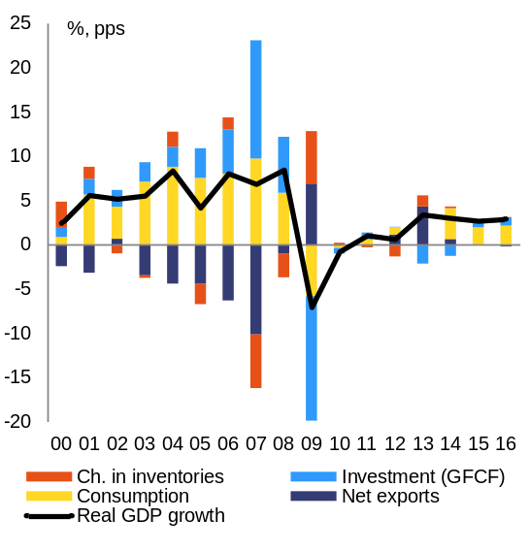
Source: European Commission
With the onset of the crisis, foreign private capital inflows declined sharply. This decline reflected both the increased risk aversion of financial markets and Romania’s vulnerabilities. It led to an external funding gap that was eventually closed by borrowing under a joint EU/IMF/World Bank financial assistance programme. The reduction in foreign capital inflows and the correction measures adopted under the programme led to an immediate but contained adjustment in domestic demand and to a quick recovery of economic growth, after a cumulated contraction in economic activity of almost 8 % over 2009-10.
Economic growth has been back in positive territory since 2011 and is forecast to remain robust over 2015-16. Since the crisis, GDP growth has been driven by a gradual recovery of domestic demand and strong exports. Despite a recent acceleration of economic growth, GDP is still below its pre-crisis level (Graph 1.2, expressed in 2010 prices). The pace of real GDP growth is estimated to have slowed down from 3.5 % in 2013 to 3 % in 2014, mainly due to a significant drop in investments. Romania’s economic growth is expected to remain robust in 2015 and 2016, mainly driven by domestic demand and accompanied by a stable labour market. GDP growth is forecast to stay above potential and remain robust at 2.7 % in 2015 and 2.9 % in 2016 based on the Commission 2015 winter forecast.
Graph 1.2: GDP dynamics
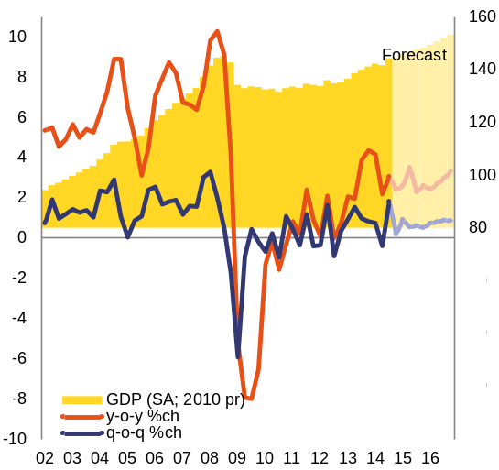
Source: European Commission
Further progress is needed in terms of real convergence to the EU average level. The authorities announced the intention to adopt the euro in 2019 but the challenges are substantial. In 2014, Romania fulfilled all the five numerical Maastricht criteria for joining the euro zone. However, as illustrated in Graph 1.3, the country is still well below the convergence level reached by recent euro adopters (i.e. Slovakia, Estonia, Latvia and Lithuania).
Graph 1.3: Income per capita, PPS
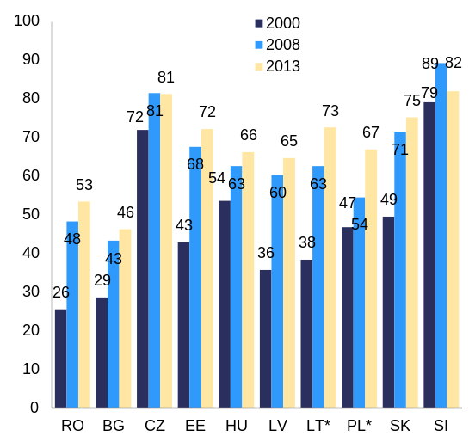
Note: * LT & PL estimation based on ESA 95,
100 represents EU average income per capita
Source: European Commission
The crisis had a large and lasting impact on the Romanian economy. Potential growth estimates show that recovering to pre-crisis growth rates is unlikely (Graph 1.4). After a large drop in 2009, potential growth has started a timid recovery. It is forecast to reach 2.9 % in 2019; this is 0.5 % lower than the average potential growth in the pre-crisis period (i.e. 1996-2008). In 2009-12, potential growth has been driven solely by capital accumulation, reflecting the high level of investment in the economy. In turn, in 2013 and 2014 investment fell sharply.
The level of investment remains above EU average. Investment accounts for almost 24 % of GDP in Romania as opposed to 19 % of GDP in the EU, in 2013. However, the contribution of investment to the overall competitiveness and growth potential is hampered by instable priorities over time for public investment, which represents almost 20 % of total investment (or 5 % of GDP). Ensuring efficient investments in public infrastructure is an important challenge for the Romanian economy. Developments in investment and implementation of the structural reforms announced under the current (precautionary) balance of payments assistance programme have an impact on the convergence process.
Total factor productivity is projected to gradually increase in the next years while growth contributions from labour are broadly neutral. This should come as a result of the labour and product market reforms started under the previous two balance-of-payments programmes. However, reforms have slowed down lately, limiting the increase in potential growth.

Graph 1.4: Components of potential growth
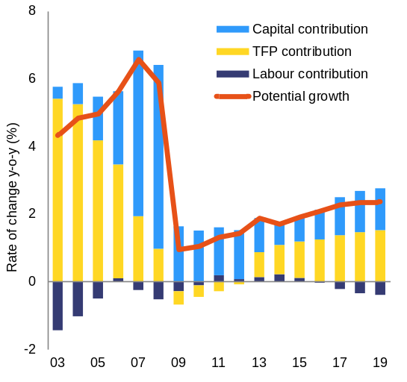
Source: European Commission
Price developments
Inflation was persistently high in Romania but has been decelerating sharply. The high pre-crisis levels of inflation were not reverted with the 2009 crisis. A succession of upward price shocks resulted in inflation levels well above those in the EU. A sharp drop during the 2008-09 crisis was followed by strong price increases. In 2011, significant increases in indirect taxation led to an inflation peak of 8.5 % (Graph 1.5). A temporary decrease at the beginning of 2012 was soon reverted, due to the pressure from rising food prices in the second half of the year and phasing-out of administrative prices in 2013.
Following a sharp decrease in 2014, inflation is forecast to remain moderate in 2015-16. After reaching an historical low of 0.9 % in June 2014, HICP inflation slightly picked up in recent months. Annual average inflation declined from 3.2 % in 2013 to 1.4 % in 2014 mainly reflecting a VAT cut for bread, a good harvest and lower global energy prices. It is forecast to remain at moderate levels and to reach an annual average of 1.2 % in 2015, mainly due to the significant decline in energy prices, subdued inflation in the EU and lower inflation expectations. Inflation is forecast to accelerate to 2.5 % in 2016 as the recovery in domestic demand continues.
Graph 1.5: Inflation
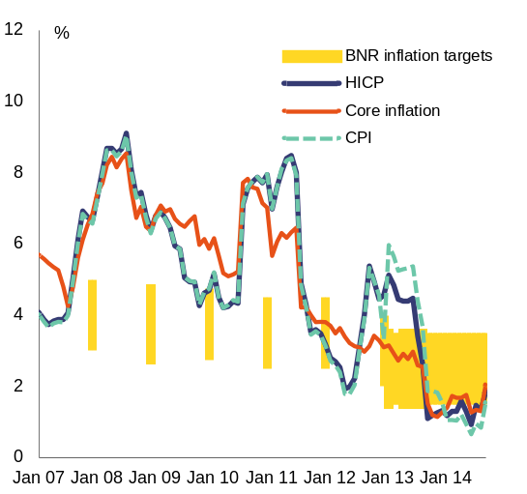
Source: NSI, European Commission
Labour market developments
The labour market shows signs of improvement in 2013 and 2014. Employment and activity rates in Romania continue to be among the lowest in the EU. The employment rate for the 20-64 age group stagnated in 2013, but then increased to 67.4 % in the third quarter of 2014. The recovery is forecast to continue in 2015 and 2016, supported by stronger GDP growth as compared to 2014. It will however still remain below the current EU average of 69.8 %.
Unemployment levels have been relatively stable also during the crisis. Romania’s unemployment rate has been hovering around 7 % for a long period, including during the crisis. This is below the average of its peer group and of the EU (Graph 1.6), but Romania also records a lower activity rate. The unemployment rate increased in 2013 to 7.3 % but decreased again to 6.7 % in 2014 and is expected to further decrease somewhat in 2015 and 2016.
Graph 1.6: Unemployment rates
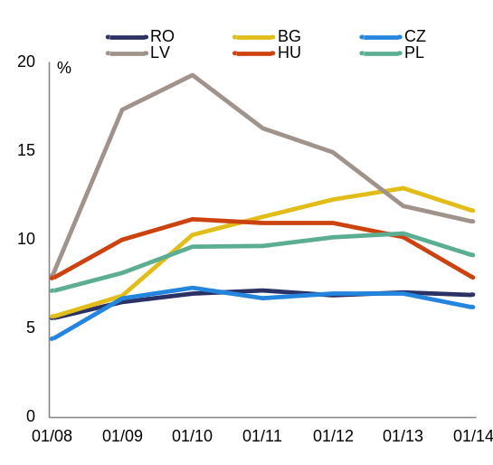
Source: European Commission
Public finances
Fiscal imbalances have gradually unwound as the budget deficit followed a decreasing path. Before and at the height of the crisis, Romania exhibited twin fiscal and current-account deficits, both exceeding 8 % of GDP. With the support of three consecutive EU/IMF programmes, Romania managed to reduce the budget deficit to 1.8 % of GDP in 2014 (according to the Commission 2015 winter forecast). The adjustment was frontloaded but spread over various years, with a reduction from 8.9 % in 2009 to 5.5 % in 2011 and to 3.0 % in 2012, when the Excessive Deficit Procedure was abrogated. Following a good outcome in 2013, the adjustment has slowed down in 2014. The 2015 deficit is forecast to be at 1.5 % of GDP. This is estimated to be in line with a structural deficit of 1.25 % of GDP, which corresponds to the target agreed under the balance of payments programme for Romania: reaching the medium-term objective of a deficit of 1.0 % of GDP in structural terms plus a so-called EU funds adjustor of 0.25 % of GDP. The latter is an additional budget allocation to be used only for a significant acceleration of EU funds absorption. Furthermore, Romania is adopting measures to strengthen fiscal governance. Public debt increased from 13.2 % of GDP in 2008 to 37.3 % of GDP in 2012, driven by high budget deficits and a contraction in output. Public debt is forecast to plateau out in 2015-16 at around 39 % of GDP as a result of the reduced deficit and the economic recovery.
Graph 1.7: Government deficit and debt (2006-16)
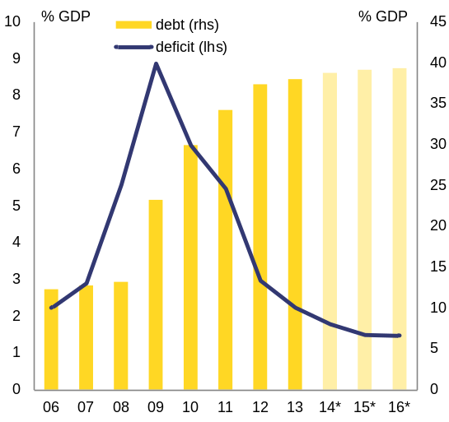
Source: European Commission
The tax mix has improved over the years, but tax policy is changing frequently and revenue collection remains weak. Over the past years, indirect taxation, such as VAT and excise duties, has gained weight in the tax mix. The tax wedge was reduced in 2014 by a cut in social security contributions of 5 pps. across the board, after an increase by 3 pps. in 2009. However, frequent changes in tax policy continue to disrupt the business environment. Tax collection remains weak, and the VAT gap is the biggest in the EU27, at 44 % of GDP in 2012.
The expenditure side still includes significant inefficiencies which weigh on Romania’s growth potential. Domestically financed investment projects sometimes lack thorough preparation, economic justification and steady financing. EU funds’ absorption is lagging behind, at only 52.2 % of the available structural and cohesion funds as of end-2014. Increasing public investment capacity remains a challenge. This is notably due to insufficient shift away from domestically financed projects towards projects co-financed with EU funds. Public investment efficiency also suffers from weaknesses in public investment management. The public wage bill remains contained, but the unified wage grid across the public sector is still not implemented (see section 4.1).
Court rulings and loss-making state-owned enterprises pose risks regarding future budget deficits. Unforeseen court rulings with significant budgetary impact were common in past years. Anticipating possible legal risks ahead remains a challenge. Some state-owned enterprises and other companies reclassified in the general government contributed to the budget deficit, which reflects inefficiencies and weak corporate governance (see section 3.2).
Continued fiscal adjustment and sustainable public debt contribute to comfortable financing conditions. Romania lost access to international financial markets in 2009, requiring EU/IMF financial assistance, but regained market access quickly. Since 2011, Romania is fully financing its deficit and debt on the financial markets. In 2013, JP Morgan included Romania’s treasury bonds in its emerging market index. All three major rating agencies rank Romania at investment grade (Table 1.1) and credit default swap (CDS) spreads are at their lowest levels since mid-2007 (Graph 1.8). Still, market conditions have proven sensitive to deteriorating market sentiment. Both announcements of tapering by the Federal Reserve and the early 2014 financial turmoil in Turkey have immediately impacted financing conditions and put pressure on the exchange rate.
Table 1.1: Evolution of long-term ratings
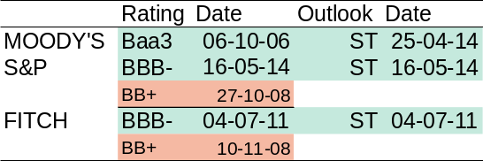
Source: European Commission

Graph 1.8: CDS spreads over BUND
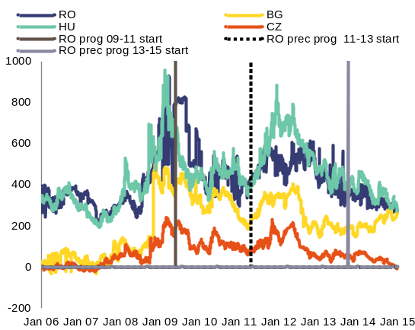
Source: European Commission
Financial sector
Romania’s financial sector is bank-based and 80 % of the banks are foreign owned. Overall, credit institutions hold the largest share of the financial system’s assets (roughly 80 %) (Graph 1.9). Banks with Austrian capital have dominated the market since 2000, followed by French and Greek banks.
Graph 1.9: Banking assets evolution (2000-13) and composition by ownership
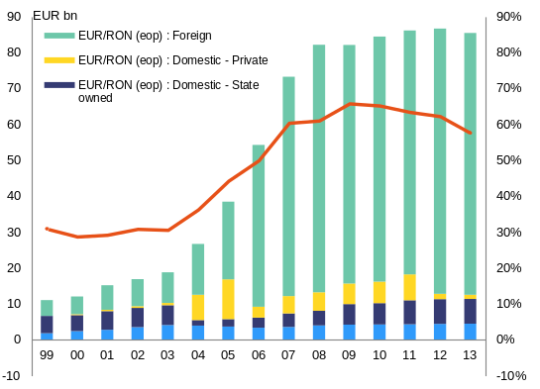
Source: National Bank of Romania (NBR), annual reports
The Romanian banking sector has weathered well the economic and financial crisis and capitalisation remains strong. No public intervention measures to support the banking sector were needed. Non-performing loans declined from 22.6 % in March 2014 to about 14 % in December 2014 (see Graph 3.5 in section 3.3). Moreover, the risks associated with high non-performing loans have been mitigated by the prudent loan-loss provisioning policy of the banking supervisor.
Provisioning for impaired assets is weighing on banks’ profitability. Against the backdrop of increasing loan-loss provisions and high funding costs (in particular for banks with Greek and Cypriot capital), banking sector profitability came under pressure over the last years (Graph 1.10). After three years of losses, in 2013 the banking sector recorded a modest aggregate profit. In 2014 banks' profitability suffered again due to measures implemented for the clean-up of banks' balance sheets under the non-performing loans' resolution plan of the National Bank of Romania. According to preliminary data, the sector recorded a loss of RON 4.3 billion at the end of December 2014.
Graph 1.10: Profit ROA and ROE
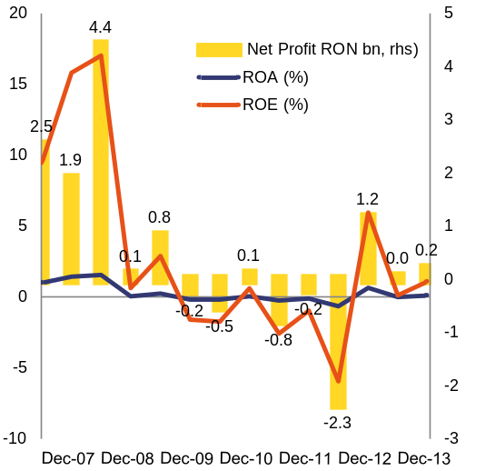
Source: NBR
Credit growth remains subdued due to both supply and demand factors. In line with regional trends, in 2014 the Romanian banking system experienced a further contraction in the loan stock, a decline in parent bank funding, and an expansion of the local deposit base, the latter due to precautionary savings by both households and companies. On the back of these developments, the funding gap was also reduced. The loan-to-deposit ratio declined to just below 100 % at end-July 2014 for the first time after almost seven years and to 91.4 % at end-December 2014.
Foreign bank deleveraging has continued in 2014. During the first balance of payments assistance programme (2009-11), foreign-owned banks maintained their exposure to Romania in the framework of the Vienna Initiative. Since spring 2011, however, there has been a gradual and orderly deleveraging with the exposure of these banks declining by about 25 % as of June 2014, compared to March 2009.
The main vulnerabilities and challenges faced by the banking sector have been mitigated so far, but pockets of vulnerability remain. The main challenges regard: (i) the still significant level of non-performing loans; (ii) ongoing but orderly deleveraging; (iii) substantial share of foreign-currency-denominated loans; (iv) legislative initiatives which may have an adverse impact on financial sector stability; and (v) geopolitical risks potentially impacting the parent banks of the Romanian affiliates (see section 3.3).

Box 1.1: Economic surveillance process
The Commission’s Annual Growth Survey, adopted in November 2014, started the 2015 European Semester, proposing that the EU pursue an integrated approach to economic policy built around three main pillars: boosting investment, accelerating structural reforms and pursuing responsible growth-friendly fiscal consolidation. The Annual Growth Survey also presented the process of streamlining the European Semester to increase the effectiveness of economic policy coordination at the EU level through greater accountability and by encouraging greater ownership by all actors.  In line with streamlining efforts this Country Report includes an in-depth review — as per Article 5 of Regulation no. 1176/2011 — to determine whether macroeconomic imbalances exist, as announced in the Commission’s Alert Mechanism Report published in November 2014.  This Country Report includes an assessment of progress towards the implementation of the 2014 country-specific recommendations adopted by the Council in July 2014. The country-specific recommendations for Romania concerned the EU/IMF financial assistance programme implementation, budget, taxation, pension and health system, labour market, social policies, public administration, energy, transport and EU funds’ absorption. |  | So far, the surveillance of imbalances and monitoring of economic policies in Romania has taken place under the balance of payments adjustment programme, which is supported by precautionary financial assistance. However, since the agreement of the arrangement in autumn 2013, no semi-annual review of the programme has been successfully completed and the programme is set to end by September 2015. In autumn 2014 it was deemed useful to integrate Romania in the Macroeconomic Imbalance Procedure surveillance. In addition to regular programme review missions, the Commission’s assessment in this Country Report is based on the December bilateral meetings with the Member State and the associated reporting on the implementation of the 2014 country-specific recommendations. Furthermore, the Commission carried out in January 2015 a fact-finding mission for the purpose of the in-depth review, which ran in parallel with the balance of payments review mission.  Country Reports provide the basis for the recommendations that the Council will address to Member States in June. The earlier publication of the Commission’s assessment this year will allow time for more detailed discussions and strengthen the multilateral nature of the European Semester. This will help to advance Europe’s reform agenda.

Table 1.2: Key economic, financial and social indicators
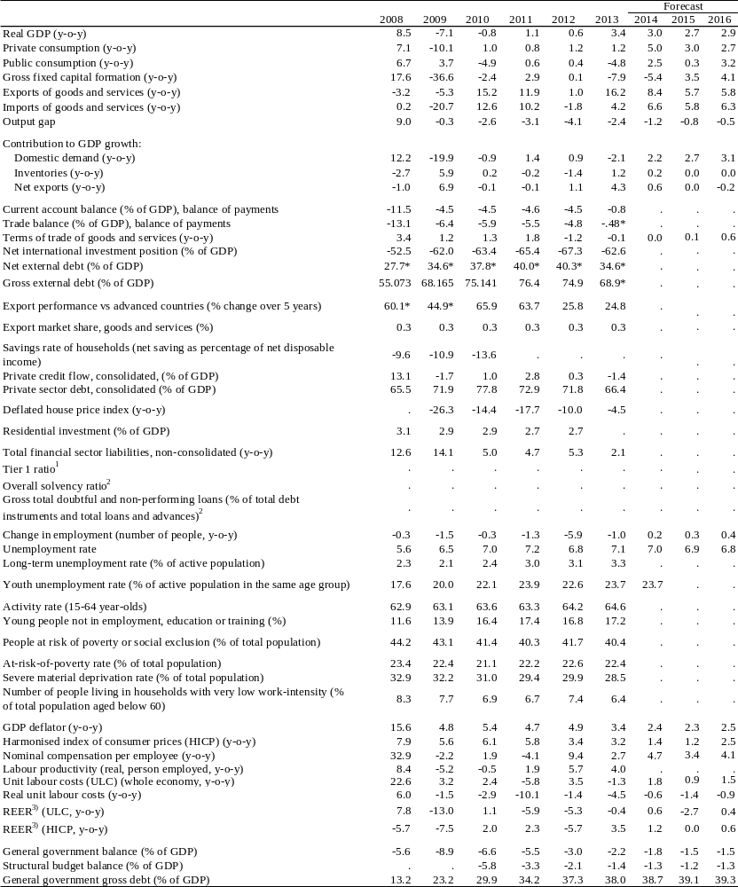
(1) domestic banking groups and stand-alone banks.
(2) domestic banking groups and stand-alone banks, foreign-controlled (EU and non-EU) subsidiaries and branches.
(3) Real effective exchange rate
Source: European Commission

Table 1.3: MIP scoreboard indicators
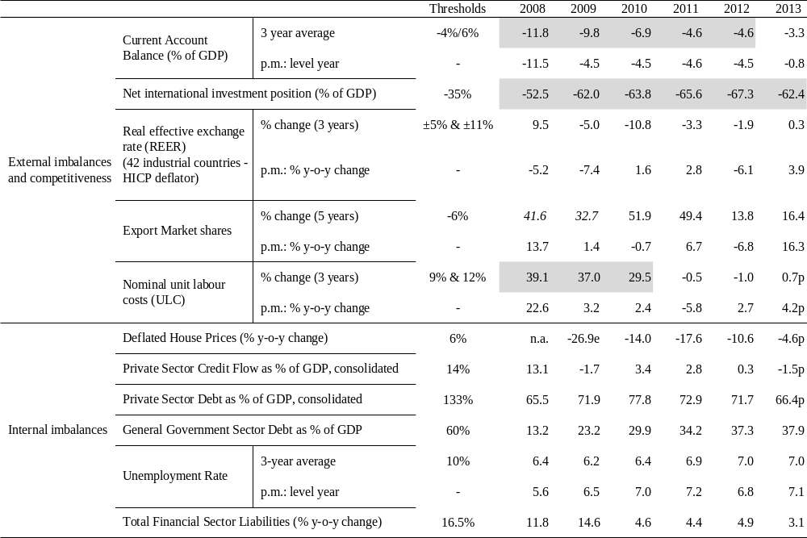
Flags: e: estimated. p: provisional.
(1) Figures highlighted are those falling outside the threshold established in the European Commission’s Alert Mechanism Report. For REER and ULC, the first threshold applies to euro area Member States;
(2) Figures in italics are calculated according to the old standards (ESA95/BPM5);
(3) Export market share data: total world exports are based on the fifth edition of the Balance of Payments Manual (BPM5).
Source: European Commission

Net international investment position
The net international investment position of Romania has substantially improved since 2012. Romania had a net international investment position of -58.3 % of GDP at end-July 2014, which is the lowest value since the first quarter of 2010 (Graph 2.1.2) and a significant improvement as compared to -67.5 % of GDP in 2012, when the NIIP hit a historical low. This correction comes as a result of strong nominal GDP growth and a low current-account deficit (Graph 2.1.2), in spite of a deteriorating investment income balance and negative valuation effects.
A negative net international investment position is not unusual for a catching-up economy. Peer countries face similar or, for the most part, even more negative net international investment positions (Graph 2.1.1). Those most exposed in the peer group (Hungary, Bulgaria and Latvia) started reducing their international exposure earlier than Romania, possibly as a reaction to nervous international financial markets. Still, an elevated negative net international investment position makes a country more exposed to sudden stops or reversals of capital flows. It also feeds back into the current account through higher net-income deficits, as in the Romanian case (Graph 2.1.1). Moderate current-account deficits can thus help to keep the net international investment position in control in the long run.
Graph 2.1.1: NIIP in Romania and peer countries
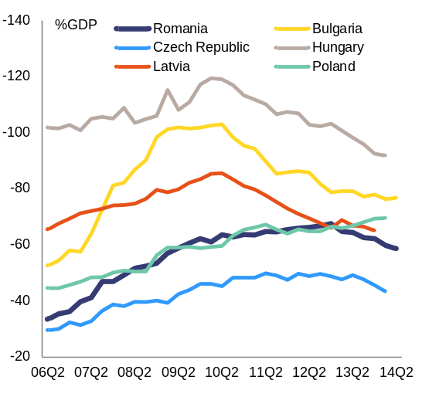
Source: European Commission

Graph 2.1.2: Decomposition of rate of change of NIIP
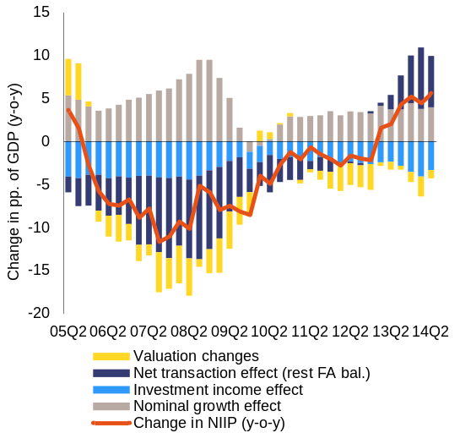
Source: European Commission
In the expansionary years prior to the crisis the deterioration of the net international investment position was financed in part from rather volatile sources. A considerable part of the financing of the net international investment position stemmed from volatile or easy-to-retrieve sources, such as portfolio investments and loans, exposing Romania to financial market risk (see Graph 2.1.3 and section 3.3). The sudden deterioration of market sentiment during the global economic crisis put significant strain on public borrowing and the exchange rate, leading to a significant external funding gap that in early 2009 was eventually closed by a joint EU/IMF financial assistance programme of about EUR 20 bn. Together with the decision by the international banks to maintain their exposure to Romania, under the Vienna Initiative, this financial support and the economic adjustment triggered by the balance of payments assistance programme helped towards a gradual unfolding of Romania’s imbalances.
Graph 2.1.3: NIIP financing
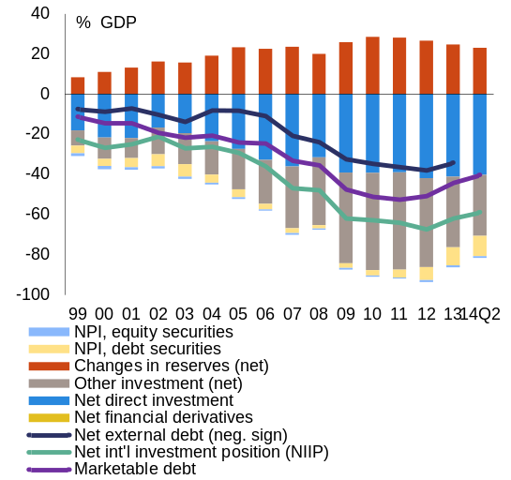
Source: European Commission
The composition of the net international investment position confirms the persistence of volatile financing sources. Net portfolio investment and the net balance of other investments were -72 % of GDP at end-2013, substantially higher than the -43 % of GDP for net foreign direct investment liabilities. This composition is relatively unfavourable compared to regional peers.
Foreign direct investment is, however, recovering its role as a stable source of funding. From a record low of 17 % of GDP in 2002, the net stock of inward foreign direct investment increased steadily in Romania until 2009, to just above 40 %. In flow terms, foreign direct investment has declined sharply from the onset of the financial crisis. Foreign direct investment inflows fluctuated between 1.3 % and 1.9 % of GDP in 2010-13. This is well below the average of 7.4 % of GDP over 2004-08. Consequently, inward foreign direct investment stocks have increased only slightly since 2009, to 43 % of GDP at end-2013. Given the evolution of the net international investment position, this means that, before the crisis net foreign direct investment financed a decreasing proportion of the net external position: falling from 94 % of the net international investment position in 2005 to 66 % in 2009. Since 2011, however, this share has been rising again, reaching 69 % in 2013. The trend reversal is only partially due to the lower negative net international investment position.
Current-account developments
Romania’s current-account deficit decreased in recent years. It has rebalanced from a deficit of over 10 % of GDP in 2006-2008 to around 1 % of GDP in 2013. The adjustment took place in two steps (Graph 2.1.4). In 2009, the current account deficit adjusted to 4.2 % of GDP, mainly driven by lower imports. Following a period of stability, the deficit dropped again in 2012-13 to 1.1 % of GDP. This second adjustment was broader in scope. It resulted from strong exports, stagnant imports and a decrease in (negative) primary incomes. The strong export growth, and increasing services trade surplus is indicative of the structural change in the Romanian economy (see below). The current account surplus is estimated at 1 % of GDP in 2014 and to stabilise in 2015 and 2016.

Graph 2.1.4: Current account balance by components (4qma)
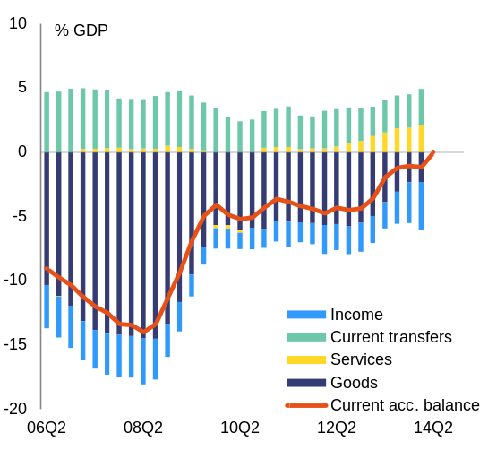
Source: European Commission
Lower government financing needs and corporate deleveraging helped the current-account adjustment that started in 2009. With the unfolding of the crisis, non-financial and financial corporations in Romania increasingly adjusted their balance sheets, turning previously growing borrowing needs into surpluses (Graph 2.1.5). In the financial sector much of the adjustment is attributed to the reduction of exposure of the foreign parent banks to the Romanian banking sector. Additional factors supporting the readjustment process were the successive EU/IMF assistance programmes, which reduced the government's financing needs and ensured underlying structural reforms.
Households did not exhibit the same adjustment capacity. Strongly exposed to foreign-currency denominated mortgage-backed loans (see section 2.3), households saw their external negative balances growing both as a percentage of GDP and as a percentage of their disposable income. These developments are further discussed in section 2.3.2.
Graph 2.1.5: Net lending by sector
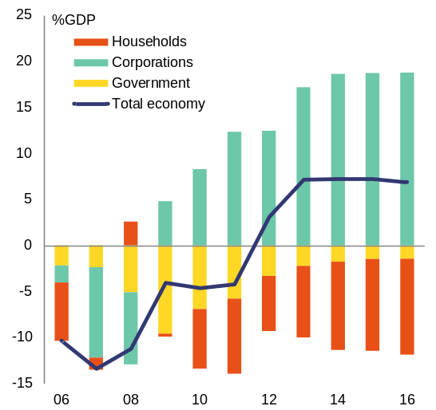
Source: European Commission
A comparison with regional peers shows that the current-account adjustment of Romania fits in a wider pattern while being more gradual. Like that of most countries in Central and Eastern Europe, Romania’s current account adjusted sharply in 2009, which was made necessary by the correction of international financing flows. The joint EU/IMF assistance programmes allowed Romania in the following years to undergo a more gradual adjustment (Graph 2.1.6) and thus to limit temporary or even permanent losses of growth.
Graph 2.1.6: Current-account balance in peer countries
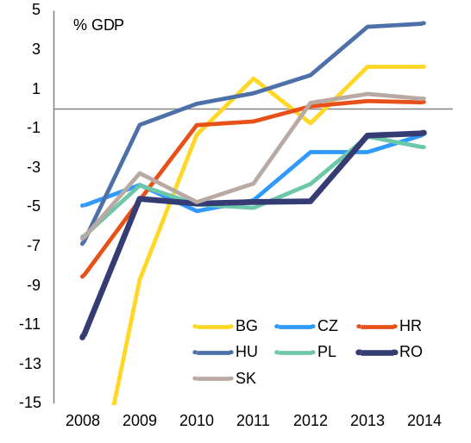
Note: BG in 2008, 22.7 % of GDP
Source: European Commission
Exports have been the main driver of the recent improvement in the current account balance. Exports grew sharply in recent years, to reach a record high of 41 % of GDP in 2013 (Graph 2.1.7), against 27 % of GDP in 2008 and 2009. Imports, in turn, have been largely stable, at around 42 % of GDP. Both goods and services have contributed to this result, but the evolution of the latter was more noticeable (Graph 2.1.4). In 2013 alone, services contributed 0.9 pp. of GDP to the reduction of the current account deficit. This positive development is partly due to improvements in data collection introduced in 2013, which had a positive impact on the services balance, suggesting that past current account deficits were moderately overestimated. Future growth in services’ exports may be negatively affected by the ensuing basis effect.
The growth of exports translated into strong gains in export market shares. Romania’s market share grew on average by 4.6 % per year in the decade 2004-13. Romania was a top performer among EU Member States in 2013, recording almost 15 % growth in export market share (Graph 2.1.8). Market share growth was stronger for services (6.9 % per year in the period 2004-13) but also important for manufacturing (4.1 % per year) (Graph 2.1.9).
Graph 2.1.7: Romanian exports and imports
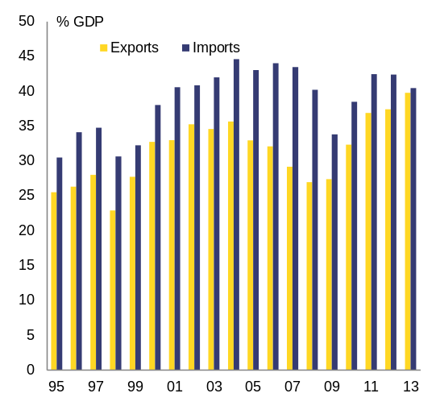
Source: European Commission

Graph 2.1.8: Growth in export market shares in the EU
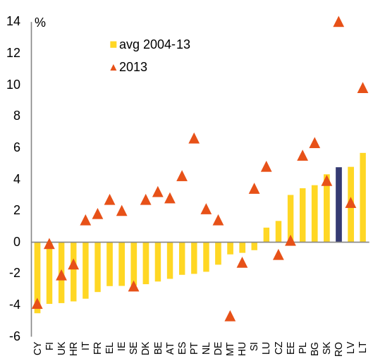
Source: European Commission
The improvement in Romania’s current account is structural in nature. The current-account balance used to exhibit a strongly negative correlation with the output gap during between 2002 and 2009, revealing that the built up of the strongly negative current account was driven by booming internal demand. However, in recent years this correlation did not hold anymore, indicating that the improvement is not only driven by cyclical factors (Graph 2.1.10). In addition, cyclical and non-cyclical current-account balances as percentage of GDP converge towards a balanced level since 2012 (Graph 2.1.11).
Graph 2.1.9: Export market share decomposition
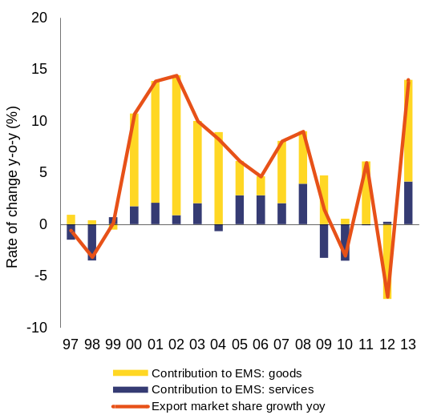
Source: European Commission

Graph 2.1.10: Current account balance and output gap
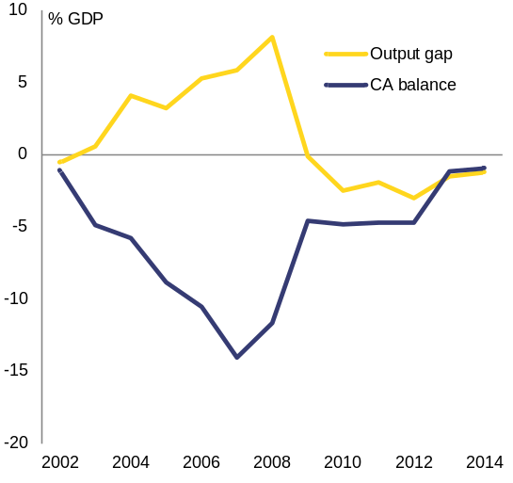
Source: European Commission
The improvement in Romania’s current account has been accompanied by a readjustment in the exports’ structure. Exports of food and agriculture products have experienced the highest growth rates since the crisis (Graph 2.1.12). Together with vehicles and machinery and electrical equipment, they represented 58 % of Romania’s total exports of goods in 2013. At the same time, sectors such as textiles and footwear suffered a sharp drop in their exports, a trend that started well before the crisis. Metal products have also been losing weight. As for the exports of services, the strong performance is largely due to transportation and business services. For the latter, this may also reflect the good performance of goods exports.
Graph 2.1.11: Cyclical and non-cyclical CAB
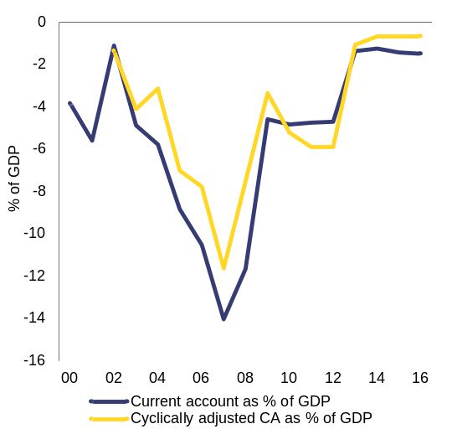
Source: European Commission
The current account deficit is expected to widen in 2015-16 to around 1 % of GDP. Strong domestic demand is expected to boost imports faster than exports. This was already apparent in the first nine months of 2014, with exports above expectations (9.1 % growth year-on-year) but still being outpaced by imports’ growth (9.6 % year-on-year).
The EU is the destination for 70 % of Romania’s exports. The proportion of exports going to the EU has decreased somewhat since Romania joined in 2007. This evolution is due to the sharp decline of exports to Italy, from 17 % in 2007 to 12 % in 2013 (Graph 2.1.13). Other EU countries only partially compensated for this. Outside the EU, the most relevant markets are neighbouring countries: Turkey, the Russian Federation, Ukraine and Moldova, but in this group only Turkey has a share above 5 %.
Graph 2.1.12: Evolution of exports by groups of products
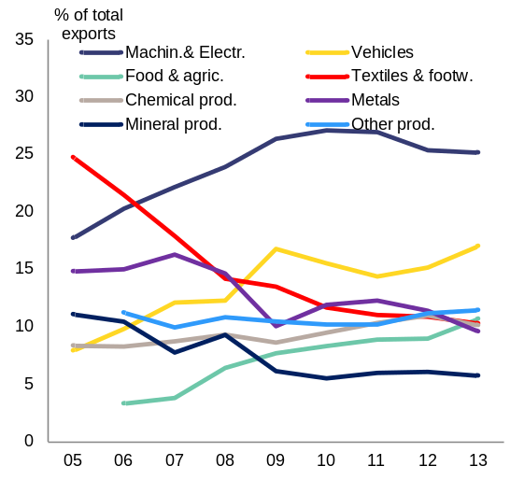
Source: European Commission

Graph 2.1.13: Evolution of exports for selected destinations
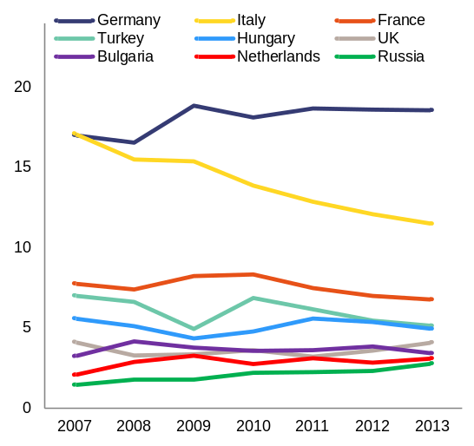
Source: European Commission
Romania’s exports to its main markets followed a divergent pattern. In 2007, Germany and Italy had the same share of Romania’s exports of goods (17 % of the total). In the following years, exports of clothing and footwear to both countries dropped significantly. In the case of Germany, this was more than offset by higher exports of machinery and electrical equipment, and of chemical products, bringing its total to 19 %. There was no such substitution of exports to Italy, so the proportion of Romania’s goods exports to Italy dropped to 11.5 % (Graph 2.1.14). These developments also reflect broader trends in Europe, including a rapid increase in intra-industry trade and Germany’s strong position in this regard.
Graph 2.1.14: Exports to Germany and Italy, by groups of products
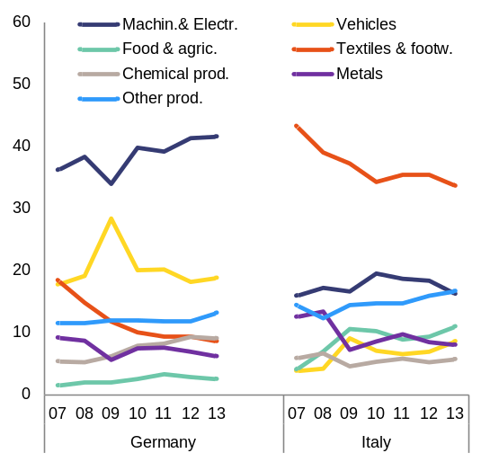
Source: European Commission
Current transfers have remained broadly stable over the past years, while the balance of net incomes has deteriorated in 2013. Private transfers, mostly remittances from the Romanian diaspora, accounted for 73 % of net current transfers in 2013. They have remained relatively stable over 2010-13, even if apparently aligned to the business cycle in the euro area. The remaining current transfers, linked to EU structural funds’ absorption, have somewhat increased at the end of 2013 and at the beginning of 2014, but slowed down again since then.
The balance of primary incomes somewhat decreased. It fell from -1.2 % of GDP in 2010 to -2.7 % of GDP in 2014, as dividends and interest from foreign direct investment have increased sharply due to an improved macroeconomic environment and higher corporate profits. Further increases in dividends and interest from foreign direct investment are forecast, as the economy is expected to continue growing above potential. Such a primary income balance is typical for a catching-up economy with high shares of foreign capital (Graph 2.1.15).
Graph 2.1.15: Balance of primary incomes
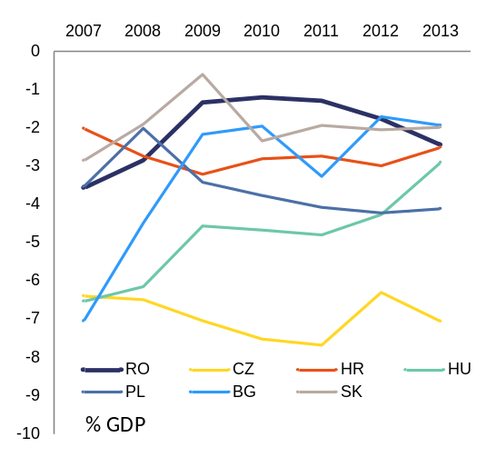
Source: European Commission
Cost competitiveness
Romania’s cost competitiveness improved between 2009 and 2012, but deteriorated somewhat in 2013. Following years of strong growth, unit labour costs-based real effective exchange rate decreased sharply in Romania in 2009 (Graph 2.1.16). It results from the nominal devaluation and lower compensation per employee. At least some of the recent trade dynamism can be linked to this favourable cost development. In this context, the real effective exchange rate appreciation in 2013 could prove a turning point, especially since shifts in competitiveness usually affect trade performance with a lag. Whether that will be the case depends on the evolution of unit labour costs and on the dynamism of Romania’s tradable sector in terms of non-price competitiveness.
Unit labour costs' growth is slowing down but is still higher than in peer countries. Since the financial crisis, unit labour costs have recorded historically low growth rates in Romania (Graph 2.1.18). Subdued compensation per employee (in 2009-12) and productivity gains (in 2013) explain this reduction. They did, nevertheless, continue to grow above those of Romania’s main competitors (Graph 2.1.18).
Graph 2.1.16: REER decomposition
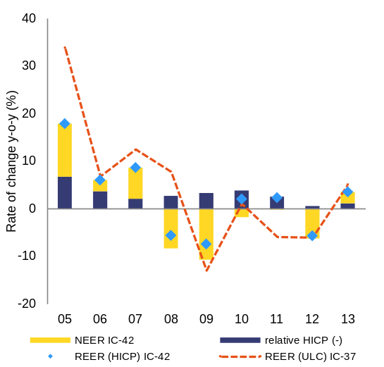
Source: European Commission
Unit labour costs in the tradable sector are faring better than in non-tradables. The aggregated unit labour costs are pushed upwards by the non-tradable sector (Graph 2.1.17), where productivity gains were insufficient to compensate for increases in labour costs. In the tradable sector, productivity gains and contained labour compensation converged to restrain unit labour costs. Consequently, sectors exposed to international competition were able to retain competitiveness, with a positive impact on the trade balance. However, the increase in unit labour costs in the non-tradable sector poses a risk of higher costs in protected sectors feeding into the costs of tradables, eroding Romania’s international competitiveness.
Competitiveness improvements over 2008-12 came to a halt in 2013. When corrected for export prices, Romania’s unit labour costs-based real effective exchange rate shows a substantial improvement since 2007. This ratio can be seen as a proxy for profitability of exporting firms. The adjustment was stronger in Romania than in the peer group and the EU as a whole, suggesting strong competitiveness gains. This indicator warns, however, that 2013 may have been an inversion point.
Wage growth has been moderate but uneven, with the wage distribution becoming increasingly compressed at the bottom due to strong increases in minimum wages. The minimum wage in Romania is RON 975 (around EUR 217) as of 1 January 2015 and used to be low also in relative terms (36.3 % of average gross earnings in 2013). It has been increasing sharply since 2012 and is expected to reach close to 48 % of average gross earnings at the end of 2016. During 2009-2012, the minimum wage has increased cumulatively by 17 %, against an increase in the consumer price index by 16 %. Over the same period, the average wage increased by 19 %. Growth in the last two years followed a period of roughly no increase in real terms, and this increase has so far not reverberated at the higher levels of the wage distribution. However, this implies that wage scales in different sectors (including in the public sector) are being increasingly compressed and the proportion of employees earning the minimum wage is reaching high levels (27 % of total employees at the end of 2014, a substantial increase from the 8 % registered in 2011). With the planned increases for 2016, to RON 1200, the share will further increase.
Graph 2.1.17: ULC in tradable and non-tradable sectors
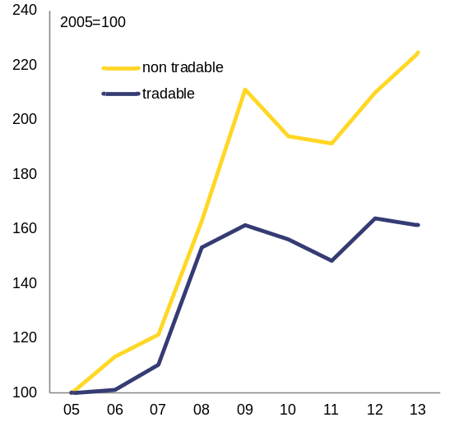
Source: European Commission
Minimum wage setting processes are not following a clear and transparent mechanism. According to the Romanian Labour Code, the gross minimum wage is established through a government decision, after consultation with social partners. Prior to the abolition of the national level of collective bargaining with the reform amendment of the Labour Code and of the new Social Dialogue Law in 2011 a number of terms of employment and working conditions including a national minimum wage floor (different from the statutory minimum wage set by the government) and a grid with coefficients depending on qualifications were negotiated and set by a national collective contract which covered all employees in the country. No explicit guidelines exist with respect to the criteria to be followed. Changing the minimum wage without properly taking into account underlying economic and labour market conditions does not ensure a balance between facilitating employment and competitiveness, on the one hand, and safeguarding labour income on the other. In particular, it can pose risks in terms of increased pressure on the overall wage distribution, pushing less productive workers into unemployment and informality and distorting education and skills’ wage premia. Discretionary increases can also contribute to making the business environment less predictable. The Romanian authorities are reviewing the wage setting mechanisms in place in other EU Member States, and are planning to table a discussion with the social partners on the criteria to be followed in setting the minimum wage in the course of 2015.
Graph 2.1.18: Decomposition of ULC
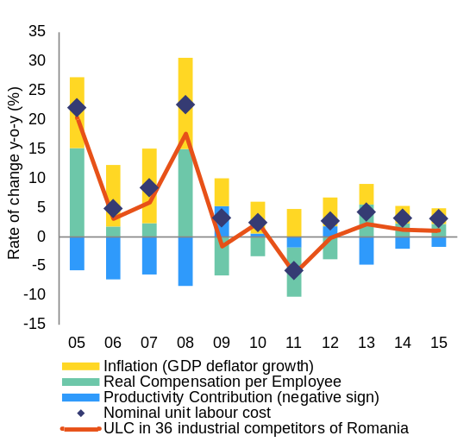
Source: European Commission

Graph 2.1.19: REER vs. export prices
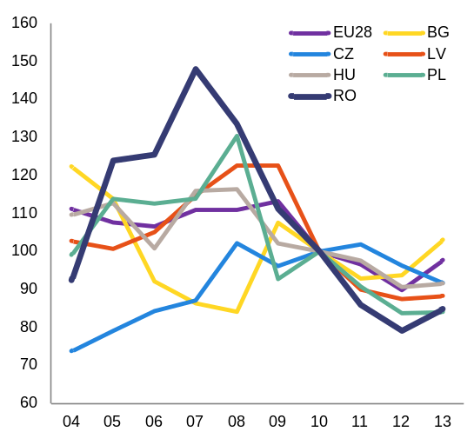
Source: European Commission
Labour productivity in Romania is the second lowest in the EU. Romania faced a decrease of around 4 % in labour productivity during 2008-10, and fell by an additional 0.5 % during 2011-12. In 2013 labour productivity grew by almost 5 %, providing the first clear indication of an improvement (Graph 2.1.21). The labour productivity losses of the last years can be seen as an indication of the low level of adjustment capacity in the economy.
Graph 2.1.20: Labour productivity per hour worked (EU27=100)
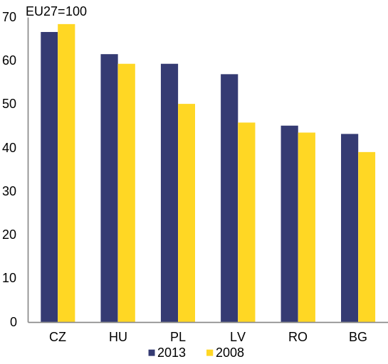
Source: European Commission
The structural adjustment between 2008 and 2012 had unequal productivity benefits. The decomposition of labour productivity growth rate (Graph 2.1.22) shows that the sectoral redistribution of resources in the economy favoured less productive sectors and pulled down aggregate productivity performance by 10 percentage points (7.6 percentage points from the shift effect and 2.3 percentage points from the interaction effect). The shift of resources in sectors with high productivity or high productivity growth (within effect in Graph 2.1.22) made a positive contribution of around 5 percentage points, which was not enough to balance the overall productivity losses of -5 %.
Graph 2.1.21: Labour productivity in Romania 2008-2013
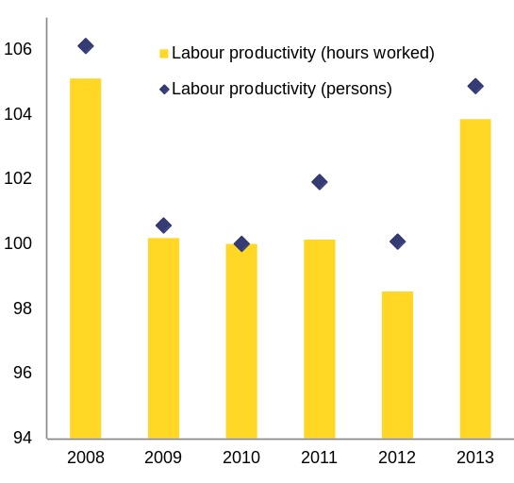
Source: European Commission
Manufacturing and real estate are the sectors with the highest within-sector productivity improvements and thus positive contribution to the aggregate labour productivity. Productivity improvements are also observed in trade, transport and accommodation, in construction and in professional, scientific and technical activities (Graph 2.1.23). Productivity in the agricultural sector is low, and it has followed a decreasing path in the recent years.
Graph 2.1.22: Decomposition of aggregate labour productivity growth
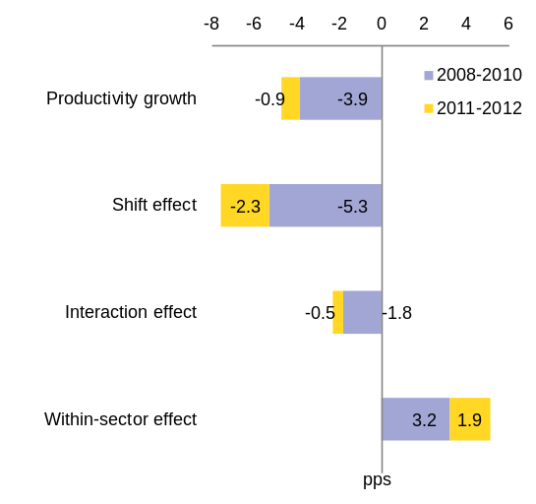
Note: Shift effect, indicates the effect of the reallocation of resources to sectors with different productivity levels. Interaction effect, indicates the effect of the reallocation of resources to sectors with different productivity growth rates. Within-sector effect, indicates the effect of productivity gains/losses in each sector of the economy.
Source: European Commission

Graph 2.1.23: Productivity gains/losses due to changes in sectoral productivities (within effect)
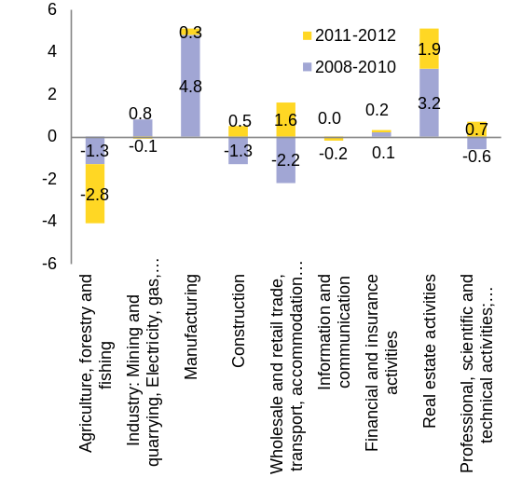
Source: European Commission
Non-cost competitiveness
The somewhat lower dynamism of Romania’s main geographic and product markets has been counterbalanced by market share gains in these markets (Graph 2.1.25). The geographic specialisation was rather a hampering factor for Romania’s exports while the product specialisation was rather neutral. The exceptionally good results in 2013 can only partially be explained by the improved economic conditions in Romania’s main markets (see Graphs 2.1.24). Even in such a good year, the contribution of specialisation to market share gains was negligible. In turn, Romania was able to gain market shares in these markets.
Graph 2.1.24: Dynamism and competitiveness of exports (goods) in top-10 destinations, 2012-13
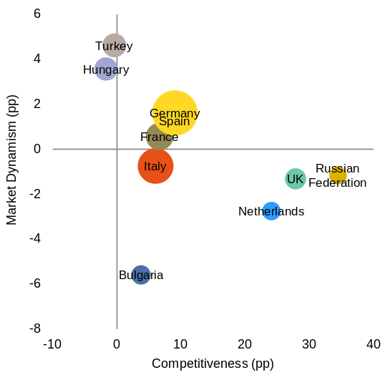
Source: European Commission
Over the last decade, manufacturing moved up the respective value-chains, but progress may have stalled. In 2013 manufacturing as a proportion of total value added in Romania was the second highest in the EU (25 % of gross value added comparing to 15 % in the EU). Manufacturing also plays an important role as the main driver of exports.
The revealed comparative advantages indicator suggests an increase in intra-industry trade. Usually this is associated with more integrated production chains (Graph 2.1.26). However, the import content of exports has been dropping in almost every sector, which suggests rather less integration into international production chains (Graph 2.1.27).
Graph 2.1.25: Geographical and sectoral composition of nominal USD rate of change of goods exports
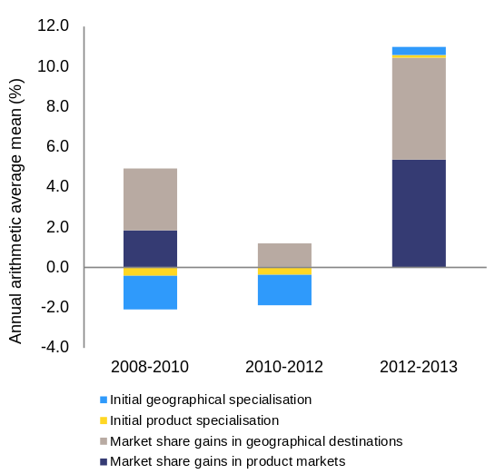
Source: European Commission

Graph 2.1.26: Revealed comparative advantages (goods)
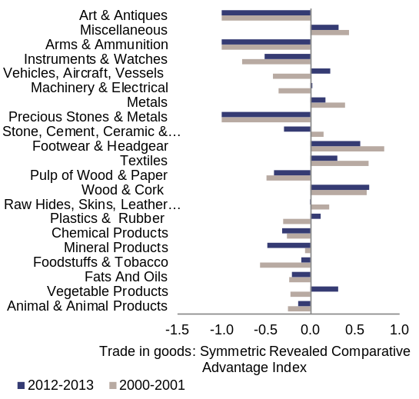
Source: European Commission
High-tech products’ share of total exports increased sharply as compared to a decade ago, but recent trends are less positive (Graph 2.1.29). After peaking in 2010, the high-tech products’ share of exports fell in 2013 to its 2008 level, lower than in all other EU Member States except Bulgaria.
Graph 2.1.27: Import content of exports
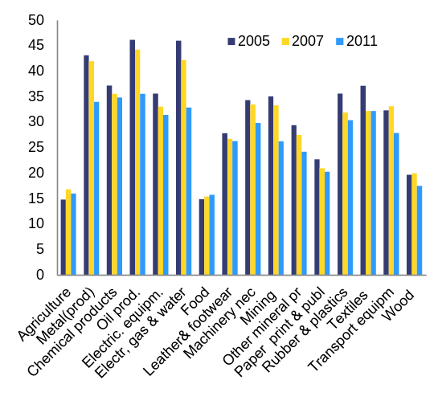
Source: European Commission

Graph 2.1.28: High-tech products as a proportion of exports in peer countries
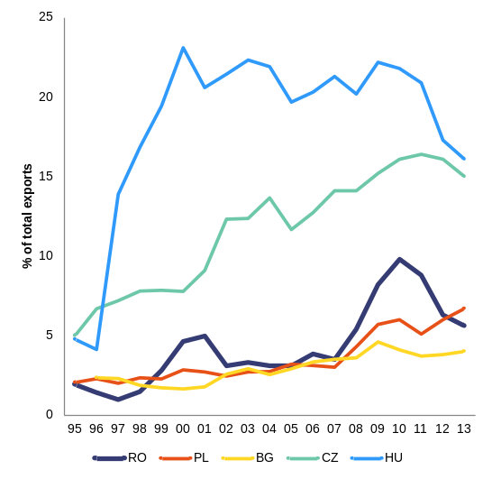
Source: European Commission
Romania lags behind other EU Member States in terms of research and development and innovation capacity. Businesses’ expenditure on research and development was equivalent to 0.19 % of GDP in 2012, seven times below the EU average. It fell further in 2013, to 0.12 % of GDP (despite the existing tax incentives for eligible research and development costs). The underfinancing in the research and development affects the system in structural terms, resulting in a brain drain and decreased quality of human skills. Romania is also among the worst performers in the innovation union scoreboard and the only EU Member State not having registered any improvement in this indicator between 2008 and 2013. The government has adopted a number of policy measures to increase the economy’s capacity for research and innovation. A number of these are, however, not yet fully operational or are rarely used. The cooperation between the public and the private sector in research is also weak. The low level of investment in research and development stands in contrast to relatively high level of total investment in the country.
Graph 2.1.29: Share of high-tech products in exports
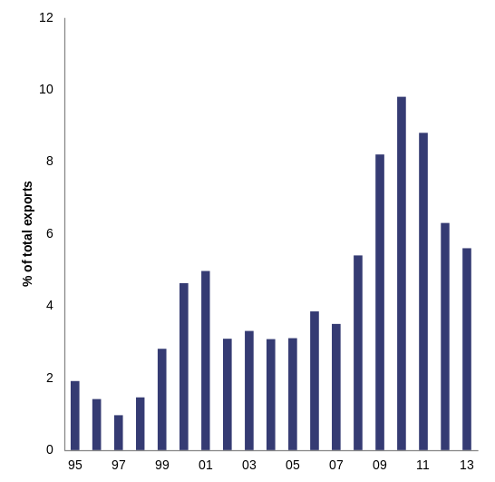
Source: European Commission
Gross fixed capital formation spending is among the highest in EU. Gross fixed capital formation was on average 26 % of GDP between 2009 and 2013 (Graph 2.1.30) and remains well above the EU average. The main areas on investment include construction, machinery, and transport equipment, a structure that is typical for middle income countries like Romania. A deepening of the supply chain in machinery and transport might raise technology- and innovation-related investments in the future, but is not yet apparent in the data. Investment in equipment has an average of 10 % of GDP.
Graph 2.1.30: GFCF by type
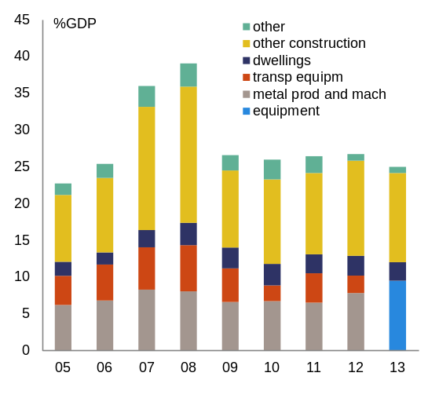
Source: European Commission
Foreign direct investment
Inward foreign direct investment, as an important long-term source of financing, is diversified in sectoral terms. With a large part of the Romanian banking sector being foreign owned, foreign direct investment in services is a key component of inward foreign direct investment, followed by manufacturing (Graph 2.1.31). Within manufacturing a wide range of sectors profit from foreign direct investment (Graph 2.1.32).
Most foreign direct investment into Romania has its origin in the EU. Statistics on the origin of foreign direct investment are difficult to interpret. In the case of Romania, the Netherlands invest the most, followed by Austria and Germany (Graph 2.1.33). However, these figures may be distorted as many international companies are formally headquartered in the Netherlands, or have the holding company of their European activities in that country.
Foreign direct investment into the tradable sector supports export competitiveness, while credit-boom driven foreign direct investment into the construction sector has been correcting. Since the crisis, inward foreign direct investment in tradables outperformed foreign direct investment in non-tradables. Over 2009-12, the proportion of foreign direct investment into the tradable sectors grew by 1.7 % per year, while that of non-tradables grew by 0.9 %. Reflecting the credit boom correction, the stock of foreign direct investment into real-estate activities and the construction sector fell in 2010 and has stagnated since (Graph 2.1.34).
Graph 2.1.31: Stock of FDI per sector, 2013
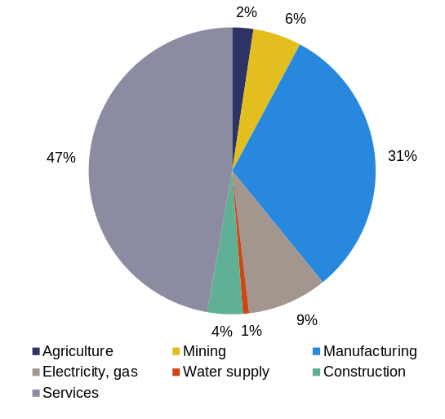
Source: European Commission

Graph 2.1.32: Stock of FDI in Manufacturing
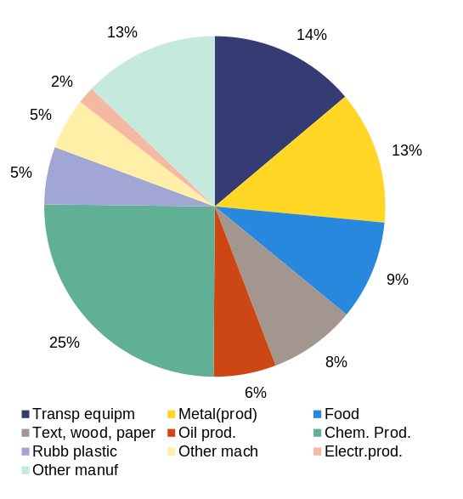
Source: European Commission
Foreign-owned companies play a key role in integrating Romania in international trade. In 2013 foreign-owned companies accounted for 67 % of Romania’s exports of goods and 64 % of its imports, being responsible for much of the intra-industrial trade identified above. Manufacturing foreign direct investment alone contributed 58 % of Romania’s goods’ exports and 43 % of its imports, causing a net balance equivalent to 4.1 % of GDP.
Graph 2.1.33: Stock of FDI per country, 2013
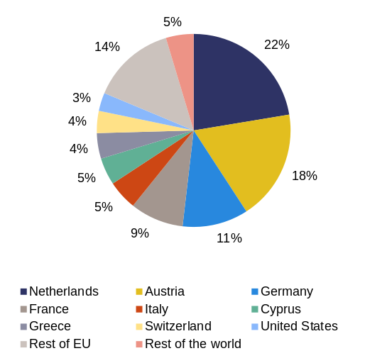
Source: European Commission

Graph 2.1.34: FDI stocks in tradables vs. non-tradables
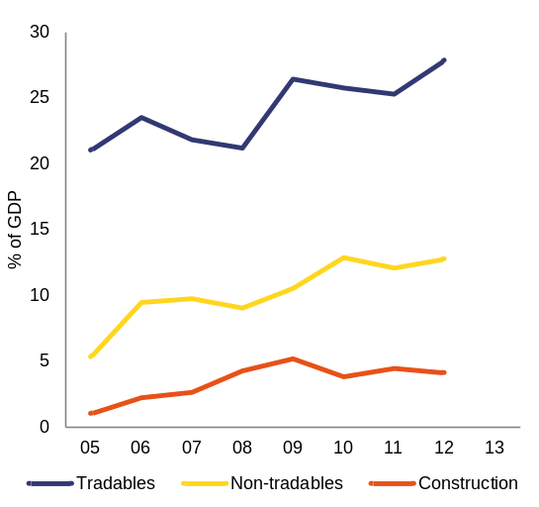
Source: European Commission

Resources
Infrastructure
Romania lacks high-quality infrastructure. Survey results show a much lower satisfaction of economic agents with infrastructure in Romania than in any other EU Member State. Romania has the second worst score in the EU in overall perceived quality of infrastructures (including roads, railroads, air transport, electricity supply and telephony), the second worst score in quality of roads infrastructure and the worst score in railroads (Graph 2.2.1 ). This indicator has slightly deteriorated in comparison to 2007-08.
The underdeveloped basic transport infrastructure continues to be a bottleneck to growth in Romania. The motorways network remains small compared to that of peers, despite the size of the country (Graph 2.2.2) and insufficient against the needs of the economy. High growth of the vehicle fleet and an underdeveloped road infrastructure hamper businesses and the economy. Poor maintenance of the railway network affects service quality, safety and competitiveness of railways. Freight transport on inland waterways remains far below its potential, particularly on the Danube. Limited efficiency and non-transparent governance of state-owned enterprises have hindered the development of network infrastructures, including transport (see below).
Graph 2.2.1: Quality of public infrastructure
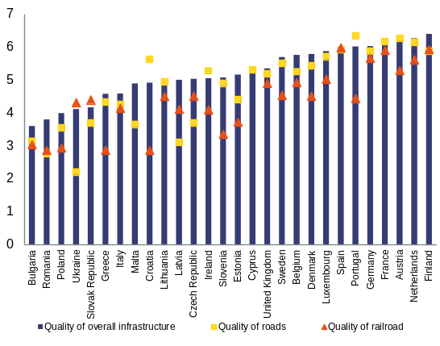
Source: World Economic Forum, The Global Competitiveness Report 2014-2015
The development of Romania’s infrastructure is affected by low absorption of EU structural funds. Despite the financing opportunities offered by the EU structural funds, the low absorption rate (see below) and poor strategic management limit Romania’s ability to improve its infrastructure in a sustainable manner. As a result, the elaboration and approval of a transport master plan was made an ex-ante conditionality under the new EU-funds programming period.
The preparation of the General Transport Master Plan is still ongoing. The plan defines the transport strategy for 2014-2030. It maps and prioritises the future transport network by considering the economic sustainability of the infrastructure and the Trans-European Transport core and comprehensive network (as defined in Regulation (EU) No. 1315/2013). There are concerns with political commitment and ownership. Some unsustainable railway lines are still not closed, which affects the system’s efficiency. A commitment to allocate 2 % of GDP to the transport sector has not yet been operationalised.
Graph 2.2.2: Length of motorways, 2012
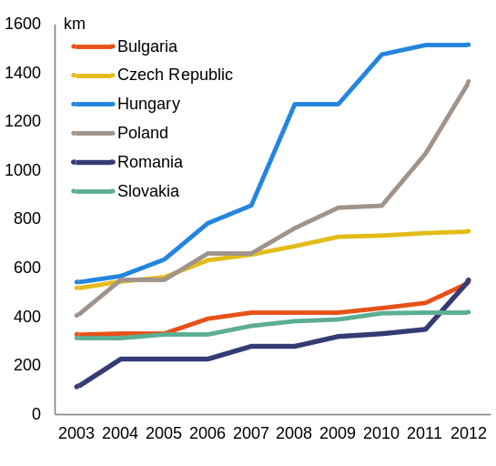
Source: European Commission
Recent progress with the promotion of competition in energy markets can lead to a more efficient energy infrastructure. Electricity prices for non-households are fully liberalised since 2014 and gas prices for non-households are fully liberalised since the beginning of 2015. In addition, Romania introduced market coupling for its electricity markets.
Set-backs with the liberalisation of gas markets for residential consumers and gas wholesale markets may reduce the impact of other reforms. Romania currently does not have a timeline for the gas-price liberalisation for residential consumers. Also, gas wholesale markets are virtually non-existent, primarily due to the failure to adopt an improved gas code, incentivising gas trading and the limited volumes subject to gas release. The delay in the liberalisation of energy prices for domestic consumers undermines the profitability and attractiveness of energy efficiency investments, for which EUR830 million has been earmarked under ESIF for 2004-2020 programmes.
Romania is one of the most energy and carbon intensive economies in the EU. The CO2 intensity of the economy is more than twice the EU average, while the energy intensity of the economy is among the five highest in the EU. This is partially due to the lack of energy efficiency of the Romanian economy, but also due to the high proportion of energy-intensive industries and the significant proportion of solid fuels in the energy mix. Both policy (e.g. delays in transposition of Energy Efficiency Directive) and implementation limitations are hampering Romania’s progress towards achieving its energy efficiency potential. In the transport sector, for instance, energy consumption has increased at an annual rate of 3 % between 2005 and 2012. Under the Europe 2020 strategy, Romania committed to limiting its greenhouse gas emissions. According to national projections, with existing measures Romania is set to increase its non-Emission Trading System emissions by 2020 by 7 % compared to 2005, staying below its target by a margin of 12 pps.
Broadband coverage is high and with high-speed in the main cities, but it is limited outside urban areas. Broadband take-up is limited and affects the exploitation of digital services, including e-commerce and e-government. Based on most recent data (2013), broadband coverage is available to 90 % of Romanian homes. However, the take-up of broadband subscriptions is the second lowest in the EU. According to Digital Agenda Scoreboard 2014, 58 % of households had a broadband subscription, considerably lower than the EU average of 78 %. The lack of digital skills and affordability are part of the explanation. The potential of e-commerce is still largely untapped in Romania, with the lowest percentage of consumers in the EU buying online and one of the lowest percentages of enterprises selling online (). Consumers’ and retailers’ confidence in domestic online transactions is also below the EU average ().
Financing
Romania does not fully utilise the available funding for investments. Access to finance is the most problematic factor for doing business in Romania according to the World Economic Forum’s 2014-15 report on global competitiveness. Not only EU structural funds, but also banking loans and financial markets proved to be little used. This is due to structural shortcomings of the economy as discussed below, underdeveloped financial markets as well as deleveraging process of the banking system. The latter is further elaborated in the section 3.3. The difficulties with enforcing contracts, including the long average time for court rulings can also be a further disincentive to formal financing channels, even if a positive trend may be emerging on the efficiency of civil justice.
Graph 2.2.3: EU funds absorption in Romania and peers
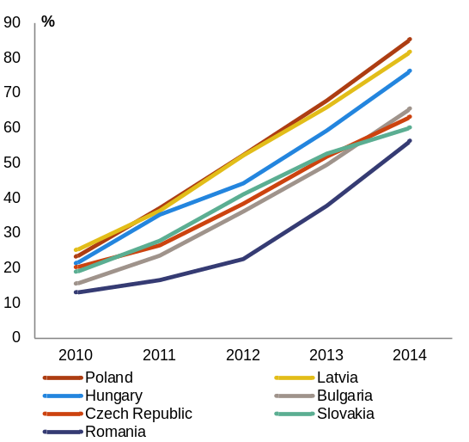
Source: European Commission, inforegio Cohesion Policy Data
Despite significant progress in 2014, Romania continues to display a low rate of structural funds absorption in the EU. Romania ranks last among the group of peer countries in Cohesion Policy funds' absorption. This is despite the accelerated absorption in the last two years (Graph 2.2.3. Structural funds absorption (excluding the European Agricultural Fund for Rural Development, EAFRD) has continued to progress, from 33.7 % at the end of 2013 to 52.2 % at the end of 2014 of the total structural, cohesion and agricultural funds allocated for the 2007-2013 programming period. The highest absorption rate, 72 %, is observed in the Operational Programme for administrative capacity development. The programmes related to basic infrastructure, such as transport, environment and human resources development managed to absorb 57 %, 42 % and 47 % respectively by the end of 2014 (Graph 2.2.4).
Graph 2.2.4: EU funds absorption per Operational Programme
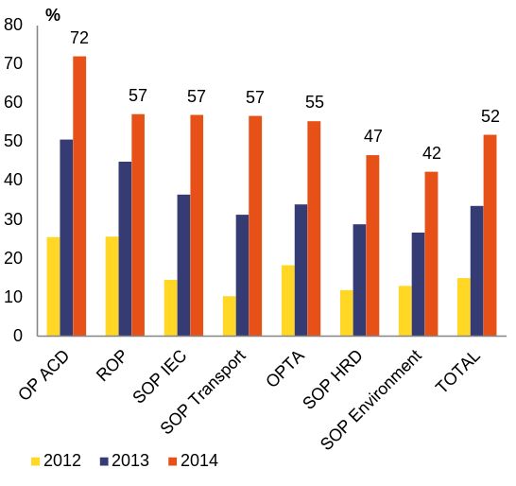
Source: Ministry of EU funds
Difficulties in implementing the structural funds programmes hamper achieving the objectives of the operational programmes. Besides poor strategic steering, difficulties as regards the implementation of the programmes include: persistent weaknesses in the management systems, failure to proactively anticipate and tackle implementation shortcomings, low coordination between responsible departments, low institutional capacity to implement sectoral strategies, cumbersome national procedures for managing public investment projects, weak financial situation in the construction sector, and persistent shortcomings in the public procurement system. Risk of decommitment of structural and cohesion funds remain for 2015 and at closure in 2017. Due to the insufficient and delayed preparation of the project pipeline, implementation difficulties might arise also in the 2014-20 programming period.
Table 2.2.1: EU Funds absorption rates
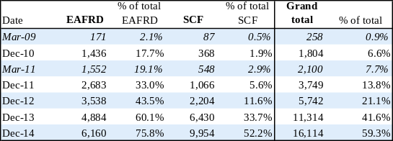
Source: European Commission
Access to finance for enterprises remains difficult and expensive, especially for SMEs. Access to finance was identified as the main obstacle for doing business in Romania by the World Economic Forum (Global Competitiveness Report 2014-2015). In 2013, Romania’s performance on the SME access to finance index was the third lowest in the EU, showing a declining trend compared to 2007 (). Even if they have been increasing their exposure to bank lending, only 43 % of SMEs in Romania consider bank loans as relevant for their operation (). This compares with 57 % in the EU, 54 % in Bulgaria, 52 % in Latvia and 50 % in Poland and the Czech Republic. The average interest rate for loans up to and including EUR 1 million is the highest in the EU(), and bank loans are often substituted by other, more costly, sources, including credit lines, bank overdrafts and credit cards overdraft. When contracting bank loans, SMEs are also especially affected by bureaucracy, collateral requirements, and low transparency. In the first half of 2014, a government-sponsored attempt to introduce minimum transparency standards for bank-lending conditions did not gain the support of the Romanian Banking Association. The state guarantees scheme for bank lending to SMEs was re-launched in 2014 under more favourable conditions. The procedures are being further shortened and simplified, but the scope of the scheme remains limited.
Capital market funding is limited in Romania. The Romanian capital market is underdeveloped. Big companies do not yet identify it as a source of finance and no alternative market exists for SMEs. There is no appropriate regulatory framework, including investor and entrepreneur protection, for venture capital and other alternative sources of financing. Venture capital investments have fallen by almost 74 % between 2007 and 2012. With a view to developing alternative forms of financing, a law on business angels has been submitted to Parliament. It is expected to be adopted in early Spring. In addition, work is ongoing on legal initiatives on business incubators, credit mediators for SMEs and crowd-funding.
Human capital
Romania is confronted with a shrinking labour force, due to population ageing and outward migration. The population decreased by 7.2 % between 2002 and 2011 (). According to the National Institute of Statistics, 2.3 million Romanians were living abroad in 2013, amounting to about 12 % of the total resident population (). Demographic projections show a steady decline in total and working-age population, coupled with an increasing old-age dependency ratio. The dependency ratio stood at 23.9 % in 2013 and is projected to double around 2050. Such demographic trends are weighing on economic growth over the medium- to long-term. In addition, employment is limited by a low activity rate.
Productivity of the labour force is constrained by a low average skills level and a high skills mismatch. A study on skills mismatch in Europe () shows only one third of Romanian workers having skills matching their current job. The skills mismatch is also reflected in significant disparities across employment figures by education level. For those with at most lower secondary education (levels 0-2) the employment rate reaches 67 % (2013), and decreases to 56 % for upper secondary education (levels 3-4) while for tertiary graduates the employment rate is 76 %, which is lower when compared to previous years. At the same time companies report difficulties in recruiting skilled labour (30 % of Romanian companies report are facing difficulties in recruiting staff for skilled jobs).
Higher education degrees and vocational education and training qualifications are insufficiently aligned with labour market needs. The relevance of university education for the labour market is a major concern, with limited connection of universities with innovation and research areas and slow adaptation of university curricula and teaching practices to labour market requirements. Participation of adults to lifelong learning is low, especially in the case of adults with lower qualification levels and from rural areas. Furthermore, Romania’s labour force has the lowest level of digital skills in the EU. Based on Eurostat 2014 data, 77 % of the labour force has low or no digital skills compared to 32 % in the EU. The draft Digital Strategy for Romania focuses, among other things, on the development of digital skills, but lacks concrete implementation measures. These developments weigh on labour productivity which in Romania is one of the lowest in the EU (see section 2.1).
Research and innovation
Romania lags considerably behind other EU Member States in terms of resources invested in research and development. The research and development intensity in Romania is the lowest in the EU. This is true for both businesses and public expenditure. Also, recent trends in public research and development expenditure are negative, which is contrary to the Europe 2020 national target of 1 % of GDP spending in public research and development. Research and development expenditure was 0.39 % of GDP in 2013, while business expenditure fell from a rather low 0.19 % of GDP in 2012 to 0.12 % of GDP in 2013. The public research and development intensity decreased from 0.31 % in 2011 to 0.27 % in 2013. In addition, Romania performs far below the EU average in terms of the share of firms that have introduced both technological (34 % of the EU average) and non-technological innovation (63 % of the EU average) onto the market or within their organisations, with a strong decline in 2014 compared to the previous year for the SMEs innovating in-house (see Innovation Union Scoreboard 2014).
Insufficient predictability, as well as fragmented and under-financed institutional setting, affect public policies for innovation and research and development. The capacity of Romania to attract business research and development investment is hampered by the overall low quality of the science base (the lowest in the EU based on the Commission’s composite indicator on research excellence). The lack of predictability and low level of public research and development funding affected the system in structural terms, contributing to a significant brain drain, decreasing the quality of human resources and leading to under-usage of advanced infrastructure available in several research facilities. The high degree of fragmentation of the public research system hampers its efficiency and effectiveness. A comprehensive approach aiming at a possible concentration of institutional resources is not yet being developed. Furthermore, providing SMEs with tailored high-quality services to facilitate innovation remains a challenge in order to improve the firms’ research and innovation capacity.
Business environment
Burden to business
Romania’s business environment is poor and hardly improving. Romania ranks only 48th in the World Bank’s "Doing Business 2015" index (Graph 2.2.6). Romania ranks the lowest among EU countries in a number of key elements for investment, such as dealing with insolvencies, construction permits, registering property or getting electricity, as well as trading across borders (Graph 2.2.6). Additionally, the gap between the EU average and Romania increased from 2008 to 2013 as improvements in Romania did not keep pace with reforms in its European partners. There are exceptions, however: Romania was identified by the World Bank as the economy improving the most in 2013/14 in the ease of paying taxes.
Graph 2.2.5: Ease of doing business
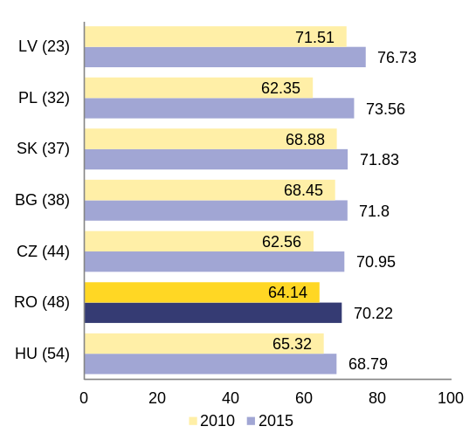
Source: World Bank (2014), "Doing Business 2015"
Entrepreneurship suffers from an unstable regulatory framework. The lack of transparency and predictability of the regulatory framework continue to represent a burden for business. SMEs and start-ups are especially concerned. Although stakeholder consultation is mandatory in Romania, there is no consistent approach to consultations between ministries and procedures are often inefficient and opaque. Impact assessments are presented more like explanatory notes than detailed analysis. The government excessively uses emergency procedures to pass legislation, bypassing the standard legislative procedures. There are also concerns about the lack of consolidations of existing laws and the absence of systematic evaluations to ensure that regulations remain fit for purpose. If effectively implemented, the strategy for better regulation adopted in December 2014 can help to increase the quality of regulation. The new strategy on the business environment for SMEs is also a step in the right direction. However, developing a common methodology for impact assessments was postponed until September 2015 and the introduction of common commencement dates for the legislation affecting businesses is not being operationalised.
Graph 2.2.6: Doing business in Romania
–––– 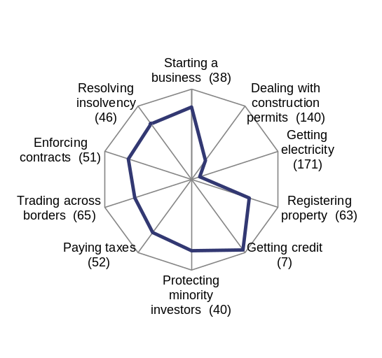
In brackets, Romania’s world rank
Source: World Bank (2014), "Doing Business 2015"
Inefficiencies in public administration and corruption represent an extra burden on business. Romania ranks last in the EU in terms of government effectiveness and among the last three Member States in terms of regulatory quality and control of corruption (World Bank, Worldwide Governance Indicators, 2013). Corruption and inefficient government bureaucracy are identified as key obstacles to Romania’s competitiveness by the World Economic Forum (Global Competitiveness Report 2015). Improvements in the public administration can be expected if the Strategy for the Public Administration approved in October 2014 is effectively implemented. In addition to inefficient administrative services, Romania shows a low uptake of e-Government by citizens. According to the Commission's e-Government scoreboard 2014, less than two fifths of citizens use e-government services. The rate of interaction of small enterprises with public authorities is 59 % and lags behind other EU countries (18 pps. below the second last Member State, according to the EC e-Government scoreboard 2014). According to the Digital Agenda Scoreboard, the user-centricity of e-Government services for regular business operations is the lowest in the EU and government transparency the second lowest.
Land planning is a source of uncertainty and costs for investors. The absence of an effective system of cadastre represents an obstacle to the development of infrastructure, property management and consolidation of agricultural land. The status of the land registration agency has been upgraded in March 2014 giving it a degree of self-financing capacity and substantial funding has been allocated for 2015. However, low prioritisation of the project led to slow progress so far. Land-registry remains well behind the target of covering 1/4 of the properties by end-2015, while the absorption of the relevant funds is still low.
Public procurement
Legal uncertainty related to public procurement causes inefficiencies for both public and private actors. The difficulties of the public procurement system in Romania are linked to a combination of several factors. These include the lack of stability and the fragmentation of the legal framework, deficient checks and balances in the institutional system, the quality of competition in public procurement, and the administrative capacity of public purchasers, including the capacity and the degree of expertise of staff dealing with public procurement procedures at both national and local level. The adoption of a Public Procurement Strategy aiming at reforming the current public procurement framework is expected to be adopted within this year.
Addressing corruption and fraud in public procurement remains a challenge. Civil society observers have noted major differences in the number of cases identified and pursued in different parts of the country and by various agencies. Authorities at local level are particularly affected by the lack of transparency in the allocation of public funds and the risks of corruption in awarding public contracts at the local level being substantial (see COM(2015)35 final). The repeated use of exceptions affects the transparency and openness of the market and creates the potential for corruption.
Conflicts of interests constitute a particular concern in public procurement. In 2014, the National Integrity Agency solved a total of 514 cases, out of which 101 concerned administrative conflicts of interests and 60 concerned criminal conflicts of interests. Many of these cases involve politicians and public officials at local level. A system for ex ante checks being developed by the National Integrity Agency ("Prevent") should help to prevent and detect better conflicts of interests. However, problems remain with overlapping responsibilities (e.g. in the field of ex-ante control), insufficient inter-institutional cooperation, and checks and balances leading to inconsistent interpretation of legislation and conflicting decisions of the public procurement authorities. It remains difficult to cancel contracts that suffer from a conflict of interest, especially if they were already totally or partially executed.
Insufficient needs assessment and budgetary planning result in low quality of tenders. The institutional set-up consists of various actors with frequently overlapping responsibilities. Authorities at local level are particularly affected by the lack of transparency in the allocation of public funds to public procurement projects. The central institutions lack the capacity to provide appropriate guidance to the contracting authorities. The repeated use of exceptions affects the transparency and the openness of the market.
The deficient application of public procurement rules triggers substantial financial corrections and contributes to a low absorption of EU funds. There is still a general perception of high levels of corruption, fraud and conflict of interests continuing to raise serious concerns for contracting authorities, which relates to both EU and national funds (see COM (2014) 38 final). 40 % of the complaints related to public procurement in Romania are about public procurement contracts financed by EU funds (see SWD (2015) 8 final). There is a growing number of cases opened and solved by the specialised prosecution services dealing with EU funds ().
Romania has recently started to develop an overarching strategy and an implementation action plan. The strategy would address the quality of the legislative framework, the overall coherence and efficiency of the institutional system, the regularity and quality of the public procurement process, the capacity of the public purchasers, with emphasis on professionalisation and integrity issues and the capacity of the Romanian public procurement system to stimulate effective competition. The strategy and the action plan should be delivered by the Romanian authorities by end June 2015. The related actions and measures should be implemented by the end of 2016.
E-procurement is an important factor for the modernisation of public administration. E-procurement can generate significant cost savings, improve the transparency of public procurement, shorten the time to contract, and increase competition. Pre-award e-procurement is mandatory since 2010 and specific implementation targets have been set for e-submission. Several other phases of procurement have also been made available in electronic format. However, progress appears to be limited and is hampered by the challenges identified for public procurement more broadly.
Fiscal management and fiscal policy stability
A stable fiscal environment could significantly enhance state credibility and confidence in the economy. The Fiscal Responsibility Law as well as the fiscal rules that were introduced in 2010 represent an effort towards credibility, stability and transparency in fiscal management. However, the challenge of proper and timely implementation of the new fiscal management framework remains, since several rectifications have already led to breaches of fiscal rules in 2014.
Some positive steps have been taken to simplify and modernise the tax administration. The reorganisation of the National Agency for Fiscal Administration is still ongoing, aiming to run until end of 2015 to increase flexibility and efficiency in the tax administration. Tax compliance and tax evasion remain important challenges, especially in the areas of VAT, excises and labour taxation (16.2 % of GDP, with the highest shares in the VAT and social security contributions areas, according to Fiscal Council’s Annual Report 2013).
State-owned enterprises
State-owned enterprises play an important role in Romania, dominating economic sectors which are crucial for the overall economy (). State-owned enterprises() generate 8 % of total output of non-financial corporations and employ close to 4 % of the total workforce, whereas government subsidies and transfers to these entities account for 2 % of total government expenditure or 0.7 % of GDP (Graph 2.2.7). State-owned enterprises constitute 44 % of the energy sector and almost 25 % of the transport sector turnover (Graph 2.2.8) which provide crucial inputs to the overall economy.

Graph 2.2.7: Importance of SOEs in the Romanian economy
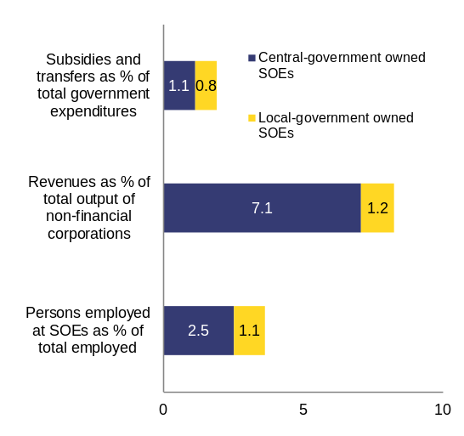
Source: Ministry of Public Finance 2013 data, Commission analysis
State-owned enterprises absorb a significant share of labour and capital. Combining OECD data on state-owned enterprises with data on Romania, which is not an OECD member, allows for basic cross-country comparison of the state-owned enterprises sector’s share of the national economies and the number of employees as a proportion of total employment (data are not fully comparable, due to exclusion from the dataset of state-owned enterprises at local-government level for some OECD members). Although these ratios are imperfect proxies for measuring the importance of state-owned enterprises in the respective countries, they show that the equity valuation of Romanian state-owned enterprises in proportion to GDP and the Romanian workforce employed in state-owned enterprises are markedly above the average (Graphs 2.2.9 and 2.2.10). The weight of state-owned enterprises in the Romanian economy is thus significantly above the EU average. The prevalence of state ownership in the Romanian economy does not necessarily constitute a source of concern, if it was not for their underperformance compared to other companies.
Graph 2.2.8: Importance of SOEs by sector
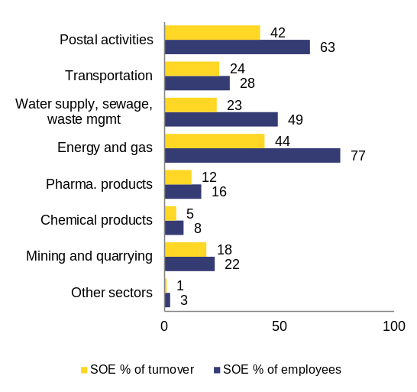
Note: Central- and local-government-owned SOEs combined. Other sectors comprises NACE R2 categories C (excl. C20 and C21), G, I, J, L, M, N, P, and Q. The graph does not include NACE R2 categories A (108 SOEs), F (141 SOEs) and R (27 SOEs).
Source: Ministry of Public Finance 2013 data, Commission analysis

Graph 2.2.9: Equity valuation of SOEs expressed relative to GDP
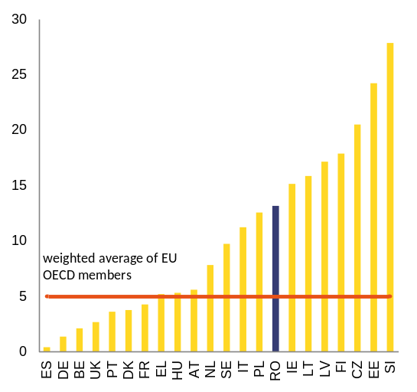
Note: Data excludes entities in which the state has a minority stake
Source: OECD dataset on the size and composition of national state-owned enterprise sectors, Ministry of Public Finance data Orbis database, 2012 data, Commission analysis

Graph 2.2.10: Employment at SOEs as a proportion of total employment
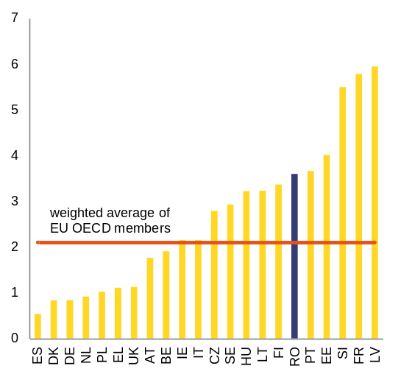
Note: Data excludes entities in which the state has a minority stake
Source: OECD dataset on the size and composition of national state-owned enterprise sectors, Ministry of Public Finance data, 2012 data, Commission analysis
Suboptimal operational performance
The economic performance and financial situation of Romanian state-owned enterprises is worrisome. State-owned enterprises are less profitable (Graph 2.2.11) and less productive, while paying higher salaries than their privately-owned peers (Graph 2.2.12).
Productivity of state-owned enterprises in many sectors remains substantially lower compared to that of private- and foreign-owned companies. Following the approach in a recent World Bank study (), comparisons of the labour productivity levels show that the Romanian state-owned enterprises underperform relative to their private- and foreign-owned peers in chemical industry and utilities. However, they outperform privately-owned companies in other sectors (Graph 2.2.13). In adjusted estimations, a significant underperformance of state-owned enterprises is observed in the chemical industry and Information and Communication Technology. In manufacturing and tourism state-owned enterprises outperform their private-owned peers (Graph 2.2.14). Foreign-owned firms have higher average productivity, especially in terms of labour productivity. Given the substantial role of state-owned enterprises in value added creation in e.g. the chemical industry, underperformance in terms of total factor productivity can imply a substantial cost.
Graph 2.2.11: Return on equity of SOEs and foreign-owned companies compared to domestic privately-owned companies
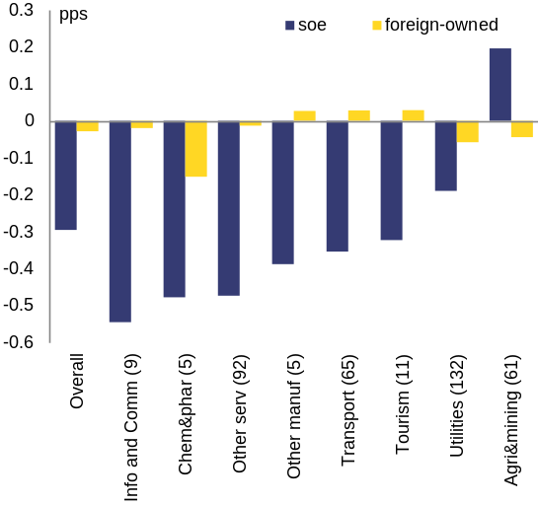
Note: Analysis based on the Orbis database, in this and subsequent graphs, companies owned by other states are not considered as SOEs for the purposes of this analysis.. Any company in which government(s) have a stake of 25 % or higher is classified in the SOE category.
Note: Sectors are defined in terms of NACE R2 categories as follows: agri & mining A-B, chem&phar C19-C21, , ICT H53 & J, other manufacturing C31-C33, other services M-U excl N79 & R, , tourism I, N79, R, transport H excl H53, utilities E. The sectors where SOEs represent less than 5 % of value added are not included, these are construction F and L, durables C25-C30, materials C22-C24, staples C10-C18, trade G. The energy sector (D) has also been excluded as private-owned companies represent less than 5 % of value added.
Number of companies included in the database for the specific indicator in parentheses.
Source: Orbis database 2004-2013 data, Commission analysis
State-owned enterprises in Romania are also outperformed by their peers in neighbouring countries. Out of four sectors with large state-owned enterprises presence, Romanian state-owned enterprises outperform their peers only in the utilities sector, in terms of profitability (Graph 2.2.14).
State-owned enterprises are contributing to the illiquidity in the economy. In 2012 they accounted for 17 % of overdue payments to suppliers (state-owned and privately-owned combined), weighing on the smooth functioning of the economy.
High indebtedness and low rates of return generate solvency problems for state-owned enterprises. In 2012, the total debt of state-owned enterprises climbed to 7.7 % of GDP. The total operational profit of all state-owned enterprises combined was 0.4 % of GDP in 2013, with a limited number of state-owned enterprises being profitable. The stock of overdue payments on the balance sheets of all state-owned enterprises (including those under insolvency or liquidation procedure) amounted to 3.4 % of GDP at end-2014 (Graph 2.2.15), down from about 5 % of GDP in 2010. The reduction in overdue payments has mainly been achieved involving significant fiscal resources, including a mix of debt restructuring, cancellations of overdue tax liabilities, ad hoc increases in transfers from the government budget, restructuring of companies and liquidations.
Graph 2.2.12: Staff expenses at SOEs and foreign-owned companies compared to private-owned companies
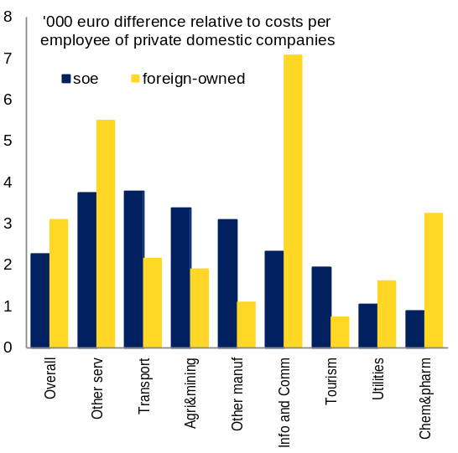
Source: Orbis database 2004-2013 data, Commission analysis
Some of the loss-making companies are performing a public-service obligation. It could be argued that, apart from the need to improve operational performance, another challenge for state-owned enterprises performing a public-service obligation regards receiving adequate government transfers to appropriately cover operational costs linked to the public service obligation.
Many companies, notably CFR Marfa, Tarom and Oltchim operate in a competitive environment. In these cases, EU law strictly regulates the conditions under which they can receive state support, underlying even more the need for improvements in operational performance.
Graph 2.2.13: Labour productivity of SOEs and foreign owned companies compared to domestic privately owned companies
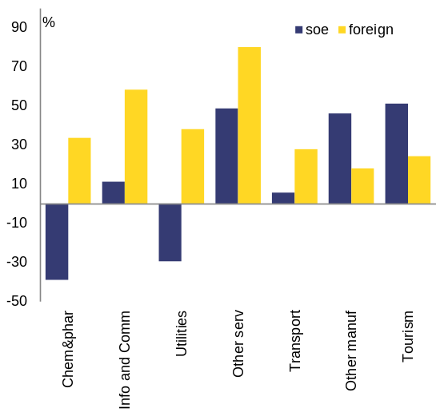
Source: Orbis database 2004-20123 data, European Commission calculations

Graph 2.2.14: Total factor productivity of SOEs and foreign owned companies compared to domestic privately owned companies
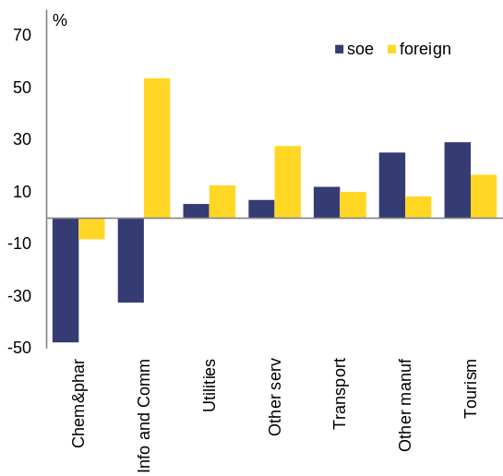
Source: Orbis database 2004-20123 data, European Commission calculations

Graph 2.2.15: Payments past due date at state-owned enterprises
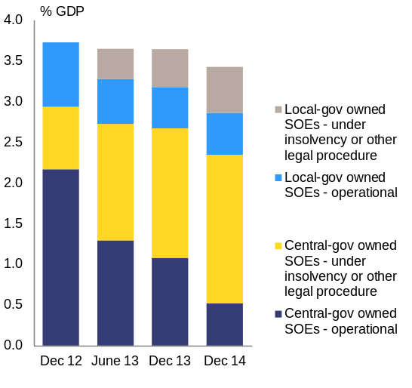
Source: Ministry of Public Finance 2014 data, Commission analysis
State-owned enterprises and public finances
Loss-making state-owned enterprises represent a burden to the general government budget. End-2013, state-owned enterprises accounted for 50 % of all tax arrears of companies. One explanation for the high proportion of total tax arrears could be that state-owned enterprises on average are much more loss-making than private sector companies and therefore encounter more difficulties in paying tax liabilities. Another explanation could be that payments of tax obligations are less enforced in the case of state-owned enterprisescompared to private companies. Such preferential treatment would put state-owned enterprises at an advantage vis-à-vis their private sector competitors.
Several state-owned enterprises classified outside general government represent contingent liabilities for the state budget. When sales of a publicly-owned entity drop below 50 % of production costs, the entity is classified into the general government sector (as defined in ESA) and its financial situation impacts directly the government’s deficit and debt levels. State-owned enterprises classified outside general government carried debt levels equivalent to 5.4 % of GDP in 2012, more than two thirds of total state-owned enterprises debt. They had a stock of overdue payments equivalent to 1.9 % of GDP in 2013, more than half of the total stock of overdue payments of all state-owned enterprises together.
In order to avoid job losses through liquidation or restructuring, the Romanian authorities are supporting certain loss-making state-owned enterprises. This is done mostly through foregone tax liabilities and through government subsidies or transfers. Recent examples in 2013 and 2014 include support to the state-owned rail freight operator, the rail passenger operator and the defence industry. Those support measures alone total to 0.5 % of GDP.
Corporate governance
Corporate governance is a key factor determining performance of state-owned enterprises. The management of state-owned enterprises is dispersed across different government entities, with some companies managed by line ministries or central government entities and some managed by local government (local administrative units organised at different local levels: municipalities, cities, counties). Each line ministry has a department supervising the state-owned enterprises under its responsibility. Such a governance structure is not an ideal setup for avoiding political interference in the day-to-day management of the companies, or guaranteeing a separation between the authorities’ ownership and policy-making functions. Moreover, there is no asset management strategy laying down which assets the authorities consider strategic and which assets could be privatised over time, although this could help in reducing the opportunities for vested interests to influence privatisation processes.
General OECD corporate governance rules apply also to state-owned enterprises. General corporate governance principles, as defined by the OECD in 2005 (), were incorporated in the Romanian legislation on commercial companies already in 2006, and are also applicable to most state-owned enterprises as most are organised as commercial companies. Sound corporate governance principles for state-owned enterprises include (i) the separation between the ownership and policy-making function of the government, (ii) full transparency on strategic decisions, related-party transactions and audited financial information, (iii) clarity on public-service obligations versus competitive operations, and (iv) professional and transparent board and management nomination and remuneration processes. Above all, company board members and management need to be able to operate independently from direct government interference, within only the overall strategy set out by the government as the sole or main shareholder.
Specific rules for state-owned enterprises were systematically only introduced through government emergency ordinance 109/2011, but various areas remain uncovered. Government emergency ordinance 109/2011 did not attempt to modify the state ownership setup, nor does it lay down detailed rules for the functioning of boards. Shielding off state-owned enterprises from interference of line ministries is also not tackled through the ordinance. Government emergency ordinance 109/2011 provisions focus inter alia on: (i) selection procedures, appointment and responsibilities of board members and management; (ii) transparency; and (iii) oversight by a dedicated unit within the Ministry of Public Finance. Ceilings for the remuneration levels of state representatives participating in general shareholder meetings and board members are defined in separate government ordinances. Performance monitoring is included, while rules for the enforcement of this monitoring and the improvement of performance are weak. There is thus ample room for improving corporate governance legislation for state-owned enterprises, along the domains spelled out in the World Bank Toolkit of 2014.
Graph 2.2.16: Return on equity in of SOEs in selected sectors in Romania and neighbouring countries
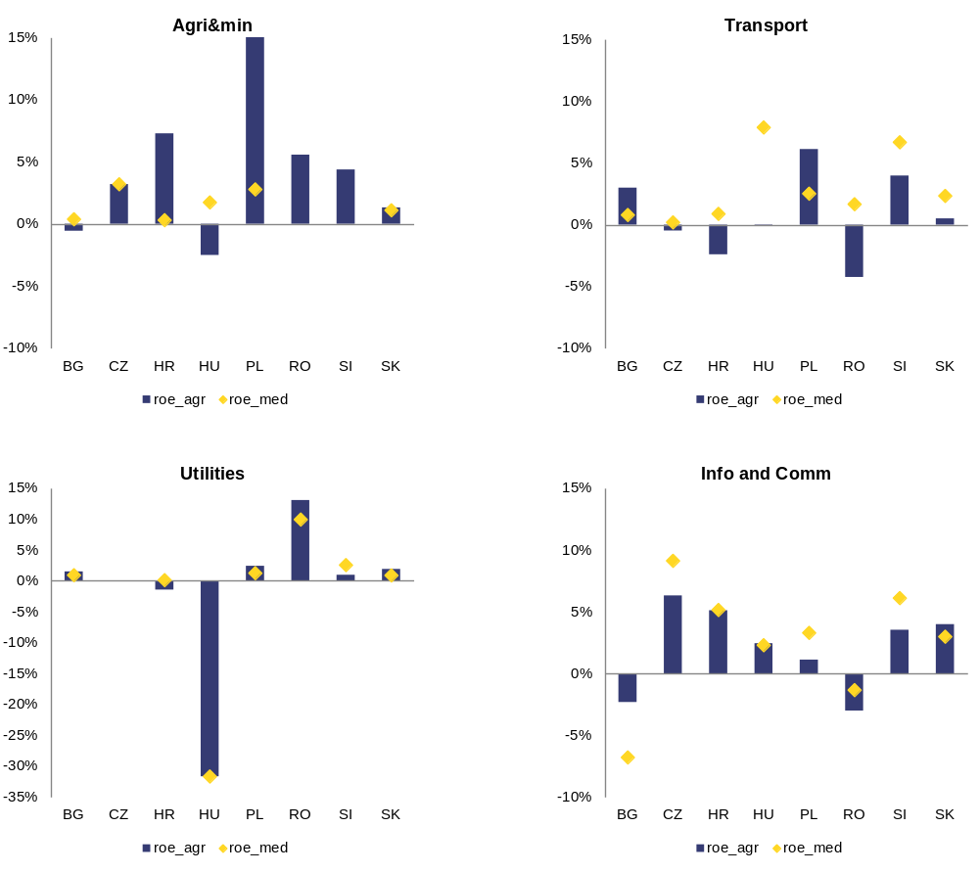
Source: Orbis database 2004-13 data, Commission analysis
The rules laid down in government emergency ordinance 109/2011, although straightforward, are still not fully adhered to. When implemented, selection procedures for managers and board members often adhere to the letter but not to the spirit of the law. One such example is the dismissal of management and board members upon the arrival of a new minister, only to appoint interim managers and board members while a new lengthy selection procedure is started. The monitoring unit within the Ministry of Public Finance lacks proper enforcement tools as line ministers do not feel accountable to this unit. As a result, enforcement rules laid down in the emergency ordinance are not applied to companies not adhering to transparency provisions.
The government emergency ordinance 109/2011 is already binding but will be amended and probably adopted by Parliament. The Romanian authorities, together with the World Bank, are currently performing an assessment of the current text in order to identify potential revisions to enhance transparency, compliance monitoring and enforcement. The Romanian government’s aim is to submit a new draft to Parliament in early 2015.
Restructuring and privatisation
Restructuring and privatisations are an important pillar in the successive balance of payments assistance programmes to Romania. This is due to the large number of state-owned enterprises, their dominance in the energy and rail transport sectors, their suboptimal operational performance and their impact on public finance. Under the programmes, corporate governance legislation specific to state-owned enterprises was introduced in 2011 (through government emergency ordinance 109/2011). In addition, payments past due date were reduced from 5 % of GDP (2010) to 3.4 % (2013). Lastly, five tenders for shares of state-owned enterprises were concluded (). However, out of the 20 companies selected for minority or majority privatisation or liquidation under the balance of payments programmes, 11 procedures are still pending. Only one majority privatisation procedure has been completed, despite a selection of 13 companies.

Overview of the banking sector
Graph 2.3.1: Structure of the financial sector (%GDP)
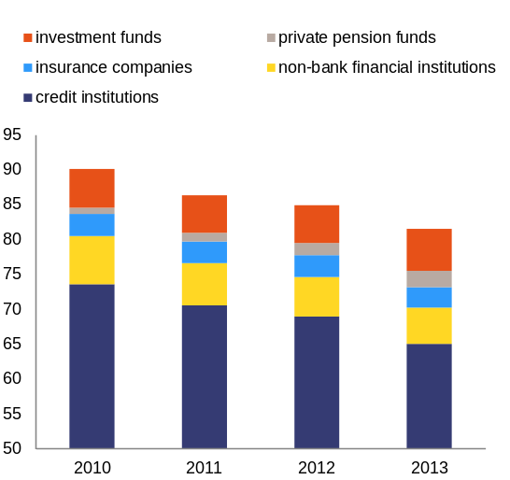
Note: Investment funds incl. "Fondul Proprietatea"
Source: NBR, Financial Stability Report 2014
Similar to other countries in Central and Eastern Europe, the Romanian financial sector is heavily bank-based. Overall, credit institutions hold the largest share of the financial system’s assets (roughly 80 %), followed by non-bank financial institutions and investment funds. In recent years, private pension funds and investment funds are becoming more important in the Romanian financial system. However, the total financial system’s assets as a proportion of GDP decreased over the past years, reaching 81.5 % at year-end 2013 (Graph 2.3.1).
Banks in Romania are mainly involved in traditional financial intermediation. Loans represent over 70 % of total banking sector assets as of July 2014. Roughly 60 % of total loans are denominated in foreign currency (see Graph 2.3.3). Private credit is distributed between households (47 %) and corporations (53 %). On the liabilities side, deposits of domestic residents account for 57 % of total liabilities, whereas non-residents deposits represent 18 % of total liabilities. Roughly 65 % of deposits are denominated in local currency.
Credit developments
Romania experienced a double-digit annual credit growth prior to the crisis. Before 2008, lending growth outstripped local sources of funding and therefore banks increasingly relied on external funding coming primarily from foreign parent banks. The latter provided relatively cheap capital to their Romanian affiliates (subsidiaries in most cases).
Graph 2.3.2: Private credit in selected countries (%GDP)
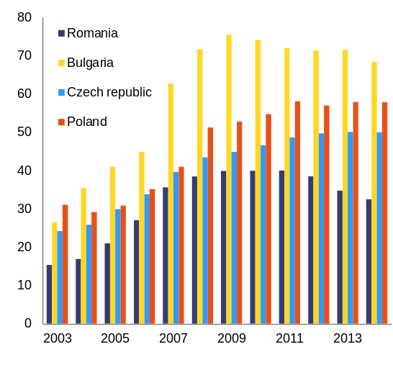
Note: For 2014, July 2014 data was used
Source: ECB
The 2008-09 global financial crisis and the subsequent euro-area sovereign-debt crisis led to a change in banking business models in Central and Eastern European countries (Graph 2.3.2). Domestic credit growth decelerated after the onset of the crisis (Graph 2.3.3). Furthermore, banks with foreign parent banks have increased their reliance on local sources of funding, in particular resident deposits and domestic debt instruments.
Graph 2.3.3: Credit developments (2004-13, %GDP)
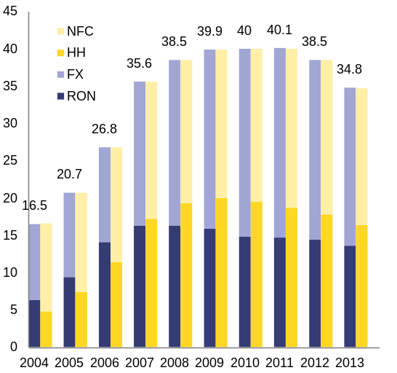
Note: The current exchange rate was used to calculate the split between RON and foreign-exchange-denominated (FX) loans.
Source: NBR
Credit to households and non-financial corporations have been decreasing. Credit to households continued to decline in 2014 (as a % of GDP), driven mostly by declining consumer loans. Local currency denominated household loans increased mostly due to mortgage loans, but they still account for less than 40 % of total household loans. Corporate lending has continued to lose ground in 2014 (Graph 2.3.4), despite a 5 % year-on-year growth in the stock of local currency denominated loans (as of November 2014).
Credit growth in Romania and in Central and Eastern Europe in general remains subdued due to both supply and demand factors. Credit supply is affected by the high level of non-performing loans, stricter credit conditions and an ongoing deleveraging process of foreign parent banks. At the same time, demand is subdued due to a low consumer and investment sentiment, and the balance-sheet adjustment of households and domestic companies. The households' leverage ratio declined from 76.4% in December 2011 to 68.4% in 2014, end-June figure.
Graph 2.3.4: Loans to private sector (EUR mn and %ch)
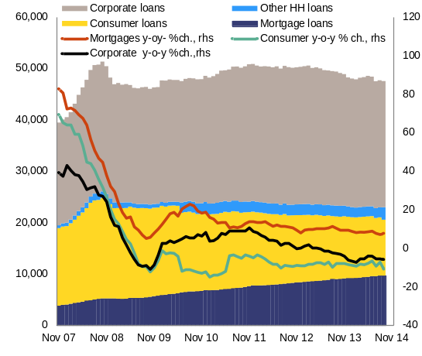
Source: ECB
The accommodative monetary policy stance of the National Bank of Romania had a limited impact on the credit recovery so far. The policy rate was gradually reduced to a record low of 2.25 % in February 2015 (from a value of 6 % in December 2012) in line with price developments and low inflation expectations. Moreover, the minimum reserve requirements for RON-denominated liabilities were reduced from 15 % to 12 % in January 2014 and to 10 % in September 2014, while minimum reserve requirements for liabilities denominated in foreign exchange (FX) were reduced from 20 % to 18 % in January 2014 and further to 14 % in November 2014. Both measures are expected to positive impact lending going forward.
The National Bank of Romania expects the shift from foreign to local currency lending to continue. The proportion of foreign-currency-denominated loans (FX loans) dropped in the last few years (Graph 2.3.3) () driven by: (i) the decline in foreign parent bank funding (pushing local subsidiaries to obtain their funding locally); (ii) lower interest rates for loans denominated in local currency (driven by successive cuts in monetary policy rates to record lows); and (iii) the state-guarantees programme ‘Prima Casa’ for mortgage loans denominated in local currency. Almost half of the mortgage loans are state guaranteed.
Asset quality developments
Graph 2.3.5: Evolution of the NPL ratio at system level
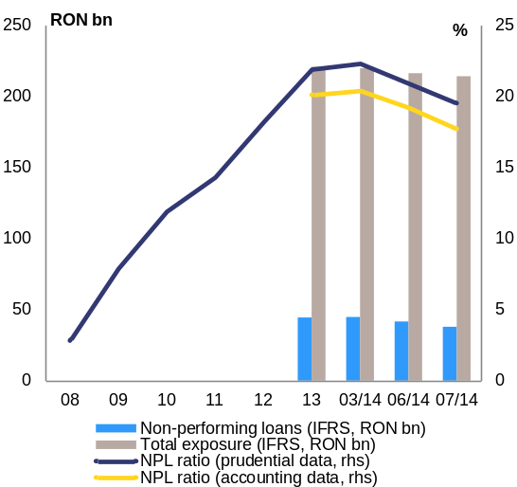
Source: NBR
Despite rapid improvement recently, asset quality remains a challenge in the Romanian banking sector. It deteriorated gradually after the onset of the global financial crisis. The non-performing loans ratio stood at 2.8 % in December 2008 and peaked in March 2014, when it reached 22.6 % (Graph 2.3.5) ().According to the latest data from the National Bank of Romania, non-performing loans at system level stood at 15.4 % at end-September 2014 and further declined to roughly 14 % at the end of December 2014 based on preliminary estimates from the National Bank of Romania. This is due to the acceleration in the banks’ balance-sheet cleaning process, driven by the write-off of fully-provisioned non-performing loans and sales of impaired loans. The process of cleaning up has negatively impacted profitability; the banking system recorded a loss of RON 4.3 billion (around EUR 1 bn) at the end of December 2014.
The risks associated with the deterioration in asset quality have been mitigated by the loan-loss provisioning policy of the National Bank of Romania. Romania has the highest coverage ratio of non-performing loans among its regional peers and one of the highest in the EU (Graph 2.3.6). The non-performing loans coverage ratio stood at 69.8 % compared with 46 % in the EU (in IFRS accounting terms without prudential filters) by end-December 2014, as compared to 67.6 % at end-December 2013. In prudential terms (i.e. factoring in prudential filters), the non-performing loans coverage is almost 90 % (it was 89.9 % as of end-March 2014).
Graph 2.3.6: Coverage ratio of NPLs (%; comparison with selected regional peers)
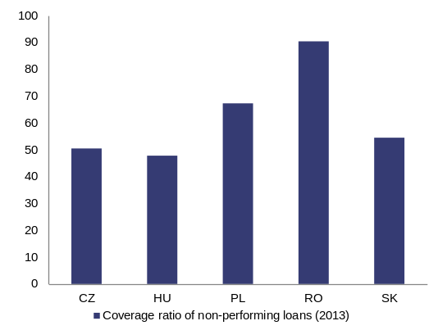
Source: IMF
Capitalisation, funding and trends in deleveraging
Notwithstanding the deterioration in asset quality until the first half of 2014, the Romanian banking sector has maintained reassuring capital buffers. In 2009, as the financial sector came under pressure due to the economic and financial downturn, the National Bank of Romania requested that banks maintain solvency ratios of at least 10 %. Capital adequacy at system level hovered around 14 % from 2007 to 2012 and has increased to 17.1 % at end-September 2014 on the back of capital increases made by weaker banks and the gradual phasing-out of prudential filters in line with the requirements of the Capital requirements regulation and directive (Graph 2.3.7). Banking supervision has closely monitored the corporate governance of banks in order to ensure that potential shortcomings are tackled in a timely manner.
Graph 2.3.7: Evolution of capital adequacy at system level (%; 2007- Q2 2014)
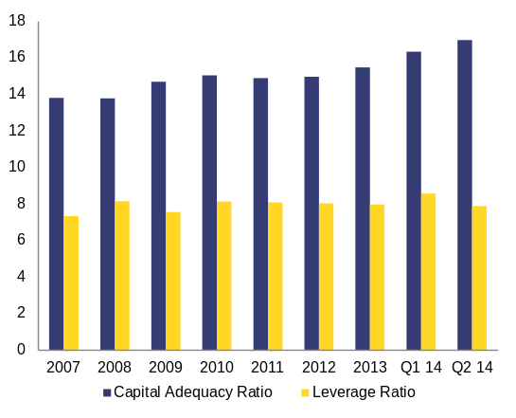
Source: NBR
The commitments of the foreign parent banks under the Vienna Initiative have supported the capitalisation of the banking system. The foreign parent banks which signed bilateral commitment letters to maintain their exposure to Romania and provide capital support to their Romanian subsidiaries are Erste Group Bank, Unicredit Group, Raiffeisen International, Volksbank, Société Générale, Piraeus Bank, Alpha Bank, National Bank of Greece and EFG Eurobank. Parent banks committed to maintain their exposure to Romania throughout the first balance of payments assistance programme period (2009-11) and to provide capital support to their Romanian subsidiaries as needed. Although the commitments to maintain exposure are no longer in place, the nine foreign parent banks are still committed to maintain the capitalisation of their subsidiaries at above 10 % (). From the end of March 2009 until December 2014, the additional capital support provided by these banks to their Romanian affiliates amounted to EUR 1.87 billion.
Graph 2.3.8: Total exposure of the nine euro area foreign parent banks to Romania (EUR bn, March 2009 - August 2014)
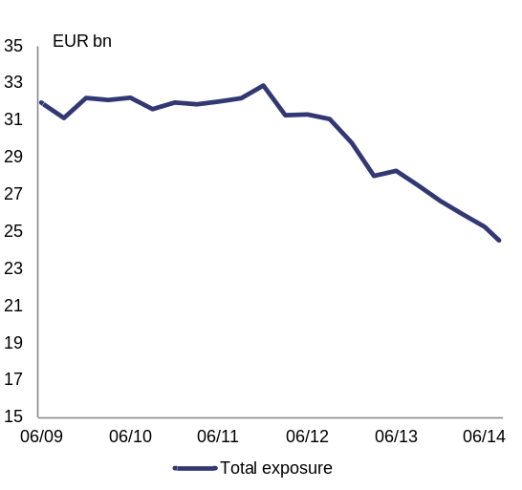
Source: Vienna Initiative reporting
Although parent bank funding has declined due to the ongoing cross-border deleveraging, it has mainly longer term maturity. Parent funding represented roughly 20 % of total assets at the end of December 2011, but went down to nearly 15 % at the end of August 2014. Close to 70 % of parent funding has maturities of over one year, which should mitigate the risk of sudden withdrawal. The nine foreign parent banks have reduced their exposure to Romania by EUR 3.5 billion in 2014 (see Graph 2.3.8). This process has not caused major disruptions as the Romanian banks have turned to domestic funding sources instead. The maturity gap is deepening as more than 50 % of total private sector loans have a long-term maturity and majority of long-term loans is funded by short-term deposits.
Liquidity of the banking sector has improved recently. The improvement results from the ongoing deleveraging process of Romanian banks, more liquid assets and National Bank of Romania's operations (weekly repo operations). The National Bank of Romania has stepped up efforts to maintain an adequate management of liquidity in the domestic banking sector, extending the list of available instruments and eligible collateral for open market operations. Immediate liquidity has steadily increased. Immediate liquidity shows how much of total funding is covered by cash and deposits, and it increased from 38 % to 40 % between September 2013 and June 2014. Moreover, the loan-to-deposit ratio (LTD) decreased from roughly 117 % at the end of 2012 to 91.4 % at the end of 2014 (Graph 2.3.9).
Graph 2.3.9: Loan-to-deposit ratio (RON, FX, Total)
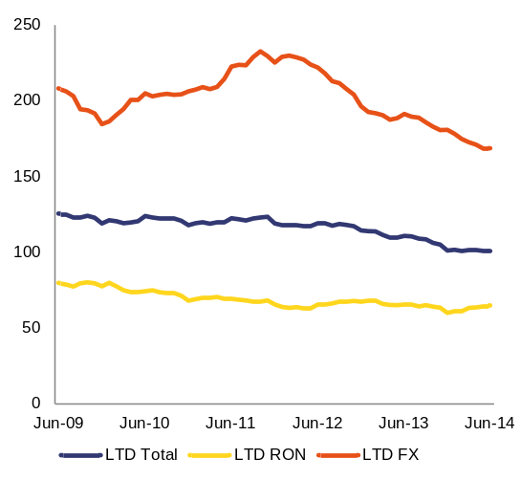
Source: NBR
Risks to the banking sector stability
Financial stability has been safeguarded since 2009 when the balance of payments financial assistance programmes started. Structural improvements in financial sector oversight and bank resolution were implemented in line with the balance of payments programme conditionality, even if sometimes with delays. Financial sector policy conditionality was geared towards: (i) maintaining financial stability; (ii) enhancing the bank-resolution framework and the safety nets available in cases of financial distress; (iii) addressing the vulnerabilities associated with foreign-currency lending; and (iv) speeding-up the banks’ balance-sheet cleaning and diversifying the banks’ sources of funding. To increase confidence in the quality of banking sector assets and in view of joining the banking union, the National Bank of Romania committed to launch a comprehensive asset quality review and stress test with third-party involvement in May 2015. Furthermore, the National Bank of Romania has also carried out a local asset quality review covering three local banks with Romanian capital, completed in October 2014.
The Romanian banking sector remains vulnerable to adverse developments in the euro area, as suggested by the events in early 2013 prompted by the Cypriot crisis. The latter had finally only a limited impact on Romania, as the bail-in of depositors of the branch of a Cypriot bank was prevented following a common solution of the Cypriote and Romanian banking supervisors. Despite the small size of the Cypriot branch, systemic relevance was pleaded due to potential spill-overs to other banks with parents from the euro area periphery.
In spite of reassuring capital buffers, the banking sector continues to be susceptible to several ‘home-grown’ vulnerabilities. Notwithstanding the sale of impaired assets in 2014 and the enforcement of the measures included in the National Bank of Romania’s non-performing loans resolution plan, the overhang of impaired assets is likely to continue to pose challenges to banks, especially smaller ones. Furthermore, the draft legislative proposals currently discussed by Parliament aimed at imposing high turnover taxes (i.e. 85 %) on asset recovery companies which acquire impaired assets from banks may hamper the clean-up of bank balance sheets. Past legislative initiatives with unwarranted impact on the banking sector (e.g. government emergency ordinance 50/2010 covering inter alia the calculation of interest rates in loan contracts) have been modified in the context of the programme conditionality.
Against the backdrop of the recent appreciation of the Swiss franc, the risks arising from the foreign-exchange-denominated loans continue to require close oversight (). The recent appreciation of the Swiss franc has re-opened discussions aimed at converting foreign exchange denominated currency loans into RON loans or other currencies at the exchange rate when the loan contract was signed while also keeping the original foreign exchange-based interest rate to shift the entire burden of conversion on banks. As compared to other countries which have been impacted by the recent appreciation of the Swiss franc, Romanian households have a limited exposure to Swiss franc denominated loans (i.e. these loans represent roughly 1.5 % of GDP). In case of adoption by Parliament, such legislation may impose losses on banks, weaken their capital base and lead therefore to an unwarranted impact on financial stability. Another option presented as solution for households indebted in Swiss franc has been the rapid adoption of a personal insolvency law. The government already approved a draft legislative proposal on personal insolvency in autumn last year. However, this draft legislation may not be tailored to address the specific situation of individuals with Swiss franc denominated loans.
Private indebtedness
Graph 2.3.10: Private sector indebtedness (% GDP)
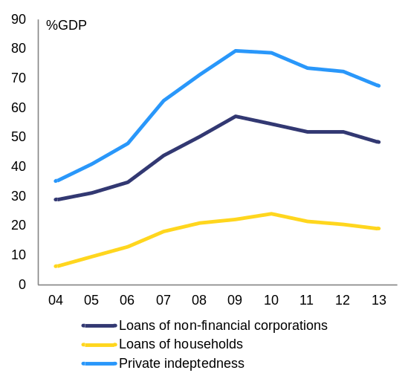
Source: European Commission
Romania is characterised by relatively low private sector indebtedness. Loans to the private sector amount to 69 % of GDP. Moreover, the aggregate private indebtedness was reduced by more than 10 pps. of GDP between 2009 and 2013 (Graph 2.3.10). Romanian households are among the least indebted in the EU, with their loans totalling 19 % of GDP in 2013 (Graph 2.3.11). Non-financial corporations’ loans amount to 48 % of GDP, well below the EU average of 79 % of GDP (Graph 2.3.12).
Graph 2.3.11: HH loans as % of GDP (2008 and 2013)
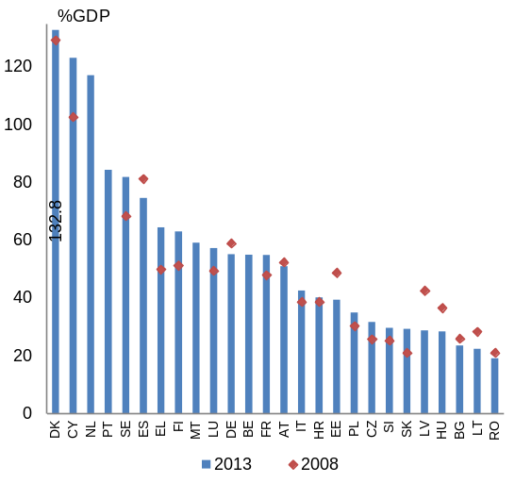
Source: European Commission
The build-up of household debt took place between 2000 and 2010. Household debt relative to household disposable income increased from 1 % in the early 2000s to 37 % in 2010 (Graph 2.3.14). This indicator was below the EU-wide average (106 %) and the average of the new Member States (56 %). Household debt relative to
Graph 2.3.12: NFC loans as a % of GDP (2008 and 2013)
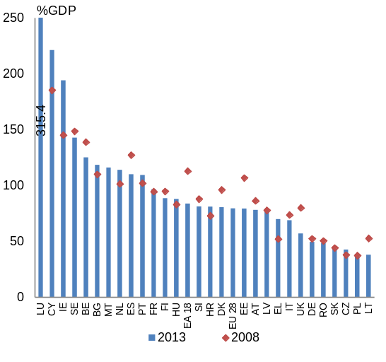
Source: European Commission
GDP increased from 1% in the early 2000s to 23 % in 2010. Despite the surge, the level remained significantly below the EU-wide household debt level of 69 % of GDP. After 2010, Romanian households started deleveraging.
Housing costs, including mortgage repayments, represent a large proportion of total household expenditure in Romania. Debt service is high as a proportion of monthly debt service in monthly gross income appears high compared with other Member States (Graph 2.3.13). On average, Romanian households spend one third of total consumption expenditure on housing. For 20 % of the home-owner households, housing costs represent more than 40 % of disposable income. This is twice the European average.
Graph 2.3.13: Households’ monthly debt service
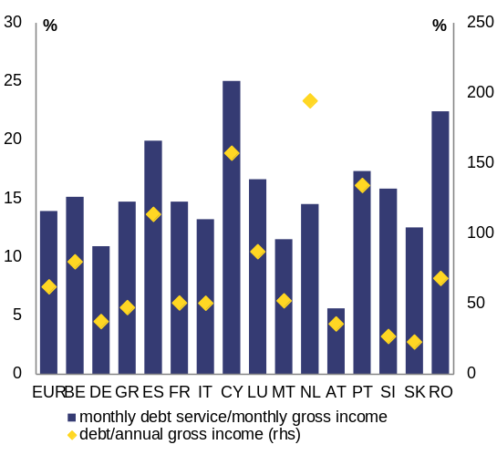
Source: European Commission, 2010 household budget survey
Also consumer loans contribute to the high debt servicing burden of households (Graph 2.3.15). Despite the contraction in consumer loans since December 2009, they still represent half of the total household loans. They reached 14 % of GDP in 2009, far above the euro-area average of 6 % (Graph 2.3.18). About one third of these loans are mortgage-backed, according to the NBR's Financial Stability Report, 2013.
Graph 2.3.14: Household debt developments
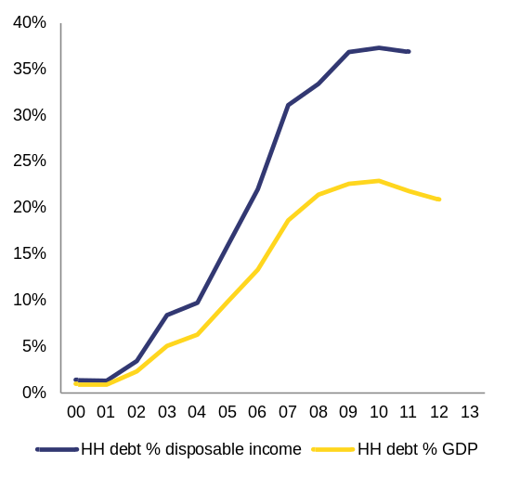
Source: European Commission

Graph 2.3.15: Stock of loans granted by purpose and currency
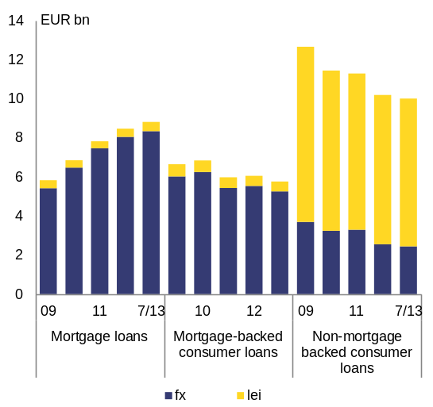
Source: European Commission
Housing valuation has an impact on both households and banks, via the mortgage and mortgage-backed loans. Inflation-adjusted house prices halved between 2008 (peak value) and end-2013 (Graph 2.3.16). Over the same period, the number of building permits fell by almost 40 % (Graph2.3.17). The correction continued throughout 2014, albeit at a slower pace. Based on industry data, house prices have dropped below the end-2005 level in nominal terms. A similar trend applies to both cities and rural areas, although there is a difference in price level between the Bucharest region and other cities on one hand, and rural areas on the other hand. Going ahead, Commission staff expects the housing market to gradually recover, with housing construction growing in 2015 and 2016.
Graph 2.3.16: Relative house price index and price-to-income ratio
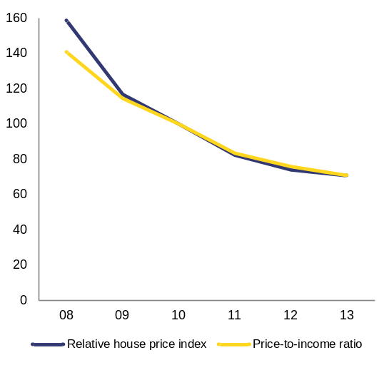
Source: European Commission
The exposure of households to exchange rate volatility remains high. The lower interest rate on foreign exchange loans encouraged borrowers to take up loans in foreign currency, mostly in euros but also in Swiss francs. Non-performing loans ratio is higher for foreign exchange denominated loans to households than for household loans in lei since 2011, around 10 % and 7 % respectively. The depreciation of domestic currency versus the euro and Swiss franc increases the debt servicing effort and debt burden. The National Bank of Romania's regulation No 24/2011 on loans to households and the restriction of the ‘Prima Casa’ programme to domestic-currency lending since August 2013 has contributed to the reduction in the foreign-exchange-denominated loans as a proportion of new loans. Namely, since August 2013, in the framework of the mentioned programme, the Romanian government has provided state guarantees only for mortgage loans denominated in lei. The state guarantee covers up to 80 % of the mortgage value for a loan of maximum 60,000 euros.
Graph 2.3.17: Residential investment and building permits
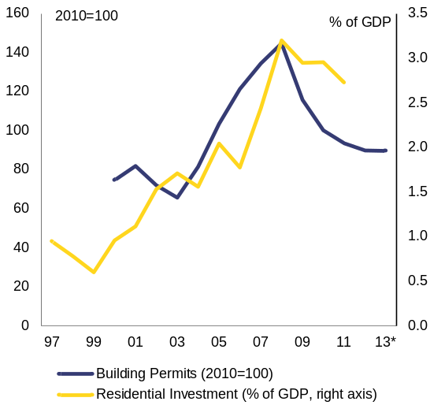
Source: European Commission
While representing more than half of the Romanian private debt, corporate credit remains comparatively low. It totals to 48% of the GDP, reduced by almost 9 percentage points since 2009 (Graph 2.3.10). In nominal terms, the loans to the corporate sector decreased after 2012. New loans to SMEs and large corporations went down by 5.2 % in 2013 and by roughly 4 % up to August 2014 (Graph 2.3.19).
Graph 2.3.18: Loans for house purchase and consumption, % GDP
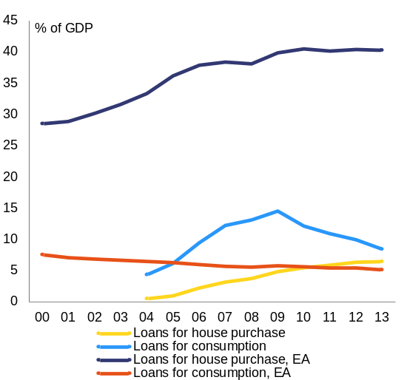
Source: European Commission

Graph 2.3.19: Decomposition of corporate lending growth rate by firm size
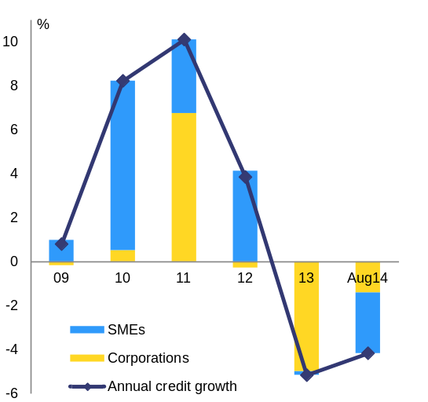
Source: NBR, Financial Stability Report 2014
Whereas current deleveraging can be interpreted as an adjustment following excesses in the pre-crisis period, increasing lending in order to support growth remains a challenge. According to the National Bank of Romania, the proportion of companies with bank loans is relatively low. Available data from companies that submitted financial statements to the Ministry of Finance show that less than 15% of them have a bank loan, irrespective of the stage of the business cycle according to the National Bank of Romania's Financial Stability Report, 2014.
Low level of corporate lending is due to both supply and demand factors. On the demand side, some companies are deleveraging and risk aversion is limiting demand for bank lending as funding source for long-term investments. Supply side factors relate to financing capacity of the banking sector, including availability of funds, collateral requirements and lending practices.
The level of indebtedness in the corporate sector is related to the size of the company. SMEs have been increasing their exposure to bank lending and other third party liabilities, while shareholders' participation in total SMEs liabilities decreased to 17% in 2013 (from 23% in 2009). SMEs leverage ratio increased from 4.5 to 4.8 between 2012 and 2013 (Graph 2.3.20). In contrast, large corporations deleveraged between 2012 and 2013, supported by equity increases (see Graph 2.3.20). The leverage ratio of large corporations therefore decreased from 1.26 to 1.14 in the same period, partly explaining the decreasing ratio of non-performing loans in this group of enterprises.
Graph 2.3.20: Financial soundness indicators for corporates
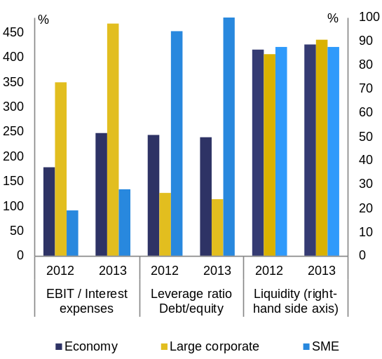
Source: NBR, Financial Stability Report 2014
The payment discipline of companies differs not only across the company sizes, but also across sectors. Micro-companies and SMEs both exhibit non-performing loans higher than 20 %. Construction and real estate sectors have the highest levels of non-performing loans. Total non-performing loans of this sector stood at 28 % in August 2014, followed by trade with 24 % and industry with 21 %. Services and agriculture exhibit also a high non-performing loans ratio of nearly 18 %, while the energy sector seems to be the most diligent in repaying the debt with a non-performing loans ratio of less than 7 % (Graph 2.3.21).
Corporate insolvencies declined in 2014, after a re-acceleration in 2013. In 2013 and 2014, almost 72 % of the non-performing loans for corporates were due to insolvencies or bankruptcies. The number of insolvent companies in 2014 was around 35.700 as compared to 38.400 in 2013 and 34.300 in 2012. By comparison, in 2012, only 66 % of non-performing loans for corporates originated from bankrupt or insolvent companies.
Graph 2.3.21: Non-performing loans per sector, August 2014 (% of loans in the sector)
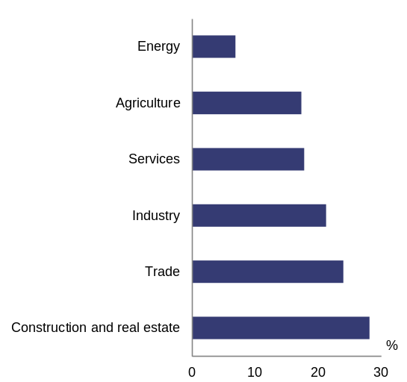
Source: NBR, Financial Stability Report 2014 and Commission calculations

Tax policy and compliance
Romania’s tax revenue composition is generally favourable to growth. Romania has one of the most ‘growth-friendly’ tax compositions in the EU. Indirect taxes have been substantially above the EU average (), while direct taxation has been substantially below the EU average ().
Tax policy is lacking continuity, predictability and strategic planning. In the course of 2014, among others, social security contributions were cut by 5 pps. and the special constructions tax was introduced (the rate was reduced as of January 2015 and its scope modified). In addition, a tax exemption for reinvested profits on new technological equipment (applied temporarily between July 2014 and the end of 2016) was introduced. Such incentives for additional investments are more commonly used rather as a counter cyclical tax policy instrument during a downturn. Stakeholders’ consultation of some of these measures was limited and implementation timelines were rather short. A tax incentive for private debt restructuring, targeting low and middle income earners with performing loans was also introduced in June 2014. The scheme may have an adverse impact on credit discipline. It also entails additional provisioning obligations and thus losses for banks. Take-up is limited so far, but the authorities intend to change eligibility criteria in order to make the scheme more attractive.
The recent cut in employers' social security contributions paid by employers has decreased the labour tax wedge, but in an untargeted way. While the tax burden for high-income earners in Romania is low - thanks to the flat-rate personal income tax and the cap on social security contributions - the tax wedge remains high in comparative terms at lower income levels (see graph 3.1.1). The recent cut in social security contributions by 5 pps. across the board (as of 1 October 2014) decreased the tax wedge from 42.3 % to 40 % for single individuals earning 50% of the average wage, and from 43.5 % to 41.2 % for those earning 67 % of average wage (the 8th highest value in the EU - EC/OECD Tax-benefit database) (). However, the authorities expect the social security contributions to have a positive impact on the economy and the labour market in the medium and long term, thanks to a reduction in labour costs. A challenge will be to monitor carefully how the social security contributions cut might translate into higher wages, which would then feed back into labour costs.
Graph 3.1.1: Change in the tax wedge following 5 pps. reduction, by earnings level
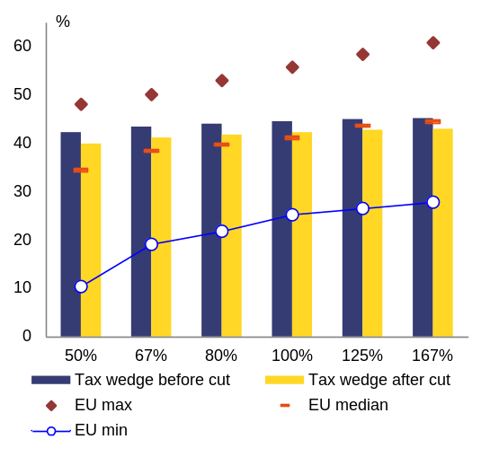
(1) Reduction in the tax wedge simulated on 2013 data, for the case of a single individual without children.
Source: European Commission/OECD Tax-benefit database
The reduction in social security contributions is expected to yield a net loss of tax revenues of around 0.75 % of GDP for 2015 (). Not targeting the reduction of the tax wedge for low and middle income earners resulted in this significant revenue loss. Budget neutrality is intended to be ensured mainly via expenditure cuts as in the 2015 budget and for the fourth quarter of 2014. The sustainability of this approach remains to be verified in the course of 2015.
Undeclared work and under-declared earnings weigh on tax revenue. The discrepancy between the relatively high tax wedge on labour (calculated on the basis of the legal tax obligation) and the low implicit tax rate on labour (calculated on the basis of actual tax receipts) suggests a high amount of concealed earnings. According to the Fiscal Council (Annual Report 2013), in 2012 figures show around 1.57 million people were performing their activity without legal arrangements. This has a negative impact on fiscal revenues, labour productivity, working standards and human capital investment. In 2013, the amount of tax evasion attributable to undeclared work and the informal sector was 3.2 % of GDP, including uncollected social security contributions (for about three quarters) and foregone personal income taxes (about one quarter). A pilot compliance project targeting undeclared labour and under-declared wages and tax evasion was implemented in two counties in 2014 by the newly established anti-fraud unit. The project is to be rolled out to a number of additional counties in 2015, covering all eight administrative regions of the country. However, efforts should go beyond fining and collecting past tax debts, towards also ensuring formalisation of work relationships, as the latter is rather weak ().
A well-functioning system of labour inspections is a key to address the challenge of undeclared labour. In this respect, recent initiatives to restructure the Labour Inspection (merging it with the National Agency for Payments and Social Inspections) should avoid creating disruptions in the work and organisation of the institution, ensuring that its independence and autonomy are preserved.
Despite steps taken, VAT compliance remains a concern. Since 2000, the average VAT gap () exceeds 40 %, with a VAT gap of 44 % in 2012, the highest gap in the EU and significantly above the average of 16 % of 26 EU member states (see graph 3.1.2). However, the VAT revenue ratio was 50.6 % in 2012, slightly above the EU average of 48.8 %. () To improve efficiency of its VAT collection, the authorities are gradually introducing a number of measures including electronic cashiers, a new procedure for VAT-registration numbers and a lottery of tax receipts. The legislation to streamline VAT reimbursement procedures has been improved by adjusting threshold for ex ante control. According to a recent report on VAT administrative cooperation, Romania makes limited use of multilateral control in VAT, a tool to tackle cross-border VAT fraud, especially in cooperation with neighbouring countries. The impact on revenue of the reverse-charge mechanism introduced in certain areas is still to be assessed (). Starting September 2013, the reduced VAT rate is applied for bakery products. The declared policy goal of this rate reduction was to fight tax evasion (). Subject to the necessary available fiscal space, the authorities contemplate a more frequent use of the reduced VAT rate or a reduction in the standard VAT rate in the future. Concerning excises, recent studies indicate that, in the context of frequent rate hikes, the black market in the area of production and distribution of alcohol remained substantial ().
Graph 3.1.2: VAT gap in selected Member States, 2012
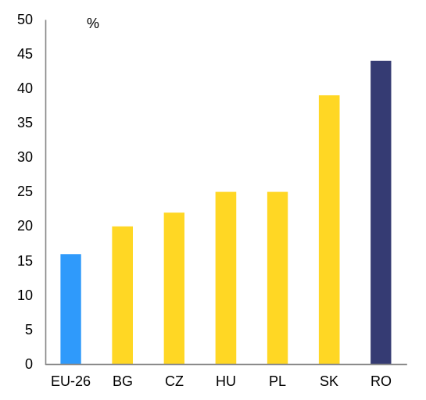
Source: European Commission
The ongoing reorganisation of the Romanian tax administration aims at increasing flexibility and efficiency. Some steps have already been taken to simplify and modernise the tax administration. The compliance time for businesses, i.e. a standardised medium-sized company, showed a positive trend, with a reduction from 200 hours in 2012 to around 160 hours in 2013, below EU-EFTA average (). Also, though the number of payments was strongly reduced from 39 in 2012 to 14 in 2013, Romania still ranks slightly above the EU-EFTA average. An online payment system was introduced three years ago for natural persons, but is still rather limited in use. Personal e-communication channels ('spaţiul virtual') between the taxpayers and tax administration were put in place. There is an ongoing discussion about a possible decentralisation of the Large Taxpayers Office. International experience suggests the need for a strong central office, given the specialised skill-set to provide taxpayer services and support compliance for large taxpayers.
The level of environmental taxation has increased in 2014, bringing it close to the EU average. Environmental taxation is considered relatively growth-friendly, inter alia as it provides incentives to avoid environmental damage. In 2012, the most recent data available, Romania’s environmental tax revenues were 1.9 % of GDP, as opposed to 2.4 % for the EU average (see Eurostat, Taxation Trends in the EU, 2014). Excise rates on fuel were increased by 7 eurocents in 2014. According to preliminary European Commission’ estimates, this increase raises environmental tax revenue by around 0.4 %, bringing it close to the EU average. The vehicle taxation system was improved but the impact of the new 'environmental stamp' tax is still to be assessed. This will impact revenues from non-fuel taxation on transport, which currently stand at 0.2 % of GDP, compared to an average of 0.5 % of GDP in EU-27. The landfill tax remains to be enforced. The existing air pollution, water abstraction and wastewater treatment taxes are set at low levels ().
Fiscal framework
Fiscal governance was strengthened over the past years through fiscal anchors such as the Fiscal Council. The Fiscal Responsibility Law was amended with a view to transposing Fiscal Compact provisions, in particular the structural balanced-budget rule and its automatic correction mechanism. This builds on top of a set of existing numerical fiscal rules. The Fiscal Council was strengthened in its role and capacity. However, access to draft budgets and proposals for budget rectification is not provided in a timely manner and the management of the budget process usually does not allow for the Fiscal Council’s opinion to feed back into the process. Numerical fiscal rules are not regularly respected, in particular during budget rectifications ().
The medium-term budgetary framework does not effectively guide the budget process. The 2015-17 Fiscal Strategy, which is the document setting out medium-term budget planning and expenditure ceilings, was passed with more than four months delay, at the same time as the 2015 budget law. Passing the Fiscal Strategy on time () would allow guiding the budget process beyond the short term and would strengthen continuity in Romania’s public finances.
Medium- and long term challenges
The public wage bill remains contained, but the unitary wage grid is not yet implemented. In the run-up to the crisis, frequent public wage increases fuelled overall wage levels in the economy and thereby contributed to an erosion of the Romanian competitiveness. The unified wage law, as adopted in November 2009, introduced a unitary wage grid and abolishes a number of discretionary wage supplements and 'stimulente' (significant bonuses for selected groups of public employees). The grid was not yet effectively implemented due to limited public funds. In past years, wage increases were given on an ad hoc basis to particular categories which are below the grid. There is no comprehensive approach or strategy on how to phase-in the grid over the coming years. Repeated requests to re-introduce 'stimulente' or to allow for other exceptions from the unified wage law were mitigated under the subsequent balance of payments financial assistance programmes.
Public investment management suffers from a lack of stronger prioritisation and coordination. Technical guidance at the selection stage of the public investment cycle is limited and not fully harmonised across line ministries. This leads to a big number of projects included in the investment planning and in the budget, which are not fully ready for implementation. Some progress has been achieved through the creation of a public investment prioritisation unit at the Ministry of Finance. However, the institutional setting is not fully clarified and the unit’s capacity and staffing could be further strengthened. Better public investment prioritisation would feed into more realistic medium-term budgetary plans given the multi-annual nature of many investment projects.
Romania faces low fiscal sustainability risks in the medium term. Government debt (around 39 of GDP in 2014 according to the Commission 2015 winter forecast) is below the 60 % of GDP Treaty threshold. Under the no-policy-change assumption, public debt might remain broadly stable until 2025. However, in different historical scenarios assuming that macroeconomic and fiscal variables gradually converge to last 10-year historical averages, debt is projected to steadily increase to around 60 % of GDP in 2025.
Pension system
The Romanian pension system is confronted with the challenge of ensuring the long-term sustainability of public finances and, at the same time, guaranteeing adequate retirement incomes. The 2010 pension reform abolished special pension regimes for most professions, which improved the transparency and fairness of the system. It also increased the number of contributors to the main pension system, leading to some improvement in the number of pensioners per contributor, which now stands at around 1 according to the Ministry of Labour (compared to 1.2 in 2010). A draft law currently discussed in Parliament would re-introduce such a special pension scheme for aviation personnel, which risks creating a precedent questioning the current framework. The medium- and long-term demographic trends and low labour-market evolution may pose a challenge to the long-term sustainability of the system. Updated long-term projections of the cost of ageing components will be available in the first half of 2015. Farmers and low-income earners often do not contribute to the pension system, also because there is no mandatory contribution for workers with low incomes. This puts a drag on revenues but also leaves a significant part of the rural population without pension insurance and vulnerable to the risk of poverty.
Some steps are being taken to continue the reform in the pension system, but progress is slow and a parliamentary initiative questions past achievements. Romania is one of the two EU countries that have not yet legislated a path to equalisation of statutory retirement age for men and women. Legislation proposed by the government in December 2013 foresees the equalisation of the pensionable age between men and women to take place by 2035 (but does not link it to life expectancy). The pensionable age would become 65 for both men and women, for a full contribution period of 35 years and a minimum contribution period of 15 years. However, the law has not yet been adopted by the lower chamber of Parliament.
The average duration of working life and the employment rate of older workers, women in particular, are among the lowest in the EU. The number of early retirees further increased in 2014, in spite of the restrictions imposed by the 2010 pension reform (). The majority of early retirees are concentrated within the lower income groups. As these do not qualify for pension benefits that are much above the level of the guaranteed minimum pension, the penalty for not having a complete contributory period only affects their final pension in a limited way. Lower pension entitlements are determined by shorter careers which explain the persistently high at-risk-of-poverty rate in old age, especially among women (18.6 % for women against 9.7 % for men). Higher participation rates and longer working lives are important for sustainability and pension adequacy in the long run ().

Labour market
Despite the recent economic recovery, improvements in labour-market conditions remain modest. The Romanian labour market continues to be characterised by persistently low employment and high inactivity rates coupled with a shrinking working-age population due to population ageing and outward migration, as well as under-employment in agriculture. The unemployment rate (Graph 3.2.1) has remained broadly stable around 7 % since the end of 2009, while slightly decreasing recently. Overall, labour cost dynamics have been contained, as real wages, after reductions during the crisis years 2010-11, have been recovering at a pace which is broadly in line with productivity growth .
Graph 3.2.1: Labour market indicators
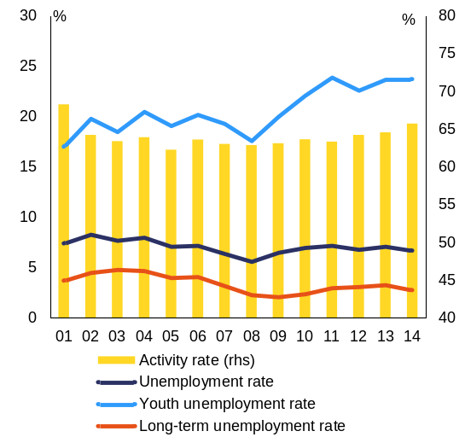
Source: European Commission
Labour demand and job creation remain subdued (). Despite a slight increase of the job vacancy rate in the first three quarters of 2014 (to 0.9 %), this remains below the EU average (1.6 %) and the ratio of unemployed to hirings is the fifth highest in the EU (above 4 for 2013). The lack of job opportunities forces people into inactivity or informality, and contributes to migration of both qualified and unqualified labour. In the short term, migration could balance demand and supply, but if the flow is not circular it risks becoming a structural problem as the country loses valuable productive labour resources.
Low employment and activity rates affect particularly women, young people, older workers and Roma, with some improvements being registered in 2014. At 67.4 % in the third quarter of 2014, the employment rate in Romania is increasing, but remains below the EU average and the national EU2020 target of 70%. The employment rate is particularly low for the young and falls sharply beyond the age of 55, while for women activity rates decline sharply already from the age of 50. Employment of older workers is hampered by early exit from the labour force, the average duration of working life being 32 years (vs. 35.1 in the EU, 2013). Planned changes in the pensionable age would be more effective if complemented by active ageing measures such as lifelong learning, incentives to remain at work, adapting working arrangements and improving health and safety conditions. The Active Ageing Strategy is expected to be adopted by March 2015 instead of 31 January, as initially committed in the Operational Programme Human Capital. Concerning female employment, many women leave the workforce in order to take care of their children or dependent relatives. Employment among Roma remains low, covering many low-skilled jobs, informal employment and under-employment.
Romania has taken steps in addressing youth unemployment, in particular under the umbrella of the Youth Guarantee, but the high number of young people who are not in education, employment or training remains a challenge. Youth unemployment reached 24 % in 2014, well above total unemployment level and with strong regional variation (Graph 3.2.1). The number of young people not in education, employment or training (NEETs) is high (17 % of youth population aged 15-24), with more than 60 % of them being economically inactive, the third highest proportion in the EU (Graph 3.2.2). This situation is particularly adverse for young Roma. Financing of large projects supporting apprenticeships and traineeships is envisaged in the Operational Programme Human Capital 2014-2020 and should contribute to increasing the low take up of such schemes. Romania set up 27 pilot Youth Guarantee (YG) centres aimed at identifying young NEETs and providing packages of personalised services, but their impact and coverage remain uneven. Public employment services (PES) are developing an integrated database of non-registered NEETs and putting in place new measures supporting early activation for them, but their capacity to effectively reach out, support and activate young people remains a challenge ().
Graph 3.2.2: NEETs and inactive NEETs (% of population aged 15-24)
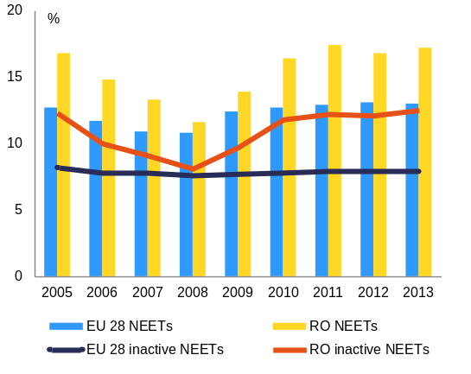
Source: European Commssion
So far, Romania has taken some steps to improve the integration of Roma into the labour market. There is no evidence that existing active labour-market policies are effective in ensuring Roma inclusion in employment and there have been no changes over 2013-14 in addressing their situation (). In view of the projected rise in the share of Roma in the total population, as well as in the share of new labour market entrants, better integration is a challenge also from an overall employment and growth perspective. However, Romania has adopted a revised national Roma integration strategy in January 2015. Although the strategy is well structured in terms of objectives, proposed actions and monitoring indicators, the results are to be seen. An effective coordination mechanism at national and local level is still not in place, which has a direct impact on advancing Roma inclusion. In addition, discrimination remains a cross-cutting issue.
Spending on labour-market policies remains low, with passive policies absorbing the highest share. Against high levels of long-term unemployment, accounting for in 39.7% of total unemployment in 2014, spending on active measures is low, the budget still being at one third of the pre-crisis level. Passive labour-market support has also decreased, driven by the rise in the long-term unemployment rate and by a low coverage of unemployment benefits. A very limited proportion of jobseekers registered with the PES benefit from active measures.
Active labour-market policies were revised, but the overall participation and financing remain limited. Limitations are particularly strong for vocational training, recognition of prior learning and mobility incentives, as well as their coverage of the long-term unemployed. Changes to Law 250/2013 on unemployment insurance and employment stimulation were implemented slowly, as methodologies were only published late 2014 and were not accompanied by a rise in expenditure. While some of the active measures were adjusted to increase their attractiveness and targeting, the imbalance between the increased administrative tasks of the PES and its high caseload remained unaddressed. Further efforts could bring a more coherent delivery across counties and target groups and for lowering the administrative burden for beneficiaries.
The 2014 National Employment Strategy entails measures to increase employment of different groups, to reduce the extent of subsistence agriculture and to improve skills of workforce. In the context of the ex-ante conditionalities for the EU funds, Romania has committed to put forward an integrated delivery framework for measures and services financed through the unemployment insurance budget and European Social Fund that would ensure common standards of quality, an even level of delivery and a more coherent implementation of the Strategy. Results are awaited at the end of 2015 from a research project aimed at assessing the impact of all active measures commissioned by the Ministry of Labour.
The coverage of public employment services' activation, job search and retraining services remains limited. Limited resources do not allow for personalised services to jobseekers (according to their employability) and employers, as well as the integration of active and passive labour-market policies. An important step forward is a benchmarking and mutual learning exercise of the European PES network that was piloted in Romania. Romania has committed to accelerate the professional card programme monitoring actions taken for jobseekers and the updating of the PES portal with extended e-services that would ensure efficiency and better transparency of labour supply and demand. PES could benefit from operational, process and resource autonomy based on a reinforced performance management system and from more partnerships with social partners, strategic employers and private service providers.
Social protection
Reduction of poverty and social exclusion remains a major challenge for Romania. In spite of registering a decreasing trend, the rate of people at risk of poverty or social exclusion, remains high at 40 % in 2013, far above the EU average (Graph 3.2.3). Single parents and families with numerous children appear particularly exposed to poverty (). A decreasing, yet high, proportion of Romanians is severely materially deprived – 29 % in 2013, almost three times the EU average.
Graph 3.2.3: Persons at-risk-of-poverty or social exclusion in Romania
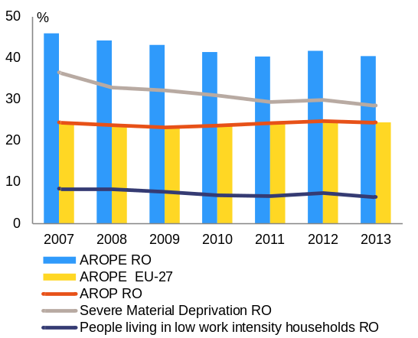
Source: European Commission
Paid employment does not safeguard against the risk of poverty for a large part of the population. In-work poverty is the highest in the EU. Evidence from the national authorities suggests that this stems mostly from the high number of low-wage earners, poor self-employed subsistence farmers and unpaid family workers. The minimum wage remains among the lowest in the EU, although its level has been increased significantly.
The social protection system is not equipped to address the high risk of poverty and social exclusion. The impact of social transfers (excluding pensions) in reducing poverty appears limited, remaining the second lowest in the EU and resulting particularly low in the case of children (). The low impact of social transfers and the high levels of in-work poverty are affecting the overall living standard of the population. Both the adequacy and coverage of social transfers and their capacity to reach out to some of the poorest segments of the population are low (). The decreasing effectiveness of social transfers also reflects that the value of the Social Reference Index, which according to the social assistance reform should be linked to all social assistance benefits and reflect the minimum wage and unemployment benefits, has remained frozen since 2008, in spite of a cumulative inflation of 26 % between 2008 and 2013.
The effectiveness of social transfers is hampered by the absence of a mechanism to automatically adjust benefits levels by updating the Social Reference Index. According to the social assistance reform, all benefits are linked to the Social Reference Index. So far, benefits have been adjusted on an ad hoc basis by arbitrarily changing their relative value with respect to the Social Reference Index, while the value of the latter has been kept frozen (at 500 RON) since 2008, in spite of a cumulative inflation rate of 28 % between 2008 and 2014. As a consequence, in the absence of a coherent methodology for updating the Social Reference Index, the value of benefits such as the child rearing allowance, the heating benefit and the unemployment benefit diminished in real terms, triggering a significant increase in the severe material deprivation rate for the unemployed in 2013. Disability benefits were increased by 16 % starting with January 2015 (this was the first update in the last 6 years).
Social transfers are not adequately linked to activation measures. The Guaranteed Minimum Income (GMI) and the family allowance are subject to the fulfilment of certain conditions by the beneficiaries, such as registration with the PES for the former and children school attendance for the latter. However, even if conditionality is in place, there are large gaps in active labour-market policies addressing GMI beneficiaries. Following an evaluation by the Romanian authorities, financing has been stopped for local public works schemes, where people on social assistance were sometimes hired. There are limited paths for cross-referring beneficiaries among the different activation, social inclusion or educational programmes. Stronger involvement of the PES for the GMI beneficiaries who are employable in the medium run and of municipalities for GMI beneficiaries who are not employable/with complex needs would be helpful.
The implementation of the 2011 social assistance reform is still lagging behind schedule. The adoption of the Strategy for Social Inclusion and Combating Poverty and its Action Plans was delayed to March 2015. Limited progress was made in adopting the Minimum Insertion Income, which would simplify social assistance by combining three existing social transfers (the GMI, the family allowance and the heating benefits): a draft law – planned for the end of 2014 – did not materialise. To strengthen the link with activation measures, a social economy law was adopted by the Government in 2013, but is still under debate in the Parliament.
Roma people are facing high poverty. Almost 80 % of Roma households have a disposable income below the national at-risk-of-poverty threshold, the lowest among the EU Member States. Many have no health insurance but difficulties in accessing social services and face poor housing conditions. In particular, 84 % of Roma households report lack of water, sewage or electricity.
The transition from institutional to alternative care for children deprived of parental care is progressing slowly. Although a system of foster families is in place, a large proportion of children in the child protection system is hosted in old-style residential institutions (). Similarly, there is still a high number of persons with disabilities in large residential institutions, while community services for the disabled are not sufficiently developed. The total number of children (including those with disabilities) placed in the child protection system decreased between 2012 and 2013. However, there were still 723 children aged under 3 placed in institutional care at the beginning of 2014.
Monitoring of effective implementation of children rights is lacking. Romania has taken some measures, including with regard to prevention of institutionalisation for children under three years (gatekeeping). However, a comprehensive and coordinated approach to rights of the child throughout all policies and programmes is still missing. Romania is experiencing a severe shortage in the number of social workers available and this has an impact on measures and services to protect the rights of the child. A national strategy for protecting and promoting the rights of the child was adopted in December 2014. It includes measures promoting the de-institutionalisation of children and preventing abandonment. In addition, since December 2014 the set of allowances relating to children in alternative care have been increased to 600 RON irrespective of their placement. A one-time allowance equal to the minimum wage is granted in case of exit from the system (because of reintegration, age limit, or adoption). The system of foster families and personal assistants to persons with disabilities continues to encounter difficulties in terms of funding and quality control. Several measures aimed at supporting de-institutionalisation and transition towards community based care, supporting young people leaving institutions and the development of social and maternal assistants’ network are foreseen to be financed under the Human Capital Operational Programme.
Health and long-term care
The Romanian healthcare system faces several major challenges. This includes poor health outcomes, accessibility, including in financial terms and especially in rural areas, low funding (public expenditure on healthcare was 4.3% of GDP in 2012, the third lowest in the EU) and inefficient use of resources. There is a continuous mismatch between spending commitments and available funding, which leads to budget overruns and the accumulation of arrears, especially at the level of decentralised hospital under county ownership. The latter continues to be a challenge to the health sector’s efficiency, posing a significant constraint to much needed restructuring and consolidation of the hospital capacity. Informal payments are widespread and hinder the efficiency, quality and accessibility of the system .
Various healthcare reforms have narrowed the funding gap, improved services and enhanced efficiency. The National Health Strategy 2014-2020 sets the strategic base for health sector reforms. Fiscal controls have been put in place, with monthly monitoring of hospitals’ budget execution and registering of arrears, monitoring of pharmaceutical expenditure via e-prescription and setting clear spending limits. Further, the implementation of e-health card, started end-2014, will improve the monitoring of health services delivered and will improve fraud detection. The revision of the basic benefits basket and the increase in the proportion of spending on primary care and ambulatory services in 2014 (and 2015) set better incentives for providers to deliver services at the right level of care. Access to innovative medicines has been improved in 2014, and legislation for evidence-based revisions of the list of reimbursed pharmaceuticals was put in place. A technical assistance programme with the World Bank seeks to streamline hospital services, shift the delivery of health services to outpatient services, and build physical and functional integrated referral networks, including regional hospitals.
Various measures are considered to speed up reform in the health sector. The Ministry of Health and the National Health Insurance House are considering various measures to improve the performance of the health provisioning: a clear strategy for hospital consolidation, with a detailed mapping, to complement the National Health Strategy; further strengthening of incentives to shifting care from inpatient to outpatient sector; setting up external auditing for hospitals accumulating arrears and measures to deal with underlying causes; strengthening the fiscal sustainability of pharmaceutical expenditure; fostering access to primary healthcare especially in remote and rural areas and increasing its financing; starting implementing the World Bank project for health sector reform; expanding considerably the system of centralised procurement under National Health Programmes and including county hospitals; and improving the governance of the health system and the administrative capacity of health institutions.
Corruption in the health sector appears to be widespread. Survey data reveals that more than two thirds of Romanians consider that the level of corruption in the public health system is high and very high, and one fifth report personal experience with informal payments (AID Romania and Ministry of Health Report). 28 % of Romanians who visited public medical facilities in the preceding year had to make an extra payment, beyond the official fees or offer a gift or donation. This is the highest percentage in the EU, far above the EU average of 5 %, according to the EU Anti-corruption report 2014. Public procurement in the health sector is believed to be another area affected by corruption.
As a first step towards curbing informal payments, new controls and feedback mechanisms are being introduced. The introduction of an electronic health card that will register all consultations and prescription will help highlight abusive and fake consultations or prescriptions. A system of feedback mechanism for patients is now being tested. Other elements to curb informal payments proposed by the civil society include addressing the issue of remuneration for medical staff in public hospitals. In addition, the High Court of Cassation and Justice established in December 2014 that any doctor employed in a Health Ministry's unit is considered a public official and is thus punishable according to the Criminal Code for bribe taking.
Several projects to fight high-level corruption and improve public procurement in the health sector were pursued in 2014. As regards higher level corruption, the Ministry of Health identified three priority areas: i) monitoring the spending of public funds in public hospitals; ii) identifying risk areas in public procurement; and iii) monitor conflicts of interests for the management positions in the health system. In addition, a platform to monitor public procurement and the contracts carried out by public health units and a portal to monitor the conflicts of interests is underway. Public procurement is centralised at national level for the main products (e.g. like standard equipment or vaccines). However, staffing constraints seem to limit the potential of these measures to effectively detect and prevent corruption.
Romania lacks an integrated system of long-term care. There is a lack of clear governance of long-term care services (residential and home care), with different components under different authorities. Integration is made difficult by fragmentary sources of funding for different components of the service. Funding is also low (public expenditure on long-term care was 0.7% of GDP in 2014). Only 0.45 % of the over 65 benefit from long-term home care, compared to 8.5 % on average in OECD countries (World Bank, 2014). Long-term care interventions are foreseen to be financed mostly through EU funds, primarily supported by the European Social Fund. However, attention must be paid to the sustainability of projects beyond the EU funding period.
Air pollution still represents a serious threat for human health, while having direct economic costs. The main sources of air pollution remain solid fuel use in the energy sector and domestic solid fuel combustion. The direct economic costs related to air pollution could be significantly reduced by stepping up pollution and prevention control measures.
Waste management remains underdeveloped. Waste management is characterised by low recycling and high landfilling rates, far below the recycling targets set at EU level. Romania is late in adopting waste management plans and a waste prevention programme. The landfill tax enforcement has been postponed to 2017 and the economic instruments in place do not incentivise separate collection and recycling.
Education
Ensuring adequate investment in education and improving its effectiveness remain a challenge. General government expenditure in education was 3.0 % of GDP in 2012, the lowest in the EU. Annual expenditure in public and private institutions per student in primary and secondary education is a quarter of the EU-28 average (Eurostat, 2011 estimates). Low investment has a negative impact on the quality of education. According to the 2012 PISA survey, Romania was the second worst performer in the EU-28 in reading and science and the third worst performer in maths.
Early school leaving is a key concern. The early school leaving rate remains well-above the EU average (17 % against 12 % in 2013). Lack of human resources and lack of accessibility of facilities and public transportation contribute to keep the early school leaving rate high (UNICEF, 2013). Early school leaving is higher in rural areas (see Box 3.2.1) and for the Roma population (). The lack of evaluation of measures for early school leavers, the shortage of data collection, and the insufficient initial and continuing training of teachers to support new teaching skills and practices for working with students at risk, are further factors that exacerbate the early school leaving challenge. School integration is difficult, with more than 25 % of Roma children attending ethnically separated school classes.
Some steps have been taken to tackle the issue of early school leaving. Curriculum reforms are progressing in line with a competence based pedagogical approach. There are significant delays in adopting the national strategy for reducing early school leaving, which is now expected to be adopted in the first quarter of 2015. The institutional and administrative capacity and mechanisms for its implementation are still being set up. An integrated data collection system on early school leaving has been designed based on a new set of national indicators and a module on primary education is operational.
The uneven availability and limited access of early childhood education and care services presents a challenge and contributes to the high early school leaving rate. Romania’s participation rate in early childhood education was 86% in 2012, below the EU-28 average of 94% (). With 15 % of children under three years in formal childcare facilities in 2012 Romania has not met the Barcelona target of 33 % . Existing formal childcare services are unable to meet demand. Programmes to increase access of disadvantaged children to early childhood education and care (ECEC) are still sporadic, unevenly developed and highly relying on non-governmental organisations and EU funding. There is a gap between urban and rural access to kindergarten and between Roma and the remaining population (). Higher availability and access to early childhood services at the local level, in particular in rural areas, would influence pre-school participation.
Efforts to enhance the availability of early childhood education and care, in particular for disadvantaged children, are ongoing. The revision of the legislative framework and the definition of unified curricula and standards is in process of adoption and is not yet concluded. A national programme for early childhood education and care (comprising ante-preschool education and preschool education) was designed for 2014-19, aiming, among others, at reaching a 95 % enrolment rate for children 4-6 years old and will become operational with the new school year, 2015-16. Romanian authorities declared their intention to decrease the compulsory age to 3 years.
Graph 3.2.4: Participation in lifelong learning
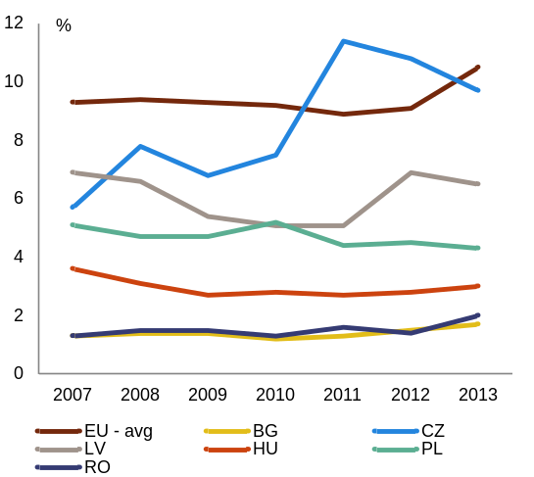
Source: European Commission
The participation in lifelong learning continues to be among the lowest in the European Union. Despite a slight increase participation in lifelong learning activities remained with 2 % (Graph 3.2.4) far below the EU average of 10.5 % in 2013. Both supply and demand barriers are at play, including insufficient provision of training programmes based on social partnership and limited access to systems of prior learning validation and certification. The lowest participation to training is recorded among employees with low levels of education and professional qualification, working in companies with less than 10 employees and aged over 40 (National Observatory for Permanent Learning Development). Training participation rates are also lower in rural areas than in urban areas and for men, compared to women. The national lifelong learning strategy was developed with the support of the World Bank and awaits adoption in the first quarter of 2015, together with the methodology for the organisation and operation of community lifelong learning centres. Priority target groups have been identified, among which early school leavers, graduates with formal qualifications that are no more relevant on the labour market, individuals returning to the country after period of working abroad, and low-skilled adults over 40.
Improving the quality and labour-market relevance of higher education represents a serious challenge. Romania’s tertiary attainment rate remains the second lowest in the EU (23 % in 2013) well below the average of 37 %, although it has consistently increased over 2010-2013. The net enrolment rate for the 19-23 age cohort actually declined in the 2012/13 university year, from 33 % the year before to 31 %. This reduction can be explained by migration, a growing interest in other forms of tertiary education (especially vocational educational) and a decrease in programmes provided by private universities. The relevance of university education for the labour market is a major concern, with limited connection of universities with innovation and research areas and a slow process of adaptation of university curricula and teaching practices to labour-market requirements. The draft strategy on tertiary education aims at increasing the relevance of higher education in line with labour market needs as well as increasing accessibility to disadvantaged groups. In the meantime, a database integrated into the management systems of 50 public universities has been completed and will allow monitoring of higher education graduates insertion in the labour market. The process of correlating occupational standards with labour-market requirements and the updating of the educational offer was continued with 36 new standards developed. All universities are expected to establish by beginning 2015 counselling and career guidance centres. The National Qualifications Register in higher education has been completed. Student social programmes (scholarships, grants for accommodation and meals, partial reimbursement of transport) were continued.
Measures have been implemented with the aim of reinforcing vocational education and training and apprenticeships schemes. The participation of upper-secondary students in vocational education and training remains above the EU average (2012: 62 % vs 50 % Eurostat). However, vocational education and training high schools have the lowest pass rate in the final national examination (38 % as compared to 76 % in general education in 2013, Institute of Educational Sciences) . Also, the dropout rate in 2012 was twice as high compared with general upper-secondary education. The most significant challenges for initial vocational education and training include the improvement of the mechanism aiming to forecast the labour market needs and the development of a set of common principles for a coherent qualifications’ development. New initiatives in cooperation with private companies have proven successful. As regards the continuous vocational education and training, after the change of legislation, the number of apprenticeships has started increasing but remains limited. A number of measures planned by the new education law were implemented as pilot schemes (e.g. the work-based learning vocational training scheme), and will be further rolled-out. Several projects aiming to revise the curricula and to strengthen partnerships with schools and social partners in vocational education and training were implemented, but their mainstreaming still remains to be done. A new vocational education and training strategic framework is being prepared as part of a lifelong strategy to include also study pathways which are under-supplied compared to labour market needs. The setting up of the occupational standards in education and vocational training will strengthen apprentices’ prospects on the labour market. As of the 2015-16 school year, ' vocational education and training colleges' can be organised by universities enabling a form of tertiary vocational training giving access to the labour market. Apprenticeships schemes have been enhanced to cover a broader age group (above 24) and facilitate employers’ participation through partnership with vocational training providers.

Box 3.2.1: Agriculture in Romania
Agriculture plays an important role in Romania, due to its proportion in total employment and its contribution to the GDP. Agriculture accounts for around 30 % of total employment in Romania, six times higher than the EU average. Its contribution to GDP is around 7 %, compared to the EU average of 3 %. Many rural properties are not recorded in the Land Register and only few of the agricultural farms are organised as legal entities. Average productivity is low, currently 30 % of the EU average levels. Subsistence and semi-subsistence farms mostly have low or no market orientation, and they are mostly not involved in cooperative activities, which could assist them to better integrate in markets.  The farms are poorly technically equipped, access to insurance and to credit is difficult. A comprehensive insurance system for small farmers does not exist. Access to credit for agriculture is constrained which has been a significant impediment to the implementation of the 2007-13 Rural Development Programme under EAFRD.  Self-employment in agriculture is, for the most part, associated with subsistence agriculture. The high level of self-employed workers in agriculture reflects more a lack of alternatives than genuine entrepreneurship. Over 1 million jobs represent unpaid family workers, mostly women. The lower unemployment rate in rural areas (5.1%) disguises hidden under- and unemployment.  Low formal education and skills of those employed in agriculture raise vulnerabilities. The average educational attainment among those employed in agriculture is low. In 2012-13, the gross enrolment rate in primary and lower secondary education in rural areas was 85 %, compared to 97 % in urban areas. Only about 40 % reach secondary education and the graduation rate and participation in tertiary education are well below urban areas. At the same time, the availability and uptake of vocational education within the sector is limited: every fifth person employed in agriculture has followed a vocational school or college course related to agriculture. |  | Employment in agriculture is associated with higher risks of poverty and social exclusion. Low incomes together with high proportion of self-employed and contributing unpaid family members reinforce the in-work poverty rate, which is the highest rate in the EU. This reverberates into poor pension prospects: under the current pension system, most farmers/agriculture workers are not stimulated to contribute, as there is no mandatory coverage for workers with low incomes. A non-trivial part of the rural population is left without pension insurance and may only be covered by social assistance. The exception are the agriculture workers who have been active in the former communist agriculture cooperatives, who will be receiving pensions according to the number of activity years. Additionally, only 1 % of nurseries are founded in rural areas, even if this is where 45 % of children aged 0-4 year are registered. The number of rural inhabitants per medical doctor was in 2011 seven times higher than in urban areas and access to health is often constrained by the limited contributions to the health insurance system.  Since 2007 Romania takes part in the Common Agricultural Policy which improves the situation in agriculture. The CAP alone (EAFRD and EAGF) provides around EUR19 billion in the period 2014-2020. The ESIF programmes for the financial period 2014-2020 (Rural development programme (RDP), Human Capital and Regional OP) have specific measures aimed at addressing the priorities of the rural areas. These are: more competitiveness and professionalization within the agricultural sector and the diversification of activities outside agriculture, alongside improving infrastructure and services (also in health and education). Schemes to increase the productivity and to support young farmers, to develop further or restructure small farms, as well as the development of short supply chains are being supported. Reducing employment in subsistence agriculture and facilitating the reallocation of workers towards non-agriculture activities are part of the action plan to implement the national employment strategy 2014-2020.

Public administration
Administrative capacity in Romania is low, fragmented, and with unclear delegation of responsibilities. Public institutions are perceived as favouring bureaucracy, over-regulation and limited transparency, weighing on the competitiveness of the economy. The lack of trust among political and administrative layers is not conducive to a real empowerment of professional civil servants, resulting in weak ownership of decisions and policies (). Romania scores below the regional average in many key areas of governance (Graph 3.3.1). Perceptions on the quality of public services, civil service, policy making and implementation, as well as credibility of government’s commitment to policies, which are captured by the 'government effectiveness' indicator, are well below the EU average (). Romania also scores poorly in other relevant indicators including accountability, regulatory quality, political stability, rule of law and control of corruption (Graph 3.3.2).
Graph 3.3.1: Overall profile of public administration
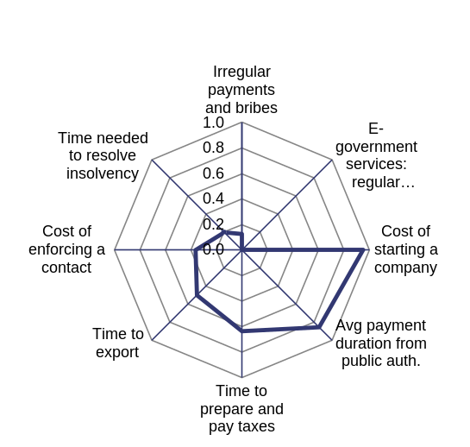
1 corresponds to the best performer and 0 to the worst performer among EU28 Member States
Source: European Commission

Graph 3.3.2: Governance indicators, Romania and EU
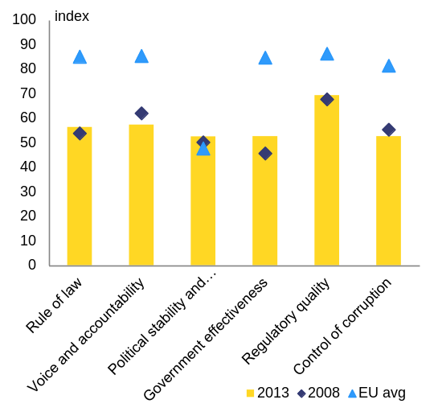
Scores for 2011 (0=lowest, 100=highest)
Source: WB Worldwide Governance Indicators
The root causes of the structural weaknesses have been identified but implementation of the solutions is delayed. To tackle the challenges in public administration and policy prioritisation and coordination, a strategy for strengthening public administration was adopted in October 2014, together with an action plan for its implementation in 2014-2020. The strategy addresses the ex ante conditionality for the new programming period of EU structural and investment funds. Implementation is, however, starting with substantial delay. The inter-ministerial committee that will coordinate implementation had its first meeting in mid-December but some of the working groups that will drive each of the five pillars of the strategy are still to hold their first meeting.
The reform of the public administration envisages enhancing quality and access in the public services. To ensure a climate of stability and predictability and to increase the efficiency of public administration, the strategy aims to clarify mandates and competences between the central and local levels. It also seeks the modernisation of management processes, by linking strategic planning with financial resources. A special focus will be given to human resources management, and likewise to reducing bureaucracy and simplifying procedures for both citizens and business environment. The latter will be also supported through a Better Regulation strategy adopted in December 2014 and which is to have its action plan adopted in February 2015.
A weak administrative capacity is causing delays in structural reforms and low absorption of EU funds. Structural reforms are often delayed by the lack of implementation capacity and unstable structures. Administrative capacity is also affecting EU funds absorption, as discussed in section 3.2.
Judicial system and fight against corruption
The implementation of new Civil and Criminal Codes and Procedural Codes is progressing, but there remains scope for progress in the field of judicial reform. A report by the European Commission of January 2015 () concluded that the progress registered in many areas in 2013 has continued in 2014, in particular the implementation of new Civil and Criminal Codes and Procedural Codes and the fight against high-level corruption. In the implementation of the new codes the government and judiciary have been working together in a productive and pragmatic way, but many legislative issues remain outstanding. The government and judicial management have developed a Strategy for the development of the judiciary 2015-2020 () () setting out the key steps for further reform to improve the independence, quality and efficiency of justice, but concrete actions and timetables are still to be defined.
Workload is a persistent problem within the judiciary. The workload is an issue at all levels of courts. At the start of 2014, for all courts and all types of cases there were more than 1.2 million cases pending, while incoming cases amounted to more than 2.2 million (). The number of incoming litigious civil and commercial cases, which are in particular relevant from an economic perspective, is particularly high. This results in a considerable workload for judges, while the courts’ resources remain limited (). In 2013, the Government proposed a reform of the judicial map, closing down 30 courts and prosecutor’s offices with low workload, but the draft law was rejected in the Chamber of Deputies in June 2014. It is now under discussion in the Senate, where there is already a motion to reject the proposal. The workload is further affected by the division of tasks between judges and law clerks. This seems to vary from court to court, according to the specific court organisation or each individual judge. A draft law has been pending for some years setting out the possibility for court clerks to take over part of the legal work of the judges, but it has been blocked in the Senate. The government and the SCM (Superior Council of Magistracy) are working on a new proposal, seeking to unblock the situation. Despite efforts to promote Alternative Dispute Resolution, alternatives to court proceedings such as mediation are not commonly used, as there are few incentives to do so.
There is a positive trend as regards the efficiency of the civil justice. For several years (2010, 2012, 2013), the first instance courts have resolved more civil, commercial and administrative cases than they have received, leading to a decrease in the time needed to resolve these cases (). A systematic monitoring of the implementation of the new Civil Codes started in the second half of 2014 suggests an overall fall in workload as a result of the new codes: an increase in the number of cases of 5% at first instance courts but a decrease of 17% in tribunals and courts of appeal. The average duration for having a first instance decision has fallen to 1.5 years and the timing for the first hearing has also decreased to about six months. Amendments have also been made to the enforcement procedure (). which are expected to diminish the workload of courts (about 300.000 cases a year). The resolution of insolvency cases takes on average more than three years, which does not contribute to an attractive investment environment. Recently developed indicators on the efficient functioning of courts () and an initiative to collect judicial statistics from all courts () should improve the monitoring and evaluation of judicial activities, and help addressing the issue of workload more effectively.
The quality and professionalism of the judicial system has been improving, but the lack of predictability of judicial decisions is a continuous concern for the business environment. In response to concerns about lack of predictability in the interpretation of the law, the judiciary uses proactively various legal and managerial measures to improve consistency of its practice and case-law. The High Court of Cassation and Justice continues to publish all its case-law online. Some steps were taken to ensure the publication and update of decisions of all other courts (). Intensive trainings of magistrates and court clerks are organised throughout the country, with a large offer of initial and in-service training courses. The regular horizontal thematic inspections and the recent development of management tools including indicators also contribute to improving the quality of the judicial system. The electronic processing for small claims and undisputed debt recovery continues to be available in just a quarter of the courts.
The lack of quality and coherence of legislation affects the consistency of jurisprudence. Many legislative proposals are put forward without thorough analysis on the legal consequences on the existing framework. The 'strategy for strengthening the public administration' adopted by the government in October 2014, proposes actions to improve the quality of law-making (). The Ministry of Justice has finalised a project (financed with the support of EU funds) of a portal consolidating existing legislation, N-LEX ().
Judicial independence continues to be threatened through pressure on key institutions. Media and politically motivated attacks targeting judges and prosecutors, in particular those involved in high-level corruption files, remained a problem in 2014. The number of demands for defending the independence of the judicial system has slightly increased in 2014, compared to 2013 ().
The perceived judicial independence as well as public trust in the judiciary improved (). Perceived judicial independence upgraded from position 114 in 2012-2013 to 84 in 2013-2014 (among 144 countries in the world).
Enforcing civil and administrative court decisions and recovering criminal assets from corruption crimes remains an issue. There seems to be an increasing acknowledgement and willingness from the justice system to take action to ensure that court decisions are followed up. However, important problems remain and businesses and NGOs have pointed repeatedly to the non-respect of decisions by public authorities. The strategy for the development of the judiciary includes an objective to improve the organisation and functioning of bailiffs in order to improve effective enforcement of court decisions, but there is not yet any action or deadline. Effective confiscation and asset recovery are a key element to ensure that decisions of the courts with financial consequences accrue to the public purse. They can also be effective in the dissuasion of corruption and in illustrating an effective anticorruption regime to the public. However, the recovery rate remains low, with only around 8% of assets notified by courts (). In December 2014, the government approved the creation of an agency dedicated to the administration of assets seized in criminal procedure cases. The agency will manage the activities performed currently by several different institutions and is designed to bring a more systematic approach to handling and valuing the confiscated goods. The new structure should become operational by end of March 2015.
Difficulties in consumer law enforcement capacity affect the business environment. The lack of adequate resources does not allow the Romanian authorities to fully take part in the activities of the EU Consumer Protection Cooperation Network. The enforcement capacities as regards digital environment are particularly limited and ill-equipped for the challenges of the Digital Single Market. Difficulties in consumer law enforcement are mirrored by high levels of unfair commercial practices and unfair contract terms reported by consumers and retailers and low levels of consumers’ trust in public authorities to protect consumer rights and in businesses to respect these rights ().
Corruption remains a major issue in Romania, with consequences for both governance and the economy. Evidence from perception surveys and experts in the field (including the prosecution services) shows low-level corruption to be broadly tolerated by the society at large. The integrity rules for preventing corruption, such as incompatibilities and assets declarations, are applied with some degree of resistance. While the recognition that general corruption needs to be tackled is building inside the government and the administration, the approach is not sufficiently systematic given the scale of the problem.
There is an impressive track-record in effectively fighting high-level corruption and steps taken may improve the results of prosecution in the area of low-level corruption. In 2014 many people involved in high-level corruption have been prosecuted and trialled. There was also an increase of cases of corruption within the judiciary brought forward by the prosecution. Steps taken to fight low-level corruption include more systematic risk analysis for fighting corruption at local level. The number of cases brought to courts has increased, but the number of court decisions on corruption cases has decreased.
The National Anticorruption Strategy 2012-2015 has evolved into an important preventive framework for the public administration. The strategy involves 2500 institutions. The peer-review system helps to develop best practices and improve preventive measures. However, the identification of corruption-risk areas and prevention measures remain insufficient.
Commitments | Summary assessment ()
2014 country-specific recommendations (CSRs)
CSR1: Implement the EU/IMF financial assistance programme by fully addressing the policy conditionality - included in the Memorandum of Understanding of 6 November 2013 and its subsequent supplements ‐ that complements and supports the implementation of these country‐specific recommendations. | Romania has made no progress in addressing CSR 1 of the Council recommendation (This overall assessment of CSR 1 excludes an assessment of compliance with the Stability and Growth Pact):  The first formal review mission (2-16 June 2014) to assess the implementation status of programme conditionality was not concluded. Also the second formal review mission (27 January – 10 February) was not concluded.
CSR2: Implement the budgetary strategy for 2014, significantly strengthen the budgetary effort to ensure reaching the medium‐term objective in 2015 in line with commitments under the Balance of Payments programme and as reflected in the 2014 Convergence Programme, in particular by specifying the underlying measures, and remain at the medium‐term objective thereafter. Improve tax collection by continuing to implement a comprehensive tax compliance strategy, stepping up efforts to reduce VAT fraud. Fight undeclared work. Reduce tax burden for low‐ and middle‐income earners in a budget‐neutral way. Finalise the pension reform started in 2010 by equalising the pensionable age for men and women. | Romania has made some progress in addressing CSR 2 of the Council recommendation:  Limited progress has been made in improving tax collection and fighting undeclared work. A pilot project on undeclared labour is in progress. The VAT reimbursement procedure is being streamlined and implemented.  Substantial progress has been made on reducing the tax burden on labour. The tax burden has been reduced through a 5 pp. reduction in employers’ social security contributions across the board. However, the recommendation on targeting the reduction was not followed and the tax wedge on low-income earners remains comparatively high.  Limited progress has been made in pension reform; a law has been adopted by the Senate but not yet discussed by the lower chamber.
CSR 3: Step up reforms in the health sector to increase its efficiency, quality and accessibility, including for disadvantaged people and remote and isolated communities. Increase efforts to curb informal payments, including through proper management and control systems. | Romania has made limited progress in addressing CSR 3 of the Council recommendation:  Some progress has been made in health sector reform. The basic benefits package was introduced in June 2014. The minimum package is being introduced as of January 2015. The National Health Strategy was approved in December 2014. The Health Technology Assessment system has been implemented, together with e-health measures.  Limited progress has been made in management and control systems, albeit feedback mechanism for patients has been implemented. It can also be used to report informal payments.
CSR 4: Strengthen active labour market measures and the capacity of the National Employment Agency. Pay particular attention to the activation of unregistered young people. Strengthen measures to promote the employability of older workers. Establish, in consultation with social partners, clear guidelines for transparent minimum wage setting, taking into account economic and labour market conditions. | Romania has made limited progress in addressing CSR 4 of the Council recommendation:  Limited progress has been made in strengthening active labour-market measures and the capacity of the National Employment Agency. Important steps forward are a benchmark learning exercise of the PES network that was piloted in Romania, the rolling out of the professional card programme, monitoring actions for jobseekers and the updating of the PES portal to provide extended e-services, all of which need to be accelerated. Limited progress has been made on activation of older workers, as support to employers recruiting them continued. The adoption of the Active Ageing Strategy was delayed to March 2015.  Some progress has been made on activation of unregistered young people. New measures under the Youth Guarantee Implementation Plan and Youth Guarantee pilot schemes are being implemented. Public Employment Services are developing an integrated database on young people who are not in employment, education or training. Its impact remains however limited: take-up, coverage and effective implementation of existing measures need to be enhanced and sustained in the long run.  No progress has been made in setting guidelines for transparent minimum wage setting. A review of wage setting mechanisms in other Member States is ongoing. Based on this, a methodology will be developed and discussed with social partners in 2015.
CSR 5: Increase the quality and access to vocational education and training, apprenticeships, tertiary education and of lifelong learning and adapt them to labour market needs. Ensure better access to early childhood education and care. | Romania has made limited progress in addressing CSR 5 of the Council recommendation:  Limited progress has been made in access to early childhood education and care (ECEC). There is a legislative proposal on baby sitters and nannies in Parliament, but access to ECEC remains a challenge, particularly for children aged 0 to 3. A national ECEC programme has not yet been adopted.  Some progress has been made in increasing the quality of and access to (i) vocational education and training and apprenticeships, with actions including the reform of Vocational Education and Training (VET) which is being implemented (duration increased from 2 to 3 years), partnerships with schools and social partners are being rolled out, the introduction of VET colleges has been announced, and support for apprenticeship schemes in continuing VET has been increased; (ii) higher education, where actions include setting up a database allowing monitoring of the recruitment of higher education graduates, a requirement that all universities establish counselling and career guidance centres, a new methodology for recording and analysing the insertion on the labour market of higher education graduates and drafting 36 new occupational standards. Strategies for tertiary education and lifelong learning to be adopted in the first quarter of 2015, later than planned.
CSR 6: In order to alleviate poverty, increase the efficiency and effectiveness of social transfers, particularly for children, and continue reform of social assistance, strengthening its links with activation measures. Step up efforts to implement the envisaged measures to favour the integration of Roma in the labour market, increase school attendance and reduce early school leaving, through a partnership approach and a robust monitoring mechanism. | Romania has made limited progress in addressing CSR 6 of the Council recommendation:  Limited progress has been made in integrating the Roma population, due to a lack of coordination between various governmental structures and a systematic lack of effective measures. However, a revised strategy for Roma integration was adopted in January 2015, with some delay and implementation is lagging behind.  Some progress has been made in increasing the efficiency and effectiveness of social transfers, particularly for children, and reform of social assistance, strengthening its links with activation measures. A government decision approved in November 2014 has been implemented, increasing disability benefits by 16 %. An emergency ordinance adopted in October 2014 increases the financial allowance for children placed in alternative care and introduces a one-off allowance equal to the minimum wage on exit from the system. A national strategy for protecting and promoting the rights of the child was adopted in December 2014. A social economy law was adopted by the government in 2013, but is still under debate in the Parliament. Limited progress has been made towards the Minimum Insertion Income; active labour-market measures aimed at persons receiving social assistance are limited. The adoption of the Strategy for Social Inclusion and Combating Poverty and its action plans has been postponed to March 2015.  Limited progress has been made in reducing early school leaving, with action including the design of a data collection system on early school leaving; the module on primary education is already operational. Progress has been made in curriculum reforms following competence-based pedagogical approach conducive to ensuring educational achievement. The strategy on early school leaving will be adopted in the first quarter of 2015, later than planned.
CSR 7: Step up efforts to strengthen the capacity of public administration, in particular by improving efficiency, human resource management, the decision‐making tools and coordination within and between different levels of government; and by improving transparency, integrity and accountability. Accelerate the absorption of EU funds, strengthen management and control systems, and improve capacity of strategic planning, including the multi annual budgetary element. Tackle persisting shortcomings in public procurement. Continue to improve the quality and efficiency of the judicial system, fight corruption at all levels, and ensure the effective implementation of court decisions. | Romania has made limited progress in addressing CSR 7 of the Council recommendation:  Some progress has been made in strengthening the capacity of public administration by adopting the Strategy for the Public Administration (Oct 2014) and complementing action plans, but implementation is slow. Consumer law enforcement capacity remains very limited, in particular as regards the digital environment. Limited progress has been made in improving the decision-making tools. A strategy for better regulation was adopted in December 2014, but its implementing action plan remains to be adopted. Limited progress has been made in the speeding up the absorption of EU funds.  Limited progress has been made in strengthening management and control systems.  Limited progress has been made in improving capacity for strategic planning by adopting emergency ordinances and methodological norms, to improve vetting of public investments, setting public investment appraisal standards, and public investment prioritisation at the centre of government.  Limited progress has been made in tackling persisting shortcomings in public procurement. A working group of Commission officials (from DG GROW&DG REGIO) and their Romanian counterparts was set up to develop a public procurement strategy and action plan by end-June 2015. The objective is to tackle the shortcomings of the public procurement system.  Some progress has been achieved in enhancing the quality and efficiency of the judicial system, fighting corruption at all levels, and ensuring the effective implementation of court decisions. Namely, new criminal codes have been implemented and many high-level corruption cases have been prosecuted. Legislative amendments in civil procedural law are expected to speed up the enforcement procedure. However, the effective implementation of court decisions remains weak in many cases. Strategy and projects have been adopted defining future reforms of the judicial system to improve efficiency and quality of justice, but actions and implementation still need to be defined. Limited progress was achieved in preventing and fighting low-level corruption. The effective implementation of court decisions remains weak.
CSR 8: Promote competition and efficiency in energy and transport industries. Accelerate the corporate governance reform of state‐owned enterprises in the energy and transport sectors and increase their efficiency. Improve and streamline energy efficiency policies. Improve the cross‐border integration of energy networks and enable physical reverse flows in gas interconnections as a matter of priority. | Romania has made limited progress in addressing CSR 8 of the Council recommendation:  Some progress has been made in promoting competition and efficiency in energy through the gas prices liberalisation roadmap (delayed for households). Romania introduced market coupling for its electricity markets. Some progress has been made in promoting competition and efficiency in rail transport (with the adoption of a law on a new award authority for rail passenger transport contracts, the implementation of a monitoring system as regards the management of the rail infrastructure manager and of the state-owned railway undertakings, the reintroduction of incentives for the infrastructure manager CFR SA to reduce costs and charges, the reduction of certain track access charges for Diesel trains to align to EU rules, headway in leasing of railway lines and stations).  No progress has been made regarding reform of the corporate governance of state-owned enterprises in the energy and transport sectors.  Limited progress has been made in energy efficiency policies due to delays in submitting the national energy efficiency action plan and insufficient work on effective transposition of the Energy Efficiency Directive.  Limited progress has been made on cross-border integration of energy networks and on enabling of physical reverse flows in gas interconnections. Cooperation between neighbouring Transmission System Operators is underway in order to apply for CEF cofinancing for an important set of projects in 2015.
Europe 2020 (national targets and progress)
Employment rate target | The national target of 70 % by 2020 remains ambitious, but the gap is reducing as the employment rate in the age group 20-64 reached 67.4% in the third quarter of 2014.
R&D target : 2 % of GDP | The Romanian R&D-intensity target is ambitious and difficult to reach. To reach the 2020 target, an average annual growth rate of 14.6 % over the period 2014-2020 is required. However, over the 2007-2013 period Romanian R&D intensity fell sharply (at a compound annual rate of -7.5 %). In 2013, both business R&D and public R&D intensity fell compared with the previous year. In 2013, business R&D intensity was only 0.12 % of GDP (27th in the EU) and public R&D intensity was only 0.27 % (27th in the EU).
National Greenhouse gas (GHG) emissions target: | Based on the latest national projections submitted to the Commission and considering existing measures, it is expected that Romania will achieve the target: +7 % in 2020 as compared to 2005 (i.e. a margin of 12 percentage points below target).
Renewable energy target:  Share of renewable energy in all modes of transport:  10 % | Romania is on track to meet its 2020 renewable energy (RES) target. According to Eurostat, the share of RES in 2012 was 22.9 % of total gross energy consumption, above the benchmark set by the indicative trajectory in the Renewable Energy Directive for 2011/2012 (19 %). Industry surveys put the figure for 2013 at 26.1 % (above the 2020 objective). The proportion of RES used in transport for 2012 stands at 4.1 %.
Energy efficiency: reduction of energy consumption | Romania’s progress on energy efficiency is limited and it is behind in implementation of EU energy efficiency legislation, in particular the Energy Efficiency Directive. The lack of tangible measures and poor progress on capacity building move Romania from achieving its energy efficiency potential and may hinder economic performance.
Early school leaving target | No progress has been made on meeting the target. The early school-leaving rate was steady at 17.3 % in 2013.
Tertiary education target | Some progress has been made on meeting the target. The tertiary attainment rate improved from 21.8 % in 2012 to 22.8 % in 2013. A decrease in enrolment and graduation rates has been recorded in the last three years and this may put at risk attainment of the target of 26.7 %.
Target on the reduction of population at risk of poverty or social exclusion in number of persons: | In order to monitor this target, Romania opted to use one of the three sub-indicators of the headline indicator, the ‘at-risk-of-poverty rate, which showed a slight improvement from 23.4 % in 2008 to 22.4 % in 2013. In absolute terms, 211 000 people were lifted out of the risk of poverty between 2008 and 2013 (national target: 580,000).

Table B.1: Macroeconomic indicators
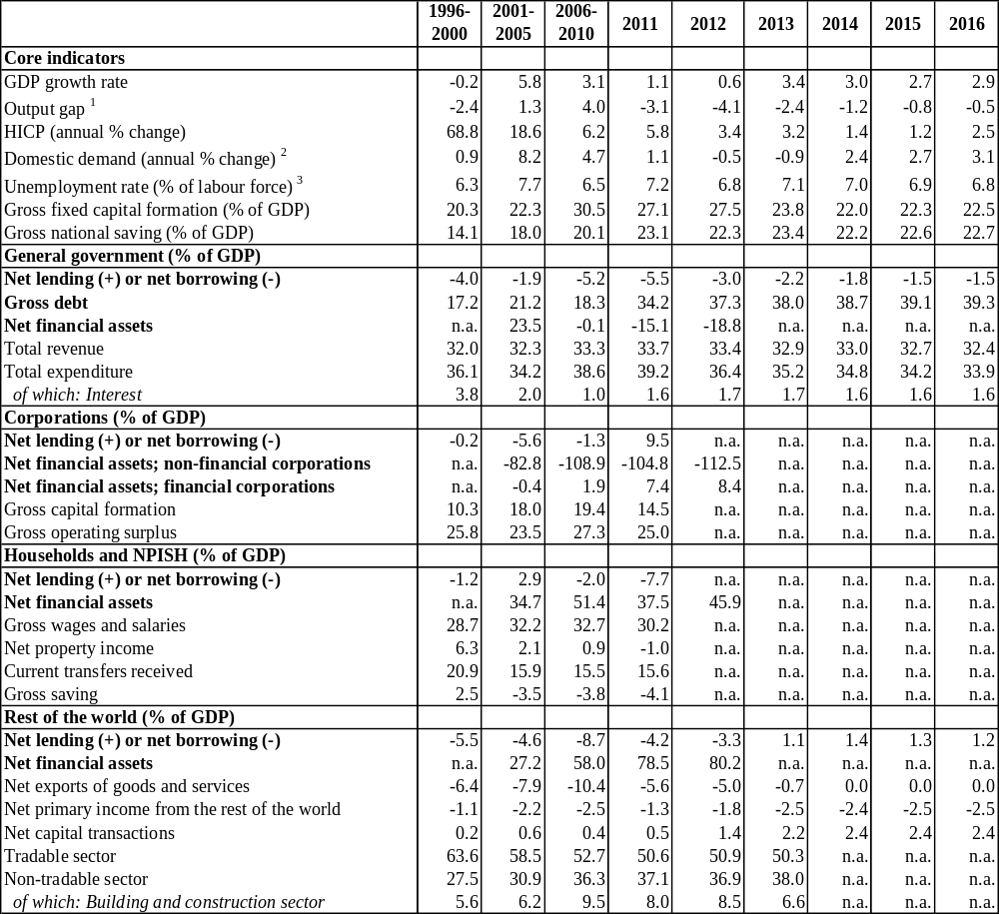
Notes:
1 The output gap constitutes the gap between the actual and potential gross domestic product at 2010 market prices.
2 The indicator of domestic demand includes stocks.
3 Unemployed persons are all those who were not employed, had actively sought work and were ready to begin working immediately or within two weeks. The labour force is the total number of people employed and unemployed. The unemployment rate covers the age group 15-74.
Source: European Commission

Table B.2: Financial market indicators
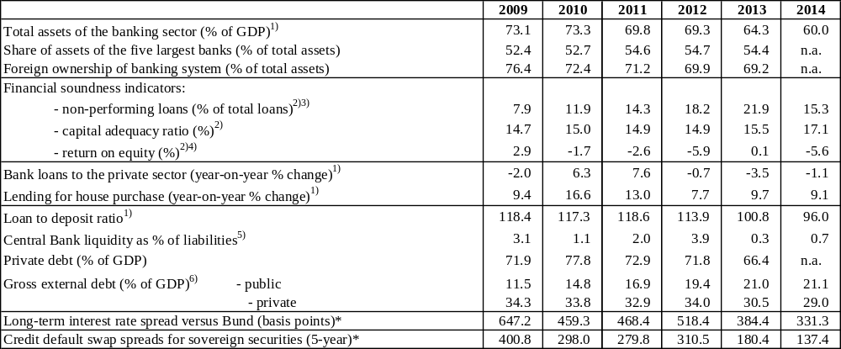
Notes:
1) Latest data November 2014.
2) Latest data Q2 2014.
3) Non-performing loans are defined as loans and interest past due for over 90 days and/or for which legal proceeding were initiated against the loan or debtor.
4) After extraordinary items and taxes.
5) Latest data September 2014.
6) Latest data June 2014. Monetary authorities, monetary and financial institutions are not included.
* Measured in basis points.
Source: IMF (financial soundness indicators); European Commission (long-term interest rates); World Bank (gross external debt); ECB (all other indicators).

Table B.3: Taxation indicators
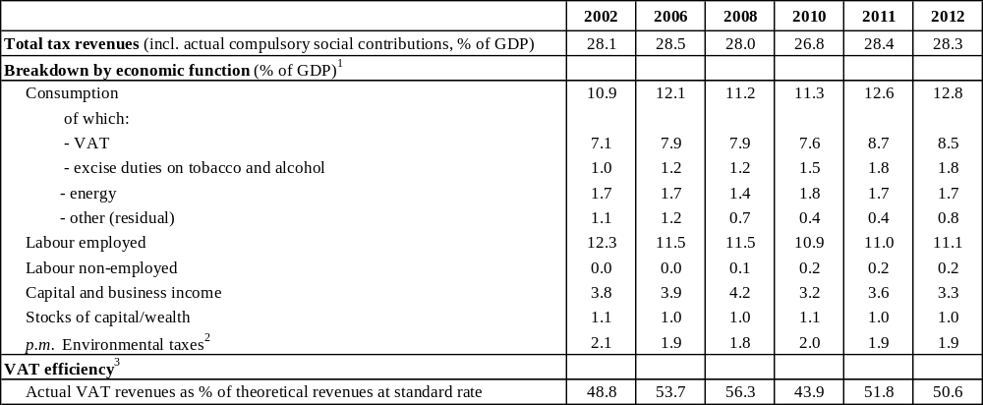
Notes:
1. Tax revenues are broken down by economic function, i.e. according to whether taxes are raised on consumption, labour or capital. See European Commission (2014), Taxation trends in the European Union, for a more detailed explanation.
2. This category comprises taxes on energy, transport and pollution and resources included in taxes on consumption and capital.
3. VAT efficiency is measured via the VAT revenue ratio. It is defined as the ratio between the actual VAT revenue collected and the revenue that would be raised if VAT was applied at the standard rate to all final (domestic) consumption expenditures, which is an imperfect measure of the theoretical pure VAT base. A low ratio can indicate a reduction of the tax base due to large exemptions or the application of reduced rates to a wide range of goods and services (‘policy gap’) or a failure to collect all tax due to e.g. fraud (‘collection gap’). It should be noted that the relative scale of cross-border shopping (including trade in financial services) compared to domestic consumption also influences the value of the ratio, notably for smaller economies. For a more detailed discussion, see European Commission (2012), Tax Reforms in EU Member States, and OECD (2014), Consumption tax trends.
Source: Source: European Commission

Table B.4: Labour market and social indicators
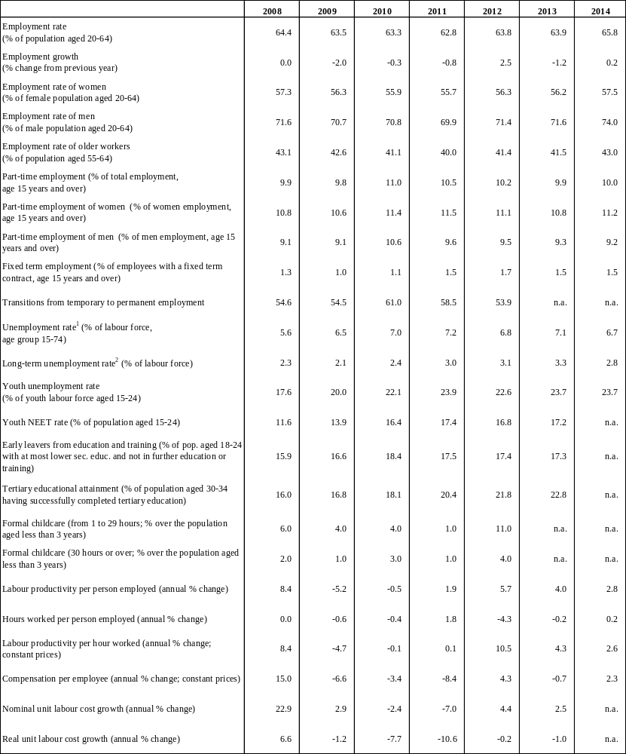
Notes:
1 Unemployed persons are all those who were not employed, but had actively sought work and were ready to begin working immediately or within two weeks. The labour force is the total number of people employed and unemployed. Data on the unemployment rate of 2014 includes the last release by Eurostat in early February 2015.
2 Long-term unemployed are persons who have been unemployed for at least 12 months.
Source: European Commission (EU Labour Force Survey and European National Accounts)

Table B.4: Labour market and social indicators (continued)
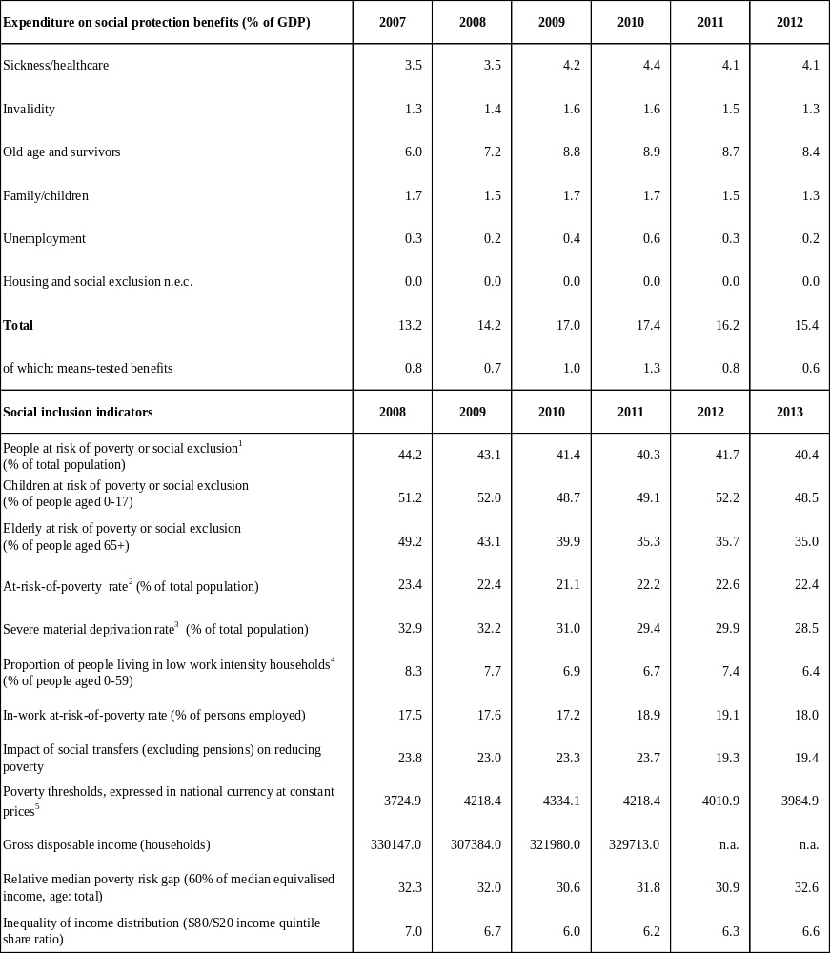
¹ People at risk of poverty or social exclusion (AROPE): individuals who are at risk of poverty (AROP) and/or suffering from severe material deprivation (SMD) and/or living in households with zero or very low work intensity (LWI).
² At-risk-of-poverty rate (AROP): proportion of people with an equivalised disposable income below 60 % of the national equivalised median income.
³ Proportion of people who experience at least four of the following forms of deprivation: not being able to afford to i) pay their rent or utility bills, ii) keep their home adequately warm, iii) face unexpected expenses, iv) eat meat, fish or a protein equivalent every second day, v) enjoy a week of holiday away from home once a year, vi) have a car, vii) have a washing machine, viii) have a colour TV, or ix) have a telephone.
⁴ People living in households with very low work intensity: proportion of people aged 0-59 living in households where the adults (excluding dependent children) worked less than 20 % of their total work-time potential in the previous 12 months.
⁵ For EE, CY, MT, SI and SK, thresholds in nominal values in euros; harmonised index of consumer prices (HICP) = 100 in 2006 (2007 survey refers to 2006 incomes)
⁶ 2014 data refer to the average of the first three quarters.
Source: For expenditure for social protection benefits ESSPROS; for social inclusion EU-SILC.

able B.5: Product market performance and policy indicators
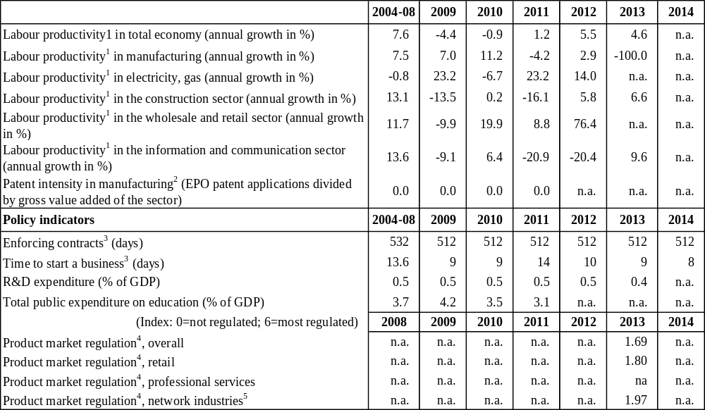
Notes:
1Labour productivity is defined as gross value added (in constant prices) divided by the number of persons employed.
2 Patent data refer to applications to the European Patent Office (EPO). They are counted according to the year in which they were filed at the EPO. They are broken down according to the inventor’s place of residence, using fractional counting if multiple inventors or IPC classes are provided to avoid double counting.
3 The methodologies, including the assumptions, for this indicator are presented in detail here: http://www.doingbusiness.org/methodology.
4 Index: 0 = not regulated; 6 = most regulated. The methodologies of the OECD product market regulation indicators are presented in detail here: http://www.oecd.org/competition/reform/indicatorsofproductmarketregulationhomepage.htm
5 Aggregate OECD indicators of regulation in energy, transport and communications (ETCR).
Source: European Commission; World Bank — Doing Business (for enforcing contracts and time to start a business); OECD (for the product market regulationindicators)"

Table B.6: Green growth
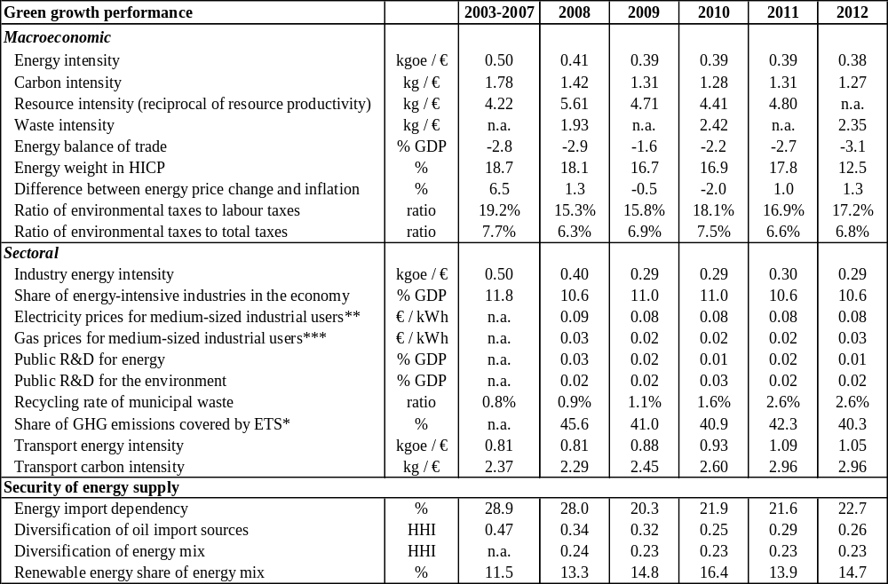
Country-specific notes: 2013 is not included in the table due to lack of data.
General explanation of the table items:
All macro intensity indicators are expressed as a ratio of a physical quantity to GDP (in 2000 prices)
Energy intensity: gross inland energy consumption (in kgoe) divided by GDP (in EUR)
Carbon intensity: Greenhouse gas emissions (in kg CO2 equivalents) divided by GDP (in EUR)
Resource intensity: Domestic material consumption (in kg) divided by GDP (in EUR)
Waste intensity: waste (in kg) divided by GDP (in EUR)
Energy balance of trade: the balance of energy exports and imports, expressed as % of GDP
Energy weight in HICP: the proportion of "energy" items in the consumption basket used for the construction of the HICP
Difference between energy price change and inflation: energy component of HICP, and total HICP inflation (annual % change)
Environmental taxes over labour or total taxes: from DG TAXUD’s database ‘Taxation trends in the European Union’
Industry energy intensity: final energy consumption of industry (in kgoe) divided by gross value added of industry (in 2005 EUR)
Share of energy-intensive industries in the economy: share of gross value added of the energy-intensive industries in GDP
Electricity and gas prices for medium-sized industrial users: consumption band 500–2000MWh and 10000–100000 GJ; figures excl. VAT.
Recycling rate of municipal waste: ratio of recycled municipal waste to total municipal waste
Public R&D for energy or for the environment: government spending on R&D (GBAORD) for these categories as % of GDP
Proportion of GHG emissions covered by ETS: based on greenhouse gas emissions (excl LULUCF) as reported by Member States to the European Environment Agency
Transport energy intensity: final energy consumption of transport activity (kgoe) divided by transport industry gross value added (in 2005 EUR)
Transport carbon intensity: greenhouse gas emissions in transport activity divided by gross value added of the transport sector
Energy import dependency: net energy imports divided by gross inland energy consumption incl. consumption of international bunker fuels
Diversification of oil import sources: Herfindahl index (HHI), calculated as the sum of the squared market shares of countries of origin
Diversification of the energy mix: Herfindahl index over natural gas, total petrol products, nuclear heat, renewable energies and solid fuels
Renewable energy share of energy mix: %-share of gross inland energy consumption, expressed in tonne oil equivalents
* European Commission and European Environment Agency
** For 2007 average of S1 & S2 for DE, HR, LU, NL, FI, SE & UK. Other countries only have S2.
*** For 2007 average of S1 & S2 for HR, IT, NL, FI, SE & UK. Other countries only have S2.
Source: European Commission unless indicated otherwise; European Commission elaborations indicated below

(?) Eurostat Community Survey on ICT usage in households and by individuals, [isoc_ec_ibuy], 2014, Eurostat Community Survey on ICT usage and e-commerce in enterprises [isoc_ec_eseln2], 2014.
(?) Flash Eurobarometer 397, “Consumer attitudes towards cross-border trade and consumer protection”, 2014, Flash Eurobarometer 396, “Retailers’ attitudes towards cross-border trade and consumer protection”, 2014.
(?) http://ec.europa.eu/growth/tools-databases/smaf/index_en.htm
(?) European Commission, Survey on the access to finance of enterprises (SAFE), 2014.
(?) European Commission, Competitiveness Report 2014: Reindustrialising Europe. Country chapters.
(?) http://www.recensamantromania.ro/wp-content/uploads/2013/07/REZULTATE-DEFINITIVE-RPL_2011.pdf
(?) In 2013, Romanians were the largest single national group (20 %) of all working-age EU-28/EFTA movers across the EU-28 Member States (followed by Polish, Italian, Portuguese and German movers) European Commission, “2014 Annual report on labour mobility” http://ec.europa.eu/social/main.jsp?catId=1154&langId=en
(?) Skill mismatch. The role of the enterprise, 2012 http://www.cedefop.europa.eu/EN/Files/5521_en.PDF, based on the Eurofound 2009 European company survey (ECS).
(?) DNA activity report http://www.pna.ro/bilant_activitate.xhtml?id=29
(?) Marrez, H. (2015), The role of state-owned enterprises in Romania, ECFIN Country Focus.
(?) It refers to all companies in which the state or a territorial administrative unit is the single shareholder, has the majority stake or controls the company. This includes companies in which one or several SOEs hold a majority stake or participation granting them the control right. It also includes the "regii autonome" and research institutes. It does not include state-owned banks, insurance companies or financial institutions.
(?) Iootty, M., P. Correa, S. Radas, B. Skrinjaric (2014). Stylized Facts on Productivity Growth: Evidence from Firm-Level Data in Croatia. Policy Research Working Paper, No. 6990, the World Bank.
(?) OECD (2005), "OECD guidelines on corporate governance of state-owned enterprises", OECD publishing. http://www.oecd.org/daf/ca/34803211.pdf. The guidelines are currently under revision by the OECD.
(?) 15 % SPO in Transelectrica in March 2012, 15 % SPO in Transgaz in April 2013, 10 % IPO in Nuclearelectrica in September 2013, 15 % IPO in Romgaz in November 2013, and 51 % IPO in Electrica in June 2014.
(?) In line with the ESRB recommendations, the NBR introduced in 2011 a number of measures aimed at discouraging un-hedged borrowing in foreign exchange by households: a) Inclusion of branches of foreign banks operating on the Romanian market under the umbrella of the regulation on loans granted to individuals; b) An implicit reduction of the allowed debt-to-income ratios (DTI) for consumer credit; c) Introduction of the obligation for debtors to provide real and/or personal guarantees at a minimum level of 133 % of the value of the credit in relation to consumer loans denominated or indexed in a foreign currency; d) Introduction of maturity caps for FX denominated consumer loans (i.e. maximum maturity of 5 years); and e) Introduction of explicit maximum levels of loan-to-value ratios (LTV) for loans for real estate investments, differentiated by the currency.
(?) Starting from March 2014, the ‘Non-performing loans ratio’ is determined based on reports from all banks for loans that meet the non-performance criteria (i.e. overdue loans for more than 90 days and/or in which case legal proceedings were initiated). Before March, the NPL ratio included only banks implementing the standardised approach for calculating their minimum capital requirements for credit risk. Two banks using internal models were excluded from the calculation of the NPL ratio at system level. The NPL-ratio Graph 2.3.5 includes the NPLs calculated based on the two methodologies: (i) the NBR's prudential reporting rules which include only banks using the standardised approach for measuring their capital requirements for credit risk; and (ii) the IFRS accounting rules (that became effective for the Romanian banking sector as of January 2012), according to which the NPL ratio is covering now all banks. This is the measure of NPL ratio that will be used going forward.
(?) To signal the return to normal market conditions, the exposure commitments of these parent banks were not formally prolonged under the second balance of payments programme (2011-13).
(?) The CHF denominated loans represent roughly 10 % (RON 10 bn/ EUR 2.3 bn) of the total loans to households, creating mainly social problems for some individuals indebted in this currency. The stock of CHF denominated loans has steadily declined since 2008 in line with the low appetite of banks to offer new CHF denominated loans to clients.
(?) Accounting for 47.2 % of overall tax revenues in 2012 (against an EU-28 average of 34.5 %).
(?) Representing 21.6 % of overall tax revenues (against an EU-28 average of 33.4 %).
(?) European Commission’ calculations: The tax wedge is defined as the sum of personal income taxes and social security contributions paid by the employer and the employee over the gross wage plus social security contributions paid by the employer. To ensure consistency with past data, these computations of the tax wedge include compulsory contributions to private pension funds, although, strictly speaking, they should be classified as non-tax compulsory payments rather than taxes.
(?) The net loss, as estimated by European Commission, takes direct savings in personnel expenditure into account. According to the EUROMOD-JRC interface, a 5 pps reduction in the rate of employers’ SSC would decrease government revenue from SSC by around 22 %, which corresponds to a gross budgetary cost of approximately 1 % of GDP in 2014, all other things being equal. Source: European Commission, Joint Research Centre, based on the EUROMOD model.
(?) http://www.inspectmun.ro/site/RELATII%20DE%20MUNCA/Relatii%20de%20Munca.html.
(?) 2012 Update Report to the Study to quantify and analyse the VAT Gap in the EU-27 produced for the European Commission; 2012 data, the most recent available: http://ec.europa.eu/taxation_customs/resources/documents/common/publications/studies/vat_gap2012.pdf.
(?) European Commission (ECFIN and TAXUD), 'Tax Reforms in EU Member States 2014', page 90 (http://ec.europa.eu/economy_finance/publications/european_economy/2014/pdf/ee6_en.pdf)
(?) General information about the assessment of the application and impact of the reverse charge mechanism can be found here: http://ec.europa.eu/taxation_customs/resources/documents/common/publications/studies/kp_07_14_060_en.pdf.
(?) The authorities estimate a positive impact: http://www.mfinante.ro/acasa.html?method=detalii&id=84905. European Commission’ calculations show a negative net impact of around - EUR 241 m, based on the preliminary figures available.
(?) See Fiscal Council - op. cit. and ATKearney - Alcoholic drinks: illicit market impact assessment 2014. The latter estimates the illicit part of the market segment at 58 %.
(?) Also confirmed in PwC - Paying Taxes 2015: http://www.pwc.com/gx/en/paying-taxes/pdf/pwc-paying-taxes-2015-low-resolution.pdf.
(?) see "Study on environmental fiscal reform potential in 12 EU member states", Aarhus University and Eunomia. 2014.
(?) The fiscal responsibility law includes fiscal rules for specific expenditure categories. For instance, personnel expenditure, the nominal budget deficit and expenditure net of contributions to the EU should not be increased in budget rectifications.
(?) Article 18(1) of law 377/2013 requires that the Fiscal Strategy is sent by the Ministry of Public Finance to the Government by end-July (and presented in the Parliament in mid-August).
(?) The average duration of working life is 34.6 years for men and 29.2 years for women in 2013. There were 19.789 early retirees and 93.555 partial early retirees in September 2014, as compared to 8.750 early retirees and 124.474 partial early retirees in December 2010 (CNPAS, 2014).
(?) Working to 65 as compared to the currently legislated pensionable age is projected to increase the replacement rate of women’s pensions from 40.1 % to 43.9 % for a full 40 year career in 2053, while a 30 year career would result in a replacement rate as low as 20.7 % (SPC WG AGE, 2015).
(?) The hiring rate in Romania (as a percentage of employed people) in 2013 was the lowest across the European Union. Moreover, the share of newly employed in total employment is low (5.7 % as against an EU average of 13.3 %).
(?) Overall a total of 154.195 NEETs have benefited from active labour-market policies from PES, and 59.652 of these were employed. Source: YGIP report published on 31 Dec 2014. According to the 2011 FRA Roma pilot survey, the share of self-declared NEETs was more than twice as high among young Roma.
(?) According to national 2011 census data, there are 622.000 Roma in Romania. Other estimates place the number of Roma living in the country almost three times higher (Council of Europe estimates 1.850.000). With an above average population growth rate, Roma represent a growing proportion of the school-age population and the future workforce: young Roma aged 0-15 years old make up 29.8 % of the Roma population in Romania and 1 in 5 of new labour market entrants are Roma (World Bank, 2014).
(?) The at-risk-of poverty and social exclusion rate stood at 59 % for single parents and 73 % for households with three or more dependent children in 2013. At-risk-of-poverty rate for disabled persons was 45.8 % in 2013-the second highest in the EU.
(?) The impact of social transfers in reducing child poverty, although increasing from 18 % in 2012 to 20 % in 2013, is still less than half the EU average. With regard to monetary poverty, children aged 12-17 are the most vulnerable age group (35 % were at risk of poverty in 2013, the highest rate in the EU).
(?) Non-coverage rate of jobless poor (by social benefits other than childcare) is the 4th highest (at 44 %) in 2013, while the cash minimum income including housing benefits relative to the median income in the 4th lowest (at 17.9 %) in 2012. (Source : Commission services calculations).
(?) According to the Ministry of Labour, at the end of 2013, there were 1.514 residential institutions in Romania, out of which 365 were hosting children with disabilities. The number of children in the state protection system decreased from 22.798 in 2012 to 21.728 in September 2014.
(?) According to the UNDP/World Bank/EC Regional Roma survey (2011), the early school leaving rate of Roma is almost twice as high as in the non-Roma population. About 14 % of Roma older than 10 are illiterate and about 20 % of Roma have not attended school, while around 34 % of According to the UNDP/World Bank/EC Regional Roma survey (2011), the early school leaving rate of Roma is almost twice as high as in the non-Roma population. About 14 % of Roma older than 10 are illiterate and about 20 % of Roma have not attended school, while around 34 % of
(?) In 2012-13, with the introduction of the 'preparatory class' in the primary education system, based on to the new theoretical age group (3-5 years old), the gross enrolment in pre-school education reached 90 % in 2012-2013.
(?) According to the Institute of Educational Sciences, in 2013 in rural areas, only 70 % of 3 year-old children are attending kindergarten, compared to 86 % in urban areas. According to the UNDP/WB/EC in 2011, the pre-school enrolment rate of non-Roma children is almost twice as high as for Roma living in the same community (37 % in case of Roma children and 63 % for Non-Roma neighbours).
(?) Government of Romania, Strategy for Strengthening Public Administration 2014-2020.
(?) World Bank, Worldwide Governance Indicators.
(?) More than one paragraph in this subsection refers to COM(2015) 35 final. Upon accession, in 2007, serious weaknesses remained in the functioning of the judicial system and the fight against corruption. Romania has engaged in an important deep rooted reform process that is still underway. The Commission assists Romania in these reforms and monitors developments through the Cooperation and Verification Mechanism (CVM).
(?) In the first semester of 2014, the average workload per judge was 789 at Judicatorie level, 670 at Tribunalele level, and 600 at appeal level.
(?) The Strategy for the development of the judiciary 2015-2020 was approved by Government Decision no. 1155/23.12.2014.
(?) Statistics from Superior Council of Magistracy.
(?) This paragraph refers to the 2015 EU Justice Scoreboard (to be published in March 2015). The expenditure on courts is around the EU average (0.3% of GDP) but in terms of expenditure per inhabitant it is among the lowest in the EU. It does not seem to correlate to the comparatively high workload of courts.
(?) More than one paragraph in this subsection refers to the EU Justice Scoreboard (to be published in March 2015).
(?) Law no 138/2014 for amending and completing the Law no. 134/2010 on the Civil Procedure Code.
(?) Report on the Progress Registered by Romania in Addressing the CVM Benchmarks in the Areas of Judicial Reform and Corruption (Ministry of Justice Report), p.25.
(?) Decision no 1134/21 October 2014 of the Section of Judges of the Supreme Judicial Council on the countrywide implementation of the StatisEcris application.
(?) The Romanian Legal Information Institute.is leading a project on anonymising and publishing the case-law of all courts, expected to be implemented in 2015.
(?) http://www.mdrt.ro/userfiles/strategie_adm_publica.pdf
(?) The national module of the N-Lex legislation portal was launched on 12 November 2014 and is accessible from the home page on the official web site of the MoJ: http://legislatie.just.ro/. The data base offers free access of citizens to the Romanian legislation after 1989 in a user friendly format. The date base includes a search engine and it shall be updated daily.
(?) While in 2013, Judicial Inspection received 17 demands for defending the independence of the judicial system (6 regarding judges and 11 regarding prosecutors), in Jan-Nov 2014, it received 23 such demands (11 regarding judges and 12 regarding prosecutors). The number of requests for defence of the professional reputation, independence and impartiality remained the same in the compared periods (28 requests in total: 12 from individual judges and 16 from individual prosecutors). Source: Judicial inspection, Statistical data charts (1 Jan – 1 Dec 2014).
(?) Barometrul 'Inscop-Adevarul despre Romania' conducted by Inscop Research
(?) COM(2012) 410 final.
(?) Flash Eurobarometer 396, 'Retailers’ attitudes towards cross-border trade and consumer protection', 2014, Flash Eurobarometer 397, 'Consumer attitudes towards cross-border trade and consumer protection', 2014.
(?) The following categories are used to assess progress in implementing the 2014 CSRs of the Council Recommendation: No progress: The Member State has neither announced nor adopted any measures to address the CSR. This category also applies if a Member State has commissioned a study group to evaluate possible measures. Limited progress: The Member State has announced some measures to address the CSR, but these measures appear insufficient and/or their adoption/implementation is at risk. Some progress: The Member State has announced or adopted measures to address the CSR. These measures are promising, but not all of them have been implemented yet and implementation is not certain in all cases. Substantial progress: The Member State has adopted measures, most of which have been implemented. These measures go a long way in addressing the CSR. Fully addressed: The Member State has adopted and implemented measures that address the CSR appropriately.

