STUDENT FUNDS OF KNOWLEDGE IN A NORTHERN CALIFORNIA MIGRANT COMMUNITY

Sarah Fonte
B.A., University of California, Davis, 2000

THESIS

Submitted in partial satisfaction of
the requirements for the degree of

MASTER OF ARTS

in

EDUCATION
(Bilingual/Multicultural Education)

at

CALIFORNIA STATE UNIVERSITY, SACRAMENTO

FALL
2009
STUDENT FUNDS OF KNOWLEDGE IN A NORTHERN CALIFORNIA MIGRANT COMMUNITY

A Thesis

By

Sarah Fonte

Approved by:

___________________________________________, Committee Chair
Dr. Peter Baird

___________________________________________, Second Reader
Dr. Lisa William-White

________________________
Date

Student: Sarah Fonte

I certify that this student has met the requirements for format contained in the University format manual, and that this thesis is suitable for shelving in the Library and credit is to be awarded for the thesis.

______________________________________________ __________
Dr. Albert Lozano, Graduate Coordinator Date

Department of Bilingual and Multicultural Education

Abstract

of

STUDENT FUNDS OF KNOWLEDGE IN A NORTHERN CALIFORNIA MIGRANT COMMUNITY

by

Sarah Fonte

Students from culturally diverse backgrounds possess knowledge (funds of knowledge or cultural capital) which is often not recognized by their teachers and schools. When a student’s prior knowledge is not activated nor utilized within the classroom, his or her performance does not accurately reflect ability or potential. Learning about student community funds of knowledge can assist teachers in developing culturally relevant pedagogical practices which support culturally diverse students in achieving their full potential in school.
This study describes some of the funds of knowledge held by a group of thirteen migrant children, ages 10-13, in a Northern California town. These students took part in a summer school program where the researcher was their teacher. As part of this class, the students produced their own photographs and video recordings related to their community and their community funds of knowledge. The teacher-researcher categorized and analyzed the themes which emerged from these photographs and videos, as well as those which emerged from class writings and discussions. This student produced data was supported by the researcher’s own ethnographic observations as a trusted visitor within the community.
Analysis of this body of data makes apparent that the students in this study possess a wide range of cultural capital. A sample of these funds of knowledge includes academic, practical, social, cultural and behavioral knowledge. The data suggests that the students have ample opportunity to gain new knowledge within their community, and that knowledge appears to be acquired and developed as part of productive social activity. In addition, students were able to apply this knowledge and demonstrate higher level thinking processes when a culturally congruent pedagogy was utilized. These findings support previous research.

______________________________________, Committee Chair
Dr. Peter Baird

TABLE OF CONTENTS

Page
List of Tables ix
Chapter
1 INTRODUCTION 1
Background 1
Codification of Literature Review 5
Problem Statement 7
Purpose of Study 8
Research Questions 8
Nature of the Study 8
Significance of the Study 9
Definition of Terms 10
Assumptions and Limitations 11
2 REVIEW OF RELATED LITERATURE 14
Introduction 14
Personal Story as a Symbol of a Trend 14
Culture Counts 16
Personal Story and Connecting School and Community Knowledge 20
Community Funds of Knowledge 22
Culturally Relevant Pedagogy as a Means to Reverse the Trend 26
Summary and Rationale for the Study 30
3 METHODOLOGY 32
Introduction 32
Population and Sample 32
Design of the Study 38
4 DATA AND ANALYSIS 43
Introduction 43
Data and Analysis 44
Section One: Student Photographs and Corresponding Writing 44
Section Two: Student Videos 53
Section Three: Student In-Class Writing Assignment 56
Section Four: In-Class Discussion 61
Section Five: “El Noticiero” 66
Section Six: Researcher’s Journal 68
Summary 74
5 SUMMARY, CONCLUSIONS, AND RECOMMENDATIONS 76
Summary 76
Conclusions 76
Recommendations for Action 81
Recommendations for Future Research 85
Researcher Reflections 86
Final Remarks 86
Appendix A. Sample Student Photographs and Videos 88
Appendix B. Funds of Knowledge Depicted in Student Videos 93
Appendix C. Photo Project #3 95
Appendix D. Lowrider 97
Appendix E. Conectando con Imágenes 98
Appendix F. 99
Appendix G. Consent for Your Child to Participate in Research 100
References 104

LIST OF TABLES

Table Page
1 Funds of knowledge depicted through student photographs 44
2 Funds of knowledge depicted through student video recordings 53
3 Funds of knowledge reflected in the images of four books 56
4 Knowledge of culture and cultural conflict 61
5 Funds of knowledge apparent through El noticiero 66
6 Funds of knowledge observed by the teacher/researcher 68

Chapter 1
INTRODUCTION

Background
It is a Friday afternoon in mid-October. I am visiting the home of Edgar and Diana Gomez. We have just arrived from the pet store, where Edgar, a fifth grader, purchased fish for the tank he has put into working order after receiving it as a cast off garage sale item. His mom, Fernanda, laughs when she finds out he has purchased a catfish, saying, “I could have gone down to the river to get you a catfish.”
Diana, a fourth grader, is doing her math homework and requests my help. Fernanda, who achieved a fourth grade education in Mexico, wants to be able to help her, but does not understand the English directions on the math homework. Fernanda also hesitates because she is afraid she will teach Diana “wrong” because “in Mexico they do math differently.”
As I begin to assist Diana with the math rounding homework, Edgar remains busily occupied. He first checks on his personal garden outside the house. Then he returns to play with his baby sister. Edgar also attempts to cook eggplant for the first time. Fernanda instructs him from across the room to prepare it “like you do with squash,” upon which he finds a sharp knife and begins slicing and chopping. Later he cooks the eggplant in a bowl in the microwave and brings it to Fernanda for approval.
Meanwhile, Diana has finished the math homework and Fernanda is telling me about her week at work at an agricultural research farm, where she works six days a week hand pollinating watermelon, a very precise and labor intensive task. This week was the harvest. Fernanda explains how she and her co-workers harvested 2,518 watermelons from which they will later retrieve the seeds to send “all over the world, to Germany, all over. These watermelons are worth a lot of money.” The teacher in me cannot resist mentioning that this is the type of situation where rounding comes in handy, and Diana, Fernanda, and I discuss how one could explain the watermelon harvest with estimated numbers versus the exact number 2,518 to simplify things.
Edgar is now brewing a pot of coffee for his Friday night ritual of staying up late to watch Luchas Libres (Mexican wrestling) on television. Fernanda serves me vegetable soup and fresh tortillas. On a previous visit she had explained to me that, despite having been married at 14, “I learned how to cook well.” In fact, she is an excellent cook. The topic of conversation returns to fish, including the new catfish for the tank, and fishing, which Edgar has been doing a lot of with his uncles and dad on weekends.
Fernanda tells the story of “el campito donde viven los hombres solos” (the farmworkers’ camp for single men):
Fernanda: One year, the year with all the rain, when the road was washed out and that electric cable hit our car, remember?
Researcher: Oh yeah, a couple of years back, ok.
Fernanda: Well, over in the campito where the men live alone . . .
Reseacher: Where’s that?
Fernanda: It’s out past Campo del Nopal (the regular migrant housing center). It costs $116 per week.
Edgar: That man who is in charge, he’s a gruñon (grouch).
Fernanda: The farmer runs it, the men sleep on bunks and there’s a woman who cooks the food. In the morning they leave for work with their burrito, their tacos, then she makes them the comida (main meal) when they come back from the fields. That’s why it costs $116 each week.
Fernanda: So, that year there was so much rain, there wasn’t any work. All the ditches in the field, they were filled with water, whole fields were filled with water up to here. And there were carpas swimming around in the field. The men went out to the fields and clubbed the fish, and caught lots of fish.
Researcher: That’s incredible. And the carpas, are they good to eat?
Fernanda: No, they are all boney.
Edgar: No, they’re good.
The above description of two hours of Edgar and Diana’s home life illustrates the wealth of learning opportunities regularly present in their home. Further, the amount and variety of activities in which Edgar, in particular, takes part during the hours at home stand out as noteworthy. I have had many contacts with Edgar and Diana’s family, including with other members of their large network of extended family. I have also had many contacts with the families of other migrant students like Edgar and Diana. On these occasions, the children’s engagement in diverse intellectual and practical activities, their motivation to learn new skills and attempt new tasks, and the opportunity for acquisition of diverse and extensive intellectual and practical family knowledge have been readily apparent.
This richness of knowledge and stimulation present in these homes often contrasts sharply with the perception many teachers, and the school system at large, seem to hold of the learning opportunities and resources present in households with class and ethnic backgrounds similar to that of Edgar and Diana. Comments heard from teachers and other staff to this effect include:
“The problem with native Spanish speakers not being successful at our school has a lot to do with their parents not knowing how to read.”
“What do you do if the family doesn’t understand the system? They just aren’t motivated to learn, to succeed in school.”
“He’s just not motivated.”
“_____________ can do it, he just won’t.”
“____________’s fine [in school] but we need her to learn English.”
“That mom, ugh. She just doesn’t get it.”
Besides being on the receiving end of the negative attitudes of some teachers, migrant students at Edgar and Diana’s school have been observed to be on the receiving end of classist and racial epithets by other students. After one particular such incident in 2007, where several popular, older, economically affluent white students harassed a younger migrant student, it was observed that most of the migrant students tended to play separately from the other students at recess. In spite of the obvious hostility the small group of migrant students were facing on the playground, one teacher at the school commented that “the migrant students are isolating themselves” and were “trying to persecute themselves.”
Codification of Literature Review
Although the observations presented thus far were made in Oakville, a small, suburban, community in Northern California, many researchers speak to the theme of the discrepancy between minority students’ actual knowledge and capabilities outside of school versus the knowledge which is valued and utilized in the mainstream school setting. This discrepancy is described by Lisa Delpit (2006) in her work with African American and Native Alaskan students and teachers, and by Antonia Darder (1991), who describes how the “bicultural student voice” is often silenced in the classroom. Con Respeto, by Guadalupe Valdés (1996), is an ethnographic account which describes knowledge necessary for survival of newly arrived immigrant families in a Texas border town. Valdés explains how this knowledge and some cultural practices conflict with the type of knowledge and knowledge-acquisition practices expected of students in mainstream schools. Harry and Klinger’s Why Are So Many Minority Students in Special Education? (2005) describes how the discrepancy between abilities demonstrated at home and those demonstrated in school, as well as teacher attitudes towards culturally diverse students and families, play out in relation to the special education system.
Two critical educators focused on improving the educational experience and outcomes of African American students, Geneva Gay and Gloria Ladson-Billings, describe “culturally responsive” (Gay, 2000, p. xiii) or “culturally relevant” (Ladson-Billings, 2009, p. 17) pedagogy as a solution to this problematic trend. This pedagogy is exemplified elsewhere, including in the “critical pedagogy” of Brazilian educator Paulo Freire (2007) and the “centered pedagogy” described by African-centered educator Peter Murrell (2002).
The culturally relevant approach to teaching recognizes the students themselves as important contributors of knowledge, respects the students’ culture, allows for the presence of student voice, and situates classroom practices in the cultural knowledge (and in many cases, cultural practices) of the learners. A culturally relevant pedagogy is also intellectually engaging and academically sound (Sleeter, 2005), and, like culture, is dynamic.
Much of this study is based on the work of Luis Moll of the University of Arizona, and colleagues (Moll, Amanti, Neff, & Gonzalez, 1992). Moll and his team added an important contribution to this field; a research approach through which a teacher hailing from a different cultural background than his or her students can learn about his or her students’ “funds of knowledge” (Moll et al., 1992, p.133). This approach relies on “ethnographically informed classroom practices” and is “particularly important in dealing with students whose households are usually viewed as being ‘poor,’ not only economically but in terms of the quality of experiences for the child” (Moll et al., 1992, p. 191).
Moll and colleagues worked with Latino communities along the United States-Mexico border and “use the term ‘funds of knowledge’ to refer to historically accumulated and culturally developed bodies of knowledge and skills essential for household or individual functioning and well-being” (1992, p.133). The approach they propose is one in which the “teacher-as-ethnographer” conducts interviews with members of student households. These interviews and observations allow teachers to better understand their students’ funds of knowledge and utilize these funds in designing culturally relevant classroom instruction. Another outcome of this research approach was that the teachers were able to better recognize and begin to move beyond their own previously held biases and stereotypes related to the students’ families (Moll et al., 1992, p. 135).
The work of Luis Moll is further described in the upcoming chapter’s review of literature, along with more discussion on the relationship between knowledge, culture, and power in society. Many researchers and theorists, including Antonia Darder (1991) and Christine Sleeter (2005), explain the hegemonic nature of schools in society. Sleeter (2005) specifically focuses on the way certain knowledge is validated through the intense focus on certain content standards to the detriment of other funds of knowledge that students bring with them. She also proposes practical ways for teachers to “un-standardize curriculum” in order to engage in culturally responsive and transformative classroom practices (pp 43-125).

Problem Statement
Some of the teaching and support staff in Oakville and elsewhere are specifically invested in supporting migrant students through culturally-responsive classroom practices which validate and utilize the unique and important “funds of knowledge” these students possess. However, many other teachers do not hold an adequate understanding of the funds of knowledge of the migrant students they currently serve. Such teachers may also hold a deficit view of migrant children’s families and culture. In order to ensure that current classroom curriculum and learning practices reflect and support migrant students, teachers must gain an understanding of the types of knowledge that are present in migrant households and communities as well as more holistic understanding of the children’s culture.

Purpose of the Study
This study proposes to describe some of the funds of knowledge, or cultural capital, held by migrant children in Oakville, ages 10-13, as expressed through their own perspectives and through observations made by the researcher.

Research Questions
What are some funds of knowledge present in the lives of 13 migrant students in Oakville? What does this knowledge look like through the eyes of the students themselves? How is this knowledge described in the students’ own words? What funds of knowledge can be observed through the ethnographic eyes of their teacher, a trusted visitor in the community?

Nature of the Study
In keeping with the example set by Moll and colleagues (Moll & Greenberg, 1990; Moll et al., 1992; Gonzalez, Moll, Floyd Tenery, Rivera, Rendon, Gonzales, & Amanti, 1995), this study utilizes an ethnographic approach. Although of a different class and ethnic background than the students, the researcher of this study is a respected teacher of many of the students in the community, to the point of holding a somewhat honorary family member status with one large, extended family in the community. When the study took place, the researcher was co-teacher of a summer school class held at Oakville Migrant Housing Center, where most of the study students lived. During the course of the summer school program, each student completed one or two photo projects and a video recording related to their perceptions of nature, culture, their families and community, as well as family and community knowledge and experience. These photo and video projects took place outside of school hours, mostly during afternoons and weekends, in the students’ own homes and community. Along with the photos and videos created by the 13 students, other data sources include written assignments, transcripts of a classroom conversation, and descriptions by the researcher of visits to the households of five focus students. The researcher organized this data into six different tables and then undertook an analysis of the emergent themes.

Significance of the Study
At the time of the study, there were 67 resident migrant students and 24 seasonal migrant students enrolled in the Oakville School District (United States Department of Education National Center for Education Statistics, 2005). This number represents approximately two percent of the population of this predominantly white, native-English speaking, and economically advantaged school district. Personal observations by the researcher, such as those mentioned earlier in this chapter, reveal that the families and communities of these migrant students in Oakville are viewed in a negative light by some teachers and their funds of knowledge are not recognized in school. Not being aware of migrant students’ funds of knowledge, or cultural capital, makes it difficult or impossible to connect school curriculum with the realities of these students through a culturally responsive pedagogy.
Although one cannot generalize that this study will help all migrant students and the teachers they work with, the baseline qualitative data generated through this study can serve as a positive start by providing a window into the richness of resources present in the Oakville migrant community. Furthermore, some generalizations from the study may serve to help non-migrant students who may share some of the same non-mainstream knowledge bases and practices as their migrant peers. The study will hopefully serve as a catalyst for teachers and administrators to take a more holistic look at the types of knowledge their culturally diverse students possess in order to then connect this with work in the classroom and school.

Definition of Terms
Funds of knowledge or cultural capital
These terms are used interchangeably in this thesis refer to the knowledge students from non-dominant cultural or class backgrounds are exposed to, practice, or develop in their homes and communities. This knowledge can include academic, practical, social, and behavioral knowledge.

Migrant
The term migrant has been used historically to refer to migrant farm workers who move seasonally based on the availability of work in certain crops. In the case of this paper, the researcher has chosen a local school district’s use of the term, which refers to “migrant students” as students whose parents are indeed farmworkers, but who may or may not actually migrate on a seasonal basis. In the case of the five focus students in the study, for example, only one actually migrated to and from Mexico every six months, two were recent immigrants intending to remain in the United States as long as possible, and two had always lived in the Oakville area except for one short visit to Mexico. The students are classified as migrant because of their parents’ employment as farmworkers, and their corresponding ability to qualify for migrant housing and other services.

Bicultural or culturally diverse students
These terms are used in this paper to identify students whose cultural background differs from that of European American (white or Anglo) and middle or upper-middle class students, whose culture is traditionally favored in schools.

Assumptions and Limitations
A significant assumption of this study is that the many Oakville teachers do not possess a strong understanding of the knowledge migrant students bring with them from their communities, and thus they are not currently utilizing teaching strategies that would bridge migrant students’ previous knowledge and learning practices with actual classroom curriculum and practice. This assumption is surely not valid for every teacher, and is not intended to put into question teacher quality or potential. The assumption merely serves as a basis for the need for the study, and, in naming one aspect of the problem, allows for an attempt to understand the problem further in order to develop solutions. This assumption could be made more valid if this study were carried out after or concurrently with a study of teachers and their actual knowledge, assumptions, and professional development needs in relation to the migrant students they serve.
Besides the limitation of not being able to generalize about teachers, one cannot generalize about the students themselves. Cultural groups are not homogenous, nor are they static entities (Olneck, 2003, p. 318). The information provided from the data presented provides insight into the understandings, perceptions, and interests of 13 individual students in a particular setting during a particular summer in their lives. Thus, while this data may serve as a base from which teachers can guide practice with their own students, caution should be used to avoid overgeneralization, stereotyping, or acceptance of this information as essential truth.
Another significant limitation of this study is that the teachers of migrant students, with the exception of the teacher researcher, did not have the opportunity to make personal connections with or first-hand observations of the students and families in the study. Such personal connections serve to build trust and foster a sense of cooperation between teachers and parents, a key component in the academic success of students from traditionally marginalized groups. If teachers had the opportunity to take part in similar research with the families of students they teach- for example, using the teacher-as-ethnographer model described by Moll and colleagues- they would probably be more likely to develop ways to support these students that reflect not only the needs of their particular students, but also the particular needs and teaching style of the teacher.

Chapter 2
REVIEW OF RELATED LITERATURE

Introduction

This review of literature seeks to familiarize the reader with the concepts of funds of knowledge, or cultural capital, and culturally relevant pedagogy. Particular attention is paid to the work of Luis Moll and colleagues. Moll et al. (1990, 1992) describe the transformative practice that begins with the teacher-as-ethnographer. They suggest that this approach can provide a powerful counter-ideology to the deficit lens through which many culturally diverse students are viewed.
In light of the ethnographic nature of the Oakville study described in this paper, a particular effort was made to cite works of literature and research which included ethnography or thick description in some form.

Personal Story as a Symbol of a Trend
Multicultural educator and theorist Geneva Gay (2000) describes the “need for and nature of story” (p.2) and presents the notion of “a personal story and a symbol of a trend” (p.4). In keeping with the ethnographic tradition, Gay shares the story of siblings Amy and Aaron, bright, inquisitive youth who are “critical thinkers, questioners and problem solvers,” but who “struggled academically since kindergarten.” They found school lessons “boring,” teachers who didn’t “seem to care” about students, and performed poorly on standardized tests and high school exit exams (pp.5-6). This story is similar in many ways to the story of Edgar and Diana presented at the opening of chapter 1 of this thesis. It leaves one wondering how educators can better serve such students, who obviously possess intellectual curiosity and capabilities which are not manifested as school success.
School success, as defined by traditional or standardized measures, is indeed an issue for culturally diverse students nationwide. Migrant students in particular are affected by this trend. The drop-out rate for migrant students may be as high as 43 percent (Romanowski, 2003, p. 77). Relative lack of school success holds true for migrant students in Oakville as well. Only four of 67 migrant students (5.9%), for example, scored in the proficient or advanced category in both English and Math, the academic areas tested on statewide exams (Oakville District Data, 2008).
When one sees evidence of such discrepancy between actual capabilities versus measured success, it makes “simply blaming students, their socioeconomic background, a lack of interest in and lack of motivation for learning, and poor parental participation in the educational process…not very helpful” as Gay puts it (2000, p.15). In light of the capabilities and out-of-school motivation of culturally diverse students such as Edgar and Diana, such blame seems not beneficial indeed. It also appears to be a means to excuse inadequate instruction for such students and/or deny the premise that
much intellectual ability and many other kinds of intelligences are lying untapped in ethnically diverse students. If these are recognized and used in the instructional process, school achievement will improve radically (Gay, 2000, p. 20).

The focus of this research study is to learn how to recognize the abilities and intelligences of culturally diverse students, specifically migrant students in a particular town, with the hope that teachers will use this information in a way that improves instructional outcomes for these students. Gay refers to this instructional process as culturally responsive teaching (2000, p.25). In her book of the same name, Gay provides examples of how such teaching looks in practice and evidence of how it improves student achievement. The philosophy outlined in her work is based on five main premises. The first of these premises, “culture counts,” has special relevance to this paper and research (Gay, 2000, p. 8-10).

Culture Counts
Critical educator Antonia Darder, in her important work Culture and Power in the Classroom (1991), explains the differences between culture as defined traditionally as a value-free or “neutral category” versus a critical view of culture as being a fundamentally political concept (p.26). According to Darder, “culture” has traditionally been defined as “[a] discrete, neutral phenomena or as a complex that includes knowledge, beliefs, art, morals, laws, customs, or other capacities or habits acquired by humans as members of society” (p. 26). Cultural values, artifacts, language, and cognitive styles are among the types of data used to define culture in this traditional view.
Contrary to this traditional view of culture as static, culture and cultural identities are constantly changing and adapting. They are “ongoing active constructions that emerge out of interactions among groups within sociopolitical and symbolic contexts” (Olneck, 2003, p.318). Additionally, Gay explains that cultural characteristics manifest along a continuum where certain cultural characteristics are manifested to different degrees within different families as well as for different individuals within families (2000, p. 8-12). These differences can be based in part on specific life experiences, gender, age, and degree of contact or affiliation with each culture involved. Regardless, it is expected that immigrant or bicultural Latino students will share at least some of the characteristics put forth as being common to their larger cultural group.
Darder (1991) further explains that “what is readily apparent from the standpoint of any critical analysis of much of this [traditional view of culture] is the obvious absence of specific reference to the issue of power and its relationship to the nature in which cultural relationships are structured and perpetuated within and between groups” ( p. 26). Issues of power and ideology come into play in the classroom when they determine what information is considered important to teach and how this information is taught.
This concept is examined further by multicultural educator and researcher Christine Sleeter in Un-Standardizing Curriculum (2005). In her discussion of the “knowledge selection process,” Sleeter explains that, in California, under the standards movement, this decision is a top-down process made by “disciplinary experts” without the input of historically marginalized communities (p. 174). Because of the mainstream cultural background and conscious or unconscious ideologies of such “experts,” this knowledge is “anchored in a largely traditional, European American, Western, English language knowledge base” (p. 172). The standards prescribe “one definition of what everyone should learn” and are generally “presented as consensus documents, even if their adoption was controversial” (p. 21).
Education researcher Mariella Espinoza-Herold (2003) explains that when bicultural students enter the classroom possessing a knowledge base different from that which reflects English language and middle-class Euro-American values, such students are judged not in terms of the valuable cultural knowledge they do possess, but in terms of that which they do not have. She explains that this type of thinking “confirms the deficit hypothesis common in American schools” (p. 2).
This deficit hypothesis, or ideology, holds a “taken-for-granted acceptance” (Sleeter, 2005, p. 2). This has led many educators and members of society at large to expect bicultural students to be intellectually incapable, or to view those who do achieve as somehow unique within their culture or mere beneficiaries of affirmative action practices (Ladson-Billings, 2009; Tatum, 1997). Harry and Klinger (2005) suggest that teacher attitudes related to the deficit model led to over-referral and over-representation of culturally diverse students in special education in a Florida school district. Further, culturally diverse students are underrepresented in gifted education programs (Ford, Harris, Tyson, & Trotman, 2002). Over-representation in special education and subsequent labeling as “intellectually different” or “deficient” adds credence to the deficit model when students and teachers from all ethnic groups are given reason to believe students of color and poor students within their school are less “smart” and “normal” than their white or economically advantaged peers.
Lisa Delpit, whose work mainly focuses on African American and Native Alaskan students, describes how this deficit ideology is present throughout all levels of education, including at the college and teacher training levels. In her highly quoted work Other People’s Children: Cultural Conflict in the Classroom (2006), a series of essays describes how cultural conflict in the classroom is not only related to what content is taught, but how it is taught. She argues that certain culturally-mediated behaviors related to how knowledge is acquired, as well as culturally accepted modes of interactions between children and adults, make learning difficult for bicultural students in classrooms where middle-class and Eurocentric teaching styles are taken for granted as the norm. This idea is substantiated by the work of Guadalupe Valdés (1996) in Con Respeto, an ethnographic account of the knowledge of ten Latino families living on the Texas-Mexico border. These families’ cultural norms and expectations relating to the role of teachers and schools (academic education) and the role of families (spiritual and moral education, everyday survival of the family unit) differed from the mainstream expectation of parents as partners in their child’s formal education. This led to much confusion and misunderstanding by members of both sides, and was linked to negative stereotyping of the families by school staff and low educational outcomes for most of the children in the study.
For the purposes of this study, less emphasis will be placed on the social and behavioral aspects of knowledge acquisition and more will be placed on the content knowledge which could be utilized in a school setting. This is an important factor in light of the disconnect present between the knowledge that exists in culturally diverse communities and the content knowledge taught as school curriculum. As previously mentioned, this disconnect is thought to contribute to lack of school success for culturally diverse students. It can also contribute to a lack of interest in school. In Issues in Latino Education, Espinoza-Herold (2003) describes her ethnographic work with urban Latino high school students and the fact that they are consciously aware of this problem. She states, “according to the students, the lack of interest in school has to do with lack of connection between the school curriculum and the reality of their communities and experiences” (p. 8).

Personal Story and Connecting School and Community Knowledge
Critical educators and theorists Murrell (2002), Delpit (2006), and Ladson-Billings (2009) weave their own and their students’ personal stories into their academic level texts. These stories provide powerful and important examples which contradict the deficit paradigm. However, these examples are not out-of-the ordinary. Students from all cultures possess important “funds of knowledge,” or “bodies of knowledge and skills essential for household or individual functioning or well-being” (Moll, 1992, p.133). Sleeter quotes Vygotsky, who in 1930 explained:
Children’s learning begins long before they attend school . . . any learning a
child encounters in school always has a previous history. For example, children begin to study arithmetic in school, but long beforehand they have had some experience with quantity--they have had to deal with operations of division, addition, subtraction, and determination of size (Sleeter, 2005, p. 106).
It is common practice for teacher education programs to prepare teachers to activate student prior knowledge, or tap into a child’s history and experience with the content to be taught before beginning a lesson. However, “the process of learning from and valuing student language and life experiences often occurs in classrooms where students speak a language and possess cultural capital that more closely matches that of the mainstream” (Darder and Torres, 2003, p. 416). Sleeter explains that classroom contexts where
students’ cultural context is different from that of the teacher and/or subject matter do not necessarily activate students’ prior knowledge. When students’ prior knowledge is not activated, and teachers are unfamiliar with their lives outside the classroom, they may assume students know far less than they actually do, an assumption that feeds the deficit ideology (2005, p. 110).
Furthermore, asserts Sleeter, “stereotypes about students’ lives outside school [often] substitute for knowledge of their lives” (2005, p.107). The research of Luis Moll and colleagues (1990, 1992) is instrumental in exemplifying an effort to challenge teacher stereotypes and assist teachers in learning about the knowledge their students bring to school so that they may design classroom practice incorporating this knowledge. Moll’s research greatly influenced this study, and thus this theoretical framework will be explained here in some detail.

Community Funds of Knowledge
Luis Moll, a professor of education at the University of Arizona, and colleagues, studied “household and classroom practices within working-class, Mexican communities” as part of a “collaborative project between education and anthropology” (Moll et al, 1992, p.131). Participants included researchers, teachers, students, and families. They found that this approach was “particularly important in dealing with students whose households are usually viewed as being ‘poor,’ not only economically but in terms of quality of experiences for the child” (1992, p.131).
This “qualitative study of households” (Moll et al., 1992, p.133) included understanding the socio-political and economic context of households, and their social and labor history, in order to better understand their accumulated funds of knowledge. Again, these funds of knowledge are defined by Moll and colleagues as “bodies of knowledge and skills essential for household or individual functioning or well-being” (1992, p.133). Teachers were trained in basics of ethnographic research in order to work as teachers-as-ethnographers and conducted home visits. In the ethnographic tradition, these visits were not meant to teach or change the families, but, instead, to learn more about them. Teachers were often welcomed by families into the households as researchers because the “common bond of concern for the child overrode most constraints [related to researcher access]” (Gonzalez et al., 1995, p. 445).
The teachers and formal researchers developed a table describing a sample of household funds of knowledge. The categories described in the table relate to the researchers’ focus of interest in social, economic, and labor history of the families. Thus, it includes categories such as agriculture and mining, economics, medicine, household management, material and scientific knowledge, and religion (Moll et al., 1992, p. 133).
Besides the tangible knowledge listed in the table, another important finding of the researchers was the “social matrix” in which children acquired these skills (Moll & Greenberg, 1990, p.326). For example, in a case study analysis of two families, children would acquire knowledge through engaging in a productive and social activity. Examples of such activity include: caring for siblings; selling candy to neighborhood children; swapping bike parts at a swap meet; assisting an older relative in cooking; and fixing a neighbor’s car. As suggested by Moll and Greenberg:
These social relations provide a motive and a context for applying and for acquiring knowledge. The key point is that funds of knowledge are manifested through events or activities. That is, funds of knowledge are not possessions or traits of people in the family but characteristics of people-in-an-activity (1990, p. 326, italics in original).
Moll and colleagues also explain that “within these activities, much of the teaching and learning is initiated by the children’s interests and their questions” (1990, p. 326) and children “are not passive bystanders” (1992, p. 134). In contrast, what was found from observing the classrooms of children in these families was that the school setting tended to provide opportunities for “performance within rather limited contexts” (1992, p. 134) and, furthermore, often centered on rote-instruction imposed by adults.
These authors suggest that:
analysis of funds of knowledge represent a positive (and we argue, realistic) view of households as containing ample cultural and cognitive resources with great, potential utility for classroom instruction. This view of households, we should mention, contrasts sharply with prevailing and accepted perceptions of working- class families as somehow disorganized socially and deficient intellectually; perceptions that are well-accepted and rarely challenged in the field of education and elsewhere (1992, p. 134, italics in original).
The collaborative research process which brought to light this “positive and realistic” view of households led to “transformative consequences for teachers, parents, students and researchers” (Gonzalez et al., 1995, p. 443). For one, many teachers used the knowledge about families gained from the home visits in order to transform their classroom into one where student interests, experiences, and social activity framed the curriculum. Teachers in the study developed classroom units related to construction and building and candy production, and connected sixth grade social studies to the knowledge of international economics and governments that their students possessed. In both the candy and construction units, parents were brought in as teachers, and many literacy skills were developed and practiced. In the candy unit, students made connections between their identity and the international community by asking questions such as, “What candy do they eat in China?” They also engaged in a productive and social learning task when a mother taught the children to make candy which they later sold at the school talent show (Moll & Greenberg, 1990; Moll et al., 1992).
One can see how, as a result of this approach, classrooms were transformed as students and parents took on new roles in the development of curriculum content and activities. Additionally, and powerfully, teacher attitudes toward their culturally diverse students were also transformed. Reflecting on this change, teacher Martha Floyd-Tenery explains:
I realized that I had discussed my students in terms of low academics, home-life problems, alienation and SES (socio-economic status), and that I was oriented toward a deficit model. I no longer see the families I visited that way. Since I am looking for resources, I am finding resources, and I recognize members of the families . . . for their talents and unique personalities. We now have a reciprocal relationship where we exchange goods, services, and information (Gonzalez et al., 1995, p. 461).
Ms. Floyd-Tenery also explains how the knowledge she acquired through this process allowed her to advocate on behalf of a student. A colleague, the music teacher, was describing the student as irresponsible for not attending two chorus rehearsals. In turn, Ms. Floyd-Tenery explained that the student was actually caring for her younger siblings while her mom underwent a series of operations, and her missing the rehearsals was actually “an act of responsibility, obedience, and loyalty to her family” (Gonzalez et al., 1995, p. 462).
Thus, one of the important results of the teacher-as-ethnographer approach was that teachers could help “separate truths from myths” (Gonzalez et al., 1995) when they gave voice to the students and families to whom they had listened and observed (p. 462). According to Antonia Darder (1991), this “bicultural voice” is silenced when the experiences of bicultural students are “negated and ignored.” This act “manifests itself in various forms of cultural invasion that, consciously or unconsciously, teach bicultural students to deny their lived cultures and their bicultural voice, and to take on uncritically the ideology of the dominant culture” (p. 68).
The work of Moll’s team was important in challenging the trends of perceiving culturally diverse students and their families as deficient and of negating their bicultural experiences. It also provided knowledge which teachers used as a basis for a pedagogy which better allowed students to achieve their potential as learners, creating a new trend of achievement within their classrooms. The following section will describe more about the history, theory, and characteristics of this particular pedagogy.

Culturally Relevant Pedagogy as a Means to Reverse the Trend
The centered curriculum followed by the teachers who participated in the Moll study has been carried out in many different settings since the mid-twentieth century. During the 1960’s, Freedom Schools used African Americans’ lived experiences with racism as a basis for instruction in literacy and civil rights (Emery, Braselmann, & Reid Gold, 2004). Around this same time, Paulo Freire (2007) framed literacy curriculum for impoverished Brazilian adults within a critical understanding of their own social and economic reality, a method now referred to as “critical pedagogy.”
Gloria Ladson-Billings (2009) describes the work of several researchers from 1981 on who looked at ways to “improve the academic performance of students who are culturally and linguistically diverse” (p. 17). She states this has been called “compatible” and “responsive” teaching (p. 18). She quotes researchers Mohatt and Erikson, and Au and Jordan, whose 1981 studies respectively describe such pedagogy as “culturally congruent,” and “culturally appropriate” (Ladson-Billings, 2009, p. 17-18). Ladson-Billings herself uses the “culturally relevant teaching,” which she defines as:
a pedagogy that empowers students intellectually, socially, emotionally, and politically by using cultural referents to impart knowledge, skills and attitudes. These cultural referents are not merely vehicles for bridging or explaining the dominant culture; they are aspects of the curriculum in their own right (2009, p. 20).
Ladson-Billings’ research, presented in The Dream-Keepers: Successful Teachers of African American Children (2009) uses her personal story as a bicultural student along with ethnographic descriptions of the classroom practice of eight exemplary teachers who practiced culturally relevant pedagogy. Through these thick descriptions, the characteristics of teachers with culturally relevant classroom practices become apparent.
First, such teachers see teaching as “digging knowledge out” of students (pp. 56-58). They also hold high-regard for others and believe all students can succeed (pp. 37-41). They see themselves as artists and teaching as an art (pp.45-48). These teachers help students make connections between their community, national and global identities (pp. 52-56). They see themselves as part of the community, see teaching as giving back to the community, and encourage students to do the same (pp. 41-45).
Thus, culturally relevant pedagogy is far from what Freire (2007) would call dehumanizing (p. 43), nor is it based on a “banking” or transmission model of knowledge transfer (pp. 71-75). Instead, it is a transformative process for students, teachers, and communities. A culturally relevant teacher is not only an ethnographer, but also a creative practitioner of the art of teaching. He or she not only possesses valuable knowledge of students’ communities, but views his or her life work as a means of providing a positive benefit to the community. This teacher also assists students in “mining out knowledge” (Ladson-Billings, 2009, p. 38) they already possess and making connections between their communities and the larger world.
These explanations of culturally relevant pedagogy make clear that such pedagogy is centered in the reality of the culturally diverse learner. It is not a superficial mention of ethnically diverse individuals or holidays within an otherwise mainstream curriculum. Murrell, in African-Centered Pedagogy (2002) describes culturally relevant pedagogy (which he terms “centered pedagogy” and “phase-two pedagogy”) as an “alternative to” and “implicit critique of” the practice of traditional education, even when it includes culturally relevant literature as a focal point. Although culturally relevant literature is an important component of centered pedagogy, he argues that traditional “diversity” curriculum is often designed for white children in order to “expand them culturally” (p. xx). Such curriculum does not necessarily hold as a goal the best interests of culturally diverse children, whose own identity development is often neglected within the school setting. He states:
Knowing about diverse people and experiences should not supersede a child’s own understanding of self and culture when they are learning (to use Paulo Freire’s phrase) to ‘read the world.’ Young people need to find meaningful connections among language, literature and their lived experience (2002, xxi).
In light of the current reality which holds teachers accountable to a specific set of learning goals and which increasingly views teachers not as artists or intellectuals, but, rather, as technicians, many teachers are unsure how to begin to implement meaningful curriculum centered on children’s lived experiences. The works of Sleeter (2001, 2005), and Sleeter and Grant (2003), describe and illustrate a myriad of creative ways a teacher can create a curriculum that builds on what Sleeter terms the “cultural capital” (funds of knowledge) of his or her students. She shows how this can be done despite the constraints placed on teachers in the test-focused and standardized environment. She is adamant about the fact that, despite institutional constraints, “teachers have agency to make decisions” within their classrooms (2005, p. 29).
Both Sleeter and Delpit also make a strong point that culturally relevant pedagogy is not a watered-down curriculum. Delpit (2006) argues for the necessity of bicultural students acquiring of the skills necessary to succeed in mainstream society as an important component of the curriculum. Sleeter (2005) explains that a successful culturally relevant teacher holds his or her students to high standards, but does this without employing a standardized, one-size-fits-all curriculum (pp. 3-4).
Murrell (2002) also adds to the theme that culturally relevant teaching must be high quality when he describes “the tendency teachers sometimes have of viewing their instructional activity and student’s learning achievement as independent from one another” (p. xxxii). Both Ladson-Billings (2009) and Murrell (2002) describe many examples of teachers who view their instructional intent for the lesson (the material the teacher had intended to “cover” with students) as evidence of what they actually taught. However, it students regularly did not actually learn the topic which was supposedly taught to them. In examples of classroom observations carried out by both of these researchers, bicultural students engaged in off task behaviors, including non-involvement, as a result of their failing to see how the topic was relevant to their lives or futures. Murrell explains “under our current system, one can be considered a ‘good teacher’ and still not be effective with African American learners in urban communities” (2002, p. xxv).
The researcher’s own observations in Oakville suggest this statement applies there as well. The majority of Oakville teachers are considered very good teachers by the mainstream parent community, colleagues, and administrators, even though they may not be effective teachers of migrant students in their classrooms.

Summary and Rationale for the Study
Many culturally diverse students’ level of success in school does not reflect their true capabilities. The political nature of culture and the cultural nature of schooling lead to the negating of the previous experiences, knowledge, and voice of bicultural students and the viewing of their communities as culturally poor. Many critical educators and researchers propose culturally relevant pedagogy as a practice which supports the success of culturally diverse students, allowing them to reach their true potential in school. Culturally relevant pedagogy counters the deficit ideology through recognizing and validating the funds of knowledge, or cultural capital, of diverse students and their communities, and then utilizing these funds of knowledge as a basis for developing curriculum.
In an effort to better understand the funds of knowledge present in the Oakville migrant community, this research looks to the personal stories of five students and their descriptions of their community funds of knowledge. These stories take shape through their own photos, videos, writings, and conversations. It is the researcher’s hope that these efforts provide a knowledge base which will help these particular students in their current schooling, as well as provide a model for teachers to carry out their own efforts to know and respect the valuable knowledge, potential, and personal stories of their students and the of the students’ families and communities.

Chapter 3
METHODOLOGY

Introduction
This chapter details the steps taken to acquire the wide variety of data utilized to create a thick description of community funds of knowledge in the Oakville migrant community. The ethnographic nature of this study makes understanding of the study participants and the researcher herself especially important. Thus, this chapter describes aspects of the Oakville migrant community in general and five focus students in particular, as well as the researcher’s entrance into this community.

Population and Sample
Migrant Farmworkers in the United States and Oakville
It is estimated that there are over 3 million migrant and seasonal farmworkers in the United States, with more than one-third of these in California. (Office of Minority Health, 1993). An estimated 75 percent of these workers were born in Mexico, with 46 percent from the traditional sending states of Guanajuato, Jalisco, and Michoacán (United States Department of Labor, 2005). Among the most economically disadvantaged people in the United States, three-fifths of migrant families earn below the national poverty level (United States Dept. of Labor, 2000).
These national household demographic trends ring true for the migrant farm worker community in Oakville. Oakville is an affluent, suburban, university town in Northern California. Only 12.8 percent of students in the Oakville School District qualify for free or reduced lunch (National Center for Education Statistics, 2005), and district Adequate Yearly Progress (AYP) scores are among the highest in the state (California Department of Education, 2009).
At the time of the study, there were 67 resident migrant students and 24 seasonal migrant students enrolled in the Oakville School District. In contrast to the general Oakville student population, all but two of these students qualified for free and reduced lunch. Only four of the students scored in the proficient or advanced category in both English and math, the academic areas tested on statewide exams (Oakville District Data, 2008). The majority of the migrant families come from Guanajuato, and most of these from the same rural rancho or community, with others from Jalisco, Michoacán, Sinaloa, and Mexico City (researcher, informal survey).
The National Council for Farmworker Health (2005) states “farmworkers have always lived in the shadows of communities” (Facts About Farmworkers, on-line). This statement reflects the physical reality of the migrant community in Oakville, where the majority of migrant workers and their families reside six months of the year in a federal government housing center. This center is located in the midst of fields isolated seven miles south of the town itself. Few non-migrant Oakville residents are aware of the existence of the housing center. The Oakville Migrant Housing Center is known affectionately by the Oakville migrant community as Campito del Nopal (Little Camp of the Prickly Pear), a reference to Mexican identity as well as the well-kept grounds and kitchen gardens many families have in front of their homes. The center is fenced and gated and consists of 61 two- to four-bedroom housing units, a center office and community room, a laundry room, a large childcare center serving infants through age twelve, a playground, a soccer field, and a potable water vending machine.
Rather quiet during weekdays, on one particular Sunday, the housing center is bustling. Visiting extended family members sit and chat in white plastic chairs on the lawns in front of different homes, youth ride bikes, younger children ride tricycles, and teenagers congregate on a curb near the entrance gate. An elote (corn-on-the-cob) and shaved-ice vendor passes with his wheeled cart, and a woman sells used clothes from the trunk of her van in the visitor parking area.
During the winter months, a small portion of the families return to Mexico. Most residents, however, continue to reside in and around Oakville, in the homes of relatives or temporary rental housing. Increased “build-up” of security along the Mexican border may be responsible for this pattern of families remaining longer in the United States versus traveling between the two countries (Reyes, 2004, p. 235). Families may also stay in order to ensure more educational continuity for their children (Fonte, 2009).

The Student Participants and the Researcher
The students who took part in this study were a rather diverse group of eight girls and five boys, ages 10 to 13. These students were enrolled in a migrant summer school program at the housing center. The researcher was a co-teacher of the class. Students were enrolled in the program based on their residence at the housing center, or due to their attendance at the Oakville Migrant Childcare Center. Eleven of the students’ families were originally from the rural Mexican state of Guanajuato and four of these students or their families came from the same rancho in Mexico. Seven had attended school in the Oakville School District for a year or more and had been the researcher’s science class students for one to three years prior to being in the summer school class. Four of the remaining students attended school in a neighboring school district and two were new arrivals from another California town.
The researcher, besides being a teacher of several of the migrant students during the school year and a migrant summer school teacher, has a close personal relationship with several of the families in the community. The researcher, a middle-class, white, elementary bilingual teacher, is fluent in Spanish as a result of a study abroad year in Chile and friendships with Mexican-American students while growing up. Ten years prior to this study, she was awarded a grant to host a four-week environmental education summer camp program for students 10 to 14 years old at the Oakville Migrant Housing Center. The next year, she combined this work with her regular job as education coordinator at a university nature center, which allowed the students to take part in week-long day camps at the university.
Later, as a teacher in an Oakville elementary school which received about half of the Oakville migrant students, the researcher set up a special after-school program on Wednesdays, when the students had to wait longer for the bus. This program included field trips, which involved many trips to the housing center to meet personally with families to explain the trip and pick up or drop off students. By this point, the researcher was known and trusted by the childcare center staff and the families.
This work eventually allowed the researcher to become acquainted with Ricky Gomez, who later became her student when he started fourth grade. A bright child, Ricky could not read in either English or Spanish when he arrived at the researcher’s school site at the end of second grade. Ricky loved geology, and with support was able to earn A’s in the researcher’s science class. During the winter of his fourth grade year, Ricky’s parents asked for the researcher’s help in transporting him to and from school from his temporary home at a relative’s house. The researcher and the extended Gomez family grew to know each other better. Ricky and his two younger cousins, Edgar and Diana, eventually accompanied her on more than 20 trips to places such as science museums, movies, local swimming pools, and the mountains. Sometimes their neighbor, Susana Vasquez, also attended and the researcher spent many evening chatting with Susana’s parents and once accompanied them on an errand to secure Susana’s birth certificate and passport. The Gomez family eagerly anticipated the arrival of the researcher’s first baby saying, “That baby is like one of our family.” They even visited her in the hospital the day of the birth of her daughter. The researcher was invited to and attended one cousin’s 15th birthday celebration, another cousin’s birthday party, and both bridal and baby showers for Gomez siblings. She was always one of only a few non-relatives and the only non-Mexican (besides her husband and baby) in attendance.
During the regular school year, Edgar, Diana, Susana, Ricky, and several other migrant students spent a lot of recess time in the researcher’s classroom, hanging out, looking at science materials, and generally chatting. The classroom was sort of a “safe haven” for them during the especially challenging year of 2007 described in chapter 1.
Because of the ongoing relationship with their families and their attendance in the migrant summer school the year the study took place, the researcher chose Edgar, Diana, and Susana as focus students for this study. Valeria Morales, a good friend of Susana’s, from the same rural community as the Vasquez and Gomez families, and Isabel Diaz, a newcomer from Sinaloa who had become fast friends with Valeria and Susana, were also chosen.
Edgar, Diana, and Susana were all born in or near Oakville. Edgar and Diana reside year-round with their parents and younger sister in a rental house a few miles from the Oakville Migrant Housing Center. Diana has never been to Mexico and Edgar spent one winter there with his grandparents and Ricky. Susana spends half of every year in Mexico, where she recently completed sixth grade and received her elementary school diploma. She is an only child whose parents run a small store in the rancho when they stay there.
Like the Gomez and Vasquez families, Valeria’s family also has many relatives who reside permanently in Oakville and neighboring communities. Valeria attended first grade in Oakville, but returned to Mexico for four years while her parents cared for her great-grandmother. The great-grandmother passed away the year of the study and Valeria re-entered Oakville schools as a fifth grader.
Isabel is a newcomer to the United States, who had only lived in and attended school in Oakville for one year before the study began. The researcher had no prior contact with Isabel’s family before the study began.
Two of the remaining summer school students did attend school at the researcher’s school in Oakville during the school year, but, although the mother was friendly with the researcher and even requested her help on one occasion to navigate some bureaucratic issues she was facing with the school district, she never accepted any of the researcher’s invitations to take her children on outings and the researcher never developed a close connection with the two students. The other six students were not chosen as focus students for the study due to the fact that they attended school in a different town and the only contact they had with the researcher was during the three weeks of half days where she served as their summer school teacher. However, the words of two of these students, in particular, are included in the data.

Design of the Study
In order to answer the question “what are some funds of knowledge present in the lives of Oakville migrant students,” an ethnographic research method seemed most useful. Ethnographic research includes as key characteristics a “focus on culture or aspects of culture,” and “thick description” (Gall, Gall and Borg, 1999 in Cowan, p. 161). These characteristics fit the goal of this research to provide dominant culture teachers with information about knowledge held in the local migrant culture.
Cowan (2007) also states that “one of the most valuable tools in ethnographic research is the researcher” (p.161). However, she also describes thick description as “the level of detail and extensive use of subjects’ own words to describe the culture or subculture” with the intent to “bring life to the culture or subculture for those unfamiliar with it” (2007, p. 162). This idea of using the subjects’ own voices as the source of ethnographic data also figures among the criteria for a good ethnography listed by George and Louise Spindler (Cowan, 2007, p.163).
In light of this idea, this research uses the students themselves as the primary source of information related to their funds of knowledge in order to support the thickness and authenticity of the data. In this way, this research differs somewhat from the teacher-as-ethnographer model proposed by Moll and colleagues (1990, 1992), as it does not include formal interviews of families by the teacher. Instead, ethnographic observations made by the researcher are utilized as a means of providing additional context to support the data produced by the students themselves.

Data Collection
The data collected took on two forms: data created by the students themselves and some additional ethnographic data collected through the researcher’s observations and experiences in the students’ community. The student-created data was produced as part of a migrant summer school program in which the researcher was a co-teacher. The summer school curriculum was designed more or less day-to-day and emerged in response to the different themes the students themselves expressed a desire to learn. At the same time, the researcher also hoped to use the opportunity that was presented by working with a class of all migrant students to recognize the unique bicultural experiences of the students in the program and make explicit the relationship between school knowledge and home knowledge. As someone familiar with curriculum design and teaching may surmise, intertwining such a range of learning goals in an engaging and intellectually challenging way was not a simple task. However, the diverse themes and desires of the different students and the researcher’s own goals actually aligned quite well, and connected under an umbrella theme of “Nature, Culture and Art in the World Around Us.”
The students took photographs relating to five themes: respect for life, celebrating community, knowledge, innovation, and non-violence. They took these photos after school and on weekends with new digital cameras the school district purchased through a grant geared to foreign language education. They recorded photographer’s notes about the photos on a chart designed for this purpose. After studying some about the brain and the processes of learning, the students undertook a video and photo assignment to describe the kinds of knowledge they or their family members have, or learning activities they take part in outside of school.
In the classroom, students engaged in different writings and conversations relating to lived experiences and also studied the political and cultural nature of knowledge itself. A copy of their written work was kept by the researcher. The formal class discussions were recorded on chart paper and later the researcher added notes about the order of the conversation and other contextual details. Spontaneous conversations were transcribed as soon as possible after they took place. On some occasions, such as recess or a more informal classroom time, the researcher took a photo to remind her of an action or conversation which took place.
The researcher collected and analyzed the student-produced data from all 13 students in the summer school class. In addition, the researcher also engaged in the collection of ethnographic data with five focus students during follow-up visits to their homes and during informal visits to the community on approximately ten occasions.
The researcher explained the nature of the study orally and in a hand-delivered permission form to the five focus students, as well as to the other students whose work was quoted as part of the data analysis and to their families. All of these students and their parent signed the permission forms. A sample copy of these forms is included in the appendix.
Student photos, videos, and writing were part of the data collected for this study. Transcriptions of classroom conversations and descriptions of ethnographic observations the researcher made during informal household and community visits were other sources of data included and analyzed for this study.

Data Analysis Procedures
Following the summer school program, the researcher viewed the photos, videos, and written work produced by all 13 students, then listed and categorized themes. She also compiled a list of themes and highlights of a class conversation and wrote short descriptions of several outside-of-school visits she made within the Oakville migrant community.
Following the example of Moll et al. (1992), the researcher created a table for each of these sections portraying a sample of the funds of knowledge present in the data, with specific areas of knowledge listed under thematic headings. These tables, along with preliminary analysis of this rather large body of data, are included in chapter 4.
Chapter 4
DATA AND ANALYSIS
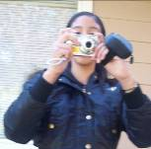
Introduction
The data presented in this chapter is organized into six sections. Each section is based on a different type of student work or activity. The data sections include: student photographs and corresponding writings, student-made video recordings, writings from a culturally-centered classroom assignment, transcriptions of a classroom conversation, researcher observations of “El noticiero,” an activity which emerged during recess, and descriptions of conversations and observations made by the researcher during her visits to the households of the focus students in the study.
In each of these sections, the researcher created a table listing funds of knowledge which are apparent through that particular data sample (Tables 1 through 6). These tables are then followed by further description and explanation of the data and a preliminary analysis of the emergent ideas and themes related to funds of knowledge. Since the teacher-researcher is a participant in some of the activities, the third person voice gives way to the researcher’s own voice as the chapter progresses.

Data and Analysis
Section One: Student Photographs and Corresponding Writing
Table 1

Funds of knowledge depicted through student photographs
Category | Subjects
Respect for Life | Caring for pets: dogs, cats, birds, chicks  Nature: flowers, trees, cacti, crops, water for crops, birds  Picking up litter, recycling  Beer bottles  Receiving relatives
Celebrating  Community | Family gatherings  Drinking soda and eating together  Riding bikes or playing together outside  Games: Snakes and Ladders, Nintendo DS  Playing on the playground or soccer field  Baile folclórico (Mexican folk dance)  Fourth of July Fireworks: town event, personal fireworks in the street
Knowledge | Gardening and crops: squash, tomatillos, watermelon, sunflowers, alfalfa, a student’s personal garden  Cooking: salad, BBQ, cooking large quantities, tortillas, beans, toasting garbanzos  Essentials for field work: hat, lunch tote, gloves  “Sandy Cheeks” (“Smart” Sponge Bob character)  Smart and artistic siblings  A teacher  Different states in the United States  Cameras and photography  Computers, reading and writing  Laundry
Innovation | Student-made model electric car  New Lego set  PSP, DS (video games)  High definition TV
Non-Violence | Religion (Jesus, God, Virgin Mary, Virgin of Guadalupe)  Shaking hands, working together, playing together
Artist’s Choice | Automobiles: large trucks, low riders, fancy hubcaps, small cars  Younger siblings  Lotería (A Mexican BINGO type game)
The six themes listed in the above table stem from the homework assignment “Photo Project 3.” Five of the themes (respect for life, celebrating community, knowledge, innovation, and non-violence) were selected by the researcher because they were representative of five core values of farm worker organizer César Chávez (Smith and Osborn, 2009, p. 61). The class was reading about the life of César Chávez. Using these five themes as a focus for the photo project created an opportunity for the students to portray their community in a positive light. In each case, however, students were allowed to choose between taking a photo that corresponded with that theme, or one swhich demonstrated the opposite of the theme. Students were also provided a sixth category, “Artist’s Choice.”
Photos taken as part of “Photo Project #4” are also included for analysis in this section, in order to keep the body of data related to photographs together. This assignment was specifically related to funds of knowledge the students perceived existed within their homes and communities.
Students kept notes as they took the photos for “Photo Project #3” and also wrote detailed descriptions of several of their photos during an in-class writing session. The notes of Susana and Isabel are included in Appendix C as they are an important source of data in and of themselves. They suggest that both girls have a strong understanding of these six themes and that their foundation for this understanding is based primarily within the larger fabric of Mexican culture and social norms, as will be explained in some of the examples below.

Respect for Life

Susana’s “thoughts about the photos” (Appendix C) includes statements such as, “Respect for life should always remain para la educación (for/in order to ensure education). As Valdés explains in Con Respeto (1996), “education” in Spanish could mean either formal education or it could mean manners and moral values (p.125). It appears that Susana is referring to the latter definition, as the photo accompanying the text shows family embracing as they arrive at a get-together in a relative’s backyard.
The category of “respect for life” also included children picking up trash and recycling, plants, nature, and caring for animals. One student chose flowers for this category and describes the flowers within the context of her family. She writes, “I think that the flower is so beautiful because when I was a little girl my mom used to have a garden full of flowers and I always helped her water the plants. So now I love flowers as much as I love my mom.”
A group of four male students artistically arranged and photographed an array of beer bottles. One student refers to this as “trash pollution,” and describes in his writing that one can “usually” find some bottles “on the street in front of Campo del Nopal.” This student also took many photos of well-tended flower beds and the Welcome sign for the Oakville Migrant Housing Center. This series of photos suggests that this student recognizes the community as generally a well-cared for and welcoming place that nevertheless has a “polluted” side to it.

Celebrating Community
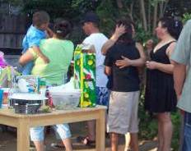
This category was the most widely photographed, as well as the most widely described in writing. Overwhelmingly, students wrote about “celebrating community” in terms of spending time playing and eating with family and friends. The community described by different students includes both a community including adults and extended family members who live in Campo del Nopal or in nearby towns. It also includes a community of children who play, eat, and celebrate without adults in the photos.
Every student, for example, took photos of each other playing a group game called “traffic jam” which caused many shouts of laughter. This game involved many children who would go down the slide of Campo del Nopal play structure and not get off, causing a group pile up that would eventually span the entire length of the slide. Susana and Isabel speak of “sharing more things” when celebrating with family and “conviviendo más” (being/socializing together) by riding bikes and playing such games, as Snakes and Ladders and Nintendo DS.
Valeria took a group photo of several children standing outside, smiling and holding up hot dogs and condiment bottles. She writes that they are “eating very good hot dogs and using a stroller as a table. They are happy and not just acting, except for one girl, who participated [brought food to share] more than anybody and nobody thanked her.” The photos related to celebrating community suggest that these occasions are valued by the students and that certain social norms and expectations, such as sharing food and being thanked for that, are also valued.
In examining the “Celebrating Community” photographs, many other details related to the community’s funds of knowledge are apparent. These include preparing food/cooking for large numbers of people, participating in a baile folclórico presentation, and celebrating the Fourth of July. The many photographs of children playing outside together also indicate that adults believe that Campo del Nopal is a safe place to allow children to play outside freely, well into the evening.
Knowledge
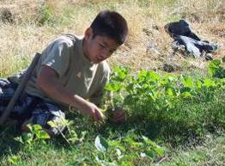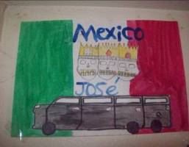
A theme suggested in student photographs and writing within the category of knowledge has to do with the nature of knowledge itself and the idea that knowledge resides within people one is close to. Diana took a photo of me, as her teacher, as well as of a picture that her brother drew of a Mexican flag, three skulls with crowns, and a Hummer limo. To Diana, this drawing “represents that my brother knows how to draw better than I do.” Isabel photographed her younger sister because, “She is smart and her teachers say she is smart.” Valeria took a photo of her father because, “Even though he didn’t go to school he has knowledge of something.”
Knowledge that students were developing in the moment is also apparent in the many photos they took of each other taking photos. Other “new” knowledge is depicted in a photo of a “smart” Sponge Bob character, Sandy Cheeks, and in photos of computers and video games.
Practical knowledge is also a common theme in these photos. Laundry hanging to dry on a line is one example. Agriculture and nature also figure prominently. A watermelon, squash plants, a sunflower, and a field of hay represent the specific crops where their parents may work. Edgar and another boy both make mention of watering the crops, which is the job Edgar’s father is most regularly employed to do. Edgar’s photos also depict his personal garden. A photo of an Arizona license plate represents knowledge of and a connection to another state. Cooking again figures prominently, although many of the details related to cooking and food, such as toasting garbanzos and making large quantities of beans, salads and tortillas, are depicted in photographs placed in the “Celebrating Community” category. There are also images of clothing items necessary for field work, reading and writing, and riding bikes. These diverse images suggest funds of knowledge related to the labor activities of the community’s adults, household chores, popular culture, and new and innovative technologies.
Innovation
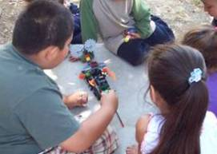
For the category of “Innovation,” Edgar took a photo of a working model electric car that he built. Other images in this category include the “new destroyer Legos,” the PSP video game, “the new Nintendo with a phone,” and fancy television sets. This suggests students’ familiarity with modern technological gadgets, especially those currently popular among youth.
Two images of such gadgets stand out especially. One is a series of photos of a PSP video game whose screen displays the words “Mexican pride” and several other cultural symbols commonly associated with Mexican and Chicano cultures, such as the Virgin, the low rider, and a certain dress style. Another photo is of a large, new television that shows an image of different kinds of beans and corn. This indicates that knowledge of these new technologies may actually be being acquired or interpreted through a lens of traditional culture, popular youth culture, or cultural pride. These images could also be interpreted to mean that innovative technologies are a realm where the student’s experiences as bicultural youth are reflected. An underlying theme of “Mexican pride” and Mexican or Chicano culture in general is apparent in several of the other categories of photographs as well, such as Edgar’s drawing, as shown in the previous subsection, that Diana chose to depict to represent knowledge.
Non-Violence
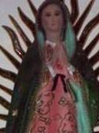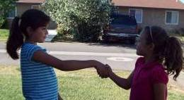
Religion was depicted repeatedly in the category of non-violence. Many of the students have relics and images of religious icons such as God, Jesus, the Virgin Mary, and the Virgin of Guadalupe displayed prominently in their homes and it appears that they believe that God is a symbol of non-violence. Several students also took photos of children shaking hands after an argument or smiling at or hugging one another, suggesting that knowing how to cope with others is valued by them. Friendship seems an especially important theme, as there are numerous photos of children playing together, embracing, and smiling. Susana explained, “Violence does not resolve anything.”

Artist’s Choice

Besides photos of people and nature, the most commonly photographed subject matter in this project was automobiles. Large trucks, small cars, low riders, and fancy hubcaps figured prominently. One automobile-related photo included “Sinaloa,” a Mexican state, written in a popular white cursive lettering style on the back window of a truck. In most of these photos, the cars were clean to the point of shining. Three boys wrote descriptive pages about the low rider. I have included one of these in Appendix D. Despite some issues with spelling and grammar, this writing indicates a detailed knowledge some of the students possess about this particular type of car and cars in general. This knowledge is especially significant given the importance of cars in the daily lives of migrant farmworkers. Considering that Campo del Nopal is located amid fields several miles from the town of Oakville itself, the only method of getting anywhere is by car. Furthermore, cars are necessary for farmworkers’ going to and from work and for moving back to homes in Mexico or to a new crop once one work season ends.
Students also took many photos of younger siblings and other younger relatives and babies. This suggests that younger siblings play an important role in the students’ lives. Another photo simply depicted part of a loteria game, a game common in Mexico.

Section Two: Student Videos
Table 2

Funds of knowledge depicted through student video recordings
Children playing together on the play structure and field at Campo del Nopal
A baptismal party
Baile folclórico
Meal preparation
PSP video game and “Lego Racers” game for Nintendo 64
A student’s personal garden with squash and tomatillos

The assignment for the video project was to create a video that depicted either funds of knowledge present in the students’ families or areas of particular interest to the student. Because this assignment took place during the final days of summer school, the researcher did not have a chance to engage in immediate follow-up conversations with the students about their work. Furthermore, she was later only able to access the work of six students (the five focus students and another boy) on the DVDs where this work was saved. Despite this downfall, this small sample of video recordings provides a significant amount of data related to student interests, as well as the community’s cultural capital.
For example, Susana recorded a cousin’s bautismo (baptismal) party. This party was outdoors, in some sort of large empty lot. However, no expense seems to have been spared for decorations, a bounce house, a DJ, and a live mariachi band. This video depicts a wide array of cultural details, from clothes and food to music, dancing and fun for the multi-generational guests. Susana chose to make this video because it was an event that was important to her.
Other videos also indicate that the children, although living in the rather isolated Campo del Nopal, were well-occupied during the summer months. Some videos depict their participating in traditional Mexican dance performances (baile folclórico), playing soccer, playing with friends in front of homes, playing video games, and gardening. In fact, the majority of the videos created were of children playing with their friends on the play structure or sports field at Campo del Nopal. Although these themes do not necessarily indicate knowledge per se, they do indicate that the students are active and engaged socially during the summer months.
In addition to Susana’s recording of the bautismo, two other recordings stand out as indicative of cultural capital within the Oakville migrant community. One, a series of video clips created by Susana, Isabel, Valeria, and a fourth student, Flor, is more than an hour long. It shows Isabel’s mother preparing a chopped salad, a fruit platter, juice, and beans. The precision with which Mrs. Diaz chops and prepares the food makes these videos resemble a professional cooking show. This recording suggests that some of the student participants in this study gain knowledge of traditional Mexican cooking styles through observation of adult family members. It also suggests that, contrary to negative perceptions some teachers hold regarding the diet of children in working-class families, several focus students in this study are exposed to a varied and nutritionally-sound diet.
The second video depicts a novel source of cultural capital. This recording details the entire process of setting up and playing the “Lego Racers” video game. This video clip makes it apparent that youth culture and technology is an important aspect in the lives of some of the students. A close look at the game recorded in this video also indicates that some video games may be sources of new Spanish vocabulary as well as sources of popular portrayals of different real-world geographical locations, such as Egypt.
These videos make apparent that the students in this study are active and engaged in a wide variety of activities during outside-of-school time. Some of these activities are cultural celebrations and play. Other experiences are opportunities for the children to learn valuable practical skills or apply knowledge of academic Spanish vocabulary in a video game. This data supports a counter story to the deficit model which assumes that these students’ lives outside-of-school lack educational stimulus.

Section Three: Student In-Class Writing Assignment
Table 3

Funds of knowledge reflected in the images of four books
Image | Number of student writings
picking nopales (prickly pear pods)* | 2
picking tunas (prickly pear fruit)* | 1
una tamalada (tamale cooking event) | 1
birthday parties* | 2
Quinceañera (15th birthday party) | 2
PSP video game | 3
peaches | 1
hammerhead shark/fishing* | 2
regular dinners with extended family while living in Mexico* | 2
flea market | 1
farm/field labor | 1
* indicates this image was chosen by a focus student in the study

Before students began writing about their photographs, they practiced descriptive writing using two books by Carmen Lomas Garza, Family Photos/Cuadros de Familia (2005) and In My Family/En Mi Familia (2000). The teacher-researcher wanted to highlight not only the detailed drawings, which were much like photographs, but also wanted the students to see the way that Carmen Lomas Garza wrote about the images and highlighted many details that one might take for granted or simply fail to notice upon first glance. Because the books were first published a decade ago and Lomas Garza’s family was based in Northern Mexico and Texas, the teacher-researcher had some doubts as to whether or not the students would easily connect with the images.
The students each chose a photo that connected with a memory or experience of their own. Then they wrote one page using as many details as they could to describe this event in their life. While most of these images came from Carmen Lomas Garza’s two aforementioned works, three students chose images from a book called Cool Stuff and How It Works (Woodford, Morgan, Collins & Jones, 2005), while two others chose from Alma Flor Ada’s Gathering the Sun (2001). Several students asked if they could write about more than one image because they had stories related to several of the drawings. This indicates that they did indeed connect with the images. Ultimately, the 13 students wrote about 19 different images, as listed in Table 3.
Diana’s writing about eating prickly pear fruits indicates that she not only connected with the image, but was able to contrast the image with her own memory, a higher-level thinking skill. She writes:
[This image] surprises me because the girl picks the prickly pears with her hands. Because I pick the prickly pears with a knife and I put them in a tub. Then I put them on the ground and I get a lot of grass. Later I shake them and the spines come off. Later I grab the knife again and I open them. I take off the peel and I eat it.
Diana’s description of how to pick and prepare the prickly pear for eating indicates a practical knowledge related to a food common in Mexico, and which also grows abundantly near her house and the migrant housing center. Practical knowledge related to picking, harvesting, fishing for, and preparing food was common in the writings of this section. Susana and Valeria, for example, describe practical knowledge related to food preparation, as both discuss assisting in the killing and preparation of chickens for family dinners in Mexico.
Susana’s and Valeria’s writings stem from an image of a large family dinner called “Para la cena” (“for dinner”). This image connects with the girls because, in Valeria’s words, “Es lo que hace nuestra familia regularmente en México. . .los sábados y domingos” (This is what our family regularly does in Mexico on Saturdays and Sundays), and which Susana’s family takes part in “Sundays and during the week.” Valeria lists the names of the six relatives involved in these dinners along with “myself, Valeria Morales Contreras.” Susana explains, “My family are my dad, mom, godmothers, and also my godfather, and the workers who are building our house, and their brother.” Susana also lists the names of nine relatives who took part in a dinner the weekend before the writing assignment, during the Fourth of July. At this gathering “we grilled meat and toasted garbanzos. It was really fun.” She finishes her piece with “me gusta convivir en familia y más en México porque hay mucha cultura” (I like to spend time with family and more so in Mexico because there is a lot of culture).
Valeria’s and Susana’s writings illustrate an apparent appreciation for regular family gatherings in which they take part, both in Mexico and in Oakville. Their naming of so many individual family members seems to indicate the importance of each of these people within the larger family unit. In analyzing the entire collection of student writings, one notices that this strong connection to family is a common theme. In fact, with one exception, every piece of writing in this section included mention of relatives (siblings, parents, grandparents, godparents, cousins, or friends). Often, an older relative, such as a grandfather or aunt, assists the child in learning about or developing a particular practical skill.
The children’s role in support of their household function is also an evident theme. In Isabel’s writing, for example, she describes her role assisting her mom in household chores when she helps to clean up after her own birthday party. The student who chose an image related to work in the fields, Flor, had just arrived in Oakville and had only joined our summer school class the day of this assignment. Nevertheless, she wrote an entire page about her family’s experience as migrant farmworkers and her own important role in helping her family. This piece is included in Appendix E as an example of the theme in which, through application of their practical knowledge or skills, children play an important role in supporting the function and daily routines of the household as a whole.
Three writings also indicate the important role other children play in the lives of the writers. Diana’s writing about prickly pear is one example. She states, “My friend David helps me to eat them. We ate them outside and my mother never knew.” Even two of the three writings about playing the PSP video game, which one may assume to be an isolated or individual experience, include mention of family and friends . One student, Angel, states, “I post photos with Manuel” and “I don’t like sharing with my sister because she erases my score or my photo.” Another student states, “. . . [The] PSP screen is too small so I would rather go to my cousin’s house and use his computer.”
One piece of cultural capital which is apparent from analysis of this section was practical knowledge and skills, specifically related to acquisition and preparation of food, as well as knowledge of modern popular technology such as the PSP. Significantly, the data in this section indicates that these practical funds of knowledge are acquired and utilized in a social context where family members and the family unit play a central role.

Section Four: In-Class Discussion
Table 4

Knowledge of culture and cultural conflict
Themes
Holidays and celebrations
The culture of money
Agriculture
Traditions
Mexican history and historical figures
United States history and historical figures
Leaving known (home) culture to start school
Adobe architecture
Sadness and loss
Enjoying learning but not necessarily enjoying school
Inter-cultural identity development and conflict
Language, race, and power
School knowledge versus life knowledge

To form a preliminary idea of what students understood by the concept of “culture,” the teacher-researcher created a page with six questions about culture (see Appendix F) for the students to complete in class. Students were told there were not “right” or “wrong” answers, so they should just write what they thought. In notes from that day, the researcher describes the frustration she felt when it appeared that many students were resisting the writing task. During a class discussion related to the questions that had been posed, it appeared to her that their understanding of what culture means was rather superficial, if not inaccurate. Their definition of culture basically included “Mexico” and a list of different holidays and festivals celebrated in both Mexico and the United States. One student stated, “My culture is my birthday.” Different students’ understandings also contradicted each other, as they explained that culture could be changed by “las personas ó los partidos politicos” (people or political parties), “el tiempo” (time), “nada” (nothing), and “nobody”
Despite what the teacher-researcher considered a rough start to the conversation about culture, students ended up demonstrating a broad and keen understanding of the subject during a discussion which centered around the reading of a book about César Chávez called Cosechando Esperanza (Harvesting Hope) (Krull, 2003). As she read each page, she stopped and asked the students, “Who connects with this part?” Starting with the first pages, which describe a family gathering where people “brought watermelon, lemonade, and fresh corn” (p. 1) and the Chavez family’s “house of adobe” (p. 2), several students raised their hands to indicate their connection with the writing. Three-fourths of the class connected with the line, “Cesar was so happy at home that he felt a little scared when he started school” (p. 3). One student even raised her hand to indicate she connected with the statement, “A day came when Cesar’s mother could not stop crying” (p. 4). Several hands raised for “Cesar’s former life had disappeared. Now he and his family were migrant farmworkers” (p.5).
Even though the students indicated personal understanding of and experience with aspects of César Chávez’ life as described in the beginning of the book, the class only became fully engaged once the topic of the story began to encompass the idea of knowledge and power. On page six, César was told to “Speak English.” The text also explains that “even though he liked to learn, he started to hate school because of the conflicts that took place there.” In the illustration, César is forced to wear a sign that says: “I am a clown. I speak Spanish.”
In response, a student, Monica, stated: Mi maestra siempre me dice que hable inglés. (My teacher always tells me to speak English).
Teacher-researcher: How does this make you feel?
Monica: Bad, she tells me this all the time.
The teacher-researcher then wrote “conflict” on the chart under the question, “Is one culture sometimes considered ‘better’ or ‘worse’ than another? Explain.” She explained to the class that this question is about a conflict that sometimes exists at school between one culture and another. Then, she asked for an example.
Monica: One teacher always made me speak Spanish and not English.
Teacher: Does speaking Spanish mean you are less smart than if you speak English?
Class: No
Monica: (still speaking Spanish) It’s like ‘Whites only’--the sign in the photo, like in the time of Martin Luther King . . . all the kids in my school thought that the Mexicans are dumb and they would make fun of them.
Edgar: When I went to Mexico everyone called me gabacho (white person).
Teacher: How did this make you feel?
Edgar: Bad.
Teacher: What does gabacho mean to you?
Edgar: Blanco (White)
Monica: (in English) Other Mexicans call Americans gringos (pronounces gringos with a “gringo” accent).
The teacher-researcher ended the day’s reading with the line, “Not being able to study embarrassed Cesar for the rest of his life” (p. 7). She stated, “Sometimes people leave school for one reason or another and they feel embarrassed by the fact that they left school. Does this mean they are less smart?” Many students answered, “No.” Valeria responded, “Like my dad, he only went to second grade and he knows a lot about agriculture.”
The above dialogue indicates that some of the migrant students are aware of underlying societal tensions related to language, race and power or are experiencing their own issues, sometimes uncomfortable, upsetting, or confusing, related to the understanding and development of their own bicultural or inter-cultural identity. This data also suggests that many of the students possess an understanding of the funds of knowledge of their family and community members who may have not had the opportunity for formal education.
As an aside, it is interesting and perhaps significant to note that, once the discussion became more emotionally relevant to her, Monica, who had contributed the most that day about issues of language and power, spoke clearly and passionately in Spanish. However, the researcher’s notes from the beginning of the discussion describe how she interrupted the earlier discussion in Spanish to complain about using Spanish. She actually interrupted three different times to request, not exactly politely, that the class speak in English. This observation suggests that Monica was indeed quite capable of expressing herself in Spanish. Her resistance to doing so might suggest that she had internalized some of the negative feelings of her teachers towards using Spanish in the classroom.
The following day, the class continued the reading of Cosechando Esperanza (Krull, 2003) and Susana remarked that César Chávez was similar to Miguel Hidalgo, a leader of the Mexican movement for Independence from Spain. When asked if she could explain more, she said that he was an important figure in Mexican history and he fought for human rights. Being able to make this comparison suggests that Susana not only possesses knowledge of certain aspects of Mexican history, but is also able to apply this knowledge to her construction of new knowledge. Application is another example of higher-order thinking.

Section Five: “El Noticiero”
Table 5:

Funds of knowledge apparent through
El Noticiero
Apparent Categories
Popular media as a source of information
Current events
Popular culture (songs, musicians, actors, etc.)
Popular sports
Oral language fluency
Use of formal or “standard” Spanish

During the second week of summer school, the noticiero (news show) emerged as a recess activity. Susana, Valeria, and Isabel, who were three of the focus students in this study, created and carried out this activity. It looked and sounded something like this:
At a picnic table, Susana, Valeria, and Isabel sit on the bench and gaze professionally ahead, as if they were indeed taking part in a news broadcast. A forth student is holding a paper script up several feet away. Several other children gather around watching. When it is each girl’s turn to speak, she presents the events she is reporting in fluid, fast-paced, and assertive news broadcaster Spanish. At the end of her turn, she uses the classic news transition, “And now we will move onto sports with Ms. Valeria Morales.” Valeria, in turn, says, “Thank you, Susana. And, yes, in sports we must report . . .”
This noticiero became a regular daily occurrence during summer school. As the students arrived in class in the morning, Susana would rapidly write out the script for the day’s broadcast on lined paper. When asked how she knew what to write, she replied that Valeria and Isabel would tell her what they wanted her to write and then she would write the script. Apparently, they would tell her this information at some time outside of school hours and she would remember it and then write it in the news format. Susana would always put away the script when asked to take out the day’s work, leading the teacher-researcher to conclude that she wrote the entire script in a very short period of time.
During a follow-up conversation the researcher undertook with Susana about the noticiero, Susana explained that she gathered the information for the script from the TV news the night before, but for information about the popular songs she would watch MTV. Each of the three girls was responsible for her own section of the news. Susana’s job was music, movie stars, and pop culture, Valeria’s was sports, and Isabel’s was other news.
The noticiero was never sanctioned or not sanctioned, per se, by the teachers, although in my class the students were doing some work with video cameras and Valeria mentioned early on in summer school that she really wanted to “record a show.” The girls, however, could not say exactly how the noticiero started, nor why they started it during summer school as opposed to during the regular school year, when they also had recess together. In any case, this emergent display of student funds of knowledge and cultural capital was quite impressive. Table 5 lists the funds of knowledge which the three students involved demonstrated through this activity.

Section Six: Researcher’s Journal
Table 6

Funds of knowledge observed by the teacher/researcher
Observed funds of knowledge
Putting on a party
Caring for younger siblings or young
Running a store
Awareness of perceptions of dominant
culture towards own culture
Geography and international borders
Texas and Mexico
Agriculture
Food preparation and storage
United States holidays
Locating winter housing
Seasonal labor
Two different school systems
Technology (youth knowledge)

The list of funds of knowledge and cultural capital contained in Table 6 come from descriptions of observations made by the teacher/researcher, beginning at a baby shower at Campo del Nopal the day before summer school started and culminating in October, when the migrant center was set to close and families prepared to change homes. In these descriptions, the researcher’s first person voice emerges due to the fact that she is not only an observer, but, also, a participant in the events described. Further, the present tense is used to assist the reader in entering into the description as well.

Un Baby Shower
The evening before the first day of summer school, the entire Gomez family is working at serving up plates in the small kitchen at Edgar and Diana’s grandparents’ house when I arrive for the baby shower for Fernanda Gomez’ youngest sister. Edgar is busily passing out food to the guests as they arrive and sit themselves at the tables set up outside. There are coolers full of carnitas, ensalada de macaroni and ensalada de nopales, and huge pots of beans, rice, and pozole. There are tortillas, chips, salsa, and soda, and an in-law has also brought her specialty of giant tamales wrapped in plantain leaves. After nearly two hours of eating and socializing, we play several active games which leave everybody laughing. The family passes out recuerdos (party favors) of personalized magnets and statuettes which they spent an entire day shopping for at a flea market about an hour away. Gifts for the mother-to-be filled two full tables.
This observation supports previous data including children’s writing about family gatherings and parties, and Susana’s video of a large family party, which were described in sections two and three of this chapter. It suggests that households possess cultural capital which allows them to successfully put on a party in honor of family members. In the case of this particular baby shower, this knowledge not only had a social value, but also a practical, or survival value, as the mother-to-be, a recent high school graduate without a job whose boyfriend worked for minimum wage at a local business, received many of the material items necessary to care for her new baby.

Household Chores
I drive to the Gomez’ because I know the children have to stay home alone on Saturday while their parents work. My husband has been working for a month in Africa and I am desperate for some help in my yard. I ask Edgar, Ricky, and Diana if they would like to come help me for an hour or so, after which I will take them to the pool. Edgar and Ricky are happy to come along, but Diana cannot. She is responsible for caring for her younger sister, as well as two younger nieces and a cousin, while the parents are working.
Later, when I am returning the boys to their house in the afternoon, I learn that Fernanda Gomez was not actually at work that day but instead was at the laundromat. The children cannot accompany her, however, because they and the week-long accumulation of laundry cannot all fit into her small car. Edgar explains to me that his mom probably will not be at home yet, because it takes her five hours to do all the laundry, “Because there are five of us. My aunt will be home, though, because they are only three and it takes her only three hours to do the laundry.” He also states the exact cost of doing the laundry for both his mom and his aunt.
This observation indicates that Diana in particular has knowledge and bears a responsibility for caring for younger family members. This knowledge is practical in nature and contributes immediately and directly to the functioning of the family unit. Edgar’s detailed understanding of the costs, both in terms of time and money, of washing the family’s clothes at the laundromat, indicate his understanding of household economics and the value of time.
Explaining this Study
I am explaining this study and the corresponding permission form to Valeria’s mother. I say, “I want to teach other teachers about the kinds of things that children coming from Mexico know already, from their life in Mexico and from what their parents teach them, because, you know, sometimes they come here and some teachers think children come from Mexico not knowing anything.” She gives me a knowing smile.
I say basically the same thing to Susana Chavez’ father a few days later, and he says, “Maestra, it is true that a lot of people think that.” These two incidents make apparent to me that at least some of my students’ families recognize the negative perceptions of some members of the dominant culture toward other cultural groups.

Chicken and Tomatillos
I am dropping Edgar and Diana off at the Gomez household. They introduce me to an aunt who is visiting for a few days. The aunt is in the yard plucking the feathers off two chickens she had just killed and is preparing to cook. The Gomez’ entire front porch is piled with tomatillos, which Fernanda explains the whole family will be peeling that night. She will then freeze the tomatillos along with chiles in an extra freezer the family keeps and “they will last us through the winter.”
These observations support the children’s depictions and descriptions of their knowledge of acquiring and preparing food. Killing and plucking chickens, while common practice in Mexico and rural United States communities, is virtually unknown to children in affluent, suburban United States communities such as Oakville. Further, this observation also suggests that practical knowledge related to food preparation is embedded within a social context in which extended family members are expected to be active participants.

Camp Closure
The week before Campo del Nopal is to close for the season in mid-October, I make a final visit to the homes of Isabel, Susana and Valeria. It turns out to be the night that the community is celebrating an early Halloween. The day before, children brought flyers made at the childcare center to all the houses informing the neighbors of their desire to hold a trick-or-treating activity since the campo would close before Halloween.
Besides the excitement of Halloween, the upcoming move is on everybody’s mind. Juanito, a second grader I also taught in summer school, stops me in the street to tell me that his family will be leaving any day for Texas. Lupe, another second grader, says she will be leaving for Mexico on Monday. Isabel, whose family stayed over winter in the Oakville area last year, will return to Mexico for the upcoming winter as the trailer they had rented before is in need of repair and will not be available for rent.
I do not speak long with Isabel, as her parents have gone out to buy candy. At Valeria’s house, Valeria and her younger brother, Nico, are doing homework on the floor of the living room. Valeria’s godmother is a relative who lives in an upper-middle class neighborhood of Oakville and has a daughter who is attending a prestigious university. She gave Valeria a new lap-top computer as a birthday gift a few weeks earlier. Valeria is using the computer to complete her English assignment. Valeria’s mom is at the table, watching a talk show program and writing out an entire multiplication table by hand. She explains that she is assisting Nico in his division homework. She tells me, “The way they taught us to solve division [growing up in Mexico] was to use the tabla (multiplication table) and ask oneself, how many times does 8 go into 64?” The family was planning to spend the winter with a relative in Colorado, but have decided to look for an apartment in a town about 15 miles from Oakville, where the rents are cheaper than in Oakville. “Even if I have to drive the kids back and forth everyday so they can stay in their same school it will be worth it. I don’t want them to change schools. I want them to complete the year in their school,” explains Valeria’s mother.
Three days later, I stop by Susana’s house. Her parents, Lourdes and Emilio immediately offer me a seat on a white plastic chair. As on all of my previous visits to the household, the Vasquez family is very courteous. We have often spent an hour or more chatting about many aspects of life, including the family’s work as laborers in a nearby agriculture research station, their life in Mexico, and their dreams for Susana.
The Vasquez family has just learned that Campo del Nopal will remain open an additional three weeks, after which they will return to their rural community in Mexico where they run a small store next door to their house during the winter months. Lourdes explains that they will remain less time in Mexico than usual now because Susana is now in junior high. When I ask how junior high is going, Lourdes asks Susana to show me “the test” which is actually not a test, but a school progress report. Junior high has been a challenging transition for Susana, as it is taught entirely in English, whereas she was in a Spanish immersion program in elementary school.
Susana has an “F” in social studies. Her reading grade is a “D” due to “work not turned in.” Susana does not understand this and states she has done all the work and has already read three books on her own this year. When we discuss her math grade, which is also low, I mention that Susana was always good with math, especially since she worked in the store. Emilio says, “We know Susana can do it, she is capable, she needs to talk to the teachers and also empeñarse (work hard).” I notice Susana’s eyes fill with tears which she is barely able to control.
These October visits to the households of the focus students provided information that indicates, yet again, that there exists a wide range of knowledge within the Oakville migrant community. Specifically observed were knowledge of math, technology, the United States’ Halloween tradition, winter housing possibilities, Texas, Mexico, agriculture and agricultural labor, parents’ understanding of the ramifications of seasonal moves on children’s schooling, managing a store, crossing an international border, and two different school systems. These observations also suggest that some families do indeed lack knowledge in some aspects of mainstream Oakville culture, such as where to find an alternate affordable winter home when the place they lived previously is being renovated or how to understand the junior high report card.

Summary

What is apparent through analysis of this body of data is that the student participants in this study possess knowledge in many areas. The data produced by students is supported by the researcher’s own observations. This data suggests that the funds of knowledge present in the Oakville migrant community are wide-ranging and include knowledge about Mexican history and culture, United States history and culture, the bicultural experience, cultural conflict, field work and agriculture, technology, religion, youth culture, popular culture, food preparation, caring for plants, animals, and people, automobiles, household chores, geography, housing, relationships and more. The following chapter includes additional analysis of this data and provides specific suggestions for how this data may be used by educators to better serve migrant students in the Oakville schools.
Chapter 5

SUMMARY, CONCLUSIONS, RECOMMENDATIONS

Summary
This study proposed to describe some of the funds of knowledge, or cultural capital, held by migrant children in Oakville, ages 10 to 13. Thirteen students depicted their community funds of knowledge through photographs, videos, and writings about their own lives outside of school. The teacher-researcher was able to add to this student- produced data through her own observations made within a culturally relevant classroom setting and during household visits and other social activities with five focus students. The upcoming chapter highlights the important themes which emerged through analysis of this data. It also lists recommendations for action that will build upon the data presented, as well as the researcher’s own reflections on the research process.

Conclusions
Analysis of this body of data made apparent that the migrant students in the study possess a large body of cultural capital. The data also indicates that, contrary to certain deficit perceptions about migrant students, these students have ample opportunities to acquire new knowledge within their community. Furthermore, this data suggests that the students live active and enriching lives outside of school.
A sampling of the cultural capital present in the Oakville migrant community during the time of this study is listed in the previous chapter (Tables 1 to 6), with additional pieces of student work included in the Appendices. In the upcoming chapter, these community funds of knowledge are described and analyzed in more depth.
In addition to a providing insight into what funds of knowledge the students possess, this data makes apparent that utilizing student cultural capital as a basis for curriculum supported students’ display of higher-level thinking skills. Further, analysis of this data also suggests interconnectedness between tangible or academic knowledge and the socio-cultural matrix in which such knowledge appears to be acquired, practiced, and developed in the Oakville migrant community. Further explanations of these socio-cultural connections are included in the following sections of this chapter.

Community funds of knowledge are apparent in the Oakville migrant community.
Students depicted a wide variety of knowledge directly related to academic subjects. This includes knowledge of Mexican history and culture, United States history and culture, economics, money and time, plants and agriculture, technology, religion, geography, and more. In addition to knowledge related to academics, the data indicates that the students and families also possess knowledge related to culture, behavior, labor, and survival. A sampling of this knowledge includes the bicultural experience, cultural conflict, field work, agriculture, food preparation, technology, geography, religion, youth culture, popular culture, household chores, economics, housing, caring for plants, animals, and people, and how to maintain relationships which support household functions.
As these two lists make apparent, there is considerable overlap between what is traditionally considered academic knowledge and that which would be considered practical knowledge, and socio-cultural knowledge. This suggests that knowledge, like culture itself, cannot be easily defined by discrete and static categories. Instead, academic knowledge and cultural, social, behavioral, and practical knowledge intertwine. This finding is especially important for teachers interested in utilizing a culturally relevant pedagogy in light of the fact that academic knowledge is the main or only knowledge upon which school curriculum is centered.

Culturally relevant pedagogy is a means for accessing and applying funds of knowledge.
In this study, culturally relevant curriculum was used by the teacher-researcher as a way to access and bring forth student prior knowledge. Students demonstrated they were able to depict their funds of knowledge through culturally-centered projects, such as the photo and video projects, as well as through writings and discussions about culturally relevant topics.
Additionally, there are at least three examples described in Chapter 4 which suggest that the students were able to demonstrate higher level thinking processes, especially that of comparing and contrasting, when curriculum was culturally relevant. The three students involved in the Noticiero were also able to apply new knowledge and utilize academic language during a learning activity which was culturally relevant.
These observations support the premise made by both Sleeter (2005) and Delpit (2006) that culturally relevant pedagogy is not a watered-down curriculum, but a means for higher-level thinking. It also supports Sleeter’s statement that “when students’ prior knowledge is not activated…[teachers] may assume students know far less then they actually do, an assumption that feeds the deficit ideology” (2005, p. 110). In the case of this study, some student funds of knowledge and higher level thinking skills may not have been apparent, if not for the culturally relevant context of the curriculum.

Culture counts.
It is interesting to note that the researcher had originally intended this study to describe the social and behavioral context of the community funds of knowledge, but later deemed this beyond the scope of the study. Thus, she narrowed the focus of the research to include only a description of academic funds of knowledge. It became evident, however, as Moll et al (1990, 1992), Delpit (2006) and Valdés (1996) postulate, that within the Oakville migrant community, these apparent funds of knowledge emerged and existed within a social context. For example, student videos, writings, and researcher observations within the community suggest that new knowledge was often acquired through engagement in a social activity. These activities were often productive (food preparation, serving guests at a party, caring for siblings, for example). In other cases, such as in playing video games with friends, the activity was less productive but still social and initiated by the children’s interests. These two observations strongly support the hypothesis of Moll and Greenberg (1992, p. 134).
The overall data suggests that the social context for these students is influenced not only by an overarching Mexican culture, but also the particular culture of the Oakville migrant farmworker community, the bicultural experience of the youth of this community, and the popular and youth cultures of which these students are also a part. This observation supports Darder’s definition of culture as dynamic (1991, p. 26) and Olneck’s definition of cultural identities as “ongoing active constructions that emerge out of interactions among groups within sociopolitical and symbolic contexts” (2003, p.318).
This data also supports the theory of Shawn Ginwright, whose writings in Black in School (2004), add to this discussion. Ginwright explains that cultural relevancy cannot be defined by outsiders, even those with good intentions. He also posits that popular and youth cultures play prominent roles in the construction of youth cultural identities. In the case of this study, the youth experience was especially distinct from the experience of adults in the community in terms of knowledge related to technology and popular culture. Also evident among the youth was a unique bicultural experience that many of their parents, whose entire upbringing took place in Mexico, did not specifically share. Further, although researcher observations supported the data about funds of knowledge produced by the students, it was the student-produced data which created the framework from which the researcher observations were viewed. The majority of the data produced and presented in this study would not have existed if the researcher simply relied on her own ethnographic observations.
The apparent finding that the students’ funds of knowledge often emerged as part of a productive, social activity supports the idea that class plays a role in cultural relevancy, another hypothesis of both Ginwright (2004) and Valdés (1996). Many of the students’ funds of knowledge derived from activities necessary to support what Moll terms day-to-day “function or well-being” of the family unit (Moll & Greenberg, 1992, p. 130), or, in the term used by Guadalupe Valdés, “survival” (1996, p. 96) of working class households.
This finding makes apparent that a culturally relevant pedagogy does not merely consist of providing relevant academic content material in an otherwise traditional classroom setting. Instead, culturally relevant pedagogy for students such as the students in this study would center the acquisition of new knowledge in a productive, social activity. Such pedagogy would also take into consideration the important role of the children’s knowledge in supporting the day-to-day functioning and well-being of their family as a whole.

Recommendations for Action
The above-mentioned research findings provide a strong foundation of understanding from which to develop potential solutions that will support migrant students in Oakville schools. The following section outlines a list of recommendations for action that the researcher believes teachers, schools, students, and families could take in order to build upon the data and conclusions presented in this paper. Also included are recommendations for further research.

1. Teachers can act by seeking out the cultural capital of migrant students and utilizing this resource within the classroom.
One way for teachers to learn about student’s cultural capital is through the teacher-as-ethnographer approach. This approach appears to be especially useful in transforming conscious or unconscious biases which teachers may hold about students and families. Another way teachers can learn about the funds of knowledge of their students is by designing curriculum and projects which promote the students’ telling of their stories or depicting aspects of their communities through art or technology, for example. Teachers can also utilize the knowledge of community members, such as the parents of migrant students, by inviting them to present in class. Many of the parents in this study, for example, do not work outside of the home during winter months and would thus be more likely available to accept such an invitation at that time. Teachers should consider the particular transportation and translation needs of the parent when making the request.
Teachers can use knowledge gained through these approaches to develop a culturally relevant curriculum. Data from this study shows that using a culturally centered curriculum allows students to demonstrate and apply more of their prior knowledge. This then allows the teacher to learn even more about the student and family knowledge in order to create more relevant curriculum, thus evolving into a positive feedback cycle.

2. Teachers can act by consulting the literature.
Much has been written about the subject of culturally relevant pedagogy (Freire, 1970; Gay, 2000; Ladson-Billings, 2009). Such literature can also provide examples of what such a pedagogy looks like in real classrooms (Sleeter, 2001, 2005). Even literature with a focus on culturally-centered pedagogy for students from other backgrounds can provide a framework for creating a culturally relevant pedagogy for migrant students. For example, literature on African-centered pedagogy (Delpit, 2006; Ginwright, 2004; Murrell, 2002) describes the relationship of social context and culturally-mediated learning behaviors on knowledge acquisition of African American students. These concepts appear to be relevant to the students in this study as well.

3. Schools can act by supporting teachers in developing culturally relevant practices for migrant students.
Schools can provide stipends or other incentives for teachers to make household and community visits evenings or on weekends, and provide interpreters as needed. They can also provide release time for teachers to plan culturally relevant lessons and to observe classrooms where culturally relevant pedagogy is already taking place. Giving teachers permission to differentiate curriculum, or, better yet, empowering them to do so, is an inexpensive and very powerful action schools can take.

4. Schools can act by recognizing the resources migrant families do provide and by providing additional support when family and school resources do not match.
This study makes apparent that migrant students have many opportunities for acquiring knowledge within their community. However, certain aspects of school knowledge and culture are less accessible to migrant students. For example, parents may need help with understanding grading systems and report cards, or students or parents may need transportation in order to attend a homework club, parent/teacher meeting, or school event. (Conversely, the teacher or club could also come to them). If migrant students are expected to complete certain projects or assignments at home, they may need to be provided certain material or technological resources in order to do so.
Ideally, the school would undertake efforts to connect with migrant students who leave during the winter through independent study programs or through a larger scale effort involving working in partnership with the student’s other school, whether in Mexico or in another city or state within the United States.

5. Students and families can act by seeking to connect home and school knowledge.
When presented with new information in school, students can ask themselves, “How does this relate to me,” or, “How can this information be useful for my community?” If the information does not seem relevant or useful, students can speak to a trusted teacher or school staff member and let them know this. Perhaps this candid conversation will encourage the teacher to make the curriculum more relevant.
Students should also take into consideration the fact that mainstream teachers have much to learn from them and their families. While students may experience a bicultural existence every day, mainstream teachers may have little exposure to any cultural experience except for their own. Students can consider inviting a teacher to visit their family at home or elsewhere within the community.

Recommendations for Further Research
An interesting area of research in an affluent, primarily Anglo community like Oakville, where migrant students are a minority, would be the effect of a culturally relevant pedagogy for migrant students on the non-migrant students. Would such pedagogy support the higher level thinking of both groups? Would it have transformative effects on how students view each other as human beings?
The researcher also has a specific interest in creating an opportunity to engage in culturally centered pedagogical practices with parents. This would contrast with the transmission model that often permeates committees comprised of parents from culturally diverse backgrounds. It would be interesting to find out what are the particular interests and perceived needs of the parents, and to answer the question, “How can knowledge migrant parents possess aid other parents as they support their students in navigating the Oakville school system?” Would such a model indeed be transformative for parents, as Moll and colleagues would suggest?
Further, it would be helpful to develop a group of teachers-as-ethnographers, following the example of Moll and colleagues. Such research could follow the transformations, if any, that the teachers undergo in both attitudes and teaching practices. This group could also be a study group that utilizes existent research in the areas of culture, knowledge, and power in order to engage in a critical reflection of their teaching.

Researcher Reflections
This study was transformative for the teacher-researcher in several ways. Simply viewing the many photographs the children took of each other gave me a renewed appreciation for their humanity. I also felt this process of delving into student photographs and videos helped in developing more mutual trust and respect with some of my male students, especially. This was an unanticipated outcome which caused me to reflect on my potential biases or challenges as a female, white, teacher of male, Latino, migrant students.
Finally, undertaking this study reinforced my commitment to serving the migrant families and working for educational equity and justice for the children of the community. Before completing this thesis, I was already able to utilize the knowledge gained from the research process to provide a critical counter-argument to a group of teachers engaged in a litany of comments espousing a deficit view of migrant students and families. As a result of this research process, I have also begun undertaking a critical analysis of whether my own classroom indeed supports migrant students in reaching their full academic potential.

Final Remarks
In conclusion, the focus of this study was to gain information needed to support migrant students in reaching their full academic potential in school. The information gained from the research can assist teachers who are already currently engaging in culturally relevant teaching practices, as it provides up-to-date data about the funds of knowledge of actual Oakville students. Further, the research findings serve as a counter-story to the deficit ideology of migrant students common among teachers and administrators in Oakville. Using the research design and research findings to shape classroom practice should theoretically support the success of migrant students in Oakville schools.
The bridge between home knowledge and school knowledge goes both ways. Thus, when culturally diverse students are successful in school because school is relevant to their reality at home, they can then take their school success home with them and apply it in ways that add to and strengthen the existent funds of knowledge of the community.
Further, when teachers support our culturally diverse learners as they cross the bridge between home and school, they also join them on this bridge. Like their students, teachers become both more successful learners and more successful supporters of the community in the process of working to create stronger connections between two previously disconnected worlds. Utilizing such a funds of knowledge approach to teaching thus appears to not only enhance the academic outcomes of students within schools, which in turn supports the community, but also serves to create and sustain respectful and egalitarian relationships between teachers, students, and students’ home communities. Through this process, the entire power structure of the school and even the traditional definition of knowledge itself are transformed.
.

APPENDIX A

Sample Student Photographs and Videos

Respect for Life
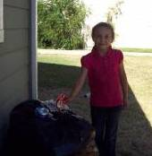

Celebrating Community
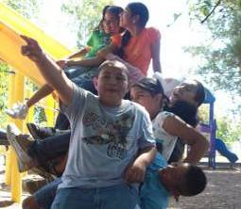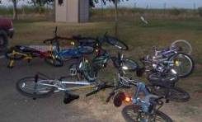
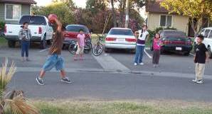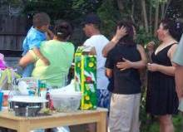

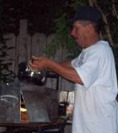

Knowledge
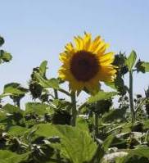



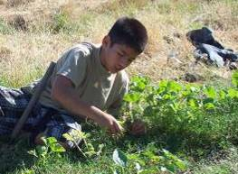
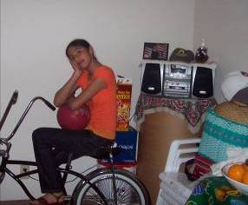

Innovation
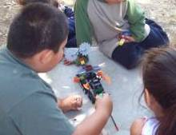

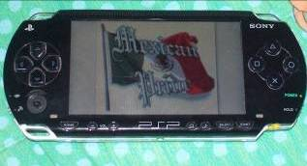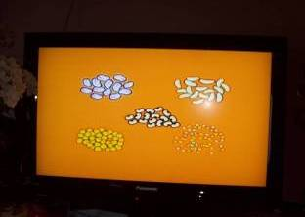

Non-Violence
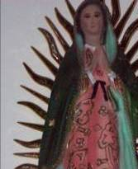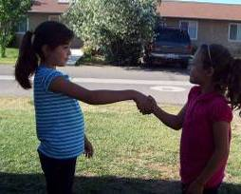

Artist’s Choice


APPENDIX B

Funds of Knowledge Depicted in Student Videos

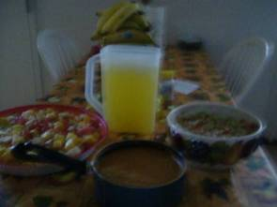
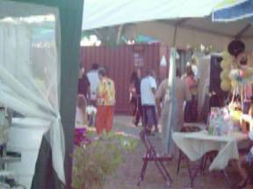
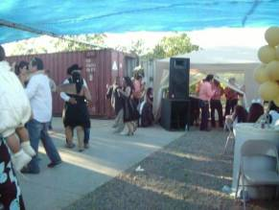

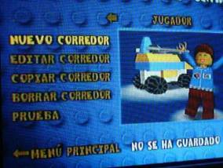
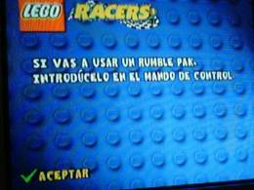
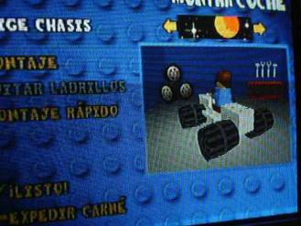

APPENDIX C

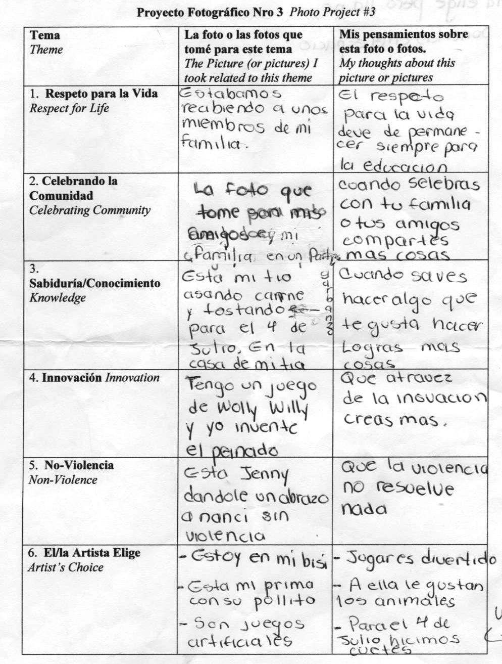
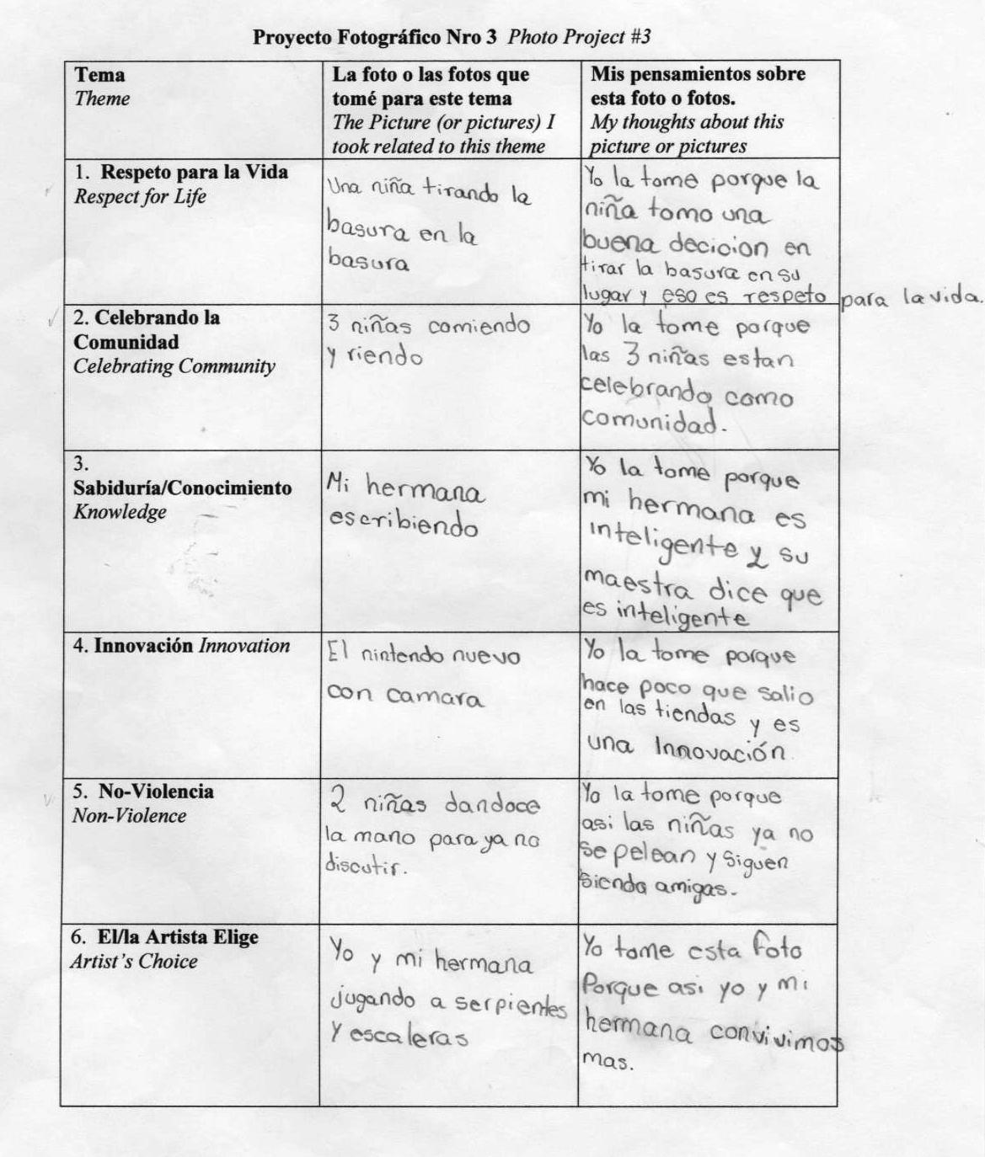
APPENDIX D

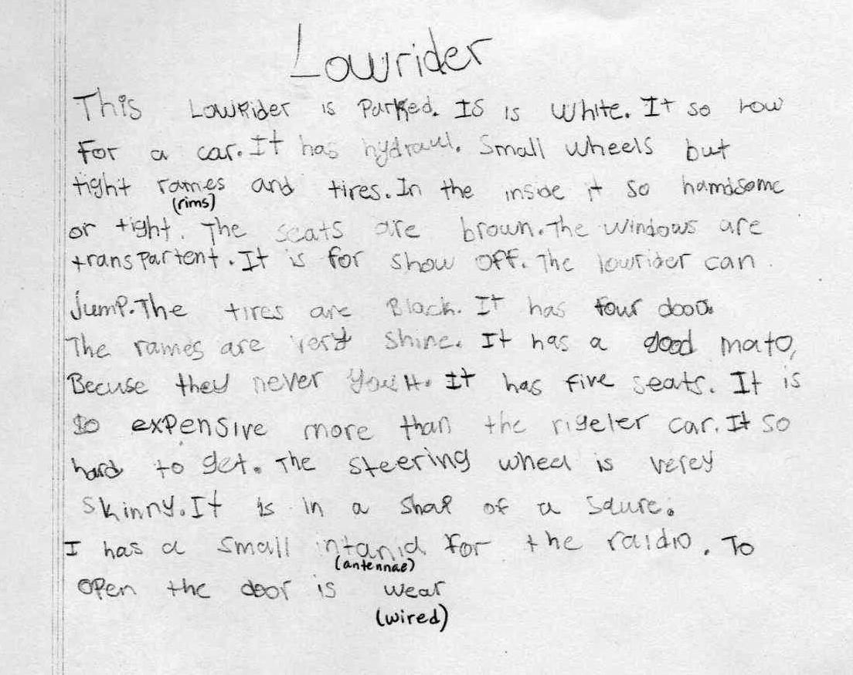

APPENDIX E

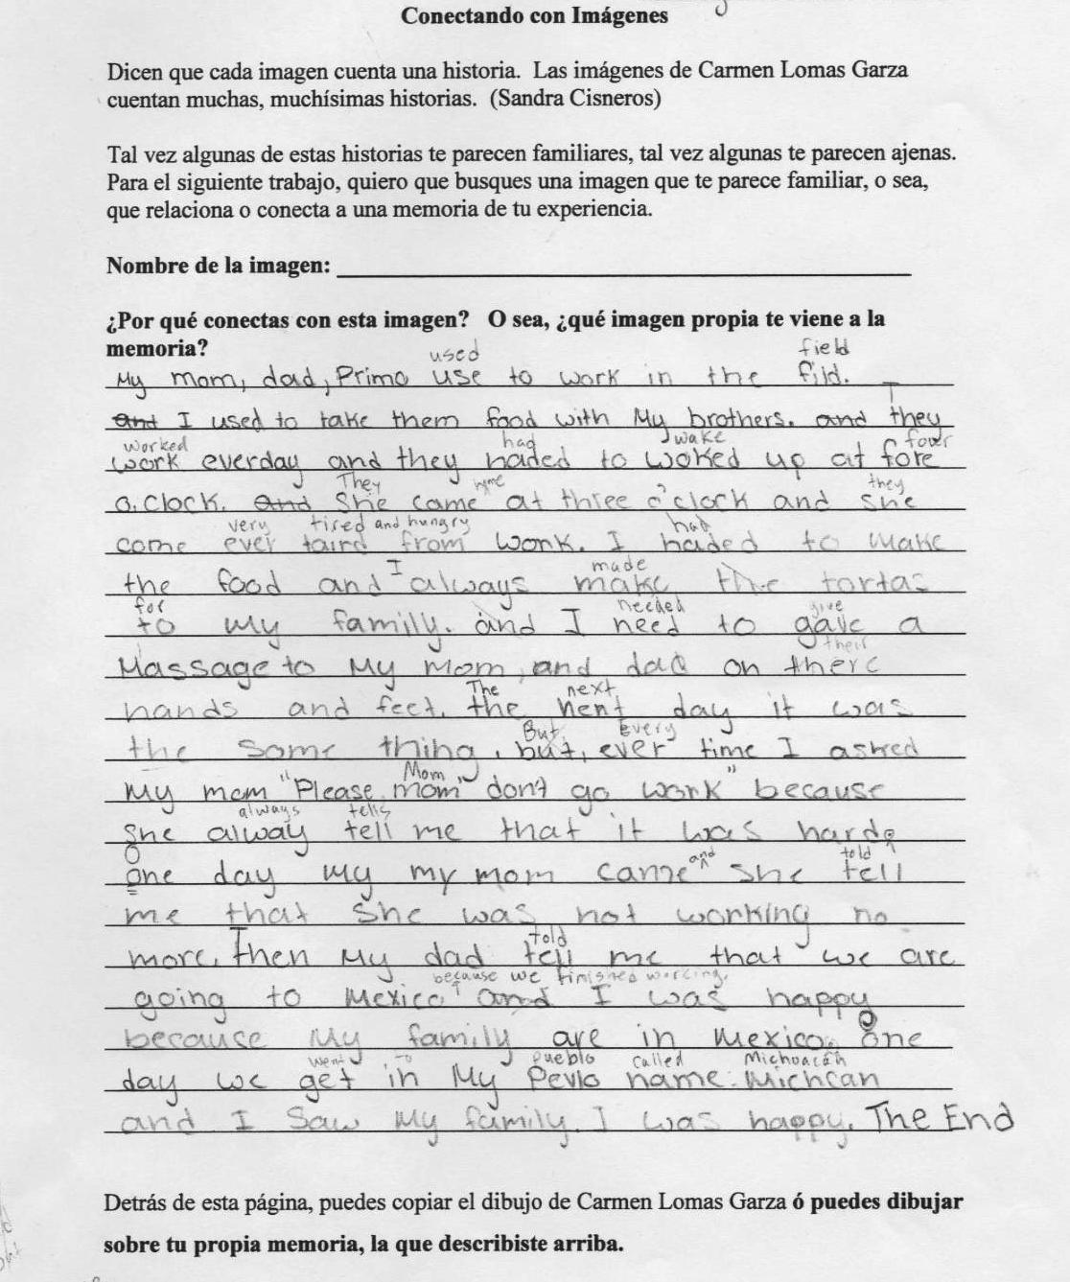

APPENDIX F

Nombre/ Name:___________________________________________Fecha/Date______
Escribe tus pensamientos e ideas. No hay respuesta correcta ni incorrecta, lo importante es lo que tu piensas.

1. ¿Qué es CULTURA? What is culture?

2. ¿Puedes hacer una lista de todo lo que compone una cultura? Can you make a list of everything that comprises a culture?

3. ¿Tu tienes una cultura? Explica. Do you have a culture? Explain.

4. ¿A veces se considera una cultura ‘mejor’ o ‘peor’ que otra? Explica.
Is one culture sometimes considered “better” or “worse” than another? Explain.

5. ¿Piensas una cultura cambia o siempre queda igual? Explica.
Does a culture change or does it always stay the same? Explain.

6. ¿Qué ó quién puede hacer cambiar una cultura? Explica.
What or who can change a culture? Explain.

APPENDIX G

Consent for Your Child to Participate in Research

Your child is being asked to participate in research which will be conducted by Sarah Fonte, a graduate student in the Department of Bilingual/Multi-cultural Education at California State University, Sacramento. Mrs. Fonte was your child’s summer school teacher. The purpose of the research is to find out more about the funds of knowledge your child brings from his/her home and community. By funds of knowledge, we mean things that your child knows about or knows how to do because it is a knowledge he or she learned thanks to the expertise of someone in his or her family or community.

As part of this research, Mrs. Fonte would like to describe some of your child’s work from summer school. She may also ask your child some questions about the pictures he or she took and videos he or she made as part of our summer school program. The questions will be something like “could you tell me why you took this picture to represent ‘knowledge’?” or “I see you took a picture of your garden. Could you tell me what you know about gardening? How did you learn that about gardening?” This will be done after school and will take between five and fifteen minutes. Your child can choose to skip any question he or she is asked and can also choose to stop the conversation at any time. This conversation with your child may be tape recorded. This tape recording will be stored in a locked drawer in Mrs. Fonte’s home and will be destroyed when she completes the research.

After learning information from your child about his or her community funds of knowledge, Mrs. Fonte will write a report to share with colleagues at her university. In this report, your child’s name will never be used, and any description of his or her work that includes details that would identify your child or family will be changed in such a way that others will not know the work was produced by your child specifically.

Mrs. Fonte hopes this information will help her to design a classroom curriculum that is related to what your child already knows well and is interested in. However, no one will be upset with you or your child if he or she does not take part in this research.

Participation in this research is voluntary, and deciding not to participate will not affect your child at school. Please do not hesitate to contact Mrs. Fonte with any questions at phone number (530) 758-3728.

If you agree to allow your child to participate in this research, please write your
name and today’s date on the line below.

________________________________ ____________________
Signature of Guardian Date

Student Agreement to Participate in Research

You are being asked to participate in a research project being done by Sra. Fonte. She is hoping to find out what kinds of things kids like you are good at, know a lot about and are interested in. She wants to learn this information in order to make your class more interesting and helpful for you and other students.

If you agree to take part in this research, Sra. Fonte will look at some of your work from summer school. She may also ask you some questions about some of the photos you took and videos you made during summer school. Sra. Fonte may tape record the conversation so she doesn’t forget what you said. This should take between five and fifteen minutes, but you can choose to stop at any time. You can also choose not to answer any questions you would rather not answer.

After Sra. Fonte finishes this research, she will write a report called a thesis to share with her professors (teachers) at her university. In the report she will not tell anybody your name or share any other information that would make someone know that she is talking about you, your work, or something you said.

Whether you want to take part in this research is entirely up to you. No one will be upset if you do not participate. Also, if you choose not to participate, this will not affect you at school.

If you agree to take part in this research, please write your name and today’s date on the line.

________________________________ ____________________
Signature of Participant Date

Permiso para que su hijo/a participe en un estudio

Sarah Fonte, una alumna de pos-graduado en el Departamento de Educación Bilingue y Multicultural en California State University, Sacramento, que fue la maestra de escuela de verano de su hijo/a, pide que el/ella participe en un estudio que ella misma llevará a cabo. El propósito del estudio es aprender cuáles son los fondos de conocimiento comunitartios de su hijo/a. O sea, estos son conocimientos que su hijo/a ya tiene gracias a lo que aprende de la gente de su familia o comunidad.

Como parte de esta investigación, Sra. Fonte quiere describir algunos de los trabajos que su hijo/a hizo durante la escuela de verano y posiblemente preguntarle a su hijo/a acerca de algunas de estos trabajos. Las preguntas serán algo así como ‘¿Por qué tomaste esta foto para representar el conocimiento?’ ó ‘Veo esta foto de tu jardín. ¿Qué sabes de jardinería? ¿Cómo aprendiste esto?’ Esta conversación ocurrirá después de escuela y durará entre cinco y quince minutos. Su hijo/a puede decidir terminar la conversación en cualquier momento. También puede decidir no contestar cualquier pregunta que él/ella no quiere contestar. Es possible que esta conversación sea grabada con grabadora de caset. Este caset se guardará en una gaveta cerrada con llave en la casa de Sra. Fonte y, al final del estudio, se destruirá.

Después de aprender información sobre los fondos de conocimiento comunitarios de su hijo/a, Sra. Fonte escribirá un reporte para compartir con sus colegas en la universidad. En este reporte, nunca usará el nombre de su hijo/a. Tampoco se dará de conocer cualquier detalle que podría identificar el trabajo de su hijo/a, ó que identifique a su hijo/a ó a su familia.

Se espera que esta información le ayude a Sra. Fonte diseñar un curriculo de estudio basado en los conocimientos e interéses previos de su hijo/a. De todos modos, nadie se enojará con usted ni con su hijo/a si el/ella no participa en esta investigación.

La participación en este estudio es opcional. Si se decide no participar, esto no afectará a su hijo/a en la escuela. Si tiene preguntas, favor de comunicarse con Sra. Fonte al número de teléfono (530) 758-3728.

Si usted esta de acuerdo con permitir a su hijo/a participar en esta investigación, favor de escribir su nombre y la fecha de hoy en la linea abajo.

________________________________ ____________________
Firma de Padre de Familia Fecha

Acuerdo de Participar en un Estudio- Estudiante

Sra. Fonte te pide participar en un proyecto de investigación. Ella quiere averiguar cuáles cosas niños ó niñas como tú saben hacer bien, lo que saben, y lo que les interesa. Ella quiere aprender esto para poder hacer tu clase más interesante e utíl para ti y para los demás estudiantes.

Si estás de acuerdo con participar en este estudio, Sra. Fonte mirará algunos de tus trabajos de escuela de verano y posiblemente te hará unas preguntas sobre algunas de las fotos y videos que tomaste durante la escuela de verano. Ella tal vez grabe la conversación para no olvidar lo que tú dijiste. Esto debe tomar entre cinco y quince minutos, pero tu puedes escoger parar en cualquier momento. También puedes escoger no contestar cualquier pregunta que no quieres contestar.

Después de que Sra. Fonte termine la investigación, escribirá un reporte llamado un tesís para compartir con sus profesores (maestros) en la universidad. En este reporte nunca dirá tu nombre ni tampoco compartirá cualquier información que pueda hacer que la gente sepa que ella esta hablando de tí, tu trabajo, o algo que dijiste.

Tu decides si quieres participar en esta investigación. Nadie se enojará contigo si decides no participar. Además, si decides no participar, esto no te afectará en la escuela.

Si estás de acuerdo con participar, entonces favor de escribir tu nombre y la fecha de hoy en la linea abajo.

________________________________ ____________________
Firma del partipante Fecha

REFERENCES
Ada, A.F. (2001). Gathering the sun: An alphabet in Spanish and English. Singapore: HarperCollins.
California Department of Education (2009). Retrieved from http://dq.cde.ca.gov/dataquest.
Cowan, G. (2007). Understanding and conducting research in education: A user-friendly approach. Dubuque, Iowa: Kendall/Hunt.
Darder, A. (1991). Culture and power in the classroom: A critical foundation for bicultural education. New York: Bergin and Garvey.
Darder, A. & Torres, R.D. (2003). Shattering the ‘race’ lens. In A. Darder, M. Baltodano, and R.D. Torres (Eds.), The Critical Pedagogy Reader (pp. 245-261). New York: RoutledgeFalmer.
Delpit, L. (2006). Other People’s Children: Cultural conflict in the Classroom. New York: The New Press. (Originally published 1995)
Emery, K. Braselmann, S., & Reid Gold, L. (2004) Freedom summer and the freedom schools. Retrieved November 4, 2009 from www.educationanddemocracy.org.
Espinoza-Herold, M. (2003). Issues in latino education: Race, school culture, and the politics of academic success. Boston: Allyn and Bacon.
Fonte, S. (2009). Researcher’s Journal. Unpublished
Ford, D., Harris, J., Tyson, C., & Frazier Trotman, M. (2002). Beyond deficit thinking: Providing access for gifted African American students. Roeper Review, 24, 52-58.
Freire, P. (2007). Pedagogy of the oppressed (30th Anniversary ed.). New York: The Continuum International Publishing Group Inc.
Gay, G. (2000). Culturally responsive teaching: Theory, research & practice. New York: Teachers College Press.
Ginwright, S. (2004). Black in school: Afrocentric reform, urban youth, and the promise of hip-hop culture. New York: Teachers College Press.
Gonzalez, N., Moll, L., Floyd Tenery, M., Rivera, A., Rendon, P., Gonzales, R., & Amanti, C. (1995). Funds of knowledge for teaching in Latino households. Urban Education, 29, 443-470.
Harry, B. & Klinger, J. (2005) Why are so many minority students in special education? New York: Teachers College Press.
Krull, K. (2003). Cosechando esperanza: La historia de César Chávez. New York: HarcourtBooks.
Ladson Billings, G. (2009). The dreamkeepers: Successful teachers of African American children (2nd ed.). San Francisco: Jossey-Boss.
Lomas Garza, C. (2000). In my family/ En mi familia. San Francisco: Children’s Book Press.
Lomas Garza, C. (2005) Family pictures/ Cuadros de familia. San Francisco: Children’s Book Press.
Moll, L., Amanti, C., Neff, D., & Gonzalez, N. (1992). Funds of knowledge for teaching: Using a qualitative approach to connect homes and classrooms. Theory Into Practice, 31, 131-141.
Moll, L., & Greenberg, J. (1990). Creating zones of possibilities: Combining social contexts for instruction. In L. Moll (Ed.), Vygotsky and Education (pp. 319-348). Cambridge, UK: Cambridge University Press.
Murrell, P. (2002). African-centered pedagogy: Developing schools of achievement for African American children. Albany, NY: State University of New York Press
National Center for Education Statistics (2005). Retrieved from http://ZIPskinny.com/index.php?zip=95616&pagetype=schools.
National Center for Farmworker Health (2005). Facts about farmworkers. Retrieved from http://www.ncfh.org/docs/fsFacts%20about%20Farmworkers.pdf.
Office of Minority Health (1993). Migrant Enumeration Study. Washington, D.C.: Larson, A. & Plasencia L. Retrieved from http://www.ncfh.org/docs/fs- Migrant%20Demographics.pdf.
Olneck, M. (2003) Immigrants and education. In Banks, J. (Ed.) Handbook of Research in Multicultural Education (2nd ed., pp. 310-327). New Jersey: Jossey-Boss.
Reyes, B. (2004). Changes in trip duration for Mexican immigrants in the United States. Population Research and Policy Review, 23, 235-257.
Romanowski, M. (2003). Meeting the unique needs of the children of migrant farm workers. Clearing House: A Journal of Educational Strategies, 77, 27-33.
Sleeter, C. (2001). Culture, difference & power CD-ROM. New York, Teachers College Press.
Sleeter, C. (2005). Un-standardizing curriculum: Multicultural teaching in the standards-based classroom. New York: Teachers College Press
Sleeter, C.E. and Grant, C.A. (2003). Making Choices for Multicultural Education: Five Approaches to Race, Class, and Gender. New Jersey: John Wiley and Sons.
Smith, M. & Osborn, J. (2009). Connected to the community: An effective model for preparing and retaining teachers. Rethinking Schools, 23, 57-61.
Tatum, B.D. (1997). Why are all the black kids sitting together in the cafeteria? New York: Basic Books.
United States Department of Labor (2005). National Agricultural Workers Survey 2001- 2002. Washington, D.C. Retrieved from http://www.ncfh.org/docs/fs- Migrant%20Demographics.pdf.
United States Department of Labor (2000). National Agricultural Workers Survey. Washington D.C. (retrieved November 8, 2009 from http://www.ncfh.org/docs/fs-Facts%20about%20Farmworkers.pdf).
Valdés, G. (1996). Con respeto: Bridging the distance between culturally diverse families and schools. New York: Teachers College Press.
Woodford, C., Morgan, B., Collins, L., & Jones, K. (2005). Cool stuff and how it works. New York: DK Publishing, Inc.

