
ABN 44 023 477 348
Waverley Hockey Club (Inc)
P.O. Box 2069
Mount Waverley 3149

Ground and Club Room
Cnr High Street Road and Winbirra Parade
Ashwood 3147
Ph: (03) 9807 7805

www.waverleyhc.org.au

Senior Registration and Fee Structure - 2015

2015 Fee Structure

The Waverley Hockey Club Executive Committee has reviewed the fee structure for the mens and womens units for the 2015 season. The following considerations were taken into account when reviewing the fees:
- The change in Hockey Victoria individual player membership structure
- Current financial position of the club
- Fees charged by other comparable clubs
- Impact on members

The table below outlines the comparison of 2014 to 2015 rates:

Year | Senior Fee PL & PLR | Student Fee PL & PLR | Senior Fee Pennant & Metro | Student Fee Pennant & Metro | Veterans/ Masters Fee | Social/Non-playing Member | Multi Comp Fee | GK
2014 | $680 | $585 | $580 | $430 | $400 | $60 | $140 | $195
Less Individual Membership* | ($45) | ($45) | ($45) | ($45) | ($45) | N/A | N/A | ($45)
2015 Fee** | $635 | $540 | $535 | $385 | $355 | $60 | $140 | $150

Note the cost of a Seniors and Masters registration is $675. ($535 Senior Pennant & Metro Fee plus $140 Multi Comp Fee)

*2015 Individual Membership Fees payable to Hockey Victoria

Hockey Victoria has expanded the Individual Player membership into a $45 cost payable by each player directly to Hockey Victoria ($35 for players aged under 18 as at 31/12/2014). This fee must be paid via debit/credit card when you initially register online (i.e. before being eligible to play). The breakdown of the individual registration fee as determined by Hockey Victoria is summarised below:

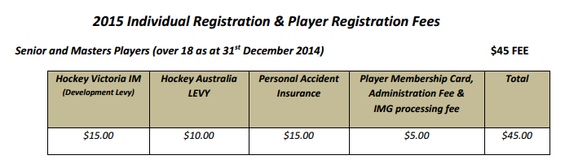

**2015 Fee
The 2015 fee is the fee payable to the Waverley Hockey Club by Round 4, excluding the Individual Membership Fee. You will note that the 2015 fee is simply the 2014 fee reduced by the individual registration fee.

Early Bird Discount

The club will introduce an Early Bird discount in the 2015 year. The discount available for fees being paid in full on or before 28 February 2015 is $20 off the 2015 Fee.

Coaching Discount

The discount available for coaching a Junior team remains the same as last year, that is 65% for coaches and 35% for assistant coaches. To enquire about coaching a Junior team, please email juniors@waverleyhc.org.au or contact a junior committee member.

How to Register

To register for the 2015 winter season, members register online via Hockey Victoria registration system. To access the registration page, please visit the Hockey Victoria website (http://www.hockeyvictoria.org.au/) and click on the “HV MEMBERSHIP ICON”. This will bring you to the Registration Home Page.



There are How To Guides and FAQs to assist with the registration process which are available on the Hockey Victoria Website and on the registration page:
http://www.hockeyvictoria.org.au/ABOUT-US/Player-Registration-FAQs

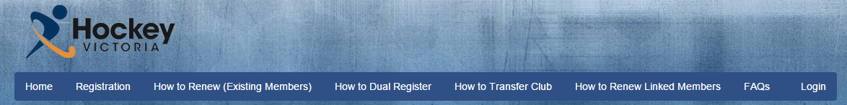

Once you begin the Registration, you will be asked to select a Category, Association and Club. Please ensure that you select “Hockey Victoria (Comps)”, “Hockey Victoria – Metro” and “Waverley Hockey Club” for the Category, Association and Club respectively.

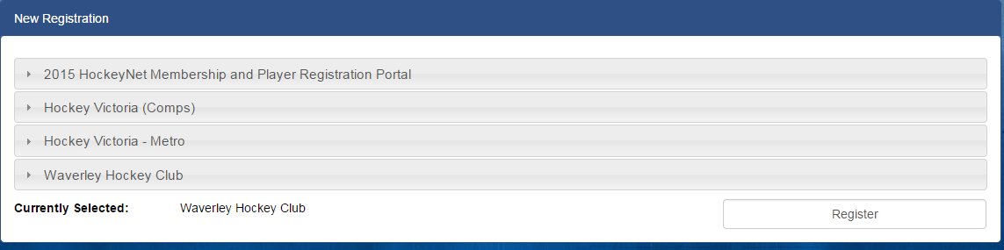

You will then be brought to the subscriptions page.

The subscriptions in blue text are the Hockey Victoria fees and the subscriptions in black text are the Club fees. Please select one Hockey Victoria subscription and at least one Club subscription. If you are unsure of the Club subscription(s) to select, please email Elliot Kitchingman at treasurer@waverleyhc.org.au.

For example, to register for a both a seniors and masters competition, you would select the “HV Senior Player Registration” (Blue Text) and “Seniors and Masters (Dual Competition) Fee $675” (Black Text).

Once you have selected the appropriate subscriptions and completed the required information, you will be required to pay for the Hockey Victoria Subscription ($45 or $35 for under 18s) immediately in order to complete the registration.

An invoice for the club fee will also be emailed to you. Payment in full will be required by Round 4.

If you have any questions about the registration process or the fee structure, please contact Elliot Kitchingman via email at treasurer@waverleyhc.org.au or via phone on 0432415337 (for urgent queries only).

