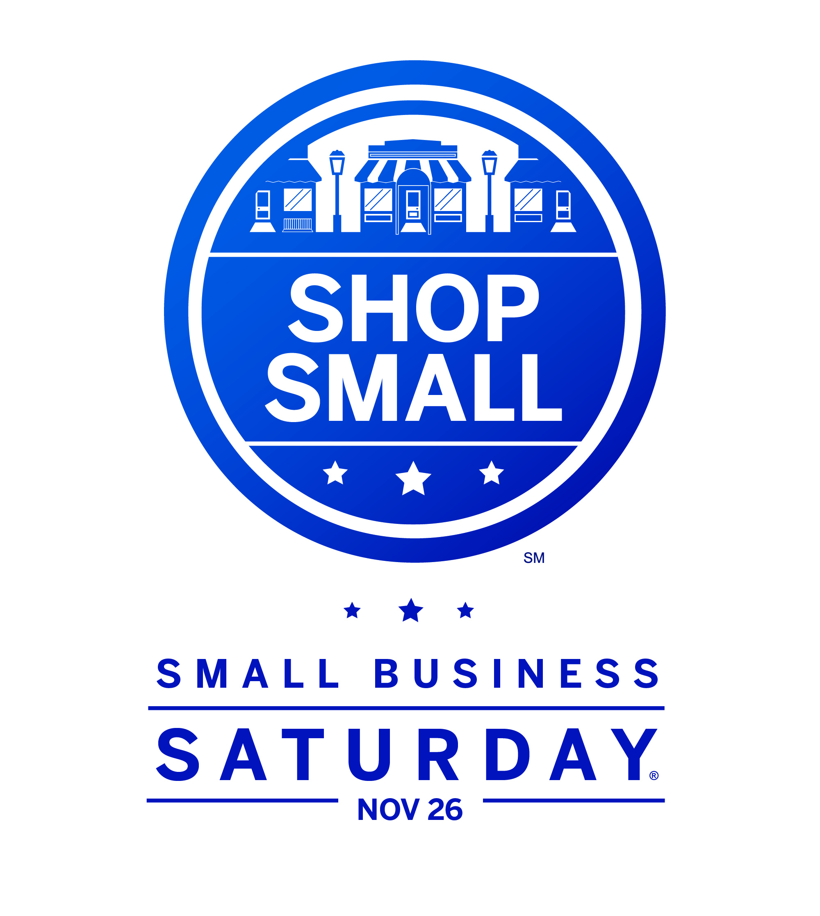

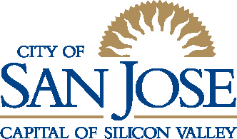

News Release
Office of Economic Development
For Immediate Release
November 4, 2011

Media Contacts
Jeff Ruster, Director of Strategic Partnerships
City of San José Office of Economic Development
Phone: (408) 535‐8183
Email: jeff.ruster@sanjoseca.gov
OR Lenka Wright, Communications Manager
City of San José
Phone: (408) 535-8113
Email: lenka.wright@sanjoseca.gov

City of San José to Designate Small Business Saturday
City will urge consumers to Shop Small on November 26, 2011 to encourage job growth, maintaining the environment and supporting public services

SAN JOSE, Calif. - On November 8, the City of San José’s Mayor and Council will join other communities nationwide in proclaiming November 26, 2011 as Small Business Saturday. This campaign to prompt residents to dedicate a portion of holiday shopping to local, independently-owned small businesses aligns closely with the City’s Shop San José Initiative. Both acknowledge the importance of small businesses to the strength of the San José economy and encourage consumers to help create local jobs, maintain the environment and sustain local public services through their purchasing choices

“I am pleased to accept this proclamation on behalf of Women Impacting Public Policy and the Small Business Saturday Coalition,” said Lynn Bunim, Director Special Projects at WIPP. “We salute YOU and the team here this afternoon that is making the Shop SJ Initiative the envy of other cities. YOU really "get it".....that is you really understand the economic importance of your local, independently owned small businesses.”

American Express, the founding sponsor of Small Business Saturday, is joined by Facebook, FedEx, Google and hundreds of other businesses and organizations to build on last year’s inaugural program that drove millions of dollars to main street merchants.

“These initiatives are an important way to connect our residents with the many great shops, restaurants and small businesses located here in San José,” said Mayor Chuck Reed. “I hope all of our residents will take this opportunity to support local businesses that provide jobs in our community and bring tax revenue to our city.”

American Express and Facebook are helping further by offering $100 in free advertising on Facebook and offering card holders a $25 credit for use at any locally-owned, independent small business that accepts American Express.

--- More ---

Social media tools now make those connections easier than ever to achieve, explained Jeff Ruster of the City of San José Office of Economic Development. “Now, consumers can find new local companies,” said Ruster. “With recommendations from their friends and people whose opinions they trust on sites like Yelp or LikeList, they can also get special San José-specific offers and experiences from LivingSocial, Dishcrawl, or Trubates.”

Councilmember Rose Herrera (District 8), suggested that the reasons to shop local extend beyond convenience. “Buying goods and services in San José helps create local jobs as opposed to shopping online with an out-of-area retailer. San José residents can also maintain the environment by choosing to patronize a San José business rather than driving long distances.”

She also pointed out that the sales taxes from local purchases support public services. “San José residents can help sustain their parks and libraries by spending money locally that they would have spent anyway. I was surprised that, as a community, we buy $1.9 billion more in goods and services than expected outside San José. If all of us commit to shopping locally, some of that money will come back into the community and help pay for services like Police and Fire.”

More information about Small Business Saturday is available on Facebook (search for “Small Business Saturday.” Shop San José information can be found at www.ShopSanJose.biz.

ABOUT SMALL BUSINESS SATURDAY
November 26th marks the second annual Small Business Saturday, a day to support the local businesses that create jobs, boost the economy and preserve neighborhoods around the country. Small Business Saturday (SBS) was created in 2010 by American Express in response to small business owners’ most pressing need: creating more demand for their products and services. 1.5 million Facebook users, 130 public and private organizations, and 41 elected officials declared their support for SBS last year. 100,000 small businesses downloaded SBS marketing materials, 10,000 businesses signed up for free Facebook advertising that ran on SBS and 200,000 consumers registered their American Express cards to receive $25 statement credits when they shopped at a small business on SBS. In the first year, small retailers who accept the American Express Card saw a 28% increase in sales on SBS.

ABOUT THE SHOP SAN JOSE INITIATIVE
Officially launched on October 12, 2011, Shop San Jose is a new program to educate San Jose residents about the importance of purchasing their goods and services in their own community. At the same time, the Shop San Jose initiative encourages businesses to engage in social media to capture some of the $1.9 billion in sales that are unexpectedly spent by San Jose residents outside of their community currently. These dual approaches will help create local jobs, maintain the environment and support local public services. Consumers and businesses can find out more at www.shopsanjose.biz the “Shop San Jose” section of www.BusinessOwnerSpace.com respectively.

--- More ---

ABOUT WOMEN IMPACTING PUBLIC POLICY
Women Impacting Public Policy is a national nonpartisan group with over half-a-million members. WIPP is the collective voice in Washington, D.C., for over 50 national women and small business organizations. WIPP advocates for and on behalf of women in business in the legislative process of our nation, creating economic opportunities for members and building alliances with other small business organizations. Visit www.wipp.org.
ABOUT THE CITY OF SAN JOSE’S OFFICE OF ECONOMIC DEVELOPMENT
The City of San José's Office of Economic Development (OED), part of the San José Office of the City Manager, catalyzes job and revenue growth, assists business success, connects employers with trained workers, and enhances cultural amenities. For more information, please visit www.sjeconomy.com.

ABOUT THE CITY OF SAN JOSE
From its founding in 1777 as California's first city, San José has been a leader, driven by its spirit of innovation. Today, San José stands as the largest city in Northern California and the Capital of Silicon Valley - the world's leading center of innovation. The city, the 10th largest in the U.S., is committed to remaining a top-ranked place to do business, to work and to live. For more information, visit, www.sanjoseca.gov.

###
This news release is posted online at www.sanjoseca.gov.

