SURVIVAL GUIDE
for
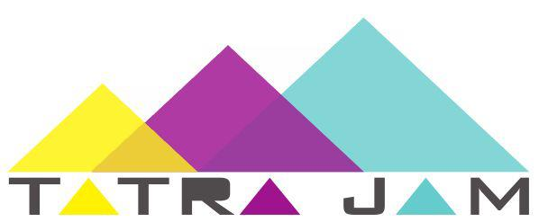

TATRA JAM 2011

Index

Index 2
Introduction 2
Welcome 2
General info 2
What we ask from you 2
About Slovakia 3
About Bratislava 4
About Telgárt 5
About us 5
Slovak University of Technology in Bratislava (STU) 5
BEST Bratislava 5
Getting to POPRAD from Bratislava 6
Getting to POPRAD from Košice 6
Practical informations 6
Meeting point 6
Do not forget list 6
Some restrictions 7
What Languages are spoken 7
Health Services 7
Telephone/GSM 7
Electricity 8
Smoking 8
Money 9
Credit cards 9
Product and servicies price (EUR) 9
Weather 9
Time 10
Habits and Customs 10
Quick lesson 10
Greetings 10
Important words 10
Important sentences (in order to survive) 11
Contacts 11
Address 11
Main Organizers 12

Introduction

Welcome
Welcome to the Survival Guide of TATRA JAM BEST NEW YEAR´S PARTY 2011 in Telgárt. Do not hesitate to ask us for any extra information if there is something that is not clear to you. This guide should serve you all the information you need, so don't forget it at home! We wish you very pleasant stay in Telgárt.

General info
TATRA JAM 2011 will take place from the 30th of December to the 2nd of January. All nights we will stay in a beautiful hotel in Telgárt.

What we ask from you
Tell us if you have any allergies!
Tell us if you need a visa as soon as possible!!!
Please let us know in advance if you are a vegetarian or by any other reason, such as religion or health, need a special diet. Then we can try to arrange it as well as possible.
Book your travel!
Tell us the date and place of your arrival!

About Slovakia

Slovakia is a peaceful country, with beautiful scenery, inexpensive shopping and tourism and hospitable people. Slovakia is becoming one of Europe's focal points for travel and tourism."Slovensko" in the native language of Slovak, officially named the Slovak Republic, the country enjoys moderate weather and a prime map location, bridging east and west. Slovakia's capital city Bratislava is a growing hub of culture, as well as the national seat of politics and business. Its thousand year history offers a great deal to visitors.

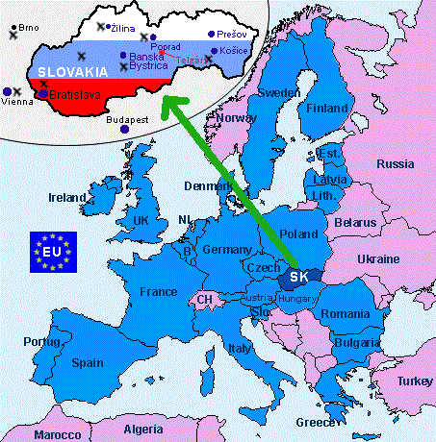

The second largest city is Košice. It is a centre of heavy industry, but also of architecture and multiculturalism. It's not easy for a country to overcome a situation like Slovakia's. Although its location is very close for travellers in the region (especially to Austria), many do not realize how near it is. More than a few still feel prejudiced against any recently communist country. Some people have the incorrect impression that war in the former Yugoslavia somehow involved Slovakia. The truth is that life in Slovakia (the food, the shopping, the cultural events) is very European, much like in countries to the west, except that commercialism has not yet advanced so far. Among other things, this means many things are much less expensive here...
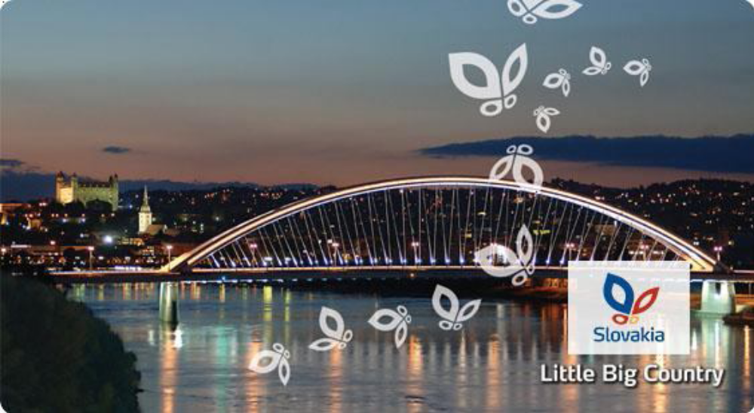

Come and discover this near but unexploited treasure!

www.slovakia.travel
www.slovakia.com
www.slovakia.org

About Bratislava

The pearl on the Danube is called our capital - Bratislava. It's a beautiful city situated in the south-west part of Slovakia. In the past it was an important junction of the main trades and nowadays it's a gate to Slovakia from Austria and Hungary.
Bratislava is situated among the warmest places in Slovakia - in the Danube lowland. It offers a lot of oportunities how to use your free time. The history of the city is very rich and it dates back to the fifth century. At that time arrived the first Slovanic tribes into this locality. They formed their own principality which soon gave a race to the Great Moravian Empire in the 9th century. In l29l Bratislava become a free royal town. Now it's an administrative, political and economical centre of the state.
http://visit.bratislava.sk/

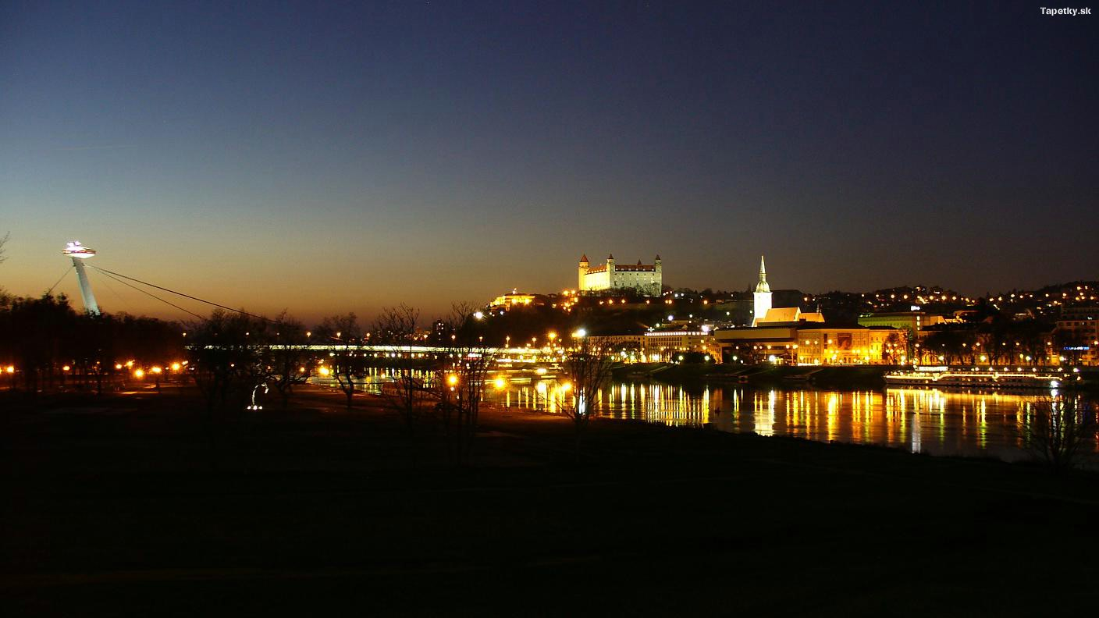

About Košice
In terms of its size and importance in the Slovak Republic, the city of Košice ranks right after the capital Bratislava. It lies in the eastern part of Slovakia, not far from the borders with Hungary (20 km), Ukraine (80 km) and Poland (90 km).
The advantages of this location, near the borders of three states and lying on important domestic and international transport routes, translate into the preconditions for good commercial connectivity. This is significantly enhanced by the existing railway junction and international airport.
The city occupies the Košice Basin formed by the wide valley of the River Hornád, contained by the outlying ridges of the Slovakian Ore Mountains to the west and the Salt Hills to the east. The city centre lies at 208 metres above sea-level, and the climate in Košice is moderately warm with average temperatures of 19° C in July and -3° C in January.
The historic center of Kosice - kilometer long walking zone with magnificent historic buildings, attended by the king and lived by important representatives of the aristocracy will take you back in time through preserved medieval design of Main Street.
http://www.visitkosice.eu/en
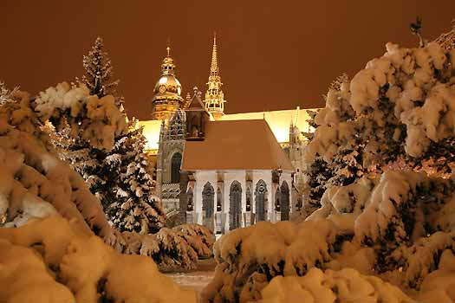
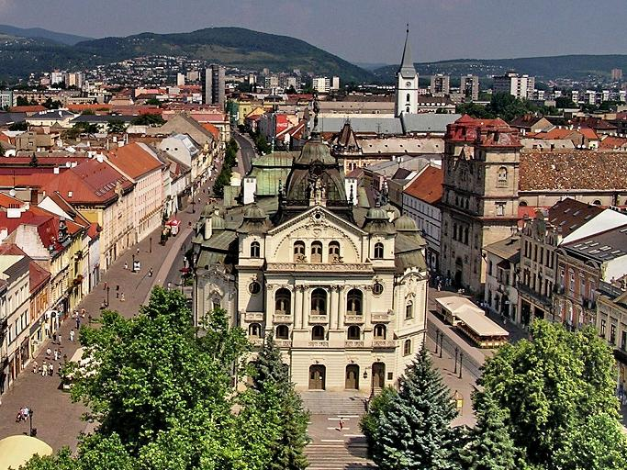
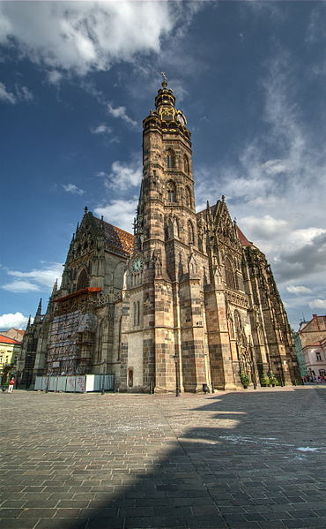

About Telgárt

Telgárt is a village and municipality in Brezno District, in the Banská Bystrica Region of central Slovakia. It has population of about 1,531 people. The Hron river rises in the cadastral area of the village, under the Kráľova hoľa mountain (1752 meters above the see level). Telgárt is a beautiful village situated in National Park Low Tatra mountains. No words are as good as one view, so here it is:
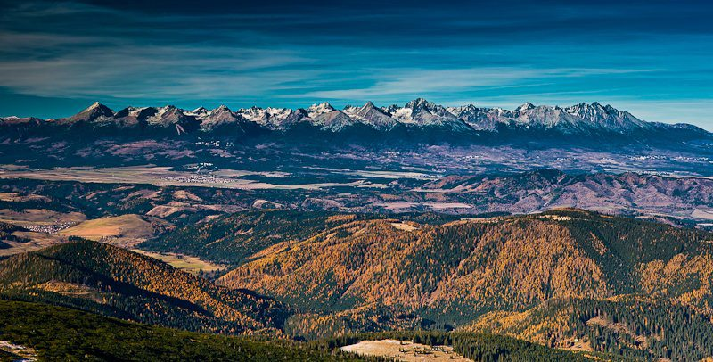

About us

Slovak University of Technology in Bratislava (STU)
Slovak University of Technology in Bratislava (STU) is a modern educational and scientific institution. Since its foundation in the year 1937 more than 105.000 students have graduated. In average, 16.000 students study at the STU every year. At present, the STU consists of seven faculties. All the STU faculties provide a study in accredited study programs within the complex system of a bachelor, master and PhD study. Faculties realise credit system compatible with the European credit transfer system enabling mutual mobility of students within European Union member countries and a larger European space. In the area of scientific and research activities the STU successfully joins European Union programs.
www.stuba.sk

The Technical University of Košice
The Technical University of Košice was founded in 1952, but its roots must be sought much deeper in the past.
TUKE caters for a wide range of educational needs not only in the East-Slovak region, but throughout Slovakia and Central Europe, as in many specializations it is the only centre of education and research in this area. TUKE closely co-operates with other universities and with industrial organizations throughout the region and the Slovak Republic.
The number of students currently attending nine TUKE Faculties exceeds 16,000. Approximately 13,000 of them are full-time students, out of which there are 8,500 Bachelor students, 4,000 Master students and over 500 PhD students. Almost 900 teachers work here, and the same number of research and administrative staff.
http://www.tuke.sk/

BEST Bratislava BEST Košice
LBG Bratislava was established in year 1992 LBG Košice was founded in 1994.
and 18000 students can use it’s services :)
BEST Office Adress:
BEST Bratislava BEST Košice
Fakulta elektrotechniky a informatiky STU BEST Technická univerzita Košice
Ilkovicova 3 Boženy Němcovej 32
812 19 Bratislava 040 01 Košice
Slovakia Slovakia
+421 2 602 91 649
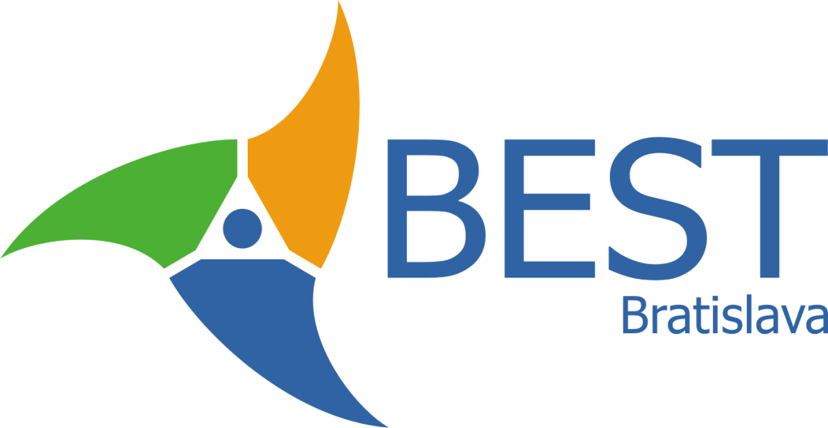

The first stop of your journey to Telgart will be for sure Bratislava or Košice. Than, you will have to come to POPRAD. This city is the meeting point for our event. So here are some advices how to get to Poprad from Bratislava and from Košice.

Getting to POPRAD from Bratislava

STEP 1: If you are in Bratislava railway station – Hlavná Stanica the easiest way how to get to Poprad is to take a train. There is a train to Poprad every 2 hours. You just have to buy a ticket to station POPRAD-TATRY. (if you have a student international ID card ISIC you can buy a student ticket which costs only a half of price). There will be somebody from us waiting for you, just tell us when you´re coming! ☺
STEP 2: If you´re on Bratislava bus station, you will have to go by our urban mass transport to Main railway station – Bratislava Hlavná stanica. The only thing is that you have to buy a ticket in a ticket machine. Ticket for one hour will cost 0,90 €. Then you take a trolleybus number 210 and it gets you to Railway station – it is the last station in that trolleybus. And when you´re in railway station follow STEP 1.

Getting to POPRAD from Košice
If you are in Košice you are probably in railway or bus station. They are really close to each other so you don´t need to use urban mass transport, you can get from one to other by foot. From railway station you can get to Poprad Tatry by direct train, which goes almost every hour (10:07 / 10:48 /11:15 /12:07 / 13:33 / 14:07 / 14:25 etc) .
It will take less than 2 hours to get to the Poprad Tatry by train.
Timetables are here: http://cp.atlas.sk/vlakbus/spojenie/ (change language-right down corner) ☺
Buses are less comfortable and don't go so often. There is one at 12:05.

Practical informations

Meeting point
We will pick you up in the railway station POPRAD-TATRY. Only thing you have to do, let us know when you will get to the station. ☺

Do not forget list

- valid passport / EU ID
- travel and health insurence
- money
- ISIC or Euro 26
- Euro for fee
- sleeping bag
- confortable shoes
- raincoat
- sportswear
- smile, enthusiasm and funny mood

Some restrictions
Some common laws in Slovakia that might be good to know:
You're not allowed to have had consumed any alcohol if you drive (zero tolerance). You're not allowed to have, consume or distribute any drugs (not even light ones, such as joint, 1 gram etc.). You’re not allowed to drink alcohol in some public places (especially in the center of the town).

What Languages are spoken
English and German are the most often used foreign languages. Less frequent is the knowledge of French, Spanish, Italian or Russian. In the South of Slovakia Hungarian is used many times. Basic phrases in Slovak language are to be found in short vocabulary.

Health Services
There are hospitals in all larger towns. In smaller towns and tourist areas outpatient clinics and pharmacies are available. Pharmacies are open usually on workdays from 8:00 to 18:00, during weekends and holidays there is always one pharmacy in town non stop on duty. It is recommended to close a health insurance contract before coming to Slovakia, which is usually a part of the travel insurance package.

Telephone/GSM
All over Slovakia, there are crediphones where phone cards can be used. These can be bought in post offices and news agents. To phone abroad, dial 00 then the country code and city/local code. You can call from Slovakia to another country using your own mobile phone. There are three operators of mobile-phones in the Slovak Republic: T-Mobile, O2, Orange. You can also buy a SIM card of our local operator if you wish, but it is not necessary.
Slovakia has 900MHZ GSM networks coverage of 99.6% of the national population. Before leaving your country, check with your GSM provider that roaming service in Slovakia is available for you.

Emergency Calls

Emergency services : 155
Police : 158
Fire : 150
All in One: 112
But first, call to organizers (the phone number will you get during welcome party).

Electricity
The voltage in the Slovak Republic as well as the socket and plug sizes is identical to the most of European countries (220V / 50Hz).
Socket looks like: o l o

Smoking
In catering facilities, in trains and at workplaces smoking is allowed only in areas reserved for smokers. Smoking prohibition is valid in closed public areas (covered bus stops, closed sports fields), in publicly accessible spaces (stations, cinemas, theatres, museums, galleries, exhibition grounds and similar) and at schools and dormitories.

Money
From the 1.1.2009 the official currency in Slovakia is Euro (EUR). You can change money in exchange offices and in banks.

Credit cards
Of course in towns(cities), you can find plenty of ATMs of shops acceptings all known cards ( Visa, Eurocard/Mastercard, American Express, Maestro, EC, Cirrus)

Product and servicies price (EUR)
Bread 1-1.5,- EUR
Milk 0.5-0.8,- EUR
Big Mac 2.5,- EUR
Pizza 3.5-6,- EUR
Coffee 0.6-1.3,- EUR
Wine 2-3.5,- EUR
0,5 l Beer 0.5-1.5,- EUR
Juice 1-1.5,- EUR
Condoms 1.5-2,- EUR
Bus ticket 0.7,- EUR
A pack of cigarettes 3,- EUR
1 postcard+stamp for EU 1,- EUR
Beautiful sightings for free
to find beautiful girl for free (and quite easy) :-)

Weather
Slovakia has a continental climate, with four distinct seasons. Winters are typically cold and dry, while summers tend to be hot and humid. The average daily temperature range in Telgart is -12° to 2° C in January. Temperatures tend to be cooler in the mountains.

Time
The Slovak Republic uses the Central European Time, CET, which is GMT+1.

Habits and Customs
When entering a Slovak dwelling the residents change their shoes in the entrance hall and offer some house slippers to the guests as well. In many households it is considered as misbehaviour, if you move in the dwelling space in shoes, which is used outside. To offer the guests a lot of slivovica (a strong, colorless alcoholic beverage primarily made of distilled fermented plum juice, often referred to as plum brandy) or similar distilled liquor (spirits) is considered here as a demonstration of hospitality and respect and if there is not a cogent reason, it is impolite to refuse such an offer. This is especially true in the country, when the residents offer distilled liquor of own production (home made liquor). When meeting/welcoming the acquaintances are shaking hands. Close friends or family members usually kiss once on the cheek or both cheeks and hug slightly. When introducing strangers it is polite to shake hands, in a more informal atmosphere also to give peck (fleeting kiss). In Slovakia it is a custom to eat 3-times daily, whereby the most is consumed usually in the lunch time between 11:30 - 13:30. The dinner consists of soup and main course, sometimes also a dessert. For supper warm meals are served often, as well, generally between 18 - 21 h.

Quick lesson

Greetings
Cau! Nazdar! Ahoj! Hi! Ciao! Hello!
Dobre rano [dobre: ra:no] Good morning
Dobry den [dobri: djen] How do you do? (Literally: Good day)
Dobry vecer [dobri: vetcher] Good evening
Vitajte Welcome
Dovidenia [dovidjenja] See ya later aligator :)
Uvidime sa [uvidji:me sa] See you
Dakujem [djakujem] Thanks
Prosim [prosi:m] 1:Please, 2:You are welcome

Important words
Dakujem za jedlo [djakujem za jedlo] Thanks for the food
Jedno pivo, prosím [prosi:m] One beer, please
Na zdravie! Cheers
Áno [a:no] Yes
Nie [nje] No
Prosím Vás, kde nájdem.... Please, where can I find.....
Stratil som sa! I'm lost!
Pomoc! Help!
Pomoc, napadol ma medved! Help, I'm attacked by the Bear! :-)
Kde je moja batožina? Where is my baggage?
Prosím Vás, kde je autobusová zastávka? = Please, where is the bust stop?
Prosím si jeden hodinový lístok. = Please, I'd like to buy one hour bus ticket

Important sentences (in order to survive)
Ako sa máš? = How are you?
Páčiš sa mi = I like you
Milujem ťa = I love you
Sex = Sex
Použi kondóm = Use condom
Chceš sa milovať? = Wanna fuck?
Kde je tu krčma? = Where is the pub?

Contacts

Address
BEST Bratislava
Fakulta elektrotechniky a informatiky STU
Ilkovicova 3
812 19 Bratislava
Slovakia
Phone: +421 2 602 91 649
Web: http://best.stuba.sk
Mail: bratislava@BEST.eu.org

Main Organizers
Juraj Kostroš
Nickname: Yetti, Juri, Duri, Kostri
e-mail:
Cell Phone:

