Improvement of
Prediction of Customer Response
in Direct Marketing

THESIS

Submitted in partial fulfillment
of the requirements for the degree of
DOCTOR OF PHILOSOPHY

by
A. SUNDARAMURTHY

Under the Supervision of
Prof. Dr. M.J.XAVIER



BIRLA INSTITUTE OF TECHNOLOGY AND SCIENCE
PILANI (RAJASTHAN) INDIA

2009

ACKNOWLEDGEMENT
I express my gratitude to Prof.L.K.Maheshwari, Vice Chancellor, BITS, Pilani for giving me this opportunity to pursue PhD and Prof.Ravi Prakash , Dean, Research & Consultancy Division, BITS, Pilani for his continuous encouragement and support in carrying out my PhD work smoothly. I thank Prof.S.P.Regalla, Assistant Dean and Dr.Hemant Jadav, Ms.Monica Sharma, Mr.Dinesh Kumar, Mr.Gunjan Soni, Mr.Sharad Srivastava and Mr.Amit Singh, nucleus members of Research &Consultancy Division, BITS, Pilani for their constant help and advice at all stages of my Ph/d work. I also thank the other office staff of Research & Consultancy Division, BITS, Pilani who rendered a lot of help in organizing various forms of paper work related to PhD progress.
I express my deep felt sense of gratitude and sincere thanks to my PhD supervisor Dr.M.J.Xavier, without whose constant guidance, help and tutelage this PhD work would not have been completed .He has been a constant source of inspiration and encouragement throughout my PhD work.
I thank Dr.Anil K Bhat and Prof.S.B.Mishra, my Doctoral advisory committee (DAC) members at BITS, Pilani for their constructive criticism and useful suggestions that helped me in immensely improving the contents and quality of presentation of my PhD thesis.

My heartfelt thanks for all the support and guidance to Dr.Anil K Bhatt, Group Leader of Management Department who has supported, inspired, encouraged and guided me during the various phases of my research work.
My sincere thanks to Dr.G.Balasubramaniam, Dean, IFMR who taught me data analysis, using artificial neural network and has been a constant source of encouragement.
I dedicate this thesis to my Beloved Mother who was a Noble Soul of Selflessness, who passed away recently.

A.Sundaramurthy

SYNOPSIS
Improving prediction of Customer Response in Direct Marketing

Objective
The objective of this Research is to improve the accuracy of prediction of customer response in direct marketing.
Scope
The Research focuses on methods used for prediction and their relative accuracy.
Milestones
1. Identification of methods of research
2. Data collection
3. Data Analysis and model development
4. Validation of model
Methodology
The sector chosen is financial services marketing and the model developed is based on qualitative and quantitative analysis of data from the data bases of customer. Data is used to score customers where improvement in prediction is shown and which is useful in direct marketing campaigns for cross selling and up selling.
The data is divided into three parts one for model building one for testing and the third for validation.
Different methods like Linear Regression, Logistic Regression, Discriminant analysis and neural network are used for model development and their prediction accuracy is compared.
First the transformation of business from the orbit of production centric to that of ever increasing consumer centric orbit is explained. Thus Customer insight as the heart of the business in the 21st century is brought out. The complexity of the consumer behavior , various attempts to model the consumer behavior by various experts in the field of marketing, economics and psychology and attempts to quantify the behavior in the science of psychology ,sociology and anthropology follow next.
The recent advances in studying human behviour in the fields of neuro psychology is explained.
Next the fundamentals of models and model building, different methods of model development, application of various mathematical methods, validation and application of models in various fields is brought out.
Response models and their crucial role in marketing in sustaining the competitive edge by improving the ROI of marketing is brought out. Specifically the effectiveness and efficiency of marketing campaigns, which are playing increasingly a dominant role in acquiring and retaining customers by direct marketing and maintaining customer relations to harvest their life time value is brought out.
Birth and evolution of financial services as a business and its birth and growth in India is discussed. How the rapid growth of the sector has given rise to the snowballing debt and non performing assets due to the bad repayment behavior of the borrowers and how this has led to the urgent and important need to assess the customer as good or bad and the development of the field of risk management is discussed.
Different methods of risk modeling and their merits and demerits are discussed.
Neural network has been used and compared with other methods for model development and neural network has been found to be most accurate. Hence NN its theory and application is discussed in detail. Once the classification of good and bad customers is done, the data of good customers are useful to profile customers based on various factors like their financial needs, repayment behavior, their risk ranking, their risk taking ability, their thirst for risk, their financial and buying behavior etc and other data to develop a response model.
The possible potential areas of future research are given briefly in the conclusion.
The improvement in prediction accuracy achieved in this research enables accurate scoring and profiling of customers in financial service
and its importance is globally important as has been proved by the global crisis triggered by Subprime lending.
LIST OF TABLES

Tables No. | Title | Page No.
 | Consumer choice model | 76
 | ANN’s relative contribution factor | 78
 | Out of sample forecast | 80
 | C5 Algorithm training data | 83
 | Comparative model performance | 123
 | NN model -parameters for comparison | 165
 | Logistic Regression- parameters for comparison | 165
 | Markov Model -parameters for comparison | 166
 | Multi Variate proportional hazard estimation -parameters for comparison | 166
 | Logistic Binary regression model -parameters for comparison | 167
 | Classification & Regression Tree-parameters for comparison | 167
 | Evaluation of classification models | 168
 | Summary of variables in creditworthiness models across the globe | 186
 | Customer Profile-Age | 205
 | Customer Profile-Educational qualification | 207
 | Customer Profile-No. of dependents | 209
 | Customer Profile-Income | 211
 | Customer Profile-Other Income | 213
 | Customer Profile-Experience | 215
 | Customer Profile-Type of House | 217
 | Customer Profile-Rent | 219
 | Customer Profile-Down payment | 221
 | Customer Profile-TV ownership | 223
 | Customer Profile-Music system ownership | 225
 | Customer Profile –Fridge | 227
 | Customer Profile-Washing machine | 229
 | Customer Profile-Two wheeler | 231
 | Customer Profile-Four wheeler | 233
 | Customer Profile-Amount Overdue | 235
 | Customer Profile-no of Dues | 237
 | Customer Profile-Classification | 239
 | Age-Customer classification | 241
 | Qualification-Customer classification | 243
 | No. of dependents-Customer classification | 245
 | Income-Customer classification | 247
 | Other Income-Customer classification | 249
 | Experience-Customer classification | 251
 | Type of house-Customer classification | 253
 | Rent-Customer classification | 255
 | Down payment-Customer classification | 257
 | TV ownership-Customer classification | 260
 | Music system ownership-Customer  Classification | 263
 | Fridge ownership-Customer classification | 266-267
 | Washing machine-Customer classification | 269
 | Two wheeler ownership-Customer classification | 272
 | Four wheeler ownership-customer classification | 275
 | Variables extracted in data analysis | 296
 | Confusion matrix to measure model fit | 325
 | Multiple Regression model Summary | 328
 | Multiple Regression -ANOVA | 329
 | Multiple Regression –Significant Variables | 329
 | Multiple Regression-Coefficients | 330
 | Logistic Regression- Significant Variables | 330
 | Logistic Regression-Non significant Variables | 331
 | Discriminant analysis-classification results | 331
 | Factor Analysis-Rotated Component Matrix | 332
 | Neural Network –performance Table | 332
 | Classification Table for NN | 334
 | Summary Of Models | 334
 | Optimum MLP configuration | 335

LIST OF FIGURES

Figure No. | Title | Page No.
 | Howard Model of Buyer behavior 1974 version | 26
 | Howard Model 1977 version | 27
 | Engel Black Well Kollat Model | 31
 | Behavioral model –A model of decision making | 56
 | Customer response model | 82
 | Case based reasoning model 1 | 84
 | Case based reasoning model2 | 85
 | Sales Response Models | 88
 | Rural Economy Statistics | 139
 | Classification Tree | 168
 | Process of credit appraisal and loan disbursal | 190
 | An Integrated model for credit scoring | 203
 | Customer Profile-Age | 206
 | Customer Profile-Educational qualification | 208
 | Customer Profile-No. of dependents | 210
 | Customer Profile-Income | 212
 | Customer Profile-Other Income | 214
 | Customer Profile-Experience | 216
 | Customer Profile-Type of House | 218
 | Customer Profile-Rent | 220
 | Customer Profile-Down payment | 222
 | Customer Profile-TV ownership | 224
 | Customer Profile-Music system ownership | 226
 | Customer Profile –Fridge | 228
 | Customer Profile-Washing machine | 230
 | Customer Profile-Two wheeler | 232
 | Customer Profile-Four wheeler | 234
 | Customer Profile-Amount Overdue | 236
 | Customer Profile-no of Dues | 238
 | Customer Profile-Classification | 240
 | Age-Customer classification | 242
 | Qualification-Customer classification | 244
 | No. of dependents-Customer classification | 246
 | Income-Customer classification | 248
 | Other Income-Customer classification | 250
 | Experience-Customer classification | 252
 | Type of house-Customer classification | 254
 | Rent-Customer classification | 256
 | Down payment-Customer classification | 259
 | TV ownership-Customer classification | 262
 | Music system ownership-Customer  Classification | 265
 | Fridge ownership-Customer classification | 268
 | Washing machine-Customer classification | 271
 | Two wheeler ownership-Customer classification | 274
 | Four wheeler ownership-customer classification | 277
 | MLP NN architecture | 288
 | Over learning in NN | 309
 | Statistical Power | 316
 | Probability of error Vs No of comparisons | 321
 | Expected Error Vs Comparisons | 321
 | Comparison of ROC curves | 325
 | NN topology adopted | 333
 | ROC of the NN Model | 333

LIST OF ABBREVIATIONS
ANN - Artificial Neutral Network

AQRE - Agent Based Quantal Response Equilibrium

BF - Basis Function

BP - Back Propogation

CART - Classification and Regression Trees

CEM - Conditional Expectation Maximization

DM - Direct Marketing

FF - Feed Forward

FFT - Fast Fourier Transform

FMCG - Fast Moving Consumer Goods

GA - Genetic Algorithm

GDP - Gross Domestic Product

KNN - K Nearest Neighbour

MARS - Multiple Adaptive Regressing Splines

MCR - Magnetic Character Recognition

MFI - Micro Financial Institution

MFT - Mean Field Theory

MLP - Multi Layer Perceptron

NASA - National Aeronautics and space Administrators.

NFC - Need for Closure

NN - Neural Network

NPA - Non Performing Assets

OCH - Optimum Collective Harvest

OCR - Optical Character Recognition

OLS - Ordinary Least Squares

RBF - Radial Basis Function

ROC - Receiver Operating Curve

ROI - Return on Investment

SE - Sequential Equilibrium

SES - Socio Economic Status

SHG - Self Help Groups

T.E.D.I.C. - Technological, Economic, Demographic Institutional & Cultural Developments

ABSTRACT
Business is Consumer and all successful businesses have always understood their customers. This research is in consumer behaviour and the objective is to get an insight of customer. This work is basically to predict the customers who would be good customers among the hundreds of thousands of borrowers and then who could be targeted for cross selling and up selling to improve the response to campaigns. This work has compared various methods like regression, discriminant analysis, logistic regressions and neural network and compared their prediction accuracy and established that a neural network gives the maximum prediction accuracy. Input to neutral network is factor scores from factor analysis. Also both qualitative and quantitative analysis is done based on customer data. Another important feature of this study is that extensive discussion, interviews and focus groups study have been carried out with both good bad customers and an attempt has been made incorporate to the behavioural aspects of the customer in the model.

CONTENTS

- INTRODUCTION 1
- RESEARCH PROBLEM 6
- LITERATURE REVIEW 14
- RESEARCH METHODOLOGY 170
- FINDINGS OF THE QUALITATIVE RESEARCH 173
- FINDINGS OF THE QUANTITATIVE RESEARCH 205
- CONCLUSION 336
- LIMITATIONS 339
- SCOPE FOR FURTHER RESEARCH 344
BIBLIOGRAPHY
ANNEXURES

1. INTRODUCTION
The world is turning into one macrocosm of a market place, as regimes of controls, quotas; regulations and protectionism are fading off as past. This has lead to the proving of the proverbial law of the jungle, “Survival of the Fittest”. It cannot be an exaggeration to say that the global market is like, “The Deer gets up in the morning and finds itself to run faster than the previous day to prevent itself from being eaten by its predators and the Cheetah gets up to find itself to run faster than the previous day to prevent itself from starving by not being able to catch up with its prey”.
Having said that, co-opetition is the buzz word and has proved to be the reality rather than being a rhetoric and jargon. But this still means that markets have to be competitive and remain so even to retain its position, “Keep pedaling even with more vigor to stay where you are and prevent from falling off the slippery roads”. More so, the transformation of the consumer to a brand new avatar, “The most discerning customer from buying what is offered to him/her to demanding and getting what he/she needs in a product or service”, be it food, dress, shelter, health care, entertainment or anything and everything under the sun. The result of this is that the world has witnessed crashing of larger than life brands and meteoric rise of some other brands. Revolution in communication and internet is arming the consumer with data on every thing one would find in the Oxford Dictionary and beyond. The brighter side of this is that the marketer can use the same medium to reach a larger mass of the consumer. Thus has evolved Mass Customization.
Another new dimension of looking at the market is “Blue Ocean Strategy”. Typically, to grow their share of a market, companies strive to retain and expand existing customers. This often leads to finer segmentation and greater tailoring of offerings to better meet customer preferences. The more intense the competition is, the greater, on average, is the resulting customization of offerings. As companies compete to embrace customer preferences through finer segmentation, they often risk creating too-small target markets.
To maximize the size of their blue oceans, companies need to take a reverse course. Instead of concentrating on customers, they need to look to noncustomers. And instead of focusing on customer differences, they need to build on powerful commonalities in what buyers value. That allows companies to reach beyond existing demand to unlock a new mass of customers that did not exist before.
Although the universe of noncustomers typically offers big blue ocean opportunities, few companies have keen insight into who noncustomers are and how to unlock them. To convert this huge latent demand into real demand in the form of thriving new customers, companies need to deepen their understanding of the universe of noncustomers.
What does all this mean to the Marketer? Business is, knowing your customer and delivering his/her needs and going beyond his/her expectations. Customer insight has become the lifeline of business. In the recent past even in India we have witnessed how an automobile design was developed after expensive research was carried out on how a two wheeler is used by different cross sections of people in rural, urban and semi urban areas and by different age groups and people in different occupations and the two wheeler based on these varied consumer needs, when introduced in the market was a runaway success. On the other hand we have also witnessed many market leaders falling by the wayside like dinosaurs, not able to respond to the market environment. Thus customer data is the start line in the race to get customers and the life line to reap the life time value. Customer data collection, data mining and model development to predict loyalty, response to campaigns, price elasticity, sales, product attributes etc. have become imperative to sustain and grow.
The purpose of this journey so far through the forest of marketing is to prepare the appropriate canvas so that what is presented in this thesis is correlated to the main theme of customer response modeling and hence a holistic picture evolves.
The thesis is structured in the following fashion.
- In the introduction chapter the backdrop for the case is developed.
- The Research problem is ascertained and described in detail in Chapter 2.
- Chapter 3 presents literature review carried out on the following lines.
- First the transformation of business from the production centric paradigm to that of consumer centric paradigm is explained. Thus Customer insight as the heart of the business in the 21st century is brought out.
- The complexity of consumer behavior, various attempts to model the consumer behavior by various experts in the field of marketing, economics and psychology and attempts to quantify the behavior in the science of psychology, sociology and anthropology follow next.
- Consumer behavior models are usually developed for a specific objective like churn prediction, campaign response, customer profiling, advertising effectiveness, price elasticity, learning of behavior, learning of attitudes, models developed specifically for each stage of processing of choice i.e. need arousal, information search, evaluation, purchase and post purchase;awareness and exposure models, consideration set models, subliminal beahviour models, learning models which is to predict the future purchase based on the reinforcement/variety seeking for each purchase, attitude and preference models etc. The models that are relevant to this study are in italics.
- The recent advances in the study of human behavior in the fields of neuro psychology are explained.
- Next the fundamentals of models and model building, different methods of model development, application of various mathematical methods, validation and application of models in various fields is brought out.
- Subsequent discussion revolves around the Response models and their crucial role in marketing in sustaining the competitive edge by improving the ROI of marketing. Specifically the effectiveness and efficiency of marketing campaigns, which are playing increasingly a dominant role in acquiring and retaining customers by direct marketing and maintaining customer relations to harvest their life time value is brought out.
- Then the birth and evolution of financial services as a business and its growth in India is discussed next. How the rapid growth of the sector has given rise to the snowballing debt and non performing assets due to the bad repayment behaviour of the borrowers and how this has led to the urgent and important need to assess the customer as good or bad and the development of the field of risk management are discussed.
- Different methods of risk modeling and their merits and demerits are discussed afterwards.
- Then the discussion turns to the use of neural network model for default prediction. The theoretical background to model development, testing and validation are also discussed.
- Chater 4 on research methodology presents an overview of the qualitative and quantitative research methods employed in the present study.
- Findings of the Qualitative research are presented in Chapter 5. Insights gained with regard to the social, cultural ethnic and psychological aspects of borrower behavior are presented in detail.
- Data analysis using quantitative methods and the findings are presented in Chapter 6. The tools employed include linear regression, factor analysis, discriminant analysis and neural network.
- Interpretations of the results are discussed in Chapter 7. Comaprision of prediction accuracies using different methods are presented in this chapter.
- Limitations of the study are presented in Chapter 8.
- Chapter 9 outlines the scope for future research.
2. RESEARCH PROBLEM
Inadequacy of accuracy in prediction of customer response
Financial services is one of the engines of growth in the emerging economies and hence offers immense scope for research as there are numerous challenges due to the size, complexity and speed of the business.
Now, banks are offering not only the savings facility but numerous products like credit cards, debit cards, auto loans, personal loans, home loans, personal, medical and property insurance, mutualfunds, demat etc. In recent years, dramatic growth of the Internet and the increasing sophistication of database technologies have contributed to an extraordinary expansion of direct marketing Hence direct marketing and data base marketing have strated driving the business rapidly.
The rapid growth of financial service sector has its attendant challenges, the most critical being the default risk.
The company studied is a financial services company and it is a part of a big business group. The company is a leading player in automobile, automobile sub assemblies and financial services. The company has good network of DSAs and it has a fairly good penetration into semi urban and rural areas. It has a risk management team and Field investigators.
The objective is to develop a more accurate model of borrower behavior so that it can be used for pricing of loans, developing of different collection mechanisms and customer profiling so that campaigns can be targeted for different products more accurately to get a better ROI.
2.1 Need for accuracy in prediction
Anatoly Nachev (2007), “Data mining with fuzzy art map neural network: prediction of profiles of potential customers”, International Conference -Knowledge-Dialogue-Solutions (2007).
Andrew Neitlich (1998) Wide variety of methodological approaches was used to solve this prediction task. Methods include: standard statistics [Van Der Putten(2000)], backpropagation MLP neural networks [Brierly, 2000], [Crocoll(2000)], [Shtovba et al., (2000)], self-organizing maps (SOMs) [Vesanto et al., (2000)], genetic programming, C4.5, CART, and other decision tree induction algorithms, fuzzy clustering and rule discovery, support vector machines (SVMs), logistic regression, boosting and bagging, all described in [Van Der Putten, 2000]. The best predictive technique reported in [Elkan, 2001] and [Van Der Putten, 2000] is the Naive Bayesian learning. It has been tested on 800 predictions and gives a hit rate about 15.2%. Predictors based on the backpropagation MLP networks show accuracy rateabout 71% and hit rate about 13% as reported in[Brierly, 2000], [Candocia, 2004], [Crocoll, 2000], and [Van Der Putten, 2000].”
Precision- marketing for cross selling and upselling.
“Profit in business comes from repeat customers that boast about your project or service, and that bring friends with them”, W. Edwards Deming
2.2 Present typical low levels of response

Andrew Neitlich, 1998, “Tips on a direct marketing campaign” http://www.fastmarketingresults.com/., “My clients get anywhere from 3-15% response sending a stream of letters and following up in person and with calls.
A single letter only generated about 0.45% response. This rate was tripled to 1.5% when followed up with a phone call only”.
2.3 Acccuracy in prediction of response in direct marketing is vital to the bottomline of business
Direct marketing has witnessed phenomenal growth worldwide in the past decade (Bodenberg & Roberts 1990; Bult & Wansbeek 1995). According to the statistics of the Direct Marketing Association (2002), consumer sales generated through direct marketing channels in 31 countries reached US$2.28 trillion in 2000 and will grow at an annual rate of 13% until 2005, accounting for a significant portion of the economic activity in these countries.
The expenditure of direct marketing to consumers will grow roughly 9.8% annually during the same period. In the UK alone, the total expenditure on direct marketing has grown by 5.9% since 2000 to reach a value of £18 billion or US$26.7 billion in 2001 (Euromonitor International 2002). The total value of the market has increased by 35% over the same period in the UK
Despite the progress, consumer responses to direct marketing have remained low; for instance, 2-4% or even less. (Cui, Geng) 2004, “Implementing neural networks for decision support in direct marketing”, International Journal of Market Research, One of the reasons for such dismal results is the violation of the key assumptions of the research methods when the models are applied to real data. In addition, conventional statistical approaches have several limitations. First, they can typically handle only a limited number of variables, which are subject to a number of assumptions and constraints on the types of data and their distribution. Second, the traditional methods are largely based on fixed-form equations such as logistic regression and treat consumer response as a linear additive model. Studies using linear models assume a single best solution and can compare only a few alternative solutions manually. Today's commercial databases can often be very large, poorly structured and very noisy and they are constantly updated with new data.
Modelling consumer responses is critical for direct marketing operations to increase sales, reduce cost and augment profitability. Researchers have developed various methods to model consumer responses to direct marketing. A common approach is to use logistic regression to classify consumers based on their probability to purchase from a specific promotion (Berger & Magliozzi 1992).
Given the tremendous growth of direct marketing in recent years, accurate prediction of consumer responses to direct marketing has become a top priority for many companies (Bodenberg & Roberts 1990).
Business has evolved and transformed over the years. The transformations have been production concept, product concept, selling concept and marketing concept.
2.4 Consumer credit risk prediction in Financial Services –Leads to customer profiling and improving campaign effectiveness in upselling and cross selling
In 2003 consumer indebtedness totaled about $9.09 Trillion in U.S., according to Pratt who notes, mortgages account for 66% of the sum, home equity 10%, auto loans 7%, credit cards 7%, small business loans 6%, student loans 3% and rising credit balances often points to declining quality of loan portfolios(Karen krebs bach 2004).
2.5 Retail credit markets offer special challenges to practitioners
Owing to the special features of the retail market, one cannot analyze small, retail loans by simply downsizing the models used to analyze large, wholesale loans. The retail credit market provides funds to small, typically unrated borrowers. The relatively small size of each loan implies that the absolute size of the credit risk on any individual loan is minimal. Losses on any single retail loan will not cause a bank to become insolvent. Thus, the cost per loan of determining the credit risk of retail loans is often greater than the benefit in terms of loss avoidance, and ascertaining the credit risk on an individual retail loan basis may not be worthwhile. Moreover, the propensity to default or become delinquent may be affected by social factors, as well as standard economic and business cycle effects. Gross and Souleles (2002) find that retail borrowers were increasingly willing to default on their credit card debt between 1995 and 1997 due in large part to the falling social, information, and legal costs of default. Although several models exist to guide the providers of wholesale loans, the body of research on retail credit risk measurement is quite sparse.
2.6 Customer Insight
The key to success of business is in understanding the Customer. Hence specialists like clinical psychologists, neural scientists and market researchers are trying to get an insight of the response of buyers to various impulses and their decision making process especially as to what are the factors and their interplay. The unimaginable computing power available at the Researchers’ command, millions of data could be explored and analyzed. There are tons and tons of data of customers which can give tremendous insight on customers. Thus the field of data mining has opened up unlimited vistas to understand the consumers’ mind and the brain of the buyer.
Peter Delegge (1997), “The Bottom Line on Marketing Accountability”, email <peterdl@hotmail.com>, Marketing Today (tm). Marketing accountability continues to be a hot topic. The reality is that there is a lot of talk, but not an equivalent degree of action.
A recent study by the CMO Council that found less than 20% of top technology marketers surveyed had developed meaningful, comprehensive measures and metrics for their marketing organizations. The last major study on marketing ROI found that 68% of marketers were unable to determine the ROI of their initiatives.
2.7 The challenge of Predictive Marketing
PredictiveMarketing customers faced a common challenge, the need to reduce marketing costs while improving marketing effectiveness. Many Marketers had extensive historical data that they had either gathered or purchased from multiple sources, and they wanted to better leverage that data to reach customers without overwhelming them. As one Marketer said, “We knew we were mailing a little too deep and a few customers were receiving a little too much from us. We wanted to find a way to reduce the number of customers in mailings but also to hopefully identify new types of customers that we couldn’t target properly using our existing selection techniques.”
To identify unsatisfied consumer needs, companies had to engage in intensive marketing research. In this process, it was discovered that consumers are highly complex individuals subject to variety of psychological and social needs quite apart from their survival needs. The needs and priorities of different consumer segments differ dramatically and hence, the goods have to be manufactured after understanding the consumer needs thoroughly and the consumer behavior in depth. Intuitively, it is realistic to expect any consumer purchase decision is the result of convergence of the relevant (to each individual consumer) elements of the marketing mix.
“The fact remains that so far as any one willing to use marketing as the basis for strategy is likely to acquire leadership in an industry or make a mark fast and almost without risk”, Director (1985).
Hence all the promotional marketing efforts should be targeted at the right customers and with the right marketing mix. The communication should be of the right quality and right quantity at the right time.
The Aberdeen group suggest close to $19 billion investment in CRM technologies through 2006, Peppers and Rogers Group, (2003), “Striking CRM Balance, Greater Productivity, Lower Costs, Tight Integration”
However, failure or under delivery of CRM systems is also rampant, and many organizations have already burned their fingers. Hence, a better strategy is to focus on improving marketing campaigns, an area where businesses expend huge resources”.
There are many marketing models available but each is very specific, designed for a specific purpose like loyalty, frequency of purchase, advertisement response etc and are qualitative models which have considered certain exogenous and endogenous vaialbles have many problems while applying in real life. And more importantantly, the typical response to campaigns is of the order of single digit.
Response models or scorecards can be used to select customers with higher probability of response to offers. This often results in savings from 25% to 40 % in campaign costs, Regi Mathew (2003), “Analytics Driven Marketing Campaigns Lessons for the Consumer Finance Industry”.
Also it is more profitable to retain and sell to existing customers than creating new customers. Every business wants to get the lifetime value of the customers. Typical campaign response is in single digit and with increasing competition and with IT powering the engine for direct marketing it is imperative to increase the prediction accuracy.
3. LITERATURE REVIEW
3.1 Consumer behaviour
Fechner formulated his famous principle, “Intensity of sensation increases as the log of stimulus”.
S = K log R - to characterize psycho physical relations, Fancher, R. E. (1996).
Wilhelm Max Wundt (1873) felt that there was a need to transcend the limitation of the direct study of the consciousness through the case of genetic, comparative, statistical, historical and particularly experimental methods. Then this would lead to the understanding of the conscious phenomena as "Complex products of unconscious mind". Helmholtz (1867) theory was sensational, to not to provide direct access to objects and events but only serve the mind as signs of reality. Perception requires an active unconscious, automatic logical process on the part of perceiver which utilizes the information provided by sensation to understand the properties of external objects and events.
According to cognitive neuroscientists (2006) we are conscious of only about 5% of our cognitive activity, so most of our decision, actions, emotion and behavior depends on 95% of brain activity that goes beyond our conscious awareness.
Ventromedial frontal region is reported to be responsible for emotional processing and social cognition through connections with the amygdala and hypothalamus. After a series of tests Saver and Damasio (1996) concluded that in the absence of emotional input the Subject's decision making process was overwhelmed by trivial information.
Damasio hypothesised that the somatic marker is, that bodily feeling normally accompany our representation of the anticipated outcomes of option i.e. Feelings mark response option to real or simulated decisions. Somatic markers serve as an automatic device to speed one to select biologically advantageous options and patients with frontal lobe damage fail to activate these somatic markers which are directly linked to punishment and reward and originate in previously experienced social situation.
Coherence theory of decisions Barnes Allison, Thagard Paul (1996), theorize that people make decisions by assessing and ordering various competing actions and goals.
- Decisions arise when new information is inconsistent with one or more currently held goals. The mismatch yields a negative emotion which produces a rupture in ordinary activity.
- Decision functions cause a simulation to occur in which goals are reevaluated on the basis of new information. The evaluation of goals elicits somatic markers.
- Once the goals are prioritized by somatic markers, new options are simulated and evaluated.
- Coherence calculation produce the best option and equilibrium is restored between the present situation and existing goals.
- A technology of using headsets to read the Subject's brainwaves was developed by NASA to monitor the alertness levels of astronauts. This was used to monitor the various regions of the brain in response to advertisement or impulses from other medium and inputs.
- Power of emotion has been under study in efforts to capture customers and keep them. We now know that our emotion plays a part in every aspect of our lives, including what we think are logical decisions. Different emotions comprise complex neural fixings in many parts of the brain, the nerves as well as the other parts of the nervous system.
Combining logic and feelings has been used in a limited way in advertising copy writing. This is mainly when described product benefits in a more emotionally appealing way. Everybody has two sided brain and by different degrees we respond to both emotional and logical appeal.
By using right mind strategies the marketer can gain not just share of the mind but also share of the heart. A Mark & Spencer advertisement for personal loans goes thus, “You might find that life's little pleasures become a lot more affordable”. In this case imagined right brain indulgences (little pleasure) could slip through the logic of the left brain (affordability) and address the bigger market that two rather than one brain represents. An appeal to the right brain above would be "You have earned it; go on spoil yourself".
Field of economics and field of decision making have for a very long time resisted talking about emotions. It can be shown biologically emotions are not just important in a tangential way, is that making a decision makes you feel a certain way. A sufficiently negative emotion can induce you to make certain decision that would seem to go against your self interest.
Shultz, Steven(2003), "Brain imaging study reveals interplays of thought and emotion in economic decisions". Studies have shown that when people process information they develop unconscious strategies or biases that simplify their decisions. WuShelly(2005), "Research on decision making may help US military leaders".
Clinical psychology is used for psychotherapy and psychoanalysis. Psycho analysis is the revelation of unconscious relations in a systematic way through an associative process. The fundamental subject matter of psychoanalysis is the unconscious patterns of life revealed by analysis and its free associations.
A subliminal message is designed to pass below the normal limits of perception. It might be inaudible to the conscious mind but audible to deeper or unconscious mind.
- The initial thrust of consumer research was from a managerial perspective. They researched from the perspective that if they could predict consumer behavior they would influence it. This approach is known as positivism. Another perspective is from the point of view of understanding the meaning of consumer behavior such as effects of moods and emotions and types of situations on consumer behavior, the roles of play, roles of fantasy, even of sensory pleasures that certain products and services provide. The research has touched various facets of consumer behavior and researchers from various disciplines starting from Psychologists, clinical psychologists, anthropologists, sociologists, econometrists and market researchers to statisticians have tried to understand the purchase decision making process.
These two approaches complement each other and they ultimately enable marketers to make better strategic decisions. The field of consumer behavior is rooted in marketing concept, a marketing strategy that evolved in late 1950 after marketers passed through a series of marketing approach referred to as production concept, product concept and selling concept.
3.2 Consumer behaviour models
According to Rau and Samiee (1981), “The field of consumer behavior has increasingly become a subject of intense inquiry among marketing theorists since early sixties. During the last fifteen years, several models have been advanced for explaining the behavior of consumer in general decision-making situations. Many of these models are impressive in scope but their true strength in explaining the behavior of consumer has been significantly obscured by the fact that most research efforts so far have only been directed toward specific segments of the models rather than at the models as a whole in terms of comprehensiveness.”
Howard-Sheth (1969) model is one of the most comprehensive model of consumer behaviour. When it comes to estimation of parameters, many variables involved substantial definitional and measurement problems (Farley and Ring 1970). Later Farley and Ring’s work was criticized for deficiencies in the operational definitions of various variables employed in their study (Dominguez 1974;Lutz and Resek 1972). A major reason for this self-imposed restriction on the part of researches is that the models in their present forms have inherent problems in the way variables are identified and defined, and the way in which relationships between variables have been specified.
In this regard, Schultz and Parsons (1976) state: “…. The model Validity of the general consumer behavior models is a serious question and one deserving a good deal more research. When tested for validity, the general models can provide good descriptions of consumer behavior, although the larger problem of marketing system behavior would still be open. Consumer behavior research is an important part of marketing system research although for certain purpose they can be pursued independently.”
From a practical standpoint, at least two attempts to evaluate the current state of the art in the understanding of consumer behavior have been made in recent years. Both of these studies, the first by Zaltman, Pinson, and Angelmar (1973) and the second by Lunn (1974), have focused on three well-known models of consumer behavior: the Nicosia Model (1966), the Howard-Sheth Model (1969), and the Engel-Blackwaell-Kollat Model (1979). The studies have identified two areas of improvement in the three models they studied. They are (a) methods of measurement of all variables have to be clearly identified and (b)interactions among the any variables have to be clearly identified.
3.2.1 Evaluation of Models
Models are designed to depict and explain some phenomenon. They can be descriptive, predictive, or normative. In marketing, it is depiction of reality that is of importance to the marketing practitioner and researcher. In turn, a model which depicts reality can be used to predict purchase behavior. Any set of criteria used for evaluating marketing and Consumer behavior models must include questions relating to the model’s predictive ability.
While it is difficult to develop a universal set of criteria for evaluating models, an effort is made to synthesize major marketing and non-marketing sources on models Bunge (1976);Kotler (1971); Melcher(1976) et al; Montgomery and Urban (1969);Parson and Schultz (1976); Zaltman et al.) Nine criteria which are listed below have been modified to take into account the stated objectives of Consumer behavior models.
- Has the focus of the model been clearly stated? What is the central question the model seeks to answer? Have the assumptions underlying the model been clearly stated?
- What is the unit of analysis? Has the unit been consistently maintained throughout the model?
- Have elements/factors in the model been clearly stated?
- Have the factors identified been restated in variable terms? If two or more factors make up the variable, is the analytic element the same and additive? Have the variables been defined in terms of conditions or relationships? Do the polar dimensions of the variable refer to contrasting features of the same analytic dimension?
- Further, are the variables conceptually independent of each other, and have their domains been specified? Has cross classification of the variables been done? Finally, have structural and process variables been defined so that they can be independently measured?
- Have the variables been operationalized i.e. have measurement methods been provided in each case? What instruments have been provided for these measurements? Do the instruments seem to measure the same analytic dimension as specified in the definition of the variable? Have the range of values as measured by the instrument been stated in analytically or normative terms along individual scales?
- Have a set of propositions been developed to specify relationships between variables and the direction of causality? Have descriptive statements or relations been separated from analytic statements? Are there any tautological relationships to methodology for empirical testing of the model?
- Are the variables conceptually independent of each other, and have their domains been specified? Has cross classification of the variables been done? Finally, have structural and process variables been defined so that they can be independent measured.
- In general, how parsimonious is the model? Are there certain variables that can be dropped either because they contribute to unnecessary complexity or that overlap?
- Based on the results of research studies and other work in the field, what can be said about the predictability and external consistency of the model?
3.2.1a THE NICOSIA MODEL (1996)
With regard to the first criterion, a statement of focus is hard to find at any point in Nicosia’s exposition of the “Comprehensive Scheme”.
For example, he states:“Its comprehensive and structural nature provides a point of departure for the acquisition of engineering knowledge needed by markets, advertisers and public agencies, indeed it can be used to inquire into both general and detailed properties of the consumer decision making;it offers guide lines for applications by specific firms to specific products and brands, finally the scheme can be used experimentally either in the real world or in the laboratory either with mathematical structures or with computer simulations” (NICOSIA 1966).
A few contradictions come to light when the author later states the assumptions and qualifying comments.
The first assumption made by Nicosia’s is that neither the firm nor the consumer has any history directly relevant to the content of a firm’s message. Even if one does not question the necessary restrictiveness of this assumption, one is likely to be faced with the impossible task of validating this assumption before the model is put to use. In addition, this assumption is also confounding because through feedback loops, there is a possibility that the model is being used for more than one consumer decision cycle. Nicosia’s position could be justified by assuming that the model is supposed to be used for new product/ brand introductions. But here again this does not satisfy the requirement of a person not being exposed to the firm’s advertising message.
The second criterion (b) to be considered deals with units of analysis. In Nicosia‘s model, the unit of analysis is supposed to be the individual consumer. Nicosia does not mention what kind of consumer. This creates problems because he does say that the variables and functional relationships not only will differ from case to case and are product or brand specific, but will also change frequently. In the presence of such conditions, specifying the individual consumer as the unit of analysis seems too general to be useful.
With regard to the identification of factors/elements (c), Nicosia has listed the major elements that the determinants of the consumer decision process. However, identification of the elements is not without conceptual overlap. A relationship between a particular organizational Attributes and consumer Attributes is implied. But such a relationship has not been clearly identified. For example, the purpose “Policies and procedures” does not in any way specifies a property and is merely a label.
In addition to the stated problems, Nicosia’s model suffers from lack of specificity. For example, statement regarding the sub attributes phrases like “and so forth” or “these include”. Use of such phrases can hardly qualify for the element/factors of this model as having been clearly identified.
Finally, a multitude of Attributes are listed under each element/factors that appear to lack a common analytic dimension among them. Because of this, it is unlikely that one can arrive at an overall description of particular element/factors.
No attempt has been made by Nicosia to define any of the element/factors in variable terms (d). In discussing element/factors of the model, the element “Firm’s organization Attributes” was examined. However, in the absence of a clear specification of the stated Firm’s organization Attributes” it seems unlikely that an element can be defined in variable terms.
Again, when the attributes listed under various factor/element labels are considered, one finds that both structural and process attributes occur simultaneously e.g., environmental factors are defined, word-of-mouth and personal influence as process attributes while number and types of customers are structural attributes. By subsuming both types of attributes under a single factor/element label it further precludes the possibility of redefining and operationalizing these factors as variables.
Change in the measurement scale makes the task of relating factors inherently more difficult.
The variables have not been operationalized in Nicosia’s model because there appears to be a lack of definition for them. Therefore the questions of measurement, the consistency of the definition, and the analytic property measured does not arise for the reasons which were stated earlier.
Since the apriori statements are descriptive rather than analytic, one wonders whether these mathematical formulations would have any general applicability even if variables had been defined and operationalized. For example, a postulate states that the level of a consumer’s motivation [m] toward a certain brand X at time t is a function of (labeled by the author as fm) the level of a consumer’s attitude [a] toward that brand X at time t. This postulate indicates nothing about the nature or direction of the relationship except the fact that they are related. An analytic statement, on the other hand, should point out the relationship between variables regardless of whether it is based on a priori theoretical grounds or on the results of empirical research. Finally, with regard to feedback mechanisms in the model, nothing definitive in nature can be identified in the model.
The foregoing discussion of Nicosia‘s model based on specific criteria demonstrates the need for careful emulation view of the model, of descriptive and diagrammatic marketing models. Going beyond an overall view of the model such an analysis can be helpful in reformulating the model so as to make it more focused. If the ultimate aim of models is to lead to predication and control as the literature seems to suggest, the necessity for their assessment needs to be underscored.
3.2.1b Howard–Sheth Model (1969)
The purpose of their theory to be the description, application, and assessment of those elements of the theory of human behavior which they believe to be essential in understanding the range of activities that they call “buying” as a broad statement of focus, this statement seems to be adequate. However, since the specific focus of the model is on brand choice, the question arises as to how the model would differ when one considers a situation where a service or a non-branded industrial product is being purchased.

Fig.1 Howard Model of Buyer Behaviour 1974 version

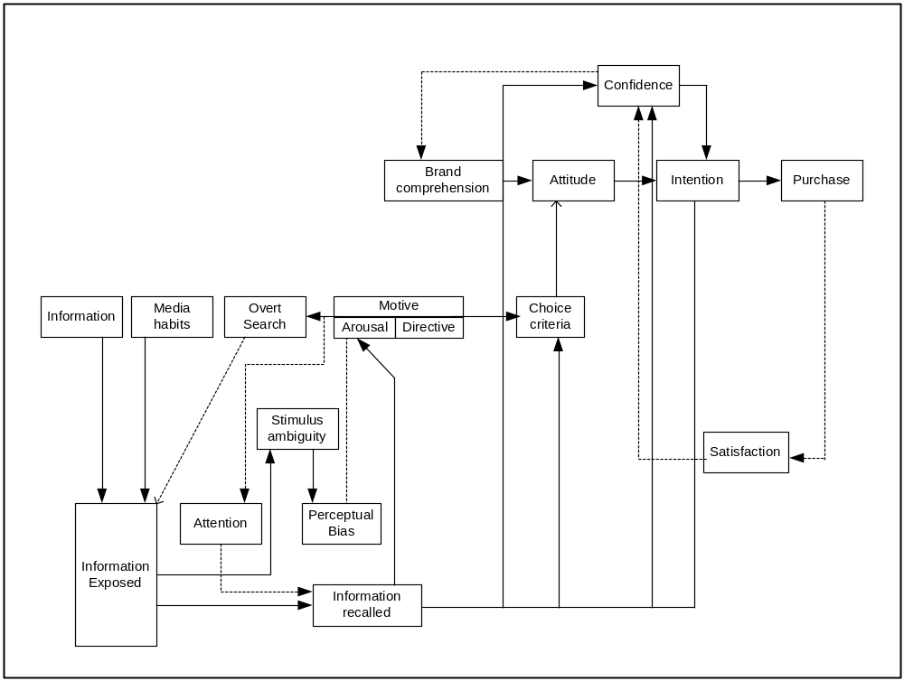

Fig.2 Howard Model 1977 version 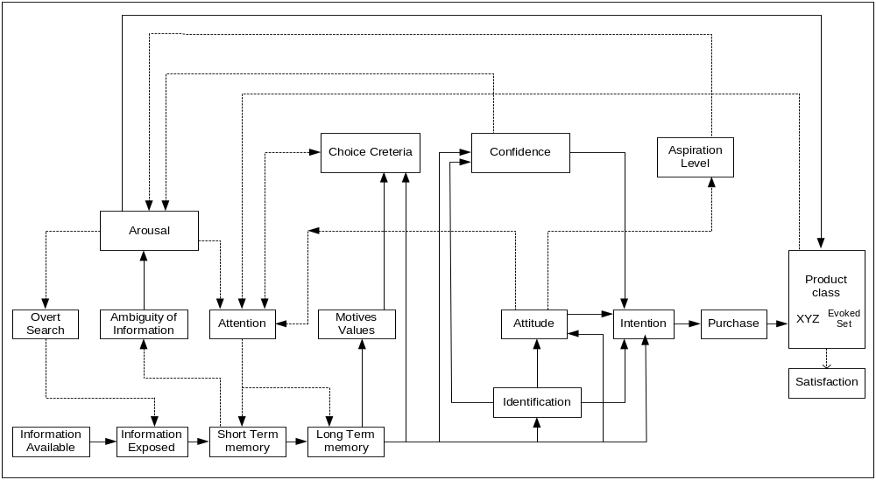
The unit of analysis of the model is supposed to be the individual buyer. The industrial buyer is at a general level similar to the consumer buyer, two questions regarding the nature of these buyers can be raised (1) are these buyers fundamentally different from one another? If so, (2) what effect would such differences have on the structure of the model? Industrial buying situation, for example is expected to be marked by a greater emphasis on information, occasional group decision making, and different set of behavior factors. The model, in its present form, does not provide a clear answer for this issue.
With regard to the identification of factors, the authors first identify four sets of factors: Input Variables, Output Variables, Hypothetical Constructs, and Exogenous Variables. The latter set of factors is assumed to be constant during any one cycle of the decision process and is supposed to be of help in segmenting markets. This assumption of constancy of exogenous variable during any one cycle is a questionable one. This is particularly the case for products that require extensive search and a longer decision cycle.
The first set of factors is called input Variables. The authors begin by attaching labels of significative, symbolic, and social to the three subdivisions of input variables. These factors respectively originate from the physical brand /product, the message disseminated by the seller, and the people who are in a face-to face relation with the buyer. Later the authors consider all three subdivisions together as a single multidivisional variable called stimulus display. Some explanatory comments are then made about stimulus display, but a clear identification of the exact dimensions of this variable does not emerge.
In the case of Output Variables, attitude is identified as a factor that is psychophysical, namely pupil dilation. This factor identification for Brand Comprehension is quite inadequate since the subdivisions are merely labeled without any clear explanation. There is also the problem of conceptual overlap between brand comprehension and attitude. Clearly, a consumer‘s evaluation of a (brand attitude) is likely to influence his verbal description of it (brand comprehension). In this sense, the second and third factors are not clearly identified and seem to overlap. The fourth output factor is intention which also appears to be conceptually dependent on attitude and purchase the last factor.
Purchase refers to the final act of exchange of goods or services for some consideration. Since this act is likely to take place at a specific point when the purchase is made. Therefore, purchase and intention might overlap to a great extent.
Hypothetical constructs appear to be defined in the same manner as those discussed earlier. Further more, there seems to be a great degree of overlap between the individual hypothetical constructs for example confidence is defined in terms of brand ambiguity, which is itself a function of brand comprehension. Again, motives and intention are not clearly identified and seem to overlap. Another hypothetical learning construct, satisfaction, according to the authors is the buyer’s cognitive state of being adequately or inadequately rewarded in a buying situation for the sacrifice he has undergone”. This description stops short of clearly identifying satisfaction, since the Authors further state that satisfaction may sometimes arise not only from consuming the brand but also from the mere act of purchase.
In discussion of the Perceptual Constructs, attention is identified as the openness of the buyer’s sensory receptors such as visual, auditory, olfactory etc. The next Perceptual Construct as ‘an enduring disposition or is once again of an overt search, instead of being identified as a “state” similar to others, is identified as process. This mixing of structural and process elements among the hypothetical constructs can cause problems because of the overlap among them. Stimulus ambiguity and perceptual bias also seem to overlap greatly. require some clarification. Therefore, the independence of input and output variables as well as whether they overlap is open to question.
Definitation of the factors in variable terms (or so-called “factor variables”) has Exogenous variables are not considered to changing during individual decision cycles, but the inadequacy of factor identification is once again present. Personality as “an enduring disposition or quality of a person that accounts for his relative consistency in emotional, temperamental, and social behavior” is too vague a description to allow the application of the model. If personality is to be measured through one of the available instruments, a discussion of the outcome of such tests on the model is in order. Social class, culture and social organization setting are also included in exogenous degree of overlap between these input and exogenous variables is difficult to assess.
The input variables have also been poorly identified. After passing through a complex array of interdependent hypothetical constructs, they end up in the input variables which, as stated earlier, not been attempted. Therefore, it is not possible to determine the exact degree of overlap among these variables.
In the absence of definitions, no attempt has been made to operationalize variables. Measurements techniques (semantic differentials, etc.) have been suggested in specific cases, as in measurement of attitudes, brand comprehension. etc., but an exhaustive set of measures and methodology for measurement for the variables factors has not been provided.
The only set of relationships that has been specified among the factors is the forward and reverse influences between variables that have been shown on the schematic description of the model. In the absence of a clear definition of variables it is difficult to assess the exact nature of causality between any two factors. No relationships have been developed through proposition, either analytic or otherwise.
In regard to the other criteria for evaluating models the Howard-Sheth model seems to have vast scope for further research with regard to operationlization. Earlier attempts to test these models were faced with many of the above problems, Farley and Ring (1970). Therefore, it is difficult to say whether the model has any predictive power. As far as parsimony is concerned, having hypothetical constructs acting on input variables and covering them to what may be referred to as a set of hypothetical constructs (output variables), seems to needlessly confuse and make the task of application of the model more complicated.
Fig.3 Engel Blackwell Kollat Model
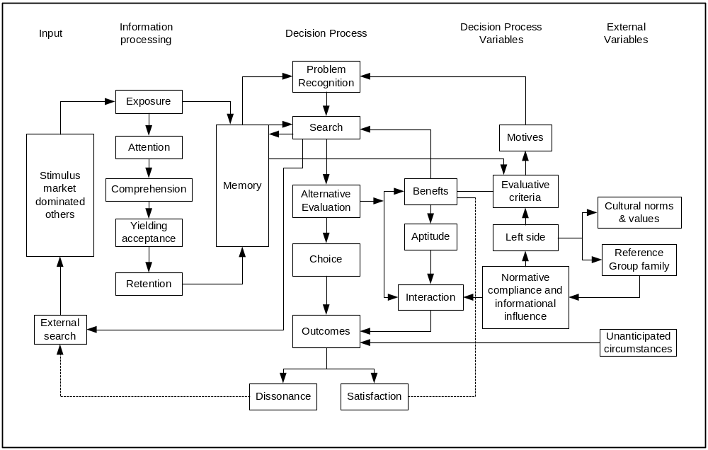
The Engel–Kollat- Blackwell Model was first introduced in 1968. The model has been revised twice: once in 1973 and again in 1979. The latest revision, according to the authors, has had several distinct purposes:
- To highlight more clearly the inter relationships between stages in the decision process and the various endogenous and exogenous variables.
- To clarify the relationships between attitude and behavior to reflect the contribution of Fishbein extended model. Beliefs and intentions are introduced as explicit variables for the first time as in normative compliance.
- “To define variables with greater precision and to specify functional relationships to permit empirical testing” (Engel –Kollat- Blackwell 1979).
The 1979 version as compared to the earlier model is more like the Howard-Sheth model of consumer behavior. The introduction of the new variables and their interrelation with the decision process has made the new version more realistic. With regard to the total statement of the focus of the model, although the general purpose is identified, the assumptions are to be made clear. As in the previous models it is to be established that it can be applied to different situations. For example, is the model applicable to the consumer purchase process of goods, or can it be applied to services items?It appears as though the model is intended to encompass all of these situations. Its effectiveness in dealing with these different situations may, however, is to be studied.
The units of analysis of the model are the individual consumer, although the authors suggest that it can easily be utilized to explain the buying process of a family. Their unit of analysis seems to be consistently maintained throughout the model.
With regard to identifications of factors, several problems arise. In the earlier versions of the model, no clear statement of the properties possessed by the various factors in the Central Control Unit was provided. Stored information and experience that is stored in either conscious or unconscious memory. Evaluative criteria, such as price, performance, durability, were better defined, but that seemed to be only an abbreviated list. These shortcomings appear to have been carried over to the model.
Both evaluation criteria and information are said to be components of attitude, but are separately examined in the model. In case of personality and life style, for example, a simplified identification is given. Personality is defined as “the individual’s way of thinking, behaving, and responding that make him unique”. This definition is too general a description to be used in empirical testing.
In the information processing section, the variables (exposure, attention, and reception) are to be clearly identified. In addition, problem recognition, search process, purchase process, and post-purchase evaluation and further behavior have scope for further research in depth.
Stimuli supposedly include a wide range of external influences. However, it is to be more clear as to how some stimuli are different from the internalized environmental influences, factor such as anticipated circumstances are included which have been adequately identified as factor. Although the new model is a significant improvement over the earlier versions, a number of variables still suffer from the lack of a clear identity. For example unanticipated circumstances cannot be clearly identified because it can include so many different conditions. The point here is not whether all unanticipated circumstances should be covered, but rather whether the user of the model can adequately identify such a factor and adequately measure it.
Definition of the variables in terms of property (ies) which continually varies(y) on a bipolar scale has not been attempted. Such a definition would have helped trace any overlap among variables. For example, is normative compliance a measurable variable?If so the researcher must know its exact nature and whether its components are of similar analytic dimension.
With regard to operationalization of the variables description of each individual element has been done, but such descriptions are not always helpful to the user. For example, in discussing exposure apart from laboratory, exposure is difficult to, measure directly and is usually inferred. They provide research findings and instruments for some of the variables to help the user. However, because research findings are situation–specific and may not be available for every case, the researcher is left with no methodology or instruments for measurement with which to use or to test the model.
Propositions have been formulated for specifying relationships between variables by means of schematic representations, and are only descriptive in the sense that the exact direction and magnitude of influence are not specified. For example, the relationship between the internalized environmental influences are not clarified. Although the relationship of a factor such as reference group and personality is clear, it is not clear why cultural norms do not affect personality furthermore, if one of the personality tests is to be used as a measure of this variable, can it be assumed that the family and reference group influences have also been jointly measured? If so, then the model can be simplified by removal of the internalized environmental influences. Similar questions can be raised with respect to other parts of the model.
In the absence of clear identification, definition, and measurement of the variables, little can be said about the predictability, parsimony, or external consistency of the model. A fair degree of predictability based on a few studies have been claimed, but more tests are needed before anything definitive can be stated about the practical utility of the model.
Thus the points raised in this study are mainly directed to the scope for further research toward a model that increases the applicability of the model to predict buyer behavior.
Scope for improvement for consumer behaviour models: Indeed the field of consumer behavior has come a long way since the ‘black box’ however, much more needs to be done to refine the models. Perhaps the two major areas associated with these models which could be researched further are that method(s) of measurement of many variables have to be clearly identified and interactions among the multitude of variables is to be clearly stated.
3.3 Personality and Marketing
Jung (1932) defined PERSONALITY as the supreme realization of the innate individuality of a particular living being.
a. PERSONALITY in ascertaining good customers
The study of personality has been approached by theories in a variety of ways. Some have emphasized the dual influence of heredity and early childhood experiences on personality development;others have stressed broader social environmental influences and the fact that personalities develop continuously over time. Some theories prefer to view personality as a unified whole: others focus on specific traits. The wide variation in view points makes it difficult to arrive at a single definition. Personality can be defined as those inner psychological characteristics that both determine and reflect how a person responds to his/ her environment. Understanding personality in addition to the socio economic and demographc factors was found to be important in predicting intentional defaulters.
b. Nature of Personality
In the nature of personality, three distinct properties are of central importance: (1) personality reflects individual differences (2) personality is consistent and enduring: and (3) personality can change.
Personality is a useful concept because it enables us to categories consumers into different groups on the basis of single trait or a few traits. If each person were different in all respects, it would be impossible to group consumers into segments, and there would be little reason to develop standardized products and promotional campaigns.
c. Personality is Consistent and Enduring
Personality has both consistency and endurance, both qualities are essential for marketers to explain or predict consumer behavior in terms of Personality. At the same time it is not uncommon to see how the personalities of certain individuals change to diametrically opposite traits due to change in environment, discontinuities in any factors in one’s life like loss of dear and near, financial or natural disaster, a windfall, change in status etc.
Even though an individual’s Personality may be consistent, consumption behavior often varies considerably because of psychological, socio culture, and environmental factors that affect behavior, for instance, while an individual’s personality may be largely stable, specific needs or motives, attitudes, reactions to group pressures, and even responses to newly available brands may cause a change in the person’s behavior or by major life events, such as the birth of a child, the death of a loved one, a divorce to abrupt events, but also as part of gradual maturing process.
Personality is only one of a combination of factors that influence how a consumer behaves.
Theories of Personality
(1) Freudian theory, (2) Jungian theory, (3) neo-Freudian theory, and (4) trait theory. These theories have been chosen for discussion from among many theories of Personality because each has played a prominent role in the study of the relationship between consumer behavior and Personality.
3.3.1 Freudian Theory and “Product Personality”
Researchers who apply Freud’s psychoanalytic theory to the study of consumer personality tend to stress the idea that human drives are largely unconscious and that consumers are primarily unaware of their true reason for buying what they buy. These researchers tend to focus on consumer purchases and/or consumption situations, treating them as a reflection and an extension of the consumer’s own personality. In other words, one’s appearance and possessions-how well groomed one is, what one wears, carries, and displays-are taken to reflect the individual’s personality (the relationship between how consumers see the products or brands they use and how they see themselves is considered)
3.3.2 Jungian Personality Types
Jung’s personality types have been made particularly useful for marketers by the Myers-Briggs Type indicators (a personality inventory) that measures the following pairs of Jungian- inspired psychological dimensions: (1) sensing – intuiting, (2) thinking-feeling, (3) extroversion-introversion, and (4), judging- perceiving. Each of these four pairs of dimensions reflects two distinctly different personality characteristics that offer a picture as to how consumers respond to the world around them.
Using a psychological inventory, such as the Myers-Briggs Type Indicators, or by creating a consumer specific personality inventory, it would be possible to learn how these four personality types impact on consumer information processing, consumer decision making, and other consumption-related issues-personality-related insights that would enable marketers to better satisfy consumer needs.
It is likely that advertising and, marketing executives have used some of these Jungian personality types intuitively in creating consumer-targeted messages.
3.3.3 Neo-Freudian Personality Theory
Several of Freud’s colleagues disagreed with his contention that Personality is primarily instinctual and sexual in nature. Instead, these neo-Freudians believed that social relationships are fundamental to the formation and development of personality. For instance, Alfred Adler viewed human beings as seeking to attain various rational goals, which he called style of life. He also placed much emphasis on the individual’s efforts to overcome feelings of inferiority (i.e., to strive for superiority).
Harry stack Sullivan, another neo-Freudian, stressed that people continuously attempt to establish significant and rewarding relationships with others. He was particularly concerned with the individual’s efforts to reduce tensions, such as anxiety.
A personality test based on Horney’s theory (i.e., the CAD) has been developed and tested within the context of consumer behavior. The initial CAD researcher uncovered a number of tentative relationships between college students’ scores and their product and brand usage patterns. For instance, highly compliant students were found to prefer name brands products, such as Bayer aspirin; students classified as aggressive showed a preference for old spice deodorant over other brands (seemingly because of its masculine appeal); and highly detached students proved or be heavy tea drinkers (possibly reflecting their desire not to conform). More recent researcher reveals that children who scored high in self-reliance-who preferred to do things independently of others (which is similar to being a detached person)-were less likely to be very brand loyal and, up to a point, were more likely to try different brands.
3.4 Trait Theory
Trait Theory constitutes a major departure from the basically qualitative measures that typically the Freudian and neo-Freudian movements (e.g., personal observations, self-reported experiences, dreams analysis and projective techniques).
In the present context this has relevance because here an attempt was made to find the traits to predict the Good Customer.
Each Individual differs from another. Accordingly, trait theories are concerned with the construction of personality tests (or inventories) that pinpoint individual differences in terms of specific traits.
Selected single-trait personality tests (which measure just one trait, such as self-confidence) are increasingly being developed specifically for use in consumer behavior studies. These tailor-made personality tests measure such traits as consumer innovativeness (how receptive a person is to new experiences, ) consumer susceptibility to interpersonal influence (SUSCEP gauges how consumers attachment to “world” possession), and consumer ethnocentrism (CETSCALE identifies consumer’s likelihood to accept or reject foreign-made products).
Based on experience using personality inventories to understand consumption-related behavior, researchers have learned that it is generally more realistic to expect personality to be linked to how consumers make their choices and to the purchase or consumption of a broad product category, rather than a specific brand. For example, there is more likely to be a relationship between personality and whether or not an individual owns a convertible sports car, than between personality and the brand of convertible sports car purchased
3.4.1 Consumer Innovativeness and Related Personality traits
Personality traits that have proved useful in differentiating between consumer innovators and non innovators include consumer innovativeness, dogmatism, social character, optimum stimulation level, and variety-novelty seeking.
3.4.2 Altering the self
Sometimes consumers wish to change themselves to become a different or “improvement of self, Clothing, grooming aids, and all kinds of accessories (e.g., cosmetic, jewelry) offer consumers the opportunity to modify their appearances and thereby to alter their “selves” in using “self altering products”, consumers are frequently attempting to express their individualism or uniqueness by creating a new self, maintaining the existing self and extending the self.
In terms of consumer behavior, the idea that an individual embodies a number of different “selves” (i.e., has multiple self-image) suggest that marketers should target their products and services to consumers within the context of a particular “self”(The notion of a consumers having multiple selves or multiple roles is consistent with the idea of use situation segmentation).
3.4.3 The makeup of the Self-image
A variety of different self-images, have been identified in the consumer behavior literature. One popular model depicts four specific kinds of self-image :(1) actual self-image (e.g., how consumers in fact see themselves, (2) ideal-self-image (e.g., how consumers would like to see themselves, (3) social self-image (e.g., how consumers feel others see them), and (4) ideal social self-image(e.g., how consumers expect to see them), other researcher has identified a fifth type of self-image, expect self-image (e.g., how consumers expect to see themselves at home specified future time.) the expected self-image is somewhere between the actual and ideal and self-images.
The relevance of this aspect in the preset study was found in the repayment behaviour in terms of peer and social pressure in that borrowers would not want the collection peope to frequent their homes.
  - Mathematical Modelling
A mathematical model uses mathematical language to describe a system. Mathematical models are used not only in the natural sciences and engineering disciplines (such as physics, biology, earth science, meteorology, and electrical engineering) but also in the social sciences (such as economics, psychology, sociology and political science); physicists, engineers, computer scientists, and economists use mathematical models most extensively.
Eykhoff (1974) defined a mathematical model as 'a representation of the essential aspects of an existing system (or a system to be constructed) which presents knowledge of that system in usable form'.
Mathematical models can take many forms, including but not limited to dynamical systems, statistical models, differential equations, or game theoretic models. These and other types of models can overlap, with a given model involving a variety of abstract structures. The scientific attitude is one of objectivity. Procedures are selected to minimise possible experimental bias. (Wiltam Skraker, Harvard University Edwin Kuh and Roy E Welsch (MIT), “Estimation for dirty data and flawed models”:
For further information on Modelling refer Annexure:
3.5.1 Simulation in the Social Sciences
In the beginning of computing, when the first programming languages became available, some social scientists had large expectations about the possibilities of capturing behavioural processes in computer models. For example, Newell, Shaw and Simon (1958) postulated a theory of human problem solving that resembled a computer programme.
Their theory consisted of three parts: (1) a control system consisting of a number of memories, (2) a number of primitive information processes which operated on the information in the memories, and (3) a perfect definite set of rules for combining the processes into whole programs of processing. Newell et al. (1958) state that at this level of theorising, the observed behaviour of an organism is explained by a program of primitive information processes that generates this behaviour and concludes optimistically that ‘the vaguenesses that have plagued the theory of higher mental processes and other parts of psychology disappear when the phenomena are described as programs’ (Newell et al., 1958, pp. 166). Hovland (1960) made a comparison between humans and computers with respect to solving theorems in Euclidean geometry, and concluded that these problems were solved in an analogous manner.
With respect to psychology, Hovland (1960, pp. 692) states that ‘Computer methodology may make possible a broadening of our understanding of behavior by emphasizing the simulation of single individuals and then studying variations between them. The integration of these complementary approaches in new computer work will help us to reduce the gap between group averages and individual processes’. The large expectations in the beginning of the sixties stimulated a lot of researchers to experiment with the simulation of social behaviour.
These bear a lot of importance in getting customer insight. Especially in the field of financial services the Field Investigator makes a loan decision, especially self employed people only based on his assessment on the spot.
Besides Newell et al. (1958) and Hovland (1960), Abelson (1968) mentions several other researchers who developed simulation programmes. Colby, Watt and Gilbert (1966) worked on simulating a neurotic belief system and on a simulated interviewer (‘doctor’) that could ‘talk’ with the ‘patient’.
However, a social scientific community is emerging in this field, as is indicated by e.g. the First International Conference on Computer Simulation and the Social Sciences (Cortona Italy, 1997) and the start of The Journal of Artificial Societies and Social Simulation. (http://www.soc.surrey.ac.uk/JASSS/JASSS.html).
3.6 Models in the Social Sciences
These programs aimed to simulate a particular single individual, in contrast to e.g., the Elementary Perception and Memory (EPAM) simulation (Feigenbaum and Simon, 1963), which was aimed at simulating unspecified or average individual behaviour. Cohen (1963) tried to model social influence within the Asch paradigm. McWhinney (1964), tried to simulate information exchange in small groups. Hägerstrand (1965) tried to simulate the innovation diffusion among farmers with a spatially oriented model. Coleman (1965) modelled teenage smoking as depending on the smoking habits of friends and the choice of friends. Raino (1965) used a stochastic theory of social interaction to simulate and study sociometric group structure. Abelson and Bernstein (1963) simulated the change of opinions on fluoridation in a community. A good discussion of the social science simulations was developed in the sixties by Abelson (1968) and Nowak, Szamrej and Latané (1990).
3.6.1 The Constructive role of Models
When we study behavior of each player (individual) it cannot be studied in isolation. As soon as the individual takes life it has constant interaction with the environment around and hence there is a bidirectional flow of influence and it could be analogised to that of a field in physics where there is a field around each particle and there is an interplay of forces when the fields overlap. The state of each particle is probabilistic in statistical mechanics and it the behavior of individual also could be said to be probabilistic, stochastic and occasionally deterministic.
The state of the particle in terms of its velocity, energy, location etc. depend on its previous states and the interactions with it environment. The state through which the particle undergoes also makes an impact on the environment and again which impacts the particle and so on. How much the mutual inpact between the particles depends on the elastic properties say the resilence and the relative velocity etc., in the context of the mechanical properties and in terms of the electro magnetic properties it depends on the polarity and quantity of charge etc. Metaphorically the mutual impact on the individuals who come into ontact depends on the their relative strengths in various attributes of personality, polarity, power (money, muscle) etc.
Same person in the same situation may behave differently depending on various factors which may be because of a different contributions by factors rational, emotional, conscious and subconscious hence the probabilistic nature and further there are uncertainties in the environment and the perceptions of the individual at different times, of the need, threat, utility etc, contribute. So the behavioral science could be metaphorically compared with field theory and particle mechanics. Without realizing the scientific truth of the statement people use phrases like the chemistry between people, matching of wavelengths and polarisaton etc. The stochastic nature, the randomness, of the human behaviour is brought out by the following citations.
“Another basic feature of human decision-making appears to be stochasticism; a degree of randomness such as is manifested when the same individual makes different decisions about the same object at different points in time under otherwise identical conditions. Such patterns of randomness can normally be determined based on a statistical distribution of probabilities with known variance. An individual's decisions are not usually static, as they are portrayed in most models, but rather are dynamic, with later decisions depending on those that preceded them. Related to this is the fact that satisfaction or aspiration levels also change as decisions are made in sequence”-United Nations University Press (1983)
Ward, L.M. and West, R.L. (1998) asks and concludes “Does the unpredictability of human behavior arise from randomness, from deterministic but chaotic processes, or from humans' use of (possibly nonlinear deterministic) heuristics in coping with complicated situations? One way to find out might be to see whether humans can behave chaotically when asked to. Previous work showed that when humans are asked to generate a series of numbers according to a particular chaotic equation they can do so but not in exactly the way the equation would generate them. Nonetheless, their series of guesses do contain nonlinear deterministic structure, which is one indication that they may be generated by a chaotic process. Series of guesses generated by a computer simulation of a model that simulates the heuristic thought processes of the humans making the guesses also contain nonlinear deterministic structure of the same order as the logistic the humans are attempting to mimic. Thus, when faced with a chaotic process, humans seem to cope by using a heuristic process that approximates the chaotic process within the limitations of human memory and performance.”
Wolfram, Stephen (2006) (Laws of human behavior) states that over the past century there have been a fair number of quantitative laws proposed for features of human behavior. Some are presumably a direct reflection of human biological construction. Thus for example, Weber's law that the perceived strength of a stimulus tends to vary logarithmically with its actual strength seems likely to be related to the electrochemistry of nerve cells. Of laws for more complicated cognitive or social phenomena the vast majority are statistical in nature. And of those that withstand scrutiny, most turn out to be transformed versions of statements that some quantity or another can be approximated by perfect randomness.
Gaussian distributions typically arise when measurements involve sums of random quantities; other common distributions are obtained from products or other simple combinations of random quantities, or from the results of simple processes based on random quantities. Exponential distributions (as seen, for example, in learning curves) and power-law distributions (as in Zipf's law below) are both, for example, very easy to obtain. (Note that particularly in economics there are also various laws derived from calculus and game theory that are viewed as being quite successful, and are not fundamentally statistical).
3.6.2 Towards Meta-Model of Behaviour
The discipline of psychology has a lot to contribute regarding how people behave, what processes guide that behaviour, and which factors affect these processes. Psychology is a relatively young science, taken to be founded in 1879, when Wilhelm Wundt started the first formal psychological laboratory at the University of Leipzig. Modern psychology comprises a large number of theories explaining different but often overlapping aspects of human behaviour. As regards environmental behaviour, relevant theories deal with issues like attitude formation and change, the principles of reasoned action, human needs and motivation, classical and operant conditioning, social learning and social comparison processes, self-awareness theory, social facilitation and inhibition, cognitive dissonance, equity and justice, and the likelihood of elaboration.
Up to now, no integrative models of human behaviour exist that link the various psychological theories together, thereby indicating when, which theory is relevant. Whereas, for example, physics is working on a grand unifying theory that integrates a multitude of theories on various phenomena (see, e.g., Hawkins, 1998), psychology lacks such an integrative framework.
A CONCEPTUAL META-MODEL OF HUMAN BEHAVIOUR is a model that models the human behaviour as an interplay between micro level and macro level factors, with respect to macro-level factors in terms of technological, economic, demographic, institutional and cultural developments is by Gatersleben and Vlek (1997).
3.6.3 The Micro-Level Driving Factors of Human Behaviour
At the micro-level the basic driving forces of behaviour refer to human needs and values, behavioural opportunities, consumer abilities and consumer uncertainty. These four basic driving forces will be discussed in separate sections. Combining needs with opportunity consumption results in a level of need satisfaction, which determines their motivation to consume certain opportunities and to elaborate on opportunities. Combining consumer abilities with opportunity demands yields a behavioural control, indicating the feasibility of opportunity consumption, which also affects the consumers motivation to elaborate on alternative opportunities. The consumer’s level of need satisfaction, behavioural control and uncertainty are key factors that determine the type of cognitive processing he or she is most likely to engage in.
3.6.4 Human Needs and Values
The concept of need has many connotations (e.g., Gasper, 1996). First, it can be used both as a verb and a noun. The verb ‘need’ usually refers to wanting a certain item as a prerequisite for a certain behaviour, without referring to the deeper source of that wanting. For example, one may need a car to travel to work. The noun ‘need’ has many meanings, which can be grouped in three generic categories (Gasper, 1996, p. 5). The first refers to needs as related to wants or desires.
Theories in this realm postulates needs as underlying internal forces that drive our actions, e.g. the theories of McDougall (1928), Maslow (1954) and Max-Neef (1992). For example, the need for safety refers to the desire people have to feel safe. This desire may elicit various behaviours, depending on the circumstances. The second meaning refers to needs as an external (environmental) requirement for achieving an end. Theories in this area analyse satisfaction and try to identify what makes people fulfilled, happy or content (e.g. Scitovsky, 1992; Argyle, 1987). This approach, for example, studies the conditions in which people feel safe. The third meaning refers to needs as justified requirements for performing behaviour. Corresponding theory is concerned with normative and ethical aspects of needs and arguments about which prerequisites have a priority status (e.g., Doyal and Gough, 1991).
The theories of McDougall (1928), Maslow (1954) and Max-Neef (1992) offer starting points to model needs as driving factors of behaviour. McDougall (1928) identified eighteen human needs (innate propensities or instincts). Examples are the need to seek (and perhaps to store) food, the need to explore strange places or things, the need to cry aloud for assistance when our efforts are utterly baffled, and the need to laugh at the defects and failures of our fellow-creatures. McDougall’s listing of what people need represents an early attempt to state universal motivational forces. However, the listing lacks a theoretical perspective on the relationships between the various needs.
Maslow (1954) has presented a well-known hierarchical ordering of needs, assuming that needs low in the hierarchy must be at least partially satisfied before needs higher in the hierarchy may become important sources of motivation. From the bottom to the top of his needs-pyramid, represented in, Maslow (1954) discerns physiological and safety needs, needs to belong and be loved, and esteem, cognitive, aesthetic and self-actualisation needs.
Human values are often referred to as relatively stable beliefs about the personal or social desirability of certain behaviours and modes of existence (Rokeach, 1973). For example, whereas some people attach great value to comfortable living, adhering to a materialistic life-style, other people are more concerned with the environment and adhere to a more non-material life-style. In this section we will relate values and related concepts as basic orientors and cultural perspectives to the level of need satisfaction people experience.
When the environment people live in is relatively stable, they are most likely to experience a relatively stable need satisfaction. For example, having a good relation with spouse, family and friends, being secure of a job, living in a city with a lot of street-crime and owning a house, will provoke a relatively stable level of need satisfaction. In this example the need for protection is not satisfied because one is living in a city with a lot of crime. Hence this suggests that the values that govern human behaviour can be related to the profile of need satisfaction. Various values can be distinguished, depending on which (combinations of) need(s) or need satisfaction profile dominates the preferences for certain types of opportunities.
When the overall profile of need satisfaction changes also a person’s cherished values will change. Many people live in relatively stable environments and thus their values will be quite stable. However, serious changes in one’s natural or human environment may cause a persevering change in one’s prevalent need satisfaction profile.
But here the value system goes beyond the satisfaction profile alone and probably factors like one’s family background(the values held the family), education, influence of friends and relatives, general value principles in the society, social pressure etc contribute. Here one could assume that there are certain fundamental aspects in the framework of value system which perhaps remain unchanged or change at a particular satisfaction profile. How and when this changes again need a detailed research but will be very useful for the borrower behaviour. Hence there may be borrowers who are in such a profile that even at the time of borrowing are not serious about repayment or those for whom the repayment as an important attribute of the value system during the tenure of the loan. This is another important aspect that bears a lot of importance in the study in relation to the values of the borrower which determines his/her repayment behaviour.
3.6.5 Four Cognitive Processing Styles
The two dimensions of cognitive processing first, reasoned versus automated processing, followed by individual versus social processing. These distinct dimensions yield a fourfold categorisation of existing behavioural theories. Several theories that are relevant for understanding the cognitive processes guiding consumer behavior can be organised in this fourfold perspective. For matters of clarity, the four processing types are labelled as deliberation, social comparison, repetition and imitation, respectively.
3.6.6 Models of people (Rom Harre, 1976)
Human beings are physico-chemical mechanisms and conscious, self-monitoring, rule-following, intention-pursuing, meaning-endowing agents.
Four kinds of person model are the ethogenic, the cybernetic, the system theoretic, and the physiological. What is required is in fact something more than just a set of models.
Each person has a mode of representing to himself the structure of the social world, and he manages his social action, when rules and habits run out, by reference to that representation
3.6.7 Game Theory Based Model
A Learning-based Model of Repeated Games with Incomplete Information, Juin-Kuan Chong, Colin F. Camerer, Teck H. Ho (Feb2005)
Many transactions in the economy are conducted repeatedly by players who know the history of behavior by others and anticipate future interactions.
Examples include cartels, employment relations, merchant banking relationships, long-standing corporate rivalries, customers who are loyal to retailers, lending to customers with known credit histories, and so forth. Game theorists model these situations as repeated games with incomplete information and study their sequential equilibria (SE). For further study on this refer Annexure.
3.7 Checking the Authenticity of a Model
3.7.1 Testing models by simple prediction
The older view saw a theory as a logically organized structure of hypotheses, from which predictions were made by deducing the consequences of supposing that certain boundary conditions held. If the prediction turned out to be correct when those boundary conditions were realized, inductivists held that this added a modicum of weight to the theory, while if it turned out to be mistaken, fallibilists held that this showed that the theory was worthy to be rejected.
3.7.2 The replication of reality
In addition to the process of testing, chemists use a technique of checking their models of reality, the development of the analogue of which by Mixon (1972: 145-77) for the social sciences must be regarded as a methodological breakthrough of considerable importance.
Organic- and biochemists not only try to discover the structure of the compounds that come their way, and to check their hypotheses as to that structure by seeing that the predicted products of decomposition actually appear, but they regard the ultimate triumph of their science as consisting in the synthesis of the very compounds they have analyzed. The crowning achievement of chemistry is the replication of reality.
3.7.3 Testing people models
Developing a model of the unknown, cognitive structure of a human being not only passes limits analogous to those of the extended senses, in that it may involve elements and structures of which we are unaware (and perhaps never could become aware), but it may also involve modes of organization that are not found in ordinary experience. It will certainly involve modes of organization that are not found in structures that the traditional natural sciences study. For instance, it may be necessary to explain the succession of one thought by another by the principle that the latter is the reason, in a context of justification for the other; rather than that the former is the cause of the latter. How can we check the authenticity of such models?
If the model produces a pretty good simulation of the known patterns it could be said to be functionally equivalent to whatever was really producing the patterns. In the case of natural science the check on functional equivalence is confined to the effectiveness of simulation of the observed patterns.

Model inter play of factors in the making of a personality
Fig.4 : Behavioral model - A model of decision making
Person--Inheritance, Genes/physiology
Impulse, data, info, environment, society
Person--

Acquired (environment-macro, micro) -social
background
-experience
-education
-cognitive
learning
-behavioral
Learning
-economics
-technology

FILTERS
Personality
Opinions/attitudes/likes dislikes/aggression, habits
needs/memory/values/ social disposition /morality /fears, aspirations, motivation/ belief/ occupation/ culture/ emotions-anger, love, jealosy, hatred, greed, deception/Ego-ID, Ego, Superego /child+parent+adult
MIND
Conscious/
Subconcious
Decision/rational+ emotional
Response, action, / experience
3.7.4 Model of Dilemmas
The immense use of these theories of Dilemmas would at once become evident when we consider the borrower behaviour in the rural scenario especially in the rural credit linked to SHGs.
This weighting may be a very deliberate act, but more often it is a less conscious process. Vlek and Keren (1992) distinguish between the following four types of weightings that people have to make, which take the form of dilemmas. For more details see Annexure.
Uncertainty-Borrowers in agricultural sector are exposed to the uncertainties in climate and returns and have been found to be important in the repayment behavior. The more uncertain people are regarding the size and growth, and thus the optimal collective harvest (OCH) of a collective resource (environmental uncertainty), the more people tend to harvest from that resource (Wit and Wilke, 1998; Hine and Gifford, 1996; Suleiman and Rapoport, 1989; Messick, Allison andSamuelson, 1988). It appears that people, who become less quickly uncertain following unforeseen developments in the resource growth, tend to harvest less than people who become more quickly uncertain (Wit and Wilke, 1998). This indicates that not the fluctuations of the resource, but rather the person’s sensitivity for these fluctuations trigger feelings of uncertainty.
Expectation of other person’s behavior: The expectation regarding the behaviour of other persons is an important behaviour-determining factor (Dawes et al, 1977; Messick, Wilke, Brewer, Kramer, Zemke and Lui, 1983; Schroeder, Jensen, Reed, Sullivan and Schwab, 1983; McClintock and Liebrand, 1988). If one expects that many others will defect, one will avoid being the ‘sucker’ whose cooperative behaviour is being exploited by the defecting others. This again is relevant in SHG groups in the Indian Rural context.
Other explanations that Van Lange et al. (1992) mention for this expectations–choice relationship refer to the inference of social norms on the basis of one’s expectations, the conformity of people, the expectation that others will do as oneself, and a post hoc justification for one’s choice behaviour (Messé and Sivacek, 1979).
Trust: People differ with respect to the degree to which they trust other people (Yamagishi, 1988). People having a high trust in others are more willing to cooperate. People with a low trust in other people will be less likely to cooperate.
Social Value Orientation:The social value orientation of a person, defined as preference for a particular distribution of outcomes for oneself and others, is an important behaviour-determining factor in social dilemmas (Messick and McClintock, 1968; McClintock, 1978). These three orientations are (1) cooperation, aimed at maximising the outcomes of self and the other, (2) individualism, aimed at maximizing one’s own outcomes, and (3) competition, aimed at maximising one’s own outcomes in contrast to others’ outcomes. This attribute could be found to have strong relationship with the propensity to willful default but to build this into the scoring models, one need to capture the character in the form of suitable factors and scales. An important conclusion from research on social value orientations is that not all people are a priori inclined to value only their own outcomes, or to see the pursuit of self interest as rational (Van Lange et al., 1992, p.17).
Personality factors: Extraversion and agreeableness are personality factors affecting the harvesting behaviour in a resource dilemma (Koole, Jager, Van den Berg, Vlek and Hofstee, in press).
Personal responsibility: (More relevant in SHG scenario and in the case of cooperative societies) Personal responsibility is a factor which is somewhat related to identifyability (Van Lange et al., 1992, p. 20). A classic study by Latané and Darley (1968) showed that people are less helpful when more people are involved. Fleishman (1980) found that people felt more responsible the more others depended on one’s contribution.
Morality: People tend to cooperate more if they previously discussed the morality of cooperation and immorality of defecting (Dawes, 1980). The morality of non-cooperation is often a topic of discussion in groups involved in a dilemma (Dawes, McTavish and Shaklee, 1977). Individuals who perceive the social dilemma as a moral issue tend to cooperate more often (Van Lange, Liebrand and Kuhlman, 1990).
Empirical studies in this field taught us a lot about the factors that influence human behaviour in a dilemma. However, the laboratory setting of this research differs significantly from real-world dilemma situations.
A difference refers to the type and relevance of outcomes. In the experimental games the outcomes usually are framed in terms of credit points or money, and depending on the number of points the subjects collected they will receive more or less money at the end of the experiment. The size of the monetary reward will usually have no significant effects on the subjects’ daily lives. In the real world the outcomes are usually much more diverse and significant.
Several researchers tried to increase the realism of natural resource systems by developing computer simulations of more complex systems which provide a tool to study the behaviour of people in more realistic yet controllable situations, thereby compressing long-term processes in short experimental simulation sessions. Several others developed simulations of behaviour itself, operationalising agents via algorithms that represent certain decision processes. This approach allows for testing different algorithms against each other, and to evaluate these in terms of the sustainability of the underlying processes.
3.8 Action Reaction Learning: Analysis and Synthesis of Human Behaviour (Tony Jebara Alex Pentland (1994))
This experiment is Action-Reaction Learning as an approach for analyzing and synthesizing human behaviour. This paradigm uncovers causal mappings between past and future events or between an action and its reaction by observing time sequences. This is applied to analyze human interaction and to subsequently synthesize human behaviour.
Using a time series of perceptual measurements, a system automatically uncovers a mapping between gestures from one human participant (an action) and a subsequent gesture (a reaction) from another participant. A probabilistic model is trained from data of the human interaction using a novel estimation technique, Conditional Expectation Maximization (CEM). The system drives a graphical interactive character which probabilistically predicts the most likely response to the user's behaviour and performs it interactively. Thus, after analyzing human interaction in a pair of participants, the system is able to replace one of them and interact with a single remaining user.
With advances in computation, the simulation and the analysis of behaviour has become a feasible proposition. In simulation domains, dynamics, kinematics, animal behaviour, rule based systems and reinforcement learning have been proposed to synthesize compelling interaction with artificial characters] N.I. Badler, C. Phillips, and B.L. Webber (1993), B. Blumberg, P. Todd, and P. Maes. (1996), N.I. Badler, C. Phillips, and B.L. Webber (1994), D. Terzopoulos, X. Tu, and Grzeszczukm R.(1994). Simultaneously, computer analysis and automatic learning of behaviour and dynamics from perceptual measurements has also strongly developed A. Bobick(1997), C. Bregler(1997), A. Pentland(1995), A. Pentland and A. Liu (1995), [T. Starner and A. Pentland (1995), Y. Yacoob and L. Davis (1998). Of particular relevance is the ability to predict regularities in human behaviour using computational models trained with machine learning. An attempt is made to study the combination of the effects of both behaviour simulation and perceptually driven behaviour analysis into a common automatic framework. The Action-Reaction learning approach acquires models of human behaviour from video and controls synthetic characters. Driven by these models and perceptual measurements, these characters are capable of interacting with humans in realtime. Ultimately, the user need not specify behaviour directly (and tediously) but teaches the system merely by interacting with another individual. (This has a tremendous potential in predicting the intentional defaulters)
Earlier models of human behaviour proposed by cognitive scientists analyzed humans as an input-output or stimulus-response system J.B. Watson.(1913),.L. Thorndike. (1898), These behaviourists came under criticism as cognitive science evolved beyond their over-simplified model and struggled with higher order issues (i.e. language, creativity, and attention), K.S. Lashley (1951). Nevertheless, much of the lower-order reactionary behaviour was still well modeled by the stimulus-response paradigm.
Of particular relevance is the close similarity of the stimulus-response behaviourist model to input-output learning algorithms.
The Action-Reaction learning system is a probabilistic algorithm that uncovers a mapping between the stimulus and the response from interaction data. The goal of the model is not to classify behaviour into a variety of categories or for surveillance, T. Starner and A. Pentland (1995). Typically, these classifications involve manual supervised segmentation and identication of specific types of behaviour. Rather, the model will be used for unsupervised analysis and its ultimate goal is the synthesis of such human behaviour with minimal artificial constraints, hard-wired knowledge and zero user intervention.
The behaviour in question is limited to physical activities which can be measured by the system. The approach treats present activity as an input and future activity as an output and attempts to uncover a probabilistic mapping between them (i.e. a prediction). In particular, by learning from a series of human interactions, one can treat the past interaction of two individuals as an input and try to predict the most likely reaction of the participants.
3.9 Market Response Models
3.9.1 Dominique M. Hanssens, Peter S.H. Leeflang Dick, R. Wittink, (2004) Market response models are intended to help scholars and managers understand how consumers individually and collectively respond to marketing activities, and how competitors interact. Appropriately estimated effects constitute a basis for improved decision making in marketing.
Marketing as a discipline and market response models as a technology may often not receive top management attention. In order to have enhanced relevance for senior management, marketing models should be cross-functional, include short- and long-term effects, and be considerate of capital markets and most importantly simple, user friendly and operationally practical especially from the point of data. From my study and the search and run for data and that too reliable data, I would say any model is useful only if the data that it needs is available in quantity and quality.
A comprehensive knowledge on the marketing models could be obtained in Lilien, Kotler, Moorthy Leeflang, Wittink, Wedel, Naert, Hanssens, Parsons, Schultz and Lilien, Rangaswamy.
Little “why are so many models developed but not used?With regard to market response models, using a supply and demand perspective the following need to be addressed:
• What is the current state of supply and demand regarding market response models?
• What are the characteristics of models that gain industry implementation?
• How can market response models gain strategic impact at the senior-management level?
• What are emerging areas of application of market response models?
Track: In the past thirty years market response models have diffused in the practioners’ community. Leading firms, especially in consumer goods and services, database marketing companies and traditional market research companies developed and used increasingly sophisticated models and analyses. The successful implementation of models depends on data availability, the methodology used, and other characteristics. It appears, however, that sophistication in model specification and estimation are often not conducive to acceptance. On the other hand, standardization is an aspect that favors model use.
Alignement between academic research and Business: Research on actual model use is scarce. A recent study focused on the application of segmentation and response modeling in database marketing: its use is positively related to firm size, frequency of customer contact and the use of a direct channel of distribution but model acceptance is negatively related to model complexity. Marketing practice commonly focuses on relatively simple approaches such as data splitting, cross tabulations and/or univariate frequencies. See for example, the following services offered by AC Nielsen: ‘Category Management’, ‘Direct Product Profitability’, ‘Out of Stock’ and ‘Shelf Metrics’. It appears that many models appearing in the academic literature have little relation to marketing practice. Such models often deal with specific problems, are more descriptive than prescriptive, and include complexities that reduce the chance of implementation in practice.
There is now a growing alignment between the objectives of academic research and the needs of managers. Relevance to real-world problems will improve the likelihood of implementation. To illustrate, consider a study in which the sales increase resulting from an item’s promotion in a store is decomposed into (i) changes in sales of other items in the same category (cross-item effect), (ii) changes in sales in other periods (cross-period effect), and (iii) changes in sales of items in other categories (cross-category effect). These effects can be either positive (complementary) or negative (substitution). The results are based on models, with unique estimates for a single store, applied to daily data for two categories at a time. Such a study is subject to many problems: multicollinearity, endogeneity, day-of-the-week effects, category-specific seasonalities, trends etc. This study took about two years to complete. Extensive validation, cost-benefit analysis, and standardization will have to be done before model implementation can be expected.
Much of marketing decision making is of a repetitive or tactical nature. For example, advertising expenditures, sales promotion budgets, shelf space allocations, prices, margins etc. have to be determined for each period. The consideration of changes in decisions is facilitated by the development of ever more detailed databases, for example those developed by Nielsen, IRI and IMS. The availability of these databases also makes it easier to justify the use of econometric modeling (e.g. bimonthly audit data would not permit the estimation of deal effect curves). And the increasing frequency and amount of marketplace feedback also demands a systematic approach for data analysis. Standardized models have become important tools to improve the quality of tactical marketing decisions at functional levels such as brand management.
In the academic literature, the following areas have received numerous contributions:
• Main own- and cross-brand effects of marketing mix elements;
• Interaction effects between marketing mix instruments;
• Competitive structures and competitive reaction effects;
• Marketing effects on (cross) category demand;
• Short-run vs. long-run marketing effectiveness.
Innovation in research occurs when idiosyncratic models are developed to tackle new marketing problems. Examples of new problems include the customization of marketing efforts, the linkages between marketing efforts and behavioral, attitudinal and intention measures, Leeflang PSH, Wittink DR(2003), the role of web sites in consumer decision making processes, BucklinRE, SismeiroC(2003), and an understanding of brand equity, SimonCJ, SullivanMW(1993) and customer equity, GuptaS, Lehmann(2003);GuptaS, Lehmann(2004)
Trends in Market Research:Customer equity in particular is drawing increasing interest, consistent with a shift in marketing focus from products (brands) to customers. Vastly improved databases and improved tools allow researchers to estimate the value of customer loyalty. Loyal customers are attractive in terms of cost to serve and willingness to pay. Loyalty may be further enhanced if the characteristics of the offer are customized. Models, including those applicable to internet marketing and direct marketing, can support customization, Verhoef PC, SpringPN, HoekstraJC, Leeflang PSH(2002). A large part of the empirical model-based research in marketing pertains to consumer products, and this area is an important source for the supply of models. The successful use of models for consumer packaged goods, Bucklin RE, Gupta S(1999) may stimulate the adaptation of models for durables, services, retailing and B2B marketing. Although these areas have unique characteristics, a common trend is the greater emphasis on customer satisfaction, Gomez MI, McLaughlin EW, Wittink (2004).
Database based market research: The shift toward the use of customer-centric databases allows also for the integration of customer satisfaction data with models of customer acquisition and retention. Models have been developed to support strategic decisions with respect to, for example new-product development, HiLo versus EDLP pricing strategies. Ailawadi KL, Lehmann DR, Neslin SA. (2001)The more strategic the marketing decision, the more important it is: (1) to gauge its long-term consequences on demand and (2) to gauge its impact on other parts of the organization such as finance and operations (models of the firm). Models of the firm are of particular relevance for senior executives.
New databases facilitate the direct focus on the demand side so that policy decisions now often hinge on cross brand-price elasticities (to determine market boundaries). For pharmaceutical products, public policy concerns often focus on prices and price elasticities. Of particular interest is the effect of advertising and other marketing activities on price sensitivities. Given relaxation of the restriction in the U.S. on Direct-to-Consumer advertising in 1997, an important question is whether health outcomes improve due to, for example, improved patient awareness and compliance, (Bowman D, Heilman CM, Sethuraman PB. (2004), Wosinska W.(2004). In litigation, market response models are used to estimate, for example, whether a defendant’s contested marketing strategy had an adverse impact on a plaintiff’s business performance.
E mail marketing and returns
Darrell Zahorsky, 2007, “A Magic Box and Email Marketing”, (Your Guide to Small Business Information, From About, Inc., A part of The New York Times Company)Business today is finding email marketing with newsletters attractive for several reasons:
1. Cost of sending a direct mail piece by postal service runs over a dollar, email marketing can cost pennies.
2. A 1% response rate from direct mail is considered terrific. An e-mail marketing campaign can have a 5 to 10% response rate.
3. Based on “DoubleClick” Email Consumer Study, over 78% of online shoppers have purchased because of permission-based emails and 59% of email recipients have bought in a retail store as a result of a merchant email.
4. The benefits of email marketing range from increased sales and lead generation to stronger brand awareness and improved customer relationships
As direct marketing is getting tremendously increasing share of the marketing efforts, it is imperative that the ROI of the Direct marketing efforts eg: campaigns are optimized. This will demand development of models based on extensive data base, that will be able to predict most accurately the customers who would respond to campaigns. This would improve the response manifold and wasteful expenditure on the customers who are most likely not to respond will be eliminated. This is called Precision marketing.
Improving Response prediction in direct marketing by optimizing for specific mailing depths (D.Van den Peel, A.Prinzie & P.Van Kenhove, 2002)Response modeling is a very important application field of classification methods in direct marketing because the success of a direct-mail campaign is highly dependent on who is being targeted. To date, standard classification models are applied to predict future purchasing behaviour for the complete customer profile. In practice, however, companies use mailing budgets, i.e. only a subset of customers will be sent mail. Just those customers with sufficiently high-expected response rates are mailed to. The percentage of the total population that will actually receive the mailing is referred to as mailing depth.
Hence, the real classification problem is not to classify all potential recipients as well as possible, but rather to find those customers, within the budget limitation, with the highest probability of response. Therefore an innovative alternative route would be to improve overall performance by tailoring the classification method to fit the problem at hand. In binary logistic regressions, iteratively, the true values of the dependent variable are changed during the maximum-likelihood estimation procedure.
Those customers who rank lower than the cutoff in terms of predicted purchase probability, imposed by the mailing-depth restriction, will not contribute to the total likelihood. The results show that for mailing depths up to 48% the method achieves significant and substantial profit increases.
3.10 Predictive modeling
Identify those customers who will respond to promotions or at risk of switching to the competitors or can be sold additional goods and services are critical to optimizing the value of each customer relationship.
SPSS.com(2007), “PredictiveMarketing enables you to make the right offer to the right customer at the right time. Using powerful predictive analytics and business rules, PredictiveMarketing chooses the highest-value offer or campaign that a customer is likely to accept”.
With this customer-focused approach, A Marketer intending to do Predictive Marketing is typically able to:
- Reduce direct marketing costs by 25 to 40 percent
- Double campaign response rates
- Increase revenues by 20 to 50 percent without increasing budget or adding resources
Natexis Assurances, the insurance division of Groupe Banque Populaire, reduced its direct mail volume by 50 percent, and increased direct mail revenue by 200 percent, using PredictiveMarketing.
3.11 Incremental value models
A powerful analytical tool which enables retailers to predict incremental spending in response to existing promotions and offers, to identify those customers who are likely to spend more when promoted to, so that retailers can target their marketing efforts and dollars to that specific customer segment maximizing returns on investment. Behavioral and attitudinal instruments allow retailers to send highly and targeted communication to an identified segment.
3.12 Response Models
They can be used to decide which of various possible products or services to offer the customer based on a predicted probability of accepting an offer that is estimated on the basis from data already available on the customers or obtained with questions.
Traditionally a linear statistical method such as logistic regession has been used to model response based on a test of random sample of customers from the complete list (Aaker, Kumar, Dey 2001). In order to overcome the limitation of logistic regression other approaches like RIDGE Regression (Malt house 1999), Stochastic RFM response models, (Colombo & Jians, 1999), Hazard function models (Goniil, Kim & Shi 2000) were developed. Neural networks a class of nonlinear models that mimic brain function have been shown to produce better predictive accuracies for a wide variety of business problems such as retail banking, finance, insurance, telecommunication and operation management, Smith &Guptha(2000). Neural networks have also been employed in marketing because no a priori knowledge or assumption about the error distribution is required, Zahavi & Leuin (1997b).
It has been shown in one instance that neural network models improved the response rate upto 15% in direct marketing (Bounds & Ross, 1997). In another application bank customer's response was predicted using a neural network (Moutinho, curry, Davies and Rebe, 1994) yielding superior results. A neural network was also shown to outperform multinominal logistic regression (Bentz & Merunkay 2000). Input variables have also been related successfully to direct marketing application using neural network (Viaene, Baesons, Yan den Poel, Dedene & Yanthenen, 2001).
There have also been reports that neural network did not outperform simpler logistic regression model (Suh, Noh & Suh, 1999; Zahavi & Levin, 1997(a). It is often the case that a simple logistic regression predicts better than a neural network. One major reason is that a neural network model has to be built up with great care. In particular its performance is sensitive to its complexity, determined by the number of synapses or weight parameters. If a network is more complex than the problem at hand or the available data set requires, then the network learns not only the underlying function but also the noise peculiar to the finite training data set. (Hansen & Salamon, 1998). Over fitted neural network model will fit the training data perfectly but will fail to predict well for the unseen test data.
Kyoungnam Ha, Sungzoon cho & Douglas Maclachloan –(2005)An overly complex neural network is said to have a large variance. Performance of the network varies greatly over different data sets from an identical population distribution. Simple models such as logistic regression would have a large discrepancy between the true target and the expectation of the model output over different data sets, the models are said to have a large bias. Both bias and variance create classification error. A complex model has a large variance and a small bias while a simple model has a large bias and small variance. One can typically improve one type of error at the expense of the other, thus the bias variance dilemma (German, Bienenstock and Doursat, 1992).
Given a finite training data set, it is usual practice to select a model which is tedious, time consuming, trial and error search for optimal complexity. Bagging or bootstrap aggregating is a method that aggregate outputs of many models that were trained separately with bootstrap replicates of the original training data set.
Bagging reduces variance or model variability over different data sets from a given distribution without increasing bias which results in a reduced overall generalization error and an improved stability. Since bagging transforms a group of overfitted networks into better than perfectly fitted network, the tedious time consuming model selection is no longer necessary. This could even offset the computational overhead introduced by bagging that involves training L neural networks.
3.12.1 Case Study of Response model in a New Zealand Bank
Data for this analysis was obtained through a random mail survey sent to 1, 960 household in Canterbury Region, New Zealand. The questionnaire gathered information on consumers’ decision to use electronic banking versus nonelectronic banking. The mail survey was designed and implemented according to the Dillman Total Design Method (1978), which has proven to result in improved response rates and data quality. The response rate of the survey was about 27%. The data set consisted of 527 observations – 384 electronic banking users (EB) and 143 non- 54 electronic banking users (NEB). LIMDEP software is used to estimate the logistic regression and NeuroShell2 package is used to construct the artificial neural network models to examine the predictive power of the models, the out-of-sample forecasting technique is applied. The sample is randomly divided into two subsamples: a training sample and a forecasting sample. The training sample and the forecast sample contain 422 observations (304 EB and 118 NEB) and 105 observations (80 EB and 25 NEB), respectively. All models are re-estimated by using only the training samples and the out-of-sample forecasting were conducted over the forecasting samples. Then, the classification rates of each model are computed and compared. The modelwith the highest percentage correct is considered as a superior model.
3.12.1a Empirical studies
The estimated logistic regression Equation 3 is as shown in Table 1. In general, the logit model fitted the data quite well. The chi-square test strongly rejected the hypothesis of no explanatory power and the model correctly predicted 92% of the observations. Furthermore, SQ, PR, UIF, OLD, WHITE, CASUAL, HIGHSCH, HIGH, and RURAL are statistically significant and the signs on the parameter estimates support the a priori hypotheses outlined earlier. The estimated coefficients indicate that service quality dimensions and user input factors have a positive impact on consumers’ likelihood to choose electronic banking. This implies the level of service quality in electronic, the independence and freedom associated with electronic banking and the enjoyment that could be derived from electronic banking will favorably influence consumers’ decision in using electronic banking. Perceived risk factors were found as hypothesized, to negatively affect the probability to use electronic banking. Research tells us a consumer who is risk adverse perceives electronic banking as a financial risk when it is not possible to reverse a mistakenly entered transaction or stopping a payment. Furthermore, the threat of personal information accessed by a third party negatively influences a consumer’s likelihood to us electronic banking. This supports the finding of Ho and Ng (1994) and Lockett and Littler (1997). The demographic variables(age, employment, education, income and residence) were also significant in explaining the respondents’ probability in using electronic banking. For example, the negative coefficient of the age group above 56 years showed that senior consumers were less likely to use electronic banking. Senior consumers are more risk adverse and prefer a personal banking relationship to non personal electronic banking. High school respondents may be less likely to use electronic banking due to their low income status. Furthermore, electronic banking transaction could be costly for this age group who primarily work part-time.

Table 1. Consumer Choice Model

Variable | Coefficient | S.E. | Marginal Effect | Rank
SQ**  PR**  UIF**  PI  SP  IN  YOUNG  OLD*  GEN  MAR  HIGHSCH**  EURO  MAORI  RURAL*  HIGH*  LOW  BLUE  WHITE**  CASUAL**  Constant | 0.9589  -3.5081  2.2332  0.0595  -0.1069  -0.2003  -0.2582  -0.7996  -0.1911  0.2143  -1.1449  0.4724  1.1719  0.6655  -0.6430  0.3964  0.3254  1.4765  1.4619  0.1450 | 0.4295  0.4442  0.3336  0.1716  0.3375  0.3100  0.6410  0.5115  0.4109  0.4241  0.3985  0.6251  1.7379  0.4350  0.4991  0.5173  0.5455  0.6114  0.8873  2.0079 | 0.0664  -0.2431  0.1547  0.0041  -0.0074  -0.0139  -0.0192  -0.0623  -0.0134  0.0152  -0.0866  0.0382  0.0511  0.0420  -0.0492  0.0255  0.0209  0.0893  0.0638  0.0104 | 5  1  2  19  18  16  14  7  17  15  4  11  8  10  9  12  13  3  6

Log likelihood function -99.3037 McFadden R2 0.6777
Chi squared (df = 19) 417.5549 Prob. 0.0000
Predicted NEB EB Overall (n = 527)
% Correct 83.22 95.31 92.03
% Incorrect 16.78 4.69 9.97
Notes: Dependent variable is EBANKING.
* & ** represent 10% and 5% significant level respectively.
Rank is based on the absolute marginal effect.
Additional information can be obtained through analysis of the marginal effects calculated as the partial derivatives of the non-linear probability function, evaluated at each variable’s sample mean (Greene, 1990). For example, the consumers’ choice of electronic banking is relatively sensitive to the perceived risk (PR) (Rank =1) and the user input factor (UIF) (Rank = 2), where an unit increases in PR and UIN scores would decrease and increase the probability of being an electronic banking user by 24.31% and 15.47%, respectively. The overall percentage correct of 92.03 shows that the logistic model is quite accurate in consumers’ choice prediction. However, the percentage incorrect indicate that the logistic model is likely to produce Type I error (wrongly reject H0 or accept non-electronic banking user as electronic banking user) compared to than Type II error (wrongly accept H0 or accept electronic banking user as non-electronic banking user), as it has 19.78% and 4.69% incorrect on non-electronic 55 banking and electronic banking classifications, respectively ( Table 1).
Given that the ANN uses nonlinear functions, it is difficult to demonstrate the algebraic relationship between a dependent variable and an independent variable. Furthermore, the learned output or connection weights could not be elucidated and tested. Therefore, only the relative contribution factors and the classification rates are presented in Table 2. Both MLFN and PNN used the same numbers of independent variables as the logistic model for the input layer nodes. The best network for the MLFN in this study is the one hidden layer network with 19 hidden neurons (19-19-1) and applies the logistic function as the activation functions. For PNN, the network requires the number of pattern units must be at least equal the number of training patterns and the number of summation units must equal to the number of classes (or choices). Thus, the network configuration is 19-527-2-1.
Table 2. ANNs’ Relative Contribution Factor

Input  Variable | MLPN  Relative  contribution | Rank | PNN Relative  contribution | Rank
SQ  PR  UIF  PI  SP  IN  YOUNG  OLD  GEN  MAR  HIGHSCH  EURO  MAORI  RURAL  HIGH  LOW  BLUE  WHITE  CASUAL | 0.0648  0.1259  0.1165  0.0331  0.0808  0.0811  0.0316  0.0406  0.0451  0.0246  0.0426  0.0386  0.0377  0.0480  0.0425  0.0313  0.0380  0.0403  0.0371 | 5  1  2  16  4  3  17  10  7  19  8  12  14  6  9  18  13  11  15 | 0.0524  0.1113  0.1091  0.0960  0.0563  0.0808  0.0092  0.0004  0.1082  0.0576  0.0227  0.0258  0.0803  0.0096  0.0236  0.0000  0.0559  0.0070  0.0938 | 11  1  2  4  9  6  16  18  3  8  14  12  7  15  13  19  10  17  5

Predicted NEB EB Overall NEB EB Overall
outcome (n=527) (n=527)
% Correct 86.71 97.92 94.88 99.30 100.00 99.81
% Incorrect 13.29 2.08 5.12 0.70 0.00 0.19
The classification results in Table 2 show that both MLFN and PNN exhibit a superior ability to learn and memorize the patterns corresponding to consumers’ choice on the electronic banking. Both of methods have higher overall percentage correct on consumers’ choice predictions than the logistic model. Generally, the MLFN model can predict quite well on the electronic banking group but its performance is relatively poor when predicting the non-electronic banking group. In contrast, the PNN can predict well for both groups. Therefore, the PNN is assumed to be the best prediction model in this study since it has the highest overall percentage correct (99.81%) and a very low percentage error on Type I error (0.70%) with 0.00% of Type II errors.
The relative contribution factors and the ranks in Tables 1 and 2 showed a consistency result across all the models. That is both perceived risk (PR) and user input factor (UIF) have strong influence on the consumers’ decision between electronic banking and non electronic banking in all three models, Rank = 1 and 2 respectively, whereas the other variables have strong influence in some models but they might have less influence in another model or vice versa. Therefore, these two factors must be considered and set as high priority factors as they have strong impact to the consumers’ decision in choosing between electronic banking and non electronic banking. The within-sample forecast always yields an upward bias; the out-of-sample forecast is a more appropriate measure of the future predictive power. Table 3 shows the classification rates on out-of-sample prediction for the logistic, MLFN and PNN models. The classification results show that the ANN models are better precision on the out-of-sample forecast than the logistic model. In addition, the PNN model outperforms the MLFN model. The PNN yields the highest overall percentage correct and the smallest error rate for both in sample forecast and out-of-sample forecast. This implies that the PNN can predict consumers’ choices more accurately than the MLPN and the logistic model. It can also be considered as the superior model for the consumers’ choice prediction.
Table 3: Out-of-Sample Forecast
Model | NEB | EB | Overall  (n = 105)
LOGIT  % Correct  % Incorrect  MLPN  % Correct  % Incorrect  PNN  % Correct  % Incorrect | 88.00  12.00  84.00  16.00  96.00  4.00 | 92.50  7.50  95.00  5.00  100.00  0.00 | 91.43  8.57  92.38  7.62  99.05  0.95

3.12.1b Conclusion
The estimated results from the logistic regression indicate that age, occupation, qualification, income, area of residence, service quality, perceived risk and user input factor are the major factors which influence consumers’ decision between electronic banking versus non electronic banking. The logistic model can be considered as an accurate prediction model because the overall correct classification is high, above 90.00% in both in-sample and out-of sample predictions.
3.13 Improvement of Response Modeling: Combining Rule Induction and Case-Based Reasoning
(Filip Coenen, Gilbert Swinnen, Koen Vanhoof, Geert Wets) have studied an improved classification method for studying response modeling in market research. Combined rule-base classification and statistical sorting, however, does offer promising potential in improving classification accuracy.
To effectively direct promotional brochures to consumers who have high potential in making responding purchases, market researcher must first identify a metric on which such potential can be reliably estimated. The authors suggest that a method employing rule-based decision tree classification followed by typicality sorting can produce more accurate classification then any standalone methods considered. When applied to a Direct Mail marketing experiment, a 2.5% improvement in accuracy was observed over classification with no sorting. To begin, a careful consideration of the C5 algorithm and Case-based reasoning is necessary.
Assume that consumers are divided into two non-overlapping classes, Buyer and Non Buyer. Assume also that both classes share the same set of social-demographic and economic attributes. That is, a consumer can be characterized as follows.

Class Name | Attribute 1 | AttributeII
Buyer / Non Buyer | Residence Type | Made Purchase within last 6 months
Buyer
Non Buyer
Non Buyer
mistaken to be Buyer
Buyer
mistaken to be Non Buyer
Fig.5. Customer Response Model
It is then possible to devise a learning algorithm to construct a decision tree. This tree can be used to classify instances of various class objects. A response model is one application of decision tree classification.
To achieve efficient utilization of marketing resources, one needs a response model that contains a minimum overlap in the center region. This region indicates class instances that had been erroneously labelled. Class label of a potential Buyer / Non Buyer object is assigned using a decision tree that implements the C5 algorithm. Within each class, typicality of class objects is then ranked in decreasing importance. The final classification decision is a result of both C5 and typicality computation. Marketing resources are directed to only the highly typical buyer candidates.
3.13.1 Classifiers
Algorithm CHAID presents 75.74% accuracy, no significant difference from the 75.46% accuracy for algorithm CART, nor should it be considered more superior under the premise of accuracy alone.
3.13.1.1 C5 Algorithm
The C5 algorithm divides a data set of known classes into two subsets; the training data set and the test data set. The ratio of each set varies according to implementation. Using the training data, a collection of rules can be derived.
Table 4 : C5 : Algorithm - Training Data
Name | Mail ordered within past 6months | Favorite Store | Residencnce | Class
Jeanne | Yes | Old Navy | Home | Buyer
Wei | No | Wal-Mart | Dormitory | Non Buyer

One such rule can be of the following form
(Mail Order (6 mo))   (Favorite Store = Old Navy)   (Residence = Home)  Class = Buyer
This rule theorizes that if a consumer has made mail ordered purchases within the past 6 months, and her favorite store is ’Old Navy’, and she resides at home with her family, then, she is likely to respond well to direct mail marketing. The C5 algorithm constructs a decision tree using the set of rules that has attained the highest confidence among training data. Figure below demonstrates one branch of such decision tree using the same data presented in Table.
To classify data into two groups, each rule must attain at least 50% confidence among training data. That is, at least 50% data of the same class in the training set is used to derive the rule. Therefore, given a 100-customer training set, with 97 non-buyers and 3 buyers, a rule can be derived if 2 among the 3 only buyers obliged. Such rule would show strong confidence (2/3 * 100% = 67%). However, it is clearly risky to rank buyers using a rule originated from so little support.
The objective of response modeling is to compute a reliable response probability associated with each consumer (case) through the classification exercise; 2 methods of computation are suggested. The first method is to simply rank a case according to the confidence index associated with the decision rule that classifies the customer. Note that such ranking is useful only when the applied rule correctly classifies a case. Without solid support, ranking would simply amplify an assertion regardless of the correctness of the rule from which it is based upon.
Residence=
home
Yes
Buyer
Mail ordered
in 6 months

Store=old
navy
Yes

Fig.6 : Case Based Reasoning Model 1
3.13.2 A Combined Approach
C5 algorithm formulates decision rules according to the most frequently occurred combinations of attribute values. Test (and later unknown) cases are funneled down a decision tree constructed from these rules and be classified accordingly. The level of support had not been considered in the selection of decision rules. Therefore, a rule amplifies the accuracy of classification only when it correctly describes the characteristic of a class. It provides false assertion if it has incorrectly represented a class.
The design of the combined algorithm is based on the idea that a preliminary class label can be assigned to a test case using an implementation of C5. Its similarity among members of this class is then computed using the Typicality function.
The quality of the earlier classification on d is critical to the accuracy of Combined. The authors have presented a 2.5 % improvement in classification using Combined over unsorted data.
Buyer
Non buyer
Buyer classified
By C5
Non Buyer
mistaken to be Buyer
Buyer filtered
again byTypicality
Buyer mistaken to be Non Buyer

Fig.7. Case Based Reasoning Model 2
3.14 Sales Response Functions
One of the primary goals of marketing science is to provide a structural insight of how current and future sales are determined in a market. More precisely; marketer is interested in the estimation of the sales response, market share response function in order to have a better knowledge of future market movements.
Building models generally involves three stages: First the selection of the relevant variables, second the determination of the functional relation between them, and third the estimation of the actual parameters of the model. As the models reach higher level of sophistication, generally more complex relations are able to be modelled correctly, but also the more difficult their handling (respectively their estimation) will get.' Market Response Models’ by Hanssens, Parsons &Schultz. The dependent variable in such models can either be a quantity measure (e.g. sold units), a monetary measure (e.g. turnover), or a proportion (e.g. market share). Practitioners should be aware of what they want to achieve with their model before deciding on a particular one. Market share models are generally said to be more robust in respect to external influences (e.g. economic trends, inflation, seasonality).
A 20% increase in sales for example is not that significant anymore, if the overall market has doubled during the same time. On the other hand, the number of sold units is the decisive figure for production planning, which should be known as early as possible in order to adjust production accordingly.
Note that with a monetary measure problematic correlation between dependent and independent variables might appear, if price is also used as an explanatory variable in the model.
3.14.1 Linear Model
Due to its simplicity this model is still commonly used, although it clearly contradicts numerous market characteristics. E.g. linear models assume constant returns to scale, which implies that each additional unit in advertising would lead to an equal incremental change in sales. Furthermore no interaction among the explanatory variables can be explained by such a model. Nevertheless advertising practitioners have a well advanced, powerful set of methods at hand for estimating and testing parameters. The classification and notation is taken from Hanssens and Parsons [4] p.413ff.
The reason why linear models are able to show such a (surprisingly) good fit to real data might be that the available observed data generally shows very little variance. i.e. generally in a small subspace of the complete parameter space, a linear approximation of the actual functional relation turns out to be sufficiently good in a local context.
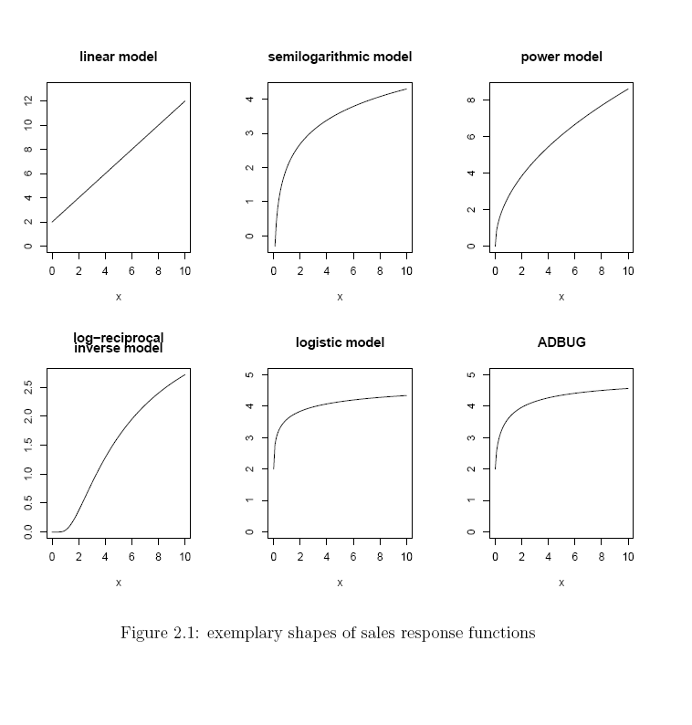
Fig. 8 : Sales Response Functions
In order to estimate multiplicative models the logarithm can be applied to the equation which yields a linear model.
With a multiplicative model it is possible to model diminishing returns to scale: common observation is that each additional unit of a marketing instrument will subsequently increase sales, but these generated increments will become less and less at higher levels. Basically this transfers to an increasing, strict concave response function.
Another advantage of the multiplicative model is, that the power coefficients i can be directly interpreted as the elasticity of that particular instrument:
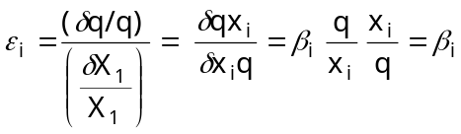
An obvious downside of the multiplicative model would be that as soon as a single market instrument is not used (i.e. equals 0), the product evaluates to 0, and therefore no sales would occur within such a model. If we have several different marketing instruments in our model, then this is generally a rather unrealistic assumption.
3.14.2 Semi-Logarithmic Model
q = β ln x
In this model, which also has a concave shape, a constant percentage increase in x will lead to a constant absolute increase in sales. Hermann Simon, for example, used such a relation for his sales response model. A problem of the logarithmic function is its behavior close to zero (where sales would diverge towards minus Infinity), which is commonly tried to be circumvented by adding a constant (e.g.1) to the marketing effort x.
3.14.3 Modified Exponential Model
q = Qº(1- e^{- βx})
It should be clear that regardless of how much effort is put into marketing, that there is a certain upper bound for sales. This maximum sales potential is usually referred to as saturation level, and is here denoted with Qo. Obviously the modified exponential model is an example for a model which explicitly incorporates such a saturation level: lim_{x−›∞} q(x) = Qo. Note, that despite their popularity neither a linear nor a multiplicative model are able to reflect saturation appropriately.
3.14.4 Log-Reciprocal Model
q= e^{β0− β1/x,} β₀ > 0
The models presented so far have been all concave, a property of the sales response function which is not taken for granted by all marketing researchers.
There is also some belief that the response function is actual
S-shaped, i.e. has a convex and subsequently a concave section. The reasoning behind such a shape is a so-called threshold effect takes place, i.e. the phenomena that marketing efforts are not effective until they exceed a certain minimum level.
But it should be noted that there seems to be hardly any empirical evidence for such S-shaped responses. The reason why this issue is so difficult to resolve, is that companies usually operate in the concave part anyway, and therefore just few data exist which could support one or the other hypothesis.
3.14.5 Logistic Model
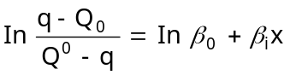
Similar to the saturation level, we can also incorporate a minimum level (the so-called base sales), denoted with Qo. This sales level is obtained when no marketing effort at all is present. The logistic model incorporates base sales, a saturation level, and an S-shaped function simultaneously.
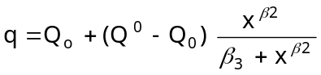
S-shaped sales response functions are one of the key factors which can lead to pulsing policies as optimal.
The logistic model requires information about Qº and Q_{o} before the actual estimation. A functional form which would also allow these two parameters to be estimated, is the ADBUG model by Little.
3.14.6 Quadratic Model
q = β₀ + β₁x - β₂x²
Supersaturation is the phenomena of decreasing sales when marketing efforts are pushed above a certain level. Ambar Rao presents a sales response function with this property in Rao p.20. The quadratic model is another example for models incorporating supersaturation. It is certainly arguable to what extent such an effect might really occur. Since companies usually operate well below such a level, models which do not explicitly incorporate supersaturation usually also prove to be adequate enough for the actual operating range.
3.14.7 Transcendental Logarithmic Model
After modelling each marketing effort separately, interactions among variables are to be considered. It should be clear that the success of one marketing instrument may very much depend on the simultaneous use (resp. non-use) of others. A price promotion for example is hardly ever performed by companies without a corresponding advertising campaign.
One possibility to incorporate these interactions would be, to have the parameter of one marketing effort depend on another marketing effort. Udo Wagner for example models in his paper price elasticity in dependency on advertising.
Another, rather general approach, is the transcendental logarithmic model
ln q= β₀ + β₁ lnx₁ + β₂ lnx₂ + β₃ lnx₃ + β₁₂ lnx₁ lnx₄+ β₁₃ lnx₁ lnx₃+ β₂₃ lnx₂ lnx₃+ β₁₁ (lnx₁ )² +β₂₂ ( lnx₂ )² + β₃₃( lnx₃ )²
Three explanatory variables are considered here
The obvious downside of the newly won flexibility of this model is the high number of parameters which need to be estimated. Therefore it is common practice to apply a-priori restriction on the parameters.
3.14.8 Alternative Model Building
Three "alternative" approaches to obtain the sales response functions: artificial neural networks, non-parametric kernel estimation and structural equation models. The application of all three of them in marketing science has a relatively young history, and therefore the number of published papers is still relatively small.
It should be kept in mind, that all of these methods can be and actually are used in combination with other models.
For example neural networks could be used for modelling the influence of price within an MLN model, whereas the other explanatory variables are modelled as usual.
a. Non-Parametric Estimation
Non-parametric estimation is generally based on a kernel estimation of the underlying density function. Similar to Neural Networks, the model builder is not forced to determine, respectively assume structural relations a-priori. Accordingly this procedure also requires a lot of data, it will also only provide a good fit within the operating range of the available data, and furthermore suffers the curse of dimensionality, which just allows us to model a very few number of explanatory variables.
Sales S are modelled as the conditional expected sales plus a random term (S = E(S_{j}x) + u). In order to calculate the conditional expectation we first estimate the conditional distribution fS_{j}x, which is the ratio of the joint distribution fS_{j}x to the marginal distribution fx. These distributions can be estimated by smoothing the histogram of the observations over the complete data space. This is done via a so called kernel, which basically calculates for every point in the space a weighted average of the number of observations within the "near" distance.
A quite common approach in marketing is also to use a semi-parametric approach, which could for example combine a parametric model for the structural relation with a non-parametric estimation for the random component.
b. Artificial Neural Networks
Artificial Neural Networks have become popular due to their flexibility. Loosely speaking, any kind of continuous function can be approximated arbitrarily well. The estimation of attraction models requires data about competitor’s advertising spending, pricing policy, and so on, which might not be available.
The model builder does not have to build up the response function guided by his knowledge and assumptions of the market theory, but rather lets the data itself determine the functional shape. Obviously such an approach requires by far more data, and will only be useful if prediction is performed within the range of the available data. Another downside is that the estimated function does not provide any further insight via the estimated parameters, since they allow no particular interpretation.
c. Structural Equation Models
Structural Equation Models (SEM) and its application has also been facing growing popularity for modelling sales functions in marketing science over the past two decades.
Curse of dimensionality denotes the phenomena, that with each extra variable an additional dimension is added to the data space, and therefore the amount of required observations grows exponentially.
Crucial parameter within this process is the chosen bandwidth of the kernel, which determines the trade-off between the bias and the variance of our estimator relations among latent (i.e. non-observable) variables from their actual measurement.
Each of these latent variables is tried to be measured through a number of manifest (i.e. observable) variables, whereas this process is disturbed by exogenous errors. In a first step the model builder determines (respectively guesses) the relevant latent and manifest variables and their causal ordering. This result in a corresponding path diagram, the left side represents the inputs, respectively the right side the outputs. Each relation is represented by a path, whereas the direction of the path corresponds to the causal ordering.
3.15 Dynamics
The full impact of a change of a sales driver might not occur immediately (i.e. in the same observation period), but will still show significant impact later on (this phenomena is referred to as the carryover effect). One of the reasons for this is that customers, retailers and competitors actually need a certain time to react to marketing activity (the so-called delayed response effect), and that these reactions might be more like a gradual adjustment, than an abrupt change. Sometimes people can even show a reaction in advance, i.e. anticipate an expected action. It is for these reasonings that market response models are generally required to incorporate dynamic effects appropriately, in order to provide an adequate representation of the market mechanism.
Especially the impact of advertising is considered to be a dynamic process. Brand awareness is for example the result of all past advertising efforts (and not just of the current ones), which will certainly decrease under the absence of it.
3.15.1 Lag Structure Models
A common practice is to incorporate advertising dynamics into a model by aggregating past advertising expenditures into one stock variable, which is then used in the overall model. On the one hand a stock variable (usually referred to as adstock for advertising) and its impact are easy to communicate to the management, on the other hand it simplifies the estimation since the dynamic effects are already subsumed into one variable.
Sometimes campaigns do not show any effects at all in the beginning, but will lead to purchases later on. In such cases a negative binomial distribution for the weights k could be used.
3.16 Direct Response Modeling-Applications of the Multiple Adaptive Regression Splines (Mars) in Joel Deichmann, Abdolareza Eshghi, Dominique Haugholas Teebagy (2002)
Direct markets in wide range of industries from banking and financial services (Capital One, MBNA, etc.) to customer electronics (J&R) to computers (Dell) to office supplies (Staples) to consumer retail (Bloomingdale’s) to catalogers (L.L.bean )are faced with the challenge of continually rising printing and postage costs, on the one hand, and decreasing response rates on the other. The U.S postal Service increased its rates on certain classes of mail Moniter, the direct mail researcher service of BAI Global, Inc., consumer response to credit card acquitions letters dropped to an all time low of 6% in march 2001 (Simpson, 2001).
To combat rising costs and declining response rates, direct markets are advised to shift from intuitive selection of their audience or the profiling method to more scientific approaches such as predictive modeling. The underlying premise is that even a small improvement in response can have significant implications for the three credit card issues (MBNA Corporation, Capital One, and Providian Financial Corporation) mailed a total of 419 million acquisition letters to prospective consumers in the first quarter of 2001, generating 4.6 million new accounts (Simpson, 2001). Given the size of the mailings, even a slight improvement in response rate, say from 1% to 1.5%, can generate millions more new accounts (Collins, 2001).
While various techniques have been applied to model customers’ response behavior, and while some attempts have been made to evaluate the relative effectiveness of the techniques, one particular technique- logistic regression-has become an industry standard, because, in practice, it has been hard to beat the performance of logistic regressing models when predicting different response, especially that the performance of logistic regression can be improved when it is combined with other techniques.
The objective here is to show how the applications of multiple Adaptive Regressing Splines (MARS) as a technique of appropriate data transformations to address the effects due to nonlinearities or the presence of interactions and improve the Predictive power of direct response modeling.
3.16.1 The MARS Methodology
Introduced by Stanford physicist and statistician Jerome Friedman in 1991, MARS is an innovative modeling tool that excels at finding optimal variable transformations and interactions. MARS essentially builds optimal models in two steps. In the first step, MARS builds a collection of basis functions(bf), which are transformations of independent variables taking into account, nonlinearities and interactions in the model. In the second step, MARS estimates a least-squares model with its basis functions as independent variables. MARS’s capability to handle nonlinearities and interactions in complex data structures makes it particularly suited to direct marketing applications.
- Consider, for example, the problem of prediction of the response rate as a function of the number of orders in the past 12 months, the effect of the number of orders on the propensity to respond may be high for relative small number of orders: however, this effect may become weaker beyond a certain point, indicating a possible saturation effect; in other words, the effect of the number of orders on propensity to buy may not be uniform throughout its range, and hence the direct marketer would want to identify the point (knot) at which the slope of the line changes, for each continuous independent variable, MARS creates a piecewise linear function with too many change points (knots)to begin with, and prunes unnecessary knots by a backward procedure.
For segmentation and profiling purposes the direct marketer may wish to investigate the impact of, say, occupation on the propensity to respond to a marketing offer; suppose for a moment that ‘professional” and “managerial” categories in the categorical variable of occupation have a similar effect on the propensity to respond, in such a case MARS combine these categories into a single variable to include in the model. This is in contrast to the typical approach used in regression and logistic approach where a categorical independent variable is transformed into a set of dummy variables that are mutually exclusive and collectively exhaustive. MARS capability to combine levels of a categorical independent variable allows for more parsimony and improved predictive power.
As in the aforementioned example, direct marketers are always interested in examining the impact of a set of socio-economic demographic variables on the propensity to respond to an offer, as is often the case; these variables may interact to produce a certain effect. For example, the effect of income on the likelihood to respond may depend upon gender or age. Conventional statistical methods such as regression can handle interactions terms. But the analyst must decide which two or three variables interact with each other. However, this is not easy in practice, as it requires trying many combinations of the variables in the data set, a fairly daunting task given the shear number of variables in a typical marketing dataset and can in fact be computationally infeasible. MARS automatically looks for suitable interactions between independent variables, which makes it particularly desirable in situations in which the direct marketer must deal with a fairly large number of interacting variables.
There is a growing literature on MARS and rather large literature on its predecessor CART (Classification and Regression Trees). Salford System Website (www.Salfordsystem.com). The seminal article by Friedman(1991) gives a complete (and more technical) introduction to the methodology. The article by De Veaux, Psichogious, and Ungar(1993) includes a good introduction to MARS, albeit in the article by Sephton (2001) gives an introduction to MARS, albeit in the context of chemical engineering on, how well introduction to MARS performs at forecasting recessions. For articles where CART and MARS are used in analysis of living standards in Vietnam(Haughton and Haughton (1997), Haughton, Haughton, Loan, and Phong (2001), Deichmann, Haughton, Phong, and Tung (2001).
Similar to decision tree techniques such as CART and CHAID, MARS divides the data into two more parts. However, MARS differs from decision tree techniques in that it then assigns a coefficient (a slope) to each part. In other words, where decision tree techniques use step function to model the dependent variable, MARS uses piecewise linear functions, which makes for a more effective way to model non-linear ties (De Veaux et al., 1993, for a very clear exposition for the differences between MARS and CART).
A combination of MARS with logistic regression has sometimes been referred to as a “hybrid” method (Steinberg & Cardell, 1998, for a study that combines CART with logistic regression and neural nets.)
3.16.2 Building the models
First a MARS analysis is performed on the original predictor variables using a subset of the data. This is done to identify a pool of basis functions to be used as predictor variables in the data mining analysis described below. In general, data with many variables. The data is to be mined in order to determine the ‘best” predictive model. The essential components of the data-mining project are model training, validation, and testing.
The data-mining project first consists of partitioning of the data set into three random samples: training (30% of entire data), validation (35%), and testing (35%). The training sample is used to build the model, and the validation sample is used to further refine the model. Finally accuracy of the model is determined by the testing of the model.
Three models (1) a stepwise logistic model with the original variables (2) a stepwise linear model with MARS Basis Functions (BF) as predictor variables and (3) a stepwise logistic model with MARS Basis functions as predictor variables have been compared.
Salford Systems have software for MARS which also distributes an implementation of CART(Classification and Regression Trees). In fact MARS is an extension of CART ( De Veaux, 1993; Friedman, 1991). An implementation of CART is available in S-Plus, and a partial implementation is available in SPSS Answer Tree. In this study, MARS package has been used to build the MARS model, and the resulting basis function exported into SAS Enterprise Miner for the data mining analysis.
When building the MARS model, the default number of 15 for the maximum number of basis functions allowed in the model, and the default “cost” of three per knot recommended in Friedman (1991) on the basis of simulation aimed to see what the cost per knot should be in order to avoid modeling noise. The choices are quite conservative and yield a rather parsimonious model. For Results refer Annexure II.
3.17 The Convergence of FMCG Marketing and Direct Marketing
3.17.1 The research challenge
Market research is widely used to pre-test and track brands and products and their marketing campaigns. It is surprising given the scale of UK expenditure on direct mail (£2.4 billion in 2002, 14.2% of total UK advertising spending and growing - ASA figures) that so little work has been done by the market research industry to shed light on consumer behaviour and develop forecasting techniques to help the planning and piloting of DM campaigns. A major factor in the difference of approach is the nature of the industries that have developed these two types of marketing communications.
TV advertising was originally dominated by the large international FMCG companies such as Unilever and Proctor & Gamble whose approach to business includes: -
• Building big brands with high expenditure on launches, re-launches and advertising campaigns
• Using market research to understand consumer behaviour and guide their decision making.
Increase direct marketing response rates using consumer research
(SCANTEST-THG Ltd) For many companies, there has been a convergence of traditional consumer goods marketing and direct marketing that is creating opportunities for market research to address. As the markets are opening up and every country has to face global competition, they need to sustain their competitive edge in every aspect including price and the effectiveness and efficiency of marketing (ROI) of all marketing activities have to be as precise as possible(Precision marketing). This is possible only if and when complete insight of the customer is obtained and used effectively in producing and marketing product and services. There is an ever growing imperative to reach more and more customers and more importantly the right customers. This imperative has been fortunately accompanied by the galloping developments in technology in data warehousing, data mining, computation and communication. Thus a new era has begun where the marketer wants to be sure that he is making the right product for the right customer at the right time, making it available at the right place and right time at the right price, since now business is knowing your customer or else your out. Direct marketing and E-commerce are making greater inroads in the business and contributing an increasing share.
Direct mail was pioneered by large “big book” mail order companies and subscription based companies typified by Readers Digest. Characteristics of the businesses include: -
• A strong sales focus, detailed analysis of the return on DM spending through the phases of customer acquisition, activation and retention with on-going market place testing to achieve incremental improvements in performance
• Intensive use of customer databases, extensive use of test mailings and split runs to improve targeting, promotional and incentive offers and creative treatments
The FMCG and Direct Mail business models have both produced highly successful companies and their respective approaches to research have served them well. The trend over the last 20 years has been for the cross-over of the two models and for companies to combine brand building with intense use of DM: the financial services sector has been particularly active in embracing both models.
The growth of multi-channel campaigns has created a number of major challenges for direct marketing:
• The ability to move quickly, often in the face of competitive activity
• The requirement to target very specific consumer groups
• The need to have reliable prediction of response levels so that appropriate response handling resource can be put in place
In complex, fast moving markets, traditional DM pre-testing by trial mailings is not usually feasible. This is when proven marketing research techniques can be used to evaluate DM options and predict the likely response rates.
Various consumer behaviour models have been developed but each with a different and definite objective. One needs to be extra cautious in and generalizing these models applying to specific situations. For instance models have been used successfully in over 3000 tests for the in-depth evaluation of propositions, designs, colours, names, and packaging. It allows the secure screening of a large number of variants and the forecasting of performance against market benchmarks. It has been used in 22 countries for a wide range of sectors including cars, home appliances, furnishings, fashion, footwear, financial services, food and drink and pharmaceuticals (Rod kilgour, Bill Dunning, SCANTEST®). Forecasting models are used to identify incentives and offers that maximise response rates.
3.17.2 Impact of incentives on response.
Response incentives for home contents insurance (Scantest®)
Recently a research was by one of the Market research companies in US to evaluate a wide range of promotional incentive offers used in DM campaigns for home contents insurance. It was in one of the lowest interest product sectors in financial services and hence achieving good response levels is a major challenge. A total of 14 offers covering prize draws, free gifts, a range of store vouchers and discount vouchers were included.
The model confirmed the difficulty of selling this product, with almost 40% of the sample saying that they would not be influenced by any incentive offered. However the research produced a number of clear conclusions for improving response rates including:
• Incentives offering the chance to win a large prize (money, cars, holidays) have the broadest appeal(For a nation of gamblers!)
• Incentive gift items (CD players, radios, store vouchers etc) have a very narrow appeal with limited impact on response rates.
• There are big regional, age and social group variations in the appeal of different incentives: matching the incentive to the target group improves response rates( SCANTEST-THG)
3.17.3 New developments: internet research
The pressure of marketing departments is always for faster results at lower costs. Internet based research and forecasting model addresses both these issues and is a natural development for DM research.
The concerns about the validity of internet samples can now be addressed given the high penetration of home internet access across the main demographic profiles (the 65+ age group and the very lowest income groups would be the only sectors of any concern). A very successful internet study for a leading financial services company validated the internet results against traditional face-to-face interviews across a number of product fields to check that there are no attitudinal biases and that the stimulus material presented on screen is adequate for assessment. There was a time when the same concerns about recruitment and bias were being raised about telephone research!
3.17.3.1 The Consumer Decision-Making Process
The consumer decision-making process pioneered by Dewey (1910) in examining consumer purchasing behavior toward goods and services involves a five-stage decision process. This includes problem recognition, search, and evaluation of alternatives, choice, and outcome.
Dewey’s paradigm was adopted and extended by Engel, Kollat and Blackwell (1973) and Block and Roering (1976). Block and Roering (1976) suggested that the environmental factors such as income, cultural, family, social and physical factors are crucial factors that constraint consumers from advancing to the first four stages in the consumer decision-making process. Analogous to Dewey’s (1910) paradigm for goods, Zeithaml and Bitner (2003) suggested the decision-making process could be applied to services. The five stages of the consumer decisionmaking process operationalized by Zeithaml and Bitner (2003) were; need recognition, information search, evaluation of alternatives, purchases and consumption, and post-purchase evaluation. Furthermore, they imply that in purchasing services, these five stages do not occur in a linear sequence as they usually do in the purchase of goods.
3.17.3.2 Logistic model in electronic banking
For many durable commodities, the individual's choice is discrete and the traditional demand theory has to be modified to analyse such a choice
Ben-Akiva and Lerman(1985)Let U( yi, wi, zi) be the utility function of the consumer i, where yi is a dichotomous variable indicating whether the individual is an electronic banking user, wi is the wealth of the consumer and zi is a vector of the consumer's characteristics. Also, let c be the average cost of using electronic banking, then economic theory posits that the consumer will choose to use electronic banking if Ui( yi= 1, w -c, z ) ≥U( y =0, w, z )
Even though the consumer's decision is straightforward, the analyst does not have sufficient information to determine the individual's choice. Instead, the analyst is able to observe the consumer's characteristics and choice, and using them to estimate the relationship between them. Let xi be a vector is of the consumer's characteristics and wealth, xi= (wi, zi ), then Equation 1 can be formulated as an ex-post model given by: y= f( xi) +εi where εi is the random term. If the random term is assumed to have a logistic distribution, then the above represents the standard binary logit model. However, if we assume that the random term is normally distributed, the model becomes the binary probit model, Maddala(1993); Ben-Akiva and Lerman(1985);Greene(1990). The logit model will be used in this analysis because of convenience as the differences between the two models are slight, Maddala(1993). The model will be estimated by the maximum likelihood method used in the LIMDEP software. The decision to use electronic banking is hypothesized to be a function of six variables (measured on a 5-point Likert-type scale) and demographic characteristics. The variables include service quality dimensions, perceived risk factors, user input factors, price factors, service product characteristics, and individual factors. The demographic variables include age, gender, marital status, ethnic background, educational qualification, employment, income, and area of residence. Implicitly, the empirical model can be written under the general form:
EBANKING = f (SQ, PR, UIF, PI, SP, IN, YOUNG, OLD, GEN, MAR, HIGHSCH, EURO, MAORI, RURAL, HIGH, LOW, BLUE, WHITE, CASUAL, ε) where EBANKING = 1 if the respondent is an electronic banking user and 0 otherwise; SQ (+) =Service quality dimensions; PR (-) = Perceived risk factors; UIF (+) = User input factors; PI (-) =Price factors; SP (+) = Service product characteristics; IN (+) = Individual factors;YOUNG (+) = Age level (1 if respondent age isbetween 18 to 35 years old and 0 otherwise); OLD (-) = Age level (1 if respondent age is above 56 years old and 0 otherwise); GEN (+) = Gender (1 )if respondent is a male and 0 otherwise); MAR (+)= Marital status (1) if respondent is married and 0 otherwise); HIGHSCH (-) = Education level (1 if respondent completed high school and 0 otherwise); EURO (+) = Ethnic group level (1) if respondent ethic group is New Zealand European and 0 otherwise); MAORI (+) = Ethnic group level (1 if respondent ethic group is Maori and 0 otherwise); RURAL (+) = Residence level(1 if respondent resides in rural area and 0 otherwise);HIGH (+) =Income level (1 if respondent income level is above $40, 000 and 0 otherwise); LOW (+) = Income level (1 if respondent income level is below $19, 999 and 0 otherwise); BLUE (+) = Employment level (1 if respondent is a blue-collarworker and 0 otherwise); WHITE (+) = Employment level (1 if respondent is a whitecollar worker and 0 otherwise); CASUAL (+) =
Employment level (1 if respondent is causal worker, i.e. unemployed, students and house persons, and 0 otherwise); ε = Error term.
A priori hypotheses are indicated by (+) or (-) in the above specification. For example, service quality dimensions, user input factors, service product characteristics and individual factors are positively related to the use of electronic banking. Furthermore, consumers’ decision to use electronic banking is negatively related to perceived risk factors and price factors. Demographic characteristics such as age, gender, marital status, education, ethnic group, area of residence, and income were hypothesized to influence the respondent’s decision to use electronic banking. Income was divided into low (below $19, 000), medium (between $20, 000- $39, 000) and high (above $40, 000); age group was 53 divided into young (between 18 to 35 years old), medium (36 to 55 years old) and old (above 56 years old); ethnic group was divided into New Zealand European, Maori, and others (Pacific Islander or Asian); and employment level was divided into blue-collar workers, white-collar worker, casual worker (including unemployed, students and house persons) and retirees. These are dummy variables and one dummy variable is dropped from each group to avoid the dummy trapproblem in the model.
Daniel T. Larose (30 Jan 2006), Chapter Author: Case Study: Modeling Response to Direct Mail Marketing, Data Mining Methods and Models Print, ISBN: 9780471666561, Online ISBN: 9780471756484
The benefits of internet consumer research for the DM sector are great in terms of rapid response and lower costs; we believe it will quickly become one of the best ways of pretesting DM campaigns.
3.18 Predicting Response Rates
To create successful direct marketing campaign by developing customer marketing response models to identify the most likely respondents to your offers, by knowing who is going to reply to your solicitation increases the bottom line. Targeting the right accounts
- Increases sales and reduces costs.
- Improves profitability by optimizing your campaign yield.
- Increases overall response rates & sales / prospect.
- Leverages Precious marketing campaigns response / non-response results.
- Reduce data acquisition and marketing costs.
Marketing response models can be designed and used as a prospect product mail/email, telemarketing and or sales lead generation.
They are empirically derived multivariate statistical models that incorporate many different data elements.
3.19 Maximising Profitability from cross sell Program
Business had been conducting several campaigns to cross sell its personal loan product to pre-approved customers from its existing credit card customer base. All such campaigns also involved a follow up in the form of phone calls. The nature and size of these campaigns were constrained by limited marketing budgets. The challenge therefore lay in identifying the right segment of customers who would most likely respond favourably to an offer. The goal is also to maximise these response rates at the right price(Interest rates)
3.20 Improvements in response rates
The consultant is to be aware that the optimal price point (interest point) on the personal loan offer that would maximize the probability of response and with maximum profitability.
"Improved productivity of earning of even elder people of 60 and beyond is improving the overall economy and also the financial markets"
3.21 Why are models failing?
DavidShepard, June2001, Why are all the models failing?, (Primedia Business Magazines & media)
In most situations where this problem arises, what are called response models are logistic regression models that were never intended to predict the absolute level of response for promotions of different depth. (By depth it is meant how deeply you go into your prospect or customer files.)
But if regression models don't predict response, what do they predict? They don't really predict anything. What they do is spread an average, and if they're really good models, their ability to spread an average will hold up well over time.
Most response models are based on one or more promotions that took place in the past, and for which results are known. To keep it simple, think about one mailing. Let's assume the mailing delivered a 2% response. What a good model will do is allow you to predict the expected response rate for each individual promoted. The average of all the expected response rates should be 2%.
Let's assume time has passed and you're ready to do the next promotion. And let's further assume we want to promote to only the top 70% of the file, and that the file has been updated and rescored. A reasonable but incorrect assumption is that if the model works, the cumulative response rate will be 2.4%. But that would only be true if there were no changes in the environment, and that promoting the entire file would have again resulted in a 2% response rate.
But what if conditions had changed (due to fatigue, seasonality or competition), so that mailing to the entire file would have resulted in only a 1% response rate? The reasonable assumption would be mailing to the top 70% of the file would result in a cumulative response rate of only 1.2%.
The critical point is that logistic regression response models don't tell the whole story. To accurately determine what's going to happen if you promote to only a fraction of your target, you must first predict what will happen if you promoted to the entire population. Then you can use your regression models to spread the average expected response. If nothing else has radically changed, your predictions should be valid.
After this, you can find prospects from your database or elsewhere who look like your best customers and promote to them. These frequently fit because similar descriptive comparable response or performance is evoked by customers with similar profiles. For example while all your customers may be green eyed men not all green eyed men want to be your customers.
3.22 Penetration model Vs Response models:
David Shepard Ay1(1999)“Penetration model Vs Response models”, Primedia business magazine & media Inc.). Penetration Models are not descriptive and are by definition predictive and can be used as a good starting point for developing an effective customer contact strategy.
Suppose you sell multiple products and you have already segmented your customer data base into a handful of life stage or different segments. Now you are trying to decide which products to offers to members of each segment.
The first step is to measure the penetrating of each product for each segment and market the products in terms of their penetration rate. If the penetration rate moves from 2% to 10% (from a technical perspective penetration rate is equal to response rate)
In penetration the logistic regression is used and to assign a probability of the prospect already having the product in question success can be gauged by the decile analysis technique used to evaluate models.
Let's assume we're modeling a product with a 5% penetration. If our model is good, the penetration rate among those in the top decile should be four or five times the penetration rate of those in the bottom decile. If the model is terrible, the penetration rate in each decile will be around 5%.
The next step requires an assumption that customers with a high probability of owning the product (but also don't own yet) will be much more probable to respond to a promotion than customers who have a low probability of owning the product.
This assumption is almost true. Of course after the Marketer does the promotion to high probability owners, they will then be in a position to model and refine their forecast. Their response model will likely include variables that have to do with processes of purchase or promotion history.
3.23 Maximum likelihood estimation of binary response models.
The most common way to estimate binary response models is to use the method of maximum likelihood. Because the dependent variable is discrete, the likelihood function cannot be defined as a joint density function as per models with a continuously distributed dependent variable. When the dependent variable is related to discrete values the likelihood function for those values should be defined as the probability that the value is realized rather than as the probability density at that value. This value, the sum of the possible values of the likelihood is equal to just as the integral of the possible values of a likelihood based on an continuous distribution is equal to. If for observation t, the realised value of the dependent variable is y_{t} them the likelihood for that observation if y_{t}=1 is just the probability that y_{t}=1 and if y_{t}=0 then the probability that y_{t}=0.
Since the probability that y_{t}=1 is F (X_{t}ß) the contribution to the likelihood function for observation t when y_{t}=1 is log F (X_{t}ß), similarly the contribution to the likelihood function for observation t when y_{t}=0 is log [1-F (X_{t}ß)] therefore if g is an n-vector with typical element y_{t}, the likelihood function for g is
l(y, β)=_{t=1..n}∑ (y_{t}logF(x_{t} β)+(1-y_{t})log(1-F(x_{t} β))
For each observation one of the terms inside the large parenthesis is always 0 and the other is always is -ve. The first term is 0 when y_{t}=0 and second term is zero when y_{t}=1. When either terms is non zero it must be -ve because it is equal to the log of the probability and this probability must be less than 1 wherever X_{t}ß is finite. For the model to fit perfectly [F (X_{t}ß)] would have to be equal to 1 when y_{t}=1 and 0 when y_{t}=0 and for entire parenthesis would be then 0. This could happen only if X_{t}ß=α Whenever y_{t}=1 and X_{t}ß = ∞, then y_{t}=0 therefore the equation bounded above by 0.
Maximising the log likelihood function is quite easy to do. For the logit and probit models this function is globally concave with respect
to ß. This implies that the first order conditions or likelihood equations uniquely define the ML estimator ß except for one special ease.
Their likelihood equations can be written
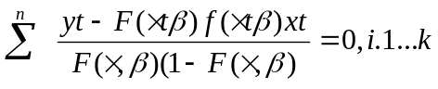
3.24 Classification/Prediction ANN
Among many applications of the feed-forward ANNs, the classification or prediction scenario is perhaps the most interesting for data mining. In this mode, the network is trained to classify certain patterns into certain groups, and then is used to classify novel patterns which were never presented to the net before(The correct term for this scenario is schemata-completion ).
This example is of particular importance since the study is on cutomer response.
Example: A company plans to suggest a product to potential customers. A database of 1 million customer records exists; 20, 000 purchases (2% response) is the goal. Instead of contacting all 1, 000, 000 customers, only 100, 000 are contacted. The response to the sale offers is known; so the subset is used to train a neural network to tell which of the 100, 000 customers decide to buy the product. Then the rest 900, 000 customers are presented to the network which classifies 32, 000 of them as buyers. The 32, 000 customers are contacted and the 2% response is achieved; Total savings is $2, 500, 000.
3.24.1 Mortgage assessment
- Assess risk of lending to an individual.
- Difficult to decide on marginal cases.
- Neural networks have been trained to make decisions, based upon the opinions of expert underwriters.
- Neural network produced a 12% reduction in delinquencies compared with human experts in investment analysis: to attempt to predict the movement
- Test mail data- Networks have been used to improve marketing mailshots. One technique is to run a test mailshot, and look at the pattern of returns from this. The idea is to find a predictive mapping from the data known about the clients to how they have responded. This mapping is then used to direct further mailshots.
- Fraud Detection - Detect fraudulent credit card transactions and automatically decline the charge Fraud detection in credit card transactions
- Targeted Marketing - Finding the set of demographics which have the highest response rate for a particular marketing campaign.
- Business applications: Credit risk, Response modeling, Demand forecast, churn prediction, Stock market prediction etc.
3.24.2 Prediction of consumer behavior
Consumer behavior seems difficult to grasp, but definitely displays typical patterns. An obvious example is the demand for ice creams on a beautiful Sunday in May. But also less obvious relationships, as for example how the sales figure of a department store depend on the weather, can be investigated through a data mining approach. A related example is the prediction of the demand for fruit juices as a function of (among others) the weather. Knowing how weather affects consumer behavior, the department store has a better grip on the allocation of its personnel and the juice company can better tune the planning of its production. More traditional techniques from statistics look at correlations in the data. In this way, linear relationships between the explanatory variables (e.g. weather variables) and the dependent variables.
More traditional techniques from statistics look at correlations in the data. In this way, linear relationships between the explanatory variables (e.g. weather variables) and the dependent variables (e.g. sales figures) can be understood. Consumer behavior may be much more complex than simply linearly dependent on explanatory variables. Neural networks can be trained on a database of explanatory and dependent variables to grasp these nonlinear, complex dependencies.
A trained neural network basically summarizes the relationship between the explanatory and dependent variables. It is possible to quantify the relevance of weather information to the sales of department stores and contrast it with the relevance of other explanatory variables such as the season or the day of the week, the reaction of different groups of retailers on changes in the price settings.

3.24.3 Applications of ANN

3.24.3.1 Prediction of Newspaper Sales

Company background
De Telegraaf is one of the major Dutch publishing companies of newspapers and magazines.

The problem
For each new issue of a newspaper or magazine, `De Telegraaf' has to estimate the number of issues that will be sold in supermarkets, bookshops, kiosks etc. Too many delivered issues result in a loss of investment. On the other hand, a sell out is a loss of potential profit and may result in unsatisfied consumers. The ideal is to deliver the number of issues that will be sold plus an additional one to verify that each customer has been able to buy it. Of course, in reality only an approximation of this ideal is feasible, as the sale of newspaper is highly determined by chance. Since there are thousands of different sales points, an automated system is desirable.
On the other hand, the applied method should be robust, since it should be used for thousands of different sales points with largely different characteristics. The number of sales could range from a handful to several hundreds for the largest shops. The variability of sales could be small or large and might depend on season as well. Sudden changes, due to a new competitor, a new location or owner, but often even without any known cause, should be detected and used for new predictions as soon as possible. Up to now, `De Telegraaf' uses a traditional multiple linear regression method.

Neural network application
The Foundation for Neural Networks (SNN) investigated the use of neural computing to provide more accurate predictions. A large number of neural networks - one for each individual sales point - has been trained on the basis of last 3 years of sale figures. The training procedure has been fully automated. This procedure is designed in such a way that sell outs - which are more undesirable than unsold issues - are avoided by the networks. Pilot studies indicate that this newly developed method could avoid up till 40% of the sell outs without increase of the number of unsold issues. Currently the system is implemented and tested at `De Telegraaf'.

Benefits
The neural networks provide better estimates of the number of issues of newspapers and magazines that should be delivered to the sales point. Importantly, a reduction of sell outs is not only an increase in sale, but also implies a reduction of unsatisfied consumers who might run to a competitor. The fully automated training procedure allows that the neural networks can easily be retrained with new data. This, combined with the fact that `De Telegraaf' uses a neural network for each individual sales point, results in a highly flexible system that easily adapts to new market situations.

Generalization
The prediction of newspaper sales is a typical problem for which no good numerical model exists. In addition, the problem has a large chance component. The fact that conventional statistical techniques performed reasonable on this task was indicative that the performance could be improved by neural networks. In a similar way, neural computing can be used for sales prediction in the food - and durables markets for department-stores and supermarket chains.
3.24.3.2 Granting of Loans
The granting of loans by a financial institution (bank or home loan business) is one of the important decision problems that require delicate care. It can be performed using a variety of different processing algorithms and tools. Neural networks are considered one of the most promising approaches. In this study, optimal parameters and the comparative efficiency and accuracy of three models: Multi Layer Perceptron, Ensemble Averaging and Boosting by Filtering have been investigated in the light of credit loan application classification. The goal was to find the best tool among the three neural network models for this kind of decision context. The experimental results indicate that Committee Machine models were superior to a single Multi Layer Perceptron model.
3.24.3.2a Boosting by Filtering outperformed Ensemble Averaging
A knowledge discovery tool has been built, the tool consisting of 3 neural network models: a Multi Layer Perceptron, an Ensemble Averaging committee machine and a Boosting by Filtering committee machine. The tool was tailored for loan applications evaluation. The experimental results confirm that committee machines are able to perform in superior manner compared to MLP, with Boosting by Filtering outperforming the Ensemble Averaging model.
With their high accuracy in classifying loan applications, all neural network models implemented in this project, can certainly be helpful for the decision making process.
3.24.3.2b Ensemble averaging results
A static committee machine model called Ensemble Averaging was the subject of the following experiment. It is argued that ensemble averaging brings stability in performance. Different weights can lead to better or worse performance and ensemble averaging compromises the two extremes by lessening the effect of choosing "wrong" weight combinations. It has been proven to be able to enhance MLP performance in other applications, like medical reports. The purpose of the current study was to find out the degree of improvement that Ensemble Averaging could provide over MLP in the context of loan application evaluation. The committee machine was built upon the ten experts from MLP experiments. The combiner program used simple voting for combining the results from these experts. As a committee, the model achieved 1.73% error on negative data, and 2.06% on all data. However, it came at the cost of increased training time (245 sec).
3.24.3.2c Boosting by filtering results
To test the performance of the Boosting by Filtering committee machine in classifying loan applications, three experts were used. Each of the experts was MLP with optimum configuration based on the result from MLP experiments. Each expert was trained with 500 epochs. The first expert on average produced 278 training instances for the second expert. The first and second expert together on average produced 38 training instances for the third expert. This shows that there were roughly 38 cases that were hard to classify and the third expert concentrated on these cases. The average performance of Boosting by Filtering indicated small error scores of 1.32% on negative data and 1.65% on all data within a reasonable training time (32 sec).
3.24.3.2d Comparative performance analysis
The overall results of the study are presented in Table below and clearly suggest that MLP performance in classifying loan applications can be further improved by committee machines models. In particular, Ensemble Averaging
Table 5: Comparative Model Performance
Neural Network Model | No.of Epochs | % Error on Negative Data | %Error on All Data | Average Training Time
Multi Layer  Perceptron | 600 | 1.81% | 2.38% | 13sec
Ensemble average  (10 MLPs) | 6800 | 1.73% | 2.06% | 245sec
Boosting by filtering(3MLPs) | 1500 | 1.32% | 1.65% | 32sec

It has been shown to be able to reduce the percentage error due to the bias-variance problem inherited by MLP model. However, on average, the improvement ensemble averaging brings on negative data classification is not great. This is evidenced by marginal 0.09% improvement on negative data. The performance on all data was more convincing with 0.32% improvement. While ensemble averaging was able to produce lower percentage errors, it did so at the cost of training time, as evident in the training time for this model compared to other models.
Furthermore, the results indicate that Boosting by filtering outperformed other models in this study. It was able to improve the performance of MLP model by 0.49% on negative data and 0.73% on all data. The boosting by filtering committee machine was the best performer in this experiment, in that it was able to produce the least percentage error. This was done at a comparatively low training time cost.
Overall, the small percentage error produced by neural network models in this experiment (1.32% - 1.81% average percentage error on negative data and 1.65%-2.38% average percentage error on all data) confirms that neural network models are well suited for loan application evaluation. The boosting by filtering committee machine shows that training different experts on hard to classify applications brings a significant performance improvement.
Boosting by filtering also shows that these performance improvements can be achieved at a low cost (less training time and computational cost).

3.24.3.2f Marketing

Maximize Returns on Direct Mail with Neural Network Software
Microsoft, a leading computer software developer based in Redmond, Washington, is using BrainMaker neural network software to maximize returns on direct mail. Each year, Microsoft sends out about 40 million pieces of direct mail to 8.5 million registered customers. Most of these direct mailings are aimed at getting people to upgrade their software or to buy other related products. Generally, the first mailing includes everyone in the database. The key is to send the second mailing to only those individuals who are most likely to respond.
Company spokesman Jim Minervino when asked how well BrainMaker neural network software had maximized their returns on direct mail responded, "Prior to using BrainMaker, an average mailing would get a response rate of 4.9%. By using BrainMaker, our response rate has increased to 8.2%. The result is a huge dollar difference that brings in the same amount of revenue for 35% less cost!"
To get a BrainMaker neural network to maximize returns on direct mail, several variables were fed into the network. The first objective was to see which variables were significant and to eliminate those that were not. Some of the more significant variables were:
- Recency - the last time something was bought and registered, calculated in number of days. It is a known fact that the more recently you've bought something, the better the chance you're going to buy more.
- First date to file - the date an individual made their first purchase. This is a measure of loyalty. The longer you've been a loyal customer, the better the chance is you're going to buy again.
- The number of products bought and registered.
- The value of the products bought and registered - figured at the standard reselling price.
- Number of days between the time the product came out and when it was purchased. Research has shown that people who tend to buy things as soon as they come out are the key individuals to be reached.
Additional variables include information taken from the registration card including yes/no answers to various questions - scored with either a one or zero - areas of interest like recreation, personal finances, and such personal information as age, and whether an individual is retired or has children. Microsoft also purchased data regarding the number of employees, place of employment, as well as sales and income data about that business. While Microsoft has designed this neural network for their own specific needs, some of these inputs could be applied to any network.
Prior to training, the information taken from the response cards was put into a format the network could use and yes/no responses were converted to numeric data. Minimums and maximums were also set on certain variables.
Initially, the network was trained with about 25 variables. To make sure the data was varied, it was taken from seven or eight campaigns and represented all aspects of the business including the Mac and Windows sides, from high and low price point products.
The model trained for about seven hours before it stopped making progress. At that point, variables that didn't have a major impact were eliminated. This process was repeated. Currently the model is based on nine inputs. Jim Minervino explains some of the other training considerations: "During training I used 'modify size' and I used 'prune neurons'; as training completes, I used 'add neuron', and we did an experiment with 'recurrent operations' although in the net model we ended up using the default."
The output was a quantitative score from zero to one indicating whether an individual should receive or should not receive a second mailing. Minervino found that anybody scoring above 0.45 was more responsive to the mailing than anybody below.
The neural network was tested on data from twenty campaigns with known results not used during training. The results showed repeated and consistent savings. An average mailing resulted in a 35% cost savings.

3.25 Chaos, Strange Attractors and Neural Net Plots
Take the last 200 years' data on cotton production. Plot a point which is one years' production versus the next years'. You get data points scattered all over the screen like stars at night. If you were to plot a LOT of points (without lines connecting them) you get a shape, like a donut. The points seem to fall on or near a circle. This is a Strange attractor.
In a Normal or Real attractor, you get dense collection of points in the middle and spreading out fading out. The price has an equilibrium, the production has an equilibrium, represented by the dense collection around a single point. A Strange attractor is an attractor for which there is not an equilibrium point.
The presence of a strange attractor means you're dealing with a chaotic system. A chaotic system is a nonlinear feedback system. In the chaotic cotton production system, what you learn by seeing the strange attractor is that there is some sort of a feedback mechanism, there is an analytic solution to what the system is doing and there is feedback around the analytic solution.
You get strange attractors when you look at the population of foxes over the years as it grows and shrinks. This is chaotic, rather than random. In a random system, you get points scattered all over with no shape whatsoever and there is no underlying mechanism, therefore any way to predict anything. In a chaotic system there is an underlying mechanism with nonlinearity and feedback. It is believed by some that because there is an underlying mechanism analytic approaches can be used to make predictions.
You can make plots to find strange attractors. You put cotton price in a column, cotton price shifted down by one in another, plot one on the X and one on the Y. Plot lots of months worth of data. You will see a donut, a Strange attractor, which indicates an underlying mechanism with nonlinearity and feedback.
3.26 Financial Services Market
Financial services has been chosen considering that (a) no of transaction are really huge (b) it is a booming sector growing at the rate of 20-30% / year (c)dictated by need to understand the customer, whether it is for lending or for seeking investments in various portfolios, considerable data is collected. The drivers of growth in consumer finance are auto finance, housing finance, consumer durable finance, credit card and personal finance. The risk faced by the mortgage portfolio performance are sharp drop in real estate prices, drop in rents, changes in tax laws removing exemptions from mortgage repayments. Auto loans can get affected by drop in resale value of automobile decrease in price of automobiles, exchanged rates. Unsecured products like personal loans and credit cards can get affected by main economic factors like employment rates, inflation, interest rates etc. Twentieth century is the era of instant buys. Research indicates that 60% of the cars bought in the last decade were through finance.
Growth of consumer finance
Consumer financing business in India has been witnessing an uptrend for the past few years and is expected to remain so in future, fuelled by sweeping changes in the consumption habits of Indian middle class (Punnathara2007) 2006-07 is more likely to go down in the country's economic history as one in which linkages between rural and urban India began to yield results. In 2005-06, the fixed farm credit was more than Rs 1, 05, 000 crore, a 30 per cent growth over the previous year. Public sector and regional rural banks added 58.20-lakh new farmers to their portfolio of borrowers. By December 2006 an additional 53.37-lakh new farmers were brought into the institutional credit system. Against this, the 2007-08 target, at Rs 2, 25, 000 crore, is extremely modest bringing an additional 50-lakh new farmers into the banking system — just 18 per cent growth over last year.
Interestingly the Retail loans have almost tripled over the past three years, according to the Reserve Bank of India, reaching $124 billion for the fiscal year ended March 31, 2007 (Raghu Mohan - 2008). ICICI Bank has been India's most aggressive bank in the retail market, using the Internet, phone banking and automated teller machines to target the increasingly affluent middle class. As of March 31, 2007, retail loans accounted for 65% of the bank's total amount of money the bank has lent.
But the change has come at a cost. The bank's gross nonperforming loans in the retail segment more than doubled during the financial year ended March 31, 2007, rising from $364 million to $790 million, and accounted for almost 74% of all its bad loans by value, Rob Katz(2008). And defaults are expected to keep rising, according to a Fitch Ratings report on Indian banks released recently. Loans are typically classified as nonperforming if a customer fails to make payments for 90 days. At that point, banks are supposed to issue legal notices to those in default.
According to a source of RBI, personal loans recorded a growth 34.9% by December 2006 whereas the default rate trended around % in auto loans, 5-6 % percent in personal loans and 11-12 % in credit cards. State bank of India data gives a default rate of 5-10% in the housing loan sector.
The increase in NPAs is due to the change in the portfolio composition. And with the unsecured portion as percentage of total loan portfolio going up while this segment has credit loss, it has higher income. Unsecured loans of the bank account for about Rs 22, 000 crore, or 18 per cent of the total retail loan portfolio of Rs 1, 32, 311 crore. The increasing exposure to higher risk customers is mainly through personal loans and credit card receivables. These are unsecured in nature and now form 17 per cent of total outstanding retail loans in March 2007, up from 6 per cent in 2004, according to Crisil data. Delinquencies across all retail asset categories have gone up and are likely to further increase in 2008-09. Gross NPAs in housing loans, which constitute over half of the total retail loans in India, has increased to 2.2 per cent in March 2007, from 1.8 per cent in 2005; these are expected to increase to 2.7 per cent in financial year 2008-09. Gross NPAs in these segments have increased to 2.3 per cent and 4 per cent as of end March 2007, from 0.9 per cent and 3.2 per cent respectively in 2005. In 2008-09, these numbers are seen at 3 per cent for car loans and 5.5 per cent for commercial vehicles, according to Crisil. ‘Sub-prime’ assets in India are still relatively low at 7 per cent of total outstanding retail loans. The rating agency estimates the loss levels in this segment to be currently at 7 to 9 per cent, and expects them to increase to 10 to 13 per cent over the medium term, George and Chakraborty (2008).
It has been found that the high end Indian consumer has the same aspiration as upwardly mobile buyers around the world. At the, other end of the spectrum there are 300 million of middle class.
There are Tier 2 towns with population of 500000 where shopping malls complete with Movie Theater, pizza parlour and other food chains are pepping up.
There is more spending power and importantly there is an increasing willingness to spend. This is being aided by growing availability of consumer finance which in turn is spurring up industrial growth as manufacturers lift output to meet demand.
In the past rural consumers in particular were conservative and averse to debt. But now that there is a radical shift in the ethos of the Indian Society across the section there is no qualms or inhibition among people to take a loan for a house, vehicle, consumer durable or jewels, or education. Buyers are willing to downgrade some of the FMCG purchase.
India's geography, languages, cultures, demography is so diverse that there is no one model that fits all of its 1 billion consumers.
Growth of GDP was 4.0 in 2002, 8.2% in 2003, 6.4% for 2004 and 6.2 for 2005.
3.26.1 Consumer Financing Business In India-One of the Kick Starters Of Indian Economy?
Consumer financing business in India has been on an uptrend recently and is expected to remain so in future, fuelled by sweeping changes in the consumption habits of Indian middle class. The burgeoning middle class with high disposable income, the youngest population in the world, the increased acceptance and use of credit cards, the increased demand for housing loans spurred by attractive tax breaks, the changing living styles and the consumption patterns still offer a lot of potential for a strong growth of retail business in the country, when compared with global trends. Peoples’ ethos and attitude changed towards using credit to acquire all comforts in life. There is still huge unexplored opportunity in the retail banking segment. To drive home the point, Taiwan, a developing nation, whose retail loans are 41% of GDP as compared to India where it is less than 5%.
There are 300 million middle income earners in India with an annual take home income of USD 2000 to 4000 a year, with much higher purchasing power than the figure would indicate. Economists say that the take off point to car purchases is at an annual income of USD 3000 in Asia.
So, the financial services companies realized the potential and started growing at phenomenal rates. Naturally, many more jumped into the bandwagon not leaving the MNC banks and the public sector banks. People use credit for various purposes including housing, four wheeler and two wheeler, educational needs, personal needs, consumer durable needs etc., Akash Guptha(2004).
3.26.2 The Boom and Thereafter
As fallout of the boom in the financial services sector a host of other sectors like auto, consumer durables, construction materials etc. also tend to boom which in turn increase consumer spending.
But the flipside of this is the risk of default and delinquency and the accumulation of NPA resulting in loss. After all the efforts for collection have proved futile, when the company goes for realization of the debt by disposing of the assets like the automobiles or the immovable properties, they are susceptible to the market conditions, and sometimes it might happen that the realized value is less than half of the outstanding. Even delayed payments and the consequent increase in collection expenditure would eat into the margins which are already razor thin, thanks to the cut throat competition in the market.
The plateauing of the top line is perhaps because all the low hanging fruits have been exhausted by the scramble by all the companies. Now the companies have to be innovative in their market mix to get a share in the pie. Hence the market is left with the options of speedy processing as the only significant differentiator and reach to newer segments as the only way to make volumes. And more importantly Financial services Companies are exploring and reaching out to newer markets like Rural India.
Talking about Finance Giants getting into retail consumer financing, the sourcing of customers and transaction processing is outsourced to regional players by means of direct selling agents. One of the biggest impediments in foreign players leveraging the Indian Markets is the absence of positive credit bureaus. In the west the risk profile can easily mapped. What has been a positive step towards this is a negative file sharing/g started by a consortium of 11 banks.
But actual write off of NPAs shows a strong negative correlation with sharing of positive information. On top of this spend now - pay later culture in India is just not picking up. A swift legal procedure against consumers creating bad debt is virtually non existent.
3.26.3 Untapped Markets - Rural India? (India Infoline.Com, Sep 3, 2003)
70 % of India’s population lives in 627000 villages in rural areas. 90 % of the rural population is concentrated in villages with a population of less than 2000, with agriculture being the main business. This simply shows the great potentiality rural India has to bring the much-needed volumes and help the FMCG companies to bank upon the volume-driven growth. This brings a boon in disguise for the FMCG Company who has already reached the plateau of their business curve in urban India.
As per the National Council for Applied Economic Research (NCAER) study, there are as many 'middle income and above' households in the rural areas as there are in the urban areas. There are almost twice as many 'lower middle income' households in rural areas as in the urban areas. At the highest income level there are 2.3 million urban households as against 1.6 million households in rural areas.
According to the NCAER projections, the number of middle and high-income households in rural India is expected to grow from 80 million to 111 million by 2007. In urban India, the same is expected to grow from 46 million to 59 million. Thus, the absolute size of rural India is expected to be double that of urban India.
So much for the vital statistics of the financial market but without belaboring further, it is to be understood that the critical success factor for the retail financing business is good risk management.
3.26.4 The Problem of Limited Access to Financial Services and Stable Incomes in Rural India
(Survey covered over 30 million small scale units across India, Agricultural Rural development working paper 9, The World bank.)
For the rural poor in India, formal financial services would enable them to maximize returns on their surplus, smooth their consumption, and reduce their vulnerability to risk. However, their financial service needs—which include consumption credit and cash savings (Duggal, 2002)— are seldom met due to systemic problems in the financial sector and monsoon risk. In 1991, a comprehensive household survey addressing rural access to finance revealed that barely one-sixth of rural households had loans from formal rural finance institutions (RFIs). In fact, the survey found that only 35-37 percent of the credit needs of the rural poor were met through formal RFIs. This means that the share of household debt to informal sources is as high as 52-62 percent, at annual interest rates ranging from 36-120 percent.
Another study by Price Waterhouse Coopers in 1997 indicated the dependence of low-income households on the informal sources for finance to be as high as 78 percent. A survey based on the Economic Census of 1998, showed that India’s formal financial intermediaries, through their commercial lending programs, reportedly meet a mere 2.5 percent of the credit needs of the unorganized sector. Beyond credit, most of the rural poor also lack access to the banking system for savings.
According to a leading microfinance practitioner in India (Mahajan, 2001), the transaction costs of savings in formal institutions were as high as 10 percent of the savings amount for the rural poor, due to the small average size of transactions and the proximity of rural villages to bank branches. Farmers respond to the lack of formal financial services by turning to moneylenders; reducing inputs in farming; over capitalizing and internalizing risk; and/or by over diversifying their activities which leads to sub-optimal asset allocation.
The combined effect of these coping strategies is a poverty trap. Smallholders cannot risk investing in fixed capital or concentrating on the most profitable activities and crops, because they cannot leverage the start-up capital and they face systemic risks that could wipe out their livelihoods at any point in time. The challenge for banks is to innovate a low-cost way of reaching farmers and helping them better manage risk.
3.26.5 Evolution and Growth of Financial Services / Banking
Traditionally, debt requirements of the public were met by money lenders and when banks came into existence some of the banks offered loan against jewels. Then, banks started lending to public as mortgage loans. Primarily in the urban sector it was mortgage loans for immovable property and in the rural sector, for agricultural inputs.
From a 19% growth in 1999, when the retail loans started getting a thrust, the growth hasshot up to a whopping 51% in 2002-03. The fastest growing segment in the banking industry, retail banking has posted a 25-30% CAGR for the past five years and constitutes 22% of the total loan outstanding of banks in India. The banking industry is shifting gear towards volumes rather than quantum. More than 50% of the incremental credit these days goes to retail. (Prof. T.S. Ramakrihna Rao, 2004)
Here an attempt has been made to use different methods like multiple regression, logistic regression, discriminant analysis, factor analysis, answer tree analysis and neural network, compare their performance and ascertain the model which has the highest prediction accuracy. This encompassed analysis of a large data base, qualitative analysis of data gathered by interviews with borrowers both good and bad in various rural, semi urban and urban areas. However the whole study has been carried out with underlying emphasis on rural areas in line with the focus of the client.
3.26.6.6 Why Rural?
- Sustainable development of the global economy can take place only by inclusion and equity of the rural whether it is in India, China, Africa, South America etc.
- For the rural poor in India, formal financial services would enable them to maximize returns on their surplus, smooth their consumption, and reduce their vulnerability to risk.
- However, their financial service needs—which include consumption credit and cash savings (Duggal, 2002)— are seldom met due to systemic problems in the financial sector and monsoon risk.
- Dependence of low-income households on the informal sources for finance to be as high as 78 percent (study by Price Waterhouse Coopers in 1997)
3.26.7 Microfinance Opportunity in India
“There is enormous opportunity for a greatly enlarged, thriving and economy building microfinance industry in India, ” Motshegare believes. According to Motshegare it was reported that “The majority of the population is un banked: 60% of the population has no access to deposit products and 80% have no access to credit products and yet most are Self Help Groups, creditworthy with a loan recovery rate of 98%. An encouraging development is the increase in Self-Help Groups (SHGs), especially in rural areas, giving rise to stronger flows of micro-credit as a result”. Some 90% of SHGs are run by women.” (Anto Bodimo, 2003).

Fig. 9 : Rural Economy Statistics
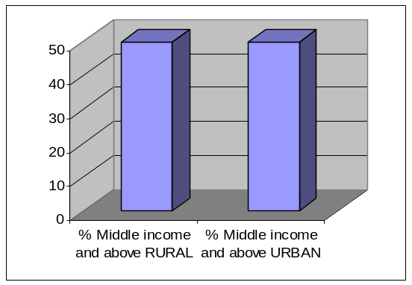
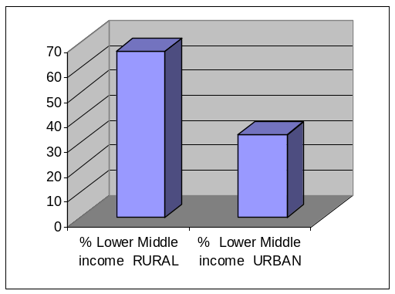
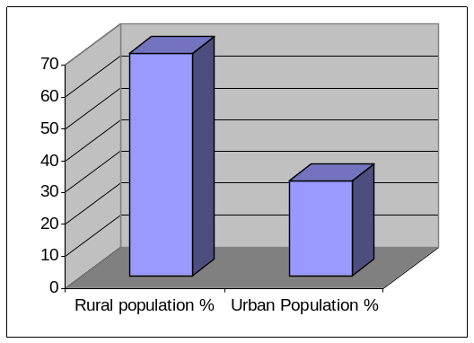
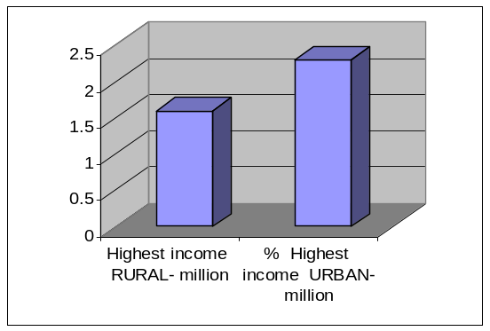

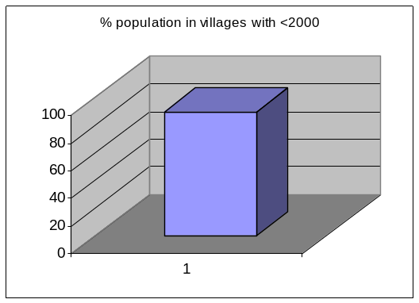

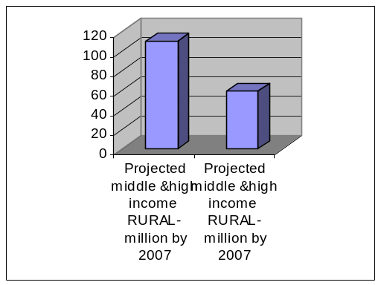

3.27 Risk Management
According to Christine Pratt, Tower group analyst, lenders do a pretty good job of managing real credit risk which she defines as individual credit worthiness as well as insider loan fraud but are still managing the overall portfolios’ credit risk reactively and not proactively, she says. In 2003 consumer indebtedness totaled about $9.09 Trillion in U.S., according to Pratt who notes, mortgages account for 66% of the sum, home equity 10%, auto loans 7%, credit cards 7%, small business loans 6%, student loans 3%, autoloans 1%and rising credit balances often points to declining quality of loan portfolios. ( Karen krebs bach 2004)
Good risk management with the advanced communication technologies has led to an online processing and loan disbursement decision in a matter of hours. Having said that, a badly designed credit scoring system could lead to the loss of good customers or lending to bad customers. At the same time, being overcautious would not lead to improving top line and bottom-line. Hence the capability of the models to predict accurately the good customer and bad customer need not be overemphasized. Both Type I and Type II could be killers in retail financing. Bower is of the opinion that risk management practices in the consumer lending business are generally much stronger than in the early 1990s and the industry is far better positioned to weather the current economic downturn than it was a decade ago. (Peter Burns Anne Stanley, 2001)
3.28 BIS Basel New Capital Accord
The Bank for International Settlements (BIS (2001), p. 55) defines retail credit as, “Homogeneous portfolios comprising a large number of small, low value loans with either a consumer or business focus, and where the incremental risk of any single exposure is small.” These types of loans include loans to individuals such as credit cards, residential mortgages and home equity loans as well as other personal loans such as educational or auto loans. Small business loans could also be included as long as the bank treats these facilities the same way it treats other retail credits.
The proposed Basel New Capital Accords allows banks to choose among several approaches to determine their capital requirements. The Standardized Approach allows less sophisticated banks to use external credit ratings to classify the bank’s assets into risk classes. Over time, banks are expected to evolve to the Internal Ratings-Based Approaches (Foundation and Advanced) that rely on the bank’s own experience in determining the risk characteristics of various asset classes.
For example, the Foundation IRB Approach for corporate, sovereign, and bank exposures allows banks to provide estimates of probability of default, but requires banks to use supervisory estimates of loss given default, exposure at default, and maturity. The Advanced IRB Approach for such exposures allows banks to provide estimates of PD(Probability of default), LGD(Loss given default), and EAD(Exposure at default of retail assets), and requires banks to provide estimates of maturity. (Linda Allen, Anthony Saunders, 2003)
3.29 Credit Scoring Models
The most commonly used traditional credit risk measurement methodology is the multiple discriminant credit scoring analysis pioneered by Altman (1968). Mester (1997) documents the widespread use of credit scoring models:97 percent of banks use credit scoring to approve credit card applications, whereas 70 percent of the banks use credit scoring in their small business lending. There are four methodological forms of multivariate credit scoring models: (1) the linear probability model, (2) the logit model, (3) the probit model, and (4) the multiple discriminant analysis model. All of these models identify financial variables that have statistical explanatory power in differentiating defaulting firms from non-defaulting firms. Once the model’s parameters are obtained, loan applicants are assigned a Z-score assessing their classification as good or bad. The Z-score itself can be converted into a PD.
One of the most widely used credit scoring systems was developed by Fair, Isaac and Co. Inc. (FICO). During the 1960’s and 1970’s, the firm created credit scoring systems tailored to meet the needs of individual clients, mainly retail stores and banks in the United States. In the 1980’s, Fair, Isaac serviced more industries including insurance, as well as more countries in Europe. During the 1990’s, the firm developed products to evaluate credit of small businesses including trade credit (CreditFYI.com) in 1998 and loan credit (LoanWise.com) in 1999. Personal credit evaluation became more accessible with the development of myfico.com in 2001. Customers can determine their credit score directly using the internet.
Credit scoring systems vary according to the information they evaluate and how they evaluate it. For example, Fair, Isaac assesses credit reports and credit history to determine a score that ranges between 300 and 850. The assessment considers all outstanding debt such as mortgage loans and credit card balances as well as the proportion of balances to credit limits on credit cards. Payment history, such as whether and how often an individual was late in making payments as well as the length of the credit history is also included. The evaluation does not include characteristics that could bias a lender such as race, religion, national origin, gender, or marital status. How ever, the evaluation also ignores salary and occupation so that a person with a good, steady income and a history of always paying his/her credit card receivables may not achieve a perfect score.
Risk management encompasses discrimination of good and bad customers, prediction of default and perhaps proper collection mechanisms depending upon the credit risk of the customer. Most of the financial companies classify the customers based on a credit score card, where different attributes are assigned scores which vary from customer to customer depending upon their demographic factors. A cutoff score is fixed and credit is given as long as the score is more than this. The variations in the package involve interest rates, down payment, EMI, loan tenure, pre-processing, time and fees and the documents required for the processing.
3.30 A Case for Credit Scoring
There are several benefits from credit scoring. It promotes great efficiencies and time savings in the loan sanction process. In the traditional scheme of things the sanction process could take anywhere between three days time to almost a month. The implementation of credit scoring can reduce it to a couple of hours. The tremendous growth in the retail credit industry has spurred the need for credit scoring
A few companies have made the credit scoring more rigorous by developing scoring models which use customer data to develop statistical models. These scoring models could be used to classify / categorize / rank customers. This could be used for risk based pricing. Also, at the stage of collection, for defaulters with higher score; a reason could be some spikes in expenses or bottoming of income, for which the payments could easily be streamlined. For defaulters with lower scores, collection mechanisms need to be different.
“A score is but one element of a larger set of subjective factors that go into the lending decision; since we buy credit on the character and the strength of the customer, it is necessary to look at subjective and personal factors, and not just analytical aspects". (Jack Hanley, executive vice president and CAO).
The probability acceptance models will become increasingly important as the consumer lending market matures and it becomes a buyers’ rather than a sellers’ market. They are ideally suited to the interactive application processes that modern telecommunication technology is supporting. They also satisfy the customer relationship marketing credo of tailoring the product to the customer (L. C. Thomas, Ki Mun Jung, Steve D. Thomas, Y. Wu 2004)
3.30.1 Credit Scoring for Microfinance: Can It Work?
In rich countries, lenders often rely on credit scoring-formulae to predict risk based on the performance of past loans with characteristics similar to current loans to informed decisions. Can credit scoring do the same for microfinance lenders in poor countries?
Mark Schriener of “Microfinance risk management, Louis, USA”, argues that scoring does have a place in microfinance. Although scoring is less powerful in poor countries than in rich countries, and although scoring will not replace the personal knowledge of character of loan officers or of loan groups, scoring can improve estimates of risk. Furthermore, the derivation of the scoring formula reveals how the characteristics of borrowers, loans, and lenders affect risk, and this knowledge is useful whether or not a lender uses predictions from scoring to make daily decisions. In the next decade, many of the biggest microfinance lenders will likely make credit-scoring models one of their most important decision tools.
3.30.2 Data mining
Data warehousing and data mining have become so powerful tools of analysis that combined with the incredible computing power, the huge customer database available with the lending companies could be used for modeling and prediction. It is said that past performance does not guarantee future results, but in the world of credit decisions, history often proves to be a reliable indicator (A Zanasi, CA Brebbia, NFF Ebecken & P Melli). Datamining brings out all the hidden information, and with the advanced computing power, the datamining capacity in terms of volume of data and the complexity of relationship hidden in the data, the possibility to bring out strategic information and accurate predictions is indeed mind boggling.
3.30.3 Demographic and Behavioral aspects
In designing retail credit risk models there appears to be widespread belief that models should recognize major changes or disruptions in `lifestyle' variables; examples include such events as divorce, termination of employment, heart attack. In many cases, the lifestyle data is only available in small samples at critical points of time and may be buried or hidden from view in the data on characteristics of individuals that is normally available. Nevertheless, the effects of lifestyle data may influence some of the characteristics in the standard datasets.
Özdemir’s Özlem (2004) study examined the probability of risk of default in terms of various financial and demographic variables and serves a useful function for creditworthiness. Their study is unique and important in many aspects. First because it examines the relationship between consumer credit clients’ payment performance and their demographic characteristics whereas most previous research has been done on consumer credit applicants. Financial variables, are included in addition to the demographic variables, while most of the previous studies done on clients’ payment performance dwell upon only demographic variables.
Second, the findings may enable banks and financial institutions to optimize their lending policies without changing their market structure and potential clients.
Third, this study is the first attempt to collect adequate information about how to decrease the credit default risk and develop credit scoring criteria for the banking sector in Turkey.
The empirical results indicate that financial variables rather than the demographic characteristics of clients have a significant influence on customers’ payback performance. Thus, the longer the maturity time, the higher the interest rate, and the higher the credit default risks. This suggests, bankers apply appropriate adjustments to financial variables in order to minimize credit default risk.
In order to understand the findings and interpretation of the results of this study better, one has to keep in mind the dynamism of the Turkish economic environment. At the end of the study in June 2001 Turkey has been announced as a risky country by S&P in terms of credibility, where as at the beginning of the study in January 2001
Turkey’s credibility mark was B+. This unstable economy causes fluctuations in interest rates and currency rates, thus debtors’ payback ability.
3.30.4 Analytics
Predictive Analytic scan help significantly improve customer response to marketing campaigns (Nicholas M. Kiefer and C. Erik Larson)
Model should have Internal Validity (Changes in dependent variables should be produced by changes in independent variable only) and External Validity (Valid across different subjects, settings and methods), (Cook& Campbell) on Credit Scoring models.
3.30.5 Predictive Models
3.30.5.1 Credit Risk and Related Models (Developed from actuarial
models)
A default model with two states (default, not default) calculates capital requirement based on actuarial approaches found in the property insurance literature. It has minimal data input but only gives loss rates, not loan value changes. It assumes each loan has a small probability of default that is independent of default of other loans. So the distribution is Binomial; one usually takes the Poisson approximation to get analytic expressions. The severities of losses are put into bands; combining frequency of default and severity of losses gives distribution of losses for each exposure band which are then summed across exposure bands. Most of these results can be applied to consumer loans, but it was pointed out the model proves difficult if default probabilities are high (above 4%) since the Poisson approximation is no longer valid and one would need to simulate using the Binomial distribution.
(David Feldman and Shulamith Gross (2003)) portray the usefulness of CART as a classification tool and compare with other traditional statistical classification tools. Flexible and computationally efficient are the nonparametric Classification and Regression Trees (CART) [Breiman, Friedman, Olshen, and Stone (1998) have applied (BFOS)] algorithm to the real estate analysis of mortgage data. CART’s strengths is in dealing with large data sets, high dimensionality, mixed data types, missing data, different relationships between variables in different parts of the measurement space, and outliers. Moreover, CART is intuitive and easy to interpret and implement.
CART classifies individuals or objects into a finite number of classes on the basis of a collection of features, or independent variables. CART uses binary trees, a method that Morgan and Sonquist introduced in the sixties at the University of Michigan and Morgan and Messenger developed there in the seventies into an ancestor.
CART can be used as as a classification tool and also a regression tool. In fact, any guided classification, including the CART algorithm, may be regarded as a regression method where the response variable is categorical. Presented this way, it becomes evident that CART’s chief competitors are discrimination methods in general, and polytomous logistic regression in particular.
If any mortgage data is taken for the binary classification of borrowers into two risk classes: potential defaulters and those unlikely to default. The database referred to as a learning sample is used, to develop the decision rule for the classification. Learning sample consists of data both on the predictors, which are independent variables or features, and on the binary outcome variable: defaulted, or did not default. Learning sample consists of data on 3, 035 mortgage borrowers. The features include asset value, asset age, mortgage size, the main applicant’s occupation, income, and family information, and other characteristics of the asset and the applicant, thirty three features in all.
3.30.5.2 Why CART?
A particularly important CART feature is its treatment of missing data. Regression, including logistic regression, and other classification methods that use feature data to associate individual cases with one of two or more classes, require the elimination of whole observation vectors when even one of their elements is missing. CART seems to have introduced a novel way to deal with missing data efficiently, particularly for classification and prediction.
Classification algorithm creates a simple binary tree structure. Then, it uses this tree structure to classify new cases. In the likely event that a case with missing features is presented to be classified, CART offers alternative trees for each combination of missing features.
Among the important facilities that CART offers is a weighting facility. This facility is particularly relevant when the learning sample does not represent a simple random sample from the population, e.g., when the sample is stratified.
For example, when the tree is intended to discriminate between members of a very rare class in the population, and the remainder of the population, it is often advantageous to “oversample” the rare subset of the population. Weighting the different classes in a way that compensates for their proportion in the population allows CART to produce a consistent classification procedure. A Bayesian decision maker will also find a Bayesian classification feature in CART, where the user provides subjective class probabilities that the algorithm uses to evaluate error rates of candidate trees using its Cross Validation facility, before making its final tree choice. These prior probabilities serve in effect as user selected class weights, and are therefore useful for analyzing data from complex samples, even when the researcher is not an avowed Bayesian.
For selecting the best classification tree for a particular set of requirements, and to evaluate the classification performance of a selected tree, CART uses robust methods such as Cross-Validation. As is well known, a naive classification error-rate that is computed directly on the entire data set tends to be over-optimistic.
It is usually recommended that a certain portion of the data be kept out of the classification tool selection process, and then be used for testing the selected classification tool. When CART constructs a classification tree, it performs this procedure, usually called Cross- Validation, automatically. CART divides the data into K (usually 10) equal parts, using K-1 parts to construct the tree, and testing it on the remaining data, repeating this procedure K times.
CART handles independent categorical variables as easily as continuous ones, and is resistant to outlying values present in one or more continuous features. CART’s resistance to outliers is due to its use of splits of the form X≤s or X>s. Such splits hardly depend on outlying values. Furthermore, the splits considered by CART are invariant under monotone transformations. That is, any monotone transformation such as log or square root, of one or more of the features, does not alter the final tree. Therefore, CART does not require any pre-transformation of the data.
Because the selection of candidate variables for splitting may be too limiting, CART permits the expansion of the set of candidate variables to include linear combinations of variables in the feature set. Naturally, any user who wishes to use a different function of existing features may define it and add it to the feature set. Moreover, the choice of features to be included in the feature space will depend on the subject matter, and is left to the user to select.
The process of selecting the features to be included in the tree, and the structure of the binary tree itself is completely automatic. No expert statistician is required to reduce the number of features to a manageable number, and transformations are required.
Another advantage of CART stems from the tree structure of the decision algorithm: decision processes of subgroups in the population may reveal themselves. In addition, CART is computationally efficient, and has unusual ability to find quasiefficient combinations of features for classification.
3.30.5.2.1 CART and Its Competitors
The task of predicting a binary outcome from a collection of relevant features is traditionally carried out using well known tools such as logistic regression. There are two main types of logistic regressions: the completely parametric linear one, and the nonparametric additive one, Hastie, Tibshirani, and Friedman (2001). In the latter, functions of the features are inserted into the logit function additively, and the form of each function is left open and is estimated by the data. In our case, the logit would have been the log of the odds of being classified a likely defaulter. These two logistic procedures may be considered complementary. When the dependence of the logit on the collection of features is patently non linear, the additive logistic procedure is usually adopted.
Another class of classifiers is the linear, quadratic, or nonparametric discriminant analyzers [Hastie, Tibshirani, and Friedman (2001)]. The first two procedures divide the feature space into two complementary subspaces assuming normality of the features. This assumption is unlikely to hold in most cases, particularly when many of the features are ordinal or nominal categorical variables, as is common in business data. The nonparametric procedures include K-nearest neighbor rules, partial least squares classifiers, or neural networks.
The logit function is the log of odds function. Thus if the odds are n:k (p/1-p), the logit function is log(n/k) [log(p/(1-p))]. The logit function is also the inverse function of the logistic cumulative distribution function.
Roughly speaking, linear, non-linear, and non-parametric analyzers divide the space of features, linearly, non-linearly, and by ordinal ranking, respectively.
The K-nearest neighbor rule due to Fix and Hodges (1958) may be succinctly defined as follows: Let d(X, Y) be a distance function, say Euclidian distance, between two points, X, Y in the feature space.
When we compare CART to traditional methods, we note that, as is the case of CART, traditional methods do not truly search for an optimum model in an organized fashion. Consider logistic regression, or discriminant analysis (of any type). Given a group of features, these procedures will find the optimal coefficients for the linear or quadratic function that will split the feature space into subsets that are predicted to belong to different classes. But ‘optimality’ here is definitely model-dependent.
Model parameters that are optimal under the assumption of a logistic model are not, strictly speaking, optimal under a probit model. Thus optimality is contingent on the model assumed. In order to find the optimal model, logistic regression and discriminant analysis may, depending on the software used, search for the optimal subset of independent variables that minimizes the Akaike information criterion (AIC), or similar criteria, among all models built on the given features. In the case of logistic regression for example, that choice, optimal for estimating the probability of belonging to a given class (e.g., being a potential defaulter in our example) provided the logistic model is correct, may not be optimal for predicting class identity (e.g., potential defaulter).
As is well known, the use of logistic regression for classification usually involves the application of ROCs (Receiver Operating Curves), and the use of the latter is not fully understood in terms of optimal classification. The curve helps determine the cutoff probability p* that separates class predictions (in the binary classification case). If the estimated conditional probability of being a ‘case’ exceeds p*, the individual is classified as a ‘case’, and a ‘non-case’ otherwise. However, the rules governing the choice of p* are not clearly associated with any single optimality criterion. It is also unclear that an integer K>0. Classify a new point X into class j if the largest number of points among the K points nearest to X that belong to one class, belong to class j.
The probit function is the inverse normal cumulative distribution function.
AIC is a likelihood related criterion used to compare parametric statistical models (particularly non nested ones).
A ROC curve is a plot of the sensitivity versus one minus the specificity as a function of the splitting value, for a binary classifier. Please see next paragraph for the definitions of sensitivity and specificity. Optimal estimated logits, and the subset of features selected, lead directly to ‘optimal’ classification.
The various discriminant procedures lead directly to classification, without the estimation procedure required by logistic regression. Nonetheless, the latter is usually found to be more efficient when the specificity (the probability of classifying non-cases as such) and sensitivity (the probability of classifying cases as such) achieved by the two procedures are considered. The fact that linear and quadratic discriminant analysis are based on the assumption of normal data may explain their lack of efficiency in real data.
Several authors have addressed the question of the relative efficiency of tree based methods such as CART, neural networks classifiers, and logistic regression, including spline-based logistic regression. For comparative studies of the various methods, see for example Rousu, Flander, Suutarinen, Autio, Kontkanen, and Rantanen (2003), and Moisen and Frescino (2002). Of the many remaining traditional classification methods, some of the particularly effective ones are given in Breault, Goodall, and Fos (2002), for a study that considers probably most methods of classification in use, but uses a questionable method of comparison on real data). Two that we find particularly interesting are the Partial Least Squares (PLS) discrimination procedure, and neural networks for Discrimination.
Both methods start out with the complete set of features to predict a response variable with a finite number of classes, but create a smaller set of “factors” on which they define a classification rule. PLS sequentially selects “factors” that maximize the correlation between the response (corrected for previously extracted factors). In the spline based logistic regression, spline functions (piecewise polynomial functions) are fitted to each independent variable before it is entered into the linear form in the logit function. This may increase the efficiency of the method as a classifier, although this has not been definitely shown, but it certainly renders the method even more remote from practical experience, and renders interpretation far harder than traditional linear logistic regression. The number of factors thus defined is usually left to the user.
Neural networks algorithms for discriminations usually build a simple feed-forward network, in which variables are divided into layers. The input layer contains all the features, or independent variables. The output layer contains all the response variables, and the sandwiched layer contains the unobservable, or latent, variable layer. Arcs connecting variables in different layers describe the general functional structure of the neural networks that optimizes the prediction of the output layer from the input layer by a nonlinear function of weighted linear combinations of input variables. The structure is reminiscent of factor analysis, with the important difference that the latter does not allow non-linear functions. See Goel, Prasher, Patel, Landry, Bonnell and Viau (2003) for a detailed comparison of CART with neural networks in the field of agricultural economics. Markham, Mathieu, and Wray (2000), analyzed a just-in-time kanban production system using CART and neural networks. They found the two methods “comparable in terms of accuracy and response speed, but that CARTs have advantages in terms of explainability and development speed”.
De'ath and Fabricius (2000) analyzed ecological data of soft coral taxa from the Australian central Great Barrier Reef. They found that for their data, CART dominated its competitors, primarily linear models in their case, because “1) the flexibility to handle a broad range of response type, including numeric, categorical, ratings, and survival data; invariance to monotonic transformations of the explanatory variables; 2) ease and robustness of construction; and 3) ability to handle missing values in both response and explanatory variables. Thus trees complement or represent an alternative to many traditional statistical techniques, including multiple regression, analysis of variance, logistic regression, log-linear models, linear discriminant analysis and survival models.”
The circumstances under which CART is particularly recommended are precisely the circumstances that stomp CART’s major traditional competitor, logistic regression. The traditional competitors to CART do not in general handle well data sets that include a large number of explanatory variables relative to the number of cases; they also require data homogeneity, i.e., the same relations among the features all over the measurement space.
Another compelling reason for adopting CART over traditional model-based classifiers is its intuitive appeal. Most statistics consumers would find nonlinear, generalized regression, such as logistic regression, far less intuitive, and far more indirectly related to their application than CART’s classification tree. The latter represents in a simple and accessible tree structure the decision process associated with the classification. Generally the tree involves only a small fraction of the features available in the data, and gives a clear indication of the importance of the various features in predicting the outcome. CART requires no intensive interpretation for understanding the output, as is the case, for example, in logistic regression.
It is not to be argued, however, that under any circumstances, using CART dominates using one of CART competitors, or a combination of CART and alternative methods. For many data sets CART produces trees that are not stable. A slight change in the learning sample data may alter the structure of the tree substantially, although it will not alter its discrimination ability very much. This property exists in data sets with markedly correlated features. This property is of course shared by other methods, and is well recognized by users of linear or logistic regression. In CART, the problem translates into the existence of several splits at a single node that are almost equivalent in reducing the total diversity of the daughter nodes. The selection of a particular split is then rather arbitrary, but may lead to widely different trees. This instability implies that users must beware of over-interpreting the location of certain features in the tree produced by CART, despite the temptation to do so (see BFOS). On the other hand, this property implies the availability of different trees of similar discrimination capacity which allows flexibility in the choice of the features used by the tree, an advantage under many circumstances.
CART is not a fully efficient (in the statistical decision sense) alternative to traditional classification methods. CART’s occasional reduced relative efficiency stems primarily from its recursive nature, which is also the secret to its transparency and simplicity, and the fact that it does local optimization on single variables at a time. At each node, CART considers all available features, and all possible splits on those features, to choose the best feature and the best split that will create the least internally diverse pair of daughter nodes. This is done with complete disregard for the history of splits carried out in previous tree nodes, leading to the present node.
The recursive nature of the CART algorithm then, and its consideration of one feature at a time, instead of working on multiple features at a time, as most other parametric and nonparametric methods do, suggests that CART cannot be as efficient in predicting class affiliation as truly multivariate methods. However, the truly multivariate methods will also tend to be more opaque than the recursive, single-variable at a time CART. It is important to note here, however, that CART does allow the user to select linear combinations of features, precisely to overcome the locally single-variable feature of the method.
When should CART be preferred to traditional methods then? For small data sets CART tends to provide somewhat less accurate classifications, when compared to logistic regression for instance. For most users, however, and certainly in applications such as default risk classification, where transparency and ease of use are of paramount importance, a small loss in accuracy is not decisive. In simulation experiments carried out by BFOS, it was shown that in most simulated learning samples CART performed (in terms of true misclassification rate) as well or better that the K-nearest neighbor rule, except for one data set. They also compared CART to a stepwise (in deciding which features to retain in the discriminant function) linear discriminant rule. The latter was found slightly more accurate than CART, but of course its form is less appealing than CART’s decision tree rule.
3.30.5.2.2 CART and Traditional Classification Methods in Management Applications
Classification has found various applications in business areas both as a sole tool of analysis and in combination with other analysis tools. Frydman, Altman, and Kao (1985) report on the use of decision trees for financial analysis of firms in distress, and compare it to discriminant analysis. Trostad and Gum (1994) describe the use of CART following a dynamic programming solution to a range of culling decisions. Finally CART is used as a data pre-processor, before the data is submitted to systems such as neural networks. Kennedy (1992) discusses the importance of classification in accounting, and examines the performance of seven methods of multiple classification, including classification trees. He stresses that the comparison of classification trees with logistic regression have yielded mixed results. That situation remains true to this day.
Simulation results seem to prefer logistic regression, but in real data the differences are minimal, and not all research appears to use robust methods, such as cross validation, to carry the comparisons in real data.
Faraggi, LeBlanc, and Crowley (2001) report on an interesting use of CART following a neural networks analysis of censored regression data. The output (predictions) from the neural networks was fed into CART, and a classification procedure resulted, despite the incompleteness of the data. For more on the topic of hybrid methods, see Michie, Spiegelhater and Taylor (1994), Kuhnert, Do, and McClure (2000), and Averbook, Fu, Rao, and Mansour (2002).
In Marketing, CART could be useful in analyzing data consisting of price, product information, and consumer information together with brand choice. O’Brien and Durfee (1994) use and compare classification tree software for market segmentation. Haughton and Oulabi (1997), compare CART and CHAID (Chi-Square Automatic Interaction Detector) in analyzing direct marketing data and find them comparable. CART has been extensively used in the fast developing field of Data Mining, and the field of Medical diagnosis. Pomykalski, Truszkowski, and Brown (1999), suggest an approach to developing an expert classification system.
In the finance literature, Hoffman (1990) reports (in German) on the use of tree methodology for credit scoring. Chandy and Duett (1990) use CART, multiple discriminant analysis, and logistic regression to rate commercial paper and report 85% success. Mezrich (1994) uses CART to develop a decision rules for the attractiveness of buy-writes. DeVaney (1994) used CART and logistic regression to examine the usefulness of financial ratios as predictors of household insolvency and Sorensen, the simultaneous writing of a stock call option and purchase of the underlying stock.
Miller and Ooi (2000) use CART to select outperforming stocks. In addition the Salford Systems web site reports on the use of CART software in the financial services industry to retain customers by making preemptive offers to mortgage holders identified as most likely to refinance their homes. Additional practitioners applications are in Gerritsen (1999) and Thearling (2002), and additional references in Komorad (2002).
3.30.5.2.3 Chezy Ofir, Andre Khuri (1986), Multicollinearity in Marketing Models: Diagnostics and Remedial Measure
Linear models are frequently used in marketing studies like in the fields of consumer attitudes, Judgment and choice, the modeling of the effect of advertising on sales, and others have utilized linear models, (eg. Bechtel and O’Connor (1979), Brodie and Kluyver (1984), Farris and Buzzell (1979), Holbrook (1978), Llehmann et al. (1974), Oliver(1980), Wilkie and Pessimier(1973). Ordinary least squares is a common procedure used to estimate parameters in linear models, a potential problem associated with OLS is multi collinearity in the predictor variables, namely, when linear dependencies exist among these variables, which decreases the precision of the parameter estimates.
In an experimental setting, researchers are able to design the predictor variables to be uncorrelated, thereby avoiding the multicollinearity problem. In survey and field studies, however, the researcher has much less control over the predictors and is thus vulnerable to this problem. These latter studies are very prevalent in marketing The increased usage of various latent variable models has not eliminated the collinearity problem and this could potentially affect estimates in linear models which are used in conjunction with latent variable models (Bechtel (1981), Jaspal (1982).
3.30.5.2.4 The Problem
As an introduction to the problem of collinear predictors consider the following linear model:
Y = Xβ + ε,
Where Y is an (n x 1) vector of observations on a response variable y; X is an (n x p) matrix consisting of n observations on p predictor variables; is (p x 1) parameter vector variables of p unknown coefficients; and ε is an (n x 1) vector of normal random errors with ε~ N (0, σ² I). The ordinary least squares (OLS) estimates are given by β= (X’X) ⁻¹
X’ Y. all variables are corrected for their means and scaled to unit length so that X’ X and X’Y are in correlation form.
In order to get a unique estimate of β, X ‘ X, or equivalent X, must be of rank p and n>p. if the columns of X exhibit a perfect linear dependency, a unique solution does not exist. This case will be referred to as perfect collinearity. In many cases, however, only near collinearity, which does not violate the rank condition, occurs, a situation referred to as multicollinearity. In the presence of multicollinearity an OLS procedure provides all expected properties (i.e., BLUE-best linear unbiased estimates). However, some negative consequences are also associated with it. For more information refer Annexure:
3.31 Ridge regression
Ridge estimates developed by Hoerl and Kennard (1970a) are based on adding a positive constant k to the diagonal elements of the X’X matrix where X is the matrix in model (1). Ridge estimates are biased but have lower variances, and thus have the potential to reach lower mean square error.
Many studies have demonstrated that with little bias and only small reasonable increases in the residual sum of squares (RSS), there is a reduction in the variance and an improvement of the SMSE e.g., Mahajan et al.(1997), Marquardt and Snee(1975). It is impossible, however, to choose such a k that would minimize the SMSE without knowledge of (the ‘true’ parameters).
3.32 The evaluation of classification models for credit scoring
Understanding mortgage default is necessary for appropriately valuing mortgages and for borrowers’ and lenders’ optimization. Rough extrapolation of Miles’s (1990) several estimates of U.S. real estate value puts today’s value at the order of magnitude of 7 trillion dollars.
For related results and references, the following very partial sample of recent related works may be refereed:Foster and Van Order (1984), Clauretie (1990), Kau, Keenan, Muller, and Epperson (1992), Kau and Keenan (1993), Lekkas, Quigley, and Van Order (1993), Vandell (1993), Kau, Keenan, and Kim (1994), Quigley and Van Order (1995), Vandell (1995), Ambrose, Buttimer, and Capone (1997), Deng (1997), Capozza, Kazarian, and Thomson (1997), Capozza, Kazarian, and Thomson (1998), Karolyi and Sanders (1998), Stanton and Wallace (1998), Ambrose and Buttimer (2000), Deng, Quigley, and Van-Order (2000), Ambrose, Capone, and Deng (2001), Sanders (2002) and Ambrose and Sanders (2003).
In a consumer loan related model one could envisage the ratings being behavioral score buckets plus a bucket for default. One could use historical transition matrices (roll out rates) and then follow the rest of the Markov chain reduced form approach. There would be lots of parameters to estimate but it has the advantage that as one gets ratings distributions at each period, one can check early and often that the model is tracking reality.
Table 6: Neural Network Model Parameters for Comparison
Method | People | year | variables | Result
Neural network | Glorfeld | 1996 | Income, down payment, collateral, assets, employment | Nonlinearity, adaptivity.  Generalization are advantages While some studies reviewed here indicate that a neural network approach is better than other techniques (Nittis et al. 1998, Malhorta et al. 2001), other studies suggest otherwise (Galindo et al. 1997, Desai et al. 1997, Yobas et al. 1997). This makes it hard to draw any general conclusions.

Table 7: Logistic Regression - Parameters for Comparison
Method | People | Year | variables | Result
Logistic regresssion, Decision Tree and neural network | Koh HianChye  Nanyang Business School ; Nanyang Technological University  Tan Wei Chin  Goh Chwe Peng  National Computer Systems Pte Ltd | 2004 | age, annual income,  number of children, number of other credit cards held, gender, marital status, and mortgage loan | The overall accuracy rate of the neural network model is 76.6 per cent,  The neural network  model is the most accurate. However, as the performance of the three models  on the construction/training sample is upward biased since the same observations are used for model construction and model evaluation, it is important to assess the performance of the models on the validation/test sample.  (1) logistic regression model:71.1% (2) decision tree model: 74.2 % and (3) neural network 73.4 %.

Table: 8 Markov Model - Parameters for Comparison
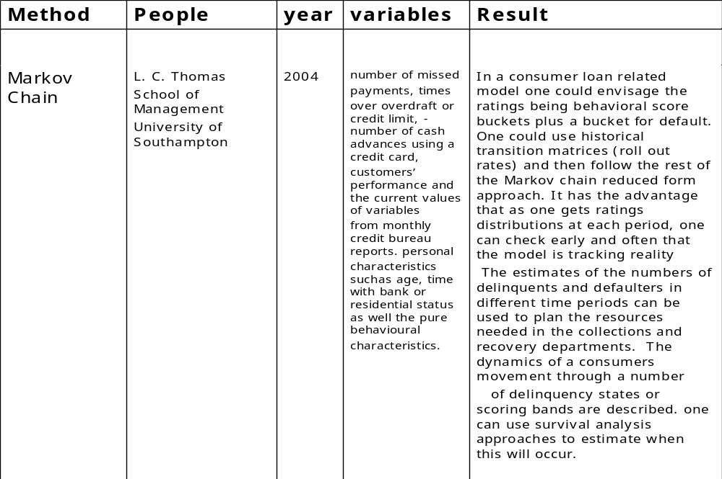
Table: 9 Multivariate Proportionate Hazard Estimation Model - Parameters for Comparison
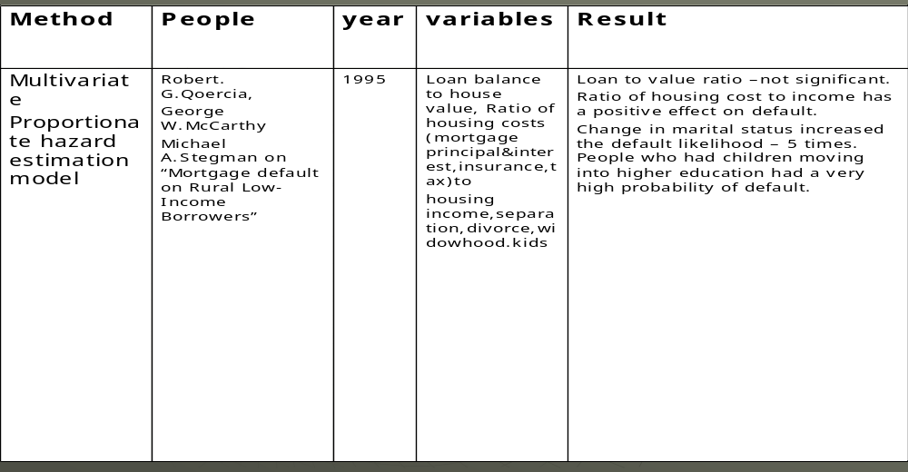
Table: 10 Logistic Binary Regression Model - Parameters for Comparison
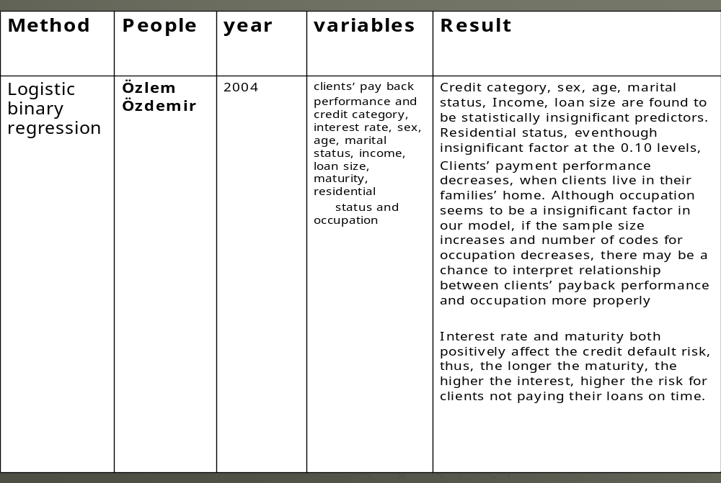
Table: 11 CART - Classification & Regressions Trees Model - Parameters for Comparison
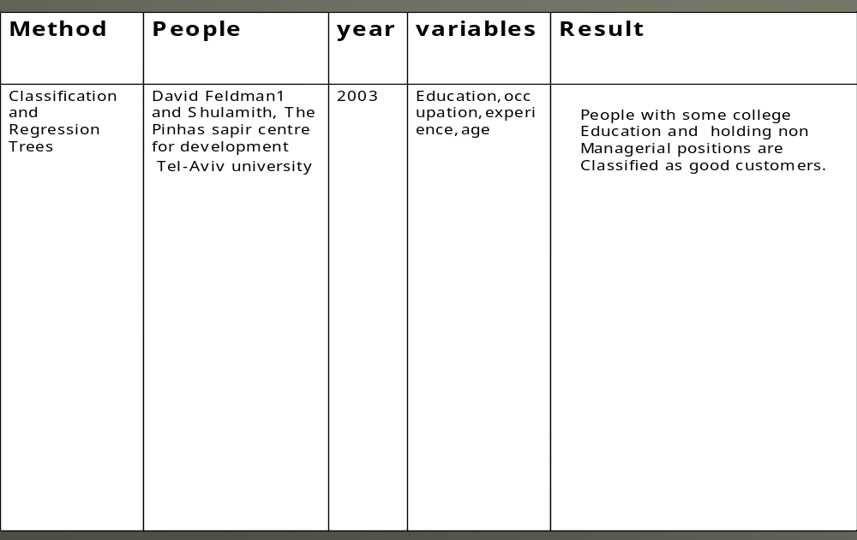
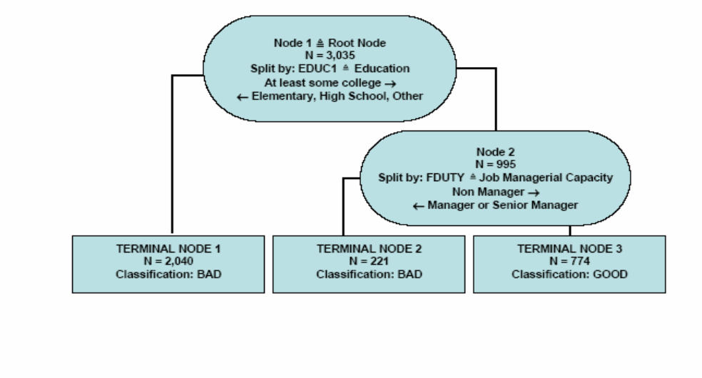
Fig. 10 : Classification - Tree
George- August-Universität Göttinge Institut für Wirtschaftsinformatik
Professor Dr. Matthias

Table: 12Evaluation of Classification Models
Algorithms | E1 | E2 | Total error
MLP | 5.00% | 5.6% | 5.3%
KNN | 9.8% | 14.4% | 12.1%
LR | 10.0% | 24.7% | 17.4%
LDA | 10.2% | 25.8% | 18.0%

3.33 Comparison methods of default prediction models
This stage involves considering various models and choosing the best one based on their predictive performance (i.e. explaining the variability in question and produces of stable results across samples). Even though it sounds like a simple operation, in fact it sometimes involves a very elaborate process. There are a variety of techniques developed to achieve that goal many of which are based on "comparative valuation of models" i.e. applying different models to the same data set and then comparing their performance to choose the best. These techniques which are often considered the core of predictive data mining include Bagging (Voting, averaging), Boosting, Structuring and meta learning.
4. RESEARCH METHODOLOGY
The Research problem was studied using qualitative techniques and quantitative methods and both approaches have given converging conclusions.
4.1 Qualitative Approach
In the Qualitative Study of the problem various tools were adopted to gather information on the demographic, macro & micro economic and psychographic aspects of the customers and gain insight into their behaviour. Attempts were made to find out patterns of behaviour. Also very importantly this understanding played an important rule in deciding the inputs for datamining especially artificial neural network.
4.1a Visit to show rooms
To gain knowledge on the processes, the dynamics of selling, process of prima-facie assessement of creditworth of prospective customers, observation of patterns in footfalls, visits were made to different auto show rooms of the Company and other Companies in different regions. The selling process was observed and discusiions were held with the sales executives, customers and show room managers.
4.1b Visits to Fairs
To understand effectiveness of campaigns like loan fairs, auto fairs, relationship between customers from such fairs and their loan repayment behaviour especially compared to the customers obtained by conversion of footfalls in the showrooms, factors which contribute better conversion rates in such fairs.
4.1c Days spent in the call centres
Discussions were made with Call centre manager and operators, to understand the customer data capturing, authentification process.
4.1d Experiences with the Field Invetigators
Accompanied the FIs for the interviews/discussion with the leads, generated by sales executives from the footfalls to the showrooms and by dealers at the loan fairs and processed by call centres. This enabled to gain understanding of the process of assessment of leads by which FIs recommend a “yes” or ‘ No” to Lending decision.
4.1e Experiments with various information sources like local grocery shop, vegetable vendor, post office, local money lenders, mechanics, teachers, fertiliser dealer, auto dealer, local administration, hardware dealers to assess as a source of information in urban, semiurban and rural areas in different regions
4.1f Visits to judicial courts where the cases of default were examined
Attended a couple of Lok adhalats. Lok Adalats is a legal framework where by an order of the Supreme court of India certain judicial officials are autorised to conduct inquiries over the cases of default and adjudicate certain orders to make a settlement between the Lending Company and the borrower who defaulted
Quantitative Approach
Extensive information gathering from the various players in the system of lending and analysis led to an understaning of the system processes, behaviour which was critical define the problem, inputs and choice of algorithms in the Quantitative analysis. The company had a data warehouse and COGNOS was the software used for datamining and Querying. From the data warehouse data was cleaned and preprocessed. Numerous Queries were used to discover new patterns and relationships. Descriptive statistical analysis was carried out first to get a qualitative idea of the customer behavior. This was followed by linear regression analysis, logistical regression, descriminant analysis, multiple regression, factor analysis, decision tree analysis and neural network analysis were performed.
5. FINDINGS OF THE QUALITATIVE RESERACH
5.0 Predicting Credit default for a consumer financial services company
The objective of improvement of prediction of customer response has many aspects(a)the mathematical aspect and(b) identification of customers who are most likely to respond and (c) design of the campaign i.e right product, right price even the media, message, contents of campaign etc. based on the customer profile.
5.1 Response models in retail lending
Data analysis in the form of response models help companies design and execute suitable from sell, upsell, deepsell and retention strategies. In the dry run creative use of past customer data through predictive modelling helps companies in building powerful and effective analytical CRM platform. These analytical CRM platforms allow firms to make suitable offer to its customers and optimize campaigns through email, telemarketing and inbound call channels.
Prevention and Mitigation of Lending Risks
In managing loan default, prevention is better than cure. Hence, lenders exercise vigil at the time of lending by carefully studying the characteristics of the borrowers and making a judgment call about the relationship between borrower characteristics and loan default event. Over a period of time, the database of lending and default history captures this relationship, which can then be modeled using the appropriate algorithms. Using this relationship, lenders take credit decisions. Models, once tested for their reliability; facilitate automation of lending process, which helps lenders to scale up their operations. Lenders here include banks, financial institutions and other agencies like micro finance institutions engaged in lending.
Historical data relating to borrower characteristics and their default status is used to predict loan default. Past data is studied for discerning any patterns between certain characteristics and the loan default status. An interesting case in point is that a bank found that its rural customers belonging to a particular community never default and consequently the only important criteria used for screening was whether the customers belonged to that community or not. Most institutions tend to use very simple rules to score their customers on their credit worthiness. But today, with high speed computing power, more data can be captured and complex data structures could be analyzed to detect hidden patterns. More sophisticated techniques are used for improving prediction accuracy.
An empirical, rather than a clinical approach to classifying delinquent debtors has been attempted to avoid the pitfalls mentioned above (Keleghan Kevin, Chief Credit Officer for Sears Credit) (http://www.i2credit.com/img/white/archivo-23.pdf, 2001).He derived six conceptual clusters of delinquent customers that include: 1) the imprudent (who have no money put away for a rainy day and live financially one day at a time); 2) the naïve (who are ignorant of the consequences of too much debt); 3) fortune's victim (for whom, despite adequate planning, some catastrophic life event caused financial collapse); 4) the reckless spender (who spends beyond his or her means); 5) the unethical (who have no intention to repay); and 6) the impoverished (the high-risk customer to whom a card was issued).
There are several benefits from credit scoring. It promotes great efficiencies and time savings in the loan sanction process. In the traditional scheme of things the sanction process could take anywhere between three days time to almost a month. The implementation of credit scoring can reduce it to a couple of hours. The tremendous growth in the retail credit industry has spurred the need for credit scoring.
A few companies have made the credit scoring more rigorous by developing scoring models which use customer data to develop statistical models. These scoring models could be used to classify / categorize / rank customers. This could be used for risk based pricing. Also, at the stage of collection, for defaulters with higher score, the reason could be some spikes in expenses or bottoming of income, for which the payments could easily be streamlined. For defaulters with lower scores, collection mechanisms need to be different.
Given the inevitability of the financial reform process, and the pressure there from on the banks and financial institutions to be competitive and productive, institutions must explore some new approaches consistent with the changing scenario, such as group lending, saving mobilization, enhanced supervision and support service facilitation, Kumar, Ashutosh, (2004).
A score is but one element of a larger set of subjective factors that go into the lending decision, Jack Hanley, executive vice president and CAO made the following remark about the subjective and personal factors. "Since we buy credit on the character and the strength of the customer, it is necessary to look at subjective and personal factors, and not just analytical aspects".
The repayment performance of a borrower depends on his financial ability to pay, his attitude and intentions. So by capturing the financial and demographic factors like age, qualification, occupation, income, family details etc. would give the necessary data contributing to the financial ability to pay, but will not give any clue with respect to their integrity, honesty, priorities in life, social responsibility, risk taking tendencies, social thought and behavior, conscious and subconscious perceptions and thoughts, social conscience, cognitive behavior etc and capturing of such factors will give the knowledge on the intentions of the borrower and this will help in arriving at a more realistic prediction.
Experience of Different Countries in credit assesment
Özlem Özdemir (2004) made a study in Turkey that examined the probability of risk of default in terms of various financial and demographic variables. Their study is unique and important in many aspects: first because it examines the relationship between consumer credit clients’ payment performance and their demographic characteristics whereas most previous research has been done on consumer credit applicants; second the financial variables are included in addition to the demographic variables, while most of the previous studies done on clients’ payment performance dwell upon only demographic variables; and third, this study is the first attempt to collect adequate information about how to decrease the credit default risk in order to develop credit scoring criteria for the banking sector in Turkey. The findings may enable banks and financial institutions to optimize their lending policies without changing their market structure and potential clients.
The empirical results indicate that financial variables rather than the demographic characteristics of clients have a significant influence on customers’ pay back performance. Thus, the longer the maturity time, the higher the interest rate, and the higher the credit default risks. This suggests bankers apply appropriate adjustments to financial variables in order to minimize credit default risk.
In order to understand the findings and interpretation of the results of this study better, one has to keep in mind the dynamism of the Turkish economic environment. At the end of the study in June 2001 Turkey has been announced as a risky country by S&P in terms of credibility, where as at the beginning of the study in January 2001 Turkey’s credibility mark was B+. This unstable economy causes fluctuations in interest rates and currency rates, thus debtors’ payback ability.
A Thailand experience
Bunchai, Gan and Lee (2005) carried out a study on agricultural farm loans in Thailand. The empirical results in this study support the use of the Probabilistic Neural Network (PNN) model in classifying and screening agricultural loan applications in Thailand. The estimated results of the logistic credit scoring model show the significance of total assets value, capital turnover ratio and duration in determining the probability of a good loan. The results show that a higher value of assets implies a higher creditworthiness and a higher probability of a good loan. However, the negative signs in both capital turnover ratio and duration, which contradict the hypothesized signs, suggest that the borrower who has a longer relationship with the bank and who has a higher gross income to total assets has a higher probability to default on debt repayment.
Dummy variables such as province, farm type, loan type, loan size and lending year are included to describe the systematic effects relating to the type of borrowers and the type of contracts and are hypothesized to influence the borrowers’ credit risk and the probability of a good loan. For example, borrowers who have cash crop (horticulture) as the major production would require a smaller amount of credit than the other farm types, and the contract term for the cash crop production is short-term contract. Thus, this group of borrowers would have a higher probability to obtain a loan than the others. This is because the short-term loan is less risky than medium-term or long-term loan and the lending risk is relatively low. In contrast, if the major production of the borrowers is either orchards or livestock, which requires a larger long-term loan, they would be expected to have higher credit risks and a higher probability to default.
The probability of a good loan would increase if the borrower has larger assets and more than a primary education. On the other hand, the probability of a good loan deteriorates as the borrower improves his or her leverage (solvency) and capital turnover ratios (efficiency). This contradicts the hypothesis on capital turnover ratio, which shows that the borrower who has a higher gross income to total assets has a higher probability to default on debt repayment. It seems when borrowers earn more they prefer to spend the extra earned income on other activities rather than repaying their debt. When duration is included into the model there are only 3, 965 observations that can be used to estimate the model. This is because there is no available information to estimate the duration for all the samples, due to recent changes in the BAAC’s database policy. The estimated results show that assets and capital turnover ratio are significant at the 5 percent level, while education and leverage ratio are insignificant. Furthermore, the estimated coefficient on capital turnover ratio is negative, which is consistent with the estimated result in model. However, the relationship between duration and lending decision contradicts the postulated hypothesis. The estimated coefficient is negative and significant at the 5 percent level. Thus, it suggests that the borrower who has a longer relationship with the bank has a higher probability to default on debt repayment and bank should cautiously deal with this group of borrowers.
Bangladesh experience:
According to Kamaluddin (2008) Grameen Bank's default rate is about 2%, astonishingly low compared with what Bangladesh’s commercial banks suffer: about 70% for agricultural loans and 90% for industrial loans. The success of the Grameen Bank in Bangladesh has shown that it is possible to provide a large number of low income people with financial services using a group lending methodology. As a result, group lending programs funded by international donors have proliferated at a rapid pace throughout the world. The mechanisms of group lending, such as peer pressure and group solidarity are touted as instruments to attain favorable repayment rates. However, repayment rates vary dramatically from one program to another, suggesting an inherent instability in the financial technology, Paxton (1996).
Based on the work of Besley and Coate(Sharma, Zeller, 1996) a model for group lending repayment has been devised. The model incorporates stabilizing and destabilizing determinants of group loan repayment. Influences that can increase the probability of loan repayment include the effective use of group dynamics (ex ante and ex post peer pressure and group solidarity) as well as other factors such as appropriate training and leadership. The degree to which pressure versus solidarity occurs is shown to be dependent on the reason given for the repayment problem and can be formulated as an “intragroup contract” for insurance purposes. Negative externalities can diminish the probability of successful group loan repayment. The “domino effect” occurs when one or more members of a credit group default due to the default of other members. Another negative influence on repayment occurs when the credit terms and conditions are no longer appropriate for each member as credit cycles continue, creating an inherent “matching problem” as group lending is repeated over time.
A study by Godquin (2004) indicates that the use of non financial services has a positive impact on microfinance repayment performance but that group homogeneity and social ties among group members are not always associated with a better repayment performance. The results also show that MFIs allocate larger loans to borrowers as the age of their borrowing group increases. This can be justified by the use of dynamic incentives, as the number of allocated loans is likely to grow with the age of the group. The age of the group was also found to have a negative impact on the repayment. This raises the need to develop new incentives for experienced borrowers to avoid decreasing repayment performance and negative domino effects as the clientele of the MFI becomes more mature.
Another important point that emerged from the study is that MFIs tend to attribute larger loans to homogeneous groups in terms of age. Group homogeneity was not, however, found to affect the repayment performance in a significant way. It was observed by Ghatak that the question of the predicted positive impact on repayment of group homogeneity in terms of risk as a result of peer selection was not addressed (Godquin, 2002). Nevertheless, according to the studies of Zeller (1998) and of Sharma and Zeller (1997), with evidence from Madagascar and Bangladesh this kind of homogeneity has a negative impact on repayment performance (Godquin, 2002). As group homogeneity is frequently used as a methodological guideline for group formation in many microfinance programs, further research must be undertaken to understand what type, if any, of group homogeneity has a positive impact on the borrowers’ repayment performance. Microfinance programs have been successful in extending credit to the poor thanks to appropriate lending methodologies. The negative impact on the repayment performance of the size of the loan and of the age of the borrowing group could reveal the incompleteness of this lending methodology.
An individual dummy variable for on-time repayment and a probit model were used to estimate the probability for a borrower to repay his loan at the due date. The method of Smith and Blundell (1986) as referred in (Godquin, 2002) to test for exogeneity has been in the probit model. Endogeneity of the size of the loan could not be rejected and the size of the loan was instrumented.
Indonesia Study
A study by Azhar (1999) shows that, with the exception of the tapping frequency, there is no significant difference between the non-defaulters and the defaulters in terms of some of the economic variables such as level of productivity, income level and adoption of technology. The analysis of logit model which provides 81 percent of correct prediction indicates that, with the exception of the farmers' income level, the signs of the estimated coefficients of other explanatory variables are as expected according to a priori reasoning. Generally, the model indicates that the probability that a farmer will become a non-defaulter is positively related to educational attainment, farming experience, productivity, other sources of income, attitude towards loan repayment, knowledge about the rubber technology and satisfaction with the NES I project activities and services, but negatively related to age, family size and income. However, only the coefficients of educational attainment, family size and knowledge about the rubber technology are found to be significant at the 5 percent level.

A report by the World Bank (Robinson, 1996) states clearly the reasons for the success of BRI's unit banks:"The programme succeeded because the banks loaned at market rates, used income to finance their operations, kept operating costs low and devised appropriate savings instruments to attract depositors. By mobilizing rural savings, [the unit banking system] was not only provided with a stable source of funds, it also kept financial savings in rural areas, thus helping development growth in the countryside. Other reasons for success included: the simplicity of loan designs, which enabled the banks to keep costs down, effective management at the unit level, backed by close supervision and monitoring by the centre; and appropriate staff training and performance incentives."
Lending model – Rural India
Microfinance is gathering momentum to become a major force in India (Rajesh Chakrabarti). The self-help group (SHG) model with bank lending to groups of (often) poor women without collateral has become an accepted part of rural finance. With traditionally loss-making rural banks shifting their portfolio away from the rural poor in the post-reform period, SHG-based micro finance, nurtured and aided by NGOs, have become an important alternative to traditional lending in terms of reaching the poor without incurring a fortune in operating and monitoring costs. The government and NABARD have recognized this and have emphasized the SHG approach and working along with NGOs in its initiatives. Over half a million SHGs have been linked to banks over the years but a handful of states, mostly in South India, account for over three-fourth of this figure with Andhra Pradesh being an undisputed leader. In spite of the impressive figures, microfinance in India is still presently too small to create a massive impact in poverty alleviation, but if pursued with skill and opportunity development of the poor, it holds the promise to alter the socioeconomic face of the India’s poor.
A private sector bank in India innovated lending by effectively delegating a large part of the lending and collection process to de facto agents such as traders or agricultural service providers or local brokers that are close to the farmer by the nature of their business. Farmer Service Center operating model with Mahindra Shubhlabh. Here the bank identified an integrated agricultural services provider (IASP) that has a good relationship with the farmer and provides genuine and timely information through extension services.
The bank enters into a tripartite agreement with the IASP and the output buyer and provides credit to the farmers on the recommendation of the IASP, the farmer pledges its produce to the output buyer, and the IASP provides inputs to the farmer. Loan processing, disbursement and collection are effectively done by the IASP, while the credit decision remains nominally with the Bank. At the end of the season, the farmers supply the crop to the output buyer and the output buyer deducts the loan amount from the sale proceeds and remits the loan to Bank in full settlement of the loan amount. The IASP receives a service fee for the loan processing and supervision services(1.5 percent on recovered loans). Currently 45 Such offices operate on a franchise basis, financing around 4, 000 farmers. Loan default rates have been significantly lower with this integrated model that traps receivables and provides little actual cash to farmers. Transaction costs are reduced through more efficient loan processing by an agent close to the farmer and a de-facto wholesale credit approval process at the bank. This agency model allows the bank to lend to farmers without a significant branch network and with almost no due diligence costs.
How the scheme works – and its key benefits
The example of a maize farmer in Belgaum, Karnataka illustrates the simplicity of the scheme (Ulrich Hess, 2004). The key benefits for the participants in the scheme are given below.
- A farmer receives a crop loan from a bank.
- The farmer pays the premium on weather index insurance and starts a risk management account (combined cost <6 percent of loan amount).
- The risk management account (RMA) premiums are deposited in an interest bearing savings account. The minimum balance is 2 percent of the crop loan.
- The farmer can access his RMA funds with charge card at banks, agricultural and financial service providers and ATMs and through the charge card.
- At the end of the season there are three possible outcomes:
a. In a normal year the farmer accumulates savings.
b. In a mild drought year, the farmer receives interest relief as the weather insurance kicks in. If the weather insurance payout is not triggered, the farmer can dip into his risk management account to meet his interest payments.
The different models and the variables used to assess credit worthiness are summarized
Table –13

Region | Authors | Financial/Economic Variables | Psychographic  /demographic  variables
Turkey | Ozlem/Ozdemir (2004) | Income, loan size, interest rate, maturity, credit category | Marital status, sex, age, residential status, occupation
U.S. | Crook & Jappeli  Sexton.D.E. (1996) | Income | Family size, age, education, Sex
Sweden | Roszbach&Jacobson (1998 to 2007) | Income | Marital status
Thailand | Limsom bunchai, Christopher Gan and Minsoo Lee (2005) | Duration of loan, assets, income, loan type, loan size | Attitude to repayment, education
Bangladesh | Rural/Agriculture  (Ghatak, 1999) Zeller (1998) and of Sharma and Zeller (1997) | Farm size. loan size, | Group homogeneity, Age of group,
Indonesia | Marguirite.R. Robinon(1997) | Other sources of income, but negatively related to age, family size and income. | Educational attainment, farming experience, productivity, attitude towards loan repayment, knowledge about the rubber technology and satisfaction with the NES I project activities and services, family size
India | Ulrich Hess (2004) | Income | Group homogeneity
Indonesia | Azhar (1999) | Other income | Educational qualification, farming experience, productivity, attitude to loan repayment

Different Credit Worthiness Assessment Models
The need for a holistic model
It can be seen from above that the models have considered either only certain financial/economic factors or a combination of certain financial and demographic factors. In order to improve the accuracy of prediction of borrower behavior a holistic picture of the borrower is to be acquired which shall encompass the psychological and social aspects of borrower.
A study of credit risk management –an attempt at a 360° approach
The present study was undertaken for a financial services company based in South India that extends loans for buying automobiles and durables like TV, Fridge etc.
They have a customer base in all the four states of South India, in urban, semi urban and rural areas. In fact their strength is their reach to the rural areas and they are expanding their base in rural areas of South India. There is a large untapped potential in the rural sector as elaborated above. They have a very good brand image in South India and they are known for their professionalism, integrity and customer focus and commitment to social responsibility. Their customers include lower middle class, middle class and upper middle class in the salaried segments in private, government and joint sectors, traders, small farmers, and others in various own small enterprises in urban, semi urban and rural areas. Those in self employment, in small trade or marginal farming or some form of small business. The vehicles bought using loans availed from the company are used directly by traders and business men in their occupation or indirectly to help in their business or farming to transport farm inputs or farm produce.
Due to heavy competition in the automobile market, the margins were thin and the quality of assessment of credit risk was also not satisfactory. As the speed of processing was a critical factor for success, several bad customers were extended loans which led to higher bad debts. The un-recovered loans for companies operating in this market varies anywhere between 1% at the best to as high as 25% in the worst. For the company understudy the typical collection is around 2.5%.
Process of acquiring customers for Auto loans: The Company is part of a larger Business Group that has an automobile company with a leading brand in the two wheeler market. The automobile Company has appointed authorized dealers who have their show rooms in various places. The Customers walk in to the show room and once they decide to buy the vehicle they are approached by DSAs (Direct Selling Agents) from different financing companies represented in the show rooms. So the financial company under consideration has to compete with other companies to win over customers. Another process of acquiring customers is when the financial services company conducts loan melas (kind of a fair) at different locations. It is organized either by the company directly in alliance with the dealers or by the dealers themselves. It turns out that the conversion rate in melas is considerably higher than the conversion of walk-in customers in to the show rooms.
Once a customer expresses interest in availing loan from the company being studied, they collect contact information and some basic information from the customer and the same is sent to their call center for further processing. The call center passes on this information to respective regions and the regional heads allocate field investigators to carry out face-to-face interviews to make credit assessment. The assessment of the prospective customer for giving a loan is done by a team of staff called Field Investigators who visit the customers, their work places, and their residence and fill in a format. Apart from interviewing potential customers, insight is gained by talking to people such as Fertilizer dealers, teachers, vendors, randomly picked people on the road, local administrative officials, and local money lenders. The subjective assessment of the field investigator through these informal means is converted into a score out of 10 and recorded in the format and sent to the call center.
The process used for loan processing is illustrated in Figure1. The information given in the format is used by the DSAs to arrive at a credit worthiness score for each potential customer and make a recommendation to the concerned branches. Typically, the score is arrived at by summing up the marks given for various attributes like income, ownership of house, consumer durables, age etc. and adding up the FIs score. If the score arrived at is more than a cutoff set by the company then the person is deemed eligible for a loan. The final decision to extend a loan or reject an application is taken by the risk manger in the risk manager. Then the branch handles further formalities of the process up to loan disbursement.
Figure 11
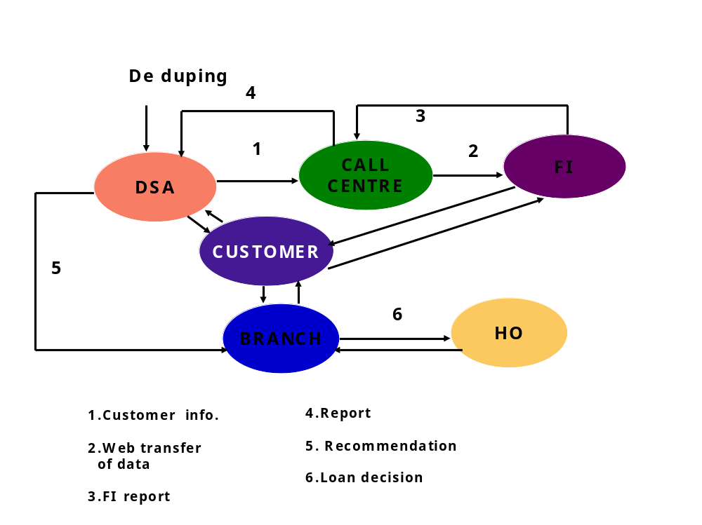
Process of Credit Appraisal and Loan Disbursal
Credit Scoring Method
Credit scoring is a method to discriminate between a customer who can be given a loan and who should not be given. In this case credit scoring is done by the risk management team. The sales executive at the showroom or exhibitions evokes interest in the customer in getting loan from the Company the prospective customer’s name, address, qualification, income, occupation are collected and entered in a format at the call center. The FIs who are assigned a loan applicant, makes an appointment with him/her and visits him/her. There is a template for scoring which has various fields for various attributes like Name, age, qualification, experience, occupation, marital status, children, dependents, ownership of durables, two wheeler and four wheeler, residing in rented or own house etc. Each attribute is allotted different marks ascending or descending. For example for increasing age the marks are given in the descending order or they have an inverse relationship and for factors like income there is a direct relationship. Then all the marks are totaled. Finally the Field investigator is allotted 5 marks which he can use for the assessment of the customer which is added to the total marks, out of 100.
Process of acquiring customers for Consumer Durable Loans
The financial services company has tied up with the dealers of the consumer durables and a similar process as explained above for the auto loans is carried out for the assessment and disbursement of the loans. Another avenue for acquiring customers is by cross selling to auto loan or personal loan customers who exhibit(ed) good repayment behavior.
Process of acquiring customers for personal loans
Here again the existing customers of auto loans or the consumer durable loans are the customers. Good customers who have not defaulted even once are offered these loans. Finally when there is need to grow aggressively there is a need to disburse the loans as fast as possible but at the same time giving the loan only to the right customer?Hence it has become imperative for the Company under study to develop a credit scoring model which should (a)identify and predict a good customer and a bad customer (b) take all the relevant factors into consideration and assign weights according to their relative importance with respect to the repayment behavior (c)arrive at a final score based on the various parameters so that the customers can be ranked and the pricing of the loan in terms of interest, initial down payment, etc and collection mechanism can be arrived at.
The company had a very good data warehouse of customer data. This was used to collect secondary data of the customers. The customers comprised of people who had availed loans for buying a two wheeler. Most of them are from the rural and semi urban areas. Most of them are in self employment, in small trade or marginal farming or some form of small business. The vehicles are used directly by traders and business men in their occupation or indirectly to help in their business or farming to transport farm inputs or farm produce.
There are avenues for improvement in the process followed by the company and the manner in which it is implemented. Due to the high pressure for speedy processing of loans, certain procedures get overlooked from time to time. The financial information gathered from the loan applicants typically can only predict the ability of the persons to repay. However the willingness to repay depends on a number of demographic, psychographic and social factors.
The present study aims at capturing the factors which contribute to the prompt payment, habitual default, temporary disruption in payment, wrong attitudes due to various reasons including culture, apart from the economic factors of income, expenditure, bottoming of former and peaking of latter etc. Attempt has been made to identify major changes or disruptions in `lifestyle' variables;examples include such events as divorce, termination of employment, heart attack etc.

Methodology
In-depth interviews were conducted with good as well as bad borrowers. Apart from interviewing people directly involved in the credit management, insight was gained by talking to people such as Fertilizer dealers, teachers, vendors, randomly picked people on the road, local administrative officials, and local money lenders. The interviews were audio recorded, transcribed and used for further analysis.
Insights from Qualitative Research
The insights gained from the customers, money lenders and Lok Adalats and the local public on the assessment and scoring methods and the suggestions for improvement are presented below.
Customers Related Insights
Agricultural customers may be broadly classified into the following:
(a) Intentionally good but face set backs in income or expense seasonally(b)Culturally do not feel that payments should be paid promptly(c)No previous experience in such transactions and hence to be reminded of periodic payments and lack financial planning (d)Owing to the status they have been enjoying, traditionally they feel infra dig to be compliant or conforming to any system(e)A mindset that the loans given for self employment or agriculture or other development need not be paid back since they have always been written off for political reasons and the vicious cycle of trap which the people get into and(f)People who borrow with an intention to cheat right in the beginning.
In the case of customers with own business may be classified into
(a) those with unsteady income due to un stabilised business and (b) those operating in businesses that experience high levels of seasonality. The persons in the first category can become totally bad if their business fails. In the case of people operating in seasonal businesses, the money gets locked up in business during peak seasons resulting in payment default. However they catch up with the repayment schedule when they are out of the peak season.
Insights - Assessment Related
While assessing the credit worthiness of the applicants, income is treated as one of the key variables. However, while collecting income details care is not exercised to assess the disposable income accurately. Typically commitments to education, loans, rent etc. do not get captured. The present method of assessing income may distort the basic repaying capacity of the borrower.
It is not enough to capture the current income alone but one needs to assess the future repayment capacity of the borrower. This projection may have to take into account the commitments of the borrower to his family members in the next 3 to 5 years, including higher education for wards or marriage of a son or daughter and so on.
The present method tries to look at the ownership of different consumer durables but does not take in to account the loans taken for procuring these items. While in most cases consumer durables reflected a stabilized and prosperous household and resulted in good repayment behavior, in some cases it reflected too much liabilities and hence tendency to default. Hence the loan liabilities for consumer durables should also be taken into account while assessing credit worthiness.
The system of assessment followed currently has been designed for nuclear families. In the present model, large number of dependents is considered a negative factor. In the case of joint families, people could be dependents and still be contributing to the overall household maintenance. This is not reflected appropriately in the present system.
Cross-validation of the information provided by loan applicants can be done through sources like vegetable vendor, laundry, bank, local revenue office, post office, local fertilizer dealer/pesticide dealer in case of agriculturists, cement and other construction material dealer in case of housing related people, local teacher, local lender etc. The researcher was able to prove that a respondent who claimed to be a Building Contractor in reality was a mason by just talking to few of the local people in his area. The field investigators should be properly trained to bring out the correct information through enquiry.
Scoring for agriculturists should be based on the type of crop typically cultivated and their domestic and international price trends. For example, in case of a natural disaster, the losses are more in banana crops than in sugarcane. Similarly the prices of rubber fluctuate drastically depending on the global trends and it also follows some economic cycles. This may be also factored into the scoring model.
Insights from local money lenders
Historically, world over only the local money lenders played the role of modern lending institutions. This continues even today. Their strength is that they know all the families in the village like the back of their hand and all aspects like birth, death, marriages, education, income, financial loss, and medical history of the people.
The researcher visited a typical money lender’s house in a small village and found a black board mounted on the wall. The blackboard displayed details of the name, loan amount, amount due, interest rate and the maximum amount of fresh loan eligible. The moneylender’s wife was able to extend additional loan to their customers based on the information on the blackboard when her husband is away on collection duty.
The blackboard display of borrower and loan details gives transparency and social pressure for the borrowers. Hence the financial companies should develop local agents like these who could act as assessment and collection agents. This should not replace the scoring process but rather support it and reinforce it.
Insights from Lok Adhalats
A Lok Adalat has the jurisdiction to settle, by way of effecting compromise between the parties, any matter which may be pending before any court, as well as matters at pre-litigative stage i.e. disputes which have not yet been formally instituted in any Court of Law. Such matters may be civil or criminal in nature, but any matter relating to an offence not compoundable under any law cannot be decided by the Lok Adalat even if the parties involved therein agree to settle the same. Lok adalats can take cognizance of matters involving not only those persons who are entitled to avail free legal services but of all other persons also, be they women, men, or children and even institutions.
Anyone, or more of the parties to a dispute can move an application to the court where their matter may be pending, or even at pre-litigative stage, for such matter being taken up in the Lok Adalat whereupon the Lok Adalat Bench constituted for the purpose shall attempt to resolve the dispute by helping the parties to arrive at an amicable solution and once it is successful in doing so, the award passed by it shall be final which has as much force as a decree of a Civil Court obtained after due contest.
In one case the couple running a cafeteria were pleading that there was a discontinuity in the business and they had to repay some other loan. The financial company’s local office did not believe the story but if they had acted proactively the money used by the borrower to repay another loan should have been captured. Also the true situation of the borrower would have been assessed. In many cases it was found that the trend of the borrower behavior would have captured the situation.
In two other cases the asset was bought for a friend and the friend had defaulted. In my opinion a proper assessment would have brought out this information right at the beginning. In such cases a proper assessment and scoring of the guarantor would have helped, this is important because in many cases, in the rural areas, it is common for the people to buy on their behalf or as dowry or as a security for repayment of another loan.
Another case was where the borrower claimed that his small business of chemicals trading was in a cash flow crisis. This is again a case of poor assessment business stability.

Another case was where the borrower had political connection and was trying to use influence and this could have been avoided through a 360 degree feed-back from friends, relatives and others in his social circles.
In another case the borrower’s business was seasonal namely manufacturing of daily tear off sheets for calendar and hence the income was cyclical and during periods of lows the partner had taken some money out. This highlights the point that even a study of business partnership deed or memorandum of understanding of documents is important.
There was one genuine case where a headmaster developed a health problem and was hospitalized but he had applied for a loan and was taking all efforts to pay the loan. This clearly indicates the point that there are unforeseen circumstances too that cannot be built into formal models.
Some observations on credit worthiness assessment
The field investigators are very central and critical to the process of obtaining inputs for the credit rating process. The following instances highlight the same point.
A mason posing as a contractor was exposed by the researcher when he enquired with a local hardware shop, a vegetable shop and a local resident. But as a mason he had a job and he was involved in a couple of construction jobs. A visit to his house showed that there were no immediate commitments for education, marriage or medical expenses. He was also found to have a positive intention to repay. Taking all the positive and negative factors, the decision was in favor of extending a loan to the mason. However, the concerned field investigator had oversimplified the task by making him a contractor and jacking up his income. Hence training, integrity and motivation of the field investigators are all important in setting up a good system of credit assessment.
In another case a retired male nurse was given a low score and was given the loan purely based on the dealer’s recommendation. But a cordial conversation with the applicant revealed that he was getting pension and that his wife was a nurse in government service. They also received income from a small rubber plantation. Additionally he was a TV star. Considering all this and a chat with him showed that he could have been given a good score without any problem.
There was a case where we found out that the loan was to be used for business for a new venture whereas in the application it was mentioned as a loan for buying a vehicle. This came out from a friendly chat with the borrower’s father. But also it was possible to elicit from him that he would get support from his eldest son who was a technician in a gulf country who was also supporting his brother’s engineering education. So some more investigation was required to get the capability and intentions clear.
In a remote village a FI was sent to assess a farmer who was growing chilies. The researcher found through informal chat with the FI that he had no knowledge of chilly crop, typical yield, income, risks and uncertainties in the crop and market trends. Field investigators should be supplied with a hand-book that covers irregularities, seasonality and uncertainties in income, risks in inputs, cultivation and marketing in agriculture, risks and uncertainties in trade and business both micro economic and macroeconomic factors. The information contained in the handbook should be reviewed and updated by the risk management team from time to time.
FIs have a critical role to play and they are paid a meager salary. Ideally a FI should have at least a basic degree in psychology or social work and they should be highly motivated and should be trained in communications, body language and should be able to elicit information, should be able to think on their feet to ask the right questions. But unfortunately, for the salary levels prevalent in this industry these skill sets are not seen in the FIs and for most of the FIs the job is taken as a transit one.
Out of 100 marks in the scoring, 5 marks are allocated for the FI’s personal assessment and for marginal cases this can be used by the FIs for making a risky customer to a good customer.
Some insights from discussions with defaulting borrowers
These visits were undertaken along with collection executives. One textile businessman who had defaulted twice was willing to pay immediately and the reason for default was that he wanted to spend every bit of time and money to maximize his business during the festival season. Here the collection mechanism should be such that the executive collects from such people by visiting them and also the repayment schedule should be such that the installments are more during seasons of plenty.
In another case the borrower had defaulted 5 times. Here the following thoughts are worth considering:
- The reasons are the shop which the borrower started had not stabilized
- His daughter was married off 5 months back
- His second daughter was studying in engineering college.
The key lesson from this case is:
- The commitments of marriage and educational expenses should have been captured or at least there should be an ongoing relationship between the borrower and the lender through a local agent to capture this information.
- The scoring should have taken care of the new business with a lower score.
- In such cases there should be a high score for the guarantor and guarantor should be assessed rigorously and the family’s involvement in the borrowing should be ensured.
- In the case of business due diligence should be exercised when it is new and not established.
There was an instance where the customer had defaulted for 4 months and he had closed one business and started another. This once again is a case of un-stabilized income.
This should have been captured in scoring and a high score guarantor should have been tied up. These factors should have been reckoned in pricing and collection mechanism.
Insights - Process Related
FIs concur with the fact that customer information like occupation and income could be masked from the FIs to avoid any bias and also to facilitate an independent assessment. It would help the FIs to achieve the time target much better if DSAs get as far as possible accurate info of Customer's location and also do a preliminary screening.
In a number of cases the entries are made without any basis and absurd entries like age more than 100, experience more than age, expenditure more than income, disproportionate income etc are present. Also it would be helpful if the DSAs are given inputs on fundamentals of marketing and how to face competition.
An Integrated Model for Credit Scoring
As mentioned earlier prediction of borrower’s repayment behavior has many facets. Credit scoring, capturing the age, income and assets will mirror the financial face of the borrower. But in order to get a realistic and more accurate prediction the lender needs to know the other faces of the borrower like his attitudes, social behavior, conscious and subconscious behavior, borrower’s hidden agenda, his own personality known to himself and known to only others. Hence we have attempted a 360 degree appraisal of the borrower as shown in Figure-2.

Figure - 12 An Integrated Model for Credit Scoring
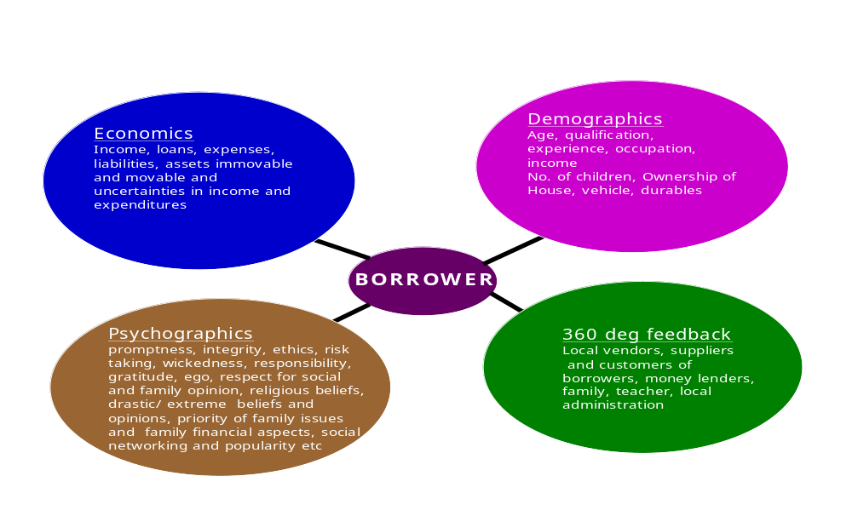
From the psychographic perspective social consciousness, integrity, honesty, risk taking, cognitive abilities, ego, response in adversities, priorities and values in adverse situation, perseverance would enable to capture the personality of the borrower at the conscious and subconscious levels which will reveal the intentions to a considerable extent.
It is known from Johari’s window that there are areas of one personality hidden from self and certain others hidden from others. So such hidden parts of the personality are obtained by projective techniques and getting the opinion of the people about the borrower in their society with whom they come into contact like vegetable vendor, teacher, police, postman, hardware, fertilizer dealer etc. All these are especially important in the Indian context since borrower behavior is not known especially in the rural areas because(1)absence of banking habits(2)low usage of credit cards(3)non existence of smart cards(4)non sharing of customer database.
Apart from the questions in the scoring process and getting opinion about the borrower from various people in the society certain projective techniques shall be used to understand the subconscious and subliminal parts of the personality. Also a psychographic test shall be conducted to know the personality. Some of the questions are for example as follows:
(1) What is life for them (2) Do they like to continue as they are or they want to be different and how (3) At what cost do the want to be different (4) Do they like horses, mountains adventure, fire (5) Do they explore new things (6) What is risky for them (7) How much will they compromise to get what they want (8) What is sacrifice (9) What is a promise; How valuable is it (10) What is help (11) What is friendship (12) What is society, culture, values and how important are they.
(13) what is truth and lie and when can one lie (14) Do they respect society’s opinion and if so for what aspects of life (15) what can be compromised for money (16) what do you do when you are angry
(17) Happy moments in life and sad moments in life (18) is not jealousy good for growth (19) Most fearful situation and you got out /will get out. Refer Annexure I for the detailed questionnaire for credit scoring, upselling and cross selling.

6. FINDINGS OF THE QUANTITATIVE RESEARCH
Analysis and Findings
Table: 14
Profile of the Customers included for the analysis
Age
 |  | Frequency | Percent | Valid Percent | Cumulative Percent
Valid | 25 or less | 1060 | 8.8 | 8.8 | 8.8
 | 26 to 35 | 3867 | 32.1 | 32.1 | 40.9
 | 36 to 45 | 2937 | 24.4 | 24.4 | 65.2
 | 46 to 55 | 1323 | 11.0 | 11.0 | 76.2
 | 56 and above | 2866 | 23.8 | 23.8 | 100.0
 | Total | 12053 | 100.0 | 100.0

23.8
11
24.4
32.1
8.8
56 and above
46 to 55
36 to 45
26 to 35
25 or less
Fig13-cutomer profile
Age
As can be expected a considerable percentage of the customers are in the age group of 26 to 35 and since majority of the borrowers use the loan for automobiles this distribution is explainable. The next major group of customers fall into the age group of 36 to 45 and the use the loans for buying automobiles for using in their business, agriculture etc.

Table: 15
Educational Qualification

 |  | Frequency | Percent | Valid Percent | Cumulative Percent
Valid | Degree | 2090 | 17.3 | 17.3 | 17.3
 | Higher Secondary | 1404 | 11.6 | 11.6 | 29.0
 | Missing Values | 1104 | 9.2 | 9.2 | 38.1
 | Other Qualification | 5152 | 42.7 | 42.7 | 80.9
 | Post Graduation | 480 | 4.0 | 4.0 | 84.9
 | S S L C | 1823 | 15.1 | 15.1 | 100.0
 | Total | 12053 | 100.0 | 100.0

15.1
4
42.7
11.6
17.3
S S L C
POST GRADUATION
OTHER QUALIFICATION
HIGHER SECONDARY
DEGREE
Fig-14 Customer Profile

Educational Qualification

About 22% of the customers are graduates and Post Graduates and majority of them are in urban and semi urban areas. Other qualifications comprise of people who have other vocational qualifications and those who have not passed higher secondary. Most of the are in their own business and agriculture.

Table - 16
No. of Dependents

 |  | Frequency | Percent | Valid Percent | Cumulative Percent
Valid | .00 | 1176 | 9.8 | 9.8 | 9.8
Valid | 1.00 | 668 | 5.5 | 5.5 | 15.3
Valid | 2.00 | 2776 | 23.0 | 23.0 | 38.3
Valid | 3.00 | 3015 | 25.0 | 25.0 | 63.3
Valid | 4.00 | 2743 | 22.8 | 22.8 | 86.1
Valid | 5.00 | 1041 | 8.6 | 8.6 | 94.7
Valid | 6 or more | 634 | 5.3 | 5.3 | 100.0
Valid | Total | 12053 | 100.0 | 100.0

5.26
8.64
22.76
25.01
23.03
5.54
9.76
6 or more
5.00
4.00
3.00
2.00
1.00
.00
Fig-15 Customer profile
No. of Dependents

There is almost equal distribution of two dependents, three dependents and four dependents. Two dependents would be mostly parents and four dependents would be mostly parents, wife and child. Sometimes it is grand parents, sisters. The real financial picture would be obtained if the age, medical commitments, marriage commitment, extra income from the dependents like rent, pension, agricultural income etc., are captured.

Table - 17
Income
 |  | Frequency | Percent | Valid Percent | Cumulative Percent
Valid | Less than Rs. 5000 | 3165 | 26.3 | 26.3 | 26.3
Valid | Rs. 5001 to Rs. 7000 | 2830 | 23.5 | 23.5 | 49.7
Valid | Rs. 7001 to Rs. 9000 | 2043 | 17.0 | 17.0 | 66.7
Valid | Rs. 9001 to Rs. 11000 | 1831 | 15.2 | 15.2 | 81.9
Valid | Rs. 11001 to Rs. 13000 | 581 | 4.8 | 4.8 | 86.7
Valid | Rs. 13001 and above | 1603 | 13.3 | 13.3 | 100.0
Valid | Total | 12053 | 100.0 | 100.0

13.3
4.8
15.2
17
23.5
26.3
Rs. 13001 and above
Rs. 11001 to Rs. 13000
Rs. 9001 to Rs. 11000
Rs. 7001 to Rs. 9000
Rs. 5001 to Rs. 7000
Less than Rs. 5000
Fig-16 Customer profile
Income

There is equal distribution in the income group of less than 5000Rs and in the range 5001 to 7000Rs. So the majority of the customers are not in the middle class. Due to the easy availability of loans and choice of cars most of the middle income group have migrated to four wheelers.

Table - 18
Other Income

 |  | Frequency | Percent | Valid Percent | Cumulative Percent
Valid | Rs.0.00 | 7404 | 61.4 | 61.4 | 61.4
Valid | Rs. 1 to Rs. 2500 | 3812 | 31.6 | 31.6 | 93.1
Valid | Rs. 2501 to Rs. 5000 | 373 | 3.1 | 3.1 | 96.2
Valid | Rs. 5001 to Rs. 7500 | 464 | 3.8 | 3.8 | 100.0
Valid | Total | 12053 | 100.0 | 100.0

3.8
3.
1
31.6
Rs. 5001 to Rs. 7500
Rs. 2501 to Rs. 5000
Rs. 1 to Rs. 2500
Rs. 0.00
Fig-17 Customer Profile
Other Income

Majority of the customers either do not have other income or it is not captured.

Table - 19
Years of Experience

 |  | Frequency | Percent | Valid Percent | Cumulative Percent
Valid | 0 | 1409 | 11.7 | 11.7 | 11.7
Valid | 1 to 4 | 2163 | 17.9 | 17.9 | 29.6
Valid | 5 to 8 | 3389 | 28.1 | 28.1 | 57.8
Valid | 9 to 12 | 2674 | 22.2 | 22.2 | 79.9
Valid | 13 to 16 | 1015 | 8.4 | 8.4 | 88.4
Valid | 17 to 20 | 709 | 5.9 | 5.9 | 94.2
Valid | 21 and above | 694 | 5.8 | 5.8 | 100.0
Valid | Total | 12053 | 100.0 | 100.0

5.8
5.9
8.4
22.2
28.1
17.9
11.7
21 and above
17 to 20
13 to 16
9 to 12
5 to 8
1 to 4
0
Fig-18 Customer Profile
Years of Experience
Around 45% of the customers fall in the range of 1-8 years experience. Around 11% have zero years experience and so they are mostly students guarantored by their parents. The range of 1-4 years according to the data have less defaulters compared to 4-8 years probably because they get commitments like marriage, children etc. This has to be drilled down further.

Table - 20
Type of House

 |  | Frequency | Percent | Valid Percent | Cumulative Percent
Valid | Rented House | 1866 | 15.5 | 15.5 | 15.5
Valid | Own House | 10187 | 84.5 | 84.5 | 100.0
Valid | Total | 12053 | 100.0 | 100.0

84.5
15.5
Own House
Rented House
Fig-19 Customer profile
Type of House
Most of the customers have own house and it has been proved in many models, world wide that possession of own assets is a positive contribution to a good customer.

Table - 21
Rent Paid Per Month

 |  | Frequency | Percent | Valid Percent | Cumulative Percent
Valid | Less than  Rs. 500 | 218 | 1.8 | 14.2 | 14.2
Valid | Rs. 501 to  Rs. 1000 | 565 | 4.7 | 36.9 | 51.1
Valid | Rs. 1001 to  Rs. 1500 | 370 | 3.1 | 24.2 | 75.3
Valid | Rs. 1501 to  Rs. 2000 | 184 | 1.5 | 12.0 | 87.3
Valid | Rs. 2001 to  Rs. 2500 | 92 | .8 | 6.0 | 93.3
Valid | Rs. 2501 and above | 102 | .8 | 6.7 | 100.0
Valid | Total | 1531 | 12.7 | 100.0
Missing | System | 10522 | 87.3
Total |  | 12053 | 100.0

6.7
6
12
24.2
36.9
14.2
Rs. 2501 and above
Rs. 2001 to Rs. 2500
Rs. 1501 to Rs. 2000
Rs. 1001 to Rs. 1500
Rs. 501 to Rs. 1000
Less than Rs. 500
Fig-20 Customer Profile
Rent Paid Per Month

Rental income is mostly in the range of either 500 -1000 or 1001 to 1500 Rs which means that it is mostly in the semiurban areas or suburbs or a portion of the house which is let out. But this would be definely a security as a last resort.

Table - 22
Down Payment

 |  | Frequency | Percent | Valid Percent | Cumulative Percent
Valid | Less than Rs. 5000 | 1297 | 10.8 | 10.8 | 10.8
Valid | Rs. 5001 to  Rs. 8000 | 3077 | 25.5 | 25.5 | 36.3
Valid | Rs. 8001 to  Rs 11000 | 2789 | 23.1 | 23.1 | 59.4
Valid | Rs. 11001 to  Rs. 14000 | 1696 | 14.1 | 14.1 | 73.5
Valid | Rs. 14001 to  Rs. 17000 | 1104 | 9.2 | 9.2 | 82.7
Valid | Rs. 17001 to  Rs. 20000 | 782 | 6.5 | 6.5 | 89.2
Valid | Above Rs. 20000 | 1306 | 10.8 | 10.8 | 100.0
Valid | Total | 12051 | 100.0 | 100.0
Missing | System | 2 | .0
Total |  | 12053 | 100.0

10.84
6.49
9.16
14.07
23.14
25.53
10.76
Above Rs. 20000
Rs. 17001 to Rs. 20000
Rs. 14001 to Rs. 17000
Rs. 11001 to Rs. 14000
Rs. 8001 to Rs 11000
Rs. 5001 to Rs. 8000
Less than Rs. 5000
Fig-21 Customer profile
Down Payment
Majority of the customers have made a considerable downpayment and these customers have a good record of repayment behavior.

Table - 23
TV Ownership

 |  | Frequency | Percent | Valid Percent | Cumulative Percent
Valid | No | 1933 | 16.0 | 16.0 | 16.0
Valid | Yes | 10120 | 84.0 | 84.0 | 100.0
Valid | Total | 12053 | 100.0 | 100.0

84
16
Yes
No
Fig-22 Customer Profile
TV Ownership

Most of the customers own a television.

Table - 24
Music System

 |  | Frequency | Percent | Valid Percent | Cumulative Percent
Valid | No | 2882 | 23.9 | 23.9 | 23.9
Valid | Yes | 9171 | 76.1 | 76.1 | 100.0
Valid | Total | 12053 | 100.0 | 100.0

76.1
23.9
Yes
No

Fig-23 Customer Profile
Music System

Most customers own a television and a music system.

Table - 25
Fridge
 |  | Frequency | Percent | Valid Percent | Cumulative Percent
Valid | No | 6424 | 53.3 | 53.3 | 53.3
Valid | Yes | 5629 | 46.7 | 46.7 | 100.0
Valid | Total | 12053 | 100.0 | 100.0

46.7
53.3
Yes
No
Fig-24 Customer Profile
Fridge

Around 50% of the customers own a fridge and this is consistent with the income that we have seen above.

Table - 26
Washing Machine

 |  | Frequency | Percent | Valid Percent | Cumulative Percent
Valid | No | 9330 | 77.4 | 77.4 | 77.4
Valid | Yes | 2723 | 22.6 | 22.6 | 100.0
Valid | Total | 12053 | 100.0 | 100.0

22.6
77.4
Yes
No
Fig-25 Customer Profile

Washing Machine
We have already seen that most of the customers are in the income group which cannot be categorized as middle income and hence thay do not posess a fridge or washing machine.

Table - 27
Two-wheeler

 |  | Frequency | Percent | Valid Percent | Cumulative Percent
Valid | No | 10190 | 84.5 | 84.5 | 84.5
Valid | Yes | 1863 | 15.5 | 15.5 | 100.0
Valid | Total | 12053 | 100.0 | 100.0

15.5
84.5
Yes
No
Fig-26 Customer Profile

Two-wheeler

Most of the people do not own a two wheeler and that is the potential.

Table - 28
Four -wheeler
 |  | Frequency | Percent | Valid Percent | Cumulative Percent
Valid | No | 11893 | 98.7 | 98.7 | 98.7
Valid | Yes | 160 | 1.3 | 1.3 | 100.0
Valid | Total | 12053 | 100.0 | 100.0

1
.
3
…
Yes
No
Fig-27 Customer Profile
Four -wheeler

They will migrate to four-wheeler only when their income level goes up.

Table - 29
Amount Overdue
 |  | Frequency | Percent | Valid Percent | Cumulative Percent
Valid | Rs. 0.00 | 6508 | 54.0 | 54.0 | 54.0
Valid | Rs. 1 to rs. 4000 | 820 | 6.8 | 6.8 | 60.8
Valid | Rs. 4001 to Rs. 6000 | 1634 | 13.6 | 13.6 | 74.4
Valid | Rs. 6001 to Rs. 8000 | 1076 | 8.9 | 8.9 | 83.3
Valid | Rs. 8001 to Rs. 10000 | 670 | 5.6 | 5.6 | 88.8
Valid | Above Rs. 10000 | 1345 | 11.2 | 11.2 | 100.0
Valid | Total | 12053 | 100.0 | 100.0

11.2
5.6
8.9
13.6
6.8
54
Above Rs. 10000
Rs. 8001 to Rs. 10000
Rs. 6001 to Rs. 8000
Rs. 4001 to Rs. 6000
Rs. 1 to rs. 4000
Rs. 0.00
Fig-28 Customer Profile
Amount Overdue

Amout overdue varies from one EMI to more than 10 EMIs.

Table - 30
No. of Overdues
 |  | Frequency | Percent | Valid Percent | Cumulative Percent
Valid | 0 | 6508 | 54.0 | 57.4 | 57.4
Valid | 1 to 3 | 1675 | 13.9 | 14.8 | 72.1
Valid | 4 to 6 | 2050 | 17.0 | 18.1 | 90.2
Valid | 7 to 9 | 645 | 5.4 | 5.7 | 95.9
Valid | 10 to 12 | 256 | 2.1 | 2.3 | 98.2
Valid | Above 12 | 209 | 1.7 | 1.8 | 100.0
Valid | Total | 11343 | 94.1 | 100.0
Missing | System | 710 | 5.9
Total |  | 12053 | 100.0

1.
8
2
.
3
5.7
18.1
14.8
Above 12
10 to 12
7 to 9
4 to 6
1 to 3
0

Fig-29 Customer Profile
No. of Overdues

Table - 31
Customer Classification

 |  | Frequency | Percent | Valid Percent | Cumulative Percent
Valid | Bad Customer | 5545 | 46.0 | 46.0 | 46.0
Valid | Good Customer | 6508 | 54.0 | 54.0 | 100.0
Valid | Total | 12053 | 100.0 | 100.0

53.99
46.01
Good Customer
Bad Customer
Fig-30 Customer Profile
Customer Classification

There are more good customers than bad customers but there is only a marginal difference.

6.1 Relationship of background Variables With Customer Type (Good or Bad):

Table - 32
Age Vs Customer Type
Age * Customer Classification
584
476
1060
55.1%
44.9%
100.0%
2187
1680
3867
56.6%
43.4%
100.0%
1434
1503
2937
48.8%
51.2%
100.0%
535
788
1323
40.4%
59.6%
100.0%
805
2061
2866
28.1%
71.9%
100.0%
5545
6508
12053
46.0%
54.0%
100.0%
Count
% within Age
Count
% within Age
Count
% within Age
Count
% within Age
Count
% within Age
Count
% within Age
25 or less
26 to 35
36 to 45
46 to 55
56 and above
Age
Total
Bad
Customer
Good
Customer
Customer Classification
Total

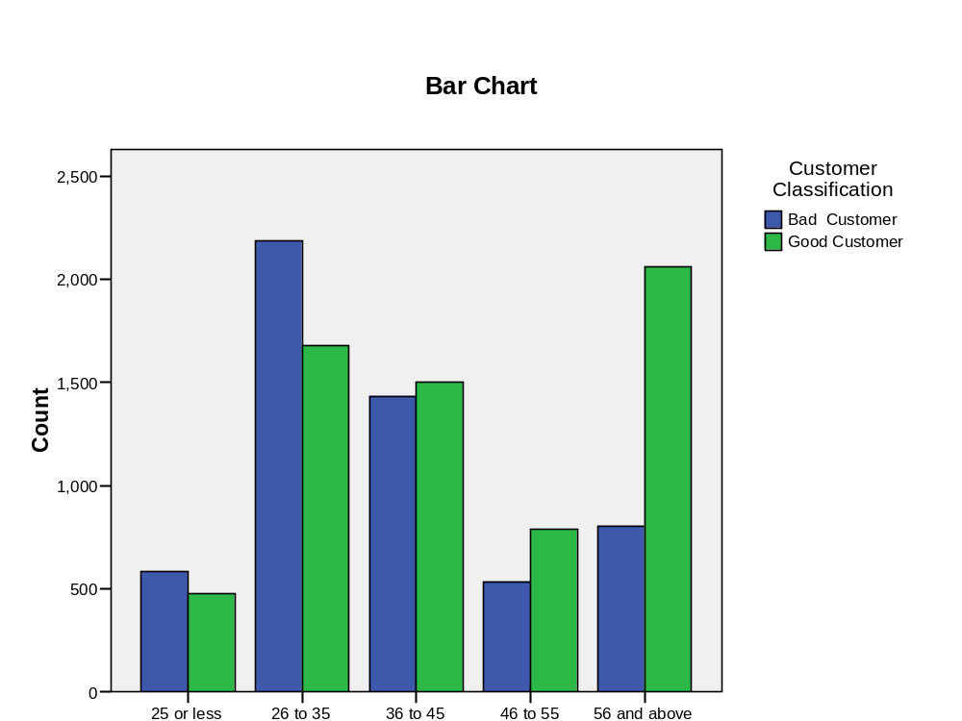
Fig-31 Age-Customer classification

From the table and the chart above, it can be seen that the customers in the age group of 26 to 35 are more likely to default than the customers in the age group of 46 and above. The chi-squared value of 605 at 4 degrees of freedom is statistically significant at 99.9 confidence level, implying that age and customer type are related.

Table - 33
Educational Qualification Vs Customer Type
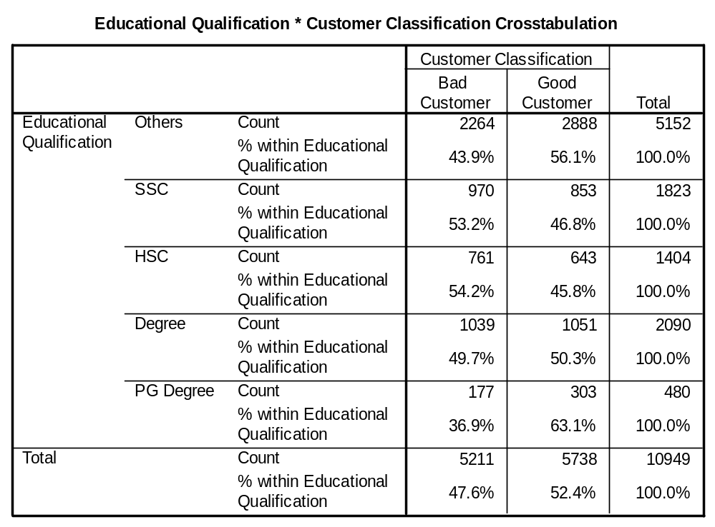

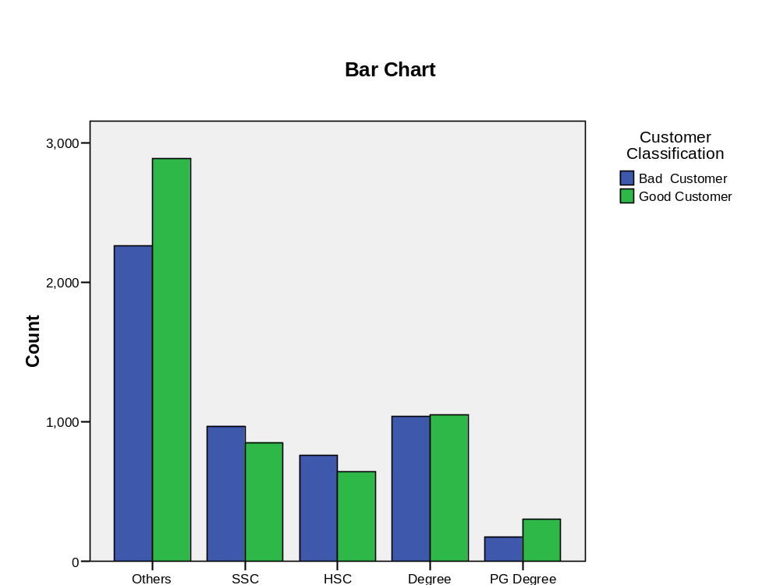

Fig-32 Qualification-Customer classification

The less educated and those with PG qualification are less likely to default than those with school and degree qualification. The chi-squared value of 101 at 4 degrees of freedom is statistically significant at 99.99% confidence level, implying that educational qualification and customer type are related.

Table - 34
Number of dependents Vs Customer Type
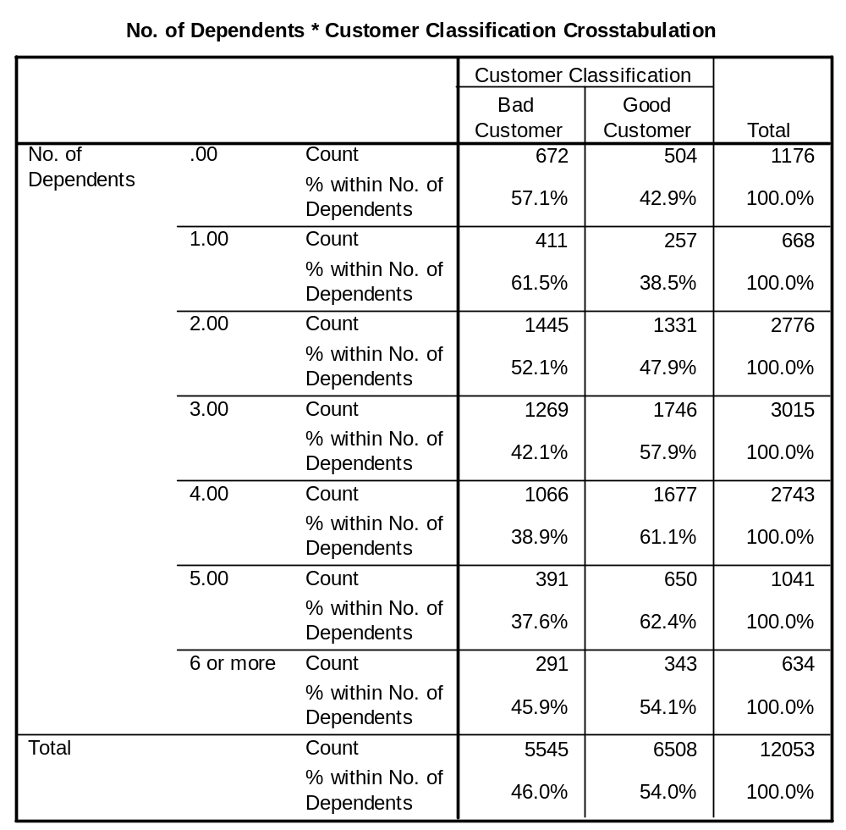

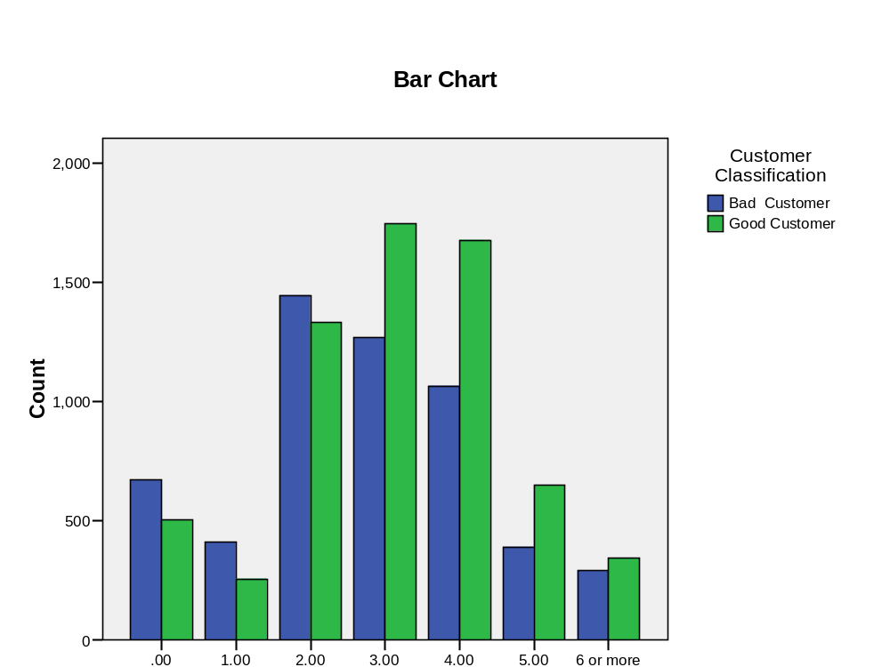

Fig-33 No of dependents-Customer classification

Customers with 2 or less dependents are more likely to default that those with 3 or more dependents. The chi-squared value of 269 at 6 degrees of freedom is statistically significant at 99.99% confidence level, implying that number of dependents and customer type are related.

Table - 35
Income Vs Customer Type

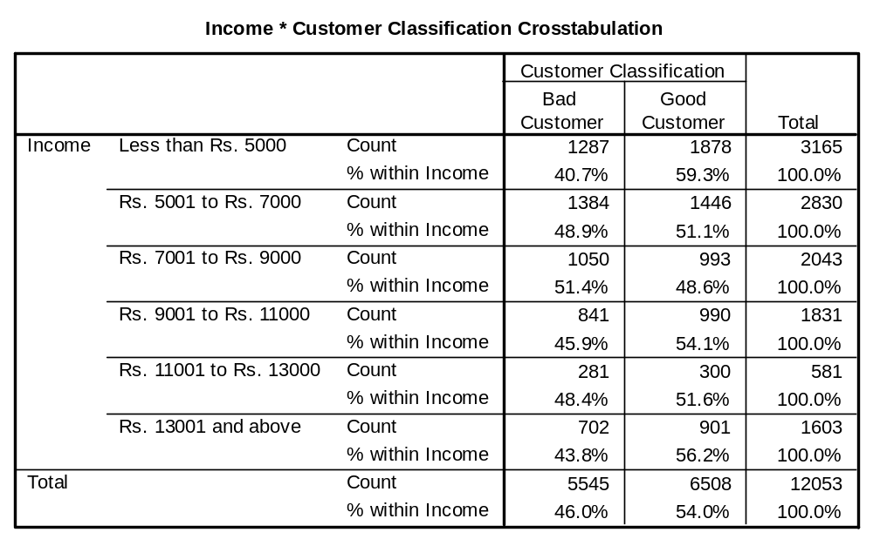

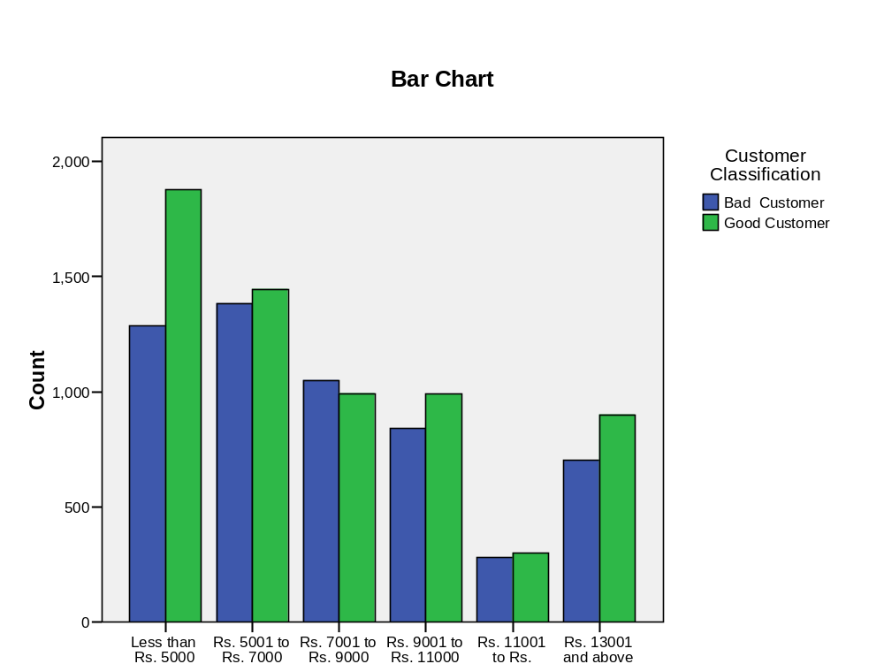
Fig-34 Income –Customer classsification
Customers in the Rs. 7000 to 9000 income group are more likely to default than those in other income groups. The chi-squared value of 74 at 5 degrees of freedom is statistically significant at 99.99% confidence level, implying that income and customer type are related.

Table - 36
Other Income Vs Customer Type

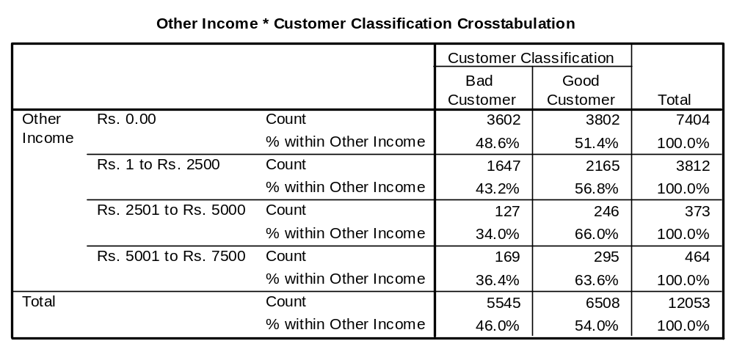

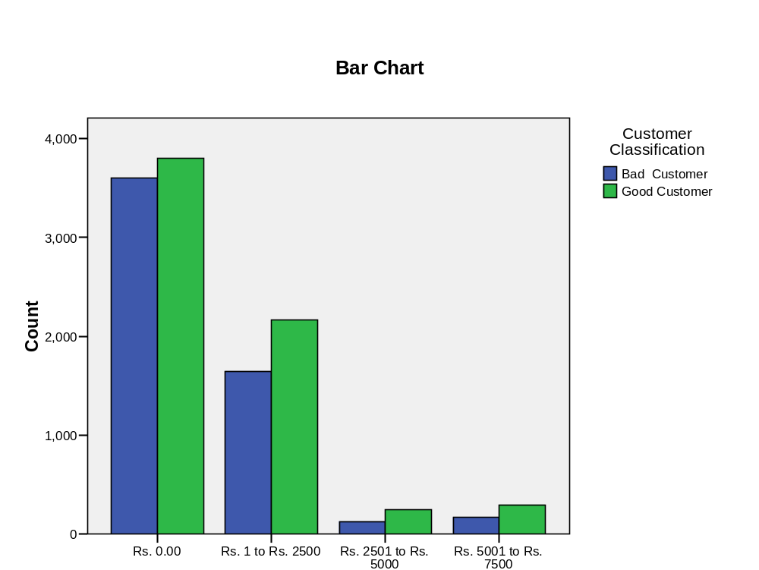

Fig-35 Other income- Customer classification

As other income increases the likelyhood of default decreases. The chi-squared value of 71 at 3 degrees of freedom is statistically significant at 99.99% confidence level, implying that other income and customer type are related.

Table - 37
Years of Experience Vs Customer Type
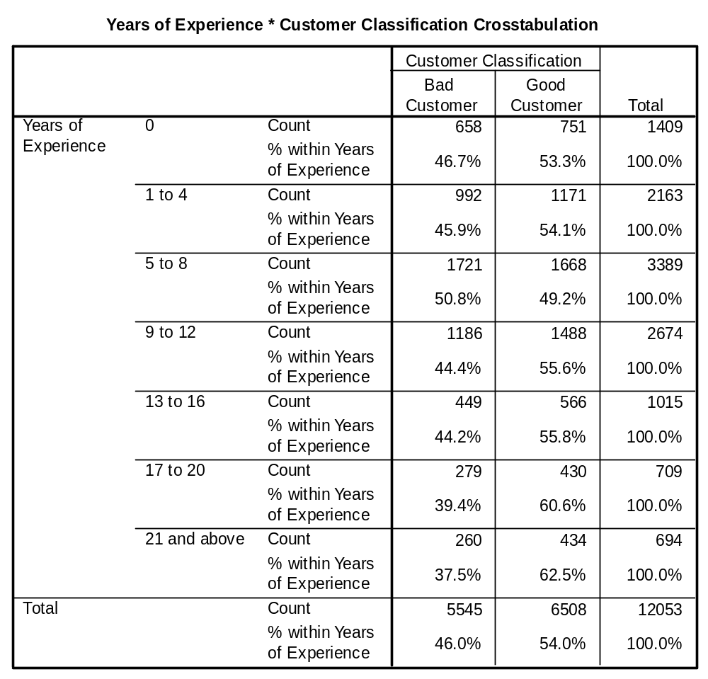

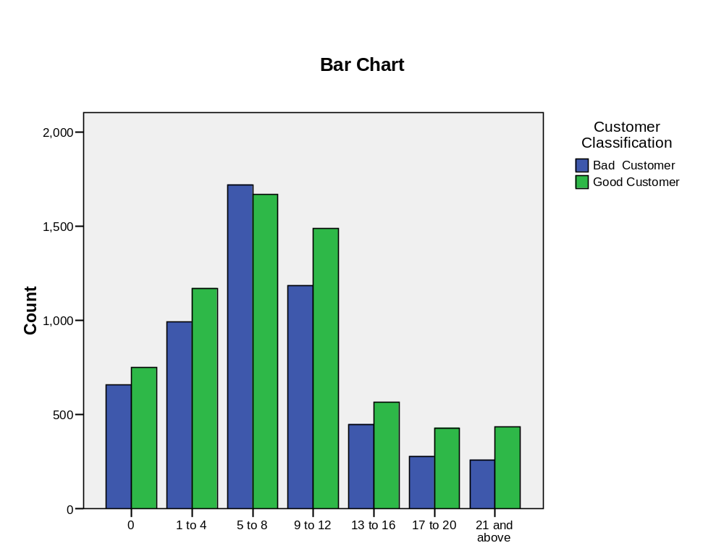

Fig-36 Experience – Customer classification

Customers in the 5 to 8 years experience group are more likely to default than others. The chi-squared value of 69 at 6 degrees of freedom is statistically significant at 99.99% confidence level, implying that other income and customer type are related.

Table - 38
Type of house Vs Customer Type

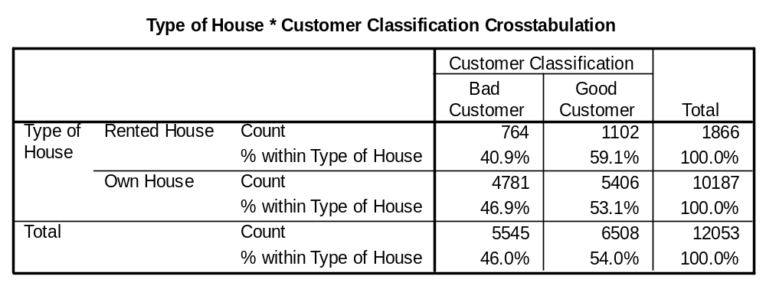

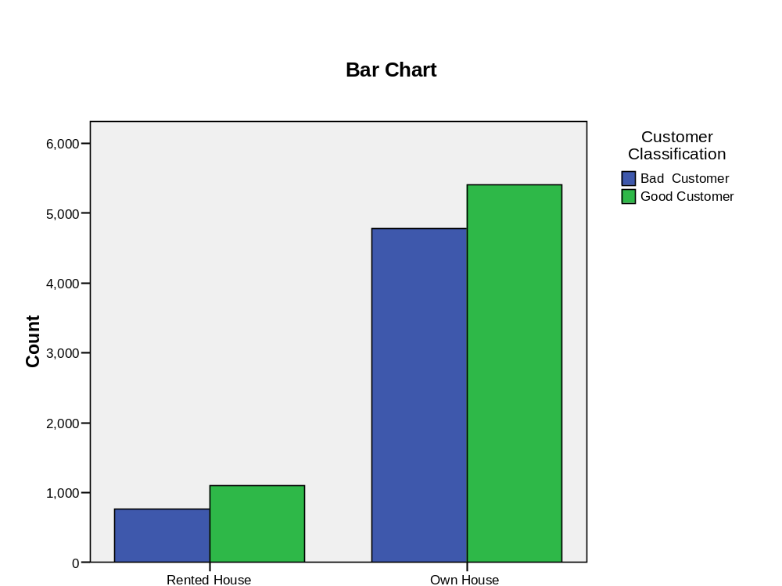

Fig-37 Type of house-Customer classification

Customers living in their own house are more likely to default than those in rented or leased houses. The chi-squared value of 23 at 1 degrees of freedom is statistically significant at 99.99% confidence level, implying that other income and customer type are related.

Table - 39
Rent Paid Vs Customer Type

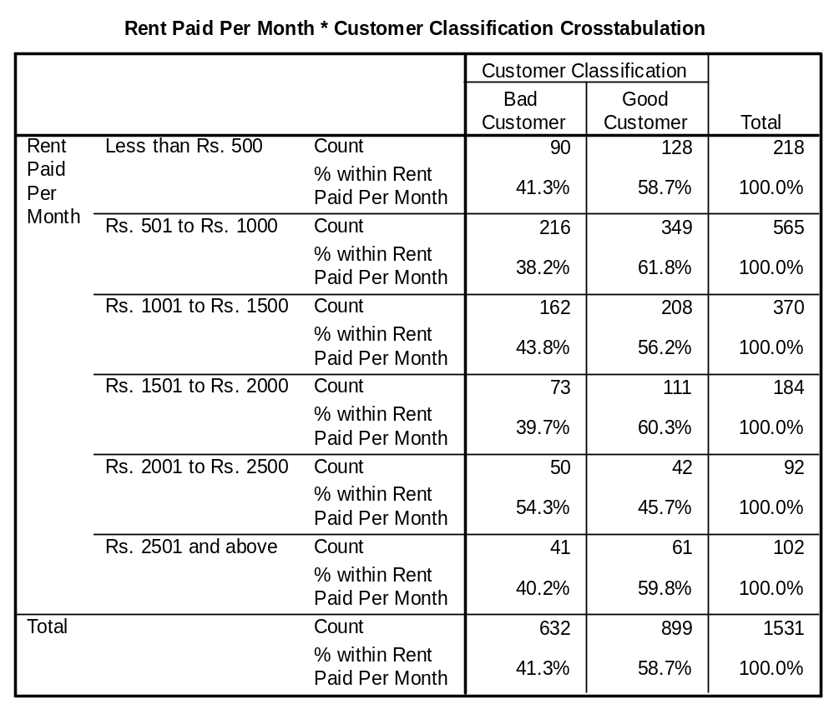

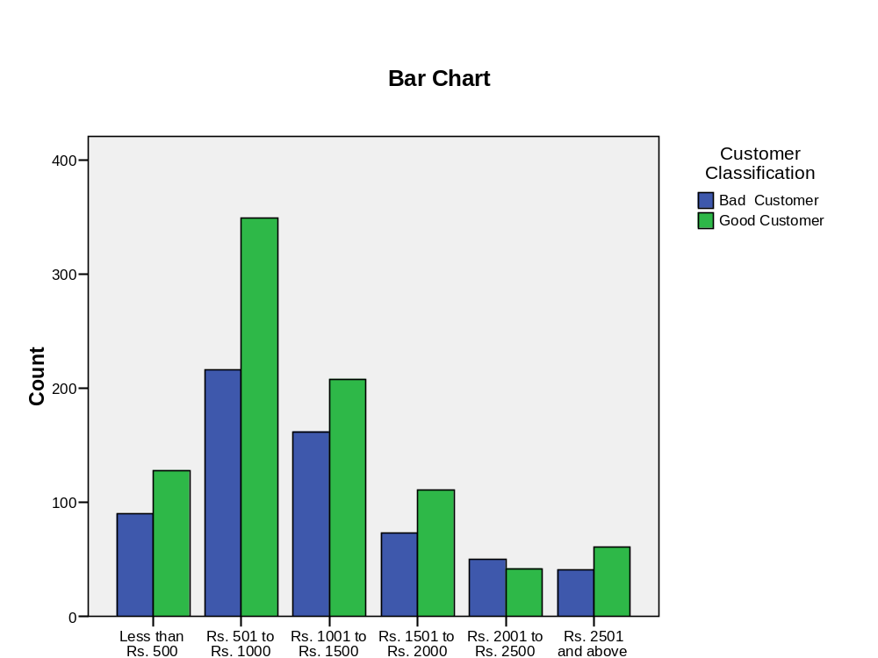

Fig-38 Rent-Customer Classification

There is no significant relationship that could be established between rent amount paid and the customer type. The chi-squared value of 9.8 at 5 degrees of freedom is not statistically significant at (p value = 0.08), implying that rent paid and customer type are related.

Table - 40
Down Payment * Customer Classification Crosstabulation
 |  |  | Customer Classification |  | Total
 |  |  | Bad Customer | Good Customer | Bad Customer
Down Payment | Less than Rs. 5000 | Count | 956 | 341 | 1297
 |  | % within Down Payment | 73.7% | 26.3% | 100.0%
 | Rs. 5001 to  Rs. 8000 | Count | 1567 | 1510 | 3077
 |  | % within Down Payment | 50.9% | 49.1% | 100.0%
 | Rs. 8001 to  Rs 11000 | Count | 1078 | 1711 | 2789
 |  | % within Down Payment | 38.7% | 61.3% | 100.0%
 | Rs. 11001 to Rs. 14000 | Count | 751 | 945 | 1696
 |  | % within Down Payment | 44.3% | 55.7% | 100.0%
 | Rs. 14001 to Rs. 17000 | Count | 541 | 563 | 1104
 |  | % within Down Payment | 49.0% | 51.0% | 100.0%
 | Rs. 17001 to Rs. 20000 | Count | 392 | 390 | 782
 |  | % within Down Payment | 50.1% | 49.9% | 100.0%
 | Above Rs. 20000 | Count | 259 | 1047 | 1306
 |  | % within Down Payment | 19.8% | 80.2% | 100.0%
Total |  | Count | 5544 | 6507 | 12051
 |  | % within Down Payment | 46.0% | 54.0% | 100.0%

Chi-Square Tests

 | Value | df | Asymp. Sig. (2-sided)
Pearson Chi-Square | 862.985(a) | 6 | .000
Likelihood Ratio | 904.867 | 6 | .000
Linear-by-Linear Association | 450.784 | 1 | .000
N of Valid Cases | 12051

0 cells (.0%) have expected count less than 5. The minimum expected count is 359.76.

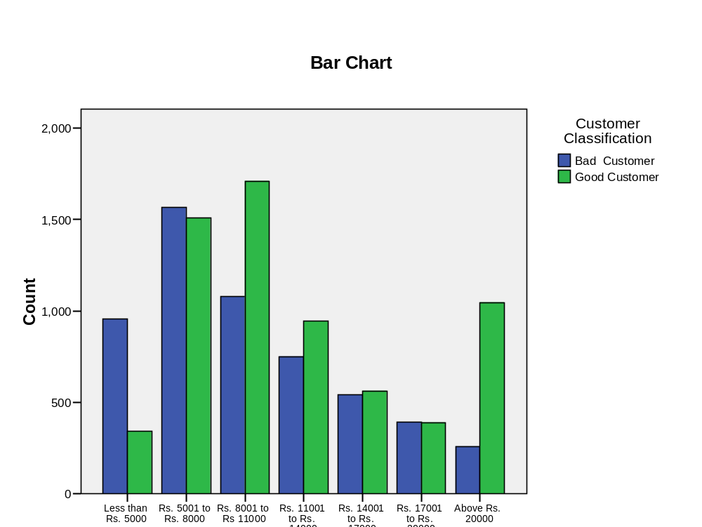

Fig-39 Downpayment-Customer classification

Down payment has significant relationship with the class of customers as reflected in the Chi-square value of 862.985 at 6 degrees of freedom. Customers who have paid Rs 20000 and more have a very good Repayment behavior.

Table - 41
TV Ownership * Customer Classification Crosstabulation

 |  |  | Customer Classification |  | Total
 |  |  | Bad Customer | Good Customer | Bad Customer
TV Ownership | No | Count | 1103 | 830 | 1933
TV Ownership | No | % within TV Ownership | 57.1% | 42.9% | 100.0%
TV Ownership | Yes | Count | 4442 | 5678 | 10120
TV Ownership | Yes | % within TV Ownership | 43.9% | 56.1% | 100.0%
Total |  | Count | 5545 | 6508 | 12053
 |  | % within TV Ownership | 46.0% | 54.0% | 100.0%

Chi-Square Tests

 | Value | Df | Asymp. Sig.  (2-sided) | Exact Sig. (2-sided) | Exact Sig.  (1-sided)
Pearson Chi-Square | 113.297(b) | 1 | .000
Continuity Correction(a) | 112.767 | 1 | .000
Likelihood Ratio | 112.998 | 1 | .000
Fisher's Exact Test |  |  |  | .000 | .000
Linear-by-Linear Association | 113.287 | 1 | .000
N of Valid Cases | 12053

a. Computed only for a 2x2 table
b. 0 cells (.0%) have expected count less than 5. The minimum expected count is 889.28.

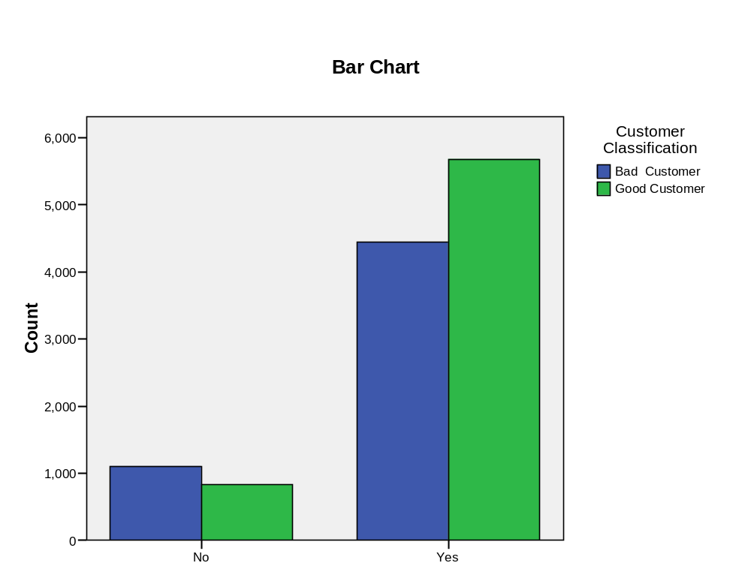

Fig-40 TV ownership-customer classification

TV ownership has a good impact on the customer class as seen in the bar graph and also refleacted by the Chi-square value of 113.297 at 1 degree of freedom and hence they have a significant relationship.

Table - 42
Music System * Customer Classification Crosstabulation

 |  |  | Customer Classification |  | Total
 |  |  | Bad Customer | Good Customer | Bad Customer
Music System | No | Count | 1694 | 1188 | 2882
Music System | No | % within Music System | 58.8% | 41.2% | 100.0%
Music System | Yes | Count | 3851 | 5320 | 9171
Music System | Yes | % within Music System | 42.0% | 58.0% | 100.0%
Total |  | Count | 5545 | 6508 | 12053
 |  | % within Music System | 46.0% | 54.0% | 100.0%

Chi-Square Tests

 | Value | df | Asymp. Sig.  (2-sided) | Exact Sig.  (2-sided) | Exact Sig.  (1-sided)
Pearson Chi-Square | 248.790(b) | 1 | .000
Continuity Correction(a) | 248.114 | 1 | .000
Likelihood Ratio | 248.598 | 1 | .000
Fisher's Exact Test |  |  |  | .000 | .000
Linear-by-Linear Association | 248.769 | 1 | .000
N of Valid Cases | 12053

a. Computed only for a 2x2 table
b. 0 cells (.0%) have expected count less than 5. The minimum expected count is 1325.87.

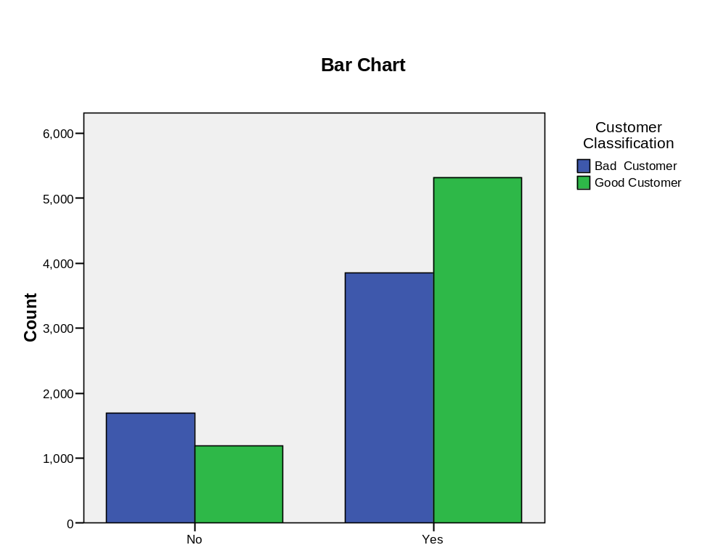
Fig-41 Music system ownership-Customer classification

Customers who own music systems have a good repayment behavior. This is is also seen from the chi-square value of 248.79 at a degree of freedom 1.

Table - 43
Fridge * Customer Classification Crosstabulation

 |  |  | Customer Classification |  | Total
 |  |  | Bad Customer | Good Customer | Bad Customer
Fridge | No | Count | 2955 | 3469 | 6424
Fridge | No | % within Fridge | 46.0% | 54.0% | 100.0%
Fridge | Yes | Count | 2590 | 3039 | 5629
Fridge | Yes | % within Fridge | 46.0% | 54.0% | 100.0%
Total |  | Count | 5545 | 6508 | 12053
 |  | % within Fridge | 46.0% | 54.0% | 100.0%

Chi-Square Tests

 | Value | Df | Asymp. Sig.  (2-sided) | Exact Sig.  (2-sided) | Exact Sig.  (1-sided)
Pearson Chi-Square | .000(b) | 1 | .989
Continuity Correction(a) | .000 | 1 | 1.000
Likelihood Ratio | .000 | 1 | .989
Fisher's Exact Test |  |  |  | 1.000 | .502
Linear-by-Linear Association | .000 | 1 | .989
N of Valid Cases | 12053

a. Computed only for a 2x2 table
b. 0 cells (.0%) have expected count less than 5. The minimum expected count is 2589.63.

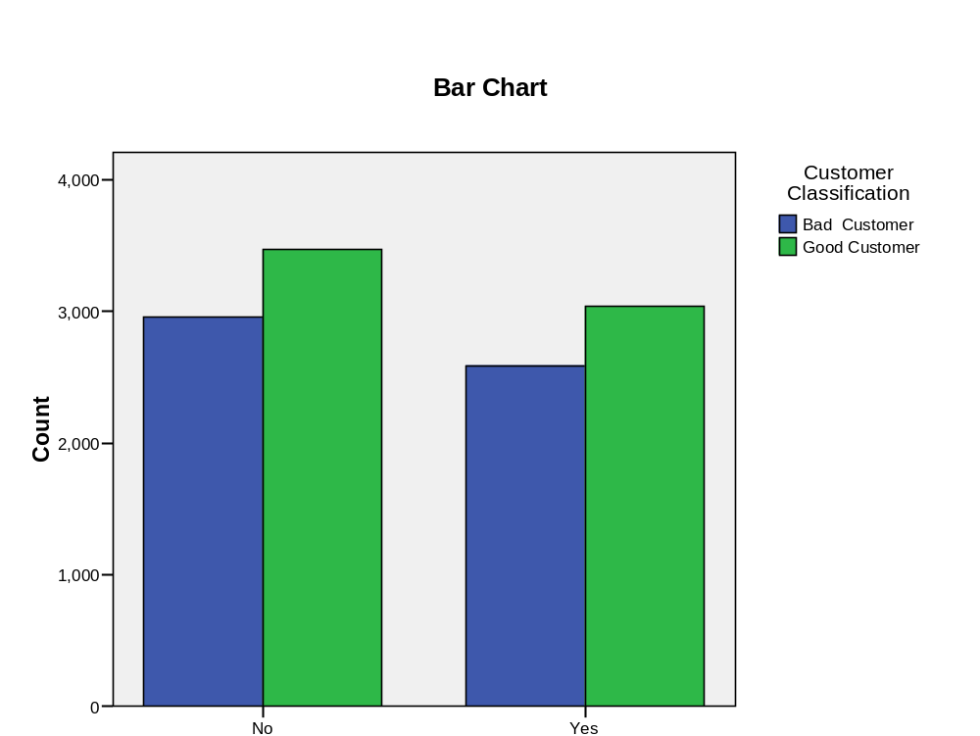

Fig-42 Fridge Ownership-Customer classification

Table - 44
Washing Machine * Customer Classification Crosstabulation
 |  |  | Customer Classification |  | Total
 |  |  | Bad Customer | Good Customer | Bad Customer
Washing Machine | No | Count | 4139 | 5191 | 9330
Washing Machine | No | % within Washing Machine | 44.4% | 55.6% | 100.0%
Washing Machine | Yes | Count | 1406 | 1317 | 2723
Washing Machine | Yes | % within Washing Machine | 51.6% | 48.4% | 100.0%
Total |  | Count | 5545 | 6508 | 12053
 |  | % within Washing Machine | 46.0% | 54.0% | 100.0%

Possession of washing machine does not have any impact on the classification of customers and this is confirmed by the chi-square value.

Chi-Square Tests
 | Value | Df | Asymp. Sig. (2-sided) | Exact Sig. (2-sided) | Exact Sig. (1-sided)
Pearson Chi-Square | 44.872(b) | 1 | .000
Continuity Correction(a) | 44.580 | 1 | .000
Likelihood Ratio | 44.757 | 1 | .000
Fisher's Exact Test |  |  |  | .000 | .000
Linear-by-Linear Association | 44.869 | 1 | .000
N of Valid Cases | 12053

a. Computed only for a 2x2 table
b. 0 cells (.0%) have expected count less than 5. The minimum expected count is 1252.72.

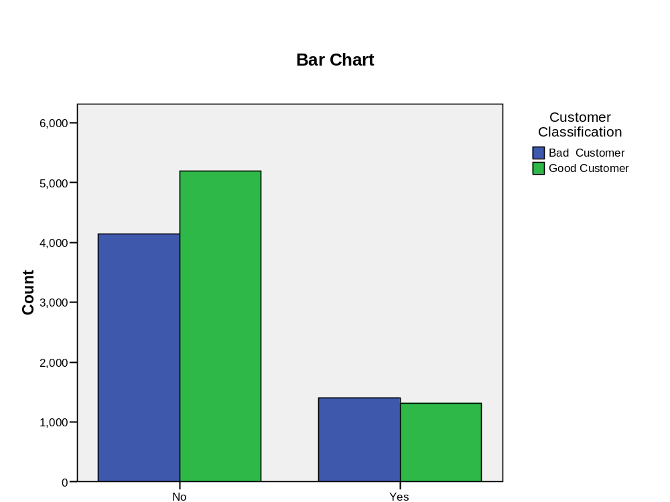

Fig-43 Washing machine-Customer classification

Table - 45
Two-wheeler * Customer Classification Crosstabulation
 |  |  | Customer Classification |  | Total
 |  |  | Bad Customer | Good Customer | Bad Customer
Two-wheeler | No | Count | 4757 | 5433 | 10190
Two-wheeler | No | % within  Two-wheeler | 46.7% | 53.3% | 100.0%
Two-wheeler | Yes | Count | 788 | 1075 | 1863
Two-wheeler | Yes | % within  Two-wheeler | 42.3% | 57.7% | 100.0%
Total |  | Count | 5545 | 6508 | 12053
 |  | % within  Two-wheeler | 46.0% | 54.0% | 100.0%

Possession of two wheelers does not seem to affect significantly the classification and the chi-squre value is also low at 44.97 at a degree of freedom 1. Another reason could be that the percentage of customers with two wheelers is less.

Chi-Square Tests
 | Value | df | Asymp. Sig. (2-sided) | Exact Sig. (2-sided) | Exact Sig. (1-sided)
Pearson Chi-Square | 12.196 (b) | 1 | .000
Continuity Correction(a) | 12.020 | 1 | .001
Likelihood Ratio | 12.245 | 1 | .000
Fisher's Exact Test |  |  |  | .000 | .000
Linear-by-Linear Association | 12.195 | 1 | .000
N of Valid Cases | 12053

a. Computed only for a 2x2 table
b. 0 cells (.0%) have expected count less than 5. The minimum expected count is 857.08.

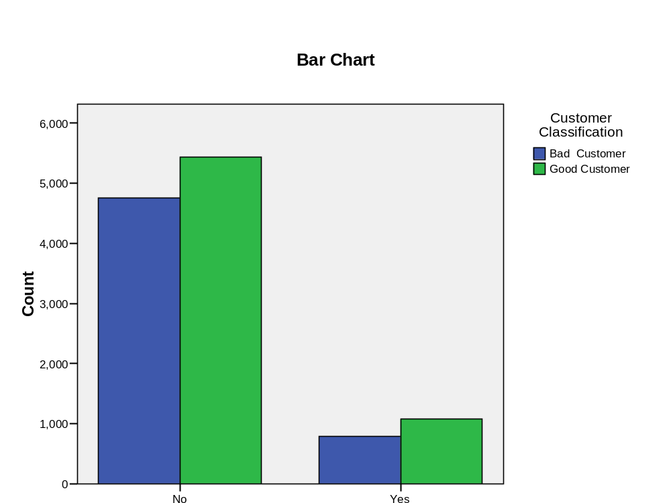

Fig-44 Two -Wheeler ownership- Customer classifications

Table - 46
Four -wheeler * Customer Classification Crosstabulation

 |  |  | Customer Classification |  | Total
 |  |  | Bad Customer | Good Customer | Bad Customer
Four –wheeler | No | Count | 5457 | 6436 | 11893
 |  | % within Four –wheeler | 45.9% | 54.1% | 100.0%
 | Yes | Count | 88 | 72 | 160
 |  | % within Four –wheeler | 55.0% | 45.0% | 100.0%
Total |  | Count | 5545 | 6508 | 12053
 |  | % within Four –wheeler | 46.0% | 54.0% | 100.0%

Chi-Square Tests

 | Value | df | Asymp. Sig. (2-sided) | Exact Sig. (2-sided) | Exact Sig. (1-sided)
Pearson Chi-Square | 5.281(b) | 1 | .022
Continuity Correction(a) | 4.921 | 1 | .027
Likelihood Ratio | 5.260 | 1 | .022
Fisher's Exact Test |  |  |  | .025 | .013
Linear-by-Linear Association | 5.281 | 1 | .022
N of Valid Cases | 12053

a. Computed only for a 2x2 table
b. 0 cells (.0%) have expected count less than 5. The minimum expected count is 73.61.

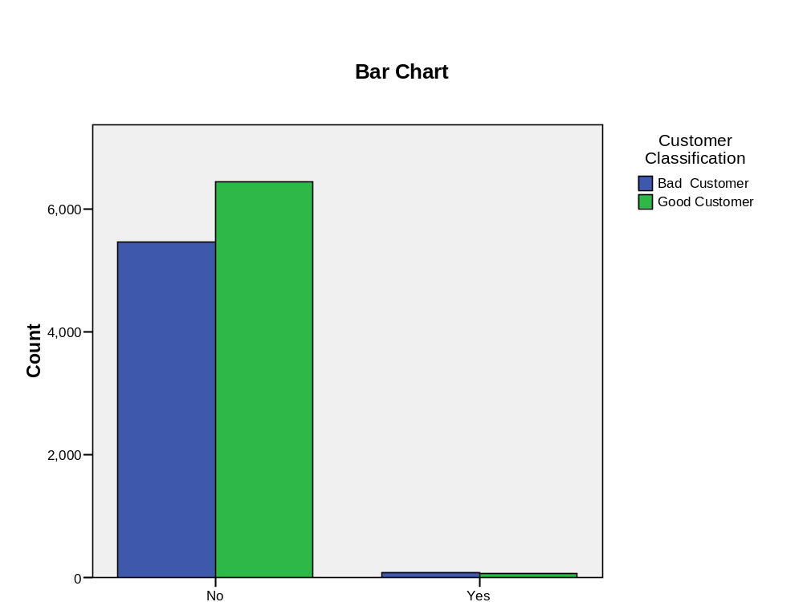

Fig-45 Four wheeler ownership –Customer classification

Four wheeler ownership does not have a significant impact on the repayment behavior of the customers. Once again the percentage of four wheelers is very less.

Data Analysis is the process of collecting and analysis and using data (related to demographic information, past behaviour trends its) to better understand and predict the behaviour of existing and prospective customers for business decision making.
6.2 Data analysis techniques
While Data Analysis Methods have been extensively used in FMCG, Pharma and telecom companies, their mainstay has been the consumer finance industry.
The common tools used to conduct data analytic range from sample cross tabulation and segmentation analysis to more sophisticated statistical methods such as multivariate and logistic regression, CART analysis and cluster analysis. In the last few years computational tools and machine learning algorithm such as neutral networks and genetic algorithm have also been used to perform advanced data analysis.
Recent years have seen increased use of data in driving business strategies across various industries. While the data analytics methods have been extensively used in FMCG, Pharma & telecom their mainstay has been the consumer finance industry. Today the FICO (Fair lease & Co). Risk score is the bench mark for credit decision process, so much so that the "Prime" & Sub Prime" markets depend on the basis of this score. With the exponential increase in computing power and application of information technology in business processes, more and more data analystics techniques and statistical tools are now being applied for marketing risk management pricing and NPI functions in the consumer finance industry.
Data Mining
These two words mean getting an insight of the customer. Data mining is exploring the data and discovering relationship among the data to explain certain outcome and thus build model. Millions of customer data lying unused can be put to tremendous use to understand consumer.
The important general difference in the focus and purpose between data mining and the traditional exploratory data analysis is that data mining is more oriented towards applications than the basic nature of the underlying phenomena. Data mining is often considered be a blend of statistics, artificial intelligence and data base research.
This is an analysis process designed to explore large amounts of (typically business or market related)data(tera data, of the order of tera bites) in search for consistent patterns and/or systematic relationship between variables and then to validate the findings by applying the detected patterns to the new subsets of data. Data mining uses many of the principles and techniques traditionally referred to as exploratory data analysis.
The ultimate goal of data mining is prediction and this is one that has the most direct applications. This process involve
1. Initial exploration
2. Model building
3. Deployment.
6.3 Datamining Tools
Many methods like regression(In fact a feed forward neural network consisting of units with linear transfer function and and a weighted sum combination function is just doing a linear regression), CART type of decision tree, descriminant analysis, memory based reasoning, Survival analysis, artificial neural network, genetic algorithms are possible methods that could be used for prediction
6.3.1a Artificial Neural Network
The ANN model, inspired by the structure of the nerve cells in the brain, can be represented as a massive parallel interconnection of many simple computational units interacting across weighted connections. Each computational unit consists of a set of input connections that receive signals from other computational units, a set of weights for input connection, and a transfer function. The output for the computational unit (nodej) Uj, is the result of applying a transfer function Fj to the summation of all signals from each connection (Xi) times the value of the connection weight between node j and connection i (Wij). The multi-layer feed-forward neural network (MLFN) computational units are grouped into 3 main layers ; input layer, hidden layer(s), and output layer.
W_{ij} are connection weights from input layer (nodei) to hidden layer (nodej) and from hidden layer (node j) to output layer, respectively, West et al(1997).
The calculation of the neural network weights is known as training process. The process starts by randomly initializing connection weights and introduces a set of data inputs and actual outputs to the network. Then the network calculates the network output and compares it to the actual output and calculated the error. In an attempt to improve the overall predictive accuracy and to minimize the network total mean squared error, the network adjusts the connection weights by propagating the error backward through the network to determine how to best update the interconnection weights between individual neurons.
6.3.2 Probabilistic neural network (PNN)
The PNN proposed by Specht (1990) is basically a classification network. Its general structure consists of 4 layers; an input layer, a pattern layer, a summation layer, and an output layer. PNN is conceptually based on the Bayesian classifier statistical principle.
Advantages
- Very flexible in the types of hypotheses it can represent.
- Boars some resemblance to a very small human brain.
- Can adapt to new data with labels.
Disadvantages
- Very difficult to interpret the hypothesis as a simple rule.
- Difficult to compute.
6.4 Steps in Datamining
6.4.1 Data Preparation
Data preparation and clearing is often neglected but extremely important step in the data mining process. For example Data may contain experience = 100. Impossible data combination Gender - Male: Pregnant: yes and so on.
The stages involved in data preparation involves cleaning the data, data transformation, reducing subsets of records and in case of data sets with large number of variables performing some preliminary operation to bring the number of variables to a manageable range(depending on the statistical methods which are being considered). Then depending on the nature of the analytic problem the first stage of the process of data mining may involve anywhere between a simple choice of straight forward prediction for a regression model to elaborate exploratory analysis using a wide variety of graphical and statistical methods in order to identify the most relevant variables and determine the complexity and or the general nature of models that can be taken in the next stage.
6.4.2 Data reduction
This type of data reduction is applied in exploratory graphical data analysis of extremely large data sets. The size of the data set can obscure an existing pattern (especially in large line graphs or scatter plots) due to the density of markers or lines. Then it can be made useful by a plot of only a representative subset of the data (so that the pattern is not hidden by the number of point markers) to reveal the otherwise obscured but still reliable pattern.
Then there is another which pertains to analytic methods, typically multivariate exploratory techniques such as factor analysis, decision tree analysis, multidimensional scaling, cluster analysis and canonical correlation that involve reducing the dimensionality of the data set by extracting a number of underlying factors;dimensions and cluster, that can account for the variability in the (multi dimensional) data set. In a poorly designed questionnaire all responses provided by the participants on a large number of variable (scales, questionnaire dimensions) could be explained by a very limited number of trivial or artifactual factors. For example two such underlying factors could be(1) the respondents’ attitude towards the study (positive or negative) and(2) the social desirability factor (a response bias representing a tendency to respond in a socially desirable manner).
6.4.3 Preprocessing Input Data
Once the most appropriate raw input data has been selected, it must be preprocessed;otherwise, the neural network will not produce accurate forecasts. The decisions made in this phase of development are critical to the performance of a network.
Transformation and normalization are two widely used preprocessing methods.
6.4.4 Transformation
Involves manipulating raw data inputs to create a single input to a net, while normalization is a transformation performed on a single data input to distribute the data evenly and scale it into an acceptable range for the network. Knowledge of the domain is important in choosing preprocessing methods to highlight underlying features in the data, which can increase the network's ability to learn the association between inputs and outputs.
Some simple preprocessing methods include computing differences between or taking ratios of inputs. This reduces the number of inputs to the network and helps it learn more easily. In financial forecasting, transformations that involve the use of standard technical indicators should also be considered. Moving averages, for example, which are utilized to help smooth price data, can be useful as a transform.
When creating a neural net to predict tomorrow's close, a five-day simple moving average of the close can be used as an input to the net. This benefits the net in two ways. First, it has been given useful information at a reasonable level of detail; and second, by smoothing the data, the noise entering the network has been reduced. This is important because noise can obscure the underlying relationships within input data from the network, as it must concentrate on interpreting the noise component. The only disadvantage is that worthwhile information might be lost in an effort to reduce the noise, but this tradeoff always exists when attempting to smooth noisy data.
While not all technical indicators have a smoothing effect, this does not mean that they cannot be utilized as data transforms. Possible candidates are other common indicators such as the relative strength index (RSI), the average directional movement indicator (ADX) and stochastics.
6.4.5 Data Normalization
Data normalization is the final preprocessing step. In normalizing data, the goal is to ensure that the statistical distribution of values for each net input and output is roughly uniform. In addition, the values should be scaled to match the range of the input neurons. This means that along with any other transformations performed on network inputs, each input should be normalized as well.
Here are three methods of data normalization,
6.4.5a. Oneof the normalization methods is a simple linear scaling of data. At the very least, data must be scaled into the range used by the input neurons in the neural network. This is typically the range of -1 to 1 or zero to 1. Many commercially available generic neural network development programs such as NeuralWorks, BrainMaker and DynaMind automatically scale each input. This function can also be performed in a spreadsheet or custom-written program. Of course, a linear scaling requires that the minimum and maximum values associated with the facts for a single data input be found. Let's call these values Dmin and Dmax, respectively. The input range required for the network must also be determined. Let's assume that the input range is from Imin to Imax. The formula for transforming each data value D to an input value I is:
I = Imin + (Imax-Imin)*(D-Dmin)/(Dmax-Dmin)
Dmin and Dmax must be computed on an input-by-input basis. This method of normalization will scale input data into the appropriate range but will not increase its uniformity.
6.4.5b The second normalization method utilizes a statistical measure of central tendency and variance to help remove outliers, and spread out the distribution of the data, which tends to increase uniformity. This is a relatively simple method of normalization, in which the mean and standard deviation for the input data associated with each input are determined. Dmin is then set to the mean minus some number of standard deviations. So, if the mean is 50, the standard deviation three and two standard deviations are chosen, then the Dmin value would be 44
(50-2*3).
Dmax is conversely set to the mean plus two standard deviations. All data values less than Dmin are set to Dmin and all data values greater than Dmax are set to Dmax. A linear scaling is then performed as described above. By clipping off the ends of the distribution this way, outliers are removed, causing data to be more uniformly distributed.
6.4.5c The third normalization method minimizes the standard deviation of the heights of the columns in the initial frequency distribution histogram.
There are other methods for data normalization. Some methods are more appropriate than others, depending on the nature and characteristics of the data to be normalized.
6.5 Choice of ANN architechture/Topology
ANNs have proven to be a useful, if complicated, way of learning. They adapt to strange concepts relatively well in many situations. They are one of the more important results coming out of machine learning.
One of the complexities with using ANNs is the number of parameters you can tweak to work with the data better. You choose the representation of attribute vectors and labels the architecture of the network, the training rate and how many interactions through the examples you want to do. The process is much more complicated than simply feeding the data into a linear regression program. A variety of decisions have to be made in order to get a good neural network for predicting first classification advantages.
Connections between the hidden layer and the output layer are called W1 and W0 is here the threshold value of the activation function of the input layer.
T in the input layer indicates the pre-processing of the variable. In the hidden layer, the tank function is used as the activation function; it is of a sigmoid shape and its values are in the interval (-1, 1).
Before the calculation of the weight coefficients of the connections between the input layer and the hidden layer, and correspondingly, between the hidden layer and the output layer, the error function
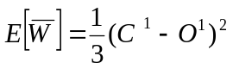
was minimized in relation to the connection vector W between the hidden layer and the output layer. In the formula for the error function K is the number of data sets in the development sample, and C' is the correct answer of data set number 1, the weight coefficients T, are obtained using the gradient descent method.
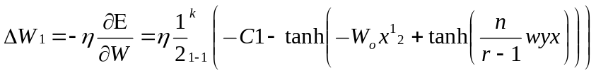
η- Co-efficient used for adjusting the learning rate.
The weights of the earlier layers can be calculated in a corresponding manner, through repeated application of the chain rule.
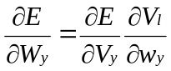

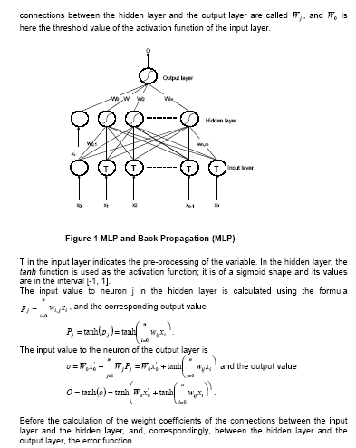

Fig-46: MLP NN architecture
Stop conditions determine when the MLP algorithm will terminate training typically, the stop conditions are implemented for a maximum number of epochs of training or when the RMS fell below a target value.
6.6 Denormalisation
When the network is run on a new test fact, the output produced must be denormalized. If the normalization is entirely reversible with little or no loss in accuracy, there is no problem. However, if the original normalization involved clipping outlier values, then output values equal to the clipping boundaries should be suspect concerning their actual value. For example, assume that during training all output values greater than 50 were clipped. Then, during testing, if the net produces an output of 50, this indicates only that the net's output is 50 or greater. If that information is acceptable for the application, then the normalization method would be sufficiently reversible.
6.7 Performance of Models
CAP Plots, ROC Curves and Power Statistics
More general measures of predictive power ROC (relative or receiver operating characteristic) curves (Green and Swets, 1966;Hanley, 1989;Pepe, 2002;Swets, 1988; Swets, 1996), generalize contingency table analysis by providing information on the performance of a model at any cut-off that might be chosen. They plot the FP rate against the TP rate for all credits in a portfolio.
ROCs are constructed by scoring all credits and ordering the non-defaulters from worst to best on the x axis and then plotting the percentage of defaults excluded at each level on the y axis. So the y axis is formed by associating every score on the x axis with the cumulative percentage of defaults with a score equal to or worse than that score in the test data. In other words, the y axis gives the percentage of defaults excluded as a function of the number of non-defaults excluded.
A similar measure, a CAP plot, Sobehart, Keenan and Stein(2000), is constructed by plotting all the test data from "worst" to "best" on the x axis. Thus a CAP plot provides information on the percentage of defaulters that are excluded from a sample (TP rate), given we exclude all credits, good and bad, below a certain score. CAP plots and ROC curves convey the same information in slightly different ways. This is because they are geared to answering slightly different questions.
CAP plots answer the question: "How much of an entire portfolio would a model have to exclude to avoid a specific percentage of defaulters?"ROC curves use the same information to answer the question: "What percentage of non-defaulters would a model have to exclude a specific percentage of defaulters?" The first question tends to be of more interest to business people, while the second is somewhat more useful for an analysis of error rates. In cases where default rates are low (i.e., 1-2%), the difference can be slight and it can be convenient to favor one or the other in different contexts. The Type I and Type II error rates for the two are related through an identity involving the sample average default probability and sample size. In statistical terms, the CAP curve represents the cumulative probability distribution of default events for different percentiles of the risk score scale. CAP plots can also be more easily used for direct calibration by taking the marginal, rather than cumulative, distribution of defaults and adjusting for the true prior probability of default.
6.8 Deployment
The concept of deployment in predictive data mining refers to the application of a model for prediction or classification of new data. After a satisfactory model or set of models has been identified for a particular application, one usually wants to deploy those models so that the predicted classification can quickly be obtained for new data. For example a credit card company may want to deploy a trained model or set of models of neural network to quickly identify transactions which have a high probability of being fraudulent.
This stage involves considering various models and choosing the best one based on their predictive performance(i.e. explaining the variability in question and producing stable results across samples). There are a variety of techniques developed to achieve that goal many of which are based on "comparative evaluation of models" i.e. applying different models to the same data set and then comparing their performance to choose the best. These techniques which are often considered the core of predictive data-mining include bagging(voting, averaging), boosting, stacking and meta learning.
6.9 Data preparation in the current problem
- NN is an assumption free, non-algorithmic approach to estimate the relationship between dependent and independent variables.
- The given dataset is divided into training and testing data sets. NN uses the training data set to model the relationship between input (independent variables) and output (dependent variable).
- Starting with a randomly assigned weight matrix, NN maps the input and output with the help of this weight matrix and continuously refines the weight matrix to get the perfect fit between input variables and output.
- Performance of NN can be improved through various methods of configuring the network and giving the proper inputs. Transformation is manipulating raw data inputs to create a single input to a net
- Normalization is transformation performed on a single data input to distribute the data evenly and scale it into an acceptable range for the network.
- Knowledge of the domain is important in choosing preprocessing methods to highlight underlying features in the data, which can increase the network's ability to learn the association between inputs and outputs.
In data mining the input data are often noisy containing many errors and sometimes information in unstructured form. For example suppose whether it is a method of questionnaire or online data collection there will certainly be a set of data where the faulty information is given other intentionally or by typing error or other unintentional error. For example some individuals might clearly enter faulty information (eg. age = 300).
If these type of data as not detected prior to analysis phase of the data mining project they can greatly bias the result and potentially cause unjustified conclusions. Typically during data preparation phase the data analyst applies `filters' to the data to verify correct data ranges and to delete impossible occurrence of values (Aj = 5, Retired = yes).
To give a flavor of the data bloomers that was come across during this profile at least there was atleast 0.05% of data where the age was entered as more than '100' or the experience was given as '25' when the age was 25, which would have been possible only if they had started working before birth. Also in terms of qualification, in the demographic data, many of the cases are classified under others and hence are of no use to find out any relationship among the data. The other option is in the set with base data of qualification and ascertain to see if there is any pattern that can be discovered and validated with the qualification.
6.10 Data Reduction
- In this project the data is set is clustered that is each cluster is a depiction of a specific borrower profile of income, age, down payment, etc. Then for each profile which forms one cluster the a factor analysis is carried out. This will identify those profiles which significantly explain the variation of the dependent variable and thus result in reduction.
- The data set of 12000 customers with seventeen variables was subjected to factor analysis, which reduced the seventeen variables to the following five factors.
  - Income & assets
  - Consumer durables
  - Initial payments (down payments, advance EMI)
  - Vehicles
  - Dependents
6.11 Input Data Selection
Data selection can be a demanding and intricate task.After all, a neural network is only as good as the input data used to train it.If important data inputs are missing, the effect on the neural network's performance can be significant.Developing a workable neural network application can be considerably more difficult without a solid understanding of the problem domain.When selecting input data, the implications of following a market theory should be kept in mind. Existing market inefficiencies can be noted quantitatively by making use of artificial intelligence tools.
Individual perspective on the markets also influences the choice of input data.Technical analysis suggests the use of only single-market price data as inputs, while conversely, fundamental analysis concentrates solely on data inputs that reflect supply/ demand and economic factors.In today's global environment, neither approach alone is sufficient for financial forecasting. Instead, synergistic market analysis combines both approaches with inter market analysis within a quantitative framework using neural networks.This overcomes the limitations of interpreting inter market relationships through simple visual analysis of price charts and carries conceptualization of inter market analysis to its logical conclusion.
Here, then, is an example of a neural network that predicts the next day's high and low for the Treasury bond market. This way, we will be able to see how synergistic market analysis can be implemented in a neural network. First, technical price data on T-bonds should be input into the network, allowing it to learn the general price patterns and characteristics of the target market. In addition, fundamental data that can have an effect on the market;for example, the federal funds rate, the Gross Domestic Product, money supply, inflation rates and the consumer price index can all be input into the network.
Because the neural network does not subscribe to a particular form of analysis, it will attempt to use all of the input information available to model the market.Thus, using fundamental data in addition to technical data can improve the overall performance of the network.Finally, incorporating intermarket input data on related markets such as the US Dollar Index, Standard & Poor's 500 index and the German Bund allows the network to utilize this information to find intermarket relationships and patterns that affect the target market.The selection of fundamental and intermarket data is based on domain knowledge coupled with the use of various statistical analysis tools to determine the correlation between this data and target market price data.
Preprocessing Input Data in current problem
6.12 Data selection
Identify the source data as the Automobile Loan data base and the monthly payment data base. Focus on all historic Loan application and all payment records. Basis of analysis is that the borrowers who do not repay more than 3 EMIS are considered as defaulters.
6.13 Data Preparation
- Extract Automobile application records
- Extract payment records
- Form application & payment tables
- Define the need field as total income fields ----, age, ---- Loan/ property value etc., records
6.14 Data Exploration
- Explore the frequency distribution of data fields
- Explore the correlation between data field,
- Plot the goal (arrears status) against other fields
6.15 Pattern Discovery
Perform data analysis by various methods like linear regression discriminant analysis, logistic regression, factor analysis and neural network.
6.16 Variables Extracted
Table 47: Variable extracted in Data Analysis
Variable | Description
Qualific | Qualification
Dependen | Number of dependents
Children | Number of Children
Income | Monthly Household Income
Othincom | Other Income
Experien | Years of Experience
Resident | Type of Residence
Rent | Rent Paid per month
Age | Age
Downpaym | Down Payment
TV | TV Ownership
Ms | Music System ownership
Fridge | Fridge Ownership
WM | Washing Machine Ownership
TV | Two-wheeler Ownership
FW | Four wheeler Ownership
Advemi | Advance EMI
Overdue | Amount Overdue
Noofdue | Number of installments Overdue
good_cus | Good customer

6.17 Exploratory Analysis
6.17.1 Profile of Good Customers
6.17.1.1 More than 60% of Good Customers are with Income to EMI of 5 and more.
6.17.1.2 Around 70% of good Customers are who have made a DP of more than 25%.
6.17.1.3. Around 70% of the Good Customers are with around 10 year’s experience
6.17.1.4. 80%of the Good Customers are in the age group 30 to 57.The range of30 to 57 should be split further.
6.17.2 Profile of bad Customer
6.17.2.1 60% of Defaulters are with an Income to EMI ratio of 3 to 4.
6.17.2.2 More no. 65% of Borrowers with Large family default.
6.17.2.3 Around 65% of customers with 2 and 3 Consumer durables Default
6.17.2.4 There are equal no. of bad customers with 1, 2 and 3 CDS.
6.17.2.5 More than 70% of Bad Customers are those who have made less than 25% DP
6.17.2.6 Bad Customers are equally distributed among Customers with experience of 4-6, 7-10 and more than 10 years.
6.17.2.7 More than 70% of the Bad Customers are in the age group 30 to 57.
6.18 Model Development
Multiple regression, Logistic regression, Discriminant analysis and neural network analysis were carried out using the secondary data. The input data was derived from a Factor analysis as the variables were found to be highly correlated among themselves.
Quantitative analysis for forecasting in business and marketing, especially in consumer behavior and consumer decision-making process (consumer choice model), has become more popular in business practices.The ability to understand and to accurately predict the consumer decision can lead to more effectively target the products (and/or services), cost effectiveness in marketing strategies, increasing in sale and result in substantial improvement in the overall profitability of the firm. Conventional econometric models, such as discriminant analysis and logistic regression can predict consumers’ choices, but recently, there has been a growing interest in using ANN to analyze and model consumer decisionmaking process.
ANN have been applied in many disciplines, including biology, psychology, statistics, mathematics, medical science, and computer science. Recently, the ANN have been applied to a variety of business areas such as accounting, finance, management and decision making, marketing, and production.
However, the technique has been sparsely used in modeling consumer choices.For example, Dasgupta et al.(1994) compared the performance of discriminant analysis and logistic regression models against an ANN model with respect to their ability to identify consumer segment based upon their willingness to take financial risks and to purchase a nontraditional investment product.Fish et al. (1995) examined the likelihood of clustering managers customers purchasing from a firm, via discriminant analysis, logistic regression and ANN models.Vellido et al. (1999), using the Self-Organizing Map (SOM), an unsupervised neural network model, carried out an exploratory segmentation of the on-line shopping market while Hu et al. (1999) showed how neural networks can be used to estimate the posterior probabilities of consumer situational choices on communication channels(verbal vs. non-verbal communications)
6.19 ANN Models
6.19.1 Multi-layer feed-forward neural network ANN node produces an output as follows:
1. Multiplies each component of the input pattern by the weight of its connection
2. Sums all weighted inputs and subtracts the threshold value => total weighted input
3. Transforms the total weighted input into the output using the activation function
Behavior of an artificial neural network in response to any particular input depends upon:
- structure of each node (activation function)
- structure of the network (architecture)
- Weights on each of the connections.
6.19.2 Major steps in building ANN
a. The first step is to design a specific network architecture (that includes a specific number of "layers" each consisting of a certain number of "neurons"). The size and structure of the network needs to match the nature (e.g., the formal complexity) of the investigated phenomenon. Because the latter is obviously not known very well at this early stage, this task is not easy and often involves multiple "trials and errors." (Now, there is, however, neural network software that applies artificial intelligence techniques to aid in that tedious task and finds "the best" network architecture.)
b. The new network is then subjected to the process of "training." In that phase, neurons apply an iterative process to the number of inputs (variables) to adjust the weights of the network in order to optimally predict (in traditional terms one could say, find a "fit" to) the sample data on which the "training" is performed.After the phase of learning from an existing data set, the new network is ready and it can then be used to generate predictions.
c. Learning in artificial neural networks is done in terms of adaptation of the network parameters.Network parameters are changed according to pre-defined equations called the learning rules. The learning rules may be derived from pre-defined error measures or may be inspired by biological systems.An example of an error measured in a network based on supervised learning could be the squared error between the output of the model and the desired output. This requires knowledge of the desired value for a given input. Learning rules are written so that the iterative learning process minimizes the error measure. Minimization might be performed by gradient descent optimization methods, for instance. In the course of learning, the residual between the model output and the desired output decreases and the model learns the relation between the input and the output.
d. The training must be stopped at the right time. If training continues for too long, it results in over learning.Over learning means that the neural network extracts too much information from the individual cases forgetting the relevant information of the general case.
6.19.3 Input and Output Variables
6.19.3.1 Selection of input variables is a critical step in response modeling. No matter how powerful a model is non relevant input variables lead to poor accuracy.
6.19.3.2 Transformation and normalization can greatly improve a network's performance. Basically, these preprocessing methods are used to encode the highest-level knowledge that is known about a given problem.
Here are some suggestions for transforming the input data prior to training a neural network, some of which are relevant have been used :
a) Preprocess internal data from the target market. This gives the network a basic understanding of the target market. Transforms should include:
i) Changes over time, such as changes in the opens, highs, lows, closes, volume and open interest.
ii) A method to reduce the noise in the data.To do so, use simple or exponential moving averages or other appropriate forms of smoothing. More advanced noise reduction techniques such as a fast Fourier transform (FFT) can be attempted.
iii) Directional indicators.
iv) Over-bought and oversold indicators.
Transforms that classify the state that the market is in should be explored: For example, whether the market is in a bull, bear or sideways state.By using indicators that help identify these conditions, the neural network can interpret similar data in different ways when they occur during different market states.
b) Preprocess the intermarket data associated with the target market.
One way to do this is to calculate spreads between the target market and the various inter-market.This will make the relationship between the markets more apparent to the neural network.
c) Preprocess associated fundamental data.
Find, or attempt to find, data that is updated in the appropriate time frame for the predictions.When predicting the high for tomorrow, for example, attempt to utilize data that is available daily or at least weekly. For weekly predictions, weekly or monthly data would be more appropriate.Daily data can be transformed to weekly data through averaging or taking maximum or minimum values.
d) Normalize the data.
Here are some rules of thumb when performing data normalization:
i) All inputs and outputs are to be normalised.
ii) It need not be restricted to the same type of normalization for all inputs/outputs.
iii) Same normalization type for testing data as well as for training data is to be used for each input and output.
iv) It has to be ensured that normalization of output data is sufficiently reversible.
Once the network architecture has been selected and the inputs chosen and preprocessed, the neural network is ready to be trained.
According to Lou Mendelsohn 813 973-0496, president of Market Technologies Corporation, Wesley Chapel, FL., a research, development, and consulting firm involved in the application of artificial intelligence to synergistic market analysis, the main difficulty was in determining the best possible set of model parameters. For instance, the model requires foundational knowledge of consumer behavior to be factored in.
Neural network models have a very high degree of freedom.What this means is that there is a wide range of different combinations of parameters that can affect the performance of a particular network.This causes difficulties because there are still no really fixed and justified ways to set the values of parameters, so it is expected that the user, the company or the decision making team will need a period time to find the most suitable or near perfect parameters of any given neural network model.Future studies could include longitudinal studies of ‘successful’ loan applications so as to analyze the factors of repayment success. Also, it would be interesting to conduct a comparative study of positive data misclassified as bad application versus negative data misclassified as good application.
A newly developed genetic algorithm has been proposed to be a solution for parameter selection problem.Integrating such elements into the knowledge discovery tool should enhance the performance of the tool, Marakas(1999).Furthermore, a genetic algorithm may improve the efficiency of the knowledge discovery tool as it should provide an automated procedure to find better parameter selections.In addition, providing a visualization component to obtain a more sophisticated Graphical User Interface (GUI) would be a useful thing to pursue, as it would provide the decision maker with a greater justification of network performance.The explanatory capability of neural networks is still a weak point.
6.19.4 Optimal MLP Parameters
Finding the best parameters for MLP model is a crucial issue. The optimal MLP would have a combination of parameters that minimize the classification error. The goal of the MLP experiments therefore is to find these combination parameters that are best for evaluating loan applications. In determining optimal MLP parameters, average values from a series of repeated experiments are used. Taking the average results is an approach applied to lessen the instability inherited by the MLP model.
6.19.4.1 Number of hidden neurons
This step requires to find the number of hidden neurons needed for the network to be able to evaluate loan applications with the highest accuracy possible given a fixed number of training epochs.
This step is started by using one hidden neuron, then the number of hidden neurons was increased until the performance improvement was no longer observed.
In a typical exercise, six runs of the network were used; each run had different weight initialization. The result of a particular exercise was the average from the runs. A run was finished when the training epochs reached 500.An MLP with 15 hidden neurons had the best performance compared to other numbers of hidden neurons. The study found that the network reached its peak performance when 15 hidden neurons were used and then the network suffered a decrease in performance when more hidden neurons were added. This result confirms the theory that having too many or too few neurons in a hidden layer can have a negative effect on the network performance.
6.19.4.2 Weight initialization
In theory, the variations of initial weights will result in variations in network performance. Ten trials were conducted, each using MLP with different weight initializations. These trials were measuring the number of training periods needed to reach a desired error percentage.
From the 10 trials conducted, one of the networks was unable to meet the thresholds after 1500 epochs, while the other 9 were able to do so with an average of 716.4 epochs. From this finding, the significance of weight initialization is apparent. A network with bad weight initialization results in slower convergence (more training epochs are needed); in fact there is no guarantee that this network will converge at all to the performance thresholds. Despite this, the chance of a network in getting the “wrong” weights initialization is quite small (1 out of 10 in this trial). These results confirm Smith’s (1999) finding that the effect of weight initialization for most applications is not significant.
6.19.4.3 Momentum
The aim of the momentum trials is to find momentum that effectively helps the network to avoid local minima and speed up the convergence. For each trial if there are five runs, each run with different weight initialization.With the error threshold set on, a network would terminate training when the error percentage falls below the threshold, or when after 1000 epochs the network was still unable to reach the desired performance.The results indicate that having a momentum value in the range between 0.6 and 0.7 contributed to speeding up the network’s pace of learning.When momentum is set to 0.8, few runs are unable to meet the thresholds after 1000 epochs. For the rest of trials if 0.6 is used as an optimal value. Setting the momentum to above 0.7 makes the network too volatile causing it to fail to descend to better minima.
6.20 Learning rate
Several trials are carried out to find a learning rate that effectively controls the extent of weight modification during training epochs. For each trial six runs of the network are done. Then the average epochs needed to reach the desired threshold value are calculated. If after 1000 epochs, the network is still unable to reach the desired performance, the training is stopped. The results shows a somewhat non-linear behavior of the impact of learning rate on performance, hence it is difficult to find a general trend. In later trials (after experimenting with a learning rate of 0.5), some of the trials did not converge within the 1000 epochs. Interestingly, some earlier research using a learning rate greater than 0.5 produced networks which required 150 training epochs. This suggests that a learning rate greater than 0.5 causes the network to have volatile performance, hence for loan application problem it is desirable to use a learning rate lower than 0.5. Commercial neural network packages use learning rate of 0.2, Smith(1999).
6.21 Credit Scoring Performance
After determining the optimal parameter combination for the MLP model, the next step is to determine its credit scoring performance and compare it with that of the two committee machines. The credit scoring performance of all three models is measured against the test data and evaluated in terms of their accuracy and speed.
Two measures of accuracy used are percentage error on negative data and percentage error on all data.These metrics are used to assess the ability of the network to reduce error.Percentage error on negative data measures misclassified negative data against the number of negative data in the set.Percentage error on all data measures misclassified data (both positive and negative) against the number of all data in the set. The two measures of speed are number of epochs and training time.These metrics are used to assess how fast the network could learn, and also how much training is needed for the network to perform according to the training requirements.
6.22 Pitfalls of Data Analysis

Underfitting and Overfitting of ANN
6.22.1 Fitting the Data
Application of neural networks to Data Mining uses the ability of ANN to build models of data by capturing the most important features during training period.What is called "statistical inference" in statistics, here is called "data fitting".The critical issue in developing a neural network is this generalization: how well will the network make classification of patterns that are not in the training set? Neural networks, like other flexible nonlinear estimation methods such as kernel regression and smoothing splines, can suffer from either underfitting or overfitting.

6.22.2 Dealing with Noisy Data
The training set of data might as well be quite "noisy" or "imprecise".The training process usually relies on some version of least squares technique which ideally should abstract from the noise in the data.However, this feature of ANN is dependent on how optimal is the configuration of the net in terms of number of layers, neurons and, ultimately, weights.
Under fitting: ANN that is not sufficiently complex to correctly detect the pattern in a noisy data set.
Over fitting: ANN that is too complex so it reacts on noise in the data
A network that is not sufficiently complex can fail to detect fully the signal in a complicated data set leading to underfitting.A network that is too complex may fit the noise, not just the signal, leading to overfitting. Overfitting is especially dangerous because it can easily lead to predictions that are far beyond the range of the training data with many of the common types of neural networks.But underfitting can also produce wild predictions in multilayer perceptrons, even with noise free data.
Over learning data:
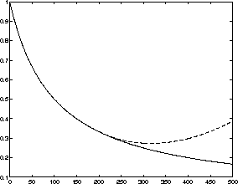
Fig. 47 : Over Learning in a NN
The model residual versus time for the training and the testing set
In the figure above we can see two different curves. The difference between the network output and desired output, or the model residual is plotted as a function of training time.We can see that the model residual decreases for the training set marked with a solid line but starts to increase for the testing set marked with the dashed line.When the network starts to learn the characteristics on individual samples rather than the characteristics of the general phenomenon, the model residual for the testing set starts to increase.The model is departing from the general structure of the problem to learning about the individual cases instead.
6.22.3 Avoiding Underfitting and Overfitting
The best way to avoid overfitting is to use lots of training data. If there are at least 30 times as many training cases as there are weights in the network, the model is unlikely to suffer from overfitting.But arbitrarily the number of weights can’t be reduced for fear of underfitting.
Given a fixed amount of training data, there are some effective approaches to avoiding underfitting and overfitting, and hence getting good generalization:
- Model selection
- Jittering
- Weight decay
- Early stopping
6.22.3.1 How Pitfalls were avoided in the ANN analysis
- The factor scores for the five factors were computed.
- The factor scores were given as inputs for the neural network.
- The inputs were in the range of -1 to +1 and hence satisfy the condition for the sigmoid or tanH transfer functions to linearise and also since the inputs are minimised it also helps in a proper neural network
- The pitfall of memorising has been avoided by shuffling and randomising the data.
- The data is divided into three parts one set used for training second for testing and third for verification
- Over fitting has been avoided by optimising the number of hidden layers and it has been confirmed by testing and verification
- Multi co linearity is avoided by varimax rotation
Bayesian estimation: Usually, the neural network performance is tested with a testing set which is not part of the training set.The testing set can be seen as the representative cases of the general phenomenon.If the network performs well on the testing set, it can be expected to perform well on the general case, as well.
Cross-validation methods can also be used to avoid over learning. In cross-validation, we switch the places of the training set and the testing set and compare the performance of the resulting networks.
It is essential to understand the characteristics of a particular neural network model before using it. In this way, one can avoid many pitfalls of neural networks
Neural Network techniques can also be used as a component of analyses designed to build explanatory models because Neural Networks can help explore data sets in search for relevant variables or groups of variables; the results of such explorations can then facilitate the process of model building.Moreover, now there is neural network software that uses sophisticated algorithms to search for the most relevant input variables, thus potentially contributing directly to the model building process.
One of the major advantages of neural networks is that, theoretically, they are capable of approximating any continuous function, and thus the researcher does not need to have any hypotheses about the underlying model, or even to some extent, which variables matter.
6.23 Training ANN as an Optimisation Task
Training a neural network is, in most cases, an exercise in numerical optimization of a usually nonlinear function.Methods of nonlinear optimization have been studied for hundreds of years, and there is a huge literature on the subject in fields such as numerical analysis, operations research, and statistical computing, e.g., Bertsekas 1995, Gill, Murray, and Wright 1981. There is no single best method for nonlinear optimization.A method is to be chosen based on the characteristics of the problem to be solved.For functions with continuous second derivatives (which would include feedforward nets with the most popular differentiable activation functions and error functions), three general types of algorithms have been found to be effective for most practical purposes.
For a small number of weights, stabilized Newton and Gauss-Newton algorithms, including various Levenberg-Marquardt and Trust-region algorithms are efficient.
For a moderate number of weights, various quasi-Newton algorithms are efficient.
For a large number of weights, various conjugate-gradient algorithms are efficient.
All of the above methods find local optima.For global optimization, there are a variety of approaches.Any of the local optimization methods could be run from numerous random starting points.Or more complicated methods could be designed for global optimization such as simulated annealing or genetic algorithms,
Reeves (1993) "What about Genetic Algorithms and Evolutionary Computation?".

6.24 Statistical assumptions

6.24.1 Sources of Bias
The core value of statistical methodology is its ability to assist one in making inferences about a large group (a population) based on observations of a smaller subset of that group (a sample).In order for this to work correctly, a couple of things have to be true: the sample must be similar to the target population in all relevant aspects; and certain aspects of the measured variables must conform to assumptions which underlie the statistical procedures to be applied.
6.24.2 Representative sampling
This is one of the most fundamental tenets of inferential statistics: the observed sample must be representative of the target population in order for inferences to be valid. Of course, the problem comes in applying this principle to real situations.The ideal scenario would be where the sample is chosen by selecting members of the population at random, with each member having an equal probability of being selected for the sample.Barring this, one usually tries to be sure that the sample "parallels" the population with respect to certain key characteristics which are thought to be important to the investigation at hand, as with a stratified sampling procedure.
While this may be feasible for certain manufacturing processes, it is much more problematic for studying people.For instance, consider the construction of a job applicant screening instrument: the population about which it is reqired to know something is the pool of all possible job applicants. It is difficult to have access to the entire population--you only have access to a certain number of applicants who apply within a certain period of time. So you must hope that the group you happen to pick isn't somehow different from the target population. An example of a problematic sample would be, if the instrument were developed during an economic recession; it is reasonable to assume that people applying for jobs during a recession might be different as a group from those applying during a period of economic growth (even if one can't specify exactly what those differences might be). In this case, it is important to exercise caution when using the instrument during better economic times.
There are also ways to account for, or "control", differences between groups statistically, as with the inclusion of covariates in a linear model. Unfortunately, as Levin (1985) points out, there are problems with this approach, too. One can never be sure one has accounted for all the important variables, and inclusion of such controls depends on certain assumptions which may or may not be satisfied in a given situation
The validity of a statistical procedure depends on certain assumptions it makes about various aspects of the problem.For instance, well-known linear methods such as analysis of variance (ANOVA) depends on the assumption of normality and independence.The first of these is probably the lesser concern, since there is evidence that the most common ANOVA designs are relatively insensitive to moderate violations of the normality assumption (see Kirk, 1982).Unfortunately, this offers an almost irresistible temptation to ignore any non-normality, no matter how bad the situation is.
The robustness of statistical techniques only goes so far- as robustness" is not a license to ignore the assumption.If the distributions are non-normal, try to figure out why; if it's due to a measurement artifact (e.g. a floor or ceiling effect) try to develop a better measurement device (if possible).Another possible method for dealing with unusual distributions is to apply a transformation.However, this has dangers as well;an ill-considered transformation can do more harm than good in terms of interpretability of results.
The assumption regarding independence of observations is more troublesome, both because it underlies nearly all of the most commonly used statistical procedures, and because it is so frequently violated in practice. Observations which are linked in some way, parts manufactured on the same machine, students in the same classroom, consumers at the same mal, all may show some dependencies. Therefore, if you apply some statistical test across students in different classrooms, say to assess the relationship between different textbook types and test scores, you're introducing bias into your results.This occurs because, in our example, the kids in the class presumably interact with each other, chat, talk about the new books they're using, and so influence each other's responses to the test.This will cause the results of your statistical test (e.g. correlations or p-values) to be inaccurate.
One way to try to get around this is to aggregate cases to the higher level, e.g. use classrooms as the unit of analysis, rather than students. Unfortunately this requires sacrificing a lot of statistical power, making a Type II error more likely. Happily, methods have been developed recently which allow simultaneous modeling of data which is hierarchically organized (for example with students nested within classrooms). (Christiansen & Morris) introduces these methods.Additionally, Bryk & Raudenbush (1988) and Goldstein (1987) are also relevent for good overviews of these hierarchical models.

6.24.3 Errors in methodology
There are a number of ways that statistical techniques can be misapplied to problems in the real world.Three of the most common hazards are designing experiments with insufficient power, ignoring measurement error, and performing multiple comparisons.
6.24.4 Statistical Power
This graph will help illustrate the concept of power in an experiment. In the figure, the vertical dotted line represents the point-null hypothesis, and the solid vertical line represents a criterion of significance, i.e. the point at which difference is said to be significant.
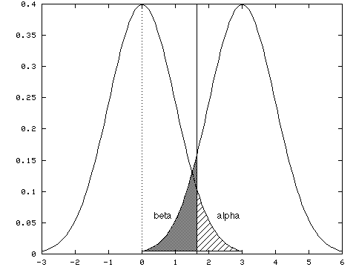
Fig. 48: Statistical Power
There are two types of errors which can occur when making inferences based on a statistical hypothesis test: a Type I error occurs if the null hypothesis is rejected when it should not have been rejected (if the probability of this is called "alpha", and is indicated by the cross-hatched region of the graph); a Type II error occurs if it is not rejected when it should have been rejected(the probability of this is called "beta", and is indicated by the shaded area).Power refers to the probability of avoiding a Type II error, or, more colloquially, the ability of the statistical test to detect true differences of a particular size.The power of the test generally depends on four things: sample size, the effect size to be able to be detected, the Type I error rate (alpha) specified, and the variability of the sample. Based on these parameters, the power level of your experiment can be calculated. Or, as is most commonly done, the desired power can be specifed (e.g. 0.80), the alpha level, and the minimum effect size which would be considered "interesting", and the power equation could be used to determine the proper sample size for the experiment, Cohen(1988).
With too little power, there is risk of overlooking the effect that is desired.This is especially important if the intenion is to make inferences based on a finding of no difference.This is what allows advertisers to claim "No brand is better at relieving headaches (or what have you)" will not a valid claim if they use a relatively small sample (say 10 people), of course any differences in pain relief won't be significant. The differences may be there, but the test used to look for them may not be sensitive enough to find them.
While the main emphasis in the development of power analysis has been to provide methods for assessing and increasing power, Cohen (1991) it should also be noted that it is possible to have too much power.If the sample is too large, nearly any difference, no matter how small or meaningless from a practical standpoint, will be "statistically significant". This can be particularly problematic in applied settings, where courses of action are determined by statistical results.
Most statistical models assume error free measurement, at least of independent (predictor) variables.However, as it is well known, measurements are seldom if ever perfect.Particularly when dealing with noisy data such as questionnaire responses or processes which are difficult to measure precisely, we need to pay close attention to the effects of measurement errors. Two characteristics of measurement which are particularly important in psychological measurement are reliability and validity.
Reliability refers to the ability of a measurement instrument to measure the same thing each time it is used.So, for instance, a reliable measure should give similar results if the units (people, processes, etc.) being measured are similar.Additionally, if the characteristic being measured is stable over time, repeated measurement of the same unit should yield consistent results.
Validity is the extent to which the indicator measures the thing it was designed to measure.Thus, while IQ tests will have high reliability (in that people tend to achieve consistent scores across time), they might have low validity with respect to job performance (depending on the job). Validity is usually measured in relation to some external criterion, e.g. results on a job-applicant questionnaire might be compared with subsequent employee reviews to provide evidence of validity.
Methods are available for taking measurement error into account in some statistical models.In particular, structural equation modeling allows one to specify relationships between "indicators", or measurement tools, and the underlying latent variables being measured, in the context of a linear path model, Bollen (1989).

6.24.5 Problems with interpretation
There are a number of difficulties which can arise in the context of substantive interpretation as well.
Confusion over significance.The difference between "significance" in the statistical sense and "significance" in the practical sense continues to elude many statistical dabblers and consumers of statistical results. There is still a strong tendency for people to equate stars in tables with importance of results for example for a p-value was less than 0.001 is said to have a really big effect.Significance (in the statistical sense) is really as much a function of sample size and experimental design as it is a function of strength of relationship.With low power, a really useful relationship may be overlooked;with excessive power, microscopic effects may be found with no real practical value.A reasonable way to handle this sort of thing is to cast results in terms of effect sizes, Cohen(1994) that way the size of the effect is presented in terms that make quantitative sense. A p-value merely indicates the probability of a particular set of data being generated by the null model, it has little to say about size of a deviation from that model (especially in the tails of the distribution, where large changes in effect size cause only small changes in p-values).
6.24.6 Precision and Accuracy
These are two concepts which seem to get confused an awful lot, particularly by those who aren't mathematically inclined.It's a subtle but important distinction:precision refers to how finely an estimate is specified (akin to number of decimal places given, e.g. 4.0356 is more precise than 4.0), whereas accuracy refers to how close an estimate is to the true value.Estimates can be precise without being accurate, a fact often glossed over when interpreting computer output containing results specified to the fourth or sixth or eighth decimal place.
Multiple comparisons
This is a particularly thorny issue, because often what we want to know about is complex in nature, and we really need to check a lot of different combinations of factors to see what's going on.However, doing so in a haphazard manner can be dangerous, if not downright disastrous. Each comparison that is made(assuming we're using the standard hypothesis testing model) entails a Type I error risk equal to our predefined alpha.We might assign the conventional value of 0.05 to alpha. Each comparison made has a (1 -.05) =.95 probability of avoiding a Type I error.
Now suppose there are 12 process variables, and the relationships among them are to be seen. If the 66 possible correlations arecalculated, to see which ones turn out to be statistically significant: in the best-case scenario, where the comparisons are independent (not true for this example, but we'll assume it for the sake of argument), the probability of getting all the comparisons right is the product of the probabilities for getting each comparison right. In this case that would be (.95) ^66, or about 0.03. Thus the chance of getting all 66 comparisons right is almost zero. This figure shows the probability of getting one or more errors based on how many comparisons is made, assuming a per-comparison alpha of 0.05.
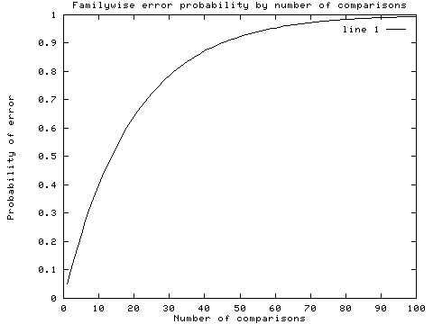
Fig.49 : Probability of errors Vs No of Comparisons
In fact if, a sample from each of 12 uncorrelated variables is taken and the set of 66 correlations are calculated, about 3 spurious correlations will be seen in each set. (Note that this is the best-case scenario;if dependence among the separate tests is allowed, the probability of errors is even greater.) This figure shows the expected number of errors based on number of comparisons, assuming a nominal alpha of 0.05.
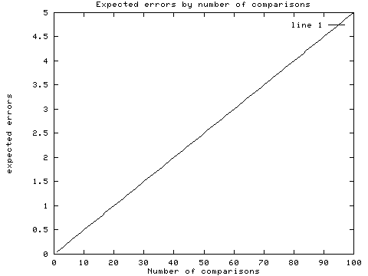
Fig. 50: Expected Errors Vs Comparisons
So, suppose on determining the correlations it is discovered that 10 of them seem to be significant.It will be a tough time sorting out which ones are real and which are spurious. Several strategies can be used to overcome this problem.The easiest, but probably the least acceptable, is to adjust the alpha criterion (by making it smaller) so that the "familywise" error rate is what is preferred. The problem with this strategy is that it is impractical for large numbers of comparisons: as the alpha for each comparison becomes smaller, power is reduced to almost nil.
The best strategy, but usually an expensive one, is replication i.e. rerun the experiment and see which comparisons show differences in both groups. This is not quite foolproof, but it should be pretty good idea, to ascertain which effects are real and which are not.If replication can’t be done, the next best thing is a technique called cross-validation, which involves setting aside part of the sample as a validation sample.Statistics of interest is computed on the main sample, and they are checked against the validation sample to verify that the effects are real.Results that are spurious will usually be revealed by a validation sample.
6.24.7 Evaluation measure
Colder and Malthouse (2003) suggested fit and performance as criteria to evaluate a score model.Fit is concerned with how close the model output is to the target while performance is concerned with how many people out of the direct mail receipants will actually respond.
6.24.8 Validation of Consumer Credit Risk Models
Traditionally, statistical models are evaluated in terms of goodness of fit. However, it has been argued that superior goodness of fit does not necessarily guarantee superior performance.In the Direct Marketing industry, a variety of descriptive statistics and terminology have been used to evaluate response performance: decile analyses, gains charts, lift charts, whisker plots and banana curves.Less common is the Gini index, traditionally used in economics and other social sciences, which was originally created to measure the disparity of income and wealth among a population.It has also been used to measure other social phenomena such as disparity in educational attainment among groups of people. In a direct marketing context, Gini has been used to indicate disparity of catalog sales among customers.It recently has been used as a general measure to assess response model performance.
In comparison to descriptive statistics that use a set of points, Gini is a single statistic that can be used to investigate the distribution properties of the estimator.Knowledge of the Gini estimate and its distribution properties provides an opportunity for inferential assessments of the Gini statistic.This is not possible with the other commonly used descriptive statistics (lift charts, gains charts, decile analysis tables, whisker plots, etc).
A large Monte Carlo simulation study conducted under 1, 620 different conditions (varying response rate, file size and Gini index ), taking for each combination, 200 random samples from a large master data, randomly chosen, the Gini index and the standard deviation of Gini computed.As file size increases, variance in Gini decreases and 2) as response rate increases, variance in Gini decreases. More importantly, when the sample file size is <15, 000 (relatively small for a direct marketer), the variability of Gini is excessively large and when the file size is extremely large (N > 100, 000 and response rates > 0.01) the variability of Gini is expected to be very small.

In summary, Direct Marketers will find the Gini statistic more useful for assessing model performance when the statistical properties of Gini are known and used in the analysis.When comparing two different models, it is possible to determine if one model’s performance falls outside the expected performance range of another model.By utilizing the Gini index and its statistical properties, it is possible to validate a response model with statistical precision.

6.24.9 Model performance
Can be measured in terms of cumulative gains charts referred to a banana charts.
- Confusion matrix
- ROC charts
- P Gains Charts
6.24.9.1 Receiver Operating Characteristic (ROC) Curve
A Receiver Operating Characteristic (ROC) curve is a graphical representation of the trade off between the false negative and false positive rates for every possible cut off. By tradition, the plot shows the false positive rate (1-specificity) on the X axis and the true positive rate (sensitivity or 1 - the false negative rate) on the Y axis.
The accuracy of a test (i.e.the ability of the test to correctly classify cases with a certain condition and cases without the condition) is measured by the area under the ROC curve.An area of 1 represents a perfect test, while an area of 0.5 represents a worthless test.The closer the curve follows the left-hand border and then the top border of the ROC space, the more accurate the test; the true positive rate is high and the false positive rate is low.Statistically, more area under the curve means that it is identifying more true positives while minimizing the number/percent of false positives.
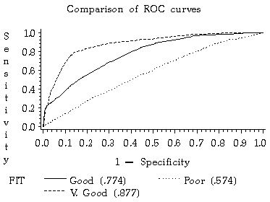
Fig.51: Comparison of R.O.C. curves
Table.48. Confusion Matrix to measure model fit
I/O | NR | R | Sum
NR | A | B | A + B
R | C | D | C + D
Sum | A + C | B + D | Total

The fit of the model can be measured by various measures.In the confusion matrix number of peredictis for response (R) and non-response (NR) for model output (O) and target (T) respectively.
Entry A denotes the number of NR outputs when the target is NR while B denotes the number of R outputs while the target is NR. C denotes the number of NR outputs when the target is R while D denotes the number of R output when the target is R. A model with large A & D is a better one. The accuracy is defined as the ratio of the diagnoal entries A+D over total number.
The performance of a binary classifier with a division thereshold is often plotted using Receiver operating characteristic (ROC) curve.
1 - Sensitivity = C / C+d
1 - Specificity = B /A+B
Using the ROC Curve to Measure Sensitivity & Specificity
Two indices are used to evaluate the accuracy of a test that predicts dichotomous outcomes(e.g. logistic regression);sensitivity and specificity. They describe how well a test discriminates between cases with and without a certain condition
6.24.9.2 Sensitivity
The proportion of true positives or the proportion of cases correctly identified by the test as meeting a certain condition (e.g. in mammography testing, the proportion of patients with cancer who test positive).
6.24.9.3 Specificity
The proportion of true negatives or the proportion of cases correctly identified by the test as not meeting a certain condition (e.g. in mammography testing, the proportion of patients without cancer who test negative).
6.24.9.4 Choosing a Cut-off
The position of the cut-off determines the number of true positives, true negatives, false positives, and false negatives.If the sensitivity is increased (true positives) and more cases with a certain condition can be identified, accuracy is sacrificed on identifying those without the condition (specificity).

6.25 Evaluation criteria for response models
- Percentage correctly classified at the economically optimal cutoff purchase probability (PCC).
- Area under the receiver operating characteristics (AUC).
- The focus is knowing (1)what the additional predictive power of an additional variable over a model which does not contain this variable over a model which does contain this variable (2) to product purchase behaviour (3) when using correlated predictions the hypothesis testing approach may suffer as multicollinearity may cause inflated variance of the estimate which may in turn lead to insignificant parameters (4) predictive approach to model has gained substantial importance in econometrics at the expense of the hypothesis testing approach, Geisser and Eddy(1979), the increased availability of larger deta sets has played a catalysing effect in this respect because in large samples almost all coefficients become statistically significant, Granyer(1998), and (5) using the predictive evaluation criterion entails the use of separate test sample which follows Morrison’s warning against the upward bias that results from classifying, the same individuals used to calculate the classification model in the estimates of the resubstitution rate.

6.25.1 Percentage correctly classified
The potential buyers are ranked according to their predicted likelihood of repurchase (from most likely to least likely buyer).When an absolute cutoff value is chosen all customers with a posterior’ probability of repurchase higher than the absolute cut off use classified as buyers and all customer with a lower likelihood of repurchase are labeled as non-buyers.The result of classifiers are labeled as non buyers.
Time  Status |  | Predicted status
Time  Status |  | Buyer | Non Buyer
Time  Status | Buyer | True positive (TP) | False Negative (FN)
Time  Status | Non buyer | False Positive (FP) | True Negative (TN)

TP + TN
Accuracy = -----------------------
TP + TN + FP + FN
6.26 Results of Quantitative Analysis
6.26.1 Multiple regression
Table 49: Multiple Regression Model, Summaries
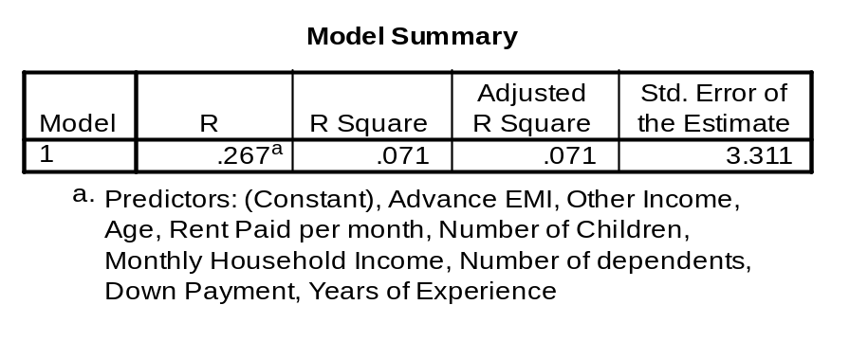

Table 50: Multiple Regression, ANOVA
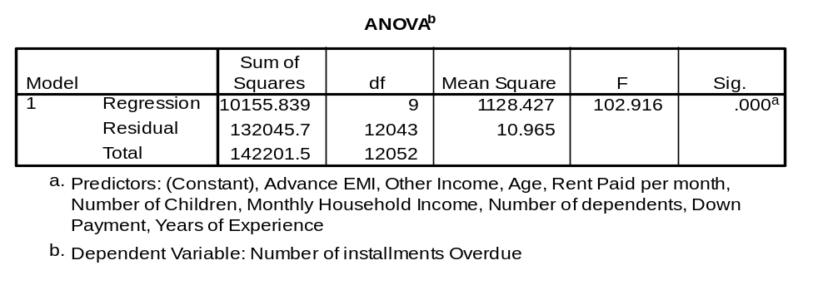

Table 51: Multiple Regressions - Significant Variables
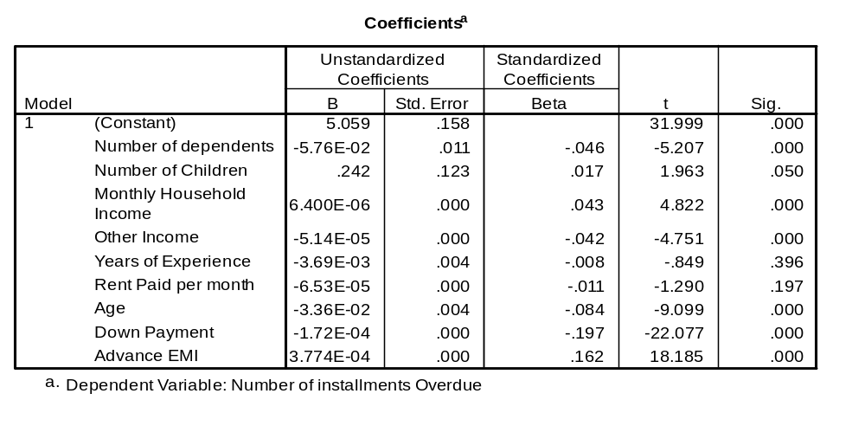
Table 52: Multiple Regression, Co-efficients
6.26.2 Logistic Regression
Table 53: Logistic Regression - Significant variable
 | B | S.E. | Wald | Df | Sig.
DOWNPAYM | 0.000131 | 5.3E-06 | 611.1172 | 1 | 6.4E-135
ADVEMI | -0.00029 | 1.44E-05 | 395.8029 | 1 | 4.51E-88
AGE | 0.033034 | 0.002476 | 177.9919 | 1 | 1.33E-40
QUALIFIC |  |  | 150.7463 | 4 | 1.41E-31
MS | 0.800038 | 0.068714 | 135.558 | 1 | 2.49E-31
WM | -0.56064 | 0.055685 | 101.3668 | 1 | 7.64E-24
Constant | -2.08064 | 0.215209 | 93.46961 | 1 | 4.12E-22
DEPENDEN | 0.066459 | 0.011312 | 34.5172 | 1 | 4.23E-09
RESIDENT |  |  | 28.1598 | 2 | 7.68E-07
TV | -0.3573 | 0.081688 | 19.13186 | 1 | 1.22E-05
CHILDREN | -0.33143 | 0.10673 | 9.64268 | 1 | 0.001901

Table 54 : Logistic Regression - Non-significant variable

 | B | S.E. | Wald | Df | Sig.
TW | 0.10305 | 0.056502 | 3.32642 | 1 | 0.068175
OTHINCOM | 9.81E-06 | 7.22E-06 | 1.843272 | 1 | 0.174568
EXPERIEN | -0.0038 | 0.002923 | 1.690376 | 1 | 0.193551
FW | -0.21096 | 0.175445 | 1.445819 | 1 | 0.2292
RENT | -5.7E-05 | 5.31E-05 | 1.163939 | 1 | 0.28065
INCOME | -5.7E-07 | 8.64E-07 | 0.43288 | 1 | 0.510579
FRIDGE | 0.008998 | 0.048723 | 0.034104 | 1 | 0.853487

6.26.3 Discriminant analysis
Table 55: Discriminant analysis - Classification Results
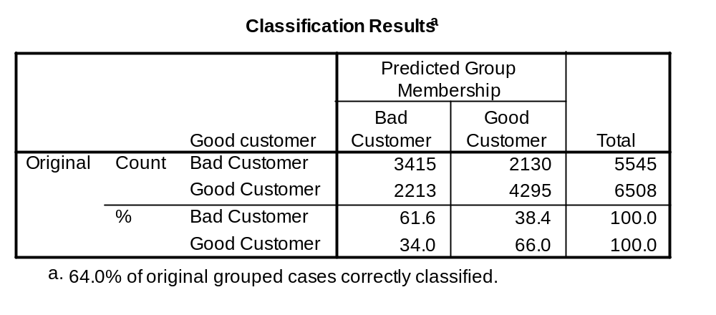
6.26.4 Factor Analysis
Table 56: Factor Analysis Rotated Component Matrix
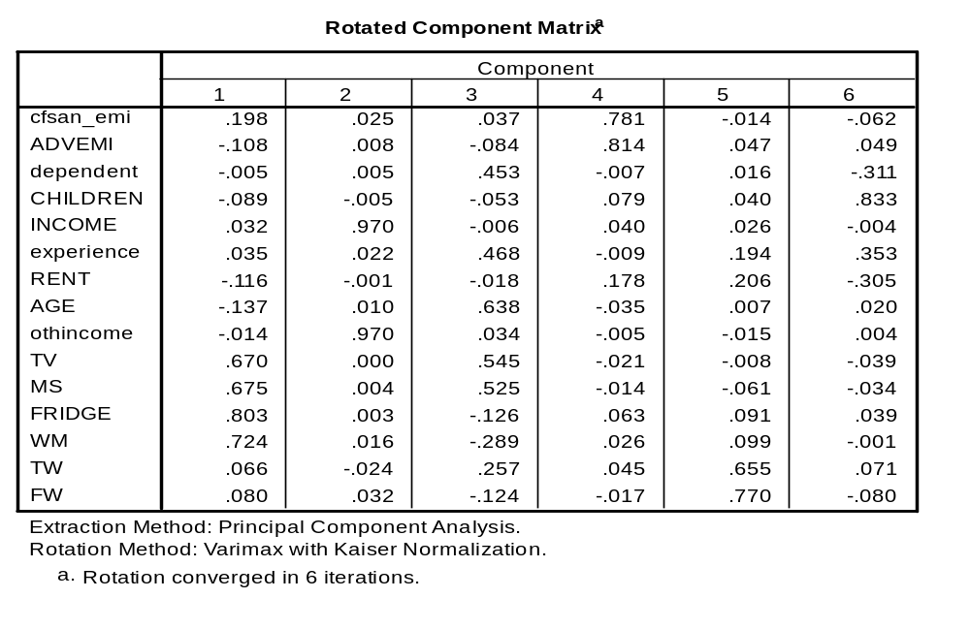
6.26.5 Neural Network
Table 57: Neural Network - Performance Table
Type | Error | Input | Hidden | Performance
RBF | 0.4992672 | 2 | 1 | 0.5429804
RBF | 0.4979886 | 2 | 2 | 0.5532692
RBF | 0.4866627 | 2 | 4 | 0.6120146
Linear | 0.3427409 | 1 | - | 0.9857285
Linear | 0.3361037 | 2 | - | 0.9844009
Linear | 0.3357424 | 4 | - | 0.9751079
MLP | 0.0973995 | 2 | 8 | 0.9897113
MLP | 0.09143 | 2 | 12 | 0.9907069
MLP | 0.09043 | 3 | 10 | 0.9907069
MLP | 0.08835 | 3 | 12 | 0.9907069

Fig. 52: Neural network Topology adopted
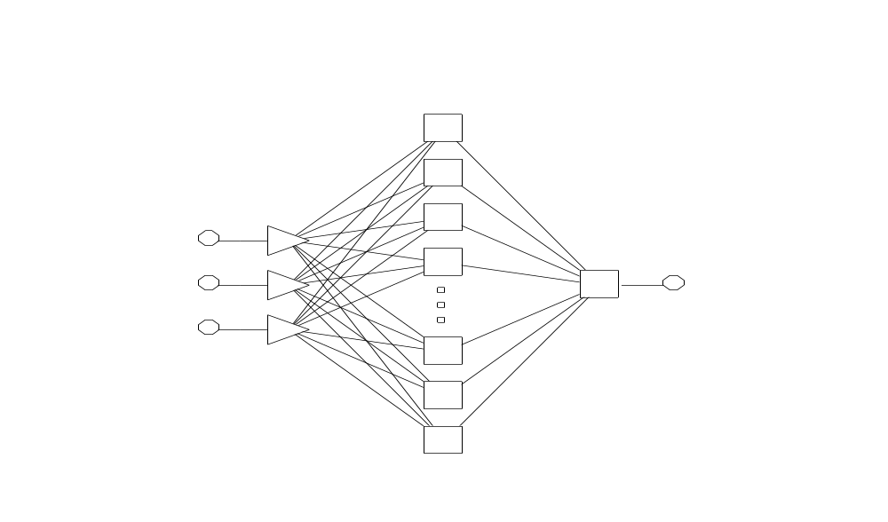

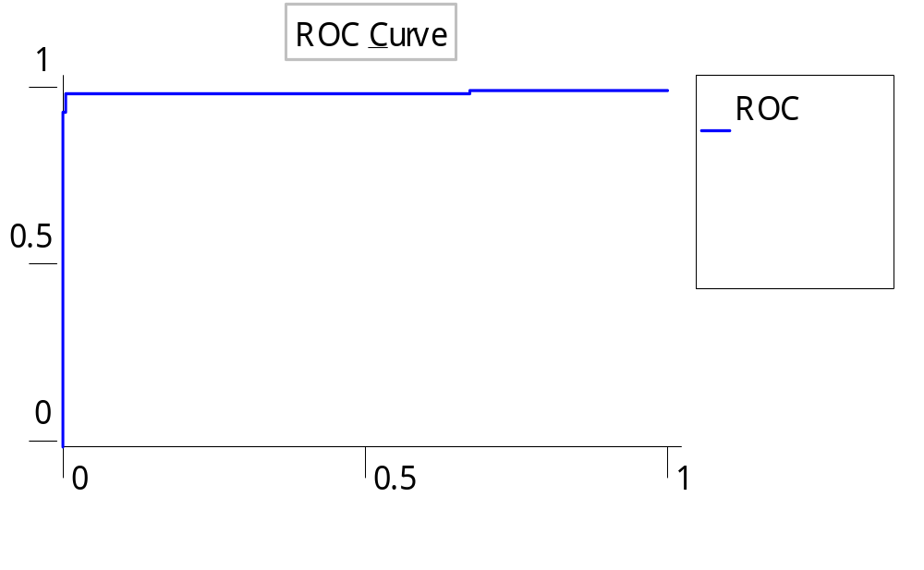
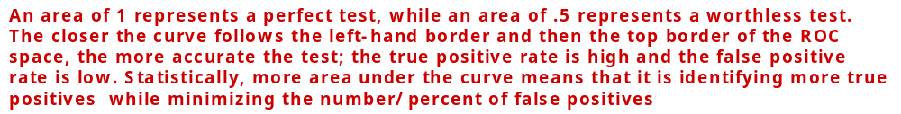

Fig. 53: Receiver Operating Curve (ROC)

Table: 58 Classification Table for NN
 | V1 | V2 | V3 | V4 | V5 | V6
Total | 2612 | 3415 | 1494 | 1519 | 1439 | 1574
Correct | 2595 | 3382 | 1477 | 1508 | 142 | 1500
Wrong | 17 | 33 | 17 | 11 | 15 | 14
Unknown | 0 | 0 | 0 | 0 | 0 | 0
V1 | 2595 | 33 | 1477 | 11 | 1424 | 14
V2 | 17 | 3382 | 17 | 1508 | 15 | 1560

6.26.5 MLP results
The combination of parameters presented in Table, provide us with an MLP model that is customized for predicting bad loans, and at the same time performance in predicting or classifying other classes of loan applications is not overly sacrificed.
6.26.6 Summary of Models
Table 59 : Summary of Models
Model | Variables | Results
Multiple Regression | Advanced EMI, down payment, rent, no. of children, no. of dependents, years of experience, household income | R squared value of0.071.Very poor for prediction. All variables except rent and years of experience make significant contribution.
Logistic regression | Down payment, advance EMI,, dependents children,, rent, music system, washing machine | Prediction accuracy of model is 65.9%, very poor, cannot be used for prediction or classification
Discriminant analysis | Down payment, advance EMI, age, children, house hold income, other income, rent, experience | Prediction accuracy of 64% is not adequate. Except income and rent paid all others are significant.
Factor analysis | Age, income, advance EMI, rent, TV, music system, dependents, children, 2 wheeler, 4 wheeler, experience. | Five factors identified and factors extracted. Finance parameters(Income and assets), consumer durables, initial payments (down payment and advance EMI), vehicles, dependents
Neural network | Factor scores for Finance parameters (Income and assets) consumer durables, Initial payments, (down payments, advance EMI), vehicles, dependents | Best prediction accuracy  Good classification

6.26.7 Optimal MLP Configuration
Table: 60 Optimal MLP Configurations
Parameters | Value
Number of Data in Training Set | 346
Number of Data in Test Set | 344
Number of Hidden Neurons | 15
Seed | 0
Learning Rate | 0.2
Momentum | 0.6
Training epochs | 1000

7. CONCLUSION
The analytics involved in this context pave the way for evolving robust credit scoring models and automation of the lending process.They also help discern the pattern of relationship between the input [borrower characteristics] and the output [loan default status].If the underlying relationship is not strictly linear in nature, routine ways of using factor analysis and non-linear oriented neural network may not improve predictive accuracy due to intense level of complexity present in the data.
Multiple regression, Logistic Regression and Discriminant analysis have been shown to be performing inadequately as prediction models whereas neural network is proved to give an improvement in accuracy. This shows that the function is nonlinear, which could not generalize with the existing data and the same data was subjected to NN.
This model will be useful to decide the weights that could be given to various attributes for example the net income, down payment advance could be allotted more marks out of 100.Next priority should be given to education followed by durables and then dependents.
From the classification of the customers and financial behavior as observed by the collection staff the various needs would be assessed and different financial products like insurance, educational loan, medical insurance and systematic investment planning could be designed and targeted. This would result in accurate campaigns for upselling and cross selling.
The scoring and profiling would enable adopting different pricing policies and collection mechanisms for different clusters.
Performance and Optimisation of neural network
NN is a powerful technique for predicting the behavior of output based on a given set of input values.It has a very good potential for application in loan default prediction and lending automation through credit scoring models.
Performance of NN can be improved through various methods of configuring the network and giving the proper inputs.
Conventional techniques like factor analysis can reduce the complexities to a great extent by reducing the number of variables to a few numbers of dimensions.Instead of subjecting the raw data to NN, the extracted factor scores for each case was used as an input to NN.
This dramatically improved the performance of NN which converged in three hours but with 98% accuracy as shown in the classification matrix is shown in the earlier section.
When these factor values are given as input values to NN, it is able to perform dramatically well, what Factor analysis alone is not able to achieve and 98 percent prediction accuracy has been achieved as illustrated in this thesis with the help of live data from a financial services company.
The future holds for a combinatorial approach to prediction with help of linear and non-linear based techniques.
Recommendation : The commitments of marriage and educational expenses should have been captured or at least there should be an ongoing relationship between the borrower and the lender through a local agent to capture the information on the income pattern and spending behaviour, family happenings, seasonality, impact of global and local factors etc.
The scoring should have taken care of the new business with a lower score.
In such cases there should be a high score for the guarantor and guarantor should be assessed rigorously and the family’s involvement in the borrowing should be ensured.
In the case of business due diligence should be exercised when it is new and not established.
In another case the customer had defaulted for 4 months and he had closed one business and started another.So again a case of un stabilized income.This should have been captured in scoring and a high score guarantor should have been tied up.These factors should have been reckoned in pricing and collection.
FIs are of the opinion that Customer information like Occupation and income could be masked from the FIs to avoid any bias and also to facilitate an independent assessment.
It would help the FIs to achieve the time target much better if DSAs get as far as possible accurate information of Customer's location and also do a preliminary screening.
Also it would be helpful if the DSAs are given inputs on fundamentals of marketing and how to face competition.

8. LIMITATIONS

An important disadvantage, is that the final solution depends on the initial conditions of the network, and, as stated before, it was until recently not possible to "interpret" the solution in traditional, analytic terms, such as those used to build theories that explain phenomena but now techniques and algorithms have been evolved develop to analytical equations from the machine learnt models.

Three broad classes of statistical pitfalls can be considered. The first involves sources of bias.These are conditions or circumstances which affect the external validity of statistical results.The second category is errors in methodology, which can lead to inaccurate or invalid results. The third class of problems concerns interpretation of results or how statistical results are applied or misapplied to real world issues.

Pitfalls of classification modeling techniques:
Classification models predict events into categorical classes, say, "risky" or "safe".Classification methods are supported by decision tree, SVM, neural network, etc.
However, there is a serious drawback in applying classification techniques to credit risk management.The problem lies with the fact that credit defaults are in general very low ratio events say, less than 10%. Developing predictive models with skewed data is very difficult; especially with decision tree classification.Decision trees develop predictive models by segmenting populations into smaller groups recursively.It uses the dominant category or most frequent value of each segment as the predicted value for the segment.Dominant categories are the values represented by over 50% segment population.Credit users are already well screened.It is possible that no segments may contain risky customers in excess over 50%. Even if it exists, it may be slightly over 50%. Segments in which 49% customers have default-history will be predicted as "not" risky, although they are in very high risk segments. This type of models will have very low accuracy in predicting risky customers as "risky".
Much worse is that, as a consequence, more non-risky customers may end up being classified as "risky". Not much useful properties.It is important to note that all classification techniques have this limitation.To overcome this problem, one may be tempted to use tricks by introducing extra instances.However, such tricks will necessarily distort overall representation of population.Still the problem remains; A better approach is credit scoring using statistical probability.
As is well known, the use of logistic regression for classification usually involves the application of ROCs (Receiver Operating Curves), and the use of the latter is not fully understood in terms of optimal classification.The curve helps determine the cutoff probability p* that separates class predictions (in the binary classification case).If the estimated conditional probability of being a ‘case’ exceeds p*, the individual is classified as a ‘case’, and a ‘non-case’ otherwise.However, the rules governing the choice of p* are not clearly associated with any single optimality criterion.
Causality: Probably nothing has caused as much mischief in research and applied statistics as unclear thinking about causality. Assessing causality is the raison d'être of most statistical analysis, yet its subtleties escape many statistical consumers.
The bottom line on causal inference is this: there must be random assignment. That is, the experimenter must be the one assigning values of predictor variables to cases. If the values are not assigned or manipulated, the most that can be hoped for is to show evidence of a relationship of some kind. Observational studies are very limited in their ability to illuminate causal relationships. Take for example a hypothesized relationship between number of health-care visits and socioeconomic status (SES), i.e. the higher the SES, the more the number of visits to the clinic. There are three possible explanations for this: one is that people with high SES have the means to pay for frequent clinic visits (SES -> visits); another is that people who visit their doctor frequently are in better health and so are able to be more productive at work, get better jobs, etc. (visits -> SES);the third is that something else (e.g.size of city) affects both clinic visitation and SES independently(larger cities have more clinics and offer better paying jobs), making them go up and down together (visits <- X -> SES).
This factor of causal inference (i.e. random assignment) is the key regardless of the statistical methodology used. It has been drummed into our heads that "correlation is not causation". Unfortunately, some people seem to interpret that as implying that correlation and regression can't be used for causal analysis; or worse, that experimentally oriented statistical designs (e.g. ANOVA) are necessary and sufficient conditions for causal inference.Neither of these interpretations is correct; if values are assigned to a predictor variable (e.g. by manipulating drug dosages), it is perfectly legitimate to use a correlation coefficient or a regression equation to generate inferences about the effectiveness of the drug.
Now, of course, many of the things we might have studied are not subject to experimental manipulation (e.g.health problems/risk factors). If they have to be understood in a causal framework, great cautioun must be exercised. It will require a multifaceted approach to the research (it might be thought of as "conceptual triangulation"), use of chronologically structured designs (placing variables in the roles of antecedents and consequents), and plenty of replication, to come to any strong conclusions regarding causality.
It may be helpful to consider some aspects of statistical thought which might lead many people to be distrustful of it.First of all, statistics requires the ability to consider things from a probabilistic perspective, employing quantitative technical concepts such as "confidence, reliability and significance".This is in contrast to the way non-mathematicians often cast problems: logical, concrete, often dichotomous conceptualizations are the norm: right or wrong, large or small, this or that.
Additionally, many non-mathematicians hold quantitative data in a sort of awe.They have been lead to believe that numbers are, or at least should be, unquestionably correct.Consider the sort of math problems people are exposed to in secondary school and even in introductory college math courses: there is a clearly defined method for finding the answer, and that answer is the only acceptable one.It comes, then, as a shock that different research studies can produce very different, often contradictory results.
If the statistical methods used are really supposed to represent reality, how can it be that different studies produce different results?In order to resolve this paradox, many naive observers conclude that statistics must not really provide reliable (in the non-technical sense) indicators of reality after all.And, the logic goes, if statistics aren't "right", they must be "wrong".It is easy to see how even intelligent, well-educated people can become cynical if they don't understand the subtleties of statistical reasoning and analysis.
The best thing that can be done in the long run, is make sure we're using our tools properly, and that our conclusions are warranted.
9. SCOPE FOR FURTHER RESEARCH
A questionnaire has been prepared to capture the additional factors covering psychographic variables and detailed aspects of demographic and economic factors.This could be administered to good customers and bad customers.
A Survey conducted among good as well as bad customers covering demographic, psychographic and economic factors using direct, indirect and projective techniques would further give a comprehensive model.
Analysis of the resulting data can be used to test several hypotheses that have been developed in the qualitative research phase.
Decision Tree analysis and path analysis could be used for identifying a combination of attributes which lead to a good customer or bad customer.This information inturn cound be used for arriving at clusters.
Using mixed data; data that incorporates structured, transactional and textual information; for predicting customer behavior has proven to increase model accuracy across a wide range of modeling problems. Hence a combined data mining and text mining could be used to get more insight into customer behavior
Bagging (Voting, Averaging): The concept of bagging (voting for classification, averaging for regression-type problems with continuous dependent variables of interest) applies to the area of predictive datamining, to combine the predicted classifications (prediction) from multiple models, or from the same type of model for different learning data.It is also used to address the inherent instability of results when applying complex models to relatively small data sets.Suppose the data mining task is to build a model for predictive classification, and the data set from which to train the model (learning data set, which contains observed classifications) is relatively small;one could repeatedly sub-sample (with replacement) from the dataset, and apply, for example, a tree classifier (e.g., C&RT and CHAID) to the successive samples.In practice, very different trees will often be grown for the different samples, illustrating the instability of models often evident with small datasets.
One method of deriving a single prediction (for new observations) is to use all trees found in the different samples, and to apply some simple voting: The final classification is the one most often predicted by the different trees. Some weighted combination of predictions (weighted vote, weighted average) is also possible, and commonly used. Sophisticated machine learning algorithm for generating weights for weighted prediction or voting is the Boosting procedure.
Greater weights are assigned to those observations that were difficult to classify (where the misclassification rate was high), and lower weights are assigned to those that were easy to classify (where the misclassification rate was low). In the context of C&RT for example, different misclassification costs (for the different classes) can be applied, inversely proportional to the accuracy of prediction in each class.Then the classifier is applied again to the weighted data (or with different misclassification costs), and the next iteration is continued with (application of the analysis method for classification to the re-weighted data).
Boosting will generate a sequence of classifiers, where each consecutive classifier in the sequence is an "expert" in classifying observations that were not well classified by those preceding it.During deployment (for prediction or classification of new cases), the predictions from the different classifiers can then be combined (e.g., via voting, or some weighted voting procedure) to derive a single best prediction or classification.
Boosting can also be applied to learning methods that do not explicitly support weights or misclassification costs. In that case, random sub-sampling can be applied to the learning data in the successive steps of the iterative boosting procedure, where the probability for selection of an observation into the subsample is inversely proportional to the accuracy of the prediction for that observation in the previous iteration (in the sequence of iterations of the boosting procedure).
Bagging: The concept of bagging (voting for classification, averaging for regression type problems with continuous dependent variables of interest) applies to the area of predictive data mining to combine the predictive classification from multiple models or from the same type of model for different learning data.It is also used to address the inherent instability of results when applying complex, models to relatively small data sets i.e., the datamining task is to build a model for predictive classification and the data set from which to train the model is relatively small.
Monte Carlo Simulation: Using this, the accuracy of various methods like multiple regression, logistic regression, decision tree, factor analysis combined with decision tree factor analysis combined with neural network could be simulated.The inputs to these calculations could be random from the data.
Game Theory: Another analysis framework could be developed using game theory approach.Game theory could be very well applied in this loan situation. The lender wants to maximise his profits and minimize his costs while the borrower does not want to repay if possible.This conflict could be of varying degrees.This is best captured by clustering the borrowers depending on demographic, psychographic and other socio economic factors and then applying game theory.
Markov transition matrix: On the basis that customers transform to defaulting state with a probalisitic pattern, probabilities being derived from the data these probabilities could used to predict when they will default.This should be tried with aggregate and disaggregate models. Clusters of customers should be formed depending on their demographic and psychographic profiles and markov probabilities used to predict transition to default state.
Joy V. Joseph, ”An Alternative Method of Measuring Direct Mail ROI” May2007, Marketing Prof.com, Direct mail accounts for up to 20% of total advertising spend, and it might be well worth the effort to compare standard direct mail ROI measurement to methods used in measuring ROI for other vehicles.
How do DM campaigns typically measure ROI?
Typical DM campaigns use control groups to evaluate performance of campaigns. A control group is a subset of the total population that is to receive mail in a campaign. This control group is set aside and not sent any mail as part of that campaign, which gives marketers a measure of what sales would have been in the absence of direct mail.
The population that receives mail is called the test group. Revenue per customer is calculated for both groups over a time period that includes the promotion period and a sufficient amount of time afterward to rule out purchase acceleration impact (revenue per customer = Total Revenues in group / Number of people in the group).The higher the number of responders in a group (control or test) the greater the revenue per customer.
Incremental revenue per customer is calculated as the difference in revenue per customer for the test group and revenue per customer for the control group. Incremental revenue per customer is a measure of revenue that is above and beyond revenue that could be expected in the absence of the direct mail campaign.
Dividing this number by the campaign cost per customer (calculated as campaign cost / number of people mailed) yields the ROI of the campaign.

BIBLIOGRAPHY
Abelson R.P, (1968), “Simulation of Social Behaviour”, The Handbook of Social Psychology(G Lindzay & E Aronson Editors) Vol 2,
274-356
Abraham M.M, Lodish L.M, (1990), “Getting the most out of advertising and promotion”, Harvard Business Review 68, 50-60
Abu-Hanna A & de Keizer N, (2003), “Integrating classification trees with local logistic regression in Intensive care prognosis”, Artificial Intelligence in Medicine.
Ailawadi K.L, Lehmann D.R, Neslin S.A, (2001), “Market Response to a major policy change in the marketing mix: Learning from Procter & Gamble’s Value Pricing Strategy”, Journal of Marketing 65,
44-61
Ajzen I & Madden T.J, (1985), “Prediction of Goal directed behaviour: Attitudes, intentions and perceived behavioural control”, Journal of Experimental Social Psychology Vol 22, 453-474
Ajzen I, (1985), “From Intentions to Actions : A Theory of Planned behaviour”, Action Control – From Cognition to Behavior, 11-39, Springer
Ajzen I, (1988), “Attitudes, Personality & Behaviour”, Open University Press, Milton Keynes, England
Ajzen I, (1991), “The Theory of planned behaviour”, Organizational Behaviour and Human Decision Processes, 50, 179-211
Allen L & A Saunders, (2002) “A Survey of Cyclical effects in credit risk measurements models”, Risk books, BIS Working Paper
Allen P.M, (1990), “Why the future is not what it was: New models of evolution”, Futures, July/August, 555-570
Altman E, Marco G & Varetto F, (1994), “Corporate Distress Diagnosis : Comparison using Linear discriminant Analysis & Neural networks (The Italian experience)”, Journal of Banking & Finance 18,
505-529
Altman E.I, (1968), “Financial Ratios, Discriminant Analysis and the prediction of corporate bankruptcy”, Journal of Finance 23,
589-609
Ambrose B.W & Buttimer R.J Jr, (2000), “Embedded Options in the mortgage contract”, The Journal of Real Estate Finance & Economics 21, 95-111
Ambrose B.W & Sanders A.B, (2003), “Commercial Mortgage Backed Securities: Prepayment & Default”, Journal of Real Estate Finance & Economics 26, 175-192
Ambrose B.W, Buttimer R.J Jr & Capone C.A, (1997), “Pricing Mortgage Default and Foreclosure Delay”, Journal of Money, Credit & Banking, 29, 314-325
Aumann R.J, (1959), “Acceptable points in general cooperative N-person games”, Contributions to the Theory of Games Volume IV, Princeton University Press
Axelrod R, (1980), “Effective Choice in the prisoner’s dilemma”, Journal of Conflict Resolution 24, 3-25
Axelrod, R, (1980), “More effective choices in the prisoner’s dilemma”, Journal of conflict resolution 24, 379-403
Azerbayejani & Pentland A, (1996), “Real-time self-calibrating stereo person tracking using 3-d shape estimation from blob features”, In International Conference on Pattern Recognition (ICPR), 1996.
Azhar (1999), “Loan Repayment behavior among the rubber farmers in NES I Project in East Aceh, Indonesia” – Dissertation & Thesis.
Baird.John.S, (2006), “Effects of group cohesiveness and prior sharing “Journal of Community Psychology, Volume 10 Issue 3, Pages
210 - 215.
Bandura A, (1977), “Social Learning Theory”, Englewood Cliffs, New Jersey: Prentice Hall
Bandura A, (1986), “Social Foundations of Thought & Action: A Social cognitive Theory”, Englewood Cliffs, New Jersey: Prentice Hall
Bannerjee, A.V, (1992), “A Simple model of herd behaviour”, The Quarterly Journal of Economics, Vol 152 No 3, 797-817
Bannister D, Mair J.M.M, (1968), “The Evaluation of Personal Constructs”, London: Academic Press
Barnes Allison, Thagard Paul (1996), “Emotional Decisions”, pthagard@watarts.uwaterloo.ca
Basset W.F & Brady T.F, (2001), “The economic performance of small banks 1985-2000”, Federal Reserve Bulletin, November 2001, 719-728
Bentler P.M & Speckart G, (1979), “Models of Attitude-behaviour relations”, Psychological Review, Vol 86(5), 452-464
Berger A & Udell G, (1995), “Relationship lending and lines of credit in small firmfinance”, Journal of Business 68, 351-381
Berger A.N & Udell G.F, (1996), “Universal Banking and the future of small business lending”, financial system design: The case for Universal Banking (Irwin Publishing, Burr Ridge, IL)
Berger A.N, A Saunders, Scalise J.K & G Udell, (1998), “The effects of bank mergers and acquisitions on small business lending”, Journal of financial economics 50, 187-229
Berger A.N, Klapper L.F & Udell G.F, (2001), “The ability of banks to lend to informationally opaque small businesses”, Journal of Banking & Finance 25
Berger A.N, Rosen R.J, Udell G.F, (2001), “The effect of banking market size and structure on bank competition: The case of small business lending”, Federal Reserve Board Working Paper
Bergstresser D, (2001), “Banking Market concentration & Consumer credit complaints: Evidence from the survey of consumer finances”, Working paper, MIT
Black S.E & Strahan P.E, (2002), “Entrepreneurship & bank credit availability”, The Journal of Finance 57, 2807-2833
Blumberg B, Todd P, Maes P, (1996), “No bad dogs: Ethological lessons for learning”, From Animals to Animats, Proceeding of the fourth international conference on the simulation of adaptive behaviour
Bobick A., (1997), “Movement, activity & action: The role of knowledge in the perception of motion”, Proceedings of Royal Society: Special Issue on Knowledge-based Vision in man & machine, 1997.
Bodenberg & Roberts (1990);Bult & Wansbeek (1995).“Implementing neural networks for decision support in direct marketing” International journal of marketing research. - Aug 26, 2004.
Bodimo Anto, (2003), “SA Microfinance know-how to benefit India”, Microfinance Regulatory Council, Media Release, 8 Feb 2005
Bollen, K. A. (1989). Structural equations with latent variables. New York:Wiley.
Boot A.W.A, (2000), “Relationship banking: What do we know?”, Journal of Financial Intermediation 9, 7-25
Bossel H & Strobel M, (1978), “Experiments with an ‘Intelligent’ world model”, Futures, June, 191-210
Bossel H, (1977), “Orientors of nonroutine behaviour”, Concepts and Tools of computer-assisted policy analysis. Basel: Birkhauser Verlag, 227-265
Bossel H, (1994), “Modeling and Simulation”, Wellesley MA: A.K Peters, Wiesbaden: Vieweg
Bossel H, (1996), “20/20 Vision: Explorations of sustainable futures”, Center for Environmental Systems Research, University of Kassel, Germany
Bowman D, Heilman C.M, Seetharaman P.B, (2004), “Determinants of Product Use Compliance Behaviour”, Journal of Market Research
Breault J.L, Goodall C.R & Fos P.J, (002), “Data Mining: A Diabetic Data Warehouse”, Artificial Intelligence in Medicine 26, 27-54
Brechner K.C, (1977), “An experimental analysis of social traps”, Journal of Experimental Social Psychology 13, 552-564
Bregler C., (1997), “Learning and recognizing human dynamics in video sequences”, In IEEE Conf on computer vision and pattern recognition
Breiman L, (1996), “Bagging Predictors”, Machine Learning 24, 123-140
Breiman L, Friedman J.H, Olshen R.A & Stone C.J, (1998), “Classification and Regression Trees”, Chapman & Hall / CRC, New York
Brewer and Kramer (1986), “Social Identity Processes in Organizational Contexts” -by Michael A. Hogg, Deborah J. Terry - 2001 - Psychology - 339 pages
Bryk A.S & Raudenbush S.W, (1992), “Hierarchical Linear Models”, Newbury Park: Sage Publications
Bucklin R.E, Gupta S, (1999), “Commercial use of UPC Scanner Data: Industry & Academic Perspectives”, Marketing Science 18,
247-273
Bucklin R.E, Sismeiro C, (2003), “A Model of web-site browsing behaviour estimated on clickstream data”, Journal of Marketing research 40, 249-267
Burger A.E, Zellmer M & Robinson D, (1997), “The digital revolution : Delivering financial services in the future” Madison, WI : Filene Research Institute
Burns Peter & Ann Stanley, (2001), “Managing Consumer Credit Risk”, Discussion Paper, Payment card center, Federal Reserve Bank of Philadelphia
Cambridge M.A, Berlin M & Mester L.J, (1998), “On the profitability and cost of relationship lending”, Journal of Banking & Finance 22, 873-897
Camerer C.F, (2003), “Behavioural Game Theory: Experiments on Strategic Interaction”, 1st Edition, Princeton University Press, Princeton, New Jersey
Camerer C.F, Ho T.H, (1999), “Experience-weighted attraction learning in normal-form games”, Econometrica 67, 827-874
Camerer C.F, Ho T.H, Chong J.K, (2002), “Sophisticated EWA learning and strategic teaching in repeated games”, Journal of Economic Theory 104(1), 137-188
Camerer C.F, Weigelt K, (1988), “Measuring beliefs in reputation games”, Presentation to the economic Science Association
Camerer C.F, Weigelt K, (1988), Experimental tests of a sequential equilibrium reputation model”, Econometrica 56, 1-36
Camerer C.F, Weigelt K, (1990), “Inducing bubble expectations in experimental asset markets”, Unpublished Manuscript
Camerer C.F, Weigelt K, (2005), “Belief Calibration, QRE and learning in repeated trust games”, Essays in Honor of Richard McKelvey, Lupia A & Alt K(Eds.)
Capozza D.R, Kazarian D & Thomson T.A, (1997), “Mortgage Default in Local Markets”, Real Estate Economics 25, 631-655
Capozza D.R, Kazarian D & Thomson T.A, (1998), “The Conditional probability of Mortgage default”, Real Estate Economics 26,
359-390
Chakrabarti Rajesh, (Dupree College of Management, Georgia Tech USA), (2002), “The Indian Microfinance Experience – Accomplishments & Challenges”
Chakrabarti, Rajesh (2002), “The Indian Microfinance Experience – Accomplishments & Challenges” (Social Science Research Network) SSRN: http://ssrn.com/abstract=649854
Chandy P.R & Duett E.H, (1990), “Commercial Paper Rating Models”, Quarterly Journal of Business & Economics, 1990, 29, 79-101
Chaney P.K, Devinney T.M, Winer R.S, (1991), “The Impact of New Product introductions on the value of firms”, Journal of Business 64, 573-610
Cialdini R.B, Kallgren C.A & Reno R.R, (1991), “A Focus theory of normative conduct: a theoretical refinement and re-evaluation of the role of norms in human behaviour”, Advances in Experimental Social Psychology, 24, 201-234
Ciazza S & S Borra (Faculty of Economics, University of Rome “Tor Vergata”, Italy) (2002), “Comparitive performance of credit scoring models using aggregated predictors”, Data Mining III, WIT Press, ISBN 1-85312-925
Clauretie T, (1990), “A Note on Mortgage Risk: Default vs Loss Rates”, AREUEA Journal 18, 202-206
Cohen J, (1988), “Statistical Power Analysis for the behavioural sciences”, Hillsdale, New Jersey: Lawrence Erlbaum Associates
Cohen J, (1990), “Things I have learned so far”, American Psychologist, 45, 1304-1312
Cohen, B.P. (1963). Conflict and conformity: A probability model and its application. CambridgeMA.: MIT Press.
Cohen, J. (1994). The earth is round (p < 0.05). American Psychologist, 49, 997-1003
Colman A.M, (1982), “Game Theory & Experimental Games”, Pergamon Press, Oxford
Conte R, Hegselmann R & Terna P, (1997), “Simulating social phenomena”, Berlin: Springer
Cook S.W & Berrenberg J.L, (1981), “Approaches to encouraging conservation behaviour: A Review and conceptual framework”, Journal of Social Issues, 37(2), 73-107
Coombs C.H & Avrunin G.S, (1977), “Single-peaked functions and the theory of preference”, Psychological Review 84(2), 216-230
Cui, Geng and Man Leung Wong (2004), "Implementing Neural Networks for Decision Support in Direct Marketing, " International Journal of Market Research, Vol. 46, No. 2, 235-254.
D.P.Bertsekas (1995), “Nonlinear Programming”, Athena Scientific.
Daniel A.L, Olshen R.A & Walker M.G, 2002, “Risk Estimation for Classification Trees”, Journal of Computational and Graphical Statistics 11, 263-288
Dasgupta P.S, Heal G.M, (1979), “Economic Theory & Exhaustible Resources”, Welwyn (UK) Nisbet & Co., Cambridge University Press
Dasgupta, C.G., G.S. Dispensa and S. Ghose, (1994), “Comparing the predictive performance of a neural network model with some traditional market response models”, Intl. J. Forecasting, 10:
235-244.
Dawes R.M, (1980), “Social Dilemmas”, Annual Review of Psychology 31, 161-193
Dawes R.M, McTavish J & Shaklee H, (1977), ”Behavior, Communication & assumptions about other people’s behavior in a commons dilemma situation”, Journal of Personality & Social Psychology 35, 1-11
De Vries S & Wilke H.A.M, (1992), “Constrained egoism and resource management under uncertainty”, Social Dilemmas: Theoretical Issues & Research Findings, Pergamon Press, Oxford
De’ath G & Fabricus K.E, (2000), “Classification & Regression Trees: A Powerful yet simple technique for Ecological data analysis”, Ecology 81, 3178-3192
Dempster A.P, N.M Laird & D.B Rubin, (1977), “Maximum likelihood from incomplete data via the EM algorithm”, Journal of the Royal Statistical Society, B39, 1977
Deng Y, (1997), “Mortgage Termination: An Empirical Hazard Model with a Stochastic term structure”, Journal of Real Estate Finance & Economics, 14, 309-331
Deng Y, Quigley J.M & Van Order R, (2000), “Mortgage Terminations, Heterogeneity and the exercise of mortgage options”, Econometrica 68, 275-307
Deutsch M, (1960), “The effect of motivational orientation upon trust and suspicion”, Human Relations 13, 122-139
DeVaney S, (1994), “The usefulness of financial ratios as predictors of household insolvency: Two perspectives”, Financial counseling and planning 5, 15-24
Dijk A Van, Perrano Silva J, Leeflang P.S.H, Wittink D.R, (2004), “Sales Decomposition to Infer cross-category effects using daily data”, Working paper, Dept of Economics, University of Groningen
Duggal, Bikram & Amit Singhal, (2002), “Extended Banking the poor in India”, www.icicisocialinitiatives.org
Elias N, (1984), “The Civilizing Process”, (Translated from German), Oxford: Blackwell
Eykhoff, Pieter System Identification: Parameter and State Estimation, Wiley & Sons, (1974). ISBN 0471249807
Fancher, R. E. (1996), Pioneers of psychology (3rd Ed.), New York: W. W. Norton & Company.
Faraggi D, LeBlanc M & Crowly J, (2001), “Understanding Neural Networks Using Regression Trees: An Application to multiple Myeloma Survival Data”, Statistics in Medicine 20, 2965-2975
Farley J.U, Lehmann D.R, Sawyer A, (1995), “Empirical Marketing Generalization using Meta-Analysis”, Marketing Science 14,
G36-G46
Feigenbaum, E. A., & Simon, H. A. (1962) A theory of the serial position effect. Brit. /. Psychol, 53, 307-320.
Festinger L, (1954), “A Theory of social comparison processes”, Human Relations 7, 117-140
Fish, K.E., J.H. Barnes and M.W. Aiken, 1995.Artificial neural networks: A new methodology for industrial market segmentation. Industrial Marketing Management, 24: 431-438.
Fishbein M & Ajzen I, (1975), “Belief, Attitude, Intention & Behaviour: An Introduction to theory and research”, Reading, MA, USA: Addison-Wesley
Fix E & Hoddges J, (1951), “Discriminatory analysis, Nonparametric discrimination: Consistency properties”, Technical Report, Randolph Field Texas, USAF School of Aviation Medicine
Forrester J.W, (1971), “World Dynamics”, Cambridge: Wright-Allen Press
Foster C & Van Order R, (1984), “An Option-based model of mortgage default”, Housing Finance Review 3, 351-372
Fox J, Guyer M (1978), public choice and cooperation in n-person prisoner's dilemma, journal of conflict resolution volume:22 issue:, pages:469-481, Sage publications, inc
Fraser A.M & A. Dimitriadis, (1993), “Forecasting probability densities by using hidden markov models with mixed states”, Time Series Prediction: Forecasting the future and understanding the past: Addison-Wesley, 1993
Freund Y & Schapire R.E, (1997), “A Decision-Theoretic Generalization of on-line learning and an application to boosting”, Journal of Computer & System Sciences 55, 119-139
Friedman J.H, (1991), “Multivariate Adaptive Regression Splines”, Annals of Statistics 19, 1-141
Frijda N.H & Mesquita B, (1992), “Emoties, natuur of cultuur”(Emotions, nature or culture), Nederlands Tijdschrift Voor de psychologie en haar grensgebieden, 47(1), 3-14(In Dutch)
Frydman H, Altman E.I & Kao D.L, (1985), “Introducing Recursive Partitioning for Financial Classification: The case of Financial Distress”, The Journal of Finance 40, 269-292
Fu C.Y, (2003), “Combining Loglinear models with Regression Tree(CART): An Application to birth data”, Computational Statistics & Data Analysis, Forthcoming
Fudenberg D, Levine D, (1989), “Reputation and equilibrium selection in games with a patient player”, Econometrica 57, 759-778
Gasper D, (1996), “Needs and basic needs: A Clarification of meanings, levels and different streams of work”, Working paper series No. 201. The Hague, The Netherlands: Institute of Social Studies
Gatersleben B & Vlek Ch, (1997), “Understanding household metabolism in view of environmental quality and sustainable development”, Advances in Economic Psychology, Chichester: Wiley, Chapter 9, 145-168
Geels F, (1996), “The miraculous return of uncertainty and the end of modernity”, Masters Thesis, Enschede: University of Twente
Gerritsen R, (1999), “Assessing Loan Risks: A Data Mining Case Study”, Exclusive Ore, Pennsylvania
Gershenfeld N. & A. Weigand, (1993), “Time Series Prediction: Forecasting the Future & Understanding the past”, Addison-Wesley
Gill P.E., W. Murray, M.H. Wright (1981), “Practical Optimization”, Academic Press, New York
Gintis H, (1998), “The individual in economic theory: A research agenda” Report to the MacArthur Foundation Economics Initiative, Massachusetts – Department of Economics, University of Massachusetts
Goel P.K, Prasher S.O, Patel R.M, Landry J.M, Bonnell R.B & Viau A.A, (2003), “Classification of Hyperspectral Data by Decision Trees & Artificial Neural Networks to identify weed stress and nitrogen status of corn”, Computers and Electronics in Agriculture 39,
67-93
Goffman E, (1968), “The Presentation of Self in Everyday Life”, London: Allen Lane, The Penguin Press
Goldstein H.J, (1987), “Multilevel Models in educational and social research”, London, Oxford University Press
Golob T.F, Horowitz A.D & Wachs M, (1979), “Attitude-Behaviour relationships in travel-demand modeling”, Behavioural Travel Modelling, London: Croom Helm
Gomez M.I, McLaughlin E.W, Wittink D.R, (2004), “”Customer Satisfaction & Retail Sales Performance”, Journal of Retailing
Green C.H, Tunstall S.M, N’Jai A & Rogers A, (1990), “Environmental Evaluation: Economic Evaluation of Environmental Goods”, Project Appraisal, Vol 5, 70-82
Green, David M. and John A. Swets (1966), “Signal Detection Theory and Psychophysics”, Los Altos, California: Peninsula Publishing.
Grendstad G, (1999), “A political cultural map of Europe: A Survey approach”, GeoJournal, Vol 47, 3, Special Issue Grid – Group Cultural Theory, 463-475
Gross David B, Souleles Nicholas S.(2002), “An Empirical Analysis of Personal Bankruptcy and Delinquency”, Review of Financial Studies Volume 15, Number 1, Pp. 319-347
Grzelak, J. Ł., Poppe, M., Czwartosz, Z., Nowak, A. (1988). "Numerical trap": A new look at outcome representation in studies on choice behaviour. European-Journal-of-Social- Psychology, 18, 2, 143-159
Gupta Akash, (2004), “The Consumer financing business in India – Building blocks for the future”, Paper provided by the Economics working paper Archive at WUSTL in Macroeconomics – Handle: RePEc.wpa.wuwpma.0411010, http://econwpa.wustl.edu
Gupta S, Lehmann D.R, (2003), “Customers as assets”, Journal of Interactive Marketing 17, 9-24
Gupta S, Lehmann D.R, Stuart J.A, (2004), “Valuing Customers”, Journal of Marketing Research, February
Hägerstrand, T. (1965), “A Monte Carlo approach to diffusion”, European Journal of Sociology, 6, 43-67.
Hamburger H, (1979), “Games as Models of Social Phenomena”, San Francisco, W.H Freeman & Co.
Hanley, John A. (1989). “Receiver Operating Characteristic (ROC) Methodology: The Sate of the Art”, Critical Reviews in Diagnostic Imaging, 29, 3.
Hanssens D.M, Parsons L.J, Schultz R.L, (2001), “Market response models: Econometric & Time Serie Analysis”, Kluwer Academic Piblishers: Dodrecht / Boston
Hardin, R.G, (1968), “The Tragedy of the commons”, Science 162,
1243-1248
Harre Rom& Others (1976) “Rethinking Psychology”, Sage publishers, London
Harré R & Secord P.F, (1972), “The Explanation of Social Behaviour”, Oxford: Blackwell
Hastie T, Tibshirani R & Friedman J.H, (2001), “The Elements of Statistical Learning: Data Mining, Inference & Prediction”, Springer Series in statistics, Springer Verlag, New York
Haughton D & Oulabi S, (1997), “Direct Marketing Modeling with CART and CHAID”, Journal of Interactive Marketing 11, 42-52
Helberg Clay, (1995), “Pitfalls of data Analysis”, Third International Applied Statistics in Industry Conference in Dallas, TX, June 5-7, chelberg@spss.com
Hess, Ulrich (2003), “Innovative Financial Services for Rural India”, The World Bank, Agricultural & Rural Development Department.
Hoffman H.J, (1990), “Die Unwendung des CART-Verfahrens zur Statistichen Bonitatanalyse von Konsumentenkrediten”, ZeitSchrft-fur-Betriebswirtschaft, 60, 941-62
Holland J, (1975), “Adaptation in Natural &Artificial systems”, Ann Arbor: University of Michigan Press
Hovland C.I, (1960), “Computer simulation of thinking”, American Psychologist, 15, 687-693.
Hu Michael Y, Shankar Murali, Hung Ming S., (1999), “Estimation of posterior probabilities of consumer situational choices with neural network classifiers”, International Journal of Research in Marketing Volume 16, Issue 4, December 1999, Pages 307-317
Jager W, Janssen M.A & Vlek C.A.J, (2000), “Experimentation with Household dynamics: The consumat Approach” To appear in: International Journal of Sustainable Development
Jager W, Janssen M.A, DeVries H.J.M, De Greef K & Vlek C.A.J, (2000), “Behaviour in common dilemmas: Homo economicus and Homo Psychologicus in an ecological-economic model”, to appear in a special issue of Ecological Economics
Jager W, Van Asselt M.B.A, Rotmans J, Vlek C.A.J & Costerman Boodt P, (1997), “Consumer Behaviour: A Modeling perspective in the context of Integrated Assessment of Global Change”, Globo Report Series No 17, RIVM, Bilthoven, The Netherlands
Janis I.L & Mann L, (1977), “Decision making; A Psychological study of conflict, choice and commitment”, New York/London: The Free Press
Janssen M.A, (1998), “Modeling Global Change – The art of integrated assessment modeling”, Edward Elgar Publishers, Cheltenham UK/Northampton, MA, USA
Jebara Tona, Alex Pentland, (1994), “Action Reaction Learning: Analysis & Synthesis of Human Behaviour, Perceptual Computing”, M.I.T Media Laboratory, Massachusetts Institute of Technology
Jerdee TH & Rosen B, (1974), “Effects of opportunity to communicate & visibility of individual decisions on behaviour of the common interest”, Journal of Applied Psychology 59, 712-716
Jorgerson, DO, Papciak, AS (1981), The effects of communication, resource feedback, and identifiability on behavior in a simulated commons dilemma, Contemporary Psychological Research on Social Dilemmas - Page 329, Ramzi Suleiman, David M. Messick - Psychology - 2004 - 408 pages
Joshi A, Hanssens D.M, (2003), “Advertising Spending & Market Capitalization”, Working Paper, UCLA Anderson School of Management
Juin-Kuan Chong(The NUS Business School), Colin F Camerer(Division of Humanities & Social Sciences, California Institute of Technology), Teck H. Ho, (Haas School of Business, University of California), (2005), “A Learning-Based Model of repeated games with incomplete information”
Jung Y.J, Kagel J.H, Levin D, (1994), “On the existence of predatory pricing: An Experimental study of reputation and entry deterrence in the chain-store game”, RAND Journal of Economics 25,
759-778
Kamalluddin.S. (2005), “Lender with a Mission-Bangladesh’s Grameen Bank targets poorest of poor”, The WWW Virtual Library.
Karen Krebs Bach, (2004), “Risk Management, Is consumer credit a too risky business”, Bank Technology News, September 2004
Karolyi A & Sanders A.B, (1998), “The Variation of Economic Risk Premiums in Real Estate Returns, Journal of Real Estate finance & Economics, 17, 245-262
Kau J.B, Keenan D.C & Kim T, (1994), “Default Probabilities for Mortgages”, Journal of Urban Economics 35, 278-296
Kau J.B, Keenan D.C, Muller W.J III & Epperson J.F, (1992), “A Generalized Valuation model for fixed-rate residential mortgages”, Journal of Money, Credit & Banking 24, 279-299
Khalil E.L, (1992), “Economics & Biology: Eight areas of research” Methodus, December 4(2), 29-45
Kirk R, (1982), “Experimental Design: Procedures for the behavioural sciences”, Monterrey, CA: Brooks / Cole
Kolyshkina I & Brookes R, (2002), “Data Mining approaches to Modeling Insurance Risk”, Report, PriceWaterhouseCoopers
Komor’ad K, (2002), “On Credit Scoring Estimation”, Masters Thesis, Institute for Statistics & Econometrics, Humboldt University, Berlin
Krasker William S, Kuh Edwin Welsch, Roy E., (1983), “Estimation for dirty data and flawed models”, Chapter 11 in Handbook of Econometrics, 1983, vol. 1, pp 651-698, Elsevier.
Krebs F & Bossel H, (1997), “Emergent Value orientation in self-organization of an animat”, Ecological Modelling, 96, 143-164
Kreps D, (1990), “Corporate culture and economic theory”, Perspectives on positive political economy, Cambridge University Press, Cambridge
Kuhn T.S, (1970), “The structure of scientific Revolutions”, Chicago, University of Chicago press, Second Edition
Kuhnert P.M, Do K.A & McClure R, (2000), “Combining Non-parametric models with logistic regression: An Application to motor vehicle injury data
Kyoungham Ha, Sungzoon Cho & Douglas Maclachloan, (2005), “Response models based on bagging neural networks”, Journal of Interactive Marketing Vol 19 No. 1
Lange Van P.A.M, Liebrand W.B.G & Kuhlman D.M, (1990), “Causal attribution of choice behaviour in three N-person prisoner’s dilemmas”, Journal of Experimental Social Psychology 26, 34-48
Lange Van P.A.M, Liebrand W.B.G, Messick D.M, Wilke H.A.M, (1992), “Social dilemmas: The state of the art – Introduction and literature Review”, “Social Dilemmas: Theoretical Issues & Research Findings, Oxford/New York, Pergamon Press
Lashley K.S, (1951), “The problem of serial order in behaviour”, Cerebral Mechanisms in Behaviour; The Hixon Symposium, John Wiley
Latane, Darley, (1968), “Bystander intervension in Emergencies”, Journal of personality and social psychology, 1968, 8(4), 377-383.
Leefland P.S.H, Wittink D.R, Wedel M, Naert P.A, (2000), “Building Models for Marketing Decisions”, Kluwer Academic Publishers: Dodrecht / Boston
Leeflang P.S.H, Wittink D.R, (1970), “Building models for marketing decisions: Past, present & future”, International Journal of Research in Marketing 17, 105-126
Leeflang P.S.H, Wittink D.R, (2000), “Models for marketing decisions: Postscriptum”, International Journal of Research in Marketing 17, 237-253
Lei V, Noussair C, Plott C, (2001), “Nonspeculative bubbles in experimental asset markets: Lack of common knowledge of rationality vs. actual irrationality”, Econometrica 69 (4), 831-859
Lekkas V, Quigley J.M & Van Order R, (1993), “Loan Loss Severity and Optimal Mortgage Default”, Journal of the American Real Estate and Urban Economics Association
Levin J.R, (1985), “Some methodological and statistical ‘bugs’ in research on children’s learning”, Cognitive Learning & Memory in Children; New York: Springer Verlag
Lewis Barbara R, Littler Dale (1999), ”Buyer behavior models”, The Blackwell Encyclopedic Dictionary of Marketing Dryden Press, NY, 1978.
Liebert R.M, Neale J.M & Davidson E.S, (1973), “The Early Window: Effects of Television on children and Youth”, New York: Pergamon Press
Liebrand W.B.G, (1983), “Interpersonal differences in social dilemmas: A Game-theoretical approach”, Dissertation abstracts, 43, (7b), 2373
Liebrand W.B.G, (1984), “The effect of social motives, communication and group size on behaviour in a N-person multi-stage mixed-motive game”, European Journal of Social Psychology 14, 239-264
Liebrand W.B.G, Messick D.M, (1996), “Computer simulation of cooperative decision making”, Frontiers in Social Dilemmas Research, Berlin: Springer
Liebrand W.B.G, Messick D.M, (1996), “Social dilemmas: individual, collective & dynamic perspectives”, Frontiers in Social Dilemmas Research, Berlin: Springer
Liebrand W.B.G, Messick D.M, (1996), Frontiers in Social Dilemmas Research, Berlin: Springer
Lilien G.L, Rangaswamy A, (2003), “Marketing Engineering, 2nd edition”, Prentice Hall: Upper Saddle River, New Jersey
Lillien G.L, Kotler P.H, Moorthy K.S, (1992) “Marketing Models”, Prentice Hall: Englewood Cliffs,
Limsombuchai, (2005), “An Analysis of Credit Scoring for agricultural loans in Thailand”, American Journal of Applied Sciences 2 (8) 1198-1205, ISSN 1546-92391198
Linda Allen & Gayle DeLong (Zicklin School of Business, Baruch College, CUNY), Anthony Saunders (Stern School of Business, New York University) (2003), “Issues in the credit risk modeling of retail markets”
Lindgren K & Nordahl M.G, (1995), “Cooperation and community structures in artificial ecosystems”, Artificial Life, An overview, Cambridge(Massachusetts), London : The MIT Press
Little J.D.C, (1970), “Models and Managers: The Concept of a decision calculus”, Management Science 16, 446-485
Loomis, J. L. (1959), Communication, the development of trust and cooperative behavior. Human Relations, 12, 305-315.
Lotka A.J, (1925), “Elements of physical biology”, Waverly Press, Baltimore
Luce R.D & Raiffa H, (1957), “Games and decisions, Introduction and critical survery”, New York: Wiley
Machiavelli N, (1525), “Istorie Florentine (The Florentine Histories)” – A series of eight books commissioned by the Florentine officials, presented to Pope Clement VII
Malhotra D.K, (2003), “Evaluating Consumer Loans using neural networks”, Omega Oxford Vol 31, P 83-97
Malhotra Rashmi & DK Malhotra, (2002), “Differentiating between good credits & bad credits using neuro fuzzy systems”, European Journal of Operational Research, vol 136, issue 1
Malthouse, E.C., Mah, R.S.H., Tamhane, A.C. (1995), “Some theoretical results on nonlinear principal components analysis”, American Control Conference, Proceedings of the, Publication Date: 21-23 Jun 1995 Volume: 1, On page(s): 744-748.
Marakas, G.M. (1999), Decision support systems in the twenty-first century, Prentice Hall, New Jersey, USA.
Masters J.C & Smitch W.P, (1987), “Social Comparison, Social Justice and relative deprivation: Theoretical and policy perspectives”, Volume 4, Hillsdale, NJ: Erlbaum
Mathew Regi, (2003), “Analytics driven marketing campaigns”, White paper – Lessons for the Consumer Finance Industry, November 2003
Max-Neef M, (1992), “Development and human needs”, Real Life economics: Understanding Wealth Creation, London, New York: Routledge
McClintock Charles G, Messick David M, Roderick M Kramer, “Social values and cooperative response to a simulated resource conservation crisis”, Journal of Personality, Volume 54 Issue 3, Pages 576 - 582
McClintock C.G & Liebrand W.B.G, (1988), “The role of interdependence structure, individual value orientation and others’ strategy in social decision making: A transformational analysis”, Journal of Personality and social Psychology, 55, 396-409
McClintock C.G, (1978), “Social Values: Their definition, measurement and development”, Journal of Research and Development in Education 12, 121-137
McDougall W, (1928), “Emotion and Feeling Distinguished”, Feelings & Emotions, Worcester, Massachussets: Clark University Press
McKelvey R.D, Palfrey T.R, (1998), Quantal response equilibria for extensive form games”, Experimental economics 1, 9-41
McWhinney, W.H. (1964), Simulating communication network experiments. Behavioural Science, 9, 80-84.
Meadows D.H & Robinson J.M, (1985), “The Electronic oracle: Computer models & social decisions”, Chichester: John Wiley & sons
Meadows D.H, Meadows D.L, Randers J & Behrens W.W, (1972), “The Limits to Growth”, New York, USA: Universe Books
Mela C.F, Gupta S, Lehmann D.R, (1997), “The Long Term impact of promotion and advertising on Consumer brand choice”, Journal of Marketing Research 34, 248-261
Meliha Handzic, Felix Tjandrawibawa & Julia Yeo (2003), “How Neural Networks can help loan officers to make better informed application decisions”, Informing Science, July 2003
Mendel G, (1865), “Fundamenta genetica”, Revised edition of Jaroslav Krizenecky, Prague: Publishing House of the Czechoslovak academy of Sciences; Oosterhout (N.Br): Anthropological Publications, 1965
Mezrich J.J, (1994), “When is a tree a hedge”, Financial Analysts Journal 50, 75-81
Michie D, Spieglehater D.J & Taylor C.C, (1994), “Machine learning, Neural & Statistical Classification”, Ellis Hortwood Ltd, London
Miles M, (1990), “What is the Value of U.S Real Estates”, Real Estate Review 20, 69-75
Mixon D, (1972), “Instead of Deception”, Journal for the Theory of Social Behaviour 2(2): 145-177
Moisen G.G & Frescino T.S, (2002), “Comparing Five Modeling Techniques for predicting forest characteristics”, Ecological Modeling 30, 209-225
Monod J, (1972), “Chance & Necessity”, London: Collins
Mozer M.C, (1993), “Neural net architectures for temporal sequence processing”, Time Series Prediction: Forecasting the future & understanding the past, Addison-Wesley
Nachev Anatoli: Forecasting with ARTMAP-IC Neural Networks - An Application Using Corporate Bankruptcy Data. 167-172 BibTeX
Neral J, Ochs J, (1992), “The Sequential equilibrium theory of reputation building: A Further test”, Econometrica 60, 1151-1169
Newell A & Simon H.A, (1972), “Human Problem Solving”, Englewood Cliffs, New Jersey: Prentice Hall
Nijs V.R, Dekimpe M.G, Steenkamp J.B.E.M, Hanssens D.M, (2001), “The Category-demand effects of price promotions”, Marketing Science 20, 1-22
O’Brien T.V & Durfee P.E, (1994), “Classification Tree Software”, Marketing Research 6, 36-39
Opschoor J.B, (1993), “Economische expansie en de beperkte milieugebruiksruimte”, (Economic Expantion and the Limited Environmental User Space), Greep Op Groei: het therma van de jaren negentig(Grip on Growth: The Theme for the nineties),
167-185, Utrech, The Netherlands: Jan Van Arkel (In Dutch)
Ostrom E, Burger J, Field C.B, Norgaard R.B & Policansky D, (1999), “Revisiting the commons : Local lessons, global challenges”, Science Vol 284, 278-282
Özlem Özdemir, (2004), “An Empirical Investigation on consumer credit default risk”, Discussion paper 2004/20, Turkish Economic Association, http://www.tek.org.tr
Papini L, Rabino G.A, (1997), “An Evolutionary Urban cellular automata: The model & some first simulations”, Simulating Social Phenomena, Berlin: Springer
Pauwels K, Srinivasan S, Silva-Risso J, Hanssens D.M, (2004), “The Long-Term impact of new-product introductions on financial performance & Firm Value”, Journal of Marketing
Pavlov I.P, (1927), “Conditioned Reflexes”, New York: Oxford University Press
Paxton, Julia Anne (1996), “Determinants of successful group repayment: an application to Burkina Faso”, Dissertation presented in partial fulfillment of the requirements for the degree Doctor of Philosophy in the Graduate School of The Ohio State University.
Pentland & A. Liu, (1995), “Modeling & Prediction of human behaviour”, IEEE Intelligent Vehicles 95
Pentland, (1995), “Machine understanding of human action”, Technical Report 350, M.I.T Media Laboratory – Vision & Modeling
Pepe, Margaret Sullivan (2002), “Receiver Operating Characteristic Methodology” In Statistics in the 21st Century, edited by Adrian Raftery, E., Martin A. Tanner and Martin T. Wells: Chapman & Hall/CRC.
Pomykalski J.J, Truszkowski W.F & Brown D.E, (1999), “Expert Systems”, Wiley Encyclopedia for Electrical & Electronics Engineering, John Wiley & Sons Inc, New York
Pruitt D.G & Kimmerl M.J, (1977), “Twenty years of experimental gaming: Critique, synthesis and suggestions for the future”, Annual review of psychology 28, 363-392
Quigley J.M & Van Order R, (1995), “Explicit Tests of Contingent Claims Models of Mortgage Default”, The Journal of Real Estate Finance & Economics, 11, 99-117
Raino K, (1965), “Social Interaction as a stochastic learning process”, European Journal of Sociology 6, 68-88
Rao Rama Krishna TS (ICFAI University, India), “Retail Credit changes tack – The Reach vs Risk Debate”
Rapoport A, Budescu D.V, Suleiman R & Weg E, (1992), “Social dilemmas with uniformly distributed resouces”, Social Dilemmas: Theoretical Issues & Research Findings, 43-57, Oxford/New York Pergamon
Rapoport C & Chammah, A.M, (1965), “Prisoner’s Dilemma: A study in conflict and cooperation”, Ann Arbor: University of Michigan Press
Rau Pradeep, Samie Saeed, (1981) “Models of Consumer Behavior: The State of the Art”, Journal of Academy of Marketing Science, Vol.9, No 3, 300-316.
Robinson, Marguerite S. (1997), “Microfinance in Indonesia”, UNESCO Courier, January
Rod Kilgour, Bill Dunning, Bollen K, (1989), “Structural Equations with Latent variables”, New York, John Wiley & Sons
Rogert M Stein, (2002), “Benchmarking default prediction models, pitfalls and remedies in model validation”, Technical Report #030124, Moody’s KMV
Rokeach M, (1973), “The Nature of Human Values”, New York: The Free Press
Rotmans J, (1990), “IMAGE: An Integrated model to assess the greenhouse effect”, Dodrecht, The Netherlands: Kluwer Academic Publishers
Rotmans K & De Vries H.G.M, (1997), “Perspectives on Global Change: The TARGETS Approach”, Cambridge, UK: Cambridge University Press
Rousu J, Flander L, Suutraninen M, Autio K, Kontkanen P & Rantanen A, (2003), “Novel computational tools in bakery process data analysis: A Comparitive Study”, Journal of Food Engineering, 57, 45-56
Sanders A.B, (2002), “Governmental Sponsored Agencies: Do the benefits outweigh the costs?”, Journal of Real Estate Finance & Economics, 25, 121-127
Sargent T, (1999), “The Conquest of American Inflation, 1st edition”, Princeton University Press, Princeton
Schachter S, (1964), “The Interaction of cognitive and physiological determinants of emotional state”, Advances in Experimental Social Psychology, Vol 1, New York: Academic Press
Schultz Steven, “Brain imaging study reveals interplay of thought and emotion in economic decisions”, News from PRINCETON UNIVERSITY, June 12, 2003, sschultz@princeton.edu
Scitovsky, T, (1992), “The Joyless Economy: An Inquiry into Human satisfaction and consumer dissatisfaction” (2nd Edition), London: Oxford University Press
Selten R. and R. Stoecker, End Behavior in Sequences of Finite Prisoner's Dilemma Supergames: A Learning Theory Approach, " Journal of Economic Behavior and Organization, 7 (1986), 47-70.
Sharma Manohar, Zeller Manfred (1996) “repayment performance in group-based credit programs in Bangladesh: an empirical analysis”, FCND discussion paper no. 15, International Food Policy Research Institute
Shelly Wu Xiaonan, Wolfgang Banzhaf, "Combatting Financial Fraud: A Coevolutionary Anomaly Detection Approach", In GECCO '08: Proceedings of the 10th Annual Conference on Genetic and Evolutionary Computation, pp 1673-1680, Atlanta, GA, USA, July 12-16, 2008
Sheth J.N & Frazier G.L, (1982), “A Model of strategy mix choice for planned social change”, Journal of Marketing, 46(1), 15-26
Sheth J.N & Frazier G.L, (1982), “A model of strategy mix choice for planned social change”, Journal of Marketing, 46(1), 15-26
Shiffrin R.M, (1975), “Capacity Limitations in Information Processing, Attention & Memory”, Handbook of Learning & Cognitive Processes, Hillsdale New Jersey: Erlbaum
Simon C.J, Sullivan M.W, (1993), “The Measurement and determinants of brand equity: A Financial Approach” Marketing Science 12,
28-52
Simonov P.V, (1970), “The information theory of emotion”, Feelings And Emotions: The Loyola Symposium, New York, London: Academic Press
Sims K, (1994), “Evolving virtual creatures”, In proceedings of
Sig-Graph ’94, Vol 26
Skinner B.F, (1938), “The Behaviour of Organisms: An Experimental Analysis”, Englewood Cliffs, New Jersey, Prentice-Hall
Skinner B.F, (1953), “The Behaviour of Organisms”, New York: Appleton-Century-Crofts
Smith V.L, Suchanek G, Williams A, (1988), “Bubbles, Crashes & Endogenous expectations in experimental spot asset markets”, Econometrica 56
Smith, K.A. (1999). Introduction to neural networks and data mining for business applications. Eruditions Publishing, Australia.
Sorensen E.H, Miller K.L & Ooi C.K, (2000), “The Decision Tree Approach to Stock Selection”, Journal of Portfolio Management 27, 42-52
Specht, (1990), “Topology structure of a four-layer PNN”, Developments in mechanics of structures and materials: Proceedings of the 18th Australasian Conference on the Mechanics of Structures and Materials, Perth, Australia, 1-3 December 2004, Andrew J. Deeks, Hong Hao, CRC Press
Sriram MS (2002), “The Transformation of Microfinance in India : Experiences, Options & Future”, Indian Institute of Ahmedabad Working paper series
Sriram MS, (2004), “Microfinance and the state : Exploring Areas & Structures of Collaboration”
Sriram MS, Rajesh S, S Upadhyayula, (2002), “The Transformation of the Microfinance sector in India”, Journal of Microfinance Vol 6 No 2
Stanton R & Wallace N, (1998), “Mortgage Choice: What is the point?” Real Estate Economics 26, 173-205
Stanton R & Wallace N, (1998), “Mortgage Choice: What is the point?” Real Estate Economics 26, 173-205
Starner T. & A. Pentland, (1995), “Visual Recognition of American sign language using hidden markov models”, International Workshop on automatic face and gesture recognition, 1995
Stern P.C, (1992), “Psychological dimensions of global environmental change”, Annual Review of Psychology, 43, 269-302
Swets, J.A. (1988), “Measuring the Accuracy of Diagnostic Systems.” Science, 240, June: 1285-1293.
Swets, John A. (1996) Signal Detection Theory and ROC Analysis in Psychology and Diangostics. Mahwah, New Jersey: Laurence Erlbaum Associates
Terzopoulos D., X. Tu & Grzeszczukm R, (1994), “Artificial Fishes: Autonomous locomotion, perception, behaviour & learning in a simulated physical world”, Artificial Life 1(4): 327-351
Thearling K, (2002), “Scoring your customers”, http://www.thearling.com
Thomas LC, Y.Wu, Steve D. Thomas, University of Southampton, Ki Mun Jung, (Kyungsung University, South Korea), (2004), “Modeling Consumer Acceptance Probabilities”, Discussion Papers in Management, September 2004, No. M04-20, ISSN 1356-3548
Thorndike E.L, (1898), “Animal intelligence: An Experimental study of the associative process in animals”, Psychological Review, Monograph supplements, 2(4), 109
Timmermans, D.R.M, (1991), “Decision aids for bounded rationalists, an evaluation study of multiattribute decision support in individual and group settings”, Thesis, Groningen, the Netherlands: University of Groningen
Toulmin S, (1990), “Cosmopolis: The Hidden Agenda of Modernity”, New York: The Free Press
Tronstad R & Gum R, (1994), “Cow Culling decisions adapted for management for CART”, American Journal of Agricultural Economics, 76, 237-249
Tufte E.R, (1983), “The Visual Display of Quantitative Informations”, Cheshire, CT: Graphics Press
Uchibe E., M Asada, K Hosoda, (1998), “State Space construction for behaviour acquisition in multi agent environments with vision and action”, In proceedings of the International conference on Computer Vision
Urban G.L, (1993), “Pretest Market Forecasting”, Handbooks in Operations Research & Management Science, Vol 5; Marketing: 315-348
Urban G.L, Karash R, (1971), “Evolutionary Model building”, Journal of Marketing Research Vol 8, 62-66
Van den Peel D., A Prinzie & P. Van Kenhove, (2002), “Improving response prediction in direct marketing by optimizing for specific mailing depths”, Department of Marketing, Ghent University, Belgium
Van Heerde H.J, Leeflang P.S.H, Wittink D.R, (2002), “Flexible Decomposition of Price promotion effects using Store-Level Scanner Data”, Working Paper, Marketing Science Institute
Van Heerde H.J, Leeflang P.S.H, Wittink D.R, (2002), “How Promotions work: SCAN*PRO-based evolutionary model building”, Schmalenbach Business Review 54, 198-220
Vandell K.D, (1993), “Handing over the keys: A Perspective on mortgage default research”, Journal of the American Real Estate & the Urban Economics Association 21, 211-246
Vellido, A., P.J.G. Lisboa and K. Meehan, 1999b.Segmentation of the on-line shopping market using neural networks. Expert Systems with Applications, 17: 303-314.
Verhoef P.C, Spring P.N, Hoekstra J.C, Leeflang P.S.H, (2002), “The commercial use of segmentation and predictive modeling techniques for database marketing in the Netherlands: Decision support systems 34, 471-481
Volterra V, (1931), “Leçons sur la théorie mathématique de la lutte pourla vie”, Paris: Gauthier-Villars
Wander Jager, (University of Groningen, The Netherlands) (2000), “Modelling Consumer Behaviour”, Ph.D Thesis
Wander jager, marco a. Janssen, charles a. J. Vlek. “how uncertainty stimulates over-harvesting in a resource dilemma: three process explanations”, Journal of Environmental Psychology, Volume 22, Issue 3, September 2002, Pages 247-263
Ward L.M & West R.L, (1988), “Modeling human chaotic behaviour: Nonlinear forecasting analysis of logistic iteration, Nonlinear Dynamics, Psychology and Life sciences, 2, 261282
Watson J.B., (1913), “Psychology as the behaviourist views it”, Psychological Review, 20:158
Watson J.D & Crick, F.H.C, (1953), “A Structure for Deoxyribose Nucleic Acid”, Nature 171, 737
West et al., (1997), A comparative analysis of neural networks and statistical methods for predicting consumer choice, Marketing Science, v16 i4. 370-391
Wittink D.R, Addona M.J, Hawkes M.J, Porter J.C, (1988), “SCAN*PRO: The Estimation, Validation & Use of promotional effects based on scanner data”, Internal Paper, Cornell University
Wosinka W, (2004), “Advertising & the optimal consumption path: The Case of Prescription Drugs”, Journal of Marketing Research
Wrightsman L.S, O’Connor J & Baker N.J, (1972), “Cooperation and competition: Readings on mixed-motive games”, Belmont: Brooks-Cole
Yacoob Y. & L. Davis, “Learned temporal models of image motion”, proceedings of the international conference on computer vision, 1998.
Yamagishi T, (1988), “The provision of a sanctioning system in the United States and Japan”, Social psychology Quarterly 51, 264-270
Zanasi A., Brebbia C.A, Ebecken N.F.F & Melli P(2002), “Data Mining III”, ISBN 1-85312-925-9; www.witpress.com
ANNEXURE - I
XXXX Finance and Services

BEHAVIORAL ANALYSIS
Dear Respondent:
Kindly provide us the following information.

1. Based on the interaction you have had with X finance, indicate the extent to which you will agree with following statements

 | Strongly Disagree | Some what  Disagree | Neither  Agree or Disagree | Some what Disagree | Strongly  Agree
X Finance’s loan offerings my requirements very well | [ ] | [ ] | [ ] | [ ] | [ ]
X Finance’s loan disbursement was very fast | [ ] | [ ] | [ ] | [ ] | [ ]
X Finance’s has a very good product range. | [ ] | [ ] | [ ] | [ ] | [ ]
X Finance rate’s and prices are competitive. | [ ] | [ ] | [ ] | [ ] | [ ]
X Finance’s takes keen interest on its customers | [ ] | [ ] | [ ] | [ ] | [ ]
Overall, I am satisfied with the service rendered by X Finance. | [ ] | [ ] | [ ] | [ ] | [ ]

2. Indicate your extent of agreement with the statements made by customers like you about the X finance service representatives.

 | Strongly Disagree | Some what  Disagree | Neither  Agree or Disagree | Some what Disagree | Strongly  Agree
X Finance representatives (CSRs) are well trained. | [ ] | [ ] | [ ] | [ ] | [ ]
X Finance service representatives (CSRs) are well supervised. | [ ] | [ ] | [ ] | [ ] | [ ]
X Finance service representatives (CSRs)adhere to professional standard of conduct. | [ ] | [ ] | [ ] | [ ] | [ ]
X Finance service representatives (CSRs)act in my best interest. | [ ] | [ ] | [ ] | [ ] | [ ]
Overall, I am satisfied with the by X Finance. service representatives (CSRs) | [ ] | [ ] | [ ] | [ ] | [ ]
3. Indicate your agreement with the following statement about the account managers of X Finance

 | Strongly Disagree | Somewhat Disagree | Neither Agree or Disagree | Somewhat Disagree | Strongly Agree
The X Finance account manager is knowledgeable and professional. | [ ] | [ ] | [ ] | [ ] | [ ]
I feel like have a good personal relationships with the X Finance account manager. | [ ] | [ ] | [ ] | [ ] | [ ]
The X Finance account manager understands the customers in atimely manner. | [ ] | [ ] | [ ] | [ ] | [ ]
The X Finance account manager responds to may inquiries in a timely manner. | [ ] | [ ] | [ ] | [ ] | [ ]
Overall, I am very with the X Finance account manager. | [ ] | [ ] | [ ] | [ ] | [ ]

4. What would be your top reason for being very satisfied or dissatisfied with X Finance service Representatives?

Very Good Brand Image/Value for X

5. What would top reason for being very satisfied or dissatisfied with X Finance account manager?

Interiction of collections process with customers proper time / proper approach

6. How likely are you to recommend X Finance to any of your friends or relatives who may need a loan?

- Definitely recommend [ ]
- May or May not recommend [ ]
- Not Likely to recommend [ ]

7. Compared to how you felt about X Finance before availing a loan, what would you now say is the likelihood of taking another loan from X Finance?

- Better, based on their performance [ ]
- About the same [ ]
- Worse, based on their performance [ ]

8. As a privileged customer of X Finance, if you are offered more loans, which of the following you are likely to avail and for each one, please indicate how soon are you likely to avail? Also please indicate the amount that you are likely to avail for each category.

Type of Loan | 8a. Likelihood of availing the Loan |  |  | 8a. Time Likely to avail |  |  | 8a. Likely  Amount in  Rupees
Type of Loan | Yes | Maybe | No | Within  a month | Within  This year | Call when need arises | 8a. Likely  Amount in  Rupees
Educational loan | [ ] | [ ] | [ ] | [ ] | [ ] | [ ]
New or Additional Vehicle Loan | [ ] | [ ] | [ ] | [ ] | [ ] | [ ]
Property purchase | [ ] | [ ] | [ ] | [ ] | [ ] | [ ]
House Construction | [ ] | [ ] | [ ] | [ ] | [ ] | [ ]
Consumer durables | [ ] | [ ] | [ ] | [ ] | [ ] | [ ]
Marriage Loan | [ ] | [ ] | [ ] | [ ] | [ ] | [ ]
Medical Loan | [ ] | [ ] | [ ] | [ ] | [ ] | [ ]
Any Other loan  (Specify | [ ] | [ ] | [ ] | [ ] | [ ] | [ ]

9. The following are statements made about life in general by people like you. Please indicate the extent of your agreement with each one of them by putting a tick mark in the appropriate box. Please note that there is no right or wrong answers for these questions.

Statement | Strongly Disagree | Somewhat Disagree | Neither Agree or Disagree | Some what Disagree | Strongly Agree
I like the way I am now | [ ] | [ ] | [ ] | [ ] | [ ]
I like to explore new things | [ ] | [ ] | [ ] | [ ] | [ ]
I like horses, mountains and adventures | [ ] | [ ] | [ ] | [ ] | [ ]
I like others to call me a good man | [ ] | [ ] | [ ] | [ ] | [ ]
I want to become rich | [ ] | [ ] | [ ] | [ ] | [ ]
when somebody is in trouble, I go of the way  to help | [ ] | [ ] | [ ] | [ ] | [ ]
consciously a good man will not tell lies | [ ] | [ ] | [ ] | [ ] | [ ]
I am unselfish when it comes to may family | [ ] | [ ] | [ ] | [ ] | [ ]
my friends have told me that they can depended on my commitment. | [ ] | [ ] | [ ] | [ ] | [ ]
I care for my conscience more than society’s opinion about me | [ ] | [ ] | [ ] | [ ] | [ ]
I don’t think we will worry about other’s opinion | [ ] | [ ] | [ ] | [ ] | [ ]
I get angry when others point out my mistakes | [ ] | [ ] | [ ] | [ ] | [ ]
As a family head one should be careful and should not get into debts | [ ] | [ ] | [ ] | [ ] | [ ]
So far, I have always kept my commitments | [ ] | [ ] | [ ] | [ ] | [ ]
I allot my resources for the following expenses in order? : Wife, Children, loan liability, medical expenses, marriage, regular household expenses | [ ] | [ ] | [ ] | [ ] | [ ]
I listen to others when they point out mistakes and try to rectify at the earliest | [ ] | [ ] | [ ] | [ ] | [ ]
I like natural surroundings | [ ] | [ ] | [ ] | [ ] | [ ]
I have helped friends in trouble physically, monetarily and I expect the same. | [ ] | [ ] | [ ] | [ ] | [ ]
I am buying a vehicle for my convenience | [ ] | [ ] | [ ] | [ ] | [ ]
I feel Important decisions should be taken by discussion in the family. | [ ] | [ ] | [ ] | [ ] | [ ]
I care for my neighbor’s opinion, about me | [ ] | [ ] | [ ] | [ ] | [ ]
I am buying a vehicle for business improvement | [ ] | [ ] | [ ] | [ ] | [ ]
In life one should take a change once in a while | [ ] | [ ] | [ ] | [ ] | [ ]
My philosophy is :Be happy today, don’t worry about tomorrow | [ ] | [ ] | [ ] | [ ] | [ ]
I am buying a vehicle because I want to gets a status | [ ] | [ ] | [ ] | [ ] | [ ]
No human being can live without telling lies. | [ ] | [ ] | [ ] | [ ] | [ ]
My customers have told me that they trust me. | [ ] | [ ] | [ ] | [ ] | [ ]
My friends have helped me when I needed | [ ] | [ ] | [ ] | [ ] | [ ]
When somebody is in trouble, I will help only if it is not affecting me | [ ] | [ ] | [ ] | [ ] | [ ]
As I remember, only on one or two occasion, I could not keep my commitments because… | [ ] | [ ] | [ ] | [ ] | [ ]
I always plan for the future while enjoying the present also | [ ] | [ ] | [ ] | [ ] | [ ]
I don’t take risks when the future is uncertain  I consider that mutual trust is important in any transaction | [ ] | [ ] | [ ] | [ ] | [ ]
I don’t like to get into any courtier | [ ] | [ ] | [ ] | [ ] | [ ]
I hate to be a Borrower | [ ] | [ ] | [ ] | [ ] | [ ]
A Borrower should consider the loan repayments an of it must priority | [ ] | [ ] | [ ] | [ ] | [ ]
It is natural to run away from difficult | [ ] | [ ] | [ ] | [ ] | [ ]

10. Please furnish the following information about you, Kindly note that this information will be kept confidential

- Name: __________________________

- Present address __________________________

__________________________

__________________________

C. How long have you been living at this current address?

D. Educational Qualification:

- SSC/Certificate course [ ]
- Some College [ ]
- Diploma [ ]
- Degree [ ]
- Professional Qualification [ ]
- Post Graduate [ ]

Occupation-employment/own enterprise/agriculture/combination

- Agriculture [ ]
- Trader [ ]
- Small Business Person [ ]
- House wife [ ]
- Teacher [ ]
- Clerk/Sales person [ ]
- Officer/Executive [ ]
- Doctor [ ]
- Lawyer [ ]
- Unemployed [ ]
- Others [ ]

If Agriculture, type of crop
- Rice [ ]
- Sugarcane [ ]
- Banana [ ]
- Rubber [ ]
- Tea / Coffee [ ]
- Tobacco [ ]
- Cotton [ ]
- Fruits [ ]
- Others [ ]- Please Specify : ____________
- No. Of Crops 1 [ ] 2 [ ] Intercrop [ ]

If Business, type of business / Enterprise

- Wholesales [ ]
- Retail [ ]

- Seasonality : 3 Months [ ] 6Months [ ]

Single most important reason for notable to pay

- Not Planed [ ]
- Emerging Medical problem [ ]
- Lost in Business / Agriculture [ ]
- Product / service [ ]
    - Grocery [ ]
    - Hardware [ ]
    - Fancy Store [ ]
    - Tea shop / Hotel [ ]
    - Textiles [ ]
    - Drugstore [ ]
    - Others [ ]- Please Specify________

How long have you been in the present occupation/business?

Age:
  - 20-30 [ ]
  - 30-40 [ ]
  - 40-45 [ ]
  - 45-50 [ ]
  - 50-55 [ ]

Resident type : if rented Indicate the Rent Amount per month
  - Own House [ ]
  - Rented House [ ]
  - Rent amount Rs._________

Total Number of members in the family: _____________

No. Of earning members ____________

Number of children below the age of 18:_____________

Pet leisure activity/ Habit:

Walking [ ]
Music [ ]
Movies [ ]
Playing Cards [ ]
Smoking [ ]
Visiting the bar [ ]
Sports/ Games [ ]

Total income/disposable income (Per month) Rs._______________

Sources of additional income ________________

Educational expense per annum: Rs._______________

Medical expense per annum Rs._______________

Saving method
Savings Bank Account [ ]
Fixed Deposit [ ]
Investment in Gold [ ]
Investment in Land [ ]
Mutual Funds [ ]
Share [ ]
Total savings amount Rs._______________
Vehicles owned
Bicycle [ ]
Moped [ ]
Scooter [ ]
Motor Cycle [ ]
Tractor [ ]
Car [ ]
Van [ ]

Consumer durables owned
Television [ ]
VCR/DVD [ ]
Home Theatre [ ]
Microwave Oven [ ]
Cell Phone [ ]
Fridge [ ]
Air Conditioner [ ]

What other loans have you availed in the past and indicate amount and the name of the financial institution

That served you? Also please indicate the amount outstanding for each loan.

 | q1.Availed or Not |  | q2. Name of the financial Institution or Bank | q3.Amount outstanding  in Rupees
 | Yes | No | q2. Name of the financial Institution or Bank | q3.Amount outstanding  in Rupees
Educational loan | [ ] | [ ]
Vehicle Loan | [ ] | [ ]
Property purchase | [ ] | [ ]
House Construction | [ ] | [ ]
House Repair Work | [ ] | [ ]
Consumer durables | [ ] | [ ]
Marriage Loan | [ ] | [ ]
Medical Loan | [ ] | [ ]
Any Other loan  (Specify) | [ ]

For Contingencies, source of finance

Local Moneylender [ ]
Loan from bank [ ]
Jewel loan [ ]
Friends [ ]
Father/Brother/Relatives [ ]
At what rate of interest:_______________
Financial Planning done
Weekly [ ]
Monthly [ ]
Yearly [ ]

In case of seasonal intermitted income, savings take care of non period: Yes [ ] No [ ]
Do you have any other comments or suggestions for X Finance?

Thank you Very Much for Your Time

ANNEXURE - II
MATHEMATICAL MODELS
The time honoured point of departure in econometrics is the ordinary least square (OLS) estimates b = (X^{T}X)⁻¹ X^{T}y for the linear regression model y=Xβ+∈ where y is the response variable data vector, X is the explanatory variable data matrix, α and β are coefficients to be estimated and ∈ conditional on X is a random vector with E (∈∈’)^{T}[∑=0²] and E (∈)=0.
The widespread appeal of this model lies on its simplicity, its low computational cost and the BLUE (Best linear unbiased estimates) property shown by Gauss Markov theorem. When ∈ is normally distributed there is the maximum likelihood and attendant full efficiency. Also for fixed X, exact small sample tests of significance are possible.
When ∑σ² I then generalized least squares (GLS) replaces OLS leading to Aikkin estimates b=(X^{T} ∑⁻¹X)
Metaphors and Models
A metaphorical comparison (This has a lot of relevance in applying projective techniques to identify the intentional defaulters).
According to Khalil (1992) there are at least four types of metaphors. The superficial metaphor refers to an observed similarity but is not meant to indicate any functional likeness.
An example is ‘He’s got a head like a potato’. Superficial metaphors may be used as illustrations, but, because they do not refer to a deeper similarity (e.g., at the functional level), it is not recommendable to use them in a scientific context.
The heterologous (or analogous) metaphor refers to a similarity of analytical functions.
Khalil (1996) mentions as an example the comparison of the wings of a bat with the wings of a butterfly, which perform the same function but which have totally different (evolutionary) origins. The economic models that were developed analogous to chemical processes is one example of this type of metaphor that is being widely used in science.
The homologous metaphor designates a similarity from the resemblance of contexts.
An example is the similar origin of the forelimbs of the bat and the mouse, which have the same origins but have different functions. This type of metaphor may be describing the similarity between e.g., fighter-jet training simulators and flight-simulator games, which have the same origin, but have been developed to fit very different functions. This type of metaphor is hardly relevant for the formalisation of scientific models.
The unificational metaphor expresses similarities arising from the same law.
For example, Newton’s law of gravitation can be understood as a metaphor that expressed celestial movement (Kepler’s laws) and terrestrial gravity (Galileo’s laws) in terms of the same law or principle. The genetic algorithms used in simulating processes of adaptive behaviour (e.g., Holland, 1975) can also be understood as unificational metaphor, being isomorphous to the principles underlying the genetic recombination of DNA (Watson and Crick, 1953), which explains the laws of heredity as formulated by Mendel (1865).
According to Meadows and Robinson (1985), all mathematical models share a general biased starting point by assuming that the world is not only knowable by a rational process of observation and reflection, but is also assumed to be controllable.
Of course, this holds in different degrees for various modelling approaches, as system dynamical models are assuming a much larger controllability than e.g. models of adaptive systems using genetic algorithms. Because these differences stem from different (implicit) assumptions of how the real world system works, these various modelling approaches seem to fit the concept of paradigm (Kuhn, 1970).
Metaphors as Modelling Paradigms
The developments in the natural sciences influenced the number and nature of modeling paradigms to a large extent. The start of mathematical modelling can be dated to the 17th century, in which physical science developed a mechanistic, reversible, reductionistic and equilibrium-based explanation of the world. This proved to be very successful in calculating trajectories of moving objects (e.g. cannon balls) and predicting the positions of celestial bodies. Especially the work of Newton, culminating in, “Principia Mathematica”.
Some Methodologies of Modeling
Philosophiae Naturalis (1687) was and still is very influencing. The associated rational and mathematical way of describing the world around us was also applied in social science, economics and biology. Despite the fact that later developments in the natural sciences seriously constrained the applicability of the mechanistic paradigm, its relative simplicity had a large appeal on scientists from various disciplines working with models. However, despite the wide-spread use of this approach, the mechanistic paradigm becomes increasingly criticised.
The foundations of the mechanistic view, reversibility, reductionistic, equilibrium-based and controllable experiments fade away in the light of a number of new scientific insights.
First, the discovery of the Second Law of Thermodynamics brought down the notion of reversibility. The Second Law states that the entropy of a closed system is increasing. This means that heat flows from hot to cold, so that less useful energy remains.
One of the consequences of the Second Law is the irreversibility of system behaviour and the single direction of time. Changes within systems cannot reverse back just like that (irreversible). This is in contrast to many mechanistic models, in which the time can easily be reversed to calculate previous conditions.
Second, the equilibrium view on species was brought down by Darwin’s (1859) book on the origin of species. The static concept of unchanging species was replaced by a dynamic concept of an evolution by natural selection and adaptation of species, thereby fundamentally changing our view of nature. Natural systems are in continuous disequilibrium, being interdependent and constantly adapting to changing circumstances.
Third, the theories of quantum mechanics confronted us with a fundamental uncertainty regarding knowledge about systems, especially on the level of atoms and particles. Well known is the uncertainty theorem of Heisenberg (1927), stating that it is impossible to simultaneously measure the position in space and momentum (mass times velocity) of any particle. The statement by Laplace (1805 –1825) that if every position of every atom was known, the future might be predicted exactly, became therefore a lost illusion. But quantum mechanics has opened new vistas to explain the universe and many things around. Especially relativity and E=mc² have been used to explain various phenomena including reincarnation and various others in meta physics. Quantum mechanics have been applied successfully as a technique to model many phenomena and processes. Moreover, the notion of fundamental uncertainty implied that fully controlled experiments are strictly spoken not possible.
Notwithstanding the fact that the just described developments in the natural sciences changed our perception of the world, mathematical models are still mainly based on a mechanistic view on systems. However, the rapid growth of computing power and the increase in simulation research has also yielded a new modelling paradigm and associated tools. This new paradigm uses the metaphor of the organism, including notions of adaptability and learning.
Whereas the computer is a typical product of the mechanistic worldview, it allows to model irreversible, non-equilibrium, unpredictable and uncontrollable processes that are typical for organic systems. Because no organic counterpart of mechanistic mathematics exists special tools have been developed to simulate organic processes using mechanistic model rules.
Agent-based modelling, which implies formalising a multitude of relatively autonomous agents that interact, proved to be a successful approach within this organic modelling paradigm. The associated notion of distributed intelligence is being used in a rising number of simulations of complex adaptive systems (Allen (1990), Toulmin (1990), Geels (1996) and Janssen (1998)).
System Dynamics
The system-dynamic modelling paradigm implies that a model gives a precise description of a system’s behaviour, which can be compared with the behaviour of the real world system. An example is the use of Lotka-Volterra equations to simulate a predator-prey system Lotka (1925), Volterra (1931). Lotka and Volterra independently developed the necessary manipulation of logistic equations that constitute one of the stock phrases of ecological modelling.
Important studies employing a system-dynamical modelling approach are the Club of Rome models of the early seventies (Forrester 1971; Meadows, Meadows, Randers and Behrens, 1972; Meadows, Behrens, Meadows, Naill, Randers, and Zahn, 1974).Some models include insights from psychology/cultural anthropology to include adaptive agents (Bossel and Strobel, 1978), although these more advanced descriptions of behaviour remain exceptions. Later integrated assessment models using a system-dynamic framework are IMAGE1 (Rotmans, 1990) and TARGETS (Rotmans and De Vries, 1997).
Stochastic simulation models
Due to the complexity of the real world, many processes are unpredictable, and hence uncertain. To capture this notion of uncertainty in simulation models, system dynamical models have been equipped with stochastic variables. This type of simulations may be useful to demonstrate the behaviour of a system, as is clearly demonstrated with e.g., the relation between predators and prey described by Lotka-Volterra equations.
Agent-based models
Many macro-level processes that can be observed in social systems, such as crowding, over-harvesting and stock-market dynamics, emerge from the interactions between multitudes of individual agents. Here, an agent is being considered as a system that tries to fulfil a set of goals in a complex, dynamic environment, and ‘agent’ thus may refer to e.g., bacteria, plants, insects, fish, mammals, human households, firms and nations. Agent based modelling implies that agents are being formalised as making decisions on the basis of their own goals, the information they have about the environment and their expectations regarding the future. The goals, information and expectations an agent has are being affected by interactions with other agents. Usually, agents are adaptive, which implies that they are capable of changing their decision strategies and consequently their behaviour.
Conceptual tools for agent-based modeling
The modelling of autonomous agents has become increasingly popular in the last decade. Along with this increase, also the variety of tools to model such agents by software (computer-programs) and hardware (robots) has increased. The tools that are currently being used in this field are neural networks, cellular automata, fuzzy logic, genetic algorithms, cybernetics, artificial intelligence and sets of non-linear differential equations (chaos and catastrophe theories). Tools that are most common in social scientific research are being discussed here: genetic algorithms, cellular automata and artificial intelligence. Those readers interested to learn more about other kinds of modelling tools are referred to, e.g., Langton (1989; 1995), Holland (1995), Goldberg (1989), Rietman (1994) and Sigmund (1993).
Standardized Models
A standardized model is a set of one or more relations where the mathematical form and the relevant variables are fixed. A variation consists of the use of subsets of relations as modules. This is attractive if the relevance of modules depends on, say, client factors. In a module-based approach, the structure of each module is fixed. Of course the estimated equations will often still vary somewhat between applications. For example, predictor variables can be deleted from the relations based on initial empirical results. Standardized models are calibrated with data obtained in a standardized way (audits, panels, surveys),covering standardized time periods. Outcomes are reported in a standardized format such as tables with predicted own-item sales indices for all possible combinations of display/feature and specific price points (SCAN*PRO, Wittink DR, AddonaMJ, HawkesWJ, PorterJC(1988)) or predicted market shares for new products(ASSESSOR,)UrbanGL(1993) SCAN*PRO was developed by Nielsen based on clients’ needs for quantified expressions of the impact of temporary price cuts. The availability of more detailed data (l for many metropolitan areas)at more frequent intervals(weekly versus bimonthly) avoided many aggregation concerns that used to hamper model estimation, and at the same time mandated a different approach for managers to interpret market feedback. IRI created similar models. Abraham MM, Lodish LM(1990). Wide applicability of these models is not possible without the availability of detailed data sets for many products and access to appropriate software and estimation methods.
Model building often is a compromise between a desire to have complete representations of market place phenomena and the need to have simplified equations. The model builder and the model user must understand how results can be interpreted, what limitations pertain to the model, and in what manner the model can be extended to accommodate unique circumstances. To achieve implementation of model results, the structure of standardized models is often simple and robust. Simple means that a user can easily obtain a basic understanding of the model and its proper use. Robustness means that the model structure makes it difficult for users to obtain poor answers (e.g. implausible outcomes). One benefit of standardization is that both model builders and users can learn under which conditions the model fails so that the base model can be adjusted over time: evolutionary model building, Urban GL, Karash R(1971). For an evolutionary perspective on SCAN*PRO-based modeling Van Heerde HJ, Leeflang PSH, Wittink (2002).
Generalizations
Marketing Managers benefit from having performance benchmarks relative to the competition. The use of benchmarks in market response is subject to the uncertainty inherent in parameter estimates. Empirical generalizations, derived from meta-analyses of market response estimates, provide one basis for benchmarks. For example, extant research includes average price and advertising elasticities, and decompositions of sales effects resulting from temporary price cuts. The assumption is that brands, product categories and markets are comparable at a general level. However, the analyses also allow for systematic variation across brand/model settings in an identifiable manner (Farley JU, Lehmann DR, Sawyer A. (1995)). Examples of such generalizations based on marketing models, are found in Leeflang Wittink, Wedel, Naert ( Chapter 3), and Hanssens, Parsons, Schultz (Chapter 8) and the special issue of Marketing Science, vol.14.
The use of econometric models of marketing effectiveness has grown substantially over the last few decades. At the same time, only a small fraction of the published models is used in actual business decisions. Implementation depends critically on two characteristics of a standardized model: simplicity and robustness. Standardized models tend to have high face validity and facile interpretability. Market response models should be expanded to include cross-functional, long-term, and investor response components.
Application of Models
An Overview of a number of Representative Simulation Models that are being used within Psychology
Simulation is a young and rapidly growing field in the social sciences (cf.Axelrod, 1997, pp. 21). The development of simulation models originates from the field of mathematics. Only in the last ten years a rapid growth can be witnessed in the field of psychology. The growth in computer processing speed was one of the important conditions that facilitated this. Overviews of this new and rapidly developing area can be found in Vallacher and Nowak (1994), Doran and Gilbert (1994), Gilbert and Conte (1995), Conte, Hegselmann and Terna (1997) and Gilbert and Troitzsch (1999).
Simulations can be used for: 1: prediction (e.g., weather forecasting), 2: performance (e.g., medical diagnosis), 3: training (e.g., flight simulators), 4: entertainment (e.g., flight simulators, SimCity2000), 5: education (e.g., simulations of medical interventions), 6: proof (e.g., proof of the thesis that ‘complex behaviour results from simple rules’), and 7: discovery (e.g. of new principles and relationships).
GAME THEORY, EXPERIMENTS AND APPLICATION
Two early experimental studies evaluated the accuracy of SE predictions in repeated trust games (Camerer and Weigelt (1988a)) and entry deterrence games (Jung, Kagel, and Levin (1994)). In these games, a long-run player is matched repeatedly with a group of short-run players. The long-run player can be one of the two types (normal or special). The short-run players know the proportions of the two types, but do not know which type of the long-run player they face.
In the trust game, a single borrower B (i.e., the long-run player) wants to borrow money from a series of 8 lenders denoted Li (i = 1, . . . , 8) (i.e., the short-run players) (cf. Kreps (1990)). A lender makes only a single lending decision (either Loan or No Loan). The borrower makes a string of decisions, (either Repay or Default), each time a lender chooses Loan.
The payoffs in the trust game imply that if the games were only one stage, the borrower would Default; anticipating this, the rational lender would choose No Loan. The special types of borrowers have payoffs which create a preference for repaying rather than defaulting.
Both experimental studies showed three empirical regularities:
(1) The basic patterns predicted by SE occur in the data: In the trust game, borrowers are more likely to default in later rounds than in earlier rounds, and lending rates fall after a previous default.
(2) There are two systematic deviations from the SE predictions: (a) There are too few defaults (by borrowers) and (b) the predicted rates of lending increasing smoothly across rounds, while the SE predicts a step function across periods.
(3) In the experiments, subjects played 50-100 eight period sequences.
Equilibration occurred across sequences (”cross-sequence learning”) and between experimental sessions (experienced subjects were closer to SE than inexperienced subjects). Camerer and Weigelt (1988a) and Jung et al. (1994) showed that the SE prediction could be modified to explain both the basic patterns (1) and the deviation (2a) above by assuming that some proportion of normal-type players acted like the special types induced by the experimenter (the “home-made prior”).
The data could be fit to statistical learning models (e.g., Selten and Stoecker (1986)), though new experiments or new models might be needed to explain learning adequately.”
When all players are sophisticated, believe all others are sophisticated, and best-respond, the model reduces to simply another boundary case – Bayesian Nash equilibrium. IN Agent Quantal Response Equilibrium (AQRE) version of Bayesian-Nash equilibrium, players optimize noisily but update their beliefs using Bayes’ rule and anticipate accurately what others will do (McKelvey and Palfrey (1998)).
Adaptive lenders will continue lending until a default occurs, after which later lenders are less likely to lend. A sophisticated lender, in contrast, anticipates default by assessing the probability of the borrower being a normal (“dishonest”) type. Hence she will stop lending when the posterior probability of dishonest type is high enough that the expected payoff from lending exceeds not lending.
MODEL OF DILEMMAS
a. The everyday benefit–risk dilemma: if security, comfort and wealth are primary human desires, then to what extent should the level of achievable benefits be restricted to keep associated risks acceptably low? It is assumed here that benefit and risk levels across sets of human activities are correlated so that optimal benefit-risk combinations must be identified (Coombs and Avrunin, 1977). This factor would contribute greatly to the risk taking behavior in deciding on the investment options and response to campaigns for different financial products.
b. The temporal dilemma: if the principal task of individuals, groups and organisations is to survive ‘now’, to what degree should current security, comfort and wealth be restrained in order to safeguard future survival conditions (which one may not live to see)?
c. The spatial dilemma underlies environmental degradation: if it is our principal task to survive here (in this place), to what extent should our local security, comfort and wealth be limited so as to secure more general survival conditions, such as the quality of seas and forest areas?
d. Environmental degradation can bring about a social dilemma: if one's principal task is to survive as an individual, then to what extent should individual security, comfort and wealth be restricted in order to maintain collective survival conditions such as public utilities, education, transport and health care? This would be more relevant in the SHG scenario.
Research traditions in the study of the commons dilemma
Game theory, originating from Von Neumann and Morgenstern (1944), formed the basis on which Luce and Raiffa (1957) developed experimental games to study the actual behaviour of people in social dilemmas.
Each self-interested decision, however, creates a negative outcome or cost for the other people who are involved (Van Lange, Liebrand, Messick and Wilke, 1992, pp. 4).
Experimental games can be thought of as empirical research tools that can be used to test the predictive accuracy of the formal theory of games (Van Lange et al., 1992, pp. 4). Many experiments have been performed in this experimental game tradition, using different experimental games and identifying psychological variables that affect choice behaviour in such situations (Rapoport and Orwant, 1962; Rapoport and Chammah, 1965,Deutsch, 1960; Pruitt and Kimmel, 1977; Wrightsman, O’Connor and Baker, 1972,Colman, 1982; Hamburger, 1979). Many of these experiments teach much about the basic forces driving people’s behaviour in dilemmas. However, also critique was uttered regarding the lack of mundane realism and the associated external validity of many experiments (e.g., Nemeth, 1972, Pruitt and Kimmel, 1977; Kelley and Thibaut, 1978; Hamburger, 1979; Colman, 1982; Liebrand, 1983; Liebrand et al., 1992).
Group factors influencing behaviour in a dilemma
The following group factors have been shown to affect the harvesting behaviour of individuals in an experimental dilemma.
Group size: When there are more persons caught in a dilemma, the level of cooperation will decrease (e.g, Fox and Guyer, 1977). This effect typically becomes visible if the group size increases from two to about seven or eight persons.
Pay-off structure of the dilemma. The cooperative behaviour in a dilemma is promoted by decreasing the incentive associated with noncooperative behaviour and/or increasing the incentive associated with cooperative behaviour. Kelley and Grzelak (1972)., Van Lange et al., (1992).
Identification of behaviour: Jorgerson and Papciak (1981) found that cooperative behaviour is promoted if the other people can observe one’s personal choice behaviour. This suggests that identifiability has about the same effect as communication, namely the promotion of ‘social control’ to exercise personal restraint. This factor bears great relevance in the loan repayment behaviour driven by social and peer pressure. This ‘social control’ mechanism may be responsible for the fact that people are more willing to work hard under conditions of high visibility than in more anonymous settings (Williams, Harkins and Latané, 1980).
Group size also plays a role in the identifiability of behaviour: the larger the group, the more anonymous one is.
Group identity is important in the context of SHGs in rural financing. If the persons in a dilemma experience a strong group identity, they feel more responsible for the outcomes and are more inclined towards cooperative behaviour (Brewer, 1979; Edney, 1980). Baints (2006), Brewer and Kramer (1986) showed that the effects of group identity were the strongest in large groups, suggesting that personal responsibility is more important in large groups.
Personal restraint: If the persons involved in a resource management task believe that personal restraint is essential to maintain the shared resource pool (sustainable use),people are more likely to cooperate, (e.g., Jorgerson and Papciack, 1981;Samuelson, Messick, Rutte and Wilke, 1984).
RESULTS OF MARS MODEL
Results
The MARS linear model produced the following basis functions:
- BF1 = max (0,ORD36MD – 8.000); (ORD36MD:Orders last 36 mths Div.D)
- BF2= max (0, 8.000- ORD36MD)
- BF3= max (0, DRFMD – 62.000) X BF2; (DFRMD: Div.D RFM scores)
- BF4= max (0,62.000-DFRMD) X BF2
- BF6= max (0,1288.999 – FRECII; (FRECH: Recency of first purchase Div.H)
- BF8= max (0,51.000 – LRECD) X BF2; (LRCED: Recency of last purchase Div.D)
- BF10= max (0,14.000 – PRC455_1) X BF6; (PRC455_1:% occupied housing units age 45_54)
- BF11= max (0,PRCBLC_1 – 11.000) X BF6;(PRCBLE_1:%occupied housing holds black)
- BF12= max (0,11.000 – PRCBLC_1) X BF6
- BF13= max (0,TOTCANCL – 2.000) X BF2; (TOTCANCEL:total number of cancellation)
- BF15 max (0,ITMLTDD + .610189E-06) X BF1; (ITMLTEDD: Total life to date items Div.D)
Note that BF1 is zero for values of ORD36MD less than or equal to 8, while BF2 is zero for values of ORD36MD greater or equal to 8. BF1and BF2 together define a piecewise linear function of ORD36MD, with a break at the value of 8. Similarly of DRFMD with a break at 62, multiplied by BF2. Note that or equal to 2, and there is no matching basis function that would be non zero for such values of TOTCANCEL. That means in the model proposed by MARS, the effect of TOTCANCEL only appears when TOTCANCEL is at least 2.
The model built by MARS on 30% of the file (5,695 observations) to predict the target variables BUY10is given by:
Y= 0.036 – 0.112 x BF1 + 0.002 X BF3
-0.000119701.119701E-03 X BF6
+ 0.0000116545.116545E-04 X BF8
+ 0.000095559.955559E-04 X BF10
+ 0.0000109842.109842E-04 X BF11
+ 0.041 X BF13 + 0.004 X BF15.
Note that all basis functions intervene in the model, expect for BF2, which is used to compute other basis functions but does not enter the model directly. The R-square obtained by MARS is of 5.5%. The results of the MARS analysis offer two important insights about the data. First, MARS identifies nonlinearities in the dependence between the target variable (BUY10) and the predictor variables. For example, examining basis function 11 and 12 (BF11and BF12), we note that the relationship between the target variable and percent black is slightly different for percent black values of 11% and beyond and for percent black values less than 11% (see the coefficients of 0.00001098 and 0.00001362 for BF11 and BF12). Similarly, the relationship between the target variable and the number of division D orders in the last 36 months is different for a number of orders less than 8 and for a number of orders more than 8, second we also note the presence of interactions between predictor variables, which mean that the effect of a predictor on the target variable may depend on the value of another predictor. For example, we see that in the definition of the basis functions 8(BF8), that recency of first purchase from division 11. This means that the effect of division D buying behavior on buy 10 depends on buying behavior in division 11. Hates interactions effects are difficult to identify particular with close to 200 possible predictors and can be a little difficult to interpret.
However, MARS provides graphs to help understand the interactions involved in the model. Each graph plots the parts of the model equation which contains contributions from the two variables on the horizontal axes. looking at surface 1 in fig,we note that propensity to purchase from division D increases with division D REM scores (DRFMD), but this increase is sharper from DRFMD scores of 62 and higher, and for low (and in any case less than 8) values of the number of division D orders in the past 36 months (ORD36MD). For prospects with low DRFMD scores, the propensity to purchase increases beyond 8.
To illustrate this more clearly, Figures displays the contribution of one variable while holding the other constant. We see that the highest propensity occurs when the DRFMD is high and ORD36MD is low. Also, observe that for ORD36MD less than 8, the effect of ORD36MD on propensity to buy is dependent on DRFMD. For example, if DRFD equals. 10, propensity increases as ORD36MD increase. But if DRFMD equals. 90, propensity decreases as ORD36MD increases, regardless of DRFMD. Clearly, propensity to purchase from decision D is not uniformly affected by RFM scores, as might have been expected, and a second predictor, number of orders in the last 36 months, interacts with low RFM scores: an shown clearly in Figure 4, the effect of DRFMD is null when ORD36MD is eight or above (note the shift of about 0.11-the coefficient of BF1 in the MARS model-between the horizontal line corresponding to ORD36MD=8, and that corresponding to
ORD36MD =9).
Surface 2 indicates that the effect of recency of last purchase from division D on propensity to purchase from division D depends on the recency of first purchase from division H. However, this interaction intervenes only for recencies of last division D division purchase (LRECD) up to 51 days, and for recencies of first division D purchase (FRECH) UP TO 1289 days, a small part of the range of values for these recencies, this is why surface 2 looks essentially flat, except for low values of FRECH and very low values of LRECD.
Surface 4 in Figure a reveals that for customers who bought recently from division H, there is an increase in propensity to buy from the most recent division D catalogs as the proportion of housing units occupied by black households increases. In other words, the percent of African Americans in a person neighborhood has a positive effect on the propensity to respond only for prospects that recently purchased from division H (surface 4). The peak in surface 4 revels that propensity to buy is higher for low housing units occupied by residents aged 45-54 (below 10% or so). Such insights can be very helpful in deciding what kind of neighborhoods are more likely to respond more propensity to a direct mail campaign.
Finally, in Surface 5 we note that the effect of total number of cancellations on the target variable depends on the number of orders from division D in past 36 months (ORD36MD). Interestingly, the total number of cancellations has a positive effect on the ORD36MD up to 8;this positive effect is more pronounced for lower values of ORD36MD.
Thus it is seen that MARS basis functions is used as a predictor variable in a stepwise linear model and a stepwise logistic model.
Multiple Adaptive Regression Spline in Direct Response modelling (Courtesy - Journal of Interactive Marketing)
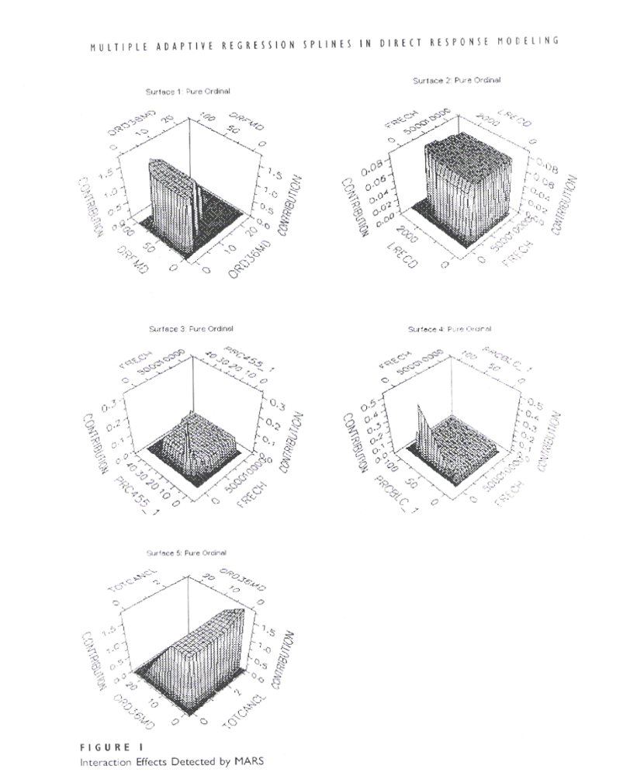

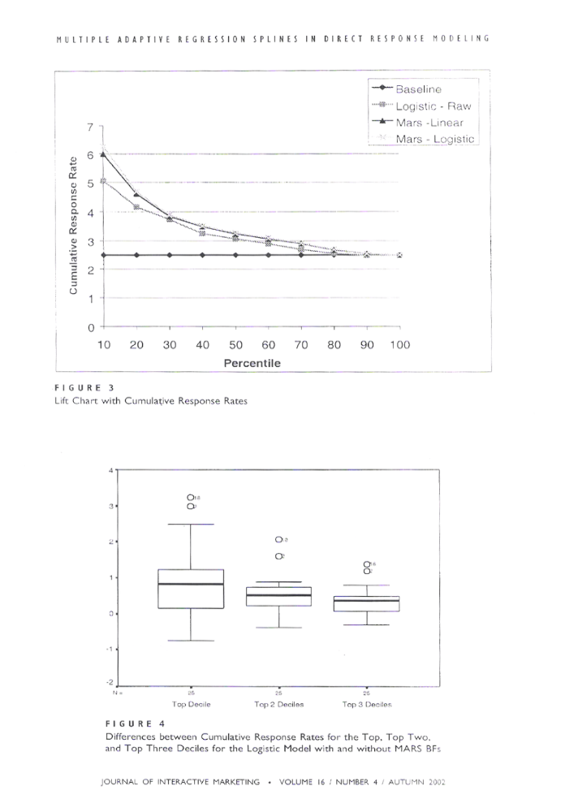
Multiple Adaptive Regression Spline in
Direct Response modelling (Courtesy - Journal of Interactive Marketing)

MULTI COLLINEARITY
Sources of multicollinearity
Employment of a subspace of the predictors
When only a region of the space of predictor variables is used, covariation may result and the problem of multicollinearity may arise. This might be due to unsuccessful sampling or to the sampling method itself. The problem could be identified through application of theoretical or substantive knowledge which would suggest that the interrelationships among the predictor variables did not exist in the population. Multicollinearity of this kind is a characteristic of a specific data set. An additional data collection might solve the problem.
Employment of only a subspace of the predictors variables may be necessary due to an inherent characteristic of the population. For example, specifications of a product category are usually bounded (e.g., price range, technical specifications, etc.) constraints of this kind in the population will lead to Multicollinearity regardless of the sampling method used.
The choice of model
Some models are likely to induce the Multicollinearity problem. In polynomial models, the terms are very likely to be correlated; the polynomial model used with time series data by Lindberg (1982) to predict demand in several countries was accompanied by severe multicollinearity. Shifting slope models (e.g., Wildt and Winer (1979) are also likely to induce multicollinearity. In these models the slopes are functions of time or other variables (e.g., Parsons and Abele (1981). In form suitable for estimation these models possess interactions terms which are potentially collinear (e.g., Erickson and Montgomery (1980). Two additional somewhat related problems may rise in dealing with time series data; namely, autocorrelation within each series e.g., Cochrance and Orcutt (1949) and multicollinearity among series (Ofir and Rave (1986) ). Finally, models which include lag or carry-over effects are prone to the Multicollinearity problem (e.g., Palda (1964), see also Davidson et al.(1978) fore this and other issues pertaining to time series).
Ill-conditions of data could result from the usage of certain models with population in which the predictor variables are constrained. For example, an attempt to build a psychophysical model for price the following may be very attractive: y=β₀P^{β1}e ^{β1P} .ε where y is some response to price and P-price. This model, introduced by Horel (1954), also Daniel and Wood (1980), is attractive due to it that price is restricted to a certain region for a given product class; in the form used for estimation of the model, the terms P and ln P are most likely to be collinear given the constraints on price.
An over defined model
This case typically refers to models in which the number of predictor variables (p) is larger than or equal to the number of observations (n). Such occurrences are frequent in medical research (e.g., Mason, Gunst and Webster (1975) and personnel selection (e.g., Darlington (1978) but are less common in marketing. A related problem is when the ratio of n/p is small, approaching one from above, and thus affecting the mean square error of prediction (Green and Srinivasan (1978; 109)). This problem could arise in an individual level conjoint modeling (e.g., Cattin, Gelfand and Danes (1983)) and could be even more serious individual level models in which experimentally designed data were inapplicable.
Effects of multicollinearity
Estimates
Given ill-conditioned data, the diagonal elements of (X’X)⁻¹ are large, resulting in estimates with large variances; this implies that with different samples OLS estimates would probably change. Stability of OLS estimates is also affected by minor changes in the data. Beaten, Rubin and Baron (1976) perturb multicollinear data beyond the last digit by adding a uniform random variable. These minor changes in the data caused drastic changes in the OLS estimates. Moreover, it was demonstrated that different computer programs produce different OLS estimates and signs (Wamplear (1970)). Omission of variables from or addition of them to the model could also change the estimates of the remaining predictors. Finally, deletion of observations from or additions of them to multicollinear data could change OLS estimates as well.
Prediction
It is evident that multicollinearity in the data negatively affects OLS estimates. It is also of interest to assess its effects on the quality model predictions. In general, if the data points at which predictions of the response is made are within the region where the model was fitted and where the same pattern of multicollinearity holds then prediction is fairly precise. If the research attempts to extrapolate outside the region prediction will most likely be adversely affected. This was shown analytically by Mason, Gunst and Webster (1975) was corroborated by Snee and Maruqqrdt (1984) and wood (1984). Hocking and Pendleton (1983:500)In a model with 2 collinear predictors the responses then, then resembles the pickets along a straight fence row fitting a regression surface to this data is analogous to balancing a plane on these pickets. The plane is clearly unstable in the direction perpendicular to the fence row and its slope in this direction can be greatly influenced by a single picket. Predictions based on points outside or far from the fence line are therefore highly variable. In the event such predictions are desired additional data should be appropriately collected in an attempt to reduce the effect of multicollinearity in the combined sample. If this is not feasible, because of economic or technical limitations, for example, than one should seek additional information about the model’s parameters from other sources.
Variables selection
Common variables selection procedures applied to ill conditioned are also suspect, as they may produce conflicting results (Hocking (1983)). In particular methods based on the residual mean square R², C_{p} statistic (mallows (1973)) and hierarchical tests (Cohen and Cohen (1975)) are all sensitive to multicollinearity on the data. If the objective is prediction this problem may not be severe since compensating variables remain in the specification. If the model however is designed for understanding or have a theoretical significance dropping the wrong variables from the specification is not desirable.
Multicollinearity diagnostics
Despite the recognition of the effects of multicollinearity (e.g., Green (1978)), systematic procedures to examine the condition of data are rarely employed in the marketing literature. On the other extreme the multicollinearity problem is raised (sometimes without proper empirical evidence) to justify results or lack of face validity of results. In cases where multicollinearity diagnostics are not employed, the parameters estimated by OLS may suffer from the negative symptoms of multicollinearity based estimation, or other remedies are probably not being seriously considered.
In some instance multicollinearity is hypothesized to exist in data when individual model parameters are not significantly different from zero and the overall F-test is significant. It could be shown, however, that this may result when all predictors are mutually uncorrelated (Geary and Leaser (1968). This and other disturbing results, (e.g., ‘incorrect’ signs may be associated with multicollinearity, but they are neither sufficient nor necessary conditions for its existence.
Pairwise correlation
It is not true that pairwise correlations between the independent variables in regression analysis are indicators of multicollinearity (Dhrymes (1978), also Montgomery and peck (1982: 297-299). Pairwise correlation are cannot identify dependencies among more than two predictors. If the correlations are either very high close to one or low, close to zero, a researcher can reach a more certain conclusion regarding the existence of multicollinearity. In any event, Pairwise correlation should be used only as a very preliminary step in the diagnostic procedure.
The determinant of X’X
Another starting point for assessing multicollinearity would be examination of the determinant of X’X. In order to remove the effects of units of measurement, X’X is usually used in correlation form. If the predictors exhibit perfect linear dependencies the determinant is zero. If multicollinearity exists in the data, the determinant is small. A more meaningful interpretation of this indicator was suggested by Willan and Watts (1978). They showed that the ratio of the volume of the confidence region for β (based on the observed data) to that of an orthogonal reference design is equal to׀X’X׀^{-0.5,} this indicators the loss power due to linear dependencies in the data. A problem with the determinant as an indicator to multicollinearity (when X’X is not given in a correlational form) is that it could be small when some columns of X are close to zero, thus limiting its usefulness.
VIF
The diagonal elements of (X’X)⁻¹are an important indicator to collinearity termed variance inflation factors (VIF) due to their impact on the variance of β ^(Marquardt (1970)). VIF, is also equal to (1-R²_{j})-1, where R² is obtained by regressing the j’s predictors in X on the remaining p-1 predictors. Another meaningful interpretation of the VIF’s is given by the ratio of the length of the confidence interval associated with βj, based on the observed data, to the length of the interval associated with orthogonal reference design. This ratio equals the square root of the VIF (Willan and Watts (1978)). VIF’s are therefore very useful in detecting multicollinearity as well as the indications of the precision of the estimates.
Examination of eigenvalues
Another indication of the condition of the data can be by means of the eigenvalues of X’X. Observation of the spread of these values can give preliminary indication of the problem, particularly if some roots were close to zero. The average squared distance between β and β^ is given by Σ ^{p} _{i=1} 1/ λ_{i.}. Thus, if one or more eigenvalues were much smaller than one, this average distance would be quite larger indicating imprecision. If however the original levels of the predictor variables were orthogonal, the expected (average) squared distance would be E(L2)= pσ². By comparing Σ ^{p} _{i=1} 1/ λ_{i} to p the researcher could further assess the condition of the data and the precision of the estimates.
Another indicator associated with the eigenvalues is λmax / λmin, where λmax and λmin are, respectively, the largest and smallest eigenvalues of X’X. The square root of this ratio is the condition number of X, which is also equal to the ratio of the largest to the smallest singular values of X (Belsley et al. (1980: 98-104)). This ratio should be compared to unit in an orthogonal system. Belsley (1984) argued that the condition number measures the sensitivity of the estimates to changes in the data. Berk (1977), further showed that the maximum VIF is a lower bound of this ratio (see also Snee and Marquardt (1984)). A related indicator is the index given by
μ_{i}= (λ max/ λ_{i} ) ^{1/2} .
Localization of multicollinearity
The above indicators are very useful in detecting and analyzing the effects of multicollinearity. If used independently, however, they fail to provide deeper insights into the nature of the problem.
Two methods are recommended for the localization of multicollinearity and are available in current computation packages. The first; introduced by Belsley et al. (1980), decompose the variance of the estimates. The entries in the resulting matrix are proportions of the variance of the relevant eigenvalue. If one small eigenvalue contributes to variances of several parameters; multicollinearity and its patterns are identified. While this procedure is generally available, the usage and interpretation of the results may require from some researchers to acquire additional knowledge and training (see belsely et al. (1980).
The second procedure was suggested by Gunst and Mason (1977a) who pointed out that large elements in the eigenvectors which correspond to small eigenvalues of X’X indicate which independent variables are most involved in multicollinearity. The basis for method is the relation
(Xa_{i} )’(Xa_{i} )= λ_{i}. Given a very small eigenvalues the elements of a_{i} define the multicollinearity among the predictors (a_{i} is the ith eigenvector of X’X). This localization method is very useful in practice for the following reasons: (1) it is directly connected to the definition of multicollinearity (e.g., Gunst (1984), Sharma and James (1981), silvey (1969) ), and (2) it relates directly to the familiar principal component.
Remedial measures
Since some sources of multicollinearity are under the control of the researcher the problem can be avoided or reduced. First, careful selection of the model to be used in a specific population can prevent problems of inherent collinear terms Hendry (1979, 1983).
Unfortunately, this is not always possible due to insufficient knowledge regarding the underlying process. However, careful consideration of the predictor variables and their corresponding ranges may help. Secondly, whenever possible, polynomial models should be designed so that orthogonal polynomial producers can be applied (Bright and Dawkings (1965)). In cases where this is not possible, the predictor variables could be centered before creating the polynomial terms. It was argued that this (Bradley and Srivastava (1979), marquardt (1980), Snee and marquardt (1984). Finally, proper sampling may prevent sample-based multicollinearity.
Assessment criteria
The question facing the analyst confronting ill-conditioned data is which method to use and whether the method chosen outperforms OLS. Superiority of one estimator over another is usually assessed by comparison of the mean square error (MSE) matrices e.g., Lilien and Kotler (1983: 106). Such matrices are of the form E [(β^- β) ‘( β^- β)]. Applying the trace operator to MSE matrix we get the following scalar: trace MSE (β^) = E [(β^- β) ‘(β^- β)]
Following Toutenburg (1982) this latter criterion is referred to as the Scalar Mean Square Error (SMSE).
OLS estimates are unbiased when they are based on ill-conditioned data. However, they do have certain negative proprieties, one of which is large variances. In contrast, all the proposed remedies are biased. These procedures could potentially reduce the SMSE (via variance reduction); the tradeoff, however, is some bias.
Researchers may also be concerned with the adequacy of the estimators with regard to model predictions (e.g., Allen (1974), Cattin (1981). In such a case researcher may consider using the mean square error of prediction of this latter indicator, however, is not needed. Theoblad (1974) provide a general theorem which could be applied here; specifically, if an estimate is superior to another with regard to the SMSE it will outperform it with regard to its MSEP. We shall now discuss some remedial measures that are available in the literature to combat the multicollinearity effects.
The addition of new data
It is noteworthy here to point out that the addition of new data may not necessarily solve the multicollinearity problem. This is particularly true when multicollinearity is inherent in the system generating the data due to certain structural constrains on the predictor variables. Furthermore, MSE, the new data may not be consistent with the original data due to conditions that did not prevail when the original data were collected.
Omission of variables from the model
A common method used to deal with multicollinearity is to drop collinear variable(s). This method is very simple to implement and is designed to obtain more precise estimates of the set parameters judged to be relevant. Its effectiveness is contingent upon the multicollinearity being inherent in the system generating the data. If, however, multicollinearity is a characteristic of only sample data and not population, then the omission of variables can have adverse effects on the prediction of future response values. Researchers should also be aware of the following limitations of this method: (1) procedures used to select the preferred set (e.g., stepwise regression) are affected by multicollinearity (e.g., Hocking (1983)). Alternatively this selection is frequently based on subjective judgment. In either case the selection is arbitrary; (2) dropping variables from models in which every parameter has theoretical importance does not enhance the researcher’s ability to reject the model, nor does it improve his/her chances of increasing understanding of the underlying process; (3) unless the omitted variables are orthogonal to those retained, OLS estimates of parameters in the reduced model are biased, the estimates of the omitted set of variables, which are set to zero, are also biased, except for the case where the true parameters indeed zero, and (4) it is impossible to determine whether the mean square error (MSE) of the estimated parameters of the reduced model is superior to the MSE of the same set of parameters estimated with OLS applied to the full model.
Principal Components
The principal components procedure was originally introduced by Hotelling (1933) and was only later adopted to regression analysis, Principal components estimates were shown to be superior to OLS estimates in several stimulations. These stimulations however could not guide the analyst when to prefer principal components over OLS in a real setting. A preferred method is to derive the difference between the SMSE of OLS and principal components. If it is positive, use principal principle components.
Utilization of the principle components procedure should be accompanied by careful consideration of its limitations. First number of principles components utilized in the model is reduced by the number of zero or near zero, eigenvalues of f the X’X matrix.
Secondly it is applicable to multiplicative models only if all the observations have positive values fit to a logarithm transformation, Mahajan et al (1977). In addition researchers using principal components should always examine whether they gain any improvement over OLS in terms of SMSE.
The Bayesian Approach
Multicollinearity results in some loss of information concerning the model’s parameter vector. In the Bayesian approach β is a random variable with a known prior distribution. The specification of the prior is tantamount to providing additional information concerning β. The use of Bayesian approach in regression was discussed in Leamer (1973, 1978) and zellner (1971). One of the main criticisms of this approach is concerning its subjectiveness as it requires an exact specification of the prior distribution. In this respect a study of the sensitivity of the posterior mean to changes in the prior distribution, particularly those in the prior variance-covariance matrix, would be very useful. Chamberlain and Leamer (1976) considered a given location of the prior and developed a correspondence between classes of prior variance-covariance matrices and bounded regions in the space of the posterior mean vector was generalized by Leamer (1982) by assuming that the prior variance-covariance matrix is considered to lie between a minimum variance-covariance matrix and a maximum variance-covariance matrix.
A Bayes-like technique, called mixed estimation, was proposed by Theil and Goldberger (1961) and Theil(1963) in which certain prior restrictions are made on β. These restrictions are formulated in terms of an additional model involving β and a random vector independent of the error vector ε. The prior and sample information (provided by the original model) are combined via the method of weighted least squares to produce an unbiased mixed-estimation estimator. The advantage of the mixed estimation technique is that it allows the user to incorporate prior knowledge about β in the model without having to specify a particular prior distribution for β. If, however, normality is assumed and the prior knowledge about β can be used to determine the mean and variance, then a normal prior would be fully specified.

LIST OF PUBLICATIONS & PRESENTATIONS
1. Published on article in the Journal of Institution of Engineers on Computers in Chemical Engineering.
2. Presented a paper in "International Seminar" held at IFMR, in the area of Rural Finance.
3. Monograph on "Neural Network" nearing completion.
4. Presented a paper on “Improving prediction accuracy of loan default- A case in rural credit”, at the national conference of Operations Research Society.
5. The abstract was published in the Operations Research Society proceedings since, the article did not reach them.
6. Was a Co-Chairman in a national level seminar on “Paradigm Shift Of Finance Function”, organized by a business school in Coimbatore.
7. Published a paper titled “Default prediction in Financial services –A Quantitative approach”, In SRM Digest , a journal published by SRM University.
8. A paper titled "An Integrated Model for Credit Risk Assessment In
the Rural Context in India” has been published in Academy of Taiwan Business Management Review, Vol .4,Num.3,December
2008. The ISSN number issued by the ISSN INTERNATIONAL CENTRE, FRANCE is 1813-0534
9. Have made various Presentations to different customers for customer profiling, Positioning, Business Process mapping, Business Solution, Business Strategies etc.
10. Story in Science fiction in progress
SPECIFIC CONTRIBUTION

The improvement in prediction accuracy achieved in this research enables accurate scoring and profiling of customers in financial service
and its importance is globally important as has been proved by the global crisis triggered by Subprime lending.
In the financial services sector and specially in the retail lending sector, as expressed by people in the industry, there is no comprehensive model to profile borrowers which takes all micro, macro economic factors, diversities in the socio, economic, cultural and demographic, psychographic aspects of customers in different regions and in this work an attempt has been made towards this. An integrated model has been developed which is a holistic approach towards behavior of customer. This was reiterated by the appreciation of many top people from the industry during the paper presentation in a seminar and expression of interest in using my services to develop models for their business.
This work could be further used for response modeling since as a method this has been proved in this work, to be very accurate in predictive modeling. This would be a step forward in scoring customers not only for default prediction but to improve ROI in campaigns for upselling and cross selling.
BIOGRAPHY OF A. SUNDARAMURTHY
A. Sundaramurthy started as a Management Trainee in a public sector Engineering Company 28 years ago and has contributed extensively in R&D. engineering, design, simulation and modeling, investment analysis, projects QMS, marketing, HR, strategic management, in various Indian and MNC's both in India and abroad. Some of the companies associated include ICI, Technip, Shell, American Express Bank, Parry, Alpha Laval, General Foods, BG,BP,MODEC International, CST Vulcan, Kelllog, etc.
Rose as Department head, Divisional Head and headed Corporate functions of Technology and HR and also as Country business head of application software division in an American MNC.
Has developed products and processes and have developed implemented various business policies and strategies. Now a Director and Principal Consultant of a Pvt. Ltd. Management Consulting Company offering Technical and Management consulting for businesses in Middle East, US, Australia and India for Financial Sector, FMCG, Telecom, Oil & Gas etc. Some of the Clients include Shell, American Express Bank Financial Services, , Parry ware, Valued Epistemic, a publishing house, an International Energy Co etc.
Is a Director in a Singapore based company in the business of PLM, Business process solutions and engineering services.
Is a Director in Company in the business of data mining, analytics and CRM in collaboration with a Market Research company in Wisconsin.
Have worked in Malaysia, Singapore, Japan, Middle East, USA, UK and European Countries.
Was a faculty for a BITS, Pilani, Distance Learning Program.
Have Co-Chaired a National level Seminar “Financial Services Business” and was a panel member in a discussion titled “Paradigm shift of financial function” where other panel members were GM(FIN) of LMW, Director of Sankara Business School, Director of Chennai Business School and CNBC ,Cochin Correspondent.
SHORT BIO-DATA OF PROF. MJ XAVIER
Prof. MJ Xavier obtained his Doctorate in Management (1984) from the Indian Institute of Management, Calcutta. He is basically an engineer with an M.Tech. (1979) in Chemical Plant Engineering from Regional Engineering College, Warangal and B.Tech. (1976) in Chemical Engineering from Coimbatore Institute of Technology.
He has more than 20 years of professional experience in teaching, academic administration and industry. He has served as a Research Executive in Mode Research Pvt. Ltd., Calcutta (1982-84) and as Manager in-charge of Management Development and Services with SPIC Ltd., Chennai (1985-91). He has taught at XLRI, Jamshedpur (1984-84), IIM Bangalore (1991-96) and IFMR Chennai (1998 till date). For a brief period he served as the Director of the Karunya Management School and the Principal of the Karunya Institute of Technology at Coimbatore. He also served as the Dean of the Academy for Management Excellence (a division of IFMR) for a period of three years (200-03).
His areas of interest include CRM, Marketing Research, Strategic Marketing and Data Mining. He has conducted a number of training programmes for executives and has also been a consultant to several companies.
He has authored three books and published more than 70 articles in Journals and Magazines in India and Abroad. His book `Marketing in the New Millennium’ won the DMA-Escorts Award for the best Management Book of the Year 1999.
He has served as Visiting Faculty to a number of business schools in India and abroad including The University of Buckingham, U.K. (1993), The Texas Christian University, U.S.A. (1999), California Polytechnic State University, USA (2003-05) and The American University of Armenia, Armenia (2006).
Contact Address:

Dr. M.J. Xavier
K.B. Chandrasekar Distinguished Professor of Marketing &
Director – Kotler-Srinivasan Center for Research in Marketing
Great Lakes Institute of Management,
24, South Mada Street , Srinagar Colony,
Saidapet, Chennai-600015.
Telephone: 42168828 – Ext:214
Website : www.greatlakes.edu.in
Email: xavier_mj@yahoo.com & xavier@greatlakes.edu.in

H.J. Kappen, Foundation for neural Network, Postbus 9101, 6500 HB Nijmegen, The Netherlands. Tel. +31 24 3614241, Fax. +31 24~3541435

