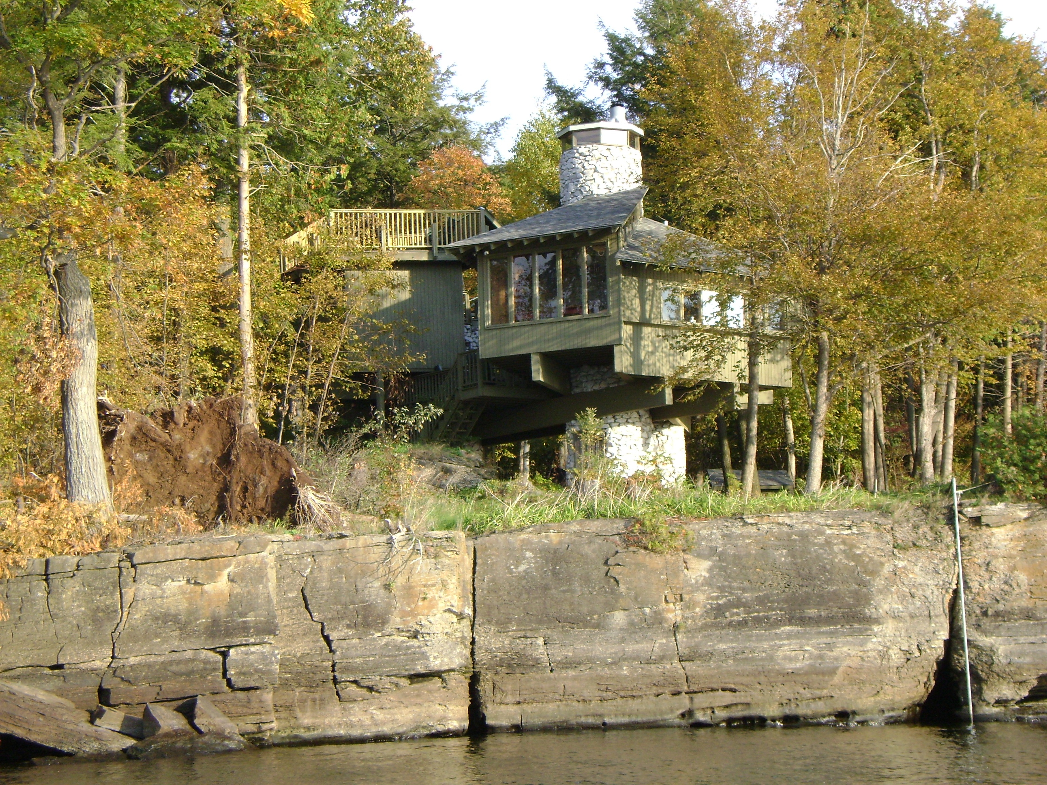

TURNER TREE HOUSE ON LAKE CHAMPLAIN
.
The Turner Tree House was built in 1970 by Selby and Maureen Turner as a summer camp –
with three levels of decks (with railings!) that take you to over 30 feet high with a glorious view of the lake, mountains, sunsets, and starry skies. It is at the end of a private road on the 280 acre Turner Farm and that has miles of wooded trails and over 1.5 mile water frontage- a truly special preserve on Isle La Motte, Vermont- only 1 hour drive from Burlington, Plattsburgh, and Montreal. The Tree House is only available to rent on rare occasions.

Outdoor amenities:
-Very private setting on cliffs surrounded by woods (do not jump off cliffs-too shallow below!)
-Private swimming area (rocky, so please bring swimming shoes!)
-Use of 1.5 miles of abutting private trails
-Gas grill
-Small outdoor fire pit
-Outdoor hot tub within screened porch
-Three levels of decks with a hammock and chairs
-Sunset views
-Mowed tent area on the point

Sleeping arrangements (Tree House sleeps 6-8):
-Master bedroom: queen size bed
-Lower guest room: queen size bed
-Upper guest room: 2 twins
-Living room: 2 couches (2 twin beds)
LODGING RESERVATIONS: The Turner Tree House (Excusive Pre-Season)
Hypnovations: Age Regression Workshop Retreat Rates: June 11-13. 2010
Please contact for availability and Reservation: Proprietor, Selby Turner,
802-922-7573/selbyt@aol.com and please have the following information ready:

Options: Friday, June 11 Arrival at 4 PM PAYMENT
1 Room – Master/Queen w/ Shared Bath - $75/night
Friday _____Sat. ________Sun_____ ________________________________

1 Room – Queen w/shared Bath - $65/night
Friday ____Sat. ____Sun._____ ________________________________

1 Room – 2 Twin Beds w/shared Bath - $55/night
Friday ____Sat. ____Sun._____ ________________________________

LODGING TOTAL Plus 9% Vermont Rooms Tax: ________________________________

Please make checks out to: Turner Family Limited Partnership
Address: Selby Turner, 24 Turners Lane, Isle La Motte, VT 05463
Workshop Registrant Name: ________________________________________________________
___MC __Visa __ AmEx __Discover
Credit Card #________________________________ Exp. ______ Security Code:____________
Card Holder’s Name as Appears on Card: ______________________________________________
Address As Appears on Card: ________________________________________________________
Address: ______________________________________________Zip Code: ___________________
Credit Card: __MC __Visa / # _____________________ Exp. ______ Security Code:__________
Address As Appears on Card: ________________________________________________________
Address: ______________________________________________Zip Code: ___________________

