Toroidal Tank
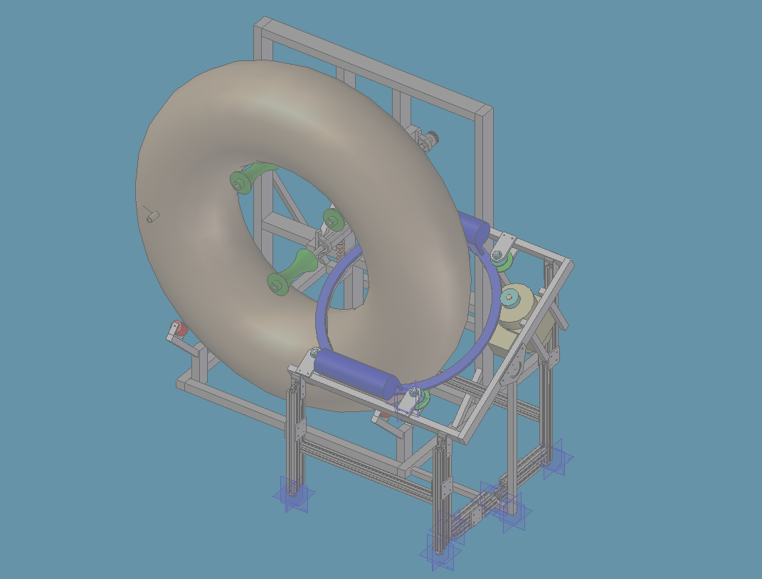
Wrapping System

NASACorp
Ceasar Garcia Leigh Pipkin Brian Stuart
Ken Nebrig Eric Nickoli Shuan Rhudy
Grant Tyler Adam Epling
Matt Uhrig Mike Duran
FINAL PRESENTATION
Senior Design – Fall 2004
Dr. David Beale
Corporate Sponsor – Tom Delay (NASA)
ABSTRACT

NASA has an existing procedure by which they wrap toroidal fuel tanks with pre-impregnated composite Kevlar material. This process is to provide the toroidal tanks with the very necessary extra strength. The existing procedure is done manually by hand lay-up, consumes many man-hours, and is quite tedious. The presented problem is to design and fabricate a machine that will do this manual process automatically.
The existing process used by NASA is very lengthy and involved and requires multiple persons to complete the process. The proposed design problem will not only shorten the time it will take to wrap a toroidal tank, but will make the entire process more efficient. Creating a machine that will wrap a tank automatically will decrease the number of operators required to successfully wrap the toroidal tank as well as provide a much more uniform wrapping. Hand lay-up of the toroidal tanks allows for human errors in wrapping and inconsistencies in the wrapped surface. The automation of this process should establish a much more consistent wrapped surface on the toroid.
The new system should not only be able to wrap the toroidal tanks with the composite material, but should be all-inclusive and free standing. This means that the system should provide both support for the toroid and wrapping devices, while wrapping the toroid with minimal to no human aid.
Table of Contents
Introduction (EN)………………………………………………………………………….4
Background
1.1 Current Process (LP)……………………………………………………....5
1.2 Toroid dimensions (LP)…………………………………………………...5 1.3 Specifications and Constraints (EN)………………………………………6
1.4 Existing Solutions (LP)……………………………………..……………..7

Concepts
  - Group One Conceptual (EN).……………………………………………..8
  - Group Two Conceptual (EN).…………………………………………….9
  - Chosen Concepts (EN)…………………………………………………..10

Design
  - Support (MU)……………………………………………………………11
  - Toroid Drive (EN)……………………………………………………….15
  - Wrapping System………………………………………………………..24
    - Tensioner (BS)…………………………………………………..24
    - Ring Gear (LP)…………………………………………………..27
    - Ring Gear Support(CG)…………………………………………33
    - Ring Gear Tilting Table (AE/GT)……………………………….40
Engineering Analyses
  - Wrapping Drive Model Prototype (BS/SR)……………………………...45
  - Gear System and Strength Analytical Calculations (LP)………………...48
  - Support Stress Analysis from Algor (MD)………………………………52
Economic Analysis (KN)………………………………………………………………...62
Conclusion (CG)…………………………………………………………………………65
References………………………………………………………………………………..68
Appendix – Solid Edge Drafts (Combined Effort)………………………………………69
INTRODUCTION
This project is a design project sponsored by NASA. NASA has a need to increase the efficiency and speed with which they wrapped toroidal fuel tanks with composite material. They wrap these toroidal tanks with pre-impregnated Kevlar fibers to increase the strength of the tank itself. Up to this point, NASA has been forced to manually wrap these tanks with the composite material because no system existed in which a toroidal shape could be wrapped. NASA’s existing process is extremely slow and tedious. It requires multiple man-power and many man-hours to wrap the toroids with the composite material. Also, manually wrapping creates inconsistencies in wrappings caused by human error.
The project presented is to design a system that will automatically wrap a toroidal shape with composite material. The goal is to create this system so that it will automatically wrap the toroid as well as support it. Both radial and angular wraps are desired. An assumption is that this new system would wrap the toroid much more effectively and efficiently, while requiring very little human assistance.
To tackle this project, we divided the design group into two teams to come up with preliminary designs. Once the midterm presentation had been delivered and evaluated, the design team rejoined and re-evaluated the design project. The final prototype design was then split up into multiple parts. The system design was subdivided into the categories as follows: support, toroid drive system, ring drive system, and wrapping/tensioning device. Each member of the design team was then assigned to a separate subsystem based upon technical skills, previous experience, and personal preference. For the rest of the report, the design analysis will be evaluated by each of the subsystems as it affects the entire system.
1.1 Current Process
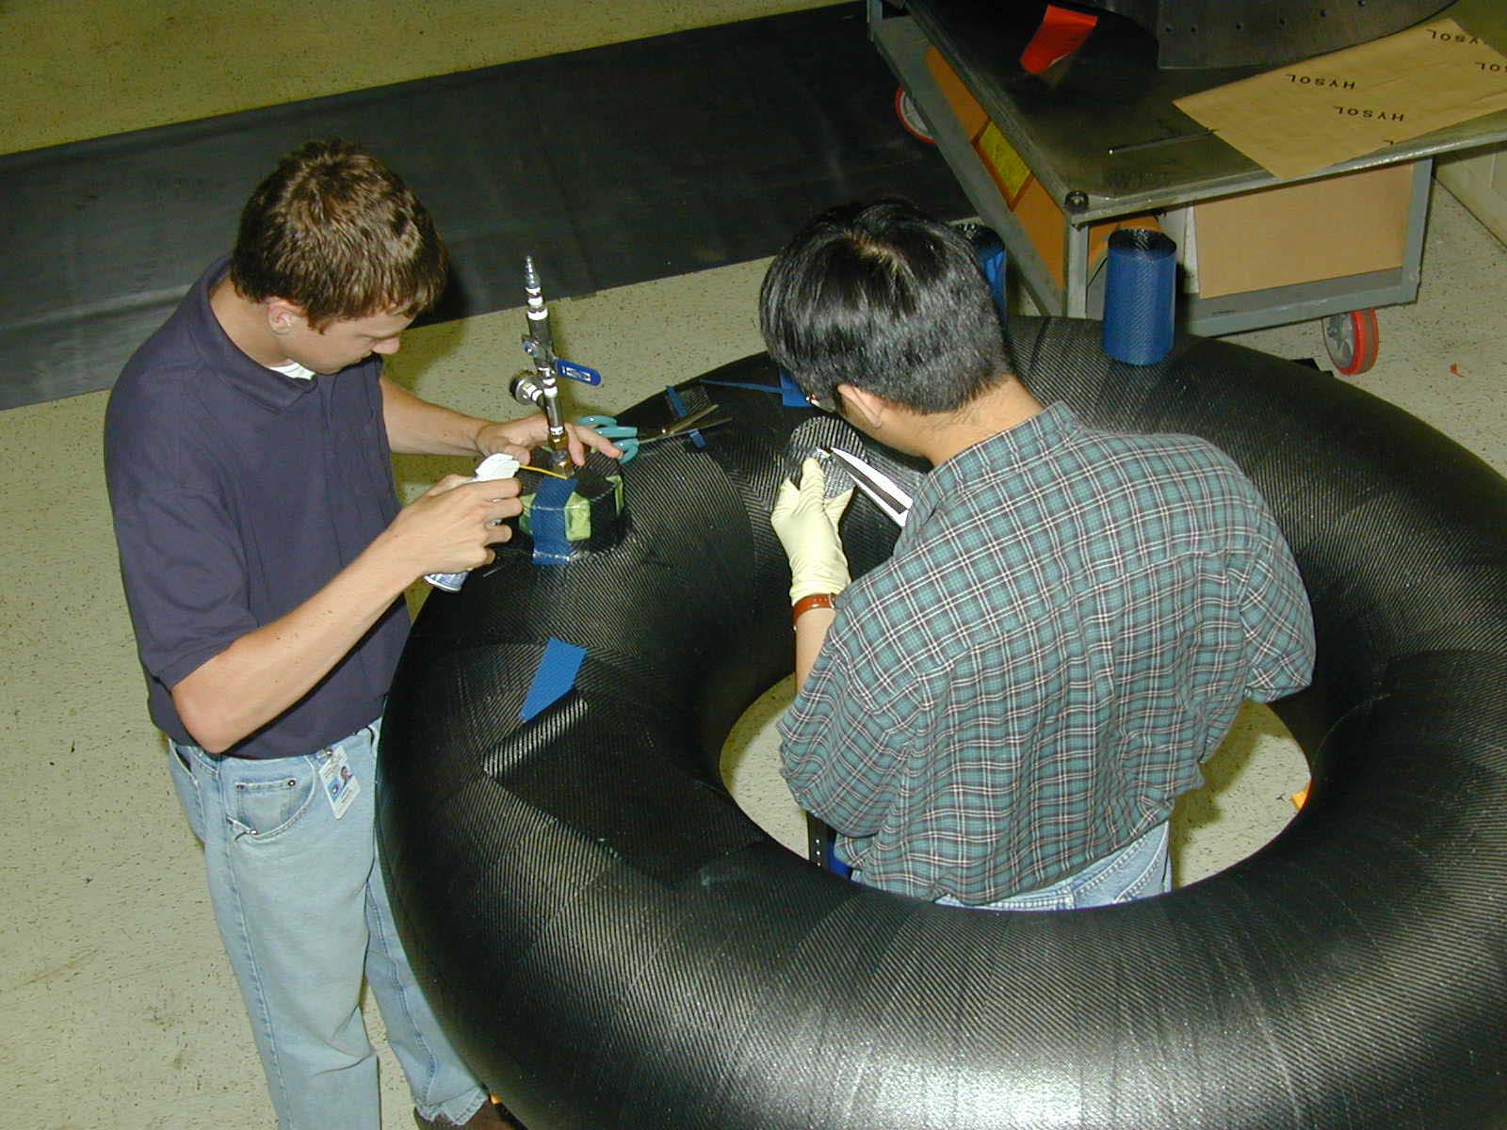
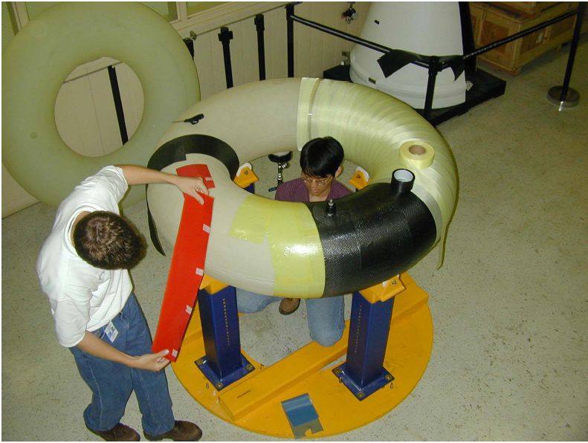
Currently, the method for applying the composite material is a hand lay-up of 6 layers of 6 inch wide strips of fiber. Fittings are covered with patches of different diameters laid in different orientations between wrappings. The process involves many man hours. In addition, it introduces susceptibly to wrinkling of the carbon fiber, which can cause stress concentrations.

  - Toroid Dimensions

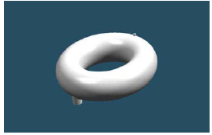
The tank is 60 inches in diameter, with a 16 inch cross section. It has two ports, 180 degrees opposite from each other. One port has a 5 inch diameter, and the other is a one inch diameter. The tank is made of rotationally molded thermoplastic, and must be wrapped in a composite material to increase strength. The composite covered toroid weighs less than 40 lbs. Results of a burst test show the highest point of strain lies in the inner radius. This toroid is 1/3 scale of what could fit in a delta 4 fairing.
1.3 Specifications and Constraints
We, as a design group, have a considerable amount of freedom on this project in terms of design specifications. The main requirement of this project is to design an automatic toroidal wrapping machine that effectively and efficiently wraps a toroid with composite tow that is approximately .008 inches thick, with a bandwidth of .125 inches. In addition, the machine needs to accommodate at least 3 orientations of wrapping - horizontal, 30º and -30 degrees from the horizontal. To prevent stress concentration, it is important to keep constant tension on tow while wrapping. The entire surface of the tank must be covered, except for the openings of the ports. The current process achieved a burst pressure of 425 psi, so the new method should aim for the same or higher.
As with any engineering design project, economic, environmental, safety, and manufacturability issues are of concern. The machine should be operator friendly, yet be cost effective enough to warrant replacing NASA’s existing process of manual wrapping. Very little constraints were put on size and shape and even component selection for our system. We venture to design a system that causes little or no effect on its environment other than minimal noise pollution. Our system is designed to be was self contained and to release no harmful agents to its surroundings. Many precautions have been taken to make the system harmless to the operator as well.
Our NASA sponsor gave us no specific space requirements initially, however the mid-term presentation produced a sense that the sponsor felt less floor space was desirable; therefore a vertical orientation of the doughnut was adopted.
As for budget concerns, we were also given a rather lenient budget with which to work. For the entire design and fabrication process, we have been allotted between $3000 and $4000 U.S. dollars.
1.4 Existing Solutions
An existing machine made by cooperation between Lockheed Martin and Adre Incorporated was discovered. This machine was made for wrapping a one inch thick epoxy resin tape around a 10 inch outer diameter, 2.5 inch cross section toroid. An attempt to adjust this design to accommodate a tank our size would result in an enormous machine. Therefore, we decided that this concept would not be suitable for adjustment to our specifications. In addition, the project was abandoned by Lockheed and Adre in favor of using titanium tanks. The machine is no longer being used or tested.

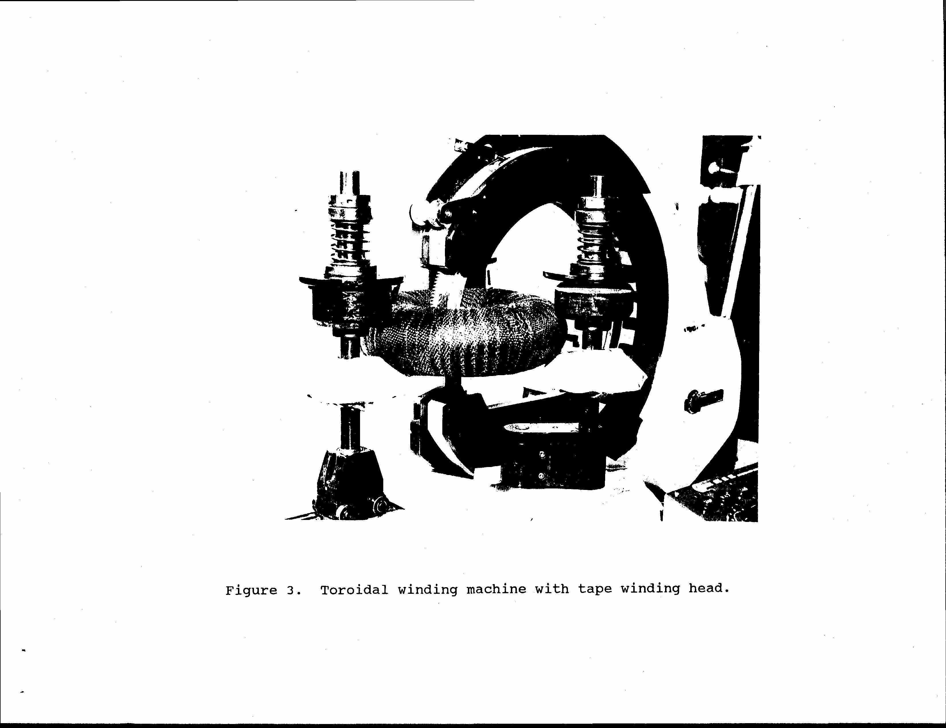

CONCEPTS
As previously mentioned, our design group was originally separated into two initial design groups. The idea was to have two competing initial designs to choose from in order to pick the best design, or a combination of the best components.
  - Group One Conceptual
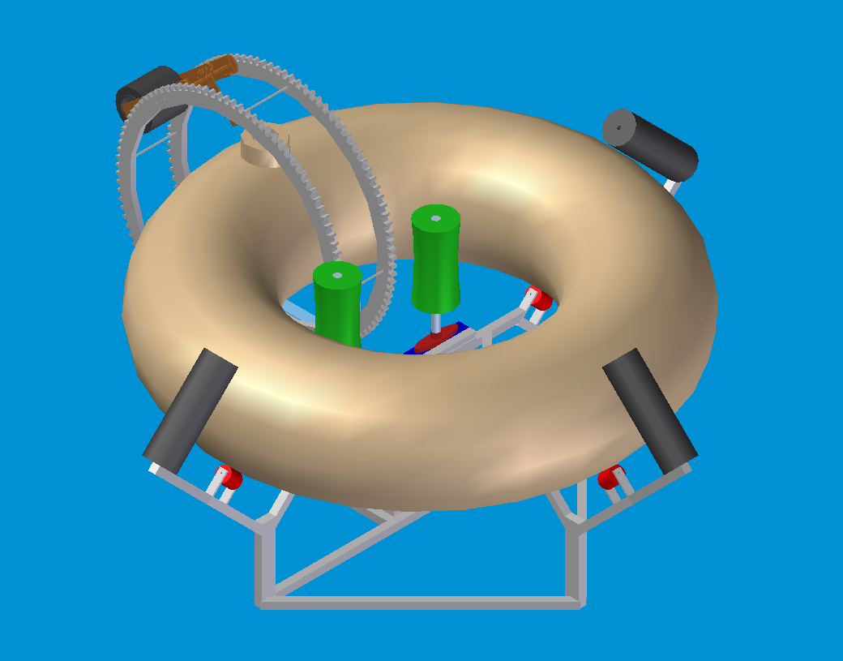
Group 1’s concept utilized a horizontal position of the tank supported by an 80-20 frame. This design rotated the tank with a three point drive system on the inner diameter of the toroid. The spool traveled between two parallel ring gears that maintained a position perpendicular to the tank. This design achieved angular wrapping by using reversible variable speed motors to control the rotating speed of the toroid.

2.2 Group Two Conceptual
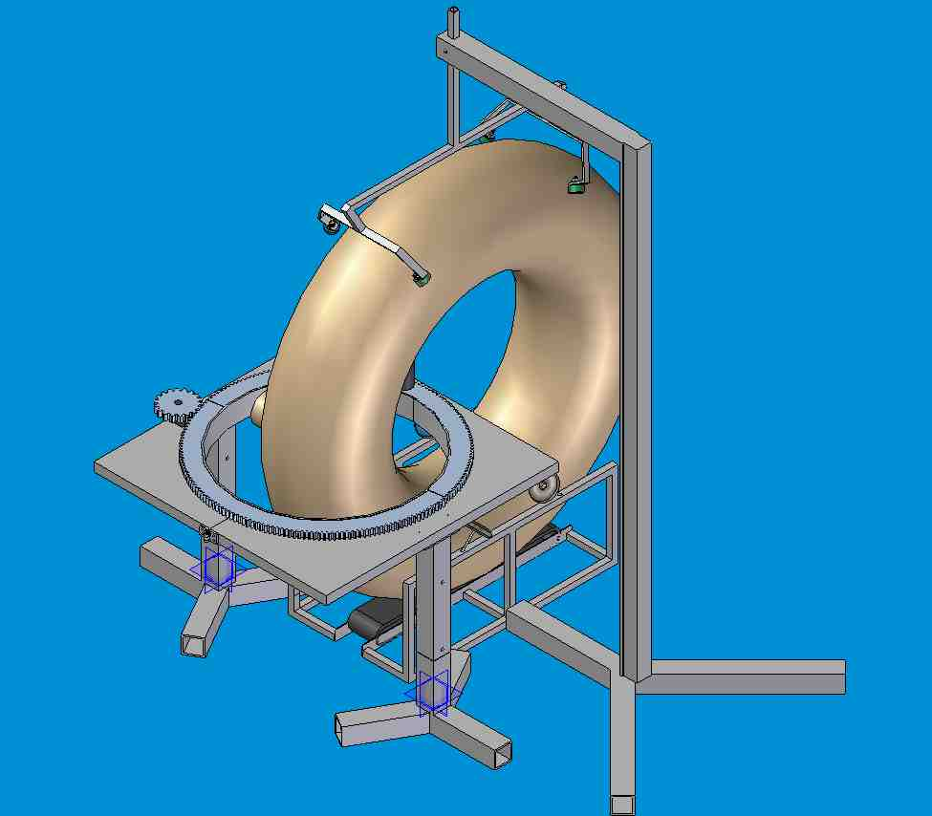
Group 2’s original concept utilized a vertical tank orientation supported and constrained by an aluminum square tubing frame. The spool traveled around the tank bolted to the top of a ring gear which sat on top of casters on a metal plate. The entire plate (including both gears and the motor) tilted to the angled planes to create the angular wraps. The toroid was rotated by a conveyor belt at the bottom of the tank.

2.3 Chosen Concepts
The final concept chosen ended up being a conglomeration of the best design aspects of both teams’ initial concepts. Contributions from team one included the 3-point drive system for the toroid, as well as the use of the 80-20 aluminum base assembly pieces. Team two brought the idea of the vertical orientation of the toroid as well as the rotating ring gear as the main wrapping mechanism for the composite material. A combined effort was made on the spool/tensioning device and a brand new concept was adopted.
For the entire final design concept, many different ideas were used from the first two initial concepts. In many cases, a combination of both conceptual ideas were morphed together to create what we felt was the best design for our system. The following chapter will describe in detail the workings of each sub-assembly of the overall system.
DESIGN
  - Support
Framing Overview:

Our choice for the main body support framing consists of Aluminum extrusions from 80-20 Inc. The aluminum consists of 6105-T5 alloy. There are numerous advantages to using the 80-20 system for our framing:
- Aluminum is lightweight and very easy to fabricate, which will allow us to customize our parts in the shop as needed.
- The extrusion is actually T slotted which allows for linear adjustment of ALL of our positions. This should ease the trouble of positioning our three point drive system to fit snug against the toroid.
- The fasteners require simple hand tools; therefore diminishing assembly time allowing for focus on the complex wrapping components and extensive prototype testing.
- The 6105-T5 alloy has extremely strong material proprieties
(Ultimate tensile strength: 38,000 psi , yield strength: 35,000 psi)
which are comparable to A36 steel but with lower cost and weight

Joint Analysis:

C
B
A

Failure Point for 1.5’’ X 1.5’’ Cross Section Horizontal distance = 6’’
 | Direct Force (A) | Cantilevered Force (B) | Torsional Force (C)
Single Anchor | 950 lbs. | 1,000 lbs. | 700 inch-lbs
Double Anchor | 1,200 lbs. | 1,200 lbs. | 2,000 inch-lbs
End Fastener | 1,000 lbs. | 820 lbs. | 1,150 inch-lbs
Joining Plate | 225 lbs. | 200 lbs. | 1,100 inch-lbs
90۫ Joining Plate | 250 lbs. | 200 lbs. | 1,260 inch-lbs
Corner Bracket | 575 lbs. | 225 lbs. | 500 inch-lbs
Corner Gusset | 575 lbs. | 750 lbs. | 500 inch-lbs

Upon completion of the frame design, it was necessary to select joint fasteners to the joint locations of the frame. Some locations will experience a direct force while others experience a cantilevered one. The 80-20 manufacturer’s specifications are listed above. Different types of joints have different forms of strengths. Our job here was to match the correct fastener application to the correct location on the frame assembly. We knew that members in the middle of the frame (especially the “arms” of the frame) are susceptible to cantilevered and torsional forces. From the data given by the manufacturer, it was determined that gusset and corner brackets were not as good as the jointing plates in applications in which torsional forces are experienced. From our own testing, we determined that the force needed to secure the toroid in place should be about 10 pounds. Finite element analysis shows that this cantilevered force produces stresses and strains well within the confines of our material and fasteners; and with the added security of having the correct fastener for the force application with only reinforce the stability of the frame.
Beam Deflection:
We would like to use a 1.5’’ x 3.0’’ cross section extrusion for most components in the frame. The manufacturer quotes this cross section extrusion to have a moment of inertia of I = .4824 in⁴ and a modulus of elasticity of E =10,200,000 lbs/ in². Knowing this, we can calculate the deflection of the beam or, conversely, the max load we can apply to achieve a safe amount of deflection in the beam.

Our most critical piece to be loaded is 40’’ long and we would like to get a worst case scenario deflection of 1/8 inches or .125 in.

Using the beam deflection formula for a distributed load:
D = (5L³ W) / (384*E*I)
Where
D= desired deflection of beam = .125 in
L = length of beam = 40’’
E = modulus of elasticity = 10,200,000 lbs/ in²
I = moment of inertia = .4824 in⁴
W = evenly distributed load

From the beam deflection formula it was determined that we can apply a distributive load of 738 lbs. This is a good number for a distributed load, but many of our loads are concentrated in one area. The most simple and cost effective solution to this issue is to place additional support members underneath the loaded beam to strengthen the area in question. This should be enough to reinforce enough to support the weight of the “arm” members, pillow block bearings and motor (which will be mounted directly to the beam in question.)

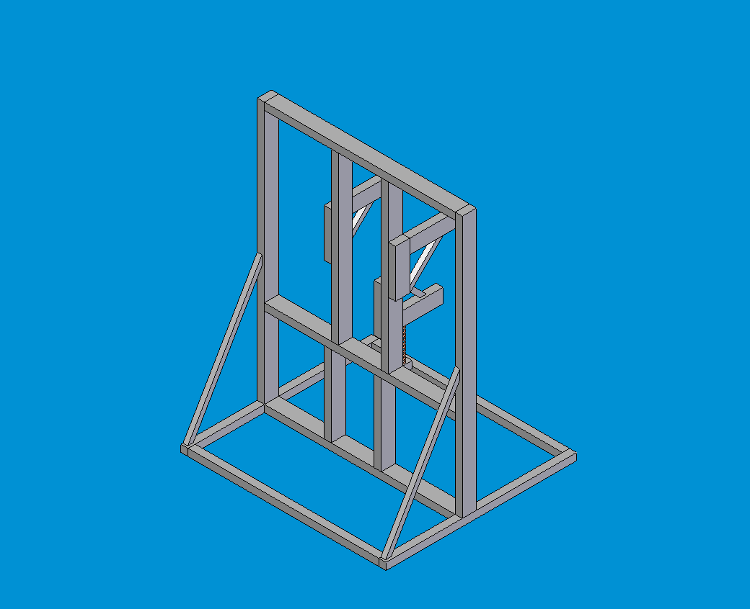
Note the added support to strengthen loaded bar

Rollers for Toroid Support:

The rollers upon which the toroid will sit on will be purchased from Fairlane Products. The roller material is black neoprene, which should give us a good contact on both the unwrapped plastic surface and the wrapped (somewhat sticky) surface. The diameter is only 2.0 inches with just less than 2 inches on “contact width” which could be an issue. However, we feel that the linear adjustment provided by the 80-20 frame will allow us to adjust the roller to the optimal contact area along the curve of the toroid. The roller comes with an internal bearing containing an external locking mechanism that allows for easy attachment to the shaft. We will have to buy 5/8’’ steel stock to serve as a shaft and will have to fabricate a bracket to support the assembly. The load ratings and dimensions for the rollers are shown below. The load ratings are again well above the loads that we expect to exert on them.

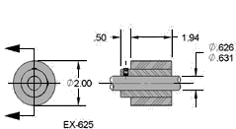

Neoprene roller

3.2 Toroid Drive Design
Specifications and Constraints
Although no specifications and constraints were required by our sponsor for this sub-assembly of the system, our design group came up with a few important constraints. We felt that in order to successfully solve the problem, the toroid would need to be driven at a constant/synchronous speed to insure a continuous wrap of the composite material. We also wanted to design this system to be as manufacturable, durable, and cost effective as possible.

Conceptuals
The initial design ideas proposed by the two teams were a 3 Point Drive system and a Conveyer Belt Drive system.
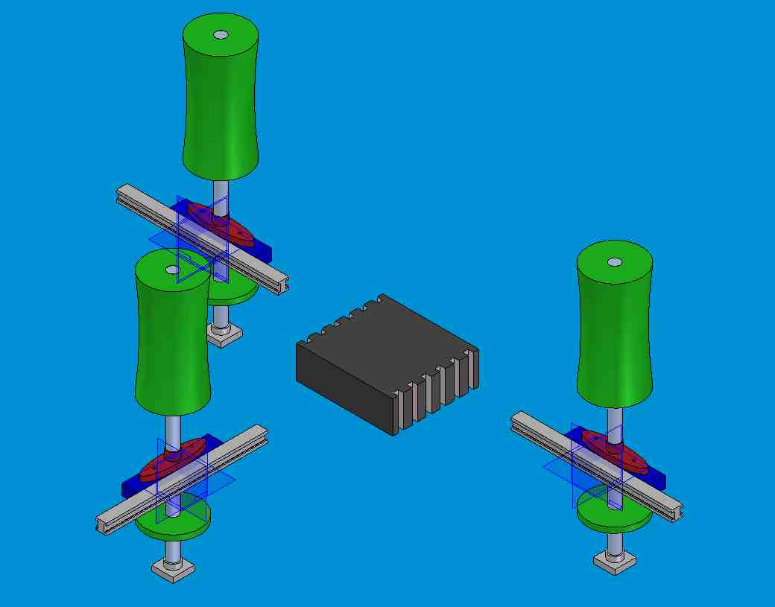
The 3 Point Drive system was designed to increase the amount of contact area between the drive and the actual toroid. It was also decided that the 3 Point drive system would decrease the amount of potential of slippage between the drive system and the toroid. An advantage to the 3 Point Drive system is that it allows one of the drive roller mounts to be spring loaded, which eases in the installation of the toroid, and allows for inconsistencies in the shape of the toroid.

The second drive system design concept was the Conveyer Belt Drive system. This system utilized a conveyer belt in contact on the bottom of a vertically oriented toroid. This design used the weight of the toroid to keep the surface of the toroid and the drive system in constant contact. An advantage of the conveyer belt drive system is its simplicity of design and the fact that the entire system was pre-existing. A disadvantage of this particular system is that it was very prone to slippage creating a non-continuous wrapping of the composite material. Also, because of the orientation of the toroid, this drive system was going to require an extensive and elaborate support system to secure the toroid, but still allow for the insertion of the toroid into the system.
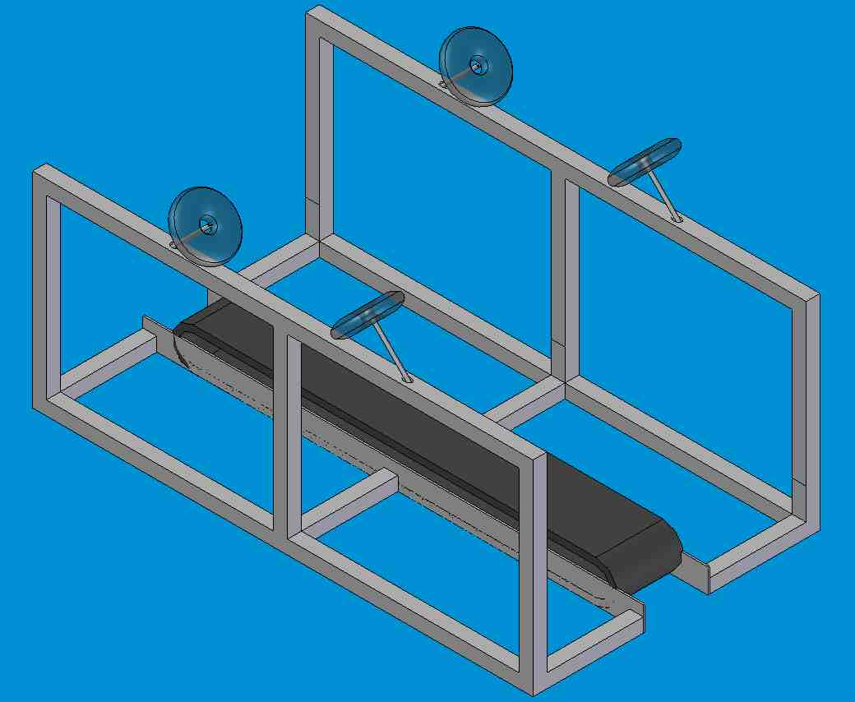

Summary of Selected Drive System:
The goal of this drive system is to effectively drive the toroid without slipping or excessive vibration. It has been determined that a 3 point drive system will not only adequately drive the toroid, but will provide efficient support for the driving of the toroid. Enabling the toroid to be driven at 3 points will increase the reliability of the drive system, as well as decrease the potential for causing disruptions to the layers of composite material being laid.
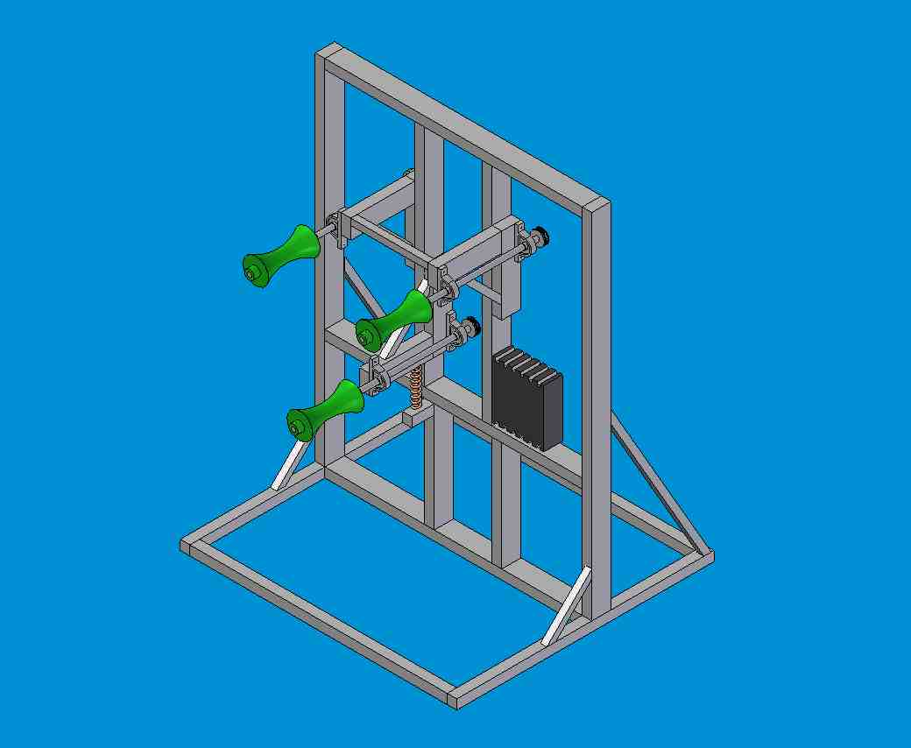
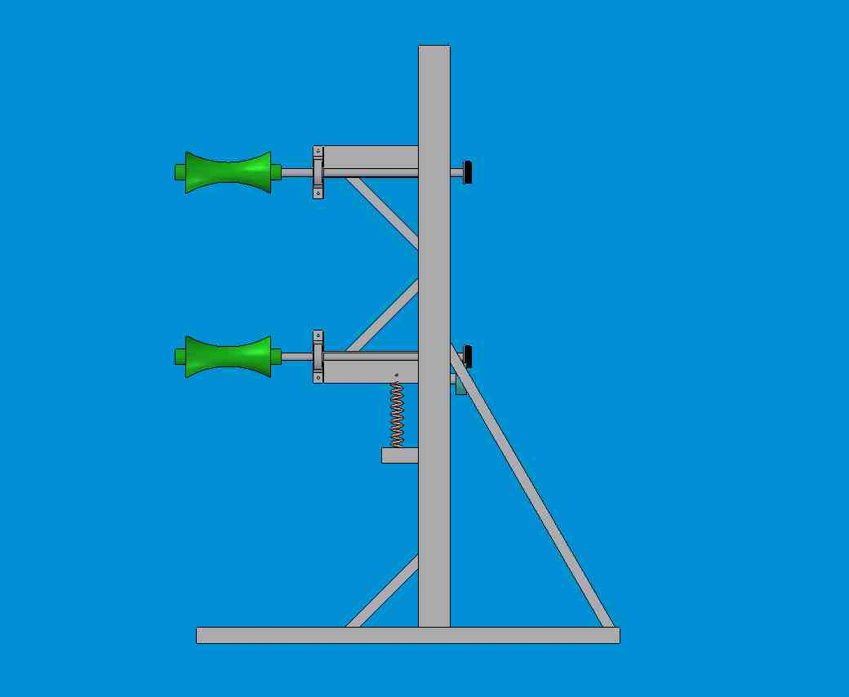
The Toroid Drive system will consist of 3 rollers mounted on 3/4 inch shafts. These shafts will be driven by a belt that is connected to an AC motor. An AC motor with a control adapter was chosen so that variable speed can be attained, thus allowing the toroid to be driven at incremental speeds. The roller assemblies as shown below, as well as the motor, will be mounted on a 80-20 support system. The 80-20 will allow for stable mounting of the roller drives, but will also allow for free translation of the spring loaded roller along the vertical plane. This capability will allow for the toroid to be mounted on the system in an easier fashion, and allow for a snug fit of the drive system on the interior wall of the toroid.
The Toroid Drive system will have the capability of wrapping at variable speed to allow for multiple wrapping patterns of the toroid. The object is to be able to wrap the toroid radial, counter-clockwise angular, and clockwise angular. By manipulating the speed at which the toroid is driven, these wrapping patterns can be achieved.

Toroid Drive Motor Selection Analysis:
Due to the nature of our design, the toroid will only have to spin at a very small rate (see calculation below).
d_{o} = 60 in.
Circum = 60pi in.
If we want to wrap the toroid once every second and the width of the composite material is 1/8 inch, then we will be wrapping at 7.5 inch per second. (60 rev/min *.125 in/rev = 7.5 in/min).
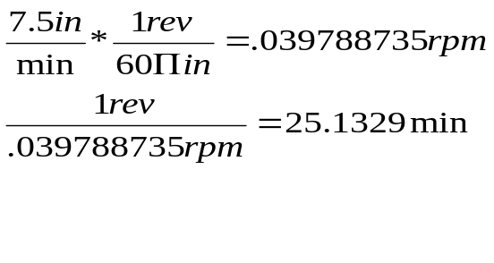

This means that the toroid will make 1 full revolution in about 25 minutes. As previously stated, an AC motor with a control adapter has been decided upon due to the fact that it allows for variable speed. For all three wrapping patterns (radial, CW angular, and CCW angular), the ring apparatus will be driven at a constant rpm while the toroid will be set according to the appropriate wrapping phase.
To begin the analysis needed to select the toroid drive motor, it is first necessary to assume reasonable values of opposing forces of the toroid due to tension in the composite material and frictional losses due to the toroid rollers. Once selected, these values may be used to properly select the correct size motor needed to drive the toroid.
- Motor Horse-Power Calculation
We must first assume values for resistive forces that oppose the motion of the toroid. The majority of the opposition will come from the wrapping of the composite material. The composite material will be wrapped around the toroid at a constant tension of approximately 10lbs. Assuming that we will be wrapping at the sharpest angle possible (45 degrees), this lends the maximum circumferential component of the resistive force to be 7.07 lbs.

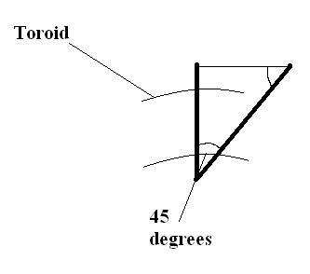

10 lbs
F

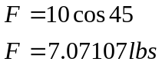

Now taking the value of 7.07 lbs, we will double it to account for frictional losses in the roller bearings and drive bearings, as well as the various gears. So our final assumption for our resistive force is approximately 15 lbf.
We will now calculate the necessary HP of the toroid driver motor. Assuming that Power into a system equals the Power out of a system, we will set the required horsepower of the AC motor equal to the power that will be lost by the system.
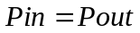
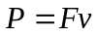
The resistive force (F) being used for the calculation is 15lbf. So the only unknown is the velocity (v) that the toroid will be moving at.
The toroid’s outer diameter is 60 inches so each revolution equates to 60*Π inches traveled. The width of the composite wrap is .125 inch and will be wrapped once per second. This means that the toroid will be covered at 1/8 inch/sec. Calculating the conversion gives the following:
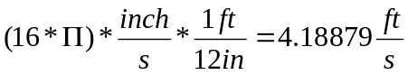
This shows that the composite material will be placed on the toroid at approximately 4.18879 ft/sec. This value is our velocity (v).

Plugging in to the P=Fv equation:

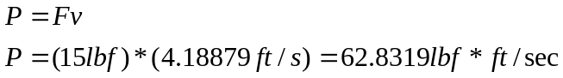

converting to HP

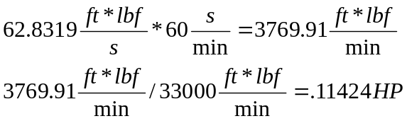

This means that we need a .11424 HP motor to drive the toroid. Taking into account error due to assumptions and the fact that this only accounts for steady state start up horsepower, we will select a larger motor. This is not going to pose any trouble at all due to the small size of our motor. Most AC motor applications are offered starting at .5 HP. This allows us to have a large variety of motors to choose from! Because of the slow rotation of the toroid, it is necessary for us to purchase and include a gear reducer in the drive system. The gear reducer will allow us to convert the speed of the AC motor into a useable speed according to the extremely slow rpm of the toroid. This gear reducer will be purchased from Bison Gear & Engineering Corp. (Part# 030-255-0133).

Bearing Selection:
To select the bearings we will be using to support the roller shafts, the only constraint that needed to be considered was size. A bearing that would fit on the 80-20 slider mechanism and that had a 3/4 inch bore was the only criteria we considered. After searching on the internet, a pillow block bearing from McMaster Carr was chosen (part# 6244K53). These bearings have a rigid one piece housing to allow for solid mounting on the 80-20 support system. They also come with a locking collar to lock down the shaft. These bearings were selected for their reliability and durability! Six total bearings will be used to insure stability in the shaft as the shafting will be used mainly as a source of motive power and as a source of support.

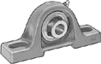 McMaster Carr Part# 6244K53

Shafting:
The shafting will simply be purchased from McMaster Carr in a pre-machined diameter of ¾ inch. In order to insure that the shafts will be able to withstand the weight given by the toroid, we decided upon a 1018 carbon steel rod. This shaft will not only fit precisely with our selected bearings, but will be more than adequate to support the weight of our toroid.

Drive Rollers:
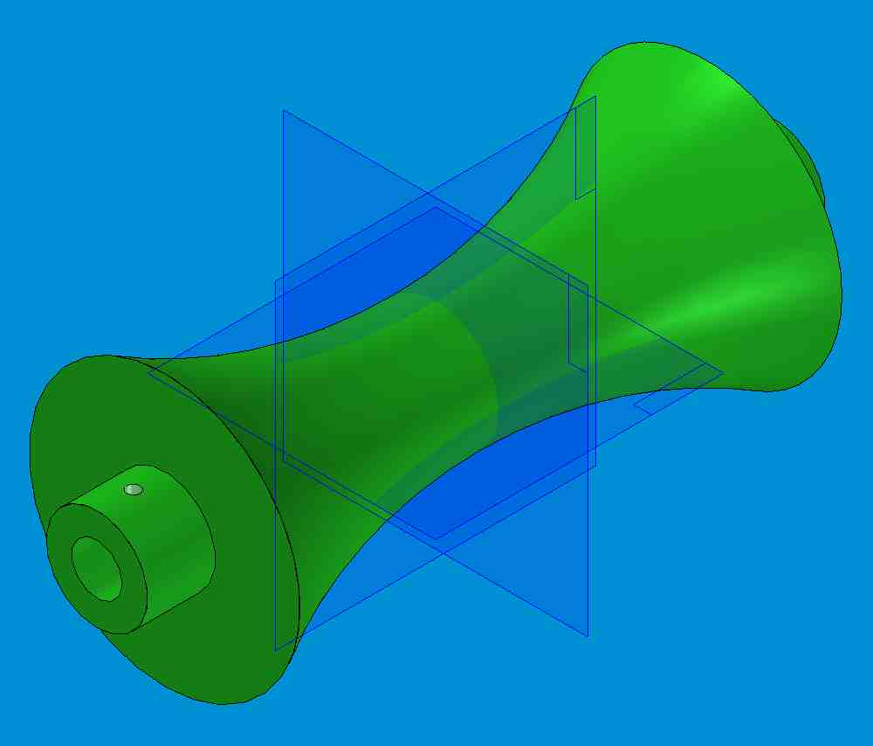
The drive rollers used in our system are the only components of this system that will have to be manufactured. We concluded that the most accurate and efficient way to drive the toroid would be to use some sort of a cylindrical roller with a radius of curvature along its face. We also felt that we needed to select a material that would not only be strong and not deform under the weight of the toroid, but that would be durable under many hours of repetitive use. Polyurethanes and other hard rubber rollers were going to be extremely expensive to make and were considered very incompatible with our project budget. Our final selection of material was a tough machine-able plastic know as High Density Polyethylene. This material is not only extremely strong and durable, but it is very machine-able as well. This allows us to cheaply purchase the round stock of the plastic and cost-effectively machine the correct radius into the face of the stock. This solution not only exceeds our constraints for the project, but solves the drive roller problem way under the expected budget allowance!
3.3 Wrapping System Design

3.3.1 Tensioner Design
A critical element in our wrapping process is keeping a constant tension on the carbon fiber tow as it is laid around the toroid. The difficulty with fulfilling this need is that we are not able to use anything that requires an electric source due to the fact that any wiring that is linked to the gear would also be wound around the toroid. Because of this, most commonly used solutions, such as powder brakes, had to be thrown out. We chose a system that uses a device called a permanent magnet brake to apply the required tension to the spool.
Permanent magnet brakes are ideally suited for tension control. The torque is generated magnetically as a function of the unit’s mechanical setting, which is controlled by a knob on the unit. The larger the unit, the larger the torque the can be applied. The company that manufactures the unit we have chosen, Warner Electric, supplied us with the following calculations to help us decide upon the right size unit.

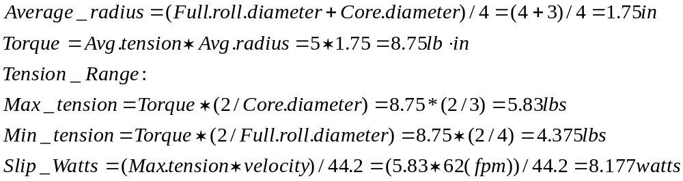

Once that torque is set, it is generally stable, regardless of speed. The units require no electrical power source, which means no wiring and no malfunctions due to power fluctuations. Since the units are sealed, and there are no rubbing parts, there is no chance of contaminates causing wear in the unit. Figure 1, below, shows a typical configuration of the units. Also, since the torque is created magnetically, there is no static friction induced for the roller to break away from, giving us a soft start.

Most units contain a hysteresis disk, which is directly attached to the hub that passes through the brake. Two circular multiple pole magnets are solidly attached internally within the unit. The magnets face each other with the hysteresis disk between them. There is an air gap between the magnets and the hysteresis disk, so the hysteresis disk can turn without any frictional contact. The opposing circular magnets set up magnetic flux, which causes drag on the hysteresis disk, which in turn, causes drag to the hollow hub in the unit. (10)
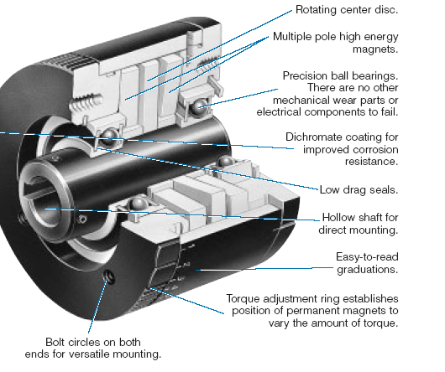
Fig 1
The maximum tension is achieved when the magnetic poles are aligned directly opposite at the north and south poles. When the alignments of the poles are changed, a magnetic flux is created through the hysteresis material that causes a higher drag, thus creating a higher tension.
These units can be attached many different ways, but for our application, the unit will be secured onto a plate that will sit on the large ring gear of the wrapping drive. A shaft will be attached to the unit and the spool will be locked into this shaft. This design is illustrated in the pictures below. The actual unit we have chosen to use is manufactured by Warner Electric and is part # MB4. It has a variable applied torque dial from .5-11 lb.in. and can handle a maximum heat dissipation of 22 watts. Both of which fall within our criteria.

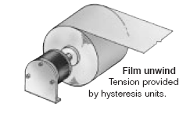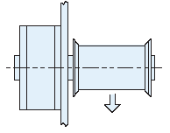

3.3.2 Ring Gear Design
The gear system is the component of the design which moves the spool package around the toroid. The system must allow for several specifications:
- Move the spool continually around the tank
- Allow for movement in horizontal plane and in planes plus and minus thirty degrees from the horizontal.
- Keep the spool moving at a constant speed regardless of the plane in which it is traveling.
In addition to these constraints, some additional aspects were considered to enhance the system. For the operator, it is important that the structure be easy to disassemble to insert the tank. In addition, because many spools will be required, the spool should be easily changed. As the gear needed is large and potentially costly, it should be a piece that will sustain many full wrappings. Several ideas for this system were considered.
Corporation one’s original idea was to have two parallel ring gears which guided the spool around the toroid. Speed adjustment (speeding up the movement of the toroid) created the helical wraps. However, in the angled planes, this method did not provide a uniform overlap of the tow. Instead, it relied on many wraps to approximate a continual lay up. Because continuous helical wraps are integral to the ability of the toroid to the withstand stress along the outer diameter, this idea was discarded.
Corporation two’s idea utilized a large ring gear driven by a small pinion turned by a motor. The spool package was mounted on the large gear which traveled around the tank. The entire system was fixed to a plate which could be positioned at horizontal and thirty degrees above and below horizontal. The gear was supported on casters which also provided friction reduction and was constrained by a lip on the inner diameter of the plate. This support and constrain of the gear provide to be the most troublesome parts of this concept. There was concern over whether the casters could provide adequate support and over how the constraining lip could be manufactured.
With the merging of the two corporations, two main ideas were considered 1) a variation on the gear-pinion system of corporation two 2) a similar system which used a master link chain for power transfer. Within the gear driven concept, the decision still had to be made about where to attach the spool – to the ring gear or to the chain.
With a small gear turning a chain, the chain could be guided around the tank with the spool attached to a link. This idea is similar to the mechanism on a bicycle. The small driven gear must be on the interior of the path of the chain. The chain is guided around the tank by a shouldered split ring. The huge advantage to this is it eliminates the need to purchase a large ring gear. A large ring with a track along the outer diameter could be manufactured by the team. Other advantages include: the ease of opening a link in the chain to insert the tank; the imprecise meshing requirements between the driving gear and the chain; the minimal required starting torque; the rolling elements that are already integrated into a chain. However, the chain simply moves around the large ring – the ring itself does not turn. Therefore, the spool package must be attached to the chain itself. With the spool package weighing approximately six pounds, the chain alone would not be able to support it. An answer to this would be to create a track in the supporting plate in which the spool could run, but then bearings or some other friction reducing technique would be required. Investigation into such a technique revealed that it would be extremely difficult. In addition, having a spool attached to the chain in that way would create a moment that would distort the path of the chain. This moment would be complicated to counteract as it would change as the spool empties of the tow.
A solution to the problems that come from attaching the spool to the chain is to bolt the spool package to the large ring that circles the tank. In order for the spool to travel around the tank, the large ring must also be moving around it. This can be done with the chain drive system, but it requires the addition of teeth to the shouldered ring. This system retains the advantage of the imprecise meshing requirements between the driving gear and the chain. However, it loses the main argument for the chain driven system – the elimination of the need for a large ring gear. The same result accomplished by this system can be accomplished with a meshing ring gear and pinion system that does not require a chain.
To make the decision between the gear-pinion systems and the two chain driven systems, the group performed a grid analysis between the three. The factors considered were, in order of importance:
- availability of parts
- reliability
- cost
- changes required to other components
- precision required in setup
- complexity of support needed
- ease of reattachment of halves
- speed precision
- ease of splitting in to halves
- lubrication requirements

Factor | A | B | C | D | E | F | G | H | I | J | Total
Importance | 5 | 5 | 4 | 4 | 3 | 3 | 2 | 2 | 1 | 1
Gear-Pinion | 2 | 3 | 2 | 3 | 2 | 2 | 3 | 3 | 1 | 2 | 72
Chain Driven - Spool attached to chain | 3 | 1 | 2 | 1 | 1 | 1 | 1 | 1 | 3 | 1 | 46
Chain Driven - Spool attached to gear | 1 | 2 | 3 | 2 | 3 | 1 | 2 | 2 | 2 | 2 | 59

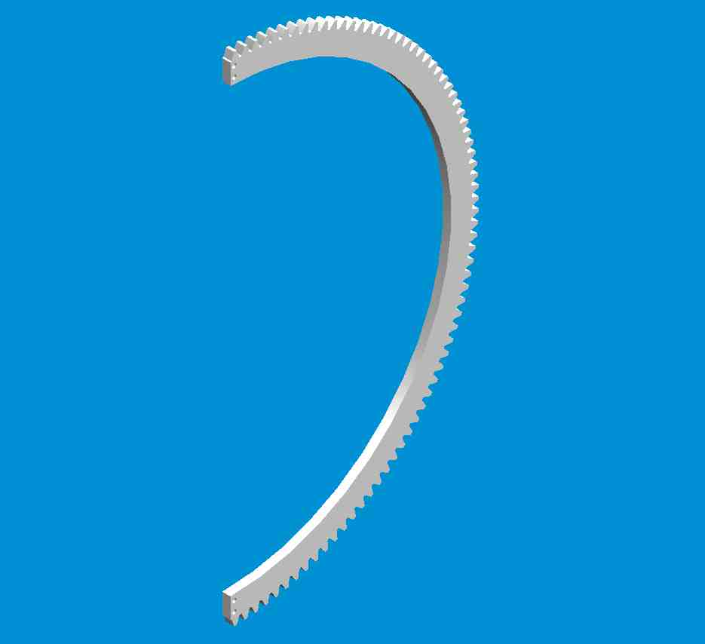

Thus, the decision was made to run the spool with a gear-pinion system. The pinion is made of steel with a diameter (d_{p}) of three inches. The rotational speed of the pinion (w_{p}) is 600 rpm, which is produced by a 1 horsepower motor (see page 35 for motor specifications). The pinion drives a gear made of aluminum with diameter (d_{g}) of thirty inches. The rotational speed (w_{g}) of the gear is 60 rpm. The gear teeth have 20º stub involute profile. The face width of both is 0.5 inches, and the diametral pitch is 5 teeth per inch. See page 48 for the gear and pinion system calculation and analytical stress analysis.

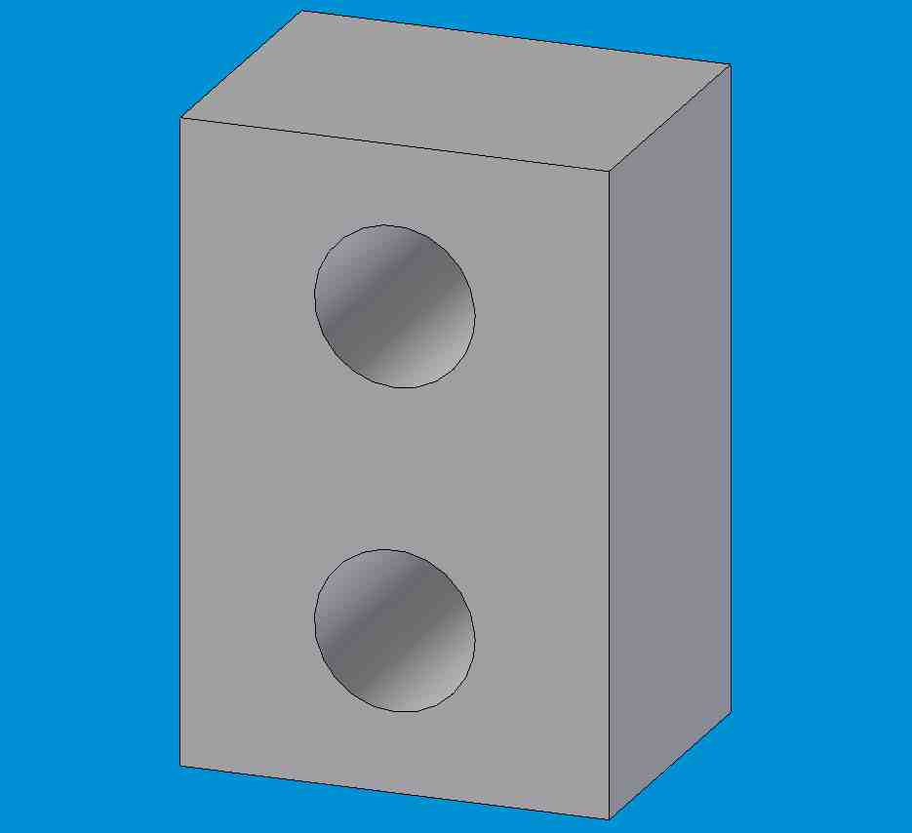
As shown in the picture to the right, the gear is split in half and reattached to enable insertion of the tank. An attachment part, shown below, is used to bolt the two halves together. The part is bolted onto each half of the gear from the bottom. Two bolts are used to secure the parts together. This part will be manufactured out of aluminum.

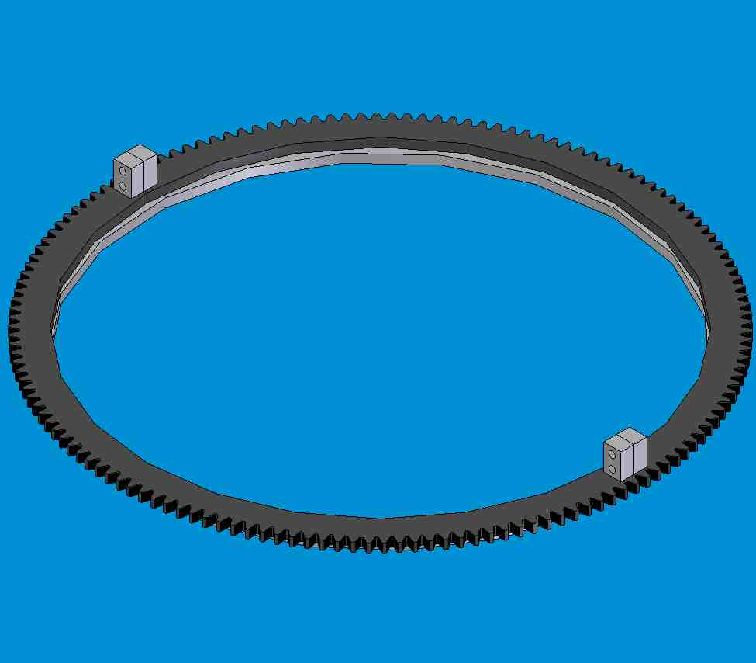

The gear will be custom laser fabricated by Gear Pro Machine Shop. The pinion is from Martin Gear and Sprocket and will be purchased through the distributor, Motion Industries.

REFER TO SECTION 4.2 ON PAGE 48 FOR CALCULATIONS

Final Gear Specifications:
pinion made of steel, diameter d_{p}= 3”, rotational speed w_{p}= 600 rpm, endurance strength σ_{o}= 15,000 psi
gear made of aluminum, d_{g} = 30”, w_{g} = 60 rpm, σ_{o} = 14,000 psi
20º stub involute profiles
i (gear ratio) = d_{g}/d_{p} = w_{p}/w_{g} = 10
maximum power transmitted by the motor = 2 hp
Circular pitch, P_{d} = 5 teeth/in
Face width, B = .5 in
Contact Ratio, CR = 1.46
Addendum, a = 0.16 in.
Minimum dedendum d_{min} = 0.20 in.
Addendum radius of the pinion, r_{a p} = 3.16 in.
Addendum radius of the gear, r_{a g} = 30.16 in

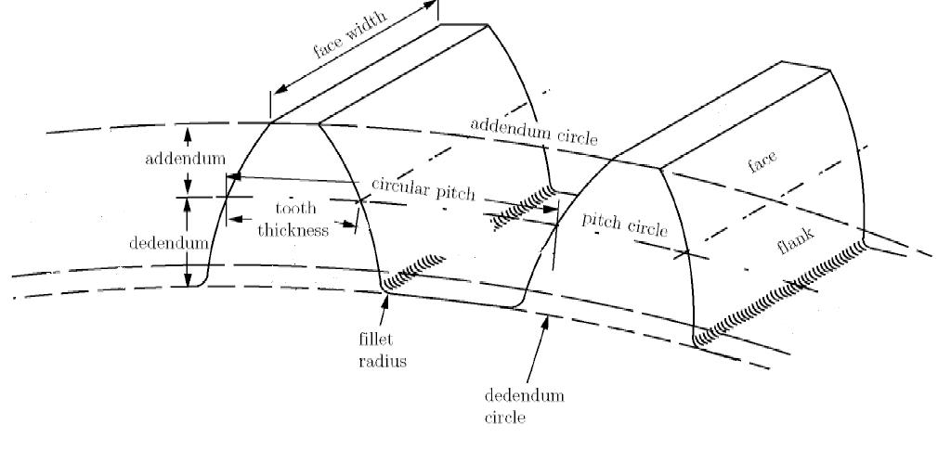

    - Ring Gear Support Design
Original Designs
Two designs originally proposed both utilized ring gears to control the rotation of the spool. However, the idea supporting table was not limited to but favored over the parallel ring.
Group 1 Group 2
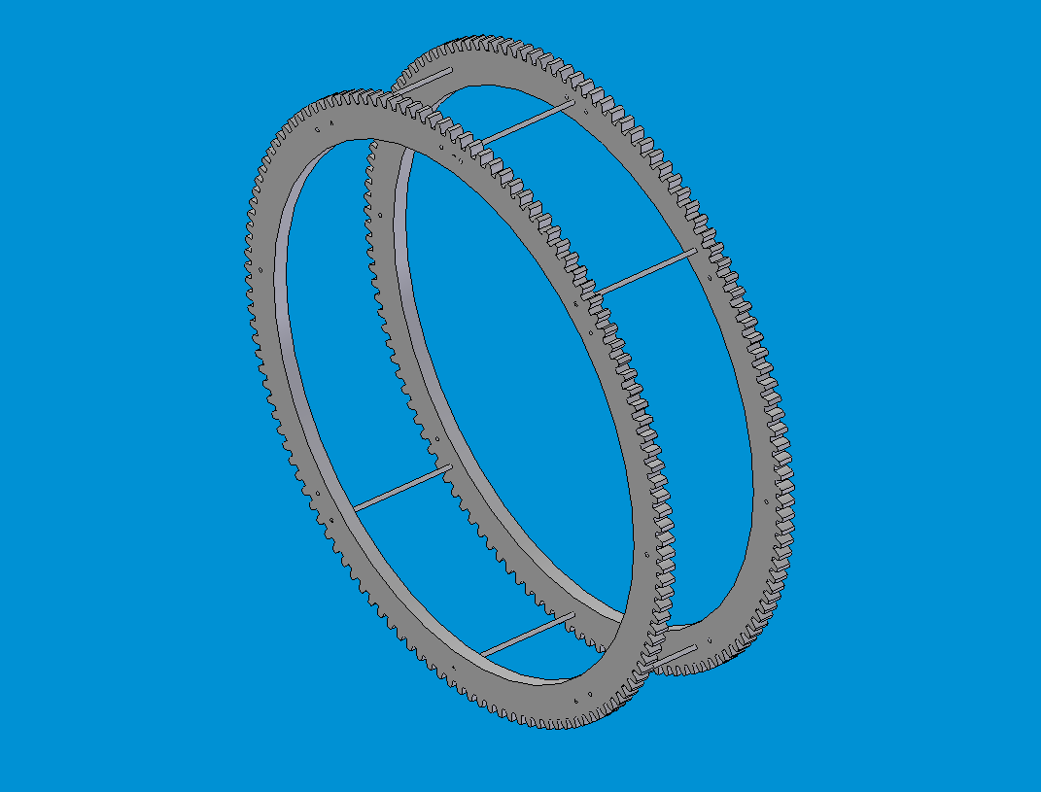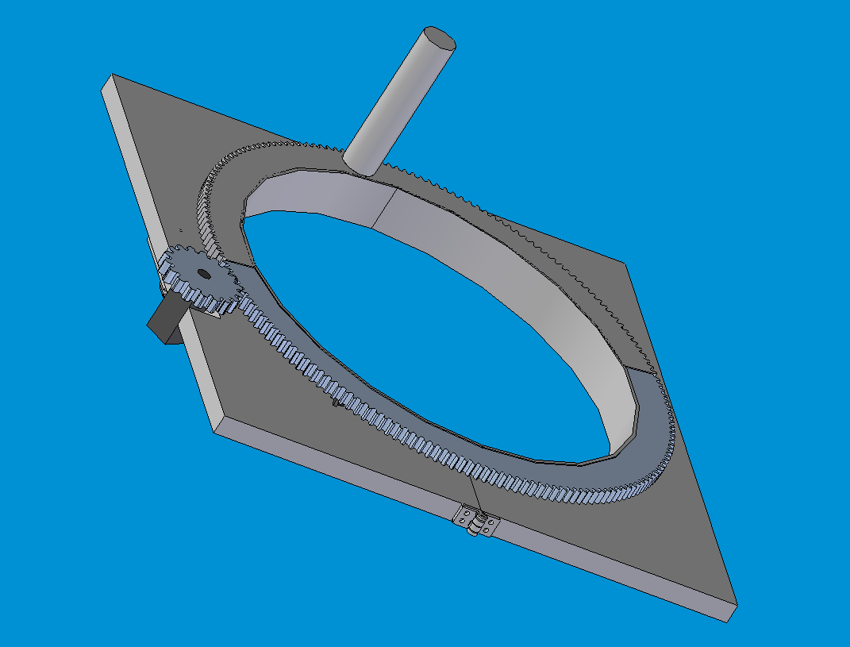
Evaluation of Ring Gear Support and Rotation Options

Rotation of the ring gear requires a design that will fix the axis of rotation. A number of designs were investigated including rubber idlers that contact the gear teeth, positioning flanges located on ring gear, and replacement of the ring gear with a friction ring drive. Other designs that were found in industry primarily used a friction-based design to accomplish rapping however applications varied and were designed to meet alternative specifications.
The nature of this problem calls for a uniform carbon fiber wrap first and foremost. However, the different designs considered brought up other concerns as well. The concept of rubber idlers presented a concern because contact with aluminum gear teeth may cause excess wear on the teeth. Another potential downfall to this design is that the rubber caster wheels intended for this application would require machining. The accuracy this machining would impart to the rubber casters would be considerably less than traditional machining materials.
The idea of positioning flanges intends to support the ring gear without making unnecessary contact with the teeth. In this design, a circular lip is mounted to the bottom of the ring gear and would make contact with flanges that support the weight of the ring gear and rotate about a fixed axis. The flanges will not only support the weight of the ring gear but they will also constrain the ring gear so that it rotates about a fixed axis. Figure 1 illustrates the basic concept of this design (see also Drw # 3.0.B).
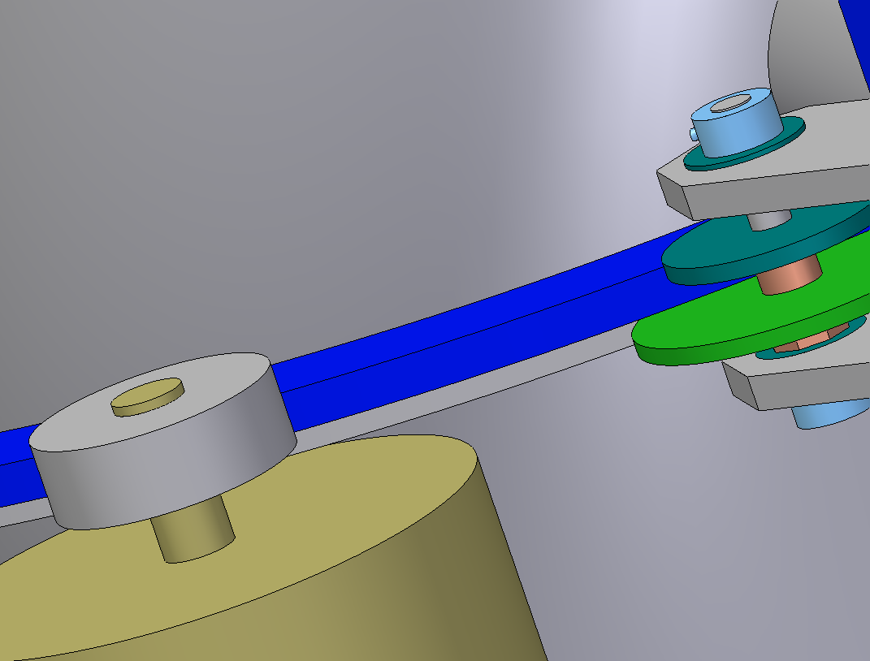
Pinion
Flanges
Lip
Ring Gear
Figure 3.1.2-1
Another option that would keep the ring gear spinning about a fixed axis would be to replace the ring gear with a toothless ring that would be driven by a belt or some other type of friction device. This design however has a downside that allows the potential for slippage between the driver, which determines the speed and therefore dictates the wrapping homogeneity and the friction ring. If slippage did occur, the inconsistent wrapping pitch would cause patches of weakness on the toroid.
In order to test these ideas, a prototype was built and tested that incorporated the rough arrangement of some of these concepts. The second design that incorporates the top and bottom flanges to fix the ring rotation was thought to be most feasible and a smaller scale model was constructed based primarily on its parameters. The results of this experiment showed that this design did in fact fix the inner gear axis of rotation without attaching the gear about an axial shaft. However, it also brought up certain concerns that needed to be addressed in the design of an idling system. During observation of the prototype, the main problem that occurred was undesirable noise and friction between the positioning flanges and the ring gear lip. The design for the ring gear idling portion of the actual machine should significantly reduce these quandaries.

Ring Drive Motor Selection:

Primary selection criteria:
- 3-phase 230 V power supply
- Motion control to adjust and maintain wrapping pitch.
- Ability to mount onto gear table

To begin the analysis needed to select the ring gear drive motor, it is first necessary to assume reasonable values for the carbon fiber line tension, the angular velocity of ring gear, and the friction loss in the system. Once selected, these values will be used to calculate the motor specifications.

1) Angular Velocity of Ring Gear.

A maximum value of 60 rpm was assigned to the rotation of the ring gear as the criteria for design. This value is intended to wrap the toroid at a reasonable pace without generating excessive centripetal force.

2) Carbon Fiber Line Tension (T).

Based on experimental evaluation of the carbon fiber as it is wound axially around the torroid element, a value of T=20 lbs was assigned. This maximum value of T is expected to reduce the amount of slip that will occur due to the toroid drive system. This value of T is then used to calculate a minimum steady state torque as well as a starting torque for the motor.

Ring Gear Top View FBD
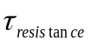

Idlers
Ring Gear

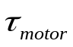

Pinion Gear
Figure 3.1.2-2

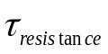=Line tension * radius = 20lb * 15in/12 = 25 ft-lb
Steady state torque provided by the motor is therefore 2.5 due to the 10:1 gear/pinion ratio.

The power (P) required spinning this ring gear is subsequently:

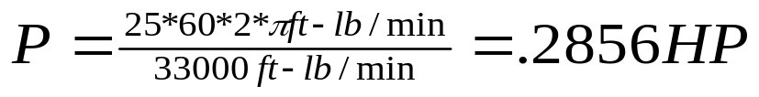
This is the power, assuming no losses to friction, to power the ring gear system once it reaches steady state, however, the starting torque should also be calculated.

To accelerate from 0 to 2π rad/s in 5 seconds, α=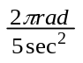=1.25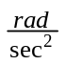.
Rotational inertia of the ring gear was calculated to be I=1.4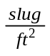 using Solid Edge physical properties abilities.

From a torque analysis:
I α=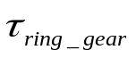-
1.4*=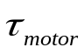-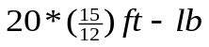
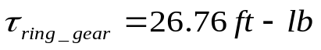 & 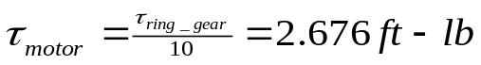
The starting torque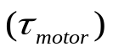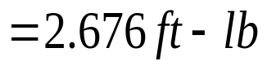

3) Friction

To account for frictional losses in the system, the calculated values for steady state and starting torque will be doubled. This gives the following as the final criterion for motor selection:

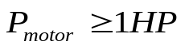

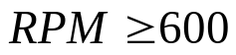

Motor Options

Initially stepper motors were considered because of their resistance to external torque, which could potentially affect wrapping pitch. Furthermore, stepper motors while compensating for variable torque are capable of maintaining precise position control in an open loop system [8]. After investigating them further and discovering the limited power capabilities of stepper motors as well as their high price ranges, an alternative of AC motor control was considered. According to a number of manufacturers the desired control of motor speed can be achieved in a more cost affective manner through inverter drives that would also resist external torque once steady state shaft speed was reached.
Due to the drastic advances in AC motors over the past few years, variable speed control is now a plausible solution to the precise control of wrapping required. With the capability to control motors down to 1Hz at full output torque a standard sensorless vector AC drives, will provide plenty of speed options in the form of adjustable digital frequency readout and will offer exceptional speed precision. AC motor controllers such as those manufactured by AC Tech [Fig 3.1.2-3] do so even with resistance torque peaks that are likely to occur [6, 7].

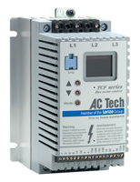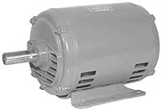
Figure 3.1.2-3

Bearing Selection and Design

Allowing the idling support system to rotate freely with minimal friction is essential because this system should not produce irregular resistance to wrapping speed and the ring gear’s rpm. A total of eight bearings will be needed to accomplish the task of smooth ring gear rotation and will be mounted in four locations around the ring gear. Drawing number 3.0.B shows and assembly view of the proposed design used to rotate and support the ring gear.

- Static and Dynamic Loads: What is the maximum load that the bearings will
experience?
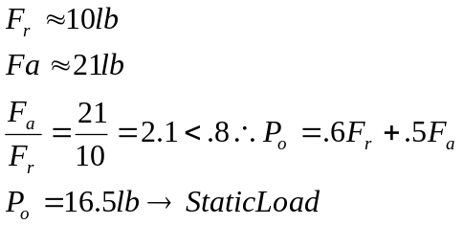

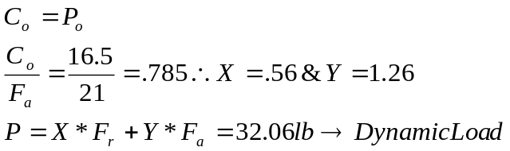
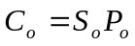 Where 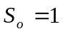

- Life of bearings: How many revolutions will bearing make during total wrapping
process?

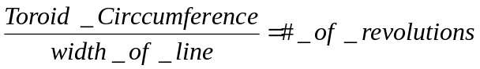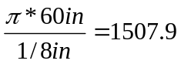

Therefore the ring gear must rotate 1508 times to complete one layer of wrapping

To cover 6 layers the ring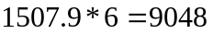 revolutions

With ring gear rotation @ 60rpm, time=150.79min =2 ½ hours to complete wrapping

Because the ratio between the ring gear and the idlers is 10:1, the bearings will rotation 10 times the amount of the ring gear.

Total wrapping will require 90,481 bearing revolutions

Double sealed flanged bearings (catalogue number 6384K363) from McMaster-Car easily meet the design requirements and are ideal for this application.

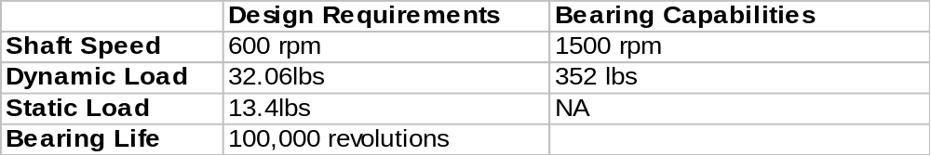

3.3.4 Ring Gear Tilting Table
The Table support should be a support system that will not only hold firm when the toroid is being wrapped in a radial direction, but also one that will hold under the 30° angular wraps. The system needs to be able to support the wrapping table, gear, and motor, which combined will be no more than several hundred pounds; easily less than half a ton. To that end, several different ideas were taken into account when choosing the support.
Our original idea was to make four supporting legs out of square steel tubing. Each leg would be made of two separate pieces of tubing, one having a slightly larger cross-section than the other, so that they could slide within one another, and allow for a lengthening or shortening of the leg. There would be pin holes at 3 separate places on both tubes, corresponding to the 3 different lengths needed to create the 0 degree, 30 degree, and -30 degree angles of wrap. We would have simply lengthened two of the legs and shortened the other two, thus creating an angled table. There would be hinges attached to the top portions of the legs, which would allow the table to remain fixed to the legs while still being able to rotate. The figure on the following page shows one of the four legs of this support system.

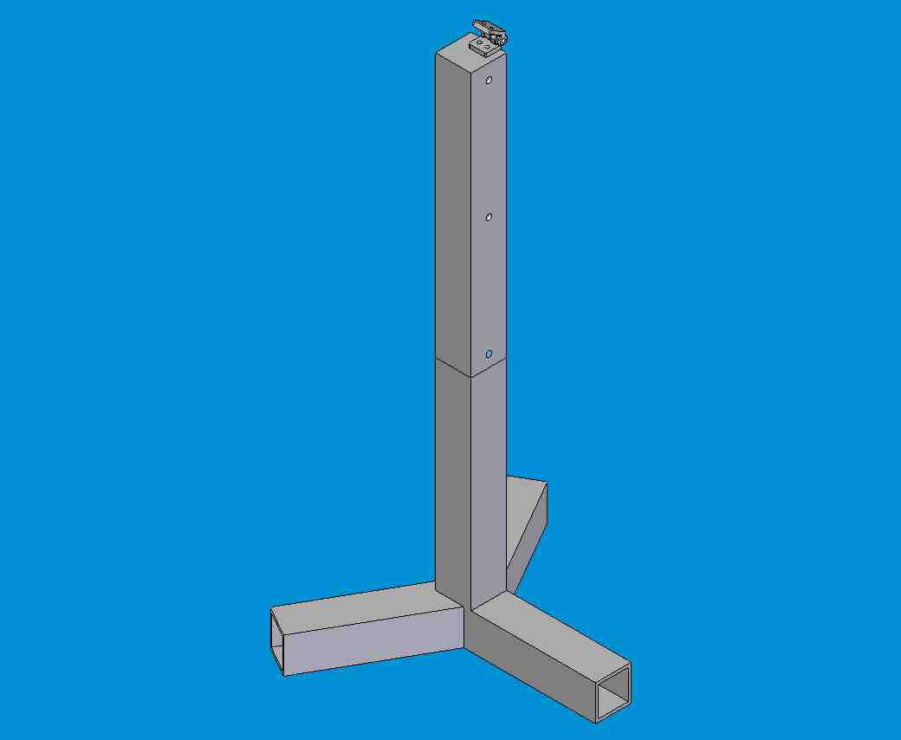

This idea seemed favorable to begin with, but upon further inspection, we found three major problems with the system. First, we did not feel that the pin-lock system was sturdy enough. With just one pin, in double-shear, supporting all the weight for that leg, we thought the load would be too much for the pin to withstand. Secondly, with the hinge system fixing the table to the legs, we felt that might cause some chatter, or make the system less stable. Plus, we were concerned that the hinges might not be able to hold the required loads. And finally, our original system had stationary legs, which did not account for the fact that when the table is angled, the legs need to be able to move inward slightly, due to the fact that rotating a table with a constant length sweeps an arc. The only alternative, which was to make the table so that its length could be changed, was deemed not to be a viable option. This, of course, was a major oversight, since it completely took away the rotational degree of freedom needed to create the angular wrap. Therefore, for overall ease of use, sturdiness, and space-saving considerations, we felt this setup was not a feasible solution.
The second idea that was considered was to make a support out of 80-20®. This would have been more cost effective, and would have provided a sturdier base than our previous solution. To help simplify the angular wrapping, we came up with the idea of having one side act as a rotating joint. The other side would have the ability to raise and lower its legs by having 2 pieces of 80-20® attached side by side with a locking plate. One side of the plate would be able to stay locked to one side, holding it firm on the upper leg, while the lower leg would be locked down with a T-handle knob. At the same time the leg could be raised or lowered, it would be connected to the table be by a sliding track. The idea of the sliding track would be able to keep the leg planted firmly in one position to the ground. This idea seemed the best way to solve the problem until we tested the idea and found that, for the purposes of reducing the likelihood of interference with the toroid, having the table rotate around one side was not as effective as having it rotate about a center axis.
Our final design is to modify the second idea by adding a fifth leg on its central pivoting axis. This leg will also be made of 80-20, and would attach to the table by a pivoting nub, and a 180 degree rotational plate assembly. The original four legs will now lengthen and shorten just as before. Shown on the following pages are close-up views of (a) One of the 4 dynamic legs of the assembly, (b) The 180-degree pivot leg, and (c) The full assembly.

(a) 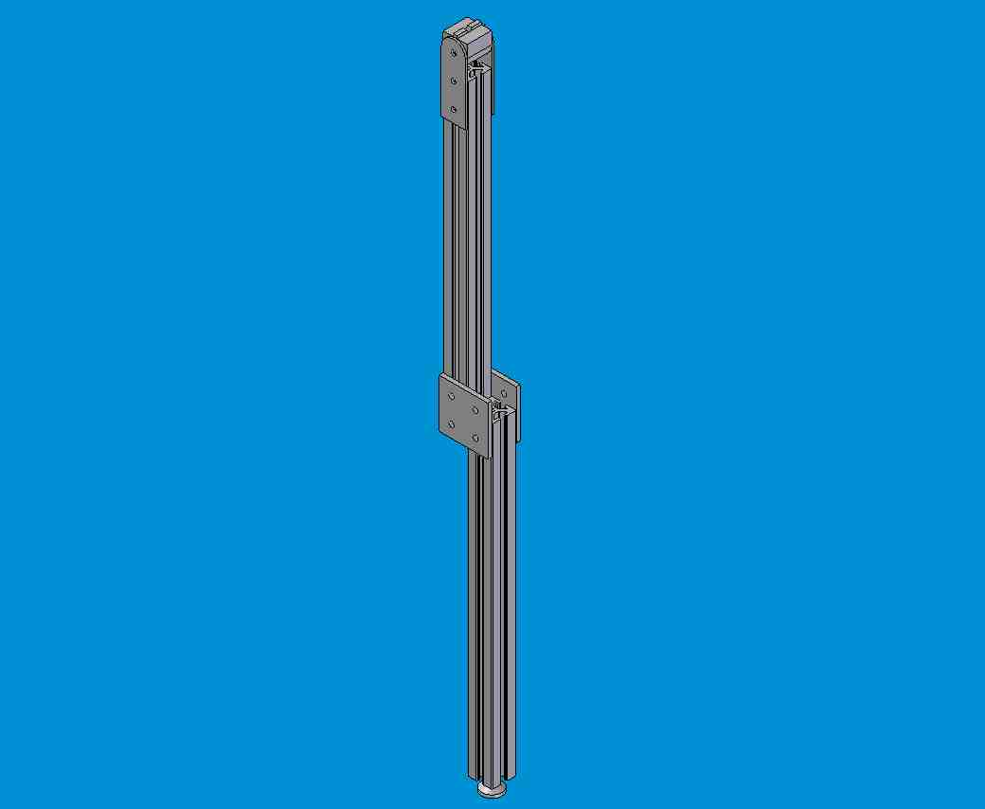

- 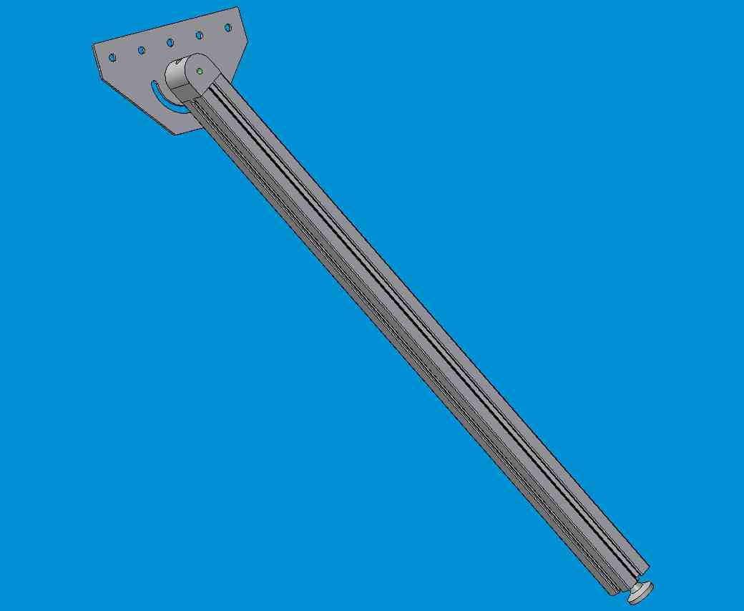

(c) 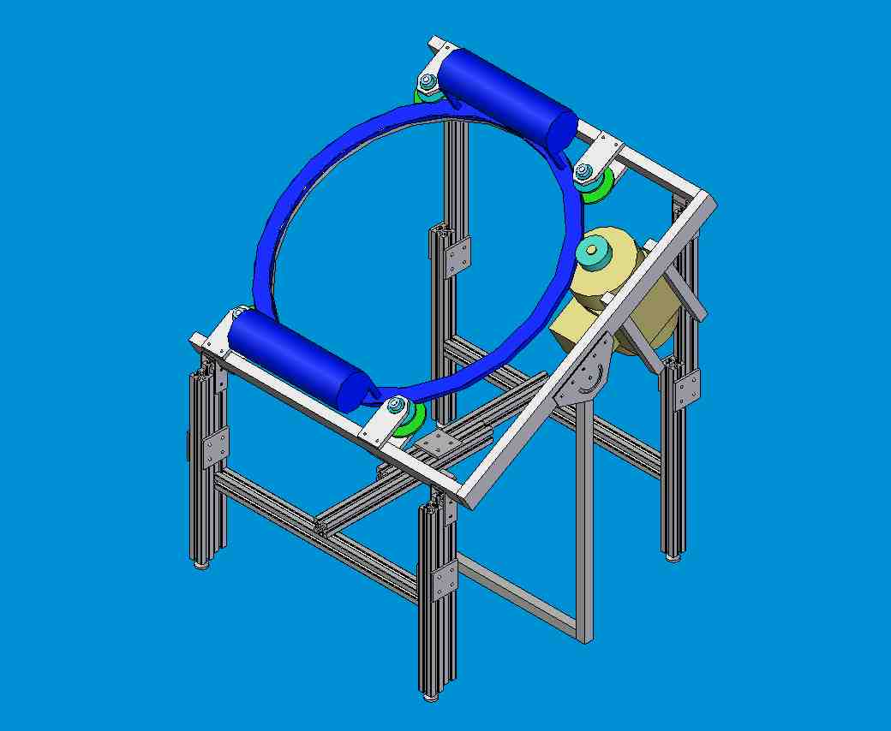

This system eliminates the need of a sliding track on the table base. The user will accurately be able to stop the legs at the positive and negative 30° mark by stoppers added to the lower part of the front 80-20 legs. This solution proved to be the best in terms of accuracy, space saving, and overall feasibility, while still providing the needed amount of support.

4.0 Engineering Analysis
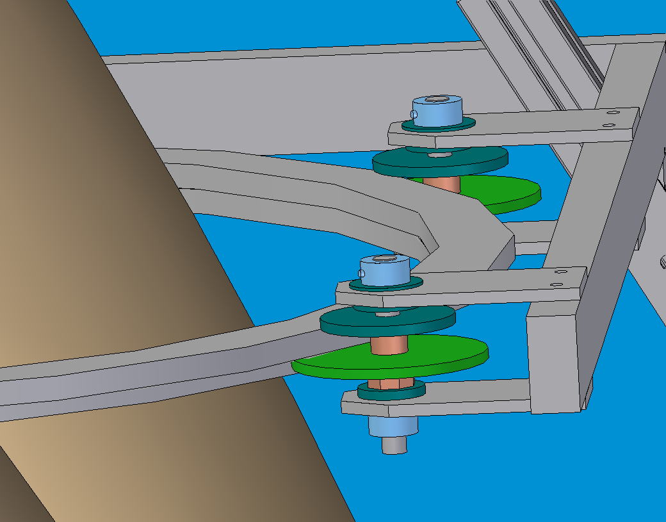
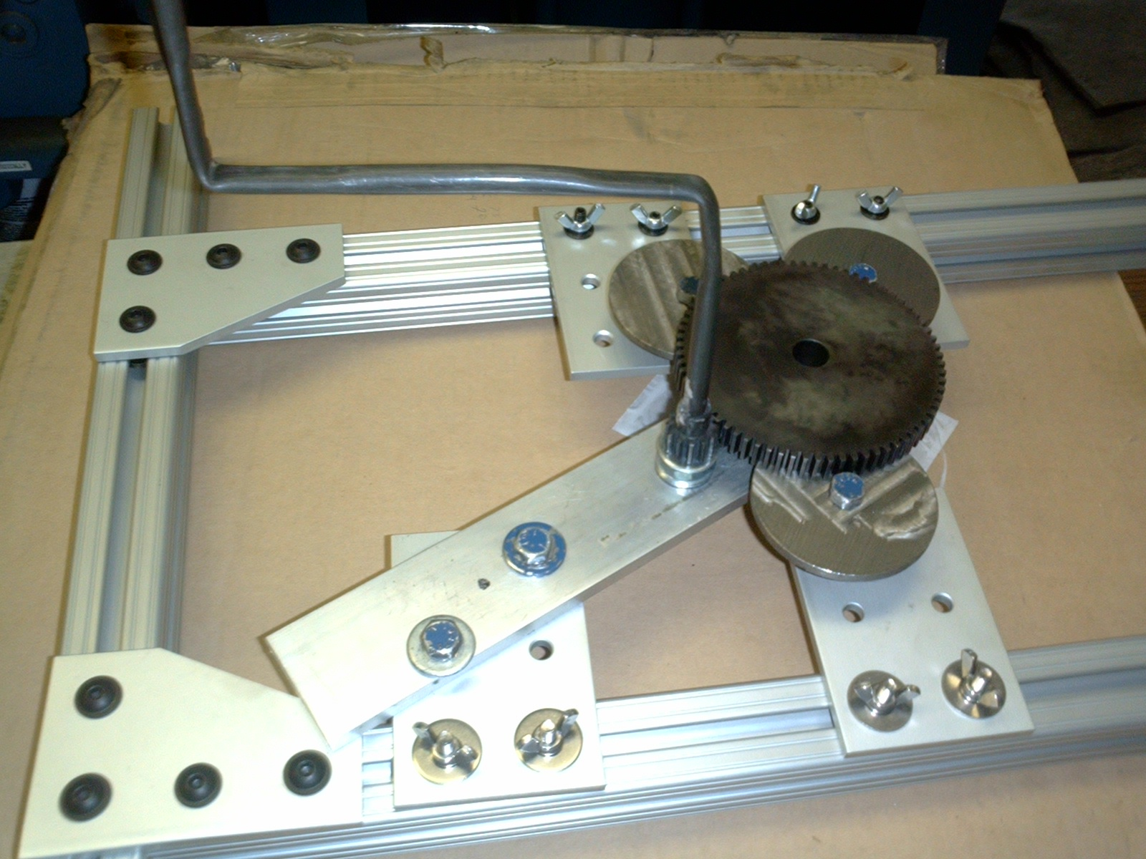
4.1 Wrapping Drive Model Prototype

(fig 1) Prototype
A major concern with the design of the ring gear support was the possibility of the large ring gear not being fully constrained from vertical and horizontal motion. (See 3.3.2 Ring Gear Support Design) The large ring gear that will be spun around the doughnut is supported by several flanges (fig. 1). We felt that this system would constrain the gear, but decided that it would be interesting and helpful to construct a scaled down model of our wrapping drive assembly to test our theory.
The support of the gears and rollers in our model will be handled by three 1.5x1.5 pieces of 8020. We chose 8020 because, like in the full scale design, we wanted to be able to adjust the positions of our rollers easily. The large ring gear in the original design was scaled down to a 4 inch spur gear. There was no need to design this gear as a ring due to the fact that nothing would be passing through the middle in the model. The driver gear was scaled down to a 1 inch pinion. We felt that there was no need for the top flanges in our design due to the fact that, unlike the full scale design, there are no positive vertical forces applied to our gears. Through measurement of the gears we found that we needed position flanges of approximately 3 inch diameter. These flanges were machined from a piece of 3 inch diameter stock. Instead of bearings, our design rotates by friction between the flanges and copper spacers that we installed to give the proper vertical position. In order to drive the large gear, a shaft with a handle, which allows us to manually rotate the gear, was welded to the pinion gear. In the actual design a motor is used to rotate the pinion.
The results of the prototype were very promising. The ring and pinion gears function very smoothly and there is no floating of the large ring gear. We feel that the model accurately proves that the 8020 is rigid and will thoroughly support the drive system allowing for precise meshing of the gears. The most challenging part of the design was accurately machining and assembling the positioning flanges. From figure 2 below, you can see that the radius needed for the positioning plates can be found from the following formula.
R position + R1 hub = R1 + R2
so….
R position = R1 + R2 - R1 hub
R1

R1 hub
R2
R position

(fig. 2)

When the radius of the positioning plates was accurately calculated the ring gear and the pinion meshed properly and the ring gear was not allowed to float. Because of this accurate meshing and no problems with the ring gear floating we feel that the prototype has proven that our design will sufficiently support and drive the ring gear with no anticipated problems, and plan to continue on with our design as is.
4.2 Gear System and Strength Analytical Calculations
Tentative specifications:
pinion made of steel, diameter d_{p}= 3”, rotational speed w_{p}= 600 rpm, endurance strength σ_{o}= 15,000 psi
gear made of aluminum, d_{g} = 30”, w_{g} = 60 rpm, σ_{o} = 14,000 psi
20º stub involute profiles
i (gear ratio) = d_{g}/d_{p} = w_{p}/w_{g} = 10
maximum power transmitted by the motor = 2 hp

In order to determine the diametral pitch to be used, the minimum number of teeth for the pinion will be selected N_{p} = 15. Then the number of teeth for the gear is
N_{g} = N_{p} i = 15 (10) = 150 teeth
Now find the diametral pitch (P_{d}) P_{d}= N/d (N = number of teeth, d = diameter)
P_{d} = 150/30 = 15/3 = 5 teeth/inch

Determine which is weaker, the gear or the pinion. The load carrying capacity of the tooth is a function of the σ_{o}γ product.
For a 20º stub involute gear with 15 teeth the Lewis form factor γ is
γ_{p} = 0.115. For the pinion the load carrying capacity is
F_{p} = σ_{op}γ_{p} = 15 000 (0.115) = 1725 psi.

For a 20º stub involute gear with 150 teeth the Lewis form
factor γ is γ_{p} = 0.165. For the gear the load carrying capacity is
F_{g} = σ_{og}γ_{g} = 14 000 (0.165) = 2310 psi.
Since F_{p}<F_{g}, the pinion is weaker and will fail first .

The moment transmitted by the pinion =
M_{t} = 63000*H / w_{p} (H = maximum power transmitted, w_{p} = rotational speed)
M_{t} = 210 lb in

Assuming a safety factor of 2, σ_{p} allowable = σ_{o}/2 = 7500 psi
σ = 2*M_{t}*P_{d}³ = 2*210*P³
kП²γ_{p}N_{p} 4*П²*.115*15
(k is a constant, start out with maximum value k = 4)
max P_{d} = 11 teeth/inch
Desired P_{d} = 5 teeth/inch, well below the maximum.
Check to see if 5 teeth/inch induces a stress below the allowable amount.

To calculate pitch line velocity, V
V = П*d*w / 12 = П * 3 * 600 / 12
V = 471.2 ft/min
The allowable stress for V < 2000 ft/min is given by:
σ_{pallowable} = σ_{po} 600 = 15000 (600)
600+V 600+471.2
σ_{pallowable} = 8402 psi

Induced Stress
σ_{p induced} = 2*M_{t}*P_{d}³ = 2*210*5³
kП²γ_{p}N_{p} 4*П²*.115*15
σ_{p induced} = 770.9 psi

The pinion is strong because the induced stress is less than the allowable stress.

The constant k can be reduced from the maximum value of k = 4
σ_{p} = 2*M_{t}*P_{d}³ = 2*210*5³ = 8402 psi
kП²γ_{p}N_{p} k*П²*.115*15
k = .41

The minimum face width (B) should be
B = kp = k*(П/P_{d}) = .41*П / 5 = .25 in
B = .5 in
Tentative Design
P_{d} = 5 teeth/in B = .5 in r_{p} = 3 in r_{g} = 30 in

Center Distance
c = r_{p} + r_{g} = 3+30
c = 33 in.
Addendum of the gears
a = .8/P_{d} = .8/5
a = 0.16 in.
Minimum dedendum for 20º stub involute gear profiles
d = 1/P_{d} = 1/5
d_{min} = 0.20 in.
Radii of the base circle
r_{b} = r cos Ф
r_{bp} = 3 cos(20) = 2.819 in.
r_{bg} = 30cos(20) = 28.19 in.
Maximum possible addendum circle radius without interference is:
r_{a max} = (r_{b}² + c² sin²(Ф))^{1/2}
r_{a p max} = (2.819² + 33² sin²(20))^{1/2}
r_{a p max} = 11.63 in.
r_{a g max} = (28.19² + 33² sin²(20))^{1/2}
r_{a g max} = 30.37 in.
The addendum radii of the pinion and gear are:
r_{a} = r + a
r_{a p} = 3 + .16 = 3.16 in.
r_{a g} = 30+.16 = 30.16 in.
r_{a max} > r_{a} for the gear and the pinion, so there will be no interference.
Contact Ratio
CR = (r_{ap}² – r_{bp}²)^{1/2} + (r_{ag}² – r_{bg}²)^{1/2} – c sin(Ф) (p = п/P_{d})
p cos(Ф)
CR= (3.16²–2.8²)^{1/2}+(30.16²–28.2²)^{1/2}–33sin(20)
.6283 cos(20)
CR = 1.46. This suitable because it is CR>1.2.

Analysis of Gear Tooth Bending Stress using Refined Lewis Equation
σ = (F_{t} P) / (b J) K_{v}K_{o}K_{m}
F_{t} = tangential load on tooth
H = F_{t} * V / 33000 (H = max horsepower, V = pitch line velocity)
F_{t} = (2)*33000/471.2 = 140.1 lb
P = diametral pitch = 5 teeth/in
B = face width = .5 in
J = Geometry factor. For 20º stub involute, 150 teeth J = .45
K_{v} = velocity factor – function of pitch line velocity and manufacturing accuracy. For a pitch line velocity of 471.2 ft/in and a precision shaved and ground gear, K_{v} = 1.2
K_{o} = overload factor – estimating for uniform power and uniform driven machinery, K_{o} = 1.
K_{m} = mounting factor – for a less rigid mounting with a 0<b>2, K_{m}=1.6.
σ = (140.1 * 5) / (.5* .45)(1.2*1*1.6)
σ = 5978 psi

Effective Fatigue Stress S_{n}
S_{n} = S_{n}′C_{L}C_{G}C_{S}k_{r}k_{t}k_{ms}
Sn′ = standard endurance limit, for Aluminum S_{n}′ = 14000 psi
C_{L} = load factor, for bending loads, C_{L} = 1
C_{G} = gradient factor, for P=5, C_{G} = .85
C_{S} = surface factor, for aluminum tensile yield stress of 40 ksi and a machined surface, C_{S} = .8
k_{r} = reliability factor, for 90% reliability, k_{r} = .897
k_{t} = temperature factor = 620/(460+T), for T = 75, k_{t}= 1.16
k_{ms} = mean stress factor = 1.4 for output gear
S_{n} = (14000)*1*.85*.8*.897*1.16*1.4
S_{n} = 13, 868 psi
σ < S_{n}, so gear tooth should not bend

Analysis of Pinion Tooth Bending Stress usingRefined Lewis Equation
σ = (F_{t} P) / (b Y)
F_{t} =140.1 lb
P = diametral pitch = 5 teeth/in
B = face width = .5 in
J = geometry factor. For 20º stub involute, 15 teeth J = .25
K_{v} = velocity factor – function of pitch line velocity and manufacturing accuracy. For a pitch line velocity of 471.2 ft/in and a precision shaved and ground gear, K_{v} = 1.2
K_{o} = overload factor – estimating for uniform power and uniform driven machinery, K_{o} = 1.
K_{m} = mounting factor – for a less rigid mounting with a 0<b>2, K_{m}=1.3

σ = (140.1 * 5) / (.5* .25)*1.2*1*1.6
σ = 10 759.7 psi
Effective Fatigue Stress S_{n}
S_{n} = S_{n}′C_{L}C_{G}C_{S}k_{r}k_{t}k_{ms}
Sn′ = standard endurance limit, for Steel S_{n}′ = 15000 psi
C_{L} = load factor, for bending loads, C_{L} = 1
C_{G} = gradient factor, for P=5, C_{G} = .85
C_{S} = surface factor, for aluminum tensile yield stress of 80 ksi and a machined surface, C_{S} = .75
k_{r} = reliability factor, for 90% reliability, k_{r} = .897
k_{t} = temperature factor = 620/(460+T), for T = 75, k_{t}= 1.16
k_{ms} = mean stress factor = 1.4 for input gear
S_{n} = (15000)*1*.85*.75*.897*1.16*1.4
S_{n} = 13, 930 psi
σ < S_{n}, so gear tooth should not bend

Surface Fatigue Anaylsis using Refined Hertz Procedure
σ_{H} = C_{p} √ ( F_{t} K_{v}K_{o}K_{m} ) / ( b d_{p} I)
C_{p}= elastic coefficient, for an alumnium gear and a steel pinion, C_{p} = 1950
F_{t} = 140.1 lb
b = .5 in.
d_{p} = 3 in.
I = geometry factor = sin(φ)cos(φ) R R = d_{g}/d_{p}
2 R+1
I = .1461
K_{v} = 1.2
K_{o} = 1.
K_{m}= 1.3
σ_{H} = 1950√ ( 140.1*1.2*1*1.3 ) / ( .5*3*.1461)
σ_{H} = 61580 psi

S_{H} = S_{fe}C_{Li}C_{R}
S_{fe} = Surface fatigue strength, for aluminum S_{fe} = 65 000 psi
C_{Li} = life factor, for 10⁸ cycles, C_{Li} = .95
C_{R} = relibility factor, for 99%, C_{R} = 1
S_{H} = (65000)*.95*1
S_{H} = 61 750 psi
σ_{H} < S_{H}, which shows satisfactorily low surface fatigue damage
4.3 Support Stress Analysis from ALGOR
FEA Analyses
Using ALGOR, a finite element analyses (FEA) software package, the stress, strain and nodal displacement of the frame was calculated. Due to limitations in the software, it was not possible to create an exact duplicate of the frame. For example, in the computer model, welded joints were used. The actual frame that is to be built will have joining plates and bolts holding the joints together. Also the type of aluminum alloy that the frame will be constructed of was not available in ALGOR, so a similar alloy was used that was slightly stronger. ALGOR is still a very useful tool. It will not give us the exact values of the stresses and strains, but it will show us where they are occurring at, giving us the ability to add supports where they are needed and to construct the best frame possible.

In the model below, two ten pound loads were distributed on the two cross members to simulate the downward force of the tank onto the frame. 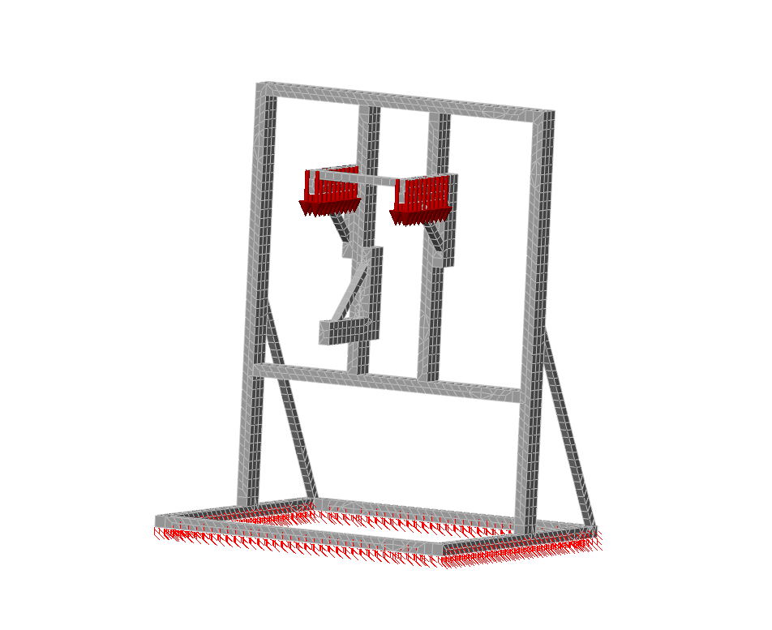

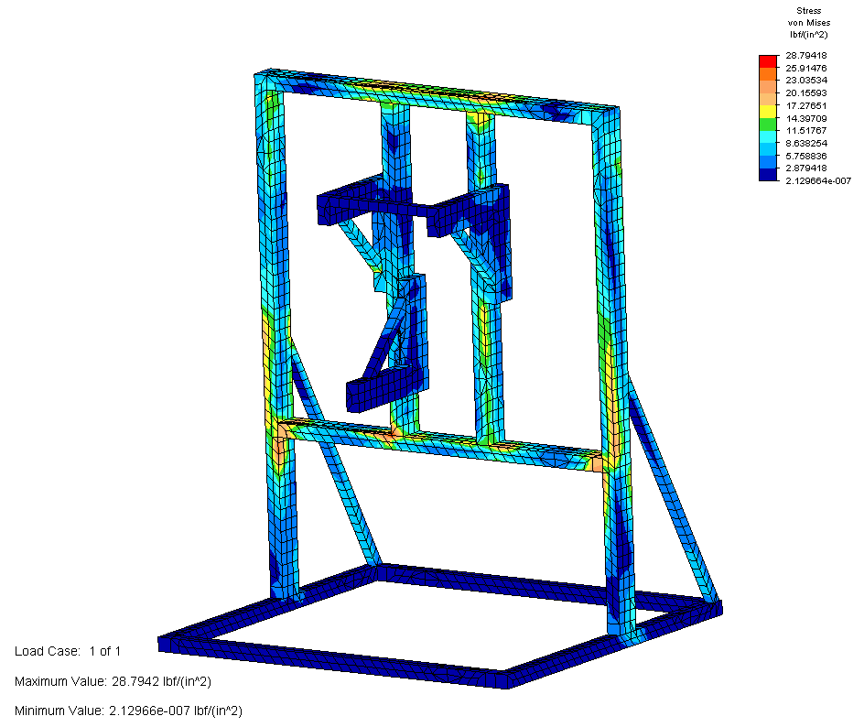
The stress analyses on the frame in the figure below shows a considerable amount of stress located on the lower-middle horizontal cross member’s joints and on the two outside vertical supports. Over time these stresses at the joints could shear the bolts that are holding them together. These stresses should be reduced.

As shown in the figure below, the amount of strain on the frame is small. The maximum value is 3.877x10⁻⁸ inch/inch. This does not mean it is negligible though. Most of the strain is concentrated at the joints. This strain, in combination with the stress, will help to shear the bolts that are holding the frame together and therefore must be reduced.
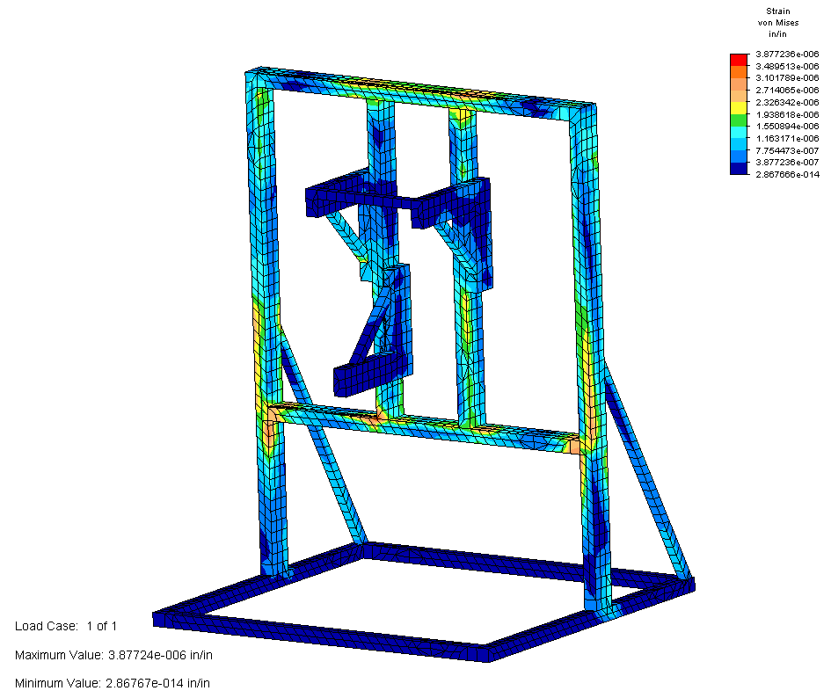

The figure below shows where the frame is going to deflect the most. The maximum value is very small, but the deflection is concentrated at the top two middle joints of the frame. The displacement in combination with the stress and strain at the joints will aid in shearing the bolts and should be reduced if possible.

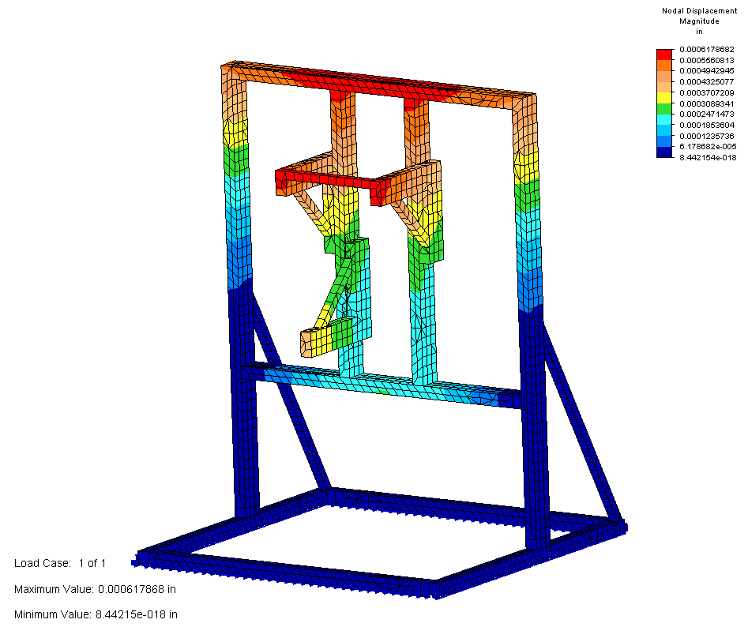

In the model below, the same two ten pound distributed forces are applied. To reduce the stress, strain and nodal displacement in the original model, five new supports were added. Three in the lower middle of the frame and two small ones toward the bottom front of the frame.

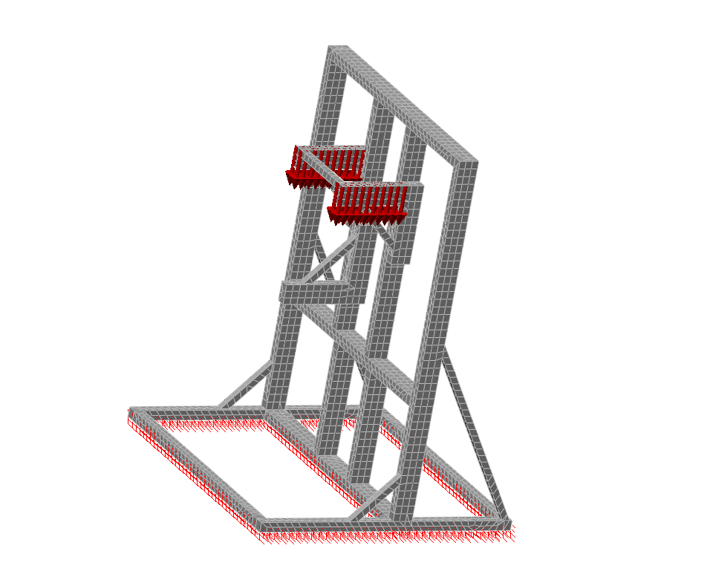

As shown in the figure below, the maximum stress was reduced by almost eight lbs/in² because of the new supports. Also, the overall stress on the frame was significantly reduced. The stresses at the joints in this model are one half or less of what they were in the previous model.

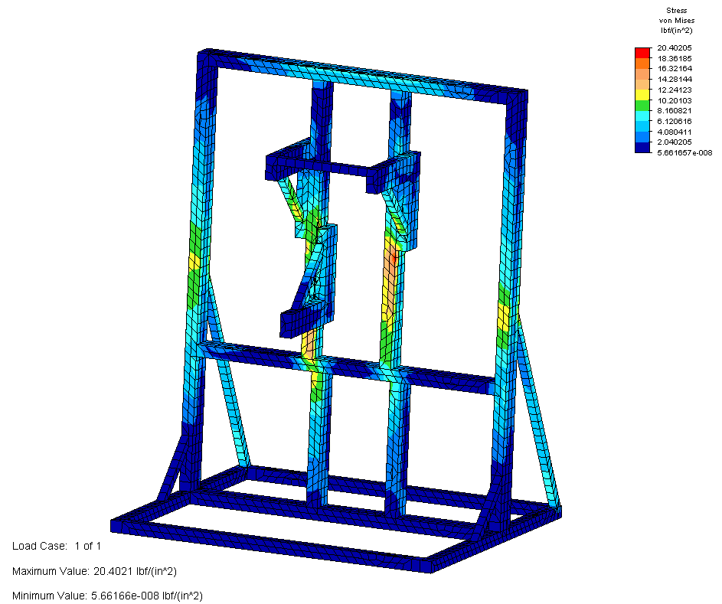

The strain at the joints and the overall strain on the frame were reduced by adding the new supports. The maximum strain in the previous model, which was concentrated mostly at the joints, was 3.877x10⁻⁸ inch/inch. It has been reduced to a maximum value of 2.747x10⁻⁶ and diverted away from the joints.

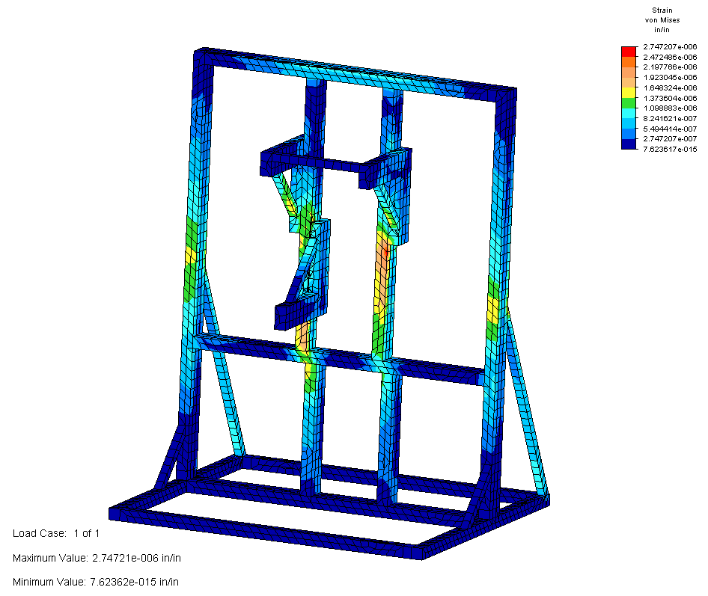
The nodal displacement was also reduced from 0.00618 inches to 0.000429 inches. Although the displacement is still concentrated at the top joints of the frame, the reduction will aid in a longer life expectancy of the bolts at the joints.

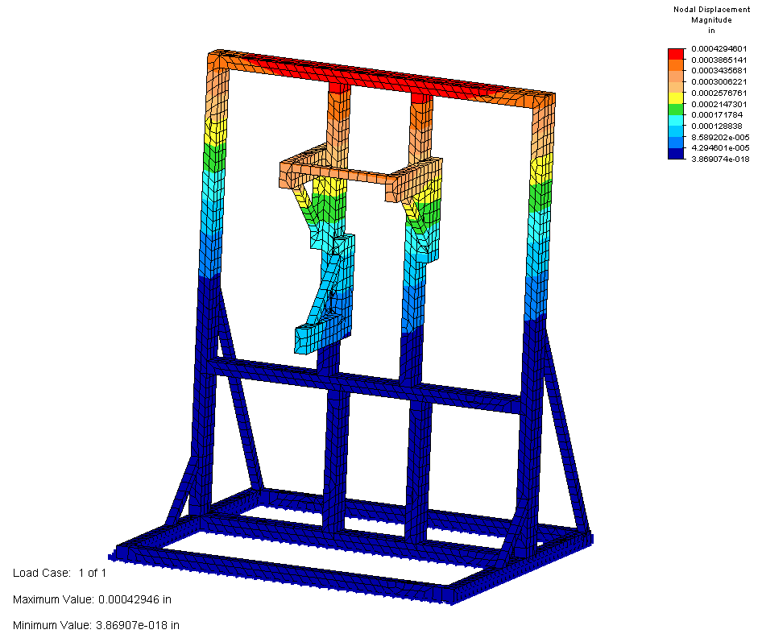

Overall, ALGOR was a very useful tool in designing the frame for this project. Although we could not build an exact duplicate of the frame in ALGOR, the frame is much stronger and will last longer because of it. And the stresses and strains that could shear the bolts at the joints were reduced to tolerable levels.

Economic Analysis
(See Following Excel Spreadsheets)

Conclusion
In a collective assessment of the toroid wrapping challenge, the many aspects of the final design were selected from several other competing ideas not to mention countless other possibilities that remain unexplored. However, in order to optimize the effectiveness of the team’s effort, three main objectives were established and followed in respective order: 1) accomplish uniform radial and angular wrapping 2) maintain ease of assembly 3) minimize project budget. This criterion guided the design process and was used to make crucial decisions that impacted the final proposal.
Conceptual design was originally influenced by the merger of two competing design teams and ultimately the suggestions of NASA sponsor Tom Delay. The first aspect of this design designated as a desirable design aspect was the vertical orientation of the toroid during wrapping. Secondly, a three point drive system was chosen drive the toroid over a conveyor system in hopes that it would produce a more stable and controllable design. Finally, angular tilting of a wrapping device will produce the desired angular wrapping rather than an alternatively considered speed ratio varying concept.
The process of design proved that the vertical orientation of the toroid resulted in to major harms other than a higher cost than originally projected. FEA analysis done on the L-base and its various components showed that its design could easily handle the loads intended. Additionally, the adjustment capabilities and spring loaded option of the L-base make it a robust design that conforms to the rest of the design rather than placing more constraints on the system.
The three point drive system which is integrated into the L-base shares the same adjustability with its parent support. This system also contains in itself the added benefit of variable speed control made possible through a cost effective AC inverter drives from ACTech. A concluding evaluation of this sub-system however, suggests that there is still testing to be conducted on the contact surface between the polyethylene rollers and the toroid. Recommendations from the roller manufacturers however, support the design and suggest that slip will be minimal.
The majority of ambiguity within this proposal lies in the unique spool wrapping technique which is based on the rotation of a large ring gear. From the onset of design, complexities were encountered when searching for a suitable wrapping technique. Research into existing solutions for smaller toroid wrapping applications provided only a diminutive indication of what might be a feasible solution to the much larger problem that NASA seeks a solution for. Also, material differences between existing wrapping devices and the carbon fiber intended for the fuel tank reinforcing carbon fiber made the existing solutions even more dissimilar to NASA’s challenge. After this research as well as investigation into other possibilities such chain and belt drives variations, a ring gear design was selected as the most viable resolution. Concerns in this area however prompted the construction of a smaller scale model that could give further insight into possible pitfalls. Results of this experiment were generally positive and problems that arose have been accounted for in hopes that they will be minimized if not eliminated in the full scale mechanism.
Anticipated dilemmas have been compensated for as much as possible although unexpected quandaries may arise once the assembly and testing phases of the project are reached. To a certain extent however, the overall design allows for manipulation and may be able to solve these quandaries should they arise. In conclusion, it was the team’s most possible impartial consensus that the design objectives were met and the proposed design will in fact accomplish the designated task of uniform unmanned toroid reinforcement.
References

1) www.mcmaster.com (McMaster Carr)
2) www.motionmro.com (Motion Industries)
3) www.80-20.net (80-20 Aluminum Manufacturer)
4) www.fairlaneproducts.com (Fairlane rollers)
5) www.centuryspring.com (Toroid Drive System spring)
6) http://www.actechdrives.com (AC Motor Capabilities)

7) http://www.yaskawa.com (AC Motor Capabilities)

8) http://users.pandora.be/educypedia/electronics/motorstep.htm (Stepper Motors)

9) http://www.dig.bris.ac.uk/hbook/bdata.htm (Ball Bearing Design)
10) www.ogura-clutch.com/tech/tech10.html

11) Juvinall, Robert C. Fundamentals of Machine Component Design. John Wiley & Sons Inc. 2000. p 618-670. (Gear Analysis)
APPENDIX

Solid Edge Draft Files on Following Pages

