Author(s) | Arun Arkala Reddy
Phase/Activity | Draft
Contributor(s)
Document Version | Version 1.0

Revision History

Inspections

Date | Reviewer | Notes

Table of Contents
Transaction Tracker
1.1 Revision History 1
1.2 Inspections 1
2. Introduction 3
2.1 Feature Overview and Description 3
2.2 Assumptions 4
3. USE CASE: Enter/VIEW BY ITEM 5
3.1 Brief Description 5
3.2 Pre-Conditions 5
3.3 Main Flow 5
3.4 Alternate Flows 6
3.5 Post-Conditions 6
3.6 Special Requirements 6
4. USE CASE: VIEW BY TRANSACTION 7
4.1 Brief Description 7
4.2 Pre-Conditions 8
4.3 Main Flow 8
4.4 Alternate Flows 8
4.5 Post-Conditions 8
4.6 Special Requirements 8
5. USE CASE: enter/VIEW BY ASSOCIATE 10
5.1 Brief Description 10
5.2 Pre-Conditions 10
5.3 Main Flow 10
5.4 Alternate Flows 11
5.5 Post-Conditions 11
5.6 Special Requirements 11
6. USE CASE: VIEW BY Retailer 13
6.1 Brief Description 13
6.2 Pre-Conditions 13
6.3 Main Flow 13
6.4 Alternate Flows 14
6.5 Post-Conditions 14
6.6 Special Requirements 14
7. USE CASE: VIEW BY SIGNATURE 16
7.1 Brief Description 16
7.2 Pre-Conditions 16
7.3 Main Flow 16
7.4 Alternate Flows 17
7.5 Post-Conditions 17
7.6 Special Requirements 17
8. USE CASE: VIEW BY ELECTRONIC JOURNALS 18
8.1 Brief Description 18
8.2 Pre-Conditions 18
8.3 Main Flow 18
8.4 Alternate Flows 19
8.5 Post-Conditions 19
8.6 Special Requirements 19
9. USE CASE: DISPLAY TRANSACTION DETAIL 20
9.1 Brief Description 20
9.2 Pre-Conditions 20
9.3 Main Flow 20
9.4 Alternate Flows 20
9.5 Post Conditions 20
9.6 Special Requirements 20
10. USE CASE: DISPLAY JOURNAL VIEW 21
10.1 Brief Description 21
10.2 Pre-Conditions 21
10.3 Main Flow 21
10.4 Alternate Flows 22
10.5 Post Conditions 22
10.6 Special Requirements 22
11. USE CASE: DISPLAY SIGNATURE CAPTURE 22
11.1 Brief Description 22
11.2 Pre-Conditions 22
11.3 Main Flow 22
11.4 Alternate Flows 23
11.5 Post Conditions 23
11.6 Special Requirements 23
12. USE CASE: DISPLAY RETAILER INFORMATION 24
12.1 Brief Description 24
12.2 Pre-Conditions 24
12.3 Main Flow 24
12.4 Alternate Flows 24
12.5 Post Conditions 24
12.6 Special Requirements 24
13. USE CASE: EXPORT TO EXTERNAL FILE 26
13.1 Brief Description 26
13.2 Pre-Conditions 26
13.3 Main Flow 26
13.4 Alternate Flows 26
13.5 Post Conditions 26
13.6 Special Requirements 26
14. Supplementary Specifications 28
14.1 Main Package 28
14.2 Store Directory Package 28
14.3 Store and Enterprise Access Point List 28
14.4 Parameter Names and Values Addendum 28
Returns Management 28
14.5 Exception File and Alerts 28
15. Removed/Disabled Features 29
16. Screen Layouts 29
16.1 Common View Sections across Screens 29
16.2 View by Item 44
16.3 Journal View 48
16.4 View by Transaction 50
16.5 Transaction View Results 54
16.6 Transaction Detail 57
16.7 View by Associate 64
16.8 View by Retailer 68
16.9 View by Signature 72
16.10 Signature Capture View 75
16.11 Export Journal Data 78
16.12 Retailer Information 79
17. DIALOG SCREEN LAYOUTS 82
17.1 View in Progress 82
17.2 Export Error 82
17.3 Duplicate File 82
17.4 Too Many Matches 83

Introduction

Feature Overview and Description
The Transaction Tracker package allows the user to store and query electronic journal data. These data include Transaction information (Tlog/POSLog), signature capture, and journal data.
Data can include details such as Transactions made while paying salary to their employees, purchasing the infrastructure for the company, storing the peoplesoft details( such as employee information, skill set, timesheet, Project assignment), leave tracking system, etc.
The user can view for a transaction by various combinations of criteria. Transaction Tracker contains five view options.
- The Enter/View by Item use case allows the user to enter the details and even an option to view records using item criteria such as item number or style. The functionality defaults to View by Item, but the user can select to view by transaction.
- The View by Transaction use case allows the user to view for records by transaction criteria such as transaction number, date and time, transaction type (Purchase/Return/etc.)
- The Enter/View by Associate use case allows the associate to enter/view/update their details. An employee can view/edit his own details. However, the leadership team can view the details of all the associates who report to them.
- The View by Retailer use case allows the user to view by Retailer ID or retailer information.

- The View by Signature use case allows the user to transaction date, type, account number, amount, and transaction amount for a signature associated with for a transaction.
- The View By E-Journal use case allows the user to view by specific information that is transported with the electronic journal “blob” (Binary Large Object)
The Display Transaction Detail, Display Journal View, Display Signature Capture, and Display Retailer Information use cases allow the user to view specific types of information captured for the transaction. The Export to External File use case allows the user with appropriate security access to save any of the types of information as a PDF or TXT file.
The users have an access based on their privileges. An employee can only insert/update his data while administrator has complete access to the system. There are several other roles defined such as Vice president, Facility Manager, Project Manager, Team Lead etc.

Assumptions

- An XML format is defined for electronic journal import.
- An XML format is defined for transaction log import
- View result reports can be saved as .pdf or .txt files for exporting.
- View capability on tender IDs depends on the user’s decision to store and retain the information in the database.
- Fields in screen areas that are deselected/collapsed are excluded from the View criteria.
- Province names are represented with a two-letter code, the same as U.S. State names and are handled the same.
- The country field is populated based on the State or Province selected.
- The system retrieves all the information regardless of status.
- An entity can be an individual or a business.
- The system finds no results if the entity is not attached to any transactions.
- The system does not find captured signatures on the signature View if the user does not have access based on the user’s assigned security.
- Signatures are currently captured for: All types of credit cards – MasterCard, Visa, JCB, Diner’s Club, American Express, AmEx, Discover and House Account cards.
- Debit card used as a credit card follows the above assumptions.
- Field storage type for captured signatures is Binary Large Object (BLOB) this accommodates multiple signature formats including, but not limited to, XY coordinates and PNG (Portable Network Graphics.)

USE CASE: Enter/VIEW BY ITEM

Brief Description
This use case allows the user to View for transaction information by item level criteria.
Each item is stored along with the hierarchy such as infrastructure, payment of salary, operational costs etc. Under each hierarchy, user can drill down to specific items such as Desktop, Salary for an employee, etc.
The system displays the transaction details if one match is found or a list of the transactions if multiple matches are found, with links to each transaction’s detail. Once the detail on the transaction is displayed, the user can select to view the journal information that was captured for the transaction.
Also this is the same screen where the user can input their data. This screen is only visible to the Administrator and leadership team such as Vice-president, Facility Manager, HR, Project Manager.. etc.

Pre-Conditions
- The user has selected to View for transaction information by item.

Main Flow
- The system prompts the user to enter item View criteria.
- If the user selects to View using the store hierarchy, the system executes the Select Hierarchy Level use case to capture entry of the desired level of the store directory.
- If the user selects to View by store number range, the user enters a store number or store number range.
- The user enters item View criteria.
- If the user selects to include transaction criteria, the system displays the transaction View fields.
- If the user selects to clear the View information, the system resets the View fields to the defaults.
- The user accepts the entry.
- The system Views for records that meet all of the chosen criteria.
- If the user selects to cancel the View in progress, the system restarts the flow with the previously entered information defaulted.
- If a database error occurs, the system displays an error message, the user acknowledges the message, and the use case restarts.
- If a match is not found, the system displays a message informing the user that no records were found matching the journal View criteria entered, the user acknowledges the message, and the main flow restarts.
- If the system finds one match, the system executes the Display Transaction Detail use case.
- The system displays the list of transactions that meet the View criteria.
- If the user selects to export the information, the Export to External File use case is executed.
- If the user selects to view a specific transaction’s details, the system executes the Display Transaction Detail use case.
- The user acknowledges the information and the use case restarts.

Alternate Flows
None

Post-Conditions
- Transaction information is viewed, printed, or exported.

Special Requirements
None

Data Input/Output
<A bulleted list of the destination for the data from beginning, during, and ending the process. For this release it should include: E-journal, POSLog, Receipt Printing, Database, and Hard Totals.…Information such as e-journal and receipt header/footer info is documented in the UI Guidelines.>
Data Element | Description | Destination
Hierarchy Information | If the section is deselected, it is not included in the View criteria. | - View criteria
Hierarchy View Method | Determines if View should be performed by hierarchy or store | - View criteria
Item Information | If the section is deselected, it is not included in the View criteria. | - View criteria
Item Number | System Searches for a transaction that includes this item number. | - View criteria
Retailer ID | System retrieves the data of the retailer. | - View criteria
Associate ID | System retrieves the data of the Associate. | - View criteria
UPC | System Searches for a transaction that includes this United Postal Code | - View criteria
Style | System Searches for a transaction that includes this Style. | - View criteria
Price | System Searches for items within a transaction where a price was entered. | - View criteria
Item Cleared | System Searches for items that were deleted (rung up and then Cleared from the transaction). | - View criteria
Transaction Information | If the section is deselected, it is not included in the View criteria. | - View criteria
Transaction Number | System Searches for transactions where the transaction number is equal to this id. | - View criteria
Start Sequence Number | System Searches for transactions where the transaction sequence number is greater than or equal to this id. | - View criteria
End Sequence Number | System Searches for transactions where the transaction sequence number is less than or equal to this id. | - View criteria
From Register Number | System Searches for transactions where the register number is greater than or equal to this number. | - View criteria
To Register Number | System Searches for transactions where the register number is less than or equal to this number. | - View criteria
Start Transaction Date | System Searches for the transaction date equal to or greater than the entered date. | - View criteria
End Transaction Date | System Searches for the transaction date less than or equal to the entered date. | - View criteria
Start Time | System Searches for the transaction time greater than or equal to the entered hours and minutes. | - View criteria
End Time | System Searches for the transaction time less than or equal to the entered time. | - View criteria
Transaction Type | System Searches for the transaction types available for item. | - View criteria
Training Mode | System Searches for transactions that were entered in Training Mode (On), only transactions that were entered in non-training mode (Off), or Both. | - View criteria
Show per Page | Number of Results to show per page. | - View criteria

Special Offline Requirements
<Define offline requirements. Describe the system behavior when offline to the database, server, and network. Obtain this information during the JAD session with development and QA assistance.>
Offline | Behavior
Database | If the database is offline, this use case cannot be executed.
Server | If the server is offline, this use case cannot be executed.
Network | If the network is offline, this use case cannot be executed.

USE CASE: VIEW BY TRANSACTION

Brief Description
This use case allows the user to View for transaction information by transaction criteria. The system displays details of the transaction if one match is found or a list of the transactions if multiple matches are found, with links to each transaction’s detail. Once the transaction detail is displayed, the user can select to view the journal information that was captured for the transaction. The user can also select to view signature(s).
This screen is only visible to the leadership team such as Vice-president, Facility Manager, HR, Project Manager... etc and Administrator too.
Here the human resource manager view the transactional information which was obtained while paying the salary for the employees, Facility manager views the transaction information while buying infrastructure for the company.

Pre-Conditions
- The user has selected to View for transaction information by transaction.

Main Flow
- The system prompts the user to enter transaction View criteria.
- If the user selects to View using the store hierarchy, the system executes the Select Hierarchy Level use case to capture entry of the desired level of the store directory.
- If the user selects to View by store number range, the user enters a store number or store number range.
- The user enters View criteria.
- If the user selects to include tender criteria, the system displays the tender View fields.
- If the user selects to clear the View information, the system resets the View fields to the defaults.
- The user accepts the entry.
- The system Searches for transactions that meet all of the chosen criteria.
- If the user selects to cancel the View in progress, the system restarts the flow with the previously entered information defaulted.
- If a database error occurs, the system displays an error message, the user acknowledges the message, and the use case restarts.
- If the system finds one transaction that matches the entered criteria, the system executes the Display Transaction Detail use case.
- If too many matches are found to display based on the E-Journal Maximum Matches parameter, the system displays an error message, the user acknowledges the message, and the main flow restarts with the previously entered information defaulted.
- The system displays the list of transactions that meet the View criteria.
- If the user selects to export the information, the Export to External File use case is executed.
- If the user selects to view a specific transaction’s details, the system executes the Display Transaction Detail use case.
- The user acknowledges the information and the use case restarts.

Alternate Flows
None

Post-Conditions
- Transaction information is viewed, printed, or exported.

Special Requirements
None

Data Input/Output
<A bulleted list of the destination for the data from beginning, during, and ending the process. For this release it should include: E-journal, POSLog, Receipt Printing, Database, and Hard Totals.…Information such as e-journal and receipt header/footer info is documented in the UI Guidelines.>
Data Element | Description | Destination
Hierarchy Information | If the section is deselected, it is not included in the View criteria. | - View criteria
Hierarchy View Method | Determines if View should be performed by hierarchy or store | - View criteria
Transaction Information | If the section is deselected, it is not included in the View criteria. | - View criteria
Transaction Number | System Searches for where the transaction number is equal to this id. | - View criteria
Start Sequence Number | System Searches for where the transaction sequence number is greater than or equal to this id. | - View criteria
End Sequence Number | System Searches for where the transaction sequence number is less than or equal to this id. | - View criteria
From Register Number | System Searches for transactions where the register number is greater than or equal to this number. | - View criteria
To Register Number | System Searches for transactions where the register number is less than or equal to this number. | - View criteria
Start Transaction Date | System Searches for the transaction date equal to or greater than the entered date. | - View criteria
End Transaction Date | System Searches for the transaction date less than or equal to the entered date. | - View criteria
Start Time | System Searches for the transaction time greater than or equal to the entered hours and minutes. | - View criteria
End Time | System Searches for the transaction time less than or equal to the entered time. | - View criteria
Transaction Type | System Searches for the transaction types available for View. | - View criteria
Training Mode | System Searches for transactions that were entered in Training Mode (On), only transactions that were entered in non-training mode (Off), or Both. | - View criteria
Show per Page | Number of Results to show per page. | - View criteria

Special Offline Requirements
<Define offline requirements. Describe the system behavior when offline to the database, server, and network. Obtain this information during the JAD session with development and QA assistance.>
Offline | Behavior
Database | If the database is offline, this use case cannot be executed.
Server | If the server is offline, this use case cannot be executed.
Network | If the network is offline, this use case cannot be executed.

USE CASE: enter/VIEW BY ASSOCIATE

Brief Description
This use case allows the user to View for transaction information filtered by the associate numbered.
Also on this screen, user can enter his peoplesoft details (such as employee information, skill set, timesheet and Project assignment), leaves, etc.
Here based on the privileges of the user, the corresponding details are displayed. An employee can view/edit his information. A project manager can view the details of all the employees, supervised by him.
Similar there are other roles such as Vice president, Manager (Human resource/Project/Facility) and administrator.
The system displays details of the associate if a match is found. Once the transaction detail is displayed, the user can select to view/edit the journal information that was captured for the transaction. The user can also select to view signature(s).

Pre-Conditions
- The user has selected to View for transaction information by associate.

Main Flow
- The system prompts the user to enter associate View criteria.
- If the user selects to View using the store hierarchy, the system executes the Select Hierarchy Level use case to capture entry of the desired level of the store directory.
- If the user selects to View by store number range, the user enters a store number or store number range.
- The user enters associate View criteria.
- If the user selects to include transaction criteria, the system displays the transaction View fields.
- If the user selects to include item criteria, the system displays the item View fields.
- If the user selects to clear the View information, the system resets the View fields to the defaults.
- The user accepts the entry.
- The system Searches for transactions that meet all of the chosen criteria.
- If the user selects to cancel the View in progress, the system restarts the flow with the previously entered information defaulted.
- If a database error occurs, the system displays an error message, the user acknowledges the message, and the use case ends.
- If the system finds one transaction that matches the entered criteria, the system executes the Display Transaction Detail use case.
- If too many matches are found to display based on the E-Journal Maximum Matches parameter, the system displays an error message, the user acknowledges the message, and the main flow restarts with the previously entered information defaulted.
- The system displays the list of transactions that meet the View criteria.
- If the user selects to export the information, the Export to External File use case is executed.
- If the user selects to view a specific transaction’s details, the system executes the Display Transaction Detail use case.
- The user acknowledges the information.
- The main flow restarts.

Alternate Flows
None

Post-Conditions
- Transaction information is viewed, printed, or exported.

Special Requirements
None

Data Input/Output
<A bulleted list of the destination for the data from beginning, during, and ending the process. For this release it should include: E-journal, POSLog, Receipt Printing, Database, and Hard Totals.…Information such as e-journal and receipt header/footer info is documented in the UI Guidelines.>
Data Element | Description | Destination
Hierarchy Information | If the section is deselected, it is not included in the View criteria. | - View criteria
Hierarchy View Method | Determines if View should be performed by hierarchy or store | - View criteria
Associate Information | If the section is deselected, it is not included in the View criteria. | - View criteria
Associate ID | System Searches for transactions that include this associate number. | - View criteria
Information type | The information type column gives the option such as leave, peoplesoft details. | - View criteria
Transaction Information | If the section is deselected, it is not included in the View criteria. | - View criteria
Transaction Number | System Searches for where the transaction number is equal to this id. | - View criteria
Start Sequence Number | System Searches for where the transaction sequence number is greater than or equal to this id. | - View criteria
End Sequence Number | System Searches for where the transaction sequence number is less than or equal to this id. | - View criteria
From Register Number | System Searches for transactions where the register number is greater than or equal to this number. | - View criteria
To Register Number | System Searches for transactions where the register number is less than or equal to this number. | - View criteria
Start Transaction Date | System Searches for the transaction date equal to or greater than the entered date. | - View criteria
End Transaction Date | System Searches for the transaction date less than or equal to the entered date. | - View criteria
Start Time | System Searches for the transaction time greater than or equal to the entered hours and minutes. | - View criteria
End Time | System Searches for the transaction time less than or equal to the entered time. | - View criteria
Transaction Type | System Searches for the transaction types available for View. | - View criteria
Training Mode | System Searches for transactions that were entered in Training Mode (On) at the Point-of-Sale, only transactions that were entered in non-training mode (Off), or Both. | - View criteria
Item Information | If the section is deselected, it is not included in the View criteria. | - View criteria
Item Number | System Searches for a transaction that includes this item number. | - View criteria
UPC | System Searches for a transaction that includes this United Postal Code | - View criteria
Style | System Searches for a transaction that includes this Style. | - View criteria
Item Cleared | System Searches for items that were deleted (rung up and then Cleared from the transaction). | - View criteria
Show per Page | Number of Results to show per page. | - View criteria

User privileges:

Special Offline Requirements
<Define offline requirements. Describe the system behavior when offline to the database, server, and network. Obtain this information during the JAD session with development and QA assistance.>
Offline | Behavior
Database | If the database is offline, this use case cannot be executed.
Server | If the server is offline, this use case cannot be executed.
Network | If the network is offline, this use case cannot be executed.

USE CASE: VIEW BY Retailer

Brief Description
This use case allows the user to View for transaction information filtered by retailer information.
The retailer provides the required infrastructural/maintenance needs for the company.
This screen is only visible leadership team such as Vice-president, Facility Manager.. etc and Administrator too. Facility manager enters the transaction information while buying infrastructure for the company. He can also view all the past transactions that have been made with the retailer.
The system displays details of the transaction if one match is found or a list of the transactions if multiple matches are found, with links to each transaction’s detail. Once the transaction detail is displayed, the user can select to view the journal information that was captured for the transaction. The user can also select to view signature(s)

Pre-Conditions
- The user has selected to View for transaction information by retailer.

Main Flow
- The system prompts the user to enter retailer View criteria.
- If the user selects to View using the store hierarchy, the system executes the Select Hierarchy Level use case to capture entry of the desired level of the store directory.
- If the user selects to View by store number range, the user enters a store number or store number range.
- The user enters retailer View criteria.
- If the user selects to include transaction criteria, the system displays the transaction View fields.
- If the user selects to clear the View information, the system resets the View fields to the defaults.
- The user accepts the entry.
- The system Searches for transactions that meet all of the chosen criteria.
- If the user selects to cancel the View in progress, the system restarts the flow with the previously entered information defaulted.
- If a database error occurs, the system displays an error message, the user acknowledges the message, and the use case ends.
- If the system finds one transaction that matches the entered criteria, the system executes the Display Transaction Detail use case.
- If too many matches are found to display based on the E-Journal Maximum Matches parameter, the system displays an error message, the user acknowledges the message, and the main flow restarts with the previously entered information defaulted.
- The system displays the list of transactions that meet the View criteria.
- If the user selects to export the information, the Export to External File use case is executed.
- If the user selects to view a specific transaction’s details, the system executes the Display Transaction Detail use case.
- The user acknowledges the information.
- The main flow restarts.

Alternate Flows
None

Post-Conditions
- Transaction information is viewed, printed, or exported.

Special Requirements
None

Data Input/Output
<A bulleted list of the destination for the data from beginning, during, and ending the process. For this release it should include: E-journal, POSLog, Receipt Printing, Database, and Hard Totals.…Information such as e-journal and receipt header/footer info is documented in the UI Guidelines.>
Data Element | Description | Destination
Hierarchy Information | If the section is deselected, it is not included in the View criteria. | - View criteria
Hierarchy View Method | Determines if View should be performed by hierarchy or store | - View criteria
Retailer Information | If the section is deselected, it is not included in the View criteria. | - View criteria
Retailer ID | System Searches for a transaction that includes this Retailer ID. | - View criteria
First Name | System Searches for a transaction that includes this First Name | - View criteria
Last Name | System Searches for a transaction that includes this Last Name | - View criteria
Address Line 1 | System Searches for a transaction that includes this Address Line 1 | - View criteria
Address Line 2 | System Searches for a transaction that includes this Address Line 2 | - View criteria
City | System Searches for a transaction that includes this City | - View criteria
State/Province | System Searches for a transaction that includes this state/province code. | - View criteria
Postal Code | System Searches for a transaction that includes this Postal Code | - View criteria
Telephone No. | System Searches for a transaction that includes this Telephone No. | - View criteria
Transaction Information | If the section is deselected, it is not included in the View criteria. | - View criteria
Transaction Number | System Searches for where the transaction number is equal to this id. | - View criteria
Start Sequence Number | System Searches for where the transaction sequence number is greater than or equal to this id. | - View criteria
End Sequence Number | System Searches for where the transaction sequence number is less than or equal to this id. | - View criteria
From Register Number | System Searches for transactions where the register number is greater than or equal to this number. | - View criteria
To Register Number | System Searches for transactions where the register number is less than or equal to this number. | - View criteria
Start Transaction Date | System Searches for the transaction date equal to or greater than the entered date. | - View criteria
End Transaction Date | System Searches for the transaction date less than or equal to the entered date. | - View criteria
Start Time | System Searches for the transaction time greater than or equal to the entered hours and minutes. | - View criteria
End Time | System Searches for the transaction time less than or equal to the entered time. | - View criteria
Transaction Type | System Searches for the transaction types available for View. | - View criteria
Training Mode | System Searches for transactions that were entered in Training Mode (On, only transactions that were entered in non-training mode (Off), or Both. | - View criteria
Show per Page | Number of Results to show per page. | - View criteria

Special Offline Requirements
Offline | Behavior
Database | If the database is offline, this use case cannot be executed.
Server | If the server is offline, this use case cannot be executed.
Network | If the network is offline, this use case cannot be executed.

USE CASE: VIEW BY SIGNATURE

Brief Description
This use case allows the user to View for signatures that have been captured in conjunction with a tender, and transmitted to the database. This signature is associated with each transaction for a specific retailer.
The system displays the Signature Capture View if one match is found or a list of the transactions if multiple matches are found, with links to each transaction’s Signature Capture View. Once the Signature Capture View is displayed, the user can select to export the signature capture information or return to the starting signature capture View screen.

Pre-Conditions
- The user has selected to View for captured signatures.

Main Flow
- The system prompts the user to enter View criteria.
- If the user selects to View using the store hierarchy, the system executes the Select Hierarchy Level use case to capture entry of the desired level of the store directory.
- If the user selects to View by store number range, the user enters a store number or store number range.
- The user enters signature capture View criteria.
- If the user selects to clear the View information, the system resets the View fields to the defaults.
- The user accepts the entry.
- The system Searches for captured signatures, associated with retail transactions, that meet all of the chosen criteria.
- If the user selects to cancel the View in progress, the system restarts the flow with the previously entered information defaulted.
- If a database error occurs, the system displays an error message, the user acknowledges the message, and the use case ends.
- If the system finds one transaction that matches the entered criteria, the system executes the Display Signature Capture use case.
- If too many matches are found to display based on the E-Journal Maximum Matches parameter, the system displays an error message, the user acknowledges the message, and the main flow restarts with the previously entered information defaulted.
- The system displays the list of transactions that meet the View criteria.
- If the user selects to export the information, the Export to External File use case is executed.
- If the user selects to view a specific transaction’s captured signatures, the system executes the Display Signature Capture use case.
- The user acknowledges the information.
- The main flow restarts.

Alternate Flows
None

Post-Conditions
- Signature capture information is viewed or exported.

Special Requirements
- This use case finds signatures captured for a tender used in conjunction with a retail transaction. This use case does not find signatures captures that are required by the transaction type such as purchase or return.

Data Input/Output
<A bulleted list of the destination for the data from beginning, during, and ending the process. For this release it should include: E-journal, POSLog, Receipt Printing, Database, and Hard Totals.…Information such as e-journal and receipt header/footer info is documented in the UI Guidelines.>
Data Element | Description | Destination
Hierarchy Information | If the section is deselected, it is not included in the View criteria. | - View criteria
Hierarchy View Method | Determines if View should be performed by hierarchy or store | - View criteria
Signature Capture Information | If the section is deselected, it is not included in the View criteria. | - View criteria
Transaction Number | System Searches for the transaction number equal to the entered transaction number. | - View criteria
Transaction Date | System Searches for the transaction date equal to the entered date. | - View criteria
Tender Amount | System Searches for where the tender amount (for any one tender, upon a split tender) is equal to this amount. | - View criteria
Transaction Amount | System Searches for where the transaction total is equal to this amount. | - View criteria
Tender Type | System Searches among potentially multiple tenders per transaction. | - View criteria
Tender Account Number | System Searches for transactions where any of the Tender Types selected have a Tender ID equal to this field. | - View criteria
Show per Page | Number of Results to show per page. | - View criteria

Special Offline Requirements
Offline | Behavior
Database | If the database is offline, this use case cannot be executed.
Server | If the server is offline, this use case cannot be executed.
Network | If the network is offline, this use case cannot be executed.

USE CASE: VIEW BY ELECTRONIC JOURNALS

Brief Description
This use case allows the user to View for transaction information through the minimal key data that has been captured with the electronic journal and transmitted through the Electronic Journal import.
The system displays the Electronic Journal View if one match is found or a list of the transactions if multiple matches are found, with links to each transaction’s Electronic Journal View. Once the Electronic Journal View is displayed, the user can select to export the journal information or return to the starting electronic journal View screen.

Pre-Conditions
- The user has selected to View for electronic journals.

Main Flow
- The system prompts the user to enter View criteria.
- If the user selects to View using the store hierarchy, the system executes the Select Hierarchy Level use case to capture entry of the desired level of the store directory.
- If the user selects to View by store number range, the user enters a store number or store number range.
- The user enters electronic journal View criteria.
- If the user selects to clear the View information, the system resets the View fields to the defaults.
- The user accepts the entry.
- The system Searches for electronic journals meet the chosen criteria.
- If the user selects to cancel the View in progress, the system restarts the flow with the previously entered information defaulted.
- If a database error occurs, the system displays an error message, the user acknowledges the message, and the use case ends.
- If the system finds one transaction that matches the entered criteria, the system executes the Display Journal View use case.
- If too many matches are found to display based on the E-Journal Maximum Matches parameter, the system displays an error message, the user acknowledges the message, and the main flow restarts with the previously entered information defaulted.
- The system displays the list of transactions that meet the View criteria.
- If the user selects to export the information, the Export to External File use case is executed.
- If the user selects to view a specific transaction’s electronic journals, the system executes the Display Journal View use case.
- The user acknowledges the information.
- The main flow restarts.

Alternate Flows
None

Post-Conditions
- Electronic journal information is viewed or exported.

Special Requirements
None

Data Input/Output
<A bulleted list of the destination for the data from beginning, during, and ending the process. For this release it should include: E-journal, POSLog, Receipt Printing, Database, and Hard Totals.…Information such as e-journal and receipt header/footer info is documented in the UI Guidelines.>
Data Element | Description | Destination
Hierarchy Information | If the section is deselected, it is not included in the View criteria. | - View criteria
Hierarchy View Method | Determines if View should be performed by hierarchy or store | - View criteria
Electronic Journal Information | If the section is deselected, it is not included in the View criteria. | - View criteria
Transaction Number | System Searches for where the transaction number is equal to this id. | - View criteria
Start Sequence Number | System Searches for where the transaction number is greater than or equal to this id. | - View criteria
End Sequence Number | System Searches for where the transaction sequence number is less than or equal to this id. | - View criteria
From Register Number | System Searches for transactions where the register number is greater than or equal to this number. | - View criteria
To Register Number | System Searches for transactions where the register number is less than or equal to this number. | - View criteria
Start Transaction Date | System Searches for the transaction date equal to or greater than the entered date. | - View criteria
End Transaction Date | System Searches for the transaction date less than or equal to the entered date. | - View criteria
Start Time | System Searches for the transaction time greater than or equal to the entered hours and minutes. | - View criteria
End Time | System Searches for the transaction time less than or equal to the entered time. | - View criteria
Show per Page | Number of Results to show per page. | - View criteria

Special Offline Requirements
Offline | Behavior
Database | If the database is offline, this use case cannot be executed.
Server | If the server is offline, this use case cannot be executed.
Network | If the network is offline, this use case cannot be executed.

USE CASE: DISPLAY TRANSACTION DETAIL

Brief Description
This use case displays the transaction detail. The information displayed is specific to the type of transaction.

Pre-Conditions
- The user has selected to view transaction details after a successful View.

Main Flow
- The system displays the details of the transaction.
- If the user selects to export the information, the system executes the Export to External File use case.
- If the user selects to view the journal version of the information, the system executes the Display Journal View use case.
- If a signature was captured on the transaction and the user selects to view it, the system executes the Display Signature Capture use case.
- If the user selects to view captured retailer information, the system executes the Display Retailer Information use case.
- The user acknowledges the information.
- The system returns to the calling View flow where the list of records meeting the View criteria is displayed; if only one record met the View criteria, the system returns to the calling View flow where the system prompts the user to enter View criteria, with the previously entered criteria displayed.

Alternate Flows
None

Post Conditions
- Transaction detail information is viewed.

Special Requirements
Transaction Information Displayed None

Data Input/Output
<A bulleted list of the destination for the data from beginning, during, and ending the process. For this release it should include: E-journal, POSLog, Receipt Printing, Database, and Hard Totals.…Information such as e-journal and receipt header/footer info is documented in the UI Guidelines.>
Data Element | Description | Destination
Hierarchy | Displays hierarchy of transaction as it relates to the company. | - Transaction Information Displayed
Transaction Number | Displays the found Transaction Number. | - Transaction Information Displayed
Date | Displays the found transaction’s Date. | - Transaction Information Displayed
Time | Displays the found transaction’s Time. | - Transaction Information Displayed
Type | Displays the found transaction’s Type. | - Transaction Information Displayed
Sales | Displays the found transaction’s Associate ID. | - Transaction Information Displayed
Training Mode | Displays the found transaction’s Training Mode activity. | - Transaction Information Displayed
Reentry Mode | Displays the found transaction’s Reentry Mode activity. | - Transaction Information Displayed
Status | Displays the found transaction’s Status. | - Transaction Information Displayed
Items Sold | Displays the found transaction’s items sold. | - Transaction Information Displayed
Totals | Displays the found transaction’s totals. | - Transaction Information Displayed
Tenders Applied | Displays tenders applied in the found transaction. | - Transaction Information Displayed

Special Offline Requirements
Offline | Behavior
Database | If the database is offline, this use case cannot be executed.
Server | If the server is offline, this use case cannot be executed.
Network | If the network is offline, this use case cannot be executed.

USE CASE: DISPLAY JOURNAL VIEW

Brief Description
This use case displays the electronic journal ‘blob’ for a found transaction.

Pre-Conditions
- The user has selected to view the journal of a transaction after a successful View.

Main Flow
- The system displays the journal information that was captured for the transaction.
- If the user selects to export the information, the system executes the Export to External File use case.
- If the user selects to view transaction details, the system executes the Display Transaction Detail use case.
- If a signature was captured on the transaction and the user selects to view it, the system executes the Display Signature Capture use case.
- If the user selects to view captured retailer information, the system executes the Display Retailer Information use case.
- The user acknowledges the information.
- The system returns to the calling View flow where the list of transactions meeting the View criteria is displayed; if only one transaction met the View criteria, the system returns to the calling View flow where the system prompts the user to enter View criteria, with the previously entered criteria displayed.

Alternate Flows
None

Post Conditions
- Transaction Detail information is viewed.

Special Requirements
None

Data Input/Output
<A bulleted list of the destination for the data from beginning, during, and ending the process. For this release it should include: E-journal, POSLog, Receipt Printing, Database, and Hard Totals.…Information such as e-journal and receipt header/footer info is documented in the UI Guidelines.>
Data Element | Description | Destination
Transaction Journal | Displays the found journal information. | - Transaction Journal Information Displayed

Special Offline Requirements
Offline | Behavior
Database | If the database is offline, this use case cannot be executed.
Server | If the server is offline, this use case cannot be executed.
Network | If the network is offline, this use case cannot be executed.

USE CASE: DISPLAY SIGNATURE CAPTURE

Brief Description
This use case displays applicable captured signatures for a transaction.

Pre-Conditions
- The user has selected to view captured signatures after a successful View.

Main Flow
- The system checks the Signature Storage Format parameter to determine the proper rendering conversion required.
- The system checks the Signature Compression parameter and uncompresses the signature if the parameter is set to Y.
- The system displays the signature(s) captured for appropriate tenders.
- If the user selects to export the information, the system executes the Export to External File use case.
- If the user selects to view transaction details, the system executes the Display Transaction Detail use
- If the user selects to view the journal version of the information, the system executes the Display Journal View use case.
- If the user selects to view captured retailer information, the system executes the Display Retailer Information use case.
- The user acknowledges the information.
- The system returns to the calling View flow where the list of transactions meeting the View criteria is displayed; if only one transaction met the View criteria, the system returns to the calling View flow where the system prompts the user to enter View criteria, with the previously entered criteria displayed.

Alternate Flows
None

Post Conditions
- Signature Capture information is viewed.

Special Requirements
1. The Signature Storage Format parameter sets the format in which the signature is stored, for conversion/rendering to display on screen.
2. The Signature Compression parameter determines whether the signature must be uncompressed for conversion/rendering to display on screen.

Data Input/Output
<A bulleted list of the destination for the data from beginning, during, and ending the process. For this release it should include: E-journal, POSLog, Receipt Printing, Database, and Hard Totals.…Information such as e-journal and receipt header/footer info is documented in the UI Guidelines.>
Data Element | Description | Destination
Hierarchy | Displays hierarchy of transaction as it relates to the company. | - Transaction Information Displayed
Transaction Number | Displays the found Transaction Number. | - Transaction Information Displayed
Date | Displays the found transaction’s Date. | - Transaction Information Displayed
Time | Displays the found transaction’s Time. | - Transaction Information Displayed
Type | Displays the found transaction’s Type. | - Transaction Information Displayed
Signature’s Captured | Displays the found transaction’s captured signatures. | - Transaction Information Displayed

Special Offline Requirements
Offline | Behavior
Database | If the database is offline, this use case cannot be executed.
Server | If the server is offline, this use case cannot be executed.
Network | If the network is offline, this use case cannot be executed.

USE CASE: DISPLAY RETAILER INFORMATION

Brief Description
This use case display captured retailer information, if a retailer was linked to the transaction.

Pre-Conditions
- The user has selected to view retailer information after a successful View.

Main Flow
- The system displays the retailer information captured for the transaction.
- If the user selects to export the information, the system executes the Export to External File use case.
- If the user selects to view transaction details, the system executes the Display Transaction Detail use case.
- If the user selects to view the journal version of the information, the system executes the Display Journal View use case.
- If a signature was captured on the transaction and the user selects to view it, the system executes the Display Signature Capture use case.
- The user acknowledges the information.
- The system returns to the calling View flow where the list of transactions meeting the View criteria is displayed; if only one transaction met the View criteria, the system returns to the calling View flow where the system prompts the user to enter View criteria, with the previously entered criteria displayed.

Alternate Flows
None

Post Conditions
- Captured retailer information is viewed.

Special Requirements
None

Data Input/Output
<A bulleted list of the destination for the data from beginning, during, and ending the process. For this release it should include: E-journal, POSLog, Receipt Printing, Database, and Hard Totals.…Information such as e-journal and receipt header/footer info is documented in the UI Guidelines.>
Data Element | Description | Destination
Retailer ID | ID associated with the retailer. | - Retailer information displayed.
Retailer Type | Indicates whether the retailer is an individual or business. | - Retailer information displayed.
First Name | Displays the first name of the retailer. | - Retailer information displayed.
Salutations | Displays the salutation of the retailer. | - Retailer information displayed.
MI | Displays the middle initial of the retailer. | - Retailer information displayed.
Suffix | Displays the last name of the retailer. | - Retailer information displayed.
Address Line 1 | Displays the first line of address for the retailer. | - Retailer information displayed.
Birthday | Displays the birthday of the retailer. | - Retailer information displayed.
Address Line 2 | Displays the second line of address for the retailer. | - Retailer information displayed.
Mail | Indicates if the retailer is included in mailings or not. | - Retailer information displayed.
City | Displays the city location of the retailer. | - Retailer information displayed.
Telephone | Displays the telephone of the retailer. | - Retailer information displayed.
State/Province | Displays the state/province of the retailer. | - Retailer information displayed.
Email | Displays the email address of the retailer. | - Retailer information displayed.
Country | Displays the country location of the retailer. | - Retailer information displayed.
Preferred Retailer Discount | Indicates if the retailer is preferred for retailer discounts. | - Retailer information displayed.
Postal Code | Displays the postal code of the retailer. | - Retailer information displayed.
Employee ID | Displays the employee ID associated with the retailer’s transaction. | - Retailer information displayed.
Preferred Language | Displays the preferred language of the retailer. | - Retailer information displayed.
Tax Certification | Displays the tax certification number associated with the retailer. | - Retailer information displayed.
Exempt Reason | Displays the exempt reason associated with the retailer. | - Retailer information displayed.

Special Offline Requirements
Offline | Behavior
Database | If the database is offline, this use case cannot be executed.
Server | If the server is offline, this use case cannot be executed.
Network | If the network is offline, this use case cannot be executed.

USE CASE: EXPORT TO EXTERNAL FILE

Brief Description
This use case allows the user to enter a file location and name, as well as type of file, to save the transaction detail, journal, or signature capture.

Pre-Conditions
- The user has selected to View for transaction information by associate.

Main Flow
- The system prompts the user to enter the filename and output type.
- The user enters the information and accepts the entry to save.
- If a database error occurs, the system displays a message, the user acknowledges the message, and the use case ends.
- If an export error occurs, the system displays a message, the user acknowledges the message, and the system restarts the main flow with the previously entered information as the default.
- The system identifies the directory where the filename is to be saved.
- If the system finds a duplicate filename, a message is displayed indicating there is a duplicate file and prompts the user to select to overwrite the existing file with the new file.
- If the user selects not to overwrite the file this flow restarts with the previous information defaulted.
- The user selects to overwrite the existing file.
- The system saves the report to the location identified with the user defined filename and output type.
- The system returns to the calling flow at the point where the user selected to export.

Alternate Flows
None

Post Conditions
- Information is saved to a .pdf or .txt file.

Special Requirements
None

Data Input/Output
<A bulleted list of the destination for the data from beginning, during, and ending the process. For this release it should include: E-journal, POSLog, Receipt Printing, Database, and Hard Totals.…Information such as e-journal and receipt header/footer info is documented in the UI Guidelines.>
Data Element | Description | Destination
File Name | File Name given to file. | - Database.
Output | Allows the user to select whether to export journal data to a file in the format of PDF or TXT. | - Database.

Special Offline Requirements
Offline | Behavior
Database | If the database is offline, this use case cannot be executed.
Server | If the server is offline, this use case cannot be executed.
Network | If the network is offline, this use case cannot be executed.

Supplementary Specifications

Main Package

Main Use Case
The Main use case executes the View by Item use case when the user selects the E-Journal navigation tab.

Store Directory Package

Select Hierarchy Level Use Case
The View by Item, View by Transaction, View by Associate, and View by Retailer use cases execute the Select Hierarchy Level use case when the user sets View criteria to a level of the hierarchy. The hierarchy selection is a “black box” that passes information back to the screen on which the user is setting the hierarchy levels.

Store and Enterprise Access Point List
This list includes the security access points that are checked upon initial login and throughout the application.

Parameter Names and Values Addendum
The Parameter Names and Values Addendum describe the complete set of parameters for Store and Enterprise applications, including those used in this requirement.

Returns Management

Exception File and Alerts
The Exception Inquiry use case executes the Display Transaction Detail use case if the user selects a Transaction ID on the appropriate exception detail screen.

Removed/Disabled Features
- References to Layaway
- References to Orders

Screen Layouts

Common View Sections across Screens

Brief Description
The following descriptions, screen subsection mockups, and data fields describe the common View sections across the View screens. For a particular View screen, different sections are expanded/selected versus collapsed/deselected, depending on the screen’s target View. For example, on the View by Item screen, the Hierarchy Information and Item Information sections default to expanded/selected, while the Transaction Information section defaults to collapsed/deselected. See the individual screens on the subsequent pages for their default information. Each section contains the same fields on each View screen on which it is used.

Note: When the user enters information in a View section(s), then collapses/deselects the section before an action button is pressed, and subsequently expands/reselects the section, the entered information is retained and displayed.

Hierarchy Information

Description
Hierarchy Information represents the levels that are defined as the store hierarchy through the Store Directory package. The selection of a level of the hierarchy uses a “black box” defined in the Store Directory package, Select Hierarchy Level use case. In addition to the selections in the hierarchy down to the store level, the Store from/to fields allows the user to enter a range of store numbers. Either hierarchy entries or a store range is required.
Note: To display the store or lower levels, such as department, as part of the hierarchy, the retailer populates the hierarchy files in the database to include the stores as hierarchy nodes.

Screen Subsection Mockup
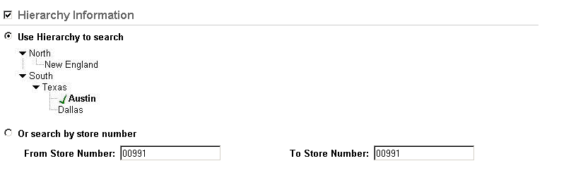

Data Fields
Field Name | Label | Default | Editable | Req’d | Data Type | Min Len | Max Len | Notes
Hierarchy Information | Hierarchy Information | Always defaults to Checked/ Expanded | True | False | Checkbox | 1 | 1 | Checkbox and header for the Hierarchy Information section. If the section is deselected, it is not included in the View criteria.
Hierarchy View Method | Use Hierarchy to View | Checked | True | True* | Radiobox | 1 | 1 | *Either “Use Hierarchy to View” or “Or View by store number” must be selected.
Hierarchy View Method | Or View by store number | Unchecked | True | True* | Radiobox | 1 | 1 | *Either “Use Hierarchy to View” or “Or View by store number” must be selected.
FromStore Number | From Store Number: | None | True | False | Alphanumeric | 5 | 5 | System Searches for transactions where the store number is equal to or greater than this number. If the field entry is deleted, the system Searches all stores up to the entry in the ‘to’ field. The store number range is limited by the user's allowed hierarchy level and its entries as entered on the user's user id. Any store numbers that fall within the range but outside the allowed hierarchy level and entries are not returned in the View results.
ToStore Number | To Store Number: | None | True* | False | Alphanumeric | 5 | 5 | System Searches for transactions where the store number is less than or equal to this number. *Defaults to uneditable. Enabled when the user types an entry in the ‘from’ field, and autofills the entry from the ‘from’ field. If the field entry is deleted, the system Searches all stores from the ‘from’ field entry forward. (no end)

Item Information

Description
Item Information View criteria includes item number, UPC, or style, as well as items that received a price or were cleared (deleted) from the transaction before tendering.

Screen Subsection Mockup
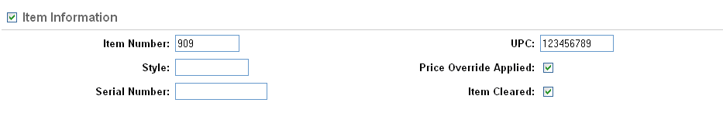

Data Fields
Field Name | Label | Default | Editable | Req’d | Data Type | Min Len | Max Len | Notes
Item Information | Item Information | See particular screens. | True | False | Checkbox | 1 | 1 | Checkbox and header for the Item Information section. If the section is deselected, it is not included in the View criteria.
ItemNumber | Item Number: | None | True | False | Alphanumeric | 1 | 14 | None
UPC | UPC: | None | True | False | Alphanumeric | 1 | 15 | None
ItemStyle | Style: | All | True | True* | Alphanumeric | 1 | 10 | Alphanumeric 1-10
Price Override | Price Override Applied: | Unchecked | True | False | Checkbox | 1 | 1 | If this box is selected, the system Searches only for items where a manual price override was entered.
Serial Number | Serial Number | None | True | False | Alphanumeric | 1 | 25 | If this field is entered, Searches for where a serial number was captured for an item on the transaction at the point-of-sale.
ItemCleared | Item Cleared: | Unchecked | True | False | Checkbox | 1 | 1 | If this box is selected, the system Searches only for items that were deleted (rung up and then Cleared from the transaction). Thus, on items that were rung and cleared, then rung again, the item initially rung and cleared would be included in the View results.

Transaction Information

Description
Transaction Information contains criteria captured on each transaction including transaction number, date, time, from and to register numbers, transaction types, Training Mode and Reentry Mode indicators.

Screen Subsection Mockup
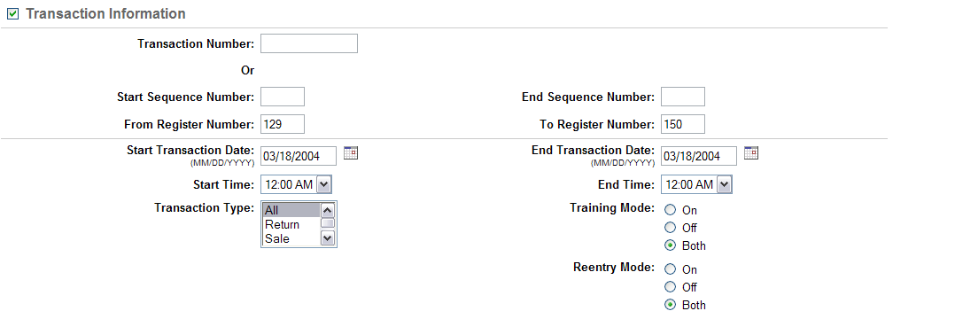

Data Fields
Field Name | Label |  | Default |  | Editable | Req’d | Data Type | Min Len |  | Max Len |  | Notes
Transaction Information |  | Transaction Information |  | See particular screens | True | False | Checkbox |  | 1 |  | 1 |  | Checkbox and header for the Transaction Information section. If the section is deselected, it is not included in the View criteria.
Transaction Number |  | Transaction Number: |  | None | True | False | Alphanumeric |  | 12 |  | 12 |  | Store Number + Register Number + Transaction Sequence Number. Case Insensitive. Also known as Receipt Number. System Searches for where the transaction number is equal to this id.
Start Sequence Number |  | Start Sequence Number: |  | None | True | False | Alphanumeric |  | 4 |  | 4 |  | Transaction Sequence Number. System Searches for where the transaction sequence number is greater than or equal to this id.
End Sequence Number |  | End Sequence Number: |  | None | True | False | Alphanumeric |  | 4 |  | 4 |  | Transaction Sequence Number. System Searches for where the transaction sequence number is less than or equal to this id.
FromRegisterNumber |  | From Register Number: |  | None | True | False | Alphanumeric |  | 1 |  | 3 |  | System Searches for transactions where the register number is greater than or equal to this number. If the field entry is deleted, the system Searches all registers up to the entry in the ‘to’ field.
ToRegisterNumber |  | To Register Number: |  | None | True* | False | Alphanumeric |  | 1 |  | 3 |  | System Searches for transactions where the register number is less than or equal to this number. *Defaults to uneditable. Enabled when the user types an entry in the ‘from’ field, and autofills the entry from the ‘from’ field. If the field entry is deleted, the system Searches all registers from the ‘from’ field entry forward. (no end)
StartTransactionDate |  | Start Transaction Date: (MM/DD/YYYY) |  | None | True | False | Date |  | 10 |  | 10 |  | System Searches for the transaction date equal to or greater than the entered date. Format MM/DD/YYYY for domestic implementations; additional format(s) may be required for international implementations.
EndTransactionDate |  | End Transaction Date: (MM/DD/YYYY) |  | None | True | False | Date |  | 10 |  | 10 |  | Format MM/DD/YYYY for domestic implementations; additional format(s) may be required for international implementations. System Searches for the transaction date less than or equal to the entered date.
StartTransactionTime |  | Start Time: (HH:MM) |  | 00:00 | True | False | Listbox |  | 10 |  | 10 |  | Displayed in the format HH:MM AM/PM, with no seconds, in 30 minute increments. System Searches for the transaction time greater than or equal to the entered hours and minutes. 00:00 represents the stroke of midnight.
EndTransactionTime |  | End Time: (HH:MM) |  | 23:59 | True | False | Listbox |  | 10 |  | 10 |  | Displayed in the format HH:MM AM/PM, with no seconds, in 30 minute increments.  System Searches for the transaction time less than or equal to the entered time. 23:59 represents time up to the stroke of midnight. (includes 23:59:59)
Training Mode |  | Training Mode |  | Both | True | True | Radiobutton |  | 1 |  | 1 |  | User can select to View only for transactions that were entered in Training Mode (On, only transactions that were entered in non-training mode (Off), or Both.

Associate Information

Description
Associate Information allows the user to enter the employee ID of the associate assigned to items.

Screen Subsection Mockup
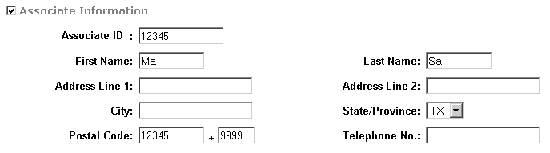

Data Fields
Field Name | Label | Default | Editable | Req’d | Data Type | Min Len | Max Len | Notes
Associate Information | Associate Information | See particular screen | True | False | Checkbox | 1 | 1 | Checkbox and header for the Associate Information section. If the section is deselected, it is not included in the View criteria.
Associate Number | Associate Number: | None | True | False | Alphanumeric | 1 | 10 | Employee ID of the associate, captured on the item level.
First Name | First Name: | None | True | True | Text | 0 | 16 | None
Last Name | Last Name: | None | True | True | Text | 0 | 20 | None
Address Line 1 | Address Line 1: | None | True | False | Text | 0 | 30 | None
Address Line 2 | Address Line 2: | None | True | False | Text | 0 | 30 | None
City | City: | None | True | False | Text | 0 | 20 | None
State/ Province Code | State/ Province: | None | True | True | List Box | N/A | N/A | Default to state/province code for the store. All Canadian provinces should be together in alphabetical order at the bottom of the list.
Postal Code | Postal Code: | None | True | True | Text | 5 | 7 | For US format must be 5-digit number. For Canadian postal code format must be Alpha/Number/Alpha (optional space) Number/Alpha/Number. The min for Canadian is 6, the max is 7.This field must have one of these two formats to be valid. Postal codes are validated against the State/Province Code.
Ext Postal Code | - | None | True | False | Numeric | 4 | 4 | This is the +4 extension of the USA postal code.
Telephone Number | Telephone No: | None | True | False | Numeric | 10 | 10 | None

Retailer Information

Description
Retailer Information allows the user to enter the retailer ID and other retailer View information.

Screen Subsection Mockup
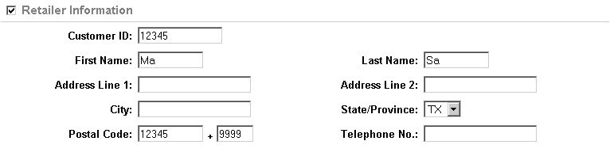

Data Fields
Field Name | Label | Default | Editable | Req’d | Data Type | Min Len | Max Len | Notes
Retailer Information | Retailer Information | None | False | True | Text | 1 | 20 | Header
Retailer ID | None | None | True | True | Alphanumeric | 1 | 14 | Case Insensitive. Retailer ID regardless of whether the retailer is a business or individual.
First Name | First Name: | None | True | True | Text | 0 | 16 | None
Last Name | Last Name: | None | True | True | Text | 0 | 20 | None
Address Line 1 | Address Line 1: | None | True | False | Text | 0 | 30 | None
Address Line 2 | Address Line 2: | None | True | False | Text | 0 | 30 | None
City | City: | None | True | False | Text | 0 | 20 | None
State/ Province Code | State/ Province: | None | True | True | List Box | N/A | N/A | Default to state/province code for the store. All Canadian provinces should be together in alphabetical order at the bottom of the list.
Postal Code | Postal Code: | None | True | True | Text | 5 | 7 | For US format must be 5-digit number. For Canadian postal code format must be Alpha/Number/Alpha (optional space) Number/Alpha/Number. The min for Canadian is 6, the max is 7.This field must have one of these two formats to be valid. Postal codes are validated against the State/Province Code.
Ext Postal Code | - | None | True | False | Numeric | 4 | 4 | This is the +4 extension of the USA postal code.
Telephone Number | Telephone No: | None | True | False | Numeric | 10 | 10 | None

Signature Information

Description
Signature Information allows the user to enter identifying information for locating a signature or signatures captured with tenders used on a retail transaction.

Screen Subsection Mockup
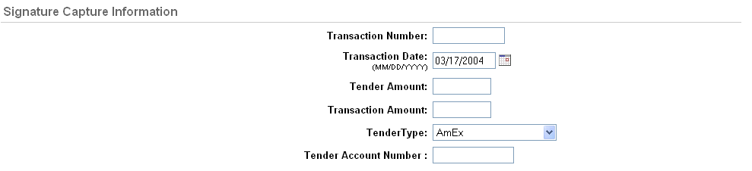

Data Fields
Field Name |  | Label | Default | Editable | Req’d | Data Type | Min Len | Max Len | Notes
Signature Capture Information | Signature Capture Information |  | None | False | True | Text | 1 | 29 | Header
Transaction Number | Transaction Number: |  | None | True | False | Alphanumeric | 12 | 12 | Store Number + Register Number + Transaction Sequence Number. Case Insensitive. Also known as Receipt Number. System Searches for where the transaction number is equal to this id.
TransactionDate |  | Transaction Date: (MM/DD/YYYY) | None | True | False | Date | 10 | 10 | System Searches for the transaction date equal to the entered date. Format MM/DD/YYYY for domestic implementations; additional format(s) may be required for international implementations.
TenderAmount |  | Tender Amount: | None | True | False | Currency | 4 | 9 | System Searches for where the tender amount (for any one tender, upon a split tender) is equal to this amount. Accurate to two decimal places.
TransactionAmount |  | Transaction Amount | None | True | False | Currency | 4 | 9 | System Searches for where the transaction total is equal to this amount. Accurate to two decimal places.
TenderType |  | Tender Type: | All | True | False | Listbox | N/A | N/A | Choices are populated from the combination of the Tenders for Signature View parameter as defined in the default parameter file through the Parameter UI requirement of Central Office and the Parameters Names and Values Addendum document for POS, and the granted Role/Security permissions by tender type. System Searches among potentially multiple tenders per transaction. If two tenders on the same transaction are found as a match, the transaction is only displayed once and counted as one match.
TenderID |  | Tender Account Number: | None | True | False | Alphanumeric | 1 | 19 | Used in conjunction with the Tender Type field. Length should accommodate the longest id format, currently Gift Card Number at 19. System Searches for transactions where any of the Tender Types selected have a Tender ID equal to this field. If more than one tender type is selected, e.g. credit card and debit card, system Searches for where the tender type = credit card and tender id = this number OR tender type = debit card and tender id = this number.  Displayed as asterisks during typing and subsequent screen display, according to security setting.

Electronic Journal Information

Description
The Electronic Journal View section allows the user to View for the minimal data that is captured with the electronic journal ‘blob’ transmitted from the point of sale. This View section is neither optional nor included in other Searches, since it Searches different information than the other Searches.

Screen Subsection Mockup
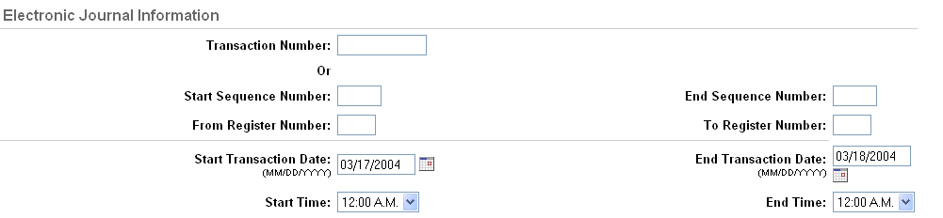

Data Fields
Field Name | Label |  | Default |  | Editable | Req’d | Data Type | Min Len |  | Max Len |  | Notes
Electronic Journal Information |  | Electronic Journal Information |  | None | False | True | Text |  | 1 |  | 30 |  | Header
Transaction Number |  | Transaction Number: |  | None | True | False | Alphanumeric |  | 12 |  | 12 |  | Store Number + Register Number + Transaction Sequence Number. Case Insensitive. Also known as Receipt Number. System Searches for where the transaction number is equal to this id.
Start Sequence Number |  | Start Sequence Number: |  | None | True | False | Alphanumeric |  | 4 |  | 4 |  | Transaction Sequence Number. System Searches for where the transaction number is greater than or equal to this id.
End Sequence Number |  | End Sequence Number: |  | None | True | False | Alphanumeric |  | 4 |  | 4 |  | Transaction Sequence Number. System Searches for where the transaction sequence number is less than or equal to this id.
FromRegisterNumber |  | From Register Number: |  | None | True | False | Alphanumeric |  | 1 |  | 3 |  | System Searches for transactions where the register number is greater than or equal to this number. If the field entry is deleted, the system Searches all registers up to the entry in the ‘to’ field.
ToRegisterNumber |  | To Register Number: |  | None | True* | False | Alphanumeric |  | 1 |  | 3 |  | System Searches for transactions where the register number is less than or equal to this number. *Defaults to uneditable. Enabled when the user types an entry in the ‘from’ field, and autofills the entry from the ‘from’ field. If the field entry is deleted, the system Searches all registers from the ‘from’ field entry forward. (no end)
StartTransactionDate |  | Start Transaction Date: (MM/DD/YYYY) |  | None | True | False | Date |  | 10 |  | 10 |  | System Searches for the transaction date equal to or greater than the entered date. Format MM/DD/YYYY for domestic implementations; additional format(s) may be required for international implementations.
EndTransactionDate |  | End Transaction Date: (MM/DD/YYYY) |  | None | True | False | Date |  | 10 |  | 10 |  | Format MM/DD/YYYY for domestic implementations; additional format(s) may be required for international implementations. System Searches for the transaction date less than or equal to the entered date.
StartTransactionTime |  | Start Time: (HH:MM) |  | 00:00 | True | False | Listbox |  | 10 |  | 10 |  | Displayed in the format HH:MM AM/PM, with no seconds, in 30 minute increments. System Searches for the transaction time greater than or equal to the entered hours and minutes. 00:00 represents the stroke of midnight.
EndTransactionTime |  | End Time: (HH:MM) |  | 23:59 | True | False | Listbox |  | 10 |  | 10 |  | Displayed in the format HH:MM AM/PM, with no seconds, in 30 minute increments.  System Searches for the transaction time less than or equal to the entered time. 23:59 represents time up to the stroke of midnight. (includes 23:59:59)

Results

Description
The Results section allows the user to specify the number of records to display before Next 1/2/3 navigation is invoked. The value in the field defaults from the Default Lines on View Result parameter, but can be overridden. Results is always shown, and never deselected or collapsed via a checkbox.

Screen Subsection Mockup

Data Fields
Field Name | Label | Default | Editable | Req’d | Data Type | Min Len | Max Len | Notes
Results | Results | None | False | True | Text | 1 | 7 | Header for the Results section.
ShowResultsPerPage | Show per page: | Value held in the Default Lines on View Result parameter | True | True | Numeric | 0 | 3 | Parameter description found in Central Office parameters list.

View by Item

Brief Description
This screen allows the user to perform a detailed View/insert for records in the transaction data captured through the point of sale application, targeted by item. The View criteria consists of four areas:
- Hierarchy Information: defaults to expanded/selected
- Item Information: defaults to expanded/selected
- Transaction Information: defaults to collapsed/deselected
- Results
When the user selects View, the system Searches for records that meet all of the criteria entered. Any entry fields that are left blank or appear in a collapsed/deselected section are not used as View criteria (e.g. if no transaction dates are entered, all transaction dates are eligible for inclusion in the result.).
If the user does not have access to a particular left navigation link, the link is hidden. The Transaction Tracker tab is hidden if the user does not have access to any of the left navigation links.

Mockup
Mockup shows the default expansion/collapse.

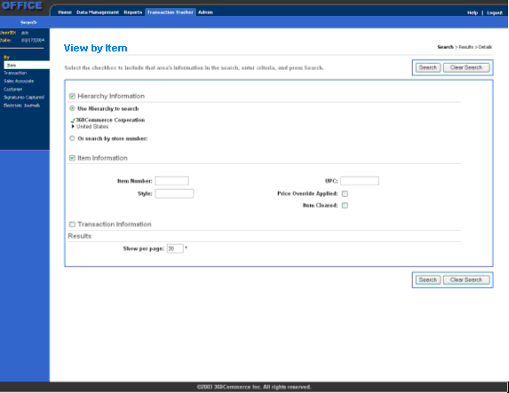

Screen Definition
Screen ID | VIEW_BY_ITEM
Screen Name | View by Item
Screen Layout | View
Message Text | Select the checkbox to include that area's information in the View, enter criteria, and press View.

Breadcrumb Definition
Crumb | Highlighted | Link
View | True | None
Results | False | None
Details | False | None

Action Buttons
 | Button | Next | Notes
1 | View | VIEW_IN_PROGRESS dialog, then  If multiple matches found: TRANSACTION_VIEW_RESULTS  If one match found: TRANSACTION_DETAIL  No matches found: INFORMATION_NOT_FOUND  Database error: DATABASE_ERROR | Performs View of database using the criteria entered or defaulted. View in Progress dialog allows the user to cancel a View that is taking too long. As soon as the record set is retrieved, the appropriate screen is displayed.
2 | Clear View | Resets the field entries to the defaults described in the Data Fields. | None

Left Navigation Links
 | Heading | Label | Next | Notes
1 | By | Item | VIEW_BY_ITEM | None
2 | By | Transaction | VIEW_BY_TRANSACTION | None
3 | By | Associate | VIEW_BY_ASSOCIATE | None
4 | By | Retailer | VIEW_BY_RETAILER | None
5 | By | Signatures Captured | VIEW_BY_SIGNATURE | None
6 | By | Electronic Journals | VIEW_BY_ELECTRONIC_JOURNALS | None

Data Fields
Field Name | Label | Default | Editable | Req’d | Data Type | Min Len | Max Len | Notes
Hierarchy Information | Hierarchy Information | Checked/ Expanded | True | False | Checkbox | 1 | 1 | Checkbox and header for the Hierarchy Information section. See the Common View Elements screen information for the exact data fields.
Item Information | Item Information | Checked/ Expanded | True | False | Checkbox | 1 | 1 | Checkbox and header for the Item Information section. See the Common View Elements screen information for the exact data fields.
Transaction Information | Transaction Information | Unchecked/Collapsed | True | False | Checkbox | 1 | 1 | Checkbox and header for the Transaction Information section. See the Common View Elements screen information for the exact data fields.
Results | Results | None | False | True | Text | 1 | 7 | Header for the Results section. See the Common View Elements screen information for the exact data fields.

Journal View

Brief Description
This screen shows the journal information that was captured for the transaction. From this screen the user can:
- Return to the data view.
- Go to the signature capture view, if signature capture was required and completed on the transaction.
- Export the journal data.
- Return to the View by Item screen, View by Transaction, or View by Associate screen
The left navigation link that is highlighted depends on the View route that the user selected.
If the user does not have access to a particular left navigation link, the link is hidden. If the user does not have access to any of the left navigation links the E-Journal tab is hidden.
If the user does not have access to Transaction Tracker:
- Show Transaction Detail, the ‘Go to Data View’ link is hidden.
- Show Signatures Captured, the ‘Go to Signature Capture View’ link is hidden.
- Show Retailer Information, the ‘Go to Retailer Information’ link is hidden.

Screen Definition
Screen ID | JOURNAL_VIEW
Screen Name | Journal View
Screen Layout | Detail
Message Text | Go to Data View (goes to TRANSACTION_DETAIL)  Go to Signature Capture View (goes to SIGNATURE_CAPTURE_VIEW; hidden if inapplicable for this transaction)  Go to Retailer Information (goes to RETAILER_INFORMATION, hidden if not captured for this transaction)  Select the appropriate action button or link to continue.

Breadcrumb Definition
Crumb | Highlighted | Link
View | False | None
Results | False | None
Details | True | None

Action Buttons
 | Button | Next | Notes
1 | Export | EXPORT_JOURNAL_DATA | None
2 | Done | ITEM_VIEW_RESULTS or TRANSACTION_VIEW_RESULTS | None

Left Navigation Links
 | Heading | Label | Next | Notes
1 | By | Item | VIEW_BY_ITEM | None
2 | By | Transaction | VIEW_BY_TRANSACTION | None
3 | By | Associate | VIEW_BY_ASSOCIATE | None
4 | By | Retailer | VIEW_BY_RETAILER | None
5 | By | Signatures Captured | VIEW_BY_SIGNATURE | None
6 | By | Electronic Journals | VIEW_BY_ELECTRONIC_JOURNALS | None

Data Fields
Field Name | Label | Default | Editable | Req’d | Data Type | Min Len | Max Len | Notes
Transaction Journal | None | None | False | True | Text | N/A | N/A | This is the journal “blob” as captured at the point of sale application.  Note: any credit card or debit card numbers must be masked with asterisks at the point of sale if the information is to be hidden in Central Office.

View by Transaction

Brief Description
This screen allows the user to perform a detailed View for records in the transaction data captured. The View criteria consist of four areas:
- Hierarchy Information: defaults to expanded/selected
- Transaction Information: defaults to expanded/selected
- Tender Information: defaults to collapsed/deselected
- Results
When the user selects View, the system Searches for records that meet all of the criteria entered. Any entry fields that are left blank are not used as View criteria (e.g. if no transaction number is entered, all transaction numbers are eligible for inclusion in the result.).
While the View is being performed, the system displays a View in Progress dialog that allows the user to cancel a View that is taking too long. When the user cancels the View, the system returns to this screen with the previously entered criteria defaulted so that the user can refine the criteria.
If the user does not have access to a particular left navigation link, the link is hidden. If the user does not have access to any of the left navigation links the E-Journal tab is hidden.

Mockup
Mockup shows the default expansion/collapse.
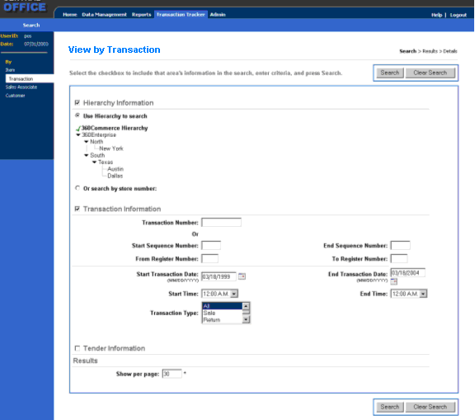

Screen Definition
Screen ID | VIEW_BY_TRANSACTION
Screen Name | View by Transaction
Screen Layout | View
Message Text | Select the checkbox to include that area's information in the View, enter criteria, and press View.

Breadcrumb Definition
Crumb | Highlighted | Link
View | True | None
Results | False | None
Details | False | None

Action Buttons
 | Button | Next | Notes
1 | View | VIEW_IN_PROGRESS dialog, then  If multiple matches found: TRANSACTION_VIEW_RESULTS  If one match found: TRANSACTION_DETAIL  No matches found: INFORMATION_NOT_FOUND  Database error: DATABASE_ERROR | Performs View of database using the criteria entered or defaulted. View in Progress dialog allows the user to cancel a View that is taking too long. As soon as the record set is retrieved, the appropriate screen is displayed.
2 | Clear View | Resets the field entries to the defaults or blank, according to the Data Fields. | None

Left Navigation Links
 | Heading | Label | Next | Notes
1 | By | Item | VIEW_BY_ITEM | None
2 | By | Transaction | VIEW_BY_TRANSACTION | None
3 | By | Associate | VIEW_BY_ASSOCIATE | None
4 | By | Retailer | VIEW_BY_RETAILER | None
5 | By | Signatures Captured | VIEW_BY_SIGNATURE | None
6 | By | Electronic Journals | VIEW_BY_ELECTRONIC_JOURNALS | None

Data Fields
Field Name | Label | Default | Editable | Req’d | Data Type | Min Len | Max Len | Notes
Hierarchy Information | Hierarchy Information | Checked/ Expanded | True | False | Checkbox | 1 | 1 | Checkbox and header for the Hierarchy Information section. See the Common View Elements screen information for the exact data fields.
Transaction Information | Transaction Information | Unchecked/Collapsed | True | False | Checkbox | 1 | 1 | Checkbox and header for the Transaction Information section. See the Common View Elements screen information for the exact data fields.
Tender Information | Tender Information | Unchecked/ collapsed | True | False | Checkbox | 1 | 1 | Checkbox and header for the Item Information section. See the Common View Elements screen information for the exact data fields.
Results | Results | None | False | True | Text | 1 | 7 | Header for the Results section. See the Common View Elements screen information for the exact data fields.

Transaction View Results

Brief Description
This screen displays the results of an item, transaction, or associate View. The user can:
- Select individual entries with a checkmark and export the details of those entries.
- Export the entire View results list (with all entries in the list, spanning all results pages).
- Select the link on the transaction number to go to details for the entire transaction, when the originating View was by item, transaction, associate, or retailer. When the originating View is by signature, the link goes to the Signature Capture View.
If more than one page of View results exists, Next/1/2/3 navigation is displayed at the bottom of the table per the UI guidelines.
If only one matching View result is found, this screen is skipped.
If the user does not have access to a particular left navigation link, the link is hidden. If the user does not have access to any of the left navigation links the Transaction Tracker tab is hidden.
If the user does not have access to Transaction Tracker -Show Transaction Detail, the system links to:
- Journal View from the Transaction View Results screen, if the user has access.
- To Signature Capture View, if Journal View is not allowed.
- The link is removed if none are allowed.

Screen Definition
Screen ID | TRANSACTION_VIEW_RESULTS
Screen Name | Transaction View Results
Screen Layout | List
Message Text | Select the appropriate action button or link to continue.

Breadcrumb Definition
Crumb | Highlighted | Link
View | False | None
Results | True | None
Details | False | None

Action Buttons
 | Button | Next | Notes
3 | Export | EXPORT_JOURNAL_DATA | Prompts the user for the desired export format to receive the entire list.
4 | Done | VIEW_BY_TRANSACTION | None

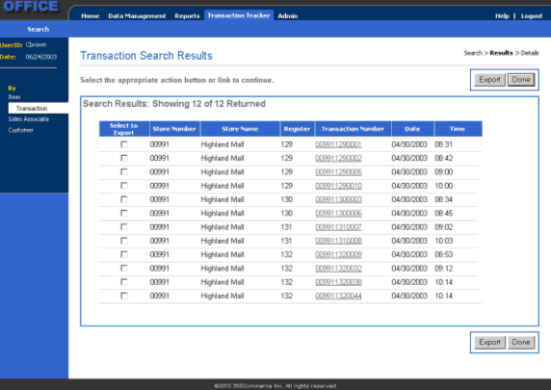Left Navigation Links
 | Heading | Label | Next | Notes
1 | By | Item | VIEW_BY_ITEM | None
2 | By | Transaction | VIEW_BY_TRANSACTION | None
3 | By | Associate | VIEW_BY_ ASSOCIATE | None
4 | By | Retailer | VIEW_BY_RETAILER | None
5 | By | Signatures Captured | VIEW_BY_SIGNATURE | None
6 | By | Electronic Journals | VIEW_BY_ELECTRONIC_JOURNALS | None

Data Fields
Field Name | Label | Default | Editable | Req’d | Data Type | Min Len | Max Len | Notes
CheckToSelect | Select to Export | Unchecked | True | False | Checkbox | 1 | 1 | Designates items for use in the Export
StoreNumber | Store Number | None | False | True | Alphanumeric | 1 | 5 | None
StoreName | Store Name | None | False | True | Text | 1 | 20 | None
Register | Register | None | False | True | Alphanumeric | 1 | 3 | None
TransactionID | Transaction Number | None | False | True | Alphanumeric | 12 | 12 | None  From Searches by item, transaction, associate, and retailer, goes to appropriate screen based on security hierarchy. See Brief Description for details.  From View by signature, goes to SIGNATURE_CAPTURE_VIEW
TransactionDate | Date | None | False | True | Date | 10 | 10 | None
TransactionTime | Time | None | False | True | Time | 5 | 5 | None
TransactionType | Transaction Type | None | False | True | Alphanumeric | 1 | 16 | Sale, Return, etc. (see Assumptions)

Transaction Detail

Brief Description
This screen displays detailed transaction information, with the item
This screen is also used when the user has selected to View for journal information by Associate, and the user has selected to go to the transaction detail, or when the user has selected to View by Item, and the user selected to go to the transaction detail. In that case, the highlight on the left side is on the appropriate View option and control returns to the calling View screen.
Sections shown in transaction detail are dependant on the transaction type. See Data Fields and Mockups for further information.
If the user does not have access to a particular left navigation link, the link is hidden. If the user does not have access to any of the left navigation links the E-Journal tab is hidden.
If the user does not have access to Transaction Tracker:
- Allow Export of Transaction Detail, the Export button is hidden.
- Show Journal View, the ‘Go to Journal View’ link is hidden.
- Show Signatures Captured, the ‘Go to Signature Capture View’ link is hidden.
- Show Retailer Information, the ‘Go to Retailer Information’ link is hidden.

Mockup – Pay in Transaction for Salary of associate
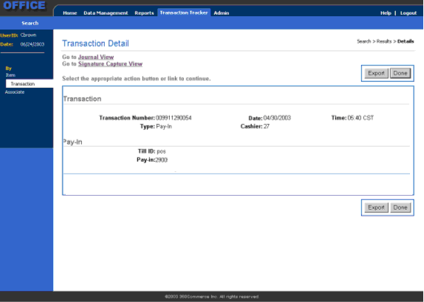

Mockup – Unsupported Transaction Type
The mockup displayed is what appears when you attempt to view a transaction which does not exist.

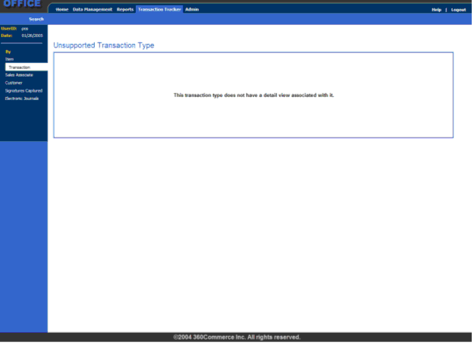

Screen Definition
Screen ID | TRANSACTION_DETAIL
Screen Name | Transaction Detail
Screen Layout | Detail
Message Text | Go to Journal View (goes to JOURNAL_VIEW)  Go to Signature Capture View (goes to SIGNATURE_CAPTURE_VIEW; hidden if inapplicable for this transaction)  Go to Retailer Information (goes to RETAILER_INFORMATION, hidden if not captured for this transaction)  Select the appropriate action button or link to continue.

Breadcrumb Definition
Crumb | Highlighted | Link
View | False | None
Results | False | None
Details | True | None

Action Buttons
 | Button | Next | Notes
1 | Export | EXPORT_JOURNAL_DATA | None
2 | Done | If the result of one match:  VIEW_BY_TRANSACTION, VIEW_BY_ASSOCIATE, or VIEW_BY_ITEM  If the result of > 1 match:  TRANSACTION_VIEW_RESULTS | Screen depends on the View route followed into this screen.

Left Navigation Links
 | Heading | Label | Next | Notes
1 | By | Item | VIEW_BY_ITEM | None
2 | By | Transaction | VIEW_BY_TRANSACTION | None
3 | By | Associate | VIEW_BY_ASSOCIATE | None
4 | By | Retailer | VIEW_BY_RETAILER | None
5 | By | Signatures Captured | VIEW_BY_SIGNATURE | None
6 | By | Electronic Journals | VIEW_BY_ELECTRONIC_JOURNALS | None

Data Fields
The following sections show on all transaction detail screens:
Field Name | Label | Default | Editable | Req’d | Data Type | Min Len | Max Len | Notes
Hierarchy Levels 1 through n | Hierarchy | None | False | True | Text | N/A | N/A | The full hierarchy, including store number-name and register, separated by chevrons.
VOIDED | VOIDED | VOIDED | False | False | Text | 6 | 6 | If transaction is voided, the word VOIDED in red should display just above Transaction Number. Link to Void Transaction.
TransactionID | Transaction Number: | None | False | True | Alphanumeric | 12 | 12 | None
TransactionDate | Date: | None | False | True | Date | 10 | 10 | The transaction date.
TransactionTime | Time at which the transaction occurred. | None | False | True | Time | 5 | 5 | Represents the time recorded on the transaction (no conversion between time zones into local time.) Displayed in the format HH:MM, military time, with no seconds.
TransactionType | Type: | None | False | True | Alphanumeric | 1 | 16 | None
Employee Name | Associate: | None | False | True | Alphanumeric | 0 | 36 | Employee Name  captured on the transaction.
Employee ID | Sales: | None | False | False | Alphanumeric | 1 | 10 | Associate employee id as captured on the item if applicable, otherwise blank.

The following information shows on Sales, Returns, and Exchanges:
Field Name | Label | Default | Editable | Req’d | Data Type | Min Len | Max Len | Notes
ItemNumber | Item Number/Description (column header) | None | False | True | Alphanumeric | 1 | 14 | (column header over the following)
ItemDescription | None | None | False | True | Alphanumeric | 0 | 255 | Item Description (long) truncated according to screen real estate.
UPC | UPC: | None | False | False | Alphanumeric | 0 | 15 | UPC is captured in database; if multiple UPCs exist, first one retrieved.
Color | Color: | None | False | False | Text | 0 | 30? | Color from Item Maintenance package.
Style | Style: | None | False | False | Alphanumeric | 0 | 10 | Style from Item Maintenance package.
Size | Size: | None | False | False | Alphanumeric | 0 | 10 | Size from Item Maintenance package.
Quantity | Quantity | None | False | True | Numeric | 1 | 6 | Shows decimal points for fractional unit of measure, if applicable. (999.99)  Label also serves as column header over the following.
SalesAssociateName | Associate: | None | False | False | Alphanumeric | 1 | 40 | Label and Associate Name show if one was captured for the item; otherwise blank with no label.
GiftRegistryID | Gift Registry: | None | False | False | Alphanumeric | 1 | 14 | Label and Gift Registry Number show if one was captured on the item; otherwise blank with no label.
SerialNumber | Serial Number: | None | False | False | Alphanumeric | 1 | 25 | Label and Serial Number show if one was captured on the item; otherwise blank with no label.
SendIndicator | Send | None | False | False | Text | 1 | 4 | “Send” shows if the item was selected for send; otherwise blank.
PriceOverride | Price overriden | None | False | False | Text | 1 | 15 | “Price overridden” shows if the item’s price was overridden on this transaction; otherwise blank.
ItemCleared | Item Cleared: | None | False | False | Text | 1 | 12 | “Item cleared” indicates the item was cleared from the transaction before tendering.
Subtotal | Subtotal | None | False | True | Currency | 4 | 9 | Transaction subtotal.
Discount | Discount | None | False | True | Currency | 4 | 9 | Total discounts applied to item or transaction level.
Tax | Tax | None | False | True | Currency | 4 | 9 | Total tax applied to the transaction.
Quantity | Quantity | None | False | True | Numeric | 1 | 6 | Shows decimal points for fractional unit of measure, if applicable. (999.99)
Total | Total | None | False | True | Currency | 4 | 9 | May not necessarily match the total of items shown above, since some items may have been cleared from the transaction.
TenderType | Type | None | False | True | Text | 1 | 25 | Name of each tender applied to the transaction, including Change (Cash) if applicable.
TenderID | Tender ID: | None | False | False | Alphanumeric | 1 | 19 | Length should accommodate the longest id format, currently Gift Card Number at 19.  Displayed as asterisks according to security setting.
TenderAmount | Amount | None | False | True | Currency | 4 | 9 | Amount applied or (refunded) for this particular tender type.
Signature(s) Captured | Signature(s) Captured | None | False | False | Text | 21 | 21 | Section header and following fields appear only if 1. the user has appropriate security to view captured signatures and 2. signature(s) were captured on the transaction.
TenderType | Type | None | False | True | Text | 1 | 25 | Name of each tender applied to the transaction, including Change (Cash) if applicable.
TenderID | Tender ID: | None | False | True | Alphanumeric | 1 | 19 | Length should accommodate the longest id format, currently Gift Card Number at 19.  Displayed as asterisks according to security setting.
TenderAmount | Amount | None | False | True | Currency | 4 | 9 | Amount applied or (refunded) for this particular tender type.
ExpirationDate | Expires: | None | False | False | Date | 10 | 10 | Expiration date of the tender id if applicable. Displayed as asterisks according to security setting.
ApprovalCode | Auth: | None | False | False | Alphanumeric | 1 | 15 | Approval code, if applicable for the tender type, and indicator of (M) manual entry or (A) automatic scan.

View by Associate

Brief Description
This screen allows the user to perform a detailed View for records contained in the transaction data, captured through POS, with View fields for associates assigned to the transaction level or item level. The View criteria consist of four areas:
- Hierarchy Information: defaults to expanded/selected
- Associate Information: defaults to expanded/selected
- Transaction Information: defaults to collapsed/deselected
- Item Information: defaults to collapsed/deselected
- Results
When the user selects View, the system Searches for records that meet all of the criteria entered. Any entry fields that are left blank are not used as View criteria.
While the View is being performed, the system displays a View in Progress dialog that allows the user to cancel a View that is taking too long. When the user cancels the View, the system returns to this screen with the previously entered criteria defaulted so that the user can refine the criteria.
If the user does not have access to a particular left navigation link, the link is hidden. If the user does not have access to any of the left navigation links the E-Journal tab is hidden.

Mockup
Mockup shows default expansion/collapse.
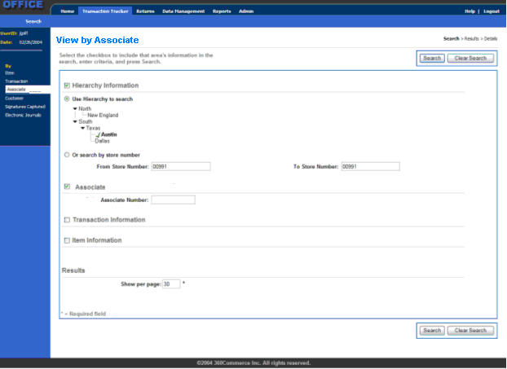

Screen Definition
Screen ID | VIEW_BY_ASSOCIATE
Screen Name | View by Associate
Screen Layout | View
Message Text | Select the checkbox to include that area's information in the View, enter criteria, and press View.

Breadcrumb Definition
Crumb | Highlighted | Link
View | True | None
Results | False | None
Details | False | None

Action Buttons
 | Button | Next | Notes
1 | View | VIEW_IN_PROGRESS dialog, then TRANSACTION_VIEW_RESULTS  If one match found: TRANSACTION_DETAIL  No matches found: INFORMATION_NOT_FOUND  Database error: DATABASE_ERROR  Too many matches: TOO_MANY_MATCHES_ERROR | Performs View of database using the criteria entered or defaulted. The View in Progress dialog allows the user to cancel a View that is taking too long to display records. As soon as the record set is retrieved, the appropriate screen is displayed.
2 | Clear View | Resets the field entries to the defaults or blank, according to the Data Fields. | None

Left Navigation Links
 | Heading | Label | Next | Notes
1 | By | Item | VIEW_BY_ITEM | None
2 | By | Transaction | VIEW_BY_TRANSACTION | None
3 | By | Associate | VIEW_BY_ASSOCIATE | None
4 | By | Retailer | VIEW_BY_RETAILER | None
5 | By | Signatures Captured | VIEW_BY_SIGNATURE | None
6 | By | Electronic Journals | VIEW_BY_ELECTRONIC_JOURNALS | None

Data Fields
Field Name | Label | Default | Editable | Req’d | Data Type | Min Len | Max Len | Notes
Hierarchy Information | Hierarchy Information | Checked/Expanded | True | False | Checkbox | 1 | 1 | Checkbox and header for the Hierarchy Information section. See the Common View Elements screen information for the exact data fields.
Associate Information | Associate Information | Checked/Expanded | True | False | Checkbox | 1 | 1 | Checkbox and header for the Associate Information section. See the Common View Elements screen information for the exact data fields.
Transaction Information | Transaction Information | Unchecked/Collapsed | True | False | Checkbox | 1 | 1 | Checkbox and header for the Transaction Information section. See the Common View Elements screen information for the exact data fields.
Item Information | Item Information | Unchecked/Collapsed | True | False | Checkbox | 1 | 1 | Checkbox and header for the Item Information section. See the Common View Elements screen information for the exact data fields.
Results | Results | None | False | True | Text | 1 | 7 | Header for the Results section. See the Common View Elements screen information for the exact data fields.

View by Retailer

Brief Description
This screen allows the user to perform a detailed View for records in the transaction data captured through POS, with View fields for retailers and transaction criteria. The View criteria consist of four areas:
- Hierarchy Information: defaults to expanded/selected
- Retailer Information: defaults to expanded/selected
- Transaction Information: defaults to collapsed/deselected
- Results
When the user selects View, the system Searches for records that meet all of the criteria entered. Any entry fields that are left blank are not used as View criteria.
While the View is being performed, the system displays a View in Progress dialog that allows the user to cancel a View that is taking too long. When the user cancels the View, the system returns to this screen with the previously entered criteria defaulted so that the user can refine the criteria.
If the user does not have access to a particular left navigation link, the link is hidden. If the user does not have access to any of the left navigation links the E-Journal tab is hidden.

Mockup
Mockup shows default expansion/collapse.
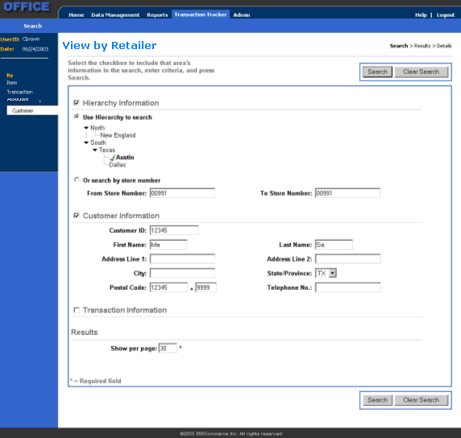

Screen Definition
Screen ID | VIEW_BY_RETAILER
Screen Name | View by Retailer
Screen Layout | View
Message Text | Select the checkbox to include that area's information in the View, enter criteria, and press View.

Breadcrumb Definition
Crumb | Highlighted | Link
View | True | None
Results | False | None
Details | False | None

Action Buttons
 | Button | Next | Notes
1 | View | VIEW_IN_PROGRESS dialog, then TRANSACTION_VIEW_RESULTS  If one match found: TRANSACTION_DETAIL  No matches found: INFORMATION_NOT_FOUND  Database error: DATABASE_ERROR  Too many matches: TOO_MANY_MATCHES_ERROR | Performs View of database using the criteria entered or defaulted. The View in Progress dialog allows the user to cancel a View that is taking too long to display records. As soon as the record set is retrieved, the appropriate screen is displayed.
2 | Clear View | Resets the field entries to the defaults or blank, according to the Data Fields. | None

Left Navigation Links
 | Heading | Label | Next | Notes
1 | By | Item | VIEW_BY_ITEM | None
2 | By | Transaction | VIEW_BY_TRANSACTION | None
3 | By | Associate | VIEW_BY_ASSOCIATE | None
4 | By | Retailer | VIEW_BY_RETAILER | None
5 | By | Signatures Captured | VIEW_BY_SIGNATURE | None
6 | By | Electronic Journals | VIEW_BY_ELECTRONIC_JOURNALS | None

Data Fields
Field Name | Label | Default | Editable | Req’d | Data Type | Min Len | Max Len | Notes
Hierarchy Information | Hierarchy Information | Checked/Expanded | True | False | Checkbox | 1 | 1 | Checkbox and header for the Hierarchy Information section. See the Common View Elements screen information for the exact data fields.
Retailer Information | Retailer Information | Checked/Expanded | True | False | Checkbox | 1 | 1 | Checkbox and header for the Retailer Information section. See the Common View Elements screen information for the exact data fields.
Transaction Information | Transaction Information | Unchecked/Collapsed | True | False | Checkbox | 1 | 1 | Checkbox and header for the Transaction Information section. See the Common View Elements screen information for the exact data fields.
Results | Results | None | False | True | Text | 1 | 7 | Header for the Results section. See the Common View Elements screen information for the exact data fields.

View by Signature

Brief Description
This screen allows the user to perform a detailed View for signatures captured with a tender on a retail transaction. This View includes:
- Hierarchy Information: defaults to expanded/selected
- Signature Capture Information: defaults to expanded/selected
- Results
When the user selects View, the system Searches for records that meet all of the criteria entered. Any entry fields that are left blank or appear in a collapsed/deselected section are not used as View criteria (e.g. if no transaction dates are entered, all transaction dates are eligible for inclusion in the result.).
While the View is being performed, the system displays a View in Progress dialog that allows the user to cancel a View that is taking too long. When the user cancels the View, the system returns to this screen with the previously entered criteria defaulted so that the user can refine the criteria.
If the user does not have access to a particular left navigation link, the link is hidden. If the user does not have access to any of the left navigation links the E-Journal tab is hidden.

Mockup
Mockup shows the default expansion/collapse.
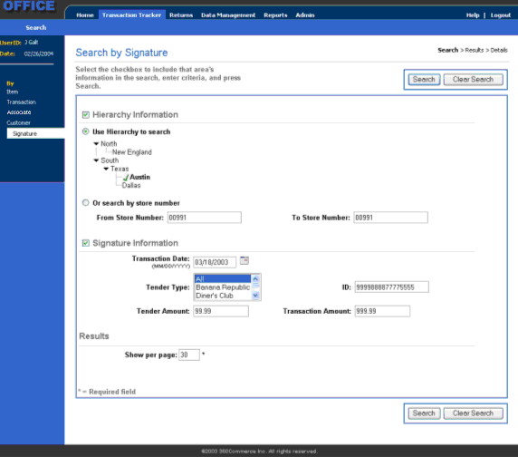

Screen Definition
Screen ID | VIEW_BY_SIGNATURE
Screen Name | View by Signature
Screen Layout | View
Message Text | Select the checkbox to include that area's information in the View, enter criteria, and press View.

Breadcrumb Definition
Crumb | Highlighted | Link
View | True | None
Results | False | None
Details | False | None

Action Buttons
 | Button | Next | Notes
1 | View | VIEW_IN_PROGRESS dialog, then  If multiple matches found: TRANSACTION_VIEW_RESULTS  If one match found: SIGNATURE_CAPTURE_VIEW  No matches found: INFORMATION_NOT_FOUND  Database error: DATABASE_ERROR | Performs View of database using the criteria entered or defaulted. View in Progress dialog allows the user to cancel a View that is taking too long. As soon as the record set is retrieved, the appropriate screen is displayed.
2 | Clear View | Resets the field entries to the defaults described in the Data Fields. | None

Left Navigation Links
 | Heading | Label | Next | Notes
1 | By | Item | VIEW_BY_ITEM | None
2 | By | Transaction | VIEW_BY_TRANSACTION | None
3 | By | Associate | VIEW_BY_ASSOCIATE | None
4 | By | Retailer | VIEW_BY_RETAILER | None
5 | By | Signatures Captured | VIEW_BY_SIGNATURE | None
6 | By | Electronic Journals | VIEW_BY_ELECTRONIC_JOURNALS | None

Data Fields
Field Name | Label | Default | Editable | Req’d | Data Type | Min Len | Max Len | Notes
Hierarchy Information | Hierarchy Information | Checked/ Expanded | True | False | Checkbox | 1 | 1 | Checkbox and header for the Hierarchy Information section. See the Common View Elements screen information for the exact data fields.
Signature Capture Information | Signature Capture Information | Checked/ Expanded | True | False | Checkbox | 1 | 1 | Checkbox and header for the Signature Capture Information section. See the Common View Elements screen information for the exact data fields.
Results | Results | None | False | True | Text | 1 | 7 | Header for the Results section. See the Common View Elements screen information for the exact data fields.

Signature Capture View

Brief Description
This screen displays signature capture information if captured on the transaction.
If the user does not have access to a particular left navigation link, the link is hidden. If the user does not have access to any of the left navigation links the Transaction Tracker tab is hidden.
If the user does not have access to Transaction Tracker
- Allow Export of Signature Capture View, the Export button is hidden.
- Show Journal View, the ‘Go to Journal View’ link is hidden.
- Show Transaction Detail, the ‘Go to Data View’ link is hidden.
- Show Tender Ids, applicable tender ids are masked with asterisks, e.g. specific gift card number, credit card number, etc.
- Show Retailer Information, the ‘Go to Retailer Information’ link is hidden.
A signature captured for more than one type of credit card, if the user does not have access to the tender type on which one of the signatures was captured, that signature and its accompanying information are not displayed.

Mockup
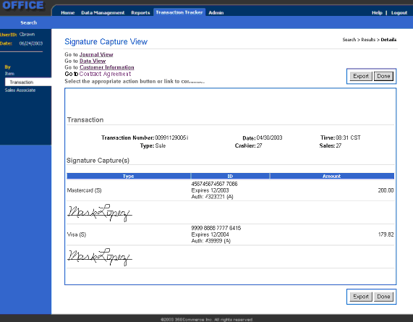

Screen Definition
Screen ID | SIGNATURE_CAPTURE_VIEW
Screen Name | Signature Capture View
Screen Layout | Detail
Message Text | Go to Journal View (goes to JOURNAL_VIEW)  Go to Data View (goes to TRANSACTION_DETAIL)  Go to Retailer Information (goes to RETAILER_INFORMATION)  Select the appropriate action button or link to continue.

Breadcrumb Definition
Crumb | Highlighted | Link
View | False | None
Results | False | None
Details | True | None

Action Buttons
 | Button | Next | Notes
1 | Export | EXPORT_JOURNAL_DATA | None
2 | Done | Depending on route to the screen:  One match found: VIEW_BY_ASSOCIATE, VIEW_BY_TRANSACTION, VIEW_BY_ITEM, VIEW_BY_RETAILER, VIEW_BY_SIGNATURE  > 1 match found: TRANSACTION_VIEW_RESULTS | None

Left Navigation Links
 | Heading | Label | Next | Notes
1 | By | Item | VIEW_BY_ITEM | None
2 | By | Transaction | VIEW_BY_TRANSACTION | None
3 | By | Associate | VIEW_BY_ASSOCIATE | None
4 | By | Retailer | VIEW_BY_RETAILER | None
5 | By | Signatures Captured | VIEW_BY_SIGNATURE | None
6 | By | Electronic Journals | VIEW_BY_ELECTRONIC_JOURNALS | None

Data Fields
Field Name | Label | Default | Editable | Req’d | Data Type | Min Len | Max Len | Notes
Hierarchy Levels 1 through n | Hierarchy | None | False | True | Text | N/A | N/A | The full hierarchy, including store number-name and register, separated by chevrons.
TransactionID | Transaction Number: | None | False | True | Alphanumeric | 12 | 12 | None
TransactionDate | Date: | None | False | True | Date | 10 | 10 | The transaction date.
TransactionTime | Time at which the transaction occurred. | None | False | True | Time | 5 | 5 | Represents the time recorded on the transaction (no conversion between time zones into local time.) Displayed in the format HH:MM, military time, with no seconds.
TransactionType | Type: | None | False | True | Alphanumeric | 1 | 16 | None
Employee Name | Associate: | None | False | True | Alphanumeric | 0 | 36 | Employee Name captured on the transaction.
Employee ID | Sales: | None | False | False | Alphanumeric | 1 | 10 | Associate employee id as captured on the item if applicable, otherwise blank.
TenderType | Type | None | False | True | Text | 1 | 25 | Name of each tender applied to the transaction, including Change (Cash) if applicable.
TenderID | Tender ID: | None | False | True | Alphanumeric | 1 | 19 | Length should accommodate the longest id format, currently Gift Card Number at 19.  Displayed as asterisks according to security setting.
TenderAmount | Amount | None | False | True | Currency | 4 | 9 | Amount applied or (refunded) for this particular tender type.
ExpirationDate | Expires: | None | False | False | Date | 10 | 10 | Expiration date of the tender id if applicable. Displayed as asterisks according to security setting.
ApprovalCode | Auth: | None | False | False | Alphanumeric | 1 | 15 | Approval code, if applicable for the tender type, and indicator of (M) manual entry or (A) automatic scan.
SignatureCapture | None | None | False | True | Binary Large Object | N/A | N/A | Note: Line is not necessary below the signature.  Portable Network Graphic  Data storage field type is BLOB. This accommodates storage of various signature formats including PNG and XY coordinates.

Export Journal Data

Brief Description
This screen allows the user to select whether to export journal data to a file in the format of PDF or TXT.
If the user does not have access to a particular left navigation link, the link is hidden. If the user does not have access to any of the left navigation links the Transaction Tracker tab is hidden.

Mockup
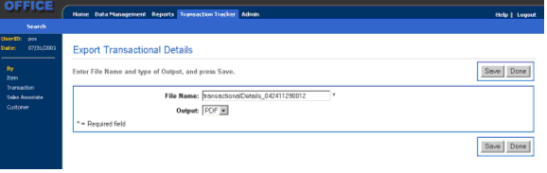

Screen Definition
Screen ID | EXPORT_TRANSACTION_DETAILS
Screen Name | Export Transaction Details
Screen Layout | Detail
Message Text | Enter File Name and type of Output, and press Save.

Breadcrumb Definition
None

Action Buttons
 | Button | Next | Notes
1 | Save | Error situations:  Database error: DATABASE_ERROR  Export error: EXPORT_ERROR  File already exists: DUPLICATE_FILE_EXISTS  Depending on route to screen: TRANSACTION_DETAIL , TRANSACTION_VIEW_RESULTS, JOURNAL_VIEW, SIGNATURE_CAPTURE_VIEW, RETAILER_INFORMATION | None
2 | Done | VIEW_BY_TRANSACTION, VIEW_BY_ITEM, VIEW_BY_ASSOCIATE, VIEW_BY_RETAILER, or VIEW_BY_SIGNATURE | None

Retailer Information

Brief Description
This screen displays retailer information if a retailer was attached to the transaction. This information is manually entered in POS, attached to a transaction and maintained in the retailer tables.
If the user does not have access to a particular left navigation link, the link is hidden. If the user does not have access to any of the left navigation links the Transaction Tracker tab is hidden.
If the user does not have access to Transaction Tracker:
- Allow Export of Retailer Information, the Export button is hidden.
- Show Journal View, the ‘Go to Journal View’ link is hidden.
- Show Transaction Detail, the ‘Go to Data View’ link is hidden.
- Show Signatures Captured, the ‘Go to Signature Capture View’ link is hidden.

Mockup
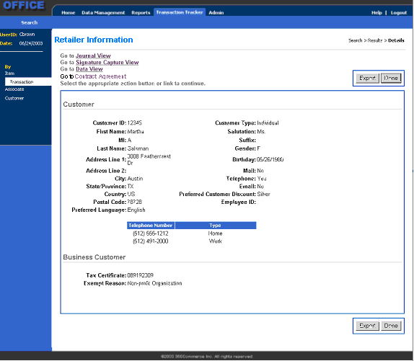

Screen Definition
Screen ID | RETAILER_INFORMATION
Screen Name | Retailer Information
Screen Layout | Detail
Message Text | Go to Journal View (goes to JOURNAL_VIEW)  Go to Data View (goes to TRANSACTION_DETAIL)  Go to Signature Capture View (goes to SIGNATURE_CAPTURE_VIEW)  Select the appropriate action button or link to continue.

Breadcrumb Definition
Crumb | Highlighted | Link
View | False | None
Results | False | None
Details | True | None

Action Buttons
 | Button | Next | Notes
1 | Export | EXPORT_JOURNAL_DATA | Prompts the user for the desired export format.
2 | Done | Depending on route to the screen:  One match found: VIEW_BY_ASSOCIATE, VIEW_BY_TRANSACTION, VIEW_BY_ITEM, VIEW_BY_RETAILER  > 1 match found: TRANSACTION_VIEW_RESULTS | None

Left Navigation Links
 | Heading | Label | Next | Notes
1 | By | Item | VIEW_BY_ITEM | None
2 | By | Transaction | VIEW_BY_TRANSACTION | None
3 | By | Associate | VIEW_BY_ASSOCIATE | None
4 | By | Retailer | VIEW_BY_RETAILER | None
5 | By | Signatures Captured | VIEW_BY_SIGNATURE | None
6 | By | Electronic Journals | VIEW_BY_ELECTRONIC_JOURNALS | None

Data Fields
Field Name | Label | Default | Editable | Req’d | Data Type | Min Len | Max Len | Notes
Retailer Header | Retailer | None | False | False | Text | 8 | 8 | Header and line for the Retailer information section.
Retailer ID | Retailer ID: | None | False | False | Alphanumeric | 1 | 14 | Display only
First Name | First Name: | None | False | False | Text | 2 | 16 | Display only
MI | MI: | None | False | False | Text | 1 | 5 | Display only
Last Name | Last Name: | None | False | False | Text | 2 | 20 | Display only
Address Line 1 | Address Line 1: | None | False | False | Text | 1 | 30 | Display only
Address Line 2 | Address Line 2: | None | False | False | Text | 0 | 30 | Display only
City | City: | None | False | False | Text | 1 | 20 | Display only
State/Province | State/Province: | None | False | False | Text | 2 | 2 | Display only
Country | Country: | None | False | False | Text | 1 | 30 | Display only
Postal Code | Postal Code: | None | False | False | Text | 5 | 9 | Complete postal code, concatenated.
Preferred Language | Preferred Language: | None | False | False | Text | 1 | 20 | Display only
Retailer Type | Retailer Type: | None | False | False | Text | 1 | 20 | Individual or Business
Salutation | Salutation: | None | False | False | Text | 1 | 4 | Display only
Suffix | Suffix: | None | False | False | Text | 0 | 4 | Display only
Gender | Gender: | None | False | False | Text | 1 | 1 | Display only
Birthday | Birthday: | None | False | False | Date | 10 | 10 | Display only
Mail | Mail: | None | False | False | Text | 2 | 3 | Yes or No
Telephone | Telephone: | None | False | False | Text | 2 | 3 | Yes or No
Email | Email: | None | False | False | Text | 2 | 3 | Yes or No
Preferred Retailer Discount | Preferred Retailer Discount: | None | False | False | Text | 0 | 30 | Display only
Employee ID | Employee ID: | None | False | False | Text | 1 | 10 | Display only
Telephone Number | Telephone Number: | None | False | False | Numeric | 10 | 10 | Display only
Type | Type: | None | False | False | Text | 1 | 10 | Type for the telephone number: Home, Work, Mobile, Fax, etc.
Business Retailer | Business Retailer: | None | False | False | Text | 17 | 17 | Header and line for the business retailer information section. Section is hidden if the retailer type = Individual.
Tax Certificate: | Tax Certificate: | None | False | False | Alphanumeric | 1 | 15 | Tax Exempt Certificate, if a business retailer.
Exempt Reason: | Exempt Reason: | None | False | False | Text | 1 | 30 | Tax Exempt Reason, if a business retailer. (from reason codes)

DIALOG SCREEN LAYOUTS

View in Progress

Brief Description
This screen is displayed when the user chooses to View for journal data from the item, transaction, or associate View screen. As soon as the record set is retrieved, the system proceeds to the appropriate View results screen.
If the user selects to cancel, the system returns to the calling View screen with the previously entered View criteria defaulted.

Screen Definition
Screen ID | VIEW_IN_PROGRESS
Screen Name | View In Progress
Screen Layout | Acknowledgement
Text 3 | View in progress.
Text 6 | Press Cancel to cancel the View.

Export Error

Brief Description
This error message is displayed when the system is unable to retrieve report data to export. The next screen is the screen from which the export originated (TRANSACTION_VIEW_RESULTS, TRANSACTION_DETAIL_DATA_VIEW, SIGNATURE_CAPTURE_VIEW, or JOURNAL_VIEW).

Screen Definition
Screen ID | EXPORT_ERROR
Screen Name | Export Error
Screen Layout | Acknowledgement Layout
Text 3 | An export error occurred while accessing the database.
Text 5 | The report was not exported.
Text 6 | Press Enter to continue.

Duplicate File

Brief Description
This dialog message displays when a duplicate file exists in the directory where the export is being saved. The user can select to overwrite the existing file or enter a new filename. If the user selects to overwrite the next screen is the screen from which the export originated (TRANSACTION_VIEW_RESULTS, TRANSACTION_DETAIL_DATA_VIEW, SIGNATURE_CAPTURE_VIEW, or JOURNAL_VIEW). If the user selects to rename the file the next screen is EXPORT_REPORT. The <ARG/> is the filename.

Screen Definition
Screen ID | DUPLICATE_FILE
Screen Name | Duplicate File
Screen Layout | Confirmation Layout
Text 3 | A file already exists with the entered filename.
Text 4 | Do you want to replace the existing <ARG/>?
Text 6 | Press Yes to overwrite the existing file.
Text 7 | Press No to rename the exporting file.

Too Many Matches

Brief Description
This is the error screen that is presented whenever the number of responses from the database inquiry exceeds the E-Journal Maximum Matches setting.
The user acknowledges the message, and the system returns to the View by Item, View by Transaction, or View by Associate screen with the previously entered information defaulted.

Screen Definition
Screen ID | TOO_MANY_MATCHES_ERROR
Screen Name | Too Many Matches
Screen Layout | Acknowledgement Layout
Text 3 | There are too many possible matches to display.
Text 5 | Press Enter to return to the previous screen and narrow the View.
.

