

TSD

DOUBLE AUTOMATIC ROUNDING OFF TENONING MACHINE

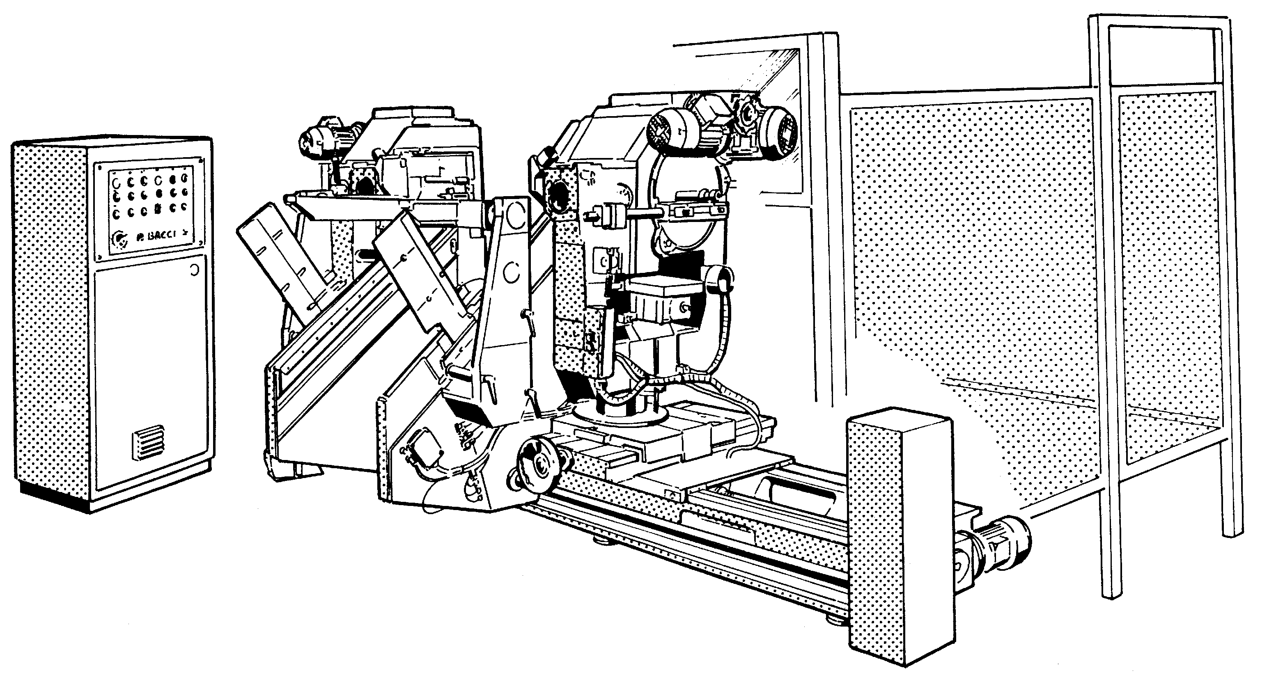

Instruction manual

TABLE OF CONTENTS

CHAP. 1 INTRODUCTION 3
CHAP. 2 HANDLING AND TRANSPORT OF THE MACHINE 7
2.1 Transport and instructions for handling 7
2.2 Dimensions, mass value(s), slinging 8
2.3 Storage of the machine 10
CHAP. 3 PUTTING THE MACHINE INTO SERVICE 11
3.1 Fastening instructions 11
3.2 Space necessary for use and maintenance 13
3.3 Allowable environmental conditions 13
3.4 Connection of the machine to its power supply 14
3.5 Indications of the noise generated by the machine (ENCLOSURE I) 19
3.6 Recommendations for the precautionary measures that must be adopted 19
CHAP. 4 DESCRIPTION OF THE MACHINE, ITS ACCESSORIES, GUARDS AND/OR SAFETY DEVICES 21
4.1 Description of the machine 21
4.2 System 24
4.3 Guards 26
4.4 Safety devices 29
4.5 Range of applications for which the machine has been projected 32
CHAP. 5 USE OF THE MACHINE 33
5.1 Control board 33
5.2 Adjustments 34
5.2.1 Adjustment of the width and thickness of the tenon 34
5.2.2 Head shift (Axis 1) 35
5.2.3 Head traverse shift (Axis 2-3) 35
5.2.4 Inclination of the head (Axis 4-5) 36
5.2.5 Head rise (axis 8-9) 37
5.3 Start-up 38
5.4 Ways and means of stopping 39
5.5 Information about risks that cannot be eliminated by the measures adopted by the designer - Remaining risks 40
5.6 Troubleshooting 41
CHAP. 6 MAINTENANCE 43
6.1 Nature and frequency of the inspections 44
6.1.1 Daily maintenance 44
6.1.2 Weekly maintenance 44
6.1.3 Monthly maintenance 44
6.1.4 Annual maintenance 45
6.1.5 Lubrication program 46
6.1.6 Lubrication points 47
ENCLOSURE 1: Indications of the noise generated by the machine 53

TABLE OF CONTENTS OF THE FIGURES

Fig. 1 Slinging of the machine 8
Fig. 2 Handling and transport 9
Fig. 3 Storage of the machine 10
Fig. 4 Support points with load distribution 11
Fig. 5 Upright anti-rotation screws 12
Fig. 6 Tightening of the loaders 12
Fig. 7 Space necessary for use and maintenance 13
Fig. 8 Electric box 14
Fig. 9 Compressed air connection 15
Fig. 10 Tools rotation direction 16
Fig. 11 Layout 17
Fig. 12 Suction piping connection 18
Fig. 13 Front view (operator side) 22
Fig. 14 Rear view 23
Fig. 15 Pneumatic system 24
Fig. 16 Electric system 25
Fig. 17 Side view 26
Fig. 18 Rear view from A 26
Fig. 19 Front view 27
Fig. 20 Plan view 27
Fig. 21 Side view 27
Fig. 22 Chips containing bulkhead 28
Fig. 23 Suction system and dome protection 28
Fig. 24 Loader protection 28
Fig. 25 Interlocked safety microswitch 30
Fig. 26 Working data 32
Fig. 27 Control panel 33
Fig. 28 Tenon adjustment 34
Fig. 29 Head shift 35
Fig. 30 Head traverse shift 35
Fig. 31 Inclination of the head - Head control push button panel 36
Fig. 32 Inclination of the head - Head control push button panel 36
Fig. 33 Head rise (standard) 37
Fig. 34 Head rise (optional) 37
Fig. 35 Rotation of the head 37
Fig. 36 Remaining risks 40
Fig. 37 Chip suction inside domes 44
Fig. 38 Lubrication points 47
Fig. 39 Lubrication points 47
Fig. 40 Lubrication points 47
Fig. 41 Lubrication points 48
Fig. 42 Lubrication points 48
Fig. 43 Automatic lubrication system diagram 49
Fig. 44 Automatic lubrication electric diagram 50
Fig. 45 Automatic lubrication electric diagram 50

INTRODUCTION

All the specifications of assembly, use and maintenance are described in this manual in order to obtain the best results from the machine and a longer life.
We recommend that you carefully read these recommendations before putting the machine into service, and observe them scrupulously.
While we of course remain at your service for all needs for assistance that may occur, we would like to remind you that the lack of observance of the instructions described in this manual, shall invoke the loss of the warranty.

P.BACCI reserves the right to bring about all the modifications which it considers necessary for a better operation of the machine.

For any explanations or problems that could occur, please contact:

PAOLINIO BACCI S.R.L. - MACCHINE PER IL LEGNO
Viale Campania, 32 – 56021 CASCINA – PISA
Tel. ++39 050 75491 – FAX ++39 050 754975
E-MAIL: info@bacci.com - http: www.bacci.com

EC STANDARD

This manual has been written in accordance with the indications of the EC DIRECTIVE 98/37 as indicated in the machine design definition, the use instructions are an integral part of the machine.

The criteria used for writing comply with the indications of the EUROPEAN STANDARD EN - 292 and in particular the point concerning "USE INSTRUCTIONS" (instructions, general requirements and nature of the instructions).

THE INSTRUCTIONS INCLUDED IN THIS MANUAL ARE ADDRESSED TO THE USERS (OPERATOR ETC.)

Legislative decree N°626-Implementation of directive 89/391 CEE regarding the improvement of workers’ safety and health in the workplace

Art.5
Workers’ obligations
Point 2
2b) they use machinery, equipment, tools, dangerous substances and compounds, means of transport and work equipment, as well as safety devices, correctly;

2c) they use the protective devices placed at their disposal correctly;

2d) they immediately inform their employer, the manager or appointed head of the deficiencies of the means and devices listed in points b) and c), as well as of other possible dangerous conditions that they discover, endeavouring, in the case of an emergency, within their area of expertise and possibilities, to directly eliminate or reduce such deficiencies and dangers, informing the workers’ safety representative;

2e) they do not remove or modify the safety, signalling or control devices without authorisation;

2f) they do not carry out operations or manoeuvres on their own initiative that are not within their area of expertise or that might place their own safety or that of other workers at risk;

Identification plate

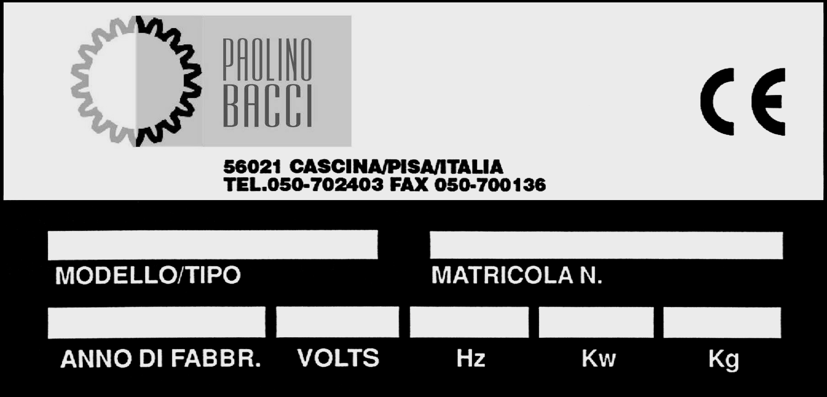

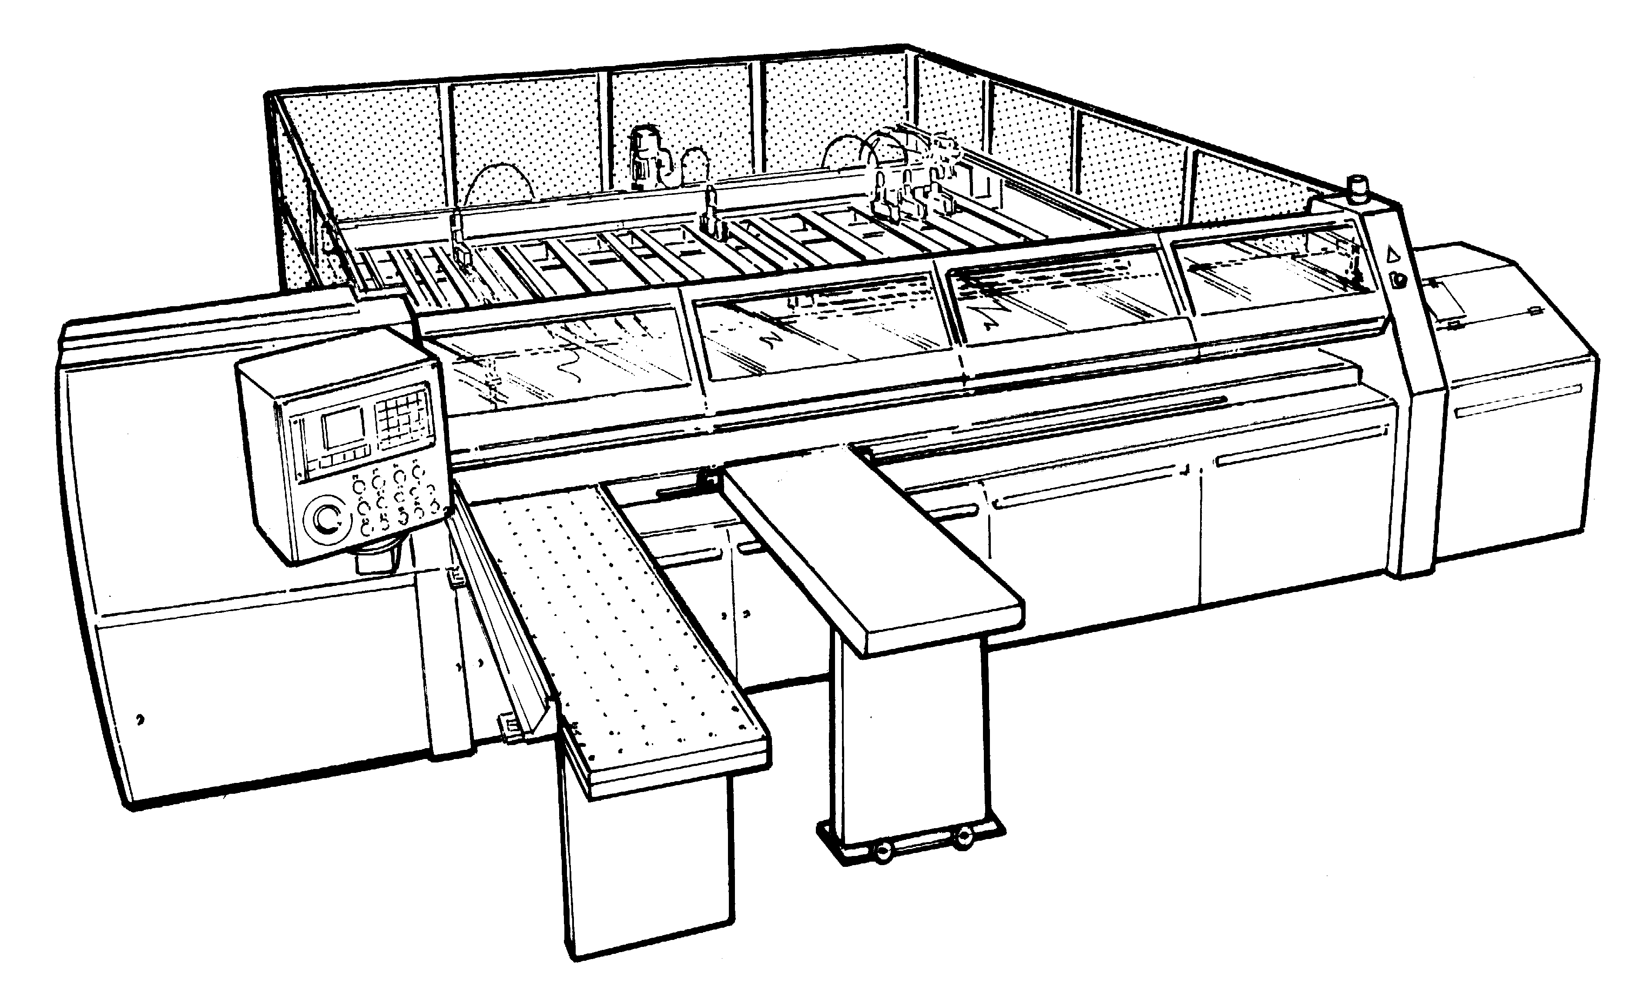
HANDLING AND TRANSPORT OF THE MACHINE

Transport and instructions for handling

The transport of the machine can take place in three ways:


- by means of container -


- by means of truck -

With the transport by means of container packing in plastic of the thermo-retractable type is foreseen; the machine is shipped in one whole part. The container is provided with a barrier bag for the thermoretraction. Inside the container the machine is anchored to the base and fastened to a crate of wooden beams that is necessary for the containment and the stowage of the load. Before the thermoretraction, bags containing salt are inserted to protect the material from corrosive agents.

With the transport by means of truck, protection in plastic may be foreseen. The components of the load are prepared and stowed with the same method employed for the transport by means of container. The security of the load is obtained by tensioning bands. The machine is shipped in one whole part and is anchored by means of the support traverses to the of the truck.

Dimensions, mass value(s), slinging

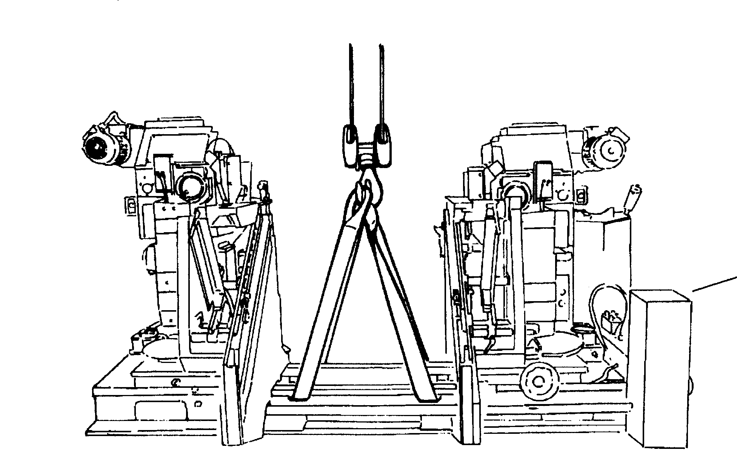

Kg 2460
Kg 2910 (long version)

CSF2 LOADER

The machine must be slung as indicated and you must use belts that are suitable for bearing the load.
The belts must be located in the prearranged spaces of the base, while paying attention to their passage.
Incorrect assembly provokes the bending of the screws V during the hoisting and compromises the operation of the machine

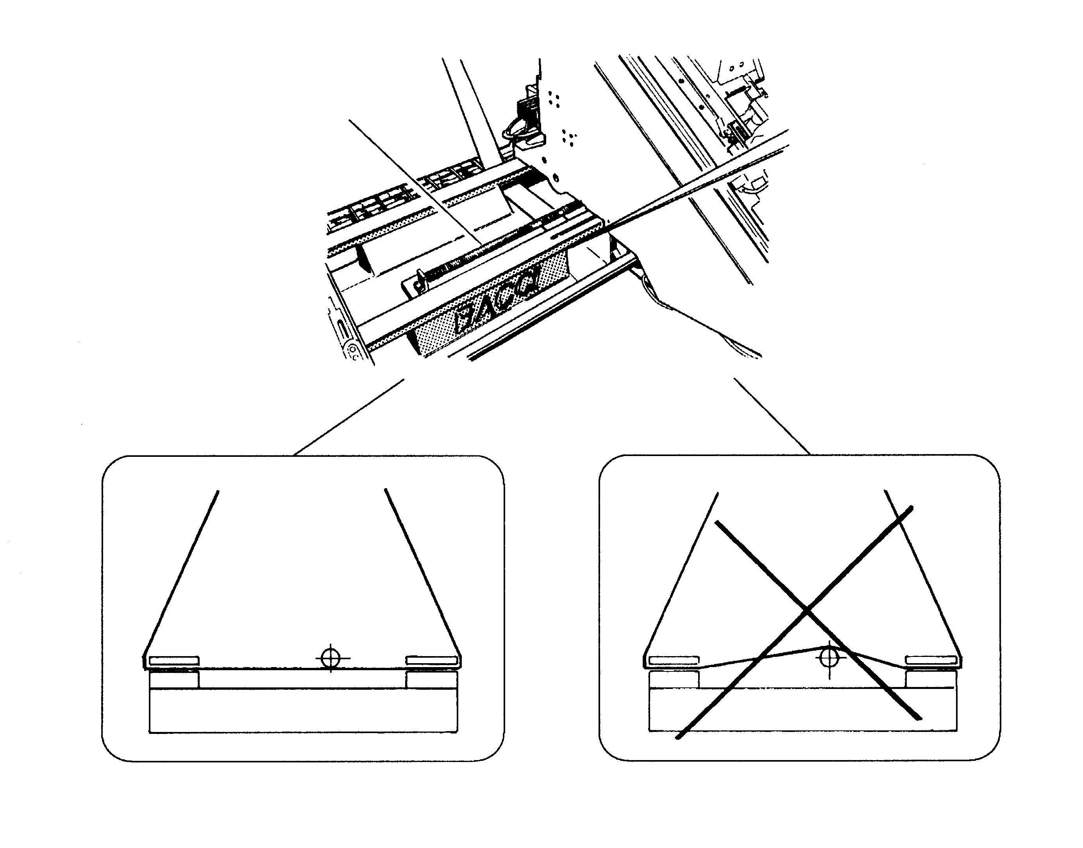

V

YES
NO

Fig. 1 Slinging of the machine

Net weight Kg 2460/2910 (long version)

Packing dimensions 3300x2000x1950
4490x2000x1950 (long version)

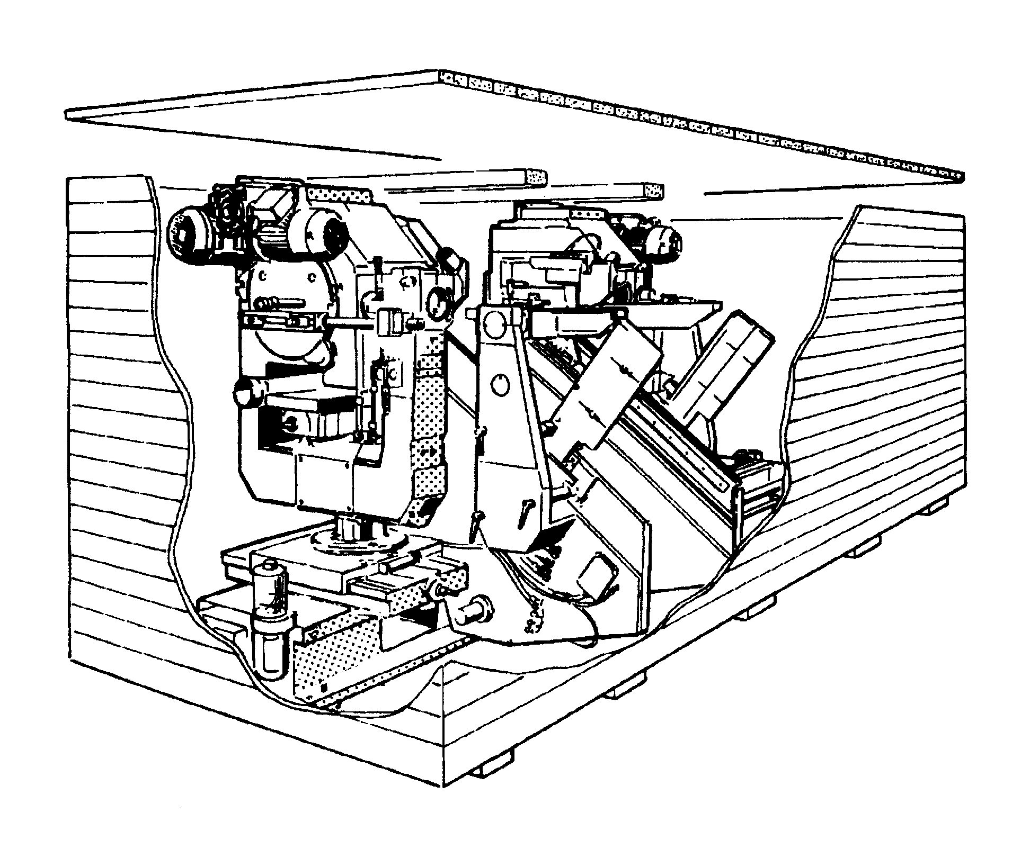

Case packing

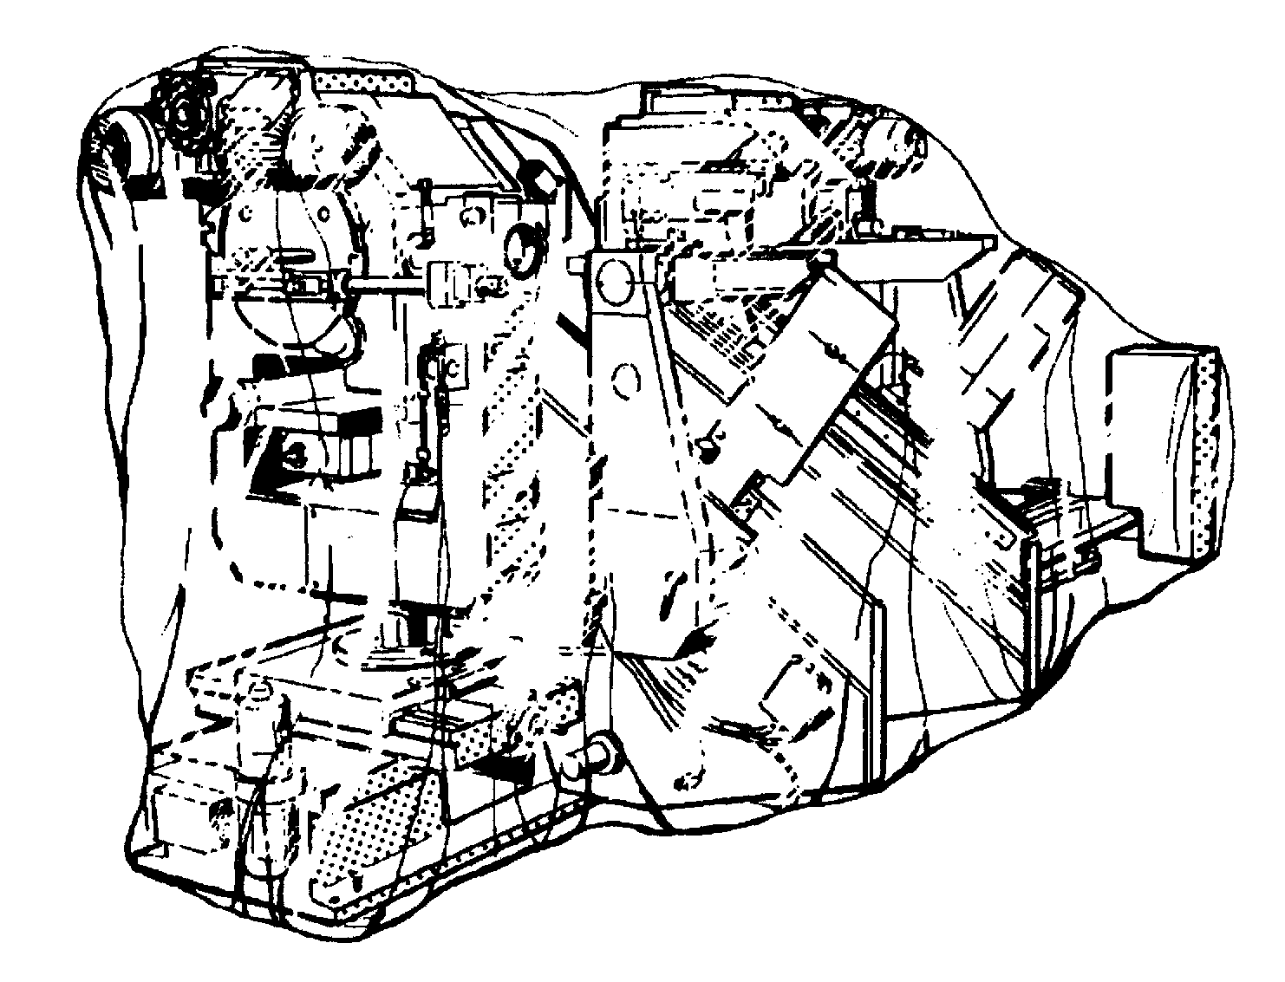

Plastic protection packing

Fig. 2 Handling and transport

Storage of the machine

The best conditions for a good storage of the machine, if it is not immediately placed in its specific location, require a dry place with controlled temperature and surroundings while awaiting the assembly, and avoiding leaving the machine outside.

The stored parts should be periodically inspected for the purpose of detection of possible deterioration.

The methods of handling and storage of the materials must foresee pallets, containers, conveyor vehicles, fixtures and lifting devices suitable for preventing damages caused by vibrations, impacts, abrasions, corrosion, temperature or other conditions that could occur.

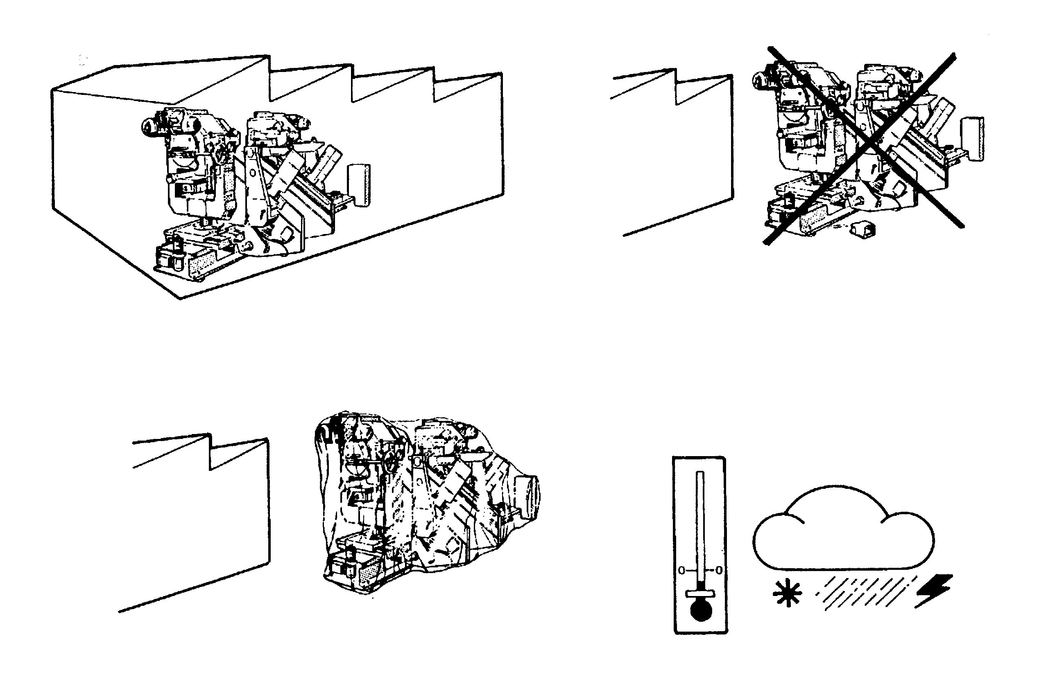

Fig. 3 Storage of the machine

PUTTING THE MACHINE INTO SERVICE

Fastening instructions

La macchina viene sempre spedita in perfette condizioni di funzionamento dopo essere stata sottoposta ad un The machine is always shipped in perfect working condition, after it has been subjected to scrupulous inspection at our plant.

Installation verification of the machine
The machine may rest on the floor and must be accurately leveled. To level the machine you must use screws that must exercise force on the feet with which the base is foreseen. If the floor does not guarantee resistance, you must carry out a concrete foundation of at least 20 cm. The load of each support point is indicated in Fig. 4

Assembly and preliminary operations

3.1.1. - Upon receipt, open the packaging, verify that the machine has not undergone any damage during the transport; if it has, notify the transporter of this in time.

3.1.2. - The slinging must be carried out with the means provided with the machine if there are any, or in any case with suitable fixtures and a sufficiently powerful lifting device and appropriate for the use, following attentively the indications of Fig.1.

3.1.3. - Position the machine in conformity with the indications supplied by the general installation planimetry, verifying its correct position with respect to the other previously assembled, or already existing, machines. In any event, check that the correct distance indicated in fig. 3.2 necessary for the maintenance is observed.

3.1.4. - Remove the fixtures used for the slinging; service beams, reinforcement tie rods, etc. and in addition, cords, steel cables, etc., used during the transport.

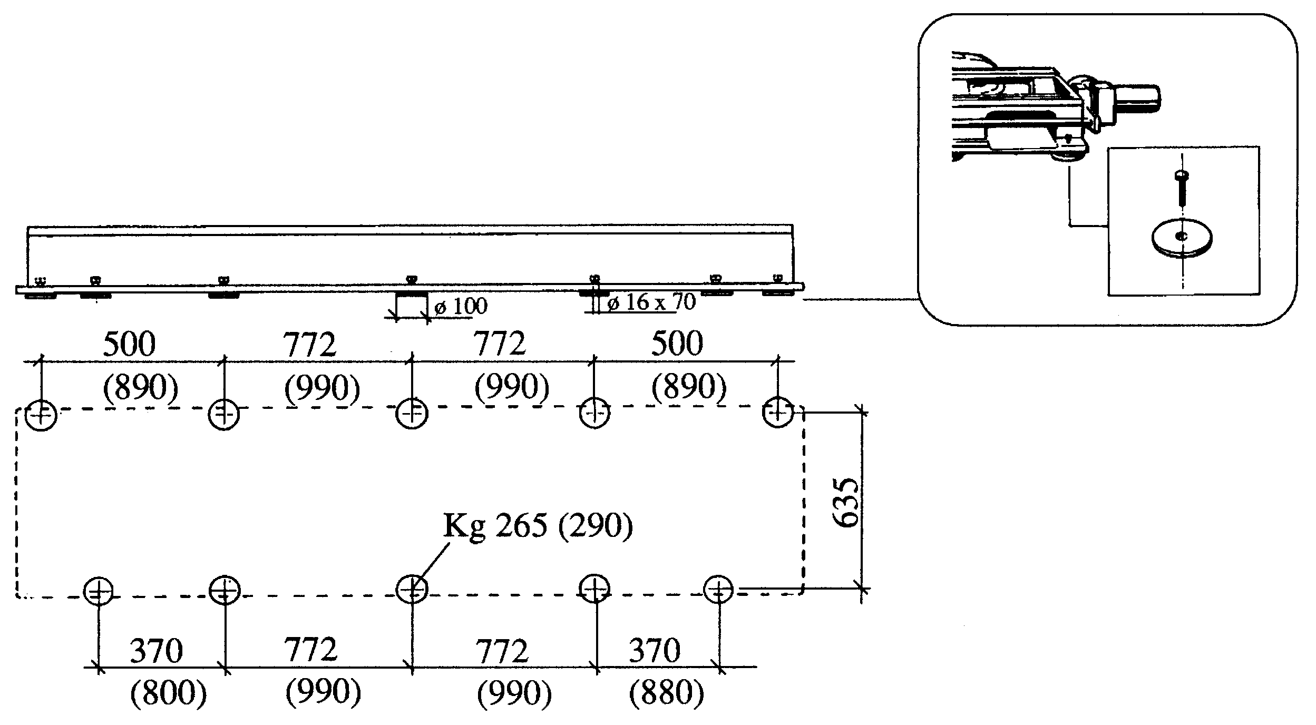

(Long version)

Fig. 4 Support points with load distribution
3.1.5. - Carry out the leveling of the machine by putting the base plate on the floor in correspondence with the screws, act on these while checking the various points with a precision level.

3.1.6. - Carry out the electrical and pneumatic connection according to the indications of chapter 3.4. The electrical connection must be carried out by specialized electrotechnical personnel.

3.1.7. - With the control located on the two push button panels on the machine you must lift the unit AXES 8-9 MOTOR HEAD LIFT in order to have access to the screws V. The machine is shipped with the units lowered so as not to have hanging loads.

3.1.8. - Loosen the 4 screws V (2 per side) that lock the upright against any rotation during the shipment.

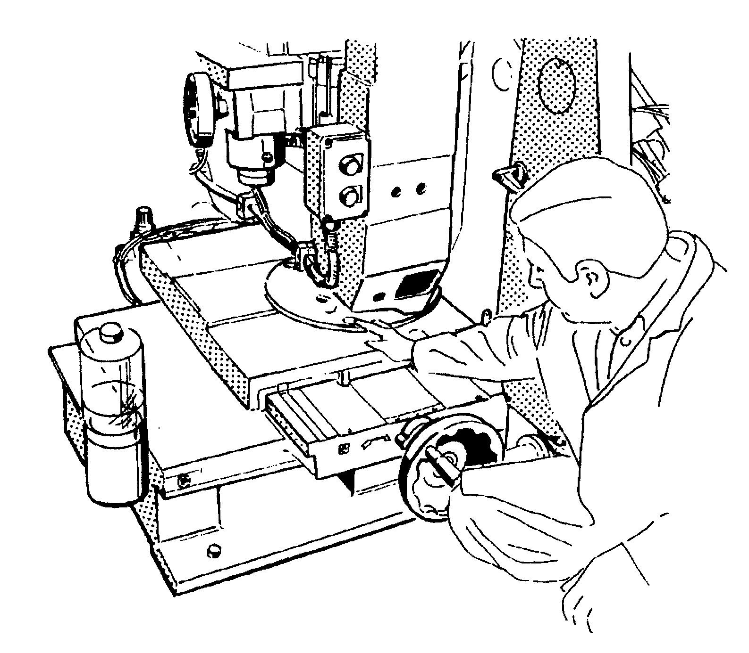

Fig. 5 Upright anti-rotation screws

3.1.9. - Loosen the 2 handles M that lock the sliding of the loaders; the screws are locked for shipment necessity (version TSD- TSD-D)

3.1.10. - Assemble all the protection devices (chap. 4.3) that for transportation needs are shipped disassembled, in particular the overturning protection screen.
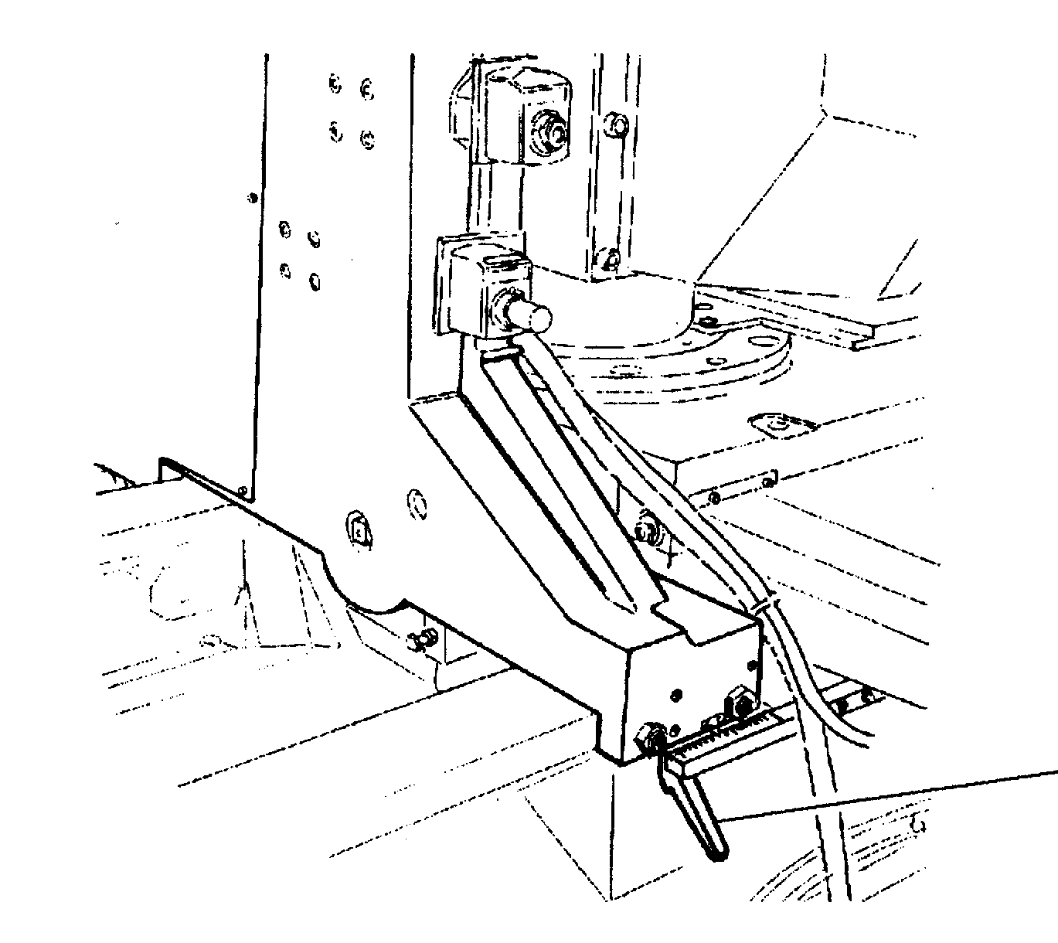

M

Fig. 6 Tightening of the loaders

Space necessary for use and maintenance

It is advisable to leave sufficient space for the maintenance interventions as indicated in Fig. 7

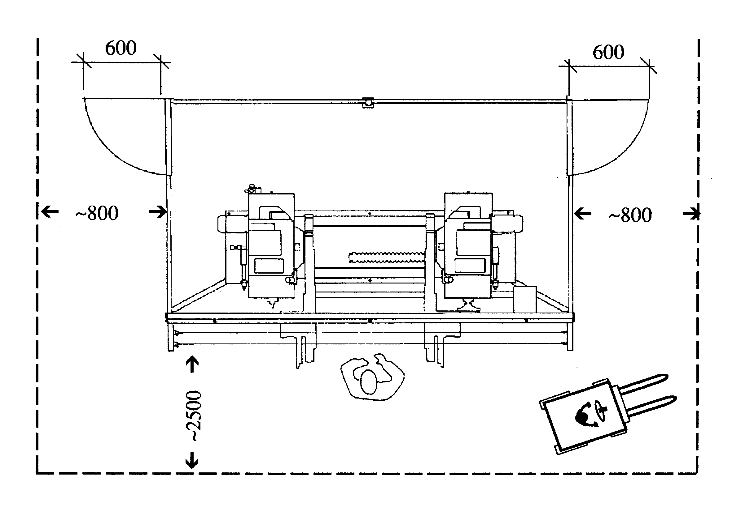

Fig. 7 Space necessary for use and maintenance

Allowable environmental conditions

Working temperature: 0-40°C
Climate: Variable tropical (according to DIN 40 046 sheet 5)
Altitude: Up to 1000 a.s.l., above this height contact our office

Connection of the machine to its power supply

Connection to the electric power supply grid (only for specialized electrotechnical personnel)

It is sufficient to bring one line, of a cross section adequate for the load of the machine, to the general switch. Check that the power grid voltage is equal to that for which the electric components of the machine are foreseen.
For the connections, observe the local law regulations in force for electrical installations
Carry out the connection of the connectors and encoders

Short circuit cut-off power and connection cable section
cut-off power (KA) cable section (mm2)
100KA (fuses after 380V: 4X6
disconnecting device) 220V: 4X10
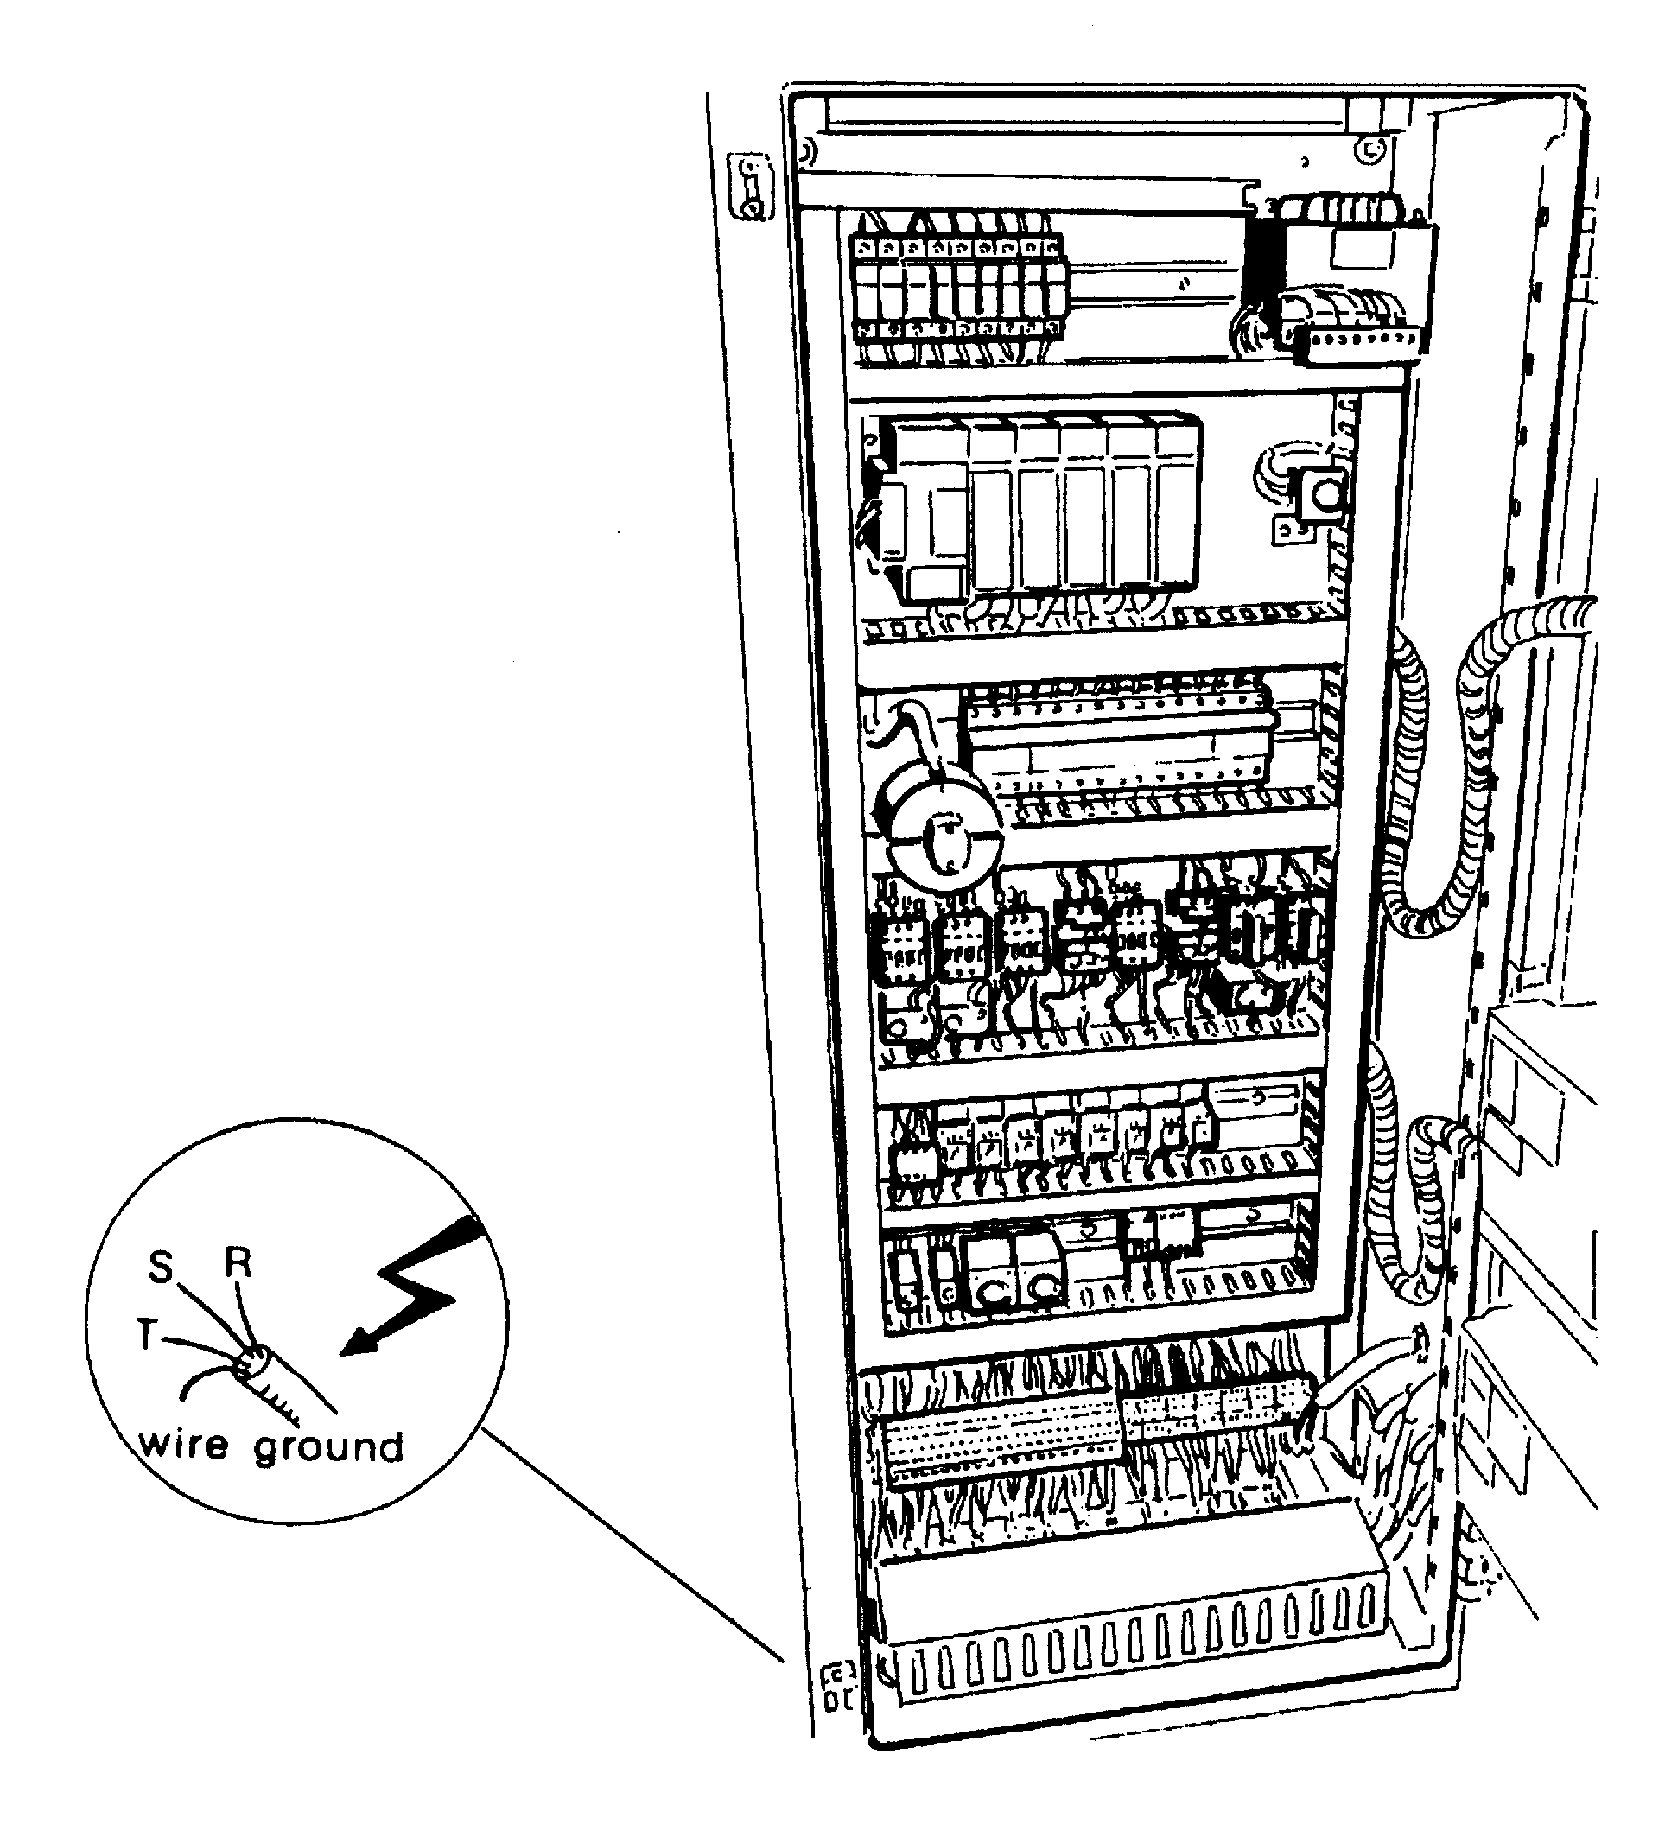

The connection must be carried out with a differential switch coordinated with the end user’s existing earthed protection

Power installed: 8 KW

At the end of the assembly, after having completed all the connections, carry out a functional check of all the controls placed on the main panel and on the various consoles on the machine.

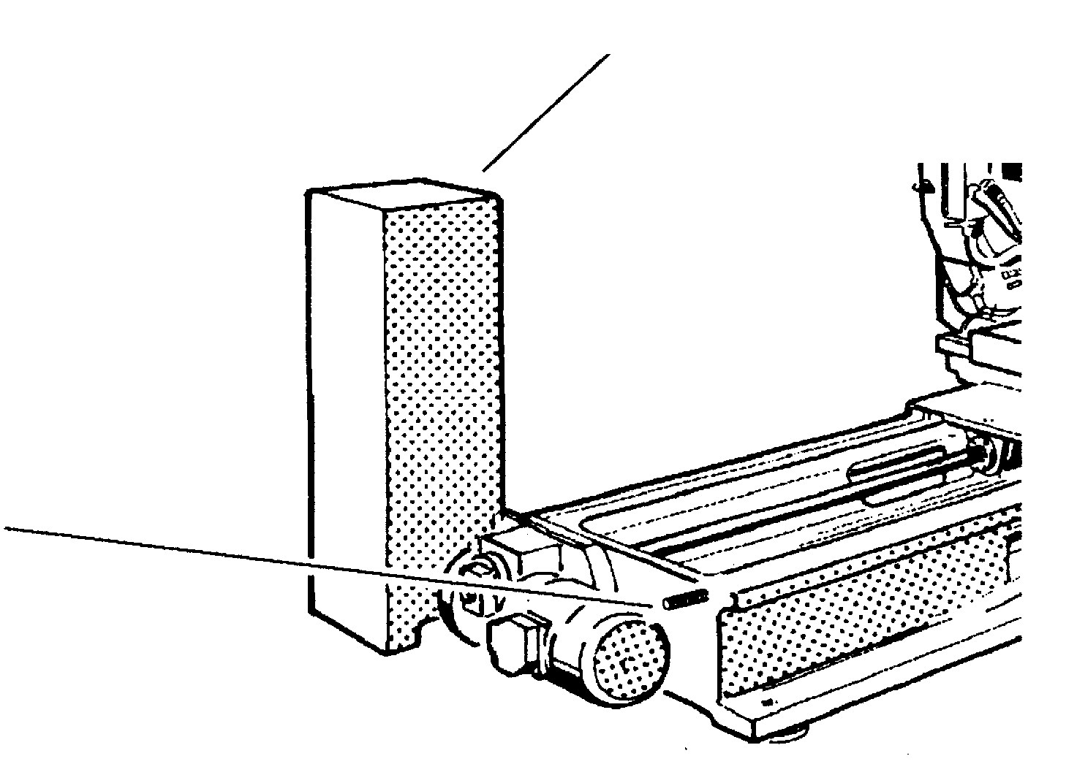
CSF2 LOADER

External terminal for the ground of an M8 threaded shank marked with the abbreviation PE

Fig. 8 Electric box
Connection to the compressed air network

The connection of the machine is carried out by means of the connection of the regulator, filter, machine greaser, RFL assembly.
Avoid the use of temporary or unsuitable piping for the connection, because it is easily subject to deterioration.
It is advisable to use standard pipes of proper section.
The pressure of the air for the machine must be regulated at 6 Bar with the regulator.

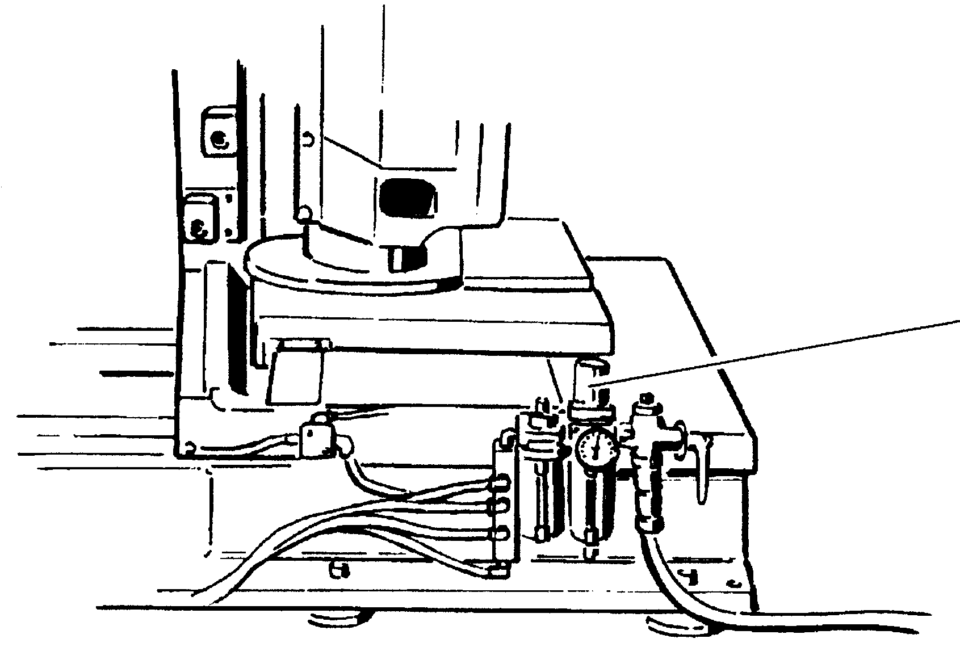

Lockable RFL unit
(Filter Regulator - Lubricator)

Compressed air connection pipe ø16 mm

Fig. 9 Compressed air connection

Connection to the suction piping

The connection to the machine is carried out with 2 inlets arranged on the dome of each upright. The diameter of the inlets is of 100 and 60.
When arranging the connection piping you must take the data stated in Fig. 12. into consideration. The connection must be carried out with piping in antistatic and inflammable material and at least the last section must be made up of flexible elements of which the length must enable the necessary amplitude to the movements the machine is provided with, which are indicated in Fig. 12.

At the end of the assembly, after having completed all the connections, carry out a functional check of all the controls located on the main board and on the various consoles on the machine, and in particular, the correct operation of the axes and the verification of the tools rotation direction.

Tools rotation direction verification

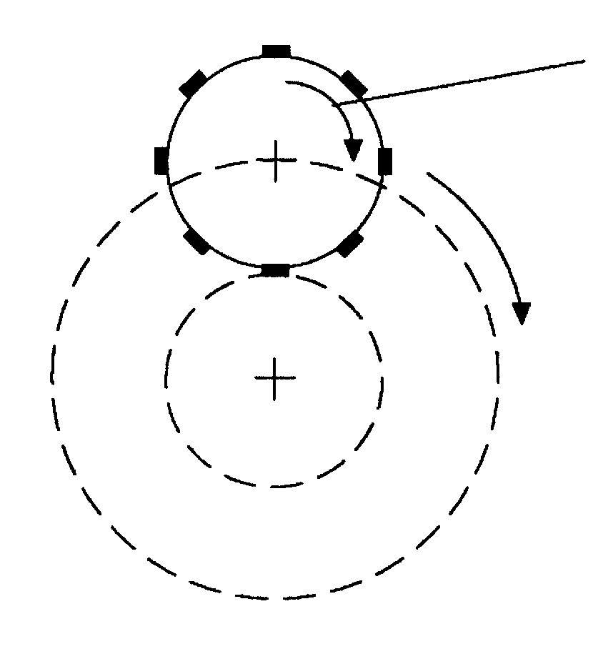
Rotation direction of the cutter

Rotation direction of the revolution movement

VIEW FROM A

The rotation direction must be consonant and clockwise, from the point of view A, consonant and counterclockwise from the point of view B. Should the cutter turn counterclockwise, serious failure inside the mechanism could occur.
The inspection is carried out with the machine in manual operation

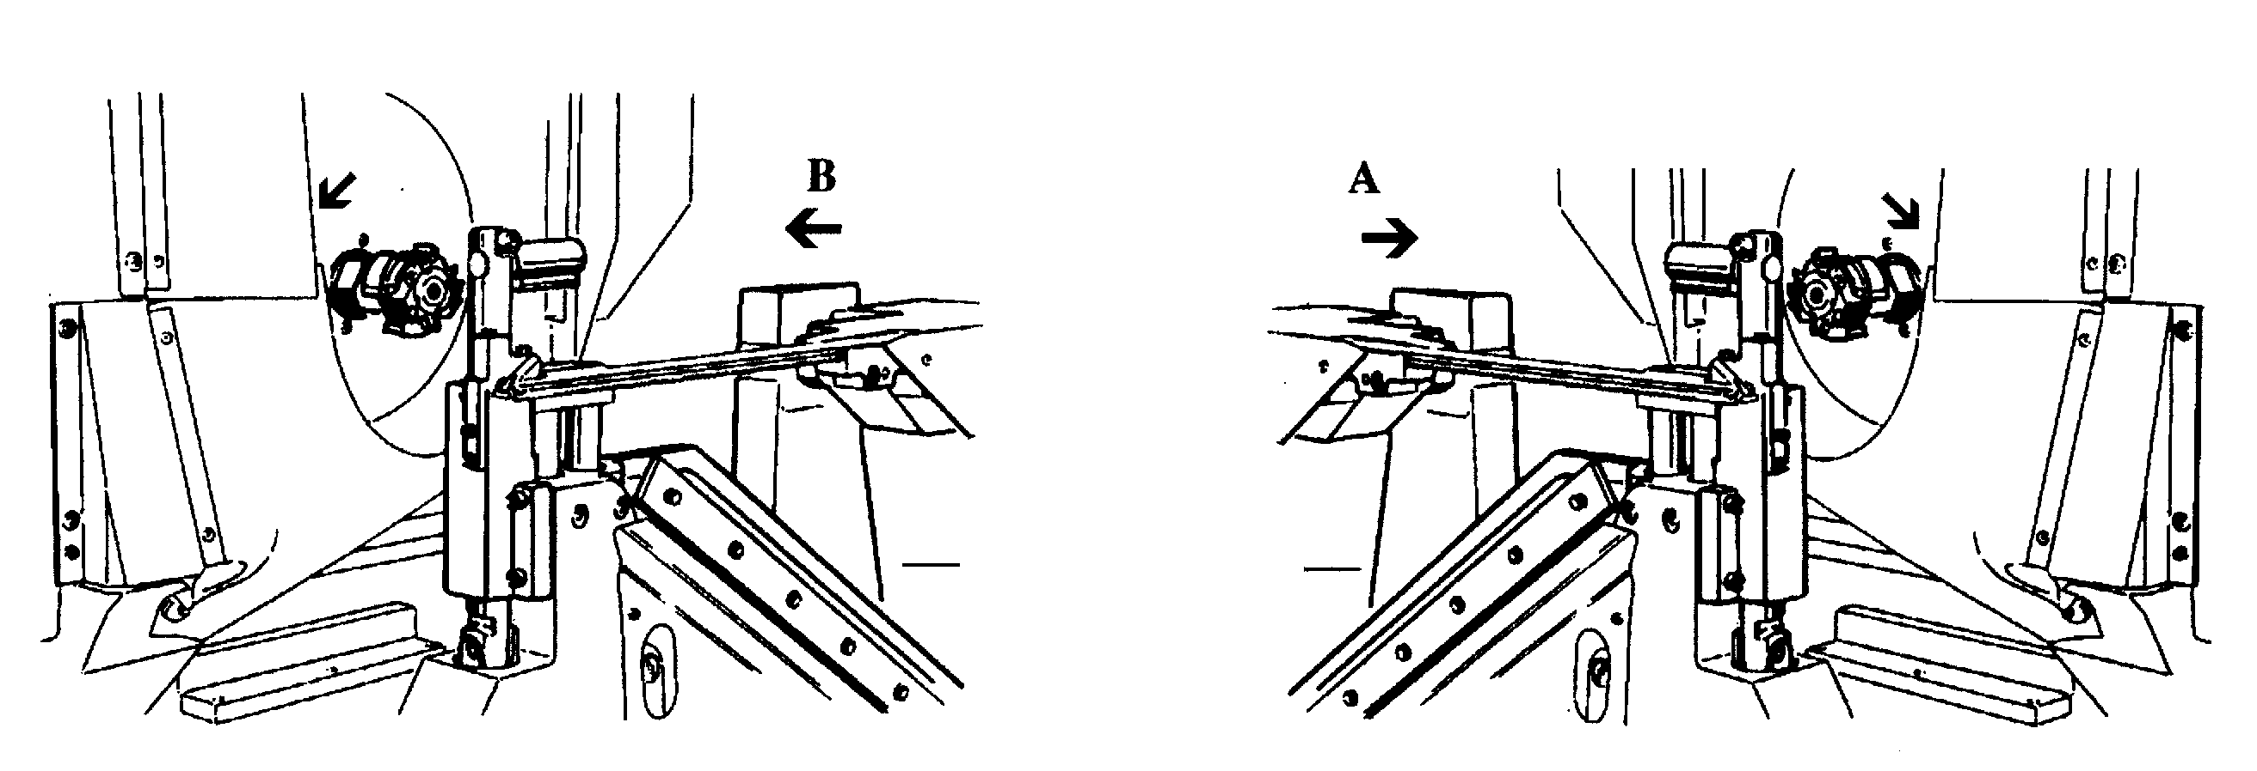

CSF2
LOADER

Rear side view

Fig. 10 Tools rotation direction

LAYOUT

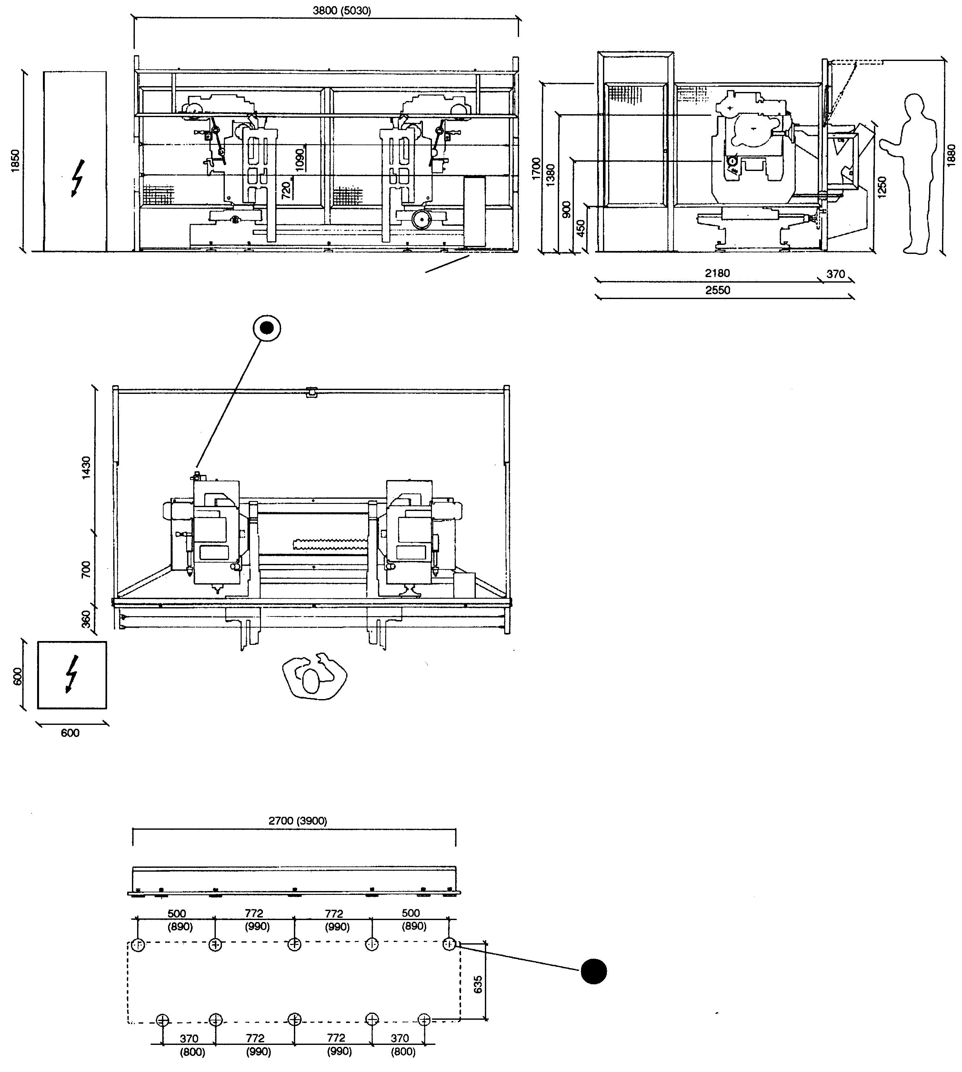

CSF2 LOADER

ø16 mm

320 Nl/1'

(Long version)

Support foot

Fig. 11 Layout
SUCTION PIPING CONNECTION

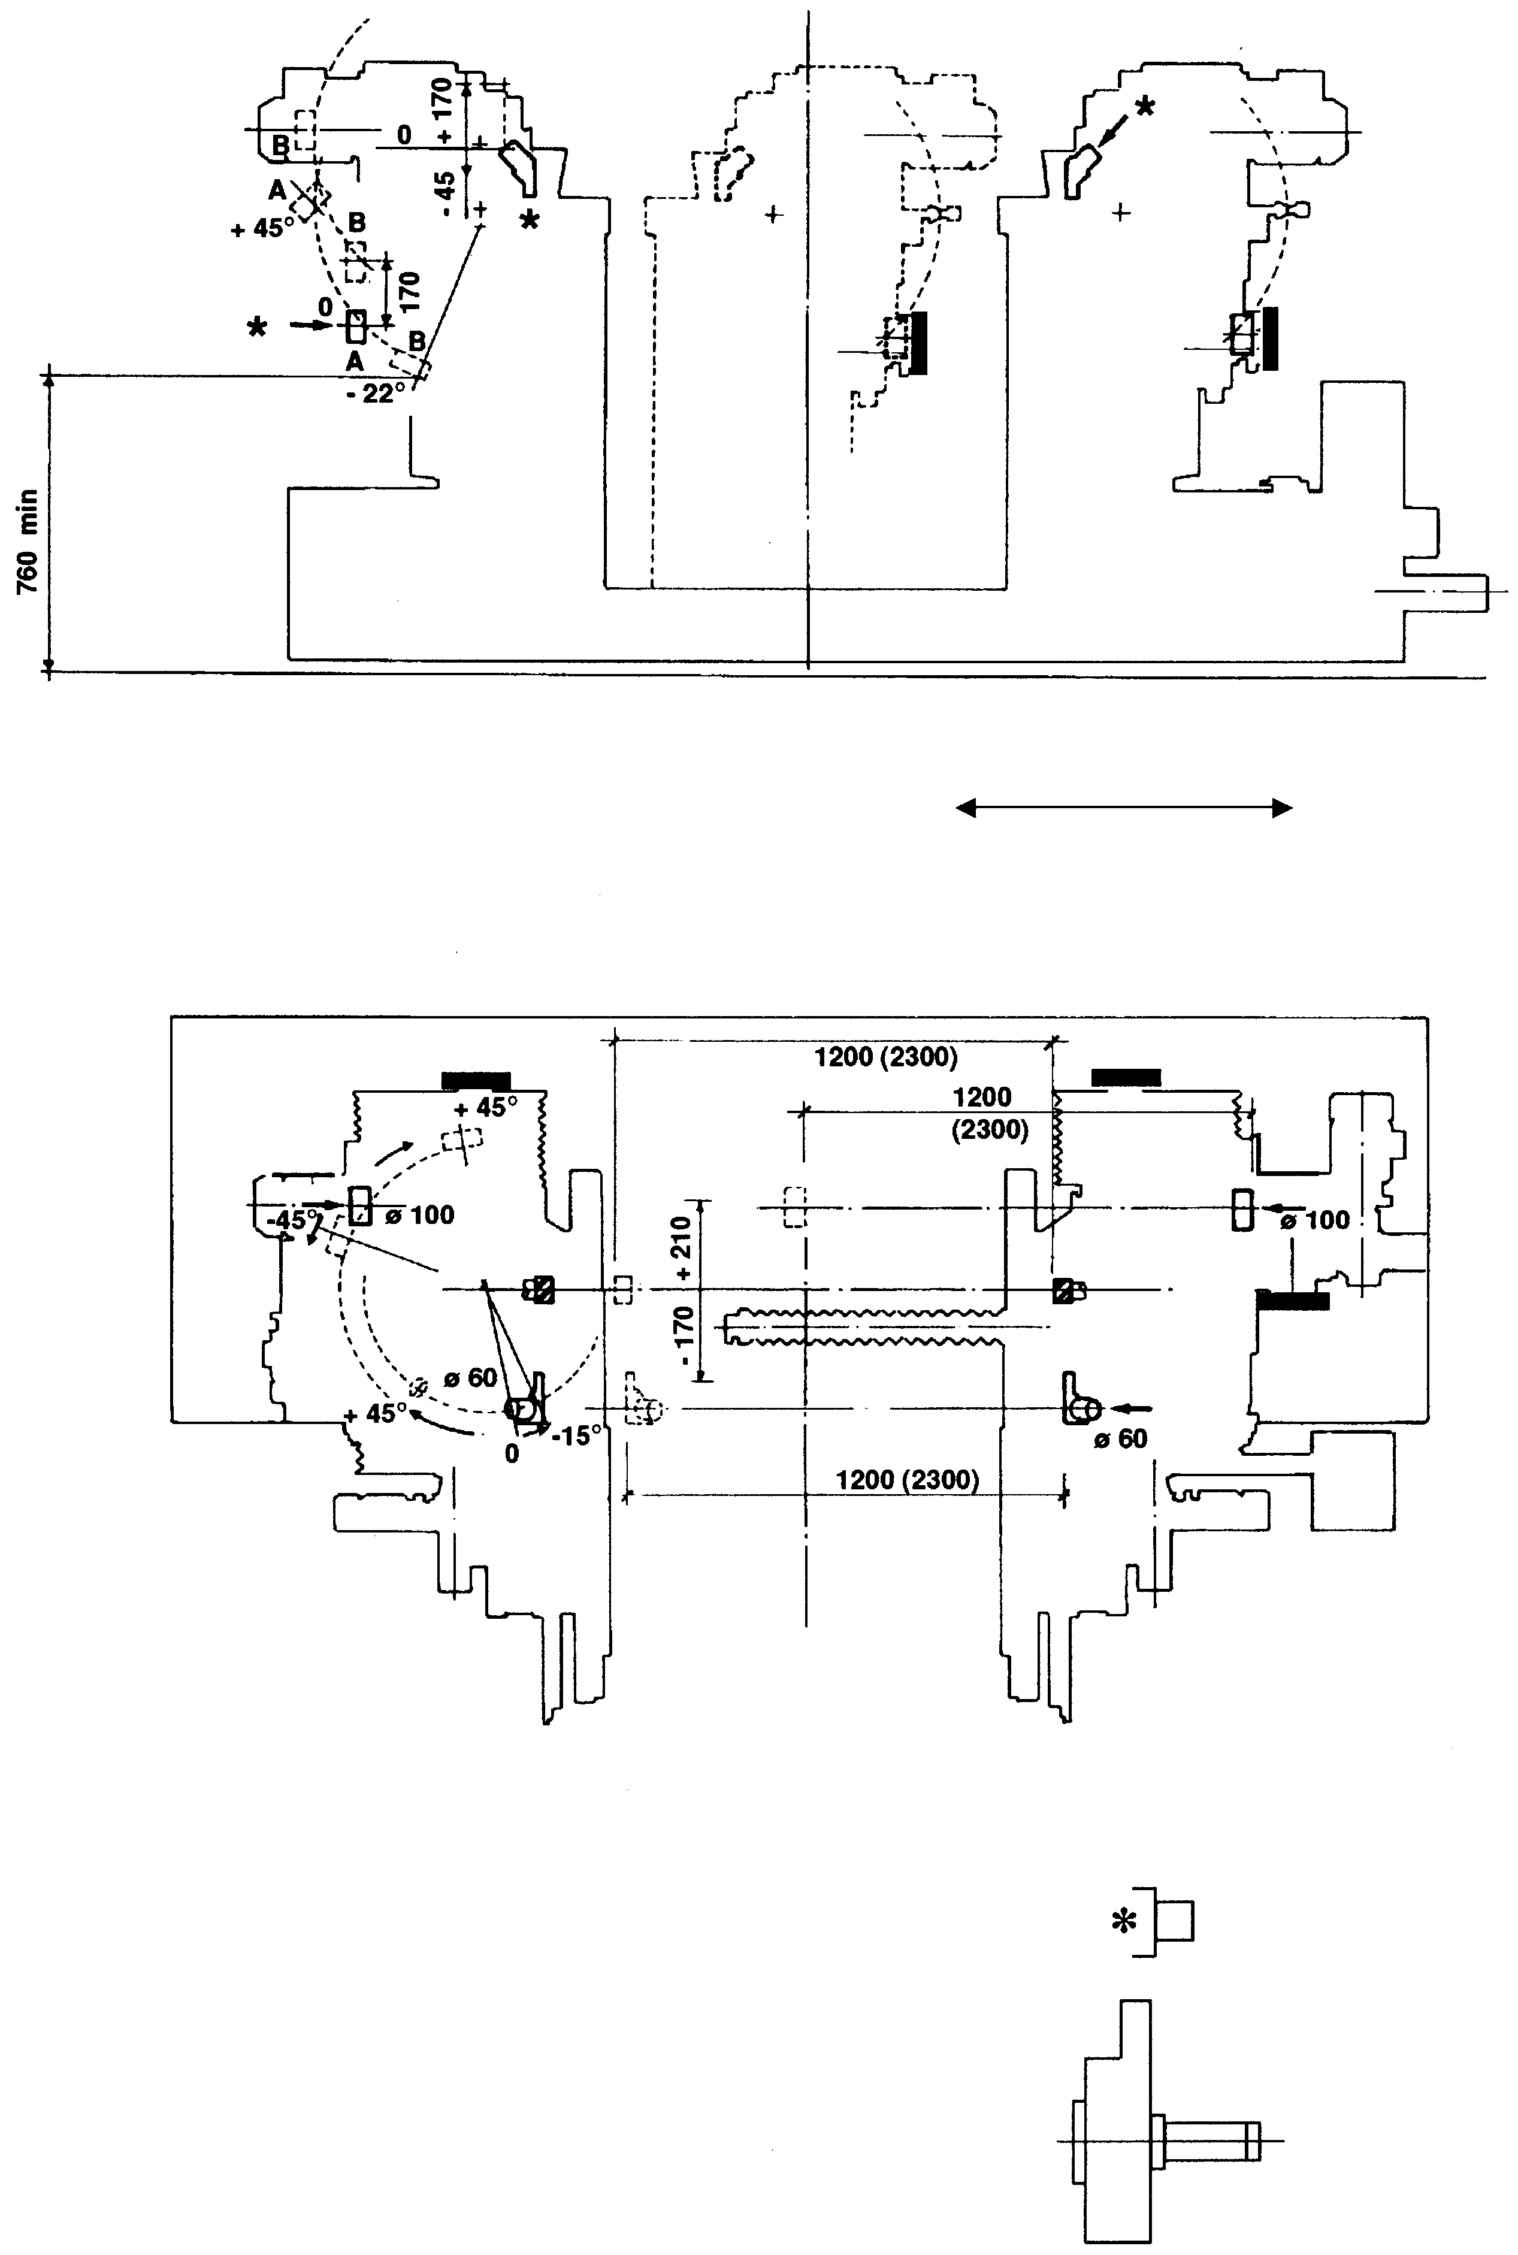

MOBILE UPRIGHT
STATIONARY UPRIGHT

(Long version)

Suction intake
2 ø100
2 ø60

Suction 1520 m3/h

Speed 20mt/sec

* It is obligatory to install suction piping of inflammable and antistatic material

Fig. 12 Suction piping connection

Indications of the noise generated by the machine (ENCLOSURE I)

Recommendations for the precautionary measures that must be adopted

Safety specifications

In order to keep the machine in perfect running state, and in order to guarantee the operator its utilisation in the safety conditions, we advise scrupulously observing the following directions:

3.6.1 - Distribute the instructions in this manual to the various operators.

3.6.2 - Keep the machine in perfect state of operation and always use the various protection devices with which it is provided.

3.6.3 - Do not modify the protection devices and only remove them in case the machine is at a standstill and the electric feeding is excluded.
Do not disable the possible protection microswitches (e.g. those activated by the interlocked mobile guards).

3.6.4 - Do not carry out any interventions of maintenance adjustment, cleaning or lubrication on the electrical or mechanical parts without previously having excluded the electric feeding by means of the general switch.

3.6.5 - The replacement or repair of the elements that make up the electric system must be carried out exclusively by assigned, qualified personnel.

3.6.6 - Make sure that the machine is perfectly “grounded”.

3.6.7 - The input cables, of the electric feeding line, to the main switch must be marked with appropriate danger indications.
Do not remove these indications and do not intervene on these cables before having taken all precautions that are imposed (for example, excluding the upstream electric feeding).

3.6.8 - Do not come near the parts in motion (gears, belt assemblies, etc.) with loose clothing.

3.6.9 - Do not use water for the extinction of fires on the electrical parts.

3.6.10 - It is strongly advisable to avoid a temporary or makeshift connection with the electric power supply grid and to protect the conductors in an appropriate way.

3.6.11 - During the loading and unloading, pay attention to the choice of the hooking points in order to arrange the steel cables or the cotton belts in such a way as to avoid damage to the machine or the slinging means. When the latter are used, be sure not to put these in contact with cutting parts, which could provoke their wear.

DESCRIPTION OF THE MACHINE, ITS ACCESSORIES, GUARDS AND/OR SAFETY DEVICES

Description of the machine

The TSD double end rounding off tenoning machine makes tenons, on both ends of the piece at the same time, with all the three possible angles.
The reduced dimensions of the working units have been studied in order to allow the execution of also very angled tenons on pieces of reduced length.

This offers the possibility of making tenons in the vertical or whatever angle between the horizontal and the vertical is required and the possibility of putting difficult pieces on any of the four sides.

An incomparable productivity of 2400 tenons/hour has been accomplished.

This outstanding performance is attributable to more than thirty years experience in the manufacture of round tenoning machines and to the advanced technology and to the continuous revolution of the tool around the tenon.
The approach of the two heads is motorized; all other movements can be motorized upon request.

TECHNICAL FEATURES

Cutterholder shaft speed 9000 rpm
Max tenon length (in any event slanted) 100+2R mm (R=tenon radius)
Max tenon depth 40 mm
Min. tenon depth 10 mm
Max tenon thickness 30 mm
Cutters motors capacity (2 of 3Kw) 6 Kw
Rotation motors capacity (2) 0.5 Kw
Total installed power 8 Kw
Suction inlets n°2 ø 60 -n° 2 ø 100
Net weight 2460 Kg (2910 Kg Long version)
Gross weight 2915 Kg (3560 Kg Long version)
Overall dimensions (with protection) 3800x2600x2010 mm
Overall dimensions (with protection) 5030x2600x2010 mm (Long version)
Packing dimensions (without protection) 3300x2000x1950
Packing dimensions (without protection) 4490x2000x1950 (Long version)

Revolution movement
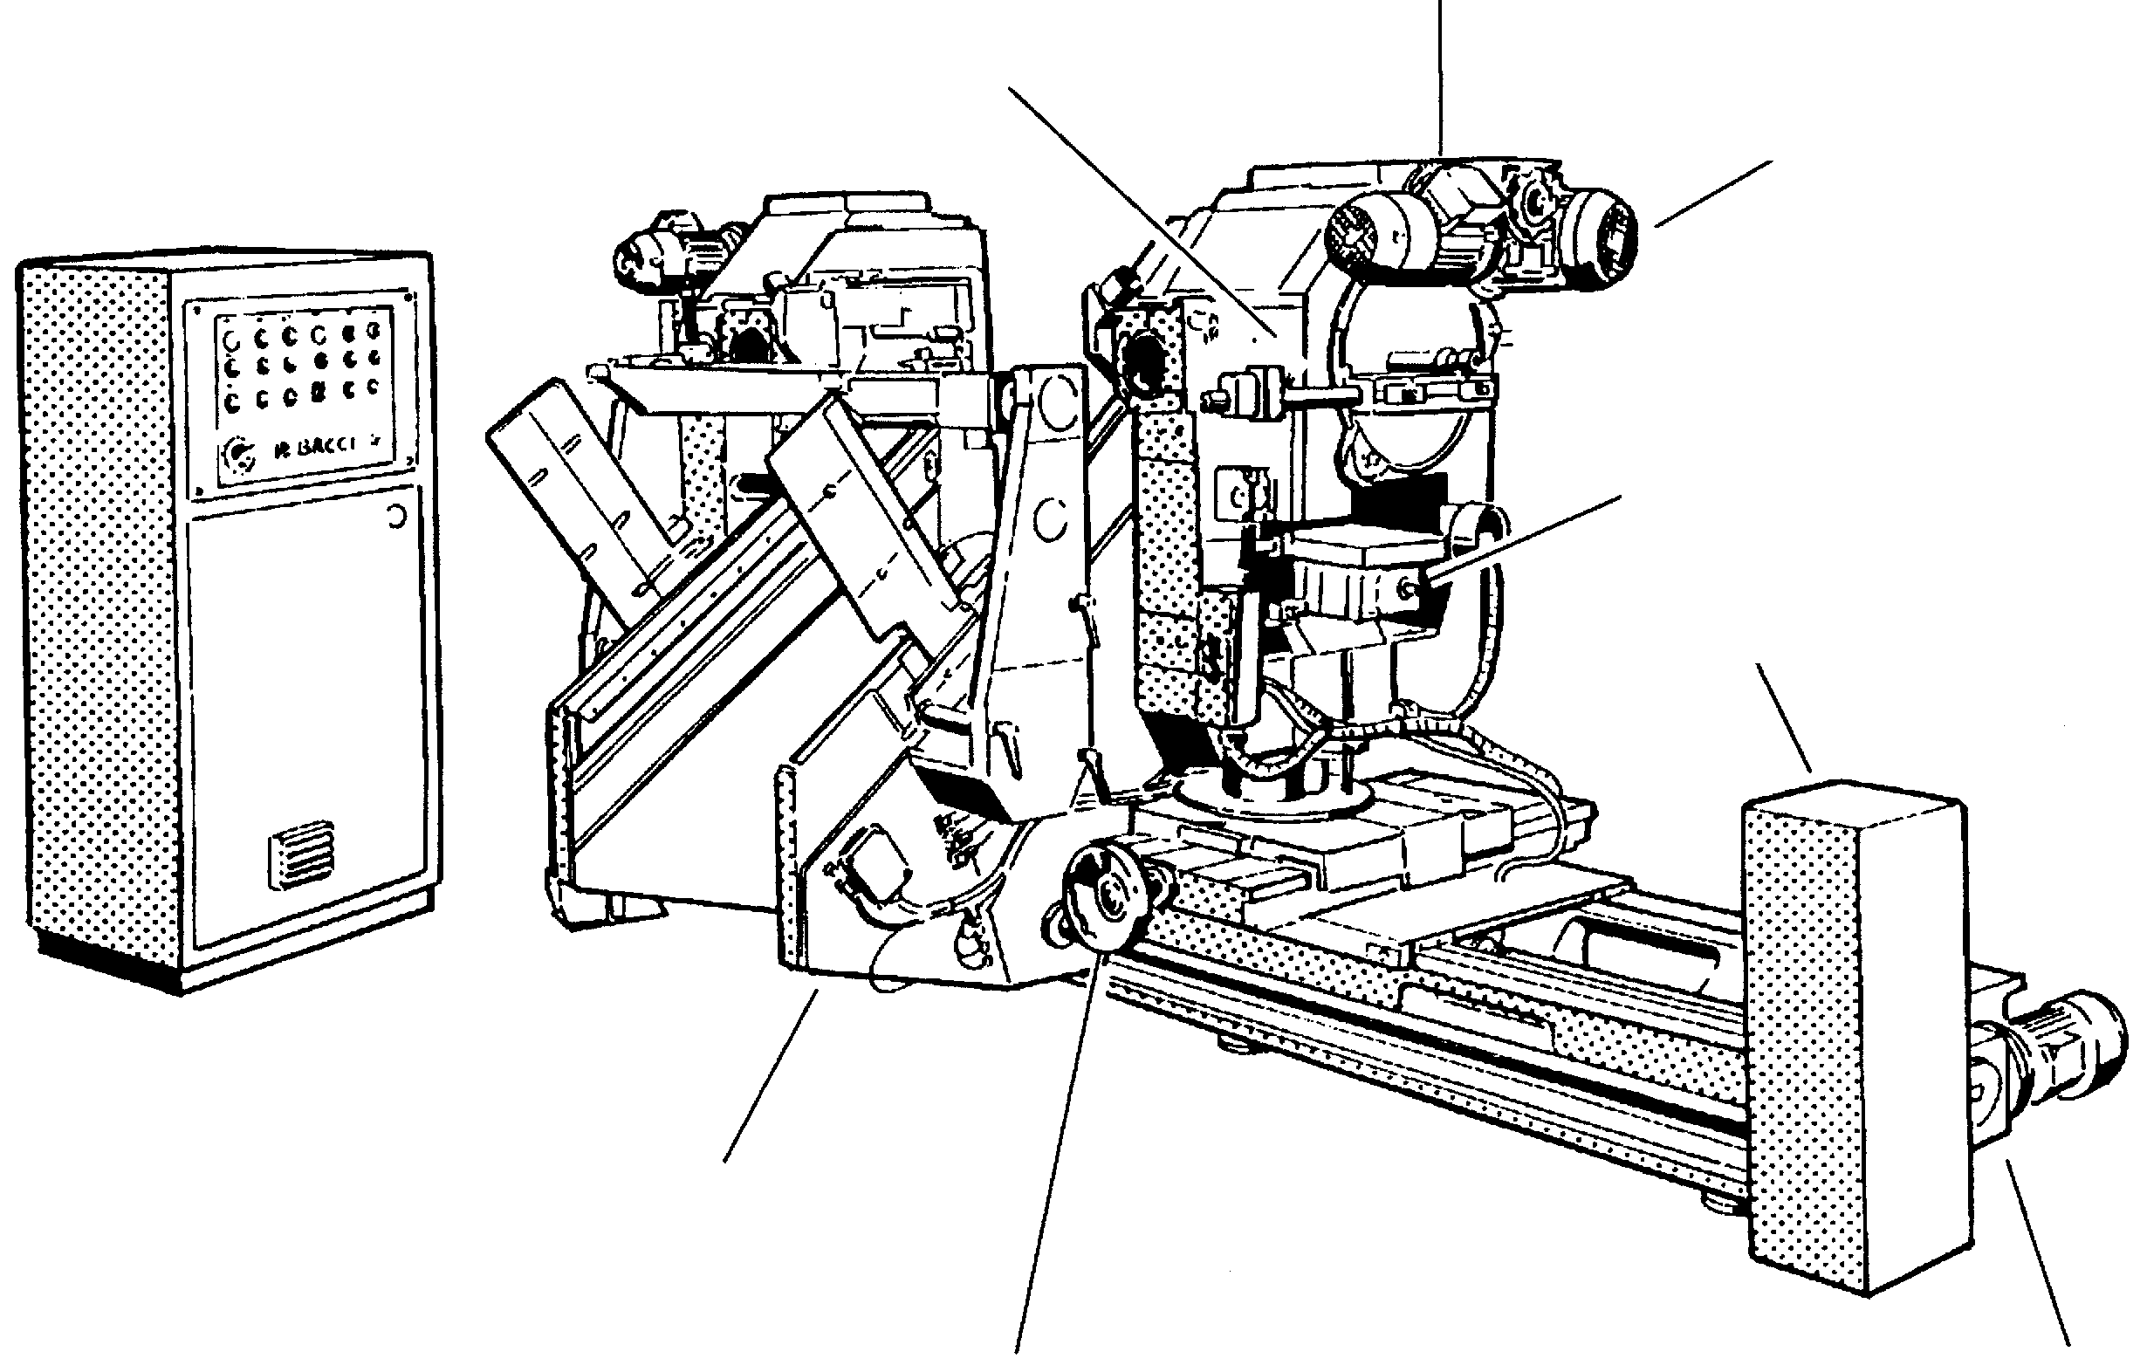
Axis 5
Head inclination

Spindle rotation

Axis 9
Head lift

CSF2 Loader

Electric box

CSF2 Loader

Axis 3
Head traverse shift
Axis 1
Head shift

Pieces bin
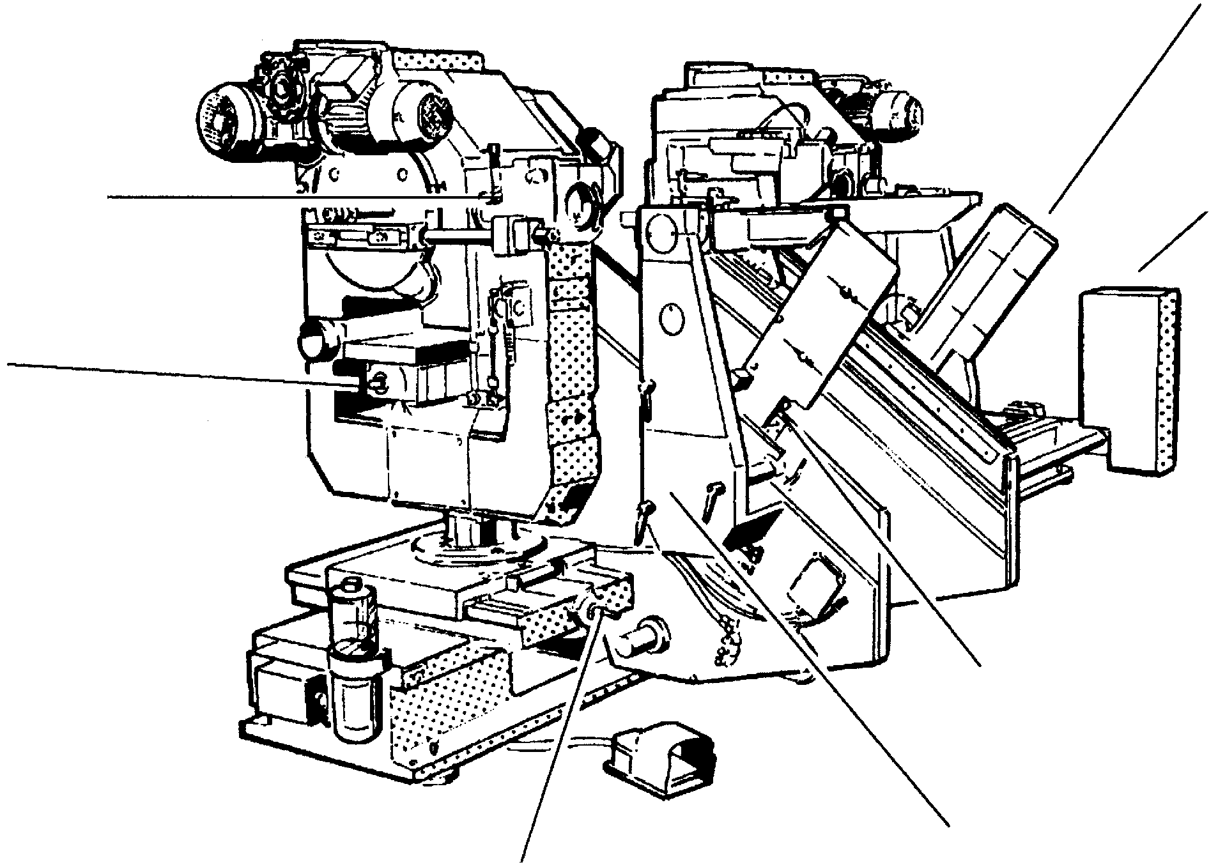

Axis 4
Head inclination
CSF2 Loader

Axis 8
Head lift

Piece approach slide

Movement transmission
Axis 2
Head traverse shift

Fig. 13 Front view (operator side)

Revolution movement
Spindle rotation
Dome
Dome
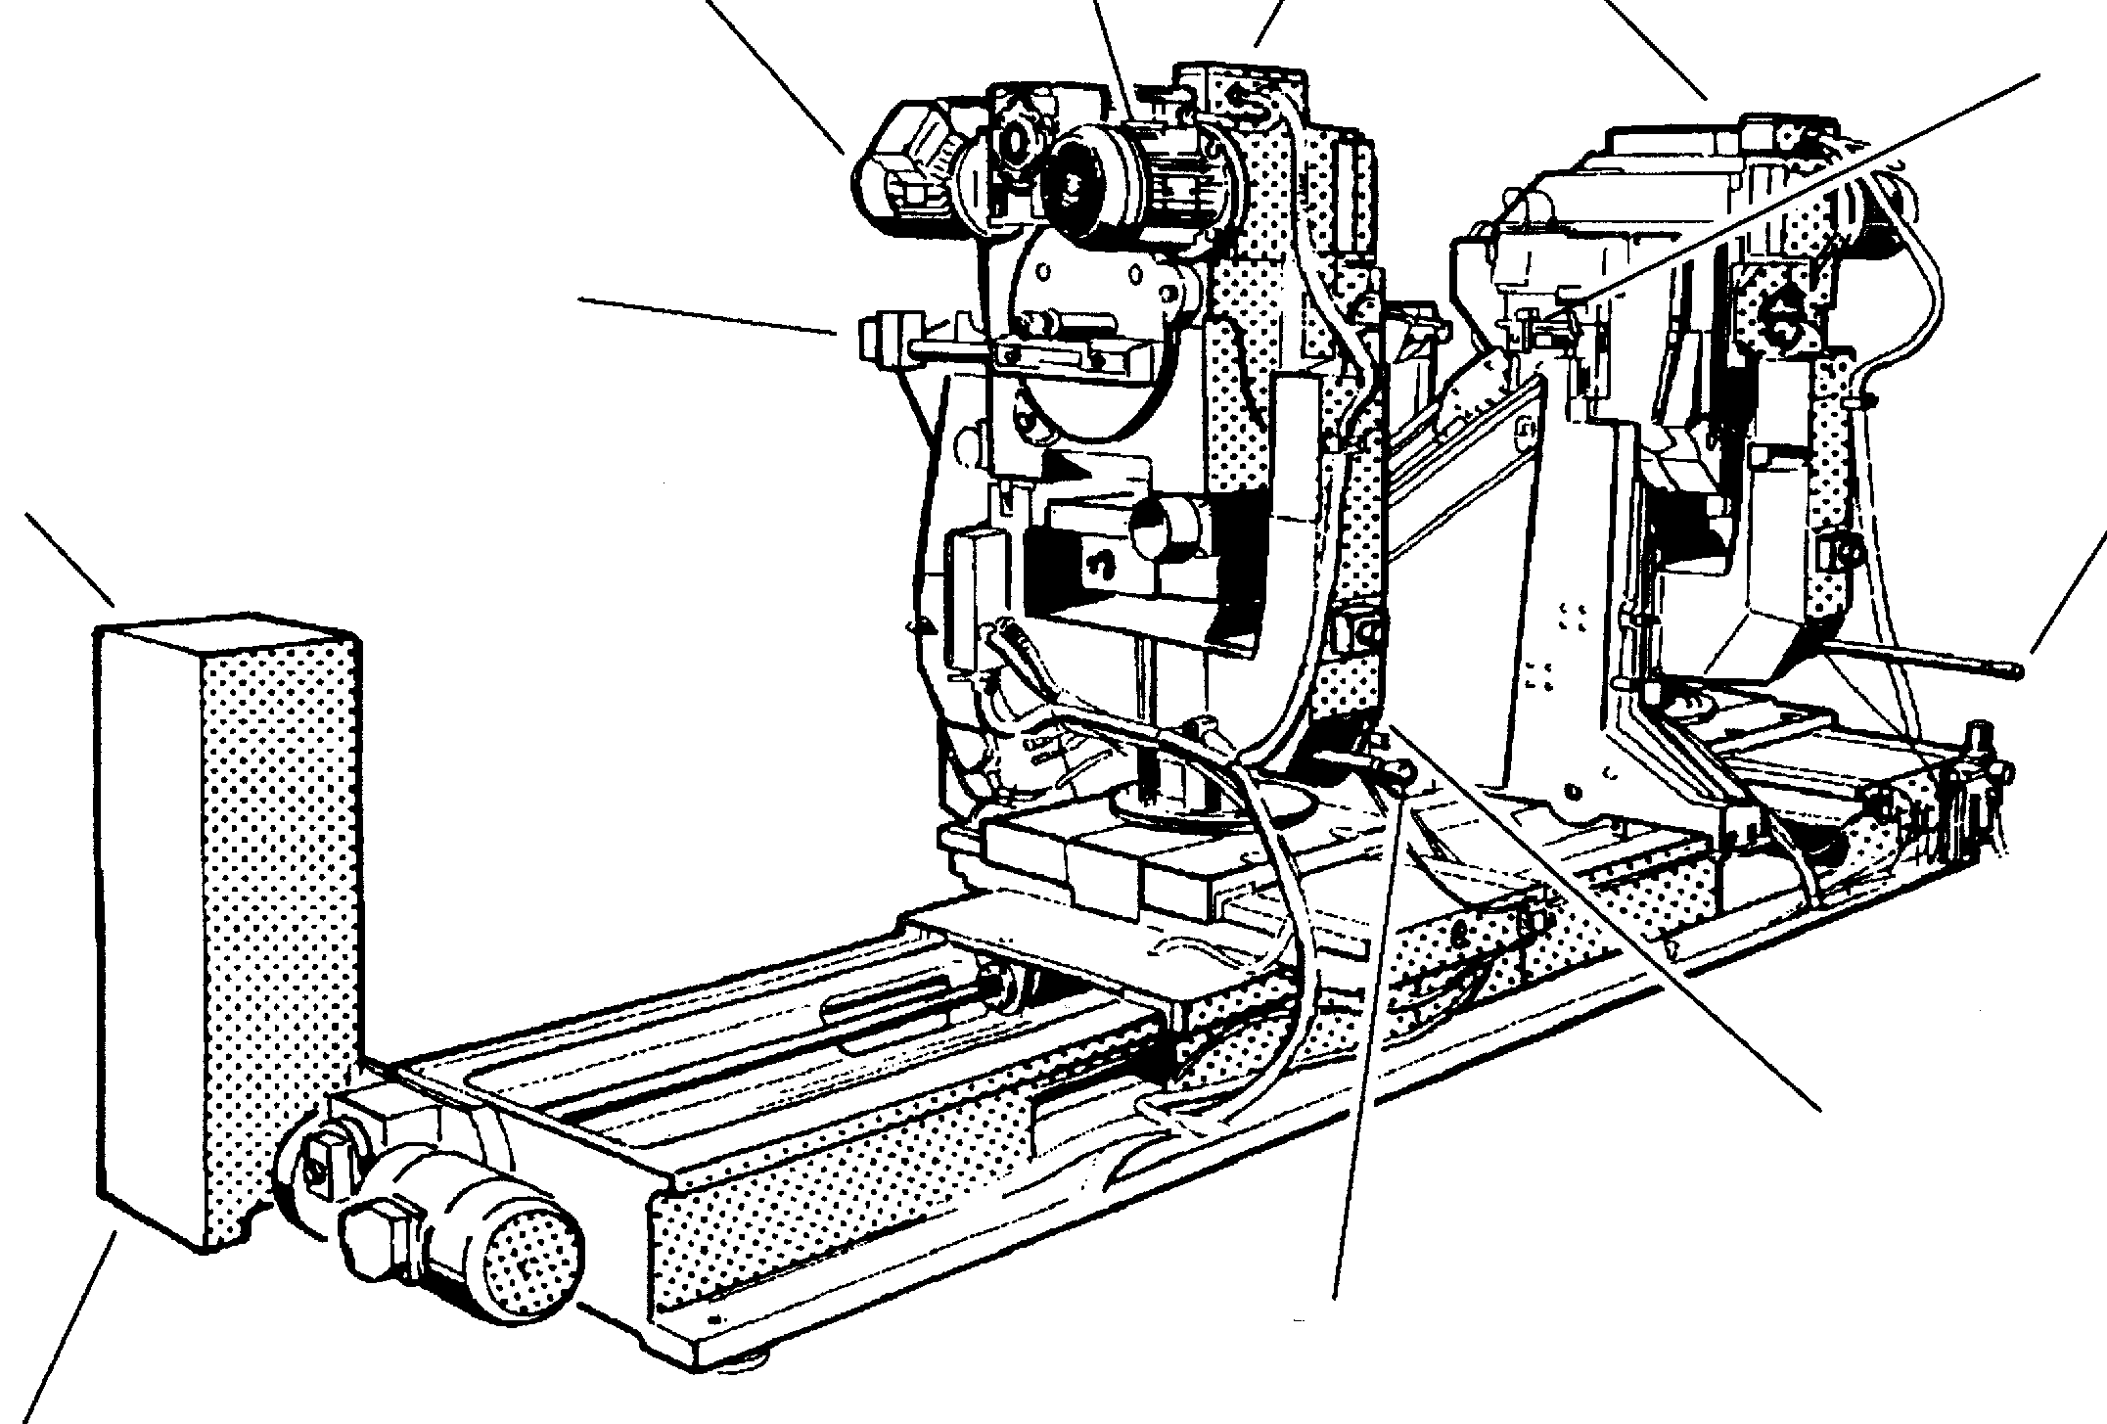
Clamps

Tenon width adjustment
Axis 6
Head rotation control lever
CSF2 Loader

Shift of the loader with internal key grip

Axis 7
Head rotation control lever

Main lever controlling loader

Fig. 14 Rear view

System

Pneumatic system on machine

Cutter down magnetic limit switch
SQ2 (sx)
SQ5 (dx)
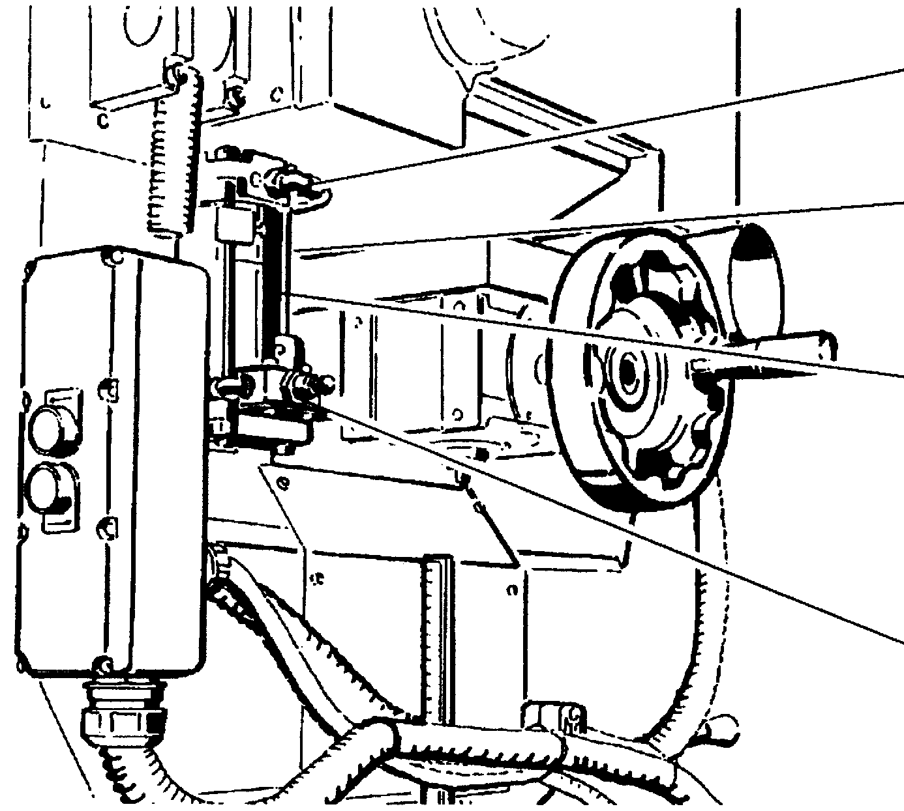

Magnetic limit switch
SQ11 (sx)
SQ12 (dx)

Cutter lift cylinder
(33SX-36DX)

Head up magnetic limit switch
SQ1 (sx)
SQ4 (dx)

Fig. 15 Pneumatic system

Electric system

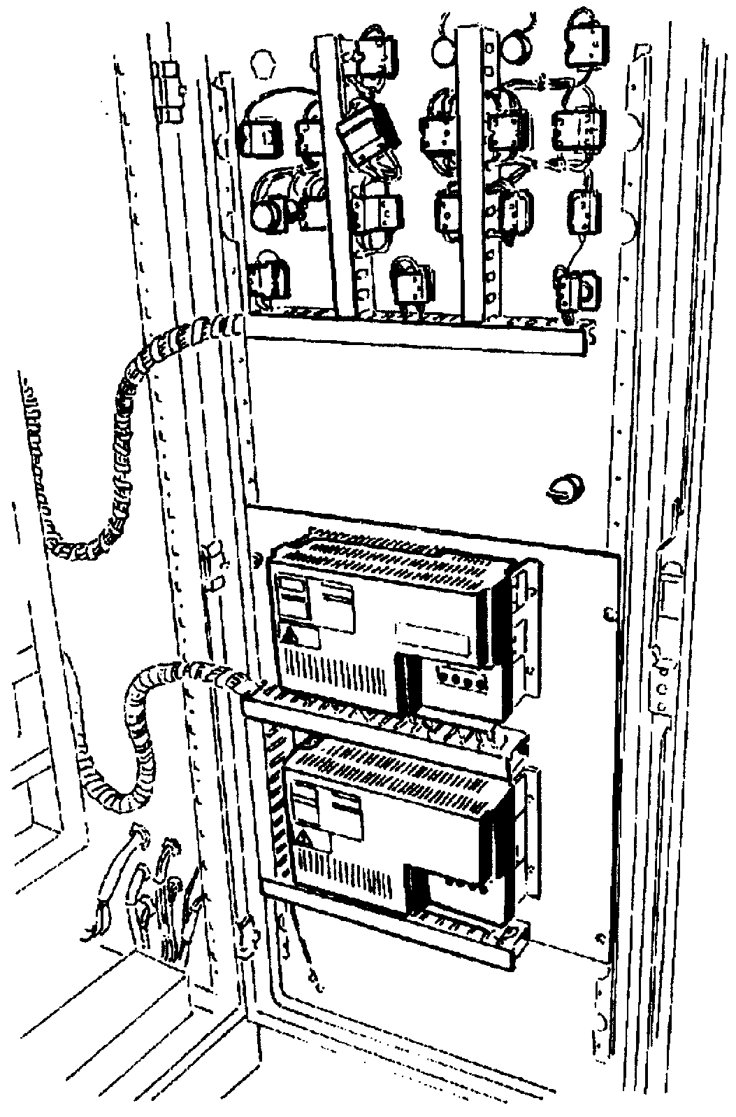

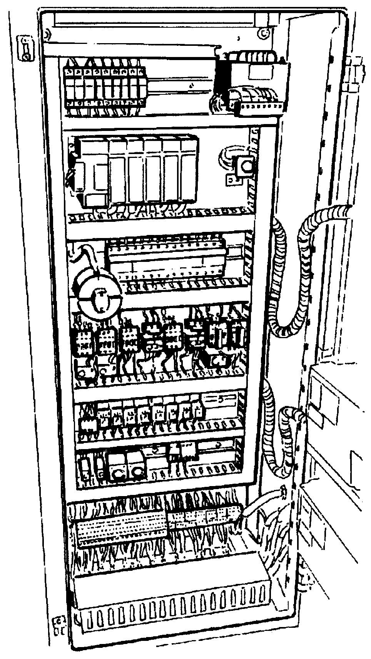

Fig. 16 Electric system

Guards

The machine is provided with guards and protection devices that obstruct the access to the dangerous parts and those in motion. They are of the following types:
- interlocked mobile guards
- fixed guards with locking screws
- electric box with lockable isolation disconnector

Accident prevention safety
It is absolutely prohibited to remove or deactivate the accident prevention safety devices, and in particular:
- the fixed guards indicated in Fig. 17-18-19-20-21-22-23-24.
- the interlocked mobile guards Fig. 25.
- the locking valves of the clamp cylinders
- the lockable isolation disconnector (electric box) Fig. 19 and the compressed air (lockable) connection unit Fig. 9
- the emergency push buttons Fig. 20
- the safety microswitches Fig. 20-25.
- the cable devices Fig. 19-20.

Fire prevention safety
It is absolutely prohibited to remove or deactivate the suction guard and the inlets Fig. 23.

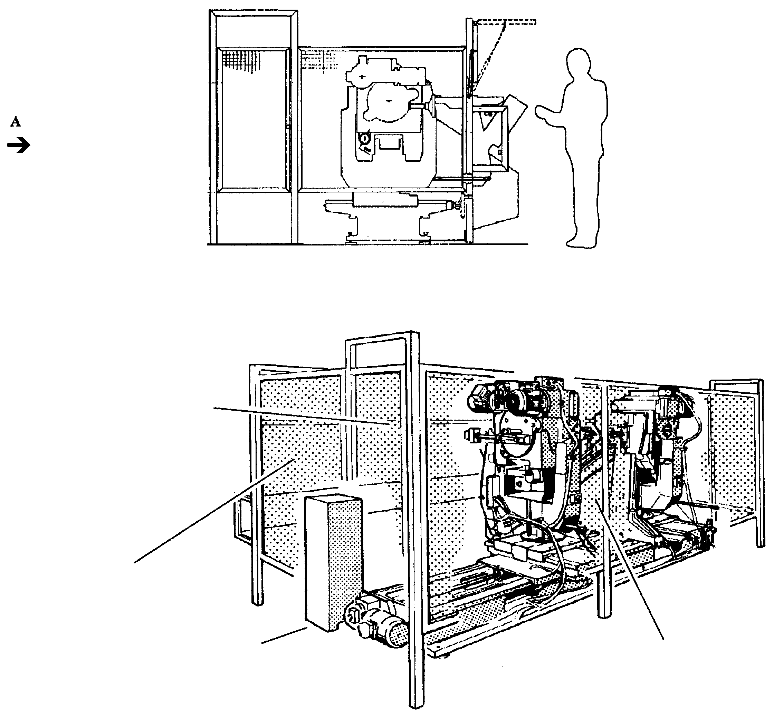
Interlocked mobile guard
Fixed guard
CSF2 Loader

Fig. 17 Side view

Rear fixed guard
(standard)

Fig. 18 Rear view from A

Cycle start bi-manual push button
Emergency push button
Reset push button
Suction inlet
Safety device Fig. 25
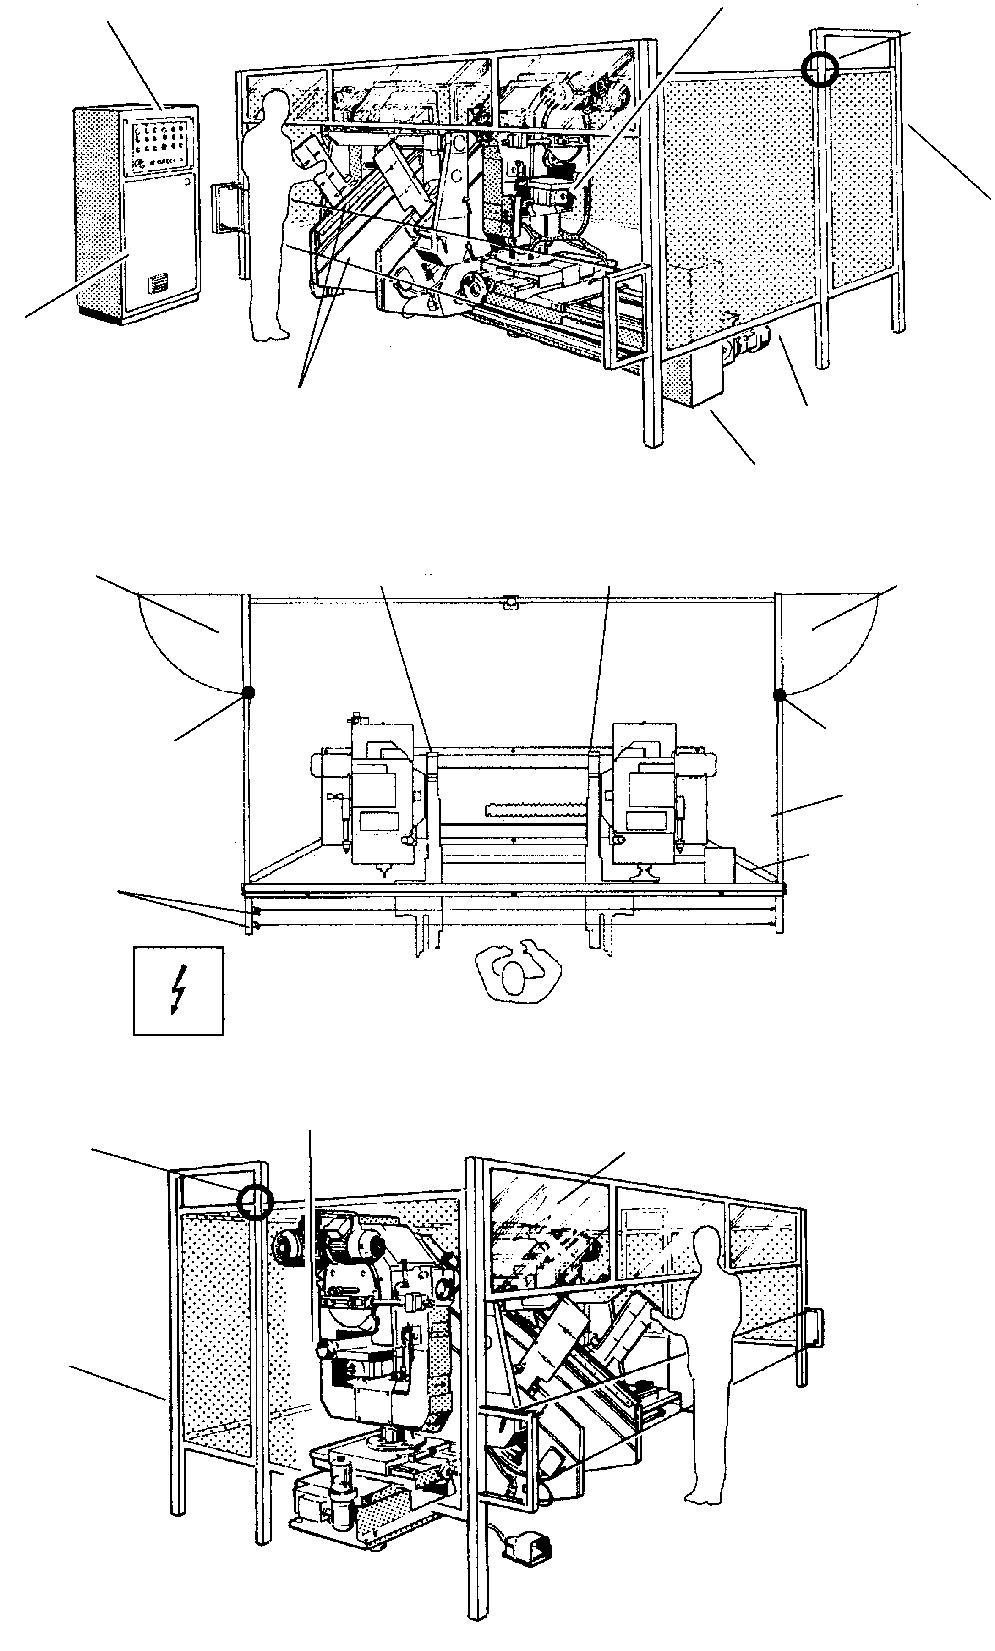

Interlocked mobile guard

Electric box with lockable isolation disconnector

Interlocked cable device

Fixed guard

CSF2 Loader
Fig. 19 Front view

Interlocked mobile guard
Interlocked mobile guard

Emergency push button
Emergency push button

Safety device
Safety device

Fixed guard

Cable device with safety microswitch
Anchoring traverse of the base protection

Fig. 20 Plan view
Safety device Fig. 25
Suction inlet

Overturning protection screen

Interlocked mobile device

Fig. 21 Side view

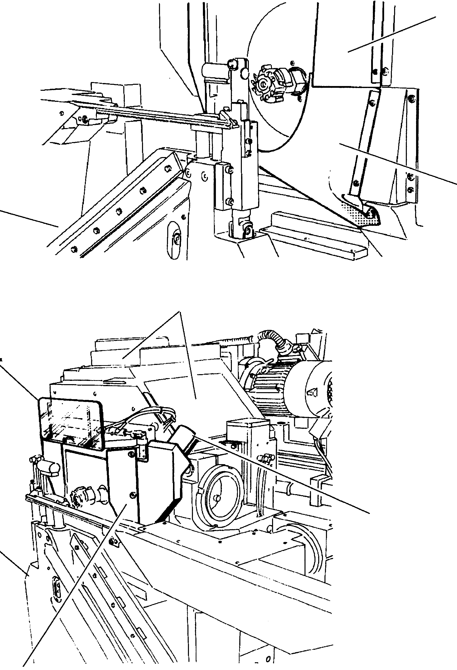
Chips containing bulkhead

Chips containing bulkhead

CSF2 LOADER

Fig. 22 Chips containing bulkhead

Fixed dome guards
Adjustable transparent protection

Guard with suction inlet

CSF2 LOADER

Chips containing mobile bulkhead
(is only activated in the working cycle)
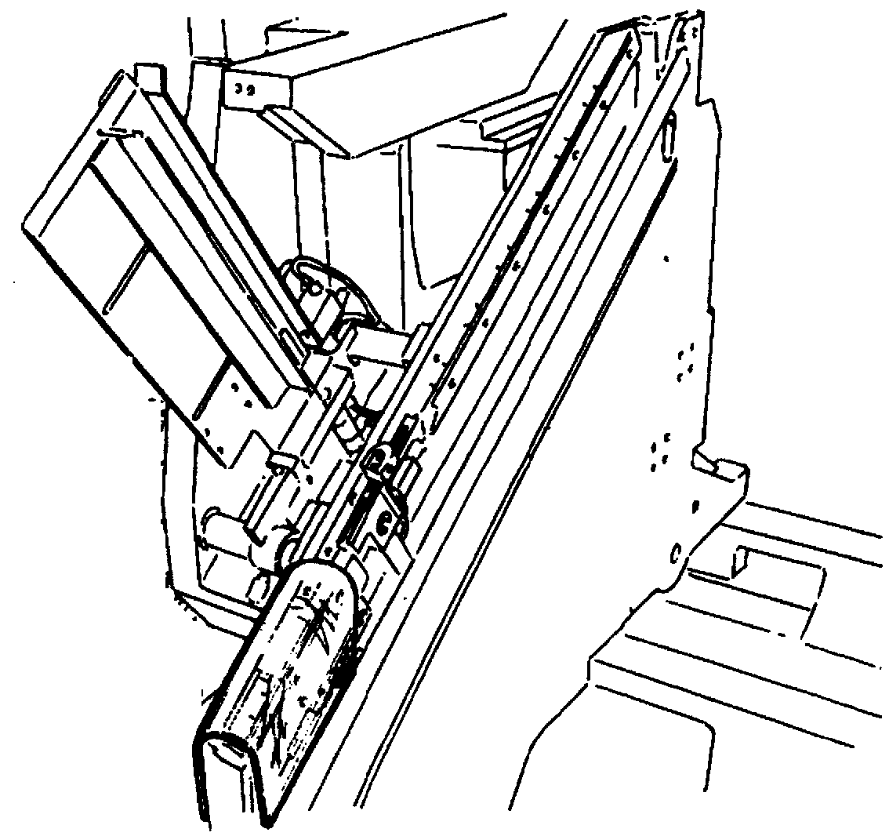

Fig. 23 Suction system and dome protection

CSF2 LOADER

Loader protection

Fig. 24 Loader protection

Safety devices


- Lockable isolation disconnector on electric box Fig. 19.

- Filter regulator lubricator unit for pneumatic energy isolation Fig. 9.

- Modal lockable selector with 4 operation modes.
The Manual and Semiautomatic mode, necessary for preparation and setup, allows the starting of the machine with the protection open (only cable released)

- Automatic end cycle limit switch at the last piece loaded in the bin

- The tools are supplied with suction intakes that can be connected to a suction installation.

- Emergency push button (no. 1 on the control panel; no. 1 at the rear part of the fixed unit; no.1 at the rear part of the mobile unit)

- Reset push button on control panel (reset after having pressed emergency)

Piece clamping/release device

During the working, the piece is held locked by the clamps; the release of the piece, in case of accidental loss of pressure, is obstructed by a pilot operated open check valve installed at the inlet of the pneumatic control cylinder.

Interlocking at the control level

1) The working cycle only occurs when the tool is in rotation.

2) In case of normal or emergency stopping, the simultaneous stop of the rotation and revolution movement of the tool is obtained by means of the self-braking device.

3) The start in the four operation modes always takes place upon intentional action, at the starting of the machine, after each normal emergency stop, as well as after each intervention of the safety microswitch on the protection devices.

Pneumatic feed line interlocking

1) In case of loss of pressure on the pneumatic line, the following takes place:

- the activated clamp remains locked
- the cutter stops rotating and moving.
- the loader stops
- all the movements of the axes are inhibited

2) If the pressure on the pneumatic line is not present at the moment of the restart of the work, the machine is not activated in any function.

Klöckner Moeller AT0-11-1-ZB
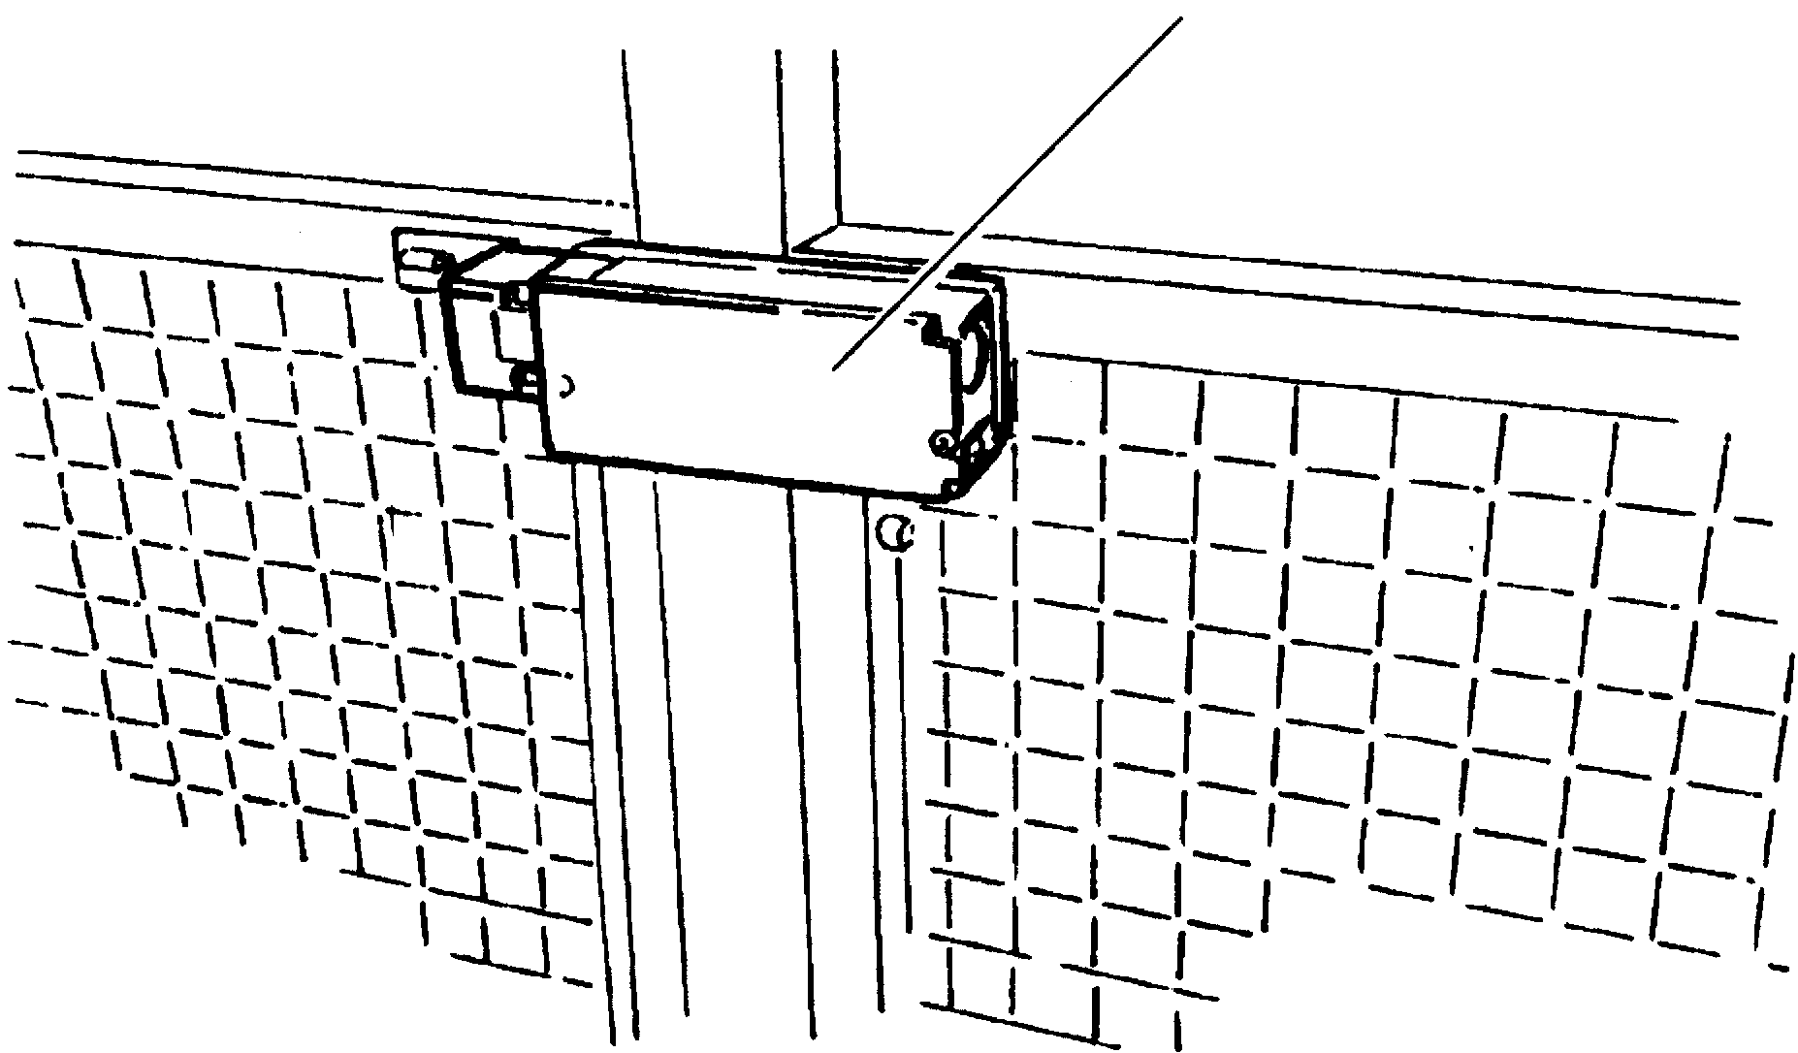

Fig. 25 Interlocked safety microswitch

Lateral access door interlocking of the net protection

The machine foresees enclosures on three sides (rear and sides). The access doors are interlocked Fig. 25.
The opening of a door sends the machine into emergency conditions.
With a door open you may only exit from the emergency condition with the key selector in “manual” or “test cycle” (semiautomatic) position.

Interlocked cable device

On the free front space a cable device is installed located at 400+50 mm and at 800+50 mm interlocked Fig. 19-20.
The device does not obstruct the access to the inside of the protection but functions as a obstruction and dissuasion system to control the access from the operator station. The device, if excited, sends the machine into emergency condition in the Automatic (single cycle) function and the Automatic function in which the piece loading in the bin and piece unloading in the unloader is foreseen. The device obstructs reaching dangerous zones of the machine with the limbs. The cables are released to allow the preparation and the setup and the safety microswitches are bypassed in the Manual and Semiautomatic modes.

Protection device against piece ejection

On the front side is installed a transparent bulkhead which avoids the direct projection of pieces and/or parts of tools towards the operator from a height of <1400 to a height of >1800 and with a width that is equal to the entire front access. The bulkhead is overturning and must be closed by the operator during the work.

Cycle start bi-manual control

This device is only enabled at the cycle start function in the Semiautomatic mode, when the cable device is bypassed and the single testing cycle is carried out.
The obligation of the two-hand control on the main panel is a deterrent for the operator to not reach the dangerous zone where the tool is operating, though this does not exclude a REMAINING RISK, see chapter 5.5.

Range of applications for which the machine has been projected

USE ACCORDING TO DIRECTIONS

Your machine has been built with the aim of producing tenons or pins, working with removal of chips through a tool. The use is conceded to only one operator. The machine is foreseen for working automatically only with the loader CSF2. The use with manual feed of the piece is not foreseen, except for a single cycle. The machine may carry out an automatic single cycle when the pieces to be worked are not stackable in the loader because they have different heights and as a consequence may not be placed one on top of the other. In the automatic single cycle the operator must load one piece at a time and wait for the return form the unloader at the work end.
The material used is made up of wood blocks or assimilated material.
The following data are valid for straight pieces as in the figure

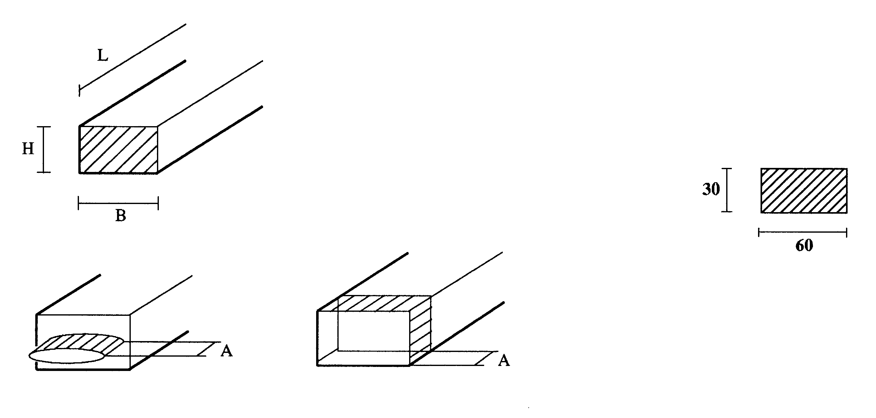
H max= 55mm H min= 10mm
B max= 145mm B min= 10mm
L max= 1190mm (standard) L min= 150mm (Fig. 4.4)
Lmax= 2200mm (long machine) Max weight = 10Kg

A max=25 mm
With section 30X60
- medium consistency wood (e.g. beech)
- with tool centered on the piece (rotation center in rough center line)
- to be gradually verified for pieces of greater sizes (starting from 0 removal)

Fig. 26 Working data

- Any use outside of this is not within the norm
The manufacturer is not responsible for possible damage resulting from this. The risk is at care of the user.
- The specifications of safety, work and maintenance of the manufacturer must be observed, as well as the measurements indicated in the technical data.
- The appropriate specifications for prevention of accidents and other acknowledged technical safety rules must be observed.
- The machine may be used, maintained and repaired only by persons that are experienced and that have been instructed about possible dangers. Arbitrary modifications to the machine exclude the responsibility of the manufacturer for possible resulting damages.
- The machine may only be used with original accessories and tools of the manufacturer.

Features of the tools
ø max 130mm (ø standard tenoning cutter=70mm, standard shredding machine = 100mm)
Max rpm 9500 rpm
Max length 70 mm
ø hole 27 mm H7

USE OF THE MACHINE

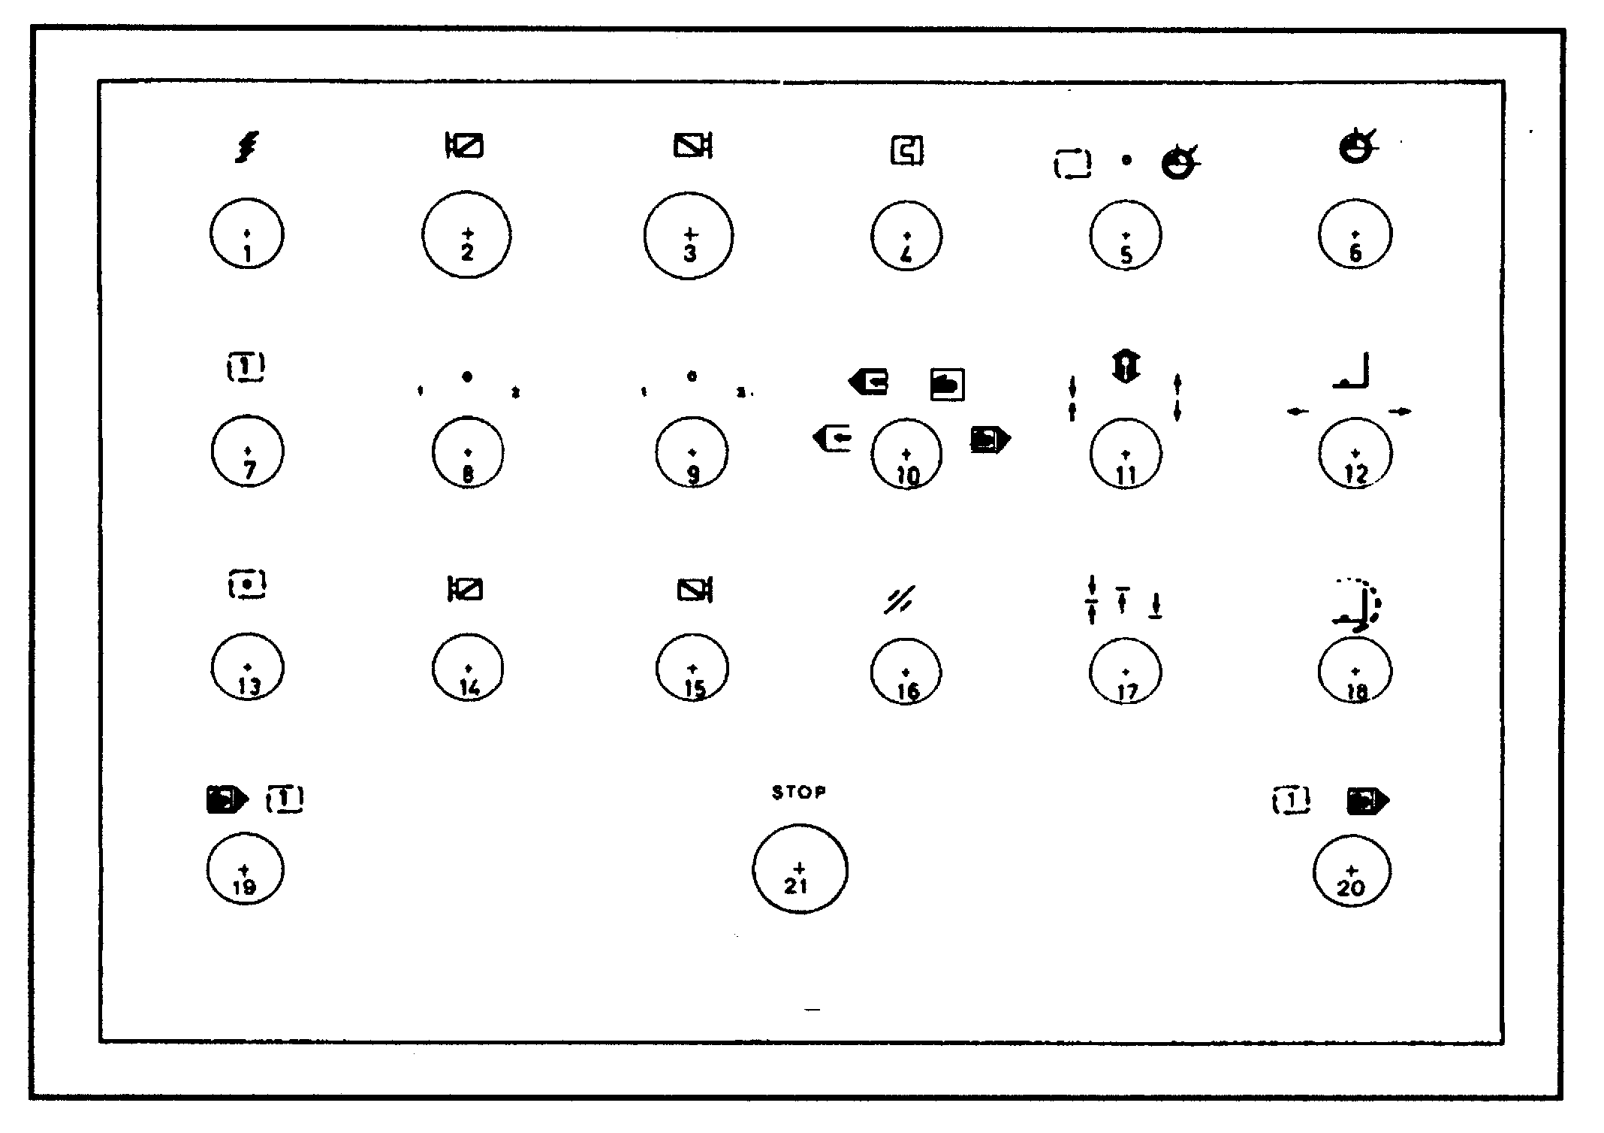
Control board

Fig. 27 Control panel
1 Power grid ON Lamp  2 Left cutter motor running Lamp (2-speed motor)  Left cutter revolution speed adjustment potentiometer (inverter)  3 Right cutter motor running Lamp (2-speed motor)  Right cutter revolution speed adjustment potentiometer (inverter)  4 Thermal tripping Lamp  5 3-position selector:  a - working cycle (axes locked)  b - rest position (axes locked)  c - axes positioning (axes locked)  6 Positioning in progress Lamp  7 Cycle start push button  8 3-position selector, left head revolution motor: (2-speed motor)  1 - slow revolution  0 - head not on  2 - fast revolution  Revolution enabling selector (inverter)  9 3-position selector, right head revolution motor: (2-speed motor)  1 - slow revolution  0 - head not on  2 - fast revolution  Revolution enabling selector (inverter) |   10 4-position key selector  - setup cycle  - manual piece testing cycle  - automatic single cycle  - automatic cycle  11 Clamps open/close control push button (only in manual cycle)  12 Loader forward/backward control push button (only in manual cycle)  13 Cycle stop push button (automatic cycle end)  14 Left cutter up/down control push button (only in manual cycle)  15 Right cutter up/down control push button (only in manual cycle)  16 Reset push button  17 3-position selector, clamps:  - both clamps move, upper and lower; the reference is given by the lower clamp  - the lower clamp moves; the reference is given by the upper clamp which is stationary  - the upper clamp moves; the reference is given by the lower clamp which is stationary  18 Loader speed control timer  19-20 Manual piece test cycle bi-manual control (after piece locking with pedal control)  21 Emergency push button  22 Pedal control (on machine)

Adjustments

In order to ensure better performances of the machine you must carry out the following adjustment operations.


All the adjustments must be carried out in the mode manual

manual piece test

5.2.1 Adjustment of the width and thickness of the tenon

The unit installed behind the head allows adjusting the thickness and the width of the tenon that you want to obtain. You may carry out pins and tenons with a thickness and widths as indicated in chapter 4.5.

1 - The thickness is adjusted by releasing the graduated slider C and by turning knob P up to the desired size
2 - The width is adjusted by releasing tie rods T and rotating screw V until the counter Ct indicates the desired size.

With this unit you may obtain inclined tenones: loosen the locking screws V1 and rotate the disk around its own axis by using screw V as a lever. The reading is effectuated with the graduated scale S.

C
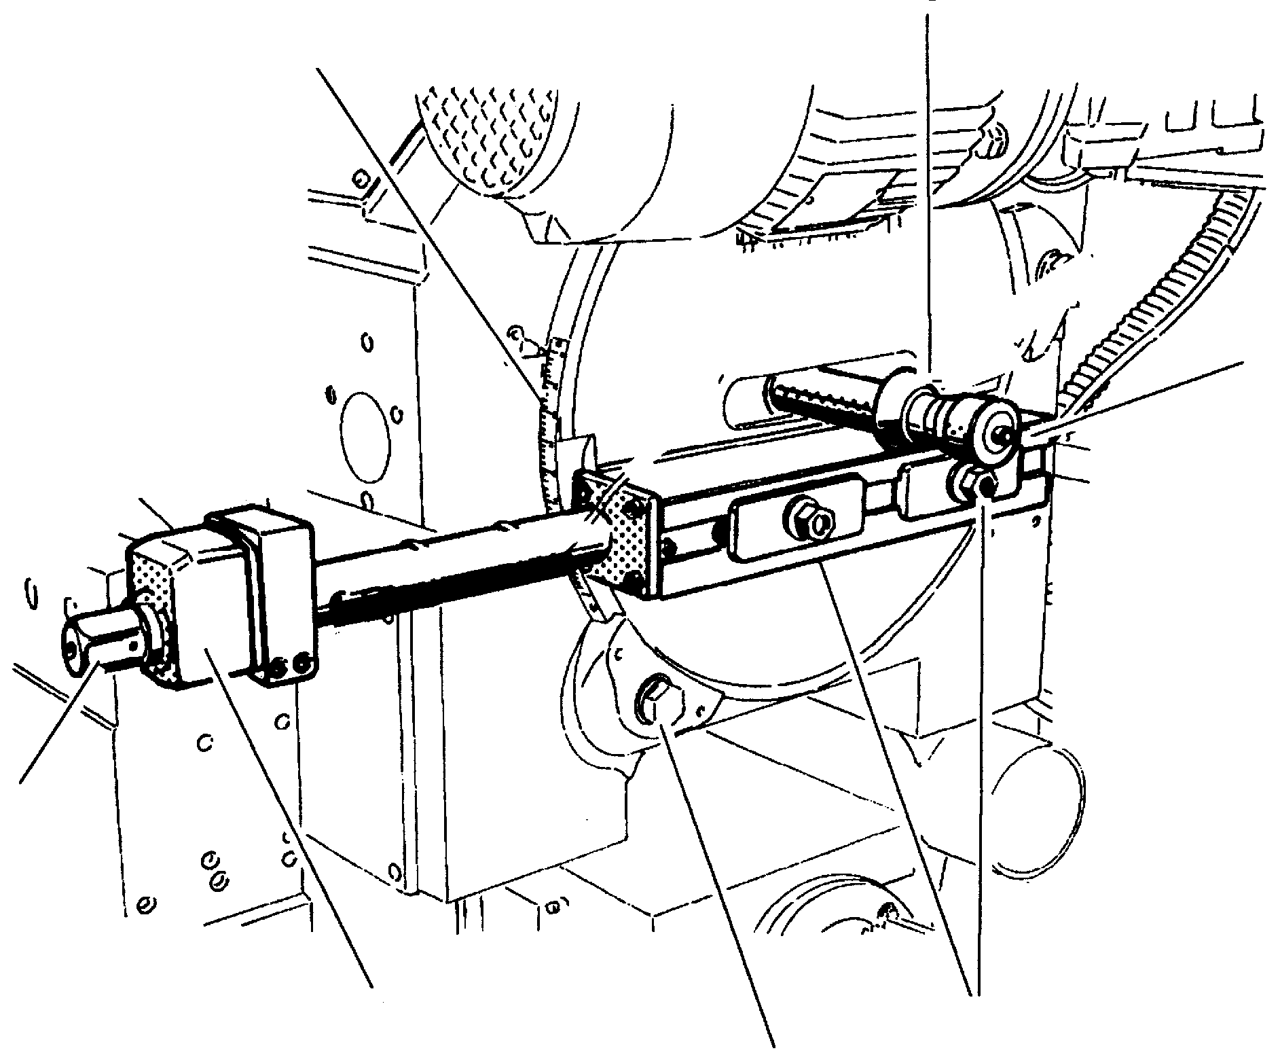
S

P

V

T
Ct

V1

Fig. 28 Tenon adjustment

5.2.2 Head shift (Axis 1)

To obtain the shifting of the head, keep the push buttons 5 or 6 of Fig. 32 pressed.
When you are near the desired height, which you can read on the Siko S meter, release the push button and act on handwheel V for the precision adjustment.

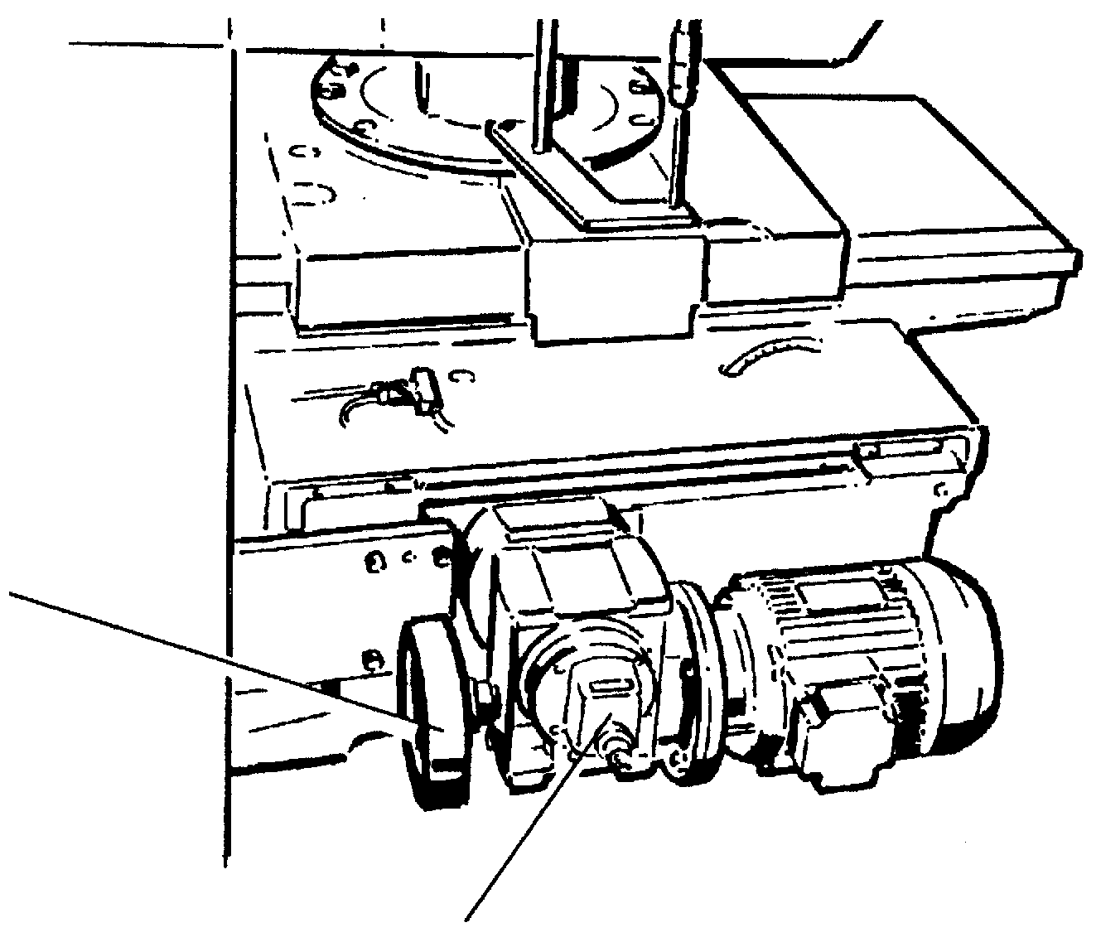

V

S

Fig. 29 Head shift

5.2.3 Head traverse shift (Axis 2-3)

To shift traversal, act on handwheel V1, and check the movements on the relative graduated scale

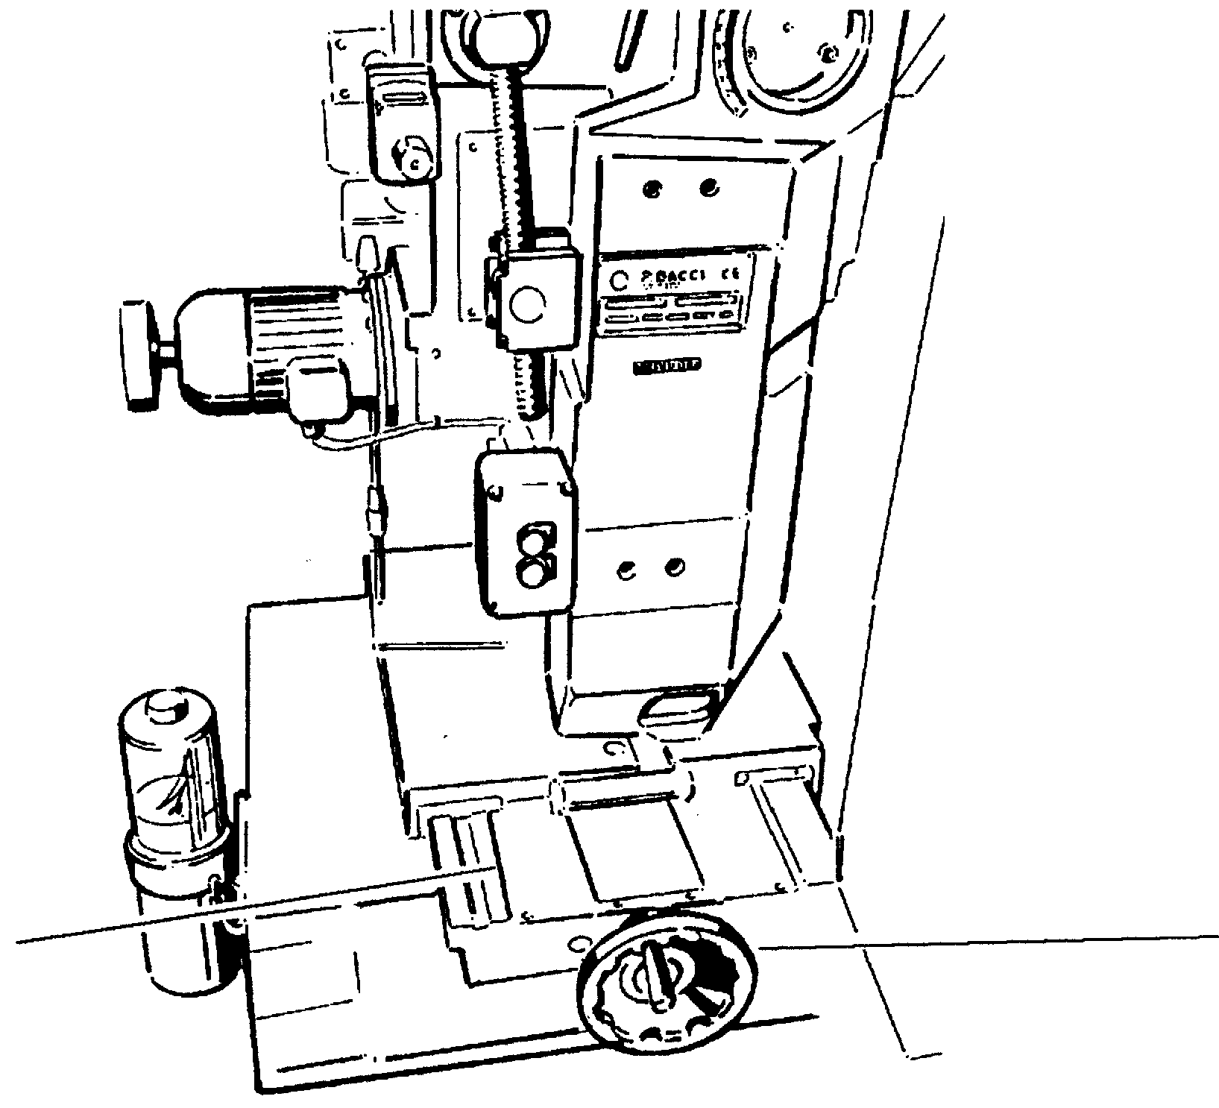

V1
Graduated scale

Fig. 30 Head traverse shift

5.2.4 Inclination of the head (Axis 4-5)

To incline the head, loosen the lever L and suitably act on the threaded bar B with a wrench, reading the movements on the graduated scale Sg.
Tighten lever L again at the end of the operation.

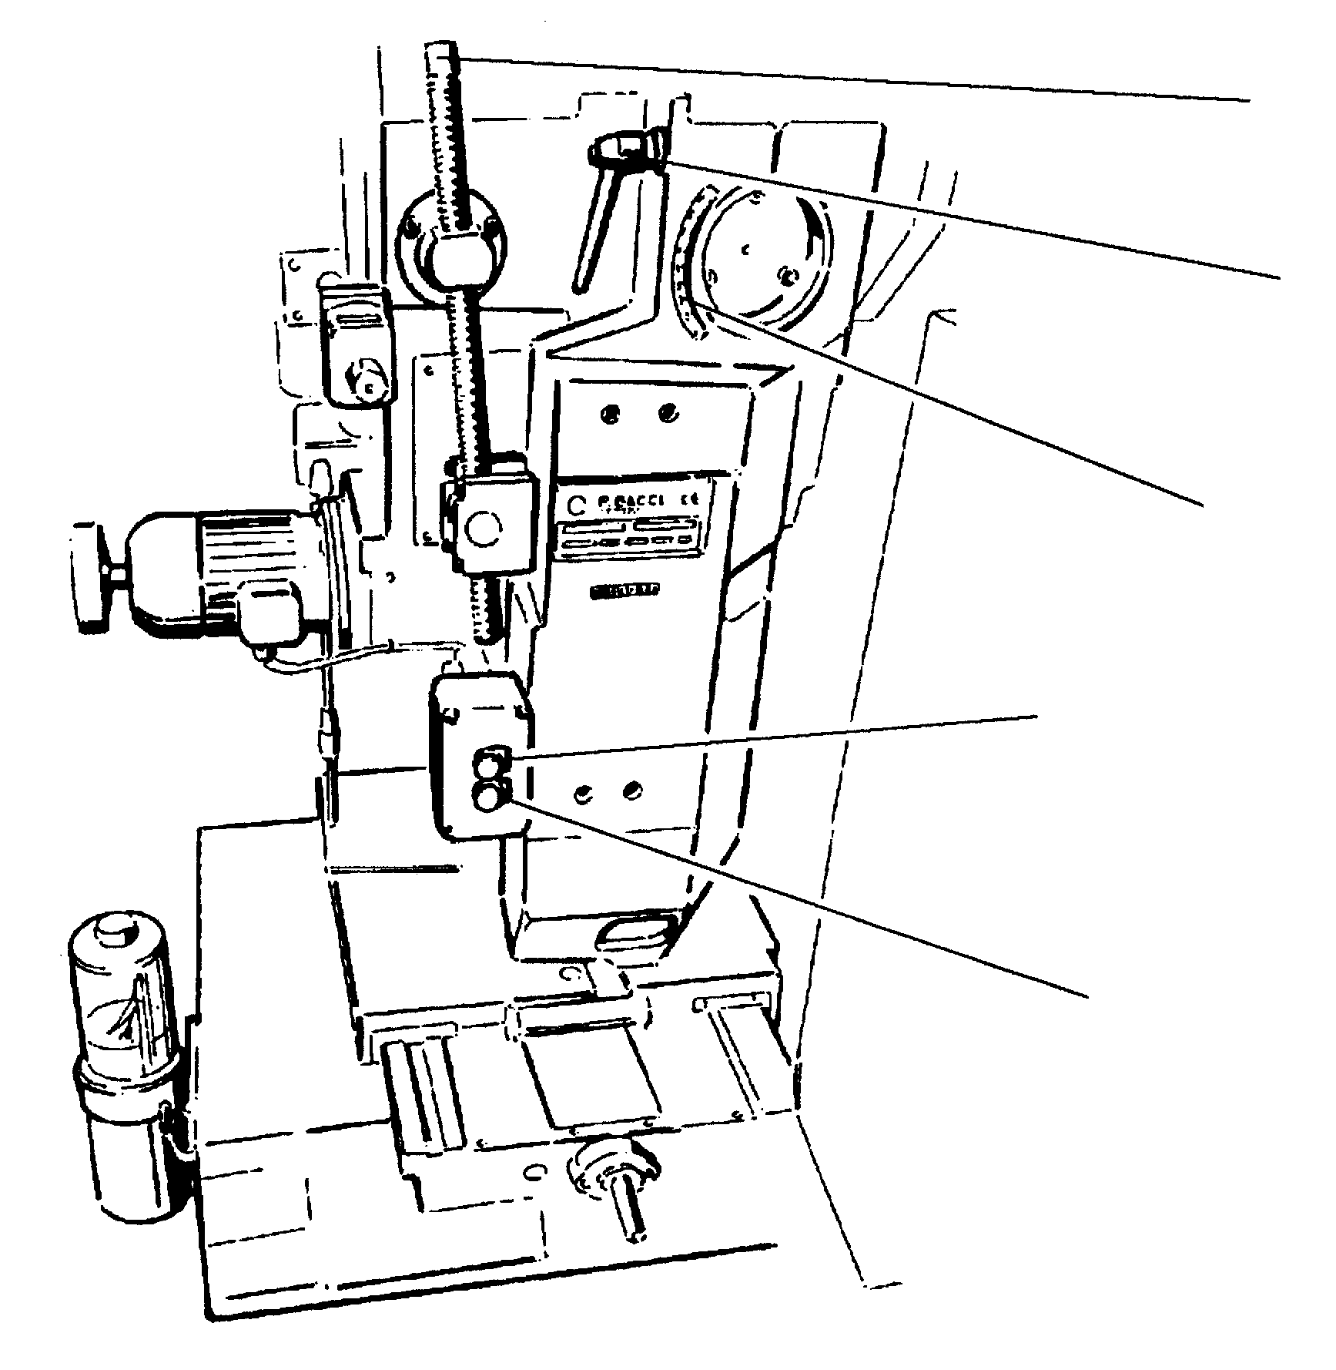
B

L

Sg

1

Head rise
(Axis 8)

2

Head lower
(Axis 8)

Fig. 31 Inclination of the head - Head control push button panel

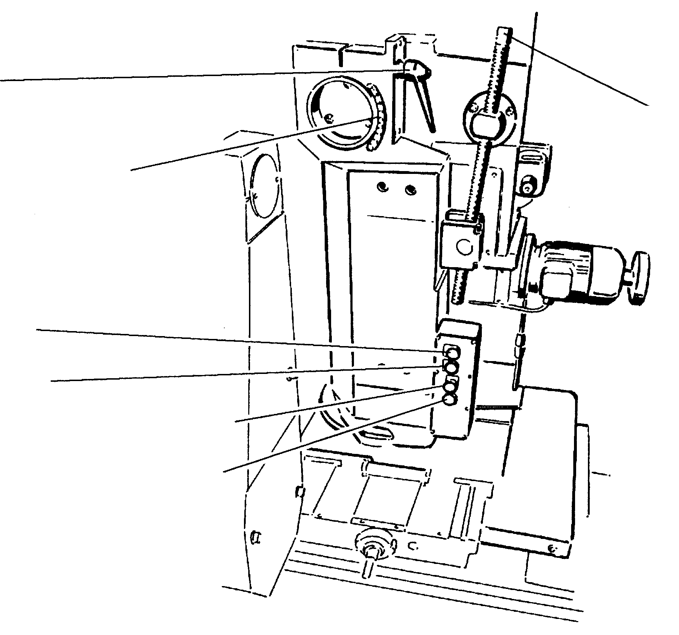

L
B

Sg

3 Head rise (Axis 9)

4 Head lower (Axis 9)
5 Shift of head to operator’s left (Axis 1)

6 Shift of head to operator’s right (Axis 1)

Fig. 32 Inclination of the head - Head control push button panel

5.2.5 Head rise (axis 8-9)

To rsise the head in the standard machines, turn the handwheel and read the movements on the graduated scale Sg1.
Moreover, it is possible to have a device with motor as optional. In this case the push buttons 3 or 4 (Fig. 32) must be pressed until obtaining the desired position.
Check the movements on the relative graduated scale Sg1.
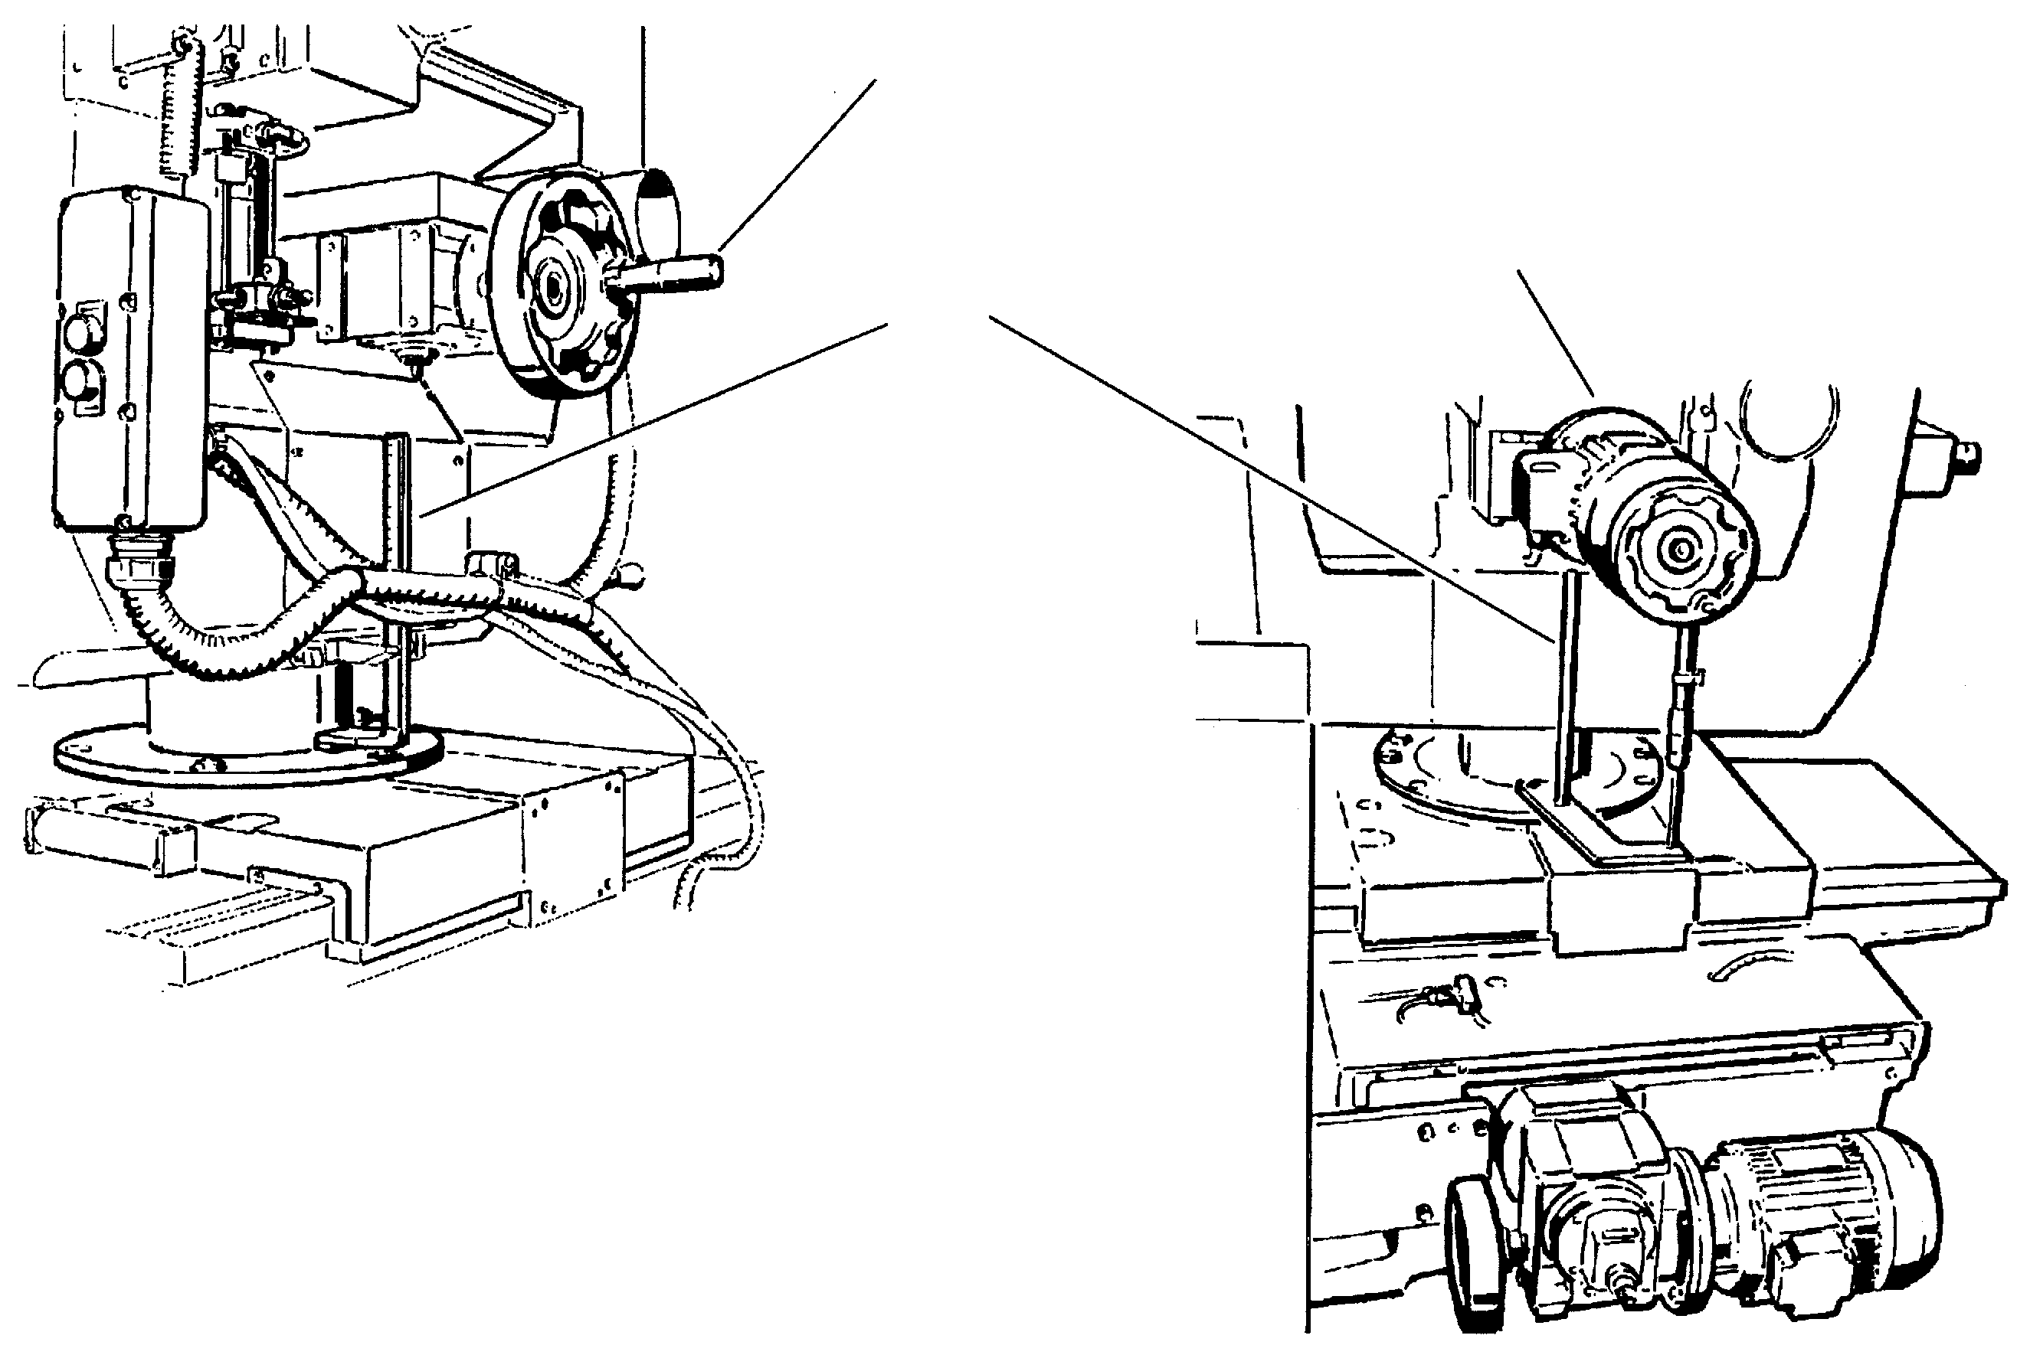

Head rise handwheel

Head rise motor with handwheel for precision adjustment

Sg1

Fig. 33 Head rise (standard)

Fig. 34 Head rise (optional)
5.2.6 Rotation of the head (Axis 6-7)

For the rotation of the head loosen the screws V and act on rod A, while checking the variations on the circular graduated scale.

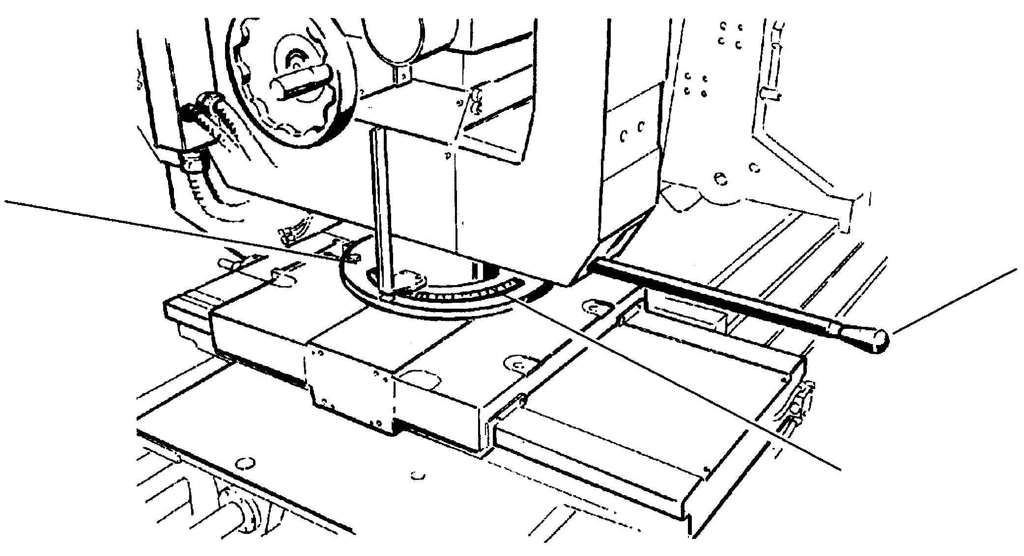

V

A

Circular graduated scale

Fig. 35 Rotation of the head

Start-up

The machine may operate in four different modes that can be selected with the key selector Pos. 10 Fig. 27:

MANUAL
This operation enables operations that are necessary for the verification of the setup of the machine functions. The operator is inside the protection devices. The possible safety conditions (see chapter Safety devices) are activated, which do not completely eliminate the dangers for the operator (see chapter Remaining risk).

SEMIAUTOMATIC (single test cycle)
This mode enables the Set-up of the machine with test pieces. The operator is inside the protection devices. The possible safety conditions (see chapter Safety devices) are activated, which do not completely eliminate the dangers for the operator (see chapter Remaining risk).

AUTOMATIC - SINGLE CYCLE
In this condition the machine is preset for the actual production and only carries out a single cycle to allow a last verification before the continuous automatic cycle. The operator is outside of the protection devices and must load the rough piece and check the finished piece that is returned by the unloader. All the safety conditions are activated, the machine may start the continuous production.

AUTOMATIC
The machine is preset for the continuous cycle; the operator must only load the rough pieces and unload the finished ones. The machine stops when it has effectuated the last piece of which the presence is signaled by a detector located on the bin.

Start-up (Ref. control board Fig. 27)

MANUAL (setup verification)

- key selector (10) on manual
in this operation mode the protection (microswitches) are bypassed
- Push button (7) is used to control the tools rotation (activated with selectors (8) and (9); push button (13) stops the rotation.
- the push button (11) provokes opening/closing of the clamps
- the push button (12) provokes the feed-return of the loader (only with clamps open)
- the push button (13) provokes the stop of the spindles rotation
- the push buttons (14-15) provoke the up/down movement of the cutters
SEMIAUTOMATIC (single test cycle)

- key selector (10) on “semiautomatic”
in this operation mode the protection (microswitches) are bypassed.

single cycle sequence:
- manual positioning of the piece to be worked with pedal locking
- bi-manual control, cutter rotation start, cutter revolution execution, cutter return to rest position, cutter rotation stop, delayed release of the piece.


AUTOMATIC - Single Cycle

as “AUTOMATIC” but with single cycle, start cycle with pedal control

AUTOMATIC (work)

- key selector (10) on “automatic”
in this operation mode all the protection (microswitches) are active

automatic cycle sequence:
- Press push button (7) if it flashes
- Start initial cycle with pedal
- simultaneous finished/rough automatic unloading/loading
- high pressure locking
- work
- Push button (13) stops the machine at the end of the cycle.

Ways and means of stopping

1- emergency stopping by means of push buttons on machine
The emergency stopping may be carried out by pressing one of the push buttons that are located on the control panel and on the machine.
After having pressed the push button the machine stops after approx. 3 seconds and remains timed.
To restart proceed as follows:
- Remove the cause that provoked the stop
- Rest the emergency mushroom push button
- Press the reset push button
- Press the machine start push button.

2- emergency stopping due to interlocked cable device opening
The machine stops in emergency conditions when the cable protection of the front access is pressed or opened.
To restart, reset the emergency, press the reset push button and the machine start push button.

3- machine in emergency conditions due to the opening of an access door
To restart proceed as follows:
- Close the door
- Press the reset push button
- Press the machine start push button

Emergency due to the intervention of magnetothermic switches
This emergency condition, signaled by the lamp located on the control board, foresees the intervention of the operator who must open the electric board and press the reset push button of the switch.
Press the start push button to restart.

Information about risks that cannot be eliminated by the measures adopted by the designer - Remaining risks

The machine has been designed for reducing to a minimum the possibility of risk for the operator during the production and for those responsible for the maintenance during the ordinary and special interventions.

The interlocked mobile guards, the perimeter protection, and the cable device obstruct the approach of the body to the tool and the loader during the automatic single cycle and the automatic cycle.

BE CAREFUL DURING THE PREPARATION AND SETUP PHASES, WHICH ARE CARRIED OUT IN MANUAL AND SEMIAUTOMATIC. WHEN THE CABLE DEVICE IS RELEASED AND THE BULKHEAD IS LIFTED, THE ACCESS TO THE TOOL IN MOTION IS NOT OBSTRUCTED!

DO NOT APPROACH THE TOOL IN MOTION AND MAKE SURE NO ONE ELSE DOES!

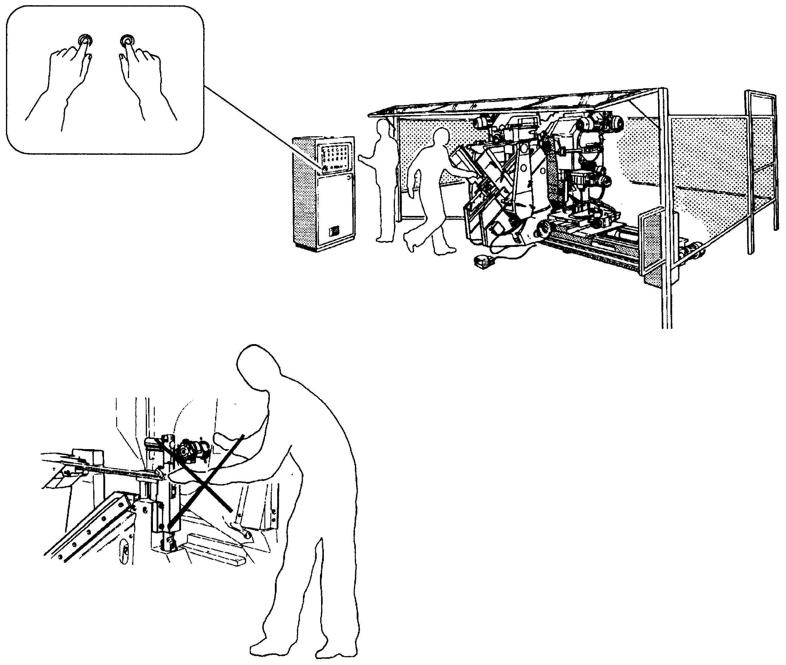

Fig. 36 Remaining risks

Troubleshooting

In the following list, a number of possible electrical defects are indicated with the relevant suggestions for the identification of their cause.
Those that have a high possibility of arising are taken into consideration

EFFECTS TO BE CHECKED

Voltage is lacking at the main panel  The PLC is not on-line  The machine turns on but no control is enabled  The cutters do not rotate  The cutters do not carry out the revolution movement  The cutters do not go into position for working cycle start  The cutters do not go into end working rest position  The cutters carry out the revolution continuously without stopping  The cutters go to working position but do carry out the revolution  The cutters go to working position without slowing down  In the "test cycle" the clamps do not carry out locking | - general power supply  - general switch QS  - fuses of the transformer FU6 and FU8  - the fuse of the PLC power supply FU9  - PLC on-line  - inverters operating  - line pressure  - line pressure switch BP1  - red emergency mushroom SBE, SBE1, SBE2  - wire emergency SQF1, SQF2  - emergencies on the protection doors SQP1 and SQP2  - thermal protections FR1- FR5  - cycle start with push button SBR  - the selection of the cutters with selectors SA2 and SA3  - fuses FU1 and FU2  - contactors KM1 and KM2  - fuses FU3 and FU4  - contactors KM3 and KM4  - any messages of anomalies on the inverters  - inverters reference POT1 and POT2  - inverters enabling KA3 and KA4  - solenoid valve controlling head up cylinders YV1 and YV3  - locking pressure switches relevant to the selected locking mode BP50SX, BP50DX, BP63SX and BP63DX  - mechanical lock of the cylinders  - the solenoid valve controlling head low cycle cylinders YV2 and YV4  - mechanical locking of the cylinders  - the stop revolution proximity limit switch SQ3 and SQ6  - the repeater relays KA6 and KA7  - the relays KA8 and KA9  - inverter 1 output (PLC input 2-B6) and inverter 2 output (PLC input 2-B8)  - the low cutters rise cylinders magnetic not microswitches SQ1 and SQ4  - the regulators on cutters rise cylinders  - pedal SB31

MAINTENANCE

GENERAL RULES

The machine has been designed so as to reduce the need of maintenance to a minimum. The following rules must be observed at all times in order to guarantee a long life and operation without trouble.

N.B.: These rules are projected for a continuous operation of 16 hours a day. If the machine is stopped for short periods of time, the intervals between the maintenance operations should increase proportionately.

In any event, a number of general rules must be observed for keeping the machine in perfect running order:
- keep the machine clean and in order
- avoid any preventable damage
- avoid having temporary or urgent repairs become systematic
- avoid carrying out work on the machine that produces metal shaving; if necessary, for example for making holes, check carefully that no fragment remains in the components of the machine.

The strict observance of the periodical maintenance rules is extremely important:

all the components of the machine must be regularly checked in order to avoid that possible anomalies occur, this way anticipating time and means necessary for the possible maintenance intervention.

SAFETY RULES FOR THE MAINTENANCE INTERVENTIONS

All the interventions on the machine must be compatible and in strict observance of the operator’s safety specifications.

When it is necessary to intervene on the electric circuit, it is indispensable to turn the general door locking switch to “O” position in order to guarantee the access safety on the inside of the board.

The use of gloves is obligatory with the assembly and disassembly of the tools.

NON-PROGRAMMED MAINTENANCE

This maintenance must be carried out when the machine is put into service and during the running-in phase.

When the machine leaves our factory, all its parts are lubricated; the gear motors of the life-long lubricated type do not need any intervention.

The technicians appointed to the maintenance of the machine must, in any case, check the correct lubrication of the different components.

Nature and frequency of the inspections

Verification of the braking times of the self-braking motors

It must be periodically checked that the braking takes place in the foreseen time (max. 10 seconds); should this not be the case, you are to adjust the brake according to the instructions of the motor’s manufacturer.

6.1.1 Daily maintenance

The pneumatic system of the machine is lubricated with machine greaser L of the FRL assembly that also includes a pressure regulator R and a filter F of the condensate.

One must:
- Regulate the machine greaser for sending a drop of oil into the pneumatic system every 30/35 seconds.
- Check that oil is never lacking in the machine greaser. Use the lubricant in TAB.I.
- Check that the automatic drain of the condensate S functions regularly. To avoid damage to the pneumatic system, the condensate must never exceed the maximum level indicated in its sump.
- At the conclusion of the work, using extreme care, remove all the paper dust from the entire machine with an exhauster.
In addition to the maintenance of the machine, this operation considerably reduces the fire hazards.
- Replace the broken components, crushed sheaths, unprotected wires, etc.
- Check the lubricant level according the LUBRICATION PROGRAM (Chap. 6.1.5)

6.1.2 Weekly maintenance

- Accurate cleaning with exhauster of the electric boards (this also reduces the fire hazards).
- Check that all microswitches trip correctly, are well fastened on their supports and the latter well fastened on the machine.
- Check that all the sensors are well fastened on their supports and the latter well fastened on the machine.
- Inspection of the correct functioning of the push buttons
- Inspection of the connectors
- Inspection of the sheaths

Check the lubricant level according to the LUBRICATION PROGRAM (Chap. 6.1.5)

6.1.3 Monthly maintenance
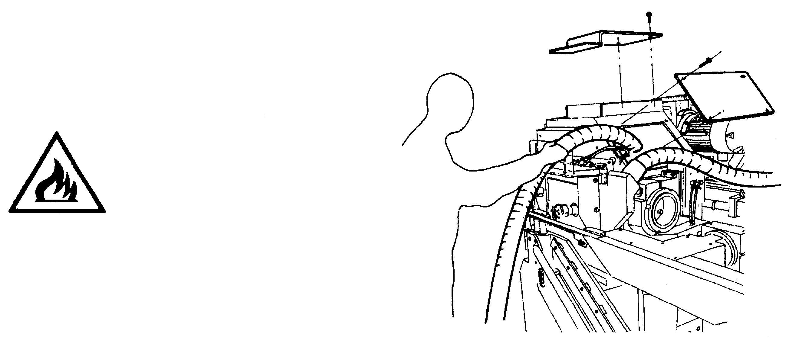
Against fire hazard!

Accurate cleaning with vacuum inside the two domes.

Fig. 37 Chip suction inside domes
Check the system elements on the machine

Proximity and limit switches
Visual inspection of the proximity and limit switches and inspection of their position
Check of the distance on the cams

Pneumatic circuit
Check and cleaning of the solenoid valves and/or coupling components
Check of pressure switch and inspection of the calibration
Check of the air lubrication system and filter

Electric equipment
External cleaning and dust suction on the inside
Check of electromagnetic switch contacts, auxiliary relays, switches, etc.
Check of safety protection devices
Check of push buttons, selectors, lamps

Test of operation
Check of all operation cycles of the machine in the various operating conditions
Controls with push buttons
Controls with automatic tools
Check of the protection barriers and the emergency stopping safety components

Check the lubricant level according to the lubrication program (Chap. 6.1.5).

6.1.4 Annual maintenance

Check the tension of the belts and their condition. If necessary, reset the correct tension by the relevant tie rod or replace it.

Check the lubricant level according to the lubrication program (Chap. 6.1.5).

We remind that the preventive maintenance must be integrated with the special maintenance, if necessary.
In addition, we recall the responsibility of the operator of the machine to notify any failure to the person responsible for the maintenance and to the person in charge of the department.

6.1.5 Lubrication program

 | Lubricat. points | Function | Lubricant | Type of lubrication | Quantity | Frequency
Filter regulator lubric. (Fig. 38) | 0 | Pneumatic system lubrication | Oil | Automatic TABLE 1 | See chapter 6.1.1 | Daily
Greaser (Fig. 43) | 6 right  9 left | Clamps guides | ARTAC oil EP68 | Manual | A few drops | Daily
Greaser (Fig. 42) | 11 right  12 left | Bronze ring  Pulley | ARTAC oil EP68 FINA | With closed circuit |  | Daily
Greaser (Fig. 41) | 19 | Base screw |  |  | A few drops | Weekly
Greaser (Fig. 40) | 20 right  21 left | Column | ARTAC oil EP68 FINA | Manual | A few drops | Weekly
Greaser (Fig. 42) | 24 right  25 left | Manual lubrication | ARTAC oil EP68 FINA | Manual | A few drops | Weekly
Reduction gears | Coaxial to the motors  Axes movement control |  | Synthetic oil Life-long

6.1.6 Lubrication points
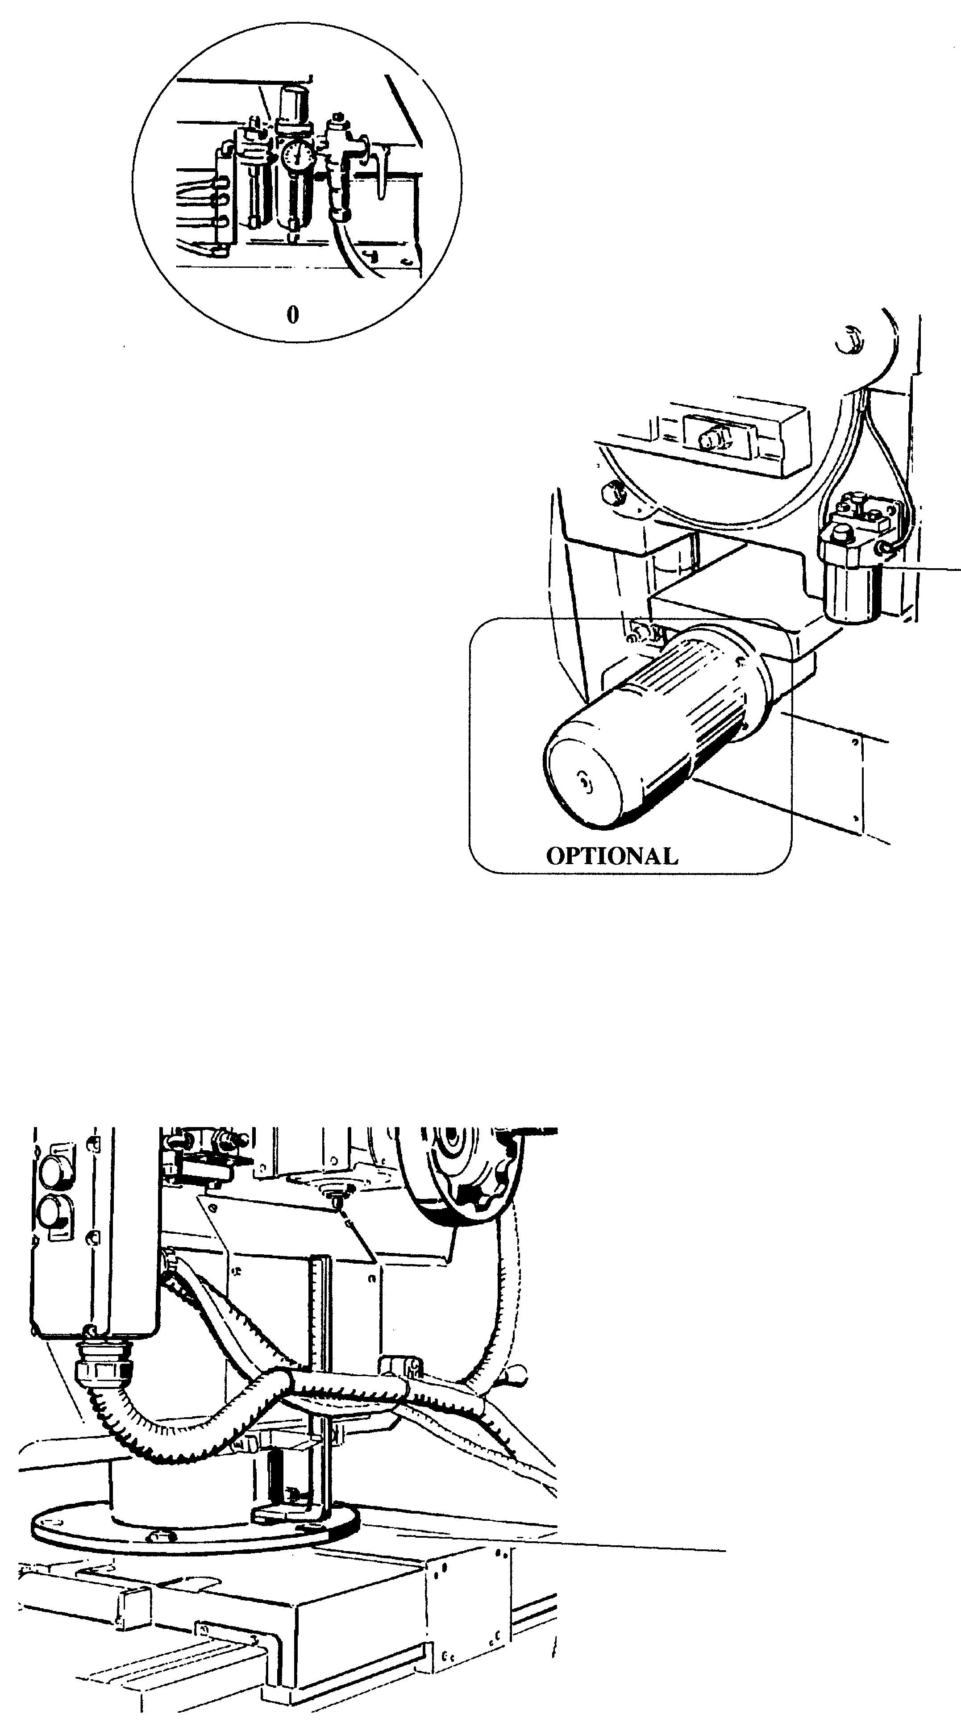

Fig. 38 Lubrication points

P
Oil type:
FINA-ARTAC EP68

Fig. 39 Lubrication points

20 Right
21 Left

Fig. 40 Lubrication points
Lubrication points (manual version)

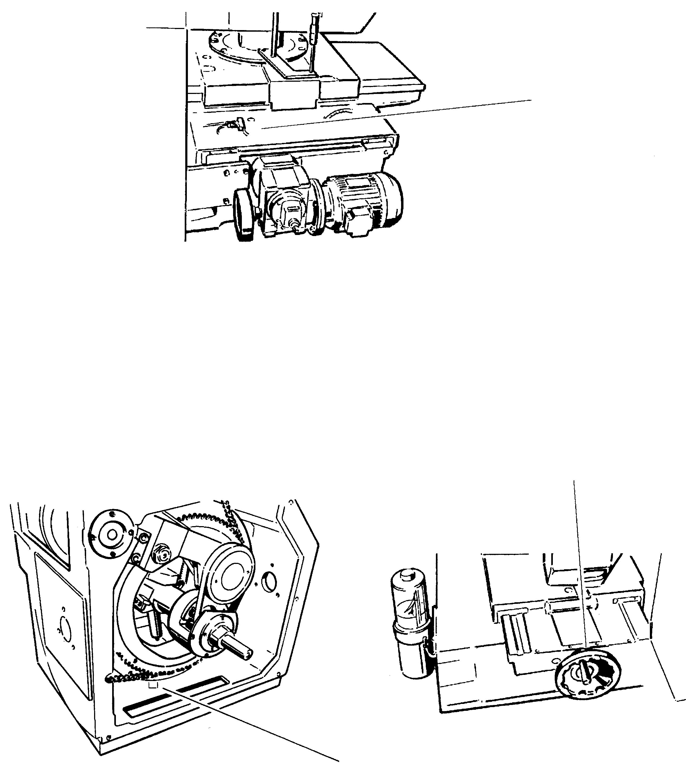
19

Fig. 41 Lubrication points

24 right
25 left

11 right
12 left

Fig. 42 Lubrication points

6.1.7 Automatic lubrication (optional)

On request, the machine may be equipped with an automatic lubrication system, illustrated in Fig. 43.

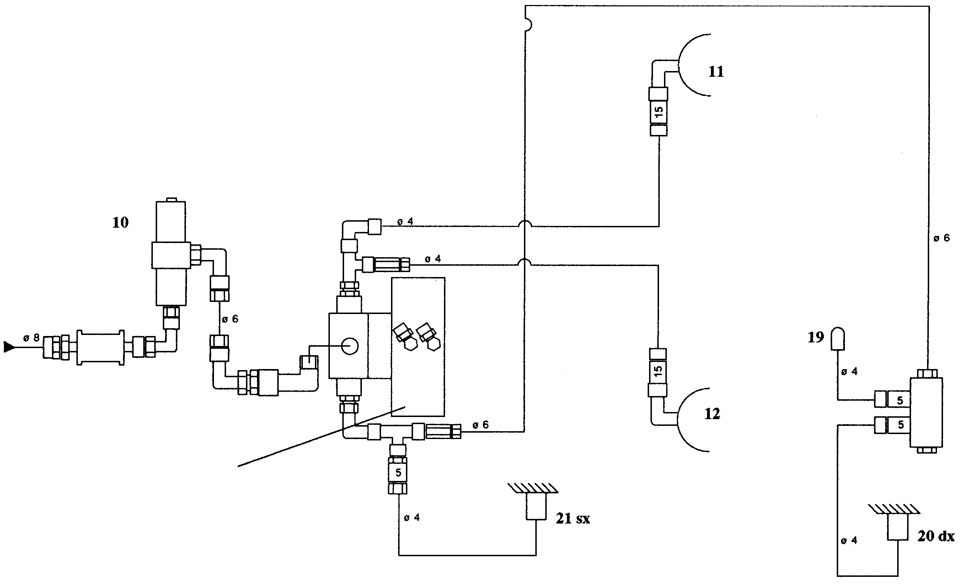

Pulley

Base screw

Pulley

Ball valve
(pneumatic actuator))
Small left slider column
Small right slider column

Fig. 43 Automatic lubrication system diagram

The lubrication system is turned on the moment the machine is turned on; the solenoid valve YVL activates the lubrication pump and solenoid valve YVPL changes the position of the lubrication route in the POSITIONING AXES direction (points 19-20-21). This lubricant flow is activated each time the machine is started and it is sufficient for proceeding with the work.

The valve YVPL sends pressure to the line of the pneumatic actuator which operates as direction exchanger of the lubrication flow in two directions :POSITIONING AXES - WORK UNITS.
Normally the direction of the flow is towards the work units because they require more. the frequency of the pump impulses is determined by the timers.

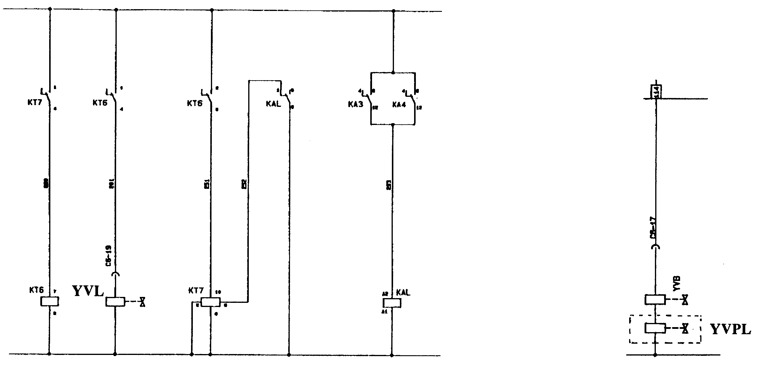

YVL Lubricant pump solenoid valve
YVPL Solenoid valve controlling lubricant route

Fig. 44 Automatic lubrication electric diagram

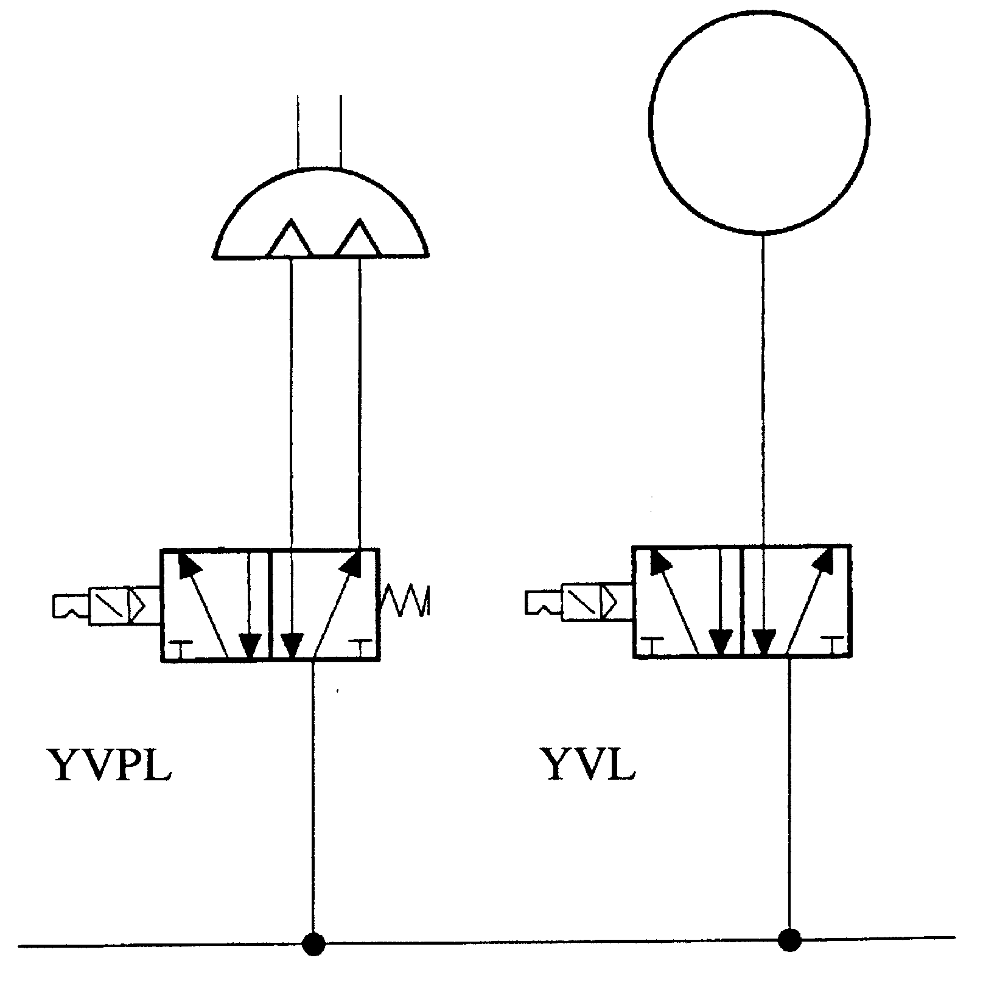
LUBRICATION PUMP

PNEUMATIC ACTUATOR

LINE 6 ATM

Fig. 45 Automatic lubrication electric diagram

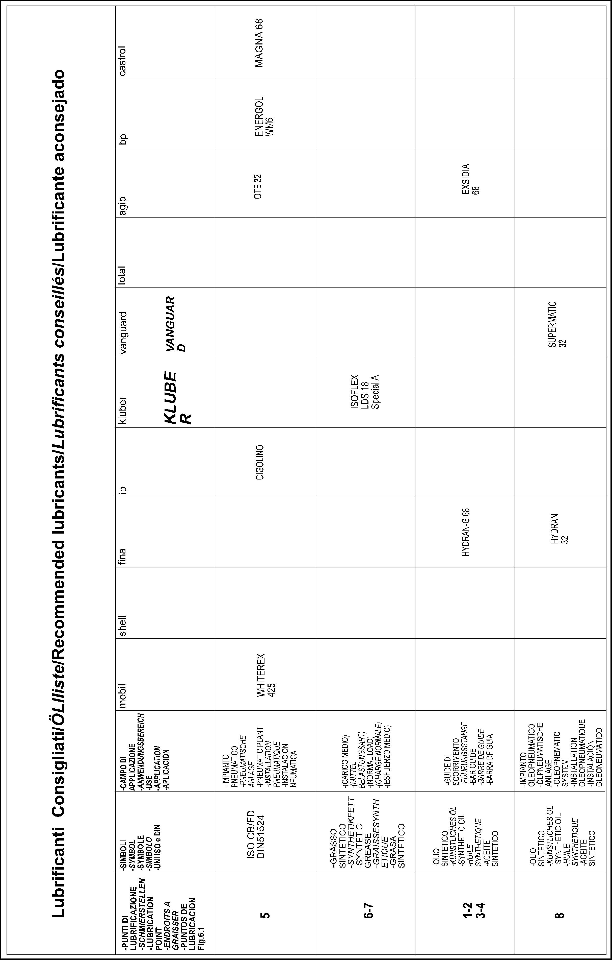
















Lubricants table TAB.1

CONVERSION CHART METRIC TO AMERICAN STANDARD AND VICE VERSA
Measurement or | METRIC  AMERICAN STD | TO  TO | AMERICAN STD  METRIC |  | MULTIPLY BY  DIVIDE BY
LENGTH  LENGTH  LENGTH  LENGTH  LENGTH  LENGTH | KILOMETERS  METERS  METERS  METERS  CENTIMETRES  MILLIMETERS | (Km)  (m)  (m)  (m)  (cm)  (mm) | MILES  INCHES  FEET  YARDS  INCHES  INCHES | (M)  (in)  (ft)  (yd)  (in)  (in) | 0.6214  39.37  3.2808  1.0936  0.3937  0.03937
AREA  AREA  AREA  AREA  AREA  AREA  AREA  AREA  AREA  AREA | SQUARE KM  SQUARE KM  HECTOMETER  HECTOMETER  ARA  ARA  SQUARE MT  SQUARE MT  SQUARE CM  SQUARE MM | (Km2)  (Km2)  (Hm)  (Hm)  (Ara)  (Ara)  (m2)  (m2)  (cm2)  (mm2) | SQUARE MILE  ACRES  ACRES  SQUARE FT  ACRES  SQUARE FT  SQUARE FT  SQUARE YDS  SQUARE IN  SQUARE IN | (M2)  (ft2)  (ft2)  (ft2)  (yds2)  (in2)  (in2) | 0.3861  247.1  2.471  107.639  0.0247  1076.4  10.764  1.196  0.155  0.00155
VOLUME  VOLUME  VOLUME  VOLUME  VOLUME  VOLUME  VOLUME  VOLUME  VOLUME | CUBIC METERS  CUBIC METERS  CUBIC METERS  CUBIC CM  LITERS  LITERS  LITERS  LITERS  LITERS | (m3)  (m3)  (m3)  (cm3)  (lt)  (lt)  (lt)  (lt)  (lt) | CUBIC FT  CUBIC YDS  US GALLONS  CUBIC IN  CUBIC FT  CUBIC IN  US GALLONS  US QUARTS  MPERIAL GAL | (ft3)  (yds3)  (gal U.S)  (in3)  (ft3)  (in3)  (gal U.S)  (qts U.S)  (gal Imp.) | 35.315  1.308  264.2  0.061  0.0353  61.023  0.2642  1.0567  0.21997
MASS  MASS  MASS  MASS  MASS  MASS  MASS  MASS  MASS | METRIC TONS  METRIC TONS  KILOGRAMS  KILOGRAMS  KILOGRAMS  GRAMS  GRAMS  GRAMS  GRAMS | (T)  (T)  (Kg)  (Kg)  (Kg)  (g)  (g)  (g)  (g) | LONG TONS  POUNDS  LONG TONS  POUNDS  OUNCES AVOIRDUPOINDS  POUNDS  OUNCE TROY  OUNCES AVOIRDUPOINDS  GRAINS | (Tl)  (lbt)  (TI)  (lbs)  (lbs)  (grains) | 0.9842  2204.6  0.00098  2.2046  35.274  0.0022  0.03215  0.03527  15.432
PRESSURE  PRESSURE  PRESSURE  PRESSURE | Kg/mm2  Kg/mm2  Kg/cm2  Kg/m2 |  | P.S.I.  TONS PER SQUARE INCH  P.S.I.  P.S.ft. |  | 1422.32  0.635  14.223  0.2048
MASS/VOL.  MASS/VOL. | Kg/m3  g/cm2 |  | Ibs per ft3  bs per ft3 |  | 0.0624  0.03613
SPEED  SPEED | KmH  m/sec. |  | KNOTS  100 ft per min. |  | 0.5396  1.9685
POWER  POWER  POWER | Kilowatt  Horse power  Kilogrammeter | (Kw)  (CV)  (Kgm) | HP  HP  FTLBS |  | 1.34102  0.9863  7.233
HEAT | KILOCALORIES | (Kcal orC) | BTU |  | 3.96832

ENCLOSURE 1: Indications of the noise generated by the machine

1) - PREMISE

This report, relevant to the professional assignment requested by Engineer Bacci, legal representative of the company Bacci Paolino of Bacci Agostino, located in Cascina (PI) in Viale Campania n° 32, has as subject the measurement of phonometric detection in the working environment of the aforementioned machine, according to the indications of the company.

The above-mentioned is in compliance with that foreseen and prescribed by the L.D. 15/08/1991 no. 277 as regards protection of the workers against risks deriving from explosion to chemical, physical and biological agents during work.

Therefore, technical research was carried out on the basis of the phonometric evaluation in working surroundings, to evaluate the possible exceeding of the max limit of noise of the machinery. This report was elaborated on the basis of the obtained results.

2) - MACHINE IDENTIFICATION

The machine of this report is a TSD/E, two-head rounding off tenoning machine with loader.

The operation of the machine is completely automatic; in fact, once the pieces have been positioned on the loader, the machine works on both sides, due to the combined action of two cutters that carry out the tapping, and of a number of jacks that allow holding the piece clamped during the work.

Tanks to its automatic operation, the machines does not require an operator during the work.

3) - MEASURING SURROUNDINGS

The tests were carried out inside the laboratory room of the above-mentioned company.

The laboratory room is in a rectangular shape with plan measurements of 17 m width x 89 m length, constructed with a bearing structure in reinforced concrete pillars and tile curtain walls.

The covering of this room is realised in reinforced concrete with an average height of 6 m.

4) - MACHINE OPERATION CONDITION

The above-mentioned machine was positioned in the centre of the laboratory room in a perfect position for the measurements to be carried out.

It has been equipped with two tenonig units with a shavings machine with a diameter of 70/100 mm and a bit with a diameter of 23 mm.

It was operated continuously for a complete cycle, for such a period of time in order to supply the exact evaluation of the emitted noise.

For this objective, rough-shaped beech parts were used with an average thickness of 50 mm.

It is to be noted that the values in paragraph 6 were realised without the suction system.

5) - INSTRUMENTATION EN METHODS OF MEASUREMENT

The phonometric research was carried out according tot that provided in Art. 40 of the L.D 277 and more precisely according to the procedures of the Enclosure VI.

The measuring instrument consists of a real time analyser Brüel & Kjaer model 2143.

The above-mentioned analyser has a precision degree of Class I, is in conformity with the standards 651/79 and was calibrated in the month of January 1993.

The technical parameters of the analytical instrumentation, during the course of the phonometric research, were carried out:

INTEGRATION TIME LINEAR
INCIDENCE FRONT
WEIGHTING CURVE A
MEASURING RANGE 25-110 dB(A)

6) - DETECTED DATA

The following data emerged from the phonometric research:

BACKGROUND NOISE 63,6 dB(A)
NOISE WITH MACHINE ON WITH LOADER 77,75 dB(A)
NOISE WITH MACHINE ON - WORKING WITH LOADER 80,71 dB(A)

7) - CONCLUSIONS

From the collected data it is possible to draw the conclusion that the general worker that operates this machine will have absorbed, during the course of eight working hours with the tools and the wood used in the test, a doses of noise less than 80 dB(A).

The actual working time with the machine under strain is definitely less than 8 hours/day, taking considerable dead times into consideration for the preparation of the machine and other things.

Therefore the fact that the doses of absorbed noise will be certainly less than that detected by us at a full load, must be taken into consideration.

The indicated values are emission levels and are not necessarily levels of secure work. While there is a correlation between the emission levels and the exposure levels, this may not be used reliably to determine if further precautions are requested.
Factors that influence the actual exposure level of the worker include the duration of the exposure, the characteristics of the working environment, other sources of noise etc., e.g. the number of machines and other processes that are adjacent. Also, the allowed exposure levels vary from country to country. Nevertheless, this information lets the user make a better evaluation of the risks and dangers..

