V. UNDERSTANDING THE TEXT - PROBLÉMY TEXTU

English for Academic Purposes (EAP)

1. Introductory remarks

The purpose of the course is also to make students aware of the fact that there are differences between academic and general English. They should be able to distinguish between a formal (academic) style and informal one, as well as to understand that what may be acceptable in spoken language may not be appropriate in writing a paper/report/thesis/project/a formal letter/personal statement, etc. Also, jumping from informal speech (i.e., using colloquialisms, slang, and contracted forms) to formal writing is inappropriate.
In academic writing the writer´s approach to the topic is objective (rather than subjective), intellectual (rather than emotional), and rational (rather than polemical). His/her tone is serious (not conversational), impersonal (not personal), and formal (not colloquial).

Examples of various levels of formality:
- The inclement climatic conditions obliged the president to return earlier than scheduled.
The president was obliged to return earlier than planned due to poor weather conditions.
The president had to go back sooner than he´d planned because the weather was poor.
- Please, await instructions before dispatching items.
Please, wait for instructions before sending things off.
Don´t send anything off until you´re told to do so.
- Prior to the discovery of America, potatoes were not consumed in Europe.
Before America was discovered, potatoes were not eaten in Europe.
Before they discovered America, Europeans didn´t eat potatoes.

What is to be avoided?
- contracted forms /e.g., it´s (use: it is), hasn´t (use: has not), etc./
- frequent phrasal verbs /e.g., look into (use: investigate), find out (use: discover), etc./
- colloquialisms/slang /e.g., you know, you see, a lot of, a bit of – leave them out/
- personal pronouns /e.g., I, you (use: it , there one + passive verb forms
What is to be used or preferred?
- appropriate punctuation – in particular commas, colons, semicolons, inverted commas)
- ing-forms and –ed forms replacing a relative
(Students who are taking the English examination are expected to have got acquainted with the requirements. = Students taking the English examination …..
The results which were obtained do not agree with the expectations.
The results obtained do not agree…
c) infinitives and gerunds as substitutes for long phrases (condensing)
The experiment was repeated about five times so that the results might be convincing.
…….. about five times to obtain convincing results.
Am I right if I think that we have met before?
Am I right thinking we ….
d) passives (in constructions where the actor is vague or not known)
Subject-specific language has been subjected to various types of analysis.
- formal nouns and compound nouns and terms
investment bank; nuclear power station; state-of-the-art lecture;
- cause-and-result constructions
A causes B: A gives rise to/ is responsible for/is the cause of/ causes/produces
A is one of the causes of B: A is a factor of/contributes to/facilitates/influences/underlies
B is caused by A: B arises from/is attributable to/is due to/is the result of/can be ascribed to/may be attributed to/follows from/stems from/results from
linking words, prepositions and conjunctions: as, because, due to, on account of, as a
result of, owing to, since
- specific prefixes and suffixes
e.g., having many channels = multichannel; semi-, extra-; ultra-; radio-; bio-;thermo-;etc.
-ogy;-ity; -ic; etc.
- conditionals (see Hedging)
- formal verbs and prepositional verbs common in scientific English
e.g.,to theorise; to hypothesise; to adjurn; to embody; …
e.g. to comment on; to participate in; to agree with/on/about; to engage in;
- less usual prepositions
e.g., in addition to (besides), due to, unlike, as opposed to, in contrast to, as agasinst,
versus, because of, as a result, as a consequence, despite, in spite of, notwithstanding,
with regard to, as for, as to, as regards, with respect to

2. Exercises :

1)/1 Look up the meaning of the prepositions given below in the following examples and then form a sentence of your own, using every preposition.

In addition to the teaching duties, he spends much of his time in the laboratory.
The company´s financial losses were due to poor management.
The conference has been a great success, unlike the previous one.
The cost of these planes is …..Euro, as opposed to the ….. Euro charged by the competitors.
In contrast to his predecessor, the present minister of ….. has not gained much support of the public.
Why is there a preference for the American English as against the British English?
The US dollar fell again versus the key currencies.
He looks like our Dean.
The project was cancelled because of lack of support
He died as a result of heart attack.
He spent many years in China, and as a consequence can speak Chinese quite fluently,
The treaty has been signed despite widespread opposition and protests.
The company will certainly sell, in spite of the fact that it is overpriced.
His house was simple inside, notwithstanding his love of luxury.
EU regulations regarding the labelling of food are quite strict.
With regard to the discussion about nuclear power plants, no better suggestions how to generate energy have been offered so far.
As for those papers, I cannot recommend them for publication.
There is some doubt as to whether the information is reliable.
As regards the potential energy crisis, the alternative sources of energy offer no solution.
The two results are very similar with respect to ambient temperature.
2)/2 Can you recognise what is formal/neutral academic writing? Write F/N (formal/neutral) and I (informal) before each sentence and say what you think so. Then change the informal sentences into formal ones:
- ….. The project will be completed next year.
- ….. I showed that his arguments didn´t hold water.
- ….. I wonder why he put up with those terrible conditions for so long.
- ….. Five more tests will be necessary before the experiment can be concluded.
- ….. It is possible to consider those results from a different viewpoint.
- ….. It has been proved that the arguments so far are without foundation.
- ….. He´ll have to do a couple more tests before he can stop the experiment.
- ….. It is not clear why such terrible conditions were tolerated so long.
- ….. There a number of reasons why the questionnaire should be revised.
- ….. We´ll finish the job next year.
- ….. That´s all I can think of now. Faithfully yours …..
- ….. Dear Madam or Sir , ….. I just want to let you know that ……
- ….. Professor Brown, referring to the advertisement in ….
- ….. Dear colleagues, this is to inform you that …..
- ….. As mentioned above, the measurements were carried out at room temperature.

3)/3 Read quickly the following extracts and
  - try to identify the type of source and explain the differences
  - guess for whom they were written
  - pay attention to grammar features (lengths of sentences, verb forms and tenses, vocabulary, etc.)
  - how would you rate their degree of formality (least formal to most formal)

a) Rules and Regulations
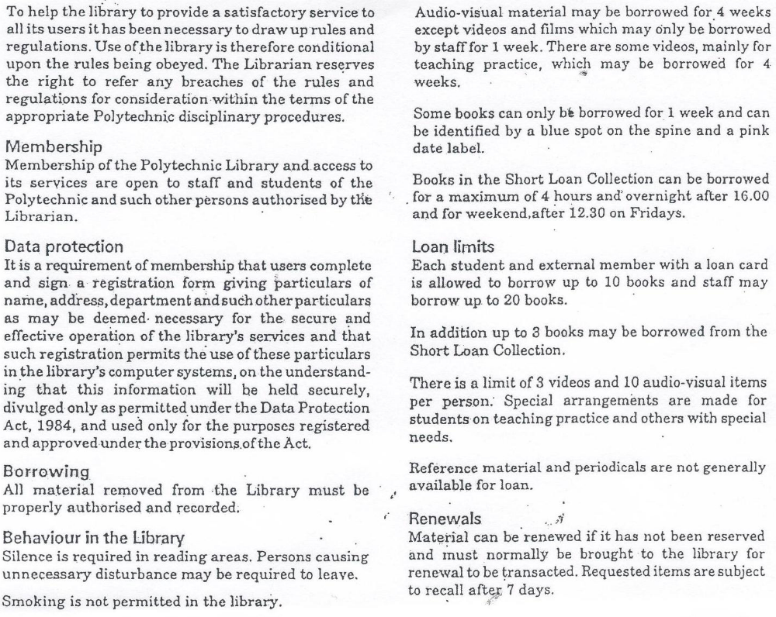
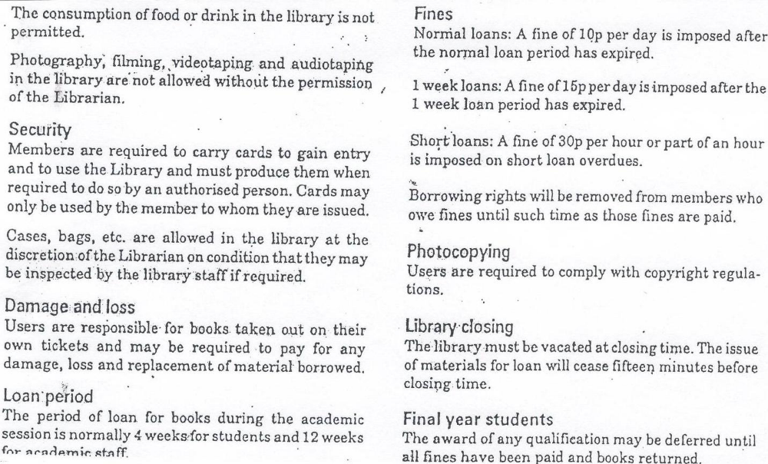

b) Dude

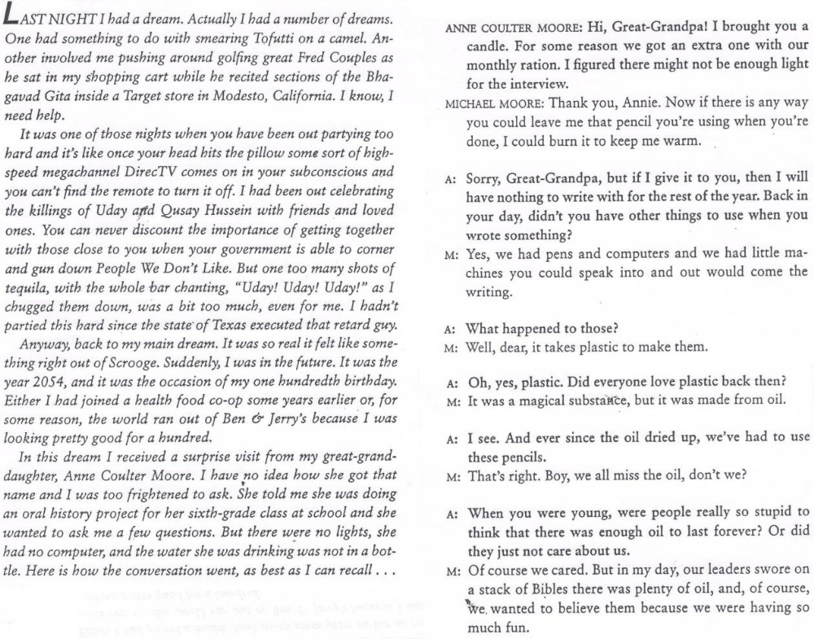

c) The European Dream

The American Dream is becoming ever more elusive.While the American Dream is languishing, says bestselling author Jeremy Rifkin, a new European Dream is beginning to capture the attention and imagination of the world. …. More important, Europe has become a giant laboratory for rethinking humanity´s future. In many respects, the European Dream is the mirror opposite of the American Dream….
One of the most popular social thinkers of our time, Jeremy Rifkin is the bestselling author of The End of Work, The Biotech century, The Age of Access, and The Hydrogen Economy. A fellow at the Wharton School´s Executive Education Program at the University of Pennsylvania, he is president of The Foundation on Economic Trends in Washington, D.C.
d) Definition of plasma
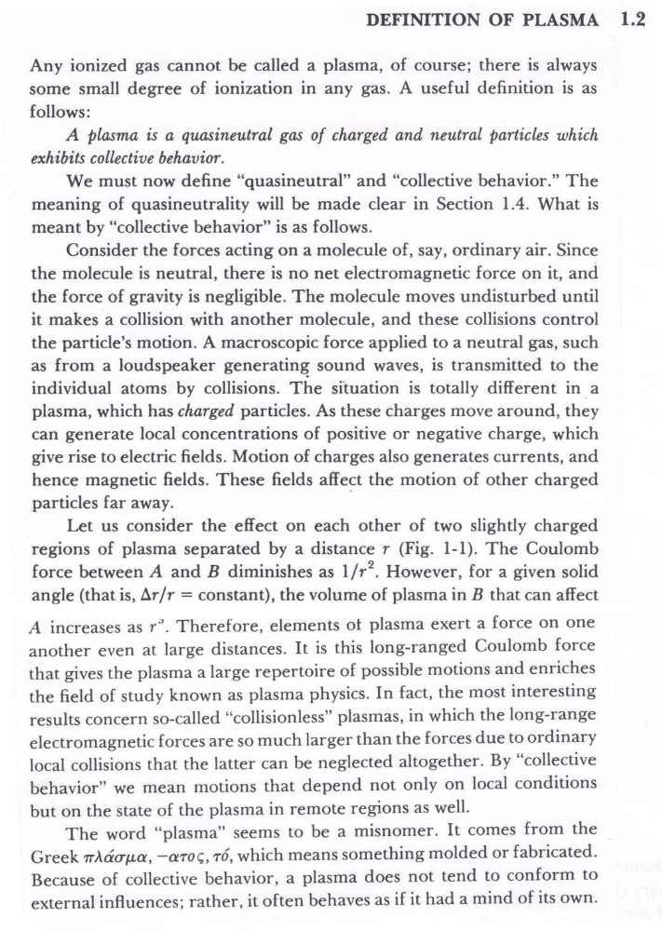

e) The Fourth State of Matter
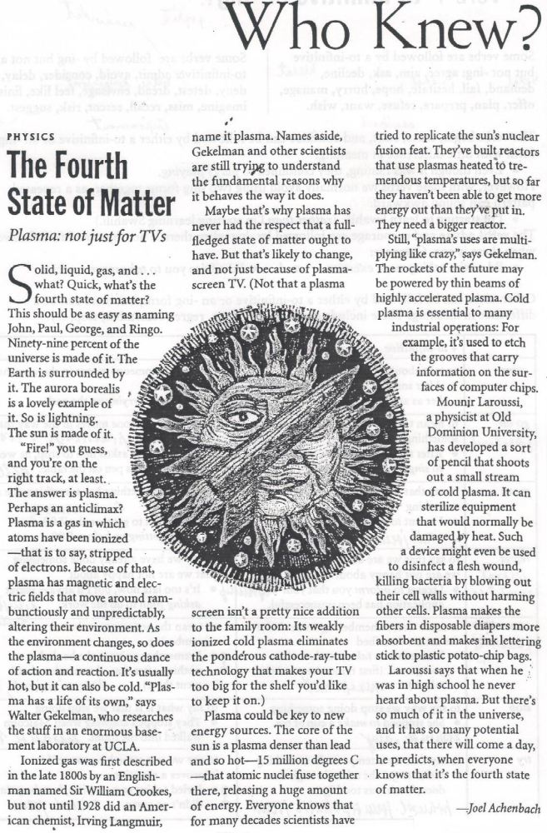

The paragraph
1. Introductory remarks

The paragraph is the fundamental element of the text. It is a collection of related sentences dealing with a single topic usually introduced at the beginning of the paragraph.. To be easily understandable to the reader, it should be coherent, i.e., it should contain certain logical and verbal bridges which carry the idea of the topic from sentence to sentence (often constructed in the parallel form – see under Parallelism). The verbal bridges can be achieved by repeating key words, using synonyms, using pronouns to refer to nouns in previous sentences, and linking ideas from different sentences by transitional (= connecting/linking) words. In a well written (spoken) text sentences are organized according to some accepted, understood, and anticipated conventions according to the type of text (e.g., an essay, report, letter, paper, etc.).

2) Exercise

1/4 Study the following paragraph.
- Look up why it is easy to understand.
- Look up the synonyms, the pronouns, and the transitional (=connecting, linking) words.
- Which sentence expresses the idea of the paragraph?

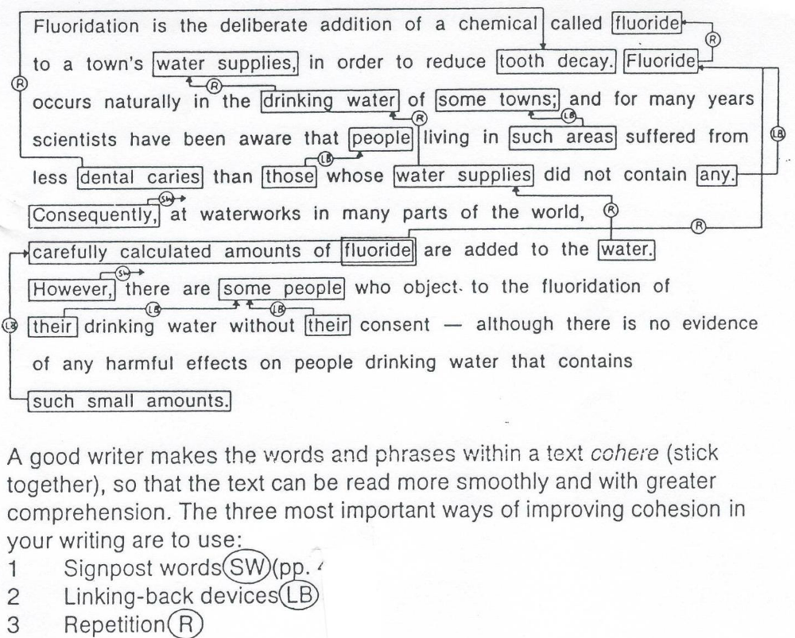

The topic sentence

1. Introductory remarks
Every good paragraph has a topic sentence, I.e., a complete sentence which clearly states what idea the paragraph is going to state. Supporting sentences help develop the idea. It may be at the beginning of the paragraph, in its middle, or end. The easiest way is to put the topic sentence at the beginning of the paragraph and then to develop the idea (by using examples, citing data, defining terms in the paragraph, comparing and contrasting, evaluating causes and reasons, examining effects, analysing and describing the topic, offering chronology of an event, etc.)

2. Examples and exercises

Example
- Hurricanes
(the topic sentence is underlined)
Hurricanes, which are also called cyclones, exert tremendous power. These violent storms are often a hundred miles in diameter, and their winds can reach velocities of 120km per hour or more. Furthermore, the strong winds and heavy rainfall that accompany them can completely destroy a small town in a couple of hours. The energy that is realized by hurricane in one day exceeds the total energy consumed by humankind throughout the world in one year.

Can you identify how the idea is developed in the text?

2)/5 Recognise the topic sentence (TS), write TS next to it, and decide the order of supporting sentences. Then give the paragraph a title.
2)a)
Title : ……………………
……………… a) Next, add antifreeze to your windshield washer fluid; otherwise, the
fluid will freeze and possibly break the container.
……………… b) First, put on snow tyres if you plan to drive on snowy, icy roads
very often.
…………….... c) Driving in winter, especially on snowy, icy roads, can be less
troublesome if you take a few simple precautions.
……………… d) Finally, it is also a good idea to carry tyre chains, a can of spray to
unfreeze door locks, and a windshield scraper in your car when
driving in winter weather.
………………. e) Second, check the amount of antifreeze in your radiator and add
more if necessary.
2) b)
Title: …………………………..
……………….. a) Furthermore, researchers are continuing to work on the
development of an efficient, electrically powered automobile.
………………. b) Researchers in the automobile industry are experimenting with
various types of engines and fuels as alternatives to the conventional
gasoline engines.
……………….. c) One new type of engine , which burns diesel oil instead of petrol, has
been available for several years.
……………….. d) Finally, several automobile manufacturers are experimenting with
methanol, which is a mixture of gasoline and methyl alcohol, as an
automobile fuel.
……………….. e) A second type is the gas turbine engine, which can use fuels made from
petrol, diesel oil, kerosene, other petroleum distillates, or methanol.
2)c)
Title: ……………………………….
………………. a After an attack by a great white, 462 stitches were required to sew up
an Australian scuba diver.
……………….. b) With their razor-sharp teeth and strong jaws, great white sharks are
very dangerous.
……………….. c) Nevertheless, one did just that near a public beach in Australia in 1985.
……………….. d) However, even when they attack humans, great whites do not usually
eat them.
……………….. e) It bit in half and totally devoured a young female swimmer.
……………….. f) Great whites do not usually attack humans, but when they do, they
always cause serious injury.
2)d)
Title: ………………………………
……………….. a) If there had been a big storm on the day of a baby´s birth, the baby
might have been named Thunder Cloud.
……………….. b) American Indian names are very descriptive, for Indians were usually
named for a physical attribute, for an occurrence in nature, or for an
animal.
……………….. c) Great Eagle, Red Dog, Big Bear, and Spotted Wolf are examples of
of Indian names after animals.
……………….. d) Indians with distinctive physical characteristics might be given names
such as Big Foot or Crooked Leg.

3)/6 Write a well structured paragraph of about 150 words on any topic of your own choice.

How to connect clauses into sentences
1. Introductory remarks - Sentence Variety (Purdue materials) + exercises
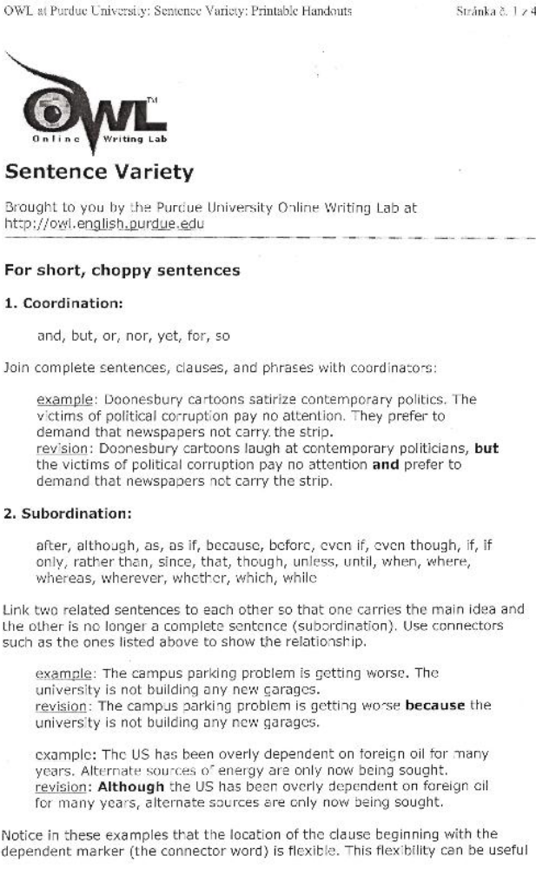
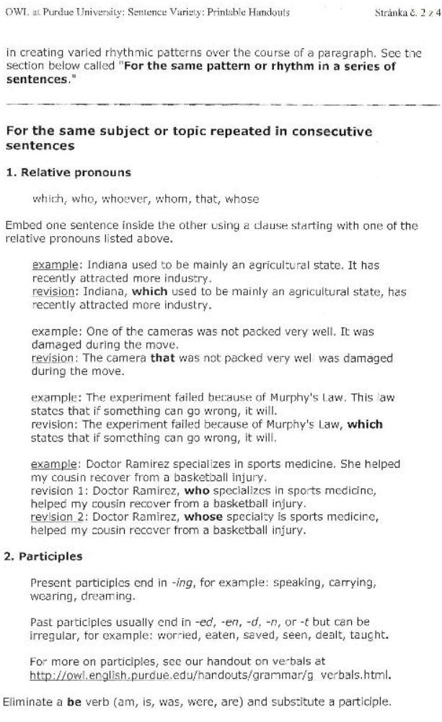
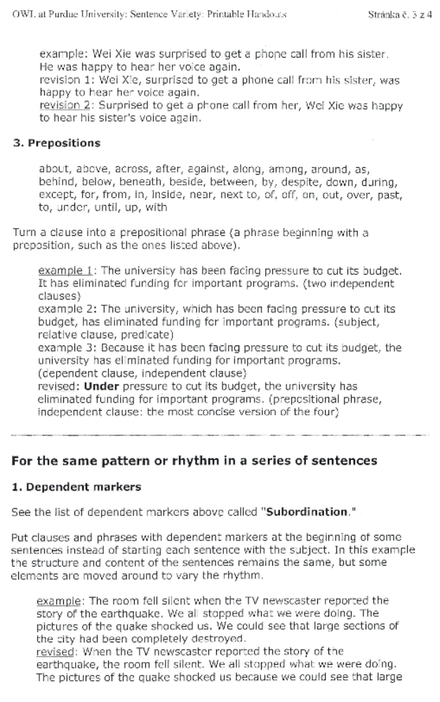
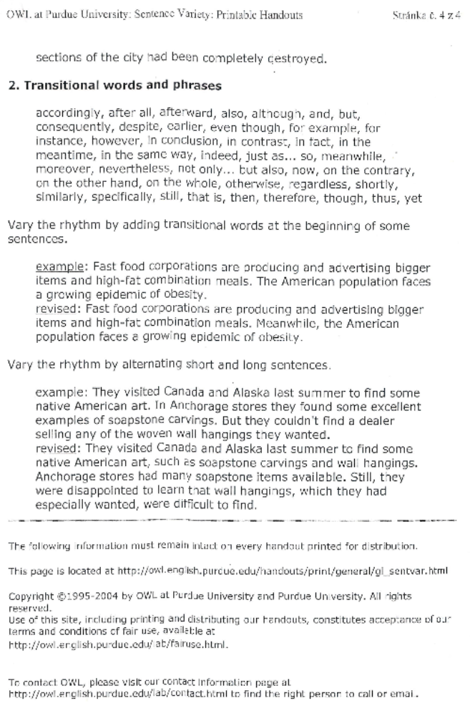
How to connect sentences
1. Introducory remarks – a list of Transitional devices (ConnectingWords) (Purdue materials)
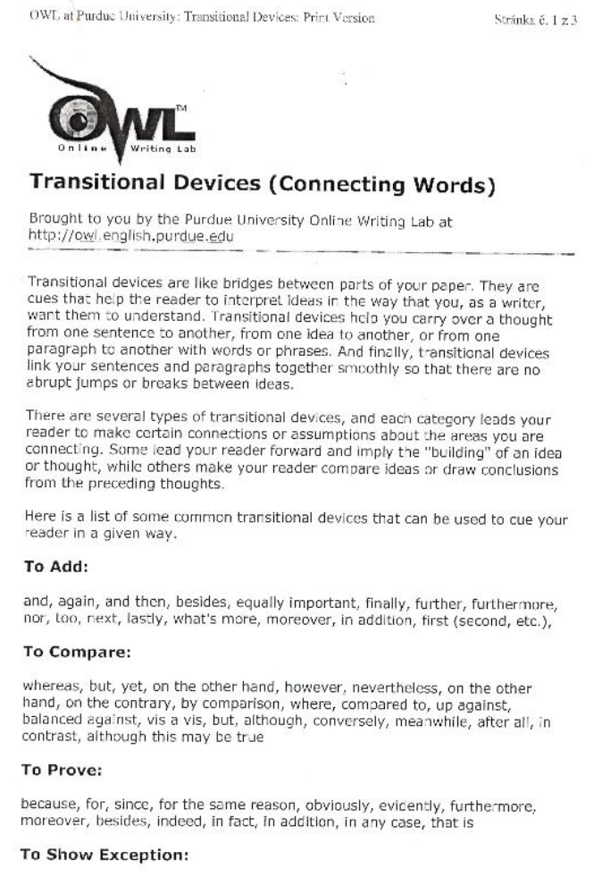
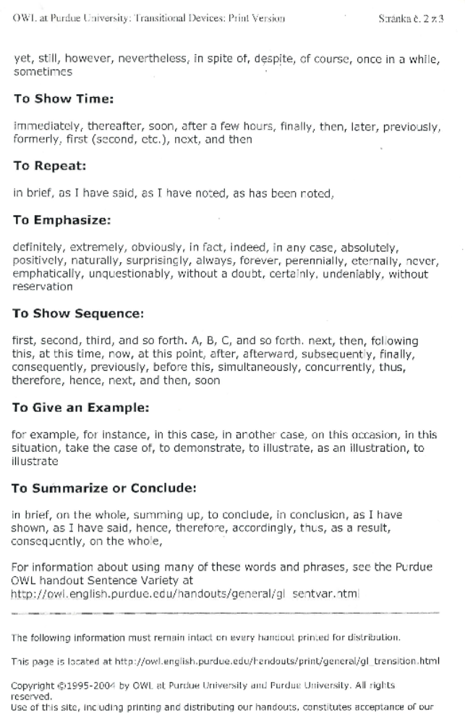
2. Exercises
1)/7 By using the offered word you can change the meaning of the sentence. Translate the result into Czech/Slovak:
I´ m going to continue with my English (,)
because I like the language.
because of this book.
due to its importance.
owing to the expected exchange programme.
on account of what my teacher has told me.
in case I need it one day.
in order to take my State exam next year.
so as not to forget all I´ve learnt.
so that I can work in Brussels one day.
whether you think it´s a good idea or not.
wherever I go.
whatever may happen.
whichever country I go next.
however difficult the language is.
whenever I can.
regardless of my slow progress so far.
even if the course fee is so high.
if it´s possible.
providing I can find a good teacher.
provided that someone agrees to teach me
unless you persuade me that Chinese is easier to learn.
although I know I am not a gifted linguist.
even though I´m a very busy person.
in spite of the cost of the lessons.
despite what you´ve said about my slow progress.
but I think I´ll give up German.
whereas everyone else in class is giving up.
unlike Mary, who is stopping.
as opposed to my Chinese.
so you´ll see me again next semester.
which is a bit silly, I think.
considering I live on a desert island.

2)/8 Choose the best connecting (linking/transitional) expression to fill in the gap. In some cases more than one expression may be suitable. However, each expression may be used only once. The punctuation may sometimes be a clue.

First, next, last, at first, at last, afterwards, eventually (= nakonec), while, by the time, once, whenever, as soon as possible, furthermore, like, similarly, even though, however, regardless of the fact that, still, otherwise, on the contrary, on the other hand, in contrast, consequently; contributed to, resulted ( from)
- Glass is a very useful material; ……………….., it breaks easily.
- Glass is fragile; ……………….., it should be handled carefully.
- ……………….. that glass is fragile, it has many useful properties.
- To make glass, ……………….., heat the sand and soda ash to about 1,500
degrees C.
e) There are two main reasons for the widespread use of glass bottles: they are
cheap and, ………………., they have no effect on the flavour, smell, or chemistry
of the contents.
f) Many consumers think that recycling glass containers is a waste of time and energy;
……………….., it produces significant savings.
g) ……………….. some recycling programmes require consumers to separate
brown, green, and clear glass, many others do not.
h) Yes, some recycling programmes do require separation of brown, green, and clear
glass; ……………., many others do not.
i) The success of glass recycling programmes has ……………….. from consumer
education programmes.
j) Many such programmes start with children in elementary school. ………………..
these children are in secondary school, they are very much aware of the value
of recycling.
k) It is important that parents should set a good example as well by recycling their
own used containers; ……………….., the children may not believe recycling
really matters.
l) ……………….., maybe we won´t have to create special programmes to remind
consumers to recycle what they can.
- ……………….. glass, paper of course is high on the list of recyclables.
- ……………….., so are many kinds of plastic.
- ……………….., maybe we have become wiser about how to manage some of
the waste our society produces.

3/9 a) Class discussion. Combine the sentences so as to get a paragraph with nine sentences.
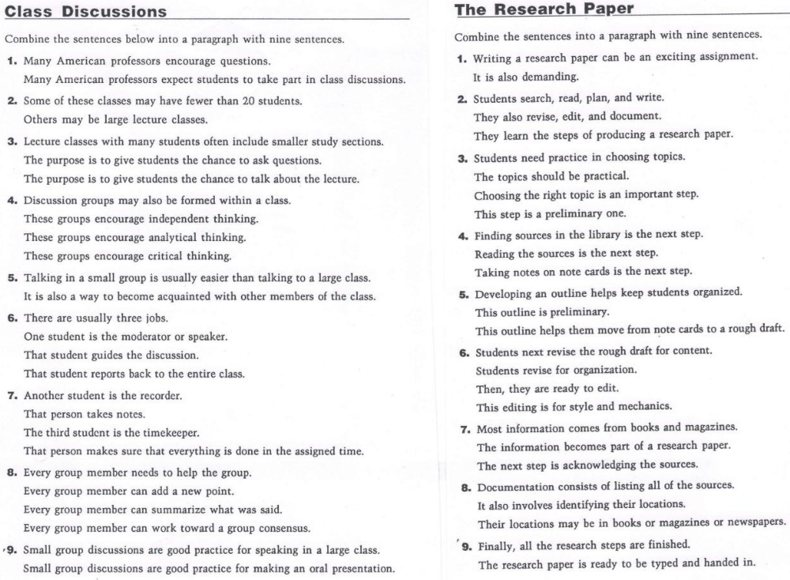
/9 b) The research paper. Do the same.

Hedging

Introductory remarks
In academic writing the author often has to be very cautious in how he/she presents his/her new result/finding/conclusion/hypothesis. To avoid a definite statement , i.e., to indicate less than a one hundred per cent certainty– whatever the reason may be –they will express their claim/view/opinion with a varying degree of certainty, i.e., use vague language. This intended “fuzziness“ is referred to as hedging and in papers may be most often encountered in the Discussion section. “To hedge against something” means to try to protect oneself against a problem. What Czech expression would you suggest? To hedge, the following expressions and phrases may be used:
  - modal verbs: e.g., may, might, could, would, etc.
  - (most often) verbs: e.g., to appear, seem, suggest, expect, assume, tend to, etc.
  - Modal adjectives and adverbs :e.g., likely, probable/probably, possible/possibly, apparent/apparently, certain/certainly, undoubtedly
  - adverbs: e.g., perhaps, roughly, often,
  - modal nouns: e.g., assumption, possibility, estimate
  - quantity expressions: e.g., about, around, approximately, a lot of, several, roughly, a certain number/amount of
  - phrases: e.g., to our knowledge, it may suggest that, it seems reasonable that, X expects Y that, according to X, X will happen if

Examples :
Definite statement : Industrialization is viewed as a superior way of life.
Hedged statement: Industrialization tends to/may be viewed as a superior way of life.

A feature of academic English is the need to be careful (i.e., to indicate ‘ less than a one hundred per cent certainty‘ ). The purpose of such writing is to show that one in generalising desires to be cautious because one might possibly be wrong (though it is not likely!).

2. Exercises:

1)/10 Make the sentences definite:

- This is also likely to appear in the development of institutions….
- The ideal of economic development tends to be associated with different policy goals…
- Perhaps greater clarity can be brought to the meaning of economic development…

2)/11 Order the sentences from the most definite statement to the least definite one:

a) The earth is probably round. ……
b) The earth is possibly round. ……
c) The earth is round. …..
d) Perhaps the earth is round. …..
e) The earth is undoubtedly round. …..
f) The earth is said to be round. …..

3)/12 Rewrite the text into using hedging:


4)/13 Look up a Discussion section in one of your home-reading, and note any instances of hedging, or vague language. Put them down.

Parallelism

1. Introductory remarks and examples
Parallelism is a textual device for linking together different elements in a text by parallel (i.e. identical) grammatical means/forms to express a relationship of coordinated and enumerated items. In other words, the words, phrases, statements, enumerated items, and even paragraphs use grammatically equivalent structures. This makes reading and understanding the text easier because the reader anticipates what is to follow. Thus, grammatical forms should not be mixed (e.g., verbs with nouns, nouns with –ing forms, imperatives with other verb forms, etc.)
Examples:
For sheer survival, the body must have a certain amount of food, water, and sleep. The other basic physiological motives include the need to maintain proper body temperature, to eliminate wastes, and to avoid pain.
(nouns, infinitive)

The application of linguistics to language teaching is an indirect one. This is why many teachers see no relevance in it for their work, and, conversely, why many linguists unacquainted with language teaching in practice disclaim any practical usefulness for their work.
(2 parallel sentence structures)

A special case of parallelism is enumeration:

Examples :
Present information in such a way that the users can
- assess observations
- repeat experiments
- evaluate intellectual processes
(infinitives)

The component parts of a scientific paper are as follows:
Introduction
Materials and Methods
Results
Discussion
Conclusions
(nouns)

Suggested rules for writing the Abstract:
- present first the nature and scope of work
- review the source
- state the method
- state the results and conclusions
(imperatives)

2) More examples of parallel structures - the Purdue materials
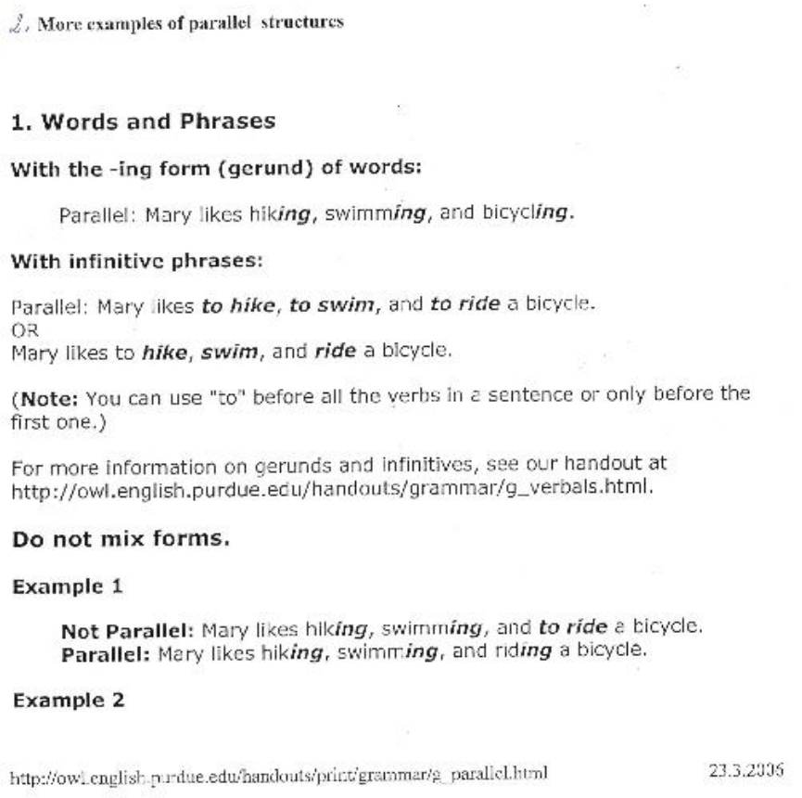
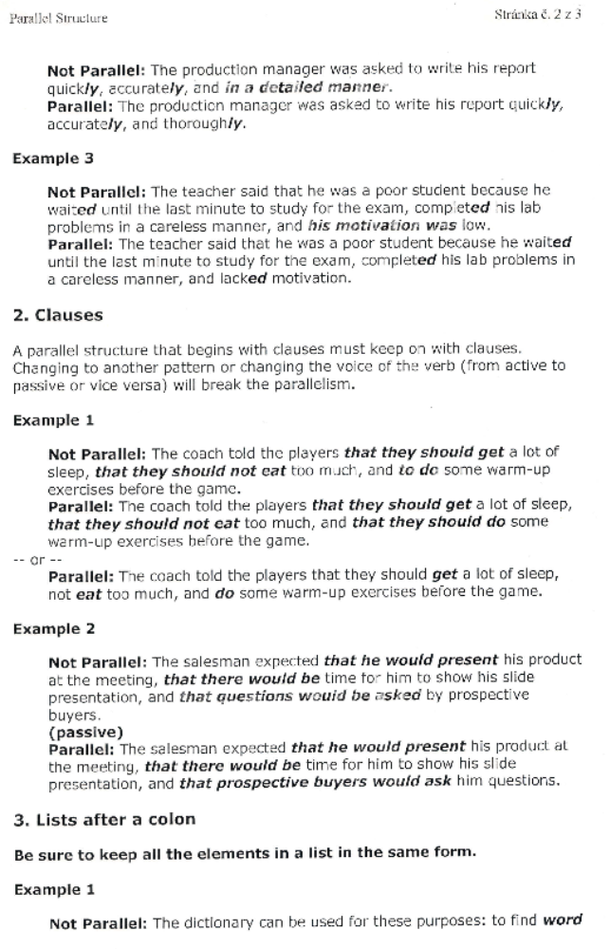
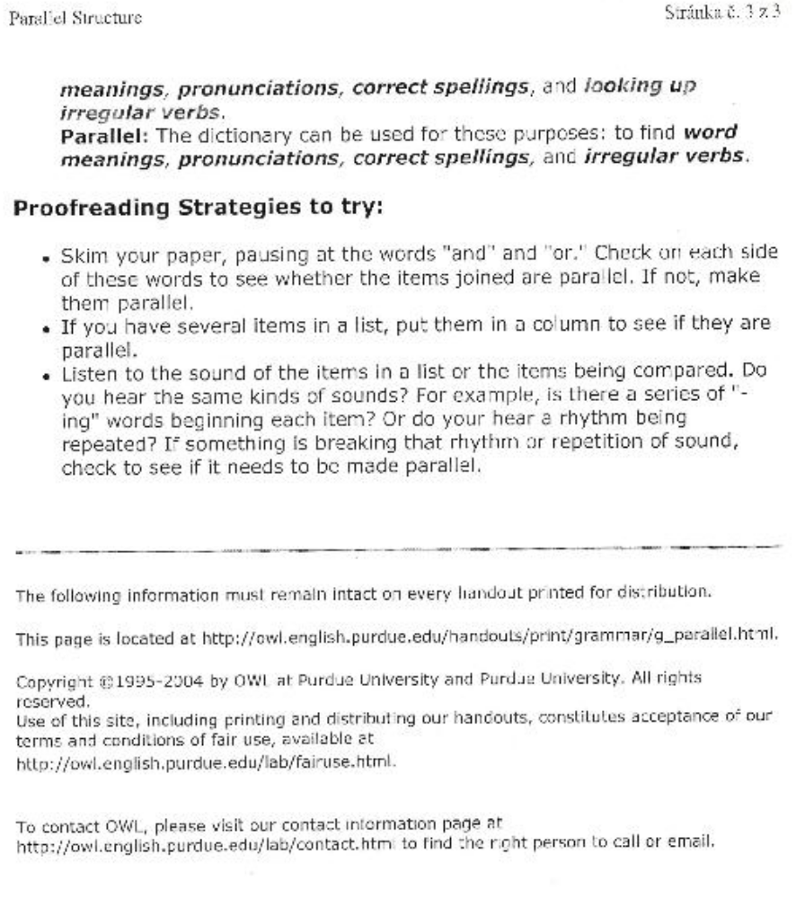
3) Exercises:

1)/14 Check the explanatory texts to this part of materials (V. UNDERSTANDING THE TEXT) for parallel constructions. What have you found?

2)/15 Compare the pairs of sentences. Which of them follows parallelism?
a) My English conversation class is made up of Chinese, Spaniards, and some are
from Bosnia.
b) My English conversation class is made up of Chinese, Spaniards, and Bosnians.

- The students who do well attend class, they do their homework, and are
practicing speaking English.
b) The students who do well attend class, do their homework, and practice
speaking English.

a) The teacher wanted to know which country we came from and our future goals.
b) The teacher wanted to know which country we came from and what our future
goals were.

a) The language skills of the students in the evening classes are the same as day
classes.
b) The language skills of the students in the evening classes are the same as the
language skills (/as of those in ….) of the students in the day classes.

2)/16 Underline the part of the sentence that is not parallel and correct it and then
rewrite the sentence in the parallel form.
a) The disadvantages of using a credit card are overspending and you pay high interest
rates.
b) Credit cards are accepted by department stores, airlines, and they can be used in
gas stations.
c) You do not need to risk carrying cash or to risk you miss a sale.
d) With credit cards, you can either pay your bill at once , or you can stretch out
your payments.
e) You can charge both at restaurants and when you stay at hotels.
f) Many people carry not only credit cards, but they also carry cash.
g) Many people want neither to pay off their balance monthly nor do they like paying
interest.
h) Not making any payment or to send in only minimum payments every month
is poor money management.

3)/17 Check your home assignment on Class discussion and Research paper (see above) for parallel structures, If you have not used them, study where they would be appropriate.

Terms and terminology

1. Introductory remarks

A typical feature of technical and scientific communication is a set of specialised items, i..e , technical and scientific terms of a particular discipline, referred to as terminology or sometimes as “terms of the art“. Besides terminology, scientific writing uses subtechnical vocabulary, e.g., words and phrases having a meaning also outside the discipline, but also used is specific situations in scientific and academic writing , e.g., phenomenon, precursor, to subsume, to carry out/perform experiments, to draw conclusions, to take into consideration, etc. Both the terms and subtechnical words are often based on words of Latin or Greek origin (e.g., focus, fusion, anaylsis, etc.), and often sound “international“.

1) A term should be unequivocal, as short as possible (if possible), binding for users of a given field, and its meaning independent of the context.
2) Terms may consist of one or more words. The most important word of the term is the last one, and it is qualified/speicified by all the preceding words , e.g.
a battery car (a car driven by a battery) x a car battery (a battery for a car)
3) In English, terms are typically coined by joining more nouns together, thus supplying information in the shortest way., e.g.
satellite communication ( communication using satellites/made possible by satellites)
communication satellite ( a sallite used for communication)
European Synchrotrone Radiation Facility
High-resolution 3D Coherent Laser Radar Imaging
This very useful way of shortening the text is not peculiar to terms only. It is useful in any written communication, e.g.,
a period of cold which was intense and lasted for three years – a three-year period of
intense cold
Dr.XY who is an anhropologist at Stanford University – a Stanford University
Anthropologist Dr.XY
4) In longer terms, i.e., those consisting of more words; there is no universal model for expressing the relations between the components of the term, let alone a model how to translate such terms into Czech, e.g.,

radio frequency transmission energy – vysokofrekvenční energie vysílání

root mean square value – střední kvadratická hodnota

peak load power station – špičková elektrárna

hot chamber die casting process – lití do kovových forem

Try to find how the words are related to express the desired idea – the term..

5) As apparent, the qualifying components are most frequently nouns and adjectives, but also other types are frequent, e.g.,
noun + noun - power engineering - energetika
adjective + noun - binding energy – vazbová energie
motor-driven pump - čerpadlo na elektrický pohon
preposition + noun- line of force – siločára
integration by parts – integrace per partes
conjunction + noun trial and error method – metoda pokusu a omylů
others - under-the-tree-top deposition of contaminants
state-of-the-art lecture – přednáška o stavu bádání v oboru
6) Hyphenation is recommended to make understanding easier or to prevent misunderstanding. However, there are no rules for the use of hyphens, so authors may differ.
The best piece of advice is to follow and use the forms from well written sources. Examples:
high-pressure turbine - vysokotlaká turbina
short-life radionuclides – radionuklidy s krátkým poločasem rozpadu
However, hyphenation is highly recommended if the qualifying item is based on participle forms, e.g.
man-made radionuclides – umělé radionuklidy
7) Nouns preceding the final noun are not used in the plural, unless they really refer to a plural idea/noun, e.g.
system software ( referring to the operating system used to operate a computer system)
x
systems analysis (referring to computer systems a project needs)

materials science (referring to various materials this science studies)
x
material consumption (referring to how much material has been used)
8) Proper nouns used as parts of a term differ in using the possessive form. Thus, e.g., the words method, equation, law, discovery, formula, theorem, rule, constant, principle , series are used with a noun in the possessive case (i.e., with an apostrophe), e.g.,
Euler´s formula, Gauss´ theorem, Riccoti´s equation, Planck´s constant, Amper´s rule
Doppler´s principle, Newton´s laws, Taylor´s series,
but , others not, e.g.,
Doppler effect, Edison effect, the Hoffmann reaction
9) Some terms are impossible to use in a short form, i.e., by placing words side by side, e.g.,
moment of momentum, speed of light
Could you suggest why?

2. Exercises:

1)/18 Make a list of about 25 typical two- or more-word terms used in your field. Give their Czech translations.

2)/19 Do you think you could translate the following terms?

reactor core configuration
neutron spectrum characteristic
reactor pressure vessel residual lifetime
solid state plasma
non-uniform magnetic field
equilibrium ion density
measurement points
Chernobyl accident fallout
prevailing winds intensity
laboratory gamma spectrometry

3)/20 Make the following phrases shorter:

monitoring of deposits of radionuclides occurring in the atmosphere
changes in biological indicators
fallout caused by the accident in Chernobyl
the revised edition of the English Dictionary published by Oxford (University Press) in 1989
material used to produce the pressure vessel of the reactor
measurements performed by in situ gamma spectrometry
high occurrence of mushrooms every year
Can you think of such phrases in your field which could be expressed in a shorter way?

4)/21 In your home reading, try to find terms consisting of two nouns, an adjective plus noun, and, if possible, of longer terms of other types as well (about 5 of each , i.e. 15 in total). Make a list of them and give their Czech equivalents.

