HandWallet

Version 4.10
Windows 98, 98se, ME, NT, 2000, XP, 2003 Server
Last Update: 18 June 2006

User Manual

MediaVision Computer Tech. Ltd.
All Rights Reserved

TABLE OF CONTENTS
1. Quick start 9
2. Introduction 10
A. What is the HandWallet software? 10
B. Who should use HandWallet? 10
C. How can I save money with HandWallet? 10
D. How to use this manual? 13
3. Installation for Windows 14
A. Minimum requirements 14
B. Downloading 14
C. Installation 14
D. Initial operation 20
E. Problems during installation time or initial operation 23
F. Update software 27
G. Uninstall 27
4. Installation for PDA's and Mobile Phones: 29
A. General 29
B. Downloading 30
C. Transfer data from and to your PDA 30
D. Licensing 30
5. General Review 31
6. Data 32
A. Accounts (Means of payment) 32
B. Actions 41
C. Payments – statement portfolio 71
D. Categories 76
E. Persons 80
F. Vendors 82
G. Clear Filters 84
H. Erase All 84
7. Analyst 85
A. Categories Pie 85
B. Categories Bar 86
C. Persons Pie 86
D. Categories Report (summary report) 86
E. Budget Status 87
F. Balances 88
G. Forecast 88
8. Tools 89
A. Swap Credit Card 89
B. Internet Sync 94
C. Options 95
D. System Status 111
E. Import 114
F. Export 119
G. My Web Site 127
9. Financial menu ($) 129
A. Rates 129
B. Stock Quotes 131
C. Index values 132
D. Interest values 133
E. Goods (Merchandise) values 134
F. Yields 135
G. Compare Yields 136
H. My Favorites 137
10. Help 146
A. This Screen 146
B. General 147
C. Online Help 148
D. Last Version: 149
E. About 150
F. Additional help options 150
11. The File menu 152
A. Open folder 152
B. New folder 153
C. Print 154
D. Backup 155
E. Restore backup 155
F. Get from PDA 156
G. Write to PDA 159
12. The View menu 160
A. Enhanced view 160
B. Change the data presented 160
C. Types of information in enhanced view 160
D. Change the layout of the enhanced page 160
13. Miscellaneous 161
A. Backup 161
B. HandWallet Files 161
C. Suggestions and Bugs 162

LIST OF ILLUSTRATIONS

Illustration No. Page No.

ILLUSTRATION 1 – Installation - Security Warning 14
ILLUSTRATION 2 – Installation - Selecting the language of the installation 15
ILLUSTRATION 3 – Installation – Opening screen 15
ILLUSTRATION 4 – Installation – License agreement 16
ILLUSTRATION 5 – Installation – Readme 16
ILLUSTRATION 6 – Installation – Destination Directory 17
ILLUSTRATION 7 – Installation – Program Shortcuts 18
ILLUSTRATION 8 – Installation – Confirm Setup Settings 18
ILLUSTRATION 9 – Installation – Copying files 19
ILLUSTRATION 10 – Installation – Finish 19
ILLUSTRATION 11 – Initial operation 20
ILLUSTRATION 12 – Welcome to HandWallet 20
ILLUSTRATION 13 – Terms & Conditions 21
ILLUSTRATION 14 – Selecting the country 21
ILLUSTRATION 15 – Selecting the interface language 22
ILLUSTRATION 16 – Selecting the main currency 22
ILLUSTRATION 17 – The initial screen (the actions screen) 23
ILLUSTRATION 18 – Illegible text 24
ILLUSTRATION 19 – Regional and Language Options 24
ILLUSTRATION 18 – Malfunction – Illegible menu 25
ILLUSTRATION 19 – Malfunction – Illegible menu 25
ILLUSTRATION 20 – Changing the menu language 26
ILLUSTRATION 21 – Missing elements for activating HandWallet 26
ILLUSTRATION 24 – Deleting HandWallet 27
ILLUSTRATION 25 – Deleting HandWallet - confirmation 28
ILLUSTRATION 24 – HandWallet for PDAs 29
ILLUSTRATION 27 – Defining a new account 32
ILLUSTRATION 28 – Defining a new account – fields 33
ILLUSTRATION 29 – A new account – credit card 35
ILLUSTRATION 30 – A new account – Internet 36
ILLUSTRATION 31 – A new account– the Internet – Bank HaPoalim 37
ILLUSTRATION 32 – A new account – the Internet – Bank Leumi 37
ILLUSTRATION 33 – A new account – the Internet – Bank Discount 38
ILLUSTRATION 34 – Account view fields 40
ILLUSTRATION 35 – Defining a new action 41
ILLUSTRATION 36 – Defining a new action – initial screen 42
ILLUSTRATION 37 – New action – What 43
ILLUSTRATION 38 – A new action – What – Refining 43
ILLUSTRATION 39 – A new action – What – Continuing to refine 44
ILLUSTRATION 40 – A new action – What – Category selection 44
ILLUSTRATION 41 – A new action – Entering a sum 45
ILLUSTRATION 42 – New action – Entering an additional category 46
ILLUSTRATION 41 – New action – Quantity and price per quantity 46
ILLUSTRATION 44 – Action – Clicking on the “More” button 48
ILLUSTRATION 45 – New action – Vendor / Customer 49
ILLUSTRATION 46 – New action – Checks 50
ILLUSTRATION 47 – New action – Customer credit card 51
ILLUSTRATION 48 – New action – Receipt, invoice and VAT 52
ILLUSTRATION 49 – New action – Timing 53
ILLUSTRATION 50 – New action – Consumption 54
ILLUSTRATION 51 – New action – Partners 55
ILLUSTRATION 52 – New action – Partners – Continued 56
ILLUSTRATION 53 – New action – Partners – Continued 56
ILLUSTRATION 54 – New action – Partners – Two people 57
ILLUSTRATION 55 – New action – Discount 58
ILLUSTRATION 56 – New action – Interest 59
ILLUSTRATION 57 – New action – Interest margin 59
ILLUSTRATION 58 – New action – Linkage 60
ILLUSTRATION 59 – New action – Linkage to an Index 60
ILLUSTRATION 60 – New action – Linkage – Foreign currency linkage 61
ILLUSTRATION 61 – New action – Exchange rate 62
ILLUSTRATION 62 – New action – Exchange rate 62
ILLUSTRATION 63 – New action – Action status 64
ILLUSTRATION 64 – Personal fields – Empty list 65
ILLUSTRATION 65 – Personal fields – after adding fields 65
ILLUSTRATION 66 – Filtering the actions – Expenses only 66
ILLUSTRATION 67 – Filtering the actions – Finding check # 66
ILLUSTRATION 68 – Sort actions 67
ILLUSTRATION 69 – Currency view 67
ILLUSTRATION 70 – Actions total 67
ILLUSTRATION 71 – Fast action 68
ILLUSTRATION 72 – New fast action 68
ILLUSTRATION 73 – Fast action – new category 68
ILLUSTRATION 74 –Fast action – select category 69
ILLUSTRATION 75 –Fast action – select category 69
ILLUSTRATION 76 – Fast action – save changes 69
ILLUSTRATION 77 – Fast action – creating new action 70
ILLUSTRATION 78 – Fast action – category selected automatically 70
ILLUSTRATION 79 – Statement 71
ILLUSTRATION 80 – Statement – payment selection 72
ILLUSTRATION 81 – Statement – Creating / modifying a payment 72
ILLUSTRATION 82 – Statement – New balance 74
ILLUSTRATION 83 – Category tree 76
ILLUSTRATION 84 – New category 77
ILLUSTRATION 85 – Budget 78
ILLUSTRATION 86 – Categories - personal fields 79
ILLUSTRATION 87 – Persons 80
ILLUSTRATION 88 – Defining a new person 81
ILLUSTRATION 89 – Vendors 82
ILLUSTRATION 90 – New vendor 82
ILLUSTRATION 91 – Expenses pie 85
ILLUSTRATION 92 – Income pie 85
ILLUSTRATION 93 – Income bar 86
ILLUSTRATION 94 – Persons pie 86
ILLUSTRATION 95 – Summary report 87
ILLUSTRATION 96 – Summary report - itemization 87
ILLUSTRATION 97 – Budget status 87
ILLUSTRATION 98 – Balances list 88
ILLUSTRATION 99 – Forecast 88
ILLUSTRATION 100 – Connection to a printer-integrated card reader 89
ILLUSTRATION 101 – Entering the sum of clearance 90
ILLUSTRATION 100 – Clearing - Entering payments and categories 90
ILLUSTRATION 103 – Transmission of credit card clearing 90
ILLUSTRATION 104 – Clearing without a credit card – Enter card number 92
ILLUSTRATION 105 – Clearing without a credit card - Entering the month up to which, card is valid 92
ILLUSTRATION 106 – Clearing without a credit card -Entering the year up to which, card is valid 92
ILLUSTRATION 107 – Clearing without a credit card – Entering CVV 93
ILLUSTRATION 108 – Clearing without a credit card – Entering the ID number 93
ILLUSTRATION 109 – Internet Sync 94
ILLUSTRATION 110 – Options 95
ILLUSTRATION 111 – Color of heading 98
ILLUSTRATION 112 – Color of windows 99
ILLUSTRATION 113 – Original keyboard 104
ILLUSTRATION 114 – HW Keyboard 104
ILLUSTRATION 115 – System Status 111
ILLUSTRATION 116 – Import – select source of data 114
ILLUSTRATION 117 – Import – pre defined import 114
ILLUSTRATION 118 – Import – select application 115
ILLUSTRATION 119 – From which memo would you like to import data? 115
ILLUSTRATION 120 – What would you like to import? 115
ILLUSTRATION 121 – Import format 116
ILLUSTRATION 122 – Import fields 116
ILLUSTRATION 123 – Import of actions 117
ILLUSTRATION 124 – Import finished 117
ILLUSTRATION 125 – Import – Save import definitions? 117
ILLUSTRATION 126 – Import – Import definitions were saved 118
ILLUSTRATION 127 – Export – new or pre-defined 119
ILLUSTRATION 128 – What would you like to export? 119
ILLUSTRATION 129 – Export – My favorites finance 121
ILLUSTRATION 130 – Export payments – Selecting account 121
ILLUSTRATION 131 – Export – Selecting the currency 121
ILLUSTRATION 132 – Selecting the index 122
ILLUSTRATION 133 – Export – Selecting the interest 122
ILLUSTRATION 134 – Export – Selecting the stock 122
ILLUSTRATION 135 – Export – Selecting the goods 123
ILLUSTRATION 136 – Export – Selecting the goods 123
ILLUSTRATION 137 – Export – Application selection 123
ILLUSTRATION 138 – Export – Select the memo to which data is exported 124
ILLUSTRATION 137 – Export to email– email address 124
ILLUSTRATION 140 – Export – Selection of fields 124
ILLUSTRATION 141 – Export – Selecting the format 125
ILLUSTRATION 142 – Export – Export finished successfully 125
ILLUSTRATION 141 – Export – Save export definitions? 125
ILLUSTRATION 144 – Export – Export definitions were saved 126
ILLUSTRATION 145 – My Internet site 1 127
ILLUSTRATION 146 – My Internet site 2 127
ILLUSTRATION 147 – My Web site – Entering a coupon 127
ILLUSTRATION 148 – My Web site – Data synchronization 128
ILLUSTRATION 149 – My Web site – My data 128
ILLUSTRATION 150 – Exchange rates 129
ILLUSTRATION 151 – Press “New” to define exchange rates 129
ILLUSTRATION 152 – Selecting stocks 131
ILLUSTRATION 153 – Index selection 132
ILLUSTRATION 154 – NASDAQ index values 132
ILLUSTRATION 155 – Selecting the interest 133
ILLUSTRATION 156 – Goods 134
ILLUSTRATION 157 – Yields 135
ILLUSTRATION 158 – Compare Yields 136
ILLUSTRATION 159 – My Favorites 137
ILLUSTRATION 160 – My Favorites - Currencies 137
ILLUSTRATION 161 – New Currency 138
ILLUSTRATION 162 – My Favorites - Indexes 138
ILLUSTRATION 163 – New Index 139
ILLUSTRATION 164 – My Favorites - Interests 139
ILLUSTRATION 165 – New Interest 140
ILLUSTRATION 166 – My Favorites - Stocks 140
ILLUSTRATION 167 – New Stock 141
ILLUSTRATION 168 – My Favorites - Goods 141
ILLUSTRATION 169 – New Goods 142
ILLUSTRATION 170 – My Favorites – Stock Markets 142
ILLUSTRATION 171 – New Stock market 143
ILLUSTRATION 172 – My Favorites – Economic News Sites 143
ILLUSTRATION 173 – New Economic News Site 144
ILLUSTRATION 174 – My Favorites – Rate Types 144
ILLUSTRATION 175 – New Rate type 145
ILLUSTRATION 176 – My Favorites - Countries 145
ILLUSTRATION 177 – New Country 146
ILLUSTRATION 178 – Help – “This screen" 147
ILLUSTRATION 179 – Help – “General" 147
ILLUSTRATION 180 – Help on the web (Internet) 148
ILLUSTRATION 181 – Help on the web– Asking a question 148
ILLUSTRATION 182 – Help on the web – Updating your e-mail 149
ILLUSTRATION 183 – Help on the web – End 149
ILLUSTRATION 184 – Last version 150
ILLUSTRATION 185 – About 150
ILLUSTRATION 186 – Open Folder 152
ILLUSTRATION 187 – New Folder 153
ILLUSTRATION 188 – Printer Selection 154
ILLUSTRATION 189 – Backup 155
ILLUSTRATION 187 – Restore Backup 156
ILLUSTRATION 188 – Get from PDA – Selection of model 156
ILLUSTRATION 192 – Get from PDA – Selection of folder 157
ILLUSTRATION 193 – Get from PDA – Options 157
ILLUSTRATION 194 – Get from PDA – Selection of Palm user 158
ILLUSTRATION 195 – Get from PDA –Palm options 158
ILLUSTRATION 196 – Get from PDA – Laptop 159
ILLUSTRATION 197 – Write to PDA – Selection of model 159

Quick start
To learn about the philosophy and principles behind HandWallet go to Chapter 2 – Introduction.
To learn how install HandWallet read Chapter 3 - Installation
Step 1:  Define an account by pressing the menu and then Data/Accounts.  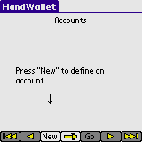  Press the "New" button. Give the new account a name and press 'OK' to save. | Step 2:  Go to menu Data/Actions and start entering actions to your new account.  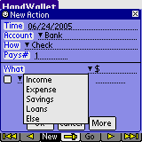  After selecting the category and entering the sum press the 'OK' button to save. | Step 3:  After entering few actions as described in step 2, you can view a pie chart of your expenses or income.  This is done by pressing the Analyst/Categories Pie menu.  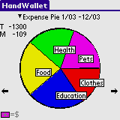
Step 4:  View the statement portfolio (payments) of your account and compare it to your online banking records.  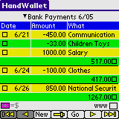 | Step 5:  Add personal categories to the pre-defined categories of HandWallet.  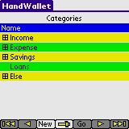  Build your own tree of expenses and income in Data/Categories menu. | Step 6:  -Add periodical actions  -View the future balance (forecast) of your account,  -Export the data to a Word or Excel document  -Plan your budget  -Import exchange rates from the web  -Contact the HandWallet support team from the software and ask a question  And much more..

Introduction

What is the HandWallet software?
The HandWallet software is a unique, advanced and sophisticated finance software. Its goal is to assist you in managing all your finances. With the help of HandWallet you will be able to follow all your expenses and earnings, manage a personal budget and manage all your bank accounts and credit cards – while having full control over all sums expected to either be added or deducted.

Who should use HandWallet?
The HandWallet software is intended for all people interested in having control over their financial matters. HandWallet is specifically adjusted for students, families and the self-employed.

How can I save money with HandWallet?
Our financial behavior is continually motivated by two conflicting forces: the temptation to buy and spend money as opposed to the fear that the money will run out. HandWallet will allow you to get to know yourself better, to understand and to balance the two forces within yourself and to bring you to a state of better personal equilibrium between these two forces. Using this program you will have more income available, and you will perform your expenses in a more efficient manner. The result of both of these is "more money", or in other words a better state of personal equilibrium.

Although this will not bring you happiness (we believe that happiness is an internal matter that doesn't depend on anything, certainly not on material things) yet it will enable you to enjoy the purchasing process more and will vacate your time for more important occupations than arguing with your bank clerk.

The temptation to buy…
The perpetual need to spend money is easy to understand. It stems from a number of reasons at the foundation of which lies the world of prosperity that we live in, the Western culture in whose lap we were brought up, the plentiful advertisements that overwhelm us and the competitive and comparative side of out characters.
The first step is to understand the temptation to buy and not to deny it. The temptation to buy is both good and natural. It proves that something is important for you and attracts you. You can be a computer freak (who is "dying" to play with the newest model that has just come out onto the market) or a swell kid (who is "dying" to try on the most modern line of swimsuits that just appeared on the fashion channel). You might be a restaurant lover (facing a special restaurant) or an insect collector (facing a rare find) . . .
It will appear accompanied by a number of sentences, such as "I have to have it" "That's exactly what I was looking for", and this will usually also be accompanied by a silencing of the other force: "We received some money not long ago", "I can afford it", "We restricted ourselves last month, we deserve a purchase now".

The Fear that the Money will Run Out
This is also easy to understand. It stems (how surprising!) from that same world of prosperity, that same Western culture and those same advertisements, credit sales and sophisticated sales methods. Once, when we used to make a living from agriculture, we knew exactly what we had. Today we are forced to cope with an assortment of abstract and confusing terms: credit, interest, overdraft, fund, linkage... and that only misleads, and even pressurizes.
Once we have understood the impulse to buy, the second step is to understand the fear that the money will run out and not to deny it. This fear is realistic. The money is after all finite: it doesn't matter how many payments you have been allowed, they all have to be paid in the end. It doesn't matter what loan you have received, your situation now (if you don't alter anything) is only more difficult because in addition to your regular expenses you also have to repay it . . .
It doesn't matter what your incomes are - since your expenses and level of lifestyle are always more or less in accordance. It also doesn't matter what your status is and to what extent you are established - you will always be accompanied by this same feeling, with regard to different things and different sums.

What should you do? HandWallet is the answer!

Let's increase the amount of money -
By locating all the mistakes, the duplicate payments and the fraudulent dealing that may be taking place on our credit cards.
By the use of preferable means of payment for each action.
By supervision of all the bodies (and people) who owe us money. It may be the refund of travel expenses from an employer, the correction of a mistake in a telephone bill or simply money that you lent.
By forgoing the expenses that are found to be expensive and don't provide us with satisfaction.
By postponing expenses that at the present time are liable to cause a problem in our balance of payments (and also to hamper the pleasure to be derived from that same expense).
And for those lovers of formulas amongst us - if (F: Fun) is the amount of pleasure that we derive from the expense and (P: Price) is the price for that expense, we aspire to an expense that gives us maximum F (fun) for a minimum P (price).
Examples? With pleasure!:
An unnecessary payment that is debited to our credit card gives us a high P (high price) and nil F (no pleasure). Unless we are masochistic . . .
It is worth making purchases in the supermarket with the use of purchase vouchers (that give a discount and decrease the P) without altering the F (the taste of the strawberries remains the same no matter how you pay).
The purchase of a dress in three payments will create a deficit in our current account for another two months (that means excess interest and consequently an increase in the - P - the cost of the dress). Should we forgo it? Not at all . . . just wait a couple of days until the beginning of the month and thus postpone the payment and prevent the problem.

I do this anyway. Why do I need HandWallet?

Perhaps. But you work hard at it. And you fight with yourself. In other words you are not objective because of the two forces having a running battle inside of you.

There are many little tips that you haven't thought about. The Media Vision company employs a staff of experts in order to lessen your purchase costs and calculates complex computations for you (such as interests, charges, exchange rates) that may influence your decisions. In addition the company collects and pays for advice from other users from all over the world and provides this to you for free.

You are not alone . . . we place a professional tool at your disposal that will precisely and faithfully keep you updated with regard to your financial situation. Is your husband really convinced (or in other words does he "internalize" this) when you scold him and tell him that this month the money is going to end? You're not sure. With HandWallet you have the proof at your finger tips.

Does this mean that now I'll have to enter every penny I spend into my computer?

Of course not. Small expenses that do not accumulate (its worthwhile, at least at first, to check this) are usually not significant (a small P) and therefore they will not cause any significant saving. It's up to you to decide what to enter and what not.

Moreover, most of the expenses will be directly updated from the Internet sites of the various banks and credit cards, and all that is left to do is only to affirm them and to attribute them to a category (if you wish to do so). This action takes a few minutes every month and it replaces going over the data sheets that you receive by post, as you would do anyway.

From what date should I begin to insert data?

Historical activities can be introduced (starting from 1950 if you have records) but we wouldn't recommend this.

Begin the use from the beginning of the month or alternatively from today. Record the purchase at the supermarket, the fuelling at the fuel station or the account for the mobile phone and you will already know what your wages "go" on. After about a fortnight of data input, you will already have an expansive graphic picture that should reveal interesting (and in some cases surprising) things to you about your expenses.

Life is Complicated. There are postponed payments; there are discounts on credit cards. Sometimes I make purchases abroad. Do you provide support for all of this?

Yes, yes and again yes!

With the help of HandWallet you can insert a postponed event, an event involving payments, a postponed event of payments, a periodic event once a month (such as a wage), a period event for another period of time, transfers of monies from one account to another, discounts, special charges, an event in foreign currency (including the potential for various currency conversions), payments with constant interest, payments with variable interest, linkage of various kinds etc.

.

How to use this manual?
The HandWallet software is complex. It includes a large number of characteristics and options. There is no need to get to know all options in order to use this software and benefit from it – it is rather the opposite that is true.
The HandWallet software as well as this manual are designed in a way that makes it possible to “get to know things” easily and operate this software even without mastering all details and capabilities. We recommend reading the general review (Chapter #3) thoroughly as well as the introduction to each item of the chapter dealing with “information” and “diagnostics”. Later on, one should read whenever necessary the detailed information by using the table of contents at the beginning of this manual or the key at the end of it.

Attention!
HandWallet is distributed and sold in several versions to different target populations. Some versions do not include all functions described in this manual. It is recommended to check at the site which function can be included in each version, and whenever necessary – to upgrade the version you have.

Installation for Windows

Minimum requirements
HandWallet is designed to run on PCs and PDA’s (personal Digital Assistant) running one of the following operating systems:
Microsoft Windows 98, 98 Second Edition, ME, NT, 2000, XP, 2003 Server
Palm OS
Windows Mobile / Win CE
- Symbian

This manual provides guidance only for the software installation and operation regarding PC computers. If you have a PDA, please review the appropriate manual.
HandWallet requires at least 10 MB of free memory on your hard disk. In addition Microsoft Internet Explorer version 5.5 or above should be installed on the computer.

Downloading
HandWallet can be downloaded from the product site:
http://www.handwallet.com/
Go to the download page or type this URL:
http://www.handwallet.com/csl/downloadpage.asp

In the download page select "Desktop PC" and download the EXE file HandWalletInstall.exe

After selecting the right file, a downloading window will open up. Please make a note of where this file is saved for the purpose of running it later.

Installation
After running the HandWalletInstall.exe file you may see this screen (depending on the version of Windows you have):

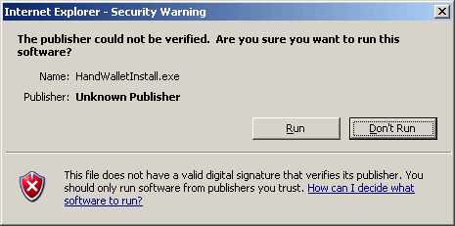
ILLUSTRATION 1 – Installation - Security Warning
Press the "Run" button to continue.
You will now be asked to select the language of the installations.

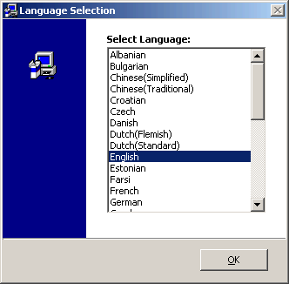
ILLUSTRATION 2 – Installation - Selecting the language of the installation

Select the language of the installation and press the "OK" button. Then you should get this welcome page:

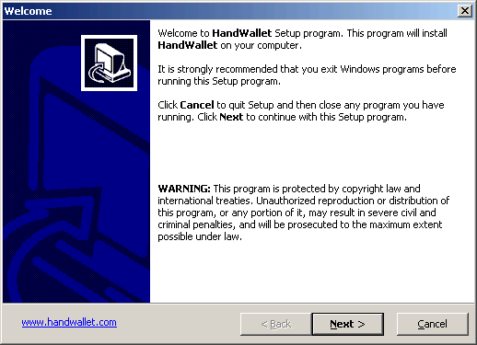
ILLUSTRATION 3 – Installation – Opening screen
Press the "Next" button at to bottom of the page.

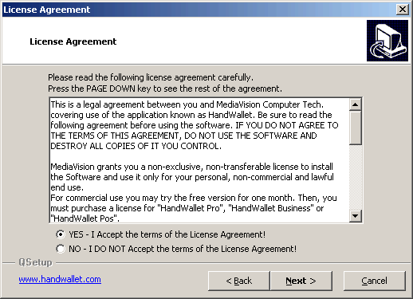
ILLUSTRATION 4 – Installation – License agreement
Please read the license agreement. If you agree to the terms and conditions of the license agreement mark "Yes" and press the "Next" button at the bottom of the page.
It is impossible to continue the installation without accepting the license agreement.
.

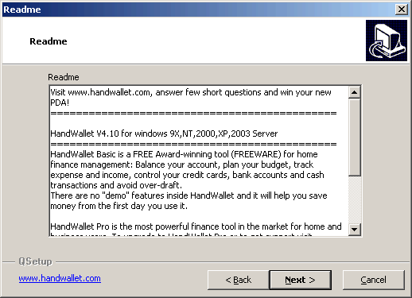
ILLUSTRATION 5 – Installation – Readme
In this screen you can read general explanations about HandWallet. To continue the installation press the "Next" button at the bottom of the page.

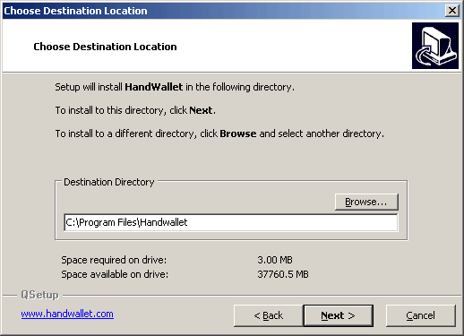
ILLUSTRATION 6 – Installation – Destination Directory
You can change the directory in which HandWallet will be installed by pressing the "Browse" button.
To continue press the "Next" button at the bottom of the page.

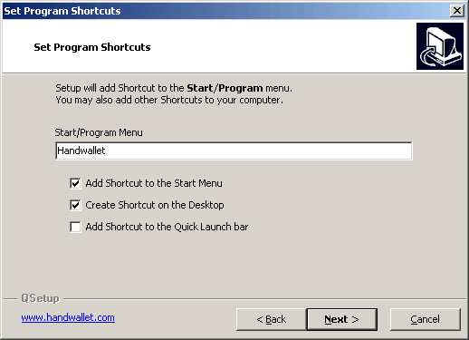
ILLUSTRATION 7 – Installation – Program Shortcuts
In this screen you can decide if you want to add one or more shortcuts for HandWallet. These shortcuts will be used to run the software in the future.
You can also set the name of the Start/Programs menu (The defaults is "HandWallet").
To continue press the "Next" button at the bottom of the page.
Now you will be asked to confirm all your previous selections.

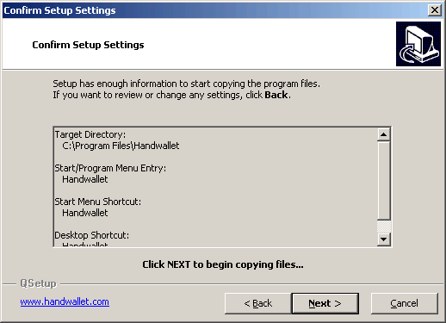
ILLUSTRATION 8 – Installation – Confirm Setup Settings

You are now ready to install HandWallet on your computer. Press the "Next" button at the bottom of the page.

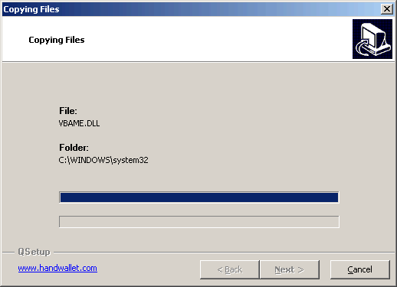
ILLUSTRATION 9 – Installation – Copying files

The files needed to run HandWallet will be now copied to your computer.

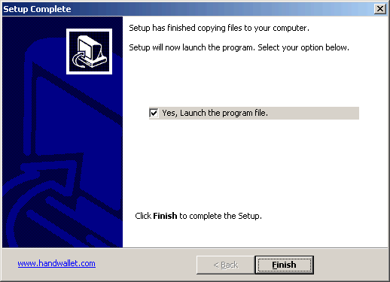
ILLUSTRATION 10 – Installation – Finish

After all the files are copied and system is updated you will be able to start HandWallet. You might be asked before first use to restart the computer.

Initial operation
It is time to operate HandWallet for the first time. If HandWallet didn't start automatically after installation, click on the software icon on your desktop. You can also use the Start / All Programs / HandWallet to start the software.

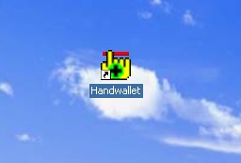
ILLUSTRATION 11 – Initial operation

When you operate the software for the first time, you see a Wizard that lets you define a number of initial parameters such as the interface language and the main currency you will be working with. The Wizard interface language is English only and it appears only upon the first operation of the software or when updating future versions.
The first screen appearing upon operation of the software is the greeting screen:

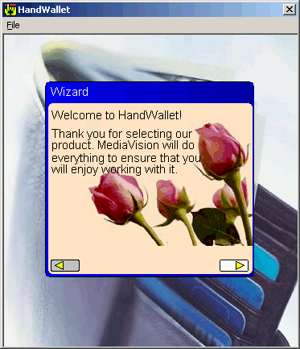
ILLUSTRATION 12 – Welcome to HandWallet

You should click on the right arrow to continue.
You should read carefully the terms & conditions and click on the right arrow if you agree to these conditions and are interested in continuing to use the software.

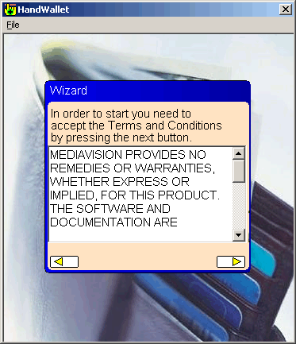
ILLUSTRATION 13 – Terms & Conditions
Please select the country you live in.

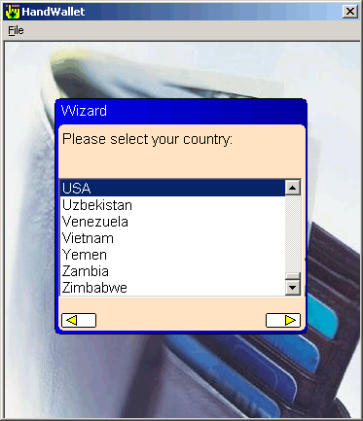
ILLUSTRATION 14 – Selecting the country

Please select the software interface language. For your attention: you can make your selection in any foreign language even if you do not have that language installed on your handheld computer. In this case, the software will operate fully in the foreign language you selected (including the keyboard) except for the menus that could appear illegible. In case you do not have the selected foreign language on your handheld computer and the menus are indeed illegible, it is possible to change only the menu language into English – as will be explained later.

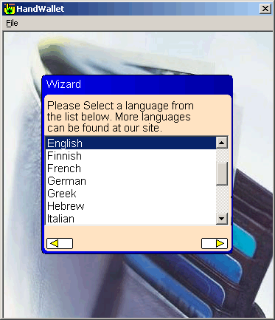
ILLUSTRATION 15 – Selecting the interface language

Select the currency you frequently work with and click on the right arrow to continue.
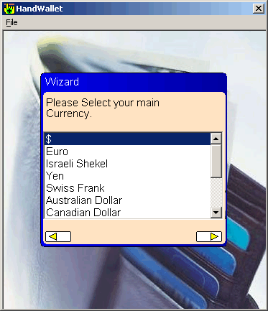
ILLUSTRATION 16 – Selecting the main currency

The system is producing files that will serve you later on. This is a one-time operation and it can take several seconds.

This is the end of HandWallet initial operation. You are on the action screen, which is the first screen that will come up whenever you operate HandWallet.

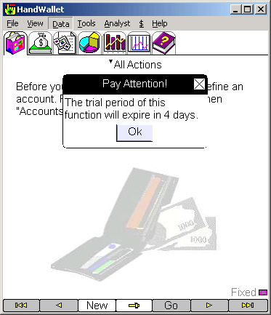
ILLUSTRATION 17 – The initial screen (the actions screen)

Problems during installation time or initial operation

During installation
In case you have no available space in your hard disk, you may receive an error message. You should free some space on your computer and re-install HandWallet.

Illegible text
The installation has been correctly completed. You selected a language different from English but you receive an illegible text.

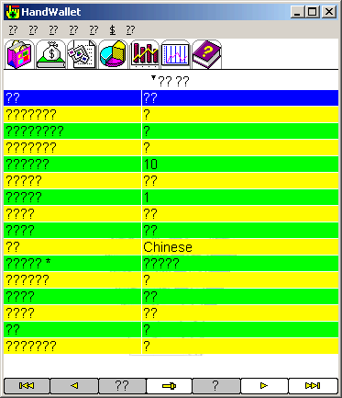
ILLUSTRATION 18 – Illegible text

This usually occurs when the language for non-Unicode programs in your Windows is different from the language you selected.
To correct this problem press the Windows Start button and then select "Control Panel". Then press the "Regional and Language Options" and select the "Advanced" tab.

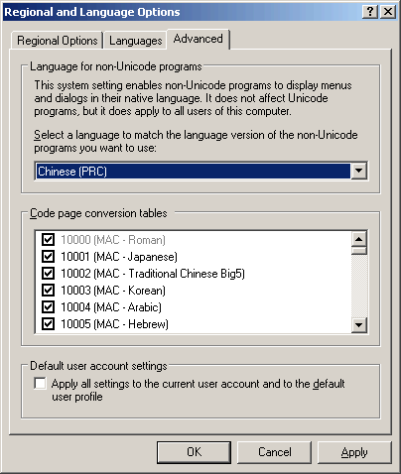
ILLUSTRATION 19 – Regional and Language Options

Change the "Language for non-Unicode programs" to the language you selected in HandWallet and press the "OK" button.
You might need to restart your computer after this change.

Illegible menu
The installation has been correctly completed. You selected a language different from English. The text appears correctly but you receive an illegible menu.

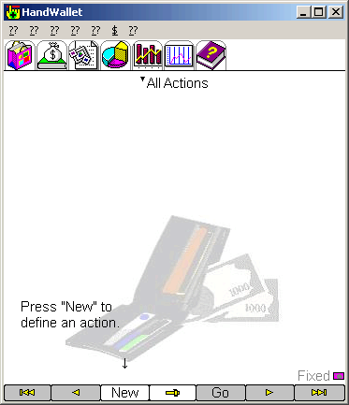
ILLUSTRATION 20 – Malfunction – Illegible menu

This usually occurs when you do not have the selected language installed on your computer and you selected it during start wizard. You can change the menu language to “English” and continue to work using your language (except for the menus).
Select the menu that is fourth from the left and then – the 2nd line.

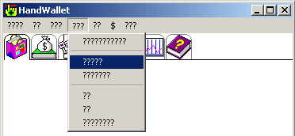
ILLUSTRATION 21 – Malfunction – Illegible menu

Double click on the “menu language” line (If needed click first on the right arrow at the bottom of the screen to move to the next group of definitions). Change the default from “Same” to “English”.

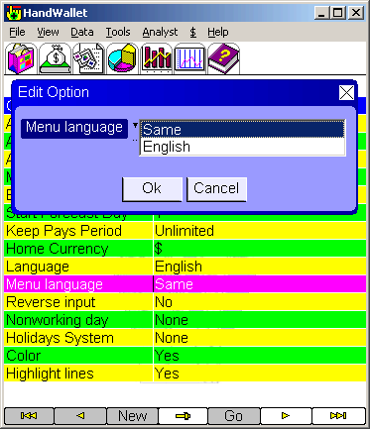
ILLUSTRATION 22 – Changing the menu language

The menus will appear from now on (and in every future operation of the software) in English.

The software does not come up and it sends a message saying that a certain component is missing.
The Booster used by HandWallet is, in fact, a collection of elements. Sometimes, not all the required elements exist in your computer. The best way to deal with this problem is to re-install HandWallet.

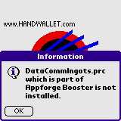
ILLUSTRATION 23 – Missing elements for activating HandWallet

Attention:
A new installation of HandWallet and/or installation of Booster do not delete the existing data, but in any case, it is recommended to perform a data backup prior to installation. A new installation of HandWallet overrides the previous installation, and it therefore does not take double space.

Update software
Once in a while, the MediaVision Company releases a new version for the HandWallet software. Performing a software update is done exactly as a new installation of HandWallet. The system identifies that an update is performed and it does not delete the existing data.
Attention:
Prior to performing an update, it is recommended to perform a complete backup of the data and the old software as explained in this manual.

HandWallet includes an automatically update mechanism. If you didn't block the update process (called X_HandWalletUpdate.exe) you will be notified when a new version of the software is available.

Uninstall
To remove HandWallet from the PC you should exit the HandWallet software. Then press the "Start" button, select the "Control Panel" and then "Add or Remove Programs".
The screen will show a list of all software programs installed on your computer. You should select the line saying “HandWallet” and click on the Remove button.

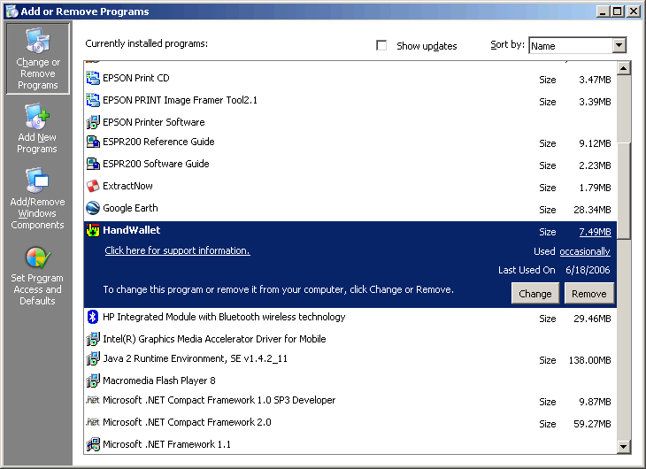

ILLUSTRATION 24 – Deleting HandWallet

A question will appear asking whether you really wish to delete the software. A click on the “Yes” button will delete HandWallet as well as all data from your PC.

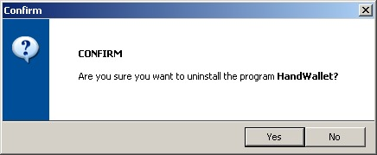

ILLUSTRATION 25 – Deleting HandWallet - confirmation

Installation for PDA's and Mobile Phones:

General
HandWallet is designed to run also on PDA’s (personal Digital Assistant) and mobile phones running one of the following operating systems:
Palm OS
Windows Mobile / Win CE:
- Symbian:

Using HandWallet on a PDA or a mobile phone has a lot of advantages:
- The information is always available and can be used also when you are out of home or office. Decisions can be made anytime anywhere based on the last updated information.
- Actions can be entered write after they occurred.
- All functions of HandWallet such as accepting credit cards from customers can work while you are out of home or office.

This manual provides guidance only for the software installation and operation regarding PC computers. If you have a PDA, please review the appropriate manual.

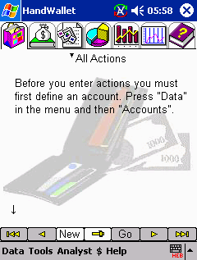
ILLUSTRATION 26 – HandWallet for PDAs

HandWallet versions for PDAs and mobile phones include most of the functionality of the PC version. In addition, they are similar to the Windows version and it is not necessary to learn again how to operate the software.

Downloading
HandWallet can be downloaded for free from the product site:
http://www.handwallet.com/
Go to the download page or type this URL:
http://www.handwallet.com/csl/downloadpage.asp

In the download page select the type of PDA or mobile phone you have.

Transfer data from and to your PDA
HandWallet include the functionality of transferring data from and to PDA's and mobile phones. For more information about how to connect the PC version and PDA's versions please refer to 11.

Licensing
In general, a license is required for each device, including PDA's and mobile phones. If you are not sure if you have a valid license for your PDA please contact the support team using the product site, or by using this email: support@handwallet.com

General Review
HandWallet includes 5 modules:

The Data module:
It is used for entering and viewing personal monetary (financial) data, such as actions, payments, means of payment (accounts) etc,

Tools module:
It serves for performing different functions regarding the financial data, such as the import and export of data, downloading and uploading data from the web, and adjustment of different parameters of the software.

Analyst module:
It is used to receive a description of the financial situation and executive summary reports regarding the data entered into the software. Use the analyst options to find out what the money was spent on, what your sources of income are and how they are distributed, meeting or not meeting your personal budget, your expected future cash flow and more.

Finance module ($):
It is used to enter and view general financial information, such as exchange rates between foreign currencies, stock rates, interest rates and financial indexes. This information has an impact on actions you feed into the system (for example: overseas purchases in foreign currency).

Help module:
It is used to receive general or specific help on the screen you see at any given time.

Data

Accounts (Means of payment)
‘Accounts’ is a general name for bank accounts, credit cards, cash or any other means of payment. One of the prevailing uses of HandWallet is a follow-up of means of payment: their current balance, what kind of actions were done with them in the past and what actions will be done in the future.

The definition of the means of payment is performed through a data/accounts menu. The options existing on the screen are:
Definition of a new account.
Edit (modify) an account.
Duplicate an account.
View the Statement portfolio of an account.
Delete an account.
Change the view fields in the screen
Add personal filed to the account details

New account
To define a new account, you should click on the “New” button at the bottom of the screen. In case the account has not yet been defined in the system, the software will guide you in defining the account by an appropriate message and an arrow.

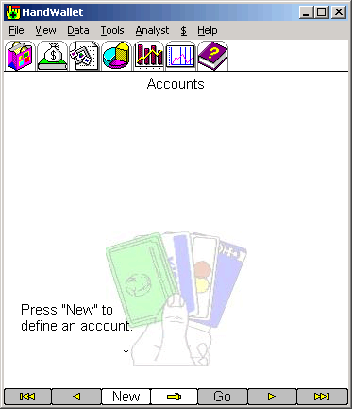
ILLUSTRATION 27 – Defining a new account

It is possible to define an unlimited number of accounts (depending on the memory available on the computer).

After clicking on “New”, the following screen will appear:

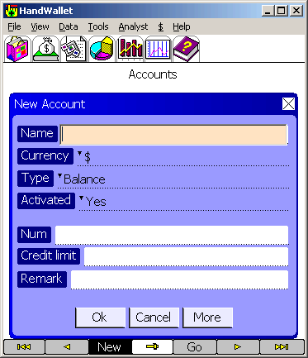
ILLUSTRATION 28 – Defining a new account – fields
Click on the lined area of each field to feed (enter) data according to the following specification:
Name (required field):
Each account has a name, which serves as a reference to it in the future. The name of an account can be any combination of numbers and letters. Two different accounts should not be given the same name.

Currency:
All accounts are executed in a certain currency. This does not prevent us from performing actions with the same account in other currencies as well. But these actions will be exchanged to the currency of your account.
It is possible to add currencies that are not build-in HandWallet in the $/my favorites menu.

Type:
This could be a bank account, a credit card, cash or a merchant account.
A merchant account is one used by business owners for the purpose of clearing customer credit cards. In case we use several currencies, you should use an account of the “cash” type for each currency.
It is possible to define credit cards and merchant accounts only after we have defined at least one bank account or one cash account.

Activated:
Feed “Yes” (default) for accounts currently being used.
Feed “No” for an account which is no longer in use but that you still wish to have in the system for follow-up purposes.

Num:
Your bank account number (in case account is of the bank account type).
The credit card number (in case the account is of the credit card type).
The merchant number (in case the account is of the merchant account) given to you by the credit card company.

This data remains encoded in the software database. It is not mandatory to enter this data. But it could be used to perform synchronization with the Internet sites of banks and credit card companies as well as direct payment from the device.
The “cash” account has no number.

Terminal Number:
This data exists only in merchant accounts. This is the terminal number you received for the purpose of credit card clearance. It is recommended to define a separate merchant account for each credit card company you work with. In this case, it is possible to define the same terminal number to all accounts.

Credit limit:
The maximum overdraft when a bank account is involved.
The maximum accumulative amount of purchases when a credit card is involved.

Remark:
Free text. You can use it for feeding additional information regarding your account (for example: the name and telephone number of the bank clerk handling your account).

The “more” button:
This button appears several times within the software and it takes you to a screen including additional details. When adding a new means of payment, the “more” button will appear when a balance account, a credit card account or a merchant account are entered (“cash” does not have any additional details).

A new account– Credit Card
If we enter a credit card, then after clicking on “more”, the following fields will appear:

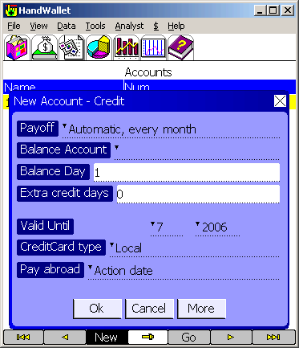
ILLUSTRATION 29 – A new account – credit card

Payoff:
The payoff mechanism used for this card by HandWallet.
The options are:
-Automatic, every month. The total sum all transactions done with this card will be deducted from the "Balance Account" once a month.
-Manually. No sums are deducted automatically. You will have to manually enter "money transfer" payments to pay for your credit cards transactions.

Balance account (required field):
The means of payment (usually a bank account) from which the credit card amount is deducted.

Balance day (required field):
The day of the month when the credit card is “deducted”. The default is 1 (first day of the month).

Extra credit days:
This field is not common in some countries, since credit cards are usually deducted on the day of payment. In some countries, credit cards are not deducted on the day of payment (due date) but rather a few days (or even up to two weeks) later. Thus, for example, a transaction made on the 30th of the month will be deducted on the 15th of the following month, and on the 1st o the month. In this case, the field “additional days of credit” should be updated to 15.

Valid until (required field):
The last day the credit card can be used as appears on the card.

Credit card type:
Is this credit card local or international?

Pay abroad:
The form of payment by credit card abroad.

The “More” button will take us to additional details regarding the means of payment.

A new account – Internet

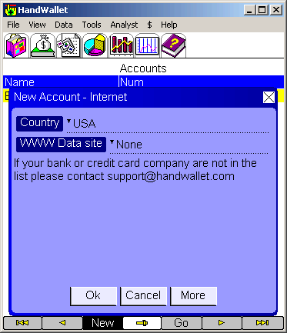
ILLUSTRATION 30 – A new account – Internet

Country:
The country where the financial institution (a bank or a credit card company), from which data has to be automatically sync, is located.

WWW data site:
The Internet site from which data can be automatically sync.
Attention!
To use this option, the computer should be connected to the Internet.
Not all devices are capable of using the option of access to the Internet or the bank and credit card sites. In addition to that, not all banks or credit card companies have Internet sites from which data can be taken, and not all existing Internet sites are accessible to HandWallet.
The list of accessible Internet sites and the way to access them is frequently updated, and they are subject to changes made by the banks and credit card companies on their sites.

Moreover, sync data through the Internet depends on linking to the Internet and on the availability of the bank and/or credit card servers. The Media Vision Company is not responsible in any way to the availability of data or its accuracy. This service is experimental, and it should be treated accordingly.

In case you choose to perform automatic synchronizations with a specific bank or credit card company, you will have to give additional data you have depending on the bank or credit card company. Thus, for example, to receive data from Bank HaPoalim, you would have to provide a user code, identity card (identity number) and a password.

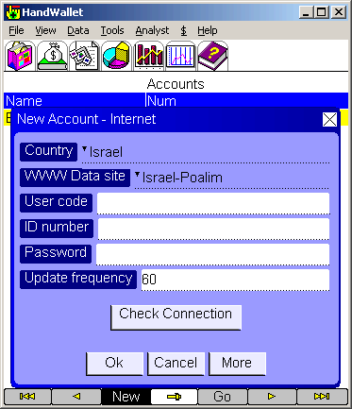
ILLUSTRATION 31 – A new account– the Internet – Bank HaPoalim

To get data from Bank Leumi, it is required to provide the user identification, the identifying field and the password.

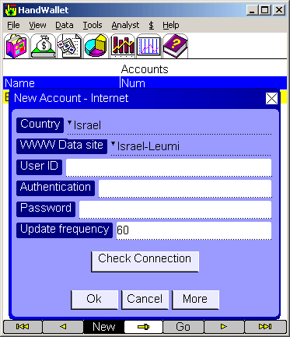
ILLUSTRATION 32 – A new account – the Internet – Bank Leumi

To get data from Bank Discount, it is required to provide the ID number and the password.

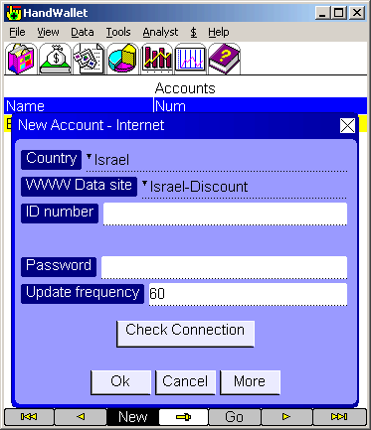
ILLUSTRATION 33 – A new account – the Internet – Bank Discount
It is required to feed the appropriate identification details exactly the way they are fed when connecting to the bank or to the credit card company in a regular Internet browser. In some cases it is necessary to pay attention to upper/lower case letters.
After feeding the identification details, it is possible to check the connection (log on) to the bank or the credit card company by clicking on the “Check Connection” button.
Attention!
The “Check Connection” button does not actually take the data but it rather connects (links) to the Internet site of the bank or the credit card company. It verifies the possibility to log into the account.

Update frequency:
Getting data from a bank or a credit card company can be periodically done.
Please use this parameter to define the frequency (in minutes) you would like to connect to the bank to get data.
Attention!
Getting the data through the Internet (web) is possible only when the HandWallet software is active. The automatic sync of data will stop upon exiting the HandWallet software and will be immediately renewed upon entering the software. In case the software has not been active for a longer period of time defined in the “frequency update” parameter, the sync will be performed immediately after activating the software.

Edit (modify) account
To modify existing account, you should click on it twice or select it by a single click and then select the “Edit” option from the list of options that will appear.
When you edit the account, the screen displays will be the same as in the definition of a new account. Saving the changes will be performed only following a click on “OK”.
To cancel the changes, click “Cancel” or move to the software menu for another option without clicking on “OK”.

Attention!
Making changes in accounts of the “credit card” or “merchant account” types could create situations that are complex for managing the account and follow-up of payments. Thus, for example, changing the credit card balance day (due date) will not change the payments already existing in the system. But editing (following this kind of change) of one of the actions on the credit card, will create the payment on the new date. If you are unsure, it is possible to define the same credit card one more time, and turn the previous account to “inactive”.

Duplicating an account
To duplicate an account select it by a single click and then select ‘Duplicate’ from the list of options that will appear.
Duplicating an account will create another account with the same name and definitions. The new created account will be empty: no actions, payments or balances associated with the original account will be duplicated.

View the Statement portfolio of an account
This will jump to the ‘Data/Payments’ screen of the account, showing all the transactions and balances of the account.

Deleting account
To delete an account existing in the system, you should select it by a single click and then select “Del” option” from the list of options that will appear. The system’s default is to request user confirmation prior to deleting the account. The screen will display the question: “Are you sure?” To confirm the deletion, click on “Yes”. It is possible to avoid the request for confirmation by updating the option “Verify deletion” on the tools/options screen.

Change the view fields in the screen
To change the view fields of the accounts screen press the 'Options' button at the bottom of the page and select "View fields".

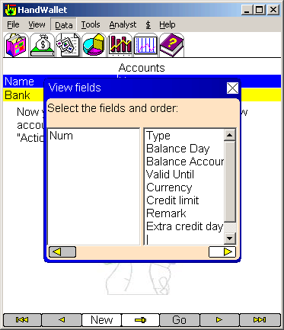
ILLUSTRATION 34 – Account view fields
Now select the fields you want to see on the screen (appears on the left side of the screen)

Personal fields:
In this screen you can edit any extra personal fields (fields related to Accounts that are not build in HandWallet).
By default, the list of personal fields is empty.
To add personal fields close the Actions window and select the ‘Options’ button at the button of the page.

Actions
Actions (known also as "Events") are financial transactions that create one or more payments (a flow of money). For example: the purchase of something, receiving a salary every month, paying off a loan etc. The most common transaction we perform with HandWallet is the addition of new actions.

The definition of actions is performed by using the data/actions menu.
The options available on the screen are as follows:
Definition of a new action.
Edit (modify) an action.
Deletion of an action.
Duplicating of an action.
Filtering the actions list.
Navigation – Go to actions of a specific year/month/day

New action
To define a new action, click on the “New” button at the bottom of the screen. In case actions have not yet been defined in the system, the software will guide you in defining an action with the help of a message and arrow.

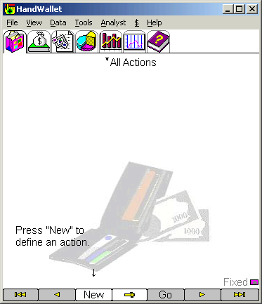
ILLUSTRATION 35 – Defining a new action
It is possible to define an unlimited number of actions (depending on the memory available).

Attention!
It is impossible to define actions within the system as long as at least one means of payment (account) has been entered. To learn how to feed means of payment into the system, please refer to data/accounts.
It is impossible to feed actions within the system if categories are not defined (the system has built-in categories). To learn how to define categories, please refer to data/categories.

After clicking on “New”, the following screen display will appear:

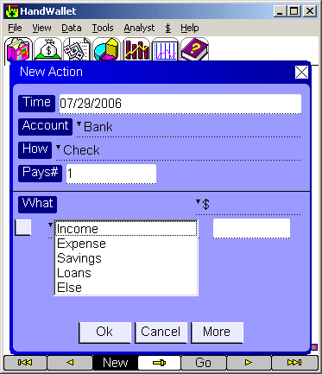
ILLUSTRATION 36 – Defining a new action – initial screen
What (required field (:
Each action is connected (linked) to one or more categories describing the action. With the help of classifying to categories, we can later receive diagnostics (see below) of our financial activities, such as: summary reports, pie of income/expenses, the ratio between income and expenses etc.
It is recommended (but not mandatory) to feed the category first when entering a new action. In a new action, the category tree (see below) window is already open. Click on the category that is most appropriate for the action:

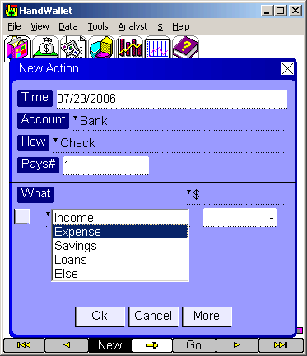
ILLUSTRATION 37 – New action – What
Please note that the category tree window remains open to “refine” the selection:

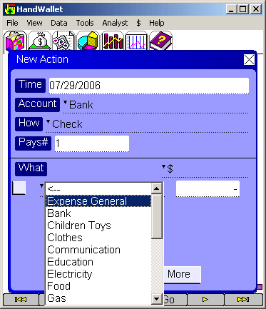
ILLUSTRATION 38 – A new action – What – Refining
It is possible to continue to drill down the category tree until reaching the description of the most appropriate action:

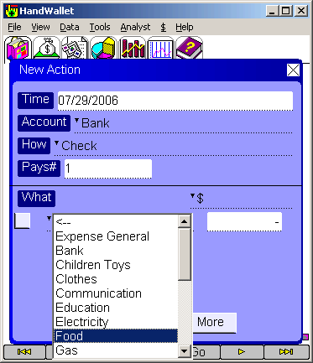
ILLUSTRATION 39 – A new action – What – Continuing to refine

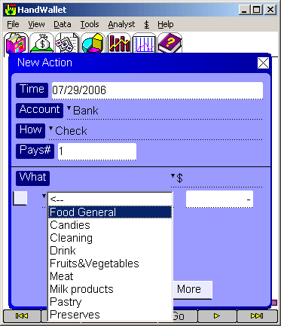
ILLUSTRATION 40 – A new action – What – Category selection
Every category selected displays the option selected earlier marked by the word “General”.
Select “General” if you do not wish to provide any further detail or if the existing additional detail refining does not meet your needs. In case you selected the “general” category or in case there is no additional refining, the category tree is closed and there is a requirement to fill in the sum.

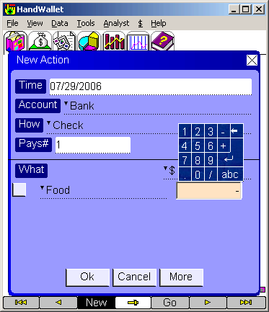
ILLUSTRATION 41 – A new action – Entering a sum

Sum:
Click the action sum near the category selected. You can enter a sum including a decimal point.
Please note that an expense should be clicked as a negative (minus) sum and an income – as a positive sum. The minus sign will automatically be added to categories of the type “Expenses” (please see the category tree below) as in our example. In case an income is involved, nothing is added and it means that a positive sum is involved.
In certain categories (for example: categories of the type “other”) the software program is unable to know whether negative or positive sums are involved. The rule to determine the sign of the sum is from the aspect of the means of payment (the account) related to the action:
If following the action, there is more money in the account, the action sign is positive.
If following the action, there is less money in the account, the action sum is negative..

Attention: In the “Expenses” category there are sometimes positive actions, e.g. if we get a refund.

Feeding additional categories to an action:
There are actions in our lives that naturally belong to several categories. For example: purchasing pet food and regular food at the same purchase. The power of HandWallet is, among other things, its ability to split an action over several categories.
To feed an additional category to the same action, click on the small menu sign next to the category and select the “Add” option.

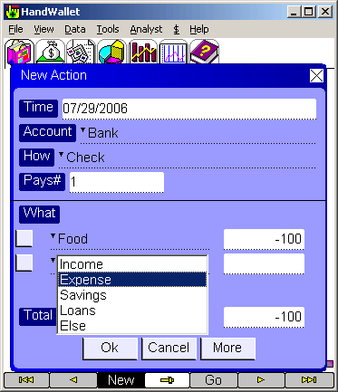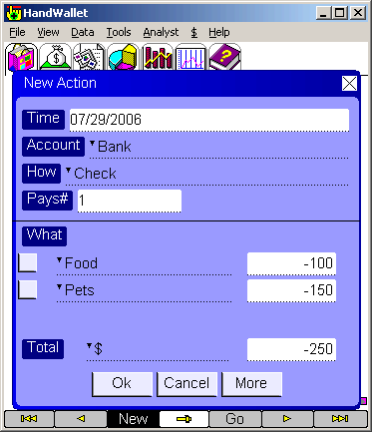
ILLUSTRATION 42 – New action – Entering an additional category

An additional line of category and sum will appear on the screen.
Select the appropriate category and then feed the sum.
The total sum of the action is the total of all category sums that were fed.

Feeding the quantity and the price per quantity:
The HandWallet default is to feed the entire sum of the category.
It is also possible to feed a category by feeding the quantity and the price for the quantity. In this case, the category sum is the quantity multiplied by the price per quantity.

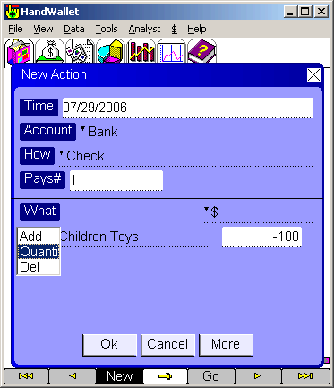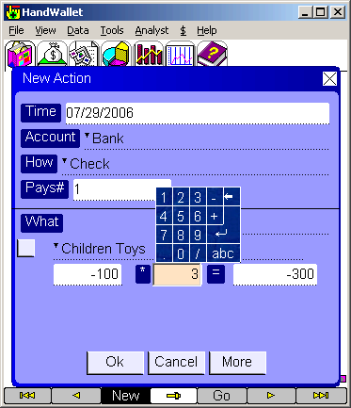
ILLUSTRATION 43 – New action – Quantity and price per quantity

For example: Painters using this software to follow-up on their purchases of paint would define the price per kilogram paint of a certain type (e.g. $10). When they buy this paint, they would feed the quantity purchased (e.g. 20 kg.). In this case, the category sum would be $200.

Time (required field):
The date of action. The default for this field is the current date. Please note that the action date could be different from the payment dates for this action.
It is possible to feed actions that took place in the past (starting from 1950) as well as actions that will take place in the future.

Account (required field):
The means of payment (see above) used to pay for the action – in case of an expense, or in the case of income – the means of payment into which the money was entered. It is mandatory to feed an account in each action. The default for this field is the last account used or the only account existing (if only one exists).

How:
The form of payment. The possible values in this field are in accordance with the type of the account involved in the action. Thus, for example, with a bank account, it is possible to pay by:
Check
ATM (Automatic Machine Teller)
Paper (form / document)- Paper
Tel (Telephone) - Tel
Internet

An ATM feeding is really a shortcut to two activities: the transfer of money from the “bank account” means of payment to the “cash” means of payment, and then payment by this cash.

Pays#:
The default is that the action is performed by one installment. Please change this value to the number of installments scheduled for the action. In case the number of installments is greater than 1, it is possible to make a note of the first installment, which could be different from the rest of the installments.
The rest of the installments (except for the first installment) are equal. The total of all installments is equal to the sum of the action.

The “more” button:
This button appears several times in this software, and it takes you to a screen showing additional details.

A new action – additional details:
Subject:
A large number of additional details can be added to actions. To make orientation easier, you should select the relevant subject among the following:
Vendor / customer + remark
Checks
Customer credit card
Tax / Invoice / Receipt
Timing
Consumption
Partners
Discount
Interest
Linkage
Exchange rate (it will appear only if you enter actions in a currency different from the currency your account is in)
Action status
Personal Fields

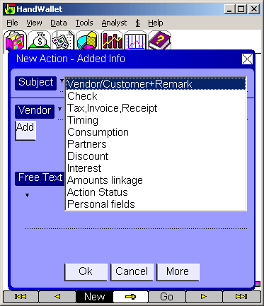

ILLUSTRATION 44 – Action – Clicking on the “More” button
Vendor / Customer:

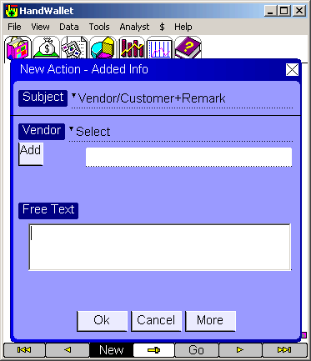
ILLUSTRATION 45 – New action – Vendor / Customer

On this screen, it is possible to make a note of the business (or the customer’s name – in case you are self-employed or companies known to customers) involved in the action.
It is possible to select a business (or a customer) already existing in the system or to add a new business (customer). To add a new business or customer, write their names and click on the “Add” button.
You can edit the entire list of customers/businesses to the data/vendors menu.
You can import the list of businesses or customers from external systems – see tools/import.

Checks:
On this screen, you can feed the details of the check (checks) you gave or received.

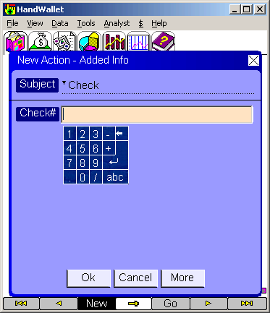
ILLUSTRATION 46 – New action – Checks
You can make a note of several checks by writing a “comma” between the different check numbers – for example: 10002, 10003.
You can make a note of a series of checks by writing a hyphen between the check numbers: 10002-10008.

The “Checks” screen appears in actions where there are no checks involved. In this case, you can use the ‘check field’ to note the reference number or voucher number.

Customer credit card:
On this screen, you can update/check and clear customer credit cards. This screen is active only if we select “Merchant account” for this action. Credit card clearing using HandWallet depends on separate registration to this service and it is done in at this stage in $ or NIS only.

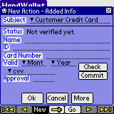
ILLUSTRATION 47 – New action – Customer credit card
Status:
The status of the deal from the credit card aspect. The initial status is “not verified”. In case verification has been performed, the verification status appears. In case clearance has been done, the clearance status appears.

Name:
The customer’s name as appears on the credit card.

I.D:
The customer’s identification card or driver’s license.

Card Number:
The customer’s credit card number.

Valid thru:
The month and year on the credit card noting that the card is valid up to this date.

CVV:
3-4 verification digits on the back of the card.

Approval:
The approval number received from the credit card company.

The “Check” button:
It connects to the credit card company and checks out the credit card.
Attention!
To use this option, the computer should be connected to the Internet.

“Commit” button:
It clears the credit card against the credit card company.
To use this option, the computer has to be connected to the web.

Tax, Invoice, Receipt:
On this screen you can make a note of the receipts (one or more), invoices (one or more) and the VAT percentage of the action.
You can also indicate the month and year the invoice is related to.
At a later date, you can export this data to external software programs, such as accounting software.

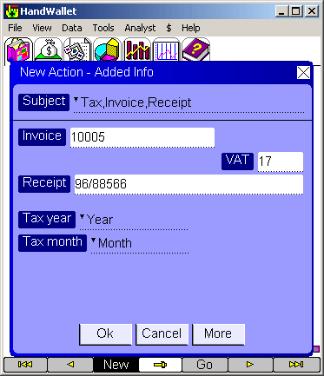

ILLUSTRATION 48 – New action – Receipt, invoice and VAT

Attention:
You can set the default VAT percentage in the Tools / options / VAT percentage menu.
Timing:

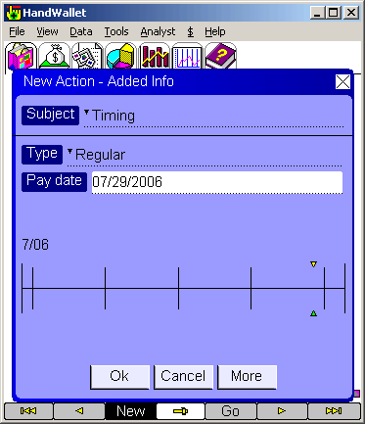
ILLUSTRATION 49 – New action – Timing

On this screen you can determine whether a one-time action is involved or a periodical one (an action repeating itself every set period of time).
HandWallet software supports actions repeating themselves:
Every week
Biweekly
Every month (e.g. salaries)
Every two months (e.g. municipality taxes)
Every quarter
Every half-year
Every year

Attention:
An installment action cannot be cyclical.
Consumption:
In this screen you can specify the period related to this action. Using this advanced option you can manage your transactions according to the real time you consume them, without any connection to the date you purchase or the date (dates) you pay.

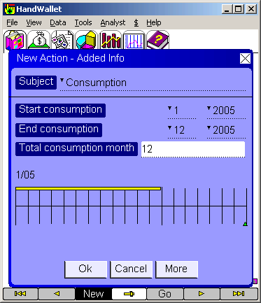
ILLUSTRATION 50 – New action – Consumption

The default consumption for each action is the purchasing month.
Pay attention that all graphs in the software reflect consumption and not the purchasing date or the pay day (dates).
For example, if you purchase a 1200$ car insurance in Jan 2004, pay for it using 4 installments (300$ each) and consume it from Jan 2004 to Dec 2004 (12 month), 100$ will appear in the "Analyst/Categories pie", "Analyst/Categories Bar", "Analyst/Categories report" etc. every month during the year.
Partners:
On this screen you can link an action to different people. This link is necessary when you wish to track settling of accounts between partners, for example: students sharing an apartment.
Another advantage of linking actions to people is when you wish to know how much money each one of them is spending and on what they are spending it. This can be done when HandWallet is used by a group of people (e.g. a family or a company) and not just one person.
You can link actions to people only if people are defined in the system.
To define people (persons) use the Data/Persons menu (see below). If people are still not defined, you will see the screen below:

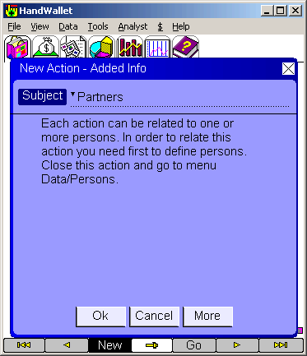
ILLUSTRATION 51 – New action – Partners

In case one or more people are already defined, you will see the screen below:

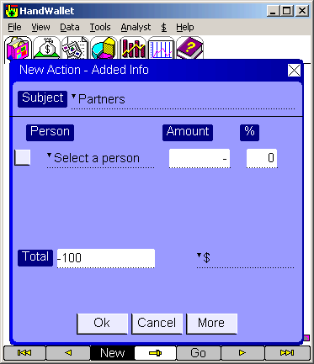
ILLUSTRATION 52 – New action – Partners – Continued

Select the person you wish to relate to the action, and make a note of the related sum and percentage:

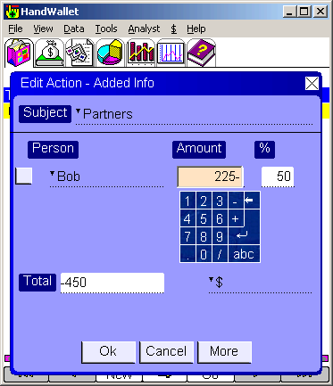
ILLUSTRATION 53 – New action – Partners – Continued
A 100% relation (as in the illustration above) means that the entire action is related to the same person.
A 50% relation means that only half of the action is related.
We can use a 50% relation when two partners sharing expenses purchase something that is used by both of them. In this case, we will define both people:

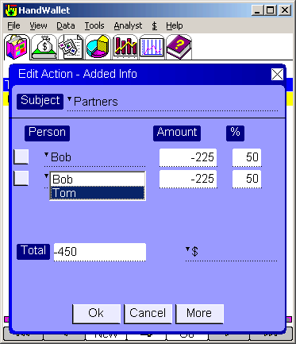
ILLUSTRATION 54 – New action – Partners – Two people
Later on, it will be possible to receive reports and graphic diagnostics presenting the different actions in a cross-section of people.

Discount:
It is possible to make a note of whether we received/give a special discount (or whether a special tax should be added).

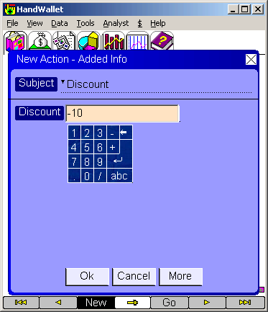
ILLUSTRATION 55 – New action – Discount

A discount should be marked as a negative number (for example, a 10% discount should be marked as “-10” (minus 10).
An addition (e.g. a 3% commission) should be marked as a positive number “3”.

Attention -
The action price on the action screen will not change as result of marking the discount or commission percentage. The change will show on the statements presenting the monetary transactions.

Interest:

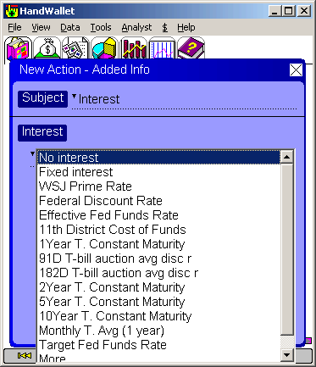
ILLUSTRATION 56 – New action – Interest
It is possible to determine whether there is interest on the action payments, and if so – what it is. It is possible to select the interest on an action is from one of the prevailing interest rates on the market, e.g. the “Prime” interest rate. The system has several built-in interest rates, among them the “Federal Discount Rate” the “11th district cost of funds” and the “Funds Rate”. A click on “More” will enable us to select an interest rate out of a large number of more international interest rates.
It is possible to update these interest rates (either manually or automatically through the Internet) by clicking the $/ interest values menu (see below). It is possible to add new interest rates that are not built-in by clicking the $/favorites menu (see below).
We can mark an interest margin, either positive or negative, of the interest rate selected:
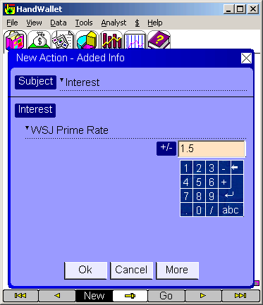
ILLUSTRATION 57 – New action – Interest margin
Amounts linkage:
You can determine whether the action payments are linked to any index (see below) and/or any currency:

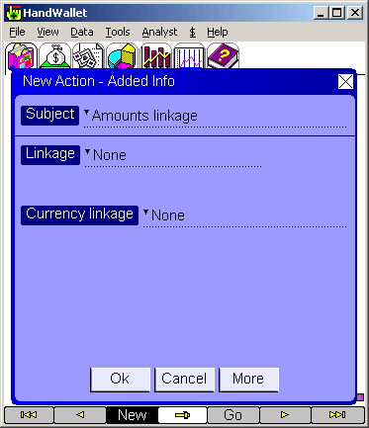
ILLUSTRATION 58 – New action – Linkage

Linkage to an index:
The system includes a built-in set of indexes organized by countries, including the DOW, NASDAQ and S&P 500. It is possible to add new indexes using the financial menu ($)/favorites.
You can update the index values (either manually or automatically from the Internet) in the financial menu ($)/index values.

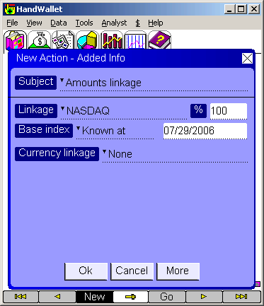
ILLUSTRATION 59 – New action – Linkage to an Index
In the linkage to the index, the base index should be noted.
You can make a note of any value or select a date. In case a date was selected (default), linkage will be done according to the index rate fed into the system in proximity to this date.

Linkage to foreign currency:
The system includes a number of useful foreign currencies including the American Dollar, the Euro, English Pound, Japanese Yen and more. You can add new currencies using the financial menu ($)/favorites.
You can update the exchange rate values (either manually or automatically from the Internet) in the financial menu ($)/exchange rates.

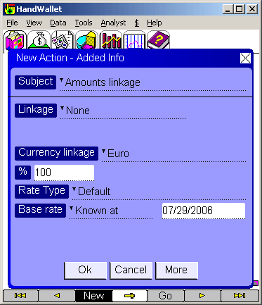
ILLUSTRATION 60 – New action – Linkage – Foreign currency linkage
In foreign currency linkage, you should make a note of the base rate and the type of the exchange rate. You can enter any value or select a date. In case a date was selected (default), linkage will be done according to the exchange rate fed into the system in proximity to this date.

Important comment:
Please note that it is possible to integrate (combine) all financial parameters together. For example: an action with the Japanese Yen carrying a “Libor” interest rate with an 80% linkage to the consumer price index and 20% linkage to the American dollar, and having a 35% discount.

Exchange rate:
This screen is active only if we have fed an action in a currency different from the currency of our means of payment (our account).
On this screen, you can decide how the exchange from the foreign currency to the local currency.

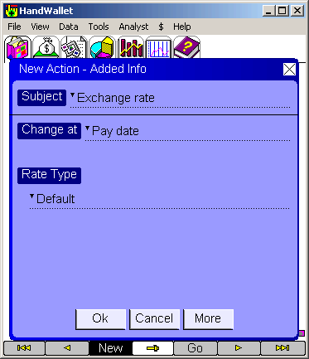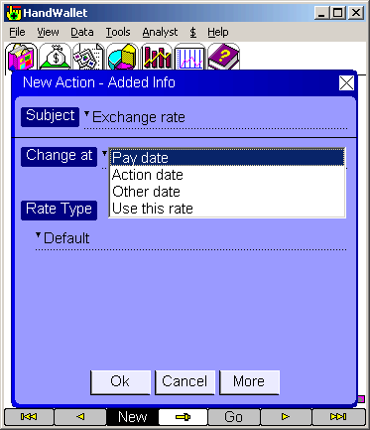
ILLUSTRATION 61 – New action – Exchange rate

The options for performing an exchange of currencies is according to the exchange rate on the day of payment (default), according to the exchange rate on the day the action was done in, accordance with any date or a defined exchange rate. If you choose to do the exchange according to a defined exchange rate, you should make a note of the exchange rate.
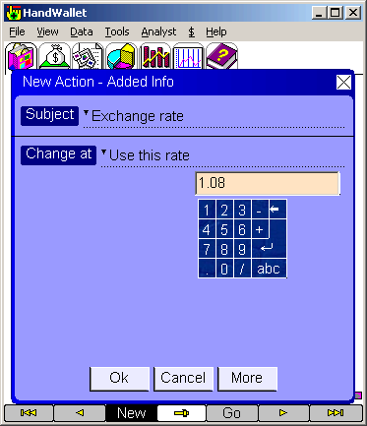
ILLUSTRATION 62 – New action – Exchange rate
Attention:
If the exchange rate has not been fed on the relevant date, the system will use the known exchange rate nearest to this date. For additional details, please see the ‘financial menu ($)/exchange rates’. If the exchange rate is not noted on any date, the software will display a question mark when the action is presented or on the statement.

Action Status:
This screen is used for displaying general information regarding the action.

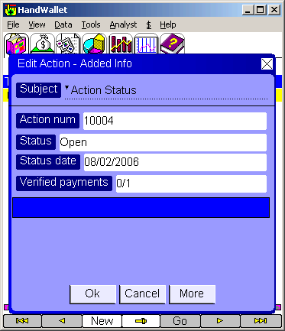
ILLUSTRATION 63 – New action – Action status
The action number is an automatic unique number (a number not repeating itself) used as identification for the action.
The action status (open or closed) provides an indication as to the state of the action.
The status date notes the date when the status has last been changed.
Verified Payments presents the number of payments in this action that were approved (either manually or automatically by synchronization with the bank or the credit card company). Approving the payments manually will be done on the ‘Data/Payments’ menu.
Personal fields:
In this screen you can edit any extra personal fields (fields related to Actions that are not build in HandWallet).
By default, the list of personal fields is empty.

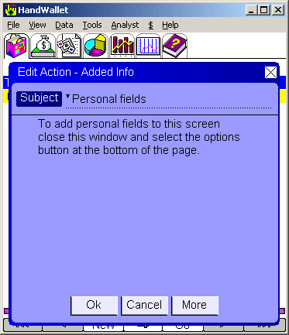
ILLUSTRATION 64 – Personal fields – Empty list

To add personal fields close the Actions window and select the ‘Options’ button at the button of the page.

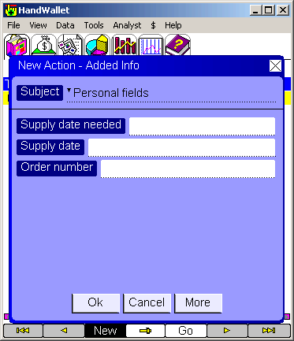
ILLUSTRATION 65 – Personal fields – after adding fields

Edit (modify) action
To modify an action existing in the system, you should click on it twice or select it by one click and then select the “Edit” option from the list of options that will appear.
The screen displays appearing when editing an action will be the same as the ones appearing when a new action is defined. Saving the changes will be performed only after clicking on “OK”.
To cancel the changes, click on “Cancel” or move on to another option on the software menu.

Delete action
To delete an action existing in the system, you select it by one click and then a select the “Del” option from the list of options that will appear.
The system’s default is to request the user’s confirmation prior to deleting actions. The question “Are you sure?” will be displayed on the screen. To confirm the deletion, click on “Yes”.
You can avoid the confirmation request by updating the “Verify deletion” on the tools/options screen.

Duplicate action
To duplicate an action existing in the system, you select it by one click and then a select the “Duplicate” option from the list of options that will appear.

Filtering the Actions list:
You can filter the action list by selecting a specific category at the top of the screen.
For example, you can decide to see only your expenses, or only your health expenses.

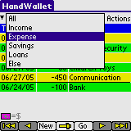
ILLUSTRATION 66 – Filtering the actions – Expenses only
You can continue filtering the actions list by selecting the 'Go' button at the button of the page.

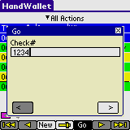
ILLUSTRATION 67 – Filtering the actions – Finding check #

Navigation in the action list:
You can move forewords or backwards in the list of actions by pressing the arrows at the bottom of the page.
You can jump to a specific year, month or day by pressing the 'Go' button at the bottom.

Sort actions:
You can change the sort of the action by pressing the 'Time' column.

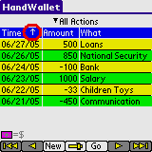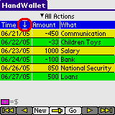
ILLUSTRATION 68 – Sort actions

Change currency view:
You can view your actions in any currency you like. If your currency is not defined in the system you can add it in the $/My favorites menu.

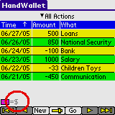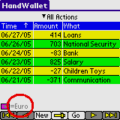
ILLUSTRATION 69 – Currency view

Totals:
You can see the total sum of all actions or a specific category by pressing the 'Options' button at the bottom of the page and then 'Total':
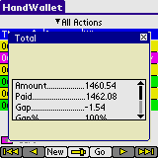
ILLUSTRATION 70 – Actions total
To see totals for a period of time go to menu Analyst/ Categories report.

Fast actions:
Fast actions are template of actions that repeat themselves often. This may include multi categories actions or actions that we use every day.
By defining a fast action we can create such an action in one click, without the need to navigate each time through the categories tree.
To define a fast action select the 'Options' button at the button of the page and then 'Fast action':

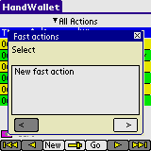
ILLUSTRATION 71 – Fast action

The first stage of defining a new "Fast Action" is to give it a name. This name will be used as a future reference for creating such an action in the future.

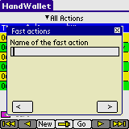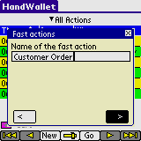
ILLUSTRATION 72 – New fast action

The second stage of creating a new fast action is to select the categories that will be included in this action. Select the 'New Category' option and then press the right arrow.

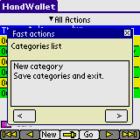
ILLUSTRATION 73 – Fast action – new category

Browse through the categories tree until you reach the relevant category. Then press the right arrow to continue.

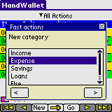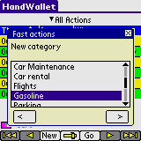
ILLUSTRATION 74 –Fast action – select category

Mark 'Yes' or 'No' if you want to see special forms price or quantity for this category and press the right arrow to continue.

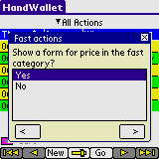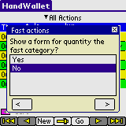
ILLUSTRATION 75 –Fast action – select category

Now save your fast action.

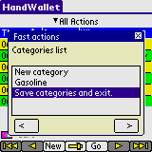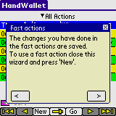
ILLUSTRATION 76 – Fast action – save changes

Whenever you press the 'New' button in the 'Actions' screen, you can now select the 'Fast Actions' you defined.

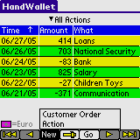
ILLUSTRATION 77 – Fast action – creating new action

By selecting a pre-defined fast action, HandWallet will create all categories automatically.

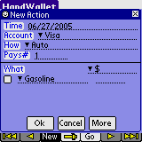
ILLUSTRATION 78 – Fast action – category selected automatically

Payments – statement portfolio
The statement screen allows us to follow the actual payments made in each one of our accounts, similarly to the statements received from banks and credit card companies.
Statements displayed on HandWallet are easy to work with and they include a large number of advantages, which regular printed statements do not include:
The possibility to move with ease from one account to another.
The option to browse through the months both forward and backward.
The option to quickly reach a certain year or month.
The option to make a note next to each payment whether it has been paid.
The option to skip (not to make a note) certain lines on a statement without losing the statement accuracy.
The option to provide information on each payment.
The option to get data into/out of files and other applications.

The options existing on the statement screen ן:
Definition of a new payment or balance.
Edit (change) a payment or a balance.
Deletion of a payment or balance.
Confirmation of a payment or balance.
Navigation – Go to payments or balance of a specific year/month/day.

New payment
To define a new payment click the “New” button at the bottom of the screen, and select “payment”. If means of payment (accounts) are still undefined in the system, the software will guide you in defining an account by exhibiting an appropriate message + arrow.

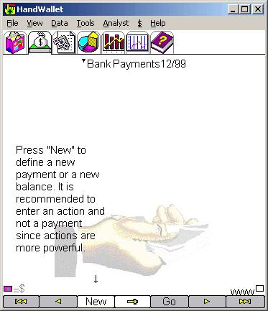
ILLUSTRATION 79 – Statement

It is recommended to define a new action rather than a new payment, since an action includes more information (an action automatically creates one or more payments).

Edit payment
To modify a payment that exists in the system, click twice or select it with a single click and then click the “Edit” option from the list of options that will appear.

ILLUSTRATION 80 – Statement – payment selection

The payment screen includes the following fields:

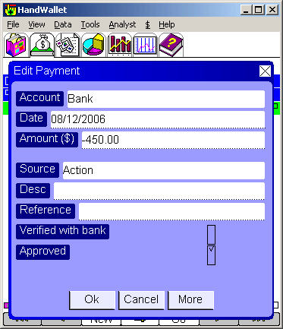
ILLUSTRATION 81 – Statement – Creating / modifying a payment

Account:
The means of payment we are currently working on (this field is for providing information only and it is impossible to have it updated).

Date:
The date of payment. This date could be different from the day of the action, which produced the payment or different from the day when this payment was supposed to be made.
It is possible to change a payment date according to the actual payment (for example: we paid by a check dated 1/1/2005 and it was paid only on 1/2/2005). Following the change of date, the payment source (see below) will be change and the words “date modified by user” will be added.

Amount (in Local Currency:(
The payment amount in the currency in which the account is managed.
The payment amount can be changed according to the actual payment (for example: in an action we reported $40, in actuality we had a discount and we were billed for only $30). Due to the change in the amount, the source of payment will be changed (se below) and the words “amount modified by user” will be added.

Amount (in another selected currency):
HandWallet has the ability to display the statements in a currency different from the currency used in the means of payment. This form of display is unique to the HandWallet software and it is useful in a number of cases. For example: if we are overseas and wish to see our account (originally managed in $) converted into Euros or if we have an account in foreign currency and wish to see it in $.

This field will be displayed only if we select a currency display that is different from the currency used in the means of payment. The information displayed in this field is provided for information purposes only, and it is impossible to change it.

Source:
From where this payment is received.
The possible values for this field are:
From user – payment entered manually by the user.
Action – payment created following an action. A comment could be added that the date, sum or both were manually updated.
Internet – A payment entered into the system as result of synchronization with one of the bank sites or the credit card companies’ sites (see below).

Description:
Free unstructured wording. You can enter different comments regarding payments that cannot be entered anywhere else.

Verification with the bank:
Indication whether the data is verified and confirmed with the bank and the credit card companies.
Verification can be executed manually or by the software.
In case the payment arrives following synchronization with one of the bank or credit card companies’ sites, this field will be marked as “Yes” automatically.

Approved:
There is indication as to whether payment has been executed. In case the payment is based on an action, this field will be marked as “Yes” automatically.

Important Notice:
Changing the payment amount does not affect statistics – they are determined by the action only. It is, therefore, recommended to correct the action (this will automatically affect the payment).

Delete payment
To delete a payment existing in the system, we have to select it by clicking once and then clicking the “Del” option from the list of options that will appear. The system’s default is the request of confirmation by the user prior to deleting the payment. The question “Are you sure?” will appear on the screen. To confirm (affirm) the deletion click “Yes”. It is possible to avoid the confirmation request by updating the option “check deletion” on the tools/options screen.

New balance
To define a new balance, you should click on the “New” button at the bottom of the screen and select “Balance”. In case accounts have not been defined in the system, the software will guide you in defining an account through a message and an arrow.

The form of adding the new balance includes the following fields:

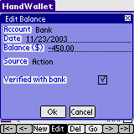
ILLUSTRATION 82 – Statement – New balance
Account:
The means of payment we are currently working with (this field is for information purposes only and it is impossible to have it updated).

Date:
The date for which the balance is valid. It is possible to define a different balance for each day (every day).

Balance (in the local currency):
The exact amount of money in the selected account in the specified date.

Balance (in another selected currency):
HandWallet has the ability to display the statements of the accounts in a currency that is different from the currency in which the account is managed. This form of display is unique to the HandWallet, and it is useful in a number of cases. For example: when we are abroad and wish to see our account in the local currency or if we have an account that is not in U.S. dollars.
This field would be displayed only if we select a display currency that is different from the currency in which the means of payment is done. The information displayed in this field is for information purposes only, and it is impossible to have it changed.

Source:
Where did the balance arrive from? The possible values for this field are:
Calculated – data calculated by HandWallet as result of previous payments and balances.
Modified by the user – a balance calculated by HandWallet and manually updated by the user.
From user – Balance originally entered by the user.
Internet – Balance that is the result of synchronization of data מול one of the bank or credit card company sites.

Verified with bank:
Checking whether this balance is identical to the one in the bank account.
This field will appear in the cash account as well. In this case, it would mean that the balance is indeed identical to the sum of money we have.

Edit balance
To modify a balance existing in the system, you should click the balance twice or select it by one click and then click on the “Edit” option from the list of options that will appear.

Delete balance
To delete a balance existing in the system, you should select it by one click and then click the “Del” option from the list of options that will appear. The system default is to request confirmation by the user prior to deleting the balance. The screen will display the question “Are you sure?” To confirm deletion, click on “Yes”. You can avoid the confirmation request by updating the option “Verify deletion” on the tools/options screen.

Attention!
HandWallet displays a balance on all days when actions took place. This balance is calculated in most cases, and therefore, there are situations where it is impossible to have it deleted. In these cases, an attempt to delete the balance will display a message saying that the balance cannot be deleted. In other cases, deleting the balance on a certain date will lead to the display of another balance – which is the calculated balance.

Categories
The category screen makes it possible for us to see and update the list of categories defined in the system. Every action is related to one or more categories. The categories are organized in the shape of a tree. Each level of the tree lists the details of the level above it. For example: under the “Expenses” category, there is a category called “Leisure”. There is a category under “Leisure” called “Vacation”. Under it there is another sub-category called “Hotels” and so on. When feeding an action, it is possible to determine the accuracy level we wish to achieve. For example, certain people will find it sufficient to note a certain action as an “Expense”. Others would also like to know the distinction between expenses, and they will therefore note “Leisure” while the third group of people would also like to know how expenses are distributed within the leisure area, and they will therefore, feed “Vacation”. The decision as to how much detail to provide regarding the categories and how to organize them is up to the user.

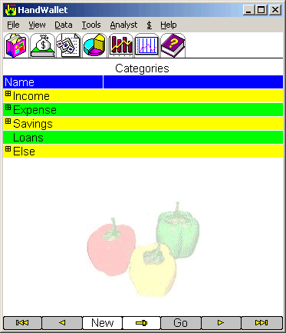
ILLUSTRATION 83 – Category tree

The category tree of HandWallet is a basic tree for starting and can be easily changed and personalized. It is possible to delete categories that are of no interest to us, add new categories, change the structure of the tree, i.e. to transfer categories from one place to another, and more.
Business users can use the category tree as an entire product tree. This product tree is, in fact, a price list, since it is possible to note the default price, the default currency and the default quantity next to each category.

The options available on the category screen:
Define a new category.
Edit (modify) a category.
Delete a category.
Navigate – Moving on the category tree forward, backward, up and down.

New category
To define a new category, you should click on the “New” button at the bottom of the screen. In case categories have not yet been defined in the system, HandWallet will guide you in defining categories through a message and an arrow.

The following screen will appear after clicking on the “new” button:

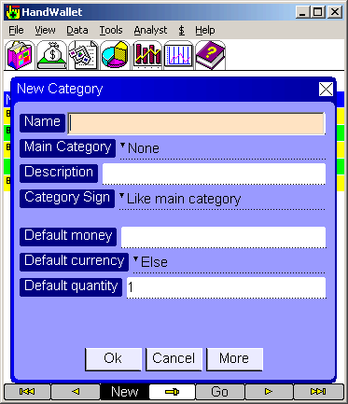
ILLUSTRATION 84 – New category

Name (required field):
Category name. How would this category be called in the system?
A name can be any combination of letters and numbers.

Main Category:
Is this category, a sub-category of another category in the tree?
Leaving this field vacant will indicate that the new category is one of the main categories of the tree (income, expenses, savings etc.).

Description:
Free text. Enter words that help you understand what exactly the category includes or any other comment.

Category Sign:
While entering a new action we sometimes enter positive sums and sometimes negative ones. For convenience purposes, the system makes it possible to determine the default sign of the sum.
The possibilities are:
The same as the main category (recommended). The sign ( + or - ) is according to the sign of the main category.
(+) The category will always appear with a positive sign.
(-) The category will always appear with a negative sign.
Undefined.

Default money:
With the help of the fields of ‘default money’, ‘default currency’ and ‘default quantity’, it is possible to build a product tree price list for the use of sales people out of the office.
The default sum is the automatic sum that will appear when a category is selected upon entering an action. It is possible to change this sum at each action.

Default currency:
The currency in which the default sum is quoted. In case of a currency different from our currency, HandWallet will perform the exchange currency (in case it has the exchange rate or an approximation).

Default quantity:
The quantity in which this category is usually purchased or sold. It is possible to change this quantity in each action.

The “more” button:
This button appears several times within the software and it takes you to a screen including additional details.

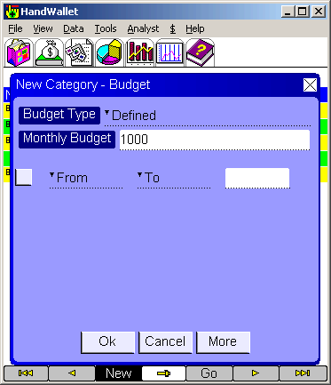
ILLUSTRATION 85 – Budget

Budget Type:
The way the budget for this category will be calculated.
The options are:
Defined
Summarized
Percentage from main
Equal actions
Equal other category
Equal the budget of

Monthly Budget:
The monthly budget for this category.

Personal fields:

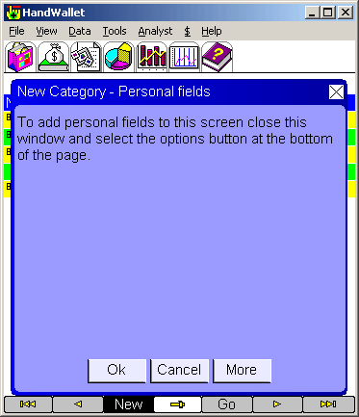
ILLUSTRATION 86 – Categories - personal fields

Edit (modify) category
To modify a category existing in the system, you should click on it twice or select it by one click and then a click on the “Edit” option from the list of options that will appear.

Duplicate category
To duplicate a category select it by a single click and then select ‘Duplicate’ from the list of options that will appear.

Delete category
To delete a category existing in the system, you should select it by one click and then a click on the “Del” option from the list of options that will appear. The system default is to request the user’s confirmation prior to deleting the category. The screen will display the question “Are you sure?” To confirm deletion, click on “Yes”. It is possible to avoid the confirmation request by updating the “verify deletion” option on the tools/options screen.

Persons
The persons screen makes it possible to see and update the list of people defined in the system. People defined on this screen can be related to actions (see data – actions).
Every action could be related to one or more people. Connecting of an action to persons enables up to know who performed each action or who is responsible for the action. This way, for example, it is possible to manage partnerships or have information regarding certain expenses.

New person
To define a new person, you should press the “New” button at the bottom of the screen. In case persons have not yet been defined in the system, HandWallet will guide you in the definition of persons through a message and an arrow.

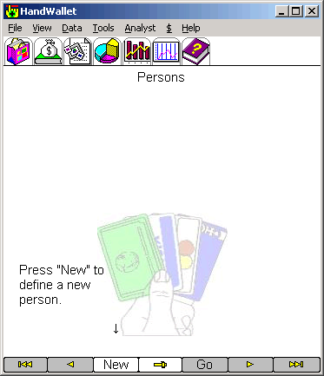
ILLUSTRATION 87 – Persons

After clicking on “New”, the following form will appear:

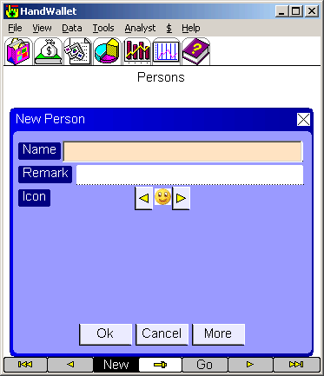
ILLUSTRATION 88 – Defining a new person

Name (required field(:
Name of person or organization. It is possible to enter either letters or numbers.

Remark:
Free text.

Icon:
A small drawing representing the person.

Edit person
To modify the details of a person existing in the system, click on him/her twice or select him/her by one click and then press the “Edit” option from the list of options that will appear.

Delete person
To delete a person existing in the system, select him/her by one click, and then press the “Del” option from the list of options that will appear. The system default is to request the user’s confirmation prior to the deletion of persons. The screen will display the question “Are you sure?”
To confirm the deletion, click on “Yes”. You can avoid the confirmation request by updating the “Verify deletion” option on the tools/options screen.

Vendors

New vendor
To define a new vendor, press on the “New” button at the bottom of the screen. In case vendors have not yet been defined in the system, HandWallet will guide you in defining vendors through a message and an arrow.

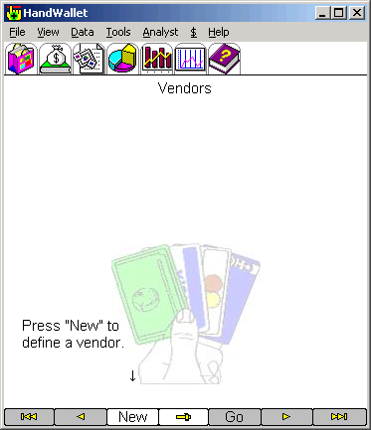
ILLUSTRATION 89 – Vendors

After clicking on “New”, the following screen will be displayed:

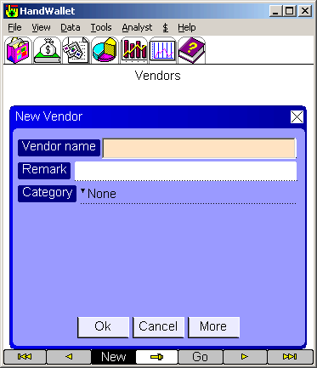
ILLUSTRATION 90 – New vendor

Edit vendor
To modify a vendor existing in the system, click on it twice or select it by one click, and then click the “Edit” option from the list of options that will appear.

Delete vendor
To delete a vendor existing in the system, select it by one click, and then click on the “Del” option from the list of options that will appear. The system default is to request the user’s confirmation prior to deleting the vendor. The screen will display the question “Are you sure?”
To confirm deletion, click on “Yes”.
You can avoid the confirmation request by updating the “Verify deletion” option on the tools/options screen.

Clear Filters
This option cancels the filters currently defined in the system.
Filters are causing that only part of the information entered into the system will be displayed. We use filters in order to focus on specific information or as a tool for searching (reaching) information.
The filters existing in the system are as follows:
The action screen – You can display only actions belonging to a certain category and not all actions.
Forecast – You can display a forecast based on all accounts or only on a specific account.

Erase All
This option deletes all data currently existing in the system.

Analyst
The “Analyst” menu helps in receiving summary and management data regarding our financial status. The different diagnostic options help us learn on what our money is spent on and the ratio between our different expenses, our sources of income and the way they are distributed, what we can expect in the future regarding our finances and more.

Categories Pie
The category pie displays the distribution of our expenses or income at a certain period of time.
Looking at the expense diagram, we can learn on what our money was spent.

ILLUSTRATION 91 – Expenses pie

Looking at the income diagram, we can learn what our income sources are:

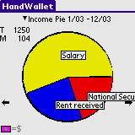
ILLUSTRATION 92 – Income pie

We can receive more details on categories by selecting the relevant category in the heading.
We can change the starting or the ending point of a period that we wish to learn about by clicking on the dates in the heading.

Categories Bar
The category bar (distribution) shows how our expenses or income change over a period of time.
Looking at the category bar, we can learn how much we spend every month, and whether there is an increase or decrease in our expenses over time:

Looking at the income distribution, we can learn about our income every month, and whether there is an increase or decrease in our expenses over time:

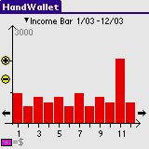
ILLUSTRATION 93 – Income bar

Persons Pie
This diagram answers the question who spent or earned the money. The Persons Pie is ideal for managing partnerships or certain activities done by a group of people together for example: a trip abroad).

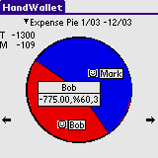
ILLUSTRATION 94 – Persons pie

Categories Report (summary report)
The categories summary report displays the summary of all our expenses, income and other actions over a period of time:

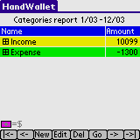
ILLUSTRATION 95 – Summary report

It is possible to receive additional details in each category (if there is this kind of itemizing) by clicking the (+) sign at the left side of the category.

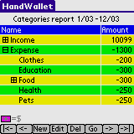
ILLUSTRATION 96 – Summary report - itemization

It is possible to change the starting or ending date of the period we relate to, by clicking on the starting or ending date at the heading. The shortest period of time that can be selected is one month. There is no limit on the length of the period of time (it is also possible to select a period greater than a year).

Budget Status
This diagram displays your position in regard to the budget objectives you set for yourself.

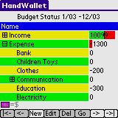
ILLUSTRATION 97 – Budget status

Balances
Analyst/Balances option displays the balance in all means of payment (accounts) that the system has on a specific date. There is a ‘total line’ at the bottom of the screen, which includes the ‘total balance’ in all accounts. Please note that the ‘total line’ includes all accounts, even accounts that are not on the display page.

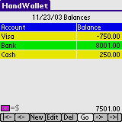
ILLUSTRATION 98 – Balances list

Forecast
The forecast screen displays current or future cash flow. With the help of this forecast, it is possible to see graphically how much money we will have in a specific means of payment (account) or in all means of payment. This way it is possible to make financial decisions based on our ability to pay.

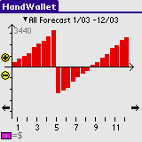
ILLUSTRATION 99 – Forecast

You can move forward in the forecast by clicking on the right arrow at the bottom of the screen or move back in time by clicking on the left arrow.
You can change the forecast scale by clicking on the (+) and (-) on the screen left hand side.

Tools

Swap Credit Card
HandWallet enables its business customers to clear credit cards of their customers. With the help of HandWallet unique clearing system, you will be able to increase the number of your customers, to perform transactions and sales any place any time, and enjoy the security and ease of working with credit cards.
Moreover, all sales you make will be integrated within HandWallet reports, diagrams and graphs. You will be able to know how much you sell each month and which is the most profitable product – all within seconds. In addition to that, you will be able to do a bank reconciliation and verify that your account is indeed credited with the correct sums – all of that on your PC or handheld PDA.

HandWallet makes it possible to clear with a credit card and without it (by phone, for example).

Clearance with a credit card
To clear with a full document, you should have one of the magnetic card readers adjusted to HandWallet. You connect the card reader to the PC, PDA or the cellular phone according to manufacturer’s instructions.

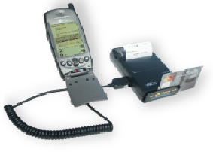
ILLUSTRATION 100 – Connection to a printer-integrated card reader

You activate HandWallet and the card reader, and pass the customer’s credit card according to the arrows at the side of the device. The screen will display the sum screen where you will be requested to enter the sum the customer is charged (or credited).

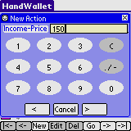
ILLUSTRATION 101 – Entering the sum of clearance

Please note that you can change this screen according to your personal preferences. If you usually sell one of 3 products, you will be able to define three screens – one for each product (see below the definition of the clearing screens).

After entering the sum, click the lower right arrow to continue.

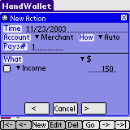
ILLUSTRATION 102 – Clearing - Entering payments and categories

On this screen, you can define the number of payments of the transaction (deal) (the default is one payment). It is also possible to change the deal category (important for the statistical reports and diagrams). If you built the previous screens well, it would be reasonable to assume that you will not have to change anything on this screen. Following the updates, click the right arrow to continue.

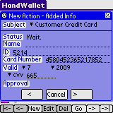
ILLUSTRATION 103 – Transmission of credit card clearing

At this point, the system contacts the ABS and validates the customer’s credit card. There is an indication regarding the success or the lack of it regarding the deal within 2-3 seconds.
The transaction status will change to one of the following possibilities:

Transaction accepted.
The customer’s credit card will be charged and the transaction is saved at the HandWallet database for follow-up.

Call Credit Card Company.
It is necessary to receive telephone confirmation from the credit card company with which clearing is required. After receiving the phone confirmation, enter the appropriate field and press the “Commit” key for renewed clearing.

Not approved.
The credit card company will not honor the transaction.
The customer does not pay and there will be no charge.

Card blocked.
The card presented to you was stolen and should be confiscated.
The customer does not pay and there will be no charge.

Card stolen.
The card presented to you is stolen and should be confiscated.
The customer does not pay and there will be no charge.

Credit card faked.
The card presented to you is counterfeit and should be confiscated.
The customer does not pay and there will be no charge.

Wrong CVV or ID.
This message will appear if you made an error in entering the CVV or the identification of the card owner. You should make the correction and press the “Commit” button for renewed clearing.

Wrong card number.
Should be corrected and then press the “Commit” button for renewed clearing.

Card not valid.
The customer’s credit card is invalid.
The customer does not pay and there will be no charge.

First payment wrong.
This message will appear in an installment transaction when the first payment is too low or too high. Return to the previous screen, correct the sum of the first payment and do the clearing again.

Amount too high.
The transaction should be divided into two or more separate transactions.

In this stage you cannot accept credit card in this currency.
As of the time of writing this manual, you can clear only in NIS or dollars. Please correct the currency on the previous screen, adjust the sums according to the exchange rate and try to clear again.

Error/Error HW
Wait a few seconds and try again. In case there is repeated malfunction, please contact our support team.

Clearing without swapping the credit card
If you do not have a magnetic card reader, you can still receive credit cards from customers through clearing with a missing document.
To clear with a missing document, enter the ‘Tools/credit card clearing’ menu.
First, you enter the customer credit card number:

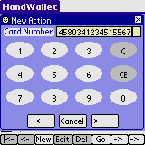
ILLUSTRATION 104 – Clearing without a credit card – Enter card number

To move to the next screen, press the right arrow at the bottom of the screen.

Enter the month of the customer’s card validity:
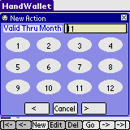
ILLUSTRATION 105 – Clearing without a credit card - Entering the month up to which, card is valid

To move on to the next screen, press the right arrow at the bottom of the screen.

Enter the year of the customer’s card validity:

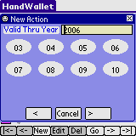
ILLUSTRATION 106 – Clearing without a credit card -Entering the year up to which, card is valid

To move on to the next screen, press the right arrow at the bottom of the screen

In some cases, the credit card company requires to enter the CVV and the card owner’s ID in transactions without a credit card.
If you need a screen for entering the CVV, mark this option in ‘Tools/Options/Credit Card Clearance’.
In case this option is marked as “Yes”, the following screen will appear:
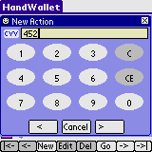
ILLUSTRATION 107 – Clearing without a credit card – Entering CVV

If the option “ID screen” is marked as “Yes” on ‘Tools/Options/Credit Card Clearing’, you will be required at this point, to enter the card owner’s ID.
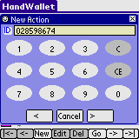
ILLUSTRATION 108 – Clearing without a credit card – Entering the ID number

Following the series of these screens, the screens of the number of installments and connecting to the credit card company will appear as in clearing with a credit card.

Internet Sync
This option makes it possible to see a list of data that is synced automatically from the Internet.

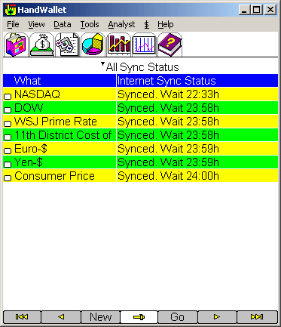

ILLUSTRATION 109 – Internet Sync

Options
This screen displays different parameters, which can be adjusted or defined in the system.

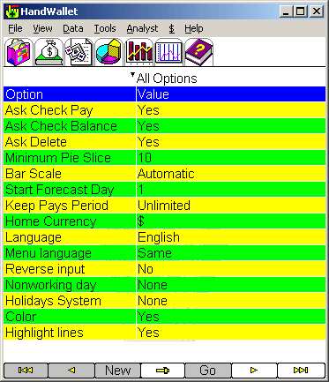
ILLUSTRATION 110 – Options

A double click on any option (or a single click and then a click on “Edit”) makes it possible to change the option according to the user’s personal preferences.
The options are divided into categories:
Regional settings
Look and colors
Behavior
Approvals
Keyboard
Security
Swap credit cards
Import Export
Licensing
Printing

You may select the relevant category by pressing the combo box in the title (default selection – show all categories).

Regional settings options:

Home currency:
This parameter determines which currency will be the common one used in HandWallet.

Language:
What will the software interface language be? HandWallet supports local languages even without installing these languages (except for the menus).
If the menu is illegible, change the “Menu Language” parameter to “English”.

Menu language:
What will the language of the software menus be? HandWallet supports local languages even without installing these languages (except for the menus).
If the menu is illegible, change the “Menu Parameter” to “English”.

Reverse input:
Should input entered by the user be reversed?
Possible values are:
Yes
No
According to the language use

Nonworking day:
In some countries there are six business days a week.
Payment done on the day of rest will be postponed to the following day. This parameter makes it possible to determine whether the country you live in, has a day where no financial activity takes place, and if so – what day it is.

Holidays system:
In some countries there is no financial activity on holidays. Payment due on a holiday will be postponed to the following day.
This parameter makes it possible to determine whether the country you live in, has any financial activity on holidays, and if there is none – then what holiday system should be taken into consideration.

Vat:
This parameter is used to determine the VAT percentage in use.
It is possible to define different VAT percentages to each action whenever necessary.

My country: :
The country you live in. This parameter affects many system defaults like banks, interest etc.

Default rate:
The currency rate type used if no specific rate type is mentioned.

Reverse menu:
Should the text in the menu be reversed?

Reverse import:
Should text fields be revered while importing?

Reverse export:
Should text fields be reversed while exporting?

Menu encoding:
The encoding system of the menu when using a language different than English.

I/E encoding: :
The text encoding in import and export when using a language different than English.
Options are:
ASCII
Unicode

Text encoding:
The encoding system when using a language different than English.
Options are:
Automatic
ASCII
Unicode

Reverse text:
Is text for languages written from right to left stored in logical or virtual way?
Look & Colors options:

Color:
Should colors be used?
People with vision problems or color blindness could possible prefer black-and-white display, which could be clearer.

Highlight lines:
Should even rows be displayed in bold print on the screens?

Highlight color 1:
If the display is colored, then what color should be used to highlight the odd rows on the screens?

Highlight color 2:
If the display is colored, what color should be used to highlight the even rows on the screens?

Show headline:
Should the field names be displayed in the heading of the different screens?

Headline color:
The color of heading (in case the heading is displayed) on the different screens.

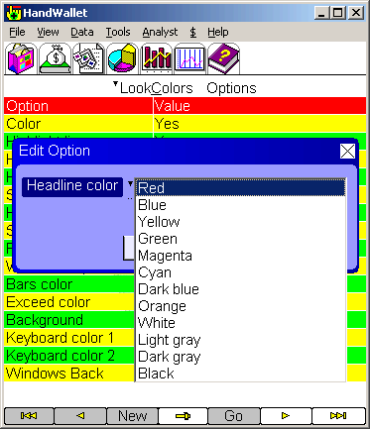
ILLUSTRATION 111 – Color of heading

Show frame:
Should there be dividing lines displayed on the screens?

Frame color:
The colsor of the dividing lines (in case they are displayed) on different screens.

Windows top color:
In case display is colored - the color to be used for the heading and the different window frames.

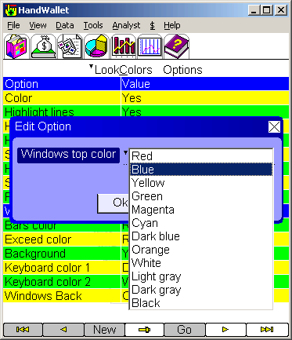
ILLUSTRATION 112 – Color of windows

Bars color:
In case display is colored -- the color to be used for the columns in the category and forecast graphs.

Exceed color:
In case display is colored – the color to be used for the overdraft in the forecasted graph.

Background:
Should there be a background picture on the different screens?
At this point, this field is active only on PDAs using WinCE or Symbian.

Keyboard color 1:
The background color of the HW-type keyboard.

Keyboard color 2:
The lettering color on the HW-type keyboard.

Windows color:
The background color of the windows.

Windows text color:
The text color in the windows.

Win label color:
The color of the labels in the windows.

Win label shape:
The shape of the labels in the windows.

Win lines color:
The color of the fields lines in the windows.

Text color:

Future text color:
The color of the text of the future transactions in the payments screen.

Form font name:
The type of font used in the screens.

Form font size:
The size of font used in the screens.

Windows font name:
The type of fonts used in the windows.

Windows font size:
The size of font used in the windows.

Num font name:
The type of font used for numbers and dates.

Num font size:
The size of font used for numbers and dates.

Buttons font name:
The type of font used in the buttons.

Buttons font size:
The size of font used in the buttons.

Win label text color:
The color of the labels in the windows.

Speed Buttons style: ::
The style of the speed buttons at the top of each form. Options are:
-Tab
-Antique
-Modern
Behavior options: :

Minimum pie slice:
What is the minimum size (in degrees) of a section on the pie diagram displaying words?

Bar scale:
Should the breakdown scale and forecast scale be automatically updated according to the sums displayed, or should a fixed scale be used.

Start forecast day:
The forecast graph (see diagnostics/forecast) displayed at a resolution of two half months. This parameter determines on which days of the month, sampling of the balance will be done. Thus, for example, if the start forecast day is 1, the forecast balance will be determined according to the balance on the 1st and the 15th of the month.

Keep pays period:
This parameter determines to which period ahead, payments or cyclical actions should be calculated. The only option on this version is “Unlimited”.

Date format:
How to enter dates on the screen headings.
The possibilities are:
Date-time picker
List

Action sort:
How to sort the records in the Data / Actions screen.

Finance sort:
How to sort the financial data.

Recalc statistics:
Recalculate the statistic data in the reports and diagrams.

F.Point actions:
Show exact amounts in the actions screen.

Recalc payments:
This will recreate all payments in the system according to the actions.

Internet policy:
When to connect the Internet and download data?

Actions shown info:
The information presented in the "What" field in the actions screen.

Payments shown info:
The information presented in the "What" field in the payments screen.

Payments date format:
The format of the date in the payments screen.

Restore defaults:
Restore all the options original defaults.

Opening screen:
The first screen when we run HandWallet.

Proxy server:
The address of the proxy server, if such a server is in use.

Proxy port:
The port of the proxy server, if such a server is in use.

Auto create actions:
While receiving data from the bank or credit card site, should HandWallet create an action?
0% - always
100% - only if HandWallet is totally sure how to classify the action.

Communication closed:
Is the communication closed after importing data from the web? Mark "No" if you have any problems importing data.

Show total payments:
Should we summarize and present the total sum of payments for each action in the Actions screen?

Approvals options: :

Ask Check Pay:
Should there be a request for the user’s confirmation each time a payment is approved? Payment confirmation is a common action performed on the “Statement” screen.
Change this option to “Yes” if you want the software to request your confirmation every time you confirm (approve) a payment.

Ask Check Balance:
Should there be a request for the user’s confirmation each time a balance is confirmed? Balance confirmation is a common action performed on the “Statement” screen.
Change this option to “Yes” if you want the software to request your confirmation (approval) each time you confirm (approve) a payment.

Ask Delete:
Should there be a request for user’s confirmation each time data is deleted?

Sort categories:
Should the category tree be sort again in alphabetical order after entering a new category?

Ask recalc payments:
Whether to ask on not to ask when we change an action with approved/modified payments?
Keyboard options: :

Keyboard type (PDAs and mobile phones only):
The type of virtual keyboard used when entering text in PDAs and mobile phones.
The existing possibilities are:
- Original keyboard (PDA keyboard)
- HandWallet keyboard (HW keyboard)
Use a keyboard of HW type if foreign language support is not installed on your PDA or if the foreign language support does not interface with the software.

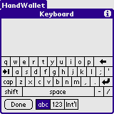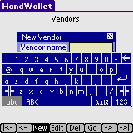
ILLUSTRATION 113 – Original keyboard
ILLUSTRATION 114 – HW Keyboard

Popup keyboard:
Should a virtual keyboard be displayed whenever the user enters a text field?

Keyboard color 1:
The background color of the HW-type keyboard.

Keyboard color 2:
The lettering color on the HW-type keyboard.

Security options: :

Ask password:
Should there be a password request upon entering the software?
HandWallet could hold sensitive data such as credit card numbers, bank account numbers etc. It is therefore recommended to add password protection that would be displayed at any entrance to the software. This way, even if your PDA is lost or stolen, it would not be possible to activate the software without your approval.

Password::
The password used in case the “Ask Password” parameter points to “Yes”.

Hide Passwords:
Show starts in password fields.
Swap credit cards options: :

Print Chit:
Should a note be printed after accepting a customer credit card?
Options are "Always", "Never" and "Ask"

Chit Language:
The language of the note.
Options are "Same" and "English"

Chit Title:
The title of the note.

Ask CVV:
Ask for CVV while swapping a customer credit card?
Options are "Yes" or "No".

Ask ID:
Ask for ID while swapping a customer credit card?
Options are "Yes" or "No".

Enable CC Swap:
Enable / disable swapping a customer credit card from a device.
Options are "Yes" or "No".

Com Pos:
The COM port of the swapping POS device.

Import Export options: :

I/E Separator:
Text separator between fields while importing to or exporting from sequential files.
The default value is the character "|"

Export File Format:
The format of the export file.
Options are "ASCII" or "UNICODE"

Import Date Format:
The format of date fields we import. Must include mm, dd and yy or yyyy.

Export Date Format:
The format of date fields we export. May include mm, dd, yy or yyyy.

Export From:
The earliest date of the data we export.

Export Until:
The latest date of the data we export.
Licensing Options: :

User profile:
User's status. This parameter helps to fit various defaults and settings to the user needs.

License:
A license is required to benefit from HandWallet advanced options.
This license can be obtained at the company site:
http://www.handwallet.com/
Printing:

Print horizon lines:
Whether or not to show lines between records in the report?

Print vertical lines:
Whether or not to show lines between columns in the report?

Print frame:
Whether or not to show a frame around the report?

Print report title:
Whether or not to show a title in the report?
Options are:
Yes, every page
Yes, first page
No

Print fields titles:
Whether or not to show field titles in the report?
Options are:
Yes, every page
Yes, first page
No

Print page numbers:
Whether or not to show page numbers in the report?
Options are:
Yes
No

Print date:
Whether or not to show the date of the report?
Options are:
Yes, every page
Yes, first page
No

Date alignment:
Alignment of the date in the report.
Options are:
Left
Right
Middle

Image top page:
Image located at the top of the report.

Image alignment top page:
Alignment of the top image.
Options are:
Left
Right
Middle

Image bottom page:
Image located at the bottom of the report.

Image alignment bottom page:
Alignment of the bottom image.

Print background image:
Background image of the report.

Background image position:
Should the background image of the report be tiled, stretched or centered?

System Status
This screen makes it possible to view data related to the software such as the software version and additional components installed, the number of records entered etc. This data is intended for display purposes only, and cannot be changed.

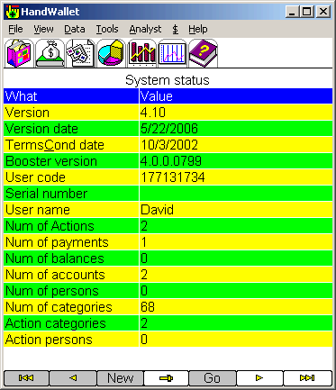
ILLUSTRATION 115 – System Status

The data displayed on the “System Status” screen includes the following details:

Version:
The HandWallet version installed on your computer.

Version date:
The version date of release.
It is recommended to visit occasionally the product site:
http://www.handwallet.com
and check for new versions.

Terms & conditions date:
Using HandWallet depends on agreement with the terms and conditions expressed upon initial operation of HandWallet. In case there is any change in the license conditions, you should read the conditions and limitations again, and give your consent.
This parameter displays the date when consent to conditions and limitations was given.

Booster version:
HandWallet uses the Booster addition to the operating system manufactured by the AppForge company (see Booster). This parameter presents the Booster version installed on your computer.

User code:
The user code is a unique personal code produced by HandWallet based on different data, such as the device model, the operating system version, the user name and the serial number.
You will use this code when purchasing or upgrading your license.

Serial number:
Some devices have a built-in serial number. This number is unique to your device – there is no other device carrying this serial number. The serial number is involved in the security mechanism integrated in HandWallet in order to ensure that your license is legal.

User name:
The user name in HotSync operation.

Num of actions:
The number of actions currently in the system.
This number may include also deleted actions. To remove deleted actions select the 'Num of actions' line and then the 'Compress' option.

Num of payments:
The number of payments currently in the system.

Num of balances:
The number of balances currently in the system.

Num of accounts:
Number of accounts currently defined in the system.

Num of persons:
The number of people currently defined in the system.

Num of categories:
The number of categories currently defined in the system.

Action categories
The number of categories per action defined in the system.

Action persons
The number of persons per action defined in the system.

Vendors
The number of vendors currently defined in the system.

Payments until:
The latest date up to which, transactions within the system are calculated (it is impossible to enter transactions or actions of a later date).

Balances until:
The latest date up to which, balances within the system are calculated (it is impossible to enter balances of a later date).

Heap free (bytes) :
The extent of available memory (in bytes) in the system. A decrease in the memory available could cause problems in the appropriate functioning of HandWallet

License type:
HandWallet is marketed with a number of license types. This data displays the license type of the software installed on your computer.

Valid until:
Some licenses for operating HandWallet are for only a limited period of time. This data displays until when the license you have is valid.

Coupon value:
Certain options in the software can be activated for a fee. Payment of this fee is done through the purchase of a coupon at the product site. This characteristic displays the coupon value still unused
.

Import
HandWallet supports import of data from external programs for different purposes. It is possible to import data to HandWallet from any accounting software supporting the export of data.
The import process is accompanied by a wizard, which can assist in the selection of different options. You can continue to the next stage in the wizard by clicking on the right arrow at the bottom of the window or go back by clicking on the left arrow. You can close the import wizard at any stage by pressing the X on the window upper right hand side, or by selecting another option on the menu.

Data import includes 6 major stages:
Selecting the source of data we want to import from (an application, from the web or a pre-defined import)
Selecting the program where the data is imported from
Selecting the file from which the import will be executed
Selecting the type of data imported
Selecting the import format
Selecting the fields to be imported

The first stage if to select the source of data we want to import from.

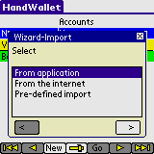
ILLUSTRATION 116 – Import – select source of data
By default, there are no pre-defined imports in the system. If you try to select a pre-defined import at this stage you will get this screen:

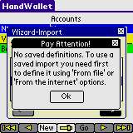
ILLUSTRATION 117 – Import – pre defined import

Select "From application" and press the right arrow.
The second stage of the import wizard is to select the application to import data from.
You can move data from other programs on Palm and/or on desktop PC's into the Memo Pad.

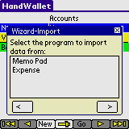
ILLUSTRATION 118 – Import – select application

If you select 'Memo Pad' you will be asked to select the memo in which the data is stored.

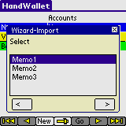
ILLUSTRATION 119 – From which memo would you like to import data?

The Third stage in the import wizard is selecting the type of data imported:

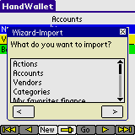
ILLUSTRATION 120 – What would you like to import?
You can import:
Accounts (Means of payment)
Vendors
Actions
Categories
Favorite finances (user defined currencies, user defined indexes etc.)
Balances
Persons
Statements
Exchange rates
Index values
Interest rates
Stock values

Forth stage:
Select the format of the data stored in the file (in some cases, the system will automatically identify the format).

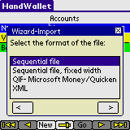
ILLUSTRATION 121 – Import format

Fifth stage:
Make a note of the fields and the field order in the file from which you import data (in some cases, the system will automatically identify the fields).

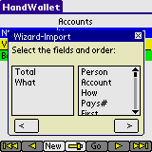
ILLUSTRATION 122 – Import fields

In contrast to the export option, where you can select any combination of fields you wish and even repeat a certain field a number of times – in the import of certain data, there are required fields. For example: when importing actions – making a note of the date is required.

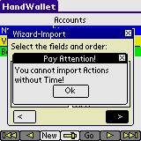
ILLUSTRATION 123 – Import of actions
At the end of the import, there is a message regarding the number of records read and the number of records imported.

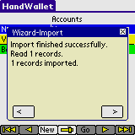
ILLUSTRATION 124 – Import finished

Sixth stage:
Select whether you want to save the import for future use.

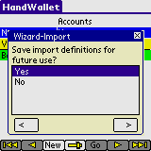
ILLUSTRATION 125 – Import – Save import definitions?

If you select 'Yes' you will be asked to give the import a name. This name will be used as a future reference to run the import next time, without going through all definitions again.

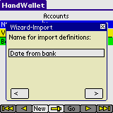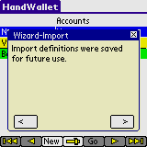
ILLUSTRATION 126 – Import – Import definitions were saved

Import tips:
  - Importing data from anther software is always a complicated task. This is not typical just to HandWallet – it is in general a problematic situation. Usually the import process will not work in the first try. Thus, if you are trying to add records to existing data it is strongly recommended to backup first your information.
  - When importing a sequential file it is important to view the file first and to see what delimiter (I/E Separator) is in use. A delimiter is a special character that separates between fields. The default delimiter used by HandWallet is the character "|". However, you may change this in Tools/Options/Import Export.
  - HandWallet supports both importing from ASCII and UNICODE data-sources. However, in some cases the program might not recognize correctly the type of file you are trying to import.
  - Trying to import data that includes dates might be problematic, since there are several ways to represent a date field. You may control the date format in Tools/Options/Import Export.
  - In any case you couldn't import data to HandWallet please contact our support team. See the chapter Help/Additional help options in this manual.

Export
HandWallet supports the export of data to external programs for different purposes. You can export data out of HandWallet to accounting programs supporting the import of outside data. You can export data out of HandWallet for printing, Internet display, for backup or transfer and partnership with another HandWallet user.
The export process is accompanied by a wizard, which assists in the selection of different options. You can continue to the next stage in the wizard by clicking on the right arrow at the bottom of the window, or go back by clicking on the left arrow. You can close the export wizard at any stage by pressing the X on the upper right hand side of the window or by selecting another option on the menu.

Data export includes 6 main stages:
Deciding if you want to define a new export or use a pre-defined one?
Selecting the type of data exported
Selecting the program where data is exported to
Selecting the file to which export is executed
Selecting the fields exported
Selecting the export format

The first stage of the export wizard is to decide if you wand to define a new export or to use a pre defined one. By default, there are no save exports in the system.

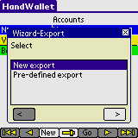
ILLUSTRATION 127 – Export – new or pre-defined

The second stage of the export wizard is the selection of type of data exported:

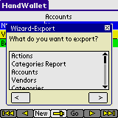
ILLUSTRATION 128 – What would you like to export?
You can export the following:
Actions
Categories report
Means of payment (accounts)
Vendors
Categories
Favorite finances
Balances
Persons
Statements (payments)
Exchange rates
Index values
Interest rates
Stock values
Goods values
Yields

Export of actions:
Select this option to export actions. You will be directed to the third stage – selecting of a program. You may export only part of your actions by changing the 'Export from' and 'Export until' fields in Tools/Options.

Export of categories report:
Select this option to export the Analyst/Categories report. You will be directed to the third stage – selecting of a program.

Export of accounts:
Select this option to export the accounts (means of payments) that are defined in the system. This will export just a list of accounts; to export the account statement select "Export payments".

Export of vendors:
Select this option to export the list of vendors defined in the system. You will be directed to the third stage – selecting of a program

Export of categories:
Select this option to export the categories defined in the system. You will be directed to the third stage – selecting of a program

Export of favorites finance:
Select this option to export favorites finance (currencies, indexes, interests, rate types, stocks etc) that are defined in the system. You will be asked to select what type of data you want to export:

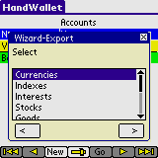
ILLUSTRATION 129 – Export – My favorites finance

Export of balances:
Select this option to export the balances of all accounts in a specific date.

Export of persons:
Select this option to export the persons defined in the system.

Statement export (payments) :
Select this option to export payments and balances of a specific account.
Before you continue to the third stage (selecting of a program) you will need to select the account (means of payment) you would like to export out of the accounts defined in the system.

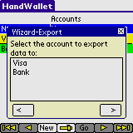
ILLUSTRATION 130 – Export payments – Selecting account

Exchange rate export:
Select the source currency and the target currency:

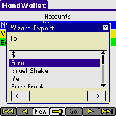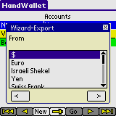
ILLUSTRATION 131 – Export – Selecting the currency

Index value export:
Select the index you would like to export.

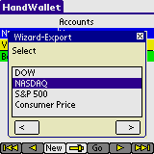
ILLUSTRATION 132 – Selecting the index
Interest rate export:
Select the interest you would like to export.
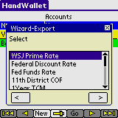
ILLUSTRATION 133 – Export – Selecting the interest
Stock value export:
Select the stock you would like to export.

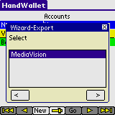
ILLUSTRATION 134 – Export – Selecting the stock

Exporting goods:
Select the goods you would like to export.

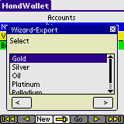
ILLUSTRATION 135 – Export – Selecting the goods

Exporting yields:
You will first need to select the country. Then select the yields you would like to export
Pay attention:
Yields data does not exist for all countries and is not included in all versions of HandWallet.

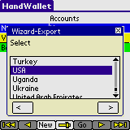
ILLUSTRATION 136 – Export – Selecting the goods

Third stage:
Select the program to which you wish to export data. In this version, export is executed only to Memo Pad, Email or Expense. You can transfer data out of Memo Pad to other Palm and/or desk computer programs.

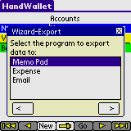
ILLUSTRATION 137 – Export – Application selection

Fourth stage:
In case you selected "Memo Pad", select the memo to which you want to export the data.
Select <New> to export data to the new memo.

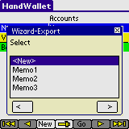
ILLUSTRATION 138 – Export – Select the memo to which data is exported

In case you selected "Email" enter the email address to which you want the data to be sent:

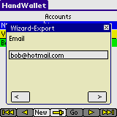
ILLUSTRATION 139 – Export to email– email address

Fifth stage:
Select the fields in the export file.

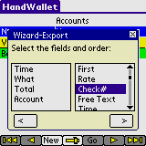
ILLUSTRATION 140 – Export – Selection of fields
Sixth stage:
Select the format.
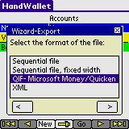
ILLUSTRATION 141 – Export – Selecting the format

At the end of the export process, there is a message indicating whether the export went through as well as the number of records written to the file.

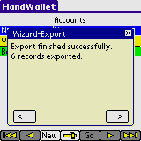
ILLUSTRATION 142 – Export – Export finished successfully

Seventh and last stage:
Select whether you want to save the export for future use.

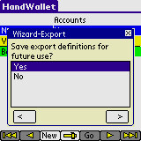
ILLUSTRATION 143 – Export – Save export definitions?

If you select 'Yes' you will be asked to give the export a name. This name will be used as a future reference to run the export next time, without going through all definitions again.

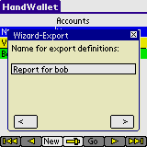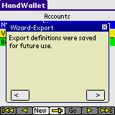
ILLUSTRATION 144 – Export – Export definitions were saved

Export tips:
- Before starting the export process make sure you have enough free space on your computer.
- If the purpose of your export is to import the data in the future to another software, make sure first that you understand the format expected by the other software. You may control several important parameters of the export in menu Tools/Options/Import Export.
- We do not recommend relying on the export option for backup. To backup you data please read the relevant chapter in this manual.
- If you are interested to export the data to Excel or Word, you may consider using the PC version of HandWallet, which has the ability of creating directly Word documents or Excel sheets. (You may still export from your PDA using a sequential file and then import the sequential file to Word or Excel, but the process might be more complex).
- In any case you couldn't export data from HandWallet please contact our support team. See the chapter Help/Additional help options in this manual.

My Web Site
Starting from Version #2, HandWallet makes it possible to synchronize all data entered into the PDA to personal page on the Internet. This way, it is possible to gather data from a number of PDAs within family or business. Data could flow between different PDAs (Palm, Pocket PC or a cellular phone).
To use this option, the computer has to be connected to the Internet.

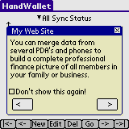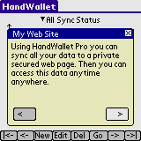
ILLUSTRATION 145 – My Internet site 1
ILLUSTRATION 146 – My Internet site 2

To receive a personal Internet page, you need to register at the product site:
www.handwallet.com/hebrew
In case you own several devices, registration is done only once.
Following registration, we will send you an e-mail address including a coupon, which should be entered at the following screen:

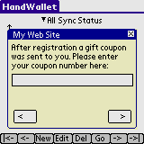
ILLUSTRATION 147 – My Web site – Entering a coupon
The system will request the coupon number only at the first time synchronization is executed.

Synchronization itself (especially the initial synchronization) could take a while. Data is transferred to the site in an encoded form that does not allow anybody to view its contents.
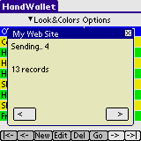
ILLUSTRATION 148 – My Web site – Data synchronization

Following the synchronization process, you can view the data at this Internet site:
www.handwallet.com/hebrew

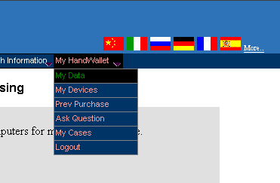

ILLUSTRATION 149 – My Web site – My data

You can view actions, accounts, categories, persons, vendors and finances.

Financial menu ($)

Rates
This screen displays the exchange rates between two different currencies. : : This information assists in entering actions in foreign currency (through the ‘data/actions’ screen) or in linking repeated actions to the exchange rate of a specific currency.
Select the two currencies exchange rates you wish to view or update:
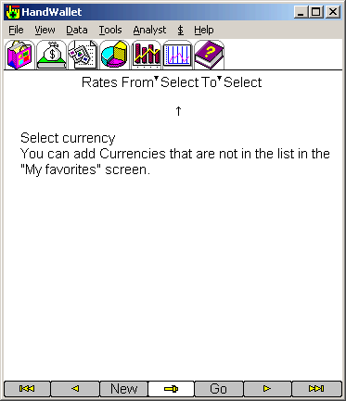
ILLUSTRATION 150 – Exchange rates
After selecting two different currencies, you can view, add or change the exchange rates.
If the exchange rates between the two currencies have not yet been defined within the system, the following guideline will be displayed:

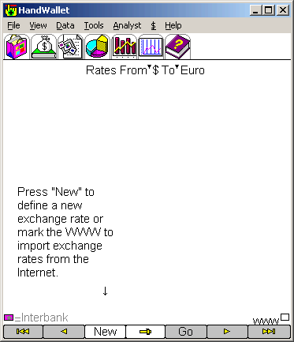
ILLUSTRATION 151 – Press “New” to define exchange rates

Downloading exchange rates automatically from the Internet::
HandWallet makes it possible to automatically download exchange rates from the Internet. To select this option, mark the square next to the www at the bottom of the screen.
To use this feature, the computer should be connected to the Internet.
For details regarding connection to the Internet, please refer to the chapter on Miscellaneous/Connecting the PDA to the Internet.

Stock Quotes
This screen displays stock quotes.
Select the stock out of the stock listing defined within the system:

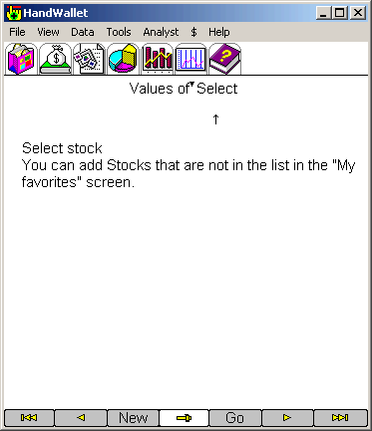
ILLUSTRATION 152 – Selecting stocks

Index values
This screen displays index rates.
Select the index out of the index listing defined within the system. :::

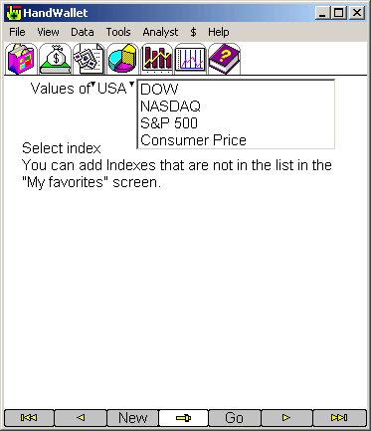
ILLUSTRATION 153 – Index selection

Downloading index values from the Internet automatically::
HandWallet makes it possible to automatically download index values from the Internet. To select this feature, mark the square next to the www: at the bottom of the screen.
To use this feature, the computer has to be connected to the Internet.

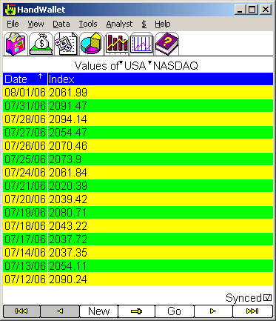
ILLUSTRATION 154 – NASDAQ index values

Interest values
This screen displays interest rates.
HandWallet makes it possible to view and update interest rates from dozens of countries worldwide.::
Select the interest out of the interest rate listing defined in the system:

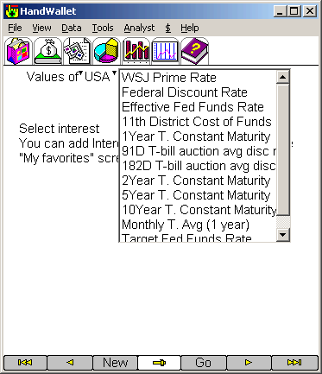
ILLUSTRATION 155 – Selecting the interest
If the interest rate you are interested in, is not defined in the system, you can add it by using the $/favorites screen (see below).

Downloading interest rates from the Internet automatically: :
HandWallet makes it possible to automatically download interest rates from the Internet. To select this feature, mark the square next to the www: at the bottom of the screen.
To use this feature, the PDA has to be connected to the Internet.
For details regarding connection to the Internet, please see the chapter on Miscellaneous/Connecting the PDA to the Internet.

Goods (Merchandise) values
This screen displays the value of goods.
Select the goods out of the list of goods defined in the system.::
If the goods you are interested in, are not defined in the system, you can add additional goods to the ‘My favorites’ screen.

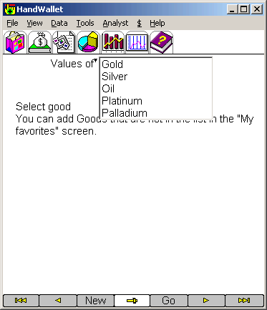
ILLUSTRATION 156 – Goods

Downloading goods quotes from the Internet automatically:
HandWallet makes it possible to automatically download goods quotes from the Internet. To select this feature, mark the square next to the www: at the bottom of the screen.
To use this feature, the computer has to be connected to the Internet.
For details regarding connection to the Internet, please see the chapter on Miscellaneous/Connecting the PDA to the Internet.

Yields
This screen shows yearly profit of a fund.
Select the country of the fund and then the fund itself.

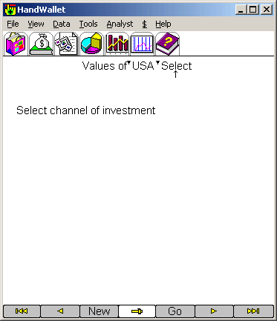
ILLUSTRATION 157 – Yields

Pay attention:
HandWallet does not support viewing yields from all countries.

Compare Yields
This screen shows comparison yields of funds.
Select the country of the funds and then the funds group.

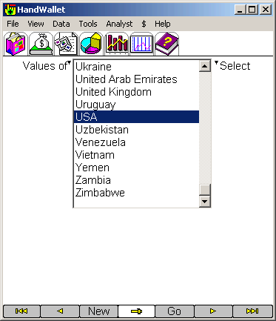
ILLUSTRATION 158 – Compare Yields

Pay attention:
HandWallet does not support viewing yields from all countries.

My Favorites

This screen displays the user’s list of finance definitions, which are not included in the HandWallet installation.
Use this screen to define new currencies, coupons, stock (shares), bonds, interest rates, indexes, goods etc.

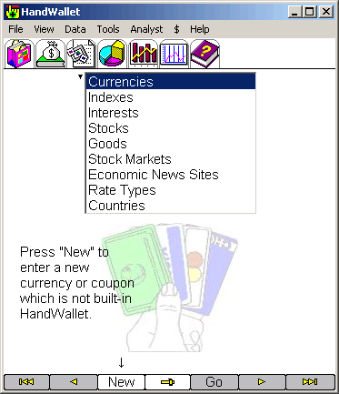
ILLUSTRATION 159 – My Favorites

Currencies:
To define a new currency verify that the 'Currencies' option is selected at the top of the screen and then press the 'New' button at the bottom of the page.

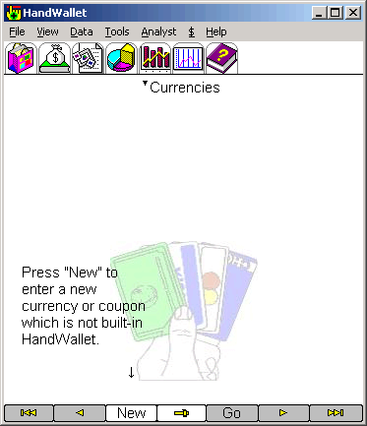
ILLUSTRATION 160 – My Favorites - Currencies

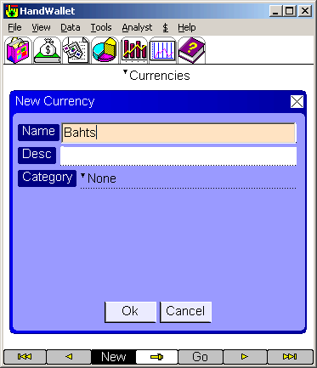
ILLUSTRATION 161 – New Currency

Indexes:
To define a new index verify that the 'Indexes' option is selected at the top of the screen and then press the 'New' button at the bottom of the page.

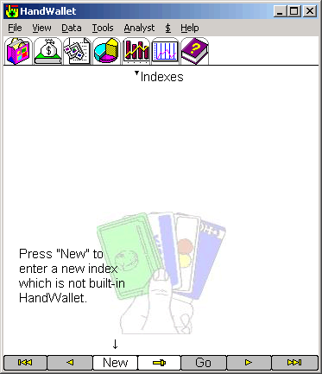
ILLUSTRATION 162 – My Favorites - Indexes

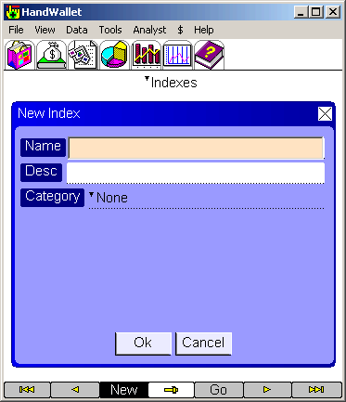
ILLUSTRATION 163 – New Index

Interests:
To define a new interest verify that the 'Interests' option is selected at the top of the screen and then press the 'New' button at the bottom of the page.

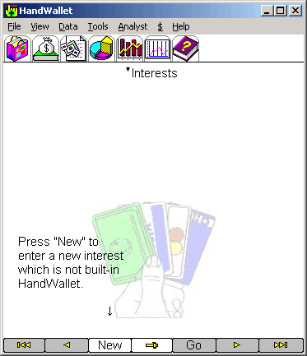
ILLUSTRATION 164 – My Favorites - Interests

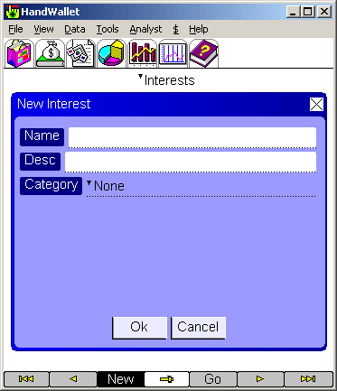
ILLUSTRATION 165 – New Interest

Stocks:
To define a new stock verify that the 'Stocks' option is selected at the top of the screen and then press the 'New' button at the bottom of the page.

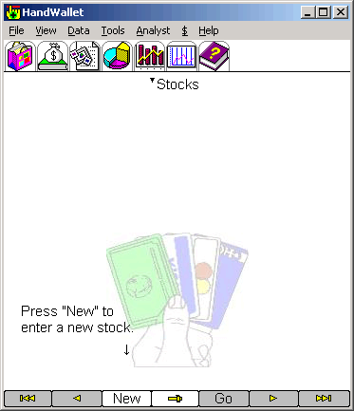
ILLUSTRATION 166 – My Favorites - Stocks

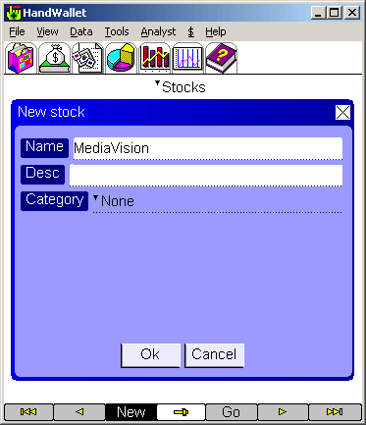
ILLUSTRATION 167 – New Stock

Goods:
To define new goods verify that the 'Goods' option is selected at the top of the screen and then press the 'New' button at the bottom of the page.

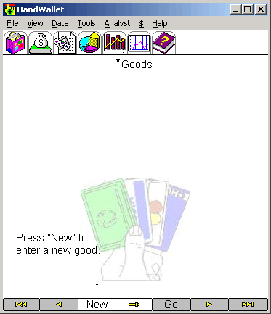
ILLUSTRATION 168 – My Favorites - Goods

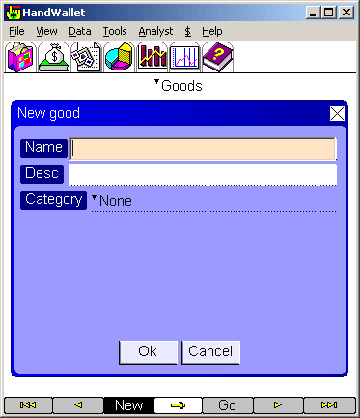
ILLUSTRATION 169 – New Goods

Stock markets:
To define a new stock market verify that the 'Stock markets' option is selected at the top of the screen and then press the 'New' button at the bottom of the page.

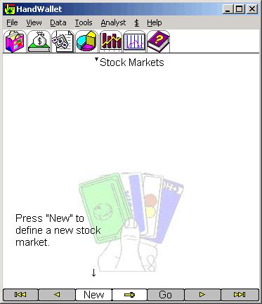
ILLUSTRATION 170 – My Favorites – Stock Markets

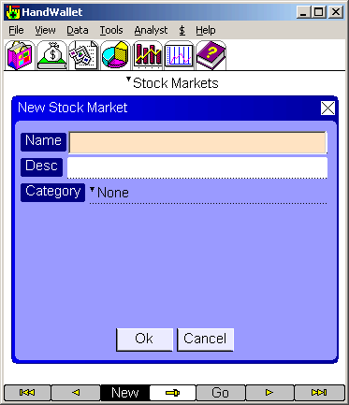
ILLUSTRATION 171 – New Stock market

Economic news sites:
To define a new economic news site verify that the 'Economic news sites' option is selected at the top of the screen and then press the 'New' button at the bottom of the page.

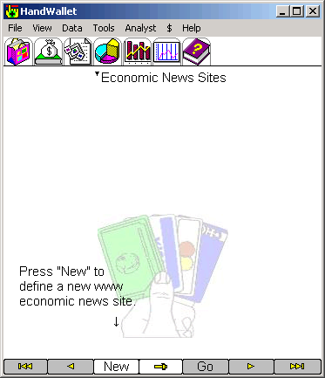
ILLUSTRATION 172 – My Favorites – Economic News Sites

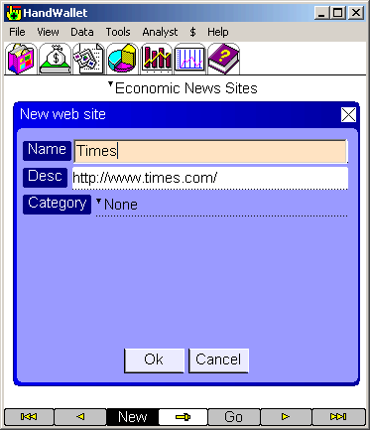
ILLUSTRATION 173 – New Economic News Site

Rate types:
To define a new rate type verify that the 'Rate types' option is selected at the top of the screen and then press the 'New' button at the bottom of the page.

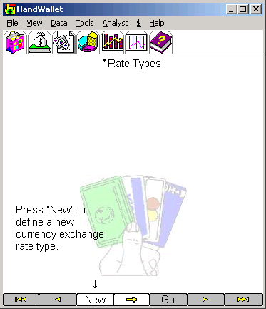
ILLUSTRATION 174 – My Favorites – Rate Types

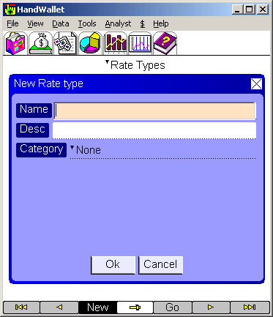
ILLUSTRATION 175 – New Rate type

Countries:
To define a new country verify that the 'Countries' option is selected at the top of the screen and then press the 'New' button at the bottom of the page.

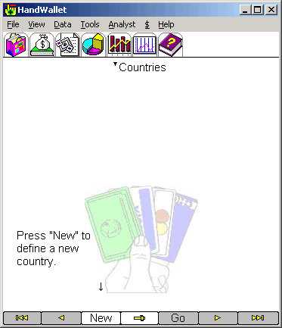
ILLUSTRATION 176 – My Favorites - Countries

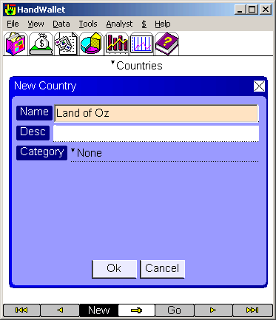
ILLUSTRATION 177 – New Country

Help
In addition to this manual, Hand Wallet provides an extensive amount of help integrated within the menus, the screens and throughout the operation of the software.
There is also a support team at your disposal. You can call in regard to any subject you wish through the product site www.handwallet.com
Select the ‘support/ask question’ option.
Answers are usually given within several hours.

This Screen
The ‘help/this screen’ window displays specific help according to the screen or activity we are currently doing. For example: when updating certain data or adding new data, you can receive a detailed listing of all fields on the screen, and a short explanation regarding each field.

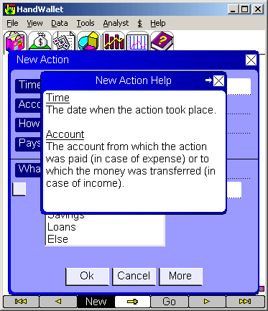
ILLUSTRATION 178 – Help – “This screen"

You can move forward on the window by clicking the right hand arrow at the window heading. You can move back by clicking the left hand arrow.
Closing the help window is done by clicking the X on the right hand side of the window.

General
The ‘help/general’ window displays general guidelines for operating the software and working with it. You can display the ‘help/general’ window out of any screen or activity with the software.

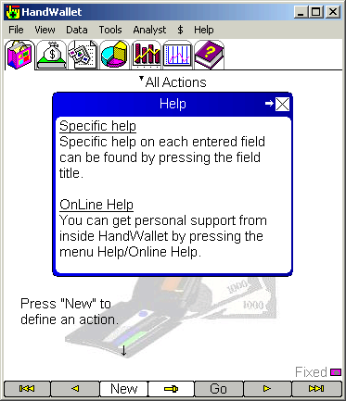
ILLUSTRATION 179 – Help – “General"

Online Help
To use this feature, the PDA as to be connected to the Internet.
For details regarding connection to the Internet, please see the chapter on Miscellaneous/Connecting the PDA to the Internet.
By selecting this feature, you can ask the HandWallet support team for help.

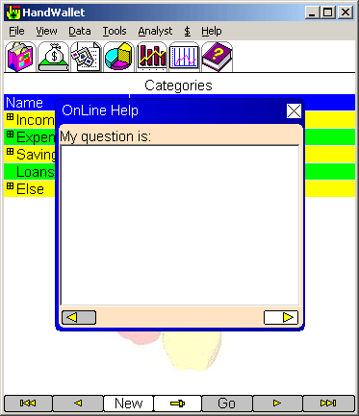
ILLUSTRATION 180 – Help on the web (Internet)

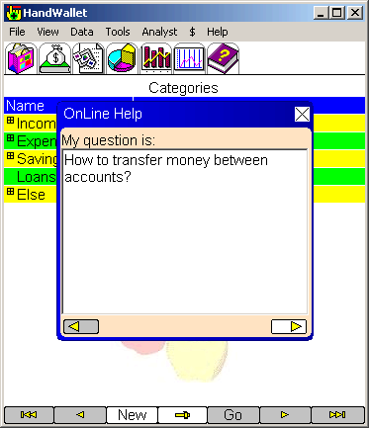
ILLUSTRATION 181 – Help on the web– Asking a question

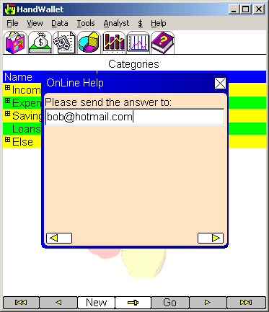
ILLUSTRATION 182 – Help on the web – Updating your e-mail
In case you have already asked a question in the past your email is saved, so you will need to type it only once.

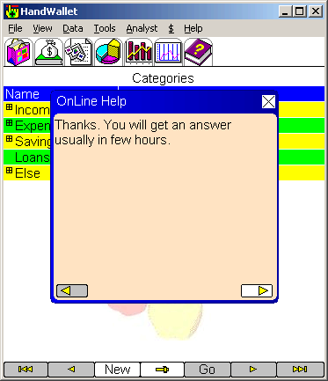
ILLUSTRATION 183 – Help on the web – End

You will get an answer usually in few hours.

Last Version:
This option will connect HandWallet servers and show the last version available of HandWallet.
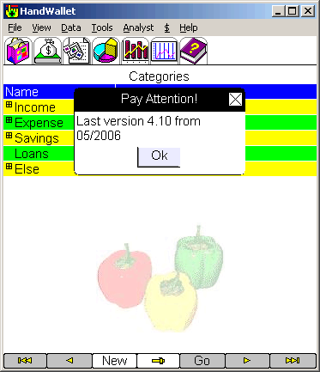
ILLUSTRATION 184 – Last version

About

The “About” window displays the HandWallet icon and version.
You can display the “About” window out of any screen or activity done with the software.

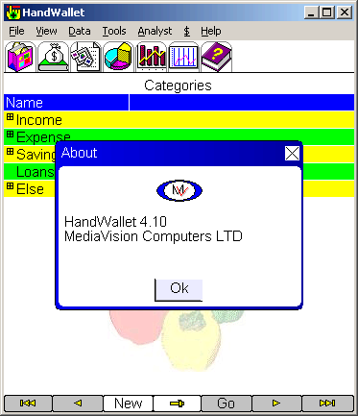
ILLUSTRATION 185 – About

Additional help options

The product Internet site http://www.handwallet.com includes a database with hundreds of questions and explanations.
The use of this database is free and is recommended.
In our site it is also possible to receive personal assistance from our support team.

The File menu
The file menu includes several options related to the working files of HandWallet and their location. It also includes some options to sync data between PDA's and mobile phones.

Open folder

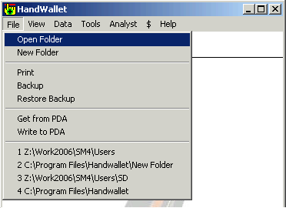

The "File/Open Folder" menu is used to change the working folder (the folder in which the data files are located). In this way it is possible to switch, for example, between the business environment and the private environment.
After pressing the "File/Open folder" menu a form appears in which it is possible to select the folder containing the data files.

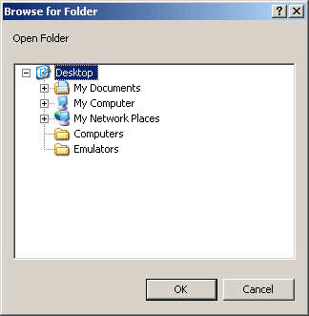
ILLUSTRATION 186 – Open Folder

New folder
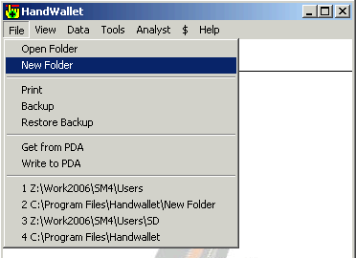

The "File/New Folder" menu is used to create a new "World": (with new data) of HandWallet.
After pressing the "File/New folder" menu a form appears in which it is possible to select the location of the new data files

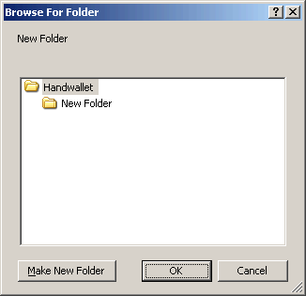
ILLUSTRATION 187 – New Folder

Print
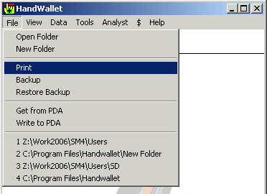
Using the "File/Print" menu it is possible to print any data, report or graph from HandWallet. After pressing the "File/Print" menu appears a screen in which it is needed to select the printer: and/or change some printing settings.

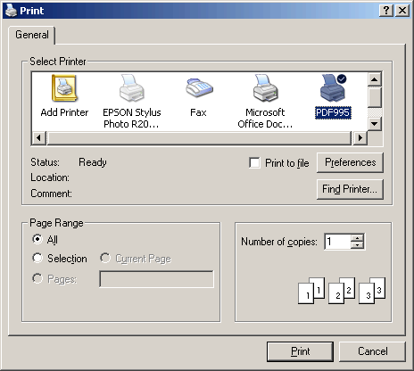
ILLUSTRATION 188 – Printer Selection

Backup

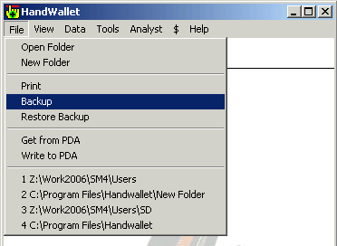
Using the "File/Backup" menu it is possible to backup (save in a safe place) the data. We recommend doing this backup often, since our financial data are usually important. The backup process is simple, fast and doesn't take a lot of space.

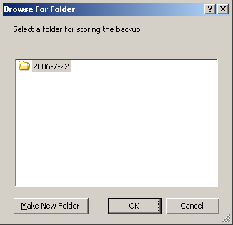
ILLUSTRATION 189 – Backup

Restore backup
The "File/Restore Backup" menu is used to restore an old backup that was saved as explained in chapter "D". After pressing the "File/Restore Backup" menu a screen appears with list of folders organized by years, months and days.
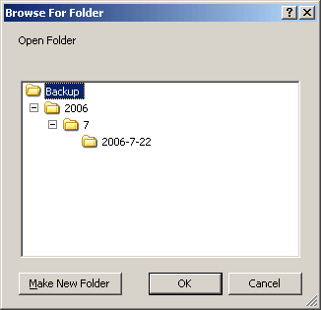
ILLUSTRATION 190 – Restore Backup

Get from PDA
The "file / Get form PDA" menu copies data files from a PDA, a cellular phone or another PC to the desktop PC, and then make this data the active data.

After selecting the "Get form PDA" menu we need to select the type of device we want to get data from.

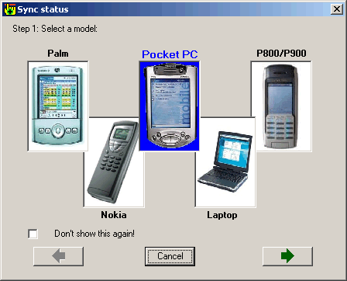
ILLUSTRATION 191 – Get from PDA – Selection of model
      - Getting data from a PocketPC, Nokia or a Sony Ericsson device.
In this screen you need to select the folder on your PDA or phone from which the data will be read.

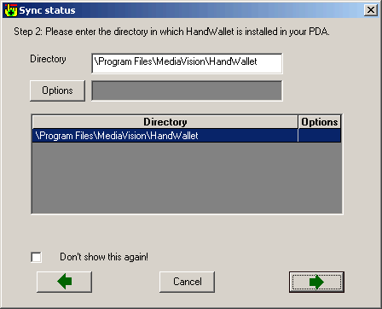
ILLUSTRATION 192 – Get from PDA – Selection of folder
In this screen you can also change some options:

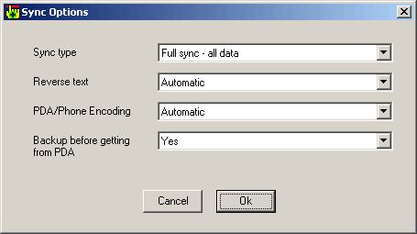
ILLUSTRATION 193 – Get from PDA – Options

      - Getting data from a Palm device.
Before reading data from Palm devices, a "HotSync": should be performed. The data are read from the backup directory on the PC and NOT from the device itself.
After the HotSync is finished we need to select the user from which to get the data.
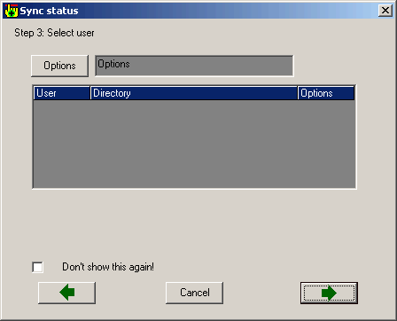
ILLUSTRATION 194 – Get from PDA – Selection of Palm user
Options can be entered for each user.
ILLUSTRATION 195 – Get from PDA –Palm options

      - Getting data from a laptop.
The best way to get data from a laptop (or any other desktop computer) is to establish a network connection between the desktop and the laptop. A window will appear in which you need to select the computer in the network and the directory in that computer.
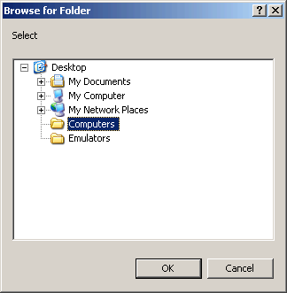
ILLUSTRATION 196 – Get from PDA – Laptop

Write to PDA
The ‘File / write to PDA’ menu copies data files from the PC to a PDA, cellular phone or another PC.

ILLUSTRATION 197 – Write to PDA – Selection of model

The View menu
Using HandWallet you can see all your financial data in one screen. In this way you can see all the information without the need to browse between several pages or to use the menu.

Enhanced view
The Enhanced view includes data windows on the right screen in addition to the main regular window on the left. Changing between a "simple" look and an "enhanced" look is done using the "View" menu.

Change the data presented
You can change the information presented in each window of the enhanced look, so it will show exactly the relevant information for you. To change the type of data in the window press the window title (in some cases you can also press the window itself).
After pressing the window's title a wizard will appear that will guide you step by step in selecting the data and the view you are interested in.

Types of information in enhanced view
In each window of the enhanced view you can select to see a report (numeric data), a graph or a web site.

Change the layout of the enhanced page
You can change not only the data presented, but also the number of windows and the layout of the page. To do so, press the tab on the title:

Miscellaneous

Backup
You can backup all data entered into HandWallet and load it at a later time whenever needed. We recommend performing this kind of backup once in a while, since there is usually important information involved. The backup process is simple, requiring little space and it can be done instantly.
To learn about the backup process please refer to chapter 11 – "File / Backup". Restoring an old backup is done using the "File / Restore Backup" option.

HandWallet Files
HandWallet data is stored on files. Attached is a list of files used by HandWallet:
Accounts.pdb - Accounts.
Actions.pdb - Actions.
ActionCategories.pdb - Action categories.
ActionPersons.pdb - Action persons.
B*.pdb - Balance Files. Each account in a different file.
P*.pdb - Payment Files. Each account in a different file.
Categories.pdb - Categories tree.
CategoriesMSum.pdb - Monthly sum by categories.
Currencies.pdb - Currencies, Rates and Interests that are not build-in HandWallet.
Def.pdb - Software definitions.
G*.pdb - Goods values. Each merchandise in a different file.
H*.pdb - Interest values. Each interest in a different file.
Holidays.pdb - Holidays.
I*.pdb - Index values. Each index in a different file.
NActions.pdb - Draft Actions.
NActionCategories.pdb - Draft Action categories.
NActionPersons.pdb - Draft Action persons.
Persons.pdb - Persons.
PersonsMSum.pdb - Monthly sum by persons.
Rsc*.pdb - Definitions file for each language.
R*.pdb - Exchange rates.
S*.pdb - Stock quotes. Each stock in a different file.
Sync.pdb Internet synchronization data
UserCategories.pdb - Categories which are not build-in HandWallet.
UserVendors.pdb - Vendors which are not build-in HandWallet.
Old files- not in use by the last version:
Defaults.pdb - Software definitions.
DefaultsDefines.pdb - Default definitions.
Script.pdb - Internet connection definitions.

Suggestions and Bugs
Each version of HandWallet is passing a set of QA tests.
You can read about the bug fixed and the new improvements in this URL:
http://www.handwallet.com/csl/versionhistory.asp

In the HandWallet site you can see a list of known bugs and instructions how to deal with these bugs in this URL:
http://www.handwallet.com/csl/windowsbugs.asp

Another good place to visit is the HandWallet Forum, in the address:
http://www.handforum.com/
The English forum is located in this URL:
http://www.handforum.com/english/

Index

$
$ menu 129
A
About 150
Account 32
Account - credit card 34
Account - currency 33
Account - delete 39
Account - duplicate 39
Account - modify 38
Account - more button 34
Account - name 33
Account - personal fields 40
Account - type 33
Account - view fields 39
Account - view statement portfolio 39
Account num 33
Accounts - export 120
Accounts - general 32
Action 41
Action - checks 50
Action - consumption 54
Action - delete 66
Action - discount 58
Action - duplicate 66
Action - fast action 68
Action - interest 59
Action - modify 66
Action - new 41
Action - partners 55
Action - personal fields 65
Action - tax, invoice, receipt 52
Action - timing 53
Action - total 67
Action - vendor/customer 49
Action categories (number of) 112
Action number 64
Action persons (number of) 112
Action sort 101
Action Status 64
Actions 41
Actions - currency view 67
Actions - export 120
Actions - filtering 66
Actions - navigating 67
Actions - sort 67
Actions shown info 101
Activated (account) 33
Amount (of payment) 73
Amounts linkage 60
Analyst menu 85
Approval options 103
ASCII 118
Ask Check Balance 103
Ask check Pay 103
Ask CVV 106
Ask Delete 103
Ask ID 106
Ask password 105
Ask recalc payments 103
ATM 47
Auto create actions 102
B
Background 99
Background image position 110
Backup 155, 161
Balance 71
Balance - delete 75
Balance - edit 75
Balance account 35
Balance day 35
Balances 88
Balances - export 121
Balances until 112
Bar graph 86
Bar scale 101
Bars color 99
Behavior options 101
Biweekly action 53
Booster version 111
Budget Status 87
Budget type 78
Bugs 162
Buttons font name 100
Buttons font size 100
Buttons style 100
C
Categories 76
Categories - export 120
Categories Bar 86
Categories Pie 85
Categories Report 86
Categories report - export 120
Category - delete 79
Category - more button 78
Category description 77
Category name 77
Category sign 77
Check 47
Check connection button 38
Checks 50
Chit language 106
Chit title 106
Clear Filters 84
Color 98
COM POS 106
Communication closed 102
Compare Yields 136
Consumer Price 132
Consumption 54
Countries 145
Country 96
Coupon value 113
Credit card 34
Credit card type 35
Credit limit 34
Currencies 137
Currency view 67
Customer 49
Customer credit card 51
CVV 51
D
Data menu 32
Date (of payment) 72
Date alignment 109
Date format 101
Default currency (of a category) 78
Default money (of a category) 78
Default quantity (of a category) 78
Default rate 96
Delete action 66
Delete balance 75
Delete category 79
Delete person 81
Delete vendor 83
Discount 58
DOW 132
Download exchange rates 130
Download index values 132
Download interest rats 133
Duplicate account 39
Duplicate action 66
Duplicate category 79
E
Economic news sites 143
Edit action 66
Enable CC Swap 106
Encoding Import/Export 97
Enhanced view 160
Erase All 84
Euro rates 129
Every week 53
Exceed color 99
Exchange rate 62
Exchange rates - export 121
Export 119
Export date format 107
Export file format 107
Export from 107
Export until 107
Extra credit days 35
F
F. Point actions 101
Fast actions 68
Favorites finance - export 120
Fed funds Rate 133
File 152
File – Write to PDA 159
Files 161
Finance sort 101
Financial Menu 129
Forecast 88
Form font name 100
Form font size 100
Forum 162
Frame color 98
Future text color 100
G
General review 31
Get from PDA 156
Gold values 134
Goods 141
Goods - export 122
Goods values 134
H
HandWallet Forum 162
Headline color 98
Heap free 113
Help 146
Help - About 150
Help - Additional options 150
Help - Online Help 148
Help - This Screen 146
Hide Passwords 105
Highlight Color 1 98
Highlight Color 2 98
Highlight lines 98
Holidays system 96
Holydays 96
Home currency 96
HotSync 157
I
I/E encoding 97
I/E Separator 107
Illegible menu 25
Illegible text 23
Image alignment bottom page 110
Image alignment top page 109
Image bottom page 110
Image top page 109
Import 114
Import date format 107
Import Export options 107
Index 163
Index - export 122
Index Values 132
Indexes 138
Installation 14
Interest 59
Interest - export 122
Interest values 133
Interests 139
Internet policy 101
Internet Sync 94
Introduction 10
Invoice 52
K
Keep pays period 101
Keyboard 104
Keyboard color 1 99, 104
Keyboard color 2 99, 104
Keyboard options 104
Keyboard type 104
L
Language 96
Last Version 149
License 108
License Type 113
Linkage 60
List of illustrations 4
Looks & Colors options 98
M
Main Category 77
Means of payment 32
Means of payment 47
Means of payment - ATM 47
Means of payment - Paper 47
Means of payment - Tel 47
Menu 96
Menu encoding 97
Menu Language 96
Minimum pie slice 101
Minimum requirements 14, 29
Monthly budget 79
More button (accounts) 34
More button (actions) 47
More button (categories) 78
My Country 96
My Favorites 137
My favorites countries 145
My favorites currencies 137
My favorites economic news sites 143
My favorites goods 141
My favorites indexes 138
My favorites interest 139
My favorites rate types 144
My favorites stock markets 142
My favorites stocks 140
My Web Site 127
N
NASDAQ 132
New account 32
New action 41
New balance 74
New category 77
New country 145
New currency 137
New economic news site 143
New folder 153
New goods 141
New index 138
New interest 139
New payment 71
New person 80
New rate type 144
New stock 140
New stock market 142
New vendor 82
Nonworking day 96
Num font name 100
Num font size 100
Num of accounts 112
Num of actions 112
Num of balances 112
Num of categories 112
Num of payments 112
Num of persons 112
O
Oil values 134
Online Help 148
Open folder 152
Opening screen 102
Options 95
Options - Approvals 103
Options - Behavior 101
Options - Import Export 107
Options - Keyboard 104
Options - Licensing 108
Options - Look & Colors 98
Options - Printing 109
Options - Regional settings 96
Options - Security 105
Options - Swap credit cards 106
P
Palm OS 14, 29
Partners 55
Password 105
Pay abroad (with credit card) 35
payment 71
Payment - Delete 74
Payment shown info 101
Payments 71
Payments - export 121
Payments date format 102
Payments until 112
Payoff 35
Pays # 47
PDA's and mobile phones 29
Periodical action 53
Personal fields 65
Persons 80
Persons - export 121
Persons Pie 86
Pie graph 85
Popup keyboard 104
Pound rates 129
Prime 59
Prime rate 133
Print 154
Print background image 110
Print chit 106
Print date 109
Print fields titles 109
Print frame 109
Print horizon lines 109
Print page numbers 109
Print report title 109
Print vertical lines 109
Printer selection 154
Printing options 109
Problems during installation 23
Proxy port 102
Proxy server 102
Q
Quarter 53
R
Rate types 144
Rates 129
Recalc payments 101
Recalc statistics 101
Receipt 52
Regional settings 96
Restore backup 155
Restore defaults 102
Reverse export 97
Reverse import 97
Reverse input 96
Reverse menu 96
Reverse text 97
S
Save money 10
Security 105
Serial number 112
Show frame 98
Show headline 98
Show total payments 102
Sort actions 67, 101
Sort Categories 103
Sort of finance data 101
Source (of balance) 75
Source (of payment) 73
Speed Buttons style 100
Start forecast day 101
Statement - export 121
Statement portfolio 71
Stock markets 142
Stock Quotes 131
Stock quotes - export 122
Stocks 140
Suggestions 162
Swap credit card 89
Swap credit cards options 106
Symbian 14, 29
Symbian 29
System Status 111
T
Tax 52
Terminal number 34
Terms & Conditions date 111
Text color 100
Text encoding 97
This Screen 146
Timing 53
Tools menu 89
U
Unicode 97
UNICODE 118
Uninstall 27
Update 27
User code 112
User name 112
User Profile 108
V
Valid until (credit card) 35
Valid until (license) 113
VAT 52, 96
VAT percentage 96
Vendor 49
Vendors 82
Vendors - export 120
Vendors (number of) 112
Version 111
Version date 111
View 160
W
Win CE 14, 29
Win label text color 100
Windows color 99
Windows font name 100
Windows font size 100
Windows Mobile 29
Windows text color 99
Windows top color 99
Wizard - import 114
Worlds 153
Write to PDA 159
www 132, 133, 134
WWW data site 36
Y
Yields 135
Yields - export 123

