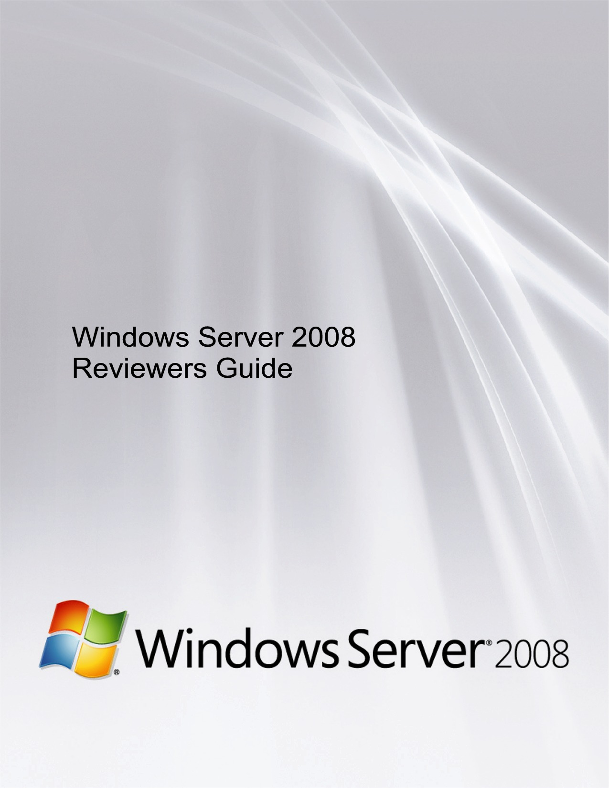

Disclaimer
THIS IS NOT A PRODUCT SPECIFICATION.
This document supports the release of Windows Server® 2008.
The information contained in this document represents the current view of Microsoft Corp. on the issues disclosed as of the date of publication. Because Microsoft must respond to changing market conditions, this document should not be interpreted to be a commitment on the part of Microsoft, and Microsoft cannot guarantee the accuracy of any information presented. This document is for informational purposes only. MICROSOFT MAKES NO WARRANTIES, EXPRESS OR IMPLIED, IN THIS DOCUMENT.
Information in this document, including URL and other Internet Web site references, is subject to change without notice. Unless otherwise noted, the companies, organizations, products, domain names, e-mail addresses, logos, people, places and events depicted in examples herein are fictitious. No association with any real company, organization, product, domain name, e-mail address, logo, person, place or event is intended or should be inferred. Complying with all applicable copyright laws is the responsibility of the user. Microsoft grants you the right to reproduce this guide, in whole or in part.
Microsoft may have patents, patent applications, trademarks, copyrights or other intellectual property rights covering subject matter in this document, except as expressly provided in any written license agreement from Microsoft, the furnishing of this document does not give you any license to these patents, trademarks, copyrights or other intellectual property.
© 2008 Microsoft Corp. All rights reserved.
Microsoft, Windows Server, the Windows logo, Windows, Active Directory, Windows Vista, BitLocker, Internet Explorer, Windows Server System, Windows NT, Windows Mobile, Windows Media, Aero, ClearType, RemoteApp, SharePoint, ActiveX, Outlook, Authenticode, Visual Basic, Win32, WinFX, Windows PowerShell, Hyper-V, and MSDN are trademarks of the Microsoft group of companies.

The names of actual companies and products mentioned herein may be the trademarks of their respective owners.

Last Updated: 01-17-08

The Windows Server® 2008 Reviewers Guide provides a comprehensive technical overview of the innovative features and functions that make Windows Server 2008 the next-generation Microsoft® Windows Server operating system and successor to Microsoft Windows Server 2003. This guide also provides information about the benefits Windows Server 2008 offers diverse users, as well as information about different scenarios.

Contents
Disclaimer 1
Contents 1
Section 1: Introduction to Windows Server 2008 3
1.01 Introduction to Windows Server 2008 4
1.02 Windows Server 2008 Editions 7
1.03 Windows Server 2008 Editions - Features 9
Section 2: Server Virtualization 14
2.01 Server Virtualization Introduction 15
2.02 Hyper-V 16
2.03 Server Core 23
Section 3: Centralized Application Access 24
3.01 Centralized Application Access Introduction 25
3.02 Terminal Services Core Functionality 26
3.03 Terminal Services Gateway 34
3.04 Terminal Services RemoteApp 41
3.05 Terminal Services Web Access 43
3.06 Terminal Services Printing 46
3.07 Terminal Services Session Broker 49
3.08 Terminal Services Licensing 52
3.09 Windows System Resource Manager 54
Section 4: Branch Office 56
4.01 Branch Office Introduction 57
4.02 Read-Only Domain Controller 58
4.03 BitLocker Drive Encryption 62
4.04 Server Core 69
4.05 Distributed File System 70
Section 5: Security and Policy Enforcement 75
5.01 Security and Policy Enforcement Introduction 78
5.02 Network Policy and Access Services 79
5.03 Network Access Protection 85
5.04 Network Policy Server 93
5.05 Routing and Remote Access Service 96
5.06 Next-Generation TCP/IP Protocols and Networking Components 99
5.07 Windows Firewall with Advanced Security 106
5.08 Cryptography Next Generation 112
5.09 Active Directory Certificate Services 115
5.10 Active Directory Domain Services 130
5.11 Active Directory Federation Services 146
5.12 Active Directory Lightweight Directory Services 152
5.13 Active Directory Rights Management Services 155
Section 6: Web and Applications Platform 160
6.01 Web and Applications Platform Introduction 161
6.02 Internet Information Services 7.0 162
6.03 Application Server 168
6.04 Transactional NTFS 172
Section 7: Server Management 174
7.01 Server Management Introduction 176
7.02 Initial Configuration Tasks 177
7.03 Server Manager 179
7.04 Windows PowerShell 193
7.05 Server Core 196
7.06 Windows Server Backup 200
7.07 Windows Reliability and Performance Monitor 203
7.08 Windows Deployment Services 206
7.09 Group Policy 212
Section 8: High Availability 225
8.01 High Availability Introduction 226
8.02 Failover Clustering 227
8.03 Network Load Balancing 231
Section 9: Better Together 232
9.01 Better Together — Windows Server 2008 and Windows Vista 233
Section 10: Miscellaneous 238
10.01 System Requirements 239
10.02 Detailed Table of Contents 241

Section 1: Introduction to Windows Server 2008

Section 1: Introduction to Windows Server 2008 3
1.01 Introduction to Windows Server 2008 4
Web 5
Virtualization 5
Security 5
Solid Foundation for Business Workloads 5
Scenarios Introduction 6
1.02 Windows Server 2008 Editions 7
1.03 Windows Server 2008 Editions - Features 9
New and Updated Features in Windows Server 2008 9
Edition Comparison by Server Role 9
Edition Comparison by Server Core Installation Option 10
Differentiated Feature Comparison by Edition 11
Edition Comparison by Technical Specification 11
Edition Comparison by Distribution Channel 12
Edition Comparison by Language 13

1.01 Introduction to Windows Server 2008

Windows Server 2008, built with web and virtualization technologies, is the most robust, secure, and reliable foundation on which to develop, deliver, and manage rich user experiences and applications
People drive business results. Amplify their impact and you create greater success. At Microsoft, we believe that people, when properly equipped with the right tools, can surmount even the most complex business challenges. Of the many options available to business, software has demonstrated a unique capacity to amplify the positive impact of people, help them overcome business management challenges and more effectively contribute to the bottom line.
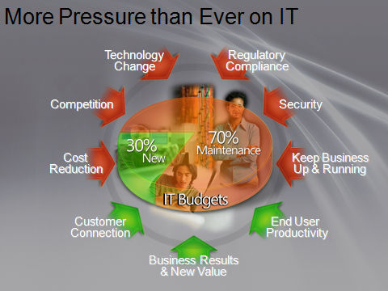
As part of helping people drive business success, Microsoft is looking to help them to manage complexity and achieve agility, protect information and control access, advance the business with IT solutions, and amplify their impact. By offering a productive platform for powering application networks, Web services and virtualization with Windows Server 2008, Microsoft helps you to improve service levels at a lower cost, enables you to build and operate a flexible platform to meet changing business demands, and provides you with capabilities to secure the IT platform on which your organization relies. The better we enable your people to be productive and resourceful, the more we can help you and the individuals in your organization drive business success today and into the future.
IT infrastructure is a strategic asset and the critical foundation upon which software can deliver services and user applications that a business needs in order to operate effectively and succeed. Windows Server 2008 enables greater business success by providing a platform that supports mission critical solutions and applications, making them available to your organization when it needs them. Windows Server 2008 is the platform on which you can build your business.
Windows Server 2008, built with web and virtualization technologies, enables you to increase the reliability and flexibility of your server infrastructure. New virtualization tools, web resources, and security enhancements help you save time, reduce costs, and provide a platform for a dynamic and optimized datacenter. Powerful new tools like IIS7, Windows Server Manager, and Windows PowerShell, allow you to have more control over your servers and streamline web, configuration, and management tasks. Advanced security and reliability enhancements like Network Access Protection and the Read-Only Domain Controller harden the operating system and protect your server environment to ensure you have a solid foundation on which to build your business.
The following figure outlines the technology investments of Windows Server 2008:
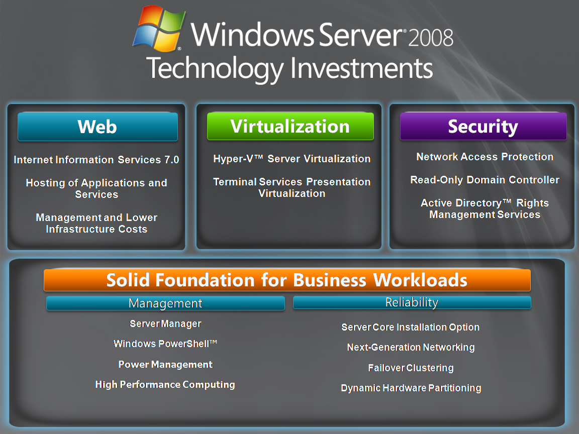
Web
Windows Server 2008 gives you the ability to deliver rich web-based experiences efficiently and effectively, with improved administration and diagnostics, development and application tools, and lower infrastructure costs.
Virtualization
With its server virtualization technology, Windows Server 2008 enables you to reduce costs, increase hardware utilization, optimize your infrastructure, and improve server availability.
Security
Windows Server 2008 is the most secure Windows Server to date. Its hardened operating system and security innovations, including Network Access Protection, Federated Rights Management, and Read-Only Domain Controller, provide unprecedented levels of protection for your network, your data, and your business.
Solid Foundation for Business Workloads
Windows Server 2008 is the most flexible and robust Windows Server operating system to date. With new technologies and features such as Server Core, PowerShell, Windows Deployment Services, and enhanced networking and clustering technologies, Windows Server 2008 provides you the most versatile and reliable Windows platform for all of your workload and application requirements.
Scenarios Introduction
Windows Server 2008 is Microsoft’s most customer-focused server release to date; this is evident in how the server is configured and managed by role through the Windows Server Manager utility. When customers consider a server, they tend to think of it as occupying one specific role in their infrastructure, even though it may be a multipurpose server hosting more than one role. In addition, in the case of the Hyper-V™ server virtualization role, it could be as a platform on which to run multiple servers where each has different roles. Either way, IT professionals will typically refer to a “print server,” “file server,” “Web server” or “domain controller,” describing that server by its primary function.
In the same way that a server is deployed in a specific role, that server will also perform part or all of a “workload,” or contribute to a business “scenario.” Workloads typically employ multiple servers running different roles to deliver an overall solution for a given scenario. For example, servers running Active Directory® Domain Services, Active Directory Certificate Services and Active Directory Federation Services might run distinct roles but they all contribute to a higher-level “Identity and Access Management” workload or scenario.
When customers deploy Windows Server 2008, they will likely choose certain scenarios and workloads where they feel the product provides greatest value or ease of implementation with minimal disruption to their existing infrastructure. For this reason, we consider Windows Server 2008 as it will be deployed by customers in specific scenarios.
We will focus on key product scenarios that support the technology investments for Windows Server 2008.
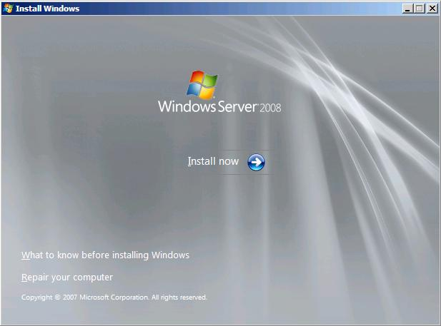

1.02 Windows Server 2008 Editions
Because different kinds of customers need different features in their operating system, Microsoft offers multiple editions of Windows Server 2008, each oriented to the needs of specific types of customers.
The following are summaries of each SKU.


Windows Server® 2008 Standard is the most robust Windows Server operating system to date. Built with enhanced Web and virtualization capabilities, it is designed to increase the reliability and flexibility of your server infrastructure while helping save time and reduce costs. Powerful tools give you greater control over your servers and streamline configuration and management tasks. Plus, enhanced security features work to harden the operating system to help protect your data and network and provide a solid, highly-dependable foundation for your business.


Windows Server® 2008 Enterprise delivers an enterprise-class platform for deploying business-critical applications. Improve availability with failover clustering. Improve security with consolidated identity management features. Reduce infrastructure costs by consolidating applications with virtualization licensing rights. Windows Server 2008 Enterprise provides the foundation for a highly dynamic, scalable IT infrastructure.


Windows Server® 2008 Datacenter delivers an enterprise-class platform for deploying business-critical applications and large-scale virtualization on small and large servers. Improve availability with clustering and dynamic hardware partitioning capabilities. Reduce infrastructure costs by consolidating applications with unlimited virtualization licensing rights. Scale from 2 to 64 processors. Windows Server 2008 Datacenter provides a foundation on which to build enterprise-class virtualization and scale-up solutions.


Designed to be used specifically as a single-purpose Web server, Windows® Web Server 2008 delivers on a rock solid foundation of Web infrastructure capabilities in the next generation Windows Server 2008. Integrated with the newly re-architected IIS 7.0, ASP.NET, and the Microsoft .NET Framework, Windows Web Server 2008 enables any organization to rapidly deploy Web pages, Web sites, Web applications, and Web services.


Windows Server® 2008 for Itanium-based Systems is optimized for large databases, line of business and custom applications providing high availability and scalability up to 64 processors to meet the needs of demanding and mission critical solutions.


Windows Server® 2008 Standard without Hyper-V™ is the most robust Windows Server operating system to date. It is designed to increase the reliability and flexibility of your server infrastructure while helping save time and reduce costs. Powerful tools give you greater control over your servers and streamline configuration and management tasks. Plus, enhanced security features work to harden the operating system to help protect your data and network and provide a solid, highly-dependable foundation for your business. This product does not include the Hyper-V™ server role.


Windows Server® 2008 Enterprise without Hyper-V™ delivers an enterprise-class platform for deploying business-critical applications. Improve availability with failover clustering. Improve security with consolidated identity management features. Reduce infrastructure costs by consolidating applications with virtualization licensing rights. Windows Server 2008 Enterprise without Hyper-V provides the foundation for a highly dynamic, scalable IT infrastructure. This product does not include the Hyper-V™ server role.


Windows Server® 2008 Datacenter without Hyper-V™ delivers an enterprise-class platform for deploying business-critical applications and large-scale virtualization on small and large servers. Improve availability with clustering and dynamic hardware partitioning capabilities. Reduce infrastructure costs by consolidating applications with unlimited virtualization licensing rights. Scale from 2 to 64 processors. Windows Server 2008 Datacenter without Hyper-V provides a foundation on which to build enterprise-class virtualization and scale-up solutions. This product does not include Hyper-V™ server role.

1.03 Windows Server 2008 Editions - Features
New and Updated Features in Windows Server 2008
New/Updated Feature | Enterprise | Datacenter | Standard | Web | Itanium | License Requirements
Hyper-V |  |  |  | ○ | ○ | Covered by server license. No incremental licensing requirements.
Internet Information Services 7.0 |  |  |  |  |  | Covered by server license. No incremental licensing requirements.
Network Access Protection |  |  |  | ○ | ○ | Covered by server license. No incremental licensing requirements.
AD Rights Management Services |  |  |  | ○ | ○ | Covered by server license, but incremental RMS CALs required, similar to Terminal Services.
Terminal Services Gateway and RemoteApp |  |  |  | ○ | ○ | Covered by server license, but incremental TS CALs required, similar to AD Rights Management Services.
Server Manager |  |  |  |  |  | Covered by server license. No incremental licensing requirements.
Windows Deployment Services |  |  |  | ○ | ○ | Covered by server license. No incremental licensing requirements.
Server Core |  |  |  |  | ○ | Covered by server license. No incremental licensing requirements.

 - Available | ○ - Not Available
Edition Comparison by Server Role
Server Role | Enterprise | Datacenter | Standard | Web | Itanium
Web Services (IIS) |  |  |  |  | 
Application Server |  |  |  | ○ | 
Hyper-V* |  |  |  | ○ | ○
Print Services |  |  |  | ○ | ○
Active Directory Domain Services |  |  |  | ○ | ○
Active Directory Lightweight Directory Services |  |  |  | ○ | ○
Active Directory Rights Management Services |  |  |  | ○ | ○
DHCP Server |  |  |  | ○ | ○
DNS Server |  |  |  | ○ | ○
Fax Server |  |  |  | ○ | ○
UDDI Services |  |  |  | ○ | ○
Windows Deployment Services |  |  |  | ○ | ○
Active Directory Certificate Services |  |  | ¹ | ○ | ○
File Services |  |  | ² | ○ | ○
Network Policy and Access Services |  |  | ³ | ○ | ○
Terminal Services |  |  | ⁴ | ○ | ○
Active Directory Federation Services |  |  | ○ | ○ | ○

 - Full |  - Partial/Limited | ○ - Not Available
* – For customers that do not need virtualization, Windows Server 2008 Standard, Enterprise and Datacenter editions are available without Windows Server 2008 Hyper-V Technology
1 – Limited to creating Certificate Authorities – no other ADCS features (NDES, Online Responder Service). See ADCS role documentation on TechNet for more information
2 – Limited to 1 standalone DFS root
3 – Limited to 250 RRAS connections, 50 IAS connections and 2 IAS Server Groups
4 – Limited to 250 Terminal Services Gateway connections
Edition Comparison by Server Core Installation Option
The Server Core installation option of the Microsoft Windows Server 2008 operating system is a new option for installing Windows Server 2008. A Server Core installation provides a minimal environment for running specific server roles that reduces the maintenance and management requirements and the attack surface for those server roles. A Server Core installation supports the following server roles.
Server Core | Server Role | Enterprise | Datacenter | Standard | Web | Itanium
Server Core | Web Services (IIS) |  |  |  |  | Not Available
Server Core | Hyper-V* |  |  |  | ○ | Not Available
Server Core | Active Directory Domain Services |  |  |  | ○ | Not Available
Server Core | Active Directory Lightweight Directory Services |  |  |  | ○ | Not Available
Server Core | DHCP Server |  |  |  | ○ | Not Available
Server Core | DNS Server |  |  |  | ○ | Not Available
Server Core | Print Services |  |  |  | ○ | Not Available
Server Core | File Services |  |  | ¹ | ○ | Not Available

 - Full |  - Partial/Limited | ○ - Not Available
* – For customers that do not need virtualization, Windows Server 2008 Standard, Enterprise and Datacenter editions are available without Windows Server 2008 Hyper-V Technology
1 – Limited to 1 standalone DFS root
Differentiated Feature Comparison by Edition
Feature | Enterprise | Datacenter | Standard | Web | Itanium
ADFS WebAgent |  |  |  | ○ | ○
Directory uIDM |  |  |  | ○ | ○
Desktop Experience |  |  |  |  | ○
Windows Clustering |  |  | ○ | ○ | 
Windows Server Backup |  |  |  |  | 
Windows Network Load Balancing (WNLB) |  |  |  |  | 
Simple TCP/IP Services |  |  |  | ○ | 
SMTP |  |  |  |  | ○
Subsystem for Unix-based Applications (SUA) |  |  |  | ○ | 
Telnet Client |  |  |  |  | 
Telnet Server |  |  |  |  | 
Microsoft Message Queuing (MSMQ) |  |  |  | ○ | 
RPC Over HTTP Proxy |  |  |  | ○ | 
Windows Internet Naming Service (WINS) |  |  |  | ○ | ○
Wireless Client |  |  |  | ○ | ○
Windows System Resource Manager (WSRM) |  |  |  |  | 
Simple SAN Management |  |  | ○ | ○ | ○
LPR Port Monitor |  |  | ○ | ○ | ○
The Windows Foundation Components for WinFX |  |  |  |  | 
BITS Server Extensions |  |  |  | ○ | 
iSNS Server Service |  |  |  |  | ○
BitLocker Drive Encryption |  |  |  | ○ | 
Multipath IO |  |  |  | ○ | 
Removable Storage Management |  |  |  | ○ | 
TFTP |  |  |  | ○ | 
SNMP |  |  |  |  | 
Server Admin Pack |  |  |  |  | ○
RDC |  |  |  | ○ | 
Peer to Peer Name Resolution Protocol |  |  |  |  | 
Recovery Disk |  |  |  |  | 
Windows PowerShell |  |  |  |  | 

 - Available | ○ - Not Available
Edition Comparison by Technical Specification
Specification | Enterprise | Datacenter | Standard | Web | Itanium
X86 Sockets | 8 | 32 | 4 | 4 | ○
X64 Sockets | 8 | 64 | 4 | 4 | ○
IA64 Sockets | ○ | ○ | ○ | ○ | 64
X86 RAM | 64 GB | 64 GB | 4 GB | 4 GB | ○
X64 RAM | 2 TB | 2 TB | 32 GB | 32 GB | ○
IA64 RAM | ○ | ○ | ○ | ○ | 2 TB
Hot Add Memory |  |  | ○ | ○ | 
Hot Replace Memory | ○ |  | ○ | ○ | 
Hot Add Processors | ○ |  | ○ | ○ | 
Hot Replace Processors | ○ |  | ○ | ○ | 
Failover Cluster Nodes (Nodes) | 16 | 16 | ○ | ○ | 8
Fault Tolerant Memory Sync |  |  | ○ | ○ | 
Cross-File Replication (DFS-R) |  |  | ○ | ○ | 
Network Access Connections (RRAS) | Unlimited | Unlimited | 250 | ○ | ○
Network Access Connections (IAS) | Unlimited | Unlimited | 50 | ○ | 2
Terminal Services Gateway | Unlimited | Unlimited | 250 | ○ | ○
Virtual Image Use Rights | Host + 4 VM | Unlimited | Host + 1 VM | Guest | Unlimited
Remote Desktop Admin Connections | 2 | 2 | 2 | 2 | 2

 - Available | ○ - Not Available
Edition Comparison by Distribution Channel
 | Channel | Enterprise | Datacenter | Standard | Web | Itanium
FPP | Retail (FPP) |  | ○ |  |  | ○
EVAL | Retail (FPP) EVALUATION |  |  |  |  | 
EVAL | Retail (FPP) NOT FOR SALE |  |  | ○ | ○ | ○
VL | Volume Licensing (VL) |  |  |  |  | 
OEM | OEM MNA |  |  |  |  | 
OEM | IOEM SBS (System Builder / COEM) |  |  |  |  | ○
Special Programs | MSDN |  |  |  |  | 
Special Programs | TechNet |  |  |  |  | 
Special Programs | IT Academy |  | ○ | ○ | ○ | ○
Special Programs | Microsoft Partner Program (MSPP) |  | ○ | ○ |  | ○
Special Programs | Microsoft Action Pack (MAPS) |  | ○ |  | ○ | ○

 - Available | ○ - Not Available
Edition Comparison by Language
Language | Enterprise | Datacenter | Standard | Web | Itanium
English |  |  |  |  | 
German |  |  |  |  | 
Japanese |  |  |  |  | 
French |  |  |  |  | 
Spanish |  |  |  |  | ○
Chinese – Simplified |  |  |  |  | 
Chinese – Traditional |  |  |  |  | 
Chinese – Hong-Kong |  |  |  |  | ○
Italian |  |  |  |  | ○
Russian |  |  |  |  | ○
Korean |  |  |  |  | 
Brazilian Portuguese |  |  |  |  | ○
Dutch |  |  |  |  | ○
Swedish |  |  |  |  | ○
Portuguese |  |  |  |  | ○
Polish |  |  |  |  | ○
Turkish |  |  |  |  | ○
Czech |  |  |  |  | ○
Hungarian |  |  |  |  | ○

 - Available | ○ - Not Available

Section 2: Server Virtualization

Section 2: Server Virtualization 14
2.01 Server Virtualization Introduction 15
Scenario Value Proposition 15
Special Hardware Requirements 15
2.02 Hyper-V 16
Virtualization Benefits 16
Microsoft’s Virtualization Road Map 18
Hyper-V 18
Usage Scenarios 18
Key Features 19
System Center Virtual Machine Manager 20
Usage Scenarios 21
Key Features 21
2.03 Server Core 23

2.01 Server Virtualization Introduction
This scenario focuses on the Hyper-V™ server virtualization role of Windows Server® 2008 that enables IT organizations to reduce costs and create an agile and dynamic datacenter.
The Hyper-V server virtualization role provides an entirely new deployment and licensing paradigm to enable multiple operating system instances — from both Microsoft and potentially third-party operating system vendors — to run in a virtual infrastructure separated from the hardware by a slim “hypervisor”-based virtualization technology.
As we look at this scenario, it will be important to keep focus on not only what the scenario provides but also what it enables — which is possibly all the other roles of Windows Server 2008 and potentially Linux and other operating systems.
Scenario Value Proposition
The Hyper-V server virtualization role enables organizations to create an agile and dynamic datacenter and reduce costs. The key value propositions that server virtualization enables are these:
- Server consolidation. To enable customers to reduce the total quantity and cost of server ownership by maximizing hardware utilization, consolidating workloads and reducing management costs.
- Development and test environments. To create a more flexible and easy-to-manage environment that maximizes test hardware, reduces costs, improves life-cycle management and improve test coverage.
- Business continuity management. To eliminate the impact of scheduled and unscheduled downtime and enable disaster recovery abilities with features such as migration and host clustering.
- Dynamic datacenter. To leverage the benefits of virtualization to create a more agile infrastructure combined with new management capabilities to allow you to move virtual machines with minimal impact to the users.
Special Hardware Requirements
The Hyper-V server virtualization role requires the following:
- Intel VT or AMD-V enabled processors

2.02 Hyper-V
Virtualization is a key enabling technology that can be leveraged to achieve business benefits. Server Virtualization technology enables customers to run multiple operating systems concurrently on a single physical server, where each of the operating systems runs as a self-contained computer.
Today there is more pressure than ever on IT with shrinking budgets, rapidly changing technologies and increasing security issues. As companies grow, their IT infrastructures grow along with them. But more often than not, the pace of that growth is uneven, driven as much by the conditions under which they operate as the model they aspire to. IT is being increasingly viewed as a key value generator for most organizations, and the focus for IT is shifting from merely keeping the business up and running to being an engine to drive responsiveness and agility across the organization.
Driving agility across IT, reducing costs and managing complexity all need to happen in an integrated fashion. Microsoft’s Dynamic Systems Initiative (DSI) leverages virtualization as a key pillar to address these business concerns, and closely ties with adding intelligence into the applications and at the management layer to enable the vision for self-managing dynamic systems across the application life cycle and across all roles within the organization. Server Virtualization as a technology has the capability to address some of these business concerns and needs to be part of the overall IT strategy.
Hyper-V™, a feature of Windows Server 2008, takes a big step forward in bringing some of the advanced capabilities of virtualization to bear and providing customers with a scalable, secure and highly available virtualization platform. The Hyper-V server virtualization role enables you to create a virtualized server computing environment using a technology that is part of Windows Server® 2008. You can use a virtualized computing environment to improve the efficiency of your computing resources by utilizing more of your hardware resources. As the platform technologies advance, it is important to ensure that overall management continues to be simplified. Microsoft System Center Virtual Machine Manager — the management application for virtualized data center — provides a unified, integrated management solution as a part of the System Center family and helps drive management costs down as the IT environment becomes more agile.
The Hyper-V server virtualization role can be useful to you if you are one of the following:
- An IT administrator, planner, or designer
- An IT architect responsible for computer management and security throughout your organization
- An IT operations manager who is looking for ways to reduce the total cost of ownership of their server infrastructure, in terms of both power costs and management costs
- A software developer or tester who is looking for ways to increase productivity by reducing the time it takes to build and configure a server for development or test use
Virtualization Benefits
IT organizations today are under incredible pressure to deliver more value to their business customers — and typically with little or no increase in budgets. Optimizing the use of physical IT assets is becoming imperative as data centers reach their capacity for power and space. Microsoft recognizes that the problem intensifies for companies whose servers run at very low utilization. Server utilization rates of less than 5 percent are not uncommon, and many customer usage rates fall into the 10 percent to 15 percent range. Many of these challenges, shared between server administrators and developers, can be addressed with the help of Microsoft’s virtualization solutions.
Machine virtualization technology is used to consolidate multiple physical machines onto a single physical machine. Virtualization can also be used to re-host legacy environments, especially as older-generation hardware becomes more difficult and costly to maintain. And because software is abstracted from the hardware, virtualization is a good solution for disaster recovery environments as well.
Hyper-V provides software infrastructure and basic management tools in Windows Server 2008 that you can use to create and manage a virtualized server computing environment. This virtualized environment can be used to address a variety of business goals aimed at improving efficiency and reducing costs. For example, a virtualized server environment can help you:
- Reduce the costs of operating and maintaining physical servers by increasing your hardware utilization. You can reduce the amount of hardware needed to run your server workloads.
- Increase development and test efficiency by reducing the amount of time it takes to set up hardware and software and reproduce test environments.
- Improve server availability without using as many physical computers as you would need in a failover configuration that uses only physical computers.
- Increase or reduce server resources in response to changes in demand.
As a key part of any server consolidation strategy, Microsoft’s virtualization solutions increase hardware utilization and enable organizations to rapidly configure and deploy new servers with the following key benefits:
- Efficient use of hardware resources. Virtual machine isolation and resource management enable multiple workloads to coexist on fewer servers, allowing organizations to make more efficient use of their hardware resources. With advancements in server hardware with 64-bit technology, multiprocessor and multi-core systems, virtualization provides an easy way to optimize hardware utilization.
- Enhanced administrative productivity and responsiveness. Hyper-V enables IT organizations to enhance their administrative productivity and rapidly deploy new servers to address changing business needs. Easy integration into existing server management tools, such as System Center Operations Manager and sophisticated tools such as System Center Virtual Machine Manager (SCVMM) facilitates management of Windows virtual machines. The ability to consolidate workloads in a hardware-agnostic environment and an integrated physical and virtual IT management framework enables administrators to lower operational costs and create more agile datacenters.
- Well-supported server virtualization solution. Virtual Server 2005 R2 is extensively tested and supported by Microsoft in conjunction with its server operating systems and applications. Hence Virtual Server 2005 R2 is a well-supported virtualization solution both within Microsoft and across the broader ISV community. With Hyper-V being an integral component of Windows Server 2008 and Virtual Machine Manager being part of the System Center family, you can be assured that the virtualization solutions from Microsoft will also be extensively tested and well-supported. The use of a common virtual hard disk (VHD) format ensures investment protection for all the virtual machines created for Virtual Server with a transparent migration path to Hyper-V.
- A key deliverable for Microsoft’s Dynamic Systems Initiative. As a part of the DSI, Microsoft’s industry wide effort to dramatically simplify and automate how businesses design, deploy and operate IT systems to enable self-managing dynamic systems, Microsoft is providing businesses with tools to help them more flexibly utilize their hardware resources. Virtual Server 2005 R2, Hyper-V, and Virtual Machine Manager are key examples of how Microsoft is continuing to deliver technology that results in improved server hardware utilization and provides for more flexible provisioning of data center resources.
Microsoft’s Virtualization Road Map
Microsoft’s virtualization road map combines the following:
- A long-term vision for how customers can drastically reduce complexity of IT infrastructure as a part of the overall DSI.
- A solid product road map that offers valuable current and near-term solutions, enabling customers to take a series of practical steps in line with the long-term vision.
Microsoft is delivering application development tools, server applications, operating systems and management solutions that provide immediate improvements to address the complexity in customers’ IT environment. As a part of the virtualization solutions, customers will see improvements in the current product offering for Virtual Server 2005 R2; new advanced products such as System Center Virtual Machine Manager that will address key management challenges; and Hyper-V as a part of Windows Server 2008 that will provide an improved virtualization platform with increased scalability, performance and reliability.
With hardware capacity growing and more robust virtualization platform and management capabilities, more customers can benefit from consolidation, easier management and automation capabilities. Virtualization is a key technology for reducing the cost and complexity of IT management, and Microsoft has committed significant resources to making virtualization more broadly accessible and affordable for customers.
Hyper-V
Hyper-V is a hypervisor-based technology that is a feature of Windows Server 2008. Windows hypervisor is a thin layer of software running directly on the hardware, which works in conjunction with an optimized instance of Windows Server 2008 that allows multiple operating system instances to run on a physical server simultaneously. It leverages the powerful enhancements of processors and provides customers with a scalable, reliable, security-enhanced and highly available virtualization platform.
Usage Scenarios
The Hyper-V feature is exposed as the Hyper-V server virtualization role in Windows Server 2008 and provides a more dynamic virtual environment for consolidating workloads. It provides a virtualization platform that enables improved operational efficiency for workload consolidation, business continuity management, automating and consolidating software test and development environments, and enabling a dynamic datacenter.
- Production server consolidation. Organizations are looking at production servers in their datacenters and finding overall hardware utilization levels often between 5 percent and 15 percent of the capacity of the server. In addition, physical constraints such as space and power are constraining them from expanding their datacenters. Consolidating several production servers with Hyper-V can help businesses benefit from increased hardware utilization and reduced overall total cost of ownership.
- Business continuity management. IT administrators are always trying to find ways to reduce or eliminate downtime from their environment. Hyper-V will provide capabilities for efficient disaster recovery to minimize downtime. The robust and flexible virtualization environment created by Hyper-V minimizes the impact of scheduled and unscheduled downtime.
- Software test and development. One of the biggest areas where virtualization technology will continue to be relevant is the software test and development area to create automated and consolidated environments that are agile enough to accommodate the constantly changing requirements. Hyper-V helps minimize test hardware, improves life-cycle management and improves test coverage.
- Dynamic datacenter. The rich set of features of Hyper-V combined with the new management capabilities extended by Virtual Machine Manager enables organizations to create a more agile infrastructure. Administrators will be able to manage resource allocations to virtual machines and move them across physical machines transparently with minimal impact to users.
Key Features
There are several new features in Hyper-V that help create a scalable, secure and highly available virtualization platform as a part of Windows Server 2008. The following are some of the key components and features of Hyper-V.
- Windows hypervisor. This is a very thin layer of software that leverages the Windows Server driver support and hardware assisted virtualization technology. The minimal code base with no third-party code or drivers helps create a more secure and robust base for virtualization solutions.
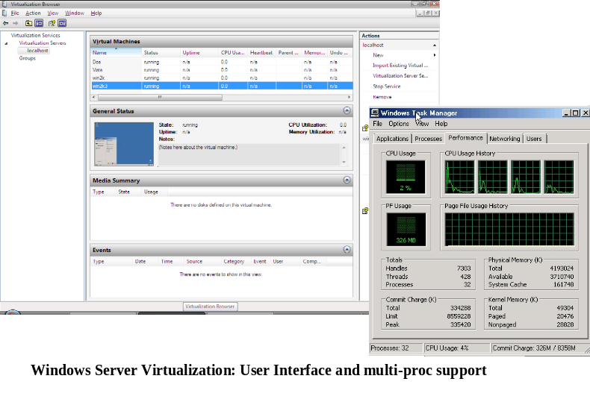
- 64-bit guest support. A key new feature of Hyper-V is the ability to support 64-bit guests. This enables organizations to virtualize more applications that are memory-intensive and benefit from the increased memory pool accessible in a 64-bit environment.
- Multiprocessor guest support. Hyper-V now provides the capability to allocate multiple CPU resources to a single virtual machine and enables virtualization of multithreaded applications. This capability combined with the 64-bit guest support makes Hyper-V a scalable platform for virtualization
- Migration of virtual machines. Hyper-V will provide the ability to move a virtual machine from one physical machine to another with minimal downtime. This capability combined with host clustering of physical machines provides high availability and flexibility to achieve an agile and dynamic datacenter.
- New device virtualization architecture. Hyper-V provides a new virtualized I/O architecture. This provides customers with high performance and low overhead.
- Offline VHD manipulation. Hyper-V provides administrators with the ability to securely access files within a VHD without having to instantiate a virtual machine. This provides administrators with granular access to VHDs and the ability to perform some management tasks offline.
- 64-bit native hypervisor-based virtualization.
- Ability to run 32-bit and 64-bit virtual machines concurrently.
- Uniprocessor and multiprocessor virtual machines.
- Virtual machine snapshots, which capture the state of a running virtual machine. Snapshots record system state, so you can revert the virtual machine to a previous state.
- Large virtual machine memory support.
- Virtual LAN support.
- Microsoft Management Console (MMC) 3.0 management tool.
- Documented Windows Management Instrumentation (WMI) interfaces for scripting and management.
Hyper-V requires specific hardware. You will need the following:
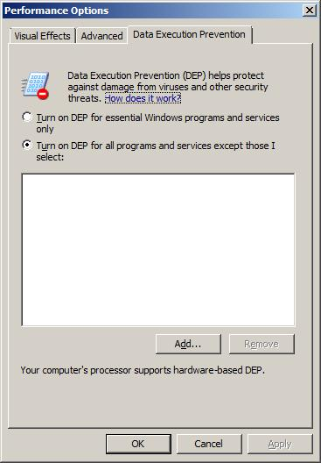
- An x64-based processor. Hyper-V will be available only in the x64-based versions of Windows Server 2008—specifically, the x64-based versions of Windows Server 2008 Standard, Windows Server 2008 Enterprise, and Windows Server 2008 Datacenter.
- Hardware-assisted virtualization. This is available in processors that include a virtualization option; specifically Intel VT or AMD-V.
- Hardware Data Execution Protection (DEP) must be available and be enabled. Specifically, you must enable Intel XD bit (execute disable bit) or AMD NX bit (no execute bit).

System Center Virtual Machine Manager
As a part of the System Center family of management products, Virtual Machine Manager facilitates management of Windows virtual machines. Virtual Machine Manager enables increased physical server utilization by allowing for simple and fast consolidation on virtual infrastructure with integrated consolidation candidate identification, fast P2V, and intelligent workload placement based on performance knowledge and user-defined business policies. Virtual Machine Manager enables rapid provisioning of new virtual machines by the administrator and end users using a self-service provisioning tool. Virtual Machine Manager is a tightly integrated member of the System Center product family of management products.
Usage Scenarios
Virtual Machine Manager delivers simple and complete support for consolidating physical hardware on virtual infrastructure and optimizing utilization. It also provides rapid provisioning of virtual machines from physical machines or templates in the image library or by end users.
- Production server consolidation. As organizations look to consolidate their production servers, Virtual Machine Manager provides a way to transfer the knowledge about the system and the environment through the virtualization process and help maintain knowledge continuity. By consolidating several production servers with Hyper-V, businesses reduce overall total cost of ownership and still maintain a unified management framework across their physical and virtual environments.
- Increasing operational agility. Businesses across segments are looking for ways to drive efficiency through their IT environments and increase operational agility. Virtual Machine Manager provides a mechanism to enable functionality such as rapid server provisioning, rapid recovery, and scalable migration capability to make the overall virtual infrastructure robust and easy to manage.
- Integrated management. Virtual Machine Manager helps create a centralized virtual machine management infrastructure across multiple Hyper-V hosts. Organizations are adopting virtualization across production and test and development areas, and as management capabilities get more sophisticated, it helps administrators deploy and manage virtual and physical environments in an integrated approach.
Key Features
System Center Virtual Machine Manager focuses on unique requirements of virtual machines and is designed to enable increased physical server utilization, centralized management of virtual machine infrastructure and rapid provisioning of new virtual machines. The following are some of the key features in Virtual Machine Manager.
- Consolidation candidate identification. The first step in migrating from a physical data center with a one-workload-per-server model is to identify the appropriate physical workloads for consolidation onto virtual hardware. The decision factors for determining the appropriate candidates are based on several factors such as historical performance, peak load characteristics and access patterns. Virtual Machine Manager leverages the existing historical performance data in the System Center Operations Manager database to list the consolidation candidates in rank order.
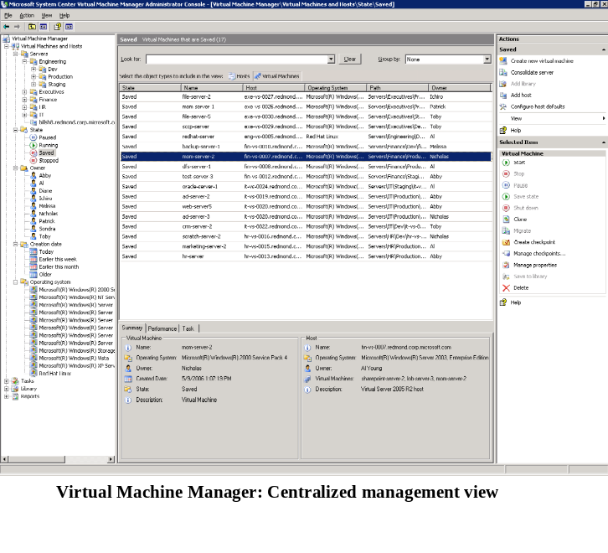
- Intelligent placement. The act of assigning and activating a given virtual workload onto a physical virtual host server is referred to as placement. Placement is at the crux of maximizing the utilization of physical assets. Virtual Machine Manager brings a deep and holistic approach to placement and combines the knowledge from historical performance data of the virtual workload and the intelligence about the virtual host system. Business rules and associated models are also leveraged by Virtual Machine Manager to determine the placement options.
- Host provisioning. Virtual Machine Manager will identify the physical virtual hosts in the enterprise through integrated discovery with Active Directory. This helps organizations easily scale the management of virtual machines and hosts across the datacenter and branch offices.
- Central library. Virtual Machine Manager provides a central repository for all the building blocks for a virtual machine such as VHDs, offline virtual machines, templates and even ISO images. Each item in the library has models or rich metadata that enable more controlled management of the objects. Template is a new object that enables an administrator to create approved virtual machine configurations that serve as a gold standard for subsequent virtual machine deployments.
- Self-service provisioning. Virtual infrastructure is commonly used in test and development environments where there is consistent provisioning and tear-down of virtual machines for testing purposes. With Virtual Machine Manager, administrators can selectively extend self-provisioning capabilities to user groups and be able to define quotas. The automated provisioning tool will manage the virtual machines through their life cycles, including tear-downs.

2.03 Server Core

In Windows Server 2008, administrators can now choose to install a minimal environment that avoids extra overhead. Although this option limits the roles that can be performed by the server, it can improve security and reduce management. This type of installation is called a Server Core installation option.

To learn more, please turn to 7.05 Server Core.

For more information on the Server Core installation option, please see section 7.05 Server Core under Section 7: Server Management.

Section 3: Centralized Application Access

Section 3: Centralized Application Access 24
3.01 Centralized Application Access Introduction 25
Scenario Value Proposition 25
Special Hardware Requirements 25
3.02 Terminal Services Core Functionality 26
Remote Desktop Connection 6.1 26
Plug and Play Device Redirection for Media Players and Digital Cameras 27
Microsoft Point of Service for .NET Device Redirection 27
Configuring a Remote Desktop Protocol File 28
Using Redirected Microsoft POS for .NET Devices 28
Remote Desktop Connection Display 28
Custom Display Resolutions 29
Monitor Spanning 29
Desktop Experience 29
Desktop Composition 30
Adjusting Additional Settings 30
Client Configuration 30
Font Smoothing 31
Display Data Prioritization 31
Single Sign-On 32
Prerequisites for Deploying Single Sign-On 32
Recommended Configuration of a Terminal Server When Using Single Sign-On 33
3.03 Terminal Services Gateway 34
TS CAPs 37
Computer Groups Associated With TS RAPs 37
TS RAPs 38
Monitoring Capabilities 38
Group Policy Settings for TS Gateway 39
3.04 Terminal Services RemoteApp 41
Additional References 42
3.05 Terminal Services Web Access 43
Lets You Easily Deploy RemoteApps Over the Web 44
Deployment 44
List of RemoteApps Is Dynamically Updated 44
Includes the TS Web Access Web Part 45
3.06 Terminal Services Printing 46
Group Policy Settings 47
3.07 Terminal Services Session Broker 49
Group Policy Settings 50
Additional Information 51
3.08 Terminal Services Licensing 52
3.09 Windows System Resource Manager 54
Installing Terminal Server 54
Resource-Allocation Policies 54
Monitoring Performance 55

3.01 Centralized Application Access Introduction
This scenario focuses centralizing application access to business applications with Terminal Services. Terminal Services enables customers to set up a centralized system that allows them to quickly and securely provide access to Windows-based applications from any network-connected location. Customers can provide this functionality using a variety of clients, including Windows®-based PCs, Windows-based thin clients or Windows Mobile®-based devices.
When users run an application with Terminal Services, the application execution takes place on the server, and only keyboard, mouse and display information is transmitted over the network. Users see only their own individual sessions, which are managed transparently by the server operating system, and remain independent of any other client session.
Scenario Value Proposition
The key value propositions that centralized application access enables are these:
- Provide centralized access to business applications on the LAN or over the Internet.
- Remove risk of data loss from laptops by using secure remote access to applications and data located centrally.
- Reduce management costs by removing the need for application servers at distributed locations.
- Provide secure access to applications without needing to enable full network access via VPN or other mechanisms.
- Consolidate existing Terminal Servers using x64 technology.
- Improve end-user productivity with seamless integration of local- and Terminal Services-based applications on the local client.
Special Hardware Requirements
The following is an additional hardware requirement:
- Hardware or software-based firewall (or other edge security device) to place between the Terminal Services Gateway server and the Internet.

3.02 Terminal Services Core Functionality
For Windows Server® 2008, Terminal Services includes new core functionality that enhances the end-user experience when connecting remotely to a Windows Server 2008 terminal server.
The new core functionality in Terminal Services will be of interest to organizations that currently use or are interested in using Terminal Services. Terminal Services provides technologies that enable access, from almost any computing device, to a server running Windows-based programs or the full Windows desktop. Users can connect to a terminal server to run programs and use network resources on that server.
For Windows Server 2008, you might be interested in the new core functionality in Terminal Services if you use any of the following hardware:
- Windows-based portable devices
- Microsoft® Point of Service for Microsoft .NET devices
- Monitors that support higher resolutions, such as 1680x1050 or 1920x1200
- Multiple monitors
You also might be interested in the new core functionality in Terminal Services if you want to support any of the following scenarios:
- Have users connect to a terminal server and have the remote computer look and feel more like the user’s local Windows Vista™ desktop experience.
- Ensure that display, keyboard and mouse data passed over a remote connection is not adversely affected by bandwidth-intensive actions, such as large print jobs.
- Allow users with a domain account to log on once, using a password or smart card, and then gain access to a terminal server without being asked for their credentials again.
To take advantage of the new Terminal Services core functionality, you will need to use the following:
- Remote Desktop Connection (RDC) 6.0 or RDC 6.1
- Windows Server 2008 configured as a terminal server
In some cases, you will also need to use Windows Vista.
Remote Desktop Connection 6.1
Remote Desktop Connection (RDC) 6.1 is available with Windows Server 2008. RDC 6.1 supports Remote Desktop Protocol 6.1.
Remote Desktop Connection (RDC) 6.0 is available with Windows Vista.
The Remote Desktop Connection 6.0 software is also available for use on Windows Server® 2003 with Service Pack 1 (SP1), Windows Server 2003 with Service Pack 2 (SP2), and Windows® XP with Service Pack 2 (SP2). To use any new Terminal Services features on any of these platforms, download the installer package from article 925876 in the Microsoft Knowledge Base (http://go.microsoft.com/fwlink/?LinkId=79373).
Plug and Play Device Redirection for Media Players and Digital Cameras
In Windows Server 2008, redirection has been enhanced and expanded. Now you can redirect Windows-based portable devices, specifically media players based on the Media Transfer Protocol (MTP) and digital cameras based on the Picture Transfer Protocol (PTP).
The Remote Desktop Protocol (.rdp) file created by the RemoteApp Wizard automatically enables Plug and Play device redirection. For more information about RemoteApps, see the TS RemoteApp Step-by-Step Guide. To access this guide, visit the Windows Server 2008 TS RemoteApp and TS Web Access TechCenter (http://go.microsoft.com/fwlink/?LinkId=79609).
When the session to the remote computer is launched, you should see the Plug and Play device that is redirected be automatically installed on the remote computer. Plug and Play notifications will appear in the taskbar on the remote computer.
If you have selected the Devices that I plug in later check box in Remote Desktop Connection, you should see the Plug and Play device get installed on the remote computer when you plug the Plug and Play device into your local computer while the session to the remote computer is active.
After the redirected Plug and Play device is installed on the remote computer, the Plug and Play device is available for use in your session with the remote computer. For example, if you are redirecting a Windows-based portable device such as a digital camera, the device can be accessed directly from an application such as the Scanner and Camera Wizard on the remote computer.
Plug and Play device redirection is not supported over cascaded terminal server connections. For example, if you have a Plug and Play device attached to your local client computer, you can redirect and use that Plug and Play device when you connect to a terminal server (Server1, for example). If from within your remote session on Server1 you then connect to another terminal server (Server2, for example), you will not be able to redirect and use the Plug and Play device in your remote session with Server2.
You can control Plug and Play device redirection by using either of the following Group Policy settings:
- Computer Configuration\Administrative Templates\Windows Components\Terminal Services\Terminal Server\Device and Resource Redirection\Do not allow supported Plug and Play device redirection policy setting
- Computer Configuration\Administrative Templates\System\Device Installation\Device Installation Restrictions policy settings
You can also control Plug and Play device redirection on the Client Settings tab in the Terminal Services Configuration tool (tsconfig.msc).
Microsoft Point of Service for .NET Device Redirection
In Windows Server 2008 you can also redirect devices that use Microsoft Point of Service (POS) for .NET 1.11.
Important
Microsoft POS for .NET device redirection is only supported if the terminal server is running an x86-based version of Windows Server 2008.
You can download Microsoft POS for .NET 1.11 from the Microsoft Download Center (http://go.microsoft.com/fwlink/?linkid=66169).
Configuring a Remote Desktop Protocol File
Microsoft POS for .NET devices, by default, is not listed under Local devices and resources on the Local Resources tab in Remote Desktop Connection. Therefore, to enable Microsoft POS for .NET devices for redirection, you need to edit the Remote Desktop Protocol (.rdp) file that you use to connect to the terminal server.
- Note
The .rdp file created by the RemoteApp Wizard automatically enables Microsoft POS for .NET device redirection. For more information about RemoteApps, see the TS RemoteApp Step-by-Step Guide. To access this guide, visit the Windows Server 2008 TS RemoteApp and TS Web Access TechCenter (http://go.microsoft.com/fwlink/?LinkId=79609).
Using Redirected Microsoft POS for .NET Devices
After you have implemented Microsoft POS for .NET 1.11 on your terminal server and have enabled Microsoft POS for .NET device redirection in your .rdp file, plug in your Microsoft POS for .NET device and then connect to the remote computer by using the modified .rdp file. After you connect to the remote computer, you should see the Microsoft POS for .NET device that is redirected be automatically installed on the remote computer. Plug and Play notifications will appear in the taskbar on the remote computer.
After the redirected Microsoft POS for .NET device is installed on the remote computer, any Microsoft POS for .NET application residing on the terminal server can access the Microsoft POS for .NET device as if the device were available locally. There is a sample application in the POS for .NET 1.11 SDK that you can use to test access to and the functionality of the redirected Microsoft POS for .NET device. The sample application is called ccltestapp.exe and can be found in the \SDK\Samples\Sample Application folder in the folder where you installed POS for .NET.
You can control Microsoft POS for .NET device redirection by using either of the following Group Policy settings:
- Computer Configuration\Administrative Templates\Windows Components\Terminal Services\Terminal Server\Device and Resource Redirection\Do not allow supported Plug and Play device redirection policy setting
- Computer Configuration\Administrative Templates\System\Device Installation\Device Installation Restrictions policy settings
You can also control Microsoft POS for .NET device redirection on the Client Settings tab in the Terminal Services Configuration tool (tsconfig.msc).
Remote Desktop Connection Display
Remote Desktop Connection (RDC) 6.0 and RDC 6.1 add support for using higher-resolution desktops and spanning multiple monitors horizontally to form a single large desktop. Also, the Desktop Experience feature and the display data prioritization settings are designed to enhance the end-user experience when connecting remotely to a Windows Server 2008 terminal server.
Custom Display Resolutions
Custom display resolution provides support for additional display resolution ratios, such as 16:9 or 16:10. For example, newer monitors with resolutions of 1680 x 1050 or 1920 x 1200 are now supported. The maximum resolution supported is 4096 x 2048.
Note
Previously, only 4:3 display resolution ratios were supported, and the maximum resolution supported was 1600 x 1200.
You can set a custom display resolution in an .rdp file or from a command prompt.
Note
For more information about .rdp file settings, see article 885187 in the Microsoft Knowledge Base (http://go.microsoft.com/fwlink/?linkid=66168).
Monitor Spanning
Monitor spanning allows you to display your remote desktop session across multiple monitors.
The monitors used for monitor spanning must meet the following requirements:
- All monitors must use the same resolution. For example, two monitors using 1024 x 768 resolutions can be spanned. But one monitor at 1024 x 768 and one monitor at 800 x 600 cannot be spanned.
- All monitors must be aligned horizontally (that is, side by side). There is currently no support for spanning multiple monitors vertically on the client system.
- The total resolution across all monitors cannot exceed 4096 x 2048.
You can enable monitor spanning in an .rdp file or from a command prompt.
Note
For more information about .rdp file settings, see article 885187 in the Microsoft Knowledge Base (http://go.microsoft.com/fwlink/?linkid=66168).
Desktop Experience
Remote Desktop Connection (RDC) 6.0 and RDC 6.1 reproduce the desktop that exists on the remote computer on the user’s client computer. To make the remote computer look and feel more like the user's local Windows Vista desktop experience, you can install the Desktop Experience feature on your Windows Server 2008 terminal server. Desktop Experience installs features of Windows Vista, such as Windows Media® Player 11, desktop themes, and photo management.
Desktop Composition
Windows Vista provides a visually dynamic experience called Windows Aero™. Windows Aero provides features such as these:
- Translucent windows
- Taskbar buttons with thumbnail-sized window previews
- A view of your open windows in a three-dimensional stack on your desktop
Note
For more information about Windows Aero features, see Windows Aero (http://go.microsoft.com/fwlink/?LinkId=71741).
A Windows Server 2008 terminal server can be configured to provide Windows Aero features when a Windows Vista client computer connects to the Windows Server 2008 terminal server by using Remote Desktop Connection. This functionality is referred to as desktop composition.
Note
For the Windows Vista client computer to use desktop composition in a remote desktop connection to a Windows Server 2008 terminal server, the Windows Vista client computer must have hardware installed that is capable of supporting Windows Aero. However, the Windows Server 2008 terminal server does not need to have hardware installed that is capable of supporting Windows Aero.
The operating system will determine if the computer has the requisite hardware to support and display the features of the “Windows Vista” theme. Even if the hardware on the Windows Server 2008 terminal server does not support the “Windows Vista” theme, the “Windows Vista” theme will still be displayed in the remote desktop connection if the hardware on the client computer supports the “Windows Vista” theme.
Adjusting Additional Settings
To ensure that desktop composition provides the desired functionality during remote desktop connections, there are additional settings that need to be configured on the Windows Server 2008 terminal server.
In addition, the terminal server must be configured to support a maximum color depth of 32 bits per pixel (bpp) for remote connections. The maximum color depth can be configured by using either one of the following methods:
- Setting the Limit Maximum Color Depth on the Client Settings tab in the Terminal Services Configuration tool (tsconfig.msc)
- Enabling the Computer Configuration\Administrative Templates\Windows Components\Terminal Services\Terminal Server\Remote Session Environment\Limit maximum color depth policy setting
Note that the Group Policy setting will take precedence over the setting in the Terminal Services Configuration tool.
Client Configuration
When you allow desktop composition, you are specifying that the local settings on the Windows Vista client computer will help determine the user experience in the remote desktop connection. Note that by allowing desktop composition, you are not changing the settings on the Windows Server 2008 terminal server.
Because Windows Aero requires and uses more hardware resources, you will need to determine what scalability impacts this will have on how many simultaneous remote desktop connections your Windows Server 2008 terminal server can support.
Font Smoothing
Windows Server 2008 supports ClearType®, which is a technology for displaying computer fonts so that they appear clear and smooth, especially when you are using an LCD monitor.
A Windows Server 2008 terminal server can be configured to provide ClearType functionality when a client computer connects to the Windows Server 2008 terminal server by using Remote Desktop Connection. This functionality is referred to as font smoothing. Font smoothing is available if the client computer is running any of the following:
- Windows Vista
- Windows Server 2003 with SP1 and the Remote Desktop Connection 6.0 software
- Windows XP with SP2 and the Remote Desktop Connection 6.0 software
By default, ClearType is enabled on Windows Server 2008.
When you allow font smoothing, you are specifying that the local settings on the client computer will help determine the user experience in the remote desktop connection. Note that by allowing font smoothing, you are not changing the settings on the Windows Server 2008 terminal server.
Using font smoothing in a remote desktop connection will increase the amount of bandwidth used between the client computer and the Windows Server 2008 terminal server.
Display Data Prioritization
Display data prioritization automatically controls virtual channel traffic so that display, keyboard and mouse data is given a higher priority over other virtual channel traffic, such as printing or file transfers. This prioritization is designed to ensure that your screen performance is not adversely affected by bandwidth-intensive actions, such as large print jobs.
The default bandwidth ratio is 70:30. Display and input data will be allocated 70 percent of the bandwidth, and all other traffic, such as clipboard, file transfers or print jobs, will be allocated 30 percent of the bandwidth.
You can adjust the display data prioritization settings by making changes to the registry of the terminal server. You can change the value of the following entries under the HKEY_LOCAL_MACHINE\SYSTEM\CurrentControlSet\Services\TermDD subkey:
- FlowControlDisable
- FlowControlDisableBandwidth
- FlowControlChannelBandwidth
- FlowControlChargePostCompression
If these entries do not appear, you can add them. To do this, right-click on TermDD, point to New, and then click on DWORD (32-bit) Value.
You can disable display data prioritization by setting the value of FlowControlDisable to 1. If display data prioritization is disabled, all requests are handled on a first-in-first-out basis. The default value for FlowControlDisable is 0.
You can set the relative bandwidth priority for display (and input data) by setting the FlowControlDisplayBandwidth value. The default value is 70; the maximum value allowed is 255.
You can set the relative bandwidth priority for other virtual channels (such as clipboard, file transfers or print jobs) by setting the FlowControlChannelBandwidth value. The default value is 30; the maximum value allowed is 255.
The bandwidth ratio for display data prioritization is based on the values of FlowControlDisplayBandwidth and FlowControlChannelBandwidth. For example, if FlowControlDisplayBandwidth is set to 150 and FlowControlChannelBandwidth is set to 50, the ratio is 150:50, so display and input data will be allocated 75 percent of the bandwidth.
The FlowControlChargePostCompression value determines if flow control will calculate the bandwidth allocation based on pre-compression or post-compression bytes. The default value is 0, which means that the calculation will be made on pre-compression bytes.
If you make any changes to the registry values, you need to restart the terminal server for the changes to take effect.
Single Sign-On
Single sign-on is an authentication method that allows a user with a domain account to log on once, using a password or smart card, and then gain access to remote servers without being asked for credentials again.
The key scenarios for single sign-on are these:
- Line-of-business (LOB) applications deployment
- Centralized application deployment
Due to lower maintenance costs, many companies prefer to install their LOB applications on a terminal server and make these applications available through RemoteApps or Remote Desktop. Single sign-on makes it possible to give users a better experience by eliminating the need for users to enter credentials every time they initiate a remote session.
Prerequisites for Deploying Single Sign-On
To implement single sign-on functionality in Terminal Services, ensure that you meet the following requirements:
- You can only use single sign-on for remote connections from a Windows Vista-based computer to a Windows Server 2008-based terminal server. You can also use single sign-on for remote connections from a Windows Server 2008-based server to a Windows Server 2008-based server.
- Make sure that the user accounts that are used for logging on have appropriate rights to log on to both the terminal server and the Windows Vista client.
- Your client computer and terminal server must be joined to a domain.
Recommended Configuration of a Terminal Server When Using Single Sign-On
To configure the recommended settings for your terminal server, complete the following steps:
- Configure authentication on the terminal server.
- Configure the Windows Vista-based computer to allow default credentials to be used for logging on to the specified terminal servers.

3.03 Terminal Services Gateway
Terminal Services Gateway (TS Gateway) is a role service in the Terminal Services server role that allows authorized remote users to connect to terminal servers and remote desktops (remote computers) on a corporate network, from any Internet-connected device. TS Gateway uses Remote Desktop Protocol (RDP) over HTTPS to form a secure, encrypted connection between remote users on the Internet and the remote computers on which their productivity applications run.
TS Gateway provides the following benefits:
- TS Gateway enables remote users to connect to the corporate network from the Internet, over an encrypted connection, without needing to configure VPN connections.
- TS Gateway provides a comprehensive security configuration model that enables you to control access to specific network resources (computers).
- TS Gateway enables users to connect remotely to terminal servers and remote desktops that are hosted behind firewalls in private networks and across network address translators (NATs).
Before this release of Windows Server, security measures prevented users from connecting to remote computers across firewalls and NATs. This is because port 3389, the port used for RDP connections, is typically blocked for network security purposes. TS Gateway transmits RDP traffic to port 443 instead, by using an HTTP Secure Sockets Layer/Transport Layer Security (SSL/TLS) tunnel. Because most corporations open port 443 to enable Internet connectivity, TS Gateway takes advantage of this network design to provide remote access connectivity across multiple firewalls.
- The TS Gateway Manager snap-in console enables you to configure authorization policies to define conditions that must be met for users to connect to network resources. For example, you can specify the following:
  - Who can connect to network resources (in other words, the user groups who can connect). These groups can be existing groups in Local Users and Groups on the TS Gateway server, existing groups in Active Directory® Domain Services, or new or existing TS Gateway-managed groups. TS Gateway-managed groups are groups that you configure by using TS Gateway Manager.
  - One or more network resources to which users can connect
  - Whether client computers must be members of Active Directory domains
  - Whether device and disk redirection is allowed
  - Whether clients need to use smart card authentication or password authentication, or whether they can use either method
- You can configure TS Gateway servers and Terminal Services clients to use NAP to further enhance security. NAP is a health policy creation, enforcement, and remediation technology that is included in Windows Vista and Windows Server 2008. With NAP, system administrators can enforce health requirements, which can include software requirements, security update requirements, required computer configurations, and other settings.
For information about how to configure TS Gateway to use NAP for health policy enforcement for Terminal Services clients that connect to TS Gateway servers, see the TS Gateway Server Step-by-Step Setup Guide (http://go.microsoft.com/fwlink/?linkid=79605).
- You can use TS Gateway server with Microsoft Internet Security and Acceleration (ISA) Server to enhance security. In this scenario, you can host TS Gateway servers in a private network rather than a perimeter network (also known as a DMZ, demilitarized zone, and screened subnet), and host ISA Server in the perimeter network. The SSL connection between the Terminal Services client and ISA Server can be terminated at the ISA Server, which is Internet-facing.
For information about how to configure ISA Server as an SSL termination device for TS Gateway server scenarios, see the TS Gateway Server Step-by-Step Setup Guide (http://go.microsoft.com/fwlink/?linkid=79605).
- The TS Gateway Manager snap-in console provides tools to help you monitor TS Gateway connection status, health and events. By using TS Gateway Manager, you can specify events (such as unsuccessful connection attempts to the TS Gateway server) that you want to monitor for auditing purposes.
If your organization makes Terminal Services-based applications and computers that run Remote Desktop available to users from outside your network perimeter, TS Gateway can simplify network administration and reduce your exposure to security risks.
TS Gateway can also make it easier for users because they do not have to configure VPN connections and can access nextref_ts_gateway servers from sites that can otherwise block outbound RDP or VPN connections.
You should review this section and the additional supporting documentation about TS Gateway if you are in any of the following groups:
- IT administrators, planners and analysts who are evaluating remote access and mobile solution products
- Enterprise IT architects and designers for organizations
- Early adopters
- Security architects who are responsible for implementing trustworthy computing
- IT professionals who are responsible for terminal servers or remote access to desktops
For TS Gateway to function correctly, you must meet these prerequisites:
- You must have a server with Windows Server 2008 installed.
- You must be a member of the Administrators group on the computer that you want to configure as a TS Gateway server.
- The following role services and features must be installed and running for TS Gateway to function:
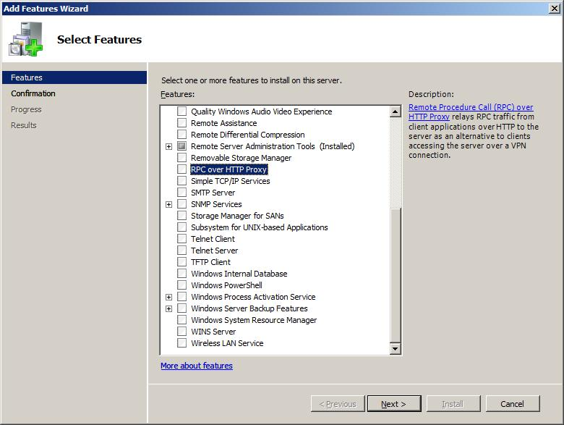
  - The remote procedure call (RPC) over HTTP Proxy service
  - Web Server (IIS) (Internet Information Services 7.0). (IIS 7.0 must be installed and running for the RPC over HTTP Proxy service to function.)
  - Network Policy Server (NPS) service. If an NPS server —formerly known as a Remote Authentication Dial-In User Service (RADIUS) server — is already deployed for remote access scenarios such as VPN and dial-up networking, you can use the existing NPS server for TS Gateway scenarios as well. By using NPS for TS Gateway, you can centralize the storage, management, and validation of Terminal Services connection authorization policies (TS CAPs).
When you use Server Manager to install the TS Gateway role service, these additional role services and features are automatically installed.
- You must obtain an SSL certificate for the TS Gateway server if you do not have one already. By default, on the TS Gateway server, the RPC/HTTP Load Balancing service and the IIS service use TLS 1.0 to encrypt communications between clients and TS Gateway servers over the Internet. For TLS to function correctly, you must install an SSL certificate on the TS Gateway server.
The certificate must meet these requirements:
  - The name in the Subject line of the server certificate (certificate name, or CN) must match the name that is configured on the TS Gateway server.
  - The certificate is a computer certificate.
  - The intended purpose of the certificate is server authentication. The Extended Key Usage (EKU) is Server Authentication (1.3.6.1.5.5.7.3.1).
  - The certificate has a corresponding private key.
  - The certificate has not expired. We recommend that the certificate be valid one year from the date of installation.
  - A certificate object identifier (also known as OID) of 2.5.29.15 is not required. However, if the certificate that you plan to use contains an object identifier of 2.5.29.15, you can only use the certificate if at least one of the following key usage values is also set: CERT_KEY_ENCIPHERMENT_KEY_USAGE, CERT_KEY_AGREEMENT_KEY_USAGE, and CERT_DATA_ENCIPHERMENT_KEY_USAGE.
For more information about these values, see Advanced Certificate Enrollment and Management (http://go.microsoft.com/fwlink/?LinkID=74577).
For more information about certificate requirements for TS Gateway and how to obtain and install a certificate if you do not have one already, see the TS Gateway Step-by-Step Setup Guide (http://go.microsoft.com/fwlink/?linkid=79605).
In addition, keep in mind the following considerations:
- TS Gateway transmits all RDP traffic (that typically would have been sent over port 3389) to port 443 by using an HTTPS tunnel. This also means that all traffic between the client and TS Gateway is encrypted while in transit over the Internet.
- You should review this topic and the additional supporting documentation on TS Gateway, including the TS Gateway Server Step-by-Step Setup Guide (http://go.microsoft.com/fwlink/?linkid=79605).
- You should prepare to acquire an SSL certificate, or to issue one from your own certification authority (CA).
- You should become familiar with the TLS and SSL protocols if you are not already.
TS Gateway provides the following new features to simplify administration and enhance security.
TS CAPs
Terminal Services connection authorization policies (TS CAPs) allow you to specify user groups, and optionally computer groups, that can access a TS Gateway server. You can create a TS CAP by using TS Gateway Manager.
TS CAPs simplify administration and enhance security by providing a greater level of control over access to remote computers on your corporate network.
TS CAPs allow you to specify who can connect to a TS Gateway server. You can specify a user group that exists on the local TS Gateway server or in Active Directory Domain Services. You can also specify other conditions that users must meet to access a TS Gateway server. You can list specific conditions in each TS CAP. For example, you might require a user to use a smart card to connect through TS Gateway.
Users are granted access to a TS Gateway server if they meet the conditions specified in the TS CAP.
Important
You must also create a Terminal Services resource authorization policy (TS RAP). A TS RAP allows you to specify the network resources that users can connect to through TS Gateway. Until you create both a TS CAP and a TS RAP, users cannot connect to network resources through this TS Gateway server.
Computer Groups Associated With TS RAPs
Users can connect through TS Gateway to network resources in a computer group. The computer group can be any one of the following:
- Members of an existing Windows group: The Windows group can exist in Local Users and Groups on the TS Gateway server, or it can exist in Active Directory Domain Services.
- Members of an existing TS Gateway-managed computer group or a new TS Gateway-managed group that you create: You can add the computers to which you want to provide user access to the TS Gateway-managed computer group by using TS Gateway Manager.
- Any network resource: In this case, users can connect to any computer on the network that they could connect to when they use Remote Desktop.
To ensure that the appropriate users have access to the appropriate network resources, plan and create computer groups carefully. Evaluate the users who should have access to each computer group, and then associate the computer groups with TS RAPs to grant users access as needed.
TS RAPs
TS RAPs allow you to specify the network resources that users can connect to through a TS Gateway server. When you create a TS RAP, you can create a computer group and associate it with the TS RAP.
Users connecting to the network through a TS Gateway server are granted access to remote computers on the corporate network if they meet the conditions specified in at least one TS CAP and one TS RAP.
Note
Client users can specify a NetBIOS name or a fully qualified domain name (FQDN) for the remote computer that they want to access through the TS Gateway server. To support either NetBIOS or FQDN names, create a TS RAP for each possible computer name.
Together, TS CAPs and TS RAPs provide two different levels of authorization to provide you with the ability to configure a more specific level of access control to corporate computer resources.
Monitoring Capabilities
You can use TS Gateway Manager to view information about active connections from Terminal Services clients to network resources through TS Gateway. This information includes the following:
- The domain and user ID of the user logged on to the client
- The IP address of the client
Note
If your network configuration includes proxy servers, the IP address that appears in the Client IP Address column (in the Monitoring details pane) might reflect the IP address of the proxy server, rather than the IP address of the Terminal Services client.
- The name of the target computer to which the client is connected
- The target port through which the client is connected
- The date and time when the connection was initiated
- The length of time that the connection is idle, if applicable
You can also specify the types of events that you want to monitor, such as unsuccessful or successful connection attempts to internal network resources through a TS Gateway server.
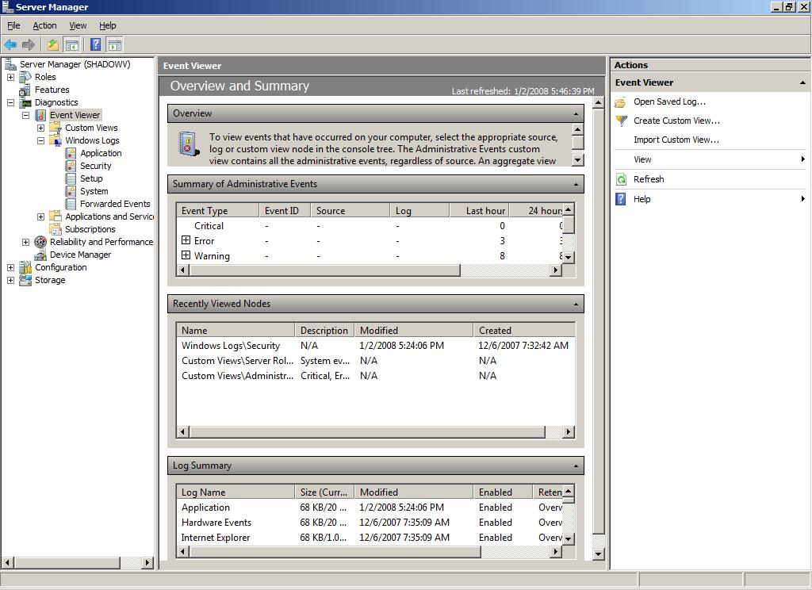
When these events occur, you can monitor the corresponding events by using Windows Event Viewer. TS Gateway events are stored in Event Viewer under Application and Services Logs\Microsoft\Windows\Terminal Services-Gateway\.
Group Policy Settings for TS Gateway
You can use Group Policy and Active Directory Domain Services to centralize and simplify the administration of TS Gateway policy settings. You use the Group Policy Object Editor to configure these settings, which are contained within Group Policy objects (GPOs). You use the Group Policy Management Console (GPMC) to link GPOs to sites, domains or organizational units (OUs) in Active Directory Domain Services.
Group Policy settings for Terminal Services client connections through TS Gateway can be applied in one of two ways. These policy settings can either be suggested (that is, they can be enabled, but not enforced) or they can be enabled and enforced. Suggesting a policy setting allows users on the client to enter alternate TS Gateway connection settings. Enforcing a policy setting prevents a user from changing the TS Gateway connection setting, even if they select the Use these TS Gateway server settings option on the client.
The following three Group Policy settings are available for TS Gateway server:
- Set the TS Gateway Server Authentication method. This enables you to specify the authentication method that Terminal Services clients must use when connecting to network resources through a TS Gateway server.
- Enable connections through TS Gateway. This enables you to specify that, when Terminal Services clients cannot connect directly to a network resource, the clients will attempt to connect to the network resource through the TS Gateway server that is specified in the Set the TS Gateway server address policy setting.
- Set the TS Gateway Server Address. This enables you to specify the TS Gateway server that Terminal Services clients use when they cannot connect directly to a network resource.
Important
If you disable or do not configure this policy setting, but enable the Enable connections through TS Gateway policy setting, client connection attempts to any network resource will fail if the client cannot connect directly to the network resource.
You do not need to change any existing code to work with TS Gateway. TS Gateway only manages the way in which the connection to the remote computer is created.
Note
TS Gateway can route connections to any Terminal Services–based session, including those on Windows Server 2008, Windows Server 2003, Windows Vista and Windows XP–based computers.
To access RemoteApp programs that are deployed as .rdp files or as Windows Installer packages, the client computer must be running Remote Desktop Connection (RDC) 6.0 or RDC 6.1. (RDC 6.1 supports Remote Desktop Protocol 6.1.) A supported version of the RDC client is included with Windows Vista and Windows Server 2008.
Note
The RDC version 6.0 software is available for use on Windows XP with SP2 and Windows Server 2003 with SP1. You can download the installer package from article 925876 in the Microsoft Knowledge Base (http://go.microsoft.com/fwlink/?LinkId=79373).
To access RemoteApp programs through TS Web Access, the client computer must be running RDC 6.1. RDC 6.1 is included with Windows Server 2008 and Windows Vista with SP1.

3.04 Terminal Services RemoteApp
Terminal Services RemoteApp™ (TS RemoteApp) enables organizations to provide access to standard Windows-based programs from virtually any location to users of any Windows Vista-based or Windows Server 2008-based computer, or to users of Windows XP with Service Pack 2 (SP2)-based or Windows Server 2003 with Service Pack 1 (SP1)-based computers that have the new Remote Desktop Connection (RDC) client installed.
TS RemoteApp is built into Terminal Services in Windows Server 2008.
RemoteApps are programs that are accessed remotely through Terminal Services and appear as if they are running on the end user’s local computer. Users can run RemoteApps side by side with their local programs. A user can minimize, maximize and resize the program window, and can easily start multiple programs at the same time. If a user is running more than one RemoteApp on the same terminal server, the RemoteApps will share the same Terminal Services session.
For Windows Server 2008, users can run RemoteApps in a number of ways. They can do the following:
- Double-click on a .rdp file that has been created and distributed by their administrator.
- Double-click on a program icon on their desktop or Start menu that has been created and distributed by their administrator with a Windows Installer (.msi) package.
- Double-click on a file whose extension is associated with a RemoteApp. (This can be configured by their administrator with an .msi package.)
- Access a link to the RemoteApp on a Web site by using Terminal Services Web Access (TS Web Access).
The .rdp files and .msi packages contain the settings needed to run RemoteApps. After opening the RemoteApp on a local computer, the user can interact with the program that is running on the terminal server as if it were running locally.
TS RemoteApp can reduce complexity and reduce administrative overhead in many situations, including these:
- Branch offices, where there may be limited local IT support and limited network bandwidth
- Situations where users need to access applications remotely
- Deployment of LOB applications, especially custom LOB applications
- Environments, such as “hot desk” or “hoteling” workspaces, where users do not have assigned computers
- Deployment of multiple versions of an application, particularly if installing multiple versions locally would cause conflicts
You should review this topic, and the additional supporting documentation on TS RemoteApp, if you are in any of the following groups:
- IT planners and analysts who are technically evaluating the product
- Enterprise architects
- IT professionals who deploy or administer terminal servers, LOB applications, or applications that can be more efficiently deployed with TS RemoteApp
For Windows Server 2008 you must use Remote Desktop Connection (RDC) client version 6.0 or later to run RemoteApps on an end user’s local computer. RDC client 6.0 is included with Windows Vista and Windows Server 2008.
Note
The RDC version 6.0 software is available for use on Windows XP with SP2 and Windows Server 2003 with SP1. You can download the installer package from article 925876 in the Microsoft Knowledge Base (http://go.microsoft.com/fwlink/?LinkId=79373).
To access RemoteApp programs through TS Web Access, the client computer must be running RDC 6.1. RDC 6.1 is included with Windows Server 2008 and Windows Vista with SP1.
Users can run programs from a terminal server and have the same experience as if the programs were running on the end user’s local computer, including resizable windows and notification icons in the notification area.
TS RemoteApp improves the user’s experience, opens new avenues for program deployment, and reduces the amount of administrative effort required to support these programs.
Instead of being presented to the user in the desktop of the remote terminal server, the RemoteApp is integrated with the client’s desktop, running in its own resizable window with its own entry in the taskbar. If the program uses a notification area icon, this icon appears in the client’s notification area. Pop-up windows are redirected to the local desktop. Local drives and printers can be redirected to appear in the RemoteApp. Many users might not be aware that the RemoteApp is different from a local program.
Because TS RemoteApp is an enhancement to existing Terminal Services technologies and uses the same technology and protocols, it does not introduce any new issues.
You should evaluate your programs to see which ones might be suited to being run as a RemoteApp, and then test the programs. To test your programs, follow the procedures described in the TS RemoteApp Step-by-Step Guide to configure your terminal server to support RemoteApps and to use the TS RemoteApp Manager snap-in to make RemoteApps available to users.
For a program to run as a RemoteApp, the terminal server that hosts the program must be running Windows Server 2008. Any program that can run in a Terminal Services session or in a Remote Desktop session should be able to run as a RemoteApp.
Some of the fundamental changes in the Windows Server 2008 operating system might impact earlier versions of programs that run correctly under earlier versions of the Windows operating system. If you experience difficulty running a program as a RemoteApp, verify that it runs correctly on the local console of a server that is running Windows Server 2008.
Review other sections of this guide for additional information about compatibility issues.
Additional References
For more information about TS RemoteApp, see the TS RemoteApp Step-by-Step Guide. To access this guide, visit the Windows Server 2008 TS RemoteApp and TS Web Access TechCenter (http://go.microsoft.com/fwlink/?LinkId=79609).

3.05 Terminal Services Web Access
Terminal Services Web Access (TS Web Access) is a role service in the Terminal Services role that lets you make Terminal Services RemoteApp™ (TS RemoteApp) programs, and a link to the terminal server desktop, available to users from a Web browser. Additionally, TS Web Access enables users to connect from a Web browser to the remote desktop of any server or client computer where they have the appropriate access.
With TS Web Access, users can visit a Web site (either from the Internet or from an intranet) to access a list of available RemoteApps. When they start a RemoteApp, a Terminal Services session is started on the Windows Server 2008-based terminal server that hosts the RemoteApp.
After you install TS Web Access on a Windows Server 2008-based Web server, users can connect to the TS Web Access server to access RemoteApps that are available on one or more Windows Server 2008-based terminal servers. TS Web Access has many benefits. These include the following:
- Users can access RemoteApps from a Web site over the Internet or from an intranet. To start a RemoteApp, they just click on the program icon.
- If a user starts more than one RemoteApp through TS Web Access, and the programs are running on the same terminal server, the RemoteApps run within the same Terminal Services session.
- Using TS Web Access means there is much less administrative overhead. You can easily deploy programs from a central location. In addition, programs are running on a terminal server and not on the client computer, so they are easier to maintain.
- TS Web Access provides a solution that works with minimal configuration. The TS Web Access Web page includes a customizable Web Part, which can be incorporated into a customized Web page or a Microsoft Windows SharePoint® Services site.
- The list of available RemoteApps that appears in the TS Web Access Web Part can be customized to the individual user if you deploy RemoteApps by using Group Policy software distribution.
The information in this topic applies to the following types of IT professionals:
- IT professionals who already run or who are interested in deploying programs to users by using Terminal Services
- IT professionals who want better control over the user’s experience
- Web administrators and developers
- Windows SharePoint Services administrators
Before you install TS Web Access, review the following installation guidelines:
- You must install TS Web Access on a computer that is running Windows Server 2008.
- You must install TS Web Access together with Microsoft IIS 7.0.
- The TS Web Access server does not have to be a terminal server.
- To use TS Web Access, client computers must be running one of the following operating systems:
  - Microsoft Windows XP with Service Pack 2 or later
  - Microsoft Windows Server 2003 with Service Pack 1 or later
  - Windows Vista
  - Windows Server 2008
Note
The Remote Desktop Connection version 6.0 software is available for use on Windows XP with Service Pack 2 and Windows Server 2003 with Service Pack 1. To use any new Terminal Services features on either of these platforms, download the installer package from the Microsoft Download Center (http://go.microsoft.com/fwlink/?LinkId=79373).
Lets You Easily Deploy RemoteApps Over the Web
With TS Web Access, a user can visit a Web site, view a list of RemoteApps, and then just click on a program icon to start the program. The RemoteApps are seamless, meaning that they appear like a local program. Users can minimize, maximize and resize the program window, and can easily start multiple programs at the same time. For an administrator, TS Web Access is easy to configure and to deploy. This functionality translates to ease and flexibility of use and deployment. With TS Web Access, you can provide users with access to RemoteApps from any location and from any computer that has intranet or Internet access.
TS Web Access provides a much improved Web experience over earlier versions of Terminal Services.
- With TS Web Access, users do not have to start the RDC client to start a RemoteApp. Instead, they access the Web page, and then click on a program icon.
- The RemoteApps look like they are running on the local desktop.
- If the user starts multiple RemoteApps and the RemoteApps are all running on the same terminal server, the programs run in the same session.
- Users do not have to download a separate ActiveX® control to access TS Web Access. Instead, RDC client version 6.0 includes the required ActiveX Control.
Deployment
If you want to deploy TS Web Access, you can prepare by reviewing the Terminal Services RemoteApp (TS RemoteApp) topic in this document for information about the new TS RemoteApp feature. More detailed deployment information is available in the TS RemoteApp Step-by-Step Guide. To access this guide, visit the Windows Server 2008 TS RemoteApp and TS Web Access TechCenter (http://go.microsoft.com/fwlink/?LinkId=79609). You may also want to review information about IIS 7.0.
If you want to use TS Web Access to make RemoteApps available to computers over the Internet, you should review the Terminal Services Gateway topic in this document. TS Gateway helps you secure remote connections to terminal servers on your corporate network.
List of RemoteApps Is Dynamically Updated
When you deploy TS Web Access, the list of RemoteApps that appears in the TS Web Access Web Part is dynamically updated. The list is populated from either the RemoteApps list of a single terminal server or from RemoteApps that are deployed through Group Policy software distribution.
An administrator can specify the data source that will be used to populate the list of RemoteApps. By default, the data source is a single terminal server.
- When the data source is a single terminal server, the Web Part is populated with all RemoteApps that are configured for Web access on that server’s RemoteApps list. The list of programs displayed in the Web Part is not specific to the current user.
- When the data source is Active Directory Domain Services, the Web Part is populated by .rap.msi packages that are published to a user through Group Policy software distribution. Because the information is obtained through Group Policy, TS Web Access displays only the RemoteApps that are specific to the individual user. Note that by default, a RemoteApp is packaged with the .rap.msi extension when you create an .msi package that is configured to allow TS Web Access. You create RemoteApp .msi packages by using the TS RemoteApp Manager snap-in.
The dynamically updated program list and the ability to specify the RemoteApps data source simplifies the deployment of RemoteApps over the Web. If you have a single terminal server, it is easy to deploy programs by using the terminal server data source. If you are already using Group Policy-based deployment of programs, then you can use .msi packages to distribute RemoteApps to clients.
Earlier versions of Terminal Services did not provide a mechanism to dynamically update a Web site with a list of RemoteApps.
If you want to populate the list of RemoteApps by using Group Policy, you must have an Active Directory Domain Services environment. You should also become familiar with Group Policy software distribution.
Includes the TS Web Access Web Part
TS Web Access provides a customizable TS Web Access Web Part, where the list of RemoteApps is displayed. You can deploy the Web Part by using any one of the following methods:
- Deploy the Web Part as part of the TS Web Access Web page. (This is the default out-of-the-box solution.)
- Deploy the Web Part as part of a customized Web page.
- Add the Web Part to a Windows SharePoint Services site.
TS Web Access provides a flexible out-of-the-box solution. The provided TS Web Access Web page and Web Part let you implement the TS Web Access site quickly and easily, and let you deploy TS Web Access by using a Web page or by using Windows SharePoint Services.
With TS Web Access, you do not have to manually add a list of available programs to a Web page to provide centralized Web access to RemoteApps. The customizable Web Part gives you flexibility with regard to site appearance and deployment method.
If you want to customize the default Web page or Web Part, you should plan the design changes that you want to make. You should also decide whether you want to provide access to TS Web Access by using the provided TS Web Access Web page, a customized Web page or by using Windows SharePoint Services.

3.06 Terminal Services Printing
Terminal Services printing has been enhanced in Windows Server 2008 by the addition of the Terminal Services Easy Print printer driver and a Group Policy setting that enables you to redirect only the default client printer.
The Terminal Services Easy Print driver is a new feature in Windows Server 2008 that enables users to reliably print from a RemoteApp or from a terminal server desktop session to the correct printer on their client computer. It also enables users to have a much more consistent printing experience between local and remote sessions.
The Redirect only the default client printer policy setting allows you to specify whether the default client printer is the only printer that is redirected in Terminal Services sessions. This helps to limit the number of printers that the spooler must enumerate, improving terminal server scalability.
To use the Terminal Services Easy Print driver in Windows Server 2008, clients must be running both of the following:
- Remote Desktop Connection (RDC) 6.1
Note
The RDC 6.1 client supports Remote Desktop Protocol 6.1.
- Microsoft .NET Framework 3.0 Service Pack 1 (SP1)
Windows Server 2008 and Windows Vista® with Service Pack 1 (SP1) include both of the required components. For the current release of Windows Server 2008, clients must be running one of these operating systems to use the Terminal Services Easy Print driver.
To test the Terminal Services Easy Print driver on a Windows Server 2008-based server (that is acting as the client), you must first add .NET Framework 3.0 SP1. For more information, see the "Terminal Services Printing" topic in the "What's New in Terminal Services for Windows Server 2008" guide (http://go.microsoft.com/fwlink/?LinkId=87440).
The Terminal Services Easy Print driver offers the following functionality:
- Increased reliability of Terminal Services printing for both RemoteApp and remote desktop sessions.
- Support for legacy and new printer drivers without the necessity of installing these drivers on the terminal server.
- Scalability improvements over Windows Server 2003 in terms of printer enumeration performance. During the Winlogon process, the spooler only enumerates printers that are available for a user in a particular session instead of enumerating all redirected printers. Therefore, printers are enumerated on a per-session basis, instead of on a per-user basis.
- Enhanced available printer capabilities. The Terminal Services Easy Print driver provides rich and complete printer capabilities in remote sessions. All the physical printer driver’s capabilities are available for use when a user views the printing preferences.
The Redirect only the default client printer Group Policy setting allows you to control whether the default client printer is the only printer redirected in a Terminal Services session, or whether all printers are redirected in a session.
The terminal server fallback printer driver is no longer included with Windows Server 2008. Although the Specify terminal server fallback printer driver behavior Group Policy setting still exists, it can only be used for Windows Server 2003 with SP1-based computers.
By default, the Terminal Services Easy Print driver is enabled in Windows Server 2008. To use the Terminal Services Easy Print driver, client computers must meet the requirements that are outlined in the Are There Any Special Considerations About These Features Section.
If there are client computers that do not support the Terminal Services Easy Print driver, and the printer driver is not already available on the terminal server, you must do either of the following to support client printing:
- Ensure that client printer drivers for both local and network printers are installed on the terminal server. If you are installing a third-party driver, make sure that the driver is a Windows Hardware Quality Labs (WHQL) signed driver.
- Add the client printer drivers for both local and network printers to a custom printer mapping file on the terminal server. For more information about how to create a custom printer mapping file, see the Resolution section of article 239088 in the Microsoft Knowledge Base (http://go.microsoft.com/fwlink/?LinkID=82784).
Group Policy Settings
The following Group Policy settings have been added for Terminal Services printing:
- Use Terminal Services Easy Print driver first. This policy setting is located in the following node of Group Policy Object Editor:
Computer Configuration\Administrative Templates\Windows Components\Terminal Services\Terminal Server\Printer Redirection
The possible values are these:
  - Enabled or not configured. If this policy setting is enabled or not configured, the terminal server will first try to use the Terminal Services Easy Print driver to install all client printers. If for any reason the Terminal Services Easy Print driver cannot be used, a printer driver on the terminal server that matches the client printer will be used. If the terminal server does not have a printer driver that matches the client printer, the client printer will not be available for the Terminal Services session. By default, this policy setting is not configured.
  - Disabled. If you disable this policy setting, the terminal server will try to find a suitable printer driver to install the client printer. If the terminal server does not have a printer driver that matches the client printer, the server will try to use the Terminal Services Easy Print driver to install the client printer. If for any reason the Terminal Services Easy Print driver cannot be used, the client printer will not be available for the Terminal Services session.
- Redirect only the default client printer. This policy setting is located in the following node of Group Policy Object Editor:
Computer Configuration\Administrative Templates\Windows Components\Terminal Services\Terminal Server\Printer Redirection
The possible values are these:
  - Enabled. If you enable this policy setting, only the default client printer is redirected in Terminal Services sessions.
  - Disabled or not configured. If you disable or do not configure this policy setting, all client printers are redirected in Terminal Services sessions. By default, this policy setting is not configured.

3.07 Terminal Services Session Broker
Terminal Services Session Broker (TS Session Broker) is a role service in Windows Server® 2008 that supports session load balancing between terminal servers in a farm, and reconnection to an existing session in a load-balanced terminal server farm. TS Session Broker stores session state information that includes session IDs and their associated user names, and the name of the server where each session resides.
Windows Server 2008 introduces the TS Session Broker Load Balancing feature. This feature enables you to distribute the session load between servers in a load-balanced terminal server farm.
Note
In Windows Server 2008, the name of the Terminal Services Session Directory feature was changed to Terminal Services Session Broker (TS Session Broker).
To participate in TS Session Broker Load Balancing, the TS Session Broker server and the terminal servers in the farm must be running Windows Server 2008. Windows Server 2003-based terminal servers cannot use the TS Session Broker Load Balancing feature.
For clients to use TS Session Broker Load Balancing, they must be running Remote Desktop Connection (RDC) version 5.2 or later.
The new TS Session Broker Load Balancing feature enables you to evenly distribute the session load between servers in a load-balanced terminal server farm. With TS Session Broker Load Balancing, new user sessions are redirected to the terminal server with the fewest sessions.
TS Session Broker is a two phased load-balancing mechanism. In the first phase, initial connections are distributed by a preliminary load-balancing mechanism, such as Domain Name System (DNS) round robin. After a user authenticates, the terminal server that accepted the initial connection queries the TS Session Broker server to determine where to redirect the user.
In the second phase, the terminal server where the initial connection was made redirects the user to the terminal server that was specified by TS Session Broker. The redirection behavior is as follows:
- A user with an existing session will connect to the server where their session exists.
- A user without an existing session will connect to the terminal server that has the fewest sessions.
Note
While any load-balancing mechanism can be used to distribute the initial connections, DNS round robin is the easiest mechanism to deploy. Deploying TS Session Broker Load Balancing with a network level load-balancing solution such as Windows Network Load Balancing (NLB) or a hardware load balancer avoids the limitations of DNS, while still taking advantage of TS Session Broker session-based load balancing, the per-server limit on the number of pending logon requests, and the user logon mode setting. (The limitations of DNS round robin include the caching of DNS requests on the client, which can result in clients using the same IP address for each initial connection request, and the potential for a 30-second timeout delay if a user is redirected to a terminal server that is offline, but still listed in DNS.)
TS Session Broker Load Balancing sets a limit of 16 for the maximum number of pending logon requests to a particular terminal server. This helps to prevent the scenario where a single server is overwhelmed by new logon requests; for example, if you add a new server to the farm, or if you enable user logons on a server where they were previously denied.
The TS Session Broker Load Balancing feature also enables you to assign a relative weight value to each server. By assigning a server weight value, you can help to distribute the load between more powerful and less powerful servers in the farm.
Note
To configure a server to participate in TS Session Broker Load Balancing, and to assign a server weight value, you can use the Terminal Services Configuration tool.
Additionally, a user logon mode setting is provided that enables you to prevent new users from logging on to a terminal server that is scheduled to be taken down for maintenance. This mechanism provides for the ability to take a server offline without disrupting the user experience. If new logons are denied on a terminal server in the farm, TS Session Broker will allow users with existing sessions to reconnect, but will redirect new users to terminal servers that are configured to allow new logons.
Note
The User logon mode setting is located under General in the Edit settings area of the Terminal Services Configuration tool.
If you want to use the TS Session Broker Load Balancing feature, both the TS Session Broker server and the terminal servers in the same farm must be running Windows Server 2008.
If you want to use DNS round-robin as the load balancer for initial connections, you must create a host resource record for each terminal server in the farm that maps to the terminal server farm name in DNS. (The farm name is the virtual name that clients will use to connect to the terminal server farm.) DNS uses round robin to rotate the order of the resource records that are returned to the client. This functionality helps to distribute initial connections across servers in the farm.
Note
If you prefer, you can use a hardware load balancer to spread the initial connection and authentication load between multiple terminal servers in the farm.
Group Policy Settings
The following Group Policy setting has been added for TS Session Broker:
Computer Configuration\Administrative Templates\Windows Components\Terminal Services\Terminal Server\TS Session Broker\Use TS Session Broker load balancing
The possible values are:
- Enabled. If you enable this policy setting, TS Session Broker will redirect users who do not have an existing session to the terminal server in the farm with the fewest sessions. Redirection behavior for users with existing sessions will not be affected. If the server is configured to use TS Session Broker, users who have an existing session will be redirected to the terminal server where their session exists.
- Disabled. If you disable this policy setting, users who do not have an existing session will log on to the terminal server that they first connect to.
- Not configured. If you do not configure this policy setting, TS Session Broker Load Balancing is not specified at the Group Policy level. In this case, you can configure the terminal server to participate in TS Session Broker Load Balancing by using the Terminal Services Configuration tool or the Terminal Services WMI provider. By default, this policy setting is not configured.
Additional Information
- For more information, see the TS Session Broker Load Balancing Step-by-Step Guide (http://go.microsoft.com/fwlink/?LinkId=92670).

3.08 Terminal Services Licensing
Windows Server® 2008 provides a license management system known as Terminal Services Licensing (TS Licensing). This system allows terminal servers to obtain and manage Terminal Services client access licenses (TS CALs) for devices and users that are connecting to a terminal server. TS Licensing manages unlicensed, temporarily licensed, and client-access licensed clients, and supports terminal servers that run Windows Server 2008 as well as the Windows Server® 2003 operating system. TS Licensing greatly simplifies the task of license management for the system administrator, while minimizing under- or over-purchasing of licenses for an organization.
Note
TS Licensing is used only with Terminal Services and not with Remote Desktop.
A terminal server is a computer on which the Terminal Server role service is installed. It provides clients access to Windows–based applications running entirely on the server and supports multiple client sessions on the server. As clients connect to a terminal server, the terminal server determines if the client needs a license token, requests a license token from a license server, and then delivers that license token to the client.
A Terminal Services license server is a computer on which the TS Licensing role service is installed. A license server stores all TS CAL tokens that have been installed for a group of terminal servers and tracks the license tokens that have been issued. One license server can serve many terminal servers simultaneously. To issue permanent license tokens to client devices, a terminal server must be able to connect to an activated license server. A license server that has been installed but not activated will only issue temporary license tokens.
TS Licensing is a separate entity from the terminal server. In most large deployments, the license server is deployed on a separate server, even though it can be a co-resident on the terminal server in some smaller deployments.
TS Licensing is a low-impact service. It requires very little CPU or memory for regular operations, and its hard disk requirements are small, even for a significant number of clients. Idle activities are negligible. Memory usage is less than 10 megabytes (MB). The license database grows in increments of 5 MB for every 6,000 license tokens issued. The license server is only active when a terminal server is requesting a license token, and its impact on server performance is very low, even in high-load scenarios.
TS Licensing includes the following features and benefits:
- Centralized administration for TS CALs and the corresponding tokens
- License tracking and reporting for Per User licensing mode
- Simple support for various communication channels and purchase programs
- Minimal impact on network and servers
The effective management of TS CALs by using TS Licensing will be of interest to organizations that currently use or are interested in using Terminal Services. Terminal Services provides technologies that enable access, from almost any computing device, to a server running Windows-based programs or the full Windows desktop. Users can connect to a terminal server to run programs and use network resources on that server.
TS Licensing for Windows Server 2008 now includes the ability to track the issuance of TS Per User CALs by using TS Licensing Manager.
If the terminal server is in Per User licensing mode, the user connecting to it must have a TS Per User CAL. If the user does not have the required TS Per User CAL, the terminal server will contact the license server to get the CAL for the user.
After the license server issues a TS Per User CAL to the user, the administrator can track the issuance of the CAL by using TS Licensing Manager.
For more information about installing and configuring TS Licensing on Windows Server 2008, see the Windows Server 2008 TS Licensing Step-by-Step Setup Guide on the TS Licensing page on the Windows Server 2008 TechCenter (http://go.microsoft.com/fwlink/?LinkID=79607).
In order to take advantage of TS Licensing, you must meet these prerequisites:
- You must install the TS Licensing role service on a server running Windows Server 2008.
- TS Per User CAL tracking and reporting is supported only in domain-joined scenarios (the terminal server and the license server are members of a domain) and is not supported in workgroup mode. Active Directory® Domain Services is used for license tracking in Per User mode. Active Directory Domain Services can be Windows Server 2008-based or Windows Server 2003-based.
Note
No updates to the Active Directory Domain Services schema are needed to implement TS Per User CAL tracking and reporting.
- A terminal server running Windows Server 2008 cannot communicate with a license server running Windows Server 2003. However, it is possible for a terminal server running Windows Server 2003 to communicate with a license server running Windows Server 2008.

3.09 Windows System Resource Manager
Microsoft® Windows® System Resource Manager (WSRM) on Windows Server® 2008 allows you to control how CPU and memory resources are allocated to applications, services, and processes on the computer. Managing resources in this way improves system performance and reduces the chance that applications, services, or processes will take CPU or memory resources away from one another and slow down the performance of the computer. Managing resources also creates a more consistent and predictable experience for users of applications and services running on the computer.
You can use WSRM to manage multiple applications on a single computer or users on a computer on which Terminal Services is installed.
For more information about WSRM, see the following documentation:
- Microsoft Windows Server 2008 Windows System Resource Manager Step-by-Step Guide on the Windows Server 2008 Technical Library Web site (http://go.microsoft.com/fwlink/?LinkId=83376).
- Windows Server 2003 Help for Windows System Resource Manager on the Microsoft Download Center (http://go.microsoft.com/fwlink/?LinkId=49774).
The ability to use WSRM to manage applications or users on a Windows Server 2008 terminal server will be of interest to organizations that currently use or are interested in using Terminal Services. Terminal Services provides technologies that enable access, from almost any computing device, to a server running Windows-based programs or the full Windows desktop. Users can connect to a terminal server to run programs and use network resources on that server.
WSRM for Windows Server 2008 now includes an Equal_Per_Session resource-allocation policy.
Installing Terminal Server
Install the Terminal Server role service on your computer before installing and configuring WSRM.
The Terminal Server role service, known as the Terminal Server component in Microsoft Windows Server 2003, enables a Windows Server 2008-based server to host Windows-based programs or the full Windows desktop. From their own computing devices, users can connect to a terminal server to run programs and to use network resources on that server.
For more information about installing the Terminal Server role service, see the Windows Server 2008 Terminal Server TechCenter (http://go.microsoft.com/fwlink/?LinkId=79608).
Resource-Allocation Policies
WSRM uses resource-allocation policies to determine how computer resources, such as CPU and memory, are allocated to processes running on the computer. There are two resource-allocation policies that are specifically designed for computers running Terminal Services:
- Equal_Per_User
- Equal_Per_Session
Note
The Equal_Per_Session resource-allocation policy is new for Windows Server 2008.
If you implement the Equal_Per_Session resource-allocation policy, each user session (and its associated processes) gets an equal share of the CPU resources on the computer.
For information about the Equal_Per_User resource-allocation policy and additional WSRM settings and configuration (such as creating a process-matching criterion by using user or group matching), see the following documentation:
- Microsoft Windows Server 2008 Windows System Resource Manager Step-by-Step Guide on the Microsoft Connect Web site (http://go.microsoft.com/fwlink/?LinkId=49779)
- Windows Server 2003 Help for Windows System Resource Manager on the Microsoft Download Center (http://go.microsoft.com/fwlink/?LinkId=49774)
Monitoring Performance
You should collect data about the performance of your terminal server before and after implementing the Equal_Per_Session resource-allocation policy (or making any other WSRM-related configuration change). You can use Resource Monitor in the Windows System Resource Manager snap-in to collect and view data about the usage of hardware resources and the activity of system services on the computer.

Section 4: Branch Office

Section 4: Branch Office 56
4.01 Branch Office Introduction 57
Scenario Value Proposition 57
Special Hardware Requirements 57
4.02 Read-Only Domain Controller 58
Read-Only Active Directory Domain Services Database 59
Unidirectional Replication 60
Credential Caching 60
Administrator Role Separation 60
Read-Only DNS 61
Deployment 61
4.03 BitLocker Drive Encryption 62
Full-Volume Encryption 63
Integrity Checking 63
Recovery Options 64
Remote Management 65
Secure Decommissioning 65
Group Policy Settings 66
BitLocker Drive Encryption — Group Policy Settings 66
TPM Behavior — Group Policy Settings 67
Deployment 67
Additional Information 68
4.04 Server Core 69
4.05 Distributed File System 70
DFS Namespaces Functionality 70
Access-Based Enumeration 70
Cluster Support 71
Improved Command-Line Tools 71
Search for Folders or Folder Targets within a Namespace 71
Windows Server 2008 Mode Domain-Based Namespaces 71
DFS Replication Functionality 71
Content Freshness 71
Improvements for Handling Unexpected Shutdowns 72
DFS Replication Performance Improvements 72
Propagation Report 73
Replicate Now 73
Support for Read-Only Domain Controllers 73
SYSVOL Replication using DFS Replication 73

4.01 Branch Office Introduction
This scenario focuses on the security, management and communication improvements that will be available for branch offices where Windows Server® 2008 is deployed.
Scenario Value Proposition
The key value propositions that branch office enables are these:
- Improve the effectiveness of branch-office server deployment and administration.
- Mitigate the physical security risks in branch offices.
- Improve the efficiency of WAN communications from the branch office.
Special Hardware Requirements
The following are additional hardware requirements:
- Trusted Platform Module 1.2 (for BitLocker™ Drive Encryption only)

4.02 Read-Only Domain Controller
A read-only domain controller (RODC) is a new type of domain controller in the Windows Server 2008 operating system. With an RODC, organizations can easily deploy a domain controller in locations where physical security cannot be guaranteed. An RODC hosts read-only partitions of the Active Directory® Domain Services database.
Before the release of Windows Server 2008, if users had to authenticate with a domain controller over a wide area network (WAN), there was no real alternative. In many cases, this was not an efficient solution. Branch offices often cannot provide the adequate physical security that is required for a writable domain controller. Furthermore, branch offices often have poor network bandwidth when they are connected to a hub site. This can increase the amount of time that is required to log on. It can also hamper access to network resources.
Beginning with Windows Server 2008, an organization can deploy an RODC to address these problems. As a result, users in this situation can receive the following benefits:
- Improved security
- Faster logon times
- More efficient access to resources on the network
Inadequate physical security is the most common reason to consider deploying an RODC. An RODC provides a way to deploy a domain controller more securely in locations that require fast and reliable authentication services but cannot ensure physical security for a writable domain controller.
However, your organization may also choose to deploy an RODC for special administrative requirements. For example, an LOB application may run successfully only if it is installed on a domain controller. Or, the domain controller might be the only server in the branch office, and it may have to host server applications.
In such cases, the LOB application owner must often log on to the domain controller interactively or use Terminal Services to configure and manage the application. This situation creates a security risk that may be unacceptable on a writable domain controller.
An RODC provides a more secure mechanism for deploying a domain controller in this scenario. You can grant a nonadministrative domain user the right to log on to an RODC while minimizing the security risk to the Active Directory forest.
You might also deploy an RODC in other scenarios where local storage of all domain user passwords is a primary threat, for example, in an extranet or application-facing role.
RODC is designed primarily to be deployed in remote or branch-office environments. Branch offices typically have the following characteristics:
- Relatively few users
- Poor physical security
- Relatively poor network bandwidth to a hub site
- Little knowledge of IT
You should review this section, and the additional supporting documentation about RODC, if you are in any of the following groups:
- IT planners and analysts who are technically evaluating the product
- Enterprise IT planners and designers for organizations
- Those responsible for IT security
- Active Directory Domain Services administrators who deal with small branch offices
To support the RODC Password Replication Policy, Windows Server 2008 Active Directory Domain Services includes new attributes. The Password Replication Policy is the mechanism for determining whether a user’s credentials or a computer’s credentials are allowed to replicate from a writable domain controller to an RODC. The Password Replication Policy is always set on a writable domain controller running Windows Server 2008.
Active Directory Domain Services attributes that are added in the Windows Server 2008 Active Directory schema to support RODCs include the following:
- msDS-Reveal-OnDemandGroup
- msDS-NeverRevealGroup
- msDS-RevealedUsers
- msDS-AuthenticatedToAccountList
For more information about these attributes, see the Step-by-Step Guide for Planning, Deploying and Using a Windows Server 2008 Read-Only Domain Controller (http://go.microsoft.com/fwlink/?LinkId=49779).
To deploy an RODC, at least one writable domain controller in the domain must be running Windows Server 2008. In addition, the functional level for the domain and forest must be Windows Server 2003 or higher.
RODC addresses some of the problems that are commonly found in branch offices. These locations might not have a domain controller. Or, they might have a writable domain controller but not the physical security, network bandwidth or local expertise to support it. The following RODC functionality mitigates these problems:
- Read-only Active Directory Domain Services database
- Unidirectional replication
- Credential caching
- Administrator role separation
- Read-Only DNS
Read-Only Active Directory Domain Services Database
Except for account passwords, an RODC holds all the Active Directory objects and attributes that a writable domain controller holds. However, changes cannot be made to the database that is stored on the RODC. Changes must be made on a writable domain controller and then replicated back to the RODC. This prevents a change that could otherwise be made at branch locations from polluting or corrupting the entire forest.
Local applications that request Read access to the directory can obtain access. Lightweight Directory Application Protocol (LDAP) applications that request Write access receive an LDAP referral response. This response directs them to a writable domain controller, normally in a hub site.
Unidirectional Replication
Because no changes are written directly to the RODC, no changes originate at the RODC. Accordingly, writable domain controllers that are replication partners do not have to pull changes from the RODC. This reduces the workload of bridgehead servers in the hub and the effort required to monitor replication.
RODC unidirectional replication applies to both Active Directory Domain Services and Distributed File System (DFS) Replication. The RODC performs normal inbound replication for Active Directory Domain Services and DFS Replication changes.
Credential Caching
Credential caching is the storage of user or computer credentials. Credentials consist of a small set of approximately 10 passwords that are associated with security principals. By default, an RODC does not store user or computer credentials. The exceptions are the computer account of the RODC and a special krbtgt account that each RODC has. You must explicitly allow any other credential caching on an RODC.
The RODC is advertised as the Key Distribution Center (KDC) for the branch office. The RODC uses a different krbtgt account and password than the KDC on a writable domain controller uses when it signs or encrypts ticket-granting ticket (TGT) requests.
After an account is successfully authenticated, the RODC attempts to contact a writable domain controller at the hub site and requests a copy of the appropriate credentials. The writable domain controller recognizes that the request is coming from an RODC and consults the Password Replication Policy in effect for that RODC.
The Password Replication Policy determines if a user’s credentials or a computer’s credentials can be replicated from the writable domain controller to the RODC. If the Password Replication Policy allows it, the writable domain controller replicates the credentials to the RODC, and the RODC caches them.
After the credentials are cached on the RODC, the RODC can directly service that user’s logon requests until the credentials change. (When a TGT is signed with the krbtgt account of the RODC, the RODC recognizes that it has a cached copy of the credentials. If another domain controller signs the TGT, the RODC forwards requests to a writable domain controller.)
By limiting credential caching only to users who have authenticated to the RODC, the potential exposure of credentials by a compromise of the RODC is also limited. Typically, only a small subset of domain users has credentials cached on any given RODC. Therefore, in the event that the RODC is stolen, only those credentials that are cached can potentially be cracked.
Leaving credential caching disabled might further limit exposure, but it results in all authentication requests being forwarded to a writable domain controller. An administrator can modify the default Password Replication Policy to allow users’ credentials to be cached at the RODC.
Administrator Role Separation
You can delegate the local administrator role of an RODC to any domain user without granting that user any user rights for the domain or other domain controllers. This permits a local branch user to log on to an RODC and perform maintenance work on the server, such as upgrading a driver. However, the branch user cannot log on to any other domain controller or perform any other administrative task in the domain. In this way, the branch user can be delegated the ability to effectively manage the RODC in the branch office without compromising the security of the rest of the domain.
Read-Only DNS
You can install the DNS Server service on an RODC. An RODC is able to replicate all application directory partitions that DNS uses, including ForestDNSZones and DomainDNSZones. If the DNS server is installed on an RODC, clients can query it for name resolution as they query any other DNS server.
However, the DNS server on an RODC does not support client updates directly. Consequently, the RODC does not register name server (NS) resource records for any Active Directory-integrated zone that it hosts. When a client attempts to update its DNS records against an RODC, the server returns a referral. The client can then attempt the update against the DNS server that is provided in the referral. In the background, the DNS server on the RODC attempts to replicate the updated record from the DNS server that made the update. This replication request is only for a single object (the DNS record). The entire list of changed zone or domain data does not get replicated during this special replicate-single-object request.
Deployment
The prerequisites for deploying an RODC are as follows:
- The domain controller that holds the PDC emulator operations master role for the domain must be running Windows Server 2008. This is necessary for creating the new krbtgt account for the RODC and for ongoing RODC operations.
- The RODC must forward authentication requests to a writable domain controller running Windows Server 2008. The Password Replication Policy is set on this domain controller to determine if credentials are replicated to the branch location for a forwarded request from the RODC.
- The domain functional level must be Windows Server 2003 or higher so that Kerberos-constrained delegation is available. Constrained delegation is used for security calls that must be impersonated under the context of the caller.
- The forest functional level must be Windows Server 2003 or higher so that linked-value replication is available. This provides a higher level of replication consistency.
- You must run adprep /rodcprep once in the forest to update the permissions on all the DNS application directory partitions in the forest. This way, all RODCs that are also DNS servers can replicate the permissions successfully.

4.03 BitLocker Drive Encryption
Windows BitLocker™ Drive Encryption (BitLocker) is a security feature in the Windows Vista® and Windows Server® 2008 operating systems that can provide protection for the operating system on your computer and data stored on the operating system volume. In Windows Server 2008, BitLocker protection can be extended to volumes used for data storage as well.
BitLocker performs two functions:
- BitLocker encrypts all data stored on the Windows operating system volume (and configured data volumes). This includes the Windows operating system, hibernation and paging files, applications, and data used by applications.
- BitLocker is configured by default to use a Trusted Platform Module (TPM) to help ensure the integrity of early startup components (components used in the earlier stages of the startup process), and "locks" any BitLocker-protected volumes so that they remain protected even if the computer is tampered with when the operating system is not running.
In Windows Server 2008, BitLocker is an optional component that must be installed before it can be used. To install BitLocker, select it in Server Manager or type the following at a command prompt:
ServerManagerCmd -install BitLocker -restart
The following groups might be interested in BitLocker:
- Administrators, IT security professionals and compliance officers who are tasked with ensuring that confidential data is not disclosed without authorization
- Administrators responsible for securing computers in remote or branch offices
- Administrators responsible for servers or Windows Vista client computers that are mobile
- Administrators responsible for the decommissioning of servers that have stored confidential data
To make use of its full functionality, BitLocker requires a system that has a compatible TPM microchip and BIOS. A compatible TPM is defined as a version 1.2 TPM. A compatible BIOS must support the TPM and the Static Root of Trust Measurement as defined by the Trusted Computing Group. For more information about TPM specifications, visit the TPM Specifications section of the Trusted Computing Group's Web site (http://go.microsoft.com/fwlink/?LinkId=72757).
BitLocker requires that the active partition (sometimes called the system partition) be a non-encrypted partition. The Windows operating system is installed to a second partition that is encrypted by BitLocker.
Whenever dealing with the encryption of data, especially in an enterprise environment, you must consider how that data can be recovered in the event of hardware failure, changes in personnel, or other situations in which encryption keys are lost. BitLocker supports a robust recovery scenario, which is described later in this article.
The major features of BitLocker include full-volume encryption, verification of the integrity of early startup components, a robust recovery mechanism, and support for a secure decommissioning process.
Full-Volume Encryption
Everything written to a BitLocker-protected volume is encrypted. This includes the operating system itself, and all applications and data.
This helps protect data from unauthorized access. While the physical security of servers remains important, BitLocker can help protect data whenever a computer is stolen, shipped from one location to another, or otherwise out of your physical control.
Encrypting the disk helps prevent offline attacks such as the removal of a disk drive from one computer and its installation in another in an attempt to bypass Windows security provisions, such as permissions enforced by NTFS access control lists (ACLs).
BitLocker is implemented in code in the early startup components ((master boot record (MBR), boot sector, boot manager, Windows Loader)), and as a filter driver that is an integral part of the operating system.
When BitLocker is first enabled, existing data on the volume must be encrypted. You can continue to use the computer during this process, but you might notice reduced performance during this initial encryption.
After the initial encryption is complete, using the encrypted volume causes a slight performance penalty on disk access. While highly dependent on particular hardware and usage patterns, an estimate of 3 to 5 percent is reasonable. On client systems, this is not usually noticeable to users. On heavily-loaded servers, you should evaluate the performance of the disk subsystem.
Using a BitLocker-enabled disk is transparent to the operating system and all applications.
For more information about the specifics of the BitLocker encryption algorithm, see AES-CBC + Elephant diffuser (http://go.microsoft.com/fwlink/?LinkId=82824).
Integrity Checking
In conjunction with the TPM, BitLocker verifies the integrity of early startup components, which helps prevent additional offline attacks, such as attempts to insert malicious code into those components.
Because the components in the earliest part of the startup process must be available unencrypted so that the computer can start, an attacker could change the code in those early startup components, and then gain access to the computer, even though the data on the disk was encrypted. Then, if the attacker gains access to confidential information such as the BitLocker keys or user passwords, BitLocker and other Windows security protections could be circumvented.
On computers equipped with a TPM, each time the computer starts, each of the early startup components (such as the BIOS, the MBR, the boot sector, and the boot manager code) examines the code about to be run, calculates a hash value, and stores the value in the TPM. Once stored in the TPM, that value cannot be replaced until the system is restarted. A combination of these values is recorded.
These recorded values can also be used to protect data, by using the TPM to create a key that is tied to these values. When this type of key is created, the TPM encrypts it, and only that specific TPM can decrypt it. Each time the computer starts, the TPM compares the values generated during the current startup with the values that existed when the key was created. It decrypts the key only if those values match. This process is called "sealing" and "unsealing" the key.
By default, BitLocker examines and seals keys to the measurements of the Core Root of Trust (CRTM), the BIOS and any platform extensions, option read-only memory (ROM) code, MBR code, the NTFS boot sector, and the boot manager. This means that if any of these items are changed unexpectedly, BitLocker will lock the drive and prevent it from being accessed or decrypted.
By default, BitLocker is configured to look for and use a TPM. You can use Group Policy to allow BitLocker to work without a TPM, and store keys on an external USB flash drive; however, BitLocker cannot then verify the early startup components.
You should consider the availability of a TPM as part of your hardware purchasing decision. In the absence of a TPM, the physical security of the server becomes even more important.
BitLocker should be disabled during planned maintenance that will change any of the measured early startup components. BitLocker can be re-enabled after the maintenance is complete, and new platform measurements will be used for the keys. Disabling and re-enabling does not require the decryption and re-encryption of the disk.
Recovery Options
BitLocker supports a robust series of recovery options to ensure that data is available to legitimate users.
It is essential that an organization's data can be decrypted, even if the most commonly used decryption keys become unavailable. Recoverability is designed into BitLocker, without any "back doors," but enterprises can easily ensure that their data is both protected and available.
When BitLocker is enabled, the user is prompted to store a "recovery password" that can be used to unlock a locked BitLocker volume. The BitLocker setup wizard requires that at least one copy of the recovery password is saved.
In many environments, however, you might not be able to rely on users keeping and protecting recovery passwords; therefore, you can configure BitLocker to save recovery information to Active Directory or Active Directory Domain Services (AD DS).
We recommend that recovery passwords be saved to Active Directory in enterprise environments.
Group Policy settings can be used to configure BitLocker to require or prevent different types of recovery password storage, or to make them optional.
Group Policy settings can also be used to prevent BitLocker from being enabled if the keys cannot be backed up to Active Directory.
For more information about how to configure Active Directory to support recovery options, see Configuring Active Directory to Back up Windows BitLocker Drive Encryption and Trusted Platform Module Recovery Information (http://go.microsoft.com/fwlink/?LinkId=82827).
Remote Management
BitLocker can be managed remotely by using Windows Management Instrumentation (WMI) or a command-line interface.
In an environment with many computers or computers in remote or branch offices, it is difficult or impossible to manage features and settings on an individual basis.
BitLocker features are exposed through the WMI subsystem. WMI is an implementation of the Web-Based Enterprise Management (WBEM) structures and functions. Accordingly, administrators can use any WMI-compliant WBEM software to manage BitLocker on local or remote computers.
For more information about BitLocker and WMI, see BitLocker Drive Encryption Provider (http://go.microsoft.com/fwlink/?LinkId=82828).
Windows also includes a command-line interface to BitLocker implemented as a script called manage-bde.wsf. You can use manage-bde.wsf to control all aspects of BitLocker on a local or remote computer. For a full list of manage-bde commands and syntax, type the following at a command prompt:
manage-bde.wsf /?
Remote management of BitLocker is an optional component that can be installed on Windows Server 2008 to allow you to manage other computers without enabling BitLocker on the server you are using.
The optional component for BitLocker remote management is called BitLocker-RemoteAdminTool. This optional component package contains manage-bde.wsf and the associated .ini file. To install only the remote management component, you must type the following at a command prompt:
ServerManagerCmd -install RSAT-BitLocker
Secure Decommissioning
BitLocker can help provide a cost-effective and quick way to prevent confidential data from being found on equipment that has been decommissioned or reassigned.
At some point, all computers need to be removed from service and many are reassigned to different purposes during their useful life. Enterprises might have plans to recycle equipment, donate or sell it, or return it at the expiration of a lease, but every enterprise must also ensure that no confidential data can be retrieved from the decommissioned or reassigned equipment. Most processes that remove confidential data from disk drives are time consuming, costly, or result in the permanent destruction of the hardware. BitLocker provides other cost-effective options.
BitLocker helps ensure that data is never stored on disk in a way that would be useful to an attacker, thief or new hardware owner. Because everything written to the disk is encrypted, you can render the data permanently and completely inaccessible by destroying all copies of the encryption keys. The disk itself is unharmed, and can be reused for other purposes.
You can choose from a number of approaches for decommissioning volumes that have been protected by BitLocker:
- You can choose to delete all copies of keys from the volume metadata, while keeping them archived in a secure central site. This can enable systems to be transported safely, or to be temporarily decommissioned if they will be left unattended for log periods of time. This ensures that authorized users could still access the data, but not any unauthorized users, such as new owners of the equipment.
- You can choose to delete all copies of keys from the volume metadata, and from any archives, such as Active Directory (perhaps by creating new keys that are not stored). Because no decryption keys then exit, it is infeasible for anyone to recover or retrieve the data.
In either of these cases, the removal and destruction of the keys contained in the volume metadata is almost instantaneous, and can be performed across multiple systems by an administrator. A minimal investment of time and effort is required but results in a very high level of permanent protection.
The format tool in Windows Server 2008 has been updated so that a format command deletes the volume metadata and uses methods accepted by the security community to delete and overwrite any sectors that could potentially be used to obtain BitLocker keys.
In evaluating how to deploy BitLocker, you should consider what decommissioning process will be used when servers reach the end of their duty cycle. Determine in advance which recovery keys will be destroyed and which, if any, would be archived.
Group Policy Settings
Two new sets of Group Policy settings have been introduced to support BitLocker and management of the TPM. All of the policy settings are explained in the Local Group Policy Editor and the Group Policy Management Console (GPMC). To view more detailed explanations, open the Local Group Policy Editor by typing gpedit.msc at an elevated command prompt or in the Start Search text box, and then examine the description provided for each of the settings in the following table.
Group Policy settings that affect BitLocker are located in Computer Configuration/Administrative Templates/Windows Components/BitLocker Drive Encryption. The following table summarizes these settings.
BitLocker Drive Encryption — Group Policy Settings
Setting Name | Default | Description
Turn on BitLocker backup to Active Directory Domain Services | Disabled | This policy setting controls whether BitLocker recovery information is backed up in AD DS. If enabled, it also can control whether backup is required or optional and whether only a recovery password or a full recovery package is saved.
Control Panel Setup: Configure recovery folder | None (User selects) | This policy setting specifies a default location shown to the user to save recovery keys. Can be a local or network location. User is free to choose other locations.
Control Panel Setup: Configure recovery options | None (User selects) | This policy setting allows you to configure whether the BitLocker Drive Encryption setup wizard will ask the user to save BitLocker recovery options.  Two recovery options can unlock access to BitLocker-encrypted data. The user can type a random 48-digit numerical recovery password. The user can also insert a USB flash drive containing a random 256-bit recovery key.  Each of these can be required or disallowed. If you disallow both options, backup to AD DS must be enabled.
Control Panel Setup: Enable advanced startup options | Disabled | This policy setting allows you to configure whether BitLocker can be enabled on computers without a TPM, and whether multi-factor authentication may be used on computers with a TPM.
Configure encryption method | AES 128 bit with Diffuser | This policy setting configures the length of the AES encryption key and whether or not the Diffuser is used.
Prevent memory overwrite on restart | Disabled (memory will be overwritten) | BitLocker keys can persist in memory between restarts if the computer is not powered off. Therefore, BitLocker instructs the BIOS to wipe all memory on "warm" restarts. This can result in a noticeable delay on systems with large amounts of memory. Enabling this setting can improve restart performance, but does increase security risk.
Configure TPM platform validation profile | PCRs 0, 2, 4, 8, 9, 11 | Configures which of the TPM platform measurements stored in platform control registers (PCRs) are used to seal BitLocker keys.

Group Policy settings that control TPM behavior are located in Computer Configuration/Administrative Templates/System/Trusted Platform Module services. The following table summarizes these settings.
TPM Behavior — Group Policy Settings
Setting Name | Default | Description
Turn on TPM backup to Active Directory Domain Services | Disabled | This policy setting controls whether TPM owner password information is backed up in AD DS. If enabled, it also can control whether backup is required or optional.
Configure the list of blocked TPM commands | None | This policy allows specific TPM functions to be disabled or enabled, but the next two settings can restrict which commands are available. Group Policy–based lists override local lists. Local lists can be configured in the TPM Management console.
Ignore the default list of blocked TPM commands | Disabled | By default, certain TPM commands are blocked. In order to enable these commands, this policy setting must be enabled.
Ignore the local list of blocked TPM commands | Disabled | By default, a local administrator can block commands in the TPM Management console. This setting can be used to prevent that behavior.

For more information about working with the TPM and using the TPM Management console, see Windows Trusted Platform Module Management Step-by-Step Guide (http://go.microsoft.com/fwlink/?LinkId=82830).
Deployment
No change to existing code is required for BitLocker.
Prior to enabling BitLocker, you should consider the following:
- Hardware requirements. If existing hardware is not powerful enough to handle the encryption, consider upgrading. To use the system integrity features, the hardware platform must be equipped with a version 1.2 TPM.
- Corporate policies. Evaluate your current policies regarding data retention, encryption, and compliance. Ensure that you have a plan for data recovery.
- How recovery information will be stored. We recommend using Active Directory Domain Services for backups of recovery information in enterprise environments.
BitLocker is an optional component in all editions of Windows Server 2008, with no difference in functionality between editions. BitLocker is available on 32-bit and 64-bit platforms.
BitLocker is available in Windows Vista Enterprise and Windows Vista Ultimate, and can help significantly in protecting data stored on client computers, particularly mobile ones.
Additional Information
- For additional information about BitLocker, see BitLocker Drive Encryption: Technical Overview (http://go.microsoft.com/fwlink/?LinkId=77977) and Windows BitLocker Drive Encryption Step-by-Step Guide (http://go.microsoft.com/fwlink/?LinkID=53779).
- Additional articles and resources about BitLocker are available on the Microsoft Windows Vista Technical Library (http://go.microsoft.com/fwlink/?LinkId=82914).

4.04 Server Core
To learn more, please turn to 7.05 Server Core.
In Windows Server 2008, administrators can now choose to install a minimal environment that avoids extra overhead. Although this option limits the roles that can be performed by the server, it can improve security and reduce management. This type of installation is called a Server Core installation option.
For more information on the Server Core installation option, please see section 7.05 Server Core under Section 7: Server Management.

4.05 Distributed File System
Distributed File System (DFS) Namespaces and DFS Replication offer simplified, highly-available access to files, load sharing, and WAN-friendly replication. In Windows Server 2003 R2, Microsoft revised and renamed DFS Namespaces (formerly called DFS), replaced the Distributed File System snap-in with the DFS Management snap-in, and introduced the new DFS Replication feature. In Windows Server® 2008, Microsoft added the Windows Server 2008 mode of domain-based namespaces and added a number of usability and performance improvements.
The Distributed File System (DFS) technologies offer wide area network (WAN)-friendly replication as well as simplified, highly-available access to geographically dispersed files. The two technologies in DFS are the following:
- DFS Namespaces. Enables you to group shared folders that are located on different servers into one or more logically structured namespaces. Each namespace appears to users as a single shared folder with a series of subfolders. This structure increases availability and automatically connects users to shared folders in the same Active Directory Domain Services site, when available, instead of routing them over WAN connections.
- DFS Replication. DFS Replication is an efficient, multiple-master replication engine that you can use to keep folders synchronized between servers across limited bandwidth network connections. It replaces the File Replication Service (FRS) as the replication engine for DFS Namespaces, as well as for replicating the AD DSSYSVOL folder in domains that use the Windows Server 2008 domain functional level.
Administrators of large networks who want to organize and increase the availability of shared folders by creating a namespace and administrators who want to keep folders synchronized between servers in an efficient manner by using DFS Replication will be interested in this feature.
DFS in Windows Server 2008 is implemented as a role service of the File Services role. The Distributed File System role service consists of two child role services:
- DFS Namespaces
- DFS Replication
To manage DFS Namespaces and DFS Replication on a computer running Windows Server 2008, you can use the DFS Management snap-in hosted by Server Manager, or you can use the DFS Management snap-in from the Administrative Tools folder.
The following sections describe the individual changes in DFS Namespaces and DFS Replication for Windows Server 2008.
DFS Namespaces Functionality
DFS Namespaces in Windows Server 2008 includes the following changes.
Access-Based Enumeration
Access-based enumeration allows users to see only files and folders on a file server to which they have permission to access. This feature is not enabled by default for namespaces (though it is enabled by default on newly-created shared folders in Windows Server 2008), and is only supported in a DFS namespace when the namespace is a standalone namespace hosted on a computer running Windows Server 2008, or a domain-based namespace by using the Windows Server 2008 mode.
To enable access-based enumeration in a namespace, open a command prompt and type the following command:
dfsutil property abde enable \\<namespace_root>
Cluster Support
DFS Namespaces in Windows Server 2008 supports creating stand-alone namespaces from within the DFS Management snap-in. To do so, specify a failover cluster on the Namespace Server page of the New Namespace Wizard.
Note
DFS Replication service is not designed to coordinate with cluster components, and the service will not fail over to another node.
Improved Command-Line Tools
DFS Namespaces in Windows Server 2008 includes an updated version of the dfsUtil command and the new dfsdiag command, which you can use to diagnose namespace issues.
Search for Folders or Folder Targets within a Namespace
DFS Management in Windows Server 2008 includes the ability to search for folders or folder targets within a namespace. To use this feature, select a namespace, click the Search tab, type your search string in the text box, and then click Search.
Windows Server 2008 Mode Domain-Based Namespaces
Windows Server 2008 includes the ability to create a domain-based namespace in Windows Server 2008 mode. Doing so enables support for access-based enumeration and increased scalability. The domain-based namespace introduced in Windows 2000 Server is now referred to as "domain-based namespace (Windows 2000 Server mode)."
To use the Windows Server 2008 mode, the domain and domain-based namespace must meet the following minimum requirements:
- The domain uses the Windows Server 2008 domain functional level.
- All namespace servers are running Windows Server 2008.
If your environment supports it, choose the Windows Server 2008 mode when you create new domain-based namespaces. This mode provides additional features and scalability, and also eliminates the possible need to migrate a namespace from the Windows 2000 Server mode.
DFS Replication Functionality
DFS Replication in Windows Server 2008 includes the following changes.
Content Freshness
DFS Replication in Windows Server 2008 has a new feature called Content Freshness, which prevents a server that was offline for a long time from over-writing fresh data when it comes back online with stale (out-of-date) data.
Improvements for Handling Unexpected Shutdowns
In Windows Server 2008, DFS Replication now allows for quicker recovery from unexpected shutdowns. Unexpected shutdowns can occur because of the following reasons:
- Unexpected shutdown of DFS Replication: This could occur if the DFS Replication process crashes, is ended, or stops because there are insufficient resources.
- Unexpected shutdown of the computer: This could occur if the computer crashes or loses power while DFS Replication is running.
- Unexpected shutdown of the volume: This could occur if the volume hosting a DFS Replication content set loses power, is disconnected, or is forced to dismount.
Unexpected shutdowns of the computer and the volume can cause the NTFS file system to lose changes which have not been copied to disk. Therefore the DFS Replication database can become inconsistent with the on-disk file system state.
On Windows Server 2003 R2, an unexpected shutdown may force DFS Replication to perform a complete database rebuild, which can be very time consuming. DFS Replication in Windows Server 2008 usually does not need to rebuild the database following unexpected shutdowns, and thus recovers much more quickly.
Note
These improvements are available only if all members of the replication group are running Windows Server 2008.
DFS Replication Performance Improvements
DFS Replication in Windows Server 2008 includes the following performance improvements:
- Faster replication both for small and large files.
- Initial synchronization completes faster.
- Better network bandwidth utilization on LANs and high latency networks such as WANs.
The following table provides additional details about the performance improvements in DFS Replication.
Windows Server 2003 R2 | Windows Server 2008
Multiple RPC calls | RPC Async Pipes (when replicating with other servers running Windows Server 2008)
Synchronous inputs/outputs (I/Os) | Asynchronous I/Os
Buffered I/Os | Unbuffered I/Os
Normal Priority I/Os | Low Priority I/Os (this reduces the load on the system as a result of replication)
4 concurrent file downloads | 16 concurrent file downloads

Propagation Report
DFS Management in Windows Server 2008 includes a new type of diagnostic report called a propagation report. This report displays the replication progress for the test file created during a propagation test.
Replicate Now
DFS Management now includes the ability to force replication to occur immediately, temporarily ignoring the replication schedule.
Support for Read-Only Domain Controllers
In Windows Server 2008, DFS Replication supports Read-Only Domain Controllers (RODCs). For more information about RODCs, see http://go.microsoft.com/fwlink/?LinkId=96517.
On an RODC, any changes made to the domain controller are rolled back by DFS Replication.
Note
DFS Replication does not support read-only replication groups other than the SYSVOL folder on domain controllers, and only supports RODCs in leaf nodes.
SYSVOL Replication using DFS Replication
DFS Replication replaces the File Replication Service (FRS) as the replication engine for replicating the AD DS SYSVOL folder in domains that use the Windows Server 2008 domain functional level.
To facilitate migrating existing SYSVOL folders to DFS Replication, Windows Server 2008 includes a tool that helps to migrate the replication of existing SYSVOL folders from FRS to DFS Replication. This tool:
- Enables administrators to initiate the migration of SYSVOL folders to the DFS Replication service by specifying all required options and has intelligent predefined defaults.
- Provides mechanisms for administrators to troubleshoot potential problems that could occur during migration.
- Has monitoring capabilities that enable administrators to view the progress of the migration process.
The results of using the Dcpromo tool on a computer running Windows Server 2008 vary depending on the domain functional level:
- If the domain functional level is Windows Server 2008, the server will use DFS Replication for SYSVOL replication.
- If the domain functional level is Windows Server 2003, the server will use FRS for SYSVOL replication.
For more information about replicating SYSVOL using DFS Replication, see (http://go.microsoft.com/fwlink/?LinkId=93057).
Note
To manage a Distributed File System namespace that uses FRS to replicate content, open the Distributed File System snap-in on a computer running Windows Server 2003 or Windows 2000 Server. The only FRS management operations that DFS Management in Windows Server 2008 can perform are displaying replica sets and deleting them.

Section 5: Security and Policy Enforcement

Section 5: Security and Policy Enforcement 75
5.01 Security and Policy Enforcement Introduction 78
Scenario Value Proposition 78
Special Hardware Requirements 78
5.02 Network Policy and Access Services 79
Role Services for Network Policy and Access Services 80
Managing the Network Policy and Access Services Server Role 82
Additional Resources 84
5.03 Network Access Protection 85
Key Processes of NAP 86
Policy Validation 86
NAP Enforcement and Network Restriction 87
Remediation 87
Ongoing Monitoring to Ensure Compliance 87
NAP Enforcement Methods 88
NAP Enforcement for IPsec Communications 88
NAP Enforcement for 802.1X 88
NAP Enforcement for VPN 88
NAP Enforcement for DHCP 88
NAP Enforcement for TS Gateway 89
Combined Approaches 89
Deployment 89
NAP Client Components 90
NAP Server Components 91
Additional Information 92
5.04 Network Policy Server 93
5.05 Routing and Remote Access Service 96
Remote Access 96
Routing 97
NAP Enforcement for VPN 97
SSTP Tunneling Protocol 97
New Cryptographic Support 98
Removed Technologies 98
5.06 Next-Generation TCP/IP Protocols and Networking Components 99
Next-Generation TCP/IP Stack 99
Receive Window Auto-Tuning 99
Compound TCP 100
Enhancements for High-Loss Environments 100
Neighbor Un-reach-ability Detection for IPv4 101
Changes in Dead Gateway Detection 101
Changes in PMTU Black Hole Router Detection 101
Routing Compartments 102
Network Diagnostics Framework Support 102
Windows Filtering Platform 103
Explicit Congestion Notification 103
IPv6 Enhancements 103
IPv6 Enabled by Default 103
Dual IP Stack 103
GUI-Based Configuration 104
Teredo Enhancements 104
Integrated IPsec Support 104
Multicast Listener Discovery Version 2 104
Link-Local Multicast Name Resolution 104
IPv6 Over PPP 104
Random Interface IDs for IPv6 Addresses 105
DHCPv6 Support 105
Quality of Service 105
Policy-Based QoS for Enterprise Networks 105
5.07 Windows Firewall with Advanced Security 106
Windows Firewall Is Turned On by Default 107
IPsec Policy Management Is Simplified 108
Support for Authenticated IP 108
Support for Protecting Domain Member to Domain Controller Traffic by Using IPsec 109
Improved Cryptographic Support 109
Settings Can Change Dynamically Based on the Network Location Type 109
Integration of Windows Firewall and IPsec Management into a Single User Interface 110
Full Support for IPv4 and IPv6 Network Traffic Protection 110
Additional References 111
5.08 Cryptography Next Generation 112
Deployment 113
Certificate-Enabled Applications 113
5.09 Active Directory Certificate Services 115
Active Directory Certificate Services: Web Enrollment 115
Active Directory Certificate Services: Policy Settings 117
Managing Peer Trust and Trusted Root CA Stores 118
Managing Trusted Publishers 119
Blocking Certificates That Are Not Trusted According to Policy 119
Managing Retrieval of Certificate-Related Data 120
Managing Expiration Times for CRLs and OCSP Responses 120
Deploying Certificates 121
Active Directory Certificate Services: Network Device Enrollment Service 121
Registry Keys in MSCEP 122
Active Directory Certificate Services: Enterprise PKI 123
CA Health States 123
Support for Unicode Characters 124
Active Directory Certificate Services: Online Certificate Status Protocol Support 125
Online Responder 126
Responder Arrays 127
Group Policy 128
Deployment 129
5.10 Active Directory Domain Services 130
Active Directory Domain Services: Auditing 130
Auditing Active Directory Domain Services Access 131
Directory Service Changes — Active Directory Domain Services Events 132
Global Audit Policy 132
SACL 133
Schema 133
Registry Settings 133
Registry Key Values — Active Directory Domain Services Auditing 133
Group Policy Settings 134
Active Directory Domain Services: Fine-Grained Password Policies 134
Storing Fine-Grained Password Policies 134
Defining the Scope of Fine-Grained Password Policies 135
RSOP 136
Security and Delegation 137
Active Directory Domain Services: Read-Only Domain Controller 137
Active Directory Domain Services: Restartable Active Directory Domain Services 138
Active Directory Domain Services: Snapshot Exposure 139
Active Directory Domain Services: User Interface Improvements 141
New Active Directory Domain Services Installation Wizard 142
Active Directory Domain Services Installation Wizard 143
Staged Installation for RODCs 143
Additional Wizard Improvements 144
New MMC Snap-In Functions 144
5.11 Active Directory Federation Services 146
Improved Installation 148
Improved Application Support 148
Better Administrative Experience When Establishing Federated Trusts 148
New Settings 151
Active Directory Federation Services Web Agent Property Pages 151
5.12 Active Directory Lightweight Directory Services 152
5.13 Active Directory Rights Management Services 155
Improved Installation and Administration Experience 157
Self-Enrollment of Active Directory Rights Management Services Server 158
Integration With Active Directory Federation Services 158
New Active Directory Rights Management Services Administrative Roles 159

5.01 Security and Policy Enforcement Introduction
This scenario focuses on the improved manageability and security compliance enabled by the policy-driven access features for organizations that have deployed Windows Server® 2008 with Windows Vista™, Windows® XP SP2 and Windows Server 2003 R2.
This scenario also includes the complete set of identity and access services that customers need to provide user management, directory consolidation, single sign-on, strong authentication, information protection and federation.
Scenario Value Proposition
The key value propositions that security and policy enforcement enables are the following:
- Determine the health and status of roaming laptops and unmanaged home computers (desktop and laptop), verify compliance and enforce remediation of noncompliant devices. Simplify administrative tasks such as system updates and application installations.
- Determine the health of visiting laptops and enforce application-layer data inspection by checking for malware. Simplify administrative tasks such as system updates and application installations.
- Use policy-based quality of service to prioritize and manage the sending rate for outgoing network traffic and filtering of outgoing and incoming traffic.
- Enhance secure wireless network access by supporting networks that use authenticating switches, improved encryption mechanisms, and integration with Network Access Protection for wireless-specific policies supporting 802.1x authentication.
- Help securely extend and protect information and applications to business partners.
- Reduce the risk of unauthorized access through strong authentication.
- Reduce the number of user accounts and repositories that need to be managed.
- Help securely manage user accounts and information outside the datacenter.
- Enable flexible exchange of information inside and outside the organization while maintaining granular access control.
Special Hardware Requirements
The following are additional hardware requirements:
- Smart cards are required for customers who are looking to deploy a strong authentication solution and thus reduce the risk of unauthorized access.
- Wireless access cards and access points are required for secure wireless access.

5.02 Network Policy and Access Services
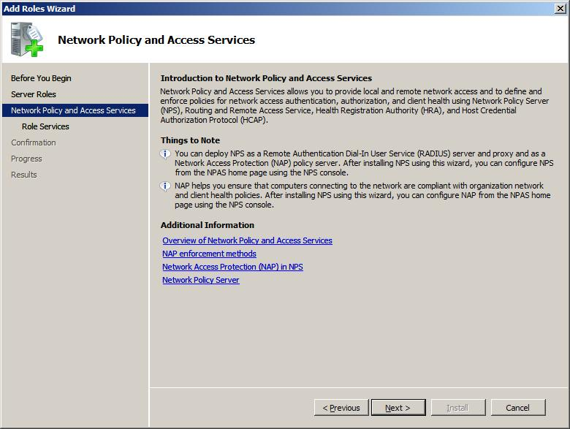
Network Policy and Access Services delivers a variety of methods to provide users with local and remote network connectivity, to connect network segments, and to allow network administrators to centrally manage network access and client health policies.
With Network Access Services, you can deploy VPN servers, dial-up servers, routers, and 802.11-protected wireless access. You can also deploy RADIUS servers and proxies, and use Connection Manager Administration Kit to create remote access profiles that allow client computers to connect to your network.
Network Policy and Access Services provides the following network connectivity solutions:
- Network Access Protection. NAP is a client health policy creation, enforcement and remediation technology that is included in the Windows Vista Business, Enterprise and Ultimate operating systems and in the Windows Server 2008 operating system. With NAP, system administrators can establish and automatically enforce health policies, which can include software requirements, security update requirements, required computer configurations and other settings. Client computers that are not in compliance with health policy can be provided with restricted network access until their configuration is updated and brought into compliance with policy. Depending on how you choose to deploy NAP, noncompliant clients can be automatically updated so that users can quickly regain full network access without manually updating or reconfiguring their computers.
- Secure wireless and wired access. When you deploy 802.1X wireless access points, secure wireless access provides wireless users with a security-enhanced password-based authentication method that is easy to deploy. When you deploy 802.1X authenticating switches, wired access allows you to secure your network by ensuring that intranet users are authenticated before they can connect to the network or obtain an IP address using DHCP.
- Remote access solutions. With remote access solutions, you can provide users with VPN and traditional dial-up access to your organization’s network. You can also connect branch offices to your network with VPN solutions, deploy full-featured software routers on your network, and share Internet connections across the intranet.
- Central network policy management with RADIUS server and proxy. Rather than configuring network access policy at each network access server, such as wireless access points, 802.1X authenticating switches, VPN servers, and dial-up servers, you can create policies in a single location that specify all aspects of network connection requests, including who is allowed to connect, when they can connect, and the level of security they must use to connect to your network.
Role Services for Network Policy and Access Services
When you install Network Policy and Access Services, the following role services are available:
- Network Policy Server. NPS is the Microsoft® implementation of a RADIUS server and proxy. You can use NPS to centrally manage network access through a variety of network access servers, including wireless access points, virtual private networking (VPN) servers, dial-up servers, and 802.1X authenticating switches. In addition, you can use NPS to deploy secure password authentication with Protected Extensible Authentication Protocol (PEAP)-MS-CHAP v2 for wireless connections. NPS also contains key components for deploying NAP on your network.
The following technologies can be deployed after the installation of the NPS role service:
  - NAP policy server. When you configure NPS as a NAP policy server, NPS evaluates statements of health (SoH) sent by NAP-capable client computers that want to connect to the network. You can configure NAP policies on NPS that allow client computers to update their configuration to become compliant with your organization’s network policy.
  - IEEE 802.11 Wireless. Using the NPS Microsoft Management Console (MMC) snap-in, you can configure 802.1X-based connection request policies for IEEE 802.11 wireless client network access. You can also configure wireless access points as Remote Authentication Dial-In User Service (RADIUS) clients in NPS, and use NPS as a RADIUS server to process connection requests, as well as perform authentication, authorization and accounting for 802.11 wireless connections. You can fully integrate IEEE 802.11 wireless access with NAP when you deploy a wireless 802.1X authentication infrastructure so that the health status of wireless clients is verified against health policy before clients are allowed to connect to the network.
  - IEEE 802.3 Wired. Using the NPS MMC snap-in, you can configure 802.1X-based connection request policies for IEEE 802.3 wired client Ethernet network access. You can also configure 802.1X-compliant switches as RADIUS clients in NPS, and use NPS as a RADIUS server to process connection requests, as well as perform authentication, authorization and accounting for 802.3 Ethernet connections. You can fully integrate IEEE 802.3 wired client access with NAP when you deploy a wired 802.1X authentication infrastructure.
  - RADIUS server. NPS performs centralized connection authentication, authorization and accounting for wireless, authenticating switch and remote access dial-up and VPN connections. When you use NPS as a RADIUS server, you configure network access servers, such as wireless access points and VPN servers, as RADIUS clients in NPS. You also configure network policies that NPS uses to authorize connection requests, and you can configure RADIUS accounting so that NPS logs accounting information to log files on the local hard disk or in a Microsoft SQL Server™ database.
  - RADIUS proxy. When you use NPS as a RADIUS proxy, you configure connection request policies that tell the NPS server which connection requests to forward to other RADIUS servers and to which RADIUS servers you want to forward connection requests. You can also configure NPS to forward accounting data to be logged by one or more computers in a remote RADIUS server group.
- Routing and Remote Access. With Routing and Remote Access, you can deploy VPN and dial-up remote access services and multiprotocol LAN-to-LAN, LAN-to-WAN, VPN, and network NAT routing services.
The following technologies can be deployed during the installation of the Routing and Remote Access role service:
  - Remote Access Service. Using Routing and Remote Access, you can deploy Point-to-Point Tunneling Protocol (PPTP) or Layer Two Tunneling Protocol (L2TP) with Internet Protocol security (IPsec) VPN connections to provide end users with remote access to your organization’s network. You can also create a site-to-site VPN connection between two servers at different locations. Each server is configured with Routing and Remote Access to send private data securely. The connection between the two servers can be persistent (always on) or on demand (demand-dial).
Remote Access also provides traditional dial-up remote access to support mobile users or home users who are dialing in to an organization’s intranets. Dial-up equipment that is installed on the server running Routing and Remote Access answers incoming connection requests from dial-up networking clients. The remote access server answers the call, authenticates and authorizes the caller, and transfers data between the dial-up networking client and the organization intranet.
  - Routing. Routing provides a full-featured software router and an open platform for routing and internetworking. It offers routing services to businesses in local area network (LAN) and wide area network (WAN) environments.
When you deploy NAT, the server running Routing and Remote Access is configured to share an Internet connection with computers on the private network and to translate traffic between its public address and the private network. By using NAT, the computers on the private network gain some measure of protection because the router with NAT configured does not forward traffic from the Internet into the private network unless a private network client had requested it or unless the traffic is explicitly allowed.
When you deploy VPN and NAT, the server running Routing and Remote Access is configured to provide NAT for the private network and to accept VPN connections. Computers on the Internet will not be able to determine the IP addresses of computers on the private network. However, VPN clients will be able to connect to computers on the private network as if they were physically attached to the same network.
- Health Registration Authority (HRA). HRA is a NAP component that issues health certificates to clients that pass the health policy verification that is performed by NPS using the client SoH. HRA is used only when the NAP enforcement method is IPsec enforcement.
- Host Credential Authorization Protocol (HCAP). HCAP allows you to integrate your Microsoft NAP solution with Cisco Network Access Control Server. When you deploy HCAP with NPS and NAP, NPS can perform client health evaluation and the authorization of Cisco 802.1X access clients.
Managing the Network Policy and Access Services Server Role
The following tools are provided to manage the Network Policy and Access Services server role:
- NPS MMC snap-in. Use the NPS MMC to configure a RADIUS server, RADIUS proxy or NAP technology.
- Netsh commands for NPS. The Netsh commands for NPS provide a command set that is fully equivalent to all configuration settings that are available through the NPS MMC snap-in. Netsh commands can be run manually at the Netsh prompt or in administrator scripts.
- HRA MMC snap-in. Use the HRA MMC to designate the certification authority (CA) that HRA uses to obtain health certificates for client computers and to define the NPS server to which HRA sends client SoHs for verification against health policy.
- Netsh commands for HRA. The Netsh commands for HRA provide a command set that is fully equivalent to all configuration settings that are available through the HRA MMC snap-in. Netsh commands can be run manually at the Netsh prompt or in administrator-authored scripts.
- NAP Client Management MMC snap-in. You can use the NAP Client Management snap-in to configure security settings and user interface settings on client computers that support the NAP architecture.
- Netsh commands for configuring NAP client settings. The Netsh commands for NAP client settings provide a command set that is fully equivalent to all configuration settings that are available through the NAP Client Management snap-in. Netsh commands can be run manually at the Netsh prompt or in administrator-authored scripts.
- Routing and Remote Access MMC snap-in. Use this MMC snap-in to configure a VPN server, a dial-up networking server, a router, NAT, VPN and NAT, or a VPN site-to-site connection.
- Netsh commands for remote access (RAS). The Netsh commands for remote access provide a command set that is fully equivalent to all remote access configuration settings that are available through the Routing and Remote Access MMC snap-in. Netsh commands can be run manually at the Netsh prompt or in administrator scripts.
- Netsh commands for routing. The Netsh commands for routing provide a command set that is fully equivalent to all routing configuration settings that are available through the Routing and Remote Access MMC snap-in. Netsh commands can be run manually at the Netsh prompt or in administrator scripts.
- Wireless Network (IEEE 802.11) Policies – Group Policy Object Editor (MMC) snap-in. The Wireless Network (IEEE 802.11) Policies extension automates the configuration of wireless network settings on computers with wireless network adapter drivers that support the Wireless LAN Autoconfiguration Service (WLAN Autoconfig Service). You can use the Wireless Network (IEEE 802.11) Policies extension in the Group Policy Object Editor to specify configuration settings for either or both Windows XP and Windows Vista wireless clients. Wireless Network (IEEE 802.11) Policies Group Policy extensions include global wireless settings, the list of preferred networks, Wi-Fi Protected Access (WPA) settings, and IEEE 802.1X settings.
When configured, the settings are downloaded to Windows wireless clients that are members of the domain. The wireless settings configured by this policy are part of the Computer Configuration Group Policy. By default, Wireless Network (IEEE 802.11) Policies are not configured or enabled.
- Netsh commands for wireless local area network (WLAN). Netsh WLAN is an alternative to using Group Policy to configure Windows Vista wireless connectivity and security settings. You can use the Netsh wlan commands to configure the local computer, or to configure multiple computers using a logon script. You can also use the Netsh wlan commands to view wireless Group Policy settings and administer Wireless Internet Service Provider (WISP) and user wireless settings.
The wireless Netsh interface has the following benefits:
  - Mixed mode support. This allows administrators to configure clients to support multiple security options. For example, a client can be configured to support both the WPA2 and the WPA authentication standards. This allows the client to use WPA2 to connect to networks that support WPA2 and use WPA to connect to networks that only support WPA.
  - Block undesirable networks. Administrators can block and hide access to noncorporate wireless networks by adding networks or network types to the list of denied networks. Similarly, administrators can allow access to corporate wireless networks.
- Wired Network (IEEE 802.3) Policies – Group Policy Object Editor (MMC) snap-in. You can use the Wired Network (IEEE 802.3) Policies to specify and modify configuration settings for Windows Vista clients that are equipped with network adapters and drivers that support Wired AutoConfig Service. Wireless Network (IEEE 802.11) Policies Group Policy extensions include global wired and IEEE 802.1X settings. These settings include the entire set of wired configuration items associated with the General tab and the Security tab.
When configured, the settings are downloaded to Windows wireless clients that are members of the domain. The wireless settings configured by this policy are part of the Computer Configuration Group Policy. By default, Wired Network (IEEE 802.3) Policies are not configured or enabled.
- Netsh commands for wired LAN. The Netsh LAN interface is an alternative to using Group Policy in Windows Server 2008 to configure Windows Vista wired connectivity and security settings. You can use the Netsh LAN command line to configure the local computer, or use the commands in logon scripts to configure multiple computers. You can also use the Netsh LAN commands to view Wired Network (IEEE 802.3) Policies and to administer client wired 1x settings.
Additional Resources
To learn more about Network Policy and Access Services, open one of the following MMC snap-ins and then press F1 to display the Help:
- NPS MMC snap-in
- Routing and Remote Access MMC snap-in
- HRA MMC snap-in
- Group Policy Object Editor (MMC) snap-in

5.03 Network Access Protection
One of the greatest challenges to today’s businesses is the increasing exposure of client devices to malicious software such as viruses and worms. These programs can gain entry to unprotected or incorrectly configured host systems, and can use this system as a staging point to propagate to other devices on the corporate network. Network administrators can use the Network Access Protection (NAP) features to better protect their network by helping ensure that client systems maintain proper system configurations and software updates to help protect them from malicious software.
Network Access Protection (NAP) is a new set of operating system components included with Windows Server® 2008 and Windows Vista® that provides a platform to help ensure that client computers on a private network meet administrator-defined requirements for system health. NAP policies define the required configuration and update status for a client computer’s operating system and critical software. For example, computers might be required to have anti-virus software with the latest signatures installed, current operating system updates installed, and a host-based firewall enabled. By enforcing compliance with health requirements, NAP can help network administrators mitigate some of the risk caused by improperly configured client computers that might be exposed to viruses and other malicious software.
NAP enforces health requirements by monitoring and assessing the health of client computers when they attempt to connect or to communicate on a network. If client computers are determined to be noncompliant with health requirements, they can be placed on a restricted network that contains resources to assist in remediating client systems so that they can become compliant with health policies.
Network and system administrators who want to enforce system health requirements for client computers connecting to the networks they support will be interested in NAP. With NAP, network administrators can do the following:
- Help ensure the health of desktop computers on the LAN that are configured for DHCP or that connect through 802.1X authenticating devices, or that have NAP IPsec policies applied to their communications
- Enforce health requirements for roaming laptops when they reconnect to the company network
- Verify the health and policy compliance of unmanaged home computers that connect to the company network through a VPN server running Routing and Remote Access
- Determine the health and restrict access of laptops brought to an organization by visitors and partners
Depending on their needs, administrators can configure a solution to address any or all of these scenarios.
NAP also includes an API set for developers and vendors to build their own components for network policy validation, ongoing compliance and network isolation.
NAP deployments require servers that are running Windows Server 2008. In addition, client computers running Windows Vista, Windows Server 2008, or Windows XP with SP2 and the Network Access Protection Client for Windows XP are required. The central server that performs health determination analysis for NAP is a computer running Windows Server 2008 and NPS. NPS is the Windows implementation of a RADIUS server and proxy. NPS is the replacement for the Internet Authentication Service (IAS) in Windows Server 2003. Access devices and NAP servers act as RADIUS clients to an NPS-based RADIUS server. NPS performs authentication and authorization of a network connection attempt and, based on configured system health policies, determines computer health compliance and how to limit a noncompliant computer’s network access.
The NAP platform is a new client health validation and enforcement technology included with the Windows Server 2008 and Windows Vista operating systems.
Note
The NAP framework is not the same as Network Access Quarantine Control, which is a feature provided with Windows Server 2003 and ISA Server 2004. Network Access Quarantine Control can provide additional protection for remote access (dial-up and VPN) connections. For more information about Network Access Quarantine Control in Windows Server 2003, see Network Access Quarantine Control in Windows Server 2003 (http://go.microsoft.com/fwlink/?LinkId=56447). For more information about this feature in ISA Server 2004, see VPN Roaming Clients and Quarantine Control in ISA Server 2004 Enterprise Edition (http://go.microsoft.com/fwlink/?LinkId=56449).
Key Processes of NAP
Several key processes are required for NAP to function properly: policy validation, NAP enforcement and network restriction, remediation, and ongoing monitoring to ensure compliance.
Policy Validation
System health validators (SHVs) are used by NPS to analyze the health status of client computers. SHVs are incorporated into network polices that determine actions to be taken based on client health status, such as granting of full network access or restricting network access. Health status is monitored by client-side NAP components called system health agents (SHAs). NAP uses SHAs and SHVs to monitor, enforce and remediate client computer configurations.
Windows Security Health Agent and Windows Security Health Validator are included with the Windows Server 2008 and Windows Vista operating systems, and enforce the following settings for NAP-capable computers:
- The client computer has firewall software installed and enabled.
- The client computer has anti-virus software installed and running.
- The client computer has current anti-virus updates installed.
- The client computer has anti-spyware software installed and running.
- The client computer has current anti-spyware updates installed.
- Microsoft Update Services is enabled on the client computer.
In addition, if NAP-capable client computers are running Windows Update Agent and are registered with a Windows Server Update Service (WSUS) server, NAP can verify that the most recent software security updates are installed based on one of four possible values that match security severity ratings from the Microsoft Security Response Center (MSRC).
NAP Enforcement and Network Restriction
NAP can be configured to deny noncompliant client computers access to the network or allow them access to a restricted network only. A restricted network should contain key NAP services, such as Health Registration Authority (HRA) servers and remediation servers, so that noncompliant NAP clients can update their configurations to comply with health requirements.
NAP enforcement settings allow you to either limit network access of noncompliant clients, or merely observe and log the health status of NAP-capable client computers.
You can choose to restrict access, defer restriction of access, or allow access by using the following settings:
- Allow full network access. This is the default setting. Clients that match the policy conditions are deemed compliant with network health requirements, and granted unrestricted access to the network if the connection request is authenticated and authorized. The health compliance status of NAP-capable client computers is logged.
- Allow full network access for a limited time. Clients that match the policy conditions are temporarily granted unrestricted access. NAP enforcement is delayed until the specified date and time.
- Allow limited access. Client computers that match the policy conditions are deemed noncompliant with network health requirements, and are placed on the restricted network.
Remediation
Noncompliant client computers that are placed on a restricted network might undergo remediation. Remediation is the process of updating a client computer so that it meets current health requirements. For example, a restricted network might contain a File Transfer Protocol (FTP) server that provides current virus signatures so that noncompliant client computers can update their outdated signatures.
You can use NAP settings in NPS health policies to configure automatic remediation so that NAP client components automatically attempt to update the client computer when it is noncompliant with network health requirements. You can use the following network policy setting to configure automatic remediation:
- Auto remediation. If Enable auto-remediation of client computers is selected, automatic remediation is enabled, and NAP-capable computers that do not comply with health requirements automatically attempt to update themselves.
Ongoing Monitoring to Ensure Compliance
NAP can enforce health compliance on compliant client computers that are already connected to the network. This functionality is useful for ensuring that a network is protected on an ongoing basis as health policies change and the health of client computers changes. For example, if health policy requires that Windows Firewall is turned on but a user has inadvertently turned it off, NAP can determine that the client computer is in a noncompliant state. NAP will then place the client computer on the restricted network until Windows Firewall is turned back on.
If automatic remediation is enabled, NAP client components can automatically enable Windows Firewall without user intervention.
NAP Enforcement Methods
Based on the health state of a client computer, NAP can allow full network access, limit access to a restricted network, or deny access to the network. Client computers that are determined to be noncompliant with health policies can also be automatically updated to meet these requirements. The way that NAP is enforced depends on the enforcement method you choose. NAP enforces health policies for the following:
- IPsec-protected traffic
- 802.1X port-based wired and wireless network access control
- Virtual private networks (VPN) with Routing and Remote Access
- Dynamic Host Configuration Protocol (DHCP) IPv4 address lease and renewal
- Connections to a Terminal Services Gateway (TS Gateway) server
The following sections describe these enforcement methods.
NAP Enforcement for IPsec Communications
NAP enforcement for IPsec-protected traffic is deployed with a health certificate server, an HRA server, an NPS server and an IPsec enforcement client. The health certificate server issues X.509 certificates to NAP clients when they are determined to be compliant with network health requirements. These certificates are then used to authenticate NAP clients when they initiate IPsec-protected communications with other NAP clients on an intranet.
IPsec enforcement confines the communication on your network to compliant clients, and provides the strongest form of NAP enforcement. Because this enforcement method uses IPsec, you can define requirements for protected communications on a per-IP address or per-TCP/UDP port number basis.
NAP Enforcement for 802.1X
NAP enforcement for 802.1X port-based network access control is deployed with an NPS server and an EAPHost enforcement client component. With 802.1X port-based enforcement, an NPS server instructs an 802.1X authenticating switch or an 802.1X-compliant wireless access point to place noncompliant 802.1X clients on a restricted network. The NPS server limits the client’s network access to the restricted network by instructing the access point to apply IP filters or a virtual LAN identifier to the connection. 802.1X enforcement provides strong network restriction for all computers accessing the network through 802.1X-capable network access devices.
NAP Enforcement for VPN
NAP enforcement for VPN is deployed with a VPN enforcement server component and a VPN enforcement client component. Using NAP enforcement for VPN, VPN servers can enforce health policy when client computers attempt to connect to the network using a remote access VPN connection. VPN enforcement provides strong limited network access for all computers accessing the network through a remote access VPN connection.
NAP Enforcement for DHCP
DHCP enforcement is deployed with a DHCP NAP enforcement server component, a DHCP enforcement client component, and NPS. Using DHCP enforcement, DHCP servers and NPS can enforce health policy when a computer attempts to lease or renew an IPv4 address. The NPS server limits the client’s network access to the restricted network by instructing the DHCP server to assign a limited IP address configuration. However, if client computers are configured with a static IP address or are otherwise configured to circumvent the limited IP address configuration, DHCP enforcement is not effective.
NAP Enforcement for TS Gateway
NAP enforcement for TS Gateway is deployed with a TS Gateway enforcement server component and a TS Gateway enforcement client component. Using NAP enforcement for TS Gateway, the TS Gateway server can enforce health policy on client computers that attempt to connect to internal corporate resources through the TS Gateway server. TS Gateway enforcement provides strong limited access for all computers accessing the network through a TS Gateway server.
Combined Approaches
Each of these NAP enforcement methods has different advantages. By combining enforcement methods, you can combine the advantages of these different methods. Deploying multiple NAP enforcement methods, however, can make your NAP implementation more complex to manage.
The NAP framework also provides a suite of APIs that allow companies other than Microsoft to integrate their software into the NAP platform. By using the NAP APIs, software developers and vendors can provide end-to-end solutions that validate health and remediate noncompliant clients.
Deployment
The preparations you need to make for deploying NAP depend on the enforcement method or methods you choose, and the health requirements you intend to enforce when client computers connect to or communicate on your network.
If you are a network or system administrator, you can deploy NAP with the Windows Security Health Agent and Windows Security Health Validator. You can also check with other software vendors to find out if they provide SHAs and SHVs for their products. For example, if an anti-virus software vendor wants to create a NAP solution that includes a custom SHA and SHV, it can use the API set to create these components. These components can then be integrated into the NAP solutions that its customers deploy.
In addition to SHAs and SHVs, the NAP platform uses multiple client and server-side components to detect and monitor the system health status of client computers when they attempt to connect or communicate on a network. Some common components used to deploy NAP are illustrated in the following figure:
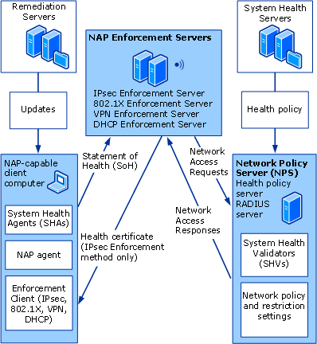

NAP Client Components
A NAP-capable client is a computer that has the NAP components installed and that can verify its health state by sending a list of statements of health (SoH) to NPS. The following are common NAP client components.
System health agent (SHA). Monitors and reports the client computer’s health state so that NPS can determine whether the settings monitored by the SHA are up to date and configured correctly. For example, the Microsoft SHA can monitor Windows Firewall; whether anti-virus software is installed, enabled and updated; whether anti-spyware software is installed, enabled and updated; and whether Microsoft Update Services is enabled and the computer has its most recent security updates. There might also be SHAs available from other companies that provide additional functionality.
NAP agent. Collects and manages health information. NAP agent also processes SoH from SHAs and reports client health to installed enforcement clients. To indicate the overall health state of a NAP client, the NAP agent uses a list of SoH.
NAP enforcement client (NAP EC). To use NAP, at least one NAP enforcement client must be installed and enabled on client computers. Individual NAP enforcement clients are enforcement method-specific, as described previously. NAP enforcement clients integrate with network access technologies, such as IPsec, 802.1X port-based wired and wireless network access control, VPN with Routing and Remote Access, and DHCP. The NAP enforcement client requests access to a network, communicates a client computer’s health status to the NPS server, and communicates the restricted status of the client computer to other components of the NAP client architecture.
Statement of health (SoH). A declaration from an SHA that asserts its health status. SHAs create SoHs and send them to the NAP agent.
NAP Server Components
The following are common NAP server components.
NAP health policy server. A server running NPS that is acting in the role of a NAP health evaluation server. The NAP health policy server has health policies and network policies that define health requirements and enforcement settings for client computers requesting network access. The NAP health policy server uses NPS to process RADIUS Access-Request messages containing the system SoH sent by the NAP EC, and passes them to the NAP administration server for evaluation.
NAP administration server. Provides a processing function that is similar to the NAP agent on the client side. It is responsible for collecting SoHs from NAP enforcement points, distributing SoHs to the appropriate system health validators (SHVs), and collecting SoH responses (SoHRs) from the SHVs and passing them to the NPS service for evaluation.
System health validators (SHVs). Server software counterparts to SHAs. Each SHA on the client has a corresponding SHV in NPS. SHVs verify the SoH that is made by its corresponding SHA on the client computer. SHAs and SHVs are matched to each other, along with a corresponding health requirement server (if applicable) and perhaps a remediation server. The SHV can also detect that no SoH has been received (such as in the case where the SHA has never been installed, or has been damaged or removed). Whether the SoH meets or does not meet the defined policy, the SHV sends a statement of health response (SoHR) message to the NAP administration server. One network might have more than one kind of SHV. If it does, the server running NPS must coordinate the output from all of the SHVs and determine whether to limit the access of a noncompliant computer. If your deployment uses multiple SHVs, you need to understand how they interact and plan carefully when you configure health policies.
NAP enforcement server (NAP ES). Matched to a corresponding NAP EC for the NAP enforcement method being used. NAP ES receives the list of SoHs from the NAP EC and passes them to NPS for evaluation. Based on the response, it provides either limited or unlimited network access to a NAP-capable client. Depending on the type of NAP enforcement, the NAP ES can be a component of a NAP enforcement point.
NAP enforcement point. A server or network access device that uses NAP or can be used with NAP to require the evaluation of a NAP client’s health state and provide restricted network access or communication. A NAP enforcement point can be a health registration authority (IPsec enforcement), an authenticating switch or wireless access point (802.1x enforcement), a server running Routing and Remote Access (VPN enforcement), a DHCP server (DHCP enforcement), or a TS Gateway server (TS Gateway enforcement).
Health requirement server. A software component that communicates with a SHV to provide information used in evaluating requirements for system health. For example, a health requirement server can be an antivirus signature server that provides the version of the current signature file for validation of a client antivirus SoH. Health requirement servers are matched to SHVs, but not all SHVs need a health requirement server. For example, a SHV can just instruct NAP-capable clients to check local system settings to ensure that a host-based firewall is enabled.
Remediation server. Hosts the updates that SHAs can use to bring noncompliant client computers into compliance. For example, a remediation server can host software updates. If health policy requires that NAP client computers have the latest software updates installed, the NAP EC will restrict network access to clients without these updates. Remediation servers must be accessible to clients with restricted network access in order for clients to obtain the updates required to comply with health policies.
Statement of health response (SoHR). Contains the results of the SHV's evaluation of the client SoH. The SoHR reverses the path of the SoH and is sent back to the client computer SHA. If the client computer is deemed noncompliant, the SoHR contains remediation instructions that the SHA uses to bring the client computer configuration into compliance with health requirements.
Just as each type of SoH contains information about system health status, each SoHR message contains information about how to become compliant with health requirements.
Additional Information
- For more information about NAP, see Network Access Protection (http://go.microsoft.com/fwlink/?LinkId=56443).

5.04 Network Policy Server
Network Policy Server (NPS) allows you to create and enforce organization-wide network access policies for client health, connection request authentication, and connection request authorization.
Network Policy Server is the Microsoft implementation of a Remote Authentication Dial-In User Service (RADIUS) server and proxy. You can use NPS to centrally manage network access through a variety of network access servers, including wireless access points, VPN servers, dial-up servers, and 802.1X authenticating switches. In addition, you can use NPS to deploy secure password authentication with Protected Extensible Authentication Protocol (PEAP)-MS-CHAP v2 for wireless connections. NPS also has key components for deploying Network Access Protection (NAP) on your network.
The following technologies can be deployed after the NPS role service has been installed:
- NAP policy server. When you configure NPS as a NAP policy server, NPS evaluates statements of health (SoH) sent by NAP-capable client computers that want to communicate on the network. You can create NAP policies in NPS that allow client computers to update their configuration to comply with your organization's network policy.
- IEEE 802.11 Wireless. Using the NPS Microsoft Management Console (MMC) snap-in, you can configure 802.1X-based connection request policies for IEEE 802.11 wireless client network access. You can also configure wireless access points as RADIUS clients in NPS, and use NPS as a RADIUS server to process connection requests, as well as perform authentication, authorization, and accounting for 802.11 wireless connections. You can fully integrate IEEE 802.11 wireless access with NAP when you deploy a wireless 802.1X authentication infrastructure so that the health status of wireless clients is verified against health policy before clients are allowed to connect to the network.
- IEEE 802.3 Wired. Using the NPS MMC snap-in, you can configure 802.1X-based connection request policies for IEEE 802.3 wired client Ethernet network access. You can also configure 802.1X-compliant switches as RADIUS clients in NPS, and use NPS as a RADIUS server to process connection requests, as well as perform authentication, authorization, and accounting for 802.3 Ethernet connections. You can fully integrate IEEE 802.3 wired client access with NAP when you deploy a wired 802.1X authentication infrastructure.
- RADIUS server. NPS performs centralized connection authentication, authorization, and accounting for wireless, authenticating switch, and remote access dial-up and VPN connections, as well as for connections to computers running Terminal Services Gateway (TS Gateway). When you use NPS as a RADIUS server, you configure network access servers, such as wireless access points and VPN servers, as RADIUS clients in NPS. You also configure network policies that NPS uses to authorize connection requests. You can configure RADIUS accounting so that NPS records accounting information to log files on the local hard disk or in a Microsoft® SQL Server™ database.
- RADIUS proxy. When you use NPS as a RADIUS proxy, you configure connection request policies that tell the server running NPS which connection requests to forward to other RADIUS servers and to which RADIUS servers you want to forward connection requests. You can also configure NPS to forward accounting data to be logged by one or more computers in a remote RADIUS server group.
Network and systems administrators that want to centrally manage network access, including authentication (verification of identity), authorization (verification of the right to access the network), and accounting (the logging of NPS status and network connection process data), will be interested in deploying Network Policy Server.
When a server running NPS is a member of an Active Directory® domain, NPS uses the directory service as its user account database and is part of a single sign-on solution. The same set of credentials is used for network access control (authenticating and authorizing access to a network) and to log on to an Active Directory domain. Because of this, it is recommended that you use NPS with Active Directory Domain Services (AD DS).
The following additional considerations apply when using NPS.
- To deploy NPS with secure IEEE 802.1X wired or wireless access, you must enroll a server certificate to the server running NPS using Active Directory Certificate Services (AD CS) or a non-Microsoft public certification authority (CA). To deploy EAP-TLS or PEAP-TLS, you must also enroll computer or user certificates, which requires that you design and deploy a public key infrastructure (PKI) using AD CS. In addition, you must purchase and deploy network access servers (wireless access points or 802.1X authenticating switches) that are compatible with the RADIUS protocol and EAP.
- To deploy NPS with TS Gateway, you must deploy TS Gateway on the local or a remote computer that is running Windows Server® 2008.
- To deploy NPS with Routing and Remote Access configured as a VPN server, a member of a VPN site-to-site configuration, or a dial-up server, you must deploy Routing and Remote Access on the local or a remote computer that is running Windows Server 2008.
- To deploy NPS with NAP, you must deploy additional NAP components as described in NPS product Help and other NAP documentation.
- To deploy NPS with SQL Server logging, you must deploy Microsoft SQL Server 2000 or Microsoft SQL Server 2005 on the local or a remote computer.
NPS provides the following new functionality in Windows Server 2008.
- Network Access Protection (NAP). A client health policy creation, enforcement, and remediation technology that is included in Windows Vista® and Windows Server 2008. With NAP, you can establish health policies that define such things as software requirements, security update requirements, and required configuration settings for computers that connect to your network.
- Network shell (Netsh) commands for NPS. A comprehensive command set that allows you to manage all aspects of NPS using commands at the netsh prompt and in scripts and batch files.
- New Windows interface. Windows interface improvements, including policy creation wizards for NAP, network policy, and connection request policy; and wizards designed specifically for deployments of 802.1X wired and wireless and VPN and dial-up connections.
- Support for Internet Protocol version 6 (IPv6). NPS can be deployed in IPv6-only environments, IPv4-only environments, and in mixed environments where both IPv4 and IPv6 are used.
- Integration with Cisco Network Admission Control (NAC). With Host Credential Authorization Protocol (HCAP) and NPS, you can integrate Network Access Protection (NAP) with Cisco NAC. NPS provides the Extended State and Policy Expiration attributes in network policy for Cisco integration.
- Attributes to identify access clients. The operating system and access client conditions allow you to create network access policies that apply to clients you specify and to clients running operating system versions you specify.
- Integration with Server Manager. NPS is integrated with Server Manager, which allows you to manage multiple technologies from one Windows interface location.
- Network policies that match the network connection method. You can create network policies that are applied only if the network connection method, such as VPN, TS Gateway, or DHCP, matches the policy. This allows NPS to process only the policies that match the type of RADIUS client used for the connection.
- Common Criteria support. NPS can be deployed in environments where support for Common Criteria is required. For more information, see Common Criteria portal at http://go.microsoft.com/fwlink/?LinkId=95567.
- NPS extension library. NPS provides extensibility that enables non-Microsoft organizations and companies to implement custom RADIUS solutions by authoring NPS extension dynamic-link libraries (DLLs). NPS is now resilient to failures in non-Microsoft extension DLLs.
- XML NPS configuration import and export. You can import NPS server configuration to a XML file and import NPS server configurations using XML files with the netsh NPS commands.
- EAPHost and EAP policy support. NPS supports EAPHost, which is also available in Windows Vista. EAPHost is a Windows service that implements RFC 3748 and supports all RFC-compliant EAP methods, including expanded EAP types. EAPHost also supports multiple implementations of the same EAP method. NPS administrators can configure network policy and connection request policy based on EAPHost EAP methods.

5.05 Routing and Remote Access Service
The Routing and Remote Access service in Windows Server® 2008 provides remote users access to resources on your private network over virtual private network (VPN) or dial-up connections. Servers configured with the Routing and Remote Access service can provide local area network (LAN) and wide area network (WAN) routing services used to connect network segments within a small office or to connect two private networks over the Internet.
Routing and Remote Access applies to network and system administrators interested in supporting the following remote access and routing scenarios:
- Remote Access (VPN) to allow remote access clients to connect to the private network across the Internet.
- Remote Access (dial-up) to allow remote access clients to connect to the private network by dialing into a modem bank or other dial-up equipment.
- Network address translation (NAT) to share an Internet connection with computers on the private network and to translate traffic between public and private networks.
- Secure connection between two private networks to send private data securely across the Internet.
- Routing between two networks for configuring a simple routing, multiple-router, or demand-dial routing topology.
The Routing and Remote Access service in Windows Server 2008 provides:
- Remote access
- Routing
Remote Access
By configuring Routing and Remote Access to act as a remote access server, you can connect remote or mobile workers to your organization's networks. Remote users can work as if their computers are physically connected to the network.
All services typically available to a LAN-connected user (including file and printer sharing, Web server access, and messaging) are enabled by means of the remote access connection. For example, on a server running Routing and Remote Access, clients can use Windows Explorer to make drive connections and to connect to printers. Because drive letters and universal naming convention (UNC) names are fully supported by remote access, most commercial and custom applications work without modification.
A server running Routing and Remote Access provides two different types of remote access connectivity:
- Virtual private networking (VPN). VPN is the creation of secured, point-to-point connections across a private network or a public network, such as the Internet. A VPN client uses special TCP/IP-based protocols called tunneling protocols to make a virtual call to a virtual port on a VPN server. The best example of virtual private networking is that of a VPN client that makes a VPN connection to a remote access server that is connected to the Internet. The remote access server answers the virtual call, authenticates the caller, and transfers data between the VPN client and the corporate network. In contrast to dial-up networking, VPN is always a logical, indirect connection between the VPN client and the VPN server over a public network, such as the Internet. To ensure privacy, you must encrypt data sent over the connection.
- Dial-up networking. In dial-up networking, a remote access client makes a nonpermanent, dial-up connection to a physical port on a remote access server by using the service of a telecommunications provider, such as analog phone or ISDN. The best example of dial-up networking is that of a dial-up networking client that dials the phone number of one of the ports of a remote access server. Dial-up networking over an analog phone or ISDN is a direct physical connection between the dial-up networking client and the dial-up networking server. You can encrypt data sent over the connection, but it is not required.
Routing
A router is a device that manages the flow of data between network segments, or subnets. A router directs incoming and outgoing packets based on the information it holds about the state of its own network interfaces and a list of possible sources and destinations for network traffic. By projecting network traffic and routing needs based on the number and types of hardware devices and applications used in your environment, you can better decide whether to use a dedicated hardware router, a software-based router, or a combination of both. Generally, dedicated hardware routers handle heavier routing demands best, and less expensive software-based routers handle lighter routing loads.
A software-based routing solution, such as the Routing and Remote Access service in Windows Server 2008, can be ideal on a small, segmented network with relatively light traffic between subnets. Conversely, enterprise network environments that have a large number of network segments and a wide range of performance requirements might need a variety of hardware-based routers to perform different roles throughout the network.
NAP Enforcement for VPN
Network Access Protection (NAP) is a client health policy creation, enforcement, and remediation technology that is included in Windows Vista® client operating system and in the Windows Server 2008 operating system. With NAP, system administrators can establish and automatically enforce health policies, which can include software requirements, security update requirements, required computer configurations, and other settings.
When making VPN connections, client computers that are not in compliance with health policy can be provided with restricted network access until their configuration is updated and brought into compliance with policy. Depending on how you choose to deploy NAP, noncompliant clients can be automatically updated so that users can quickly regain full network access without manually updating or reconfiguring their computers.
VPN enforcement provides strong limited network access for all computers accessing the network through a VPN connection. NAP VPN enforcement is similar in function to Network Access Quarantine Control, a feature in Windows Server 2003, but it is easier to deploy.
SSTP Tunneling Protocol
Secure Socket Tunneling Protocol (SSTP) is a new form of virtual private networking (VPN) tunnel. SSTP provides a mechanism to encapsulate PPP traffic over the SSL channel of the HTTPS protocol. The use of PPP allows support for strong authentication methods, such as EAP-TLS. The use of HTTPS means traffic will flow through TCP port 443, a port commonly used for Web access. Secure Sockets Layer (SSL) provides transport-level security with enhanced key negotiation, encryption, and integrity checking. Use of SSTP is supported in Windows Server 2008 and Windows Vista® with Service Pack 1 (SP1).
Traffic encapsulated with SSTP can pass through firewalls that block PPTP and L2TP/IPsec traffic.
New Cryptographic Support
In response to governmental security requirements and trends in the security industry to support stronger cryptography, Windows Server 2008 and Windows Vista support the following encryption algorithms for PPTP and L2TP VPN connections.
PPTP | - Only 128-bit RC4 encryption algorithm is supported.  - 40 and 56-bit RC4 support is removed, but can be added (not recommended) by changing a registry key.
L2TP/IPsec | Data Encryption Standard (DES) encryption algorithm with Message Digest 5 (MD5) integrity check support is removed, but can be added (not recommended) by changing a registry key.  IKE Main Mode will support:  - Advanced Encryption Standard (AES) 256 (new), AES 192 (new), AES 128 (new), and 3DES encryption algorithms.  - Secure Hash Algorithm 1 (SHA1) integrity check algorithm.  - Diffie-Hellman (DH) groups 19 (new) and 20 (new) for Main Mode negotiation.  IKE Quick Mode will support:  - AES 256 (new), AES 192 (new), AES 128 (new), and 3DES encryption algorithms.  - SHA1 integrity check algorithm.
Removed Technologies
Support for the following technologies has been removed from Windows Server 2008 and Windows Vista:
- Bandwidth Allocation Protocol (BAP). Removed from Windows Vista. Disabled in Windows Server 2008.
- X.25.
- Serial Line Interface Protocol (SLIP). SLIP-based connections will automatically be updated to PPP-based connections.
- Asynchronous Transfer Mode (ATM).
- IP over IEEE 1394.
- NWLink IPX/SPX/NetBIOS Compatible Transport Protocol.
- Services for Macintosh.
- Open Shortest Path First (OSPF) routing protocol component.

5.06 Next-Generation TCP/IP Protocols and Networking Components
Networking and communications are critical for organizations to meet the challenge of competing in the global marketplace. Employees need to connect to the network wherever they are and from any device. Partners, vendors and others outside the network need to interact efficiently with key resources, yet security is more important than ever.
Following is a technical overview of TCP/IP networking and communications enhancements in Microsoft Windows Server 2008 and Windows Vista to address connectivity, ease of use, management, reliability and security. With Windows Server 2008 and Windows Vista, IT administrators have greater and more flexible options for managing networking infrastructure, routing network traffic efficiently and effectively, and deploying protected traffic scenarios.
Windows Server 2008 and Windows Vista include many changes and enhancements to the following protocols and core networking components:
- Next-Generation TCP/IP stack
- IPv6 enhancements
- Policy-based Quality of Service (QoS) for enterprise networks
Next-Generation TCP/IP Stack
Windows Server 2008 and Windows Vista include a new implementation of the TCP/IP protocol stack known as the Next-Generation TCP/IP stack. The Next-Generation TCP/IP stack is a complete redesign of TCP/IP functionality for both Internet Protocol version 4 (IPv4) and Internet Protocol version 6 (IPv6) that meets the connectivity and performance needs of today’s varied networking environments and technologies.
The following features are new or enhanced:
- Receive Window Auto-Tuning
- Compound TCP
- Enhancements for high-loss environments
- Neighbor Un-reach-ability Detection for IPv4
- Changes in dead gateway detection
- Changes to PMTU black hole router detection
- Routing compartments
- Network Diagnostics Framework support
- Windows Filtering Platform
- Explicit Congestion Notification
Receive Window Auto-Tuning
The TCP receive window size is the amount of bytes in a memory buffer on a receiving host that is used to store incoming data on a TCP connection. To correctly determine the value of the maximum receive window size for a connection based on the current conditions of the network, the Next-Generation TCP/IP stack supports Receive Window Auto-Tuning. Receive Window Auto-Tuning determines the optimal receive window size per connection by measuring the bandwidth-delay product (the bandwidth multiplied by the latency of the connection) and the application retrieval rate. It then automatically adjusts the maximum receive window size on a regular basis.
With better throughput between TCP peers, utilization of network bandwidth increases during data transfer. If all the applications are optimized to receive TCP data, the overall utilization of the network can increase substantially.
Compound TCP
Whereas Receive Window Auto-Tuning optimizes receiver-side throughput, Compound TCP (CTCP) in the Next-Generation TCP/IP stack optimizes sender-side throughput. By working together, they can increase link utilization and produce substantial performance gains for large bandwidth-delay product connections.
CTCP is used for TCP connections with a large receive window size and a large bandwidth-delay product (the bandwidth of a connection multiplied by its delay). It aggressively increases the amount of data sent at a time, yet helps ensure that its behavior does not negatively impact other TCP connections.
For example, in testing performed internally at Microsoft, backup times for large files were reduced by almost half for a 1 gigabit-per-second connection with a 50 millisecond round-trip time (RTT). Connections with a larger bandwidth-delay product can have even better performance.
Enhancements for High-Loss Environments
The Next-Generation TCP/IP stack supports the following Request for Comments (RFCs) to optimize throughput in high-loss environments:
- RFC 2582: The NewReno Modification to TCP’s Fast Recovery Algorithm
When multiple segments in a window of data are lost and the sender receives a partial acknowledgement that data was received, the NewReno algorithm provides faster throughput by changing the way that a sender can increase its sending rate.
- RFC 2883: An Extension to the Selective Acknowledgement (SACK) Option for TCP
SACK, defined in RFC 2018, allows a receiver to indicate up to four noncontiguous blocks of received data. RFC 2883 defines an additional use of the SACK TCP option to acknowledge duplicate packets. This allows the receiver of the TCP segment containing the SACK option to determine when it has retransmitted a segment unnecessarily and adjust its behavior to prevent future retransmissions. Reducing the number of retransmissions that are sent improves the overall throughput.
- RFC 3517: A Conservative Selective Acknowledgment (SACK)-based Loss Recovery Algorithm for TCP
Whereas Windows Server 2003 and Windows XP use SACK information only to determine which TCP segments have not arrived at the destination, RFC 3517 defines a method of using SACK information to perform loss recovery when duplicate acknowledgements have been received and replaces the fast recovery algorithm when SACK is enabled on a connection. The Next-Generation TCP/IP stack keeps track of SACK information on a per-connection basis and monitors incoming acknowledgements and duplicate acknowledgements to more quickly recover when segments are not received at the destination.
- RFC 4138: Forward RTO-Recovery (F-RTO): An Algorithm for Detecting Spurious Retransmission Timeouts with TCP and the Stream Control Transmission Protocol (SCTP)
The Forward-Retransmission Timeout (F-RTO) algorithm prevents unnecessary retransmission of TCP segments. Unnecessary retransmissions of TCP segments can occur when there is a sudden or temporary increase in the round-trip time (RTT). The result of the F-RTO algorithm is that for environments that have sudden or temporary increases in the RTT, such as when a wireless client roams from one wireless access point (AP) to another, F-RTO prevents unnecessary retransmission of segments and more quickly returns to its normal sending rate
Neighbor Un-reach-ability Detection for IPv4
Neighbor Un-reach-ability Detection is a feature of IPv6 in which a node maintains status about whether a neighboring node is reachable, providing better error detection and recovery when nodes suddenly become unavailable. The Next-Generation TCP/IP stack also supports Neighbor Un-reach-ability Detection for IPv4 traffic by tracking the reachable state of IPv4 nodes in the IPv4 route cache. IPv4 Neighbor Un-reach-ability Detection determines reach-ability through an exchange of unicast Address Resolution Protocol (ARP) Request and ARP Reply messages or by relying on upper layer protocols such as TCP.
Changes in Dead Gateway Detection
Dead gateway detection in TCP/IP for Windows Server 2003 and Windows XP provides a failover function, but not a failback function in which a dead gateway is tried again to determine whether it has become available. The Next-Generation TCP/IP stack provides failback for dead gateways by periodically attempting to send TCP traffic by using the previously detected dead gateway. If the TCP traffic sent through the dead gateway is successful, the Next-Generation TCP/IP stack switches the default gateway to the previously detected dead gateway. Support for failback to primary default gateways can provide faster throughput by sending traffic by using the primary default gateway on the subnet.
Changes in PMTU Black Hole Router Detection
Path maximum transmission unit (PMTU) discovery, defined in RFC 1191, relies on the receipt of Internet Control Message Protocol (ICMP) Destination Unreachable-Fragmentation Needed and Don’t Fragment (DF) Set messages from routers containing the MTU of the next link. However, in some cases, intermediate routers silently discard packets that cannot be fragmented. These types of routers are known as black hole PMTU routers. In addition, intermediate routers might drop ICMP messages because of firewall rules. Due to black hole PMTU routers, TCP connections can time out and terminate.
PTMU black hole router detection senses when large TCP segments are being retransmitted and automatically adjusts the PMTU for the connection, rather than relying on the receipt of the ICMP error messages. In Windows Server 2003 and Windows XP, PMTU black hole router detection is disabled by default because enabling it increases the maximum number of retransmissions that are performed for a specific network segment.
The Next-Generation TCP/IP stack enables PMTU black hole router detection by default to prevent TCP connections from terminating.
Routing Compartments
To prevent unwanted forwarding of traffic between interfaces for VPN configurations, the Next-Generation TCP/IP stack supports routing compartments. A routing compartment is the combination of a set of interfaces with a login session that has its own IP routing tables. A computer can have multiple routing compartments that are isolated from each other. Each interface can only belong to a single compartment.
For example, when a user initiates a VPN connection across the Internet with the TCP/IP implementation in Windows XP, the user’s computer has partial connectivity to both the Internet and a private intranet by manipulating entries in the IPv4 routing table. In some situations, it is possible for traffic from the Internet to be forwarded across the VPN connection to the private intranet. For VPN clients that support routing compartments, the Next-Generation TCP/IP stack isolates the Internet connectivity from the private intranet connectivity with separate IP routing tables.
Network Diagnostics Framework Support
The Network Diagnostics Framework is an extensible architecture that helps users recover from and troubleshoot problems with network connections. For TCP/IP-based communication, the Network Diagnostics Framework prompts the user through a series of options to eliminate possible causes until the cause of the problem is identified or all possibilities are eliminated. Specific TCP/IP-related issues that the Network Diagnostics Framework can diagnose are the following:
- Incorrect IP address
- Default gateway (router) is not available
- Incorrect default gateway
- NetBIOS over TCP/IP (NetBT) name resolution failure
- Incorrect DNS settings
- Local port is already being used
- The Dynamic Host Configuration Protocol (DHCP) Client service is not running
- There is no remote listener
- The media is disconnected
- The local port is blocked
- Low on memory
- TCP extended statistics (ESTATS) support
The Next-Generation TCP/IP stack supports the Internet Engineering Task Force (IETF) draft “TCP Extended Statistics MIB,” which defines extended performance statistics for TCP. By analyzing ESTATS on a connection, it is possible to determine whether the performance bottleneck for a connection is the sending application, the receiving application or the network. ESTATS is disabled by default and can be enabled per connection. With ESTATS, non-Microsoft independent software vendors (ISVs) can create powerful diagnostics and network throughput analysis applications.
Windows Filtering Platform
Windows Filtering Platform (WFP) is a new architecture in the Next-Generation TCP/IP stack that provides APIs so that non-Microsoft ISVs can filter at several layers in the TCP/IP protocol stack and throughout the operating system.
WFP also integrates and provides support for next-generation firewall features such as authenticated communication and dynamic firewall configuration based on an application’s use of the Windows Sockets API. ISVs can create firewalls, antivirus software, diagnostic software, and other types of applications and services. Windows Firewall and IPsec in Windows Server 2008 and Windows Vista use the WFP API.
Explicit Congestion Notification
When a TCP segment is lost, TCP assumes that the segment was lost due to congestion at a router and performs congestion control, which dramatically lowers the TCP sender’s transmission rate. With Explicit Congestion Notification (ECN) support on both TCP peers and in the routing infrastructure, routers experiencing congestion mark the packets as they forward them. TCP peers receiving marked packets lower their transmission rate to ease congestion and prevent segment losses. Detecting congestion before packet losses are incurred increases the overall throughput between TCP peers. ECN is not enabled by default.
IPv6 Enhancements
The Next-Generation TCP/IP stack supports the following enhancements to IPv6:
- IPv6 enabled by default
- Dual IP stack
- GUI-based configuration
- Teredo enhancements
- Integrated IPsec support
- Multicast Listener Discovery version 2
- Link-Local Multicast Name Resolution
- IPv6 over PPP
- Random interface IDs for IPv6 addresses
- DHCPv6 support
IPv6 Enabled by Default
In Windows Server 2008 and Windows Vista, IPv6 is installed and enabled by default. You can configure IPv6 settings through the properties of the Internet Protocol version 6 (TCP/IPv6) component and through commands in the Netsh interface IPv6 context.
IPv6 in Windows Server 2008 and Windows Vista cannot be uninstalled, but it can be disabled.
Dual IP Stack
The Next-Generation TCP/IP stack supports a dual IP layer architecture in which the IPv4 and IPv6 implementations share common transport (TCP and UDP) and framing layers. The Next-Generation TCP/IP stack has both IPv4 and IPv6 enabled by default. There is no need to install a separate component to obtain IPv6 support.
GUI-Based Configuration
In Windows Server 2008 and Windows Vista, you can manually configure IPv6 settings by using a set of dialog boxes in the Network Connections folder, similar to how you can manually configure IPv4 settings.
Teredo Enhancements
Teredo provides enhanced connectivity for IPv6-enabled applications by providing globally unique IPv6 addressing and by allowing IPv6 traffic to traverse NATs. With Teredo, IPv6-enabled applications that require unsolicited incoming traffic and global addressing, such as peer-to-peer applications, will work over a NAT. These same types of applications, if they used IPv4 traffic, would either require manual configuration of the NAT or would not work at all without modifying the network application protocol.
Teredo can now work if there is one Teredo client behind one or more symmetric NATs. A symmetric NAT maps the same internal (private) address and port number to different external (public) addresses and ports, depending on the external destination address (for outbound traffic). This new behavior allows Teredo to work among a larger set of Internet-connected hosts.
In Windows Vista, the Teredo component will be enabled but inactive by default. To become active, a user must either install an application that needs to use Teredo, or choose to change firewall settings to allow an application to use Teredo.
Integrated IPsec Support
In Windows Server 2008 and Windows Vista, IPsec support for IPv6 traffic is the same as that for IPv4, including support for Internet Key Exchange (IKE) and data encryption. The Windows Firewall with Advanced Security and IP Security Policies snap-ins now support the configuration of IPsec policies for IPv6 traffic in the same way as IPv4 traffic. For example, when you configure an IP filter as part of an IP filter list in the IP Security Policies snap-in, you can now specify IPv6 addresses and address prefixes in the IP Address or Subnet fields when specifying a specific source or destination IP address.
Multicast Listener Discovery Version 2
Multicast Listener Discovery version 2 (MLDv2), specified in RFC 3810, provides support for source-specific multicast traffic. MLDv2 is equivalent to Internet Group Management Protocol version 3 (IGMPv3) for IPv4.
Link-Local Multicast Name Resolution
Link-Local Multicast Name Resolution (LLMNR) allows IPv6 hosts on a single subnet without a DNS server to resolve each other’s names. This capability is useful for single-subnet home networks and ad hoc wireless networks.
IPv6 Over PPP
Remote access now supports IPv6 over the Point-to-Point Protocol (PPP), as defined in RFC 2472. IPv6 traffic can now be sent over PPP-based connections. For example, IPv6 over PPP support allows you to connect with an IPv6-based Internet service provider (ISP) through dial-up or PPP over Ethernet (PPPoE)-based connections that might be used for broadband Internet access.
Random Interface IDs for IPv6 Addresses
To prevent address scans of IPv6 addresses based on the known company IDs of network adapter manufacturers, by default Windows Server 2008 and Windows Vista generate random interface IDs for static autoconfigured IPv6 addresses, including public and link-local addresses.
DHCPv6 Support
Windows Server 2008 and Windows Vista include a Dynamic Host Configuration Protocol version 6 (DHCPv6)-capable DHCP client that performs stateful address autoconfiguration with a DHCPv6 server. Windows Server 2008 includes a DHCPv6-capable DHCP Server service.
Quality of Service
In Windows Server 2003 and Windows XP, Quality of Service (QoS) functionality is made available to applications through the Generic QoS (GQoS) APIs. Applications that used the GQoS APIs accessed prioritized delivery functions. In Windows Server 2008 and Windows Vista, there are new facilities to manage network traffic for both the enterprise and the home.
Policy-Based QoS for Enterprise Networks
QoS policies in Windows Server 2008 and Windows Vista allow IT staff to either prioritize or manage the sending rate for outgoing network traffic. IT staff can confine the settings to specific application names, specific source and destination IP addresses, and specific source and destination TCP or UDP ports.
QoS policy settings are part of user configuration or computer configuration Group Policy settings and are configured by using the Group Policy Object Editor. They are linked to Active Directory Domain Services containers (domains, sites and organizational units) by using the Group Policy Management Console.
To manage the use of bandwidth, you can configure a QoS policy with a throttle rate for outbound traffic. By using throttling, a QoS policy can limit the aggregate outbound network traffic to a specified rate. To specify prioritized delivery, traffic is marked with a Differentiated Services Code Point (DSCP) value. The routers or wireless access points in the network infrastructure can place DSCP-marked packets in different queues for differentiated delivery. Both DSCP marking and throttling can be used together to manage traffic effectively. Because the throttling and priority marking are taking place at the network layer, applications do not need to be modified.

5.07 Windows Firewall with Advanced Security
Beginning with Windows Vista and Windows Server 2008, configuration of both Windows Firewall and Internet Protocol security (IPsec) are combined into a single tool, the Windows Firewall with Advanced Security MMC snap-in.
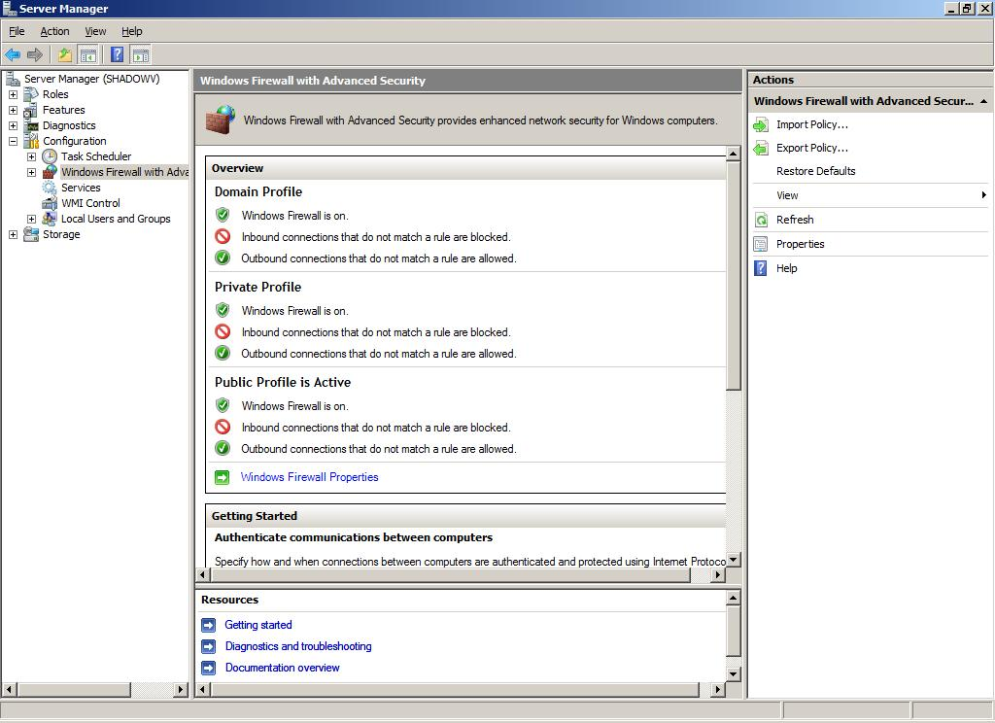
The Windows Firewall with Advanced Security MMC snap-in replaces both of the previous IPsec snap-ins, IP Security Policies and IP Security Monitor, for configuring computers that are running Windows Vista and Windows Server 2008. The previous IPsec snap-ins are still included with Windows to manage client computers that are running Windows Server 2003, Windows XP or Windows 2000. Although computers that are running Windows Vista and Windows Server 2008 can also be configured and monitored by using the previous IPsec snap-ins, you cannot use the older tools to configure the many new features and security options introduced in Windows Vista and Windows Server 2008. To take advantage of those new features, you must configure the settings by using the Windows Firewall with Advanced Security snap-in, or by using commands in the advfirewall context of the Netsh tool.
Windows Firewall with Advanced Security provides several functions on a computer that is running Windows Vista or Windows Server 2008:
- Filtering of all IP version 4 (IPv4) and IP version 6 (IPv6) traffic entering or leaving the computer. By default, all incoming traffic is blocked unless it is a response to a previous outgoing request from the computer (solicited traffic), or it is specifically allowed by a rule created to allow that traffic. By default, all outgoing traffic is allowed, except for service hardening rules that prevent standard services from communicating in unexpected ways. You can choose to allow traffic based on port numbers, IPv4 or IPv6 addresses, the path and name of an application or the name of a service that is running on the computer, or other criteria.
- Protecting network traffic entering or exiting the computer by using the IPsec protocol to verify the integrity of the network traffic, to authenticate the identity of the sending and receiving computers or users, and to optionally encrypt traffic to provide confidentiality.
Starting with Windows XP Service Pack 2, Windows Firewall has been enabled by default on client operating systems from Microsoft. Windows Server 2008 is the first server operating system from Microsoft to have the Windows Firewall enabled by default. Because the Windows Firewall is turned on by default, every administrator of a server that is running Windows Server 2008 must be aware of this feature and understand how to configure the firewall to allow required network traffic.
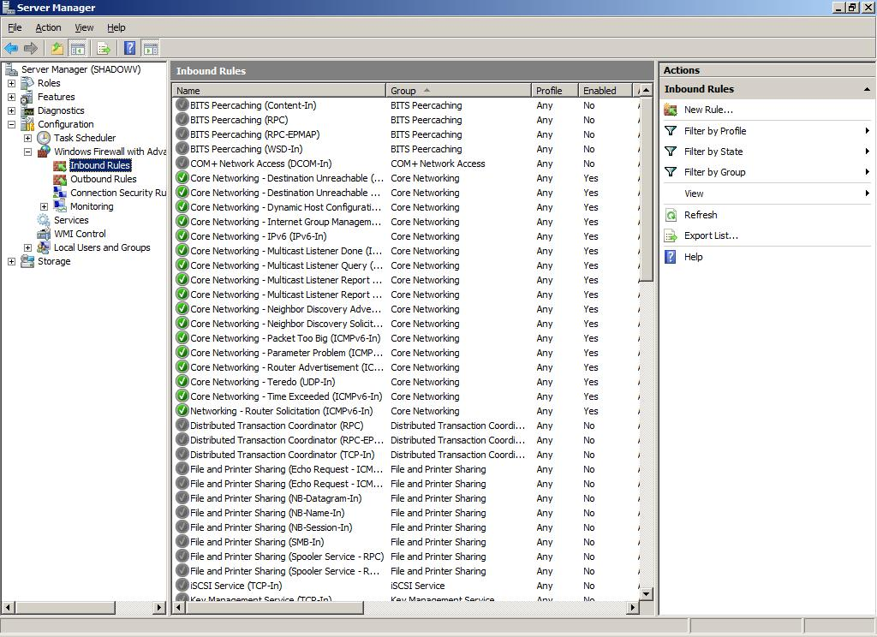
Windows Firewall with Advanced Security can be fully configured by using either the Windows Firewall with Advanced Security MMC snap-in, or the commands available in the advfirewall context of the Netsh command-line tool. Both the graphical and command-line tools support managing Windows Firewall with Advanced Security on the local computer or on a remote computer running Windows Server 2008 or Windows Vista that is on the network. Settings created by using either of these tools can be deployed to the computers attached to the network by using Group Policy.
You should review this section on Windows Firewall with Advanced Security if you are in any one of the following groups:
- IT planners and analysts who are technically evaluating the product
- Enterprise IT planners and designers
- IT professionals who deploy or administer networking security solutions in your organization
Windows Firewall with Advanced Security consolidates two functions that were managed separately in earlier versions of Windows. In addition, the core functionality of each of the firewall and IPsec components of Windows Firewall with Advanced Security is significantly enhanced in Windows Vista and Windows Server 2008.
If you create software that is designed to be installed on Windows Vista or Windows Server 2008, then you must make sure that your installation tool correctly configures the firewall by creating or enabling rules that allow your program’s network traffic to pass through the firewall. Your program should recognize the different network location types recognized by Windows, domain, private and public, and correctly respond to a change in network location type. Be aware that a change in the network location type can result in different firewall rules being in effect on the computer. For example, if you want your application to only run in a secured environment, such as a domain or private network, then the firewall rules must prevent your application from sending network traffic when the computer is on a public network. If the network location type changes unexpectedly while your application is running, it must handle the change gracefully.
Windows Firewall Is Turned On by Default
Windows Firewall has been turned on by default on Windows client operating systems since Windows XP Service Pack 2, but Windows Server 2008 is the first server version of the Windows operating system to have Windows Firewall turned on by default. This has implications whenever an application or service is installed that must be allowed to receive unsolicited incoming traffic over the network. Many older applications are not designed to work with a host-based firewall, and might not operate correctly unless you define rules to allow that application to accept unsolicited incoming network traffic. When you install a server role or feature that is included with Windows Server 2008, the installer automatically enables or creates firewall rules to make sure that the server role or feature operates correctly. To determine what firewall settings must be configured for an application, contact the application vendor. Firewall settings are often posted on the vendor’s support Web site.
Note
A computer that is running Windows Server 2003 and that is upgraded to Windows Server 2008 maintains the same firewall operational state that it had before the upgrade. If the firewall was turned off before the upgrade, then it remains off after the upgrade. We strongly recommend that you turn the firewall on as soon as you confirm that the applications on the server work with the firewall as configured, or as soon as you configure appropriate firewall rules for the applications that are running on your computer.
IPsec Policy Management Is Simplified
In earlier versions of Windows, implementations of server or domain isolation sometimes required the creation of a large number of IPsec rules to make sure that required network traffic was protected appropriately, while still permitting required network traffic that could not be secured with IPsec.
The need for a large, complex set of IPsec rules is reduced by a new default behavior for IPsec negotiation that requests but does not require IPsec protection. When this setting is used, IPsec sends an IPsec negotiation attempt and also sends plaintext packets to the destination computer at the same time. If the destination computer responds to and successfully completes the negotiation, then the plaintext communication is stopped, and subsequent communication is protected by IPsec. However, if the destination computer does not respond to the IPsec negotiation, then the plaintext attempt is allowed to continue. Earlier versions of Windows waited three seconds after the IPsec negotiation attempt before trying to communicate by using plaintext. This resulted in significant performance delays for traffic that could not be protected and had to be retried in plaintext. To avoid this performance delay, an administrator had to create multiple IPsec rules to address the different requirements of each type of network traffic.
The new behavior allows the option to request but not require IPsec protection to perform almost as well as unprotected traffic, because it no longer requires a three-second delay. This enables you to protect traffic where it is required, without having to create as many rules that explicitly allow for the needed exceptions. This results in a more secure, less complex, and easier-to-troubleshoot environment.
Support for Authenticated IP
In earlier versions of Windows, IPsec supported only the Internet Key Exchange (IKE) protocol for negotiating IPsec security associations (SAs). Windows Vista and Windows Server 2008 support an extension to IKE known as Authenticated IP (AuthIP). AuthIP provides additional authentication capabilities such as the following:
- Support for new credential types that are not available in IKE alone. These include the following: health certificates provided by a Health Certificate Server that is part of a Network Access Protection (NAP) deployment; user-based certificates; Kerberos user credentials; and NTLM version 2 user or computer credentials. These are in addition to credential types that IKE supports, such as computer-based certificates, Kerberos credentials for the computer account, or simple pre-shared keys.
- Support for authentication by using multiple credentials. For example, IPsec can be configured to require that both computer and user credentials are successfully processed before traffic is allowed. This increases the security of the network by reducing the chance of a trusted computer being used by an untrusted user.
Support for Protecting Domain Member to Domain Controller Traffic by Using IPsec
Earlier versions of Windows do not support using IPsec to protect traffic between domain controllers and domain member computers. Windows Vista and Windows Server 2008 support protecting the network traffic between domain member computers and domain controllers by using IPsec, while still enabling a non-domain member computer to join a domain by using the IPsec-protected domain controller.
Improved Cryptographic Support
The implementation of IPsec in Windows Vista and Windows Server 2008 supports additional algorithms for main mode negotiation of SAs:
- Elliptic Curve Diffie-Hellman P-256, an elliptic curve algorithm using a 256-bit random curve group
- Elliptic Curve Diffie-Hellman P-384, an elliptic curve algorithm using a 384-bit random curve group
Also, the following encryption methods using Advanced Encryption Standard (AES) are supported:
- AES with cipher block chaining (CBC) and a 128-bit key size (AES 128)
- AES with CBC and a 192-bit key size (AES 192)
- AES with CBC and a 256-bit key size (AES 256)
Settings Can Change Dynamically Based on the Network Location Type
Windows Vista and Windows Server 2008 can notify network-enabled applications, such as the Windows Firewall, about changes in the network location types available through any attached network adapters, dial-up connections, VPNs and so on. Windows supports three network location types, and programs can use these location types to automatically apply the appropriate set of configuration options. Applications must be written to take advantage of this feature and to receive notifications of changes to the network location types. Windows Firewall with Advanced Security in Windows Vista and Windows Server 2008 can provide different levels of protection based on the network location type to which the computer is attached.
The network location types are these:
- Domain. This network location type is selected when the computer is a member of a domain, and Windows determines that the computer is currently attached to the network hosting the domain. This selection is automatic based on successful authentication with a domain controller on the network.
- Private. This network location type can be selected for networks trusted by the user, such a home network or small-office network. Settings assigned to this location type are typically more restrictive than a domain network because it is not expected that a home network is as actively managed as a domain network. A newly detected network is never automatically assigned to the Private location type. A user must explicitly choose to assign the network to the Private location type.
- Public. This network location type is assigned by default to all newly detected networks. Settings assigned to this location type are typically the most restrictive because of the security risks present on a public network.
Note
The network location type feature is most useful on client computers, especially portable computers, which are likely to move from network to network. A server is not as likely to be mobile, and so a suggested strategy for a typical computer that is running Windows Server 2008 is to configure all three profiles the same.
Integration of Windows Firewall and IPsec Management into a Single User Interface
In Windows Vista and Windows Server 2008, the user interface for the firewall and IPsec components are now combined into the Windows Firewall with Advanced Security MMC snap-in, and commands in the advfirewall context of the Netsh command-line tool. The tools used in Windows XP, Windows Server 2003 and the Windows 2000 family — the Windows Firewall administrative template Group Policy settings, the IP Security Policy and IP Security Monitor MMC snap-ins, and the ipsec and firewall contexts of the Netsh command — are still available, but they do not support any of the newer features included with Windows Vista and Windows Server 2008. The Windows Firewall icon in Control Panel is also still present, but it is an end-user interface for managing the basic functionality of the firewall, and does not present the advanced options required by an administrator.
By using the multiple tools for firewall and IPsec in earlier versions of Windows, administrators could accidentally create conflicting settings, such as an IPsec rule that causes a specific type of network packet to be dropped, even though a firewall rule to allow that same type of network packet is present. This can result in very difficult troubleshooting scenarios. Combining the two functions reduces the possibility of creating conflicting rules, and helps make sure that the traffic you want to protect is handled correctly.
Full Support for IPv4 and IPv6 Network Traffic Protection
All the firewall and IPsec features available in Windows Vista and Windows Server 2008 are available for protecting both IPv4 and IPv6 network traffic.
Additional References
The following resources provide additional information about Windows Firewall with Advanced Security and IPsec:
- For more information about Windows Firewall with Advanced Security, see “Windows Firewall” (http://go.microsoft.com/fwlink/?LinkID=84639) on the Microsoft TechNet Web site.
- For more information about IPsec, see IPsec (http://go.microsoft.com/fwlink/?LinkID=84638) on the Microsoft TechNet Web site.
- For more information about server and domain isolation scenarios for IPsec, see Server and Domain Isolation (http://go.microsoft.com/fwlink/?LinkID=79430) on the Microsoft TechNet Web site.
- For more information about Network Access Protection, see Network Access Protection (http://go.microsoft.com/fwlink/?LinkID=84637) on the Microsoft TechNet Web site.
- For more information about how to write applications that are aware of network location types, see Network Awareness on Windows Vista (http://go.microsoft.com/fwlink/?LinkId=85491), and Network Location Awareness Service Provider (http://go.microsoft.com/fwlink/?LinkId=85492) on the Microsoft MSDN® Web site.

5.08 Cryptography Next Generation
Cryptography Next Generation (CNG) provides a flexible cryptographic development platform allowing IT professionals to create, update and use custom cryptography algorithms in cryptography-related applications such as Active Directory® Certificate Services, SSL and IPsec. CNG implements the U.S. government’s Suite B cryptographic algorithms, which include algorithms for encryption, digital signatures, key exchange and hashing.
CNG provides a set of APIs that are used to do the following:
- Perform basic cryptographic operations, such as creating hashes and encrypting and decrypting data.
- Create, store and retrieve cryptographic keys.
- Install and use additional cryptographic providers.
CNG has the following capabilities:
- CNG allows customers to use their own cryptographic algorithms or implementations of standard cryptographic algorithms. They can also add new algorithms.
- CNG supports cryptography in kernel mode. The same API is used in both kernel mode and user mode to fully support cryptography features. SSL/TLS and IPsec, in addition to startup processes that use CNG, operate in kernel mode.
- The plan for CNG includes acquiring Federal Information Processing Standards (FIPS) 140-2 level 2 certification together with Common Criteria evaluations.
- CNG complies with Common Criteria requirements by using and storing long-lived keys in a secure process.
- CNG supports the current set of CryptoAPI 1.0 algorithms.
- CNG provides support for elliptic curve cryptography (ECC) algorithms. A number of ECC algorithms are required by the United States government’s Suite B effort.
- Any computer with a Trusted Platform Module (TPM) will be able to provide key isolation and key storage in TPM.
CNG applies to public key infrastructure (PKI) deployments that require the use of Suite B algorithms and that do not need to integrate with certification authorities (CAs) that do not support Suite B algorithms, such as CAs installed on servers running Windows Server 2003 and Windows 2000 Server.
To use the new cryptographic algorithms, both your CA and your applications should support ECC (or any other new algorithm you implement under CNG). Although the CA needs to issue and manage these new certificate types, applications must be able to handle certificate chain validation and use the keys generated with Suite B algorithms.
Suite B algorithms such as ECC are supported only on Windows Vista and Windows Server 2008. This means it is not possible to use those certificates on earlier versions of Windows such as Windows XP or Windows Server 2003. However, it is possible to use classic algorithms such as Rivest-Shamir-Adleman (RSA) even if the keys have been generated with a CNG key provider.
Clients running Windows Vista or Windows Server 2008 can use either CryptoAPI 1.0 or the new CNG API because both APIs can run side by side. However, applications such as SSL, IPsec, Secure/Multipurpose Internet Mail Extensions (S/MIME), and Kerberos must be updated to use Suite B algorithms.
Deployment
Do not deploy certificates with Suite B algorithms before verifying these requirements:
- Before issuing certificates that use algorithms such as ECC, verify that your CAs and operating systems support these algorithms.
- Verify that your organization’s PKI-enabled applications can use certificates that rely on CNG cryptographic providers.
- If your organization uses certificates to support smart card logon, contact your smart card vendor to verify that its smart cards can handle CNG algorithms.
In Windows Vista and Windows Server 2008, the following certificate-enabled applications can handle certificates that use cryptographic algorithms that are registered in the CNG provider.
Certificate-Enabled Applications
Application Name | Verify a certificate chain that contains certificates with algorithms that are registered in a CNG provider | Use algorithms that are not supported by CryptoAPI
Encrypting File System (EFS) | Yes | No
IPsec | Yes | Yes
Kerberos | No | No
S/MIME | Outlook® 2003: no  Outlook 2007: yes | Outlook 2003: no  Outlook 2007: yes
Smart card logon | No | No
SSL | Yes | Yes
Wireless | Yes | Yes

To use Suite B algorithms for cryptographic operations, you first need a Windows Server 2008-based CA to issue certificates that are Suite B enabled.
If you do not have a PKI yet, you can set up a Windows Server 2008-based CA where the CA certificates and the end-entity certificates use Suite B algorithms. However, you still have to verify that all your applications are ready for Suite B algorithms and can support such certificates.
If you already have a PKI with CAs running Windows Server 2003 or where classic algorithms are being used to support existing applications, you can add a subordinate CA on a server running Windows Server 2008, but you must continue using classic algorithms.
To introduce Suite B algorithms into an existing environment where classic algorithms are used, consider adding a second PKI and perform a cross-certification between the two CA hierarchies.
For more information about CNG, see Cryptography API: Next Generation (http://go.microsoft.com/fwlink/?LinkID=74141).
For more information about Suite B, see the NSA Suite B Cryptography Fact Sheet (http://go.microsoft.com/fwlink/?LinkId=76618).

5.09 Active Directory Certificate Services
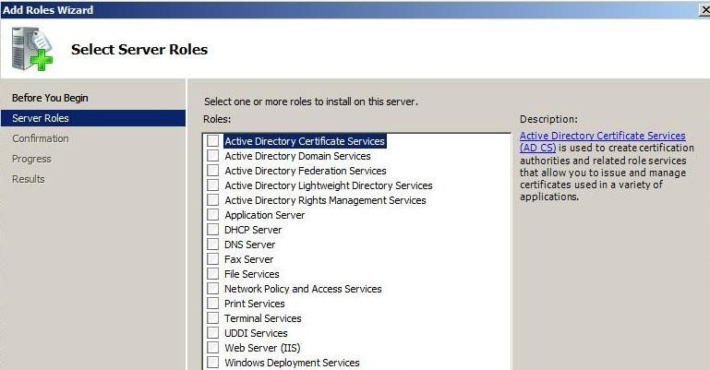
Active Directory Certificate Services provides customizable services for creating and managing public key certificates used in software security systems employing public key technologies. Organizations can use Active Directory Certificate Services to enhance security by binding the identity of a person, device or service to a corresponding private key. Active Directory Certificate Services also includes features that allow you to manage certificate enrollment and revocation in a variety of scalable environments.
The following topics describe changes in Active Directory Certificate Services functionality available in this release:
- Active Directory Certificate Services: Web Enrollment
- Active Directory Certificate Services: Policy Settings
- Active Directory Certificate Services: Network Device Enrollment Service
- Active Directory Certificate Services: Enterprise PKI (PKIView)
- Active Directory Certificate Services: Online Certificate Status Protocol Support
Active Directory Certificate Services: Web Enrollment
A number of changes have been made to certificate Web enrollment support in Windows Server 2008. These changes result from the removal of the previous ActiveX® enrollment control from Windows Vista and Windows Server 2008, and its replacement with a new COM enrollment control. The following sections describe these changes and their implications.
Certificate Web enrollment has been available since its inclusion in Windows 2000 operating systems. It is designed to provide an enrollment mechanism for organizations that need to issue and renew certificates for users and computers that are not joined to the domain or not connected directly to the network, and for users of non-Microsoft operating systems. Instead of relying on the autoenrollment mechanism of a CA or using the Certificate Request Wizard, the Web enrollment support provided by a Windows-based CA allows these users to request and obtain new and renewed certificates over an Internet or intranet connection.
This feature applies to organizations that have PKIs with one or more CAs running Windows Server 2008 and clients running Windows Vista and that want to provide users with the ability to obtain new certificates or renew existing certificates by using Web pages.
Adding support for Web enrollment pages can significantly enhance the flexibility and scalability of an organization’s PKI; therefore, this feature should interest:
- PKI architects
- PKI planners
- PKI administrators
The previous enrollment control, XEnroll.dll, has been removed from Windows Vista and Windows Server 2008, and a new enrollment control, CertEnroll.dll, has been introduced. Although the Web enrollment process takes place essentially as it has for Windows 2000, Windows XP and Windows Server 2003, this change in enrollment controls can impact compatibility when users or computers running Windows Vista or Windows Server 2008 attempt to request a certificate by using Web enrollment pages installed on those earlier versions of Windows.
XEnroll.dll is being retired for the following reasons:
- XEnroll.dll is a legacy control that was written years ago and is not considered as secure as controls written more recently.
- XEnroll.dll has one monolithic interface that exposes various sets of functionality. It has more than 100 methods and properties. These methods and properties were added over the years, and calling one function can change the behavior of another function, which makes it very difficult to test and maintain.
Note
XEnroll.dll can continue to be used for Web enrollment on computers running Windows 2000, Windows XP and Windows Server 2003. CertEnroll.dll, on the other hand, was created to be more secure, easier to script and easier to update than XEnroll.dll.
Windows Server 2008 CAs will continue to support certificate Web enrollment requests from users on Windows XP and Windows Server 2003 clients. If you are enrolling certificates through the Windows Server 2008 Web enrollment pages from a Windows XP-, Windows Server 2003- or Windows 2000-based computer, the Web enrollment pages will detect this and use the Xenroll.dll that was installed locally on the client. However, the following client behaviors will be different than those in earlier versions of Windows:
- Enrollment agent capability (also referred to as the smart card enrollment station) was removed from Web enrollment in Windows Server 2008 because Windows Vista provides its own enrollment agent capability. If you need to perform enrollment on behalf of another client with a Windows Server 2008 Web enrollment, you should use computers running Windows Vista as enrollment stations. Alternatively, you can use a Windows Server 2003-based server with Web enrollment installed and use that server as an enrollment agent to enroll certificates through a Windows Server 2008 CA.
- Only users of Internet Explorer® version 6.x or Netscape 8.1 Browser can submit certificate requests directly through the Web enrollment pages. Users of other Web browsers can still submit enrollment requests by using the Web enrollment pages, but they must first pre-generate a PKCS#10 request for submission through the Web enrollment pages.
- Certificate Web enrollment cannot be used with version 3.0 certificate templates (which are being introduced in Windows Server 2008 to support the issuance of suite b-compliant certificates).
- Internet Explorer cannot run in the local computer’s security context; therefore, users can no longer request computer certificates by using Web enrollment.
The configuration work that needs to be done for certificate Web enrollment support is to just add the role service to the server role.
If the Web enrollment support is installed on the same computer as the CA, no additional configuration steps are required.
If the Web enrollment role service and the CA are installed on different computers, the CA needs to be identified as part of the Web enrollment installation.
After the Web enrollment role service is installed, a new Web site named “CertSrv” is available through IIS.
Non-Microsoft Web enrollment pages will be heavily impacted because XEnroll.dll is not available on Windows Server 2008 or Windows Vista. Administrators of these CAs will have to create alternative solutions to support certificate issuance and renewal for clients using Windows Server 2008 and Windows Vista, while continuing to use Xenroll.dll for earlier versions of Windows.
Administrators also need to plan the appropriate configuration of their servers running IIS. IIS can only run in either 64-bit mode or 32-bit mode. If you install IIS on a server running the 64-bit version of Windows Server 2008, you must not install any 32-bit Web applications, such as WSUS, on that computer. Otherwise, the Web enrollment role service installation fails.
Active Directory Certificate Services: Policy Settings
Certificate settings in Windows Server 2008 Group Policy enable administrators to manage certificate validation settings according to the security needs of the organization.
Certificate settings in Group Policy enable administrators to manage the certificate settings on all the computers in the domain from a central location. Configuring the settings by using Group Policy can effect changes throughout the entire domain.
For example, in situations where certain intermediate CA certificates expire and clients cannot automatically retrieve a new certificate, administrators can now deploy these certificates to client computers through Group Policy.
Another scenario is when administrators want to ensure that users never install applications that have been signed with an unapproved publisher certificates. They can configure network timeouts to better control the chain-building timeouts for large certification revocation lists (CRLs). And administrators can use revocation settings to extend CRL expiration times if a delay in publishing a new CRL is affecting applications.
This feature applies to organizations that have PKIs with one or more Windows-based CAs and use Group Policy to manage client computers.
Using certificate validation settings in Group Policy can significantly enhance the ability of the following:
- Security architects to enhance the use of certificate-based trust.
- Security administrators to manage PKI-enabled applications in their environment.
As X.509 public key infrastructures become more widely used as a foundation of trust, many organizations need more options to manage certificate path discovery and path validation. Previous versions of Windows operating systems had few settings to implement this kind of control.
Certificate-related Group Policy settings can be found in the Group Policy Object Editor, under Computer Configuration\Windows Settings\Security Settings\Public Key Policies. The following policy options can be managed under separate tabs on the Certificate Path Validation Settings properties sheet:
- Stores
- Trusted Publishers
- Network Retrieval
- Revocation
In addition, four new policy stores have been added under Public Key Policies for use in distributing different types of certificates to clients:
- Intermediate Certification Authorities
- Trusted Publishers
- Untrusted Certificates
- Trusted People
These new policy stores are in addition to the Enterprise Trust and Trusted Root Certification Authorities stores that were available in Windows Server 2003.
These path validation settings and certificate stores can be used to complete the following tasks:
- Managing the peer trust and trusted root certificate stores
- Managing trusted publishers
- Blocking certificates that are not trusted according to policy
- Managing retrieval of certificate-related data
- Managing expiration times for CRLs and online certificate status protocol (OCSP) responses
- Deploying certificates
Managing Peer Trust and Trusted Root CA Stores
By using the Stores tab on the Certificate Path Validation Settings dialog box, administrators can regulate the ability of users to manage their own trusted root certificates and peer trust certificates. This control can be implemented so that users are not allowed to make any root or peer trust decisions, or it can be used to control how many or how few specific certificate purposes, such as signing and encryption, users can manage for peer trust.
The Stores tab also allows administrators to specify whether users on a domain-joined computer can trust only enterprise root CAs, or both enterprise root and non-Microsoft root CAs.
If, on the other hand, an administrator needs to distribute selected trusted root certificates to computers in the domain, they can do so by copying them into the trusted root certificate store, and they will be propagated to the appropriate certificate store the next time domain policy is refreshed.
Because of the growing variety of certificates in use today and the growing importance of decisions that need to be made about whether to recognize or not recognize these certificates, some organizations might want to manage certificate trust and prevent users in the domain from configuring their own set of trusted root certificates.
Using certificate trust-related Group Policy settings requires careful planning to determine the certificate needs of users and computers in your organization, and the amount of control they should have over those certificates. You might be able to provide users with greater leeway if you combine the use of these settings with clear and effective training so that users understand the importance of certificates, the risks of poor certificate management, and how to manage their certificates responsibly.
Managing Trusted Publishers
The policy options in the Trusted Publishers tab of the Certificate Path Validation Settings dialog box allow administrators to control which certificates can be accepted as coming from a trusted publisher.
Software signing is being used by a growing number of software publishers and application developers to verify that their applications come from a trusted source. However, many users do not understand or pay little attention to the signing certificates associated with applications that they install.
Specifying organizationwide trusted publisher policy options allows organizations to decide whether Authenticode® certificates can be managed by users and administrators, only administrators, or only enterprise administrators.
In addition, this section of the path validation policy can require that additional revocation and time stamp checks are completed before a trusted publisher certificate is accepted.
Using certificate trust–related Group Policy settings requires careful planning to determine the certificate needs of users and computers in your organization, and the amount of control they should have over those certificates. You might be able to provide users with greater leeway if you combine the use of these settings with clear and effective training so that users understand the importance of certificates, the risks of poor certificate management, and how to manage their certificates responsibly.
Blocking Certificates That Are Not Trusted According to Policy
You can prevent certain certificates from ever being used in your organization by adding them to the Untrusted Certificates store.
Just as network administrators are responsible for preventing viruses and other malicious software from entering their environments, administrators in the future might want to block certain certificates from being used. A certificate issued by your own CA can be revoked, and it will be added to a certificate revocation list. You cannot revoke certificates issued by external CAs. However, you can disallow these untrusted certificates by adding them to the Untrusted Certificates store. These certificates will be copied to the Untrusted Certificates store of each client computer in the domain the next time Group Policy is refreshed.
Using certificate trust-related Group Policy settings requires careful planning to determine the certificate needs of users and computers in your organization, and the amount of control they should have over those certificates. You might be able to provide users with greater leeway over which certificates they can manage if you combine the use of these settings with clear and effective training so that users understand the importance of certificates, the risks of poor certificate management, and how to manage their certificates responsibly.
Managing Retrieval of Certificate-Related Data
CRLs can become very large, and subsequently fail to download because it takes longer to download them than the default timeout of 15 seconds. Options on the Network Retrieval tab on the Certificate Path Validation Settings dialog box allow administrators to modify the default retrieval timeouts to solve this problem.
In addition, network retrieval and path validation settings allow administrators to do the following:
- Automatically update certificates in the Microsoft Root Certificate Program.
- Configure retrieval timeout values for CRLS and path validation (larger default values may be useful if network conditions are not optimal).
- Enable issuer certificate retrieval during path validation.
- Define how frequently cross-certificates are downloaded.
To be effective, certificate-related data such as trusted root certificates, cross-certificates, and certificate revocation lists must be updated in a timely manner. But network conditions are not always optimal, such as for remote users or branch offices. These Group Policy settings allow you to ensure that certificate-related data will be updated even when network conditions are less than optimal.
When preparing for this change, determine whether network conditions are impacting CRL download times.
Managing Expiration Times for CRLs and OCSP Responses
Revocation of a certificate invalidates a certificate as a trusted security credential before the natural expiration of its validity period. A PKI depends on distributed verification of credentials in which there is no need for direct communication with the central trusted entity that vouches for the credentials.
To effectively support certificate revocation, the client must determine whether the certificate is valid or has been revoked. To support a variety of scenarios, Active Directory Certificate Services supports industry-standard methods of certificate revocation.
These include publication of CRLs and delta CRLs in several locations for clients to access, including Active Directory Domain Services, Web servers and network file shares. In Windows, revocation data can also be made available in a variety of settings through online OCSP responses.
Network conditions can prevent the latest CRLs from being published, which can cause all certificate chain validations to fail. Extending the expiration time of the existing CRL or the OCSP response can prevent this from happening.
Using certificate revocation data-related Group Policy settings requires careful planning to determine the appropriate balance between strict adherence to the standard CRL publication schedule and the potential consequences of extending the CRL validity period if an updated CRL is not available.
Deploying Certificates
User and computer certificates can be deployed by using a number of mechanisms, including autoenrollment, the Certificate Request Wizard and Web enrollment. But deploying other types of certificates to a large number of computers can be challenging. In Windows Server 2003 it was possible to distribute trusted root CA certificate and enterprise trust certificates by using Group Policy. In Windows Server 2008 all the following types of certificates can be distributed by placing them in the appropriate certificate store in Group Policy:
- Trusted root CA certificates
- Enterprise trust certificates
- Intermediate CA certificates
- Trusted publisher certificates
- Untrusted certificates
- Trusted people (peer trust certificates)
The growing variety of certificates and certificate uses requires that administrators have an efficient means of distributing these certificates to users and computers in their organizations.
Using certificate trust–related Group Policy settings requires careful planning to determine the certificate needs of users and computers in your organization, and the amount of control they should have over those certificates. You might be able to provide users with greater leeway if you combine the use of these settings with clear and effective training so that users understand the importance of certificates, the risks of poor certificate management, and how to manage their certificates responsibly.
You must be a member of the Domain Administrators group to configure Group Policy in the domain.
Active Directory Certificate Services: Network Device Enrollment Service
The Network Device Enrollment Service (NDES) is Microsoft’s implementation of the Simple Certificate Enrollment Protocol (SCEP), a communication protocol that makes it possible for software running on network devices such as routers and switches, which cannot otherwise be authenticated on the network, to enroll for x509 certificates from a CA.
NDES operates as an Internet Server Application Programming Interface (ISAPI) filter on IIS that performs the following functions:
- Generates and provides one-time enrollment passwords to administrators
- Receives and processes SCEP enrollment requests on behalf of software running on network devices
- Retrieves pending requests from the CA.
This feature applies to organizations that have PKIs with one or more Windows Server 2008 CAs and that want to enhance the security of communications by using IPsec with network devices such as routers and switches.
Adding support for NDES can significantly enhance the flexibility and scalability of an organization’s PKI; therefore, this feature should interest PKI architects, planners and administrators.
Organizations and professionals interested in NDES may want to know more about the SCEP specifications on which it is based.
SCEP was developed by Cisco Systems Inc. as an extension to existing HTTP, PKCS #10, PKCS #7, RFC 2459 and other standards to enable network device and application certificate enrollment with CAs.
In Windows Server 2003, Microsoft SCEP (MSCEP) was a Windows Server 2003 Resource Kit add-on that had to be installed on the same computer as the CA. In Windows Server 2008, MSCEP support has been renamed NDES and is part of the operating system and can be installed on a different computer than the CA.
The NDES extension to IIS uses the registry to store configuration settings. All settings are stored under one Registry key:
HKEY_LOCAL_ROOT\Software\Microsoft\Cryptography\MSCEP
The following table defines the registry keys that are used to configure MSCEP:
Registry Keys in MSCEP
Setting Name | Optional | Default Value | Possible Values
Refresh | No | 7 | Number of days that pending requests are kept in the NDESP database.
EnforcePassword | No | 1 | Defines whether passwords are required for enrollment requests. The value 1 means NDES requires a password for enrollment requests. The value 0 (zero) means passwords are not required.
PasswordMax | No | 5 | Maximum number of available passwords that can be cached.  Note:  On previous versions the default was 1,000.
PasswordValidity | No | 60 | Number of minutes a password is valid.
PasswordVDir | Yes |  | The name of the virtual directory that can be used for password requests. If set, NDES accepts password requests only from the defined virtual directory. If the value is empty or not configured, NDES accepts password requests from any virtual directory.
CacheRequest | No | 20 | Number of minutes that issued certificates are kept in the SCEP database.
CAType | No | Based on setup | Identifies the type of CA that NDES is linked to. The value 1 means it is an enterprise CA; the value 0 means it is a stand-alone CA.
SigningTemplate | Yes | Not set | If this key is set, NDES uses this value as the certificate template name when clients enroll for a signing certificate.
EncryptionTemplate | Yes | Not set | If this key is set, NDES uses this value as the certificate template name when clients enroll for an encryption certificate.
SigningAndEncryptionTemplate | Yes | Not set | If this key is set, NDES uses the value as the certificate template name when clients enroll for a signing and encryption certificate, or when the request does not include any extended key usage.

Before installing NDES, you need to decide the following:
- Whether to set up a dedicated user account for the service or to use the Network Service account
- The name of the NDES registration authority (RA) and what country/region to use. This information is included in any MSCEP certificates that are issued
- The cryptographic service provider (CSP) to use for the signature key used to encrypt communication between the CA and the RA
- The CSP to use for the encryption key used to encrypt communication between the RA and the network device
- The key length for each of these keys
In addition, you need to create and configure the certificate templates for the certificates used in conjunction with NDES.
Installing NDES on a computer creates a new RA, and deletes any pre-existing RA certificates on the computer. Therefore, if you plan to install NDES on a computer where another RA has been configured, any pending certificate requests should be processed and any unclaimed certificates should be claimed before NDES is installed.
Active Directory Certificate Services: Enterprise PKI
Monitoring and troubleshooting the health of multiple CAs for enterprise PKI hierarchies in an Active Directory Certificate Services environment are essential administrative tasks facilitated by Enterprise PKI (PKIView). Originally part of the Microsoft Windows Server 2003 Resource Kit and called the PKI Health tool, PKIView is now an MMC snap-in for Windows Server 2008. Because it is part of the core operating system of Windows Server 2008, you can use PKIView after server installation by simply adding it to MMC. It then becomes available to analyze the health state of CAs and to view details for CA certificates published in Active Directory Certificate Services.
PKIView provides a view of the status of your network’s PKI environment. Having a view of all CAs and their current health states enables administrators to manage CA hierarchies and troubleshoot possible CA errors easily and effectively. Specifically, PKIView indicates the validity or accessibility of authority information access (AIA) locations and CRL distribution points (CDP).
For each CA selected, PKIView indicates CA health states in the tree as follows:
CA Health States
Indicator | CA State
Question Mark | CA health state evaluation
Green indicator | CA has no problems
Yellow indicator | CA has a noncritical problem
Red indicator | CA has a critical problem
Red cross over CA icon | CA is offline

Once you add the PKIView snap-in to the MMC, you see three panes:
- Tree. This pane displays a tree representation of your enterprise PKI hierarchy. Each node under the Enterprise PKI node represents a CA with subordinate CAs as child nodes.
- Results. For the CA selected in the tree, this pane displays a list of subordinate CAs, CA certificates, CRL distribution points (CDPs), and AIA locations. If the console root is selected in the tree, the results pane displays all root CAs. There are three columns in the results pane:
  - Name. If the Enterprise PKI node is selected, the names of the root CAs under the Enterprise PKI node are displayed. If a CA or child CA is selected in the tree, then the names of CA certificates, AIA locations and CDPs are displayed.
  - Status. Brief description of CA status (also indicated in the tree by the icon associated with the selected CA) or the status of CA Certificates, AIA locations or CDPs (indicated by status text descriptions, examples of which are OK and Unable to Download).
  - Location. AIA locations and CDPs (protocol and path) for each certificate. Examples are file://, HTTP:// and LDAP://.
- Actions. This pane provides the same functionality found on the Actions, View and Help menus.
Depending on the item selected in either the tree or results pane, you can view more details about CAs and CA certificates including AIA and CRL information in the actions pane. You can also manage the enterprise PKI structure and make corrections or changes to CA certificates or CRLs.
You can use PKIView in an enterprise network that uses Active Directory Certificate Services and contains one or more CAs, often with more than one PKI hierarchy.
Potential users of PKIView include administrators and IT professionals who are familiar with CA health monitoring and troubleshooting in an Active Directory Certificate Services network environment.
You can use PKIView only in an Active Directory Certificate Services environment.
PKIView now supports Unicode character encoding.
Support for Unicode Characters
PKIView provides full support for Unicode characters along with PrintableString encoding. Using Unicode character encoding allows you to present text and symbols from all languages. Unicode encoding uses a scheme or Unicode Transformation Format (UTF-8) that assigns two bytes for each character. A total of 65,536 character combinations are possible. In contrast, PrintableString encoding allows you to use only a simple subset of ASCII characters. These characters are A-Z a-z 0-9 (space) ' () + , . / : = ?.
Active Directory Certificate Services: Online Certificate Status Protocol Support
Certificate revocation is a necessary part of the process of managing certificates issued by CAs. The most common means of communicating certificate status is by distributing CRLs. In Windows Server 2008 public key infrastructures where the use of conventional CRLs is not an optimal solution, an Online Responder based on the OCSP can be used to manage and distribute revocation status information.
The use of Online Responders that distribute OCSP responses, along with the use of CRLs, is one of two common methods for conveying information about the validity of certificates. Unlike CRLs, which are distributed periodically and contain information about all certificates that have been revoked or suspended, an Online Responder receives and responds only to requests from clients for information about the status of a single certificate. The amount of data retrieved per request remains constant no matter how many revoked certificates there might be.
In many circumstances, Online Responders can process certificate status requests more efficiently than by using certificate revocation lists.
- Clients connect to the network remotely and either do not need or have the high-speed connections required to download large CRLs.
- A network needs to handle large peaks in revocation checking activity, such as when large numbers of users log on or send signed e-mail simultaneously.
- An organization needs an efficient means to distribute revocation data for certificates issued from a non-Microsoft CA.
- An organization wants to provide only the revocation checking data needed to verify individual certificate status requests, rather than make available information about all revoked or suspended certificates.
This feature applies to organizations that have PKIs with one or more Windows CAs.
Adding one or more Online Responders can significantly enhance the flexibility and scalability of an organization’s PKI; therefore, this feature should interest PKI architects, planners and administrators.
To install an Online Responder, you must be an administrator on the computer where the Online Responder will be installed.
Online Responders in Windows Server 2008 include the following features.
- Web proxy caching. The Online Responder Web proxy cache is the service interface for the Online Responder. It is implemented as an ISAPI extension hosted by IIS.
- Support for nonce and no-nonce requests. Configuration options for nonce and no-nonce request can be used to prevent replay attacks of Online Responder responses.
- Windows setup integration. An Online Responder can be set up by using the Windows Server Role Management Tool.
- Advanced cryptography support. An Online Responder can be configured to use elliptic curve cryptography (ECC) and SHA-256 cryptography for cryptographic operations.
- Preconfigured OCSP Signing certificate templates. Deployment of an Online Responder is simplified by using an OCSP Signing certificate template that is available in Windows Server 2008.
- Kerberos protocol integration. Online Responder requests and responses can be processed along with Kerberos password authentication for prompt validation of server certificates at logon.
Microsoft Online Responders are based on and comply with RFC 2560 for OCSP. For this reason, certificate status responses from Online Responders are frequently referred to as OCSP responses. For more information about RFC 2560, see the Internet Engineering Task Force Web site (http://go.microsoft.com/fwlink/?LinkId=67082).
Two significant new sets of functionality can be derived from the Online Responder service:
- Online Responders. The basic Online Responder functionality provided by a single computer where the Online Responder Service has been installed.
- Responder arrays. Multiple linked computers hosting Online Responders and processing certificate status requests.
Online Responder
An Online Responder is a computer on which the Online Responder service is running. A computer that hosts a CA can also be configured as an Online Responder, but it is recommended that you maintain CAs and Online Responders on separate computers. A single Online Responder can provide revocation status information for certificates issued by a single CA or multiple CAs. CA revocation information can be distributed using more than one Online Responder.
Applications that depend on X.509 certificates, such as S/MIME, SSL, EFS, and smart cards need to validate the status of the certificates whenever they are used to perform authentication, signing, or encryption operations. Certificate status and revocation checking verifies the validity of certificates based on:
- Time. Certificates are issued to a fixed period of time and considered valid as long as the expiration date of the certificate is not reached and the certificate has not been revoked before that date.
- Revocation status. Certificates can be revoked before their expiration date for a variety of reasons, such as key compromise or suspension.
Certificate revocation lists contain the serial numbers of all the certificates issued by a CA that have been revoked. For a client to check the revocation status of a certificate, it needs to download a CRL containing information about all of the certificates that have been revoked by the CA.
This has two major drawbacks: Over time CRLs can become extremely large, which can require significant network resources and storage for the CA and the relying party. This can result in tradeoffs between more frequent distribution of updated CRLs and the time and network bandwidth needed to distribute them. If CRLs are published less frequently, then clients have to rely on less accurate revocation information.
There have been numerous attempts to solve the CRL size issue through the introduction of partitioned CRLs, delta CRLs and indirect CRLs. All these approaches have added complexity and cost to the system without providing a solution.
When you are using Online Responders, the Online Responders, rather than the relying clients, receive all the certificate revocation data. A relying party submits a status request about an individual certificate to an Online Responder, which returns a definitive, digitally signed response indicating the status of only the certificate in the request. The amount of data retrieved per request is constant, no matter how many revoked certificates exist in the certificate database on the CA. Online Responders can be installed on computers running Windows Server 2008. They should be installed after the CAs, but before any client certificates are issued. The certificate revocation data is derived from a published CRL that can come from a CA on a computer running Windows Server 2008, a CA on a computer running Windows Server 2003, or from a non-Microsoft CA.
Before configuring a CA to support the Online Responder service, the following must be present:
- IIS must be installed on the computer before the Online Responder can be installed. The correct configuration of IIS for the Online Responder is installed automatically when you install an Online Responder.
- An OCSP Signing certificate template must be configured on the CA, and autoenrollment used to issue an OCSP Signing certificate to the computer on which the Online Responder will be installed.
- The URL for the Online Responder must be included in the AIA extension of certificates issued by the CA. This URL is used by the Online Responder client to validate certificate status.
After an Online Responder has been installed, you also need to create a revocation configuration for each CA and CA certificate served by an Online Responder.
A revocation configuration includes all the settings that are needed to respond to status requests regarding certificates that have been issued using a specific CA key. These configuration settings include the following:
- CA certificate. This certificate can be located on a domain controller, in the local certificate store or imported from a file.
- Signing certificate for the Online Responder. This certificate can be selected automatically for you, selected manually (which involves a separate import step after you complete the regular add revocation configuration procedure), or you can use the selected CA certificate.
- Revocation provider that will provide the revocation data used by this configuration. This information is entered in the form od one or more URLs where valid base and delta CRLs can be obtained.
Important
Before you begin to add a new revocation configuration, make sure you have this information available.
Responder Arrays
Multiple Online Responders can be linked in an Online Responder Array. Online Responders in an Array are referred to as Array members. One member of the Array must be designated as the Array Controller. Although each Online Responder in an Array can be configured and managed independently, in case of conflicts the configuration information for the Array Controller will override configuration options set on other Array members.
An Online Responder Array can be created and additional Online Responders added to the array for a number of reasons, including fault tolerance in case an individual Online Responder becomes unavailable, geographic considerations, scalability or network design considerations.
For example, remote branch offices might not have consistent connections with headquarters where a CA is located. Therefore it is not always possible to contact the CA or a remote Online Responder to process a revocation status request.
Because members of a Online Responder Array may be remote and subject to less-than-optimal network conditions, each member of the array can be monitored and managed independently.
Setting up an Online Responder Array requires a good deal of advance planning based on:
- Number and location of the CAs being serviced by the array
- Number of clients who will request certificates from the CAs and their locations
- Network connectivity between clients, CAs and potential Online Responders
- Volume of certificate enrollments, certificate revocations and certificate status requests that the organization’s public key infrastructure handles
- Need for redundancy in case individual Online Responders become unavailable
After the Online Responder Array has been planned, setting up the Array involves a number of procedures that must be coordinated.
Group Policy
Several Group Policy settings have been added to enhance management of OCSP and CRL data use. For example, CRLs have expiration dates just like certificates, and if the expiration date passes before an update is published or becomes accessible, certificate chain validation can fail, even with an Online Responder present. This is because the Online Responder would be relying on data from an expired CRL. In situations where network conditions can delay the timely publication and receipt of updated CRLs, administrators can use these Group Policy settings to extend the expiration time of an existing CRL or OCSP response.
You can extend the lifetime of CRLs and OCSP responses by going to the Revocation tab in Certificate Path Validation Settings (Computer Configuration, Windows Settings, Security Settings and Public Key Policies). To configure these options, you need to do the following:
- Click on Define these policy settings.
- Click on Allow for all CRLs and OCSP responses to be valid longer than their lifetime.
- Select Default time the validity period can be extended, and enter the desired value of time (in hours).
A separate option on the Revocation tab allows you to override OCSP responses with information contained in CRLs. Thus, a certificate that has been revoked by adding it to a local CRL could still be verified as valid if a client has a CRL that does not include its revocation status. Although this option is not recommended, it can be useful in circumstances where revocation changes made by a local administrator are not final until a CA administrator verifies the change.
Both of these settings are located at Computer Configuration, Windows Settings, Security Settings and Public Key Policies.
Important
Administrative credentials are needed to modify Group Policy settings.
Deployment
Because Online Responders are designed to service individual certificate status requests, an Online Responder Array often requires multiple, geographically dispersed Online Responders to balance the load. Because every status response is signed, each Online Responder must be installed on a trusted server.
Windows Server 2008 Online Responders can be installed in the following array configurations:
- Single Online Responder for multiple CAs. The Online Responder requires a key and signing certificate for each supported CA. An Online Responder must be issued a signing certificate from the issuing CA. An Online Responder cannot provide status for a certificate higher in the chain than the CA that issued the signing certificate.
- Multiple Online Responders for a single CA. Each Online Responder has a signature key and certificate from the CA that is supported. This is supported by means of clustering. The clustering logic takes care of directing the client to make requests to a specific Online Responder.
- Multiple Online Responders for multiple CAs. Each Online Responder has a signature key and certificate from each CA that is supported.
You can prepare for deploying Online Responders by doing the following:
- Evaluate the potential benefits of supplementing CRLs with the use of Online Responders to manage revocation checking in your organization
- Identify potential locations where Online Responders might be beneficial
- Depending on the number of CAs and locations you are supporting, the volume of certificate validation requests that you anticipate, and network conditions between your CAs and locations, identify the installation configuration from the preceding list that best suits your organization
- Identify the locations for each Online Responder and how they are to be managed
- Test the Online Responder and PKI configuration in a lab environment to validate the PKI design and to identify configuration options for each Online Responder and revocation configuration
- Install and configure each Online Responder

5.10 Active Directory Domain Services
Active Directory Domain Services stores information about users, computers and other devices on the network. Active Directory Domain Services helps administrators securely manage this information and facilitates resource sharing and collaboration between users. Active Directory Domain Services is also required to be installed on the network to install directory-enabled applications such as Microsoft Exchange Server and for applying other Windows Server technologies such as Group Policy.
The following topics describe changes in Active Directory Domain Services functionality available in this release:
- Active Directory Domain Services: Auditing
- Active Directory Domain Services: Fine-Grained Password Policies
- Active Directory Domain Services: Read-Only Domain Controllers
- Active Directory Domain Services: Restart-able Active Directory Domain Services
- Active Directory Domain Services: Snapshot Exposure
- Active Directory Domain Services: User Interface Improvements
Active Directory Domain Services: Auditing
In Windows Server 2008, you can now set up Active Directory Domain Services auditing with a new audit policy subcategory (Directory Service Changes) to log old and new values when changes are made to Active Directory Domain Services objects and their attributes.
Note
This new auditing feature also applies to Active Directory Lightweight Directory Services. However, this discussion refers only to Active Directory Domain Services.
The global audit policy Audit directory service access controls whether auditing for directory service events is enabled or disabled. This security setting determines whether events are logged in the Security log when certain operations are carried out on objects in the directory. You can control what operations to audit by modifying the system access control list (SACL) on an object. In Windows Server 2008, this policy is enabled by default.
If you define this policy setting (by modifying the default Domain Controllers Policy), you can specify whether to audit successes, audit failures or not audit at all. Success audits generate an audit entry when a user successfully accesses an Active Directory Domain Services object that has a SACL specified. Failure audits generate an audit entry when a user unsuccessfully attempts to access an Active Directory Domain Services object that has a SACL specified.
You can set a SACL on an Active Directory Domain Services object on the Security tab in that object’s properties dialog box. Audit directory service access is applied in the same manner as Audit object access; however, it applies only to Active Directory Domain Services objects and not to file system objects and registry objects.
This feature applies to Active Directory Domain Services administrators who are responsible for setting up auditing in the directory. Administrators set appropriate SACLs on the objects that they want to audit.
In general, permissions to modify SACLs and view the Security log are assigned only to members of the Administrators groups, including Domain Admins, Builtin\Administrators and Enterprise Admins.
Windows Server 2008 is adding the capability of Active Directory Domain Services auditing to log old and new values of an attribute when a successful change is made to that attribute. Previously, Active Directory Domain Services auditing only logged the name of the attribute that was changed; it did not log the previous and current values of the attribute.
Auditing Active Directory Domain Services Access
In Windows 2000 Server and Windows Server 2003, there was one audit policy, Audit Directory Service Access, that controlled whether auditing for directory service events was enabled or disabled. In Windows Server 2008, this policy is divided into four subcategories:
- Directory Service Access
- Directory Service Changes
- Directory Service Replication
- Detailed Directory Service Replication
The ability to audit changes to objects in Active Directory Domain Services is enabled with the new audit subcategory Directory Service Changes. The types of changes that you can audit are create, modify, move and undelete operations that are performed on an object. The events that are generated by these operations appear in the Security log.
This new policy subcategory adds the following capabilities to auditing in Active Directory Domain Services:
- When a successful modify operation is performed on an attribute of an object, Active Directory Domain Services logs the previous and current values of the attribute. If the attribute has more than one value, only the values that change as a result of the modify operation are logged.
- If a new object is created, values of the attributes that are populated at the time of creation are logged. If attributes are added during the create operation, those new attribute values are logged. In most cases, Active Directory Domain Services assigns default values to attributes (such as sAMAccountName). The values of such system attributes are not logged.
- If an object is moved within a domain, the previous and new location (in the form of the distinguished name) is logged. When an object is moved to a different domain, a create event is generated on the domain controller in the target domain.
- If an object is undeleted, the location to which the object is moved is logged. In addition, if attributes are added, modified or deleted during an undelete operation, the values of those attributes are logged.
Note
If an object is deleted, no change auditing events are generated. However, an audit event is generated if the Directory Service Access subcategory is enabled.
After Directory Service Changes is enabled, Active Directory Domain Services logs events in the Security event log when changes are made to objects that an administrator has set up for auditing. The following table describes these events.
Directory Service Changes — Active Directory Domain Services Events
Event ID | Type of Event | Event Description
5136 | Modify | This event is logged when a successful modification is made to an attribute in the directory.
5137 | Create | This event is logged when a new object is created in the directory.
5138 | Undelete | This event is logged when an object is undeleted in the directory.
5139 | Move | This event is logged when an object is moved within the domain.

The ability to identify how object attributes change makes the event logs more useful as a tracking mechanism for changes that occur over the lifetime of an object.
In Windows Server 2008, you implement the new auditing feature by using the following controls:
- Global audit policy
- SACL
- Schema
Global Audit Policy
Enabling the global audit policy Audit directory service access enables all the directory service policy subcategories. You can set this global audit policy in the Default Domain Controllers Group Policy (under Security Settings\Local Policies\Audit Policy). In Windows Server 2008, this global audit policy is enabled by default. Therefore, the subcategory Directory Service Changes is also enabled by default. This subcategory is set only for success events.
In Windows 2000 Server and Windows Server 2003, the policy Audit directory service access was the only auditing control available for Active Directory. The events that were generated by this control did not show the old and new values of any modifications. This setting generated audit events in the Security log with the ID number 566. In Windows Server 2008, the audit policy subcategory Directory Service Access still generates the same events, but the event ID number is changed to 4662.
With the new audit policy subcategory Directory Service Changes, successful changes to the directory are logged along with the previous and current attribute values. Settings for both Directory Service Access and Directory Service Changes are stored in the Local Security Authority (LSA) database. They can be queried with new LSA APIs.
The two audit subcategories are independent of each other. You can disable Directory Service Access and still be able to see change events that are generated if the subcategory Directory Service Changes is enabled. Similarly, if you disable Directory Service Changes and enable Directory Service Access, you can see Security log events with the ID number 4662.
You can use the command-line tool Auditpol.exe to view or set audit policy subcategories.
SACL
The SACL is the part of an object’s security descriptor that specifies which operations are to be audited for a security principal. The SACL on the object is still the ultimate authority in determining whether an access check must be audited or not.
The content of the SACL is controlled by security administrators for the local system. Security administrators are users who have been assigned the Manage Auditing and Security Log (SeSecurityPrivilege) privilege. By default, this privilege is assigned to the built-in Administrators group.
If there is no access control entry (ACE) in the SACL requiring attribute modifications to be logged, even if the Directory Service Changes subcategory is enabled, no change auditing events are logged. For example, if there is no ACE in a SACL requiring Write Property access on the telephone number attribute of a user object to be audited, no auditing events are generated when the telephone number attribute is modified, even if the subcategory Directory Service Changes is enabled.
Schema
To avoid the possibility of an excessive number of events being generated, there is an additional control in the schema that you can use to create exceptions to what is audited.
For example, if you want to see changes for all attribute modifications on a user object — except for one or two attributes — you can set a flag in the schema for the attributes that you do not want audited. The searchFlags property of each attribute defines whether the attribute is indexed, replicated to the global catalog or some other such behavior. There are seven currently defined bits for the searchFlags property.
If bit 9 (value 256) is set for an attribute, Active Directory Domain Services will not log change events when modifications are made to the attribute. This applies to all objects that contain that attribute.
Registry Settings
The following registry key values are used to configure Active Directory Domain Services auditing.
Registry Key Values — Active Directory Domain Services Auditing
Setting Name | Location | Possible Values
MaximumStringBytesToAudit | HKEY_LOCAL_MACHINE\ System\CurrentControlSet\ Services\NTDS\Parameters | - Minimum registry value: 0  - Maximum registry value: 64000  - Default value: 1000
5137 | Create | This event is logged when a new object is created in the directory.
5138 | Undelete | This event is logged when an object is undeleted in the directory.
5139 | Move | This event is logged when an object is moved within the domain.

Group Policy Settings
You cannot view the audit policy subcategories with the Group Policy Object Editor (GPedit.msc). You can only view them with the command-line tool Auditpol.exe. The following example auditpol command enables the audit subcategory Directory Service Changes:
auditpol /set /subcategory:"directory service changes" /success:enable
Active Directory Domain Services: Fine-Grained Password Policies
Windows Server 2008 provides organizations with a way to define different password and account lockout policies for different sets of users in a domain. In Windows 2000 and Windows Server 2003 Active Directory domains, only one password policy and account lockout policy could be applied to all users in the domain. These policies were specified in the Default Domain Policy for the domain. As a result, organizations that wanted different password and account lockout settings for different sets of users had to either create a password filter or deploy multiple domains. Both options are costly for different reasons.
You can use fine-grained password policies to specify multiple password policies within a single domain. You can use fine-grained password policies to apply different restrictions for password and account lockout policies to different sets of users in a domain.
For example, you can apply stricter settings to privileged accounts and less-strict settings to the accounts of other users. In other cases, you might want to apply a special password policy for accounts whose passwords are synchronized with other data sources.
The following individuals should review this information about fine-grained password policies:
- IT planners and analysts who are technically evaluating the product
- Enterprise IT planners and designers for organizations
- Administrators or managers who are responsible for IT security
Fine-grained password policies apply only to user objects (or inetOrgPerson objects if they are used instead of user objects) and global security groups. By default, only members of the Domain Admins group can set fine-grained password policies. However, you can also delegate the ability to set these policies to other users. The domain functional level must be Windows Server 2008.
Fine-grained password policies do not interfere with custom password filters that you might use in the same domain. Organizations that have deployed custom password filters to domain controllers running Windows 2000 or Windows Server 2003 can continue to use those password filters to enforce additional restrictions for passwords.
Storing Fine-Grained Password Policies
To store fine-grained password policies, Windows Server 2008 includes two new object classes in the Active Directory Domain Services schema:
- Password Settings Container
- Password Settings
Password Settings Container is created by default under the System container in the domain. It stores the Password Settings objects (PSOs) for that domain. You cannot rename, move or delete this container.
A PSO has attributes for all the settings that can be defined in the Default Domain Policy (except Kerberos settings). These settings include attributes for the following password settings:
- Enforce password history
- Maximum password age
- Minimum password age
- Minimum password length
- Passwords must meet complexity requirements
- Store passwords using reversible encryption
These settings also include attributes for the following account lockout settings:
- Account lockout duration
- Account lockout threshold
- Reset account lockout after
In addition, a PSO has the following two new attributes:
- PSO link. This is a multivalued attribute that is linked to users and/or group objects.
- Precedence. This is an integer value that is used to resolve conflicts if multiple PSOs are applied to a user or group object.
These nine attributes are mustHave attributes. This means that you must define a value for each one. Settings from multiple PSOs cannot be merged.
Defining the Scope of Fine-Grained Password Policies
A PSO can be linked to a user (or inetOrgPerson) or group object that is in the same domain as the PSO.
- A PSO has an attribute named PSOAppliesTo that contains a forward link to only user or group objects. The PSOAppliesTo attribute is multivalued, which means that you can apply a PSO to multiple users or groups. You can create one password policy and apply it to different sets of users or groups.
- A new attribute named PSOApplied has been added to the user and group objects in Windows Server 2008. The PSOApplied attribute contains a back-link to the PSO. Because the PSOApplied attribute has a back-link, a user or group can have multiple PSOs applied to it. In this case, the settings that are applied are calculated by Resultant Set of Policy (RSOP). For more information, see “RSOP” later in this topic.
You can link a PSO to other types of groups in addition to global security groups. However, when the resultant set of policy is determined for a user or group, only PSOs that are linked to global security groups or user objects are considered. PSOs that are linked to distribution groups or other types of security groups are ignored.
RSOP
A user or group object can have multiple PSOs linked to it, either because of membership in multiple groups that each have different PSOs applied to them or because multiple PSOs are applied to the object directly. However, only one PSO can be applied as the effective password policy. Only the settings from that PSO can affect the user or group. The settings from other PSOs that are linked to the user or group cannot be merged in any way.
The RSOP can only be calculated for a user object. The PSO can be applied to user object in either of the following two ways:
- Directly. PSO is linked to the user
- Indirectly. PSO is linked to group(s) of which user is a member
Each PSO has an additional attribute named precedence, which assists in the calculation of RSOP. The precedence attribute has an integer value of 1 or greater. A lower value for the precedence attribute indicates that the PSO has a higher rank, or a higher priority, than other PSOs. For example, suppose an object has two PSOs linked to it. One PSO has a precedence value of 2 and the other PSO has a precedence value of 4. In this case, the PSO that has the precedence value of 2 has a higher rank and, hence, is applied to the object.
If multiple PSOs are linked to a user or group, the resultant PSO that is applied is determined as follows:
- A PSO that is linked directly to the user object is the resultant PSO. If more than one PSO is linked directly to the user object, a warning message is logged in the event log and the PSO with the lowest precedence value is the resultant PSO.
- If no PSO is linked to the user object, the global security group memberships of the user, and all PSOs that are applicable to the user based on those global group memberships, are compared. The PSO with the lowest precedence value is the resultant PSO.
- If no PSO is obtained from conditions (1) and (2), the Default Domain Policy is applied.
We recommend that you assign a unique precedence value for each PSO that you create. However, you can create multiple PSOs with the same value. If multiple PSOs with the same precedence value are obtained for a user, the PSO that is obtained first is applied.
Another new attribute named ResultantPSO has been added to the user object. An administrator can query on this attribute to retrieve the distinguished name of the PSO that is ultimately applied to that user (based on the rules listed previously). If there is no PSO object that applies to the user, either directly or by virtue of group membership, the query returns the distinguished name of the domain.
By applying a PSO that is linked directly to a user or group before other PSOs, you can create exceptions for certain users of a group. You can assign a PSO to a group of users but assign a different policy to some of the members. Instead of having to create a new policy and rearrange precedence of all the previous policies just for that particular user, you can create a policy with any precedence. When you apply the policy directly to the user, it applies first.
The user object has three bits, which can be set in the userAccountControl attribute of the user object that can override the settings that are present in the resultant PSO (much as these bits override the settings in the Default Domain Policy in Windows 2000 and Windows Server 2003). These bits include the following:
- Reversible password encryption required
- Password not required
- Password does not expire
These bits continue to override the settings in the resultant PSO that is applied to the user object.
Security and Delegation
By default, only members of the Domain Admins group can create PSOs. Only members of this group have the Create Child and Delete Child permissions on the Password Settings Container object. In addition, only members of the Domain Admins group have Write Property permissions on the PSO by default. Therefore, only members of the Domain Admins group can apply a PSO to a group or user. You can delegate this permission to other groups or users.
You do not need permissions on the user or group object to be able to apply a PSO to it. Having Write permissions on the user or group object does not give you the ability to link a PSO to the user or group. The owner of a group does not have permissions to link a PSO to the group because the forward link is on the PSO. The power of linking a PSO to the group or user is given to the owner of the PSO.
The settings on the PSO may be considered confidential; therefore, by default Authenticated Users do not have Read Property permissions for a PSO. By default, only members of the Domain Admins group have Read Property permissions on default security descriptor of the PSO object in the schema.
You can delegate these permissions to any other group (such as help desk personnel or a management application) in the domain or forest. This can also prevent a user from seeing his or her password settings in the directory. The user can read the ResultantPSO or the PSOApplied attributes, but these attributes only display the distinguished name of the PSO that applies to the user. The user cannot see the settings within that PSO.
Before you can add a domain controller running Windows Server 2008 to an existing Active Directory domain, you must run adprep /domainprep. When you run adprep /domainprep, the Active Directory schema is extended to include the new object classes that fine-grained password policies require.
If you do not create fine-grained password policies for different sets of users, the Default Domain Policy settings apply to all users in the domain, just as they do in Windows 2000 and Windows Server 2003.
Active Directory Domain Services: Read-Only Domain Controller

To learn more, please turn to 4.02 Read-Only Domain Controller.
A read-only domain controller (RODC) is a new type of domain controller in the Windows Server 2008 operating system. With an RODC, organizations can easily deploy a domain controller in locations where physical security cannot be guaranteed. An RODC hosts read-only partitions of the Active Directory Domain Services database.
For more information on Read-Only Domain Controllers, please see section 4.02 Read-Only Domain Controller under Section 4: Branch Office.
Active Directory Domain Services: Restartable Active Directory Domain Services
Administrators can stop and restart Active Directory Domain Services in Windows Server 2008 by using MMC snap-ins or the command line.
Restartable Active Directory Domain Services reduces the time that is required to perform certain operations. Active Directory Domain Services can be stopped so that updates can be applied to a domain controller; also, administrators can stop Active Directory Domain Services to perform tasks such as offline defragmentation of the Active Directory database, without restarting the domain controller. Other services that are running on the server and that do not depend on Active Directory Domain Services to function, such as Dynamic Host Configuration Protocol (DHCP), remain available to satisfy client requests while Active Directory Domain Services is stopped.
Restartable Active Directory Domain Services provides benefits for the following:
- Security update planners and administrators
- Active Directory Domain Services management teams
- Active Directory Domain Services administrators
Restartable Active Directory Domain Services is available by default on all domain controllers that run Windows Server 2008. There are no functional-level requirements or any other prerequisites for using this feature.
In Active Directory in the Microsoft Windows 2000 Server operating system and Windows Server 2003 operating system, offline defragmentation of the database required a restart of the domain controller in Directory Services Restore Mode. Applying security updates also often required a restart of the domain controller.
In Windows Server 2008, however, administrators can stop and restart Active Directory Domain Services. This makes it possible to perform offline Active Directory Domain Services operations more quickly.
Restartable Active Directory Domain Services adds minor changes to existing MMC snap-ins. A domain controller running Windows Server 2008 Active Directory Domain Services displays Domain Controller in the Services (Local) node of the Component Services snap-in and the Computer Management snap-in. By using either snap-in, an administrator can easily stop and restart Active Directory Domain Services the same way as any other service that is running locally on the server.
Although stopping Active Directory Domain Services is similar to logging on in Directory Services Restore Mode, restartable Active Directory Domain Services provides a unique state for a domain controller running Windows Server 2008. This state is known as Active Directory Domain Services Stopped.
The three possible states for a domain controller running Windows Server 2008 are as follows:
- Active Directory Domain Services Started. In this state, Active Directory Domain Services is started. For clients and other services running on the server, a Windows Server 2008 domain controller running in this state is the same as a domain controller running Windows 2000 Server or Windows Server 2003.
- Active Directory Domain Services Stopped. In this state, Active Directory Domain Services is stopped. Although this mode is unique, the server has some characteristics of both a domain controller in Directory Services Restore Mode and a domain-joined member server.
As with Directory Services Restore Mode, the Active Directory database (Ntds.dit) is offline. Also, the Directory Services Restore Mode password can be used to log on locally if another domain controller cannot be contacted for logon.
As with a member server, the server is joined to the domain. Also, users can log on interactively or over the network by using another domain controller for domain logon. However, a domain controller should not remain in this state for an extended period of time because in this state it cannot service logon requests or replicate with other domain controllers.
- Directory Services Restore Mode. This mode (or state) is unchanged from Windows Server 2003.
The following flowchart shows how a domain controller running Windows Server 2008 can transition between these three possible states.
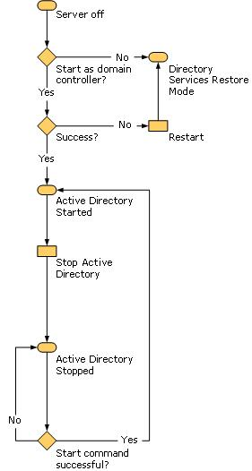
Active Directory Domain Services: Snapshot Exposure
Active Directory Domain Services Snapshot Exposure is a new feature in Windows Server 2008. It helps you identify objects that have been accidentally deleted by exposing information about the objects in snapshots of Active Directory Domain Services that are taken over time. You can view these snapshots on a domain controller without starting the domain controller in Directory Services Restore Mode. By comparing the various states of the objects as they appear in different snapshots, you can better decide which Active Directory Domain Services backup to use to restore the deleted objects.
Using Active Directory Domain Services Snapshot Exposure, you can examine any changes that are made to data that is stored in Active Directory Domain Services. For example, if a Group Policy object is accidentally modified, you can use Active Directory Domain Services Snapshot Exposure to examine the changes and help you better decide how to correct them if necessary.
Although Active Directory Domain Services Snapshot Exposure does not recover deleted objects by itself, it helps streamline the process for recovering objects that have been accidentally deleted. Before Windows Server 2008, when objects or organizational units (OUs) were accidentally deleted, the only way to determine exactly which objects were deleted was to restore data from backups. This approach had two drawbacks:
- Active Directory had to be restarted in Directory Services Restore Mode to perform an authoritative restore.
- An administrator could not compare data in backups that were taken at different points in time (unless the backups were restored to various domain controllers, a process that is not feasible).
The purpose of the Active Directory Domain Services Snapshot Exposure feature is to expose Active Directory Domain Services data that is stored in snapshots online. Administrators can then compare data in snapshots that are taken at different points in time, which in turn helps them to make better decisions about which data to restore, without incurring service downtime.
The following individuals should review this information about Active Directory Domain Services Snapshot Exposure:
- IT planners and analysts who are technically evaluating the product
- Enterprise IT planners and designers for organizations
- Administrators, operators and managers who are responsible for IT operations, including recovery of deleted Active Directory Domain Services data
There are two aspects to the problem of recovering deleted data:
- Preserving deleted data so that it can be recovered
- Actually recovering deleted data when it is required
Active Directory Domain Services Snapshot Exposure makes it possible for deleted Active Directory Domain Services data to be preserved in the form of snapshots of Active Directory Domain Services that are taken by the Volume Shadow Copy Service. Active Directory Domain Services Snapshot Exposure does not actually recover the deleted objects and containers. The administrator must perform data recovery as a subsequent step.
You can use a LDAP tool such as Ldp.exe, which is a tool that is built into Windows Server 2008, to view the data that is exposed in the snapshots. This data is read-only data. By default, only members of the Domain Admins and Enterprise Admins groups are allowed to view the snapshots because they contain sensitive Active Directory Domain Services data.
Safeguard the Active Directory Domain Services snapshots from unauthorized access just as you protect backups of Active Directory Domain Services. A malicious user who has access to the snapshots can use them to reveal sensitive data that might be stored in Active Directory Domain Services. For example, a malicious user might copy Active Directory Domain Services snapshots from forest A to forest B, and then use Domain Admin or Enterprise Admin credentials from forest B to examine the data. Use encryption or other data security precautions with Active Directory Domain Services snapshots to help mitigate the chance of unauthorized access to Active Directory Domain Services snapshots.
The process for using Active Directory Domain Services Snapshot Exposure includes the following steps:
- Schedule a task that regularly runs Ntdsutil.exe to take snapshots of the volume that contains the Active Directory Domain Services database.
- Run Ntdsutil.exe to list the snapshots that are available, and mount the snapshot that you want to view.
- Run Dsamain.exe to expose the snapshot volume as an LDAP server.
Dsamain.exe takes the following arguments:
- Active Directory Domain Services database (NTDS.dit) path. By default this path is opened as read-only, but it must be ASCII.
- Log path. This can be a temporary path, but you must have write access.
- Four port numbers for LDAP, LDAP-SSL, Global Catalog and Global Catalog–SSL.
You can stop Dsamain by pressing CTRL+C or by setting the stopservice attribute on the rootDSE object.
- Run and attach Ldp.exe to the snapshot’s LDAP port that you specified when you exposed the snapshot as an LDAP server in the previous step.
- Browse the snapshot just as you would with any live domain controller.
If you have some idea which OU or objects were deleted, you can look up the deleted objects in the snapshots and record the attributes and back-links that belonged to the deleted objects. Reanimate these objects by using the tombstone reanimation feature. Then, manually repopulate these objects with the stripped attributes and back-links as identified in the snapshots.
However, you cannot repopulate system-only attributes that were stripped when the objects were deleted. Although you must manually recreate the stripped attributes and back-links, the snapshot browser makes it possible for you to recreate deleted objects and their back-links without rebooting the domain controller into Directory Services Restore Mode. Also, you can use the snapshot browser to look up previous configurations of Active Directory Domain Services as well, including Group Policy and permissions.
Active Directory Domain Services: User Interface Improvements
To improve the installation and management of Active Directory Domain Services, Windows Server 2008 includes an updated Active Directory Domain Services Installation Wizard. Windows Server 2008 also includes changes to the MMC snap-in functions that manage Active Directory Domain Services.
Active Directory Domain Services UI improvements provide new installation options for domain controllers. Furthermore, the updated Active Directory Domain Services Installation Wizard streamlines and simplifies Active Directory Domain Services installation.
Active Directory Domain Services UI improvements also provide new management options for Active Directory Domain Services features such as read-only domain controllers (RODCs). Additional changes to the management tools improve the ability to find domain controllers throughout the enterprise. They also provide important controls for new features such as the Password Replication Policy for RODCs.
Active Directory Domain Services UI improvements are important for the following users:
- Active Directory Domain Services administrators who are responsible for managing domain controllers in hub locations and data centers
- Branch-office administrators
- System builders who perform server installations and decommission servers
Active Directory Domain Services UI improvements do not require any special considerations. The improvements to the Active Directory Domain Services Installation Wizard are all available by default. However, some wizard pages appear only if the check box for Useadvanced mode installation is selected on the Welcome page of the wizard.
Advanced mode installation provides experienced users with more control over the installation process, without confusing newer users with configuration options that might not be familiar. For users who do not select the Useadvanced mode installation check box, the wizard uses default options that apply to most configurations.
The Active Directory Domain Services UI improvements provide new functionality for the Active Directory Domain Services Installation Wizard and MMC snap-in functions.
New Active Directory Domain Services Installation Wizard
To add the Active Directory Domain Services server role interactively, you can access the Active Directory Domain Services Installation Wizard in the following new ways:
- You can click on Add Roles in Initial Configuration Tasks, which appears when you first install the operating system.
- You can click on Add Roles in Server Manager. Server Manager is available on the Administrative Tools menu or through an icon in the notification area.
- You can click on Start, click on Run, and then type dcpromo. Alternatively, you can type dcpromo at a command prompt, as in previous versions of the Microsoft Windows Server operating system.
Note
Although it is not a UI improvement, new options for running unattended installation of Active Directory Domain Services are available in Windows Server 2008. Unlike unattended installation in the Windows Server 2003, unattended installation in Windows Server 2008 never requires a response to any UI prompt, such as a prompt to restart the domain controller. This is necessary to install Active Directory Domain Services on a Server Core installation of Windows Server 2008, a new installation option for Windows Server 2008 that does not provide UI options such as the interactive Active Directory Domain Services Installation Wizard.
- You can start an RODC installation by using the Active Directory Users and Computers MMC snap-in. Either right-click on the Domain Controllers container or click on the Domain Controllers container and click on Action, and then click on Pre-create Read-only Domain Controller account. This method installs an RODC in two stages. During the next stage of the installation, you run the Active Directory Domain Services Installation Wizard on the server that you want to attach to the RODC account.
The Active Directory Domain Services Installation Wizard contains a new option on the Welcome page of the wizard to enable advanced mode as an alternative to running Dcpromo with the /adv switch (for example, dcpromo /adv). Advanced mode exposes additional options that enable more advanced configurations and provide experienced users with more control over the operation. The additional options in advanced mode include the following:
- Creating a new domain tree
- Using backup media from an existing domain controller in the same domain to reduce network traffic that is associated with initial replication
- Selecting the source domain controller for the installation
- Modifying the NetBIOS name that the wizard generates by default
- Defining the password replication policy for an RODC
In addition to these changes, the Active Directory Domain Services Installation Wizard has new pages, which are described in the following table.
Active Directory Domain Services Installation Wizard
New Wizard Page | Description
Additional options | Specifies that during the domain controller installation, the domain controller will also be configured to be a DNS server, global catalog server or RODC.
Site selection | Specifies the site in which the domain controller should be installed.
Set function levels | Sets the domain and forest functional level during the installation of a new domain or forest.
Password Replication Policy | Specifies which account passwords to allow or deny from being cached on an RODC. This page appears only if the Useadvanced mode installation check box is selected.
DNS delegation creation | Provides a default option to create a DNS delegation based on the type of domain controller installation (as specified on the Choose a Deployment Configuration page) and the DNS environment.

Other improvements reduce the chances for error during Active Directory Domain Services installation. For example, if you are installing an additional domain controller, you can select the domain name from a domain tree view rather than having to type it.
To ensure that a newly installed DNS server operates correctly, DNS is automatically configured for DNS client settings, forwarders, and root hints, as necessary, based on the installation options that are selected.
Staged Installation for RODCs
You can perform a staged installation of an RODC, in which the installation is completed in two stages by different individuals. You can use the Active Directory Domain Services Installation Wizard to complete each stage of the installation.
The first stage of the installation creates an account for the RODC in Active Directory Domain Services. The second stage of the installation attaches the actual server that will be the RODC to the account that was previously created for it.
During this first stage, the wizard records all data about the RODC that will be stored in the distributed Active Directory database, such as its domain controller account name and the site in which it will be placed. This stage must be performed by a member of the Domain Admins group.
The user who creates the RODC account can also specify at that time which users or groups can complete the next stage of the installation. The next stage of the installation can be performed in the branch office by any user or group who was delegated the right to complete the installation when the account was created. This stage does not require any membership in built-in groups such as the Domain Admins group. If the user who creates the RODC account does not specify any delegate to complete the installation (and administer the RODC), only a member of the Domain Admins or Enterprise Admins groups can complete the installation.
The second stage of the installation installs Active Directory Domain Services on the server that will become the RODC. This stage typically occurs in the branch office where the RODC is deployed. During this stage, all Active Directory Domain Services data that resides locally, such as the database, log files and so on, is created on the RODC itself. The installation source files can be replicated to the RODC from another domain controller over the network, or you can use the install from media (IFM) feature. To use IFM, use Ntdsutil.exe to create the installation media.
The server that will become the RODC must not be joined to the domain before you try to attach it to the RODC account. As part of the installation, the wizard automatically detects whether the name of the server matches the names of any RODC accounts that have been created in advance for the domain. When the wizard finds a matching account name, it prompts the user to use that account to complete the RODC installation.
Additional Wizard Improvements
The new Active Directory Domain Services Installation Wizard also includes the following improvements:
- By default, the wizard now uses the credentials of the user who is currently logged on. You are prompted for additional credentials if they are needed.
- When you create an additional domain controller in a child domain, the wizard now detects if infrastructure master role is hosted on a global catalog server in that domain, and the wizard prompts you to transfer the infrastructure master role to the domain controller that you are creating if it will not be a global catalog server. This helps prevent misplacement of the infrastructure master role.
- On the Summary page of the wizard, you can export the settings that you have selected to a corresponding answer file that you can use for subsequent operations (installations or uninstallations).
- You can now omit your administrator password from the answer file. Instead, type password=* in the answer file to ensure that the user is prompted for account credentials.
- You can pre-populate the wizard by specifying some parameters on the command line, reducing the amount of user interaction that is required with the wizard.
- You can now force the demotion of a domain controller that is started in Directory Services Restore Mode.
New MMC Snap-In Functions
The Active Directory Sites and Services snap-in in Windows Server 2008 includes a Find command on the toolbar and in the Action menu. This command facilitates finding which site a domain controller is placed in, which can help with troubleshooting various replication problems. Previously, Active Directory Sites and Services did not easily indicate which site a given domain controller was placed in. This increased the time that was required to troubleshoot issues such as replication problems.
To help manage RODCs, there is now a Password Replication Policy tab on the domain controller Properties sheet. By clicking on the Advanced button on this tab, an administrator can see the following:
- What passwords have been sent to the RODC
- What passwords are currently stored on the RODC
- What accounts have authenticated to the RODC, including accounts that are not currently defined in the security groups that are allowed or denied replication. As a result, the administrator can see who is using the RODC and determine whether to allow or deny password replication.

5.11 Active Directory Federation Services
Active Directory Federation Services is a server role in the Windows Server 2008 operating system that you can use to create a highly extensible, Internet-scalable, and secure identity access solution that can operate across multiple platforms, including both Windows and non-Windows environments. The following sections provide information about Active Directory Federation Services in Windows Server 2008, including information about the additional functionality in Active Directory Federation Services in Windows Server 2008 compared with the version of Active Directory Federation Services in Windows Server 2003 R2.
Active Directory Federation Services is an identity access solution that provides browser-based clients (internal or external to your network) with seamless, “one prompt” access to one or more protected Internet-facing applications, even when the user accounts and applications are located in completely different networks or organizations.
When an application is in one network and user accounts are in another network, it is typical for users to be prompted for secondary credentials when they attempt to access the application. These secondary credentials represent the identity of the users in the realm where the application resides. The Web server that hosts the application usually requires these credentials so that it can make the most appropriate authorization decision.
Active Directory Federation Services makes secondary accounts unnecessary by providing trust relationships that you can use to project a user’s digital identity and access rights to trusted partners. In a federated environment, each organization continues to manage its own identities, but each organization can also more securely project and accept identities from other organizations.
Furthermore, you can deploy federation servers in multiple organizations to facilitate business-to-business (B2B) transactions between trusted partner organizations. Federated B2B partnerships identify business partners as one of the following types of organization:
- Resource organization. Organizations that own and manage resources that are accessible from the Internet can deploy Active Directory Federation Services federation servers and Active Directory Federation Services-enabled Web servers that manage access to protected resources for trusted partners. These trusted partners can include external third parties or other departments or subsidiaries in the same organization.
- Account organization. Organizations that own and manage user accounts can deploy Active Directory Federation Services federation servers that authenticate local users and create security tokens that are later used by federation servers in the resource organization to make authorization decisions.
The process of authenticating to one network while accessing resources in another network — without the burden of repeated logon actions by users — is known as single sign-on (SSO). Active Directory Federation Services provides a Web-based, SSO solution that authenticates users to multiple Web applications over the life of a single browser session.
Active Directory Federation Services is designed to be deployed in medium-sized to large organizations that have the following:
- At least one directory service: either Active Directory Domain Services or Active Directory Lightweight Directory Services (formerly known as Active Directory Application Mode)
- Computers running various operating system platforms
- Domain-joined computers
- Computers that are connected to the Internet
- One or more Web-based applications
Review this information, along with additional documentation about Active Directory Federation Services, if you are any of the following:
- An IT professional who is responsible for supporting an existing Active Directory Federation Services infrastructure
- An IT planner, analyst or architect who is evaluating identity federation products
If you have an existing Active Directory Federation Services infrastructure, there are some special considerations to be aware of before you begin upgrading federation servers, federation server proxies, and Active Directory Federation Services-enabled Web servers running the Windows Server 2003 R2 operating system to Windows Server 2008. These considerations apply only when you have Active Directory Federation Services servers that have been manually configured to use unique service accounts.
Active Directory Federation Services uses the Network Service account as the default account for both the Active Directory Federation Services Web Agent Authentication Service and the identity of the ADFSAppPool application pool. If you manually configured one or more Active Directory Federation Services servers in your existing Active Directory Federation Services deployment to use a service account other than the default Network Service account, track which of the Active Directory Federation Services servers uses these unique service accounts and record the user name and password for each service account.
When you upgrade a server to Windows Server 2008, the upgrade process automatically restores all service accounts to their original default values. Therefore, you must enter service account information again manually for each applicable server after Windows Server 2008 is fully installed.
For Windows Server 2008, Active Directory Federation Services includes new functionality that was not available in Windows Server 2003 R2. This new functionality is designed to ease administrative overhead and to further extend support for key applications:
- Improved installation. Active Directory Federation Services is included in Windows Server 2008 as a server role, and there are new server validation checks in the installation wizard.
- Improved application support. Active Directory Federation Services is more tightly integrated with Microsoft Office SharePoint Services 2007 and Active Directory Rights Management Services.
- A better administrative experience when you establish federated trusts. Improved trust policy import and export functionality helps to minimize partner-based configuration issues that are commonly associated with federated trust establishment.
Improved Installation
Active Directory Federation Services in Windows Server 2008 brings several improvements to the installation experience. To install Active Directory Federation Services in Windows Server 2003 R2, you had to go to Add/Remove Programs to find and install the Active Directory Federation Services component. However, in Windows Server 2008, you can install Active Directory Federation Services as a server role using Server Manager.
You can use improved Active Directory Federation Services configuration wizard pages to perform server validation checks before you continue with the Active Directory Federation Services server role installation. In addition, Server Manager automatically lists and installs all the services that Active Directory Federation Services depends on during the Active Directory Federation Services server role installation. These services include Microsoft ASP.NET 2.0 and other services that are part of the Web Server (IIS) server role.
Improved Application Support
Active Directory Federation Services in Windows Server 2008 includes enhancements that increase its ability to integrate with other applications, such as Office SharePoint Services 2007 and Active Directory Rights Management Services.
Integration With Office SharePoint Services 2007
Office SharePoint® Services 2007 takes full advantage of the SSO capabilities that are integrated into this version of Active Directory Federation Services. Active Directory Federation Services in Windows Server 2008 includes functionality to support Office SharePoint Services 2007 membership and role providers. This means that you can effectively configure Office SharePoint Services 2007 as a claims-aware application in Active Directory Federation Services, and you can administer any Office SharePoint Services 2007 sites using membership and role-based access control. The membership and role providers that are included in this version of Active Directory Federation Services are for consumption only by Office SharePoint Services 2007.
Integration With Active Directory Rights Management Server
Active Directory Rights Management Services and Active Directory Federation Services can be integrated in such a way that organizations can take advantage of existing federated trust relationships to collaborate with external partners and share rights-protected content. For example, an organization that has deployed Active Directory Rights Management Services can set up federation with an external organization by using Active Directory Federation Services. The organization can then use this relationship to share rights-protected content across the two organizations without requiring a deployment of Active Directory Rights Management Services in both organizations.
Better Administrative Experience When Establishing Federated Trusts
In both Windows Server 2003 R2 and Windows Server 2008, Active Directory Federation Services administrators can create a federated trust between two organizations using either a process of importing and exporting policy files or a manual process that involves the mutual exchange of partner values, such as Uniform Resource Indicators (URIs), claim types, claim mappings, display names and so on. The manual process requires the administrator who receives this data to type all the received data into the appropriate pages in the Add Partner Wizard, which can result in typographical errors. In addition, the manual process requires the account partner administrator to send a copy of the verification certificate for the federation server to the resource partner administrator so that the certificate can be added through the wizard.
Although the ability to import and export policy files was available in Windows Server 2003 R2, creating federated trusts between partner organizations is easier in Windows Server 2008 as a result of enhanced policy-based export and import functionality. These enhancements were made to improve the administrative experience by permitting more flexibility for the import functionality in the Add Partner Wizard. For example, when a partner policy is imported, the administrator can use the Add Partner Wizard to modify any values that are imported before the wizard process is completed. This includes the ability to specify a different account partner verification certificate and the ability to map incoming or outgoing claims between partners.
By using the export and import features that are included with Active Directory Federation Services in Windows Server 2008, administrators can simply export their trust policy settings to an .xml file and then send that file to the partner administrator. This exchange of partner policy files provides all of the URIs, claim types, claim mappings and other values and the verification certificates that are necessary to create a federated trust between the two partner organizations.
The following illustration and accompanying instructions show how a successful exchange of policies between partners — in this case, initiated by the administrator in the account partner organization — can help streamline the process for establishing a federated trust between two fictional organizations: A. Datum Corp. and Trey Research.
The following flowchart shows how a domain controller running Windows Server 2008 can transition between these three possible states.

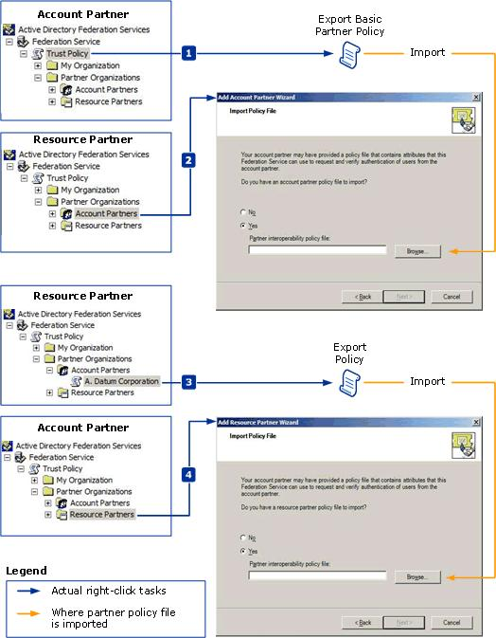

- The account partner administrator specifies the Export Basic Partner Policy option by right-clicking on the Trust Policy folder and exports a partner policy file that contains the URL, display name, federation server proxy URL, and verification certificate for A. Datum Corp. The account partner administrator then sends the partner policy file (by e-mail or other means) to the resource partner administrator.
- The resource partner administrator creates a new account partner using the Add Account Partner Wizard and selects the option to import an account partner policy file. The resource partner administrator proceeds to specify the location of the partner policy file and to verify that all the values which are presented in each of the wizard pages — which are pre-populated as a result of the policy import — are accurate. The administrator then completes the wizard.
- The resource partner administrator can now configure additional claims or trust policy settings that are specific to that account partner. After this configuration is complete, the administrator specifies the Export Policy option by right-clicking on the A. Datum Corp. account partner. The resource partner administrator exports a partner policy file that contains values such as the URL, federation server proxy URL, display name, claim types and claim mappings for the Trey Research organization. The resource partner administrator then sends the partner policy file to the account partner administrator.
- The account partner administrator creates a new resource partner using the Add Resource Partner Wizard and selects the option to import a resource partner policy file. The account partner administrator specifies the location of the resource partner policy file and verifies that all the values that are presented in each of the wizard pages — which are pre-populated as a result of the policy import — are accurate. The administrator then completes the wizard.
When this process is complete, a successful federation trust between both partners is established. Resource partner administrators can also initiate the import and export policy process, although that process is not described here.
New Settings
You configure Windows NT token-based Web Agent settings with the IIS Manager snap-in. To support the new functionality that is provided with IIS 7.0, Windows Server 2008 Active Directory Federation Services includes UI updates for the Active Directory Federation Services Web Agent role service. The following table lists the different locations in IIS Manager for IIS 6.0 or IIS 7.0 for each of the Active Directory Federation Services Web Agent property pages, depending on the version of IIS that is used.
Active Directory Federation Services Web Agent Property Pages
IIS 6.0 Property Page | Old Location | IIS 7.0  Property  Page | New Location
Active Directory Federation Services Web Agent tab | <COMPUTERNAME>\Web Sites | Federation Service URL | <COMPUTERNAME> (in the Other section of the center pane)
Active Directory Federation Services Web Agent tab | <COMPUTERNAME>\Web Sites\<Site or Virtual Directory> | Active Directory Federation Services Web Agent | <COMPUTERNAME>\Web Sites\<Site or Virtual Directory> (in the IIS\Authentication section of the center pane)

Note
There are no significant UI differences between the Active Directory Federation Services snap-in in Windows Server 2008 and the Active Directory Federation Services snap-in in Windows Server 2003 R2.

5.12 Active Directory Lightweight Directory Services
The Active Directory Lightweight Directory Services server role is an LDAP directory service. It provides data storage and retrieval for directory-enabled applications, without the dependencies that are required for Active Directory Domain Services.
Active Directory Lightweight Directory Services in Windows Server 2008 encompasses the functionality that was provided by Active Directory Application Mode, which is available for Microsoft Windows XP Professional and the Windows Server 2003 operating systems.
Active Directory Lightweight Directory Services gives organizations flexible support for directory-enabled applications. A directory-enabled application uses a directory — rather than a database, flat file, or other data storage structure — to hold its data. Directory services (such as Active Directory Lightweight Directory Services) and relational databases both provide data storage and retrieval, but they differ in their optimization. Directory services are optimized for read processing, whereas relational databases are optimized for transaction processing. Many off-the-shelf applications and many custom applications use a directory-enabled design. Examples include these:
- Customer relationship management (CRM) applications
- Human resources (HR) applications
- Global address book applications
Active Directory Lightweight Directory Services provides much of the same functionality as Active Directory Domain Services (and, in fact, is built on the same code base), but it does not require the deployment of domains or domain controllers.
You can run multiple instances of Active Directory Lightweight Directory Services concurrently on a single computer, with an independently managed schema for each Active Directory Lightweight Directory Services instance or configuration set (if the instance is part of a configuration set). Member servers, domain controllers and stand-alone servers can be configured to run the Active Directory Lightweight Directory Services server role.
Active Directory Lightweight Directory Services is similar to Active Directory Domain Services in that it provides the following:
- Multimaster replication
- Support for the Active Directory Service Interfaces API
- Application directory partitions
- LDAP over SSL
Active Directory Lightweight Directory Services differs from Active Directory Domain Services primarily in that it does not store Windows security principals. Although Active Directory Lightweight Directory Services can use Windows security principals (such as domain users) in ACLs that control access to objects in Active Directory Lightweight Directory Services, Windows cannot authenticate users stored in Active Directory Lightweight Directory Services or use Active Directory Lightweight Directory Services users in its ACLs. In addition, Active Directory Lightweight Directory Services does not support domains and forests, Group Policy or global catalogs.
Organizations that have the following requirements will find Active Directory Lightweight Directory Services particularly useful:
- Application-specific directories that use customized schemas or that depend on decentralized directory management
Active Directory Lightweight Directory Services directories are separate from the domain infrastructure of Active Directory Domain Services. As a result, they can support applications that depend on schema extensions that are not desirable in the Active Directory Domain Services directory — such as schema extensions that are useful to a single application. In addition, the local server administrator can administer the Active Directory Lightweight Directory Services directories; domain administrators do not need to provide administrative support.
- Directory-enabled application development and prototyping environments that are separate from the enterprise’s domain structure
Application developers who are creating directory-enabled applications can install the Active Directory Lightweight Directory Services role on any server, even on stand-alone servers. As a result, developers can control and modify the directory in their development environment without interfering with the organization’s Active Directory Domain Services infrastructure. These applications can be deployed subsequently with either Active Directory Lightweight Directory Services or Active Directory Domain Services as the application’s directory service, as appropriate.
Network administrators can use Active Directory Lightweight Directory Services as a prototype or pilot environment for applications that will eventually be deployed with Active Directory Domain Services as its directory store, as long as the application does not depend on features specific to Active Directory Domain Services.
- Management of external client computers’ access to network resources
Enterprises that need to authenticate extranet client computers, such as Web client computers or transient client computers, can use Active Directory Lightweight Directory Services as the directory store for authentication. This helps enterprises avoid having to maintain external client information in the enterprise’s domain directory.
- Enabling of earlier LDAP client computers in a heterogeneous environment to authenticate against Active Directory Domain Services
When organizations merge, there is often a need to integrate LDAP client computers running different server operating systems into a single network infrastructure. In such cases, rather than immediately upgrading client computers running earlier LDAP applications or modifying the Active Directory Domain Services schema to work with the earlier clients, network administrators can install the Active Directory Lightweight Directory Services server role on one or more servers. The Active Directory Lightweight Directory Services server role acts as an interim directory store using the earlier schema until the client computers can be upgraded to use Active Directory Domain Services natively for LDAP access and authentication.
Because Active Directory Lightweight Directory Services is designed to be a directory service for applications, it is expected that the applications will create, manage and remove directory objects. As a general-purpose directory service, Active Directory Lightweight Directory Services is not supported by such domain-oriented tools as these:
- Active Directory Domains and Trusts
- Active Directory Users and Computers
- Active Directory Sites and Services
However, administrators can manage Active Directory Lightweight Directory Services directories by using directory tools such as the following:
- ADSI Edit (for viewing, modifying, creating and deleting any object in Active Directory Lightweight Directory Services)
- Ldp.exe (for general LDAP administration)
- Other schema management utilities
Applications that were designed to work with Active Directory Application Mode do not require changes to function with Active Directory Lightweight Directory Services.

5.13 Active Directory Rights Management Services
For Windows Server 2008, Active Directory Rights Management Services includes several new features that were not available in Microsoft Windows Rights Management Services (RMS). These new features were designed to ease administrative overhead of Active Directory Rights Management Services and to extend its use outside your organization. These new features include the following:
- Inclusion of Active Directory Rights Management Services in Windows Server 2008 as a server role
- Administration through an MMC
- Integration with Active Directory Federation Services
- Self-enrollment of Active Directory Rights Management Services servers
- Ability to delegate responsibility by means of new Active Directory Rights Management Services administrative roles
Note
This topic concentrates on the features specific to Active Directory Rights Management Services that are being released with Windows Server 2008. Earlier versions of RMS were available as a separate download. For more information about the features that were available in RMS, see Windows Server 2003 Rights Management Services (RMS) (http://go.microsoft.com/fwlink/?LinkId=68637).
Active Directory Rights Management Services, a format- and application-agnostic technology, provides services to enable the creation of information-protection solutions. It will work with any Active Directory Rights Management Services-enabled application to provide persistent usage policies for sensitive information. Content that can be protected by using Active Directory Rights Management Services includes intranet Web sites, e-mail messages and documents. Active Directory Rights Management Services includes a set of core functions that allow developers to add information protection to the functionality of existing applications.
An Active Directory Rights Management Services system, which includes both server and client components, performs the following processes:
- Licensing rights-protected information. An Active Directory Rights Management Services system issues rights account certificates, which identify trusted entities (such as users, groups and services) that can publish rights-protected content. Once trust has been established, users can assign usage rights and conditions to content they want to protect. These usage rights specify who can access rights-protected content and what they can do with it. When the content is protected, a publishing license is created for the content. This license binds the specific usage rights to a given piece of content so that the content can be distributed. For example, users can send rights-protected documents to other users inside or outside their organization without the content losing its rights protection.
- Acquiring licenses to decrypt rights-protected content and applying usage policies. Users who have been granted a rights account certificate can access rights-protected content by using an Active Directory Rights Management Services-enabled client application that allows users to view and work with rights-protected content. When users attempt to access rights-protected content, requests are sent to Active Directory Rights Management Services to access, or “consume,” that content. When a user attempts to consume the protected content, the Active Directory Rights Management Services licensing service on the Active Directory Rights Management Services cluster issues a unique use license that reads, interprets and applies the usage rights and conditions specified in the publishing licenses. The usage rights and conditions are persistent and automatically applied everywhere the content goes.
- Creating rights-protected files and templates. Users who are trusted entities in an Active Directory Rights Management Services system can create and manage protection-enhanced files by using familiar authoring tools in an Active Directory Rights Management Services-enabled application that incorporates Active Directory Rights Management Services technology features. In addition, Active Directory Rights Management Services-enabled applications can use centrally defined and officially authorized usage rights templates to help users efficiently apply a predefined set of usage policies.
Active Directory Rights Management Services is designed to help make content more secure, regardless of wherever the rights-protected content might be moved to.
You should review this section, and additional documentation about Active Directory Rights Management Services, if you are in any of the following groups:
- IT planners and analysts who are evaluating enterprise rights management products
- IT professionals responsible for supporting an existing RMS infrastructure
- IT security architects who are interested in deploying information protection technology that provides protection for both data at rest and in motion
Active Directory Rights Management Services relies on Active Directory Domain Services to verify that the user attempting to consume rights-protected content is authorized to do so. When registering the Active Directory Rights Management Services service connection point (SCP) during installation, the installing user account must have Write access to the Services container in Active Directory Domain Services.
Finally, all configuration and logging information is stored in the Active Directory Rights Management Services Logging Database. In a test environment, you can use the Windows Internal Database, but in a production environment, we recommend using a separate database server.
Active Directory Rights Management Services includes a number of enhancements over earlier versions of RMS. These enhancements include the following:
- Improved installation and administration experience. Active Directory Rights Management Services is included with Windows Server 2008 and is installed as a server role. In addition, Active Directory Rights Management Services administration is done through an MMC, as opposed to the Web site administration presented in the earlier versions.
- Self-enrollment of the Active Directory Rights Management Services cluster. Active Directory Rights Management Services cluster can be enrolled without having to connect to the Microsoft Enrollment Service. Through the use of a server self-enrollment certificate, the enrollment process is done entirely on the local computer.
- Integration with Active Directory Federation Services. Active Directory Rights Management Services and Active Directory Federation Services have been integrated such that enterprises are able to leverage existing federated relationships to collaborate with external partners.
- New Active Directory Rights Management Services administrative roles. The ability to delegate Active Directory Rights Management Services tasks to different administrators is needed in any enterprise environment and is included with this version of Active Directory Rights Management Services. Three administrative roles have been created: Active Directory Rights Management Services Enterprise Administrators, Active Directory Rights Management Services Template Administrators, and Active Directory Rights Management Services Auditors.
Improved Installation and Administration Experience
Active Directory Rights Management Services in Windows Server 2008 brings many improvements to both the installation and administration experience. In earlier versions of RMS, a separate installation package had to be downloaded and installed, but in this version, Active Directory Rights Management Services has been integrated into the operating system and is installed as a server role through Server Manager. Configuration and provisioning is achieved through the server role installation. In addition, Server Manager automatically lists and installs all services that Active Directory Rights Management Services is dependent on, such as Message Queuing and Web Server (IIS), during the Active Directory Rights Management Services server role installation. During installation, if you do not specify a remote database as the Active Directory Rights Management Services Configuration and Logging database, the Active Directory Rights Management Services server role installation automatically installs and configures the Windows Internal Database for use with Active Directory Rights Management Services.
In the earlier versions of RMS, administration was done through a Web interface. In Active Directory Rights Management Services, the administrative interface has been migrated to an MMC snap-in console. Active Directory Rights Management Services console gives you all the functionality available with the earlier version of RMS but in an interface that is much easier to use.
Offering Active Directory Rights Management Services as a server role that is included with Windows Server 2008 makes the installation process less burdensome by not requiring you to download Active Directory Rights Management Services separately before installing it.
Using an Active Directory Rights Management Services console for administration instead of a browser interface makes more options available to improve the user interface. The Active Directory Rights Management Services console employs user interface elements that are consistent throughout Windows Server 2008, which is designed to be much easier to follow and navigate. In addition, with the inclusion of Active Directory Rights Management Services administration roles, the Active Directory Rights Management Services console displays only the parts of the console that the user can access. For example, a user who is using the Active Directory Rights Management Services Template Administrators administration role is restricted to tasks that are specific to Active Directory Rights Management Services templates. All other administrative tasks are not available in the Active Directory Rights Management Services console.
Self-Enrollment of Active Directory Rights Management Services Server
Server enrollment in Active Directory Rights Management Services is the process of creating and signing a server licensor certificate (SLC) that grants the Active Directory Rights Management Services server the right to issue certificates and licenses. In earlier versions of RMS, the SLC had to be signed by the Microsoft Enrollment Service through an Internet connection. This required that either the RMS server had to have Internet connectivity to do online enrollment with the Microsoft Enrollment Service or be able to connect to another computer with Internet access that could do offline enrollment of the server.
In Active Directory Rights Management Services with Windows Server 2008, the requirement for Active Directory Rights Management Services server to directly contact the Microsoft Enrollment Service has been removed. Instead, a server
self-enrollment certificate is included with Windows Server 2008 that signs the Active Directory Rights Management Services server’s SLC.
Requiring the SLC to be signed by the Microsoft Enrollment Service introduced an operational dependency that many customers did not want to introduce into their environment. The Microsoft Enrollment Service is no longer required to sign the SLC.
Instead of requiring the Microsoft Enrollment Service to sign the Active Directory Rights Management Services server’s SLC, the server self-enrollment certificate, included with Windows Server 2008, can sign the SLC locally. The server self-enrollment certificate allows Active Directory Rights Management Services to operate in a network that is entirely isolated from the Internet.
When upgrading from RMS with SP1 or later, the root cluster must be upgraded before the licensing-only cluster. This is required so that the licensing-only cluster receives the root cluster’s new self-enrolled SLC.
Integration With Active Directory Federation Services
Enterprises are increasingly feeling the need to collaborate outside their enterprise boundaries and are looking at federation as a solution. Federation support with Active Directory Rights Management Services will allow enterprises to leverage their established federated relationships to enable collaboration with external entities. For example, an organization that has deployed Active Directory Rights Management Services can set up federation with an external entity by using Active Directory Federation Services and can leverage this relationship to share rights-protected content across the two organizations without requiring a deployment of Active Directory Rights Management Services in both places.
In earlier versions of RMS, the options for external collaboration of rights-protected content were limited to Microsoft Passport. Integrating Active Directory Federation Services with Active Directory Rights Management Services provides the ability to establish federated identities between organizations and share rights-protected content.
If you are interested in using Active Directory Federation Services with Active Directory Rights Management Services, you must have federated trust between your organization and the external partners you would like to collaborate with before Active Directory Rights Management Services is installed. In addition, you must use the Active Directory Rights Management Services client included with Windows Vista or RMS Client with SP2 to take advantage of the Active Directory Federation Services integration with Active Directory Rights Management Services. RMS clients earlier than RMS Client with SP2 will not support Active Directory Federation Services collaboration.
New Active Directory Rights Management Services Administrative Roles
To better delegate control of your Active Directory Rights Management Services environment, new administrative roles have been created. These administrative roles are local security groups that are created when the Active Directory Rights Management Services role is installed. Each of these administrative roles has different levels of access to Active Directory Rights Management Services associated with them. The new roles are Active Directory Rights Management Services Service Group, Active Directory Rights Management Services Enterprise Administrators, Active Directory Rights Management Services Template Administrators and Active Directory Rights Management Services Auditors.
The Active Directory Rights Management Services Service Group holds the Active Directory Rights Management Services service account. When the Active Directory Rights Management Services role is added, the service account configured during setup is added to this administrative role automatically.
The Active Directory Rights Management Services Enterprise Administrators role allows members of this group to manage all Active Directory Rights Management Services policies and settings. During Active Directory Rights Management Services provisioning, the user account installing the Active Directory Rights Management Services server role and the local administrators group are added to the Active Directory Rights Management Services Enterprise Administrators role. As a best practice, membership of this group should be restricted to only user accounts that need full Active Directory Rights Management Services administrative control.
The Active Directory Rights Management Services Templates Administrators role allows members of this group to manage rights policy templates. Specifically, Active Directory Rights Management Services Template Administrators can read cluster information, list rights policy templates, create new rights policy templates, modify existing rights policy template and export rights policy templates.
The Active Directory Rights Management Services Auditors role allows members of this group to manage logs and reports. This is a read-only role that is restricted to read cluster information, read logging settings, and run reports available on the Active Directory Rights Management Services cluster.
The new Active Directory Rights Management Services administrative roles give you the opportunity to delegate Active Directory Rights Management Services tasks without giving full administrative control over the entire Active Directory Rights Management Services cluster.
Customers who would like to deploy Active Directory Rights Management Services in their organization will not have to do anything to prepare for this change. Optionally, it is recommended to create Active Directory security groups for each of these administrative roles and add them to their respective local security groups. This will give you the ability to scale your Active Directory Rights Management Services deployment across several servers without having to add specific user accounts to each Active Directory Rights Management Services server.

Section 6: Web and Applications Platform

Section 6: Web and Applications Platform 160
6.01 Web and Applications Platform Introduction 161
Scenario Value Proposition 161
Special Hardware Requirements 161
6.02 Internet Information Services 7.0 162
Flexible Extensibility Model for Powerful Customization 162
Powerful Diagnostic and Troubleshooting Tools 163
Delegated Administration 163
Enhanced Security and Reduced Attack Surface through Customization 163
True Application Xcopy Deployment 163
Application and Health Management for WCF Services 163
Improved Administration Tools 163
Integrated Management Support for Web Services 163
Windows Firewall Is Turned On by Default 163
Editions 164
Configuration 164
Administration Tools 165
Core Web Server 166
Diagnostics 166
Additional Resources 167
6.03 Application Server 168
Application Server Core 168
Web Server 170
COM+ Network Access 170
Windows Process Activation Service 170
TCP Port Sharing 170
Distributed Transactions 171
6.04 Transactional NTFS 172

6.01 Web and Applications Platform Introduction
This scenario focuses on the management, security, performance and extensibility improvements that will be available when Windows Server® 2008 is deployed to host and manage applications and services running on the server and/or over the Web.
Scenario Value Proposition
Windows Server 2008 provides a security-enhanced, easy-to-manage platform for developing and reliably hosting applications and services to run on the server and/or over the Web. The key value propositions that Web and applications platform enables are the following:
- More efficient management of server and Web applications and services
- Quicker deployment/configuration of Web applications and services across server farms
- More secure, streamlined, customized Web platform
- Greater performance and/or scalability of Web applications and services
- Fine control and visibility into how and when applications and services utilize key operating system resources
Special Hardware Requirements
None

6.02 Internet Information Services 7.0
Windows Server 2008 delivers a unified platform for Web publishing that integrates IIS, ASP.NET, Windows® Communication Foundation, and supports Microsoft® Windows SharePoint® Services. IIS version 7.0 is a major enhancement to the existing IIS Web server and plays a central role in integrating Web platform technologies.
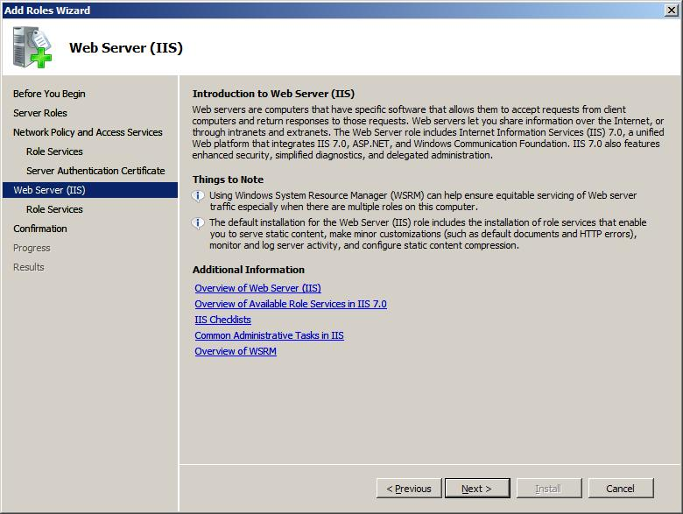
IIS 7.0 is built to be compatible with existing releases. All existing ASP, ASP.NET 1.1 and ASP.NET 2.0 applications are expected to run on IIS 7.0 without any code changes (using the compatible ISAPI support).
All existing ISAPI extensions and most ISAPI filters will also continue to work, unchanged. However, ISAPI filters that rely on READ RAW DATA notification are not supported in IIS 7.0.
For existing Active Directory® Service Interfaces and WMI scripts, IIS 7.0 will provide feature parity with previous releases, enabling them to run directly against the new configuration store.
Key pillars of the IIS 7.0 release are these:
- Flexible extensibility model for powerful customization
- Powerful diagnostic and troubleshooting tools
- Delegated administration
- Enhanced security and reduced attack surface through customization
- True application xcopy deployment
- Integrated application and health management for WCF services
- Improved administration tools
Flexible Extensibility Model for Powerful Customization
IIS 7.0 enables developers to extend IIS to provide custom functionality in new, more powerful ways. IIS 7.0 extensibility includes an all-new core server application programming interface (API) set that allows feature modules to be developed in both native code (C/C++) and managed code (languages such as C#, and Visual Basic® 2005, that use the .NET Framework).
IIS 7.0 also enables extensibility of configuration, scripting, event logging and administration tool feature-sets, providing software developers with a complete server platform on which to build Web server extensions.
Powerful Diagnostic and Troubleshooting Tools
IIS 7.0 enables developers and IT professionals to more easily troubleshoot errant Web sites and applications. IIS 7.0 provides a clear view of internal diagnostic information about IIS, and collects and surfaces detailed diagnostic events to aid troubleshooting problematic servers.
Delegated Administration
IIS 7.0 enables those who host or administer Web sites or WCF services to delegate administrative control to developers or content owners, thus reducing cost of ownership and administrative burden for the administrator. New administration tools are provided to support these delegation capabilities.
Enhanced Security and Reduced Attack Surface through Customization
You can control which features to install and run on your Web server. IIS 7.0 is made up of more than 40 separate feature modules. Each feature module can be independently installed on the server to reduce the attack surface of the server, and reduce administrative overhead where it is not needed. For more information about the various feature modules, see IIS 7.0 Modules (http://go.microsoft.com/fwlink/?LinkId=68740).
True Application Xcopy Deployment
IIS 7.0 allows you to store IIS configuration settings in web.config files, which makes it much easier to use xcopy to copy applications across multiple front-end Web servers, thereby avoiding costly and error-prone replication and manual synchronization issues.
Application and Health Management for WCF Services
To enhance the development and hosting of WCF services over many protocols, Windows Server 2008 includes the Windows Activation Service (WAS), which supports pluggable activation of arbitrary protocol listeners. WAS provides all types of message-activated applications with intelligent resource management, on-demand process activation, health-monitoring, and automatic failure detection and recycling. WAS is based on the IIS 6.0 request processing model.
Improved Administration Tools
IIS 7.0 introduces a new UI and a new command-line tool for managing and administering Web servers, Web sites and Web applications.
Integrated Management Support for Web Services
To enhance the development and hosting of Web services over many protocols, Windows Server 2008 includes the Windows Process Activation Service (WAS), which supports pluggable activation of arbitrary protocol listeners. WAS provides all types of message-activated applications with intelligent resource management, on-demand process activation, health-monitoring, and automatic failure detection and recycling. WAS is based on the IIS request processing model.
Windows Firewall Is Turned On by Default
Windows Firewall is enabled by default in Windows Server 2008. During the installation of the Web Server (IIS) role, the installation process adds the following inbound Windows Firewall rules to allow traffic for the role services that you selected:
- If you install HTTP-related and HTTPS-related role services, a rule is added to Windows Firewall to allow traffic for HTTP on port 80 and HTTPS on port 443. These rules appear in the Windows Firewall list as World Wide Web Services HTTP Traffic In and World Wide Web Services HTTPS Traffic In. They are turned on automatically.
- If you install FTP-related role services, a rule is added to Windows Firewall to allow traffic for FTP on port 21. This rule appears in the Windows Firewall list as FTP Server Traffic In. It is turned on automatically.
- If you install the Management Service, a rule is added to Windows Firewall to allow traffic for the service on port 8172. This rule appears in the Windows Firewall list as Web Management Service Traffic In. It must be turned on by the server administrator.
Editions
IIS 7.0 is available in all editions of Windows Server. There is no difference in functionality between editions. IIS 7.0 is available on 32-bit and 64-bit platforms.
Configuration
IIS 7.0 introduces some major improvements to the way configuration data is stored and accessed. One of the key goals of the IIS 7.0 release is to enable distributed configuration of IIS settings, which allows administrators to specify IIS configuration settings in files that are stored with the code and content.
Distributed configuration enables administrators to specify configuration settings for a Web site or application in the same directory as the code or content. By specifying configuration settings in a single file, distributed configuration allows administrators to delegate administration of selected features of Web sites or Web applications so others, such as application developers, can modify those features. Administrators can also lock specific configuration settings so that they cannot be changed by anyone else.
By using distributed configuration, the configuration settings for a specific site or application can be copied from one computer to another, as the application moves from development into test and ultimately into production. Distributed configuration also enables configuration for a site or application to be shared across a server farm, where all servers retrieve configuration settings and content from a file server.
IIS 7.0 configuration is based on the existing .NET Framework configuration store, which enables IIS configuration settings to be stored alongside ASP.NET configuration in Web.config files. This change provides one configuration store for all Web platform configuration settings that are accessible via a common set of APIs and stored in a consistent format. The IIS 7.0 configuration system is also fully extensible, so developers can extend the configuration store to include custom configuration with the same fidelity and priority as IIS configuration.
IIS 7.0 stores global, or computerwide, configuration in the %windir%\system32\inetsrv directory in a file called ApplicationHost.config. In this file there are two major configuration section groups:
- system.applicationHost
- system.webServer
The system.applicationHost section group contains configuration for site, application, virtual directory and application pools. The system.webServer section group contains configuration for all other settings, including global Web defaults.
URL specific configuration can also be stored in ApplicationHost.config using <location> tags. IIS 7.0 can also read and write URL specific configuration within the code or content directories of the Web sites and applications on the server in Web.config files, along with ASP.NET configuration.
Because Windows Server 2008 is a major release, you should expect to spend some time familiarizing yourself with the new configuration options.
Production Web sites and WCF services that currently run under IIS 6.0 should be thoroughly tested before being moved to production under IIS 7.0, although IIS 7.0 is designed to be compatible.
If you are using custom IIS 6.0 command-line scripts, you might want to convert them to IIS 7.0.
Administration Tools
IIS 7.0 introduces the following completely rewritten new administration tools for managing IIS:
- GUI, IIS Manager
- Command-line tool, appcmd.exe
- Configuration store, based on the .NET Framework 2.0 configuration store, which supports the direct editing of settings
- WMI provider that can read or change settings in the configuration store
- Managed interface, Microsoft.Web.Administration, which exposes the same information exposed by the WMI provider
In addition, the IIS 6.0 MMC snap-in is also provided with Windows Server 2008 to support remote administration and to administer FTP sites.
You can install administration tools and Web server components separately.
IIS 7.0 also includes a new WMI provider that broadens scripting access to all IIS and ASP.NET configuration.
The Microsoft.Web.Administration interface provides a strongly typed managed interface to retrieve the same data exposed by WMI scripts.
The IIS 6.0 command-line scripts have also been replaced with a new powerful command-line tool, appcmd.exe.
The new administration tools fully support the distributed configuration and delegation of administrative responsibility. The delegation can be very specific, allowing an administrator to decide exactly which functions to delegate, on a case-by-case basis.
The new administration tools fully support the new IIS 7.0 distributed configuration. They also allow for delegated (non-Administrative) access to configuration for individual sites and applications. The administration tools support non-Administrator, even non-Windows credentials to authenticate to a specific site or application and manage configuration for only that scope.
The new IIS Manager UI supports remote administration over HTTP, allowing for seamless local, remote, even cross-Internet administration without requiring DCOM or other administrative ports be opened on the firewall.
The administration tools are fully extensible, enabling developers to build new administration modules using the .NET Framework to easily plug in new administration UI modules that work as transparently as those that ship with IIS 7.0.
Core Web Server
The IIS 7.0 core Web server includes some fundamental changes from IIS 6.0. For example, both native and managed code is processed through a single request pipeline. In addition, IIS 7.0 features a Web server engine in which you can add or remove components, called modules, depending on your needs.
These changes enable a significant reduction in attack surface, more extensibility, and increased support for extending IIS 7.0 core functionality by creating managed code modules. The new worker process Web core also provides access to all notification events in the request pipeline. The level of integration is unprecedented, and allows existing ASP.NET features (such as Forms-based authentication or URL authorization) to be used for all types of Web content.
In previous versions of IIS, all functionality was built in by default, and there was no easy way to extend or replace any of that functionality. However, the IIS 7.0 core is divided into over 40 separate feature modules. The core also includes a new Win32® API for building core server modules. Core server modules are new and more powerful replacements for Internet Server ISAPI filters and extensions, although these filters and extensions are still supported in IIS 7.0.
Because all IIS core server features were developed so that IIS 7.0 can use the new Win32 API and as discrete feature modules, you can add, remove or even replace IIS feature modules.
IIS 7.0 also includes support for development of core Web server extensions using the .NET Framework. IIS 7.0 has integrated the existing IHttpModule API for ASP.NET, enabling your managed code modules to access all events in the request pipeline, for all requests.
Diagnostics
IIS 7.0 includes two major improvements that aid in diagnostics and troubleshooting of errant Web sites and applications.
The diagnostics and troubleshooting changes in IIS 7.0 allow a developer or an administrator to see, in real time, requests that are running on the server. Now, it is possible to filter for error conditions that are difficult to reproduce and automatically trap the error with a detailed trace log.
IIS 7.0 includes a new Runtime State and Control API, which provides real-time state information about application pools, worker processes, sites, application domains, and even running requests.
This information is exposed through a native Component Object Model (COM) API. The API itself is wrapped and exposed through the new IIS WMI provider, appcmd.exe, and IIS Manager. This allows users to quickly and easily check Web server status regardless of the management environment you use.
IIS 7.0 also includes detailed trace events throughout the request and response path, allowing developers to trace a request as it makes it way to IIS, through the IIS request processing pipeline, into any existing page level code, and back out to the response. These detailed trace events allow developers to understand not only the request path and any error information that was raised as a result of the request, but also elapsed time and other debugging information to assist in troubleshooting all types of errors and when a system stops responding.
To enable the collection of these trace events, IIS 7.0 can be configured to automatically capture full trace logs for any given request based on elapsed time or error response codes.
Additional Resources
For more information about IIS, see Internet Information Services on the Microsoft Web site (http://go.microsoft.com/fwlink/?LinkId=66138).
For more information about IIS extensibility APIs, see Internet Information Services 7.0 SDK on the Microsoft Web site (http://go.microsoft.com/fwlink/?LinkId=52351).

6.03 Application Server
Application Server is a new server role in Windows Server 2008. Application Server provides an integrated environment for deploying and running custom business applications that are built with Microsoft .NET Framework version 3.0 (formerly WinFX®). You can use the same integrated Application Server environment to deploy and run your organization’s legacy applications, such as such as applications that are built to use COM+, Message Queuing, Web services and distributed transactions.
Application Server provides the following benefits:
- A core runtime that supports effective deployment and management of high-performance business applications
- The .NET Framework development environment, which delivers a simplified programming model and a high-performance execution model for server-based applications, enables Web services, and integrates new applications with existing applications and infrastructure
- The user-friendly Add Roles Wizard that helps you choose the role services and features that are necessary to run your applications
- Automatic installation of all features that are necessary for a given role service
An Application Server environment can include, but is not limited to, the following:
- Domain-joined client computers and their users
- Computers that are connected to an intranet or to the Internet in a Web services environment
- Servers that interoperate over disparate platforms and operating systems
- Servers hosting applications that are built with .NET Framework 3.0
- Servers hosting applications that are built to use COM+, Message Queuing, Web services and distributed transactions
- Multiple servers that host multiple databases on a network
Application Server is a new server role that is installed through the Add Roles Wizard in Server Manager. Administrators who deploy LOB applications that are built with .NET Framework 3.0 will discover that setting up a hosting environment for applications is simpler with this server role. The Add Roles Wizard guides the administrator through the process of selecting the role services or supporting features that are necessary to run the applications.
Application Server Core
Application Server Core is the group of technologies that are installed by default when you install the Application Server role. Essentially, Application Server Core is .NET Framework 3.0.
Windows Server 2008 includes .NET Framework 2.0, regardless of any server role that is installed. .NET Framework 2.0 contains the CLR, which provides a code-execution environment that promotes safe execution of code, simplified code deployment, and support for interoperability of multiple languages.
Application Server Core adds .NET Framework 3.0 features to the baseline .NET Framework 2.0 features. For more information about .NET Framework 3.0, see .NET Framework Developer Center (http://go.microsoft.com/fwlink/?LinkId=81263).
The key components of Application Server Core are installed as a set of libraries and .NET assemblies. The following are the key components of Application Server Core:
- Windows Communication Foundation (WCF)
- Windows Workflow Foundation (WF)
- Windows Presentation Foundation (WPF)
The most important components for server-based applications are WCF and WF. WPF is used primarily in client-based applications.
WCF is the Microsoft unified programming model for building applications that use Web services to communicate with each other. These applications are also known as service-oriented applications. Developers can use WCF to build more secure, reliable, transacted applications that integrate across platforms and interoperate with existing systems and applications. For more information about WCF, see What is Windows Communication Foundation? (http://go.microsoft.com/fwlink/?LinkId=81260).
WF is the programming model and engine for building workflow-enabled applications quickly on Windows Server 2008. A workflow is a set of activities that describe a real-world process. A workflow is commonly described and viewed graphically —something like a flowchart. The description of the workflow is often called the model. Work items pass through the workflow model from start to finish.
Work items or activities within the model can be executed by people or by systems or computers. Although it is possible to describe a workflow in traditional programming languages as a series of steps and conditions, for more complex workflows or workflows that support simpler revisions, designing the workflow graphically and storing that design as a model is typically much more appropriate.
In addition to enabling the graphical modeling of workflows, WF enables the execution of such workflow models.
After a workflow model is compiled, it can be executed inside any Windows process, including client-based applications, such as console applications; graphical Windows forms applications; or server-based applications, including Windows Services, ASP.NET Web sites and WCF Web services.
WF supports system workflow and human workflow across a variety of scenarios, including the following:
- Workflow within LOB applications
- The sequential flow of screens, pages and dialog boxes as presented to the user in response to the user’s interaction with the UI
- Document-centric workflow
- Human workflow
- Composite workflow for service-oriented applications
- Business-rule-driven workflow
- Workflow for systems management
Application Server is essentially new for Windows Server 2008. The new Application Server role that is available in Windows Server 2008 is not an upgrade from application server technologies that you may have installed previously as a part of Windows Server 2003 or an earlier operating system. Because the functionality is completely new, administrators should be aware that there is no migration path for Application Server from Windows Server 2003 or earlier operating systems.
If you upgrade your server to Windows Server 2008 from Windows Server 2003 or an earlier operating system, you must also reinstall the Application Server role by using the Add Roles Wizard in Server Manager.
As a part of your preparation for installing the new Application Server role, create an inventory of the applications that you will run on this server. If you are an administrator, work with your developers to identify the supporting technologies and configurations that must be present on the server to run the applications. Then, map these technologies to the role services that are described in the next sections so that you can select and properly configure the services during server role installation.
Web Server
This option installs IIS version 7.0, the Web server that is built into Windows Server 2008. IIS provides the following benefits:
- IIS enables Application Server to host internal or external Web sites or services with static or dynamic content.
- IIS provides support for running ASP.NET applications that are accessed from a Web browser.
- IIS provides support for running Web services that are built with Microsoft ASP.NET or WCF.
COM+ Network Access
This option adds COM+ Network Access for remote invocation of applications that are built on and hosted within COM+ and Enterprise Services components. COM+ Network Access is one of the remote invocation capabilities of Windows Server 2008. Newer applications may use WCF to support remote invocation.
Windows Process Activation Service
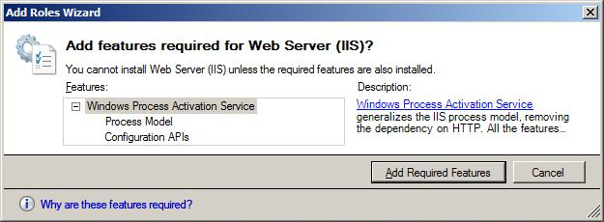
This option adds Windows Process Activation Service (WAS). WAS can start and stop applications dynamically, based on messages that are received over the network through HTTP, Message Queuing, TCP and named pipes protocols.
TCP Port Sharing
This option adds TCP Port Sharing. This role service makes it possible for multiple HTTP applications to use a single TCP port. When this role service is installed as a part of the Application Server role, multiple WCF applications can share a single port for receiving incoming messages from the network. This can help limit the surface area that is potentially open to attack because an administrator opens only one port in the firewalls.
The role service works by accepting connections using the Net.Tcp protocol. The service then automatically forwards incoming messages to the various WCF services based on the content of the messages. This simplifies the management of application servers when many instances of an application are running.
Distributed Transactions
This option enables distributed transactions that help ensure complete and successful transactions over multiple databases that are hosted on multiple computers on a network.

6.04 Transactional NTFS
Transactional NTFS file system and the Transactional Registry, the kernel transactional technology in Windows Server 2008, have been enhanced to coordinate their work through transactions. Because transactions are necessary to preserve data integrity and handle error conditions reliably, you can use Transactional NTFS to develop robust solutions on systems running Windows.
Transactional NTFS allows file operations on an NTFS file system volume to be performed transactionally. It provides support for full atomic, consistent, isolated and durable (ACID) semantics for transactions. For example, you can group together sets of file and registry operations with a transaction so that all of them succeed or none of them succeed. Although the transaction is active, the changes are not visible to readers outside the transaction. Even if the system fails, work that has started to commit is written to the disk, and incomplete transactional work is rolled back.
Transactions used with the file system or registry can be coordinated with any other transactional resource, such as SQL Server™ or MSMQ. The command line has been extended with the Transact command to allow simple command-line scripting using transactions.
Transactional NTFS is intended for use by IT professionals who need a way to ensure that certain file operations are completed without interruption or possible error.
Transactional NTFS provides the following functionality:
- Transactional NTFS integrates with COM+. COM+ is extended to use the Windows NT APIs to automatically bind the Windows NT® equivalent of the COM+ transaction with the thread on which it schedules an object. Therefore, applications that use the COM+ transaction model can simply specify an additional object property that indicates transactional file access intent. Legacy applications using the COM+ model that do not specify this additional property will access files without using Transactional NTFS.
- Each NTFS volume is a resource manager. A transaction that spans multiple volumes is coordinated by the Kernel Transaction Manager (KTM). Consistent with the Windows NT architecture, this feature supports Windows NT volume independent recovery. For example, a system can be restarted with some of the volumes “missing” without affecting the recovery on the other volumes.
- A file handle may be closed before the transaction commits or aborts. The commit or abort is typically performed by an entirely different thread from the one that performed the file work. Transacted handles are expected to be used only while the transaction is active. The system marks them as unusable after the transaction ends. Their attempt to modify the file fails, and the system presents an error message.
- You can view a file as a unit of storage. Partial updates and complete file overwrites are supported. It is not expected that multiple transactions concurrently modify parts of the file — this is not supported.
- Memory mapped I/O works transparently and consistently with the regular file I/O. The only additional work needed is for the application to flush and close an opened section before committing a transaction. Failure to do this will result in including partial changes in the transaction.
- Accessing a remote file using SMB Service and Web-Based Distributed Authoring and Versioning (WebDAV) is supported transparently. The transaction context is carried to the remote node by the system automatically. The transaction itself gets distributed and coordinated for commit or abort. This should allow applications to be distributed across the multiple nodes with a great degree of flexibility. This is powerful because it transacts network file transfers, which emulates a form of transacted messaging.
- Each volume contains its own log. The common log format is used for providing recovery and aborts. The common log format also builds a common Windows transaction-logging facility for use by other stores.

Section 7: Server Management

Section 7: Server Management 174
7.01 Server Management Introduction 176
Scenario Value Proposition 176
Special Hardware Requirements 176
7.02 Initial Configuration Tasks 177
Default Settings in Initial Configuration Tasks 178
7.03 Server Manager 179
Roles 180
Server Roles in Server Manager 180
Features 183
Features in Server Manager 183
Server Manager Console 186
Server Manager Wizards 188
Add Roles Wizard 188
Add Role Services Wizard 189
Add Features Wizard 189
Remove Roles Wizard 190
Remove Role Services Wizard 190
Remove Features Wizard 190
Server Manager Command Line 190
Registry Settings 191
Registry Settings 191
How Do I Open Server Manager? 191
Additional Resources 192
7.04 Windows PowerShell 193
Windows PowerShell Features 194
Windows PowerShell Cmdlets 194
A New Scripting Language 195
Windows Commands and Utilities 195
Additional Information 195
7.05 Server Core 196
7.06 Windows Server Backup 200
7.07 Windows Reliability and Performance Monitor 203
Data Collector Sets 203
Wizards and Templates for Creating Logs 204
Resource View 204
Reliability Monitor 204
Unified Property Configuration for All Data Collection, Including Scheduling 205
User-Friendly Diagnosis Reports 205
7.08 Windows Deployment Services 206
Create and add Boot Images 208
Create a Capture Image 208
Create a Discover Image 208
Create an Install Image 209
Associate an Unattend File with an Image 209
Enable multicast transmission of an image 210
Use Transport Server to enable multicast download of data 210
Deployment 210
Additional Resources 210
7.09 Group Policy 212
New Categories of Policy Management 213
New Format and Functionality of Administrative Template Files (ADMX) 216
Starter Group Policy Objects 217
Comments for GPOs and Policy Settings 217
Network Location Awareness 217
Group Policy Service 219
Events and Logging 219
Multiple Local Group Policy Objects 220
Finding Specific Administrative Template Policy Settings 220

7.01 Server Management Introduction
This scenario focuses on tools, technologies and installation options that are available for use on Windows Server® 2008 to improve the management experience of single and multiple servers across an enterprise.
For local administration of a single server, Server Manager is an integrated Microsoft® Management Console that offers IT professionals a seamless, integrated experience for adding, removing and configuring server roles, role services and features. It also acts as a portal for ongoing server management, monitoring and operations by exposing key management tasks based on server role, and providing access to advanced administration tools.
In larger enterprises, management of multiple servers can be automated using Windows PowerShell™, which consists of a new command line shell and scripting language designed specifically to automate administration tasks for server roles such as IIS and Active Directory®.
IT professionals can also use the Windows® Remote Shell (WinRS) tool to remotely manage servers or to obtain management data through Windows Remote Management (WinRM) and Windows Management Instrumentation (WMI) objects on remote servers. WinRM is a new remote access protocol that is based on the DMTF standard Web Services for Management.
Server Core provides a minimal installation option for certain server roles, offering a smaller server footprint and attack surface to reduce management and servicing needs.
Scenario Value Proposition
The key value propositions that server management enables are these:
- Complete initial configuration of a local server through a single interface
- Add and remove server roles and features more securely and reliably
- Examine server role status, perform key management tasks and access advanced management tools from a single local management tool
- Automate administration of multiple servers through a task-oriented scripting language
- Accelerate script authoring, testing and debugging and write customer tools in a new command shell environment
- Perform local and remote server management by accessing multiple data management stores such as WMI, ADSI, COM, Certificates, Registry and XML configuration files
- Reduce management and servicing needs, while improving reliability and security
Special Hardware Requirements
None

7.02 Initial Configuration Tasks
The Initial Configuration Tasks window is a new feature in Windows Server 2008 that opens automatically after the operating system installation process is complete, and helps the administrator finish the setup and initial configuration of a new server. It includes tasks such as setting the Administrator password, changing the name of the Administrator account to improve the security of your server, joining the server to an existing domain, enabling Remote Desktop for the server, and enabling Windows Update and Windows Firewall.
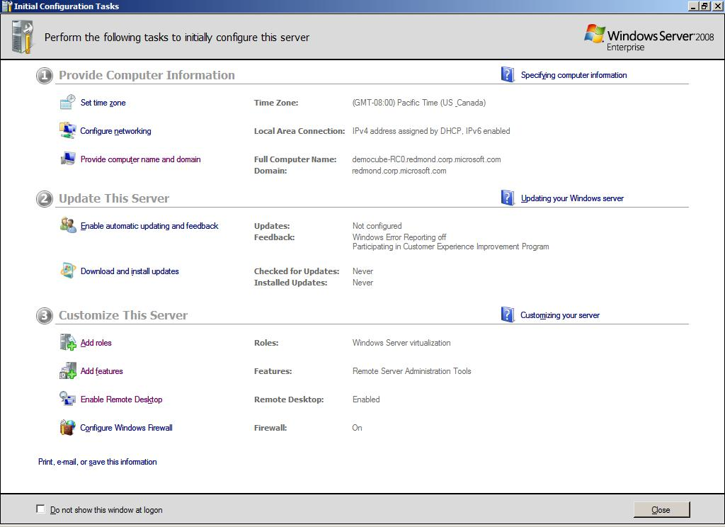
Before Windows Server 2008, Windows server-class operating system setup paused for administrators to provide administrator account, domain and network information. Feedback indicated that this practice slowed the operating system and server deployment process; because the completion of operating system installation would be delayed until administrators responded to the prompts and provided this information.
Initial Configuration Tasks allows administrators to postpone these tasks until installation is complete, meaning fewer interruptions during installation.
In addition, because product activation can be done within a grace period (typically 30 days), and is not critical for the initial configuration of the server, the Activate Your Server command, present on the Manage Your Server window in Windows Server 2003, has been removed from Initial Configuration Tasks.
The Add Roles and Add Features commands in the Initial Configuration Tasks window allow you to begin adding roles and features to your server immediately.
The Initial Configuration Tasks window helps administrators configure a server and shorten the amount of time between operating system installation and deployment of the server in an enterprise. It allows administrators to specify, in a logical manner, operating system settings that were previously exposed in Windows Server 2003 Setup, such as the Administrator account, domain information, and network settings.
The Initial Configuration Tasks window also allows you to participate in the following programs that provide anonymous feedback to Microsoft about how its software performs in your enterprise:
- Windows Server Customer Experience Improvement Program
- Windows Error Reporting
Default Settings in Initial Configuration Tasks
Setting | Default Configuration
Administrator password | The Administrator account password is blank by default.
Computer name | The computer name is randomly assigned during installation. You can modify the computer name by using commands in the Initial Configuration Tasks window.
Domain membership | The computer is not joined to a domain by default; it is joined to a workgroup named WORKGROUP.
Windows Update | Windows Update is turned off by default.
Network connections | All network connections are set to obtain IP addresses automatically by using DHCP.
Windows Firewall | Windows Firewall is turned on by default.
Roles installed | No roles are installed by default.

7.03 Server Manager
Windows Server 2008 eases the task of managing and securing multiple server roles in an enterprise with the new Server Manager console. Server Manager in Windows Server 2008 provides a single source for managing a server’s identity and system information, displaying server status, identifying problems with server role configuration, and managing all roles installed on the server.
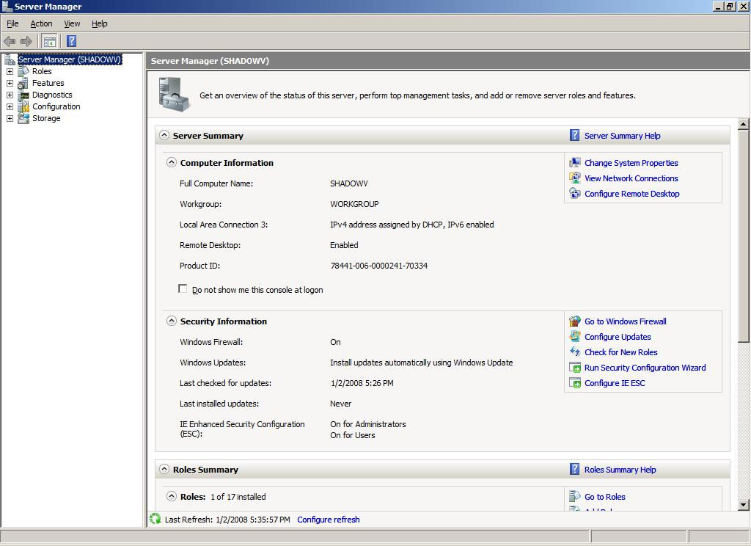
Server Manager replaces several features included with Windows Server 2003, including Manage Your Server, Configure Your Server, and Add or Remove Windows Components.
Server Manager also eliminates the requirement that administrators run the Security Configuration Wizard before deploying servers; server roles are configured with recommended security settings by default and are ready to deploy as soon as they are installed and properly configured.
Server Manager is an expanded MMC that allows you to view and manage virtually all the information and tools that affect your server’s productivity. Commands in Server Manager allow you to install or remove server roles and features, and to augment roles already installed on the server by adding role services.
Server Manager makes server administration more efficient by allowing administrators to do the following by using a single tool:
- View and make changes to server roles and features installed on the server
- Perform management tasks associated with the operational life cycle of the server, such as starting or stopping services, and managing local user accounts
- Perform management tasks associated with the operational life cycle of roles installed on the server
- Determine server status, identify critical events, and analyze and troubleshoot configuration issues or failures
- Install or remove roles, role services and features by using a Windows command line
Server Manager is designed to provide the greatest benefit to any of the following types of IT professionals:
- An IT administrator, planner or analyst who is evaluating Windows Server 2008
- An enterprise IT planner or designer
- An early adopter of Windows Server 2008
- An IT architect who is responsible for computer management and security throughout an organization
Before using Server Manager, it is recommended that you familiarize yourself with the functions, terminology, requirements and day-to-day management tasks of any roles you plan to install on your server. For more detailed information about server roles, see Microsoft TechNet (http://go.microsoft.com/fwlink/?LinkId=48541).
Server Manager is installed by default as part of the Windows Server 2008 setup process. To use Server Manager, you must be logged on to the computer as a member of the Administrators group on the local computer.
Roles
Although adding and removing server roles and features is not new, Server Manager unifies the functionality of multiple earlier tools in a single, simple, MMC-based user interface.
Roles and features installed by using Server Manager are security-enabled by default. Administrators need not run the Security Configuration Wizard following role installation or removal unless they want to change default settings.
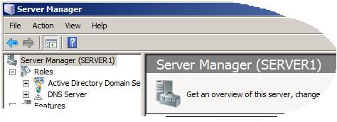
Server Manager provides a single point of access to management snap-ins for all installed roles. Adding a role automatically creates a management console home page in Server Manager for that role, which displays events and service status for all services that are part of the role. Role services, or subcomponents of a role, are listed in a section of this page. Administrators can open wizards to add or remove role services by using commands on this home page.
A server role describes the primary function of the server. Administrators can choose to dedicate an entire computer to one server role, or install multiple server roles on a single computer. Each role can include one or more role services, best described as subelements of a role. The following server roles are available in Windows Server 2008, and can be installed and managed by using Server Manager.
Server Roles in Server Manager
Role Name | Description
Active Directory Certificate Services | Active Directory Certificate Services provides customizable services for creating and managing public key certificates used in software security systems employing public key technologies. Organizations can use Active Directory Certificate Services to enhance security by binding the identity of a person, device or service to a corresponding private key. Active Directory Certificate Services also includes features that allow you to manage certificate enrollment and revocation in a variety of scalable environments.  Applications supported by Active Directory Certificate Services include Secure/Multipurpose Internet Mail Extensions (S/MIME), secure wireless networks, VPN, IPsec, Encrypting File System (EFS), smart card logon, SSL/TLS, and digital signatures.
Active Directory Domain Services | Active Directory Domain Services stores information about users, computers and other devices on the network. Active Directory Domain Services helps administrators more securely manage this information and facilitates resource sharing and collaboration between users. Active Directory Domain Services is also required to be installed on the network to install directory-enabled applications such as Microsoft Exchange Server and for applying other Windows Server technologies such as Group Policy.
Active Directory Federation Services | Active Directory Federation Services provides Web single-sign-on technologies to authenticate a user to multiple Web applications using a single user account. Active Directory Federation Services accomplishes this by securely federating, or sharing, user identities and access rights, in the form of digital claims, between partner organizations..
Active Directory Lightweight Directory Services | Organizations that have applications which require a directory for storing application data can use Active Directory Lightweight Directory Services as the data store. Active Directory Lightweight Directory Services runs as a nonoperating-system service, and, as such, it does not require deployment on a domain controller. Running as a nonoperating-system service allows multiple instances of Active Directory Lightweight Directory Services to run concurrently on a single server, and each instance can be configured independently for servicing multiple applications.
Active Directory Rights Management Services | Active Directory Rights Management Services is information protection technology that works with Active Directory Rights Management Services-enabled applications to help safeguard digital information from unauthorized use. Content owners can define exactly how a recipient can use the information, such as who can open, modify, print, forward or take other actions with the information. Organizations can create custom usage rights templates such as “Confidential—Read Only” that can be applied directly to information such as financial reports, product specifications, customer data and  e-mail messages.
Application Server | Application Server provides a complete solution for hosting and managing high-performance distributed business applications. Integrated services, such as the .NET Framework, Web Server Support, Message Queuing, COM+, Windows Communication Foundation, and Failover Clustering support boost productivity throughout the application life cycle, from design and development through deployment and operations.
Dynamic Host Configuration Protocol (DHCP) Server | The DHCP allows servers to assign, or lease, IP addresses to computers and other devices that are enabled as DHCP clients. Deploying DHCP servers on the network automatically provides computers and other TCP/IP-based network devices with valid IP addresses and the additional configuration parameters these devices need, called DHCP options, that allow them to connect to other network resources, such as DNS servers, WINS servers and routers.
DNS Server | DNS provides a standard method for associating names with numeric Internet addresses. This makes it possible for users to refer to network computers by using easy-to-remember names instead of a long series of numbers. Windows DNS services can be integrated with DHCP services on Windows, eliminating the need to add DNS records as computers are added to the network.
Fax Server | Fax Server sends and receives faxes, and allows you to manage fax resources such as jobs, settings, reports and fax devices on this computer or on the network.
File Services | File Services provides technologies for storage management, file replication, distributed namespace management, fast file searching and streamlined client access to files.
Hyper-V | The Hyper-V server virtualization role provides an entirely new deployment and licensing paradigm to enable multiple operating system instances — from both Microsoft and potentially third-party operating system vendors — to run in a virtual infrastructure separated from the hardware by a slim “hypervisor”-based virtualization technology.
Network Policy and Access Services | Network Policy and Access Services delivers a variety of methods to provide users with local and remote network connectivity, to connect network segments, and to allow network administrators to centrally manage network access and client health policies. With Network Access Services, you can deploy VPN servers, dial-up servers, routers, and 802.11 protected wireless access. You can also deploy RADIUS servers and proxies, and use Connection Manager Administration Kit to create remote access profiles that allow client computers to connect to your network.
Print Services | Print Services enables the management of print servers and printers. A print server reduces administrative and management workload by centralizing printer management tasks.
Terminal Services | Terminal Services provides technologies that enable users to access Windows-based programs that are installed on a terminal server, or to access the Windows desktop itself from almost any computing device. Users can connect to a terminal server to run programs and to use network resources on that server.
Universal Description, Discovery, and Integration Services (UDDI) | UDDI Services provides UDDI capabilities for sharing information about Web services within an organization’s intranet, between business partners on an extranet or on the Internet. UDDI Services can help improve the productivity of developers and IT professionals with more reliable and manageable applications. With UDDI Services you can prevent duplication of effort by promoting reuse of existing development work.
Web Server (IIS) | Web Server (IIS) enables sharing of information on the Internet, an intranet or an extranet. It is a unified Web platform that integrates IIS 7.0, ASP.NET, Windows Communication Foundation and supports Windows SharePoint® Services. IIS 7.0 also features enhanced security, simplified diagnostics and delegated administration.
Windows Deployment Services | You can use Windows Deployment Services to install and configure Microsoft Windows operating systems remotely on computers with Pre-boot Execution Environment (PXE) boot ROMs. Administration overhead is decreased through the implementation of the WdsMgmt MMC snap-in, which manages all aspects of Windows Deployment Services. Windows Deployment Services also provides end users with an experience consistent with Windows Setup.

The following graphic shows the File Services role home page in Server Manager.
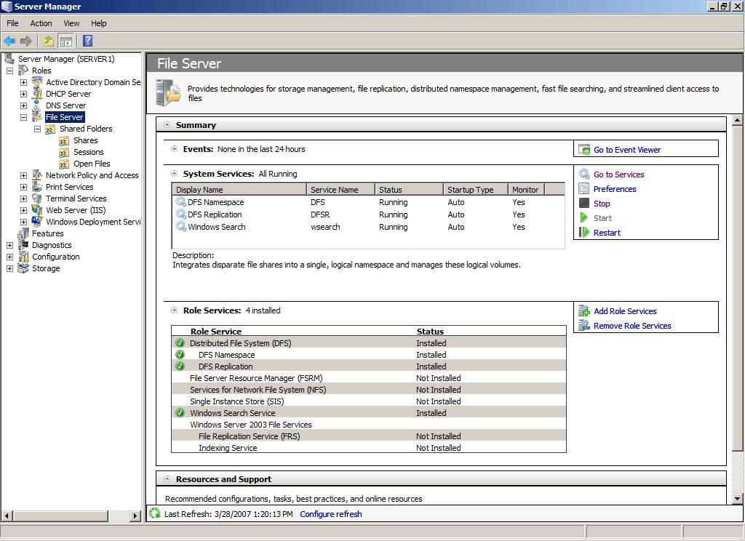

Features
Features, generally speaking, do not describe the primary function of a server. Features provide auxiliary or supporting functions to servers. Typically, administrators add features not as the primary function of a server, but to augment the functionality of installed roles.
For example, Failover Clustering is a feature that administrators can install after installing certain server roles, such as File Services, to add redundancy to File Services and shorten possible disaster recovery time.
The following features are available in Windows Server 2008 and can be installed using commands in Server Manager.
Features in Server Manager
Feature Name | Description
Microsoft .NET Framework 3.0 Features | Microsoft .NET Framework 3.0 combines the power of the .NET Framework 2.0 APIs with new technologies for building applications that offer appealing user interfaces, help protect your customers’ personal identity information, enable seamless and security-enhanced communication, and provide the ability to model a range of business processes.
BitLocker Drive Encryption | BitLocker™ Drive Encryption helps to protect data on lost, stolen or inappropriately decommissioned computers by encrypting the entire volume and checking the integrity of early boot components. Data is decrypted only if those components are successfully verified and the encrypted drive is located in the original computer. Integrity checking requires a compatible trusted platform module (TPM).
BITS Server Extensions | Background Intelligent Transfer Service (BITS) Server Extensions allow a server to receive files uploaded by clients using BITS. BITS allows client computers to transfer files in the foreground or background asynchronously, preserve the responsiveness of other network applications, and resume file transfers after network failures and computer restarts.
Connection Manager Administration Kit (CMAK) | CMAK generates Connection Manager profiles.
Desktop Experience | Desktop Experience includes features of Windows Vista™, such as Windows Media® Player, desktop themes and photo management. Desktop Experience does not enable any of the Windows Vista features by default; you must manually enable them.
Internet Printing Client | Internet Printing Client allows you to use HTTP to connect to and use printers that are on Web print servers. Internet printing enables connections between users and printers that are not on the same domain or network. Examples of uses include a traveling employee at a remote office site, or in a coffee shop equipped with Wi-Fi access.
Internet Storage Name Server (iSNS) | iSNS provides discovery services for Internet Small Computer System Interface (iSCSI) storage area networks. iSNS processes registration requests, deregistration requests and queries from iSNS clients.
LPR Port Monitor (LPR) | LPR Port Monitor allows users who have access to UNIX-based computers to print on devices attached to them.
Message Queuing | Message Queuing provides guaranteed message delivery, efficient routing, security and priority-based messaging between applications. Message Queuing also accommodates message delivery between applications that run on different operating systems, use dissimilar network infrastructures, are temporarily offline, or that are running at different times.
Multipath I/O (MPIO) | MPIO, along with the Microsoft Device Specific Module (DSM) or a third-party DSM, provides support for using multiple data paths to a storage device on Microsoft Windows.
Peer Name Resolution Protocol (PNRP) | PNRP allows applications to register on and resolve names from your computer, so other computers can communicate with these applications.
Quality Windows Audio Video Experience (qWave) | qWave is a networking platform for audio and video (AV) streaming applications on Internet protocol home networks. qWave enhances AV streaming performance and reliability by ensuring network quality-of-service for AV applications. It provides admission control, run-time monitoring and enforcement, application feedback, and traffic prioritization. On Windows Server platforms, qWave provides only rate-of-flow and prioritization services.
Recovery Disc | Recovery Disc is a utility for creating a Windows operating system installation disc. By using Recovery Disc, you can recover data on your computer if you do not have a Windows product disc, or cannot access recovery tools provided by your computer’s manufacturer.
Remote Assistance | Remote Assistance enables you (or a support person) to offer assistance to users with computer issues or questions. Remote Assistance allows you to view and share control of the user’s desktop to troubleshoot and fix the issues. Users can also ask for help from friends or co-workers.
Remote Server Administration Tools | Remote Server Administration Tools enables remote management of Windows Server 2003 and Windows Server 2008 from a computer running Windows Server 2008, by allowing you to run some of the management tools for roles, role services and features on a remote computer.
Removable Storage Manager (RSM) | RSM manages and catalogs removable media and operates automated removable media devices.
RPC Over HTTP Proxy | RPC Over HTTP Proxy is a proxy that is used by objects that receive remote procedure calls over HTTP. This proxy allows clients to discover these objects even if the objects are moved between servers or if they exist in discrete areas of the network, usually for security reasons.
Services for Network File System (NFS) | Services for NFS is a protocol that acts as a distributed file system, allowing a computer to access files over a network as easily as if they were on its local disks. This feature is available for installation on 64-bit versions of Windows Server 2008 only; in other versions of Windows Server 2008, Services for NFS is available as a role service of the File Services role.
SMTP Server | SMTP Server supports the transfer of e-mail messages between e-mail systems.
Storage Manager for Storage Area Networks (SANs) | SANs helps you create and manage logical unit numbers on Fibre Channel and iSCSI disk drive subsystems that support Virtual Disk Service (VDS) in your SAN.
Simple TCP/IP Services | Simple TCP/IP Services supports the following TCP/IP services: Character Generator, Daytime, Discard, Echo and Quote of the Day. Simple TCP/IP Services is provided for backward compatibility and should not be installed unless it is required.
Simple Network Management Protocol (SNMP) Services | SNMP is the Internet standard protocol for exchanging management information between management console applications — such as HP Openview, Novell NMS, IBM NetView, or Sun Net Manager — and managed entities. Managed entities can include hosts, routers, bridges and hubs.
Subsystem for UNIX-based Applications | Subsystem for UNIX-based Applications (SUA), along with a package of support utilities available for download from the Microsoft Web site, enables you to run UNIX-based programs, and compile and run custom UNIX-based applications in the Windows environment.
Telnet Client | Telnet Client uses the Telnet protocol to connect to a remote telnet server and run applications on that server.
Telnet Server | Telnet Server allows remote users, including those running UNIX-based operating systems, to perform command-line administration tasks and run programs by using a telnet client.
Trivial File Transfer Protocol (TFTP) Client | TFTP Client is used to read files from, or write files to, a remote TFTP server. TFTP is primarily used by embedded devices or systems that retrieve firmware, configuration information, or a system image during the boot process from a TFTP server.
Failover Clustering | Failover Clustering allows multiple servers to work together to provide high availability of services and applications. Failover Clustering is often used for file and print services, database, and e-mail applications.
Network Load Balancing (NLB) | NLB distributes traffic across several servers, using the TCP/IP networking protocol. NLB is particularly useful for ensuring that stateless applications, such as a Web server running IIS, are scalable by adding additional servers as the load increases.
Windows Server Backup | Windows Server Backup allows you to back up and recover your operating system, applications and data. You can schedule backups to run once a day or more often, and can protect the entire server or specific volumes.
Windows System Resource Manager (WSRM) | WSRM is a Windows Server operating system administrative tool that can control how CPU and memory resources are allocated. Managing resource allocation improves system performance and reduces the risk that applications, services or processes will interfere with each other to reduce server efficiency and system response.
Windows Internet Naming Service (WINS) | WINS provides a distributed database for registering and querying dynamic mappings of NetBIOS names for computers and groups used on your network. WINS maps NetBIOS names to IP addresses and solves the problems arising from NetBIOS name resolution in routed environments.
Wireless LAN (WLAN) Service | WLAN Service configures and starts the WLAN AutoConfig service, regardless of whether the computer has any wireless adapters. WLAN AutoConfig enumerates wireless adapters, and manages both wireless connections and the wireless profiles that contain the settings required to configure a wireless client to connect to a wireless network.
Windows Internal Database | Windows Internal Database is a relational data store that can be used only by Windows roles and features, such as UDDI Services, Active Directory Rights Management Services, Windows Server Update Services and Windows System Resource Manager.
Windows PowerShell | Windows PowerShell is a command-line shell and scripting language that helps IT professionals achieve greater productivity. It provides a new administrator-focused scripting language and more than 130 standard command-line tools to enable easier system administration and accelerated automation.
Windows Process Activation Service (WPAS) | WPAS generalizes the IIS process model, removing the dependency on HTTP. All the features of IIS that were previously available only to HTTP applications are now available to applications hosting WCF services, using non-HTTP protocols. IIS 7.0 also uses WPAS for message-based activation over HTTP.

The following graphic shows the Features role home page in Server Manager.
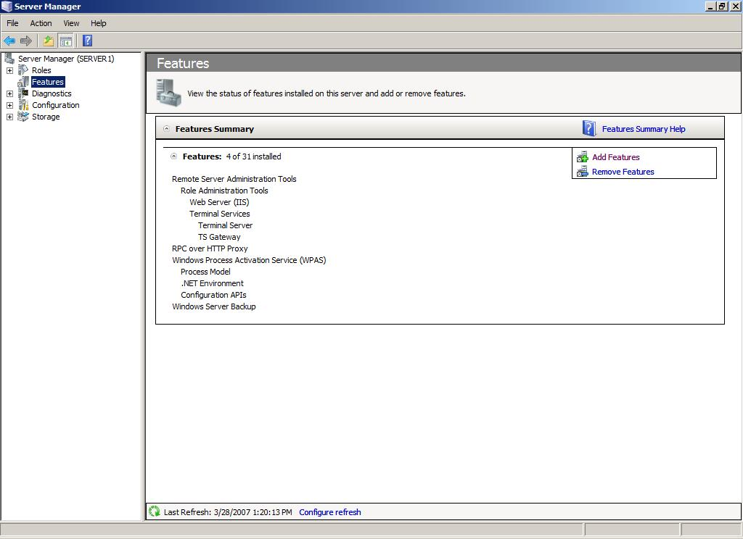

Server Manager Console
The Server Manager console is a new MMC snap-in that provides a consolidated view of the server, including information about server configuration, status of installed roles, and commands for adding and removing roles and features.
The hierarchy pane of the Server Manager console contains expandable nodes administrators can use to go directly to consoles for managing specific roles, troubleshooting tools, or backup and disaster recovery options.
The Server Manager console is much like the front page of a newspaper about your server. It provides a single location for administrators to see a concise overview of a server, change the server’s system properties, and install or remove roles or features.
The following graphic shows the Server Manager home page with multiple roles and features installed.
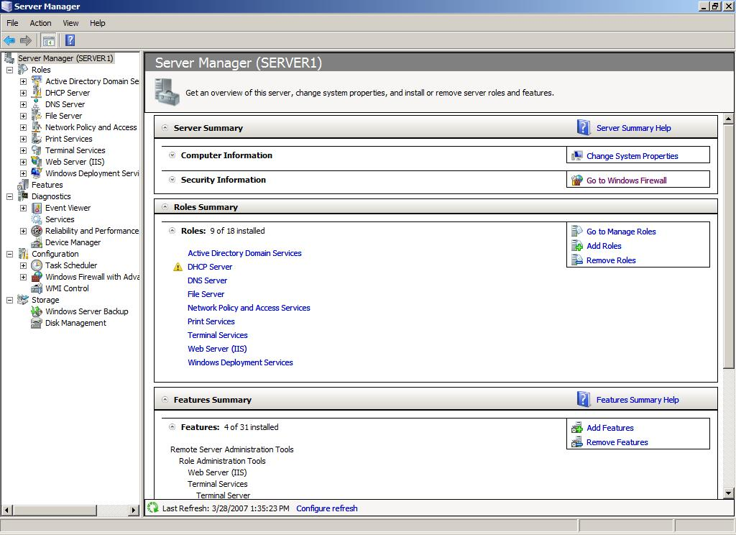

The main window of the Server Manager console contains the following four collapsible sections:
- Server Summary
The Server Summary section includes two subsections: System Information and Security Summary. System Information displays the computer name, domain, local administrator account name, network connections and the product ID of the operating system. Commands in the System Information subsection allow you to edit this information.
Security Summary displays whether Windows Update and Windows Firewall are enabled. Commands in the Security Summary subsection allow you to edit these settings or view advanced options.
- Roles Summary
The Roles Summary section contains a table indicating which roles are installed on the server. Commands in this section allow you to add or remove roles, or go to a more detailed console in which you can manage a specific role.
- Features Summary
The Features Summary section contains a table indicating which features are installed on the server. Commands in this section allow you to add or remove features.
- Resources and Support
The Resources and Support section displays whether this server is participating in the feedback programs Windows Server CEIP and Windows Error Reporting. Resources and Support is also designed to be a launch point for joining topical newsgroups, or for locating additional Help and research topics available online at Microsoft TechNet (http://go.microsoft.com/fwlink/?LinkId=48541).
Commands in this section allow you to modify the server’s participation in feedback programs, and find more help and support.
Server Manager Wizards
Wizards in Server Manager streamline the task of deploying servers in your enterprise by cutting the time it has taken in earlier Windows Server versions to install, configure or remove roles, role services and features. Multiple roles, role services or features can be installed or removed in a single session by using Server Manager wizards.
Most important, Windows Server 2008 performs dependency checks as you progress through the Server Manager wizards, ensuring that all the roles and role services needed by a role you select are installed, and none are removed that might still be required by remaining roles or role services.
Earlier versions of Windows Server required you to use Configure Your Server, Manage Your Server or Add or Remove Windows Components to add or remove server roles or other software. Dependency checks were limited, and Add or Remove Windows Components limited administrators to the installation of only one role at a time. Before you could add more roles, installation of each role had to complete.
The Server Manager collection of wizards allows you to add, remove or augment multiple roles in a single session. It is possible to have your server completely ready for deployment at the completion of a single session in one of the Server Manager wizards. Role configurations are configured with recommended security settings by default; there is no requirement to run the Security Configuration Wizard following role or feature installation unless it is necessary to modify security defaults.
Add Roles Wizard
The Add Roles Wizard, which can be used to add one or more roles to the server, automatically checks for dependencies between roles and verifies that all required roles and role services are installed for each selected role.
For some roles, such as Terminal Services and Active Directory Certificate Services, the Add Roles Wizard also provides configuration pages that allow the user to specify how the role should be configured as part of the installation process.

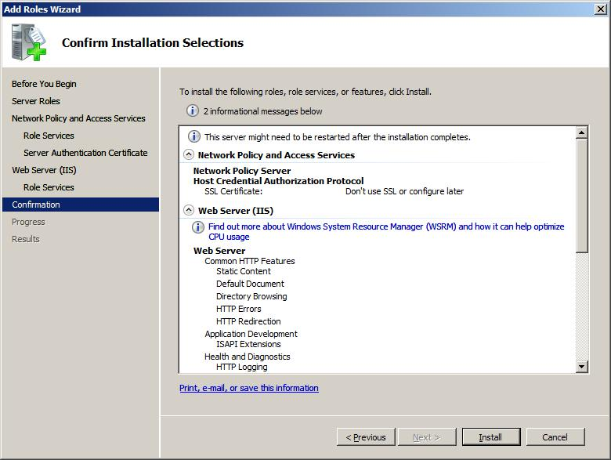
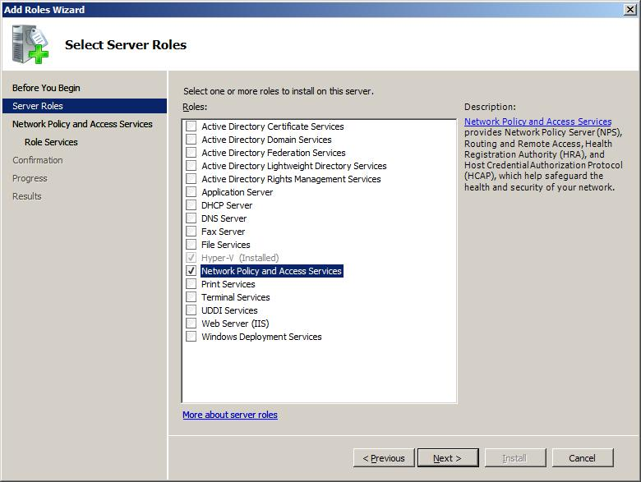

Add Role Services Wizard
Most roles, such as File Services, Terminal Services, and Active Directory Certificate Services, are composed of multiple sub-elements, identified as role services in the Server Manager interface.
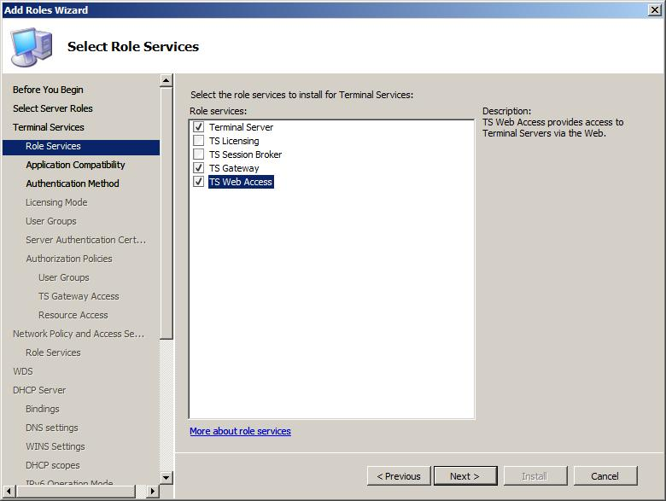
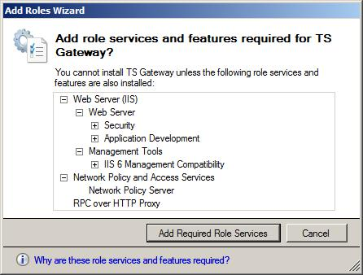
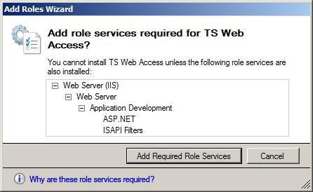
After one of these complex roles is installed, you can add role services to the role during the initial Add Roles Wizard or by using the Add Role Services Wizard. The command that opens the Add Role Services Wizard is found on each role home page in the Server Manager console.
A new intelligent prompt allows you to automatically add required role services if the role you are installing requires role services and features also to be installed.
Add Features Wizard
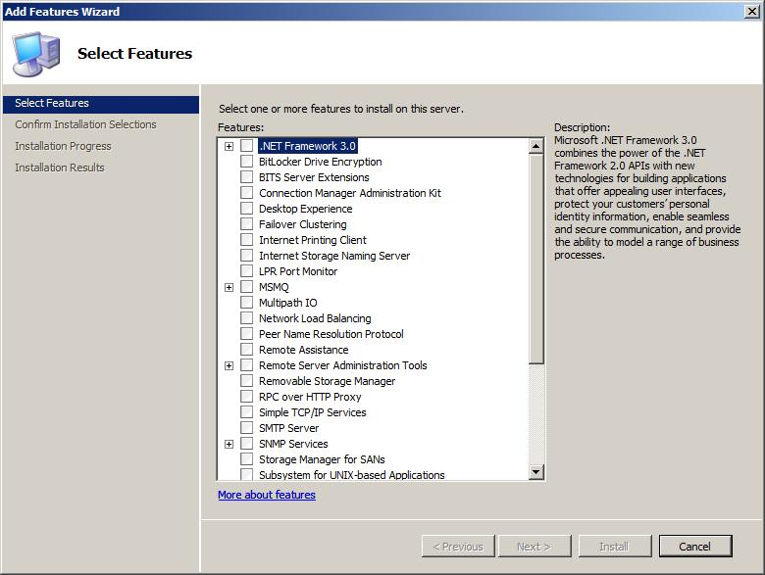
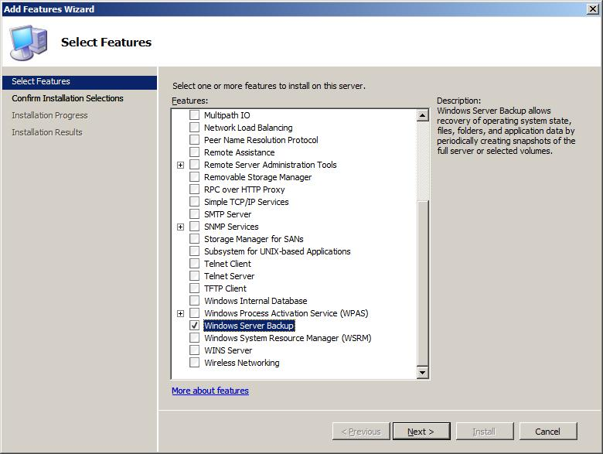
The Add Features Wizard allows you to install one or more features to the computer in a single session. Features are software programs that support or augment the functionality of one or more roles, or enhance the functionality of the server itself, regardless of which roles are installed.
Commands that open the Add Features Wizard are in the Customize this server area of the Initial Configuration Tasks window, and also in the Features Summary section of the Server Manager console window.
Remove Roles Wizard
The Remove Roles Wizard, which can be used to remove one or more roles from the server, automatically checks for dependencies between roles and verifies that required roles and role services remain installed for roles that you do not want to remove. The Remove Roles Wizard process prevents the accidental removal of roles or role services required by remaining roles on the server.
Remove Role Services Wizard
You can remove role services from an installed role by using the Remove Role Services Wizard. The command that opens the Remove Role Services Wizard is found on each role home page in the Server Manager console.
Remove Features Wizard
The Remove Features Wizard allows you to remove one or more features from the computer in a single session. Features are software programs that support or augment the functionality of one or more roles, or enhance the functionality of the server itself, regardless of which roles are installed.
Commands that open the Remove Features Wizard are in the Customize this server area of the Initial Configuration Tasks window, and also in the Features Summary section of the Server Manager Console window.
Server Manager Command Line
Server Manager offers a command-line tool — ServerManagerCmd.exe — which automates the deployment of roles and features on computers running Windows Server 2008.
You can use ServerManagerCmd.exe to install and remove roles, role services and features. ServerManagerCmd.exe parameters also display a list of all roles, role services and features both installed and available for installation on the computer.
The Server Manager command line allows for unattended installation or removal of roles, role services and features. You can use the Server Manager command line to install or remove a single role, role service or feature in a command instance, or you can use an XML answer file with the Server Manager command to add or remove multiple roles, role services, and features in a single command instance.
ServerManagerCmd.exe options enable users to view logs of its operations, and run queries to display lists of roles, role services, and features both installed and available for installation on a computer.
For detailed information about how to use the Server Manager command line, see the Server Manager Help.
Important
Because of security restrictions imposed by User Account Control in Windows Server 2008, you must run ServerManagerCmd.exe in a Command Prompt window opened with elevated privileges. To do this, right-click on the Command Prompt executable or the Command Prompt object on the Start menu, and then click on Run as administrator.
Before the implementation of the Server Manager command line, the only command-line tools available for installing Windows software packages on a computer were ocsetup and pkgmgr. The command-line syntax for these tools is complex, and the names of roles, role services and features available for installation or removal by using these two tools were not intuitive. ServerManagerCmd.exe simplifies command-line installation and removal of roles, role services and features.
Registry Settings
The following registry settings apply to Server Manager and Initial Configuration Tasks in all available variations of Windows Server 2008.
The registry settings in the following table control the default opening behavior of the Server Manager and Initial Configuration Tasks windows.
Registry Settings
Setting Name | Location | Default Value | Possible Values
Do not open Server Manager at logon | HKEY_LOCAL_MACHINE\SOFTWARE\Microsoft\Server Manager | 0 | 0 to disable and open the window normally; 1 to enable and prevent the window from opening
Do not open Initial Configuration Tasks at logon | HKEY_LOCAL_MACHINE\SOFTWARE\Microsoft\Initial Configuration Tasks | 0 | 0 to disable and open the window normally; 1 to enable and prevent the window from opening.

How Do I Open Server Manager?
Server Manager opens by default when the Initial Configuration Tasks window is closed.
After initial configuration tasks are complete, Server Manager opens by default when an administrator logs on to a computer running Windows Server 2008. If you close Server Manager and want to open it again, you can open Server Manager by using the Server Manager command in any of the following locations:
- In the Start menu, under Administrative Tools.
- In the Start menu (if you are logged on to the computer as a member of the Administrators group).
- In the Start menu, right-click on Computer, and then click on Manage.
- On the Quick Launch toolbar, adjacent to the Start button.
- In Control Panel, click on Programs, click on Programs and Features, and then click on Turn Windows features on or off.
Server Manager is installed by default as part of Windows Server 2008. To use Server Manager, you must be logged on to the computer as a member of the Administrators group.
Note
If you log on to the computer by using an Administrator account other than the default Administrator account, a dialog box might open to prompt you for your permission to run Server Manager. Click on Allow to start Server Manager.
Additional Resources
For more information about Server Manager, see Microsoft TechNet (http://go.microsoft.com/fwlink/?LinkId=48541). You can also learn how to perform specific operations in Server Manager in the Server Manager Help, available by pressing F1 in an open Server Manager Console window.

7.04 Windows PowerShell
Windows PowerShell® is a new task-based command-line shell and scripting language designed especially for system administration. Built on the Microsoft .NET Framework, Windows PowerShell helps IT professionals and power users control and automate the administration of the Windows operating system and applications that run on Windows.
Unlike most shells, which accept and return text, Windows PowerShell is built on top of the .NET common language runtime (CLR) and the .NET Framework, and accepts and returns .NET objects. This fundamental change in the environment brings entirely new tools and methods to the management and configuration of Windows.
Windows PowerShell introduces the concept of a cmdlet (pronounced "command-let"), a simple, and single-function command-line tool built into the shell. You can use each cmdlet separately, but their power is realized when you use these simple tools in combination to perform complex tasks. Windows PowerShell includes more than one hundred basic core cmdlets, and you can write your own cmdlets and share them with other users.
Like many shells, Windows PowerShell gives you access to the file system on the computer. In addition, Windows PowerShell providers enable you to access other data stores, such as the registry and the digital signature certificate stores, as easily as you access the file system.
Most shells, including Cmd.exe and the SH, KSH, CSH, and BASH Unix shells, operate by executing a command or utility in a new process, and presenting the results to the user as text. Over the years, many text processing utilities, such as sed, AWK, and PERL, have evolved to support this interaction.
These shells also have commands that are built into the shell and run in the shell process, such as the typeset command in KSH and the dir command in Cmd.exe. In most shells because there are few built-in commands many utilities have been created.
Windows PowerShell is very different.
- Windows PowerShell does not process text. Instead, it processes objects based on the .NET platform.
- Windows PowerShell comes with a large set of built-in commands with a consistent interface.
- All shell commands use the same command parser, instead of different parsers for each tool. This makes it much easier to learn how to use each command.
Best of all, you don't have to give up the tools that you have become accustomed to using. You can still use the traditional Windows tools, such as Net, SC, and Reg.exe in Windows PowerShell.
Windows PowerShell is useful to anyone who wants to manage Windows from the command line, especially system administrators who are writing automated task solutions, and developers who want to write their own Windows PowerShell cmdlets, providers, and hosting applications.
Windows PowerShell is an object-based environment, so users need to understand how to manipulate data using object properties and methods. Most existing shells are text-based, which means that scripts must parse through text-based data to find interesting data. In the Windows PowerShell object-based environment, a script needs only to access the appropriate object property to find the interesting data.
Windows PowerShell provides the ability to manipulate objects rather than just text. It provides a powerful scripting language based on the .NET Framework. It provides a consistent way of traversing data stores, such as the registry, through the concept of providers.
Windows PowerShell Features
Built-in Windows PowerShell commands, called cmdlets, let you manage the computers in your enterprise from the command line. Windows PowerShell providers let you access data stores, such as the registry and certificate store, as easily as you access the file system. In addition, Windows PowerShell has a rich expression parser and a fully-developed scripting language.
Windows PowerShell 1.0 includes the following features:
- 129 standard cmdlets that perform common system administration tasks, such as managing the registry, services, processes, and event logs, and using Windows Management Instrumentation.
- A task-based scripting language and support for existing scripts and command-line tools.
- Consistent design. Because Windows PowerShell cmdlets and system data stores use common syntax and naming conventions, data can be shared easily and the output from one cmdlet can be used as the input to another cmdlet without reformatting or manipulation.
- Simplified, command-based navigation of the operating system, which lets users navigate the registry and other data stores by using the same techniques that they use to navigate the file system.
- Powerful object manipulation capabilities. Objects can be directly manipulated or sent to other tools or databases.
- Extensible interface. Independent software vendors and enterprise developers can build custom tools and utilities to administer their software.
Windows PowerShell Cmdlets
A cmdlet (pronounced "command-let") is a single-feature command that manipulates objects in Windows PowerShell. You can recognize cmdlets by their name format -- a verb and noun separated by a dash (-), such as Get-Help, Get-Process, and Start-Service.
In traditional shells, the commands are executable programs that range from the very simple (such as attrib.exe) to the very complex (such as netsh.exe).
In Windows PowerShell, most cmdlets are very simple, and they are designed to be used in combination with other cmdlets. For example, the "get" cmdlets only retrieve data, the "set" cmdlets only establish or change data, the "format" cmdlets only format data, and the "out" cmdlets only direct the output to a specified destination.
Each cmdlet has a help file that you can access by typing:
- get-help <cmdlet-name> -detailed
The detailed view of the cmdlet help file includes a description of the cmdlet, the command syntax, descriptions of the parameters, and example that demonstrate use of the cmdlet.
A New Scripting Language
- Windows PowerShell needed a language for managing.NET objects.
- The language needed to provide a consistent environment for using cmdlets.
- The language needed to support complex tasks, without making simple tasks more complex.
- The language needed to be consistent with higher-level languages used in .NET programming, such as C#.
Windows Commands and Utilities
You can run Windows command-line programs in Windows PowerShell, and you can start Windows programs that have a graphic user interface, such as Notepad and Calculator, within the shell. You can also capture the text that programs generate and use that text in the ,shell, in much the same way you would in Cmd.exe.
Additional Information
In addition to the Help available at the command line, the following resources provide more information:
- Windows PowerShell Team Blog (http://go.microsoft.com/fwlink/?LinkID=83147). This is the best resource for learning from and collaborating with other Windows PowerShell users. Read the Windows PowerShell Team blog and join the Windows PowerShell User Forum (microsoft.public.windows.powershell). Then, as you develop your expertise, please freely contribute your ideas.
- Windows PowerShell SDK (http://go.microsoft.com/fwlink/?LinkID=89595). Provides reference content used to develop cmdlets, providers, and hosting applications.
- Windows PowerShell Programmer's Guide (http://go.microsoft.com/fwlink/?LinkID=89596). Provides tutorials for creating cmdlets, providers, and hosting applications. Also contains information about fundamental Windows PowerShell concepts.

7.05 Server Core
In Windows Server 2008, administrators can now choose to install a minimal environment that avoids extra overhead. Although this option limits the roles that can be performed by the server, it can improve security and reduce management. This type of installation is called a Server Core installation option.
A Server Core installation option is a minimal server installation option for Windows Server 2008. Server Core installations provide an environment for running the following server roles:
- Active Directory Domain Services
- Active Directory Lightweight Directory Services (AD LDS)
- DHCP Server
- DNS Server
- File Services
- Print Server
- Internet Information Services 7.0
- Hyper-V
By choosing to use the Server Core installation option on a server, you can reduce your administrative effort and help limit security risks. A Server Core installation provides these benefits in three ways:
- By reducing the software maintenance required
- By reducing the management required
- By reducing the attack surface
To accomplish this, the Server Core installation installs only the subset of the binary files that are required by the supported server roles. For example, the Windows Explorer user interface (or "shell") is not installed as part of a Server Core installation. Instead, the default user interface for a Server Core server is the command prompt.
A Server Core installation of Windows Server 2008 supports the following optional features:
- Failover Clustering
- Network Load Balancing
- Subsystem for UNIX-based applications
- Backup
- Multipath IO
- Removable Storage Management
- BitLocker Drive Encryption
- Simple Network Management Protocol (SNMP)
- Windows Internet Naming Service (WINS)
- Telnet client
- Quality of Service
The Server Core installation option is designed for use in organizations that either have many servers, where some only need to perform dedicated tasks, or in environments where high security requirements require a minimal attack surface on the server.
Since no graphical user interface is available for many Windows operations, using the Server Core installation option requires administrators to be experienced in using a command prompt or scripting techniques for local administration of the server. Alternatively, you can manage the Server Core installation with Microsoft Management Console (MMC) snap-ins from another computer running Windows Server 2008 by selecting the Server Core computer as a remote computer to manage.
You should review this topic and additional documentation about the Server Core installation option if you are in any of the following groups:
- IT planners and analysts who are technically evaluating the product
- Enterprise IT planners and designers for organizations
- Those responsible for IT security
- IT Pros managing the following server roles: DHCP Server, File Services, Print Server, DNS Server, Active Directory Lightweight Directory Services (AD LDS), or Active Directory Domain Services
The Server Core installation option does not add new functionality to the server roles it supports. Each server role, however, might have changes for Windows Server 2008.
Server Core installations provide the following benefits:
- Reduced maintenance. Because a Server Core installation installs only what is required for the specified roles (DHCP Server, File Services, Print Server, DNS Server, AD LDS, or Active Directory Domain Services roles), less servicing is required than on a full installation of Windows Server 2008.
- Reduced attack surface. Because Server Core installations are minimal, there are fewer applications running on the server, which decreases the attack surface.
- Reduced management. Because fewer applications and services are installed on a server running a Server Core installation, there is less to manage.
- Less disk space required. A Server Core installation only requires about 1 gigabyte (GB) of disk space to install, and approximately 2 GB for operations after the installation.
Server Core servers do not have a user interface or provide the ability to run applications. The management experience will also be different using a Server Core installation. A Server Core installation requires you to initially configure the system from the command line, or using scripted methods such as an unattended installation, because it does not include the traditional full user interface.
Once the server is configured, you can manage it from the command line, either locally or remotely with a Terminal Services remote desktop connection. You can also use MMC snap-ins or command-line tools that support remote connections to manage the server remotely.
Administrators managing a Server Core installation need to be aware that there is no graphical user interface (GUI) available.
Although no changes are required to the configuration of your network, you might need to become familiar with command-line tools.
The Server Core installation option does not add or change any settings. However, you should review the documentation for each of the supported server roles that are available with the Server Core installation option, to check for changes in Windows Server 2008.
The changes in each of those roles are the same whether you are using the Server Core installation or full installation option.
The Server Core installation option is not an application platform, and you cannot run or develop server applications on a Server Core installation. A Server Core installation can only be used to run the supported server roles and management tools.
Server Core servers support development of management tools and agents, which can be divided into two categories:
- Remote management tools. These tools do not require any changes, as long as they use one of the protocols supported in Server Core installations to communicate with the remote management workstation, such as remote procedure call (RPC).
- Local management tools and agents. These tools might require changes to work with Server Core installations because they cannot have any shell or user interface dependencies, and cannot use managed code.
The Windows Server 2008 Software Development Kit (SDK) includes a list of APIs that are supported in Server Core installations. You need to verify that all APIs called by your code are listed, and you also need to test your code on a Server Core installation to ensure that it behaves as expected.
No changes to your environment or infrastructure are required.
The Server Core installation option only supports a clean installation onto a server. You cannot upgrade to a Server Core installation from a previous version of Windows.
To install a Server Core installation of Windows Server 2008, start the server computer with a bootable Windows Server 2008 DVD in the computer's DVD drive. When the Autorun dialog box appears, click Install Now, and then follow the instructions on the screen to complete the installation.
In many cases, a Server Core installation will be installed using an unattended installation script.
The following optional features require appropriate hardware to be able to use them:
- Failover Clustering
- Multipath IO
- Network Load Balancing
- Removable Storage
- BitLocker Drive Encryption
Some BitLocker functionality is available without specific hardware.
There are no prerequisites for the following optional features:
- Subsystem for UNIX-based applications
- Backup
- Simple Network Management Protocol (SNMP)
- Windows Internet Naming Service (WINS)
- Telnet client
- Quality of Service
The following resources provide additional information about Server Core installations:
- If you need product support, see Microsoft Connect (http://go.microsoft.com/fwlink/?LinkId=49779).
- To access newsgroups for this feature, follow the instructions that are provided on Microsoft Connect (http://go.microsoft.com/fwlink/?LinkId=50067).
The following resources on the Microsoft Web site provide additional information about some of the commands you can use to configure Server Core installations and enable server roles:
- Command-line reference A-Z (http://go.microsoft.com/fwlink/?LinkId=20331)
- Dcpromo unattended installation files
  - Performing an Unattended Installation of Active Directory (http://go.microsoft.com/fwlink/?LinkId=49661)
- Netsh
  - Netsh overview (http://go.microsoft.com/fwlink/?LinkId=49654)
- Dnscmd
  - Dnscmd overview (http://go.microsoft.com/fwlink/?LinkId=49656)
  - Dnscmd syntax (http://go.microsoft.com/fwlink/?LinkId=49659)
  - Dnscmd examples (http://go.microsoft.com/fwlink/?LinkId=49660)
- Dfscmd
  - Dfscmd reference (http://go.microsoft.com/fwlink/?LinkId=49658)
The following resource provides additional information for deploying, configuring, and managing a Server Core installation, and also for enabling a server role on a Server Core installation:
- Windows Server 2008 Server Core Step-By-Step Guide on Microsoft Connect (http://go.microsoft.com/fwlink/?LinkId=49779)

7.06 Windows Server Backup

The Backup feature in Windows Server 2008 provides a basic backup and recovery solution for the server it is installed on. You can also use this feature to manage backups on remote servers. This version of Backup introduces new backup and recovery technology and replaces the previous Backup feature that was available with earlier versions of the Windows operating system.
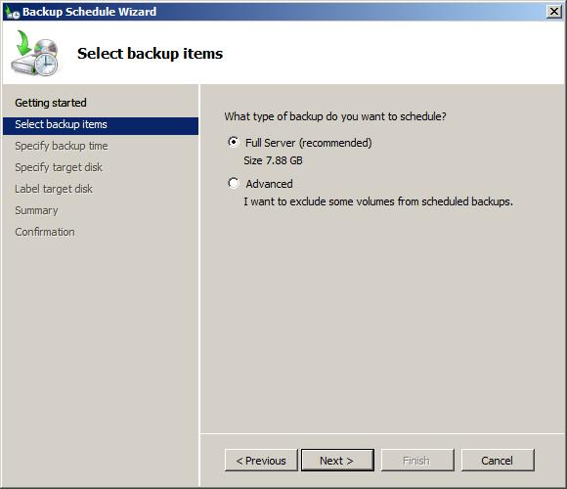
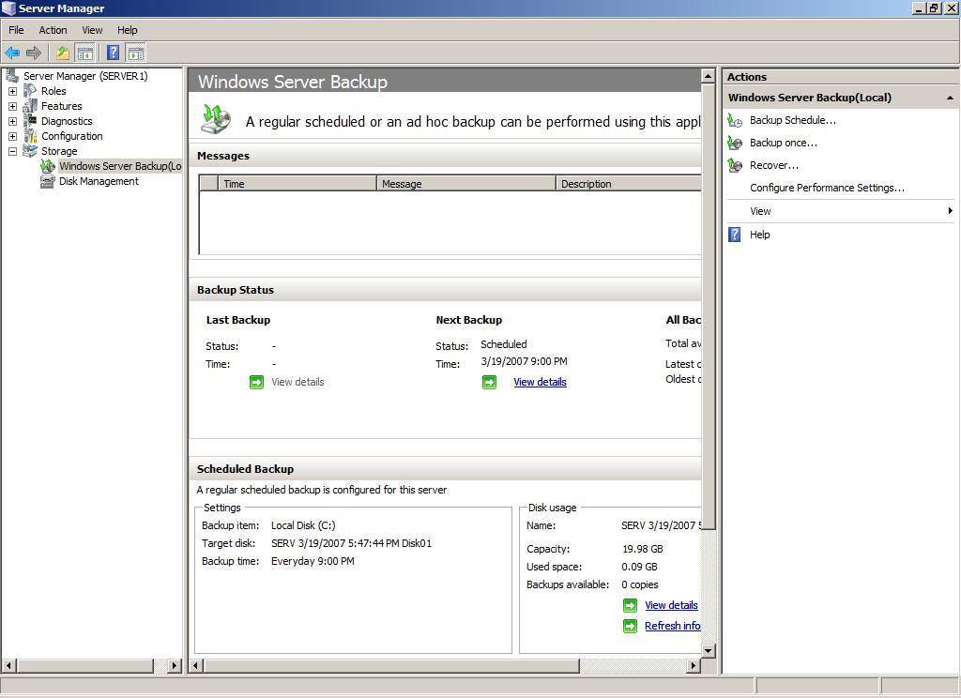
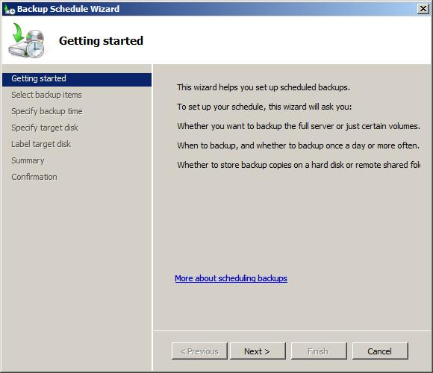
You can use the Backup feature to protect your entire server efficiently and reliably without worrying about the details of backup and recovery technology. Simple wizards guide you through setting up an automatic backup schedule, creating manual backups if necessary, and recovering items or entire volumes. You can use Backup to back up an entire server or selected volumes. And, in case of disasters such as hard disk failures, you can perform a system recovery, which will restore your complete system onto the new hard disk by using a full server backup and the Windows Recovery Environment.
Backup is intended for use by everyone from small-business owners to IT administrators in large enterprises, who need a backup solution that is easy to deploy and use, and that is available at no extra cost. However, the simple design makes it especially well-suited for smaller organizations or individuals who are not IT professionals.
You must be a member of the Administrators group or Backup Operators group to use Backup.
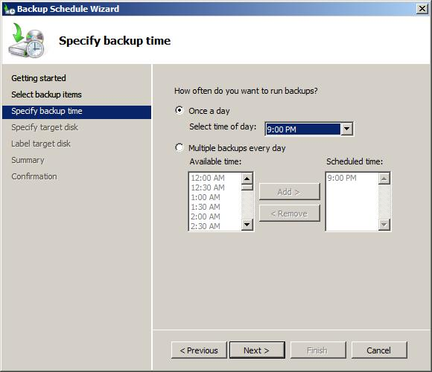
The Backup feature includes the following improvements:
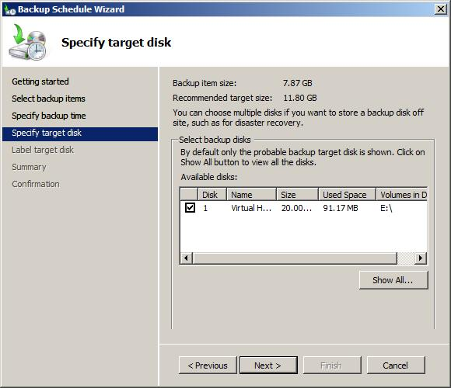
- New, faster backup technology. Backup uses Volume Shadow Copy Service (VSS) and block-level backup technology to efficiently back up and recover your operating system, files and folders, and volumes. After the first full backup is created, Backup can be configured to automatically run incremental backups by saving only the data that has changed since the last backup. However, even if you choose to always do full backups, it will still take less time than using the Backup feature in earlier versions of Windows.
- Simplified restoration. You can now restore items by choosing a backup to recover from and then selecting items to restore. You can recover specific files from a folder or all the contents of a folder. Previously, you needed to manually restore from multiple backups if the item was stored on an incremental backup. Now, you simply choose the date on which you backed up the version of the item you want to restore.
- Simplified recovery of your operating system. Backup works with new Windows recovery tools to make it easier for you to recover your operating system. You can recover to the same server, or, if the hardware fails, you can recover to a new server that has no operating system.
- Ability to recover applications. Backup uses VSS functionality that is built into applications such as Microsoft SQL Server™ to protect application data.
- Improved scheduling. Backup now includes a wizard that guides you through the process of creating daily backups. System volumes are automatically included in all scheduled backups, so that you are always protected against disasters.
- Easy removal of backups offsite for disaster protection. You can run backups to multiple disks in rotation so that it is easy to move disks offsite. Simply add each disk as a scheduled backup location and, if the first disk is taken offsite, Backup will automatically run backups to the next disk in the rotation.
- Remote administration. Backup now uses an MMC snap-in to give you a familiar and consistent experience for managing your backups. After you install the Backup snap-in, you can access this tool either through Server Manager or by adding the snap-in to a new or existing MMC console. Then, you can use Backup to manage backups on other servers by clicking on Action, and then clicking on Connect to Another Computer.
- Automatic disk usage management. Once you configure a disk for a scheduled backup, Backup will automatically manage the disk usage — you do not need to think about disk space running out after repeated backups. Backup will automatically reuse the space of older backups when creating newer backups. The management tool displays the backups that are available and the disk usage information, which can help you plan for provisioning additional storage to meet your recovery time objectives.
- Extensive command-line support. Backup now comes with extensive command-line support and documentation to enable you to perform almost all the same tasks that can be done using the management tool. You can also automate backup activities through scripting.
- Support for DVD media. You can manually back up volumes directly to DVD. This can serve as an easy solution if you want to create offsite backups on an ad hoc basis. Backup also retains support for backing up manually to shared folders and hard disks. Scheduled backups are stored on hard disks.
Note
The new Backup tool does not use tape storage devices — the use of external and internal disks, DVDs, and shared folders is supported. However, support of drivers for tape is still included in Windows Server 2008.
If you are a current user of Windows Backup (Ntbackup.exe) and plan to switch to the new Windows Server Backup, you may be impacted by the following issues and changes:
- Backup settings will not be upgraded when you switch to Windows Server 2008. You will need to reconfigure settings.
- You will need a separate, dedicated disk for running scheduled backups.
- You can no longer back up to tape.
- You cannot recover backups that you created with Windows Backup using Windows Server Backup. Windows Backup is available as a download to Windows Server 2008 users who want to recover data from backups taken using NTBackup. However the downloadable version of Windows Backup cannot be used to create backups on Windows Server 2008. To download Windows Backup (Ntbackup.exe), see http://go.microsoft.com/fwlink/?LinkId=82917.

7.07 Windows Reliability and Performance Monitor
Windows Server 2008 includes Windows Reliability and Performance Monitor, which provides IT professionals with the tools to monitor and assess system performance and reliability.
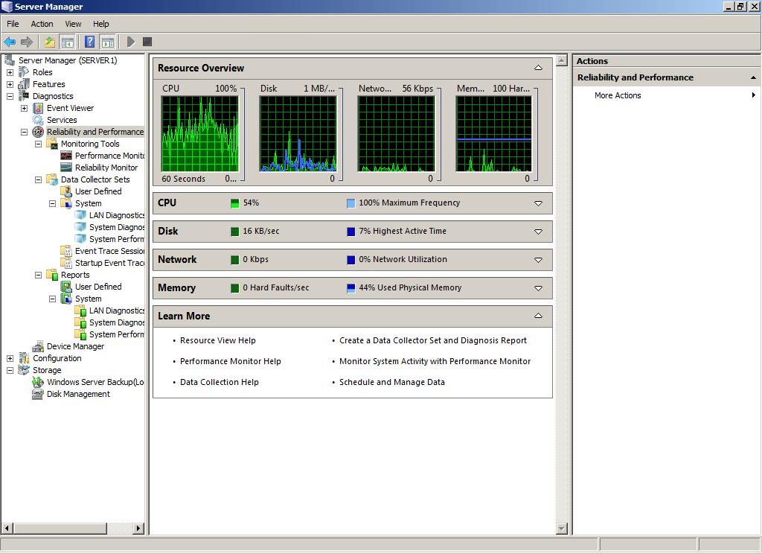
Note
In some pre-release versions of Windows, this feature was named Windows Performance Diagnostic Console.
Windows Reliability and Performance Monitor is an MMC snap-in that combines the functionality of previous stand-alone tools including Performance Logs and Alerts, Server Performance Advisor and System Monitor. It provides a graphical interface for customizing performance data collection and Event Trace Sessions.
It also includes Reliability Monitor, an MMC snap-in that tracks changes to the system and compares them to changes in system stability, providing a graphical view of their relationship.
Windows Reliability and Performance Monitor is a tool intended for use by IT professionals or computer administrators. To view real-time status in Resource View, the console must run as a member of the Administrators group. To create Data Collector Sets, configure logs, or view reports, the console must run as a member of the Administrators group or the Performance Log Users Group.
Previous performance counters, event trace providers and other performance-related code elements do not need to change to work with the new Windows Reliability and Performance Monitor or its features.
Features of Windows Reliability and Performance Monitor new to Windows Server 2008 include the following.
Data Collector Sets
An important new feature in Windows Reliability and Performance Monitor is the Data Collector Set, which groups data collectors into reusable elements for use with different performance monitoring scenarios. Once a group of data collectors are stored as a Data Collector Set, operations such as scheduling can be applied to the entire set through a single property change.
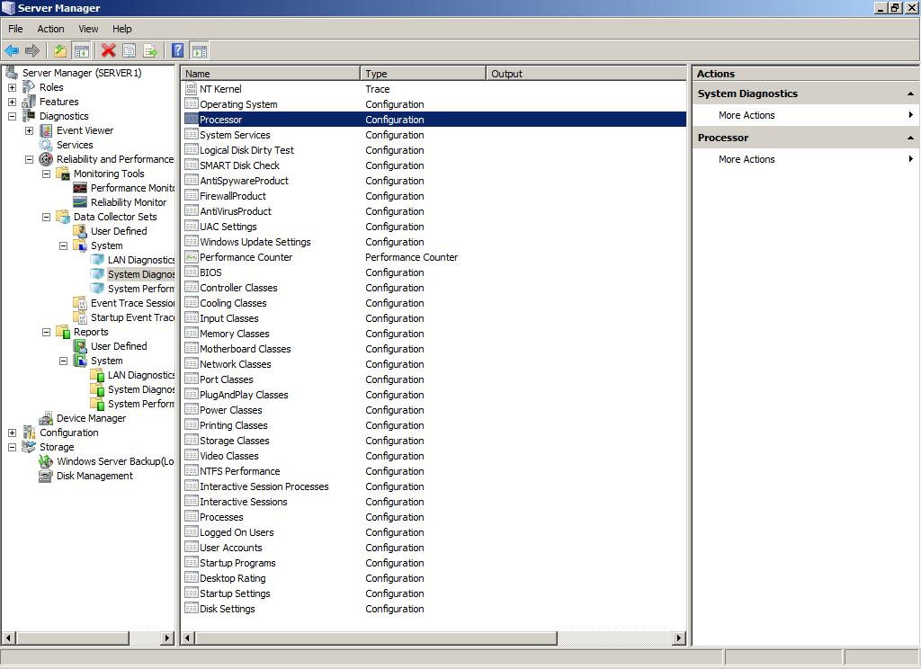
Windows Reliability and Performance Monitor also includes default Data Collector Set templates to help system administrators begin collecting performance data specific to a Server Role or monitoring scenario immediately.
Wizards and Templates for Creating Logs
Adding counters to log files and scheduling their start, stop and duration can now be performed through a Wizard interface. In addition, saving this configuration as a template allows system administrators to collect the same log on subsequent computers without repeating the data collector selection and scheduling processes. Performance Logs and Alerts features have been incorporated into the Windows Reliability and Performance Monitor for use with any Data Collector Set.
Resource View
The home page of Windows Reliability and Performance Monitor is the new Resource View screen, which provides a real-time graphical overview of CPU, disk, network and memory usage. By expanding each of these monitored elements, system administrators can identify which processes are using which resources. In previous versions of Windows, this real-time process-specific data was only available in limited form in Task Manager.
Reliability Monitor
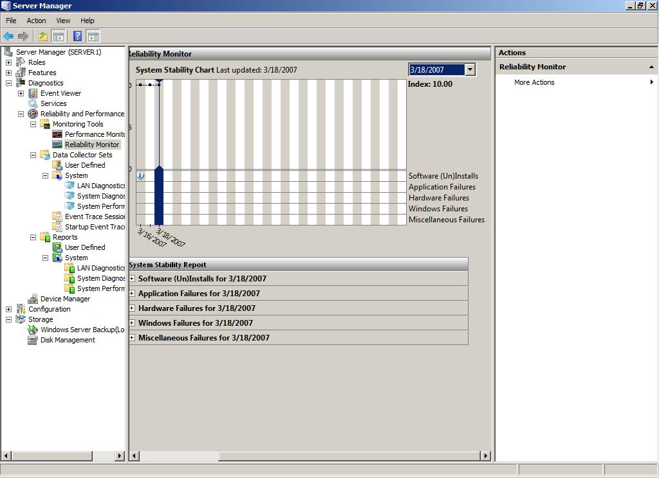
Reliability Monitor calculates a System Stability Index that reflects whether unexpected problems reduced the reliability of the system. A graph of the Stability Index over time quickly identifies dates when problems began to occur. The accompanying System Stability Report provides details to help troubleshoot the root cause of reduced reliability. By viewing changes to the system (installation or removal of applications, updates to the operating system, or addition or modification of drivers) side by side with failures (application failures, operating system crashes or hardware failures), a strategy for addressing the issues can be developed quickly.
Unified Property Configuration for All Data Collection, Including Scheduling
Whether creating a Data Collector Set for one-time use or to log activity on an ongoing basis, the interface for creation, scheduling and modification is the same. If a Data Collector Set proves to be useful for future performance monitoring, it does not need to be re-created. It can be reconfigured or copied as a template.
User-Friendly Diagnosis Reports
Users of Server Performance Advisor in Windows Server 2003 can now find the same kinds of diagnosis reports in Windows Reliability and Performance Monitor in Windows Server 2008. Report generation time is improved and reports can be created from data collected by using any Data Collector Set. This allows system administrators to repeat reports and assess how changes have affected performance or the report’s recommendations.

7.08 Windows Deployment Services
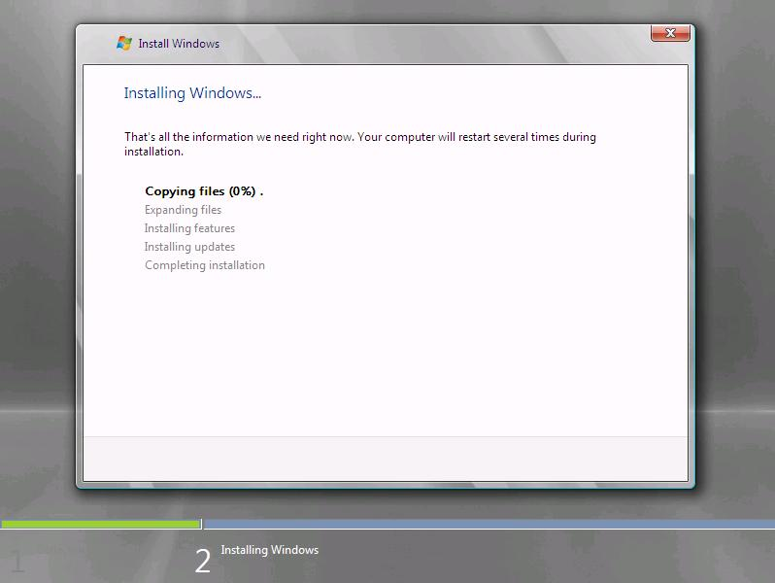
The Windows Deployment Services role in Windows Server® 2008 is the updated and redesigned version of Remote Installation Services (RIS). Windows Deployment Services enables you to deploy Windows operating systems, particularly Windows Vista® and Windows Server 2008. The components of Windows Deployment Services are organized into the following three categories:
- Server components. These components include a Pre-Boot Execution Environment (PXE) server and Trivial File Transfer Protocol (TFTP) server for network booting a client to load and install an operating system. Also included is a shared folder and image repository that contains boot images, install images, and files that you need specifically for network boot. There is also a networking layer, a multicast component, and a diagnostics component.
- Client components. These components include a graphical user interface that runs within the Windows Pre-Installation Environment (Windows PE). When a user selects an operating system image, the client components communicate with the server components to install the image.
- Management components. These components are a set of tools that you use to manage the server, operating system images, and client computer accounts.
Windows Deployment Services assists you with the rapid adoption and deployment of Windows operating systems. You can use it to set up new computers by using a network-based installation. This means that you do not have to be physically present at each computer and you do not have to install each operating system directly from a CD or DVD.
Windows Deployment Services is intended for deployment specialists who are responsible for the deployment of Windows operating systems in an organization. You can use Windows Deployment Services in any organization that is interested in simplifying deployments and increasing the consistency of their Windows-based computers. The target audiences are:
- IT planners or analysts who are evaluating Windows Vista or Windows Server 2008
- Enterprise IT planners or designers
- Deployment specialists interested in deploying images to computers without operating systems
During your Windows Deployment Services installation, you can choose to install Transport Server or Deployment Server (which includes the core parts of Transport Server). There are no requirements for installing Transport Server. If you choose to install Deployment Server, your environment must meet the following requirements:
- Active Directory Domain Services. A Windows Deployment Services server must be either a member of an Active Directory Domain Services (AD DS) domain or a domain controller for an Active Directory Domain Services domain. The Active Directory Domain Services domain and forest versions are irrelevant; all domain and forest configurations support Windows Deployment Services.
- DHCP. You must have a working Dynamic Host Configuration Protocol (DHCP) server with an active scope on the network because Windows Deployment Services uses Pre-Boot Execution Environment (PXE), which relies on DHCP for IP addressing.
- DNS. You must have a working Dynamic Name Services (DNS) server on the network to run Windows Deployment Services.
- NTFS volume. The server running Windows Deployment Services requires an NTFS file system volume for the image store.
- Credentials. To install the role, you must be a member of the Local Administrators group on the Windows Deployment Services server. To start the Windows Deployment Services client, you must be a member of the Domain Users group.
Windows Deployment Services for Windows Server 2008 includes several modifications to RIS features. There are also modifications from Windows Deployment Services that you can install onto computers running Windows Server 2003.
Changes from RIS | Changes from Windows Deployment Services on Windows Server 2003
- Ability to deploy Windows Vista and Windows Server 2008.  - Windows PE is the boot operating system.  - Image based installation using Windows image (.wim) files.  - Ability to transmit data and images using multicast.  - Ability to transmit data and images using multicast on a standalone server (when you install Transport Server).  - An extensible and higher-performing PXE server.  - A new boot menu format for selecting boot images.  - A new graphical user interface that you can use to select and deploy images and to manage Windows Deployment Services servers and clients. | - Ability to transmit data and images using multicast.  - Ability to transmit data and images using multicast on a standalone server (when you install Transport Server).  - Does not support RISETUP images or OSChooser screens.  - Enhanced TFTP server.  - Ability to network boot x64-based computers with Extensible Firmware Interface (EFI).  - Metric reporting for installations.
Create and add Boot Images
Boot images are the images that you boot a client computer into before installing the operating system image. The boot image presents a boot menu that contains the images that users can install onto their computers. These images contain Windows PE 2.0 and the Windows Deployment Services client. You can use the default boot image (boot.wim) that is included in the Windows Server 2008 installation media in the \Sources directory. Except in advanced scenarios (for example, if you need to add drivers to the image), you will not need to modify this file.
Important
You should use only the boot.wim file from the Windows Server 2008 DVD. If you use the boot.wim file from the Windows Vista DVD, you will not be able to use the full functionality of Windows Deployment Services (for example, multicasting).
In addition, there are two types of images that you can create from boot images: capture images and discover images.
If you need to modify the boot image, it is easier than it has been in the past. Previously, to modify the boot menu, you had to modify the code directly. With boot images, you use the standard tools in the Windows AIK. Also, because boot images use Windows PE instead of OSChooser, you have more freedom in what you can modify (for example, you can run Visual Basic and HTML application scripts). Another advantage of using Windows PE instead of OSChooser is that you can use the same Windows PE boot images regardless of where you are booting from (for example, the network, a USB drive, or a disk). OSChooser customizations applied to only installations that used RIS.
Create a Capture Image
Capture images are boot images that launch the Windows Deployment Services capture utility instead of Setup. When you boot a reference computer (that has been prepared with Sysprep) into a capture image, a wizard creates an install image of the reference computer and saves it as a .wim file.
You can also create media (CD, DVD, USB drive, and so on) that contains a capture image, and then boot a computer from the media. After you create the install image, you can add the image to the server for PXE boot deployment.
These images provide an alternative to the command-line utility, ImageX, when creating an image from a computer that has been prepared with Sysprep. Previously, image capture involved a complex command-line procedure. The Windows Deployment Services capture utility allows administrators who may not be familiar with working in a command prompt to capture images.
Create a Discover Image
Discover images are boot images that force Setup to launch in Windows Deployment Services mode and then discover a Windows Deployment Services server. These images are typically used to deploy images to computers that are not PXE enabled or that are on networks that do not allow PXE. When you create a discover image and save it to media (CD, DVD, USB drive, and so on), you can then boot a computer to the media. The discover image on the media locates a Windows Deployment Services server, and the server deploys the install image to the computer.
You can use a discover image from a computer that does not support PXE boot to deploy an install image from a Windows Deployment Services server. Without this functionality, computers that do not support PXE boot could not be reimaged using Windows Deployment Services resources.
Create an Install Image
You can build custom install images from reference computers and deploy them to client computers. A reference computer can be a computer with a standard Windows installation or a Windows installation that has been configured for a specific environment. You boot a computer (which has been prepared with Sysprep) into a capture image, then the capture image creates an install image of the computer.
You can use the Windows Deployment Services capture utility instead of command-line tools, eliminating the need to support and manage version-sensitive command-line utilities. By using this utility, you can boot a computer to create an install image of that computer. The process that you use is similar to the process of installing the operating system.
Associate an Unattend File with an Image
Windows Deployment Services allows you to automate the Windows Deployment Services client and the latter stages of Windows Setup. This two-stage approach is accomplished by using two unattend files:
- Windows Deployment Services client unattend file. This file uses the Unattend.xml format and is stored on the Windows Deployment Services server in the \WDSClientUnattend folder. It is used to automate the Windows Deployment Services client user interface screens (such as entering credentials, choosing an install image, and configuring the disk).
- Image unattend file. This file uses the Unattend.xml or Sysprep.inf format, depending upon the version of the operating system in the image. It is stored in a subfolder (either $OEM$ structure or \Unattend) in the per-image folder. It is used to automate the remaining phases of setup (for example, offline servicing, Sysprep specialize, and mini-setup).
To automate the installation, create the appropriate unattend file depending on whether you are configuring the Windows Deployment Services client or Windows Setup. We recommend that you use Windows System Image Manager (included as part of the Windows AIK) to author the unattend files. Then copy the unattend file to the appropriate location, and assign it for use. You can assign it at the server level or the client level. The server level assignment can further be broken down by architecture, allowing you to have differing settings for x86-based and x64-based clients. An assignment at the client level overrides the server-level settings. For more information about unattended installations, see http://go.microsoft.com/fwlink/?LinkId=89226.
Unattend files allow you to automate common installation tasks and standardize settings for your organization. Windows Deployment Services provides several options for associating unattend files with boot and install images.
Enable multicast transmission of an image
Multicast transmissions allow you to deploy an image to a large number of client computers without overburdening the network. This feature is disabled by default. When you create a transmission, you have two options for the multicast type:
- Auto-Cast. This option indicates that as soon as an applicable client requests an install image, a multicast transmission of the selected image begins. Then as other clients request the same image, they are joined to the transmission that is already started.
- Scheduled-Cast. This option sets the start criteria for the transmission based on the number of clients that are requesting an image and/or a specific day and time.
For more information about multicasting, see http://go.microsoft.com/fwlink/?LinkId=89225.
When you create a multicast transmission for an image, the data is sent over the network only once, which can drastically reduce the network bandwidth that is used.
Use Transport Server to enable multicast download of data
During installation, you can choose to install only the Transport Server. This provides a subset of the functionality of Windows Deployment Services. It contains only the core networking parts. You can use Transport Server to create multicast namespaces that transmit data (including operating system images) from a stand-alone server. The stand-alone server does not need AD DS, DHCP or DNS.
You can use Transport Server in advanced scenarios as a part of a custom deployment solution. You should use install and configure this option if you want to create multicast namespaces, but do not want to incorporate all of Windows Deployment Services.
Deployment
There are several consideration that you need to account for before you install. For more information, see the installing and upgrading sections in the Windows Deployment Services Role Step-by-Step Guide (http://go.microsoft.com/fwlink/?LinkId=84628).
The Windows Deployment Services role does not support RISETUP images or OSChooser screens. In addition, you will need to convert your RIPREP images to .wim format.
Windows Deployment Services is not included in the Itanium-based versions of Windows Server 2008.
Additional Resources
For more information about the Windows Deployment Services role, see:
- Windows Deployment Services (http://go.microsoft.com/fwlink/?LinkId=81873.
- Windows Deployment Services Role Step-by-Step Guide (http://go.microsoft.com/fwlink/?LinkId=84628)

7.09 Group Policy
Group Policy provides an infrastructure for centralized configuration management of the operating system and applications that run on the operating system.
Group Policy is designed to benefit the following types of IT professionals:
- IT professionals who need to manage users and computers in a domain environment
- Dedicated Group Policy administrators
- IT generalists
- Support personnel
Expanding on the foundation established in previous versions of the operating system, Group Policy in Windows Server® 2008 includes new features:
- New categories of policy management
- New format and functionality of Administrative template files (ADMX)
- Starter Group Policy objects (GPOs)
- Comments for GPOs and policy settings
- Network Location Awareness
Additionally, Windows Server 2008 provides enhancements to Group Policy:
- Group Policy service
- Events and logging
- Multiple local Group Policy objects
- Finding specific Administrative template policy settings
Group Policy is included in domain-based versions of Windows Server 2008. Although Group Policy is distributed with the operating system, you must install it as a feature through Server Manager.
If you have created custom Administrative templates specific to your environment using the ADM format, you can continue to use them in Windows Server 2008 without changing them to the ADMX format. However, you must change custom Administrative templates to the ADMX format if you want to use the multilanguage features.
If you have developed components to work with the Local Group Policy Editor or the Group Policy Management Console (GPMC), you might need to modify the components to work with new features in Windows Server 2008. For more information, see the Group Policy Software Development Kit (http://go.microsoft.com/fwlink/?LinkId=144).
For information about deploying Group Policy, see the Group Policy TechCenter (http://go.microsoft.com/fwlink/?linkid=31191).
Windows Server 2008 includes new categories of policy management, a new format for Administrative template files (ADMX) with increased functionality, Starter Group Policy objects, comments, and Network Location Awareness.
New Categories of Policy Management
Group Policy in Windows Server 2008 provides new ways to manage your organization. The examples in this section demonstrate how you can use policy settings introduced in Windows Server 2008 to manage your resources in an enterprise.
The new categories of policy management provide cost savings through power management, the ability to block device installation, improved security settings, expanded Internet Explorer settings management, the ability to assign printers based on location, and the ability to delegate printer driver installation to users.
Cost savings through power management
In Windows Server 2008, all power management settings have been Group Policy enabled, providing a potentially significant cost savings. Controlling power settings through Group Policy could save organizations a significant amount of money. You can modify specific power settings through individual Group Policy settings or build a custom power plan that is deployable by using Group Policy.
Ability to block device installation
In Windows Server 2008, you can centrally restrict devices from being installed on computers in your organization. You will now be able to create policy settings to control access to devices such as USB drives, CD-RW drives, DVD-RW drives, and other removable media.
Improved security settings
In Windows Server 2008, the firewall and IPsec Group Policy settings are combined to allow you to leverage the advantages of both technologies, while eliminating the need to create and maintain duplicate functionality. Some scenarios supported by these combined firewall and IPsec policy settings are secure server-to-server communications over the Internet, limiting access to domain resources based on trust relationships or health of a computer, and protecting data communication to a specific server to meet regulatory requirements for data privacy and security.
Expanded Internet Explorer settings management
In Windows Server 2008, you can open and edit Internet Explorer Group Policy settings without the risk of inadvertently altering the state of the policy setting based on the configuration of the administrative workstation. This change replaces earlier behavior in which some Internet Explorer policy settings would change based on the policy settings enabled on the administrative workstation used to view the settings.
Printer assignment based on location
The ability to assign printers based on location in the organization or a geographic location is a new feature in Windows Server 2008. In Windows Server 2008, you can assign printers based on site location. When mobile users move to a different location, Group Policy can update their printers for the new location. Mobile users returning to their primary locations see their usual default printers.
Printer driver installation delegated to users
In Windows Server 2008, administrators can now delegate to users the ability to install printer drivers by using Group Policy. This feature helps to maintain security by limiting distribution of administrative credentials.
In Windows Server 2008, there are changes to deploying power management settings, blocking device installation, security settings, Internet Explorer settings management, and printer settings management.
Deploying power management settings
For details, edit a Group Policy object (GPO) in the Group Policy Management Console (GPMC), and see the power management settings located under:
Computer Configuration
└ Administrative Templates
└ System
└ Power Management
Blocking device installation
For details, edit a GPO in the GPMC, and see the device installation settings located under:
Computer Configuration
└ Administrative Templates
└ System
└ Device Installation
Security settings
For details, edit a GPO in the GPMC, and see the security protection settings located under:
Computer Configuration
└ Windows Settings
└ Security Settings
└ Windows Firewall with Advance Security
Internet Explorer settings management
For details, edit a GPO in the GPMC, and see the policy settings for Internet Explorer located under:
Computer Configuration
└ Administrative Templates
└ Windows Components
└ Internet Explorer
User Configuration
└ Administrative Templates
└ Windows Components
└ Internet Explorer
Assigning printers based on location
For details, edit a GPO in the GPMC, and see the deployed printer connections policy settings located under:
Computer Configuration
└ Windows Settings
└ Deployed Printers
User Configuration
└ Windows Settings
└ Deployed Printers
Note
Group Policy will not automatically refresh the printer policy settings when a computer moves to a new site location. New printer assignments will be available after a Group Policy refresh following the site location change.
Delegating printer driver installation to users
For details, edit a GPO in the GPMC, and see the "Allow non-administrators to install drivers for these device classes" policy setting located under:
Computer Configuration
└ Administrative Templates
└ System
└ Driver Installation
New Format and Functionality of Administrative Template Files (ADMX)
Administrative template files contain markup language that is used to describe registry-based Group Policy. First released in the Microsoft® Windows NT Server® 4.0 operating system, Administrative template files used a unique file format known as ADM files. In Windows Server 2008, these files are replaced by an XML-based file format known as ADMX files. These new Administrative template files make it easier to manage registry-based policy settings in Windows Vista and Windows Server 2008.
The new format includes multilanguage support, an optional centralized datastore, and version control capabilities. In Windows Server 2008, ADMX files are divided into language-neutral and language-specific resources, available to all Group Policy administrators. These factors allow Group Policy tools to adjust their user interface according to the administrator's configured language. Adding a new language to a set of policy definitions is achieved by ensuring that the language-specific resource file is available.
For example, a Group Policy administrator creates a Group Policy object (GPO) from a Windows Server 2008 administrative workstation configured for English. He saves the GPO and links it to the domain deployed across geographic boundaries. A colleague in Paris browses the same domain using GPMC and selects the GPO created in English. She can view and edit the policy settings in French. The original Group Policy administrator who created this GPO will still see all the settings in his native language of English, including the changes from the French administrator.
This table summarizes the new features of ADMX files.
Feature | Description | Benefit
XML-based policy definition files | Administrative template files are replaced by an XML-based file format that incorporates multilanguage support and strong versioning. | - Eases management of multilingual administrative environments, ensuring that Group Policy tools are displayed in the administrator's operating system language  - Improves the administrative experience associated with managing registry-based policy settings while accommodating automated or fully manual change management processes
Central store of ADMX files | The central store is a domain-wide directory created in the Sysvol. | Reduces the need for additional storage and greater replication traffic resulting from increasing numbers of GPOs
Group Policy administrative tools read both ADMX and ADM files | Group Policy administrative tools use the core operating system ADMX files from the local computer before the creation of the central store. In addition, the administrative tools can read any other ADM file stored locally or in a GPO. This ensures interoperability between administration from a Windows Vista or Windows Server 2008 and Windows 2000 or Windows Server 2003 platforms. Any policy settings that exist only in the ADMX files will be available only from the Windows Vista or Windows Server 2008. | Ensures interoperability with earlier platforms for administering Group Policy
You can convert existing ADM files to the ADMX format using the ADMX Migrator Tool (http://go.microsoft.com/fwlink?LinkID=77409). You can also use this tool to edit ADMX files.
Starter Group Policy Objects
Group Policy in Windows Server 2008 provides the ability to create Starter Group Policy objects. Using a Starter GPO, you can store a collection of Administrative template policy settings in a single object and incorporate those policy settings into new GPOs.
You can import and export Starter GPOs, so you can distribute them to other environments. When you create a new GPO from a Starter GPO, the new GPO includes all of the Administrative template policy settings and their values defined in the Starter GPO.
Rather than recreate a configuration of common Administrative template policy settings in each new GPO, you can create a Starter GPO using the GPMC, configure Administrative template policy settings that you want to use in multiple GPOs, and then create GPOs from that Starter GPO. Any comments included in a Starter GPO are automatically included in GPOs created from that Starter GPO.
To use the Starter GPO in another environment, you export it by saving it as a cabinet file. After transferring it to the other environment, you import it by loading the cabinet file.
Comments for GPOs and Policy Settings
Group Policy in Windows Server 2008 provides the option to add comments at the GPO level and at the policy setting level for Administrative templates.
To support an enterprise organization, you may create many GPOs and configure complex combinations of policy settings. You can use comments to document the purpose of a GPO and the configuration of a particular policy setting.
The Comment tab is displayed when you edit a GPO and view the properties of the GPO or an Administrative template policy setting.
Network Location Awareness
Network Location Awareness allows Group Policy to respond better to changing network conditions. One benefit of the Network Location Awareness feature is the end of the reliance on the ICMP protocol (PING) for policy application.
Network Location Awareness ensures that client computers are both aware of and responsive to changing network conditions and resource availability. With Network Location Awareness, Group Policy has access to resource detection and event notification capabilities in the operating system, such as recovery from hibernation or standby, establishment of VPN sessions, and moving in or out of a wireless network.
Network Location Awareness provides these benefits:
- Startup times for the workstation or server will improve. Network Location Awareness provides an accurate indicator to Group Policy of when the network is ready. Group Policy will also be able to determine if the adapter is disabled or disconnected, enabling Group Policy to shorten its wait time for those scenarios in which the network will not be available.
- The Group Policy client will apply policy settings whenever domain controller availability returns. Examples of connection events that trigger Group Policy processing include establishing VPN sessions, recovering from hibernation or standby, and the docking of a laptop. This benefit can potentially increase the level of security on the workstation by more quickly applying Group Policy changes.
- The Group Policy client will use Network Location Awareness for bandwidth determination and removing the reliance on the ICMP protocol (PING). This benefit allows organizations to secure their networks with firewalls, filter the ICMP protocol, and apply Group Policy.
- New Group Policy settings provide administrators with more control over computer boot processing scenarios.
The following scenarios show how network location awareness can improve policy application and processing.
Connecting over Virtual Private Networks (VPN)
Network Location Awareness allows you to make changes to policy settings and ensure that they are applied efficiently to mobile users.
When mobile users connect to the corporate network, the Group Policy client will detect the availability of a domain controller. If the Group Policy refresh cycle has elapsed or the previous policy application has failed, Group Policy will initiate a background refresh over the VPN connection, updating both the computer and user policy. There is no need to reboot or log off before connecting to the corporate network over a VPN.
Ability to process Group Policy through a firewall filtering ICMP
Group Policy processes even if you have removed the ability for computers to respond to the ICMP protocol (PING). In the past, Group Policy settings would fail in this situation because slow link detection relied on ICMP. The Group Policy client in Windows Server 2008 now utilizes Network Location Awareness to determine the network bandwidth and successfully continues to process Group Policy.
Windows Server 2008 includes improvements to the GPMC, Group Policy service, events and logging, multiple local Group Policy objects, and more options for finding Administrative template policy settings.
Group Policy Service
The Group Policy infrastructure is improved with complete isolation from Winlogon, delivering a new architecture for how Group Policy performs notification and processing.
The new Group Policy service provides better reliability for Windows and Group Policy, and includes these additional benefits:
- Microsoft can deliver new Group Policy files, which can be updated without requiring a restart of the operating system.
- The application of policy is more efficient because of the reduction of resources used for background processing.
- A performance increase and a reduction in memory usage are results of the new design. These changes eliminate the need to load Group Policy functionality in multiple services.
Events and Logging
The Group Policy infrastructure has changed significantly in Windows Server 2008. Group Policy processing no longer exists within the Winlogon process but is hosted as its own service. Additionally, the Group Policy engine no longer relies on the trace logging found in userenv.dll.
Much of the troubleshooting for Group Policy in earlier versions of Windows relied on logging being enabled inside the component userenv.dll. This created a log file named userenv.log in the %WINDIR%\Debug\Usermode folder. This log file contained function trace statements with supporting data. In addition, profile load and unload functions shared this log file, making the log sometimes difficult to diagnose. This log file, used in conjunction with the Resultant Set of Policy Microsoft Management Console (RSoP MMC) was the primary way to diagnose and resolve Group Policy problems.
In Windows Server 2008, Group Policy is treated as its own component with a new Group Policy Service, a stand-alone service that runs under the Svchost process for the purpose of reading and applying Group Policy. The new service includes changes with event reporting. Group Policy event messages, previously appearing in the application log, now appear in the system log. The event viewer lists these new messages with an event source of Microsoft-Windows-GroupPolicy. The Group Policy Operational log replaces previous userenv logging. The operational event log provides improved event messages specific to Group Policy processing.
Multiple Local Group Policy Objects
Windows Server 2008 introduces greater flexibility in administering local Group Policy objects (LGPOs), providing the means to manage multiple LGPOs on a single computer. This increased flexibility eases managing environments that involve shared computing on a single computer, such as libraries or computer labs. In addition, in a workgroup each computer maintains its own policy settings. Multiple LGPOs may be assigned to local users or built-in groups. This feature will work with domain-based Group Policy or can be disabled through a Group Policy setting.
Multiple Local Group Policy gives you the flexibility to manage Group Policy based on built-in groups. For example, if you wanted to set up kiosk computers in a library, you could create tightly managed policy settings for built-in User groups and lightly managed policy settings for the built-in Administrator accounts. This approach allows patrons to use the Internet kiosk in a secure environment. Local administrators no longer have to explicitly disable or remove Group Policy settings that interfere with their ability to manage the workstation before performing administrative tasks. In addition, Windows Server 2008 administrators can turn off local Group Policy settings without having to explicitly enable domain-based Group Policy.
Finding Specific Administrative Template Policy Settings
Administrative templates are registry-based policy settings listed under the Administrative Templates node of both the Computer Configuration and User Configuration nodes when you edit a GPO in the GPMC. Windows Server 2008 provides a comprehensive list of Administrative template policy settings and new options for filtering and sorting the list of settings.
Windows Server 2008 provides many Administrative template policy settings. Filtering or sorting these settings can enable you to find a specific policy setting more quickly.
In Windows Server 2008, an All Settings node is displayed under the Administrative Templates node, providing a comprehensive list of all Administrative template policy settings, including both those in ADMX and ADM formats. You can sort this list alphabetically by setting name, state, comment, or path.
Additionally, you can filter the list of Administrative template settings using the options available when you right-click the All Settings node. When filtered, the list includes only policy settings in the ADMX format, and you can further restrict the list to include only policy settings:
- That have been configured (or that have not been configured).
- To which comments have been added (or to which comments have not been added).
- That include specified keywords in the setting title, Explain text, or comments.
- That are managed (or unmanaged).
In Windows Server 2008, you can use Group Policy to centrally manage a greater number of features and component behaviors. The number of Group Policy settings has increased from approximately 1,700 in Windows Server 2003 with Service Pack 1 (SP1) to approximately 2,400 in Windows Server 2008.
This table summarizes new or expanded categories of Group Policy settings.
Group Policy Category | Description | Location of Group Policy Setting
Antivirus | Manages behavior for evaluating high-risk attachments. | User Configuration  └ Administrative Templates  └ Windows Components  └ Attachment Manager
Background Intelligent Transfer Service (BITS) | Configures the BITS Neighbor Casting feature (new in Windows Vista and Windows Server 2008) to facilitate peer-to-peer file transfer within a domain. | Computer Configuration  └ Administrative Templates  └ Network  └ Background Intelligent Transfer Service
Client Help | Determines where your users access Help systems that may include untrusted content. You can direct your users to Help or to local offline Help. | Computer Configuration  └ Administrative Templates  └ Online Assistance  User Configuration  └ Administrative Templates  └ Online Assistance
Deployed Printer Connections | Deploys a printer connection to a computer. This is useful when the computer is shared in a locked-down environment, such as a school or when a user roams to a different location and needs to have a printer connected automatically. | Computer Configuration  └ Windows Settings  └ Deployed Printers  User Configuration  └ Windows Settings  └ Deployed Printers
Device Installation | Allows or denies a device installation, based upon the device class or ID. | Computer Configuration  └ Administrative Templates  └ System  └ Device Installation
Disk Failure Diagnostic | Controls the level of information displayed by the disk failure diagnostic. | Computer Configuration  └ Administrative Templates  └ System  └ Troubleshooting and Diagnostics  └ Disk Diagnostic
DVD Video Burning | Customizes the video disc authoring experience. | Computer Configuration  └ Administrative Templates  └ Windows Components  └ Import Video  User Configuration  └ Administrative Templates  └ Windows Components  └ Import Video
Enterprise Quality of Service (QoS) | Alleviates network congestion issues by enabling central management of Windows Server 2008 network traffic. Without requiring changes to applications, you can define flexible policies to prioritize the Differentiated Services Code Point (DSCP) marking and throttle rate. | Computer Configuration  └ Windows Settings  └ Policy-based QoS
Hybrid Hard Disk | Configures the hybrid hard disk (with non-volatile cache) properties, allowing you to manage:  - Use of non-volatile cache.  - Startup and resume optimizations.  - Solid state mode.  - Power savings mode. | Computer Configuration  └ Administrative Templates  └ System  └ Disk NV Cache
Internet Explorer 7 | Replaces and expands the current settings in the Internet Explorer Maintenance extension to allow administrators the ability to read the current settings without affecting values. | Computer Configuration  └ Administrative Templates  └ Windows Components  └ Internet Explorer  User Configuration  └ Administrative Templates  └ Windows Components  └ Internet Explorer
Networking: Quarantine | Manages three components:  - Health Registration Authority (HRA)  - Internet Authentication Service (IAS)  - Network Access Protection (NAP) | Computer Configuration  └ Windows Settings  └ Security Settings  └ Network Access Protection
Networking: Wired Wireless | Applies a generic architecture for centrally managing existing and future media types. | Computer Configuration  └ Windows Settings  └ Security Settings  └ Wired Network (IEEE 802.11) Policies  Computer Configuration  └ Windows Settings  └ Security Settings  └ Wireless Network (IEEE 802.11) Policies
Power Management | Configures any current power management options in the Control Panel. | Computer Configuration  └ Administrative Templates  └ System  └ Power Management
Removable Storage | Allows administrators to protect corporate data by limiting the data that can be read from and written to removable storage devices. Administrators can enforce restrictions on specific computers or users without relying on third party products or disabling the buses. | Computer Configuration  └ Administrative Templates  └ System  └ Removable Storage Access  User Configuration  └ Administrative Templates  └ System  └ Removable Storage Access
Security Protection | Combines the management of both the Windows Firewall and IPsec technologies to reduce the possibility of creating conflicting rules. Administrators can specify which applications or ports to open and whether or not connections to those resources must be secure. | Computer Configuration  └ Windows Settings  └ Security Settings  └ Windows Firewall with Advanced Security
Shell Application Management | Manages access to the toolbar, taskbar, Start menu, and icon displays. | User Configuration  └ Administrative Templates  └ Start Menu and Taskbar
Shell First Experience, Logon, and Privileges | Configures the logon experience to include expanded Group Policy settings in:  - Roaming User Profiles.  - Redirected folders.  - Logon dialog screens. | User Configuration  └ Administrative Templates  └ Windows Components
Shell Sharing, Sync, and Roaming | Customizes:  - Autorun for different devices and media.  - Creation and removal of partnerships.  - Synchronization schedule and behavior.  - Creation and access to workspaces. | User Configuration  └ Administrative Templates  └ Windows Components
Shell Visuals | Configures the desktop display to include:  - AERO Glass display.  - New screen saver behavior.  - Search and views. | User Configuration  └ Administrative Templates  └ Windows Components
Tablet PC | Configures Tablet PC to include:  - Tablet Ink Watson and Personalization features.  - Tablet PC desktop features.  - Input Panel features.  - Tablet PC touch input. | Computer Configuration  └ Administrative Templates  └ Windows Components  └ Tablet PC  User Configuration  └ Administrative Templates  └ Windows Components  └ Tablet PC
Terminal Services | Configures the following features to enhance the security, ease-of-use, and manageability of Terminal Services remote connections. You can:  - Allow or prevent redirection of additional supported devices to the remote computer in a Terminal Services session.  - Require the use of Transport Layer Security (TLS) 1.0 or native Remote Desktop Protocol (RDP) encryption, or negotiate a security method.  - Require the use of a specific encryption level (FIPS Compliant, High, Client Compatible, or Low). | Computer Configuration  └ Administrative Templates  └ Windows Components  └ Terminal Services  User Configuration  └ Administrative Templates  └ Windows Components  └ Terminal Services
Troubleshooting and Diagnostics | Controls the diagnostic level from automatically detecting and fixing problems to indicating to the user that assisted resolution is available for:  - Application issues.  - Leak detection.  - Resource allocation. | Computer Configuration  └ Administrative Templates  └ System  └ Troubleshooting and Diagnostics
User Account Protection | Configures the properties of user accounts to:  - Determine behavior for the elevation prompt.  - Elevate the user account during application installs.  - Identify the least-privileged user accounts.  - Virtualize file and registry write failures to per-user locations. | Computer Configuration  └ Windows Settings  └ Security Settings  └ Local Policies  └ Security Options
Windows Error Reporting | Disables Windows Feedback only for Windows or for all components. By default, Windows Feedback is turned on for all Windows components. | Computer Configuration  └ Administrative Templates  └ Windows Components  └ Windows Error Reporting  User Configuration  └ Administrative Templates  └ Windows Components  └ Windows Error Reporting

Section 8: High Availability

Section 8: High Availability 225
8.01 High Availability Introduction 226
Scenario Value Proposition 226
Special Hardware Requirements 226
8.02 Failover Clustering 227
New Validation Wizard 227
Support for GPT Disks in Cluster Storage 227
Improvements to Setup and Migration 227
Improvements to Management Interfaces 228
Improvements to Stability and Security for Increased Availability 228
Improvements to the Way a Cluster Works With Storage 229
Improvements to Networking and Security 229
Compatibility 229
Deployment 230
8.03 Network Load Balancing 231

8.01 High Availability Introduction
Providing highly available services to critical applications and services is a cornerstone for any IT deptartment. This scenario focuses on high availability: failover clustering improvements that will be available for applications deployed on Windows Server® 2008.
Failover clustering as part of Windows Server 2008 provides an easy-to-use feature for mission-critical applications and services.
Scenario Value Proposition
Failover Clustering in Windows Server 2008 provides new features that an organization can use to implement a high availability strategy making cluster servers a smart business choice for the enterprise. The key value propositions that high availability enables are these:
- With the new management interface, complexity is reduced, which provides the user with a simple interface to create, manage and use clustered servers.
- With a reduction of upfront configuration issues via new tools, support costs and implementation times decrease.
- New functionality allows implementation in geographically dispersed environments, allowing the technology to adapt to the customer’s environment.
Special Hardware Requirements
Hardware must be on Hardware Compatibility List.

8.02 Failover Clustering
In Microsoft® Windows Server 2008, the improvements to failover clusters (formerly known as server clusters) are aimed at simplifying clusters, making them more secure, and enhancing cluster stability. Cluster setup and management are easier. Security and networking in clusters have been improved, as has the way a failover cluster communicates with storage.
A failover cluster is a group of independent computers that work together to increase the availability of applications and services. The clustered servers (called nodes) are connected by physical cables as well as by software. If one of the cluster nodes fails, another node begins to provide service (a process known as failover). Users experience a minimum of disruptions in service.
Failover clusters are used by IT professionals who need to provide high availability for services or applications.
Microsoft supports a cluster solution only if all the hardware components in the solution carry the “Designed for Windows Server 2008” compatibility logo. In addition, the complete configuration (servers, network, and storage) must pass all tests in the Validate a Configuration wizard, which is included in the failover cluster management software.
New Validation Wizard
By using the new validation wizard in failover clusters, you can perform tests to determine whether your system, storage and network configuration is suitable for a cluster. The following types of tests are included in the wizard:
- Node tests. These tests analyze whether the selected servers meet specific requirements, for example, the requirement that the servers must run the same operating system version and software updates.
- Network tests. These tests analyze whether the planned cluster networks meet specific requirements, for example, the requirement that there be at least two separate subnets for network redundancy.
- Storage tests. These tests analyze whether the storage meets specific requirements, for example, whether the storage correctly supports the necessary SCSI commands and handles simulated cluster actions correctly.
Support for GPT Disks in Cluster Storage
GUID partition table (GPT) disks are supported in failover cluster storage. GPT disks provide increased disk size and robustness. Specifically, GPT disks can have partitions larger than 2 terabytes and have built-in redundancy in the way partition information is stored, unlike master boot record (MBR) disks. With failover clusters, you can use either type of disk.
Improvements to Setup and Migration
With failover clusters in Windows Server 2008, you can carry out the following setup and migration tasks more easily than with server clusters in previous releases:
- Set up a cluster. The Cluster Setup wizard has been simplified so that you can set up a cluster in one seamless step. Cluster setup is also fully scriptable so that you can automate your deployment.
- Migrate cluster configuration information from one cluster to another. Resource group settings can be captured from a cluster running Windows Server 2003 and then applied to a cluster running Windows Server 2008.
Improvements to Management Interfaces
With failover clusters in Windows Server 2008, you can carry out the following management and operations tasks more easily than with server clusters in previous releases:
- Quickly add clustered resources to your configuration. The interface for administering a cluster is simpler and more intuitive, making it easier to perform such tasks as making a shared folder highly available. You can focus on managing your applications, not your cluster.
- Use the command line or WMI to work with a cluster. You can use the command line or Windows® Management Instrumentation (WMI) for more tasks than in previous versions.
- Troubleshoot a cluster. Instead of working with the cluster log, you can use Event Tracing for Windows to easily gather, manage and report information about the sequence of events that occurred on the cluster.
- Use the Volume Shadow Copy Service to capture backups. Full integration with the Volume Shadow Copy Service makes it easier to back up and restore your cluster configuration.
- Control the way you view shared folders that have been clustered. You can control or “scope” your view of shared folders so that it is easy to understand which shared folders are clustered and on which cluster a shared folder is available.
Improvements to Stability and Security for Increased Availability
With failover clusters in Windows Server 2008, improvements to the cluster infrastructure help you maximize availability of the services that you make available to users. You can do the following:
- Configure your cluster so that the quorum resource is not a single point of failure. With improvements in failover clusters, you can use the two cluster models that previously existed — the quorum resource model or the majority node set model — or a “hybrid” of the two. For example, in a two-node cluster, you can specify that if the quorum becomes unavailable, the cluster continues running as long as the copies of the cluster configuration database on the two nodes remain available.
- Achieve greater reliability and availability because of improvements to the cluster infrastructure itself. The cluster infrastructure has been improved to help you achieve greater reliability and availability with failover clusters. For example, the software infrastructure that handles clustered resources will isolate dynamic-link libraries (DLLs) that perform actions incorrectly, minimizing impact to the cluster. As another example, the cluster will use enhanced methods to ensure consistency among copies of the cluster configuration database.
Improvements to the Way a Cluster Works With Storage
With failover clusters in Windows Server 2008, you can achieve better performance with your storage than was possible with server clusters in previous releases. You can do the following:
- Make additional disks available to the cluster while applications are online. You can modify resource dependencies while resources are online, which means you can make an additional disk available without interrupting access to the application that will use it.
- Obtain better performance and stability with your storage. When a failover cluster communicates with your SAN or DAS, it uses the least disruptive commands (avoiding SCSI bus resets). Disks are never left in an unprotected state, meaning that the risk of volume corruption is lowered. Failover clusters also support improved methods for disk discovery and recovery.
Failover clusters support three types of storage connections: Serial Attached SCSI (SAS), iSCSI and Fibre Channel.
- Perform disk maintenance tasks more easily. “Maintenance mode” has been improved so that you can run tools to check, fix, back up or restore disks more easily and with less disruption to the cluster.
Improvements to Networking and Security
With failover clusters in Windows Server 2008, network performance and security are improved, compared with previous releases. You can do the following:
- Use IPv6, which is fully integrated into failover clusters. Failover clusters fully support IPv6 for both node-to-node and node-to-client communication.
- Use DNS without legacy NetBIOS dependencies. This simplifies the transport of Server Message Block (SMB) traffic and means you do not have Windows Internet Name Service (WINS) and NetBIOS name-resolution broadcasts.
- Achieve better reliability through other improvements to networking. For example, you can fine-tune the dependencies between a network name and associated IP addresses so that the network name will be available if either (not both) of the IP addresses is available. In addition, when nodes transmit and receive “heartbeats” to confirm that each node is still available, they use Transmission Control Protocol (TCP) rather than the less reliable User Datagram Protocol (UDP).
- Achieve enhanced security through security improvements and auditing of cluster access. Security improvements in failover clusters enhance authentication and encryption. In addition, you can use auditing to capture information about who accessed your cluster and when.
Compatibility
If you have an application that ran in a server cluster running Windows Server 2003, and the application depends on the Cluster service account that was required for server clusters, you might need to change the application so that it no longer depends on the account. Failover clusters running Windows Server 2008 do not use a separate Cluster service account.
Deployment
Carefully review the hardware on which you plan to deploy a failover cluster to ensure that it is compatible with Windows Server 2008. This is especially necessary if you are currently using that hardware for a server cluster running Windows Server 2003. Hardware that supports a server cluster running Windows Server 2003 will not necessarily support a failover cluster running Windows Server 2008.
Note
You cannot perform a rolling upgrade from a server cluster running Windows Server 2003 to a failover cluster running Windows Server 2008. However, after you create a failover cluster running Windows Server 2008, you can use a wizard to migrate certain resource settings to it from a server cluster running Windows Server 2003.

8.03 Network Load Balancing
In Microsoft Windows Server 2008, the improvements to Network Load Balancing (NLB) include support for Internet Protocol version 6 (IPv6) and Network Driver Interface Specification (NDIS) 6.0, Windows Management Instrumentation (WMI) enhancements, and improved functionality with Microsoft Internet Security and Acceleration (ISA) Server.
NLB is a feature that distributes the load for networked client/server applications across multiple cluster servers. It is part of the Windows scale-out functionality and is one of three Windows Clustering technologies.
NLB is used by IT professionals who need to distribute client requests across a set of servers. It is particularly useful for ensuring that stateless applications, such as a Web server running IIS, can be scaled out by adding additional servers as the load increases. NLB provides scalability by allowing you to easily replace a malfunctioning server or add a new server.
You must be a member of the Administrators group on the host that you are configuring by using NLB, or you must have been delegated the appropriate authority.
NLB includes the following improvements:
- Support for IPv6. NLB fully supports IPv6 for all communication.
- Support for NDIS 6.0. The NLB driver has been completely rewritten to use the new NDIS 6.0 lightweight filter model. NDIS 6.0 retains backward compatibility with earlier NDIS versions. Improvements in the design of NDIS 6.0 include enhanced driver performance and scalability and a simplified NDIS driver model.
- WMI enhancements. The WMI enhancements to the MicrosoftNLB namespace are for IPv6 and multiple dedicated IP address support.
  - Classes in the MicrosoftNLB namespace support IPv6 addresses (in addition to IPv4 addresses).
  - The MicrosoftNLB_NodeSetting class supports multiple dedicated IP addresses by specifying them in DedicatedIPAddresses and DedicatedNetMasks.
- Enhanced functionality with ISA Server. ISA Server can configure multiple dedicated IP addresses per each NLB node for scenarios where clients consist of both IPv4 and IPv6 traffic. Both IPv4 and IPv6 clients need to access a particular ISA Server to manage the traffic. ISA can also provide NLB with SYN attack and timer starvation notifications (these scenarios typically occur when a computer is overloaded or is being infected by an Internet virus).
- Support for multiple dedicated IP addresses per node. NLB fully supports defining more than one dedicated IP address per node. (Previously only one dedicated IP address per node was supported.)

Section 9: Better Together

Section 9: Better Together 232
9.01 Better Together — Windows Server 2008 and Windows Vista 233
More Efficient Management 233
Greater Availability 234
Faster Communications 234
Windows Deployment Services 235
Network Access Protection 235
Policy-Based Quality of Service 235
SMB 2.0 236
Simplified Remote Access 236
Recovery and Troubleshooting 237

9.01 Better Together — Windows Server 2008 and Windows Vista

Both the Windows Server® 2008 operating system and the Windows Vista™ operating system provide numerous new and enhanced features and business benefits on their own. However, when both are installed, organizations can realize additional benefits, including more efficient management, greater availability and faster communications.
Windows Server 2008 and Windows Vista originally started as part of a single development project, code-named “Longhorn”. With a significant number of common technologies in the platform, both operating systems offer several new advancements across networking, storage, security and management. Although many of these enhancements apply to either Windows Server 2008 or Windows Vista, when organizations deploy both operating systems, they will see how the combined client-server infrastructure provides even greater advantages. Organizations will see immediate benefits when they deploy Windows Vista today, and will then see additional benefits when they deploy Windows Server 2008 after it becomes available.
More Efficient Management
IT professionals who administer a Windows Vista and Windows Server 2008 infrastructure will notice many improvements in how they control and manage their environment.
- Maintenance is greatly simplified by the use of a single model for updates and service packs across client and server. In the future, IT administrators will be able to use a single update for both client and server operating systems, across multiple languages and platforms.
- Client computers can monitor for specific events and forward to Windows Server 2008 for centralized monitoring and reporting, and vice versa. Event subscription allows IT administrators to be alerted when certain events occur so that they can take immediate corrective action. The event subscription feature also allows events to be forwarded between Windows Vista workstations without the presence of Windows Server 2008.
- Windows® Deployment Services provides a fast and reliable operating system deployment by using the new Windows Image Format (WIM) and the new disk-imaging tool, ImageX. IT administrators will be able to use similar best practices and techniques for deploying both client and server operating systems using the new imaging techniques. Image-based installation means that a single image will work on almost any hardware without any regional restrictions. This should reduce the number of images that need to be maintained. You can even add drivers, components and updates to images without starting the imaged operating system. Windows Deployment Services is part of Windows Server 2008 and a Windows Deployment Services update is also available for Microsoft® Windows Server 2003 SP2.
- Network Access Protection (NAP) features on Windows Server 2008 help ensure that Windows Vista clients connecting to the network are compliant with security policies and are restricted from accessing network resources if they are not. NAP will provide health policy validation, network access limitation, automatic remediation, and ongoing compliance with the client components already built into Windows Vista and the server components integrated into Windows Server 2008.
- Internet Information Services 7.0 (IIS7) provides the ability for developers to create new and powerful Web applications on a Windows Vista-based desktop and migrate them to a Windows Server 2008 server when complete, given that the same version of IIS7 is running on both the client and server.
Greater Availability
The reliability, scalability and overall responsiveness of the client and server infrastructure are greatly increased by improvements made to both Windows Vista and Windows Server 2008.
- Windows Vista can render print jobs locally before sending to print servers to reduce the load on the print server and increase its availability. Data is sent to print servers using the raw print format, EMF. Because more processing is done on the client, the print server can have a greater level of availability. In branch offices without a local printer server, this can also reduce the load on the network. This capability, however, does require printers with compliant drivers, but when coupled with Windows Server 2008 client-side rendering of print jobs reduces problems related to driver mismatch.
- The client-side caching capabilities of Windows Vista are greatly enhanced and work with Windows Server 2008 as well as with earlier versions of Windows Server. Server resources are cached locally so that they are available even if the server is not, and copies automatically update when the client and server are reconnected. Client-side caching improvements include smooth state transitions so that no user intervention is required because offline changes are silently synchronized in the background, and an improved slow link mode allows user requests to be satisfied from the local cache so that connections to the server occur only when required. As well, Windows Vista uses fast synchronization and differential transfers so that only modified changes in files are transferred between client and server, rather than the entire file, regardless of application type. The client-side caching capabilities of Windows Vista accrue extra benefits when working with Windows Server 2008 due to the underlying networking improvements discussed in the “Faster Communication” section.
- Applications or scripts that need to run on both client and server can take advantage of the Transactional File System to reduce the risk of error during file and registry operations and roll back to a known good state in the event of failure or cancellation.
- Policies can be created to ensure greater Quality of Service (QOS) for certain applications or services that require prioritization of network bandwidth between client and server. By using Group Policy, administrators can also restrict the amount of bandwidth that an application can use and assign differentiated services code point (DSCP) values by implementing Request for Collaboration (RFC) industry standards.
Faster Communications
Windows Vista clients connecting to networks on which Windows Server 2008 has been deployed can experience greatly improved communication speeds and reliability.
- Searching Windows Server 2008 servers from a Windows Vista client avails of enhanced indexing and caching technologies on both to provide huge performance gains across the enterprise.
- Native IPv6 support across all client and server services creates a more scalable and reliable network, while the next generation of platform networking only available in Windows Vista and the Windows Server 2008 stack makes network communication much faster and more efficient. New technologies such as Receive Side Scaling and Receive Window Auto-Tuning allow for faster communications when Windows Vista clients are downloading files from Windows Server 2008 file shares.
- The new Server Message Block (SMB) 2.0 protocol provides a number of communication enhancements, including greater performance when connecting to file shares over high-latency links, and better security through the use of mutual authentication and message signing.
- Terminal Services on Windows Server 2008 offers many improvements, including providing Windows Vista clients with remote access to internal resources through an HTTP gateway and applications that run as if on the local desktop.
Windows Deployment Services
After your system engineers design the client platform, you need to find a way to deploy the application to all your computers. With previous versions of Windows, most enterprises used a technique called imaging, in which an operating system and applications are deployed to computers as a single file. With Windows Server 2008, everyone will use imaging, even if you decide to install Windows Server 2008 one-at-a-time by walking to every computer with a CD-ROM in your hand. You won’t have to do that, though, because Windows Server 2008 makes automated deployments and migrations easy.
First, the Windows Imaging Format makes imaging a breeze compared with non-Microsoft tools you might have used in the past. A single image will work on almost any hardware, without any regional restrictions. So, you won’t need to maintain as many images, which should save you huge amounts of time. You can even add drivers, components and updates to images without starting the imaged operating system, which should save you hours each time there’s an update.
Network Access Protection
Windows Vista includes the NAP agent, which can provide information about a client’s health state and configuration to network access servers or peers. Clients that lack current security updates or virus signatures or otherwise fail to meet corporate-mandated health requirements are restricted from the network until they can be reconfigured or updated for compliance. A NAP infrastructure included with Windows Server 2008 determines whether to grant the client access to a private network or restricted network based on its compliance with established health policy. In the restricted network, the client might be granted access to remediation services to get the patches, anti-virus signatures and so on needed to comply with the health requirements policy. NAP can also be used to protect your network from unhealthy remote access clients as well as unhealthy LAN clients using 802.1X authenticated wired or wireless connections.
Policy-Based Quality of Service
Policy-based QoS in the Windows Vista and Windows Server 2008 operating systems alleviates network congestion by enabling central management of host bandwidth. For example, when the traffic for an ERP application for branch offices is given a high priority over the WAN link, a branch office sales manager accessing and entering ERP data can benefit from a consistently fast response time, even when the WAN link is loaded with other traffic.
Historically, network traffic had not been easy to prioritize and manage. Mission-critical and latency-sensitive traffic has had to compete for bandwidth with lower-priority and latency-tolerant traffic, such as bulk data transfers. At the same time, users and computers with specific network performance requirements have required differentiated service levels. So the challenge of providing predictable network performance levels often first appeared over WAN connections or with latency-sensitive applications such as Voice over IP (VoIP) and video. However, the goal of providing predictable network service levels applies to any network environment and to more than VoIP applications — it includes any custom line-of-business application.
With policy-based QoS, an IT department can define flexible QoS policies to prioritize and/or throttle outbound network traffic without requiring modifications to applications. These QoS policies apply to outbound traffic based on any or all of the following triggers: sending application, deployment through Group Policy (such as a set of users or computers), source/destination IP address, source/destination port, and protocol.
SMB 2.0
SMB, also known as the Common Internet File System (CIFS), is the file-sharing protocol used by default on Windows-based computers. SMB in Windows Vista supports SMB 2.0, a new version of SMB that has been redesigned for today’s networking environments and the needs of the next generation of file servers. SMB 2.0 has enhancements that reduce the number of packets for SMB commands and allow for larger buffer sizes and more open files for scalability. Computers running Windows Vista support both SMB 1.0 (for previous versions of Windows) and SMB 2.0 (for Windows Vista and Windows Server 2008).
Simplified Remote Access
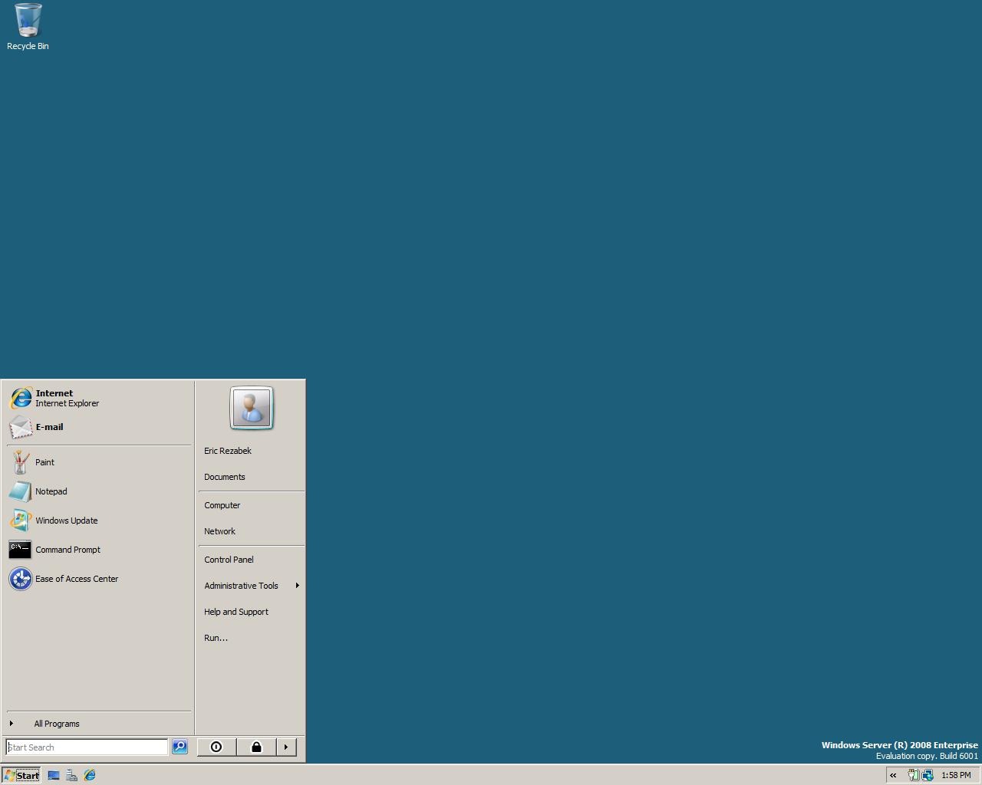
The Remote Desktop Connection feature in Windows Vista enables easier remote access to any resource or application that your organization has made available to you. For example, if you are a salesperson who requires remote access to a financial application or a CRM application, Windows Vista enables the corporate IT manager to place an icon for that application on your desktop. You just click on the icon, and an automatic Terminal Services Remote Program connection is made back to the company over the Internet and to the Terminal Server in Windows Server 2008, with no need for a VPN.
Terminal Services Gateway in Windows Server 2008 provides additional features for home computers that are used to access corporate networks. If you log on to your home PC, you simply access the corporate Web site over the Internet and click on the links that take you straight to the corporate resource you want to use.
Recovery and Troubleshooting
Every support center operator has been forced to work late at some point because an executive was having problems with his or her computer and absolutely had to get the problem fixed that night. Windows Server 2008 won’t make executives less demanding, but it will help you solve their problems faster and might even fix the problem before the executive has his or her assistant call you.
Help files in Windows Server 2008 are much more usable, and almost any user should be able to understand them — even the executives. You can add your own content to Help and Support Center so that users can get assistance with both internal network resources and custom applications. Troubleshooting tools can be customized, and you can escalate unresolved problems directly to your internal support center. Error messages in Windows Server 2008 are more meaningful than in earlier versions of Windows and will help users troubleshoot simple problems for themselves, instead of requiring them to call you.
Windows Server 2008 is designed to fix some of the most serious problems automatically. For example, if system files become corrupted, Windows XP might simply refuse to start. Windows Server 2008, however, can automatically fail over to a recovery partition. Windows Server 2008 then presents the user with Startup Repair (StR), a step-by-step, diagnostics-based troubleshooter. StR analyzes startup logs to determine the cause of the failure and can automatically resolve many problems. If StR is unable to resolve a problem, an administrator can choose to roll back the system to the last known working state. If StR can’t recover the system, StR provides the user with diagnostic information and support options to make troubleshooting easier

Section 10: Miscellaneous

Section 10: Miscellaneous 238
10.01 System Requirements 239
System Requirements for Windows Server® 2008 239
Full Versus Server Core Installations 240
10.02 Detailed Table of Contents 241

10.01 System Requirements
System Requirements for Windows Server® 2008
Actual requirements will vary based on your system configuration and the applications and features you choose to install. Processor performance is dependent upon not only the clock frequency of the processor, but also on the number of cores and the size of the processor cache. Disk space requirements for the system partition are approximate. X64-based operating systems will vary from these disk size estimates. Additional available hard-disk space may be required if you are installing over a network. For more information, please see www.microsoft.com/windowsserver2008.
Specification |  | All x86 & x64 Editions
Processor | Minimum | 1 GHz (x86 processor)  1.4 GHz (x64 processor)
Processor | Recommended | 2 GHz or faster
Memory | Minimum | 512 MB RAM
Memory | Recommended | 2 GB RAM*
Available Disk Space* | Minimum | 10 GB
Available Disk Space* | Recommended | 40 GB or greater
Other Requirements |  | - DVD-ROM drive  - Super-VGA (800x600) or higher resolution monitor  - Keyboard and Microsoft Mouse or compatible pointing device  - Internet access (fees may apply)
* Note: Computers with more than 16 GB of RAM will require more disk space for paging, hibernation, and dump files
Actual requirements will vary based on your system configuration and the applications and features you choose to install. Additional available hard-disk space may be required if you are installing over a network. For more information, please see http://www.microsoft.com/windowsserver2008/default.mspx.
Note
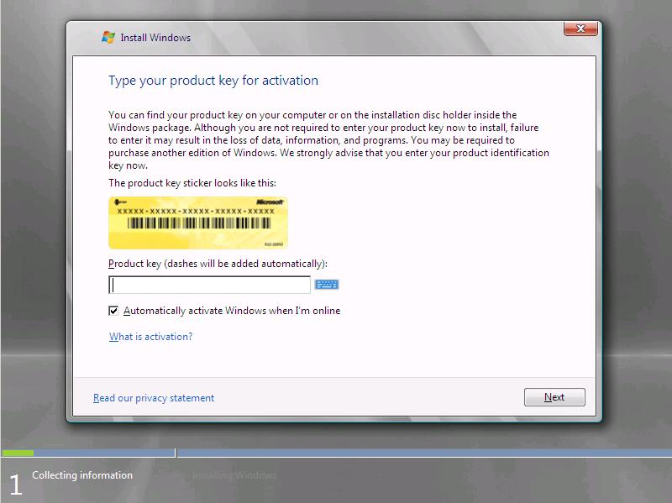
This product requires a valid product key for activation — you may install the product without activation, but if you do not enter a valid product key and activate within 30 days of installation, the software will cease to function. During installation you will be asked to select the edition of Windows Server 2008 you want to install. You must ensure you choose the edition of Windows Server 2008 for which you have obtained a product key or else you will not be able to activate the product.
Full Versus Server Core Installations
Some editions of Windows Server 2008 can be set up as a Full installation or by using the new Server Core installation option. Server Core installations may be administered locally only using command-line tools. Administration of Server Core installations using graphical management tools must be performed remotely using software that supports remote administration of Windows Server 2008. Note that once installation is complete, it is not possible to change the installation option from Server Core to Full, or vice versa, without reinstalling the software.

10.02 Detailed Table of Contents
Disclaimer 1
Contents 1
Section 1: Introduction to Windows Server 2008 3
1.01 Introduction to Windows Server 2008 4
Web 5
Virtualization 5
Security 5
Solid Foundation for Business Workloads 5
Scenarios Introduction 6
1.02 Windows Server 2008 Editions 7
1.03 Windows Server 2008 Editions - Features 9
New and Updated Features in Windows Server 2008 9
Edition Comparison by Server Role 9
Edition Comparison by Server Core Installation Option 10
Differentiated Feature Comparison by Edition 11
Edition Comparison by Technical Specification 11
Edition Comparison by Distribution Channel 12
Edition Comparison by Language 13
Section 2: Server Virtualization 14
2.01 Server Virtualization Introduction 15
Scenario Value Proposition 15
Special Hardware Requirements 15
2.02 Hyper-V 16
Virtualization Benefits 16
Microsoft’s Virtualization Road Map 18
Hyper-V 18
Usage Scenarios 18
Key Features 19
System Center Virtual Machine Manager 20
Usage Scenarios 21
Key Features 21
2.03 Server Core 23
Section 3: Centralized Application Access 24
3.01 Centralized Application Access Introduction 25
Scenario Value Proposition 25
Special Hardware Requirements 25
3.02 Terminal Services Core Functionality 26
Remote Desktop Connection 6.1 26
Plug and Play Device Redirection for Media Players and Digital Cameras 27
Microsoft Point of Service for .NET Device Redirection 27
Configuring a Remote Desktop Protocol File 28
Using Redirected Microsoft POS for .NET Devices 28
Remote Desktop Connection Display 28
Custom Display Resolutions 29
Monitor Spanning 29
Desktop Experience 29
Desktop Composition 30
Adjusting Additional Settings 30
Client Configuration 30
Font Smoothing 31
Display Data Prioritization 31
Single Sign-On 32
Prerequisites for Deploying Single Sign-On 32
Recommended Configuration of a Terminal Server When Using Single Sign-On 33
3.03 Terminal Services Gateway 34
TS CAPs 37
Computer Groups Associated With TS RAPs 37
TS RAPs 38
Monitoring Capabilities 38
Group Policy Settings for TS Gateway 39
3.04 Terminal Services RemoteApp 41
Additional References 42
3.05 Terminal Services Web Access 43
Lets You Easily Deploy RemoteApps Over the Web 44
Deployment 44
List of RemoteApps Is Dynamically Updated 44
Includes the TS Web Access Web Part 45
3.06 Terminal Services Printing 46
Group Policy Settings 47
3.07 Terminal Services Session Broker 49
Group Policy Settings 50
Additional Information 51
3.08 Terminal Services Licensing 52
3.09 Windows System Resource Manager 54
Installing Terminal Server 54
Resource-Allocation Policies 54
Monitoring Performance 55
Section 4: Branch Office 56
4.01 Branch Office Introduction 57
Scenario Value Proposition 57
Special Hardware Requirements 57
4.02 Read-Only Domain Controller 58
Read-Only Active Directory Domain Services Database 59
Unidirectional Replication 60
Credential Caching 60
Administrator Role Separation 60
Read-Only DNS 61
Deployment 61
4.03 BitLocker Drive Encryption 62
Full-Volume Encryption 63
Integrity Checking 63
Recovery Options 64
Remote Management 65
Secure Decommissioning 65
Group Policy Settings 66
BitLocker Drive Encryption — Group Policy Settings 66
TPM Behavior — Group Policy Settings 67
Deployment 67
Additional Information 68
4.04 Server Core 69
4.05 Distributed File System 70
DFS Namespaces Functionality 70
Access-Based Enumeration 70
Cluster Support 71
Improved Command-Line Tools 71
Search for Folders or Folder Targets within a Namespace 71
Windows Server 2008 Mode Domain-Based Namespaces 71
DFS Replication Functionality 71
Content Freshness 71
Improvements for Handling Unexpected Shutdowns 72
DFS Replication Performance Improvements 72
Propagation Report 73
Replicate Now 73
Support for Read-Only Domain Controllers 73
SYSVOL Replication using DFS Replication 73
Section 5: Security and Policy Enforcement 75
5.01 Security and Policy Enforcement Introduction 78
Scenario Value Proposition 78
Special Hardware Requirements 78
5.02 Network Policy and Access Services 79
Role Services for Network Policy and Access Services 80
Managing the Network Policy and Access Services Server Role 82
Additional Resources 84
5.03 Network Access Protection 85
Key Processes of NAP 86
Policy Validation 86
NAP Enforcement and Network Restriction 87
Remediation 87
Ongoing Monitoring to Ensure Compliance 87
NAP Enforcement Methods 88
NAP Enforcement for IPsec Communications 88
NAP Enforcement for 802.1X 88
NAP Enforcement for VPN 88
NAP Enforcement for DHCP 88
NAP Enforcement for TS Gateway 89
Combined Approaches 89
Deployment 89
NAP Client Components 90
NAP Server Components 91
Additional Information 92
5.04 Network Policy Server 93
5.05 Routing and Remote Access Service 96
Remote Access 96
Routing 97
NAP Enforcement for VPN 97
SSTP Tunneling Protocol 97
New Cryptographic Support 98
Removed Technologies 98
5.06 Next-Generation TCP/IP Protocols and Networking Components 99
Next-Generation TCP/IP Stack 99
Receive Window Auto-Tuning 99
Compound TCP 100
Enhancements for High-Loss Environments 100
Neighbor Un-reach-ability Detection for IPv4 101
Changes in Dead Gateway Detection 101
Changes in PMTU Black Hole Router Detection 101
Routing Compartments 102
Network Diagnostics Framework Support 102
Windows Filtering Platform 103
Explicit Congestion Notification 103
IPv6 Enhancements 103
IPv6 Enabled by Default 103
Dual IP Stack 103
GUI-Based Configuration 104
Teredo Enhancements 104
Integrated IPsec Support 104
Multicast Listener Discovery Version 2 104
Link-Local Multicast Name Resolution 104
IPv6 Over PPP 104
Random Interface IDs for IPv6 Addresses 105
DHCPv6 Support 105
Quality of Service 105
Policy-Based QoS for Enterprise Networks 105
5.07 Windows Firewall with Advanced Security 106
Windows Firewall Is Turned On by Default 107
IPsec Policy Management Is Simplified 108
Support for Authenticated IP 108
Support for Protecting Domain Member to Domain Controller Traffic by Using IPsec 109
Improved Cryptographic Support 109
Settings Can Change Dynamically Based on the Network Location Type 109
Integration of Windows Firewall and IPsec Management into a Single User Interface 110
Full Support for IPv4 and IPv6 Network Traffic Protection 110
Additional References 111
5.08 Cryptography Next Generation 112
Deployment 113
Certificate-Enabled Applications 113
5.09 Active Directory Certificate Services 115
Active Directory Certificate Services: Web Enrollment 115
Active Directory Certificate Services: Policy Settings 117
Managing Peer Trust and Trusted Root CA Stores 118
Managing Trusted Publishers 119
Blocking Certificates That Are Not Trusted According to Policy 119
Managing Retrieval of Certificate-Related Data 120
Managing Expiration Times for CRLs and OCSP Responses 120
Deploying Certificates 121
Active Directory Certificate Services: Network Device Enrollment Service 121
Registry Keys in MSCEP 122
Active Directory Certificate Services: Enterprise PKI 123
CA Health States 123
Support for Unicode Characters 124
Active Directory Certificate Services: Online Certificate Status Protocol Support 125
Online Responder 126
Responder Arrays 127
Group Policy 128
Deployment 129
5.10 Active Directory Domain Services 130
Active Directory Domain Services: Auditing 130
Auditing Active Directory Domain Services Access 131
Directory Service Changes — Active Directory Domain Services Events 132
Global Audit Policy 132
SACL 133
Schema 133
Registry Settings 133
Registry Key Values — Active Directory Domain Services Auditing 133
Group Policy Settings 134
Active Directory Domain Services: Fine-Grained Password Policies 134
Storing Fine-Grained Password Policies 134
Defining the Scope of Fine-Grained Password Policies 135
RSOP 136
Security and Delegation 137
Active Directory Domain Services: Read-Only Domain Controller 137
Active Directory Domain Services: Restartable Active Directory Domain Services 138
Active Directory Domain Services: Snapshot Exposure 139
Active Directory Domain Services: User Interface Improvements 141
New Active Directory Domain Services Installation Wizard 142
Active Directory Domain Services Installation Wizard 143
Staged Installation for RODCs 143
Additional Wizard Improvements 144
New MMC Snap-In Functions 144
5.11 Active Directory Federation Services 146
Improved Installation 148
Improved Application Support 148
Better Administrative Experience When Establishing Federated Trusts 148
New Settings 151
Active Directory Federation Services Web Agent Property Pages 151
5.12 Active Directory Lightweight Directory Services 152
5.13 Active Directory Rights Management Services 155
Improved Installation and Administration Experience 157
Self-Enrollment of Active Directory Rights Management Services Server 158
Integration With Active Directory Federation Services 158
New Active Directory Rights Management Services Administrative Roles 159
Section 6: Web and Applications Platform 160
6.01 Web and Applications Platform Introduction 161
Scenario Value Proposition 161
Special Hardware Requirements 161
6.02 Internet Information Services 7.0 162
Flexible Extensibility Model for Powerful Customization 162
Powerful Diagnostic and Troubleshooting Tools 163
Delegated Administration 163
Enhanced Security and Reduced Attack Surface through Customization 163
True Application Xcopy Deployment 163
Application and Health Management for WCF Services 163
Improved Administration Tools 163
Integrated Management Support for Web Services 163
Windows Firewall Is Turned On by Default 163
Editions 164
Configuration 164
Administration Tools 165
Core Web Server 166
Diagnostics 166
Additional Resources 167
6.03 Application Server 168
Application Server Core 168
Web Server 170
COM+ Network Access 170
Windows Process Activation Service 170
TCP Port Sharing 170
Distributed Transactions 171
6.04 Transactional NTFS 172
Section 7: Server Management 174
7.01 Server Management Introduction 176
Scenario Value Proposition 176
Special Hardware Requirements 176
7.02 Initial Configuration Tasks 177
Default Settings in Initial Configuration Tasks 178
7.03 Server Manager 179
Roles 180
Server Roles in Server Manager 180
Features 183
Features in Server Manager 183
Server Manager Console 186
Server Manager Wizards 188
Add Roles Wizard 188
Add Role Services Wizard 189
Add Features Wizard 189
Remove Roles Wizard 190
Remove Role Services Wizard 190
Remove Features Wizard 190
Server Manager Command Line 190
Registry Settings 191
Registry Settings 191
How Do I Open Server Manager? 191
Additional Resources 192
7.04 Windows PowerShell 193
Windows PowerShell Features 194
Windows PowerShell Cmdlets 194
A New Scripting Language 195
Windows Commands and Utilities 195
Additional Information 195
7.05 Server Core 196
7.06 Windows Server Backup 200
7.07 Windows Reliability and Performance Monitor 203
Data Collector Sets 203
Wizards and Templates for Creating Logs 204
Resource View 204
Reliability Monitor 204
Unified Property Configuration for All Data Collection, Including Scheduling 205
User-Friendly Diagnosis Reports 205
7.08 Windows Deployment Services 206
Create and add Boot Images 208
Create a Capture Image 208
Create a Discover Image 208
Create an Install Image 209
Associate an Unattend File with an Image 209
Enable multicast transmission of an image 210
Use Transport Server to enable multicast download of data 210
Deployment 210
Additional Resources 210
7.09 Group Policy 212
New Categories of Policy Management 213
New Format and Functionality of Administrative Template Files (ADMX) 216
Starter Group Policy Objects 217
Comments for GPOs and Policy Settings 217
Network Location Awareness 217
Group Policy Service 219
Events and Logging 219
Multiple Local Group Policy Objects 220
Finding Specific Administrative Template Policy Settings 220
Section 8: High Availability 225
8.01 High Availability Introduction 226
Scenario Value Proposition 226
Special Hardware Requirements 226
8.02 Failover Clustering 227
New Validation Wizard 227
Support for GPT Disks in Cluster Storage 227
Improvements to Setup and Migration 227
Improvements to Management Interfaces 228
Improvements to Stability and Security for Increased Availability 228
Improvements to the Way a Cluster Works With Storage 229
Improvements to Networking and Security 229
Compatibility 229
Deployment 230
8.03 Network Load Balancing 231
Section 9: Better Together 232
9.01 Better Together — Windows Server 2008 and Windows Vista 233
More Efficient Management 233
Greater Availability 234
Faster Communications 234
Windows Deployment Services 235
Network Access Protection 235
Policy-Based Quality of Service 235
SMB 2.0 236
Simplified Remote Access 236
Recovery and Troubleshooting 237
Section 10: Miscellaneous 238
10.01 System Requirements 239
System Requirements for Windows Server® 2008 239
Full Versus Server Core Installations 240
10.02 Detailed Table of Contents 241

