Welcome Marksmen Fans! We are so excited for the 2017-2018 Season and hope you are too!

As your food and beverage provider, it is our pleasure to serve you in your suite. Our online ordering system has been updated with a user friendly site at:
https://crowncomplex.ezplanit.com/

Guests or Suite Holders renting a suite should visit us at https://crowncomplex.ezplanit.com/ for all their food and beverage needs!

It’s as easy as 1, 2, 3! Fans please select:

1. Event Date
Click on desired date and corresponding event will appear.
2. Suite Number
Click on your suite number and the menu will then appear for you
3. Place Order
Place order opens to menu with Category on left
Select menu items & Click ‘Calculate Total’ to see final charges.
4. Select Menu Items
Menu Items in middle of screen and Shopping Cart is on right side of screen.
5. Submit Order
Select menu items & Click ‘Calculate Total’ to see final charges.
6. The last step will be either Creating a New user login profile OR Sign in as a returning user with your login information you previously created

Creating a New user login profile and submit credit card payment information.
NEW USER: Create customer profile with login credentials. Provide billing address of your payment credit card.
Add credit card information that is encrypted and NOT saved within our program.
Review final order for completeness
Add notes for pertinent delivery information.
Click Submit. There is immediate notification that order has been placed on the screen.
Confirmation will be emailed to you that the order has been sent.
Once the order has been processed you will receive an email with the completed Banquet Event Order.

7. Complete Payment Options
Fan login profiles will include contact information; allow fans to enter credit card information in a secure environment, and most importantly review the suite menu and examine the ordering and payment policies on this site.

Centerplate has provided this safe, protected site to maintain the security of your information. We do not store credit card information. If you wish to add multiple credit cards to your account, please add them at this location. Our customer service representative is not able to store credit card information for you.

8. Submit Order

9. Complete Notes Field
Important Note: In order to make the game day experience as smooth and comfortable for you and your guests, we are requesting additional information for each game. Please identify if there will be someone in the suite during the game who is authorized to charge to your credit card on file. If you wish to pay for the pre-order only, let us know in the Notes section of your online order prior to checking out. Likewise, identify anyone who is authorized to charge your card in the Notes Section.

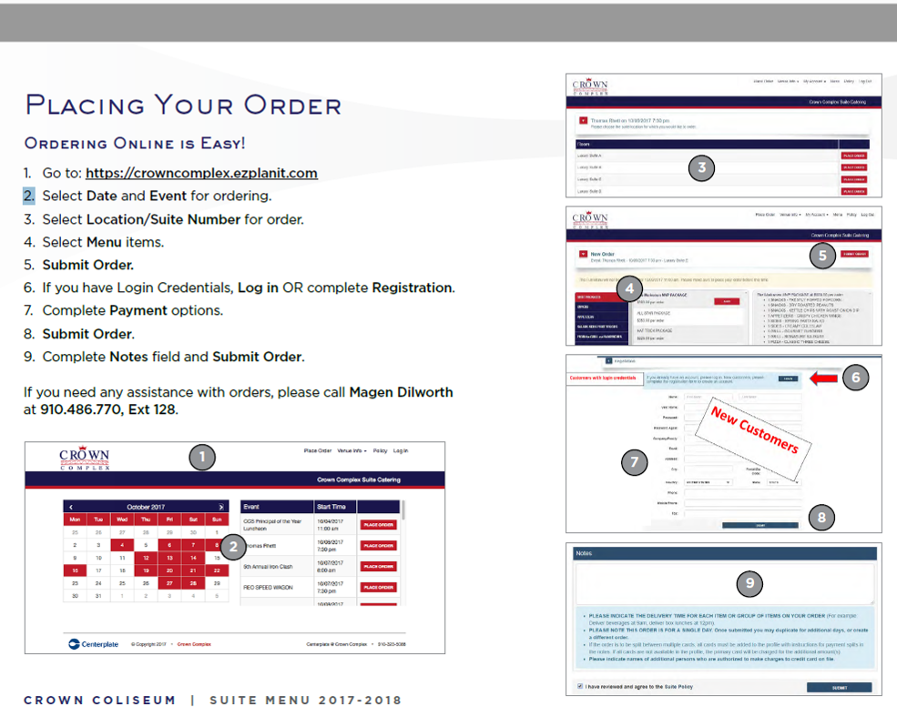

If you need any assistance with orders, please call Magen Dilworth at 910.486.770, Ext 128. Our goal is to create an experience at The Crown Complex unlike any other suite experience. Please let us know how we are doing.

Magen Dilworth
General Manager
Centerplate
(P) 910.486.7700 Ext.128
(E) magen.dilworth@centerplate.com
www.centerplate.com

