

Why Should Businesses Come to Princeton?
Useful Information:
Population: 1216
Ancestries: German (46.9%), Polish (21.7%), English (8.0%), Irish (7.1%), Norwegian (4.7%), United States (4.2%).
Population density: 849 people per square mile
Location: Princeton, WI. Northwest Green Lake County. East Central Wisconsin
Nearby cities, driving distance from Princeton, and their population:
Berlin: approx: 15 min. pop: 4977
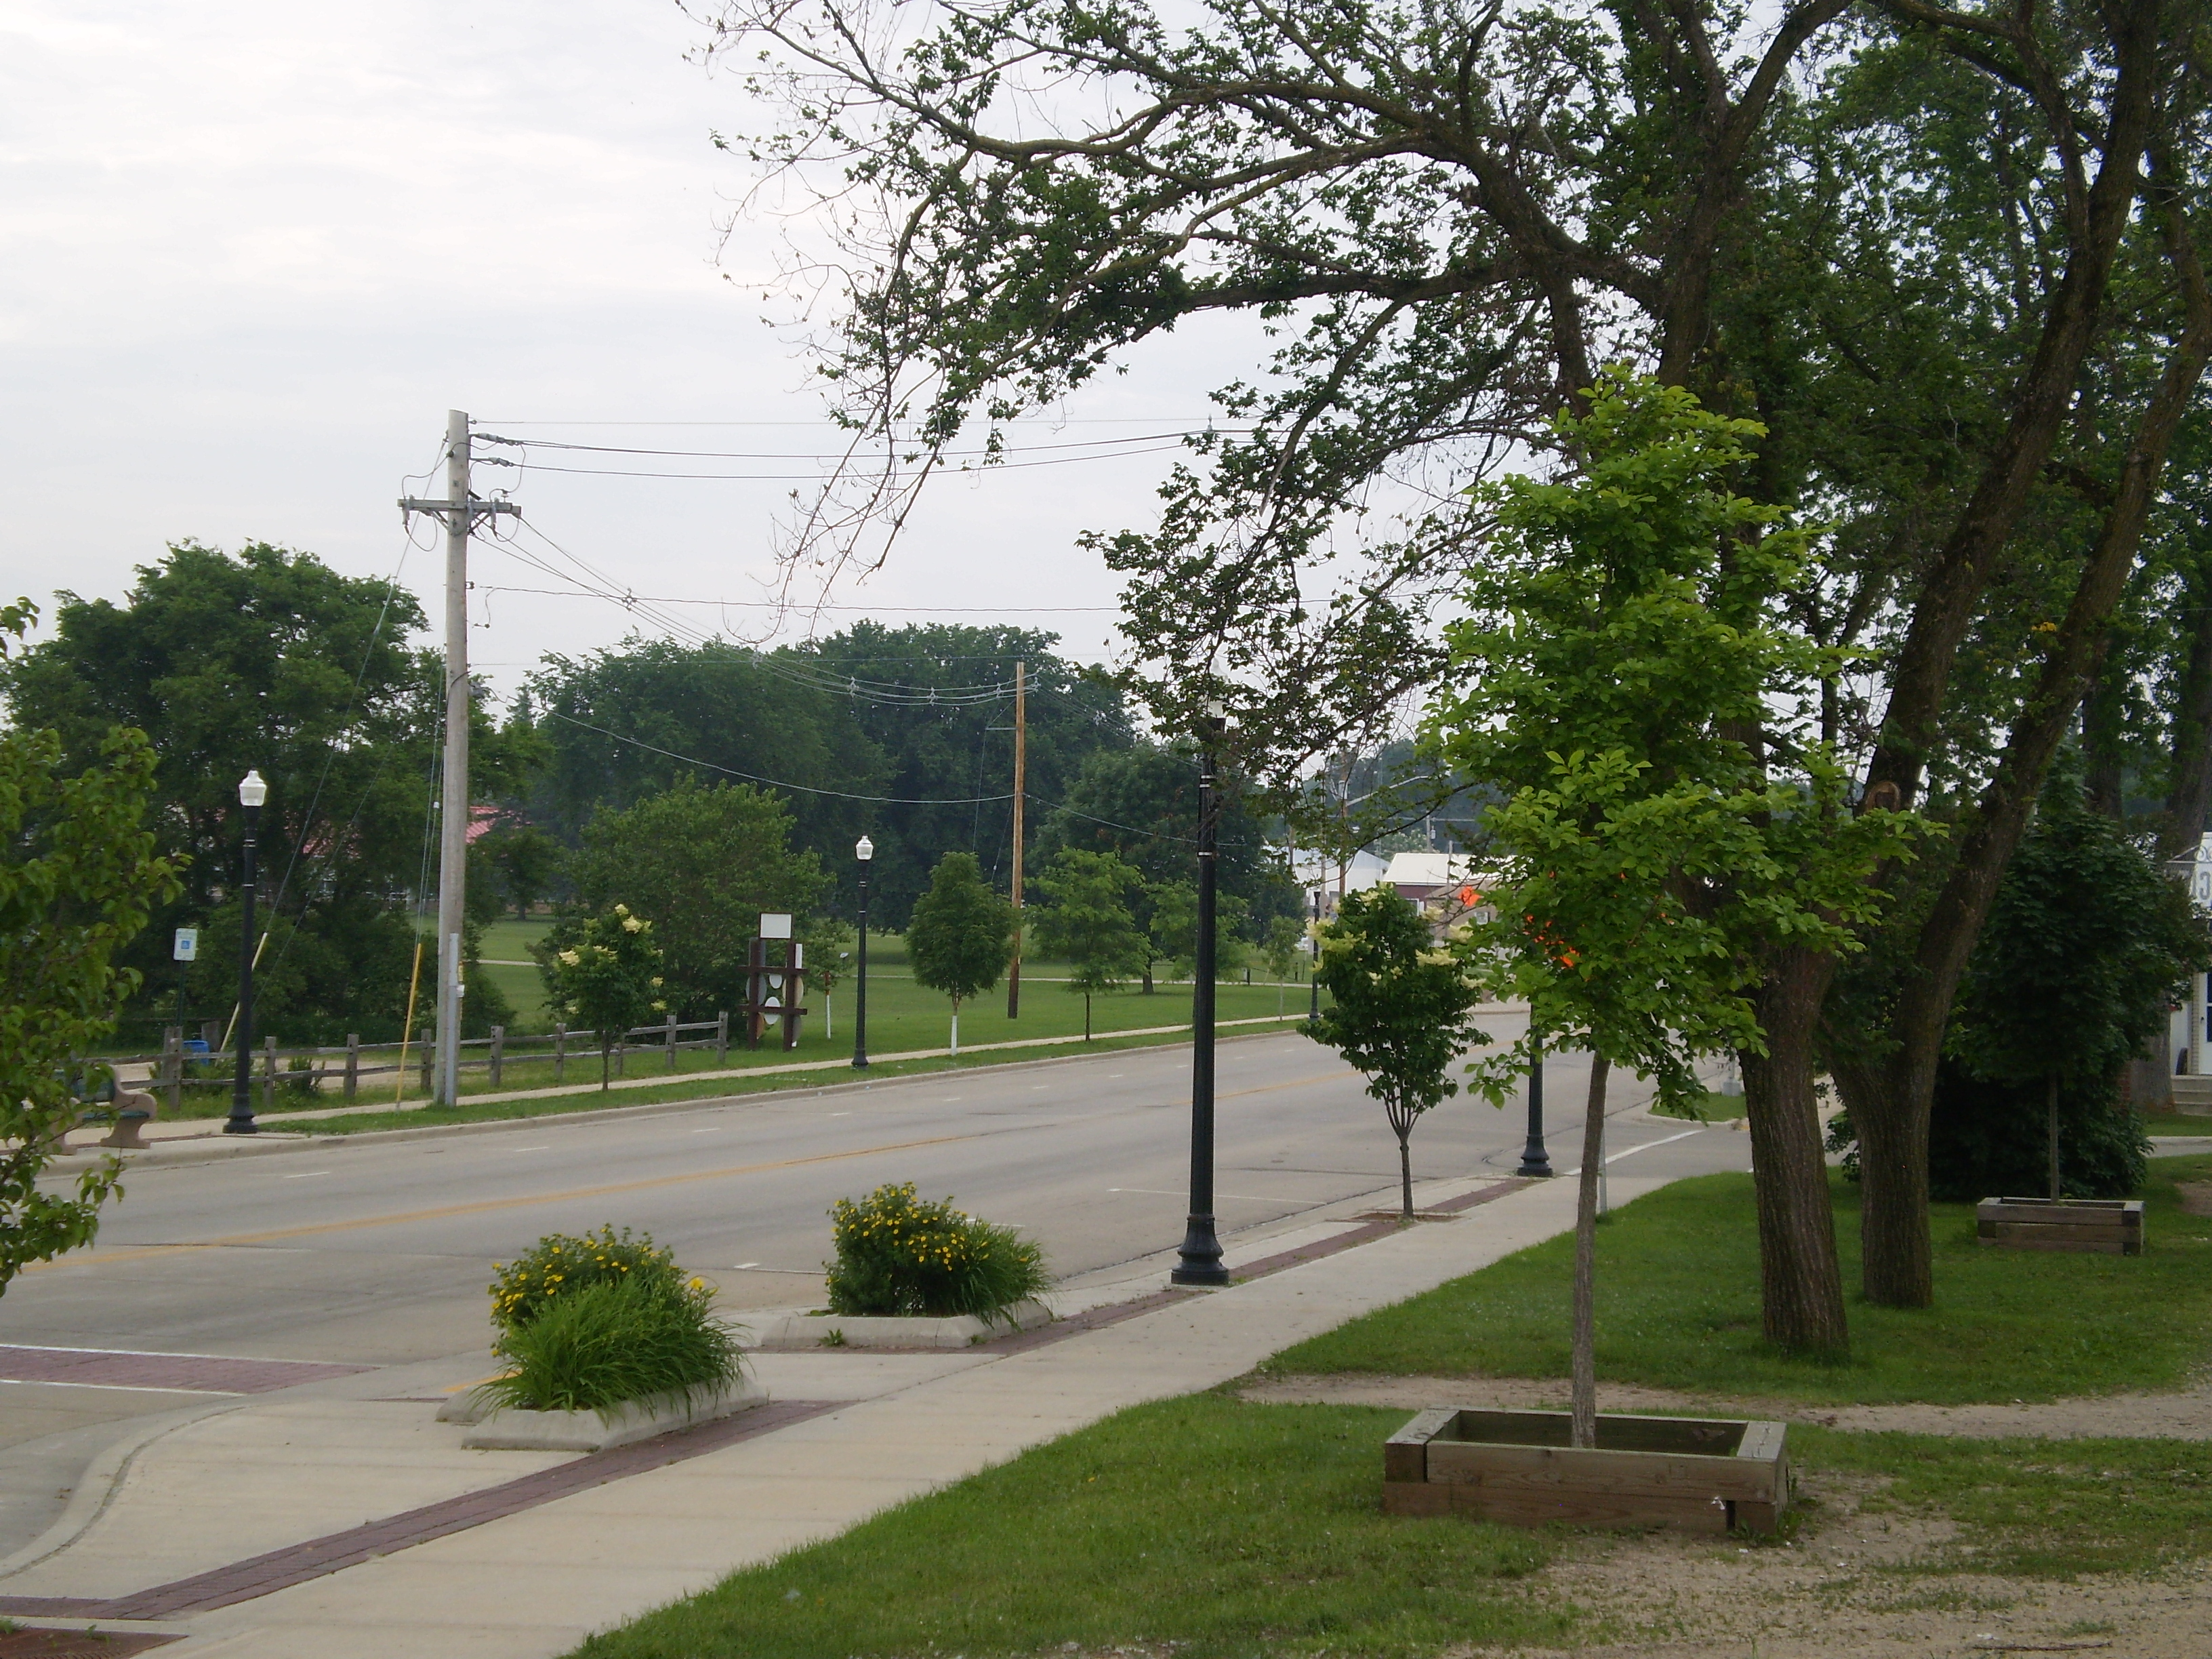
Wautoma: approx. 20 min. pop: 2197
Ripon: approx. 25 min. pop: 7479
Oshkosh: approx. 50 min. pop: 66083
Appleton: approx. 1 hr 30 min. pop: 78086
Fond du Lac: approx. 45 min. pop: 42225
Madison: approx. 1 hr 15 min. pop: 233209
Wausau: approx. 1 hr 50 min. pop: 38435
Wisconsin Dells: approx. 1 hr pop: 2476
Green Lake: approx. 8 min. pop: 1100
Markesan: approx. 12 min. pop: 1396
Montello: approx. 10 min. pop: 1397

Nearby highways and their driving distance from Princeton,
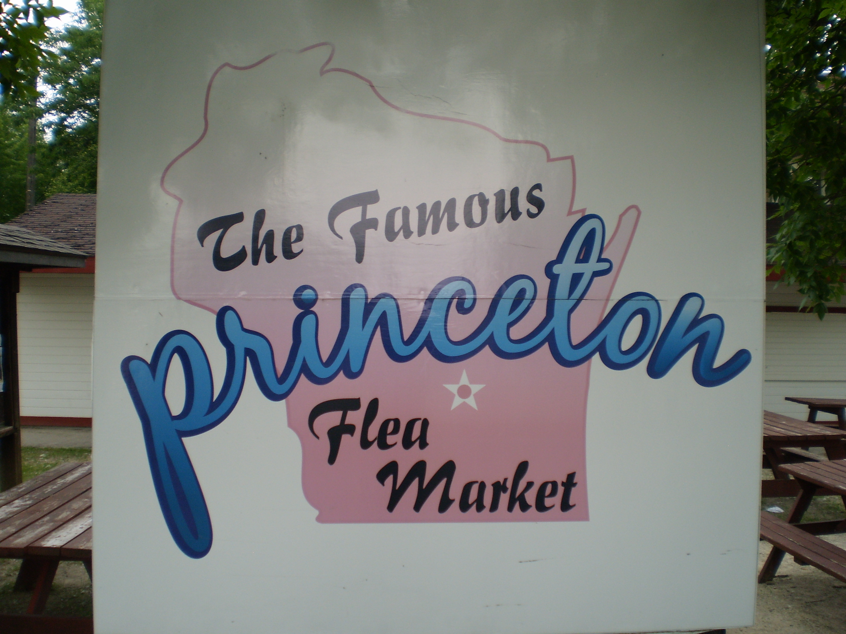
Interstate 90-94, approx. 1 hr
Hwy 23-73, goes right through town
Interstate 39, approx. 0 hr 30 min.
US 41, approx. 45 min.
US 151, approx. 30 min.
Flea Market:
There is one big reason why businesses should come to Princeton, and it’s called the Flea Market. It’s what makes Princeton famous, as Princeton’s flea market is the largest outdoor flea market in the state. This event occurs EVERY Saturday from April to October. Over 100 vendors attend and offer eye-catching deals that attract thousands of visitors from everywhere in the state and even out of state. You can definitely tell when it’s Saturday, because the streets are packed. This event draws in a huge crowd of potential customers who are eager to spend their money. The city and the chamber are looking at trafficking more of the flea market customers into the downtown area to help expand business and more customers to that area.

Vacant Lots:

The City of Princeton has a lot of vacant property that is up for sale or rent that provide an easy way for a new business to set up a presence in Princeton. Residents in Princeton are always looking for new businesses that provide new and different services and are open to any new businesses moving in. An example of this would be Dollar General, which moved in early fall of 2010 and received a huge reception by an enormous influx of first time customers. Dollar General had huge amounts of customers the first month, until it eventually died down into the regulars, which was still a pretty big crowd. A lot of the owners of the vacant properties are looking to make some deals with interested businesses.
Princeton in General:
In general, Princeton is the ideal place to set up a business for a number of reasons. First, being located in the center of the state, Princeton isn’t far away from most of the states most important roads, which puts it in a prime location for trucking routes. You’ll always see semi-trailers going through town. For that matter, most of the major cities aren’t very far away either. Princeton’s location also makes it the sight of statewide events like Green Lake County Relay for Life, and one of the few Division 3 WIAA Track & Field Sectionals. Princeton’s location also makes it easily accessible for the Flea Market. Princeton’s crime rate is very, very low. What’s more, the Fox River runs right through town, which adds to the tourism industry and enhances the breathtaking scenery already in Princeton.
Being a business in Princeton benefits everyone. Students at the high school are always eager to apply for jobs to gain experience for a minimal wage. In Princeton, residents are eager to shop local to help the community instead of traveling to another community. There are events that help promote the businesses in the town and yet still benefit the citizens, like Crazy Days, the parade, and even the citywide rummage sale, where plenty of shoppers get out and about to look for deals. Those same shoppers end up browsing about the businesses in town. And of course the Flea Market gives businesses plenty of tourists and regulars who are interested in all that Princeton has to offer. Because of the size of Princeton, everybody benefits from the successes of businesses.
Some Helpful Organizations:
Tri-County Regional Economic Development Association: www.tcredc.org (920)-382-0963 The Tri-County Regional Economic Development Corporation, based in Neshkoro, WI, is a non-profit organization seeking to revitalize the economy and business opportunities in Green Lake, Marquette and Waushara counties. The TREDC, the first three-county economic development corporation of its kind, allows Green Lake, Marquette and Waushara County businesses to share resources and information, ultimately becoming more competitive and further developed.
Address | Included | Size | Renovations/Information | Price, Other
523 W Water St | Main level & 2nd Level space | 4,000 sq ft | Restaurant, Cafe, Tavern or Retail. 12ft ceilings, tin roof, hard wood floors, floor to ceiling store front windows. Nice Kitchen. New walk in cooler, freezer, electrical and furnace. Second floor option of a party room, office, retail or living quarters. On Street parking available. | $169,999 Taxes: $2571.56 http://www.exitrealtyxl.com/chf_listings/listing-details/523-W-Water-St/Princeton/WI/54968-9142/Listing-1208125/29502917/?CurrentPage=42
544 W Water St | Main Level & 2nd Level | 6,720 sq ft | Newer mechanicals, electrical, windows, and roof, Nice, upstairs can be used as living quarters | $209,900 Taxes: $2969.59 920-295-4500
436 W Water St | Main level & Basement | 3,328 sq ft | Main level: 5 offices, storage area, foyer, and a restroom. Back and separate entrance to basement | $115, 000, Taxes: $2,461.60 920-295-9610
514, 518 W Water St | Two buildings connected, Night Club, and Dining, two upstairs apartments | 6,764 sq ft | Full bar, full liquor license, downstairs remodeled, Night Club holds 100, Dining holds 30, Used for musical productions, includes stage, One side upstairs partially renovated, other side fully renovated, one car garage in back | $299,900 Taxes: $1198.31 & $1794.53 www.yellowhousereality.com
618 W Water St | Apartment upstairs, office & shop main level | 1,800 sq ft | Recently renovated, used as a photo shop. Very nice. Upstairs can be used as living quarters | $89, 000 Taxes: $988.18 (312) 218-0016
631 W Water St | Main Level | 648 sq ft | Very historic, recently renovated, big store front windows, looks very nice | $79, 900 Taxes: $670.51 www.princetonwi.com
433 W Water St | Main level & 2 bedroom apartment upstairs | 1,200 sq ft | New roof, new windows, new wiring, new interior modeling, on the Fox River, very nice. | $XX,XXX Taxes: $1479.31 (715) 335-6040
522 W Water St | Main level & 2nd Level Space | 3,800 sq ft | Totally renovated, new roof, new windows, very nice, good parking, upstairs has two bedrooms and two baths | $199,900, Taxes $2,242.33 www.shorewest.com
230 Mechanic St | Office Space, two truck docks, Main Operations Area | 36, 031 sq ft 5.38 acres | Manufacturing Area, Sturdy Building, lots of space | $449,000 Taxes: $9493.91 http://www.loopnet.com/Listing/15702930/230-Mechanic-Street-Princeton-WI/

Qualified New Business Venture
Early-stage businesses engaged in developing innovative products or services related to proprietary technology may be designated as Qualified New Business Ventures. This designation is designed to assist businesses in their efforts to attract investors by making state tax credits available to individuals and groups investing in these businesses.
Does Your Business Qualify?
To be certified as a Qualified New Business Venture by the Department of Commerce, businesses must be able to answer "Yes" to the following six questions:
  - Are you seeking private equity funding for pre-commercialization activities related to the development of a proprietary new product or process in Wisconsin?
  - Have you been in business for no more than 10 consecutive years?
  - Are your principal administrative offices located in Wisconsin? and
Does at least 80% of your payroll go to people employed in Wisconsin?
  - Do you have less than 100 full-time equivalent (FTE) employees?
(FTE=Total number of hours worked per year multiplied by total number of employees divided by 2,080 hours)
  - Do at least 51% of your employees work in Wisconsin?
  - Since its inception, has your business received, in aggregate, no more than $10 million of private equity investment in cash?
Department of Commerce
Evaluation Criteria
Commerce will also consider the following factors when determining if an early-stage business should be certified as a Qualified New Business Venture:
  - Is the business one of Wisconsin's targeted high-technology industries (biotechnology, health technology, information technology or nanotechnology)?
  - Does the business have high-growth potential, long-term sustainability and sufficient barriers to entry?
  - What is the experience level of the management team?
  - What is the financial need of the business?
  - What percentage of funding being sought by applicants will be spent on activities in Wisconsin?
Application Materials
Applications may be obtained by contacting Aaron Hagar at Aaron.Hagar@Wisconsin.gov
A business may be designated as a Qualified New Business Venture if it meets the following criteria:
- It has the potential for increasing jobs in this state, or increasing capital investment in this state, or both, and either of the following apply:
- It is engaged in, or has committed to engage in, innovation in this state in either of the following:
a) Manufacturing, biotechnology, nanotechnology, communications, agriculture, or clean energy creation or storage technology.
b) Processing or assembling products, including medical devices, pharmaceuticals, computer software, computer hardware, semiconductors, any other innovative-technology products, or other products that are produced using manufacturing methods which are enabled by applying proprietary technology.
2. Manufacturing, agriculture or processing
or assembly products and conducting
research and development.
- Businesses engaged in real estate development, insurance, banking, lending, lobbying, political consultation, professional services provided by attorneys, accountants, business consultants, physicians or health care consultants, wholesale or retail trade, leisure, hospitality, transportation or construction are not eligible for the program.
Qualified New Business Ventures will be certified by Commerce on an annual basis. Businesses wishing to continue their certification in the program must submit verification information annually.
Businesses can receive up to $8 million in tax credit-eligible cash equity investment.
Benefits to Investors
- Qualifying angel investors and angel investor networks that invest in Qualified New Business Ventures may be eligible to claim an income tax credit on that investmentof up to 25% of the investment amount.
  - Summary of Governor's Budget Adjustment Bill (2009 Wis. Act 2) Act 255 QNBV/Investor Tax Credit Changes
  - Summary of 2007-2009 Biennial Budget Bill (2007 Wis. Act 20) Act 255 QNBV/Investor Tax Credit Changes
  - Summary of Administrative Rules Amendment
- Qualifying venture capital funds that invest in Qualified New Business Ventures may be eligible to claim up to a 25% income tax credit on that investment.
For more information about Qualified New Business Ventures, and prior to submitting an application, please contact:
Aaron Hagar
Technology Development Manager
608/2670769
Aaron.Hagar@Wisconsin.gov

http://commerce.wi.gov/BD/BD-Act255-QNBV.html
Economic Development Tax Credit
The Economic Development Tax Credit replaces five former Wisconsin tax credit programs - the Airport Development Zone, Agricultural Development Zone, Community Development Zone, Enterprise Development Zone and Technology Zone programs. The new tax credit program eliminates all former zone boundaries, as well as creating new ways in which existing Wisconsin businesses or businesses relocating to Wisconsin can earn tax credits.
The tax credits, which are nonrefundable and nontransferable, must be applied against a certified business's Wisconsin income tax liability. In the case of an S-Corporation, LLC or other pass-through entity, tax credits flow through to the owners in the same way as the income. The tax credits have a 15-year carry forward.
Eligible Activities
- Job Creation – Tax credits can be earned through the creation of new, full-time positions that pay at least $10.88 per hour. Businesses must create the jobs within three years and maintain them for at least two additional years. Tax credits will be released on an annual basis, in direct proportion to the number of jobs created.
- Capital investment – Tax credits may be earned through capital investment for property and equipment. Expenditures for working capital, employment costs, moving costs, intellectual property and unrelated fees and permits are not eligible. Tax credits will be released on an annual basis, as eligible expenditures take place. Businesses whose primary activity includes such things as retail, commercial development, recreation, entertainment or direct health care are not eligible to earn tax credits through capital investment.
- Employee Training – Tax credits may be earned through many types of training provided to existing and new employees in full-time positions. Training must be related to a specific project. Eligible training costs include trainee wages, trainer costs and trainer materials. Tax credits will be released on an annual basis, as eligible training costs are incurred.
- Corporate Headquarters – Tax credits may be earned by businesses locating global, national divisional or regional headquarters operations to Wisconsin or by businesses whose existing Wisconsin headquarters are at risk of leaving the state. Credits will be allocated on a per-job basis.
Allocation of Tax Credits: Commerce will certify applicants that have met the eligibility criteria and will allocate tax credits. In determining the allocation of tax credits, the Department will consider the following:
- Whether the project will serve a public purpose;
- Whether the project might not occur without the allocation of tax credits;
- The extent to which the project will be financed with funds not provided by the State of Wisconsin;
- Whether the project will displace workers in Wisconsin;
- The extent to which the project will retain or increase employment in Wisconsin;
- The extent to which the project will contribute to the economic growth of Wisconsin and to the well-being of Wisconsin residents;
- Whether the project will be located in an economically distressed area;
- Whether the project will be located in a rural area;
- The extent to which the project will increase the geographic diversity of available tax benefits throughout Wisconsin;
- The financial soundness of the business;
- The ability of the business to utilize Wisconsin income tax credits; and
- Any previous financial assistance that the business received from the Wisconsin Department of Commerce.
Application materials can be obtained by contacting the Department of Commerce's Area Development Managers. Princeton-Region 2 Contact: Deb.Clements@wisconsin.gov
For additional information about the Economic Development Tax Credit program, contact Todd Jensen at 608/266-3074 or Todd.Jensen@Wisconsin.gov.
http://commerce.wi.gov/BD/BD-ETC.html

Financial Incentives for your Business
Focus on Energy offers financial incentives to eligible customers for installing qualifying energy efficiency and renewable energy measures. These measures include a variety of technologies including energy efficient lighting, compressed air, HVAC equipment, and solar energy systems. It also includes custom projects such as system or building upgrades or process improvements.
To help determine what incentives are best for you, Focus has developed a quick reference guide that provides a summary of incentives available for Wisconsin businesses. Below is a list of these incentives and links to the respective applications. Applications must be submitted within 45 days of project completion and by July 31, 2011. Therefore, customers who complete projects after June 17 will not have the full 45 days to submit their invoices, but only until July 31. Incomplete applications will be returned. Review a sample invoice to ensure all required information is included. Please return the signed and completed form with ITEMIZED invoice to:
Mail: | Focus on Energy  Business Programs Incentives  8383 Greenway Blvd  Suite 600  Middleton, WI 53597
Email: | BPforms@focusonenergy.com
Fax: | 608.824.3145
Agribusiness Incentives
- Dairy & Livestock
- Greenhouses
- Lighting for Agribusiness Facilities
- Irrigation Systems
- http://www.focusonenergy.com/Incentives/Business/Agriculture.aspx

Commercial Refrigeration Incentives
- Anti-Sweat Heater Controls
- Reach-in Case Doors
- Occupancy Sensors for LED Lighting Reach-in Freezer or Cooler Cases
- Cooler Evaporator Fan Motors
- Night Curtains for Open Coolers
- Beverage Cooler Controls
- http://www.focusonenergy.com/Incentives/Business/commercial_refrigeration.aspx
Compressed Air Incentives
- Compressed Air System Audit
- Air Compressor Equipped with Variable Speed Drive
- http://www.focusonenergy.com/Incentives/Business/compressed_air.aspx
Food Service Incentives
- Food Service for Businesses
- http://www.focusonenergy.com/Incentives/Business/FoodService.aspx

Heating, Ventilation, and Cooling System Incentives
- HVAC For Businesses
- Electric Chillers
- Ground Source (Geothermal) Heat Pumps
- Boiler Combustion Controls
- http://www.focusonenergy.com/Incentives/Business/Heating_Cooling.aspx
Industrial Incentives
- Energy Efficient Repulper Rotor & Pressure Screen Rotor
- Energy Efficient Radiant Tube Inserts for Heat Treating
- Energy Efficient Radiant Heater Bands for Plastics
- Engineering Internship Grant (Due May 2, 2011)
- http://www.focusonenergy.com/Incentives/Business/Industrial.aspx
Information Systems Incentives
- Server Virtualization
- Thin Client Conversion
- PC Network Controls
- http://www.focusonenergy.com/Incentives/Business/Information_Systems.aspx

Lighting Incentives
- Lighting for Businesses
- Lighting for Agribusiness Facilities
- Whole-Building Lighting Program for Schools & Government Facilities
- http://www.focusonenergy.com/Incentives/Business/Lighting.aspx
New Construction Incentives
- New Construction Design Incentive Agreement
- New Construction Whole Building Track Project Information Form
- http://www.focusonenergy.com/Incentives/Business/Construction-Incentives.aspx
Renewable Energy Incentives
- Wind Electric System
- Solar Electric (Photovoltaic) System
- Solar Water Heating System
- Biomass Combustion System
- Biogas Digester System
- http://www.focusonenergy.com/Incentives/Business/renewable_incentives.aspx
Specialty Measures Incentives
- Guestroom Energy Management Controls
- ENERGY STAR® Vending Machines
- Vending Machine Controls
- Residential-Type Water Heaters
- Truck Loading Dock Seals
- Truck Loading Dock LED Lighting
- http://www.focusonenergy.com/Incentives/Business/SpecialtyMeasures.aspx
Other Incentives & Applications
- Custom Incentives
- http://www.focusonenergy.com/Incentives/Business/OtherIncentives.aspx
Variable Frequency Drives Incentives
- Variable Frequency Drives
- http://www.focusonenergy.com/Incentives/Business/vfd.aspx

Whole-Building Systems
- Building Tune-Up
- Retrocommissioning
- Whole-Building Lighting
- http://www.focusonenergy.com/Incentives/Business/whole_building_systems.aspx
Tax Incentives
Federal tax incentives are now available to businesses who install energy efficient equipment, adopt renewable energy measures or improve the overall efficiency of a business. Learn more to help you take advantage of these federal tax breaks.
Project pre-approvals: Any project with an expected incentive exceeding $25,000 must receive written approval BEFORE project initiation or equipment purchase. To obtain pre-approval, complete an application from the list above and submit it to Focus. Your application must include information about the qualifying equipment you plan to install. This includes product specifications, quotes, proposals, and/or make and model numbers. Once your application has been reviewed, a letter will be sent to you with a decision on your pre-approval request.
http://www.focusonenergy.com/Incentives/Business/

Wisconsin Business Incentives
The Wisconsin economic development team includes many partners, from the Department of Commerce and other state agencies to local economic development officials, utilities, the state's technical college and university systems and other groups. Through these partners, a wide variety of business incentive programs are available. For more information on financial assistance and incentive programs, contact Wisconsin Department of Commerce.
Business Employees' Program (BEST)
Established by the Wisconsin Legislature to help small businesses in industries that are facing severe labor shortages upgrade the skills of their workforce. Under the BEST program, Commerce can provide applicants with a tuition reimbursement grant to help cover a portion of the costs associated with training employees. For further information call 1-800-HELP-BUS (1-800-435-7287).
Community Development Block Grant for Economic Development Revolving Loan Fund (CDBG-ED/RLF)
Funded through the federal Small Cities CDBG Program, provides grants to communities to promote local job creation and retention. Local governments then lend the funds to businesses for start-up, retention, and expansion projects through grant funding. Funding levels depend on the number of jobs to be created or retained.
Customized Labor Training Fund
Provides training grants to businesses that are implementing new technology or production processes. The program can provide up to 50 percent of the cost of customized training if it is not available from the Wisconsin Technical College System.
Dairy 2020 Initiative
Awards grants for business and feasibility planning to dairy producers and processors considering a modernization or expansion project.
Early Planning Grant Program (EPG)
Helps individual entrepreneurs and small businesses throughout Wisconsin obtain the professional services necessary to evaluate the feasibility of a proposed start up or expansion.
Enterprise Development Zone Program
Promotes a business start-up or expansion on a particular site in any area of the state that suffers from high unemployment, declining income and property values, and other indicators of economic distress. The program offers tax credits for such activities as hiring disadvantaged workers and undertaking environmental remediation. Tax credits can be taken only on income generated by business activity in the zone. The maximum amount of tax credits per zone is $3 million.
Focus on Energy
Focus on Energy works with eligible Wisconsin businesses to install cost effective energy efficiency and renewable energy projects. Focus information, resources, and financial incentives help implement projects that otherwise would not be completed, or to complete projects sooner than scheduled. Its efforts help businesses manage rising energy costs, promote in-state economic development, protect the environment and control the state’s growing demand for electricity and natural gas.
Tax Incremental Financing (TIF)
Helps cities in Wisconsin attract industrial and commercial growth in underdeveloped and blighted areas. A city or village can designate a specific area within its boundaries as a TIF district and develop a plan to improve its property values. Taxes generated by the increased property values pay for land acquisition or needed public works.
Industrial Revenue Bonds (IRBs)
These are a means of financing the constructing and equipping of manufacturing plants and a limited number of non-manufacturing facilities. The municipality is not responsible for debt service on IRBs, nor is it liable in the case of default. IRBs are also exempt from federal income tax.
Major Economic Development Program
Offers low-interest loans for business development projects that create a significant economic impact.
Rural Economic Development Program
Makes individual awards up to $30,000 for feasibility studies and other professional assistance to rural businesses with fewer than 25 employees. Businesses that have completed their feasibility evaluations are eligible for individual micro loans up to $25,000 for working capital and the purchase of equipment.
Technology Development Fund
Helps businesses finance Phase I product development research. Firms completing Phase I projects can receive Phase II product-commercialization funding.
Wisconsin Transportation Facilities Economic Assistance and Development Program
Funds transportation facilities improvements (road, rail, harbor, airport) that are part of an economic development project.
http://www.wisconsin.gov/state/core/wisconsin_business_incentives.html

Tools for Financing Your Business
FUNDING FOR YOUR BUSINESS PLAN
The Department of Commerce offers two programs to help offset the cost of creating a business plan.
Entrepreneurial Training Grant Program
Grants are available to help all levels of entrepreneurs develop the business skills necessary for success. Offered through the Small Business Development Centers, the courses address legal and financial issues, staffing, accounting, record-keeping and marketing. Individual counseling and coaching will be available to help entrepreneurs complete a business plan and prepare them to request financing from banks, investors an dpublic institutions. Grants can cover up to 75% of eligible tuition costs (the tuition charged by the SBDC). Participants will be required to provide a cash match of at least 25% of the eligible tuition costs. For more details, contact the Wisconsin Entrepreneurs' Network at www.wenportal.org or call 608-263-0398.
Early Planning Grant
Individuals planning to start a new business or expand an existing business in Wisconsin can receive financial assistance for evaluating the feasibility of those activities. EPG grants can help cover a portion of hiring the cost of a qualified, independent third party to develop a comprehensive business plan. Types of eligible business activities include:
- Automation
- Agriculture/Food Products
- Biotechnology
- Information Technology
- Manufacturing
- Medical Devices
- Paper/Forest Products
- Printing
- Tourism
- Out-of-Home Childcare
For more details, contact the Wisconsin Entrepreneurs' Network (WEN) or call 608-263-0398.
http://www.wenportal.org/index.htm
Personal Sources of Financing
Personal sources of funds may include checking and savings accounts, personal loans, second mortgages, profit sharing, retirement accounts from former jobs, certificates of deposit, personal assets that can be sold, or credit card borrowing.
Debt Financing
Debt financing means borrowing money to be repaid over a period of time, usually with interest. Banks are the primary providers of formal loans. These institutions will require collateral, be concerned with your character and reputation, want to know about the cash flow of the business, and your willingness as the borrower to risk your own money.

Equity Financing
Equity Financing describes an exchange of money for a share of business ownership. Types of early-stage equity investing include angel investors, venture capital firms, and certified capital companies. More information is available in the Commerce publication Venture Financing: Raising Capital in Wisconsin.
Credit Counseling
If you have had credit problems in the past, you may want to work with a Credit Counseling Service. These organizations help to get your finances in order, set up a budget, or arrange to pay accounts. They are often available at low cost. Contact the Wisconsin Department of Financial Institutions (DFI) at 608-261-9555 or visit us on the Web.
Department of Commerce
For more information on the different grants and financial assistance programs available through the Wisconsin Department of Commerce call the business helpline and request the free publication Financial Resources for Businesses and Communities. 1-800-HELP-BUSiness
Agricultural Development Zone (ADZ)
The ADZ program provides tax incentives to new or expanding businesses involved in Wisconsin's agricultural sector.
Minority Business Development Fund
The Minority Business Development Fund offers low-interest loans for startup, expansion or acquisition projects. To qualify for the fund, a business must be 51-percent controlled, owned, and actively managed by minority-group members, and the project must retain or increase employment.
Rural Economic Development Program
The Rural Economic Development Program is for businesses with less than 50 employees that is either located in a city, town or village with 6,000 people or less or located in a county with a population density of less than 150 persons per square mile. The program is designed to provide working capital or fixed-asset financing for businesses.
Technology Zone Program
The Technology Zone Program provides tax incentives to new or expanding businesses involved in Wisconsin's high-technology sectors.
More details on these and other Department of Commerce financial programs can be found on the agency's Web site. www.commerce.wi.gov/BD/BD-TZ.html

OTHER FINANCIAL RESOURCES
Impact Seven
Impact Seven is a statewide, public, nonprofit community development corporation committed to helping Wisconsin companies start, grow and thrive.
http://www.impactseven.org
608-251-8450
Small Business Administration
The SBA works with other lending institutions to providing financing when funding is otherwise unavailable. For details on SBA loans, contact one of the SBA offices.
http://www.sba.gov
608-441-5263 or 414-297-3941
Wisconsin Department of Veterans Affairs
The WDVA Personal Loan Program offers veterans personal loans at low interest rates of up to $15,000 with 10 years to repay.
http://www.dva.state.wi.us
1-800-WIS-VETS or 1-800-947-8387
Wisconsin Housing and Economic Development Authority - WHEDA
The Wisconsin Housing and Economic Development Authority (WHEDA) serves Wisconsin residents and communities by working with others to provide creative financing resources and information to stimulate and preserve affordable housing, small business, and agribusiness. WHEDA has several small business financing programs.
http://www.wheda.com
1-800-334-6873
Wisconsin Women's Business Initiative Corporation - WWBIC
WWBIC offers small business loans with a maximum loan amount of $35,000 and focuses on pre-loan business assistance.
http://www.wwbic.com
414-263-5450 or 608-257-5450
Wisconsin Business Development Finance Corporation - WBD
WBD provides loan packaging and loan services such as finding appropriate and affordable financing, credit analysis, and preparing loan applications. WBD is the primary lender of the SBA 504 loan program.
http://www.wbd.org.
1-800-536-6799

Wisconsin Community Action Program Association - WISCAP
WISCAP offers Individual Development Accounts which are dedicated savings accounts opened at participating financial institutions by eligible, working, low-income persons. Funds are "matched" and can be used to start a business.
http://www.wiscap.org
608-244-4422
Small Business Innovative Research and Small Business Technical Transfer Programs - (SBIR/STTR)
SBIR is a highly competitive program that encourages small business to commercialize new technology. Through a competitive grant application, SBIR funds the critical startup and development stages and encourages the commercialization of technologies, products, or services. To learn how to qualify for the SBIR/STTR program or to receive announcements on available research and development funds, contact the SBIR Program. http://www.wisconsinsbir.org/
1-800-940-7232 or 608-263-7680.
http://www.forwardwi.com/category69/Tools-for-Financing-Your-Business

