INTRODUCTION
ELASTIC BACKSCATTERING of IONS for COMPOSITIONAL ANALYIS
© C.Jeynes, October 2011
University of Surrey Ion Beam Centre, Guildford
An article in the Ion Beam Methods Chapter of the Wiley Encyclopaedia for Characterisation of Materials (ed. Elton Kaufmann)
This article is updated and completely revised from the 2002 original of J.C.Barbour.
Composition analyses for all of the elements in the periodic table can be performed through a combination of techniques using ion beams at MeV energies (MeV-IBA: see Introduction to Ion Beam Techniques) including PIXE, RBS, EBS, ERD, NRA. See also Particle Scattering and Atomic Excitation Methods in the Common Concepts chapter.
In this unit we consider the MeV elastic backscattering techniques: RBS, Rutherford backscattering spectrometry; and EBS, elastic (non-Rutherford) backscattering. RBS, following Rutherford's treatment in 1911 of Geiger & Marsden's 1909 alpha-scattering experiment, approximates the scattering cross-section by that expected for the Coulomb interaction of point charges. This approximation is valid providing the interacting nuclei do not come too close during the interaction. As the energy is increased this approximation fails, and quantum mechanical effects become visible: then the scattering is called "EBS".
BS (elastic backscattering spectrometry, either RBS or EBS) using MeV beams is used to obtain elemental depth profiles of thin films up to ~10 μm thick. Depth resolution degrades with depth but can be ~1 nm at the surface. Various ion beams and various beam energies can be selected to obtain the optimal analytical conditions for particular samples. Barbour's article was on "Elastic Scattering", which included the important ERD technique now covered separately (see: Elastic Recoil Detection Analysis).
We will mention the use of microbeams since many samples are small or laterally non-homogeneous, but microbeam IBA is reviewed in Ion Beam Tomography. We will also mention the use of ion channelling geometries for characterising defects in single crystal samples, but this is reviewed extensively in Medium-Energy Ion Beam Analysis. We should also mention that LEIS and MEIS are both RBS techniques, but they use low energy beams and will not be covered in this article (see, respectively, Low-Energy Ion Scattering and Medium-Energy Ion Beam Analysis).
The Wiley Characterisation of Materials book of which this article is part has a section on Ion Beam Analysis (MeV-IBA: part of the Ion Beam Techniques section). The 2002 edition treated all the IBA techniques independently, but this 2012 edition will treat them synergistically. The present article considers the details of analysis using a particle detector placed in the backscattering direction.
We explicitly distinguish between RBS and EBS, even though in any particular BS spectrum there may be (and often are) both RBS and EBS signals: there is a philosophical difference of treatment between a signal resulting from an interaction that can be accurately approximated by Coulomb scattering and one resulting from an interaction that must be treated quantum mechanically.

COMPLEMENTARY Methods
An MeV ion beam striking a sample yields backscattered and forward scattered particles, forward recoiled particles (see Elastic Recoil Detection Analysis), nuclear reaction products (see Nuclear Reaction Analysis), and photons emitted from excited target atoms (see Particle-Induced X-Ray Emission). Analysts can (and should) use any or all of these together, and the way they can be used synergistically is described at some length in the Introduction to Ion Beam Techniques. This Introduction also discusses complementary (and competing) methods other than IBA methods, so we will here just indicate the most important points.
MeV-IBA properly accesses the depth profile information on a sample using the scattering (and recoiling) techniques (RBS, EBS, ERD): these often have rather poor mass resolution. PIXE usually has excellent atomic number discrimination but only has depth information implicitly in the intensity of the X-ray characteristic lines. Therefore there is an enormous advantage in putting all these techniques together (the analyst only needs to introduce appropriate detectors into the analysis chamber) and treating the data self-consistently. This is now possible.
Elemental thin film depth profiling is commonly done by SIMS (see Secondary Ion Mass Spectrometry) or AES (see Auger Electron Spectroscopy in Electron Techniques), and both of these methods can be done at quite high spacial resolution. SIMS is very sensitive (mg/kg or better) but suffers from a quantification problem which is exacerbated by interfaces. AES is not nearly so sensitive, but is very much more quantitative. AES can also give valence state information. But both techniques depend on sputtering to access the depth information, and hence have all the problems associated with sputtering artefacts, as well as being intrinsically destructive techniques.
SEM (see Scanning Electron Microscopy) and STEM (see Scanning Transmission Electron Microscopy: Z-Contrast Imaging) both have Z-contrast imaging: SEM uses the backscattered electron detector (BSE), and STEM uses EELS which can (like AES and for the same reason) be sensitive to valence state. Microbeam IBA can use either the BS signal or the PIXE signal to derive Z-contrast images. The SEM-BSE signal is normally only qualitative, and neither SEM nor STEM have depth information available.
XRF (X-ray fluorescence, see X-ray Microprobe for Fluorescence and Diffraction Analysis) should be mentioned as a complementary technique. XRF is very similar to PIXE, but small table-top instruments are regularly used to monitor film thicknesses. It does this by interpreting the X-ray spectra assuming a particular sample structure – that is, by imposing a model on the data. Of course, this is fine and valid in monitoring applications where the analyst is very sure of the structure of the samples being analysed. But in cases where the structure is unknown or questionable it must be recognised that the X-ray data is deeply ambiguous. RBS or EBS spectra can usually be inverted to give depth profiles without imposing any model on the data, even in complex cases where many elements and many layers are present.

Principles of the method
Figure 1 shows an example where a SiN_{x}:H thin film on Si was implanted with Ga. The idea was to form amorphous GaN, an interesting semiconductor []. We can illustrate the principles of RBS using this example, which shows simple spectra in a real case where the analysis is not entirely trivial.

RBS
Particle scattering is covered in detail in the article Particle Scattering in Common Methods. Here we just sketch the basics to allow everyone to appreciate the physics. Clearly, this spectrometry method depends on quite heavy computation, which has been implemented by all the computer codes that are essential to practitioners and which we will describe further below. For those interested, explicit computation details can be found in the review of Jeynes et al, 2003 [].
Rutherford backscattering spectrometry is so-called since Ernest Rutherford interpreted Gieger & Marsden's 1909 experiment of firing alpha particles at a gold foil and observing backscattered particles [] by treating the scattering event as a pure electrostatic interaction of bare point charges governed by the Coulomb potential []. It was this insight of Rutherford that allowed Niels Bohr to propose his model of the atom [] which was a triumph in 1913 precisely because it solved the problem of the hydrogen Balmer and Rydberg lines. Atomic excitation is not covered in this article, but PIXE is one of the essential MeV-IBA techniques (see Particle-Induced X-Ray Emission). It was in the same year (1913) that Henry Moseley showed the existence of characteristic K and L X-ray lines (using electron PIXE) and explicitly suggested PIXE as a analytical technique, saying, presciently: "The prevalence of [X-ray] lines due to impurities suggests that this may prove a powerful method of chemical analysis" [].
Rutherford derived the simple relation for the differential scattering cross-section dσ/dΩ:
dσ/dΩ = { Ζ₁ Ζ₂ e² cosec²(θ /2) / 4E }² (1)
where dΩ is the solid angle at the detector, θ is the angle of scattering, E is the particle energy at scattering, Z_{i} are the atomic numbers of the projectile and target nuclei and e is the charge on the electron. For simplicity, Eq.1 is written in the centre-of-mass frame of reference and therefore has no mass dependence: in the laboratory frame it is rather more complicated. This formula was verified in detail by Geiger & Marsden, also in 1913 [].

Figure 1: 1.5 MeV RBS+ERD of SiNx:H/Si implanted with 75.10¹⁵ ⁶⁹Ga/cm² at 75 keV (from Barradas et al, 1999 [ref.1]. RBS detector is at 150° scattering angle and the ERD detector is at 26° recoil angle with a 6.2 μm mylar range foil. No PHD correction is used.
(a) normal incidence RBS; (b) glancing incidence RBS simultaneous with (c) ERD. Note: channel number is proportional to the detected particle energy.
(d) Depth profile extracted from all three RBS+ERD spectra together with confidence limits from a Bayesian inference treatment.

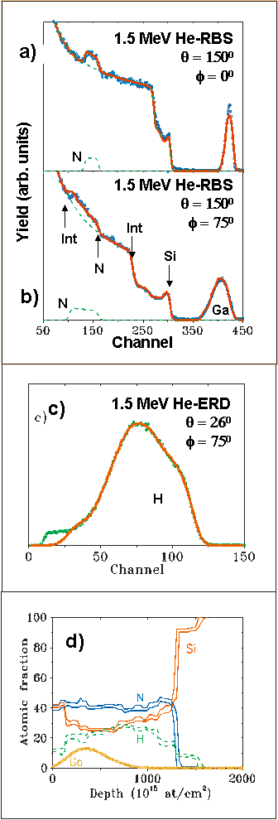

The assumption of bare point charges in Eq.1 neglects the electron screening that must shield the charges from each other until the nuclei are in very close proximity. It turns out that this screening is usually rather a small effect which was determined in adequate detail by Andersen et al in 1979 []. It is the screening correction that relieves the singularity at θ = 0 where Eq.1 makes the cross-section infinite. If there is no scattering then the supposedly interacting nuclei are so far apart that the nuclear charge is screened by the electron shells, and the cross-section vanishes.
The scattering event itself must conserve energy and momentum, and thus for an elastic scattering event the kinematics give the initial energy E₀ split between the scattered and the recoiled nuclei:
E ≡ kE₀ (2)
k_{s} = {(cos θ ± (r² – sin²θ )^{1/2})/(1 + r)}² (3)
k_{r} = (4r cos² φ ) / (1 + r)² (4)
r ≡ M₂ / M₁ (5)
where M₁ and M₂ are the masses of the incident and target nuclei respectively and r is defined as the ratio of masses; k is defined as the ratio of particle energies, and known as the "kinematical factor" given (in the laboratory frame) for the scattered particle (Eq.3) with a scattering angle of θ , and the recoiled particle (Eq.4) with a recoil angle of φ. The scattering and recoil angles are measured relative to the incident beam direction. Eq.3 is double-valued if r<1; for r>1 the positive sign is taken. Thus, for a head-on collision with r>1 (e.g., He RBS), θ =180° and k={(M₂ – M₁)/(M₂ + M₁)}².

Figure 2. Diagram of a typical IBA laboratory, with a tandem accelerator and an indication of the detector electronics (see text). 500 kV is the highest potential that can be stood off in air, and that requires humidity control. MV potentials require a pressure vessel with (for example) 6 bars of SF₆ (sulphur hexafluoride). Beam lines must be held at high vacuum, better than ~10⁻ ⁹ bars. The scattering chamber shows two detectors one for backscattered particles and the other for forward recoiled particles.

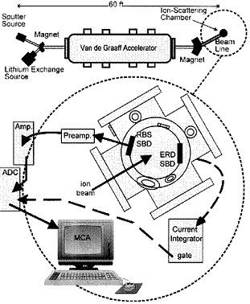
In the case r<1 (when the ion beam is heavier than the target atoms), there can be no backscattering events; and indeed, no scattering into angles θ > sin⁻¹ r. For ⁴He incident on ¹H the forbidden angles are > 15°, but of course He will scatter into the ERD detector from the heavy elements in the target (for which r>1). This scattered beam is discriminated from the H recoils in the example in Fig.1 by a range foil of 6.2 μm mylar.
Given the scattering angle (that is determined from where the detector is put) the kinematical factor is well defined for every scattering centre in the target. In the example shown in Fig.1 there are Ga, Si, N and H atoms present, and the maximum energy of particles backscattered from these atoms occurs when they are on the surface of the sample. These energies are indicated on the Figure. Notice that the kinematical factor is not a function of beam energy! This means that RBS spectra look qualitatively similar for all beam energies : one cannot tell what the beam energy is from an RBS spectrum.

The Accelerator Laboratory
Fig.2 sketches a typical IBA laboratory. The accelerator is often a 1.7 MV or 2 MV Tandem; the latter would give access to (for example) 4 MeV protons (H+) or 6 MeV alphas (He++) or 10 MeV Cl4+ beams. "Tandems" are so-called because the high voltage terminal is in the centre of the pressure vessel: a negative ion is injected into the accelerator, accelerated to the HV terminal, changed to a positive ion in the stripper at the HV terminal, and accelerated again down to earth potential, thus giving two accelerations by the single HV potential. The stripper is now usually nitrogen gas. Two sources are shown in Fig.2; sputter sources use a Cs+ sputtering beam to generate high fluxes of negative ions from nearly the whole of the periodic table (but not the inert gases like He), and a duoplasmatron source is shown which will generate a large He+ beam which can be turned into a He- beam by passing through a canal filled with Li vapour (the "charge exchange canal").
A variety of different accelerators are in use. Small accelerators can be single-ended, and they can be van der Graaff machines (with a belt) or Cockcroft-Walton types (solid state). They can also be configured as AMS machines for 14C and other isotopic analyses (see Trace Element Accelerator Mass Spectrometry). Larger Tandem machines (up to 40 MV) are used for heavy ion ERD applications (see Elastic Recoil Detection Analysis). Cyclotrons and synchrotrons are not usually used for IBA applications since NRA products are inconveniently profuse at high beam energies. However, high energy PIXE can be valuable.
Fig.2 also shows the usual particle detectors and standard electronics. Silicon diode detectors are very convenient, and devices for the simple application of energy analysing MeV particles and with active thicknesses of ~0.1 mm are relatively cheap. Protons and alpha particles do not damage silicon detectors very much, and detection systems with an acceptable energy resolution (<20 keV) can run for years without changing the detector. Thicker (and more expensive) devices are required for higher energy protons to stop in the active layer, and much thicker devices are needed for X-rays. The latter also need much more sophisticated electronics since resolutions of ~140 eV are standard for PIXE. Gamma rays need different detectors, such as high purity Ge crystals (see the NRA and PIGE article).
The particle (or photon) entering the detector is an ionising radiation, and leaves a track of electron-hole pairs in the semiconductor material. If the semiconductor is configured as a reverse-biassed diode, and the track lies entirely in the depletion region, then the electron-hole pairs will be separated by the field and all the electrons can be collected at the diode terminal. The charge-sensitive preamplifier will turn the charge pulse into a voltage pulse, and the shaping amplifier will amplify and shape the voltage pulse so that the analogue-to-digital converter can determine the pulse height. Each digitised pulse is stored in the multi-channel analyser to form the spectrum that we show examples of in Fig.1.

Energy Loss
The particle detectors we have already described in §3.2 work because the process of electron-hole pair formation is specifically an inelastic energy-loss process. It was obvious to all the early workers that the energy loss of scattered particles represented depth in the samples, and the famous Bragg rule (1905) [] obtained the compound stopping power for a fast particle from a linear combination of elemental stopping powers.
To interpret IBA spectra in general it is essential to have energy loss ("stopping power") data for the whole periodic table and the ion beams of interest. This is a massive task of both measurement and evaluation against a theoretical model. The measurements are difficult to make and the model enables both a valid comparison between different sets and also extrapolation to materials or beams for which measurements are not available. Happily this has been done, with comprehensive stopping power databases now available from Jim Ziegler's SRIM website [] [] []. Helmut Paul has also recently reviewed this field with references to other compilations (H.Paul [], MSTAR, ICRU…) [].
The Bragg rule is an approximation that clearly implies that the inelastic energy loss of an energetic particle is largely due to inner-shell (strongly bound) electrons: otherwise there would be more noticable chemical effects, which have been observed but are not large. For example, Bragg's rule applies even for heavy ions in ZrO₂ [] and TiO₂ [], but ~5% deviations were measured for light ions in polyvinyl formal []. Up to 20% deviations can be seen in some cases, and these are discussed in detail in the SRIM 2010 paper [].
In the following we will assume that the analyst has good stopping power values. However, it must be pointed out that these are basic analytical data, which are not easy to obtain accurately. Therefore any critical work must take into account the uncertainties deriving from the stopping power database. Both Paul's work cited above and the SRIM database give these uncertainties in considerable detail: as a rough indication for the reader, a stopping power value is unlikely to be known much better than about 4%.

Figure 3. Helium stopping in silicon (downloaded from SRIM2011 www.srim.org 15th August 2011). The stopping power maximum is around 400 keV.
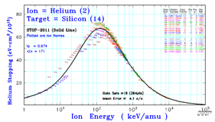
In Fig.1 the Ga signal comes from gallium implanted at a range of depths into the SiN_{x}:H layers. Therefore the energy loss of the incident 1.5 MeV He⁺ ions that spreads the Ga signal out over some 80 channels of the MCA (~240 keV) is assumed (by Bragg's rule) to come from a linear combination of the inelastic energy loss due to each constituent separately, where the actual values of these energy losses come from experiments on pure materials. And data for the two gaseous elements (N, H) comes from experiments on pure gases with a correction for proximity effects when they are in the solid form. There are no experimental data for He stopping in Ga, which is liquid near room temperatures and presents insuperable difficulties for good energy loss measurements (and only two datasets for H in Ga). For Ga the data are interpolated using a modelled Z-dependence according to energy loss theory.
Again in Fig.1, comparing (a) and (b), the two RBS spectra collected at, respectively, normal and tilted incidence (75° from normal), the Si surface signal (from the nitride layer) is at about channel 300, but the Si signal of the interface between the nitride layer and the Si substrate is at ~ch.260 for normal incidence and ~ch.220 for tilted incidence, representing the extra energy loss due to the extra pathlength through the nitride layer for the tilted incidence case. Clearly the geometry is important.
Similarly in Fig.1, the N surface signal from the nitride layer is at ~ch.150 for both (a) and (b), but the N interface signal is ~ch.120 for the normal incidence case and ~ch.100 for tilted incidence. Note that the energy losses in the nitride are different for the Si and N signals: each signal has its own depth scale. This is because the energy loss on the inward path to the scattering event is the same for all signals, but because the kinematical factor is a function of mass and the energy loss is a function of energy, the energy loss of the scattered particle on its path to the detector depends on the particular signal.
The case of the ERD signal shown in Fig.1(c) is interesting. We will not discuss ERD here in any detail (see the other article Elastic Recoil Detection Analysis), but this case helps understanding of the RBS experiment too. According to Eq.1 there should be a large flux of He ions forward scattered into the ERD detector: for detectors of equal solid angle the flux ratio of the ERD to RBS detectors is 340 in this case. In the presence of this forward scattered signal there would be no chance of seeing the H forward recoiled signal! But the ERD detector has a 6 μm mylar foil in front of it that both He scatters and H recoils have to penetrate. Because the energy loss of the He is much larger than that of the H, the He is stopped entirely in the foil.

Energy Straggling
Looking at Fig.1, the surface Si signal is about channel 300 where the implanted Ga is centred on about channel 400. Clearly, an implant profile will be at a range of depths, and therefore the Ga signal is spread out; but the sample has an interface with the vacuum system so that the beam will enter the sample at a point well-defined in space. Why then do we see an edge to the Si signal that is not perfectly sharp, reflecting this well-defined interface? The same question can be asked of the interface between the nitride and the silicon substrate, and it can be asked both of the Si and the N signals.
The number of channels over which the surface signals are distributed is almost entirely due to the finite energy resolution of the detection system. But this energy resolution is essentially constant over the whole spectrum, and therefore cannot explain the fact that the interface signals are broader than the surface signals.
As the beam penetrates the sample, the inelastic energy loss process causes it to lose energy, as described above (§3.3). But this process is stochastic, and at every specific depth below the surface there are a range of beam energies present. This range of energies increases with energy loss and is known as energy straggling.
A first approximation to the energy straggling Ω(t) as a function of the thickness of material t in the high energy limit was calculated by Bohr in 1948 [] as :
Ω² = 4π (e² Z₁)² Z₂ t (6)
where Z₁ and Z₂ are respectively the atomic numbers of the incident ion and the target atom, e is the charge on the electron and t is in proper thin film units of atoms/cm². Thus energy straggling is proportional to the square root of the number of electrons per unit area the projectile has traversed.

Figure 4. Plot of the square of the straggling (Ω²) at various energies as a function of Z for protons (left hand ordinate) and alphas (right hand ordinate), compared to Bohr straggling and Thomas-Fermi straggling. Reproduced from Fig.1 of Chu, 1976
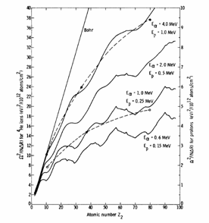
Figure 5. "S-factor" calculated from the AZURE fit to the ¹²C(p,γ)¹³N data of J.Vogl (PhD Thesis, Cal.Tech., 1963) and the ¹²C(p,p)¹²C data of Meyer et al, 1976 (see IBANDL at www-nds.iaea.org/ibandl). The red (solid) line indicates the best fit including external capture, which the blue (dashed) line neglects (reproduced from Fig.3 of Azuma et al, 2010 [25]). Note that the S-factor is significant right down to zero energy.

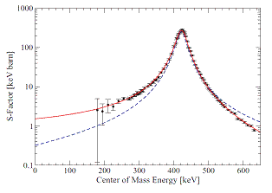

This approximation assumes that the velocity of the projectile is much larger than that of the orbital electrons of the target atoms. For slower projectiles (usually the case in MeV-IBA) a more complex calculation gives a Z₂ dependence that is sensitive to the spherically averaged electron density, which in turn is sensitive to the occupation numbers of the various electron orbitals. This calculation was done by Chu in 1976 [] and shown in Fig.4. A more sophisticated calculation is now regularly done by IBA programs using the algorithm of Szilágyi [] [].
Looking again at Fig.1, it is clear that the interface signal (from either Si or N) must be broader that the surface signals, since at the surface only the detection system energy resolution applies but at the interface the energy straggling through the nitride film thickness also applies.

Elastic (non-Rutherford) backscattering
As the beam energy is increased, Rutherford's approximation of point charges for the colliding nuclei fails, and account must be taken of the overlapping of the nuclear wavefunctions during the collision. It turns out that the detailed nuclear structure is very different for each nucleus. This is often spoken of as "exceeding the Coulomb barrier" (see chapters in both 1995 and 2010 Handbooks, and the optical model calculations of Bozoian et al [], with Table 1 below) but of course the so-called "Coulomb barrier" is not an identifiable potential useful for calculation []; this is emphasised by the calculations of the astrophysicists who calculate the probability of (p,γ) reactions at stellar temperatures (10-30 keV!) [].

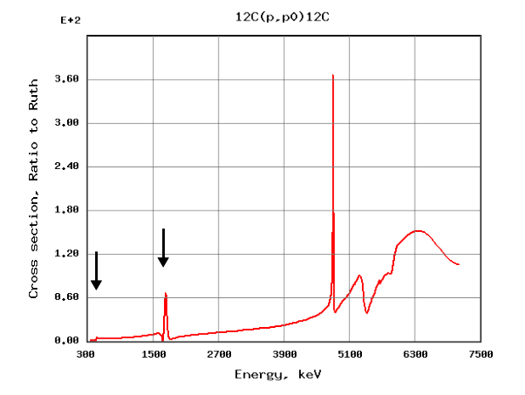
Figure 6. SigmaCalc (R-matrix) calculation of ¹²C(p,p)¹²C elastic scattering cross-section for θ=180°, relative to the Rutherford cross-section, by Gurbich & co-workers [28]. Note the resonances at 440 keV and 1734 keV (arrowed). Downloaded 21 July 2011 from www-nds.iaea.org/ibandl.

Figure 7. Evaluated ¹⁴N(α,α)¹⁴N cross-sections as a function of scattering angle, reproduced from Fig.4, Gurbich et al, 2011 [30].

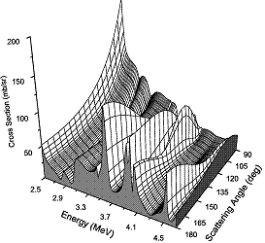

For example, the ¹²C(p, γ)¹³N reaction is critical to understanding stellar hydrogen burning in massive stars, initiating the CNO cycle. Fig.5 shows the "S-factor" for this reaction, near the resonance at the 461 keV (centre of mass frame) resonance, which is also observable in the elastic scattering ¹²C(p,p)¹²C reaction channel at 440 keV (laboratory frame: see Fig.6 []). The S-factor is the pre-factor in the expression for the cross-section which has an (approximately) exponential decrease with energy corresponding to the term for tunnelling through the Coulomb barrier. The point is that these cross-sections are dominated by the low energy tails of the resonances due to the nuclear structure that has non-zero S-factor at zero energy.
These complicated elastic scattering cross-section functions can be calculated from nuclear (R-matrix and other) models, using all available nuclear data (not only scattering cross-section data). We have already mentioned the AZURE code (see Fig.5). The materials community, under the auspices of an IAEA CRP [] has built the IBANDL website (www-nds.iaea.org/ibandl) which gathers together all the relevant cross-section measurements available []. IBANDL also gives access to the Sigma-Calc code (www-nds.iaea.org/sigmacalc) of Gurbich []. SigmaCalc is a code using R-matrix and other nuclear models, which is for the critical evaluation of existing elastic scattering cross-section measurements, enabling nuclear parameters to be chosen such that the cross-section can be calculated for any scattering angle. Relating the whole set of measurements together in the context of a nuclear model enables a critical evaluation of the various datasets, and the generation of cross-section functions with a much smaller uncertainty than for any particular dataset. As an example, Fig.7 shows the strong angular dependence of the ¹⁴N(α,α)¹⁴N reaction []. It is clear that, were a nuclear model not available, the experimenter would have to rely on measured cross-sections only, and would be forced either to make measurements for the experimental geometry used, or set the scattering angle to match the existing measurements.
For both ¹²C and natural Mg elastic scattering (p,p₀) cross-sections, optical model estimates of the so-called "actual Coulomb barrier" energy are wildly wrong, as is clear from Table 1. This Table gathers available data together to estimate the beam energy where the (p,p) cross-section differs significantly from Rutherford: the value of 4% deviation is chosen because it is not presently possible to specify the value at 1% (or even 2%) deviation with any confidence.
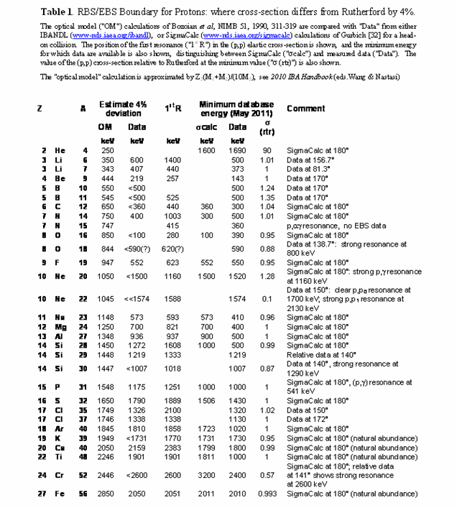
Fig.8 shows the evaluated elastic scattering cross-sections for protons on natural magnesium, relative to Rutherford, with a benchmark measurement shown in Fig.9 []. Note the exceptionally strong and sharp resonance at 1483 keV. It is not trivial to calculate spectra which involve cross-sections with such sharp resonances, and special methods need to be used [].
It is important to point out that when particle BS spectra are collected together with PIXE data, the analysing beam will usually be the one suitable for PIXE analysis. This is typically a 3 MeV proton beam: for such a beam the BS spectra are non-Rutherford up to at least Fe. This underlines the importance of the development of the evaluated EBS cross-section database in the last decade: without this database the BS spectra collected simultaneously with PIXE are uninterpretable.
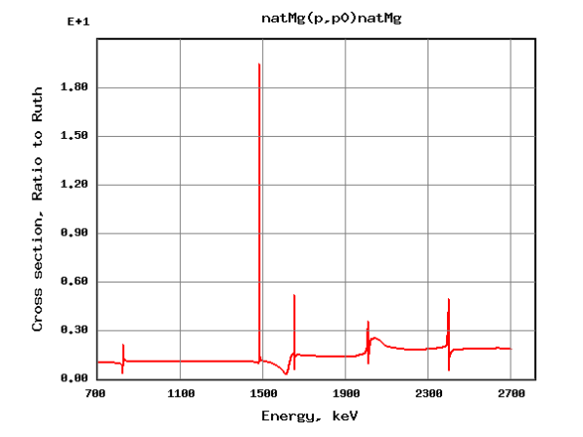
Figure 8. SigmaCalc calculation of ^{nat}Mg(p,p) ^{nat}Mg elastic scattering cross-section for θ=180°, relative to the Rutherford cross-section [31]. Downloaded 21 July 2011 from www-nds.iaea.org/ibandl.

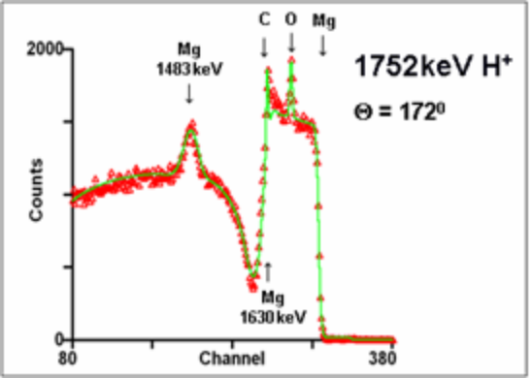
Figure 9. Benchmark EBS measurement of bulk magnesium showing strong resonances at 1483 and 1630 keV (from Fig.3 of Gurbich & Jeynes, 2007 [31]). An O peak from the surface oxide and a C peak from surface contamination are visible.

The codes used for analysing IBA data all treat EBS cross-sections in the same way: they all need the user to check that the right files are present. For RBS of course, no extra files are needed.

Channelling
If an energetic ion beam is aligned with a major axis of a crystal it will "see" a significantly lower stopping power in the so-called channels between the strings of atoms. Moreover, a slightly misaligned beam will experience a focussing effect which tends to keep it in the crystal channel. It is this focussing effect that is called channelling. It was in 1963 that the first channelling measurements were published by Davies and co-workers [], who observed the exponential channelling tails of the implant profiles of 210 keV ²²²Rn in polycrystalline Al by using the alphas emitted by the implanted radon.
Robinson & Oen's Monte Carlo calculations of the channelling effect also published in 1963 [] showed that these exponential implant tails were expected. Lindhard published his complete theoretical treatise on channelling in 1965 [] which found an immediate use in the investigation of semiconductor doping by ion implantation and annealing. There is now a very large literature on channelling (see Handbooks).
The crucial point is that in a crystal the strings of atoms shadow each other if the beam is aligned with them. Thus, in the channelling direction, there is yield from the surface layers but no (very reduced) yield from the underlying material which is shadowed by the surface
Fig.10 shows an example of plastic deformation in a brittle material: it is an image of the spatial distribution of crystalline damage in silicon turned on an ultra-stiff lathe by a single-point diamond tool, where a scanning microbeam is used to form the image []. In this case channelling conditions were maintained by rocking the beam about the principal axis of the Russian quadruplet focussing magnet using a dog-leg electrostatic scanner before the magnet. Different depths of cut can be seen on the image: in this work amorphous layers up to 350 nm are observed together with dislocation arrays of about 5.10¹⁰/cm² under the amorphous region, with quantification by the DICADA code: see [] for recent development of this code.
Fig.11 shows channelled spectra obtained from selected areas of the sample imaged in Fig.10. In particular two things are clear: that turning of brittle materials leaves a thin amorphous damage layer up to about 300 nm thick; and that there is only a thin oxide layer, not much more than 20 nm anywhere. These layer thicknesses are spacially very inhomogeneous (on a scale of 0.1 mm) and presumably are very sensitive in detail to precise conditions (sample flatness, for example).

Figure 10. Image (about 3 mm square) of circular damage tracks in a silicon sample turned on a lathe. 1.2 MeV 4He+ channelled normal to the sample and focussed to a 40 μm spot. Signal is the low-energy part of the Si signal: high yield means high damage. 128x128 pixels, 0.15 nC/pixel, pixel area (23.4 μm)2. Reproduced from Fig.4 of Jeynes et al, 1996 [ref]
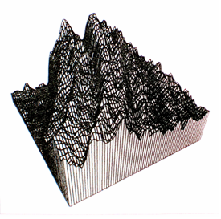
Figure 11. Channelling spectra using 1.5 MeV He RBS-c from two selected areas of sample imaged in Fig.10, together with virgin (undamaged) and non-aligned ("random") spectra. The two regions have two different thicknesses of the damaged layer (~350 nm and ~200 nm: these are demonstrated amorphous by TEM). The level of dechannelling in the single crystal substrate indicates the presence of a dislocation-rich layer beneath the amorphous region. Reproduced from Fig.5 of Jeynes et al, 1996 [ref]

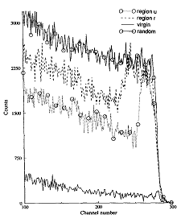

PRACTICAL ASPECTS

Typical Experimental Setup
Now we describe the apparatus used in a conventional backscattering analysis (see Fig.2 for a laboratory schematic). Rather than give an exhaustive treatment, this discussion is intended to allow a first-time practitioner to become familiar with the purpose of different parts of the apparatus before entering the laboratory. A more detailed treatment is found in the Handbooks and the textbooks (see Introduction to Ion Beam Techniques for a bibliography, but particularly Jeynes & Barradas, 2010 []).
This discussion will revolve about the physical parameters the analyst needs to control to obtain analytical information from the sample being investigated. Equations 7 & 8 govern the analysis. These are simplified for convenience, but without any loss of generality. We measure two sorts of parameters from backscattering spectra: signal areas A (in counts) as in Eq.7, and signal heights Y (in counts per channel) as in Eq.8:
A _{x} = N_{x} . QΩ . σ_{x}'(E,θ) (7)
Y_{x} = QΩ . σ_{x}'(E,θ) . { Δ / [ε]_{M} } (8)
where Q is the incident charge (in numbers of ions) on the sample, Ω is the solid angle of the detector (in steradians, sr), σ' is the differential scattering cross-section (in cm²/sr) of the ion of energy E (keV) into the detector placed at scattering angle θ, N_{x} is the areal density (atoms/cm²) of the element x. Thus, the signal area for element x is simply given by the product of the probability of finding x in the sample, and the probability of scattering into the detector.
But the height of a signal is more complicated since the channel width Δ (in keV/channel) must be involved. The channel width is compared directly to the energy loss factor in the material M: [ε]_{M} (in eV per unit thickness, where thin film units of thickness are used: see §4.2 below). The energy loss factor integrates the energy loss ε (see §3.3 above) along both the inward path of the ion to the point of scattering, and also the outward path of the scattered ion to the detector.
In the following we will consider each of these parameters, together with consideration of various non-linear effects in the spectrometry.

Thin Film Units (TFU)
In backscattering analysis, thickness is given directly by energy loss. And energy loss is always measured in thin film samples whose thickness is determined by mass per unit area. The reason for this is that the linear thickness of thin films is hard to determine directly in any case, and is also frequently rather ill defined. What if the thin film is not uniform? Or if it has pinholes? Or if it has surface oxides (or other contaminations)? Moreover, thin films do not always have the density of the bulk material.
The energy loss database is in units of eV/(10¹⁵atoms/cm²) where 10¹⁵atoms/cm² is a thickness of the order of a monolayer since most materials have a layer separation similar to 0.2 nm and an atom density similar to 5.10²²atoms/cm³. And of course, if we know what sort of atoms they are then atoms/cm² is equivalent to mass/cm². Given the atom density, TFU is equivalent to linear units of thickness (nm). Note that the abscissa of Fig.1d is given in TFU, not nm. This is because in this material of varying composition it is not clear what value of atom density to use.

Beam Energy Measurement
Small linear accelerators used for IBA can be the Cockcroft & Walton type (solid state: a stack of capacitor/diode pairs with an AC supply at ground potential []) or the van der Graaff type (with a belt feeding DC directly to the top terminal []). Most older MV machines are the van de Graaff type since these are simple and robust. Many modern IBA accelerators are the Cockcroft & Walton type since if a distributed RF is used to feed power to the whole of the stack at once the response time can be very small and very stable terminal voltages can be obtained (30 V ripple at 2 MV).
Most modern accelerators have highly reliable terminal voltage monitors. These are rotating vane devices which generate an AC voltage accurately proportional to the terminal voltage. Hence their name, "Generating Voltmeter" (GVM). These are now routinely used to give the terminal voltage to a precision better than 1 kV, which is good enough for IBA purposes. When compared with known nuclear reactions a similar accuracy is obtained. For example, Demarche & Terwagne determined the GVM calibration for their accelerator using 3 different (p,n) threshhold reactions together with 3 different (p,αγ) resonant reactions at a precision of 0.03% [].
Where a good GVM is not available, one can use the classical method of discriminating high energy particles on the basis of their position at the exit slits of the analysing magnet. Highly accurate magnetic field monitors are available: classically NMR devices were used, but Hall devices are now available at sufficient precision. The difficulty here is that the field measured by the monitor may not be the same as the effective field felt by the energetic particle, because of magnetic non-uniformities in the magnet. There is another problem: the path of the particle through the magnet must be closely controlled if the magnet is to be used for energy control []. This path control can be used systematically to sweep the energy for high resolution depth profiling using narrow nuclear resonances [] (see Nuclear Reaction Analysis).
Fig.9 shows a case where the EBS spectrum shouts aloud what the beam energy is. This is frequently the case for EBS, where of course in RBS the beam energy is ambiguous. These EBS resonances are very valuable to accurately and rapidly check the beam energy calibration, where a full calibration using neutron threshholds or (p,γ) resonances would be too time consuming. EBS resonances are also available for an alpha beam, in particular the ¹⁶O(α,α)¹⁶O resonance at 3038 keV (not 3032 keV as asserted by Demarche & Terwagne [ref.36], see the SigmaCalc values at http://www-nds.iaea.org/sigmacalc/).
Use of EBS resonances to determine the beam energy is particularly valuable in external beam applications (see Intro-duction to Ion Beam Techniques). This is because an independent check on the length of the beam path to the sample is needed since (i) the positioning of the sample is critical and (ii) it is not always clear what the atmosphere is when a helium leak is being used.

Charge Measurement
The electronic environment in any ion scattering (or ion implantation) chamber is complex: secondary electrons are everywhere! Therefore, although charge measurement of nanoampere currents per se is readily achieved at absolute accuracies better than 0.1%, the accurate measurement of ion fluences into scattering chambers has significant difficulty. In general, it is fairly easy to get better than 5% absolute accuracy, but it is very hard to get better than 1%.
Even when, as in Fig.2, the entire scattering chamber is treated as a Faraday cup (in principle this is the ideal arrangement) there are a number of leakage paths it is hard to control, and there have been no critical reports where charge collection better than 1% has been demonstrated. 1% absolute accuracy is claimed by Bianconi et al [] in an important paper that is a collaboration of five laboratories. For this work all the labs did the best they could and the results are critically compared, so we conclude both that the estimate of uncertainty is realistic and that it is not easy to better.
Further discussion of charge measurement with other arrangements and references can be found in Jeynes & Barradas [ref.33].

Solid Angle and Scattering Angle
The scattering angle of the detector is usually rather easy to measure very precisely, since goniometers are widely used for channelling, and one has only to shine a laser down the beam path and find the angle where its reflection strikes the detector.
However, the solid angle is notoriously hard to determine very accurately. It is easy to see the geometrical measurements that must be made, but it is actually quite hard to make them at the necessary accuracy. With (considerable) care, 0.5% can be achieved, as reported by, for example, Lulli et al [].
It is the charge.solid-angle product QΩ that appears in the governing equations (Eqs.7&8), and the solid angle is often determined from standard samples (see refs above and §4.10 below).

Detector Issues: Pulse Height Defect
Usually silicon diode detectors are used for RBS and EBS. These detectors have good energy resolution for MeV proton or alpha beams, and they do not suffer much beam damage under the usual fluences of such beams. Si detectors can carry on working acceptably well for years with these beams. But for Li-RBS [] Si detectors damage faster.
Other detectors can be used. Only for proton beams do the new thin window gas detectors have worse energy resolution than Si diodes []. These detectors are also immune to light and could therefore be used in in-situ annealing experiments to high temperature (see for example []).
However, when Si detectors are used for accurate work the detector response must be modelled properly. Account must be taken both of the dead layer at the entrance surface due to the diode electrode and underlying degenerate junction layer, and of the non-ionising energy losses in the stopping of the detected particles. Both of these effects together are known as the "pulse height defect" of the detector [] [].

Electronics Calibration
Discussion of the electronic gain Δ is often neglected, although it is often the factor that dominates the accuracy obtainable from BS spectra. Munnik et al, 1996 [] determined their gain with an uncertainty of 0.16%, Jeynes et al, 1998 [ref.37] determined it at 0.5%, Bianconi et al, 2000 [ref.39] determined it at 0.2% (this value is published in Barradas et al, 2007 []), and Gurbich & Jeynes [ref.31] determined it at better than 0.1%. But it is very easy to have large errors in Δ exceeding 2%: this is because a simple-minded approach just estimates the channel numbers for a couple of surface signals.
Fig.12 shows spectra from the calibration sample first discussed at length by Jeynes et al, 1998 [ref.37]. There are four near-surface signals, from Au, Ni, Si, O; and the beam energy for all of these can be obtained iteratively as the metal film thicknesses are determined. The electronics gain is then determined from the linear relation:
E = Δ.C + o (9)
where the detected energy E keV at the detector gives a count in channel number C. In a linear detection system the electronics gain Δ (in keV/ch) and the offset o (in keV) are constants. This calibration sample then gives a set of four linear equations to determine two unknowns: this enables both the determination of the constants and an estimate of their uncertainty.
The difficulty is in interpreting what E means. If E is taken as the energy of the scattered particle as it leaves the sample (as is usually done) then the offset o must be non-zero to take account of the energy loss of the beam through the dead layer. But this energy loss is itself a function of energy (see Fig.3 for the variation of ε with energy) and therefore o must have a different value for each detected energy! Hence, ignoring the detector PHD (see §4.6) must give inaccuracy in the spectral interpretation. This inaccuracy is shown clearly in Fig.1b, where the N signal at the back interface is not fitted correctly. It is also shown explicitly in Fig.12.

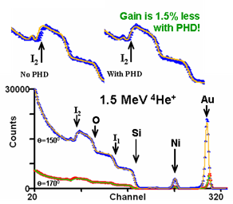
Figure 12. Calibration sample of Au / Ni / SiO₂ / silicon substrate. There is about 15 TFU of Au and Ni and about 1500 TFU of silica. Spectra from a double-detector setup are shown, with the surface position of Au, Ni, Si and O arrowed, together with the silica/silicon interface, both for the Si signal (I₁) and the O signal (I₂). Data (symbols) and fits (lines) are shown, with the PHD taken into account. The inset contrasts the O signal with and without the PHD correction.

Pulse Pileup and Dead Time
Every pulse-height detection system has a series of characteristic time constants. Si detectors have a pulse rise time ~30 ns at the preamplifier output (see Fig.2). The shaping amplifier usually has a shaping time of ~500 ns, and the ADC usually has a processing time ~10 μs (depending on its type). If pulses arrive while the ADC is processing they are simply lost – this is part of the system dead time. The shaping amplifier also often has an inspection circuit that detects when pulses arrive during the shaping time – these are also lost as part of the system dead time.
But if pulses arrive with a time separation closer than the inspection circuit time resolution, then the system will register the two separate pulses as just one detected pulse, with a pulse height given by some sort of sum of the two separate pulses. If the two pulses arrive at the same time then the sum pulse height is the sum of the two pulse heights. But if the two pulses have a time separation then the sum pulse will have a pulse height smaller than the sum of the two pulse heights.

Figure 13. EBS of a thin Mg film on C. There is RBS from a Au thin film on the surface, and the Mg has a surface oxide. A pulser signal is visible near ch.500. Note the logarithmic (base e) scale of the ordinate. The double pulse pileup is clear. The error due to the LLD is corrected with a fudge. Fig.15.3 of 2010 IBA Handbook [ref.33]. See Gurbich & Jeynes [ref.31].
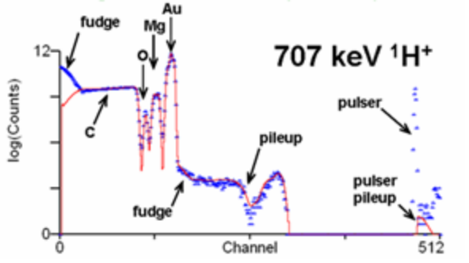
Figure 14. Tribological coating analysed at high resolution (glancing incidence, using a standard Si detector with 14 keV energy resolution): TiAlN / Mo multilayer on Si, modulation period 3.9 nm [] (reproduced from Fig.1 of Barradas & Jeynes, 2008 []). Simulations are shown : including only symmetrical effects due to multiple scattering; showing the double scattering and pileup background; the full simulation including the low energy yield (partial spectra for Ti, Al, Si, N also shown for this case)
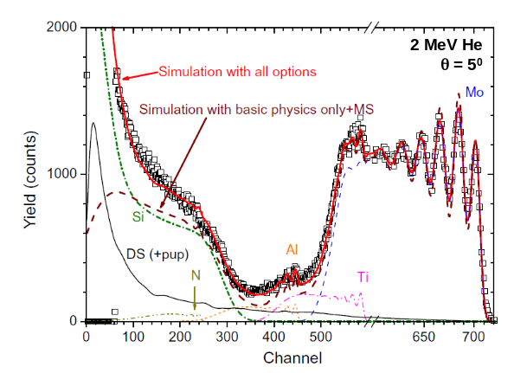
The actual values of the sum pulse heights can be determined by a statistical analysis involving the convolution of the spectrum with itself. This was done rigorously (assuming a parabolic pulse shape) by Wielopolsky & Gardner in 1976 [], with triple pulse pileup considered by Barradas & Reis in 2006 [] and a treatment using the much better approximation to the true pulse shape by Molodtsov and Gurbich in 2009 []. It is worth pointing out that the calculation of pulse pileup has no free parameters, requiring only the pulse shaping time and the detection system time resolution, both of which are system constants.
Fig.13 shows how the Wielopolsky & Gardner algorithm accurately accounts for pulse pileup. Note that the pileup spectrum is a complex shape due to the convolution of the spectrum with itself. Note also that the true pileup spectrum should be an autoconvolution of the true spectrum, that is, including the real counts that are discriminated by the lower level discriminator (LLD). The observed spectrum excludes counts below the LLD.
To calculate the pileup, it is assumed that the observed spectrum is the true (pileup-corrected) spectrum. At a high count rate there will be many counts from the true spectrum lost from the observed spectrum, and therefore the pileup spectrum calculated from the observed spectrum will be an approximation. But pileup is a usually a second order effect, and therefore the true spectrum can be accurately recovered iteratively from the observed spectrum.

Non-Linear and Other Spectral Effects
The calculation of the BS spectra has up to now been considered as a single scattering problem. But clearly there is a probability of double and plural scattering which becomes larger as the pathlength in the sample increases.
Fig.14 shows the contribution of double scattering in a case where glancing beam incidence is used to increase the depth resolution. In this case a depth resolution approaching 1 nm is achieved! What is interesting is that particles scattered at low energy have a relatively high probability of coming from plural scattering events.

Accurate Analysis and Standard Samples
All the examples shown so far have demonstrated that the spectra can be fitted very closely. This means that the physics is well understood, and therefore that the details of the spectra can be interrogated closely to extract information about the sample. Clearly, a better absolute accuracy is possible for RBS (with analytical cross-sections with uncertainties from the screening of <¼%) than for EBS where the []
It is extraordinary that the idea of an Uncertainty Budget [] to quantify experimental and traceability uncertainties for IBA was only recently published by a National Metrology Institute (NMI) []. However, no NMI now has IBA capability despite their previous interest in the use of RBS in particular for metrology (NPL for a Ta₂O₅ standard material [] and a metrology exercise on the native oxide of Si []; IRMM and BAM for the Bi and Sb implanted certified reference materials used for fluence standards in IBA [] []) .
The qualification of implantation fluence is valuable for many different purposes, and is the simplest of RBS problems. We have already demonstrated an absolute accuracy of about 4% (95% confidence) in its determination [] [], where the cited uncertainty was dominated by the uncertainty in the stopping powers used. However, we have demonstrated that for 1.5 MeV He in Si, the SRIM2003 stopping powers are accurate at 0.8% (1σ, see Fig.1 in [], but note that there are extra unaccounted uncertainties here []), and therefore the absolute traceable accuracy of RBS should approach 1% (1σ) if this beam is used with α-Si substrates to determine the actual charge.solid-angle product for a given spectrum (see Fig.15). There is no other thin film technique that can match this level of absolute accuracy for the determination of quantity of material. To achieve this accuracy it is necessary to correct properly for pulse pile-up, and to correctly determine the electronic gain of the detectors, including the appropriate pulse height defect correction (see §4.6).

Figure 15. Double-detector spectra collected simultaneously from the IRMM-BAM Sb-implanted CRM showing accurate fitting of the Si yield using SRIM2003 stopping powers. Channelling RBS shows the amorphised surface region on the crystalline substrate. From Fig.1 of [ref.62]

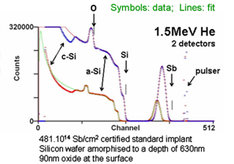

Radiation Hazards
If the Coulomb barrier of the target is approached the user should be wary since when the incident beam energy is high enough nuclear reactions other than elastic scattering are possible. High-energy proton scattering can produce unexpected gamma or neutron radiation exposures to workers, especially near the beam defining slits after the high energy magnet.
This concern is particularly significant for irradiation of light elements, but it is also important for elements such as Cu. Neutrons and γ rays are the main prompt radiation hazard while activation of the sample produces a longer lasting radiation hazard (of particular importance for deuterium and high-energy proton beams). Activated samples can be easily controlled to avoid accidental radiation exposure of workers as well as satisfying regulatory agencies, but a knowledge of possible activating nuclear reactions is necessary for this purpose. Novices should seek help from a qualified radiation-health physicist to assess the hazards when using a deuterium or high-energy proton beam.

DATA ANALYSIS & INTERPRETATION
It is quite easy (but tedious) to obtain rough values of layer thicknesses and other interesting features from RBS spectra using manual methods. However, any serious analysis must try to fit the data using a computer code. The many fitted spectra displayed so far demonstrates that modern codes can fit spectra very closely. In this section we will discuss these codes and their operation, and give further examples of interesting analyses to cover points not made so far.

Description of Codes
Codes for depth profiling using particle scattering and non-resonant nuclear reactions were reviewed by Rauhala et al in 2006 []. A detailed Intercomparison sponsored by the IAEA of selected codes was subsequently completed [], with a brief Summary also available []. The Intercomparison identified two "new generation" advanced codes (SIMNRA [] [] [] and DataFurnace (also known as NDF) [] [] []) that performed excellently and had all the facilities needed to treat complex cases. SIMNRA and DataFurnace are analytical codes based on the single scattering approximation, with other effects introduced as perturbations. Our description of single scattering codes will be limited to these two. In most cases they give indistinguishable results, but DataFurnace is specifically aimed at the self-consistent fitting of multiple spectra where SIMNRA is designed only for simulating and fitting single spectra.
Both SIMNRA and DataFurnace allow fitting of RBS, EBS, ERD, and (non-resonant) NRA spectra to models using standard algorithms (Simplex for SIMNRA and grid-search for DataFurnace []). DataFurnace also allows model-free fitting with the simulated annealing algorithm [], which facilitates the natural implementation of a Bayesian algorithm for the reliable estimation of the uncertainty of the resulting depth profile []. Examples of this estimation of uncertainty by Bayesian inference are shown in Figs.1&17, and discused in the next section.
Both SIMNRA and DataFurnace use the accurate pulse pilup algorithm of Wielopolsky & Gardner (1976) [], and DataFurnace also implements both triple pileup [] and Molodtsov & Gurbich's more accurate calculation []. DataFurnace also implements Lennard's [] pulse height defect algorithm [].
Both SIMNRA [] and DataFurnace [] use (different) calculations of the effect of mild roughness on backcattering spectra. Molodtsov et al [] implement a general algorithm which will allow the effects of severe roughness to be interpreted, but this algorithm is not yet implemented in any general purpose IBA code. SIMNRA allows calculation of the effect on spectra of roughness whose model parameters are known (perhaps from AFM measurements), using a spectral summing method (see [] for a recent example). DataFurnace allows fitting of given spectra, from the parameters of simple models for the roughness of interfaces or layer thickness inhomgeneity; sub-nm sensitivity was demonstrated for magnetic multilayers [].
The algorithm of Stoquert & Szörenyi [] allows the calculation of the effect of precipitates (density variation) on the spectra. DataFurnace implements this algorithm [] and SIMNRA implements a more accurate equivalent algorithm []. On the other hand, DataFurnace implements EBS resonances more correctly than SIMNRA (see Fig.9, and see the Intercomparison [70] for more detail). The difference is noticeable for sharp resonances. DataFurnace also implements a good approximation for low energies [] (see Fig.14).
Finally, both SIMNRA [] and DataFurnace [] implement similar algorithms for double scattering. The symmetrical components of multiple scattering are handled with Szilágy's algorithm (the DEPTH code) [] [] by both codes. DataFurnace uses DEPTH [] directly, and SIMNRA implements the algorithms []. Kinematical broadening and related effects are also treated. These effects become large for glancing incidence geometries, such as are used for high resolution or ERD. See Fig.25 for an example showing all these effects.
For high depth resolution RBS, and for ERD especially HI-ERD, glancing incidence beams are typical. In these circumstances multiple scattering and related spectral distortion effects become important, and the uncertainty of the analytical codes' calculations increases. CORTEO [] [] is a Monte Carlo code designed for routine use, optimised for speed and entirely comparable to the code MCERD [] described in the Intercomparison. It also enables the detailed simulation of geometrical effects, including the geometry of the detector (typically ToF for ERD).
For high-resolution resonant-NRA, sharp resonances (usually at low energies) are used to probe depth profiles. In these circumstances the approximations normally used for straggling fail close to the surface, where the fundamentally stochastic nature of the straggling cannot be approximated by a continuous (Gaussian) distribution. The SPACES code [] [] takes this into account. DataFurnace has been extended to treat resonant NRA, and by using a gamma function approximation to the straggling also treats high resolution NRA [], giving results comparable to SPACES provided the Lewis effect [] is not too large.

Further Examples
Fig.16 shows an interesting example of Fe/Si multilayer samples with and without ion-beam-induced intermixing. The idea is to try to find some feasible way to make amorphous iron disilicide, which is a semiconductor that could become an important thin film solar photovoltaic material if technological problems can be overcome []. Much ion beam analysis is aimed at elucidating the behaviour of materials in a variety of processes to enable some approaches to be ruled out and others to be developed effectively. This example is included as "one that didn't work", since materials scientists usually need to understand these cases rather better than the successful ones!
The coating includes layers of only a few nm thick, which is challenging for standard RBS. The analysis also showed that the presence of Ar (from the sputter-deposition) poisons the development of the silicide. Fe and Si are sequentially sputter-deposited, but although the close-packed metal does not incorporate significant Ar, the more open Si layers incorporate quite a lot. During the development of the silicide the Ar is swept out to the remaining unreacted Si, preventing the completion of the process.
In this analysis the RBS of course objectively sees only the Fe and Si elemental profiles, but it is valuable to be able to interpret these elemental profiles as profiles of the phases present. Note that the only minor element present, with the exception of a little surface oxide, is Ar, which is quite well determined in this analysis. But the high quality of the fits to the data seen in Fig.16 is only obtained when the straggling is correctly calculated, firstly by the detailed physics incorporated in Szilágyi's DEPTH code; and secondly by taking account of the extra straggling generated by "roughness" (in this case layer thickness inhomogeneity). Note that all four spectra (two separate detectors, two different beam incidence angles) are equally well fitted, showing that these profiles are well-determined.
The multilayer shown in Fig.17 is an antireflection coating on glass, that is, alternating zirconia and silica (ZrO₂ and SiO₂) layers on float glass. The glass has many elements, and the zirconia naturally has a small amount of hafnium. This analysis cannot be made unambiguously unless the problem is simplified to three logical elements, as opposed to the dozen or so real elements present: these logical "elements" are zirconia (including the usual hafnium contamination), silica, and the glass of the substrate. Again we have the problem of ambiguity (discussed at length in [2]), that is, the information we would like access to that is not unequivocally present in the data. One spectrum cannot usually determine the sample structure. Figure 17 is actually one spectrum from a pair : it was taken at normal incidence and there was another taken at 45° incidence (not shown here). The two spectra look entirely different (just as do the various spectra in Fig.16), and the two together determine the sample very much better than just one spectrum. But analysts must beware a gaping pitfall at their feet: the fact that the fit to the data is perfect is not a reason to think that the sample is perfectly known. The spectrum is ambiguous! A perfect fit means that the proposed profile is valid, not that it is true.
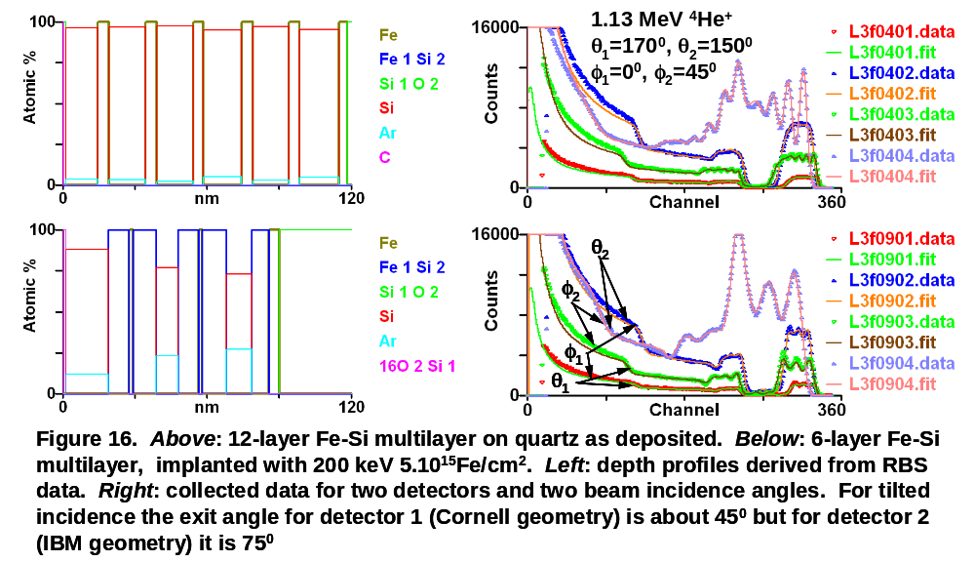
Figure 17. Antireflection coating with alternate zirconia and silica layers on float glass. Normal incidence beam : the line through the points is the spectrum calculated for the fitted structure. The surface positions of Hf, Zr, Si, O are shown. Hf is a normal contaminant in Zr. (From Fig.2 of Jeynes et al, 2000 []).

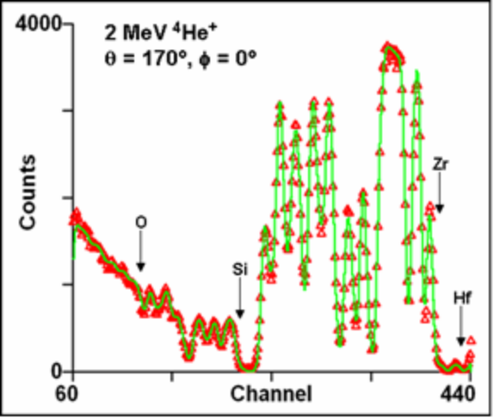
Even with two spectra the structure of the sample is completely ambiguous – until, that is, chemical information is introduced. Butler pointed out over twenty years ago [] that our knowledge of the chemistry of the sample can always supplement our objective interpretation of IBA spectra obtained from the sample. In this case of course we are certain that the Zr and Si are fully oxidised – the optical properties tell us that! And we are also certain of the glass composition – centuries of glass technology assure us of that. Therefore we confidently use molecules as the logical elements of the analysis.
The data in Fig.17 are actually analysed by the authors in an interesting way. They use simulated annealing, a mathematical global minimisation algorithm described elegantly in a Science article []. Simulated annealing was introduced into physics in 1953 [] and into IBA analysis in 1997 ([79], and see the careful discussion in [2]). Simulated annealing is powerful in IBA since the user simply gives the data to the computer, without any initial guess of the depth profile which is extracted completely automatically. The method uses "Markov chain Monte Carlo" (MCMC) mathematics: this is described in the cited literature and can be summarised for this application as a systematic way of searching the space of possible solutions. And it is because the search is systematic that we can do statistics on it, using a Bayesian inference method [80]. Thus we obtain extraordinarily precise layer thicknesses (with sub-nm precision!) extracted from the RBS data down to depths of over a micron.
Fig.1d also shows the result of a Bayesian inference analysis of the fitting uncertainty. In this case we wished to know whether the Ga ion implantation resulted in the Ga substituting for the Si and forming a nitride (the desired result) or not. In the case shown it looks as though indeed the Ga does substitute for the Si. But in the absence of a systematic analysis of the uncertainty inherent in the fitted depth profile, would we have been sure of this result? In a complex sample like this, with a large amount of H present, it is clear that a simple fit would leave us unsure whether the solution were the only solution consistent with the data!

Figure 18. "Total IBA" of an inclusion in a Darwin Glass (see text). Above: selected PIXE maps showing distribution of Si, Fe, Cu; Centre: BS spectra at varying energies of the resin region showing the ¹²C(p,p₀)¹²C resonance at 1734 keV; Below: BS spectra at 1.9 MeV for three areas marked on the Si PIXE map (above, left). (See Bailey et al, Nucl. Instrum. Methods B 267, 2009, 2219 []). From Fig.1 of Jeynes et al, 2011 [].

But the fitted profile comes with ±1σ estimates of the uncertainty in the profile (obtained from Bayesian inference). This is equivalent to doing thousands of fits in the vicinity of the best fit to determine the sensitivity of the solution to small perturbations. Or one could say that it is equivalent to quantifying the density of near-optimal fits in the vicinity of the best fit. However it is viewed, it is clear that a machine implementation of this uncertainty evaluation is very valuable. In fact, in this case, the user had already spent months obtaining XPS data to confirm that GaN was present, since these Bayesian tools to evaluate the RBS data had not been built. But now, with these tools, the RBS gives independent objective evidence of the sample composition post-implant, and collecting 5 minute RBS spectra is experimentally much easier than sputter depth profiling multiple samples in UHV by XPS!
Finally, we present in Fig.18 a very complex example, of the so-called Darwin glasses: impact glasses resulting from a meteor strike 800,000 years ago near Mt.Darwin in Tasmania. The geologist who collected these glass samples subsequently used one of them as an amorphous standard for setting up his XRD kit, and was astonished to see the diffraction spots of quartz. These crystals – unexpected in a glass! – turned out to be inside inclusions in the glass
But the nature of these inclusions was then entirely unknown to the geologists. Microbeam IBA analysis using both EBS and PIXE unequivocally demonstrated them to be carbonaceous, a result that initially baffled the geologists, for whom such a sample was unprecedented. Moreover, not only did the microbeam PIXE/BS determine the main constituents and demonstrate the great heterogeneity of the samples (both laterally and in depth: see Fig.18 and Fig.1 of [110], for example), but the IBA data could be completely quantitatively analysed without any presupposed model despite the heterogeneity.
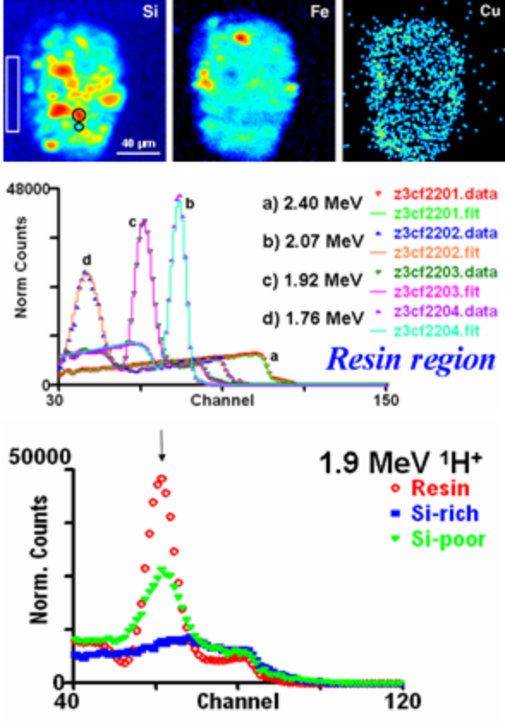
The details of this analysis are beyond the scope of this article. But the EBS spectra shown in Fig.18 are instructive. Firstly, the spectra from the resin surround of the sample (from the rectangular area marked on the PIXE Si map). As the beam energy changes, the 1734 keV resonance (see Fig.6) is excited at different depths in the sample. Note that a) the resonance shape is fitted extremely well, and b) as the resonance is buried deeper in the sample (with higher beam energy) the extra energy straggling broadens the resonance shape – this is also fitted very well. Secondly, the comparison of EBS from different areas of the sample shows that the amount of C varies inversely (as expected) with the amount of Si. What can also be seen (with more detail in the paper) is that for the Si-poor region the C-resonance structure is rather attenuated. This can be successfully fitted by using the Stoquert & Szörenyi algorithm mentioned above, and this gives information on the density inhomogeneity of this region of the sample. This inhomogeneity is entirely consistent with the presence in the inclusion of silica precipitates, as expected by XRD.

Summary
In this brief article we have tried to give a flavour of what is possible using MeV ion elastic backscattering, in such a way as to make it obvious that the complementary use of the other IBA techniques adds great power for the analyst.
The methods used today have changed very significantly over the last decade, both in the detailed understanding of the physics and in the implementation of this understanding into the computer codes essential to support the analyst. We hope that the reader will be stimulated into using IBA methods as a powerful tool for materials analysis.

For Figs.5&7, the non-SI unit of "barns" ≡ 10⁻²⁴cm² is involved in the ordinate. The word "barn" (as in large farmyard building) is a joke of the nuclear physicists: according to the Oxford English Dictionary it was first used by Holloway & Baker in 1942
NPL, IRMM, BAM, PTB, LNE, NIST: National Physical Laboratory in London, Institute for Reference Materials & Measurement in Geel, Bundesanstalt für Materialforschung und –prüfung and the Physikalisch-Technische Bundesanstalt in Berlin, Laboratoire national de métrologie et d'essais in Paris, National Institute for Science & Technology in Gaithersburg.
N.P.Barradas, S.A.Almeida, C.Jeynes, A.P.Knights, S.R.P.Silva, B.J.Sealy, RBS and ERDA study of ion beam synthesised amorphous gallium nitride, Nucl. Instrum. Methods B, 148 (1999) 463-467
C.Jeynes, N.P.Barradas, P.K.Marriott, G.Boudreault, M.Jenkin, E.Wendler, R.P.Webb, Elemental thin film depth profiles by ion beam analysis using simulated annealing - a new tool, J. Phys. D Appl. Phys., 36 (2003) R97-R126
H.Geiger & E.Marsden, On a Diffuse Reflection of the α-Particles. Proc. Roy. Soc. Series A, 82 (1909) 495–500
E.Rutherford, The Scattering of α and β Particles by Matter and the Structure of the Atom, Philos. Mag. Series 6, 21 (1911) 669–688
N. Bohr, On the Constitution of Atoms and Molecules, Philos. Mag. Series 6, 26 (1913) 1-24
H.G.J.Moseley, The high frequency spectra of the elements, Philos. Mag. Series 6, 26 (1913) 1024-1034
H.Geiger & E.Marsden, The laws of deflexion of α particles through large angles. Philos. Mag. Series 6, 25 (1913) 604
H.H.Andersen, F.Besenbacher, P.Loftager, W.Möller, Large-angle scattering of light ions in the weakly screened Rutherford region, Phys.Rev.A, 21 (1980) 1891-1901
W.H.Bragg, R.Kleeman, The α particles of radium and their loss of range in passing through various atoms and molecules. Philos. Mag. 10 (1905) 318
The SRIM (Stopping and Ranges of Ions in Matter) website http://www.srim.org (downloaded 21st July 2011)
J. F. Ziegler, "SRIM-2003", Nucl. Instrum. Methods B, 219 (2004) 1027-1036
J.F.Ziegler, J.P.Biersack, M.D.Ziegler, SRIM - The Stopping and Range of Ions in Matter, 2008, (published by print-to-order) http://www.lulu.com/content/1524197
H.Paul, "Stopping Power for Light Ions" (downloaded 21st July 2011) http://www.exphys.uni-linz.ac.at/stopping/
H.Paul, Recent results in stopping power for positive ions, and some critical comments, Nucl. Instrum. Methods B, 268 (2010) 3421–3425
M.Msimanga, C.M.Comrie, C.A.Pineda-Vargas, S.Murray, Experimental stopping powers of Al, Mg, F and O ions in ZrO₂ in the 0.1-0.6 MeV/u energy range, Nucl. Instrum. Methods B, 268 (2010) 1772-1775
Z.Siketić, I.Bogdanović Radović, E.Alves, N.P.Barradas, Stopping power of ¹¹B in Si and TiO₂ measured with a bulk sample method and Bayesian inference data analysis, Nucl. Instrum. Methods B, 268 (2010) 1768-1771
S.Damache, D.Moussa, S.Ouichaoui, Stopping of ~0.2–3.4 MeV/amu ¹H⁺ and ⁴He⁺ ions in polyvinyl formal, Nucl. Instrum. Methods B, 268 (2010) 1759-1762
James F. Ziegler, M.D.Ziegler, J.P.Biersack, SRIM – The stopping and range of ions in matter (2010), Nucl. Instrum. Methods B, 268 (2010) 1818-1823
N.Bohr, The Penetration of Atomic Particles Through Matter, Mat. Fys. Medd. Dan. Vid. Selsk. 18 (1948)
W.K.Chu, Calculation of energy straggling for protons and helium ions, Phys. Rev. A, 13 (1976) 2057-2060
E.Szilágy, F.Pászti, G.Amsel, Theoretical approximations for depth resolution calculations in IBA methods, Nucl. Instr. Methods B, 100 (1995) 103-121
E.Szilágy, Energy spread in ion beam analysis, Nucl. Instr. Methods B, 161-163 (2000) 37-47
M.Bozoian, K.M.Hubbard, M.Nastasi, Deviations from Rutherford-scattering cross sections, Nucl. Instrum. Methods B, 51 (1990) 311-319
A.F.Gurbich, On the concept of an actual Coulomb barrier, Nucl. Instrum. Methods B, 217 (2004) 183–186
R.E.Azuma, E.Uberseder, E.C.Simpson, C.R.Brune, H.Costantini, R.J.de Boer, J.Görres, M.Heil, P.J.LeBlanc, C.Ugalde, M.Wiescher, AZURE: An R-matrix code for nuclear astrophysics, Phys.Rev.C, 81 (2010) 045805
D. Abriola, A.F.Gurbich, M.Kokkoris, A.Lagoyannis, V.Paneta, Proton elastic scattering differential cross-sections for ¹²C, Nucl. Instrum. Methods B, 269 (2010) 211-216
http://www-nds.iaea.org/iba/ (downloaded 21 July 2011) Development of a reference database for IBA, An IAEA Nuclear Data Section Co-ordinated Research Project 2005-2009
D.Abriola, N.P.Barradas, I.Bogdanović-Radović, M.Chiari, A.F.Gurbich, C.Jeynes, M.Kokkoris, M.Mayer, A.R.Ramos, L.Shi, I.Vickridge, Development of a reference database for Ion Beam Analysis and future perspectives, Nucl. Instrum. Methods B, 269 (2011) 2011-2016
A.F.Gurbich, Evaluated differential cross-sections for IBA, Nucl. Instrum. Methods B, 268 (2010) 1703-1710
A.F. Gurbich, I.Bogdanović Radović, Z.Siketić, M.Jakšić, Measurements and evaluation of the cross-section for helium elastic scattering from nitrogen, Nucl. Instrum. Methods B, 269 (2011) 40-44
A.F.Gurbich, C.Jeynes, Evaluation of non-Rutherford proton elastic scattering cross-section for Mg, Nucl. Instrum. Methods B, 265 (2007) 447–452
N.P. Barradas, E. Alves, C. Jeynes, M. Tosaki, Accurate simulation of backscattering spectra in the presence of sharp resonances, Nucl. Instrum. Methods B, 247 (2006) 381–389
B.Domeij, I.Bergstrom, J.A.Davies, J.Uhler, A method of determining heavy ion ranges by analysis of alpha-line shapes, Arkiv for Fysik 24 (1963) 399-411
M.T.Robinson, O.S.Oen, Computer studies of slowing down of energetic atoms in crystals Phys. Rev. 132 (1963) 2385-2398
J.Lindhard, Influence of crystal lattice on motion of energetic charged particles, K. Dan. Vidensk. Selsk. Mat. Fys. Medd. 34(14) (1965) 1.
C.Jeynes, K.E.Puttick, L.C.Whitmore, K.Gärtner, A.E.Gee, D.K.Millen, R.P.Webb, R.M.A.Peel, B.J.Sealy, Laterally resolved crystalline damage in single-point-diamond-turned silicon, Nucl. Instrum. Methods B, 118 (1996) 431-436
K. Gärtner, Modified master equation approach of axial dechanneling in perfect compound crystals, Nucl. Instrum. Methods B, 227 (2005) 522-530
C.Jeynes, N.P.Barradas, "Pitfalls in ion beam analysis", Chapter 15 in 2010 Handbook of Modern IBA (Y.Q.Wang & M.Nastasi, eds, 2nd Edition, Pittsburgh: MRS)
J.D.Cockcroft, E.T.S.Walton, Disintegration of lithium by swift protons, Nature 129 (1932) 649-649
L.C.van Atta, R.J.van de Graaff, H.A.Barton, A New Design for a High-Voltage Discharge Tube, Phys. Rev. 43 (1933) 158-159
Julien Demarche & Guy Terwagne, Precise measurement of the differential cross section from the ¹⁶O(α,α)¹⁶O elastic reaction at 165° and 170° between 2.4 and 6.0 MeV, J.Appl.Phys. 100 (2006) 124909
C. Jeynes, N. P. Barradas, M. J. Blewett, R. P. Webb, Improved ion beam analysis facilities at the University of Surrey, Nucl. Instrum. Methods B, 136-138 (1998) 1229-1234
G. Amsel, E. d'Artemare, E. Girard, A simple, digitally controlled, automatic, hysteresis free, high precision energy scanning system for Van de Graaff type accelerators: Part I: Principle, results and applications, Nucl. Instrum. Methods, 205 (1983) 5-26
M. Bianconi, F. Abel, J. C. Banks, A. Climent Font, C. Cohen, B. L. Doyle, R. Lotti, G. Lulli, R. Nipoti, I. Vickridge, D. Walsh, E. Wendler, The Si surface yield as a calibration standard for RBS, Nucl. Instrum. Methods B, 161-163 (2000) 293-296
G. Lulli, E. Albertazzi, M. Bianconi, G. G. Bentini, R. Nipoti, R. Lotti, Determination of He electronic energy loss in crystalline Si by Monte-Carlo simulation of Rutherford backscattering–channeling spectra, Nucl. Instrum. Methods B, 170 (2000) 1-9
E. Norbeck, L.W. Li, H.H. Lin, M.E. Anderson, Rutherford backscattering (RBS) with lithium ions, Nucl. Instrum. Methods B, 9 (1985) 197-200
M.Mallepell, M.Döbeli, M.Suter, Annular gas ionization detector for low energy heavy ion backscattering spectrometry, Nucl. Instrum. Methods B, 267 (2009) 1193–1198
J.Demeulemeester, D.Smeets, N.P.Barradas, A.Vieira, C.M.Comrie, K.Temst, A.Vantomme, Artificial neural networks for instantaneous analysis of real-time RBS spectra, Nucl. Instr. Methods B, 268 (2010) 1676–1681
W.N.Lennard, G.R.Massoumi, Anomalous pulse heights in silicon detectors, Nucl. Instr. Methods B, 48 (1990) 47-50
C. Pascual-Izarra, N.P. Barradas, Introducing routine pulse height defect corrections in IBA, Nucl. Instr. Methods B, 266 (2008) 1866–1870
F.Munnik, A.J.M.Plompen, J.Räisänen, U.Wätjen, Stopping powers of 200-3000 keV ⁴He and 550-1750 keV ¹H ions in Vyns (vinylchloride-vinylacetate copolymer), Nucl. Instr. Methods B, 119 (1996) 445-451
N.P. Barradas, K. Arstila, G. Battistig, M. Bianconi, N. Dytlewski, C. Jeynes, E. Kótai, G. Lulli, M. Mayer, E. Rauhala, E. Szilágyi and M. Thompson, IAEA intercomparison of IBA software, Nucl. Instr. Methods B, 262 (2007) 281–303
C.J.Tavares, L.Rebouta, E.Alves, N.P.Barradas, J.Pacaud, J.P.Rivière, Study of roughness in Ti_{0:4}Al_{0:6}N/Mo multilayer structures, Nucl. Instr. Methods B, 188 (2002) 90-95
N.P.Barradas, C.Jeynes, Advanced physics and algorithms in the IBA DataFurnace, Nucl. Instr. Methods B, 266 (2008) 1875-1879
L.Wielopolski, R.P.Gardner, Prediction of pulse-height spectral distortion caused by peak pile-up effect, Nucl. Instr. Methods, 133 (1976) 303-309
N.P.Barradas, M.A.Reis, Accurate calculation of pileup effects in PIXE spectra from first principles, X-ray Spectrometry, 35(4) (2006) 232-237
S.L. Molodtsov, A.F. Gurbich, Simulation of the pulse pile-up effect on the pulse-height spectrum, Nucl. Instr. Methods B, 267 (2009) 3484–3487
C. Jeynes, Z. H. Jafri, R. P. Webb, A. C. Kimber, M. J. Ashwin, Accurate RBS Measurements of the Indium Content of InGaAs Thin Films, Surface & Interface Analysis 25 (1997) 254–260
Guide to the Expression of Uncertainty in Measurement, International Organization for Standardization, Geneva, Switzerland, 1995, ISBN 92-67-10188-9
K.A.Sjöland, F.Munnik, U.Wätjen, Uncertainty budget for IBA, Nucl. Instr. Methods B, 161 (2000) 275-280
Seah M P, David D, Davies J A, Jeynes C, Ortega C, Sofield C, Weber G, An inter-comparison of absolute measurements of the oxygen and tantalum thickness of Ta₂O₅ reference materials BCR 261 by six laboratories, Nucl. Instr. Methods B, 30 (1988) 140–51
M. P. Seah, S. J. Spencer, F.Bensebaa, I.Vickridge, H.Danzebrink, M.Krumrey, T.Gross, W.Oesterle, E.Wendler, B. Rheinländer, Y.Azuma, I.Kojima, N.Suzuki, M.Suzuki, S.Tanuma, D.W.Moon, H.J.Lee, Hyun Mo Cho, H.Y.Chen, A.T.S.Wee, T.Osipowicz, J.S.Pan, W.A.Jordaan, R.Hauert, U.Klotz, C. van der Marel, M.Verheijen, Y.Tamm-inga, C.Jeynes, P.Bailey, S.Biswas, U.Falke, N.V.Nguyen, D.Chandler-Horowitz, J.R.Ehrstein, D.Muller, J.A.Dura, Critical review of the current status of thickness measurements for ultrathin SiO2 on Si Part V: Results of a CCQM pilot study, Surf. Interface Anal. 36 (2004) 1269–1303
U.Wätjen, H.Bax, Bi-implanted silicon reference material revisited: uniformity of the remaining batch, Nucl. Instr. Methods B, 85 (1994) 627–32
K.H.Ecker, U.Wätjen, A.Berger, L.Persson, W.Pritzcow, M.Radtke, H.Riesemeier, RBS, SY-XRF, INAA and ICP-IDMS of antimony implanted in silicon—a multi-method approach to characterize and certify a reference material, Nucl. Instr. Methods B, 188 (2002) 120-125.
G.Boudreault, C.Jeynes, E.Wendler, A.Nejim, R.P.Webb, U.Wätjen, Accurate RBS measurement of ion implant doses in a silicon, Surf.Interface Anal., 33 (2002) 478-486
C.Jeynes, N.Peng, N.P.Barradas, R.M.Gwilliam, Quality assurance in an implantation laboratory by high accuracy RBS, Nucl. Instr. Methods B, 249 (2006) 482–485
N.P. Barradas, K. Arstila, G. Battistig, M. Bianconi, N. Dytlewski, C. Jeynes, E. Kótai, G. Lulli, M. Mayer, E. Rauhala, E. Szilágyi and M. Thompson, "Summary of 'IAEA intercomparison of IBA software' ", Nucl. Instr. Methods B, 266 (2008) 1338-1342
Helmut Paul, private communication 1st July 2011
E.Rauhala, N.P.Barradas, S.Fazinić, M.Mayer, E.Szilágyi, M.Thompson, Status of ion beam data analysis and simulation software, Nucl. Instrum. Methods B, 244 (2006) 436-456
N.P.Barradas, K.Arstila, G.Battistig, M.Bianconi, N.Dytl-ewski, C.Jeynes, E.Kótai, G.Lulli, M.Mayer, E.Rauhala, E.Szilágyi, M.Thompson, IAEA intercomparison of IBA software, Nucl. Instr. Methods B, 262 (2007) 281–303
N.P. Barradas, K. Arstila, G. Battistig, M. Bianconi, N. Dytlewski, C. Jeynes, E. Kótai, G. Lulli, M. Mayer, E. Rauhala, E. Szilágyi and M. Thompson, "Summary of 'IAEA intercomparison of IBA software' ", Nucl. Instr. Methods B, 266 (2008) 1338-1342
M.Mayer, Technical Report IPP9/113, Max-Planck-Institut für Plasmaphysik, Garching, Germany, 1997
M.Mayer, SIMNRA, a simulation program for the analysis of NRA, RBS and ERDA, AIP Conference Proceedings 475 (1999) 541-544
M.Mayer, SIMNRA version 5.0 User's Guide, © Max-Planck-Institut für Plasmaphysik, 1997-2002 (156pp) www2.if.usp.br/~lamfi/guia-simnra.pdf (downloaded 25 July 2011)
C.Jeynes, N.P.Barradas, P.K.Marriott, G.Boudreault, M.Jenkin, E.Wendler, R.P.Webb, Elemental thin film depth profiles by IBA using simulated annealing - a new tool, J. Phys. D Appl. Phys., 36 (2003) R97-R126
N.P.Barradas, C.Jeynes, Advanced physics and algorithms in the IBA DataFurnace, Nucl. Instr. Methods B, 266 (2008) 1875-1879
www.surreyibc.ac.uk/ndf (downloaded 25 July 2011)
W.H.Press, B.P.Flannery, S.A.Teukolsky, W.T.Vetterling. Numerical Recipes. Cambridge University Press, Cambridge, New York, 1988
N.P.Barradas, C.Jeynes, R.P.Webb, Simulated annealing analysis of RBS data, Appl. Phys. Lett. 71 (1997) 291–293
N.P.Barradas, C.Jeynes, M.Jenkin, P.K.Marriott, Bayesian error analysis of Rutherford backscattering spectra, Thin Solid Films, 343–344 (1999) 31–4
L.Wielopolski, R.P.Gardner, Prediction of pulse-height spectral distortion caused by peak pile-up effect, Nucl. Instr. Methods, 133 (1976) 303-309
N.P.Barradas, M.A.Reis, Accurate calculation of pileup effects in PIXE spectra from first principles, X-ray Spectrometry, 35(4) (2006) 232-237
S.L. Molodtsov, A.F. Gurbich, Simulation of the pulse pile-up effect on the pulse-height spectrum, Nucl. Instr. Methods B, 267 (2009) 3484–3487
W.N.Lennard, G.R.Massoumi, Anomalous pulse heights in silicon detectors, Nucl. Instr. Methods B, 48 (1990) 47-50
C. Pascual-Izarra, N.P. Barradas, Introducing routine pulse height defect corrections in IBA, Nucl. Instr. Methods B, 266 (2008) 1866–1870
M.Mayer, Ion beam analysis of rough thin films, Nucl. Instr. Methods B, 194 (2002) 177–86
N.P.Barradas, Rutherford backscattering analysis of thin films and superlattices with roughness J. Phys. D: Appl. Phys. 34 (2001) 2109–16
S L Molodtsov, A F Gurbich, C Jeynes, Accurate ion beam analysis in the presence of surface roughness, J. Phys. D: Appl. Phys. 41 (2008) 205303 (7pp)
Y.Sunitha, G.L.N.Reddy, SanjivKumar, V.S.Raju, Studies on interdiffusion in Pd/Mg/Si films: Towards improved cyclic stability in hydrogen storage, Applied Surface Science 256 (2009) 1553–1559
N.P.Barradas, Fitting of RBS data including roughness: application to Co/Re multilayers, Nucl. Instr. Methods B, 190 (2002) 247–51
J.P. Stoquert, T. Szörenyi, Determination of the number and size of inhomogeneities in thin films by ion beam analysis, Phys. Rev. B 66 (2002) 144108
N.P.Barradas, E.Alves, C.Jeynes, M.Tosaki, Accurate simulation of backscattering spectra in the presence of sharp resonances, Nucl. Instrum. Methods B, 247 (2006) 381–389
M.Mayer, paper presented at the Brasil IBA Conference, April 2011
N.P.Barradas, Calculation of the low energy yield in RBS, Nucl. Instr. Methods B, 261 (2007) 418-421
M.Mayer, SIMNRA version 5.0 User's Guide, © Max-Planck-Institut für Plasmaphysik, 1997-2002 (156pp) www2.if.usp.br/~lamfi/guia-simnra.pdf (downloaded 25 July 2011)
N.P.Barradas, Double scattering in grazing angle RBS spectra, Nucl. Instr. Methods B, 225 (2004) 318-330
E.Szilágy, F. Pászti, G. Amsel, Theoretical approximations for depth resolution calculations in IBA methods, Nucl. Instr. Methods B, 100 (1995) 103-121
E.Szilágy, Energy spread in ion beam analysis, Nucl. Instr. Methods B, 161-163 (2000) 37-47
Edit Szilágyi, The DEPTH code homepage. http://www.kfki.hu/~ionhp/doc/prog/mdepth.htm (downloaded 25 July 2011)
M.Mayer, RESOLNRA: A new program for optimizing the achievable depth resolution of ion beam analysis methods, Nucl. Instr. Methods B, 266 (2008) 1852-1857
François Schiettekatte, Fast Monte Carlo for IBA simulations, Nucl. Instr. Methods B, 266 (2008) 1880-1885
Homepage for François Schiettekatte's CORTEO code: www.lps.umontreal.ca/~schiette/index.php?n=Recherche.Corteo (downloaded 26th July 2011)
K.Arstila, T.Sajavaara, J.Keinonen, Monte Carlo simulation of multiple and plural scattering in elastic recoil detection, Nucl. Instr. Methods B, 174 (2001) 163-172
I.Vickridge, G.Amsel, SPACES: A PC implementation of the stochastic theory of energy loss for narrow-resonance depth profiling, Nucl. Instr. Methods B, 45 (1990) 6-11
Link on SPIRIT website (downloaded 26 July 2011) http://www.spirit-ion.eu/Techniques/IBA-software.html
N.P.Barradas, R.Mateus, M.Fonseca, M.A.Reis, K.Lorenz, I.Vickridge, Thin film depth profiling using simultaneous particle backscattering and nuclear resonance profiling, Nucl. Instr. Methods B, 268 (2010) 1829-1832
H.W.Lewis, Straggling Effects on Resonant Yields, Phys. Rev. 125 (1962) 937-940
Leong D, Harry M, Reeson KJ, Homewood KP, A silicon/iron-disilicide light-emitting diode operating at a wavelength of 1.5 μm, Nature, 387 (1997) 686-688
C. Jeynes, N. P. Barradas, H. Rafla-Yuan, B. P. Hichwa, R. Close, Accurate depth profiling of complex optical coatings, Surf. Interface Anal. 30 (2000) 237–242
Butler J W, Criteria for validity of Rutherford scatter analysis, Nucl. Instrum. Methods B, 45 (1990) 160–165
Kirkpatrick S, Gelatt C D Jr, Vecchi M P, Optimization by simulated annealing, Science, 220 (1983) 671–680
Metropolis N, Rosenbluth A W, Rosenbluth M N, Teller A H, Teller E, Equation of state calculations by fast computing machines, J. Chem. Phys., 21 (1953) 1087–92
M.J.Bailey, K.T.Howard, K.J.Kirkby, C.Jeynes, Characterisation of inhomogeneous inclusions in Darwin glass using IBA, Nucl. Instr. Methods B, 267 (2009) 2219–2224
C.Jeynes, M.J.Bailey, N.J.Bright, M.E.Christopher, G.W.Grime, B.N.Jones, V.V.Palitsin, R.P.Webb, "Total IBA" – where are we? Nucl. Instr. Methods B, (2011: in press) doi: 10.1016/j.nimb.2011.09.020

