FOCUS


2016
Dundee Blind and Partially Sighted Society
Thomas Herd House
10-12 Ward Road
Dundee DD1 1LX

Telephone: 01382 227101
E-mail: office@dbpss.org.uk
Website: www.dundeeblindsociety.org.uk

Hello everyone, it’s Fiona here again,

What a quick few months it’s been. I really can’t believe that we are nearly in December and soon to be into another year. I have to admit, when I was younger, I used to laugh when my Mum said what a quick year it had been but now I’m older (and a wee bit wiser!), I can see what she means.

We have all been really busy in the Society as you will see when you read the FOCUS this time. We have decided that the magazine needs a wee change of layout and we are going to be adding in photographs of various groups, outings etc, so you can all see what we have been up to. We would love to do stories about what you have been up to, or any stories that you think our Members would be interested in. If you have any story that you would like to share with everyone, please get in touch and we can discuss it with you.

We are going to send out a monthly “What’s On in the Society” sheet as from January because next year we intend to be putting on much more for you and we want you to have the chance to come along to whatever you fancy, as well as the usual groups that we currently run.

As it is getting nearer to Christmas, I thought I’d share with you some of the things that the Society were doing in the past around this time of year. This time, I want to tell you about Christmas at the Society in 1913. This information has come from our archive of Annual Reports 1910 – 1929. At this time the Society was named Dundee Mission to the Out-door Blind, some of the wording is not acceptable today but I am quoting directly from the report so please bear that in mind.
Numbers and Changes – There were 175 on the roll, being 83 males and 92 females. There were 29 new cases ranging in age from 17 years to 86 years and half of the roll were over 50 years old. Blindness was caused by disease or old age.
Visitation – The work done by the Mission was done entirely in the homes of the Blind. In the course of these visits “we sing them helpful hymns, and engage in expository and devotional exercises, which are greatly enjoyed by our Blind, and even those related to them. (Expository preaching is a form of preaching that details the meaning of a particular text or passage of Scripture. It explains what the Bible means by what it says).
Sick and Benevolent Help – It is well for the Mission that the Directors instituted a Benevolent Fund from which we are able to provide nourishment to the sick and infirm, food and fuel to the needy and provision of spectacles for those whose sight is defective. Last Christmas we spent £70 in giving the poorest and neediest a generous supply of coal and clothing, besides fully £70 disbursed in sick and benevolent help throughout the year.
Social Work – This new aspect of our work is growing in enthusiasm and interest. The members of the Ladies Auxiliary provided to about 100 of the Blind and their guides. It also gives me great pleasure to state that through the kindness of several gentlemen the Blind were provided with their annual outing this year. The party including many guides and stewards numbered about 180. I should also like to thank the kindness of Miss Anderson of Newport for placing her rest cottage at the disposal of the Mission for six weeks this year during the autumn months. Three of our Blind with a guide are to spend a fortnight there, where everything is found, save food.
Christmas Gifts – We are to distribute 41 tons best household coals at a cost of £40 10 shillings and tuppence. We are to distribute 45 wincey shirts (men’s), 45 pairs woollen socks (men’s), 15 flannel chemises, 8 pairs flannelette drawers, 2 shawls, 1 bed jacket, 4 blouses, 4 skirts.1 spindle Alloa yarn for Blind female knitter to get ready socks for next winter. The above were of the best material and cost of £21 12shillings a sixpence.
Gifts of tea, industrial aid cost £4 1 shilling and tuppence. Printing, Stationery and Postage at a cost of £5 7shillings. Total Christmas costs to the Mission were £71 11 shillings

As you can see, the whole ethos of being here to support visually impaired people in Dundee has never changed, and the hard work of the staff and volunteers shines through then as it does now. Needless to say, we will not be handing out coal, wincey shirts and flannel drawers to our Members this Christmas but, on behalf of the Staff, Board of Directors and myself, I wish you a very Merry Christmas and a Happy and prosperous New Year.


Social Activities
Our Members have enjoyed a number of different social activities over the last couple of months, here is an example of what they have been up to –

Eden Mill Brewery Tour
Tracey and Alison had the pleasure of taking a group of the Society's members to a tour of Eden Mill Brewery in Guardbridge on Monday.
2 car loads of enthusiastic beer lovers made their way across to Fife with the anticipation of trying out some tasty beers and they were not disappointed!
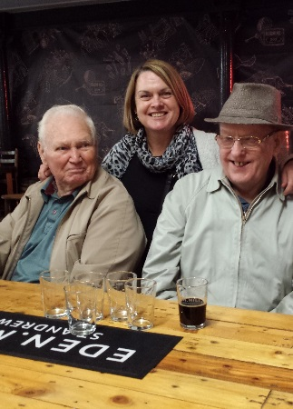
The tour started with a half pint of their finest beer and a presentation on the history of the site, and the opportunity to have a look and smell of the different hops that are used in the beers. There was then a guide around the production, bottling and packaging area.
The afternoon was finished off with a tasting session of the brewery's most popular brews and a wee look around their shop.
Tracey and Alison were delighted that everyone really enjoyed their afternoon!
Rolling Back the Years
This show had many of the Members that attended at the Whitehall Theatre remembering their youth with the medley of songs that were featured over the 2.5 hours show! They were treated to songs from the 40s, 50s and through to the 70s and the cast and dancers were fantastic with lots of sparkly costumes!
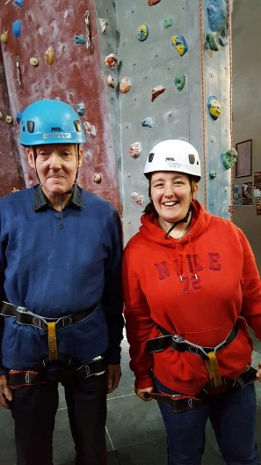
Avertical World
Eileen and Ainslay accompanied a group of adventurous Members to a session of wall climbing at Avertical World.

All of the members that attended tried a climb on the 6.5m and 9m wall, with more than half of the group reaching the top! It was a great effort by all, and everyone agreed that it was great fun and opportunity for them to try something different.

Afternoon Tea at Dobbies
A group of our lady Members were treated to an Afternoon Tea at Dobbies Garden Centre. There was also the opportunity to have a look around at all the lovely Christmas fayre that has arrived on the shelves.
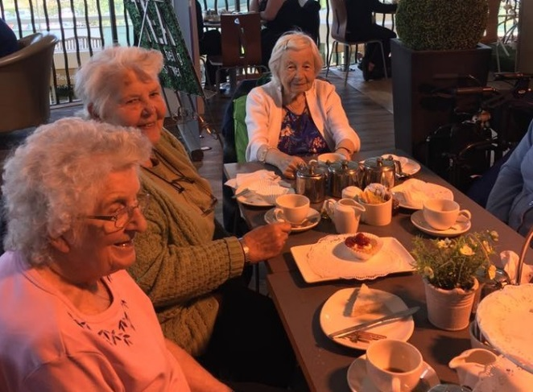
After an unfortunate wait of around an hour for our Afternoon Tea to arrive - with a certain member of staff (Alison!) getting very hangry (hungry + angry +hangry!), the food that arrived was delicious with tasty sandwiches, cream scones, meringues, strawberry tarts and chocolate covered strawberries! It was a feast!

The Broons Live
The Broons live show was the destination for some of older Members – there was lots of laughing and singing! It was a very enjoyable evening!

We will be sending out a monthly ‘What’s On’ leaflet in the New Year so if you would like to join in on any of the activities that are planned please get in touch with Tracey on 227101.

Wave 102 Community Action Week
We are delighted that the Society was featured as part of Wave 102's Community Action Week. Fiona and Alison paid a visit to the studios to record an interview (which Fiona did a fantastic job of!)
There was also an advertisement recorded which was featured daily for the entire week and we hope this encourages more people with a visual impairment to come and join us at the Society.

Meal Makers
Christmas is coming………..Sometimes the best gift of all is a home cooked meal!! If you agree and do not cook yourself then maybe you would be interested in signing up as a Diner on Meal Makers.

Meal Makers brings together those who love to cook and share food, it’s a local neighbourhood food-sharing project that connects people who love cooking, and who are happy to share an extra portion of home cooked food with an older neighbour who would really appreciate a freshly prepared meal and a friendly chat.
There are 20 Meal Maker volunteers in Dundee who are very keen to start sharing an extra portion of their evening meal with an older person in their area. If you or you know an older person who you know would appreciate a lovely home cooked meal within a 10min (approx. 1km) walking distance of any of the areas below Meal Makers could make a match happen very quickly.

Meal Makers areas
Area Postcode
Blackness/ Perth Road DD1 4JE
Blackness/ Perth Road DD1 4JE
Maryfield DD3 7LZ
Blackness/ Perth Road DD1 4JW
Blackness/ Perth Road DD1 4LS
West Marketgait DD1 5EF
Blackness/ Perth Road DD1 5LZ
Ninewells DD2 1JX
Blackness/ Perth Road DD2 1UY
Coldside/Lochee DD2 2NT
Ninewells/ Invergowrie DD2 5BN
Maryfield DD3 7LZ
Ardler/ Strathmartine DD3 9QT
East End DD4 6BE
East End DD4 6LD
East End DD4 6RF
North East (Kingsway area) DD4 8WE
Broughty Ferry DD5 1EF
Broughty Ferry DD5 2TU
For more information on this service or to sign up as a diner please call Meal Makers on 0800 783 7770

Take advantage of half-price concession TV Licence
People who are blind (severely sight impaired), or live with someone who is, should make sure they aren’t missing out on a concessionary TV Licence which allows them to save 50% on the cost.

Increasing numbers of BBC shows are provided with Audio Description (AD), with over 20% of BBC output now audio-described – Audio-described programmes are available across a range of genres.
As well as those who are blind (severely sight impaired), live-in carers or family members could also benefit from the concession and enjoy AD programming themselves. A blind concession TV Licence costs £72.75 for colour and £24.50 for a black and white TV Licence.

If you live with someone who is eligible and already have a full fee TV Licence in your name, you can transfer the licence to the name of the person who registered as severely sight impaired and halve the cost. To do this, simply fill in the form available at tvlicensing.co.uk/blind or contact TV Licensing on 0300 790 0366.

Anyone affected by sight loss can get TV Licensing information by email or in Braille, large print or audio by calling 0300 555 0300. An audio podcast about the concession is available online at audioboo.com/tvlicensing.

Paying for a TV Licence:
TV Licensing aims to make it as easy as possible for people to buy a TV Licence, which is why there are many different ways to pay.
For more information about any of our payment options and concessions, to set up Direct Debit payments or to pay by debit or credit card please visit www.tvlicensing.co.uk or call 0300 790 6112.

What a Granny is:
This was written by a 7 year old for her school essay.
A Granny is a lady with no children of her own so she likes other people’s boys and girls.

Grannies don’t have to do anything they are so old that they should not play too hard or run. They never say “Hurry Up”, usually they are fat but not too fat to tie children’s shoe laces. They don’t have to be clever, only answer questions like why dogs hate cats and why God isn’t married. They don’t talk baby talk like visitors. When they read to us they don’t skip bits or mind if it’s the same story again. Everyone should have a Granny, especially if you don’t have TV because Grannies are the only grown-ups who have time to talk to us.

A Grampa is a man Granny and he goers for walks with boys and girls and they talk about fishing and tractors.

Christmas Puzzle Time
 | 1 |  | 2 |  |  | 3 |  | 4 | 5 |  | 6
7 |  |  |  | 8 |  |  | 9
10 |  |  |  |  |  | 11 |  |  | 12
 | 13 | 14 |  |  |  |  |  |  | 15
16 |  |  |  |  |  | 17
18
 |  |  |  | 19 |  |  |  | 20
 |  |  |  | 21 |  |  |  |  | 22

Clues
Across
4 – Guided the Wise Men
7 – Gifts
10 – “O Come, all …… Faithful”
11 – White flakes that cover the ground
13 – Why shepherds were in the field
15 – Santa’s colour
17 – Striped candy
18 – “Silent Night, …… Night”
19 – The Wise Men came from a ….. country
20 – “They looked up and saw a …..”
21 – Christmas log
22 – “The First Noel, the angel did …..”

Down
1 – Where Christmas decorations are hung
2 – “….. with Gladness, Men of Old”
3 – “….. Came Upon the Midnight Clear”
5 – “Glory ….. the New-born King”
6 – Pull Santa’s sleigh
8 – Toy makers at the North Pole
9 – He lives at the North Pole
12 – Decorations that hang on doors
14 – Traditional Christmas bush
16 – What stars do
17 – Christmas song

Winter Holiday

Please note:

This Society will be closed on the following dates:

10am, Thursday 23rd December – Tuesday 3rd January (reopening on 9am, Wednesday 4th January)

“A very Merry Christmas to one and all from everyone at the Society”

Puzzle Time Solutions
 | T |  | A |  |  | I |  | S | T | A | R
P | R | E | S | E | N | T | S |  | O |  | E
 | E |  |  | L |  |  | A |  |  |  | I
Y | E |  |  | V |  | S | N | O | W |  | N
 | S | H | E | E | P |  | T |  | R | E | D
S |  | O |  | S |  | C | A | N | E |  | E
H | O | L | Y |  |  | A |  |  | A |  | E
I |  | L |  | F | A | R |  | S | T | A | R
N |  | Y |  |  |  | O |  |  | H
E |  |  |  | Y | U | L | E |  | S | A | Y

Activity Timetable
This timetable can be subject to change you will be notified of any changes through the FOCUS quarterly newsletter.
Transport costs £2 each way
Monday
Walking/Activity Group (Twice a month during summer months) | No Transport from home and back | 10am | ➔ | 3pm
Walking/Activity Group (Twice a month during summer months) | Bring Lunch  £4 with 20 mile round trip  £5 outwith 20 miles | 10am | ➔ | 3pm
Summer Outings for the elderly (Fortnightly during summer months) | Transport Available | 10am | ➔ | 5pm
 | £13 cost for Transport and Lunch | 10am | ➔ | 5pm
Winter Outings for the elderly (Fortnightly during winter months weather permitting) | Transport Available | 10am | ➔ | 5pm
 | £13 cost for Transport and Lunch | 10am | ➔ | 5pm
Tuesday
Lunch Club | Transport Available | 12 noon | ➔ | 1.30pm
Lunch Club | £5 for lunch | 12 noon | ➔ | 1.30pm
Bingo | Transport available | 1:30pm | ➔ | 3:15pm
Bingo | £3 per card  (24 games) | 1:30pm | ➔ | 3:15pm

Wednesday
Reminiscence Group | No Transport | 10:30am | ➔ | 12 noon
Reminiscence Group | Free | 10:30am | ➔ | 12 noon
Lunch Club | Transport Available | 12 noon | ➔ | 1:30pm
Lunch Club | £5 for lunch | 12 noon | ➔ | 1:30pm
Ladies’ Club | Transport Home | 1:45pm | ➔ | 3:15pm
Ladies’ Club | 50p for Tea & Biscuits | 1:45pm | ➔ | 3:15pm
Thursday
Craft Group | No Transport | 10:30am | ➔ | 12:30pm
Craft Group | Free | 10:30am | ➔ | 12:30pm
Bingo | Transport Available | 1:30pm | ➔ | 3:15pm
Bingo | £3 per card  (24 games) | 1:30pm | ➔ | 3:15pm
Friday
Tea and Chat Group | Transport Available | 1:30pm | ➔ | 3:15pm
Tea and Chat Group | £1 for Tea & Snack | 1:30pm | ➔ | 3:15pm

