Table of Contents
A. Pre-Setup 2
1) Secure a domain name: 2
2) Secure a hosting account: 2
3) Setup DNS accordingly: 2
B. Installation 2
1) Download/Install WordPress to recently secured domain and hosting account: 2
2) Purchase/Download/Install WishList Member PlugIn: 2
3) Activate PlugIn using unique license info obtained upon purchase: 2
4) Download/Install desired WordPress theme: 2
5) Activate WishList Member Widget: 2
6) Check WishList Dashboard to see if new version of WishList Member is available: 2
C. Setup – Email Settings 2
1. Set desired email settings accordingly: 2
D. Setup – Advanced 2
1. Decide on Hide/Show protection: 2
2. Decide on use of More Tags: 2
3. Decide on use of Private Tags: 2
4. Decide on Default Protection: 2
5. Decide on other Admin Options 2
E. Setup – Free Membership Level 2
1) Create Membership Level: 2
2) Create Error Pages: 2
3) Create After Registration/After Login Redirect Pages: 2
4) Set Error/Login/Registration Redirect Defaults in Settings: 2
5) Set Login/Registration Redirects for individual Membership Levels if necessary: 2
6) Create Registration Pages: 2
7) Create a New Member: 2
8) Import/Add Members if necessary: 2
9) Add Protected/Non-Protected content accordingly: 2
F. Setup – Paid Membership Level – SIMPLE Integration 2
1) Create Membership Level: 2
2) Create Error Pages: 2
3) Create After Registration/After Login Redirect Pages: 2
4) Set Error/Login/Registration Redirect Defaults in Settings: 2
5) Set Login/Registration Redirects for individual Membership Levels if necessary: 2
6) Create Registration Pages: 2
7) Integrate with desired online shopping cart: 2
8) Complete a test purchase to confirm settings: 2
9) Import/Add Members if necessary: 2
10) Add Protected/Non-Protected content accordingly: 2
G. Setup – Paid Membership Level – SIMPLE Integration – 1Shopping Cart 2
1) Create Membership Level: 2
2) Create Error Pages: 2
3) Create After Registration/After Login Redirect Pages: 2
4) Set Error/Login/Registration Redirect Defaults in Settings: 2
5) Set Login/Registration Redirects for individual Membership Levels if necessary: 2
6) Create Registration Pages: 2
7) Integrate with 1Shopping Cart: 2
8) Complete a test purchase to confirm settings: 2
9) Import/Add Members if necessary: 2
10) Add Protected/Non-Protected content accordingly: 2
H. Setup – Paid Membership Level – FULL Integration – PayPal 2
1) Create Membership Level: 2
2) Create Error Pages: 2
3) Create After Registration/After Login Redirect Pages: 2
4) Set Error/Login/Registration Redirect Defaults in Settings: 2
5) Set Login/Registration Redirects for individual Membership Levels if necessary: 2
6) Integrate with PayPal: 2
7) Complete a test purchase to confirm settings: 2
8) Import/Add Members if necessary: 2
9) Add Protected/Non-Protected content accordingly: 2
I. Setup – Paid Membership Level – FULL Integration – QuickPayPro 2
1) Create Membership Level: 2
2) Create Error Pages: 2
3) Create After Registration/After Login Redirect Pages: 2
4) Set Error/Login/Registration Redirect Defaults in Settings: 2
5) Set Login/Registration Redirects for individual Membership Levels if necessary: 2
6) Integrate with QuickPayPro: 2
7) Complete a test purchase to confirm settings: 2
8) Import/Add Members if necessary: 2
9) Add Protected/Non-Protected content accordingly: 2
J. Setup – Paid Membership Level – FULL Integration – ClickBank 2
1) Create Membership Level: 2
2) Create Error Pages: 2
3) Create After Registration/After Login Redirect Pages: 2
4) Set Error/Login/Registration Redirect Defaults in Settings: 2
5) Set Login/Registration Redirects for individual Membership Levels if necessary: 2
6) Integrate with ClickBank: 2
8) Adhere to ClickBank Rules and Regulations 2
9) Complete a test purchase to confirm settings: 2
10) Import/Add Members if necessary: 2
11) Add Protected/Non-Protected content accordingly: 2

K. Auto Responder Integration – AWeber 2
1. Integrate with AWeber: 2

L. Auto Responder Integration – AutoResponsePlus 2
1. Integrate with AutoResponsePlus: 2

M. Sequential Upgrade 2
1. Set up sequential upgrade accordingly: 2

A. Pre-Setup

1) Secure a domain name:
  - Search selected Registrar (www.godaddy.com is recommended) for availability of desired domain.
  - Purchase selected domain.
Be sure to use a reliable email address during purchase as this is what will be used to associate the domain to the admin for the duration of its use.

- Secure a hosting account:
  - Purchase hosting package based on the needs and requirements of the particular site (volume of traffic/members, etc.).
Popular Hosting Providers:
    - LiquidWeb.com
    - HostGator.com
    - LunarPages.com
  - Save and store hosting info (ftp) accordingly.
- Setup DNS accordingly:
  - Login to Registrar Control Panel and select desired domain.
  - Point DNS (Name Servers) to appropriate destinations (ex. NS1.NAMESERVERS.COM, NS2.NAMESERVERS.COM)
  - Allow up to 48 for domain to propagate. Once propagated, WordPress and WishList Member can be uploaded to the space.

B. Installation
- Download/Install WordPress to recently secured domain and hosting account:
  - Download latest version of WordPress located at http://wordpress.org/download
  - Install WordPress to server space using an FTP program (Example: Filezilla - http://filezilla-project.org/).
  - Navigate to your site home page to view the newly installed WordPress site.
For more details, please view the WordPress Installation video:
http://member.wpwishlist.com/installing-wordpress/
- Purchase/Download/Install WishList Member PlugIn:
  - Download latest version of WishList Member PlugIn using unique link provided in email titled “WishList Member Key” that is sent after purchase.
  - Install WishList Member PlugIn onto WordPress site located on server space using an FTP program (Example: Filezilla - http://filezilla-project.org/). The WishList Member install file should be uploaded to the “plugins” folder:
public_html >> wp-content >> plugins
For more details, please view the WishList Member Installation video:
http://member.wpwishlist.com/installing-wishlist-member/
- Activate PlugIn using unique license info obtained upon purchase via WishList Member License Key email:
  - Login to WordPress.
  - Navigate to PlugIns area.
Screenshot:
http://screencast.com/t/xpDEK7cy

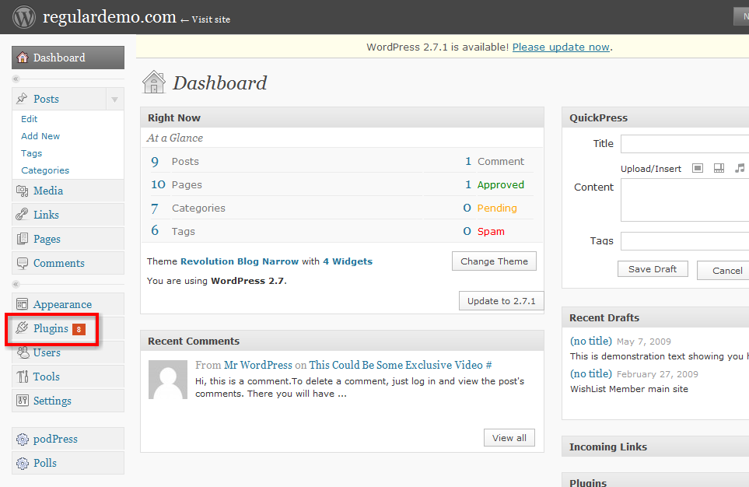
  - Activate the WishList Member PlugIn.
Screenshot:
http://screencast.com/t/dIo70G3155Q
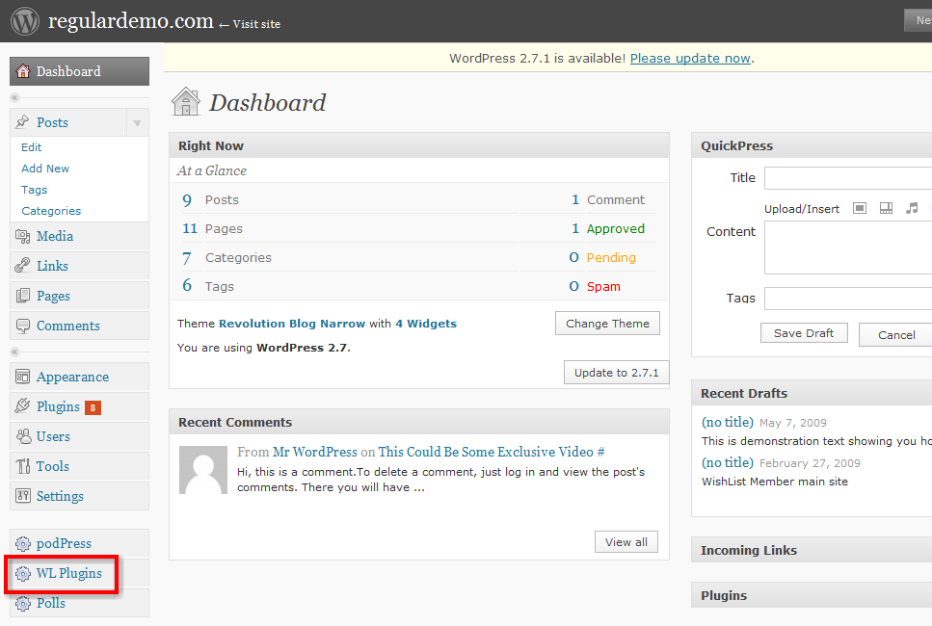
  - Enter the License Key and email address associated to the WishList Member PlugIn accordingly and click the “Save WP WishList Key” button to complete the activation.
The WishList member License Key email will have been sent to the email account associated to the WishList Member PlugIn.
Screenshot:
http://screencast.com/t/Ozm2jAqVX

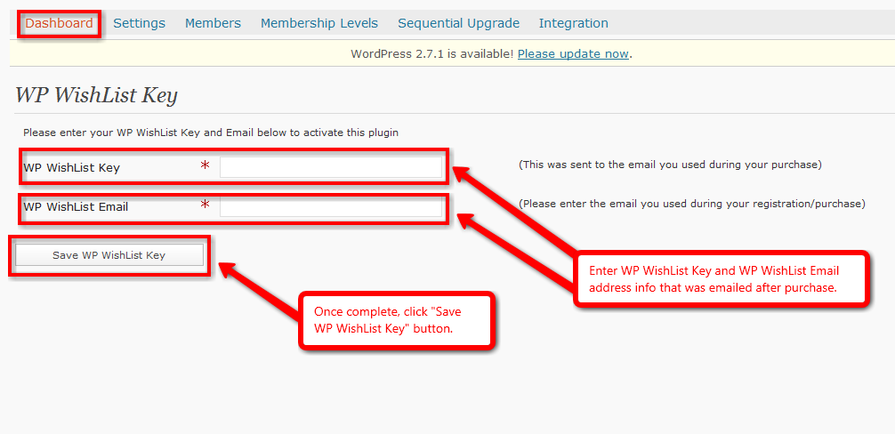
For more details, please view the WishList Member Installation video:
http://member.wpwishlist.com/installing-wishlist-member/

- Download/Install desired WordPress theme:
  - Download selected WordPress theme.
  - Unzip Theme file and save to computer.
  - Install Theme onto WordPress site located on server space using an FTP program (Example: Filezilla - http://filezilla-project.org/). The theme file should be uploaded to the “themes” folder:
public_html >> wp-content >> themes
  - Login to WordPress.
  - Navigate to Themes area in the Appearance section.
Screenshot:
http://screencast.com/t/QSsuiYSJx
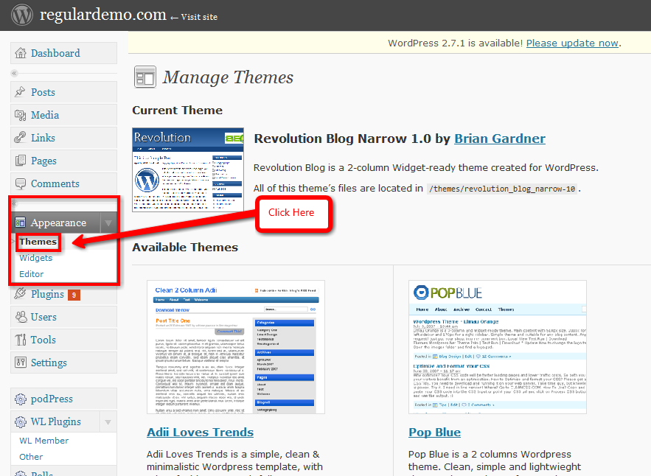
  - Activate the Theme by clicking its corresponding screenshot and then click the “Activate” button on the top right of the preview page that appears.
Screenshot:
http://screencast.com/t/1aXdUOqGLAl
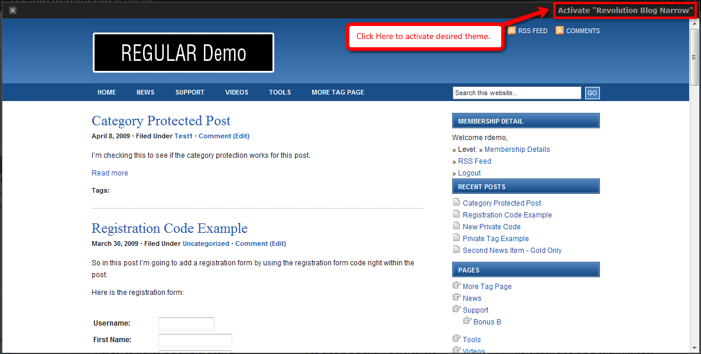
  - Navigate to your site home page to view the newly installed WordPress theme.
For more details, please view the Installing WordPress Themes video:
http://member.wpwishlist.com/installing-wordpress-themes/
- Activate WishList Member Widget:
  - Login to WordPress.

  - Navigate to Widgets area in the Appearance section.
Screenshot:
http://screencast.com/t/SAodZQmmW2L
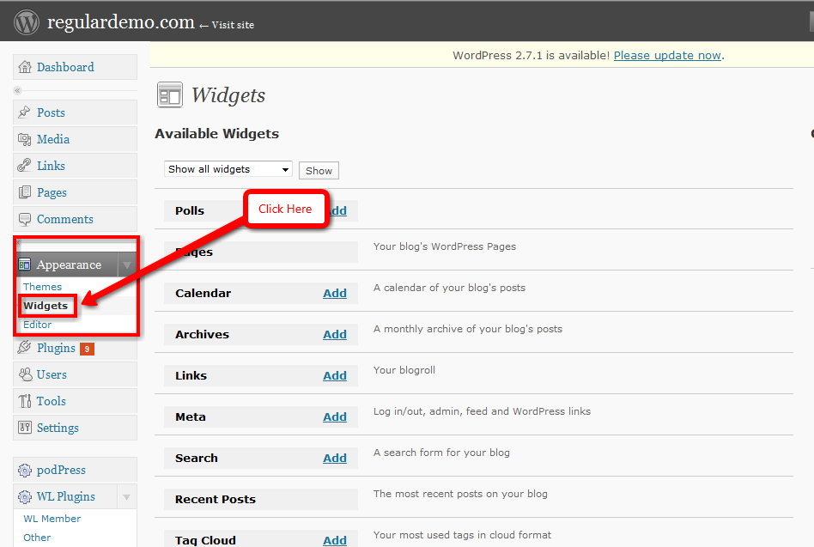
  - Activate the WL Member Widget by clicking the “Add” button on the Widget List. It will then appear in the right side column as a blue bar.
Screenshot:
http://screencast.com/t/Bk6iRUViV

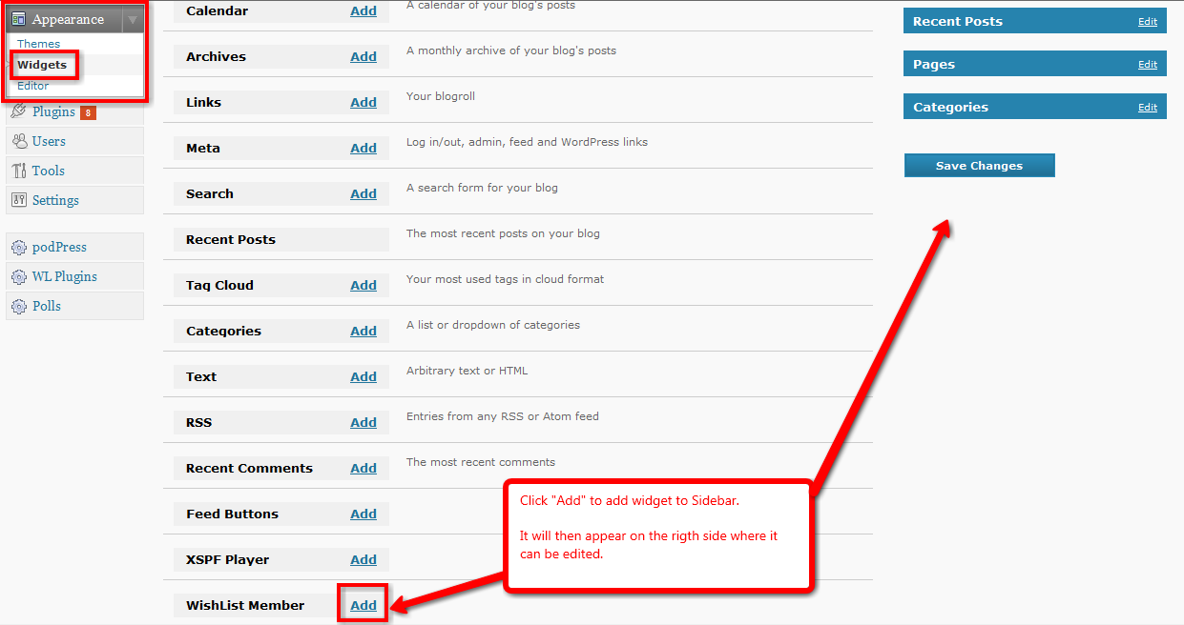
  - The WL Member Widget can now be edited by clicking the “Edit” link on the top right of the corresponding blue bar. Options can then be controlled such as the length of the login fields, the ability to hide/show the RSS and Register links, etc.
  - Once all options have been selected, click the “Done” button on the bottom of the list and the blue bar will collapse. Click the “Save Changes” button to retain the set options.
Screenshot:
http://screencast.com/t/kKNbEcIPts7

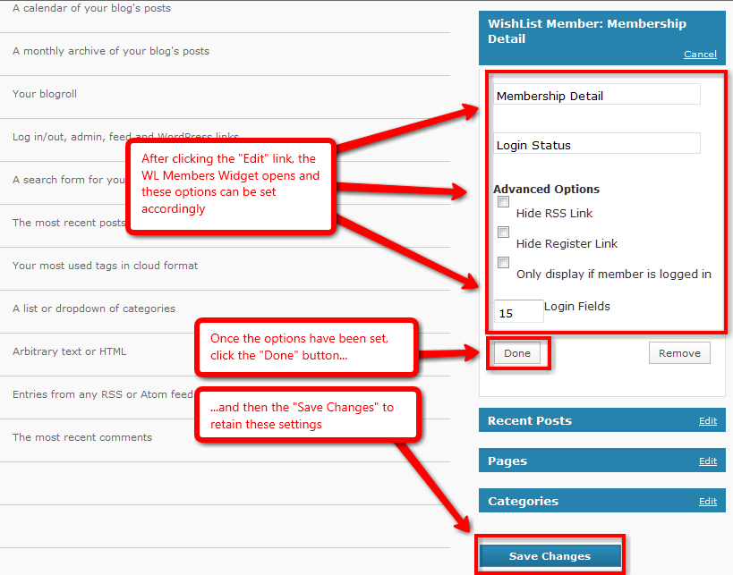
For more details, please view the Login Widget video:
http://member.wpwishlist.com/28-login-widget-wp27/

- Check WishList Dashboard to see if new version of WishList Member is available:
  - Login to WordPress.
  - Navigate to WishList Member Dashboard by selecting “WL Member” in the PlugIns section.
  - Look under “Your Membership Stats”. A line of text should read “You have the latest version of WishList Member”. If it does not, a link will be provided to download the latest version.
Screenshot:
http://screencast.com/t/I3PsJ5tP

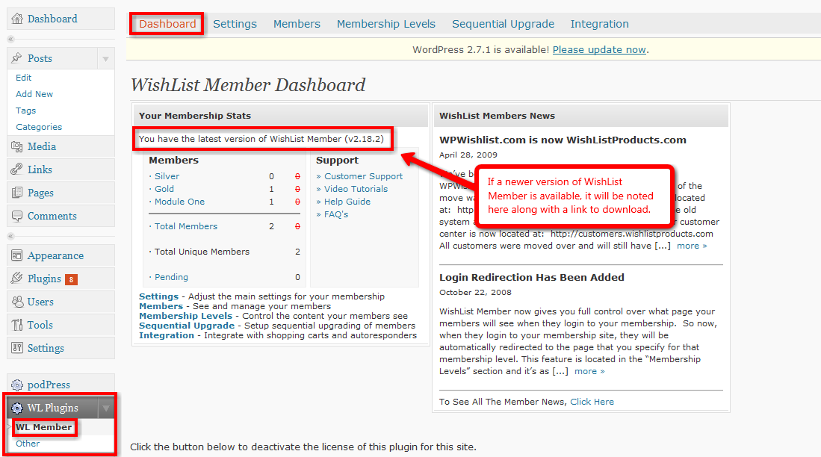
For more details, please view the Updating WishList Member video:
http://member.wpwishlist.com/updating-wishlist-member/

C. Setup – Email Settings

Emails sent from this area will be text based with little to no HTML capabilities.
- Set desired email settings accordingly:
  - Set name and email address to use when emails are sent from WishList Member.
Screenshot:
http://screencast.com/t/iUxyR6QQcxb

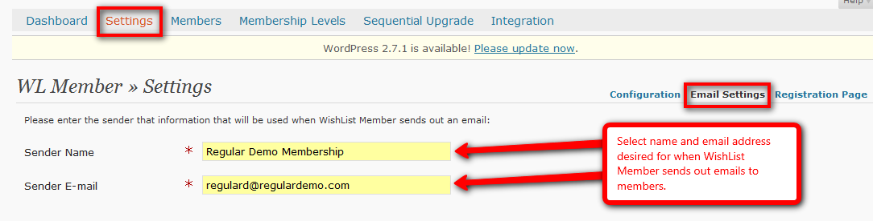
  - Set subject and body for email that members will receive after registration.
Screenshot:
http://screencast.com/t/3fxhgiZ8
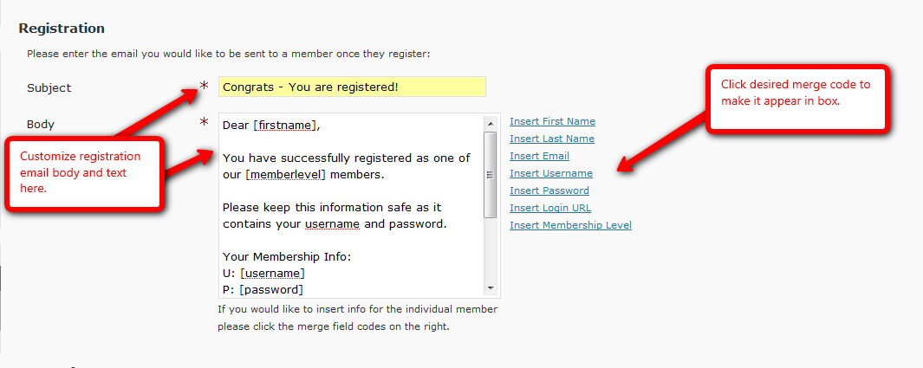

  - Set subject and body for email that members will receive if they request their login info.
Screenshot:
http://screencast.com/t/q5mLAlYDa

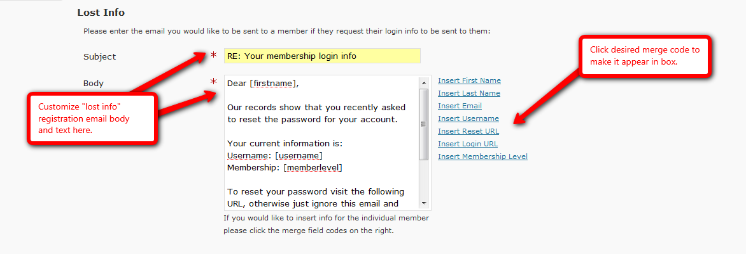
  - Set admin email, subject and body for email that admin will receive after a member registration.
Screenshot:
http://screencast.com/t/bwtgHFF7Vw
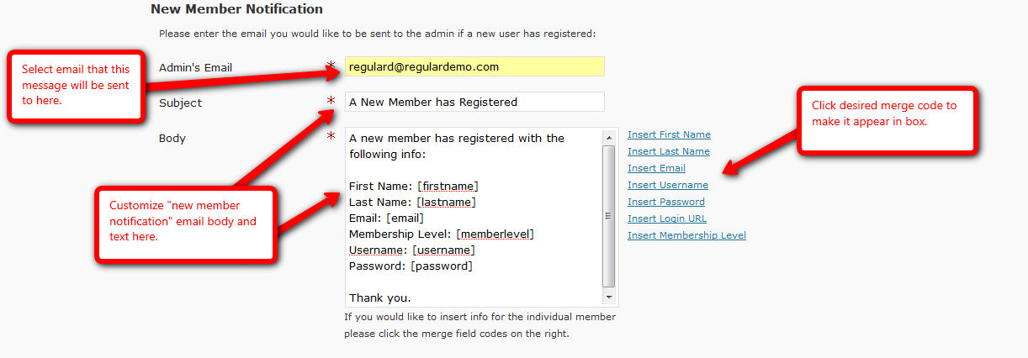

D. Setup – Advanced

- Decide on Hide/Show protection:

The Hide/Show feature allows the ability to completely hide protected content from users who do NOT belong to specific membership levels.
  - Login to WordPress.
  - Navigate to WishList Member Dashboard by selecting “WL Member” in the PlugIns section.
Screenshot:
http://screencast.com/t/znvrKkzwwI
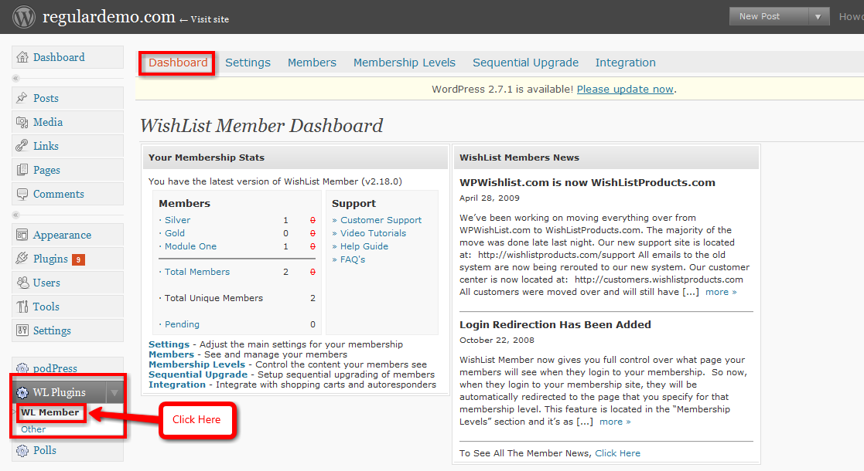
  - Navigate to WishList Member Settings tab.
Screenshot:
http://screencast.com/t/301A8m6d
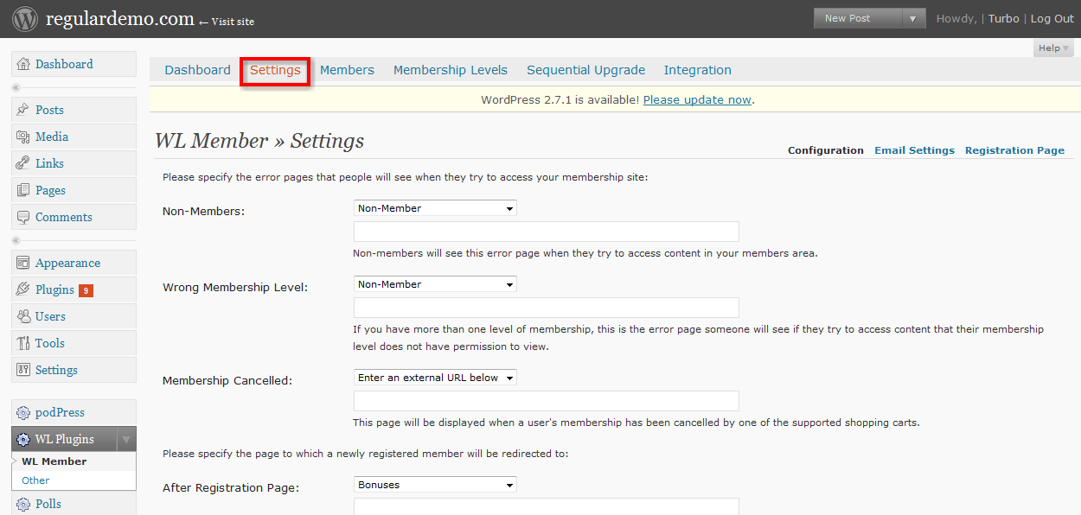
  - Set Hide/Show feature accordingly.
Screenshot:
http://screencast.com/t/YWLSb44D
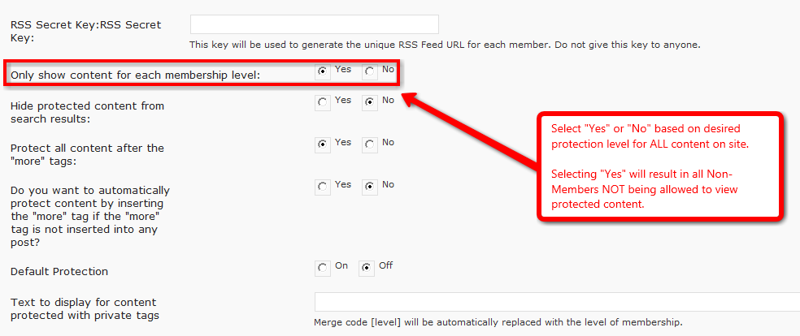
  - Scroll to the bottom of the page and click “Save Settings”.
Screenshot:
http://screencast.com/t/YyklySXs

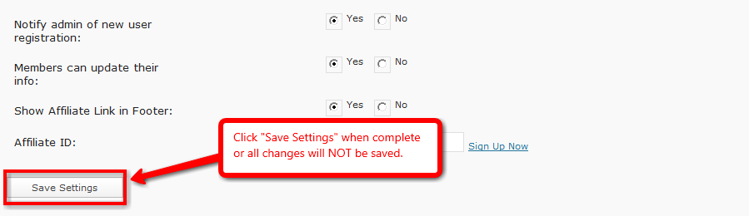
For more details, please view the Hide/Show Feature video:
http://member.wpwishlist.com/hide-and-show-feature-wp27/
- Decide on use of More Tags:

If the Hide/Show feature is turned “Off” then a “More” tag must be used to protect content.
Any content below the “More” tags will be protected. There are 2 methods that can be used to accomplish this:
  - More Tag Protection on All Posts that currently have a More Tag:
    - Login to WordPress.
    - Navigate to WishList Member Dashboard by selecting “WL Member” in the PlugIns section.
Screenshot:
http://screencast.com/t/znvrKkzwwI
    - Navigate to WishList Member Settings tab.
Screenshot:
http://screencast.com/t/301A8m6d
    - Select if all content should be protected after the “More” tag.
Screenshot:
http://screencast.com/t/GhmwNV0Hp
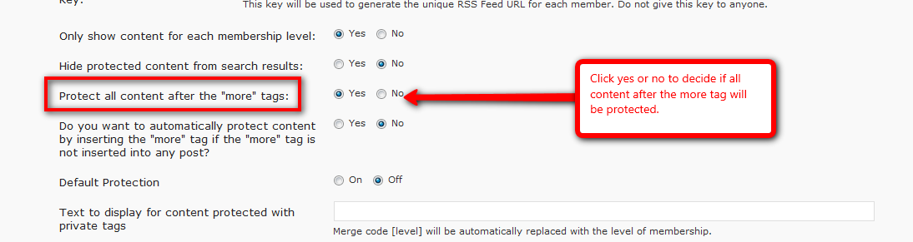
    - Scroll to the bottom of the page and click “Save Settings”.
Screenshot:
http://screencast.com/t/YyklySXs
  - More Tag Protection on a Post by Post basis:
    - Login to WordPress.
    - Navigate to WishList Member Dashboard by selecting “WL Member” in the PlugIns section.
Screenshot:
http://screencast.com/t/znvrKkzwwI
    - Navigate to desired Post.
    - Scroll down to WishList Members section below the content area.
    - Select if specific Post should be protected after the “More” tag.
Screenshot:
http://screencast.com/t/29v0E2lCYc4

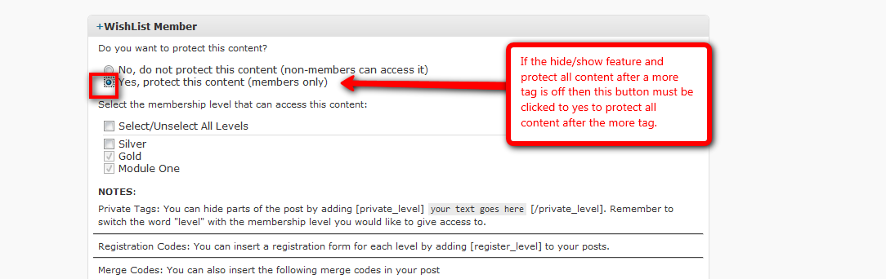
    - Select if content should be protected by inserting the "More" tag automatically if the "More" tag is not inserted into any post. Note that the number of words before the “More” tag can be set by the admin.
Screenshot:
http://screencast.com/t/v8aZ9GXRJIs
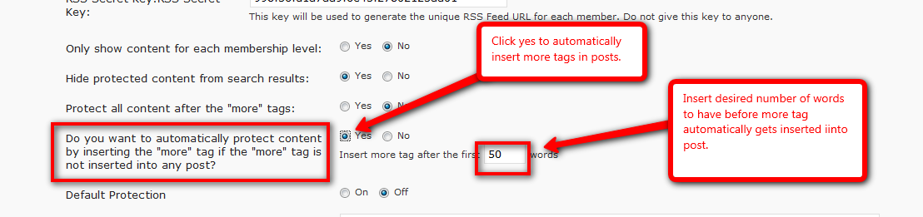
    - Scroll to the bottom of the page and click “Save Settings”.
Screenshot:
http://screencast.com/t/YyklySXs
For more details, please view the following videos:

More Tag Protection video:
http://member.wpwishlist.com/more-tag-protection-wp27/
Automatic More Tag Protection video:
http://member.wpwishlist.com/10-automatic-more-tag-protection-wp2/
- Decide on use of Private Tags:

Posts and Pages can use "Private” Tags to hide text form all users except for a specific membership level by placing [private_level] before and [/private_level] after the text to be protected.
Note that these tags will differ depending on actual membership levels. For example, a membership level named "silver" would be [private_silver] and [/private_silver]. Therefore only anyone in the silver membership level would be able to view the text.
  - Login to WordPress.
  - Navigate to WishList Member Dashboard by selecting “WL Member” in the PlugIns section.
Screenshot:
http://screencast.com/t/znvrKkzwwI
  - Navigate to WishList Member Settings tab.
Screenshot:
http://screencast.com/t/301A8m6d
  - Add text to display in “Private” Tag if desired.
Screenshot:
http://screencast.com/t/ar7aswYz3v0

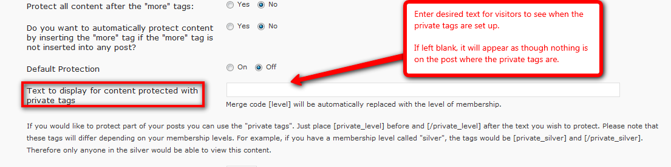
  - Navigate to desired Post or Page and insert “Private” Tags accordingly.
Screenshot:
http://screencast.com/t/63OmlP0i9

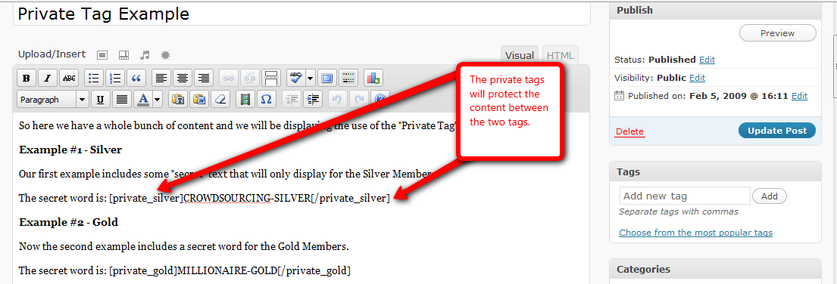
  - Once complete, click the “Publish” button.
For more details, please view the Private Tag Protection video:
http://member.wpwishlist.com/11-private-tag-protection-wp27/
- Decide on Default Protection:

Default Protection allows the option to set content protection either “On” or “Off” for ALL new Pages and Posts created.
Note that this protection can still be adjusted on each individual Page or Post.
Access will still need to be assigned to any protected Pages or Posts.
- Login to WordPress.
- Navigate to WishList Member Dashboard by selecting “WL Member” in the PlugIns section.
Screenshot:
http://screencast.com/t/znvrKkzwwI
- Navigate to WishList Member Settings tab.
Screenshot:
http://screencast.com/t/301A8m6d
- Set Default Protection accordingly.
Screenshot:
http://screencast.com/t/kAKDG5KBkqT

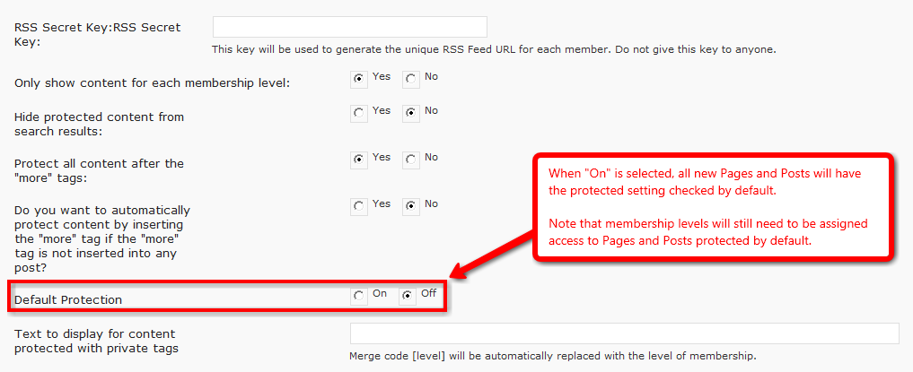
- Scroll to the bottom of the page and click “Save Settings”.
Screenshot:
http://screencast.com/t/YyklySXs
- Decide on other Admin Options
- Login to WordPress
- Navigate to WishList Member Dashboard by selecting “WL Member” in the PlugIns section.
Screenshot:
http://screencast.com/t/znvrKkzwwI
- Navigate to WishList Member Settings tab.
Screenshot:
http://screencast.com/t/301A8m6d
- Select if an email notification should be sent to the WishList admin when a new member has registered.
- Select if members are allowed to update their account info.
- Select if a unique Affiliate Link should be displayed in the footer of the live site.
- If an Affiliate Link has been selected to appear on the live site, enter the Affiliate ID accordingly.
Screenshot:
http://screencast.com/t/FlWhPQdk4K

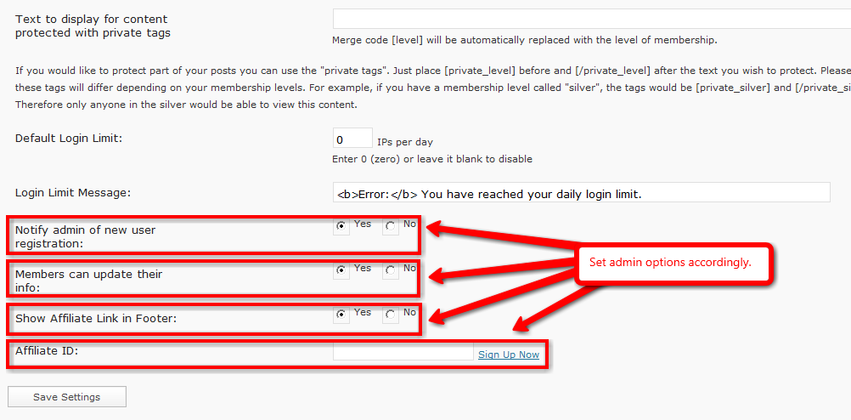
- Scroll to the bottom of the page and click “Save Settings”.
Screenshot:
http://screencast.com/t/YyklySXs

E. Setup – Free Membership Level

- Create Membership Level:
  - Login to WordPress.
  - Navigate to WishList Member Dashboard by selecting “WL Member” in the PlugIns section.
Screenshot:
http://screencast.com/t/znvrKkzwwI
  - Navigate to the Membership Levels tab and then the Membership Levels sub-tab.
Screenshot:
http://screencast.com/t/PGJcGYkfmX
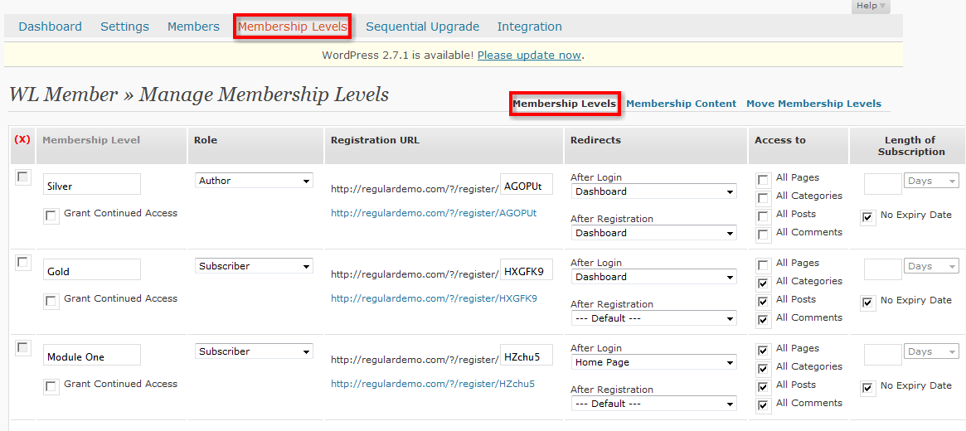
  - Scroll to the bottom of the page and the fields within the Add New Member section can be filled in accordingly.
    - Level Name: The desired membership level name.
    - Grant Continued Access: Allows the option to continue member’s access to purchased content AFTER membership cancelation OR access can be STOPPED after cancellation.
    - Role: Allows option to set specific membership role:
      - Subscribers - can view content only.
      - Contributors - can read and create posts/pages that must be approved before posting.
      - Authors - can create posts/pages that do not need to be approved.
      - Editors - can approve edit and create any posts/pages.
    - Registration URL: Displays modifiable membership level Registration URL.
    - After Login Redirect: Allows option to set specific After Login page.
    - After Registration Redirect: Allows option to set specific After Registration page.
    - Access to: Allows option to set blank security protection.
    - Length of Subscription: Allows option to set length of subscription in days, weeks, months or years.
    - No Expiry Date: Allows option to set Expiry date for Membership level.
  - Once options are set, click “Save Settings” on bottom right of the page or all work will be lost.
Screenshot:
http://screencast.com/t/8c0sjIt9YyP
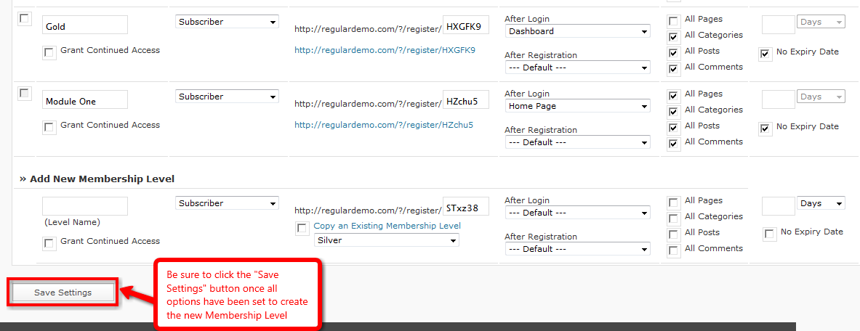

- Create Error Pages:
  - Login to WordPress.
  - Navigate to Pages section and click “Add New”.
Screenshot:
http://screencast.com/t/YdmLdW3Aj0
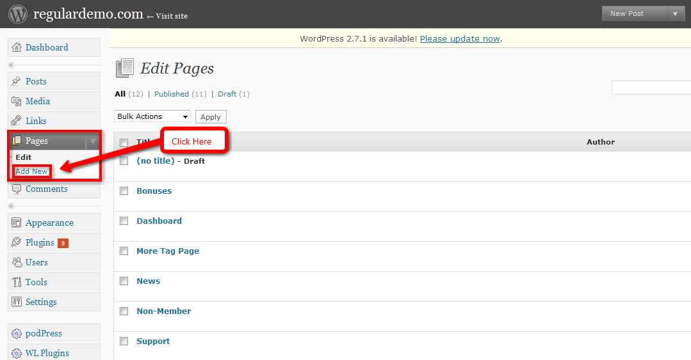
  - Create standard WordPress pages for Non-Member, Wrong Membership Level and Membership Cancelled error pages.

- Create After Registration/After Login Redirect Pages:
  - Login to WordPress.
  - Navigate to Pages section and click “Add New”.
Screenshot:
http://screencast.com/t/YdmLdW3Aj0
  - Create standard WordPress pages for After Registration and After Login pages.

- Set Error/Login/Registration Redirect Defaults in Settings:

  - Login to WordPress.
  - Navigate to WishList Member Dashboard by selecting “WL Member” in the PlugIns section.
Screenshot:
http://screencast.com/t/znvrKkzwwI
  - Navigate to WishList Member Settings tab.
Screenshot:
http://screencast.com/t/301A8m6d
  - Set the desired Error, After Registration and After Login Pages using the appropriate dropdowns.
Screenshot:
http://screencast.com/t/vUx1B1x7

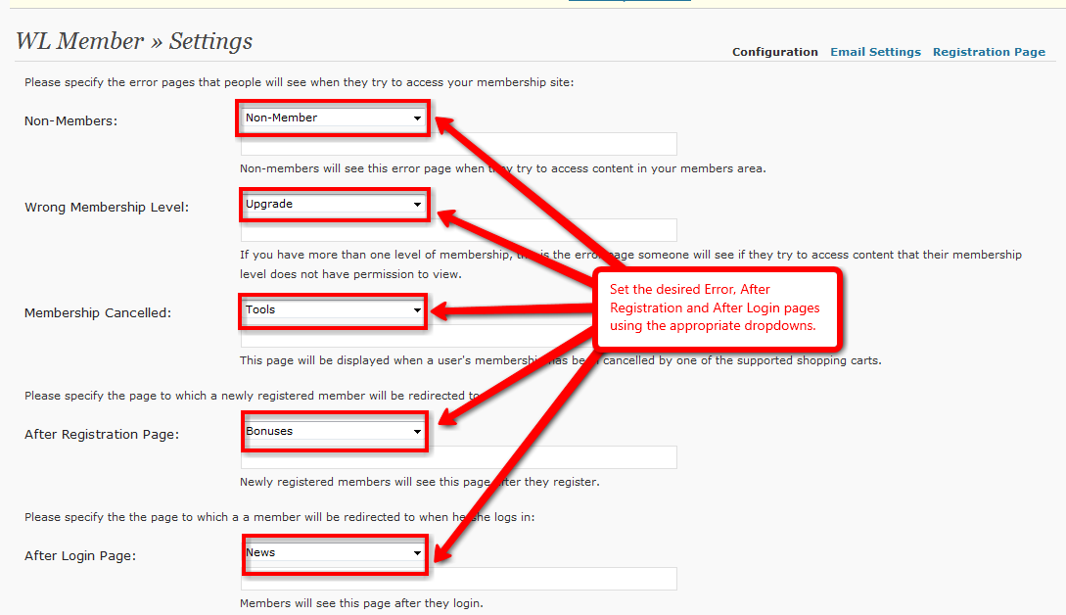
  - Scroll to the bottom of the page and click “Save Settings” button on the left or all work will be lost.
Screenshot:
http://screencast.com/t/C0Vz5v3i
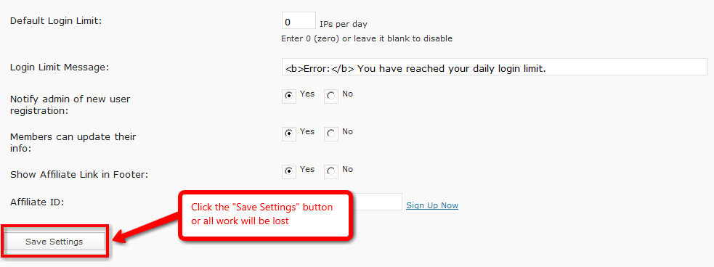

- Set Login/Registration Redirects for individual Membership Levels if necessary:
  - Login to WordPress.
  - Navigate to WishList Member Dashboard by selecting “WL Member” in the PlugIns section.
Screenshot:
http://screencast.com/t/znvrKkzwwI
  - Navigate to the Membership Levels tab and then the Membership Levels sub-tab.
Screenshot:
http://screencast.com/t/PGJcGYkfmX
  - Set individual After Registration and After Login pages accordingly using the appropriate dropwdowns for each Membership Level.
Screenshot:
http://screencast.com/t/amdOoFqin

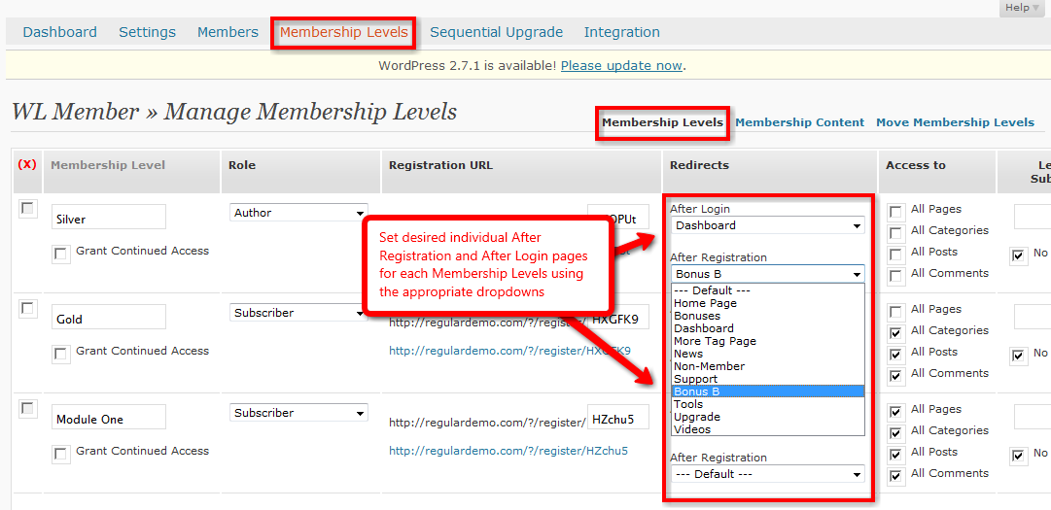
  - Scroll to the bottom of the page and click “Save Settings” button on the left or all work will be lost.
Screenshot:
http://screencast.com/t/OKD0d4YZJ

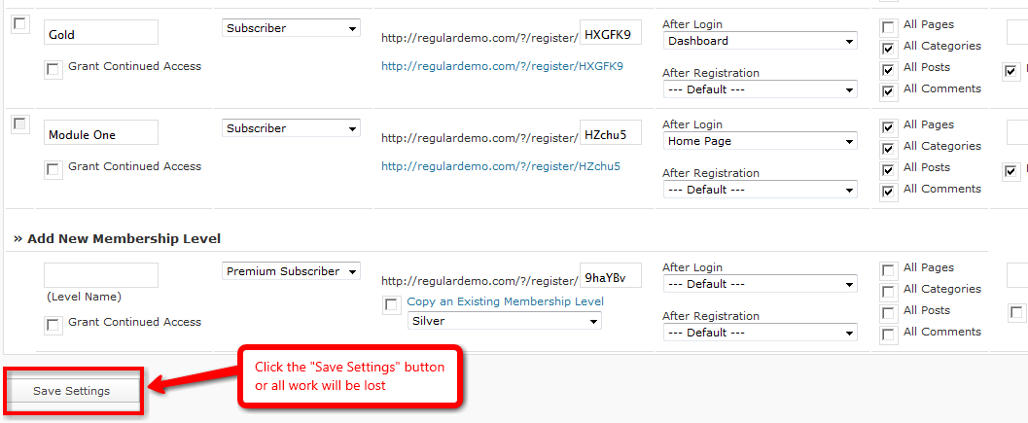
- Create Registration Pages:
  - Registration forms can be added to any page or post within WordPress by using a merge code or the Registration URL located on the Membership Levels section.
    - Registration Merge Code: [register_level] the registration merge code needs to replace the word "level" with the name of the desired membership level.
Example: a membership level named "silver" would use the following merge code: [register_silver]
    - Registration URL: Every membership level has a unique URL which can be found in the Membership Levels tab.
Screenshot:
http://screencast.com/t/mj5EotMctAu

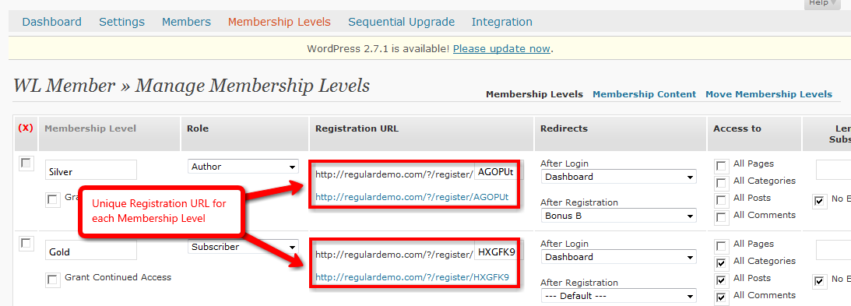
Note that when embedded on any page or post, this URL will directly link to the unique registration page.
  - Registration pages are easily customizable when using either of the following optional methods:
    - Registration Merge Code: Simply insert desired content above and/or below the merge code field in the content section of the page or post.
    - Registration URL: Using this method, the registration page for each membership level can be customized by adding HTML above and below.
To accomplish this, navigate to the "Settings” tab and “Registration Page" sub tab. Next, select the desired membership level and then simply enter the HTML above and below.
Screenshot:
http://screencast.com/t/nQf3g3gVQ

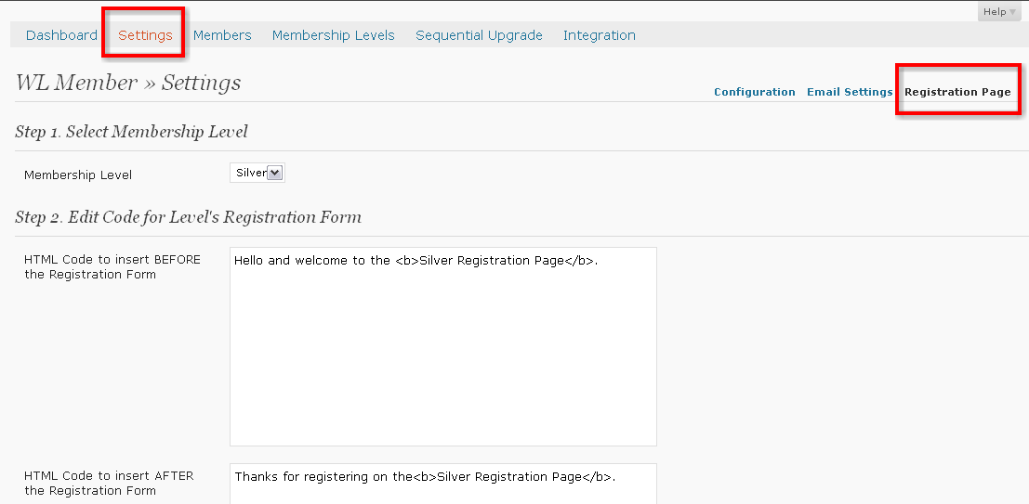

- Create a New Member:
  - Login to WordPress.
  - Navigate to WishList Member Dashboard by selecting “WL Member” in the PlugIns section.
Screenshot:
http://screencast.com/t/znvrKkzwwI
  - Navigate to WishList Member Members tab.
Screenshot:
http://screencast.com/t/v7NxMBOon
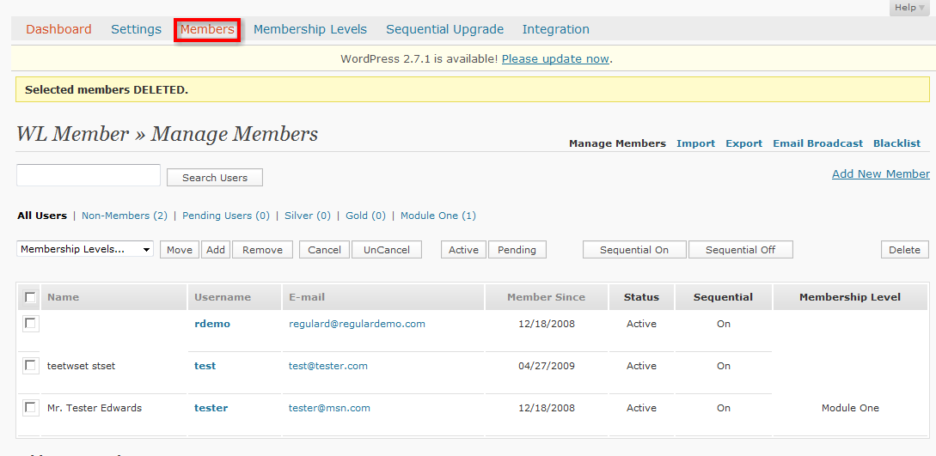
  - Scroll to the bottom of the page and fill in the Add New Member form accordingly. When complete, click the “Add Member” button. Note that the password MUST be at least 8 characters in length.
Screenshot:
http://screencast.com/t/6UR3R3gTS

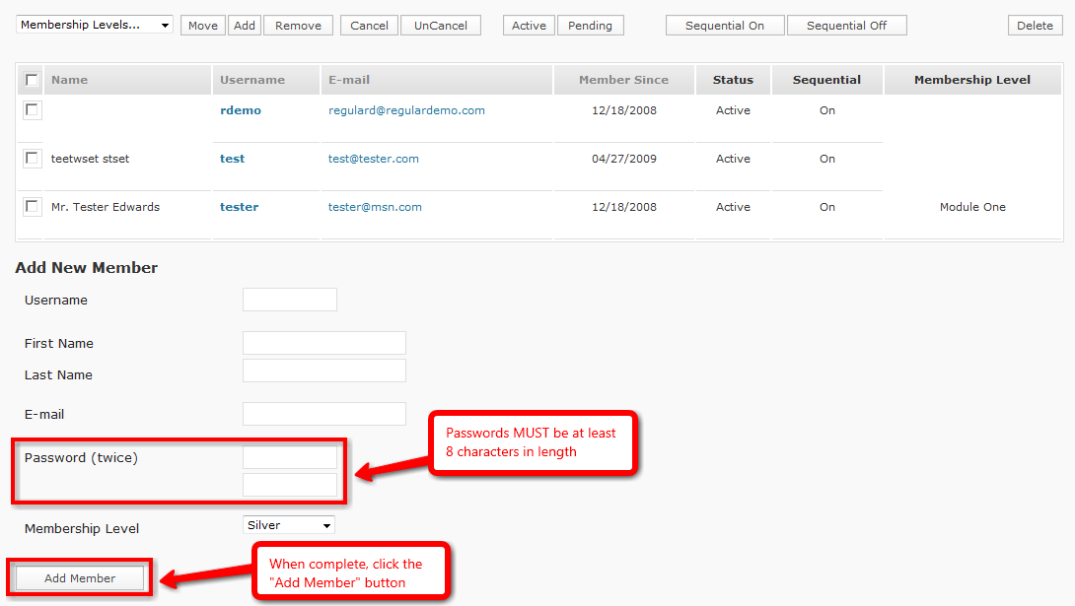
- Import/Add Members if necessary:
  - Login to WordPress.
  - Navigate to WishList Member Dashboard by selecting “WL Member” in the PlugIns section.
Screenshot:
http://screencast.com/t/znvrKkzwwI
  - Navigate to WishList Member Members tab and Import sub tab.
  - Fill in the field accordingly. Ensure that .CSV file to be imported matches the sample .CSV file provided. Note that you will need to remove the header row BEFORE importing.
Note that it is important to ensure that ALL passwords are a minimum of 8 characters long.
Screenshot:
http://screencast.com/t/g5XDk1wt

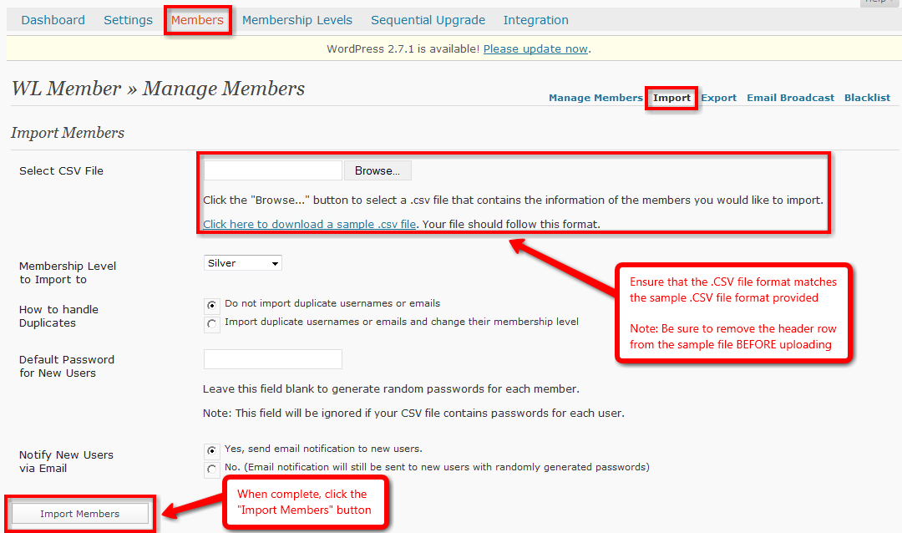
  - When complete, click the “Import Members” button.
For more details, please view the Importing and Exporting Members video:
http://member.wpwishlist.com/17-importing-and-exporting-members-wp27/
- Add Protected/Non-Protected content accordingly:

There are 2 methods that can be utilized when creating protected content:
  - Individually as Pages or Posts are created:
    - Login to WordPress.
    - Navigate to Pages or Posts section and create new Page or Post.
    - After inputting content, scroll down to WishList member section.
    - Select IF this Page or Post should be protected using the radio button.
    - Select which membership level(s) have access to this Page or Post using the check boxes.
Screenshot:
http://screencast.com/t/1DT5ePc73
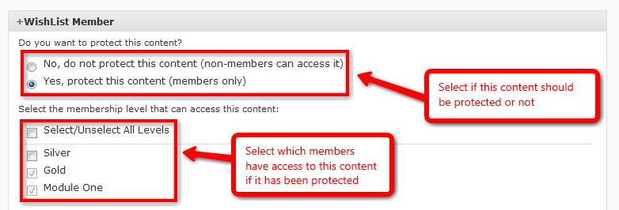
    - Once complete, click the “Publish” button.
  - Using a blanket method once Pages or Posts have been created:
    - Login to WordPress.
    - Navigate to WishList Member Dashboard by selecting “WL Member” in the PlugIns section.
    - Navigate to WishList Member Membership Levels tab and Membership Content sub tab.
Screenshot:
http://screencast.com/t/bpdZHHm4
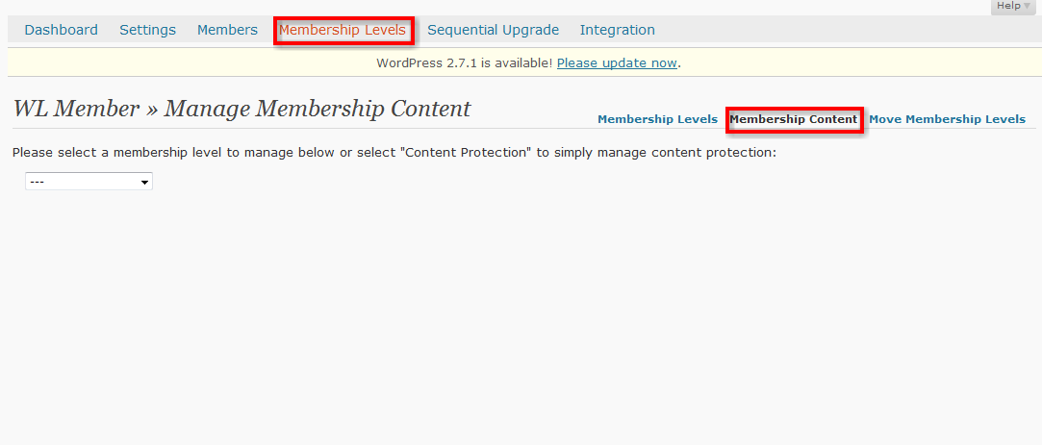
    - Select a membership level to manage using the dropdown.
    - Select the desired content to manage using the options on the far right of page (Categories, Pages, Posts, Comments).
    - Click the corresponding check boxes to allow membership access to that specific content.
    - When complete, click the “Grant Access” button.
Screenshot:
http://screencast.com/t/9k2P76rQC

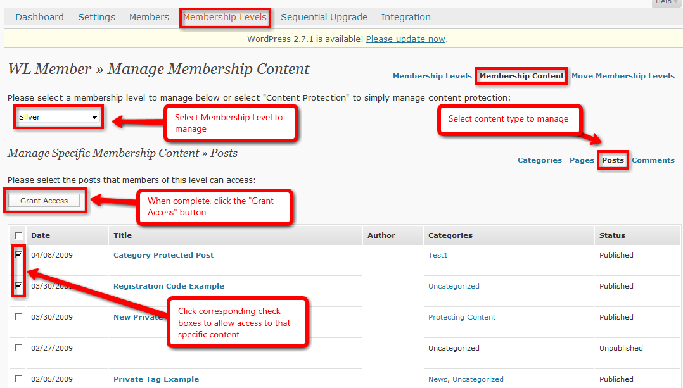
For more details, please view the Protecting Specific Content video:
http://member.wpwishlist.com/21-protecting-specific-content-wp27/

F. Setup – Paid Membership Level – SIMPLE Integration

Simple Integration allows a quick and easy integration between WishList Member and any online payment system. If a member cancels payment or doesn't pay for some reason an admin will have to manually cancel the member within WishList Member.

- Create Membership Level:
  - Login to WordPress.
  - Navigate to WishList Member Dashboard by selecting “WL Member” in the PlugIns section.
Screenshot:
http://screencast.com/t/znvrKkzwwI
  - Navigate to the Membership Levels tab and then the Membership Levels sub-tab.
Screenshot:
http://screencast.com/t/PGJcGYkfmX
  - Scroll to the bottom of the page and the fields within the Add New Member section can be filled in accordingly.
    - Level Name: The desired membership level name.
    - Grant Continued Access: Allows the option to continue member’s access to purchased content AFTER membership cancelation OR access can be STOPPED after cancellation.
    - Role: Allows option to set specific membership role.
      - Subscribers - can view content only.
      - Contributors - can read and create posts/pages that must be approved before posting.
      - Authors - can create posts/pages that do not need to be approved.
      - Editors - can approve edit and create any posts/pages.
    - Registration URL: Displays modifiable membership level Registration URL.
    - After Login Redirect: Allows option to set specific After Login page.
    - After Registration Redirect: Allows option to set specific After Registration page.
    - Access to: Allows option to set blank security protection.
    - Length of Subscription: Allows option to set length of subscription in days, weeks, months or years.
    - No Expiry Date: Allows option to set Expiry date for Membership level.
  - Once options are set, click “Save Settings” on bottom right of the page or all work will be lost.
Screenshot:
http://screencast.com/t/8c0sjIt9YyP

- Create Error Pages:
  - Login to WordPress.
  - Navigate to Pages section and click “Add New”.
Screenshot:
http://screencast.com/t/YdmLdW3Aj0
  - Create standard WordPress pages for Non-Member, Wrong Membership Level and Membership Cancelled error pages.
- Create After Registration/After Login Redirect Pages:
  - Login to WordPress.
  - Navigate to Pages section and click “Add New”.
Screenshot:
http://screencast.com/t/YdmLdW3Aj0
  - Create standard WordPress pages for After Registration and After Login pages.

- Set Error/Login/Registration Redirect Defaults in Settings:

- Login to WordPress.
- Navigate to WishList Member Dashboard by selecting “WL Member” in the PlugIns section.
Screenshot:
http://screencast.com/t/znvrKkzwwI
- Navigate to WishList Member Settings tab.
Screenshot:
http://screencast.com/t/301A8m6d
- Set the desired Error, After Registration and After Login Pages using the appropriate dropdowns.
Screenshot:
http://screencast.com/t/vUx1B1x7

- Scroll to the bottom of the page and click “Save Settings” button on the left or all work will be lost.
Screenshot:
http://screencast.com/t/C0Vz5v3i

- Set Login/Registration Redirects for individual Membership Levels if necessary:
- Login to WordPress.
- Navigate to WishList Member Dashboard by selecting “WL Member” in the PlugIns section.
Screenshot:
http://screencast.com/t/znvrKkzwwI
- Navigate to the Membership Levels tab and then the Membership Levels sub-tab.
Screenshot:
http://screencast.com/t/PGJcGYkfmX
- Set individual After Registration and After Login pages accordingly using the appropriate dropwdowns for each Membership Level.
Screenshot:
http://screencast.com/t/amdOoFqin

- Scroll to the bottom of the page and click “Save Settings” button on the left or all work will be lost.
Screenshot:
http://screencast.com/t/OKD0d4YZJ

- Create Registration Pages:
- Registration forms can be added to any page or post within WordPress by using a merge code or the Registration URL located on the Membership Levels section.
- Registration Merge Code: [register_level] the registration merge code needs to replace the word "level" with the name of the desired membership level.
Example: a membership level named "silver" would use the following merge code: [register_silver].
- Registration URL: Every membership level has a unique URL which can be found in the Membership Levels tab.
Screenshot:
http://screencast.com/t/mj5EotMctAu

Note that when embedded on any page or post, this URL will directly link to the unique registration page.
- Registration pages are easily customizable when using either of the following optional methods:
- Registration Merge Code: Simply insert desired content above and/or below the merge code field in the content section of the page or post.
- Registration URL: Using this method, the registration page for each membership level can be customized by adding HTML above and below.
To accomplish this, navigate to the "Settings” tab and “Registration Page" sub tab. Next, select the desired membership level and then simply enter the HTML above and below.
Screenshot:
http://screencast.com/t/nQf3g3gVQ

- Integrate with desired online shopping cart:
  - Login to desired online shopping cart account.
  - Create specific product related to membership level(s).
  - Login to WordPress.
  - Navigate to WishList Member Dashboard by selecting “WL Member” in the PlugIns section.
Screenshot:
http://screencast.com/t/znvrKkzwwI
  - Enter Registration URL as created in Step 6 (Merge code or Membership Levels tab Registration URL) into online payment “Thank You” field for desired membership level and save settings.
Screenshot:
http://screencast.com/t/YCJJFO59

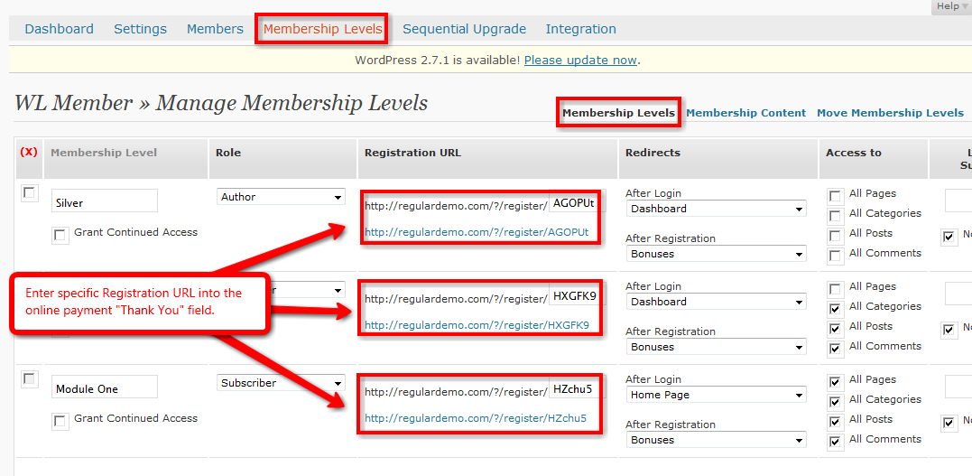
  - Copy product payment button/link and paste into desired WordPress Post or Page and click “Publish” button.
- Complete a test purchase to confirm settings:
  - Navigate to created payment button.
  - Run through payment process completely with valid credit card. As a note, the product price can be changed in the online payment system to $1 during testing if desired.
  - Register for Membership Level. Be sure to not use an email that is currently in the WishList Member database either as a member or the main admin email.
Screenshot:
http://screencast.com/t/CEr1ykANs

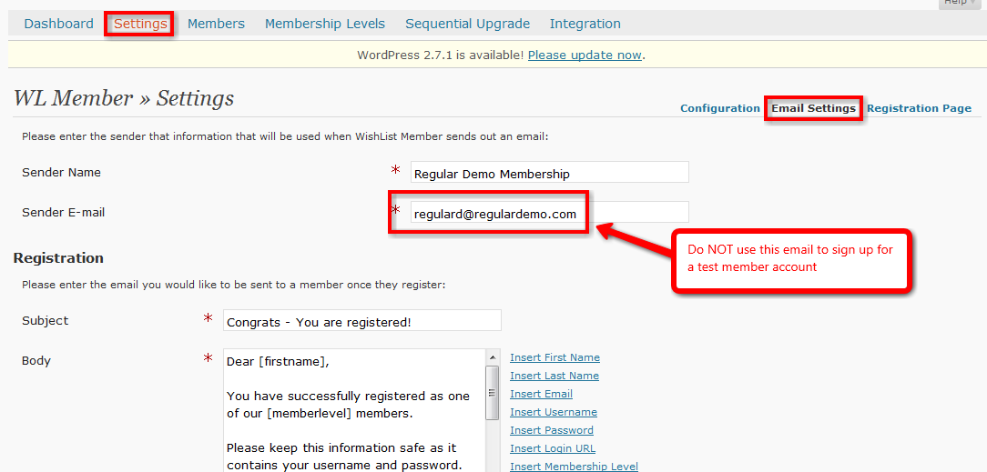
  - Once completed, confirm that a member has been created in the Members tab and that payment has been received in the online payment system.
  - If new member is not created or payment did not go through, check above steps to ensure set up was done correctly.
  - Issue refund of test purchase.
- Import/Add Members if necessary:
  - Login to WordPress
  - Navigate to WishList Member Dashboard by selecting “WL Member” in the PlugIns section.
Screenshot:
http://screencast.com/t/znvrKkzwwI
  - Navigate to WishList Member Members tab and Import sub tab.
  - Fill in the field accordingly. Ensure that .CSV file to be imported matches the sample .CSV file provided. Note that you will need to remove the header row BEFORE importing.
Note that it is important to ensure that ALL passwords are a minimum of 8 characters long.
Screenshot:
http://screencast.com/t/g5XDk1wt

  - When complete, click the “Import Members” button.
For more details, please view the Importing and Exporting Members video:
http://member.wpwishlist.com/17-importing-and-exporting-members-wp27/
- Add Protected/Non-Protected content accordingly:

There are 2 methods that can be utilized when creating protected content:
  - Individually as Pages or Posts are created:
    - Login to WordPress.
    - Navigate to Pages or Posts section and create new Page or Post.
    - After inputting content, scroll down to WishList member section.
    - Select IF this Page or Post should be protected using the radio button.
    - Select which membership level(s) have access to this Page or Post using the check boxes.
Screenshot:
http://screencast.com/t/1DT5ePc73
    - Once complete, click the “Publish” button.
  - Using a blanket method once Pages or Posts have been created:
    - Login to WordPress.
    - Navigate to WishList Member Dashboard by selecting “WL Member” in the PlugIns section.
    - Navigate to WishList Member Membership Levels tab and Membership Content sub tab.
Screenshot:
http://screencast.com/t/bpdZHHm4
    - Select a membership level to manage using the dropdown.
    - Select the desired content to manage using the options on the far right of page (Categories, Pages, Posts, Comments).
    - Click the corresponding check boxes to allow membership access to that specific content.
    - When complete, click the “Grant Access” button.
Screenshot:
http://screencast.com/t/9k2P76rQC

For more details, please view the Protecting Specific Content video:
http://member.wpwishlist.com/21-protecting-specific-content-wp27/

G. Setup – Paid Membership Level – SIMPLE Integration – 1Shopping Cart

Currently WishList member offers a variation of SIMPLE integration with 1Shopping Cart. Simple Integration allows a quick and easy integration between WishList Member and 1Shopping Cart. If a member cancels payment or doesn't pay for some reason, an admin will have to manually cancel the member within WishList Member. The added security bonus that 1Shopping Cart integration offers is the protection of the Registration URL.

- Create Membership Level:
- Login to WordPress.
- Navigate to WishList Member Dashboard by selecting “WL Member” in the PlugIns section.
Screenshot:
http://screencast.com/t/znvrKkzwwI
- Navigate to the Membership Levels tab and then the Membership Levels sub-tab.
Screenshot:
http://screencast.com/t/PGJcGYkfmX
- Scroll to the bottom of the page and the fields within the Add New Member section can be filled in accordingly.
- Level Name: The desired membership level name.
- Grant Continued Access: Allows the option to continue member’s access to purchased content AFTER membership cancelation OR access can be STOPPED after cancellation.
- Role: Allows option to set specific membership role.
      - Subscribers - can view content only.
      - Contributors - can read and create posts/pages that must be approved before posting.
      - Authors - can create posts/pages that do not need to be approved.
      - Editors - can approve edit and create any posts/pages.
- Registration URL: Displays modifiable membership level Registration URL.
- After Login Redirect: Allows option to set specific After Login page.
- After Registration Redirect: Allows option to set specific After Registration page.
- Access to: Allows option to set blank security protection.
- Length of Subscription: Allows option to set length of subscription in days, weeks, months or years.
- No Expiry Date: Allows option to set Expiry date for Membership level.
- Once options are set, click “Save Settings” on bottom right of the page or all work will be lost.
Screenshot:
http://screencast.com/t/8c0sjIt9YyP

- Create Error Pages:
- Login to WordPress.
- Navigate to Pages section and click “Add New”.
Screenshot:
http://screencast.com/t/YdmLdW3Aj0
- Create standard WordPress pages for Non-Member, Wrong Membership Level and Membership Cancelled error pages.
- Create After Registration/After Login Redirect Pages:
- Login to WordPress.
- Navigate to Pages section and click “Add New”.
Screenshot:
http://screencast.com/t/YdmLdW3Aj0
- Create standard WordPress pages for After Registration and After Login pages.

- Set Error/Login/Registration Redirect Defaults in Settings:

- Login to WordPress.
- Navigate to WishList Member Dashboard by selecting “WL Member” in the PlugIns section.
Screenshot:
http://screencast.com/t/znvrKkzwwI
- Navigate to WishList Member Settings tab.
Screenshot:
http://screencast.com/t/301A8m6d
- Set the desired Error, After Registration and After Login Pages using the appropriate dropdowns.
Screenshot:
http://screencast.com/t/vUx1B1x7

- Scroll to the bottom of the page and click “Save Settings” button on the left or all work will be lost.
Screenshot:
http://screencast.com/t/C0Vz5v3i

- Set Login/Registration Redirects for individual Membership Levels if necessary:
- Login to WordPress.
- Navigate to WishList Member Dashboard by selecting “WL Member” in the PlugIns section.
Screenshot:
http://screencast.com/t/znvrKkzwwI
- Navigate to the Membership Levels tab and then the Membership Levels sub-tab.
Screenshot:
http://screencast.com/t/PGJcGYkfmX
- Set individual After Registration and After Login pages accordingly using the appropriate dropwdowns for each Membership Level.
Screenshot:
http://screencast.com/t/amdOoFqin

- Scroll to the bottom of the page and click “Save Settings” button on the left or all work will be lost.
Screenshot:
http://screencast.com/t/OKD0d4YZJ

- Create Registration Pages:
  - The Registration page for each membership level can be customized by adding HTML above and below.
To accomplish this, navigate to the "Settings” tab and “Registration Page" sub tab. Next, select the desired membership level and then simply enter the HTML above and below.
Screenshot:
http://screencast.com/t/nQf3g3gVQ
- Integrate with 1Shopping Cart:
- Login to WordPress.
- Navigate to WishList Member Dashboard by selecting “WL Member” in the PlugIns section.
Screenshot:
http://screencast.com/t/znvrKkzwwI
- Navigate to the Integration tab.
- Select 1Shopping Cart from the Select System drop down.
Screenshot:
http://screencast.com/t/R2qhc8iQ

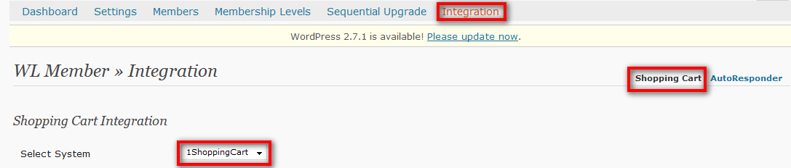
- Scroll to the bottom of the page and copy the selected SKU of the desired membership level.
Screenshot:
http://screencast.com/t/v2l5Ke5me

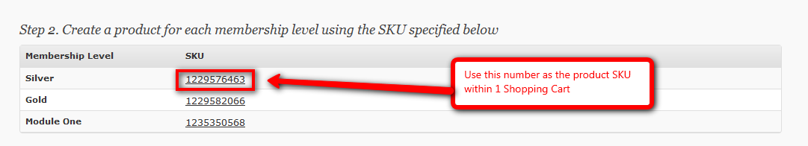
- Login to 1Shopping Cart.
- Create corresponding product for Membership Level using SKU obtained from WishList Member.
Screenshot:
http://screencast.com/t/cQshdCsL3

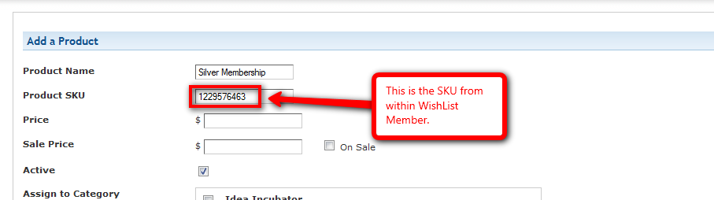
- Return to Integration tab with WishList Member and copy the displayed “Thank You URL”. Note that this unique URL is to be used for ALL Membership Level.
Screenshot:
http://screencast.com/t/D7rQ85u28le

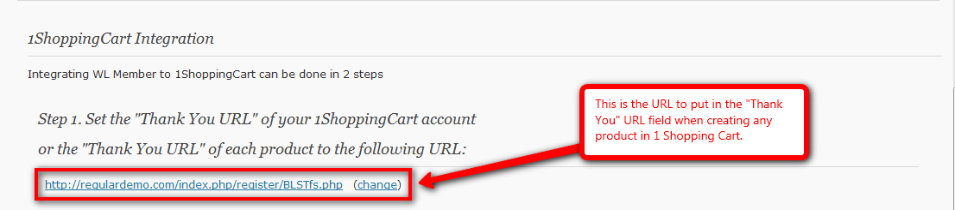
- Return to 1Shopping Cart and enter copied “Thank You URL” accordingly.
Screenshot:
http://screencast.com/t/llOBCwrJOJm

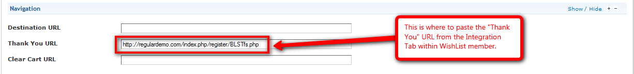
- Click “Create” button on bottom of page to create product within 1Shopping Cart.
Screenshot:
http://screencast.com/t/E2cxH7Byvd

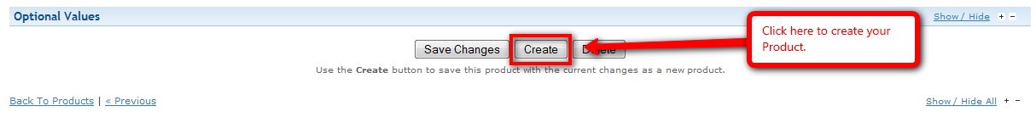
- Once product is created, insert the appropriate link/payment button into desired WordPress Page or Post.
For more details, please view the 1Shopping Cart Integration video: http://member.wpwishlist.com/24-1shoppingcart-integration/

- Complete a test purchase to confirm settings:
- Navigate to created payment button.
- Run through payment process completely with valid credit card. As a note, the product price can be changed in the online payment system to $1 during testing if desired.
- Register for Membership Level. Be sure to not use an email that is currently in the WishList Member database either as a member or the main admin email.
Screenshot:
http://screencast.com/t/y0PbvzVUY

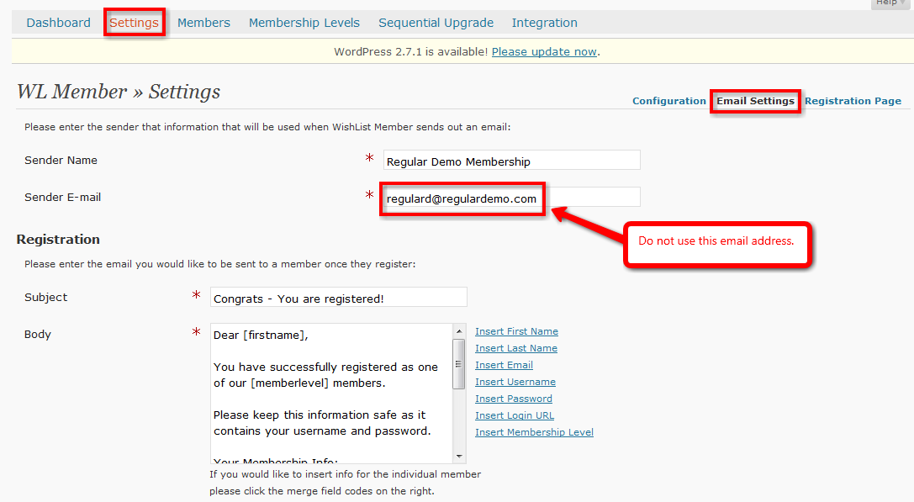
- Once completed, confirm that a member has been created in the Members tab and that payment has been received in 1Shopping Cart.
- If new member is not created or payment did not go through, check above steps to ensure set up was done correctly.
- Issue refund of test purchase.

- Import/Add Members if necessary:
- Login to WordPress.
- Navigate to WishList Member Dashboard by selecting “WL Member” in the PlugIns section.
Screenshot:
http://screencast.com/t/znvrKkzwwI
- Navigate to WishList Member Members tab and Import sub tab.
- Fill in the field accordingly. Ensure that .CSV file to be imported matches the sample .CSV file provided. Note that you will need to remove the header row BEFORE importing.
Note that it is important to ensure that ALL passwords are a minimum of 8 characters long.
Screenshot:
http://screencast.com/t/g5XDk1wt

- When complete, click the “Import Members” button.
For more details, please view the Importing and Exporting Members video:
http://member.wpwishlist.com/17-importing-and-exporting-members-wp27/

- Add Protected/Non-Protected content accordingly:

There are 2 methods that can be utilized when creating protected content:
- Individually as Pages or Posts are created:
- Login to WordPress.
- Navigate to Pages or Posts section and create new Page or Post.
- After inputting content, scroll down to WishList member section.
- Select IF this Page or Post should be protected using the radio button.
- Select which membership level(s) have access to this Page or Post using the check boxes.
Screenshot:
http://screencast.com/t/1DT5ePc73
- Once complete, click the “Publish” button.
- Using a blanket method once Pages or Posts have been created:
- Login to WordPress.
- Navigate to WishList Member Dashboard by selecting “WL Member” in the PlugIns section.
- Navigate to WishList Member Membership Levels tab and Membership Content sub tab.
Screenshot:
http://screencast.com/t/bpdZHHm4
- Select a membership level to manage using the dropdown.
- Select the desired content to manage using the options on the far right of page (Categories, Pages, Posts, Comments).
- Click the corresponding check boxes to allow membership access to that specific content.
- When complete, click the “Grant Access” button.
Screenshot:
http://screencast.com/t/9k2P76rQC

For more details, please view the Protecting Specific Content video:
http://member.wpwishlist.com/21-protecting-specific-content-wp27/

H. Setup – Paid Membership Level – FULL Integration – PayPal

Full Integration allows complete integration with select online payment systems. Currently, these systems include PayPal, ClickBank and QuickPayPro. What FULL integration means is that if a user cancels payment within the online payment system, it will communicate this with WishList Member and cancel that user’s membership while also blocking access to that membership level content.

- Create Membership Level:
- Login to WordPress.
- Navigate to WishList Member Dashboard by selecting “WL Member” in the PlugIns section.
Screenshot:
http://screencast.com/t/znvrKkzwwI
- Navigate to the Membership Levels tab and then the Membership Levels sub-tab.
Screenshot:
http://screencast.com/t/PGJcGYkfmX
- Scroll to the bottom of the page and the fields within the Add New Member section can be filled in accordingly.
- Level Name: The desired membership level name.
- Grant Continued Access: Allows the option to continue member’s access to purchased content AFTER membership cancelation OR access can be STOPPED after cancellation.
- Role: Allows option to set specific membership role.
      - Subscribers - can view content only.
      - Contributors - can read and create posts/pages that must be approved before posting.
      - Authors - can create posts/pages that do not need to be approved.
      - Editors - can approve edit and create any posts/pages.
- Registration URL: Displays modifiable membership level Registration URL.
- After Login Redirect: Allows option to set specific After Login page.
- After Registration Redirect: Allows option to set specific After Registration page.
- Access to: Allows option to set blank security protection.
- Length of Subscription: Allows option to set length of subscription in days, weeks, months or years.
- No Expiry Date: Allows option to set Expiry date for Membership level.
- Once options are set, click “Save Settings” on bottom right of the page or all work will be lost.
Screenshot:
http://screencast.com/t/8c0sjIt9YyP

- Create Error Pages:
- Login to WordPress.
- Navigate to Pages section and click “Add New”.
Screenshot:
http://screencast.com/t/YdmLdW3Aj0
- Create standard WordPress pages for Non-Member, Wrong Membership Level and Membership Cancelled error pages.
- Create After Registration/After Login Redirect Pages:
- Login to WordPress.
- Navigate to Pages section and click “Add New”.
Screenshot:
http://screencast.com/t/YdmLdW3Aj0
- Create standard WordPress pages for After Registration and After Login pages.

- Set Error/Login/Registration Redirect Defaults in Settings:

- Login to WordPress.
- Navigate to WishList Member Dashboard by selecting “WL Member” in the PlugIns section.
Screenshot:
http://screencast.com/t/znvrKkzwwI
- Navigate to WishList Member Settings tab.
Screenshot:
http://screencast.com/t/301A8m6d
- Set the desired Error, After Registration and After Login Pages using the appropriate dropdowns.
Screenshot:
http://screencast.com/t/vUx1B1x7

- Scroll to the bottom of the page and click “Save Settings” button on the left or all work will be lost.
Screenshot:
http://screencast.com/t/C0Vz5v3i

- Set Login/Registration Redirects for individual Membership Levels if necessary:
- Login to WordPress.
- Navigate to WishList Member Dashboard by selecting “WL Member” in the PlugIns section.
Screenshot:
http://screencast.com/t/znvrKkzwwI
- Navigate to the Membership Levels tab and then the Membership Levels sub-tab.
Screenshot:
http://screencast.com/t/PGJcGYkfmX
- Set individual After Registration and After Login pages accordingly using the appropriate dropwdowns for each Membership Level.
Screenshot:
http://screencast.com/t/amdOoFqin
- Scroll to the bottom of the page and click “Save Settings” button on the left or all work will be lost.
Screenshot:
http://screencast.com/t/OKD0d4YZJ

- Integrate with PayPal:

- Login to PayPal.
- Navigate to “Edit Profile” section.
Screenshot:
http://screencast.com/t/rBzEuGtu

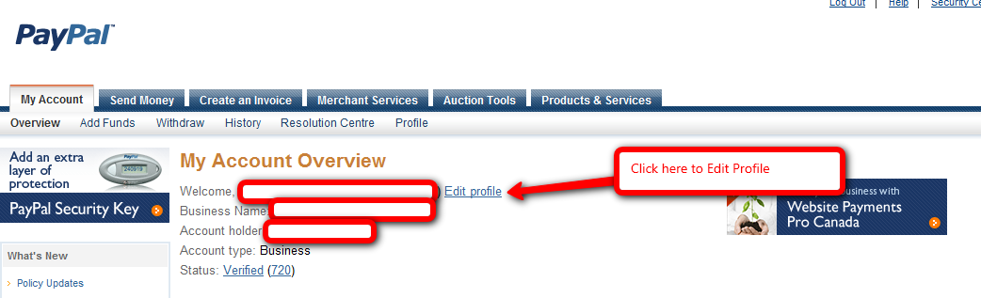
- Click on “Website Payment Preferences”.
Screenshot:
http://screencast.com/t/TFIFJyrtX
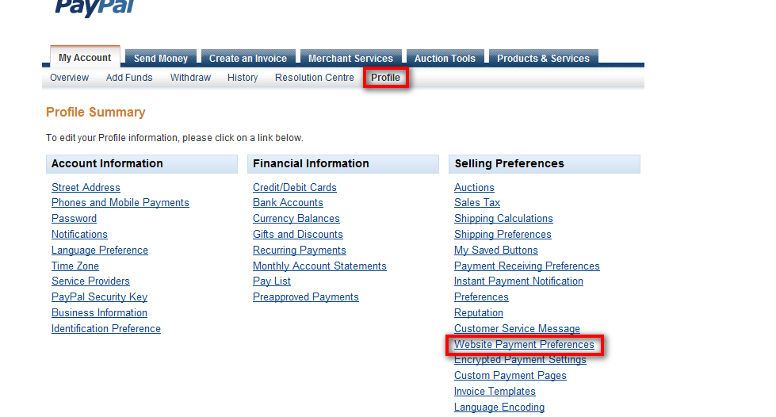
- Configure PayPal Settings – Auto Return and Payment Data Transfer.
- Select the “On” radio button for each of these options.
Screenshot:
http://screencast.com/t/XkGdSf60

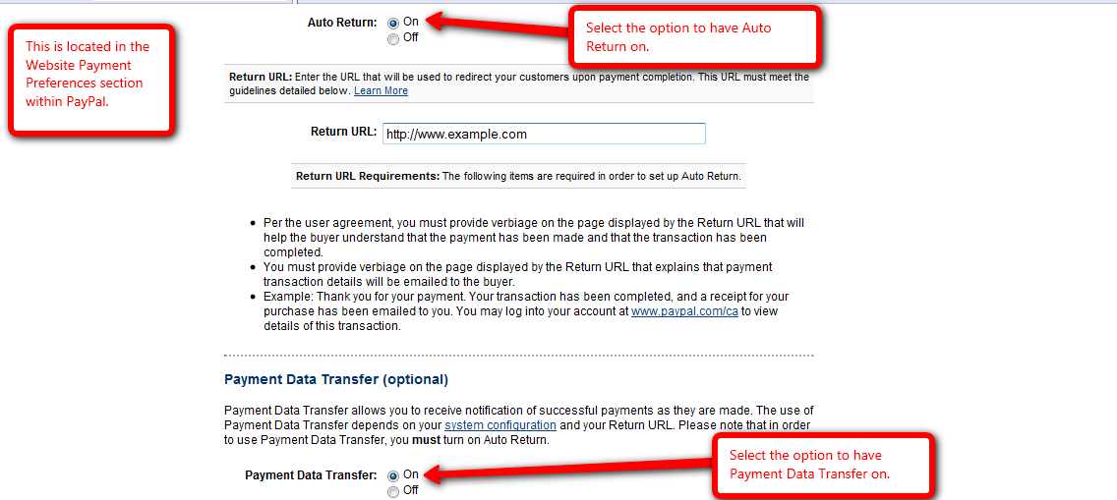

- Configure PayPal Settings – Return URL.

- Any link can be used for Return URL as long as it is NOT blank. A recommended link is the Home Page.
Screenshot:
http://screencast.com/t/qn88zBB47

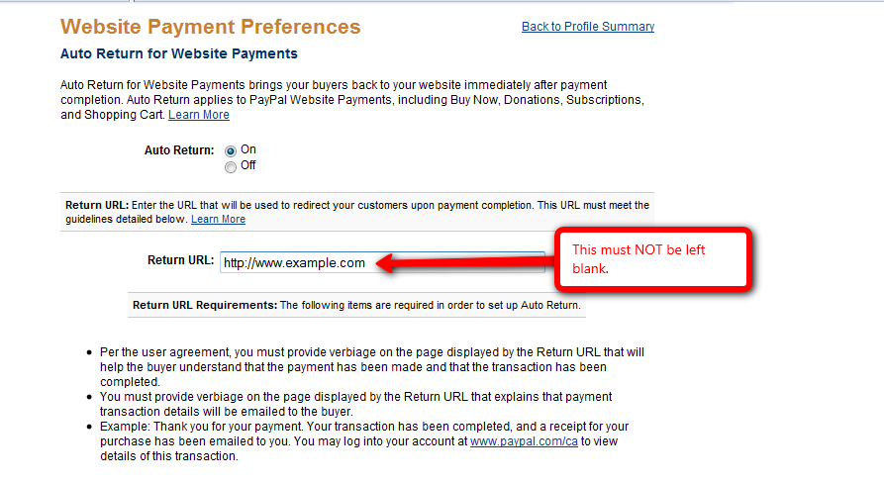

- Configure PayPal Settings – PDT Identity Token.
- Copy PDT Identity Token from PayPal.
Screenshot:
http://screencast.com/t/7fCmD4r2

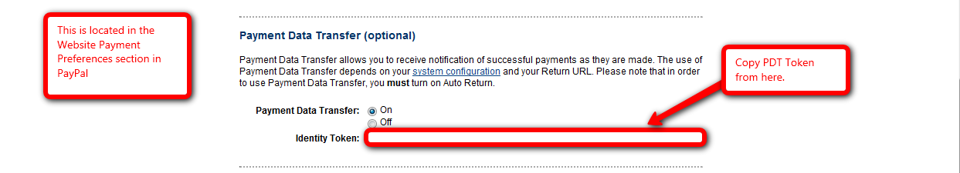
- Login to WordPress.
- Navigate to WishList Member Dashboard by selecting “WL Member” in the PlugIns section.
Screenshot:
http://screencast.com/t/znvrKkzwwI
- Navigate to the Integration tab.
Screenshot:
http://screencast.com/t/INQmSucC
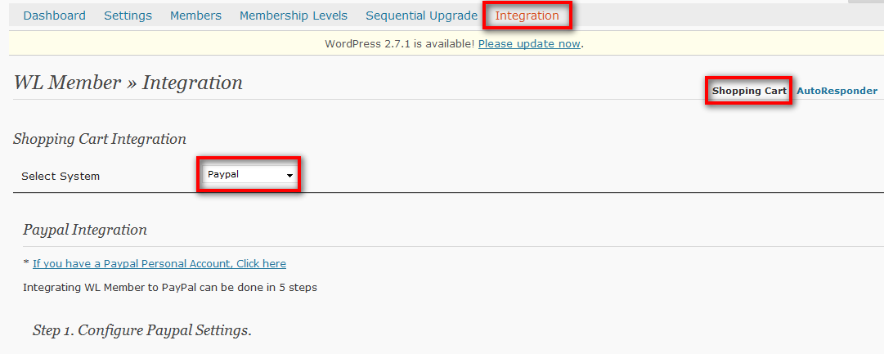
- Paste in copied PDT Identity Token accordingly and click “save” button.
Screenshot:
http://screencast.com/t/7mHF46U0

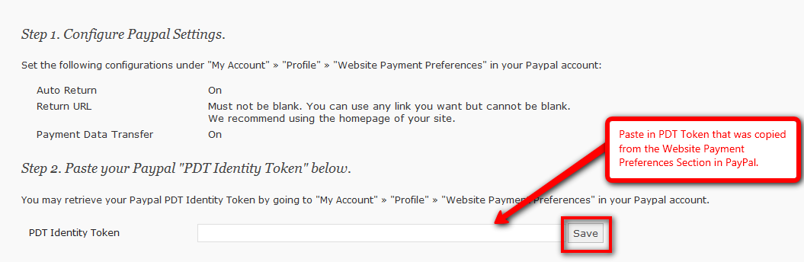

- Return to PayPal and navigate to “Merchant Services” section.
Screenshot:
http://screencast.com/t/0I0MtQhepw
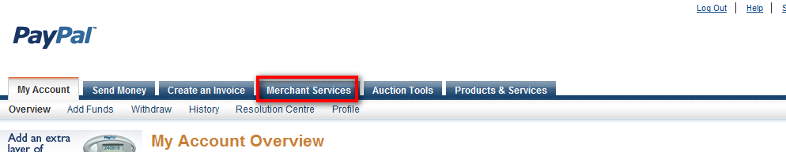
- Click on the “Buy Now” button.
Screenshot:
http://screencast.com/t/TRP67pbwhi
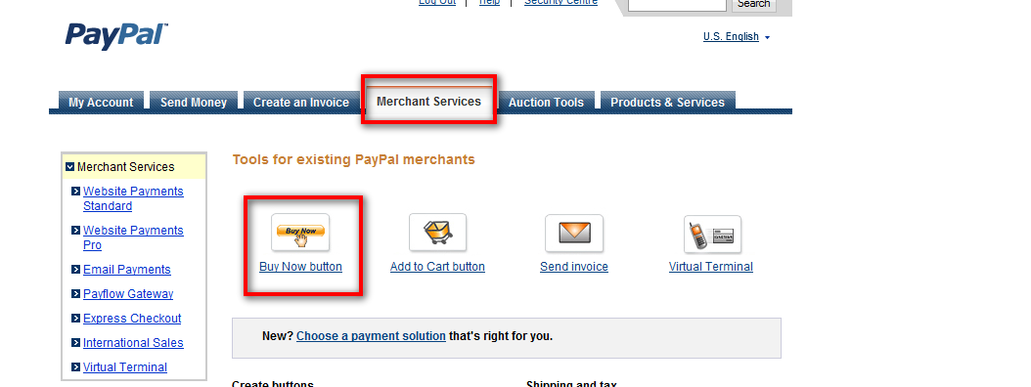
- Set “Accept Payments For” dropdown accordingly.
- Select the “No” option to create “Buy Now” button.
Screenshot:
http://screencast.com/t/w3gOz2G9P
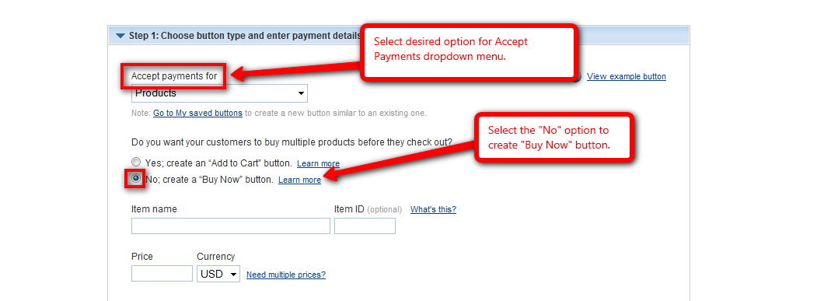

- Return to Integration tab within WishList Member and copy the displayed “Item/Subscription ID” for desired Membership Level.
Screenshot:
http://screencast.com/t/cQsQOvZxTrX
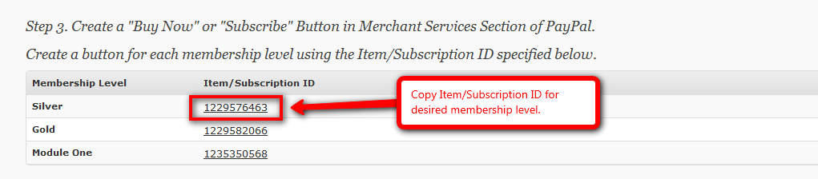
- Return to PayPal and navigate to “Merchant Services” section.
Screenshot:
http://screencast.com/t/7mHF46U0

- Select Price and Currency and enter the description of the product accordingly.
- Paste the “Item/Subscription ID into the Item ID field.
Screenshot:
http://screencast.com/t/LX6FCZ5Bnr
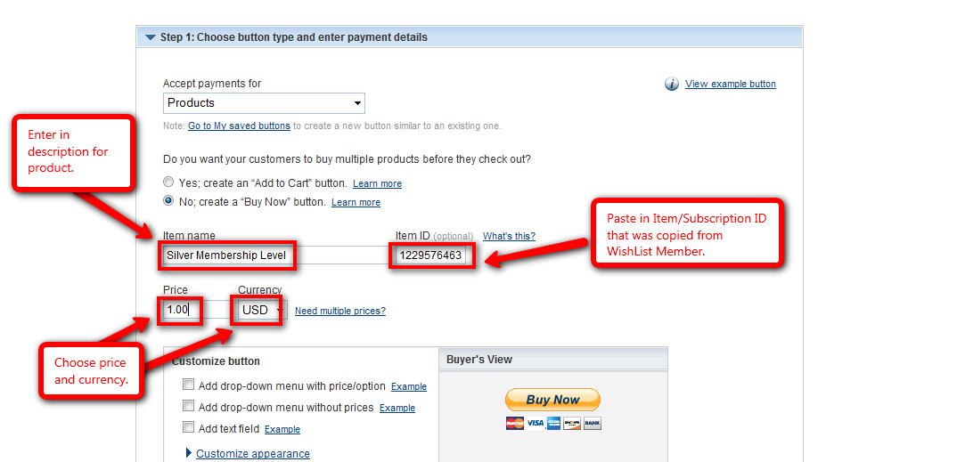
Note that the Step 1 section within PayPal is now complete.
- Within the Step 2 section of PayPal, select the “save button at PayPal” option.
Screenshot:
http://screencast.com/t/rUP5SlvJ
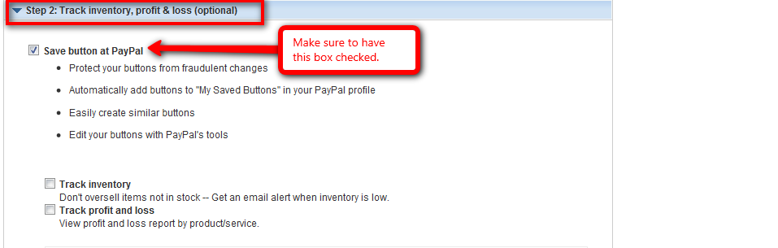
Note that the Step 2 section within PayPal is now complete.
- Within the Step 3 section of PayPal, select the “No” option for “Do you want to let your customers change order quantities”.
Screenshot:
http://screencast.com/t/77HlkVieqB
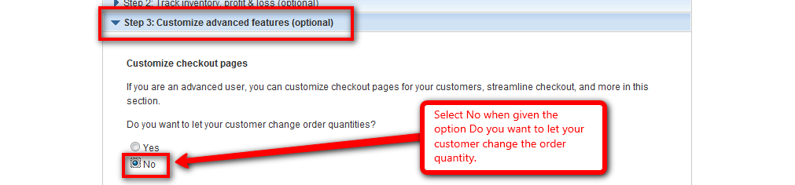
- Return to Integration tab within WishList Member and copy the displayed “Thank You URL”.
Screenshot:
http://screencast.com/t/oZOq4iiHlM
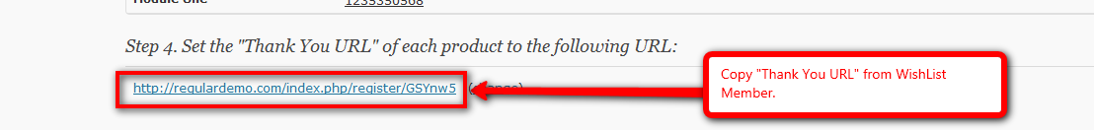
- Return to PayPal and navigate to “Merchant Services” section and paste the copied “Thank You URL” into the “Take customer to specific page (URL) after successful checkout” field.
Screenshot:
http://screencast.com/t/NSBRagOAR

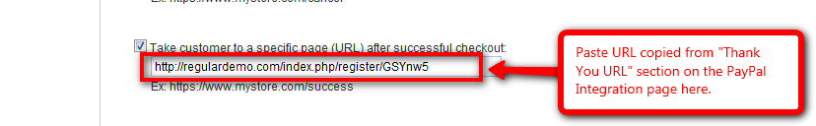
- Return to Integration tab within WishList Member and copy the displayed “Advanced Variables” code.
Screenshot:
http://screencast.com/t/3aeCFv7mJBW
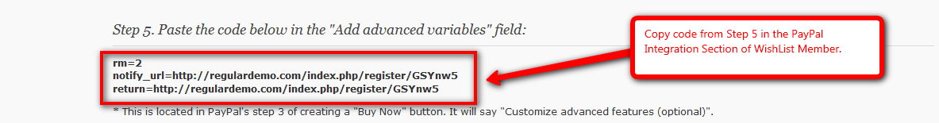
- Return to “Merchant Services” section within PayPal and paste the copied “Advanced Variables” code into the “Add advanced variables field”.
Screenshot:
http://screencast.com/t/CYprOpEQd
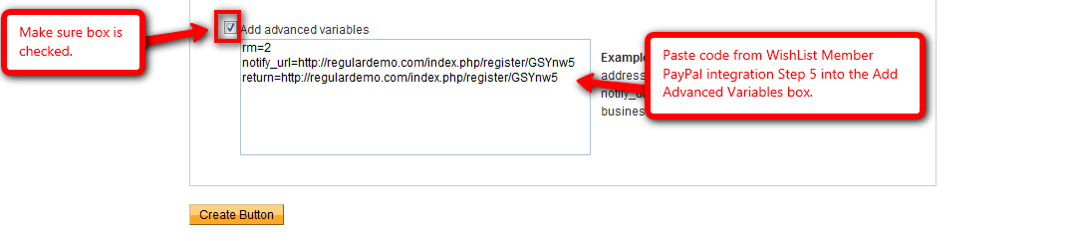
- Once product is created, return to WishList Member and insert the appropriate link/payment button into desired WordPress Page or Post.
For more details, please view the PayPal Integration video:
http://member.wpwishlist.com/23-paypal-integration-wp27/

- Complete a test purchase to confirm settings:
- Navigate to created payment button.
- Run through payment process completely with valid credit card. As a note, the product price can be changed in the online payment system to $1 during testing if desired.
- Register for Membership Level. Be sure to not use an email that is currently in the WishList Member database either as a member or the main admin email.
Screenshot:
http://screencast.com/t/y0PbvzVUY

- Once completed, confirm that a member has been created in the Members tab and that payment has been received in PayPal.
- If new member is not created or payment did not go through, check above steps to ensure set up was done correctly.
- Issue refund of test purchase.

- Import/Add Members if necessary:
- Login to WordPress.
- Navigate to WishList Member Dashboard by selecting “WL Member” in the PlugIns section.
Screenshot:
http://screencast.com/t/znvrKkzwwI
- Navigate to WishList Member Members tab and Import sub tab.
- Fill in the field accordingly. Ensure that .CSV file to be imported matches the sample .CSV file provided.
Note that it is important to ensure that ALL passwords are a minimum of 8 characters long.
Screenshot:
http://screencast.com/t/I2YgxxSj

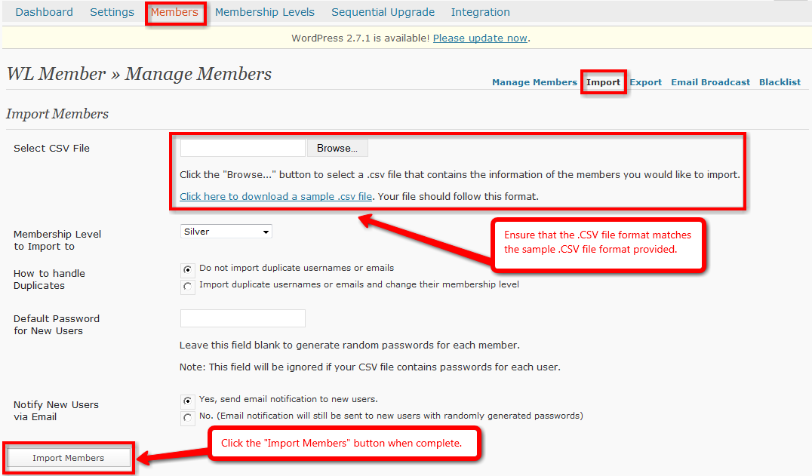
- When complete, click the “Import Members” button.
For more details, please view the Importing and Exporting Members video:
http://member.wpwishlist.com/17-importing-and-exporting-members-wp27/

- Add Protected/Non-Protected content accordingly:
There are 2 methods that can be utilized when creating protected content:
- Individually as Pages or Posts are created:
- Login to WordPress.
- Navigate to Pages or Posts section and create new Page or Post.
- After inputting content, scroll down to WishList member section.
- Select IF this Page or Post should be protected using the radio button.
- Select which membership level(s) have access to this Page or Post using the check boxes.
Screenshot:
http://screencast.com/t/1DT5ePc73
- Once complete, click the “Publish” button.

- Using a blanket method once Pages or Posts have been created:
- Login to WordPress.
- Navigate to WishList Member Dashboard by selecting “WL Member” in the PlugIns section.
- Navigate to WishList Member Membership Levels tab and Membership Content sub tab.
Screenshot:
http://screencast.com/t/bpdZHHm4
- Select a membership level to manage using the dropdown.
- Select the desired content to manage using the options on the far right of page (Categories, Pages, Posts, Comments).
- Click the corresponding check boxes to allow membership access to that specific content.
- When complete, click the “Grant Access” button.
Screenshot:
http://screencast.com/t/9k2P76rQC

For more details, please view the Protecting Specific Content video:
http://member.wpwishlist.com/21-protecting-specific-content-wp27/

I. Setup – Paid Membership Level – FULL Integration – QuickPayPro

Full Integration allows complete integration with select online payment systems. Currently, these systems include PayPal, ClickBank and QuickPayPro. What FULL integration means is that if a user cancels payment within the online payment system, it will communicate this with WishList Member and cancel that user’s membership while also blocking access to that membership level content.

- Create Membership Level:
- Login to WordPress.
- Navigate to WishList Member Dashboard by selecting “WL Member” in the PlugIns section.
Screenshot:
http://screencast.com/t/znvrKkzwwI
- Navigate to the Membership Levels tab and then the Membership Levels sub-tab.
Screenshot:
http://screencast.com/t/PGJcGYkfmX
- Scroll to the bottom of the page and the fields within the Add New Member section can be filled in accordingly.
- Level Name: The desired membership level name.
- Grant Continued Access: Allows the option to continue member’s access to purchased content AFTER membership cancelation OR access can be STOPPED after cancellation.
- Role: Allows option to set specific membership role.
- Subscribers - can view content only.
- Contributors - can read and create posts/pages that must be approved before posting.
- Authors - can create posts/pages that do not need to be approved.
- Editors - can approve edit and create any posts/pages.
- Registration URL: Displays modifiable membership level Registration URL.
- After Login Redirect: Allows option to set specific After Login page.
- After Registration Redirect: Allows option to set specific After Registration page.
- Access to: Allows option to set blank security protection.
- Length of Subscription: Allows option to set length of subscription in days, weeks, months or years.
- No Expiry Date: Allows option to set Expiry date for Membership level.
- Once options are set, click “Save Settings” on bottom right of the page or all work will be lost.
Screenshot:
http://screencast.com/t/8c0sjIt9YyP

- Create Error Pages:
- Login to WordPress.
- Navigate to Pages section and click “Add New”.
Screenshot:
http://screencast.com/t/YdmLdW3Aj0
- Create standard WordPress pages for Non-Member, Wrong Membership Level and Membership Cancelled error pages.
- Create After Registration/After Login Redirect Pages:
- Login to WordPress.
- Navigate to Pages section and click “Add New”.
Screenshot:
http://screencast.com/t/YdmLdW3Aj0
- Create standard WordPress pages for After Registration and After Login pages.

- Set Error/Login/Registration Redirect Defaults in Settings:

- Login to WordPress.
- Navigate to WishList Member Dashboard by selecting “WL Member” in the PlugIns section.
Screenshot:
http://screencast.com/t/znvrKkzwwI
- Navigate to WishList Member Settings tab.
Screenshot:
http://screencast.com/t/301A8m6d
- Set the desired Error, After Registration and After Login Pages using the appropriate dropdowns.
Screenshot:
http://screencast.com/t/vUx1B1x7

- Scroll to the bottom of the page and click “Save Settings” button on the left or all work will be lost.
Screenshot:
http://screencast.com/t/C0Vz5v3i

- Set Login/Registration Redirects for individual Membership Levels if necessary:
- Login to WordPress.
- Navigate to WishList Member Dashboard by selecting “WL Member” in the PlugIns section.
Screenshot:
http://screencast.com/t/znvrKkzwwI
- Navigate to the Membership Levels tab and then the Membership Levels sub-tab.
Screenshot:
http://screencast.com/t/PGJcGYkfmX
- Set individual After Registration and After Login pages accordingly using the appropriate dropwdowns for each Membership Level.
Screenshot:
http://screencast.com/t/amdOoFqin

- Scroll to the bottom of the page and click “Save Settings” button on the left or all work will be lost.
Screenshot:
http://screencast.com/t/OKD0d4YZJ

- Integrate with QuickPayPro:
  - Login to QuickPayPro.
  - Click Products tab in top navigation bar.
  - Click “Add” under the Products section in the left column navigation to add a new product.
  - Fill in “Add/Edit Product” form accordingly.
  - Then click “Next” button.
Screenshot:
http://screencast.com/t/9l9FNd4MyT
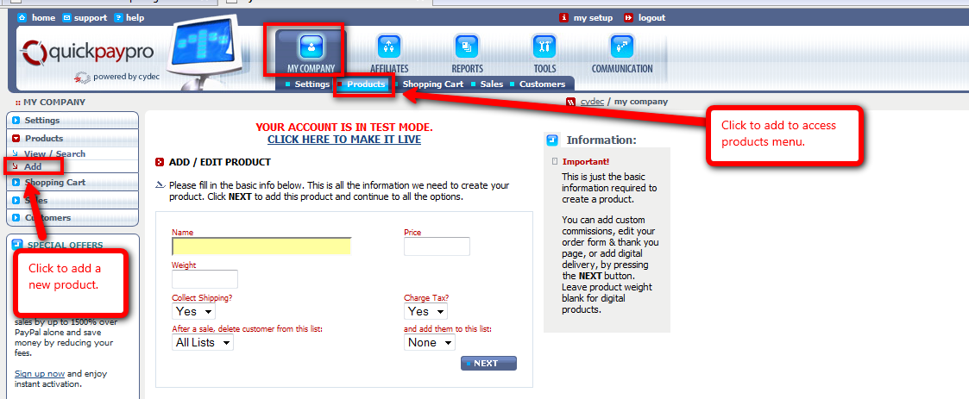
  - Fill out any option fields in the “Advanced/Order Form” accordingly.
  - Then click the “Save” button.
Screenshot:
http://screencast.com/t/XTrMtEyfQ
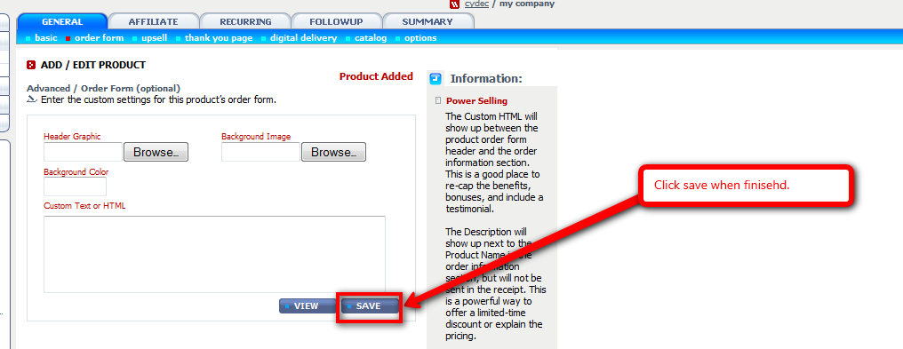
  - Click on the Recurring tab if desired, fill in form accordingly and click “Save” button. Note that this is to be used if payment needs to be received on a repeated basis.
Screenshot:
http://screencast.com/t/zuA9k90B
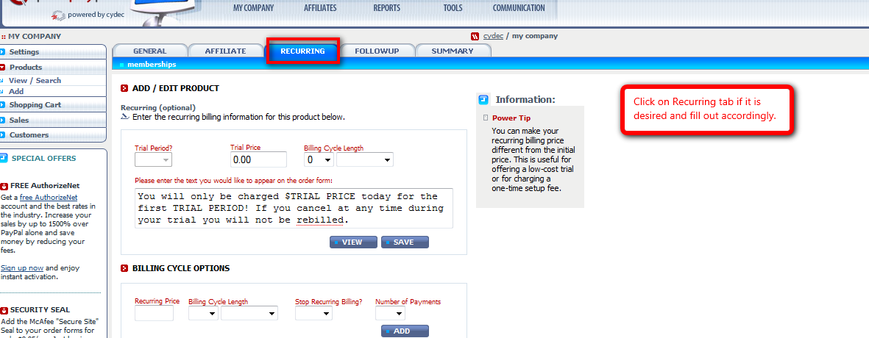
  - Click on the Recurring tab and then the Membership sub tab. Select WishList Member from the dropdown and click “Choose”.
Screenshot:
http://screencast.com/t/qSho7ZiYu
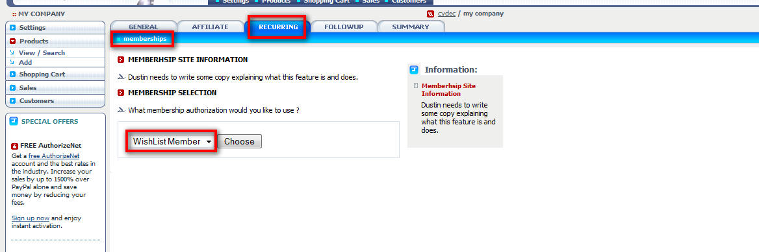
  - The “Add New WishList Member” box will appear containing a default URL.
  - Login to WordPress.
- Navigate to WishList Member Dashboard by selecting “WL Member” in the PlugIns section.
Screenshot:
http://screencast.com/t/znvrKkzwwI
  - Navigate to the Integration tab.
  - Select QuickPayPro from the Select System dropdown and copy the displayed “Post to URL”.
Screenshot:
http://screencast.com/t/DZjgt6vG
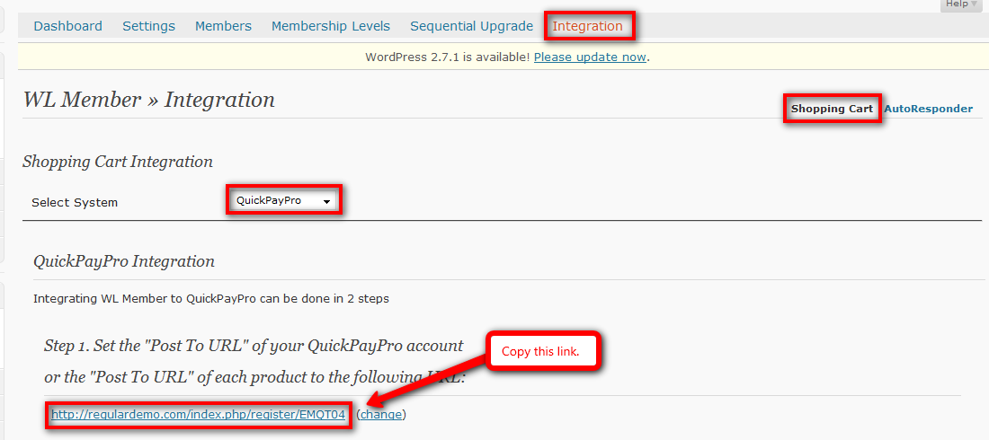
  - Return to QuickPayPro and paste the copied URL into the “Send membership info to the following URL” field.
Screenshot:
http://screencast.com/t/I76sxBzENb
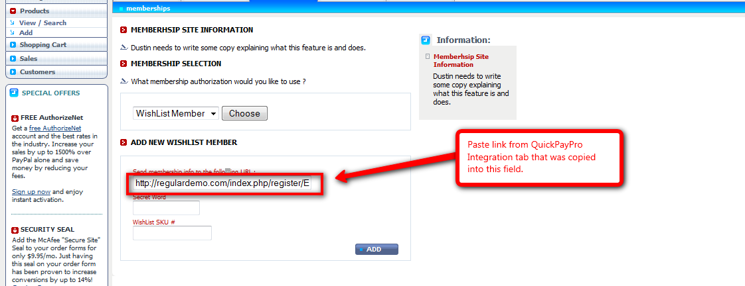
  - Return to WishList Member and copy the displayed “Secret Word”.
Screenshot:
http://screencast.com/t/YpmlyuewlfG
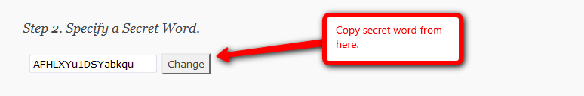
  - Return to QuickPayPro and paste the copied “Secret Word” into the “Secret Word” field.
Screenshot:
http://screencast.com/t/IZIUF6ub

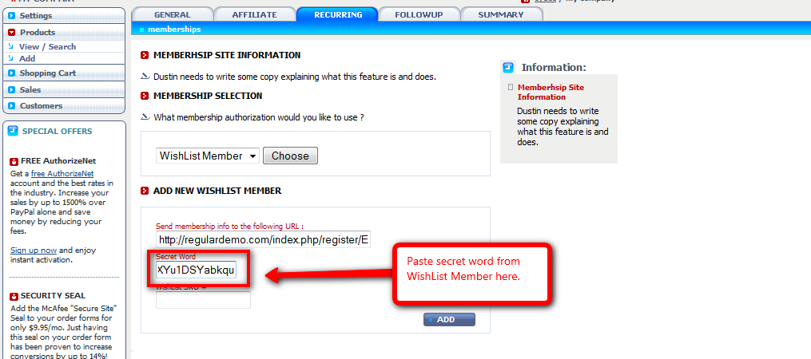
  - Return to WishList Member and copy the displayed membership level SKU.
Screenshot:
http://screencast.com/t/gLxeYQ4hkQ7

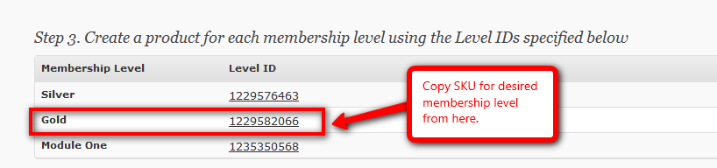
  - Return to QuickPayPro paste the copied “SKU” into the “SKU” field and click the “Add” button.
Screenshot:
http://screencast.com/t/6i0VPcNk
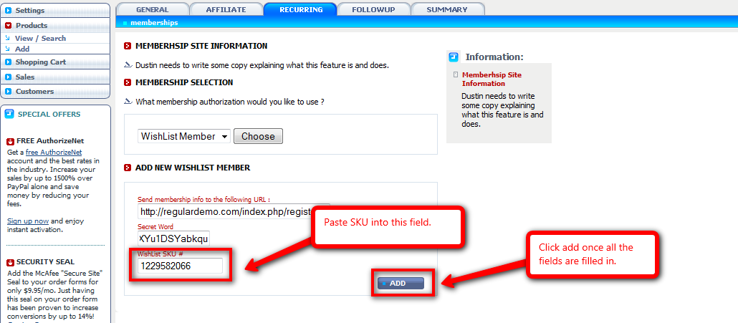
  - The Membership will now be set and the words “Membership Set” will be displayed on the top right of the page as confirmation.
Screenshot:
http://screencast.com/t/35FJyIptUMF
  - Once product is created, insert the appropriate link/payment button into desired WordPress Page or Post.
  - For more details, please view the QuickPayPro Integration video:
http://member.wpwishlist.com/25-quick-pay-pro-integration/

- Complete a test purchase to confirm settings:
- Navigate to created payment button.
- Run through payment process completely with valid credit card. As a note, the product price can be changed in the online payment system to $1 during testing if desired.
- Register for Membership Level. Be sure to not use an email that is currently in the WishList Member database either as a member or the main admin email.
Screenshot:
http://screencast.com/t/y0PbvzVUY
- Once completed, confirm that a member has been created in the Members tab and that payment has been received in PayPal.
- If new member is not created or payment did not go through, check above steps to ensure set up was done correctly.
- Issue refund of test purchase.

8) Import/Add Members if necessary:
- Login to WordPress.
- Navigate to WishList Member Dashboard by selecting “WL Member” in the PlugIns section.
Screenshot:
http://screencast.com/t/znvrKkzwwI
- Navigate to WishList Member Members tab and Import sub tab.
- Fill in the field accordingly. Ensure that .CSV file to be imported matches the sample .CSV file provided.
Note that it is important to ensure that ALL passwords are a minimum of 8 characters long.
Screenshot:
http://screencast.com/t/I2YgxxSj

- When complete, click the “Import Members” button.
For more details, please view the Importing and Exporting Members video:
http://member.wpwishlist.com/17-importing-and-exporting-members-wp27/

9) Add Protected/Non-Protected content accordingly:

There are 2 methods that can be utilized when creating protected content:
- Individually as Pages or Posts are created:
- Login to WordPress.
- Navigate to Pages or Posts section and create new Page or Post.
- After inputting content, scroll down to WishList member section.
- Select IF this Page or Post should be protected using the radio button.
- Select which membership level(s) have access to this Page or Post using the check boxes.
Screenshot:
http://screencast.com/t/1DT5ePc73
- Once complete, click the “Publish” button.

- Using a blanket method once Pages or Posts have been created:
- Login to WordPress.
- Navigate to WishList Member Dashboard by selecting “WL Member” in the PlugIns section.
- Navigate to WishList Member Membership Levels tab and Membership Content sub tab.
Screenshot:
http://screencast.com/t/bpdZHHm4
- Select a membership level to manage using the dropdown.
- Select the desired content to manage using the options on the far right of page (Categories, Pages, Posts, Comments).
- Click the corresponding check boxes to allow membership access to that specific content.
- When complete, click the “Grant Access” button.
Screenshot:
http://screencast.com/t/9k2P76rQC

For more details, please view the Protecting Specific Content video:
http://member.wpwishlist.com/21-protecting-specific-content-wp27/

J. Setup – Paid Membership Level – FULL Integration – ClickBank

Full Integration allows complete integration with select online payment systems. Currently, these systems include PayPal, ClickBank and QuickPayPro. What FULL integration means is that if a user cancels payment within the online payment system, it will communicate this with WishList Member and cancel that user’s membership while also blocking access to that membership level content.

- Create Membership Level:
- Login to WordPress.
- Navigate to WishList Member Dashboard by selecting “WL Member” in the PlugIns section.
Screenshot:
http://screencast.com/t/znvrKkzwwI
- Navigate to the Membership Levels tab and then the Membership Levels sub-tab.
Screenshot:
http://screencast.com/t/PGJcGYkfmX
- Scroll to the bottom of the page and the fields within the Add New Member section can be filled in accordingly.
- Level Name: The desired membership level name.
- Grant Continued Access: Allows the option to continue member’s access to purchased content AFTER membership cancelation OR access can be STOPPED after cancellation.
- Role: Allows option to set specific membership role.
- Subscribers - can view content only.
- Contributors - can read and create posts/pages that must be approved before posting.
- Authors - can create posts/pages that do not need to be approved.
- Editors - can approve edit and create any posts/pages.
- Registration URL: Displays modifiable membership level Registration URL.
- After Login Redirect: Allows option to set specific After Login page.
- After Registration Redirect: Allows option to set specific After Registration page.
- Access to: Allows option to set blank security protection.
- Length of Subscription: Allows option to set length of subscription in days, weeks, months or years.
- No Expiry Date: Allows option to set Expiry date for Membership level.
- Once options are set, click “Save Settings” on bottom right of the page or all work will be lost.
Screenshot:
http://screencast.com/t/8c0sjIt9YyP

- Create Error Pages:
- Login to WordPress.
- Navigate to Pages section and click “Add New”.
Screenshot:
http://screencast.com/t/YdmLdW3Aj0
- Create standard WordPress pages for Non-Member, Wrong Membership Level and Membership Cancelled error pages.
- Create After Registration/After Login Redirect Pages:
- Login to WordPress.
- Navigate to Pages section and click “Add New”.
Screenshot:
http://screencast.com/t/YdmLdW3Aj0
- Create standard WordPress pages for After Registration and After Login pages.

- Set Error/Login/Registration Redirect Defaults in Settings:

- Login to WordPress.
- Navigate to WishList Member Dashboard by selecting “WL Member” in the PlugIns section.
Screenshot:
http://screencast.com/t/znvrKkzwwI
- Navigate to WishList Member Settings tab.
Screenshot:
http://screencast.com/t/301A8m6d
- Set the desired Error, After Registration and After Login Pages using the appropriate dropdowns.
Screenshot:
http://screencast.com/t/vUx1B1x7

- Scroll to the bottom of the page and click “Save Settings” button on the left or all work will be lost.
Screenshot:
http://screencast.com/t/C0Vz5v3i

- Set Login/Registration Redirects for individual Membership Levels if necessary:
- Login to WordPress.
- Navigate to WishList Member Dashboard by selecting “WL Member” in the PlugIns section.
Screenshot:
http://screencast.com/t/znvrKkzwwI
- Navigate to the Membership Levels tab and then the Membership Levels sub-tab.
Screenshot:
http://screencast.com/t/PGJcGYkfmX
- Set individual After Registration and After Login pages accordingly using the appropriate dropwdowns for each Membership Level.
Screenshot:
http://screencast.com/t/amdOoFqin
- Scroll to the bottom of the page and click “Save Settings” button on the left or all work will be lost.
Screenshot:
http://screencast.com/t/OKD0d4YZJ

- Integrate with ClickBank:
  - Login to WordPress.
  - Navigate to WishList Member Dashboard by selecting “WL Member” in the PlugIns section.
Screenshot:
http://screencast.com/t/znvrKkzwwI
  - Navigate to the Integration tab.
  - Select “ClickBank” from the Select System dropdown.
Screenshot:
http://screencast.com/t/vj1QSHSaVO
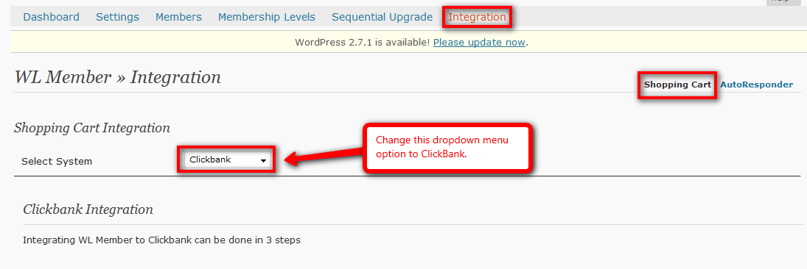
  - Login to ClickBank.
  - Click “Account Settings” tab and then “My Site” sub tab in top navigation bar.
Screenshot:
http://screencast.com/t/PteZ9fy4M57
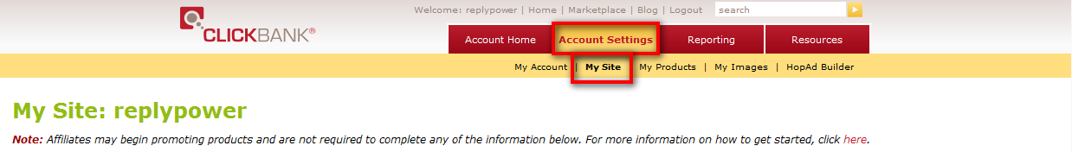
  - Scroll down to Advanced Tools and click “Edit” link.
Screenshot:
http://screencast.com/t/siWvuCyp
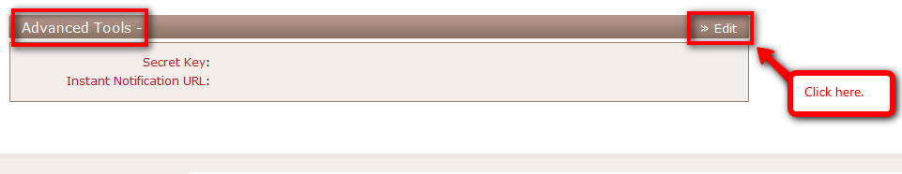
  - Return to WishList Member and copy the displayed “Secret Word”.
Screenshot:
http://screencast.com/t/q0f1RHTRb

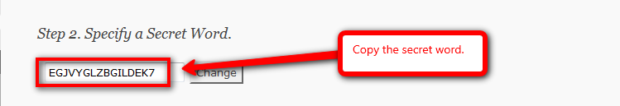
  - Return to ClickBank and paste the copied “Secret Word” into the “Secret Key” field and click “request access” link beside Instant Notification section.
Screenshot:
http://screencast.com/t/HxELNioP

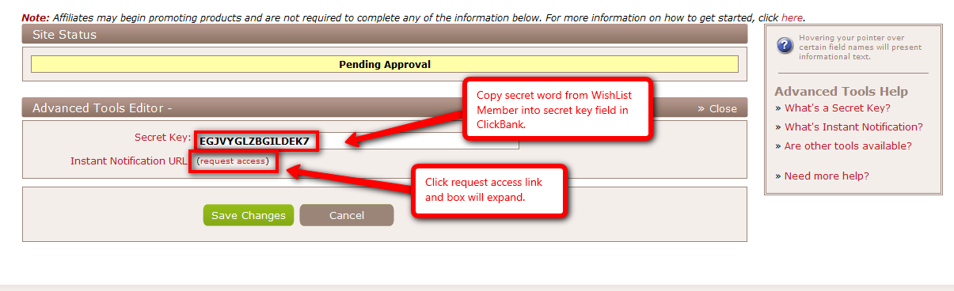
  - The Instant Notification box will open and the questions can be filled out accordingly. Note that “Yes” can be selected for all answers as WishList Member will handle these items behind the scenes. Click “Save Changes and Request API Access” button when complete and wait approval from ClickBank.
Screenshot:
http://screencast.com/t/766hC8II

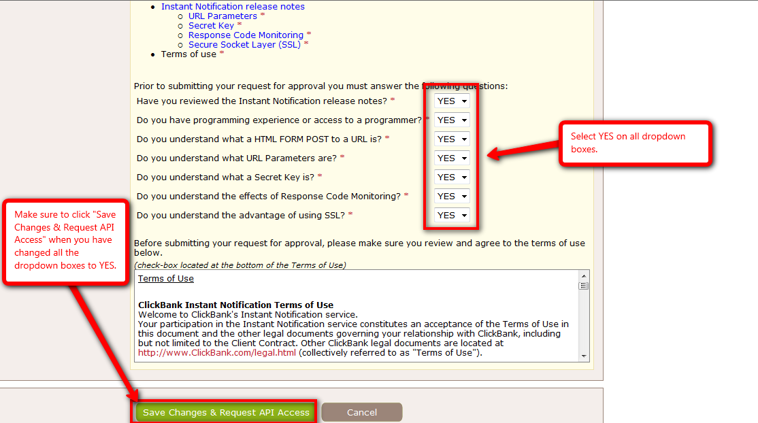
  - Once approval has been received from ClickBank return to WishList Member and copy the displayed “Thank You URL”.
Screenshot:
http://screencast.com/t/uutL55c8

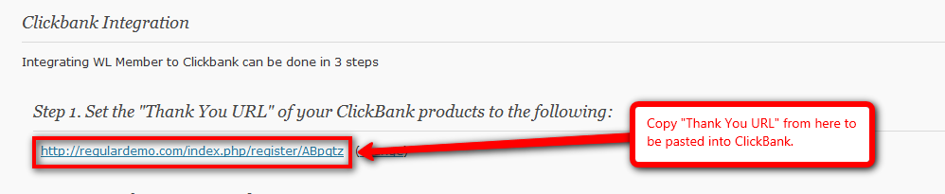
  - Return to ClickBank and paste the copied URL into the “Instant Notification URL 1” field and click “Save Changes” button when complete.
Screenshot:
http://screencast.com/t/EZt6dO8Ob

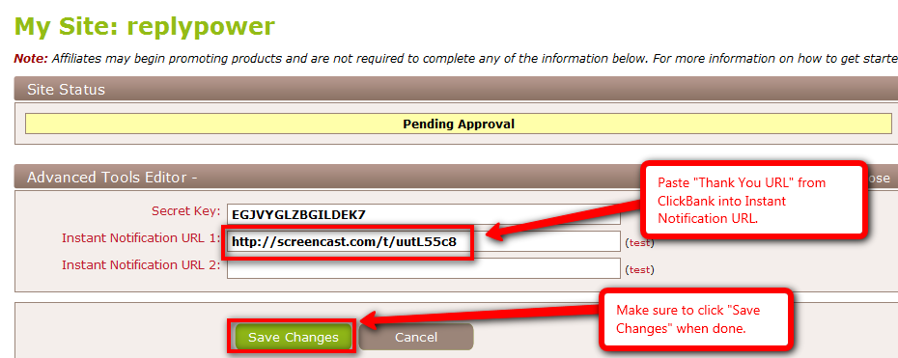
  - Click “Account Settings” tab and then “My Products” sub tab in top navigation bar. Select either “Standard Products” or “Recurring Billing Products” and then click on the “Edit this Product” icon.
Note that you may need to create a product within ClickBank if one does not already exist.
Screenshot:
http://screencast.com/t/9EH40FWy
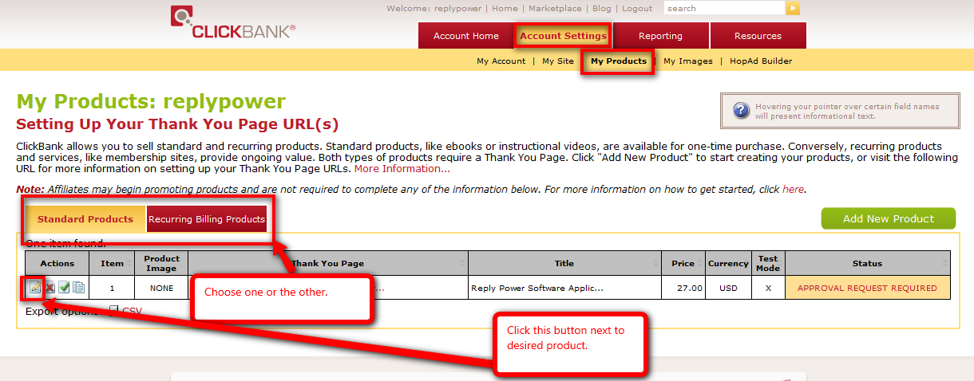
  - Return to WishList Member and copy the displayed “Thank You URL” again.
Screenshot:
http://screencast.com/t/uutL55c8
  - Return to ClickBank and paste the “Thank You URL” into the “Thank You Page’ field and fill in the remaining fields accordingly. Click the “Save Changes” button when complete.
Screenshot:
http://screencast.com/t/ICIiyhGx

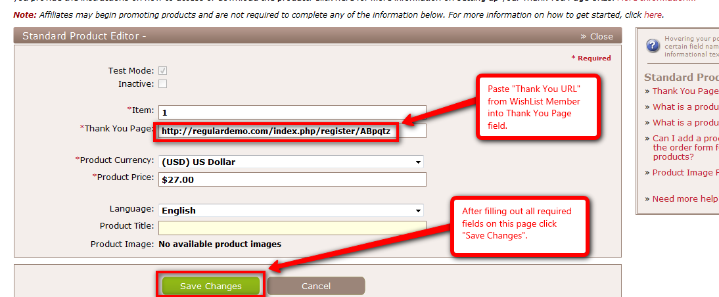
  - Return to WishList Member to create and post “Payment Link” onto desired Post or Page.
    - Copy desired “Payment Link” to be integrated with ClickBank and paste it into a Note Pad document.
Screenshot:
http://screencast.com/t/FRu8LgoxL

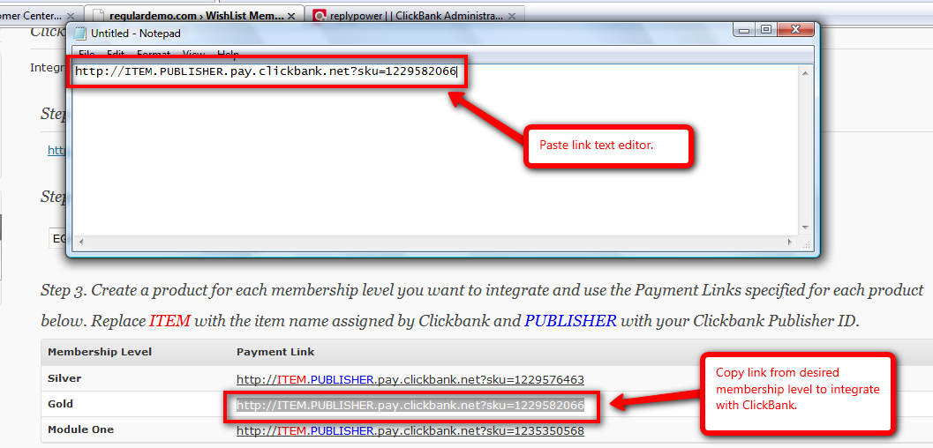
    - Return to ClickBank and navigate back to desired product and copy displayed Item number.
Screenshot:
http://screencast.com/t/LpzjOgzXtOY
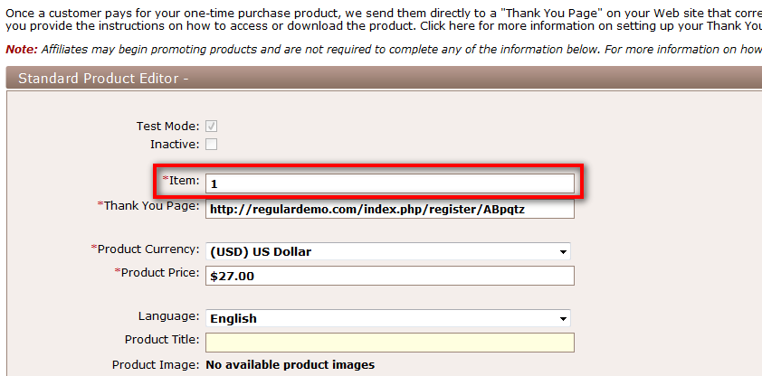
    - Return to Note Pad document and replace “ITEM” in original Payment Link with actual item number obtained from WishList Member.
Screenshot:
http://screencast.com/t/Mt9bVm92Xuv

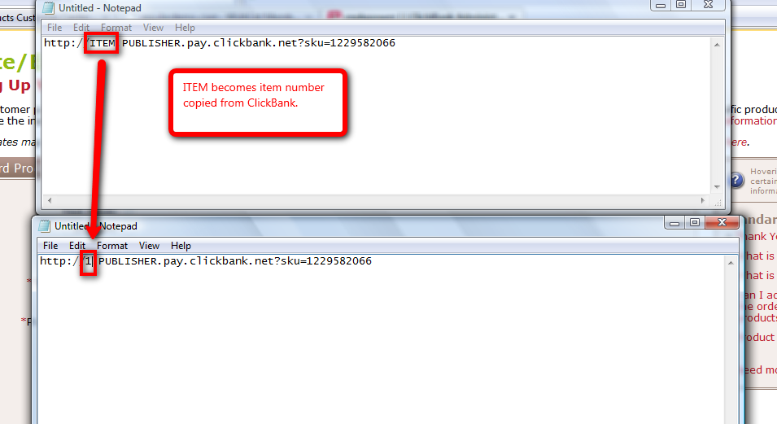
    - Return to ClickBank and scroll to top of screen. Copy “PUBLISHER” from the Welcome message.
Screenshot:
http://screencast.com/t/5p1y55X6

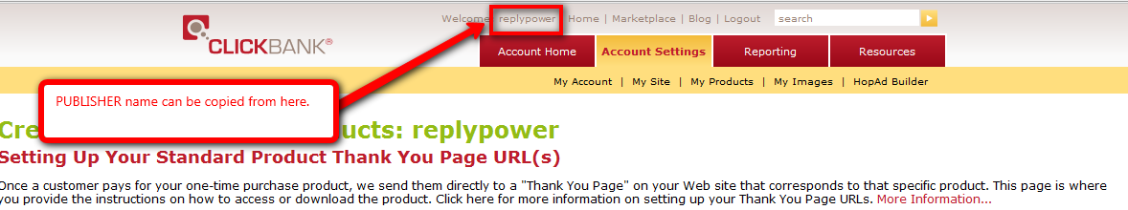
    - Return to Note Pad document and replace “PUBLISHER” in original Payment Link with actual item number obtained from WishList Member.
Screenshot:
http://screencast.com/t/xcq763hYOEG

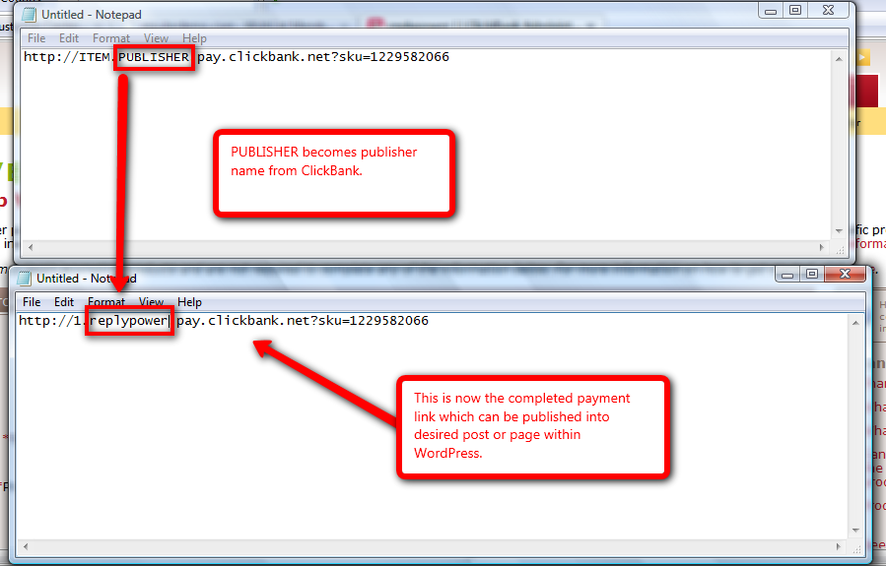
    - Paste completed “Payment Link” into desired Post or Page.
For more details, please view the 1st ClickBank Integration video:
http://customers.wishlistproducts.com/29-integrating-clickbank-part-1/
- Adhere to ClickBank Rules and Regulations

A ClickBank user must adhere to the set Rules and Regulations when creating the Registration, Order and Thank You pages. These Rules and Regulations can be found on the ClickBank site located here: http://www.clickbank.com/getting_started.html
Screenshot:
http://screencast.com/t/LAqGFUNJs

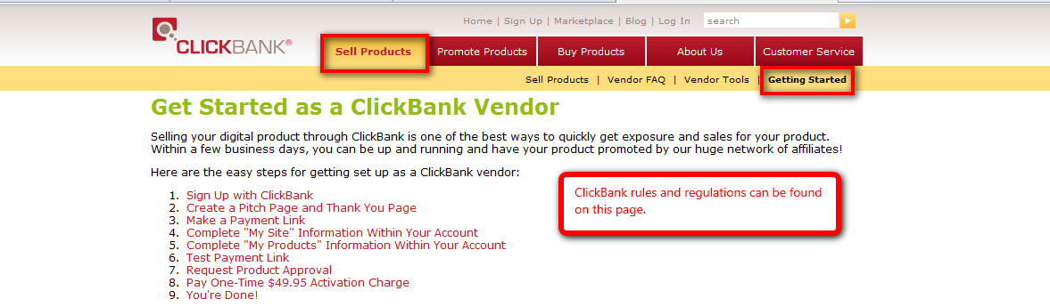
Note that HTML above and below the Registration page can be edited by navigating to the Settings tab and the Registration Page sub tab.

Screenshot:
http://screencast.com/t/CPhX88uY

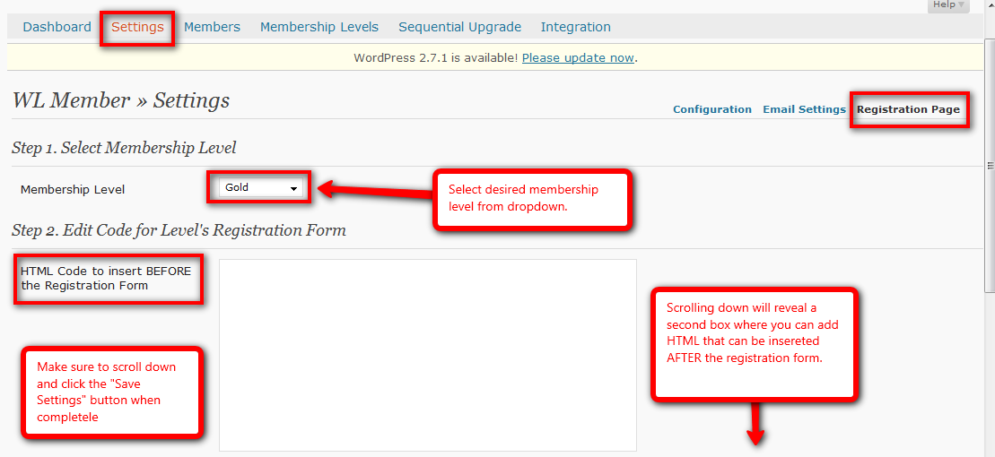
It is recommended that the same content that appears on Thank You page be added to the Registration page so that it adheres to the ClickBank Rules and Regulations. http://www.clickbank.com/getting_started.html
For more details, please view the 2nd ClickBank Integration video:
http://customers.wishlistproducts.com/30-integrating-clickbank-part-2/
- Complete a test purchase to confirm settings:
- Navigate to created payment button.
- Run through payment process completely with valid credit card. As a note, the product price can be changed in the online payment system to $1 during testing if desired.
- Register for Membership Level. Be sure to not use an email that is currently in the WishList Member database either as a member or the main admin email.
Screenshot:
http://screencast.com/t/y0PbvzVUY
- Once completed, confirm that a member has been created in the Members tab and that payment has been received in PayPal.
- If new member is not created or payment did not go through, check above steps to ensure set up was done correctly.
- Issue refund of test purchase.

- Import/Add Members if necessary:
- Login to WordPress.
- Navigate to WishList Member Dashboard by selecting “WL Member” in the PlugIns section.
Screenshot:
http://screencast.com/t/znvrKkzwwI
- Navigate to WishList Member Members tab and Import sub tab.
- Fill in the field accordingly. Ensure that .CSV file to be imported matches the sample .CSV file provided.
Note that it is important to ensure that ALL passwords are a minimum of 8 characters long.

- When complete, click the “Import Members” button.
For more details, please view the Importing and Exporting Members video:
http://member.wpwishlist.com/17-importing-and-exporting-members-wp27/

- Add Protected/Non-Protected content accordingly:

There are 2 methods that can be utilized when creating protected content:
- Individually as Pages or Posts are created:
- Login to WordPress.
- Navigate to Pages or Posts section and create new Page or Post.
- After inputting content, scroll down to WishList member section.
- Select IF this Page or Post should be protected using the radio button.
- Select which membership level(s) have access to this Page or Post using the check boxes.
Screenshot:
http://screencast.com/t/1DT5ePc73
- Once complete, click the “Publish” button.

- Using a blanket method once Pages or Posts have been created:
- Login to WordPress.
- Navigate to WishList Member Dashboard by selecting “WL Member” in the PlugIns section.
- Navigate to WishList Member Membership Levels tab and Membership Content sub tab.
Screenshot:
http://screencast.com/t/bpdZHHm4
- Select a membership level to manage using the dropdown.
- Select the desired content to manage using the options on the far right of page (Categories, Pages, Posts, Comments).
- Click the corresponding check boxes to allow membership access to that specific content.
- When complete, click the “Grant Access” button.
Screenshot:
http://screencast.com/t/9k2P76rQC

For more details, please view the Protecting Specific Content video:
http://member.wpwishlist.com/21-protecting-specific-content-wp27/

K. Auto Responder Integration – AWeber

Newly registered members can be automatically added to auto responders when integrated with WishList Member.
- Integrate with AWeber:
  - Login to WordPress.
  - Navigate to WishList Member Dashboard by selecting “WL Member” in the PlugIns section.
Screenshot:
http://screencast.com/t/znvrKkzwwI
  - Navigate to “Integration” tab and then the “AutoResponder” sub tab.
  - Select AWeber from the “AR Provider” dropdown and click the “Select Autoresponder Provider” button.
Screenshot:
http://screencast.com/t/jAB2gSB4
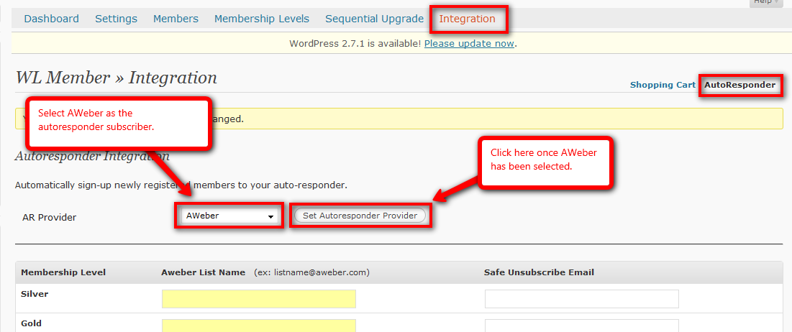
  - Login to AWeber and select desired list from “Current List” dropdown. Note that a new list may need to be created within AWeber.
Screenshot:
http://screencast.com/t/znju4pnLc

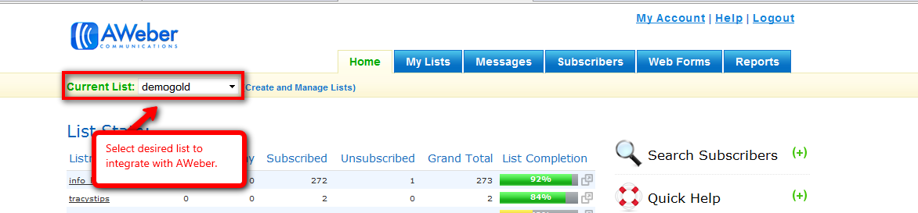
  - Click on the “List Settings” page under the “My List” tab in the top navigation bar.
Screenshot:
http://screencast.com/t/W2Upu1nn7q4

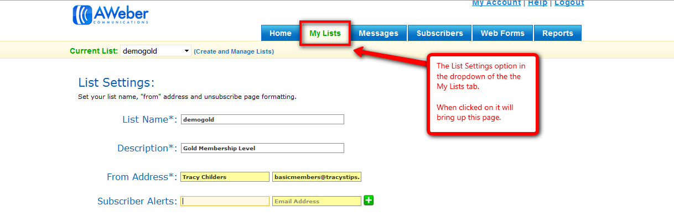
  - Copy the List Name from the “List Name” field.
Screenshot:
http://screencast.com/t/jBWreIKApv

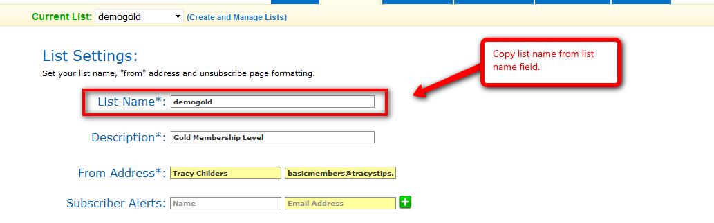
  - Return to WishList Member and paste the copied List Name followed immediately by @aweber.com into the “AWeber List Name” field for the specific membership level.
Screenshot:
http://screencast.com/t/YpU4mYie

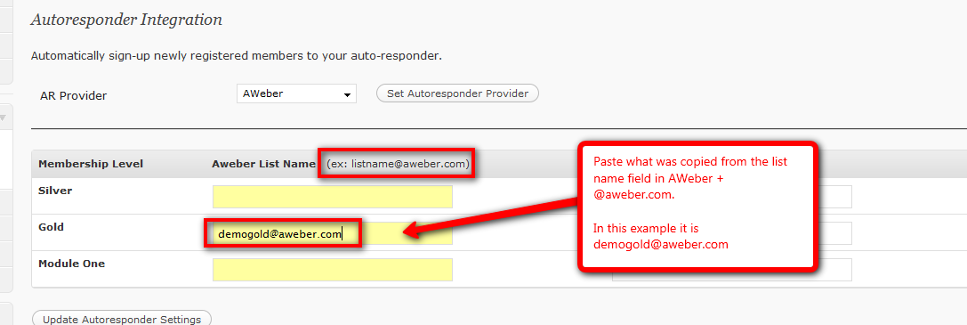
  - Create desired unsubscribe email. Note that this email can be anything@your-domain.com as it will be only used in AWeber. Once created, copy the full email address.
Screenshot:
http://screencast.com/t/rJ1mHLfXv

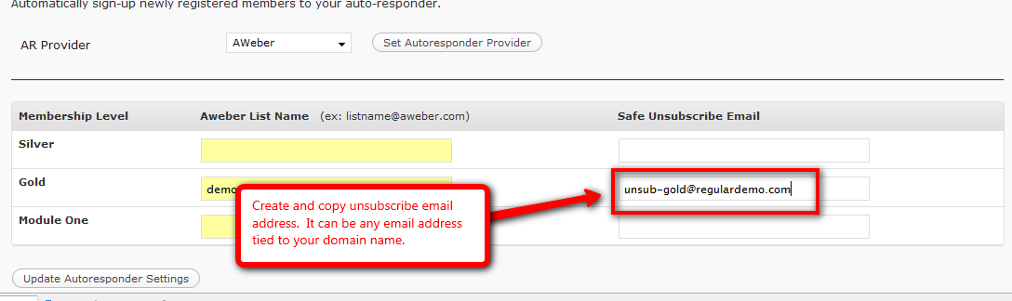
  - Return to AWeber and type Unsubscribe Address into the “Subscriber Alerts” field and paste the copied unsubscribe email address into the field to the immediate right. Click green plus button when complete.
Screenshot:
http://screencast.com/t/F4hS32QET

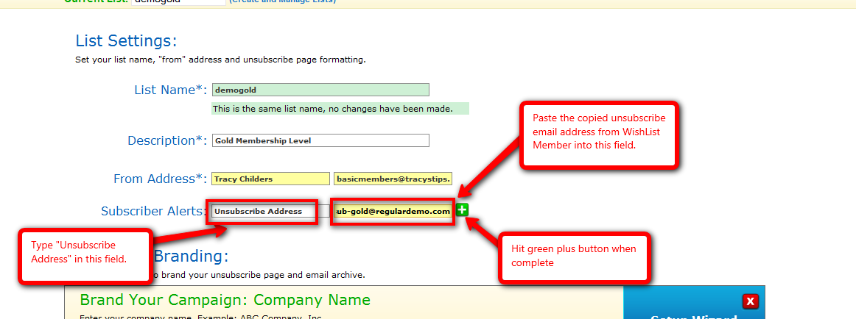
  - Scroll to the bottom of the page and click the “Save List Settings” button.
Screenshot:
http://screencast.com/t/H5yRk8q7hH

  - Click on the “Email Parser” page under the “My List” tab in the top navigation bar.
Screenshot:
http://screencast.com/t/NV6wSgXLh

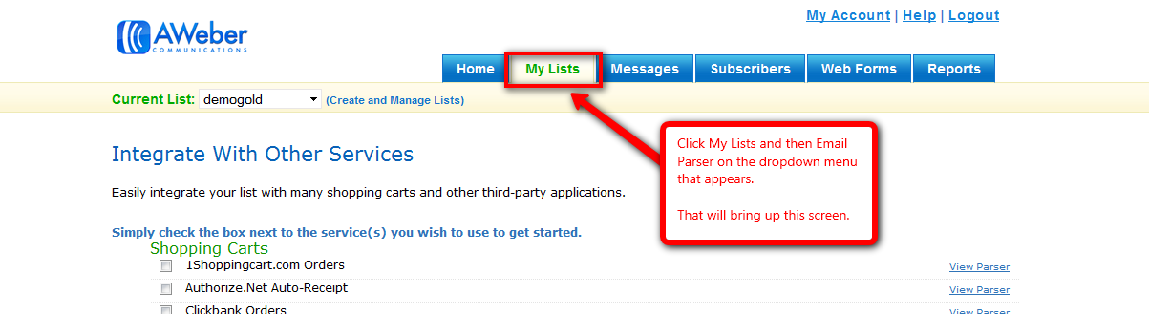
  - Scroll down to “Memberships Sites and Podcasting Tools” section and click the WishList Member option.
Screenshot:
http://screencast.com/t/HB9qbJbr
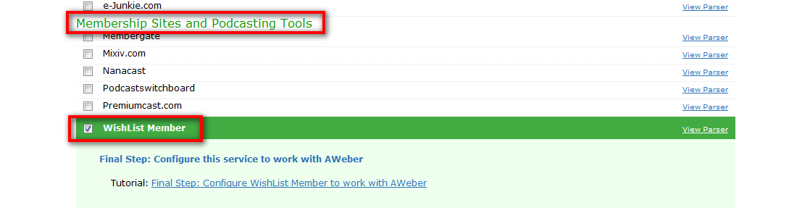
  - Return to WishList Member and click the “Update Autoresponders Settings” button.
Screenshot:
http://screencast.com/t/3AVaWaZir
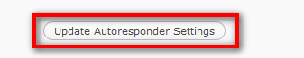
For more details, please view the AWeber video:
http://customers.wishlistproducts.com/26-aweber-integration-wp27/

L. Auto Responder Integration – AutoResponsePlus
Newly registered members can be automatically added to auto responders when integrated with WishList Member.
- Integrate with AutoResponsePlus:
  - Login to WordPress.
  - Navigate to WishList Member Dashboard by selecting “WL Member” in the PlugIns section.
Screenshot:
http://screencast.com/t/znvrKkzwwI
  - Navigate to Integration tab and then the AutoResponder sub tab.
  - Select AutoResponsePlus from the “AR Provider” dropdown and click the “Select Autoresponder Provider” button.
Screenshot:
http://screencast.com/t/msfEwrjomk9
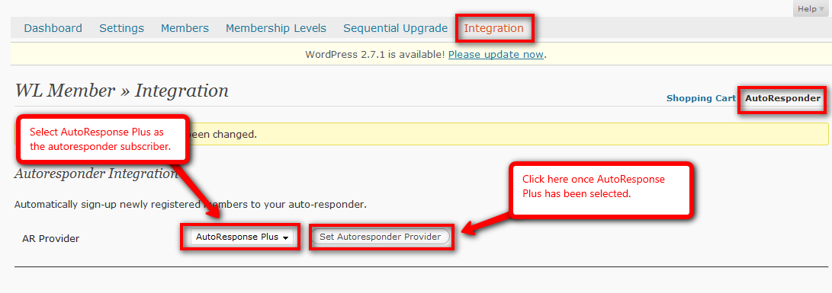
  - Copy the example URL displayed below the ARP Application URL field. Then paste it into the field and replace “your-domain” portion with the correct domain name.
Screenshot:
http://screencast.com/t/wG89X8qX

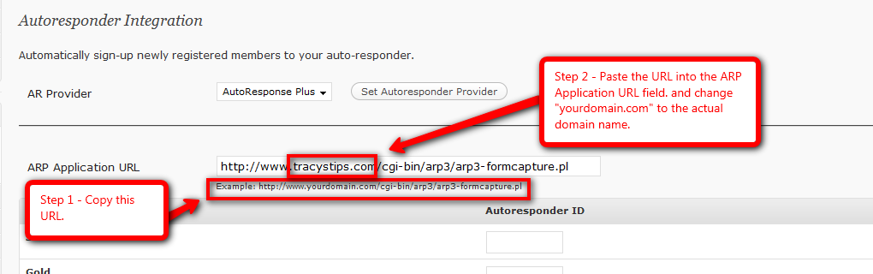
  - Login to AutoResponsePlus and locate desired Autoresponder to integrate with. Note that a new Autoresponder may need to be created within AutoResponsePlus.
  - Right click “Properties” link under the Actions section and copy the displayed shortcut.
Screenshot:
http://screencast.com/t/bE8LTk6lA

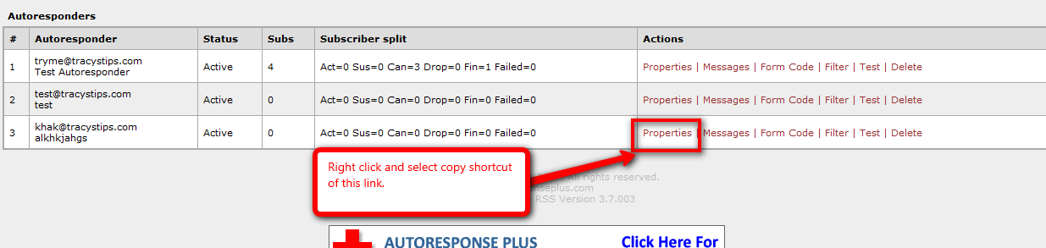
  - Paste copied link into a Note Pad document.
  - Copy the Autoresponder ID number located at the very end of the URL. Note that only the digit(s) are needed.
Screenshot:
http://screencast.com/t/2YRnofircqb

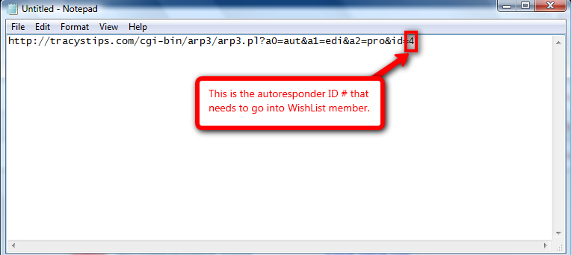
  - Return to WishList Member and paste copied ID number into the corresponding membership level’s Autoresponder ID field.
Screenshot:
http://screencast.com/t/2oKuJeEucqp

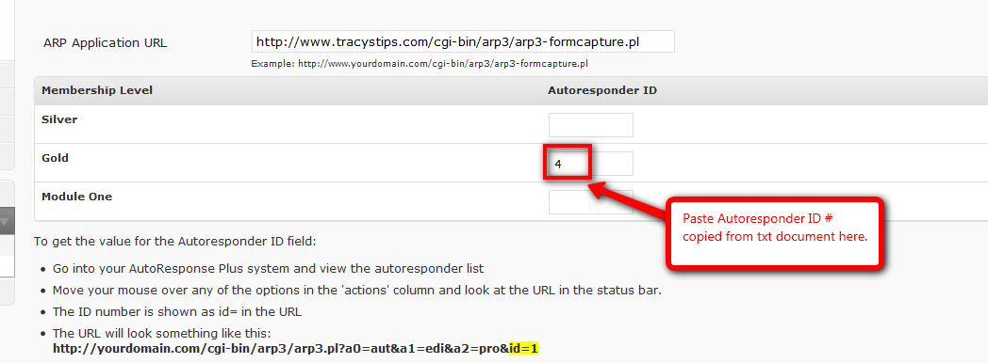
  - Return to WishList Member and click the “Update Autoresponders Settings” button.
Screenshot:
http://screencast.com/t/3AVaWaZir
For more details, please view the AutoResponsePlus video:
http://customers.wishlistproducts.com/27-autoresponse-plus-integration/

M. Sequential Upgrade

Sequential Upgrade can be used to automatically upgrade a membership level to another existing membership level after a set period of time. This can be done using either the MOVE or ADD method. The difference between the 2 is that the MOVE method removes the members from the previous level and MOVES them to the desired new membership level. The ADD method keeps them in the original level and ADDS them to the desired new membership level.

- Set up sequential upgrade accordingly:

There are 2 methods that can be utilized when sequentially upgrading:
  - Sequential Upgrade - MOVE:
    - Login to WordPress.
    - Navigate to WishList Member Dashboard by selecting “WL Member” in the PlugIns section.
Screenshot:
http://screencast.com/t/znvrKkzwwI
    - Navigate to the Sequential Upgrade tab.
    - Find desired membership level.
    - Set the “Upgrade To” dropdown to desired membership level that it will be moved to.
    - Set the “Method” dropdown to “Move”.
    - Set the “After” field to desired number of days to wait before moving.
    - Click the “Update Sequential Delivery Configuration” button.
Screenshot:
http://screencast.com/t/wg84pN7u

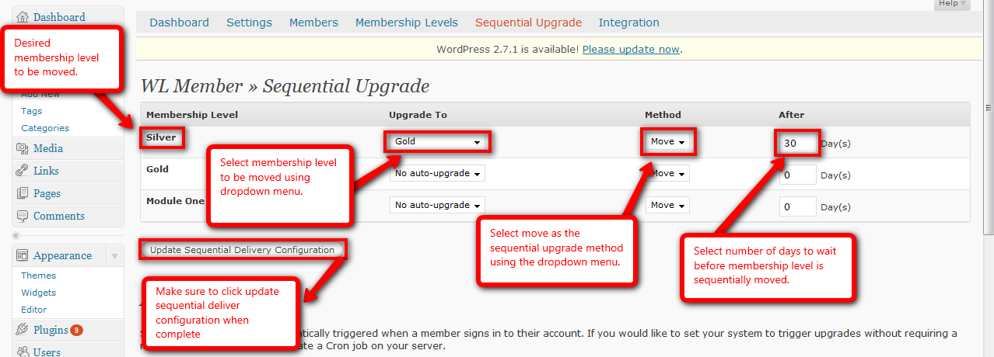
  - Sequential Upgrade – ADD:
    - Login to WordPress.
    - Navigate to WishList Member Dashboard by selecting “WL Member” in the PlugIns section.
Screenshot:
http://screencast.com/t/znvrKkzwwI
    - Navigate to the Sequential Upgrade tab.
    - Find desired membership level.
    - Set the “Upgrade To” dropdown to desired membership level that it will be added to.
    - Set the “Method” dropdown to “Add”.
    - Set the “After” field to desired number of days to wait before adding.
    - Click the “Update Sequential Delivery Configuration” button.
Screenshot:
http://screencast.com/t/vij9MN52



