To guarantee your name appears in the Program Booklet we must receive your completed contract by October 1st
FESTIVAL OF TREES
Iris Graves Wreath Chairperson
250 Harbortown Dr. E #609
Detroit, MI 48207
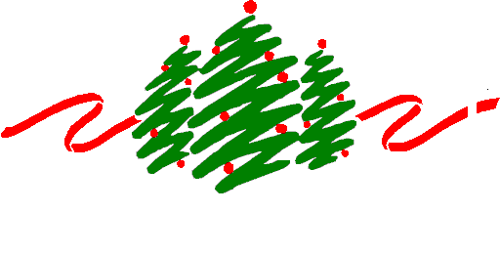313-674-0304
sirisgr@aol.com or
Fotmichigan@hotmail.com

A Benefit for Children’s Hospital of Michigan Foundation
Celebrating over 30 years of Continuous Generosity and Dedication

WREATH DESIGNER CONTRACT
SIZE | QTY
22” |  |  | 22” Wreath
23” |  |  | 23” Wreath
24” |  |  | 24” Wreath
25” |  |  | 25” Wreath
26” |  |  | 26” Wreath
THEME (Circle) CHILDRENS TRADITIONAL OTHER:

Two Main Colors Used: _______________ _______________ _______________ _______________
YOUR DONATION BECOMES THE SOLE PROPERTY OF FESTIVAL OF TREES (FOT).
FOT RESERVES THE RIGHT TO MAKE CHANGES.
PRICES OF TREES ARE DETERMINED BY FOT PROFESSIONAL CONSULTANTS.
BUSINESS/INDIVIDUALS: (as you would like it to appear in promotional materials)

ADDRESS:
CITY: STATE: ZIP:
HOME PHONE: WORK/CELL PHONE:
CONTACT PERSON:
E-MAIL:
SIGNATURE: DATE:
Preview Gala Ticket Sales  I would like to buy ______ VIP Preview Gala tickets @ $125 each (includes entry to Sky Lounge, open bar,  heavy appetizers, sweets and treats buffet, doors open at 6:30 PM - 21 and over only)  _______ Patron Preview Gala tickets @ $75 each (includes cash bar, light appetizers, sweets  and treats buffet, doors open at 7:30 PM)  _______ Child Preview Gala tickets $50.00 each - 12 and under  Total Ticket(s) Sales : $___________ |  |  |  |  | Amount enclosed for tickets  $
PAYMENT INFORMATION
[ ] Enclosed is my/our check payable to: Festival of Trees Check #
[ ] Payment by credit card: [ ] VISA [ ] MASTERCARD [ ] OTHER
Credit Card Number: Exp. Date:
FOR OFFICE USE ONLY
Date Contract Sent to Designer Chair:
Date Contract Sent to FOT Office:
Date Acknowledgement Sent:
Proceeds from Festival of Trees benefit research at Children’s Hospital of Michigan. Festival of Trees, Inc. Foundation is a recognized, non-profit corporation under Section 501©3 of the Internal Revenue code. Donation may be tax deductible as permitted by law. MICS 12437
Rev 2016

