Membership is open to all Catholic Healthcare providers…..

NAME………………………………………….

ADDRESS……………………………………..

………………………………………………..

Email………………………………………….

Phone………………………….mob…………

PAYMENT for

MEMBERSHIP  $30

Payment by Cash, Credit Card or Cheque payable to Pastoral Health Services

Credit Card Details: Master card  Visa

Signature……………………………………Exp Date /

MEMBERSHIPS $30 Annual Fee.
Please join our Membership Base and receive regular updates about our growing Ministry within the Catholic Church...

PATRON:

Sr Carmel O’Dwyer RSM

AMBASSADORS:

Monsignor James Murray

Fr Tom Furey

Fr Vic Farrugia

Convenor: Carmel McLeod
Parish Nurse, St Francis of Assissi, Mill Park.
Carmel.McLeod@gmail.com

Secretary : Leonie Rastas
Parish Nurse Consultant , Geelong. Ph 0408 217375
leonie@apnrc.org

Catholic Parish Nurse Network

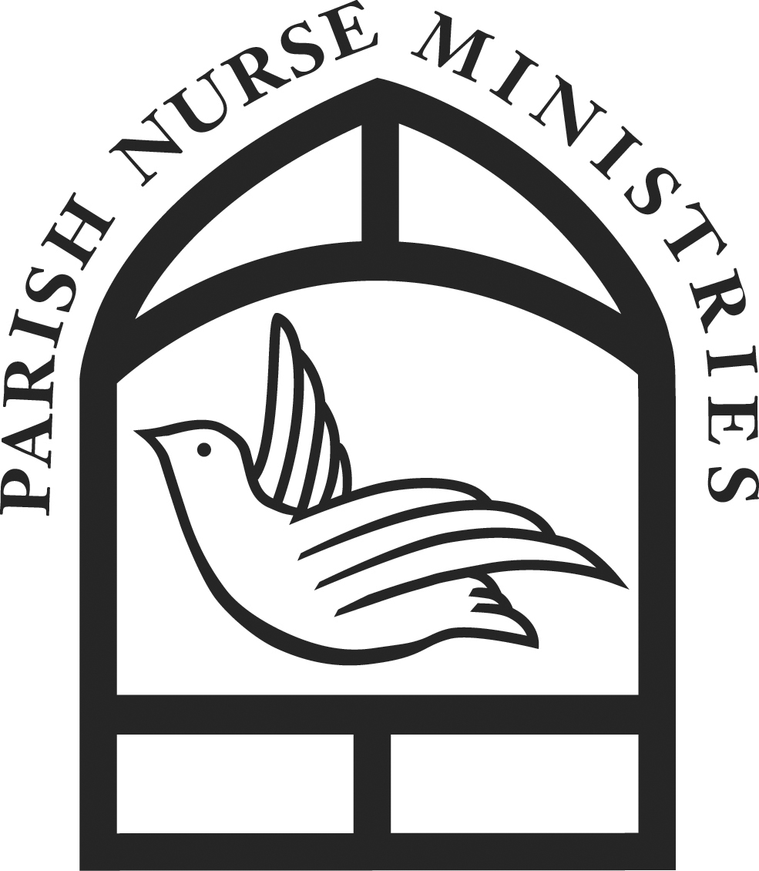

“A contemporary expression of Christ’s Healing Mission”
Archbishop Mark Coleridge

Integrating Faith
&
Health in the
Catholic Tradition

Catholic Parish Nursing……Facilitating spiritual care in the Catholic faith communities

Catholic Parish Nursing is modeled on the specialty Nursing Practice known as Parish or Pastoral Nursing, which was conceived by Reverend Granger Westburg, Lutheran Pastor, in conjunction with Loyola University Chicago, USA in 1980. Whilst working as a Hospital Chaplain, Westburg had observed the added value Christian nurses brought to patient care, and collaborated with Catholic Nurse Anne Solari Twadell to create a model of care extending beyond the Hospital walls. Today the ministry has spread to many countries around the world and currently in Australia, there are approximately 100 Parish/Pastoral Nurses trained Parish Nurse in practice.
Basic preparation courses are offered twice per year in Australia and are also available online though the International Parish Nurse Resource centre.
The Catholic Parish Nurse Network has International membership and meets Quarterly, for more information visit www.apnrc.org or call Carmel McLeod Mobile Ph 0409 948 694

- Health Information Sessions
Educating individuals to address health of mind, body and spirit, through healthy lifestyle practices and emotional and spiritual healing
Explaining illness

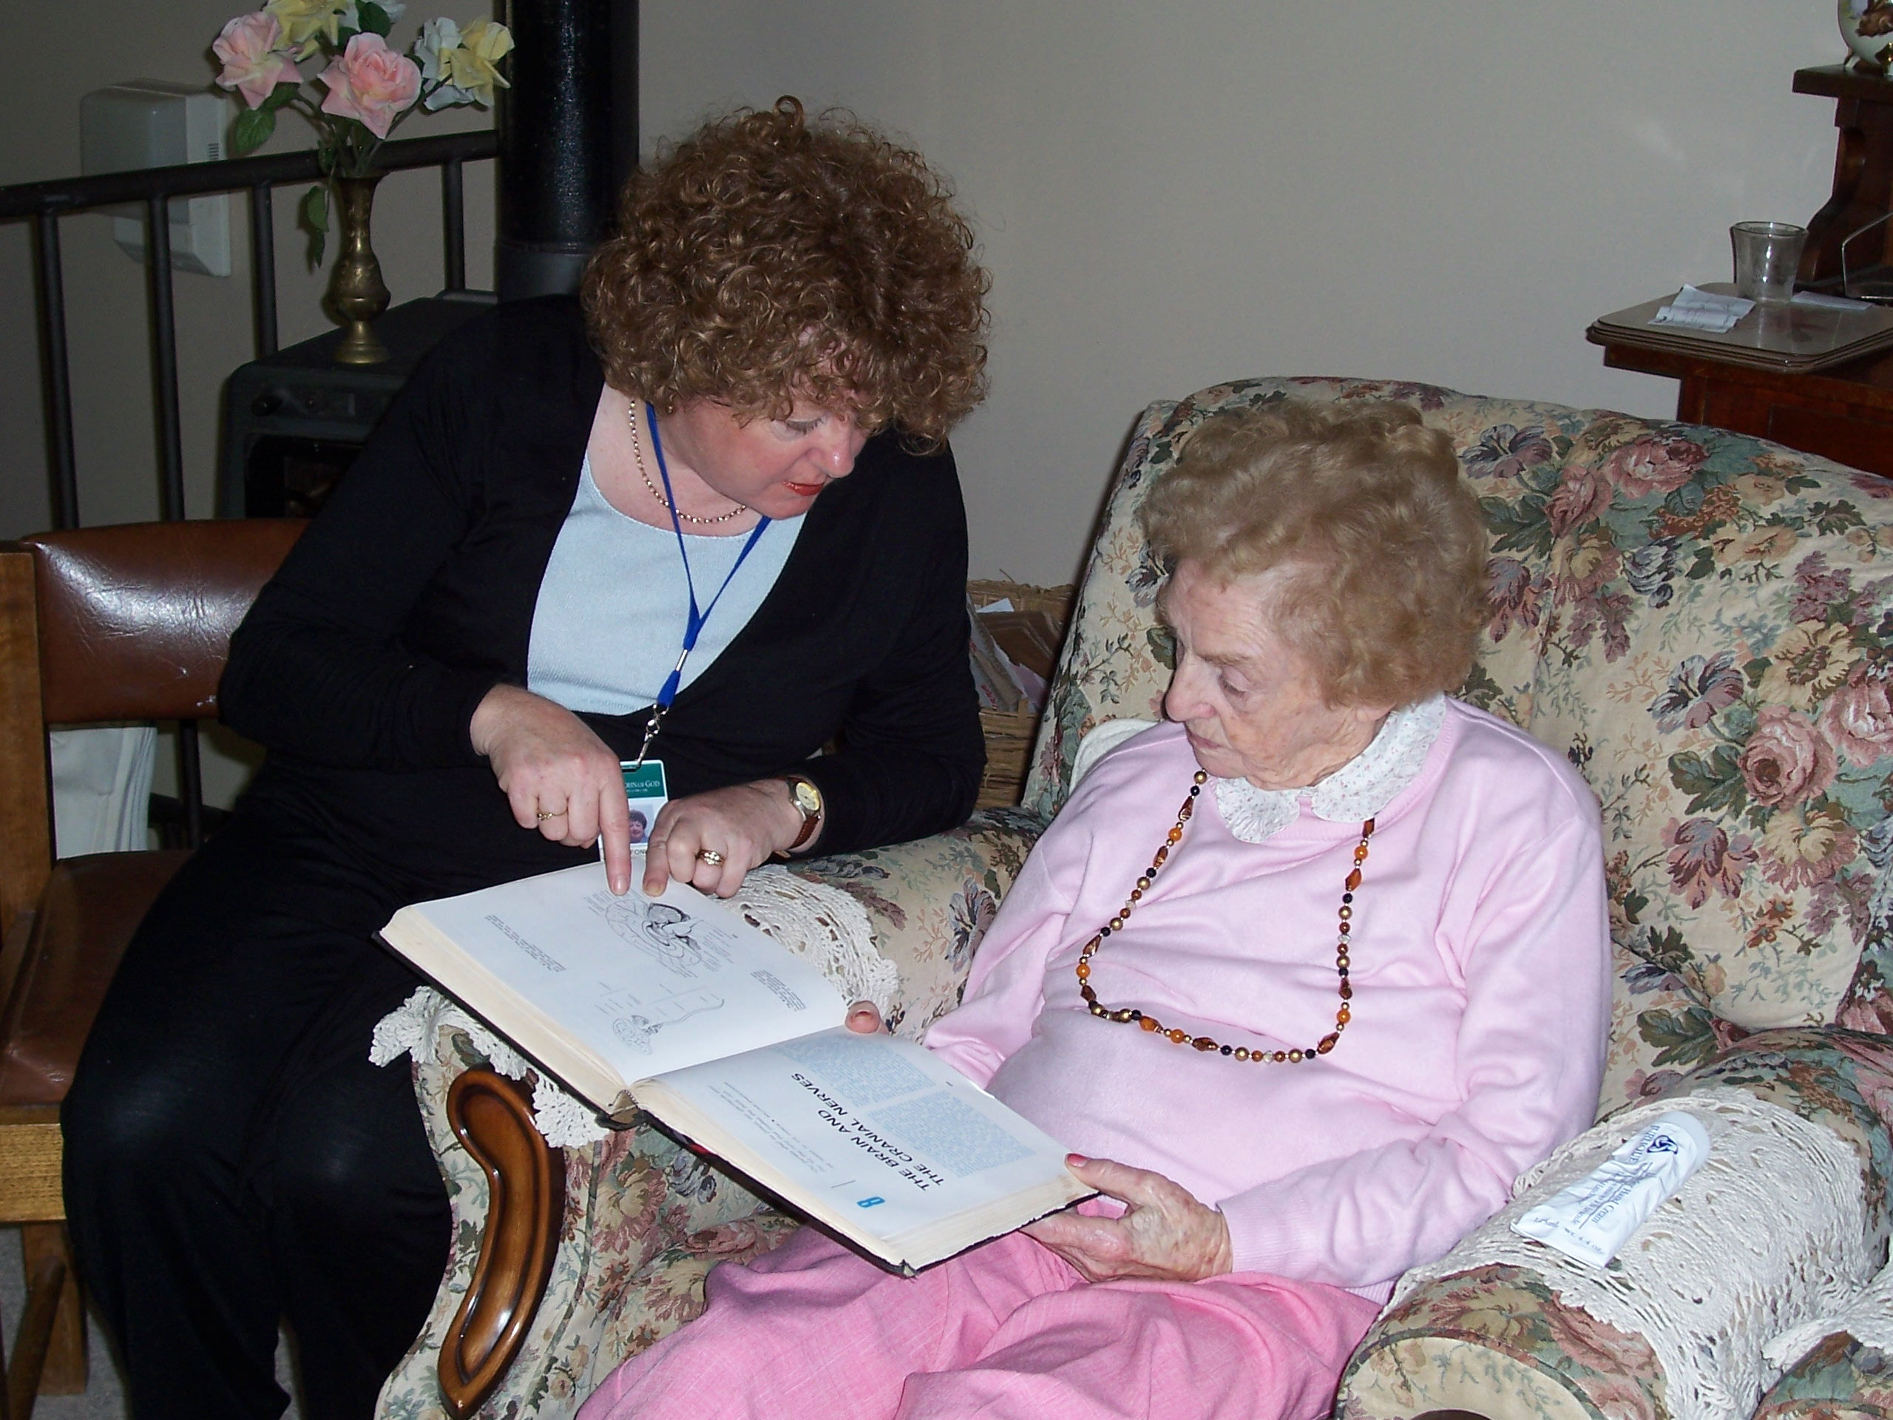

- Consultation - individual health risk assessments are conducted by Division 1 Pastoral Nurses who provide a listening ear to help people navigate the healthcare system and refer onto appropriate healthcare providers.
“He sent them out to proclaim the Kingdom of God and to heal.” Luke 9:2

- Wellness Activities – e.g. Co coordinating Wellness Programs; Facilitating Retreats; leading Sign Chi Do – The art of moving prayer - exercise classes.

- Creating Supportive Environments – Including facilitating care for families experiencing crisis; Comfort Ministries e.g. Prayer Shawl and Pocket Heart ministries to support those suffering loss and grief; Carers’ Days Out ; training Health Ministry Associates to support individuals in need; accompanying people on doctors visits to provide another set of ears and help and providing advocacy.
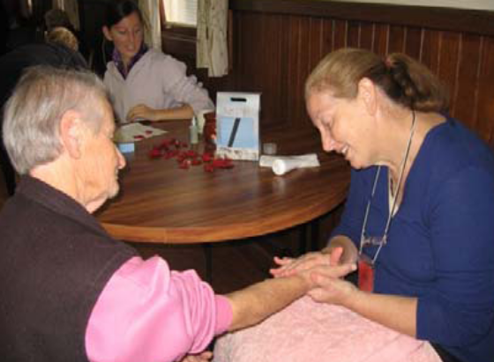

Carers’ Day Out – Hand Massage
Hand Massage at Carers Day Out

