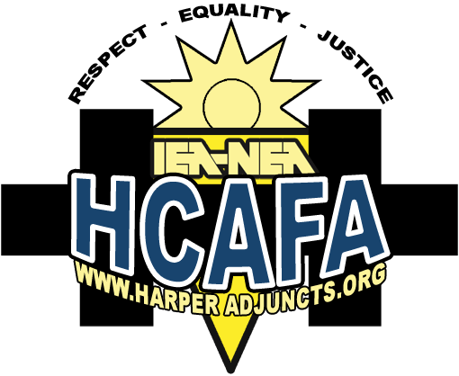
THE HARPER
ADJUNCT ADVOCATE

HARPER COLLEGE ADJUNCT FACULTY ASSOCIATION
NEWSLETTER September 2010, No.5, Vol.5

© 2010, Harper College Adjunct Faculty Association, IEA/NEA (847) 359-0300 553 N. North Court, Suite 210, Palatine, IL 60067-8124

From the Prez
Colleagues, welcome, welcome to the fall 2010 semester. The summer was hot, so it’s great to have an air-conditioned campus to return to. Many of us worked through the summer and didn’t take vacations but instead did staycations. Others, I’m sure, have stories to share of their travels near and far. We look forward to hearing them and living vicariously through you.

The good news is your HCAFA team was very busy during the summer. Charmian Tashjian and J.J. Pionke went to the SLA (Summer Leadership Academy) and learned negotiation and grievance techniques. Janice Cutler, Arlene Bublick, and Charmian Tashjian continued the relationship meetings with Mia Igyarto in Human Resources working to solve small problems before they became big ones. A ULP (unfair labor practice) is almost resolved. A two-year grievance ended in arbitration.

Our union has been growing in numbers every year. Other unions are surprised when they hear how fast we have grown. Thanks to you, we have reason to celebrate.

We rejoice in the number of members we have, but we wish there were more who would play an active role in the union. Finding time is a problem for all adjuncts. Everyone is so busy running from school to school, taking care of children, or just going home exhausted; everyone counts on someone else doing the necessary tasks. I urge you to support your union. We have negotiations coming in a year and a half. Training must take place now! In addition, we need help with our website, newsletters or mailings, serving on committees, surveys, and elections.

Come to a meeting and see how you can help. Be a part of HCAFA. Ilona Sala

strategic planning committee
This summer, HCAFA took advantage of the fact that adjuncts had lighter class loads than during the school year. We decided that this was a great time to work on our internal goals as well as our strategic plan.

The major internal goals we addressed concern membership involvement and HCAFA’s image.

For the strategic plan, we focused on Dr. Ender’s statement that “there is only one faculty at Harper College.” At this point in time, HCAFA does not consider that to be a reality but HCAFA is willing to work hard to make it one. We tried to envision the changes that would be necessary to convince adjuncts that full-time faculty and adjunct faculty at Harper were truly united.

We have set goals that we will try to reach over a three-year period. Some of the goals should be easily attainable while others will require major effort from both HCAFA and the college. We will give more details about the goals as we work on achieving them.

Our special thanks go to J.J. Pionke and her committee for their dedication to this project.

Update Your Contact Information
if You Have Not Done So Yet
Please send Janice Cutler, HCAFA membership records chair, the following: your name, division, department, non-Harper email address, home address, and phone numbers. Address your letter to
Janice Cutler, MS/Math, and put it in campus mail.

Page 2  Rights and Grievances | Page 3  Professional  Development | Page 4  Meetings &  Events
Page 5  Librarians and Counselors | Page 6  Recent Happenings | Page 7  Contact  Information

WHO SHOULD I CONTACT
IF I HAVE A PROBLEM?
Your division representative
The grievance chair
The president
The IEA Uniserv Director

HOW CAN I CONTACT THEM?
Find the contact information on p. 7 of this newsletter or at www.harperadjuncts.org.



HCAFA-HARPER RELATIONSHIP TEAM
For almost a year, adjuncts and administrators have been meeting monthly.

Mia Igyarto, former HR Director, initiated the relationship meetings. (Mia left Harper September 10th to work at the College of Dupage.) Our appreciation goes to her for giving us a forum to talk and work out solutions to problems before they escalate to grievances. The meetings have been valuable.

Once a new HR Director has been chosen, HCAFA will work with him. In the interim, Human Resources Manager Damone Richardson will head up the college team.

At our last meeting, we identified the issues we had worked on with the understanding that those issues would be reflected in our next contract.

Some of Those Issues Include:
- Appropriate Use of Student Opinionnaires.
Student Opinionnaires provide useful information to the college, but they are not to be used for adjunct evaluation or as the basis for disciplinary action.
- Rate of Pay for Private Music Lessons Taught by Adjuncts
- Maintenance of Inclusion Provision
Members may miss 2 consecutive semesters of work and still be entitled to a class assignment when they return if they have followed the required procedures. HCAFA made sure that a member who was covered by MOI was assigned a class after having been told by the college there were no classes for him to teach.
Members will have access to the Harper portal and email during their absence.
- Modifying the Librarian/Counselor Contract to Coordinate with the Teachers’ Contract.

If you have a problem, don’t wait too long to tell us about it. If we don’t know about your problem, we may not be able to meet the deadlines in our contract to help you.

WHAT ARE MY WEINGARTEN RIGHTS?
If you are ever in a situation that you believe could lead to any kind of disciplinary action, you have the right to have a union representative with you. In a situation like that, to protect yourself, say, “If this discussion could in any way lead to my being disciplined or terminated, or affect my personal working conditions, I respectfully request that my union representative be present at the meeting. Without representation, I choose not to answer any questions.” Under no circumstances should you lose your cool or walk out of the meeting

CLASS ASSIGNMENT ARBITRATION
HCAFA went through the entire grievance procedure and then to arbitration to protest the fact that some adjuncts have been denied their contractual right to a class as a result of being bumped by full-time faculty members or because the class they were scheduled to teach did not run. (HCAFA’s understanding of our contract is that members are entitled to at least one class before a non-member is assigned a class or a member is assigned two or more classes.)
We knew that this fight would be a difficult one as we had the burden of proof. However, we felt an obligation to defend our contract regardless of the outcome or expense. HCAFA was not successful. (The arbitrator reached his conclusion based on his understanding of our contract language and bargaining history.)
We may not have won, but we gave this case our all. Many deserve thanks for their hard work. In particular, HCAFA wishes to thank Amy Kunz (our Uniserv Director), Anna Lewis (our grievant), Feliz Berlanga (IEA attorney), and countless HCAFA adjuncts who worked on this important case.
Members, please contact us if you lose a class and are left with no class to teach.
It is our vow to continue monitoring class assignment problems and pursue this issue in our next contract. As Amy stated, “this arbitration was not the final chapter, but only the introductory remarks of a much larger book.”

ACT NOW!
apply for professional development funds
apply early and as often as you like!



Almost $24,000 Available in
Teaching Adjuncts’ Professional Development Fund

Teaching Adjuncts can apply for money for: Professional Travel, Workshops, Books, Tuition and Fees for College Credit Courses (Courses can be at colleges other than Harper College), Conferences, Professional Journals, and Professional Organization Memberships.

Members are entitled to money from this fund in addition to money available to all adjuncts through Harper’s faculty development opportunities. Take advantage of both!

Remember:
- Items must be discipline-specific or improve teaching.
*Note: Instructional materials aren’t allowed. The College will provide instructional materials such as books on students’ reading lists and keep them in department offices. Adjuncts may check them out, use them as needed, and keep them if they are “fully consumed.” (The Dean will determine if the book is fully consumed.) Money for these materials will come from College funds not from adjuncts’ professional development funds.

- Your benefit per year must not exceed $320.
- You must be teaching at time of application.

The Application Process
1. Apply to your Dean for pre-approval by filling out p. 1 of the professional development form.
Note: The form is on the Harper website.
Log on to the Employee Portal.
At the top of the page, place the cursor on “Divisions.” A drop-down window will open.
Click on “Provost’s Office” from the drop-down window.
On the left side of the page, click on “Adjunct Faculty Documents and Forms.”
On the right side of the page, click on “Adjunct Professional Development Form.”

2. Gain pre-approval from your Dean before paying for anything.
3. Pay for the approved items by the end of finals.
4. Submit p. 2 of the form along with original receipts for reimbursement to your Dean as promptly as possible.
Note: To ensure your reimbursement for online purchases from sites such as Amazon.com, attach both your online confirmation of purchase and either your credit card statement, a packing slip, or a photo of the covers of the books received.
5. Apply for reimbursement before the deadlines: February 10 for fall reimbursement, June 10 for spring.

On the HCAFA website, you will find the form in addition to the following information about professional development:
- Memo of Understanding attached to our contract
- Professional Development Clarification Letter

(Note: The professional development fund is a use-it-or-lose-it fund; money not used will revert to the College

SHED LIGHT ON SOME OF THE ISSUES IMPORTANT TO YOU!


HCAFA Welcomes Members
At All Meetings & Events

Executive Committee Meetings
Fri., Oct. 22, 3:00 – 5:00
Fri., Nov. 19, 3:00 – 5:00
Fri., Dec. 10, 3:00 – 5:00

At the IEA Office,
553 N. North Ct., Palatine

Interested in getting involved with something meaningful? Never been to an HCAFA Executive Committee meeting? Now’s your chance! It’s an opportunity to get connected, make friends, become familiar with the inner workings of Harper College, and help your adjunct union.

We know you’re busy. HCAFA is tailored to your schedule; you can do as much or as little as you want.

We guarantee you’ll always leave union meetings stimulated and well fed.

Need directions? Call Amy or Mary Ellen at IEA (847 359-0300).

UPCOMING EVENTS

IEA HIGHER ED SUMMIT
September 24 – 25
Doubletree Hotel, Bloomington, IL
Topics will apply to higher education faculty and staff. The agenda includes networking, legislative updates, getting members involved, NEA and IEA higher ed resources, contract negotiations and grievance processing.
Contact HCAFA if you are interested in attending. (Your expenses will be covered by HCAFA and IEA.)
MEETINGS WITH DR. ENDER
Dr. Ender and the HCAFA executive committee have decided to meet on a regular basis. Meetings are scheduled for October 4 and February 10. If other meetings are needed, we will schedule them.

SURS AND SOCIAL SECURITY MEETINGS
During the fall semester, there will be a SURS/SSA meeting for all Harper employees. In the spring semester, HCAFA and HR will sponsor a meeting designed especially for adjuncts.

HARPER COLLEGE BOARD MEETINGS
6:00, Monday, October 18, 2010
6:00, Wednesday, November 17, 2010
6:00, Wednesday, December 15, 2010
Act as an observer at one of the regular Harper College board meetings. Observing meetings is a great way to keep up-to-date about what’s happening at Harper, understand the inner workings of Harper, and socialize with others who shape Harper’s policies. Please contact Mary Ellen or Amy at the IEA office if you are able to attend a meeting. (Contact info is on p. 7.)

LASER POINTERS

HCAFA members, if you haven’t received your laser pointer/flashlight, please contact the IEA office. (See last page for contact information.)

SAY IT AIN’T SO, J.J.!

It’s hard for us to believe that J.J. Pionke, member extraordinaire, might choose to devote her time and energy to something besides HCAFA. She plans to put all the time she has been dedicating to us into going to graduate school and earning a PhD.

She has been a person willing to do all jobs, large and small. Since joining HCAFA, J.J. has played a major role in almost every aspect of HCAFA. She has been a division representative for the liberal arts division, membership chair, leader of the strategic planning committee, grassroots political activist, region 42 representative, webmaster, newsletter columnist, Facebook creator and administrator, and attendee at many conferences and workshops sponsored by IEA and NEA.

Best wishes, J.J.! We know you’ll be successful in whatever you do.

LIBRARIANS AND COUNSELORS

Dwain Thomas and Joanne Meyerhoff are the representatives for the Librarians and Counselors. You can find Dwain in the Library and Joanne in the Center for New Students and Orientation (CNSO). Their goal is to help the Librarians and Counselors have greater involvement with and access to what is going on in the HCAFA.
Dwain and Joanne are planning a social gathering to help us get to know each other better.
In addition, starting at the end of September, a monthly email will be sent to all members as well as other counselors and librarians who may be eligible to be in our unit. This email will include information about decisions that the HCAFA executive committee has made, social functions, and frequently asked questions for information and assistance from members in our group. This will be a good way for everyone to become aware of important issues facing librarians and counselors. We all want to be prepared to negotiate with the college when our contract expires in 2012.
Remember, if you feel you have a grievance that Joanne and Dwain need to be aware of, do not hesitate to contact them through the HCAFA/IEA office or their email addresses. (See p. 8 of this newsletter.
Have a great fall!
HIGHLIGHTING ADJUNCT ACCOMPLISHMENTS
Adjuncts are amazing! Let us know some of your accomplishments and activities. Email anyone on our exec committee with information. Here’s what one adjunct has shared with us.

Laine Gurley
Kudos go to Laine who was recently nominated for the NABT (the National Assoc. of Biology Teachers) two-year-college teaching award! Laine is no stranger to awards. In 1987 she received the NABT State Biology Teaching Award for Illinois, and in 1998 she received a Golden Apple Award.

Although Laine has only been at Harper for two years, she has been teaching—and loving it—for 34 years. Laine says that the best part about teaching is that she gets to share her passion for biology with people who have their sense of wonder intact. Her favorite technique is concept mapping. She feels it gets students to become more responsible for their own learning and instead of their learning by rote, they learn by conceptualization. As Cmapping focuses on building relationships among concepts, it helps students transfer information to long-term memory. Every semester, she teaches at least three Cmapping workshops to Harper faculty and hopes to be able to teach Harper students as well. She says that just thinking of the number of students who will be learning more meaningfully makes her grin ear to ear!

Laine’s credentials are many. She has co-authored a biology textbook (Heath Biology) and was the program consultant for the 2008 Holt McDougal high school biology text.

If you would like to be featured in the next issue of the Harper Adjunct Advocate, please contact Julie Cudden at hcafalibarts1@gmail.com. We hope you’ll share your accomplishments or those of other adjuncts.

IEA/NEA MEMBERSHIP CARDS
You should have received your membership card. If you haven’t received it by the end of the month, please contact Janice Cutler, MS/Math through the college mail system.

SUMMER MAY BE OVER,
BUT GREAT MEMORIES LINGER
SUMMER FAMILY BBQ
On Saturday, July 10, HCAFA held its second annual family get-together at the Plum Grove Reservoir picnic area across from Harper College. Camaraderie, great food, and a glorious day made the BBQ fantastic. HCAFA wants to thank J.J. Pionke and Julie Cudden for making the arrangements and making sure that everyone had exactly what they wanted. Aaron Center did a yeoman’s job as master chef. He makes a mean burger!

SUSHI AND SANDWICH SOIRÉE
The HCAFA “Soirée” is really not a soirée at all. It’s a late afternoon event held during orientation week that gives new and returning adjuncts an opportunity to get together informally. This semester, the Soirée took place on August 17. It was the perfect way to jumpstart the semester. Adjuncts had time to visit, learn about HCAFA, have questions answered, and feast on great food. Although the Soirée started at 4:00, by the time most adjuncts left, they felt as though they had no need for dinner.

We hope you’ll join us at the next Soirée in the spring semester.

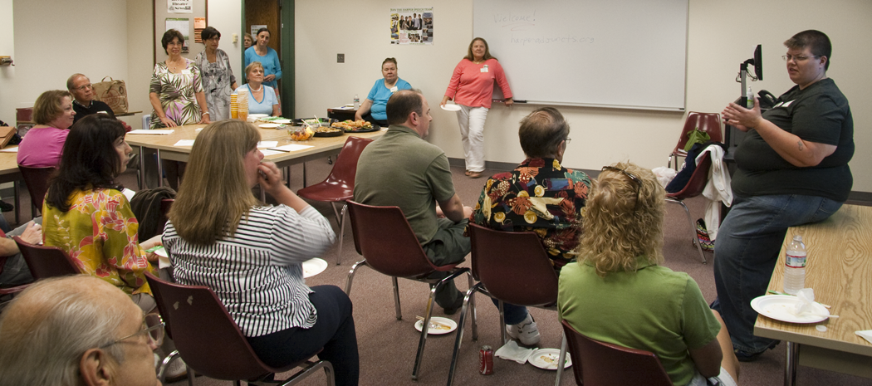
Photo taken by HCAFA member Larry Price (LIBART/ART)

HCAFA on FACEBOOK
On Facebook? So are we! Look for us under HCAFA! We are a locked community for our own protection but any adjunct may join! Dates of meetings and other announcements are posted on the Facebook page. We hope to see you there!
IEA SUMMER LEADERSHIP ACADEMY
Lucky me! I attended the IEA’s SLA at Illinois State University in Normal. Our IEA region (#42) paid the expenses for this training, and I am grateful. I have attended this program before and enjoyed it. That time I concentrated on grievance training, this time on bargaining training which will be very useful, not just for future HCAFA work, but for life in general. Many times I have felt I needed to know how to bargain for things, like job salaries or merchandise transactions. The IEA trainers each had their own area of expertise and led actual bargaining practice sessions. Other sessions I attended were on health benefits and building better relations with board members. Both will be practical in future negotiations.
I was impressed with the committed educators who gave their time to find ways to teach better and improve our working conditions and relationships with others in Illinois. All were working for the goal of improving the education of students.
I plan to attend the IEA Higher Education Conference at the end of September. I hope that others will join me there. Charmian Tashjian

Bulletin Board
Make sure to check out the HCAFA bulletin board, located near the human resources office on the third floor of building A. To keep you informed of all the latest HCAFA news, the bulletin board will be updated monthly. Currently, you can find information on our upcoming meetings, who to contact if you have any questions, and much more. Would you like to see something on the board that's not currently there? Contact Julie Cudden at hcafalibarts1@gmail.com.

MEMBERSHIP BENEFITS
$1,000,000 Educators Liability Insurance
is yours as a member of HCAFA, (IEA/NEA). Access Card Discounts
Your IEA/NEA membership card entitles you to amazing discounts at thousands of restaurants, stores, hotels, movies, etc. Go online to the IEA/NEA website (WWW.IEANEA.org) and click on the Access Savings box. To verify that you are eligible for the benefits, you will be asked for the ID number on your membership card.

HCAFA EXECUTIVE COMMITTEE
OFFICERS
President: Ilona Sala hcafapresident@gmail.com
Vice President/Grievance Chair: Charmian Tashjian hcafagrievance@gmail.com
Treasurer: Rob Alexander hcafatreasurer@ gmail.com
Membership Records Chair: Janice Cutler hcafamembership@ gmail.com
Secretary: Arlene Bublick hcafasecretary@gmail.com
IEA/NEA Uniserv Director: Amy Kunz amy.kunz@ieanea.org (847 359-0300)
Harper Adjunct Advocate Editor: Arlene Bublick hcafasecretary@gmail.com

DIVISION REPRESENTATIVES

AE/LS:
Rob Alexander hcafaels1@gmail.com
Taimi Wilk hcafaels2@gmail.com
BUS/SS:
Candace McCreary hcafabuss1@gmail.com
LIBARTS:
Julie Cudden hcafalibarts1@gmail.com
Larry Price hcafalibarts3@gmail.com
MS:
Gary Wilson hcafamath1@gmail.com
LIB/COUN
Joanne Meyerhoff hcafalibcoun1@gmail.com
Bob Kaufman
Karin Lacour Rivers
Dwain Thomas

Note: For divisions without reps, we’ll do our best to keep you informed through newsletters. If you are in CTP, HCPS, or WHP, please consider becoming a rep and join us for our monthly meetings. It will be to your advantage and you will love the friendships

There are many ways to Stay connected to HCAFA!
Join us on Facebook at HCAFA. Any Harper adjunct may friend us!
Check out our bulletin board on the 3rd floor of building A at the entrance to HR.
Read The Harper Adjunct Advocate.
Contact your division reps or officers.
Visit Our Website, WWW.HARPERADJUNCTS.ORG.

If undeliverable, please return to
Janice Cutler, MS/Math
PLEASE DELIVER TO:

