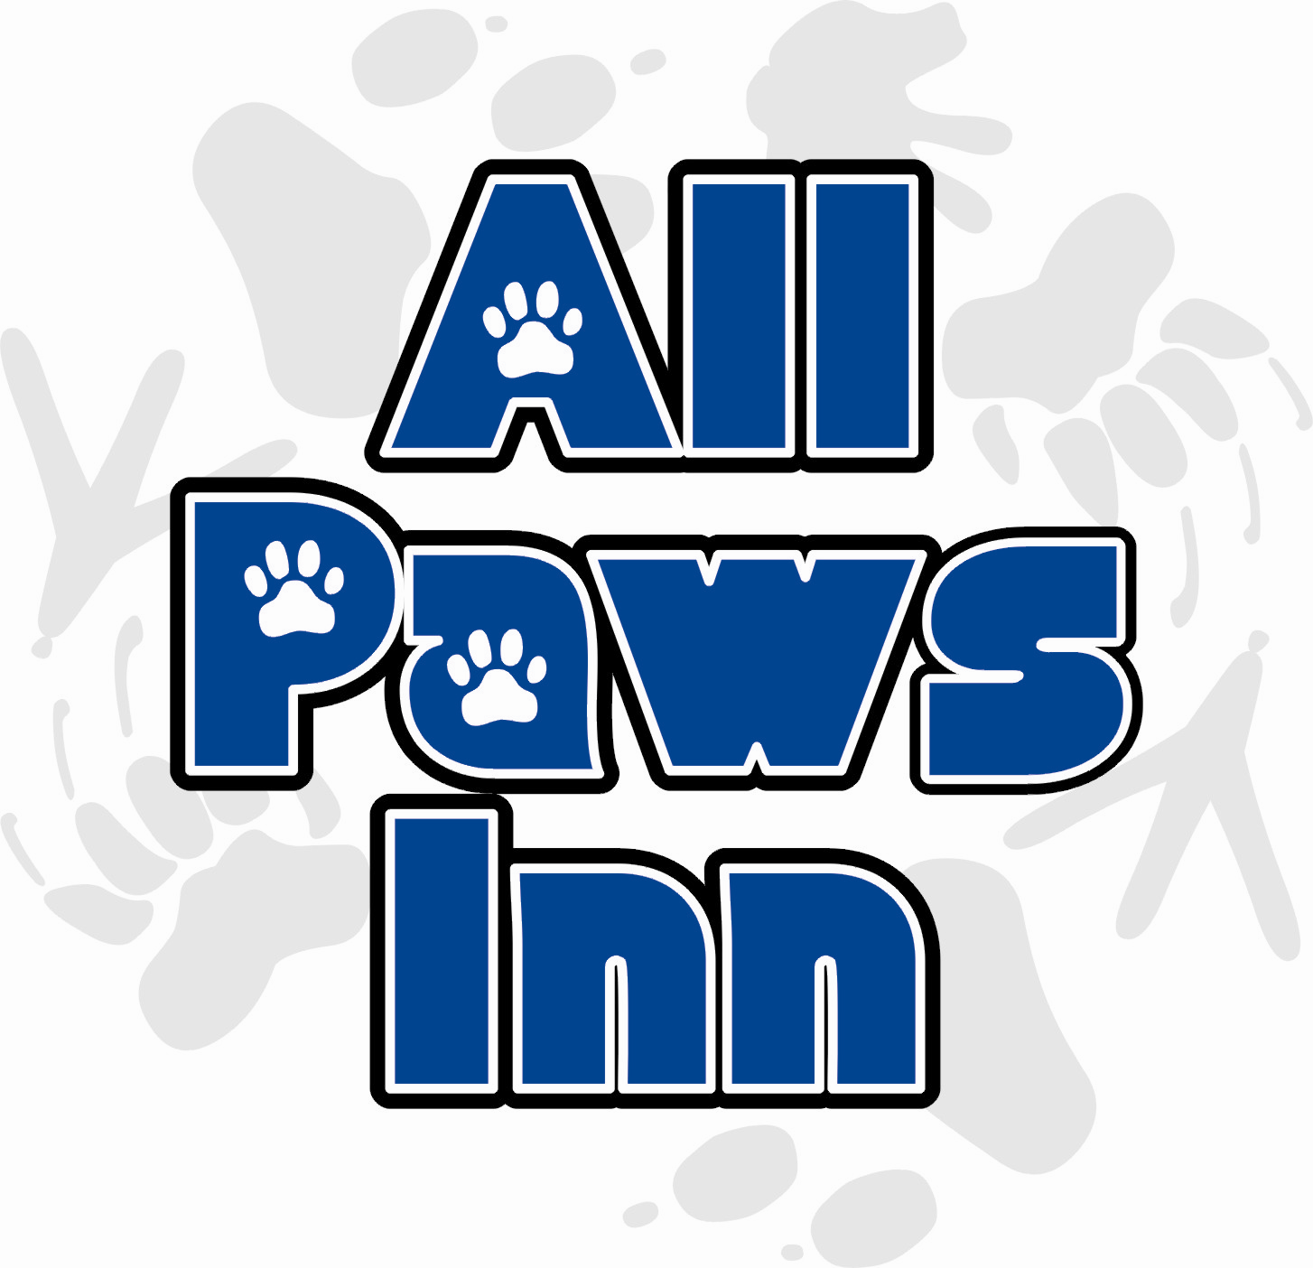 | All Paws Inn LLC – Veterinary Release Agreement VR

In the event that any of my pets or large animals appears to be ill, injured, or at significant risk of experiencing a medical problem at the start of service or while in the care of All Paws Inn, I give permission to All Paws Inn LLC to seek veterinary service from a veterinarian or a veterinary clinic. My preferred veterinary services are listed on each individual Pet Information Disclosure. Other veterinarians or emergency care clinics chosen by the pet sitter are acceptable.

I ask All Paws Inn LLC to inform the attending clinic or veterinarian of my requested total diagnosis and treatment limit of $_____________ per pet / all pets (most common values are $200, $1000, or unlimited). I understand that efforts will be made to contact me regarding any treatments, illness, injury, or potential problems as soon as the condition is deemed not life threatening and/or contact is possible. I understand that All Paws Inn LLC care providers work hard to prevent accidents and injuries, and that such problems may occur no matter how well a pet is cared for. I agree to allow All Paws Inn LLC care providers to use their best judgment in handling these situations, and I understand that All Paws Inn LLC and its staff assume no responsibility for the actions and decisions of the veterinary staff, the health, or death of my pet(s).

I will assume full responsibility for the payment and/or reimbursement for any and all veterinary services rendered, including but not limited to diagnosis, treatment, grooming, medical supplies, and boarding. Such payments will be made within 14 days of the initial incident. I also agree to be responsible for all Special Service fees assessed by All Paws Inn LLC for emergency transportation, care, supervision, or hiring of emergency caregivers, and will pay such fees within 14 days of each incident.

I further authorize All Paws Inn LLC and my primary veterinarian(s) to share all of the medical records of all of my animals with veterinary clinics in an emergency in the interest of providing the best care for my ill or injured animal(s).

Every dog, cat, and horse at the site of service will be current (per my veterinarians recommendations) on its rabies vaccinations prior to the arrival of any caregiver. I will also make arrangements to guarantee that each animal will remain current on its rabies vaccinations throughout each service visit period.

I agree to notify All Paws Inn LLC of any signs of injury or possible illness before any visit as soon as the condition appears. All Paws Inn LLC reserves the right to cancel service at any location where a pet with a potentially infectious condition exists. All Paws Inn LLC strives to provide clean, safe service to each of our clients. In doing so, All Paws Inn LLC strongly insists that each pet and large animal be vaccinated, dewormed, and protected from harmful insects according to veterinarian recommended standards.

This agreement is valid from the date below and grants permission for future veterinary care without the need for additional authorization each time All Paws Inn LLC cares for one or more of my pets. I understand that this agreement applies to all of the pets and large animals within All Paws Inn LLC care. In signing this contract, I agree that I have the sole authority to make health, medical, and financial decisions regarding the animals that will be scheduled to receive service.

Client/Owner Name:

Client Signature: _______________________________ Date: ___________

All Paws Inn LLC – Legal Considerations LC

For the purposes of this document, the terms Client, Owner, Pet Owner, and Customer are synonymous with the person contracting services for one or more domestic animals.
- A signed Service Request must be provided to your sitter before service is provided for any period.
- Deposit in full is due at time of reservation. Reservations are not held until payment in full is received by All Paws Inn LLC or special arrangements are agreed upon by both parties in writing. A $2 per visit late charge will be assessed to service that is not paid in advance. Reservations for not yet cleared PayPal payments will be honored.
- There will be a $20 service charge for each returned check.
- Unpaid service may be cancelled without notice, including prior to or during the service period.
- Cancellation Charge Schedule effective 1/19/2004 (% applies to entire service period total):
    - 0 - 48 hours prior to any service, and/or Holidays: Payment in full is charged (no refunds)
    - 2 - 7 days prior to service: 20% of service total is due (equals an 80% refund)
    - 8 days prior to service or more: No charge, refund in full.
- Reservations are made to plan sitter availability to clients. Therefore, clients returning home early will be required to pay for the reserved amount of time scheduled including travel time. Clients will not have to pay for scheduled services other than visits or overnights not preformed.
- All Paws Inn LLC is not responsible for wilted, dead or otherwise unhealthy plants. All Paws Inn LLC will work hard to follow your written directions as precisely as possible, but cannot be responsible if the results are not favorable. Please place all indoor plants together on a waterproof surface in plain sight, as your pet sitter is not responsible for water damaged areas or missed plants.
- All Paws Inn LLC is not responsible for damage to the home beyond the control of the Pet Sitter. This includes, but is not limited to leaks, electrical problems, and acts of nature. In these situations, the company will attempt to contact the customer and then the emergency contact before making a subjective decision on dealing with the problem. All repairs and related fees (including Special Service emergency service time and coordination fees) will be paid by the client, or fully reimbursed to All Paws Inn LLC within 14 days.
- All Paws Inn LLC is not responsible for any damage to property of the client or others unless such damage is caused by the negligent act of the Pet Sitter. All Paws Inn LLC agrees to remain fully insured through Pet Sitters Associates L.L.C. or a comparable entity. All Paws Inn LLC accepts no responsibility for security of the premises or loss if other individuals have access to a client’s home, or if the home is not properly secured.
- Client shall cause all other individuals that visit the home to leave a log of their visit.
- All Paws Inn LLC is not liable for any loss or damage in the event a burglary or other crime that should occur while under this contract. Pet Owner agrees to secure home prior to leaving the premises. All Paws Inn LLC will re-secure the home to the best of its ability at the end of each visit. While keys are in the possession of a Pet Sitter, they will be either on the Sitter’s physical person, or be properly stored an undisclosed location.
- Pet Owner must have legal rights to place the animals in the care of Pet Sitters, Kennels, and Veterinary Clinics. The Pet Sitter cannot service a home with “Visiting” pets or animals that do not belong to the resident of the service site without separate sets of agreement forms, including a Legal Considerations Agreement, accepted and signed by each rightful owner(s).
- The terms of this document apply to all the pets owned by the client, including any and all new pets that the customer obtains on or after the date this document was signed, at any and all locations the owner designates for service.
- Pet Owner is responsible for pet-proofing house and yard, and the security fences/gates/latches. All Paws Inn LLC will not be responsible for the safety of any pets and will not be liable for the injury, disappearance, death, or fines of any pet with unsupervised access to the outdoors.
- All Paws Inn LLC is authorized to seek any emergency veterinarian assistance needed during visits, at the cost of the client, from any veterinarian as chosen by the sitter. However, the company is not responsible for the health/well being of the animal.
- Pet Owner is responsible for supplying the necessary, safe equipment/supplies needed for care of their pet(s), including but not limited to a sturdy, well-fit harness (halter, collar, etc…) for walks or in case of emergencies, firmly affixed vaccination tags, a lead rope or leash, pooper-scoopers, litter boxes, food, cleaning supplies, medicines, pet food, and cat litter. Pet Owner authorizes any purchases necessary for the satisfactory performance of duties. Pet Owner agrees to be responsible for the payment of such items, as well as service fees for obtaining items, and will reimburse All Paws Inn LLC within 14 days for all purchases made.
- Pet Owner will be responsible for all medical expenses and damages resulting from an injury to a Pet Sitter, or other persons, by the Pet. Customer agrees to indemnify, hold harmless, and defend All Paws Inn, in the event of a claim by any person injured by the Pet.
- It is suggested that arrangements be made with someone to evacuate your pets in case of a disaster or weather related event/crisis/”Code Red”. All Paws Inn LLC shall use best efforts to see to your pets safety/care should such events occur, but cannot guarantee it.
- Future Services: I authorize this contract to be valid approval for services so as to permit All Paws Inn LLC to accept all future telephone, online, mail or email reservations and enter my home without additional signed contracts or written authorizations.
- All Paws Inn LLC reserves the right to terminate this contract at any if the Pet Sitter, in his/her sole discretion determines that Owner’s pet poses a danger to the health or safety of itself, other pets, other people, or the Pet Sitter. If concerns prohibit the Pet Sitter from caring for the pet, the Owner authorizes the pet to be placed in a kennel (or previously arranged locale), with all charges (including but not limited to transportation, kenneling, tranquilizing, treating, accessing, and liability) to be the responsibility of the Owner.
- All Paws Inn LLC agrees to provide services stated in this agreement in a reliable, caring and trustworthy manner. In consideration of the services as an express condition thereof, the client expressly waives and relinquishes any and all claims against the company and its employees, except those arising from negligence.
- Client agrees to notify All Paws Inn LLC of any concerns within 24 hours of return.
- This agreement is valid from the date signed, and replaces any prior Legal Considerations agreements. Client agrees to any future All Paws Inn LLC term changes relayed verbally to the client, mailed or emailed in writing to the client, or posted on our website under the heading Terms .
- The owner states that he/she as read this agreement in its entirety and fully understands and accepts its terms and conditions.
- Client represents and warrants that no latent or patent defects exist at Client’s property that would adversely affect the health and/or well-being of the Pet Sitter. All Paws Inn, LLC reserves the right to inspect Client’s property prior to commencing services hereunder.
- During the period of service under this Agreement, Client shall maintain homeowner's insurance, or equivalent insurance coverage, covering personal injury to the Pet Sitter while located on Client's property.

Client/Owner Name:
Signature: _______________________________ Date: ____________
All Paws Inn, LLC

By:
April Green, Manager
All Paws Inn LLC – Pet Information Disclosure PI

Please complete one Pet Information Disclosure form per pet or litter.

Owner: Pet Name:
Length of Time Owned: Pet Type: Dog / Cat / Horse /
Breed: Sex: M/F Declawed: Y/N Neutered: Y/ N
License #: Microchip/Tattoo/Dog Tag #:
Physical Description (if similar to another): Birth date: Or Age:
Weight: Or Size:

Feeding Instructions:

Feed apart from other pets/supervise Dispose of uneaten food Remove food after ____ Mins

Dry Brand:  Measure with:  Amount:  Where to feed: |  | Morning  Afternoon  Dusk  Night | Procedure:
Wet Brand:  Measure with:  Amount:  Where to feed: |  | Morning  Afternoon  Dusk  Night | Procedure:
Medication(s):  Amt:  Location:  Hide In Treat: |  | Morning  Afternoon  Dusk  Night | Procedure:
Medication(s):  Amt:  Location:  Hide In Treat: |  | Morning  Afternoon  Dusk  Night | Procedure:
Water | Water will be cleaned and filled frequently | Tap  Bottled  Filtered | Dish Location:  Water Location:
Treats Name:  Amt:  Location: |  | Notes:
Pet’s Living Area:

NOT allowed outdoors at all  ONLY allowed outdoors on leash  Turn out, invisible fenced yard with collar  Turn out, secure fence: _________________  Turn out, no fence, but doesn’t leave yard  NOT allowed indoors | Allowed on furniture, counters, beds  Restrict pet area/crate only when pet is alone  Restrict pet area/crate at all times  Restricted Area/Crate Location:  Other off-limit areas:
Owner: Pet:

Emergency Care: *Placing Credit Card on file at vets office is recommended
Vet Name: Pet Allergies:
Clinic Name: Vaccinations up to date on (month/yr):
Phone: Heartworm test: Negative / Positive

Pet Medical History: (ongoing or reoccurring known illnesses/injuries, treatments & medications)

Temperament/Personality:
Pet Doesn’t Like:
Baths Hot Days Sharing Food Dishes
Toenail Clip Rain / Snow / Cold Loud Noise / Vacuum / Garbage Disposal / Thunder
Massage New Animals All Humans
Touch Ears Other family pets Strangers
Sprays People near food dish

Pet reacts to the above by:

Has Pet Ever: Describe (even if mild, or under extreme/unusual situations)

Attacked someone/bit someone
Attacked another animal
Injured self /escaped out of fear
Injured self out of boredom
Escaped from home,
Where does he/she like to escape to?
How can he/she be retrieved?

Commands: (Please circle commands we know, and underline commands we are working on):
Sit No Outside Make Poo Potty Bad Bath In the House
Stay Down Walk Food Who’s Here Good Move Ride
Come Lay Don’t Pull Treat Back Drop [it] Come-on
Heel Out Walk Nice Cookie Naughty Don’t Touch Off
Allowed to go for rides in sitter vehicle? Y / N May play with sitter’s personal pet(s) for socialization? Y /N

Favorite Games, Toys, and Activities:

Comments:

Client/Owner Name:

Signature: _______________________________ Date: ____________
All Paws Inn LLC – Contact Information CI

First Name: |  |  |  |  | Last Name:
Pet(s): |  |  |  |  | Inquiry Date: | / / Method:
 |  |  |  |  | Returned Call:
 |  |  |  |  | Home Phone:
 |  |  |  |  | Cell Phone:
Address: |  |  |  |  | Work Phone:
 |  |  |  |  | Email:
Directions: |  |  |  |  | Prior Sitter:
 |  |  |  |  | Referred By:
 |  |  |  |  | Contact Method: | □ Home Phone □ Cell □ Email
 | Date | Time |  |  | Status: | □ Will Call Back  □ Interviewing Others Also
Consultation: |  |  |  |  | Service Type: | □ Vacation □ Periodic □ Daily
First Sit: |  |  |  |  | Frequency: | X per □ Day □ Week
Start |  |  |  |  | Length: | ________ Minutes Per Visit
End |  |  |  |  | Rates Quoted:
Second Sit:
Start |  |  |  |  | Travel: $____ | Miles: ______ Mins:______
End
Scheduling: | □ Tentative | □ Reserved
References:
Emergency Contacts |  | (Alternate) |  |  | Special Alerts
Name: |  |  |  |  | □ FLIGHT RISK, Describe:
Phone: |  |  |  |  | □ OUT ON LEASH ONLY □ No Leash Outside
Cell/Work: |  |  |  |  | □ WATCH DURING FEEDINGS □ Separate Dishes
Relationship: |  |  |  |  | □ NO TREATS □ Pick Up Dish after ______ Mins
Location: |  |  |  |  | □ Other:

All Paws Inn LLC – Home Guide HG

Owner: |  |  |  |  | Usual Vehicles & Visitors At Home:
Pet(s):
 |  |  |  |  | Snow & Ice Care Instructions / Contacts:
Locations:
Crated Area
Leash/Collar |  |  |  |  | Notes & Misc:
Grooming
Food Dish
Food
Water |  | □ Tap □ Filtered □ Bottled
Water Dishes
Medications |  |  |  |  | Key - MUST TEST
Treats |  |  |  |  |  | □ Pet Sitter Has |  | □ Use Code
Litter Box |  |  |  |  |  | □ Will Mail |  | □ Unlocked
Poop Scoop |  |  |  |  |  | □ Drop □ff |  | □ Client Present
Kitchen Waste |  |  |  |  |  | □ Will Leave |  | □ Other
Outside Waste
Recycle Bin |  |  |  |  | Describe Key:
Paw Towels
Paper Towel |  |  |  |  | Backup Entry:
Spot Cleaner
Broom/Vacuum |  |  |  |  | Usual Visits |  | Length | Time Slot
Put Mail |  |  |  |  | Morning
Indoor Plants |  |  |  |  | Afternoon
Outdoor Plants |  |  |  |  | Dusk
Birdfeeders |  |  |  |  | Night
 |  |  | All Paws Inn LLC – Service Request SR

Pets
  Client Full Name or ID
  Best Way to Contact Today
  Contact At
  Service Begins | / / | Time
  Service Ends | / / | Time
  □ Daily | □ Every Other Day | □ Weekdays

Details | Visit Time | Length | Rate | Travel Fee | Cost/Visit | # of Visits | Total
Morning |  |  | + |  | X | =
Afternoon |  |  | + |  | X | =
Dusk |  |  | + |  | X | =
Night |  |  | + |  | X | =
Subtotal
Additional Charges
Discounts
Grand Total Deposit Due

How may we reach you while you are away? |  |  | Trip Description/Hotel/Notes & Visitors Expected
Phone:
Email:

Tasks |  |  |  |  | Special Notes & Other Tasks
 |  | Email Log
 |  | Walk Dog
 |  | Feed
 |  | Pill / Shots
 |  | Injections
 |  | Plants
 |  | Clean Litter Box |  |  | Payment Method
 |  | Take Out Trash |  |  | Pay Date
This request must be confirmed by my pet sitter, and a Signed Copy must be left for the pet sitter. By submitting this request, I agree to all terms as stated on our website http://www.allpawsinnpetsitting.com.

Signature: ______________________________ Date: ___________

