“In this great land
called America, no child
will be left behind.”
.
President George W. Bush

Archived Information



Washington, DC
March 2002

U.S. Department of Education
ANNUAL PLAN
2002 - 2003

This report was produced under U.S. Department of Education Contract No. ED-01-CO-0137 with de Val Grafik Source LLC., Washington D.C., Geneise Cooke served as the contracting officer representative. The views expressed herein do not necessarily represent the positions or policies of the Department of Education. No official endorsement by the U. S. Department of Education of any product, commodity, service or enterprise mentioned in this publication is intended or should be inferred.
U.S. Department of Education
Rod Paige
Secretary

Office of the Deputy Secretary
Bill Hansen
Deputy Secretary
Planning and Performance Management Service
Hugh Walkup
Director
March 2002

This report is public domain. Authorization to reproduce it in whole or in part is granted.
While permission to reprint this publication is not necessary, the citation should be: U.S.
Department of Education, Office of the Deputy Secretary, Planning and Performance
Management Service, U.S. Department of Education Strategic Plan, Washington D.C., 2002.

To order copies of this report:
write to: ED Pubs, Education Publications Center, U.S. Department of Education,
P.O. Box 1398, Jessup MD 20794-1398;
or fax your request to: (301) 470-1244;
or e-mail your request to: edpubs@inet.ed.gov
or call in your request toll-free: 1-877-433-7827 (1-877-4-ED-PUBS). If 877 service is not
yet available in your area, call 1-800-872-5327 (1-800-USA-LEARN). Those who use a
telecommunications device for the deaf (TDD) or a teletypewriter (TTY), should call
1-877-576-7734.
or order online at: www.ed.gov/about/ordering.jsp.

This report is also available on the Department’s web site at:
www.ed.gov/pubs/planrpts.html.

On request, this publication is available in alternate formats, such as Braille, large print,
audiotape, or computer diskette. For more information, please contact the Department’s
Alternate Format Center at (202) 260-9895 or (202) 205-8113

Mission
To ensure equal access
to education and
to promote educational
excellence throughout
the nation.

Department of Education
Strategic Goals

Goal 1: Create a Culture of Achievement
Create a culture of achievement throughout the nation’s education system by effectively implementing the president’s plan, No Child Left Behind, and by basing all federal education programs on its principles: accountability, flexibility, expanded parental options and doing what works.

Page 20

Goal 2: Improve Student Achievement
Improve achievement for all groups of students by putting reading first, expanding high quality mathematics and science teaching, reforming high schools, and boosting teacher and principal quality, thereby closing the achievement gap.

Page 36

Goal 3: Develop Safe Schools and Strong Character
Establish safe, disciplined, and drug-free educational environments that foster the development of good character and citizenship.

Page 62

Goal 4: Transform Education into an Evidence-based Field
Strengthen the quality of educational research.

Page 72

Goal 5: Enhance the Quality of and Access to Postsecondary and Adult Education
Increase opportunities for students and the effectiveness of institutions.

Page 78

Goal 6: Establish Management Excellence
Create a culture of accountability throughout the Department of Education.

Page 62

Secretary’s Statement

Just a few weeks ago, I released the Department of Education’s Strategic Plan for 2002-2007. (It is available on our web site at www.ed.gov.) This plan embraces the vision set forth by President George W. Bush: to leave no child behind. It acknowledges the boldness of that vision. Never before has any society, anywhere in the world, at any time attempted to educate every single one of its citizens to his or her full potential. Every nation—ours included—has always accepted that some children will be left behind. No longer. For the President and for me, .no child left behind. is not just a slogan, it is a pledge. We take it literally, and we take it seriously.
Congress takes it seriously too. In December, Congress passed the No Child Left Behind Act of 2001, the most significant transformation of the federal role in education in over thirty-five years. This law and its principles for reform—accountability, flexibility, expanded parental options and doing what works—are embedded throughout our Strategic Plan, and will be our North Star in the years to come. Those same principles will be embedded in future legislative proposals in areas including special education, vocational education and higher education.
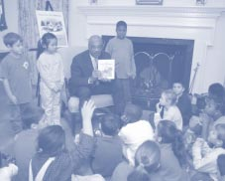
More than anything, No Child Left Behind is about results. No longer will symbolism or good deeds carry the day. We must demand results from our schools, and we must demand results from our government.
We have already started implementing the new law, and ensuring that its focus on results permeates the entire organization. Since my confirmation over a year ago, we have been working hard to build a culture of —accountability within the agency. The development of—this Annual Plan is another important milestone. While it looks and

feels very similar to our Strategic Plan, it provides much greater detail about the specific action steps we will take in the next 18 months to achieve our goals and objectives. It provides transparency to the public and direction to the organization.
What it does not do is report on our measurable progress toward our goals and objectives. Because our five-year plan was released just a few weeks ago, such a progress report is not yet possible. Next year’s Annual Plan and Report will provide a full accounting of the Department’s progress toward our goals and objectives—a report card if you will—so the public can hold us accountable for results just as we expect schools to be held accountable for results.
To leave no child behind, this Department will work with many partners. Congress; policymakers at the state and local levels; educators in schools and colleges and literacy programs; parents, students and other federal agencies. But make no mistake. We take responsibility for achieving the goals and objectives in this plan. More than ever, education is a national priority, and this Department of Education will make it a source of national pride.
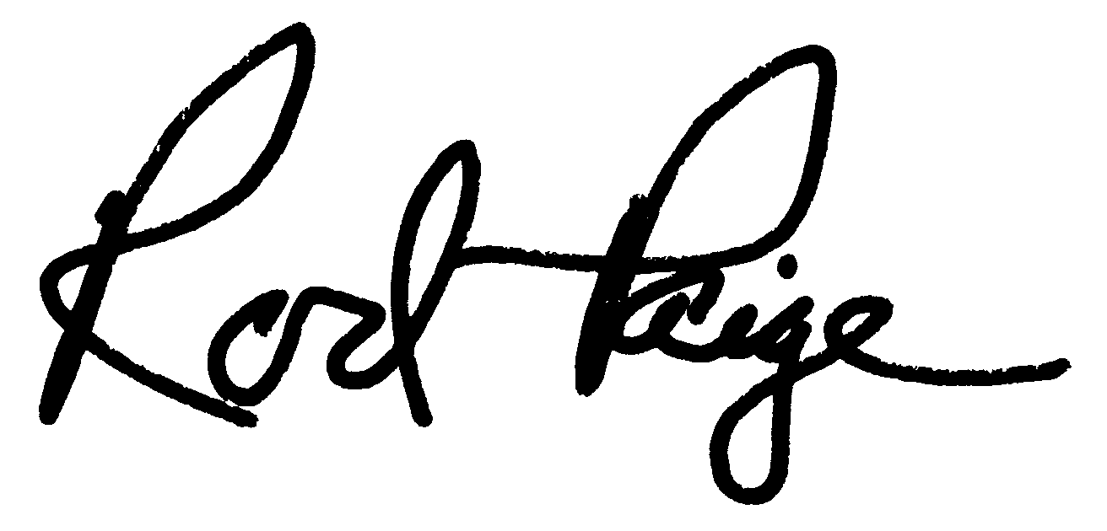
Introduction



About the 2002-2003 Annual Plan
In early March, Secretary Rod Paige released the Department’s Strategic Plan for 2002-2007. This plan establishes six ambitious goals for the agency, and for the nation. It identifies specific performance measures and annual targets that give substance to the goals. And it provides an indication of the Department’s strategies to reach its goals. (The plan is online at www.ed.gov.)
The Strategic Plan integrates the policy shifts embodied by No Child Left Behind with the management improvements of the President’s Management Agenda. It acknowledges that policy and management efforts must work together for us to achieve our objectives.
The Department’s 2002-2003 Annual Plan builds on the new Strategic Plan. It breaks the plan down into bite-sized pieces, called .action steps,. and it provides much more detail about our intentions over the next 18 months. Members of Congress, stakeholders and the general public can view, with great transparency, our plans for putting ideas into action. Employees throughout the Department can gain greater insight into how their work connects with the results we are attempting to achieve.
This document does not provide an official report on the Department’s past performance. Because new strategic goals and objectives were just announced, such a report is not possible. However, where feasible, we provide trend line data to provide the reader with an indication of how the Department has performed on similar goals and objectives in the past. Frankly, in most areas, the news is not good. Our new Strategic Plan acknowledges the failed approaches of the past four decades and seizes on the principles of the landmark No Child Left Behind Act to transform the federal role in education and to improve the performance of the nation’s education system.

No Child Left Behind
The passage of the No Child Left Behind Act marks the most significant shift in federal education policy in 35 years. In signing the Act, President George W. Bush proclaimed, “Today begins a new era, a new time in public education in our country. As of this hour, America’s schools will be on a new path of reform, and a new path of results”.
About the new law, Secretary Rod Paige declared, “Reform is no longer about access or money. It is no longer about compliance or excuses. It is about improving student achievement by improving the quality of the education we offer American students..
This Act calls for revolutionary change, change that is desperately needed because too many children are being left behind. Our system educates some of our children very well, and their success is a testament to many excellent teachers and administrators. We need to help our whole system identify, honor, and emulate these successes. But we cannot be satisfied with islands of excellence. Great public schools should be found in every city and in every neighborhood in America. No child should ever be written off because every child is important and every child can learn.
The No Child Left Behind Act demands progress and achievement. It embraces the principles supported by the president: accountability for results, flexibility and local control, expanded parental options and doing what works. Putting these principles into action will transform our K-12 educational system. These same principles will serve as the foundation for upcoming reforms in areas such as special education, vocational rehabilitation, higher education, and vocational education.
Today begins a new era, a
new time in public education in our country. As of this hour, America’s schools will be on a new path of reform, and a new path of results.

President George W. Bush

Establishing Management Excellence at the U.S. Department of Education
The No Child Left Behind Act is a mandate for the transformation of the Department. Not only does it embrace the president’s education principles, it also embraces the spirit of the Government Performance and Results Act. It demands achievement in return for investment, and it requires a system of performance measurements throughout the educational enterprise. But in order to create a culture of achievement throughout the nation’s education system, first we must create a culture of accountability within the Department itself. The work of creating such a culture has now been underway for almost a year.
When Secretary Paige arrived at the Department, he found financial and management problems that over time had damaged our credibility with Congress and the American public. Auditors had been unable to issue a clean opinion on the Department.s financial statements for each of the prior three fiscal years; the federal student assistance programs remained a fixture on the General Accounting Office.s High-Risk List; and information technology security and internal control issues were not being addressed appropriately. Secretary Paige attacked these problems head-on.
In April 2001, Secretary Paige tasked a .SWAT. team of senior career managers. called the Management Improvement Team (MIT).to identify and fix the most urgent management problems at the Department. They developed a Blueprint for Management Excellence (Blueprint) that, in addition to overall strategies, now includes 176 action items designed to address long-standing management concerns. (The Blueprint is online at www.ed.gov/inits/mit/index.html.)
While the work of the MIT was already well underway, it was greatly strengthened with the release of the President’s Management Agenda (PMA), a comprehensive plan to improve the performance of the federal government. The PMA identifies five government-wide goals: the strategic management of human capital; competitive sourcing; improved financial management; expanded e-government; and budget and performance integration. These goals have been integrated into the Department’s strategic goal, .Establish Management Excellence,. and, more important, into the management improvement efforts of the Department.
No Child Left Behind is
more than a slogan. It is a
promise, a promise that the
Department of Education
intends to keep.
The formation of the MIT was just the first step. Since then, Secretary Paige has taken other important actions to improve the Department’s management structure and address pressing issues, including: (1) creating the Executive Management Team (EMT), which consists of top political appointees and career senior managers who oversee all management improvement processes; (2) establishing a Culture of Accountability Team to help better ingrain a culture of accountability throughout the Department; and (3) entering into partnerships with the National Academy of Public Administration, the Private Sector Council, and the Council for Excellence in Government to develop a 5-Year Human Capital/Strategic Sourcing/Restructuring Plan.

Culture of Accountability Team
Secretary Paige recognized that our biggest challenge was developing a culture across the Department that emphasized individual responsibility and accountability. The Culture of Accountability Team, consisting of career and political employees from across the Department, completed a set of specific actions with assigned ownership, clear timetables and performance measures, designed to establish a mature Culture of Accountability within our agency. The Team developed these actions based upon ideas and feedback obtained from employees across the Department, which will help promote employee buy-in. The EMT and MIT will ensure these actions become reality.

.
Five-Year Human Capital/Strategic Sourcing/Restructuring Plan
On January 31, the Department began an effort to produce our first Five-Year Human Capital/Strategic Sourcing/Restructuring Plan. This Plan’s overall thrust is to ensure we have “the right people in the right place to perform the right job in the right way”.
The Human Capital/Strategic Sourcing/Restructuring Plan will ensure that our staff is structured to deliver services efficiently and allow us to be as close as possible to the citizens we serve. We must ensure that we maintain a highly trained, high-performing workforce capable of implementing the Department’s Strategic Goals and Objectives. Like other federal agencies, we face significant challenges regarding workforce capacity:
- We must ensure our employees possess adequate knowledge and skills to adapt to technology changes and revised program requirements.
- We must evaluate our employees. skill levels, how we train them, and find creative and motivating methods of rewarding them.
- We must ensure we have a succession plan to replace key leaders and retain our institutional memory as significant numbers of our employees enter retirement.
Seventeen percent of our workforce is eligible for voluntary retirement by the end of the year, including 25 percent of our supervisors.
- We must continue to operate and plan within our existing systems, while proposed changes to federal hiring and accountability systems are debated.
The Five-Year Human Capital/Strategic Sourcing/Restructuring Plan will address these challenges. Three teams of employees, working with advice and assistance provided by National Academy of Public Administration and Private Sector Council consultants, are developing the Plan. We expect to complete the Plan by June, and begin implementation immediately thereafter.

Turning Plans into Action
Secretary Paige has said on many occasions that he does not want the Strategic Plan to be a “trophy to hang on the wall.. He knows that it will become a truly useful document only when it is integrated into the fabric of daily life at the Department. To make this happen, we are launching an education campaign to ensure that every manager and employee in the Department understands the Department’s new direction and we are starting to align the work of our offices, teams, and individual employees with our strategic goals and objectives.
While the Strategic Plan gives direction to the Department. and transparency to the public. greater detail is needed in order to put the plan into action. Such detail is provided by this Annual Plan” in the form of the action steps listed herein. Each action step will be “owned” by an office, which will be held accountable for getting work done. To connect this process with ongoing management improvement efforts, most of the action steps within Goal Six have been drawn directly from the Blueprint and the Culture of Accountability Report and aligned with the President’s Management Agenda.
A system has been built to track progress on these action steps so that everyone in the organization. from the Secretary on down—will know if an action needs attention. This tracking system builds on the work of the MIT, which has already been tracking action items from the Blueprint, President.s Management Agenda, and Culture of Accountability Report for months. The database will be updated weekly and each action item will be assigned a green (everything is on track), a yellow (deadlines are slipping or the action step needs attention) or a red (intervention needed immediately). The Executive Management Team will oversee the implementation of the Strategic Plan, as well as the other management initiatives, to ensure perfect alignment and coordination.
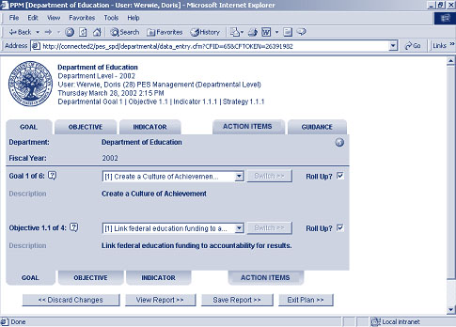
While this performance management system will shine the light on activities that need attention, it will also provide an easy way to identify and recognize successes. It will be very important to demonstrate momentum, both to maintain support from our stakeholders and to improve and sustain the Department’s morale.
Though details must be finalized, the Department plans to publish, on a monthly basis, a list of action items which have been completed successfully or which are proceeding exceptionally well. We also intend to put our money where our mouth is by providing tangible rewards for great work. The Department is in the process of creating a cash bonus and recognition program that will award teams for exceptional performance on these action steps.
Linking Employee Performance with the Department’s Goals and Objectives
While the awards program will recognize excellent team performance, it will also be important to link individual employee performance with the Strategic Plan, the President’s Management Agenda and the other management initiatives. One of the best ways to do this is through the formal employee review system. The Department is preparing to overhaul the General Performance Appraisal System (GPAS) that evaluates most employees in order to link standards for employee evaluation directly with the action steps in this plan.
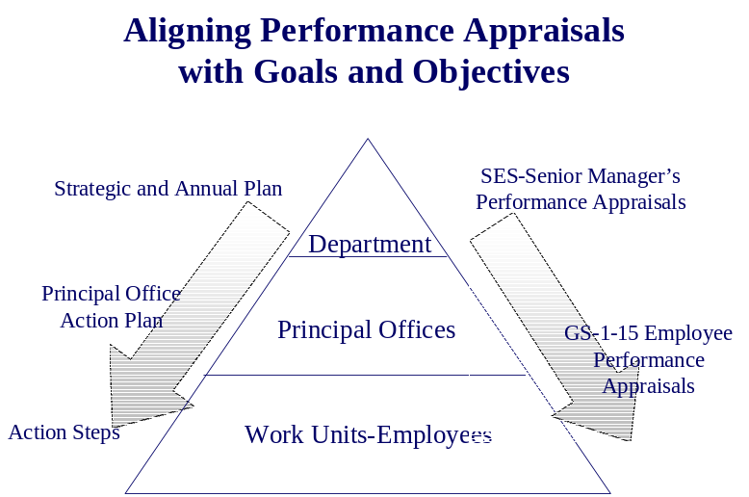

In addition to changing the appraisal system for GS-level employees, Senior Executive Service (SES) members will also experience a change to their appraisal system. All SES members will be required to link activities on their performance plans to the Strategic Plan and other management initiatives, including the five-year human capital/restructuring/competitive-sourcing plan.
Assistant Secretaries will also have performance contracts that will be reviewed and signed by the Secretary. These contracts will be based on the 8-10 highest priority action steps for which the Assistant Secretaries are responsible. While cash bonuses cannot be tied to these contracts, they will focus attention on what matters most.

The Real Challenge: Getting the Work Done
Even with an elaborate tracking system, incentives tied to the strategic plan, monthly updates on progress, and more, this effort will be successful only if we achieve results. How will we actually get the work done? Once offices and teams within the Department understand the new direction the Secretary is leading us toward, how will they actually change their processes in order to accomplish our goals? The Change Management group within the Office of Management will facilitate this difficult, day-to-day work. These experts will help action team leaders think through the organizational changes needed to get their work done. They will link the policy objectives communicated in the Strategic Plan with the ongoing work in human capital development, competitive sourcing and restructuring. Working with managers and senior officers, they will ensure that change happens and goals are achieved.
We intend for the Department of Education to be a model of management excellence and accountability, both for other government agencies and for the nation’s education system. This plan provides the roadmap.
Goals &

Goals &
Objectives
Goal One:
Create a Culture of Achievement
1.1 Link federal education funding to accountability for results.
1.2 Increase flexibility and local control.
1.3 Increase information and options for parents.
1.4 Encourage the use of scientifically-based methods within federal education programs.

Goal Two:
Improve Student Achievement
2.1 Ensure that all students read on grade level by the third grade.
2.2 Improve mathematics and science achievement for all students.
2.3 Improve the performance of all high school students.
2.4 Improve teacher and principal quality.

Goal Three:
Develop Safe Schools and Strong Character
3.1 Ensure that our nation’s schools are safe and drug-free and that students are free of alcohol, tobacco, and other drugs.
3.2 Promote strong character and citizenship among our nation’s youth.
Goal Four:
Transform Education into an Evidence-based Field
4.1 Raise the quality of research funded or conducted by the Department.
4.2 Increase the relevance of our research in order to meet the needs of our customers.
Goal Five:
Enhance the Quality of and Access to Postsecondary and Adult Education
5.1 Reduce the gaps in college access and completion among student populations differing by race/ethnicity, socioeconomic status, and disability while increasing the educational attainment of all.
5.2 Strengthen accountability of postsecondary institutions.
5.3 Establish effective funding mechanisms for postsecondary education.
5.4 Strengthen Historically Black Colleges and Universities, Hispanic Serving Institutions, and Tribal Colleges and Universities.
5.5 Enhance the literacy and employment skills of American adults.
Goal Six:
Establish Management Excellence
6.1 Develop and maintain financial integrity and management and internal controls.
6.2 Improve the strategic management of the Department’s human capital.
6.3 Manage information technology resources, using e-gov, to improve service for our customers and partners.
6.4 Modernize the Federal Student Assistance programs and reduce their high-risk status.
6.5 Achieve budget and performance integration to link funding decisions to results.
6.6 Leverage the contributions of community- and faith-based organizations to increase the effectiveness of Department programs.
6.7 By becoming a high performance, customer-focused organization, earn the President’s Quality Award.

1


Strategic Goal One
Create a Culture of Achievement
Individuals and groups who work in social systems such as the American education system are strongly influenced by the system’s culture. To improve such a system, the most potent strategy for change is cultural change. Therefore, through the effective implementation of the No Child Left Behind Act, we will create a culture characterized by accountability for results, flexibility and local control, expanded parental options, and the use of instructional practices based on scientific research; and we will embed these principles in programs and activities throughout the Department.
Objective 1.1
Link federal education funding to accountability for results.
Objective 1.2
Increase flexibility and local control.
Objective 1.3
Increase information and options for parents.
Objective 1.4
Encourage the use of scientifically-based methods within federal education programs.
The purpose of prosperity is to
make sure the American dream
touches every willing heart. The
purpose is to leave no one out. to
leave no child behind.

.President George W. Bush

Objective 1.1
Link federal education funding to accountability for results
To create a culture of achievement, we must demonstrate that achievement counts, at the local, state and federal levels. We will work with our partners to make accountability for results the hallmark of our education system. In alignment with No Child Left Behind, states will develop systems that hold local schools accountable for results. State progress on a number of achievement indicators will be reported annually. Federal education programs will also be held accountable; those that do not demonstrate results in terms of student outcomes will be either reformed or eliminated.
Strategies and Action Steps for Objective 1.1
Provide technical assistance
1. Publish regulations and guidance on Title I accountability provisions and provide technical assistance to ensure implementation.
2. Convene national conference on Title I to provide technical assistance on its new provisions.
3. Provide support to organizations that assist states with implementing the standards, testing and accountability provisions of the No Child Left Behind Act.
4. Provide technical assistance to ensure that states understand and meet the new testing and accountability requirements under Title I and Title III for English language learners.
5. Provide technical assistance to ensure that states understand and meet the new testing and accountability requirements under Title I for students with disabilities.
6. Provide technical assistance to state migrant education directors to ensure that they understand and meet the new testing and accountability requirements of the No Child Left Behind Act.
7. Provide technical assistance to states and districts on the utilization of online assessments.
8. Provide technical assistance to the states on using accountability data to improve vocational/technical education.
9. Provide technical assistance to the states on using accountability data to improve adult education.
- Develop a new public service advertising campaign with leading business, government and education organizations to build awareness of the No Child Left Behind Act, including its accountability provisions.
Publish a national education performance report
- Publish an annual national education performance report that provides data about state progress on a number of K-16 indicators (data largely drawn from consolidated reports).
Create performance-based grants
12. Develop a legislative proposal to encourage Congress to provide incentives to grantees to improve performance within the Individuals with Disabilities Education Act.
13. Develop a legislative proposal to encourage Congress provide incentives to grantees to improve performance within the Rehabilitation Act.
14. Develop a legislative proposal to encourage Congress to provide incentives to grantees to improve performance within the Perkins Act.
15. Develop a legislative proposal to encourage Congress to provide incentives to grantees to improve performance within the Adult Education and Family Literacy Act.
16. Develop a legislative proposal to encourage Congress to provide incentives to grantees to improve performance within the Higher Education Act
17. Improve monitoring of IDEA state grants to increase the focus on improved student achievement.
18. Establish formal mechanisms within the National Institute on Disability and Rehabilitation Research to link past performance to future awards.
Support Department programs that work
19. Revise program performance indicators to focus on results and integrate them into the Performance Based Data Management Initiative.
20. In the Congressional Justifications document program effectiveness, propose to reform or eliminate ineffective programs, and include outcome targets.
21. Develop and implement an evaluation plan that will produce rigorous information on the effectiveness of Department programs, as well as the effectiveness of interventions supported by federal funding streams.
Objective 1.1 Link Federal Education Funding to Accountability for Results

Performance Measures for Objective 1.1
Objective 1.1 Link Federal Education Funding to Accountability for Results

 |  | ‘02 | ‘03
State Accountability Systems | The percentage of states with complete school accountability systems in place as required by the No Child Left Behind Act.* | 30 | 40
Federal Program Accountability | The percentage of Department programs that demonstrate effectiveness in terms of outcomes, either on performance indicators or through rigorous evaluations. | Base  line  +  5 PP | Base  line  +  10 PP
Federal Program Accountability | The percentage of Department program dollars that are in programs that demonstrate effectiveness in terms of outcomes, either on performance indicators or through rigorous evaluations. | Base  line  +  10 PP | Base  line  +  20 PP

* For this indicator, a complete accountability system includes annual assessments in grades three through eight in mathematics and reading; the publication of adequate yearly progress targets for each student subgroup; the publication of student achievement data (by school, district, and statewide) disaggregated by race/ethnicity, poverty, disability, and Limited-English proficiency; and the choice provisions for students in low-performing schools. This entire system is not required to be in place until 2005-2006.

* For more detailed information on Department programs, visit the site: www.ed.gov/pubs/annualreport2001

PP = Percentage Points
The baseline year is FY 2001.
Objective 1.2
Increase flexibility and
local control
Objective 1.2 Increase flexibility and local control

As the president has said, .Local schools now have a mandate to reform, and we are giving them the freedom to reform.. States, school districts and other grantees will receive increased flexibility over the use of federal funds, and greater responsiveness from the Department to their concerns, in exchange for greater accountability for results. Information technology initiatives will dramatically reduce the data collection burden on state and local officials by seamlessly collecting and disseminating performance information. Increased flexibility will be a core principle incorporated in all legislative proposals.

Strategies and Action Steps for Objective 1.2
Publicize flexibility provisions to the states
22. Aggressively publicize state flexibility opportunities through letters, conferences and other means.
23. Publish State-Flex notice and select first states.
24. Provide technical assistance to targeted states to help them meet the qualifications for Ed Flex.
25. Develop and disseminate guidance on flexibility within Title I school-wide programs.
Publicize flexibility provisions to local districts
26. Publish Local-Flex notice, hold first competition, and select first sites.
27. Commission a study about local barriers to using flexibility provisions.
Foster a customer service orientation at the Department
28. Create and staff the No Child Left Behind resource room to provide rapid response to state and local questions about the Act.
29. Assign senior officers to develop personal relationships with individual state education chiefs and to help answer their questions about the law.
Increase flexibility within other Federal programs
30. Develop a legislative proposal to encourage Congress to provide grantees with greater flexibility in the use of funds and reduce paperwork and reporting burden within the Individuals with Disabilities Education Act.
31. Develop a legislative proposal to encourage Congress to reduce reporting burden within the Rehabilitation Act.
32. Develop a legislative proposal to encourage Congress to provide grantees with greater flexibility in the use of funds and reduce reporting burden within the
Perkins Act.
33. Develop a legislative proposal to encourage Congress to provide grantees with greater flexibility in the use of funds and reduce reporting burden within the Adult Education and Family Literacy Act.
34. Develop a legislative proposal to encourage Congress to provide grantees with greater flexibility in the use of funds and reduce reporting burden within the Higher Education Act.
Reduce data collection and reporting burden while increasing the usefulness of data
35. Reduce the regulatory burden on institutions of higher education through the FED-UP project.
36. Implement the long-term Performance-Based Data Management Initiative to centralize and dramatically reduce reporting burden; align data definitions and collections with it.
37. Implement a short-term pilot project to collect school-level achievement data and align it with financial and demographic information.
38. Develop a streamlined consolidated application and report for formula No Child Left Behind Act programs and align with Initiative.
39. Revise the Office of Civil Rights “E” and “S” Survey to reduce data burden, improve data quality, and align with Performance Based Data Management Initiative.

Performance Measures for Objective 1.2
Objective 1.2 Increase Flexibility and Local Control

Performance
Target
 |  | ‘02 | ‘03
Local Flexibility | The percentage of school districts utilizing transferability or rural flexibility provisions. | Base  line + 5 PP | Base  line + 10 PP
State Flexibility | The number of States approved for Ed-Flex.  (2001 baseline = 9) | 15 | 20
Federal Data Collection Burden | The OMB burden hour estimates of Department program data collections per year. (2001 baseline = 40.5 million) | 40M | 38M
Customer Service | The percentage of Department grantees that express satisfaction with ED customer service (responsiveness, timeliness, efficiency, etc.).* | TBD | TBD

Data collection burden
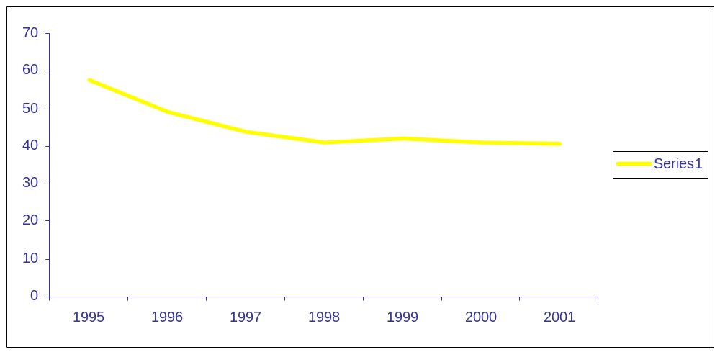

Note: The OMB burden hour estimates of Department program data collections per year.
Objective 1.3
Increase information and options for parents

Parents are children’s first and most important teachers. The Department will aggressively implement the parental involvement, information and options components of No Child Left Behind and encourage states and communities to provide additional choices to parents. States and districts will be required to publish report cards that provide school performance information to parents. Children trapped in failing or unsafe schools will have the opportunity to attend better public schools (including charter schools) or use federal funds for private tutoring. Public school options, including charter schools, will be strongly supported for all students, as will private school options for disadvantaged children. The Department will also work with Congress to embed greater parental choice, involvement and information in all federal education programs, as well as within the tax code.

Strategies and Action Steps for Objective 1.3
Require school report cards
40. Develop and issue guidance on school report cards; provide technical assistance to states to ensure implementation.
41. Develop and implement a coordinated campaign to publicize the report cards to parents, businesses, and other users.
42. Publish and disseminate a guide for states and the public highlighting the best school performance information online, including state and private sites.
Support charter schools
43. Convene the National Charter Schools Conference.
44. Draw media attention to National Charter Schools Week.
45. Publish a monthly newsletter about the Department.s charter school activity.
46. Provide technical assistance to states and schools on effective and innovative special education approaches within charter schools.
47. Through the charter school credit enhancement program, leverage private dollars to fund facilities financing for charter schools.
Provide choices to children trapped in failing or unsafe schools
48. Develop and publicize guidance that clarifies public school choice provisions of Title I; provide technical assistance to ensure implementation.
49. Develop and publicize regulations that clarify supplemental services provisions of Title I; provide technical assistance to ensure implementation.
50. Establish intra-district and inter-district public school choice programs through the voluntary public school choice program.
51. Promote the proposed education tax credit and choice demonstration program.
52. Through speeches and publications, encourage states and communities to provide additional choices to families.
Expand choice in other federal programs
53. Develop a legislative proposal to encourage Congress to embed greater parental choice and information within the Individuals with Disabilities Education Act.
54. Develop a legislative proposal to encourage Congress to embed greater choice and information within the Rehabilitation Act.
55. Develop a legislative proposal to encourage Congress to embed greater parental choice and information within the Perkins Act.
56. Develop a legislative proposal to encourage Congress to embed greater choice and information within the Adult Education and Family Literacy Act.
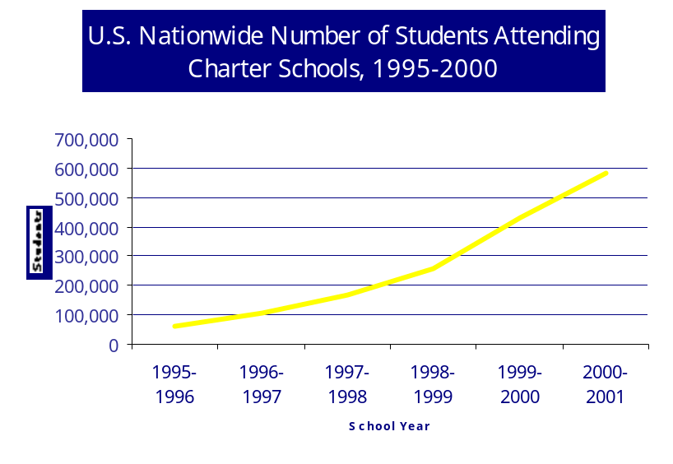
57. Develop a legislative proposal to encourage Congress to embed greater choice and information within the Higher Education Act.
58. Provide technical assistance to the states and follow up with monitoring to ensure that parents of English language learners are provided information about their choices under the No Child Left Behind Act.
59. Fund projects that provide training and information to enable parents, guardians, and other family members to participate more effectively with rehabilitation professionals in meeting the vocational, independent living, and rehabilitation needs of family members with disabilities.
U.S. Nationwide Number of Students
60. Provide information and technical assistance to the private school community to promote equitable participation of private school students and teachers in federal education programs.
61. Coordinate an annual .Back to School. campaign to help make parents aware of their options, including events, publications, satellite town meetings, etc.
62. Explore the expansion of educational options for students using distance learning and e-learning programs.
63. Provide technical assistance to states with virtual high schools, cyber charter schools and other e-learning opportunities focusing on best practices in these areas.

Performance Measures for Objective 1.3

Objective 1.3 Increase Information and Options for Parents
 |  | Performance Targets
 |  | ‘02 | ‘03
Information | The percentage of parents who report having the information they need to determine the effectiveness of their child’s school. | Base  line | Base  line + 5 PP
Parental Choice | The percentage of students in grades K-12 that are attending a school (public or private) that their parents have chosen.  (1999 baseline = 15%) | 18 | 19
Parental Choice | The number of children attending charter schools (in thousands).*  (2001 baseline = 575,000) | 690 | 828
Supplemental Educational Services | Of eligible children, the percentage using supplemental educational services under the provisions of Title I.** | --*** | Base  line

* Students included in this indicator either attend a private school or a public school outside their regular attendance zone.
** Targets assume 20% annual growth, which was the rate of growth from 2000-2001 to 2001-2002.
*** Eligible children are low-income children who attend a Title I school in “school improvement” status.
**** This provision does not go into effect until September 2002 for the 2002-2003 school year. This equates with the Department’s 2003 fiscal year; therefore 2003 data will be used as the baseline.
PP = Percentage Points

Percentage Students in Grades K-12
in Public Schools Chosen by Students or Parents
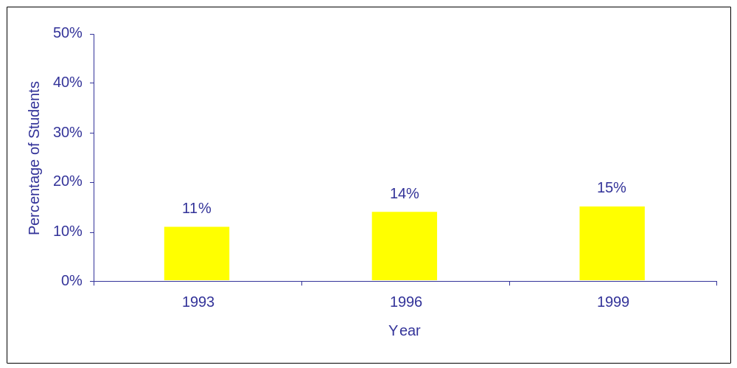
Objective 1.4
Encourage the use of scientifically-based methods
within federal education programs

Part of the cultural transformation needed throughout the American education system is the switch from a fascination with instructional fads to a focus on scientifically-based research. This cultural change is addressed further in Goal Four, where we describe how the Department will develop and disseminate sound educational research. The Department will also work to embed the best science in all of our programs to ensure the use of methods that work.

Strategies and Action Steps for Objective 1.4
Develop .what works. guides for each Department program
64. Develop standards and process for .what works. guides and launch inter-office team on their development. Review guides for scientific base before their publication.
65. Develop .what works. guides for selected programs and distribute them to states and other grantees.
Revise guidance documents to reflect scientifically-based research
66. Update guidance and technical assistance for all programs to reflect research-based instruction.
Work with Congress to embed scientifically-based research in all federal programs
67. Develop a legislative proposal to encourage Congress to embed scientifically-based research within the Individuals with Disabilities Education Act.
68. Develop a legislative proposal to encourage Congress to embed scientifically-based research within the Rehabilitation Act.
69. Develop a legislative proposal to encourage Congress to embed scientifically-based research within the Perkins Act.
70. Develop a legislative proposal to encourage Congress to embed scientifically-based research within the Adult Education and Family Literacy Act.
71. Develop a legislative proposal to encourage Congress to embed scientifically-based research within the Higher Education Act.
Performance Measures for Objective 1.4
Objective 1.4 Encourage the Use of Scientifically-based Methods
Objective 1.4 Encourage the Use of Scientifically Based Methods
within Federal Education Programs
 |  | Performance Targets
 |  | ‘02 | ‘03
What Works Guides | The percentage of Department programs that have developed and disseminated research-based “what works” guides to their grantees. | 10 | 25
What Works Guides | The percentage of “what works” guides that are deemed to be of high quality by an independent review panel of qualified scientists. | 90 | 95

2
Strategic Goal Two
Improve Student Achievement

More and more, we are divided into two
nations. One that reads, one that doesn’t.
One that dreams, one that doesn’t.

.No Child Left Behind

In education, the bottom line is student learning. As a result of the hard work of students, educators, parents, and leaders at the state and local levels, American students will dramatically improve their achievement in reading, mathematics and science, while receiving a rich, well-rounded education. The Department will lead a national campaign to ensure that every child is reading at grade level by third grade. Pre-school and elementary school teachers throughout the nation will receive training in the proven components of effective early reading instruction. To ensure that students become proficient in mathematics and science, the Department will establish a broad collaboration of school districts, colleges and universities, and research institutions to improve the quality of instruction. The Department will lead a campaign to improve the rigor of the high school curriculum and to design new options for adolescent students. Because student achievement is dependent upon the effort of well-prepared teachers and school leaders, the Department will establish initiatives to ensure that the supply of high-quality teachers and principals meets demand.
Objective 2.1
Ensure that all students read on grade level by the third grade.
Objective 2.2
Improve mathematics and science achievement for all students.
Objective 2.3
Improve the performance of all high school students.
Objective 2.4
Improve teacher and principal quality.

Some people say it is unfair to
hold disadvantaged children to
rigorous standards. I say it is
discrimination to require anything
less–the soft bigotry of low
expectations.
.
President George W. Bush

Objective 2.1
Ensure that all students read on grade level by the third grade
President Bush and Congress set a goal through No Child Left Behind that all children will read at grade level by third grade. To reach this goal we must ensure that reading instruction is based on solid scientific research. We will build a strong understanding of the five essential components of good reading instruction and the importance of early cognitive development. We will boost reading achievement for all students, including minority and low-income children, English language learners, and children with disabilities.
Strategies and Action Steps for Objective 2.1
Promote early cognitive development
72. Through the Education/Health and Human Services Early Childhood Task Force, develop and disseminate publications for parents and teachers on early childhood cognitive development.
73. Conduct three technical assistance meetings for Early Reading First applicants.
74. Publicize the Early Reading First grantees as model pre-school programs.
75. Develop and disseminate guidance on No Child Left Behind Act of 2002 NCLB Title I Early Childhood Education Programs; provide technical assistance to assure program quality.
76. Update Even Start guidance and provide technical assistance to the states to base the program on scientific research.
77. Meet regularly with Interagency Coordinating Committee on Early Childhood to establish a research agenda and launch a public information campaign.

Publicize the rigorous research on reading instruction
78. Commission and disseminate a study that identifies 500 high-poverty schools nationally with model reading programs (and the results to prove it).
79. Hold Reading First Writers. Workshops for state applicants and provide individualized technical assistance to any state that seeks further guidance.
80. Ensure that peer reviewers for Reading First are of exceptional quality and check out state applications .on the ground..
81. Provide states with technical assistance and monitoring to ensure that Reading First and Title I are implemented in line with evidence-based research.
82. Provide information and technical assistance to state Migrant Education directors about research-based reading instruction.
Objective 2.1
Encourage early identification and intervention of reading difficulties
83. Provide technical assistance to state special education directors about effective early identification and intervention of reading difficulties.
84. Develop a legislative proposal to encourage Congress to emphasize early identification and prevention of reading difficulties within the Individuals with Disabilities Education Act.
Include special education students in state reading assessments
85. Through Title I negotiated rulemaking, develop regulations that ensure the inclusion of special education students in state reading assessments, and follow up with technical assistance to ensure full implementation.
86. Prepare and disseminate a report on the extent of inclusion of children with disabilities in state assessments.
87. Support and collaborate with a new center to improve literacy results for children who are unresponsive to effective classroom or school-wide programs in preschool through grade six.
88. Emphasize the importance of implementing high quality research-based reading programs in the Office of Civil Rights. minority and special education proactive initiatives and complaint resolutions.
Fourth Grade Reading Achievement

Fourth Grade Reading Achievement
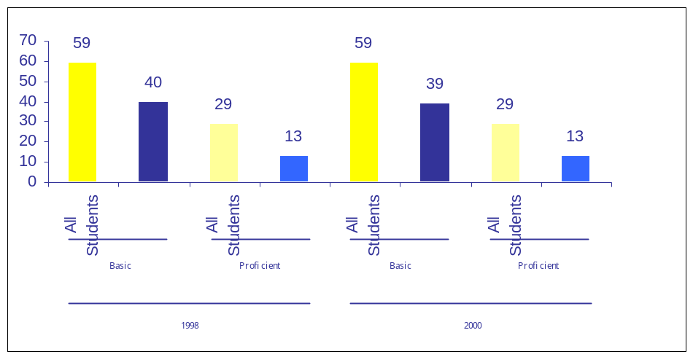
Ensure that English language learners meet rigorous standards
89. Through negotiated rulemaking, develop regulations that ensure the inclusion of limited English proficient students in state reading assessments, and follow up with technical assistance to ensure full implementation.
90. Provide information and technical assistance to state NCLB Title III directors about research-based reading instruction for English language learners.
91. Work proactively with districts to help them develop good evaluation plans to ensure that language acquisition programs are research-based and that English Language Learner (ELL) students are meeting performance standards.
92. Conduct proactive outreach and technical assistance specifically focused on encouraging ELL parents to actively participate in their children’s education.
Other Actions
93. Publish .Helping Your Child. books on early childhood and reading and disseminate widely to parents and child care providers.
94. Commission and disseminate a study of best practices in state pre-K reading guidelines and in early reading teacher certification.

Performance Measures for Objective 2.1
Objective 2.1 Reading Achievement
 |  | Performance Targets
 |  | ‘02 | ‘03
State Reading Assessments | All Students. The number of states meeting their targets for third-grade reading achievement for all students. | N/A | 45
State Reading Assessments | Low-Income Students. The number of states meeting their targets for third-grade reading achievement for low-income students. | N/A | 45
State Reading Assessments | African American Students. The number of states meeting their targets for third-grade reading achievement for African American students. | N/A | 45
State Reading Assessments | Hispanic Students. The number of states meeting their targets for third-grade reading achievement for Hispanic students. | N/A | 45
State Reading Assessments | Students with Disabilities. The number of states meeting their targets for third-grade reading achievement for students with disabilities. | N/A | 45
State Reading Assessments | English Language Learners. The number of states meeting their targets for third-grade reading achievement for English language learners. | N/A | 45

Objective 2.1 Reading Achievement
 |  | Performance Targets
 |  | ‘02 | ‘03
NAEP Reading | All Students. The percentage of all 4th grade students scoring at or above the basic and proficient levels on the NAEP.  2000 Basic Baseline = 59%  2000 Proficient Baseline = 29% | 60  30 | 61  31
NAEP Reading | Low-Income Students. The percentage of low-income 4th grade students scoring at or above the basic and proficient levels on the NAEP.  2000 Basic Baseline = 39%  2000 Proficient Baseline = 13% | 40  14 | 41  15
NAEP Reading | African American Students. The percentage of African American 4th grade students scoring at or above the basic and proficient levels on the NAEP.  2000 Basic Baseline = 35%  2000 Proficient Baseline=10% | 36  11 | 37  12
NAEP Reading | Hispanic Students. The percentage of Hispanic 4th grade students scoring at or above the basic and proficient levels on the NAEP.  2000 Basic Baseline = 36%  2000 Proficient Baseline=13% | 37  14 | 38  15
NAEP Reading | Students with Disabilities. The percentage of 4th grade students with disabilities scoring at or above the basic and proficient levels on the NAEP.  2000 Basic Baseline = 23%  2000 Proficient Baseline = 8% | 24  9 | 25  10
NAEP Reading | Limited English Proficient Students. The percentage of 4th grade limited English proficient students scoring at or above the basic and proficient levels on the NAEP.  2000 Basic Baseline = 18%  2000 Proficient Baseline = 3% | 19  4 | 20  5

Annual Plan 2002 - 2003 43
Notes:
A Using the 2001-2002 school year as a baseline, states are required to set the same annual achievement target
for all students and for several student subgroups, starting with the 2002-2003 school year. (This equates to the
Department’s 2003 fiscal year, which is the first year this indicator can be measured.) Under the No Child Left
Behind Act, these targets must increase at least every three years for the next 12 years, when 100 percent of all
students within all subgroups are expected to achieve proficiency. Therefore, while the targets listed above are
stable, student achievement will actually need to improve steadily in order to meet these goals. When a state
does not test students in the third-grade, results from fourth- or fifth-grade assessments will be used instead.

B Achievement targets: These targets assume a 4 percentage point gain for all students from 2000 to 2007 and
an 8 percentage point gain for each subgroup, thus narrowing the achievement gaps. While this is very
ambitious when compared to long-term national trend lines, some states have shown that such rapid progress is
possible. For example, from 1992 to 1998, African American students in Minnesota made gains of 8
percentage points at the proficient level on the fourth-grade NAEP reading assessment, as did Hispanic students
in Connecticut. At the basic level, two states showed gains of 8 percentage points or more for African Americans
. Rhode Island and Connecticut, plus the Virgin Islands. For Hispanics, at the basic level, one state
(Connecticut) showed gains of 8 percentage points or more. Due to relatively small sample sizes, American
Indians/Alaska Natives and Asian/Pacific Islanders are not reported.
Under the current schedule, NAEP Reading will not be given in 2004 and 2006.
Trends in the Reading Performance of 9-, 13-, and 17-Year-Olds:
Average reading performance, by age: 1971.99
Trends in the Reading Performance of 9-, 13-, and 17-Year-Olds:
Average reading performance, by age: 1971–99

NOTE: Descriptions of performance at different levels on the assessment scale can be found in NCES’ supplemental table 10-5.
SOURCE: U.S. Department of Education, NCES. NAEP 1999 Trends in Academic
Progress: Three Decades of Student Performance (NCES 2000–469), 2000.
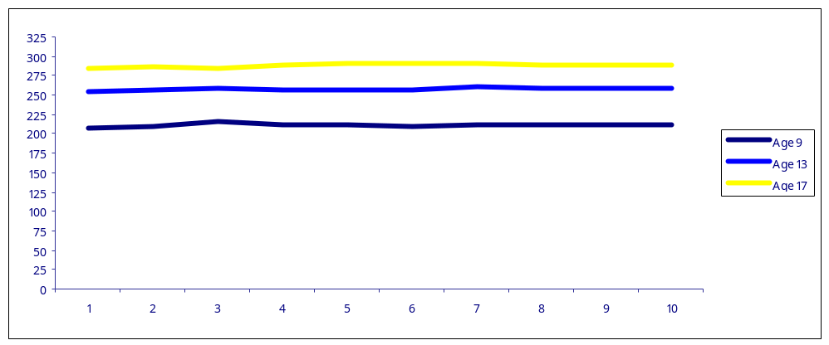
Objective 2.2
Improve mathematics and science achievement for all students
The National Commission on Mathematics and Science Teaching for the 21st Century (the Glenn Commission) and the Hart-Rudman commission on national security both made clear that America.s future depends upon improvements in mathematics and science achievement. Currently, international comparisons such as the Third International Mathematics and Science Study show middle and high school students in America performing at or below the average level. The National Assessment of Educational Progress shows eighth-grade student performance below proficient in mathematics and science for 70 percent of our students and 90 percent of our minority students. For this situation to improve, the quality of teaching in these subjects must improve. Every student deserves to have teachers who possess strong content knowledge in their areas of teaching, as well as effective strategies to engage all students. Mathematics and science teachers must have opportunities to remain current in their fields and take advantage of new technologies to make their subject areas meaningful and engaging for their students.

Strategies and Action Steps for Objective 2.2
Use data to inform instruction
95. Provide technical assistance to Math and Science Partnership Program grantees to help them use student assessment data to inform instruction.
96. Support organizations that provide training to states and districts in using data to inform instruction.
97. Convene states to highlight effective data management systems that can be used to improve instruction.
Develop mathematics and science partnerships
98. Collaborate with the National Science Foundation to strengthen the research base on mathematics and science instruction and to support high-quality professional development.
99. Partner with business and scientific organizations to support effective math and science instruction.
Include special education students and English language learners in state mathematics assessments
100. Include special education students and English language learners in state mathematics assessments.
Support high quality professional development
101. Provide technical assistance and guidance on high quality professional development through the Math and Science Partnership program.
102. Provide technical assistance and guidance on high quality professional development in math and science through the NCLB Title II program.
103. Provide technical assistance to state education technology directors to ensure that technology is used to support student achievement and accountability.
Strengthen the research on math and science instruction
104. Generate and launch a research agenda on mathematics and science instruction (including seeking funding from other agencies). This agenda will be informed by the forthcoming RAND report on the topic and will include research on instructional interventions utilizing technology.

Eigth Grade Mathematics Achievement
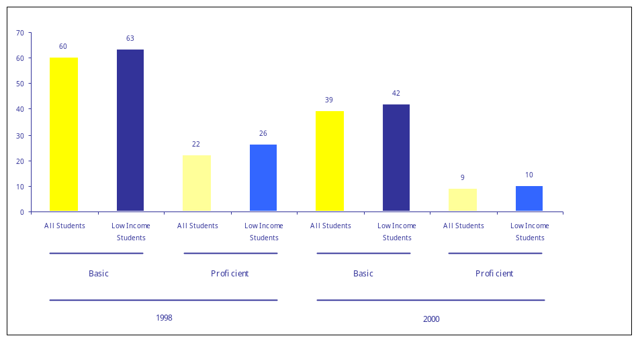
105. Support research to improve instructional interventions and results in algebra for students with disabilities.

Note: Action steps on recruiting and retaining high quality mathematics and science teachers are included within Objective 2.4 (teacher quality)

Performance Measures for Objective 2.2
Objective 2.2 Mathematics Achievement
Objective 2.2 Mathematics Achievement
 |  | Performance Targets
 |  | ‘02 | ‘03
State Mathematics Assessments  (See Note A) | All Students. The number of states meeting their targets for eighth-grade mathematics achievement for all students. | N/A | 45
State Mathematics Assessments  (See Note A) | Low-Income Students. The number of states meeting their targets for eighth-grade mathematics achievement for low-income students. | N/A | 45
State Mathematics Assessments  (See Note A) | African American Students. The number of states meeting their targets for eighth-grade mathematics achievement for African American students. | N/A | 45
State Mathematics Assessments  (See Note A) | Hispanic Students. The number of states meeting their targets for eighth-grade mathematics achievement for Hispanic students. | N/A | 45
State Mathematics Assessments  (See Note A) | Students with Disabilities. The number of states meeting their targets for eighth-grade mathematics achievement for students with disabilities. | N/A | 45
State Mathematics Assessments  (See Note A) | English Language Learners. The number of states meeting their targets for eighth-grade mathematics achievement for English language learners. | N/A | 45


Objective 2.2 Mathematics Achievement
 |  | Performance Targets
 |  | ‘02 | ‘03
NAEP Mathematics  (See Note B) | All Students. The percentage of all 8th grade students scoring at or above the basic and proficient levels on the NAEP.  2000 Basic Baseline = 63%  2000 Proficient Baseline = 26% | X  X | 64  27
NAEP Mathematics  (See Note B) | Low-Income Students. The percentage of low-income 8th grade students scoring at or above the basic and proficient levels on the NAEP.  2000 Basic Baseline = 42%  2000 Proficient Baseline = 10% | X  X | 43  11
NAEP Mathematics  (See Note B) | African American Students. The percentage of African American 8th grade students scoring at or above the basic and proficient levels on the NAEP.  2000 Basic Baseline = 30%  2000 Proficient Baseline = 5% | X  X | 31  6
NAEP Mathematics  (See Note B) | Hispanic Students. The percentage of Hispanic 8th grade students scoring at or above the basic and proficient levels on the NAEP.  2000 Basic Baseline = 39%  2000 Proficient Baseline = 8% | X  X | 40  9
NAEP Mathematics  (See Note B) | Students with Disabilities. The percentage of 8th grade students with disabilities scoring at or above the basic and proficient levels on the NAEP. 2000 Basic Baseline = 22%  2000 Proficient Baseline = 4% | X  X | 23  5
NAEP Mathematics  (See Note B) | Limited English Proficient Students. The percentage of 8th grade limited English proficient students scoring at or above the basic and proficient levels on the NAEP.  2000 Basic Baseline = 21%  2000 Proficient Baseline = 2% | X  X | 22  3

Notes:
A Using the 2001-2002 school year as a baseline, states are required to set the same annual achievement target
for all students and for several student subgroups, starting with the 2002-2003 school year. (This equates to the
Department.s 2003 fiscal year, which is the first year this indicator can be measured.) Under the No Child Left
Behind Act, these targets must increase at least every three years for the next 12 years, when 100 percent of all
students within all subgroups are expected to achieve proficiency. Therefore, while the targets listed above are
stable, student achievement will actually need to improve steadily in order to meet these goals. When a state
does not test students in the eighth-grade, results from sixth- or seventh-grade assessments will be used instead.

B Achievement targets: These targets assume a 4 percentage point gain for all students from 2000 to 2007 and
an 8 percentage point gain for each subgroup, thus narrowing the achievement gaps. While this is very
ambitious when compared to long-term national trend lines, several states have shown that such rapid progress
is possible. For example, from 1992 to 2000, Hispanic students in six states (Ohio, Maryland, North Carolina,
West Virginia, Tennessee and Massachusetts) made gains of at least 8 percentage points on the eighth-grade
NAEP mathematics assessment, and African-American students in Nebraska and New York made gains of at
least six percentage points. At the basic level, African American students in 14 states achieved gains of at least
8 percentage points on the 8th grade NAEP mathematics assessment, and Hispanics gained at least 8
percentage points in 18 states.
Note: Under the current schedule, NAEP Mathematics will not be given in 2002, 2004 and 2006.

Mathematics Performance: Average mathematics performance of students in their final year of secondary school from the TIMSS, 1995
Significantly higher

Not significantly different

Significantly lower
Australia1
Austria1
Canada1
Denmark1
France1
Germany1
Hungary
Iceland1

Czech Republic
Italy1

Cyprus1

International average
Netherlands1
New Zealand
Norway1
Slovenia1
Sweden1
Switzerland

Lithuania
Russian Federation

South Africa1

Average score relative to U.S.
Country
1. Did not satisfy one or more of the sampling or other guidelines. In the final year of secondary school, this included the United States. Latvia is designated LSS for Latvian-speaking schools only. See NCES’ Supplemental Note 7 for more information.
SOURCES: U.S. Department of Education, NCES. Pursuing Excellence: A Study of U.S. Fourth-Grade Mathematics and Science Achievement in International Context (NCES 97-255), 1997; U.S. Department of Education, NCES. Pursuing Excellence: A Study of U.S. Eighth-Grade Mathematics and Science Teaching, Learning, Curriculum, and Achievement in International Context (NCES 97-198), 1996; U.S. Department of Education, NCES. Pursuing Excellence: A Study of U.S. Twelfth-Grade Mathematics and Science Achievement in International Context (NCES 98-049),1998.

Objective 2.3
Improve the performance of all high school students
The demands of a competitive economy and flexible workplace require every American youth to acquire solid academic preparation for an effective transition from high school to postsecondary education and then to the workplace. Today’s youth need strong academic skills in written and oral communication, mathematics and science, problem solving and teamwork. Yet the National Assessment of Educational Progress shows 12th grade achievement declining at the same time that the national dropout rate is increasing. We must do better. American high schools must be held accountable for raising the academic achievement of all students. At the same time, our education system should offer customized learning opportunities to adolescents, tapping into community colleges, education technology, and other nontraditional sources to boost learning and career preparation for students.

Strategies and Action Steps for Objective 2.3
Hold schools accountable for student achievement
106. Develop a legislative proposal to encourage Congress, through the reauthorization of the Perkins Act, to promote activities that have been demonstrated to be effective in improving the academic performance of high school students and closing the achievement gaps.
107. Work with interested states and private organizations to investigate ways to link high school graduation exams with postsecondary entrance requirements.
108. Implement the Secondary Student Initiative for Migrant Children.
Improve the rigor of the high school curriculum
109. Work with private organizations to launch a media campaign encouraging all high school students to take more challenging courses.
110. Support programs that enable low-income students to take the Advanced Placement exams free of charge.
Strengthen research and development efforts focused on high schools
111. Establish a scientific advisory group for ongoing development of high school models.
112. Complete National Assessment of Vocational Education.
113. Commission rigorous evaluations of effective interventions at the high school level, especially for low-income or minority children, that improve student achievement and reduce dropout rates.
114. Host a series of regional forums to gather input from educators, parents, students and community groups on improving student achievement and closing achievement gaps at the high school level.
Increase learning options for students
115. Collaborate with NICHD on adolescent literacy study.
116. Support a new center to improve literacy results for secondary school-aged children who are unresponsive to effective classroom or school-wide programs.
117. As required by No Child Left Behind, issue guidelines for local educational agencies seeking funding for programs to provide same gender schools and classrooms.
Performance Measures for Objective 2.3
Objective 2.3 High School Achievement
 |  | Performance Targets
 |  | ‘02 | ‘03
State Reading Assessments  (See Note A) | All Students. The number of states meeting their targets for high school reading achievement for all students. | N/A | 45
State Reading Assessments  (See Note A) | Low-Income Students. The number of states meeting their targets for high school reading achievement for low-income students. | N/A | 45
State Reading Assessments  (See Note A) | African American Students. The number of states meeting their targets for high school reading achievement for African American students. | N/A | 45
State Reading Assessments  (See Note A) | Hispanic Students. The number of states meeting their targets for high school reading achievement for Hispanic students. | N/A | 45
State Reading Assessments  (See Note A) | Students with Disabilities. The number of states meeting their targets for high school reading achievement for students with disabilities. | N/A | 45
State Reading Assessments  (See Note A) | English Language Learners. The number of states meeting their targets for high school reading achievement for English language learners. | N/A | 45

Objective 2.3 High School Achievement
State Reading
Assessments
(See Note A)
N/A
Objective 2.3 High School Achievement
 |  | Performance Targets
 |  | ‘02 | ‘03
State Mathematics Assessments  (See Note B) | All Students. The number of States meeting their targets for high school mathematics achievement for all students. | N/A | 45
State Mathematics Assessments  (See Note B) | Low-Income Students. The number of states meeting their targets for high school mathematics achievement for low-income students. | N/A | 45
State Mathematics Assessments  (See Note B) | African American Students. The number of states meeting their targets for high school mathematics achievement for African American students. | N/A | 45
State Mathematics Assessments  (See Note B) | Hispanic Students. The number of states meeting their targets for high school mathematics achievement for Hispanic students. | N/A | 45
State Mathematics Assessments  (See Note B) | Students with Disabilities. The number of states meeting their targets for high school mathematics achievement for students with disabilities. | N/A | 45
State Mathematics Assessments  (See Note B) | English Language Learners. The number of states meeting their targets for high school mathematics achievement for English language learners. | N/A | 45

N/A
N/A
N/A
N/A
N/A
45
45
45
45
45
45
All Students. The number of states meeting their targets
for high school reading achievement for all students.
Objective 2.3 High School Performance
 |  | Performance Targets
 |  | ‘02 | ‘03
NAEP Reading  (See Note C) | All Students. The percentage of all 12th grade students scoring at or above the basic and proficient levels on the NAEP.  1998 Basic Baseline = 75%  1998 Proficient Baseline = 38% | 76  39 | X  X
NAEP Reading  (See Note C) | African American Students. The percentage of African American 12th grade students scoring at or above the basic and proficient levels on the NAEP.  1998 Basic Baseline = 56%  1998 Proficient Baseline = 16% | 57  17 | X  X
NAEP Reading  (See Note C) | Hispanic Students. The percentage of Hispanic 12th grade students scoring at or above the basic and proficient levels on the NAEP.  1998 Basic Baseline = 60%  1998 Proficient Baseline = 23% | 61  24 | X  X
NAEP Reading  (See Note C) | Students with Disabilities. The percentage of 12th grade students with disabilities scoring at or above the basic and proficient levels on the NAEP.  1998 Basic Baseline = 30%  1998 Proficient Baseline = 7% | 31  8 | X  X
NAEP Reading  (See Note C) | Limited English Proficient Students. The percentage of 12th grade students with limited English proficiency scoring at or above the basic and proficient levels on the NAEP.  1998 Basic Baseline = 27%  1998 Proficient Baseline = 8% | 28  9 | X  X

Low-Income Students. The number of states meeting their
Objective 2.3 High School Performance
 |  | Performance Targets
 |  | ‘02 | ‘03
NAEP Mathematics  (See Note D) | All Students. The percentage of all 12th grade students scoring at or above the basic and proficient levels on the NAEP.  2000 Basic Baseline = 62%  2000 Proficient Baseline = 16% | X  X | 63  17
NAEP Mathematics  (See Note D) | African American Students. The percentage of African American 12th grade students scoring at or above the basic and proficient levels on the NAEP.  2000 Basic Baseline = 29%  2000 Proficient Baseline = 2% | X  X | 30  3
NAEP Mathematics  (See Note D) | Hispanic Students. The percentage of Hispanic 12th grade students scoring at or above the basic and proficient levels on the NAEP.  2000 Basic Baseline = 42%  2000 Proficient Baseline = 4% | X  X | 43  5
 | Students with Disabilities. The percentage of 12th grade students with disabilities scoring at or above the basic and proficient levels on the NAEP.  2000 Basic Baseline = 24%  2000 Proficient Baseline = 4% | X  X | 25  5
 | Limited English Proficient Students. The percentage of 12th grade students with limited English proficiency scoring at or above the basic and proficient levels on the NAEP.  2000 Basic Baseline = 28%  2000 Proficient Baseline = 2% | X  X  X | 3  29  3

targets for high school reading achievement for low-income
students.
Objective 2.3 High School Performance
 |  | Performance Targets
 |  | ‘02 | ‘03
Advanced Placement Participation  (See Note E) | All Students The percentage of all 12th grade students who took at least one of the AP exams. (1999 Baseline = 13.1%) | 14 | 15
Advanced Placement Participation  (See Note E) | African American Students. The percentage of all 12th grade African American students who took at least one of the AP exams. (2001 Baseline = 3.7%) | 4 | 5
Advanced Placement Participation  (See Note E) | Hispanic Students. The percentage of all 12th grade Hispanic students who took at least on of the AP exams. (2001 Baseline = 8.5%) | 9 | 10
Advanced Placement Achievement  (See Note F | English. The percentage of all 12th grade students who scored 3 or higher on at least one of the AP English exams. (2001 Baseline = 4.9%) | 5.4 | 5.9
Advanced Placement Achievement  (See Note F | History. The percentage of all 12th grade students who scored 3 or higher on the AP American history exam. (2001 Baseline = 3.0%) | 3.5 | 4
Advanced Placement Achievement  (See Note F | Calculus. The percentage of all 12th grade students who scored 3 or higher on at least one of the AP calculus exams. (2001 Baseline = 3.4%) | 3.9 | 4.4
Advanced Placement Achievement  (See Note F | Science. The percentage of all 12th grade students who scored 3 or higher on at least one of the AP science exams. (2001 Baseline = 2.6%) | 3.1 | 3.6

African American Students. The number of states meeting
Objective 2.3 High School Achievement
 |  | Performance Targets
 |  | ‘02 | ‘03
High School Completion  (See Note G) | Total.* The percentage of 18-24 year-olds who have completed high school. (2000 Baseline = 85.9%) | 86.1 | 86.5
High School Completion  (See Note G) | African Americans. The percentage of 18-24 year-old African Americans who have completed high school.  (2000 Baseline = 83.5%) | 84.0 | 84.5
High School Completion  (See Note G) | Hispanic Americans. The percentage of 18-24 year-old Hispanic Americans who have completed high school. (2000 Baseline = 63.4%) | 64.0 | 66.0

College Preparation: Nearly a third of our college freshmen find
they must take a remedial course before they are able to
even begin regular college level courses.
Percentage of freshmen enrolled in remedial courses, by subject, control and type of institution, and minority enrollment:
Fall 1989 and 1995
 |  | Fall 1995
 |  |  |  | Public |  | Private |  | Minority Enrollment
Subject | Fall 1989 | Public |  | 2-year | 4-year | 2-year | 4-year | High | Low
Reading, writing, or mathematics  Reading  Writing  Mathematics | 30  13  16  21 | 29  13  17  24 |  | 41  20  25  34 | 22  8  12  18 | 26  11  18  23 | 13  7  8  9 | 43  25  29  35 | 26  11  15  21
Percentage of higher education institutions offering remedial courses, by subject, control and type of institution, and minority enrollment: Fall 1989 and 1995
 |  | Fall 1995
 |  |  | Public |  |  | Private |  | Minority Enrollment
Subject | Fall 1989 | Public | 2-year |  | 4-year | 2-year | 4-year | High | Low
Reading, writing, or mathematics  Reading  Writing  Mathematics | 74  58  65  68 | 78  57  71  72 | 100  99  99  99 |  | 81  52  71  78 | 63  29  61  62 | 63  34  52  51 | 94  87  85  93 | 76  53  70  70
*Institutions with high minority enrollment are defined as those in which total student enrollment, excluding nonresident aliens, is less than 50 percent white.
Source: U.S. Department of Education, national Center for Education Statistics,Postsecondary Education Quick Information System, Remedial Education at Higher Education Institutions in Fall 1995, 1996.

Notes:
A Using the 2001-2002 school year as a baseline, states are required to set the same annual achievement target
for all students and for several student subgroups, starting with the 2002-2003 school year. (This equates to the
Department.s 2003 fiscal year, which is the first year this indicator can be measured.) Under the No Child Left
Behind Act, these targets must increase at least every three years for the next 12 years, when 100 percent of all
students within all subgroups are expected to achieve proficiency. Therefore, while the targets listed above are
stable, student achievement will actually need to improve steadily in order to meet these goals. States may
assess reading achievement in either grade 10, 11 or 12.

B Using the 2001-2002 school year as a baseline, states are required to set the same annual achievement target
for all students and for several student subgroups, starting with the 2002-2003 school year. (This equates to the
Department.s 2003 fiscal year, which is the first year this indicator can be measured.) Under the No Child Left
Behind Act, these targets must increase at least every three years for the next 12 years, when 100 percent of all
students within all subgroups are expected to achieve proficiency. Therefore, while the targets listed above are
stable, student achievement will actually need to improve steadily in order to meet these goals. States may
assess mathematics achievement in either grade 10, 11 or 12.

C Achievement targets: These targets assume a 4 percentage point gain for all students from 1998 to 2007 and
an 8 percentage point gain for each subgroup, thus narrowing the achievement gaps. This rate of progress is
equivalent to our targets for 4th grade reading. (See objective 2.1 for detail about how we set those targets.)
.Low-income students. are not included because the data for this subgroup are unreliable at the 12th grade
level.
Note: Under the current schedule, NAEP Reading will not be given in 2003, 2004 and 2006.

D Achievement targets: These targets assume a 4 percentage point gain for all students from 2000 to 2007 and
an 8 percentage point gain for each subgroup, thus narrowing the achievement gaps. This rate of progress is
equivalent to our targets for 8th grade mathematics. (See objective 2.2 for detail about how we set those
targets.) .Low-income students. are not included because the data for this subgroup are unreliable at the 12th
grade level.
Note: Under the current schedule, NAEP Mathematics will not be given in 2002, 2004 and 2006

E These targets demonstrate a narrowing of the AP participation rate gaps (between all individuals and African
Americans/Hispanic Americans) by half. The denominator is the universe of all 12th grade students in the U.S.
Source: The College Board Advanced Placement Program.

F English exams include AP English Literature & Composition and AP English Language & Composition. Calculus
exams include AP Calculus AB and AP Calculus BC; science exams include AP Biology, AP Chemistry, AP
Environmental Science, AP Physics B, AP Physics C (Electricity & Magnetism), and AP Physics C (Mechanics).
The denominator is the universe of all 12th grade students in the U.S; these targets reflect a goal of having more
students pass the test, but also of having more students taking AP classes and exams.

G These targets demonstrate a narrowing of the high school completion gaps (between all individuals and African
Americans/Hispanic Americans) by half.
Source: U.S. Department of Commerce, Bureau of the Census, Current Population Survey.
Objective 2.4
Improve teacher and principal quality
The president has called for a quality teacher in every classroom. He has said, Education reform is empty if it does not take account of the needs of educators. Teachers are not the objects of “education reform. They are the engines of education reform. They have a high calling, and we must respect it”. We will work to ensure that all of our nation’s schools have the high-quality teachers they need to boost student achievement, both by recruiting new, highly qualified teachers and by providing current teachers access to rigorous professional development. This is especially critical in schools where many children have been left behind. In addition, we will work to strengthen the leadership corps, as we know from research and experience that strong principals are essential for the improvement of student achievement.
Strategies and Action Steps for Objective 2.4
Reduce barriers to teaching for highly qualified individuals
118. Complete guidance on Title II of NCLB and provide technical assistance to the states, especially on how they can use their funds to streamline their certification systems and support alternate routes to certification.
119. Revamp the guidance and peer review process for the Transition to Teaching program to ensure that high quality, streamlined alternate route programs are funded.
120. Work with states and teacher recruitment grantees (under Title II of HEA) to increase the number and quality of alternate routes to certification.
121. Actively promote the Department’s loan forgiveness program for teachers in high-poverty schools.
Support professional development in research-based instruction
122. Develop and implement a process to review all offices’ technical assistance materials on research-based professional development to ensure scientific rigor.
123. Provide technical assistance to the states, through NCLB Title II, in research based professional development.
124. Provide technical assistance to the states, through NCLB Title II Part D, in research based professional development in the use of technology to improve instruction.
125. Conduct regional institutes for states to revise their professional development plans for technical education teachers to include research-based practices, especially in math and science.
126. Host professional development institute for adult education, incorporating current knowledge and findings of Adult Basic Education (ABE) and English as a Second Language (ESL) studies.
127. Provide technical assistance to states to ensure that they are providing research-based professional development for ELL teachers.
128. Publish selection criteria on research-based instruction for national professional development program and provide technical assistance on these criteria to applicants and grantees.
129. Under Individuals with Disabilities Act (IDEA), award grants for professional development projects of national significance that use research-based practices.
130. Collaborate with the American Federation of Teachers to provide high quality professional development in scientifically-based reading instruction.
Improve the quality of teacher preparation programs
131. Promote induction and mentoring programs for new teachers through speeches, conferences and publications.
132. Follow up on the First Lady’s conference on teacher preparation by identifying exceptional teacher preparation programs and disseminating their best practices.
133. Collaborate with accreditation agencies to improve the quality of teacher preparation programs, especially in the area of early reading.
134. Work with state and partnership grantees [within Title II of the Higher Education Act (HEA)] to streamline teacher preparation programs and base them on research.
135. Encourage Teaching American History Program grantees to work with Institutions of Higher Education (IHE) to provide pre-service professional development in traditional American history teaching to future teachers.
136. Make awards under the Math and Science Partnerships Program that support efforts to increase the role of arts and sciences programs in the preparation of math and science teachers.
137. Under IDEA, support statewide models of personnel preparation to ensure that children with disabilities are served by highly qualified teachers, and disseminate their best practices nationally.
Encourage innovative teacher compensation and accountability systems
138. Encourage the development of alternative compensation systems and personnel accountability systems linked to student achievement gains through speeches, conferences and publications.
139. Examine tenure systems and promote alternatives through speeches, conferences and publications.
Develop new leadership training models
140. Host a Leadership Summit to examine effective recruitment, development and retention of high quality school leaders.
141. Provide technical assistance to the states, through NCLB Title II, in the development of high-quality recruitment and professional development models for school leaders.
Strengthen the research base
142. Use NCLB Title II evaluation funds to support rigorous studies of effective interventions related to professional development and teacher quality.

Performance Measures for Objective 2.4
We know from research that improving teacher and principal quality will lead to improved achievement, though we also know that measuring “teacher quality” or “principal quality” is very difficult. While research has shown that a few measurable attributes relate to student achievement—such as master’s degrees in math or science or teachers’ verbal ability—more than 90 percent of a teachers’ influence on student achievement goes unexplained. So the best performance measure for this objective is student achievement, as expressed in the indicators for objectives 2.1, 2.2, and 2.3 (achievement on national and state assessments in reading, mathematics, and science, disaggregated by subgroups).

3
Strategic Goal Three
Develop Safe Schools
and Strong Character


First we must do everything in
our power to ensure the safety of
our children.

.President George W. Bush
The terrorist attacks have created a new environment in which we must ensure that our children are safe from threats both foreign and domestic. The Department will work to maintain a safe and drug-free environment in which every child can learn. In addition, as the president has said, ”Teaching is more than training, and learning is more than literacy. Our children must be educated in reading and writing—but also in right and wrong”. He quoted Martin Luther King, Jr., who said “Intelligence plus character—that is the true goal of education”. We will focus the nation’s education system on our children’s hearts, as well as their minds.
Objective 3.1
Ensure that our nation’s schools are safe and drug-free and that students are free of alcohol, tobacco and other drugs.
Objective 3.2
Promote strong character and citizenship among our nation’s youth.
Objective 3.1
Ensure that our nation’s schools are safe and drug-free and that students are free of alcohol, tobacco and other drugs
Teaching and learning to the high standards demanded in No Child Left Behind requires that our nation.s schools be safe and that our students abstain from the use of alcohol, tobacco and other drugs. In order to ensure that our schools are safe and our students drug-free, the Department of Education will focus on four areas: best practices; data collection and dissemination; coordination of efforts; and addressing safe school priorities in a timely manner.
Strategies and Action Steps for Objective 3.1
Focus on results and progress
143. Develop and publish an annual report on school safety.
144. Provide technical assistance to the states in the development of a Uniform Management and Information System, in alignment with the Performance Based Data Management Initiative.
145. Hold conference of Safe and Drug-Free School “coordinator” grant recipients to provide training on drug prevention and school safety.
Disseminate information on best practices
146. Hold teleconference on best practices in improving children’s mental health.
147. Hold teleconference on bioterrorism and disseminate information on best methods for dealing with bioterrorist threats
148. Develop and disseminate in paper and electronic versions a “What Works Guide” on best prevention practices for alcohol, drug, and violence. Topics addressed should include best practices in threat assessment and model school safety plans. (See action step 66 for more information.)
149. Ensure that all principal offices that provide technical assistance to school districts and postsecondary institutions on issues of harassment include Department-identified best practices.
Encourage the revision of school safety plans to reflect new threats
150. Provide technical assistance to states on lessons learned from 9/11 and from lessons learned from international meeting on terrorism and crisis.
151. Develop and announce model safe school plans grant program.
Ensure that Department activities are coordinated
152. Develop and coordinate an intra-agency group on school safety.
153. Develop and coordinate an inter-agency group on school safety.
Performance Measures for Objective 3.1
Objective 3.1: Safe and Drug-Free Schools
 | Performance Targets
Violent Crime at School | ‘02 | ‘03
The number of violent crimes experienced at school by students ages 12 through 18.  (2000 Baseline = 884,100) | 876,700 | 869,400
The number of serious violent crimes experienced at school by students ages 12 through 18.  (2000 Baseline = 185,600) | 184,000 | 182,500

Source: U.S. Department of Justice, Bureau of Justice Statistics, National Crime Victimization Survey, 1999. “Serious violent crime” includes rape, sexual assault, robbery and aggravated assault. “Violent crime” includes serious violent crime and simple assault. “Serious violent crime” is a subset of “violent crime”. These data are collected annually and are analyzed and released two years after collection.

School Violence: There were 60 school-associated violent deaths
in the United States between July 1, 1997 and June 30, 1998
.including 47 homicides

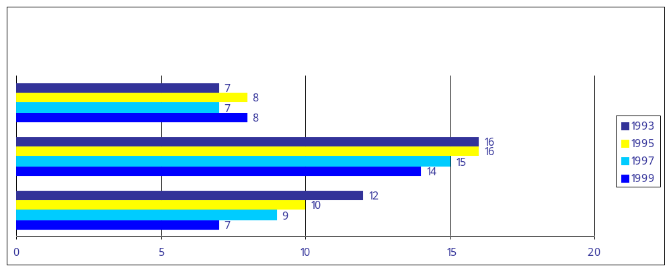
As appears in the Condition of Education, 2001. NOTE: The data do not meet NCES standards for response rates. For definitions of the racial/ethnic categories used in this indicator.
SOURCE: U.S. Department of Health and Human Services, Public Health Service, Centers for Disease Control and Prevention, National Center for Health Statistics. National Health Interview Survey.Youth Risk Behavior Survey, 1993, 1995, 1997, and 1999.

Objective 3.1: Safe and Drug-Free Schools
Objective 3.1 Safe and Drug-Free Schools
 |  | Performance Targets
 |  | ‘02 | ‘03
Drug Use | Alcohol. The percentage of youth ages 12-17 who reported using alcohol in the past 30 days.  (2000 baseline = 16.4%) | 13.2 | 12.2
Drug Use | Tobacco (cigarettes). The percentage of youth ages 12-17 who reported smoking a cigarette in the past 30 days. (2000 baseline = 13.4%) | 11.2 | 10.3
Drug Use | Marijuana. The percentage of youth ages 12-17 who reported using marijuana in the past 30 days.  (2000 baseline = 7.2%) | 5.8 | 5.3
Drug Use | Cocaine. The percentage of youth ages 12-17 who reported using cocaine in the past 30 days.  (2000 baseline = .6%) | 0.40 | 0.37
Drug Use | Heroin. The percentage of youth ages 12-17 who reported using heroin in the past 30 days.  (1999 baseline = .20%) | 0.16 | 0.15

Note: The source is the National Household Survey on Drug Abuse. The Office of National Drug Control
Policy set these targets.

Students in Grades 9 through 12 who reported that drugs were made available to them on school property during the last 12 months
Objective 3.1: Safe and Drug-Free Schools
Measures
 | Performance Targets
Substance Use At School | ‘02 | ‘03
Alcohol. Percent of high school students who report any alcohol use on school property in the previous 30 days. (2001 Baseline = 5%) | X | 5
Cigarettes. Percent of high school students who report any cigarette use on school property in the previous 30 days. (2001 Baseline = 14%) | X | 14
Marijuana. Percent of high school students who report any marijuana use on school property in the previous 30 days. (2001 Baseline = 7%) | X | 7
Illicit Drugs. Percent of high school students who report being offered, sold, or given an illegal drug on school property in the previous 12 months. (2001 Baseline = 30%) | X | 29

*The response rate for this survey was less than 70 percent and a full nonresponse bias analysis has not been done to date.
NOTE: “On school property” was not defined for survey respondents.
SOURCE: Centers for Disease Control and Prevention, National Center for Chronic Disease Prevention and Health Promotion, Youth Risk Behavior Surveillance System (YRBSS), “Youth Risk Behavior Survey” (YRBS), 1993, 1995, 1997, and 1999.

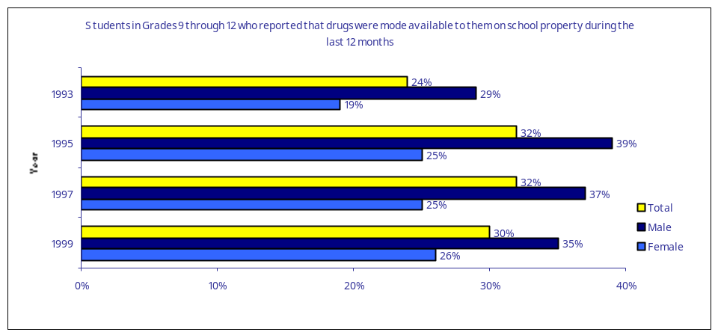
30-Day Prevalence of Alcohol Use for

30-Day Prevalence of Drug Use for
8th-, 10th-, and 12th-Graders

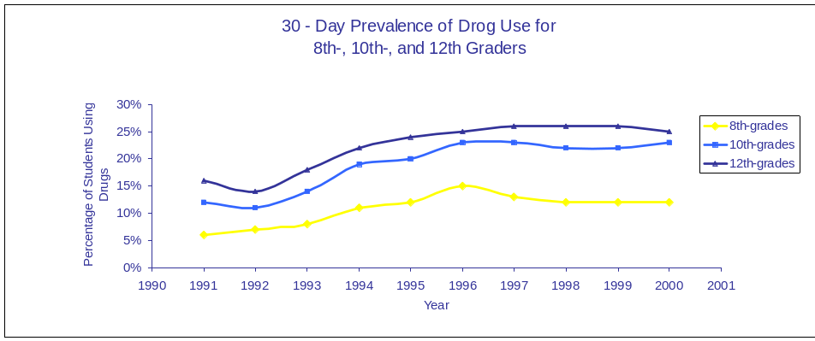
8th-, 10th-, and 12th-Graders
SOURCE: Monitoring the Future (MTF), 2000. Frequency: Annual. Next Update: 2001. Validation Procedure: Data validated by University of Michigan Institute for Social Research and National Institute on Drug Abuse procedures. Limitations of data and planned improvements: According to NCES calculations, the total response rate for this survey has varied between 46 percent and 67 percent since 1976.

30-Day Prevalence of Alcohol Use for
8th-, 10th-, and 12th-Graders

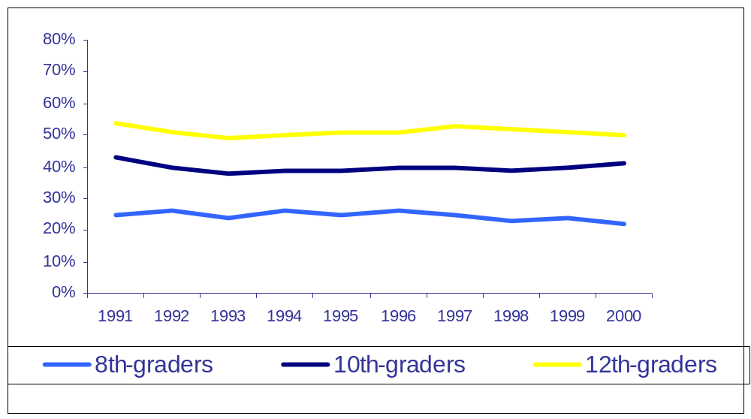

Objective 3.2
Promote strong character and citizenship among our
Nation’s youth
Recent events have unified our nation and rekindled a spirit of community and patriotism. The Department will build upon this energy to launch a national campaign to promote character development and citizenship in our youth. We will also highlight programs and schools that have demonstrated evidence of improved student safety and the development of character in their students.
Strategies and Action Steps for Objective 3.2
Launch a campaign for character
154. Launch a public campaign to promote character education.
Partner with faith-based and community organizations
155. Convene regional conferences featuring faith-based and community partners to showcase and disseminate best practices in character education.
156. Issue regulations implementing the .Boy Scouts of America Equal Access Act. to provide equal access for Boy Scouts and other patriotic organizations.
Support and evaluate character education pilots
157. Select high quality pilot sites through character education program and evaluate and publicize their work.
158. Fund rigorous evaluations of the effectiveness of specific character education interventions.
These reforms
express my deep belief
in our public schools
and their mission to
build the mind and
character of every
child, from every
background, in every
part of America.
.President George W. Bush

Performance Measures for Objective 3.2
Measures | Performance Targets
Community Service | ‘02 | ‘03
Percentage of students in grades 6–12 who participated in community service. (1999 baseline = 52%) | 55% | 56%
Source: U.S. Department of Education, NCES. Youth Service-
Learning and Community Service Among 6th- Through 12th-Grade
Students in the United States: 1996 and 1999 (NCES 2000–028), 2000.
Cheating | ‘02 | ‘03
Percent of 14 to 18 year olds who believe cheating occurs by half or most students. (2000 baseline = 41%) | 40% | 39%

Source: State of America’s Youth Survey, Horatio Alger Association.

4
Strategic Goal Four
Transform Education into
an Evidence-based Field

Unlike medicine, agriculture and industrial production, the field of education operates largely on the basis of ideology and professional consensus. As such, it is subject to fads and is incapable of the cumulative progress that follows from the application of the scientific method and from the systematic collection and use of objective information in policy making. We will change education to make it an evidence-based field. We will accomplish this goal by dramatically improving the quality and relevance of research funded or conducted by the Department. Also, we will provide policymakers, educators, parents, and other concerned citizens with ready access to syntheses of research and objective information that allow more informed and effective decisions, and we will encourage the use of this knowledge (especially within federal education programs, as explained in Objective 1.4).
Objective 4.1
Raise the quality of research funded or conducted by the Department.
Objective 4.2
Increase the relevance of our research in order to meet the needs of our customers.
Objective 4.1
Raise the quality of research funded or conducted by the Department
The Department is a primary source of funding for education research. Thus, we have an opportunity and an obligation to ensure that the research funded or published by the Department is of the highest quality. We will develop and enforce rigorous standards, overhaul the peer review process, and focus the Department’s research activities on topics of greatest relevance to educational practice.
Strategies and Action Steps for Objective 4.1
Develop rigorous standards
159. Work with Congress to reauthorize the Office of Educational Research and Improvement (OERI) in order raise the quality of research in the Department and provide the flexibility that a high quality research agency needs.
160. Following OERI reauthorization, establish high standards for peer review of new projects that are at least as rigorous as those employed by peer-reviewed scientific journals.
161. If funds are available, support new fellowship programs at universities to improve the preparation of education researchers through well-designed training programs and by attracting scientists and scholars from various relevant disciplines into the field of education research.
Enforce rigorous standards
162. Ensure that new research initiatives meet high standards by preparing program announcements that specify in detail the standards that must be met in research design and methods. Hold pre-application meetings to reinforce for interested potential applicants the standards by which their applications will be judged.
163. Fund only high quality applications with scores above the agreed upon minimum.
164. Ensure that new program studies meet the new standards.
Improve peer review of research proposals
165. Develop peer review procedures for OERI that conform to new standards and criteria for peer reviewer training and selection. Require approval of all reviewers by the Assistant Secretary or principal research adviser.
166. For studies sponsored by the Office of Special Education and Rehabilitative Services, train reviewers on standing review panels in protocols to ensure high- quality evaluations. Use standards developed by OERI.
167. For competitions sponsored by the National Institute on Disability and Rehabilitation Research (NIDRR), review and update rosters of peer review panels for appropriate expertise.
168. Conduct program reviews (reverse site visits) of NIDRR centers during FY 2002 and convey feedback to centers to improve methods.
Develop editorial review
169. Develop and implement an editorial review process for the entire Department in which external experts review research-based products before their publication.
Performance Measures for Objective 4.1

Objective 4.1 Quality and Rigor of Department-funded Research
 |  | Performance Targets
 |  | ‘02 | ‘03
Quality as Judged by Independent Review | Projects. The percentage of new research and evaluation projects funded by the Department that are deemed to be of high quality by an independent review panel of qualified scientists.* | Base  Line + 25 PP | Base  Line + 50 PP
Quality as Judged by Independent Review | Publications. The percentage of new Department research and evaluation publications that are deemed to be of high quality by an independent review panel of qualified scientists.* | Base  Line + 25 PP | Base  Line + 50 PP
Use of Randomized Experimental Designs | Projects. Of new research and evaluation projects funded by the Department that address causal questions, the percentage that employ randomized experimental designs.* | Base  Line + 10 PP | Base  Line + 25 PP
Use of Randomized Experimental Designs | Publications. Of new research and evaluation publications funded by the Department that address causal questions, the percentage that describe studies that employ randomized experimental designs.* | Base  Line + 10 PP | Base  Line + 25 PP

PP = Percentage Points
* These would include all research and evaluation studies initiated by any office within the Department, but would
exclude collections of statistics. The independent review panel referenced here is different than the peer review
panels that oversee the selection of projects. This panel would be convened at the close of the fiscal year and would
review projects and publications after-the-fact as a way to judge the effectiveness of the Department.s quality
control mechanisms.
Quality as Judged
by Independent
Review
Use of
Randomized
Experimental
Designs
PP = Percentage Points
* These would include all research and evaluation studies initiated by any office within the Department, but would exclude collections of statistics. The independent review panel referenced here is different than the peer review panels that oversee the selection of projects. This panel would be convened at the close of the fiscal year and would review projects and publications after-the-fact as a way to judge the effectiveness of the Department’s quality control mechanisms.
Objective 4.2
Increase the relevance of our research in order to
meet the needs of our customers
The Department will seek to understand the needs of our primary customers.federal, state and local policymakers, educators, parents and individuals with disabilities.and will ensure that our research is relevant to those needs. The Department will ensure that high-quality research.whether or not it is funded by the Department.is synthesized, publicized, and disseminated widely. In order to facilitate access to high-quality research, the Department will create and regularly update an online database of scientifically rigorous research on what works in education. The Department also will create user-friendly syntheses of quality research that communicate effective practices to a wide audience.

Strategies and Action Steps for Objective 4.2
Survey decision makers
170. Survey chief state school officers, governors. aides, Congressional staff, state higher education officers, and state legislators about their research needs.
171. Oversee and coordinate with the Interagency Committee on Disability Research in the development of a web site for consumers to identify research questions that they need answered.
Create and maintain the What Works Clearinghouse
172. Create and maintain the What Works Clearinghouse.
Translate research results so they are
applicable to the classroom
173. Develop high quality research syntheses that meet customer needs for information.
174. Launch interoffice research coordinating committee to make sure all research addresses customer needs and is coordinated across offices.
175. Provide technical assistance to all Knowledge Dissemination and Utilization Centers (funded by NIDRR) to ensure their improved performance and increase their understanding of the Department’s performance based standards.
Develop guides for evidence-based education
176. Develop and disseminate guide explaining what evidence-based education is.
Increase focus and allocate resources in response to needs
177. Design and implement the following major, new research initiatives in areas that are of immediate need and interest to our customers: Preschool Curriculum Evaluation, Reading Comprehension, and Cognition and Student Learning.

Performance Measures for Objective 4.2
Objective 4.2 Meeting Needs of our Customers
 |  | Performance Targets
 |  | ‘02 | ‘03
Relevance as Judged by Independent Review | The percentage of new research projects funded by the Department that are deemed to be of high relevance to educational practice as determined by an independent review panel of qualified practitioners.* | Base  Line + 20 PP | Base  Line + 30 PP
What Works Clearing-house | The number of hits on the What Works Clearinghouse Web site.*** | Base  Line | Base  Line x2
Decision Maker Survey | The percentage of K-16 policymakers and administrators who report routinely considering evidence of effectiveness before adopting educational products and approaches. | Base  Line | 50
Decision Maker Survey | The percentage of policymakers and school administrators who report that they use research products of the Department in policy-making decisions. | Base  Line | 25

*The independent review panel referenced here is different than the peer review panels that oversee the selection of projects. This panel would be convened at the close of the fiscal year and would review projects and publications after-the-fact as a way to judge the effectiveness of the Department’s quality control mechanisms.
**This target demonstrates recognition that some important research will be funded that may not seem highly
relevant in the moment but will make contributions over the long term.
Strategic Goal Five
Enhance the Quality of and
5
Access to Postsecondary
and Adult Education

The Department provides support for enhancing the quality of and access to postsecondary and adult education and employment in multiple ways. The Department’s programs provide financial aid to increase access to college; help institutions of higher education improve their quality; provide mentoring and tutoring services to help students master the knowledge needed to get into and complete college; inform middle and high school students about what it takes to go to college; provide needed support to help people with disabilities achieve employment; and provide support to adults in meeting more basic educational needs. The Department will work to improve the effectiveness of all institutions, including four-year schools, community colleges, technology-based programs and others.
Objective 5.1
Reduce the gaps in college access and completion among student populations differing by race/ethnicity, socioeconomic status, and disability while increasing the educational attainment of all.
Objective 5.2
Strengthen accountability of postsecondary institutions.
Objective 5.3
Establish effective funding mechanisms for postsecondary education.
Objective 5.4
Strengthen Historically Black Colleges and Universities, Hispanic Serving Institutions, and Tribal Colleges and Universities.
Objective 5.5
Enhance the literacy and employment skills of American adults.

Objective 5.1
Reduce the gaps in college access and completion
among student populations differing by race/ ethnicity, socioeconomic status, and disability while increasing the educational attainment of all
The economy of the 21st century requires more workers than ever to develop skills and master knowledge beyond the high-school level. Although progress has been made over the years to increase participation and graduation levels for all individuals, large gaps still exist between low-income and middle- and high-income students, between minority and non-minority students, and between students with disabilities and their non-disabled peers. In the year 2000, according to NCES data, 65.7 percent of white youth aged 16 to 24 enrolled in college the fall following high school graduation, while only 54.9 percent of their African American peers and 52.9 percent of their Hispanic peers were similarly enrolled. Graduation rates show similar gaps. The Department will work to close these gaps through its student financial aid and institutional aid programs. In addition, the Department will continue its efforts to enhance preparation for college, increase knowledge about college preparation and financial aid availability, and improve college support services for students from all economic and social backgrounds.
Strategies and Action Steps for Objective 5.1
Enhance efforts to prepare low-income and minority youth for college
178. Provide technical assistance and support to new College Assistance Migrant Program (CAMP) grantees on effective practices that lead to retention and graduation.
179. Implement changes in the Upward Bound competition to improve program effectiveness by targeting higher risk students and providing work-study positions.
Increase communication about postsecondary opportunities
180. Provide technical assistance to Gear Up, Upward Bound, Talent Search And Education Opportunities Centers grantees to improve their outreach to students and parents about academic preparation for college, college entrance requirements and costs, and financial aid availability.
Highlight effective Strategies and Action Steps for nontraditional students
181. Through the TRIO Training Program offer training to TRIO professionals on retention and graduation strategies for nontraditional students.
182. Develop and disseminate information about best practices for using web-based distance learning to increase access to high quality postsecondary education.
183. Eliminate regulatory barriers in the use of federal student aid for students engaged in distance learning.
184. Identify requisite skills and knowledge for successful transition between high school and community colleges, as well as strategies to enhance successful completion of programs for students enrolled in community colleges and their transition to four-year programs.
Provide support to students with disabilities
185. Identify factors in secondary school and post-school experiences of youth with disabilities that contribute to positive results through the National Longitudinal Transition Study.
186. Conduct rigorous evaluations of educational supports that contribute to the completion of postsecondary programs and workplace success for students with disabilities.
187. Develop and distribute practical guide on transitioning students with disabilities from high school to postsecondary education and employment.
188. Within the Office of Civil Rights. 2003 Enforcement Plans, identify and complete initiatives to assist parents, students, and schools on effective high school to college transition for students with disabilities.
Percentage of 24 to 29 Year Old High School Completers with a
Bachelor's Degree or Higher by Race/Ethnicity from 1971 to 2000

Percentage of 24 to 29 Year Old High School Completers with a Bachelor's Degree or Higher by Race/Ethnicity from 1971 to 2000

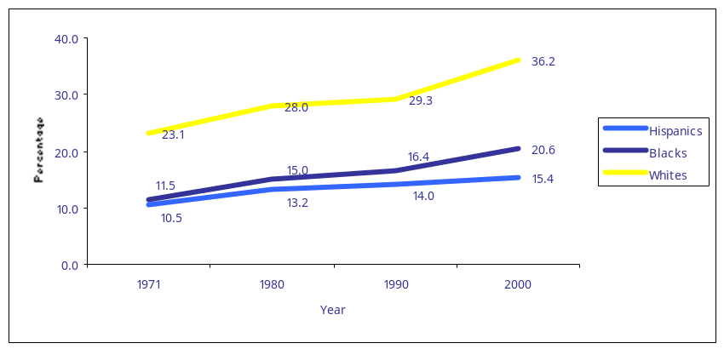

SOURCE: U.S. Department of Commerce, Bureau of the Census. March Current Population Surveys, various years.

Performance Measures for Objective 5.1
Measure | FY 2002 (Baseline) | FY 2003
Percentage of 16-24 year-old high school graduates
enrolled in college the October following graduation.
Overall | 63.8 | 64.1
White | 66.9 | 67.0
Black | 59.6 | 60.3
White-Black Gap | 7.3 | 6.7
Hispanic | 50.0 | 51.5
White-Hispanic Gap | 16.9 | 15.5
Low-Income | 51.5 | 53.5
High-Income | 76.9 | 77.0
Income Gap | 25.4 | 23.5

The national percentage of full-time, bachelor degree-seeking students who graduate within six years, and the percentage of full-time, two-year degree-seeking students who graduate, earn a certificate, or transfer to a four-year school within three years.
Measure | FY 2002 | FY 2003
The national percentage of full-time, bachelor degree-
seeking students who graduate within six years, and the
percentage of full-time, two-year degree-seeking students
who graduate, earn a certificate, or transfer to a
four-year school within three years.
4-Year Institutions
All | 52.7 | 53.1
White | 56 | 56.1
Black | 37 | 38.9
White-Black Gap | 19 | 17.2
Hispanic | 41 | 42.5
White-Hispanic Gap | 15 | 13.6
2-Year Institutions
All | 32.5 | 32.7
White | 34 | 34.1
Black | 26.3 | 27
White-Black Gap | 7.7 | 7.1
Hispanic | 30.5 | 30.8
White-Hispanic Gap | 3.5 | 3.3

Note: Three-year averages are used to help smooth out yearly fluctuations. The Department is considering adding an annual collection of these data for students with disabilities.
Source: October Current Population Survey (CPS) conducted by the Census Bureau.
Note about targets: These projections illustrate a goal of cutting the various gaps in half from 2002-2007.
Source: Graduation Rate Survey (GRS) conducted by NCES as part of the Integrated Postsecondary Data System (IPEDS).
Note: The Department is considering adding an annual collection of these data for students with disabilities.
Note about targets: These projections illustrate a goal of cutting the various gaps in half from 2002-2007.

Objective 5.1 College Access and Achievement
Measure | FY 2002 | FY 2003
Awareness of Financial Aid. The percentage of parents of students in middle and high school who talked with a counselor about the availability of financial aid for postsecondary study.*
Middle-School
All | 28 | 29
Low-income | 25 | 27
High-income | 30.2 | 30.4
Income Gap | 5.2 | 3.4
High-School
All | 49.5 | 50.5
Low-income | 42.5 | 46
High-income | 52.2 | 52.4
Income Gap | 9.7 | 6.4

Objective 5.1 College Access and Achievement

Measure | FY 2001 | FY 2003
Awareness of Academic Requirements. The percentage of parents of students in middle and high school who talked with a counselor about the academic requirements for postsecondary study.*
Middle-School
All | 10.8 | 11.6
Low-income | 9 | 10.5
High-income | 12.2 | 12.4
Income Gap | 3.2 | 1.9
High-School
All | 40 | 43
Low-income | 33 | 38
High-income | 48.2 | 48.4
Income Gap | 15.2 | 10.4

* Among parents who indicated they expected their child to attend college.
Source: National Household Education Survey conducted by NCES.
Note: These data are not available by race/ethnicity.
Awareness of Academic Requirements. The percentage of parents of students in middle and high school who
talked with a counselor about the academic requirements for postsecondary study.*
Percentage of 16 to 24 Year Old High School Graduates
Enrolled in College the October Following Graduation

Percentage of 16 to 24 Year Old High School Graduates
Enrolled in College the October Following Graduation

* 3-year weighted averages; year listed is the last year in the series
SOURCE: U.S. Department of Commerce, Bureau of the Census. March Current Population Surveys, various years.
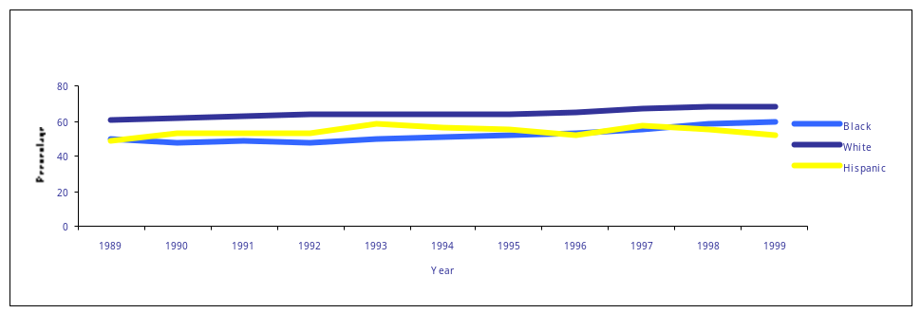
White*
Black*
Hispanic*
80
60
40
20
0
1989 1990 1998
Year
Percentage
1991 1992 1993 1994 1995 1996 1997 1999
* 3-year weighted averages; year listed is the last year in the series
SOURCE: U.S. Department of Commerce, Bureau of the Census. March Current Population Surveys, various years.
Objective 5.2
Strengthen accountability of postsecondary institutions
Although American institutions of higher education are among the best in the world, the public and many policymakers are especially concerned about the effectiveness of postsecondary institutions in two areas: preparing high-quality teachers and completing the education of students within a reasonable time. An effective strategy for ensuring that institutions are held accountable for results is to make information on student achievement and attainment available to the public. This way, prospective students will be able to make informed choices about where to attend college and how to spend their tuition dollars.
Addressing widespread concern about the quality of new teachers, Congress established an accountability system for teacher preparation programs in Title II when reauthorizing the Higher Education Act (HEA) in 1998. This system provides for the first time basic information on the quality of teacher program completers. Public and Congressional critics of this system note, however, that it needs to be strengthened to produce information that is more useful to the public and policymakers. As part of the next reauthorization of HEA, the Department will recommend refinements to this system.
Congress also has addressed concerns about the effectiveness of postsecondary institutions in graduating students in a timely fashion. In amendments to the HEA in 1992, Congress required institutions of higher education to report the proportions of their students who complete their educational programs. Critics have pointed out that these measures are not effectively integrated into accountability systems in most states, and thus are not routinely used in evaluating postsecondary institutions. In the next reauthorization, the Department will recommend steps to strengthen the usefulness of these measures so that they can be incorporated into state accountability systems. Successfully meeting this objective will require the cooperation of the postsecondary community, the states and Congress.
Strategies and Action Steps for Objective 5.2
Refine the Title II accountability system
189. Close the loopholes in the Higher Education Act (HEA) Title II reporting system to ensure fairness and accountability.
190. Align relevant HEA Title II definitions with those in the No Child Left Behind Act to lessen reporting burden on respondents.
191. Encourage Congress to improve data quality in institutional and state questionnaires used in annual report through the reauthorization of the Higher Education Act.
Create a reporting system on retention and completion that is useful for state accountability systems
192. Prepare a report on the current Integrated Postsecondary Education System (IPEDS) graduation rate survey to determine the extent to which the data required to support state accountability systems are collected.
193. Consult with states to determine what additional information is needed in a postsecondary accountability system; make changes to IPEDS accordingly.

Performance Measures for Objective 5.2

Objective 5.2 Acountability of Postsecondary Institutions
Measure | FY 2002 | FY 2003
The percentage of states and territories submitting Title II reports with all data reported using federally required definitions. | 80 | 100
The percentage of states with comprehensive reporting systems for colleges and universities that include student retention data and graduation rates for four-year degree seekers after 4, 5 and 6 years; graduation rates for two-year degree and certificate seekers after 2 and 3 years; and transfer rates for students at 2-year and 4-year institutions, disaggregated by student demographic factors such as race, gender, ethnicity, disability, and federal aid versus non-federal aid recipient. | 50 | 60

nAnnual Plan 2002 - 2003 86
Objective 5.3
Establish effective funding mechanisms for
postsecondary education
The financing of postsecondary education continues to be a challenge for many students and their families. According to the College Board, the average costs of attendance for 2001-2002 are $17,123 for four-year private institutions (up 5.5 percent from the previous year); $3,754 in four-year public institutions (up 7.7 percent from the previous year); and $1,738 for two-year public institutions (up 5.8 percent from the previous year). With tuitions rising faster than inflation, students are borrowing more money than in the past to attend college. The median student federal loan amount tripled between 1990 and 1999, rising from $4,000 to $11,199, and students are increasingly turning to non-federal sources of loans including credit cards to pay college expenses. These trends are occurring even though funding for Pell Grants, Supplemental Educational Opportunity Grants and other campus-based aid programs continue to grow.
In response to the concerns about the price of college, the Department will create a study group to examine the factors that contribute to the rising costs of postsecondary education. Through the study group, the Department will seek ideas and suggestions for achieving cost efficiencies and cost reductions among postsecondary institutions. The group will also consider effective funding strategies for nontraditional and part-time students, including those participating in distance learning via technology. The Department will then disseminate the findings. In addition, the Department will continue to work toward a more efficient Title IV aid process for the benefit of all parties participating in these programs.

Strategies and Action Steps for Objective 5.3
Investigate postsecondary funding strategies
194. Publish and widely disseminate to postsecondary institutions, states and others a study group’s recommendations for achieving cost efficiencies and cost reductions at postsecondary institutions.
195. Encourage Student Support Services grantees to use the maximum amount of federal grant funds (up to 20%) for grant aid by providing examples of how they might reallocate funds.
Improve the efficiency of the Title IV aid process
196. Consult with higher education community on ways to improve the efficiency of the Title IV aid process in preparation for the Administration’s Higher Education Act reauthorization proposal.
197. Based on study group recommendations and consultations with higher education community, develop a legislative proposal to encourage Congress to improve the efficiency of the Title IV aid process through Higher Education Act reauthorization.
198. Develop a legislative proposal to encourage Congress to increase the targeting of Pell Grants and other federal student aid to increase access to postsecondary education.
Note: All action items related to FSA modernization and efficiency are listed under objective 6.4.

Performance Measures for Objective 5.3
Objective 5.3 Effective Funding

Objective 5.3 Effective Funding Mecanisms

Measure | FY 2002 | FY 2003
Average national increases in college tuition, adjusted for inflation | 3.1% | 3.0%
Unmet need as % of cost of attendance for low-income dependent students | 42** | 41**
Unmet need as % of cost of attendance for low-income independent students with children | 59** | 58**
Unmet need as % of cost of attendance for low-income independent students without children | 63** | 62**
Borrower indebtedness and average borrower payments (for federal student loans) as a percentage of borrower income | Less than  10 % in first year of repayment | Less than  10 % in first year of repayment

Note: In 1998, the median debt burden was 7.1% of borrower income.
* Preliminary estimates from unreleased NPSAS 2000
** NPSAS is only collected every four years so estimates will have to be made for intervening period
Source: Federal loan records from the National Student Loan Data System (NSLDS) merged with income data from the Internal Revenue Service.

Objective 5.4
Strengthen Historically Black Colleges and Universities, Hispanic Serving Institutions, and Tribal
Colleges and Universities
An important strategy in closing the gap between low-income and minority students and their high-income, non-minority peers is to strengthen the quality of educational opportunities in institutions dedicated to serving low-income and minority students. Through various programs and initiatives, the Department promotes the quality of institutions serving low-income and minority students.
There is more, however, that can and should be done by the Department to offer access to information, training and technical assistance opportunities that contribute to the fiscal soundness of these institutions.

Strategies and Action Steps for Objective 5.4
Offer technical assistance for planning, implementation, and
evaluation
199. Design and implement a grantee mentor program to help new Institutional Development Undergraduate Education Service (IDUES) project directors.
200. Plan and implement discussion groups on institutional planning, implementation and evaluation for HEA Title III and Title V grantees.
201. Incorporate planning, implementation and evaluation components into the annual project directors meetings with expert speakers from the field.
Assist in promoting the technology infrastructure of institutions serving low-income and minority students
202. Develop a ”Grantee Technology Resource Page” on the IDUES web site for posting technology insights focusing on the creative use of technology for institutional needs, free or low-cost software, software developed by grantees, and technical personnel issues.
203. Sponsor an ongoing technology discussion group among eligible HEA Title III and Title V institutions to identify the current areas of greatest institutional technology need and discuss the different solutions for these needs.

204. Incorporate technology components into the annual project directors meetings with expert speakers from the field.
Collaborate with Historically Black Collages and Universities, Hispanic Serving Institutions and Tribal Colleges Universities on K-12 improvement efforts
205. Provide outreach and technical assistance to HBCUs, HSIs and TCUs to encourage them to submit an application to the Department.s Transition to Teaching program.
206. Encourage states to include HBCUs, HSIs and TCUs in their Title II (ESEA) activities to improve teacher preparation and professional development.

Performance Measures for Objective 5.4

Objective 5.4 HBCUs, HSIs and TCUs

Measure | FY 2002 | FY 2003
The percentage of HBCUs, HSIs and TCUs with a positive fiscal balance. | 74 | 79
The percentage of HBCU’s HSI’s and TCU’s with evidence of increased technological capacity (such as wireless systems, high speed Internet connections, distance learning programs, or other evidence of technological innovation). | Base  line | Baseline + 10 PP

PP = Percentage Points

Objective 5.5
Enhance the literacy and employment skills of
American adults
National surveys indicate that between 70 and 90 million adults in the United States have Limited-English literacy skills that inhibit their ability to support their families and exercise other important social responsibilities. Shockingly, this includes an estimated ten million high school graduates and 1.5 million college graduates. Current classroom-based services reach only about three million individuals with adult basic education and English literacy services. Combined with education services delivered through other social services for adults, only a fraction of the need for enhanced literacy is being addressed. Working with state and local partners, we will develop new models of flexible, high-quality basic education and English literacy services to help a larger percentage of America’s adult population, including individuals with disabilities, receive the literacy skills they need for workplace learning, postsecondary learning and lifelong personal and career growth. We will also work with state vocational rehabilitation programs, other federal agencies and others to improve employment outcomes for adults with disabilities and will aggressively implement the president’s New Freedom Initiative.

Strategies and Action Steps for Objective 5.5
Invest in research on adult literacy and English acquisition
207. Maintain collaboration with the National Institute of Child Health and Development (NICHD) on DELLS biliteracy research program to improve the research base in this area.
208. Initiate random assignment evaluation of federally funded Adult English as a Second Language programs.
209. Provide support to NICHD for the development of a new strand of research on effective practices in Adult Education and family literacy programs; create “What Works in Adult Literacy” publication.
210. Comprehensively review English language acquisition, work-based programs, and skills training through Postsecondary Education Futures project to identify best practices.
Develop high-quality community- and faith-based models
211. Develop partnerships, where possible, that involve community- and faith-based organizations in the provision of adult literacy programs.
Develop technology solutions
212. Develop, with state partners, a multi-state evaluation of distance learning for Adult Education.
213. Develop online curriculum resources to support the use of technology-based instruction in adult education, English as a second language, and literacy development.
214. Collaborate with the National Technology Laboratory for the Improvement of Adult Education to document best practices in technology-based instruction, hold town meetings, create professional development in the use of technology and sponsor hands-on demonstration sites.
215. Develop and implement the new loan program that will provide financial support to individuals with disabilities to purchase technology and other equipment that enables them to work from home.
216. Award, monitor and provide technical assistance for the National Institute on Disability and Rehabilitation Research (NIDRR) Small Business Innovation Research grants to maximize the likelihood of successful phase I projects advancing to phase II.
217. Facilitate interagency coordination in the development of improved technology transfer so that the results of federally funded research have a higher probability of becoming solutions for improving the employment and independent living skills of people with disabilities.
Implement performance standards
218. Identify vocational rehabilitation state agencies that are at risk of not meeting the established performance levels for Standard I (employment outcomes) and provide targeted technical assistance.
219. Convene a conference for state vocational rehabilitation agencies to highlight effective practices for improving agency performance, especially employment outcomes.
220. Make vocational rehabilitation state agency performance data available to the public on the Department of Education’s website.
Fund demonstration projects
221. Support and evaluate demonstration projects designed to enhance literacy levels, earnings and other employment outcomes of individuals with disabilities.

Performance Measure for Objective 5.5
Objective 5.5 Literacy and Employment Skills
 |  | Performance Targets
 |  | ‘02 | ‘03
Adult Literacy | The percentage of adults reading at the lowest level of literacy in national adult literacy assessments. *  (1992 Baseline = 21%) | 19 | X
Employment of Individuals with Disabilities | The percentage of all persons served by State VR agencies who obtain employment.  (2000 Baseline = 62.5%) | 63 | 63.5

* Source: Periodic national surveys of Adult Literacy. The National Assessments of Adult Literacy (NAAL) will be conducted in 2002. For this indicator, we are measuring “prose” literacy. These targets may need to be adjusted pending the results of the 2002 study. The Department is considering adding a biennial collection of these data.

Vocational Rehabilitation Employment Outcomes
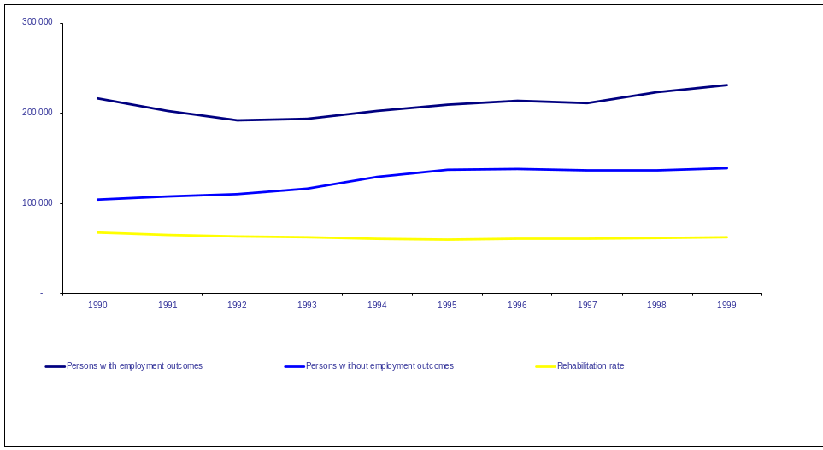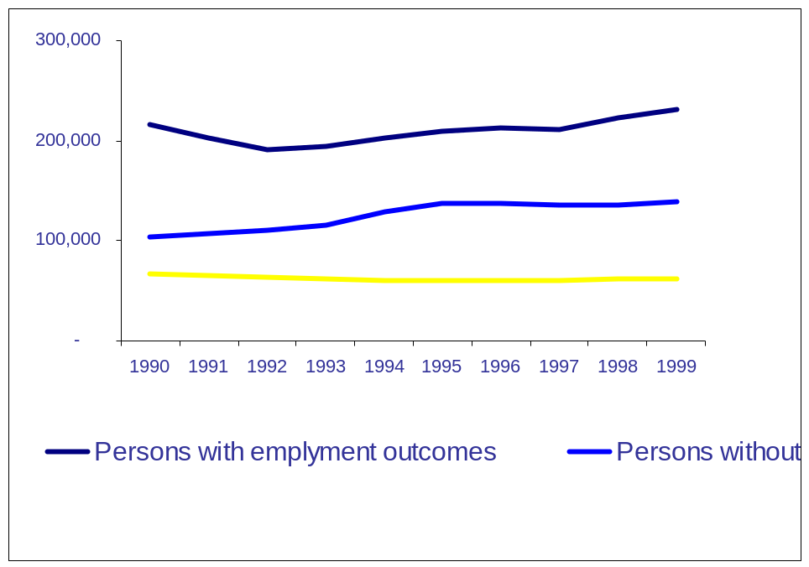

Strategic Goal Six
6
Establish Management
Excellence throughout
the Department of Education

There is an understandable
temptation to ignore
management reforms in favor of
new policies and programs.
However, what matters most is
performance.

President George W. Bush

In order to create a culture of achievement throughout the nation’s educational system, we must first create a culture of accountability within the Department. We will do so by aggressively implementing the President’s Management Agenda, including his initiative on community- and faith-based organizations. Through our work to create a culture of accountability and establish management excellence, we will earn the President’s Quality Award.
Objective 6.1
Develop and maintain financial integrity and management and internal controls.
Objective 6.2
Improve the strategic management of the Department’s human capital.
Objective 6.3
Manage information technology resources, using e-gov, to improve service for our customers and partners.
Objective 6.4
Modernize the Federal Student Assistance programs and reduce their high-risk status.
Objective 6.5
Achieve budget and performance integration to link funding decisions to results.
Objective 6.6
Leverage the contributions of community- and faith-based organizations to increase the effectiveness of Department programs.
Objective 6.7
By becoming a high performance, customer-focused organization, earn the President.s Quality Award.
Objective 6.1
Develop and maintain financial integrity and
management and internal controls
The first step to management excellence is to provide managers and external stakeholders with timely financial information to aid them when making programmatic and asset-related decisions. Financial integrity also means that we maintain effective internal controls to reduce the risk of errors and permit effective monitoring of programs and processes and that employees assume responsibility for identifying and addressing problems.
Strategies and Action Steps for Objective 6.1
Update and integrate financial systems
222. Develop accurate, fully documented loan loss liability and allowance estimates for the federal student loan programs for inclusion in the Department’s annual financial statement.
223. Implement Oracle Federal Financials, a software package that meets federal accounting standards.
224. Prepare quarterly financial statements with analysis and make accounting adjustments as necessary within 60 days.
225. Perform feeder systems reconciliation’s to the general ledger within 45 days of the end of each calendar month, improving their timeliness and effectiveness.
226. Develop a project plan to upgrade Oracle Federal Financials to version 11 in fiscal year 2003 to keep the accounting systems current.
227. Develop a project plan and commission a task force to gather Department-wide requirements for an Executive Information System capable of integrating program, financial, contracts and administrative data. Provide stakeholders with accurate and timely Financial Management Information using Oracle Financials and electronic dissemination techniques.
228. Through a Department of Education/OMB Student Loan Credit Modeling Working Group, the Department will clarify the underlying assumptions used to generate baseline and policy estimates and summarize the key issues regarding the subsidy calculation methodology that requires an OMB policy decision for formulating the FY 2003 budget. Use these assumptions and decisions to define requirements for a mutually supported auditable model that will allow all parties in OMB and the Department to replicate and

Department of Education Audit Opinions
Fiscal Year | Audit Opinion | Material Weaknesses | Reportable Conditions
1997 actual  1998 actual  1999 actual  2000 actual  2001 actual | Unqualified  Disclaimer  Qualified  Qualified  Qualified | 4  3  4  3  1 | 3  4  4  2  3

Department of Education Audit Opinions

test all estimates used for policy and management decisions, as well as financial management reporting.
229. Reconcile the inventory database to determine with reasonable assurance that identified Information Technology (IT) purchases have been inventoried according to Department policy.
230. Complete the concept of operations for implementing Oracle multi-organizational capability. Complete a project plan to implement it for fiscal years 2003 and 2004 if the proof-of-concept initiative indicates multi-org should be implemented. (and August 30, 2002, respectively)
231. Improve the mechanism to age cash received by schools and systematically monitor progress towards 30-day reporting requirements.
232. Establish an OCFO/FSA CFO issues team of senior managers to meet weekly to address issues, discuss joint activities, and ensure that OCFO, OM and OCIO get the information they need from FSA to fulfill their responsibilities, and that FSA gets needed information from OCFO. 233. Develop microsimulation model to project FFEL and Direct Loan program cash flows.
Prepare financial statements to provide leading data on Department performance
234. Review accounting and budget execution activity to ensure that data included in the Department’s financial statements can be fully reconciled and documented.
235. Put a Financial Management Structure in place that is optimal for the Department’s needs and requirements.
236. Implement postproduction validation of the Financial Management System.
237. Submit the Department’s audited fiscal year 2002 financial statements to OMB by the required reporting date.
238. Publish in one integrated document Government Performance and Results Act (GPRA) Strategic Plan results and financial reports to demonstrate to the public the relationship of financial and programmatic management.
239. Submit the Department’s combined financial and GPRA report to the Association of Government Accountants for consideration for a Certificate of Excellence in Accountability Reporting.
Analyze data to reduce fraud
240. Initiate a project to implement data mining to detect possible fraud or abuse, set up a remedial program and increase efficiencies. Suspected fraud or abuse cases will be referred to the OIG.
Review existing internal controls and implement changes where necessary
241. Complete the first of regular reviews of internal controls that support the Department’s primary activities. Implement recommendations and ensure that controls are understood and applied in Department operations. Provide reports to management on review findings and recommendations.
242. Annually review internal controls consistent with the Federal Managers Financial Integrity Act (FMFIA) process.
243. Implement a plan to assure that discretionary and formula grant programs operate with the highest level of efficiency, effectiveness, and integrity.
244. Award 60 percent of new grants by May 31 each year.
245. Prepare action plans within 60 days of OIG issuance of final reports. Implement 95 percent of accepted OIG and GAO recommendations using action plans within the committed timeframes.
246. Complete the examination of structures for effectively monitoring and holding accountable grantees, other intermediaries and contractors.
247. Assist PO staff in developing and implementing corrective action plans to address internal control weaknesses identified by the Department’s auditors. (ongoing)
248. Based on an independent security assessment, prepare a comprehensive physical security plan for the Department.
249. Prepare the strategic monitoring plans, annual monitoring plans and reports currently required for discretionary grant programs, if not already prepared.
250. Review and analyze administrative services provided by the Department to ensure responsiveness to customer needs, innovative approaches to problem solving, and best use of scarce resources.
251. Implement a modified and improved system for monitoring and reporting corrective actions.
252. Using the completed and approved project plan, reengineer the official process of developing directives, securing program feedback, issuing, and disseminating administrative directives.
253. Develop an implementation plan to establish a high-level security office with the responsibility for coordinating all Department security programs and activities.
254. Develop IT inventory procedures and incorporate, as appropriate, KPMG’s recommendations, which were formulated while performing a sample IT procurement inventory, into the procedures.
255. Review and, if necessary, revise ED’s suggestion program so that it can be used to promote innovation and facilitate improvement and efficiencies within the Department.
256. Identify and evaluate the advantages and disadvantages of centralizing the program monitoring function.
257. Develop and administer internal control training initiatives for presentation at all levels within the Department.
Increase the use of performance-based contracting
258. Increase the use of performance-based contracting, and hold contractors accountable to performance criteria.
259. Ensure that contracting officials, contracting officer representatives and others responsible for monitoring contracts receive proper training and certification.
260. Review the Department’s contract monitoring process to evaluate its ability to identify and monitor high-risk contracts.
Performance Measures for Objective 6.1

Objective 6.1 Financial Integrity and Internal Controls

Objective 6.1 Financial Integrity and Internal Controls
Measure | FY 2002 | FY 2003
The achievement of an unqualified audit opinion. | Yes | Yes
The financial management grade received on “report card” by the Subcommittee on Government Efficiency, Financial  Management and Intergovernmental Relations. | C | B
The number of audit recommendations from prior year financial statement audits remaining open. | 8 open  recommendations | 7
The percentage of performance-based contract actions. | 20% of contract actions;  48% of eligible service contract dollars | 25% of contract actions;  50% of eligible service contract dollars
The amount of erroneous payments. | Set and validate the baseline. | Baseline minus 20%
The number of erroneous payments. | Baseline minus 10% | Baseline minus 20%
The Federal administrative cost per grant transaction. | Baseline minus 10% | Baseline minus 20%

Objective 6.2
Improve the strategic management of the
Department’s human capital
A key element of creating a Department-wide culture of performance excellence and accountability is the strategic investment in human capital. The Department will develop and carry out a plan for human capital management that supports the Department’s mission by ensuring that skilled, high-performing employees are available and deployed appropriately. This plan will be supported by a competitive sourcing plan that ensures that services are provided at a maximum level of cost effectiveness. We will delayer the organization and ensure that our work is citizen-centered.
Strategies and Action Steps for Objective 6.2
Develop a five-year human capital plan
261. Develop an overarching vision of human capital that ties to the strategic plan and the Department’s mission.
262. Complete the development of the five-year human capital/restructuring plan.
263. The Department’s restructuring plan will address appropriate numbers of organizational layers.
264. The Department’s restructuring plan will review positions to improve citizen access to services.
265. The Department will address its supervisory ratio.
266. Determine the specific actions needed to implement the workforce and restructuring plan, including a timetable for each action.
267. Detail estimated costs and/or savings from the first through fifth year of implementing the changes in the organization structure.
268. Estimate the impact of the workforce restructuring on the Department’s plan for improving program performance outcomes.
Identify and obtain needed skills
269. Determine employee skills needed by each office’s management to most effectively perform program functions, with consideration given to attrition and retirement over the next five years.
270. Develop systems to capture employee knowledge including technology systems.
271. Increase the number of on-site college courses and certificate programs, especially for information technology, project management and financial management.
272. Provide training to managers on their responsibilities as managers, including values-based ethics training that addresses the specific ethics obligations of managers. All managers will receive this training.
273. Initiate revised ethics training for non-managers, incorporating financial management issues.
274. Develop a process to ensure that supervisors identify professional development opportunities that are tied to organizational work plans and individual development plans that each employee on their staff must have.
275. Develop a process to ensure that managers are encouraged to identify staff who show great potential and be flexible and receptive to staff professional development opportunities that include 1) Mobility Assignment Program assignments, 2) Details, 3) Interagency Personnel Agreements, 4) SES rotations, 5) HQ-Regional Rotations.
276. Implement a development program for senior managers.
277. Bring in speakers who are our customers (e.g., school superintendents, grant recipients, chief school officers, financial aid administrators, accrediting agencies) to help employees understand the impact of their work, customer needs, etc.
278. Implement the administration’s Managerial Flexibility Act, which provides permanent buyout authority, early retirements for workforce restructuring, and increased benefits for SES employees.
279. Publicize special hiring authorities (e.g., outstanding scholars, Presidential Management Interns, excepted service) and encourage managers to use those authorities.
280. Publicize and expand the use of strategically targeted recruitment and retention bonuses.
Improve employee performance and accountability
281. Every senior officer will reach agreement with the secretary on the program and management results they are responsible for in FY 2002 and the following two years. These agreements will link to the strategic plan, be updated annually, and be used to determine bonuses and other awards in the Principal Offices (PO). Senior leadership will begin to use the agreements in FY 2002 and will use them increasingly as the Department develops practical measures that link individual and organizational performance to the achievement of results.
282. Each senior officer will have performance agreements with the managers reporting to them that are consistent with the Department’s strategic plan. These agreements will link to the strategic plan, be updated annually, and be used to determine bonuses and other awards.
283. The Department’s employee performance agreements and bonuses/awards will link to the Department’s Strategic Plan, Blueprint for Management Improvement, and Culture of Accountability Team Report.
284. Establish a panel in each PO to review all probationary employees before they are allowed to receive “career” status.
285. Make it clear that managers are responsible for performance and conduct in their work units, including modeling a proper work ethic and appropriately addressing employee performance and conduct problems.
286. Develop and implement a new appraisal system to replace the General Performance Appraisal System.
287. Develop and disseminate a Department-wide core values statement.
288. Just as we do for Contracting Office Representative, require certifications for certain positions, such as grants specialists and system accountants, and tie the certification to promotions, Quality Service Increment, and awards.
289. Revise and publicize new “disciplinary standards” to help ensure that discipline is applied consistently.
290. Establish a process to ensure that rating officials annually review the position description of their staff to ensure that they accurately cover the employee’s duties and responsibilities.
Improve core processes related to human capital management
291. Create a national recruitment network with key university programs, especially graduate programs in public affairs, public administration, financial management and information technology.
292. Expand innovative strategies to recruit mid-level employees, including notification in trade publications and state agencies.
293. Establish a process to ensure that when supervisors are recruited “content knowledge” is balanced with “management skills”.
294. Seek authority to provide managers with expanded personnel flexibilities.
Improve the use of competitive sourcing
295. Complete the competitive sourcing plan.
296. Initiate competitive sourcing of appropriate tasks performed by employees, consistent with the FAIR Act.
297. Plans will be completed to implement competition between interagency reimbursable support service arrangements and the private sector.
298. All such interagency arrangements will be competed with the private sector on a recurring basis.
Performance Measures for Objective 6.2
Objective 6.2 Strategic Management of Human Capital

Measure | FY 2002 | FY 2003
ED employees are focused on results and show interest in improving the services of their organization. * | 52% | 56%
ED employees hold their leaders in high regard. * | 56% | 60%
ED employees believe that their organization has set high but realistic results-oriented work expectations for them. * | 62% | 65
Employees believe that their organization supports their development and expects them to improve their skills and learn new skills to do their jobs better. * | 71% | 72%
ED meets skills gap reduction targets included in its human capital management plan. | Baseline | TBD
The percentage of managers satisfied with services received from OM when hiring staff. | Baseline | 70
ED meets its annual goals for competitive sourcing. | Compete 43 positions | Compete 86 positions

* Performance measure recommended by OPM Human Capital Scorecard. Data collection instrument currently
being developed by OPM. Adoption and use of this instrument will allow for updated baselines and benchmarking
for purposes of setting targets using data gathered from other federal agencies, government-wide averages and
highs and private sector survey participants.
1 survey respondents who agree .employees have a feeling of personal empowerment and ownership of work
processes..
2 survey respondents who favorably responded to, .Overall, how good a job do you feel is being done by your
immediate supervisor/team leader?. Government-wide high score reported at 71%.
3 survey respondents who agree .managers set challenging and attainable performance goals..
4 survey respondents who agree .employees receive the training they need to perform their jobs.. Government-
wide high score reported at 75%.
Objective 6.2 Strategic Management of Human Capital

Objective 6.3
Manage information technology resources, using
e-gov, to improve services for our customers and partners
The Department must leverage information technology to perform its business functions more efficiently and to better serve our partners, internal customers and external customers. Improved Department accountability requires that we effectively manage IT investments, protect data integrity and confidentiality, improve data management and increase our effectiveness in the use of technology in customer service. We will use information technology to support effective business processes and we will improve and simplify ineffective business processes before applying information technology. We will prioritize IT investments across program offices based on our prioritization of the Department’s business needs. Re-engineered business processes will ensure that state and local educational institutions and institutions of higher education can communicate effectively with the Department without undue burden. We will assure confidentiality and accessibility.
Strategies and Action Steps for Objective 6.3
Encourage customers to conduct business with the Department on-line
299. Work with the community and Department offices to implement the capability to receive all grant applications electronically.
300. Develop easy-to-use technology that allows peer reviewers to review grants online.
301. Provide customers the option of electronic data provision and data exchange. pursuant to the Government Paperwork Elimination Act.
302. Utilize electronic media, i.e. websites, listservs, and email to disseminate information and provide technical assistance to grantees.
303. Improve the Department’s web site to better serve our customers in Congress.
304. Begin implementation of Case Management System to permit end-to-end electronic processing of complaints.
305. Increase the number of self-assessment tools and amount of information for recipients and parents accessible on website.
306. Increase the number of FAFSA.s Filed electronically to 5.5 million.
307. Implement government-wide On-Line Access for Loans Initiative.
308. Install web conferencing and video conferencing technology.
Ensure security of the IT infrastructure
309. All general support systems and major applications will be certified and accredited or receive interim approval to operate, and the Department will develop and test disaster recovery plans that are updated annually.
310. Complete remedial actions on all problems identified in the recently completed security reviews of all Department IT systems under the Government Information Security Reform Act reviews and Critical Infrastructure Protection assessments.
311. Complete the Department’s vulnerability and threat assessment; and begin remedial action plans, which are expected to be completed by spring 2002.
312. Conduct a Department-wide IT security awareness campaign, including mandatory completion by all employees of a new computer-based security awareness training program, and a computer security day.
313. Establish a core of project management professionals with the necessary training and skills to manage the Department’s IT initiatives.
314. Develop training curricula and a program to train executives on their IT investment management responsibilities. New leadership will receive IT investment management training within two months of arrival.
315. Department IT staff and managers will complete specialized IT security training curricula.
Reduce our partners’ data reporting burden
316. Implement a short-term pilot project to collect school-level achievement data and align it with financial and demographic information. Consolidate several ongoing data and technology projects.
317. Implement the long-term Performance-Based Data Management Initiative to centralize and dramatically reduce reporting burden; align data definitions and collections with it.
318. Review all data collection plans of program evaluation studies to minimize data burden, focus on student results, and utilize data from Performance Based Data Management Initiative.
319. Certify at least 50 percent of major agency and program databases for data quality.
Complete enterprise architecture
320. Make known the approximate amount of funding available for significant IT initiatives at the beginning of the IT investment management process.
321. Identify technology infrastructure and adopt technology standards necessary to support the Department’s Government Paperwork Elimination Act (GPEA)-identified electronic transactions.
322. Put in place a robust enterprise architecture along with a well-defined capital planning and investment control program and an agency-wide performance measurement process.
323. The Investment Review Board (IRB) will review, approve and prioritize 100 percent of the Department’s enterprise-wide significant information system investments.
324. Fully integrate the IRB process with the budget and procurement processes.
325. The contracting officer, project sponsor, and project manager will approve the business cases for significant IT initiatives before consideration by the IRB.
326. Contracting Officers will ensure 100 percent of significant IT procurements, (e.g., hardware, software, and services) are tied to an approved business case before processing.
327. Ensure appropriate integration of the IT investment management process with the acquisition process.
328. Existing and new IT initiatives will have reasonable and reliable cost, schedule, and performance data in their business cases.
329. Appropriately integrate IT investment management process with the budget process by the time the FY 2004 budget is submitted to OMB.
330. Ensure that 100 percent of significant IT projects are consistent with the target architecture and its implementation plan.
331. Track significant IT initiatives against cost, schedule, and performance goals with the target that variances will be below 10 percent.
Performance Measures for Objective 6.3

Objective 6.3 Manage Information Technology Resources

Measure | FY 2002 | FY 2003
The percentage of significant IT investments that achieve less than a 10% variance of cost and schedule goals. | 50 | 60
Percent customer ratings of ED IT services “good” or better. | Baseline | Base  line + 5 PP
The OMB burden hour estimates of Department program data collections per year. (2001 baseline = 40.5 million) | 40 M | 38 M

PP = Percentage Points
M = Million

Objective 6.4
Modernize the Federal Student Assistance programs
and reduce their high-risk status
While Federal Student Assistance (FSA) has made some progress in recent years in modernizing its systems, it remains on the General Accounting Office’s high-risk program list. It is also the only Department program identified for corrective action by the President’s Management Agenda. The Department, in partnership with FSA, will continue to improve and integrate its financial and management information systems to manage the student aid programs effectively. We will reduce the programs. vulnerability to fraud, waste, error and mismanagement.
Strategies and Action Steps for Objective 6.4
Create an efficient and integrated delivery system
332. Release version 2 of School Portal to provide a common look to FSA websites for schools, enhance query capabilities, and development of regional presence.
333. Establish web portal for financial partners to provide one stop access to FSA services and information.
334. Develop a .single sign-on. capability for the School Portal that will allow schools to access Title IV databases with just one sign-on.
335. Implement Phase II of our eCampus Based modernization project by replacing the mainframe system with a new Oracle-based system.
336. Implement improved Direct Loan (DL) servicing infrastructure to better support DL financial management reporting.
337. Implement a common business process and system for aid origination and disbursement of Pell Grants and Direct Loans to provide the infrastructure to improve school reporting, cash management and internal control processes.
338. Improve reliability of lender billing data through a redesigned lender payment process.
339. Develop a design for providing consistent data across FSA from modernized systems to deliver consistent answers to customers and provide consistent information to employees for program oversight. This will be accomplished by consolidating the number of toll-free numbers and customer service functions into one logical customer contact center that utilizes a common data platform. Additionally, this effort will seek to implement proven customer relationship management tools and practices.

340. Implement Phase II of the Financial Partners Data Mart. This phase will provide self-monitoring and oversight tools and focus on the data load, and link with the new FMS to provide a continuous stream of financial data and selected NSLDS elements necessary to augment data comparisons and lender risk management assessment.
341. Implement Phase III of the Financial Partners Data Mart. This phase will provide augmented monitoring tools and oversight ability. The release will focus on the data load and links from Financial Management System, Postsecondary Education Participant System, National Student Loan Data System, and an evaluation of any newly implemented processes or systems that may replace existing legacy links.
342. Electronically integrate drawdown information with disbursement reporting data to track cash balances at schools.
343. Retire the DLOS and REMS systems.
344. Retire the FARS system.
345. Implement Internet billing and online correspondence as part of the Direct Loan e-Servicing initiative.
346. Integrate the PEPS system with Consistent Answers project.
347. Integrate the MDE functionality into the CPS system.
348. Integrate the DMCS system into the common borrower system (a system that will have the functionality of the DL servicing system, DMCS and the Consolidation system).
Improve Program Monitoring
349. Institute eligibility check for valid ISIR on file for all Direct Loan recipients (except PLUS).
350. Improve institutional records by developing a design for electronic school financial statements and compliance audits, and improve FSA record keeping by imaging current and future records in the DRCC and better deployment of workflow. Benefits realized will include a more effective and efficient process to identify institutions that are not compliant with Title IV program regulations through the elimination of backlogs, shortened cycle times, minimized errors, reduced paper, and the elimination of lost documents.
351. If authorized by Congress, implement legislation providing increased authority to match applicant income information with the Internal Revenue Service to prevent over-awards.
352. Develop and Implement Phase IV of the Financial Management System, providing a reliable tool to improve the internal controls and financial management of the programs.
353. Strengthen FSA.s internal controls and financial integrity.
354. Identify areas for improving compliance effectiveness and take the appropriate steps toward improvement.
355. Review baseline budget data for student aid administration and develop a framework for budget requirements using the single appropriation that has been agreed to by the Department and OMB.
356. Identify trends in risk areas and provide targeted technical assistance to schools.
357. Prepare action plans within 60 days of OIG issuance of final reports.Implement 95 percent of accepted OIG and GAO recommendations using action plans within the committed timeframes.
358. Review FSA.s current strategy for monitoring schools, lenders, guaranty agencies and third-party servicers; identify the various levels and types of monitoring, including where performed and by whom. Determine which kinds of monitoring are linked to the basic administration of the student financial aid programs.
359. Increase the number of FSA program reviews by 10%. The schools targeted for review will be identified through risk analysis.

Government likes to begin things—to declare
grand new programs and causes. But good
beginnings are not the measure of success. What
matters in the end is completion. Performance.
Results. Not just making promises, but making good
on promises. In my Administration, that will be the
standard from the farthest regional office of
government to the highest office in the land.

President Bush
(opening letter to the President’s Management Agenda)
Performance Measures for Objective 6.4

Objective 6.4 Modernize Federal Student Assistance Programs
Measure | FY 2002 | FY 2003
By 2003, Student Financial Assistance will leave the GAO high-risk list and will not return. | Accomplish FSA High Risk Plan | Leave GAO High Risk List
Default recovery rate.* (2001 Baseline=7.8%) | 7.2% | 7.6%
Pell Grants overpayments. (2001 Baseline = 138 Million) | 138M | 110M
Timeliness of FSA major system reconciliations to the general ledger. | Reconciled within 45 days of the end of the calendar month. | TBD**
Customer service (measures of service levels of targeted FSA transactions with public). | TBD | TBD
Integration of SFA systems. | 100% of 2002 integration targets met; goals established for 2003-2007. | TBD

Modernize Federal Student Assistance Programs
M = Million
* Defined as the sum of FSA.s collections on defaulted loans—less consolidation—.divided by the
outstanding default portfolio at the end of the previous year.
** System and operational plans to be developed in FY 2002; targets will be set for 2003 and 2004 upon
completion of these plans.

Objective 6.5
Achieve budget and performance integration to
link funding decisions to results
The Department will seek funding for programs that work, and will seek to reform or eliminate programs that do not. The budget execution process will be linked to the Secretary’s strategic plan to ensure that high priority activities are funded. The Department will have standard, integrated budgeting, performance, and accounting information systems at the program level in order to provide timely feedback for management that will be consolidated at the agency and government levels.
Strategies and Action Steps for Objective 6.5
Align Budget and Planning Processes
360. Prepare and implement instructions that require Principal Offices to include evidence of program effectiveness in the FY 2004 budget submission to the Secretary. (This is the same evidence used for GPRA reports.)
361. In the Congressional Justifications, document program effectiveness, propose to reform or eliminate ineffective programs, and include outcome targets.
362. Combine 2002 Annual Financial Report and 2002 GPRA Performance Report. 363. Align budget execution processes, like preparing spending plans, with Strategic Plan Action Steps.
Document program effectiveness
364. Develop and implement an evaluation plan that will produce rigorous information on the effectiveness of Department programs, as well as the effectiveness of interventions supported by federal funding streams.
365. Revise program performance indicators to focus on results and integrate them into the Performance Based Data Management Initiative.

Performance Measures for Objective 6.5
Objective 6.5 Budget and Performance Integration

Objective 6.5 Budget and Performance Integration

 |  | ‘02 | ‘03
Program Effectiveness | The percentage of Department programs that demonstrate effectiveness in terms of outcomes, either on performance indicators or through rigorous evaluations. | Base  line  +  5 PP | Base  line  +  10 PP
Program Effectiveness | The percentage of Department program dollars that are in programs that demonstrate effectiveness in terms of outcomes, either on performance indicators or through rigorous evaluations. | Base  line  +  10 PP | Base  line  +  20 PP

*For more detailed program information, visit the Department’s website: www.ed.gov/pubs/annualreport2001
PP = Percentage Points
The baseline year is FY 2001.
Objective 6.6
Leverage the contributions of community- and faith-
based organizations to increase the effectiveness of
Department programs
America is richly blessed by the diversity and vigor of neighborhood heroes: civic, social, charitable and religious groups. These quiet champions lift people’s lives in ways that are beyond government’s know-how, usually on shoestring budgets, and they heal our nation’s ills one heart and one act of kindness at a time. The indispensable and transforming work of charitable service groups— including faith-based groups—must be encouraged. These organizations bring the spirit of compassion, volunteerism and close connection to communities to their work. The Department will encourage their active participation in its programs.
Strategies and Action Steps for Objective 6.6
Provide technical assistance and outreach and implement novice applicant procedures
366. Plan and execute the Department’s technical assistance and outreach summits.
367. Develop partnerships with Historically Black Colleges and Universities to deliver technical assistance.
368. Host 25 meetings to explain the mission of the Initiative to key leaders of community- and faith-based organizations.
369. Develop user-friendly materials—in print and electronic—explaining grants process and specific information on grant programs available on web site and in packets.
370. Train Secretary’s Regional Representatives in concept of level playing field and equip them to provide technical assistance to community- and faith-based organizations in surmounting barriers.
371. Communicate to the senior officers, program heads, and general public, the Secretary’s support for the initiative.
372. Establish a clearinghouse of best practices by community- and faith-based organizations, featuring members of the Partnership for Family Involvement in Education.
373. Provide technical assistance on the Migrant Education Even Start Program to community- and faith-based organizations on an equal basis as traditional participants and implement novice applicant procedures.
374. Provide technical assistance on Early Reading First to community- and faith-based organizations on an equal basis as traditional participants and implement novice applicant procedures.
375. Provide technical assistance on the Even Start Family Literacy Program to community- and faith-based organizations on an equal basis as traditional participants.
376. Provide technical assistance on the 21st Century Learning Centers Program to community- and faith-based organizations on an equal basis as traditional participants.
377. Provide technical assistance on the Adult Education and Family Literacy Act to community- and faith-based organizations on an equal basis as traditional participants.
378. Provide technical assistance on the Upward Bound Program to community- and faith-based organizations on an equal basis as traditional participants and implement novice applicant procedures.
Remove barriers to the full participation of community- and faith-based organizations
379. Publish grant announcements in non-traditional publications read by community- and faith-based organizations.
380. Ensure that grant announcements in the Federal Register clarify that community- and faith-based organizations are eligible to apply provided that they meet all statutory and regulatory requirements.
381. Recruit highly qualified peer reviewers for amenable programs (those listed above) from community- and faith-based organizations and provide appropriate training.
382. Inform Congress of programs operated by community- and faith-based organizations that have demonstrated successful educational outcomes.

Performance Measures for Objective 6.6
Objective 6.6 Leverage Community- and Faith-Based organizations
 |  | ‘02 | ‘03
Community and Faith-Based Organizations | The percentage of non-statutory barriers relating to technical assistance and outreach identified in the Report on Findings that are removed. | 50 | 75
Community and Faith-Based Organizations | The percentage of appropriate programs in which the novice applicant procedures are implemented. | 25 | 50

Objective 6.7
By becoming a high performance, customer-focused organization, earn the President’s Quality Award
As a result of implementing the Blueprint for Management Excellence, the President’s Management Agenda, the recommendations of the Culture of Accountability team and our Strategic Plan, the Department will be in a position to compete for and win the President’s Quality Award by FY 2004.
Strategies and Action Steps for Objective 6.7
Earn the President’s Quality Award
383. Put structure and process in place to apply for the Award.

Performance Measure for Objective 6.7

Objective 6.7 President’s Quality Award
Measure | FY 2002 | FY 2003
President’s Quality Award | Put structure and process in place to apply for Award. | Apply for the Award and gain insight.

* Agencies may not re-apply for five years after winning the award.

Appendices

A
Appendix
Opportunities for Collaboration
with Other Federal Agencies

To reach our strategic goals, we must build strong partnerships and alliances with our counterparts across the federal government. Below is a brief overview of the highlights of some of our collaborative initiatives with partnering agencies.
Creating a Culture of Achievement
We work closely with the Department of the Treasury to expand parental options in education. For example, we collaborate with Treasury to promote Coverdell Education Savings Accounts and to develop the proposed education tax credit for children trapped in failing schools.
Improving Student Achievement
We will continue to work closely with the Department of Health and Human Services to improve educational services to preschool children, especially those from underserved populations. We participate with HHS in a joint task force to translate research on early cognitive development and pre-literacy into action through federal preschool programs. Additionally, we participated with the Child Development and Behavior Branch of the National Institutes of Health in a summit on early childhood cognitive development.
We will continue to partner with the National Science Foundation to promote improved instruction in mathematics and science, and to coordinate our professional development programs for teachers. NSF also cooperates with us on research and international assessments related to mathematics and science.
Education has worked with NASA to emphasize the importance of math and science education and the need to work more closely with our neighbors around the world by holding live discussions between elementary school students and astronauts aboard the International Space Station.
Education will continue to work with the Department of Defense Education Activities team, which will better inform the Pentagon and DOD schools in serving as a laboratory for the President’s education initiatives.
We partner with the Department of Interior’s Bureau of Indian Affairs to promote equitable access to high quality, standards-driven education for all American Indian and Alaska Native students. Additionally, we cooperate in an interagency agreement with the Departments of Health and Human Services and Labor to improve collaboration with Indian tribes.
Developing Safe Schools and Strong Character
Our Safe and Drug Free Schools and Communities Program in our Office of Elementary and Secondary Education works in partnership with the Departments of Justice and Health and Human Services to promote drug and alcohol education programs and information dissemination to schools and private organizations. We coordinate closely with the White House Office of National Drug Control Policy. Education works closely with the Office of Juvenile Justice and Delinquency Prevention Programs to share innovative ideas and promote prevention strategies and programs.
Transforming Education into an Evidence-Based Field
The Department of Education’s Office of Educational Research and Improvement collaborates with other federal research agencies, such as the National Science Foundation and the National Institute for Child Health and Development, to support and disseminate high quality research on a number of topics, including reading comprehensive and science education.
Enhancing the Quality of and Access to
Postsecondary and Adult Education
The Department will continue to collaborate with several federal agencies, including Labor, on issues including adult literacy, career awareness, access to quality postsecondary education, and school completion among students from diverse ethnic and socioeconomic backgrounds. For example, we partner with the U.S. Department
of Transportation to create career awareness in aviation at the elementary and secondary school levels and to improve skills in math, science, technology, and computer literacy.
Establishing Management Excellence
The Department will continue to work closely with the Office of Management and Budget, the General Account Office, and the Office of Personnel Management to address longstanding management challenges and establish management excellence. To improve strategic management of the Department’s human resources, we work with the Office of Personnel Management to develop core competencies for our workforce, especially those in the Senior Executive Service. The Department participates in forums with the National Academy of Public Administration and the Human Resources Consortium on issues such as work force planning, human capital management, and results-based performance planning.
Education participates in electronic government initiatives with the Federal CIO Council to better direct the strategic management of federal information technology resources and to modernize our information technology resources. We work with the Office of Federal Procurement Policy and the Small Business Administration to maximize the use of performance-based requirements in financial management, research and analysis, and information dissemination.
The Office of Student Financial Assistance (OSFA) conducts data matches to ensure that only eligible students receive financial aid. Agencies with whom the Department matches applicant information include the Selective Service System, the Immigration and Naturalization Service, the Internal Revenue Service, and the Department of Justice. In tracking defaulters on student loans, OSFA works with a wide range of federal agencies including the Social Security Administration, the U.S. Postal Service, and the Departments of Defense, Justice, Housing and Urban Development, Treasury, and Health and Human Services.
The Department of Education and each of its program offices maintains a close relationship with state and local educational agencies. The work of the Department would not be possible without the advice and collaboration of educators at the state and local levels. Secretary Paige has instituted a series of meetings with chief state school officers to build partnerships for the implementation of .No Child Left Behind. and other Departmental priorities. The Secretary’s Regional Representatives maintain communication with state and local partners on these priorities. The highly successful Improving America’s Schools regional conferences provide an opportunity for Department outreach to and dialogue with education practitioners at all levels in the field of education.
The Department participates as part of the Center for Faith-Based and Community Initiatives that includes the departments of Health and Human Services, Justice, Housing and Urban Development and Labor and works closely with the White House Office of Faith-Based and Community Initiatives to improve student achievement and promote strong character and citizenship among our nation.s youth.

B

Appendix
Program to Objective Crosswalk
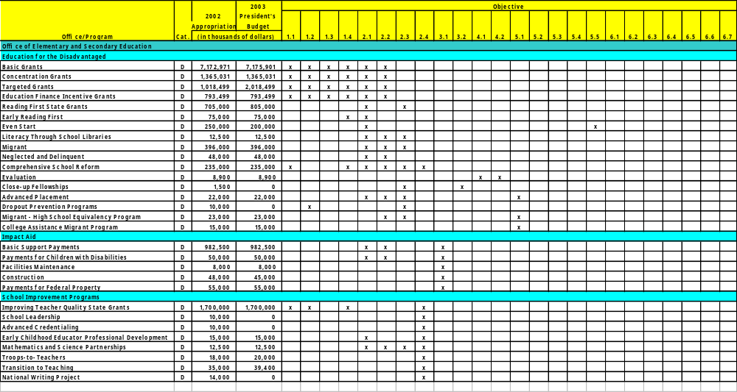
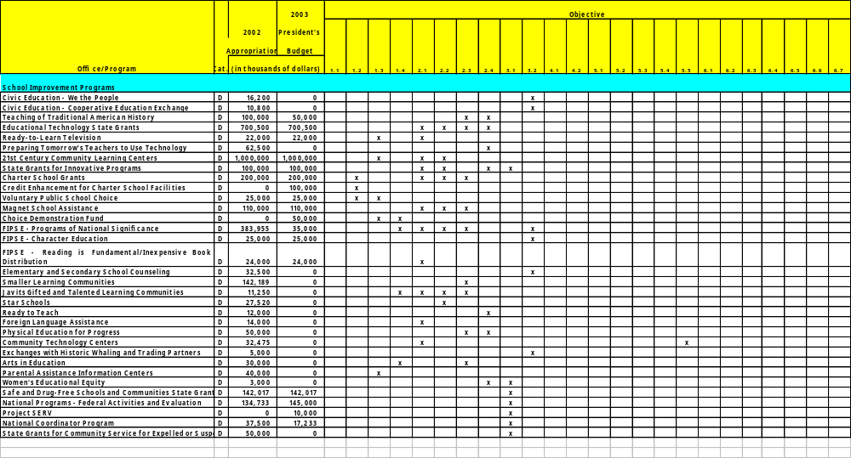
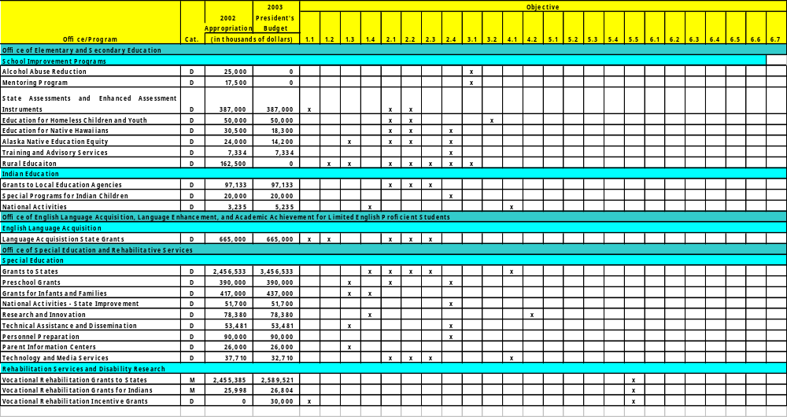
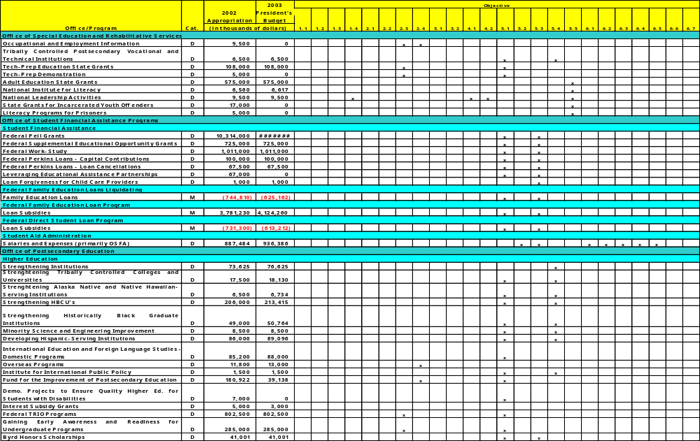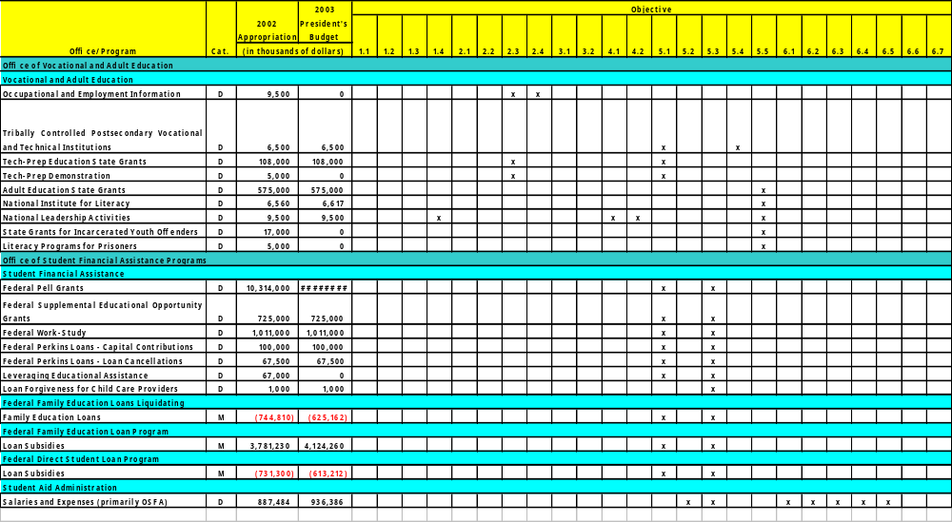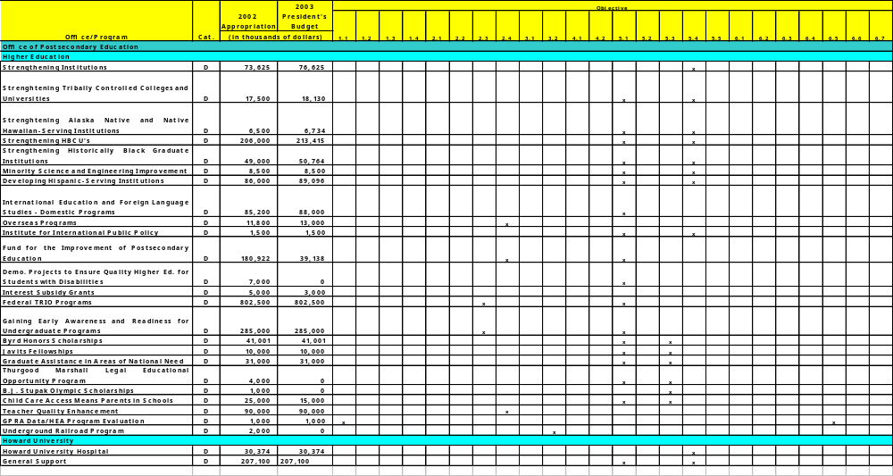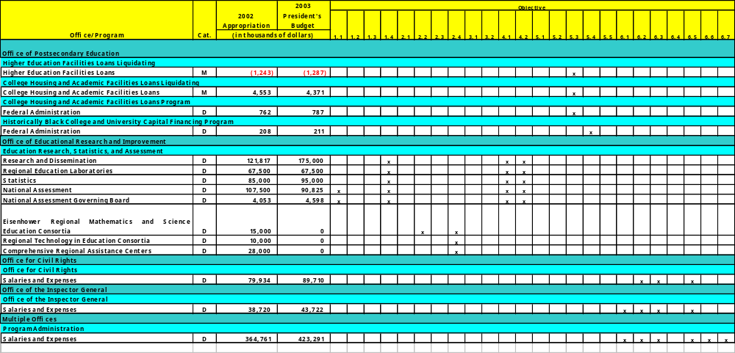
C

Appendix
Data Quality Standards

These draft data quality standards are intended to assist ED managers as they collect, analyze, and report data about Federal education programs and the programs’ performance. Although no single document can anticipate the entire range of data uses, we designed these standards to have broad applicability.
Program managers can use the standards as a tool when monitoring grantees and evaluating the quality of the reported data and preparing submissions for the GPRA annual report.
To fully evaluate the quality of program data, data managers must ask themselves:
- Have I selected the appropriate measures? (Standard 1: Validity)
- Am I collecting sound data on those measures? (Standards 2 through 5: Accurate Description, Editing, and Calculation)
- Am I reporting the data in a timely fashion (Standard 6: Timeliness)
- Am I reporting the measures accurately? (Standard 7: Reporting)
- Am I minimizing respondent burden in collecting data? (Standard 8: Burden Reduction)
These standards are an attempt to provide criteria against which to evaluate these aspects of program DQ. Not every example or item on the checklist is relevant to every indicator, or appropriate for every program.
How the Standards are Used within ED
Programs systematically review the quality of their data collection systems. Program managers use these standards to review performance indicators for their program.
Program managers examine the GPRA indicators and data for their programs to determine their accuracy and validity, and to develop plans for their improvement. In addition, the Office of Inspector General (OIG) independently monitors the reliability of its data quality (DQ) in high-priority areas.
Managers attest to the reliability and validity of their performance measures or submit plans for data improvement. Program managers and division directors, assert that they are aware of any DQ limitations and concur with the recommendations and plans for improvement.
How this Document Is Structured
The document consists of eight standards for judging program performance DQ: validity, accurate description, accurate counts, editing, calculation, timeliness, reporting, and burden reduction. Associated with each standard are definitions, examples, and possible checks for application of that standard.
The DQ checklist for each standard consists of a series of questions that both primary data providers and secondary data managers should ask themselves as they evaluate the quality of the data. A primary data provider is a person or organization who carries out all or part of the study design, data collection, data processing, and initial reporting. A secondary data manager is someone who sponsors or requests a primary data collection or who uses data from the reports for other purposes. Not every item on the DQ checklist might be appropriate for every study; however, each represents a step that can be taken to ensure the quality of program data.
Standard 1: Validity
Validity: Data align with goals. Data are measuring (a) what is most important and (b) the same constructs as the goals. Goals, objectives, indicators, and measures all align.
Examples Meeting the Standard
- The performance indicators measured the goal or objective of interest.
- The data .matched. the performance indicator because they measured the same phenomena.
- The indicators and data were a useful guide to policy decisionmaking.
Examples Failing the Standard
- The program objective did not have a realistic, measurable performance indicator.
- The measures assessed a different phenomenon than the indicator. (E.g., Safe environment: vandalism; Japanese teachers verses American teachers)
- The indicators provided data about aspects of the program that were unrelated to policy questions.
Question-by-question Explanations
1. Do the objective, indicator, and data all describe the same phenomena of
interest, and do they all align?
You will want to measure exactly what your objective describes. For example, if your objective is to improve school safety, what you mean by .safety?. Do you mean that kids feel safe or that there are fewer crimes perpetrated? Do you mean violent crimes or any crimes including vandalism? Counting the number of vandalism incidents alone probably is not the meaning of school safety, as described in your objective.
2. Do the indicators, and data address the core goals of the program?
If you had to take away every part of your program but one, what would it be? Chances are this is your defining strategy and, as such, should be what is measured first and foremost. Also, if you have multiple objectives, such as safe and drug free schools, make sure you measure BOTH aspects (I.e., safe AND drug-free).
Otherwise, do not bother writing them into your goal; if they are not worth measuring, they are not worth being a part of your objectives.
3. Do the indicators, cover aspects of the program that are useful and important for policy decisionmaking?
If you will not USE the data, do not waste everyone’s time collecting that data. If you do, you are asking for low quality data because the collectors will wonder why they should work hard to make it right when no one will even notice.
4. Are the instruments (e.g. surveys used to collect the data) statistically reliable and valid?
Is your survey measuring what you think it is measuring? A good example of a mismatch would be a survey of bad habits. If you asked people how often they leave dishes in the sink, sit endlessly in front of the television, and eat fast food every meal, you probably would not get accurate answers. You would get an accurate estimate of social desirability, the extent to which people saw these behaviors as undesirable and therefore denied practicing them. So, your survey was not measuring what you might have thought it was measuring. If your measuring tools are not valid, obviously your results will not be either.
5. Is a realistic plan in place to improve data validity and collection (especially to resolve any mismatches addressed in question # 1)?
Data can always be improved, and often, by making small systems changes, the quality of the data can improve significantly. It may or may not be true for you, but make sure to set aside time to ask that question.
Standard 2: Accurate Definitions
Accurate definitions: Definitions are consistent. All data providers and users are using the same, agreed-upon definitions for all terms.
Examples Meeting the Standard
- A page of definitions was given to all data collectors that clearly defined each term on the data collection sheets. For example, the sheet defined “program participants” as people who came more than half the time (dosage) and for whom their first and last visits were at least 5 weeks apart (duration).
- Data sent from one grantee were for the same time period as data from another grantee.
- Stakeholders helped to develop the reporting forms and definitions pages.
Examples Failing the Standard
- Each data provider used her/his state’s definition of who was or was not limited
- English proficient, instead of using the program’s given definition.
- Grantees were not given opportunities to give feedback on the definitions that they used.
Question-by-question Explanations
1. Have clear written definitions of term (including exclusions/inclusions) been communicated to data providers?
Often terms that seem self-explanatory are not. A simple example is the word .participants.. Almost all programs collect data on who their participants were, e.g., demographic information. But is everyone defining participants in the same way? If you have an eight week program and someone only comes the every other week, is she a participant? What if someone came the first four weeks then never again? If you do not clearly define the population, the data providers will use their own definitions, which may be different for every provider. Why is that a concern?
One good reason is that your program may be working, but the data does not show it! In the above example, it might be that someone who attends all eight weeks shows significant improvement, but anyone who attends less shows little or no improvement. If you average all of these people together, the improvement disappears in the mix! So, clearly define who you want to be included in the population on which you are collecting information.
2. Do reporting forms provide spaces for data providers to report deviations from definitions and uses of estimations at the same time they provide the data?
No matter how detailed and comprehensive your definitions and instructions, you will not be able to anticipate every definitional variation. That is why it is critical to leave a space for data providers to write in any deviations. If enough providers used the same variations, you may consider changing your reporting format.
3. Have you solicited feedback from data providers about data collection issues and possible problems?
Sometimes data providers have good reasons for collecting data one way over another, for example, state mandates that define terms for them or old systems that can only handle data the same way. Before you request data, it is useful to ask your future data providers in what form they already collect the data, and if they do not, in what form it would be easiest or most beneficial for them to collect it.
4. Have definitions been communicated in sufficient time for data providers to prepare their system to properly implement them?
Data providers often started collecting data long before the final reporting forms are released. They set up computer and management systems around data collection and often these systems are difficult and costly to change. To the extent possible, keep data providers involved and informed about any possible data requests or definitional changes. For example, if a proposed change to the authorizing legislation is in Congress, keep them updated on the progress and the potential changes it could have.

5. Have respondents been involved in setting definitions for key terms?
This question is along the same lines as question #2 and simply points to the importance of involving those people who will be filling out your forms in the development of those forms. The best way to test your forms is to pilot test them. Ask a few of your grantees to try to complete the forms with you (or preferably an unbiased third party) there, so you can listen and understand each step of the process and any problems that come about. Do not ask them to try to use the forms and then get back to you. In that situation, they may have problems that cause a lot of frustration, but that they eventually figure out and therefore may not report as problems.
Standard 3: Accurate Counts
Accurate counts: Counts are correct. The raw data are an accurate reflection or estimate of reality.
Examples Meeting the Standard
- Each data point represented one individual with no double-counts.
- The program accurately reported that 15 different people participated in each of the 10 classes for a total of 150 unique participants.
- Samples were of sufficient size to generalize to the population.
- Since the data changed by more than 10%, two administrators and one contractor reviewed the data for accuracy.
- For a survey, a sub-sample of the non-respondents was completed to determine (a) whether their answers differed significantly from non-respondents and (b) why they did not answer the survey.
Examples Failing the Standard
- Achievement tests, used as outcome measures, were given to all participants except the LEP students even though they represented 50% of participants.
- In a survey, 90% of the respondents were high-income families when only 50% of the surveys sent out went to these families. No one interviewed a sub-sample of low-income families who were sent the survey but did not reply.
- Estimates were used to fill in the remaining 20% of the raw data.
Question-by-question Explanations
1. Have entities for which counts have change more than 10% since the
previous report been double-checked?
If a school has the highest test scores in the state for five years, and then that school drops to the lowest scoring school in the state, you would take a second
look at the data, right? Why? Because, in general, change takes time. That’s why we recommended double-checking the accuracy of your data if it jumps by more than 10% in either direction.
2. Have estimates been used for no more then 10% of the phenomena counted, and are estimates clearly differentiated from actual counts?
In some cases we find that we do not have all the data that we need. For example, we may get surveys back where people filled out all but one question. We want to use their data, but for various statistical reasons, we need a complete survey.
Rather than throw that survey out, some analysts will choose to estimate the missing number based, for example, on that person’s other responses. This is an accepted procedure, but we recommend that you do it for no more than 10% of your data. If you do it for more than 10%, you may be creating a self-fulfilling prophesy of sorts. That is, you are estimating so much of your data that you are creating the data—and therefore your resultS—through that estimation process.
3. Are independent under and over-count checks in place?
Built-in over and under count checks are a simple, effective, and efficient way to ensure the accuracy of your data. If you are collecting data by computer, simply build in validity checks. For example, if in one part of the forms you ask for individual class attendance totals and in other you ask for the aggregate number, then you could build in a check that makes sure that the sum of the classes equals the number entered and gives an error message to the enterer if it does not. If you are using paper reporting systems, simply outline a similar checking procedure for the data administrators. Ideally, you also want an independent check of the data; have someone outside the project go through the same procedure that the administrator would go through.
4. Have counts been tallied at least twice and totals agree?
This question relates to question #3 and reiterates the importance of double-checking counts, preferably at every step in the data chain (e.g., data collectors, contractors, and administrators).
5. Have samples been drawn randomly (otherwise specified) and from the most up-to-date population lists?
Often the ideal sample is the random sample, where everyone in the defined population has an equal chance of being selected into the sample. Think of it as a lottery. For example, let’s say that a teacher has a project for only five students but there are thirty in her class. To make the process fair, she gathers all the students’ names, puts them in a hat, and selects five students. Every student had an equal chance of being selected. In studies, this sampling method is usually ideal because you will a range of people in your sample. If the teacher had asked for volunteers, she would have gotten students who all had something in common: they were
more likely to volunteer. It may be impossible for you to select samples randomly. In these cases, take with experts on how to do stratified, matched, or other sampling methods that best meet your goals.
6. Have weights been properly applied and reported?
Let’s say that a teacher has three volunteers for a special and fun project that requires only one person. One of those students got to do a fun project yesterday, while a second got to done one last week. The third has not done a fun project in several weeks, so she picks her. The teacher was implicitly applying weights to her decision, the greatest weight for the longest period of time. Statisticians have other reasons for applying weights, often because a group is over or under sampled. For example, if in a study of schools, too many principals replied proportional to the number of teachers, we may weight the teachers answers more heavily to balance out the data to match the existing proportion (I.e., there are more teachers than principals).
7. Have non-responses or data gaps been followed up?
If people did not complete your data request or survey, it may be extremely useful for you to find out why. Often it is because the survey was too confusing, complicated, or had some other problem that made it prohibitive to complete. If you find out what the problems are, you can fix them. Another good reason to track down non-respondents is because they may be different from your respondents in important ways. If they are, you have a biased sample; your results are questionable; and you may be missing information that will help you to more successfully implement your program.
Standard 4: Editing
Editing: Data are clean. The data collected from sources is cleaned, edited, and stored accurately.
Examples Meeting the Standard
- After merging all of the data into one data file, frequency distributions were calculated for every variable. These distributions were reviewed to make sure that all values were in the expected ranges (e.g., if the answer scale ranges from 1-7, there should be no .12.s). One variable was identified as incorrect and examined. It was found that there was an extra space in this file, which was removed.
- Data elements were hand-entered from original sources and randomly checked by two administrators for accuracy.
- A print out of the data file was made so that the administrators could scan the columns and make sure that there were no obvious problems with the integration of the data sets from all sources.

Examples Failing the Standard
- Data are entered into a database but no checks, such as frequency distributions, were made. When analyses were performed, the results did not make sense. When forced to go back to the data set, the analysts found multiple entries were out of range.
- The total of the percentages of the aggregated sets did not sum to 100%.
- Grantee data was reviewed for accurate counts then merged into one large data file. No review of the aggregate file was made.
Question-by-question Explanations
1. Have you “eyeballed” the data (e.g. looked at frequency distributions to make sure data are in proper range?
You know that the counts from each of your data sources are correct, so you merge all the individual files into one large master data file. In that merging process, something may have, and often does, go wrong. If data from one of the sources is entered wrong (e.g., a common occurrence is an extra space shifting the data one space to the right), all of your results will be incorrect. There are two easy ways to check your data: 1. Print out the data file. Scan it for any uneven columns. Randomly check to make sure that the numbers are all in the appropriate range (e.g., if response options ranged from 1-7, there should not be any numbers above 7 or below 1). 2. Do what are called frequency distributions. These distributions show all the answers clustered together and make it easy to tell whether there are any numbers out of the possible range. If a contractor is handling your data, ask to see and verify the data set using frequency distributions.
2. Have you discussed large changes or unusual findings with the primary data providers to see if they might be due to editing errors?
Similarly to Standard #3, always keep an eye out for unusual findings. Sometimes findings really are unusual, but always double check your data set first.
3. Have data errors been traced back to their original source and mistakes
corrected?
When you do find a data error, and everyone does, make sure you find out where it came from. For example, it may be that certain types of data files always cause the same problems. By identifying these problems, you can address them and possibly change your system so they do not happen again.
4. Has the data been collected electronically with checks?
Just like you can build in checks to your electronic grantee data collection, you can also build in checks to your overall database. For example, when disaggregating data, always check to make sure that those numbers, when aggregated, match the aggregated numbers in your database.
5. Has an electronic program been used to clean or flag problems with the data?
This question builds on #4. To the extent possible, try to build in data editing checks. If you can program checks into the software, it will mean that no one will forget to make that second check.
Standard 5: Calculation
Calculation: The math is correct. The data are manipulated and analyzed correctly, and the hypotheses are tested correctly.
Examples Meeting the Standard
- The data administrator requested that the contractor give a detailed description of how they coded and dealt with missing data in the creation of each new variable for analysis. The administrator requested frequency distributions of all new variables created.
- Measured amounts (numbers, percentages, ratios, etc.) were accurately computed using the right numbers and formulas.
- Since the data were not independent, the analyst used the appropriate statistical tests for non-independent data.
- Examples Failing the Standard
- The increase from 3% to 13% was reported as a .10 percent increase. rather than an increase of 10 percentage points.
- Non-responses (blanks in the data set) were included in the .responded yes. category because the data analyst did not account for the default method of dealing with missing values in the statistical software she was using.
- The significance level (e.g., .05) was not modified (i.e., made smaller) when the analyst did multiple t-tests using the same variables and data.
Question-by-question Explanations
1. Are missing data procedures applied correctly?
Statistical software programs have different default ways to deal with missing data. Sometimes they automatically exclude missing values from your analysis, but sometimes they require you to specify that the missing values should be removed. In fact, you may find that missing values are actually included as actual values. This often happens when recoding or creating new variables. For example, let’s say that a question on a survey asks how many times in the last seven days the respondent read a newspaper. There are five answer choices: 1= none, 2= one day, 3=two days, 4=two to six days, and 5= everyday. You may want to recode this variable to be dichotomous where 1= did not read the paper and 2= did read the paper.
Respondents will have selected a number, 1 through 5, or they may have skipped this question (missing data). To recode this variable, a programmer will instruct the software to make all the respondents who answered 1, stay a .1. and all the respondents who answered anything other than 1 to be a .2,. In this way, all the missing data may become a .2;. all the people who skipped this question are now people who read the paper! What does all this mean? It is important to be mindful that missing data may cause problems. Be aware of how all variables are coded and recoded. Ask for frequency distributions of all new variables and ask how missing values were handled.
2. Have the “+” and “-” confidence intervals been reported for sample data?
Confidence intervals are really error rates. They show that, with 95% probability, the accurate value is in this range. For example, let’s say that in a survey candidate X got 45% approval and candidate Y got 47% approval, BUT the confidence interval for the survey was 4%. In this case, the candidates are EQUAL. Since candidate X’s real value ranges from 43 to 47% and Y’s from 45 to 49%, there is not a statistically significant difference between the candidates. approval ratings.
3. Did you double-checked that the right formulae were used and that variable coding was done and reported correctly (e.g., through frequency
distributions)?
If you’re not a statistician, it never hurts to have one check over the analysis plan that you intend to use or to double-check the analysis or statistical program. There are many assumptions in statistical testing (e.g., assumptions of heteroscedasticity or independence) that must be addressed if violated.
4. For sample data, has the data analysis plan been reviewed by outside experts to ensure that appropriate formulae and procedures are applied?
Again, having outside experts review your analysis plan and performance can only enhance your project’s quality. Sample data raises additional statistical concerns and a statistician will be able to account for the various issues (e.g., weights).
Standard 6: Timeliness
Timeliness: The data are recent. The data are recent enough to address current policy concerns and to be used to improve the program.
Examples Meeting the Standard
- Data were reported in time to inform policy action.
- Data were collected and reports were forwarded as soon as possible after the close of the data collection period.
- Automated electronic processes were used to speed data collection, analysis, and reporting.

Examples Failing the Standard
- Data from 1997 were used to determine whether or not programs met their 2002 targets.
- Data were available only years after-the-fact.
- Paper records were copied out by hand.
Question-by-question Explanations
1. Are data relevant to the policy period of interest? That is, are the data recent and timely? Is the period in which the data was collected similar to the period for which policy decisions are to be made?
Data are meaningful to the extent that they are relevant to the time period for which decisions are being made. For example, if our latest national literacy data come from 1992, how able are we to assess accurately and made decisions about literacy policy with that data in 2002, ten years later? Literacy data may have changed significantly over that time and the policy decisions made off of old data may be misguided. In some areas, timeliness will be a greater concern than in others. For example, in studying technology, an area that changes rapidly, recent data are more important than in areas such as school construction, where changes usually evolve over years in steady trends.
2. Is a regularized schedule of data collections in place to meet policy
information needs?
When is the data most useful? This question can be asked for any of the data users. For example, if the schools use your data to set curriculum, then getting that data out to schools by August may be important. Think about when your data collection should optimally occur and then schedule it appropriately. Think about all the different users of your data, too, and consider having different data collection and release cycles for each.
3. Are improvements to data systems in place so that data may be reported as soon as possible after collection?
The focus is always on moving up the data quality continuum: how can we collect and use data more efficiently and effectively? The best time to think about improvements is while you are going through the process. Have your data collectors keep running notes, e.g., on the intranet, about how to improve the systems. Give stakeholders rewards for suggesting improvements.
4. Are the data entered and processed in electronic machine-readable form?
Computer-accessible data come up here again because electronic data collection usually means a faster turn-around time.
5. Are respondents involved in setting time schedules?
Following up on question #2, try to involve the stakeholders, those who use your data and those who collect it in the first place in data scheduling decisions. If they use the data, they will be more interested in increasing the quality of that data. So, if we can make the data more useful for them, it benefits everyone to do so.
6. Are review processes designed to ensure that findings are made public in a timely fashion?
Data help to identify successes (to replicate) and problems (to fix before it is too late). The release of data to the public, which often motivates change, may be a central part of improving your program and getting the resources you need.
7. Are time schedules for providing data enforced with clear and frequent
reminders?
Data collection is a process that takes time and often cannot be accomplished after-the-fact. Even if you give out your data collection forms in the beginning of the year, do not expect that people are reviewing the forms periodically to make sure they are tracking all the information that you need. Keep your data collectors informed and reminded of data requirements and their importance as well as collection timeliness. Reminders throughout the funding cycle will only serve to refocus everyone on the importance of high-quality data.
Standard 7: Reporting
Reporting: Full disclosure is made. Since data quality is a continuum, all data should be reported with notes about their quality and limitations.
Examples Meeting the Standard
- For each figure or chart in the report, there was a box of limitations that described the limitations of the data presented.
- The details of the survey’s sampling procedure was presented in the appendix of the report.
- Every table was labeled with source, time frame, error rates and cell sizes.
Examples Failing the Standard
- It was difficult to tell which years the charts covered and from where the data came.
- Confidence intervals were omitted as extraneous when sample data was presented.
- States each defined .participants. differently, but were all presented together without any notes about the different definitions.
Question-by-question Explanations
1. Are the data quality problems described in detail with suggestions for
improvement?
If you were describing your results to a researcher in the field, how would you describe them? What caveats would you attach to the results? Was the sample on the small side? Was the test slightly different in year 1 and year 2? Whatever the potential issues with your data, you will want to report them wherever your data appear. Also, for the sake of improving your data, think about how those limitations could be addressed in revised future data collections.
2. Are data quality problems reported together with the findings?
Building on the first question, this question asks you to make sure to attach the data limitations to every presentation of the results. If a table from your study is used in another report, be sure to put all of the data quality information in a footnote or on the table.
3. Are reports designed for and effectively disseminated to intended users and used for program improvement?
We collect data so we can USE it. Did you get the data out to all of the potential users? For example, likely the people who collected the data would benefit from a summary comparing them to others who collected similar data.
4. Are the data collection method, year, and sample size clearly stated?
Whenever data are presented, make sure to include how it was collected, the year it was collected (and, of course, the years for which the data apply), and the sample sizes, where appropriate. For example, you may have collected paper survey data from 3,000 randomly sampled teachers in seven states in the year 2000 for the 1998-1999 school year. All of these aspects of your collection should be reported.
5. Have significant changes in program definitions been noted with suggestions for improvement?
When changes in data definitions do occur, report them along with your data. For example, let’s say that you report on two years of data (2001, 2002) on the numbers of students with disabilities in each state. In 2002, before your data collection that year but after 2001 collection, .students with disabilities. is broadened to include more categories of disabilities than in 2001. So, although your data use the same terms, they have different meanings each year When these data are reported, there should be a clear note explaining the change in definitions and how it likely affected the data.
6. Is each step in the data collection process required to report deviations and problems in data quality?
Since data quality is often a chain (from the schools, to districts, to states, to USED), it is useful to make sure that there are opportunities for suggestions for improvement to come from any part of that chain. Just like CEOs will sometimes visit factory floors to get ideas for improving business practices, we can go to any level of our data chain and see how we can improve our data processes.
7. Are good graphics techniques used (e.g. axes begin at zero and charts are
clearly labeled with year and cell sizes?
Standards for graphs exist (e.g., NCES. standards for graphs and tables) because graphs, like statistics, can be misleading and lack critical information. For example, graph axes should always begin at zero unless clearly marked (“//”); bar graphs should show the exact values next to or on the bar; and tables should include error rates and cell sizes.
8. Have the types of exclusions and amount of non-response been clearly
described?
Who is missing from your sample? Were types of people, places, or things intentionally or otherwise excluded? Make note of any missing subpopulations.
9. Are data collection, cleaning, and analysis procedures documented in writing?
You care about data quality or you would not have read this far. So, you probably have developed or will develop a data system that accounts for data quality issues. Make sure to document that system and have those documents accessible to everyone on your team at headquarters and in the field.
Standard 8: Burden Reduction
Burden Reduction: Data collected is used. Seek opportunities for making data collection more efficient, e.g., coordination, and less burdensome, e.g., do not ask for data not used.
Examples Meeting the Standard
- Data collected is used in program management decisions.
- Grantees and other key stakeholders, such as states, were included on the data collection decisions.
- There was and continues to be on-going communication with offices providing similar services or targeting similar customers/grantees.
- Upon a review of decisions made last year and after discussions with stakeholders, one-quarter of the required reporting was eliminated.
Examples Failing the Standard
- Before collecting data, the program office failed to ask whether someone else was already collecting that data.
- The program administrator argues that the data is being used because pie charts are made of the data and are distributed. People find the data interesting, but no one actually uses the data to make decisions.
Question-by-question Explanations
1. Are ALL the data that are requested used for either reporting to Congress, management improvements, or technical assistance within two years of collection?
Go through your annual reporting forms and ask yourself, over the last year, what data from those forms have you, Congress, or your stakeholders used to make decisions about your program? Eliminate any questions that provide data that have not been used. Do this review every year.
2. Before requiring any data, was there a review of data already available being submitted by the same grantees through other federal programs?
If you need data, the first option should be to look for it somewhere else. Does some other program in the Department have it? Would another agency collect it? What about a not-for-profit group? If you still cannot find the data you need, the next step is to approach programs in or outside of ED that serve the same customers and ask to coordinate a data collection with them. As a last resort, collect the data in isolation.
3. Is there on-going communication with offices providing similar services or targeting similar customers/grantees?
Who is serving the same customers you are? Or who is providing similar services to different customers? There may be opportunities to share data collection or have common indicators (i.e., ways to measure) across programs. For example, Congress has identified Head Start and Even Start as programs that could and should coordinate more. They could develop common indicators, for example, about school readiness.
4. Were grantees and other key stakeholders, such as states, included on the data collection decisions?
Since a major objective of data collection is to USE it to IMPROVE the services that we provide, asking people involved in the provision of those services what data should be collected is a useful exercise. Have a few focus groups and ask grantees what would be the most useful data for them to provide. What data are they already collecting for their own use? What data are they required to collect for other ED or federal grants or state funds? Determine with providers what data are necessary to collect to meet both local and national needs and collect nothing more.
Appendix
Acronyms
D

ABE Adult Basic Education
BP Blue Print
CAMP College Assistance Migrant Program
CBO Congressional Budget Office
COR Contracting Office Representative
DL Direct Loan
DLOS Direct Loan Origination System
DRCC Document Receipt and Control Center
ED Education Department
ELL English Language Learners
EMT Executive Management Team
ESEA Elementary and Secondary Education Act
ESL English as a Second Language
FAFSA Free Application for Federal Student Aid
FAIR Act Federal Activities Inventory Reform Act
FFEL Federal Family Education Loan
FMFIA Federal Managers Financial Integrity Act
FSA/SFA Financial Student Assistance/Student Financial Assistance
FSA Family Support Act
FY Fiscal Year
GAO General Accounting Office
GEAR UP Gaining Early Awareness and Readiness for Undergraduate Programs
GPAS General Performance Appraisal System
GPEA Government Paperwork Elimination Act
GPRA Government Performance and Results Act
HEA Higher Education Act
HBCU Historically Black Colleges and Universities
HQ Headquarters
HSI Hispanic-Serving Institutions
IDEA Individuals with Disabilities Education Act
IDUES Institutional Development and Undergraduate Education Programs
IHE Institute of Higher Education
IPA Instructions for (SFA/FSA) Program Audits
IPEDS Integrated Postsecondary Education Data System
IRB Investment Review Board
ISIR Institution eligibility data in Direct Loan Process
IT Information Technology
MAP Mobility Assignment Program
MOU Memorandum of Understanding
NCES National Center on Education Statistics
NCLB No Child Left Behind
NICHD National Institute of Child Health and Human Development
NIDRR National Institute on Disability and Rehabilitation Research
NSLDS National Student Loan Data System
OCR Office for Civil Rights
OCFO Office of the Chief Financial Officer
OCIO Office of the Chief Information Officer
ODS Office of the Deputy Secretary
OELA Office of English Language Acquisition
OERI Office of Education Research and Improvement
OESE Office of Elementary and Secondary Education
OET Office of Education Technology
OGC Office of the General Counsel
OIG Office of the Inspector General
OIIA Office of Interagency and Intergovernmental Affairs
OLCA Office of Legislative and Congressional Affairs
OM Office of Management
OMB Office of Management and Budget
OPA Office of Public Affairs
OPE Office of Postsecondary Education
OS Office of the Secretary
OSERS Office of Special Education and Rehabilitative Services
OUS Office of the Under Secretary
OVAE Office of Vocational and Adult Education
PD Position Description
PMI Presidential Management Intern
PO/POC Principal Office/Principal Operating Component
QSI Quality Step Increase
RSA Rehabilitative Services Administration
SES Senior Executive Service
TCU Tribal Colleges and Universities

