S. O. P.

Accounts Payable

Verified and Updated November 2007

TABLE OF CONTENTS

 | SECTION | PAGE
1. | General Information | 4
2. | Daily FTP Procedures for the AXW & LXG | 5
3. | Prevalidating Vendor Payments | 7
4. | Prevalidating MOCAS Payments | 12
5. | Clearing Crosswalk Transactions in ODS | 15
6. | Downloading the SRD-1 Bridge | 17
7. | Processing the SRD-1 Bridge | 18
8. | Balancing Cash | 21
9. | Processing the Daily Preliminary Balance | 27
10. | Using DARS to Make Accrual, Interest and F Card Adjustments | 28
11. | Performing NULO Management | 30
12. | Processing 1080s & 1081s | 36
13. | Using the IPAC Wizard | 38
14. | Clearing Chargebacks | 39
15. | Processing Transactions By Others | 40
16. | Processing DFAS-IN Transportation Documents | 44
17. | Processing CARE transactions | 45
18. | Performing General Fund Accounting | 49
 | I. Deposit Funds and Suspense Clearing Accounts
- Transactions that Fail Appropriation Validation or Cause
An Out-of-Balance Condition
 | III. Recertified and Limited Payability Transactions
 | IV. Recyclable Materials Suspense Accounts
 | V. Individual Income Tax/Dity and Individual FICA/Medicare Taxes
 | VI. Payroll Budget Suspense Clearing Accounts
 | VII. Chargeback Account for Uncleared Cross Disbursements
 | VIII. Reporting Requirements
19. | Flowchart | 54
20. | Attachments | 55
 | I. Balancing Cash
 | a. Sample ODS Worksheet | 56
 | b. Sample of AVK-060 Spreadsheet | 57
 | c. Sample of AVK-072 Spreadsheet | 59
 | d. Sample AVK-575 Worksheet | 60
 | II. DPB
 | a. Sample of DPB (AVK-018) | 61
 | b. STANFINS Entry Screen | 64
 | c. STANFINS Mode 6/Function 1 | 65
 | d. STANFINS Correction Mode Screen | 66
 | III. ODS 1080/1081 Procedures
 | a. Input Procedures | 67
 | b. Certification Procedures | 82
 | IV. CARE Reject E-mail Format | 92

General Information

Overview: This standard operating procedure is designed to provide the processes necessary to maintain the proper status of disbursements against the Army Customer’ Obligations and Funding Authority. Accounts Payables are generated at the point where the government is obligated to pay for goods or services, good and services have been received and payment is pending.

Timely posting of the government’s disbursements is crucial to maintain an accurate status of the Unliquidated and Unobligated balance conditions. Many times the obligation is an estimate only, creating the potential for Funds availability to be much lower than expected. The timely posting of the disbursement and the subsequent immediate resolution of the NULOs and other abnormal condition will ensure accurate fund status.

NOTE: Definitions, acronyms and references can be found within various sections of this SOP.

Daily FTP Procedures for the AXW & LXG

Purpose: To prescribe daily file transfer protocol (FTP) procedures for the AXW & LXG files.

Run the FTP, AXW, and LXG Files (per schedule) for each installation.
- The FTP is run daily (if a cycle did not run from the day before, do not need to run a new FTP).
- Go into DARS to upload the LXG and AXW files.
a. The AXW file is run the first workday of the week. This upload needs to be accomplished prior to the daily upload of the LXG file.
b. The LXG file is run daily and needs to be uploaded first thing each morning. If a cycle did not run from night before, do not need to run a new LXG

NOTE 1: Maintain complete documentation of all processes performed in a log showing the files received and processed with file names and signatures.

PROCEDURES:

- AXW Files
- FTP
- Open FTP for (ex: Huntsville). Password is the same as password for Installation in DARS.
- When FTP is connected, select the drive, directory and subdirectory (left side of FTP) where you want to store the uploaded file. (SHARED DRIVE:\Shared\DARS\Recon)
- Select the file to be uploaded from the files on the right side of FTP. (AVK.AXW##.G00##V00)
- Select “COPY” and a screen appears to name the file which contains AXW##.txt (## is the filename). When the proper file name has been typed in, activate “ENTER”. This FTP transaction loads the file onto the SHARED drive under subdirectory “recon”.
- Explorer
- Copy the uploaded file from SHARED DRIVE:\Shared\DARS\Recon to S:\Shared\DARS\DARS##.
- Rename the file if necessary. The file name in DARS## must be “AXW##.TXT”.
- DARS
- Select “A”, Master File Menu.
- Select “1”, Upload APC Master File – (Upload Date xx/xx/xx is date last uploaded).
- Select “C”, Upload the AXW File from Text File on Network Drive.
- Enter current date. (This is the date the file is uploaded)
- Select “1”, Upload a New APC Master File.
- Select “D”, Copy the DARs AXW File from the Network Drive to the Hard Drive.
- Select “4”, Upload the entire AXW file from the Network Drive.

- LXG
  - FTP
- Open FTP for (ex: Huntsville). Password is the same as password for Installation in DARS.
- When FTP is connected, select the drive, directory and subdirectory (left side of FTP) where you want to store the uploaded file. (SHARED DRIVE:\Shared\DARS\Recon)
- Select the file to be uploaded from the files on the right side of FTP. (AVKPX.LXG##.G00##V00)
- Select “COPY” and a screen appears to name the file. The file name will contain an LXG##? and will be uploaded as a text file. (LXG##??.TXT and the file name will contain an alpha character to identify the day of the week). When the proper file name has been typed in, activate “ENTER”. This FTP transaction loads the file onto the SHARED drive under subdirectory “recon”.
  - Explorer
- Copy the uploaded file from SHARED DRIVE:\Shared\DARS\Recon to SHARED DRIVE:\Shared\DARS\DARS##.
- Rename the file if necessary. The file name in DARS## must be “LXG##.TXT”.
c. DARS
- Select “C”, Master File Menu.
- Select “1”, Upload New LXG File – (Upload Date xx/xx/xx is date last uploaded).
- Select “C”, Menu to Upload the LXG File (network) from Text File (network).
- Select “A”, Upload LXG file to the Network Drive only.
- Enter current date. (This is the date the file is uploaded)
- Select “1”, Upload New LXG File.
- Select “D”, Copy the DARs LXG File from the Network Drive to the Hard Drive.
- Select “4”, Upload the entire LXG file from a Network Drive.

Prevalidating Vendor Payments

Purpose: To ensure that the obligation supporting the proposed vendor payment has been recorded in the official accounting system and that the line(s) of accounting cited on the payment matches the data recorded in the accounting system. Prevalidation procedures help ensure that contracts and miscellaneous payments are not overpaid.

References: DoDFMR Vol 3, Chapter 8, Section 081401 and 081402
http://www.defenselink.mil/comptroller/fmr/

Note 1: Because the procedures below were written to be used with the Vendor Pay Prevalidation Program (VPPP) which does not recognize foreign currency, DFAS Europe will continue to use their locally developed PREVAL Program.

Other Useful Information:

I. PREVAL Codes:
Code | Definition
WO | Without Obligation - No Obligation exists for the accounting line
EO | Exceeds Obligation - An obligation exists but is not sufficient to cover the accounting line.
IA | Invalid APC - Not found in APC Master file
RP | Ready to Pay – Obligation is sufficient to cover accounting line and will be processed through the CAPS system.
RR | Research Required - Additional research is required on a requested change to a line of accounting.
VC/NC | Vendor Pay Correction – Correction of CAPS information to bring the payment information in line with the contract.
AC | Accounting Correction – Correction of the obligation to bring the obligation in line with the contract.

II. Locally Assigned Blocks:
Types of Blocks | Definition
External Prevalidation Correction Block | Block used by accounting technicians to input obligations to match the payment per the program director.
Internal Prevalidation Correction Block | Block used by accounting technicians to input obligations in agreement with the DoDFMR Volume 3, Chapter 8.
Internal Matrix Block | Block used by accounting technician to input obligations in agreement with the Obligation Matrix.
- Prevalidation Reports:
Report | Definition
Payment with Errors | Daily report worked
Contracts Ready to Pay (Compute and Certify) | Daily report Vendor Pay uses to certify payments
Status of Payment | Change Sheet used by Vendor Pay to input changes from accounting (identified by error codes)
Over Aged Report | Report that shows all lines/invoices on Preval that have been downloaded 1 - 5 days, 6 - 10 days, 10 days
Pay Today Report | Report that shows any lines / invoices that are clear for payment.
Accounting Status Report | Report used by accounting technician to verify changes made on previous day's Payment with Errors Report

NOTE 2: Maintain complete documentation of all processes performed in a log showing the files received and processed with file names and signatures.

PROCEDURES:

      - Check for new files before running PREVAL:
a. Vendor Pay file via COGNOS
            - Go to hard drive and folder where files are normally placed
            - Scroll to 1 – Compute
            - Input (Look for date files were updated)
            - Userlist (should all have current day’s date)
b. LXG Files - Go to DARS to look at each Database Id (DPI) Code to see when the files were last updated. There should be 3 files under each DPI with the current day’s date.

NOTE 1: The above procedures should be run daily to ensure files to be used with the PREVAL are up to date.

NOTE 2: At the end of the month, some LXG files may not be run daily but Vendor Pay still inputs data each day. Therefore, PREVAL must be run to update status.

2. Click on the PREVAL PROGRAM – ICON

NOTE 1: CAPS LOCK must be on
NOTE 2: Put a disk in the A: Drive

              - A - Upload the APC Master File. Once it runs, it will go back to the Main Screen.
              - B - Browse the APC Master File to verify files are there. Then hit Cntrl + End to return to the Main Screen.
              - C - Upload the LXG File. Once it runs, it will go back to the Main Screen.
              - D - Browse the LXG File to see if the files are there. Then hit Cntrl + End to return to the Main Screen.
              - E - Reset LXG File (only during closeout) at month-end
              - H – Update the User List
              - A - Upload the User List. Once it runs, it will go back to the Main Screen.
              - B - Browse the User List to see if the files are there. Then hit Cntrl + End to return to the Main Screen.
              - X – Quit
              - F - Upload COGNOS Query and press any key to continue. Once it runs, it will go back to the Main Screen.
              - G - Browse the COGNOS Query to see if the files are there. Then hit Cntrl + End to return to the Main Screen. Record the number of files into a daily logbook. Hit Ctrl + End

3. Working Today’s Payments
a. Verify obligations

NOTE: Never select "A" more than once. If not sure if “A” has been selected once, the computer must be shut down completely and the process must be started from the beginning.

  - Create Non-Verified Matches. This will take about 20 to 30 minutes.
  - Correct Non-Verified Matches
      - A - Work APC Errors. Then, hit Cntrl + End.
      - B- Work EOE Errors. Then, hit Cntrl + End.
      - C - Work FY Errors. Then, hit Cntrl + End.
      - D - Work Document Numbers (DRN) (pos. 1-3). Then, hit Cntrl + End.
      - E - Work Document Number (pos. 4-7). Then, hit Cntrl + End.
      - F - Work Document Number (pos. 8-9). Then, hit Cntrl + End.
      - G - Work Document Number (pos. 10-14). Then, hit Cntrl + End.
      - Type notes on research done and POCs contacted in the COMMENTS field (for future reference.)
      - H -Print Mismatched Reports
      - A – Print Report
      - X – Quit
      - I – To combine changes; must be done daily
      - X - QUIT

4. Information needed for the next steps
        - Type the letter "D" in the first block (OBME COLUMN) of the line being obligated.
        - When lines are marked, they come out on the Ready to Pay List today. Although this is the case, the block will not go in until that night and will not be seen in the system until the next day.
        - Have a block number, the julian date and a formatted disk for the A: Drive available.
        - Save the block to the disk.

NOTE: NEVER OBLIGATE "GRP…" NUMBERS**

5. D - Work Remaining Errors/Create Obligations
a. A – Correct Remaining without obligations (WO)
            - Look for EOR 21T1 and 26RB
            - Obligate by using "D" (amounts under $2500 can be obligated; comments can be put in the DOC1 Column)
- b. D – Correct Remaining Exceeding Obligations (EO)
            - Look for EOR 21T1 and 26RB
            - Obligate by using "D" (amounts under $2500 can be obligated if there is no credit already in STANFINS totaling more than the allowed amount)

NOTE 1: If nothing was marked with “D”, the next Step G (Create Obligation Files) is skipped. Go directly to F.

  - G – Create Obligation Files
      - A – Download DPIs
        - 1 – Create Obligation File
        - 2 – Browse Obligation File (shows the blocks that were obligated)

NOTE 2: The following Steps (c-f) are omitted if there were no files identified in Step b.

NOTE 3: If files were identified in Step b, a block number is needed.

c. Assign block number. (Select Option 3 from the Obligation Program)
  - Create a total card. (Select Option 4 from the Obligation Program). Browse total card, change 3rd line to TA 23.
  - Create file for STANFINS Upload. (Select Option 5 from the Obligation Program)
  - Print File Listing (Select Option 6 from the Obligation Program)
2. Repeat Steps 1.a-f (above) for all DPIs
            - After block numbers have been assigned, Hit ALT Tab
            - Open Windows Explorer
            - Click on A: Drive
            - Highlight Detail.txt
            - Click on File
            - Click on Rename
            - Rename the text file and ensure it includes the 2 digit DPI. (Samples: DTL(DPI)Block#.txt, Team??.txt (where ?? = DPI), etc.)
            - Double click on Rename file and delete the 2 files that do not have 23 at the beginning of the lines.
            - Save to hard drive and folder where files are normally placed for that DPI
            - Print
            - Complete Steps 1-12 for each block number that was assigned.
            - ALT Tab back to PREVAL
            - X-QUIT
            - X-QUIT
            - X-QUIT
- F – Browse Final Payment File (Based upon request from PREVAL Section, this is where any deletes/changes are made.)
1. Tab over to area (FY1, APC1, EOE1, or DOC1) where deletes/changes are needed.
2. Click on Go to forward search and enter requested information
3. Press Enter when done
- G – Update counters before printing
- H - Print Reports
1. C - Print Accounting Reports by DPI
2. D -Print Pay Today File. If an error message pops up, call the Vendor Pay Supervisor to get the person out of that file.
- E – Print Invoices without Receiving Reports (Skip)
- F – Print Management Report
- X – Quit
- I – Backup Counters After Print and Download, Enter Julian Date
- X – Quit
- X – Quit
- Type Quit then Press Enter
- Copy Daily Backup Files to the LAN
1. Go to Explorer
2. Open the hard drive and folder were backup files are normally stored
- Highlight-VER***.dbf (current day’s backup file)
- Edit
- Copy

Prevalidating MOCAS Payments

Purpose: To track obligation and disbursement activity for a particular contract.

Definition: MOCAS (Mechanization of Contract Administration Services) - used to pre-approve contract lines

NOTE 1: Maintain complete documentation of all processes performed in a log showing the files received and processed with file names and signatures.

- Checking Contracts and Contract Payments via DYNACOMM
  - Select “St Louis”
  - Enter
  - Type your Selection of “SK” for “ASIMS-S”
  - Enter
  - Type your USERID, Password, and Acct (account).
  - Enter
  - Place cursor to left of “EUDP” “APVN STANFINS P3”.
  - Enter
  - Type “EC99”
  - Enter
  - Type Password.
  - Enter
  - Type in the accounting station to be checked. This station number must start with “S” (example: S01044 for Fort Rucker, S30356 for Fort Drum, and S09177 for Fort McPherson).
  - Press “F5”. This will pull up the denied list in the system and reveals a list of lines to be worked.
  - Click on the Print Screen button to print this page.
  - If no data is found, press 'F3' to exit to menu, 'F3' again to exit MOCAS.
  - If data is available go to the next step.
  - To approve the line, type ‘E’ in the space to the left of the denied line.
  - Press Enter. The update screen should appear so the payment can be approved.
  - Replace the Reason Code of “031” with “999”and Press the F9 (update) key. Input accounting classification information in the narrative (can be printed after update for record or queried at a later date). Reason Code comment will change to “Accounting approval” and when update is successful, the comment “Manual update successful” will appear at the bottom of the screen.
  - Click on the Print Screen button to print this screen/page.
  - Press “F3”. The previous screen should appear. The previous screen, which is the denied list, should not have the line that was just approved. If the line is still present, it has not been approved and cleared. Work to clear it. If the line is cleared, print the screen showing the line is cleared.
  - Press “F3” until exit from program is complete.

2. Researching Contracts and Contract Payments using:
        - DYNA COMM:
            - Go into DYNACOM-Columbus
            - Enter LOGON code: (i.e. FC0MOCH, FC0MOCG, or FC0MOCL)
            - Enter
            - Type in the following data:
              - USER ID: P4
              - Facility Password: (alpha characters)
              - User password: #####
              - Application ID:
1. ycpm (contract payment)
2. ycu2 (new contracts)
            - Select 7- FINANCIAL DATA ENTRY MENU
            - Enter
            - Select 7- CONTRACT PAYMENT & REPORTING MENU Enter
            - Select C- CONTRACT OBLIGATION AND DISBURSEMENT INQUIRY MENU

See example of query screen below. Fill in the necessary blocks to retrieve information.

Select one of the following:

CONTRACT OBLIGATION HISTORY..............A
CONTRACT DISBURSEMENT HISTORY............B
DELAYED CONTRACT HISTORY INQUIRY.........C
BATCH STATUS INQUIRY.................C1
MODE XC...............................X

FUNCTION:

PIIN: SPIIN: BATCH ID:

OPTIONAL INQUIRY LEVEL (SELECT ONE OR MORE LISTED BELOW)

DATE BEGINNING: DATE ENDING:
ACRN: ACTG STATION: TYPE PAYMENT CD:
SHIPMENT NO: TYPE WITHHOLD:
* MAY SELECT OPTIONAL LEVEL: DATE, ACCTG STATION, AND/OR ACRN.
** MUST ENTER BATCH-ID FOR THIS FUNCTION.
*** MAY ONLY SELECT OPTIONAL LEVEL ACRN WITH TYPE WITHHOLD

Enter
To exit all the way out of each of the screens, hit the CTRL key 6 or 7 times.

- b. Electronic Document Access (EDA): http://eda.ogden.disa.mil/
- c. STANFINS: Use as much information from the accounting line that can be used in the query. See query below:

------------------------------------------------------------------------------------------------------------------------
NAME: MAF-LXG TYPE: QUERY STATUS: PUBLIC
DESCRIPTION:
+....1....+....2....+....3....+....4....+....5....+....6....+....7....+.
================================ T O P ================================
01 FIND ALL LXG0## WITH DOC-NO = '##############' APC ='####' EOE ='####'
02 FY ='#' ASN = '####' OA = '##' OBLIG = '########'
03 SORT BY DOC-NO FY APC EOE OA
04 PRINT TITLE
05 FY 'F/Y' EOE APC ODC 'O/D' DOC-NO LI 'L/I'
06 (OBLIG) PIC 'ZZZZZZ9.99-'(ACCRUAL) PIC 'ZZZZZZ9.99-'
07 (DISB) PIC 'ZZZZZZZ9.99-'
08 OBLIG-DATE 'OBLIG/DATE' DISB-DATE 'DISB/DATE'
=========================== B O T T O M ==============================

Clearing Crosswalk Transactions in the Operational Data Store (ODS)

Purpose: To correct any accounting lines that have a mismatch prior to the line coming across on the daily bridge.

References: ODS Website
https://odsw.csd.disa.mil/index.html

Definition:

a. Impromptu – COGNOS software tool used to query databases
b. ODS (Operational Data Store) – Oracle database that serves as a conduit between entitlement systems (IATS & CAPS), the disbursing system (SRD-1) and the accounting systems (STANFINS, SIFS, SOMARDS).

NOTE 1: Maintain complete documentation of all processes performed in a log showing the files received and processed with file names and signatures.

1. Query and print transactions held in ODS (Status Code “C”) using Impromptu
  - Enter User Id and Password, Press Okay.
  - Open the ODS canned query titled XWALK – DETAILS.imr
  - Enter Accountable Site ID (ex: 60 for McPherson, 77 Rucker, 31 Drum), hit okay.
To check each installation without getting out of Impromptu each time, click on the little box with the arrow on left of ? mark. This will bring up the block of Accountable Site Id, enter the next site Id., etc.
  - Print out the spreadsheet:
- If no lines are showing, exit all the way out.
- If lines need to be corrected, shrink Impromptu and go into the ODS icon to make corrections.

2. Correct or manually release transactions held in ODS

NOTE: Since you cannot print “Held” lines directly from ODS, it is important to run the XWALK – DETAILS.imr query in Step 1 above to keep record of these transactions. Once lines have been corrected or released in ODS, they will not appear as “Held” transactions running Impromptu queries.

  - Go into ODS, input the User Id, Password and Database.
  - Then click on ACCOUNTING/CROSSWALK CORRECTION (left top corner), input the information needed to correct the line or lines that come up in Impromptu.
  - When the Correction Screen appears, the cursor will be on the Site Id. Therefore, Press Enter once before doing any transactions. The cursor will then be on the APC block.
  - Tab over to Site ID
  - Enter the Site ID
  - Click on Execute. This will bring up the lines for corrections.
  - After each correction is made, click on Revalidate. Then, click Next if there are more corrections to be made.
  - If all corrections are done, then click on Exit.

- Go back into Impromptu
  - Enter your USER ID and PASSWORD, press okay.
  - Check each site again to assure that all lines cleared in ODS. IMPROMPTU should come up with 0 lines.
  - If lines are remaining, go back into ODS and clear as above in Item d. Again, go back into IMPROMPTU to assure that all lines are cleared.
  - Print sheet.
  - Exit all the way out to main menu.

NOTE: ODS has a month-end cut off date; however continue to clear transactions on a daily basis. At month-end cut off, a second bridge is run to clear all ODS lines that were received throughout the month. This is done to keep accountability in balance.

Downloading the SRD-1 Bridge

Purpose: To prescribe procedures for downloading the daily SRD-1 Bridge and distributing the transactions to the accounting teams to be reviewed and worked.

NOTE 1: Maintain complete documentation of all processes performed in a log showing the files received and processed with file names and signatures.

Procedures:

- 1. FTP PROCESS:
- a. Get new spreadsheet from Corp2 Server or via email
- b. Get and check new variance from Corp2 Server or email
c. Copy new bridge file from FTP-Server (1PAL.RI.DISA.ML.SFT) onto shared drive. (Rename if necessary)

2. DARS PROCESSES:
a. Enter DARS:
- 1. A - APC Master File Menu (Press Enter)
- 2. 1 - Upload New APC Master File
- 3. D - Copy the DARS AXW File from the Network Drive to the Hard Drive
- 4 – Upload the Entire AXW File from the Network Drive. (Check the date on line number 2 – Upload Date should be the date of the last cycle run.)
5. X – Exit
- 6. C - LXG File Menu. Press Enter (twice)
- 7. 1 – Upload the New LXG Text File
9. D – Copy the DARS LXG File from the Network Drive to the Hard Drive
- 10. 4 – Upload the Entire LXG File from the Network Drive
11. X – Exit (twice). (Check the date on line number 2 – Upload date should be the date of the last cycle run.)
12. X – Exit. Press Enter
13. D - SRD1 Bridge Menu
14. A - SRD1 Bridge Control Program One SRD1 Disk Mode
15. A – Balance Daily Bridge Menu
16. Day 1
17. A – Start New Bridge File
18. B – Upload Bridge File Disk 1 Database
19. A – Copy the Bridge File for this Database (Floppy or Hard Drive)
20. C – Calculate/Print. (Pick the file for the date being worked)
21. D – View Bridge File
22. E – Create the Final Balance Bridge File. Pick Drive (ex. A,B,C)
23. B – Upload Balance Bridge File (Drive ex. A,B,C). Enter Julian Date of the Bridged and Press Enter
24. C – Print Daily Accountability. Press Enter
22. D – Create Database Disk. Pick the date being worked and the Drive being used (ex. A,B,C)
23. D – Bridge (Site Cntrl and Team Combined)
24. A-Upload Bridge.
25. Yes
26. Help Me Menu
27. C – Obligation Menu
28. A – Create Print
29. B – View the LXG
30. 1 – View the LXG File in FY, EOE, APC, ODC, DOCNBR Sequence
31. C – Edit the No Obligation File. (It will give the number of lines)
32. D – Disbursement Greater than Obligations
33. 1 – Create Disbursements Greater than Obligations
34. 2 – Print the Disbursements Greater than Obligations
35. X – Exit (twice)
36. R – Print Menu
37. X – Exit. Press Enter
38. E – Print Daily Sum
39. L – Print Final Summary
40. M – Create STANFINS Input
41. 1 – To Create File STANFINS. Input the Julian Date; for EOR 4110 use the current date.
42. X – Exit
43. 1 – To Create File for STANFINS Upload
44. 3 – Create File on Floppy
45. 1 – To Enter a (4) Digit Date for the Total Card. Enter the Julian Date for the Total Card.
46. 3 – Create the File on the Floppy Disk
47. X – Exit (twice)

- b. Do necessary corrections via DARS (i.e. TA, Zero EORs, Invalid EORs, invalid DRNs for open allotment)
- c. Copy updated file to disk and FTP to ROSCOE Library
d. Separate NULO Listings by ASN and forward to appropriate accounting team for correction

- NOTE: Bridge must be ready for processing in the next daily cycle.
If not in balance:
      - Check ODS X-WALK
      - Print items from ODS that did not process on the bridge
      - Query ODS and make corrections to the ODS X-WALK

- e. Change TA to 40, Delete DSSN in Total Card Line
- f. Export file to STANFINS when corrections are done

Processing the SRD-1 Bridge

Purpose: To prescribes procedures for balancing the SRD-1 Bridge on a daily basis.

Acronyms:

a. DARS – Database Accounting Reconciliation System
b. SRD-1 – Standard Redesign One

NOTE 1: Accounting will pull, review and make any necessary corrections to the bridge. Then, notify Systems that the file is ready.

NOTE 2: For field sites with a large volume of supply transactions, it may be necessary the strip supply transactions from the bridge. Therefore, this step will not be standardized across the network.

NOTE 3: Maintain complete documentation of all processes performed in a log showing the files received and processed with file names and signatures.

- NT Explorer
- Go to SHARED DRIVE: \Shared\DARS\Bridge\0???(??? = bridge #)\brdg##.zip.
- Copy the file to “A” Drive.

2. DARS
- Select “D”, SRD1 Bridge Menus.
- Select “D”, Bridge (site control and team combined).
- Select “A”, Upload Brand New Bridge file.
- Select “Y”, Yes – Upload the file.
- Select “A”, A Drive.
- Check active bridge date: (example: 031)
- Select “C”, No Obligation Menu.
- Select “E”, Compare the Stand Alone Disbursement to the LXG File.
- Select “A”, Create/Print your No Obligation file.
- Select “C”, Edit the no obligation file.
- Select “A”, Create print no obligation file.
- Review printout and if corrections are required, X back to where “K” can be seen. If no corrections are required, go to “q” below.
- Select “K”, View Bridge File.
- Select “2”, View the Bridge File – You Select the Sequence.
- Select “3”, Document #. You can select whatever sequence you wish.
- We are now in the data. Check the BLK column and verify the Julian date is correct. Make changes and look at the data for large amounts.
- “Control End” to exit.
- Select “O”, Final LXG Menu.
- Select “1”, Create the Final LXG File.
- Select “2”, View the Errors/Open Lines on the Final LXG File.
- Select “3”, Print the Errors/Open Lines on the Final LXG File.
- X back to where “M” can be seen.
- Select “M”, Create the STANFINS input file. Arrow down to current file to be used.
- Select “1”, To Create file for STANFINS upload.
- Select “1”, To enter a (4) digit date for the total card.
- Enter the Julian date of data.
- Select “2”, To view your Total Cards.
- Select “X”, Finished with Total Cards.
- Select “6”, Create the file on the network drive. File name requires all CAPS. File name example: Rucker is “S77BR???”. ??? = Julian day of the year of the data which equals the bridge number.
- Select “8”, View Directory of Files on the Network Drive.
- Exit out of DARS.

Balancing Cash

Purpose: This Standard Operating Procedure (SOP) identifies steps required to reconcile the cash balances of each accounting site to the bridge files and accountability spreadsheets received from Centralized Disbursing (DFAS-IN).

NOTE 1: Maintain complete documentation of all processes performed in a log showing the files received and processed with file names and signatures.

PROCEDURES:

- Collect all documents needed prior to balancing.
- Hold File data (results from an ODS queries).
      - Query ODS via Impromptu
      - Enter User Id and Password, Press Okay.
      - Open the ODS canned query titled XWALK – DETAILS.imr
      - Enter Accountable Site ID (ex: 60 for McPherson, 77 Rucker, 31 Drum), hit okay. To check each installation without getting out of Impromptu each time, click on the little box with the arrow on left of ? mark. This will bring up the block of Accountable Site Id. Enter the next site Id., etc.
- Print results.
- Close the query.
- Block Totals (Daily blocks by DPI from ODS)
- Open query "BLK_TOTALS_BY_DPI.imr" (Daily blocks)
- For each installation serviced by the field site, enter the DPI code on the first line and the business day of cash that is being balanced on the second line.
- After all information is input click OK.
- Print results.
- Exit ODS
- Bridge Accountability Spreadsheet and Variance Spreadsheet (produced by Centralized Disbursing)
- Using FTP, open the session Corp 2 (the session name may be different on individual PC).
- Switch to Binary mode and click OK.
- On the remote side (right side of screen) under filename, arrow to the right to find the current day's bridge. This date must correlate with the bridge sheets. There are two files, the bridge accountability spreadsheet and the variance spreadsheet (usually has a V in the file name).
- Open the Bridge Accountability Spreadsheet.
- Highlight the data that represents your Field Site.
- Click File, Print and Selection.
- Exit file without saving changes.
- Open the Variance Spreadsheet.
- Highlight variances that represent your Field Site.
- Click File, Print and Selection.
- Exit file without saving changes.

Daily Disbursement Bridge Summary Sheets produced from dARS.

NOTE: Category 1 indicates non-stock fund items processed; Category 2 indicates single stock fund items processed; and Category 3 indicates TFOs (transactions for others) items processed. Ensure that category 3 items are contained only in a database that normally processes TFOs.
- AVK-018 Daily Preliminary Balance Listing from OLRV for each installation serviced by the field site: Print only those pages that effect cash (TA 20, 40, 42, 43, B0, B2, D0, FK, 4K).
- AVK-060 MTD Automated Control Register by Dollar Amount from OLRV for each installation serviced by the field site.
- AVK-072 Daily Net Disbursement Report from OLRV for each installation serviced by the field site.
- AVK-575 Date Block Totals of Cash Transactions Report from OLRV for each installation serviced by the field site.

NOTE: In case ORLV is down, please use the following queries to balance cash

1. Print Suspended Lines (shows same data as the AVK-018). See Query below:

-----------------------------------------------------------------
NAME: SUSPPAN TYPE: QUERY STATUS: PUBLIC
DESCRIPTION: SUSPENSE DETAIL
1....+....2....+....3....+....4....+....5....+....6....+....7..
================================ T O P ==========================
01 FIND EXG1### WITH LINE-NBR = ###
02 TA ='D0', '20', '40', '42', '43', 'B0'
03 SORT LINE-NBR
04 PRINT ODC LINE-NBR TA DOV (AMOUNT) AVK###MD$
==================+===== B O T T O M ==========================

2. Print Month to Date Figures (shows same data as the AVK-060). See Query below:

-----------------------------------------------------------------
NAME: CASH/053 TYPE: QUERY STATUS: PUBLIC
DESCRIPTION: AFCR CASH BAL
1....+....2....+....3....+....4....+....5....+....6....+....7. ============================ T O P =======================
01 FIND KXUAVK01-R-### WITH TA ='20' 'D0' '40' '42' '43' 'B0'
02 PRINT
03 TA (C1-AMT) 'FAO INPUT' AVK###MD$ (C5-AMT) 'MON-PROS-CREAT'
04 AVK###MD$ (C6-AMT) 'MON-NON-PROS' AVK###MD$
======================= B O T T O M ==========================
3. Print Current Month Figures. See Query below:

-----------------------------------------------------------------
NAME: INST/36-ROX TYPE: QUERY STATUS: PUBLIC
DESCRIPTION: CURRENT MONTH HISTORY
1....+....2....+....3....+....4....+....5....+....6....+....7. ============================ T O P =======================
01 FIND NXGAVK01-R-### RECORDS WITH DOC-NO NE ‘0’
02 DOV = ‘######’
03 BLK = ‘###’
04 TA ='20' 'D0' '40' '42' '43' 'B0'
05 EOE = ‘####’ ODC = ‘#’ FY = ‘#’ JUL-CYC-DATE = ‘02###’
06 SORT BY (BLK) DOV TA
07 PRINT TITLE1 ‘CURRENT MONTH HISTORY- (INSTALLATION)’
08 TA FY ‘F/Y’ EOE APC ODC ‘O/C’ DOC-NO
09 (AMOUNT) AVK###MDS DOV JUL-CYC-DATE ‘DATE’ BLK FI-LI ‘FI/LI’
10 WHEN FINISHED DO COUNT NXGAVK01-R-### DOV
======================= B O T T O M ==========================

- Preparing the ODS Spreadsheet (Daily basis): This spreadsheet balances the bridge totals that DFAS-IN sends to the bridges the DFAS Field Site receive. A separate spreadsheet is prepared for each DPI/site. (See Attachment Ia., page 60)
- Insert the bridge dates for the new month, starting with the first bridge after previous month's bridge cutoff and continue through the current month’s cut-off date. The DFAS-IN Centralized Disbursing Office provides the bridge dates.
- Input the numbers from the DFAS-IN Cash Accountability Spreadsheet into the INDY column for each installation’s ODS Spreadsheet.
- Using the Daily blocks by DPI from ODS, insert the total amount of all blocks in the DFAS Field Site bridge column of the ODS Spreadsheet. The difference will identify any ODS differences between the Field Site bridges and what DFAS-IN has accounted for.
- A credit amount in the difference column indicates that a debit amount is needed to balance to DFAS-IN.
- A debit amount in the difference column indicates that a credit amount is needed to balance to DFAS-IN.
- Print out the spreadsheet for any installation that has an amount in the difference column. The DFAS Field Site must always balance to DFAS-IN. They do not balance to the field site.
- Prepare internal cash balancing spreadsheets.
- There are two internal cash balancing spreadsheets. Both spreadsheets are prepared and/or updated on a daily basis.
- The AVK-060 spreadsheet compares the DFAS Field Site's cash balance to DFAS-IN's cash balance. (See Attachment Ib., page 62)
- The AVK-072 Spreadsheet balances all of the current month's bridge amounts and variances received from DFAS-IN to all of the current months’ bridges processed into STANFINs. Both the top and bottom portion of the spreadsheet should equal when all data is entered. (See Attachment Ic., page 63)
- The AVK-575 Spreadsheet compares the DFAS Field Site’s cash balance to DFAS-IN’s cash balance to the AVK-575 Report. (See Attachment Id., page 64)
- Preparing the AVK-072 Spreadsheet. This spreadsheet is broken into two pieces. The top portion is the sum of MTD Net Disbursements, suspended cash items, bridges not processed and variances identified by DFAS-IN. The bottom portion shows the daily bridge total dollars from the dARS Bridge Summary Sheet and any variances identified by DFAS-IN.
- Using the AVK-072 produced by STANFINS, insert the MTD Net Disbursement figures in the first line of the AVK-072 Spreadsheet for each DPI code/installation.
- If there are any amounts listed on the DFAS-IN Variance Spreadsheet, insert those amounts into the AVK-072 Spreadsheet for each DPI code/installation. This amount is needed under both sections (top and bottom).
- Using the AVK-060 produced by STANFINS, input the disbursement and collection amounts that have suspended. Go to the bottom of the first column, "BLOCK BAL SUSPENSE", to locate the dollar amounts next to the "DISB BY STATION" and "COLL BY STATION". Input these dollar amounts into the AVK-072 Spreadsheet into the rows labeled "Susp.-Disb." and "Susp.-Coll." for each Field Site/DPI.
- Input the bridge total dollars from the dARS Bridge Summary Sheet into the current day's business on the AVK-072 Spreadsheet by DPI code/installation. These amounts must be input under both sections (top and bottom).
- Examine the AVK-018 produced by STANFINS to identify the bridge blocks processed. It is important to be sure that the total bridge processes prior to deleting from the AVK-072 Spreadsheet. Once a bridge is processed into STANFINS it can be deleted from the top portion of the AVK-072 Spreadsheet.
- If a block is processed involving cash transactions (i.e. TA 20, 40, 42, 43, B0, B2, D0, FK, 4K), it must net to zero or an “out-of-balance” condition will occur. These amounts must be annotated on the AVK-072 Spreadsheet on separate lines under the bridge dates and amounts.
- The row labeled “ADJ AVK-072” is the sum for the top portion of the spreadsheet. The row labeled “DARS Bridge total” is the sum of the bottom portion of the spreadsheet. Review the row labeled "Difference" (difference between “ADJ AVK-072” and “DARS Bridge total”) to determine if there are any out of balances. Research any differences to determine corrective action.
- Preparing the AVK-060 Spreadsheet. This spreadsheet compares the DFAS Field Site's cash balance to DFAS-IN's cash balance.
- Input the bridge total dollars from the dARS Bridge Summary Sheet into the current day's business on the AVK-060 Spreadsheet for each DPI/installation.
- In the column labeled “Change in Accountability”, input the total accountability for the Field Site for that day’s daily business.
- If an installation has a variance on the DFAS-IN spreadsheet, then a line for the variance needs to be added. Input the variance amount.
- Using the AVK-060 produced by STANFINS, input net processed disbursements and collections into the AVK-060 Spreadsheet by DPI code/installation. Go to the bottom of the last column "NET PROCESSED", to locate the dollar amounts next to the "DISB BY STATION" and "COLL BY STATION". Input these dollar amounts into the AVK-060 Spreadsheet on the rows labeled "Disb by Station - Net Processed" and "Coll by Station - Net Processed" for each Field Site.
- The disbursement and collection amounts that have suspended also need to be input into the spreadsheet. Go to the bottom of the first column, "BLOCK BAL SUSPENSE", to locate the dollar amounts next to the "DISB BY STATION" and "COLL BY STATION". Input these dollar amounts to the AVK-060 Spreadsheet into the rows labeled "Block Bal Susp-Disb" and "Block Bal Susp-Coll" for each Field Site.

NOTE: When updating the AVK-060 Spreadsheet for the Collection Blocks Net Processed and Blocks Suspended, do not put in a credit (-) sign. The spreadsheet will always assume a credit. If the amount is a debit, then a credit sign needs to be put in with the amount to reflect the debit.

- Using the ODS hold file query information, input these figures into the AVK-060 Spreadsheet for each DPI code/installation.
- Examine the AVK-018 produced by STANFINS to identify the bridge blocks processed. It is important to be sure that the total bridge processes prior to deleting from the AVK-060 Spreadsheet. The total cash amount for each bridge is listed in the AVK-060 Spreadsheet by bridge date. Once a bridge is processed into STANFINS it can be deleted from the AVK-060 Spreadsheet.
- If a block is processed involving cash transactions, it must net to zero or an “out-of-balance” condition will occur. These amounts must be annotated on the AVK-060 Spreadsheet on separate lines under the bridge dates and amounts.
- When all these figures are added to the spreadsheet, the Net Change In Accountability should be zero. If the amount does not equal zero, an out-of-balance condition exists. Research the out-of-balance and correct as needed.
- Supporting documentation and distribution.
- Save the files after each site is balanced so that information is not lost.
- Make sure the AVK-072 Spreadsheet difference is zero and the Net Change in Accountability is zero on the AVK-060 Spreadsheet before moving to the next site.
- Print out copies of the AVK-072 and AVK-060 Spreadsheets.
- Attach all of the backup documentation to the spreadsheets, i.e. OLRV printouts, ODS query results, and other supporting documents.
- Once completed, email the internal cash balancing spreadsheet to the appropriate branch/section.

HINTS

Field Sites always have to balance to DFAS-IN. DFAS-IN does not balance to Field Sites.

DFAS-IN Cash = Total Bridge Cash + ODS Variances

Type Actions that affect cash are T/A 20, 29, 40, 42, 43, B0, B2, D0, FK, 4K

Be sure to pull the most current data. Check the dates of the AVK reports and the DFAS-IN spreadsheets.

At yearend when multiple runs are done on the weekends, DFAS-IN is behind in getting the spreadsheet updated so it can be confusing as to when items are accounted for.
- The net processed amount on the AVK-060 produced by STANFINS is the cash balance that must balance to DFAS-IN Cash Accountability Spreadsheet.
- The AVK-072 produced by STANFINS lists the daily transactions that were posted to STANFINS.

COMMON BALANCING PROBLEMS

- An internal or external correction block that affects cash doesn't balance to zero.
- SSF transactions being processed before accounted for at DFAS-IN (usually a year end problem).
- Transposition of numbers when inputting data into the spreadsheet.
- The AVK-060 has an out of balance condition under process creations.
- The Collection Blocks Suspended or the Net Collection Blocks Suspended
Amount is a debit amount and a credit sign is not used for these amounts on the AVK-060 Spreadsheet.
- The wrong TA code is used (particularly see this with reimbursement blocks that use a TA 43).
- A block that affects cash is suspended on the DPBL.
- A block that affects cash is released on the DPBL and not re-input.
- Forgetting that problem items on the DPBL that are affecting cash have to be input to the spreadsheet with the opposite sign as they appear on the DPBL.
- Adding rows to the cash balancing spreadsheets and forgetting to copy the formulas to appropriate cells to ensure the totals are included in the overall balancing amounts.
- *EOM ODS not accounted for properly*

Processing the Daily Preliminary Balance (DPB)

Purpose: To prescribe procedures for processing the Daily Preliminary Balance Report that provides a listing of daily business transactions that didn’t pass the bridge.

Acronyms:
a. CARE – Customer Automated Reporting Environment
b. DPB – Daily Preliminary Balance Report - AVK-018
c. OLRV – On-line Reports Viewing
d. STANFINS – Standard Finance System

NOTE 1: Maintain complete documentation of all processes performed in a log showing the files received and processed with file names and signatures.

1. Retrieve the DPB Report
a. Go into OLRV
b. Print a copy of the AVK-018 Report (See Attachment IIa., page 65)
- Analyze the DPB Report:
a. Ensure no duplicate blocks processed from previous days.
b. Ensure the block total cards are changed to agree with changes made to type action codes or released lines.
- Maintain a log of assigned block numbers. The logbook is updated daily by posting the processing date next to the block number. This ensures that all blocks assigned have processed to STANFINS or have been appropriately voided. The logbook also provides the POC for any suspended transaction if the block is processed locally.

NOTE: CARE blocks (See CARE Procedures, page 43)
- 1. Maintain a spreadsheet for CARE blocks
- 2. Log all blocks and verify that they are sequentially received
- 3. Validate that all blocks are in balance

- Research errors from the DPB Report

NOTE: There are many different errors that may occur on the DBP and they all have different ways of correcting them. In order to correct these errors, you need to know where the block was processed, whom to see for valid data, what system to research and where to get backup. Many of the errors occur frequently while others occur occasionally. If a line(s) needs to be released and re-input, a variety of Mode/Functions are used.

- Annotate the DPB with any corrective measures required to clear the suspended lines, and include the source of the information. Input the corrections into TAPS using Mode/Function 61. (See Attachment IIb-d., page 68-70)
- Maintain a copy of the DPB and any backup per customer.

Using DARS to Make Accrual, Interest and F Card Adjustments

Purpose: To provide information to assist with adjusting accruals, interests and F Cards.

Definitions/Acronyms:

a. DARS – Database Accounting Reconciliation System
b. LXG - file used to update records on the Non-Stock Funds Payable
c. STANFINS – Standard Army Finance System

NOTE 1: Pull DARS Accruals daily and the Obligation Matrix at least weekly (except for the first week of the month when the system is down).

NOTE 2: LXG must be updated prior to running the DARS Maintenance.

NOTE 3: Maintain complete documentation of all processes performed in a log showing the files received and processed with file names and signatures.

1. Accrual and Interest Adjustments
- Select “C” LXG File Menu.
- Select “6” LXG Query Menu.
- Select “2” F Card Program (TA 23/32 Program).
- Select “1” Erase all Records from the Current Query Files.
- Select “Y” Yes to Erase.
- Select “2” Select the F Card Queries to Run.
- Browse queries. Mark queries for use with an “X” (example: Ft. McPherson queries 1-4 & 11 – ACCRUALS ONLY).
- Select “3” Process Queries.
- Select “7” Create the STANFINS input file.
- Select “2” To create your adjustment file. (Create adjustment File for STANFINS Upload)
- Select “3” To view your adjustment file. (View file for STANFINS Upload)
- Select “5” Create file for STANFINS Upload.
- Enter Block # “E??”. This will be an “E” Block and the numbers are controlled.
- If date is correct, activate enter.
- Select “1” To enter a (4) digit date for the total card.
- Select “2” To View your total cards.
- Select “X” Return to previous menu.
- Select “1” Copy STANFINS input file to Network Drive.
- Select “3” View Directory of STANFINS Input file on Network Drive (to verify that it’s there).
- Select “X” Return to previous Menu.
- Select “B” Print the adjustment file (file1.dbf)
- Select ‘1” Print adjustment file.
- Select “2” Document Number. This will print in document number sequence.
Run accrual queries daily.

2. Obligation Matrix or F-Card Adjustments

Select “C” LXG File Menu.

Select “6” LXG Query Menu

Select “2” F Card Program (TA 23/32 Program).

Select “1” Erase all Records from the Current Query Files.

Select “Y” Yes to Erase.

Select “2” Select the F Card Queries to Run.

Browse queries. Mark queries for use with an “X” (Mark query 10).

Select “3” Process the selected Queries.

Select “7” Create the STANFINS input file.

Select “2” To create your adjustment file. (Create adjustment File for STANFINS Upload)

Select “3” To view your adjustment file. (View file for STANFINS Upload)

Select “5” Create file for STANFINS Upload.

Enter Block # “MF?”. The first two characters of the number are “MF” and the last character is 1-9 and then A-Z. If date is correct, Press Enter.
  - Select “1” To enter a (4) digit date for the total card.
  - Select “2” To View your total cards.
  - Select “X” Return to previous menu.
  - Select “1” Copy STANFINS input file to Network Drive.
  - Select ‘3’ View Directory of STANFINS Input file on Network Drive (to verify that it’s there).
  - Select “X” Return to previous Menu.
  - Select “B” Print the adjustment file (file1.dbf)
  - Select ‘1” Print adjustment file.
  - Select “2” Document Number. This will print in document number sequence.
  - Send a copy of the matrix file to the installation and give a copy to the reviewer in Accounting for their input prior to finalizing the file that will go into SHARE DRIVE.
Run the obligation matrix query at least weekly.

Performing NULO Management

Purpose: To prescribe procedures for managing NULOs.

Definitions:

a. Negative Unliquidated Obligations (NULOs) – a disbursement that has been received and posted by the accounting activity and it exceeds the recorded obligation at the detail obligation level. (i.e. disbursement > obligation)
b. Element of Resource (EOR) - four digit code which identifies the type of resources that are being consumed (such as military personnel, civilian personnel, travel, utilities, rent, and communication).
c. EOR 4600/4620 - Overpayments or erroneous payment given to individuals, contractors, local or foreign government for anticipated expenses other than travel advances. When the payment becomes delinquent and a demand letter has been issued, it is transferred to refunds receivable.
d. Accounting Processing Code (APC) - four digit code that identifies specific elements of the accounting classification and may be used as a shortcut of entering numerous elements into the accounting system for each transaction.
e. Database Commitment Accounting System (dbCAS) - a PC based automated commitment ledger system for recording and managing commitments and funding data, and for uploading and receiving obligation data to/from STANFINS and other automated systems.
f. STANFINS Analysis Tool (STAT 2000) – locally developed access program that calculates all STANFINS NULO statistics by individual installation.

NOTE 1: Maintain complete documentation of all processes performed in a log showing the files received and processed with file names and signatures.

- Send a message to the Budget Analyst that is responsible for the account that has a NULO. Verify signatures of budget personnel to ensure they are valid and current.

- Request an increase in obligated funds to match the disbursement.
a. If the budget analyst claims that the disbursement was erroneously applied to their accounting line, then it is up to accounting to research the disbursement that caused the NULO by:
1. Checking the disbursement for the disbursement date and voucher number in DynaComm (NXG, AX5 or Atlas)
2. Going into EDA to print a copy of the voucher or to request a copy of voucher and back up if processed from another installation.
3. Checking the backup to see the accounting line that the payment should be processed against.
b. If the NULO is legitimate and the budget analyst has not increased the obligation to cover the NULO, the NULO will clear once the weekly Obligation Matrix is run. (as long as the NULO is within the Obligation Matrix guidelines and DoDFMR, Volume 3 regulation)

- To identify NULOs, query STANFINS. See query below:

--------------------------------------------------------------------------DQD10
DATAQUERY: EDITOR
-------------------------------------------------------------------------------
NAME: NULO>0K TYPE: QUERY STATUS: PUBLIC
DESCRIPTION: DISB > OBLIG 0K
....+....1....+....2....+....3....+....4....+....5....+....6....+....7....+.
.. ================================ T O P ========================
01 FIND LXG0## WITH DOC-NO = '##############'PE NE '9###' OA = '##'
02 ASN = '####'
03 LC NE '21' OBLIG < DISB APC NE '####' EOE NE '41##','46##'
04 LI NE 'A','Y' (DISB - OBLIG) > '0000.00'DISB NE '0'
05 SET TOTAL-NULO (9.2) = (OBLIG - DISB)
06 SORT BY ASN DOC-NO
07 PRINT TITLE1 'NULOS > 0K'TITLE2 'PROBLEM DISBURSEMENTS'
08 ASN DOC-NO FY EOE APC (OBLIG) AVK0##MD$
09 (DISB) AVK0##MD$ (TOTAL-NULO) AVK0##MD$

4. Other queries/tools used to perform NULO Management

a. Credit Obligations
- Reduce the amount of an obligation.
- Include but are not limited to:
a. Adjustments
  - Corrections
  - Reductions
  - Cancellations

See query below:
--------------------------------------------------------------------------DQD10
DATAQUERY: EDITOR
-------------------------------------------------------------------------------
NAME: CREDIT-OBS TYPE: QUERY STATUS: PUBLIC
DESCRIPTION:
....+....1....+....2....+....3....+....4....+....5....+....6....+....7....+.
.. ================================ T O P ==========================
01 FIND LXGAVK01-R-0## WITH FY = '#' BSN = '####' OA = '##'
02 DOC-NO = '##############' ASN = '####' OBLIG < '0' LI NE 'A' 'Y'
03 APC = '####' EOE = '####' OBLIG = '###########' DISB NE OBLIG
04 ASN = '####'
05 SET ULO (9.2) = LXG0## (OBLIG - DISB)
06 SORT BY ASN DOC-NO
07 PRINT TITLE 'CREDIT OBLIGATIONS'
08 ASN DOC-NO FY APC EOE ODC (OBLIG) AVK0##MD$
09 (DISB) AVK0##MD$ (ULO) AVK0##MD$
b. Credit Disbursements – a disbursement showing a credit. The credit needs to be researched to determine if it is legitimate and why it occurred.
      - Go into the history data query to see if the disbursement had been processed.
      - Check the disbursement date to see if the credit was input after the disbursement was paid. If so, the error must be corrected. (If a travel situation- it may have occurred because the travel was not performed. Disbursement was input creating a NULO, then the obligation matrix ran washing this line. Subsequently, a stand-alone credit disbursement was posted that requires research.) See data query below.

--------------------------------------------------------------------------DQD10
DATAQUERY: EDITOR
-------------------------------------------------------------------------------
NAME: CREDIT-DIS TYPE: QUERY STATUS: PUBLIC
DESCRIPTION:
....+....1....+....2....+....3....+....4....+....5....+....6....+....7....+.
.. =========================== T O P =================================
01 FIND LXGAVK01-R-0## WITH FY NE 'F','X' BSN = '####' OA = '##'
02 DOC-NO = '##############' ASN = '####' DISB < '0' LI NE 'A' 'Y'
03 APC = '####' EOE = '####' OBLIG = '###########' OBLIG NE DISB
04 ASN = '####'
05 SET ULO (9.2) = LXG0## (OBLIG - DISB)
06 SORT BY DOC-NO
07 PRINT TITLE 'CREDIT DISBURSEMENTS'
08 ASN DOC-NO FY APC EOE ODC (OBLIG) AVK0##MD$
09 (DISB) AVK0##MD$ (ULO) AVK0##MD$

c. LXG:
--------------------------------------------------------------------------DQD10
DATAQUERY: EDITOR
-------------------------------------------------------------------------------
NAME: LXG TYPE: QUERY STATUS: PUBLIC
DESCRIPTION: (NSFOP)
....+....1....+....2....+....3....+....4....+....5....+....6....+....7....+.
.. ================================ T O P ==============================
01 FIND ALL LXG0## WITH DOC-NO = '##############' APC ='####' EOE ='####'
02 FY ='#' LI = '#' OA = '##'
03 SORT BY DOC-NO FY APC EOE OA
04 PRINT TITLE 'MK'
05 FY 'F/Y' EOE APC ODC 'O/D' DOC-NO LI 'L/I'
06 (OBLIG) PIC 'ZZZZZZ9.99-'(ACCRUAL) PIC 'ZZZZZZ9.99-'
07 (DISB) PIC 'ZZZZZZZ9.99-'
08 OBLIG-DATE 'OBLIG/DATE' DISB-DATE 'DISB/DATE'
.. ====================== B O T T O M ================================

d. EOR 4600
Do not obligate against this EOR. Collections received from individuals or companies will be credited to the accounting line citing EOR 4600, 4610 or 4620. Query the LXG to ensure no obligations are recorded against these EORs. See query below:

----------------------------------------------------------------------------------------------------------------DQD10
DATAQUERY: EDITOR
---------------------------------------------------------------------------------------------------------------
NAME: 4600 TYPE: QUERY STATUS: PUBLIC
DESCRIPTION: 46##
.…...+…....1…....+…....2…....+..…..3…....+…....4…....+…....5…....+…....6…....+…....7.......+…..
================================ T O P ====================================
01 FIND LXG### WITH EOE = '46##' OBLIG NE '0'
02 SORT BY FY APC DOC-NO EOE ODC
03 PRINT TITLE '4600'
04 DOC-NO FY EOE APC OA
05 (DISB) AVK###MD$ (OBLIG) AVK###MD$
========================== B O T T O M ===============================

e. QUAD 9999 APC - used as a default APC.

--------------------------------------------------------------------------DQD10
DATAQUERY: EDITOR
-------------------------------------------------------------------------------
NAME: QUAD 9999 TYPE: QUERY STATUS: PUBLIC
DESCRIPTION:
..+....1....+....2....+....3....+....4....+....5....+....6....+....7....+.
.. ===================== T O P ======================
01 FIND BXU0## WITH FY = '#' APC = '9999' EOR = '####' OA = '##'
02 ASN = '####' BSN = '####' AMS8 = '########' FY = '#'
03 SET TOT-OBLIG (11.2) = (OBLIG-INC + OBLIG-FYTD + OBLIG-CM + DEOB-FYTD + 04 DEOB-CM)
05 SET TOT-ACCR (11.2) = (ACCR-INC + ACCR-FYTD + ACCR-CM)
06 SET TOT-DISB (11.2) = (DISB-INC + DISB-CM-BY-US + DISB-CM-BY-OTH + DISB-FYTD
07 + DISB-CM-BY-INT)
08 SET TOT-DEOB (11.2) = (DEOB-FYTD + DEOB-CM)
09 SORT FY EOR
10 PRINT TITLE1 'APC 9999'
11 APC FY RT EOR (TOT-OBLIG) AVK0##MD$ (TOT-ACCR) AVK0##MD$
(TOT- DISB)
12 AVK0##MD$

f. Unmatched Disbursements (UMDs) via DARS

Accounting can retrieve this information through DARS. This program
is used to find possible obligations for UMDs. See below:

Go into DARS:
1. C-LXG File
2. 1-upload new LXG file
- D-copy the DARS LXG file
- 2-Edit the criteria to split LXG
- Put an ‘X’ next to the criteria
- Control End (keys at the same time)
- X
- X
- 1-upload new LXG file
- D-copy the DARS LXG file
- 3-upload the partial LXG file
- X
- 3-unmatched disbursement
- A-create a new error detection file
- 1-create the LXG error detection file
- Creating your LXG error detection file (take a few minutes to run file)
- 1-to run exact error routine
- Do you want to create the error listing: Y (yes) or N (no), enter Y
- The file listing will print out all of the unmatched disbursements.
- Once this process is completed in DARS, go back to the menu screen from the Network drive to reload the full LXG file. It is very important to reload the full LXG to the hard drive.
- D-copy the DARS LXG file from the Network drive to the Hard Drive
- 4-upload the entire LXG from a network drive

g. STAT 2000 (to be used once program is deployed to all field sites)

What does it do?
- Imports the installation’s LXG files from DARS that have been downloaded from FTP.
- Facilitates NULO aging because date sensitive
- Generates the weekly/monthly “Shine NULO Report every business Friday.
- Provides read-only access to accountants but restricted import access for a few employees
- Retrieves data at summary level and detail level if needed
- Sort information by STANFINS data criteria (i.e. PD, OA, BSN)

1. Open Program
2. Update LXG from FY 1900 to 2000 - Select all installations
3. Set criteria for NULO queries
4. Check:
a. Overwrite LXG data
b. All transactions
- Import LXG files for selected sites
NOTE: Program downloads current LXG files for each site from DARS
- Query downloaded file for:
  - Total NULOs received during the week/period (summary)
(Set condition: NULO-AGE < 8)
  - Total NULOs as of report date (summary)
(Set condition: NULO-AGE < 9999 or NULO > 0)
- Print output and toggle to MS Excel for NULO Report Worksheet
- Open last report
- Highlight all pages on the spreadsheet
- Copy and paste current week’s data columns to previous week columns.
- Highlight one installation at a time
- Use data from STAT 2000 queries to update the current week’s data
- Print NULO Report and email copies with appropriate footnotes to the authorized recipients.

Processing SF 1080s & SF 1081s

Purpose: To define standard procedures for use and preparation for the SF 1080 and SF 1081 (excludes reimbursable billings).

Definitions:

a. ODS (Operational Data Store) – Oracle database that serves as a conduit between entitlement systems (IATS & CAPS), the disbursing system (SRD-1) and the accounting systems (STANFINS, SIFS, SOMARDS).
b. SF 1080 - Voucher for Transfers Between Appropriations and/or Funds
c. SF 1081 - Voucher and Schedule of Withdrawals and Credits

NOTE 1: Maintain complete documentation of all processes performed in a log showing the files received and processed with file names and signatures.

1. SF 1080s
a. Preparation of the SF 1080s is via SRD1, ODS and the IPAC Wizard
- For checks use SRD1 1080 screen
- If there is a Bilateral Trading Partnership Agreement (TPA) only use IPAC

1. Ensure all items on the SF 1080 are completed with correct and accurate information.

NOTE: It is not necessary to complete the Voucher Number or Paid by blocks.

2. Complete the appropriation blocks (Office Receiving Funds and Office Charge) with full accounting classification information including EOR, APC, SDN and FSN.
- Provide full explanations and reason for charges in the Articles or Services Section.

b. The designated certifying officer will:
      - Review the SF 1080 for accuracy
      - Certify the SF 1080 in SRD1, ODS or IPAC Wizard (whichever applicable)
      - Provide backup:
a. From SRD1 processing - to the person designated to collect and run the daily Vouchers Awaiting Payment (VAP) as per schedule.
b. From IPAC processing – to the individual that processed the SF 1080.

2. SF 1081s
a. Preparation of the SF 1081 is via ODS:
            - Ensure all items on the SF 1081 are completed with correct and accurate information.
            - Complete the appropriation blocks with full accounting classification information including the FY, EOR, APC, SDN, DPI and FSN)
            - Provide full explanations and references in the Remarks Section
            - Maintain hard copies (only if the supporting documentation can not be retrieved via an Impromptu Query from ODS)
b. The designated certifying officer will:
      - Review the SF 1081 for accuracy
      - Certify the SF 1081 in ODS
      - Reject any errors back to the individual that processed the SF 1081 for corrections to be made. After required corrections are made, SF 1081 is sent for certification. If errors can’t be fixed, the SF 1081 is sent to the certifier for deletion.

NOTE: See Attachment IIIa-b, pages 63-97 for further details on processing 1080/1081s in ODS.

Using the IPAC Wizard

Purpose: To prescribe procedures for processing IPAC Bills either pulled or pushed to Accounting

References: Centralized Disbursing Website – IPAC Transactions http://www.dfas.mil/more/accounting/centraldisbursingservicesipacinformation/Guidance.pdf
Agency Location Codes: http://www.dfas.mil/more/accounting/centraldisbursingservicesipacinformation/TPAlisting3.pdf

Acronyms:
a. ALC –Agency Location Code
b. IPAC - Intra-Governmental Payment and Collection
c. TPA – Trading Partner Agreement

NOTE 1: Maintain complete documentation of all processes performed in a log showing the files received and processed with file names and signatures.

- IPAC Bills that are pulled must be processed in 3 days:
a. Access the IPAC Wizard
b. Select Update Bills Charge
1. Verify the bills being charge
2. Enter the data into the system
c. The certifier will:
1. Go into IPAC to review the file
2. Certify the bill or reject the bill back to the individual that processed the charged. The individual will make necessary changes and send back to the certifier.

- IPAC Bills that are pushed (GSA and Standard SF 1080s):
- Received either by fax, mail, or e-mail
- Reviewed for validity of charge
a. Access the IPAC Wizard
b. Go into the Input Bills Entered or Collections.
c. Enter the data into the system.
d. Input the information into the SRD-1 input screen.
e. Provide a copy of the IPAC payment and back up to the certifier for certification. After payment is certified it is then returned to the individual technician.

NOTE: If a Customer ALC is not available, the payment can’t be made through IPAC. Therefore, a SF 1080 must be processed through SRD-1.
Clearing Chargebacks

Purpose: To outline procedures to process chargebacks from other fiscal stations

References: DoD FMR, Volume 3; Chapter 11
http://www.defenselink.mil/comptroller/fmr/
AR 37-1, Chapter 19
http://www.asafm.army.mil/secretariat/document/37-1reg/37-1reg.asp

Definitions/Acronyms:
a. Chargeback – when a transaction is disbursed using Army Funds on the behalf of another service and the other service is charged for the transaction. If the documentation provided to the service, usually Navy or Air Force, is incorrect or insufficient to identify the charge, it is charged back to the Army.
b. DJAS – Defense Joint Accounting System
c. Fund Holder – individuals who manage financial resources to include major activity, activity, sub-activity directors and their representatives who are delegated fund certification responsibility
d. TFO - Transactions for Others

NOTE 1: Maintain complete documentation of all processes performed in a log showing the files received and processed with file names and signatures.

Procedures:

1. TFO chargebacks are received via a transmittal on the Monthly Uncleared Listing from DFAS Indianapolis. When a chargeback is received, block it to the appropriate accounting personnel responsible for that Funded Fiscal Station (FSN) receiving the chargeback. This individual will:
a. Input the chargeback using suspense account: 21 F 3875.XXX. (XXXX = limit) Limits for the various services are:
      - NAVY- 0400
      - Air Force – 0600
      - DoD – 0700
b. Contact the installation returning the transaction to Army to determine why the item was charged back. Verify the signature(s) of budget personnel to ensure they are valid and current.
1. If there is evidence to support clearing the chargeback, prepare a Standard Form 1081 crediting the suspense account and debiting the service’s account.
2. If the chargebacks are from DFAS, the transaction will be re-entered in the system.
3. If the transaction is a true cross-disbursement chargeback, the SF 1081 will be mailed with the 110 weekly report.
2. All chargebacks must be cleared within 60 days or funded by the paying FSN, Fund Holder.

Processing Transactions by Others (TBOs)

Purpose: To describe procedures to be used when processing transactions by others (TBOs). Prompt clearance and reporting of all TFO/TBO disbursements is necessary to reflect the current execution status of appropriations. Uncleared TBO/TFO transactions distort unliquidated obligations (ULOs), accounts receivable and undistributed balances.

References: AR 37-100-**
Army Accounting and Fund Control, Chapter 19
http://www.asafm.army.mil/secretariat/document/dfas37-100/dfas37-100. 100.asp

MTMC Customer Service Center
http://dsc.mtmc.army.mil/CustomerService

Definitions:
- TBO (Transaction by Others) - Disbursements or collections processed for a Fiscal Station Number (FSN) by a Disbursing Station Number (DSSN) that does not normally service them.
- TFO (Transaction for Others) - Disbursements or collections processed by a Disbursing Station Number (DSSN) for a Fiscal Station Number (FSN) they do not normally service.
- TFO/TBO Uncleared List - Monthly report pulled from FTP, which lists all TFO/TBO transactions that do not have a clearance transaction against them. This list is organized by DSSN and Transmittal number. It also ages the transactions.
- RCS CSCFA-110 Report - The transmittal (TL) report for TBOs. This report is from the DSSN to the FSN detailing the charge(s) processed against the FSN. It should contain a list of all vouchers and amounts processed.

NOTE 1: Maintain complete documentation of all processes performed in a log showing the files received and processed with file names and signatures.

Procedures:

- Processing TBOs
a. Control Section/Mail Clerk
- Receive and verify that all 110s belong to your FSN. If not, forward all information to correct FSN.
- After review, assign each 110 a block number. Use the block scheme associated with these types of transactions assigned by your Field Site.
- Log 110 Reports into TBO Log by block number.
- Forward block with its corresponding DSSN folder to Accounting.

b. Accounting (Obtaining documentation)
1. DCAS transactions
- Run a daily Impromptu query for TL processed through DCAS.
- Process DCAS transactions within five working days of receipt.
* Presently, most Air Force, Navy and Columbus (6551 and 6355) transactions process through DCAS. If the information on the download is insufficient, vouchers should be requested from the listed DSSN.
2. Non-DCAS transactions
- Verify that the transmittals are on the Uncleared List and that all vouchers are attached. If vouchers are missing, contact the DSSN and obtain required copies.
- Ensure that the FSN on each voucher is correct. If the FSN is incorrect on a voucher, process the line into the suspense APC.
- Process 1081s to move the payment from the suspense APC to the proper FSN.

- MOCAS payments
- Obtain MOCAS (DSSN 6356, 6469 and 6422) 110 Reports and vouchers via EDA (Electronic Document Access).
- If a copy of the contract is needed to determine the line of accounting it should also be available via EDA.

- Transportation Payments
- Obtain 110 Reports and 582 Reports (GTR and GBL details) through the DTP subdirectory on the Corp2 Server. Locate hard copies of GTRs and GBLs on EDA. There is sometimes a delay between the charge and the hard copy appearing on EDA. The 582 Report will list a GBLOC for GBLs.
- Go to http://dsc.mtmc.army.mil/CustomerService
- Fill in the GBLOC and submit the query for a POC to obtain the GBL.

c. Accounting (Inputting into TAPS)

- Coding Vouchers:
- Query STANFINS, ATLAS and/or EDA and annotate voucher with needed information for input (i.e. standard document number, APC, EOR, FY and ODC). Some may want to print the query results and attach it to the voucher so there is no doubt of the status of the line on the NSFOP.
- If funds are not available to make the payment call Program Directors to request an increase in the obligation or for the authority to obligate additional funds. Depending on the type of transaction, you may be able to implement the DoD FMR and/or the Army Obligation Matrix for obligating funds.
- Inputting into TAPS
a. Login to TAPS when block is complete and ready for input.
- b. Use the following Type Actions Codes (TA) and Mode/Function:

Type Action | Mode/Function
TA 41 - TBO Disbursement/Collection | BR 71
TA 41 - Travel Advance (EOR 4110) | BR 72
TA 41 – RDTE Man-hours (Navy Payroll for CW only) | BR 7B
TA 4L - Reimbursement/Collection | BR 74
TA 32 – Accrual | BR 18
TA 21 - Obligation/Accrual | BR 14
TA 23 – Obligation | BR 14
*A combination of these may be necessary to complete a block. If at all possible, avoid processing a partial TBO. It will create an UMD.

- Type BTC on the CMD Line when all input for that block is complete.
- Fill in Blk#, TA, Julian Date and Amount.
- Fill in the DSSN, TL# and DPI Code from the TL for TA 41s and 4Ls.
- Ensure each TA input is on a separate line.
- Type ALT on the CMD Line after completion.
- Fill in the Blk# and TA before pressing Enter.
- Print the resulting screen (the Block Total Card) and press Enter again to view the input data.
- Print this page and press Enter again to go to the next page.
- Continue printing the screens until all input has been printed.
- Attach all printouts to the block ticket.
- Initial and date the block ticket.
- Return all blocks to the control section to be balanced with the daily preliminary balance (DPBL) on a daily basis.

To maintain a separation of duties, different employees will perform items o & p (below).

- KC Cards
- Pull the AVK045 Daily TBO Balance List, which lists all input broken down by appropriation, from Atlas or OLRV.
- Process KC Cards in TAPS using mode/function BR7C in the same month as the detail input.
- Compare the AVK045 to the Uncleared Listings to ensure all input matches.
* All information for the KC Card is on the AVK045 and must match the detail input in order for the block to clear the Uncleared List. If the information is incorrect, the TBO needs to be backed out and re-input. Otherwise, the TBO will not match the Uncleared Listing and will show as file maintenance for the next month.
- At least weekly:
- Reconcile the TBO detail input with the KC Cards using STANFINS queries JXG1 and JXG2 after the SRD-1 Bridge cutoff.
- Correct any errors that were not previously identified.
* A KC Card processed without corresponding detail will create a rejection to the originating DSSN. If a rejection is intended, a rejection letter must be typed and mailed to the DSSN. The only valid reasons to reject a charge are:
- the amount on the 110 Report differs from the supporting voucher
- the charge is not supported by a voucher (call for supporting vouchers-if not received it can be rejected)
* Do not reject to 5570, instead pull the charge into suspense and process a 1081 returning the charge to the originating FSN or forwarding it to the correct FSN.
- Closeout
- Pull the AVK643 TBO Balance Report after closeout.
- Check for a final time that all detail input has a corresponding KC Card.
- Reverse any rejected transactions.

2. Maintaining the TBO Uncleared List
- Pull the TBO Uncleared List from the FTP site as soon as it is available after month-end; generally around the 12th of the month
- Transfer notes on research, block numbers and technician assignment on uncleared blocks from previous list.
- Obtain block numbers on new transactions from TBO Log maintained by the control section/mail clerk.
- Annotate list as input and KC Cards are processed. Be prepared to give current status on all transactions on list to supervisor and customers as requested.
- Analyze each Uncleared List for charges/clearances that do not zero out.
* A clearance without a corresponding charge may be the result of input using the wrong DSSN/TL#. For example, if the Block Total Card was input with a nonexistent DSSN, the clearance will show up under your station’s DSSN. If the corresponding charges can be found, fax the information to DFAS-IN for file maintenance.

Processing DFAS-IN Transportation Documents

Purpose: To prescribe procedures to process government bills of lading, government transportation request and meal tickets

References: MTMC Customer Service Center
http://dsc.mtmc.army.mil/CustomerService
AR 37-100-**, Chapter 19
http://www.asafm.army.mil/secretariat/document/dfas37-100/dfas37-100.asp

Acronyms:

        - GBL – Government Bill of Lading
        - GTR – Government Transportation Request
        - MTMC – Military Traffic Management Command

NOTE 1: Maintain complete documentation of all processes performed in a log showing the files received and processed with file names and signatures.

Procedures:

            - Explanation of GBL Number
              - Freight GBLs start with a letter followed by numbers (i.e. M2718462, G6369556, D0236782, etc).
              - Personal Property GBLs start with 2 letters followed by numbers (i.e. AP 379085, AP 123458, etc).
              - GTR (Airline and Bus Tickets) start with the letter ‘B’ followed by numbers (i.e. B487719, B3473429, etc.).
              - Meal Tickets start with DAE (i.e. DAE227089, DAC227081, DAD227081, etc.)

            - Processing GBL transmittals
a. Use the GBLOC on the transmittal to find the Transportation Office to call for a copy of the GBL:
      - Go to:
http://dsc.mtmc.army.mil/customerservice/csc/CustomerSearch.asp
2. Fill in the GBLOC and submit the query for a POC to obtain the GBL
b. Verify accounting classification
c. Code voucher document to process the block
d. Input block into TAPS using TA 41 for each line

Processing CARE Transactions

Purpose: To prescribe procedures for processing government purchase card transactions via the Customer Automation & Reporting Environment (CARE).

References: DFAS-IN 37-100-FY
http://www.asafm.army.mil/secretariat/document/dfas37-100/dfas37-100.asp

NOTE 1: Maintain complete documentation of all processes performed in a log showing the files received and processed with file names and signatures.

NOTE 2: Verify that authorizing signatures on source documents, i.e., obligations, receiving reports, etc are authentic and maintain evidence that the procedure was performed.

PROCEDURES

1. Review of the CARE process:
        - Billing statement will be available for review by the Cardholder (CH) and the Billing Official (BO) on the 1st day after the cycle, the 24th of each month (Start cycle 24th – End cycle 23rd).
        - The Cardholder verifies all charges and then the Billing Official certifies the billing statement.
        - Once the Billing Official certifies the invoice an 821 Obligation file will be created.

Note: If the statement is not certified it will not generate an 821 Obligation file.

        - Two days after the 821 obligation file, an 810 invoice will be created for Vendor Pay.
        - If the 810 invoice has no rejects the 810 invoice will be processed and an 820 payment is sent to the bank.
        - If the 810 invoice rejects then a manual process is done with a paper copy submitted from the Agency Organization Program Coordinator (AOPC).

2. Accounting process:
- a. The 821 obligation file will be brought in automatically (DO Cycle) and accounting will not see the file until the block hits the Daily Preliminary Balance (DPB). However, a traffic report is received detailing the number of expected transactions for a particular block.
- b. Block number will start with “B” (example B01).
- c. Obligations will come in as TA 21 and Standard Document Number (SDN) will be created per DFAS-IN Manual 37-100-FY, Standard Document Number, Chapter and file 2F-SDN-2, Item 24.b, as follows:

STANFINS Standard Document Number Format
1) 1-3 – Constant PC0 (zero)
2) 4-5 – Site Code
3) 6-7 – Last 2 digits of FY
4) 8-9 - Billing Cycle Month (e.g. 01 = Oct)
5) 10-14 – Bank generated number
d. The blocks should be monitored based on the DPB to ensure no blocks are missing (Example BAA, BAB BAC etc). Accounting needs to keep a log on all incoming B blocks to ensure that there are no missing blocks. If there are any missing blocks elevate those missing blocks to your systems POC.

3. Accounting Rejects:

a. Handling Rejects:
      - DFAS Field Site will notify AOPC and/or RM when a reject occurs. Rejects WILL NOT be placed in suspense accounts.
      - AGENCY/ORGANIZATION PROGRAM COORDINATOR (AOPC) and/or Resource Manager (RM): The AOPC/RM will immediately (within 1 business day) upon notification of reject contacts the appropriate cardholder/approving official (CH/AO) for the corrected LOA information. The same day notification is received the AOPC/RM will enter corrected LOA information into the CH and/or AO’s profile in the bank’s data warehouse. All future transactions will reflect the corrected LOA of the CH/AO profile.
      - DFAS Field Site will coordinate with AOPC/RM and ensure corrections are made in the accounting and/or finance system.

b. Types of Rejects:
1. Obligation Rejects (EDI 821):
        - DFAS systems will process all correct transactions and only reject the erroneous transactions.
        - DFAS Field Site will notify the AOPC and/or RM of all obligation rejects using the "Reject E-mail format". (See Attachment IV, page 98) The notification will identify the rejected transaction as well as the reason for the reject, for example invalid accounting data.
        - AOPC/RM will make correction in the bank's data warehouse. Correction will apply to any new transactions posted to the account.
        - DFAS Accounting personnel and/or RM will make correction in the accounting system.
        - Correction should be made using the Standard Document Number (SDN) of the original transaction (as indicated in the email notification).

2. Invoice Rejects (EDI 810):
              - DFAS systems will reject invoice transactions in its entirety. All EDI 810-invoice transactions are at the managing account (billing official) level.
              - DFAS Field Site will send email notification using the "Reject Email Format" to inform the AOPC/RM of the rejected EDI 810-invoice transaction. The notification will identify the rejected transaction as well as the reason for the reject, for example invalid accounting data.
              - AOPC/RM will mail or fax a certified hardcopy invoice to the field site. Corrections will be annotated by the AOPC/RM using the Standard Document Number and Contract Number of the original transaction.
              - AOPC will make correction in the bank's data warehouse.
              - DFAS Field Site will coordinate with the AOPC/RM and ensure correction is made in the finance system.

3. Prevalidation Reject:
              - Transactions placed in suspense pending prevalidation are not considered rejects.
              - DFAS Field Site will make corrections in the accounting and/or finance system within 1 business day.
              - DFAS Finance personnel will make correction in finance system if research determines EDI 810-invoice transaction data caused reject. DFAS Accounting personnel and/or RM will make correction in accounting systems if research determines EDI 821-obligation transaction data caused reject.
              - Corrections will be made using the Standard Document Number and Contract Number of original transaction.

4. Disbursement Reject:
a. Disbursing information could not properly post to the accounting and/or finance system.
  - DFAS Field Site will make correction in the accounting and/or finance system within 1 business day of the reject.
  - DFAS Finance personnel will make correction in finance systems if research determines EDI 810-invoice transaction data caused the reject.
  - DFAS Accounting personnel will make correction in accounting systems if research determines EDI 821-obligation transaction data caused the reject. Corrections will be made using the Standard Document Number and Contract Number of original transaction (as applicable).

5. Missing/Invalid Data Reject:
        - DFAS Field Site will research a transaction to determine if a bank file transmission or improper billing official certification caused the reject.
        - DFAS Field Site will notify the Purchase Card Program Management Office (PCPMO) Response Cell of the rejected transaction.
        - DFAS Field Sites will send email notification using the "Reject E-mail Format" to inform the AOPC/RM of the rejected EDI 821-obligation and/or EDI 810-invoice transaction.
        - AOPC will make correction in bank's data warehouse.
        - AOPC/RM will fax or mail a certified hardcopy invoice to the Field Site. Corrections will be annotated on the certified invoice by the AOPC/RM.
        - DFAS Field Site and/or RM will use manual procedures for processing invoice rejects due to missing/invalid accounting data. Transactions will be obligated using the "IMPAC" SDN. The SDN will be constructed as follows; "IMPAC", Julian Date, and the first 5 characters of the cardholders last name (i.e., IMPAC0131JONES). Use this method for constructing the SDN only when the bank generated SDN shows anything other than PC0###########.
        - DFAS Field Site representative will coordinate with AOPC/RM to ensure corrections are made in accounting and/or finance system.
6. Duplicate File(s) Reject:
              - Duplicate files should not be processed into accounting and/or finance systems.
              - DFAS Field Site will notify the PCPMO Response Cell of the duplicate file transmission.
              - CAPS will reject all duplicate invoices. DFAS Finance personnel will notify DFAS Accounting personnel of the duplicate EDI 810-invoice.
              - DFAS Field Site and/or RM will manually reverse duplicate obligations within 1 business day. The reversal will be made using the Standard Document Number of the duplicate transaction.

DFAS Field Site, AOPC, and RM personnel will work collectively to ensure rejects are worked timely and accounting records are posted properly.

Performing General Fund Accounting

Purpose: To prescribe procedures for using disbursing officer (DO) deposit and general fund clearing accounts to control receipts temporarily held in suspense.

NOTE 1: Moneys in these accounts are later transferred to another appropriation or other entity; or held by the Army or Defense Agency as banker or agent for others and paid out at the direction of the owner. Since these are collections the normal balances are credits, all debit balances must be explained. These funds are not available for paying salaries, grants, or other expenses of the U.S. Government.

NOTE 2: In a timely manner, actions are taken to clear balances by fiscal year-end. If items remain in the DO deposit funds, suspense or general fund clearing accounts for more than six months and no action has been initiated for six months, review for a potential loss of funds investigation.

References: DFAS-IN 37-1, Chapters 18, 19, 27 & 31
http://www.asafm.army.mil/secretariat/document/37-1reg/37-1reg.asp

DoD FMR, Volume 5, Chapter 8
http://www.defenselink.mil/comptroller/fmr/05/05_08.pdf

Centralized Disbursing Website
http://www.dfas.mil/more/accounting/volume5disbursingpolicyprocedures.html

Definitions:
a. Collection – any repayment or deposit received by an agency of the Federal Government such as direct receipts, including cash, checks, drafts and money orders.
  - Deposit Fund Account – an account established to receive and expend money held in suspense pending a determination of its disposition, and money held by government as a fiscal agent or banker.
  - General Fund Receipt Account – An account used to record receipts of the general fund, except those from specific sources required by law to be covered in other designated funds or accounts.
  - Suspense Account – a group of deposit fund accounts maintained by the finance office to which collections (cash and voucher) are deposited and held until properly classified in accordance with regulations.

NOTE 1: Maintain complete documentation of all processes performed in a log showing the files received and processed with file names and signatures.

Procedures:

I. Deposit Funds and Suspense Clearing Accounts (21F3875.01111)
a. Listing of Accounts. See DFAS-IN Manual 37-1 for specific deposit funds and suspense accounts and associated limits.

b. Unidentified Remittances. All remittances received for collection must be deposited expeditiously. Unidentified remittances that ultimately will be credited to a receipt, appropriation, or fund account within the federal budget will be held temporarily in Budget Clearing Account F3875. All other unidentified remittances that will later be credited to an account outside the federal budget will be held temporarily in Deposit Fund Account X6500.

c. The True Suspense Accounts (21F3875.0111) are for the deposits of check and/or cash received that cannot be identified to an appropriation, based on information available at the time of a collections. According to ACCTG POL IMPL MSG 01-37 all deposits in the True Suspense Account will be clear within in 60 days of deposit. The following sections will be notify of these deposits by e-mail by the Reports and Analysis Section, to help in the clearing of these deposits to the appropriate appropriation. (Travel, Vendor Pay, Reimbursement, Debt Management, and the Installations General Fund Customer Service Representatives) If the appropriate appropriation is not identified within the 60 days time frame, Reports and Analysis Section will transfer deposits to the General Fund Miscellaneous Proprietary Income Accounts. (21R3210.0001) This is a budget clearing accounts and is classified as non-exempt account and all balances are aged on the HQ Monthly Suspense Account Report (SAR).

- Transactions that Fail Appropriation Validations or Cause an Out-of-Balance Condition (21F3885/3875) (Information Only)

a. Disbursements, reimbursements, and collections included on the Statement of Accountability (SF 1219) and reported in the Statement of Transactions (DD Form 1329) or Statement of Interfund Transactions (DD Form 1400) that contain invalid appropriation symbols may need to be reported temporarily in account F3875 and Undistributed Intergovernmental payments account F3885, respectively. Do not use account X6875 for these purposes. The DD Form 1329 must balance to the net disbursement figure of the related SF 1219. Additionally, an out-of-balance condition may occur when the electronic transmission of the SF 1219/DD Form 1329 contains errors or garbled data. Again, use accounts F3875 if time constraints do not allow for the data to be resubmitted.

b. In accordance with ACCTG POL IMPL MSG 00-39, Centralized Disbursing records the chargebacks of DELMAR errors to account: 21F3875.3000, APC: DHCB and DPI: 58. This account will only be used for DCD Suspense History Chargebacks. The accounting activity that input the transaction is responsible for clearing it from this limit within 90 days of receipt. The accounting activity responsible for the input of these DELMAR error will be notified by Reports and Analysis and asked to clear these errors as soon as possible. This is a budget clearing account that is classified as non-exempt. All balances are aged on the HQ Monthly Suspense Account Report (SAR)

III. Recertified and Limited Payability Transactions (21F3880.****)
a. The F3880 account is a clearing account used to hold credits/chargebacks for recertified and limited payability transactions pending their transfer to the appropriation charged on the original payment. The F3880 account will not be charged directly for any payment. DFAS IN will transfer the credit(s)/debit(s) to the appropriate field site by Standard Form 1081. (For example: a credit received from DFAS-IN is charged to APC 995L, EOR 4620, DRN 000000LIMPAYLW.) A spreadsheet, providing detail information, via e-mail will follow all transfers.

b. If the accounting activity receives a recertified or limited payability credit/chargeback, they must transfer the credit/chargeback to the appropriation originally charged for the payment by the end of the month. After the spreadsheet is received, transfer the credit/chargeback using a unique APC with special project code ‘9955’ to the original appropriation. Accounting will request that sub-accounting be set up based on the ASN of the original accounting line to control the sub-accounting lines. Use the guidance below for transferring these credits/chargebacks:

      - If the original appropriation has been canceled, transfer the credit to 21R3210 and transfer the chargeback to a current appropriation available for the same general purpose as the original appropriation. Chargebacks will initially be established as refund receivable using EOR 4600/4620 and special project 9955/Unique APC.
      - Establish an accounts payable for credits transferred to the original appropriation. Use special project 9955 along with the original line of accounting with Unique APC. These credits may only be used to satisfy a recertified or limited payability claim.
      - If a recertified check claim is paid prior to receipt of the recertified credit, charge the payment to the same appropriation as charged for the original payment and establish a refund receivable (use EOR 4600/4620). When the recertified credit is received, clear the refund receivable.

c. Accounting activities must maintain records of all recertified and limited payability credits/chargebacks received and all actions pertaining to those transactions. Each activity involved in the Recertified/Limited Payability process will maintain those documents in which they created. These records must support the accounting records for the appropriation credited/charged and should include all necessary information to properly validate a request for a second payment.
d. Limited payability credits will remain in the appropriation from which the check was originally issued until disbursed to satisfy a claim, returned to Treasury in accordance with yearend procedures for canceling accounts, or transferred to a miscellaneous receipt account. Limited payability credits that are in annual and multi-year appropriations must be returned to Treasury when the appropriation cancels as part of the yearend process. Limited payability credits in no-year appropriations must be retained until the end of the fifth fiscal year after the fiscal year in which credit was received. At the end of the fifth fiscal year, transfer the credit to 21R1060, Forfeitures of Unclaimed Money and Property.

IV. Recyclable Materials Suspense Accounts (21F3875.1111)
a. Recyclable materials are generally trash and waste materials that can be reused. The proceeds from the sale of these materials are used to reimburse the costs of operating program at an installation, including the purchase of equipment used for recycling purposes. Recyclable funds are deposited into Budget Clearing Account (21F3875.1111). Accounting will assist the recycling program manager in the transfers of funds to the correct appropriation. Accounting will also provide program managers with a monthly spreadsheet with a complete history of all collections and disbursement as well as a copy of all vouchers.

b. These clearing accounts are classified as exempt and not required to be cleared within a certain timeframe. However, the accounts must not be aged on the HQ Monthly Suspense Account Report (SAR).

- Individual Income Taxes, DITY and Individual FICA/Medicare Taxes 21F3875.6001/.6010)
a. Travel Pay is responsible for the collections of these deposits into the temporary clearing accounts. Accounting is provided a monthly spreadsheet via e-mail with detail information on all collections. Accounting reconciles this spreadsheet with the STANFINS AVK 075 Report, ATLAS, and the General Sub-Ledger to verify and each collection transaction. Once the reconciliation is completed, the spreadsheet is forward back to Travel Pay with notification of any error(s) to be corrected. Via e-mail, Travel Pay will request Accounting to make a check or EFT payment to the Internal Revenue Service (IRS). The e-mail includes the exact dollar amount to be disbursed.

b. Accounting prepares a memo request for check/EFT payment and forwards it to the appropriate section for disbursement on a monthly basis. Accounting also maintains a spreadsheet with all pertinent data related to payments made to the IRS. These clearing accounts are classified as exempt and not required to be cleared within a certain timeframe. However, the accounts must not be aged on the HQ Monthly Suspense Account Report (SAR).

VI. Payroll Budget Suspense Clearing Accounts (21F3875.9111)
Accounting teams for each installation deposit and disburse these collections. All collections should be cleared within 30 days of deposit. These Budget Clearing Accounts are classified as non-exempt accounts and all balances are aged on the HQ Monthly Suspense Account Report (SAR)

- Chargeback Account for Uncleared Cross Disbursements (21F3875.****)
a. Accounting monitors each chargeback deposited or transfer from these budget clearing accounts. When a field site receives a rejected cross disbursement chargeback from another service, they must accept and try to resolve it. If the field site can provide adequate justification for the initial transaction, transfer the charge or credit back to the other service’s accounting activity using normal cross disbursing procedures. The field site must provide explanation for the charges or credits on the Standard Form 1081. The chargeback is separated using limits to determine the service that is charging back. The limits are:
            - NAVY – 0400
            - Air Force – 0600
            - UIDR differences or Army – 0500
            - Treasury - 0700

b. All transactions will be cleared within 60 days of deposit or there needs to be an establishment of a loss of funds. These budget clearing accounts are classified as non-exempt accounts and are aged on the HQ Monthly Suspense Account Report (SAR)

- Deposit Funds, Suspense and General Fund Clearing Accounts Reporting Requirements
- Accounting prepares two monthly Suspense Account Reports (SAR); an internal SAR and a Headquarters SAR. The internal report is used for local briefing requirements and for research. It is has more detail than the Headquarter SAR. The internal SAR is broken down by each individual limit, were as the Headquarter SAR is broken down by BSNs. The internal SAR is due the 6 workday of each month while the Headquarter SAR is due the 16 workday of each month. These reports provide corporate-level status of transactions in the budget clearing and deposit fund account that require research for proper disposition. The internal SAR data is aged using these categories: 0-90 days, 91-180 days, more than 181 days. The Headquarters SAR data is aged using these categories: 0-60 days, 61-90 days, 91-180 days, 181-365 days. Justification is required for all transactions that are over 60 days for the Headquarters SAR report and must be attached to the report.

- The General Sub-ledger (STANFINS AVK 901, GLAC 2411) and ATLAS are used to reconcile the spreadsheets for these reports. AVK 075 Report is ran daily for each installation to monitor, record and transfer deposits to the Deposit Funds, Suspense, and General Fund Clearing Accounts.

Flowchart

Attachment(s)

ATTACHMENT Ia.

SAMPLE ODS Worksheet

ATTACHMENT Ib

SAMPLE AVK-060 Spreadsheet

ATTACHMENT Ic

SAMPLE AVK-072 Spreadsheet

ATTACHMENT Id

SAMPLE AVK-575 Spreadsheet
ATTACHMENT IIa

* FINANCIAL MANAGEMENT SYSTEM

* DAILY PRELIMINARY BALANCE

* PROGRAM PBKAVK77 00000 RRC AVK-018 PCN AVK-018

* TIME 13.51.15

* DATE PREPARED 01 02 02

* PRINTER * PUNCH

* NO COPIES 2 * CARD FORM N/A

* FORM NO 1413 * STKR P1 N/A

*

*

BLK T A BLOCK AMOUNT LINE TO PROCESSING SUSPENDED RELEASED COST
C BILLN/END STR CNTR ELE LC AMOUNT CYCLE

BSN 2 1 T 116.44 AAA .00 116.44 .00
C
BSN 2 1 < AAB 2 0000000 26RB X6GH 2PC09502032B303 L 116.44 01003

NOTE: THE LETTER 'C' OVER THE APC (REFERENCE BALANCE LEGEND BELOW) INDICATES THE APC IS NOT VALID.

DAILY PRELIMINARY BALANCE LEGEND

NOTE EXPLANATION

A NO MATCHING ACCOUNTING CLASSIFICATION MASTER
B INPUT CONTAINS NEITHER A COMPLETE ACCOUNTING CLASSIFICATION, NOR APC CODE
C NO MATCHING APC CODE IN APC MASTER
D TFO EITHER NO MATCHING STATION OR APPROPRIATION MASTER
E POS 64 NOT EQUAL TO ZERO OR EIGHT OR POS 27 OF INPUT OBS DEOBS CODE NOT EQUAL TO BLANK OR A OR C
F TYPE-CODE DESIGNATES INQUIRY-ACTION CODE ERRONEOUS
GG TOTAL CARD VCHER NMBR AND/OR DOV FIELD BLANK
H APC INVALID FOR I P L YEAR OR CONTAINS AN INVALID APPROPRIATION CODE FOR PROFORMA VALIDATION
J OBJECT CODE 000 IN ERROR
K OBJECT CODE MUST BE 000
L FIELDS DO NOT AGREE
M ACCOUNTING CLASSIFICATION ON APC AND CUSTOMER NUMBER DO NOT MATCH
N APC IN POS 51-54 DOES NOT MATCH APC FILE
O FIELD FAILED TO PASS VALIDITY OR REASONABLENESS CHECK
P FIELD SHOULD NOT BE ZERO OR BLANK / STORE CODE CAN NOT BE BLANK
Q FIELD SHOULD BE ZERO OR BLANK
R UNABLE TO ASSIGN PROFORMA CODE USING APP-CODE, SOF, EOR, DEOB CODE, OR PROG ELEMENT
S MIL. PERS. RECORD NOT OBJECT CODE 140
T FIELD SHOULD BE NUMERIC
U FIELD SHOULD BE ALPHABETIC
V G/L PROFORMA - TA CONTAINS AN INVALID PROFORMA
W TFO; TYPE/ACTION 41 NOT VALID
X TRANSMITTAL/DSSN NUMBER ERROR
Z BILLN/DUE DATE REQUIRED, OR POS 50 NOT B, C OR S, OR POS 41-42 OR 48-49 BLANK, OR END STRENGTH NOT NUMERIC
Y INVALID ORIGINAL CUSTOMER NUMBER OR DUE DATE
1 COST RECORD (OTHER THAN ACT. G OR Z); FISCAL YEAR OL0 CURRENT
2 COST RECORD; MATCHING APC MASTER REFLECTS COST CODE 9999
3 REMITTER CODE MISSING OR INVALID
4 OBJECT CODE 140 INVALID FOR OTHER THAN MIL. PER. RECORDS
5 CORRECTION CODE OTHER THAN BLANK, C, R, T
6 FIELD FAILS TO MATCH AN EDIT TABLE IN FILE
7 CUSTOMER NUMBER NO MATCHING CUSTOMER NUMBER MASTER
8 T/A - EOE ARE NOT COMPATIBLE OR, T/A CUST IDENTIFIER NOTCOMPATIBLE
9 MASTER FILE ASSIGNED LEDGER CODE NOT VALID FOR TYPE/ACTION INDICATED
< FIELD DOES NOT CONTAIN VALID ALPHANUMERIC CHARACTER
* ACCOUNTING CLASSIFICATION FORCE THROUGH
+ TA/LC REQUIRES VALID REIMBURSEMENT DESIGNATOR
PAGE 2

ATTACHMENT IIb

STANFINS Entry Screen

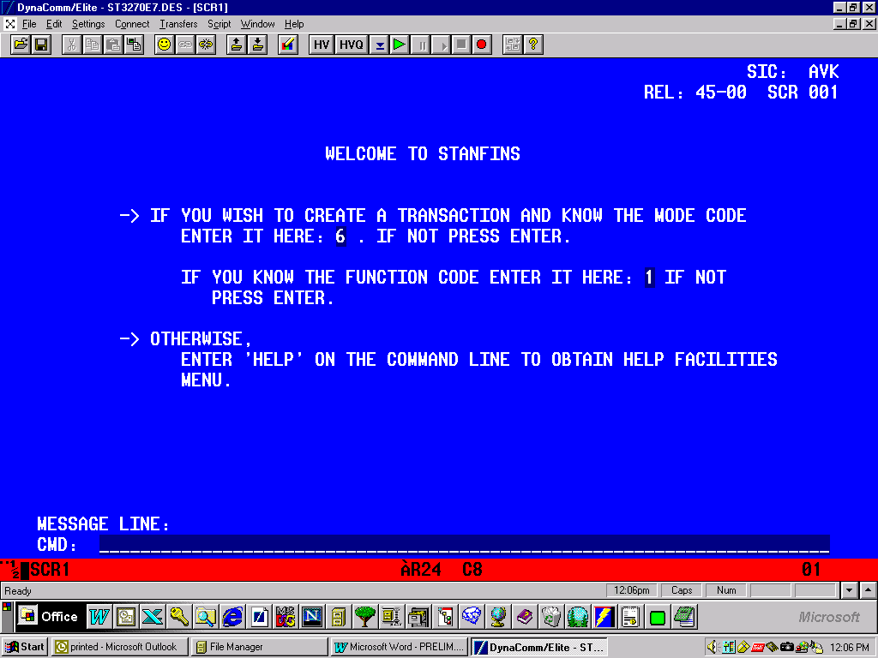

ATTACHMENT IIc

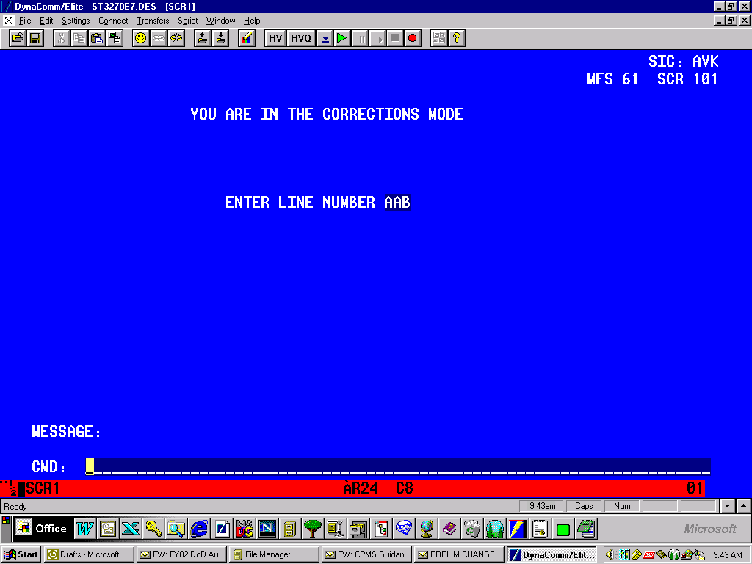
Input Line Number from the Daily Preliminary Balance and Hit ENTER

ATTACHMENT IId

Input "C" for correction code to change the invalid data and input the correct data in the appropriate field.
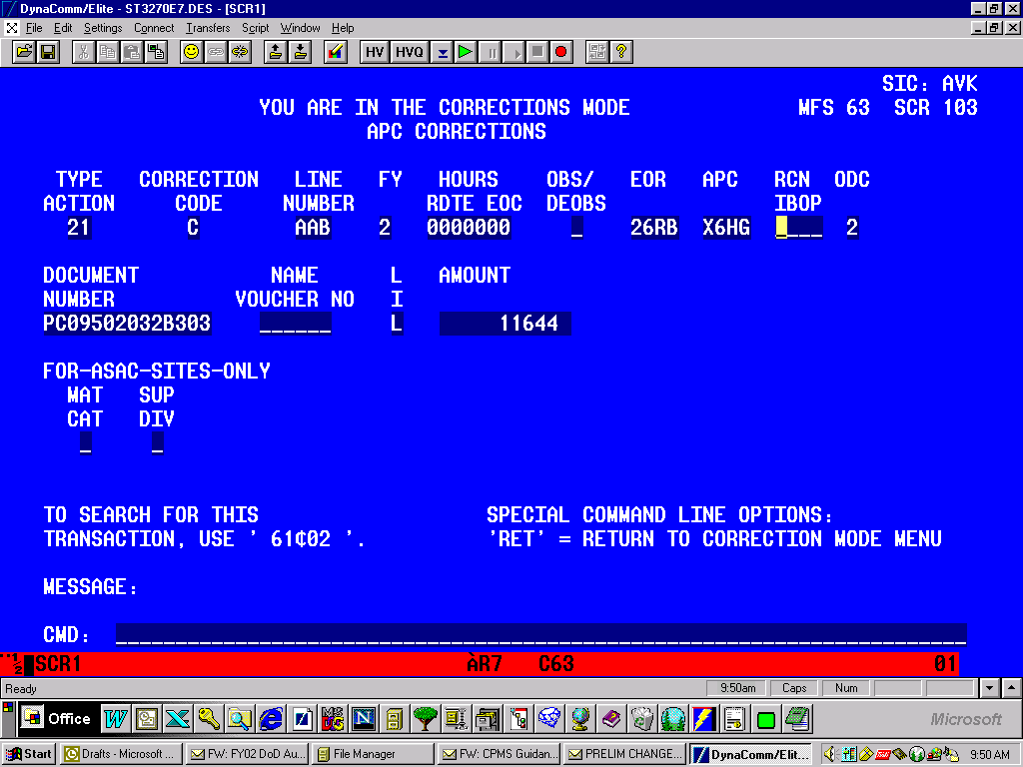

ATTACHMENT IIIa

Input Procedures:

DOUBLE CLICK ON THE ODS ICON

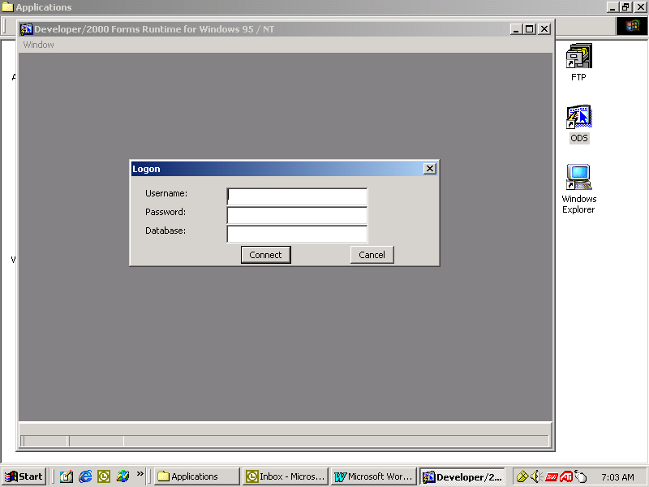

USER NAME: (TYPE IN USERID)MDFE___
TAB
PASSWORD: ______________
TAB
DATABASE: SDODSPRD

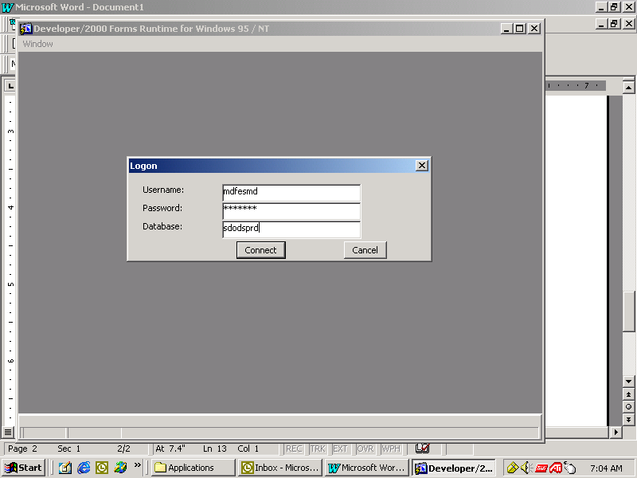

CLICK CONNECT

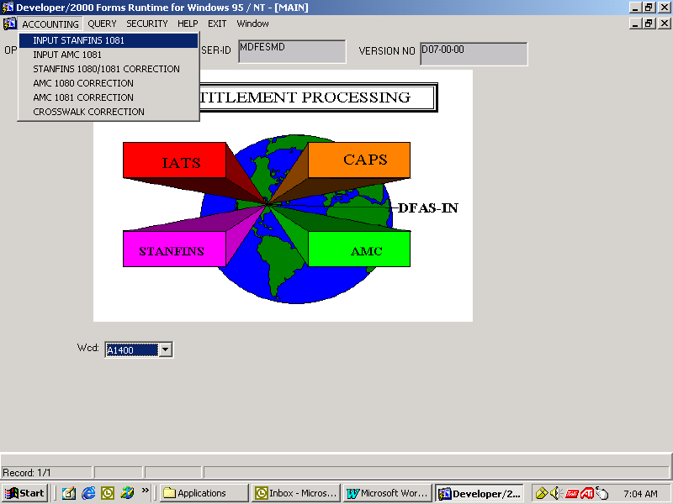

TO MANUALLY INPUT 1081s:

CLICK ON ACCOUNTING

CLICK ON INPUT STANFINS 1081

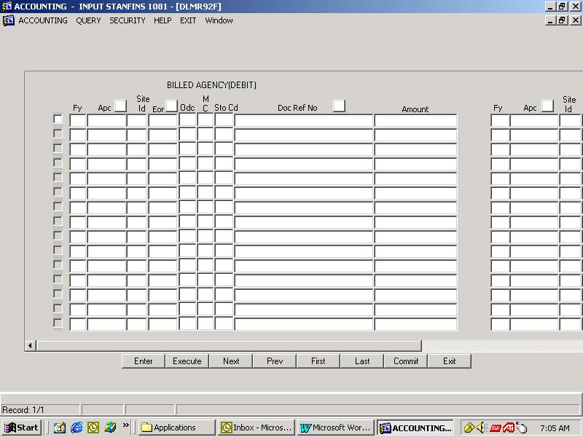

CLICK ENTER BEFORE TYPING

NOTE: THIS IS THE DEBIT SIDE OF THE SCREEN.

AFTER TYPING, MOST COLUMNS WILL AUTOMATICALLY FORWARD UNLESS NOT COMPLETELY FILLED.

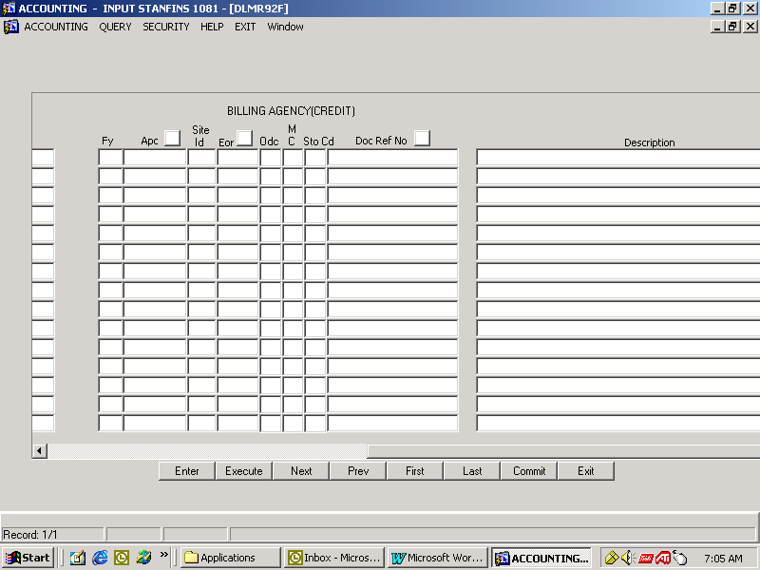

CLICK ENTER BEFORE TYPING

NOTE: THIS IS THE CREDIT SIDE OF THE SCREEN.

AFTER TYPING, MOST COLUMNS WILL AUTOMATICALLY FORWARD UNLESS NOT COMPLETELY FILLED.

QUERY BUTTONS: (SCREENS EXAMPLE FOLLOWS:)

APC
EOR
DOC REF

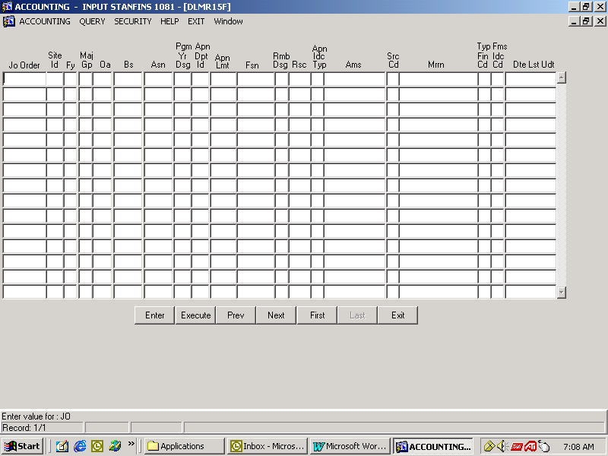

APC QUERY SCREEN:

CLICK ENTER THEN TYPE THE APC YOU WANT TO QUERY ON

CLICK EXECUTE

CLICK EXIT TO CLOSE THE SCREEN

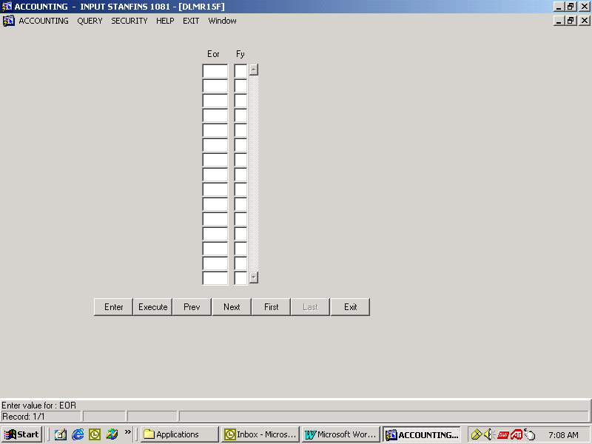

EOR QUERY SCREEN:

CLICK ENTER THEN TYPE THE EOR YOU WANT TO QUERY ON

CLICK EXECUTE

CLICK EXIT TO CLOSE THE SCREEN

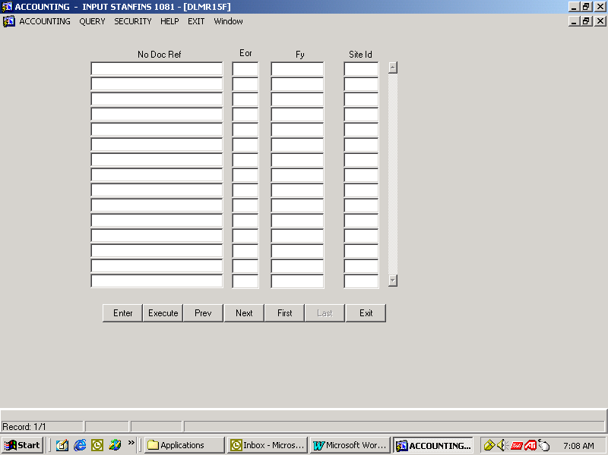

DOC REF # QUERY SCREEN:

CLICK ENTER THEN TYPE THE DOC REF # YOU WANT TO QUERY ON

CLICK EXECUTE

CLICK EXIT TO CLOSE THE SCREEN

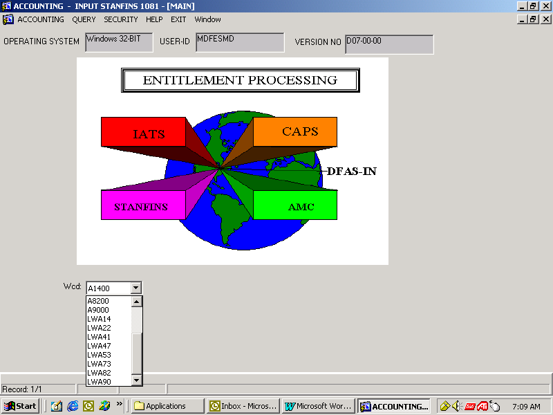

NEED TO MAKE SURE THE WCD IS CORRECT FOR YOUR SITE-ID:

SELECT:

LWA__(SITE-ID)
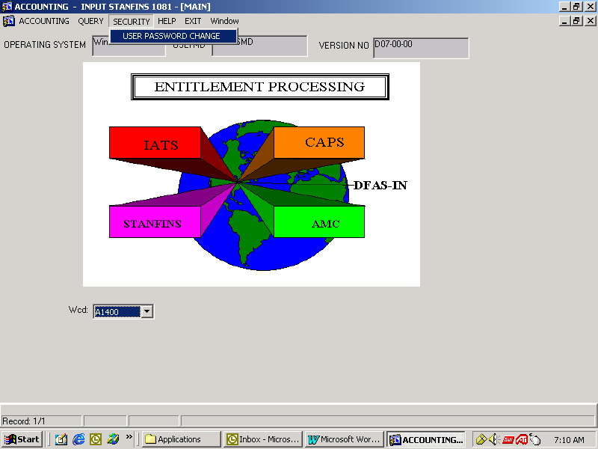

CHANGE YOUR ORACLE PASSWORD:

CLICK ON SECURITY

CLICK ON USER PASSWORD CHANGE
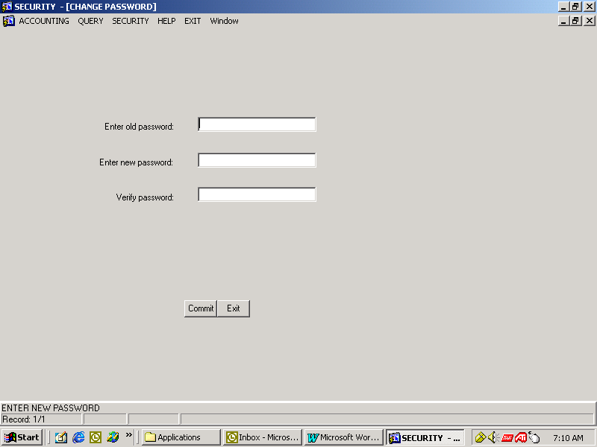

TYPE OLD PASSWORD

TAB

TYPE IN NEW PASSWORD (8 CHARACTERS – ALPHANUMERIC)

TAB
RETYPE NEW PASSWORD

CLICK ON COMMIT

WHEN THE LEFT CORNER SHOWS ACCEPTED (WHERE ENTER NEW PASSWORD IS ON THIS SCREEN)

CLICK ON EXIT
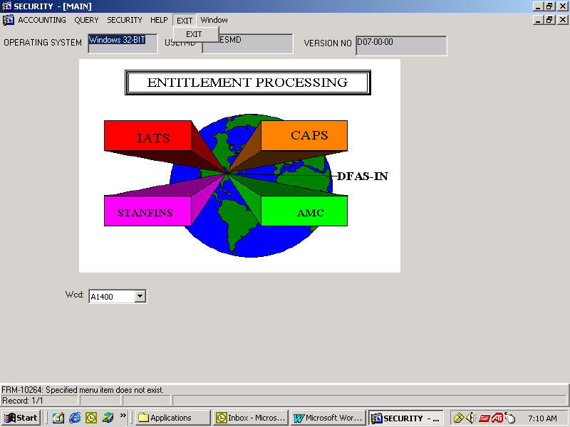

NOTE: AFTER SELECTING CORRECT WCD-CODE, SCREEN DISPLAYS YOUR SELECTION.

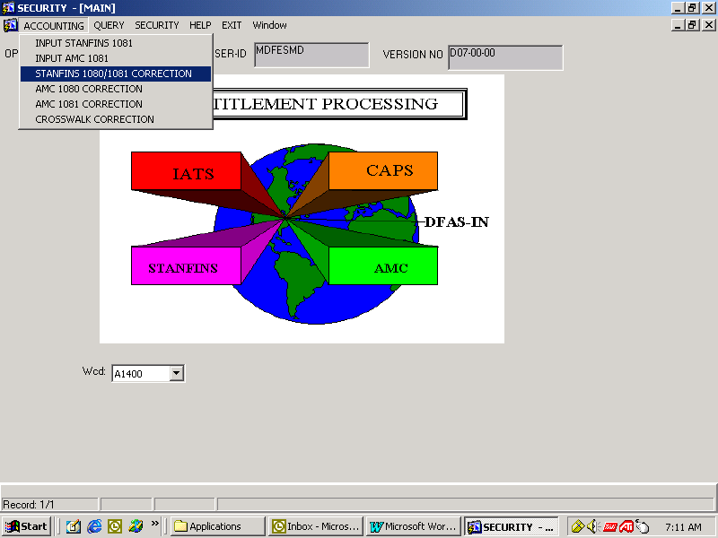

TO MAKE 1080/1081 CORRECTIONS:

CLICK ACCOUNTING

CLICK ON STANFINS 1080/1081 CORRECTIONS
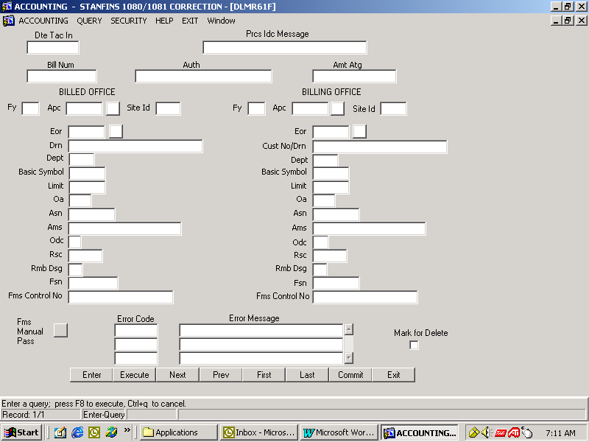
CLICK ENTER TO TYPE

DOUBLE CLICK IN THE ERROR CODE

AFTER CORRECTIONS CLICK COMMIT

CLICK EXIT

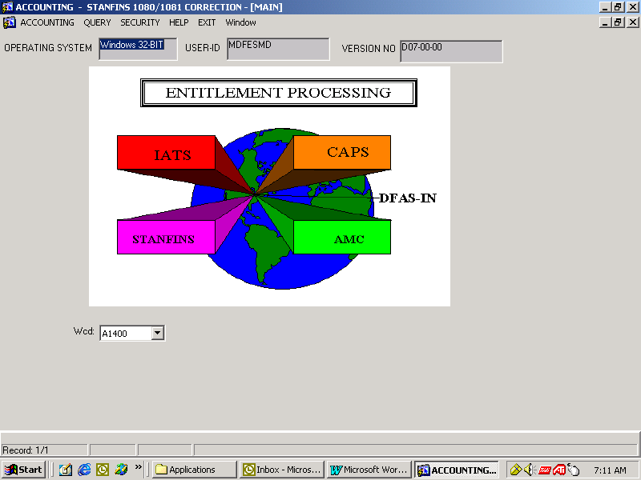

CLICK EXIT TO LOGOFF

ATTACHMENT IIIb

Certification Procedures:

DOUBLE CLICK ON THE ODS ICON

USER NAME: (TYPE IN USERID)MDFE___
TAB
PASSWORD: ______________
TAB
DATABASE: SDODSPRD
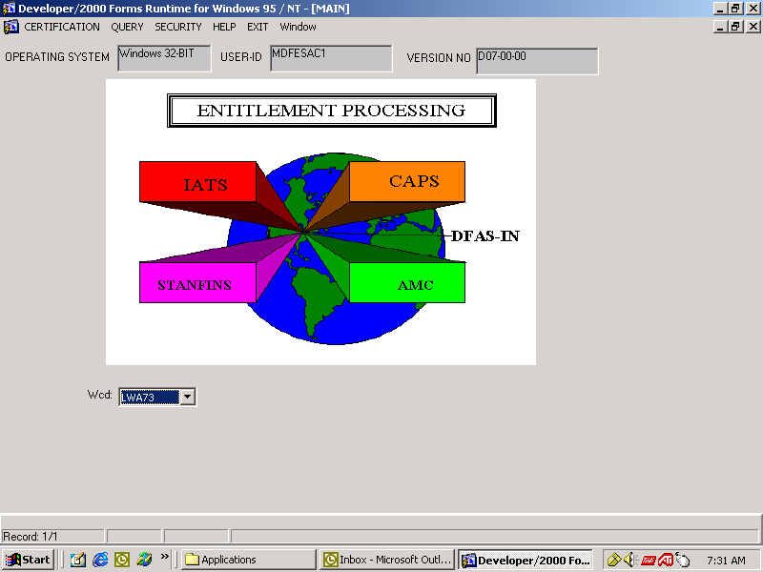

FIRST STEP:

MAKE SURE TO USE THE DOWN ARROW IN THE WCD FIELD TO SELECT THE CORRECT WCD

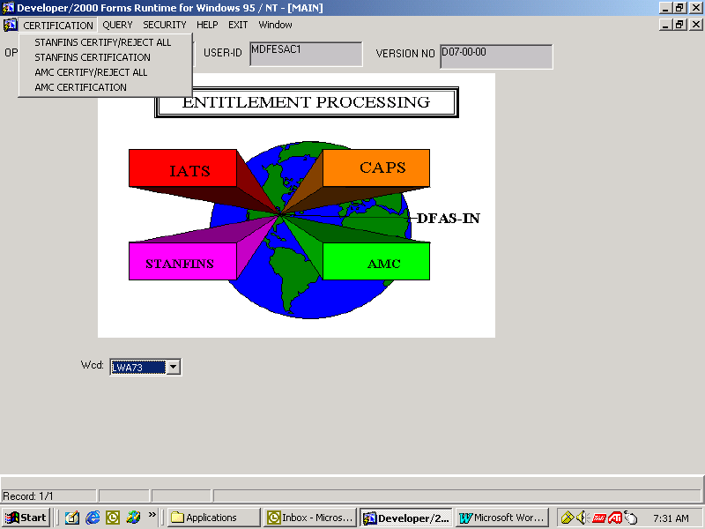

SECOND STEP:

TO CERTIFY 1080/1081: (INDIVIDUAL)

CLICK ON CERTIFICATION

CLICK ON STANFINS CERTIFICATION

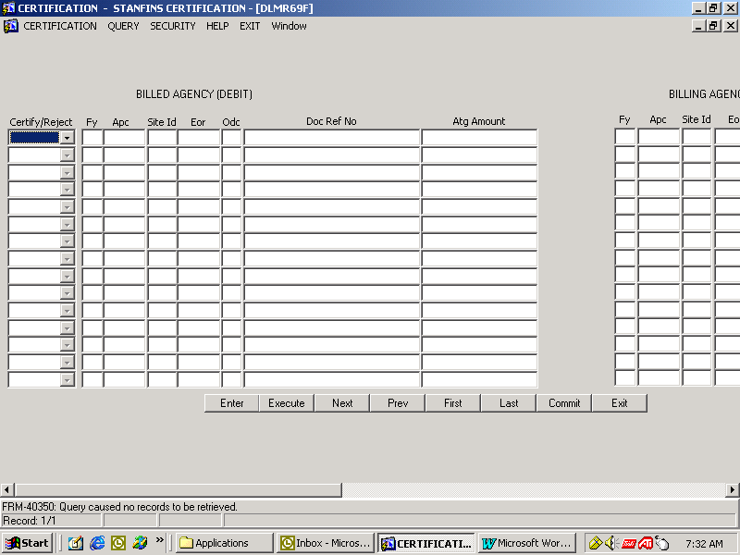
THE BILLED (DEBIT) SCREEN

NEXT TO EACH 1080/1081

SELECT EITHER

REJECT
APPROVE

AFTER YOU HAVE COMPLETED ALL CERTIFICATIONS

CLICK ON COMMIT

CLICK EXIT TO LEAVE THE SCREEN

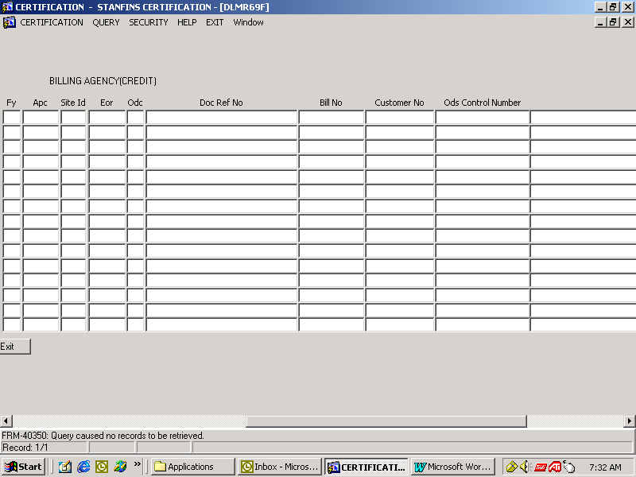

THE BILLING (CREDIT) SCREEN

TO CERTIFY ALL 1080/1081s:

CLICK ON CERTIFICATION

CLICK ON - STANFINS CERTIFY/REJECT ALL

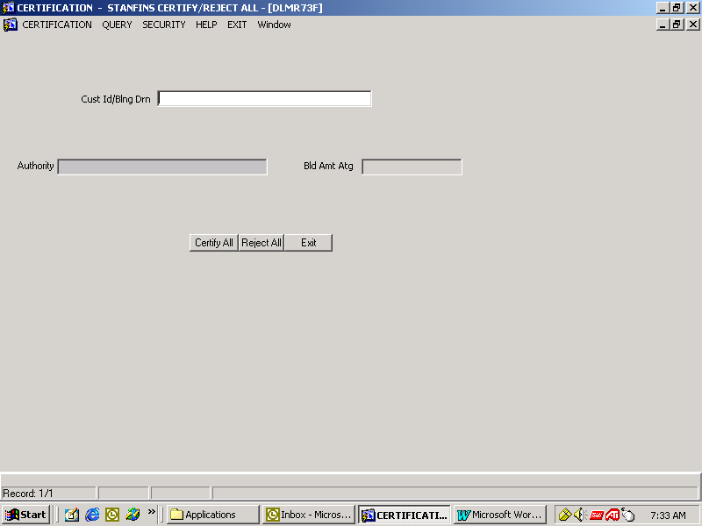

TYPE CUSTOMER ID

CLICK EITHER
CERTIFY ALL
REJECT ALL

CLICK EXIT TO CLOSE THE SCREEN

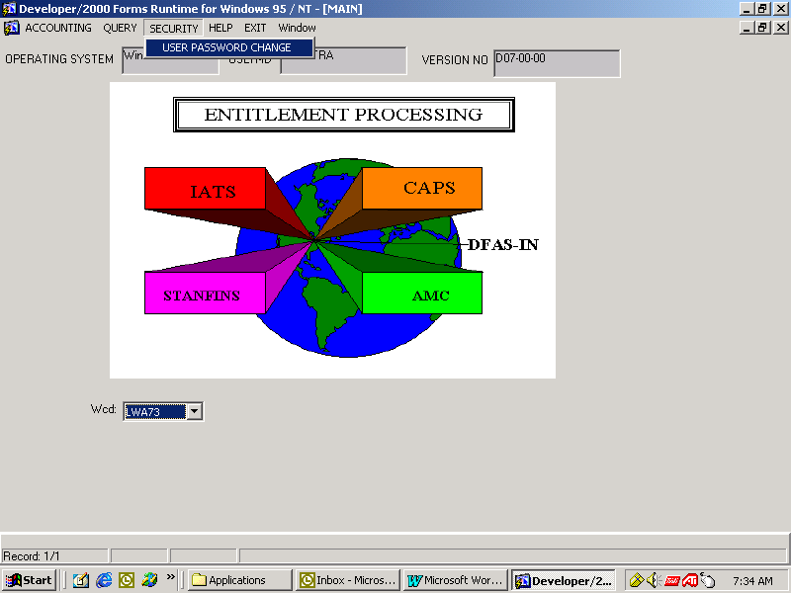

CHANGE YOUR ORACLE PASSWORD:

CLICK ON SECURITY

CLICK ON USER PASSWORD CHANGE

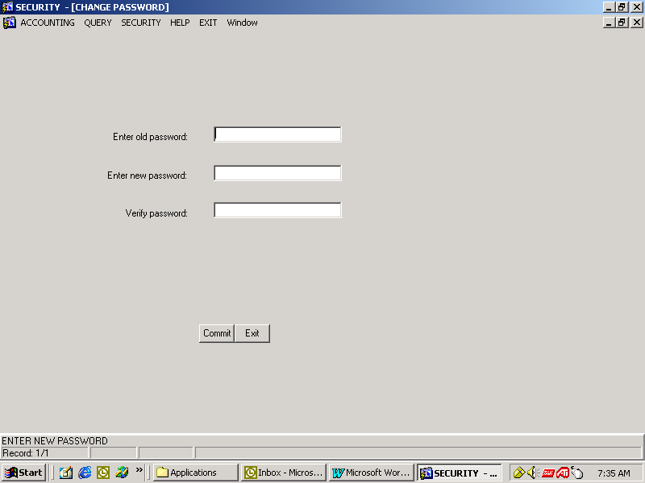

TYPE OLD PASSWORD

TAB

TYPE IN NEW PASSWORD (8 CHARACTERS – ALPHANUMERIC)

TAB
RETYPE NEW PASSWORD

CLICK ON COMMIT

WHEN THE LEFT CORNER SHOWS ACCEPTED (WHERE ENTER NEW PASSWORD IS ON THIS SCREEN)

CLICK ON EXIT

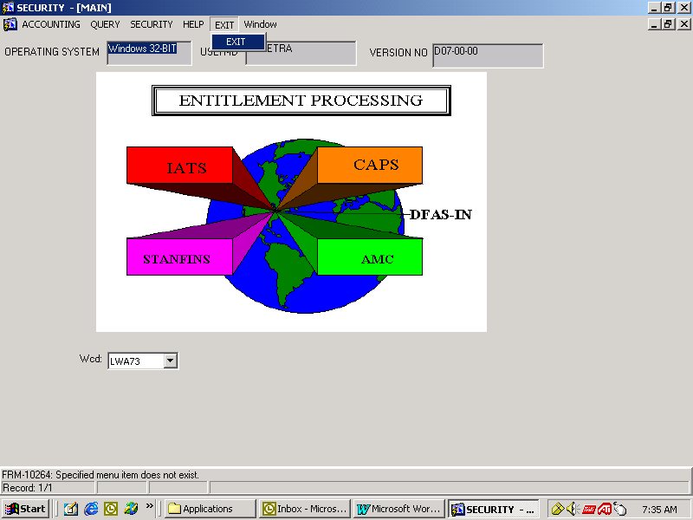

TO LOG OFF

CLICK EXIT

ATTACHMENT IV.

CARE REJECT E-MAIL FORMAT: Use this format to notifying the AOPC/RM of a rejected LOA:

TO: E-Mail address of appropriate AOPC/RM

CC: E-Mail address of applicable DFAS Field Site Representative (If 821 reject (See Reference
Paragraph 9) cc: Accounting Point of contact (POC),
If 810 reject, (See Reference Paragraph 8),
cc: Finance POC)

SUBJECT: REJECTED TRANSACTION(s)

The following _______ (enter 810 for invoice or 821 for obligation) transaction is being rejected for enter reason. (ex: invalid LOA; invalid invoice date; certified invoice amount does not equal obligated amount; obligation LOA(s) not the same as payment LOA(s), etc.) Transaction SDN: Enter Standard Document Number and Invoice Number (as applicable) assigned to LOA.

Transaction Monetary Amount: Enter dollar amount of rejected LOA(s).

Billing Statement Number (if applicable): Enter Billing Statement Number and Invoice date.

Contract Number (if applicable): Enter Contract Number of rejected LOA(s).

Date: Enter date rejected LOA(s) was received.

CH/BO’s Activity Address: Enter CH/BO’s FA2 AI Value (FSN, ADSN, and AAA) contained in LOA(s) being rejected.

System Name: Enter name of system (i.e. STANFINS, CAPS, SOMARDS, and SIFS)

Your Name: Enter DFAS POC name and commercial phone # of Field Site's POC.

