REIMBURSEMENTS USING CONCUR SYSTEM (updated April 2018)
www.concursolutions.com

TOPIC | PAGE NUMBER
NEED ASSISTANCE? | 1
CREATING A PROFILE IN CONCUR | 2 (see also Appendix A)
DOWNLOADING THE CONCUR APP | 2
IMPORTING RECEIPTS | 3
CREATING A NEW EXPENSE REPORT | 4
ATTACHING RECEIPTS | 8
ITEMIZING EXPENSES | 9
ALLOCATING EXPENSES | 10
ENTERING MANY EXPENSES AT ONE TIME | 10
SELECTING MULITPLE EXPENSES | 11
ADDITIONAL TIPS | 12
CONCUR FIRST TIME USER AND SUPPORT DESK  (APPENDIX A)  REQUEST FOR TRAVEL ADVANCES THROUGH CONCUR  (APPENDIX B)  ADD A TRAVEL ADVANCE TO AN EXPENSE REPORT  THROUGH CONCUR  (APPENDIX C)  CONCUR REIMBURSEMENTS FAQ  (APPENDIX D) | 13  16  17  18

NEED ASSISTANCE?
- Tasha Johnson – tashajohnson@apta.org (703/706-3247)
- Concur Help – top right side of the webpage – training videos, contact support, etc.

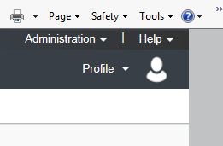

CREATING A PROFILE IN CONCUR. Please complete all of the sections in this area (DO NOT enter personal credit card information—it is not necessary for reimbursement). Make sure that you include your bank account information as all reimbursements will be deposited directly into your checking account. Only you have access to this information (this information is highly secure https://www.concur.com/en-us/data-security).
Emails must be verified in order to link your specific email address to your personal Concur record and receive concur e-mail notifications.
For more information on setting up a profile or if you are a first-time user of the system, see Appendix A: CONCUR FIRST TIME USER AND SUPPORT DESK.

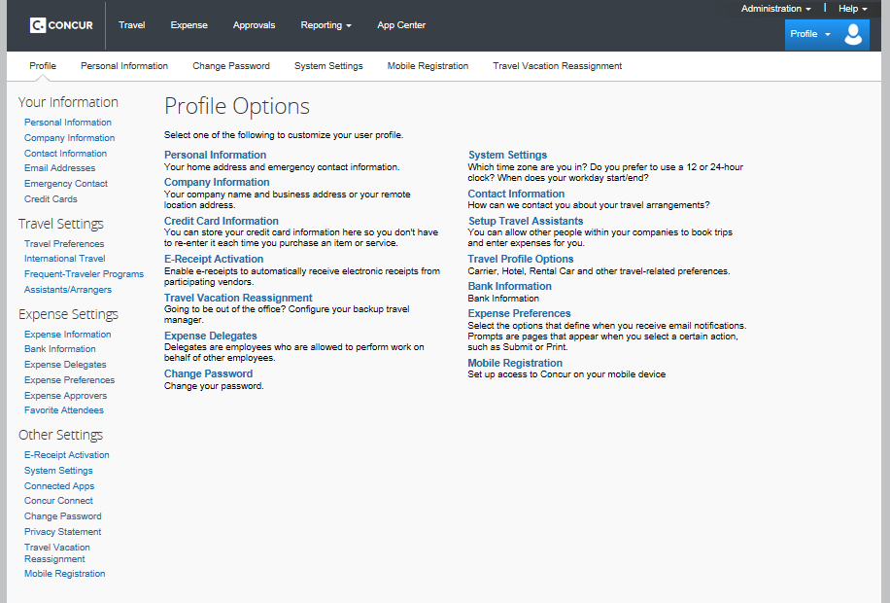

DOWNLOADING THE CONCUR APP. The App allows you to plan trips, track expenses, and take photos of receipts using your smartphone.

IMPORTING RECEIPTS
Once your profile is set you may submit receipts several ways:
- Email: Email receipts to receipts@concur.com (Important – this feature will only work if you have verified your email address via your profile and you MUST send the attachments (pictures/scans) to receipts@concur.com from one of the e-mail address in your profile.)
- App: From the App main page select “Expense”.
- Once on the Expense page select the plus sign “+” and enter the information requested (attach receipt, expense type, amount, vendor, etc).
- Select “Attach Receipt” to take a photo.
- These expenses will automatically populate within your Concur account.
- Computer: Save receipts to a folder in your computer so that you can upload them to your reimbursement form.
CREATING A NEW EXPENSE REPORT
- Select “Expense” and “Create New Report”
- Note, if you imported receipts using receipts@concur.com they will appear on this page (see below “Available Receipts”.

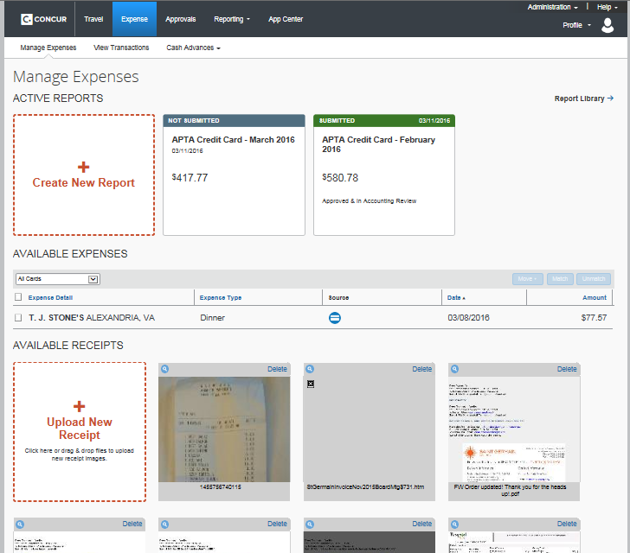

- Once you have selected “Create New Report” you will be taken to the “Create a New Expense Report” page.

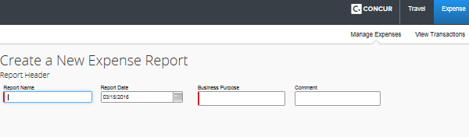

REPORT NAME: Important to use this naming format: Meeting Name Month Year
Examples:
- CAPTE Training Apr 2016
- Site Visit Apr 2016
- Candidacy Visit Dec 2016

REPORT DATE: The date you created report

BUSINESS PURPOSE: For example, University of Denver Travel, Travel to APTA, etc.

COMMENT: Additional comments as necessary.

- After these fields have been completed click the blue “Next” arrow on the lower right portion of the page. You will be taken to your newly created expense report (see below). If you have already uploaded receipts using the Concur App, they will be listed here.
- Adding Expenses:
If no expenses have been imported, click on “+ New Expense” to create a new record.
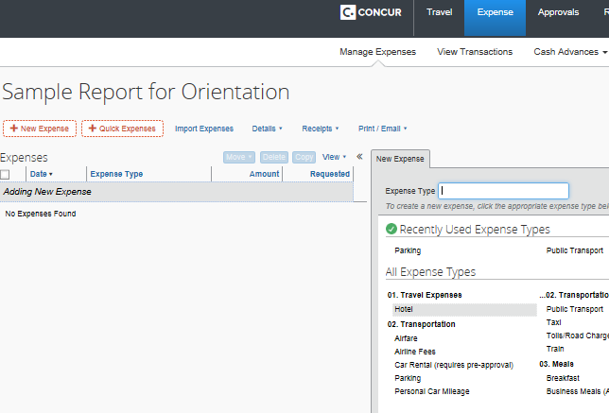
- Select the “Expense Type” from the list below (for example, parking, lunch, airfare, etc).
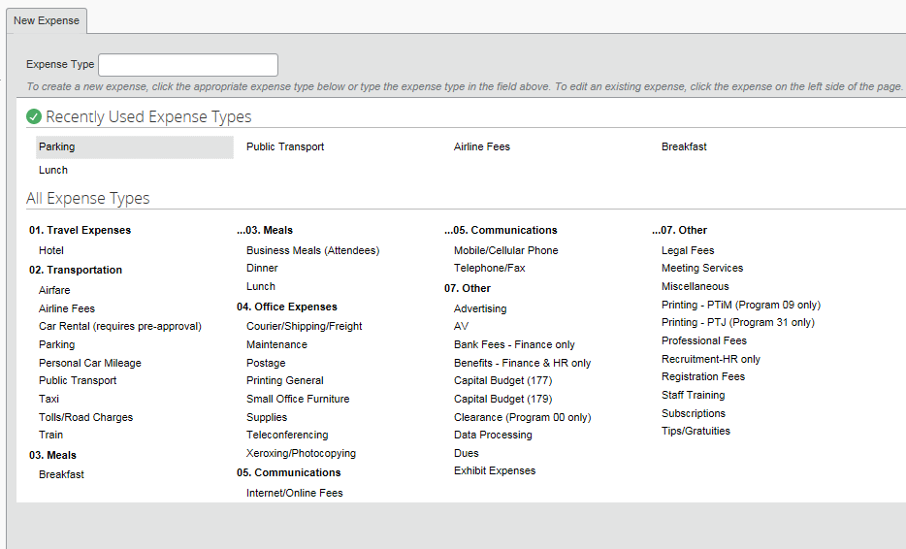

Complete the Transaction Date, Business Purpose (if needed), Vendor Name, Payment Type, Amount, Comment (if needed), Department Name, Activity Name, Sub-activity, and Staff/Member/Non-Member.

TIP: Once you save your initial record, subsequent records will auto-populate certain fields: Transaction Date, Payment Type, Department Name, Activity Name, Goal/Objective Name, and Staff/Member/Non-Member.

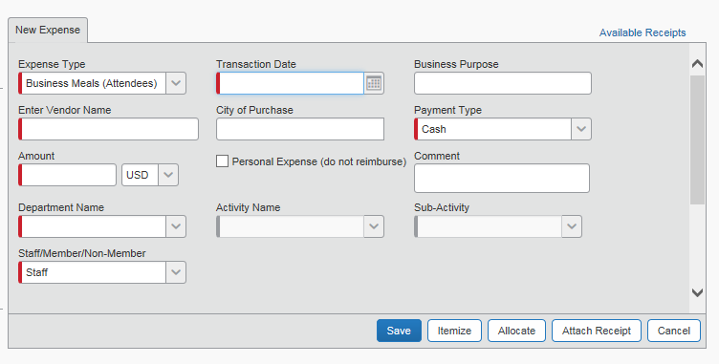

TRANSACTION DATE: The date on the receipt (not the date that you are completing your expense form).

BUSINESS PURPOSE: Name of Meeting and purpose (i.e., CSM Travel, etc.)

ENTER VENDOR NAME: The name of the restaurant or other vendor that provided the service (i.e., McDonalds, USAir, Hilton Anaheim, etc.), and for tips please enter “Bellman”, “House-keeping”, etc. (note: tips for meals should be included in the total and should not be listed as a separate expense).

CITY OF PURCHASE: City in which expense took place

PAYMENT TYPE: Cash (anything you paid out-of-pocket including payments with your personal credit card) or APTA Company Travel Card (if you booked your plane or train via option travel/concur travel)

AMOUNT: Amount of expense

COMMENT: Use as needed to provide an explanation about the expense

DEPARTMENT NAME: For Accreditation travel, the department name will always be: (62) Education
Tip: in the drop down box, under “Type to search by” select “Code” – this will put the codes in numeric order and will make it easier to find (02)

ACTIVITY NAME: For Accreditation travel, the activity will always be (04) Accreditation

SUB-ACTIVITY: The options for Sub-activity will vary depending upon the type of travel. The options are as follow:
(000) | Not Applicable | To be used only by staff
(001) | General Activities | To be used only by staff
(002) | Candidacy | Use for expenses related to candidacy visits
(003) | On-Site Visits | Use for on-site visits travel and expenses
(004) | CAPTE | Use for CAPTE visits and expenses
(005) | Workshops | Use for Workshops travel and expenses
(006) | On-Site Reviewer Training | Use for on-site reviewer training, here at APTA headquarters

STAFF/MEMBER/NON-MEMBER: Please select your designation according to APTA membership status (“Member” or “Non-Member”)

ATTACHING RECEIPTS:
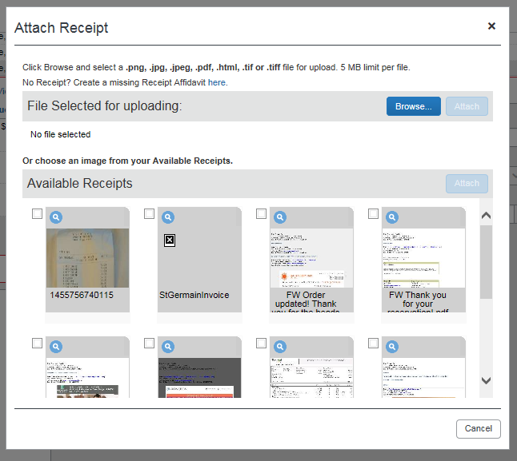

At the bottom of the page you will see a button that reads “Attach Receipt”. Once “Attach Receipt” is selected the page above will appear. A receipt must accompany each expense.
- If you have used the Concur App the receipt that you imported will already be listed in the itemized record.
- If you submitted your receipt via receipts@concur.com you will find your receipt listed under “Available Receipts”
- If you have uploaded your receipt to your computer, click on “Browse” and select your receipt
- If you do not have a receipt or have lost a receipt, select the “Receipts” drop down at the top of the page (see below) and select “Missing Receipt Affidavit”

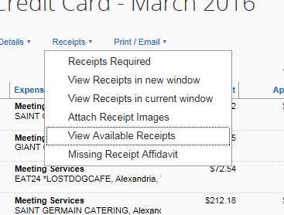
IMPORTANT: It is important for the auditors that receipts are legible and that all information is captured. When submitting receipts make sure that:
1) the date of the receipt is listed
2) the complete amount of the receipt is submitted – if a hotel invoice make sure to submit all pages so that the total is shown
3) the receipt is legible – if it is out of focus and cannot be read easily please take another picture

If any of the above is missing or not legible, the report will be returned to the sender. Only one receipt can be attached to an expense. If you need to attach two receipts (one listing the items your ordered, and one with the tip), place them side by side before taking a picture/scan.

ITEMIZING EXPENSES:
If you paid for a meal where several funded members attended you must itemize that expense. Under “Expense Type” select “Business Meals (Attendees)”. To select individuals that attended the meal, start with “Advanced Search”. Many funded members are already populated in the system and you may find that you can search for them using this function. If you cannot find them, select “New Attendee” and enter the necessary information.
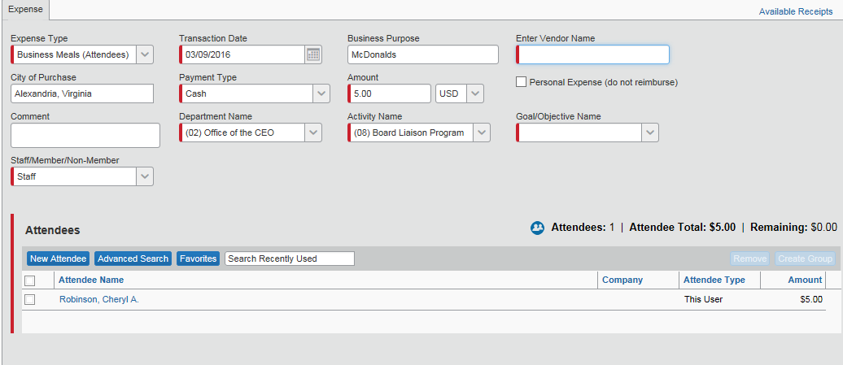

ALLOCATING EXPENSES:
This function allows you to split costs between different programs. For example, if a Board member pays for a meal that was attended by members funded under various programs, you will want to allocate a certain portion to the appropriate Department and Activity numbers. The system will automatically divide the expense evenly among the department and activities or you may edit the percentage as appropriate. You can also allocate by dollar amount instead of percentage.

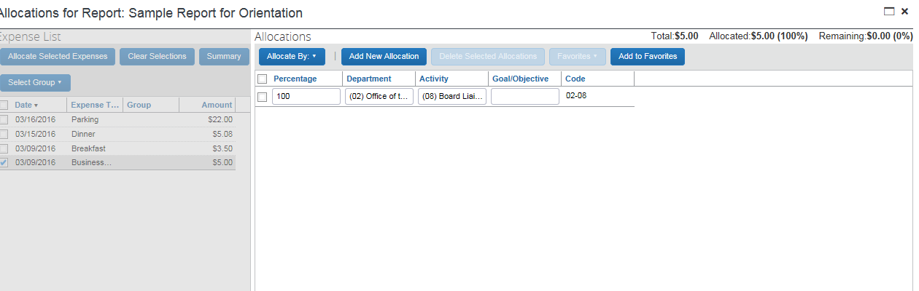

ENTERING MANY EXPENSES AT ONE TIME
Expenses may be added one at a time or by using the “Quick Expenses” function. This function allows you to enter several expenses in one table rather than walking through each expense separately. The Quick Expense function does not allow you to insert the Department, Activity, Goal/Objective for each expense, but after inserting the information requested in the table below, you can add this information by selecting multiple expenses (see next section).

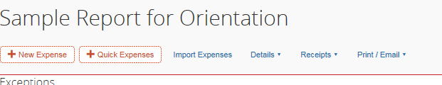

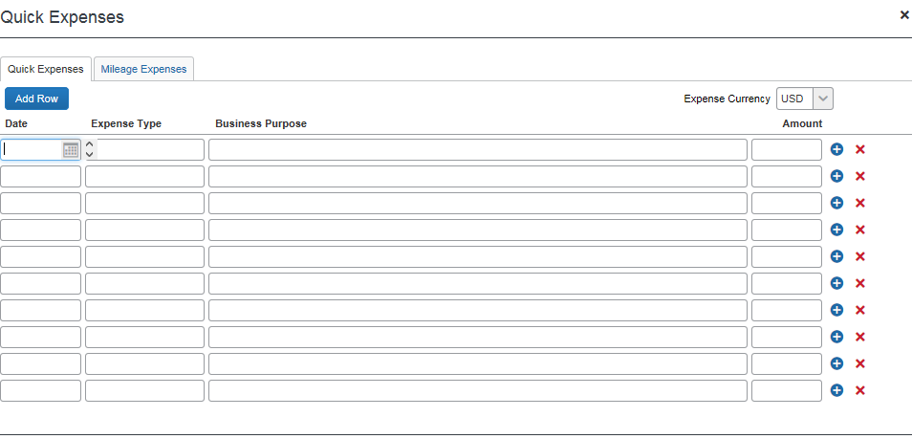
SELECTING MULTIPLE EXPENSES
If you have used the “Quick Expenses” function and want to add the Department, Activity, Goal/Objective to several records at a time, or you realize that changes to several records are necessary, a fast way to fix is to click on the box found directly under “Expenses” (see arrow below). Once the prompt to the right appears you will find that you can Delete the selected expenses; Allocate the selected expenses; or Edit one or more fields for the selected expenses.

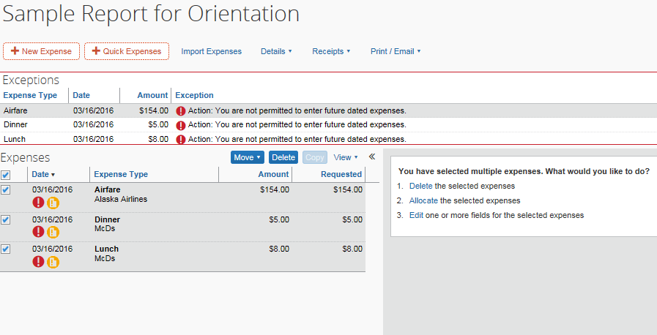

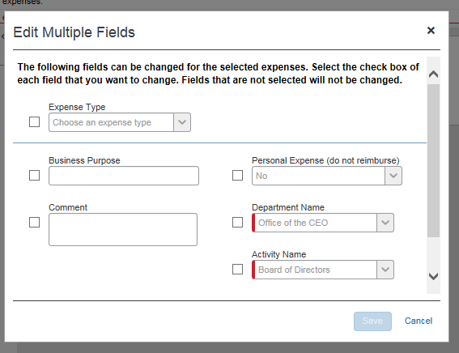

IMPORTANT: REMEMBER TO SAVE EACH RECORD! The system will prompt you to save so this shouldn’t be a problem. But it’s a good habit to get into – save the record before moving on to the next one.

SUBMITTING REPORT
When your form is complete, select the “Submit Report” button on the upper right side of the screen. Your report will be forwarded to the staff member assigned to review the information for that department and activity.

ADDITIONAL TIPS:
- To review/search reports that you have already submitted, select “Expense” and select “Report Library”
- A report that has been submitted can’t be modified. If you need to modify a report that you just submitted (which has not been paid yet) you need to recall the report (click on “Expense”, then “Report Library” find the report you submitted, open it and click on the “Recall” button). If you need to add an expense to a report that has already been paid, you will need to create a new report and call it “Addendum to report xxx”
- If you’re not using a mobile app, to save time, you can scan an entire set of receipts on the scanner bed in the office and use the snipping tool on your PC to create/save individual receipts
- Enter all the requested field for the first expense and most fields will auto-populate for the following expenses. You can also choose previously used expense types
- The copy tool is a quick way to add expenses that are similar (i.e. mileage, parking), but don’t forget to change the date
- There can’t be 2 receipts for 1 expense, so place both receipts (the receipt showing the orders and the receipt showing the tip) side by side and take a picture or scan
- Type “house-keeping” or “bellman” in the vendor’s name field for the Tip expense type
- If you share a meal with someone who is not funded by APTA, enter a note in the comment box that you’re asking for a partial reimbursement from the amount showing on the meal receipt that is attached.

APPENDIX A

CONCUR FIRST TIME USER AND SUPPORT DESK:

To log into Concur: https://www.concursolutions.com/
Login Name: apta e-mail address (example: tashajohnson@apta.org)
Password (case sensitive): to be provided by Tasha Johnson

Please complete the following steps:
- Log in and change your password (if you are not prompted to do this when you first log in, then go to Profile – Profile Setting – Other Settings – Change Password).
- Click on Help in the upper right hand corner then click on Training. You will find great training material here. You can find additional great resources under the Help menu.
- Click on Profile (also in the upper right hand corner) then Profile Settings. Please complete all of the sections in this area (DO NOT enter personal credit card information—it is not necessary for reimbursement). Note: out-of-pocket expenses are reimbursed directly to your bank account so you must enter your bank information. Only you have access to this information (this information is highly secured https://www.concur.com/en-us/data-security). You cannot be reimbursed if the bank information is left blank or is incorrect. Once the correct banking information is entered, it will be verified (penny test, 3-5 days). When that is complete you will be able to submit an expense report and be reimbursed directly into your account.
- Be sure to complete “Verify Email” (see below for more information) and “E-Receipt Activation” so that you can upload or email copies of receipts to Concur.
- Download and set up the concur app on all of your mobile devices.

In order to make sure you receive Concur notification e-mails:
1. In concur, click on “verify” your e-mail address. If the address is incorrect, contact us, then click on the pencil icon to correct the address, and finally click on “verify”. Until you click on “verify” you won’t receive the concur notification e-mails, and any receipts you sent to receipts@concur.com will not be available for you to insert into an expense report.
2. In outlook add autonotification@concursolutions.com to your safe senders list:
- Under the Home tab of Outlook, click on the Junk drop down menu and select “Junk Email Options”
- In the box that comes up, click on the “Safe Senders” tab and add AutoNotification@concursolutions.com. Click Add.
- That’s it.
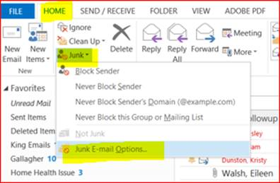
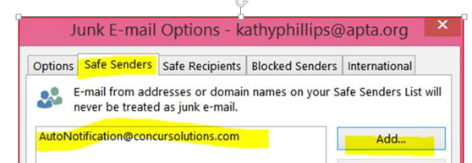

Verify e-mail
Please go to the section in your concur profile “Email Addresses” and click on “Verify”
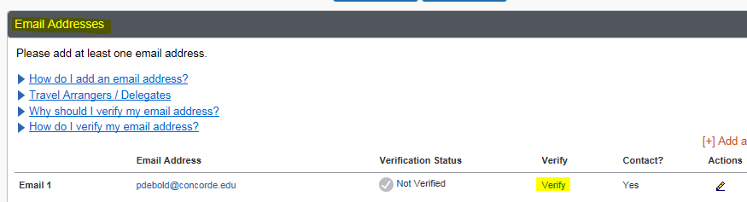
You will then see the following message:
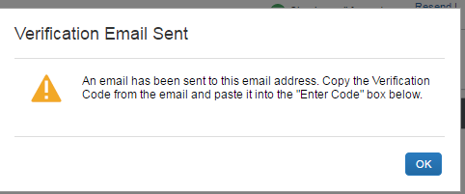
Please check your e-mail and copy and paste the code that you received.
You will then see the following message.
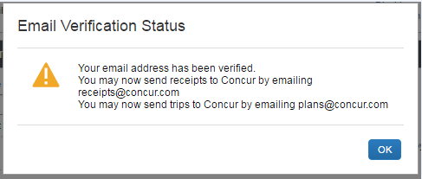

CONCUR USER SUPPORT DESK:

You can contact Concur directly for navigational assistance, application questions or incidents that are Concur specific.

Just Click Contact Support! The Contact Support option is located in the Help menu on the upper right hand corner of the Concur Home page. You can also locate the Contact Support link in the black banner along the bottom of the Concur Home page.

Your first step in using Concur is to login to the product and complete two security questions. Simply click Contact Support as described above to access the end user support portal. You will be immediately brought to the User Information Confirmation screen, where you will need to enter a work phone number and select and answer two security questions. Once saved, you may then contact Concur User Support via phone, chat or by submitting a case.

Phone Support: Available in English 24/7/365. US, Canada and Puerto Rico - 1-866-793-4040. International numbers, chat, and case submission options are found from the Contact Support option.

Please note: Upon subsequent visits to the support portal, the User Information Confirmation screen can be accessed by clicking the “My Profile” link in the upper right hand corner of the page.

APPENDIX B

Request for Travel Advances through Concur

- Sign in to Concur
- Under the expense tab click on Cash Advances
- In the drop down menu, click on New Advance
- On the Active Cash Advances page click the blue button for New Cash Advance
- In the pop up menu for New Cash Advance fill in the appropriate information – Name, Cash Advance Amount, Purpose and Cash Advance Comment (any pertinent information you think may apply to approval)
- Click the red Submit button at the bottom
- Read the Final Confirmation/User Electronic Agreement box. Click accept to submit for processing.
- The advance has been submitted and will be sent to your Concur expense approver. She/he will receive an email announcing that you have an advance pending approval and will forward your request to Finance for processing.
- The progress of the approval trail of an advance request can be monitored under the Cash Advance tab, View Cash Advances, Status.

APPENDIX C

Add a Travel Advance to an expense report through Concur

- Sign in to Concur
- Create an expense report as usual
- On the expense report page, click Details > Available (under Cash Advances). The Cash Advances window appears.
- Select the check box for one or more cash advances that you want to associate with the current report.
- Click Assign Cash Advance to Report.
The cash advance amount offsets the amount that is to be reimbursed to you; the report totals are adjusted accordingly. To view the report totals, select Details > Totals (under Report). The Report Totals page appears.

Dealing with the remaining cash advance balance

You must fully account for the entire cash advance amount in one expense report. For example, assume that you have a cash advance of $500 associated with an expense report that includes $300 in cash expenses, you are required to complete a cash advance return for the remaining $200. NOTE: You will be prompted to complete a cash advance return when you submit the report. To process the cash advance return in an expense report:

- After adding the cash advance to the report, create a new expense using the expense type named Cash Advance Return.
- Complete all required fields.
- Click Save.
- Physically return the remaining currency to the appropriate person (mail a check to your Concur expense approver).
- The returned amount will be recorded by Finance

APPENDIX D

CONCUR REIMBURSEMENTS FAQ

I HAVE SUBMITTED MY REPORT. WHEN SHOULD I EXPECT A REIMBURSEMENT?
- All reports submitted and approved by the Finance department on Friday will trigger a direct deposit by Wednesday of the following week. When Finance approves the report, the Concur report will be labeled “Paid Report” but the funds will not be transferred until Wednesday.

I NEED HELP! WHO CAN I CONTACT? (Page 1)
- Tasha Johnson – tashajohnson@apta.org (703/706-3247)
- Concur Help – top right side of the webpage – training videos, contact support, etc.

HOW DO I UPLOAD RECEIPTS? (Page 2)
- Email: Email receipts to receipts@concur.com (Important – this feature will only work if you have verified your email address via your profile.)
- App: From the App main page select “Expense”.
- Once on the Expense page select the plus sign “+” and enter the information requested (attach receipt, expense type, amount, vendor, etc).
- Select “Attach Receipt” to take a photo.
- These expenses will automatically populate within your Concur account.
- Computer: Save receipts to a folder in your computer so that you can upload them to your reimbursement form.

I AM MISSING A RECEIPT! WHAT DO I DO?? (Page 8)
- For nominal items (gratuities and expenses up to $10) you may make a note on a piece of paper or sticky note, take photo, and upload that as your receipt. Include the date, amount, and other pertinent information.
- For anything over $10 (taxis, etc) and for per diem meals, use the missing receipt affidavit option within Concur and include a comment explaining the expense. (Select the “Receipts” drop down and click on “Missing Receipt Affidavit.”) Note: the Concur app doesn’t have the missing receipt affidavit feature (you must login from a PC).

HOW DO I CREATE A NEW EXPENSE REIMBURSEMENT REPORT? (Page 3)
- Log on to the system
- From the main page select “Expense”
- Then select “Create New Report”

I HAVE MANY EXPENSES TO DOCUMENT – IS THERE A WAY TO AUTO-POPULATE THE FIELDS SO THAT I DON’T HAVE TO RE-ENTER EVERYTHING FOR EACH EXPENSE?
- After entering all of the requested fields for the first expense most fields will auto-populate for subsequent expenses within that report.
- You can also select multiple expenses within the report and edit one or more fields for the selected expenses (see page 11; Selecting Multiple Expenses)

I PAID FOR A MEAL THAT WAS ATTENDED BY MULTIPLE FUNDED MEMBERS. HOW DO I RECORD THAT? (Page 9)
- If you paid for a meal where several funded members attended you must itemize that expense. Under “Expense Type” select “Business Meals (Attendees)”. To select individuals that attended the meal, start with “Advanced Search”. Many funded members are already populated in the system and you may find that you can search for them using this function. If you cannot find them, select “New Attendee” and enter the necessary information.

I PAID FOR A MEAL THAT WAS ATTENDED BY MULTIPLE MEMBERS FUNDED UNDER DIFFERENT PROGRAMS. HOW DO I RECORD THAT? (Page 10)
- You will need to allocate a certain portion of the meal to the appropriate Department and Activity numbers. The system will automatically divide the expense evenly among the department and activities or you may edit the percentage as appropriate.

APTA FUNDED MY AIRFARE/TRAIN TRAVEL. DO I NEED TO INCLUDE THAT IN MY EXPENSE REIMBURSMENT?
- Yes. You would enter that like any other expense; however, instead of selecting “Cash” as the payment type, you would select “APTA Company Travel Card.”

APTA FUNDED MY AIRFARE/TRAIN TRAVEL. THE RECEIPT IS IN TRIPIT BUT NOT IN CONCUR EXPENSE. CAN YOU HELP?
- If the Amtrak Option Travel receipt is not in the “available receipts” list in your concur account, please forward the e-mail you received at the time you booked your train to “receipts@concur.com. If you did not pay for this ticket, please enter like any other expense; however, instead of selecting “Cash” as the payment type, you would select “APTA Company Travel Card.”

APTA FUNDED MY HOTEL. DO I NEED TO INCLUDE THAT IN MY EXPENSE REIMBURSMENT?
- No. You do not need to enter that expense in your report. Hotel is not booked through Option Travel/Concur Travel, so an APTA-paid hotel will not appear in concur.

I HAVE SUBMITTED MY REPORT AND I HAVE NOT BEEN REIMBURSED, WHAT IS THE STATUS OF MY REPORT? (Page 13)
- If you have not received any e-mail notifications from concur which would give the status of your report, please log in your profile and verify your e-mail address (concur will e-mail you a verification code).
- If you have already verified your e-mail address and are still not receiving the e-mail notifications, please make sure to add “autonotification@concursolutions.com to your safe senders list.
- Log in to concur and if your report has been returned to you, please adjust the report and press “submit” again.

I FORGOT TO ADD THE MISSING RECEIPT AFFIDAVIT BEFORE SUBMITTING MY REPORT, AND I RECEIVED RED FLAGS ON MY REPORT. NOW THAT I HAVE ATTACHED ALL MY RECEIPTS, HOW DO I REMOVE THE RED FLAGS?
- The red flags will be removed when you press the submit button again.

I ALREADY SELECTED THE PROGRAM NUMBER AND ACTIVITY BUT WHEN I SELECTED THE SUB-ACTIVITY, THE PROGRAM NUMBER AND ACTIVITY CHANGED AND ARE NOT WHAT I SELECTED ORIGINALLY. WHY?
- Please select the sub-activity at the bottom of the list (highlighted in yellow below). Do not click any lines that are showing in bold (circled in red below). The bold lines are sets of program/activity/sub-activity that you used in a previous expense report and are available for convenience. However if you click any of these bold lines, it will revert to a particular coding.
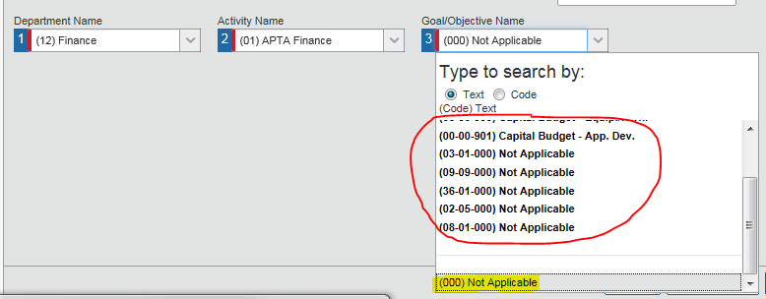

WHAT ACTIVITIES DO I USE FOR MY ACCREDITATION EXPENSES? (Page 6)
DEPARTMENT NAME: For Accreditation travel, the department name will always be: (62) Education
Tip: in the drop down box, under “Type to search by” select “Code” – this will put the codes in numeric order and will make it easier to find (62)
ACTIVITY NAME: For Accreditation travel, the activity will always be (04) Accreditation
SUB-ACTIVITY: The options for Sub-activity will vary depending upon the type of travel. The options are as follow:
(000) | Not Applicable | To be used only by staff
(001) | General Activities | To be used only by staff
(002) | Candidacy | Use for expenses related to candidacy visits
(003) | On-Site Visits | Use for on-site visits travel and expenses
(004) | CAPTE | Use for CAPTE visits and expenses
(005) | Workshops | Use for Workshops expenses
(006) | On-Site Reviewer Training | Use for on-site reviewer training, here at APTA headquarters

