Notes for Teachers

This is a fairly long chapter that covers the basic anatomy and physiology of the skeletal and muscular systems related to participation in sport and exercise. Once students have this background knowledge, the chapter then delves into the impact that different types of physical activity can have on these body systems in relation to lifelong participation in physical activity.

Chapter Overview
The chapter covers the following sections of the specification.
Introduction to the skeleton
It is assumed that students will already have some level of knowledge, so this section of the chapter is designed as a reminder of the functions of the skeleton, the axial and appendicular skeleton and types of bone and cartilage. This knowledge will not be directly examined. However, some time is also spent in the student book describing a ligament, a tendon and the structure of a long bone. This is also designed to provide the student with background knowledge to enable them to understand the disorders of the skeletal and muscular systems that can result from different types of physical activity, which are discussed later in the chapter.
You should note that many of the names of the bones of the skeleton will be new to the students, so the more they can practise using this terminology, the quicker they will become familiar with it. The student book therefore emphasises the names of bones and links them with the joints that they make up, and this is how the students’ knowledge will be examined in an exam question on joint movement.
Joints and movements
This section of the chapter introduces the student to the classification of joints, and types and structure of synovial joints. It is designed to encourage the student to start to think about the shape and structure of each type of joint and how this links with stability and mobility. A discussion or investigation into sports injuries follows on quite well from this and there are some good video clips of stomach-churning injuries on websites such as “YouTube” (www.youtube.com).
The student is then introduced to the important section on movements of synovial joints, where there is a significant amount of new anatomical terminology for them to digest. Once they have an appreciation for the movements possible at each of the joints identified in the specification they need to be given the time to practise using this knowledge in relation to various sporting movements. Once the student is confident and competent at identifying a joint movement, it is then relatively straightforward to apply the other knowledge required in a question on movement analysis: the muscles in action and the type of contraction taking place.
The muscular system
The muscles that the students need to know are listed in the specification and covered in detail in the student book. This means that students are introduced to an agonist (and antagonist) muscle for each joint movement covered earlier in the chapter. In addition, new to this specification is a requirement that the students have an understanding of two additional groups of muscles. Firstly, the role of the rotator cuff muscles at the shoulder joint, which can lead on to a two-pronged discussion: their function in relation to joint stability and the types of physical activity that might cause tears and strains in this group of muscles. Secondly, the role of the transverse abdominis and multifidus muscles in relation to core stability, which opens up a number of extension activities linked with the importance of core stability in relation to posture, the prevention of injury and optimising physical performance.
The role of muscular contraction
This section can sometimes cause the student problems, so the opportunity for them to feel certain muscles working with concentric, eccentric and isometric contraction is useful. A session in the fitness suite often fits in well here.
Movement analysis of physical activity
This section is a synopsis of everything covered so far, an example of which is given on pages 29–32 in the student book. The more the student can practice drawing together this knowledge, the more adept they will become and the easier they will find it to score maximum marks on these topic areas in an examination question.
Muscle fibre types in relation to choice of physical activity
The structural and functional characteristics of the three types of muscle fibre are relatively straightforward, although the student may not be familiar with mitoch ondria or myoglobin or the impact of the energy stores phosphocreatinine (PC), glycogen and triglycerides, so a basic explanation by way of an introduction may be required.
The section on how an individual’s mix of muscle fibres might impact on the choice of activity selected is new to this specification but is, again, relatively straightforward. However, it can open up some interesting extension activities such as discussions on cloning and talent identification programmes.

Warm-up and cool-down
This section should cause few problems, but to aid understanding muscles can be compared to an elastic band that becomes more “stretchy” when warm, or to spaghetti that becomes less prone to damage when cooked! This can also lead to some interesting discussions about the latest warm-up and cool-down techniques used by elite athletes and the physiological reasons behind them.
The impact of different types of physical activity on the skeletal and muscular systems
This section is new to the specification and encourages the student to think about the positive and negative impacts of different types of physical activity on the skeletal and muscular systems. It is hoped that the background knowledge they have gained from this chapter will enable them to critically examine the ways in which these body systems can be kept healthy to promote lifelong involvement in physical activity. However, the student is also encouraged to think about the risks to these body systems in relation to the types of activity that they undertake. The conditions that might be directly examined are listed in the specification but there is nothing to stop the student investigating this area in greater depth, particularly in relation to current thinking of models of long-term athletic development (LTAD). There are many useful websites that cover this area.
The learning outcomes for Chapter 1 are for the student to be able to:
• describe an overview of the skeletal system to include its functions, the axial and appendicular skeletons as well as types of bone and cartilage
• understand, describe and give examples of the different types of joint found in the body
• use a variety of anatomical terms to describe a moving body during physical activity
• analyse a range of sporting techniques in terms of joint movements

• identify the major muscles associated with the main joints of the human body and explain their role as an agonist or an antagonist with reference to specific movements in physical activity
• carry out a full movement analysis of specific movements in physical activity
• understand the difference between concentric, eccentric and isometric muscular contraction
• distinguish between the three types of skeletal muscle fibre in the body and apply their characteristics to suggest reasons why certain individuals choose to take part in specific types of physical activity
• recognise the considerable benefits for skeletal muscle of a warm-up and cool-down
• discuss the advantages of lifelong involvement in an active lifestyle in relation to bone, joint and muscle health and evaluate certain disorders of bones, joints and muscles that can result from different types of physical activity.

1.1 | The skeleton

- Close all references before attempting this worksheet.
Label the diagram below by writing the name of the bone at the end of the leader lines. Select two different colours, one for the axial skeleton and one for the appendicular skeleton, and use them to colour the coding circles and the corresponding structures in the diagram.
Axial skeleton ○ Appendicular skeleton ○
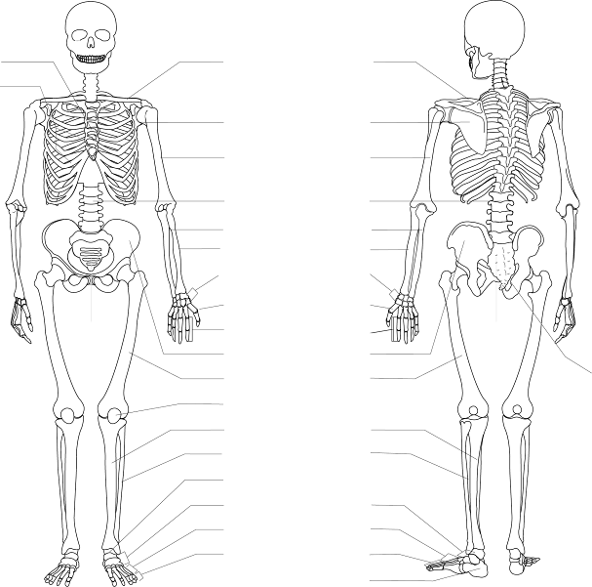
2. On the skeleton below use colour coding circles to shade in:
○ two long bones
○ one region where short bones are located
○ one sesamoid bone
○ two irregular bones
○ one flat bone
○ one site where elastic cartilage is located
○ one site where fibrocartilage is located
○ four sites where articular cartilage is located.
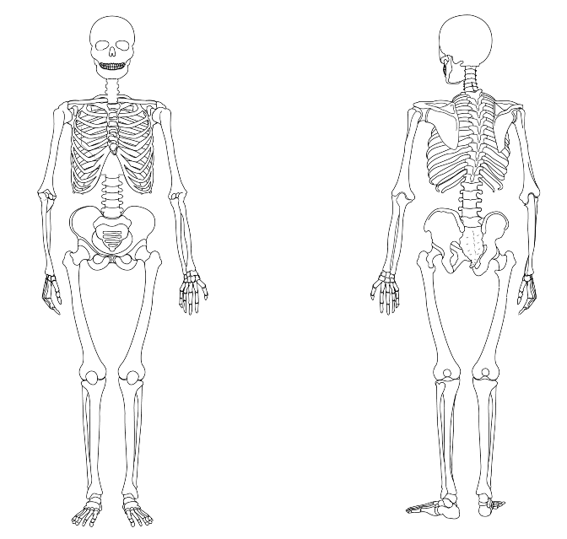

3. Draw on to the diagram, and label, a ligament of the shoulder joint.
1.2 | The structure of a long bone
1. Match the following features of a long bone to the correct leader lines on the diagram.

diaphysis epiphysis articular cartilage
growth plate cavity containing bone marrow
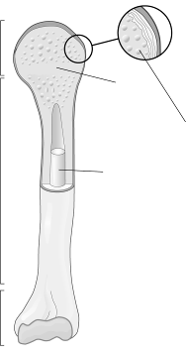

2. Using the terms above, write a paragraph to describe the structure of a long bone.

3. Match the following terms with the correct definition.

diaphysis epiphysis articular cartilage
growth plate bone marrow collagen calcium

Definition | Term
99% of the store of this mineral is found in bone – it keeps bone hard and strong.
The shaft of a long bone.
A connective tissue found in the spaces inside bone that is the site of blood cell production and fat storage.
A thin layer of a glassy-smooth substance that covers the end of long bones to prevent friction and wear and tear.
A fibrous protein with great strength that is the main component of bone.
The end portion of a long bone that flares out.
Also called the epiphyseal plate, this is the area of growing bone found in children and adolescents; it can be easily injured.

1.3 | Joints and movement
Complete the following table by:
• naming the joints of the upper, lower limbs and spine
• identifying the joint type
• listing the articulating bones
• naming and illustrating (using stick people) the joint movements that occur at the joint.

UPPER LIMB
Illustration | Joint name | Joint type | Articulating bones | Movements possible
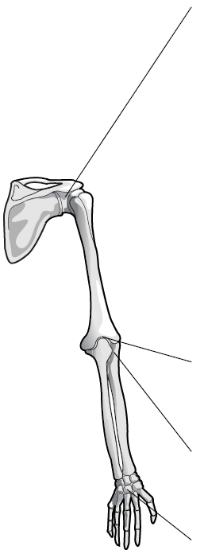 |  |  |  |   flexion

LOWER LIMB
Illustration | Joint name | Joint type | Articulating bones | Movements possible
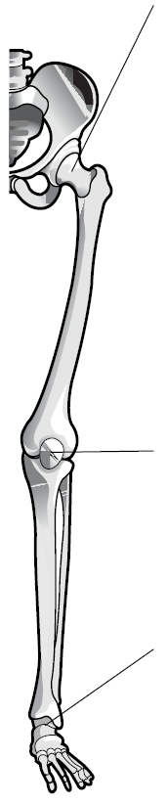 |  |  |  | 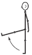  flexion

SPINE
Illustration | Joint Type | Example of where it is found in the spine | Articulating bones | Movements possible
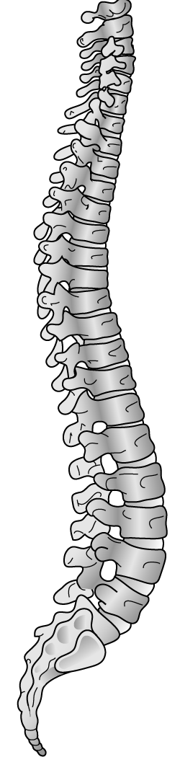 | Pivot |  | Vertebrae | flexion
 | Gliding |  | Vertebrae
 | Cartilaginous |  | Vertebrae

1.4 | Muscles of the body
1. Label the major muscles of the body in the diagram below.
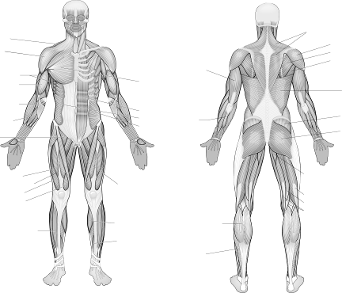

2. Write a paragraph to explain how an agonist and antagonist muscle work together to produce coordinated movement. Give two different examples from sport to illustrate your answer.

example 1:
example 2:
3. (a) List the four rotator cuff muscles.
1
2
3
4
(b) What role do the rotator cuff muscles play?

(c) Why are they necessary?

4. (a) Name two important muscles of the trunk that help maintain good posture.
1
2

(b) What do you understand by the term core stability and why is it so important?

5. Complete the missing information in the following table.

Joint | Joint Movement | Agonist | Antagonist
wrist |  | wrist flexors
radio-ulnar |  |  | pronator teres
elbow | extension
shoulder | flexion
shoulder |  |  | middle deltoid
spine | extension
hip |  | iliopsoas
hip | abduction
knee |  |  | biceps femoris  semiteninosus  semimembranosus
ankle |  | gastrocnemius
6. Select six muscles from the table in question 5 and describe where on the body they are located.
Name of muscle Location on body
1
2
3
4
5
6
1.5 | The role of muscular contraction
1. Complete the sentences below by filling in the missing information using the words listed.

isotonic isometric stops concentric
shortening controls lengthening
If there is no movement of a joint when tension is developed in a muscle, this is called
contraction, which joint movement.
contraction of a muscle results in the muscle producing joint movement. There are two types:
contraction causes joint movement and involves the muscle while developing tension. Eccentric contraction joint movement and involves the muscle while developing tension.
2. Using the sit-up as an example, describe in your own words the type of muscular contraction occurring in the rectus abdominis during:
(i) the upward phase and (ii) downward phase.
(i) Upward phase

(ii) Downward phase

3. Look at the diagrams below that show different strengthening exercises. For each exercise identify:
- the muscle being worked at the joint specified
- the type of muscular contraction occurring in the upward phase
- the type of muscular contraction occurring in the downward phase.
Exercise | Working muscle | Type of contraction in upward phase | Type of contraction in downward phase
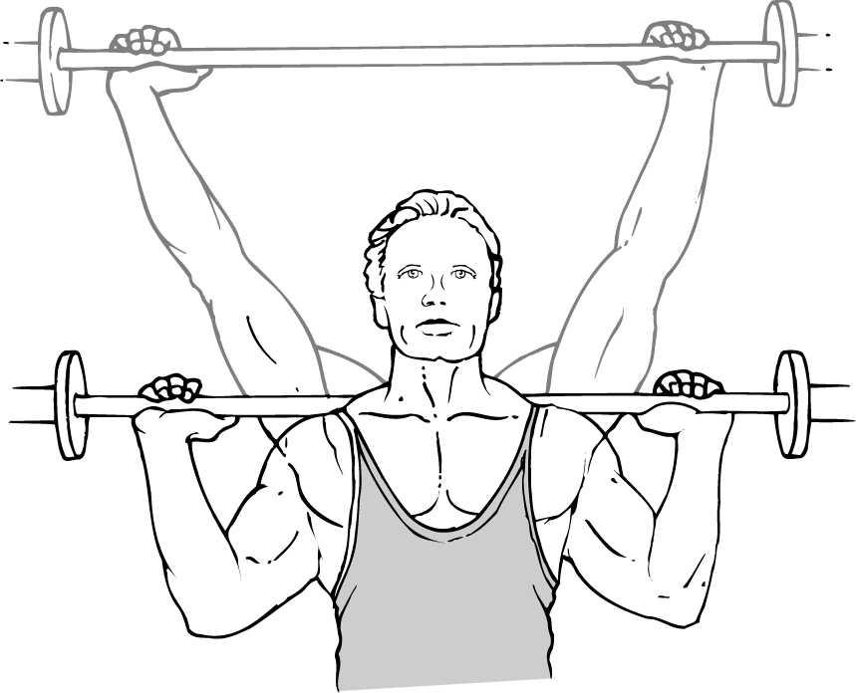  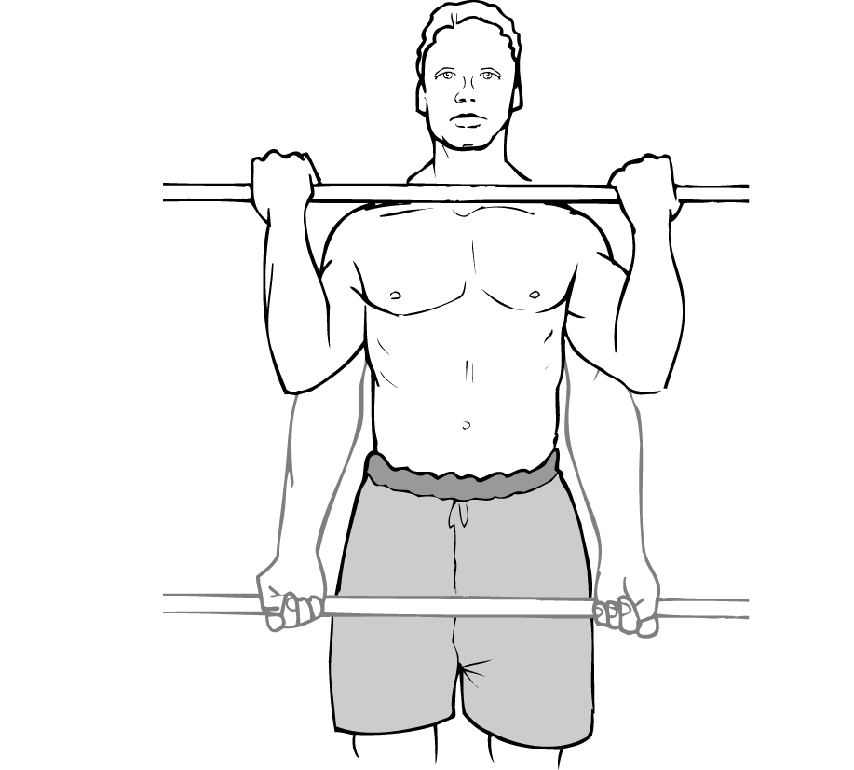  Shoulder press | Elbow joint
Biceps curls | Elbow joint
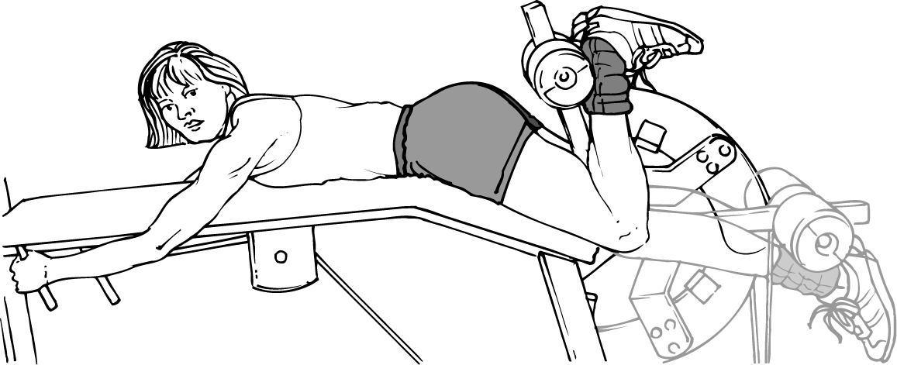  Leg curls | Knee joint
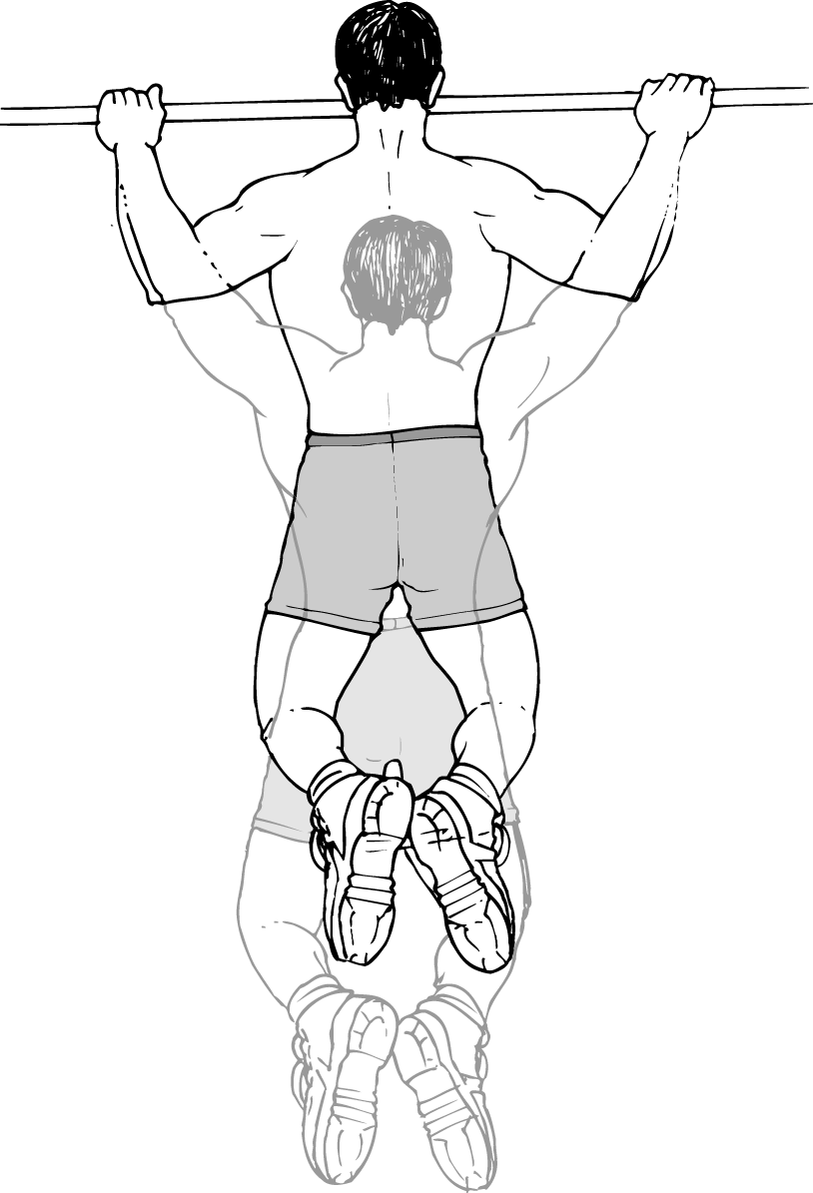  Chin ups | Shoulder joint
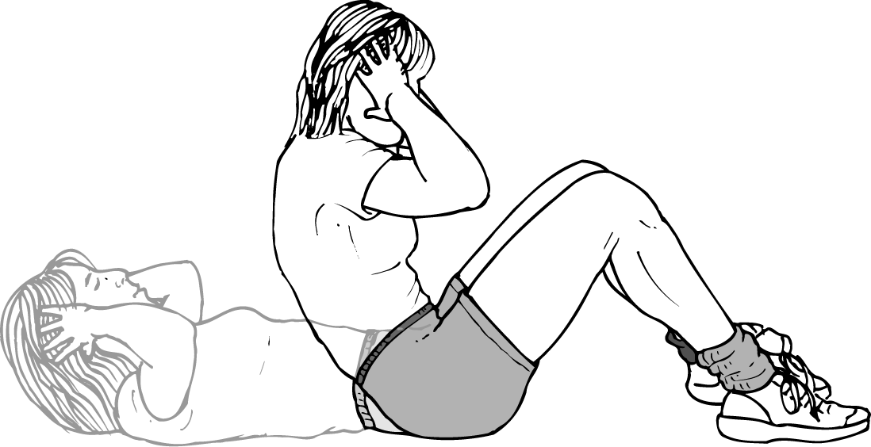  Sit ups | Hip joint

1.6 | The impact of different types of physical activity on the skeletal and muscular systems
The diagram below shows an adolescent boy
who is hoping to become an elite performer
in rugby union when he is a little older.

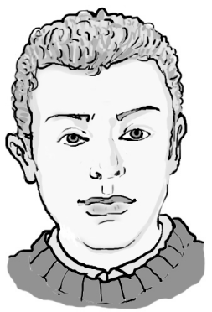

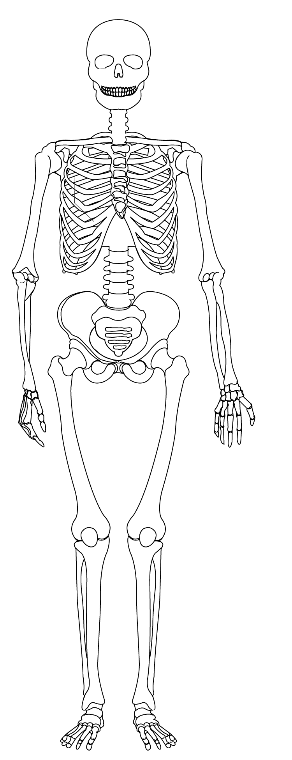

1. Using colour-coded circles, identify where on his body
he could be susceptible to the following bone, joint and
muscle disorders:
osteoporosis
growth plate injury
osteoarthritis
joint stability problems
posture and alignment issues.
2. Identify which of the conditions listed on the previous page could be caused as a result of a sudden impact at any time and which could be caused as a result of general wear and tear in the future:

Sudden impact Wear and tear

3. To look after their potential elite performers, individual governing bodies have devised models for long-term athletic development (LTAD). Research an LTAD model for a governing body of your choice and outline the main objectives and guidelines below.

4. Compare your findings with somebody else in your group who has researched an LTAD model from a different governing body. What are the common features?
1.1 | The skeleton – answers

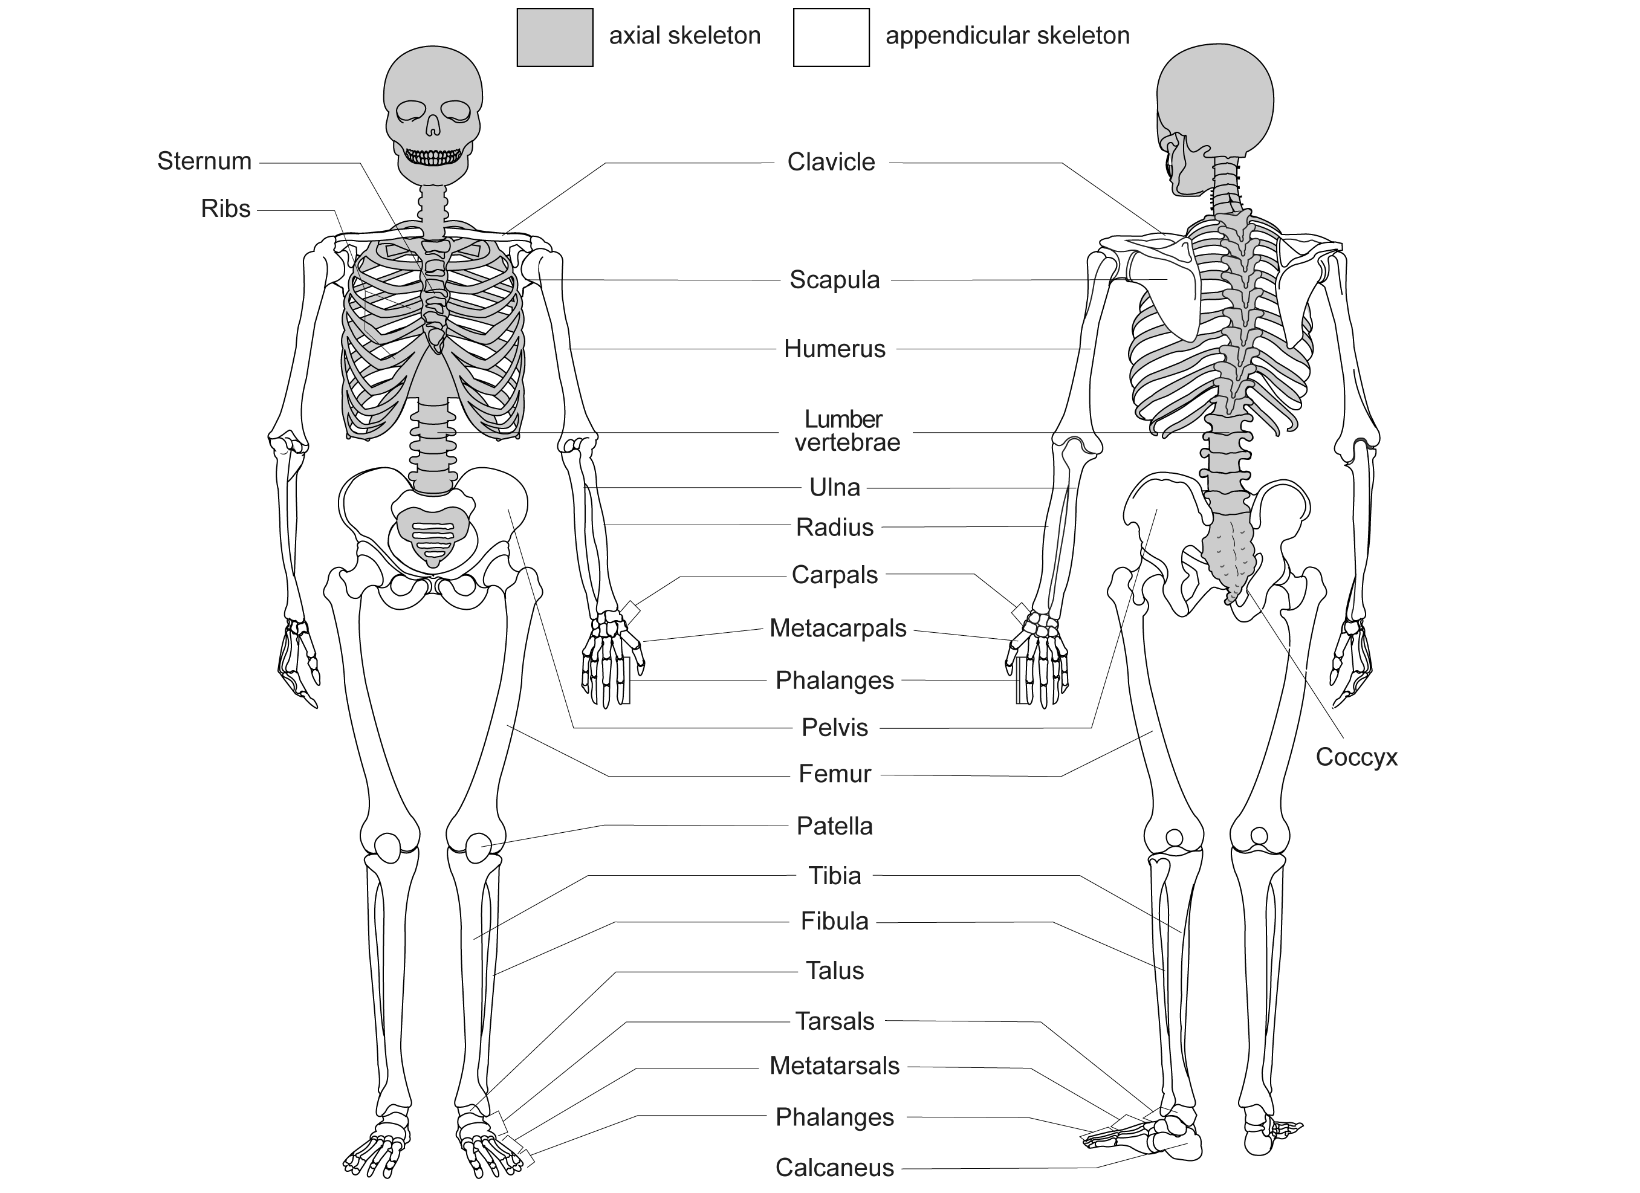

2. On the skeleton below use colour coding circles to shade in:
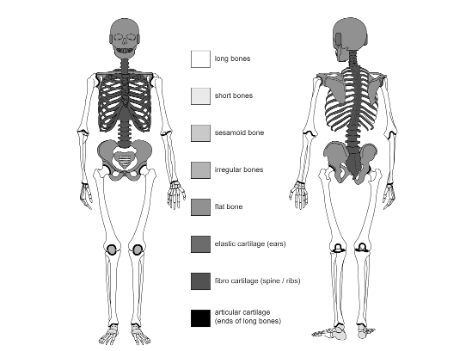

Note:
The spine is made up of irregular bones and fibro cartilage.

1.2 | The structure of a long bone – answers
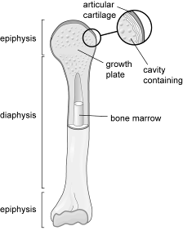
1.

2. Using the terms above, write a paragraph to describe the structure of a long bone.
Interpret student’s own answer to include the following. A long bone is longer than it is wide. It consists of a shaft called the diaphysis and two ends, each called the epiphysis. The epiphysis is covered by articular cartilage. This acts as a cushion and prevents friction during joint movement. Children and young adults have a region between the diaphysis and each epiphysis called the growth plate. This is responsible for promoting longitudinal bone growth until physical maturity. Bones also contain a cavity filled with bone marrow. This generates new blood cells.
3.
Definition | Term
99% of the store of this mineral is found in bone – it keeps bone hard and strong. | calcium
The shaft of a long bone. | diaphysis
A connective tissue found in the spaces inside bone that is the site of blood cell production and fat storage. | bone marrow
A thin layer of a glassy-smooth substance that covers the end of long bones to prevent friction and wear and tear. | articular cartilage
A fibrous protein with great strength that is the main component of bone. | collagen
The end portion of a long bone that flares out. | epiphysis
Also called the epiphyseal plate, this is the area of growing bone found in children and adolescents; it can be easily injured. | growth plate

1.3 | Joints and movement – answers
Complete the following table by:
• naming the joints of the upper and lower limbs
• identifying the joint type
• listing the articulating bones
• naming and illustrating (using stick people) the movements that occur at each joint.

UPPER LIMB
Illustration | Joint name | Joint type | Articulating bones | Movements possible
 | Shoulder | Ball and socket | Head of humerous with glenoid fossa of scapula | Flexion  Extension  Horizontal flexion  Horizontal extension  Abduction  Adduction  Rotation  Circumduction
 | Elbow | Hinge | Humerus, radius, ulna | Flexion  Extension
 | Radio-ulnar | Pivot | Radius, ulna | Pronation
 | Wrist | Condyloid | Radius, ulna, carpals | Flexion*  Extension

LOWER LIMB
Illustration | Joint name | Joint type | Articulating bones | Movements possible
 | Hip | Ball and socket | Head of femur with acetabulum of pelvis | Flexion**  Extension  Abduction  Adduction  Rotation
 | Knee | Hinge | Femur, tibia | Flexion  Extension
 | Ankle | Hinge | Tibia, fibula, talus | Doriflexion***  Plantar flexion

SPINE
Illustration | Joint Type | Example of where it is found in the spine | Articulating bones | Movements possible
 | Pivot | Between the atlas and the axis | Vertebrae | Flexion  Extension  Rotation  Lateral flexion
 | Gliding | Between the bony processes of adjacent vertebrae | Vertebrae | Flexion  Extension  Rotation  Lateral flexion
 | Cartilaginous | Between the body’s of adjacent vertebrae | Vertebrae | Flexion  Extension  Rotation  Lateral flexion

1.4 | Muscles of the body – answers
1. Label the major muscles of the body in the diagram below.
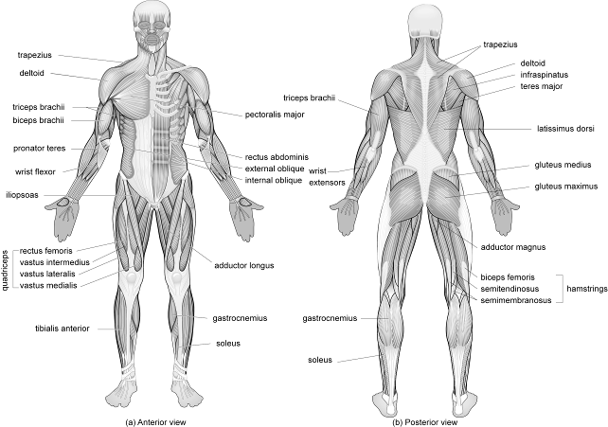

2. Write a paragraph to explain how an agonist and antagonist muscle work together to produce coordinated movement. Give two different examples from sport to illustrate your answer.
The agonist muscle is directly responsible for the movement at a joint. The antagonist muscle has an action opposite to that of the agonist and helps in the production of a coordinated movement. Antagonistic muscle action means that as the agonist muscle shortens, the antagonist lengthens to allow movement to take place.
example 1: In the execution phase of kicking a football, the kicking leg flexes at the hip joint. The iliopsoas is acting as the agonist and the gluteus maximus is lengthening to act as the antagonist.
example 2: In the take off phase of the vertical jump the knee extends. The muscles of the quadriceps (rectus femoris, vastus lateralis, vastus medialis and vastus intermedius) are shortening to act as the agonist, while the muscles of the hamstrings (biceps femoris, semitendinosus, semimembranosus) are lengthening to act as the antagonist.
3. (a) List the four rotator cuff muscles.
1 supraspinatus
2 infraspinatus
3 teres minor
4 subscapularis
(b) What role do the rotator cuff muscles play?
• improve the stability of the shoulder joint
• help to hold the head of the humerus in contact with the glenoid fossa of the scapula
• preventing the large muscle groups from displacing the head of the humerus during
movement of the shoulder
(c) Why are they necessary?
• the shoulder is the most mobile joint in the body
• it has the largest range of movement
• it is relatively shallow
• it is therefore prone to dislocation under large forces
4. (a) Name two important muscles of the trunk that help maintain good posture.
1 Transverse abdominis
2 Multifidis
(b) What do you understand by the term core stability and why is it so important?
Core stability is the ability of the trunk to support the forces from the muscles in the arms
and legs that come about during movement. It enables joints and muscles to work in their
safest and most efficient positions, reducing the risk of injury.
5. Complete the missing information in the following table.

Joint | Joint Movement | Agonist | Antagonist
Wrist | flexion | wrist flexors | wrist extensors
Radio-ulnar | supination | supinator | pronator teres
elbow | extension | triceps brachii | biceps brachii
shoulder | flexion | anterior deltoid | posterior deltoid
shoulder | adduction | latissimus dorsi | middle deltoid
spine | extension | erector spinae | rectus abdominis
hip | flexion | iliopsoas | gluteus maximus
hip | abduction | gluteus medius/minimus | adductor group
knee | extension | rectus femoris  vastus lateralis  vastus medialis  vastus intermedius | biceps femoris  semiteninosus  semimembranosus
ankle | plantar flexion | gastrocnemius | tibialis anterior
6. Select six muscles from the table in question 5 and describe where on the body they are located.
Name of muscle Location on body
1
2
3
4
5
6
Answers can be found on pages 22–32 of the student book.
1.5 | The role of muscular contraction – answers
1. Complete the sentences below by filling in the missing information using the words listed.

isotonic isometric stops concentric
shortening controls lengthening
If there is no movement of a joint when tension is developed in a muscle, this is called isometric contraction, which stops joint movement.
Isotonic contraction of a muscle results in the muscle producing joint movement. There are two types:
Concentric contraction causes joint movement and involves the muscle shortening while developing tension. Eccentric contraction controls joint movement and involves the muscle lengthening while developing tension.
2. Using the sit-up as an example, describe in your own words the type of muscular contraction occurring in the rectus abdominis during:
(i) the upward phase and (ii) downward phase.
(i) Upward phase
• flexion of the hip/spine
• rectus abdominis acting as the agonist
• causes joint movement
• tension develops while shortening
(ii) Downward phase
• extension of the hip/spine
• rectus abdominis is controlling the downward movement
• acting against gravity
• tension develops while lengthening

3. Look at the diagrams below that show different strengthening exercises. For each exercise identify:
• the muscle being worked at the joint specified
• the type of muscular contraction occurring in the upward phase
• the type of muscular contraction occurring in the downward phase.

Exercise | Working muscle | Type of contraction in upward phase | Type of contraction in downward phase
Shoulder press | Elbow joint  triceps brachii | concentric | eccentric
Biceps curls | Elbow joint  biceps brachii | concentric | eccentric
Leg curls | Knee joint  Hamstrings:  biceps femoris  semitendinosus  semimembranosus | concentric | eccentric
Chin ups | Shoulder joint  latissimus dorsi | concentric | eccentric
Sit ups | Hip joint  iliopsoas | concentric | eccentric

1.6 | The impact of different types of physical activity on the skeletal and muscular systems – answers
The diagram below shows an adolescent boy
who is hoping to become an elite performer
in rugby union when he is a little older.

4. Using colour-coded circles, identify where on his body
he could be susceptible to the following bone, joint and
muscle disorders:
osteoporosis
growth plate injury
osteoarthritis
joint stability problems
posture and alignment issues.
This was devised as an extension activity which would lead to
individual presentations or a group discussion. See pages 35–38
of the student book and additional resources.
5. Identify which of the conditions listed on the previous page could be caused as a result of a sudden impact at any time and which could be caused as a result of general wear and tear in the future:

Sudden impact Wear and tear

6. To look after their potential elite performers, individual governing bodies have devised models for long-term athletic development (LTAD). Research an LTAD model for a governing body of your choice and outline the main objectives and guidelines below.

Compare your finding with somebody else in your group who has researched an LTAD model from a different governing body. What are the common features?
1 | Sample questions with mark schemes

SAMPLE QUESTIONS

(a) The figure below shows an athlete during the take off phase of the long jump.

right hip
right knee
left ankle
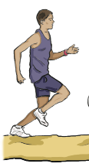

Complete the missing information, A–F, in the movement analysis table below.

 | Joint Type | Articulating bones | Joint  Action | Agonist Muscle | Antagonist muscle
Right Hip | Ball and socket | (Acetabulum of) pelvis, (head of) femur | Flexion | C | D
Right Knee | Hinge | B | Flexion | E | Recturs femoris
Left Ankle | A | Femur, tibia, fibula | F | Gastrocnemius | Tibialis  anterior

[6 marks]

(b) To execute explosive movements such as those needed at the take off in the long jump, the athlete will need to recruit fast glycolytic muscle fibres.

Explain why fast glycolytic muscle fibres are most suited to explosive movements.
[4 marks]

(c) Identify and explain the types of muscular contraction occurring in the muscles of the quadriceps, the rectus femoris, vastus lateralis, vastus medialis and vastus intermedius during:
(i) the take off and (ii) the landing phases of the long jump
[5 marks]

(d) Involvement in an active lifestyle is to be encouraged. However, certain types of activity can impact in a negative way on the skeletal and muscular systems.

Describe the risks to the skeletal and muscular system that can be caused by regular involvement in contact sports.
[5 marks]

(e) Describe the main components of a warm up and explain the positive effects of a warm up on skeletal muscle tissue.
[10 marks]

MARK SCHEME

(a) The figure below shows an athlete during the take off phase of the long jump.

6 marks for:

A = hinge
B = femur, tibia (NB: Not fibula or patella)
C = Iliopsoas
D = Gluteus maximus
E = Biceps femoris / semitendinosus / semimembranosus
F = Plantar flexion

(b) To execute explosive movements such as those needed at the take off in the long jump, the athlete will need to recruit fast glycolytic muscle fibres.

Explain why fast glycolytic muscle fibres are most suited to explosive movements.
[4 marks]

4 marks for 4 of:
1. large fibre size
2. generate a high force of contraction
3. in a small amount of time
4. large stores of phosphocreatine / PC
5. allowing quick access to energy
6. high anaerobic capacity
7. explosive / powerful fibres

(c) Identify and explain the types of muscular contraction occurring in the muscles of the quadriceps, the rectus femoris, vastus lateralis, vastus medialis and vastus intermedius during
(i) the take off and (ii) the landing phases of the long jump

[5 marks]
(i) (take off)
sub max 3
1. acting as the agonist
2. directly responsible for extension of the knee
3. tension develops while the muscle shortens
4. muscle is causing movement

(ii) (landing)
sub max 3
5. working to control the landing
6. working against gravity
7. tension develops while the muscle lengthens
8. muscle is controlling movement / landing
9. to stop body collapsing completely on landing

(d) Involvement in an active lifestyle is to be encouraged. However, certain types of activity can impact in a negative way on the skeletal and muscular systems.

Describe the risks to the skeletal and muscular system that can be caused by regular involvement in contact sports.
[5 marks]

5 marks for 5 of:
1. dangerous for osteoporosis sufferers
2. risk of fractures / stress fractures
3. risk of sprains / dislocations
4. particularly in less stable joints (knee, shoulder)
5. affecting joint stability
6. increased risk of damage to growth plates in children and adolescents
7. muscle tears / strains
8. damage to articular cartilage
9. injury can increase chances of osteoarthritis in later life

(e) Describe the main components of a warm up and explain the positive effects of a warm up on skeletal muscle tissue.
[10 marks]

Indicative content:
Warm Up - description
• crucial part to any sport
• increase the quality of performance of physical activity
• reduce the chance of muscle or joint soreness in days following exercise
• involves light aerobic exercise to elevate heart rate / increase muscle or body temperature

• involves mobilising exercises to loosen the joints / secrete synovial fluid
• involves stretching to loosen the muscles / connective tissue
• involves some skill practices to prepare body for the movement patterns to follow
• prepares the body for exercise
• reduces the risk of injury

Warm up – explanation
• the positive effects of a warm up are as a result of an increase in body temperature
• reduction in muscle viscosity, leading to an improved efficiency of contraction
• higher speed of nerve transmission allows for a greater force and speed of contraction of muscle fibres
• increased flexibility of muscles reduces the risk of injury
• increased extensibility of ligaments / tendons / connective tissue reduces the risk of injury

Lever descriptors:
Level 3 – 8-10 marks
• there is detailed knowledge and good understanding of the topic
• there is effective analysis and/or critical evaluation
• knowledge has been clearly and consistently linked to practical performance throughout the answer if appropriate
• accurate technical and specialist vocabulary is used throughout
• there is a high standard of written communication

Discriminators from level 2 are likely to include:
• detailed knowledge of the components of the warm up and the reasons for each
• sufficient knowledge credited for the explanation of a warm up to the efficiency of skeletal muscle

Level 2 – 5-7 marks
• there is satisfactory knowledge and understanding of the topic
• analysis and/or critical evaluation is attempted with some success
• knowledge has been linked to practical performance with some success where appropriate
• technical and specialist vocabulary is used with some accuracy
• written communication is generally fluent with few errors

Discriminators from level 1 are likely to include:
• a level of knowledge of the components of the warm up and the reasons for some of them
• some ability to explain why a muscle works more efficiently after a warm up

Level 1 – 0-4 marks
• there is basic knowledge but little understanding of the topic
• little or no attempt to analyse and/or evaluate
• little or no attempt to link to practical performance
• technical and specialist vocabulary is used with limited success
• written communication lacks fluency and there will be errors, some of which may be intrusive

1 | Answers to student book tasks

TASK 1

Joint number | Joint name | Bones that articulate
1. | Wrist | Radius, ulna, carpals
2. | Radio-ulnar | Radius, ulna
3. | Elbow | Humerus, radius, ulna
4. | Shoulder | Head of humerus, glenoid fossa of scapula
5. | Spine | Vertebrae  The atlas and axis are the top two bones. The regions are: cervical, thoracic, lumbar, sacrum and coccyx
6. | Hip | Head of femur, acetabulum of pelvis
7. | Knee | Femur, tibia
8. | Ankle | Tibia, fibula, patella

TASK 2

Type of bone | Example from body
Long | Humerus/radius/ulna/metacarpals/phalanges/femur/tibia/fibula/metatarsals
Short | Carpals/talus/tarsals
Flat | Bones of the skull/sternum/scapula/bones of the pelvis
Irregular | Vertebrae/(facial bones)
Sesamoid | Patella

Type of cartilage | Function | Example from body
(Articular cartilage) | Supports and cushions joints/resists compression/provides friction-free movement | Found at the ends of long bones
Elastic cartilage | Maintains shape while allowing great flexibility | External ear
Fibrocartilage | Very strong shock absorber | Cartilaginous discs found between the bodies of adjacent vertebrae/menisci in knee are discs of fibrocartilage

TASK 3
1. Features that increase joint stability:

Feature of joint | Function
Joint capsule | The external layer (fibrous capsule) strengthens the joint so that bones are not pulled apart
Ligaments | These join bone and bone to reinforce and strengthen the joint
Meniscus | These discs of fibrocartilage improve the fit between the ends of long bones at a joint, making the joint more stable and minimising wear and tear
Muscle tone | Muscle tone keeps the tendons that cross a joint in a constant taut state; they therefore contribute to the stability of the joint

2. Features that increase joint mobility:

Feature of joint | Function
Articular cartilage | Glassy-smooth cartilage that covers bone surfaces at joints and prevents friction during movement
Joint capsule | The internal layer (synovial membrane) covers all internal joint structures apart from the articular cartilage and secretes synovial fluid during movement, therefore reducing friction
Synovial fluid | This is secreted by the synovial membrane and the articular cartilage during movement; its egg-white consistency provides a slippery film within the joint to prevent friction during movement
Bursa | These are fibrous sacs of synovial fluid that prevent friction between adjacent joint structures during movement, e.g. in the shoulder joint between the scapula and long tendon on the biceps brachii

TASK 4
Students can check their answers using Table 4 on page 10 of the student book.

TASK 5
Student’s own sporting examples.

TASK 6
Student’s own sporting examples.

TASK 7
Student’s own sporting examples.

TASK 8
Student’s own sporting examples.

TASK 9
Student’s own sporting examples.

TASK 10

Joint | Joint type | Articulating bones | Movements possible at joint
Wrist | Condyloid | Radius, ulna, carpals | Flexion, extension
Radio-ulnar | Pivot | Radius, ulna | Pronation, supination
Elbow | Hinge | Radius, ulna, humerus | Flexion, extension
Shoulder | Ball and socket | Head of humerus, glenoid fossa of scapula | Flexion, extension,  horizontal flexion, horizontal extension,  abduction, adduction,  rotation, circumduction
Spine | Cartilaginous, pivot, gliding | Vertebrae (cervical, thoracic, lumbar, sacrum, coccyx) | Flexion, extension, lateral flexion
Hip | Ball and socket | Head of femur, acetabulum of pelvis | Flexion, extension,  abduction, adduction,  rotation
Knee | Hinge | Femur, tibia | Flexion, extension
Ankle | Hinge | Tibia, fibula, talus | Dorsiflexion, plantar flexion

TASK 12
Student’s own answer.

TASK 13

Upper limb | Joint movement | Agonist muscle | Antagonist muscle
Wrist joint | Flexion | Wrist flexors | Wrist extensors
 | Extension | Wrist extensors | Wrist flexors
Radio-ulnar joint | Pronation | Pronator teres | Supinator
 | Supination | Supinator | Pronator teres
Elbow joint | Flexion | Biceps brachii | Triceps brachii
 | Extension | Triceps brachii | Biceps brachii
Shoulder joint | Flexion | Anterior deltoid | Posterior deltoid
 | Extension | Posterior deltoid | Anterior deltoid
 | Horizontal flexion | Pectoralis major | Trapezius
 | Horizontal extension | Trapezius | Pectoralis major
 | Abduction | Middle deltoid | Latissimus dorsi
 | Adduction | Latissimus dorsi | Middle deltoid
Spine | Joint movement | Agonist muscle | Antagonist muscle
Spine | Flexion | Rectus abdominis | Erector spinae
 | Extension | Erector spinae | Rectus abdominis
 | Lateral flexion | Obliques | Obliques
Lower limb | Joint movement | Agonist muscle | Antagonist muscle
Hip joint | Flexion | Iliopsoas | Gluteus maximus
 | Extension | Gluteus maximus | Iliopsoas
 | Abduction | Gluteus medius | Adductor group
 | Adduction | Adductor group | Gluteus medius
Knee joint | Flexion | (Hamstrings)  Biceps femoris  Semimembranosus  Semitendinosus | (Quadriceps)  Rectus femoris  Vastus lateralis  Vastus medialis  Vastus intermedius
 | Extension | (Quadriceps)  Rectus femoris  Vastus lateralis  Vastus medialis  Vastus intermedius | (Hamstrings)  Biceps femoris  Semimembranosus  Semitendinosus
Ankle joint | Dorsiflexion | Tibialis anterior | Gastrocnemius
 | Plantar flexion | Gastrocnemius | Tibialis anterior

TASK 14

Isotonic contraction |  | Isometric contraction
Concentric contraction | Eccentric contraction | Isometric contraction
• Concentric contraction in the rectus abdominis during upward phase of exercise.  • The rectus abdominis produces tension and shortens.  • It pulls the upper body upwards to cause flexion of the hip and spine. | • Eccentric contraction occurs in the rectus abdominis during the downward phase of the exercise.  • The rectus abdominis produces tension and lengthens.  • It slows the lowering of the upper body and controls extension of the hip and spine. | • Isometric contraction occurs in the rectus abdominis when the muscle is holding the body still.  • The rectus abdominis develops tension and stays the same length.  • It stops flexion and extension of the hip and spine.

For question 2, the students will come up with their own answers.

TASK 15
Student’s own answer.

TASK 16
Student’s own answer.

TASK 19
This should lead the student into extension activities linked with long-term athletic development (LTAD) and research carried out into special consideration for young athletes.

TASK 20

Factor affecting the skeletal and muscular systems | Positive impact of physical activity and type of activity needed | Negative impact of physical activity and type of activity needed
Osteoporosis | Low-impact activity in childhood and adolescence builds strong, healthy bones  High-impact activity is also encouraged to increase peak bone density | If somebody is already suffering from osteoporosis, high-impact activity can cause bone fractures at the site of the weakened bone and joint  With high-impact activity and contact sports there is an increased risk of sprains, strains and dislocations
Growth plate |  | Excessive and repetitive exercise can damage the growth plate  High-impact or contact activity can cause growth plate injuries
Osteoarthritis | Low-impact activity manages weight so less strain on joints and less wear and tear | Exercise carried out too frequently or at too high intensity promotes wear and tear on the joint and promotes the start of osteoarthritis
Joint stability | Low-impact activity strengthens muscles, ligaments and tendons, and improves muscle tone, therefore increasing joint stability | Exercise that causes damage to the joints can reduce joint stability as ligaments and tendons are stretched, making the joint less stable
Posture & alignment | Low-impact activity strengthens muscles and muscle tone, improving posture  Swiss ball work strengthens multifidis and transverse abdmonis and improves core stability, which improves posture and alignment | A complete lack of physical activity or a sedentary lifestyle reduces muscle tone, reduces core stability and results in poor posture and alignment

Notes for Teachers

This chapter covers the basic principles of sports mechanics and introduces the student to the field of biomechanics, which is the scientific option B2 in the A2 unit G453.

The chapter covers the following sections of the specification:
• Types of motion
• Force
• Newton’s laws of motion
• Centre of mass
There are no changes to this area of the specification from the previous OCR AS Physical Education specification. However, it is worth remembering that although the mechanical concepts discussed in this chapter should be familiar to the students from their background in GCSE science, they are not familiar with applying the concepts to human movement and physical activity. So, time needs to be spent developing their confidence in this area, and the greater the variety of types of physical activity used as examples, the deeper their understanding will become. The student book takes them through the basic concepts listed above while regularly making reference to their link with sporting techniques.
The Learning Outcomes for Chapter 2 are for the student to be able to:
• understand the types of motion produced in different sporting techniques
• describe and give sporting examples of linear, angular and general motion
• apply all three of Newton’s Laws of Motion to a variety of sporting techniques
• understand the effect of size of force, direction of force and position of application of force on a body
• apply their knowledge of centre of mass to increasing and decreasing stability in sporting techniques
• carry out a practical analysis of typical sporting actions.

2.1 | Motion and force

1. There are three types of motion: linear, angular and general.

Linear motion
Description: linear motion is motion along a line where all body parts are moving the same distance, in the same direction and at the same speed. This line can be a straight line or a curved line.
First example from sport: an example of linear motion in a straight line is a bobsleigh at the end of its run as it goes down the straight section of the course to the finish line.
Second example from sport: an example of linear motion in a curved line is the path taken by a shot put during flight.
Complete the missing information for angular and general motion.

Angular motion
Description:
First example from sport:
Second example from sport:

General motion
Description:

First example from sport:
Second example from sport:
2. A force is defined as “a push or a pull that alters, or tends to alter, the state of motion of a body.” A force is needed to:
• cause a body at rest to move
• cause a moving body to change direction
• cause a moving body to accelerate
• cause a moving body to decelerate
• cause a body to change its shape.
Complete the table below to give examples of the effects of a force in sport.

Effect of force | Sporting example 1 | Sporting example 2
 | A diver jumping from a spring board
Cause a body at rest to move
Cause a moving body to change direction
Cause a moving body to accelerate
Cause a moving body to decelerate
Cause a body to change its shape

2.2 | Newton’s laws of motion
1. Complete the table below.

Newton’s law | Number of law (circle the correct number) | Sporting example 1 | Sporting example 2
A body _____________ in a state of rest or ___________ ___________ unless acted upon by an ___________ ___________ | 1 2 3 | A 100 m sprinter on the blocks at the “bang”!
For every ___________ there is an __________ and ___________ ___________ | 1 2 3
When a _____________ acts on an object the rate of change of ____________ experienced by the object is _______________ to the ______________ of the force and takes place in the _______________ in which the force acts. | 1 2 3
2. Use your knowledge of Newton’s laws to explain the following. Remember to identify which law you are applying in each case. You can use one, two or all three laws where appropriate.
(a) How does a basketball player jump up for a rebound?

(b) How does a netball player avoid breaking the footwork rule when landing after having caught the ball?

(c) How does a rugby player side step to avoid a tackle?

(d) How does a gymnast maintain a balanced position on the beam?

(e) How does a skier stop at the end of a downhill race?

2.3 | Centre of mass – a quick test
1. Define centre of mass. [1]
_________________________________________________________________________
2. (a) Give an example from PE or sport where an athlete’s centre of mass would be located
inside their body. [1]
_________________________________________________________________________
(b) Give an example from PE or sport when an athlete’s centre of mass would be located outside their body. [1]
_________________________________________________________________________
(c) Why does the location of the centre of mass change? [1]
_________________________________________________________________________
3. Explain briefly the concept of the line of gravity and its link with stability. [4]
_________________________________________________________________________
_________________________________________________________________________
4. Identify a situation in sport where a performer needs to be stable. Draw a stick figure to show the position of the athlete. Use a dot to indicate the position of the centre of mass. Use an arrow to indicate the line of gravity. [3]

Situation in sport: _________________________________________________________________________
5. Explain three principles that make the performer in question 4 stable. [3]
Principle 1 _________________________________________________________________
__________________________________________________________________________
Principle 2 _________________________________________________________________
__________________________________________________________________________
Principle 3 _________________________________________________________________
__________________________________________________________________________
6. A tennis player may wish to impart topspin to the ball at contact. Explain how this might be achieved. [2]
__________________________________________________________________________
__________________________________________________________________________
__________________________________________________________________________
__________________________________________________________________________
2.1 | Motion and force - answers

1. There are three types of motion: linear, angular and general.

Linear motion
Description: linear motion is motion along a line where all body parts are moving the same distance, in the same direction and at the same speed. This line can be a straight line or a curved line.
First example from sport: an example of linear motion in a straight line is a bobsleigh at the end of its run as it goes down the straight section of the course to the finish line.
Second example from sport: an example of linear motion in a curved line is the path taken by a shot put during flight.
Complete the missing information for angular and general motion.

Angular motion
Description: angular motion is when a body or part of a body moves in a circle, or part of a circle, about a particular point called the axis of rotation.
First example from sport: an example of angular motion is the movement of the arm around the
shoulder joint when swimming front crawl.
Second example from sport: an example of angular motion is the movement of a gymnast’s body
when they complete a giant circle on the high bar in Olympic gymnastics.

General motion
Description: general motion is a combination of linear and angular motion.

First example from sport: an example of general motion is the athlete’s whole body during
100 m sprint.
Second example from sport: an example of general motion is a cyclist.

2. A force is defined as “a push or a pull that alters, or tends to alter, the state of motion of a body.” A force is needed to:
• cause a body at rest to move
• cause a moving body to change direction
• cause a moving body to accelerate
• cause a moving body to decelerate
• cause a body to change its shape.
Complete the table below to give examples of the effects of a force in sport.

Effect of force | Sporting example 1 | Sporting example 2
 | A diver jumping from a spring board | Students can choose their own sport and their analysis should tie in with that shown for a diver
Cause a body at rest to move | The diver must exert a force onto the board in order to start to move
Cause a moving body to change direction | At the top of the dive, the force of gravity will cause the diver to change direction and come down towards the water
Cause a moving body to accelerate | The force generated at take off will cause the diver to accelerate upwards from the board
Cause a moving body to decelerate | The force caused by the water on the diver as he enters the pool will cause the diver to decelerate
Cause a body to change its shape | When the diver applies a force to the board, the board changes shape

2.2 | Newton’s laws of motion – answers
1. Complete the table below.

Newton’s law | Number of law (circle the correct number) | Sporting example 1  A 100m sprinter on the blocks at the “bang”! | Sporting example 2
A body continues in a state of rest or uniform velocity unless acted upon by an external force | 1 | The sprinter will remain on the blocks until they apply an external force large enough to get them moving | Students can choose their own sport and their analysis should tie in with that shown for a sprinter
For every action there is an equal and opposite reaction | 3 | The sprinter applies a backward and downward force on the blocks, which, in turn, apply a forward and upward force on the sprinter
When a force acts on an object the rate of change of momentum experienced by the object is proportional to the size of the force and takes place in the direction in which the force acts. | 2 | The larger the force generated, the greater the acceleration of the sprinter at the start of the race, and this acceleration will take place in the direction in which the force acts.
2. Use your knowledge of Newton’s laws to explain the following. Remember to identify which law you are applying in each case. You can use one, two or all three laws where appropriate.
(a) How does a basketball player jump up for a rebound?
Newton 3
The basketball player applies a downward force on the ground, which applies an
upward force on the basketball player, allowing him to take off from the ground.
Newton 1
Without this external force, there would be no change to the basketball player’s
state of motion .
Newton 2
The greater the force the basketball player can generate in an upwards direction, the
greater their acceleration into the air.

(b) How does a netball player avoid breaking the footwork rule when landing after having caught the ball?
Newton 3
The player exerts a force on the court in the forward direction so that the court
exerts an equal and opposite force on the player to push them backwards.
Newton 1
Without this external force, the player will continue to travel forwards with the same velocity.
Newton 2
The larger the force, the quicker they will stop.
(c) How does a rugby player side step to avoid a tackle?
Newton 1
If side stepping to their left, the rugby player pushes right with their right foot. This applies a force to the right on the ground, which in turn applies an equal and
opposite force to the left on the rugby player.
Newton 1
Without this external force there would be no change to the state of motion of the rugby
player.
Newton 2
The greater the force generated, the faster the acceleration of the rugby player to
the left hand direction .
(d) How does a gymnast maintain a balanced position on the beam?
Newton 1
The gymnast keeps all forces equal and opposite so that there is no external net
force, and therefore no change to their state of motion.
(The gymnast also ensures that the line of gravity remains within the base of support)
(e) How does a skier stop at the end of a downhill race?
Newton 3
The skier exerts a force on the snow, which applies an equal and opposite force on the skier
to cause them to stop. Without this external force, the skier would continue to travel in
their original direction, and there would be no change to their state of motion.
Newton 2
The greater the force applied, the quicker they will decelerate and stop.
2.3 | Centre of mass – a quick test – answers
1. Define centre of mass.
The centre of mass is an imaginary point at which the body is balanced in all directions.
2. (a) Give an example from PE or sport where an athlete’s centre of mass would be located inside
their body.
Balancing in a handstand is one example where the centre of mass is inside the body.
(b) Give an example from PE or sport when an athlete’s centre of mass would be located outside their body.
The pike jump in trampolining is one example where the centre of mass is outside the body.
(c) Why does the location of the centre of mass change?
The position of the centre of mass changes with changes in body position (to ensure that the balance is maintained in all directions).
3. Explain briefly the concept of the line of gravity and its link with stability.
The line of gravity is an imaginary line that originates from the centre of mass and travels vertically downwards towards the ground.
If the line of gravity falls to the centre of the base of support the body is at its most stable.
If the line of gravity falls to the edge of the base of support the body is less stable.
If the line of gravity falls outside the base of support the body becomes unstable.
4. Identify a situation in sport where a performer needs to be stable. Draw a stick figure to show the position of the athlete. Use a dot to indicate the position of the centre of mass. Use an arrow to indicate the line of gravity.
Situation in sport where stability is necessary: Preparing to tackle in rugby, for example. (Further 2 marks for correct location of centre of mass and correct placement of line of gravity towards the centre of the base of support).
5. Explain three principles that make the performer in question 4 stable.
Principle 1: The lower the centre of mass the more stable the body.
Principle 2: The bigger the base of support the more stable the body.
Principle 3: The closer the line of gravity to the centre of the base of support the more stable the body.
Alternative principle 1: The more points of contact the more stable the body.
Alternative principle 2: The greater the mass the more stable the body.
6. A tennis player may wish to impart topspin to the ball at contact. Explain how this might be achieved.
The tennis player must exert a force that travels outside the tennis ball’s centre of mass. This is called an eccentric force.
2 | Sample questions with mark schemes

SAMPLE QUESTIONS

(a) Figure 1 shows a sprinter in the “on your marks” position.
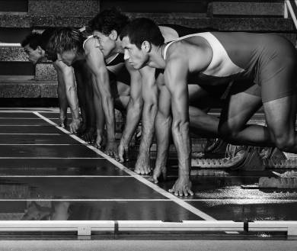

Figure 1

Using your knowledge of Newton’s Laws of Motion, explain how the sprinter is able to accelerate away from the blocks at the start of the race.
[6 marks]

(b) General motion is most commonly observed in sports performers. Identify the other two types of motions that can be observed in sports performance and use your knowledge of force to explain how each type of motion is generated, giving examples from sport where appropriate.
[4 marks]

MARK SCHEME

(a) Using your knowledge of Newton’s Laws of Motion, explain how the sprinter is able to accelerate away from the blocks at the start of the race.
[6 marks]

6 marks for 6 of:

1. Newton’s first law is the law of inertia
2. a body will remain at rest or travelling with uniform velocity unless acted on by an 3. external force
3. in order for the sprinter to leave the blocks, they must apply an external force
4. Newton’s second law is the law of acceleration
5. the acceleration of a body is proportional to the force causing it and takes place in the direction in which the force acts
6. the greater the force generated by the sprinter on the blocks / track surface, the greater their acceleration
7. Newton’s third law is the law of reaction
8. for every action there is an equal and opposite reaction
9. the sprinter applies a downward and backward force on the blocks
10. the blocks apply an equal and opposite / upward and forward force on the sprinter

(b) General motion is most commonly observed in sports performers.

Describe the other two types of motions that can be observed in sports performance and use your knowledge of force to explain how each type of motion is generated, giving examples from sport where appropriate.
[6 marks]

6 marks for 6 of:

1. linear motion
2. occurs when a body moves in a straight or curved line, with all its parts moving the same distance at the same speed
3. it is generated by a direct force
4. a force that travels through a body’s centre of mass
5. e.g. luge , shot put, vertical jump, bobsleigh, etc.
6. angular motion
7. occurs when a body or part of a body moves in a circle or part of a circle about the axis of rotation
8. it is generated by an eccentric force
9. a force that travels outside the body’s centre of mass
10. the further the force acts from the centre of mass, the greater the rotational effect
11. e.g. arm action around shoulder joint in cricket bowling, giant circle on high bar in men’s gymnastics, etc.

2 | Answers to student book tasks

TASK 1
Students’ own answers.

TASK 2
Students’ own answers in form of completed table like the one on page 50 of the student book.

TASK 3
Requires students to look for sporting action pictures and identify centre of mass in each one they find.

TASK 4
1. Practical task in pairs.
2. Practical task in pairs.
3. Practical task in pairs.
4. The biomechanical principles that this task encourages the students to conclude are:
• the lower the position of the centre of mass, the more stable the body;
• the larger the base of support (i.e. the more points of contact), the more stable the body;
• the closer the line of gravity falls to the centre of the base of support, the more stable the body.

TASK 5
Practical task

Notes for Teachers

The cardiovascular and respiratory systems in relation to the performance of physical activity and sustained involvement in an active and healthy lifestyle.

Introduction
In this chapter you will cover the following with your students.
Part I: Heart
Describe the link between the cardiac cycle and the conduction system of the heart.
Describe the relationship between stroke volume, heart rate and cardiac output, and resting values for each.
Explain the changes that take place to stroke volume, heart rate and cardiac output during physical activities of different intensities.
Explain the regulation of heart rate during physical activity.
Part II: Cardiovascular system
Describe the distribution of cardiac output at rest and during exercise (the vascular shunt mechanism).
Explain the role of the vasomotor centre and the involvement of arterioles and pre-capillary sphincters.
Explain how carbon dioxide and oxygen are carried within the vascular system; how effective transportation of carbon dioxide and oxygen within the vascular system aids participation in physical activity; and how smoking impacts on transportation of oxygen.
Define blood pressure and identify resting values.
Explain the changes that occur during physical activity and hypertension.
Explain how venous return is maintained; the effects that a warm-up and cool-down period has on the cardiovascular system; and how venous return impacts on the quality of performance.
Evaluate critically the impact of different types of physical activity on the cardiovascular system (coronary heart disease (CHD), arteriosclerosis, atherosclerosis, angina, heart attack) with reference to lifelong involvement in an active lifestyle.
Part III: Respiratory system
Describe the mechanics of breathing at rest and the respiratory muscles involved (including the diaphragm and external intercostal muscles).
Explain the changes in the mechanics of breathing during physical activity (to include reference to additional muscles involved – sternocleidomastoid and pectoralis minor) and the active nature of expiration (internal intercostals and abdominal muscles).
Explain how the respiratory centre regulates changes in the mechanics of breathing during physical activity (both neural and chemical control) to take into account the demands of different types of physical activity.
Describe the process of gaseous exchange that takes place between the alveoli and blood and between the blood and tissue cells (awareness of partial pressures is required but candidates will not be expected to provide specific respiratory pressures).
Explain the changes in gaseous exchange that takes place between the alveoli and blood and between the blood and the tissue cells (increased diffusion gradient and accelerated dissociation of oxyhaemoglobin) as a direct result of participation in physical activity.
Explain the effect of altitude on the respiratory system and how it influences the performance of different types of physical activity.
Evaluate critically the impact of different types of physical activity on the respiratory system with reference to lifelong involvement in an active lifestyle (to include an awareness of asthma and smoking).
Parts I, II and III pose three main but similar problems to student learning.
• The recall of an abundance of scientific language (structure).
• Applying structure, in a logical order, to function to show an understanding of how it works.
• Application (of structure and function) to practice with reference to performance and sustained involvement in an active and healthy lifestyle.
While lower-order questions will only require descriptions using structural terms and definitions, the higher-order questions will require explanations and
analysis. The strengthening of the link between structure and function and then application and practice is best reinforced throughout the teaching of the chapter content.
Lessons might include provision of as many opportunities as possible for students that require them to use the structural language. If learning is structured to require students to develop logic and order, this will mirror exam marking-schemes and develop good examination technique for higher-order questions.
The use of role plays, flow diagrams, summary memory maps, investigations and analyses, comparisons, acronyms, and personal examples/application are all useful learning strategies and can provide a varied means of using the structure in relation to how it functions. More time spent using the structural language directly promotes an understanding of function while simultaneously improving the recall of structure.

3.I.1 | Chambers of the heart
1. On the diagram, use your ruler to draw lines to identify the structures of the heart listed below:
• right and left atrium and ventricle
• pulmonary artery
• pulmonary vein
• aorta
• tricuspid valve
• bicuspid valve
• atrioventricular (AV) valves – tricuspid and pulmonary valves
• semilunar (SL) valves – aortic and pulmonary valves
• septum.
2. Indicate with arrows where blood enters and leaves the heart.


3.I.2 | The conduction system of the heart
1. On the diagram, label the structures involved in the conduction of the cardiac impulse through the heart, which are listed below.
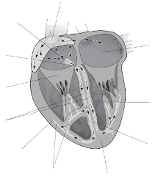
Adapted from: Seeley and Tate
• sinoatrial (SA) node
• AV node
• left atrium
• bundle of His
• left and right bundle branches
• left ventricle
• right ventricle
• right atrium
• apex of the heart
• purkinje fibres
• septum.
3.I.3 | Cardiac cycle
Briefly describe, in order, the events during the cardiac cycle in the diagrams below.
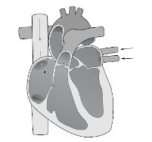 |  | Diastole

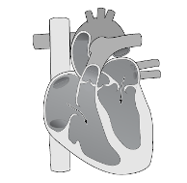 |  | Atrial systole

Lungs
Lungs
Body
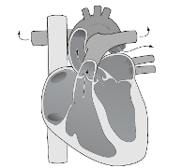 |  | Ventricular systole

3.I.4 | Distribution of cardiac  output at rest
‘Approximately litres of blood is pumped out of the heart every minute.’
• Look at the distribution of cardiac output during resting conditions in the diagram below.
• To simplify the diagram, let us split all the divisions into:
(a) muscles
(b) organs (liver, kidneys, heart, brain and others).
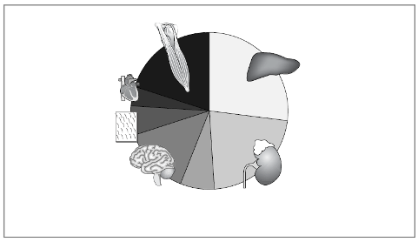
Other (7%)
350ml
Muscles (20%)
1000ml
Skin (6%)
300ml
Heart (4%)
200ml
Brain (14%)
700ml
Liver (27%)
1350ml
Kidneys (22%)
1100ml
1. | Where is the greatest percentage of cardiac output distributed during resting conditions?
2. | In relation to their overall mass, compare the percentage of cardiac output distributed to the kidneys, and that distributed to the muscles.
3. | Why is the distribution of cardiac output to muscles so low during resting conditions, despite the larger surface area of muscle?

3.I.5 | Distribution of cardiac output during exercise
1. Fill in the missing spaces with the following words:
supply
cardiac output
oxygen
demand
increased
During exercise the muscles’ for increases in line with exercise intensity.
If the of oxygen is to be met then the % of distributed to the working muscles will need to be .
2. Show your understanding of the redistribution of cardiac output during exercise by filling in the spaces to label the graph below. Use the labels provided.
80%
REST
MUSCLES
ORGANS
EXERCISE
20%

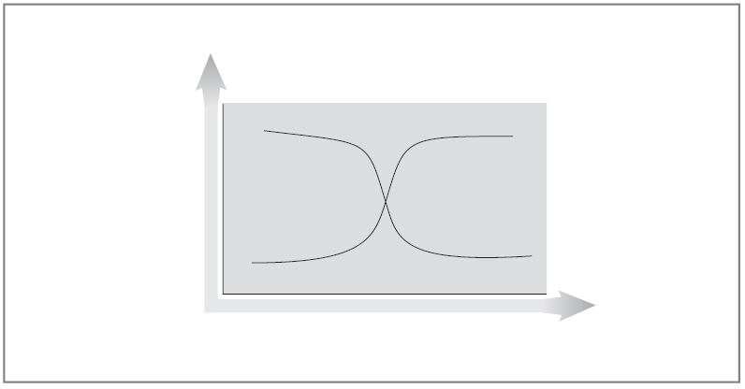
Redistribution of cardiac output from rest to exercise
AT DURING
Intensity
Approx
Q

Approx
Q

Cardiac output Q

3.I.6 | Stroke volume response to exercise
1. Stroke volume is determined by four main factors:
• volume (Starling’s Law of the Heart)
• ventricular (EDV)
• ventricular /force of contraction (ESV)
• and artery pressure.

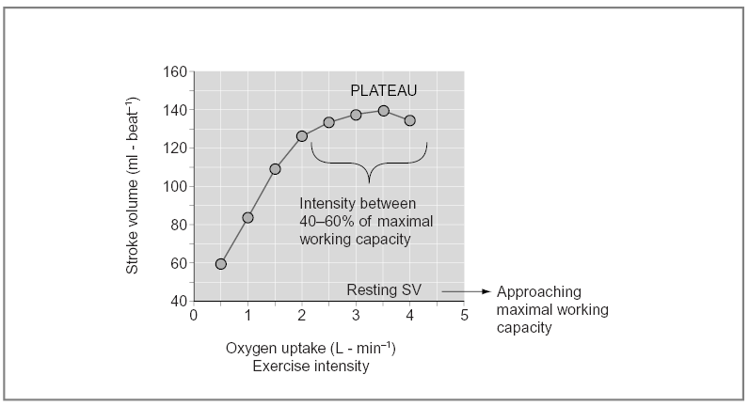
Stroke volume (SV) ? with exercise intensity

2. What happens to SV as exercise intensity increases?
3. What happens to SV before exercise intensity approaches maximal working capacity?
4. Why does SV not continue to increase towards maximal capacity as exercise intensity increases?
5. What is the benefit of an increased SV during exercise?

3.I.7 | Heart rate, stroke volume and Q response to changes in posture and exercise
Study the three graphs and the table below, and answer the following questions.
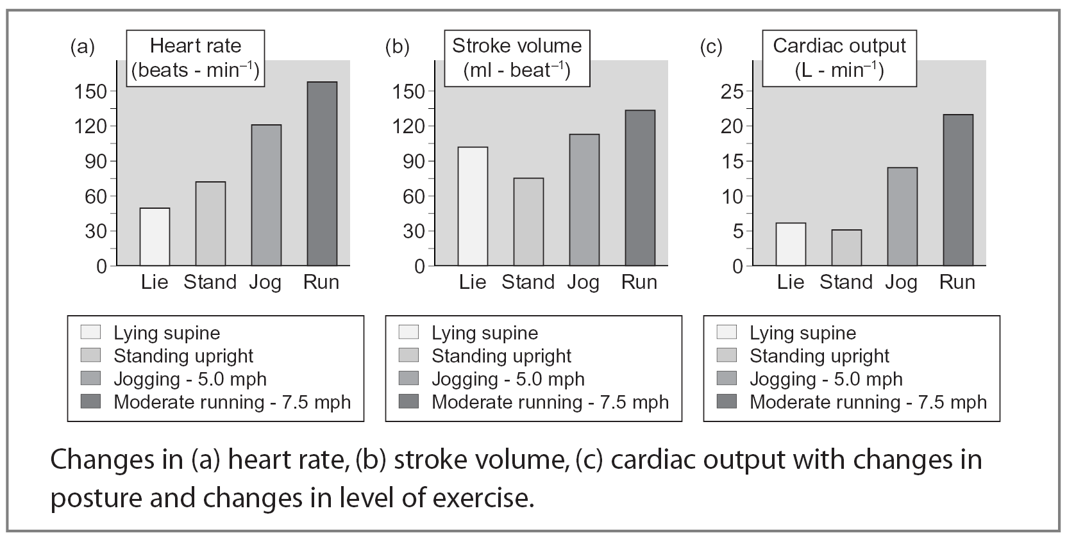
Active untrained male | HR (bpm) | SV (ml) | Q (L/min)
From: reclining/supine | 50 | 95 | 5.2
To: sitting | 55 | 70/80 | 4.7
Standing/upright | 60 | 60/70 | 4.2
Walking | 90 | 80/90 | 9
Jogging | 140 | 110 | 15
Fast paced running | 190 | 130 | 25
Cycling | 185 | 120 | 22
Swimming | 170 | 135 | 23
1. What happens to heart rate (HR) as exercise intensity increases?
2. What happens to SV from supine to sitting, and then to standing? Why?
3. What happens to cardiac output (Q) from supine to sitting and standing?
4. What happens to HR, SV and Q from walking to jogging and running?
5. Why does the swimmer have the highest SV?
6. Why does the cyclist have the lowest SV from the three exercise activities?

3.I.8 | Resting cardiac output, stroke volume and heart rate
1. Fill in the missing information to provide definitions and volumes for HR, SV and Q.
70 5 The amount of blood ejected from the heart ventricles in 1 minute.
The amount of blood ejected from the heart each time the ventricles contract.

4970 100

Heart Rate (HR) | The number of ventricular contractions in one minute. | Untrained  bpm | Trained  50 bpm
Stroke Volume (SV) |  | Untrained  71 ml | Trained  ml
Cardiac Output (Q) |  | Untrained  ml (4.97 litres) | Trained  5000 ml ( litres)
Cardiac output (Q) ×

3.I.9 | Stroke volume
‘The difference in the amount of blood in the ventricle before and after contraction of the heart.’
1. Write the following three definitions under the appropriate heading.
• The volume of blood ejected from the heart ventricles per beat.
• The volume of blood in the ventricles when it has completed its relaxation phase.
• The volume of blood remaining in the ventricles when it has completed its contraction phase.

End-Diastolic Volume EDV (before/filling)
__________________________________________________________________________

End-Systolic Volume ESV (after)
__________________________________________________________________________

Stroke Volume SV (difference)
__________________________________________________________________________
2. Formulate an equation to show the link between the three definitions above.
__________________________________________________________________________
3. Calculate SV during rest and exercise, using the analogy of the glasses below.
__________________________________________________________________________
4. What percentage of EDV is pumped out at rest?
__________________________________________________________________________
5. What does this tell you?
__________________________________________________________________________
At rest:
BeforeAfterSV
–=
EDV = 130 ml
ESV = 60 ml
SV =
?ml
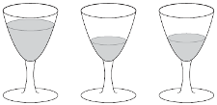
Notice that around 40–50% of the blood in the ventricles is pumped out at rest.
During exercise:
BeforeAfterSV
–=
EDV = 130 ml
ESV = 10 ml
SV =
?ml
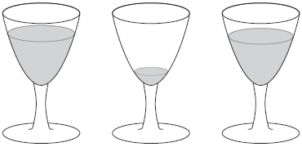

3.I.10 | Cardiovascular drift
1. The ‘cardiovascular drift’ shown below is the gradual decrease in SV and increase in HR during prolonged exercise. Research and discuss what might cause cardiovascular drift.

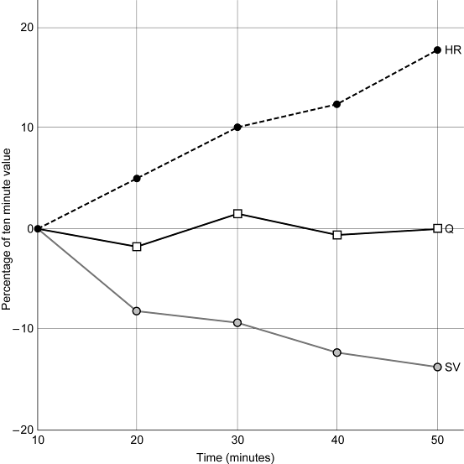

HR, Q and SV changes to prolonged moderate intensity exercise. Percentage of change from the values measured at the ten minute point of the exercise.

3.I.11 | Control of heart rate
1. Put the following words into the appropriate space within the following section.
involuntary medulla oblongata
intrinsic cardiac
neural motor
timings sympathetic
number

The is in the brain
This contains the following three control centres:
• the control centre
• the respiratory control centre
• the vasomotor control centre.

The cardiac control centre
This controls the / of heart contractions (HR), which are altered by three factors:
• control (most important)
• hormonal control
• control.

The autonomic nervous system
This is:
• under control
• made up of sensory/receptor and nerves
• motor nerves are referred to as the and parasympathetic nerves.

3.I.12 | Summary of factors affecting cardiac control centre
Fill in the boxes to complete the summary.

During exercise
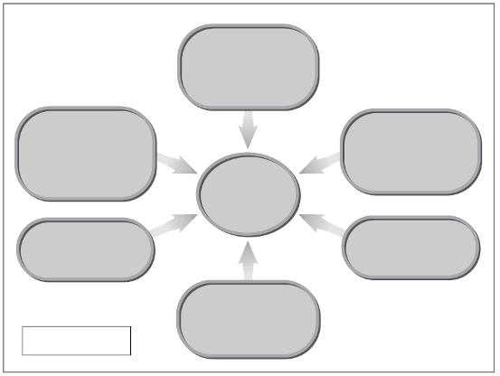
+
–

Neural
Neural
Neural
Intrinsic
Intrinsic
Hormonal
Temperature
Adrenaline
Venous return
Baroreceptors
Chemoreceptors
Proprioreceptors
Cardiac control centre in medulla oblongata
Key + increases HR
Key – decreases HR
+
+
+
+

3.II.1 | Blood vessel walls
Fill in the missing spaces.
There are three main groups of blood vessels:
1. and – that transport oxygenated blood away from the heart towards tissues/muscles.
2. – that bring blood directly into contact with tissues where oxygen and CO₂ are actually exchanged.
3. and – that transport deoxygenated blood back towards the heart.
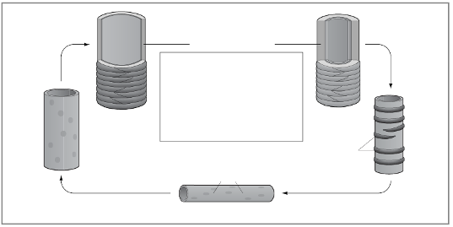
Smooth muscle layer
Arteries
Veins
Venule
Smooth muscle cell

Capillary

Endothelial cells

Arteriole

Six structural features related to their functions summarise what you need to know:
1. All blood vessels have three layers (except capillaries).
2. Arteries and arterioles have a larger middle layer of muscle to allow them to
and to alter their shape/size to regulate blood flow.
3. Arterioles have a ring of surrounding the entry to the capillaries. Called , they can vasodilate and vasoconstrict to alter their shape/size to regulate blood flow.
4. have a very thin, one-cell-thick layer to allow gaseous exchange to take place.
5. Larger veins have to prevent the backflow of blood and to direct blood in one direction back to the heart.
6. Venules and veins have a much thinner muscular layer, allowing them to and
to a lesser extent, and a thicker outer layer to help support the blood that sits within each pocket valve.
3.II.2 | Venous return
‘The flow of blood through the veins back to the heart.’

Starling’s Law of the Heart: Stroke volume is dependent on venous return. If venous return (VR) increases, stroke volume increases and vice versa.

Problem
During exercise the pressure of blood in the veins is not sufficient to maintain VR so SV and cardiac output will decrease. The body needs additional mechanisms to help push the blood through the veins, against gravity, back to the heart to increase VR and therefore SV.
Five mechanisms help maintain venous return (see diagram). Describe the function of each in the spaces provided.
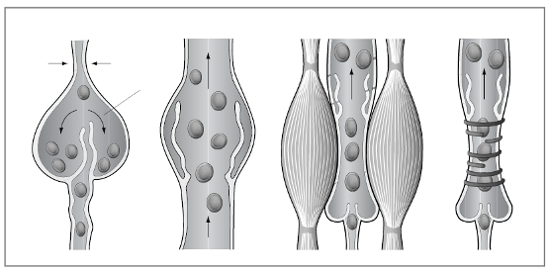
Blood poolingPocket valveMuscle pumpSmooth muscle
Blood pooling
1. | Pocket valves
2. | Muscle pump
3. | Respiratory pump
4. | Smooth muscle
5. | Gravity

3.II.3 | The muscle pump
1. Put the following points in the appropriate box to complete a logical explanation of the muscle pump action.
• Valve opens and blood is squeezed through.
• Skeletal muscles contract.
• One-way valves close when muscles are relaxed.
• Veins are situated between skeletal muscles.
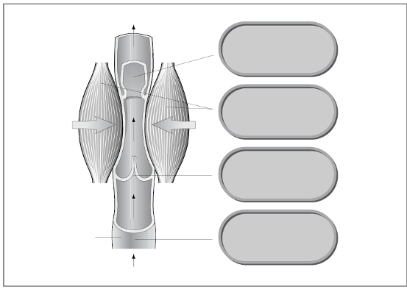
Venous return
To heart
Vein
Skeletal muscles
4.
1.
2.
3.

3.II.4 | Vascular shunt mechanism
1. Fill in the missing spaces.
Vascular shunt refers to . During exercise, the vascular system redistributes blood to areas with the greatest for O₂, from areas with demands for O₂.
2. Study the table below showing the relative distribution of cardiac output from rest to maximal exercise conditions.
Tissue | Rest |  | Light |  | Moderate |  | Maximal
 | % | ml | % | ml | % | ml | % | ml
LIVER | 27 | 1350 | 12 | 1100 | 3 | 600 | 1 | 300
KIDNEYS | 22 | 1100 | 10 | 900 | 3 | 600 | 1 | 250
BRAIN | 14 | 700 | 8 | 750 | 4 | 750 | 3 | 750
HEART | 4 | 200 | 4 | 350 | 4 | 750 | 4 | 1000
MUSCLE | 20 | 1000 | 47 | 4500 | 71 | 12 500 | 88 | 22 000
SKIN | 6 | 300 | 15 | 1500 | 12 | 1900 | 2 | 600
OTHER | 7 | 350 | 4 | 400 | 3 | 500 | 1 | 100
TOTAL | 100 | 5000 | 100 | 9500 | 100 | 17 600 | 100 | 25 000
Adapted from: Physiology for Sportspeople.
Summarise the distribution of cardiac output (Q) at rest and during exercise under the two headings below.

At rest: | During exercise:

3.II.5 | Vasomotor control
1. Fill in the missing spaces.
The vascular shunt mechanism is controlled by the __________ __________ __________ located in the medulla oblongata, which stimulates the __________ nervous system to either vasodilate or vasoconstrict the __________ __________ and __________ that control the supply of blood to muscles and organs.

Vasomotor control
VCC receives information from:
• __________ in muscles, aorta and carotid arteries, which inform the VCC that lactic acid and CO₂ levels have increased and O₂ and pH levels have decreased.
• __________ in aorta and carotid arteries, which inform the vasomotor centre that systolic blood pressure has increased/decreased.

Sympathetic nervous system
The VCC responds by sending messages via the sympathetic nervous system to:

Organs
• Increasing sympathetic stimulation, which __________ the arterioles and precapillary sphincters, decreasing Q and distributing blood flow away from the non-essential capillaries of the organs.

Muscles
• Decreasing sympathetic stimulation, which __________ the arterioles and precapillary sphincters, which increases the distribution of Q to the capillaries of the working muscles.
3.II.6 | O₂ and CO₂ transport
1. Link together the boxes with arrows to show how O₂ and CO₂ are transported within the blood.
As carbaminohaemoglobin, HbCO₂
In plasma
As oxyhaemoglobin, HbO₂
Dissolved in rbcs as carbonic acid,
as carbaminohaemoglobin, H₂CO₃

O₂
CO₂

2. Show with arrows where O₂ and CO₂ are picked up and dropped off in the diagram below.

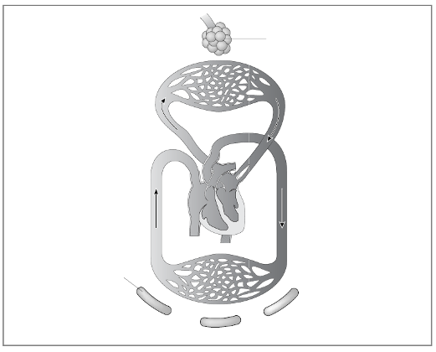
External respiration
Internal respiration
Muscles
Lungs

3.II.7 | Impact of climatic conditions on aerobic performance
The table shows air pollution data taken in 1995 from many major cities around the world. As well as the population of each city, the levels of air pollution are displayed under three separate headings: suspended particles, sulphur dioxide and nitrogen dioxide (the three main contributors of air pollution in cities).
Discuss the possible impact of these climatic conditions on aerobic performance. Include reference to asthma and O₂ transport in your discussions.
City | Population/ million | Suspended particles (mg/m³) | Sulphur dioxide (mg/m³) | Nitrogen dioxide (mg/m³)
WHO recommended max. levels |  | 90 | 50 | 50
Amsterdam | 1.1 | 40 | 10 | 58
Athens | 3.1 | 178 | 34 | 64
Beijing | 11.3 | 377 | 90 | 122
Brussels | 1.1 | 78 | 20 | 48
Bombay | 15.1 | 240 | 33 | 39
Cairo | 9.9 | — | 69 | —
Copenhagen | 1.3 | 61 | 7 | 54
Dublin | 0.9 | — | 20 | —
Kuala Lumpar | 1.2 | 85 | 24 | —
London | 7.6 | — | 25 | 77
Los Angeles | 12.4 | — | 9 | 74
Moscow | 9.3 | 100 | 109 | —
Mexico City | 16.6 | 279 | 74 | 130
Milan | 4.3 | 77 | 31 | 248
Montreal | 3.3 | 34 | 10 | 42
Singapore | 2.8 | — | 20 | 30

What strategies did the Chinese government put in place to try to alleviate concerns over air pollution prior to and during the 2008 Beijing Olympic Games?

3.II.8 | Blood pressure and HR baroreceptor control
To show the impact of blood pressure (BP)/response of baroreceptors on heart rate (HR) by measuring the HR of a performer during a headstand and from seated to standing position.
1. Use a BP and HR monitor to measure the changes in HR of a performer during a headstand and from a seated to standing position
2. How does the response of BP and baroreceptors account for the changes in HR?
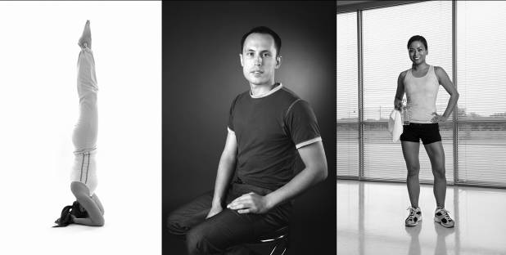

3.II.9 | CHD primary risk factors
1. Add up your scores for 1 to 5 to calculate a simplistic assessment of your level of risk of developing CHD.
2. You will not know your blood lipids results but you may wish to estimate the quality of your diet in terms of a healthy lifestyle from 1 to 5.
3. You will also need to look up a body mass index (BMI) table to calculate your obesity score.
4. Compare your own results with those of your group (min 5 to max 25 risk score).

 | Level of risk
Risk factor | 1 | 2 | 3 | 4 | 5
 | V Low | Low | Mod | High | V High
1. Physical/activity (minutes/week)
Above 60% HR max | 120 | 90 | 30 | 0 | 0
2. Blood pressure (mmHg)
Systolic | <110 | 120 | 130–140 | 156–160 | >170
Diastolic | <70 | 76 | 82–88 | 94–100 | >106
3. Smoking  (cigarettes/day) | 0 | 5 | 10–20 | 30–40 | >50
4. Blood lipids
Cholesterol (mg/dl) | <180 | <200 | 220-240 | 260-280 | >300
Triglycerides (mg/dl) | <50 | <100 | <130 | <200 | <300
5. Obesity (BMI) | >25–27 | 27–30 | 30–34 | 35–<39 | >40
Source: adapted from Wilmore.
3.II.10 | Body mass index
1. Calculate your body mass index (BMI) using the calculation below, for use in calculating your CHD risk factor score in Worksheet 3.II.9.
2. Compare your own results with those of your group.
3. How do you compare with the criteria for being overweight and obese?
4. What problems do you see in the general use of BMI calculations?

Calculation
Example:
Height squared = 1.88 m x 1.88 m = 3.53
Weight divided by height squared = 95.2 ÷ 3.53 = 26.9

My height squared = ______ x ______ = ______
My weight divided by my height squared = ______ ÷ ______ = ______
My BMI = ______

A BMI of 27 is overweight

A BMI of over 30 is considered obese

3.III.1 | Lung structure
Add the following labels to the diagrams below.
Lungs Nasal cavity Oral cavity Pharynx
Larynx Bronchi (L & R) Trachea Nose
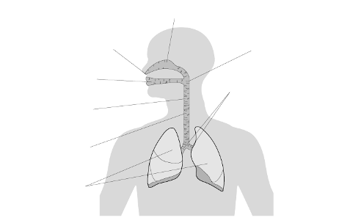

Trachea L and R bronchi Alveolar ducts Alveoli Bronchioles

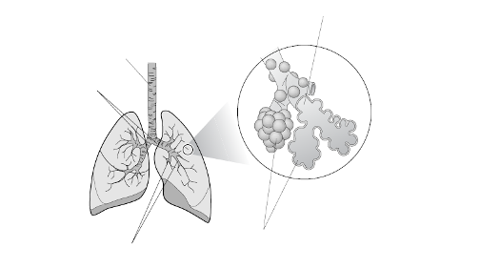
3.III.2 | The respiratory system
1. Label the diagram below to refresh your knowledge of the respiratory structures, using the labels provided.
Nasal cavity Larynx Trachea Primary bronchi
Pharynx Alveolus Pulmonary capillaries
Bronchiole Capillary network Lung
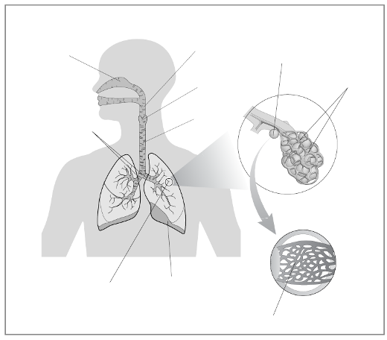
3.III.3 | Mechanics of breathing at rest
Fill in the missing spaces to describe the processes of inspiration and expiration at rest.

Inspiration
1. Diaphragm ____________
2. External intercostal muscles ____________
3. Ribs move ____________ and ____________
4. Volume of the thoracic cavity ____________
5. Pressure of air within the lungs ____________
6. Air rushes ____________

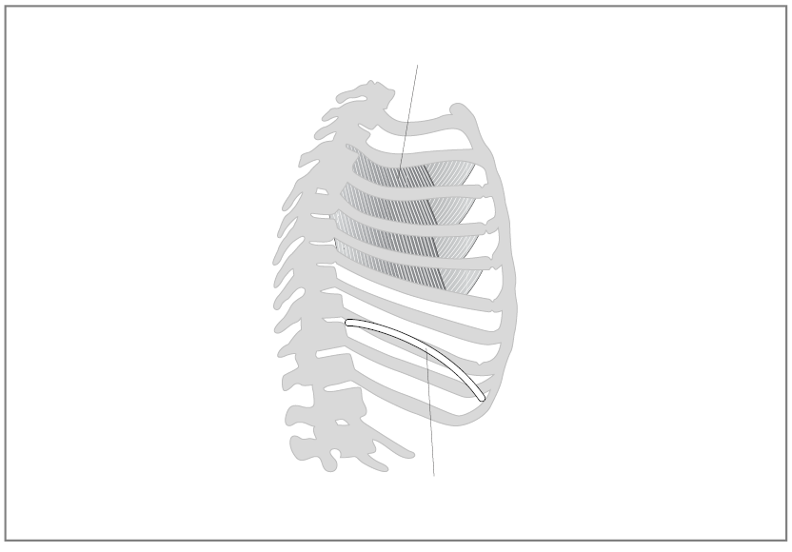
Diaphragm contracts
External intercostal muscles contract

Expiration
1. Diaphragm ____________
2. External intercostal muscles ____________
3. Ribs move ____________ and ____________
4. Volume of the thoracic cavity ____________
5. Pressure of air within the lungs ____________
6. Air rushes ____________
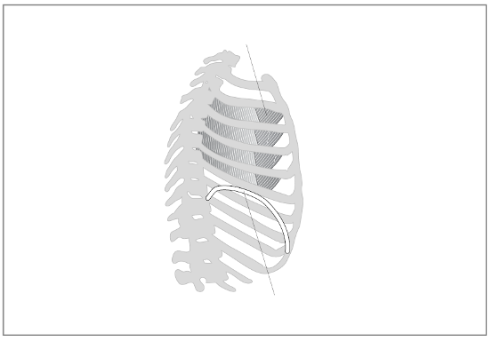
____________ ____________ muscles relax
Diaphragm ____________

3.III.4 | Respiratory processes
Fill in the missing spaces to make the distinction between ventilation (of air) and gaseous exchange at the lungs and at the muscle cell (of oxygen and carbon dioxide).

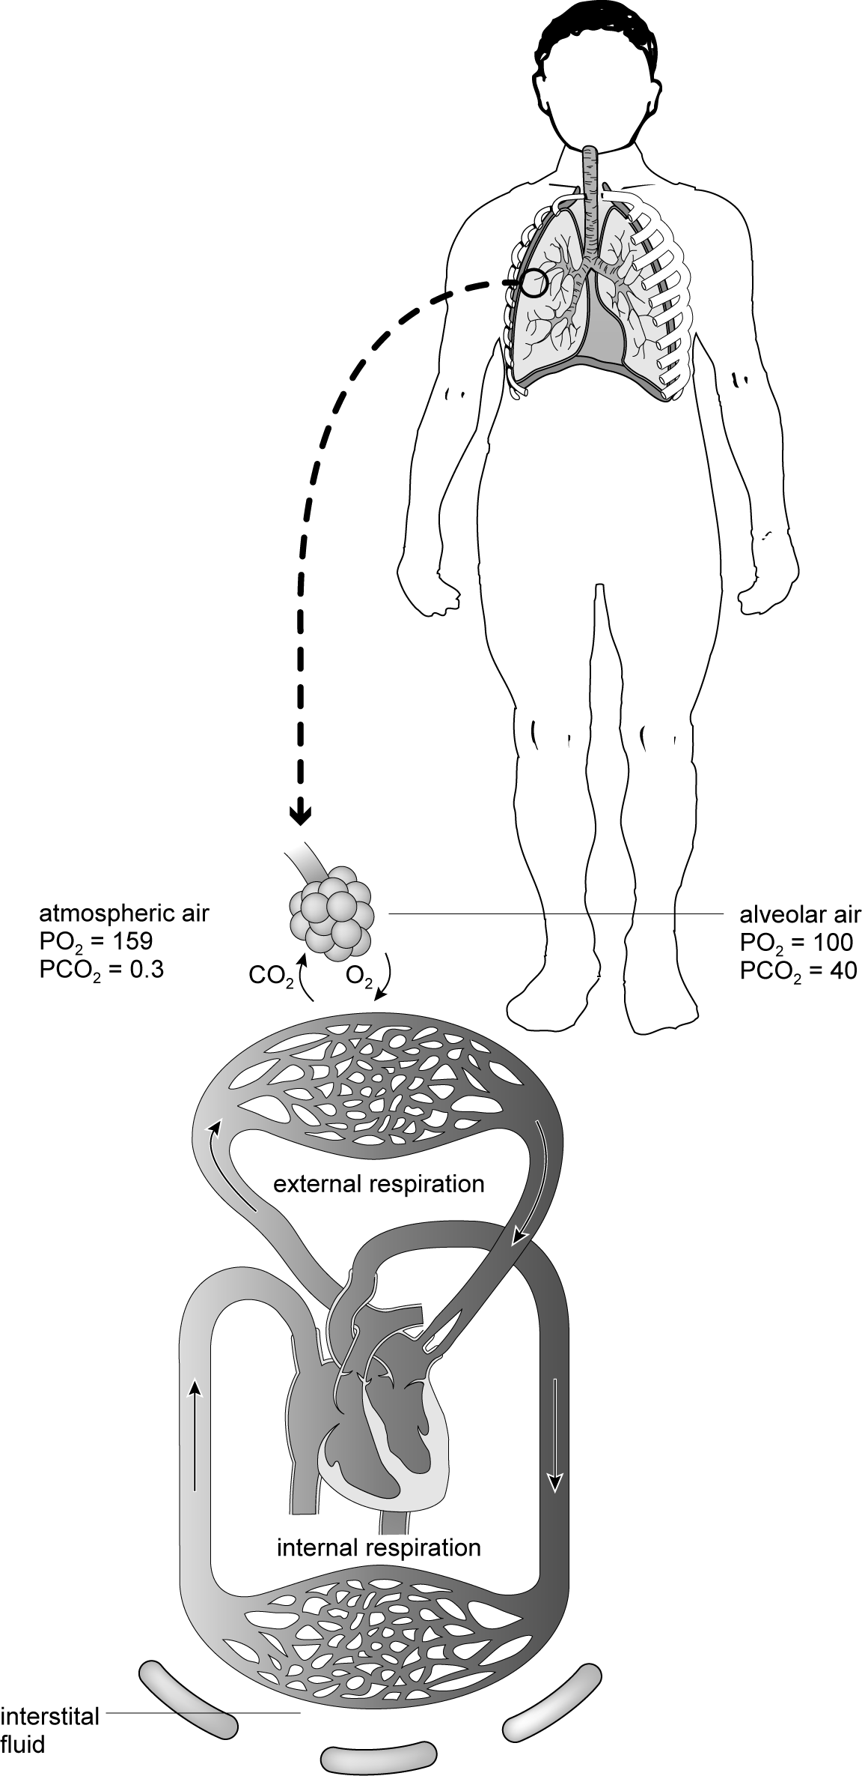

3 main processes within respiratory system
1. ______________ ventilation.
The breathing of air into and out of the lungs.

2. ______________ respiration.
Exchange of O₂ and CO₂ between the ______________ and blood.

1 and 2 are linked to 3 by the transport of O₂ and CO₂ in the blood to the heart and around systemic and pulmonary circulation.

3. ______________ respiration.
Exchange of O₂ and CO₂ between the blood and _____________/_____________.

3.III.5 | Diffusion gradients
Analyse and compare the two graphs below, which show the association of haemoglobin at rest and during exercise.
Discuss why at rest the diffusion gradient is relatively small for gaseous exchange and why during exercise the diffusion gradient gets bigger.
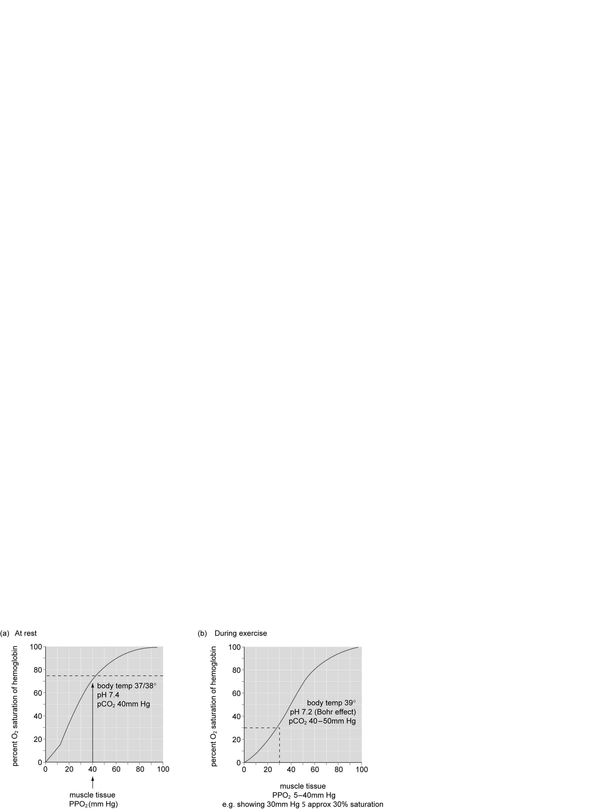

3.III.6 | Gaseous exchange
1. Complete the following table by adding one of the four terms below to show your understanding of gaseous exchange.
High Low Higher Lower
2. Draw arrows () to show the direction of diffusion. Remember that gases always move from an area of high pressure to an area of low pressure.

External respiration
Partial pressure | Alveolar air | Direction of diffusion  High to low pp | Alveoli capillary blood
O₂ resting | High |  | Low
O₂ during exercise
CO₂ resting
CO₂ during exercise

Internal respiration
Partial pressure | Capillary blood | Direction of diffusion  High to low pp | Muscle tissue
O₂ resting
O₂ during exercise
CO₂ resting
CO₂ during exercise

3.III.7 | Efficiency of gaseous exchange
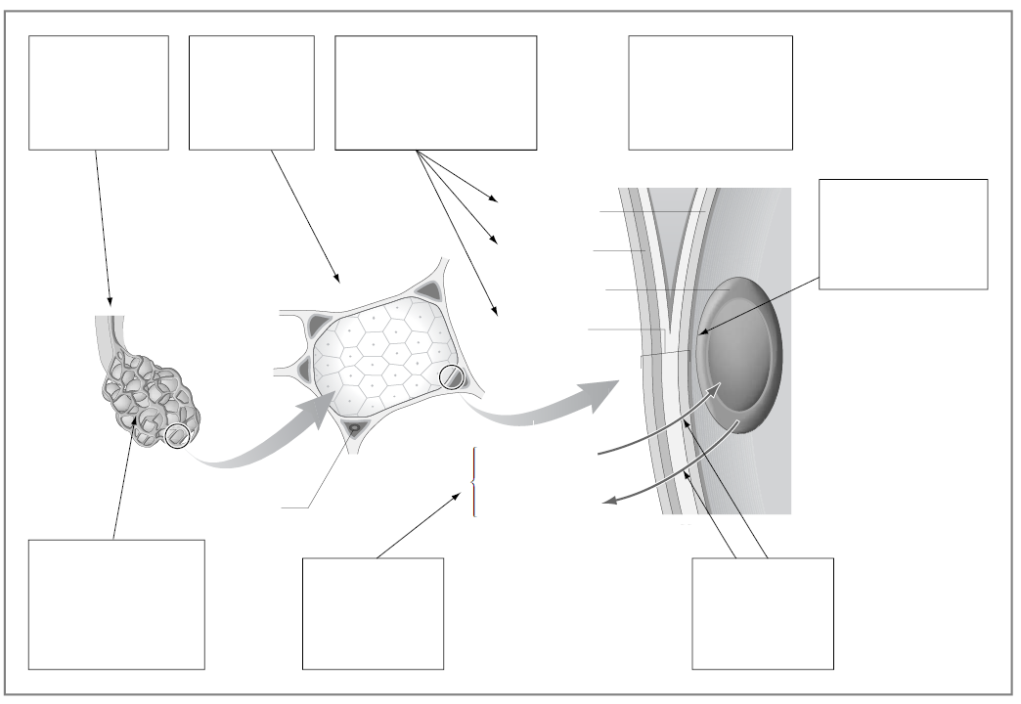
Fill in the empty boxes to show why gaseous exchange in the lungs is an efficient process.
Capillary wall
Alveolar wall
Respiratory membrane
Red blood cell in capillary
Red blood cell
Diffusion of O₂
Diffusion of CO₂
LOW
LOW
HIGH
HIGH
3.III.8 | Respiratory volumes
1. Complete the table below to compare resting and exercise lung volumes.

Lung volume | Definition | Resting volume | Change during exercise
Tidal
volume
Frequency
Minute ventilation |  |  | Untrained _____  Post training ____  Elite ___ / ___ L/min
2. Put the abbreviations below into the correct order to show the link between them.
Tidal Volume (TV)
Frequency (f)
Minute Ventilation (VE)
The link between TV, f and VE is shown by the equation:
____ = ____ x ____
3. Summarise the benefits/adaptations of training on the respiratory volumes above.

4. How do the benefits/adaptations of respiratory volumes help improve performance?
3.III.9 | Respiratory response to exercise
1. Plot the two curves to show typical minute ventilation (VE) response to submaximal and maximal work for an 18-year-old student.
2. Where have you seen similar shaped graphs before?
3. What does this tell you about the response of the body to exercise?
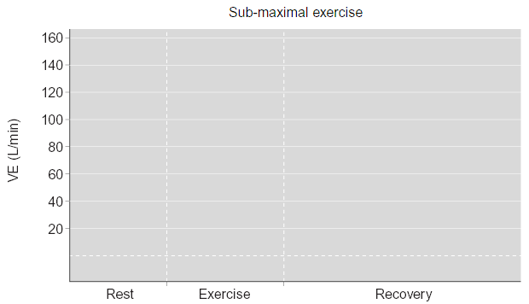
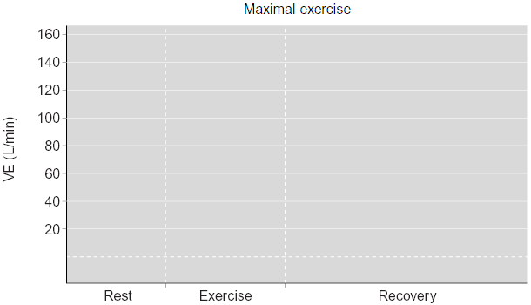

3.III.10 | The ventilatory response to light, moderate and heavy exercise
1. Describe and explain the response of VE for the three exercise intensities, remembering to break the process down into six steps, as with HR response.
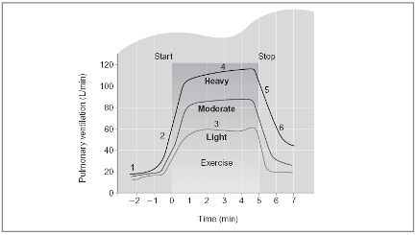
1.
2.
3.
4.
5.
6.

3.III.11 | Effect of altitude on the respiratory system
Fill in the boxes to show your understanding of the effect of altitude on the respiratory system.
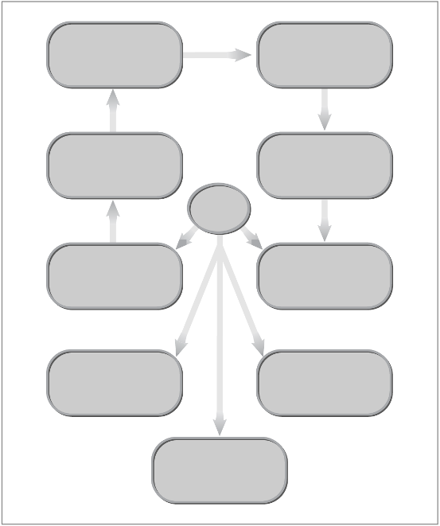
9. Long-term effect

5.

4.

3.
2.

1.

8.

7.

6. Net effect

Effects of altitude on respiratory system
Primary effects
Other effects

3.III.12 | Asthma and an active lifestyle

Complete the spaces below to summarise how you may evaluate critically a lifelong involvement in an active/healthy lifestyle in relation to asthma.
1. Symptoms:

2. Measurement:

3. Triggers:

4. Performance affects:

5. Management:
• Medical treatments

• Non–medical treatments

3.III.13 | Control and regulation of cardiorespiratory control during exercise
Sketch a diagram to show the link between neural control of the respiratory system, the cardiac control centre and the vasomotor control centre.

3.I.1 | Chambers of the heart – answers
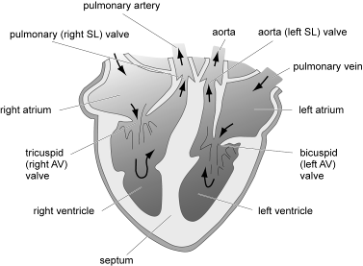
1.

3.I.2 | The conduction system of the heart – answers
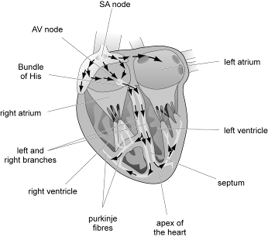
1.

Adapted from: Seeley and Tate

3.I.3 | Cardiac cycle – answers
Briefly describe, in order, the events during the cardiac cycle in the diagrams below.
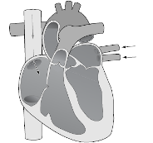 |  | Diastole
 |  | Relaxation/passive filling phase lasting 0.5 seconds.
 |  | Deoxygenated blood enters right atria from superior and inferior vena cavae.
 |  | Oxygenated blood enters left atrium from pulmonary veins.
 |  | Rising pressure of blood against AV valves forces blood through into ventricles.
 |  | Past tricuspid valve on the right side of the heart.
 |  | Past bicuspid valve on the left side of the heart.
 |  | Volume of blood after filling is termed end diastolic volume (EDV).

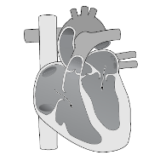 |  | Atrial systole
 |  | Contraction of left and right atria.
 |  | Increased pressure in atria forces the remaining blood into the left and right ventricles.

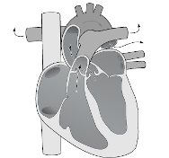  Lungs  Lungs  Body |  | Ventricular systole
 |  | Contraction of both left and right ventricles.
 |  | Increases ventricle pressure, forcing blood out of both ventricles (stroke volume).
 |  | Right ventricle forces blood out of pulmonary valve into pulmonary artery and to the lungs.
 |  | Left ventricle forces blood out of aortic valve into aorta to the body tissues.
 |  | A reserve volume of blood may be left in ventricles (ESV).
 |  | Tricuspid and bicuspid valves remain shut.
 |  | Aortic and pulmonary valve close after ventricular systole to prevent blood flow back into ventricles. Next diastole phase begins.

3.I.4 | Distribution of cardiac output at rest – answers
‘Approximately 5 litres of blood is pumped out of the heart every minute.’
• Look at the distribution of cardiac output during resting conditions in the diagram below.
• To simplify the diagram, let us split all the divisions into:
(a) muscles
(b) organs (liver, kidneys, heart, brain and others).
Other (7%)
350ml
Muscles (20%)
1000ml
Skin (6%)
300ml
Heart (4%)
200ml
Brain (14%)
700ml
Liver (27%)
1350ml
Kidneys (22%)
1100ml
1. | Where is the greatest percentage of cardiac output distributed during resting conditions?
 | Greatest percentage distributed to organs. Only 20% distributed to muscles.
2. | In relation to their overall mass, compare the percentage of cardiac output distributed to the kidneys, and that distributed to the muscles.
 | Percentage distributed to kidneys is much the same as muscles and yet kidneys are very small compared with muscle mass.
3. | Why is the distribution of cardiac output to muscles so low during resting conditions, despite the larger surface area of muscle?
 | During rest muscles are mostly inactive and do not require a large percentage of cardiac output to supply the oxygen for their energy demands.

3.I.5 | Distribution of cardiac output during exercise – answers
1. Fill in the missing spaces with the following words:
supply
cardiac output
oxygen
demand
increased
During exercise the muscles’ demand for oxygen increases in line with exercise intensity.
If the supply of oxygen is to be met then the % of cardiac output distributed to the working muscles will need to be increased.
2. Show your understanding of the redistribution of cardiac output during exercise by filling in the spaces to label the graph below. Use the labels provided.
80%
REST
MUSCLES
ORGANS
EXERCISE
20%

Redistribution of cardiac output from rest to exercise
AT RESTDURING EXERCISE
Intensity
Approx
80% Q

Approx
20% Q

MUSCLES

ORGANS

Cardiac output Q

3.I.6 | Stroke volume response to exercise – answers
1. Stroke volume is determined by four main factors:
• Venous return volume (Starling’s Law of the Heart)
• ventricular stretch (EDV)
• ventricular contractility/force of contraction (ESV)
• and pulmonary artery pressure.

Stroke volume (SV) increases with exercise intensity

2. What happens to SV as exercise intensity increases?

SV increases with increase in intensity but only up to exercise intensities between 40–60% of an individual’s maximal working capacity.
3. What happens to SV before exercise intensity approaches maximal working capacity?

After this, stroke volume is thought to plateau or fall slightly.
4. Why does SV not continue to increase towards maximal capacity as exercise intensity increases?

Heart rate increases as exercise intensity increases; therefore there is less time for diastole/venous return to fill the heart. The physical size of the heart also limits/prevents SV from continuing to increase. SV changes with heart rate to ensure the most efficient supply of cardiac output to the working muscles.
5. What is the benefit of an increased SV during exercise?

Increased SV increases Q and therefore increases supply of O₂ to the working muscles, increasing aerobic endurance and delaying fatigue.
3.I.7 | Heart rate, stroke volume and Q response to changes in posture and exercise – answers
1. What happens to heart rate (HR) as exercise intensity increases?

HR increases in line with exercise intensity.
2. What happens to SV from supine to sitting, and then to standing? Why?

SV decreases from supine to sitting, and decreases further to standing. Blood pooling does not occur in the supine position so VR is easily returned to the heart. In sitting and standing VR has to return against gravity, increasing blood pooling, which reduces VR and therefore SV (Starling’s Law).
3. What happens to cardiac output (Q) from supine to sitting and standing?

Q is a product of SV and therefore decreases in line with SV from supine to sitting and standing.
4. What happens to HR, SV and Q from walking to jogging and running?

HR and SV increase and consequently increase Q as exercise intensity increases.
5. Why does the swimmer have the highest SV?

Swimmer is in a supine position so there is less blood pooling in the legs.
6. Why does the cyclist have the lowest SV from the three exercise activities?

Cycling position causes the most blood pooling, and fewer muscles are active, reducing muscle pump action.

3.I.8 | Resting cardiac output, stroke volume and heart rate – answers
1. Fill in the missing information to provide definitions and volumes for HR, SV and Q.

Heart Rate (HR) | The number of ventricular contractions in one minute. | Untrained  70 bpm | Trained  50 bpm
Stroke Volume (SV) | The amount of blood ejected from the heart each time the ventricles contract | Untrained  71 ml | Trained  100 ml
Cardiac Output (Q) | The amount of blood ejected from the heart in  1 minute | Untrained  4970 ml  (4.97 litres) | Trained  5000 ml (5 litres)
Cardiac output (Q) SV × HR

3.I.9 | Stroke volume – answers
1. End-Diastolic Volume EDV (before/filling)
The volume of blood in the ventricles when it has completed its relaxation phase.
End-Systolic Volume ESV (after)
The volume of blood remaining in the ventricles when it has completed its contraction phase.
Stroke Volume SV (difference)
The volume of blood ejected from the heart ventricles per beat.
2. EDV – ESV = SV
3. (See below in the glasses.)
4. Only up to 40–50% of the blood in the ventricles is pumped out at rest.
5. Heart has a reserve volume (ESV), which can be used during exercise to increase SV.

At rest:
BeforeAfterSV
–=
EDV = 130 ml
ESV = 60 ml
SV =
70 ml
Notice that around 40–50% of the blood in the ventricles is pumped out at rest.
During exercise:
BeforeAfterSV
–=
EDV = 130 ml
ESV = 10 ml
SV =
120 ml

3.I.10 | Cardiovascular drift – answers
1. Cardiovascular drift is the gradual decrease in SV and increase in HR during prolonged exercise.
2. Arterial (systemic/pulmonary) pressure also declines.
This effect is generally associated with an increase in body temperature, which causes an increase in Q redirected to the skin to reduce body temperature and a decrease in blood plasma volume as a result of sweating. Together, these decrease VR, which in turn decreases EDV, which in turn decreases SV. The HR increases to compensate for the decrease in SV to maintain the required Q. Relate the control mechanisms to HR response e.g. anticipatory rise due to effect of adrenaline on SA node.

3.I.11 | Control of heart rate – answers
1. Put the following words into the appropriate space within the following section.
involuntary medulla oblongata
intrinsic cardiac
neural motor
timings sympathetic
number
The medulla oblongata is in the brain
This contains the following three control centres:
• the cardiac control centre
• the respiratory control centre
• the vasomotor control centre.

The cardiac control centre
This controls the timings/number of heart contractions (HR), which are altered by three factors:
• neural control (most important)
• hormonal control
• intrinsic control.

The autonomic nervous system
This is:
• under involuntary control
• made up of sensory/receptor and motor nerves
• motor nerves are referred to as the sympathetic and parasympathetic nerves.

3.I.12 | Summary of factors affecting cardiac control centre – answers
Fill in the boxes to complete the summary.

During exercise
Neural
Neural
Neural
Intrinsic
Intrinsic
Hormonal
Temperature
Increase in temperature = increase in HR
Adrenaline
From adrenal glands
Stimulates SA node directly via blood = increases in HR & SV
Venous return
Increase in VR (Starling’s Law) = increase in HR & SV
Baroreceptors
In aorta & carotid arteries
Increase in blood pressure = decrease in HR but neutralised due to demand for O₂
Chemoreceptors
In muscles, aorta &
carotid arteries
1. Decrease in pH
2. Increase in pp CO₂
3. Decrease in pp O₂
Proprioreceptors
e.g. Golgi tendon organs, muscle spindles/joint receptors
Increase in motor activity = increase in HR & SV
Cardiac control centre in medulla oblongata
Key + increases HR
Key – decreases HR
+
+
+
+
–

+
3.II.1 | Blood vessel walls – answers
Fill in the missing spaces.
There are three main groups of blood vessels:
1. Arteries and arterioles – that transport oxygenated blood away from the heart towards tissues/muscles.
2. Capillaries – that bring blood directly in contact with tissues where oxygen and CO₂ are actually exchanged.
3. Venules and veins – that transport deoxygenated blood back towards the heart.
Smooth muscle layer
Arteries
Veins
Venule
Smooth muscle cell

Capillary

Endothelial cells

Arteriole

Six structural features related to their function summarise what you need to know:
1. All blood vessels have three layers (except capillaries).
2. Arteries and arterioles have a larger middle layer of smooth muscle to allow them to
vasodilate and vasoconstrict to alter their shape/size to regulate blood flow.
3. Arterioles have a ring of smooth muscle surrounding the entry to the capillaries. Called pre-capillary sphincters, they can vasodilate and vasoconstrict to alter their shape/size to regulate blood flow.
4. Capillaries have a very thin, one-cell-thick layer to allow gaseous exchange to take place.
5. Larger veins have pocket valves to prevent the backflow of blood and direct blood in one direction back to the heart.
6. Venules and veins have a much thinner muscular layer, allowing them to vasodilate and
vasoconstrict to a lesser extent, and a thicker outer layer to help support the blood that sits within each pocket valve.
3.II.2 | Venous return – answers
Five mechanisms help maintain venous return.
Blood poolingPocket valveMuscle pumpSmooth muscle
Blood pooling
1. | Pocket valves
 | One-way valves, called pocket valves, in the veins prevent backflow of blood and direct blood flow back towards the heart.
2. | Muscle pump
 | Veins are situated between skeletal muscle which, when contracting and relaxing, helps push/squeeze blood through the veins back towards the heart.
3. | Respiratory pump
 | During exercise, breathing becomes deeper/faster. This causes pressure changes to occur in the thorax and abdomen. This increases the pressure in the abdomen causing the large veins in that area to be squeezed/sucked. This forces the blood back to the heart.
4. | Smooth muscle
 | Contraction and relaxation of smooth muscle within the middle layer of veins’ walls also helps to push blood through the veins and back toward the heart.
5. | Gravity
 | Blood from the upper body, above the heart, is aided by gravity, which helps blood flow back to the heart.

3.II.3 | The muscle pump – answers
1. Put the following points in the appropriate box to complete a logical explanation of the muscle pump action.
• Valve opens and blood is squeezed through.
• Skeletal muscles contract.
• One-way valves close when muscles are relaxed.
• Veins are situated between skeletal muscles.

1.
Veins are situated between skeletal muscles.
2.
One-way valves close when muscles are relaxed.
Venous return
To heart
Vein
Skeletal muscles
4.
Valve opens and blood is squeezed through.
3.
Skeletal muscles contract.

3.II.4 | Vascular shunt mechanism – answers
1. Fill in the missing spaces.
Vascular shunt refers to the redistribution of blood. During exercise, the vascular system redistributes blood to areas with the greatest demand for O₂, from areas with low demands
for O₂.
2. Study the table below showing the relative distribution of cardiac output from rest to maximal exercise conditions.
Summary of the distribution of cardiac output.
At rest:
• Only 15–20% resting cardiac output is supplied to muscles.
• The remaining cardiac output (80–85%) supplies bodily organs, e.g. kidney, liver, stomach, intestines.
During exercise:
• Increased cardiac output (80–85%) is supplied to the working muscles as exercise intensity increases.
• Decreasing % of cardiac output is supplied to bodily organs.
• Blood supply to the brain is maintained.
• Increased blood supply to skin surface during lighter work to help control body temperature, but decreases as exercise intensity increases.
3.II.5 | Vasomotor control – answers
1. Fill in the missing spaces.
The vascular shunt mechanism is controlled by the vasomotor control centre located in the medulla oblongata, which stimulates the sympathetic nervous system to either vasodilate or vasoconstrict the precapillary sphincters and arterioles that control the supply of blood to muscles and organs.

Vasomotor control
VCC receives information from:
• Chemoreceptors in muscles, aorta and carotid arteries, which inform the VCC that lactic acid and CO₂ levels have increased and O₂ and pH levels have decreased.
• Baroreceptors in aorta and carotid arteries, which inform the vasomotor centre that systolic blood pressure has increased/decreased.

Sympathetic nervous system
The VCC responds by sending messages via the sympathetic nervous system to:

Organs
• Increasing sympathetic stimulation, which vasoconstricts the arterioles and pre-capillary sphincters, decreasing Q and distributing blood flow away from the non-essential capillaries of the organs.

Muscles
• Decreasing sympathetic stimulation, which vasodilates the arterioles and pre-capillary sphincters, which increases the distribution of Q to the capillaries of the working muscles.
3.II.6 | O₂ and CO₂ transport – answers
1. Link together the boxes with arrows to show how O₂ and CO₂ are transported within the blood.
As carbaminohaemoglobin, HbCO₂
In plasma
As oxyhaemoglobin, HbO₂
Dissolved in rbcs as carbonic acid,
as carbaminohaemoglobin, H₂CO₃

O₂
CO₂

2. Show with arrows where O₂ and CO₂ are picked up and dropped off in the diagram below.
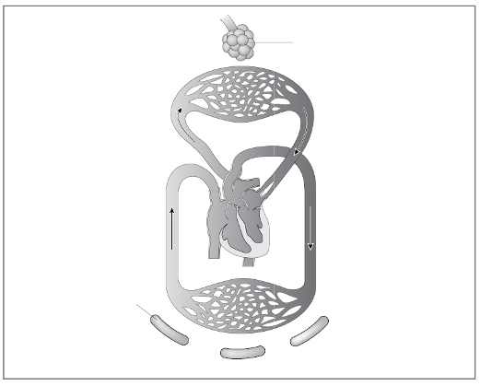

3.II.7 | Impact of climatic conditions on aerobic performance – answers
Discuss the possible impact of these climatic conditions on aerobic performance. Include reference to asthma and O₂ transport in your discussions.
The table show air pollution data taken in 1995 from many major cities around the world. As well as the population of each city, the levels of air pollution are displayed under three separate headings: suspended particles, sulphur dioxide and nitrogen dioxide (the three main contributors of air pollution in cities).
What strategies did the Chinese government put in place to try to alleviate concerns over air pollution prior to and during the 2008 Beijing Olympic Games?

Analysis of table
From this data it can be seen that the most polluted cities include Beijing and Mexico City, which have high levels of all three pollutants. As well as this, Athens, Moscow and Bombay have high levels of suspended particles, Cairo and Moscow have high levels of sulphur dioxide and Amsterdam, Athens, Copenhagen, London, Los Angeles, Milan and Tokyo have high levels of nitrogen dioxide.
Chinese government measures
• Shut down all major industries a month before the Games.
• Restricted vehicle use during the Olympic Games in Beijing in an attempt to reduce air pollution.

Additional sample articles for inclusion in discussions are summarised below.
In summary, aerobic performance is impaired. There will be less O₂ and more CO and other pollutants in the atmosphere, which reduces O₂ supply and transport to the working muscles. Furthermore the air pollution will impair respiratory structures, reducing respiratory efficiency and will likely trigger asthma attacks.

WHO fears over Beijing pollution: BBC website
Some spectators attending the 2008 Olympic Games in Beijing face serious health problems due to air pollution, a leading health expert has warned. Dr Michal Krzyzanowski of the World Health Organisation told the BBC that those with a history of cardiovascular problems should take particular care. He also said the city’s poor air quality could trigger asthma attacks. “All of the cities are pretty highly polluted by European standards, but even by the standards of Asia, Chinese cities are pretty highly polluted,” he told BBC Sport. “The main problem in Chinese cities is air pollution, small particles which are suspended in the air and penetrate deep into the lungs,” he added. “More importantly they penetrate other systems, like the cardiovascular

system, and travel in the blood through the body.” Dr Krzyzanowski said people who were not in perfect health ought to think twice before travelling to the games, given the additional stress generated by the excitement of a sporting event, the heat and the poor quality air. “For them, exposure to high pollution levels may be a trigger to serious problems if they already have, for instance, cardiovascular disease,” he said. “Those who come with asthma may suffer attacks – they usually know how to respond to it, but I would be concerned for those who have some cardiac condition,” he added. “This might be more serious as it requires a much more specialised medical response. International Olympic Committee chief Jacques Rogge warned last week that events could be postponed if conditions were unhealthy, while some countries say their competitors will arrive in Beijing as late as possible to avoid exposure to pollution.

Pollution risk for Olympic events
Olympic chief Jacques Rogge says air pollution could lead to some events at the 2008 Beijing Games being postponed. Speaking a year to the day before the start of the 2008 Games, the president of the International Olympic Committee (IOC) said: “It is an option.” Sports with short durations would not be a problem, but endurance sports like cycling are examples of competitions that might be postponed or delayed.”
BBC sports news correspondent Gordon Farquhar said: “All the talk has been about human rights but there has been a growing realisation that Beijing has a smog problem.” People are beginning to come to terms with the fact it could be a major issue. Rogge said that some of the endurance events may be postponed and that would be disaster for the organisers.” BBC News’ James Reynolds in Beijing added: “China is spending billions of pounds on new roads, new venues and on perfect celebratory shows but all that may come to nothing unless this city cleans up its air.” However, postponing events might not be an option because race schedules have already been decided, according to Wang Junyan, the director of cycling events for the games. Australian Olympic Committee president John Coates has already revealed that the country’s athletes won’t arrive in Beijing until just before the Games begin next August to avoid possible respiratory problems.

Guidance on how the Air Quality Index (AQI) works
In over 700 counties across the nation, air pollution levels are measured daily and ranked on a scale of 0 for pristine air all the way up to 500 for air pollution levels that pose immediate danger to the public. The AQI further breaks air pollution levels into six categories, each of which has a descriptor (name), an associated colour, and advisory statements to go along with it.

Index Value | Descriptor | Colour | Advisory
0 to 50 | Good | Green | None
51 to 100 |  | Yellow | Unusually sensitive individuals should limit prolonged outdoor exertion
101 to 150 | Unhealthy for sensitive groups | Orange | Children, active adults, and people with respiratory disease, such as asthma, cardiovascular disease, or diabetes should limit prolonged outdoor exertion
151 to 200 | Unhealthy | Red | Everyone may begin to experience health effects and should limit prolonged outdoor exertion; members of sensitive groups may experience more serious effects
201 to 300 | Very Unhealthy | Purple | Everyone may experience more serious effects and should limit outdoor exertion
301 to 500 | Hazardous | Maroon | The entire population is likely to be affected. Everyone should avoid all physical activity outdoors.
However, different countries have different descriptors for different API/Index values, as shown in the table below.
API/Index levels | China interpretation | Hong Kong interpretation | USA interpretation
0–50 | Excellent (level 1) | Low to medium pollution | Good
51–100 | Good (level 2) | High pollution | Moderate
101–150 | Slightly polluted (level 3A) | Very high pollution | Unhealthy for sensitive groups
151–200 | Lightly polluted (level 3B) | Very high pollution | Unhealthy
This looks like a perfect illustration of the “one country, two systems” policy – what is very high pollution in Hong Kong only gets a label of slightly polluted in Beijing, and the Beijing Olympic Committee seems to share the view that level 2 is acceptable for athletic competition. The accepted red line for API is 100; above 100 we are breathing unhealthy air. In July 2007 Beijing was in the red almost every day.
3.II.8 | Blood pressure and HR baroreceptor control – answers
To show the impact of blood pressure (BP)/response of baroreceptors on heart rate (HR) by measuring the HR of a performer during a headstand and from seated to standing position.
1. Use a BP and HR monitor to measure the changes in HR of a performer during a headstand and from a seated to standing position.
2. How does the response of BP and baroreceptors account for the changes in HR?

Answer (purposefully simplified for the purpose of the information students require)

Headstand
• HR should decrease in the headstand position.
• In the headstand position, venous return (VR) increases as blood flow from the lower body/legs is now assisted by gravity, compared with standing.
• If VR increases, Starling’s Law dictates that stroke volume (SV) will increase; therefore the heart does not have to beat as many times to maintain the same Q, and this reduces HR.
• Increased VR increases SV, which increases BP.
• Baroreceptors stimulated by increased BP send information to the cardiac control centre (CCC) and vasomotor centre (VMC).
• The CCC stimulates the sinoatrial (SA) node to decrease HR while the VMC decreases stimulus to blood vessels to vasodilate, decreasing BP.

Sitting to standing
• HR will increase from sitting to standing.
• Principally, this is the opposite of the events in the headstand.
• Standing from sitting increases the height/gravity that VR has to flow against and therefore reduces VR.
• If VR decreases, SV decreases and HR will increase in order to maintain the same Q.
• Decreased VR decreases SV, which decreases BP.
• Baroreceptors stimulated by decreased BP send information to the CCC and VMC.
• The CCC stimulates the SA node to increase HR and VMC increases stimulation of blood vessels, causing vasoconstriction to increase BP.
3.II.9 | CHD primary risk factors – answers
1. Add up your scores for 1 to 5 to calculate a simplistic assessment of your level of risk of developing CHD.
2. You will not know your blood lipids results but you may wish to estimate the quality of your diet in terms of a healthy lifestyle from 1 to 5.
3. You will also need to look up a body mass index (BMI) table to calculate your obesity score.
4. Compare your own results with those of your group (min 5 to max 25).

Answer
No right or wrong answers here. The purpose of the task is to make students use the CHD risk factors to assess the consequences of their own behaviour and associated health risks. For many it will be the first time they have given serious thought to their social and physical behaviours.

 | Risk factors (scores)
 | 1 | 2 | 3 | 4 | 5 | Total (25)
Name | Physical  activity | Systolic  BP | Smoking | Lipids | Obesity

3.II.10 | Body mass index – answers
1. Calculate your body mass index (BMI) using the calculation below, for use in calculating your CHD risk factor score in Worksheet 3.II.9.
2. Compare your own results with those of your group.
3. How do you compare with the criteria for being overweight and obese?
Answers
Questions 1 to 3 are individual tasks but it may be useful to put into a table to better compare group scores and compare against gender, sport and participation in weight training, which may increase muscle mass.
4. What problems do you see in the general use of BMI calculations?

Answer
Muscle weighs three times more than fat per unit of volume.
Hence, Jonah Lomu, age 18 (1994), New Zealand All Black, height =1.96 m, weight =120 kg,
BMI = 31.25: OBESE
A better measure of how healthy and fit you are is body composition, or the basic ratio of muscle to fat.
Body weight is referred to in terms of body fat and fat-free weight or lean body mass. The body fat is the amount of fat stored in the adipose tissue, the lean body mass being equivalent to the weight of the rest of the body.
Men carry an average of 12–15% of their body weight as fat, whereas women carry about 20%.

3.III.1 | Lung structure – answers
Add the following labels to the diagrams below.
Lungs Nasal cavity Oral cavity Pharynx
Larynx Bronchi (L & R) Trachea Nose
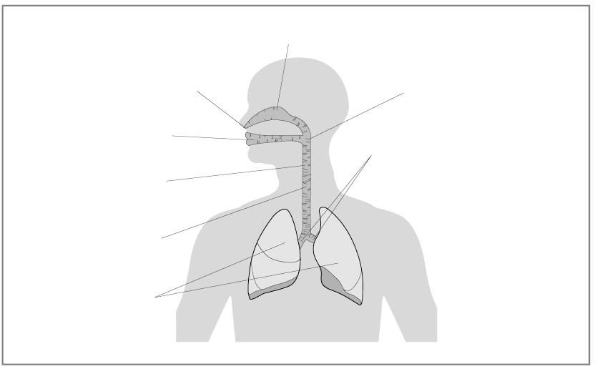
Bronchi (L & R)
Oral cavity
Pharynx
Nasal cavity
Lungs
Nose
Trachea
Larynx
Trachea L and R bronchi Alveolar ducts Alveoli Bronchioles
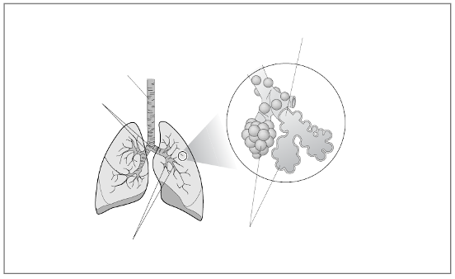
Alveolar ducts
L and R bronchi
Bronchioles
Alveoli
Trachea
3.III.2 | The respiratory system – answers
1. Label the diagram below to refresh your knowledge of the respiratory structures, using the labels provided.
Nasal cavity Larynx Trachea Primary bronchi
Pharynx Alveolus Pulmonary capillaries
Bronchiole Capillary network Lung
Pulmonary capillaries
Lung
Bronchiole
Alveolus
Capillary network
Primary bronchi
Nasal cavity
Pharynx
Larynx
Trachea

3.III.3 | Mechanics of breathing at rest – answers
Fill in the missing spaces to describe the processes of inspiration and expiration at rest.

Inspiration
1. Diaphragm contracts
2. External intercostal muscles contract
3. Ribs move up and out
4. Volume of the thoracic cavity increases
5. Pressure of air within the lungs decreases
6. Air rushes into lungs
External intercostal muscles contract

Diaphragm contracts

Expiration
1. Diaphragm relaxes (passive)
2. External intercostal muscles relax (passive)
3. Ribs move down and in
4. Volume of the thoracic cavity decreases
5. Pressure of air within the lungs increases
6. Air rushes out of lungs
External intercostal muscles relax
Diaphragm relaxes

3.III.4 | Respiratory processes – answers
Fill in the missing spaces to make the distinction between ventilation (of air) and gaseous exchange at the lungs and at the muscle cell (of oxygen and carbon dioxide).

3 main processes within respiratory system
1. ______________ ventilation.
Pulmonary
The breathing of air into and out of the lungs.

2. ______________ respiration.
External
Exchange of O₂ and CO₂ between the ______________ and blood.
lungs

1 and 2 are linked to 3 by the transport of O₂ and CO₂ in the blood to the heart and around systemic and pulmonary circulation.

3. ______________ respiration.
Internal
Exchange of O₂ and CO₂ between the blood and _____________/_____________.
tissues
muscle

3.III.5 | Diffusion gradients – answers
Analyse and compare the two graphs on page 70, which show the association of haemoglobin (Hb) at rest and during exercise.
Discuss why at rest the diffusion gradient is relatively small for gaseous exchange and why during exercise the diffusion gradient gets bigger.

Answers

At rest
The simplest way to explain why the diffusion gradient is smaller for gaseous exchange at rest is that the partial pressure (pp) difference of O₂ and CO₂ across the tissues of external and internal respiration is smaller than that during exercise. This reduces the size of the diffusion gradient and therefore the amount of gaseous exchange. In addition, two other factors that increase Hb association, pH and temperature, are also lower at rest than during exercise.

During exercise
External respiration:
• Skeletal muscles produce greater amounts of CO₂.
• Deoxygenated venous blood returning to the lungs from the right ventricle has a higher pp of CO₂ and lower pp of oxygen.
• Alveolar air has a high pp of O₂ and low pp of CO₂.
• This increases the diffusion gradient for both O₂ and CO₂ between the alveoli–capillary membrane resulting in both a quicker and greater amount of gaseous exchange.
• The high pp of O₂ in the alveoli and low pp of O₂ in the capillaries ensures Hb is almost fully saturated with O₂.
Internal respiration:
• Four factors all have the effect of shifting the dissociation curve to the right or, more simply, increasing the dissociation of oxygen from Hb in the blood capillaries to the muscle tissue.
1. Increase in blood and muscle temperature during muscular work.
2. Use of more O₂, decreasing pp O₂ within muscle, increasing O₂ diffusion gradient.
3. Increase in pp of carbon dioxide, increasing the CO₂ diffusion gradient.
4. Bohr effect – increase in acidity (lower pH), increasing muscle/blood acidity levels.
• All of these factors increase during exercise and increase the dissociation of O₂ from Hb which increases the supply of oxygen to the working muscles.
3.III.6 | Gaseous exchange – answers
1. Complete the following table by adding one of the four terms below to show your understanding of gaseous exchange.
High Low Higher Lower
2. Draw arrows () to show the direction of diffusion. Remember that gases always move from an area of high pressure to an area of low pressure.

External respiration
Partial pressure | Alveolar air | Direction of diffusion  High to low pp | Alveoli capillary blood
O₂ resting | High |  | Low
O₂ during exercise | High |  | Lower
CO₂ resting | Low |  | High
CO₂ during exercise | Low |  | Higher

Internal respiration
Partial pressure | Capillary blood | Direction of diffusion  High to low pp | Muscle tissue
O₂ resting | High |  | Low
O₂ during exercise | High |  | Lower
CO₂ resting | Low |  | High
CO₂ during exercise | Low |  | Higher

3.III.7 | Efficiency of gaseous exchange –answers
Fill in the empty boxes to show why gaseous exchange in the lungs is an efficient process.
Capillary wall
Alveolar wall
Respiratory membrane
Red blood cell in capillary
Red blood cell
Diffusion of O₂
Diffusion of CO₂
LOW
LOW
HIGH
HIGH
Good pulmonary lung ventilation
Vast network of alveoli capillaries surrounding alveoli
Short diffusion path
Steep diffusion gradients
Narrow capillaries bringing rbcs close to alveoli

Moist lining/water helping dissolve
& exchange O₂

Thin/single cell layer
of alveoli and capillary respiratory membranes
Large/vast surface area
of alveoli

3.III.8 | Respiratory volumes – answers
1. Complete the table below to compare resting and exercise lung volumes.

Lung volume | Definition | Resting volume | Change during exercise
Tidal  volume | Volume of air inspired or expired per breath | 500 ml | Increases during lower intensity work
Frequency | Number of breaths taken in one minute | 12–15 | 40–60
Minute ventilation | Volume of air inspired or expired in one minute | 6/7.5 L/min | Untrained 120 L/min  Post training 150 L/min  Elite 160/180 L/min
2. Put the abbreviations below into the correct order to show the link between them.
Tidal Volume (TV)
Frequency (f)
Minute Ventilation (VE)
The link between TV, f and VE is shown by the equation:
VE = TV x f
3. Summarise the benefits/adaptations of training on the respiratory volumes above.
• In general, lung volumes and capacities change little with training, while the subject is at rest or during sub-maximal activity.
• However, TV may increase during maximal exercise.
• Respiratory frequency decreases at rest/sub-maximal activity but can increase during maximal exercise.
• Maximal VE can significantly increase from around 120 litres/minute in an untrained athlete to 150 litres/minute following training.
• 180/200+ in elite subjects due to increase in TV and f (2 & 3) at maximal exercise.
4. How do the benefits/adaptations of respiratory volumes help improve performance?
• Aerobic performance during higher/maximal work rates is both increased and prolonged.
• More effect is observed with aerobic endurance activities which are dependent more upon O₂, although this will delay the anaerobic threshold and therefore delay fatigue during anaerobic activity.
• The effort of sub maximal activity is reduced therefore increasing duration of performance.
• A more efficient and healthy respiratory system encourages and promotes a lifelong involvement in an active, healthy lifestyle.
3.III.9 | Respiratory response to exercise – answers
1. Plot the two curves to show typical minute ventilation (VE) response to submaximal and maximal work for an 18-year-old student.

2. Where have you seen similar shaped graphs before?

HR response to exercise.
3. What does this tell you about the response of the body to exercise?

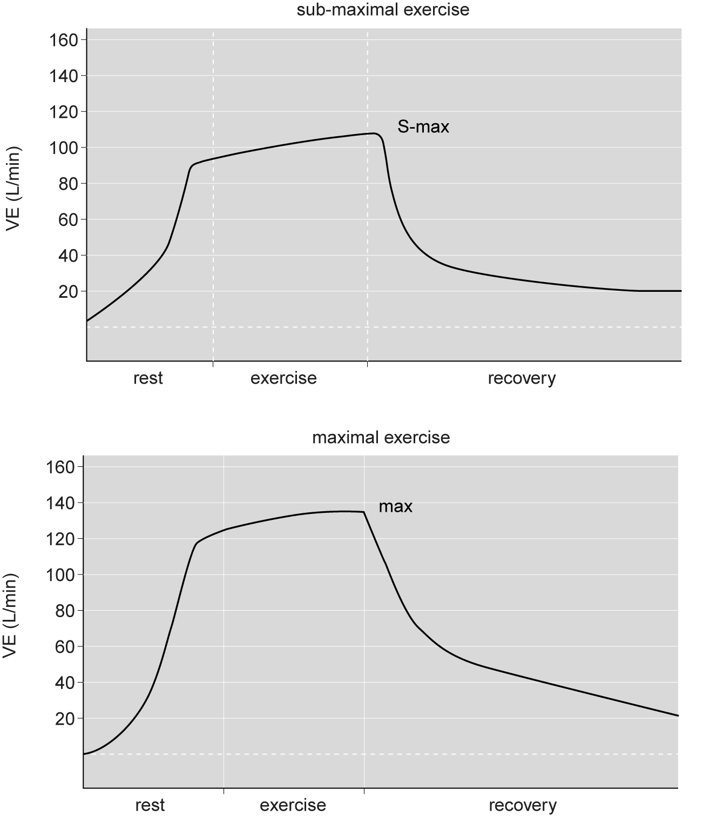
The respiratory response follows the same pattern as heart rate. Both HR and VE respond simultaneously to exercise.
3.III.10 | The ventilatory response to light, moderate and heavy exercise – answers
Describe and explain the response of VE for the three exercise intensities, remembering to break the process down into six steps, as with HR response.

Answers
Ventilatory response to exercise mirrors that of the heart, except that it is the RCC controlling the respiratory muscles that increases or decreases breathing. Let us look at the VE response in steps, numbered 1 to 6 to make this process easier to understand.
1. Anticipatory rise prior to exercise in all three work intensities, due to release of hormones, including adrenalin, which stimulate the RCC.
2. Rapid rise in VE for all three work intensities at the start of exercise due to neural stimulation of RCC by muscle/joint proprioreceptors.
3. Slower increase/plateau in sub-maximal exercise due to continued stimulation of RCC by proprioreceptors, but with additional stimulation from temperature and chemoreceptors due to increase in temperature, CO₂ and lactic acid levels and a decrease in oxygen in the blood. Plateau represents a steady state where the demands for oxygen by the muscles are being met by oxygen supply.
4. Continued but slower increase in HR towards maximal values during maximal work, due to continued stimulation from the receptors above and increasing chemoreceptor stimulation due to increasing CO₂ and lactic acid accumulation.
5. Rapid decrease in VE in all three intensities once exercise stops, due to the cessation of proprioreceptor and decreasing chemoreceptor stimulation.
6. Slower decrease towards resting VE values. The more intense the exercise period the longer the elevated level of respiration required to help remove the increased byproducts of exercise, e.g. lactic acid.

3.III.11 | Effect of altitude on respiratory system – answers
Fill in the boxes to show your understanding of the effect of altitude on the respiratory system.
9. Long-term effect: decreased pO₂ increases Hb and RBC production, which increases external respiration and O₂ transport
5. Causing a reduction in oxygen available to muscles due to a reduction in diffusion gradient and O₂ exchanged during internal respiration
4. Resulting in decreased O₂ transport in the blood
3. Decrease in O₂ and Hb association (HbO₂) during external respiration
2. Decreased pO₂ causes a reduction in the diffusion gradient
1. Decrease in pO₂ in alveoli (hypoxia) due to a decrease in pO₂ in atmospheric air
8. Decrease in muscle O₂ detected by chemoreceptors, stimulating respiratory centre to increase breathing rate (hyperventilation)
7. Colder air increases water loss as air warms/moistens in lungs, leading to dehydration
6. Net effect decreases VO₂ max/aerobic capacity, which decreases aerobic performance and increases the onset of muscular fatigue
Effects of altitude on respiratory system
Primary effects
Other effects

3.III.12 | Asthma and an active lifestyle –answers
Complete the spaces below to summarise how you may evaluate critically a lifelong involvement in an active/healthy lifestyle in relation to asthma.
1. Symptoms: Asthma is characterised by a reversible narrowing of the airways with common symptoms of hyperirritability of the airways, coughing, wheezing, breathlessness or mucus production. Asthma occurs in response to a trigger or allergen.
2. Measurement: Inhaling into a spirometer and measuring the exhaled volume of air. If an individual improves their expiratory volumes after inhaling bronchodilator treatments they are considered to have asthma. The IOC now requires medical evidence of asthma and accepts a 15% improvement in forced expiratory volume in 1 second within 10 minutes of using a bronchodilator treatment.
3. Triggers: The major trigger is the drying of the respiratory airways, normally due to water loss from the airway surfaces causing an inflammatory response that triggers the constriction/
narrowing of the airways, termed bronchoconstriction. Bronchoconstriction is often brought on shortly after exercise or some hours after. The link between exercise and asthmatic symptoms is termed ‘exercise-induced asthma’ (EIA). Common allergens inducing asthma are exhaust fumes, air pollutants, dust, hair and pollens.
EIA is particularly high in cold-weather sports as cold air is dryer than warm air and therefore it is more likely in winter when the respiratory airways are processing ice-cold air. Similarly, ice surface sports like ice hockey and skating act as triggers due to the ice resurfacing machine pollutants, and chlorine in water triggers asthma during swimming-related activities.
4. Performance affects: Asthma and related respiratory problems are increasingly common in athletes, especially elite aerobic athletes, and the respiratory system can limit performance in people with asthma.
5. Management:
• Medical treatments
Normally treated with inhaled medication, known as Bronchodilators, which are ‘reliever’ (blue) medication and relax muscles around the airways. They are normally taken before exercise or in response to symptoms.
Corticosteroids are ‘preventer’ (non-blue) medication; they suppress the chronic inflammation, improve pre-exercise lung function and reduce the sensitivity of airway structures. A daily dose for mild asthma is the normal treatment.

• Non-medical treatments
A warm up, at least 10–30 minutes at 50/60% max HR, provides a ‘refractory period’ for up to 2 hours, after which exercise can be performed without triggering EIA.
Dietary modification of reducing salt and increasing fish oils and (antioxidant) vitamins C and E has also shown to help reduce the inflammatory response to EIA.
Caffeine is a bronchodilator, but you must be aware that the IOC limit is 12 mg/ml.
• Inspiratory muscle training
Increased respiratory effort is a principal symptom of breathlessness; hence, there is a strong relationship between the strength of the respiratory muscles and the sense of respiratory effort.
IMT cannot cure asthma but it has shown to increase airflow and alleviate breathlessness, so asthmatic athletes may benefit more in terms of their performance as well as control of their symptoms.
For competitive athletes, when asthma is short of the IOC criteria for pharmacological treatments, non-pharmacological approaches may be only the means of minimising the negative impact of EIA on their ability to fulfil their potential.
Reduces the use of medication and improves quality of life.
‘Power breathe’ is now available on prescription and shows that IMT is now a well-established drug-free method of managing asthma.
The more obvious management strategies are simply to stop the conditions that act as triggers in the first place. Hence, refrain from endurance training when suffering respiratory infections, avoid exercise in cold (winter)/dry air conditions or if unavoidable minimise the effects by wearing a mask to cover the nose/mouth to enable exhaled air to help raise the temperature of the air inhaled.
3.III.13 | Control and regulation of cardiorespiratory control during exercise – answers
Sketch a diagram to show the link between neural control of the respiratory system, the cardiac control centre and the vasomotor control centre.
This task is aimed at highlighting to students that neural factors affecting the respiratory control centre are also involved in the control of the cardiac and vasomotor centres and occur simultaneously.
Many of the factors affecting the activity of the CCC, VCC and RCC are the same and stimulate the control centres to respond at exactly the same time. The figure below shows the overlap between the heart, vascular and respiratory systems.
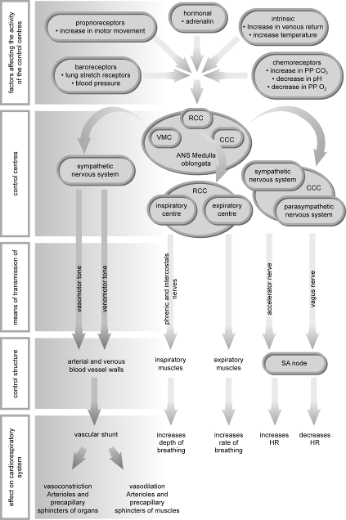

3(part I) | Sample questions with mark schemes
1. A long-distance runner completes a 60-minute sub-maximal training run.
Complete the graph below to show the changes in heart rate in the following three stages:
• before the run
• during the run
• for a 10-minute recovery phase. [4]

4 marks max (must visit each section to gain max)
Before: 1. Resting heart rate around 50–90 beats/minute
2. Rise in heart rate prior to exercise/anticipatory rise
During: 3. Steep rise at beginning of exercise
Plateau during exercise (115–180 beats/minute range)
Recovery: 4. Initial fast fall during recovery
5. Followed by gradual decline to rest value

2. Explain how the cardiac control centre (CCC) (neural control) increases the heart rate. [4]

2 sub max (CCC stimulated by)
• Prorioceptors detect movement.
• Baroreceptors monitor (blood) pressure.
• Chemoreceptors detect changes in pH/blood chemistry/oxygen tension.
• Thermoreceptors detect changes in temperature.

No sub max (CCC responds by)
• Sends information down cardiac accelerator nerve.
• Autonomic control.
• Sympathetic control.
• Acts on sinoatrial (SA) node.

3. Cardiac output is a determining factor during endurance activities. Describe how cardiac output is increased during endurance activities. [4]

4 marks max
• Increase in heart rate.
• Increase in stroke volume.

• Adrenaline/noradrenaline/epinephrine released.
• Increase in venous return/more blood returning to the heart/increased muscle pump/
increased respiratory pump/venomotor control.
• Stretches wall of right atrium, which increases firing of SA node.
• Greater stretching of cardiac walls increases force of contraction/Starling’s law.
• Information sent from proprioceptors/baroreceptors/chemoreceptors/thermoreceptors to cardiac control centre (CCC).
• Increase in sympathetic control/impulse sent down cardiac accelerator nerve.
• Increase in temperature, which speeds up nerve impulse. [4]

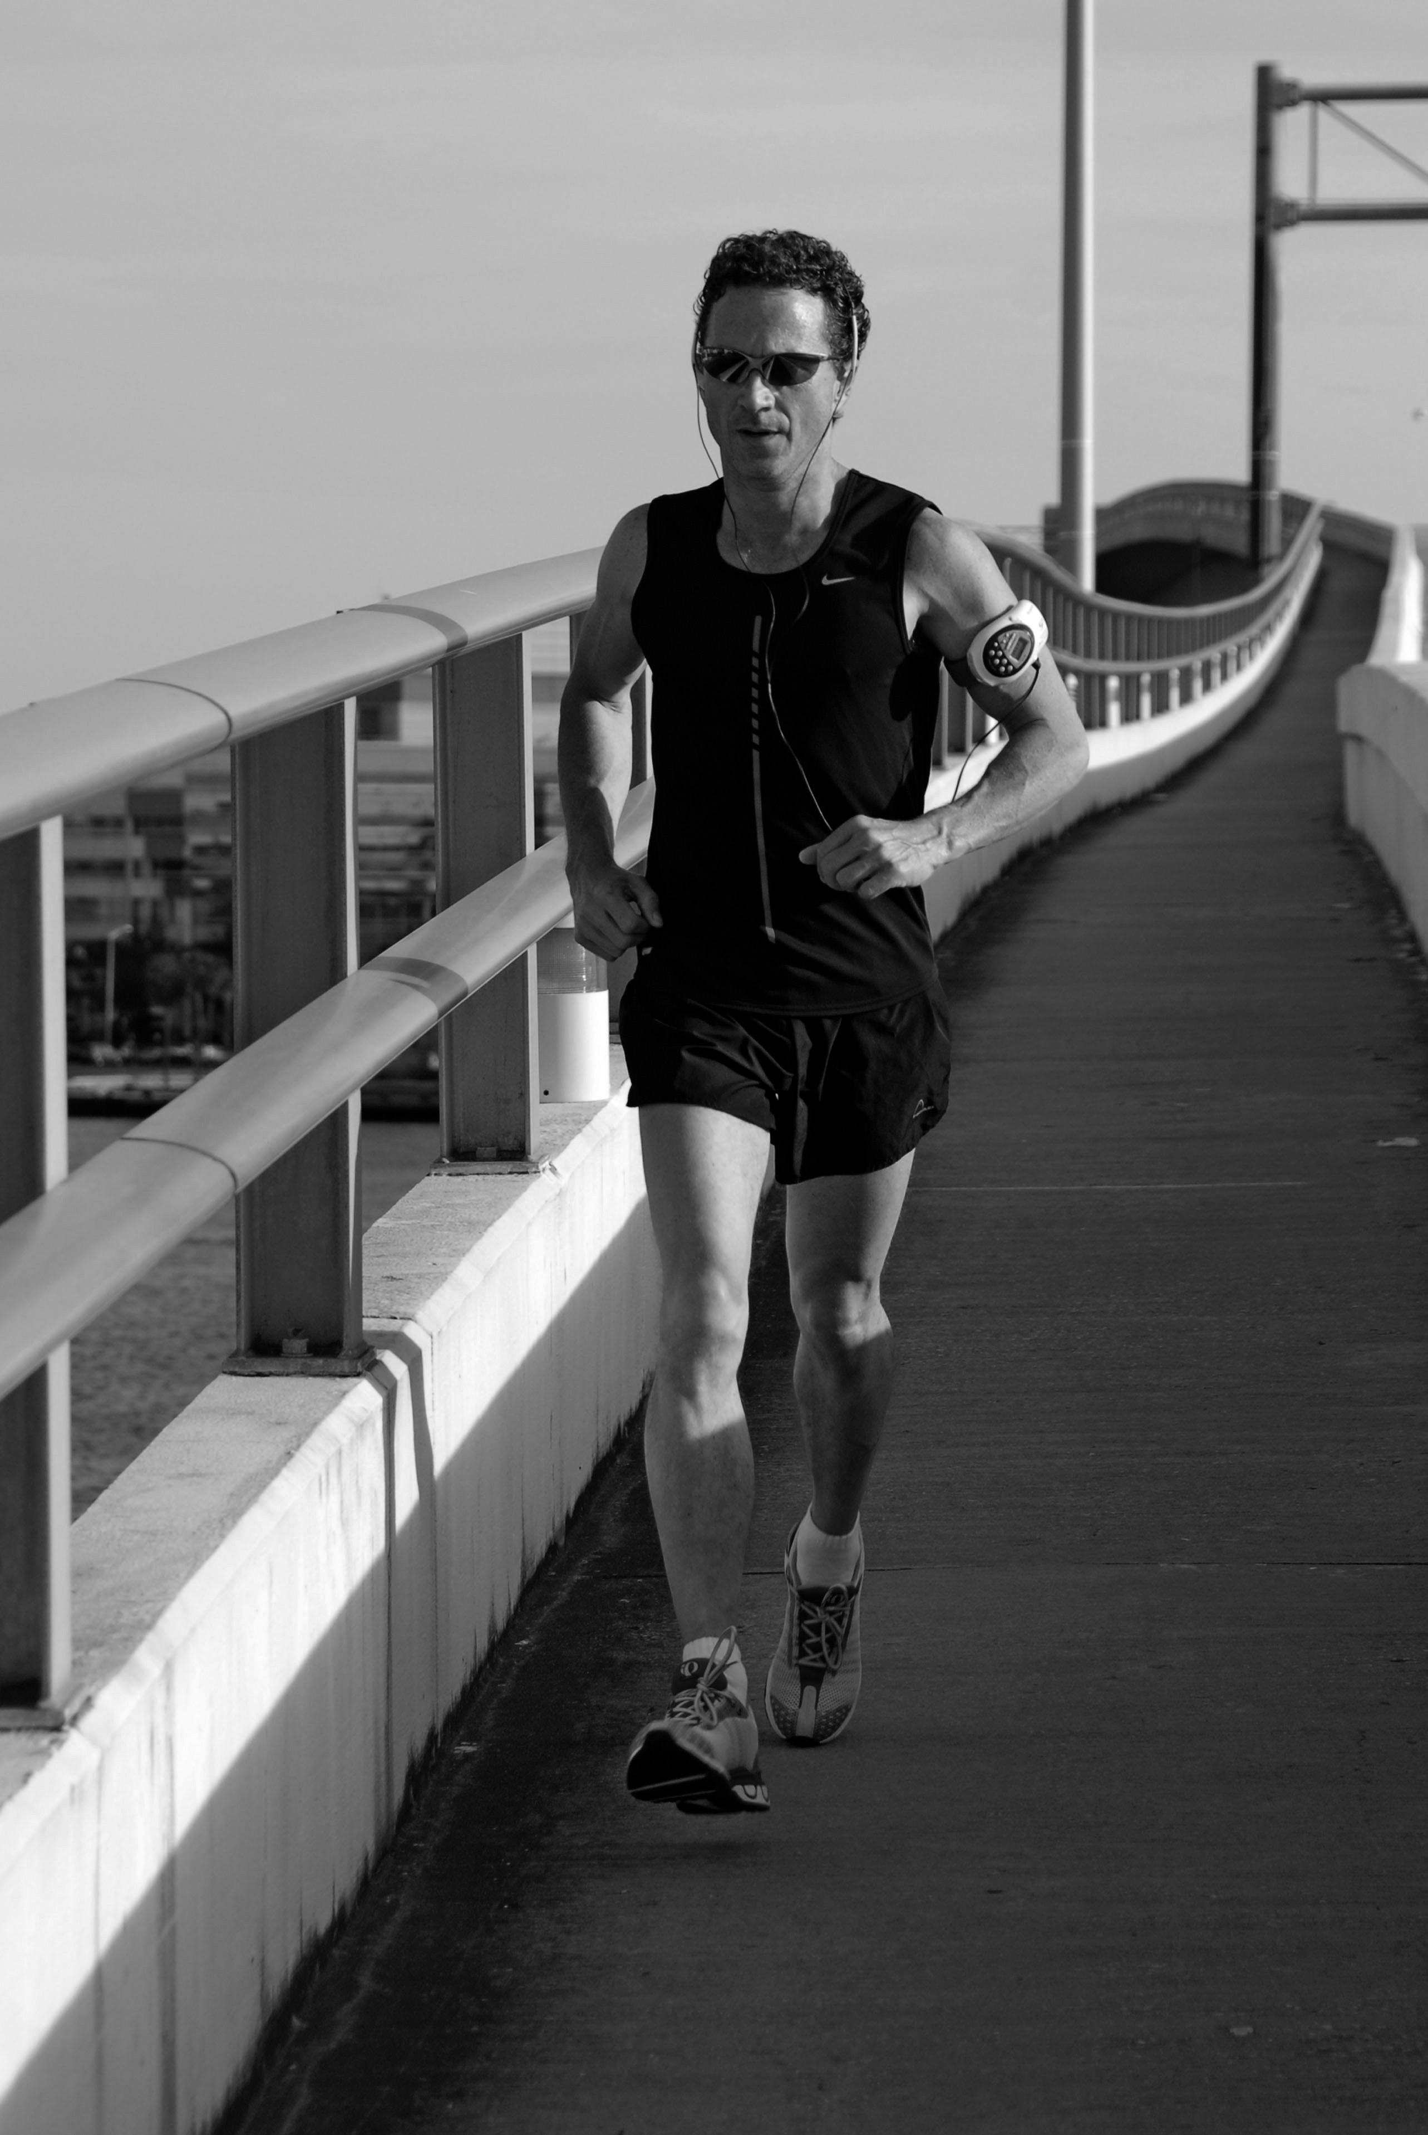
4. The figure below shows a marathon runner during a five-mile training run.

Describe how the conduction system of the heart controls the cardiac cycle to ensure enough blood is ejected from the heart during the training run. [3]

3 marks max
• Impulse initiates from SA node.
• This causes atria to contract/atrial systole/blood ejected from the right and left atria/atrial depolarisation.
• Impulse received by AV (atrioventricular) node.
• Impulse conducted down Bundle of His.
• Up the Purkinje fibres.

• This causes ventricles to contract/ventricular systole/blood ejected out of right and left ventricles/ventricular depolarisation.
• The atria/ventricles relax to allow the heart to refill with blood.

5. At full time in a team game, players will enter a period of recovery, during which the body will return to its pre-exercise state. Describe how the sensory receptors inform the cardiac control centre (CCC) that exercise has stopped at the end of the match. [5]

Sensory receptors (when exercise stops)
• Proprioceptors (in the muscles/tendons/joints) inform the CCC that activity levels have decreased.
• Chemoreceptors (in the muscles/aortal carotid arteries) inform the CCC that lactic acid/CO₂ levels have decreased and that O₂/pH levels have increased.
• Baroreceptors (in the aorta/carotid arteries) inform the CCC that blood pressure has decreased.

6. The figure below shows a cyclist completing a 10-mile training ride. [4]
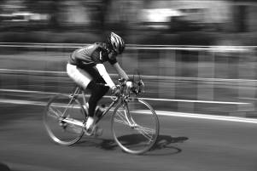

Draw a graph to show how the cyclist’s cardiac output changes in the following phases of the aerobic training session.
• Prior to exercise.
• Exercise session.
• Recovery period.

One mark must be from three areas to attain maximum 4 marks.
• Resting value 5 litres/minute approx. (4–6 litres/minute).
• Anticipatory rise before exercise.
• Sharp increase.
• Plateau between 10 and 20 litres/minute.
• Initial sharp decline with slow decline towards resting level.

3(part II) | Sample questions with mark schemes
7. After the final whistle, it is recommended that players complete a cool-down. Describe the physiological benefits of an active cool-down. [5]

An active cool-down (sub max 5 marks)
• Reduces the risk of injury.
• Reduces the possibility of delayed onset muscle soreness (DOMS).
• Keeps metabolic activity levels elevated, which gradually decreases HR/RR.
• Maintains respiratory pump.
• Maintains muscle pump.
• To prevent blood pooling in the veins/enhance venous return.
• Which maintains SV/Starling’s law of the heart.
• Keeps capillaries dilated to flush muscles with oxygenated blood/remove lactic acid CO₂.

8. Describe the changes that occur in the distribution of cardiac output as a performer moves from rest to exercise. Explain how the vasomotor centre controls this distribution. [4]

4 marks max
Description
• More blood is distributed to the working muscles.
• Less blood is distributed to non-essential organs.
Explanation
• Vasodilation of arteries/arterioles supplying working muscles/vascular shunt.
• Opening/vasodilation of pre-capillary sphincters supplying working muscles.
• Vasoconstriction of arteries/arterioles supplying non-essential organs.
• Closing/vasoconstriction of pre-capillary sphincters supplying non-essential organs.

9. Large amounts of blood need to be circulated around the body during prolonged aerobic exercise.
Identify the mechanisms of venous return that ensure a sufficient supply of blood is returned to the heart during exercise. Give one reason why a good venous return helps a performer. [4]
• Valve.
• Skeletal muscular pump.
• Respiratory pump.
• Venoconstriction/venomotor control/smooth muscle.
• Gravity for blood from above heart.

How it helps (1 mark max)
• Increases stroke volume.
• Increases cardiac output.
• Therefore more blood/oxygen supplied to working muscles.
• Greater amounts of carbon dioxide removed via lungs.

10. The figure below shows a marathon runner during a five-mile training run. [3]

Identify two ways in which oxygen is transported in the blood during the training run. [2]
Identify two mechanisms of venous return that enable the athlete to deliver deoxygenated blood back to the heart during the training run. [2]

2 marks max
• Carried in the plasma.
• Combines with haemoglobin.
• Forms oxyhaemoglobin/HbO₂.

2 marks max
• Muscle pump/skeletal muscle pump.
• Valves.
• Venoconstriction/venomotor control.
• Respiratory pump.
• Gravity forces blood back from above heart.

11. During aerobic performance a large amount of carbon dioxide is produced at the muscles. Identify two ways in which carbon dioxide is carried in the blood during aerobic performance. [2]

Mark the first two only
• Dissolves in the plasma.
• Combines with haemoglobin.
• Forms carbaminohaemoglobin.
• Dissolves in water/forms carbonic acid/forms H₂CO₃
• In plasma, dissociates to hydrogen ions/bicarbonate ions.

12. Outline the changes that occur in the vascular system during a period of submaximal activity and explain how these changes are controlled. [10]

Changes (sub max 5 marks)
• During exercise the vascular system redistributes blood.
• So that areas with the greatest need/skin/muscles receive more blood.
• This mechanism can increase the volume of blood going to the working muscles fourfold.
• And areas with low demand/liver receive less blood.
• This is called the vascular shunt mechanism.
• Opening and closing of the pre-capillary sphincters.
• Increase in blood pressure.
• (A fall in blood pressure) causes vasoconstriction/constriction of the arteries feeding the less important tissues.
• Causes vasodilation/dilation of the arteries feeding tissues with the greatest need for O₂.
• pH / blood acidity / blood CO₂ / H+ ions / O2 tension / blood temperature / changes in blood viscosity.

Control – 1 mark or each up to a sub max of 5
• Vasomotor control.
• Vasomotor centre stimulated by changes in blood pressure.
• Detected by baroreceptors (in the aorta and carotid arteries).
• Sympathetic nervous system.
• Controls the muscular layer of a blood vessel.
• Increased sympathetic stimulation (causes vasoconstriction).
• Decreased sympathetic stimulation (causes vasodilation).
• Pre-capillary sphincters/ring-shaped muscle at the opening of a capillary.
• Controls blood flow into the capillary bed.
• (Contraction/closed) restricts blood flow through the capillary bed.
• (Relaxation/open) increases blood flow through the capillary bed.
3(part III) | Sample questions and mark schemes
13. The figure below shows a performer carrying out a bench press.
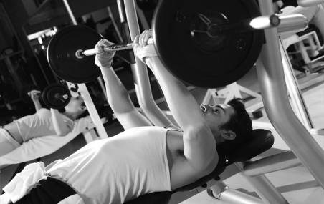
<Insert ph_017>

In order for the performer to exercise for a period of time oxygen must be delivered and taken up by the working muscles. This is called tissue respiration.
Explain how the exchange of oxygen is achieved between blood and muscle tissue at rest. [4]
Explain why this process is increased during exercise. [4]

At rest (sub max 4)
• Oxygenated blood reaches the capillaries (in the muscles).
• Blood in the capillaries has a high partial pressure of oxygen/high ppO₂.
• Because it has come from the lungs (via the heart).
• The muscle tissue has a low partial pressure of oxygen/low ppO₂.
• Because it has used its oxygen for energy production/muscular contraction.
• Gases will always move from areas of high pressure to areas of low pressure/down the diffusion gradient.
• Oxygen passes/diffuses from the blood into the muscle tissue.
• Haemoglobin/blood releases its oxygen to myoglobin (in the muscle tissue).
• Myoglobin has a greater affinity for oxygen than haemoglobin.
• Myoglobin transports the oxygen (within the muscle tissue) to the mitochondria.

During exercise gaseous exchange increases because (sub max 4)
• There is a greater dissociation of oxygen from haemoglobin to myoglobin/the oxygen dissociation curve shifts to the right/suitable graph.

(Due to) an increase in body temperature.
• (Due to) a decrease in partial pressure of oxygen/ppO₂ within the muscle tissue.
• (Due to) an increase in partial pressure of carbon dioxide/ppCO₂ within the muscle cell.
• (Due to) a steeper diffusion gradient.
• (Due to) an increase in acidity/lower pH in the blood and muscles/the Bohr effect.
14. The figure below shows oxygen diffusing into the blood stream and being transported in the blood to the working muscles.
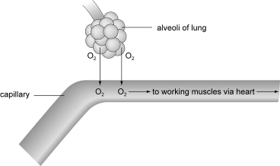

Explain how gas exchange is increased at the lungs to ensure that a greater amount of oxygen is diffused into the blood during exercise. [4]
• There is high partial pressure/concentration of oxygen (ppO₂) in the lungs/alveoli.
• There is a low partial pressure/concentration of oxygen (ppO₂) in the blood.
• During exercise there is an increased pressure/concentration /diffusion gradient.
• Faster diffusion will occur.
• Increased blood supply/temperature.
• Increased surface area of lungs/respiration rate.
• Reduced resistance to diffusion.

15. Minute ventilation is defined as the volume of air inspired or expired in one minute.
Sketch a graph below to show the minute ventilation of a swimmer completing a 20-minute sub-maximal swim. Show minute ventilation:
• prior to the swim
• during the swim
• for a 10-minute recovery period. [4]

4 marks max

Prior
• Starting value below 20 litres/minute.
• Anticipatory rise prior to exercise.
During
• Rapid rise (60–120 litres/minute).
• Slower rise/plateau (60–120 litres/minute).
Recovery
• Rapid decrease at end of exercise.
• Slower decrease towards resting value (refer to diagram).

16. During endurance activities at altitude there may be a reduction in performance. Why do the changes in pressure at altitude reduce performance? [4]

4 marks max
• Less oxygen available in atmosphere at high altitude.
• The partial pressure of oxygen/ppO₂ is reduced/hypoxia.
• Hyperventilation/increased rate of breathing/dehydration.
• A reduction in the diffusion gradient occurs.
• Haemoglobin saturation depends upon the partial pressure of oxygen.
• Haemoglobin is not fully saturated.
• Less oxygen is carried in the blood.
• Therefore less oxygen available for muscles.
• Fatigue sets in quicker/decrease VO₂ max/early onset of blood lactate accumulation (OBLA).

17. Exercise results in an increase in the volume of gas exchanged in the lungs. Define tidal volume and describe how a performer is able to increase lung volumes during exercise using neural control. [5]
• Definition (sub max 1)
• The amount of air breathed in/out of the lungs in one breath.
• Description (sub max 2)
• Movement detected by proprioceptors.
• Changes in blood pressure via baroreceptors.
• Emotional influences/lung stretch receptors.
• Change in blood pH via chemoreceptors/drop in oxygen tension.
(Sub max 2)
• Respiratory centre (in medulla) controls breathing.
• Inspiratory/expiratory centre initiate impulses (apneunistic/pneumotaxic).
• Impulses sent via (phrenic/intercostal) nerves.
• Impulses received by respiratory muscles.
• This leads to increased rate and depth of breathing.

18. The figure below shows the two sites of respiration in the body. Efficient respiration is an important factor for effective performance in sport.
Describe in detail the process of gaseous exchange either at site A or at site B.
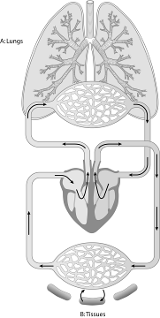
Explain why gaseous exchange increases at both of these sites during exercise. [13]

A: Lungs

Fig B
B: Tissues

Description [NB credit one only] (sub max 4)
At site A (lungs)
• External respiration/alveolar–capillary membrane/exchange of gases between air and blood/via diffusion.
• The movement (through a semi-permeable membrane) from areas of high pressure to areas of low pressure.
• The partial pressure of the oxygen in the blood is less than that in the alveoli.
• Oxygen travels from the alveoli to the blood.
• Carbon dioxide travels from the blood to the alveoli.
• The partial pressure of carbon dioxide in the blood is greater than that in the alveoli.
OR at site B (tissues)
• Internal respiration/tissue–capillary membrane/exchange of gases between blood and tissues/via diffusion.
• The movement (through a semi-permeable membrane) from areas of high pressure to areas of low pressure.
• Oxygen travels from the blood to the tissues.
• The partial pressure of oxygen in the blood is greater than that in the tissues.
• Carbon dioxide travels from the tissues to the blood.
• The partial pressure of carbon dioxide in the blood is less than that in the tissues.

Explanation of increased gaseous exchange with exercise (sub max 8)
At site A (lungs)
• Partial pressure of carbon dioxide in the blood has increased due to more by-products being produced.
• Partial pressure of oxygen in blood has decreased due to increase uptake of working muscles.
• Partial pressure of oxygen in the alveoli has increased due to increased rate and depth of breathing.
• Produces a steeper diffusion gradient.
• Ensures haemoglobin is fully saturated with oxygen.
AND at site B (tissues)
• Oxygen dissociation curve shifts to the right/greater dissociation of oxygen from haemoglobin in the blood to the tissues due to:
• Increase in body temperature.
• Decrease in partial pressure of oxygen within the muscle as more oxygen used.
• Increase in partial pressure of carbon dioxide in the muscle.
• Produces steeper diffusion gradient.
• The Bohr effect/increase in acidity/decrease in pH in the muscles.

3 | Answers to student book tasks (part I)

TASK 1
There is no correct answer to this task. It is simply meant to ensure students can identify aerobic and anaerobic activities and identify those which are a mixture of the two. Be careful not to jump too heavily into A2 work topics during these discussions as this may confuse students.
1. It is advisable to choose extreme examples:
Aerobic = marathon
Anaerobic = 100m sprint
Mix = team games
You can then challenge them further as to the % mix, more aerobic or anaerobic.
Basketball / Volleyball = more anaerobic high intensity work.
Football / Hockey = more an equal mix
2. Question 2 takes it further in terms of positional differences within different activities.
GK in all team games are predominantly anaerobic. Midfield positions / centre in netball are generally more aerobic. Forwards are generally more anaerobic.
You could consider how skill/physical attributes can negate the above generalizations, e.g. old fashioned centre forwards are not generally high intensity sprinters.

The comparison exercise looks to identify any similarities between different activities and individual positions within these activities.

TASK 2
1. The heart is the first tissue/organ to receive oxygenated blood. Coronary arteries lead directly from the aorta and immediately supply oxygen to the myocardium wall of the heart. Having just returned from the lungs, coronary artery blood is fully loaded with oxygen.
2. Having a constant supply of O₂, the heart works aerobically. It never fatigues, until you die of course, hence it is made up of slow twitch type I fibres. As quickly as it may produce waste products, e.g. lactic acid, it immediately removes them, preventing any fatigue.

TASK 3
This task is best answered as a table:

Structure | What you are carrying
Vena cavae  Right atrium  Tricuspid valve  Right ventricle  Pulmonary valve  Pulmonary artery  Alveoli/lung Capillaries | Deoxygenated blood
Pulmonary veins  Left atrium  Bicuspid valve  Left ventricle  Aortic valve  Aorta | Oxygenated blood

TASK 4
1. Sketch should look something like the heart in the centre of Figure 3.1.2 with the chambers labelled correctly.
2. Please refer to Figure 3.1.4 from page 64 of student book – diagram showing the structures involved in the conduction of the cardiac impulse.
3. This information can be found on pages 63 and 64 of the student book.

TASK 5
Please see the diagram on page 69 of the old AS TRF.

TASK 6
72 bpm x 70ml = 5040ml or Dm³ or 5.04 L or Dm³

This third volume is cardiac output, ‘the volume of blood ejected from one/both heart ventricles in one minute’. Students should be able to come close to a definition using the definition of Stroke Volume.

TASK 7
5000 = 83.3ml
60
This question is challenging students to understand the relationship between Q, SV and HR and summarise what determines SV and therefore what needs to change for SV to increase. A more detailed and expanded explanation is looked at in Task 8.

SV is the volume of blood pumped out during each heart beat. SV is dependent upon the capacity of the heart to fill and empty. If SV is to increase, both filling (EDV) and emptying (force of ventricular contraction) must increase.

TASK 8
This question attempts to build upon Task 7 while applying the knowledge to both rest and exercising conditions.

Stroke volume increases in the trained athlete primarily due to hypertrophy, an increase in the size/thickness of the heart myocardium. Hypertrophy of the heart myocardium is a long-term adaptation to aerobic training. This is evident in the table. The trained athlete’s HR of 50 is known as ‘bradycardia’. Hypertrophy increases the heart’s capacity to fill (EDV), which increases the stretch/recoil from the ventricle walls, thus increasing the force of contraction and allowing it to empty more (SV). If more blood is pumped out per beat (SV) then the heart of a trained athlete does not have to beat as many times to maintain the same cardiac output as an untrained athlete, hence HR decreases.

TASK 9
1. a) The actual physical size of the heart chambers and time for filling limits its capacity to fill and this determines the volume of blood it can ultimately eject/empty.
b) With SV reaching maximal values during sub maximal work any further increase in work requiring a greater cardiac output can only come from an increase in HR. As HR increases, the time for the heart to fill (diastole) decreases further.

2. This question attempts to recap on the language used to explain changes in SV during rest and exercise conditions, but asks the student to apply this knowledge to improve performance.

Table to show/describe changes in EDV, ESV and SV during rest and exercise:

Changes | EDV | ESV | SV
Rest (ml) | 130 | 60 | 120
During exercise (ml) | 130 | 10 | 70
Benefits to improve performance:
• Increase in SV during exercise increases cardiac output/blood ejected per minute.
• Increase transport/supply of blood/O₂ to working muscles.
• Therefore there is less anaerobic work at the start of the exercise.
• This reduces OBLA/anaerobic work at the start of the exercise.
• This delays/prevents the onset of muscle fatigue.
• This speeds up the recovery process after exercise.

TASK 10
This task makes students re-visit HR responses to exercise and highlights the main differences (in bold) between sub-maximal and maximal exercise.

Sub-maximal exercise | Maximal exercise
E.g.  A,B,E,F,G, | Eg.  A,B,C,F,G,H

TAKE IT FURTHER
The ‘cardiovascular drift’ is the gradual decrease in SV and increase in HR during prolonged exercise. Research and discuss what might cause the cardiovascular drift.
Answer
• CV drift is the gradual decrease in SV and increase in HR during prolonged exercise.
• Arterial (Systemic / Pulmonary) pressure also decline.

This effect is generally associated with an increase in body temperature which causes an increase in Q redirected to the skin to reduce body temperature, and decrease in blood plasma volume as a result of sweating. Together, these decrease VR which in turn decreases EDV which in turn decreases SV. The HR increases to compensate for the decrease in SV to maintain the required Q.

TASK 11
1 to 3 are tasks to complete with no answers.
4. HR should increase from supine to exercising conditions.
HR will increase to compensate for the decrease in SV from supine to sitting and standing in an attempt to maintain Q.
HR continues to increase with exercise intensity, to increase Q, to meet the increasing demands for O₂ from the active muscles. HR must continue to increase as SV reaches maximal values during sub-maximal work and any further increase in Q is a result of an increase in HR.
5. This question raises the issues concerning differences in HR and may be pursued along the following lines:
1 Gender – Generally males have lower resting and higher maximal HR.
2 Fitness level – The more aerobically athletic the individual the lower the resting HR and higher maximal HR.
3 Activity/sports – Comparison of aerobic versus anaerobic activities/sports. The more aerobic the activity then generally the lower the resting and maximal HR.

TASK 12
1. Heart rate increases in line with exercise intensity.
2. SV decreases from supine to sitting, and decreases further to standing. Blood pooling does not occur in the supine position so VR is easily returned to the heart. In sitting and standing VR has to return against gravity, increasing blood pooling which reduces VR and therefore SV (Starling’s Law).
3. Cardiac output is a product of SV and therefore decreases in line with SV from supine to sitting and standing.

TAKE IT FURTHER
1. Swimmer is in a supine/flat position so there will be less blood pooling in legs allowing an increase in venous return.
2. Cycling position causes more blood pooling and using less active muscles reduces the muscle pump action which helps VR.

TASK 13
This question requires students to apply the description and explanation of the response of HR to both sub-maximal and maximal exercise.
Depending upon the results, and therefore graphs produced, the answers will obviously differ.
Some issues to consider include:
• Validity refers to the appropriateness of the investigation to measure HR. Does the investigation measure what it purports to measure? In this respect is it a valid test?
• Reliability refers to the consistency of the results. Can the test be repeated and similar results obtained?

3 | Answers to student book tasks (part II)

TASK 1
VR is important to performance because Starling’s Law dictates that if VR decreases, stroke volume (SV) decreases; and this directly decreases cardiac output (Q).
A reduction in SV/Q decreases blood/oxygen transport to the working muscles reducing their ability to contract/work aerobically. The net effect on performance is that exercise intensity has to be reduced or muscles will have to work anaerobically and muscle fatigue will result. Conversely, an increase in VR will increase SV & Q increasing O₂ transport and therefore allowing intensity to be potentially increased and performance prolonged.
Although, more significant in prolonged aerobic based exercise, which is dependant upon oxygen supply, it can also affect performance in anaerobic activities in that a good VR will speed up recovery and therefore allow performers to work anaerobically for longer.
In considering VR before, during and after physical activity:
Before – It is beneficial to increase VR prior to activity commencing otherwise the initial activity will be without sufficient VR, SV and Q demanded and therefore represent anaerobic work.
During – VR is not a problem during aerobic exercise as VR return is maintained due to the VR mechanisms.
After – After physical activity it is important to maintain VR to speed up the process of recovery to help remove the by-products of respiration like lactic acid. It is advisable not to include the prevention of blood pooling at this point as it is covered in task 2.

TAKE IT FURTHER
• When exercise begins, skeletal muscles in the legs increase their demand for oxygen, and cardiac output (Q) to the legs is increased.
• In stopping and standing immediately afterwards, blood pooling occurs in the pocket valves of the veins in the cyclist’s legs (approx 80% of Q) due to insufficient pressure to maintain venous return (VR) against gravity.
• By stopping immediately, the cyclist switched off the muscle and respiratory pump mechanisms of VR.
• With VR decreasing, SV and therefore Q decreases (Starling’s Law), and the reduced blood pressure threatens the blood supply to the brain, which simply responds by making the cyclist dizzy/faint.

• As the cyclist falls it lowers the head/body aiding VR, and therefore, blood pressure and Q, thereby restoring blood flow to the brain.
• An active cool down is essential to maintain VR and prevent blood pooling by maintaining muscle and respiratory pumps.

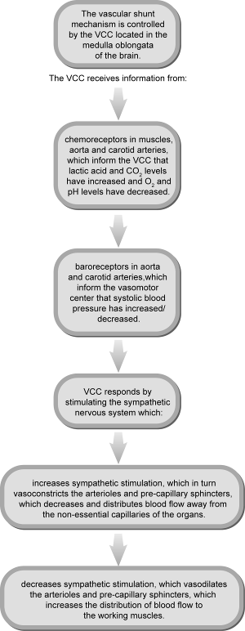
TASK 2

TAKE IT FURTHER
1. Athletes travelling by car are at a higher risk of breathing in high levels of CO and therefore reducing O₂ transport prior to arriving at their events. This has the same affect when competing in physical activity within polluted city atmospheres. There is also an increased risk that such air pollutants may act as asthmatic triggers and irritants to the respiratory structures which will reduce the efficiency of taking air into the lungs and reducing O₂ transport into the blood.
2. Preventative measures are the use of face masks which have air filters, however they will still not prevent CO passing through so they are only useful in filtering irritants within the air.
The only true preventative measure is not to perform in such conditions but of course this is not always possible!

APPLY IT!
The answer to this exercise is contained on page 88 of the student book.
This exercise is simply designed to make students orally recall and apply the knowledge of O₂ transport to smoking and the affect it has on performance. It also has the dual purpose of practising their oral skills in preparation for the evaluation and appreciation talk as part of their practical coursework.

TASK 3
This exercise is primarily designed to allow students to actively measure their BP to help them recall the use of the sphygmomanometer and be able to explain what it is measuring; systole and diastole. It is likely that results will be variable but this exercise allows the comparison between; the average 120/80 value, between male and female and whether aerobic fitness has any affect on decreasing BP. Any higher (they will not know what is a high value at this time) values can be linked to anxiety/stress as they will have a general knowledge that stress increases blood pressure.

TAKE IT FURTHER
The left ventricle pumps blood around the whole body (systemic system) whereas the right ventricle only pumps blood to the lungs which are in very close proximity. The left ventricle therefore has a thicker/stronger muscular wall which can contract with greater force which pushes the blood out into the aorta under greater pressure. The diastolic pressure decreases in both aorta and pulmonary artery as the blood vessels stretch and absorb the energy/pressure as blood flows out into body tissues.

TAKE IT FURTHER
1. In more detail, HR+SV increase blood flow (Q) to supply the extra demand for O₂ and this increases systolic pressure. Muscles, arteries, arterioles and pre-capillary sphincters vaso-dilate to reduce their resistance to blood flow and increases blood flow to muscles in preference to other tissues (organs) whose resistance is unchanged. Despite this vaso-dilation, overall systole pressure still increases due to the increase in VR and SV as a result of exercise.
2. Increase in arterial vasodilation decreasing resistance to blood flow.
3. Due to increasing vasodilation in large muscle groups blood flows rapidly out of these arteries during diastole reducing BP. This may be more significant in aerobically adapted athletes who have a greater capillarisation and therefore receive greater blood flow from their muscle arteries.

TAKE IT FURTHER
1. First, well-trained muscles usually have many more capillaries (small blood vessels) than untrained muscles. These capillaries 'drain off ' blood from the arteries, lowering overall pressure. The veins of fit people also tend to have greater capacities, again preventing pressure from building up in arteries.
2. A low BP means there is insufficient pressure to force the blood/O₂ through the arterial system and can lead to fainting, organ failure and death.

TASK 4
No right or wrong answers here. Purpose of the task is to make students use the CHD risk factors to assess the consequences of their own behaviour and associated health risks. For many it will be the first time they have given serious thought to their social and physical behaviours.

TASK 5
2. Ideally, organise in groups so at least one individual will not meet the recommended guidelines.
3. Looking back at task 4 creates an opportunity for students to make the link between their risk level and prevention via exercise prescription. Discussions will also allow students to engage in an evaluation and possibly lead towards making decisions to change/shape their future life-style.
4. A wide range of possible responses but the following should provide a stimulus for discussion:
• Moderate activity is all that is needed for general health benefits.
• More is better both in terms of intensity and frequency above the recommended minimum recommendations.
• Exceeding the minimum recommendation further reduces the risk of inactivity-related chronic disease.
• Physical activity does not have to be continuous – short bouts are OK.
• Vigorous activity can reduce the need for frequency therefore more time efficient.
• A variety of activities can be combined to meet the recommendation although aerobic physical activity is a key element for all recommendations.
• Includes muscle strength exercise, flexibility in addition to aerobic activity.
• Recommendation’s focus is towards health and not sports performance.
• The new recommendation emphasises the important fact that physical activity above the recommended minimum amount provides even greater health benefits.
• The point of maximum benefit for most health benefits has not been established but likely varies with genetic endowment, age, sex, health status, body composition and other factors.
5. There will be variations to the table below in response but as long as they pull out the generic recommendations they have achieved the task objective.

Generic recommended exercise prescription
moderate intensity for 30-60 minutes
5-7 days a week
Or
vigorously intense cardio 20 minutes a day,
3 -5 days a week
At least twice a week some of these activities should help to enhance and maintain muscular strength and flexibility
The min 30 minutes can be split up into shorter periods, ideally no less than 10 minutes
The 30-minute recommendation is for the average healthy adult to maintain health and reduce the risk for chronic disease. To lose weight or maintain weight loss, 45 to 90 minutes of physical activity per day may be necessary to prevent clustering of cardiovascular disease risk factors
Moderate-intensity physical activity means working hard enough to raise your heart rate and break a sweat, yet still being able to carry on a conversation. E.g. quick or brisk walking. Cycling, swimming and gardening with moderate effort

3 | Answers to student book tasks (part III)

TASK 1
nose > mouth> oral cavity > nasal cavity > pharynx > larynx > trachea > left and right bronchi > lungs > bronchioles > alveoli sacs > alveolus

TASK 2
This task is asking students to focus on what happens to respiration rate during different types of exercise and during recovery.

Ensure the students do not count their own respiration rate as this may make them consciously slow it down / speed it up.

Expected results should show:
- an increase in breathing rate (f) for the anaerobic work
- longer recovery to resting breathing rate after anaerobic work

TASK 3
1. TV x f = VE (Air)
SV x HR = Q (Blood)
2. TV x f = VE
500ml x 12 = 6000ml/min = 6 L/min

TASK 4
• 4000ml x 24 = 96000ml/min = 96 L/min
• 16-fold increase in VE therefore increasing O₂ supply and transport to the working muscles.
• Maintaining and/or increasing anaerobic threshold aerobic work.
• Preventing accumulation of fatiguing by-products of anaerobic work (OBLA).
• Resisting fatigue and increasing the duration and aerobic performance.

TASK 5
Students should sketch a schematic representation of internal and external respiration and label the changes (high or low) in the partial pressures of O₂ and CO₂ as the blood circulates around the double circulatory systems.

Their sketch should be based on the information contained in Figure 3.3.6 on page 107 of the student book.

TASK 6
1. The x axis shows the pressure of O₂.
2. The y axis value = 98% Hb saturated/associated with O₂ in the lungs.
3. Tissue O₂ pressure of 40 = 75% saturation/association of Hb with O₂.
4. 25% O₂ is no longer saturated/associated. O₂ has left/dissociated from Hb into the tissues.

TASK 7
50% saturation of Hb with O₂.
For the same pressure of O₂ in the tissues, the saturation of haemoglobin and O₂ decreases (approx 50%). Hence, dissociation of O₂ from haemoglobin has increased.
The curve shifting to the right increases the dissociation of O₂ from Hb. Increased O₂ is therefore available for the working muscles. Increased O₂ supply ensures work remains aerobic, preventing the build of fatiguing by-products.

TASK 8
2. Inspiratory centre controls ‘depth’ of breathing.
3. Expiratory centre controls ‘rate’ of breathing.

TASK 9
Adaptations to altitude training:
• At altitude the (partial) pressure/concentration of oxygen is reduced.
• Induces increase in RBC production increasing both haemoglobin and myoglobin.
• Respiratory muscles increase in their efficiency having worked harder at altitude (hyperventilation).
• When running at sea level the pressure/concentration of O₂ is higher than altitude and the athlete may benefit from the above adaptations.
• The above adaptations will gradually return to pre-altitude levels.
Benefits:
• Increased RBC/haemoglobin increasing the capacity for O₂ diffusion in the lungs.
• Increase in O₂ transport to muscle tissues.
• Increased tissue diffusion gradient increasing O₂ diffusion into muscles.
• Increased myoglobin increases transport of O₂ to mitochondria for energy production.
• More oxygen (VO₂ max) delivered to working muscles.
• Delayed onset of fatigue.
• Results in an increase in aerobic performance.
• Increasing potential running pace and duration of athlete.

TASK 10
1. Live High Train High – LHTH
This form of training maximises exposure to altitude conditions and possibly altitude sickness but there is mixed evidence and support. However, research does support that the acclimatisation effect at altitude does increase performance at altitude, above those having no training at altitude.
2. Live Low Train High - LLTH
Also known as intermittent hypoxic training (IHT) it is based on the assumption that unlike LHTH exercising in hypoxic conditions for 1-2 hrs will gradually help the body to adapt to perform better in both high and sea level performance. However, evidence has shown that athletes cannot train at the same volume and intensity at altitude as they can at sea level due to the hypoxic air, which decreases VO₂ max and can lead to a detraining effect and can negate the positive adaptations that occur as a result of being at altitude. There is also some evidence suggesting the increase in rbc production is only sustained for 2/3 days before returning to normal levels. However, travelling several times a week to train at altitude is impractical for most athletes.
3. Live High Train Low – LHTL
LHTL assumes that sleeping at altitude is sufficient to increase EPO to stimulate an increase in rbc’s production. Research suggests LHTL does improve performance at sea level but only up to 23 days upon returning to sea level. Similarly, the residence at altitude is thought to require up to 12 hrs for at least three weeks to improve performance at sea level in activity lasting more than 8 minutes.
As with LLTH, the practicality of moving to a high altitude location and travelling several times a week to train at sea level is impractical for most athletes. LHTL overcomes the detraining effects of LLTH as it maintains/increases the intensity of performance at sea level and therefore any training adaptations remain.
Altitude simulators in the form of house/tent/rooms now help athletes replicate the LHTL conditions from home and alleviate the problems of expense and practicality.

TASK 11
This task is simply to encourage students to visit the power breathe website in order to be able to discuss this modern form of training and make the synoptic link to its use as a form of ergogenic aid and the application to improving performance.
‘Power breathe’ is one type of Spiro meter that is used as a training aid to improve the strength, power and endurance of the respiratory muscles. Termed Inspiratory Muscle Training (IMT). IMT, like all other skeletal muscle training, provides a resistance to the respiratory muscles when the athlete breathes into the power breath spiro meter, against a set resistance. Various brands are available with the better models allowing the resistance to be increased as the respiratory muscles adapt and become stronger.
It is now accepted that during and after sustained higher intensity endurance activity the respiratory muscles do become fatigued and this can limit performance – this is termed Inspiratory muscle fatigue (IMF). We do of course train the respiratory muscles during normal training/physical activity, but it is now thought we need to increase this resistance even further to increase their fatigue resistance on to new heights.
Simply put, when the key muscles of respiration, the diaphragm and intercostals tire/fatigue, breathing capacity drops and the exercise feels harder and this decreases performance. It is also thought that fatigued respiratory muscles may require more O₂ and subsequently divert O₂ away from the working muscle which impairs lactate removal reducing their intensity of work or leading to muscle fatigue.
They have many benefits in relation to their applied use; they have no side effects, time efficient (4 min – 15 min day), and as they can be taken/used anywhere they are very practical.
A quote from a leading rowing coach in ‘peak performance’ best summarized IMT in that it was a ‘no brainer’ – ‘there’s nothing else you can add to training that takes so little time and provides such a large guaranteed benefit to performance’ and in this respect IMT is now viewed as a credible training aid.

TAKE IT FURTHER
Increasing research into misdiagnosis. ‘Inspiratory stridor’ (IS) is caused by vocal cord dysfunction (VCD) – the vocal cords close over airway reducing size of glottis increasing air flow resistance and work of breathing. The breathlessness & wheezing sound (stridor) is often misinterpreted as asthma. IMT has been shown to reduce wheezing and reduce IS by reducing the intensity of breathlessness and the sense of effort perceived.

LINK = A drug free intervention which benefits both asthma and IS symptoms.

Notes for Teachers

This chapter of the Students’ Book covers the following sections of the specification:
- Classification of skill.
- Describing methods of manipulating skills practice to facilitate learning and improve performance.
- Evaluating critically these methods and their effectiveness in the learning of movement skills.
- Ability, types, definitions, characteristics.

Classification of skill
The important aspects in this area are:
• understanding the concept of a continuum
• knowledge of the six continua that the specification identifies
• understanding the importance/implications that a knowledge of classification has for the structuring of learning/practice.
A continuum is an imaginary scale between two extremes that shows a gradual increase/decrease in a number of characteristics.
The following points should be stressed.
• The classification of movement skills is not simple or precise.
• Many skills have elements of all characteristics to a greater or lesser extent.
• It is difficult to be specific about the characteristics that a skill has because many of them can change depending on the situation in which the skill is performed.
• When classifying skills we always have to justify (explain):
(i) the situation in which the skill is being performed
(ii) our reasons for placing the skill at that point on the continuum.
Normally we illustrate a continuum by placing the two extremes either end of a line. This allows us to identify the classification of a skill by placing it at an appropriate position between the two extremes. For example, shot put:
Gross  Fine
The following continua are identified in the specification. Students should learn the definitions, and also sporting examples to accompany them.
Muscular involvement continuum
Gross skills – Those involving large muscle movements.
Fine skills – Those involving more intricate movements using small muscle groups.
Environmental influence continuum
Open skills – Affected by the environment; predominantly perceptual; movements must be adapted; mostly externally paced.
Closed skills – Not affected by environment; predominantly habitual; set movements; self-paced.
Continuity continuum
Discrete skills – Clear beginning/end; skill can be repeated but performer starts again; single specific skills.
Continuous – No obvious beginning/end; continued for as long as performer wishes; the end of one cycle is the beginning of the next; repetition of the same skill or movement; no clear sub-routines.
Serial skills – Several discrete elements put together to make integrated movement/sequence; the order of the elements is important.
Pacing continuum
Self (internally) paced – The performer has the rate in which the skill is carried out under control; involves proactive performance.
Externally paced – Control over the rate is not held by performer; often involves the reaction of the performer.
Complexity (difficulty) continuum
Simple skill – Small amounts of information to be processed and few decisions to be made.
Highly complex skill – Large amounts of information to be processed and a number of decisions to be made quickly; high number of sub-routines that are co-ordinated and performed quickly and accurately.
Organisation continuum
High-organisation skills – Sub-routines are closely integrated and difficult to separate in practice; best practised as a whole.
Low-organisation skills – Sub-routines tend to be discrete and may be practised separately and then integrated into the whole skill; can be learnt/practised using part method.
All the above must be viewed in the context of a continuum (Worksheets 4.1 and 4.2).
The application of classification to the organisation and determination of practice
Students need to be made aware that the method by which a teacher/coach teaches a skill is determined by that skill’s classification. In relation to methods of manipulating skills practice this classification will be on the organisational and difficulty continua.
Students should be asked to discuss how they were taught various skills such as:
• swimming – front crawl
• throwing a tennis ball
• front somersault in trampolining
• cartwheel in gymnastics.
They should discuss why different methods were used.
Methods of manipulating skills practice
Select a skill suitable to be introduced using each of the following four practice methods.
• Part practice – e.g. tennis serve.
• Whole practice – e.g. cartwheel.
• Progressive practice – e.g. gymnastic/trampolining sequence.
• Whole–part–whole – e.g. overhead clearance in badminton.
Teach these skills using the appropriate method. Discuss why each method is used and the advantages and disadvantages of each method.
Worksheets 4.3 and 4.4
Ability
It is important to get students to understand the differences between ability and skill. Exam questions usually look for the following characteristics of ability:
• Innate/genetically determined.
• Stable and enduring.
• Supports skills.
Abilities are seen as being building blocks helping us to learn and develop skills. It is useful to identify some definitions of ability. Students are unlikely to be asked for a definition in their exam but they help to reinforce learning of the characteristics.
Schmidt says that ability is ‘an inherited, relatively enduring, stable trait that underlies or supports various kinds of motor and cognitive activities, or skills. Abilities are thought of as being largely genetically determined and essentially unmodified by practice or experience.’
Bull states: ‘Abilities are usually thought of as stable and enduring traits that underpin skills and contribute to the speed with which individuals learn psychomotor skills and to the quality of their performance.’
Psychologists differ in their opinion as to whether abilities can be developed. It is thought that abilities develop through maturation (and degenerate through ageing), are modified through experience but are stable and enduring. In other words, if you are born with low levels of an ability you will be able to modify it slightly but you will never have a high level of that ability.
Our levels of ability determine whether or not we will be good or successful at an activity. If we have poor levels of the balance ability then we will probably never be good at beam work in gymnastics.
Types of ability
It should be stressed that different psychologists use different ways of identifying abilities, and different terminology to describe them. There is no definitive list of abilities. Two psychologists whose work is regularly referred to are:
• Fleishman (1972), who developed a taxonomy of human perceptual motor abilities; he identified eleven identifiable and measurable perceptual motor abilities; he also identified nine physical proficiency abilities (gross motor abilities)
• Stallings (1982), who identifies abilities on the basis that they have been identified by other psychologists, can be developed and assessed and are relevant to physical education.

It is important that students are able to identify that there are two types of ability:
1. Gross motor abilities
2. Psychometer abilities
It is also important that they are able to give examples of each type of ability.
Get each student to perform a different, simple gymnastic movement. Ask the students to identify the abilities that are needed to be able to perform each of the skills.
They should identify that very similar abilities are needed for the vast majority of the gymnastic skills performed.
This can be repeated with students taking part in activities that are similar, for example: badminton, tennis and volleyball; basketball and netball; soccer and hockey.
It should become apparent that similar abilities are needed in each ‘group of activities’. Worksheet 4.5
Measurement of abilities
This is a useful student activity. There are many standard tests for the measurement of abilities. Students can be set the task of identifying standardised tests for specific abilities, for example: stork stand, sit and reach, reaction ruler.
Details of suitable tests can be found in Arnot R, Gaines C, 1984, Sports Talent, Harmondsworth: Penguin.

4.1 | Continua
Link the following continua with the numbered descriptions.

Continua

Muscular involvement continuum
• Gross skills
• Fine skills
Environmental influence continuum
• Open skills
• Closed skills
Continuity continuum
• Discrete skills
• Serial skills
• Continuous skills
Pacing continuum
• Self-paced skills
• Externally paced skills
Complexity continuum
• Highly complex skills
• Simple skills
Organisation continuum
• High-organisation skills
• Low-organisation skills

Descriptions
1. Affected by the environment; predominantly perceptual; movements must be adapted; mostly externally paced; no clear beginning or end.
2. Clear beginning/end; skill can be repeated but performer starts again; single specific skill.
3. Those involving more intricate movements using small muscle groups.
4. Control over the rate is not held by the performer; often involves the reaction of the performer.
5. Small amounts of information to be processed and few decisions to be made.
6. Sub-routines tend to be discrete and may be practised separately and then integrated into the whole skill; can be learnt/practised using part method.
7. Those involving large muscle movements.
8. Several discrete elements put together to make an integrated movement/sequence; the order of elements is important.
9. No obvious beginning/end; continued for as long as the performer wishes; the end of one cycle is the beginning of the next; repetition of the same skill or movement; no clear sub-routines.
10. Not affected by the environment; predominantly habitual; set movements; self paced.
11. Sub-routines are closely integrated and difficult to separate in practice; best practised as a whole.
12. Those involving a large amount of information to be processed and a number of decisions to be made quickly; a high number of sub-routines, which are co-ordinated and performed quickly and accurately; feedback is available.
13. The performer has the rate at which the skill is carried out under control; involves proactive performance.

4.2 | Classification of skills
Consider a variety of skills. For example: serving in badminton; receiving a serve in badminton; passing in pairs standing still; passing in basketball/netball; gymnastic skills; jogging; net play in badminton.
Work in pairs/groups. Using the table below, classify these skills on the continua by ticking the boxes. Each pair/group should take it in turns to justify/explain their reasons for their classification.
 | Skill
Classification | Serving in badminton | Receiving a serve in badminton | Passing in pairs standing still | Passing in basketball/  netball | Gymnastic skills
Gross
Fine
Open
Closed
Discrete
Serial
Continuous
Self paced
Externally paced
Simple (low in complexity)
Complex (high in complexity)
High organisation
Low organisation

4.3 | Methods of manipulating skills practice
1. For each of the following practice methods, identify the classes of skill they are most suitable for and give a practical example of each.
• Part.
• Whole.
• Progressive.
• Whole–part–whole.

Type of practice | Classes of skill most suitable | Practical example
Part
Whole
Progressive
Whole–part–whole

4.4 | Practice methods
1. For each of the following practice methods, identify the advantages and disadvantages of its use.
• Part.
• Whole.
• Progressive.
• Whole–part–whole.

Type of practice | Advantages | Disadvantages
Part
Whole
Progressive
Whole–part–whole

4.1 | Continua – answers
- Link the following descriptions with the continua.

Continua

Muscular involvement continuum
• Gross skills: 7
• Fine skills: 3
Environmental influence continuum
• Open skills: 1
• Closed skills: 10
Continuity continuum
• Discrete skills: 2
• Serial skills: 8
• Continuous skills: 9
Pacing continuum
• Self-paced skills: 13
• Externally paced skills: 4
Complexity continuum
• Highly complex skills: 12
• Simple skills: 5
Organisation continuum
• High-organisation skills: 11
• Low-organisation skills: 6

4.2 | Classification of skills – answers
Consider a variety of skills. For example: serving in badminton; receiving a serve in badminton; passing in pairs standing still; passing in basketball/netball; gymnastic skills; jogging; net play in badminton.
Work in pairs/groups. Using the table below, classify these skills on the continua. Each pair/group should take it in turn to justify/explain their reasons for their classification.
 | Skill
Classification | Serving in badminton | Receiving a serve in badminton | Passing in pairs standing still | Passing in basketball/  netball | Gymnastic skills
Gross | ✓ | ✓ | ✓ | ✓ | ✓
Fine
Open |  | ✓ |  | ✓
Closed | ✓ |  | ✓ |  | ✓
Discrete | ✓ | ✓ | ✓ | ✓
Serial |  |  |  |  | ✓
Continuous
Self paced | ✓ |  | ✓ |  | ✓
Externally paced |  | ✓ |  | ✓
Simple (low in complexity) | ✓ |  | ✓ |  | ✓
Complex (high in complexity) |  | ✓ |  | ✓
High organisation |  | ✓ |  | ✓
Low organisation | ✓ |  | ✓ |  | ✓

4.3 | Methods of manipulating skills practice – answers
1. For each of the following practice methods, identify the classes of skill they are most suitable for and give a practical example of each.
• Part.
• Whole.
• Progressive.
• Whole–part–whole.

Type of practice | Classes of skill most suitable | Practical example
Part | Skills low in organisation, serial skills, complex skills | Tennis serve
Whole | Skills high in organisation, skills low in complexity | Golf swing
Progressive | Complex skills, skills low in organisation, serial skills | Triple jump, trampoline routine
Whole–part–whole | Skills low in organisation | Tennis serve

4.4 | Practice methods – answers
1. For each of the following practice methods, identify the advantages and disadvantages of its use.
• Part.
• Whole.
• Progressive.
• Whole–part–whole.
Type of practice | Advantages | Disadvantages
Part | Good for skills easily broken down (low in organisation), good for learning serial skills, reduces the amount of information to be processed, good for dangerous skills, learner will be motivated by being successful in parts of the skill; this will also build confidence | Cannot be used for high-organisation skills, learners do not get the feel of the movement, can take longer than other methods
Whole | Good for high-organisation skills and skills low in complexity, good for ballistic skills, allows learner to experience and develop a feel for the movement (kinaesthesis), helps develop the flow and efficiency of the movement, helps with the learner’s understanding of the movement, can be quicker than the part method | Not suitable for complex skills, not suitable for dangerous skills
Progressive | Good for complex skills, good for skills low in organisation, good for serial skills, reduces the information load for learners, can help with the transfer of skills into the whole skill | Not suitable for high-organisation or dangerous skills, not suitable for ballistic skills
Whole–part–whole | Learner gets a feel for the skill (kinaesthesis) and its flow, can be quicker than part methods | Not suitable for high organisation skills which cannot be broken down or for skills which are dangerous

4 | Sample questions with mark schemes

SAMPLE QUESTIONS
Developing movement or motor skills is important if you wish to follow a balanced, active and healthy lifestyle.
1. Describe what is meant by gross, fine, open, closed, high organisation and low organisation movement skills. Use examples of motor skills to support your answer. (6 marks)
1 mark per point, maximum 6 (each must be accompanied by a suitable practical example).
• (Gross) large muscle movements/dynamic/ballistic movements.
• (Fine) small muscle movements/intricate movements.
• (Open) affected by the environment/predominantly perceptual/externally paced.
• (Closed) not affected by the environment/predominantly habitual/open-loop movement/internally paced.
• (High organisation) continuous/one sub-routine becomes the beginning of the next/cannot be split into parts/sub-routines easily.
• (Low organisation) serial/easily split into sub-routines/made up of separate discrete elements.
2. Describe the two extremes of the pacing continuum and give practical examples of each.
(4 marks)
Sub max 1
• (Self paced) performer is in control of rate/speed/timing of skill/proactive.
• (Self paced) often closed skills.
Sub max 1
• (Externally paced) performer’s action controlled by environmental factors/reactive.
• (Externally paced) often open skills.
Practical examples
• (Self paced) shot put/golf drive/tennis serve.
• (Externally paced) batting in cricket/receiving a hockey pass/sailing.

3. Identify the characteristics of abilities.
Give examples of a gross motor ability and a psychomotor ability. (5 marks)
1 mark per point, maximum 5:
• innate/genetic/natural/born with them
• enduring/stable/underlying/a potential
• specific (to groups of movements)
• (gross motor ability) speed/power/flexibility/endurance, etc.
• (psychomotor ability) decision making/reaction time/hand–eye coordination/spatial awareness, etc.
4. Progressive–part, whole–part–whole and whole methods can be used to practise movement skills used in an active life style. Use a practical example to describe the whole–part–whole method of practice. Why might the organisation of a skill determine whether it is practised in parts or as a whole? What are the advantages of practising a movement skill as a whole?
(7 marks)
Sub maximum 2 marks – must use practical example (maximum 1 mark without a practical example)
• While skill demonstrated/attempted by the learner.
• Components of the skill that are weak are isolated/practised.
• Complete skill is then practised.
Why might the organisation of the skill determine whether it is practised in parts or as a whole?
Sub maximum 2
• Skills low in organisation are easily broken down/separated into sub-routines and so are practised in parts.
• Skills high in organisation are not easy to break down/sub-routines are closely linked and need to be kept as a whole.
What are the advantages of practising a movement as a whole?
Sub maximum 3 marks
• Learner gains an insight/idea of the whole skill/how sub-routines are linked.
• Kinaesthetic awareness developed/get the feel of the skill.
• Timing/fluency/flow of the movement experienced.
• Transfer into game/real situation more likely.
• Time not wasted on practice of individual parts.

4 | Answers to student book tasks

TASK 1
Students’ own answers. However, we use the shot put below as an example:

It is being performed in an athletics competition and in a standard shot put circle.
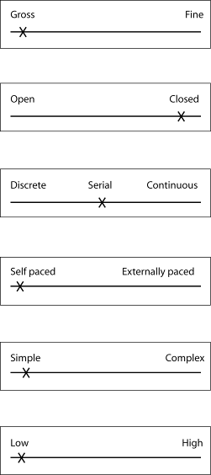
• Muscular involvement continuum – it is gross because it involves all the large muscle groups in the body – legs, trunk, shoulders and arms. There are few delicate, accurate parts of this skill.
• Environmental influence continuum – it is a closed skill because we are attempting to reproduce the set technical model. It is a self-paced skill involving few decisions as it is not affected by the environment.
• Continuity continuum – it is a serial skill because it is made up of several elements: the grip of the shot, the initial stance and preparation, the travel across the circle, the throw and release, and the recovery. They must be performed in this specific order.
• Pacing continuum – the shot put is self paced because the athlete has complete control over when they take their put and how fast they move.
• Complexity continuum – shot put is a simple skill because there is little information to process and few decisions to make. There is no pressure on the athlete to put the shot quickly and only a small number of sub-routines; i.e. travel across the circle, throw and recovery to time.
• Organisation continuum – the shot put is low in organisation because it can easily be broken down into
sub-routines, i.e. grip; stance at rear of circle; travel across circle; throw and release; recovery.
These parts can be practised separately.

TASK 2
Students’ own suggestions of skills that can be learned using the progressive part method.

TASK 3
• Dynamic strength – shot put
• Static strength – weight lifting
• Explosive strength – discus throw
• Stamina – triathlon
• Extent flexibility – gymnastics
• Dynamic flexibility – gymnastics
• Gross body coordination – springboard diving
• Gross body equilibrium – skiing
• Trunk strength – sit-ups

TASK 4 (see page 138 of student book)
1. Students’ own answers to practical task.
2. Students’ own results.

TASK 5
Students’ own answers. We have used gymnastics below as an example:
• Abilities – dynamic and extent flexibility: gymnastics skills require a large range of movements by limbs and the spine.
• Explosive strength – vaults require the gymnast to apply strength quickly at take-off.
• Static strength – when holding balances gymnasts have to support their body weight.
• Multi-limb coordination – gymnasts have to be able to organise the movement of several limbs at the same time in order to perform agilities and vaults successfully.

Notes for Teachers

This chapter of the Students’ Book covers the following sections of the specification:
• Phases/stages of movement skill learning that affect participation and performance in physical activity.
• Types of guidance and their impact on effective performance and participation in a balanced, active and healthy lifestyle.
• Practice methods and their impact upon effective and efficient performance of movement skills.

Phases/stages of movement skill learning
Students should be able to identify the three phases of learning together with their characteristics:
• Cognitive – first/initial.
• Associative – second phase.
• Autonomous – third/final phase.
Students must be able to identify Fitts and Posner’s characteristics of each of these phases and apply them to practical examples.
Students should try to recall their own skill-learning experiences and relate them to the phases of learning.
Types of guidance
Students should be able to describe the four types of guidance and relate them to their importance in different phases of learning.
They should also be able to discuss the strengths and weaknesses of each type of guidance:
• Visual • Manual
• Verbal • Mechanical
Activity 1
Ask students to teach new skills using only visual or verbal guidance. They will soon realise that it is normal to use both methods of guidance, particularly in the early stages of learning.
For example, ask students to teach short serve in badminton using only demonstrations and no explanations (visual guidance) and to teach the overhead clear in badminton using only verbal instructions and no demonstrations.
Practice methods and their impact upon effective and efficient performance of movement skills
Students should be able to describe the four methods of physical practice:
• Massed.
• Distributed.
• Fixed.
• Varied.
Activity 2
New skills should be taught using each of the methods, with students asked to discuss their experiences of the different methods. They should identify what they felt were the advantages and disadvantages of each method.
Mental practice/rehearsal
Students should be able to describe mental practice/rehearsal and compare it with physical practice.
Appropriate use of practice methods
Students should be able to explain which are the most appropriate practice methods to use in terms of:
• different levels of ability
• different classes of skills
• developing schema theory.
Critical evaluation
It is essential that students are able to discuss the advantages/strengths and disadvantages/weaknesses of the different types of practice methods.
Mental practice/rehearsal
Students should be to explain what mental practice/rehearsal is and explain its role in effective learning. They should be able to explain for whom it is most suitable to be used, when it is best used and how effective it is.

5.1 | Phases of learning
Characteristics of the phases of learning: use the table below to identify the three phases of learning, the characteristics of each phase and give a practical example of each.

Phase | Characteristics | Practical example
1.
2.
3.

5.2 | Guidance types
Using the table below, identify and describe the four types of guidance.

Types of guidance | Description | Practical example
1.
2.
3.
4.

5.3 | Guidance
Use the table below to identify in which phase of leaning each type of guidance is most appropriate, together with the advantages and disadvantages of each type.

Type of guidance | Most appropriate use | Advantages | Disadvantages
Visual
Verbal
Manual
Mechanical

5.4 | Types of practice methods
Use the table below to identify and describe methods of physical practice.

Practice method | Description
1.
2.
3.
4.

5.5 | Evaluation of practice methods
Use the table below to:
1. discuss the most appropriate use of each practice method
2. discuss the strengths and weaknesses of each practice method.

Practice method | Most appropriate use | Strengths | Weaknesses

5.1 | Phases of learning – answers
Characteristics of the phases of learning: use the table below to identify the three phases of learning, the characteristics of each phase and give a practical example of each.

Phase | Characteristics | Practical example
1. Cognitive | First/initial phase. Learner tries to create a mental picture. Demonstrations and verbal explanations very important. Learners need to be directed to the important cues. Trial and error learning takes place. Successes need to be reinforced with positive feeback. Performances are inconsistent and full of errors. | The teacher/coach demonstrates the overhead clear to the badminton learner and decribes two or three coaching points before the learner has a go at performing it. The teacher praises the learner for the parts of the skill they get right.
2. Associative | Second/practice phase. Usually longer than cognitive phase and some learners never leave this phase. Learner begins to eliminate mistakes. The fundamentals of the skill are learned and mastered. The skill becomes more consistent. Motor programmes are developed with sub-routines becoming more co-ordinated resulting in the skill becoming smoother. The learner is able to attend to relevant cues. The learner develops the ability to use internal/kinaesthetic feedback to detect some of their errors. | The performer has a good mental picture of the overhead clear and has practised it. They are now getting the feel for the shot and it is becoming more fluent and consistent. They are aware of what is right and what is wrong with the shot without being told and attempt to correct any faults.
3. Autonomous | Third/final phase of learning. The learner is able to execute the skill with the minimum of conscious thought and can concentrate on other factors such as where to place the shuttle in order to beat their opponent. The motor programme is established and stored in the long-term memory. Self-confidence is increased and the learner is able to detect errors and correct them. There is less need for external feedback but when it is given it can be specific and highlight errors to ensure improvement. Improvements are slow and if practise is not maintained the learner may return to the associative phase. | The overhead clear is now performed consistently and fluently with little attention paid to its execution. The learner is now able to focus on their opponent’s position on the court, the next shot and where to place the shuttle.

5.2 | Guidance types – answers
Using the table below, identify and describe the four types of guidance.

Types of guidance | Description | Practical example
1. Visual | This is when the teacher/coach shows the learner information. Guidance is in the form of demonstrations, which are important as vision is usually the dominant sense and we learn through imitation. Visual aids, such as videos, wall charts pictures, diagrams and models, can also be used. Demonstrations should be accurate and focus the learner’s attention on the important aspects. | The teacher shows the learner a demonstration of the overhead clear in badminton.
2. Verbal | This is when the teacher/coach tells the learner information. Often used in conjunction with visual guidance to direct the learner to the important cues. Should be clear and concise. Can be used for tactics and strategies. | The teacher tells the learner the coaching points of the overhead clear.
3. Manual | This involves the teacher/coach holding and physically manipulating the learner’s body through the correct pattern of movement. | The teacher puts the learner’s arm through the overhead clear so that they get the feel of the shot.
4. Mechanical | This involves the use of equipment to help support the learner and shape the skill. | The learner uses a float in swimming.

5.3 | Guidance – answers
Use the table below to identify in which phase of leaning each type of guidance is most appropriate, together with the advantages and disadvantages of each type.

Type of guidance | Most appropriate use | Advantages | Disadvantages
Visual | Used in all stages of learning but is particularly useful in the cognitive/early stages. | Helps learner to form a mental picture of the skill to be learned; vision is the dominant sense and we learn through imitation; demonstrations need to be accurate; can enable skilled performers to analyse their performances. | Not good for complicated or long skills with too much information; static displays quickly lose their impact.
Verbal | Is often used in conjunction with visual guidance; it is more effective with advanced performers in the autonomous phase. | Good for the conveying of detailed and technical knowledge in the autonomous phase e.g. strategies and tactics; good to use with learners in early stages of learning to direct them to the important cues in visual guidance. | Amount of information has to be limited; learners have to understand the information and be able to remember it and relate it to the skill; in complex skills it is difficult to be concise and the learners get bored.
Table continued on next page

Table continued.

Type of guidance | Most appropriate use | Advantages | Disadvantages
Manual | Useful in the early stages of learning to allow the learner to gain the kinaesthetic sense of the movement; is of limited use to the experienced performer. | Allows the teacher/coach to take the learner’s body through the correct pattern of movement; gives confidence and ensure safety, particularly in skills with a danger element. | This form of guidance needs to be removed as soon as possible so that the learner does not become dependent on it; the feel of the movement the learner experiences is different to the actual movement and it is important that the learner does not become accustomed to this adapted feel; manual guidance is difficult to give with groups.
Mechanical | Useful in the early stages of learning to allow the learner to gain the kinaesthetic sense of the movement; is of limited use to the experienced performer. | Allows the learner to experience the spatial and timing aspects of the movement; gives confidence and ensures safety particularly in skills with a danger element | This form of guidance needs to be removed as soon as possible so that the learner does not become dependent on it; the feel of the movement the learner experiences is different to the actual movement and it is important that the learner does not become accustomed to this adapted feel; mechanical guidance is designed to eliminate errors and therefore the learner does not get to experience and correct mistakes.

5.4 | Types of practice methods – answers
Use the table below to identify and describe methods of physical practice.

Practice method | Description
1. Massed | Learners practice continuously without any breaks or rest intervals. Practice sessions are usually long.
2. Distributed | Practice sessions have rest intervals included. Rest intervals allow time to recover physically and mentally.
3. Fixed | A fixed movement pattern is practised repeatedly in the same environment. Sometimes referred to as a skill drill. Best method of practice for closed skills.
4. Varied | The skill is practised in many different environments. Best method of practice for open skills.

5.5 | Evaluation of practice methods – answers
Use the table below to:
1. discuss the most appropriate use of each practice method
2. discuss the strengths and weaknesses of each practice method.
Practice method | Most appropriate use | Strengths | Weaknesses
Massed | Good for grooving-in habitual skills; good for simple, discrete skills of short duration. | Good for experienced, highly motivated learners who have high fitness levels; can save time, as skills do not have to be re-introduced after breaks; good for when the coach wants to stimulate performance conditions where there is an element of fatigue. | Can cause fatigue and de-motivation and lead to poor performance and learning.
Distributed | Good for most skill learning, particularly for beginners and learners with low levels of motivation and fitness; good for learning continuous skills. | Rest intervals allow learners to recover both mentally and physically; learner has opportunity to receive extrinsic feedback; good for potentially or complex skills; rest intervals allow mental practice/rehearsal to be undertaken; helps to maintain motivation. Research has shown it to be the most effective practice method. | Can take longer than massed practice.
Fixed | Most suitable for closed skills that require a specific movement pattern to be practised repeatedly in the same environment. | Skills learned become over-learned and habitual; environment is always the same; once the movement is learned and perfected it never changes; attention can be directed elsewhere. | Not suitable for open skills.
Varied | Most suitable for open skills when the skill needs to be performed in many different environments; practice conditions, however, need to be as realistic as possible. | Practice in a variety of situations allows schema to be developed; the learner is able to adapt the skill to suit the environment and the information relating to these adaptations is stored; variable practice develops the learner’s perceptual and decision-making skills. | Not suitable for learning closed skills; before the learner can be introduced to varied practice the learner should establish the motor programme in the fixed practice environment.

5 | Sample questions with mark schemes
1. It has been suggested that in the learning of movement skills the learner passes through three phases of learning. What is meant by the cognitive phase of learning? Use a practical example to explain the methods of guidance used with performers in the cognitive phase of learning. (6 marks)

What is meant by the cognitive phase of learning? Sub maximum 3 marks.
• First phase of learning.
• Learner tries to form an accurate mental picture of the skill.
• Demonstrations and verbal explanations very important.
• Tries to understand the linking of the movements and the flow of the skill.
• Need to selectively attend to the important cues.
• They practise with trial and error.
• Successes need to be reinforced with positive feedback.
• Performances are inconsistent and contain many errors.
Use a practical example to explain the methods of guidance used with performers in the cognitive phase of learning. Sub maximum of 2 if no practical example.

Example – front crawl stroke.
• (Visual guidance) demonstration by teacher or performer of front crawl stroke.
• (Visual guidance) learners shown video/charts with front crawl stroke.
• (Verbal guidance) teacher directs learners’ attention to the main coaching points.
• (Manual guidance) teacher guides learners’ legs through the movement.
• (Mechanical guidance) learner uses a float to support themselves.
2. Identify two different mechanical products for movement skill learning. Give reasons for the use of these mechanical products to guide a learner of a motor skill. (5 marks)
1 mark per point, maximum 2.
• Any two examples of ‘mechanical’ aids for learning, e.g. twisting belt in trampolining, arm bands in swimming, stabilisers on a bicycle, etc.
1 mark per point, maximum 3.
• Gives confidence to learner.
• Provides safety.
• Enables success/builds up sub-routines/enables part-learning.
• Gives an idea of the activity/similar kinaesthesis.
3. Practice can be massed or distributed. What is distributed practice, when might it be used and what are the advantages of this type of practice? (5 marks)
What is distributed practice? Sub maximum 1.
• Practice sessions with rest periods/breaks included.
When might it be used? Sub maximum 1.
• Beginners/less experienced.
• Task is dangerous/complex/gross/continuous.
• Task is physically demanding/for unfit performers.
What are the advantages?
• Not as tiring as massed practice/allows for recovery/can help maintain motivation/not as boring as massed.
• Allows for mental rehearsal between sessions.
• Allows sessions to be varied.
• Feedback can be given and mistakes corrected.
• Allows sessions to be made progressively more demanding.
• Research suggests it is more effective than massed.
4. Discuss the advantages and disadvantages of massed and distributed practice, explaining what type of skills they are most suited for use with. When might you consider using mental practice and what are its advantages compared with physical practice? (10 marks)

Level 3 (8–10 marks)
• There is detailed knowledge and good understanding of the topic.
• There is effective critical evaluation.
• Knowledge is clearly and consistently linked to practical performance throughout the answer if appropriate.
• Accurate technical and specialist vocabulary is used throughout.
• There is a high standard of written communication.

Discriminators from Level 2 are likely to include:
• Understanding of the terms ‘massed’ and ‘distributed’ practice and their application.
• Detailed knowledge of mental practice and its application.

Level 2 (5–7 marks)
• There is satisfactory knowledge and understanding of the topic.
• Critical evaluation is attempted with some success.
• Knowledge has been linked to practical performance with some success where appropriate.
• Technical and specialist vocabulary is used with some accuracy.
• Written communication is generally fluent with few errors.

Discriminators from Level 1 are likely to include:
• Explanation rather than mere description.
• Knowledge shown for at least two practices.
• There is satisfactory evaluation of one or more relevant factors.

Level 1 (0–4 marks)
• There is basic knowledge but little understanding of the topic.
• Little or no attempt to evaluate critically.
• Little or no attempt to link knowledge to practical performance.
• Technical and specialist vocabulary is used with limited success.
• Written communication lacks fluency and there will be errors, some of which may be intrusive.

Indicative content
Massed practice – Repeated/continuous attempts at a skill without breaks or rest intervals. The sessions are usually long.
Advantages
• Good for the grooving-in of habitual/closed skills.
• Good for experienced performers.
• Good for highly motivated performers with good fitness levels.
• Suitable for discrete skills of short duration.
• Time saving, as skills do not have to be re-introduced after breaks.
• Good for coach to simulate performance conditions where fatigue is a factor.
Disadvantages
• Can cause fatigue, boredom and de-motivation, which lead to poor performance and learning.

Distributive practice – Practice sessions with rest periods/breaks included.
Advantages
• Used with beginners/less experienced/short attention spans.
• Used if task is dangerous/complex.
• Used if task is physically demanding or performers unfit.
• Can help maintain motivation/good for those with low motivation.
• Allows for recovery – mental and physical.
• Not as boring as massed.
• Mental rehearsal/practice can occur during rest intervals.
• Allows sessions to be varied.
• Feedback can be given and corrections made between sessions.
• Mistakes are not grooved-in.

• Allows for sessions to be progressively demanding.
• Research shows it to be more effective than massed.
Disadvantages
• Time consuming.
• Skills may have to be reintroduced at the start of each session.
• Can lead to negative transfer.
• Not good for discrete skills.
Mental practice – The learner goes through the movement in their mind without any physical movement occurring. It can be used during rest intervals in distributed practice. In the early/cognitive stages it is used to build up a mental picture of the skill to be learned. Advanced performers use it to rehearse complex skills and to go over strategies and tactics. It can also be used for re-enforcing successful movements and experienced performers use it for emotional control and to establish optimum levels of arousal.
It is not an alternative to physical practice as when used on its own it is not as effective as physical practice. It should be used in conjunction with physical practice i.e. rest intervals in distributed practice. It is more effective with skills with a cognitive element than simple skills.

5 | Answers to student book tasks

TASK 1
1. Check the video of your demonstration to see if it clear and more importantly, accurate, in that it matches the technical model. It should have no faults.
2. The verbal guidance will direct the learner’s attention to two or three important coaching points of the demonstration, e.g. overhead clear in badminton: body sideways-on to net with right foot furthest away, weight on rear foot, eyes looking at shuttle.
3. Advantages – allows body of the learner to go through the correct pattern of movement, gain kinaesthetic awareness, gives confidence, ensures safety when skill is dangerous.
Disadvantages – feel of the movement the learner experiences is different to the actual movement. This means it is of limited use to the experienced performer. Mechanical guidance eliminates errors and does not give the learner the opportunity to experience and correct errors.

TASK 2
1. Distributed practice is best suited to learning potentially dangerous skills as it allows learners to recover both mentally and physically during the rest intervals. It also permits learners to receive feedback to guide them.
2. Massed practice is most beneficial for experienced, highly motivated performers who have good fitness levels. It allows them to groove-in closed skills. It also allows coaches to simulate performance situations where fatigue is a factor for players.

TASK 3
1. Open skills are best practiced in varied practice situations. This is where the skill is practised in many different environments and this variety allows schema to be developed. The performer has to adapt the skill to suit the environment and this information is stored. It is important that the practice conditions are as realistic as possible.
2. Closed skills are best practised in fixed practice situations. This is where a specific movement pattern is practised repeatedly in the same environment. Closed skills require specific movement patterns to be over-learned and become habitual. Closed skills are always performed in the same environment and once the movement is learned it never changes.

Notes for Teachers

This chapter of the Students’ Book covers the following sections of the specification:
- Models of information processing and effectiveness in the learning and performance of movement skills.
- Memory and its role in developing movement skills.
- Reaction time and developing effective performance in physical activity.

Information processing models
Information processing is a vital topic for students to understand if they are to be successful in appreciating later topics. It is probably better to start with a basic processing model before progressing on to the more complex ones, which include more detailed features.
Whiting covers basic information processing principles by identifying models for:
• physical components
Sense organs
Central mechanisms
Muscular system

• functional components
Input
Decision making
Output

• central mechanisms
Perceptual mechanisms
Translatory mechanisms
Effector mechanisms

• sense organs
• muscular system
• input
• decision-making
• output
• perceptual mechanisms
• translatory mechanisms
• effector mechanisms.
Students should be introduced to the concept of detection–comparison–recognition (DCR).
Welford and Whiting’s models
Students should gain an understanding of the features of the processing models:
• sensory input – proprioception, touch, kinaesthesis, equilibrium, sight, hearing
• perception
• memory – short-term sensory stores, short-term memory and long-term memory
• effector mechanisms
• feedback.
Students should be made aware of the sensory systems that are most important in sporting activities and the different functions they have, i.e. vision, hearing, touch, proprioception and kinaesthesis. Refer to Figures 6.2 and 6.3 of the Students’ Book.
Sensory input
To raise students’ awareness of the importance of sensory input they should be put into practical situations and have their ‘senses’ restricted.
• Play a team game with headphones that prevent them hearing.
• Play a team game with goggles or blinkers that restrict their vision.
• Play a racquet game with headphones that prevent them hearing.
Students should be asked to comment on the effects that sensory limits have on their performances.
Proprioception
The following two activities are designed to raise the students’ awareness of proprioception and the effect it has on performance.
• Ask students to perform a racquet sport wearing thick gloves that restrict their ‘feel’ of the contact; then ask them to perform the same activity ‘normally’. Ask the students to identify the differences in their performances, together with the reasons for them.
• Students are blindfolded. They are told that they will be required to roll a tennis ball (shot put, cricket ball, etc.) on two occasions. Their aim is, on each occasion, to roll it the same distance. They should be asked to think about what they did to compensate for their lack of vision. This should lead to the identification of proprioception (the feel of the movement) being important.
Signal detection
Students should be aware of the importance to performance of the detection that a stimulus is present. Their awareness can be raised with a simple discussion on developments in a range of activities that have been specifically designed to improve signal detection. Examples might include using an orange football when it snows, using a white cricket ball for night games, the yellow jersey worn by the leader in the Tour de France, white sight screens in daytime cricket, etc.
After discussing a range of examples, students should be asked to identify other examples from a range of activities.
Encourage the students to take part in practical activities where signal detection is emphasised; for example, a small-sided team game with both sides wearing the same colours. The same game should then be played with the teams in different colours. Students should discuss the differences between the two games.
Perception
This is an important concept but is often difficult for students to grasp. It is important that they realise that perception is a very personal thing and is in many cases based on past experiences.
Activity 1
The following picture gives an example of how individuals can interpret (perceive) the same piece of information in different ways. It is based on figure–ground visual perception but can be used to illustrate differences in interpreting information. Look at the picture for ten seconds and write down what you see.
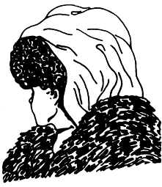

Feedback
All types of feedback should be covered in relation to the information processing models. These also need to be linked to the phases of learning and types of learner. Feedback can be categorised as:
• intrinsic–extrinsic
• positive–negative
• concurrent–terminal
• knowledge of results–knowledge of performance.

Memory
The three components of memory are referred to as the ‘multi-store model’ of the memory process. These three components are:
• short-term sensory stores
• short-term memory
• long-term memory.
The relationship of the three components should be identified in a diagram.
Students should be made aware of the characteristics of each of the components of memory together with the links between these components. It is important that students are aware of the relationship that memory has with other components of information processing.
It is difficult to create sports-related student tasks to reinforce the learning of memory, but there are numerous non-sport related activities.
Activity 1
Have the students attempt to remember a series of random letters that are read out to them. These initially should be no more than seven. Students should be asked to write them down after a gap of 30 seconds. Students should not talk. They should then check to see how many they managed to remember.
This activity relates to the capacity of the short-term memory.
Activity 2
Ask the students to attempt to remember a series of 20 random numbers read out. Students should be asked to write them down after a gap of 45 seconds. During the interval they should not be allowed to talk. They should then be asked to write them down and check to see how many they remembered correctly.
They should perform better on Activity 1 than
Activity 2.
This activity relates to the limited capacity of the short-term memory.
Activity 3
Working in pairs, student A has to remember for one minute 20 random letters that have been read out. Once the letters have been read out, B will say a number, which A will count backwards from in threes. This effectively prevents the subject from rehearsing/repeating the letters. After one minute of counting, A has to write down the 20 letters. The performance should be poorer on this activity than Activity 2.
This activity shows that to transfer information to the long-term memory we need to rehearse/repeat the information.
The application of memory to the learning process could be explored by discussing examples that students will have experienced, e.g. only being given two or three coaching points to remember when learning a skill, or the coach asking learners to practise coaching points immediately after telling them these points, i.e. whilst they still remember them. These illustrate the characteristics of the short-term memory.
Permanency of long-term memory is indicated by our ability to perform skills whose motor programmes have been stored in the long-term memory but which we have not used for a considerable time, e.g. riding a bike, swimming.
Reaction time
Students should be made aware of the different types of reaction time – simple and choice. In sport, most reaction time situations are choice because we have to decide which stimulus to react to and which response to make.
It helps students to understand reaction time if they are aware of the component parts, i.e. the time it takes for:
• the stimulus to activate the particular sensory system
• the stimulus to travel from the sensory system to the brain
• the brain (central mechanism) to process the stimulus
• the command to be sent from the central mechanisms to the relevant muscles.
Factors that affect reaction time should be investigated. If the group is mixed the results of the simple reaction time task can be used to compare male/female reaction times to show the gender difference. Simple reaction time experiments such as those with a reaction time ruler can be compared between preferred and non-preferred hands.
It is important that choice reaction time and Hick’s law are covered and that students realise that reaction time increases as the amount of information to be processed increases.
Hick’s law: “Choice reaction time is linearly related to the amount of information which needs to be processed in order to respond.”
Students should be able to sketch a ‘graph’ depicting the relationship between reaction time and the number of choices of response available.
Methods of improving reaction time should also be covered, as this is an application of the concept and can be examined.

6.1 | Simple reaction time
1. Work in pairs, using a metre rule.
• Student A holds the ruler so that its end is between the thumb and forefinger of student B’s right hand.
• Student A releases the ruler and student B catches it between thumb and forefinger.
• Student A measures and records the point on the ruler at which student B has caught it.
• Repeat for ten trials.
• Calculate the mean of the results.
• Reverse the roles and repeat the task.
• Compare the mean simple reaction times.
• Repeat the task with both partners using his or her left hand.
• Compare your right hand and left hand means and discuss the reasons for any differences.

6.2 | Choice reaction time
1. Work in pairs, using a pack of cards and a stopwatch.
• Student A times student B and records the time.
• Student B simply turns over the cards and places them in a pile face up.
• Student A shuffles the cards.
• Student A times and records whilst student B turns the cards over and divides them into reds and blacks (two piles).
• Student A shuffles the cards.
• Student A times and records whilst student B turns the cards over and divides them into four piles – hearts, clubs, diamonds and spades.
• Student A shuffles the cards.
• Student A times and records whilst student B turns over the cards and places them into eight piles: one pile for two to ten and one pile for face cards for each suit, i.e. hearts, spades, diamonds and clubs.
• Students A and B reverse roles and repeat the tasks. Record your results in the table below.
• Draw a graph to illustrate your results. Discuss your findings.
Number of piles | Student A time | Student B time
1
2
4
8
2. Either indoors or outdoors, set up eight cones in the form of a circle approximately
20–40 metres in diameter, all equidistant from a cone in the middle. Use numbers or letters to identify the cones. Use a stopwatch to time the following tasks.
• Each student, on the command “1”, sprints from the middle cone to cone 1 and back to the middle. Record the times.

• Tell students that the command will be either “1” or “2”, and time them sprinting to whichever number cone is called and back to the middle cone. Record the times.
• Tell students the command will be “1”, “2”, “3”, or “4” and time them sprinting to whichever number cone is called and back to the middle. Record the times.
• Repeat the process using all eight numbers.
Work out the mean of the group’s results for each of the four trials and plot a graph. Discuss your findings.

 | Time
Name | 1 cone | 2 cones | 4 cones | 8 cones
Mean time

6.3 | Feedback effects
1. Work in pairs.
• Student A is blindfolded and has ten attempts at throwing a beanbag into a hoop 10 metres away. No indication is given of where they have landed.
• Student B records the number of successes.
• Student A repeats the task without the blindfold.
• Student B records the number of successes.
• Compare the results.
• Reverse roles.

Student | Successful throws blindfolded | Successful throws with sight

6.4 | Feedback types
1. Work in pairs.
• Place a hoop on the floor 10 metres away.
• Student A faces away from the hoop and attempts to throw a beanbag over their shoulder into the hoop.
• No feedback is given.
• Student B records the number of successes in ten attempts.
• Repeat the task. This time student B gives feedback, telling student A where the beanbag landed in relation to the hoop.
• Student B records the number of successes out of ten attempts.
• Reverse the roles.
2. Using one of your practical activities, identify one example of the following forms of feedback that you have experienced.

Type of feedback | Activity | Description of feedback
Intrinsic (kinaesthesis)
Extrinsic
Terminal
Concurrent
Knowledge of performance
Knowledge of results

6.5 | Information processing
1. In groups of three, nominate a batter, a bowler and a fielder. Whilst taking part in the game, each of you must examine the following aspects of your role.
• What are the input characteristics of the skill?
• What are the important aspects of the display?
• What are the demands on the memory?
• What are the other perceptual skills and abilities needed?
• What physical skills and abilities are needed?
• What types of feedback are involved?
As a class, base a discussion on:
• the input/display
• perception
• memory and selective attention
• reaction time
• feedback – knowledge of performance, knowledge of results.

6.1 | Simple reaction time – answers

Answer
Reaction times of the preferred hand are usually faster than those of the other hand because this is the hand that we practise with more often.
6.2 | Choice reaction time – answers

Answers
1. The reaction time should increase as the number of piles increases. This is because the number of decisions and the amount of information to be processed increases.
Ask students how many decisions they would have to make to place:
• a card on either the red or black pile? One decision: is the card red?
• a card on the correct suit pile? Two decisions: (i) is the card red? (ii) is the card a heart?/is the card a spade?
This indicates the number of decisions and the amount of information being processed.
2. The answers for question 2 will depend on the times recorded by the group.

6.3 | Feedback effects

Answer
Since the student is blindfolded on the first attempt, they are denied any feedback, so the performance should improve when they are able to see the result of their attempts.
6.4 | Feedback types

Answer
1. Practical activity
2. Student’s own answer
3. On comparing the results from the first and second attempts, there should be an improvement when the student receives feedback.
6.5 | Information processing

Answer
The discussion should centre on the students’ experiences and thoughts relating to the components of information processing they have focussed on in their game.

6 | Sample questions and mark schemes
1. Feedback plays an important part in the learning and performance of movement skills in an active lifestyle. Use practical examples to explain both intrinsic and extrinsic feedback.
(4 marks)

Sub maximum 2 if no examples.

Intrinsic
• Feedback or feeling from within the performer/internal/kinaesthetic/proprioceptive/
knowledge of performance.
• Suitable example: gymnast feels legs are not straight in a handstand.

Extrinsic
• External information about the performance/information gained from environment or others/knowledge of results.
• Suitable example: seeing ball go into the net/coach informing about the technique.
2. What is selective attention and why is it important to the short-term memory? How does the teacher/coach ensure that information is retained and easily retrieved form the long-term memory? (6 marks)

What is selective attention? 2 marks sub maximum
• Focus on relevant/important detail.
• Filters information into the short-term memory.
• Irrelevant information is ignored.

Why is selective attention important? 1 mark
• Short-term memory has limited capacity/can only store four to nine items/can only store for 30 seconds.

How does the teacher/coach ensure that information is retained and easily retrieved form the long-term memory? 3 marks
• Practice/rehearse/repeat/overlearn the skill.
• Intensify the stimulus/make stimulus more noticeable.
• Intensify the emotional experience.
Link to past experience/associate with familiar information/imagery.
• Information must be relevant/meaningful.
• Reward/positive reinforcement.
• Chunking.
3. Fast reaction times are important in many activities in which we participate as part of an active lifestyle. Define reaction time, movement time and response time. Use an example from an invasion game to explain why a fast response time is important. Sketch a graph to show how the number of choices affects a performer’s reaction time. (7 marks)

Define reaction time, movement time, response time. (1 mark for each.)
• (Reaction time) the time from the onset/start of the stimulus to the initiation of the response.
• (Movement time) the time from the start of the movement to completion.
• (Response time) the time from the onset of the stimulus to the completion of the movement. Reaction time + movement time = response time.

Use an example from an invasion game to explain why a fast response time is important.
(1 mark for appropriate invasion game example.)
• Attacker standing alongside a defender is able to run to reach a pass before the defender.

Sketch a graph to show how the number of choices affects a performer’s reaction time.
(1 mark for each.)
• Correct labelling of axes.
• Units/indication of increases on axes.
• Correct shape of curve.
Shape of curve can be taken from Figure 7.10 on Page 139 of current AS textbook.

4. Human information processing can be explained through the use of a model such as the one below.
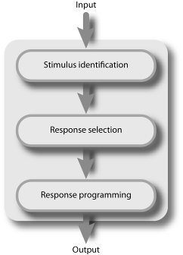

Use a practical example to explain what perception is. Use practical examples to explain both intrinsic and extrinsic feedback. On which type of feedback will the learner be dependent?
(6 marks)

Use a practical example to explain what perception is.
• The process that interprets and makes sense of information received. The tennis player sees the flight and speed of his/her opponent’s serve and moves to play it back.

Use practical examples to explain both intrinsic and extrinsic feedback.
Intrinsic
• Feedback/feeling from within the performer/internal/kinaesthetic/proprioceptive/ knowledge of performance.
• A suitable example would be a gymnast feels for his/her balance on a beam.
Extrinsic
• External information about the performance/information gained from the environment/from coach/knowledge of results.
• Coach tells performer about their techniques/tennis ball goes into the net.

On which type of feedback will the learner be dependent?
• Learners will be dependent on extrinsic feedback from teachers/coaches as they are very limited in their use of intrinsic feedback.
6 | Answers to student book tasks

TASK 1

You get intrinsic feedback from your proprioceptors about the feel of the movement. Kinaesthesis is also involved.
Extrinsic feedback is received from the teacher or coach. This type of feedback is received by your visual and auditory systems.

TASK 2
Example answer below illustrating how each component of Welford’s model works.

Welford’s model
• Sense organs receiving stimuli from outside – the information generated by the display is taken in by the visual and auditory systems. Football – information is received about the flight of the ball and the positions of teammates and opponents.
• Internal sensors – information generated from proprioception – touch, kinaesthesis and equilibrium is processed. If you are going to control the ball you will ‘feel’ the impact of the ball on the surface you control it with.
• Perception – the information received via the sense organs in relation to the ball, teammates and opponents is interpreted by the central mechanisms. You interpret the information about the flight of the ball to enable you to get into the correct position to receive the ball.
• Perception involves three elements – detection, comparison and recognition.
• Short-term store – information that is considered to be important/relevant is transferred to the short-term memory, e.g. flight path of the ball.
• Long-term store – information in the short-term store is compared with that in the long-term memory.
• Decision-making – a motor programme is selected from those available in the long-term memory on the basis of the information perceived and processed.
• Effector control – the motor programme sends the stimuli to the appropriate muscles to carry out the movement to control the ball.
• Effectors – the muscles carry out the movement and control the ball.
• Feedback – information is generated relating to what happens to the ball and how the movement feels to the player. This is in the form of extrinsic and intrinsic feedback.

TASK 3
For example, sprinting: you focus on preparing for your start. You focus on your start checks – distance of blocks from start line, width of hands apart, looking at track set distance in front of you and listening for the starter’s commands and then the gun. You ignore – your opponents, other track officials, spectators, noise from spectators.

TASK 4
When you average out the male and female reaction times you may find that the males have quicker reaction time than the females.

TASK 5
You should find that the greater the number of piles, the more choices you have and the slower your time becomes. The greater the number of choices you have, the more information you have to process to make your decisions and this slows down your reaction time.

TASK 6
The student may have experienced a number of the following:
• Mental rehearsal – This practice can be performed in the form of mental rehearsal. This enables the performer to ensure that they attend to the correct cues and expect and respond to the correct stimuli. It also activates the neuromuscular system, acting like physical training. It is also thought to have an effect on the control of arousal levels. Mental rehearsal works better with complex tasks that require a lot of information processing.
• Experience – Playing the activity enhances the performer’s awareness of the probability of particular stimuli occurring.
• Stimulus–response compatibility – If the response you are expected to make to the stimulus is the one you would normally make you will react quicker than with a different response.
• Cue detection – Analysing an opponent’s play to anticipate what they are going to do. For example, analysing a badminton player’s shots so that you are able to detect the difference between their overhead clear and drop shot.
• Improve the performer’s physical fitness – This will influence response time. The fitter you are, the quicker you will be.

• Concentration/selective attention – In simple reaction-time situations you focus on the relevant stimulus and ignore everything else. This limits the information you process. For example, during a sprint start, focusing on the gun.
• Level of arousal/motivation – The teacher/coach has to ensure that the performer is at the appropriate level of arousal/motivation for the activity.
• Warm-up – Ensuring physical and mental preparation for the activity.
• Anticipation – We have left this to last because it is a very important strategy in reducing both types of reaction time. There are two main forms of anticipation:
Spatial – predicting what will happen. The cricket batsman who has detected the difference in the fast bowler’s action is able to pick out the disguised slower ball.
Temporal – predicting when it will happen. The sprinter who has identified the period between the ‘set’ command and the gun will be able to move as the gun goes off.
Anticipation has very important implications for teachers and coaches. They should encourage their performers to look for relevant cues in their opponents’ actions in order that they will then be able to predict what they will do and also to disguise their own actions to prevent opponents anticipating. They should also ensure that their performers do not become too predictable in what they do.

TASK 7
Other situations mentioned could be:
• Football – ball hitting crossbar or post from a shot.
• Netball /basketball – ball hitting ring and rebounding from a shot.
• A game where a player ‘sells their opponent the dummy’.
• Tennis, badminton – a player is able to disguise a shot, e.g. badminton drop shot disguised as an overhead clear.

Notes for Teachers

This chapter is divided into three components, each with specific learning outcomes.

• Motor and executive programmes and their impact upon the learning of movement skills. Candidates should be able to: (i) describe the nature of, and give examples of, motor programmes stored in long-term memory; (ii) explain the links to open-loop control and the autonomous stage of learning.
• Types of motor control and their impact on movement skill acquisition and competence in physical activities. Candidates should be able to: (i) describe open-loop control and closed-loop control; (ii) explain the role of open loop and closed loop in the performance of motor skills; (iii) evaluate critically different types of feedback to detect and correct errors.
• Schema theory and its role in developing movement skills and strategies. Candidates should be able to: (i) explain relationships with the motor programme; (ii) demonstrate knowledge and understanding of sources of information: recall schema (knowledge of initial conditions, knowledge of response specification); recognition schema (knowledge of sensory consequences, knowledge of movement outcomes); (iii) demonstrate knowledge and understanding of motor programmes (relevant sub-routines and possible schema identification from the candidate’s physical activity experiences).

Introduction
Students find this section of the syllabus to be less then straightforward. It involves the learning of essential technical language that must be understood if learners are to perform well in examinations. Furthermore, the concepts of closed-loop and schema theories are perceived as difficult. When these theories are presented on the examination paper they differentiate between students who have acquired depth in understanding as opposed to those with superficial knowledge.
Both of these theories, practical examples and the underpinning technical language are outlined in the student textbook. The features in this resource are designed to provide additional help to teachers and students in an area that has traditionally proved to be problematic.
Students who develop a deeper understanding of the syllabus will become aware of the relationships that exist between most concepts. These relationships or links initially emerge during classroom delivery but are developed when students undertake personal study and revise for practice examinations.
Links between concepts will arise when teachers address the impact of motor programmes on the learning of movement skills. This approach must consider the problem of how a motor programme is created and operated. Large areas of the syllabus, including major areas such as information processing and skill learning, could be incorporated as links to help bring a conclusion to this problem. However, to remain relevant to this chapter the focus of the solution will be on the link between closed-loop and schema theories.
Closed-loop theory emerged as a result of a drawback alleged against the connectionist view of learning, which is based on the formation of stimulus–response (S–R) learning bonds. A psychologist named Adams agreed that the notion of S–R bonding is an explanation of learning but it did not account for the performance of a motor programme. In his closed-loop theory Adams stated that a motor programme is initiated by a ‘memory trace’ and controlled during performance by a ‘perceptual trace’. As the perceptual trace provides feedback to the memory, any adjustments to performance are stored as new motor programmes.
In turn, schema theory evolved from weaknesses in closed-loop theory. Closed-loop theory was criticised on the grounds that every movement would require a separate memory trace resulting in problems for the long-term memory in the storage and retrieval of an infinite number a motor programmes. Furthermore, novel and creative responses such as those associated with open skills would not be possible because the necessary motor programme may not exist.
Schema theory does not rely on fixed memory traces but assumes that experiences are developed through live situations and varied practices. Adaptations of these experiences are transferred to meet the demands of related but different situations. Recall schema stores information about the production of the generalised movement and initiates the response. Note that both recall and recognition schema must be mentioned. Recognition schema provides feedback in that it evaluates the movement outcome and stores any new experience.
Whilst both closed-loop and schema theory provide an explanation as to how motor programmes are controlled and operated, they also indicate how movement is learned and created.
It would appear that in both theories feedback plays a key role in the process of learning.

7.1 | Motor programmes
1. Fill in the spaces below by choosing from the following list of words or phrases.
generalised series of movements, subroutine, long-term memory, grooved, fluent, over-learned, sequentially, mini-skills, automatic, feedback.
A motor programme is a ____________________ or plan of movements stored in the ____________. The executive motor programme is updated and modified each time a skill is performed through a process called ____________. Executive motor programmes are made up of ____________, which are usually performed ____________ and are described as ____________. As the novice player eventually reaches the autonomous stage of learning and becomes an expert, these lower-order skills are performed almost without thought, the execution of the movement becomes ___________ and skills appear to be ____________. If this standard of control is acquired the skill is said to have been ____________ or ____________.
2. Perform and/or watch a demonstration of a shot put and a tennis serve. Now consider the following task.
In the diagrams below the executive motor programmes of shot putt and tennis serve are highlighted. The blank boxes below represent the subroutines, which in these examples are ‘run off’ sequentially. Fill in each box with the name of the appropriate subroutine.
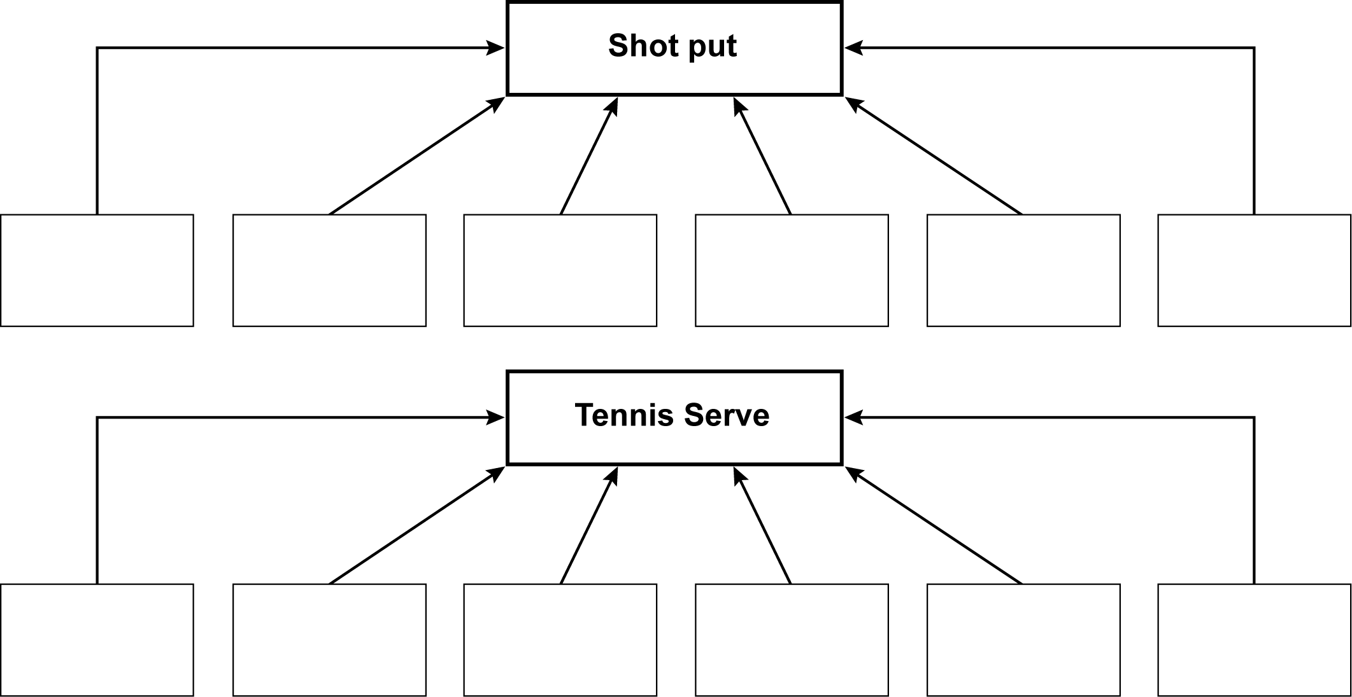

3. Select a motor programme, preferably from an activity in which you will be assessed. Decide whether the programme can be performed by one individual or whether the programme requires a partner or a group to make it work.
Perform the skill that you have chosen.
Draw and label a diagram similar to those shown above to depict the hierarchical and sequential organisation of the skill.

Discussion
The subroutines of some motor programmes can be ‘run off’ sequentially, while in other motor programmes the subroutines appear to merge. Using practical examples, discuss why the sequencing of subroutines can impact upon the learning and improvement of performance.
7.2 | Open and closed loop control
Open loop Closed loop
Motor command Motor command
The plan
or
EMP
Movement
effectors
The plan
or
EMP
Movement effectors

Level two

Level one Level three

Match three appropriate statements with each level of control.
Open-loop
level one
Closed-loop
level two
Closed-loop
level three

1. Operates without feedback and is termed the memory trace.
2. This is the longer of the feedback loops and operates through the process of cognition at a level of consciousness.
3. As this feedback loop does not reach the level of cognition, the adjusted movement can be completed without interrupting the fluency and continuity of performance.
4. Like the short loop this feedback loop terminates the skill and formulates the perceptual trace. Both explain control and learning.
5. The memory trace initiates the response after it has been triggered from the long-term memory by an environmental stimulus.
6. Operates by way of a short feedback loop that passes through the muscle spindles. This loop enables quick adjustment without conscious thought, e.g. skiing.
7. At this level feedback cannot be referenced because the execution of the skill is, by nature, too rapid, e.g. the swing of the club during a drive in golf.
8. This short feedback loop operates at speed at a subconscious level. The brain takes note of adjustments and stores them for future reference. It forms a perceptual trace.
9. This longer loop references the brain when major decisions are required. In terms of learning it tends to operate at the associative stage of learning before the correct feel of the skill has been acquired.

Discussion
Discuss the topic below with a partner. Make supplementary notes during discussion. Refer to your notes during the plenary discussion with the whole group.
Open- and closed-loop theory explains how skills are controlled and learned; however, there are several drawbacks with this theory. Using practical examples, discuss these drawbacks.
7.3 | Open and closed loop control in theory and in practice
Design and display a poster to give the important facts and practical examples of open-loop and closed-loop control. Below is an example of a possible layout and practical images that could make up an information poster. It is better to use your own design; use the textbook as a guide for knowledge.
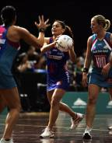
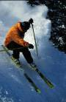
Closed-loop
level 2 control
A skier making a fast descent would operate through closed-loop level 2 control because ____
______________________________________________________________________________________________________________________________________.
Key terms
Closed-loop
level 3 control
A netball player taking position before making a pass would operate through closed-loop control level 3 because ______________________
____________________________________________________________________________________________________________________________________________.
Key terms
Open-loop
level 1 control
A golf swing is a product of open-loop control because _____
_________________________________________________________________________________________________________________________________________________________________.
Key terms
Open-loop control links to the autonomous phase of learning because __________________________________________.
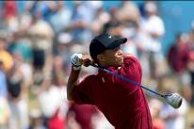
Most movements made in sport are made up of open- and closed-loop control because _________________________________________.
7.4 | Schema theory
1. Schema theory offers an explanation as to how the novel response is made possible and answers the problems relating to storage and retrieval of information. Fill in the blanks by using the following terms or words.
experiences, adapted, memory items, generalised movements, relationships, transfer
Schema is a build-up of ____________, which the theory states can be ____________ and used to respond to the demands of new situations. The process of applying previous experiences to new situations is called ____________. Schema theory is based on the idea that plans are not stored as separate items presented by closed-loop theory but retained in long-term memory as ____________ with motor programmes. These links are termed ____________ and allow the performer to adapt quickly in response to a given situation.
Experience is accumulated by gathering information from four areas. These areas are termed ____________ and represent an important basis of schema theory.
2. Model of schema theory: schema theory comprises four memory items. Identify these memory items in the boxes below. Explain each memory item in the context of a practical situation in sport or physical education
Recognition schema
1
2
3
4
Recall schema

Identify two functions of recall schema:

Identify two functions of recognition schema:
7.5 | PowerPoint presentation – schema theory
1. Design and deliver a PowerPoint presentation on schema theory. Try to bring together the relationships between motor programmes, and open- and closed-loop control while directing the main focus towards schema theory. Below is an example of how you may wish to approach the task.

Memory Item 2

Knowledge of response specifications.

Explanation

Practical example

Illustrate this slide with a relevant image
Memory items 1 and 2 are called recall schema.

The role of recall schema is:

Illustrate this slide with a relevant image
Schema Theory

Schema theory explains three drawbacks found in open- and closed-loop control. These drawbacks are:
1.
2.
3.
Schema theory does not involve storing separate motor programmes.

It involves storing relationships relating to motor programmes.

These relationships are called memory items.

Illustrate this slide with a
relevant image
There are four memory items, sometimes called parameters.

Knowledge of initial conditions

Knowledge of response specifications

Knowledge of sensory consequences

Knowledge of movement outcome
Memory Item 1

Knowledge of initial conditions.

Explanation

Practical example

Illustrate this slide with a relevant image

Memory Item 3

Knowledge of sensory consequences.

Explanation

Practical example

Illustrate this slide with a relevant image
Memory Item 4

Knowledge of movement outcome.

Explanation

Practical example

Illustrate this slide with a relevant image
Memory items 1 and 2 are called recognition schema.

The role of recognition schema is:

Illustrate this slide with a relevant image
Schema is best developed or expanded through varied practice.

Experiences are transferred from schema to help solve problems in different but related situations.

Illustrate this slide with a relevant image or images

7.6 | Feedback
1. You should learn eight types of feedback. Study the types of feedback identified in the list below. Match the type of feedback against the correct explanation.
Use the textbook as a guide towards the correct answer.
positive, negative, intrinsic, extrinsic, terminal, concurrent, knowledge of performance (KP) and knowledge of results (KR).
____________ feedback comes from external sources such as the teacher, coach and team mates. This type of feedback is also called augmented feedback. Augmented feedback is the general term give to all types of feedback that supplement sensory feedback.
____________ feedback is received when the movement is incorrect. It can be intrinsic or extrinsic.
____________ feedback can be given externally by the teacher or coach when the player is praised following success.
____________ is feedback about the result or outcome of the movement and is extrinsic. It is given by teachers or coaches actually seeing the result, e.g. did the ball go into the goal, or by watching a visual recording of the movement.
____________ feedback is received during the performance of the skill.
____________ feedback is received after the movement has been completed and is extrinsic feedback.
____________ is feedback that concerns the quality of the movement. It can be internal as it arises from kinaesthetic awareness
____________ feedback is a form of sensory feedback about the physical feel of the movement as it is being performed. It is received via the internal proprioceptors, and kinaesthesis is also involved. For example, the feeling of high knee lifts in sprinting.

Discussion
2. Discuss with a partner the benefits of feedback to the learning and performance of motor programmes. Write down the benefits that arise in your discussion in the space provided below and report them to the whole group during plenary discussion.
____________________________________________________________________________________________________________________________________________________________________________________________________________________________________________________________________________________________________________________
7.7 | Critical evaluation of feedback types
The correct application of the appropriate type of feedback is necessary if the process is to benefit the learning and performance of motor skill. The coach or teacher will be aware when it is good and when unadvisable to use a particular type of feedback. Most importantly, the grounds on which this choice has been made must be justified on a knowledge basis. This informed judgement is a result of a critical evaluation of the type of feedback.
1. In the table below, make a critical evaluation of eight types of feedback.

Type of feedback | Critical evaluation (application)
Positive feedback
Negative feedback
Extrinsic feedback
Intrinsic feedback
Terminal feedback
Concurrent feedback
Knowledge of performance
Knowledge of results

7.1 | Motor programmes – answers
A motor programme is a generalised series of movements or plan of movements stored in the long-term memory. The executive motor programme is updated and modified each time a skill is performed through a process called feedback. Executive motor programmes are made up of subroutines, which are usually performed sequentially and are described as mini-skills. As the novice player eventually reaches the autonomous stage of learning and becomes an expert, these lower-order skills are performed almost without thought, the execution of the skill becomes automatic and movements appear to be fluent. If this standard of control is acquired the skill is said to have been grooved or over-learned.

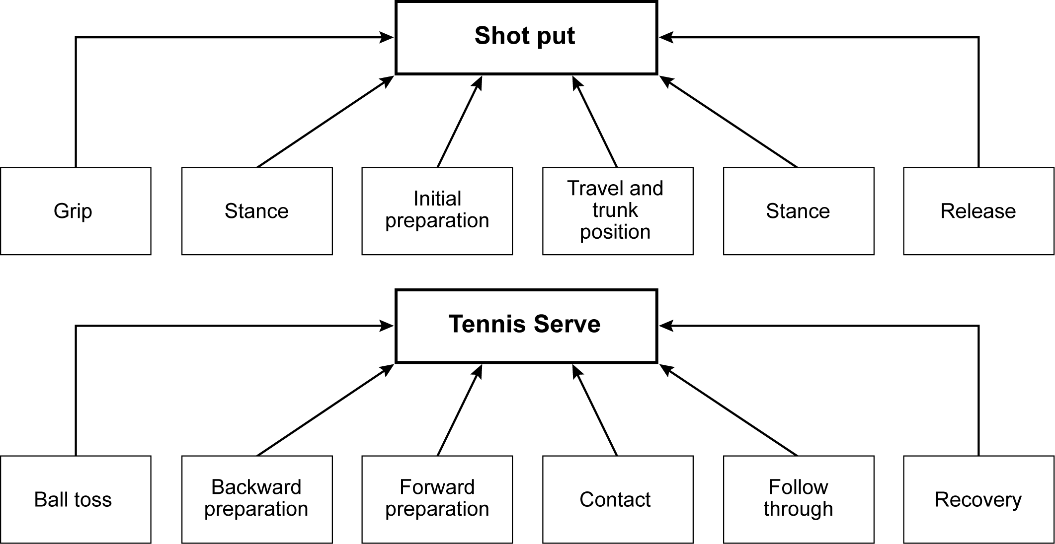

Answer
Student’s own answer.

Discussion
The subroutines of some motor programmes can be ‘run off’ sequentially, while in other motor programmes the subroutines appear to merge. Using practical examples, discuss why the sequencing of subroutines can impact upon the learning and improvement of performance.

Answer
The basis of discussion is that some skills do not follow a sequenced pattern and in these cases the subroutines do not separate into individual units. This is the case in skills such as sprinting, cycling, rowing and dribbling a hockey ball. Such skills are considered to be high in organisation and need to be taught as a whole.
Conversely, the subroutines of other skills will separate into individual units and these skills are considered to be of low organisation, e.g. a lay-up shot in basketball or the action of bowling in cricket. In this case a subroutine in need of attention can be isolated and focused upon. The practices that best suit skills of low organisation are part presentation, whole–part–whole presentation and progressive–part presentation.

7.2 | Open and closed loop control – answers

Match three appropriate statements with each level of control.

Open-loop
level one
Answers
1, 5 and 7

Closed-loop
level two
Answers
3, 6 and 8

Closed-loop
level three
Answers
2, 4 and 9

Discussion
Discuss the topic below with a partner. Make supplementary notes during discussion. Refer to your notes during the plenary discussion with the whole group.
Open- and closed-loop theory explains how skills are controlled and learned; however, there are several drawbacks with this theory. Using practical examples, discuss these drawbacks.

Answers
1. A closed loop states that a separate memory trace or programme of movement is required for each execution of skill. The drawback would be that it is not possible to store an infinite number of motor programmes.
2. If it were possible to store an infinite number of motor programmes, retrieval from long-term memory would be slow and inaccurate.
3. A spontaneous and creative response would not be possible if the programme did not exist. A one-off response is called a novel response and will never have been previously executed.
7.3 | Open and closed loop control in theory and in practice – answers

Answers
Open-loop control links to the autonomous phase of learning because the decision to make a movement is triggered from the long-term memory, in the form of a memory trace to the working muscles. The memory trace is formed only when the skill has been well learned, hence the link with the autonomous learning phase.

Golfer
A golf swing is a product of open-loop control because the skills produced via open loop are performed without conscious control and are often associated with quick ballistic actions such as those evident in closed skills, e.g. a golf swing.
Key terms: memory trace, no feedback, triggering, motor command, sub-conscious control, movement effectors and ballistic actions.

Skier
A skier making a fast descent would operate through closed-loop level 2 control because after the memory trace has triggered the response, internal feedback is gathered through kinaesthesis and proprioception during the execution of the skill. This allows quick subconscious corrections to take place that are necessary for the skier.
Key terms: perceptual trace, involves feedback, internal feedback, kinaestheisis, proprioception and subconscious correction.

Netballers
A netball player taking position before making a pass would operate through closed-loop control level 3 because information on performance is relayed to the brain. The brain in turn controls and modifies the movement by passing corrective messages back to the working muscles. Therefore, the loop involves conscious thought and attention to external feedback, e.g. the netball environment.
Key terms: perceptual trace, external feedback and conscious control.
Most movements made in sport are made up of open- and closed-loop control because open loop (memory trace) stores the plan and initiates the response whilst closed loop (perceptual trace) provides feedback and makes adjustment if required. Significantly, the perceptual trace completes the skills.

7.4 | Schema theory – answers
1. Schema is a build up of experiences, which the theory states can be adapted and used to meet the demands of new situations. The process of applying previous experiences to new situations is called transfer. Schema theory is based on the idea that plans were not stored as separate items presented by closed-loop theory but retained in long-term memory as relationships with motor programmes. These links are termed ‘generalised movements’ and allow the performer to adapt quickly in response to a given situation.
Experience is accumulated by gathering information from four areas. These areas are termed memory items and represent an important basis of schema theory.
2. Model of schema theory: schema theory comprises four memory items. Identify these memory items in the boxes below. Explain each memory item in the context of a practical situation in sport or physical education
Recognition schema
1. Knowledge of initial conditions
2. Knowledge or response specifications
3. Knowledge of sensory consequences
4. Knowledge of movement outcome
Recall schema

Identify two functions of recall schema:
• To store information in a generalised form about the production of the movement.
• To start or initiate the movement.
Identify two functions of recognition schema:
• To control the movement throughout production.
• To form an evaluation regarding the effectiveness of the response after performance. This feedback of information enables the player to store additional motor programme relationships, which in turn are adapted in response to ‘novel situations’. The schema of the performer is now said to have expanded and learning has taken place.

An explanation of each memory item in the context of a practical situation
The first of the four items of information stored in the long-term memory to formulate the development of ‘schema’ would be the ‘knowledge of environmental conditions’. This refers to recognising the nature of the environment in which the skill is to be performed. For example, a single defender stands between you, as the attacker, and the try line in rugby. The second factor to be stored is the knowledge of ‘response specifications’. This involves knowing what to do in the given environmental circumstance, e.g. side-stepping from the dominant leg in an attempt to evade the defender. ‘Knowledge of sensory consequences’ would be the third item of information stored by the long-term memory and this concerns the kinaesthesis or ‘feeling tone’ of the skill. The sidestepping attacker would need to know the amount of pressure to apply to facilitate precision during the sudden change in direction. Finally, the attacker would retain ‘knowledge of the outcome’ or result of the action, e.g. the player needs to be aware that a side-step is an effective evasion strategy.
7.5 | PowerPoint presentation – schema theory

Students’ own presentations.
7.6 | Feedback – answers
External feedback comes from external sources such as the teacher, coach and team mates. This type of feedback is also called augmented feedback. Augmented feedback is the general term give to all types of feedback that supplement sensory feedback.
Negative feedback is received when the movement is incorrect. It can be intrinsic or extrinsic.
Positive feedback can be given externally by the teacher or coach when the player is praised following success.
Knowledge of results is feedback about the result or outcome of the movement and is extrinsic. It is given by teachers or coaches actually seeing the result, e.g. did the ball go into the goal, or by watching a visual recording of the movement.
Concurrent feedback is received during the performance of the skill.
Terminal feedback is received after the movement has been completed and is extrinsic feedback.
Knowledge of performance is feedback that concerns the quality of the movement. It can be internal as it arises from kinaesthetic awareness
Intrinsic feedback is a form of sensory feedback about the physical feel of the movement as it is being performed. It is received via the internal proprioceptors and kinaesthesis is also involved. For example, the feeling of high knee lifts in sprinting.

Discussion
Students’ own discussions.
7.7 | Critical evaluation of feedback types – answers

Type of feedback | Critical evaluation (application)
Positive feedback | • Positive feedback should clearly indicate the parts of the skill that were performed correctly, e.g. the teacher would say the drive shot in cricket is good because the foot was to the pitch of the ball and there was a good follow-through.  • Positive feedback reinforces learning and strengthens the stimulus–response (S-R) bond.  • Learners at the cognitive and associative stages of learning are motivated by positive feedback but discouraged by negative feedback.
Negative feedback | • Negative feedback should not be criticism but must address how the skill can be improved, e.g. the serve at tennis will improve with higher reach to strike the ball.  • Negative feedback is beneficial to expert performers as it helps them to perfect their skills.
Extrinsic feedback | • The learner can become dependent on external feedback and this does not help to develop kinaesthesis.  • The performer receives extrinsic feedback through visual and auditory systems.
Intrinsic feedback | • Performers at the autonomous stage of learning can access this type of feedback; therefore, performance will be fluent and well timed.  • Performers at the associative stage are still learning what the skill should feel like. They require extrinsic (augmented) feedback.
Terminal feedback | • Can be given immediately by the teacher or some time after the movement has been completed.  • Feedback given immediately is beneficial because it addresses the situation when it is fresh in the learner’s mind  • A delay in feedback, for example until the next training session, can also be advantageous as it allows the athlete to think about the performance.

Type of feedback | Critical evaluation (application)
Concurrent feedback | • Can be intrinsic, thereby providing information as to how the skill feels, e.g. downward pressure on the ball when dribbling in basketball.  • Can also be extrinsic in the form of verbal guidance from the coach or teacher.  • This type of feedback is good for continuous skills.  • It allows quick correction to take place.
Knowledge of performance (KP) | • KP is used to good effect only by the expert performer.  • KP can also come from an external source, e.g. the teacher will provide information as to why the performance was successful or otherwise.  • KP motivates the performer only if used correctly.
Knowledge of results (KR) | • KR is essential in skill learning, particularly during the early stages.  • KR helps the development of KP.  • KR can be both positive and negative. It is seen as being important in improving a particular phase in performance e.g. if the hip position in javelin throwing is front-on the throwing action can now be improved.  • KR can motivate the performer but only if used correctly.

7 and 8 | Sample questions with mark schemes

1. Drive reduction is one method that can be used to motivate a performer in Physical Education and sport. Use a practical example to explain Drive Reduction Theory. (5 marks)

Five marks are awarded for any five points given below. If an example is not given you can only achieve a maximum of two marks.
• Drive reduction is the term given to a loss of motivation that an athlete may experience during performance.
• Initially there is a great drive or motivation to solve a new problem or to learn a new skill, for example learning a cover drive in cricket.
• The performer will take action to satisfy the drive and this will show itself in the willingness to practice the cover drive.
• When the skill has been well learned a habit is formed and the S–R learning bond has become strong.
• It is at this point that the drive to continue performing the skill is reduced.
• Deceased motivation occurs if too much practice has taken place and the skill has become overlearned.
• Overlearning may lead to reactive inhibition which reduces drive. At this point new goals or targets need to be put into place to re-motivate the athlete.
2. What is transfer of learning? How can the teacher or coach ensure that positive transfer takes place? (5 marks)

One mark for what transfer of learning is.
• The influence that one skill has on the learning and the performance of a second skill.

Four marks are awarded for any four points relating to how the teacher or coach can ensure that positive transfer takes place:
• The teacher must make the learner aware of the transferable elements through strong emphasis. The environmental conditions need to be similar. For example, the elbow position at the point at which the ball is released in a football throw-in transfers positively to the elbow position during the throwing phase in javelin.
• The elements of information processing may be similar, for example ‘cutting’ in basketball has the same perceptual requirements as moving free in netball.
• In his Identical Elements Theory, Thorndike suggests that the closer the practice replicates reality or the game situation then the greater the chances of positive transfer.
• Transfer will only operate successfully if previous skills have been well learned, for example the child who develops a good throwing schema will be at an advantage when learning to serve in tennis.
• A wide range of experiences enhances the probability of transfer.
• The use of reinforcement ensures that positive transfer can take place and the teacher will be mindful that strong S–R learning bonds from related skills are good foundations on which new skills can be built.
3. Thorndike suggested three laws that may be applied to strengthen the S–R bond. Explain what is meant by the term S–R bond and use a practical example to explain each of these methods. (5 marks)

One mark for explaining the term S–R bond
• The connection or link that is made between a stimulus and the response made to this stimulus.

Four marks are awarded for any four of the points given below. If an example is not given you can only achieve a maximum of two marks.
• The Law of Effect states that if the response is followed by a satisfier in the form of reinforcement the S–R bond will be strengthened.
• For example, the coach showing approval of the forehand shot in tennis.
• If an annoyer is presented the S–R bond will weaken.
• The Law of Exercise states that repeating a skill through practice will cause the bond to strengthen.
• For example, repetitive shooting drills in hockey.
• The Law of Readiness states that the learner must be at the appropriate stage of physical and mental maturation before a skill can be learned.
4. Describe intrinsic and extrinsic motivation and give a practical example of each of these two types of motivation (4 marks)

One mark is given for each description and one mark for each practical example.
• Intrinsic motivation sources the drive to perform as coming from within the performer.
• Performance is pursued for personal enjoyment and satisfaction, for example climbing a
pitch on a rock face.
• Extrinsic motivation is a source of motivation that is derived from an outside source.
• External sources include the pursuit of rewards.
• Rewards can be tangible, for example swimming to gain a certificate or they can be intangible, for example playing football to gain the approval of peers.
5. Operant Conditioning is one way of learning movement skills. Use a practical example to explain Operant Conditioning. (5 marks)

Five marks are awarded for any five points given below. If an example is not given you can only achieve a maximum of two marks.
• The teacher would first structure or manipulate the environment to bring about the desired response.
• For example when learning to play a cross court forehand in tennis, a target may be drawn at the back of the opponent’s court during practice.
• A period of trial and error learning will occur as the learner attempts to perform the desired action, that is to say to land the ball in the target.
• During this period the learner’s response or behaviour is being shaped or modified.
• A good response is positively reinforced by the teacher in order to strengthen the S–R learning bond.
• Similarly, negative reinforcement can serve to strengthen a correct learning bond.
• Any response receiving no reinforcement will disappear.
• Complete reinforcement after every attempt increases the speed of learning but the drawback with this method is that behaviour tends to be forgotten more easily than if partial reinforcement is applied.
• When the desired behaviour has been overlearned the target is taken away.
6. What is meant by the term feedback? Explain four functions of feedback. (5 marks )

One mark for what feedback is.
Feedback is information about the performance of the skill.

Four marks for any four of the points given below.

• Feedback helps to increase the performer’s confidence.
• It motivates the sports performer.
• Feedback will help to prevent the onset of reactive inhibition and drive reduction.
• The process of feedback is vital to learning as it detects and corrects errors.
• Actions can be reinforced through feedback so that learning bonds are strengthened and the athlete knows what to do in future situations.
7. Observational Learning involves the replication of a demonstration. Before an action can be copied the learner must apply four factors. Use practical examples to explain attention, retention, motor reproduction and motivation. (5 marks)

One mark is given for each explanation. A maximum of two marks is achieved if no example is given.
• Attention is the amount of concentration given by the learner to the model.
• Without the learner’s attention the model can not be copied.
• The learner’s concentration will be enhanced if the model is competent and of high status. The demonstrator must use verbal guidance to draw the learner’s attention to the most important parts of the model.
• For example, watching the bowling arm during a cricket demonstration.
• Retention infers that the learner must remember (retain) the mental image of the demonstration otherwise copying cannot take place.
• Retention can be aided if the demonstration is not only repeated but if it is novel and meaningful.
• Mental and symbolic rehearsal will help the performer retain the mental picture.
• Motor reproduction is the factor that requires the learner to be physically capable of copying the skill.
• The learner must have sufficient ability and schematic development before replication can take place, for example explosive strength is required for a smash in volleyball.
• The learner must be motivated to copy and learn the observed skill.
8. Use an example from Physical Education or sport to explain recall and recognition schema.
(5 marks)
• Recall schema is information stored in the long-term memory which is available prior to
the movement.
• This is a store of previous experiences which involve the initial conditions of the environment and/or the position of the performers body.
• For example a state of balance when swerving to avoid a challenge in football.
• Recall schema also involves response specifications.
• For example knowing the action or skill which is most suited to the initial conditions.
• Recognition schema relates to information which is available to the performer during and after the performance.
• This information indicates how the skill feels and concerns kinaesthesis.
• For example the correct feeling tone of the body during the swerve.
• The term used in the theory to describe the feeling tone is sensory consequences and involves internal proprioceptive information.
• Recognition schema also involves movement outcomes. This is feedback on the result of the action.
9. Cognitive theories of learning related to the work of the Gestaltists explain how we learn movement skills. Describe four of the key terms of the cognitive learning theory and give a practical example of how cognitive theories of learning can be applied to the teaching of a skill in Physical Education or sport. (5 marks)

Four marks for any four points that describe the key terms:
• Intervening variables. This term refers to the mental processes or thoughts that occur between receiving a stimulus and making a response.
• Insight learning. Involves using previous experience stored in the memory to solve an arising problem. Insight also depends upon having the perception and intelligence to understand the problem.
• Perception. This is the process of interpretation and understanding. It involves making sense of incoming data. Understanding the problem is necessary before it can be solved.
• Past experiences. Previous experiences or schemas can be adapted and transferred to help with the solution of a current problem.
• Whole learning. Learning is achieved more efficiently if the problem can be seen as a whole. Therefore, a skill is best learned as a whole.

One mark for the practical example.
By teaching the skill as a whole, for example teaching the whole swimming stroke as opposed to teaching leg and arm actions separately.
10. Use a practical example to explain how open loop control operates. (5 marks)

Three marks for any three points given below. A maximum of two marks is awarded if there is no practical example.
• An example of a skill which is executed by way of open loop control is a golf swing.
• This requires a fast ballistic movement that cannot be controlled or adjusted during execution.
• Feedback cannot be acted upon during the skill.
• Open loop operates via a memory trace.
• The motor programme is triggered from long-term memory.
• Open loop operates at a level of subconscious control (level one) and now attention can be given to the plan after the action has started.
• However, referencing Knowledge of Performance (KP) and Knowledge of Results (KR) can adjust the executive programme for future use after the skill has been completed.
11. Explain proactive and retroactive transfer and give practical examples of each. (4 marks)

Two marks for an explanation and a practical example of each type of transfer.
• Proactive transfer occurs when a previously learned skill influences a skill that is currently being learned.
• Similarly, a skill being learned at present will influence a skill learned in the future.
• For example, a throwing motor programme learned as a child transfers positively and proactively to the movement of the racquet arm in a tennis serve learned in later years.
• Retroactive transfer occurs when a newly learned skill influences a previously learned skill.
• For example, the acquisition of a successful tennis serve may influence the previously learned overarm throw.
12. Explain how negative transfer can be avoided. (4 marks)

Four marks for four of the following points:
• The performer must understand the requirements of the task before beginning practice.
• The teacher must ensure that the environment in which the skill is learned and practiced matches that which will be experienced in the applied situation.
• The learner’s attention must be drawn towards motor programmes that transfer positively to the skill being currently performed.
• Attention drawn away from movements causing negative transfer.
• Negative transfer can be avoided if conflicting skills, for example badminton and tennis strokes, are not taught close together in time.
• It is essential that if a part presentation method of delivery is used by the teacher that the first subroutine is thoroughly learned before progressing to the second.
• The learner must be motivated.
13. Use a practical example to explain each of the four parameters of schema theory. (5 marks)

Four marks for explanations and one for a practical example.
The example in the response below focuses on the ball carrier in an attacking 2 versus 1 situation in rugby.
The four parameters represent memory items. Memory items help to formulate a response.
• Initial Conditions. Involves knowledge of the environment, for example has the player experienced a similar situation previously?
• Response Specifications. Concerns the knowledge of what to do in this situation, for example the nature and direction of a pass.
• Sensory Consequences. Focuses on the kinaesthetic feel of the skill. For example a correct ‘feeling tone’ is associated with the pass. This concerns balance and how hard the delivery of the pass will be.
• Movement Outcomes. Involves knowing what the result is likely to be, for example after the generalised motor skill of passing has been executed, the ball will reach its target as intended.
14. Describe the Inverted U theory of arousal and explain how it could affect a student’s performance at a sports trial. (5 marks)

Four marks are awarded for any four points given below.
• Inverted U theory states that as arousal increases so does the quality of performance up to a critical or optimal point.
• After this threshold if arousal continues to increase performance will deteriorate. A trial situation is likely to increase arousal levels.
• The learner performs best at the optimal level of arousal.
• At this point concentration is best focused and selective attention is in full operation.
• The most appropriate cue is chosen so that information can be processed quickly and accurately.
• Performance drops if arousal becomes too high.
• The important cue may be missed as the perceptual field narrows.
• The performer will experience a state of panic.
• Low arousal will also result in performance deterioration.
• The perceptual field will widen allowing additional cues to enter the information processing system.
• Overload will cause confusion and mistakes in performance will follow.
15. What is a motor programme and how is a motor programme created and operated? (5 marks)
One mark given for explaining what a motor programme is.
• A motor programme is a plan of the overall skill which is to be performed.
• Referred to as a generalised series of movements, a motor programme is stored in the long-term memory and is made up of subroutines.

Two marks maximum is given for the creation of a motor programme and two marks maximum is given for the operation of a motor programme.

Creation of motor programme:
• A programme is created by repetition leading to a movement being grooved or overlearned.
• Feedback and reinforcement.
• Following or copying a model.
• Use of guidance.

Operation of motor programme:
• A programme runs automatically following a decision and is retrieved from LTM by STM as a whole.
• A motor programme is put into action by the effector mechanism.
• Adams believed that the open loop (or memory trace) initiated the movement while the closed loop (or perceptual trace) concluded it.
• Therefore, motor programmes are operated by the dual action of open and closed loops.
16. Arousal is seen as the amount of drive that we have. Arousal can affect our levels of motivation when participating in physical activities as part of a balanced, active and healthy lifestyle.
Compare and contrast Drive Theory, Inverted U Theory and Catastrophe Theory as explanations for the relationship between arousal and performance of motor skills.
(10 marks)

This is a levels question. Levels questions are designed to enable students with a deep knowledge and understanding to excel. It is marked in the following way:

Level 3 is the top level and candidates require 8–10 marks to achieve level 3. 8–10 marks are given for the following criteria:
• There is detailed knowledge and good understanding of the topic.
• There is effective comparison and contrasting and/or critical evaluation.
• Knowledge is clearly and consistently linked to practical performance throughout the answer if appropriate.
• Accurate technical and specialist vocabulary is used throughout.
• There is a high standard of written communication.

Discriminators from Level 2 are likely to include:
• Understanding of the term dominant response.
• Detailed knowledge of Catastrophe Theory.
• Good comparison/contrast of one or more relevant factors.

Level 2 is the middle level and candidates require 5–7 marks to achieve level 2. 5–7 marks are given for the following criteria:

• There is satisfactory knowledge and understanding of the topic.
• Comparison and contrasting and/or critical evaluation is attempted with some success.
• Knowledge has been linked to practical performance with some success where appropriate.
• Technical and specialist vocabulary is used with some accuracy.
• Written communication is generally fluent with few errors.

Discriminators from Level 1 are likely to include:
• Explanation rather than mere description.
• Knowledge shown for at least two theories.
• There is satisfactory comparison/contrast of one or more theories.

Level 1 is the lowest level and candidates score 0–4 marks to fall into this level. 0–4 marks are given for the following criteria:
• There is basic knowledge but little understanding of the topic.
• Little or no attempt to compare and contrast and/or evaluate critically.
• Little or no attempt to link knowledge to practical performance.
• Technical and specialist vocabulary is used with limited success.
• Written communication lacks fluency and there will be errors, some of which may be intrusive.

Knowledge marks are given for the following:
Drive Theory | Inverted U Theory | Catastrophe Theory
• Performance increases as arousal increases.  • An increase in arousal is proportional to an increase in the quality of performance.  • The dominant response is more likely to occur.  • The dominant response is the strongest from a number of motor programmes.  • Drive Theory explains the performance of ballistic/gross/closed skills – the other theories do not.  • Drive Theory applies more to able performers than the other theories do.  • Drive Theory does not explain how good performers decline when arousal is too high – other theories do. | • Performance increases up to an optimal point.  • Performance decreases as arousal passes optimal/moderate.  • This theory explains open and complex skills, e.g. invasion games as opposed to other theories, especially Drive Theory.  • More able players benefit from high arousal.  • Less able prefer lower arousal.  • Graph includes variables of personality, task type, stage of learning and experience.  • The curve of increase and decrease is never as smooth as indicated.  • Theory does not take into account cognitive anxiety. | • Performance increases as arousal increases as predicted by Inverted U.  • Sharp decrease after the optimal. Not a curve. No other theory predicts this.  • The theory takes into account the interaction between cognitive and somatic arousal. Other theories do not.

7 | Answers to student book tasks

TASK 1
If the example is a discus throw (or javelin or shot put throw) the diagram would be as follows.

Discus Throw
Executive motor programme

Grip
Stance
Initial Preparation
Travel & Trunk position
Throw
Release

TASK 2
The discussion should relate directly to the specific example.
A gymnast performing a sequence on the rings would store the plan of the movement known as the executive motor programme in the long-term memory. Open loop (memory trace) would initiate the movement after triggering the plan. Closed loop (perceptual trace) provides feedback to allow adjustment to be made if required during performance. The perceptual trace completes the movement.
Notes for Teachers

The chapter is divided into three sections with the following learning outcomes:
• Motivation and arousal and their impact upon young people’s participation, performance and aspirations in physical activity.
• Theories relating to the learning of movement skills and the development of positive behaviours associated with a balanced, active and healthy lifestyle.
• Transfer of learning to develop effectiveness in physical activity.

The overarching syllabus criteria emphasise the need to improve participation and develop positive behaviours associated with a balanced, active and healthy lifestyle amongst young people. These criteria must be endorsed throughout your teaching.
The topic of motivation is of central interest and the inclusion of catastrophe theory is a welcome addition to the syllabus. When placed alongside drive and inverted U, catastrophe theory gives to students a balanced view of the impact of arousal on learning and performance. In order to improve young people’s participation, performance and aspirations both learning and motivation are drawn together and attention should be drawn to a sentence in the student textbook: ‘Learning as whole is reflected in a change from a dependence on extrinsic sources of motivation and information feedback to internal sources of the same’.
Learning theories are popular examination topics and students must be able to identify, explain and apply each theory to practical situations in order to access top marks in the examination. It is with cognitive learning theories and the Gestalt perspective that students experience most difficulty. An attempt to simplify the basic concept of cognitive learning has been attempted in this edition.
The importance of ‘transfer’ was endorsed by Schmidt: ‘No learning takes place without transfer’. Students must therefore have an understanding of five types of transfer and be aware how positive transfer can be maximised whilst the negative effects of transfer are minimised during the teaching of motor skills in sport and physical education.

Motivation and arousal and their impact upon young people’s participation, performance and aspirations in physical activity
• Demonstrate knowledge and understanding of arousal as a drive affecting levels of motivation.
• Explain the major motivation and arousal theories, namely drive theory, inverted U theory and catastrophe theory.
• Explain drive reduction theory and its impact on a lifelong, balanced, active and healthy lifestyle.
• Demonstrate knowledge and understanding of motivational strategies and their application in order to encourage participation in a balanced, active and healthy lifestyle.
• Evaluate critically motivation and arousal theories and the application of motivational strategies.

Theories relating to the learning of movement skills and the development of positive behaviours associated with a balanced, active and healthy lifestyle
• The associationist/connectionist theory of operant conditioning (Skinner).
• The cognitive theory, related to the work of Gestaltist principles.
• Social/observational learning theory; the importance of significant others in the adoption of a balanced, active and healthy lifestyle.
• Bandura’s model and the factors that affect modelling.
• Reinforcement of movement skill learning and behaviours associated with a balanced, active and healthy lifestyle.
• Positive reinforcement, negative reinforcement and punishment.
• Thorndike’s Laws as they apply to the formation and strengthening of the stimulus–response learning bond.
• Appropriate use of reinforcement in skill learning and in promoting positive, healthy lifestyle behaviour.

Transfer of learning to develop effectiveness in physical activity
• Describe types of transfer that occur in practical performance.
• Demonstrate knowledge and understanding of ways of optimising the effect of positive transfer.
• Demonstrate knowledge and understanding of ways of limiting the effect of negative transfer.
• Critically evaluate different types of transfer and their impact on the development of movement skills.
• Explain the effects of transfer of learning on schema development and the importance of variable practice.

8.1 | Motivation and arousal
Using the textbook as a guide, complete the tasks given below.
1. Identify the four theories of motivation and arousal.
2. Draw and label diagrams to show each of the four theories of motivation and arousal.
3. Briefly describe each of the four theories of motivation and arousal.
Name of theory______________________________

Description_______________________________________________________________________________________________________________________________________________________________________________________________
Name of theory______________________________

Description_______________________________________________________________________________________________________________________________________________________________________________________________

Name of theory______________________________

Description_______________________________________________________________________________________________________________________________________________________________________________________________
Name of theory______________________________

Description_______________________________________________________________________________________________________________________________________________________________________________________________

8.2 | Motivational theories and theories of arousal
1. Explain in detail drive theory, inverted U theory and catastrophe theory as they relate to the influence of arousal during the performance of motor skills. Where possible, an attempt should be made to make comparisons between these theories.

Drive Theory | Inverted U Theory | Catastrophe Theory
The prediction made by drive reduction theory can impact significantly on a lifelong, balanced, active and healthy lifestyle. Therefore, teachers and coaches must implement motivational strategies to prevent a loss in drive.
2. In the boxes below identify eight motivational strategies that could be used to encourage young people to participate in a balanced, active and healthy lifestyle.

1 | 2 | 3 | 4
5 | 6 | 7 | 8
3. Discuss with a partner the impact of external and internal motivational strategies on lifelong participation in a balanced, active and healthy lifestyle. Refer to your notes during the plenary discussion with the whole group.
8.3 | Operant conditioning
1. Mark the following answer, which was given in response to a question on the topic of operant conditioning. A numbered mark scheme has been provided as a guide. Underline and tick any fact in the response if it appears in the mark scheme. Enter the number of the point as it appears in the mark scheme in the left margin (e.g. 6). Enter the numeral 1 (one) in the right margin level with the fact that has been ticked.
Use an example from physical education or sport to explain how a performer learns by operant conditioning.
Number on the mark scheme
Enter number 1 level with the tick

Operant conditioning involves the learner forming and strengthening a stimulus–response (S–R) bond. The link between the stimulus and the response is often called a connection or association. Hence, operant conditioning is referred to as a connectionist or associationalist theory.
The environment is structured or manipulated to bring about the required response; for example, a 2 v1 passing drill in hockey, netball or football would create an environment similar to that found in a game and this would enhance passing skills. This structure would shape the behaviour of the learner. During performance, trial and error occurs, as the player will attempt different forms of pass. The teacher must apply reinforcement to ensure learning or behaviour modification takes place. Positive reinforcement presents a ‘satisfier’ or the stimulus of approval regarding performance and forms and strengthens an S–R learning bond. Negative reinforcement or behaviour receiving no reinforcement causes an undesired action to fade from memory.

Mark scheme
Total =
5 marks
4 marks maximum for the following:
1. Involves the formation of an S–R bond.
2. Operant condition is an associationalist/connectionist theory.
3. Structured environment to be similar to game/sport situation.
4. Operant conditioning involves behaviour shaping.
5. The learner will undertake trial and error.
6. Positive reinforcement strengthens the learning bond.
7. Negative reinforcement causes behaviour to fade.
An additional 1 mark is available for a suitable example.

2. Using the textbook as a guide, identify seven points that would be evident if the teacher decided to teach a badminton shot using operant conditioning.

1.
2.
3.
4.
5.
6.
7.

8.4 | Cognitive learning theory – a scenario
As a newly appointed member of staff you are required to teach the section of the syllabus entitled ‘Learning Skills in Physical Activity’ to a group of students who vary greatly in ability. Most of the class has understood the previous topic, the connectionist theory of operant conditioning; you are now required to introduce cognitive learning theory.
1. In order to review operant conditioning, write down five questions on this topic. Present these questions verbally and allow the class a short period of discussion before inviting an answer. Your questions must enable students who are uncertain to respond, while those who have developed a sound understanding must be challenged.
2. Using your own words write down a definition of cognitive learning theory and present it to the class. Being brief and containing no technical language, it must be understood by all. Use a practical example to support your definition.
At this point the class will have the knowledge to achieve a pass standard in this topic. It is now important to improve the potential examination grade.
3. Produce a visual aid or handout that will introduce the technical language of cognitive learning theory. It may look as simple as this:
Cognitive Learning Theory

Gestalt Patterning
Insight Learning

4. Explain each part of the model to the class. Try not to read from a script. Take time to plan and rehearse your explanation.
To allow the top grades in the examination to be accessed, a deeper understanding of the topic is necessary.
5. Using a practical example from sport or physical education, explain to the group how perception, previous experience and intervening variables can facilitate problem solving. Outline the practical strategies that a teacher may adopt to help a pupil to solve a complex problem arising in motor skill learning.
6. Students in class who are most able may have understood the concept of cognitive learning theory after the initial explanation. It is important, therefore, to extend their knowledge and to stimulate deeper thought about the subject. At a higher level, here are some ideas for discussion, consideration or further reading.
• Outline the advantages that might be brought about by successful cognitive learning.
• The role of transfer in cognitive learning.
• The influence of cognitive learning on schematic development.
• How games can be created, adapted and conditioned to stimulate insight learning.
• The incorporation of cognitive learning into varied practices.
• Compare connectionist learning theory with cognitive learning theory.
8.5 | Observational learning
1. Use the following words to fill the blank spaces in the passage below.
verbal, demonstration, visual model, visual guidance, imitation, stages of learning, cognitive stage, autonomous stage, associative stage
Observational learning is a form of ____________ usually associated with ____________.
The aim of the aforementioned is to present the learner with a ____________ that can be copied and matched. Learning by ___________ is a very powerful principle, being both time saving and more interesting than a lengthy ____________ explanation. Demonstrations are important at all ____________. During the ____________ and the ____________ the novice will be able to grasp the general idea of what is required and be motivated by the exhibition.
At the ____________ a demonstration is useful in highlighting detailed and specific points in performance.
2. Learning by demonstration is not a fail-safe method. A psychologist named Bandura indicates that observational learning takes place only if the learner can put into place four elements. Explain these elements.

Attention | Retention
Motor reproduction | Motivation

8.6 | Reinforcement of movement skill
When dealing with operant conditioning, it was strongly emphasised that connectionist or association theories rely on the learner linking or connecting a stimulus from the environment with a movement response. These connections are called ‘stimulus–response (S–R) learning bonds’. When the demands of the environment allow, learning bonds can be recalled and repeated.
A learning bond can be formed and strengthened by a number of different strategies. In this section, however, focus will be given to the process of reinforcement as a way of establishing an S–R bond.
Reinforcement has been defined as the process that causes a response or behaviour to reoccur by forming and strengthening the S–R learning bond.
1. Identify two types of reinforcement.
2. Explain each type of reinforcement
3. Outline a practical example as to how each of these types of reinforcement can be used to promote skill learning and behaviours associated with a balanced, active and healthy lifestyle.

Type of Reinforcement | Explanation | Example
1.

2.

4. Discussion: to what extent does punishment promote skill learning and behaviours that are associated with a balanced, active and healthy lifestyle?
8.7 | Strengthening the S–R learning bond
1. Although reinforcement is the major process, a learning bond can also be formed and strengthened by a number of other strategies. Review the syllabus and identify 11 strategies that will help to form this connection.

1. Reinforcement | 2. | 3. | 4.
5. | 6. | 7. | 8.
9. | 10. | 11. | 12.
Remember, a learning bond will only be forged if the performer is motivated.

Thorndike’s Laws
2. A psychologist named Thorndike strongly believed that connecting stimulus–response (S–R) bonds was the most effective way to learn. Thorndike applied three rules to the connectionist theory. Identify and explain the laws of Thorndike.

Name of law | Explanation
1.
2.
3.

8.8 | Transfer
Transfer means the influence that one skill has on the learning and performance of another. The process is extremely important to the acquisition of movement skills because practically all learning is based on some form of transfer.
It is important that students can identify and explain five types of transfer. Complete the table given below.

Type of Transfer | Explanation
1. | This type of transfer occurs when one skill helps or enhances the learning and performance of another skill. For example, the skill of throwing transfers positively to the racquet arm action of a tennis serve.
2. Negative transfer
3. | This type of transfer occurs when a previously learned skill influences a skill that is currently being learned. Similarly, a skill being learned at present will eventually influence a skill to be learned in the future. For example, a throwing motor programme learned as a child will later transfer positively and proactively to an over-arm volleyball serve.
4. | This type of transfer occurs when a newly learned skill influences a previous learned skill. For example, the acquisition of a successful tennis serve may influence the previously learned over-arm throw used in cricket.
5. Bilateral transfer

8.9 | Optimising transfer
During the course of a physical education lesson the teacher must ensure both that positive transfer is taking place and that its effects are optimised. Furthermore, care must be exercised to limit the possibility of negative transfer.
1. Below are 15 statements, ten of which will help to optimise positive transfer whilst at the same time prevent negative transfer from taking place. Five, although not false, are out of place. Tick the ten appropriate statements and cross the statements that are out of place.

Learning situations need to allow for positive transfer.
The learner must be made aware of the transferable elements of a previously learned skill.
Take the performer back to the associative stage of learning.
Use level-2 closed loop as the way to modify performance.
Clear and concise demonstrations must be used.
The environmental conditions need to be similar to the real situation.
The elements of information processing may be similar.
The closer the practice is to the replication of the game situation, the greater the chance of positive transfer.
Operant conditioning will form and strengthen the stimulus–response (S–R) learning bond.
Transfer will only operate successfully if previous skills have been well learned.
Cognitive learning will promote positive transfer.
Diverse experiences enhance the probability of transfer.
Reinforcement ensures that positive transfer can take place.
Simplify the task during initial learning and transfer it later into the real situation.
Mechanical guidance minimises the negative effect of transfer.
2. Explain why you believe that the five chosen statements are out of place.
8.1 | Motivation and arousal – answers

Answers
1. Drive reduction theory, drive theory, inverted U theory and catastrophe theory.
2. Drive Reduction Theory
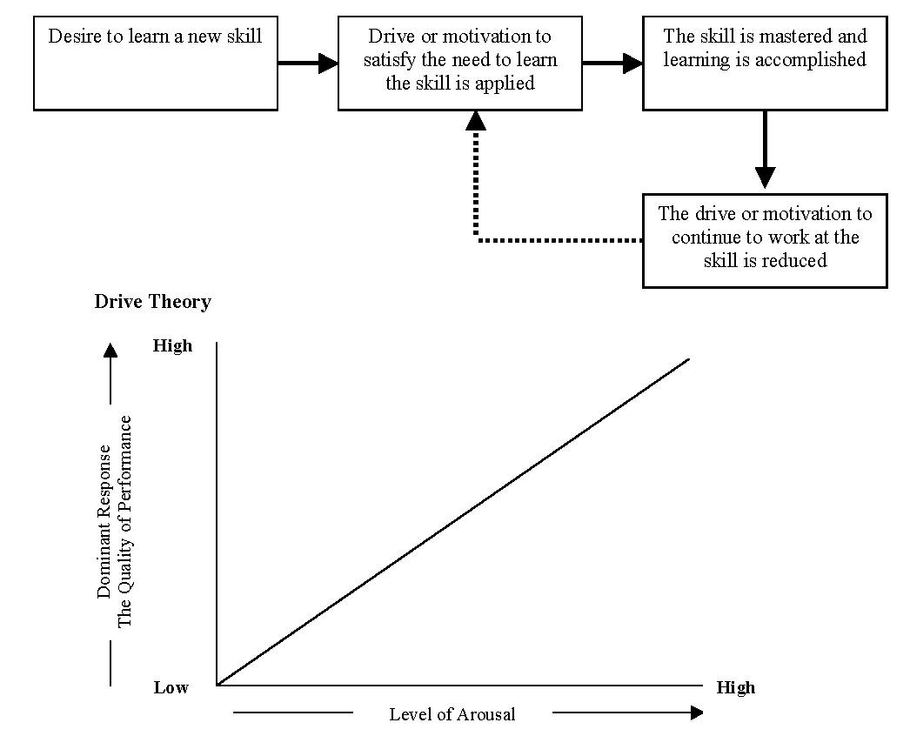

Inverted U Theory

Optimum Point

High

Performance

Low
High
Arousal

Catastrophe Theory

Performance

Arousal

3. Drive reduction theory: initially, there is a great drive or motivation to solve a new problem or to learn a new skill. The performer will take action to satisfy the drive and this will show itself in the willingness to practise. When the skill has been well learned and the autonomous stage has been reached, a habit is formed and the S–R learning bond has become strong. It is at this point that the drive or motivation to continue performing the skill is reduced.
Drive theory indicates a relationship between arousal and performance. An increase in arousal is proportional to an increase in the quality of physical performance. The quality of performance depends on how well the skill has been learned. Motor programmes that have already been learned are said to be ‘learned behaviours’ and are therefore dominant responses. A dominant response is a response or behaviour that is most likely to emerge when a performer experiences an increase in arousal. As arousal increases there is a greater likelihood of our dominant responses occurring.
The inverted U theory indicates or predicts that as arousal increases so does the quality of performance. Quality improves up to a point mid-way along the arousal axis. This point is called the optimum point or the threshold of arousal and predicts that best performance occurs at moderate levels of arousal. If arousal should increase beyond the optimum point, the performer becomes over aroused and the capacity both to learn, and to perform a motor skill will deteriorate.
The catastrophe theory examines how performance is influenced by the relationship between somatic arousal (physiological arousal) and cognitive arousal (worry and anxiety). Catastrophe theory, like the inverted U hypothesis, claims that as somatic arousal increases then the quality of performance improves. However, catastrophe theory adds a third dimension to this prediction by stating that performance will reach maximum potential at the optimum level only if cognitive arousal is kept low.

8.2 | Motivational theories and theories of arousal – answers
1. Explain in detail drive theory, inverted U theory and catastrophe theory as they relate to the influence of arousal during the performance of motor skills. Where possible, an attempt should be made to make comparisons between these theories.

Drive Theory
• Performance increases as arousal increases.
• An increase in arousal is proportional to an increase in the quality of performance.
• The dominant response is more likely to occur.
• The dominant response is the strongest from a number of motor programmes.
• Drive theory explains the performance of ballistic/gross/closed skills – the other theories do not.
• Drive theory applies more to able performers than the other theories.
• Drive theory does not explain how good performers decline when arousal is too high – other theories do.
The prediction made by drive reduction theory can impact significantly on a lifelong, balanced, active and healthy lifestyle. Therefore, teachers and coaches must implement motivational strategies to prevent a loss in drive.

Inverted U theory
• Performance increases up to an optimal point.
• Performance decreases as arousal passes optimal/moderate.
• This theory explains open and complex skills, e.g. invasion games, unlike the other theories, especially drive theory.
• More able players benefit from high arousal.
• Less able players prefer lower arousal.
• Graph includes variables of personality, task type, stage of learning and experience.
• The curve of increase and decrease is never as smooth as indicated.
• The theory does not take into account cognitive anxiety.

Catastrophe theory
• Performance increases as arousal increases, as predicted by inverted U.
• Sharp decrease occurs after the optimal point, rather than a curve. No other theory predicts this.
• The theory takes into account the interaction between cognitive and somatic arousal; other theories do not.
2. Identify eight motivational strategies that could be used to encourage young people to participate in a balanced, active and healthy lifestyle.

1. Fun activities | 2. Positive reinforcement | 3. Progression opportunities | 4. Social experience
5. Attainable targets | 6. Transfer of skills | 7. Improved fitness and skills | 8. Role models

3. Discuss with a partner the impact of external and internal motivational strategies on lifelong participation in a balanced, active and healthy lifestyle. Basis of discussion:
• External motivation can come in the form of tangible rewards such as medals or certificates, or intangible rewards such as praise from the teacher. Both are thought to be of greatest importance in attracting young people into sport and during early learning. Extrinsic rewards provide concrete proof of success and formulate status in the peer group. However, the impact of external motivation must be considered a short-term strategy compared with internal motivation.
• Internal motivation is the key to lifelong participation. It involves giving learners positive feelings about their performance. This can be established through positive reinforcement and the setting of achievable personal goals. Once interest has been stimulated, the teacher can endorse the value of participation by indicating that sport promotes confidence, personal satisfaction and self-realisation. These are factors that encourage participation throughout life.

8.3 | Operant conditioning – answers
1. Mark the following answer, which was given in response to a question on the topic of operant conditioning. A numbered mark scheme has been provided as a guide. Underline and tick any fact in the response if it appears in the mark scheme. Enter the number of the point as it appears in the mark scheme in the left margin (e.g. 6). Enter the numeral 1 (one) in the right margin level with the fact that has been ticked.
Use an example from physical education or sport to explain how a performer learns by operant conditioning.
1
1
1
1
1
Operant conditioning involves the learner forming and strengthening a stimulus–response (S–R) bond. The link between the stimulus and the response is often called a connection or association. Hence, operant conditioning is referred to as a connectionist or associationalist theory.
1

2

3
8 (prac e.g.)
5

Max. scored
6
7
The environment is structured or manipulated to bring about the required response; for example, a 2 v1 passing drill in hockey, netball or football would create an environment similar to that found in a game and this would enhance passing skills. This structure would shape the behaviour of the learner. During performance, trial and error occurs, as the player will attempt different forms of pass. The teacher must apply reinforcement to ensure learning or behaviour modification takes place. Positive reinforcement presents a ‘satisfier’ or the stimulus of approval regarding performance and forms and strengthens an S–R learning bond. Negative reinforcement or behaviour receiving no reinforcement causes an undesired action to fade from memory.
Total = 5

Mark scheme
4 marks maximum for the following:
1. Involves the formation of an S–R bond.
2. Operant condition is an associationalist/connectionist theory.
3. Structured environment to be similar to game/sport situation.
4. Operant conditioning involves behaviour shaping.
5. The learner will undertake trial and error.
6. Positive reinforcement strengthens the learning bond.
7. Negative reinforcement causes behaviour to fade.
8. 1 mark max for a suitable example.
2. Using the textbook as a guide, identify seven points that would be evident if the teacher decided to teach a badminton shot by using operant conditioning.

1. | In order to teach a smash shot in badminton the teacher could mark a target at the back of the court and then serve high to the learner.
2. | The learner would attempt to smash the shuttle into the target. The stimulus has therefore been presented in a structured environment that is closely aligned to the game situation.
3. | Through trial and error, the learner would attempt a number of responses to repeated serves. The learner’s behaviour is now being shaped or modified during this process.
4. | When the correct response is made into the target area, the teacher will give positive reinforcement. Poor attempts are not rewarded and in time the correct technique becomes dominant. The actions would also be reinforced by the player’s success.
5. | At this point a desired S–R bond has been formed and strengthened. Any incorrect bonds are weakened due to the lack of reinforcement.
6. | It is important that reinforcement is applied immediately and before the learner has another chance to act.
7. | The target will eventually be removed and more advanced practices that transfer to the game situation can be administered.

8.4 | Cognitive learning theory – answers

Answers
1. Five questions that could be presented as a way to review the topic of Operant conditioning may resemble the following. The questions become progressively more difficult and develop from closed to open questions. A closed question will require one response and is based on recall in the examination. These questions usually begin with ‘identify’. An open question is more complex: a number of responses may be required by way of an answer and students need to apply their knowledge. In the exam this type of question usually begins with ‘explain’.
• Is operant conditioning a connectionist learning theory or a cognitive learning theory?
Increasing difficulty
• Identify the components that are connected in order for learning to take place during the application of operant conditioning.
• Describe an S–R learning bond and give a practical example to support your answer.
• Explain how a learning bond is strengthened and how an incorrect S–R learning bond may be weakened.
• Use an example from physical education or sport to explain how a performer learns by operant conditioning.
2. The cognitive learning theory of learning states that learning is best achieved by presenting the whole skill to the learner, who will be given access to the ‘big picture’ within the context of a realistic situation, e.g. learning to shoot in basketball is best achieved in a practice that replicates the game situation. The learner can work out the appropriate motor programme from their position on court.
3.
Cognitive Learning
Presents the whole problem
to the learner. The learner is required to work out a solution. Cognitive
learning does not form
S–R learning bonds.
Gestalt Patterning
Gestalt is a German word for shape or complete form. The view of Gestalt philosophy is that learning takes place when the whole problem is understood. ‘The whole is greater than the sum of the parts.’
Insight Learning
Insight learning refers to problem solving that incorporates the use of perception, intelligence and previous experience. The learner has a cognitive experience and does not respond thoughtlessly, as in connectionist philosophy.

4. • Perception is the cognitive process of interpreting (making sense of) incoming environmental cues.
• Previous experience involves utilising previous knowledge from related situations in order to solve the present problem. Experiences are transferred and adapted.
• Intervening variables are mental processes that help with problem solving. These include mental rehearsal and reminiscence.
5. The teacher would adapt or condition games to help the learner to solve the problem. Adapted games like kwik cricket and flag rugby allow children to gain a basic understanding that will transfer later to the full version of the games. Conditioned games like ‘two touch’ football develops positional play in football.
6. Students’ own answers to further discussion ideas.
8.5 | Observational learning – answers
1. Observational learning is a form of visual guidance usually associated with demonstration. The aim of the aforementioned is to present the learner with a visual model that can be copied and matched. Learning by imitation is a very powerful principle, being both time saving and more interesting than a lengthy verbal explanation. Demonstrations are important at all stages of learning. During the cognitive stage and the associative stage the novice will be able to grasp the general idea of what is required and be motivated by the exhibition. At the autonomous stage a demonstration is useful in highlighting detailed and specific points in performance.
2. Attention. The learner must focus directly on the model. The teacher can help this process by telling the learner to watch for, or attend to, specific items in the demonstration. For example, watch the hip turn before the discus is released. This instruction is called verbal guidance. To hold the attention of the learner the model of performance must be brief, attractive and meaningful.
Retention. The image of the demonstration must be stored or retained by the learner if it is to be copied successfully. Verbal guidance will prevent information overload and help to hold the picture in the short-term memory but the demonstration should be repeated several times as insurance. The observer should be encouraged to picture the image in the ‘mind’s eye’. This process is called mental rehearsal. A good teaching technique to aid retention is to connect a second image to the demonstration. For example, to be told to “put the ball onto the shelf” helps to achieve the correct trajectory of the set shot. This technique is called symbolic rehearsal.
Motor reproduction. The learner must have the maturation, confidence and physical ability to copy or replicate the skill being modelled.
Motivation. A key element in learning and performance is motivation. In order to reproduce the model the observer must have the drive or motivation to learn.
8.6 | Reinforcement of movement skill – answers

Answers

Positive reinforcement
• After a successful response or after the desired behaviour has been demonstrated by the learner, the teacher would present a show of approval, e.g. positive verbal acknowledgement of good positional play in netball.
• Approval may be in the form of praise and is an intangible reward, e.g. “well done”.
• Positive reinforcement could be presented by some other form of ‘satisfier’, e.g. a certificate is a tangible reward. (See intrinsic and extrinsic motivation.)

Negative reinforcement
• Negative reinforcement involves withdrawing a negative or aversive stimulus. For example, the teacher may show disapproval when the learner gives a poor response.
• When the learner eventually responds correctly the aversive stimulus of disapproval is withdrawn.
• Negative reinforcement is not punishment.
• Negative reinforcement is an operation that weakens the incorrect learning bond but, most importantly, also strengthens the correct learning bond. For example, when learning to dive in water most beginners experience pain; when the correct technique is acquired pain is removed. Negative reinforcement has reinforced the correct diving technique.
Students’ discussions should include the following points:
• Punishment should not be confused with negative reinforcement.
• Punishment is given as an unpleasant (or noxious) stimulus following a response and therefore can not be withdrawn.
• Punishment is given to eliminate a particular response.
• Only behaviours that are intolerable and unacceptable should be met by punishment, e.g. responses that are dangerous to others or disruptive to the entire group.
• In practice, punishment seldom works as the teacher or coach intends. It can, furthermore, create problems in the teaching process.
• Punishment will not accelerate learning.
• Punishment can actually draw attention to undesired behaviour and inadvertently reinforce it.
• According to Kauss, punishment has a role in teaching and learning but its role is limited.
• It is unlikely, therefore, that punishment will convince an individual to pursue a balanced, active and healthy lifestyle.

8.7 | Strengthening the S–R learning bond – answers

1. Reinforcement | 2. Repetition | 3. Response conditioning  (behaviour shaping) | 4. Fixed practices
5. Varied practices | 6. Trial & error | 7. Demonstration (observation) | 8. Verbal guidance
9. Manual guidance | 10. Mechanical guidance | 11. Task simplification | 12. Transfer
Remember, a learning bond will only be forged if the performer is motivated.

Thorndike’s Laws
2. The law of effect: If behaviour is reinforced, the learning bond is strengthened. Positive reinforcement or the presentation of a ‘satisfier’ is the most effective way to strengthen the learning bond, e.g. positive feedback or approval given by the teacher following a good performance.
The law of exercise states that if reinforcement is to strengthen the learning bond the performer must be both physically and mentally capable of performing the skill, e.g. a young child would find shooting into a basket at full height impossible and therefore behaviour could not be positively reinforced.
The law of readiness states that the S–R bond will be strengthened by practice and repeated reinforcement, e.g. the netball shooter will practise repetitively. A lack of practice will cause the S–R bond to weaken.
8.8 | Transfer – answers
Transfer means the influence that one skill has on the learning and performance of another. The process is extremely important to the acquisition of movement skills because practically all learning is based on some form of transfer.
It is important that students can identify and explain five types of transfer. Complete the table given below.
Type of Transfer | Explanation
1. Positive | This type of transfer occurs when one skill helps or enhances the learning and performance of another skill. For example, the skill of throwing transfers positively to the racquet arm action of a tennis serve.
2. Negative | Negative transfer arises when one skill hinders or impedes the learning and performance of another skill. For example, a loose wrist required to play a badminton shot transfers negatively to the firm wrist needed to perform a tennis stroke.
3. Proactive | This type of transfer occurs when a previously learned skill influences a skill that is currently being learned. Similarly, a skill being learned at present will eventually influence a skill to be learned in the future. For example, a throwing motor programme learned as a child will later transfer positively and proactively to an over-arm volleyball serve.
4. Retro-active | This type of transfer occurs when a newly learned skill influences a previous learned skill. For example, the acquisition of a successful tennis serve may influence the previously learned over-arm throw used in cricket.
5. Bilateral | Bilateral transfer refers to the capacity of the performer who may be dominantly right sided to perform a skill with the left side of the body. For example, a footballer who can shoot with the right and left foot with matching power and accuracy is a considerable asset to the team.

8.9 | Optimising transfer – answers
During the course of a physical education lesson the teacher must ensure both that positive transfer is taking place and that its effects are optimised. Furthermore, care must be exercised to limit the possibility of negative transfer.
1. Below are 15 statements, ten of which will help to optimise positive transfer whilst at the same time prevent negative transfer from taking place. Five, although not false, are out of place. Tick the ten appropriate statements and cross the statements that are out of place.

Learning situations need to allow for positive transfer. | ✓
The learner must be made aware of the transferable elements of a previously learned skill. | ✓
Take the performer back to the associative stage of learning. | ✗
Use level-2 closed loop as the way to modify performance. | ✗
Clear and concise demonstrations must be used. | ✓
The environmental conditions need to be similar to the real situation. | ✓
The elements of information processing may be similar. | ✓
The closer the practice is to the replication of the game situation, the greater the chance of positive transfer. | ✓
Operant conditioning will form and strengthen the stimulus–response (S–R) learning bond. | ✗
Transfer will only operate successfully if previous skills have been well learned. | ✓
Cognitive learning will promote positive transfer. | ✗
Diverse experiences enhance the probability of transfer. | ✓
Reinforcement ensures that positive transfer can take place. | ✓
Simplify the task during initial learning and transfer it later into the real situation. | ✓
Mechanical guidance minimises the negative effect of transfer. | ✗

2. Explain why you believe that the five chosen statements are out of place.

Take the performer back to the associative stage of learning. This is a very good strategy for grooving or over-learning a skill and will also keep the performer at the autonomous stage of learning. The statement is, however, out of place in this context.
Use level-2 closed loop as the way to modify performance. This concerns sub-conscious control and although muscular adjustments are stored in long-term memory for future reference, closed loop is out of place in this context.
Operant conditioning will form and strengthen the S–R learning bond. The statement is true but operant conditioning does not rely on transfer.
Cognitive learning will promote positive transfer. Transfer of previous experience helps the learner to solve the problem. The statement is out of context in this question.
Mechanical guidance minimises the negative effect of transfer. Mechanical guidance helps to form a learning bond and gives the learner an initial kinaesthetic experience. However, if mechanical guidance is overused the performer becomes dependent on it; therefore, mechanical guidance can eventually produce a negative effect.

8 | Answers to student book tasks (part I)

TASK 1
At the autonomous stage of learning the correct response will be grooved and overlearned. The execution of the skill will be fluent and efficient while appearing to be automatic. The dominant response therefore will be correct and highly effective. Performance at the autonomous stage is therefore facilitated by increased arousal.
At the associative stage the dominant response is likely to be jerky, ineffective and often incorrect. At this stage of learning performance is inhibited by increased arousal.

TASK 2
1. Concentration is maximised.
2. Perception becomes increasing accurate.
3. Selective attention is facilitated.
4. The appropriate environmental cue is more easily detected (cue utilisation).
5. The performer becomes more aware of warning signals as they become more alert.
6. Information processing becomes more efficient.
7. Decision making improves.
8. Reaction time decreases.
9. The performer becomes more aware of feedback.

TASK 3
An example of a catastrophe in sport could be the full back in rugby dropping a ball which has been kicked high into the air. This error may have occurred because the performer is experiencing high somatic arousal and this condition has coincided with high cognitive arousal.
Strategies must be implemented to lower cognitive arousal (anxiety). These strategies include the use of:
• Positive reinforcement
• Social reinforcement
• Positive feedback

Various stress management techniques can help to lower cognitive anxiety. These techniques can be found in the Sport psychology section of the A2 textbook.

TASK 4
If basketball shooting is implemented performance may deteriorate as practice continues e.g. the frequency of success will decrease. The participant may attribute this decrease to boredom and/or fatigue. To eliminate fatigue or drive reduction through boredom rest breaks could be incorporated into practice (distributed practice) new goals could be set and feedback could be provided.

TASK 5
This discussion will be anecdotal and specific to the individual. Try to relate the issues of discussion to the motivational strategies for an active lifestyle that are outlined on page 191. Emphasise the fact that intrinsic motivation best ensures a sustained application toward an active lifestyle.

8 | Answers to student book tasks (part II)

TASK 1
The design and administration of the practice should follow the format of the advice given in the Apply It section as it relates to operant conditioning.
The drill will involve a pass to a player who is ‘cutting’ into the key area in basketball. The player making the cut will receive the pass in a shooting position.
The passer will stand at a cone or marker and direct the pass toward a second cone or marker. The pass will be received at the second marker and a shot to basket will be made. When the receiver has learned the pathway of the cut and the distributor has learned the direction and pace of the pass the cones can be removed. The pass can later be practiced in a conditioned game situation. Positive reinforcement should be applied for all successful actions.

TASK 2
The design and administration of the practice should follow the format of the advice given in the Apply It section as it relates to cognitive learning.
The practice involves adapting a game to teach the skill of passing to player ‘cutting’ into the key in basketball.
Nominate five attacking players and three defensive players. The objective is to work close to the basket and shoot to goal. Advise the attacking players that the best way to secure a shooting position is to cut toward the ball carrying player. Allow the players to work out the solution in the adapted game situation.

TASK 3
The design of the practice involves demonstrating how to deliver a pass to player who has ‘cut’ into the key in order to secure a scoring position in basketball. The coach would in turn demonstrate the movement of the passer and the pathway of the cutting attacking player. The demonstration would be repeated to facilitate retention. Players would then attempt to replicate the demonstration.

TASK 4
The chosen skill drill may be two offensive players approaching one defensive player in an invasion game situation e.g. a situation such as that outlined on pages 178-179 as an example to explain schema theory.
The ball carrying attacker attempts to deceive the defender.

Application of Thorndike’s Laws
Law of effect. When the ball carrier is successful the action is reinforced. The S–R bond is strengthened and the appropriate response is stored in long-term memory.
Law of exercise. As the practice is repeated and successful actions are reinforced the S–R learning bond becomes stronger.
Law of readiness. The player who is learning the skill must have the ability, experience and maturity to perform the skill in question. If the learner cannot meet these criteria reinforcement cannot be effective.

TASK 5
The discussion will focus on the fact that positive reinforcement facilitates learning. When a skill has been well learned the participant is likely to enjoy performance. Enjoyment increases intrinsic motivation. Positive reinforcement improves confidence and threfore increases the motivation to engage in new skills. A healthy, active and balanced lifestyle will therefore be promoted.

8 | Answers to student book tasks (part III)

TASK 1
The benefits of a varied practice include:
1. Schematic development/development of experience.
2. A chance to adapt motor programmes.
3. Opportunity to transfer skills.
4. Opportunity to interpret knowledge of results and knowledge of performance.
5. Game/match situations are simulated.
6. Decision making is enhanced.
7. Perception and awareness is improved.
8. Detection of cues and warning signals is enhanced.
9. Reaction time decreases.
10. Eliminates the possibility of drive reduction.

Notes for Teachers

In this chapter you will cover the following with your students:
• Physical activity as an umbrella term.
• The meaning of the terms: exercise; healthy balanced lifestyles; lifetime sport/lifelong physical activity; physical prowess; physical endeavour; sportsmanship; gamesmanship; deviance.
• The benefits of regular participation in physical activity.
• Factors contributing to increasingly sedentary lifestyles.
• Recommendations in terms of frequency, intensity and type of physical activity.
• Possible barriers to regular participation in physical activity by young people.
• Definitions, characteristics and benefits of: physical recreation; outdoor recreation; physical education; outdoor education; and sport.

Items in this chapter are likely to be relatively accessible to students. The aim is that students should learn key definitions (e.g. for physical recreation, outdoor recreation, physical education, outdoor education, sport) and meanings of important terms (e.g. for exercise, healthy, balanced lifestyles, lifetime sport/life-long physical activity). Where stated in the specification, students must also be aware of the characteristics and benefits of certain aspects of physical activity.
In addition to being able to recall key terms and meanings, students should be encouraged to ‘deep process’ their knowledge so that they could, if necessary, answer questions that require more thought and which might start with a command word such as ‘explain’, ‘discuss’ or ‘analyse’ – rather than a more straightforward ‘identify’ or ‘state’, which are less cognitively demanding. With this in mind, your lessons might include opportunities for discussion, comparison between terms, student presentations and/or peer teaching of key themes, etc.

9.1 | Quiz: physical activity
Risk that is not real. | P _ _ _ _ _ _ _ _
A way of life that has equilibrium and wellbeing. | H _ _ _ _ _ _ B _ _ _ _ _ _ _ L _ _ _ _ _ _ _ _
A life-long physical activity. | Y _ _ _
Lifestyles that have less than 30 minutes of physical activity per week. | S _ _ _ _ _ _ _ _
How much effort you put into a physical activity (along with frequency, time and type). | I _ _ _ _ _ _ _ _
Things that might stop someone taking part in physical activity. | C _ _ _ _ _ _ _ _ _ _
A key part of outdoor education in the natural environment. | A _ _ _ _ _ _ _ _
Activities that you can enjoy over the course of your lifetime. | L _ _ _ _ _ _ _ S _ _ _ _
Action or movement. | A _ _ _ _ _ _ _
These can affect your health and wellbeing. They may relate to your personal life, leisure, food, training schedule, television, video and computer use. | C _ _ _ _ _ _
It might help if there were more of these specialising in PE in UK primary schools. | T _ _ _ _ _ _ _
We need to prevent this to ensure a balanced, healthy lifestyle. | I _ _ _ _ _ and I _ _ _ _ _ _
Young people should take part in physical activity because it is beneficial or … | V _ _ _ _ _ _ _
The odds of suffering from this and from diabetes and stress are reduced if you are physically active. | I _ _ _ _ _ _ _
A useful personal quality encouraged in PE and sport. | T _ _ _ _ _ _ _
A group in society that needs more exercise. | Y _ _ _ _ P _ _ _ _ _

9.2 | Benefits of physical education
Fill in the following chart with specific examples of how games, dance, swimming and outdoor education (each part of Physical Education) can help to develop the following values:
• Physical benefits.
• Preparation benefits.
• Personal benefits.
• Quality of life benefits.
 | Games | Dance | Swimming | Outdoor Education
Physical benefits (development of health & motor skill) |  |  | Learning to do a tumble turn
Preparation benefits (for active leisure) | Enjoying netball or cricket at school and joining a club outside school
Personal benefits (self-realisation) |  |  |  | Increasing self- confidence and teamwork as a result of an outdoor adventure education week.
Qualitative benefits (positive influence on lifestyle) |  | Appreciating the aesthetic qualities of a dance routine.

9.3 | Physical activity: test
“To some degree this is part of every able-bodied person’s life and might involve walking up stairs or doing housework. It is anything that gets the body moving and the heart pumping harder than at rest.”
1. What is being explained here? (1)
__________________________________________________________________________
2. Explain what is meant by a healthy, balanced lifestyle. (2)
____________________________________________________________________________________________________________________________________________________
3. Explain ‘lifetime sport’ with an example. (2)
____________________________________________________________________________________________________________________________________________________
4. Benefits of regular participation can be divided into four categories.
What are the four categories? (4)
____________________________________________________________________________________________________________________________________________________
5. Explain the term ‘sedentary lifestyle’. (2)
____________________________________________________________________________________________________________________________________________________
6. What factors have led to increasingly sedentary lifestyles in recent years? (3)
________________________________________________________________________________________________________________________________________________________________________________________________________________________________________________________________________________________________________

7. List some possible barriers to participation in physical activity by young people. (3)
______________________________________________________________________________________________________________________________________________________________________________________________________________________________

8. What is meant by each of the terms ‘opportunity’, ‘provision’ and ‘esteem’? (3)
Opportunity –

Provision –

Esteem –

9. What is being described here? “Physical activities that are pursued for a variety of reasons and benefits at a relatively unsophisticated level.” (1)
__________________________________________________________________________
10. With reference to outdoor education and outdoor recreation, explain each of the terms ‘real risk’ and ‘perceived risk’, with examples. (4)
________________________________________________________________________________________________________________________________________________________________________________________________________________________________________________________________________________________________________
(25 marks)
9.4 | Key word matching task
Shade each of the five boxes with a different colour. Underline each key phrase with the corresponding colour. You may wish to link some key phrases with more than one key box.
Prowess and endeavour Personal satisfaction
High skill level Knowledge and benefits
SPORT
PHYSICAL RECREATION
PHYSICAL EDUCATION
OUTDOOR RECREATION
OUTDOOR EDUCATION
Risk and safety Flexible rule structure
Amateur or professional
Enjoyment the main aim Sportsmanship
A form of stress relief for adults
Specialist teachers and/or leaders
For extrinsic rewards Compulsory Wimbledon
Limited organisation and competition
National Governing Bodies (NGBs)
Real and perceived risk
Physical, personal, preparation and qualitative benefits
Jogging or a ‘kick about’
Constraints include lack of funding & specialist leaders
High organisation Natural environment
Expensive equipment National Curriculum
Escape from stresses of life
High levels of commitment
An aspect of Physical Education
Duke of Edinburgh Award
9.5 | The effects of sportsmanship and gamesmanship – a comparison
It is important to understand the difference between sportsmanship and gamesmanship and how each affects a sporting situation – in this analysis, a game.
Complete the chart below with an appropriate comparative phrase.

Sportsmanship | Gamesmanship
 | Causes bad feeling, retaliation and stops a game being successful
Helps a game to operate successfully
 | Causes friction among spectators
Encourages goodwill
 | Gives the referee problems
Important in 19th century English Public Schools, e.g. Rugby School
 | Tarnishes the reputation of the game
A model for behaviour both on and off the field of play

9.6 | Benefits of regular participation in physical activity
What physical, mental, personal and/or social benefits can physical activity promote?

Fill in the blanks with your answers.

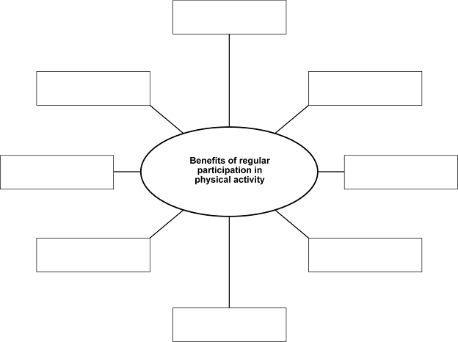

9.1 | Quiz: physical activity – answers

Risk that is not real. | Perceived
A way of life that has equilibrium and wellbeing. | Healthy Balanced Lifestyle
A life-long physical activity. | Yoga
Lifestyles that have less than 30 minutes of physical activity per week. | Sedentary
How much effort you put into a physical activity (along with frequency, time and type). | Intensity
Things that might stop someone taking part in physical activity. | Constraints
A key part of outdoor education in the natural environment. | Adventure
Activities that you can enjoy over the course of your lifetime. | Lifetime Sport
Action or movement. | Activity
These can affect your health and wellbeing. They may relate to your personal life, leisure, food, training schedule, television, video and computer use. | Choices
It might help if there were more of these specialising in PE in UK primary schools. | Teachers
We need to prevent this to ensure a balanced, healthy lifestyle. | Injury and Illness
Young people should take part in physical activity because it is beneficial or … | Valuable
The odds of suffering from this and from diabetes and stress are reduced if you are physically active. | Insomnia
A useful personal quality encouraged in PE and sport. | Teamwork
A group in society that needs more exercise. | Young People

9.2 | Benefits of physical education – answers
Accept any suitable answers, such as these below:

 | Games | Dance | Swimming | Outdoor Education
Physical benefits (development of health & motor skill) | Learning to do a penalty flick in hockey | Learning to balance | Learning to do a tumble turn | Learning to abseil
Preparation benefits (for active leisure) | Enjoying netball or cricket at school and joining a club outside school | Deciding to become a dance teacher | Preparing you for safety | Deciding to become an Outdoor Education instructor
Personal benefits  (self-realisation) | Developing leadership skills as captain of a team | Improving self or body concept | Gaining confidence by achieving badges | Increasing self- confidence and teamwork as a result of an outdoor adventure education week.
Qualitative benefits (positive influence on lifestyle) | Appreciating value of perfect team play/tactics | Appreciating the aesthetic qualities of a dance routine. | Feeling the freedom of movement through water weightless-ness | Experiencing the beauty of the natural environment

9.3 | Physical activity: test answers
1. “To some degree this is part of every able-bodied person’s life and might involve walking up stairs or doing housework. It is anything that gets the body moving and the heart pumping harder than at rest.”
What is being explained here? (1)

Physical activity
2. Explain what is meant by a healthy, balanced lifestyle. (2)

A healthy, balanced lifestyle is day-to-day life that has equilibrium, quality and wellbeing. It includes: a nutritious diet; physical exercise; injury and illness prevention; rest/sleep; hobbies/social; personal hygiene; ‘free’ time; control of stress and pressure; and relationships.
3. Explain ‘lifetime sports’ with an example. (2)

Activities that can be enjoyed over the course of a lifetime, well into middle and even older age, e.g. badminton or tennis.
4. Benefits of regular participation can be divided into four categories. What are the four categories? (4)

The four categories are: physical, mental, personal and social.
5. Explain the term ‘sedentary lifestyle’. (2)

A sedentary lifestyle is one that includes less than one 30-minute period of moderate physical activity per week.
6. What factors have led to increasingly sedentary lifestyles in recent years? (3)

Suitable answers include: general changes due to modern technology, e.g. washing machines and so on that reduce the need for manual work; children getting lifts to school; people sitting at computers more; golf clubs having buggies, etc.
7. List some possible barriers to participation in physical activity by young people. (3)

Possible barriers include: expense; lack of suitable facilities; exhaustion after school/college/paid work; lack of suitable kit; reticence to show off body and/or sweat; dislike of outdoors and poor weather; risk of being outside alone; lack of friends who participate.

8. What is meant by each of the terms ‘opportunity’, ‘provision’ and ‘esteem’? (3)

Opportunity: the chance to take part, based on factors such as time, money, etc.

Provision: the availability of features that allow for participation, such as facilities or transport.

Esteem: confidence.
9. What is being described here? “Physical activities that are pursued for a variety of reasons and benefits at a relatively unsophisticated level.” (1)

Physical recreation.
10. With reference to outdoor education and outdoor recreation, explain each of the terms ‘real risk’ and ‘perceived risk’, with examples. (4)
• Real risk can be dangerous or even fatal. It is avoided at all costs by careful preparation and use of appropriate kit and equipment. It is sometimes embraced by committed experts seeking great challenges. An example is a natural disaster such as a flash flood or a freak accident.
• Perceived risk is completely safe. It is imagined risk that is sought by teachers and leaders to give learners a sense of adventure and opportunities for personal challenge and development.
(25 marks)

9.4 | Key word matching task – answers

SPORT
Prowess and endeavour Personal satisfaction
High skill level Amateur or professional
Sportsmanship For extrinsic rewards
Wimbledon National Governing Bodies (NGBs)
High organisation Expensive equipment
High levels of commitment

PHYSICAL RECREATION
Personal satisfaction Flexible rule structure
Enjoyment the main aim A form of stress relief for adults
Jogging or a ‘kick about’ Limited organisation and competition
Escape from stresses of life

PHYSICAL EDUCATION
Prowess and endeavour Personal satisfaction
Knowledge and benefits Sportsmanship
Compulsory Physical, personal, preparation and qualitative benefits
High organisation National Curriculum

OUTDOOR RECREATION
Sense of adventure Personal satisfaction
Risk and safety Real and perceived risk
Natural environment Escape from stresses of life

OUTDOOR EDUCATION
Sense of adventure Personal satisfaction
Knowledge and benefits Specialist teachers and/or leaders
Real and perceived risk Constraints include lack of funding & specialist leaders
Natural environment An aspect of Physical Education
Duke of Edinburgh Award

9.5 | The effects of sportsmanship and gamesmanship – a comparison – answers
It is important to understand the difference between sportsmanship and gamesmanship and how each affects a sporting situation – in this analysis, a game.
Complete the chart below with an appropriate comparative phrase.

Sportsmanship | Gamesmanship
Helps to make an enjoyable experience | Causes bad feeling, retaliation and stops a game being successful
Helps a game to operate successfully | Disrupts play and breaks continuity
Is admired by spectators | Causes friction among spectators
Encourages goodwill | Encourages ill feeling
Helps the referee do a good job | Gives the referee problems
Important in 19th century English Public Schools, e.g. Rugby School | Becoming increasingly common in some sports
Improves the status of the game in society | Tarnishes the reputation of the game
A model for behaviour both on and off the field of play | Can lead to increased violence on the field and among spectators

9.6 | Benefits of regular participation in physical activity – answers

Answers
Physical benefits including:
• lower risk of heart disease
• protection against some forms of cancer
• preserved bone density, so lower risk of osteoporosis
• improved co-ordination, strength, flexibility and balance
• lower blood pressure
• reduced risk of stroke
• less likely to suffer from insomnia and/or diabetes
• reduced stress
• maintenance of healthy body weight
• increased energy levels.
Mental benefits including:
• possibility of reduced anxiety, depression and stress – better mood
• possibility of increased academic performance.
Personal benefits including:
• good self-control and/or self-discipline
• good self-esteem
• knowing yourself better – self-realisation.
Social benefits including:
• meeting new people
• good relationships
• decreased antisocial behaviour in communities.
9–11 | Sample questions with mark schemes

SAMPLE QUESTIONS
(a) Name a surviving ethnic sport in the UK. Identify characteristics of surviving ethnic sports and give reasons for their continued existence.
[5 marks]

(b) Give reasons for the Modern Olympic Games being classed as sport rather than as physical recreation.
[5 marks]

(c) Describe the background to the Olympic Games and the aims of the Modern Olympic Movement.
[5 marks]

(d) Give social and cultural reasons for sport being a high status national pre-occupation in Australia.
[5 marks]

(e) Discuss the positive and negative impact that the media can have on sport.
[10marks]

MARK SCHEME

(a) Name a surviving ethnic sport in the UK. Identify characteristics of surviving ethnic sports and give reasons for their continued existence.

5 marks total
1 mark for example:

- (named surviving  ethnic sport) | Suitable examples include:  Lakeland Games / Ashbourne football / (Gloucestershire) cheese rolling

4 marks for 4 of:
- (local) | local / unique to area / local pride
- (rowdy) | rowdy
- (occasional) | occasional / annual / on public holidays
- (social) | social / community / focus on pub / brings people together
- (tradition) | traditional / folklore/ celebration of past /  generation to generation
- (isolation) | isolated / rural / natural / natural environment
- (ritual) | ritual / ceremonial / celebrations / religious / festival / supernatural / medieval customs / carnival atmosphere
- (tourism) | attracts tourism or publicity / commercial

(b) Give reasons for the Modern Olympic Games being classed as sport rather than as physical recreation.

5 marks total
5 marks for 5 of:

- (equipment) | Specialist or high level equipment or kit.
- (golden triangle) | Media coverage / sponsorship / commercialism / spectatorism / highly funded.
- (skill) | skilfulness / physical prowess / fitness / ‘international’ / high level / elite
- (organisation) | Strict rules / organised / structured / officials / NGBs / BOA / IOC
- (chance) | element of chance
- (competitive) | competitive /competition
- (commitment) | commitment / dedication / determination / effort /physical  endeavour / training / coaching
- (extrinsic) | extrinsic rewards / as a job / professional / occupation / for money or fame / serious / winning important
- (time) | Strict time limits
- (space) | Designated space / fixed boundaries / purpose built or specialist facilities

(c) Describe the background to the Olympic Games and the aims of the Modern Olympic Movement.

5 marks total
Sub max of 3 from one section

Background to Olympic Games
1. (Ancient Olympics) | Ancient Olympics
2. (Dover Games) | Robert Dover founded / Cotswold Olympik Games.
3. (Much Wenlock Games) | Much Wenlock Games / work of Dr William Penny Brookes
4. (English public schools) | Influence of English Public Schools / influence of schools such as Rugby and Harrow
5. (De Coubertin) | Efforts of Baron Pierre de Coubertin / De Coubertin visited the Much Wenlock Games
Aims of Modern Olympic Movement
6. (peace) | To develop world peace and understanding
7. (culture) | To link sport with culture
8. (fair play) | To promote fair play or friendship or respect for others
9. (education) | To educate young people through sport / to use positive role models
10. (anti-discrimination) | To fight discrimination to encourage tolerance
11. (effort) | To promote values of effort and commitment

(d) Give social and cultural reasons for sport being a high status national preoccupation in Australia.

5 marks total
5 marks for 5 of:

1. (climate) | Favourable climate
2. (space) | Plenty of space / access to natural resources / outdoor life
3. (fashion) | Sport a fashionable pastime
4. (funding) | Political support and funding
5. (economy) | Australia currently has healthy economy / is happy to spend on sport
6. (age) | Relatively young population
7. (role models) | Several positive role models
8. (bush culture) | ‘bush culture’ suits sport / pioneering spirit of early settlers / much manual labour
9. (media) | Media interest in sport
10. (equality) | Australia an egalitarian society where sport is for all
11. (schools) | Sport and PE have high status in schools

(e) Discuss the positive and negative impact that the media can have on sport.

10 marks total

Candidate answers are likely to include some of the following:

Positive impacts:
• promotion of healthy lifestyles and participation
• money to sport
• career opportunities / financial opportunities
• sporting standards improved
• positive role models
• myths and stereotypes can be broken
• minority sports and sports of minority groups highlighted
• rules, timings, seasons, format and structure of sport can be changed in a positive way to speed up action and scoring e.g. Twenty20 cricket
• advanced technology e.g. slow-motion replays, video umpires, etc.

Negative impacts:
• media focus on trivial / sensational aspects
• negative role models on show
• loss of privacy for top performers
• myths and stereotypes can be reinforced
• minority sports get minimal coverage
• reduced participation – more spectatorism
• rules, timings, seasons, format and structure can be changed in a negative way
• only very few get big financial rewards
• some forced to perform more frequently than is sensible / safe
• sporting overload / boredom
• national prejudices can be encouraged by bigoted / sensational headlines
• increased ‘win-at-all-costs’
• increased pressure which might lead to corruption / violence / drug abuse
• impact of ‘pay per view’

Marks will be awarded according to the following:

Level 3  8–10 marks | • There is detailed discussion of a number of relevant impacting factors.  • There is detailed analysis of one or more relevant impacting factors.  • There is detailed knowledge and understanding of the topic of sport and the media.  • There is a high standard of written communication.  Discriminators from Level 2 are likely to include:  • Qualitative comments  • Independent opinion and examples
Level 2  5–7 marks | • There is satisfactory discussion of some relevant factors.  • There is satisfactory analysis of one or more relevant factors.  • There is satisfactory knowledge and understanding of the topic.  • There is a satisfactory standard of written communication evident.  Discriminators from Level 1 are likely to include:  • The number of points made by candidates / greater breadth  examples
Level 1  0–4 marks | • There may be basic discussion of one or more relevant factors.  • There may be basic analysis of one or more relevant factors.  • There is basic knowledge and understanding of the topic.  • Written communication may lack fluency with errors present.

9 | Answers to student book tasks

TASK 1
Student’s own answer.

TASK 2
The list might include:
• yoga
• pilates
• keep fit
• golf
• tennis
• badminton
• bowling
• recreational ice skating

TASK 3
Student’s own answer.

TASK 4
Student’s own answer.

TASK 5
Student’s own answer.

TASK 6
Student’s own answer.

TASK 7
Student’s own answer.

TASK 8
Student’s own answer.

TASK 9
Student’s own answer.

TASK 10
Student’s own answer.

TASK 11
Student’s own answer.

TASK 12
Student’s own answer.

TASK 13
Student’s own answer.

TASK 14
Student’s own answer.

Notes for Teachers

In this chapter you will cover the following with your students:

• Surviving ethnic sports and games that are still played in the UK.
• The role of 19th century public schools in promoting and organising sports and games.
• The relatively recent move from the traditional amateur approach to a more professional approach to sport in the UK.
• Characteristics of the USA and Australia and the nature of sport in each of those countries.
• American football and Australian rules football.

In this section students will be taken beyond their normal experience of sport and will look at cultural factors that influence its nature elsewhere. You will probably start with the UK and ‘ethnic sports and games’. This is an area that students are likely to enjoy and relate to very well. Use of DVD analysis such as clips of Gloucestershire Cheese rolling and/or the Highland Games would be very useful resource material here. You may ask students to pick out key characteristics such as local, occasional, tourism, etc. as they view the resource or listen to the commentary.
You will need to take an historical look at the role of 19th century public schools in promoting and organising sports and games. Teachers who are already familiar with the ‘historical studies’ option at A2 will be happy with this subject – but please note that we don’t need great depth and/or detail here at AS.
Prepare your students so that they could answer a five-mark question such as:
“How did public schools such as Eton or Rugby School help to promote and organise sports and games after 1850?”
Students should be aware that these public schools were often selective and usually fee-paying and that they had a lot ‘going for them’ in terms of finance and facilities. They should also know that they were usually boarding schools and often had plenty of land. Crucially, in public school at this time, games were thought to help ‘character development’. It would also be valuable if students knew that having left school and university and become teachers, industrialists, vicars, parents, community members and leaders and army officers, the ex-public-school boys helped to spread team games around Britain, Europe and the rest of the world.
The USA and Australia are new aspects for this course at AS level and we imagine that students will relate to them well. Characteristics of each nation need to be clarified and key words are clearly stated in the specification, i.e. young, capitalist and with a relatively large population for the USA; and young, colonial influence, immigration and with a relatively small population for Australia.
When looking at the games of American football and Australian Rules football, some DVD highlights will help in the classroom. The more demanding aspects of these two cultural sections are likely to be when students have to explain the nature of sport in the USA and Australia. Here they will need to understand some underlying cultural factors in each country that are likely to be new and outside of their experience so far. Teachers with first-hand experience of these countries or who have students in their classes who have lived in the USA or Australia clearly have some valuable primary evidence to use here.
As always, stick to the requirements of the specification and ensure that students understand and can apply the following to the USA:
• win ethic
• commercialism
• American Dream.
For Australia they need to know why sport has such high status. Reasons include:
• favourable climate
• outdoor life
• sport is fashionable
• a health-conscious society
• role models
• political support
• healthy economy
• egalitarian society – so opportunity, provision and esteem for all (in theory)
• PE/sport has high status in schools
• ‘bush culture’ of manliness and strength, which is suited to certain rugged, physically demanding sports.

10.1 | Quiz: sport and culture
The top of the sports development pyramid. | S _ _ _ _ _ _ _ E _ _ _ _ _ _ _ _ _
USA – 300 million  Australia – 20 million. | P _ _ _ _ _ _ _ _ _
One characteristic of surviving ethnic sports such as the Highland Games. | O _ _ _ _ _ _ _ _ _
His Cotswold Olympics, which continue as a multi-sport occasion, were originally established by permission of James I in 1605. | R _ _ _ _ _ D _ _ _ _
Another characteristic of surviving ethnic sports. | T _ _ _ _ _ _
The most popular spectator sport in the USA, | A _ _ _ _ _ _ _ F _ _ _ _ _ _ _
Organisations that look after all aspects of their own sport. | N _ _ _ _ _ _ _ G _ _ _ _ _ _ _ _ B _ _ _ _ _
The American one of these means going from ‘rags to riches’. | D _ _ _ _
A system based on private or corporate ownership and the investment of money for profit. | C _ _ _ _ _ _ _ _ _
The country where sport and commercialism is at its height. | U _ _
The Vince who said, “Winning isn’t the most important thing, it is the only thing.” | L _ _ _ _ _ _ _
Without this there would be no ‘golden triangle’. | T _
One form of Rugby popular in Australia. | U _ _ _ _
A famous public school where games playing became important in the 19th century | R _ _ _ _ S _ _ _ _ _
Another word for the top of the sports development pyramid. | E _ _ _ _

10.2 | Sport and culture: test
1. Name an area of the UK where each of the following still occurs: cheese rolling and mob football. (2)
____________________________________________________________________________________________________________________________________________________
2. With reference to surviving ethnic sports in the UK, explain the meaning/relevance of each of the terms ‘traditional’, ‘local’ and ‘isolation’. (3)
______________________________________________________________________________________________________________________________________________________________________________________________________________________________
3. Name two famous elite 19th century public boarding schools. (2)
__________________________________________________________________________
4. State three careers that ex-public schoolboys might have gone in to and through which they promoted sports and games. (3)
__________________________________________________________________________
5. Complete the following sentences: (4)
An amateur is someone who takes part for _______________, not for _______________.
A professional is someone who participates for _______________ as a _______________.
6. Explain the meaning of the terms ‘capitalism’, ‘American Dream’ and ‘franchise’. (3)
______________________________________________________________________________________________________________________________________________________________________________________________________________________________
7. State some key words relating to the origins and nature of the game of American football. (4)
______________________________________________________________________________________________________________________________________________________________________________________________________________________________
8. List some social and cultural reasons for sports being a high-status national pre-occupation in Australia. (4)
______________________________________________________________________________________________________________________________________________________________________________________________________________________________ (25 marks)
10.3 | Key word matching task
Shade each of the six boxes with a different colour. Underline each key phrase with the corresponding colour. You may wish to link some key phrases with more than one key box.
Capitalism 20 million population
Ivy League universities
Promotion and organisation of team games
‘Golden triangle’
Influence as teachers, army officers and industrialists
James Cook and Botany Bay
Retention of ethnic identity ‘Footy’
‘American Dream’ Pioneering spirit
Eton, Harrow and Rugby Highland Games
Influence of ‘old boys’ The Super Bowl
Six states and two territories
300 million population Immigration
Winter training game for cricketers
Gloucestershire cheese rolling
Violence and strategy Appeals to all classes
Win ethic The ‘house system’ Land of opportunity
Ashbourne football match Tom Wills
Character building Commercialism Cheerleaders
SURVIVING ETHNIC SPORTS
19TH CENTURY PUBLIC SCHOOLS
THE USA
AMERICAN FOOTBALL
AUSTRALIA
AUSSIE RULES FOOTBALL
Colonial influence
Gentleman amateur Tradition and tourism
10.4 | Quick cultural review
Fill in the gaps in the following paragraphs with appropriate words or phrases.

Surviving ethnic sports and games
The British Isles are rich in surviving ___________ and ___________ (or traditions), many of which are ancient and which reflect the changing ___________ of the year and the rhythm of country life. Several mob football games still take place each ___________ such as the ___________ game in ___________ (or other suitable example). In additional to these single-sport occasions, there are also _________-sport ___________ such as the ___________ Games, which are grand _________ occasions that reflect the traditional lifestyle and severe ___________. There is great enthusiasm for retaining these customs, so that _____________________ traditions are not lost and also because nowadays they attract ___________ and, therefore, money! The relative ___________ of some areas is one reason that they survive; and also they are simply great fun!

The USA
In the USA, sport is driven by the _________ ethic. High school, college and professional sport all take sport very ___________ and link sport inextricably with ____________. Professional sport reflects the ___________ and _____________ nature of the USA. The __________ not only funds professional sport, but influences, or even dictates, _________, scheduling and the __________ of events. The ‘American Dream’ is the idea that anyone can be successful, irrespective of their ________, __________ or __________ background, and sport is used as a vehicle for upward social __________ by certain minority groups. Top professional sports performers can earn millions from playing contracts and even more from ____________ and _____________ deals.

Australia
Australia is a __________ nation that was inhabited solely by ___________ peoples until just a few hundred years ago. Australia has been strongly influenced by ___________ and is now a nation of ___________ with a policy of multiculturalism. It is ___________ populated with just _____ million people who live in only just over 3% of the land. Australians are known for their desire to beat England in international sport, known as ___________________. Australia is often said to be passionate or even ___________ with sport. Certainly, the ___________ helps, along with generous government ___________ and PE having a ____________ in schools. The game that perhaps most clearly reflects Australian __________ and __________ is __________ rules football, or just __________.

Word Bank
You may choose to give the word bank to some students and not to other students.

Surviving ethnic sports
DERBYSHIRE | ANCIENT | MULTI | FESTIVALS | HIGHLAND
TOURISM | CUSTOMS | SEASONS | ANCIENT/LOCAL/ETHNIC | ASHBOURNE
YEAR | ISOLATION

The USA
SERIOUSLY | GENDER | MEDIA | MOBILITY | CULTURE
AGE | ETHNIC | ADVERTISING | WIN | FORMAT
COMMERCIALISM | SPONSORSHIP | RULES

Australia
IMMIGRANTS | OBSESSED | CLIMATE | COLONIALISM | HIGH PROFILE
ABOROIGINAL | YOUNG | SOCIETY | FUNDING | CULTURE
‘FOOTY’ | POMMIE BASHING | SPARSELY | AUSTRALIAN | TWENTY

10.5 | Surviving ethnic sports: characteristics and reasons for their continued existence and popularity
1. Name each of the activities shown.
2. Insert key terms related to characteristics and reasons for continued existence in the spaces provided.
3. Can you think of an acronym that would help you remember these key terms?

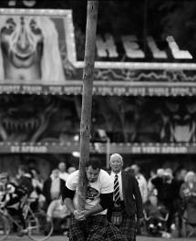
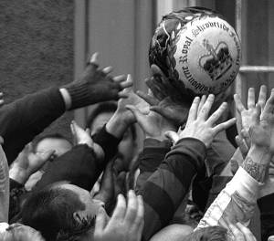

10.6 | American football

Fill in the blanks with key terms related to the following:
• The origins of American football.
• The nature of the game.
• Commercialism of the game.

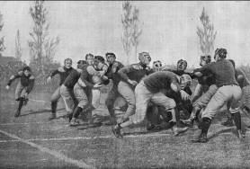

Questions to help you think:

• What is the game sometimes called?
• How would you describe the game?
• In which educational institutions did the game develop?
• How does the game reflect American culture?
• What is the name of the major league for this game?
• What is the huge annual championship game called?
• How does it link with the American Dream?

10.7 | Australian rules football
Fill in the blanks with key terms to do with:
• The origins of the game
• The factors that shaped its development
• Commercialism and the impact of the media.

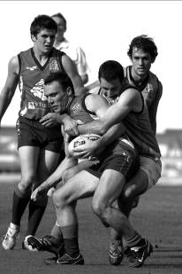

Questions to help you think:
• What is the game also known as?
• On what type of ‘pitch’ is the game played?
• What was the name of the Englishman who thought up the game?
• What was the game originally intended to be?
• What do some people argue that it is a mixture of?
• Is the game only played in Australia?
• To whom does the game appeal?
10.1 | Quiz: sport and culture – answers

The top of the sports development pyramid. | Sporting Excellence
USA – 300 million  Australia – 20 million. | Population
One characteristic of surviving ethnic sports such as the Highland Games. | Occasional
His Cotswold Olympics, which continue as a multi-sport occasion, were originally established by permission of James I in 1605. | Robert Dover
Another characteristic of surviving ethnic sports. | Tourism
The most popular spectator sport in the USA, | American Football
Organisations that look after all aspects of their own sport. | National Governing Bodies
The American one of these means going from ‘rags to riches’. | Dream
A system based on private or corporate ownership and the investment of money for profit. | Capitalism
The country where sport and commercialism is at its height. | USA
The Vince who said, “Winning isn’t the most important thing, it is the only thing.” | Lombardi
Without this there would be no ‘golden triangle’. | TV
One form of Rugby popular in Australia. | Union
A famous public school where games playing became important in the 19th century | Rugby School
Another word for the top of the sports development pyramid. | Elite

10.2 | Sport and culture: test – answers
1. Name an area of the UK where each of the following still occurs: cheese rolling and mob football. (2)

Cheese rolling – Gloucestershire.

Mob football – Ashbourne in Derbyshire; Haxey Hood in Lincolnshire; Alnwick in Northumberland; Sedgefield in County Durham; and Corfe Castle in Dorset.
2. With reference to surviving ethnic sports in the UK, explain the meaning/relevance of each
of the terms ‘traditional’, ‘local’ and ‘isolation’. (3)

Traditional: a celebration of the past; activities that have been going on for hundreds of years or have been passed from generation to generation.

Local: unique to area and a way of increasing community pride.

Isolation: comparative remoteness and inaccessibility of some rural areas allows local customs to continue and ethnic identity to be retained.
3. Name two famous elite 19th century public boarding schools. (2)

Answers might include two of the following: Eton, Harrow, Rugby, Charterhouse, Winchester, Shrewsbury.
4. State three careers that ex-public schoolboys might have gone in to and through which they promoted sports and games. (3)

Vicar/priest; teacher; industrialist; army officer; politician; community leader.
5. Complete the following sentences: (4)
An amateur is someone who takes part for pleasure/enjoyment, not for financial gain/money.
A professional is someone who participates for money as a job/career.

6. Explain the meaning of the terms ‘capitalism’, ‘American Dream’ and ‘franchise’. (3)

Capitalism: a system based on private or corporate ownership and the investment of money for profit.

American Dream: rags to riches; the idea that anyone can be successful irrespective of background.

Franchise: the business that owns, runs and has voting rights for a team.

7. State some key words relating to the origins and nature of the game of American football. (4)

Key words relating to American Football might include: complicated/planned/strategic; Ivy League universities, e.g. Yale; frontier spirit; adaptations/modifications; commercialism; golden triangle; violence; sensational; gridiron; franchise; conference; NGL; Super Bowl; television Rights.
8. List some social and cultural reasons for sports being a high-status national pre-occupation in Australia. (4)

Reasons include:
• the manliness, strength and ‘bush culture’ that shaped Australian society was suited to certain rugged, physically demanding sports
• Australia’s favourable climate
• the outdoor life is the norm in this health-conscious society
• political support for sport is strong
• there is a tradition of success that provides role models
• sport unites the relatively small and young population with a ‘feel good’ factor
• sport is fashionable
• Australia has a healthy economy
• Australia is an egalitarian society; inequalities of opportunity, provision and esteem are less of an issue than in the UK
• sport and PE have high status in schools.
(25 marks)
10.3 | Key word matching task – answers
Shade each of the key boxes with a different colour. Underline each key phrase with the corresponding colour. You may wish to link some key phrases with more than one key box.

SURVIVING ETHNIC SPORTS
Retention of ethnic identity Highland Games
Gloucestershire cheese rolling Ashbourne Football match
Tradition and tourism

19TH CENTURY PUBLIC SCHOOLS
Promotion and organisation of Influence as teachers, army officers and
team games industrialists
Eton, Harrow and Rugby Influence of ‘old boys’
The ‘house system’ Character building
Gentleman amateur

THE USA
Capitalism ‘American Dream’
300 million population Immigration
Win ethic Land of opportunity
Pioneering spirit

AMERICAN FOOTBALL
Ivy League universities ‘Golden triangle’
The Super Bowl Violence and strategy
Commercialism Cheerleaders

AUSTRALIA
20 million population Immigration
Pioneering spirit James Cook and Botany Bay
Six states and two territories

AUSSIE RULES FOOTBALL
‘Footy’ Winter training game for cricketers
Appeals to all classes Tom Wills
Commercialism Colonial influence

10.4 | Quick cultural review – answers
Fill in the gaps in the following paragraphs with appropriate words or phrases.

Surviving ethnic sports and games
The British Isles are rich in surviving festivals and customs (or traditions), many of which are ancient and which reflect the changing seasons of the year and the rhythm of country life. Several mob football games still take place each year such as the Ashbourne game in Derbyshire (or other suitable example). In additional to these single-sport occasions, there are also multi-sport festivals such as the Highland Games, which are grand social occasions that reflect the traditional lifestyle and severe environment. There is great enthusiasm for retaining these customs, so that ancient/local/ethnic traditions are not lost and also because nowadays they attract tourists and, therefore, money! The relative isolation of some areas is one reason that they survive; and also they are simply great fun!

The USA
In the USA, sport is driven by the win ethic. High school, college and professional sport all take sport very seriously and link sport inextricably with commercialism. Professional sport reflects the culture and competitive nature of the USA. The media not only funds professional sport, but influences, or even dictates, rules, scheduling and the format of events. The ‘American Dream’ is the idea that anyone can be successful, irrespective of their age, gender or ethnic background, and sport is used as a vehicle for upward social mobility by certain minority groups. Top professional sports performers can earn millions from playing contracts and even more from advertising and sponsorship deals.

Australia
Australia is a young nation that was inhabited solely by aboriginal peoples until just a few hundred years ago. Australia has been strongly influenced by colonialism and is now a nation of immigrants with a policy of multiculturalism. It is sparsely populated with just 20 million people who live in only just over 3% of the land. Australians are known for their desire to beat England in international sport, known as Pommie bashing. Australia is often said to be passionate or even obsessed with sport. Certainly, the climate helps, along with generous government funding and PE having a high profile in schools. The game that perhaps most clearly reflects Australian society and culture is Australian rules football, or just ‘footy’.
10.5 | Surviving ethnic sports: characteristics and reasons for their continued existence and popularity – answers

1. Tossing the caber and Royal Shrovetide football.

2. Answers might include:
• tourism
• tradition
• festival
• local
• ritual
• isolation
• occasional
• rural
• social.

3. Students’ own suggestions.

10.6 | American football – answers

Chosen key terms might include:
• gridiron
• sensational
• violent
• body checking
• like mobile chess
• strategic
• Ivy League universities
• Harvard/Yale/Princeton
• highly competitive – only the best make it
• NFL (National Football League)
• Super Bowl
• Lombardian ethic
• highly commercialised
• golden triangle
• vehicle for achieving the American Dream.
10.7 | Australian rules football – answers

Chosen key terms might include:
• ‘footy’/Aussie Rules
• played on an oval
• tom Wills
• a winter training game for cricketers
• some say a cross between Gaelic football and rugby
• appeals to all classes in Australia
• played by some Australian overseas
• unique
• more popular than rugby union and league and association football in Australia
• some players have converted from other styles of football
• many aboriginal people play the game
• 42% increase in participation from 2001 to 2005
• very popular in schools – where fair play and sportsmanship emphasised.

10 | Answers to student book tasks

TASK 1
1. Students’ own answers – no written answer necessary.

TASK 2
Students’ own posters.

TASK 3

What helped to promote games?
• Money for specialist facilities.
• Support from academic staff (‘assistant masters’).
• Employment of professional coaches.
• The large amount of time available (due to them being boarding schools).
• The space/land available; space to build facilities.
• Support from head teachers.
• The belief that games playing developed character.

How were games organised?
• Via the house system.
• By the boys.
• Compulsory/every afternoon.

How did ex-public schoolboys help to spread team games?
• At university.
• As administrators of the British Empire abroad.
• As vicars, industrialists, parents, teachers, politicians, and army officers.

TASK 4
Discussion might include the following (not an exhaustive list):

Advantages of being amateur | Advantages of going professional
Players develop careers outside of sport – good if injury stops career early | Likely to get more media coverage
Retains notion of being a ‘schoolgirl’ game – traditions maintained | Can train full time…
Much amateur support available –  e.g. volunteers at NGB | …so higher standards overall
Recreation notion maintained – not too serious; good for physical activity and healthy lifestyles | Opportunity for career
 | Greater opportunity of being best in world
 | Excellent medical back-up
 | More effective organisation and administration likely
 | Better talent identification likely to develop
 | More role models gain a high profile
Disadvantages of being amateur | Disadvantages of going professional
Lack of funding | ‘Love’ of game lost
Lack of media coverage | Win-at-all-costs ethic might dominate
Individuals cannot devote adequate time to training | Game might become too serious
Individuals need a job as well | ‘Professional’ fouls might creep into the game more
More difficult to find high levels of sponsorship

TASK 5
Discussion – students’ own answers.

TASK 6
Students’ own answers.

TASK 7
Practical activity requiring students to download and label a map of Australia for their file.

TASK 8
Students’ own answers based on video research.
2. In groups of three, discuss whether modern commercial sport does and should retain the traditional ethics of sportsmanship or have things moved beyond that? Have we returned to gladiatorial combats where anything goes as long as you can get away with it and profit it be made?
One of you should speak to retain traditional ethics, one speak against and one manage the discussion, summing up at the end and putting key points to paper.

No written answer necessary
3. Read this list of prerequisites that a venue must have in order to be considered to host the Super Bowl. Which of them are to do with commercialism?
• Space for 10 photo trailers and 40 television trucks – yes.
• 600,000 square feet of exhibit space for fan events – yes.
• 50,000 square feet of space for news media – yes.
• Stadium with 65,000 seats or more – yes.
• Large, luxury hotel for teams and NFL – yes.
• Enough ‘quality’ hotel rooms within a one-hour drive for 35% of the stadium's
capacity – yes.
• Average high of 50ºF (10ºC) in February, unless game to be played in indoor stadium – yes.
• Separate practice facilities for each team – not necessarily, though quality of performance likely to add to commercial return.
Download a map of Australia for your file. Add states and main cities if they are not already identified.
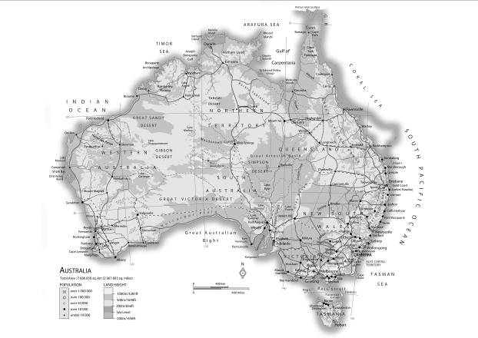

Any suitable map will be fine.
4. Go to www.youtube.com and watch a few clips of Australian rules football. Would you describe the game as hard, spectacular, unique, exciting and exhilarating? What evidence do you see of commercialism and the impact of the media on the game?

No written answer necessary.

Notes for Teachers

In this chapter you will cover the following with your students:

• Public, private and voluntary funding (including the national lottery).
• UK Sport; the UK Sports Institute (UKSI) and home country organisations such as Sport England.
• Current government and national governing body initiatives that influence and promote participation in physical activity.
• The sports development pyramid and the continuum from mass participation to sporting excellence.
• Opportunity, provision and esteem – in the context of mass participation and sporting excellence.
• Social and cultural factors impacting on participation by certain groups in the UK, such as people with disabilities and young people.
• Measures to increase participation and sporting excellence.
• The issues of drugs and violence in sport.
• Sport, sponsorship and the media.
• The Olympic Games.

This is by far the largest chapter in this socio-cultural studies section and it can usefully be sub-divided as follows:
Section 1:
• Funding in physical activity.
• Influential bodies.
• Excellence and participation.
Section 2:
• Performance-enhancing products.
• Sport, sponsorship and media.
• Violence in sport.
Section 3:
• The Olympic Games.
• London 2012.
• Sport as a political tool/China.
Due to the size of this chapter, the ‘Revise as you Go’ questions in the exam café have been divided
into three sections to give students more opportunity for checking learning of more areas.
The first section of this chapter is likely to be the least appealing of the three to students; however, it is essential to understanding sport and PE in the UK – just as the skeleton is to anatomy and physiology, grammar in English Language or research methods in psychology.
The words of the specification will clarify what depth of cognitive engagements the students need for each part.
For example a question which asks students to “Demonstrate knowledge and understanding of UK sport” requires a relatively low level response, while the question “Evaluate critically initiatives that impact upon young people’s aspirations and their regular participation in physical activity in the UK” entails greater consideration and depth, including judgements on the work covered.
The only organisational bodies that will be examined are:
• Devolved National Institutes of Sport, e.g. EIS
• UK Sport
• United Kingdom Sports Institute (UKSI)
• Home country organisations, i.e. Sport England, Sports Council Northern Ireland, Sportscotland, Sports Council for Wales
• national governing bodies (current initiatives)
• International Olympic Committee (IOC)
• British Olympic Association (BOA).
Students are likely to engage very well with Section 2. If you have taught this specification in the past you will have done a lot of planning and preparation that can be used again. Note, however, that in the ‘Performance enhancing products’ section there is an item that has not been examined before, as follows: “Explain the impact of
performance(s) in sport of modern technological products (with reference to particular products and activities).” This refers to items such as gum shields, full-body lycra suits, super bikes, motion analysis and/or materials such as carbon fibre and titanium that not only improve performance, but also might increase the safety and comfort of performers.
Section 3 is our Olympic Games study. Students need some background here and knowledge of both the International Olympic Committee (IOC) and the British Olympic Association (BOA). A key section is that on the impact of hosting the Games in the UK in 2012. Finally, students must be able to explain how the Olympic Games can be a vehicle for nation-building in China, where sport is used as a political tool. The huge success of Team GB in Beijing 2008 may be useful context for students here.

11.1 | Bodies that influence and/or promote participation or sporting excellence
Match the body (or organisation or item) to what they do – either colour code or join with lines.

National Lottery | The organisation that focuses on sporting excellence and provides strategic support
UK Sport | The philosophy of the Olympic Games
Devolved National Institutes e.g. EIS | The pathway from learning basic movement skills to reaching the elite level
Home Country Organisations e.g. Sport England | The organisation responsible for the Olympic Games
National governing bodies | Organisations that look after all aspects of their individual sports and produce ‘Whole Sport Plans’
The sports development pyramid | Companies that are appointed to be official sponsors, suppliers or licencees for an Olympic Games
International Olympic Committee (IOC) | This has transformed British sports funding in recent years and helped Team GB win an impressive haul of medals in Beijing 2008
British Olympic Association (BOA) | Centres that provide practical support in the pursuit of sporting excellence
The Modern Olympic Movement | The organisation responsible for the UK’s participation in the Olympic Games
The Olympic Partner Programme | Organisations that want people to start getting active and continue being active

11.2 | Quiz: sporting issues
The triangle that goes from foundation to participation to performance to excellence | S _ _ _ _ _ D _ _ _ _ _ _ _ _ _ _  P _ _ _ _ _ _
Two sources of funding for sport | P _ _ _ _ _ and P _ _ _ _ _ _
Having the chance to participate – maybe relating to having enough money | O _ _ _ _ _ _ _ _ _ _
Someone who is an inspiration to others | R _ _ _ M _ _ _ _
This has modernised sport; it can improve safety, comfort and performance | T _ _ _ _ _ _ _ _ _
The organisation responsible for the Olympic Movement | I _ _
This has transformed the funding of British sport in recent years | N _ _ _ _ _ _ _ L _ _ _ _ _ _
The strong relationship between sport, sponsorship and the media | G _ _ _ _ _ T _ _ _ _ _ _ _
One role of the media | I _ _ _ _ _
One of the Home Country Councils | S _ _ _ _ E _ _ _ _ _ _
In the past, some of these have shown hooligan behaviour at some football matches | S _ _ _ _ _ _ _ _ _
The ‘Peter’ who commercialised the Los Angeles Olympics (1984) | U _ _ _ _ _ _ _
A focus group for participation | E _ _ _ _ _ M _ _ _ _ _ _ _ _ _
The positive outcome of a country ‘showing off’ their best athletes at a major sporting event such as the Olympic Games | S _ _ _ W _ _ _ _ _ E _ _ _ _ _

Shade each of the five boxes with a different colour. Underline each key phrase with the corresponding colour. You may wish to link some key phrases with more than one key box.
11.3 | Key word matching task
Legacy Golden triangle Baron Pierre De Coubertin
Cheating, role modelling and illegality World-class facilities
100% ME Employment opportunities
SPORT AND THE MEDIA
THE OLYMPIC GAMES (GENERAL)
PERFORMANCE-ENHANCING PRODUCTS
VIOLENCE IN SPORT
LONDON 2012
Deviance Agents and endorsements
Infrastructure Tougher deterrents
Influence of English public schools e.g. Rugby School
Drugs and doping in sport Boost to the economy
Use of CCTV and other security measures
Sky, satellite and ‘pay per view’
Robert Dover and Dr William Penny Brookes
Education, use of role models, lifetime bans
Positive and negative impacts Urban renewal
Gum shields, Hawk-eye and lycra bodysuits
Summer and winter format World Anti-doping Agency (WADA)
Increased participation The IOC and BOA
Drug and alcohol use Police liaison
“Citius, Altius, Fortius” or “Swifter, Higher, Stronger”
All-seater stadia and removal of perimeter fencing
Inform, educate, entertain, advertise ‘Feel good factor’
Pressure from coaches, belief everyone else is doing it and a ‘win at all costs’ ethic
11.4 | Contemporary sporting issues: test
1. Which of the following is public, which is private and which is voluntary funding? (3)
• Funding from donations or charities or private clubs. _________
• Funding from government and local authorities, including national lottery. _________
• Funding from businesses, companies and investors, often by way of sponsorship. ______________
2. Identify some current Government initiatives that impact upon young people’s participation in physical activity in the UK. (3)

3. What social and cultural factors might impact upon a disabled person’s likelihood of taking part in physical activity and achieving sporting excellence? (3)

4. To which sporting issue that you have studied do the following key terms refer: danger to health, cheating, role modelling, illegality? (2)
__________________________________________________________________________
5. State two key roles of the media (2)
__________________________________________________________________________
6. State three possible positive and three possible negative impacts that the media can have on sport. (6)

7. Make a word bank of key terms and phrases relating to the impact of the UK being a host nation for the Olympic Games in 2012. Consider benefits to the UK as whole; benefits to sport; and benefits to the local area. (6)
(25 marks)
11.5 | The Olympic Games: background, principles and commercialism
Quick starter activity: match the correct statement to the correct description.

Baron Pierre de Coubertin | The Olympic Charter
Looks after ‘all things Olympic’ in  the UK | For companies appointed to sponsor or supply the Olympic Games
Dr William Penny Brookes | Athens
The first Olympic Games to embrace commercialism | Founder of the Much Wenlock Olympian Games
Robert Dover | Los Angeles – 1984
The ‘rule book’ that governs how the Olympic Games and the IOC are run | The BOA
The Olympic Partner (TOP) Programme | Founder of the Modern Olympic Games
The first Modern Olympic Games were here in 1896 | Founder of the Cotswold Olympik Games in the 1600s

11.6 | Drugs in sport
Fill in the blanks with key terms that link to the main theme.

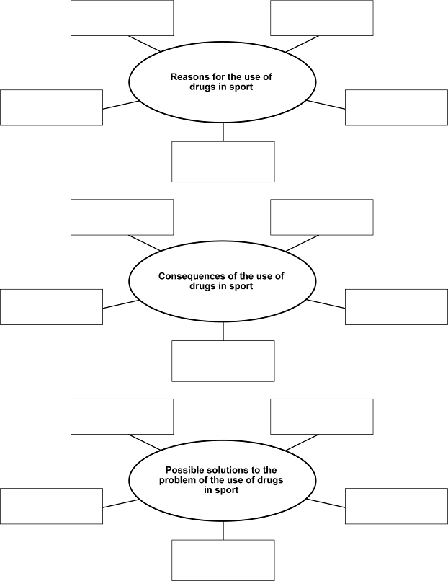
11.7 | Modern technological products
Quick warm up task: state whether the key function of each of the products in the boxes below is safety, comfort, improved performance or something else.

Gum shield | Lycra full-body running suit | Sports watch | Cricket headgear
Skis | Golf clubs | Tennis racquet | Boots with bladed studs
Motion analysis (e.g. of golf swing or discus throw), which can be computer analysed | Electronic timing equipment that measures fractions of seconds | Improved/advanced surgery including artificial ligaments and joint replacements | A 400 m track running
Full body swimming suit & tight swimming cap | An ice bath | Physiotherapist – ultrasound equipment | A modern high-tech racing bike

11.1 | Bodies that influence and/or promote participation or sporting excellence – answers
Match the body (or organisation or item) to what they do – either colour code or join with lines.

National Lottery | This has transformed British sports funding in recent years and helped Team GB win an impressive haul of medals in Beijing 2008
UK Sport | The organisation that focuses on sporting excellence and provides strategic support
Devolved National Institutes e.g. EIS | Centres that provide practical support in the pursuit of sporting excellence
Home Country Organisations e.g. Sport England | Organisations that want people to start getting active and continue being active
National governing bodies | Organisations that look after all aspects of their individual sports and produce ‘Whole Sport Plans’
The sports development pyramid | The pathway from learning basic movement skills to reaching the elite level
International Olympic Committee (IOC) | The organisation responsible for the Olympic Games
British Olympic Association (BOA) | The organisation responsible for the UK’s participation in the Olympic Games
The Modern Olympic Movement | The philosophy of the Olympic Games
The Olympic Partner Programme | Companies that are appointed to be official sponsors, suppliers or licencees for an Olympic Games

11.2 | Quiz: sporting issues – answers

The triangle that goes from foundation to participation to performance to excellence | Sports Development Pyramid
Two sources of funding for sport | Public and Private
Having the chance to participate – maybe relating to having enough money | Opportunity
Someone who is an inspiration to others | Role Model
This has modernised sport; it can improve safety, comfort and performance | Technology
The organisation responsible for the Olympic Movement | IOC
This has transformed the funding of British sport in recent years | National Lottery
The strong relationship between sport, sponsorship and the media | Golden Triangle
One role of the media | Inform
One of the Home Country Councils | Sport England
In the past, some of these have shown hooligan behaviour at some football matches | Spectators
The ‘Peter’ who commercialised the Los Angeles Olympics (1984) | Uberroth
A focus group for participation | Ethnic Minorities
The positive outcome of a country ‘showing off’ their best athletes at a major sporting event such as the Olympic Games | Shop Window Effect

11.3 | Key word matching task – answers

PERFORMANCE-ENHANCING PRODUCTS
Gum shields, Hawk-eye and lycra bodysuits Cheating, role modelling and illegality
Education, use of role models, lifetime bans Pressure from coaches, belief everyone
else is doing it and a ‘win at all costs’
100% ME ethic
Tougher deterrents WADA – the World Anti-doping Agency

VIOLENCE IN SPORT
Deviance Tougher deterrents
Drug and alcohol use Police liaison
All-seater stadia & removal of Use of CCTV and other security
perimeter fencing measures

SPORT AND THE MEDIA
Inform, educate, entertain, advertise Golden triangle
Positive and negative impacts Sky, satellite and ‘pay per view’
Agents and endorsements

THE OLYMPIC GAMES (GENERAL)
World class facilities Baron Pierre De Coubertin
Robert Dover and Dr William Penny Brookes Influence of English public schools
Summer and winter format e.g. Rugby School
‘Citius, The IOC and BOA Altius, Fortius’ or The IOC and BOA
“Swifter, Higher, Stronger”

LONDON 2012
‘Feel good factor’ Infrastructure
Urban renewal Legacy
Employment opportunities Boost to the economy
Increased participation World-class facilities

11.4 | Contemporary sporting issues: test – answers
1. Which of the following is public, which is private and which is voluntary funding? (3)
• Funding from donations or charities or private clubs. Voluntary
• Funding from government and local authorities, including national lottery. Public
• Funding from businesses, companies and investors, often by way of sponsorship. Private
2. Identify some current Government initiatives that impact upon young people’s participation in physical activity in the UK. (3)

Current Government initiatives might include:
• the national curriculum
• The PE, School Sport and Club Links Strategy (PESScLS) including: sports colleges; school sports partnerships; school sport co-ordinators; gifted and talented; sporting playgrounds; club links; step in to sport.
3. What social and cultural factors might impact upon a disabled person’s likelihood of taking part in physical activity and achieving sporting excellence? (3)
Impacting social and cultural factors might include:
• factors related to ‘opportunity’, including funding, ability, time, and choice
• factors related to ‘provision’, including suitable equipment, facilities, access (including ramps), transport, clubs, coaching, and competition
• factors related to ‘esteem’, including self-confidence, respect from others, positive or negative perceptions of certain physical activities, and status of the activity in society.
4. To which sporting issue that you have studied do the following key terms refer: danger to health, cheating, role modelling, illegality? (2)

The issue of drugs in sport (1 mark) and possible reasons for their use (1 mark).
5. State two key roles of the media (2)

Two from inform, educate, entertain, advertise.
6. State three possible positive and three possible negative impacts that the media can have on sport. (6)

Positive impacts include:
• balanced, healthy lifestyles and participation promoted/increased
• more money to sport
• professional sporting career opportunities
• big money for some performers
• sporting standards raised
• positive role-models created
• myths and stereotypes can be broken
• minority sports and sports of minority groups can be highlighted
• rules, timings, seasons, format and structure of sport can be changed in a positive way
• advanced technology, e.g. slow-motion replays
• sport more serious with fewer draws and clear results.

Negative impacts include:
• media focus on trivia
• the public can have views dictated by media
• loss of privacy for performers
• myths and stereotypes can be reinforced
• minority sports get minimal coverage
• reduced participation – armchair spectators
• rules, timings, seasons, format and structure can be changed in a negative way
• only very few get big monetary rewards

[continued]
• some forced to perform more frequently than is safe
• audiences may suffer from overload/boredom
• national prejudices can be encouraged/reinforced
• increased ‘win-at-all-costs’ ethic
• as result becomes more important, this can increase problems such as corruption, violence and drug abuse
• negative aspects of ‘pay’ to view.
7. Make a word bank of key terms and phrases relating to the impact of the UK being a host nation for the Olympic Games in 2012. Consider benefits to the UK as whole; benefits to sport; and benefits to the local area. (6)

Key terms and phrases might include some of the following:
Opportunities; implications; challenge; benefits; legacy; world-class facilities; investment; training camps; high profile for sport; Team GB; modernisation; improved organisation and administration of sport; increased participation; media coverage; sponsorship; young people; role models; motivate; inspire; ‘feel-good factor’; carnival atmosphere; infrastructure; Olympic Park; tourism; economy; social integration; employment opportunities; deprived area; urban renewal.
(25 marks)
11.5 | The Olympic Games: background, principles and commercialism – answers

Baron Pierre de Coubertin | Founder of the Modern Olympic Games
Looks after ‘all things Olympic’ in  the UK | The BOA
Dr William Penny Brookes | Founder of the Much Wenlock Olympian Games
The first Olympic Games to embrace commercialism | Los Angeles – 1984
Robert Dover | Founder of the Cotswold Olympik Games in the 1600s
The ‘rule book’ that governs how the Olympic Games and the IOC are run | The Olympic Charter
The Olympic Partner (TOP) Programme | For companies appointed to sponsor or supply the Olympic Games
The first Modern Olympic Games were here in 1896 | Athens

11.6 | Drugs in sport – answers

Reasons for the use of drugs in sport
Answers might include:
• physiological reasons, e.g. to build muscle or overcome injury
• psychological reasons, e.g. to steady nerves or increase aggression
• social reasons, e.g. pressure to win from coach
• having a ‘win-at-all-costs’ attitude
• belief that everyone else is doing it
• fear of not winning.

Consequences of the use of drugs in sport
Answers might include:
• it is unfair/cheating/against the laws of sport
• it undermines the spirit of sport
• it reflects badly on self, coach, country
• it is dangerous to health
• it sets a bad example (negative role models)
• it lowers the status of sport.

Possible solutions to the problem of the use of drugs in sport
Answers might include:
• improved testing methods/procedures or more money for testing/keeping ahead of the game
• lifetime bans
• education and information for coaches and performers, e.g. 100% ME
• use positive role models to spread the word of ‘clean sport’
• or the counter-culture idea of legalising and monitoring their safe use.
11.7 | Modern technological products – answers

Gum shield  • Safety | Lycra full-body running suit  • Improved performance | Sports watch  • Entertainment | Cricket headgear  • Safety
Skis  • Improved performance | Golf clubs  • Improved performance | Tennis racquet  • Improved performance | Boots with bladed studs  • Safety  • Improved performance
Motion analysis (e.g. of golf swing or discus throw), which can be computer analysed  • Improved performance | Electronic timing equipment that measures fractions of seconds  • Improved performance | Improved/advanced surgery including artificial ligaments and joint replacements  • Comfort  • Recovery  • Participation | A 400m track running  • Improved performance
Full body swimming suit & tight swimming cap  • Improved performance  • Comfort | An ice bath  • Safety  • Recovery  • Improved performance | Physiotherapist – ultrasound equipment  • Recovery  • Performance | A modern high-tech racing bike  • Improved performance

11 | Answers to student book tasks

TASK 1
No written answer needed.

TASK 2
Answers might include:

Sporting | Social | Cultural | Economic
Role models to inspire  Higher standards of performance  Improved facilities | Increased community spirit  ‘Feel good’ factor  Improved local relationships / reduced local crime | Showing British ‘culture’ to visitors and TV viewers  Sharing culture with visiting teams / nations | Tourism  Business development  Employment opportunities

TASK 3
Answers are likely to include:
Practical support for athletes including:
• sport science and sports medicine
• medical consultation and medical screening
• physiology
• biomechanics
• nutritional advice
• podiatry (care of feet and ankles)
• performance analysis and planning
• psychology
• physiotherapy
• strength and conditioning
• career, education and lifestyle advice
• sports massage
• sports vision
• performance lifestyle advice

TASK 4
No written answer needed.

TASK 5
No written answer needed.

TASK 6
No written answer needed.

TASK 7
Some National Governing Body (NGB) initiatives:
• Select national team / talent ID / select for World Class Programme.
• Provide sport science support or analysis.
• Provide high level coaching / performance directors / national coach / train high perfornace coaches or officials
• Seek sponsorship or develop commercial links; obtain media coverage / negotiative with media
• Give access to high level facilities or equipment
• Work with UK Sport or UKSI or home country sports council or sports colleges or high level clubs.
• Provide anti-doping education / give information about 100% ME / deal with discipline.
• Encourage or support academic education / provide lifestyle or career advice

TASK 8
Student’s own answer.

TASK 9
No written answer needed.

TASK 10
Think about:
UK Sport
• it manages and distributes public investment and National Lottery funding through the World Class Pathway Programme.
• it promotes ethical standards of behaviour through its athlete-centred anti-doping programme called 100% ME.
• it coordinates programmes to attract major sporting events.
• it manages the UKs international sporting relationships of the UK.
• it helps elite performers develop a ‘performance lifestyle’.
• it runs a World Class Coaching Strategy to support world class coaches.
• it coordinates other organisations in the UK encouraging administrative efficiency.
• it works with the home country sports councils (e.g. The Sports Council for Wales) and other agencies to achieve its goals.
• it is responsible for the strategic direction of the UKSI and English Institute of Sport (EIS).
• it launched Mission 2012 to support, monitor and evaluate the work of the NGBs.
• it is responsible for the Talented Athlete Scholarship Scheme (TASS).

UKSI
Practical support for athletes including:
• sport science and sports medicine
• medical consultation and medical screening
• physiology
• biomechanics
• nutritional advice
• podiatry (care of feet and ankles)
• performance analysis and planning
• psychology
• physiotherapy
• strength and conditioning
• career, education and lifestyle advice
• sports massage
• sports vision
• performance lifestyle advice

Home Country Councils e.g. Sport England
In short – each of the Home Country Councils want people to start getting active and stay being active.

What does Sport England want?
• Most importantly, it wants to get people active!
• It wants regular participation to increase by two million by 2012.
• It wants current non-movers to start exercising, current limited-movers to build to 30 minutes three times a week and current regular-movers (30 minutes three times a week) to do more.
• It wants to ensure that young people stay in sport once they leave school.

What does Sport England do?
• It invests in, advises on and promotes community sport for children, young people and adults.
• It works to increase opportunities to take part in community sport and physical recreation– especially in hard-to-reach or priority groups such as people with disabilities.
• It supported the government’s initial target for school sport ‘that by 2008 at least 85% of school children aged 5-16 spend at least two hours each week on high quality PE and school sport.’ and the government’s updated aim (July 2007) for ‘the equivalent of an hour of ‘sport’ every school day.’ (including two hours within the curriculum and three hours extra curricular/community participation).

• It promotes volunteering, coaching, leadership and officiating as well as actual performing.
• It works closely with local, regional and national partners and brings together NGBs, regional sporting bodies, coaches, clubs and volunteers – all in order to increase participation.
• Creates and funds initiatives such as Sporting Champions – which organises visits by world-class athletes to schools and communities to raise awareness and to motivate.
• Develops school/club links.
• It is keen to use sport to fight obesity.
• It works with partners to ensure that the London 2012 Olympic and Paralympic Games leave a lasting sporting legacy.
• It is responsible for funding elite performers in sports such as squash and netball that are non-Olympic.
Government initiatives
• PESSCL – and all its strands including:

sports colleges
school sports partnerships
gifted and talented
sporting playgrounds
club links
step into sport
swimming
professional development

• ‘Sport: Raising the Game’ – the 1995 document which resulted (among other things) in specialist sports colleges and the UKSI.
• ‘A Sporting Future for All’ – (2001) set out the government’s vision for sport. Highlighted need for co-operation, communication and co-ordination between schools, local clubs and organisations.
• ‘Game Plan’ (2002) – Game Plan recognised the importance of physical activity to health and the potential social and economic costs of increasing inactivity in the population. It stated that government saw sport and physical activity as ways of reducing inequalities of opportunity and lead to improved health and employment, be diverted from antisocial behaviour and be better educated.
• The National Sports Foundation – encourages partnerships between private investors and community sports projects in England. It matches private investment with Foundation funding, on a pound for pound basis.
National Governing Body (NGB) initiatives
See TASK 7 for NGB initiatives.

TASK 11
No written answer needed.

TASK 12
Spider diagram should include the following points:

Opportunity
• discounted membership / entrance rates
• free or cheap hire of equipment
• special
• classes for this group
• suitable ‘timings’ of events or classes during the day / evening
• give a varied choice of activites – not just carpet bowls!

Provision
• make sure that physical access is suitable and safe
• provide social area / encourage socialising
• provide coaching for leaders so that they understand the needs and wants of the clients
• provide transport / links with local bus companies and taxi firms
• advertise / raise awareness of what is going on
• provide ‘taster’ sessions
• links with local GP surgeries

Esteem
• Specially trained ‘tuned in’ coaches or leaders / employ ‘elderly’ coaches / leaders
• Ask clients what they want / survey clients

TASK 13
Student’s own answer.

TASK 14
Accept any relevant answers that appear on pages 281 and 283 of the student book.

Notes for Teachers

It should be realised that this unit of the specification, unit 452, should not be viewed as being discrete from unit 451, but as a vehicle through which students can aid their understanding and application of the theoretical concepts that they have covered. This should lead to an improvement in activity performance, thereby increasing the marks obtained. This unit also contributes to the students’ achievement of the physical education subject criteria aims by:
• increasing their physical competence
• developing their involvement and effectiveness in physical activity
• enabling them to become informed and discerning decision-makers in relation to their own and others’ involvement in physical activity.
It also makes a significant contribution to the student achieving a balanced, active and healthy lifestyle.

The unit contains two sections.
• Section 1: the students are assessed in two practical activities – acquiring and developing practical skills in physical education.
• Section 2: the students are assessed in one oral response – evaluating practical skills in physical education. (This response will be addressed in Chapter 13.)
Students will be assessed in:
• performing two chosen activities from two different activity profiles and evaluating and planning for the improvement of performance
OR
• performing one chosen activity and coaching/leading one chosen activity from two different activity profiles together with evaluating and planning for the improvement of performance.
OR
• performing one chosen activity and officiating one chosen activity in two different activities together with evaluating and planning for the improvement of performance.
Students are assessed in two practical activities, which must be selected from two different activity categories. There are eleven activity profiles.
Activity category
Activity
• Athletic activities
• Combat activities
• Dance activities
• Invasion games
• Net/wall games
• Striking/fielding games
• Target games
• Gymnastic activities
• Outdoor and adventurous activities
• Swimming activities and water safety
• Safe and effective exercise activities
A full list of activities together with assessment details can be found on the OCR website: www.ocr.org.uk/develop/phys_ed/physedua.htm.
Structuring the practical activity component
It is not possible to be prescriptive about the structure of this component. Each centre will differ in staff expertise, time allocated, facilities available and the needs of students.
Bearing this in mind, centres have to decide whether students are going to be taught all the activities they are assessed in, or whether to allow students to be assessed in activities not being taught in the course/centre. Whichever decision is made will have implications for the delivery of the practical activities.
If students are to be taught all the activities they are to be assessed in, then it will restrict the activities available but be easier to control and assess. If this is the method to be followed, then the best way of delivery is by a modular approach, splitting the time available into a number of blocks. Students are assessed in each activity and their best two assessments used. Teachers are in control of the content delivered and can monitor student progress. The fact that all students are in the same group helps group cohesion and enables theory to be applied, within the practical sessions, to a variety of activities. In some cases, however, it prevents students from capitalising on their strengths if those activities are not included.
If students are allowed to be assessed in activities not taught in the course then this has implications. Firstly the student’s coach will have to be made aware of exactly what the student is aiming to achieve, together with the time span available. Secondly, they will also have to be made aware of the assessment criteria and how the student will be assessed. The teaching staff must, however, be involved in the assessment to ensure standardisation. This approach enables students to follow a wider variety of activities but does lead to a fragmentation of the course.
It should be stressed that whichever approach is adopted, students should be encouraged to follow their two chosen activities outside of their course. This could be by attending an extra-curricular lunchtime or after-school club, playing for a school team, going to a local club or playing for a local team. Students should be made aware that if they wish to gain good marks in their activities, then they need to practice and participate in them on a regular basis.
What should be taught?
The centre has to decide whether or not they will allow students to follow any of the three pathways, i.e. performing, coaching/leading or officiating. If students are permitted to select any of the three then this has implications for what has to be taught.
Performance
The focus of the AS assessment is on the skills and techniques that are part of the activity, together with an appreciation of the basic strategies and tactics involved. The banded assessment criteria identify the following areas for assessment.
• Level of acquired and developed skills and their standard of accuracy, control and fluency under competitive, performance or challenge pressure.
• Success in selection and application of advanced skills and their accuracy, control and fluency under competitive, performance or challenge pressure.
• Use of strategies and tactics/choreographical and compositional ideas demonstrating perceptual and technical understanding.
• Overall level of performance.
• Level of physical and mental fitness.
• Level of understanding and application of the rules/regulations of the activity.
The focus of assessment is, therefore, very much on the level of skills in a ‘competitive’, ‘performance’ or ‘challenge’ situation. As the situation is competitive-, performance- or challenge-based it will involve the use of strategies and tactics or choreography and composition. The emphasis in teaching should therefore be to ensure that students have a good range of sound skills that can be applied well under pressure in a competitive, performance or challenge situation. These skills will include both the basic skills together with the more advanced skills of the activity. To score high marks, students would be expected to be able to apply advanced techniques successfully.
It should be noted that, in some activities, the competitive, performance and challenge situation in which the acquired and developed skills take place are prescribed, e.g. dance: three 1-minute solo dances; mountain walking: two-day journey with a minimum of 14 hours walking covering at least 36km.
It should also be noted that the focus is on the application of techniques in a ‘competitive’, ‘performance’ or ‘challenge’ situation and will include all facets of the activity, i.e. for athletics, swimming, etc. this will include starts, turns and finishes.
Within the content of the practical activities, students must be made aware of:
• the coaching points of the skills covered
• progressive practices for the development of these skills
• details of opportunities locally and nationally for performers to participate and improve in the activity
• the health and fitness benefits of the activity.
It is essential that these areas are covered, as students will need this knowledge if they base their evaluating and planning for improvement response on this activity within the second part of this unit. They will also utilise this knowledge in their A2 practical assessment when they undertake their “Evaluation and Appreciation of Performance” assessment.
The identification of the coaching points should be related to the movement phases, which are identified in the OCR Teacher Support Coursework Guidance booklet.
The health and fitness benefits should be related to the students’ understanding of balanced, active and healthy lifestyles.
How should it be taught?
The skills are not assessed in isolation and it is essential, therefore, that, once the student has a grasp of the skills, they are practiced in applied situations. The OCR Teacher Support Coursework Guidance booklet refers to these situations as ‘Conditioned Competitive Situations’. These are the situations that ultimately the student will be assessed in.
Practice within a conditioned competitive, performance or challenge context ensures that students are able to select the appropriate skills, whilst also performing them repetitively and consistently as specific movements. The students’ ability to adapt and adjust them to a variety of situations can be practiced.
The conditioned, competitive situation aims to improve the students’ performance. Centres should devise their own conditioned competitive situations that place emphasis on the acquired and developed skills in question, and pressurise candidates by utilising features such as restricting numbers of players, space and range of skills. These conditioned competitive situations identify the individual candidate’s level of autonomy, whilst providing a range of contexts in which ability differentials will be displayed.
Coaching/leading
The focus of the AS assessment is on coaching/leading skills together with an appreciation of the basic strategies involved. Students will also have to have an awareness of health and safety issues.
The banded assessment criteria identify the following areas for assessment.
• The level of basic and advanced coaching/leading skills.
• Use of a range of coaching/leading strategies, demonstrating understanding of perceptual aspects.
• Level of awareness of health and safety issues.
• Level of implementation of risk assessments.
• Level of awareness of child protection issues.
• Level of awareness of fitness and health benefits of the activity.
• Overall performance in coaching/leading.
• Level of organisational skills in planning and delivering sessions.
• Implementation of risk assessments.
• Knowledge of the rules/regulations of the activity.
• Level of evaluative/reflective skills in relation to sessions delivered.
Students will be assessed in their ability to lead safe, purposeful and enjoyable activities while exhibiting motivation, responsibility, control and confidence. Coaching/leading situations that are of suitable pitch and challenge should be available for students to work in. Working with primary school pupils in top Sport/Dragon sport sessions, youth groups, and junior secondary school pupils would enable them to demonstrate a level of autonomy.
The skills the student needs to acquire and develop can be organised into the following groups.
• Planning/organisation.
• Delivery.
• Evaluative.
• Technical knowledge.
Planning/organisation
This section should include a scheme of work, individual session plans, long- and short-term objectives, facility details, equipment, participant information, health and safety, and child protection.
Delivery
This should include appearance, presence and personality, communication, voice tone, demonstrations, control, motivation/praise, enthusiasm, positive relationship with participants, equal treatment of participants, inclusion, timekeeping.
Evaluative
This should include identification of performers’ strengths and weaknesses, identification of own strengths and weaknesses in the sessions, together with the strengths and weaknesses of the sessions themselves.
Technical knowledge
This should include technical models with analytical phases and associated coaching points, and progressive practices to develop skills.
It is essential that students intending to follow this pathway make the decision early in the course as part of the assessment requires them to maintain a record of their coaching over a 3-month period. Students also have to keep a detailed log that includes:
• a record of their coaching/leading activities over a 3-month period
• a scheme of work that identifies progression and has 10 hours of session plans together with appropriate evaluations and risk assessments
• a personal video record of a minimum of
40 minutes of coaching/leading
• details of health and safety issues relevant to the activity
• details of child protection procedures in operation for the activity
• evidence of the candidates’ appropriate first-aid qualifications
• details of the fitness and health benefits of the activity and of coaching/leading the activity.
Candidates may undertake awards such as the British Sports Trust Community Sports Leader Award or a Governing Body Level 2 coaching qualification to develop the skills in which they will be assessed. Successful completion of such an award is NOT a requirement and students will still need to be assessed against OCR’s prescribed AS Physical Education criteria.
Officiating
The focus of the AS assessment is on officiating skills together with an appreciation of the basic strategies involved. Students will also have to have an awareness of health and safety issues.
The banded assessment criteria identify the following areas for assessment.
• The level of basic and advanced officiating skills.
• Use of a range of officiating strategies, demonstrating understanding of perceptual aspects.
• Level of awareness of health and safety issues.
• Level of implementation of risk assessments.
• Level of awareness of child protection issues.
• Level of awareness of fitness and health benefits of the activity.
• Level of overall performance in officiating.
• Level of organisational skills in the preparation to officiate sessions.
• Implementation of risk assessments.
• Level of knowledge, understanding and application of the rules/regulations of the activity.
• Level of evaluative/reflective skills in relation to sessions officiated.
Students are assessed in their ability to officiate in safe, purposeful and enjoyable sporting and recreational activities while exhibiting responsibility, control and confidence. Officiating situations that are of suitable pitch and challenge should be created to enable the student to develop appropriate skills, abilities and qualities. These situations could be found in primary school sports, lower secondary school sports, junior sports or youth groups, which would permit the students to display their level of autonomy.
The skills the student needs to acquire and develop can be organised into the following groups.
• Planning/organisation.
• Delivery.
• Evaluative.
• Technical knowledge.
Planning/organisation
This should include knowledge of participants, rules and regulations specific to the competition, location of venue and access, timings, health and safety, risk assessment and child protection, equipment, and fitness.
Delivery
This should include making decisions, communications, equity, control, positioning, and teamwork with other officials.
Evaluative
This should include the strengths and weaknesses of the student’s own performance.
Technical knowledge
This should include knowledge and application of rules and regulations, and fitness.
It is essential that students intending to follow this pathway make the decision early in the course, as part of the assessment requires them to maintain a record of their officiating over a 3-month period. Students also have to keep a detailed log that includes:
• record of their officiating activities over a 3-month period
• four evaluations of sessions officiated by qualified officials
• evidence of risk assessments
• a personal video record of a minimum of 40 minutes of officiating
• details of health and safety issues relevant to the activity
• details of child protection procedures in operation for the activity
• details of the fitness and health benefits of the activity and of coaching/leading the activity.
Candidates may undertake a Governing Body Level 2 officiating qualification to develop the skills in which they will be assessed. Successful completion of such an award is NOT a requirement and students will still need to be assessed against OCR’s prescribed AS Physical Education criteria.
Assessment of practical activities
The assessment of the practical activities has obvious implications not only for what and how it is taught, but also for the amount of time available for teaching the activities.
Submission of assessments
Performance
Final marks are submitted to OCR as follows.
• AS – assessments should be submitted by
31 March.
• However, summer activities may be assessed later and submitted by the second coursework submission date (15 May). When submitted to the moderator these assessments must be accompanied by video evidence.
• You should also note that assessments for every candidate in any one activity must be submitted on the same date, i.e. all assessments for candidates offering cricket must be submitted either by 31 March or 15 May.
• All activities assessed must be supported by video evidence. This will be of a sample of candidates in that activity from the top, middle and bottom of the mark range. This video evidence should be held in the centre and maybe requested by the moderator.
Coaching/leading
All final marks are submitted by 31 March.
Officiating
All final marks are submitted by 31 March.
Performance assessment
Students can be assessed in two activities from two different activity categories. The student is assessed in conditioned competitive situations, each activity being assessed out of 30 marks. These conditioned competitive situations will in some activity categories relate to the interpretation of ‘competition’ for that category. For example, in dance it will be a performance while in outdoor and adventurous activities it will be a challenge.
It is important that students are assessed continuously. This means that students are aware of the progress that they are making and that in the event of an injury the centre has some indication of the student’s level of performance on which to base their assessment.
As mentioned previously, the activities are assessed by banded criteria, which are customised for each activity but contain the same basic criteria. For example, the assessment criteria for invasion games are:
Band 1 (25–30)
• The candidate demonstrates a very high level of acquired and developed skills that show a consistently high standard of accuracy, control and fluency under competitive pressure.
• There is consistent successful selection and application of a wide range of advanced techniques that, under competitive pressure, maintain their accuracy, fluency and control.
• The candidate successfully and consistently uses a wide range of appropriate strategies and tactics, demonstrating an excellent understanding of the perceptual requirements of the activity.
• Overall performance in the competitive situation is excellent and indicative of high levels of learning and understanding.
• The candidate demonstrates excellent physical and mental fitness.
• The candidate demonstrates an excellent understanding and application of the rules/regulations of the activity.
Band 2 (19–24)
• The candidate demonstrates a high level of acquired and developed skills that show a consistently high standard of accuracy, control and fluency under competitive pressure.
• There is consistent successful selection and application of a range of advanced techniques that, under competitive pressure, maintain their accuracy, fluency and control.
• The candidate successfully and consistently uses a range of appropriate strategies and tactics, demonstrating a good understanding of the perceptual requirements of the activity.
• Overall performance in the competitive situation is very good and indicative of good levels of learning and understanding.
• The candidate demonstrates good physical and mental fitness.
• The candidate demonstrates a good understanding and application of the rules/regulations of the activity.
Band 3 (13–18)
• The candidate demonstrates a sound level of acquired and developed skills that show a consistently good standard of accuracy, control and fluency under competitive pressure.
• There is successful selection and application of a range of advanced techniques that, under competitive pressure, maintain their accuracy, fluency and control.
• The candidate successfully uses a limited range of appropriate strategies and tactics, demonstrating a sound understanding of the perceptual requirements of the activity.
• Overall performance in the competitive situation is good and indicative of sound levels of learning and understanding.
• The candidate demonstrates sound physical and mental fitness.
• The candidate demonstrates a sound understanding and application of the rules/regulations of the activity.
Band 4 (7–12)
• The candidate demonstrates a limited level of acquired and developed skills that show some accuracy, control and fluency under competitive pressure.
• There is successful selection and application of advanced techniques that, under competitive pressure, usually maintain some accuracy, fluency and control.
• The candidate successfully uses some appropriate strategies and tactics, demonstrating a limited understanding of the perceptual requirements of the activity.
• Overall performance in the competitive situation is limited, inconsistent and indicative of limited learning and understanding.
• The candidate demonstrates limited physical and mental fitness.
• The candidate demonstrates limited understanding and application of the rules/regulations of the activity.
Band 5 (0–6)
• The candidate demonstrates a poor level of acquired and developed skills that show little accuracy, control and fluency under competitive pressure.
• There is an attempt to select and apply advanced techniques that, under competitive pressure, maintain little accuracy, fluency and control.
• The candidate rarely uses appropriate strategies and tactics, demonstrating a poor understanding of the perceptual requirements of the activity.
• Overall performance in the competitive situation is poor, inconsistent and indicative of limited learning and understanding
• The candidate demonstrates inadequate levels of physical and mental fitness.
• The candidate demonstrates little understanding and application of the rules/regulations of the activity.
These criteria can be identified in six basic statements, which have previously been identified (see “What should be taught”).
How are students assessed?
Students are assessed within conditioned competitive situations. These conditioned competitive situations identify the individual candidate’s level of autonomy while providing a range of contexts in which ability differentials will be displayed.
The nature of the conditioned competitive situations devised by centres should:
• focus on the range of basic and advanced applied and acquired skills to be assessed
• be structured to allow candidates to develop basic tactical/choreographic and compositional awareness
• be realistic situations in which acquired and developed skills are assessed whilst applying the normal rules/regulations and codes of practice
• enable candidates to be placed in a rank order in terms of ability.
For some of the activities, you are required to devise your own conditioned competitive situations (some examples are given in OCR’s Teacher Support Coursework Guidance Booklet), whilst in others they are prescribed.
In the following activities the conditioned competitive situations are prescribed.
• Gymnastics: four cross-box vaults and an agility floor sequence.
• Trampolining: two ten-contact sequences
• Contemporary dance: three 1-minute solo choreographed dances
• Mountain walking: 2-day, 14-hour 36 km journey.
As indicated in the banded criteria, assessment is out of a maximum mark of 30.
The following sheet can be used to help assess students.
• Look at the students in the appropriate conditioned competitive situations.
• Place the students in a rank order: best at the top, worst at the bottom. A first stage of this might be to put the students into one of a top, middle or bottom band.
AS Assessment
Teacher’s name ______________________
Activity ______________________
Condition competitive situation _______________
General banded criteria:
• level of acquired and developed skills (accuracy, control and fluency)
• Selection and application of advanced techniques (accuracy, control and fluency)
• Introduction and use of basic tactics and strategies
• Overall level of performance.
Additional criteria for the specific activity:
__________________________________
__________________________________
__________________________________
__________________________________
__________________________________
Rank order (initially place students into three groups):
Top Middle Bottom

Rank order/assessment out of 30:
Candidate number Mark/30
1
2
3
4
5
6
7
8
9
10
11
12
13
14
15
16
17
18
Coaching/leading
Students can be assessed in one activity, which must be different from the activity in which they have been assessed performing (that is to say from a different activity profile).
They will be assessed on their ability to coach/lead safe, purposeful and enjoyable sporting and physical recreational activities. They will be assessed in authentic contexts that generate tasks of suitable pitch and challenge. These contexts may be found working with primary school or lower secondary school pupils and youth groups in which the student’s relevant skills, abilities and qualities can be assessed.
The student is assessed out of 30 marks. It is important that students are assessed continuously. This means that the student is aware of the progress they are making and that in the event of injury/illness the centre has some indication of the student’s level of performance on which to base their assessment. The nature of the log the student is required to produce means that they have to deliver ten hours of coaching/leading, enabling continuous assessment to be implemented.
The assessment is based on banded criteria that relate both to the students’ actual coaching/leading and to his/her detailed log. The criteria are:
Band 1 (25–30)
• An excellent level of basic and advanced coaching/leadership skills is demonstrated.
• The candidate successfully and consistently uses a wide range of appropriate strategies, demonstrating an excellent understanding of the perceptual aspects of coaching/leading.
• The candidate demonstrates excellent awareness of health and safety issues.
• The candidate demonstrates excellent implementation of risk assessments.
• The candidate demonstrates excellent awareness of child protection issues.
• The candidate demonstrates excellent awareness of the fitness and health benefits of the activity.
• Overall performance in coaching/leading is excellent and indicative of high levels of learning and understanding.
• Excellent organisational skills are demonstrated in planning and delivering sessions.
• The candidate demonstrates excellent knowledge and understanding of the rules, regulations and conventions of the activity.
• There are excellent evaluative/reflective skills in relation to sessions delivered.
Band 2 (19–24)
• A high level of basic and advanced coaching/leadership skills is demonstrated.
• The candidate successfully and consistently uses a range of appropriate strategies, demonstrating a good understanding of the perceptual aspects of coaching/leading.
• The candidate demonstrates a high level of awareness of health and safety issues.
• The candidate demonstrates very good implementation of risk assessments.
• The candidate demonstrates very good awareness of child protection issues.
• The candidate demonstrates very good awareness of the fitness and health benefits of the activity.
• Overall performance in coaching/leading is very good and indicative of good levels of learning and understanding.
• Very good organisational skills are demonstrated in planning and delivering sessions.
• The candidate demonstrates very good knowledge and understanding of the rules, regulations and conventions of the activity.
• There are very good evaluative/reflective skills in relation to sessions delivered.
Band 3 (13–18)
• A sound level of basic and advanced coaching/leadership skills is demonstrated.
• The candidate successfully and consistently uses a range of appropriate strategies, demonstrating a sound understanding of the perceptual aspects of coaching/leading.
• The candidate demonstrates a sound awareness of health and safety issues.
• The candidate demonstrates sound implementation of risk assessments.
• The candidate demonstrates sound awareness of child protection issues.
• The candidate demonstrates sound awareness of the fitness and health benefits of the activity.
• Overall performance in coaching/leading is sound and indicative of sound levels of learning and understanding.
• Sound organisational skills are demonstrated in planning and delivering sessions.
• The candidate demonstrates sound knowledge and understanding of the rules, regulations and conventions of the activity.
• There are sound evaluative/reflective skills in relation to sessions delivered.
Band 4 (7–12)
• A limited level of basic and advanced coaching/leadership skills is demonstrated.
• The candidate successfully and consistently uses some appropriate strategies, demonstrating a limited understanding of the perceptual aspects of coaching/leading.
• The candidate demonstrates limited awareness of health and safety issues.
• The candidate demonstrates limited implementation of risk assessments.
• The candidate demonstrates limited awareness of child protection issues.
• The candidate demonstrates limited awareness of the fitness and health benefits of the activity.
• Overall performance in coaching/leading is limited, inconsistent and indicative of limited learning and understanding.
• Limited organisational skills are demonstrated in planning and delivering sessions.
• The candidate demonstrates limited knowledge and understanding of the rules, regulations and conventions of the activity.
• There are limited evaluative/reflective skills in relation to sessions delivered.
Band 5 (0–6)
• A poor level of basic and advanced coaching/leadership skills is demonstrated.
• The candidate rarely uses appropriate strategies, demonstrating a poor understanding of the perceptual aspects of coaching/leading.
• The candidate demonstrates poor awareness of health and safety issues.
• The candidate demonstrates poor implementation of risk assessments.
• The candidate demonstrates poor awareness of child protection issues.
• The candidate demonstrates poor awareness of the fitness and health benefits of the activity.
• Overall performance in coaching/leading is poor, inconsistent and indicative of limited levels of learning and understanding.
• Poor organisational skills are demonstrated in planning and delivering sessions.
• The candidate demonstrates little knowledge and understanding of the rules, regulations and conventions of the activity.
• There are poor evaluative/reflective skills in relation to sessions delivered.
Officiating
Students can be assessed in one activity, which must be different from the activity in which they have been assessed performing.
They will be assessed on their ability to officiate safe, purposeful and enjoyable sporting and physical recreational activities. They will be assessed in authentic contexts that generate tasks of suitable pitch and challenge. These contexts may be found working with primary school or lower secondary school pupils and youth groups in which the student’s relevant skills, abilities and qualities can be assessed.
The student is assessed out of 30 marks. It is important that students are assessed continuously. This means that the student is aware of the progress they are making and that in the event of injury/illness the centre has some indication of the student’s level of performance on which to base their assessment. The nature of the log the student is required to produce means that they have to have three months’ recorded officiating activities and four evaluated sessions of officiating, enabling continuous assessment to be implemented.
The assessment is based on banded criteria that relate both to the students’ actual officiating and to their detailed logs. The criteria are:
Band 1 (25–30)
• An excellent level of basic and advanced officiating skills is demonstrated.
• The candidate successfully and consistently uses a wide range of appropriate strategies, demonstrating an excellent understanding of the perceptual aspects of officiating.
• The candidate demonstrates excellent awareness of health and safety issues.
• The candidate demonstrates excellent implementation of risk assessments.
• The candidate demonstrates excellent awareness of child protection issues.
• The candidate demonstrates excellent awareness of the fitness and health benefits of the activity.
• Overall performance in officiating is excellent and indicative of high levels of learning and understanding.
• Excellent organisational skills are demonstrated in the preparation to officiate activity sessions.
• The candidate demonstrates excellent knowledge, understanding and consistent application of the rules, regulations and conventions of the activity.
• There are excellent evaluative and reflective skills in relation to sessions officiated.
Band 2 (19–24)
• A high level of basic and advanced officiating skills is demonstrated.
• The candidate successfully and consistently uses a range of appropriate strategies, demonstrating a good understanding of the perceptual aspects of officiating.
• The candidate demonstrates a high level of awareness of health and safety issues.
• The candidate demonstrates very good implementation of risk assessments.
• The candidate demonstrates very good awareness of child protection issues.
• The candidate demonstrates very good awareness of the fitness and health benefits of the activity.
• Overall performance in officiating is very good and indicative of good levels of learning and understanding.
• Very good organisational skills are demonstrated in the preparation to officiate activity sessions.
• The candidate demonstrates very good knowledge, understanding and consistent application of the rules, regulations and conventions of the activity.
• There are very good evaluative and reflective skills in relation to sessions officiated.
Band 3 (13–18)
• A sound level of basic and advanced officiating skills is demonstrated.
• The candidate successfully and consistently uses a range of appropriate strategies, demonstrating a sound understanding of the perceptual aspects of officiating.
• The candidate demonstrates sound awareness of health and safety issues.
• The candidate demonstrates sound implementation of risk assessments.
• The candidate demonstrates sound awareness of child protection issues.
• The candidate demonstrates sound awareness of the fitness and health benefits of the activity.
• Overall performance in officiating is sound and indicative of sound levels of learning and understanding.
• Sound organisational skills are demonstrated in the preparation to officiate activity sessions.
• The candidate demonstrates sound knowledge, understanding and consistent application of the rules, regulations and conventions of the activity.
• There are sound evaluative and reflective skills in relation to sessions officiated.
Band 4 (7–12)
• A limited level of basic and advanced officiating skills is demonstrated.
• The candidate successfully uses some appropriate strategies, demonstrating a limited understanding of the perceptual aspects of officiating.
• The candidate demonstrates limited awareness of health and safety issues.
• The candidate demonstrates limited implementation of risk assessments.
• The candidate demonstrates limited awareness of child protection issues.
• The candidate demonstrates limited awareness of the fitness and health benefits of the activity.
• Overall performance in officiating is limited and indicative of limited levels of learning and understanding.
• Limited organisational skills are demonstrated in the preparation to officiate activity sessions.
• The candidate demonstrates limited knowledge, understanding and inconsistent application of the rules, regulations and conventions of the activity.
• There are limited evaluative and reflective skills in relation to sessions officiated.
Band 5 (0–6)
• A poor level of basic and advanced officiating skills is demonstrated.
• The candidate rarely uses appropriate strategies, demonstrating a poor understanding of the perceptual aspects of officiating.
• The candidate demonstrates poor awareness of health and safety issues.
• The candidate demonstrates poor implementation of risk assessments.
• The candidate demonstrates poor awareness of child protection issues.
• The candidate demonstrates poor awareness of the fitness and health benefits of the activity.
• Overall performance in officiating is poor and indicative of limited levels of learning and understanding.
• Poor organisational skills are demonstrated in the preparation to officiate activity sessions.
• The candidate demonstrates little knowledge and understanding and inconsistent application of the rules, regulations and conventions of the activity.
• There are poor evaluative and reflective skills in relation to sessions officiated.
Standardisation
Centres are required to standardise their assessments. This means that where different staff assess different activities, there is some method in place to ensure that assessments in the different activities are all at the same level, i.e. that a student given 20 marks in gymnastics is at the same level as one given 20 marks in basketball.
It is also essential that students assessed in the different pathways, i.e. performing, coaching/leading and officiating, are standardised to ensure that there is equity between students assessed in these different pathways.
One teacher being involved in all the assessments would achieve this. Alternatively, all the teachers involved in assessing should be involved in an exercise where they all assess the same group of students in the same activity and compare their assessments, to ensure they are at the same level.
Standardisation is essential when students are being assessed in activities that take place outside the centres. It is vital that the teacher responsible for assessing is involved in these assessments.
Documentation
As indicated above, assessments have to be submitted by 31 March and 15 May. The documentation is:
• Practical Activity Assessment Form (PA452)
• Final Practical Activity Assessment Form (FPA452).
Moderation
The assessments you make for your students’ practical activities will be moderated between 31 March and the end of the third week in May, usually the start of the Whit holiday. The moderation will usually involve several centres in your area that will meet at a central venue. A sample of your students will be asked to attend and perform in either one or both of the activities they have been assessed in.
Students assessed in any of the three pathways, i.e. performing, coaching/leading and officiating, will be moderated.
The teacher responsible for the assessments will be expected to attend. Students asked to attend by the moderator are required to do so, as the moderation is part of the examination process. In the case of illness or injury, the moderator should be contacted. Failure to attend the moderation when requested by the moderator may result in the student being classed as absent from the unit and awarded zero marks.
You or a teacher from your centre will be responsible for the welfare of your students at the moderation.
You will be notified by OCR, usually in February or early March, who your moderator will be. You should then be able to contact them with any queries. This notification is dependent on a provisional entry form having been submitted in November.
The moderator will sample your students, usually asking to see a top-mark student, a middle-mark student and a low-mark student in a range of your activities and pathways.
It is vital that your assessments have been standardised because the moderator will base his/her decision on the accuracy of your assessments of the sample of students and activities they see. All your marks could be altered if the moderator feels that the assessments they see are inaccurate.
Whilst OCR will provide written feedback in the form of a moderator’s report, this will not be issued until August. On the day of the moderation the moderator will give verbal feedback to staff on each of the activities viewed, as well as the general accuracy of their assessments. This feedback is often much more valuable than the written report and therefore it is essential that staff responsible for practical assessments are present at the moderation.
Video evidence
QCA regulations mean that for any piece of internally assessed work there has to be evidence. The practical activities are internally assessed and, therefore, require evidence. This will be in the form of video evidence and should be a sample of top, middle and bottom students in each activity in which students are being assessed. The format of the video should be one that the moderator will easily be able to access. The moderator will request video evidence, if they need to see it, for assessments submitted by 31 March but for ‘seasonal’ activity assessments submitted by 15 May the video evidence should be sent to the moderator with the assessments.
Moderators will only accept Video evidence in VHS, DVD or CD ROM format.

When producing video evidence you should remember what the moderator is looking for. They will want to be able to link the students performing to your assessment sheets. It is vital, therefore, that the students are easily identifiable – numbered bibs, etc. It is essential that this identification is clarified either by commentary on the video or by appropriate documentation.
The students should be involved in activities relevant to the focus of the assessment. This might be skills in a ‘drill situation’ followed by conditioned competitive situations.
It is also important to realise that, particularly in the outdoor and adventurous activities, the student’s logbook is probably more important than video evidence!
In the coaching/leading and officiating pathways the log is essential to support the student’s assessment.

12.1 | Practical Activity Assessment Form

Physical Education
Advanced Subsidiary GCE
Unit 452
Practical Activity Assessment Form
Centre number ____________________
Centre name ______________________
Activity __________________________
Complete the information above. Below, list the candidates in descending mark order with their marks. Complete a separate sheet for each activity, photocopied as required. Please sign and date the form.
Where appropriate, please indicate the candidate’s events.
Candidate Number | Candidate Name |  | Gender | Event / Skill / Position |  |  |  | Conditioned Competitive Situation /30
Candidate Number |  |  | Gender | Event/Skill/ Position | Mark | Event/Skill/ Position | Mark | Conditioned Competitive Situation /30
Name of Teacher completing this form

Signature |  | Date

12.2 | Practical Activity Assessment Form

Physical Education
Advanced Subsidiary GCE
Unit 452
Practical Activity Assessment Form

Centre Number |  | Centre Name

Complete the boxes above. Then below list the candidates in candidate number order with their marks. Please sign and date the form.
Candidate Number | Candidate Name | Activity One | Mark | Activity Two | *  Role | Mark | Evaluation & Planning to Improve Performance |  | Total  /80
Candidate Number | Candidate Name | Code* | /30 | Code* | P, C or O | /30 | Code* | /20 | Total  /80
*Enter the relevant Activity Code from those listed overleaf (e. g. Ath, AF, Bad etc). This form must be submitted by 31 March.
*In the ‘Role’ column, please indicate if the candidate is a Performer (P), Coach/leader (C) or Official (O).
The teacher responsible for internal standardisation declares that candidates' marks represent their own performance and that the assessments were conducted under the conditions laid down by the specification.
Name of Teacher completing this form |  | Signature of teacher responsible for internal standardisation |  | Date

CATERGORY | ACTIVITY | ABBREVIATION | Coach / Leader | Official

ATHLETIC | CROSS COUNTRY | CC | √ | Not available
 | DRAGON BOAT RACING | DBR | √ | Not available
 | OLYMPIC WEIGHTLIFTING | OW | √ | Not available
 | RACE WALKING | RaW | √ | Not available
 | ROWING & SCULLING | Rw | √ | Not available
 | TRACK & FIELD | Ath | √ | Not available
 | TRACK CYCLING | TC | √ | Not available
 | TRIATHALON | Tri | √ | Not available

COMBAT | BOXING | Bxg | √ | Not available
 | FENCING | Fen | √ | Not available
 | JUDO | Ju | √ | Not available
 | KARATE (non-contact) | Kar | √ | Not available
 | TAE KWON-DO | TKD | √ | Not available
 | WRESTLING | Wr | √ | Not available

DANCE | ARTISTIC ROLLER SKATING | RS | √ | Not available
 | BALLET | Bal | √ | Not available
 | BALLROOM DANCING | BD | √ | Not available
 | EDUCATIONAL DANCE | Da | √ | Not available
 | FOLK DANCING | FD | √ | Not available
 | ICE DANCE | ID | √ | Not available
 | IRISH DANCING | IrD | √ | Not available
 | TAP DANCE | TaD | √ | Not available

GYMNASTIC | DIVING | Div | √ | Not available
 | GYMNASTICS | Gym | √ | Not available
 | ICE (FIGURE) SKATING | ISk | √ | Not available
 | RHYTHMIC GYMNASTICS | Rg | √ | Not available
 | SPORTS ACROBATICS | SAw | √ | Not available
 | TRAMPOLINING | Tr | √ | Not available

INVASION GAMES | ASSOC FOOTBALL | Af | √ | √
 | BASKETBALL | BAS | √ | √
 | FIELD HOCKEY | Ho | √ | √
 | GAELIC FOOTBALL | GF | √ | √
 | HANDBALL | Hb | √ | √
 | HURLING | Hu | √ | √
 | ICE HOCKEY | IH | √ | Not available
 | INLINE SKATER HOCKEY | ISH | √ | Not available
 | KORFBALL | Kor | √ | Not available
 | LACROSSE | Lac | √ | √
 | NETBALL | Ne | √ | √
 | POLO | Pol | √ | Not available
 | ROLLER HOCKEY | RH | √ | Not available
 | RUGBY LEAGUE | RL | √ | √
 | RUGBY UNION | RU | √ | √
 | WATER POLO | WP | √ | Not available

NET/BALL GAMES | BADMINTON | Bad | √ | Not available
 | SQUASH | Sq | √ | Not available
 | TABLE TENNIS | Tt | √ | Not available
 | TENNIS | Te | √ | Not available
 | VOLLEYBALL | Vo | √ | Not available

STRIKING/FIELDING | BASEBALL | Bb | √ | Not available
GAMES | CRICKET | Cr | √ | Not available
 | ROUNDERS | Ro | √ | Not available

TARGET GAMES | ARCHERY | Ar | √ | Not available
 | FLAT GREEN BOWLING | Gb | √ | Not available
 | GOLF | Go | √ | Not available

OUTDOOR & ADVENTUROUS | CANOEING | Ca | √ | Not available
 | EQUESTRIAN (Cross Country) | HRc | √ | Not available
 | EQUESTRIAN (Dressage) | HRd | √ | Not available
 | EQUESTRIAN (Eventing) | HRe | √ | Not available
 | EQUESTRIAN (Show Jumping) | HRs | √ | Not available
 | KAYAKING | Ka | √ | Not available
 | MOUNTAIN BIKING | Mb | √ | Not available
 | MOUNTAIN WALKING | Mw | √ | Not available
 | ORIENTEERING | Or | √ | Not available
 | ROCK CLIMBING | Rc | √ | Not available
 | SAILING | Sa | √ | Not available
 | SKIING | Sk | √ | Not available
 | SNOWBOARDING | Sno | √ | Not available
 | SUB-AQUA DIVING | SAD | √ | Not available
 | SURFING | Sur | √ | Not available
 | WAKEBOARDING | Wb | √ | Not available
 | WINDSURFING | Ws | √ | Not available

SWIMMING | COMPETITIVE SWIMMING | Sw | √ | Not available
 | LIFE SAVING | Ls | √ | Not available

SAFE & EFFECTIVE EXERCISE | CIRCUIT TRAINING | CT | √ | Not available

Notes for Teachers

Students will observe a live performance by a fellow candidate in one of their own assessed activities and then compare it to the factors that make for an effective and efficient performance. In this they will evaluate:
• the quality of the acquired and developed skills
• the success of the selection and application of skills and tactics/compositional ideas
• the fitness and health aspects of the activity observed.

Students are required to give a detailed evaluative response, using appropriate technical language, in which they discuss:
• the strengths of the performance observed in relation to skills, tactics/compositional ideas and fitness.
• the weaknesses of the performance observed in relation to skills, tactics/compositional ideas and fitness.
• areas of the performance they would prioritise for improvement
• an action plan to improve those areas of performance, to include detailed coaching points and detailed progressive practices together with a timescale for the plan.
• opportunities locally and nationally for performers to participate and improve in the activity.
• The health and fitness benefits of the activity.

Students select one of the two activities in which they have been assessed to be the focus of their evaluation and planning for improvement response. This could be one in which they have been assessed coaching/leading or officiating but they will observe another student ‘performing’ that activity, not coaching/leading or officiating it.
Structuring the response
Students should be aware of the six areas of the response they are required to cover and should use these six areas as the template for their response. Their plan would be:
• strengths in relation to skills, tactics/compositional ideas and fitness
• weaknesses in relation to skills, tactics/compositional ideas and fitness
• the most important area/areas for improvement
• action plan, including detailed coaching points, progressive practices and timescale
• opportunities for participation and progression • locally and nationally
• health and fitness benefits of the activity.
Candidates should observe a fellow candidate’s performance in one of their own two chosen activities. This performance should be one that is new to them and which they have not seen before. The candidate may, if they wish, take notes as the performance progresses in order to facilitate their response. Students should be encouraged to take notes as they observe rather than try to rely on memorising every point they see. Pre-written notes are not permitted.
The candidate should be directed to the performer or aspect of the performance they are to focus on and be reminded of the structure of their response by being given a prompt such as:
“I would like you to observe the performance of X and I would like you to comment on:
• the strengths of the performance observed in relation to skills, tactics/compositional ideas and fitness
• the weaknesses of the performance observed in relation to skills, tactics/compositional ideas and fitness
• areas of the performance you would prioritise for improvement.”
You should then:
• create a viable action plan to improve those areas of performance prioritised for improvement, to include detailed coaching points and detailed progressive practices
• describe opportunities locally and nationally for performers to participate and improve in the activity
• describe the health and fitness benefits of the activity observed.”
If the candidate needs guiding this should be undertaken in the form of prompts, which will allow the candidate to express the extent of their knowledge and opinions rather than simply answering a closed and specific question.
Some examples follow.
• “Describe the strengths of the skills applied in the performance you have observed.”
• “Describe the strengths of the tactics/strategies applied in the performance you have observed.”
• “Describe the strengths of the compositional ideas applied in the performance you have observed.”
• “Describe the strengths of the performer’s fitness you have observed.”
• “Describe the weaknesses of the skills applied in the performance you have observed.”
• “Describe the weaknesses of the tactics/strategies applied in the performance you have observed.”
• “Describe the weaknesses of the compositional ideas applied in the performance you have observed.”
• “Describe the weaknesses of the performer’s fitness you have observed.”
• “Prioritise the weaknesses you have identified.”
• “Create a viable action plan to improve some of the most important weaknesses and include detailed coaching points, detailed progressive practices and a timescale.”
• “Detail the opportunities locally and nationally for young people to participate in this activity.”
• “Detail the opportunities locally and nationally for young people to improve in this activity.”
• “What are the health and fitness benefits of the activity?”
If the student has to be constantly given guidance/prompts then this is indicative that they will not fulfil the criteria for the higher bands and they should be assessed accordingly.
How do you teach evaluating and planning for improvement?
This is a skill that many students find difficult to master and to carry out. The principles of skill learning should be implemented when teaching it to students. It should be broken down, practised, and feedback given. This should be carried out over a period of time. Eventually, when the parts are mastered, it should be put together as a whole and practised.
It can be taught as part of each practical session, or an alternative approach is to have a separate lesson that just focuses on evaluation and planning for improvement.
Whichever approach is used it is essential that students build up a knowledge of the skills, tactics/
compositional ideas and fitness of the activity that they are going to observe. They will also need to have knowledge of progressive practices that can be used in the activity. This knowledge base needs to be built up by the student, which can be accomplished by taking notes after practical sessions and referring to appropriate coaching manuals. It is essential that the student have some knowledge of the skills etc. of the activity prior to embarking on evaluations.
It is also helpful for students to have some knowledge of the analytical phases used to analyse skills etc. in their activity. This will help them to focus when evaluating. An example would be the student observing swimming using the analytical phases: body position and head alignment, arm action, leg action, breathing, and overall efficiency. Analytical phases can be found in OCR’s Teacher Support Coursework Guidance material.
Identifying strengths of skills
Students should start by being asked to look at the basic skills of an activity and identify their strengths. They will do this by comparing what they observe with the ‘technical model’. It is probably helpful in this initial stage to use a video clip so that the same performance can be viewed several times. Again, initially they may focus on the strengths of just one of the analytical phases. Once their confidence builds, the skills can be viewed as whole skills and the range of skills expanded. Their knowledge base of technical models of skills will need to be expanded.
Identifying the weaknesses of skills
The same approach can be used for identifying the weaknesses of skills. Look at a phase of a basic skill initially and then build up to full skills, and then broaden the range of skills.
Always insist that when students observe a performance and identify strengths and weaknesses they talk about the strengths first! Too many students want to be negative and focus on the weaknesses.
Developing the response
Once the student can confidently and accurately discuss the strengths and weaknesses of the skills of a performance they should be encouraged to identify which weaknesses need to be addressed first. Once they are able to do this they should start to create action plans for these weaknesses. The action plans should include detailed coaching points and progressive practices. They also need to identify the timescale over which they envisage the action plan being implemented.
Once the student is confident in discussing the strengths and weaknesses of the skills of the performance, prioritising the weaknesses and creating an action plan to improve a major weakness, they should widen their horizons. When observing the performance now they should also look at the strengths and weaknesses of the tactics/compositional ideas and, where necessary, include these in their action plan. This can only be done if they have a good understanding of the basic tactics/compositional ideas used in the activity so that they are able to compare what they observe with what they know should be used.
Once this element has been successfully integrated the same approach should be used to evaluate the fitness elements of the performance, prioritise the fitness weaknesses and, if appropriate, build them into the action plan. When evaluating fitness, students should focus on the following.
• Physical fitness: strength/power, suppleness/flexibility, stamina, speed.
• Skill-related fitness: agility, co-ordination, balance, timing.
Students should focus on the aspects of fitness they know are important in the activity they are observing, to assess whether or not the performer they are observing has good levels in these aspects. Some of the aspects suggested above will be more relevant in some activities than others and students need to adapt them to suit the activity they are observing. There may be other fitness aspects appropriate to the activity and those should be included.
The full oral response
Constructing a viable action plan to improve a major weakness
This is where the student will select one or more of the major weaknesses they have identified and create a plan to remedy them, thereby improving the performance as a whole. They should know which weakness needs to be corrected first, having already prioritised the weaknesses.
The action plan has to include the following aspects:
• clear, achievable, realistic goals (the weakness they are attempting to improve)
• timescale
• method for achieving the goals – detailed coaching points and practices.
These must appear in the action plan.
Clear, realistic goals
This will, in fact, be to remedy the major fault the student has identified and thereby improve the performance. All the student has to do is select one of the major faults they have identified. They may, in addition, identify more specific goals – for example, to achieve a specific level on the multi-stage fitness test rather than just to improve stamina.
When choosing the fault they should ensure it is possible to suggest ways in which it can be remedied – that is, to construct an action plan. Sometimes it is easier to focus on weaknesses within a skill or fitness area, as these are easier for creating action plans than tactics/compositional ideas.
Timescale
The student needs to identify how long the action plan is designed to take, how often the practices or training will be and so on. Different action plans will have different timescales. Those designed to develop aspects of fitness will usually be over a longer period than those to develop skills.
The student should give an indication of the overall length of the action plan – that is, the number of weeks or months – together with the frequency of the sessions (for example, number of times a week).
Method for achieving goals
Here the student will describe the practices and drills they are suggesting the performer undertakes to remedy the weakness. This should be completed in detail, identifying the coaching points for the skills to be improved as well as each of the practices to be used. Remember, the practices identified should show progression, going from simple to complex and closed to open. Practices should, however, be realistic, starting at a level that is appropriate to the performer he/she is observing. Remember that he/she will probably need to take the performer back to the cognitive stage of learning.
The candidate should demonstrate knowledge of training by identifying exactly the aspects of fitness he/she is going to focus on together with their relevance and application in the activity. He/she should include the detailed exercises etc. that would be needed in his/her plan to improve these fitness aspects and also detail how he/she would test them to see if the performer has improved.
Opportunities to participate and progress in the activity
In addition to this evaluation and action planning the student must also discuss the opportunities for participation and improving performance, both locally and nationally. This will mean that they will have to do some research both for their own local area and for their country. They will probably already have some information about opportunities locally but could find out more by talking to teachers and coaches as well as approaching the local sports development officer or department. These people may also be able to give information about the national picture, which can be supplemented by accessing the governing/organising body’s website.
Health and fitness benefits of the activity
The criteria also require the student to discuss the health and fitness benefits participants get from taking part in the activity. In their AS Physical Education course, students will talk about a balanced, active and healthy lifestyle and the student is being asked to say what contribution taking part in this activity makes to this; this will include not only the physical benefits but also the social and emotional benefits, both short and long term. An individual’s own experiences should help in this area but again, talking to teachers/coaches and reading the coaching manuals will help build up information. Students will also discuss this aspect as part of their Anatomy and Physiology course.
Assessing the evaluation and planning for improvement response
The assessment is out of 20 marks and is based on banded criteria. The banded criteria each have six criteria within them. They are as follows.
Band 1 (16–20)
The candidate:
• accurately describes all the major strengths in relation to the skills, tactics/compositional ideas and fitness of the performance
• accurately describes all the major weaknesses in relation to the skills, tactics/compositional ideas and fitness of the performance
• accurately prioritises the areas of the performance that need improvement
• creates a viable action plan that contains all the detailed coaching points, a range of detailed progressive practices and a timescale
• accurately describes fully the range of opportunities, both locally and nationally, for progression in the activity
• accurately describes all the health and fitness benefits of the activity.
Band 2 (11–15)
The candidate:
• accurately describes most of the major strengths in relation to the skills, tactics/compositional ideas and fitness of the perf.ormance
• accurately describes most of the weaknesses in relation to the skills, tactics/compositional ideas and fitness of the performance
• prioritises the areas of the performance that need improvement
• creates a viable action plan that contains detailed coaching points, detailed progressive practices and a timescale
• accurately describes most opportunities, both locally and nationally, for participation in the activity
• accurately describes most of the health and fitness benefits of the activity.
Band 3 (6–10)
The candidate, with some supplementary questioning:
• describes some of the major strengths in relation to the skills, tactics/compositional ideas and fitness of the performance
• describes some weaknesses in relation to the skills, tactics/compositional ideas and fitness of the performance
• prioritises most of the areas of the performance that need improvement
• creates a viable action plan that contains some detailed coaching points, some detailed progressive practices and a timescale
• describes some of the opportunities, both locally and nationally, for participation in the activity
• describes some of the health and fitness benefits of the activity.
Band 4 (0–5)
The candidate, with extensive supplementary questioning:
• identifies some of the major strengths in relation to the skills, tactics/compositional ideas and fitness of the performance
• identifies some weaknesses in relation to the skills, tactics/compositional ideas and fitness of the performance
• prioritises some of the areas of the performance that need improvement
• creates a viable action plan that contains few coaching points, few progressive practices and a limited timescale
• identifies some of the opportunities, both locally and nationally, for participation in the activity
• identifies some of the health and fitness benefits of the activity.
Assessments of evaluating and planning for improvement have to be submitted by 31st March.
Please see the next page for an Evaluation and Planning for the Improvement of Performance form.

AS PHYSICAL EDUCATION - EPIP

Candidate’s Name:

Centre:

Assessment Criteria  EVALUATION & PLANNING FOR THE IMPROVEMENT OF PERFORMANCE. |  | Band 1  16-20 | Band 2  11-15 | Band 3  6-10 | Band 4  0-5
Strengths & Weaknesses | Strengths  Skills  Tactics  Fitness
Strengths & Weaknesses | Weaknesses  Skills  Tactics  Fitness
Prioritise
Weaknesses
Action Plan | Coaching Points
Action Plan | Detailed  Practices
Action Plan | Time Scale
Application Theory | Participation & Progression
Application Theory | Health & Fitness benefits
EPIP |  | BAND 1  16-20 | BAND 2  11-15 | BAND 3  6-10 | BAND 4  0-5

Further resources

Carrington, B. and McDonald, I. (2001) Race, Sport and British Society, London: Routledge
Cashmore, E. (2002) Encyclopedia of Sports Culture (Routledge World Reference), London: Routledge
Cashmore, E. (2005) Making Sense of Sports 4 edn, London: Routledge
Coakley, J. (2006) Sports in Society: Issues and Controversies 9 edn, McGraw-Hill Higher Education
Delavier, F. (2006) Strength Training Anatomy 2 edn, Human Kinetics Publishers
Davis, R., Roscoe, J., Roscoe, D. and Bull, R. (2004) Physical Education and the Study of Sport 5 edn, Mosby.
Dunning, E., Maguire, J.A. and Pearton, R.E. (1993) The Sports Process: A Comparative and Developmental approach, Human Kinetics Europe Ltd
Floyd, R.T. (2006) Manual of Structural Kinesiology 16 edn, McGraw-Hill Higher Education
Girginov, V. and Parry, J. (2005) The Olympic Games Explained, Routledge
Giulianotti, R. (1994) Football, Violence and Social Identity 1 edn, London: Routledge
Giulianotti, R. (1999) Football: A Sociology of the Global Game, Polity Press
Gotlin, R.S. (2007) Sports Injuries Guidebook, Human Kinetics Europe Ltd
Guttman, A. (2004) From Ritual to Record: The Nature of Modern Sports 2 rev edn, US: Columbia University Press
Hargreaves, J. (1994) Sporting Females: Critical issues in the History and Sociology of Women’s Sport, London: Routledge
Holt, R. (1990) Sport and the British: A Modern History, Oxford: Clarendon Press
Holt, R. and Mason, A. (2000) Sport in Britain 1945–2000, WileyBlackwell
Honeybourne, J., Hill, M. and Moors, H. (2000) Advanced Physical Education & Sport for AS Level 2 edn, Nelson Thornes
James, R. and Wiggins-James, N. (2003) Complete A-Z Physical Education Handbook 2 edn, Hodder and Stoughton
Jarmey, C. (2008) The Concise Book of Muscles 2 edn, Lotus Publishing
Kew, F. (1997) Sport: Social Problems and Issues, Butterworth-Heinemann

Lumpkin, A., Stoll, S.K. and Beller, J.M. (2002) Sports Ethics: Application for Fair Play 3 edn, McGraw-Hill Higher Education
Magill R.A. (2001), Motor Learning: Concepts and Applications, McGraw-Hill Publishing Co.
Mangan, J.A. and Nauright, J. (eds) (2000) Sport in Australasian Society: Past and Present, Routledge
Mottram, D.R. (ed) (2005) Drugs in Sport, Routledge
Polley, M. (1998) Moving the Goalposts: A History of Sport and Society since 1945, London: Routledge
Schmidt, R. (1991) Motor Learning and Performance, Human Kinetics Europe Ltd
Sprunt, K. and National Coaching Foundation (1996) An Introduction to Sports Mechanics, Coachwise Ltd
Stone, R.J. and Stone, J.A. (2008) Atlas of Skeletal Muscles 2 edn, McGraw-Hill Higher Education
Stroud, J. (2006) Little Book of the Olympics: An Olympic A to Z, Green Umbrella Publishing
Thorp, Sport Matters: Vital Issues of Sport, Carel Press Ltd
Walder, P. (1994) Mechanics of Sport Performance, Feltham Press Ltd
Wesson, K., Wiggins, N., Thompson, G. and Hartigan, S. (2000) Sport and PE: A Complete Guide to Advanced Level Study, Hodder Arnold H&S
Wigglesworth, N. (2005) The Story of Sport in England, Routledge
Wilson, W. (2000) Doping in Elite Sport: The Politics of Drugs and the Olympic Movement, Human Kinetics Europe Ltd
Woods, B. (1998) Applying Psychology to Sport, Hodder & Stoughton

This is a list of websites you may wish to refer to. There is also a list of useful websites provided with the student book.

General
PE Review magazine www.philipallan.co.uk
Sport-IQ magazine www.sport-iq.com
PEFocus www.pefocus.com
British Heart Foundation www.bhf.org.uk
My school lunch www.myschoollunch.co.uk
Official site of Ashbourne Shrovetide football club www.shrovetide.sphosting.com
Anti-doping information:
World anti-doping agency www.wada-ama.org
UK Sport www.uksport.gov.uk
Drug information database www.didglobal.com
Sport science:
Olympic Medals Institute www.olympics.org.uk/omi
The Olympic Games:
London Organising Committee www.london2012.com
International Olympic Committee www.olympic.org
British Paralympic Association www.paralympics.org.uk
British Paralympics Pack for Schools www.abilityvsability.co.uk
Wenlock Olympian Society www.wenlock-olympian-society.org.uk
Official website of the Beijing Olympics en.beijing2008.cn
National sports organisations:
UK Sport www.uksport.gov.uk
Sport England www.sportengland.org
Sport Scotland www.sportscotland.org.uk
Sports Council of Northern Ireland www.sportni.net
Welsh Institute of Sport www.welsh-institute-sport.co.uk

For all National Governing bodies of sports within the UK, use the link on the British Olympic Association website www.olympics.org.uk
Physical Education and school sport www.teachernet.gov.uk
Physical Education www.spartacus.schoolnet.co.uk

