ISBN 1 903978 19 X

 | 

Proceedings of the
1st International Scientific Conference on Information Technology and Quality

Editors: Malcolm Crowe, Costas Iliopoulos and Dimitrios Tseles

Athens, 5-6 June, 2004

TEI of Piraeus, Greece
University of Paisley, UK

Conference Chair:
Dimitrios Tseles, Professor TEI of Piraeus, Dean of Engineering School, TEI of Piraeus

Steering Committee:
Malcolm Crowe, University of Paisley
Dimitrios Tseles, TEI of Piraeus
Lazaros Vryzidis, TEI of Piraeus

Main Topics
· Digital technologies
· Information technologies
· Telecommunications
· Telematics
· Automated control systems
· Management and administration of production
· Education in information and communication technologies
· Development of human skills in information and communication technologies
· Quality in modern production environments
· Systems of total quality management
· Technology and quality systems

Key development levers in modern, knowledge based societies are the use of Information and Communication technologies and a focus in Quality.
The primary aims of the 1st International Scientific Conference in “Information Technology and Quality” jointly organized by the two Higher Education Institutions of TEI Piraeus in Athens and Paisley University in Scotland, were:
- To establish an annual forum for brain storming and academic debate in the critical areas of information technology, systems and quality.
- To strengthen the collaboration between the two institutions, mainly in the domain of postgraduate studies and research.
- To attract other Universities, Organizations, Companies, Enterprises, Institutions or other bodies related to these areas of science and technology to participate in this procedure of improvement of the perspectives of international collaboration.
- To offer to our students the opportunity to communicate with active researchers and gain knowledge from the experts.
- To improve the curriculum searching for new methods, experience and applications that would be useful to our students.
- To give to the students the opportunity to present their research and scholarly activity and have valuable discussions about the feasibility and applicability of several ideas and proposals.
- To integrate the framework of collaboration extending it further to other domains of activity, such as teaching excellence and quality assurance.
- To support, promote and disseminate scientific achievement.
- To encourage creative synergy amongst the members of scientific, research and educational communities and their respective institutions.

PROGRAM OF SESSIONS
Σάββατο, 5 Ιουνίου 2004
9:00 Προσέλευση συνέδρων
Κήρυξη της έναρξης των εργασιών του Συνεδρίου από τον Υφυπουργό Εθνικής Παιδείας και Θρησκευμάτων Αξιότιμο κ. Σ. Ταλιαδούρο - Χαιρετισμοί.
A1. 9:15 – 11:15 Chair: Kikilias P. – Pitticas N.
A.1.1. M. Crowe, “Information, Knowledge and the evolution of computing”. 9
A.1.2. J.D. Angelopoulos, “The latest efforts to bring the optical fiber to the home”. 14
A.1.3. M. Bronte – Stewart, “Improving the quality of e-business requirements analysis with an e-business Interaction model”. 22
A.1.4. A. Antoniou, “European Higher Education Area – Quality Criteria – T.E.I’s”.
A.1.5. E. MacArthur, “The good, the bad and the ugly – process performance indices” 27
A2. 11:30 -13:15 Alafodimos K. – Bronte-Stewart M.
A.2.1. C. Angeli, “From process experts to a real – time knowledge – based diagnostic system”. 31
A.2.2. M. Cano, C. Musgrove and C. McChristie, “Service quality in healthcare: A study into the perceived importance of hand hygiene in controlling cross - infection”.
A.2.3. A. Dounis, G. Nikolaou and D. Piromalis and D. Tseles, “Model free predictors for meteorological parameters forecasting: a review”. 34
A.2.4. A Usoro and A. Abid, “Measures development for factors influencing the use of information and communication technologies (ICT) for strategic planning”. 38
A.2.5. P. Kostagiolas and F. Skittides, “A holistic approach towards quality and information management integration for the healthcare environment in Greece”. 50
A.2.6. N. Pitticas, “Studying for a Higher Degree by Research”.
A3. 14:00 – 15:45 Angelopoulos J. – Iliopoulos K.
A.3.1. A. Routoulas and G. Batis, “Quality investigation of fibre reinforced materials in concrete constructions exposed to special environment”. 55
A.3.2. S. Musuroi and I. Torac, “A simulink model of a direct orientation control scheme for torque control using a current – regulated PWM inverter”. 60
A.3.3. K. Koulouris and S. Kasparidis, “Automatic data acquisition devices for the measurements of various physical parameters”
A.3.4. A. Khalimahon, A. Daminov, D. Inogamdjanov and S. Vassiliadis, “Prediction of properties in the design of woven fabrics”.
A.3.5. K. Dimopoulos, C. Baltogiannis, E. Scorila and D. Lymberopoulos, “Application of BiMoStaP – Biosignal modeling and statistical processing software package - to pre-surgical control, epilepsy and telemedicine”. 64
A.3.6. C. Lambropoulos, “Transforming the “measurements” lesson to fit in a plan for education in quality”.
A4. 16:00 – 17:45 Cantzos K. – E. MacArthur
A.4.1. A. Kakouris and G. Polychronopoulos, “Criteria of national and international management for the selection of enterprise resource planning, warehouse management systems and customer relationship management systems”. 68
A.4.2. C. Iliopoulos, “Business simulations”.
A.4.3. J. Ellinas and M. Sangriotis, “A novel stereo image coder based on quad-tree analysis and morphological representation of wavelet coefficients”. 76
A.4.4. C. Patrikakis, Y. Despotopoulos, J. Angelopoulos, C. Karaiskos and A. Lampiris, « A mechanism for rate adaptation of media streams based on network conditions”. 80
A.4.5. G. Nikolaou, A. Dounis, D. Piromalis and D. Tseles “Intelligent methods for time – series prediction: a case study”
A.4.6. P. Kouros, K. Karras, G. Bogdos and D. Yannis “Achieving Network Layer Connectivity in Mobile Ad Hoc Networks”. 84

Κυριακή, 6 Ιουνίου 2004
B1. 9:15 – 11:15 Syrcos G. – Usoro A.
B.1.1. C. Patrikakis, Y. Despotpoulos, J. Angelopoulos, C. Karaiskos and P. Fafali, “Combining centralized and decentralized media distribution architectures”. 88
B.1.2. N. Patsourakis, N. Konstantinidis and L. Aslanoglou, “Wireless data transmission from sensors and transducers to a computer”. 93
B.1.3. D. Tassopoulos, S. Vassiliadis and W. Soppa, “Multistage design procedure of analog integrated filters”. 98
B.1.4. I. Christakis, G. Priovolos and A. Logothetis, “Hybrid multiple applications network”.
B.1.5. C. Kytagias, P. Lalos and I. Psaromiligkos, “ADETO – An educational environment based on the Internet with adaptive characteristics”.
B2. 11:30 – 13: Koutsogeorgis C. – Kourouklis A.
B.2.1. G. Patelis, D. Papachristos, S. Mosialos and C. Tsiantis, “Qualitative pedagogic criteria for the design of educational software”.
B.2.2. J. Melios, A. Spyridakos and A. Usoro, “A customer satisfaction measurement system supporting e-commerce applications”.
B.2.3. K. Panagatos, A. Spyridakos, D. Tseles and A. Usoro, “Multicriteria decision aid approach with GIS technologies for the site selection problem”.
B.2.4. K. Antoniades, A. Spyridakos and C. Iliopoulos, “A prototype multi-criteria group decision support system based on the analytic hierarchy process”. 102
B.2.5. I. Tseles, A. Spyridakos and A. Rae, “Web-based group decision support systems. A pilot wGDSS application”.
B3. 14:00 – 15: Tsitomeneas S. – Musgrove C.
B.3.1. E. Moutsopoulos and D. Tseles, “Inmarsat maritime communications. Case study : Software design and implementation of Inmarsat application and database for searching Inmarsat stations”.
B.3.2. K. Vatavalis, I. Augoustatos, A. Ifantis and A. Grigoriadis, “UDP ++ (UDP – based transfer protocol)”.
B.3.3. B. Cannone, Y. Psaromiligkos, S. Retalis and D. Tseles, “Development of a Web – based digital signal processing course – A methodological approach”.
B.3.4. M. Chantziangelou, Y. Psaromiligkos and R. Beeby, “Software configuration management tools: Providing quidelines and a Web –based tool to support the selection process”.
B.3.5. P. Kontodimos and G. Syrcos, “Automatic optical character recognition using neural networks with Matlab”.
B.3.6. M. Rangoussi, K. Prekas and S. Vassiliadis, “Biometrics for person identification: The E.E.G”. 107
B4. 16:00 – 17:45 Spyridakos A. – Psaromiligkos I.
B.4.1. A. Kokkosis, S. Tsitomeneas and C. Kokkonis, “The Knowledge society”.
B.4.2. K. Karaiskos, “Analysis and design of distributed system for Athens land registry on the needs of fictitious pawn (mortgage for mobile property without delivery) via the Internet”.
B.4.3. A. Vavoussis, A. Diamandis and G. Syrcos, “Motion Isolation”.
B.4.4. D. Piromalis, G. Nikolaou, A. Dounis and D. Tseles, “Distributed smart microcontroller – based networks for data acquisition of weather parameters”. 112
B.4.5 D. Drosos, K. Nikolakopoulou, A. Skrivanou, N. Chaftas and G. Psaromatis, “To an effective framework of e-marketplaces presentation-evaluation in the internet”.
B.4.6. S. Karabetsos, A. Tsangouri, S. Skenter-Ioannou and A. Nassiopoulos, “Baseband system level design and simulation of a cofdm transceiver”.
C1. 9:15 - 11:15 Musgrove C. – Karaiskos C.
C.1.1. N. Koklas, “The modern textile manufacturing technology and the quality of human potential“.
C.1.2. M. Savoulides and E. Kondili, “New technologies in the supply chain management: Current status and future prospects“.
C.1.3. A. Primentas, V. Dontas and A. Kozoni, “Improvement of yarn quality with the application of compact spinning process“
C.1.4. G. Priniotakis, P. Westbroek and A. Ginopoulou, “The quality of textile electrodes used for surgical monitoring studied by means of electrochemical impendance spectroscopy”.
C.1.5. P. Koulouris, S. Nwaubani and A. Routoulas, “Experimental monitoring of the corrosion of reinforcing steel with the use of strain gauges and a computer - based data acquisition card”.
C.1.6. D. Venetsanos, D. Mitrakos and C. Provatidis, “Layout optimization of 2D skeletal structures using the fully stressed design”.
C2. 11:30 – 13:15 Angeli C. – Primentas A.
C.2.1. S. Vassiliadis, C. Provatidis and N. Markakis, “On the use of tensile data in the woven fabrics micromechanics”.
C.2.2. D. Venetsanos, T. Alissandratos and C. Provatidis, “Investigation of symmetric reinforcement of metal plates under tension using the finite element analysis”
C.2.3. C. Silamianos, “The philosophy of lean production (JIT & TQM) concerning the mass production system in the era of modern enterprises”
C.2.4. A. Eleftherianos, “The relation between the international standard for quality management ISO 9001: 2000 and the European model for business excellence EFQM as it comes from the comparison of these two different quality approaches“.
C.2.5. A. Tsekenis, “Statistical process control and usage of quality tools in the concrete sleepers manufacturing industry in Greece.”
C.2.6. T. Kaloudis, ”Service quality measurement with servqual “three column format”: The case of a certification body”.
C3. 14:00 – 15:45 Routoulas A. – Koulouris K.
C.3.1. N. Tsoumas, D. Papachristos, E. Mattheu and V. Tsoukalas, “Pedagogical evaluation of the ship’s engine room simulator used in apprentice marine engineers’ instruction”.
C.3.2. V. Tsoukalas, “Effect of die casting process variables on density of aluminium alloys”.
C.3.3. C. Lomvardos, “Supporting multipoint data delivery over IP. The e-learning paradigm”.
C.3.4. K. Karaiskos and G. Tsironis, “A web – based system for student registration in the center of continuing education of TEI of Piraeus”.
C.3.5. D. Drosos, P. Vasilaras, S. Georgopoulos, D.Giannakidis C. Dimas and P. Tzanis, “The evaluation of e-auctions’ application as an important quality factor”
C.3.6. E. Tsolakidou and Y. Psaromiligkos, “An Object Oriented Approach to Web-Based Application Design”
C4. 16:00 – 17:45 Alafodimos K. – Rangoussi M.
C.4.1. G. Gerakios, I. Sarras A. Diamantis, A. Dounis and G. Syrcos, “Static single point positioning using the extended Kalman filter”.
C.4.2. S. Zisimopoulou and G. Syrcos, “ PID tuning using the Taguchi method”
C.4.3. M. Pilakouta, “Experimental physics simulations”.
C.4.4. E. Gravas, “An approach to proknit system and its value to the production of knitted fabrics”.
C.4.5. A. Logothetis, D. Mantis and I. Christakis, “Inverter 24V DC/ 220 V AC /3KW with circuit of automatic protection”.
D. 17:45 – 18:00 Closing Session Antoniou A. Tseles D.

Information, Knowledge, and the Evolution of Computing
M. K. Crowe
School of Computing, University of Paisley, UK PA1 2BE
malcolm.crowe@paisley.ac.uk
http://cis.paisley.ac.uk/crow-ci0

Abstract
Some of the papers in this conference can be viewed as demonstrating the effects of Moore’s law and its corollaries, under which year on year computers become smaller, cheaper and more powerful, and telecommunications more powerful both in terms of throughput and pervasiveness, and therefore also more affordable and available, and finally, software applications become more generic, more adaptable, and more powerful. This presentation addresses some changes in the concepts of information and knowledge (as these are generally understood), that have become apparent with the massive sharing of information on the internet. These changes affect the perceived roles of computers and their applications, and the nature of collaboration both in society and in research. They represent a real growth point in the impact of scientific education on society’s use of technology. As a personal contribution to these developments the paper includes a brief outline of a database project (Sceptic), which tries to catch this new spirit of the age.
Introduction
For those of us who have watched since the 1960s, the development of computers has been an exciting story, and the growth of the internet and World Wide Web possibly the most far-reaching technology, which according to some is bringing about a second industrial revolution. Just as the invention of printing in 1468 led to the sixteenth-century renaissance, the beginning of the modern era of scientific research around 1620 (Bacon), and hence the first industrial revolution, so it seems that this further evolution of telecommunications is stimulating a step-change in scientific collaboration and research. The term “computer user” no longer has much meaning when all use computers – as a category it has gone the way of “telephone subscribers”.
In this conference, certainly, we have papers symptomatic of this changing world: on integrating e-Business and changing business processes, intelligent quality-of-service in computer networks, media streaming, bringing optical fibres to homes, several papers on control and simulation, biosignal monitoring and real-time knowledge-based diagnostic systems, stereo image capture..All these developments have led to new approaches and new questions of importance to the computing community. To focus the discussion, I would like to mention two specific problems.
First: We now have a worldwide computer-enabled sea of information and data, in which highly formalised data processing is now a comparatively small sector of computer usage. People obtain data in an ad hoc manner (e.g. using a search engine) from local and even global computer networks and are careless about its provenance, but frequently use such data as the basis of decision making, diagnosis, or planning.
Second: Many operations in our discipline use formalisms and symbolic representations of things in the world and in our abstractions. As computer scientists we work with these as though particular specific data can be inserted into our formalisms and automatically processed, even though philosophers warn us that in the case of intensional assertions such substitutions may turn a true statement into a false one.
In both cases, what is happening is a trend away from formal processing and towards natural meaning, and there is a difficult research agenda to apply our automated and formal mechanisms to such matters. In this context it is quite unhelpful to propose some mere formalism where we might have the luxury of defining terms such as “information” or “knowledge” to suit ourselves. Instead we must follow others, as in the new philosophy of computing and information (e.g. Floridi, 2004) in identifying what is implied by our normal usage of words.
Information
For Checkland (1981), information was something inside people’s heads, whereas data (or “capta”) was something public, external, even objective. In more recent times, we have become accustomed to an enormous amount of “information” being available from the Internet. Local authorities have reported that it is easier for them to share “information” than to share data: that is, they find it easier to exchange textual documents than to connect their databases. Their databases are incompatible at the machine level (for example, incompatible formats or function calling mechanisms), whereas reports that humans can read are fairly easy to exchange.
Dretske (1981) focussed on a rather different distinction: he commented that while you could have false data, there is no such thing as false information. For Dretske, the notion of “false information” is contradictory, like that of a “false policeman”: a false policeman is not a policeman, just as a decoy duck is not a duck.1 Thus a fundamental requirement for data to count as information is that it should be not just meaningful and well-formed but also true..This requirement is something of a difficulty in view of the newly relative concept of truth, or indeed the question of whether what we gather from the Internet can be counted as information unless we are certain the site contains no misinformation or inaccuracies.
The question of how we can know something is true is at least as old as Pyrrho of Elea (c. 365-275BC), whose philosophy was preserved for us in the writing of Sextus Empiricus (?-200). Sextus calls it “the problem of the criterion”, and identifies three approaches: that of the dogmatist, for whom all truth is already known, the academic, for whom it is impossible to know what is true, and the sceptic, who continues to investigate, without taking up any irrevocable position.2
Knowledge and trust
Nevertheless, we build up contexts of understanding and trust, within which we accept (at least provisionally) the validity of our data sources. We add to this trust by small acts of verification, and by observing the consequences of our use of the data. Vindication of the trust we have developed may lead us to enlarge the area of trust (again at least provisionally) to related data from related sources. But outside this zone of trust we (at least provisionally) regard data as probably misleading. Anomalies can occur when as a result of changes in organisational structures or roles (e.g. a collaborator becomes a competitor) sources once trusted can cease to be so, although the data we obtained during the period of trust may still be reliable.
Our information systems need to accommodate such shifting relationships. Of course people can believe things that are not true, or disbelieve things that are true. Ultimately it is very hard for such matters to be put right, since there are many circumstances in which the truth may be difficult or impossible to determine, and many circumstances in which belief (or disbelief) is hard to shake. As information systems professionals we cannot hope to build any system that solves this sort of problem: what we can do to help is to ensure that our systems collect and store data that provides, wherever possible, in a readable form, such metadata as: the external source and reference for the data, the authority and process used to include the data from this source, the person responsible for entering the data, ways of ensuring that the data has been accurately recorded and not subsequently altered, and any additional information about the source.
In most practical cases (such as in routine business processes) such matters need not overburden our data systems, since in a sales operation, for example, there will be a relatively small set of sources for orders (e.g. all orders taken by a call centre would count as a single source, distinguished by a reference or timestamp), and for the authority and process (e.g. a reference to the application used). In an ideal situation, such additional data will be at least partly formalised so that (for example) if doubt is later cast on a particular source or authority,.the affected records can be identified. The OceanStore project at Berkeley has verifiability built in as part of its model.
It may be objected that the best way of ensuring that data is not subsequently altered is to provide a means of refreshing the data from its source. This may be effective in some cases where the data has been imported from another computer system, but the majority of documents that incorporate such online data would run the risk that the data might change to contradict the surrounding text.
Protecting primary data
Data deriving directly from an external source can be characterised as the primary data for the database. Other data in the database might be secondary data, the result of aggregating or organising the primary data in some way.
In the business context, it is hard to see any legitimate reason for modifying or destroying primary data. In the event of a mistake in an invoice, it is not correct to change or delete the invoice: rather a credit note or further invoice should be issued. Even if it were to be accepted that a transcription error should be corrected, it can be argued that the history of the change should be recorded, if only to explain other records of a complaint from the customer or of the
efficiency of the data entry process.
It is natural to ask what support the database system might provide for such important data: what steps can be taken to prevent accidental or deliberate alteration or destruction of this data? Curiously, many people faced with the thought of “protecting” such data first think of encryption to protect it from being read or copied by authorised persons: and of course for some data these are important concerns. But protection from deletion or alteration is a much more general requirement in business data, and the mechanisms available in commercial systems are rarely used thoroughly or effectively. It seems obvious that there should be strong legal requirements on companies to safeguard such data, but businesses themselves sometimes seem keen to avoid effective controls. For a legitimate business, there are great advantages that could accrue from good data protection: for example, the ability to examine the state of knowledge in the company at any previous time (“what did they know, and when did they know it?”), and with the increasing prevalence of such enquiries and the proliferation of freedom of information legislation, it would seem increasingly useful for companies to have such automated facilities.
The Worldwide Information Base (WIB)
In parallel with the explosive growth in the World Wide Web, people simply expect to be able to find out anything about anything, and to obtain trustworthy information from the web. This.phenomenon of data and programme sharing has created a new series of security models, where arrangements for purchasing data and services can be securely supported even where inquiries are dealt with automatically. It is natural to imagine that such arrangements could be extended to cover the sort of issue dealt with above: and deal with aspects of chains of provenance and responsibility as well as of authorisation and authentication (see FDA 1997).
IBM’s autonomic computing research programme addresses similar goals. IBM’s vision is that future computer systems will have to incorporate increased levels of automation. Creating autonomic components is not enough: they want to design systems where a constellation of autonomic components can self-organise into a federated system that can deal with changing environments and transactions. This idea has great attractions but I will make some observations below about the dangers of pursuing entailments of trust by formal means.
Misleading formalisms
In considering the question of the criterion above, we hinted that the solution to the ancient problem came down to trust and verifiability. We have suggested placing additional content into databases to assist in trusting or verifying data. Unfortunately, statements of trust and belief are intensional, that is, it is usually incorrect to perform any formal calculations with them.
Many people in Computing Science come from a mathematical background and are accustomed to performing calculations, substituting things in formulae, and following logical inferences. But in philosophy it is well known that this is not allowed for intensional propositions, and so it is worth spending a little time in exploring this unfamiliar concept. In elementary mathematics, a set can be described extensionally by listing its elements, or intensionally by giving a rule that determines what its elements are. Frege (1892), discussing references a and b which happen to refer to the same thing (e.g. “Venus” and “the evening star”) he says:
“a = a holds a priori and, according to Kant, is to be labelled analytic, while statements of the form a = b often contain very valuable extensions of our knowledge and cannot always be established a priori.” (56)
The point here is that although the extension of a and b are the same, the intensions are distinct: it is a necessary truth that a=a but only a contingent truth that a-=b. However, much more than the distinction between necessary truths (such as tautologies) and contingent truths is involved once entailment is involved (see Crouch et al, 2003)
These are matters that are the subject of a lot of research at the moment. The extra data that we have suggested for our databases will enable the effects of changes in trust to be.investigated and acted upon, but at present, except in the very simplest cases, it seems best to leave human intelligence to calculate what these changes in trust are.
The sceptical database
Many of the above ideas are included in a project called Sceptic, which explores different architectures for implementation using standard database platforms such as SQLServer or Firebird/Vulcan.
Sceptic never makes any irrevocable change to primary data. A time field is used to help make queries of the database as at some past time, which is useful for certain sorts of investigation. It has built-in tables that can be used to provide metadata on authority, process, belief etc of the kinds outlined above.
Sceptic will support research into the issues of entailment and trust discussed above. Consider a scenario in which an entry in the database is no longer trusted. Sceptic should be able to give some advice on the impact of invalidating the entry, in cases where a data dependency can be inferred from the metadata stored in the database. Sceptic should allow for the situations that (a) some dependent data (especially if directly dependent on the validity of the untrustworthy data) should be deleted (b) some dependent data (e.g. only partially or indirectly dependent) may merely be marked for further consideration (c) some data marked as dependent now is trusted for other reasons, (d) the trustworthiness of dependent data serves to restore some trust in the data at issue. A set of formulae that can be automatically and blindly applied is not a realistic prospect. On the other hand, once data is marked as invalid (whether by direct repudiation, or consequentially), Sceptic will ensure that this action is recorded together with appropriate metadata (who authorised it and what their reasons were), and that for normal (non-metadata) access it is as if the data has been actually deleted
altogether from the database. No primary datum (or associated metdata) is ever actually deleted from Sceptic.
Sceptic looks at first sight like a perfectly ordinary DBMS. The only differences to the user
interface or SQL that are required in Sceptic are: (a) a way of marking new tables as primary data, or new databases as containing some primary tables, (b) a way of setting the time for SELECT operations to an earlier time (timeshift). Setting the timeshift will apparently restore the database to its state at an earlier time: although in fact no primary data tables are modified by the timeshift process.
Sceptic needs to provide a metadata namespace in which information about the invalidation of particular data items can be examined (what, when, why etc)..Initial results with a very simple Sceptic prototype have been encouraging. It is to be expected that the modest extra work required by the sceptical standpoint will carry some performance penalty, but this does not seem large in practice, at least for SQLServer.
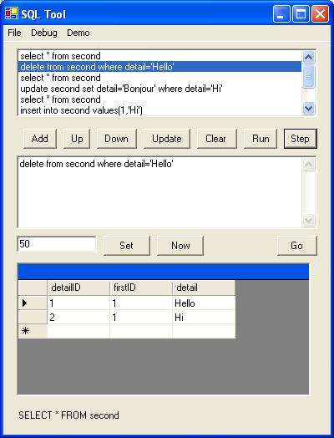
There are three main ways of implementing Sceptic based on an existing relational DBMS, illustrated above.
Each implementation scheme has advantages and disadvantages. In all three cases metadata is stored in tables added by Sceptic, and all three proposals scale to distributed databases. In A Sceptic filters all database access. No changes are required to SQL or the RDBMS, but the actual database tables are different from what the user requests, and it is awkward to implement indexes and constraints. In B the various database front-ends (ODBC etc) are available together with indexes and constraint handling, although the SQL must be slightly enhanced as described above. Sceptic translates the primitive database operations so that the lower levels of the RDMS write the same tables to media as in A. In C the suggestion is that the physical media is different, and the RDBMS operates as an in-memory DBMS whose use tables are what the user sees in normal (non-metadata) access.
The next steps for the Sceptic project will be to try out the two other ways (B and C) of implementing a sceptical DBMS, probably using Firebrird/Vulcan for the RDBMS in order to embed Sceptic as a layer either during SQL processing or disk access.
Future work
Researchers around the world are pursuing the general ideas outlined in this paper, and are just starting to develop new kinds of computing tools that embody them. This paper has discussed the use of search engines and textual analysis, data verification and collaboration, autonomic computing systems, and the new philosophy of computation and information..All of these developments follow from the increasing demands on our computer systems to deal with more and more informal data in more and more naturalistic ways. If the scientific research programme started by Francis Bacon 400 years ago is nearing completion, then surely what will follow will draw on this ocean of resulting data in using some of these new approaches.
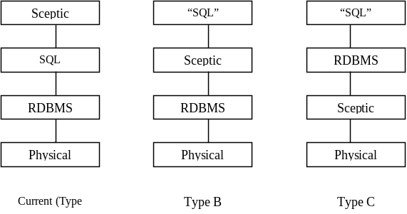
References
Agarwal M., Bhat V., Li Z., Liu H., Khargharia B., Matossian V., Putty V., Schmidt C.,
Zhang G., Hariri S. and Parashar M., “AutoMate: Enabling Autonomic Applications on the
Grid,” Proceedings of the Autonomic Computing Workshop, 5 th Annual International Active
Middleware Services Workshop (AMS2003), Seattle, WA, USA, IEEE Computer Society
Press, pp 48-57, June 2003 (PDF)
Bacon, F.: Instauratio Magna, London, 1606
Checkland P. B. Systems thinking, systems practice. Chichester: John Wiley, 1981
Crouch R., Condoravdi C., de Paiva V., Stolle R., Bobrow D.G.: “Entailment, Intensionality
and Text Understanding”. Proceedings Human Language Technology Conference (HLT-NAACL-
2003), Workshop on Text Meaning, Edmonton, Canada, May 2003. [.pdf]
Dretske, F.: Knowledge and the Flow of Information, University of Chicago Press, 1981,
1999.
FDA: US Department of Health and Human Services, US Food and Drug Administration, 21
CFR Part 11, Electronic Records; Electronic Signatures: Final Rule, 1997.
Floridi, L: Scepticism and the Foundation of Epistemology – a study in the metalogical
fallacies, Brill, Leiden, 1996.
Floridi, L.: Sextus Empiricus: the Recovery and Transmission of Pyrrhonism, Oxford, 2002
Floridi, L.: “Is information meaningful data?” Philosophy and Phenomenological Research,
2003
Floridi, L. (ed.): The Blackwell Guide to the Philosophy of Computing and Information,
Blackwell, 2004
Frege, G.: Uber Sinn und Bedeutung, 1892
Mingers, J. in Stowell F., Mingers J. (eds) Information Systems: an emerging discipline,
McGraw-Hill, 1997
OceanStore Project: http://oceanstore.cs.berkeley.edu/
1 On the other hand data can be data irrespective of what it means. Dretske’s approach is shared with
Mingers (1997) and Floridi (2002). 2 Floridi (1996). This notion of the sceptic is a positive one: some writers, including Dretske, seem toconflate the sceptical and academic position.

The latest efforts to bring the optical fiber to the home
J. D. Angelopoulos, TEI Piraeus,
P.Ralli&Thovon 250, GR12244 Aigaleo Greese,
Tel: +30 210 5381338, e-mail:jaggel@teipir.gr

Abstract
The current initiative of FSAN (Full Services Access Network) consortium to standardize a Gigabit per second PON, constitutes the most promising approach to the photonisation of the local loop. The incentive for such technology lies in cost benefits stemming from the fact that they need less fiber and less costly optical interfaces at the central office (one optical interface serves the entire network) but also achieve high traffic concentration as appropriate for low cost residential access systems. This paper presents and evaluates the FSAN access control algorithms and discusses the choice of suitable traffic parameters that optimize system performance.
Keywords: FSAN, GPON, PON, EFM, Shared access, reservation MAC.
Introduction
The optical fiber took by storm the telecommunication networks of the world and within a couple of decades in the 70’s and 80’s it had replaced copper in most of the transmission plant everywhere in the globe. A blatant exception remained the local loop also known as the last mile or lately the first mile i.e., the part from our homes to the local exchange. The reason is that the cost of photonics (fibers, laser transmitters, splicing etc.) is justified only at high traffic intensities. The optical fiber is like a motorway compared to driveway and can only be amortised with very high traffic. This delay has however grave implications for all network services and operators since the copper has become a bottleneck inhibiting a widespread deployment of broadband services which in turn could finance the fiber upgrade of the local loop. To fuel the initial boost out of this vicious circle, requires special technological solutions, which take into account the peculiarities and cost sensitivity of residential customers. Business customers can afford the dedicated access links because they have already concentrated traffic from an economically viable number of terminals by means of cheaper shared media, typically Local Area Networks (LANs). Traffic concentration, infrastructure sharing and re-use of the drop lines are cost saving measures which must also be offered to domestic sites by the access architecture. Recently attention to the special needs of the residential market is growing as reflected in the activities of the EFM (Ethernet in the First Mile) initiative of IEEE [4] and the GPON (Gbps Passive Optical Newtorks of FSAN (Full Services Access Network) initiative [5], [6], [7].
Although interim solutions like Asymmetric Digital Subscriber Loop (ADSL) can extend the useful life of the copper plant and play an important role in stimulating demand for broadband services, they inevitably exhaust their capabilities at some point sooner or later in the steadily rising bandwidth demand curve. In contrast, PONs constitute a medium and long term solution which can offer an affordable, flexible and robust access system to the domestic customer with virtually unlimited expandability. Initial low cost architectures feature a TDMA approach, but the prospects of Wavelength Division Multiplexing (WDM) expansion on the
same fiber infrastructure make PONs a future-proof system, a feature not found in competitive solutions. In such an upgrade the full system capacity is made available to smaller clusters of customers by means of separate wavelengths carried on the same initial fiber plant.
PONs emerged in the late 80s from BT labs in the quest for a way to lower the economic break-even point by sharing the expensive optical links in the residential market. However, inadequate demand due to lack of enticing applications to stimulate it, resulted in rather poor results as exemplified by the ill-fated OPAL (Optical Access Line) programme of the Deutsche Telekom in Germany which started with pilot installations in 1991-2. Yet, instead of accelerating, the programme was later abandoned despite the award of contracts for commercial deployment to 220000 households. Despite the potential for generating high revenues when deploying a B-PON [1] offering triple play services, many operators are still reluctant, because of the relatively high investment costs involved.
Although for the time being the projected penetration of optical fibre into the local loop fell far short of expectations, the effort to develop cost-effective fibre access systems continues unabated. The rationale behind such perseverance of the idea of Fiber in the Loop (FITL) lies in the fact that, although the time for the massive introduction of fibre is quite uncertain, the eventual displacement of copper by fiber in the access, as happened in the rest of the transmission plant, is indisputable. The trend is irreversible as the costs of optics are coming down, bandwidth demand is going up and optical networking spreads in the metropolitan areas, all working to drift the cost related break-even point closer to the realm of optical superiority. The major drive behind the Ethernet GPON and EPON standardisation efforts is the fact that the prevalence of packetised data traffic has increased dramatically over the last decade, due basically to the Ethernet-in-the-LAN success story and the fact that the majority of services are now transported over the IP protocol.
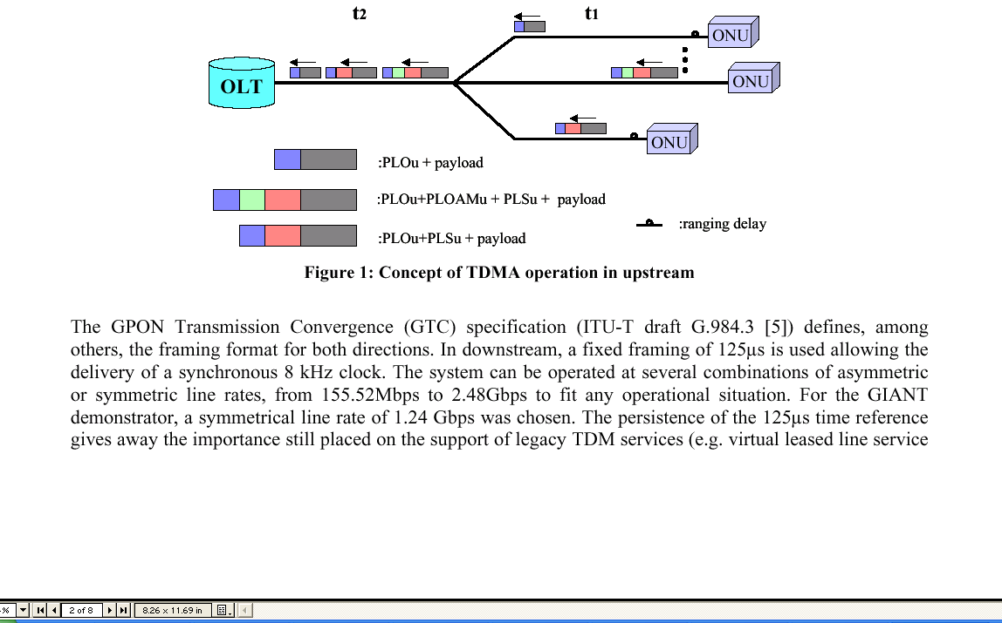
The work presented in this paper was carried out in the framework of IST project GIANT (GIgaPON Access NeTwork) [6], [7] which targets the design, implementation and demonstration of such an FSAN/ITU aligned GPON system. It will support all kind of services from very strict QoS down to plain best-effort.
Organisation of information in GPON
Conceptually, the TDMA operation in the upstream direction of a GPON is shown in Figure 1. To guarantee collision-free transport and create a common timing for the upstream frame, a ranging procedure during activation and registration measures the distance differences between the OLT and each ONU [5]. Thus, the ONUs (Optical Network Units) at the customer side can calculate the start of each upstream frame as a fixed time distance after the arrival of the strictly periodic downstream frame. Then, under guidance of the global MAC controller, which grants access allocations that are fair and compatible, the available bandwidth can be almost fully exploited for alternate transmissions from the ONUs without overlaps. A small guard-band as well as the necessary synchronisation preambles (forming the so called Physical Layer Overhead upstream –PLOu in FSAN terminology) is always found at the head of each upstream burst [5]. Optional blocks serving several functions may be marshalled in the frame under the command of the MAC controller, as elaborated in the next section (see also Figure 2 which shows the blocks in more detail). Such blocks are the Power Levelling Sequence (PLSu), the Physical Layer OAM (PLOAMu) and the Dynamic Bandwidth Report (DBRu). (The subscript u indicates the direction i.e. upstream). The allocations of the MAC controller are based on reports of the status of all ONUs queues that are occasionally sent embedded in the upstream transmissions.
The GPON Transmission Convergence (GTC) specification (ITU-T draft G.984.3 [5]) defines, among others, the framing format for both directions. In downstream, a fixed framing of 125µs is used allowing the delivery of a synchronous 8 kHz clock. The system can be operated at several combinations of asymmetric or symmetric line rates, from 155.52Mbps to 2.48Gbps to fit any operational situation. For the GIANT demonstrator, a symmetrical line rate of 1.24 Gbps was chosen. The persistence of the 125µs time reference gives away the importance still placed on the support of legacy TDM services (e.g. virtual leased line service for small and medium enterprises), which are still significant for operator earnings. This and the optional support of ATM transport constitute an important advantage over the approach of the EFM EPON (Ethernet PON).
Another difference is found in the packet segmentation approach. In contrast with IEEE EPON, the FSAN GPON does not transport Ethernet frames natively, but encapsulated using GEM (GPON Encapsulation Method) to enable fragmentation, which is not permitted in IEEE EPON. The latter transports only integral frames, which necessitates the reporting of individual packet lengths instead of queue lengths. To this end, a variable number of “queue sets”, each with a packet length from each queue, is sent upstream. This makes the reporting more complex and elaborate consuming more overhead, but in compensation this approach does away with the need for any reassembly of packets. The objectives of FSAN place more emphasis on accommodating TDM and ATM needs, leading to the adoption of the fixed periodic framing so that services with very strict requirements can be serviced at the right moment, interrupting temporarily data packets, hence the need for fragmentation. A consequence of this is the need for an encapsulation method to allow extraction of variable length packets from the fixed length frames and reconstruction of those spanning frame boundaries and this job is carried out by GEM [5].
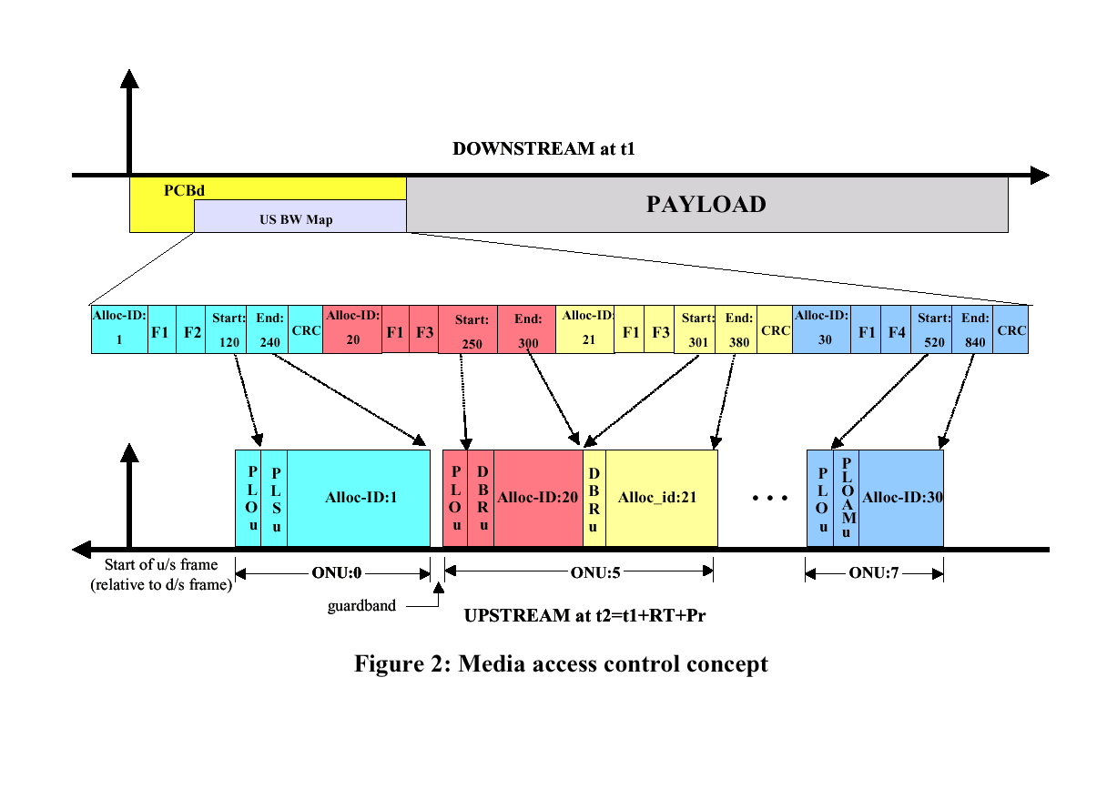
MAC control fields in the GPON frame
The organisation and the inter-relation of the up and down frames is illustrated in Figure 2 which shows a downstream frame instance at time t1 and the resulting upstream frame at a later moment t2. The periodicity of the downstream frame is the basis for keeping the timing relationships in the whole system. The format of the downstream frame starts with the Physical Control Block (PCBd), which features the following fields:
- a synchronisation pattern as in any conventional fixed frame system (e.g. PDH, SDH),
- •a 4-byte Identifier containing a 30 bit frame counter incremented by 1 with every frame,
- •a 13-byte Physical Layer OAM message used to convey management information (e.g.alarms),
- • 1 byte for Bit Interleaved Parity (BIP), used to perform bit error rate estimation,
- •the upstream BW map which contains all the allocations for one upstream frame,
- • 4 bytes for Payload Length indicator (Plend), sent twice for reasons of robustness, which provides
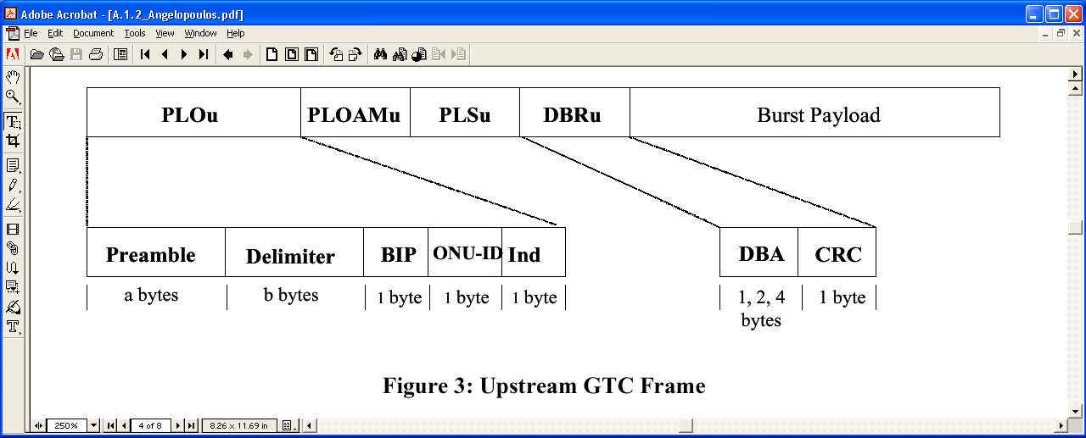
- the length of upstream bandwidth (US BW) Map and the size of the ATM segment.
In response to the BW map allocations the granted blocks will be sent in the upstream burst as shown in detail in Figure 3. The PLOAMu block contains the PLOAM message as defined in G.983.1 [1]. The PLSu block is occasionally needed for power control measurement by the ONU. This function assists the adjustment of laser power levels to reduce optical dynamic range as seen by the OLT. When the ONU is FEC enabled, it will add a number of parity bytes behind every block of data, based on the RS(255,239) encoding technique. Finally the DBRu block includes the DBA field, which is used for reporting the status of the ONU queues to the MAC controller, on which the dynamic bandwidth allocation feature is based.
The DBA report implies a request to the MAC controller for an allocation of an upstream transmission with as many bytes. So, the DBA (along with the BW map) is the tool for the reservation based MAC and the way reports are coded will be described in the MAC operation below. Naturally, it is also protected by a CRC. It is reminded, that in contrast with the above described overhead fields, which only appear in the upstream when granted through the flag bits, one type of overhead is always present at the start of an ONU upstream burst, and this is the Physical Layer Overhead (PLOu) which contains the indispensable preamble, allowing proper PHY operation on the bursty upstream link.
The transmissions are assigned to each queue, uniquely identified by the Alloc-ID field. Each queue can aggregate streams per traffic class or can be used for finer flow levels depending on implementation. Further multiplexing of traffic is possible based on the GPON Encapsulation Method using the “Port-ID” field (just as the VP/VC fields are used in the ATM part). A GPON can support almost 4k Alloc-IDs with the 12 bit long relevant field, but note that the first 254 Alloc-ID number are reserved as ONU identifiers, which are also used during the set-up/activation of a (new) ONU.
MAC operation
It is not in the scope of FSAN draft to specify the MAC algorithm, since strict uniformity is not required for OLT-ONU interoperability. FSAN restricts itself to specifying the format of the exchanged information. The exact MAC allocation algorithm is left to the implementer. However, the definition of the queue status reporting, the access granting fields, as well as the traffic classes that the standard imposes imply to a
significant extent the MAC protocol mechanisms. Long experience from previous TDMA MAC protocols for APONs [2], has identified polling as the uncontested method for PON protocols. The bandwidth delay product of the GPON further precludes any collision resolution protocols leaving as only options reservation methods or pre-arranged unsolicited allocations emulating leased line services as in [1]. As regards QoS support, the FSAN philosophy seeks to control each traffic stream by means of the MAC
protocol, so as to be able to effect the SLA (service level agreement) and provide the required quality per user and stream, which explains the high number of traffic identifiers supported (4k). To this end, logically separate queuing is employed for each flow in each ONU down to a fine level of resolution (by means of Port-ID and Alloc-ID). The quality class, and hence the service received, are determined by assigning each queue (i.e., Alloc-ID) to one of the five T-CONTs (Traffic Containers) which follow different service policies. In contrast, the EFM P2MP protocol uses eight queue classes corresponding to the quality discrimination tools recently introduced into Ethernet bridging, e.g. IEEE802.1p and IEEE802.1Q.
The five traffic classes of FSAN are a legacy from the APON DBA specification G.983.4 [3] keeping the same term: T-CONT. However, the descriptors of each T-CONT must now include apart from the service interval also the duration of the allocated upstream bursts from each queue (i.e. Alloc-ID), as required to handle variable length packets.
•T-CONT1 service is based on unsolicited periodic permits granting fixed payload allocations. This is intended for the emulation of leased line services and the support of CBR-like applications with strict demands for throughput, delay and delay variation. This is the only static T-CONT not serviced by DBA.
•T-CONT2 is intended for VBR traffic and applications with both delay and throughput requirements, such as video and voice. The availability of bandwidth for the service of this T-CONT is ensured in the SLA but this bandwidth is assigned only upon request (indicating the existence of packets in the queue) to allow for multiplexing gain.
•T-CONT3 is intended for better than best effort services and offers service at a guaranteed minimum rate while any surplus bandwidth is assigned only upon request and availability.
•T-CONT4 is intended for purely best-effort services (browsing, FTP, SMTP, e.t.c.), and as such is serviced only upon bandwidth availability up to a provisioned maximum rate.
•T-CONT5 is a combined class of two or more of the other 4 T-CONTs so as to remove from the MAC controller the specification of a target T-CONT when granting access. It is now left to the ONU to choose which queue to service. Adopting this approach (sometimes referred to as using “colourless grants”) is left to the system designer.
The operation of the MAC algorithm uses the regular reporting of the queue lengths. However, the draft allows for non-status reporting ONUs as the default case and then the MAC controller is left to surmise the status of waiting traffic by empty arriving slots. This requires the MAC to drive the queues to exhaustion and certain inefficiency is the inevitable penalty of such an approach. When DBA is adopted, the reporting can be done either in the DBA field of DBRu (called piggy-back reporting because the requests travel along with the payload in the burst) or by a whole ONU DBA report in which reports are carried in a dedicated partition of the payload section. The rationale of the latter is to provide enough space to report any number of the ONU queues, even all if wished. The piggy-backed DBA reporting can be done in one of 3 modes:
•mode 0 uses single byte reports that give the queue length expressed in ATM cells (for ATM transport) or 48byte blocks (for GEM). This mode is obligatory for status reporting ONUs, while the other two are optional.
•Mode 1 uses two bytes, the first reports the amount of data with peak rate tokens and the second byte those with sustainable rate tokens. This mode is useful for T-CONT types 3 and 5 and presumes policing units in ONU, which check compliance using a token bucket.
•Mode 2 uses 4 byte reports. The first byte reports T-CONT2 cells with peak rate tokens, the second T-CONT3 with sustainable rate tokens, the third T-CONT3 with peak rate tokens, and the fourth the T-CONT4 queue length (best-effort). This mode is useful for the T-CONT5 approach in which a summarised reporting of all the subtending T-CONTs of an ONU can be sent in a single message. In all modes a non-linear coding is used in queue length reports above the number 128 (see details in [5]) similar to that used in the ATM DBA [3]. The GIANT MAC supports only mode 0.
Equipped with a collection of queue lengths mirroring the global queuing situation in the GPON (albeit with a certain delay reflecting an earlier epoch), the MAC controller executes the assignment of both the guaranteed and the surplus part of the bandwidth to the active queues. In addition to the queue reports, which reflect the temporal properties of the traffic and change dynamically, the MAC takes into account also the
service level parameters, which govern the long-term limits of traffic. The latter were negotiated during the service activation and are provided by means of management tools during service provisioning.
The service principle is a prioritised weighted round robin. The priority order is of course: T-CONT2 first, then 3 and 4, while the weights follow SLA (Service Level Agreement) parameters. Each flow is identified by its Alloc-ID and is associated with one ONU. It belongs to one T-CONT type and characterised by two parameters: SDI (Successive Data Interval) and TB (Transmit Bytes). Upper and lower bounds of these parameters are defined in the service agreement. This provides the tool to specify a guaranteed part (based on minTB, MaxSDI) allowing the surplus bandwidth to be assigned dynamically up to the peak rate (defined by MaxTB, MinSDI) by properly varying the actual values of TB and SDI in each allocation. The MAC controller in GIANT uses the SDI timers to space the allocations to each queue, while relying on DBA to decide how many bytes to grant (but in any case less than MaxTB) in each allocation by inspecting the “request” table where past unserviced requests are stored, reflecting the queue fill level. The examination of this table follows the round robin discipline. Note that the overall server is not work-conserving as it tries to
regularly space by SDI the bursts from each Alloc-ID to avoid creating excessive packet clusters that violate traffic contracts.
More specifically, for T-CONT1 the maximum and minimum TB and SDI values are equal (to keep delay variation zero). The same is true for T-CONT2, but now the respective allocations are issued on the basis of DBA, i.e. only on condition of request existence. For T-CONT3, maximum and minimum values are differentiated, resulting in the differentiation of guaranteed and surplus bandwidth assignment, while for T-CONT4, the maximum grant interval is infinite, providing no guarantees.
Polling is used to give a chance to send a piggy-back report, whenever no outstanding requests are found in the request table for an Alloc-ID. In other words the maximum permissible SDI is used to set the next service interval for a queue appearing empty in the request table (but which may not be empty anymore due to recent and yet unreported arrivals). It is worth mentioning that the polling frequency is a critical parameter on DBA performance, since it sets an upper limit to the service time, after adding the round trip for reservation and the processing time. For example, in order to satisfy the maximum of 3ms delay budget for real-time services, a maximum polling interval of 500µs has to be adopted to guarantee an access delay below 1.5ms at all traffic situations.
Performance evaluation of GPON MAC
To study the performance of the MAC algorithm, given the lack of analytical tools due to the high system complexity, a series of computer simulations have been carried out. In this section, the overall performance of the MAC is evaluated versus the total offered load under uniform loading among all sources.
The model consisted of 32 ONUs each supporting T-CONT2 ,3, 4 with only one AllocID per T-CONT, i.e. totally 96 queues. The sources generating the traffic load were following the widely used for end-user data systems tri-modal length distribution model, which reflects IP data traffic length distribution from LANs.
Exponential interarrival times were used. So the packet length frequencies were about 60% of 64 byte long packets, 20% of 500 byte long and 20% of 1500 bytes while the load distribution among ONUs and T-CONTs was uniform. The polling period (maximum time between queue reports) was 1.25ms, i.e.10 frames.
The two parameters that change from run to run in order to vary the total load were:
The mean of time intervals between packet generation (decreasing for increasing load).
The amount of bytes TB that the MAC grants in each allocation which is based on the AllocID queue report
(implicit request) on which the reservation MAC bases its dynamic responsiveness.
Regarding T-CONT3 two options are investigated. As T-CONT 3 has in its specification a guarantied part and a surplus part, in the one scenario the assured bandwidth for T CONT 3 is about 2/3 and in the other it is 1/3 of the provisioned bandwidth on the basis of its SLA.
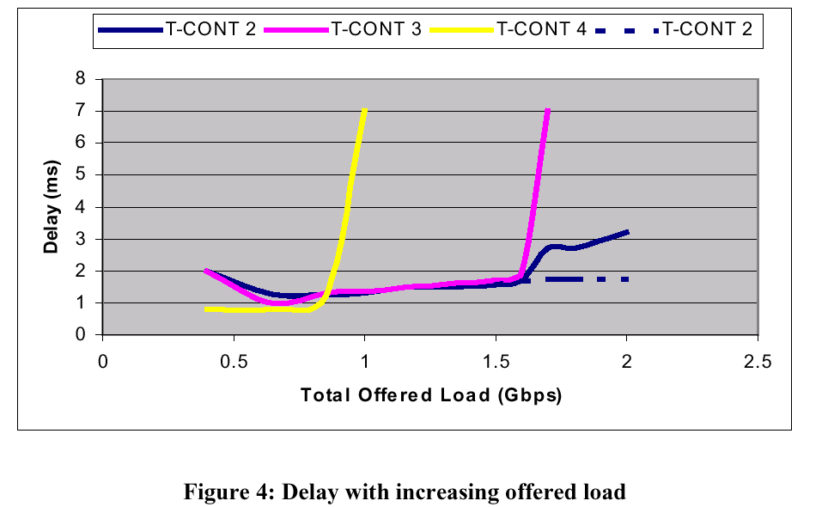
It is worth noting that for T-CONT 1 the delay has a deterministic behaviour with well-defined limits so no simulation is needed. In contrast, the evaluation of T-CONT 2 access delay is very important since it is through this T-CONT that delay sensitive applications will be serviced based on a dynamic mechanism seeking greatly improved efficiency when compared with the rigid and wasteful T-CONT1 approach. For T-CONT 3 and 4 the metric for greater interest is the throughput rather than the delay, provided that the latter stays within reasonable limits (hundreds of ms). The results are given in Figure 4, which shows the average access delay versus the offered load.
As the total offered load increases, queues of T-CONT 4 suffer first the congestion at about 0.9Gbps due to the prioritized service. Hence, for total offered load below 0.9Gbps, all traffic is serviced and the observed delay remains in the order of ms for all types of traffic. When the total offered load is above 0.9Gbps, all traffic is protected except best-effort no-guarantee T-CONT 4 traffic which suffers all the congestion. It is worth noting that the sources did not contain any closed loop congestion control (i.e. TCP-like), which would in real life come into action to reduce the offered load. It was chosen to focus on the MAC mechanism and to exclude from the model interference from other network elements that are encountered by a flow in an end-to-end travel through a network since such an approach would involve many other assumptions about the rest of the network that do not play a role in the MAC evaluation.
Delay (ms)
Queues of T-CONT 3 type are serviced to the demanded rate even when the total offered load is up to 1.6Gbps, i.e. above the nominal link rate. This of course is not expected to happen thanks to combined action of admission control and policing. So it can be considered a simulation of misbehaving T-CONT4 sources, which, as a result, have caused overflowing queues, (protecting within the designed limits the service received by T-CONT2 and 3 traffic). Of course, when the offered load reaches beyond 1.6Gbps, (at which time the offered load of T-CONT 2 and T-CONT 3 exceeds 1.06Gbps), the surplus bandwidth is not enough for the full service of T-CONT 3, which also gradually enters unstable conditions.
Focusing on the performance of T-CONT 2, this is as expected better than that of the other two, in both scenarios where the guaranteed part of T-CONT 3 is 2/3 or just 1/3 of the T-CONT 3 bandwidth. However in the scenario of high proportion of guarantied BW to T-CONT3, the access delay of T-CONT 2 start increasing earlier (solid line) than when only 1/3 is guaranteed (dotted line), though not as much as the delay of T-CONT3 which has a lower priority. In the second case, the delay for T CONT 2 is kept lower than 2 ms up to a total load of 2Gbps as shown by the dotted line. Despite the fact that such unrealistically high loads are to be prevented by SLAs, they have a value in evaluating the MAC under extreme conditions and checking the effect of instantaneous overloads, which cannot be excluded while they stay within the tolerance provided by the specified leaky bucket buffering of the policing unit.
Conclusions
The cost-effective multiplexing of a variety of traffic in a GPON relies upon a dynamic MAC protocol that allows support of a many services with a response matching the fluctuating demand. The delay performance is dominated by the polling period so for services with strict delay requirements frequent polling below 16 frames should be chosen. For the non-real-time services, efficiency dictates larger polling values. The performance evaluation based on computer simulations shows that the FSAN GPON can satisfy any mix of service classes thanks to its prioritized MAC service policy with quite satisfactory efficiency.
References
[1] ITU Rec. G.983.1, Study Goup 15: “Broadband optical access systems based on passive optical
networks (PON)”, October 1998.
[2] J.D. Angelopoulos, I.S. Venieris, G.I. Stassinopoulos, "A TDMA based Access Control Scheme for
APON's," IEEE/OSA Journal of Lightwave Technology, Special Issue: Broad-band Optical
Networks, Vol. 11, No. 5/6, May/June 1993, pp. 1095-1103.
[3] ITU-T, Rec. G.983.4, Study Goup 15, “A Broadband Optical Access System with increased service
capability using Dynamic Bandwidth Assignment”, Geneva, 15 – 26, October, 2001.
[4] Glen Kramer, Gerry Pesavento, “Ethernet Passive Optical Network(EPON): Building a Next-Generation
Optical Access Network”, IEEE Communications Magazine, February 2002, pp. 66-73.
[5] ITU Rec. G.984.3, Study Goup 15: “Gigabit-capable Passive Optical Networks (GPON):
Transmission Convergence Layer Specification, Geneva, Oct. 21-31,2003.
[6] John D. Angelopoulos, Helen-C. Leligou, Theodor Argyriou, Stelios Zontos, Edwin Ringoot, Tom
Van Caenegem, “Efficient transport of packets with QoS in an FSAN-aligned GPON”, IEEE
Communications magazine, pp.92-98, February 2004.
[7] Nick Marly, John Angelopoulos, Paolo Solina, Xing-Zhi Qiu, Simon Fisher, Edgard Laes, “The IST-GIANT
Project (GIgaPON Access NeTwork)”, 7 th Conference on Networks & Optical
Communications, Darmstadt, Germany, June 18-21, 2002.
Acknowledgement
The work presented in this paper has been partially funded by EU IST 2001-34523 GIANT project.

Improving the quality of e-business requirements analysis with an e-business Interaction Model.
Malcolm Bronte-Stewart
School of Computing
University of Paisley
PA1 2BE
bron-ci0@paisley.ac.uk

Abstract
In order to encourage Scottish firms, and particularly SMEs, to adopt and exploit e-business technologies and processes Scottish Enterprise created a number of initiatives. These initiatives included a variety of seminars, presentations and workshops; the most popular of which were known as “First Steps” and “Digital Advantage”. During these workshops representatives from hundreds of different organisations were introduced to some of the advantages of e-business development and invited to use specific models and exercises to analyse their own organisation’s situation and requirements. The e-business models discussed and explained in these workshops tended to be either developmental, such as the staged lifecycles in “First Steps”, or business process oriented, such as the questionnaire and associated 8 sector opportunities directions disc in “Digital Advantage”.
While delivering these courses it became apparent that these models only present attendees with a limited range of e-business considerations and each firm’s e-business potential was not being explored fully. This may have been caused in part by the rather narrow and focussed assumptions inherent in the models used in the workshops and the consequent singular viewpoint the attendees were asked to adopt. In this paper an Interaction Model is presented which, it is argued, provides a framework within which business managers and others can view many of the potential benefits and implications of e-business development and analyse the needs of significant stakeholders. This interaction analysis tool models the complex web of relationships of an organisation in its environment, so using the interaction model can facilitate the analysis of an organisation’s internal and external relationships. Questions concerning the likes, demands and responsibilities of the parties involved are highlighted for discussion and examination.
In student projects and consultancy it has been noted that debate about, and answers to, these questions contribute to a better understanding of the scope, direction and role of the firm’s e-business strategy. Thus the model helps to represent not only views of the present situation of an organisation but also perceptions of its future or desired situation. The model also seems to be useful in education as it can give students a deeper insight to the complexities and richness of e-business interaction.
Keywords: e-business interaction analysis model

Introduction
While much has been written about the effects and implications of the internet and WWW in relation to
B2B (business to business), B2C (business to consumer) and C2C (consumer to consumer) connections, few models have been proposed to assist with the investigation of a firm’s main information system interactions and interfaces. Based on System Picture ideas (Bronte-Stewart 2001, Quin and Bronte-Stewart 1995) the interaction model can be used to identify, focus on and study an organisation’s roles, connections, relationships and interactions, particularly with external stakeholders such as customers and suppliers. It may help students, managers and consultants develop a better understanding of current interfaces and the processes for dealing with these important contacts. It may expose problems and highlight desirable improvements that can be gained through e-business upgrades and better internal and external integration.
E-Business Analysis Models
In the late 1990s Scottish Enterprise decided to promote the advantages of e-business development to SMEs by setting up and funding a number of initiatives. Amongst other ideas they invited tenders to supply e-business workshops and training courses. Two of the winning bids were named “First Steps into E-Commerce” and “Digital Advantage”.
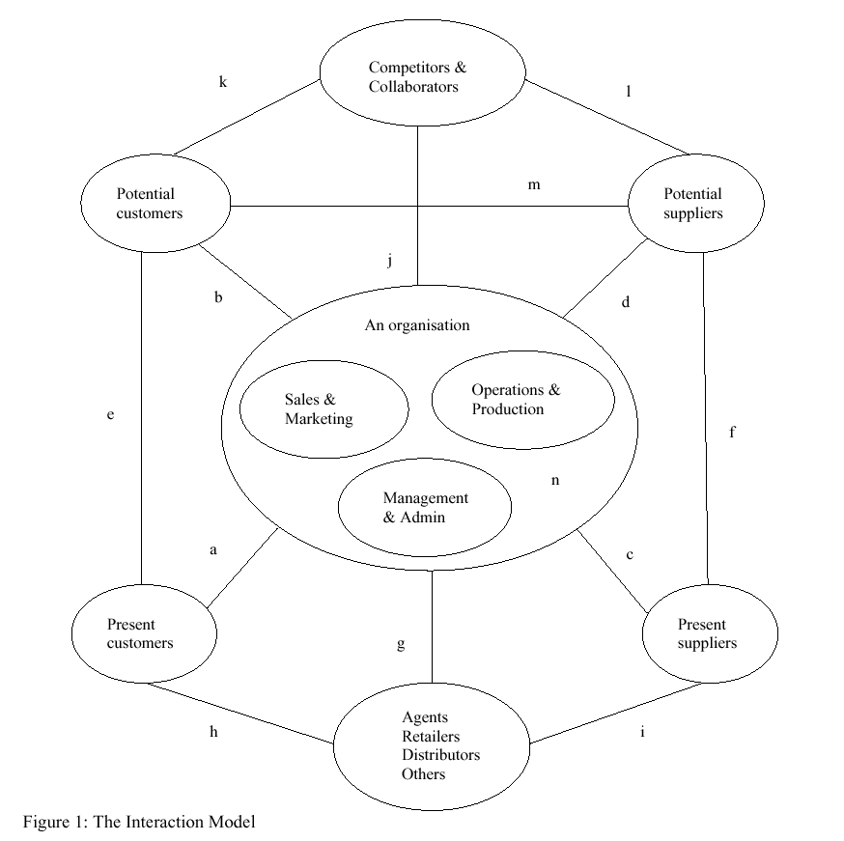
First Steps courses were organised as half-day workshops in which small groups of delegates joined in a mixture of class room presentations and hands-on exercises. The original version of the course was particularly suitable to those who had little experience of the WWW. It introduced fundamental e-business concepts and a five stage e-business adoption model (Marketing and Research, Promotion and Merchandising, Sales service, Order Fulfilment and After Sales). Delegates were asked to indicate the progress of their firm’s e-business development on this model. A website development lifecycle: (Plan Strategy, Build, Implement, Promote and Launch, Maintain) was also discussed as a 5 step process. Later the format of First Steps was expanded and redesigned into a series of separate half day courses that echoed the stages of the previous version but renamed them; (Aware, Connected, Marketing, Transacting and E-integrating). The courses started with the introductory “Making the Connection” then Transforming your Web Site”, then “Trading Electronically” and fi nally “E-Business Best Practice”. The First Steps e-business adoption model seems to assume that firms will move up through the stages like climbing a ladder. BusinessLab’s Digital Advantage course on the other hand was scheduled as a full day workshop with presentations, exercises and group discussions that concentrated on helping delegates to explore e-business possibilities for their organisation. The day introduced and was built around a business process oriented model which was based on a questionnaire and associated opportunities “Directions Disc” chart.
Having discussed some of the primary reasons for going on-line and noted various e-business statistics, examples, anecdotes and effects, delegates were asked to answer 12 questions about aspects of their business by choosing an appropriate number between 0 and 5 on likert scales. Though subjective, most questions were quantitative and began “To what degree …”. Clues were given as to how delegates should interpret the top and bottom of the range of values. Answers were transposed as points on the axes of a circular, or wheel like, diagram composed of 8 sectors. Each sector had a 2 word name beginning with the active and commanding word get: (digital, on-line, integrated, together, global, essential, personal and customised). Lines were drawn to join the points and it was proposed that the distance of these lines from the centre represented, or gave an impression of, the extent or need for development in that area. These models helped to give quite unique, and in many cases valuable, insights into each delegate’s assessment of their firm’s situation and its e-business potential. Charts were compared and analysed. Delegates from the same firm tended to produce dissimilar charts and the discussion that followed usually gave individuals the chance to appreciate the reasons for differences. A drawback of this model is its suggested implication that there are only 8 areas for e-business development, all of which are external. Another significant limitation is its dependence on such a narrow set of questions.
The Interaction Model
Instead of a step by step, (state transition), progression or a to what extent do these eight issues matter investigation the approach suggested here guides those involved to look at needs from many different points of view. The Interaction Model prompts one to consider the wishes and needs of most of the main stakeholders in any web presence. It invites the e-business analyst/designer to ask “what does each stakeholder want from this firm, and what does the firm want from them, that can be provided in a digital form?”
The next section of this paper illustrates and explains the ways the Interaction Model has been applied to analyse the e-business requirements of case study firms. The diagrammatic model is composed of a number of parts and includes a central hub with six satellites and 14 links (labelled a to n in figure 1). To begin with an examination is made of the external satellite bubbles, then each of the links and finally the internal hub. Normally this examination and analysis is carried out by a facilitator (such as a consultant) in association with a client representative or representatives. Typically the client is asked to start by naming and critically reviewing the individuals, groups and organisations that they feel fall within the boundaries suggested by the satellite bubbles’ headings. Usually this examination not only reveals views of basic environmental facts and figures (about the firm’s current customers, suppliers and third party contacts), but also gives an insight to the nature of those the client regards as important competitors and potential allies and encourages speculation on future growth and change expectations.
Having given enough time to a study of these satellite bubbles, the client(s) can next be asked to consider the links that represent many of the interactions among the firm and its main contacts. As there are so many connections depicted it is probably useful to take each of the links, (annotated on the diagram above with the letters a to n), separately and explore the type of relationships they represent and the kinds of question they pose.
- a = sell and support Consumers may previously have contacted the firm by phone, fax and letter to enquire about products and services, check availability, make orders and pay bills. A well thought out web-site can provide significant communication improvements, both to the consumer and to the firm. The firm may advance the marketing of its wares, reach a wider audience, save on brochure costs and keep their customers happy with a prompt, personal, useful and up-to-date on-line enquiry, sales and after-sales service. Airlines, hotels, banks and many retailers encourage the consumer to go on-line to view the quality, availability and prices of products, make their own bookings, keep track of their accounts or purchase goods over the internet, giving the customer more direct control while, at the same time, improving the firm’s efficiency, cutting costs and providing the means to learn more about consumer demand. What information would the customer like to be given access to 24 hours a day, 365 days a year? What services do they want on-line? How can the organisation better support and care for its customers?
- b = promote and recruit While they strive to keep present customers happy most firms expend significant resources on advertising and finding new customers. How should the firm use the internet to attract new clients and customers? What is the firm’s USP and why should others be interested in it? Who are they targeting and what is the best way to reach these potential customers over the internet? What services and tactics might improve their chances of finding new business and sales?
- c = order and pay Many firms now provide their suppliers with controlled access to databases of stock and production data so that these suppliers can constantly monitor levels and the need for more of their products. This not only removes much of the firm’s worry and overheads of having to control inventory amounts but frees up staff for other productive work. Moving to e-procurement trading negates the need for much cumbersome correspondence. Near paperless transaction processes can be brought into play without the need to invest in expensive EDI equipment. What processes, connections and arrangements would the firm’s present suppliers like to reorganise? How can these interactions be made more satisfactory to both parties?
- d = seek new sources There are bound to be suppliers that have the potential to provide more reliable, available, effective, better quality, attractive and / or cheaper products and services in a global market place. Policies to use the firm’s web presence not only to search for new sources and providers but also to attract these may be worthwhile investigating. What do others “out there” do better than our present suppliers and how can we find and catch them?
- e = user groups Forums, chat rooms and other user connections relevant to the firm’s business probably exist and it may be important to track, join, listen to and take part in some of these C2C exchanges to stay in touch with current demands and trends and to intervene directly. Buyers may use the internet to analyse and evaluate the firm’s offerings and obtain opinions. What mechanisms and lines of communications are presently available for consumer to consumer interaction? To what extent could the firm’s products and services be compared and contrasted with others?
- f = trade links Most trades and industries have federations, professional bodies, standard bearers, authorities and portal sites that may give guidance and provide centres for interchanges of views, advice and information. What supplier to supplier links are significant and in place? Could the firm’s suppliers be finding better and more profitable connections and relationships over the internet? Or could they band together to provide a better, faster, more comprehensive, or even cheaper service?
- g = third party liaison Many firms have important contacts with agents, retailers and distributors which should be reconsidered in light of the opportunities that the internet affords. For instance, extranets may give agents and remote staff fast, effective access to information and a channel for communication and business. These enhancements may also help agencies to provide a better service for the firm’s customers and suppliers. Does the firm sell, deal or organise through third parties and how can these relationships be improved by e-business?
- h = fulfilment and logistics The performance and quality of a firm may be judged more by the way in which its products and services are provided and delivered than by the way they are sourced, designed or built so the final link from agent, distributor or retailer to customer may be especially important. What are the error and customer complaint rates in these areas? Is the firm happy with these external sales, delivery and representation arrangements and what could be done to improve them?
- i = supply direct Commonly modern firms may avoid the cost and inefficiencies of obtaining, controlling and storing stock and instead pass customer orders directly to suppliers. In these cases it becomes essential that the ordering and supply information is accurate and available to all those who need it. Sometimes third parties will be expected to repackage, assemble or implement products for the purchaser or end user which require specific instructions. To what extent does the firm supply, or wish to supply, goods and services directly and how can these activities be better organised over the internet?
- j = monitor and link This connection highlights two very different yet related opportunities: (i) ensuring the firm stays competitive and continues to lock out most competitors by keeping a more attentive eye on them, their promotions and their offerings, (ii) negotiating links and alliances with organisations that provide complementary products and services can produce good results. Getting together with similar companies may improve income, service and reputation for all involved. Also, as shoe shops and estate agents often collect in geographical proximity on the High Street so, from an e-business point of view, firms may locate their web presence “close” to competitors. Can the firm forge better links and alliances with appropriate partners so that together they produce a more desirable service or range of products.
- k = lost sales Individuals and organisations are finding products and services from elsewhere. Competitors are taking a share of the market that the firm may want to capture. There may be chances for the firm to move into underdeveloped niches or new areas of business. How are competitors using e-business and taking advantage of the internet to reach customers and sell? Why are customers not buying from our firm? What is it about the competitors’ offerings they like? What are they looking for and what could be improved? Are these potential customers aware of alternatives? How can the firm capitalise on this sales opportunity?
- l = supply intelligence Staff in the firm will be keen to improve their understanding of the arrangements between competitors and potential suppliers. If competitors have access to cheaper, better or more consistent supplies of material they may be able to undercut prices or offer more attractive packages. What deals have been negotiated by others, at what costs and for which products?
- m = disintermediation The internet makes it easier for consumers to source the products and services they want more directly. It can be useful to analyse the possible (future) and existing (present) direct connections between the customers and suppliers of products like those the firm under review sells, and to determine the extent to which the firm is an agent, intermediary or middleman. What value does the firm add and what does it do that will dissuade its customers from avoiding or circumventing it and going directly to the suppliers of that product or service? Could the firm be cut out of the supply chain and how much business might be lost?
- n = internal management and communications In the same way that the WWW can be used to enhance connections and interactions with external parties, these principles can be carried over into an assessment of the opportunities for reorganising a firm’s internal information systems. It may be possible to treat the firm’s internal departments as if they were external customers and suppliers and then review the potential for further integration, process improvement and efficiency gains within the firm. In what ways does picturing the firm as an interacting system of parts (similar to the internet) help one to envisage changes that would help the firm and its stakeholders?
Finally the team can give attention to the roles and features of the hub. The discussion may focus on recommendations of the changes and improvements that should be made to the firm’s internal parts, applications, processes and procedures to achieve the innovations and e-business developments that have been proposed by the findings of the foregoing analysis. At least three parts or activity divisions (production & operations, sales & marketing and management & administration) can be examined usefully in this context. Occasionally others (such as for example staffing, distributing, procuring and research and development) may be added to the hub if need be.
Conclusions
Many IS projects will involve careful consideration of the potential opportunities and benefits to the firm of e-business and e-commerce enhancements. A model that can help the analyst or consultant to explore and analyse these opportunities – the interaction model – has been described and explained.
References:
Bronte-Stewart, M., 2001, Business Information Technology Systems Consultancy.
BusinessLab, 1999, Digital Advantage: A Fast Track Route Map to E-Business for Business Managers.
Quin, A. and Bronte-Stewart, M., 1995, Systems Pictures: A tool for Systems Analysis and Design, in:
Critical Issues in Systems Theory and Practice, (Eds:. K. Ellis et al.) Plenum Press, New York.
Scottish Enterprise Network, 2000, First Steps into E-Commerce.

The Good, the Bad and the Ugly - Process Performance Indices
Dr Ewan W MacArthur
Senior Lecturer
University of Paisley
High Street
Paisley, PA1 2BE
maca-ms0@paisley.ac.uk

Abstract
Manufacturing industries, after much trouble, have successfully managed to focus their thoughts on processes rather than maintain their traditional product view. Service and non-tactile product providers also consider many of their operations as processes and consequently are comfortable with a process view of their activities. So how can (or more interestingly, how should) we summarize process performance? A variety of indices have been proposed for variable characteristics in traditional manufacturing spheres. Some authors have issued health warnings concerning their use, but this has not diminished their popularity. The relationship between long and short-term indices has become a topic of recent papers.
Estimation of capability and performance indices can be mathematically elegant but hardly sensible in practice. In this paper, investigations into some of the most commonly used process performance indices under process behaviour seen in industry (by the author) are reported. Furthermore, the comments are not limited to variable quality characteristics.
Although little has appeared in the literature about attribute capability indices, this appears to be a growing concern so that these are also discussed here. Examples of process indices being used in computing systems will be offered. The conclusion is that “easy” mathematics makes simple indices appear useful and so commonly used, and because more “difficult” mathematics is used to derive others, they are less attractive and their use is greatly reduced.
Attributes, capability, process indices.
1. Introduction.
One of the most commonly employed numbers of this 21 st century are performance indicators. They are found in government, education, business, sport, wherever goals are set. Since the 19 th century when physicists started measuring “the universe”, the idea that putting a number to a characteristic, phenomenon, attribute means something, and means more than describing with precise technical language appears to be popular. Even though many from philosophers to economists have warned about problems with such an approach, we march onward. In quality, no less than Deming provide such warnings.
Unfortunately, the powers that be and other closely associated personnel have infinite faith in such numbers, until, of course, they backfire on them. Perhaps we should see the point made by Douglas Adams(1979).
“Some time ago a group of hyper-intelligent pan dimensional beings decided to finally answer the great question of Life, The Universe and Everything.
To this end they built an incredibly powerful computer, Deep Thought. After the great computer programme had run (a very quick seven and a half million years) the answer was announced. The Ultimate answer to Life, the Universe and Everything is ... , (You're not going to like it...) Is... 42
It has been shown that there is an answer to the great question of life, the universe and everything. It was computed by Deep Thought, but really didn't seem to provide, well... an answer. The great computer kindly pointed out that what the problem really was that no-one knew the question. Accordingly, the computer designed its successor, the Earth, to find the question to the ultimate answer.”
The ease with which capability indices (or performance measures) can be computed is staggering. Perhaps we do not always understand the full context of the question they answer. The history of capability indices is slightly longer than most American writers suggest. Ryan (1989) and Kotz and Johnson (1993) suggest that capability indices appear from about the 1980’s. However, a British Standard (1955) referred to the RPI (relative precision index) a precursor of the now common capability indices, Cp and Cpk.
In general we might imagine three different simple indices. The first are the Capability Indices based on a continuous measurement, such as Cp and Cpk. Although the usual definition is for a two-sided specification, they are easily modified for one-sided specifications. The second type is for a capability index based on attribute variables. These are not common, and this might be due to their slightly more apparently difficult statistical basis. The third type has gained little attention. It is a capability based on comparisons of rate of events, say, breakdowns, down-times etc. These may be more commonly found in the computing arena. In the following, a description of each is given briefly.
2. Standard Capability Indices.
The book by Kotz and Johnson (1994) delivers a masterful compendium of such indices. Not only are the basic forms are discussed, but also modifications that may be required in certain practical situations, one sided specifications, non-normal distributions. However, if you have forgotten your years in mathematical classes, certain sections will be demanding.
Specification limits are the fixed engineering limits for product dimensions or process characteristic usually set independently of the inherent process variation. Often they are set externally to the process, by a subsequent phase of production or even an external customer.
Only once a process is in a state of statistical control, is it sensible to assess whether or not it is capable of meeting the pre-determined specification. The specification limits for a quality characteristic can be one or two-sided, with or without target values. Where no target is specified with two-sided limits, the optimum value is taken to be halfway between the two limits to minimise the potential wastage from the product dimensions falling outside the specification limits. Since 99.73% of a Normal distribution lies within 3 standard deviations of the mean, 6 ó is taken as a measure of the natural tolerance of the process distribution assuming reflects only inherent process variation, i.e. all assignable causes have been removed.
A unitless measure of the potential of the process to meet a two-sided specification is the Cp index:
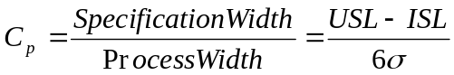
Where LSL and USL are the Lower and Upper specification limits. If the process mean is not centred or the specification is one-sided, then a more informative index is the Cpk index:
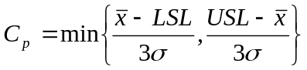
This index compares the minimum distance of the process mean, from either specification, to half the natural tolerance. If the process mean is centred between the specification limits, then the distance from mean to either specification is half the allowable spread and so Cp and Cpk will be equal.
As the mean moves further from the centre of the specification limits, Cpk will decrease in relation to Cp. The mean will become critical if Cpk is less than 1, i.e. when a significant proportion, more than 1 per thousand product, is expected to fall outside a specification limit. Any action to be taken on a process will depend on the comparison of these two indices, bearing in mind that reducing inherent variation will generally require fundamental changes.
It will also be more difficult than any action undertaken to centre a potentially capable process that may require only adjustment to machine settings.
All of this is more or less obvious. The main problem arises in the fact that all inferences (guarantees) are unreliable if the underlying distribution of the quality characteristic is not Normal. This is shown in the following example. This arose while I was consulting with a local company. The actual values have been modified to protect the innocent.
The following summary statistics were obtained from a sample of 100 values taken on a quality characteristic. The sample mean was 14.878 and the sample standard deviation was 2.834. Suppose the specification is 15 ±5. Then we have Cp = 0.588 and Cpk = 0.574. From what has been said about these values would lead us to seriously doubt the capability of the process. Note targeting is not really an issue, it appears to be the process variation that is the problem. Reducing variation in any process can be simple, but unfortunately it is often expensive financially and in effort.
Now we consider a little more information. Not one single data value violates the specification limits. This alone would make us think (the reason I was consulted). The following is a histogram of these data.
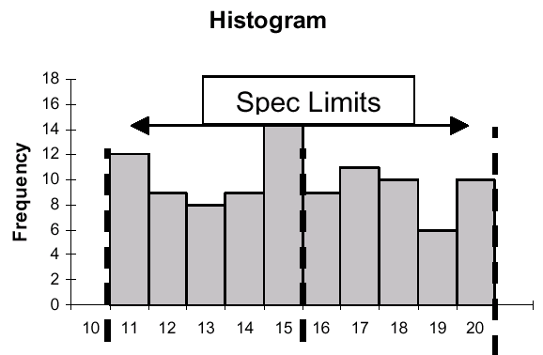
Even with no formal test, these data are not Normally distributed. Although we have no violations of the specification, how would this be communicated to the “customer” in the light of the capability indices produced? There have been proposals as to how to modify capability indices to cater for non-Normal data. These can be found in Kotz & Johnson (1993).
Before leaving such capability indices, I make a remark about the sample sizes on which their estimation is often based. Recently I have encountered in microelectronic manufacturing cases where capability indices were used as statistical control variables and were based on samples of 5 continuous measurements. The mathematics relating to the behaviour of both Cp and Cpk are outlined by Kotz and Johnson (1993). In the simpler case of Cp we note that with a sample of size 5, if we attempted to estimate Cp when the true value was 1, the estimator would give a distribution of capability values with mean 1.25 and standard deviation 0.697.
The distribution is not Normal. As we see, there is a significant bias and a variability more than 50% of the estimated value. This simple example suggests, “do not use small samples to estimate capability indices”.
3. Attribute Indices
The capability indices discussed in section 2 are in a sense obvious. Even though the opportunity for comparable attribute measures is great, their popularity, indeed the drive to establish them is much less pronounced. The question must be asked why? It is not that specifications (targets) are not issued for such processes. Perhaps it is because the most obvious index is not user-attractive. Further more the statistical framework is probably more complicated than the Cp, Cpk type.
The odds ratio was introduced by Cornfield (1951). This is the ratio of two odds. If we have an event A, the odds of A are P[A occurs]/P[A does not occur]. The reason for Cornfield’s introduction was to help with problems in medical statistics that occur with association.
Suppose we are interested in the added risk that a certain environmental factor presents. Determine the odds of death when the environmental factor is present and when it is not. The odds ratio is defined as
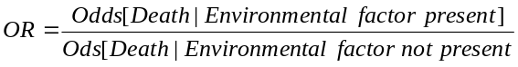
Commonly we deal with the (natural) logarithm of this, called the log-odds-ratio. One reason for this is that approximate confidence intervals for the log-odds-ratio can easily be constructed.
So how does this help with the capability problem? Marcucci and Beazley (1988) suggested the odds ratio R be used;
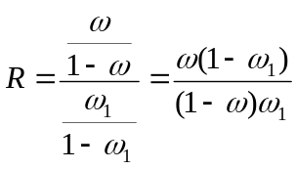
where w is the actual proportion non conforming and w1 is the maximally accepted proportion.
Note that R = 1 corresponds to a product that is just at the maximally accepted proportion non-conforming, and R = 2 to a case where the odds of a non-conforming product is twice that of the maximally accepted. Note that this is not the same as saying it is twice as likely, we are dealing with the odds, not the probability of a non-conforming product.
A more worrying issue is that we have inverted the “usual scale”, i.e. the scale established for capability indices in section 2. Here values less than 1 are desired, while those greater than 1 indicate a non-conforming process. We could rectify this by merely inverting R, but this introduces a problem when the observed proportion is 0. Although the odds-ratio is frequently found in medical contexts, the same cannot be said of other disciplines.
Again, modifications have been proposed to improve the behaviour of R when “small” samples are used. This amounts to “adding 0.5 to the number of non-conforming items found”. This is equivalent to the commonly encountered continuity correction in statistics.
Another modified estimator is outlined in Kotz and Johnson (1993), Ca. Personally, although the argument and the mathematics for it are not difficult to follow, I have never found it an improvement in practice.
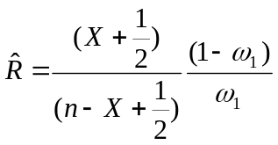
where n is the sample size, X the number non-conforming.
In a simulation, 1000 binomial random variables with n = 100 and p = 0.04 were used. The specified value was ù 1 = 0.04, giving the theoretical value for the odds ratio of 1 and again for ω₁ = 0.03, when the odds ratio is 1.35. Two indices were determined; R the uncorrected, and R* the one with the continuity correction.
 | ω₁ = 0.04 |  | ω₁ = 0.03
 | R | R* | R | R*
Mean | 0.9835 | 1.1026 | 1.325 | 1.485
Standard Deviation | 0.504 | 0.5037 | 0.679 | 0.679
As with many situations in which the continuity correction is employed, the benefit is very small indeed. In this case, we might question its use at all. It can be seen that this is not a difficult index to compute and having been proposed more than fifteen years ago might question why it has not been more frequently employed. Similar problems with interpretation exist here as with those discussed in section 2.
4. Rates
Is it possible to create a capability index to compare an actual rate with some specified rate (again, presumably this should be the maximal rate desired)? Suppose that mo is a specified rate (maximal) with complete specification e.g. 4 breakdowns per week, 2.5 un-availabilities per day. In the simplest possible case, we imagine a Poisson process with mean m, which is in the same units as m₀. Assume that we wish to test if the observed Poisson process has a mean of m₀. The standard approach would be to use the likelihood ratio statistic, λ, since we know that under the null hypothesis H₀: m = m₀, -2lnλ is Chi-squared distributed with one degree of freedom. We can show that the following is true.
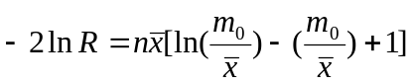
If the two rates are similar, the ratio of rates will be approximately 1. By using a Taylor series expansion, we have
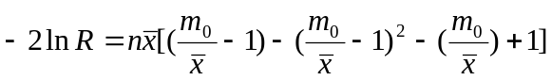
Thus an approximate 95% confidence interval is given by
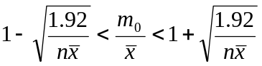
As we note below, such intervals may be too short on average. If we were to change the interval to that shown below, the rejection rates are probably better.
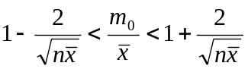
The rationale for this modification is that the likelihood ratio statistic is known to behave poorly with “small” samples, and the modified form is basically 1 ± 2sigma. The interpretation is the same in both cases. If the actual ratio misses the interval to the left, the actual rate shows an incapable process. If the actual ratio misses on the right, the process is more than capable.
In a simulation 25 samples of 16 observations from a Poisson with mean 10, and 25 samples of 16 observations from a Poisson with mean 5 were generated. For the first intervals were constructed as suggested above, i.e. approximate 95% intervals. Two ratios were formed. The first samples were generated with a theoretical mean of 10 and the second with a theoretical mean of 12, the second with theoretical means of 5 and 4 respectively. The tables below give the results. The figures in parentheses are those for the “2 sigma” modification.
Actual mean 10
Accept 10 | 22(23) | Accept 12 | 7(11)
Reject 10 | 3(2) | Reject 12 | 18(14)
Actual mean 5
Accept 5 | 22(24) | Accept 4 | 6(7)
Reject 5 | 3(1) | Reject 4 | 19(18)
The rejection rate for the true mean runs at about double that predicted. The rejection rates for the modified interval are more in line with what is expected.
5. Discussion
Much has been written concerning the use and abuse of common capability indices (Cp and Cpk). I would like to support such comments. Unfortunately, we live in a stressful and practical world. Much as I would support Newton-Raphson methods in the solution of transcendental equations, simple use of a spreadsheet like Excel will give faster information, that is often more interpretable by the user. Likewise, we live in a practical world. Although I would like to issue health warnings when capability indices are employed, expediency suggests that they will be used, even when problems may result. But why worry about such niceties? We do not often issue warnings when the mean is used when the median may be more appropriate, or when the standard deviation is interpreted incorrectly.
Capability indices can be useful. They give a particular type of summary for often complex processes. Their use should be monitored and supported when necessary with simple examples and counter-examples.
The last cry is for us to accept that some processes are complex, just as life, and that we cannot expect to answer all problems with simple arithmetical calculations. What now accountants?
References
Adams, Douglas (1979). The Hitchhikers Guide to the Galaxy. Pan Books.
B.S. 2564: 1955. Control Chart Technique. B.S.I. London
Cornfield, J. (1951). A method of estimating comparative rates from clinical data.
Applications to cancer of the lung, breast and cervix. J. natl. Cancer Inst., 11, 1269-1275.
Deming, W. E. (1986). Out of the Crisis. Cambridge, MA: Massachusetts Institue of
Technology, Center for Advanced Engineering Study.
Kotz, S. and Johnson, N. L. (1993) Process Capability Indices. Chapman & Hall.
Marcucci, M. O. and Breazley, C. C. (1988) Capability indices: Process performance measures. Trans, ASQC Tech. Conf., Dallas, Texas, 516-22.
Ryan. T. P. (1989). Statistical Methods for Quality Improvement. John Wiley & Sons, Inc.

From Process Experts to a Real-time Knowledge-based Diagnostic System
C. Angeli
General Department of Mathematics
Technological Education Institute of Piraeus
P. Ralli & Thivon 250
Egaleo, Athens, Greece
E-mail: angeli@teipir.gr
and
A. Chatzinikolaou
Bosch Rexroth S.A.
S. Patsi 62
GR-118 55 Athens, Greece
E-mail: achatzi@otenet.gr

Abstract: Knowledge and information should be used cooperatively in the structure of a knowledge based system for technical problems in order to produce a reliable and useful diagnostic system. This paper presents the use of experiential knowledge for the diagnostic problem solving procedure, the use of scientific knowledge for the same purpose as well as the use of a combination of the two sources of knowledge in a knowledge representation structure that permits their interaction. Finally, the paper discusses the suitability of each method for various requirements of the practice.
Key Words: Expert Systems, Fault Diagnosis, Hydraulic Systems, Intelligent Systems
1. INTRODUCTION
Fault diagnosis using knowledge based methods has received considerable theoretical and practical interest over the last years. The application of knowledge based methods in engineering systems is a well established approach and a lot of research work has been published [1], [2], [3], [4]. On-line knowledge-based techniques using sensors for inputs, knowledge bases for data record, reasoning and experience for the final decision, provides powerful new techniques that have the ability to reason about deep models and to operate with a wide range of information. On-line knowledge driven diagnostic techniques have been reported among other researchers by [5], [6], [7], [8], [9], [10].
One of the main characteristics of these systems is that in parallel to the knowledge base of the expert system a data base exists with information about the present state of the process that is derived on-line from sensors. The data base is in a state of continuous change. The knowledge base of the system contains both analytical knowledge and heuristic knowledge about the process. The knowledge engineering task comprises different knowledge sources and structures. The inference engine combines heuristic reasoning with algorithmic operation in order to reach a specific conclusion.
On-line diagnostic techniques are usually able to detect efficiently on time faulty behaviour in systems. In some cases these methods are not able to diagnose the particular component that is the cause of a fault although they can easily declare faulty behaviour of the technical system. In these cases the modelling of the human diagnostic problem solving process offers a quite direct and efficient method for diagnosing faulty elements in systems.
In this paper, the extend of the automatisation of intelligent diagnostic systems for hydraulic systems in relation with the suitability to the various diagnostic situations and problems of these systems is studied. This paper presents the use of experiential knowledge for the diagnostic problem solving procedure, the use of scientific knowledge as well as the use of a combination of both sources of knowledge for various diagnostic requirements of the practice.
2. USING KNOWLEDGE ACQUIRED FROM THE DOMAIN EXPERT
Experiential knowledge suitably formatted consists the basis for the classical expert system approach. Fault diagnosis requires domain specific knowledge formatted in a suitable knowledge representation scheme and appropriate interface for the human-computer dialogue. In this system the possible symptoms of faults are presented to the user in a screen where the user can click the specific symptom in order to start a searching process for the cause of the fault. Additional information about checking or measurements is used as input that, in combination with stored knowledge in the knowledge base guide to a conclusion.
A decision tree was used as technique to define the various logical paths that knowledge base must follow to reach conclusions. From the decision tree the relevant rules to each node were written and so the initial knowledge base was constructed.
Problems that are easily represented in the form of a decision tree are usually good candidates for a rule based approach. In the following example a rule is presented as it is needed to make a decision:
if ?'reduced pressure' is yes and
?'down' is No and
?'motor' is No
then ?'electrical failure' is Yes.
The system searches for the topics 'reduced pressure', 'down' and 'motor' to satisfy the rule. Each of these topics may be further a set of rules, or simply a question asked to the user.
The knowledge base of the expert system was organised in rules that were linked to "topics". The "topic" is a flexible structure that acts as a variable, function, procedure or object, depending on its usage. It gives the opportunity to group rules that refer to a specific situation. Using a special function, a topic inherits the characteristics of another topic, which provides the power of inheritance. Through the nested topics decreases the time needed to find a solution than the classical rule-based approach.
An example of a topic is presented in following Figure 1.
topic valve14on.
do (plan43).
ask ('Is solenoid SV4 of valve 1.5 energized ?',sv4,[Yes,No]).
if ?sv4 is Yes
then do (valve151)
and insert_text (?w5,['Solenoid SV4 of valve 1.5 is energized.',])
else do (ele)
and insert_text (?w5,['Solenoid SV4 of valve 1.5 is not energized.',]).
Figure 1 Example of a topic
This topic performs the dialogue with the user in a graphical environment, includes a complicated rule, keeps trace of the answers for the explanation facility and makes possible the connection with other topics depending on the user’s response to the formatting answers.
An example of the searching process is given in Figure 2.
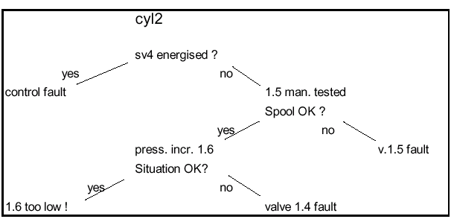
Figure 2. Example of searching.
The structure of the final program is oriented to the various hydraulic elements and not to the faults. This means that the fault-topics are related to the element-topics, which are at the end of the program. This makes possible to add topics easily about other hydraulic components and faults, so that the program can be extended and used for other more complicated or similar hydraulic systems.
3. USING SCIENTIFIC KNOWLEDGE FOR THE PROBLEM SOLVING PROCESS
Faults in systems correspond to a deviation of the parameters of the system elements from their normal values. This deviation could be evaluated to detect faults. This process requires accurate understanding of the systems dynamic process and precisely measurements of the system’s variables in order to locate any fault almost immediately by comparing the data collected with appropriate valid mathematical models.
Scientific knowledge comes from the performance of the mathematical model of the system as well as from the data acquisition process. The actual system was modelled using known physical relationships of the hydraulic components. The mathematical model takes into account the non-linear character of hydraulic systems and the incompressibility of the hydraulic fluid in the pipes as well as the special characteristics of the hydraulic elements used. The simulation results represent the behaviour of the fault free system and are used for the fault diagnosis process.
A data acquisition and monitoring module is responsible for generation and interpretation of signals coming from the actual hydraulic system into an accepted format by the computer as well as the analysis and presentation of the signal information. Measurable quantities of the variables correspond to the pressure at critical points of the hydraulic system and the velocity of the hydraulic actuators as well as digital input signals referring to the functional condition of the system are transferred to the expert system for the decision making process.
The deviation of the measurements from the simulation results in the steady state is used to declare a fault and the deviation in the dynamic range is used to predict a fault, usually long before a deviation in the steady state occurs.
4. USING A COMBINATION OF THE TWO SOURCES OF KNOWLEDGE
Theoretically, one of the advantages of the model-based expert systems is the avoidance of the knowledge acquisition process that is considered as “bottleneck” in expert system development because in these systems the knowledge is involved in the embedded model of the domain. But on the other hand, model-based diagnostic systems are criticised that are not always able to pinpoint the faulty component [11] and sometimes a lot of tests are required to reach a conclusive decision due to the lack of heuristic knowledge. It has also pointed out that no analysis is complete without face-to-face discussion with the expert [12]. Scientific knowledge of model-based systems may cannot cover the whole range of diagnostic tasks since the diagnostic activity is mainly based on the experience.
Integration of both types of knowledge in a diagnostic system leads to the construction of a more accurate model of expertise in the real world [13]. This is because the knowledge is not available to a decision maker at a sufficient depth and deep knowledge is needed to fill gaps left by the compiled knowledge of a problem solver. So by combining the two sources of knowledge additional depth in knowledge is available.
In this expert system the experiential knowledge is complementary used to the scientific knowledge of the mathematical model in order to model more precisely the expert’s reasoning activity, to gain the efficiency of heuristics and the advantages of a real world application. The empirical knowledge and the scientific knowledge solve different parts of the overall problem domain co-operatively. Deep knowledge involves concepts of cause that are not available to the relatively compiled knowledge.
Empirical knowledge is particularly useful in the diagnostic phase since the target is to find the specific faulty element and not only to declare a faulty behaviour of the system and to propose specific actions. Scientific knowledge is used for representing the dynamic behaviour of the hydraulic system as well as for predicting faults, compensating faults and detecting faults, while the empirical knowledge is used for isolating and diagnosing faults. The interaction between the two types of knowledge is driven by the current problem solving circumstances that gives a dynamic to the interaction process.
The scientific knowledge is mainly represented by the mathematical model of the system in a numerical formation and the experiential knowledge by the knowledge base of the system in a symbolic formation. Scientific on-line knowledge comes from the sensor measurements and interacts with both the knowledge of the mathematical model and the knowledge base of the system. The interaction of the various sources of information and knowledge was realised again by knowledge representation scheme the “topic”. This programming structure offers the opportunity to read external linguistic information from files that could be combined with the stored knowledge.
In this expert system rules are embedded in topics so that the structure of the final application is a collection of topics. Rules that refer to general assumptions and are represented to specific branches of the decision tree are grouped and embedded in a specific topic. In the structure of a “topic” interact stored knowledge in rules and external information from files coming directly from the data acquisition system pre-processed and transformed to linguistic values.
An example of a topic with an embedded rule and the external on-line information from files is shown in Figure 3.
topic mehi.
set_file_pos ('c:\dlab\exp\fwm.txt',40).
fwm is read_char ('c:\dlab\exp\fwm.txt',2).
if ?fwm is ME
then do (emol)
and insert_text (?w5,['Motor speed is decreased.',])
else do (hydmot)
and insert_text (?w5,['Motor speed is highly decreased.',]).
end. (* mehi *)
Figure 3. Example of a topic
In the case that multiple faults occur in the system, topics related to other elements that are possibly involved in this fault are called and checked before the final diagnosis is declared. For this task the text file information that comes on-line from the digital input signals of the system are particularly useful. These files are normally checked first to eliminate the possibility of multiple faults, but their topics can be called at any time.
5. CONCLUSION
Diagnostic problems are considered as ill-structured problems where there are no efficient algorithmic solutions because all the symptoms for all faults are not known in advance. The effectiveness of diagnostic reasoning lies in the ability to infer using a variety of information and knowledge sources, connecting or selecting between different structures to reach the appropriate conclusions.
In this paper, knowledge-based solutions to the diagnostic problem have been presented. Experiential knowledge, scientific knowledge and a combination of the two sources of knowledge has been used to perform the diagnostic task. The presented management of the knowledge leads to successful diagnostic results and offers benefits to the industrial automation by producing reliable diagnostic systems according to the real world demands.
REFERENCES
[1] Tzafestas S, (1989) “System Fault Diagnosis Using the Knowledge-Based Methodology” in
Eds. Fault diagnosis in dynamic systems, Theory and application, edited by R. J. Patton,
Frank, P. M. and Clark, R. N., Prentice Hall.

Model free predictors for meteorological parameters forecasting: a review
A. I. Dounis, G. Nikolaou, D. Piromalis, D. Tseles
Technological Education Institute of Piraeus,
Department of Automation,
P. Ralli and Thivon 250, 12244, Athens, GREECE,
email: aidounis@otenet.gr, nikolaou@in.teipir.gr, dtsel@teipir.gr

Abstract
In this paper we present a review of the existing approaches for meteorological parameters forecasting. The basic philosophy of the intelligent methodologies or model free predictors for forecasting is that they build prediction systems from input-output patterns directly without using any prior information about these meteorological parameters. Traditional model-free prediction approaches, such as neural networks, fuzzy or Gray models, use all training data. This prediction method is called global prediction. Alternately, one may make predictions based only on a set of the most recent training data. This prediction scheme is called local prediction. We include an analytical review of these methodologies. Also, we represent the error criteria that used for evaluating those forecasting algorithms.
Keywords: Intelligent methodologies, forecasting, meteorological time series, Grey predictor, Neuro-fuzzy predictor.
1. Introduction
The prediction of future behavior of a system based on knowledge regarding its previous behavior is one of the essential objectives of science [13]. There are two basic approaches to prediction: model-based approach and nonparametric method. Model-based approach assumes that sufficient prior information is available with which one can construct an accurate mathematical model for prediction. Nonparametric approach on the other hand attempts to analyze a sequence of measurements produced by a system to predict its future behavior.
The prediction of changing meteorological parameters such as air temperature, solar radiation, wind speed and direction, relative humidity, rainfall just to name a few, is very important for many reasons. The prediction of weather conditions affects the lives and the decisions of a large group of people in modern societies. For example the fishing industry depends on and expects early information in order to avoid severe weather phenomena on sea and to cut down fuel consumption. The usefulness of the prediction is important for agricultural areas, regions with high wind power, in airports so as to use the forecast for scheduling the operation of greenhouses, wind generators and other systems that depend on weather conditions. For satisfactory and appropriate use of wind power the selection of the region with proper weather conditions is of paramount importance. For such a decision it is necessary to have knowledge of the statistical characteristics of the wind and also the prediction of the wind speed among others.
Development of models for forecasting wind speed based on advanced statistical and artificial intelligence methods and namely on fuzzy logic and artificial neural networks. These techniques permit to combine various types of explanatory inputs like wind direction, wind speed from neighbour sites, high resolution meteorological information etc. Statistical techniques are very promising when high resolution meteorological information is used as input to predict wind production up to 48-72 hours ahead. Two important issues must be addressed in forecasting systems: the frequency with which data should be sampled, and the number of data points which should be used in the input representation. In most applications these issues are settled empirically.
The basic philosophy of the intelligent methodologies or model free predictors for meteorological parameters forecasting is that they build prediction systems from input-output patterns (time series) directly without using any prior knowledge about these meteorological parameters. A drawback of traditional forecasting is that they can not deal with forecasting problems in which the historical data are represented by linguistic values. Using fuzzy time series to deal with forecasting problems can overcome this drawback [16,27,28]. Thus, these intelligent methodologies can use linguistic information therefore to have better performance in predicting meteorological time series.
2. Input/Output preprocessing
In many fuzzy-neural predictors the preprocessing of inputs and outputs can improve the results of the prediction significantly [11]. With the term input/output preprocessing means extracting features from the inputs and transforming the target outputs in a way that makes it easier for the predictor to extract useful information from the inputs and associate it with the required outputs. In the prediction of time series the main inputs are the previous values of time series. In brief, the inputs can be combinations of the following:
1) values at the previous few time periods
2) the value of parameter at the same time period 1 year or 2 year ago
3) the average of the meteorological parameter daily or monthly
Generally, pre-process data is to normalize the data and eliminate stationary components which are unhelpful in prediction. The available input-output pre-processed before training using the following equations:
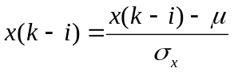
where x(k-i) is the input observational data, µ is the mean of the x(k-i)’s and ó x is the standard deviation of the x(k-i)’s.
3. Time Series Prediction
In general, the predicted value of a variable in a future time is based on m previous values. M is called lag of prediction. If we have the values of variable x for the moments from k-m to k-1, that is, x(k-1), x(k-2), …, x(k-m), we may predict x(k), and also the next time interval values x(k+1), …, x(k+p).
The methodology used to train a predictor is summarized as follows:
1. Pre-process data.
2. Decide the m lag values.
3. Separate the observational data set into a training data set and a test data set.
4. Create a local or global predictor based on the architectures that follow in the next sections.
5. Initialize the essential weights of the predictor to zero.
6. Use the training data set to train the predictor. The training proceeds as follows. At time k, apply x(k-1), x(k-2), …, x(k-m) to the predictor. Take the prediction output x(k+p). Calculate the output errors (criteria evaluation) and modify the weights of the predictor based on the learning algorithm (e.g. Back Propagation, Genetic Algorithms).
7. Evaluate the performance of the trained predictor with the test data set.
The basic architecture of the system is shown in Figure 1.
The predictor uses a set of m-tuples as inputs and a single output as the target value of the predictor. This method is often called the sliding window technique as the m-tuples slides over the full training set.
4. Local and Global prediction schemes
The prediction of meteorological parameters at a given location (e.g. meteorological station) is an interesting and open problem [7]. The current weather forecasting tools, based on numerical techniques, are not always able to capture local variabilities of the weather. Local prediction is predicting the future based only on a set of the most recent data in time series.
Predictions of this kind are to establish a curve for a most recent data, and then make predictions based on the established curve. In order to improve the current forecast system the ideas and algorithms of grey models are used [8]. Summary techniques for local prediction schemes:
1) First order polynomial fitting (built in MATLAB)
2) GM (1,1) [1,2,3,29]
3) Exact polynomial fitting: seventh order to match the most recent data are used (8 points) (built in MATLAB)
4) Fourier Gray Model (FGM) [8]
5) Exponential smoothing methods (ES). There are the linear ES and nonlinear ES. This method can be regarded as a variant of ARIMA models. [8]
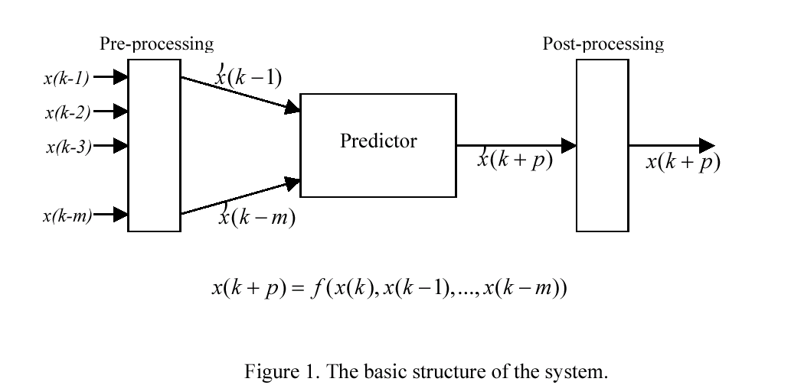
Global prediction schemes are employed all training data as input. Summary techniques for global prediction schemes:
1) Numerical fuzzy method [12,31,32,33] (Look-up Table, WM). 2) Neural Network with Back-propagation (MLP-BP). This MLP is composed by two hidden layer with 30 neurons per layer [14,15]. 3) A neural fuzzy inference network SONFIN. The SONFIN can find itself an economic network size, the learning speed, and modeling ability are all appreciated [9], 4)
Case-Based Reasoning [4], 5) Adaptive network-fuzzy inference system ANFIS. The ANFIS use off-line learning [10]. 6) DENFIS is a type of fuzzy inference system, denoted as dynamic evolving neural-fuzzy inference system, for adaptive online and offline learning for dynamic time series prediction [17]. 7) Radial Basis Functions + OLS. The Orthogonal Least Squares method is a simple and efficient learning algorithm for fitting radial basis function networks [21]. 8) A genetic fuzzy predictor ensemble (GFPE) for the accurate prediction of the future in time series [22]. 9) The Adaptive Linear Element ADALINE represents a classical example of the simplest intelligent self-learning system that can adapt itself to achieve a given modelling task [10]. 10) Group Method Data Handling GMDH, [15]. 11) FALCON is a general connectionist model of an adaptive fuzzy logic system [19]. 12) A fuzzy logic approach to complex systems modeling that is based on fuzzy discretization technique [18].
5. Intelligent methodologies
5.1. Hybrid grey predictors
Every prediction model is designed aiming to achieve system identification. If most of the factors that affect systems dynamics are identified and successfully modeled then the prediction will be satisfactory. In practice however the system dynamics are very difficult to be modeled in every aspect, thus there arise prediction errors On the other hand grey systems have the ability and power of superior modeling of dynamic systems [29]. The mean monthly temperatures of a region they follow annually a similar pattern of change.This periodic recurrence makes gray model to distort the ends of the curves.
Thus if this periodic recurrence is removed from the original time-series of temperature then the predictions will be more accurate One approach to the problem is the use of the method Standard Normal Distribution (SND). The application of SND does not dramatically improve the prediction error of the gray model. The addition of a regression model can be applied aiming for better accuracy. Since the regression model can not satisfy the presumable result a fuzzy model is attached to the original prediction model in hope to further reduce the error [3]. The overall system comprises from a SND, a linear regression model, and fuzzy model are incorporated with the grey prediction model to further enhance the prediction accuracy.
5.2. Neural Networks
Neural networks (Multi Layer Perceptron, Wavelet Network Model Neuro-fuzzy network, κ .λ .π .) have the ability to be used as intelligent prediction models [5,23,24,25]. The artificial neural network is capable of acquiring knowledge from training data patterns of temperature or any other meteorological parameter and to deliver an accurate prediction. One method for identification of nonlinear systems with a large number of inputs is the GMDH (Group Method of Data Handling). Recently new GMDH models whose basic building blocks are represented with Radial Basis Functions or fuzzy models. These new models are called neurofuzzy NF-GMDH. In [14] the temperature forecasting is achieved by a simple artificial neural network. It has ten input neurons, two hidden layers with eight and four neurons correspondingly, one output neuron. The output of the neural network is the one-step ahead prediction. This is the outdoor temperature difference for the next time step. The inputs to this neural network are: temperature (the last and three previous values), solar Irradiation (the last and three previous values), daily normalized (time value for the next interval), yearly normalized (day number for the next interval).
5.3. Neuro-Fuzzy Logic Predictors (NFLP)
The development of a neurofuzzy network for the prediction of meteorological parameters can be achieved in a number of ways [6,9,20,26,30,31,32,33]. One of these is the creation of a look-up table, which consists of the linguistic rules that came from the time-series data.
These rules make up the knowledge base of the FLP. Another method is the development of a neurofuzzy system combined with a training algorithm such as Back propagation. The fuzzy system is implemented as an MLP feedforword network with three layers. .This combination is a FLP ,that is a reconfigurable neurofuzzy system.
6. Criteria evaluation
Three criteria as error measurements are usually used for evaluating those forecasting algorithms [10]. The first criterion is the Mean Square Error (MSE), which is calculated as
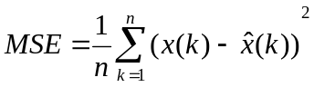
where () x k is the actual value for time k, ˆ() x k is the predicted value for the time k and n is the number of test data used for prediction. The second criterion is the Absolute Mean Error, AME, and is computed as
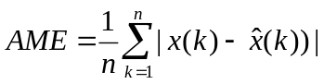
The third criterion is the Normalized Root Mean Square Index, NDEI, which is computed as
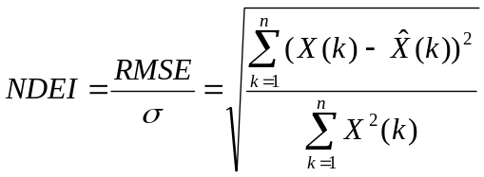
where σ is the standard deviation of the target series. Also the index average relative variance, ARV, is used, and computed as
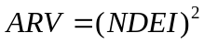
7. Conclusions
The goal of this paper is to represent a basic review of the intelligent methodologies for meteorological parameters forecasting. The basic philosophy of the model free local or global predictors for forecasting is that they build prediction systems from input-output patterns. An approach of the forecasting problem is the combination local and global prediction information so that the prediction can be more accurate.
References
1. Y.-P. Huang and C.-C. Huang, “The integration and application of fuzzy and grey modeling methods” Fuzzy Sets and Systems 78, pp. 107-119, 1996.
2. Y.-P. Huang and C.-H. Huang, “Real-valued genetic algorithms for fuzzy grey prediction system”, Fuzzy Sets and Systems 87, pp. 265-276, 1997.
3. Y.-P. Huang and Tai-Min Yu, “The hybrid grey-based models for temperature prediction” IEEE SMC-B, Vol. 27, No. 2, pp. 284-292, April 1997.
4. D. Riordan, B. K. Hansen, “A fuzzy case-based system for weather prediction”, Engineering Intelligent Systems, Vol. 10, no. 3 pp. 139-146, 2000.
5. W. Wang and J. Ding, “Wavelet network model and its application to the prediction of hydrology” Nature and Science 1(1), pp. 67-71, 2003.
6. Li Zuoyong et.al., “A model of weather forecast by fuzzy grade statistics”, Fuzzy Sets and Systems 26, pp. 275-281, 1998).
7. Reinaldo Bomfim, Silveira, Shigetoshi and Sugahara, “NN for local meteorological forecasting”, 3 rd Conference on Artificial Intelligence Applications to the Environmental Science, AMS, Feb. 2003.

Measures Development for the Use of Information and Communication Technologies (ICT) for strategic planning
Dr Abel Usoro
Dr Abbas Abid
School of Information and Communication Technologies
University of Paisley
High Street
Paisley PA1 2BE
Tel: +44 141 848 3959
Fax: +44 141 848 3542
Email: abel.usoro@paisley.ac.uk
abbas.abid@paisley.ac.uk

ABSTRACT
Management literature is full of theories and concepts aimed at helping the strategic planner. The rapid pace of change and the large amount of data, complexity of calculations needed in strategic planning and the need to work collaboratively have encouraged the use information and communication technology (ICT). ICT tools aim at making managers more efficient and proficient in using the planning theories and concepts. However, to what extent are these tools helping managers? What factors influence managers’ use of these tools, which are often classified under strategic information systems? An attempt at answering these questions was done by an exploratory survey of Managers in United Kingdom. Before answering the raised questions in this study a methodology for the construction and validation of a measurement for using the ICT for strategic planning was proposed. The analysis carried out proves that the measurement scale is a reliable and valid. A theoretical framework was adopted that grouped factors into ICT, personal, and organisational categories. Some of the key findings from an analysis of 137 responses are that to perform strategic planning managers prefer computerised tools to non-computerised models because of the speed that computerised tools offer. However, the computerised tools used are not meeting the expectation of managers. The only factor that appears to influence the level of use of ICT for strategic planning is the type of organisation. Some of the recommendations of this paper are that (a) the SWOT (Strengths, Weaknesses, Opportunities and Threats) analysis should be used as a basis of any system for strategic planning; (b) the Internet should form the foundation of strategic planning systems; and (c) further investigation needs to be carried out on the type of organisations as it affects the use of ICT for strategic planning.
Keywords: Reliability, validity, strategic planning tool (SPT), decision support systems.
INTRODUCTION
Strategic planning is the primary role of top management whose task is to interpret the environment and align the organisational strengths with the opportunities offered by the environment such that the organisation achieves a sustainable advantage over its competitors (cf. Porter, 1980; Hax, 1987; Helms and Wright, 1992; Freurer and Charharbaghi, 1995, pp 11-21); Robson, 1997; Carter, 1999, pp 46-48; and Desai 2000, pp 685-693). To carry out this task, a number of management tools have been developed. Some of them are the value chain, the SWOT analysis, various portfolio analyses and Porter’s five forces model. It is doubtful whether managers very often resort to these models when pushed by the increasingly changing business environment, which also produces large amounts of data to be analysed within compressed time. Information and communication technologies (ICT), especially along with strategic information systems, have emerged to facilitate this planning process by enabling collaborating working, building and evaluating of scenarios, handling “soft” data, giving easy and quick access to internal and external information, as well as performing different levels of analysis quickly (cf Sinclair and Rickert, 2000). However, are they delivering the goods? How do strategic managers find it in the light of their current needs? Do they find the technologies to be capable of coping with the constantly changing environment? There appears to be no coherent theory to explain and predict the use of information technology for strategic planning. As a theoretical framework this paper proposes that the predictors of the use of ICT for strategic planning could be grouped into ICT, personal and organisational factors. The rest of the paper is organised into (a) a brief explanation of the predictor factors; (b) methods; (c) development and testing of the instruments; (d) findings and discussions; (e) conclusion and recommendations; and (f) areas for further studies.
A BRIEF EXPLANATION OF THE PREDICTOR FACTORS
ICT factors
Information and communication technologies for strategic planning should support decision making components of intelligence gathering, designing of alternative solutions and selecting an option based on an analysis of alternatives (Stair and Reynolds, 1998, p 435). To achieve this objective, the technology, among other attributes, should allow linkage to various information sources, support group-working, assist in modelling and the performance of flexible analysis (cf Turban et al, 1999, p 400, Turban et al, 1999, pp 82-86; Rugman and Hodgetts, 1995, p 218, Clare and Stuteley, 1995, pp 23-4; Sinclair and Rickert, 2000).
Personal factors
Though it is common in social research to observe the differences in respondents’ demographics such as age, gender and income, there apparently is no study trying to establish the relationship of demographic variables with the use of strategic models. However, much has been written on how personal factors could affect the use of information technology. For instance, Holt (1998, p 69) has discussed how human factors can hinder the use of available information technology. Also, in the Management Development Review (1997, pp 15-17) it is stated that “much of the costly abuse which has characterized the introduction of a large percentage of new technology stems from human factors.” This study examined the personal factors of gender, age and education.
Organisational factors
Type of organisation
For the reason that strategic planning involves environmental changes, it should be expected that the more organisations are exposed to environmental changes, the more they will be concerned about strategic planning and perhaps as a consequence be using the planning models available. Typically, large organisations and government bureaucracies are noted to be less agile than small businesses. Organisations have traditionally been classified as extracting, manufacturing, distributing and service providing. Beyond that, there are varieties of classifications. Since this study is exploratory, respondents were given the freedom to describe their type of organisation. While this generated a variety of responses, it posed a challenge in classification.
Age in business
With long period of existence comes inertia such that if companies do not re-invent themselves, they tend to be reactionary and slow in responding to changes. Therefore younger businesses should be more concerned about using environmental changes to shape their plans. On the other hand, it could be argued that the older businesses have more experience, structures, financial and other resources to carry out strategic planning especially with the use of information technology.
METHODS
This study that uses the following theoretical framework:
Use of ICT in Strategic Planning = f (ICT, personal, organisational).
Practicing managers and MBA students who came from management positions were randomly selected to complete questionnaires. Mangers were the target response group because of the subject of the research which required a high level of authority from the respondents and the performance of strategic planning. 137 questionnaires were returned by managers from manufacturing and services sectors. Anonymity was maintained in the completion of the questionnaire; only when the respondents needed to receive feedback from the study did they need to state their names and addresses. Since this study is exploratory, respondents were given the freedom to describe their type of organisation. While this generated a variety of responses, it posed a challenge in classification and missed out interesting classifications such as public sector versus non-public sector, and local versus multinational. Besides, 37% (51) of the respondents failed to describe the type of their organization. The following is an attempt to classify respondents’ organization:
Type of organization | Count
Health Care | 20
Energy (petroleum, Chemicals) | 14
Distribution | 14
Service | 27
Transport (Rail, Air, Coach) | 11
Others (unknown) | 51
Total | 137

Table (1) – Profile of respondents
The results of the study should be interpreted with caution since the study is exploratory. However, the results so far obtained are interesting and instructive.
DEVELOPMENT AND TESTING OF THE INSTRUMENT
In order to identify various types of instrument measurements for the use of ICT as a strategic planning tool (SPT) we need a methodical and thorough approach. Since this study is one of the first empirical studies of using information and communication tools for the strategic planning, the measurement instrument had to be developed from the scratch, rather than accumulate it from literature. The process of developing the instrument of this study takes three sequenced stages: item creation, scale development and instrument testing.
Instrument design and item creation
The variables were derived from literature as summarized above. Initial validation was performed by informal discussion with academic staff involved with management and business courses. For pilot-testing, the questionnaire was administered, partly with a combination of interviews, to MBA postgraduate students most of whom had worked as managers similar to our proposed target sample. The pilot-testing and subsequent pre-tests revealed items that needed changing to enhance clarity.
Scale development
Drawing from the literature and a range of academic staff comments, five Likert-scale statements were written for each of the five dimensions for using ICT (Appendix I):
- Use of non-computerised SPT (C01 – C25)
- Use of computerised SPT (D01 – D20)
- Attributes of computerised SPT (D01 – D11)
- Attributes of computerised SPT used by managers (E01 –E11)
- Perception towards non-computerised SPT (C26 – C30)
Item Analysis
Frequency data for individual items were examined to test the spread of responses. Items that produce a narrow range of responses, as indicated by a low standard deviation, are of little use in discriminating between differing responses (Coulson, 1992). The findings of this study indicated that none of the scales show a reliability coefficient below 0.70, the cut-off point as recommended by Pallant (2001: 85). Only perception towards non-computerised SPT (C26 – C30) has a low reliability coefficient (0.28). The sub-scale correlations ranged from 0.35 to 0.84 for the use of non-computerised SPT (C01 – C25), 0.20 – 0.76 for the use of computerised SPT (D01 – D20), 0.18 – 0.75 for attributes of computerised SPT (D01 – D11), 0.21 – 0.76 for attributes of computerised SPT used by managers (E01 – E11), 0.30 – 0.87 for perception towards non-computerised SPT (C26 – C30), these items split into two groups. The first one contains items C26, C27 and C28 and the sub-scale correlations ranged from 0.37 to 0.56. The other includes C29 and C30 with relationship of 0.18 at the 0.01 significant levels.
Internal Consistency
To test the reliability of the instrument used in this study, measuring the internal consistently will assure that the items within each scale are achieving their measurement purposes with relative absence of error. The focus here is on the extent to which respondents are consistent in how they answer questions that are related to each other. The procedure to test the internal consistency involves correlating ratings of a group of subset of items with each other as mentioned previously in the section on item analysis. The most common statistical methods for this type of reliability investigation is Cronbach’s alpha Model (Cronbach's  α).
Cronbach's alpha measures how well a set of items (variables) measure a single unidimensional latent construct. When data have a multidimensional structure, Cronbach's alpha will usually be low. To be more precise, Cronbach's alpha is not a statistical test - it is a coefficient of reliability (or consistency).
Cronbach’s alpha can be written as a function of the number of test items AND the average inter-correlation among the items. For conceptual purpose, below is the formula for the Cronbach's alpha:
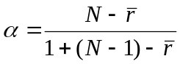
N is equal to the number of items and r-bar is the average inter-item correlation among the items.
From this formula one can see that if the number of items increases, then Cronbach's alphas increase. Moreover, if the average inter-item correlation is low, alpha will be low. As the average inter-item correlation increases, Cronbach's alpha increases as well.
For the purpose of a reliability analysis for this study, alpha coefficient was performed by correlating all the scores on individual items, with the overall score on the test. Tests with high reliability, i.e. those with high internal consistency, will achieve an alpha coefficient of 0.70 or more on a scale of 0 to 1 where a high score indicates high reliability.
The findings in table (2) present Standard deviation, means and reliability values for the five scales. The standard deviations values are satisfactorily close to the expected values for a normal distribution responses, and the Cronbach's alpha values are all greater than 0.80, except the perceptions towards non-computerised SPT (C26-C30) show inadequate level of internal consistency with alpha of 0.28. This is expected from the results at items analysis. The high coefficient reliability of the finding refers to the consistency of data derived from a measurement procedure of this study. This points out that the proportion on internal individual scores variance can be reliably attributed to individual differences among the respondents. In other words, Cronbach's Alpha shows the inter-scale reliabilities, which assure that the items within each scale are measuring consistently the factors selected in this study. This provides strong evidence for internal consistency of the scales used in this study.
*Notice that the same estimator is used whether the interaction effect is present or not.
**This estimate is computed if the interaction effect is absent otherwise ICC is not estimable.
The reliability of ‘the extent of use of non-computerised SPT’ (C01-C25) is shown to be low (α = 0.28) using all five items. The researchers, in this case, would be unable to satisfactorily draw conclusions, or make generalisation about this variable because this subset of items is not measuring the same underlying construct. This is perhaps because the data measuring this variable is multidimensional. Further statistical analysis is needed to check the dimensionality. In this case, Factor Analysis was performed to determine which items load highest and on which dimensions, and then take the Alpha of each subset of items separately. The output of the factor analysis is shown in Table 3 below.
Variables | Mean | Standard Deviation | Reliability  (Cronbach's α ) | No. of  Items | Intraclass Correlation Coefficient
 |  |  |  |  | Single ICC* | Average ICC**
Use of none-Computerised SPT(C01-C25) | 3.58 | 1.41 | 0.92 | 25 | 0.32 | 0.9223
Use of computerised SPT(D01-D20) | 2.70 | 1.06 | 0.82 | 20 | 0.19 | 0.8218
Attributes of computerised SPT(D01-D11) | 3.44 | 1.14 | 0.89 | 11 | 0.42 | 0.8857
Attributes of computerised SPT(E01-E11) | 2.52 | 1.23 | 0.93 | 11 | 0.56 | 0.9336
Perceptions towards non-computerised SPT(C26-C30) | 2.66 | 0.90 | 0.28 | 5 | 0.07 | 0.2756
Table 2 - Internal consistency- reliability coefficient
The resulting output from the above table 3 shows that the data are not unidimensional. That is C26, C27 and C28 do not seemingly measure the same latent construct as C29 and C30. In this stage we have to check the reliability of these two subsets of items separately. The finding of this test is listed in Table 4. It is unambiguous that the reliability for items C26 – C28 is high, while the reliability for C29 and C30 is lower. However, the findings for both subsets separately are higher than when using all five items for measuring the same construct. This result also implies that the correlation between items C26, C27 and C28 is higher than the correlation between C29 and C30. To check whether this is indeed the accurate investigation in analysing the subset of the perceptions towards non-computerised SPT, the correlation between these items were performed and presented at Table 5.
Variables | Alpha  (Cronbach's α ) | No. of  Items | Intraclass Correlation Coefficient
Variables | Alpha  (Cronbach's α ) | No. of  Items | Single ICC* | Average ICC**
C26-C28 | 0.69 | 3 | 0.42 | 0.6868
C29-C30 | 0.67 | 2 | 0.25 | 0.6696
Table 4: Internal consistency- reliability coefficient

 | Component
 | 1 | 2
C26 | .833 | -.154
C27 | .835 | -.033
C28 | .691 | .267
C29 | -.058 | .836
C30 | -.028 | .724
Extraction Method: Principal Component Analysis.
2 components extracted.
Rotation Method: Equamax with Kaiser Normalization.
A rotation converged after 3 iterations.
Table 3 - Factor Analysis for Perceptions towards non-computerised SPT

The correlation output indicates that each of the two subsets of items correlates within itself but between the two subsets, there is no correlation. The correlations between C26, C27 and C28 are higher than between C29 and C30. This confirms the results of the reliability analysis. On conclusion, since the data of this variable are not unidimensional, all five items should not be combined to create one single scale.
Intraclass Correlation Coefficient (ICC)
Intraclass correlations are correlations often used as reliability coefficients among evaluations of items that are deemed to be in the same category or class. They are ratios of between rating variance to total variance. They compare the covariance of the ratings with the total variance. So the use of Intraclass Correlations is to evaluate rater or respondent's reliability. Shrout and Fleiss (1979) pointed out when raters subjectively evaluate phenomena, measurement error is often found in their assessment. The careful and responsible researcher will assess this error before applying their ratings to the study of any targeted phenomena. To evaluate this measurement error, the researcher needs to be aware of intraclass correlation coefficient, and how they may be properly applied.
To explore this issue, we calculated the ICC to confirm the reliability coefficient findings of the subjects' rating for the variables under investigation. Single measures are used for single measurements of the raters while average measurements apply to get the average rating for the x respondents (raters).
The finding in table 2 demonstrates and confirms the internal consistency for the subsets of items by the single and average measure of intraclass correlation coefficient. This excluded the subset of items measuring the extent of use of non-computerised SPT (C26-C30), which have single and average ICC 0.07 and 0.28 respectively. This means that the subset is unreliable to measure the same construct.
 | C26 | C27 | C28 | C29 | C30
C26 | 1
 | .
C27 | .561(**) | 1
 | .000 | .
C28 | .367(**) | .370(**) | 1
 | .000 | .000 | .
C29 | -.126 | -.092 | .178(*) | 1
 | .142 | .286 | .037 | .
C30 | .032 | -.075 | -.007 | -.271(**) | 1
 | .710 | .385 | .939 | .001 | .
** Correlation is significant at the 0.01 level (2-tailed).
* Correlation is significant at the 0.05 level (2-tailed).
Table 5 Correlations Matrix for (C26 – C30)
Factorial Validity
The existence of a high alpha coefficient dose not assure that item loadings are caused by the influence of only one latent variable (DeVellis, 1991). Such coefficient does not point to what factorial structure is and, therefore, what the number of variables is that influences the items. In fact, the inter-item correlation can be high and consequently can the alpha coefficient. Factor Analysis one of the approaches used to construct validity of the measurement instrument. Varimax Factor Analysis identified groups of items that have variance in common to check whether the items clustered according to the intended scales. Data in Table (6) indicates that items clustered around four factors. The findings indicate that items loaded on Factor 1 and 4 both anticipated testing the use of non-computerised tools on SP. This confirmed by some items from factor 1, C01, C02, C03, C06, C08 and C10, which are loaded quite strongly on this factor and they shared some loading on Factor 4 (see Appendix II). Similar the case with items D08, D09 and D16 from Factor 3 shared some loading with Factor 2. This might be interpreted items in Factor 2 and 3 both used to test the extent of using the computerised tools in Strategic planning.
Generally the results confirmed that most items had their highest loadings on their associated intended scale. To examine whether there was one general factor underlying all the items in the instrument of this study. Principle Component Analysis was achieved. The results indicate that all 61 items had a substantial loading (0.31 – to 0.88) on one principle component. It indicates that the instrument could justifiably use as a single measure of using Information and communications technology as a tool for global strategic planning. Cronbach's Alpha for the total items (61) shows the inter-scale reliability coefficient is 0.91.
Factors
Scales | 1 | 2 | 3 | 4
C01 | .516
C02 | .638
C03 | .444
C05 | .722
C06 | .565
C07 | .823
C08 | .509
C10 | .425
C11 | .795
C12 | .385
C18 | .790
C19 | .749
C20 | .648
C23 | .547
C24 | .536
C26 | .630
C27 | .490
C28 | .310
D17 |  | .748
D18 |  | .708
D19 |  | .537
D20 |  | .520
E01 |  | .885
E02 |  | .774
E03 |  | .751
E04 |  | .688
E05 |  | .645
E06 |  | .599
E07 |  | .767
E08 |  | .750
E09 |  | .847
E10 |  | .696
E11 |  | .753
D01 |  |  | .691
D02 |  |  | .728
D03 |  |  | .722
D04 |  |  | .726
D05 |  |  | .579
D06 |  |  | .637
D07 |  |  | .595
D08 |  |  | .731
D09 |  |  | .629
D10 |  |  | .628
D11 |  |  | .563
D12 |  |  | .742
D13 |  |  | .648
D14A |  |  | .425
D15 |  |  | .262
D16 |  |  | .310
C04 |  |  |  | .671
C09 |  |  |  | .435
C13 |  |  |  | .639
C14 |  |  |  | .739
C15 |  |  |  | .712
C16 |  |  |  | .656
C17 |  |  |  | .696
C21 |  |  |  | .494
C22 |  |  |  | .559
C25 |  |  |  | .352
C29 |  |  |  | .512
C30 |  |  |  | .349
Extraction Method: Principal Component Analysis. Rotation Method: Varimax with Kaiser Normalization.
a Rotation converged in 7 iterations.
Table 6 - Factor analysis for the Use of ICT for PS
OTHER FINDINGS AND DISCUSSIONS

Use of non-computerised and computerised tools

Use of non-computerised tools
There is hardly any study in business management that endeavours to determine the extent to which managers are using the different planning models presented to them. This study afforded an opportunity to find this out with a sample of 25 of the planning models (see Appendix III.A). It is interesting to observe that the SWOT (Strengths, Weaknesses, Threats and Opportunities) matrix comes first (see Table 7 for the top 5). Surprisingly, Porter’s model, though widely known in literature, is not in the top five tools.
Tool | Use
SWOT Matrix | 3.66
Relative Market Share | 3.18
Relative Cost Position | 3.18
Total Quality Management | 3.07
Decision Tree | 2.96
Table (7) – The top 5 non-computerised tools
The top position of SWOT analysis confirms it as the basic but useful planning tool which also feeds into other forms of analyses such as the Relative Market share analysis (Usoro, 1998; Freurer and Charharbaghi, 1995, pp 11-21; Sokol, 1992). System developers should recognise SWOT analysis as a basic provision of any computerised planning tool.
If we had to place a figure on the average use of non-computerised tools it would be 2.45 on a scale of 1 (never) to 5 (frequently). The average use falls in the middle of “very seldom” and “sometimes”. This figure alone indicates that non-computerised tools are not very popular with planners. The reasons for this unpopularity are explored later.

Use of Computerised
It is difficult to discretely classify or describe computerised tools for strategic planning since they possess overlapping features. For example, SAP has some database features. Therefore the list on Table (8) is an inexact sample of known tools. Word-processing applications emerged as the primary tool; and this is followed by e-mail, spreadsheet applications, flexibility to solve divers problem and constant review of decision before implementation (see appendix III.B).

Tool | Use
Word-processing application | 4.20
Email | 3.69
Spreadsheet application | 3.67
Flexibility to solve divers problem | 3.60
Constant review of decision before implementation | 3.53
Sensitivity analysis handling | 3.51
GUI | 3.51
Alternative view of information | 3.48
Constant review of decision after implementation | 3.48
Table (8) – Computerised tools
Asked about other tools used, one respondent stated “in-house tool: mostly MS Excel-based”; and another said they use oracle and SQL databases. This indicates the need of the users to customise computerised planning tools, to be able to perform calculations and to store and retrieve essential data.
On the whole, the use of computerised tools for strategic planning is little (a score of 3 on the scale of 1 representing “none” to 5 representing “very much”. This is better use than the non-computerised tools but it is still below “much” use.

Comparison of Non-computerised with Computerised
Respondents were more closely questioned about their preference between computerised and non-computerised planning tools. They had to indicate their level of agreement to these two questions:
- Given a choice you would rather use a computerised tool.
- Information technology could make strategic planning easier.
There is some agreement that ICT would make strategic planning easier than using non-computerised tools. The average score was 3.4 and 3.5 respectively on a scale that ranges from 1 representing “disagree strongly” to 5, “agree strongly”. A major reason why computerised tools are preferred to non-computerised tools is likely that the latter is more time-consuming to use (see Appendix III.C). However, respondents were not overwhelmed with the idea of using computerised tools. The reason might be that the current tools are not assisting adequately. This is reflected in these comments from some respondents:
Respondent Number | Free Response
17 | “Help collect/collate raw data but removes transparency.”
20 | “Strategic planning is about judgment it is only as good as the data inserted. Regret no large strategic planning tools. We encourage people to think similar to sole entrepreneur rather than be driven by op of a computer.”
21 | “You can not generalise: different tools have different uses in different circumstances. Wish you will end up with a user-friendly product! Good luck.”
23 | “IT-based models are useful for collating & analysing data but should never replace individual creativity.”
26 | “In theory.”
30 | “Has its own drawbacks.”
33 | “Useful but removes 'gut feeling'.”
34 | “Technophobic. Should only be used as accessory tool.”
43 | “In the process of implementing exe info sys across the org.”
44 | “Not sure of cost/benefit of applying technology. major benefit is in the strategic thinking not the production of a strategy.”
Table 9 – Comments about computerised tools
Technology still appear to be rudimentary when creative thinking is considered. It would be naïve to expect computerised tools to replace human judgement but perhaps managers could be assisted with more creative or ‘intelligent’ tools that could enhance their ‘strategic thinking’ ability (cf Bonn, 2001, pp 63-71).

ICT attributes
Respondents were asked to rank the importance of attributes of ICT for strategic planning and Table (10) shows the five top attributes (see Appendix III.B for the full list).
Tool | Rank
Word-processing application | 4.20
Email | 3.69
Spreadsheet application | 3.67
Flexibility to solve divers problem | 3.60
Provide constant review of decision before implementation | 3.53
Provide for sensitivity analysis handling | 3.51
Easy GUI | 3.51
Alternative view of information | 3.48
Table (10) –Ranking Mean for the desirable attributes of computerised tools
The top 5 attributes portray the word-processing application, email, spreadsheet application, and the need for flexibility in the system provided such that planners can assess situations from a variety of perspectives as well as change directions quickly according to the demands of changing circumstances.

CONCLUSION AND RECOMMENDATIONS
The purpose of the investigation focused on two issues. The first is to define the ICT aspects used commonly on strategic planning. The second was to develop measurement instrument to these aspects and determine whether the measuring instrument could be considered a reliable and valid instrument. Alpha coefficient was computed by correlating all the scores on individual items, with the overall score on the test. Intraclass correlation coefficients were worked out, which is used as reliability coefficients among evaluation of items that are deemed to be in the same category or class. One subset of items "the extent of use none-Computerised strategic planning tools" appear reliably inadequate, however extra analysis were performed through factor analysis to see which items load highest on which dimensions, and then alpha of each subsets of items performed separately. Finally, Factor Analysis approaches used to construct and insure validity of the measurement instrument. The analysis carried out prove that the reliability and validity of ICT scale measurements and confirmed that it was appropriate to use as research instrument by identifying four factors to measure computerised and non-computerised tools for strategic planning.
The popularity of the SWOT analysis suggests that developers of strategic information systems should incorporate it as a basic tool for planning. The Internet is so pervasive that it has to form the basis of any strategic planning tool whether it is a bespoke or an off-the-shelf system.
While computerised systems tend to be preferred and used more frequently than their non-computerised counterparts, it appears managers use the computerised tools more out of need, than out of a satisfactory provision of planning assistance. A challenge in developing a computerised tool appears to be the inclusion of creative aspects to provide more assistance to human judgement. Designers of systems should not assume users’ deep knowledge of strategic planning as an academic discipline, but should pay adequate attention to making the user interface very intuitive.
AREAS FOR FURTHER STUDIES
It is interesting that the study considered organisational type as a relevant factor in the use of computerised and non-computerised tools in strategic planning. Rather than use a free response format to collect data, it perhaps would have been better to ask respondents to indicate which categories they belonged, for instance:
- Public sector or non-public sector
- Local or multinational
This approach will enable the testing of the notion that public sector organisations tend to employ less professionally qualified managers who are less likely to understand, let alone use the complicated strategic planning models. If this were established, it would be interesting to observe whether information and communication technologies play any significant helping role to the apparently less professional planners. Besides, public sector managers are believed to exercise less freedom in strategic planning because of bureaucratic restrictions.
Multinational organisations are supposed to be faced with environmental factors more than their local or national counterparts. Grouping responses with regards to the geographical scope of operation would enable the investigation of whether multinational organisations are more interested in strategic planning than their local counterparts are.
Moreover, organisational posture (cf Özsomer, Calantone, and Bonetto, 1997, pp 400-16) could be a useful variable to explore.
Finally, this study has not definitively tested the theoretical framework. Additional investigations need to take this work further.
APPENDIX I
Using Information Technology for Strategic Planning
- Personal Details
(Please tick as appropriate)
A01 Gender Male [ ] Female [ ]

A02 Age Less than 30 [ ]
30 – 39 [ ]
40 – 49 [ ]
50 – 59 [ ]
60 – Above [ ]

A03 How many courses on strategic planning have you attended?
(E.g. Business Management or MBA)
None One Two Three More than 3
[ ] [ ] [ ] [ ] [ ]

- Organisation
B01 What is the general business of your organisation? …
B02 How many years has your organisation been in business?.
Comments?……………………………………………………..

- Use of strategic planning models
To what extent do you use the following models?
(Please circle as appropriate)
(1) Never (2) Very seldom (3) Sometimes (4) QuiteALot (5) Frequently
 | Item | Scale |  |  |  |  | Sources
C01 | BPR | 1 | 2 | 3 | 4 | 5 | New Item
C02 | Ansoff Matrix | 1 | 2 | 3 | 4 | 5 | New Item
C03 | BPR | 1 | 2 | 3 | 4 | 5 | New Item
C04 | Business Attractiveness | 1 | 2 | 3 | 4 | 5 | New Item
C05 | Comb Analysis | 1 | 2 | 3 | 4 | 5 | New Item
C06 | Decision Tree | 1 | 2 | 3 | 4 | 5 | New Item
C07 | Delphi Technique | 1 | 2 | 3 | 4 | 5 | New Item
C08 | Experience Curve | 1 | 2 | 3 | 4 | 5 | New Item
C09 | Growth Matrix | 1 | 2 | 3 | 4 | 5 | New Item
C10 | Just-In-Time | 1 | 2 | 3 | 4 | 5 | New Item
C11 | Opportunity/Vulnerability Index | 1 | 2 | 3 | 4 | 5
C12 | Product Line Profitability | 1 | 2 | 3 | 4 | 5
C13 | Relative Cost Position | 1 | 2 | 3 | 4 | 5
C14 | Relative Market Share | 1 | 2 | 3 | 4 | 5
C15 | Relative Price Position | 1 | 2 | 3 | 4 | 5
C16 | S-Curve | 1 | 2 | 3 | 4 | 5
C17 | Segmentation | 1 | 2 | 3 | 4 | 5
C18 | Seven Ss | 1 | 2 | 3 | 4 | 5
C19 | Time-Based Competition | 1 | 2 | 3 | 4 | 5
C20 | Time Elasticity Profitability | 1 | 2 | 3 | 4 | 5
C21 | SWOT Matrix | 1 | 2 | 3 | 4 | 5
C22 | Cycle Analysis | 1 | 2 | 3 | 4 | 5
C23 | Sustainable Growth Rate | 1 | 2 | 3 | 4 | 5
C24 | Porter’s Model | 1 | 2 | 3 | 4 | 5
C25 | Total Quality Management | 1 | 2 | 3 | 4 | 5
To what extent do you agree with the following statements?
(Please circle as appropriate)
(1) Strongly Disagree (2) Disagree (3) Neither (4) Agree (5) Strongly Agree
C26 | Using strategic planning models is too time-consuming | 1 | 2 | 3 | 4 | 5 | New Item
C27 | They are too complex | 1 | 2 | 3 | 4 | 5 | New Item
C28 | They slow you down and prevent you from catching up with the rapid environmental changes | 1 | 2 | 3 | 4 | 5 | New Item
C29 | Given a choice you would rather use a computerised tool | 1 | 2 | 3 | 4 | 5
C30 | Information technology could make strategic planning easier | 1 | 2 | 3 | 4 | 5
Comments………………….

Attributes of computerised strategic planning tools

Given that you agree that a computerised tool would help in strategic planning, to what extent do you agree with the following statements?
(Please circle as appropriate)
(1) Strongly Disagree (2) Disagree (3) Neither (4) Agree (5) Strongly Agree
D01 | Easy graphical user interface (GUI) is an important factor in computerised tool | 1 | 2 | 3 | 4 | 5 | New Item
D02 | It is important that a computerised tool provides alternative views of information | 1 | 2 | 3 | 4 | 5 | New Item
D03 | Computerised tool should have on-request ‘drill down’ capability | 1 | 2 | 3 | 4 | 5
D04 | Computerised tool should have statistical analysis tool | 1 | 2 | 3 | 4 | 5
D05 | Computerised tool should have ad hoc query | 1 | 2 | 3 | 4 | 5
D06 | Computerised tool should provide for sensitivity analysis handling | 1 | 2 | 3 | 4 | 5
D07 | Computerised tool should provide access to external data pools | 1 | 2 | 3 | 4 | 5
D08 | Computerised tool should have an on-demand link to internal  information for indication of strengths and weaknesses | 1 | 2 | 3 | 4 | 5
D09 | Computerised tool should be flexible enough to solve diverse problems | 1 | 2 | 3 | 4 | 5
D10 | Computerised tool should provide for constant review of decisions before implementation | 1 | 2 | 3 | 4 | 5
D11 | Computerised tool should provide for constant review of decisions after implementation | 1 | 2 | 3 | 4 | 5
To what extent do you use the following?
(Please circle as appropriate) (1)None (2)Very Little (3)Little (4)Much (5)Very Much
D12 | Spreadsheet application | 1 | 2 | 3 | 4 | 5
D13 | Email | 1 | 2 | 3 | 4 | 5
D14 | Other internet facilities  Please specify…………………………… | 1 | 2 | 3 | 4 | 5
D15 | Word-processing application | 1 | 2 | 3 | 4 | 5
D16 | Database application | 1 | 2 | 3 | 4 | 5
D17 | Aliyah Think | 1 | 2 | 3 | 4 | 5
D18 | Andersen Consulting Strategic Information Planning | 1 | 2 | 3 | 4 | 5
D19 | IBM’s Business Systems  Planning & Information Quality Analysis | 1 | 2 | 3 | 4 | 5
D20 | SAP | 1 | 2 | 3 | 4 | 5
Others (please specify)…………………………
Comments?……………………………
If you do not use a computerised planning tool please ignore section E and proceed to

General Comments
(E) Attributes of Computerised Planning Tools used by Strategic Managers

Does your computerised planning tool(s) possess the following attributes
(Please circle as appropriate)
(1)None (2)Very Little (3)Little (4)Much (5)Very Much
E01 | Easy user interface | 1 | 2 | 3 | 4 | 5 | New Item
E02 | Provision of alternate views of information | 1 | 2 | 3 | 4 | 5 | New Item
E03 | On-request ‘drill-down’ capability | 1 | 2 | 3 | 4 | 5
E04 | Statistical analysis tool | 1 | 2 | 3 | 4 | 5
E05 | Ad hoc query | 1 | 2 | 3 | 4 | 5
E06 | Provision for sensitivity analysis handling | 1 | 2 | 3 | 4 | 5
E07 | Access to external data pools | 1 | 2 | 3 | 4 | 5
E08 | On-demand link to internal information for indication of strength and weaknesses | 1 | 2 | 3 | 4 | 5
E09 | Flexibility to solve diverse problems | 1 | 2 | 3 | 4 | 5
E10 | Provision for constant review of decisions before implementation | 1 | 2 | 3 | 4 | 5
E11 | provision for constant review of decisions after implementation | 1 | 2 | 3 | 4 | 5
Comments ………
General Comments ……………

Appendix II Factor Analysis for the Use of ICT for SP

Factors
Scales | 1 | 2 | 3 | 4
C01 | .516 |  |  | .446
C02 | .638 | .232 |  | .314
C03 | .444 | .338 |  | .374
C04 | .233 |  |  | .671
C05 | .722 | .228
C06 | .565 |  |  | .496
C07 | .823 |  |  | .233
C08 | .509 |  |  | .479
C09 | .398 | .347 |  | .435
C10 | .425 | .223 |  | .279
C11 | .795
C12 | .385 |  |  | .365
C13 |  |  |  | .639
C14 |  | -.262 |  | .739
C15 |  | -.388 |  | .712
C16 |  |  | -.204 | .656
C17 | .202 | -.295 |  | .696
C18 | .790 |  | -.243
C19 | .749 | .236
C20 | .648 | .279 | -.265
C21 |  | .303 |  | .494
C22 | .280 | .232 |  | .559
C23 | .547
C24 | .536 |  | .221 | .287
C25 |  |  |  | .352
C26 | .630
C27 | .490 |  |  | -.437
C28 | .310 | .240
C29 |  |  |  | .512
C30 |  |  | -.240 | .349
D01 |  |  | .691
D02 |  | -.295 | .728
D03 |  |  | .722
D04 |  |  | .726
D05 |  |  | .579
D06 |  |  | .637
D07 |  |  | .595
D08 |  | .213 | .731 | -.224
D09 |  | .332 | .629
D10 | .229 |  | .628 | -.240
D11 |  |  | .563
D12 |  |  | .742
D13 | -.266 |  | .648
D14A |  |  | .425
D15 |  |  | .262
D16 |  | .226 | .310
D17 |  | .748
D18 |  | .708
D19 | .326 | .537
D20 |  | .520 |  | .240
E01 |  | .885
E02 | .206 | .774
E03 |  | .751
E04 |  | .688
E05 |  | .645
E06 | .264 | .599
E07 | .205 | .767 |  | .306
E08 | .237 | .750
E09 | .209 | .847
E10 | .337 | .696
E11 | .246 | .753
Extraction Method: Principal Component Analysis. Rotation Method: Varimax with Kaiser Normalization.
a Rotation converged in 7 iterations.

Appendix III

III.A - Comparative use of Non-computerised Tools

Tool | Item | Statistic
Tool | Item | Use | Std. Error | Std
SWOT Matrix | C21 | 3.66 | .10 | 1.197
Relative Market Share | C14 | 3.18 | .11 | 1.322
Relative Cost Position | C13 | 3.18 | .12 | 1.387
Total Quality Management | C25 | 3.07 | .12 | 1.357
Decision Tree | C06 | 2.96 | .10 | 1.150
Segmentation | C17 | 2.91 | .13 | 1.517
Relative Price Position | C15 | 2.78 | .12 | 1.444
Porter's Model | C24 | 2.77 | .11 | 1.291
Product Line Profitability | C12 | 2.72 | .12 | 1.402
Business Attractiveness | C04 | 2.69 | .12 | 1.371
Ansoff Matrix | C02 | 2.58 | .13 | 1.489
Comb Analysis | C05 | 2.57 | .12 | 1.408
Growth Share Matrix | C09 | 2.54 | .12 | 1.393
Sustainable Growth Rate | C23 | 2.53 | .11 | 1.284
Experience Curve | C08 | 2.52 | .11 | 1.272
Life Cycle analysis | C22 | 2.51 | .10 | 1.195
BCG Matrix | C01 | 2.51 | .11 | 1.231
BPR | C03 | 2.45 | .11 | 1.339
Opportunity/Vulnerability Index | C11 | 2.41 | .11 | 1.320
S-Curve | C16 | 2.31 | .10 | 1.199
Time-Based Competition | C19 | 2.29 | .12 | 1.420
Just-In-Time | C10 | 2.28 | .10 | 1.123
Delphi Technique | C07 | 2.28 | .11 | 1.288
Time Elasticity Profitability | C20 | 2.20 | .12 | 1.408
Seven Ss | C18 | 2.11 | .11 | 1.258

III.B - Comparative use of computerised Tools

Tool | Item | Statistic
Tool | Item | Use | Std. Error | Std. Devia
Word-processing application | D15 | 4.20 | .07 | .803
Email | D13 | 3.69 | .11 | 1.320
Spreadsheet application | D12 | 3.67 | .11 | 1.329
Flexibility to solve divers problem | D09 | 3.60 | .12 | 1.358
Provide constant review of decision before implementation | D10 | 3.53 | .10 | 1.219
Provide for sensitivity analysis handling | D06 | 3.51 | .11 | 1.301
Easy GUI | D01 | 3.51 | .09 | 1.106
Alternative view of information | D02 | 3.48 | .10 | 1.170
Provide constant review of decision after implementation | D11 | 3.48 | .10 | 1.189
On-request ‘drill down’ capability | D03 | 3.47 | .11 | 1.255
Other internet facilities | D14A | 3.39 | .11 | 1.308
Have statistical analysis tool | D04 | 3.32 | .11 | 1.345
Ad hoc query | D05 | 3.28 | .09 | 1.055
Access to external data pool | D07 | 3.27 | .10 | 1.141
On-demand link to internal information for indication of strength and weaknesses | D08 | 3.15 | .10 | 1.175
Database application | D16 | 2.97 | .09 | 1.084
IBM’s Business Systems | D19 | 2.46 | .13 | 1.539
SAP | D20 | 2.42 | .11 | 1.241
Aliyah Think | D17 | 2.10 | .12 | 1.346
Anderson consulting Strategic Information Planning | D18 | 2.08 | .11 | 1.231

III.C - Perception towards non-computerised tool

Tool | Item | N | Statistic
Tool | Item | Statistic | Rank | Std. Error | Std. Devia
Preferred computerised tool | C29 | 137 | 3.48 | .13 | 1.568
Time consuming | C26 | 137 | 3.13 | .09 | 1.104
Too Complex | C27 | 137 | 2.81 | .08 | .943
Slow you down from catching up with rapid changes | C28 | 137 | 2.65 | .11 | 1.240
Make strategic planning easier | C30 | 137 | 2.50 | .09 | 1.051

References
Anonymous (1997) “Making the most of machines: the human factor” Management Development Review pp. 15-17, 10:1, ISSN: 0962-2519.
Bonn, I (2001) “Developing strategic thinking as a core competency” Management Decision pp 63-71, 39:01, ISSN: 0025-1747.
Carter, H (1999) “Strategic planning reborn” Work Study pp 46-48, 48: 2, ISSN: 0043-8022.
Clare, C and Stuteley, G (1995) Information Systems - Strategy to Design London: International Thomson Computer Press.
Coulson, R. (1992) Development of an instrument for measuring Attitude of Early Chilhood Educators Towards Science. Research in science Education, 22 (2), pp 101 -105.
Desai, A B (2000) “Does strategic planning create value? The stock market's belief” Management Decision pp 685-693, 38:10 ISSN: 0025-1747.
Freurer, R and Charharbaghi, K (1995) “Strategy development: past, present and future “Management Decision pp 11-21, 33: 6, ISSN: 0025-1747.
Hax, A C (1989) “Building the firm of the future” in Sloan Management Review Spring, pp 75-82.
Helms, M M and Wright, P (1992) “External Considerations: Their Influence on Future Strategic Planning” Management Decision 30: 8 ISSN: 0025-1747.
Holt, D H (1998) International Management: Text and Cases London: The Dryden Press.
Igbaria, M and Chakrabarti, A (1990) “Computer anxiety and attitudes towards microcomputer use” in Behaviour and Information Technology Vol 9 (May-Jun 90), p.229-41.
McGuire, M and Hillan, E (1999) in “Obstacles to using a database in midwifery” in Nursing Times, Vol 95, No 3, 20 Jan, p.54-5.
Özsomer, A, Calantone, R J and Bonetto, A D “What makes firms more innovative? A look at organizational and environmental factors” Journal of Business & Industrial Marketing (1997) 1997; pp. 400-16, 12:6, ISSN: 0885-8624.
Pallant, J. (2001) SPSS Survival Manual, Buckingham: Open University Press.
Porter, M E (1980) Competitive strategy: techniques for analyzing industries and competitors New York: Free Press.
Robson, W (1997) Strategic management and information systems London: Pitman Publishing.

Rugman, A M and Hodgetts, R M (1995) International Business and Strategic Management Approach NY: McGraw-Hill.
Sinclair S E and Rickert K R (2000) “An overview of the incorporation of management systems for red and rusa deer in Queensland within a decision support system” in Asian-Australasian Journal of Animal Sciences Vol 13 pp 291-4, Suppl. S JUL.

Sokol, R (1992) “Simplifying Strategic Planning” Management Decision 30:7,
ISSN: 0025-1747Rugman, A M and Hodgetts, R M (1995) International Business and Strategic Management Approach NY: McGraw-Hill.
Stair, R M and Reynolds, G W (1998) Principles of Information Systems: A Managerial Approach New York: International Thomson Publishing Company.
Turban, E, McLean, E and Wetherbe, J (1997) Information Technology for Management – Making Connections for Strategic Advantage NY: John Wiley & Sons.
Usoro, A (1998) "A tool for strategic planning to support managers", 8th Annual BIT (Business Information Technology) Conference 4/5 November ISBN 0 905304 24 1.

A holistic approach towards Quality & Information Management integration for the public healthcare sector in Greece
Dr. P.A. Kostagiolas & Dr. F. Skittides
TEI Piraeus
P. Ralli & Thivon 250
12244 Aigaleo
Tel. 210-5450959
pkostagiolas@mech.teipir.gr & skitides@mech.teipir.gr

Abstract
The healthcare providers (hospitals & healthcare centres) as well as the regional health & welfare authorities in Greece are looking for “new” solutions to “old” issues such as healthcare quality and patient safety. In order to deal with these long established problems within the healthcare environment in Greece two (2) interrelated categories of novel strategies may be adopted: Information & Quality Management. The research hypothesis is ``ISO 9000 standards may provide a foundational approach towards organizational effectiveness for the public healthcare sector in Greece’’.
The main aim of this paper is to provide an organization-wide framework for Information and Quality strategy development at a regional level for the public healthcare sector in Greece. The focal points of the overall strategy are the ISO 9000:2000 family of standards for quality management and the e-health principles. The above-mentioned holistic approach (Quality & Information Management) may form the foundation of quality improvement in public healthcare sector in Greece.
Keywords: Quality Management, e-Health, Public Healthcare, ISO 9000:2000, certification & accreditation.
1. Introduction
The newest development for the National Healthcare System in Greece is the foundation of the Regional Health & Welfare Systems (R.H&W.S) with a large-scale decentralisation and reformation effort for the public healthcare sector based on Law 2881/01. In Greece, the National Health & Welfare System is currently organised through seventeen (17) regional authorities. Furthermore, the strategic planning for the Information Society includes the development of regional-wide web-based healthcare information management systems. The information management systems may be seen as useful vehicles in reaching the primary R.H&W.S objectives: “monitoring, controlling and planning healthcare organizations in order to continually improve the quality of the healthcare services provided as well as the population epidemiological profile”.
Before going any further, let us consider the current situation for public healthcare in Greece. Although, over the last few years’ steps in the right direction have been made, in the public healthcare
system in Greece patient safety, economic effectiveness, and provider/patient morale have reached a critical juncture:
- A doctor-oriented and old-fashioned management culture firmly resist to changes. As Charles Darwin correctly noted “it’s not the strongest of the species that will survive, nor the most intelligent, but the ones who are most responsive to change”.
- Old issues such as quality performance monitoring and funding issues of the healthcare system has not, as yet been addressed (Apostolides, 1992; Angelopoulou et al. 1998).
- Healthcare poor performance has been a consequence of effort concentration on individual competence and/or applying “old solutions” with an expectation of getting different results. However, every system is perfectly designed to get the results it gets.
Patients and other stakeholders in Greece need to assured that they receive appropriate and effective healthcare services whenever and wherever come into contact with the healthcare system. As such a novel overall approach is required. The regional authorities ought to respond through the development of a quality management strategy that may be applied at a regional and/or healthcare organizational level. Within the healthcare sector in Greece there is an increasing interest on quality issues and more specifically on ISO 9000:2000 family of standards. Over the last year a number of public healthcare clinics have been ISO 9001:2000 registered, whilst the scientific community in Greece is investigating the benefits and pitfalls of a healthcare quality improvement approach based on ISO 9000 family of standards.
The main goal of this paper is to present a conceptual model for a regional healthcare information management system integrated with the ISO 9000:2000 series of standards. Our approach is based on the main hospital processes in relation to the information requirements of ISO 9001:2000 clauses. An overview of the main approaches of the quality management in Healthcare is provided in Section 2, while the e-health basic principles and definitions are briefly exhibited in the section that follows (Section 3). Section 4, is concerned with the information requirements of ISO 9001:2000 through the presentation of the main hospital processes and, finally, Section 5 provide the overall information and quality healthcare strategic model framework.
2. Quality Management in Healthcare & ISO 9000
The International Organization Standardization (ISO) developed the ISO 9000:2000 series of standards which they form together a coherent set of quality management system standards. The ISO 9001:2000 standard is the most comprehensive in scope, specifying the requirements for an organization in achieving and sustaining customer satisfaction through the continuous improvement of the quality management system and its implementation and prevention of non-conformities (ISO/CD1 9000:1998). Apart from the adoption of quality standards (such as the ISO 9000 series), the other most significant trend in quality nowadays is the implementation of Total Quality Management (TQM) programmes (Bohoris, 1995). Although research on the relationship between Total Quality Management (TQM) and ISO 9000, is relatively new, the sound link between ISO certification and TQM activities is evident (a literature review is provided by Sila & Ebrahimpour, 2002).
The assessment and the measurement of quality management in services are more difficult due to the intangible nature of services (Parasuraman et al., 1985). The healthcare environment is a complex interdisciplinary environment that may significantly benefit from research on TQM. Since 1980s onwards has been an increasing interest on the development of quality improvement programmes in healthcare (e.g. WHO, The Principles of Quality Assurance). Thereafter, a number of healthcare professional organizations, national service frameworks and accreditation bodies such as the National Institute of Clinical Excellence (NICE), the Commission for Health Improvement (CHI), the Institute of Medicine (IOM), the Institute for Healthcare Improvement (IHI), the National Consortium for Healthcare Process Excellence (NCHPE), the National Committee for Quality Assurance (NCQA), the Joint Commission on Accreditation of Healthcare Organizations (JCAHO), America’s Baldrige National Quality Award, the EU’s European Quality Award, and Japan’s Deming Prize and, other bodies that are not mentioned here, are all now asserting a “seamless and transparent” organizational process based system for quality management within healthcare (Bohigas & Heaton, 2000). However, internationally accepted external review frameworks for quality management within the healthcare industry are ISO 9000 and M. Baldrige Performance Excellence Model (Crago & Merry, 2001; Crago & É llon, 2002). Moreover, a significant amount of effort has been made by a number of technical comities of ISO, IEC and/or CEN in developing and harmonizing standards within the medical field, medical devices, e-healthcare procurement and healthcare quality management.
The international long established “healthcare quality movement” emphasize the need of a patient-focused approach in attacking quality issues (Casey, 1993; Pfeffer & Coote,1996; Ovretveit, 1999; Herzlinger, 2002), the need for both standards and quality assurance activities (Irvine & Donaldson,1993; Morgan & Everett, 1990), and the need of TQM actions within the public healthcare sector (eg. Roberts, 1993; Moody et al., 1998; Maynard, 2000; Lari & Kaynama, 2001; Nwabueze, 2001; Richardson, 2001; Dennis et al., 2002 ; Nash, 2003;Wensing & Elwyn, 2003). The ISO 9000 family of standards integrates and synchronizes Evidence Based Medicine‘s (EBM) improved efficacy of care efficiencies with the effectiveness of the total management system‘s processes. ISO 9000 may provide a foundational quality management platform for the healthcare industry (Cargo, 2002). However, the original certification and subsequently compliance with ISO 9001:2000 requirements requires a holistic approach for quality and information strategy development (Crago et al, 2001).
3. Information Society & the e-Health basic principles
The strategic planning for the “Information Society” within the healthcare environment in Greece is aligned with widely excepted definitions of e-health and the available guidelines: The definition of e-Health provided by HIMSS (Healthcare Information and Management Systems Society): “Application of the Internet and other related technologies in the healthcare industry to improve the access, efficiency, effectiveness, and quality of clinical and business processes utilized by healthcare organizations, practitioners, patients and consumers to improve the health status of the patients” (Griskewicz, 2002).
Documents and guidelines produced by international standardization organizations including the Working Groups of the ISO/TC 215 towards the development of international healthcare informatics standards.
4. Information requirements for Quality Management for Healthcare
For the industrial quality management systems there is a large number of software programs covering design of experiments (DOE), benchmarking, document control, flow charting, gage management, ISO 9000, ISO 14000, statistical process control and statistical analysis (Lari, 2002). The above mentioned industrial application software are mostly concentrated on auditing, documentation and administration purposes not adequately addressing quality improvement issues which further require corrective and preventive actions (Lari, 2002).
A regional healthcare management information system requires linking the decision-making points to the service delivery points including process that will clearly communicate the objectives involved, training requirements, responsibilities, task and resource management. Therefore, a total management information system should be linked operationally with the workflows of the healthcare professionals.
Information System Modules | Indicative Hospital Processes
Suppliers Relationship Management (SRM) | Procurement; Purchasing; Procurement Planning needs; Supplier evaluation & review of existing suppliers; Contract preparation, updating and review; financial obligations to suppliers.
Customers Relationship Management (CRM) | Nursing (Administrative Procedures); Hospital Admission & Discharge; Out-Patient Department; Laboratories Department; Operation Theatres; Patient Records; Customer Satisfaction Management; Customer Complains Management; Prevention and Hospital Infections; Pricing Information; Communication between Hospital and Health (Private & Public) Insurance companies; Call Centre.
Warehousing | Hospital Storehouse; Pharmacy; Quality Control of Stored items (pharmaceutical & non pharmaceutical); Requesting Goods from Storehouse.
Human Resource Management | Human Recourse General Procedures; Training Planning Needs Assessment; Course Scheduling; Personnel Training & Results Evaluation.
Maintenance & Calibration | Preventive Maintenance Scheduling of Hospital Machinery; Preventive Maintenance Scheduling of Hospital Medical Devices; Calibration Scheduling; Calibration; Spare Parts Management; Machine & Medical fault
Table 1: Information requirements and indicative hospital processes
In the operational level the process based service development is ensuring that specific tasks are carried out effectively and efficiently (Casey, 1993), resulting in a more reliable business information and data collection and management.
The methodological approach adopted here is in the lines of Lari (Lari, 2002) for a typical general purpose analysis of information requirements for ISO 9001 clauses as well as detailed analysis of ISO 9001:2000 standard requirements specifically for a hospital. A number of information modules are considered to be the main parts of an integrated Hospital Management Information System (HMIS).
Furthermore, each of the main information modules includes a number of hospital processes, which are included in the hospital quality manual in accordance to ISO 9001:2000 requirements. It should be noted, however, that each of the hospital processes presented here, include a number of related documented procedures and relevant information requirements. The distinct information modules should not be seen as isolated units of information bulks. The main information modules are considered as integrated through interrelations of specific subsets of information in order to fulfil the formal review, corrective and preventive requirements of ISO 9001:2000. The following table (Table 1), provide the main hospital processes according to the information requirements of ISO 9001:2000 clauses.
5. Conclusions: An overall Information & Quality Strategic Planning Interrelation
The strategic framework for information and quality management integration is presented in Figure 1.
The centrepieces of the overall strategy are the ISO 9000 standards for quality management system
and the Healthcare Management Information System (HMIS). ISO 9000 quality management system together with HMIS may synergistically augment and enhance healthcare organization efficiency. Peripheral quality and safety standards such as environmental management and food safety management as well as quality management for medical devices and medical laboratory management standards together with standards in relation to data security (eg. BS 7799) and the risk management standard for medical devices ISO 14971:2000, conjointly support certain “vertical” hospital business processes completing the overall holistic strategy.
The above-mentioned holistic approach (Quality & Information) may form the basis of the healthcare reformation strategy of the R.H.&W.S. However, the ISO 9000 series of standards have limitations and are not intended to prescriptively validate the efficiency of patient care nor the effectiveness of the clinician, other than, in terms of system-process management quality and the interconnectivity of the organization’s stated management system processes and procedures (Cargo et al., 2002). The development of a national accreditation body in Greece may provide a less elaborate, mandatory process based minimum set of requirements for quality management that will certainly effect positively the efforts of healthcare professionals towards improvements in healthcare quality and patient safety for the public healthcare system in Greece. It’s quite difficult, however, if not impossible, to predict exactly what combination of external review quality management systems will prove optimal for both healthcare providers as well as the communities they serve. Let us, however, consider the following questions looking for a path to the future of quality management within the public healthcare sector in Greece: “Is it better to do the right things wrong?” or “Is it better to do the wrong things right?” The authors believe that the answer is obvious!
References
Angelopoulou P., Kangis P. & Babis G., (1998), Private and public medicine: a comparison of quality perceptions, International Journal of Health Care Quality Assurance, 11 (1):14 -20.
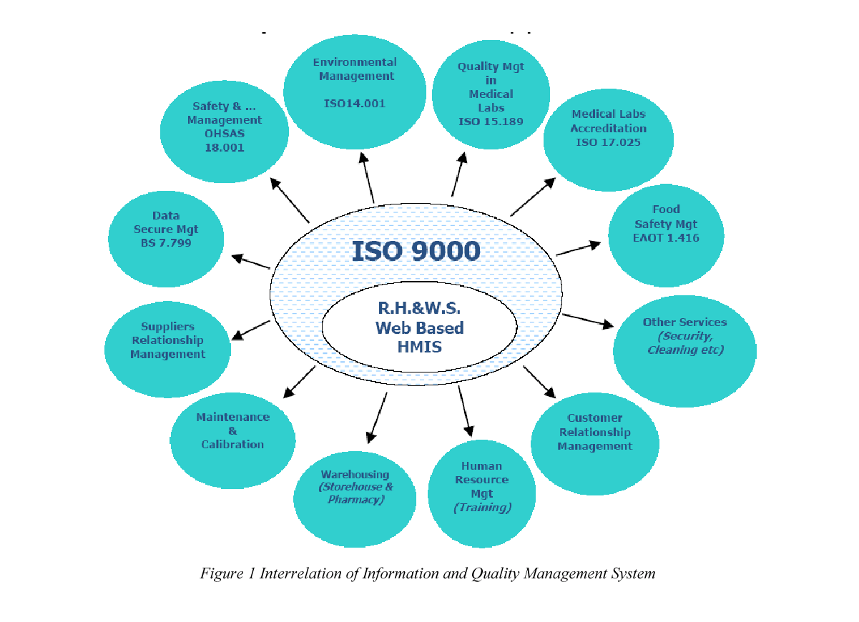
Apostolides A.D., (1992), The Health Care System in Greece since 1970: An Assessment, International Journal of Health Care Quality Assurance, Vol. 5. No 5. pp.4-15.
Bohigas L & Heaton C, (2000); Methods for external evaluation of health care institutions, International Journal for Quality in Health Care, 12 (3) : 231 – 238.
Bohoris, G.A.., (1995), A comparative assessment of some major quality awards, International Journal of Quality and Reliability Management, Vol. 12, No. 9, pp. 30-43.
Casey J. (1993), Into Battle with Total Quality Management, International Journal of Health Care Quality Assurance, Vol. 6, No.2, pp. 12-47.
Crago, M., (2002), Keeping Current - Medicare Service Pushes Certification to ISO 9001, Quality Progress, 35 (3).
Crago, M. & É llon, R. (2002), Healthcare Process Management Quality and ISO 9000, Part I. Infusion Magazine, National Home Infusion Association (NHIA), 8 (4).
Crago, M. & Merry, M., (2001), The Past, Present and Future of Health Care Quality: Urgent Need for Innovative, External Review Processes to Protect Patients, The Physician Executive, 27 (5).
Crago, M., Brown, J. & Merry, M., (2001), From Compliance to Excellence: Patient Safety Foundation for Healthy Communities, New Hampshire Hospital Association, Concord, New Hampshire, June 2001.
Dennis D. Pointer & James E Orlikoff, (2002), Getting to Great: Principles of Health Care Organization Governance, Jossey-Bass Pub., June 2002.
Griskewicz, M. (2002), HIMSS SIG develops proposed e-health definition, HIMSS News, July Vol. 13, No. 7, pp.1-12.
Herzlinger R., (2002), Let’s Put Consumers in Charge of Health Care, Harvard Business Review, July 2002.
Irvine, D. & Donaldson L., (1993), Quality and standards in health care, Proceedings of the Royal Society of Edinburgh, l (101B): 1- 30.
Lari, A. (2002), An integrated information system for quality management, Bossiness Process Management Journal, Vol. 8, No 2, pp. 169-182.
Lari A. & Kaynama S. (2001), Information management of ISO 9001, Proceedings of Biennial International Conference of Easten Academy of Management, San Jose, Costa Rica.
Maynard A., (2000), Competition and Quality, rhetoric and reality, International Journal for Quality in Health Care, 10 (5): 379 – 384.
Moody D., Motwani J. & Kumar A., (1998), Implementing quality initiatives in the human resources department of a hospital: a case study, Managing Service Quality, 8 (5): 320-326
Morgan J. & Everett T., (1990), Introducing Quality Management in the NHS, International Journal of Health Care Quality Assurance, Vol 3, no 5, p. 23-36.
Nash B.D., (2003), Education and debate, Doctors and managers: mind the gap, BMJ; 326: 652-653. Nwabueze U., (2001), The Implementaion of TQM for the NHS Manager, Total Quality Management, Vol. 12, No 5, pp. 657-675.
Ovretveit, J., (1999), Total Quality Management in European Healthcare, Japanese Society of Quality Control, Tokyo, July 1999.
Parasuraman A., Zeitham V.A., & Berry L.L. (1985), A conceptual model of service quality and its implications for future research, Journal of Marketing, Vol. 4, No 4, pp. 41-50.
Pfeffer N. & Coote A., (1996), Is Quality Good for You?, Institute for Public Policy Research. Sila I. & Ebrahimpour M., (2002), An Investigation of the total quality management survey based research published between 1989 and 2000: A literature Review, International Journal of Quality and Reliability Management, Vol. 19, No. 7, pp. 902-970.
Richardson, W., (2001), Crossing the Quality Chasm: A New Health System for the 21 st Century. March 1.
Roberts, I., (1993), Quality Management in Health Care Environments, International Journal of Health Care Quality Assurance; 6 (2): 25- 35.
Wensing M. & Elwyn G., (2003), Improving the quality of health care Methods for incorporating patients' views in health care, BMJ, 326: 877 – 879.

Quality Investigation of Fibre Reinforced Materials in Concrete Constructions Exposed to Special Environment
A. Routoulas, Associate Professor
T.E.I. Piraeus, Physics, Chemistry & Materials Technology Department
P. Ralli & Thivon 250 , 12244 Egaleo
E-mail: arout@teipir.gr
G. Batis, Professor
N.T.U.A Chemical Engineering Department, Materials Science and Engineering Section
9, Iroon Polytechniou Str. 157 80 Zografou Campus, ATHENS-GREECE
E-mail: batis@chemeng.ntua.gr

ABSTRACT
In the present work, pultruded glass and carbon fibre reinforced composite bars were subjected to UV radiation and exposure to fire conditions, to study the behaviour of FRP bars as reinforcement in concrete, through the Strain Gauges technique. To determine the conditions that most likely attack FRP bars, and to relate these to the environmental conditions found in natural concrete exposure, mortar cubes were reinforced with treated and untreated bars as reference, and were exposed to corrosive environment of 3.5% wt. NaCl solution for 3 months. Swelling stresses, caused by FRP degradation, were monitored using strain gauges. Before casting the FRP reinforcements were subjected to the following treatments: The first group was tested without any treatment, as reference. The second and the third group were heated at 200 and 300 ï C respectively for 2 hours, in order to simulate fire conditions and finally the forth group was exposed to irradiation with Xenon lamp in order to simulate sunlight exposure.
Considerable differences were observed between the CFRP and GFRP behaviour in the case of simulated sunlight exposure. In addition, both CFRP and GFRP reinforcing bars, exposed to simulated sunlight and thermal process, exhibit a different behavior than the reference one.
Results obtained confirm the important role of the properties of the matrix in the degradation mechanisms of FRPs, as well as the importance of performance in severe operating environments, fire resistance, and maintainability.
Keywords: CFRP and GFRP reinforcements, durability, Strain Gauges.
INTRODUCTION
Corrosion of steel reinforcement is considered as major factor of deterioration in concrete infrastructures such as bridges, marine constructions, buildings and chemical plants. Therefore, the development and use of alternative materials to steel reinforcement in the construction industry is urgent and necessary (Tassios,1993).
Fibre-reinforced polymer-matrix composite materials (also called fibre-reinforced plastics, FRP) have received much attention worldwide in the last 10 years, as it is known to offer excellent corrosion resistance to environmental agents. They also have the advantage of high stiffness-to-weight and strength-to-weight ratios when compared to conventional construction materials (Konsta, 1998). Other advantages of FRP include low thermal expansion, good fatigue performance and electromagnetic neutrality. All these advantages could lead to competitive with conventional materials life cycle cost of concrete structures.
Common reinforcements for FRPs are glass, aramid and carbon fibres. Their composites are referred to as GFRP, AFRP and CFRP hereafter. Carbon and aramid fibres are quite resistant to alkaline environment, such as in concrete, however, they are expensive, especially carbon fibre in comparison to glass fibres. Therefore GFRP has a higher potential to be cost-effective. Although extensive research has been conducted on the areas of creep, stress corrosion, fatigue, chemical and physical aging and natural weathering of FRPs, most of these are not aimed at applications for construction industry. The expected service life of a structure is the major factor and the acceptance of FRPs will ultimately depend on its durability. The investigation of FRPs durability in the alkaline environment of concrete, exposed to corrosive environment of a 3.5 % wt. NaCl solution is therefore important (Ton-That, 1999).
Taking into consideration that FRP reinforcements could stay for a period before casting under sunlight irradiation conditions, the study of FRP durability into concrete environment is useful. There is also very important to consider the FRP durability after thermal distress at temperatures involved in cases of fire condition.
The Strain Gauge (SG) technique, already used for a fast monitoring of steel reinforcements corrosion, is based on the appearance of swelling stresses on the area of steel rebars into the concrete.
The cause of the appearance of swelling tension is the formation of corrosion products (Fe3O4, Fe2O3, FeO(OH)), which have higher specific volume than iron (Fe). For the measurement of the swelling tension mentioned above, special SG sensors were embedded into the mortars specimens during casting (Routoulas, 1999).
The effect of the alkaline fluid of mortar mass through diffusion into FRPs and the relevant swelling of plastic matrix is investigated by Strain Gauge (SG) technique.
MATERIALS AND METHODS
Materials
The materials used for the construction of the mortar specimens were ordinary Portland Cement (PC), English sand BS4550P6 and drinking water from Athens water supply network.
The composite reinforcing bars used were made of polyester matrix, carbon or glass fibres with a cross section of 10x10 mm and a 100mm length.
In particular, reinforcement material was a fibre composite produced by the pultrusion process, its main matrix and fibre characteristics are given in Table 1.
PROPERTIES | POLYESTER | CARBON FIBRES | GLASS FIBRES E
ELASTIC MODULUS (Mpa) | 3310 | 250000 | 72450
TENSILE STRENGTH (Mpa) | 77 | 3850 | 3450
ELONGATION AT BREAK (%) | 4.2 | 1.8 | 4.8
DENSITY (Kg/m 3 ) | 1130 | 1720 | 2540
Table 1 Characteristics of pultruted materials
Methods
GFRP and CFRP rebars were used in this study. Before mortar specimens casting, the reinforcing bars weighed and prepared according to the following procedure. The first one of each type heated into a furnace for 2 hours at 200 ï C and mass-loss determination followed.
The second one of each type heated into a furnace for 2 hours at 300 ï C and mass-loss determination followed. The third one of each type exposed to irradiation with ×ÅÍÏÍ 2000 W lamp for 2 hours longitudinal one acme, equivalent to three month sunlight exposure and mass-loss determination followed. The last rebar of each type without any preparation used as reference.
Specimens
The mortar test specimens were in the form of 80 mm x 80 mm x 100 mm prisms with one FRP reinforcement. The shape and dimensions of specimens are shown in Figure 1.
The characteristics of SG sensor used was KM-30-120 type KYOWA. Distances and directions between the SGs are shown in Figure 1.
In each specimen embedded two SG sensors. The first of them was measured the swelling of the specimen due to cumulative effect of reinforcement expansion and other parameters, which change he specimen’s volume. This sensor was placed near the reinforcement. The second one was compensating the parameters of specimen volume variation except reinforcement expansion and it was placed far from the reinforcement (Colombo, 1986).
Mortar specimens were stored in the curing room for seven days and were immersed to the corrosive environment 3.5% w.t NaCl solution.
Figure 1. Shape and Dimensions of specimens
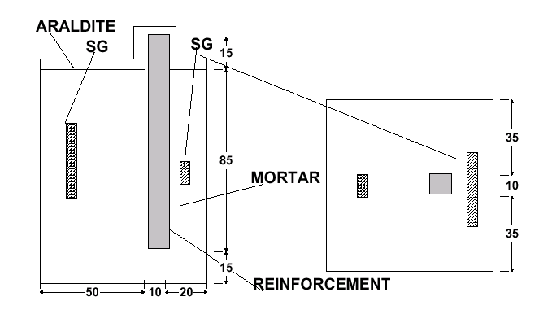
Eight (8) categories of the specimens were cast. The proportion of materials used and their code names are shown in Table 2.
Table 2. Categories of Specimens- Composition Proportions (Wt.)
Code Name | Opc | Sand | Water | Remarks
GF | 1.0 | 3 0 | 5 | Reference GFRP Reinforcement
GF200 | 1.0 | 3 | 0.5 | GFRP Reinforcement Heated at 200 0 C
GF300 | 1.0 | 3 | 0.5 | GFRP Reinforcement Heated at 300 0 C
GFL | 1.0 | 3 | 0.5 | GFRP Reinforcement Exposed to Irradiation with Xenon Lamp
CF | 1.0 | 3 | 0.5 | Reference CFRP Reinforcement
CF200 | 1.0 | 3 | 0.5 | CFRP Reinforcement Heated at 200 0 C
CF300 | 1.0 | 3 | 0.5 | CFRP Reinforcement Heated at 300 0 C
CFL | 1.0 | 3 | 0.5 | CFRP Reinforcement Exposed to Irradiation with Xenon Lamp
The test set–up, including SG bridge - amplifier circuit and the multimeter for SG elongation measurement, is shown in Figure 2.
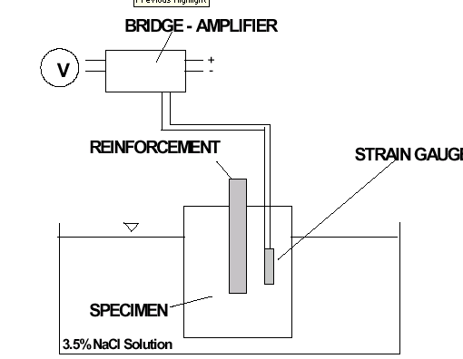
Figure 2. Schematic diagram of reinforcement expansion measurement set-up.
RESULTS AND DISCUSSION
The test results obtained for the GFRP categories of specimens by the SG technique are illustrated in Figure 3 as a function of time.
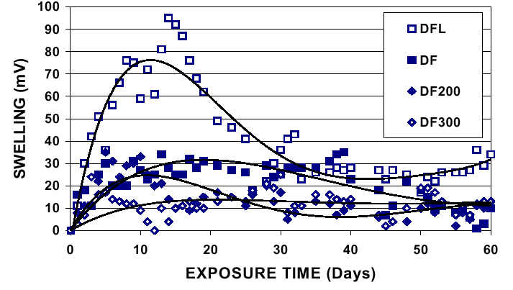
Figure 3. Swelling values versus exposure time for different GFRP specimens.
During the first few days after specimens casting, a relatively high rate of reinforcement swelling is observed which turn out in lower values. This swelling development could be explained by the liquid ingress and absorption behavior of the rebars polymer matrix. At the beginning, the absorption rate was high and then decreased with time, as water concentration gradient between the surface and the inner part of reinforcement decreased.
It is observed that the GFL reinforcement shows a higher swelling compared to that of the specimens GF, GF200 and GF300.
It is known that the diffusibility of glass fibre composites depends on the type of plastic matrix and the fibres content. High fibre content with a good protection should lead to low diffusibility. Glass fibres are considered to have negligible water permeability. The quality of the rebar outer surface also affects diffusibility (Panutso, 1999).
The higher water absorption and reinforcement swelling observed in GFL specimen could be attributed to the surface micro cracking caused by solar radiation.
Among reinforcements exposed to heating process GF200 and GF300, the relatively higher swelling of GF200 could be explained by the lower mass loss after heating. The lower polymer mass loss leads to the lower fibre content, and consequently to the higher diffusibility.
Regarding the test results obtained for the CFRP categories of specimens by the SG technique, shown in Figure 4, we could point out the following: The swelling curves show that all specimens have a fluid sorption of pseudo-Fickian tendency. The fluid saturation level is higher compared to that of GFRP reinforcements. The CFL specimen shows lower water absorption and diffusibility than GFL.
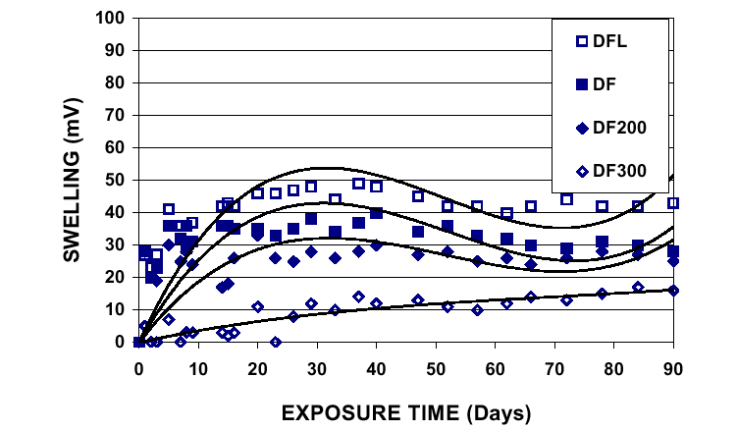
Figure 4. Swelling values versus exposure time for different CFRP specimens.
The swelling correlation of reinforcements exposed to extreme conditions referred to reference specimens is illustrated in Figures 5 and 6.
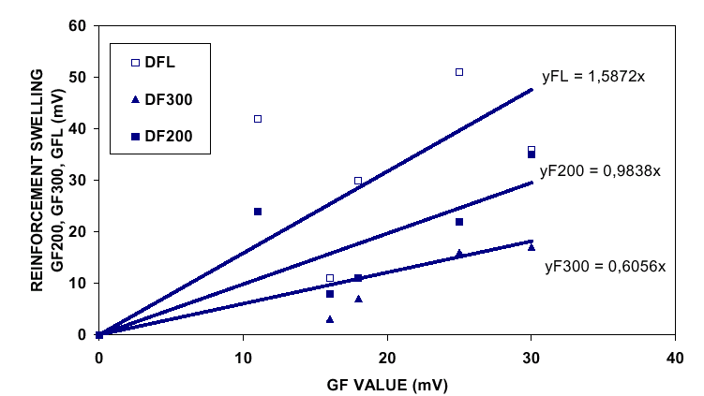
Figure 5. Swelling Correlation of GFRP reinforcements exposed in various conditions
The higher relative rate of swelling was observed in GFL specimen (1.587), the lower (0.606) was shown in GF300 and the GF200 specimen had similar swelling rate with reference one (0.984). A similar rating is achieved for specimens CFRP, (Figure 6) but the CF300 shows much lower swelling rate than the reference.
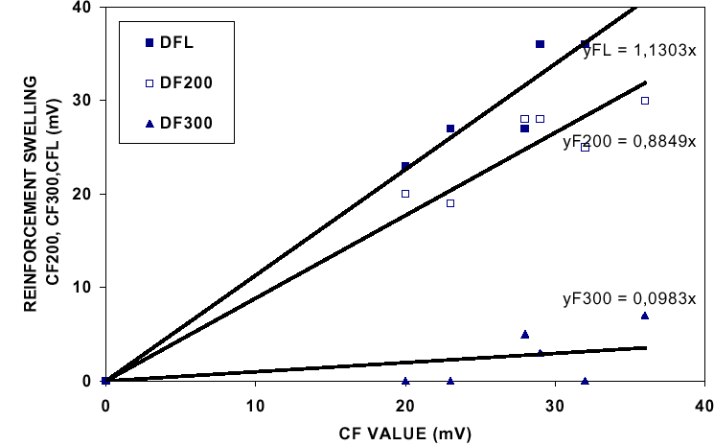
Figure 6. Swelling Correlation of CFRP reinforcements exposed in various conditions
Table 3 shows the mass loss comparison of reinforcements after heating or irradiation. It is clear that the mass loss of heated specimens is higher than light exposed ones.
All heated GFRP and CFRP reinforcements gave less swelling than the reference.
Table 3. Correlations Between Reinforcements Swelling and Mass-Loss
Specimen Code | Mass Loss (Mg) | Final Swelling Sg (Mv) | Relative Swelling Rate
GF | - | 12 | 1.000
GF200 | 187 | 12 | 0.984
GF300 | 456 | 12 | 0.606
GFL | 24 | 30 | 1.587
CF | - | 30 | 1.000
CF200 | 85 | 30 | 0.885
CF300 | 345 | 15 | 0.098
CFL | 18 | 40 | 1.130
After 90 days of exposure at 3.5%w.t NaCl solution mortar specimens were broken in order to reveal reinforcements. The revealing of GF reinforcement was impossible because of a very strong cohesion between mortar and reinforcement. This resulted in reinforcement damage as it is shown in Figure 7. However the CF revealing was normal (Figure 8).
The GF and CF reinforcements cross-section illustrated in Figures 9 and 10 are characterized by homogeneity without crackings. Some fibre disorders were observed in the surface terminals.
The GF200 reinforcement cross-section (Figure 11) shows large crackings and material degradation caused by reinforcement heating.
The GF300 reinforcement cross-section (Figure 13) shows less crackings than GF200 and color changes of the polymer matrix.
The CF200 and CF300 reinforcements cross-section illustrated in Figures 12 and 14 are characterized by homogeneity without crackings.
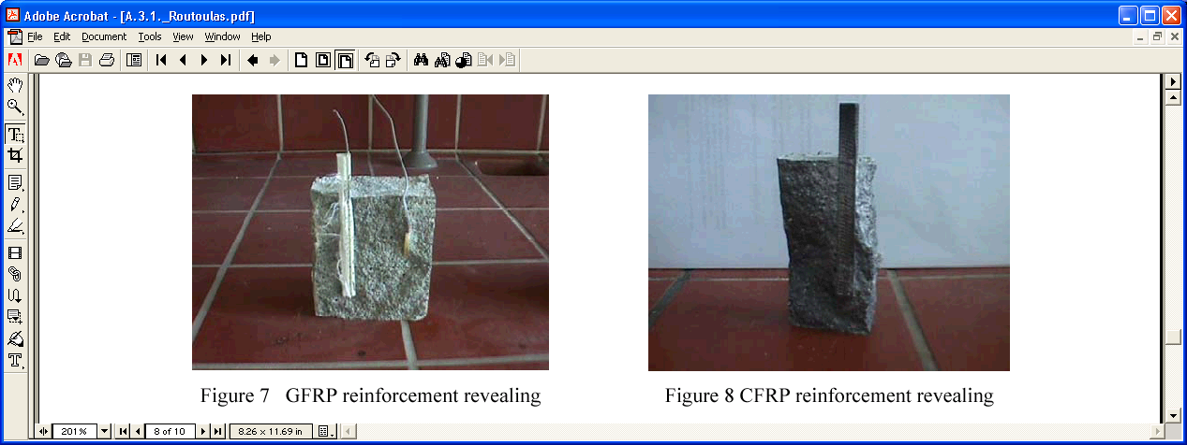
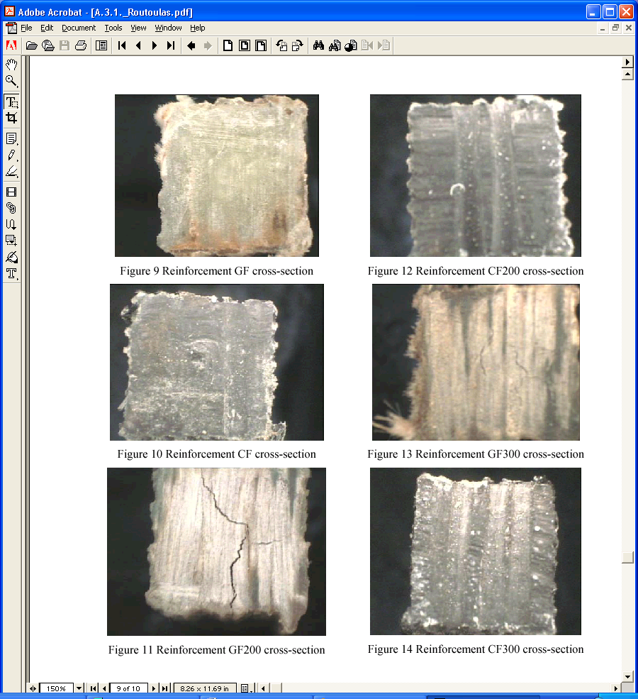
CONCLUSIONS
Based on the measurements of the FRPs swelling with strain gauge technique the following conclusions can withdrawn:
- Mortar specimens reinforced with FRP exposed to conditions of sunlight irradiation show sensitively higher reinforcement swelling compared to that of reference ones.
- 2. Mortar specimens reinforced with FRP exposed to heating conditions show lower reinforcement swelling compared to that of reference ones. Especially, the FRP exposed to 200 ï C heating had similar behaviour to the reference.
REFERENCES
COLOMBO, G. (1986). “Automazione Industriale”. Vol. 4. Dott. Giorgio, Torino.
KONSTA-GDOUTOS, M. AND KARAYIANNIS, Ch. (1998) “Flexural behaviour of Concrete Beams Reinforced with FRP Bars,” Advanced Composite Letters,, 7(5) pp.33-137.
PANTUSO, A., SPADEA, G., SWAMY, R. N. (1999) “Study of the Shear and Elastic Characteristics of FRP Bars Subject to Moisture and Alkaline Environment”. Proceedings of International Conference at University of Sheffield, pp. 567-579.
ROUTOULAS, A., BATIS, G. (1999). “Performance Evaluation of Steel Rebars Corrosion Inhibitors with Strain Gauges”, Anti - Corrosion Methods and Materials, 46, No 4, pp. 276-283.
TASSIOS, TH. P., ALIGIZAKI, Ê . (1993). “Durability of Reinforced Concrete”, Fivos Publ., Athens.
TON-THAT, T.M., BENMOKRANE, B., RAHMAN, H., ROBERT, J-F. (1999). “Durability Test of GFRP Rod in Alkaline Environment”. Proceedings of International Conference at University of Sheffield, pp. 553-566.

A Simulink Model of a Direct Orientation Control Scheme for Torque Control Using a Current-regulated PWM Inverter
Sorin Musuroi*, Ileana Torac**
*Department of Electrical Engineering, “Politehnica” University of Timisoara
Bd. Vasile Parvan 2, 300223 Timisoara, Romania
Email: sorin@et.utt.ro
**Romanian Academy-Timisoara Branch
Bd. Mihai Viteazul 24, 300223 Timisoara, Romania
Email: ileana_torac@yahoo.com

Abstract
Speed-controlled electrical drives represent one of the technological keys of the modern industry. The field-oriented principle is based on the analogy between ac machines and the separately excited dc ones. Thus, the application of the space-phasors leads to a simple mathematical model of ac machines separating the active quantities from the reactive ones and so two independent control loops are obtained.
Our paper shows a possibility of modeling and simulation of a direct field orientation control scheme for torque control using a current-regulated PWM inverter. For field orientation, controlling stator current is more direct than controlling stator voltage.
A completely algorithm use Matlab-Simulink was elaborated. In this paper we will implement a simulation of a three-phase, 60 Hz, four pole, 200 V , 735 W, induction motor.
Keywords: Simulink model, direct field orientation control scheme, torque control, current-regulated PWM inverter.
1. Presentation of the adjusting systems with field orientation with the induction motor
The induction motor used in the adjustable drive systems raises a series of problems regarding their supply from the frequency static converters and also due to the adjusting complexity. The most important problem is the control and adjustment of the electromagnetic torque. In order to adjust the torque with high dynamic performances (with low inertia and proper damping), the adjustment proceedings based on the field orientation principle have been resorted too. The field orientation principle relies on the analogy of the alternative current machines and continuous current ones, determining the separation of the magnetic and mechanic values which, finally, leads to two independent adjusting curls, with adjusting values in continuous current.
The concept of field orientation results from the fact that the direction of the flux determines the two components of the current, the active and reactive ones, which separate the mechanic phenomena of the machine from the magnetic ones.
The structure of an adjusting system conceived in relation to the field orientation principle is determined by many factors. The most important ones are:
- the sensors, namely the reacting values of the adjusting loop;
- the frequency static converter which supplies the electric motor;
- the flux according to which the field orientation is performed (stator, rotor or air gap).
The most frequently used orientation method, which is also exploited in the present study, is the one according to the rotor flux, because the adjusting measures simply results from the outputs of some PI regulators. This is the most often approached method in the literature due to the simplicity of the adjusting loop and to the calculation of the command measures. If the inductivity of the rotor leaks is neglected, then the air gap flux (measured and calculated) is mixed up with the rotor flux according to which the orientation is done. The errors are not, first and foremost, due to module of the flux, but to its direction, according to which the stator current orients itself, decomposing it in components that become adjusting measures. On this ground, the recent methods do not neglect the leaks inductivity of the rotor L σ r. Under these circumstances, the adjusting structure is little complicated, because out of the indirect and direct measured flux of the air gap, the rotor flux must be calculated, without having any access to the rotor currents.
2. The adjusting scheme of the induction motor torque supplied through a current inverter with direct measure of the field and with rotor flux orientation
Figure 1 suggests a simulation model of an adjusting scheme of the induction machine torque supplied by a current inverter with direct measuring of the field and with orientation according to the rotor flux. The frequency static converter with intermediary continuous current circuit is composed by a rectifier and an inverter, displaying at the exit an appreciatively sinusoidal current. In the intermediary circuit the voltage is filtered. This voltage will be commuted by the inverter on the stator phases. The commutations in inverter take place according to the output current which is bi-positional controlled, following the references sinusoidal signals. Due to the modulation signal on the PWM breadth, the inverter works with commutation forced to relatively high frequencies in or beyond the audio sphere (< 15 kHz). That is why these invertors are usually equipped with IGBT transistors.

Although at the exit of this converter the voltage is commuted, however the converter behaves as a current source due to the bi-positional current adjustment.
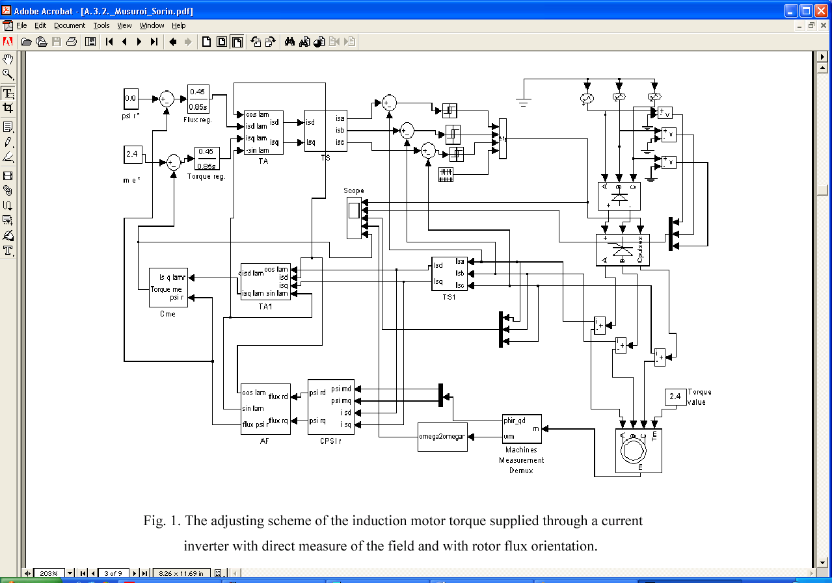
Fig.1 The adjusting scheme of the induction motor torque supplied through a current inverter with direct measure of the field and rotor flux orientation
The air gap field can be measured with specially fitted search coils or Hall-effect devices placed in slots. The three-phase system of the flux is transformed with a TS1 block (fig.2) in the bi-phase system compared to the stator axes system. In the same way is transformed the currents three-phase system.
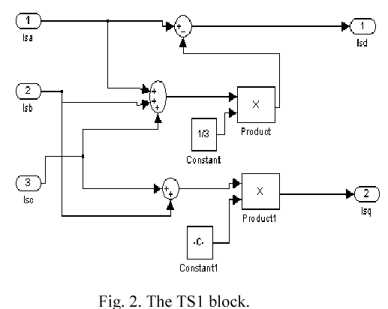
In the case of a three-phase machine, the current, voltages and flux sensors provide information of three-phase sizes. Also the frequency static converters need command sizes of three-phase system. Thus, on the reaction loops, in the adjusting schemes the TS1 blocks will appear, which performs the transformation of the three-phase system sizes (ga, gb, gc) in bi-phase system (gd, gq), based on the relations:
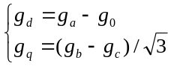 (1)
This transformation is given by the relation
[g]┴ = [A]·[g] (2)
where [A] is
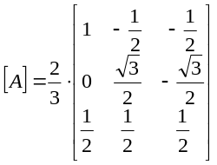 (3)
The inverse transformation is also necessary, namely of the bi-phase system measures in three-phase systems measures (fig.3). This is made by using the transforming block Ts, using the inverse matrix [A]^{–1} :
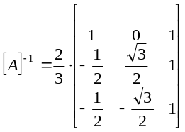 (4)
It is obtained:
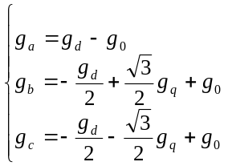 (5)
With the calculus block Cpsir (fig.4), the compensation of the rotor flux is performed. The components of the stator current do not present any problem because the adjusting system usually possesses these measures. In the compensation of the flux, errors can be input due to the iron saturation.
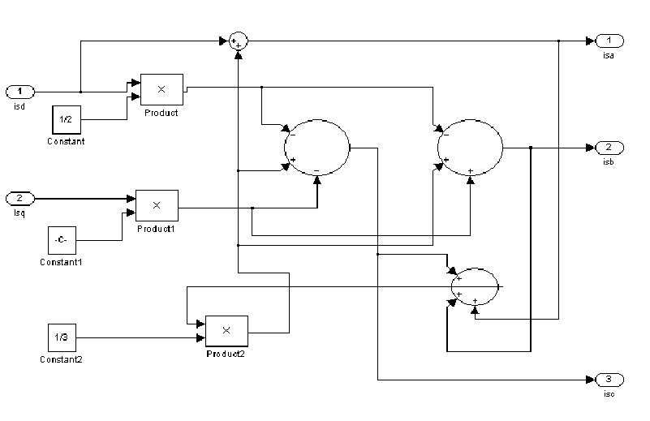
Fig. 3. The block of the transformation of the bi-phase system in three-phase system of measures – unfolded scheme.
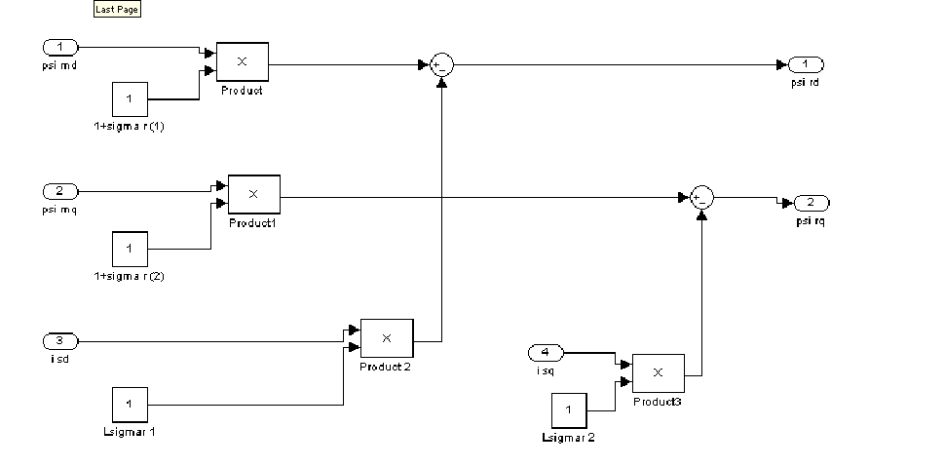
Fig. 4. Flux compensator for obtaining the orientation rotor flux (from the one measured in air gap) – unfolded scheme.
The calculus expressions are the following:
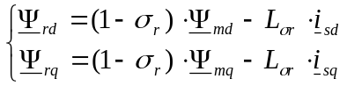 (6)
Applying the field orientation principle involves to know the position of magnetizing flux. The blockwhich provides the information regarding the field and which does the flux orientation is the phasoranalyzer block, AF (fig.5).
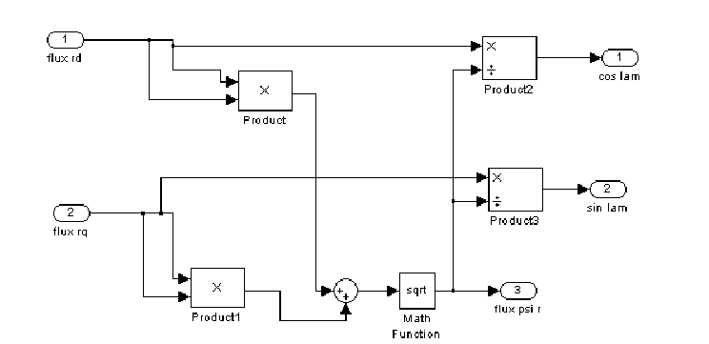
Fig. 5 The phasor analyzer AF– unfolded scheme.
The phasor analyzer identifies the position and the module of the flux phasor. The flux components Ψ_{d} and Ψ_{q} , reported to a fixed statoric axes system d-q are obtained through measurements or calculation.
The orientation of the stator current is done by help of the axes transformation block TA (fig. 6), knowing the position of λ_{r} of the rotor flux.
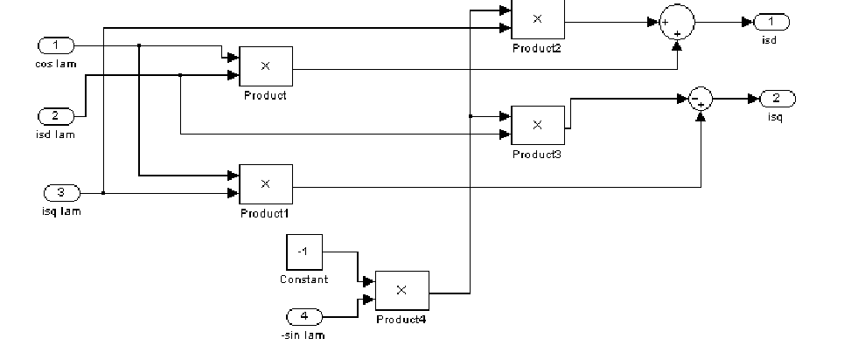
Fig. 6. The axes transformation block TA– unfolded scheme.
The field orientation measures can be expressed with those of the bi-phase model, fixed in space, bythe relations:
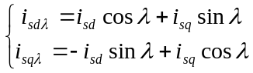 (7)
Orienting the measures according to the rotor flux, there results for the electromagnetic torque:
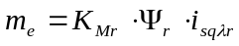 (8)
Where Khdr is the constant value of the torque.
The imposed measures for the flux Ψ_{r}* and the torque m_{e}* are compared to the corresponding values in the motor. There result the adjusting measures i*_{sdλr} respective i*_{sdr}, the reactive and active components of the stator current oriented after Ψ_{r} .
In order to obtain the command measures in current of the converter, firstly the statoric axes system is returned to, by help of TA block, then the three-phase system of the stator current at its exit from the TS block is obtained.
The statoric currents are individually adjusted by bi-positional regulators, following the sinusoidal referred signals i*_{sa}, i*_{sb}, i*_{sc}.

In the case of the induction motor commanded in current, the torque rapidly follows the variation of the active component i*_{sqr}, according to the algebraic relations (8). Yet, the rotor flux, being determined by the reactive component i*_{sdλr}, will follow the variant of this current with a delay determined by the time constant τ_{r} of the rotor, which can reach values of even 1 sec. at the bigger motors. Therefore, the measure of the flux cannot be suddenly changed.
3. Simulation results
In this paper we implemented a simulation of a three-phase induction motor: P_{N} = 735 [W]; U_{N} = 200 [V]; f_{N}=60 [Hz]; R_{s}= 3.35 [.]; L_{s}=6.94 [mH]; R’_{r}=1.99 [Ω]; L’_{r}= 6.94 [mH]; L_{m}= 163.73 [mH]; J=1.459*10^{–3} [kg m² ]; F=0.001 [Nms]; p=2; s=0.01; Θ = 20 [ºC].
The results of the simulation are shown in fig. 8.
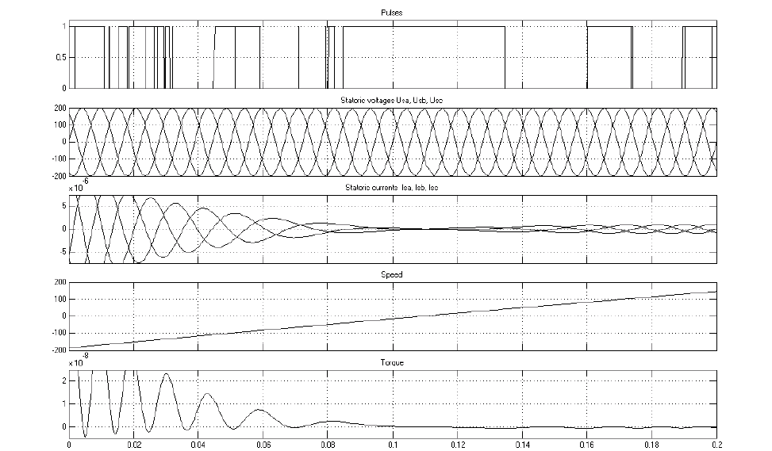
Fig. 8. Simulation results.
4. Conclusions
Our paper shows a possibility of modeling and simulation of a direct field orientation control scheme for torque control using a current-regulated PWM inverter. For field orientation, controlling stator current is more direct than controlling stator voltage.
A complete algorithm using Matlab-Simulink was elaborated for simulation of a three-phase, 60 Hz, four pole, 200 V , 735 W, induction motor.
References:
1. Kelemen, A., Imecs, M. Sisteme de reglare cu orientare dupa camp ale masinilor de current alternativ. Editura Academiei, Bucuresti, 1989.
2. Leonahard, W. Control of AC-machines with help of microelectronics, 3rd IFAC Symposium on Control in Power Electronics and Electrical Drives, Survey papers, Lousanne, 1983.

Application of BiMoStaP- Biosignal Modeling and Statistical
Processing software package- to pre-surgical control, epilepsy
and telemedicine
K. G. Dimopoulos 1 , C. Baltogiannis 2 , E. Scorila 1 and D. K. Lymberopoulos 3
1 Faculty of Applied Sciences, Technological Institute of Piraeus, P. Ralli and Thivon 250,
GR – 12244 Egaleo, Greece.
2 Department of Neurosurgery, University of Athens Medical School, Evangelismos General Hospital,
GR – 106 76 Athens, Greece.
3 Wire Communications Laboratory, Department of Electrical and Computer Engineering,
University of Patras, GR-261 10 Patras, Greece.

Abstract A new biosignal modeling and statistical processing software package –BiMoStap- has been developed primarily for EEG storing, archiving, analysis in epilepsy presurgical control. It covers algorithms of evaluation, classification, time and spectrum transformations for time series EEG acquired data. The main advantage compared to the numerous available commercial and public domain software is the integration of all available algorithms, previous medical cases, diagnoses and medical notes as well as immediate connection to EEG acquisition hardware. The open architecture permits the data sharing with other medical databases and mathematic packages for comparison. Interface simplicity permits the easy use by medical personnel with little acquaintance of complicated software.
BiMoStap has been especially accommodated for the WADA test. Recorded EEGs are analyzed and slow waves are detected, identified, aggregated and may transmitted in telemedicine network. A test EEG waveform is demonstrated in time domain as well as after possible time and spectral transformations.
The package is easily extendible to other biosignals analysis like ECGs etc.
Keywords: Medical Software, Biostatistics, Epilepsy, Wada test, Telemedicine.
I. Introduction
Medical software is an invaluable tool for medical personnel. All heterogeneous patient data stored in various formats, hard copies, distributed in several departments are difficult to have immediate and secure access without an integrated medical network environment.
Several commercial and public domain applications offer data archiving and administration systems as well as digitization and processing; to name a few Mission of the Brain Dynamics Bioengineering Research Partnership (BRP) is an on-line, real-time automated seizure warning and prevention system for use by epileptic patients and their caregivers, Hipax, an open architecture system., has available imaging modules that can be put together individually to form a powerful image processing, communication, and archiving system, DESSA is a support decision system for epilepsy. It can be used in consulting rooms as well as in a hospital or in a university clinic.
In our approach BiMoStaP integrates the archiving capabilities with time series mathematical algorithms and techniques. The main purpose is to relate normal and irregular waveforms with objective indices. After a test period the system will be able to classify automatically imported waveforms.
The package is a result of systematic scientific cooperation of information technology and medical science expert groups especially designed and developed to bring together a multi-disciplinary group of research scientists, who are pioneers in the areas of software engineering, signal processing, optimization, computation, neurophysiology, epilepsy, and neurosurgery. Simple analysis to advanced research is facilitated.
Data acquired from the medical device are saved to an external database with enhanced search and insert capabilities of extra related information and notes. Researcher medical doctors can analyze the EEG waveform as a whole, or as a part from a selected channel and/or time range.
Biosignal modeling refers to certain waveform pattern identification (e.g. alpha, theta waves etc), correlation to known types. Statistical processing refers to biosignal parameters calculation, like frequency, voltage, synchronization and periodicity.
If this package is used by the expert medical doctors, trained and tuned suitably so as to successfully identify pathological EEG waveforms then, it can be used to automatic recognition and analysis in pre-surgical control, epilepsy and telemedicine.
In this paper, there are presented the development principles, the software package operation, scenario of application, and illustrative reports of recorded and analyzed waveforms. The system is particularly adjusted to accept digital biosignals from encephalographic recordings during WADA test at pre-surgical control in epilepsy. WADA test consists of the digital acquisition of 21 channels EEG, where the system is able to cover up to 128 different recordings from equal in number channels. Figures of the analyzed waveforms and transformations are shown demonstrating the simplicity and the friendly user interface of the designed software.
II. Preliminaries
Biosignal is a set of time series data 1 2 , ,... N x xxacquired from one or more channels from a living object according to a specified medical and technical protocol. Main technical characteristics are the sampling frequency, AD word length in bits and signal to noise ratio. EEG is of the most popular biosignals as well as ECG. In fig. 1 characteristic forms of EEG signal are shown. Each case corresponds to a different physiological or pathological human state.
Presurgical control
The minimum presurgical control includes
1. Thorough clinical examination, history recording, and details about seizure characteristics.
2. EEG recording
3. video-EEG recording of two or more seizures
4. Neuropsychological and IQ evaluation
5. brain MRI
6. WADA test for speech and memory lateralization.
Wada test still remains a basic part of presurgical control of epilepsy. The test is the injection of sodium amobarbital via a catheter from femoral artery to internal carotide to anaesthetize for a little time period the ipsilateral brain hemisphere and under these conditions to record the oral and memory performance of the corresponding patient brain hemisphere electroencephalographically, neuropsychologically and clinically.
The results of the test are indisputable for speech and memory lateralization. The less operative MRI function gives best results for the front speech areas but is not as effective for back areas and memory. Amobarbital test enables the clinic investigation of the hemisphere during the anaesthetization. In the same time EEG recording is taking pace to estimate patient performance of slow waves in the under question hemisphere.
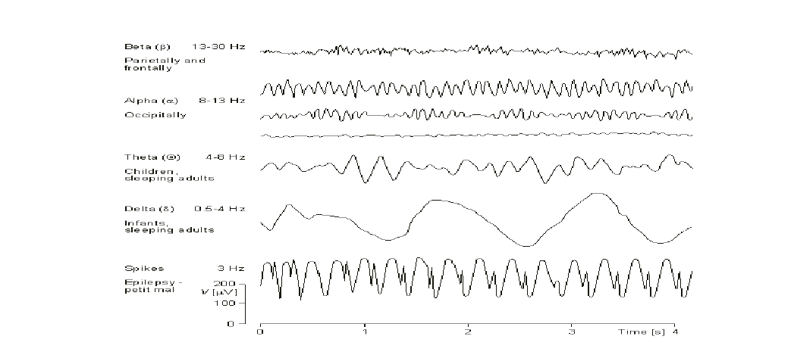
Figure 1: Various EEG waveforms.
An important transformation to frequency domain is Fourier transformation
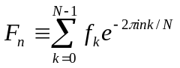 (1)
Autocorrelation function gives a measure of self-similarity of the waveform under study
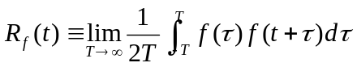 (2)
III. BiMoStap - Integrated software environment
Bimostap system
- Collect data from patients
- store information
- Apply transformations
- correlates waveforms to certain categories
- is an aid to support decisions
Table 1. Tools used in development
Microsoft Visual Basic v. 6.0
Microsoft Access for the data storage
Seagate Crystal Reports for the reports
Table 2. Minimum System Requirements
Pentium PC
64MB RAM
5MB available hard disk space
VGA Color Monitor, preferably 1024x640
Microsoft Windows 98/me/2000/XP
IV. Application scenario
Data acquired from the medical device are saved to a separate memory with capabilities to insert extra information and notes and to search within. Researcher medical doctor can analyze the EEG waveform as a whole, or as a part from a selected channel and/or time range. Biosignal modelling refers to certain waveform pattern identification (e.g. alpha, theta waves etc), correlation to known types. Statistical processing refers to biosignal parameters calculation, like frequency, voltage, synchronization and periodicity.
If this package is used by the expert medical doctor, trained and tuned suitably so as to successfully identify pathological EEG waveforms then, it can be used to automatic recognition and analysis in pre-surgical control, epilepsy and telemedicine
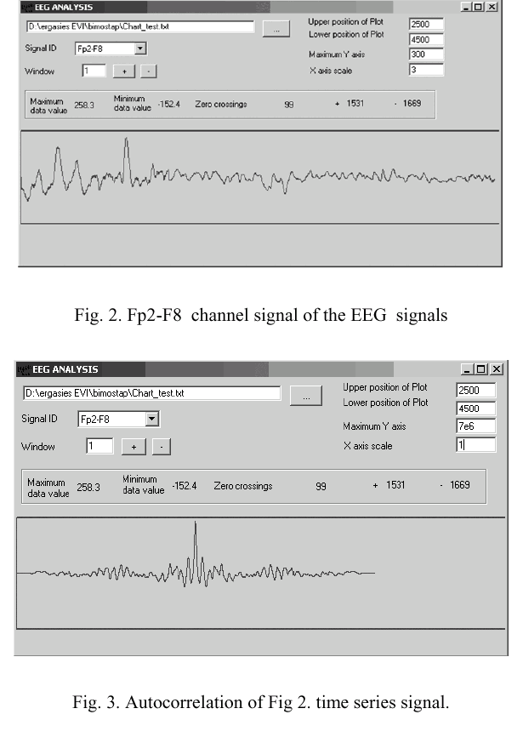
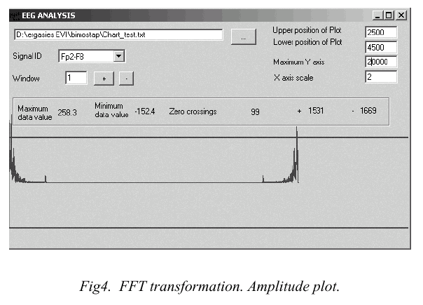
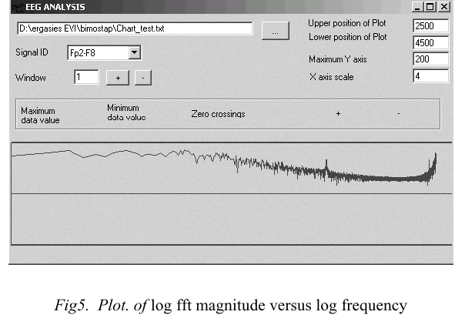
An established co-operation is taking place with University of Patras and a test system is at Evangelismos Hospital in Athens.
References
C.Baltogiannis, S.Gatzonis, A.Hatzioannou, D.Sakas, "Intracarotid injection of Amobarbital,(Wada Test) in presurgical control of epilepsy", Greek Neurologists Autumn Meeting, Nafplio, Greece, 2000.
Wada J.T., Rasmussen T.(1960), "Intracarotid injection of Sodium Amytal for lateralization of cerebral speech dominance", J.Neurosurgery.
Serafetinides E.A., Driver M.V., Hoare R.D. (1965),"EEG paterns induced by intracarotid injection of sodium amytal", Electroenc.clin.Neurophysiol.
J.Gotman, M. Bouwer, M. Jones-Gotman, (1994) "EEG slow waves and memory performance during I.A.T. ", Epilepsia, Vo 35.
Bazin B., Cohen L., Lehericy S., Pierrot –Deseilligny C., Marcsault C., Baulac M., (2000) "Etude de lateralisation hemispherique des aires du langage en IRM functionelle. Vallidation par test WADA. ", Rev.Neur., ;156(2).
Meador K.J., Loring D.W.( 1999), "Wada test: controversies, concerns and insights", Neurology, 52(8).
“Digital imaging and communications in medicine (DICOM)—Part 1-13,” Nat. Elect. Manufact. Assoc., Rosslyn, VA, PS 3.1–3.13-1996, 1997.
“Impact of telecommunications in health-care and other social services,” ITU–T, Geneva, Switzerland, Tech. Rep., Oct. 1997.
Carson E. R., Cramp D. G., Morgan A., and Roudsari A. V. (1998), “Clinical decision support, systems methodology, and telemedicine”, IEEE Trans. Inform. Technol. Biomed., vol. 2, pp. 80– 88.
K. G. Dimopoulos, C. Baltogiannis, E. Scorila, and D. K. Lymberopoulos (2004), «DESSA- A New Decision Support System for the Presurgical Assessment and Post-operational long-term monitoring in Epilepsy», Proceedings of the International Joint Meeting Euromise 2004, April 12-16, Prague, Czech Republic.
K. G. Dimopoulos, C. Baltogiannis, E. Scorila, and D. K. Lymberopoulos, (2004) « DESSA: A New Decision Support System for Neurosurgery», submitted to 26th Annual International Conference of the IEEE Engineering in Medicine and Biology Society, San Francisco, California, September 1-5. http://brp.mbi.ufl.edu/
G.B. Moody and R.G. Mark, (1996) “A database to support development and evaluation of intelligent intensive care monitoring,” IEEE Comp Cardiol., pp. 675-660,.
A.L. Goldberger, L.A.N. Amaral, L. Glass, J.M. Hausdorff, PCh. Ivanov, R.G. Mark, J.E. Mietus, G.B. Moody, C-K Peng, and H.E. Stan-ley, (2000), “PhysioBank, PhysioToolkit, and PhysioNet. Components of a new research resource for complex physiologic signals,” Circulation, vol. 101, pp. e215-e220,.
C.E. Thomsen, J. Gade, K. Nieminen, R.M. Langford, I.R. Ghosh, K. Jensen, M. van Gils, A. Rosenfalck, P. Prior, and S. White, (1997) “Collecting EEG signals in the IMPROVE Data Library. Data acquisition and visual analysis tools for obtaining prolonged recordings in intensive care,” IEEE Eng. Med. Biol. Mag., vol. 16, no. 6, pp. 33-40.

Criteria of National and International Management for the Selection of Enterprise Resource Planning, Warehouse Management Systems and Customer Relationship Management
Systems
A. P. Kakouris, Research Associate, School of Administration and Economics,
Technological Educational Institute, Ag. Spyridonas street, Aegaleo, 122 10 Athens, Greece
E-mail: akakour@ath.forthnet.gr
G. Polychronopoulos, Professor, School of Administration and Economics,
Technological Educational Institute, Ag. Spyridonas street, Aegaleo, 122 10 Athens, Greece.
E-mail: gpolyc@teiath.gr

Abstract
Nearly any company, small or large, has an Enterprise Resource Planning (ERP) system in place. But can an ERP system meet the needs of Supply Chain Execution (SCE) or Warehouse Management System (WMS) and Customer Relationship Management (CRM)? Can the installed Information Technology (IT) systems copy successfully with the needs of the companies or do the companies need to upgrade or change technology or even add these additional systems in the existing ERP? How these can be done over a short time and with a reasonable return on investment (ROI)?
The goal of this paper is to provide an insight into some of the functions that ERP, WMS and CRM systems offer today, their functionality, the advantages and disadvantages. It helps plot a decision path forward, based on objective and thorough analysis necessary for the selection of the company’s system(s).
It serves as a precursor to further investigations, keeping always in mind that the exact system will change in accordance with the company’s -subject, -size, -operational configuration, and -degree of financial leverage. Furthermore, by selecting three real business cases it discusses how each enterprise successfully implemented and integrated such systems, highlighting the processes used, the obstacles faced and the gains achieved. Also, it analyses ways in which these obstacles were overcome. Finally, it provides practical suggestions for successful implementation of such systems.
Keywords: ERP, WMS, CRM, International, National, Management, Implementation.
INTRODUCTION
Organasations change their structure, strategy and business processes to compete with and support the continuous needs and demands of the market. Technological options are also changing, continuously. Converging available technology with company’s needs is the greatest challenge for every company that wants to lead in the years ahead. Enterprise Resource Planning [ERP] is a fundamental way to achieve it.
ERP is a software system made up of a series of applicable modules, generally from the same producer, which work natively on a single database distributed geographically on a network. It integrates key business and management functions and provides a view of the happenings in the company, in the areas of finance, human resources, manufacturing, supply chain, etc (Davenport, 1998; James and Wolf, 2000). An ERP software solution is valuable when, it is:
1. Multifunctional in scope, that is, it functions from sourcing (materials) through manufacturing and supply chain (resources and people) to marketing and sales (products and people) in addition to finance (money) and human resources (people)
2. Integrated in nature with a minimum of human intervention. The idea behind is to communicate across functions, so when data is entered in one function, they transformed to valuable data for the other functions
3. Modular in structure in that it can be expansive or narrow depending on the requirements.
An ERP software can be build up either by purchasing the whole package from a single vendor or by using pieces of software from different supplier(s). In the first category, the leader is the German company SAP AG with its R/3 software, together with big vendors such as PeopleSoft Inc., Oracle Corp., Baan Co. NV and J.D. Edwards & Co. Some of their basic characteristics include: (a) they are spending amounts in the order of 10-16% on R&D, (b) they are Microsoft driven operating systems with their back-office systems using Structured Query Language (SQL), (c) they have segmented the market developing specific industry solutions of vertically integrated industries, such as pharmaceuticals, consumer products, telecommunications, etc, and (d) they try to achieve a truly integrated “cash – to – cash” solutions (Mabert et al, 2000). Today there is a great diversity of ERP tools that are available. Their proper deployment –which will eventually offer a competitive advantage and help in running the business more effectively, efficiently, and responsively [Irving, 1999; Jenson and Johnson, 1999] - is a complex task. It becomes more complex, if one thinks that their effective migration will run parallel to the running of the company.
Therefore, people, technology, costs and expectations have to be managed simultaneously to ensure success (Nah et al, 2001).
The objectives of this paper are:
- To present a closer look at some of the major trends affecting business today and how software tools can be used to effectively manage these trends
- To provide an insight into some of the functions that ERP, CRM and WMS systems offer, and help plot a decision path forward, keeping in mind that the functionality of each system deployed is almost certainly depend on the system in use and its version
- To understand the current applications and future developments, by appreciating the evolution of enterprise software as each evolutionary step has been built on the fundamentals and principles developed within the previous one
- To support all the people involved in implementing such solutions.
The paper is not primarily about computers and software. Rather, its focus is on people: how to provide them with decision-making processes for software selection in the specific areas of CRM and WMS and how to integrate these solutions with the ERP one (Slater, 1999). Three real case studies have been selected and presented as examples of how three companies had successfully implemented and integrated such systems. Moreover, it highlights the processes used, the obstacles faced and the gains achieved. Last but not least, it helps plot a decision path forward, based on objective and thorough analysis necessary for the selection of the company’s system(s), keeping always in mind, that the exact system will change in accordance with the company’s -subject, -size, -operational configuration, and -degree of financial leverage.
EVOLUTION OF ERM, CRM & WMS
1960s can be characterised as the pre-computer era. While manufacturing was the guardian for achieving competitive advantage, there was not comprehensive control on it, neither on inventories as no company could afford to own a computer and everything was regarded as an asset in the mind of each manager. In 1970s and ’80s, when computers finally became small and affordable, their use for Materials Requirements Planning [MRP] was deployed, while the Master Production Schedule [MPS] was built for the end items. The idea of feeding MPS into the MRP was further extended to the “closed loop MRP”, or Capacity Requirements Planning [CRP], as well as to routings for defined paths in the production process. The idea of using computers in manufacturing was quickly connected with finance as a way to control and follow the manufacturing happenings as well as to follow the sales of the finished products through the accounts receivables. This gave birth to the first integration package using a common database that could be accessed by all users, namely Manufacturing Resource Planning [MRP II].
Progressively other functions of the company, like sales, purchasing, logistics, customer service, human resources, etc started to developed their own sets of integrated computer systems, but with the handicap that they were unable to interact and exchange information, thus producing errors and wasting valuable time. The introduction of Application Programming Interface [API] solved the problem and the first integrated Enterprise Resource Planning [ERP] software solutions appeared in the market (Kumar and Van Hillegersberg, 2000).
Traditionally, ERP solutions focus in the enterprise internal processes. They perform well in combining the basic transaction programs of all functions, i.e. manufacturing, distribution, financials, etc inside the four walls of the enterprise, offering lean and effective operation of the enterprises. They often lack in managing the external business relationships, as they cannot accommodate real-time, physical events that occur on supply chain, external customer relationships, etc. Inevitably, the next step is to consider the enterprise opening, using technology to manage these external business relationships. Thus ERP has entered in its next evolutionary phase; basically, mirroring the transformations in the enterprise model on:
- Supply Chain Execution (SCE) or Warehouse Management System (WMS) and
- Customer Relationship Management (CRM).
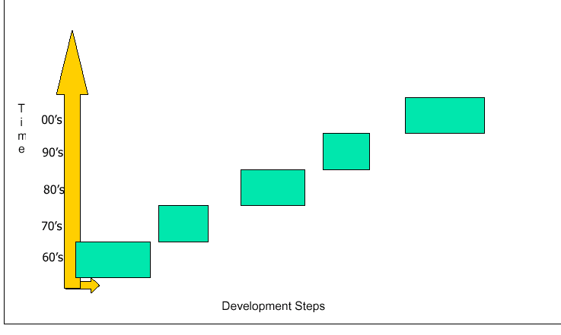
WMS IMPLEMENTATION
A successful implementation of a WMS (Christopher and Barnes, 2002; HighJump Software®, 2004) is a
heavy task and involves two phases. Firstly, the pre-implementation phase which involves: financial
justification, specifications and suppliers evaluation and secondly the actual implementation. Although
some believe that the pre-implementation period is the most difficult part of the project; unfortunately,
experience has shown that the second phase is the most susceptible as it involves to a great extend the
human factor. The steps involved in the total WMS implementation include:
I. SELECTION
A. Identification. In a first step, it is essential to understand:
- Why a WMS is needed in a company?
- What is its scope in the company?
- What will bring to the company?
- How does a company know if a WMS is needed to fulfill its strategic goals?
B. Justification. The next step is the financial and quality justification of the project from the point of view of: labour savings and inventory reductions. Labour savings come in the form of operator efficiency and effectiveness, equipment utilisation, tasks prioritisation, queue times, inaccuracies from paper picking, etc. Inventory reductions appears as space utilisation, effective use of cross docking, stocks reporting, cycle counting, damaged products, accurate placing and picking of inventories, etc.
The end result is the effective and efficient use of all resources that enhance the profitability of the company, thus bringing a return on investment from: avoiding waste, increase customer satisfaction, reduce inventory levels, eliminate inaccuracies, making receiving/storage/picking/ shipping more efficient and eliminate most of the manual (paper) process. A well-implemented WMS can produce figures in the order of:
- 25% reduction in labour, and
- 15% - 35% reduction in warehouse requirements.
C. Specification. The specification step may be approached in two ways. Either as a functional bid specification where the company-needs are translated from the vendor to a system able to satisfy those needs, or as a design bid specification where the company knows its problems and selects the system from the supplier without regard to possible customisation of the product.
D. Evaluation & Final Selection. The aim of this step is to reduce the number of suppliers to an experienced one in the specific field that the system is aiming to be used for by considering factors such as:
- Supplier financial strength and quality reputation
- System cost and operational design
- Implementation programme & Support capabilities
II. IMPLEMENTATION.
This second phase is equally important to the first one, as it needs good foundations to build and implement the chosen WMS. More specifically, it needs:
1. To develop a cross-functional team
2. To establish and monitor a schedule which will be followed thoroughly
3. To interface the WMS with the main- (or sub-) system(s)
4. To create a master database from product characteristic information, and
5. To verify the data and check the system before WMS goes alive and supplier goes offsite. (An 80% examination of the installed system seems to be acceptable).
III. OTHER FACTORS
i. Human Factor: Implementation of a WMS requires educational, training, cultural and competency experience as people are moving from a paper-intensive environment to a real-time, paperless one.
ii. Implementation Handicaps: Even with the best supplier and best in class WMS, there will always be problems with the system installed, so there will always be a transition period between the start and the trouble-free operation. A point of caution is: never raise impatient, accuse, discourage and settle for fast, momentary fixes in front of the personnel (Wilder and Davis, 1998).
iii. Contingency Planning: As in any project, a contingency plan should be in place to fix problems in the case, the WMS would not work initially or fail to work as a total system or part of it. Failure to have a contingency plan is a common and an expensive (costly) process. A contingency plan can be seen as WMS insurance.
iv. Auditing: Once the system is running smoothly, it must be audited (checked) against its qualitative and quantitative selection objectives. A process which can be done after three to six months from the full start up, with further audits taking place every six months onwards.
CRM IMPLEMENTATION
To fulfill the vision of an agile enterprise, and to make the transition from product- to customer-centric systems, businesses need to establish a robust and intelligent data warehouse system that can collect, store, transform, analyse, distribute and cross-reference the enormous amounts of customer data collected through each touch point. The traditional operational systems such as customer order entry systems, ERP systems, and transaction processing systems are unable to leverage the hidden customer information for better decision-making and personalised customer interaction (Griffin and Johnstone, 2001; Magic Software Enterprises Ltd., 2001; Hall, 2003).
If CRM will be used as an effective competitive strategy, it has to be integrated throughout the enterprise information systems and/or business processes in order to provide real-time, secure and reliable customer interaction. However, one of the most pressing challenges is how to integrate CRM solutions into the overall enterprise information architecture. Although, it is these information architectures that helped companies in opening and running existing and new channels of commerce; unfortunately, now they contribute negatively as they are not able to handle CRM solutions because they have been designed for product-related processes and not customer-related ones. All customer data is scattered across a number systems with no ability to link that data together. So companies are faced with two options, either:
To abolish the current information infrastructure and adopt a completely new one, i.e. to implement a new packaged (integrated) solution, or
To add and integrate into the existing infrastructures a new customer-related system components, i.e. to build a CRM solution into the existing ERP.
A complete CRM solution consists of a customer knowledge base of both structured- and unstructured-information in a ratio of around 25:85. Structured information is in the form of sales data while unstructured one is spread around the organisation in the form of general information, e-mails, contracts, etc locked in personal computers and notes, not generally available to the whole enterprise.
IT IMPLEMENTATIONS – CASE STUDIES
CASE STUDY 1: ERP
The following case study presents the decision approach followed by a local company in implementing a new ERP system with the aim: Integration of information and software aided procedures in order to optimise performance and support decision making.
The company and its environments
The company is a holding of a group of companies, which began its career nearly seventy years ago. During that period, it has been developed into a complex of agricultural companies providing farming supplies and services. Its annual revenues are around €25 million, and have more than 100 employees.
Before the new ERP implementation the company had a tailor made ERP solution, supported by an IT department, which had as responsibilities: the technical support of the system, its maintenance, and the extension and development of the applications. The project began by November 2002 and lasted 14 months. The company is now in its 5 th month of running with the new system. The software belongs to CSAP R/E 4.6; the relational database is the SQL Server and the functional system Windows NT.
Reasons for abolishing the old ERP solution
The current application had become obsolete (text environment), difficult to maintain and above all it was rather a pool of applications than integrated software.
The need for on-line information, the necessity of a common working platform within the group together with the elimination of multiple entries for the same operation entity.
Reasons for selecting the new ERP solution
The SAP solution was selected because:
It has the most spread base of applications throughout the world, in various industry sectors
It covers all business and operation modules of a company and for the specific one the handling of dangerous goods.
It has excellent interface to MS Office applications and other reporting tools
It is widely parametric
It is the most mature system compared with any other ERP that is supported in Greece.
The local support for implementation phase and further support is at high level.
MySAP.com was quite attractive as value for money
Selection & Implementation Problems
The project was divided into two main phases:
Selection of ERP
The first phase started early 2001, by collecting Request For Information (RFI) from the major software suppliers in Greece. After a first screening, followed by vendors presentation and Request For Offer (RFO) based on a detailed specification, SAP was finally selected. The last part of this phase involved the selection of the consultant that would assist the implementation of the system. His selection process was similar to that of ERP.
Implementation of ERP
The implementation followed the Accelerated SAP (ASAP) methodology, which was divided into four stages:
Blueprint phase: Analysis of all business modules and functions where the key users of each module together with the responsible consultant analyse and document all working scenarios in detail and finally outlining the proposed parameterisation and functionality of the system to be delivered. The problems that occurred in this phase were:
The key users were usually referred to the common daily practice and forgot to refer exceptions that occurred once or twice per year, thus preventing the full parameterisation of the system.
Key users were lacking basic knowledge of software engineering practices, necessary to understand and “translate” the proposed system functionality (as was presented by the consultant).
Consultant did not have a wide industrial background, so during the discussions of Production and Planning modules, there was a lack of understanding of the specifications.
Key users did not have the complete picture of the company’s functionality, so they eventually forgot to check if their proposed parameters affected other process areas. This was quite critical not only for the common daily practice but for statistical groupings, too.
Development phase: The problem here was again the crosscheck in the interoperation of different business areas.
Integration test: The major problem of this phase was the small time span allocated, due to the short in time, something necessary and demanding by SAP functionality. A crucial step because it reveals anything forgotten during the blueprint phase and allows modifications to be made before the system goes “live”.
Data migration and live startup: This ultimate phase comprises raw data preparation, check and validation, uploading and final verification.
Live operation: Major problems were not observed apart from the fact that the degree of familiarisation of
the end users with the new system was not at good level, due to the short time spent for training, something well balanced by the great effort put forward from these users. As a matter of reference, the system went live on 1/1/2004 and the company operated normally from 7/1/04 with minimal problems.
CASE STUDY 2: CRM
The following case study presents the decision approach followed by a multinational company in Greece in selecting a CRM system with the aim: to maximise customer satisfaction with a marketing strategy and to manage by fact with a customised IT system.
The company and its environments
The company is a large commercial and manufacturing company of agrochemicals and related products with annual revenues in the order of € 60 million. The company has been in operation for thirty years and it is amongst the leaders of its kind not only in Greece but internationally. It ranks in the top three players in its categories, not only in terms of sales but in financial performance too. It sets the industry standards.
It employs a staff of around 30 people for its sales and marketing activities servicing a national distribution system of 700 clients, who in turn serve around one million end users. The business environment is competitive. Though it offers well known and established brands, it has to ensure that the value added by its products and service is worth the cost it charges its clients; otherwise, the clients may switch to competition. Business with most of its customers has been established for years. Thus far, the company has lost very little of its customers to competition.
Maximising customer satisfaction with a CRM strategy
To demonstrate the business importance of fostering long-term customer relationships, the company decided to implement a CRM solution. The company has an IT department, which offers the technical support and maintenance of the system. The ERP vendor has the responsibility of any extension and/or development of applications. The ERP software is a tailor made solution. The relational database is an SQL Server and the functional system Windows 2000.
Reasons for going into CRM solution
The reasons for implementing CRM software are well known and beyond the scope of this paper.
However, the following three specific company oriented points are worth of mentioning:
A marketing shift from mass and targeting marketing to relationship one;
A need to handle the relatively high number of customers due to the change in marketing philosophy. Recently the company changed its strategy by trying to approach the end user, and
The pressure from the Group company to implement a CRM solution
Reasons for choosing the specific CRM software
The important capabilities of the chosen software - which was the product of a long and extensive research work, internationally - and its proven record of success abroad.
Selection & Implementation Problems
In this specific case, a multinational company that uses a local tailor made ERP solution implemented a multinational CRM software. Obviously the selection process was the least painful as the CRM software was selected by the group company in the first place. Equally the implementation process and more specific its interfacing step, which was done by the ERP vendor, did not created any serious problems.
Obviously, minor problems, such as: people discipline, employees adequacy, etc, were not avoided. These overcame by training, knowledge transmission, pilot running and users participation.
CASE STUDY 3: WMS
The following case study gives an analysis of how a WMS was selected for use in a company with a customised ERP system, aiming to achieve (a) ongoing improvement in its services cost-effectively, (b) labour savings, and (c) inventory reductions through the efficient use of WMS solution.
The company and its environments
The business activity of the company is the production of plastics products sold to national and multinational clients such as Unilever, Johnson & Johnson, Sara Lee, Famar, Delta, etc. Annual income amounts to about € 15 million. The company has been in operation for twenty years. It is one of the largest plastics producers of its kind in Greece and the supplier of many multinational companies abroad. The company is fully equipped to import/export, pack/re-pack, warehouse, invoice, physically distribute and administrate, or in short, manage its products on the request of its clients, using both make-to-stock & made-to-order process. It employs a staff of 20 warehouse people and operates a distribution centre, consisting of three (3) warehouses with direct drive access for container and delivery vehicles. The centre has a storage space of 9,000 square metres (10,000-Europallet space) spread in the three warehouses with a rack system and block stocking system accommodating 60% and 40% of pallets, respectively. The company does not own a transportation fleet; instead is being served by various distribution partners with vehicles of various sizes, which ensure prompt product delivery in optimal condition and with proof of delivery to clients.
Improving Warehouse Operation by Implementing a WMS solution
A very critical point in the optimisation of the company’s supply chain is the increasing role of the warehouse-distribution center. To fulfill the requirements set for the evolving role of this centre, a WMS was selected aiming to manage: the resources used, the processes executed within it and its configuration. The company has an IT department with responsibilities the technical support and maintenance of the ERP system. The ERP system used is the LogicDis, the relational database being Oracle and the functional system Windows 98, with all functions linked together. The system has been in existence for seven years.
Over the years, it has been modified and customised to functions' needs and facilitates the daily operation of the company. Orders can be input into the system and after going through credit control; the system will generate order-picking lists. Credit control is done by the system automatically. The warehouse staff will pick the goods according to the picking list. Normally, for the orders that received today, goods will be delivered the following day.
From that point onwards is where all problems started for the company, as:
People did not know exactly where the products were in the warehouses to pick them up
There was not any batch control, essential nowadays
There were great problems in stock taken
Great difficulties for cycle counting, etc.
Reasons for choosing the specific WMS
Having in place an ERP system which functions satisfactorily, the company decided to go to a simple bar-coded tracking solution which could be linked with the existing ERP software and achieve the anticipated benefits. The existing software did not have the capability for an extended WMS. Other alternatives that brought forward were seriously investigated but at the end dropped as they were either too expensive or they offered a lot more than what was required basically.
While the idea to implement WMS came from the logistics function, the selection process was a join cross-functional effort including amongst others: logistics, production, IT and finance. The logistics department made the final decision with the management committee having the last word. The project begun in the early of 2003 and is currently under development. The project is expected to finish by end of 2004, the latest. The vendor choice was very much depended on the technical capabilities of the system, the functionality and the services that the vendor provided to the company in other projects, as well as on his experience in similar projects in other companies.
The expected benefits include amongst others:
Visibility, Flexibility and Better access to information
Command and control of inventories
Better customer service
Cost reduction
Quality improvement of the processes, less prone to errors
Productivity improvements
Reduction of the activities times.
DISCUSSION
The paper examined the selection and implementation process of three IT systems, namely ERP, CRM and WMS, by:
Presenting the evolution of the systems in order to understand not only the current applications but mainly to appreciate and esteem the future IT developments before implement such systems. “Know the past and present to predict the future”[Evolution of ERM, CRM & WMS] (McCarthy et al, 1996).
Showing the implementation steps of a WMS; which, in turn, can be used as a basis for the implementation of the other systems, as the methodology to a great extend is similar for any system chosen [WMS Implementation]
Shortly discussing the necessity for the implementation of the CRM solution with the aim to show the exciting and challenging times that IT technology brings and also to point out that companies which can spearhead such opportunities are the ones that will lead; provided, of course, that the “right” choice, in all aspects, has been made [CRM Implementation].
Three case studies were presented each examining the implementation of each solution in three different organisations with different operational, structural and financial environment. The reasons for choosing the specific IT solutions, together with the various selection and implementation problems were discussed aiming to show the motives, the benefits brought and the skeptic for their selection.
The expectations of such solutions are always great (Jenson and Johnson, 1999) but equally the expense in terms of effort, time and money. Therefore, when there is an intention to install an IT solution, it is important to look at the reasons; if they are really the right ones. A word of caution is: Don’t expect always (new) systems to resolve (old) problems. There is a great deal of examples where IT implementations failed even though the software functioned well (Stein, 1998). In some cases, new systems can add valuable complexity that must be supported by new business processes. One should look at the situation to see and judge whether implementation of a (new) system will bring any added value (Schrage, 1997; Caldwell and Stein, 1998).
The implementation of a new system usually involves changing business processes. It even goes parallel with re-engineering (Schneider, 1999; Nah et al, 2001). One of the main reasons that IT projects fail is that they are often regarded as “systems projects” rather than as a means to facilitate business transformation.
The business process change affects the organisational structure and, more important, the individual roles of a number of people within the organisation, so it is imperative to follow an active change management approach (Soh et al, 2000). Effective migration of an enterprise to an IS solution is a complex task which requires the simultaneously management of not only the people, but costs and technology, too. In addition, it must be done at the same time as continuing to run a profitable business.
Special knowledge and insight of the system(s) are pre-requisites for successful integration, provided, of course, that the system is configured to be interactive. Integration management plays one of the most important roles in the deployment of the entire IT solution. To ignore it is to put the implementation in peril. Moreover, the active involvement of the company’s IT function is decisive to the success of such projects. In fact, its holistic knowledge of how the business elements are linked together, and what the consequences will be if one of these element changes, makes the role of IT function very critical on both the strategic level when selecting such systems, as well as at the operational one.
The scope in implementing a new system is to have in place, at the end, a fine-tuned IT solution that will meet the company’s business objectives, successfully. The implementation cost, effort and time have real worth only if the benefits of the integrated system are been achieved. Only, in this case, the success for both the company and individuals involved will be rewarding.
REFERENCES
1. Caldwell, B. and T. Stein (1998). Beyond ERP: New IT agenda. InformationWeek (Nov. 30): 30-38.
2. Christopher R. and C. R. Barnes (2002), Developing an Effective Business Case for a Warehouse Management System, Warehouse Management and Control Systems, Alexander Communications Group, Inc. Available at: http://www.DistributionGroup.com.
3. Davenport, T.H. (1998). Putting the enterprise into the enterprise system. Harvard Business Review 76 (July/August): 121-131 [& May 2003].
4. Griffin, J. and K. Johnstone (2001), Enterprise Customer Relationship Management, DM Review, February 9, White Paper. Available at: http://www.dmreview.com/article_sub.cfm?articleId=3062.
5. Hall R. (2003). To Build or Buy A CRM Solution? Touchtone Corp., 07/08/2003, White Paper.
6. HighJump Software® (2004). The ERP Warehouse Module vs. Best-of-Breed WMS, April 25, White Paper. Available at: http://www.highjumpsoftware.com/promos/ERP-warehouse-module-vs-wms.asp.
7. Irving, S. (1999). Managing ERP, post-implementation. Manufacturing Systems 17 (February): 24.
8. James, D. and M. L. Wolf (2000). A second wind for ERP. McKinsey Quarterly 2: 100-107.
9. Jenson, R. L. and R. I. Johnson (1999). The enterprise resource planning system as a strategic solution. Information Strategy 15 (Summer): 28-33.
10. Kumar, K. and J. Van Hillegersberg (2000). ERP: Experiences and evolution. Communications of the ACM 43 (April): 23-26.
11. Mabert, A. M., A. Soni and M. A. Venkataraman (2000). Enterprise resource planning survey of US manufacturing firms. Production and Inventory Management Journal 41(2): 52-58.
12. Magic Software Enterprises Ltd. (2001). The CRM Phenomenon, White Paper.
13. McCarthy, W. E., J. S. David, B. S. Sommer (1996). The evolution of enterprise information systems – From sticks and jars past journals and ledgers toward interorganizational webs of business objects and beyond. Available at: http://www.jeffsutherland.com/oopsla96/mccarthy.html
14. Nah, F., J. Lau, and J. Kuang (2001). Critical factors for successful implementation of enterprise systems. Business Process Management Journal, 7, 285–296.
15. Schneider, P. (1999), Human touch sorely needed in ERP, March 2, White Paper, Available at: http://www.cnn.com/TECH/computing/9903/02/erpeople.ent.idg/.
16. Schrage, M. (1997). The real problem with computers. Harvard Business Review Article, Sept. 01.
17. Slater, D. (1999). How to choose the right ERP software package, February 16, White Paper. Available at: ttp://www.cnn.com/TECH/computing/9902/16/erppkg.ent.idg/.
18. Soh, C., S.S. Kien, and J. Tay-Yap (2000). Cultural fits and misfits: Is ERP a universal solution? Communications of the ACM 43 (April): 47-51.
19. Stein, T. (1998). SAP installation scuttled – Unisource cites internal problems for $168 M write-off.Information Week (January 26).
20. Wilder, C. and B. Davis (1998). False starts, strong finishes. Information Week (Nov. 30): 41-53.

A novel stereo image coder based on quad-tree analysis and morphological representation of wavelet coefficients
J. N. Ellinas, M. S. Sangriotis
Department of Informatics and Telecommunications, National and Kapodistrian
University of Athens, Panepistimiopolis, Ilissia, 157 84 Athens, Greece
iellinas@di.uoa.gr, sagri@di.uoa.gr

Abstract
In this paper, we propose a novel stereoscopic image coder, which consists of a coding unit based on the morphological representation of the wavelet transform coefficients and a disparity compensation unit based on the quad-tree analysis and the disparity compensation between the images of a stereo pair. The coding unit employs a Discrete Wavelet Transform followed by a morphological coder, which exploits the intra-band and inter-band statistical properties of the wavelet coefficients in order to create partitions between significant and insignificant coefficients that reduce the entropy. The disparity compensation procedure employs the block-matching algorithm, which is implemented on blocks of variable size that appear after a quad-tree decomposition of the target image using a simplified rate-distortion criterion. Initially, the target image is segmented into blocks of homogeneous intensity by its quad-tree decomposition with an intensity difference threshold. Then, quad-tree decomposition with a simplified rate-distortion criterion follows, which permits the splitting of an already existing block to four children blocks only if there is a rate-distortion benefit.
The extensive experimental evaluation, shows that the proposed coder demonstrates very good performance as far as PSNR measures and visual quality are concerned and low complexity with respect to others state of the art coders.
Keywords: Stereo image compression; Wavelet transform; Morphology; Disparity.
1. Introduction
A stereo pair consists of two images of the same scene recorded from two slightly different perspectives. The two images are distinguished as the Left and the Right image and from the data of this pair the information in the depth-dimension of the shot scene can be evaluated. Moreover, one can perceive a 3-D image of the scene, when at the same time his left eye sees the Left image and his right eye sees the Right image. Stereoscopic vision has a wide field of applications in robot vision, virtual machines, medical surgery etc. These stereo imaging applications require efficient compression techniques for fast transmission rates and small storage capacities. The way the stereo pair is constructed implies inherent redundant information in the two images. Consequently, a stereo pair is compressed more efficiently than the two images can independently be compressed, if this redundancy is exploited. A commonly used coding strategy is firstly to encode the Left image, which is called reference, independently by taking into account its intra-spatial redundancy. Then the Right image, which is called target, is encoded by taking into account both, its intra-spatial and the cross-image redundancy of the pair. Transform coding is a method used to remove intra-spatial redundancy both from the reference and target images. The cross-image redundant information is evaluated by considering the disparity between the images. The disparity estimation involves the disparity compensated prediction of the target image, which produces the disparity compensated difference or residual target image and the disparity vectors [6].
In a recently proposed coder a mixed coding scheme, which employs DCT transform for the best matching blocks and Haar filtering for the occluded ones, is used [5]. Another DCT based coder, selects the quantization parameters for each block in the reference and residual images so as to minimize an averaged distortion measure in order to maintain a total bit budget [11]. A more advanced disparity compensation procedure proposes an overlapped block-matching scheme, which uses adaptive windows in order to improve the performance of the simple block-based schemes [12]. Another family of stereo image coders employs Shapiro’s zero- tree monocular “still” image compression algorithm adjusted for coding stereo images [2], [9]. A robust “still” image coder, which involves the Discrete Wavelet Transform (DWT) and the Morphological Representation of Wavelet Data (MRWD) coding algorithm, is employed to encode the subbands of a stereo image pair [4].
In this work, the same robust “still” image coder is combined with the classical block-matching disparity compensation procedure. The target image splits into variable size blocks by a quad-tree decomposition using a simplified rate-distortion splitting criterion. Then, the block matching algorithm (BMA) is applied between the reconstructed reference and target images for blocks of variable size. Finally, the “still” image coder provides decomposition by a DWT and employs the MRWD algorithm for compression [7]. The proposed disparity compensation procedure becomes more effective since it creates near constant disparity areas and devotes fewer bits to them. The use of the reconstructed reference image instead of the original one is called closed-loop disparity compensation and reduces the distortion at the decoder’s side [2].
The outstanding features of the proposed stereoscopic coder are the inherent advantages of the wavelet transform, the efficiency and simplicity of the employed morphological compression algorithm and the effectiveness of the disparity compensation. The main assets of the wavelet transform are the creation of almost decorrelated coefficients, energy compaction and variable resolution. The morphological coder creates partitions between significant and insignificant coefficients that reduce the entropy. The proposed disparity compensation is based on the variable size BMA, which is a more effective but more complex method than the classical fixed size BMA.
This paper is organized as follows. Section 2 describes the units of the proposed stereoscopic coder. The experimental results are presented in Section 3 and the conclusions are summarized in Section 4.
2. The proposed stereoscopic coder
The proposed stereoscopic coder consists of the following units as they are demonstrated in Fig. 1.
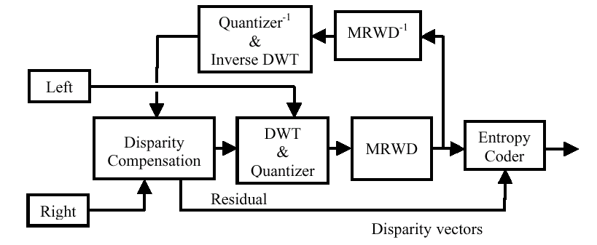
Fig. 1 Block diagram of the proposed stereo coder. The disparity compensation is performed with the reconstructed reference image, by the provided closed-loop.
- A DWT transform and quantization unit, which decomposes and quantizes the reference and the residual target images.
- A Morphological compression unit, which partitions the wavelet coefficients into significant or non-significant groups in order to reduce their entropy.
- An inverse transform unit, which reconstructs the reference image at the encoder’s side and places it as an input to the disparity compensation unit. This is quite reasonable because the reconstruction of the Right image will be performed with the aid of the reconstructed reference image at the decoder’s side. This closed-loop disparity compensation is similar to that used for motion compensation in the MPEG coder.
- A disparity compensation unit, which has as inputs the reconstructed reference image and the target image. This unit compares the two inputs, estimates the best prediction of the target image and produces the residual target image, which is the difference of the target image from its best prediction. This is called Disparity Compensated Difference (DCD) and the best prediction vectors for each block are called disparity vectors (DV).
- An entropy coding unit, which codes the reference image, the residual target image and the disparity vectors.
2.1. The disparity compensation unit
Let 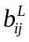and 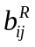are the blocks of the reference and target images at the (i,j) pixel. The block 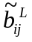 is the reconstructed , which in conjunction with produces the Disparity Compensated Difference (DCD) block.
 (1)
where (x,y) is the position of the block from the top of the image, dv_{x} and dv_{y} are the displacements from the (x,y) position for the best block matching. They are called disparity vectors and are defined as
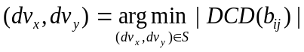 (2)
where S is the window searching area, which is usually 6 pixels around the block and the matching criterion is the Minimum Absolute Difference (MAD), that is
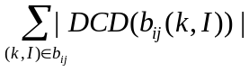 (3)
The above described disparity compensation procedure is the classical block matching algorithm (BMA) for blocks of fixed size. The proposed coder segments the target image into variable size blocks according to a quad-tree splitting procedure [3], [8]. Initially, the Right image is segmented into blocks of homogeneous intensity by its quad-tree decomposition with an intensity difference threshold. These blocks may probably belong to the same object or the background and present homogeneous disparity characteristics. Then, quad-tree decomposition with a simplified rate-distortion criterion follows, which permits the splitting of an already existing block to four children blocks only if there is a rate-distortion benefit from this splitting. The total cost of a residual block is defined as
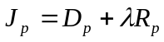 (4)
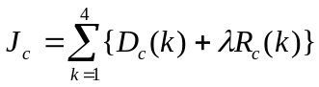 (5)
where J_{p} and J_{c} are the costs of parent and children nodes respectively. Lagrange multiplier ë , defines the relation between distortion and bit rate. Its value affects the segmentation depth of the processed image. The distortion D is the MSE for the specific node. The rate R is defined as:
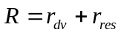 (6)
where rdv and rres are the bit-rates of the disparity vectors and the residual respectively.
Therefore a parent node splits to four children nodes if and only if the cost of the parent is greater than the cost of the children. After the split, the rdv increases, whereas r_{res} and D decrease monotonically. The splitting criterion can be formed as:
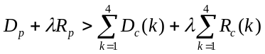 (7)
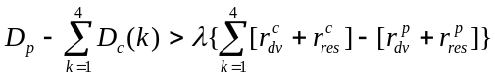 (8)
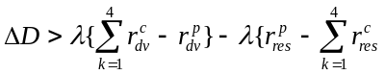 (9)
Equation (9) is finally reduced to the following form:
 (10)
which is satisfied if the following relation is valid:
 (11)
as .rres is always positive. This suggests that a parent node splits to four children if the benefit from the distortion is greater than the benefit from the vectors bit-rate.
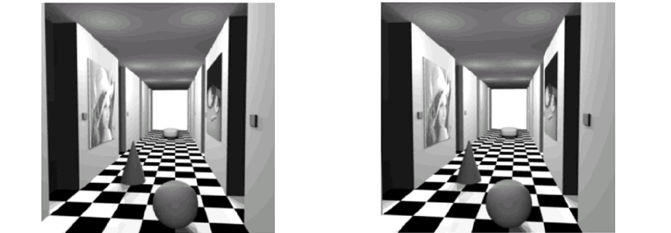
Fig.2 “Room” stereo image pair
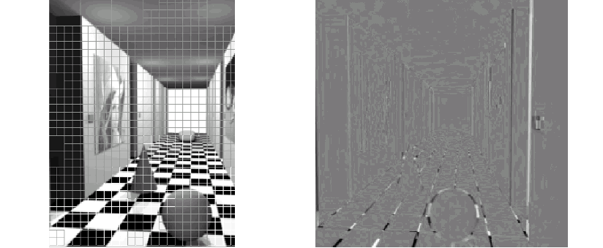
Fig. 3 (a) Quad-tree segmentation of the target image; (b) Residual target image.
Fig. 2 shows the original “room” stereo image pair. Fig. 3 shows the segmentation of thetarget image according to the previously described quad-tree decomposition and the produced residual target image.
2.2. The morphological compression unit
The employed morphological compression algorithm MRWD exploits the intra-band clustering and inter-band directional spatial dependency of the wavelet coefficients. A dead-zone uniform step size quantizer quantizes all the subbands. The coarsest detail subbands constitute binary images that contain two partitions of coefficients, the significant and insignificant. The coefficients that are greater than a predefined threshold are called significant. The intra-band dependency of wavelet coefficients or the tendency to form clusters, suggests that the application of a morphological dilation operator may capture the significant neighbours. The finer scale significant coefficients, in the children subbands, may be predicted from the significant ones of the coarser scale, parent subbands, by the application of the same morphological operator to an enlarged neighbourhood because the children subbands have double size than their parents. This partitioning reduces the overall entropy and consequently the bit-rate, including the overhead of the side information, becomes smaller than in the non-partitioning transmission.
3. Experimental results
The stereo image pairs that were used for the experimental evaluation are the following [13], [14]: “Room” (256 x 256), and “Fruit” (512X512). The proposed stereoscopic coder employs a four level wavelet decomposition with symmetric extension, based on the 9/7 biorthogonal Daubechies filters [10], for both reference and residual target images of the stereo pair. The disparity compensation process is implemented using the classical block-matching algorithm, which is applied on blocks of variable size. The searching area is 6 pixels around the block and MAD is the matching criterion. The objective quality measure of the reproduced images is estimated by PSNR. The total bit-rate is the entropy of the DWT subband coefficients, after their morphological representation and partitioning by the morphological coder and the vectors that are used for disparity compensation.
Table 1 shows the experimental results for the tested images. The estimated PSNR values express the performance of the stereo image pair for distinct bit rates.
Table 1. Performance of the proposed coder for the tested images
Image pair | PSNR (dB)
Image pair | 0.25 (bpp) | 0.5 (bpp) | 0.75 (bpp) | 1 (bpp)
Room | 30.5 | 37 | 41.8 | 45.7
Fruit | 38.2 | 40.9 | 42.9 | 44.7
In Fig. 4, the proposed coder is compared with the disparity compensated JPEG2000 [1], the Optimal Blockwise Dependent Quantization [3] and the Boulgouris et al. stereo coders [2]. It is apparent that the proposed coder outperforms about 1.5 dB on average than Boulgouris et al. stereo coder C, for the whole examined range.The performance is larger for the rest of the compared coders. The efficiency of our method is basically due to the wavelet based morphological coder, which is more efficient than EZW and DCT coders. The proposed morphological coder presents, for “still” images, about 1 dB better performance over the popular EZW [9] and also outperforms DCT because of its wavelet nature. The employed rate-distortion algorithm contributes about 0.3 dB to the final quality of the reproduced image pair. This means that if a fixed size block disparity compensation procedure was combined with the same morphological coder, the performance would be about 0.3 dB worse.
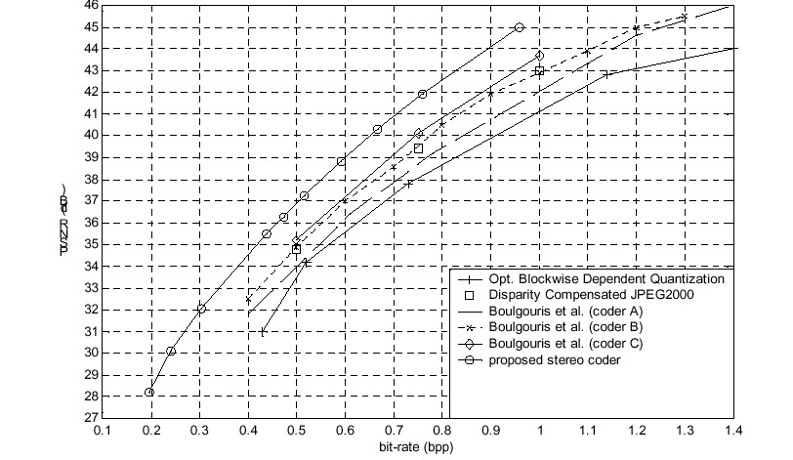
Fig. 4 Experimental evaluation of several stereoscopic coders for “Room”.
4. Conclusions
In this paper a novel stereoscopic image coder, which is based on a variable block size disparity compensation unit and a morphological coding unit, is presented. The disparity compensation unit employs closed-loop disparity compensation and in addition uses a rate-distortion quad-tree methodology in order to segment the target image into variable size blocks. This technique splits one block to four equal sized blocks if a simplified rate-distortion criterion is fulfilled. This criterion involves the relationship between distortion and rate of the parent and children blocks. The disparity compensation is performed with the classical full-search block-matching algorithm between blocks of variable size. The morphological unit employs a morphological algorithm, which partitions the significant and insignificant coefficients of a discrete wavelet transform. This is a robust “still image” coder, which inherits all the advantages of a wavelet transform and lowers the entropy of the transmitted sequence. The experimental evaluation of the proposed coder has shown that its performance is better than other state of the art stereoscopic image coders.
References
[1] Adams, M.D., Man, F., Kossentini, H. and Ebrahimi, T. (2000) JPEG 2000: The next generation still image compression standard. ISO/IEC JTC 1/SC 29/WG 1 N 1734.
[2] Boulgouris, N.V. and Strintzis, M.G. (2002) A family of wavelet-based stereo image coders. IEEE Trans. on CSVT, 12(10), 898-903.
[3] Ellinas, J.N. and Sangriotis, M.S. (2003) Stereo video coding based on interpolated motion and disparity estimation. Proc. of EURASIP 3 rd Int. Conf. on ISPA held at Rome.
[4] Ellinas, J.N. and Sangriotis, M.S. (2004) Stereo image compression using wavelet coefficients morphology. Image and Vision Computing, 22(4), 281-290.
[5] Frajka, T. and Zeger, K. (2003) Residual image for stereo image compression. Optical Engineering, 42(1), 182-189.
[6] Perkins, M.G. (1992) Data compression of stereopairs. IEEE Trans. On Communications, 40, 684-696.
[7] Servetto, S.D., Ramchandran, K. and Orchard, M.T. (1999) Image coding based on a morphological representation of wavelet data. IEEE Trans. on IP, 8(9), 1161-1174.
[8] Sethuraman, S. (1996) Stereoscopic image sequence compression using multiresolution and quadtree decomposition based disparity and motion adaptive segmentation. Ph.D Thesis, Carnegie Mellon University.
[9] Shapiro, J.M. (1993) Embedded image coding using zero trees of wavelet coefficients. IEEE Trans. on SP, 41(12), 3445-3462.
[10] Usevitch, B.E. (2001) A tutorial on modern lossy wavelet image compression: Foundations of JPEG 2000. IEEE SP Magazine, 22-35.
[11] Woo, W and Ortega, A. (1999) Optimal block wise dependent quantization for stereo image coding. IEEE Trans. on CSVT, 9(6), 861-867.
[12] Woo, W. and Ortega, A. (2000) Overlapped block disparity compensation with adaptive windows for stereo image coding. IEEE Trans. on CSVT, 10(2), 194-200.
[13] http://vasc.ri.cmu.edu/idb/html/stereo/index.html. Carnegie Mellon University.
[14] http://www-dbv.cs.uni-bonn.de. University of Bonn.

A mechanism for rate adaptation of media streams based on network conditions
Ch. Patrikakis 1 , Y. Despotpoulos 1 , J. D. Angelopoulos 1 ,
C. Karaiskos 1 , A. Lampiris 2
1 Technological Educational Institute of Piraeus,
School of Technological Applications,
Division of Automation
250 Thivon Str., GR-12244 Egaleo, Greece
bpatr@ieee.org, ydes@ieee.org, gaggel@teipir.gr, ccar@teipir.gr
2 National Technical University of Athens,
School of Electrical and Computer Engineering, Division of Communication,
Electronic and Information Engineering
9 Heroon Polytechneiou Str., GR-15773 Athens, Greece
biril@telecom.ntua.gr

Abstract. Media streaming technologies deployed over the Internet consume a considerable amount of bandwidth. Most of these technologies, either private or standards based, do not take into consideration the network conditions during the media transmission, leading to network congestion and decrease of stream reception quality due to packet loss. In this work we present an adaptation mechanism based on RTP/UDP protocols that may be used by hosts serving media streams to a large number of unicast users. Servers utilize a session man-ager in order to switch users between a number of pre-selected stream profiles, taking into account the long-term history of user receiver reports. The results of this mechanism show decrement of packet loss and more efficient utilization network resources.
1. Introduction
The enormous growth of internet based communication that has taken place during the last decade has created the need for more sophisticated methods of conveying information. Out of these, first and foremost is without doubt the use of multimedia information in the form of video and audio, which has been steadily gaining ground. Although early attempts at providing multimedia content to users were focused on ‘progressive download’ methods (in which content is downloaded but starts to play before the download is complete), current state of the art technologies have popularized the use of real time streaming as well as live broadcasts.
Still, the current internet does not provide the guarantees associated with real-time applications such as streaming video. Firstly, multimedia applications are bandwidth consuming. This poses a problem that cannot be combated by simply adding capacity to existing infrastructures, as new demanding applications for absorbing the available assets will soon appear. Furthermore, multimedia is a special case of Internet traffic with very strict QoS requirements on bandwidth, delay and loss, characteristics which are inconsistent with the best-effort nature of today’s Internet.
It is therefore, not surprising that these challenges paired with the popularity and commercial exploitability offered by multimedia technologies have attracted considerable research efforts. Thus, a variety of mechanisms have been proposed for QoS provision. These include rate adaptive streaming, resource reservation and admission control.
It is the aim of this paper to present a rate adaptation mechanism as part of a platform designed to support streaming to a large number of clients. For this, different types of existing rate adaptation mechanisms are identified and requirements are established which should be met by an effective rate adaptation scheme. These are taken into account in order to evaluate the presented solution. Finally a brief discussion is made about the issue of modelling the presented mechanism in a simulation environment such as Network Simulator.
2. Existing rate adaptation mechanisms
In this section, different types of existing rate adaptation mechanisms are briefly discussed. It should be noted before proceeding that our interest lies specifically in unicast mechanisms as the proposed solution will utilize unicast exclusively. Additionally, it is a fact that multicast based schemes place specific demands on the underlying network infrastructure, thus reducing the scope and scalability of any proposed mechanism.
Existing unicast based, rate adaptation mechanisms may be categorized into stream thinning, feedback based encoder adaptation, and multi-rate switching.
Stream thinning refers to the elimination of video packets in order to protect the audio feed when network congestion occurs on the client-server link. In this manner, al-though the video feed is suspended the stream is not altogether lost. When bandwidth returns to normal, the video feed is resumed. Even though stream thinning succeeds in somewhat preserving continuity of the client-received stream, it is a radical measure mainly used as complement to other rate control mechanisms.
Feedback based encoder adaptation[4] makes use of information provided by reporting protocols that are employed during streaming, in order to adapt the encoder output bitrate to network conditions. An example of such a protocol is RTCP[1], which is used in conjunction with RTP[2][3] to provide data concerning fraction of dropped packets, inter-arrival jitter, delay, etc to server and clients. Though the encoder can be theoretically configured to adapt content to the appropriate bitrate with respect to individual clients’ requirements, it is clear that this solution cannot service a large-scale system because real time compression is computationally expensive.
Multi-rate switching[5] allows mid-stream switching between different rates according to detected network conditions. The innovation of this approach, employed by various commercial solutions[6][7], lies in the use of multiple encodings of the original content (each at a different bit rate) optimized for various network load conditions. The result is a single file wherein all encoded streams are bundled. This file is constructed in such a way that allows the appropriate stream extraction by the server’s specific software. During the streaming session, the player monitors the bandwidth and the loss characteristics of the connection and requests the server to switch to the stream that will provide an acceptable quality. The shortcoming of this mechanism is that the size of the file in which streams are bundled dramatically increases. As a result only a few distinct bitrates are chosen and ultimately used.
3. Requirements
Presently we establish requirements, which should be met by an effective rate adaptation scheme.
•Scalability. As applications such as live broadcasts of popular events[8] gain more ground, it is evident that an effective rate adaptation scheme should scale up to meet the demands presented in the case of streaming to
large numbers of clients. Placing excessive demands on server-side processing power or relying upon specific features of network infrastructure is therefore undesirable. Furthermore component based, distributed systems are preferable since they offer better scalability than comparable monolithic systems.
•Optimal network utilization and fine adaptation granularity[5] is another requirement that has to be emphasized. Adaptation granularity reflects the extent to which the rate assigned to a receiver is proportionate to its available bandwidth and processing power. The need for sophisticated allocation of the available bandwidth resulting in better adaptation of available content to client capabilities is especially pronounced in scenarios characterized by high heterogeneity of participants.
•Suitable rate adjustment frequency is also a critical parameter of adaptive video. It refers to the frequency at which data collected by the feedback employed mechanism is evaluated in order to enforce rate adaptation. It is subject to trade-offs meaning that large rate adjustment frequency results in faster, short term adaptation whereas a smaller adjustment frequency leads to smoother adaptation over longer time scales. Ideally a compromise should be made between the two. A variable rate adjustment frequency is also an inter-esting alternative.
•Correctly placed control responsibility. Each client receiving a stream from a particular server may have enough data at its disposal to obtain in-formation such as packet loss and subsequently report it back to the server. Still, it is not possible for a client to acquire a clear picture about other clients connected to this particular server and how these affect overall system performance. Therefore, it is in some cases preferable to place control responsibility at the server side, where a clearer picture of the overall system state may be available.
4. Proposed mechanism
In this section we present a platform designed to support streaming to a large number of clients and especially focus on the inherent rate adaptation mechanism.
Our platform consists of servers, reflector nodes and transcoders. Servers are responsible for streaming stored or live content and are viewed in the proposed architecture as the point where any stream originates. As in the usual case, clients may request a particular stream directly from a server or the request may be submitted to a reflector node. In the latter case, content is transmitted to the reflector node before being for-warded to the client. A reflector node may serve a large number of clients by replicating and subsequently forwarding packets received from the server, thus reducing the server’s workload. For example, assume that a large number of clients request the same stream from a specific reflector node. In this case only one copy of the stream has to reach the reflector node. There, the stream is replicated and transmitted to the various clients. This form of application layer multicast[9] improves scalability as the system’s capacity (in terms of clients) may be increased by deployment of additional reflector nodes.
Another measure aiding scalability is the use of transcoders that need not be integrated with servers or reflector nodes. In this manner transcoders may be deployed (on dedicated hardware) as needed, according to the number and diversity of participants.
For example, consider a reflector node that is relaying a specific stream to various clients. If at some point feedback information (received by the reflector node) indicates that a large number of clients is sustaining high packet loss then it is possible to transcode the relayed content to a lower bitrate by means of a newly utilized transcoder. The latter could reside on a dedicated machine somewhere in the network in which no overhead is caused to the reflector node except that of transmitting the content to the client-transcoder and subsequently receiving the transcoded stream. It is evident that the aforementioned procedure results in better network utilization as well as a reduction of client side packet loss. The problem of rate adaptation as it relates to the aforementioned platform may be
formulated as follows: Consider a multimedia stream S encoded at n different bitrates b_{i}, giving n streams s_{i}, 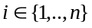. A reflector node relays the streams to various clients over an unreliable transport protocol. The clients are categorized to n groups G_{i} according to the received stream (for example, a client receiving stream s_{k} (encoded at bitrate b_{k}) belongs to group G_{k}). Moreover a group G_{k} contains g_{k} clients c_{kj}, 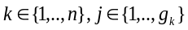. This configuration is summarized in the following diagram.
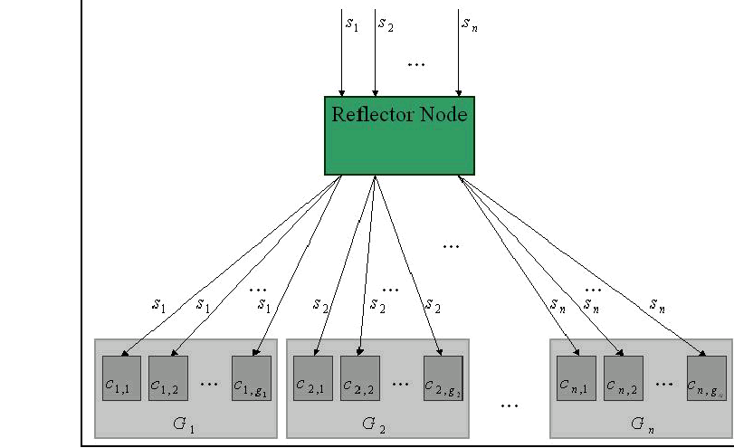
Figure 1: Client grouping according to the received stream bit-rate
In this configuration, we seek to formulate a policy of responding to varying network conditions by dynamically adapting a subset of the parameters and n {},1,, i b i n .K , in order to achieve minimization of client-side packet loss and maximization of net-work utilization and perceived quality. The term “network conditions” is loosely used to refer to the parameters that affect stream quality such as available bandwidth, net-work congestion and the number of served clients.
Considering a fixed number N of streams, each stream encoded at a fixed bitrate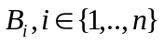, a specific case of the generally stated problem emerges. Here, we seek to find the optimal distribution of clients to available streams whereby minimization of client-side packet loss and maximization of network utilization and perceived quality is achieved. It is worth noting that the result we seek is twofold. Firstly, we wish to obtain a specific (optimal) distribution of clients as a function of their performance (specifically the sustained packet-loss). Secondly, we wish to design an algorithm of dynamically enforcing this distribution over time, as a response to fluctuating client performance.
We specifically focus on this version of the problem, as not only is it greatly simplified but also adequately fits the model of a reflector node relaying a number of transcoded streams to a number of clients. As a simple example of the aforementioned algorithm at work, consider a reflector node that relays 3 streams s₁ (64Kbps), s₂ (128Kbps) and s₃ (256Kbps). Thestreams are received by clients c₁, c₂, and c₃ respectively, as can be seen in Figure 2a.
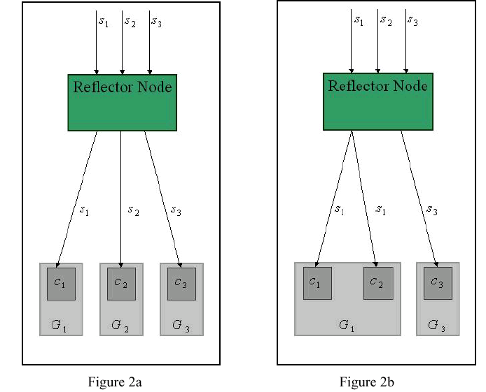
Figure 2: An example based on 3 streams
At some point it becomes known (by means of a reporting mechanism presumably established between the clients and the SAS node) that client c₂ is sustaining a significant packet loss that is deemed as unacceptable on the basis of the defined policy.
As a response the reflector node ‘switches’ the 128Kbps transmitted to c₂ with the 64Kbps stream (Figure 2b). This results in a decrement of the packet loss experienced by the client causing smoother client-side playback of the received stream as well as better network utilization.
Using the aforementioned platform, a variety of different rate adaptation policies (algorithms) could be tested. As an example consider the algorithm which examines the packet loss of each client in a group and determines the worst and best performing clients in the group. Then initiates a ‘switch’ of the stream received by the worst performing client with a stream encoded at a lower bitrate and another ‘switch’ of the stream received by the best performing client with a stream encoded at a higher bitrate.
Another example of a stream switching algorithm would be one that instead of the ‘best’ and ‘worst’ clients locates all clients beneath or over some specified threshold. In this manner it is possible to test the same scenario with different (in terms of the implemented policy) rate adaptation mechanisms. Moreover, various rate adjustment frequencies could be tested. It is also worth noting that by placing control responsibility at the reflector side, as we have done, we obtain the ability to observe the performance of the system of clients in its entirety. For example not only is it possible to obtain the packet loss occurring on a transmission to a specific client but we’re also in a position to identify the client, which suffers the most (or least) packet loss.
5. Conclusions
In this paper, a rate adaptation mechanism was presented as part of a platform designed to support streaming to a large number of clients. Various types of existing rate adaptation mechanisms were briefly discussed and requirements, which should be met by an effective rate adaptation scheme, were identified. Subsequently it was shown that the proposed solution met the aforementioned requirements and the fact that a variety of different rate adaptation policies (algorithms) could be tested on the proposed platform was explained. Future work would include modeling the components of the platform into a simulation environment such as Network Simulator in order to evaluate a variety of different rate adaptation policies (algorithms) with a large number of clients.
6. Acknowledgments
The ideas presented in this paper have been based on work performed in the context of the Greek National project Archimedes, “Design of Overlay Architecture for efficient streaming of real-time multimedia over the Internet”.
7. References
[1] H. Schulzrinne et al., “RTP: A Transport Protocol for Real-Time Applications”, IETF RFC 3550, July 2003.
[2] H. Schulzrinne, S. Casner, R. Frederick, and V. Jacobson, “RTP: A transport protocol for real-time applications”, IETF RFC1889, January 1996.
[3] I. Busse, B. Deffner, and H. Schulzrinne, “Dynamic QoS control of multimedia applications based on RTP”, Computer Communications 19 (1996) 49-58.
[4] J. Lu, “Signal Processing for Internet Video Streaming: A Review”, in Proc. Of SPIE Image and Video Communications and Processing, January 2000.
[5] B. Li and J. Liu, “Multirate Video Multicast over the Internet: An overview, IEEE Network” 17(1) (2003) 24-29.
[6] RealNetworks, “Introduction to streaming media with RealOne player”, http://service.real.com/ help/library/guides/realone/IntroGuide/PDF/ProductionIntro.pdf, October 2002.
[7] B. Birney, Intelligent Streaming, http://msdn.microsoft.com. October 2000.
[8] Ch. Z. Patrikakis, G. Koukouvakis, A. Lambiris, N Minogiannis, “A report on media streaming for large numbers of users”, to appear in the Annual Review of Communications, Volume 57" of IEC.
[9] Su-Wei Tan, Gill Waters, and John Crawford, “A survey and performance evaluation of scalable tree-based application layer multicast protocols” (July 2003)

Achieving Network Layer Connectivity in Mobile Ad Hoc Networks
Pavlos Kouros, Kimon Karras, Georgios Bogdos, Dimitris Yannis
Technological Educational Institute of Piraeus
Computer Systems Engineering Department
P.Ralli & Thivon 250
pkouros@teipir.gr

Abstract
Mobile Ad Hoc Networks (MANETs) is an area of networking which has been the focus of intense research in the past years. Due to their differences from traditional wireline networks, MANETs require a completely different set of protocols to cope with their decentralized nature. As such both evolution and innovation is required in many sectors. One such sector is the network layer which encompasses numerous important functions. This paper focuses on providing a comprehensive guide on achieving node connectivity at this layer. This includes selecting a proper routing protocol, as well as an autoconfiguration algorithm. These are assumed to operate around an IP protocol, more specifically IPv6. Finally we will discuss possibilities for ensuring QoS in Ad Hoc networks.
Keywords: ad hoc, routing, QoS, autoconfiguration
I - Introduction
Mobile Ad Hoc Networks are considered one of the most promising areas of networking. An Ad Hoc network consists of mobile nodes, which may vary in size & capabilities which communicate to create a network without preexisting infrastructure. Thus a MANET can be formed dynamically without any preexisting infrastructure, reducing both deployment time and costs and increasing flexibility. Unfortunately these advantages provide us with a set of problems. The majority of current network protocols have been developed to operate in strictly defined, mostly static environment, so using them in an ad hoc environment is the very least problematic. Thus a new protocol stack should be defined, using mostly newly developed protocols that can answer the challenges met in ad hoc networks. To define this protocol stack it is imperative that we develop a framework upon which the evaluation of such protocols can be accomplished.
The network layer is responsible for converting the facilities of the lower layer into services that the upper layers can use. It is responsible for a host of important tasks such as routing and addressing and configuring nodes. The nature of Ad Hoc nature makes it impossible to use current network layer protocols. Thus a host of new ones have been proposed to achieve connectivity at this layer. This paper examines Ad Hoc routing protocols as well as address autoconfiguration algorithms. The former are protocols specifically developed to forward packets in multi-hop networks & the later aim to allocate each node in a MANET a unique IP address. Then we attempt to use these mechanisms to provide QoS mechanisms at the network layer. QoS is a required for a number of applications particularly real-time and critical ones, which are dominant in several areas of possible MANET use, such as military or aviation applications.
Mobile Ad Hoc networks are very different from wireline networks. In the later everything predetermined, that is the network topology is already know as well as its infrastructure and the equipment used. This allows for network administrator and architects to carefully plan its deployment to meet their requirement. Unfortunately Ad Hoc Networks are very different in that there is no knowledge about any of the abovementioned parameters. So there is no real information about the physical or logical connectivity of other nodes, neither about the services provided by each. This comes in stark contrast with traditional networks where most information is preset and those that aren’t can be discovered with a simple service discovery protocol.
The rest of this paper is structured as follows: In Section II we will an overview of auto-networking technologies for MANETs. In Section III we will analyze Ad Hoc routing. Section IV will investigate the application of Quality Of Service mechanisms in Ad Hoc Networks. Finally Section V combines the above elements and provides the groundwork for future work.
II – Autoconfiguration technologies for Manet’s
One of the most important characteristics of Ad Hoc networks is their spontaneous creation. For this to be achieved a mechanism must be invented that is able to organize the network and manage resources (like IP address) and configuration parameters (like the maximum transmission unit – MTU). In most applications this is impossible to do manually. Configuring an Ad Hoc network at the network layer involves one fundamental task: Unicast Address Allocation.
Unicast Address Allocation is the first and absolutely essential goal of the presented auto-networking technologies. Without a unique network layer address unicast communication is impossible. Obviously a stateful method, such as DHCP cannot be used, because it is not possible to guarantee access to a DHCP server for each node and since introducing such an centralized component weakens one of the fundamental MANET advantages, namely distributed operation.
The newest version of the internet network layer protocol IPv6 includes algorithms for both stateful and stateless address autoconfiguration. This algorithm involves three steps: The assignment of a tentative link local address to each node, the verification of the uniqueness of this address through a Duplicate Address Detection process and finally the construction of a site-local address through the acquisition of a Router Advertisement message.
This algorithm while useful is inadequate for use in Mobile Ad Hoc Networks for several reasons. First of all it requires the presence of router on a link to configure anything but link-local addresses, but provides no means for autoconfiguring routers. In Ad Hoc networks all nodes play the role of a router thus it is practically impossible to use this algorithm. Nevertheless it has served as an inspiration for other mechanisms, some of which are described below.
The issue of node autoconfiguration (and in particular address allocation) has been the focus of significant research. Over the past few years numerous solutions have been proposed. These solutions can be subdivided into three categories:
Conflict Detection Allocation
Conflict Detection Allocation algorithms present the most straightforward solution to the problem of unicast address allocation. They adopt a method of trial and error to assign each node a valid address. The process is quite simple. The new node selects a random tentative address, then broadcasts a message to the whole network asking if that address is unique. If no response is received after a finite number of retries the address is considered unique and assigned to an interface. If an answer is received then the selected tentative address is already occupied and the node must select a new one and repeat the process.
Conflict Free Allocation
Conflict Free Allocation algorithms assign each new node an address that is already known to be unique. This is accomplished by using disjoint address pools for each node. Thus there can be no conflicts among the allocated addresses. Obviously to accomplish this each node must keep some sort of state information for each address.
Best Effort Allocation
Best Effort Allocation algorithms attempt to assign a new node an unused – to the best of their knowledge – address, but still use conflict detection methods to ensure that this address is indeed unique. Each node keeps a state for each address, but because he cannot assume to always have up-to-date information regarding the entire network cannot be sure that the information upon which it bases its address allocation is valid.
Following is a table describing the most important characteristics of each algorithm:
 | Conflict detection | Conflict free | Best effort
Network Organization | Flat/ Hierarchical | Flat | Flat/ Hierarchical
Overhead | High | Small | High
Network Settling | Time | High | -
Node Join Time | High | Small | High
Address Reclamation | Not needed | Needed | Needed
Node Depart Time | - | Medium | Medium
Distributed | Yes | Yes | Yes
Complexity | Small | Medium | High
Evenness | Even | Uneven | Even
Scalability | Small | Medium | Small
In short we can say that best effort allocation algorithms tend to be the least useful, that is because the actually combine the worst of both worlds. To elaborate a little on this:
There are two important setbacks for Conflict Detection allocation. Firstly it broadcasts information on the network and it does it quite often, resulting in rather large overhead and secondly there is considerable delay until an address is assigned to an interface due to the timeouts involved. Best effort allocation has these disadvantages. Conflict Free allocation on the other hand has neither but is usually quite complex to implement and requires that an address state table is kept thus consuming memory which is not abundant in mobile nodes. Best effort allocation also maintains state tables, which is an additional problem. In general we can say that best effort allocation can be successfully used only with proactive routing protocols so as to take advantage of their periodic signals to update it’s state tables.
To conclude we can say that both Conflict Detection and Conflict Free algorithms have their advantages. Conflict Detection Algorithms tend to be less scalable than Conflict Free ones, though the later cannot provide really large scalability either. For simple networks consisting of a few nodes a conflict detection algorithm like the one proposed in [6] would be ideal. For more demanding applications, complex solutions must be devised, possibly combining advantages from several categories.
III - Routing Protocols for Ad Ho Networks
A routing protocol must meet various requirements for its proper use in mobile ad hoc networks. Such requirements are low network and memory utilization, scalability, the ability to cope with increased node mobility, loop freedom, minimal routing overhead, Quality of Service capabilities, security and bandwidth efficiency.
Routing for MANETs has received the largest research focus in the past years. These efforts have yielded considerable results in the form of numerous protocols. These protocols can be classified into four categories: On-demand, Table-driven, Cluster-based and hybrid. Each of these categories follows a different approach and as such has its own different ups and downs. A short description of each category follows:
On Demand Protocols
On Demand protocols discover paths to a destination only when requested. Their function is compromised of two tasks. The first, route discovery involves finding valid routes to a destination. This is accomplished by broadcasting a Route Request (RREQ) packet on the network. This packet propagates through network until it reaches the destination node, which then retraces the route and replies with a Route Reply (RREP) packet. (Note that the route inversion is only possible when the links are symmetric). Since this is not always the case the node transmitting the RREP packet may also have to perform route discovery. When the node initiating route discovery receives a RREP packet it has at least one valid route to the destination node.
The second task that on-demand routing protocols must handle is route maintenance. This involves discovering and patching up problems with already discovered routes. This is handled through Route Error (RERR) packets that are transmitted when a node detects a broken link. Nodes receiving this packet stop forwarding packets using routes that use this link.
On-demand protocols have several advantages, the most important being low overhead, since routes are only discovered when requested. In addition since no routing tables are maintained they require relatively little memory to operate. On the downside they introduce a considerable delay from the request of a route until it’s discovery. Examples of on demand protocols are the Ad hoc On Demand Distance Vector (AODV) and the Dynamic Source Routing (DSR).
AODV is the most sophisticated protocol for MANETs so far and has been at the epicenter of most research. AODV follows the on-demand protocol format described above. In order to avoid the infinite looping of packets of the “Bellman-Ford” algorithm, AODV uses sequence numbers to stamp routes from an originate to a destination node. AODV is also capable to manage security considerations and it has multicast and other abilities through the various existing extensions.
Table Driven Protocols
Table driven protocols maintain tables in which they attempt to have at least one valid route to each node in the network. This is accomplished by the periodic broadcast of messages. With these messages a node declares its presence and availability to its neighbours. When the network topology changes, nodes update their tables by transmitting update packets. These tables can also contain other useful information, such as a list of all the transmitting nodes neighbours or the nodes current routing table. The major strength of proactive protocols is that there is no delay until the route request is served. Their weakness is that they produce high overhead due to the continuous packet transmissions. An example of table-driven protocols is TBRPF (Topology dissemination Based on Reverse Path Forwarding).
Cluster based Protocols
Cluster based protocols are based on the concept of grouping nodes together depending various topology parameters. These protocols usually elect a clusterhead node, which is responsible for the communication with other clusters. The connection between the different clusters can be achieved through intermediate nodes, known as gateways, which belong to many clusters at the same time. The advantages and disadvantages of these protocols may vary depending on the use of the ad hoc network. The most serious drawback is that they introduce a form a centralized structure which is difficult to maintain due to node mobility.
On the upside routing overhead is significantly limited. An example of these protocols is the Cluster Based Routing Protocol (CBRP).
Hybrid Protocols
Hybrid protocols combine various characteristics of all the above categories. Depending on the protocol, we have on demand protocols with enhanced use of procedures of table driven protocols and the opposite. Many protocols also use clustering concepts depending on the application for which the mobile ad hoc network is intended. An example of these protocols is the Zone Routing Protocol (ZRP).
IV – QoS mechanisms in Ad Hoc Networks
The mobility and dynamic topology of the nodes in a MANET make network management a really challenging. This is because the level of the offered “quality” in an established connection varies depended of a variety of external conditions. So the intention is the definition of a Quality of Service (QoS) model which will operate with the minimum resources and will adapt troublelesly in dynamic environments.
QoS is the mechanism which is responsible for the management of traffic in such a way that it can meet the demands of each application which wants to use the network each time without wasting the already scanty in MANETs resources.
When we refer to the availability of QoS we mean a set of quantitative metrics which define it. These are the available bandwidth, the packet loss rate, delay, packet jitter, hop count, path reliability.
The use of QoS is essential in applications which are sensitive to the time of their transmition, such as real time applications. People will be using MANETs to connect each other via very common devices (PDAs, laptops, mobile phones etc.) from almost anywhere and use services such as video on demand, videoconference, and internet telephony.
Some additional difficulties for providing QoS in MANETs arise from their decentralized nature, their limited - due to the wireless links - bandwidth, the case of overload, the signal attenuation, noise, external elements, limited resources, power management, end to end protocols and demands of the applications.
Up to today most research on providing QoS for MANETs is the evolution of the two main architectures for wired networks, Integrated Services and Differentiated Services. The later dissever each flow of the traffic and treat each independently according to its demands, while the in former all the flow is been treated using a single method.
QoS metrics should be taken into account when designing a routing protocol. Usually these are either the minimum bandwidth or the maximum delay, as well as the method for path calculation, the way by which the QoS will be forwarded to the other nodes and remain stable and dissever priorities. All these ought to dynamically adjusted with each topological change of the network.
CEDAR (Core-Extraction Distributed ad hoc Routing Algorithm) is an algorithm which provides routing with quality of service in MANETs. To establish a connection the algorithm divides the network into smaller subnets in which the core extraction mechanism chooses an appropriate node to be responsible for route computation. The core nodes are then informed about the condition of surrounding and their bandwidth availability. The next step is the establishment of a connection between the source and destination nodes, considering the information provided by the core nodes. The main advantage of the algorithm is its simple routing structure, as well as the fact that it’s cluster based architecture assigns most of the work to the core nodes. This architecture proves to be the algorithms main setbacks as these nodes can become overwhelmed in scenarios with high node mobility or a large number of nodes.
Research on the two aforementioned architecture had yielded a number of mechanisms for providing QoS, the most important of them being the ReSerVation Protocol, DiffServ, Multi Protocol Label Switching, Subnet Bandwidth Management.
RSVP is a very promising algorithm. It differentiates each flow from the traffic stream. A session defines the destination address, destination port and a protocol identifier. The messages needed for the propagation of the QoS metrics are transmitted to the same direction
as the media flow. It supports both multicast and unicast flows, which are reserved in one direction only. It is a soft state, receiver oriented protocol, which allows transparent flow through non-RSVP routers and switches. RSVP does not control directly the behavior of the network devices.
Another way to establish QoS conditions in a network is the through signaling. INSIGNIA is the most prominent signaling protocol. It is quite effective since it accomplishes not to use many acknowledgment packets thus not imposing a significant amount of additional overhead. It also includes a feedback mechanism, which decreases the error probability.
Finally the use of IPv6 as the default network protocol provides as with some built-in QoS capabilities, through an option in the hop by hop extension header (QoS Object Option).
V - Conclusion
In this paper we described numerous technologies that attempt to answer the most important challenges met in the network layer in Mobile Ad Hoc Networks. These technologies can be combined in various ways to achieve the desired result, which is a reliable network layer protocol under the IPv6 umbrella.
Future work includes the realization of this combination and it’s incorporation in a complete protocol stack, as well as it’s simulation and evaluation.
References
[1] Deering S, Hinden E., 1998, RFC 2460 - Internet Protocol, Version 6 (IPv6) Specification
[2] Thomson S., Narten T., 1998, RFC 2462 - IPv6 Stateless Address Autoconfiguration
[3] Perkins C., Malinen J., Wakikawa R.., Belging Royer E.M., Sun Y., 2001, IP Address Autoconfiguration for Ad Hoc Networks
[4] Misra A., Das S., McAuley A., Das S.K., 2001, Autoconfiguration, Registration & Mobility Management for Pervasive Computing
[5] Zhou H., Mi L.M., Mutka M.W., Prophet Address Allocation for Large Scale MANETs
[9] Subha D., 2002 - H.323/RSVP Synchronization for Video over IP
[10] Perkins E, Quality of Service for ad-hoc on demand distance vector routing
[11] Zhigang KAN, Dongmei ZHANG, Runtong ZHANG, Jian MA, QoS in Mobile IPv6
[12] Prasant M., Jian Li, Chao Gui, QoS in Mobile Ad Hoc Networks
[13] Kui Wu, Janelle H., QoS support in Mobile Ad Hoc Networks
[14] Kuosmanen P., Classification Of Ad Hoc Networks
[15] Perkins C., Belding-Royer E.M, Das S., AODV Routing

Combining centralized and decentralized media distribution architectures
Ch. Patrikakis 1 , Y. Despotopoulos 1 , J. Angelopoulos 1 ,
C. Karaiskos 1 , P. Fafali 2
1 Technological Educational Institute of Piraeus,
School of Technological Applications,
Division of Automation
250 Thivon Str., GR-12244 Egaleo, Greece
bpatr@ieee.org, ydes@ieee.org, gaggel@teipir.gr, ccar@teipir.gr
2 National Technical University of Athens,
School of Electrical and Computer Engineering,
Division of Communication, Electronic and Information Engineering
9 Heroon Polytechneiou Str., GR-15773 Athens, Greece
pfafali@telecom.ntua.gr

Abstract. The major bottleneck for streaming media content over the Internet was the access technologies used by residential users. As more users access the network with broadband technologies the deployment of end-to-end real time services based on multimedia content is becoming a reality. The sensitivity of such services in terms of time delay and the large amount of network’s band-width consumed must be taken into consideration when designing an architecture capable of delivering streaming media under QoS restrictions. Furthermore, the scalability of the distribution scheme for multimedia streaming must be carefully studied and should clearly define all the networking parameters responsible for content delivery. In this work we present an architecture for streaming real time content over the Internet combining centralized and decentralized architectures. The centralized approach is followed in the core of the network, permitting an efficient configuration and interconnection of the sys-tem components. The decentralized approach is followed at the client side in order to quickly select the closest media relaying point for the desired stream.
1 Introduction
In the last decade, multimedia communications have received considerable attention from the research community. The rapid growth of the Internet and the ubiquitously enabled access to it has made content delivery over Internet very popular. Though in its initial conception media clips were offered in download and play mode, this solution could not scale due to the capacity restrictions of the storage units and the extra delay introduced until the final playback of the video.
Media streaming was suggested in order to overcome the limitations of downloadable content. It is built upon the concept of progressive download, allowing a multi-media signal to be transmitted for viewing after only a momentary delay for data buffering. However, streaming over the Internet poses many challenges. Unlike other Internet applications, it has very stringent QoS requirements in order to present video of acceptable quality and avoid long delays and players’ buffer starvation. Due to the best-effort nature of the current Internet and the increased availability in multimedia rich content, much complexity is induced in the streaming services.
For the purpose of efficient media delivery over the Internet, Content Distribution Networks (CDNs) have been proposed with several commercial implementations worldwide [1][2]. A CDN [3] is a network optimized to deliver specific content, such as Web pages and real-time streaming media. There are two general approaches to building CDNs: the overlay approach, and the network approach. Generally, CDNs are considered as overlay networks. In the overlay scheme, application-specific servers or caches at various points in the network handle the distribution of specific content types. The ultimate goal is to bring the content near network edges and cache it in an efficient manner to reduce upstream bandwidth usage, response time, origin server load, probability of packet loss, and total network resource usage. The core network infrastructure plays no part in content delivery, short of providing basic connectivity or guaranteed QoS for specific types of traffic. This avoids the problems that plagued multicasting and restricted its deployment offering transparency over heterogeneous networks and administrative domains.
The most important shortcoming of CDNs is attributed to DNS-based routing mechanism applied in most cases [4]. This approach involves many levels of redirection and does not scale well, since when time-to-live (TTL) field expires, lookup incurs the long round-trip time to centralized DNS servers (root and authoritative) irrespective of clients’ location. In addition, though the short TTL used helps in responding to network dynamics, DNS servers get overloaded. Finally, when requests traverse many DNS servers, the client’s location may be hidden and the content provider server selected may be inappropriate.
Another mechanism for content delivery is that of Peer-to-Peer (P2P) systems where peers collaborate to form a distributed system for the purpose of exchanging content. Peers that connect to the system typically behave as servers as well as clients: a file that one peer downloads is often made available for upload to other peers. Users interact with P2P systems in two ways: they attempt to locate objects of interest by issuing search queries, and once relevant objects have been located, users issue download requests for the content. Unlike CDN systems, the primary goal of usage for P2P systems is a non-interactive, batch style download for content. P2P systems differ in how they provide search capabilities to clients. P2P systems have two phases: discovery phase and delivery phase. In the discovery phase, a peer tries to find another peer that has what is requested. In the delivery phase, direct communication is performed with the discovered peer.
The notion behind the work presented here is to present an architecture for streaming real time content over the Internet combining centralized and decentralized architectures. The centralized approach can be followed in the core of the network, permitting an efficient configuration and interconnection of the system components. The decentralized approach is followed at the client side in order to quickly select the closest media relaying point for the desired stream. In this way, we can provide an end-to-end decentralized system able to efficiently capture, encode and distribute hundreds of personalized audio and video streams from live sources across the Web to multiple recipients. This framework is built upon an overlay architecture aiming at dealing with the scalability problems and the deployment difficulties that IP multicast introduced [5]. The distribution mechanism provides the feature of selecting the best relay mode which is actually the key issue discussed in this paper. The innovation of the selection scheme lies in the fact that it is divided into two steps where in the first one the criteria applied are CDN inspired while in the second the selection is further refined by taking advantage of P2P techniques.
The goal of the presented platform is to offer the potential to cover major events through real-time content delivery for large audience. The scheme targets at meeting users requirements in an efficient and scalable manner even when clients have different access capabilities, terminals or preferences. For example, in a major athletic event [6], a user may not be interested in a specific competition selected for broad-casting by the director. In this case, provided that a system such the one proposed is supported, the user can chose the event to watch through connecting to the Internet via his PC or mobile phone.
The remainder of the paper is organized as follows. Section 2 describes the overall system architecture that hosts the relay nodes which are responsible for the distribution of the content along the network. Section 3 presents an analysis of the modules that constitute the distribution and relaying mechanism of the presented platform. Finally, section 4 concludes the paper with the discussion of future work issues, concerning the implementation and the foreseen difficulties.
2. System architecture
The most important component of the overlay network architecture is the modular relay node, (RN), which is the focus of the work presented here. RN has been de-signed in order to support real time media streaming. RNs support both static and dynamic configuration through the use of the Overlay Control Module. The static configuration can be used for RNs that are used in the core distribution network, in order to setup an optimum media distribution scheme that can be pre-configured such as a minimum spanning tree etc. On the other hand, the dynamic configuration can be used at the periphery in order to provide a configuration that dynamically adapts to the network dynamics. The static configuration has no innovative part, and therefore will not be further explained in this paper. However, we will proceed to a detailed description of the dynamic scheme that is based on the deployment of overlay net-work techniques at the application layer.
Before we delve into the functional description of the RN, we will briefly highlight the overall architecture in which the RNs are to be deployed. The end-to-end platform is comprised of the following areas:
1. Content production, whereby the content is prepared. More specifically, this module has a twofold role: to produce the media in terms of live video capture, and to provide pre-recorded media. The content will be available in MPEG4 format.
2. Content encoding and streaming, in which the live content is encoded into the appropriate media format and is fed to the media servers. The pre-recorded content is simply forwarded to the media servers for distribution. It should be noted that as far as the media servers are involved, there is no difference in streaming live or pre-recorded content regarding the distribution part.
3. Content distribution and relaying, which is based on the use of the RNs for the formation and maintenance of the overlay delivery network. A thorough analysis of the architecture and the functionality of the RN will be presented in the next paragraphs.
4. Content access and playback, in which we have the users’ terminals and the specialized software for media access and presentation. The infrastructure presented targets at a large number of specialized groups of audience equipped with different types of terminals (both wired and wireless) and supports heterogeneous access technologies (e.g. ADSL, Ethernet, WLAN, PSTN, ISDN, GPRS, UMTS). Access to the media is enabled through the use of commercial applications, without need for any modifications. However, an enhanced version of the client application includes a “wrapper” implementation which de-ploys an Overlay Control Module for exploiting the full benefits of the overlay architecture in terms of the best relay node (i.e. RN) selection.
5. Management of the distribution architecture based on the three major components: the Content management subsystem responsible for administering the available content to be streamed, the Network Management Sub-System (NMSS) responsible for the administration of the distribution network (actually its main focus is the management of the overlay architecture) and the Front end subsystem used for providing access point to the users for retrieving information about the available content. Since the scope of the paper is to describe the idea of a distribution network based on the use of the RNs, the focus regarding the management part will be given to the NMSS. The aforementioned components are depicted in Figure 1.
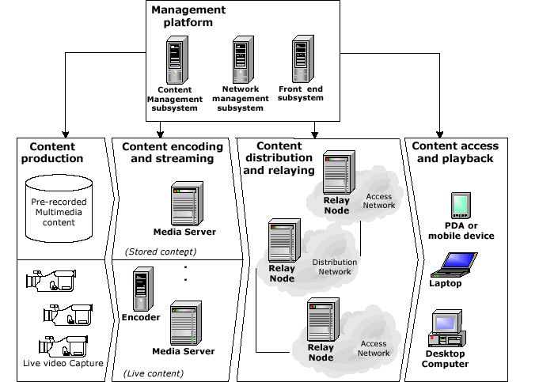
Figure 1: End-to-end system architecture
3 Content distribution and relaying
The distribution network comprises several relay points that interoperate under an overlay networking distribution scheme. This infrastructure, from the network point of view, is based on a meshed topology, while in terms of media streaming, it is built upon several distribution trees. Figure 2 illustrates this concept
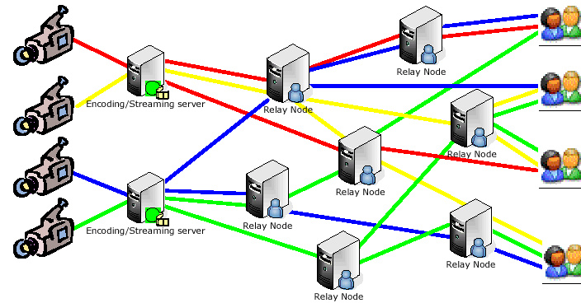
Figure 2: Media distribution and RNs
The relay points of the delivery network are the RNs. RNs do not only act as reflector points for a selected stream, but they also contribute actively to the streaming process by deploying special mechanisms such as stream switching, QoS marking and transcoding. RN functionality is depicted in Figure 3.
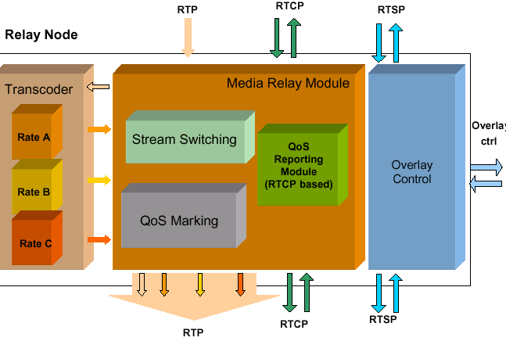
Figure 3: RN constituent modules
Next, we present the role of each constituent part of the RN.
3.1 Media relay module
At the lowest level, a RN is a proxy and stream splitter. It forwards incoming media streams to one or more clients. A series of RNs can co-operate forming a tree-like structure. Viewing the architecture on a stream-basis, the pattern is always tree-based. The RNs can serve more than one stream concurrently. In this case, the arrangement still remains tree-like for each stream but the aggregate structure constitutes a mesh. RNs communicate with higher and lower nodes in the distribution hierarchy via RTSP. In terms of functionality, a RN has a double interface: one for setting up incoming streams and one for serving outgoing streams. In the first case, the RN behaves like an RTSP client, i.e. it issues DESCRIBE, SETUP and PLAY requests. In the second case, it acts like an RTSP server and accepts DESCRIBE, SETUP and PLAY requests. The Relay Module can either be pre-configured (i.e. static configuration) or be dynamically controlled by the Overlay network managing entity: the NMSS.
3.2 Transcoder
The Transcoder is a module capable of transforming an MPEG-4 video stream coded with specific parameters into an MPEG-4 video stream coded with different parameters (usually with a lower bit rate). This module is used to match the different terminal and access network capabilities without swamping valuable transmission re-sources of the contribution and distribution networks. The input stream should guarantee a decent quality (tentatively input bitrate set at 256 Kbit/s) to allow for a reasonable result after the transcoding.
The Transcoder acts as an RTSP server: the Relay Module uses RTSP to start and stop the transcoding operation. The configuration of a transcoding session is deter-mined by the rtsp URL invoked, which identifies a specific configuration. The input and output streams are both packetized using the RTP protocol [7] : the output stream is setup according to the RTSP signaling messages, whereas the input stream is a multicast source. The usage of a multicast input stream allows for the concurrent operation of multiple transcoders on the same input stream, either on a single or on multiple hosts, and simplifies the overall Transcoder control at the Relay Module.
The Relay Module is responsible for generating the multicast flow. The Transcoding module introduces a number of important issues. The first one concerns the video quality. The question is whether the output video will experience quality comparable to that of a video with the same encoding parameters but applied to the original stream and not to an already compressed input. Early results give confidence that the quality penalty is small, provided that the input bitstream provides a decent quality. Decent quality means, for example, 256 Kbit/s, with no transmission errors.
In order to avoid transmission errors, or to minimize them, appropriate QoS measures have to be applied along the path of the input video. However, this is feasible when QoS enabled networks are traversed. In the case of conventional Internet, no QoS measures can be applied. As such, the UDP-based protocol stack, prone to packet losses, might be inadequate. RTP companion tools, such as Forward Error Correction (FEC) or Unequal Error Protection (UEP) schemes, can be used in this case, leading however to an increase in bandwidth occupancy, which might in turn deteriorate network performance.
3.3 Overlay Control Module and Distribution Control/Monitoring
The Overlay Control Module is responsible for selecting an incoming stream, among many candidates, through the use of some pre-defined criteria. These criteria are deployed in two consecutive levels.
First level of criteria deployment -CDN inspired. The first level uses a centralized approach, and is performed in the NMSS, which is constantly aware of the status of the distribution network. The philosophy behind this approach is inspired by the operation of CDNs. The Overlay Control Module of a RN, once activated for selecting the most appropriate relay point (another RN or a direct connection to the media streamer), it contacts the NMSS providing information about the requested stream.
The NMSS provides a list of relay points that can serve the requesting RN. The first level of selection is performed, based on estimated proximity between a client and an RN. This is based on domain matching between the requesting RN and all the available RNs. Using this criterion, a first list of the available RNs is formed, upon which the next set of criteria may be applied in order to fine trim the selection of the RNs. However, since this criterion cannot be used on order to provide a secure mechanism for detecting the location of a client (i.e the client is behind a large corporate
network using NAT), location detection mainly based on a different proximity detection mechanism, described later in the paper.
Second level of criteria deployment -P2P inspired. The second level of selection criteria is inspired by P2P overlay network solutions. These criteria are based on experiments performed on a P2P communication between the requesting RN and each one of the RNs in the list formed by the NMSS. This list is provided to the requesting RN, which in turn starts performing a series (or a subset) of tests regarding:
- Proximity. This test is used to provide information upon the proximity of each RN in terms of RoundTrip Time (RTT) hops. The test includes the measurement of RTT with experiments performed by the requesting RN over the whole list of candidate RNs. As stated earlier on the paper, client location detection schemes based on a centralized approach such as these used in CDNs, cannot guarantee for secure detection of a clients location. An example is the case of DNS lookup mechanism failures when requests traverse many DNS servers resulting in false reporting of the client’s location
- Stream quality. This criterion aims at filtering the list of candidate RNs according to the quality requirements of the stream. The Quality parameter is estimated by the packet loss measurements that are reported by RTCP to each RN.
- Hierarchy-level of RN. The list of candidate RNs can be further narrowed by taking into account the level of each RN in the distribution chain. This way, RNs that are not located within certain level of hierarchy could be excluded from relaying process since they are expected to suffer from accumulative quality degradation.
- Local resources availability. This is not actually a test performed by the requesting RN, but a direct criterion applied in every RN that receives a test-ing/ probing message by the requesting RN. Each enlisted RN that is probed by the requesting RN, returns an indication about its resources availability so that the latter may perform a comparison among them. It may be considered as an alternative load balancing mechanism in terms of local resources of the RNs (i.e. processing power, memory). The employment of this criterion in the distributed mode (second level of selection criteria) and not in the first is logical. It is meant to help in avoiding the burden of frequent message ex-change between the RNs and the NMSS.
- Effective bandwidth estimation. The scope of this test is to provide an estimation of the available bandwidth between the requesting RN and all other RNs contained in the list provided by the NMSS. The potentiality of a link to support the requested stream can be derived through packet pair testing mechanisms.
- Load balancing. This criterion is used by the NMSS to provide a well-balanced distribution of the media streams within the distribution network. Since the NMSS maintains the current status of all streams, it may use this criterion in order to avoid congestion in vital parts of the network though the appropriate directing of new RN requesting connection to specific relay points.
All the aforementioned criteria can be modeled in corresponding parameters that are used in order to select the most appropriate RN, according to specific scenarios.
3.4 QoS Marking Module
The QoS Module is responsible for guaranteeing end-to-end QoS of service to the media in accordance with the IP level QOS capabilities of the network (either Diff-Serv enabled or Best Effort). When DiffServ capabilities are offered in the network, this module can selectively mark video and audio content, based on the available Per Hop Behavior (PHB). If present, the audio is marked with Expedited Forwarding (EF) service class and the video with the Assured Forwarding (AF) class. Different discard options can be set. This way the DiffServ network is able to differentiate the more important data (I frames) from the less important data (P and B frames), and consequently to accordingly enforce drop policies upon congestion.
3.5 Stream Switching Mechanism
The stream switching mechanism enables the clients to change seamless from one stream to another, in case there is the need to adjust the client’s quality to the avail-able bandwidth. The client’s received quality is continuously monitored with the RTCP RR Reports received at the RN. When a predefined loss ratio is reached, the RN changes the client stream to another available bitrate. To achieve a seamless stream switching several conditions shall be met.
First of all, it is necessary that the old and new stream conform to a unique decoder configuration, so as to avoid the need to deliver an updated decoder configuration, which would be quite problematic, both if delivered in-band or out-of-band. Actually, in [8] a general solution for this problem is proposed. Keeping the decoder configuration unique among various streams might be tricky however. For example, in the case of MPEG-4 Video, this implies maintaining the same profile, with the same parameter values, including the VOP_time_increment. As a consequence, if, e.g., a stream @ 15 fps (requiring 4 bits for representing the time reference) is to be seamless switched with a stream at 5 fps (requiring 3 bits only), the latter has to be encoded as it were at 15 fps, providing however only 1 frame out of three.
Moreover, it is necessary to perform the stream switching at the “Random Access Points” of the stream, so that decoders can immediately reset their internal status, and not suffer from unintended decoding errors. In the case of MPEG-4 Video, the beginning of a Group Of Pictures (GOP) represents a Random Access Point. The simpler encodings are the ones that have a RTP header with indication of the frame type. This includes H.361/3 and MPEG1/2. For MPEG4 there is not such field in the RTP header, so in this case it is required to analyze the headers of the MPEG4 VOPs. To allow a client transparent switching, without affecting the client’s player, this module has to perform the necessary changes in the RTP header, in order to keep the session identifier (SSRC) and preserve the correct Sequence Number and Timestamp fields of the former stream.
4 Conclusions and future work
Currently the status of our work is at the level of design. We are planning to have a testbed with several PC running RN servers and relaying one media stream from a central encoding station. The connectivity and interoperation of the modules will be tested by making experiments with up to 3 levels of relaying points. We plan to con-duct measurements for the setup delay experienced under a 10Mb private LAN both for the static and the request upon demand setup. Following tests and measurements will be conducted in order to verify the overlay setup mechanism and the delay it may inject in the player setup.
5 Acknowledgments
The ideas presented in this paper have been based on work performed in the context of the Greek National project Archimedes, “Design of Overlay Architecture for efficient streaming of real-time multimedia over the Internet”.
5 References
[1] Akamai Technologies, Inc., http://www.akamai.com/.
[2] Digital Island, http://www.digisle.com/.
[3] Mathew Liste, Content Delivery Networks (CDNs) – A Reference Guide, Cisco 2000.
[4] Md Humayun Kabir, Eric G Manning, Gholamali C Shoja , "Request-routing Trends and Techniques in Content Routing" , Proc ICCIT 02, Dhaka, Bangla-desh, December 2002.
[5] C. Diot, B Levine, B Lyles, H. Kassem, D Balensiefen, Deployment Issues for the IP Multicast Service and Architecture, IEEE Network, Jan. /Feb. 2000.
[6] Ch. Z. Patrikakis, Y. Despotopoulos, A. M. Rompotis, N. Minogiannis, A.L. Lambiris, A. D. Salis, "An Implementation of an overlay network architecture scheme for streaming media distribution", Multimedia Telecommunications Track, 29th EuroMicro Conference, Antalya - Turkey, 2003.
[7] H. Schulzrinne et al., RTP: A Transport Protocol for Real-Time Applications, IETF RFC 3550, July 2003.
[8] P. Gentric, “Requirements and Use Cases for Stream Switching”, INTERNET-DRAFT, May 2003, work in progress.

Wireless data transmission from sensors and transducers to a computer
Ν . P. Patsourakis 1 , Ν . Konstantinidis 2 , L. E. Aslanoglou 3
1 Computer Engineer, Department of Electronic Computer Systems, Ô .Å .É . Piraeus,
7 Samou, 18541 Piraeus, Greece (e-mail: nickpats@panafonet.gr)
2 Computer Engineer, Department of Electronic Computer Systems, Ô .Å .É . Piraeus
25 M. Asias, 15233 Halandri, Athens, Greece (e-mail: nick_konst@yahoo.com)
3 Professor of Applications, Department of Electronic Computer Systems, Ô .Å .É .
Piraeus, 250 Thivon & P. Ralli, 12244 Aigaleo, Greece (e-mail: lasl@teipir.gr)

Abstract
The wireless communication becomes continuously more and more essential in modern life. It changes the way, that we work in the offices and the factories and the way that we spend our free time. Therefore the current wireless systems are found in the front lime of technology. This project, presents the creation of a wireless network, that its aim is the achievement of wireless telemetry. Telemetry is a technique, which is used for the distance measurement of natural sizes and can be wired or wireless.
The object of our project was the creation of a wireless network, which can transfer data functioning autonomously but also reliably. Also, it must be stable and friendly to the user. The results of this work were very good, since wireless communication was achieved in practice. Furthermore the operation of the system was very satisfactory as far as it concerns the data processing and the communication range.
Keywords: Wireless Telemetry, Base Station, Measurement Station, Protocol Communication, System management program.
1. Introduction
The system that we constructed is consisted of a base station and measurement stations, which cannot exceed the number of 255. Each workstation can have up to eight different sensors. The base station is composed of the transceiver and a computer. The transceiver is responsible for the data transfer from the measurement stations to the computer and reversely. It is generally the computer interface of the wireless network of our application. The computer is used mainly for the synchronization and the data processing by the administrator of the system.
The measurement station takes measurements in analogue form and later transmits the data via an analogue to digital converter to the base station. For the proper function of the wireless communication, a sum of rules were used that secure the communication between the base station and the measurement stations. The communication protocol, which follows these rules, was created according to the needs of this particular network. Finally for the management of this application was devised a software for the computer, that its aim was the control of this system in such a way, so that it is effective and friendly to the user.
This paper is organized as follows: Section 2 is an overview of the proposed wireless data transmission system as far as hardware and software is concerned. In section 3, the experimental evaluation of the system is reported and finally conclusions are in section 4.
2. Overview of the proposed system
In this section, we will discuss about the communication protocol that was used in this project, in order all the devices to communicate properly. Specifically, these devices could be either a base station or a workstation. Both of them will be explained in the following paragraphs. At last, we talk about the system management software, which is being used by system administrator.
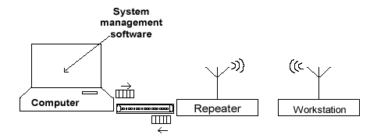
Fig. 1 Systems Block Diagram
2.1 Communication protocol
Our wireless network consists of the base station (which includes the repeater and the computer) and the workstations as shown in Fig.1. In order to accomplish communication between them, we need certain rules, so that communication is possible and secure among them. All these rules are defined by the protocol communication, which has been made for this particular application.
The rules that define the communication protocol, are:
1) Each network includes a base station and 1 to 255 workstations.
2) Each unit of network has one and unique identity. The base station has always identity “000” and workstations use any identity from “1” to “255”.
3) There are two forms of communication. In the first one, the repeater communicates with the computer wired, while in the second one, the repeater communicates with the workstations wireless. Asynchronous transmission of data is used in both cases.
4) Workstations cannot communicate with each other.
5) Base station has the role of an administrator in the network and decides which workstation will send data each time.
6) Workstation wait for a base station command, in order to execute a measurement and transmit it back.
7) In the wireless communication is allowed the existence of one signal through the network each time.
As it was mentioned before, the way of information propagation varies, depending on whether the communication is taking place between the computer and the repeater or between the repeater and workstations. In the case of computer and repeater, communication is implemented by a wired connection. The wired connection is accomplished by a serial interface RS232 and so serial connection has a baud rate of 4800 bps. We should mark right here that from the nine signals, that the serial connection allocates, only three are being used, which are receive, send and ground. In the case of repeater and workstations, the information propagation is implemented by a wireless connection. This was achieved via a pair of transceivers, which repeater and each workstation have. The wireless network, as constructed, operates at 433.925MHz, while the power at the output of each pair of transceivers is 100mW.
The structure of packet has the form of Fig. 2.
Wake | at | IDtransmitter | IDreceiver | Cmd | Data
Fig.2 General form of packet
We observe that the packet is composed of six sections. These are from left to right:
1) Wake (Transmitter wakes)
2) at (Data is following)
3) IDtransmitter (Identity of transmitter)
4) IDreceiver (Identity of receiver)
5) Cmd (Department of commands)
6) Data (Department of data)
The section of “Wake” is sent first to wake up transmitter and synchronise receiver. Its length is usually 5 bytes. The second section of the packet implies that data is following. The purpose of this section is to confirm a correct transmission-reception. As shown in Fig.2 it is composed of 2 bytes, the characters a and t. The section IDtransmitter has a length of 3 bytes and was used so that each part of the wireless network, which receives a packet, either this is the base station or a workstation knows who the sender of packet is. The section IDreceiver was used so that each part of the wireless network as before, knows whom the recipient of the packet is. Its length is 3 bytes also. The Cmd section or section of commands is consisted of 2 bytes and includes the command in the transmitted packet (the first useful information). The commands are distinguished in two big categories, depending on the sender. If the sender is the:
a) Base station, then the commands of this category are divided in two subcategories, which aim to
i. To check the proper function and communication of each workstation with the base station (“ping”), since communication may fail either due to a battery discharge or because workstation is out of range. The packet, that includes the particular command, has the form of Fig.3.
Wake | at | IDtransmitter | IDreceiver | 10 | xxx
Fig.3 Packet with command “ping”
The code of the command is “10" , while the section of data remains incurious, since
it does not carry any data in this case.
ii. Give the command, so that the specific workstation takes a measurement. In this case
the packet has the following structure as shown in Fig 4.
Wake | at | IDtransmitter | IDreceiver | 20 | xxZ
Fig.4 Packet with command “Take measurement”
Here the section of commands has the number “20”, while in the section of data the third digit “Z” denotes the number of sensor (1 to eight) from which we want to receive a measurement.
b) Workstation, then the commands of this category are divided also in two subcategories, as before, aiming to answer to the commands of the base station. Specifically:
i. The answer in command coded "10" is coded as "11". So each time the base station sends a packet with code "10", the workstation answers with a packet of the form below, declaring that communication has been accomplished. In the field of commands we have the number "11", while in the field of data the value is ignored Fig 5.
Wake | at | IDtransmitter | IDreceiver | 11 | xxx
Fig.5 Answer packet to command, “ping”
ii. The answer in command coded "20" appears in the following figure Fig.6
Wake | at | IDtransmitter | IDreceiver | 2x | xxx
Fig.6 Answer packet to command, “Take measurement”
In the section of commands the first digit (byte) has the value “2”. The second digit “x” can be expressed with a number from 1 to 8, indicating the specific sensor sending this measurement. Thus for example if the measurement comes from sensor 4 of a workstation, then the section of commands will be coded as “24”. Data of measurement is included in the field of data “xxx” and takes any value from 0 to 255.
2.2 Base station
One of the parts that our wireless network is made of is the base station. The heart of the base station is the repeater. This device is an interface with the CPU of the computer in such a way that occupies the computer as less as possible. As we mentioned already, repeater communicates wired with the computer and wireless with the workstations of the network. So due to the fact that the microcontroller we used (MCS8051), has only one serial port, we needed also a relay controlled by the microcontroller, in order to switch the communication from wired to wireless and reversely.
2.2.1 Materials used
Chip DS275 provided the required voltages for RS232 interface, as far it concerns the wired connection. We actually decide using this chip, because it does not require extra capacitors for its operation and as a result we have space saving on repeaters board. The transmitter and the receiver that we used as far the wireless network are BT37 and BR37 correspondingly, listed in Table1. They have the same antenna so we avoided transmission and reception of data in two different frequencies.
They operate at 433.925MHz and the output power of the transmitter is 100 mW. The type of communication is half duplex. For the achievement of this type of communication we needed one more relay, controlled by the microcontroller, which switches the power and the antenna from the transmitter to the receiver and reversely, depending on whether the device receives or transmits data at the given time.
Integrated. Circuits | Resistors
MCS 8051 | 1 ΚΩ. x 9
DS275 | 8,2KΩ.
LM311N x 2 | 30KΩ . x 2
Voltage. Regulators | Transistor
LM7805 x 3 | BC547 x 5
LM7812 | Crystal
Capacitors | 11,0592MHz
30pF x 2 | Transceivers
470µF x 3 | STE BT37
1 Μ f | STE BR37
Relays | Leds
DPDT x2 | LED x 2
Table 1 List of materials
2.2.2 Repeater function
In the beginning repeater uses the wired connection, waiting to receive a packet from the computer, in order to communicate wireless with the workstations. As soon as a packet is received it is stored and wired communication switches to wireless. Then packet is emitted via transmitter BT37. In the given time, having always wireless communication, the antenna and the power supply will be connected to the receiver BR37 which will be ready to receive answer packet from the workstation. After reception and storage of data in the memory of microcontroller, communication is switched again in wired connection and packet with data will be sent to the computer. Then repeater is waiting for the reception of a new packet from the computer and the whole process will be repeated. Waiting time for the wireless answer packet from the workstation is limited (roughly to 1 second). If the waiting time expires and the answer packet does not reach the repeater, then the connection is switched to wired and a packet “No Answer” is transmitted to the computer.
2.3 Workstation
The electronic circuit is similar to that of repeater. The only difference is that at the parallel port P1 of MCS 8051 has been connected an 8 bit dip switch, through which the user defines the identity of workstation in binary system of numeration (1 to 255). Also, the relay switching, from wired to wireless operation is not required, because only wireless communication is taking place. The chip DS275 (RS232 driver) is used only for testing the device for proper operation. Finally parallel port P2 is being used as an input for the A/D converter, which interfaces the 8 analog sensors.
2.3.1 Materials used
The construction of printed circuit was exactly the same as the one of the repeater and so we used the same materials (Table 1). This resulted to hardware simplicity and lower cost.
2.3.2 Workstation function
The workstation receives wireless commands from the base station. The commands that can be received are the "10" (Ping) and the "20" (take a measurement). For each command, that receives, answers with commands "11" (ping reply) and "2x" (sensor of measurement) respectively. It uses the same transceivers BT37 and BR37 and the propagation of data is performed via the serial port of MCS8051 microcontroller.
2.4 System management software
For quick, easy use and control of this system, a visual basic program was developed and installed at the computer Fig.7. The main aim of this program is to give the capability to the system administrator, to check it, whenever is needed. More specifically, the program is divided into three large parts. These are:
a) Program Initialization
i. Finding stations in the range of the base station: Base station searches workstations being in its range, which are capable to send measurements to it.
ii. Stations setup: In this function of
Program, we have the opportunity to insert, delete, and generally set
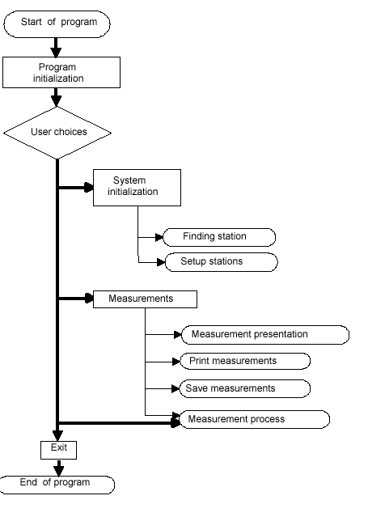
Fig.7 System management software flow chart
up workstations.
b) Measurements
i. Measurements process. With this button we activate measurements, which are being taken from the workstations and transmitted to the computer, according to the time schedule, that we predefined in the stations setup.
ii. Measurements presentation. We can classify measurements sorted by the number of sensor and by date.
iii. Print measurements. One other significant function of this program is the printing of measurements. We just have to choose the workstation and the sensor from which we took measurements.
iv. Save measurements as. Finally we can save all the measurements of a workstation, either as a text or as an html document.
c) Exit.
This button terminates the application.
3. Experimental results
The project was very successful, since wireless communication was achieved in practice. Furthermore system operation was very adequate as far as the data transmission. The power
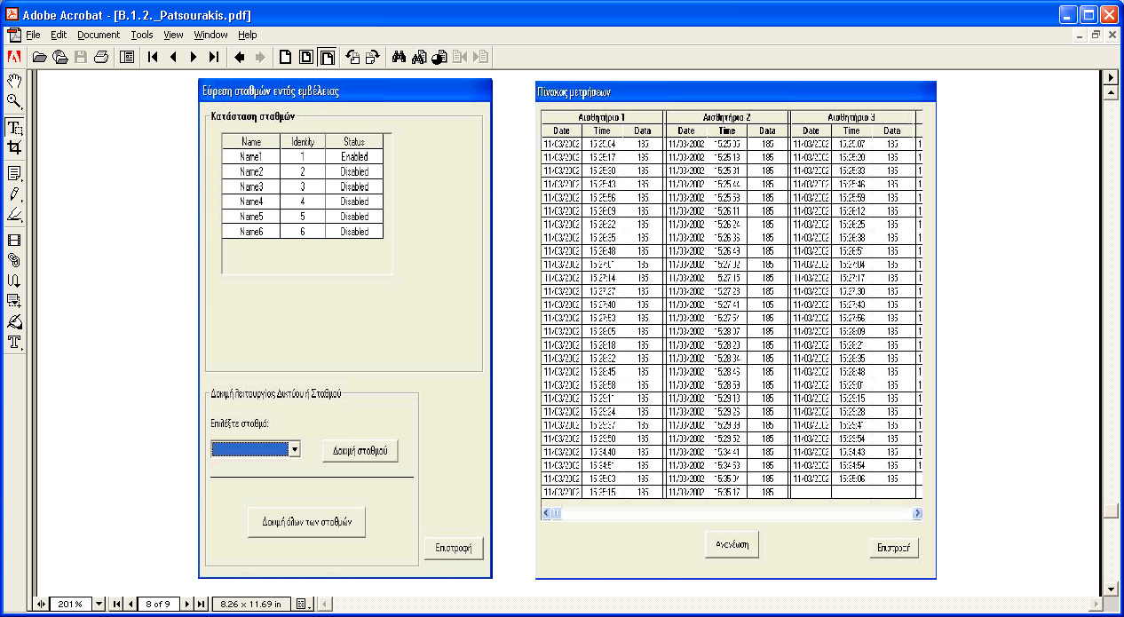
Fig. 8 “Ping” workstations test
Fig. 9 Measurement table
management was also very good. Using a 12V, 1,2Ah battery at a workstation, we noticed that the workstation could work for 12 hours. The maximum distance for communication, between the base station and a workstation was up to 120 meters (vision contact), with transmitted power only 100mW. The system management program was friendly and effective helping the user to process, view and save data. With the program’s screen of fig. 8, we were informed which of the workstations were responding, while workstations that were not communicating with the base station appeared in disabled status. This is very important for the system administrator because he can test each workstation at any time. In fig.9, we can see a screen of the program with a table of measurements that came from a specific workstation, where the sensors were sorted vertically and the measurements by date.
4. Conclusion
In this paper, a wireless telemetry system, which is based on the use of two transceivers, was presented. It is a stable and robust system with a lot of advantages among the various wireless networks. Experimental tests proved that its operation was very satisfactory despite its low cost. Possible applications of our telemetry system could be measuring various factors such as temperature, wind velocity, pressure and moisture for agricultural systems and weather stations. It could be useful also in hospitals and various industries. It is obvious that since this system is working without any wires, it could make our life much easier in many cases.
5. References
[1] Telecommunication systems (1998), Herbert Taub and Donald L. Schilling (A.Tziola E.).
[2] Telecommunication and computer networks (1997), Aris Alexopoulous and Giorgos Lagogiannis.
[3] Digital electronics (1998), Roger L. Tokheim (A.Tziola E.).
[4] Secure microcontroller data book, Dallas Semiconductor.
[5] http://www.ti.com/, Texas instruments.

Design and quality check of analog integrated filters Dimitris Tassopoulos
Department of Electronics, T.E.I. Piraeus
Email: dtass@in.gr
Savvas G. Vasiliadis
Lecturer
Department of Electronics, T.E.I. Piraeus
Email: svas@teipir.gr
Winfried Soppa
Professor
Department of Electronics
Fachhochschule Osnabrueck, Germany
Email: soppa@et.fh-osnabrueck.de

Abstract
The evolution of microelectronics and especially of the procedures of electronic circuitsintegration, has led to new ways of approaching solutions in circuit design. Major differencesappeared in the way their operation under certain quality criteria is ensured. The integration technology and particularly the analog circuit integration process present various problems in ensuring the proper function. This kind of problems does not really exist in the digital circuit integration process. Nevertheless, modern technology techniques can ensure the quality characteristics using tools like the parametric simulation procedure. They permit the first level approach of the operation of the analog integrated circuits. In a next phase by comparing the simulation data with the experimental measurements on the circuit it is possible the modification of the design parameters. That procedure guarantees a better convergence between the estimated simulation data and the real measurements. By following the steps of the procedure it is possible the collection of the data related to the real circuits’ behaviour and the creation of data libraries for future use. The correct methodology followed during the design of an integrated circuit results into more accurate simulation results and thereforebetter functionality of the integrated circuit.
Keywords: integrated, filter, analog, switched-capacitors,
1. Introduction
The analog microelectronic circuits are of complex structure. The structural complexity affects the theoretical design and imposes serious difficulties during their implementation stage. The theoretical approach of such circuits doesn’t provide the complete set of their detailed characteristics. The particular effects, which during the design were not obvious, appear during the realization phase. Consequently, there is a certain distance between the theoretical approach parameters and the respective actual measurements of the real circuit.
Usually these effects are bypassed by accepting them in order to have an easier design stage. Such an example is the simulation of the environment in which the device is expected to operate. Of course by neglecting the observation and the correction of these errors, the realization of circuits leads to different operation from the expected one. Accordingly, in order to ensure the quality standards of an analog integrated circuit a specific procedure must be followed. This kind of problems is mainly met in the analog integrated circuits design procedure, since the digital circuits are designed and realized according standard processes with very satisfactory results. The real properties and the performance of the digital circuits practically meet all the predictable properties of the theoretical design.
2. Circuit Design
The aim of this paper is to present the stages and the problems occurring during the design and the implementation of an integrated low-pass switched-capacitor (SC) filter of the sixthorder [1]. Such filters are used in several applications, like for voice filtering in mobile cell-phones, for analog signal filtering in DSP systems etc. [2]. The SC filters are preferred because of their capability to emulate high resistance conditions by using MOSFETs and small capacitors in the pico-Farad range [2], which can be easily integrated. In the opposite, the integrated N-well resistors occupy large die area and they also provide low resistance values in the class of 2100 ./µm 2 . As long as the specifications are set and the mathematical models are turned into circuit models, the stage of the main design begins. The design is divided in two steps. The first step refers to the simulation and the design crosscheck where the circuit is being simulated and it is verified if the specifications are met or not. The second step focuses on the layout design that is defining actually the form of the circuit on the die.
The difference between these two steps is significant because in the Layout step are involved the particular physical phenomena. The die geometry and shape problems are not taken in account in any theoretical approach.
As long as the first stage of the design is successful and all the specifications are fulfilled, the second stage follows where the problems concerning the topology, the connections of the
parts, as well as other factors of lower importance but also affecting the operation of the circuit are encountered. This stage is critical as the operation according to the quality requirements and the accomplishment of the specifications of the circuit are up to the proper design. In the next figure the layout of the filter is shown.
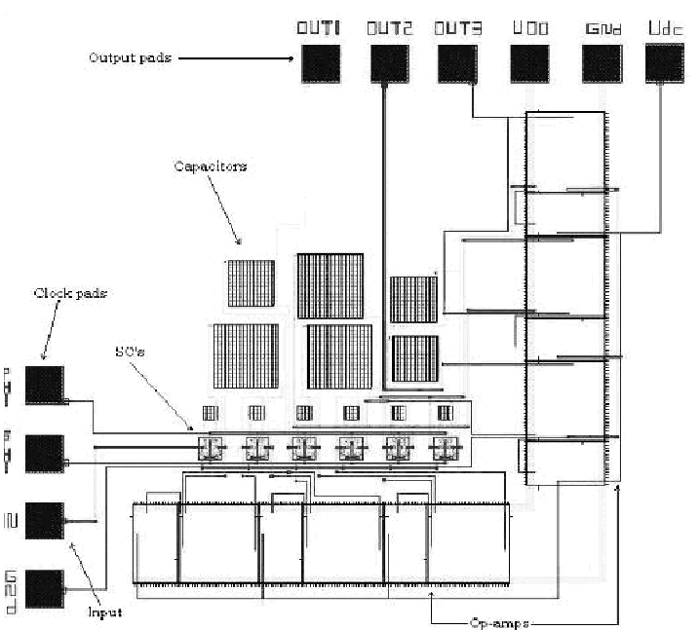
Figure 1: SC Filter Layout
In the above circuit is shown the serial connection of the op-amps, as well as the SCs networks and the capacitors area. In the integrated circuit design it is significant to minimize the space occupied by the components. Therefore the subsequent placement of the serially connected op-amps is avoided. In parallel, the gathering of the capacitors in the same area takes place. Two metal connection route layers are used in a way that one layer makes the vertical connections and the other the horizontal (net), therefore the parasitic capacitances that are created between two parallel routes on each layer are diminished and this also results in a more uniform and effective design. In general the routing of the integrated circuit is a tough procedure as it is necessary to find the most appropriate and functional routing and placing of the elements in order to achieve reduced die space and less problems [3].
3. Comments before the implementation phase
Before the implementation of the integrated circuit several factors having to do with the precise operation of the analog integrated circuit, must be taken in account. One of the most significant factors is the capacitance and resistance value of the parts. For example, when the two metal connection layers are used, a resistance of 25m ./µm 2 is introduced. Although it seems negligible, it gets considerable as the length of the routes increases. More considerable is the resistance of the polysilicon layer that reaches 20 ./µm 2 . Therefore, all these factors affect the operation of the circuit and usually increase the distance from the original specifications set. However, it is of high importance the sensitivity of the parts characteristics during the variations of the temperature and their nominal values. For example if the variation of the capacitance of a capacitor is +/-30% out of its nominal value and that nominal value is used during the theoretical design, then the impact in the operation of the circuit is expected to be significant.
In order to determine the influence of these variations, parametric and Monte Carlo simulations are used. They result in the determination of the circuit’s characteristics change under the variation of some components’ nominal values. For example, when the effect of the variation of the capacitance on the cut-off frequency was under examination, a 3000-runs Monte Carlo simulation was used. In each run the capacitance changed stepwise. The amplitude of the step was depending on the integration process used for the realization of the circuit.
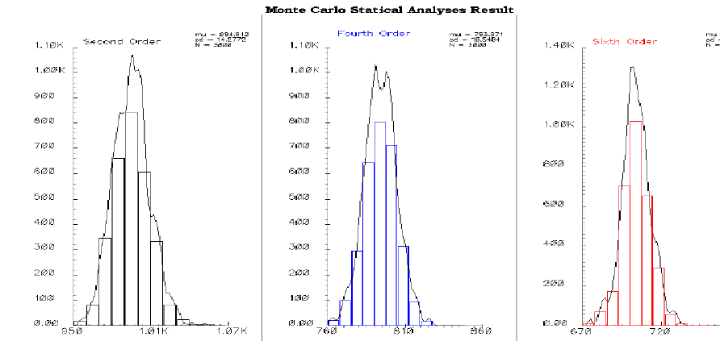
Figure 2: Cut-off frequency variation results after a Monte-Carlo simulation
In the above figure it is shown that as the order of the filter increases and there is a shift in the actual value of the parts, the cut-off frequency will alter respectively. Therefore, depending on the critical conditions of the application, the parts or their characteristic values or even the layout can be altered to reduce the errors occurring.
An additional significant advantage of the SCs filters toward the RC filters is that they have less sensitivity in the variation of the value magnitudes and actually their sensitivity is limited and depends on the capacitors and the stimulation pulses used. The sensitivity is farther reduced if the capacitors are gathered in the same area and the effects of the variations are simplified as they have the same proportions. The thickness of the oxide insulator between the polysilicon plates (layers) in a small area is almost constant, while the thickness varies as the area grows. This occurs due to inherent process imperfections. Therefore in a small die area the oxide thickness is about constant and hence the error will be within certain limits. In the equation of the sensitivity the values of the capacitors appear in fractional (nominator-denominator) form and thus any variation from their nominal value is retracted [1].
4. Differences between theoretical model and implemented circuit.
Before the total implementation of the integrated circuit, in order to ensure its proper operation in terms of quality characteristics, a critical part of the whole design is implemented, tested and certified. For the needs of the present design a SC filter of the first order was realized, so that its operation will be observed and its performance will be registered. The results of the tests will be compared to the specifications requirements and the simulations results. In the following figure the schematic and the physical layout of the filter after its implementation is shown.
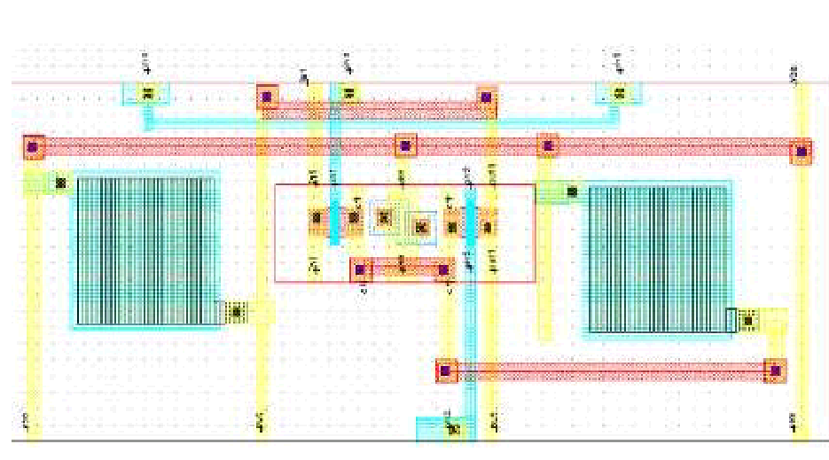
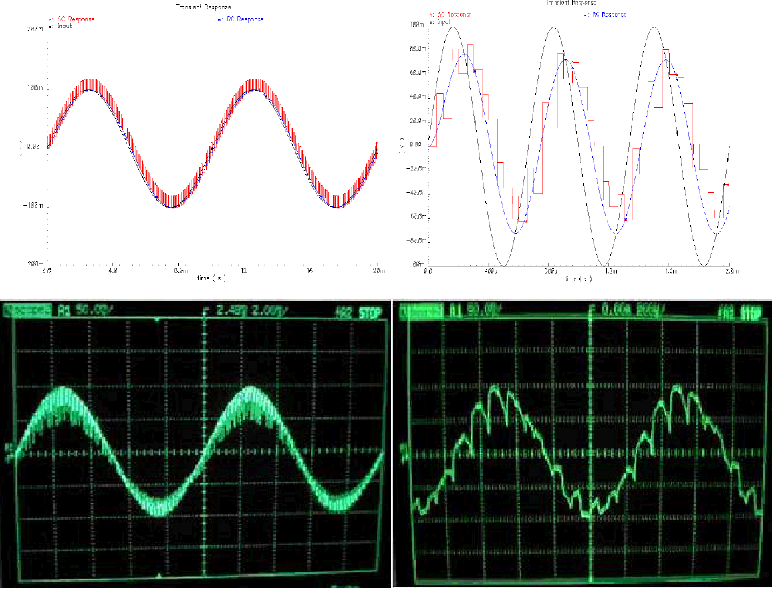
Figure 4: Simulation and measurement results
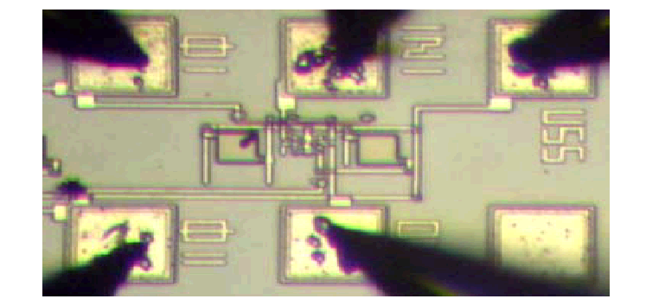
Figure 3: Schematic layout and implemented filter
It is obvious that the implemented circuit follows exactly the layout as it is foreseen from the design stage. The only differences are due to the placement of the pads, necessary for the appropriate measurements. The results are interesting and in the following figure the output response of the simulated and of the real implemented circuit is shown for the case of an input sinusoid signal at the frequencies of 1KHz and 100Hz.
The output signals coincide in a great extend so that these simulation tools are considered as very reliable and effective. Nevertheless, there are some limitations which can’t be estimated by the simulation programs and aren’t evident before the experimental measurements stage on the implemented circuit [1]. Such a limitation referring to a non-exactly estimated value during the simulation phase is the maximum amplitude of the input. Because of the implementation restrictions of the integrated circuits there are some limitations related to the structure of the MOSFETs used. In the following figure the common structure of a MOSFET is shown.
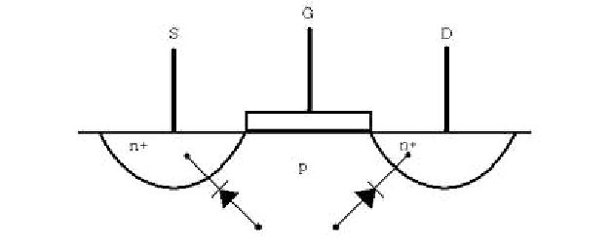
Figure 5: The MOSFET structure
As the figure shows, the two n+ wells constitute the source and the drain which form two pn+ junctions with the p-substrate. The problem occurs when the potential barrier of the pn junction is reached and then the current flows in one direction through the substrate. The result is that during the negative period of the sinusoid input the current flows through the substrate to the output and during the positive period the junction is closed and there is no current flowing. The result is shown in the following figure.
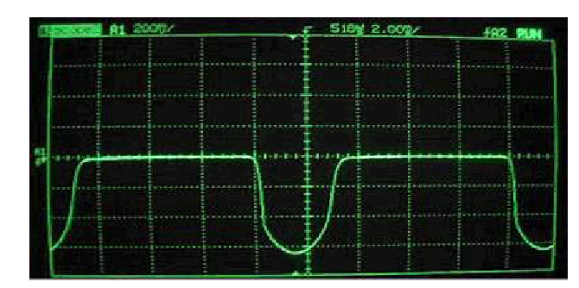
Figure 6: Current leakage
This result wouldn’t be possible to be detected and shown through the simulation procedures. The previous case indicates that the simulations have certain limitations in their use [1]. Furthermore it is necessary to implement prototype models of some parts of the circuit in order to check its real performance and extract information supporting the detection of errors. If there is no partial implementation, the indications of the errors occurring in the general implementation will be complex and it will be extremely difficult the detection of the reasons causing the non-expected effects. In the example shown above the error can be corrected by adding an offset d.c. voltage in order to keep the voltage during the negative period above the potential barrier of the pn+ junction.
5. Conclusions
According to the experience concentrated until now, using the described procedure the data from the simulations were collected and prototyping libraries were organized. They can be used when it will be necessary to evaluate the results of the simulations taking in account the experimental measurements. Consequently the library data can be used in similar implementations in the future. By using the libraries, the repeat of the same procedures is avoided and therefore the respective time is saved and the cost is minimized. Also the resulting implemented circuit is more precise according to the specifications. Using the previous described method including the partial implementation of the critical parts and the storage of the data in related libraries, the quality requirements of the operation of the analog integrated circuits are ensured.
Of course in the general case the above method seems to be complex, since the requirements range increase and become of multiple character. Although the partial implementation is of certain cost, it is proved by repeated design examples that the total cost, by all means, of the final implementation of an analog integrated circuit is reduced.
6. References
1. Tassopoulos, D., “Analog and Integrated Filter Design”, Bachelor Diploma Thesis TEI Piraeus – FH Osnabrueck, 2002
2. Gray, P. R., Wooley, A., Brodersen, R. W. “Analog MOS Integrated Circuits II”, ISBN 0- 87942-246-7, IEEE PRESS 1988
3. Worcester Polytechnic Institute, “Design of VLSI Systems Notes”, http://vlsi.wpi.edu/webcourse/toc.html

A Prototype Multicriteria Group Decision Support System based on the Analytic Hierarchy Process
Kyriacos Antoniades
Technical Educational Institute of Piraeus
Πέτρου Ράλλη & Θηβών 250, 122.44 Αιγάλεω ,
Πειραιάς , Ελλάδα .
kanton@internet.gr
Thanasis Spyridakos
Technical Educational Institute of Piraeus
Πέτρου Ράλλη & Θηβών 250, 122.44 Αιγάλεω
Πειραιάς , Ελλάδα .
tspyr@otenet.gr
Costas Iliopoulos
Paisley University
Paisley, Scotland, UK, PA1 2BE
ilio-ci0@wpmail.paisley.ac.uk

Abstract:
This paper intends to describe how decision support systems have recently become a more widespread choice for decision makers (committee) and decision analysts (select committee), and are utilised in an increasingly large number of organizations. The number of organizations that will be aided with decision support systems will increase very rapidly in the forthcoming years. Group decision support systems, in the future, will allow exercising democratic methods of decision making with the contribution of the largest possible number of participants. As a result, a majority rule (group choice) will be obtained representing the will of the majority. The main parts of this project involve: A secondary research stage, where critical review of major group decision methods and IT based group decision systems are conducted. A design, and development stage, where a rich prototype, multi-criteria, group decision support system will be developed, based on the analytic hierarchy process and Borda’s positional method. An application / evaluation stage where the rich prototype is used in real life scenarios, with real users. A reflection stage where the overall behaviour of the developed rich prototype is discussed and arguments are made, in respect of the future of group decision methods and group decision support systems. It is hoped that the conclusions and recommendations drawn from this project will be of value as to further aid prospective research in group decision support systems.
Keywords: Multi Criteria Analysis, Group Decision Support , Social Choice Theory, Analytic Hierarchy Process, Borda’s Positional Method
Introduction
Group decision making under multiple criteria in a democratic society include various voting and counting
methodologies [3]. The non-ranked voting method is the most commonly used in political elections today. Each voter has one vote and no more on all the candidates who offer themselves on the voters’ choice. Ideally, the voting procedure should be kept reasonably simple and straightforward so as to cause no difficulty to the voters. On the other hand, the primary concern of the counting process is accuracy and effectiveness. What is needed is a method that allows voters to indicate not only their chosen candidate, but also their order of preference by which all the candidates would be placed. The preferential voting method, first introduced by Chevalier Jean-Charles de Borda in 1770 proposed to add the ranks of a given alternative (candidate) on each of the criteria. For a given criterion one point is assigned to an alternative ranked last, two points to an alternative ranked second and so on. The social choice or the aggregated preorder is obtained by summing all the points assigned for each alternative and by ranking the first alternative with the most points, second the alternative with the immediately lower number of points and so forth. In general, group decision is understood to be a reduction of individual preferences among a set of criteria to a single collective preference or group choice.
In 1785 Marquis de Condorcet discovers the paradox of voting, the fact that social choice processes based on the principle of the majority rule can give rise to nontransitive (cyclical) ranking amongst candidates (alternatives). To solve for the Condorcet effect the Social Choice Theory studies the problem of the counting process classified by a Social Choice Function, where voting is a group decision making method in a democratic society, an expression of the will of the majority. The counting methods (Social Choice Function) used in this project include the Eigenvector Function, proposed by Thomas L. Saaty [7], to obtain individual priorities of preferences and Borda’s Function to obtain the group choice (ranking). The conclusions drawn in this project give rise to questions about the very idea of democracy and propose a new perspective to the whole methodology of group decision with an innovative user friendly interface.
Methodological Framework for Multiple Criteria Group Decision Support Systems
The characteristics of group decision making under multiple objectives / criteria / alternatives are studied for simple majority rule using the non-ranked and the preferential voting method.
We observe that the non-ranked voting method which is most commonly used in political elections today works perfectly well for a choice of two candidates (alternatives) but becomes ambiguous when the numbers of candidates are increased. The method lacks information of the relative merits of the other candidates producing results which are incomplete, does not represent the true will of the majority, prone to yield contradictory outcomes that depend on the counting method used.
The preferential voting method is proposed, which includes the relative merits of all the respective candidates and observe Condorcet’s paradox of voting comes into effect, producing a small percentage of nontransient majorities. The Condorcet effect is studied extensively both mathematically and systematically, to determine when inconsistencies occur with respect to the number of committee members, with respect to the alternatives and with respect to both the committee members and the number of alternatives.
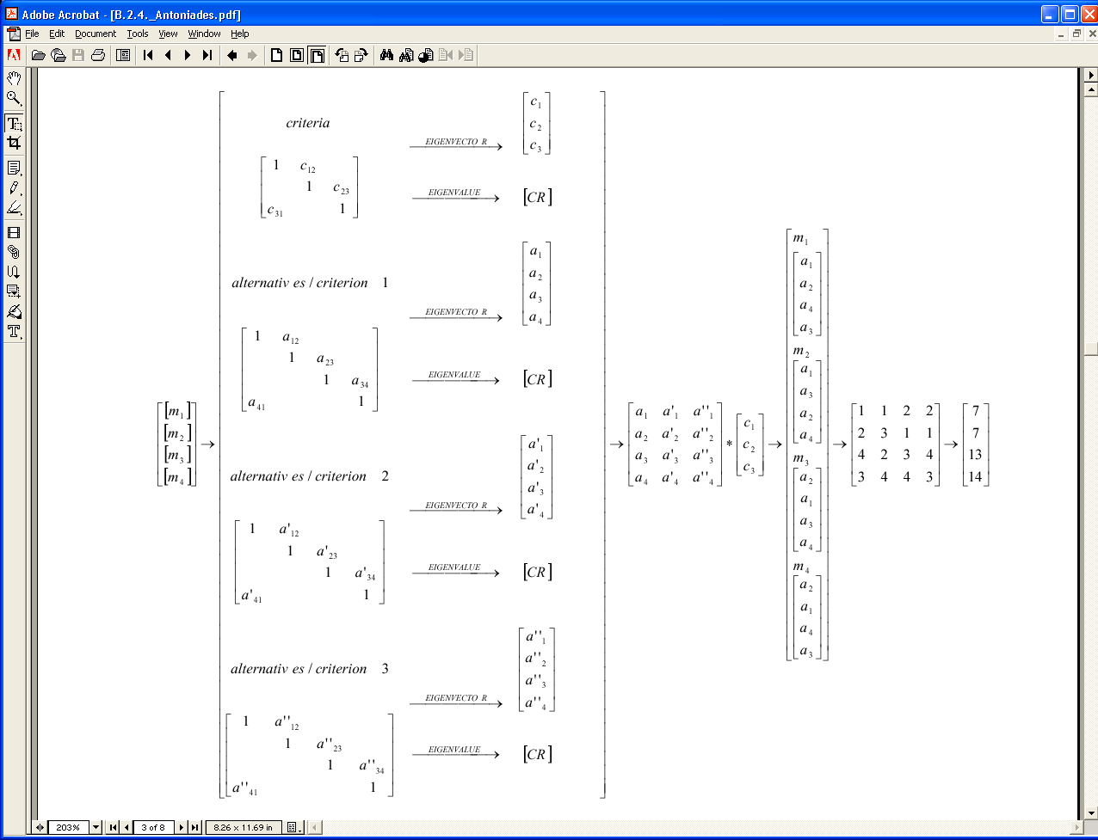
Figure 1: Methodological Framework
The results show that as the number of alternatives are increased, the probability of nontransient majority increase towards 1, with little sensitivity to the number of voters for a given number of alternatives.
The social choice theory defines the necessary social functions to solve for the Condorcet effect, which determines the counting method used, considered as an aggregation procedure based on the preferential voting system. The relational properties and the properties of group decision are defined for the Condorcet function and represented mathematically to give the group choice.
From the study of the available social choice functions, we select the Eigenvector to obtain individual priorities of alternatives under certain agreed criteria and the Eigenvalue to obtain consistency check.
The process of evaluating the alternatives is thus represented mathematically by the ordinal case of the agreed criteria approach which obtains the Borda score (ranking) for each alternative evaluated by a number of committee members.
In Figure 1: we are considering four (4) committee members, who have to evaluate a defined objective
(Hierarchon) containing four (4) alternatives under three (3) criteria, the members: m1, m2, m3, m4 enter the pairwise comparison for both the criteria decision elements, c12, c23, and c34, as well as for the alternatives, under each criterion, are annotated as, a12, a23, a34, a41, a’12, a’23, a’34, a’41, a’’12, a’’23, a’’34, a’’41. In each case, we check the consistency ratio and the eigenvector to obtain the priorities of the decision elements. Thereafter, we collect all the alternatives priorities vectors and multiply this matrix with the criteria priorities. The result gives the individual priorities for each member of the committee. Thereafter, Borda’s positional method is applied to obtain the priorities of all members by ranking the lowest of the individual preferences of alternatives under the agreed criteria, with mark 1, the second lowest with mark 2, the third lowest with mark 3 and the fourth lowest with mark 4. The row sum obtained from this matrix gives the group ranking, with the highest alternative ranked first, the second highest ranked second, the third highest third and the fourth highest ranked fourth.
Multicriteria group decision is thus put forward on a simple five step method:
1. Hierarchon [8].
Initially, a database is developed for the decision analysts (select committee members) as a tool for defining hierarchies – decision organizations comprising of the decision elements: objective, criteria, alternatives into clusters or sub clusters - the actual decision or hierarchon to be assigned to a group of decision makers (committee members). Particular attention is paid to the independence and actual scale of the decision elements. The simplified hierarchons are considered to satisfy the independence and homogeneity property of the decision elements. The advantages and disadvantages of the Analytic Hierarchy Process are discussed; minimized mainly, by setting constraints on the levels of the hierarchon and the number of decision elements (criteria and alternatives) it could contain.
2. Pairwise Comparison Matrix [10].
A decision maker thence chooses any Hierarchon available to him and makes judgments (pairwise comparisons) of the decision elements using the fundamental scale (considered to be appropriate for the decision elements). Her / his sole concern is to keep the consistency ratio below 10%.
3. Eigenvector / Eigenvalue of criteria and alternatives.
The calculations of the relative weights of the criteria and alternatives, consistency check, individual priorities and the group ranking are achieved by defining a class dealing with the main matrix operations.
We observe that as the number of decision elements increase the transitive property of the pairwise comparison needs to be taken into account. We find that there are different ways to consistency correction and show that partial consistency correction provides an optimum consistency check as far as performance and reliability of the software tool are concerned [9].
4. Individual Priorities.
Aided with the graphical user interface and the matrix class, from the aggregation of the relative weights for a given decision maker we obtain her / his overall individual priorities of the alternatives by multiplying the alternatives vectors with the criteria vector.
5. Group Choice.
The values of the individual priorities for a group of decision makers are further aggregated to produce group ranking by using Borda’s positional method. Each committee member can view the group choice obtained so as to reconsider in case of draw (tie) of the alternatives.
Methodological Comparisons
Literature review and secondary research, revealed the theoretical background and methodologies that are used for a plethora of Decision Support Systems [2]. The Analytic Hierarchy Process, belonging to the American stream, which utilizes the eigenvector social choice function, was founded by Thomas L. Saaty back in 1970, and becomes a most popular methodology and yet one of the most criticized. In 1980, Ernest H. Forman using the AHP develops Decision Support System computer software, patented as Expert Choice. Since 1983 Expert Choice has been stirring an ever increasing interest for an increasingly large number of private and public sectors worldwide, finding applications into industry, business, education, medicine, science, engineering, transportation, philosophy, psychology, social sciences, politics and many others. At the same time, the European stream [1] are involved primarily with disaggregating individual preferences first, then aggregating to obtain the value function with decision support systems such as the ELECTRE, UTA, MINORA, MIIDAS family of systems. Despite that the European stream have developed decision support systems that lack the ambiguities posed by the AHP, their popularity remained in the academic circles due to the fact that such systems still require high level expert operators who are specific to specific decision making problems
Operational research in multi criteria decision support systems analysis using the Analytic Hierarchy Process provided the requirements elicitation and analysis in order to design and develop a decision support system that is further developed and enabled for groups. This is achieved by creating a simplified environment using the basic principles of the AHP and applying this methodology to obtain the group choice under multiple criteria and alternatives by using the Borda social choice function. The project discussed the methodology of the AHP with its inherent advantages and disadvantages [4], the various software vendors involved, areas of applications [5,6] and the role of the decision analysts and decision makers in group decision making. Thence, the database is developed to accommodate group decision by assigning decision elements arranged in a hierarchy to each and every individual of the group. Thereafter, at the heart of the project, the software tool developed demonstrates group decision making, bearing in mind for a friendly graphical user interface, by allowing each user to log in the system and simply assign individual pairwise comparisons of only the qualitative decision elements. An overall priority is thus obtained for each individual and using Borda’s positional method, we aggregate these results further to obtain the group choice (ranking).
The graphical user interface developed as shown in Figure 2: merits the advantage of being user friendly to the degree of being self descriptive, transparent to the user, as the methodology of the Analytic Hierarchy Process is depicted both mathematically and graphically, dynamically interactive as the values of the Eigenvalue and Eigenvector are updated either on change or scroll of the slider control, scalable as the prototype can easily be deployed in a multithreaded environment with administrative / database group settings and policies, adaptable as to representing real life decisions involving a large number of decision makers for different application areas, functional as it can be a time saver, and at the same time a training tool of the Analytic Hierarchy Process methodology, thus reducing the learning curve of operation, and finally and most importantly, it provide grounds for further research in the operational and behavioural aspect of the proposed server component tool.
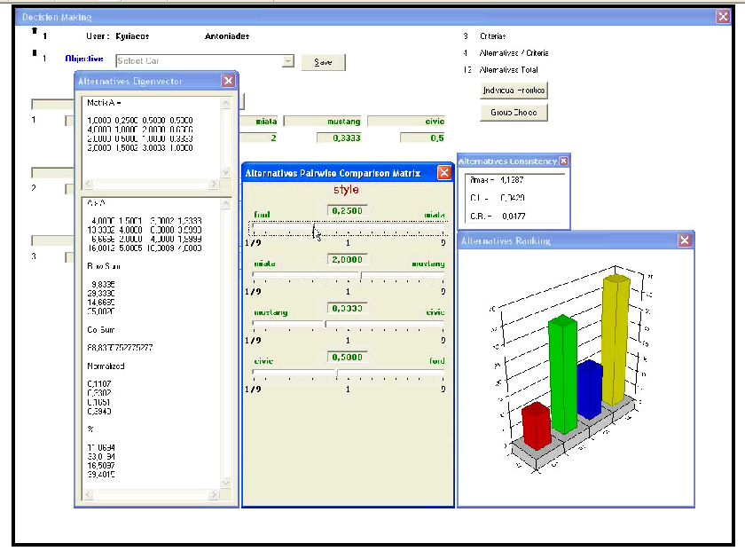
Figure 2: Entering pairwise comparisons to obtain priorities.
It is noteworthy to mention that the analogous software vendors have had their success made possible only during the last decade or so, during which computing power was been made available. Also, it is only very recently that the aforementioned software vendors are considering including group decision support either by using a network environment (intranet / internet / extranet) or with the use of add-on server components. This project recognized a window of opportunity in the realms of group decision making as no decision support system as such offers group decision making that is group user friendly, multithreaded, scalable and extensible. Realizing the need for group decision making in a multithreaded environment the evaluating and decision process of group decision making have been represented mathematically and systematically under multiple criteria. The software and database requirements are elicited and a multiple criteria group decision support system is implemented and proposals are made to run under a server / client environment.
Such support tools, thus, should be able to accommodate in the future, even wider range of decision making, for even wider range of individuals or group of individuals. The concept of the AHP however, requires pre determination of the decision elements at hand. A different pre determination normally yields completely different decision results.
For the needs of the project concerning the hierarchons, the criteria and alternatives are chosen to be simple qualitative measurements, such that they can be considered as independent entities. As far as the fundamental scale is concerned, the scale range of the criteria are kept to the same range defined as fundamental (1-9) and agreed by all decision makers. The pairwise comparisons are kept to a minimum, lessening the burden on the decision maker. Inconsistency due to rank reversal as such is reduced to a minimum, as the decision maker cannot add or remove decision alternatives. The group choice is thus constructed using the aggregation method at the end of individual assessment independently and uninfluenced by the other decision makers (democratically).Simply put, we satisfy the properties of group choice as defined, for obtaining a social choice function that nearly eliminates the Condorcet paradox for group decision making.
AHP is a multiple objective/criteria/alternatives decision making tool consolidating information, using pairwise comparisons, on qualitative and quantitative criteria and alternatives. Further research on the criticisms of this methodology should make this method even more suitable for solving complicated decision problems. It is here that the project recognizes the need for a group decision support system and amalgamating the AHP methodology with the social choice theory we propose and implement a new perspective to the AHP, namely Group AHP. This software project should demonstrate, after the recommended further improvements on the life-cycle of this software tool, that the proposed direct and interactive GUI applied would improve the ease of use as an aid to group decision making.
Conclusions
Group decision making under a variety of multiple criteria for a large number of committee members and alternatives provides a large repository of potential areas for future work. Initially, on the social choice functions, Cook and Seifords function provides perhaps improvement over Borda’s. This function investigates a compromise (consensus ranking – minimization of disagreement), a distance function that measures a metric of agreement / disagreement and determining the distance that best agrees with all the committee’s ranking.
Furthermore, a good proposal for future work could include defining all the discussed social choice functions, into class code and compare the results obtained for each. This analysis could determine the behaviour of these functions with respect to one another and the range of applicability in various decision problems. Additionally, the ordinal ranking method of the agreed criteria approach can be further developed to include ordinal ranking of individual criteria approach, whereby each member of the committee could determine their own set of criteria. On this basis, the cardinal method of either the agreed or individual approach would provide further information as in addition to ranking; their respective scores would also be included.
Ultimately, the works of Bui and Shakun [11] describe a methodological framework that includes negotiation in group decision making, namely Negotiation Support Systems which undertake to play the role of decision analysts (select committee members) capable of analyzing users’ reasoning and consistencies and understanding of the negotiation problem and process. As both decision analysis, using the AHP and negotiation analysis are both prescriptive oriented their methodology can support each other, and models can be developed to aid both the decision analysts and the decision makers (that is, negotiators) to reach consensus in decision making problems. Negotiation, thus, could be amalgamated into a group decision process to observe sensitivity of the criteria and alternatives as they are altered with respect to each other, and determine the factors that may alter a decision maker’s initial preferences in favour of others.
It appears that although decision support systems that aid isolated decision makers are common practice today, group decision support systems, on the other hand, are just coming to surface both in the academic and business sectors. This interest in group decision systems is bound to increase in the near future and may be the cause for new innovations and ideas in this diverse field of study.
Let us not forget the AHP and its methodological framework is already been debated and discussed on the inherent advantages and disadvantages it possesses for the last twenty years, at least, and this debate would very likely continue for the next twenty years.
References
1. Spyridakos T., “An Integrated Intelligent and Interactive Multiple Criteria Decision Aiding System”, Hania, Crete, Ph.D. thesis, 1996. (http://thesis.ekt.gr/6157).
2. Keeney R., Raiffa H., “Decisions with multiple objectives: Preferences and Value Tradeoffs”, John Wiley and Sons, New York, ISBN: 0-471-46510-0, 1976.
3. Ching-Lai Hwang., Ming-Jeng Lin., “Group Decision Making under Multiple Criteria, Methods and Applications”, Springer-Verlag Berlin Heidelberg, ISBN: 3-540-17177-0, 1987.
4. Zahedi F., “The Analytic Hierarchy Process – A Survey of the Method and its Applications”, INTERFACES 16 (1986), pp. 96- 108.
5. Μηνάς Μ ., «Η Εφαρ µ ογή Πολυκριτήριων στην Επιλογή και Αξιολόγηση του Προσωπικού », University of Athens, Ph.D. thesis, 1999.
6. Belton V., Goodwin P., “Remarks on the Application of the Analytic Hierarchy Process to Judgemental Forecasting”, International Journal of Forecasting, Vol:12, 155-161, 1996.
7. Saaty T., “Models, Methods and Applications of the Analytic Hierarchy Process”, Kluwer Academic Publishers, International Series, ISBN:0-7923-7267-0, 2001.
8. Saaty T., Forman E., “The Hierarchon: A Dictionary of Hierarchies”, Vol: V of the AHP Series, RWS publications, ISBN:0-9620317-5-5, 2003.
9. Ishizaka A., Lusti M., ”An Expert Module to Improve the Consistency of AHP Matrices”, The sixteenth triennial conference of the International Federation of Operational Research Societies, Edinburgh, 2002.
10. Hamalainen R., Salo A., “Rejoiner. The Issue of Understanding the Weights” Journal of Multicriteria Decision Analysis Vol: 6, 340-343, 1997.
11. Bui T, Shakun M, “Negotiation Support Systems Minitrack”, Proceedings of the 35th Hawaii International Conference on System Sciences – 2002

Biometrics for Person Identification: the E.E.G.
Maria RANGOUSSI, Kleanthis PREKAS & Savvas VASSILIADIS
Department of Electronics
Technological Education Institute of Piraeus
250, Thivon str., Athens GR-12244, Greece
Tel / Fax: +30 210 5381222, 4, 6
E-mail: { mariar, prekas, svas }@teipir.gr

Abstract
The field of Biometrics aims to draw conclusions on the identity, attitude, as well as current physiological and psychological status of the individual, through processing of signals related to the morphology and/or functions of the head and the body. Far beyond conventional personal identification via fingerprints, a variety of new methods have emerged. Retinal scanning, DNA tests, speaker verification through voice, facial and gesture recognition by image processing, as well as electroencephalogram (EEG) based methods, provide a variety of tools that can be used alternatively or complementarily. EEG based person identification, described in this paper, can be exploited for secure access to areas or resources such as software etc., as well as for process verification. The latter area is strongly connected to quality verification and quality control applications.
The proposed method is based on spectral analysis of the EEG signal recordings of healthy individuals, for the extraction of appropriate features that can serve as a “key” in any identification process. Neural network classifiers are employed for the classification step. A set of preliminary tests using real field EEG data yield satisfactory identification scores (over 96%) in a typical binary hypothesis experimental setup.
Keywords: Biometrics, EEG, Neural Networks, Person Identification, Feature Extraction.
1. INTRODUCTION
Biometrics constitute an emerging applications cross-point, exploiting methods from areas as diverse as biology, signal and image processing, biomedical engineering, data compression / coding and – last but not least - pattern recognition algorithms, in order to serve a variety of purposes: person identification and character, attitude, physiological and psychological status recognition are the prevailing goals. What unifies this diverse scientific and technological field is the use of features extracted from the function and / or morphology of the human body. The assumption underlying this choice of features is that each of them is unique to the individual, i.e. it is related up to a certain extend to the genetic material of the individual. This assumption prompts the use of the so-called biometric features for highly secure person identification, as well as for other related purposes, such as recognition of the current sentimental / psychological status of the individual (angry, anxious, relaxed, hilarious, etc.), attitude (aggressive, submissive, etc.) or character (violent, tranquil, etc.). The extracted features serve as a “key” for secure person identification, in the sense that an appropriate biometric data sequence can be encoded into a type of access token, such as a smart card. In the latter aspect, biometric person identification is strongly related to quality control and verification procedures.
Certain biometric features are extracted from biomedical signals obtained via envasive procedures, such as blood / DNA tests or retinal scanning. On the other hand, non-envasively obtained features, such as the electroencephalogram (EEG), are advantageous from a psychological aspect. The EEG is a conventional biomedical “modality” boasting an over-centennial history. It has already been extensively studied in relation to neurophysiologic and psychiatric pathologies, or in order to determine the diverse effects of medication. In a series of studies in the beginning of the 20th century, involving family members and especially (monozygotic and dizygotic) twins, the genetic basis of the EEG has been firmly established, [1], [2]. This resulted in a renewed research interest, involving contemporary studies with Evoked Potentials (EP) and recently with Cognitive Evoked Potential (CEP), with applications ranging from diagnosis to person identification and truth tests.
In this paper we propose a spectral analysis approach to the EEG feature extraction problem. As existing research has shown, the choice of the appropriate set of features is essential to the success of any subsequent identification procedure. Therefore, the focus of our work is on the steps of signal analysis and feature extraction and not on the final steps of the data sequence encoding. However, as the suitability of the extracted features can only be measured through classification scores in a person identification experiment, we have proceeded to perform a set of such tests. The aim of the experimental part is not to provide statistically significant results; such a task would require rather extensive experimentation. Rather, we provide experimental results on real field EEG data sets, as an indication of the potential of the proposed method to the goal of secure person identification.
The features extracted from the (digitized) EEG recordings are obtained through spectral analysis of the EEG. The alpha rhythm of the EEG is isolated using Fourier transform based filtering. Subsequent processing is based on the alpha rhythm spectral component solely. A linear, time-invariant all-pole model is fitted on the filtered data and the model coefficients are proposed as the features for subsequent identification. Although neither linear nor periodic strictly speaking, the EEG has been shown to have an adequately linear and quasi-periodic nature that renders the proposed model suitable.
Finally the classification experiments performed to exhibit the potential of the proposed feature set make use of two different neural network classifiers. The first is a simple Perceptron classifier while the second is a more complex Learning Vector Quantizer (LVQ) classifier. Results from either network architecture are satisfactory, indicating the appropriateness of the proposed feature set to address the person identification problem.
2. THE PROPOSED FEATURE EXTRACTION METHOD
Electromagnetic brain waves caused by electrical activities of the brain, can be detected as alternating potential differences at the scalp surface. When recorded through scalp electrodes, such potential differences result in time-continuous signals termed electroencephalogram (EEG). Typically a set of electrodes are employed, one of them serving as the reference (electrically “neutral” or “ground”) point.
What we record is the difference waveform between each other electrode and the reference electrode. The recording therefore consists of a set of simultaneously varying voltage waveforms, i.e. it is a multi-channel signal. Sixteen (16) electrodes (signal channels) are typically employed, while the placement of the electrodes on the scalp surface follows anatomic traits and is standardized as the “10-20” system.
Figure 1 shows a typical EEG recording (single channel, 4 seconds) in the upper part, accompanied by its power spectrum in the lower part. The four major rhythms (delta, theta, alpha and beta) are shown along the frequency axis of the power spectrum plot. Alpha rhythm activity (approximately 7.5 or 8 up to 12.5 or 13 Hz) represents a considerable percentage of the total power.
Spectral analysis based on the Fourier transform is fundamental to digital signal processing, if the signal is stationary. EEG recordings in principle produce non-stationary signals, i.e. signals with time-varying power spectra, thus rendering all Fourier-based spectral analysis methods inappropriate.
However, it has been found that narrow spectral bands (especially within alpha rhythm) can produce stationary features, [3], [4], [5]. A specific preprocessing algorithm for the selection of those time segments from an EEG recording that yield stationary features, has been proposed in [6]. In the present work we utilize the stationary segment selection process of [6], as a first preprocessing step in our analysis.
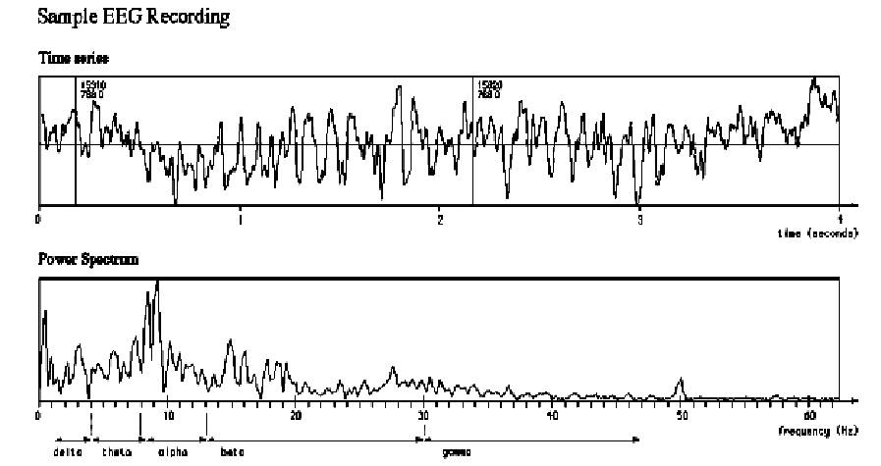
Figure 1: Typical 4 sec EEG recording (upper part) and Power Spectrum (lower part).
The next step in the proposed signal analysis method is to fit an all-pole (autoregressive, AR) model of order p to the stationary component of the EEG data. Although a full autoregressive - moving average (ARMA) type of model might provide a better fit to the data, the simpler AR model is preferred as it provides an adequately good fit while its parameters are obtained by solving of a linear set of equations. This offers a clear practical advantage over the nonlinear minimization procedure, required in order to obtain the corresponding ARMA parameters. The all-pole filter transfer function is given by:
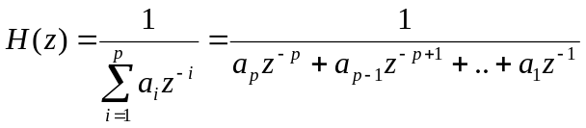By standard least squares minimization it can be shown that the optimal (in the least squares sense) set of parameters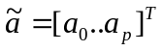, normalised so that a₀ = 1, is the solution of the linear set of equations
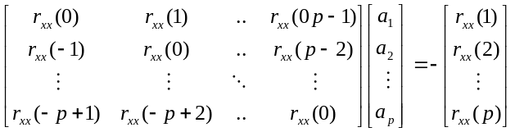or equivalently, in matrix notation
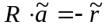
where
- ã is the p×1 vector of unknown model parameters that we seek,
- R is the p×p Toeplitz form autocorrelation matrix of the EEG data signal {x(n) , and
- is the p×1vector of known autocorrelation “lags” of the same EEG signal.
The autocorrelation sequence 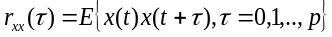 is estimated from the EEG data via its unbiased sample estimator
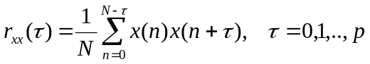
up to the first p lags, using which we can construct the linear system mentioned above. Solution of the linear system is usually sought via the Moore-Penrose matrix inversion (or pseudo-inversion) algorithm, since the data contain estimation (and possibly other) errors. The resulting solution vector ã is the p x 1 feature vector upon which person identification will be based.
It should be noted here that the novelty of the present work lies in the fact that, in contrast to existing research, it utilizes the whole of the non-zero bandwidth of the EEG data in order to extract the maximum of the information contained therein. On the contrary, most part of existing research focuses on the alpha rhythm of the EEG spectrum, or even more restrictively on the so-called “monomorphic” alpha sub-band, as well as on further segmentation of the very alpha rhythm into smaller sub-bands, [10].
3. EXPERIMENTAL PART
The proposed feature extraction method is tested on a set of 89 real filed EEG recordings (single channel), from two healthy individuals at rest (eyes closed). 45 of the recordings come from individual A; the rest come from individual B. Each recording lasted for 3 min. approximately and a 128 Hz sampling rate was used. Data were recorded on a digital electroencephalograph; further processing was done using the Matlab software by TheMathworks. The experimental setup was a binary classification problem (class A / class B), which is the simplest possible form of the identification
problem.
The AR model order is another critical parameter for the experimental part. Model order can be determined from the data, based on information-theoretic criteria, such as the Akaike Information Criterion, the Minimum Description length Criterion, etc. Instead of a theoretic approach, here we have exploited existing practical research results showing that a model order of p = 10 is enough for EEG recordings.
As for the classification method, we have employed two different neural network classifiers. The first one is a simple Perceptron classifier (Test case 1), while the second one is a more complex classifier of the LVQ type (Test case 2), [7], [8], [9]. In each test case, we have performed:
1. A first classification experiment where
a. the whole of the available data (89 EEG recordings) were used as the training set for the neural network, and
b. the same set was used as the test set.
This is clearly not a practical situation; however it is indispensable as it checks the suitability of the chosen network architecture for the given problem.
2. A second classification experiment, by two-ways cross-validation of the results:
a. 49 EEGs were used as the training set (25 As and 24 Bs), while the 40 rest EEGs were used as the test set (20 As and 20 Bs).
b. 40 EEGs were used as the training set (20 As and 20 Bs), while the 49 rest EEGs were used as the test set (25 As and 24 Bs).
c. average correct and wrong classification scores were calculated from (a) and (b) above.
This experiment is of practical interest, as it measures the ability of the network to generalize, drawing on the knowledge acquired during training.
3.1.Test Case 1 (Perceptron classifier).
Tables 1 and 2 show classification scores for Test Case 1 (Perceptron classifier) and for the experiments (2a) and (2b) mentioned above, while averages are calculated below the Tables.
out  in | A | B | Total
A | 20  (100%) | 0  (0%) | 20  (100%)
B | 3  (15%) | 17  (85%) | 20  (100%)
Total | 23 | 17 | 40
Table 1: Test Case 1, Perceptron classifier, training set of 49 EEGs, test set of 40 EEGs.
- Correct classification score from Table 1: 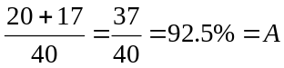
- Wrong classification score from Table 1: 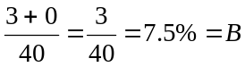
out  in | A | B | Total
A | 22  (88%) | 3  (12%) | 25  (100%)
B | 1  (4.17%) | 17  (95.83%) | 24  (100%)
Total | 23 | 26 | 49
Table 2: Test Case 1, Perceptron classifier, training set of 40 EEGs, test set of 49 EEGs.
- Correct classification score from Table 2: 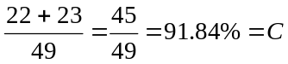
- Wrong classification score from Table 2: 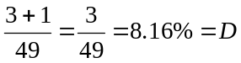
Of practical interest are the average results from Tables 1 and 2 (two-ways cross-validation):
- Average correct classification score: 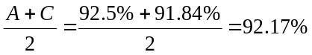
- Average correct classification score: 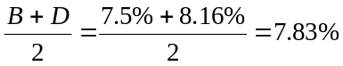
3.2. Test Case 2 (LVQ classifier).
Tables 3 and 4 show classification scores for Test Case 2 (LVQ classifier) and for the experiments (2a) and (2b) mentioned above, while averages are calculated below the Tables.
out  in | A | B | Total
A | 19  (95%) | 1  (5%) | 20  (100%)
B | 2  (10%) | 18  (90%) | 20  (100%)
Total | 21 | 19 | 40
Table 3: Test Case 2, LVQ classifier, training set of 49 EEGs, test set of 40 EEGs.
- Correct classification score from Table 3: 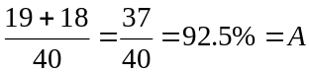
- Wrong classification score from Table 3: 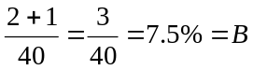
out  in | A | B | Total
A | 25  (100%) | 0  (0%) | 25  (100%)
B | 0  (0%) | 24  (100%) | 24  (100%)
Total | 25 | 14 | 49
Table 4: Test Case 2, LVQ classifier, training set of 40 EEGs, test set of 49 EEGs.
- Correct classification score from Table 4: 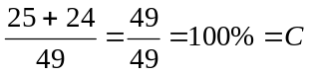
- Wrong classification score from Table 4: 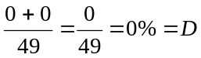
Of practical interest are the average results from Tables 3 and 4 (two-ways cross-validation):
- Average correct classification score: 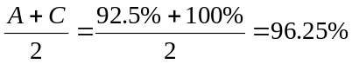
- Average correct classification score: 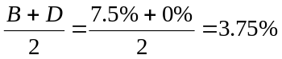
The :LVQ classifier was trained by the LVQ2 algorithm, [8], with a learning rate of 0.001 and four (4) hidden layer neurons in the competitive layer, [9]. It has yielded higher correct and lower wrong classification scores than the Perceptron. This is due to the more complex structure of the LVQ architecture, which seems to have absorbed more successfully the class information contained in the data.
4. CONCLUSIONS
We have proposed a parametric spectral analysis based method for the extraction of features from the EEG, aiming towards biometric person identification. The proposed method fits an AR model to the stationary component of the EEG data, and utilizes the model parameters as the feature vector for identification. Classification is carried out by two alternative neural network classifiers, yielding encouraging results. As a conclusion, although the potential of the proposed method is shown in limited-scale experiments on real field EEG recordings, more extensive experimentation is clearly necessary in order to obtain statistically significant classification scores. Further improvement of the efficiency of the proposed method is expected if the parameter values at the various stages of the method are trimmed based on a larger set of field data.
ACKNOWLEDGEMENTS
This work was supported by TEI Piraeus (Internal Research Funding programme).
REFERENCES
1. F. Vogel, A. Motullsky, “Human Genetics Problems and Approaches,” Spinger-Verlang, New York, 1986.
2. F. Vogel, “The Genetic basis of the normal EEG,” Human Genetic, vol. 10, pp. 91-114, 1970.
3. G. Dumermuth and L. Molinary, “Spectral Analysis of EEG Background Activity,” Methods of Analysis of Brain Electrical and Magnetic Signals, Elsevier, London, 1987.
4. J. Zhu, N. Hazarika, A. Tsoi, A. Sergejew, “Classification of EEG signals using wavelet coefficients and an ANN”, Pan Pacific Workshop on Brain Electric and Magnetic Topography, Sydney, Australia, pp. 99-104, 1994.
5. N. Hazarika, A. Tsoi, A. Sergejew, “Nonlinear Considerations in EEG signal Classification”. IEEE Transactions on signal Processing, vol. 45, pp. 829- 836, 1997.
6. M. Poulos, M. Rangoussi, V. Chrissikopoulos, A. Evangelou, "Electroencephalogram spectrum analysis for extraction of approximately stationary features," Proc. 5 th International Workshop on Mathematical Methods in Scattering Theory and Biomedical Technology, (BIOTECH 2001), Corfu, Greece, October 2001.
7. T. Kohonen, "Self-Organization and Associative Memory," 2 nd ed., Springer-Verlag, New York, 1988.
8. T. Kohonen, "Improved versions of LVQ," Proceedings of Intl. J. Conf. on Neural Networks '90, vol. 1, pp. 545-550, 1990.
9. S. Haykin, “Neural Networks,” MacMillan, USA, 1994. 10. M. Poulos, M. Rangoussi, N. Alexandris, A. Evangelou, "On the use of EEG features towards person identification via Neural Networks," Medical Informatics & the Internet in Medicine, vol. 26, no 1, pp. 35-48, 2001.

Distributed Smart Microcontroller-Based Networks for Data Acquisition of Weather Parameters
D. Piromalis, G. Nikolaou, A. Dounis and D. Tseles
TEI of Piraeus,
Department of Automation,
P. Ralli and Thivon 250, 12244, Athens, GREECE,
Tel:210 5381011, Fax: 210 5450967, Email: dtsel@teipir.gr

Abstract
Microcontrollers technology progress allows data acquisition systems to gain more capabilities and flexibility. In terms of the networking of the distributed ‘intelligence’ in a typical data acquisition system, complexities such the form factor, the cost and the incompatibilities among various sensor devices can now eliminated using microcontrollers. Various types of networking can be applied, i.e. TCP/IP, CAN, GSM/GPRS, etc. The area of measuring weather parameters can be essentially benefit because of the inherent need for control over several distributed ‘intelligence’ nodes.
The main aim of this paper is to reveal the advantages of changing the typical architecture measurement systems approach with embedded devices approach. The latter provide better performance, more compact design, lower cost, and of course, increased networking capabilities. Thus, it is very convenient to assimilate any kind of networking, either for local or distant applications, and also using wired or wireless connectivity.
After describing the typical architecture and its requirements reflecting to weather parameters measurement remote applications, the characteristics and choices for designing an embedded measurement system according to several networking options are discussed.
To demonstrate further the ultimate benefits from using an embedded approach to distributed networks, two real applications are quoted. Both applications constitute a TCP/IP networking implementation, the first one using the public telephony network, and the second using the wireless GPRS communication network.
Concluding, a reference is set up, showing the pros and cons for each one of the two approaches, in order to emphasize the advantages of the embedded approach to distributed networks.
Keywords
Data Acquisition Networks, Embedded Systems Networking, Weather parameters’ Measurement Devices,
Wireless connectivity, Remote control using GSM/GPRS.
Current status of weather parameters systems
A typical weather parameters measurement device should have the capability of measuring parameters such are the temperature, the humidity, the wind speed, and of course, thermostatic pressure.
Measurements are collected systematically according pre-defined time periods. Both the maximum and the minimum limits of the various sampling periods are determined by the post-acquisition central control scenarios of processing.
When the parameters values are digitized using analogue to digital converters, they have to locally stored in order to be disposable when the measurement device establish a communication with another local measurement device or with the central control system. The memory capacity of the local measurement device always determine the maximum time between communication sessions.
When several weather parameters have to be measured at different points then multiple devices have to be interconnected together in order to set up a distributed control network. A typical topology of such a network is shown in Figure 1.
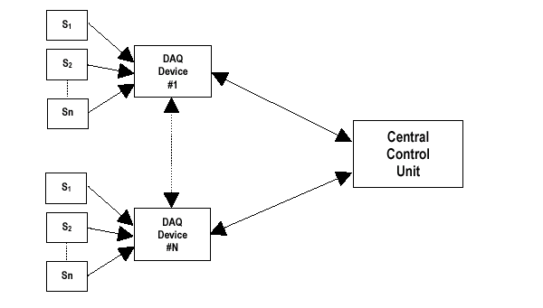
Figure 1: Weather parameters measurement systems topology
It is a common place that the various devices are located in different geographical points and they can read multiple analogue parameters through multiple dedicated sensors. Each one of the devices primarily can be networked with the central control unit, which is the master of the processing scenario, and secondarily, to be able to get interconnected with the rest of devices. For weather parameters data acquisition systems, interconnection among devices is not often needed.
Currently used networking methods are often based on a data modem connected to a personal computer. Thus, each one of the measurement devices approximately have the architecture illustrated in Figure 2.
Central control unit can communicate with distant measurement devices at speeds up to several kbps implementing a point-to-point data communication through the public telephony network.
The above architecture has several disadvantages for control purposes. First of all, the associated costs for pc platforms and operating systems are too high compared with the costs of the data acquisition devices. Also, both the reliability and stability of the operating system running in the PC, nay jeopardize systems performance. Inaccuracies resulted from power supply issues is another disadvantage. To ensure the efficiency in terms of the power supply, extra equipment such are various uninterrupted power supplies (UPSs) have to accommodated to the system. This is an extra cost parameter, and also an extra working area regarding the management of various power status situations. Practically, it is preferred that currently used weather parameters measurement systems need to be working under the control of a personnel working in the same physical environment. Unmanned systems based on the above architecture may increase the number of visits for service and support purposes.
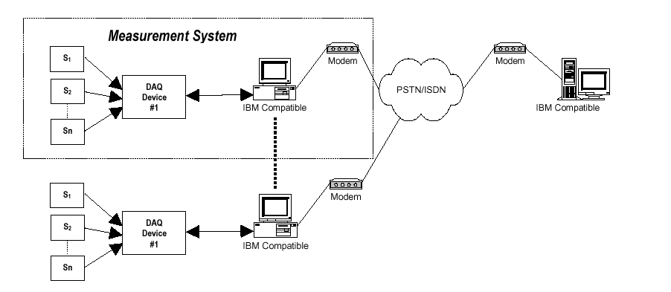
Figure 2: Typical data acquisition system’s architecture
Because of theses disadvantages, new networking approaches have to be implemented. New implementations can gain a lot of performance and efficiency adopting what new networking technologies can provide.
Embedded networking approach
Advancement in networking technology increase the flexibility to select among various protocols and networks. The area of weather data applications can be benefit from it. Systems designers and integrators is possible now to provide cost and performance effective systems. Also, the usage of modern micro-controllers and micro-processors’ can solve compatibility problems that have been identified among various systems manufactured by different brand names.
Categorizing networking applications
The need for networking in weather measurement applications can be divided into two areas: a) local, and b) distant networking.
For both the local, and distant networking, wired and/or wireless networking can be adopted. The major protocols for networking distinguished for local and distant networking applications are illustrated in Table 1.
Networking Area | Wired | Wireless
Local | Ethernet-TCP/IP  RS422/RS485  MODBus/PROFIBus  USB  CAN | RF  (ZIGBEE, ISM, WiFi,..)
Distant | SNMP TCP/IP  X25 | GSM/GPRS
Table 1: Major networking technologies
In terms of embedded measurement systems, which are systems typically based on a micro-controller unit, all of the above protocols can be implemented within the system design.
The typical architecture illustrated previously in Figure 2, can be redefined in that shown below in Figure 3. Now the measurement devices have become embedded control devices. This means that the same device is responsible for sampling and saving the data from the external environment to the internal memory, but also is responsible for the communication.
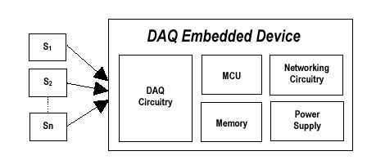
Figure 3: Embedded measurement device
Another interesting point is that the power supply control can be more accurate and cost effective because it is implemented within the device. No extra uninterrupted power supply unit is needed any more because the embedded systems have extremely low power consumption – compared to pc-based systems, and also they have inherent power status control management capabilities (through watchdog, sleep mode, brownout detection, etc).
Systems’ requirements
Systems designers have to take some preliminary decisions regarding the operating characteristics of the device. The major key factors are the number of analogue channels, the sampling time intervals, and the extent of the local memory where the data should be written to. These needs could be covered starting with a very simple and low cost microcontroller (i.e. Microchip PIC micros) up to a 32-bit processor (i.e. Philips ARM7, or Hitachi SH, etc). In terms of the requirements associated with the networking the most heavy task to perform is that of the TCP/IP connectivity. Practically, equal or more than 8kBytes of program memory, and 1kBytes of RAM could be enough to implement the SNMP TCP/IP software stack within the micro-controller. Of course any particular operating function could increase these values. In terms of input/output pins of the micro-controller, the starting point should be forty.
Most modern micro-controllers have built-in networking capabilities. So, brand names such Hitachi (after merging with Mitsubishi called Renesas), Philips, Microchip, Texas Instrument and so on, provide, micro-controllers with built-in CAN, USB, USART, etc. Thus it is very simple to design a low cost and high performance embedded system for data acquisition interconnected devices.
In terms of the systems software demands the designer can choose between of implementing his own operating system or to use a third party ready-made one. This decision depends on the total systems complexity.
In cases where there isn’t either the experience or the time to design and develop an embedded measurement system, then higher level hardware and software can be used. In terms of hardware ready made PC104 processor boards can be suitable. In terms of the software and operating system a solution from either Microsoft embedded operating systems (i.e. Windows CE.net, Windows XPe, etc), or Linux, or even Wind River will reduce time to market.
Real applications
Trying to assess the advantages of modern networking technologies, two test experiments were made. The selection focused on the greater flexibility and openness in systems architecture. The ultimate goal was to provide a systems configuration that could be serve in great extent the distant control of the remote measurement stations.
Finally, the implementation of TCP/IP protocol was chosen. Two versions of connectivity were implemented, the wired, using the PSTN public telephony network, and wireless, using a GSM/GPRS modem for cellular communication.
The device block diagram in Figure 4 shows the major hardware components used to implement a device with a TCP/IP networking capability.
The micro-controller is the PIC18F8720 from Microchip Inc. This is a 8-bit RISC micro running at 20MHz. It has several built-in analogue to digital channels and can co-operate with few external programmable amplifiers to set-up a complete data acquisition device. Its internal program and ram memory is quite enough to implement the necessary TCP/IP software stack. For writing the micro-controller’s firmware the C18 C-compiler from Microchip Inc. was used embedded into the integrated development environment (IDE) MPLAB.
For networking connectivity a network interface chip (NIC) was used from Realtek, specifically the RTL8019AS. For telephony interfacing were used just some convenient components.
The total cost of this experimental board was about 100 euros. This cost can be decreased even to 25 euros depending on quantity.
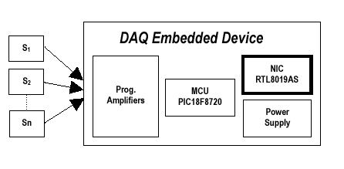
Figure 4: Wired connectivity implementation of TCP/IP
Using the above board is easy to make the distant device a mini web server. So, it is possible to control the distant device by browsing its web page from a common pc internet viewer such as Microsoft Internet Explorer, Netscape, etc. Thus, from the central control unit there is no special need to use proprietary software tools and platforms.
When the systems networking has to be implemented using wireless mediums, for example when a telephone line is not disposable, then a GPRS module has to be used. In Figure 5, the block diagram of an experimental board is illustrated.
In this board the micro-controller and the amplifiers’ circuitry have been remained the same as in the wired implementation explained above. This is intentionally done, just to demonstrate the versatility and flexibility of networking using almost the same components. Only the network component is changed.
The GPRS module is the GM862-GPRS from Telit. This module is of very small dimension and of great performance characteristics. Figure 6 shows the module and Table 2 illustrates its specifications.
Using GPRS technology in the embedded world is becoming a growing challenge that involves hardware andsoftware designers. The embedded controllers usually are required to implement in their code all the PPP/TCP/IP stack in order to gain access to the internet through the GPRS modules.
The most limiting issue to the diffusion of the GPRS applications on the embedded world is the required knowledge of all the PPP/TCP/IP protocols and internet workarounds. This knowledge is not usually part of the embedded designer background and represents an obstacle, especially for low cost applications.
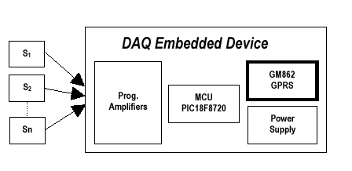
Figure 5: Wireless connectivity implementation of TCP/IP

Figure 6: GM862-GPRS module (near real size)
Tri-band E-GSM 900/1800/1900 MHz
GPRS class 8 and/or 10
MS class B
Output Power
Class 4 (2W) @ 900 MHz
Class 1 (1W) @ 1800/1900 MHz
Control via AT commands
ITU, GSM, GPRS, Telit Supplementary
Supply Voltage
Off: 26 µ Á
Idle: <3.5 mA
Dedicated mode: 250 mA
Dimensions: 6 x 43.9 x 43.9 mm
Weight: 20 gr
Temp. Range: -20 ï up to + 70 ï
Table 2: GM862-GPRS specifications
Using the GPRS module acquiring measurements and control status is feasible even using a simple mobile phone instead of a pc-station or other dedicated equipment.
A point that has to be mentioned is the charge of the SIM card inserted into the module. This SIM can any of the prepaid-time mobile cards. If the distant devices are not often visited then the central control unit has to call first the device. In this way the consumption of device’s SIM time is reduced dramatically.
Conclusions
Using the wired and wireless implementations of the TCP/IP protocol in an embedded measurement device, it is clear enough, that a lot of advantages exist compared with the typical old-fashioned architecture where pc platforms were needed near to the measurement devices. Table 3 illustrates the pros and cons when implementing either a typical or an embedded measurement device.
Typical |  | Embedded
Pros | Con | Pros | Cons
Design simplicity | Employee supervision often needed | Unmanned supervision | Thorough protocols an networking knowledge required
 | PC operating system dependencies | No PC operating systems dependencies
 | Extensive power supply precautions | Inherent power supply management
 | High equipment costs | Low power consumption
 | Decreased systems compatibility | Open architecture
 | Low efficiency | High efficiency and performance
 | High operating costs | Low operating costs
 | High form factor solutions | High hardware versatility
 |  | Great application scenarioscomplexity support
 |  | High number of controlled devices
 |  | Miniature form factorsolutions
Table 3: Pros and cons for typical and embedded measurement devices
Many thanks both to Mr. Antonio Bersani, Senior FAE of Microchip Inc, Milan Italy, and Mr. Constantinos Danos, Area Manager of Arrow Electronics Hellas SA, for their valuable support.
References
[1] D. Piromalis, D. Tseles, Security and Distant Control Over the Telephone Network, Archipelagos Technoloies Conference ’97, Technological Educational Institute (TEI) of Piraeus, Egaleo, Greece, October 1997.
[2] D. Piromalis, D. Tseles, A new secure communication protocol via telephone network extra convenient for stand- alone terminals, NETIES ’97: 3 rd International Conference of Networking Entities, University of Ancona, Ancona, Italy, 1-3 October 1997.
[3] D. Piromalis, D. Tseles, I. Melides, RISC Technology Microcontroller-based Smart Measurement and Control Device, IEEE, MELECON ’96 (Mediterranean ELEctrotechnical CONference), Bari, Italy, 13-16 May 1996.
[4] D. Piromalis, D. Tseles, RISC Technology into Measurement and Control Devices, Circuits, Systems and Computers ’96, International under the aegis of Greek IEEE branch, Hellenic Naval Force Institute, Piraeus, Greece, 15-17 July 1996.
[5] Jeremy Bentham, TCP/IP Lean – Web Servers for Embedded Systems, CMP Books, Second Edition, Lawrence, Kansas, ISBN: 1-57820-108-X, 2002.
[6] RFCs (Requests for comment), http://www.faqs.org/rfcs, The standardization documents for TCP/IP and Internet protocols.
[7] RTL8019AS Ethernet Controller, http://www.realtek.com.tw, Data sheet, Realtek Semiconductor Corp.
[8] Microchip Technical Library CD-ROM, http://www.microchip.com, Complete set of data sheets and application notes for PIC micro microcontrollers, 2004.
[9] Telit GM862-GPRS, http://www.telit.com, GSM/GPRS modules complete information
[10] Microsoft Windows Embedded Operating Systems, http://www.microsoft.com/windows/embedded.
[11] D. Piromalis, PICLab: Self-learning Assembly PIC, P. Caritato & Associates SA, Athens, 1994.
[12] D. Tseles, Data Acquisition Systems, Synchroni Ekdotiki, Athens, 2002.
[13] D. Piromalis, D. Tseles, G. Nikolaou, I. Piromali, Intelligent Distributed System’s Development for Ancient and Other Pieces of Art Precautionary Conservation, Hellenic Physic Scientists Conference 2003, Athens, Greece.

For more details on Cronbach’s' Alpha, See SPSS library: my Coefficient Alpha is Negative.
Hair, J. F., Anderson, I. E., Tatham, R. L. and Black W. C.,"Multivariate Data Analysis", Englewood Cliffs, NJ: Prentice Hall, 1998.
For more information about intraclass coefficients as a measure of reliability, see SPSS Library: Choosing an Interaclass Correlation coefficient.
For more details see: Shrout, P.E. & Fleiss, J.L. (1979). Intraclass Correlations: Uses in Assessing Rater Reliability, Psychological Bulletin, Vol. 86, 2, 420-428
Likert scales allow for use of interval measures and calculations such as arithmetic mean which is used here to measure across the respondents. Respondents were asked “To what extend to you use the following models? (Please circle as appropriate)”. To each of the tools, they had to circle a number such as 1 stands for “Never”, 2, “Very little”, 3, “Little”, 4 “Much” and 5, “Very much”. Thus, SWOT Matrix is closer to “Quite a lot” than “Sometimes”.
Very slightly closer to “very seldom” than “sometimes”.
Use of ICT in strategic planning = f(ICT, personal, organizational)
Likert scales allow for use of interval measures and calculations such as arithmetic mean which is used here to measure across the respondents

