Holy Land and Jordan

Pilgrimage
USA

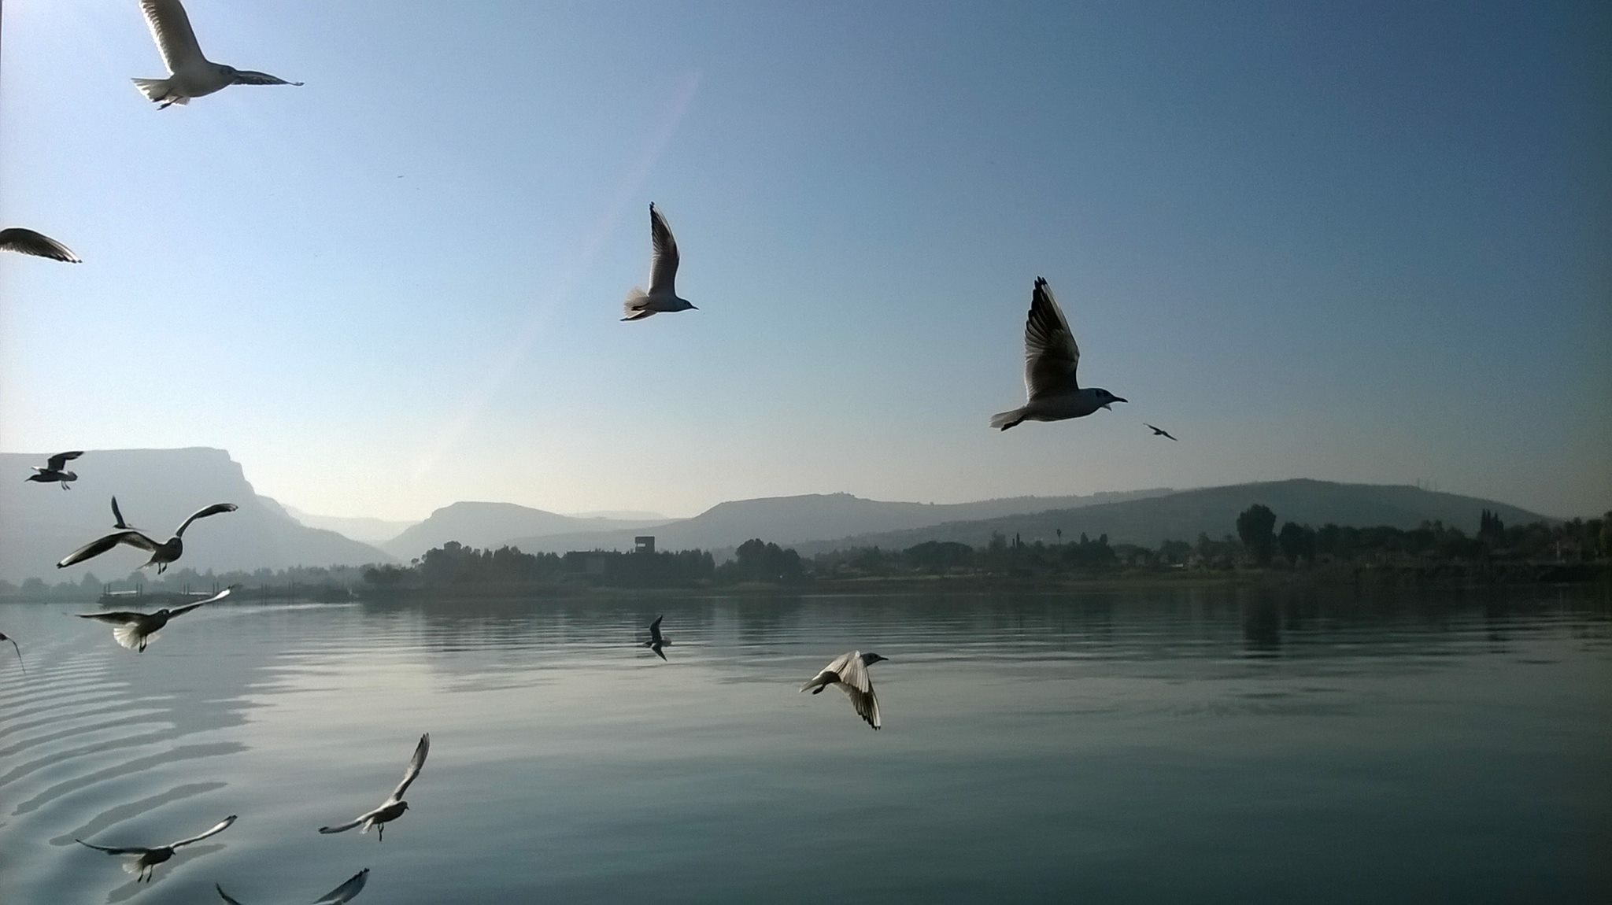

October 29 – November 14, 2015

Aims of this Pilgrimage
- To study the Life and Ministry of Jesus in context
- To rediscover the roots and traditions of Christian faith
- To explore the Bible lands as students and pilgrims
- To integrate academic biblical study with personal Christian faith
- To relate to the local Church in the Holy Land
- To begin to relate our experience to our lives and ministries back home

Staff

The Rev. Dr. Kamal Farah, Director of Studies and Senior Lecturer
The Rev. Ralph Osborne
Mr. Bishara Khoury, Group Leader & Logistics Manager
Mobile # 972 54 569 2894 (24 Hours) In Israel
TOLL FREE From USA - 209 207 7614
Mobile # 962 79 724 10 86 (24 Hours) In Jordan

Important Reminders:

You must have your passport and medical insurance card, as well as money and/or a credit card at all time during this trip

Modest Dress: Events at all Holy Sites, require that everyone’s knees and shoulders be completely covered, in consideration of local custom.

You MUST take ALL personal medication and hygienic needs with you on all overnight trips. Please note: YOU must pay for ALL your drinks, including bottled water at all time

*** You must have your passport on you at all times ***

Cover Photo: Sea of Galilee

Thursday, 29 October – Saturday 14 November, 2015

Thu Oct 29 Arrival at Queen Alia Airport Jordan/ Amman

20:00 Meet Bishara and transfer to Madaba for overnight
at Best Western Grand Hotel
www.grandhotelmadaba.com
Tel # + 962 5 3240403
light Snack upon arrival

Fri 30 “Madaba Mosaic Map”

06:30~07:30 Breakfast
07:30 Depart for Jordan River, Luke 9:28-35
Baptismal Site, Romans 6:1-14
10:30 Visit Mount Nebo ‘Moses’ last Mountain
11:30 Visit Madaba St. George Orthodox Church,
(Ancient Map)
13:15 Lunch in Madaba
14:15 Depart for Petra, for overnight at Movenpick Resort Hotel, www.movenpick-resort.petra
Tel # + 962 32157111
19:00 Dinner

Sat 31 “The Rock Rose City Petra ~ Edom”
Psalm 108

06:30~7:30 Breakfast
Visit Petra site / The Nabatean
Lunch
19:00 Dinner at Movenpick Resort Hotel,
www.movenpick-resort.petra
Tel # + 962 32157111

Sun 1 Nov “Visit Jerash”

06:00 Breakfast
07:00 Depart for Jerash
13:30 Lunch
Late Afternoon: Cross King Hussein Bridge / border Allenby to the Holy Land
Arrive in Jerusalem,
“Psalms of Ascent 116-132”
Overnight in Jerusalem at Golden Walls Hotel
www.goldenwalls.com
Tel # 972 2 6272416
19:00 Dinner
Mon 2 “Mountains”
Psalms 125

07:00 Breakfast
08:00 Depart for the Mount of Olives,
Visit Bethpage, Palm Sunday,
Matthew, 21:1-11, Mark 11:1-11
Group Photo
Walk down the Mount of Olives, Visit
Dominos Flevit, (the Lord Wept), Luke 19:41-44
Visit Garden of Gethsemane Church (All Nation)
Luke 22:39-52
Depart for Mt Zion, the Last Supper,
12:30 Lunch
Matthew 26:17-30, Mark 14:12-26 and Luke 22:7-23
Visit St Peter in Gallicantu Church,
Matthew 26:57-75, Mark 14:53-72
14:15 Holy Eucharist at St. Peter Church
Back to hotel
18:30 Dinner and overnight

Tue 3 “Mother’s day”
07:00 Breakfast
08:00 Depart for Ein Kerem
Visit the Church of the Visitation, Luke 1:39-56
Church of John the Baptist, Luke 1:57-66
Depart for Bethlehem
Lunch
The Shepherds’ field Luke 2:8-20
Church of the Nativity, Luke 2:1-7, John 1:1-5
Stop and shop, Back to Hotel
19:00 Dinner

Wed 4 “Mystery of the Annunciation”

06:30 Breakfast
07:30 Depart for the Galilee, Caesarea Maritima
(The City of Herod and the Residence of Pilate)
Cornelius the first Gentile convert, Acts 10,
Lunch in Nazareth
Visit the Church of the Annunciation
Luke 1:26-38, Luke 2:39-40 and Deut.22:13-21
Visit Sisters of Nazareth (Excavations)
Visit The Synagogue Church, Luke 4:14-30
Mary’s Well
Overnight in Nazareth, Betharram Guest House
www.nazareth360.com
Tel # + 972 4 6570046
18:30 Dinner
20:00 Holy Eucharist

Thu 5 "Around the Sea of Galilee"
06:30 Breakfast
07:30 Depart for the Sea of Galilee, Jesus Trail
Visit Mount of Beatitudes, Matthew Chapters 5-7
(Birds and Flowers) Matthew 6:26-34
(Wheat and Weed) Matthew 13:25-30
Visit Tabgha Church of the Multiplication,
Mark 6:30-44, Mark 8:1-9 and John 6:1-14
Visit Mensa Christi, John 21
Visit Capernauem, Matthew 6:26-34
Lunch
15:00 Boat Ride Matt.8:23-27 and John 14:22-23
19:00 Dinner

Fri 6 “Who am I for you!?”

06:30 Breakfast
07:30 Depart for Banias, Caesarea Philippi
(Springs of the River Jordan) Matthew 16:13-28
Golan Heights Acts 1:25
Lunch
Depart for Mount Tabor, the Transfiguration,
Luke 9:28-35
Depart back to Nazareth Betharram Guest House
19:00 Dinner

Sat 7 “The Wilderness”

07:00 Breakfast
08:00 Depart for Jericho via the Jordan Valley
(The Blind Man) Luke 18:35-43,
(Zacchaeus) Luke 19:1-11
Mount of Temptation, Matt. 4:1-11
Brief stop and Shop
12:30 Lunch in Jericho
14:00 Overview the Judean Wilderness
15:00 Depart for Bethany visit Lazarus Church,
John 11:1-46, Luke 10:38-42
17:00 Back to Golden Walls Hotel in Jerusalem
19:00 Dinner

Sun 8 “Living Water”

06:30 Breakfast
07:30 Depart for Nablus
Visit Jacob’s Well the Samaritan Woman,
John 4:1-42
Visit the Samaritans on Mount Gerizim,
2 Kings 17:27-31
Lunch
14:00 Depart for Jerusalem and Free afternoon
19:00 Dinner and overnight

Mon 9 “Dead Sea Scrolls”
06:30 Breakfast
07:30 Depart for Masada
(Ein Gedi 1 Samuel 24:1-22)
Visit Qumran Excavations, Community of the Essenes
Lunch
Float in the Dead Sea
Depart back to Jerusalem
19:00 Dinner

Tue 10 “Am I my Brother’s Guardian?”

07:00 Breakfast
09:00 Depart for Efrata Settlement
Lunch
Visit Dheisheh Refugee Camp
Depart back to Hotel
19:00 Dinner and overnight

Wed 11 “The Patriarchs’ Way”

07:00 Breakfast
08:00 Depart for Hebron
Visit the Makhpelah
(Patriarchs’ and Matriarchs tombs)
Gen.23:1-9, 49:29-33
Visit “Oaks of Mamre” Gen.18:1-15
Lunch
Stop and Shop Hebron glass and Ceramic
Depart back to Jerusalem
18:30 Dinner and overnight

Thu 12 “Sacred Places”

06:30 Breakfast
07:15 Walk for the Haram ash-Sharif (Al-Aqsa Mosque)
The Pool of Bethesda, The Church of St Anne,
John 5:1-15
Western Wall (Wailing Wall)
Lunch in the Old City
Visit the Church of the Holy Sepulcher
(Church of the Resurrection)
John 19:25-42, John 20:11-18
15:00 Free afternoon
19:00 Dinner and overnight

Fri 13 "Jesus in Jerusalem”

06:00 Walk the way of the Cross /Via Dolorosa
08:15 Breakfast back at the Hotel
09:30 Depart for Israel Museum, The Herodian Model of Jerusalem and Shrine of the Book
Lunch
Free afternoon
18:00 Dinner and overnight

Sat 14 “The Road to Emmaus”

07:00 Breakfast
08:00 Depart for Emmaus (Abu Gosh) Luke 24:13-35
Visit Benedictine Monastery
Holy Eucharist at Our Lady of the Ark of the Covenant (Kyriat Ye'arim) Psalm 132
Lunch
15:30 Back to the Hotel
19:00 Dinner
21:30 Departures to Ben Gurion Tel Aviv airport

