Ι. Book a hotel in Athens

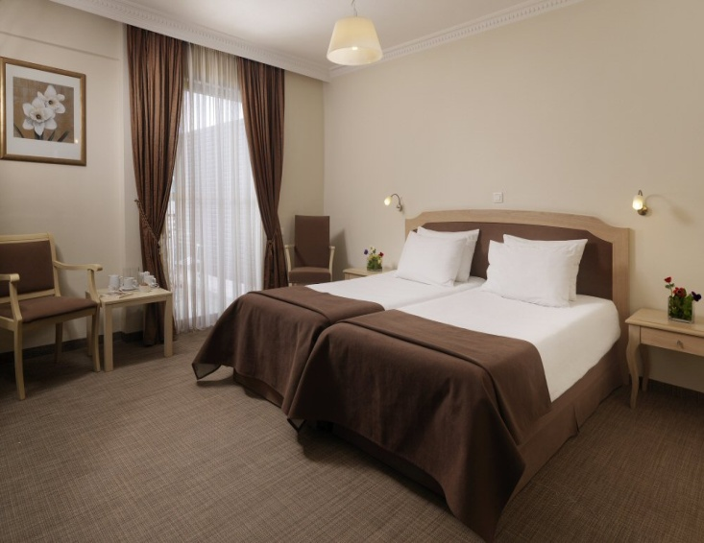
Airotel Parthenon****
--FULLY BOOKED--
6 Makri str., 11742, Athens
Website: http://www.airotel.gr/hotel/parthenon
Location: The hotel is located in the heart of the old city
Room type Rates
Single: 102
Double: 105
- The rates include breakfast and taxes

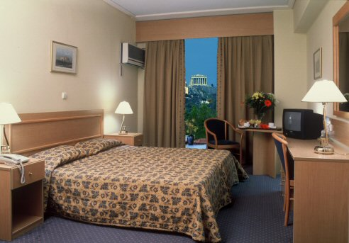
Astor****
16 Karagiorgi Servias str., 10562, Athens
Website: http://www.astorhotel.gr/index_eng.html
Location: The hotel is located in the historical triangle of Athens, only 50 m. from Syntagma Square and close to all the main sights and monuments of the city and the business centre.
Room type Rates
Single: 75
Double: 93
- The rates include breakfast and taxes

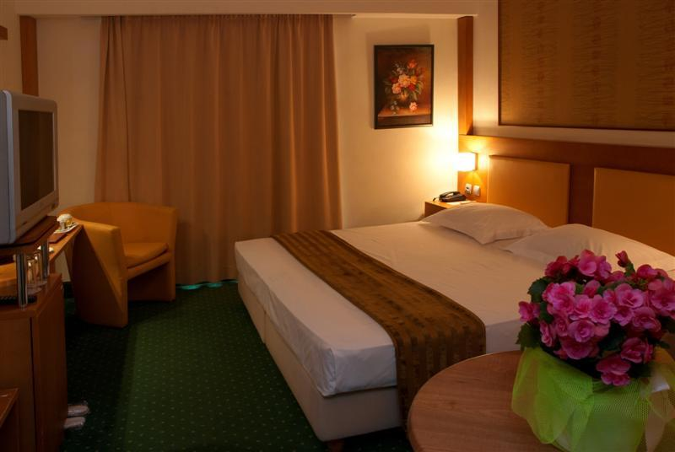
Athens Cypria***
--FULLY BOOKED—

5 Diomias str., Syntagma Sq, 10563, Athens
Website: http://athenscypria.com/
Location: Ideally situated in the heart of Athens approximately 150 meters from Syntagma Square.
Room type Rates
Single: 68
Double: 88
- The rates include breakfast and taxes

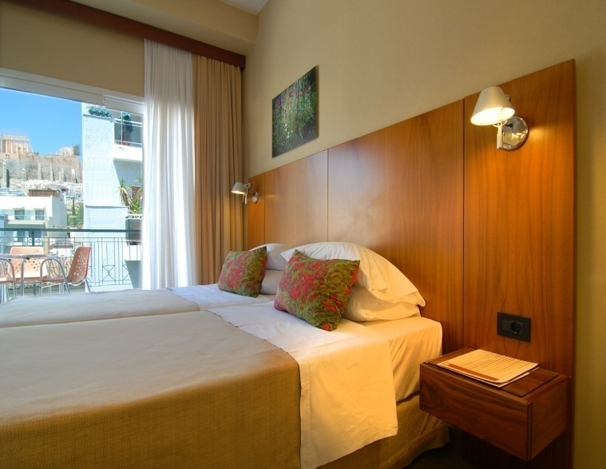
Philippos***
3 Mitseon str., Acropolis, 11742, Athens
Website: http://www.philipposhotel.gr/main.php
Location: The hotel is located in the heart of the old city district, only a two minutes walk from the Acropolis, Plaka etc. The Metro Station Acropolis is a few steps away from the hotel.
Room type Rates
Single: 85
Double: 100
- The rates include breakfast and taxes

Hotels | Arrival date | Room type  Single Double |  | No of nights | Smoking room | Total €
Astor
Philippos
A. Total cost

Cancellation policy:
In case of cancellation less than 7 days before your arrival date or in case of no-show, your deposit will not be refunded.

IΙ.Book a hotel in Nafplio

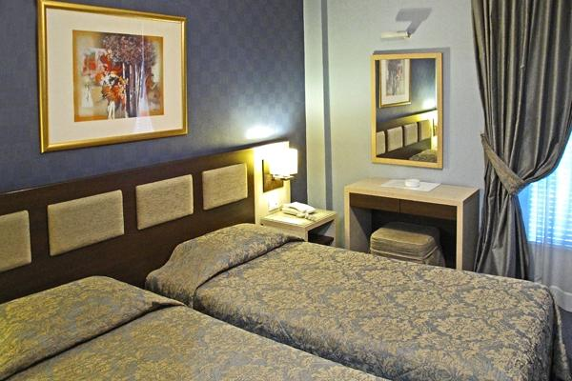

Rex***
21 Bouboulinas str., 21100, Nafplio
Website: http://www.rex-hotel.gr/lang/en
Location: The hotel is located in the centre of Nafplio, only a few meters away from the port.
Room type Rates
Single: 55
Double: 68
- The rates include breakfast and taxes
*Approximately 450 meters away from the hotel there is a sightseeing train that can transfer you to the Venue, “Fougaro”.

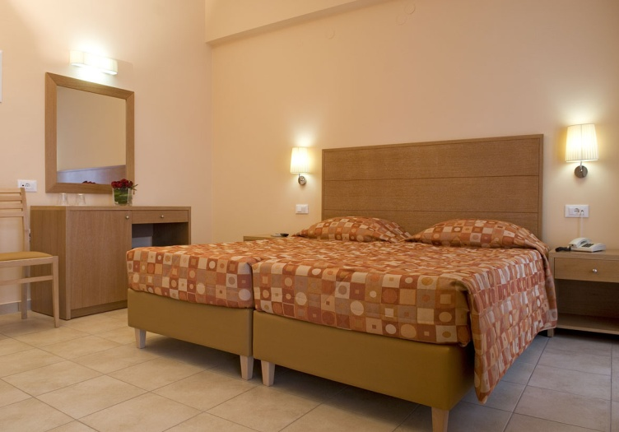
Park **
--SINGLE ROOM FULLY BOOKED--
1 Dervenakion str., 21100, Nafplio
Website: http://www.parknafplio.gr/
Location: The hotel is located at the city centre, right opposite Kolokotronis Park
Room type Rates
Single –FULLY BOOKED--: 35
Double: 48
Double for Single use: 42
- The rates include breakfast and taxes

*Approximately 200 meters away from the hotel there is a sightseeing train that can transfer you to the Venue, “Fougaro”.

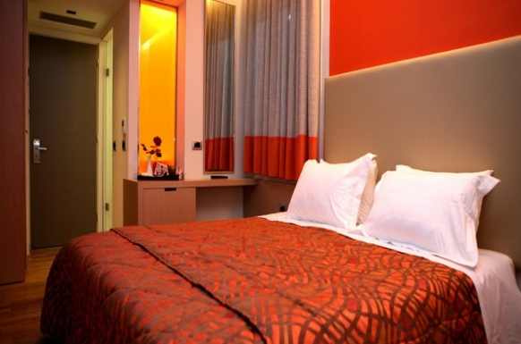
Victoria**
3 Spiliadou str., 21100, Nafplio
Website: http://hotelvictoria.gr/index.php/en
Location: The hotel is situated in the historical centre of the old city of Nafplio, only 110 yards away from the harbor of Nafplio, offers amazing views to the Palamidi and Akronafplia.
Room type Rates
Single: 58
Double: 70
- The rates include breakfast and taxes
* Approximately 150 meters away from the hotel there is a sightseeing train that can transfer you to the Venue, “Fougaro”.

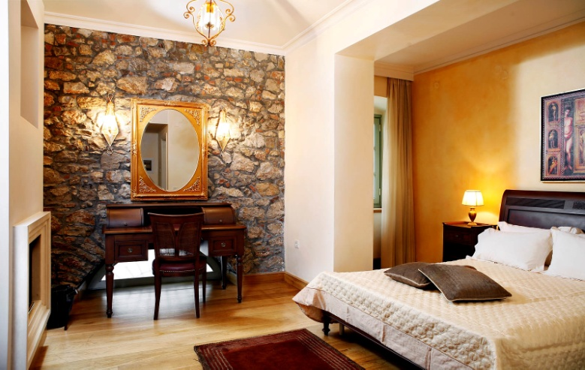
Ippoliti****
9 Aristidou & Ilia Miniati str., 21100, Nafplio
Website: http://ippoliti.gr/en/
Location: The hotel is situated in the heart of the old city centre
Room type Rates
Single Standard: 78
Double Standard: 90
Double Superior 105
Double Deluxe 128
- The rates include breakfast and taxes
*Approximately 300 meters away from the hotel there is a sightseeing train that can transfer you to the Venue, “Fougaro”.

Hotels | Arrival date | Room type  Single Double |  | No of nights | Smoking room | Total €
Rex
Park
Victoria
Ippoliti
B. Total cost

III. Personal Details

Last Name . . . . . . . . . . . . . . . . . . . . . . . . . . First Name/s . . . . . . . . . . . . . .
Affiliation/ Institution (if applicable) . . . . . . . . . . . . . . . . . . . . . . . . . . . . . . . .
Address (street, number) . . . . . . . . . . . . . . . . . . . . . . . . . . . . . . . . . . . . . . .
Post code. . . . . . . . . . . . . . . . . . . . City . . . . . . . . . . . . . . . . . . . . . . . . . . .
State. . . . . . . . . . . . . . . . . . . . . . . . . . . . . . . . . Country . . . . . . . . . . . . . . .
Telephone no . . . . . . . . . . . . . . . . . . . Mobile no . . . . . . . . . . . . . . . . . . . . . .
Fax no . . . . . . . . . . . . . . . . . . . . . . . . . . E-mail . . . . . . . . . . . . . . . . . . . . . .

IV. Total charge

Grand Total €………………….. (Sum of A + B)

V. Payment options

1. Bank deposit to the nominated bank account:
Bank: Alpha Bank
Account holder: Arkouli Aspasia & Co
Account number: 104 002 320 007 480
IBAN: GR0501 401 040 104 002 320 007 480
Swift code: CRBAGRAA

2. Credit card payment (VISA, MASTERCARD, AMERICAN EXPRESS)
For a credit card payment please send us a signed copy of the following Power of Attorney:
I authorize the company “Arkouli Aspasia & Co” to debit my credit card with the amount of ………. euro only.

Credit card number………………………………..

Cardholder Name ……………………………………

Expiry date on the card………………………………

CVC code………………………………………….
(This is the three-digit number on the back of your credit card)

VISA / AMERICAN EXPRESS / MASTERCARD
□ □ □

VI. Forwarding Details
Please send us the Hotel booking form and the Payment Information by fax or e-mail to:

Arkouli Aspasia & Co
Mager 15, 10438 Athens GR
Tel.: (+30) 210 5238777 - Fax: (+30) 210 5239886
E-mail: info@speg.gr

