SECONDARY SCHOOL NO. 2 NAMED AFTER CONSTITUTION OF 3 MAY IN KROSNO

April 2007

European citizens?
Yes, we are!
How our culture has been
and is influenced by old
and modern fusions.

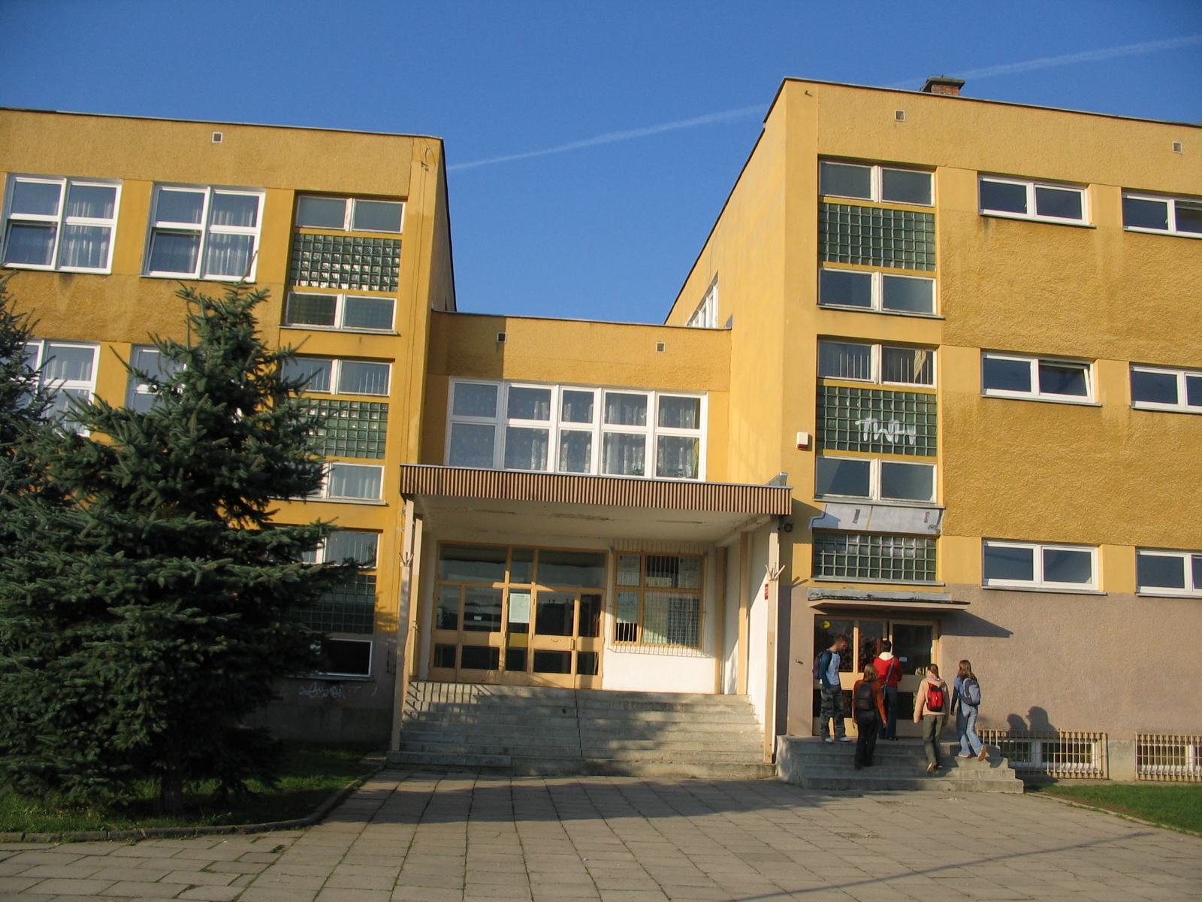
Contents

Introduction

Chapter I: National minorities in Poland in the statistics.

I.1. The size of national and ethnic minorities in Poland within the space of
XX century.
I.2. Population of the Subcarpathian Region according to the country of birth
and declared nationality.
I.3. The mobility of citizens in the Subcarpathian Region in the years 1989 – 2002.
I.4. Reason of immigration to the Subcarpathain Region between 1989 and 2002.

Chapter II: Legal situation of national minorities in Poland.

II.1. Legal basis for the functioning of national minorities in Poland in the years
1989 – 1996.
II.2. Legislativel guarantee for national minorities in Poland in the years 1997 – 2002.

Chapter III: Characteristics of national and ethnic minorities, national groups currently
inhabiting the Subcarpathian Region and characteristics of their countries of origin.

III.1. The Lemkos’ contemporary life.
III.2. The social and economic situation of the Gypsy population.
III.3. Characteristics of the immigrants’ countries of origin.
III.4. Interviews with the representatives of national groups currently inhabiting
Krosno and the surrounding areas.

Conclusion

Introduction

Nowadays almost each country is inhabited by national minorities, but no society can strive to preserve its national identity at the cost of national minorities. National minorities have a right to preserve its culture, language, and customs. Much weaker and not having its own state institutions, national minorities are left to count on the help of the country on whose territory they are inhabiting.
The Republic of Poland, like other countries, ensures all the Polish citizens who belong to national and ethnic minorities the rights to preserve their national or ethnic identity. These rights include: the right to choose their representatives to the Polish parliament, the freedom of religion, the right to form associations, to form their own educational and cultural institutions.
The conditions which the Polish authorities create for the national minorities are favourable to strengthening the relations with our neighbors and diminishing the risk of conflicts on ethnic grounds.

Chapter I: NATIONAL MINORITIES IN POLAND IN THE STATISTICS

I. 1. The size of national and ethnic minorities in Poland within the space of XX century.

These days almost each country encounters the problem of national minorities, which form social groups of a special kind which are part of the whole society. The problem of national minorities is present in Poland too. It was particularly strong in the 20-year interwar period (1918-1939). The Republic of Poland II was then a multinational country. On its territory lived about 10 million people of different nationalities, which made up 32 per cent of all citizens of Poland. The most numerous national minorities living in Poland then were: The Ukrainians, the Belorussians, the Jews and the Germans. Apart from them on the Polish grounds also inhabited the Russians, the Lithuanians, the Czechs, the Slovaks and the Gypsies.

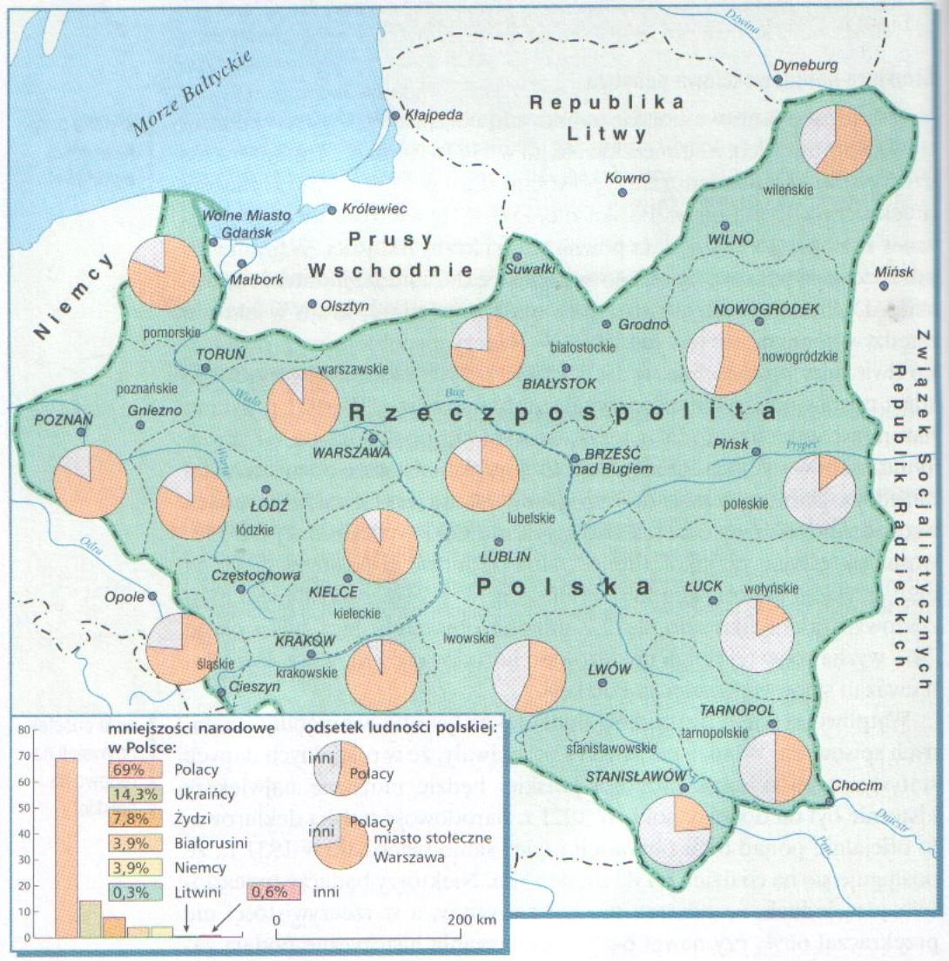

The ethnic composition of the Republic of Poland II in the interwar period 1918-1939.

This ethnic composition changed because of the extermination of the Jews and other nations done by the Germans during World War II and because of the change of the Polish borders after World War II was over. As a result, Poland has become ethnically homogeneous as nowadays national minorities make up about 3 per cent of the whole population. The most numerous national minority are the Germans (500 000 people) living mainly in the Opolskie and the Silesian provinces. The second largest group are the Ukrainians (300 000 people) mainly in south- eastern Poland.
As a result of compulsory colonization of the Western Territories (The Vistula Operation carried out in 1947) the Ukrainian minority was scattered mainly throughout the Warminsko- Mazurskie, the Zachodniopomorskie and the Dolnoslaskie provinces.
The remaining national minorities inhabiting Poland are not so numerous as the above mentioned ones. They include: the Czechs (3 000) concentrated in the klodzki and strzelinski counties, the Slovaks (20 000) living on Orawa and Spisz, Lithuanians (30 000) living in Sejny county, Jews (10 000) settled in big cities such as Warsaw or Lodz, and the Gypsies (30 000) scattered throughout the whole country.
However, the most numerous ethnic minority inhabiting Poland is the Lemkos (70 000 people), many of whom are living in the Subcarpathian Region.
Apart from national and ethnic minorities, there are some immigrants living in Poland. These people have settled in Poland seeking better living conditions or they have come to join their Polish families. For a few years there have been groups of immigrants living in big cities. The biggest part of them are the Vietnamese whose main occupation is street trade or running fast food restaurants. The immigrants lot is not easy; it’s even harder because of the differences between their indigenous culture and the Polish culture.

I. 2. The population of the Subcarpathian Region according to the country of birth and declared nationality.

National origin was a subject of research in Poland in the interwar period in the national censuses in 1921 and in 1931. In the 1931 year census it was established indirectly on the basis of the religious faith and mother tongue.
In the post-war times, national issues were first included in the national census in 2002. In this census, some questions from the 1921 year census were used. They also followed the principles of the rights of a man and a citizen which must be in effect in all European countries. On this basis it was possible to determine the nationality of the people inhabiting Poland in 2002.
While processing data gathered in the census in the Subcarpathian Region, about 70 national categories were singled out, but it must be stated that they are not numerous. Three quarters of these national groups consist of a few or several people. Ten national groups consist of 20 to 100 people. From among the nationalities which have been listed above and the answers of the people who took part in the census in the Subcarpathian Region, the nationality which occurs most often is the Ukrainian nationality- 3 271 people. Then comes the Gypsy nationality- 717 people. The remaining nationalities include: the Lemkos- 147 people, Americans- 129, the Russians- 128, the British- 14, the Arabic- 14, Austrian- 19, Belarussian- 27, Bulgarian- 21, Czech- 39, French- 69, Greek- 71, Spanish- 21, Canadian- 35, Armenian- 36, Slovak- 36, Hungarian- 23, Vietnamese- 50, Jewish- 17.

In the scale of the whole country, the Subcarpathian Region is one of the most homogeneous provinces. The total population of this province is 2 103 837. Polish people make up 2 097 208 and other nationalities- 5 574, which means that only 0,26 per cent of foreigners are living in the Subcarpathian Region (see table no.1). (It was impossible to determine the nationality of 19 055 people)

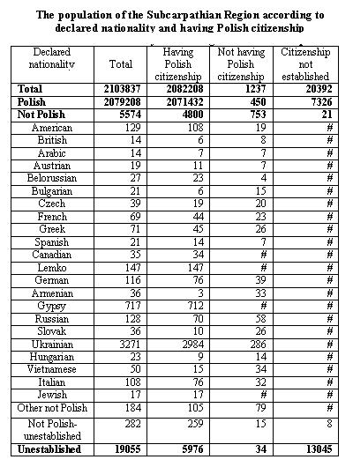

I. 3. The mobility of citizens in the Subcarpathian region in the years 1989 - 2002.

Among all the people living in the region Subcarpathian, who changed their place of living in the years 1989 - 2002, 5.4 thousand came to the region from abroad. This amount includes the people living in the region before, who left for abroad for at least one year (sometimes several years) and who came back, as well as the immigrants (foreigners or Poles) so the people whose permanent place of living was in another country and in the years of 1989 - 2002 received the right of abode (right for a permanent stay) in Poland (for settling down).

In the period of 14 years between the censuses the amount of people arriving in the Subcarpathian region systematically increased, reaching the highest level in the years 2000 - 2001. This process was inhibited in 2002. (see charts no 2 - 3)

Among the general number of people coming to the Subcarpathian region from abroad, women insignificantly predominated - they made 50,7% of immigrants.

However, among the people who came in the first half of 90s, men predominated definitely. Districts to which most people came (or came back) from abroad are: the city of Rzeszów (12,3% of all the people who came), Mielec district (9,1%) and Stalowa Wola district (8,1%). The fewest number of people came to: Bieszczady district (1,2%), Sanok district (1,4%) and Lubaczów district (1,5%).

The results of the census in 2002 showed that among the immigrants to the Subcarpathian region from abroad for a permanent stay the majority (4.7 thousand - 88,4%) had Polish citizenship, which means the Poles coming back to the homeland after years of emigration. In this group 64,4% had only Polish citizenship and 24% Polish and the other.

In the years 1989- 2002, 550 foreigners settled down in the Subcarpathian region (received a permanent stay permit) and they constituted 10,3 % of all the people who came from abroad for a permanent stay ( 1,3 % of them did not get the citizenship). Women constituted 56,4 %.

The foreigners who came to the Subcarpathian region for good most often enumerated as a previous place of living Ukraine ( 271 people- 49,3 % of all the foreigners coming), Russia (40 people- 7,3 %), Germany (23 people- 4,2 %) and Armenia (22 people- 4 %).

Mostly young people have come to the Subcarpathian region from abroad. 64,1 % of them were aged up to 30 years and children up to 14 years constituted 22,1 %. Only every 10th person coming to our region was retired.

Higher contribution of young people appeared among the foreigners coming from Ukraine- 67,4 %- people in the ages up to 39 years, including children of up to 14, who comprised 10,7 % of all coming from Ukraine. The percentage of people aged 40 and more was around 28,5 %. 69 % of those coming from Russia was in the ages up to 39 and children of up to 14 made 9,5 % of all coming from Russia.

The level of education of the people coming to the Subcarpathian region is worth mentioning. There were 37.2 % of people with secondary school education in the ages over 13, while among all the people living in the region 27,6 %. 17,8 % had higher education which means twice as many as all in general in the region.

I.4. The reasons for the movement of people to the Subcarpathian region
in the years 1989-2002.

The immigrants came to the region most often for family reasons. 41,1 % of all the immigrants pointed to such a reason and more were among the long-term immigrants
(50,6 %) than the short- term ones (24,6 %).
Many immigrants have Polish roots, many foreigners got married to Polish citizens
(in Poland as well as abroad) and chose the Subcarpathian region for their place of living but they still haven’t received the right of abode.

23,9 % of immigrants to the Subcarpathian region came with the intention of taking up a job and this was more frequent among the long- term immigrants.
10,5 % came in order to start their studies at universities, to learn and to raise their qualifications. However, this reason was mentioned mainly by the short- term immigrants (20,3 %) while only 4,9 % of the long- term immigrants pointed to it.

People who came to the Subcarpathian Province between 1989 and 2002 from abroad according to the year they came in

Year | Number of people
1989 | 194
1990 | 253
1991 | 250
1992 | 363
1993 | 292
1994 | 312
1995 | 396
1996 | 406
1997 | 403
1998 | 485
1999 | 479
2000 | 546
2001 | 541
2002 | 313

People inhabiting the Subcarpathion Province according to inhabitance period and counties

Name of the county | Total number | People inhabiting this county from birth | People who have come to this place | It has not been established how long the people have lived in this place
Powiat przeworski | 78911 | 57324 | 21509 | 78
Powiat sanocki | 94382 | 61731 | 32008 | 643
Powiat strzyżowski | 61940 | 47452 | 14266 | 222
Powiat m. Krosno | 48372 | 25891 | 22180 | 301
Powiat m. Przemyśl | 68095 | 40479 | 26731 | 885
Chapter II: Legal situation of national minorities in Poland.

II.1 Legal basis for functioning of ethnic minorities in Poland in years 1989-1996

The process of a political transformation in Poland, which started in 1989, had also
a great influence on the legal situation of ethnic minorities living in our country.
In the same year The Commission of Ethnic and National Minorities was appointed in the Sejm. The composition of the Commission was made up of Members of Parliament who were the representatives of ethnic minorities. As part of work on a new constitution, the Commission prepared a bill concerning ethnic minorities’ rights. The bill covered the following issues:
- the assurance of equal rights for all citizens regardless of their nationality,
- any direct or indirect violation of these rights is liable to punishment,
- spreading hatred or contempt for foreigners is forbidden,
- fomenting feuds or humiliating people because of their different ethnic origins is prosecuted.
The effect of the Commission work were two bills concerning the attitude of the Polish state towards the Polish Autokefalic Orthodox Church and towards the Catholic Church. The bills were passed by the Polish Sejm – the former in 1991 and the latter some time earlier in 1989.
Ethnic minorities in Poland can also form associations according to the law of April 7th 1989. After the law had come into effect, about 120 associations grouping different ethnic minorities were registered.
On September 7th 1991 another law was passed regulating the legal situation of ethnic minorities in Poland. The law concerned the state education system and its stand on the study and use of a native language by ethnic minorities during classes at school. This law supplements the Minister of Education directive on organizing education which enables students belonging to ethnic minorities to retain their ethnic, national and language identity.
Ethnic minorities living in Poland also have a right to choose their representatives to the Polish parliament. This is guaranteed by an electoral law to the Polish Sejm on May 28th 1993. This law was supplemented in 2001. Then electoral committees formed by national minorities were exempted from the requirement to exceed 5 % of electoral threshold.

II. 2 Legislative guarantee for ethnic minorities in Poland in years 1997-2002

At present ethnic minorities in Poland are given a total guarantee of retaining their own identity. It is provided by the Constitution, ratified international agreements and bilateral agreements. In the Constitution of the Republic of Poland on April 2nd 1997 there is
a regulation which says that Polish citizens belonging to ethnic and national minorities are given freedom of preserving and developing their own language, freedom of preserving traditions and customs, and freedom of developing their own culture. On the basis of the regulation minorities can form their own educational, cultural or religious institutions. They also have a right to participate in settling the affairs concerning their cultural identity. Moreover, electoral law to the Sejm guarantees ethnic minorities to have representation in the Polish parliament.
Ethnic minorities in Poland make up associations gathering their representatives. In Poland in 1999 there were 5 associations of Gypsies having over 9 000 members, 3 associations of the Lithuanian people (about 3 300 members), 5 Ukrainian associations (8 200 members) and 5 Jewish ones (4 850 members). The Germans, who have 54 associations, are the best organized ethnic minority in Poland. Among the best-known associations are The Socio-Cultural Association of German Minority in Opole Silesia (180 000 members) and The Socio-Cultural Association of the Germans in Katowice Province (80 000 members). One of the main aims of these associations is to maintain national traditions of minorities living in Poland.
Every citizen in our country is also guaranteed freedom of religion. It is of great importance to ethnic minorities because they can retain their identity. In Poland we have for example, the Lutheran Church of the Augsburg Confession, the Polish Autokefalic Orthodox Church, the Greek Catholic Church.
As far as education is concerned, according to the Education Act ethnic minorities in Poland are allowed to establish their own schools and use there their native language.
Conditions provided for ethnic minorities by our state favour good relations with our neighbours, lessen the danger of ethnic conflicts in the country and influence the situation of the Poles in neighbouring countries.

Chapter III: Characteristics of national and ethnic minorities, national groups currently inhabiting the Subcarpathian Region and characteristics of their countries of origin.

III. 1. The Lemkos’ contemporary life
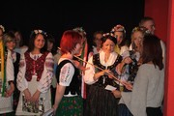
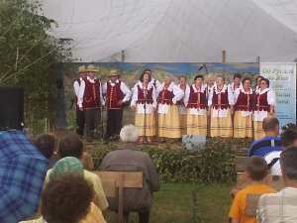

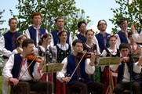

Who are the Lemko people?
The Lemko people are said to be an ethnographic group which was formed in a long historical process. The Lemko people are called either the Russian people or the Ukrainian people. The Lemko people belong to the Ukrainian ethnic-cultural community. Both their language and their culture are connected more with the culture of the western Ukraine. The Lemko language was influenced by the Polish language and the Slovakian one, but there can also be seen some Romanian and Hungarian elements in it.

Religion
The Lemko people belong either to the Greek Catholic Church or to the Orthodox Church. There are a lot of similarities, but also differences between these two religions. For example, Greek Catholics reject the teachings of the Church about the Holy Spirit origin or purgatory. Besides, they do not recognize the primacy of the Pope in the Church. They also reject the dogma of Immaculate Conception of the Blessed Virgin Mary and he Assumption Day. What is common to the Orthodox and the Greek Catholic Church is the Liturgy, although there is still some dissimilarity here. The Eastern Orthodox Church allows married men to take holy orders, however an ordained priest is not allowed to get married.
Nowadays, some new churches are being built, both in the mountains and in the west of Poland. Orthodox churches are being built in Zyndranowa and in Gorlice, and Uniat churches are being built in Komańcza and Legnica.
Orthodox churches play an important role in ethnic and cultural processes, being one of the most essential sources of preserving tradition and shaping national consciousness of the faithful. Eastern rite churches protect the Lemko people from Polonization. Church services are celebrated in the Early Orthodox language and sermons are preached in the Lemko or the Ukrainian language, and even in the Byelorussian language.

Holidays
The eve of the feast of Jordan is called “Szczedryj Weczer” and is a popular holiday to this day. The same dishes are prepared and before eating them people share prosfora and garlic with one another. After supper boys visit villagers’ houses and sing Christmas carols.
Easter (“Wełytdeń”) starts with “Kwitna Nedila”. On that day palms made of pussy willow twigs are consecrated. Later on, the twigs are used as medicine for people and animals. On Maundy Thursday people visit their relatives’ graves and a priest celebrates Mass praying for the souls of the dead. On that day women start decorating Easter eggs, which are then blessed in a church. On Good Friday boys build a big bonfire near an Orthodox church and stand guard over it for the whole night. On Holy Saturday the food is put in baskets and brought to Orthodox churches to be blessed. Among blessed food there is always big bread called “Pascha”. On Easter Sunday after the Mass the youth organize and play different games around a church.
Pentecost called by the Lemko people “Rusala” is celebrated as the feast of spring. During this holiday houses as well as graves at cemeteries are decorated with greenery. “Rusala” holiday is also the herdsmen’s holiday.
St John’s Day is another solemn holiday. The Lemko people call it “Kupała”. The day before the holiday people pick herbs which have medicinal properties, for instance, chamomile, burdock, plantain, St John’s wort, lime tree leaves, hawthorn. People also decorate their houses with hazel boughs.

Differences in rites
Before the Christmas Eve supper household members wash in a mountain stream or in a washing bowl with coins in it. Instead of the holy wafer, they share special bread-prosfora brought from Orthodox churches. In the Carpathian region people traditionally share a clove of garlic with one another, which is regarded to be a symbol of good health and a deep attachment to family. The most traditional dishes served during the Christmas Eve supper are: sour oat soup, cabbage dumplings, boiled dried plums, pea and bean. On Christmas Day ceremonies in church last over three hours and people celebrate Christmas for three days. There are no Christmas carols in the Lemko language so people sing them in the Ukrainian language.

Cuisine

The traditional Lemko and Bojko cuisine is plain but very tasty. It is mainly based on potatoes, cabbage, groats, bread and dairy products. The most characteristic dishes are:
- soup made from oatmeal (kisełycia) eaten with potatoes
- dried fruit soup
- soup made from sauerkraut juice (kwasówka)
- cabbage or sauerkraut with bean and pea
- wholemeal dumplings stuffed with cabbage
- pies with sauerkraut (huczki)
- semolina with fruit
- small dumplings eaten with milk and melted ewes’ milk cheese (maczanka)

Costumes
The most noticeable element of the Lemko folk culture were colourful clothes. Lemko clothes varied in cut, colour and a decorative motif. The Lemko women wore: a linen shirt (oplycza), a brightly coloured skirt (kabat), a woolen corset or a waistcoat (łajbyk), a shawl (facełyk), a cloth jacket (hunia) or in winter a sheepskin jacket, moccasins (kierpci) or bootees (skirni). The Lemko men wore: a linen shirt (koszela), linen and woolen trousers (nohawky, chołośni), a waistcoat made of cloth (łajbyk), a cloth jacket (hunia) or a coat (czucha), a felt hat (uhersky), leather shoes (kierpci or chodaky). Nowadays the Lemko people dress as modern people do.

The Lemko occupations
Woodwork
The Lemko people manufactured mainly wooden everyday articles such as spoons, spindles, pipes, rolling pins or butter dishes. In the Lemko villages near Rymanów there was a tradition of making wooden plates, figurines and cases. In some villages people wove wicker baskets. The Lemko people used a variety of different woods to make lots of useful things such as parts for carts, cradles, musical instruments, pieces of furniture and coffins. Of course, they also used wood – beech as fuel in winter. Some of the Lemko wooden ware survived to this day. To a certain extent, these objects remind today’s Lemko people of their ancestors. There are also objects which are still made today to be sold as souvenirs.
Bee-keeping
Another Lemko people’s occupation was bee-keeping or forest bee-keeping. Although we do not know much about its scale, taking into consideration a wide use of honey, wax and propolis, it was certainly a very important part of the industry at that time. At present the only proof of forest bee-keeping are the names of some places such as Bartne, Bartnica, Bartnie Góra. There are also a lot of bee-keepers among the current Lemko people. It is not only by tradition, but it is also a way of earning money as the Lemko people sell honey and wax figurines.

Other occupations
Other Lemko people work as teachers – they teach the Lemko language at schools their children attend or as doctors – they treat people with herb-based medicines. Some Lemko people earn their living as guides – they show tourists around open-air ethnographic museums and familiarize them with the Lemko culture.
The Lemko organizations
- The Lemko Association was registered in Legnica on April 7 th1989. The main purposes of the association are:
  - integrating the Lemko people, regardless of their views and religious beliefs
  - saving, preserving and popularizing spiritual and material culture of the Lemko people
  - teaching the Lemko language
  - popularizing the history of the Lemko territory and spreading abroad information about the life and activity of the Lemko community
To its credit, the Lemko Association has considerable achievements:
- in the field of publications ( they publish poems and legends in the Lemko language; they publish the Lemko language textbooks; they publish a quarterly “Besida”),
- in the field of education (in several schools in the Lemko territory and in the western Poland the Lemko language was introduced as an extra-curricular subject; at present a programme for a matura exam in the Lemko language is being prepared),
- in the field of culture (the Lemko Kermesz in Olchowiec and the Festival of the Lemko People in Zyndranowa take place every year).
- The Lemko Union was registered on March 30th 1990 in Nowy Sącz. It has its base in Gorlice and it aims at:
  - taking care of the Lemko culture in Poland – music, folk art and folklore
  - the development of education among the Lemko community
  - initiating the Lemko language teaching at schools with the Lemko community
The Lemko Union is ready to cooperate with all socio-cultural and educational institutions, both at home and abroad.
- The Russian Democratic Circle of the Lemko People “Hospodar” was registered in January 1989. The main purposes of the circle are:
  - defending the civil rights of people displaced from the Lemko territory
  - publishing a quarterly bulletin “Lemko”
- The Association “Ruska Bursa” in Gorlice was registered on October 22nd 1991 in Nowy Sącz.
A lot of museums in many different places in Poland signify that the Lemko culture is spreading across the country.
1. The Museum of Folk Architecture in Sanok (the Lemko cottages with their fittings; buildings connected with the social and religious life of the Lemko people; a collection of Orthodox art)
2. The District Museum in Sanok ( Orthodox art of the western Lemko territory. We can see there some historic architecture buildings, objects used in agriculture and crafts, domestic appliances, furnishings)
3. Sądecki Ethnographic Park
4. The Regional Museum of the Lemko Culture in Zyndranowa
5. The Paweł Stefanowski Lemko Museum in Bielanka (the best collection of the Lemko costumes in Poland)

Another example of the Lemko culture popularity are active folk bands, for example:
1. A Song and Dance Company “Łemkowyna”. The band performs folk melodies in a very interesting arrangement. They write new Lemko compositions, record albums and give a lot of concerts in Poland and abroad.
2. A Song and Dance Company “Kiczera” established in 1991. The band presents dance and musical culture of the Lemko people. Their performances are very original and of a high level.
Others:
The Conservation of Monuments Society which has its base in Uście Ruskie. Its main aim is to prevent monuments of material culture, especially Orthodox ones, from being destroyed.

The Lemko migration to the north
Together with the arriving of displaced persons at western and northern regions of Poland a complicated process of their assimilation into the Polish community started. The migration was accompanied by mutual antagonistic attitudes, however material needs of displaced persons forced them to take up jobs with Polish settlers, and it was Polish settlers who usually imposed working conditions and rates of pay upon them. These contacts made the Lemko people subject their traditional culture to criticism and they eliminated such elements from their culture which exposed them to mockery on the Polish side. In the process, the Lemko community started to identify themselves with the indigenous population.
As time went by the material situation of the Lemko people improved, which contributed to much better relations between the Lemko community and Polish villagers.
In contemporary times mixed marriages facilitate more rapid integration process. Thanks to such marriages prejudice against different cultures and traditions disappears.

The Polish community versus the Lemko ethnic minority
Independent Poland created conditions for free activity for the Lemko people. Actually, every Lemko child can learn his/her native language (or the Ukrainian language). The National Education Department states that if there are at least three Russian children at school and parents declare that they want their children to learn a native language, it should be made possible for them. However, there is not any purely Lemko school, and the Russian language is learned only by 90 students (the Ukrainian by 3 000).

There was also a chance to solve the problem of cemeteries. After a special committee session of national minorities, it was settled that the common commission of Lemko people, Agrarian Property of State Treasury and Municipal Councils Agency would be formed and its aim would be signing all cemeteries so that they would not be sold with lands. Enclosing necropolises was to be the next step. Only once the Lemko people dared to put notice in their native language in a public place. For two months last year there was a signpost in Kwiaton showing the way to Vatra (the highlanders in watch-fire) taking place in Zdynia. Indeed, it caused protests of the indigenous Polish, but nobody destroyed it. In contrast with the Kashubians, the Russians don’t want to set bilingual signs or notices on their own because they’re afraid of hostile reactions from their Polish neighbours. They’re waiting for the law concerning national minorities, which must make it possible. For the time being they’re looking enviously at nearby villages in Slovakia inhabited by local Carpathian Russians, where the Russian notices are common. Lemko people are also waiting for administrative restoring historical names which were changed after the deportation. They’re counting on the Uście Gorlickie being again Uście Ruskie and the Ropica Dolna becoming Ropica Ruska. The Russians don’t agree with possible referenda in this case because they’re minority in every village of the Lemko territory. “The names were changed by the government decision without asking anybody to agree and now it should be done the same” – they argue. After all, names the same as an architecture create regional identity. They also managed to get some advantageous sentences in the Principal Administrative Court concerning the return of forests confiscated after the war to the Lemko people. The Russians want to get back only these forests which are still a property of the state; they’re not going to take away any private property, even if the land was endowed after the deportation of the rightful owners. The Lemko people act more and more efficiently in order to save their culture, but without the help of the Poles they’re doomed to failure. The hunt “Wild boar” refurbished several Lemko chapels, Cracow troop scouts have signed abandoned cemeteries. However most of the Poles living in the Lemko territory treat the Russian activity as a threat. Every Russian notice, changing the names of places, every returned forest will remind them that they’re not on their own land. It seems that the rebirth of the Lemko people will automatically stir up a conflict with the Polish people. Great caution and understanding from both sides is necessary to avoid it.

A curiosity
The most famous Lemko in communist Poland was a primitive Nykyfor Drownjak, who was mistaken for Pole by some art-lovers. Nikifor, who didn’t even speak Polish well, was deported three times and three times came back to his home Lemko territory. The artist was born in Krynica, where he was christened Jepyfan (Epifaniusz) in a Greek Catholic rite. Because it was a rare name among the Lemko people they called him Nykyfor. The artist died in 1968 leaving 30 000 different works – mainly watercolours, which were inspired by icon painting.

III. 2. The social and economic situation of the Gypsy population
THE GYPSY NATIONAL ANTHEM

“I was wandering long ways,
I met happy Gypsies.
You, the Gypsies, where are you wandering from
What destination do you, the hungry, want to reach?”

THE ORIGIN OF THE GYPSIES

The Gypsies are the only nation in the world that does not have its own state or territory. Their ancestors come from India. The reason why they emigrated west are unknown. It could have been because of some wars. By the end of XIII century they reached The Balcans and stayed there longer. This European region has become their European homeland. From here they emigrated further. The Gypsies took over some elements of the culture of the nations that they encountered. The Gypsies do not have their own writing, which is such an important factor in preserving a nation’s culture. Their traditions are stored in the community and passed over orally from one generation to another. The same refers to their language, which does not have its written form.
The Gypsies scattered around the world dividing into separate groups, families, tribes. The Gypsies who are living in Poland are divided into two main groups:

A: Gypsies settled in mountainous areas, who live in poverty- Bergitka Roma or Mountain, Upland, the Carpathian. They are treated with reserve as dissenters from the tradition by former wanderers. They are living in settlements on the edge of a village, mainly in the Małopolskie province. Their main occupation was smithery, some of them gained a reputation as blacksmith masters. They were also musicians. From the 30s of XX century their occupation was breaking stones on the roads. From the 70s on this occupation started to disappear. The Gypsies started to be employed as unqualified workers. With time, they became the first victims of unemployment. Nowadays the majority of the Grypsy familiels live off social benefits. These Gypsies maintain Romani language and some Gypsy traditions.

B. Grypies belonging to several groups, wanderers in the past. They were settled in 1964 on the basis of writs and bans.
The main groups include:
The Polish Roma. In the past they dealt with trading horses, treating horses and cattle, fortune-telling and playing music. They were wandering during the warm seasons and during the cold seasons- they rented houses from the peasants. With time richer Gypsies bought their own houses. Famous singers such as Don Wasyl and Edward Debicki come from this group.

- Lovari or horse- traders. They came from Romania. The wore characteristic rich clothes with golden and silver ornaments. They gained the name of the elite among the Gypsies.
- Kolderi or Kotlarze. Their main occupation was begging.

The Gypsy language comes from the Indoaryan group of Newindian languages. It was influenced by other languages and taking on new vocabulary and syntax. Nowadays most Gypsies in the world use Romani language, but in many dialect variations.
The ancestors of Gypsies probably had some common religion, but with time, they took over the religion of the place where they were living. Nowadays they practise the religion the majority of the inhabitants of the area where they are living practise. In Poland they are mainly Catholics. The Gypsies treat religion superficially, paying special attention to some of its elements: taking the sacrament of baptism, the presence of a priest when a person is dying and at a funeral, amassing of devotional objects in flats.
The Gypsies define their Gypsy identity in different ways. In the Romani language:
- Gypsy is a Real Man
- Gadzio is not a Gypsy, a Stranger
According to them, only a Gypsy is a person with the highest moral and intellectual values. Creating a culture barrier protects the Gypsies from losing their identity.

LAWS AND PRINCIPLES

Gypsies’ sense of nationality is based on specific values and traditions:

- Keeping their identity – taking pride in their origin, contempt for ”gadzie”
- Respect for their language – “gadzie” should not know the Gypsy language
- “Patyw” – showing ostentatious respect for their guests and family; sitting down together at a table and encouraging each other to eat meal.
- Precedence – respect for the elderly; everyone who is older than me, deserves to be treated with respect, everyone is my uncle and aunt; mother and father are in a position of authority.
- The principle of truth – Gypsies must be truthful. The oath swear to the elderly clears the Gypsies of suspicions.

The Gypsy community has got a moral and legal code called “magiperen”:

- The principles of the purity of behaviour:
A person who doesn’t apply to this principles is impure. He or she becomes excluded from the community for some time and can’t eat with others. Such a punishment is inflicted on a person who:
  - Deceives a Gypsy
  - Betrays somebody to the police
  - Is detrimental to the Gypsy community
  - Beats someone in an unequal fight
  - Insults a woman
  - Unfairly accuses someone of something
  - Steals something
  - Kills somebody, murders
    - The principles of the purity of food:
Women watch over them. The rules are broken by a person who:
- Eats horse meat
- Uses dirty bowls for preparing and storing food
  - The principles of purity towards women.
The bottom parts of the body are impure, especially as far as women are concerned. Any container in which somebody washed their legs, a floorcloth or women’s underwear are considered to be impure. What is more, every piece of clothing which touches the women’s naked body from the waist down is believed to be unclear. If some food is touched by a female shirt or a shoe it might become inedible. Due to the fact that women may make a negative impact on food it can’t be stored under the floor on which the Gypsy walks. Therefore, the Gypsies aren’t allowed to live in storeyed houses.
The Gypsies never use cloth handkerchiefs because all bodily secretions as well as hair and nails are impure. Any type of denudation, e.g. in the beach, is forbidden both for men and women. In some communities who observe traditional laws, women aren’t allowed to wear short trousers or short hair.

- The canons of appearance:
Women’s outfit should be consistent with the Gypsies modesty. They ought to wear long shirts and blouses buttoned up to their chins. Gypsies aren’t allowed to wear trousers, short hair or strong make-up. A woman who comes into contact with a non- Gypsy mustn’t show coquetry so fortune tellers are often repulsive and aggressive.
Men shouldn’t wear long dyed hair and too tight- fitting trousers.

- Models of economic activity:
Some professions are prohibited for Gypsy men, as they may make them impure, e.g.:
- professions which involve dealing with dirt: a plumber, a cleaner,
- a doctor or a nurse because they entail working with human impurities or corpses,
- a policeman, a lawyer- because they might act against the Gypsies.

In the nomadic communities the elderly are responsible for enforcing the law. In most serious cases, they ask for help “Szero Gypsy”- “Head Gypsy” ( at present Henryk Kozłowski) who makes decisions. To his competitions belong:
- inflicting a punishment,
- excluding from the community,
lifting a curse.

FAMILY AND CUSTOMS

- Marriages of teenagers at the age of 16-17 years, girls even 14 years.
A girl reaching sexual maternity is, as a future wife and mother, under special supervision of her relatives. From this very moment she has to behave so as not to be accused of bad conducting. She shouldn’t be alone away from home; somebody from the family has to accompany her. Her going out is limited to minimum for fear of kidnapping. Sometimes it clashes with the school duties.
- Marriages are matched by the parents. And the marriage itself is given by somebody from seniority.
- After the death of relatives reminiscences are organized. Leaving some food, cigarettes, sprinkling the grave with vodka and drinking at the grave for the memory of the dead is often practiced.

The life of the Gypsies is based on a big, widely branched family. Seldom can you find among the Gypsies people living alone. The Gypsy families are usually with many children, a child lies a value in itself. They get married at very young age and most often marriages are arranged by the parents. The people arranging the marriage visit the house of wife-to-be and the negotiations take place. After the agreement is reached, they discuss the conditions of the marriage, so called ransom for the girl. It’s a guarantee that the husband will treat the wife well. Then, there is a wedding, the elder Gypsy ties with a scarf the hands of a bride and a groom, sprinkles them with water or vodka and delivers a proper formula. If the husband leaves his wife without a reason, he became impure. Leaving the husband by his wife occurs seldom. Another way of getting married is kidnapping. It happens when young people want to get married against the will of girl’s parents. After a night spent together, the marriage is valid. In the Gypsy families, after the wedding the wife moves to the husband’s family. The newlyweds are treated as adults after their child is born, and they prove they can provide for themselves. The head of the family is the man and he also dominates. He makes the most essential economic decisions, cares for improving and maintaining the prestige of his own family, strives for owning property and featuring of it.
The role of the woman is different. It is her duty to care for the every-day life of the family and concern for the children and food. The woman is a second-rate family member, at services of her husband.
Parents try to have a lot of children, who are loved very much, and the whole family take care of them. The Gypsy children are placed in a orphanage extremely rarely, as there is always somebody who will take a child to his or her family as their own child.
Every Gypsy is obliged to help another family member in every-day situations as well in very difficult matters.
The Gypsies don’t have their own country that is why the family cements the community and guards the cultural identity.

Because of these stereotypes, the Gypsies are often discriminated. In order to overcome these problems, the Polish government decided to prepare and introduce a special program for the Gypsy community in the Province of Małopolska, in 2001 – 2003. This program came into being in the whole country in two years’ time. The aim of this program is to promote their culture and help the Gypsy community in different areas of life, such as: living conditions, education, healthcare and unemployment.
The Gypsy’s houses were modernized (running water and toilets were provided). As far as education is concerned, children get the financial help which allows them to attend kindergartens systematically. Older children get course books and school accessories. They get financial assistance for traveling to school and lunches at school. They also go on organized winter and summer holidays. The Gypsies who suffer from different diseases can get help from district nurses. The nurses also distribute medicines the Gypsies do not have to pay for. Thanks to the government’s program, the Gypsies have more opportunities in finding jobs. They also can take part in different courses which improve their professional qualifications. The Polish government took actions in order to propagate the Gypsy’s culture. The days of culture, concerts, exhibitions and workshops were organized, and all that became an important element of the government’s program. Many Gypsy’s bands which existed close to culture centers were financed by the Polish government.
The Polish government’s program which promotes the Gypsy’s culture was recognized all over the country. The Province of Podkarpacie, including Krosno, also joined the program. Voivode’s plenipotentiary of the racial and ethic minorities is the main coordinator of the program in the Province of Podkarpacie. The city of Krosno joined the program in 2004. 105 Gypsies (incluging 20 children) were included into the program. Thanks to the government’s actions, those children can study in different schools in the Krosno area (Primary School No 6, Primary School No 10, Gymnasium No 1, Secondary School No 2).
The Association of the Gypsy Community called “Szatra” exists in Krosno. Its aim is to help the poorest Gypsies, especially in the field of education.

Parents want to have as many children as possible. The children are loved and the whole family takes care of them. They very rarely get to children’s homes because there is always someone who decides to adopts them.
The Gypsies feel responsible for helping other members of the family when they have different problems. The Gypsies do not have their own country and therefore the family is the most important for them. It is where their cultural identity is preserved.

STEREOTYPES:

- The Gypsy – a tramp without home and land; mysterious, dangerous, knowing magic; dirty and lazy; a thief and a criminal; without moral values.
- The Gypsy – romantic, free, not worried about home, land and hard work; pleased with life, independent; having fun; loving singing and dancing; leading his life close to nature.

III. 3. Characteristics of the immigrants’ countries of origin

The United States of America is a country of the western hemisphere, comprising fifty states and several territories. Forty-eight contiguous states lie in central North America between the Pacific and Atlantic Oceans, bound on land by Canada to the north and Mexico to the south; Alaska is in the northwest of the continent with Canada to its east, and Hawaii is in the mid-Pacific. The United States is a federal constitutional republic. Washington, its capital, is coextensive with the District of Columbia (D.C.), the federal capital district. The head of the state is the president George W. Bush.
At over 3.7 million square miles (over 9.6 million km²) and with over 300 million people, the United States is the third or fourth largest country by total area and third largest by population. With a gross domestic product (GDP) of over $13 trillion, the U.S. has the largest national economy in the world.
The nation was founded by thirteen colonies declaring their independence from Great Britain on July 4, 1776 as the new nation, the "United States of America." It adopted the current constitution (which has been amended several times subsequently) on September 17, 1787.

Due to its large size and wide range of geographic features, the United States contains examples of nearly every global climate. The climate is temperate in most areas, tropical in Hawaii and southern Florida, polar in Alaska, semiarid in the Great Plains west of the 100th meridian, deserts in the Southwest, Mediterranean in coastal California and arid in the Great Basin.
The United States is the second largest exporter and largest importer of goods, with Canada, China, Mexico, Japan, and Germany as its top five trading partners. It is the biggest producer of food in the world. It produces: corn, barley, tobacco, cotton, soya, fruit trees and vegetables. The breeding of cattle, pigs and poultry.
Bolivia is a country, which lies in the middle of South America, without access to the sea. The official name of Bolivia is Republic of Bolivia. Structure in this country is republic. The capital of Bolivia is La Paz. The official language is Spanish, keczua, ajmara. The currency is boliviano ($B) = 100 centavos.
Bolivia got independence from Spanish imperial in 1825. Later story of that country was full of take-overs of state, falls and unexpected changes of leaders. Civilian and democratic reign was introduced in 80s, but new leaders had to defy deep-rooted poverty, social anxieties, strikes, and drug traffic.
Currently, the biggest country problems are: attract external investors, improvement of education system, continuation of privatization, repair of judiciary system and fight with bribery.
In Bolivia live 8 586 443 people. Density of the population is 7,8 lives / km ². Total area of the country is 1 098 580 km ². Urban people are 61%. Over 80% of population live in the Andes, especially above 3000 m.a.s.l. Administrative division: 9 departments. Ethnic squad: Metises (31,2%), Keczua Indians (25,4%), Ajmara Indians (16,9%), white people (14,5%), metises (13%). Religions: catholic protestants bahai. Currency: bolivian peso = 100 centavos. Illiteracy reaches 12 %, very low level of Indians education.
We may distinguish 2 climatic zones. In the Andes region we have contact with tropical mountainous zone and clear etagement within mountain chains

Economy
Bolivia is one of the poorest countries of Latin America. Mortgage: 5,439 mld USD (2004). Structure of employment: farming (42,3%), services (39,6%), industry (18,1%). Economy is based on farming and usage of ores: tin, zinc, wolfram, antimony, silver. Foreign trade: in Bolivia people export mainly ores of zinc, tin, gold, and illegal cocaine and farming products…

Italy

Italy (Italian: Italia, officially the Italian Republic; Italian: Repubblica Italiana), is a country located in Southern Europe, that comprises the Po River valley, the Italian Peninsula and the two largest islands in the Mediterranean Sea, Sicily and Sardinia.
Italy shares its northern alpine boundary with France, Switzerland, Austria and Slovenia. The independent states of San Marino and the Vatican City are enclaves within Italian territory, while Campione d'Italia is an Italian exclave in Switzerland. Italy is divided into 20 regions.
The latest population estimate done by ISTAT (Italian Statistics Office) stated that there were 58,751,711 inhabitants in Italy in 2005, making it the fourth largest population in the European Union (after Germany, France and the United Kingdom), and the 22nd in the world. In July 2006, the Italian population climbed to an estimated 58,883,958 an increase of 0.2%, mainly supplemented by immigrants, and an increasing life expectancy of 79.81 years
Despite population growth, Italy is rapidly ageing. One in five Italian inhabitants is a pensioner; if this ageing trend continues, the Italian population could shrink by a quarter by 2050
The President of the Italian Republic (Presidente della Repubblica) is elected for seven years by the parliament sitting jointly with a small number of regional delegates. The president nominates the prime minister, who proposes the other ministers (formally named by the president). The Council of Ministers must retain the support (fiducia) of both houses.

Italy was home to many well-known and influential European cultures, including the Etruscans, Greeks, and the Romans. Its capital Rome has laid the foundations for Western Society, and is an historically important world city, especially as the core of ancient Rome and the Roman Catholic Church. For more than 3,000 years Italy experienced migrations and invasions from Germanic, Celtic, Frankish, Lombard, Byzantine Greek, Saracen and Norman peoples during the Middle Ages, followed by the Italian Renaissance period, in which the Italian Wars took place and various city-states were noted for their cultural achievements. Italy was divided into many independent states and often experienced foreign domination before the Italian unification, which created Italy as an independent nation-state for the first time in its history, took place. During the period under the Italian monarchy and during the world wars Italy experienced much conflict, but stability was restored after the creation of the Italian Republic.
Today, Italy is a highly-developed country with the 7th-highest GDP and the seventeenth-highest Human Development Index rating in the world. It is a member of the G8 and a founding member of what is now the European Union (having signed the Treaty of Rome in 1957), of the Council of Europe and of the Western European Union. Starting from January 1, 2007, Italy is a non-permanent member of the UN Security Council. It is considered by some a Great Power. Inhabitants of Italy are referred to as Italians.

Vietnam (Vietnamese: Việt Nam), officially the Socialist Republic of Vietnam. It borders China to the north, Laos to the northwest, and Cambodia to the southwest. On the country's east coast lies the South China Sea. With a population of over 85 million, Vietnam is the 13th most populous country in the world. The capital city is Hanoii. The official language is Vietnamese. The currency is dong(D).

The population density is 252p/km². There are more than 54 ethnic minorities throughout the country. The largest ethnic minority groups include the Hmong, Dao, Tay, Thai, Nung and many more. The main religious are: Roman Catholics ,Muslims ,Buddishm and Thaoism.

Vietnam has a tropical monsoon climate, with humidity averaging 84 % throughout the year. The topography consists of hills and densely forested mountains, with level land covering no more than 20%. Mountains account for 40% of the area, with smaller hills accounting for 40% and tropical forests 42%. The northern part of the country consists mostly of highlands and the Red River Delta. Phan Xi Păng, located in Lào Cai province, is the highest mountain in Vietnam at 3,143 m (10,312 ft). The south is divided into coastal lowlands, Annamite Chain peaks, extensive forests, and poor soil. Comprising 5 relatively flat plateaus of basalt soil, the highlands account for 16% of the country's arable land and 22% of its total forested land.

Private ownership was encouraged in industries, commerce and agriculture. Vietnam achieved around 8% annual GDP growth from 1990 to 1997 and continued at around 7% from 2000 to 2005, making it the world's second-fastest growing economy. Simultaneously, foreign investment grew threefold and domestic savings quintupled. Manufacturing, information technology and high-tech industries form a large and fast-growing part of the national economy. People cultivate rice, bananas, coffee, tea, pineapples and vegetables. The cattle breeding is very popular. There are many craft plants which produce leather products and mats.

Slovakia

Slovakia is situated in Central Europe. This country borders Poland to the north, Ukraine to the east, Hungary to the south, Austria to the southwest and Czech Republic to the west. This country is landlocked. Total area of Slovakia is 49,037 km².

The official name of Slovakia is Slovak Republic. Political system is parliamentary democracy. The capital is Bratislava. The official language is Slovakian. Country currency is Slovak koruna. 1 Slovak koruna equals 100 haliers.
The population of this country is over five million (~5,4 mln people). Density of population equals 111 people/km². The ethnic composition: Slovaks (85,6%), Hungarians (10,8%) and Czechs (1,0%).
Religion: Catholics (60,4%), Protestants (8,0%), people without confession (9,8%).

The Slovak climate is temperate. The Slovak landscape is noted primarily for its mountainous nature: Carpathian Mountains (with the highest point *Gerlach* at 2,655 metres), Tatra Mountains (*Dziumbier*, 2,043 meters), *Rudawy Słowackie* (*Stolica*, 1477 meters). Lowlands are only on the sounth,on Danube valley and on the east (near Ukraine border).

In 1918 year Slovakia and Czech Republic were united to Czechoslovakia. After World War II, Czechoslovakia was reconstituted. Czechoslovakia became dependent on Soviets, easteuropean, communistic country. In 1989 year Soviet influences ended and Czechoslovakia again got back its independence. On 1st January 1993 year Czechoslovakia was parted to Slovak Republic and Czech Republic. Slovakia has more problems with modern market economy than Czech Republic.

Slovakia is the least industrialized region of old Czechoslovakia. Arable lands fill only 1/3 part of the country, but farming is still very important section of economy.
In Slovak Republic grow: wheat, sugar-beets, barley and potatoes. Animal husbandry in Slovakia: sheeps, pigs, stock-farming and poultry keeping. Forestry has great weight there. Slovak Republic has got a lot of natural resources like: iron, copper, zinc, lead ores.

The Czech Republic is a landlocked country in Central Europe. Total area- 78,866 km² . The country has borders with Poland to the north, Germany to the northwest and west, Austria to the south, and Slovakia to the east. The capital and the largest city is Prague , a major tourist destination. The official language is Czech. The Czech Republic is a pluralist multi-party parliamentary representative democracy, where the Prime Minister is the head of government. The currency is Czech koruna, 1 koruna equals 100 halerzy. The population is about 10 268 607 . The population density is 130/km².
The vast majority of the inhabitants of the Czech Republic are Czechs (94.2%, out of which 3.7% claimed Moravian ethnicity and 0.1% Silesian in the 2001 census). The largest minorities are Slovaks (1.9%), Poles (0.5%), Germans (0.4%), and Roma people. According to the 2001 census, 59% of the country is agnostic, atheist, non-believer or no-organized believer, 26.8% Roman Catholic and 2.5% Protestant.
The Czech Republic has a temperate, continental climate with relatively hot summers and cold, cloudy winters, usually with snow. Most rains are during the summer. The temperature difference between summers and winters is relatively high due to the geographical position - no access to sea.
In November 1989, Czechoslovakia returned to a multi-party political system through a peaceful "Velvet Revolution". However, Slovak national aspirations strengthened until on January 1, 1993, the country peacefully split into the independent Czech and Slovak republics. From 1991 the Czech Republic, (originally as part of Czechoslovakia, and now in its own right), has been a member of the Visegrad Group and from 1995 of OECD. The Czech Republic joined NATO on March 12, 1999 and the European Union on May 1, 2004. The Czech Republic has well developed industry , it specializes in exporting a lot of goods. What is more, it has a good transport infrastructure and netroad.

The United Kingdom of Great Britain and Northern Ireland (usually shortened to the United Kingdom, the UK, Great Britain or Britain) is a country and sovereign state that lies to the north-west of Continental Europe with the Republic of Ireland to the west. It occupies all of the island of Great Britain and the north-east part of the island of Ireland, sharing a land border with the Republic of Ireland. It is a member of the European Union.
The United Kingdom is bounded by the Atlantic Ocean, and its ancillary bodies of water, including the North Sea, the English Channel, the Celtic Sea, St George's Channel, and the Irish Sea. The United Kingdom is linked to France by the Channel Tunnel. Total area is 244 820 km² and the population is 60535000.
The four capitals of the United Kingdom's constituent parts are London (United Kingdom) & (England), Edinburgh (Scotland), Cardiff (Wales) and Belfast (Northern Ireland). The biggest cities are: London, Birmingham, Manchester, Sheffield, Liverpool, Leeds, Bristol and Newcastle. The capital city is London.
The United Kingdom is a Constitutional Monarchy, with executive power exercised on behalf of the monarch by the Prime Minister and other cabinet ministers. The present monarch is Elizabeth II, who has been the queen since 1953. The monarch technically holds all executive power and must nominate a head of government (Prime Minister) that the Parliament agrees upon. The Prime Minister is nowadays always a member of the House of Commons; the last Lord to be Prime Minister was Lord Home(as Sir Alec Douglas-Home) in 1963-64. The queen is the head of the legal system of Britain. The commander-in-chief of the army forces and the head of the Church of England. The current Prime Minister is Tony Blair of the Labour Party, who has been in office since 1997. At the 2005 general election, the Labour Party had a majority of 66 seats. However, it is now a 64 seat majority due to a by-election loss to the Liberal Democrats in Scotland.
The British were the first in the world to enter the Industrial Revolution, and, like most industrializing countries at the time, initially concentrated on heavy industries such as shipbuilding, coal mining, steel production, and textiles. The empire created an overseas market for British products, allowing the United Kingdom to dominate international trade in the 19th century. However, as other nations industrialized and surplus labour from agriculture began to dry up, the United Kingdom began to lose its economic advantage. As a result, heavy industry declined, by degrees, throughout the 20th century. The British service sector, however, has grown substantially, and now makes up about 73% of GDP.

The United Kingdom contains some of the world's leading seats of higher education, such as the universities of Oxford and Cambridge, along with Imperial College, the London School of Economics and University College of the University of London. It has produced innumerable scholars, scientists and engineers including Sir Isaac Newton, Bertrand Russell, Adam Smith, James Clerk Maxwell, C.S Lewis, Lord Kelvin, Sir Humphry Davy, Joseph John Thomson, Sir Ronald Aylmer Fisher, Michael Faraday, Charles Darwin, Alexander Fleming, Francis Crick and Isambard Kingdom Brunel; the nation is credited with numerous scientific discoveries including hydrogen, gravity, the electron, structure of DNA, and inventions including the chronometer, television, the modern bicycle, the electronic computer, along with the later development of the World Wide Web.

Hungary
The Republic of Hungary is 92,103 square kilometers. The population of Hungary is around 10.6 million. The Capital of Hungary is Budapest which counts 1861300 inhabitants. Hungary borders Slovakia to the north, Ukraine to the northern east, Romania to the east, Serbia and Croatia to the south and Slovenia and Austria to the west.
The largest cities are Debreczyn, Miszkolc, Segendyn, Pecz i Gyor.
The structure of the country is multiparty republic with one parliament house or national assembly.
The outlines of political structures of Hungary were stated during the proceedings of the Triangle Table. Hungary has been a democratic republic since then.
The members of one-house Parliament are chosen every four years in common elections by secret vote. The president is chosen by National Assembly for a period of 5 years. The government is settled by the leader of the winning party. There are two major political parties in Hungary: Hungarian Socialist Party and Civil Party ,,Fidesz”.
Today's administrative distribution of Hungary is three-degree. The Area of the state is divided into megye (19), kisterseg (168), vdros (214) and kozseg and nagykozseg (2898). The Metropolitan Budapest is divided into districts (kerulet).
Among Hungarian natural resources mainly zink, tin, russet, carbon, hard coal and natural gas are exploited. Also chemical, engine, electronic, car, nutritive, clothing and polygraph industries are advanced.
The Hungarian agriculture is also advanced and is featured by high level of mechanization and chemization. Hungary cultivate wheat corn, barley, sugar beet, sunflower and tobacco. Animal husbandry in Hungary: bee-keeping, stock-farming, sheep and poultry keeping.

III.4. Interviews with the representatives of national groups currently inhabiting Krosno and the surrounding areas

AN INTERVIEW WITH MR AND MRS SIWAK- REPRESENTATIVES OF THE GYPSY COMMUNITY IN KROSNO
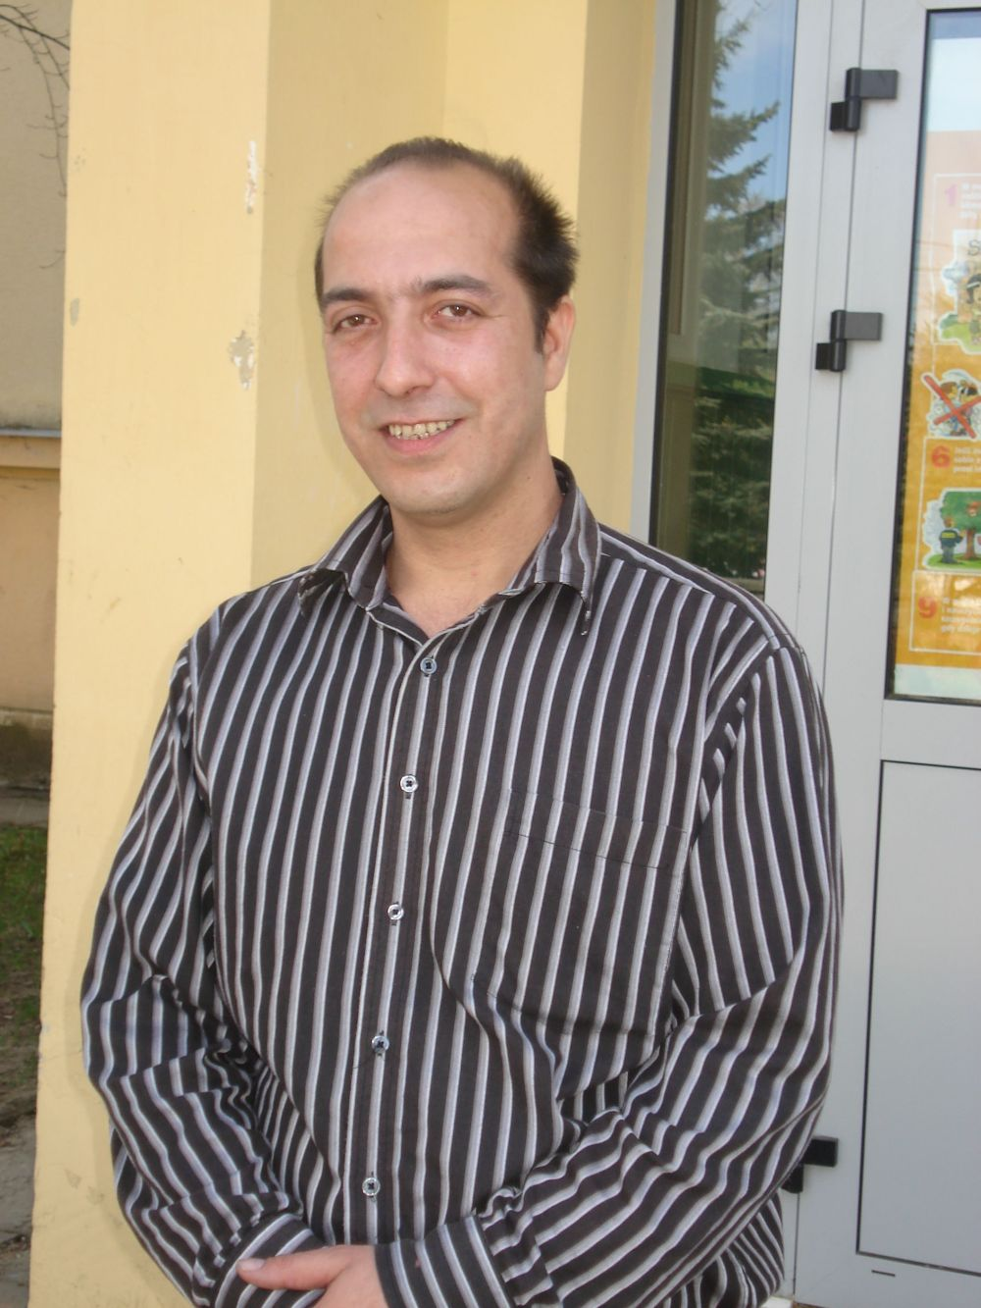

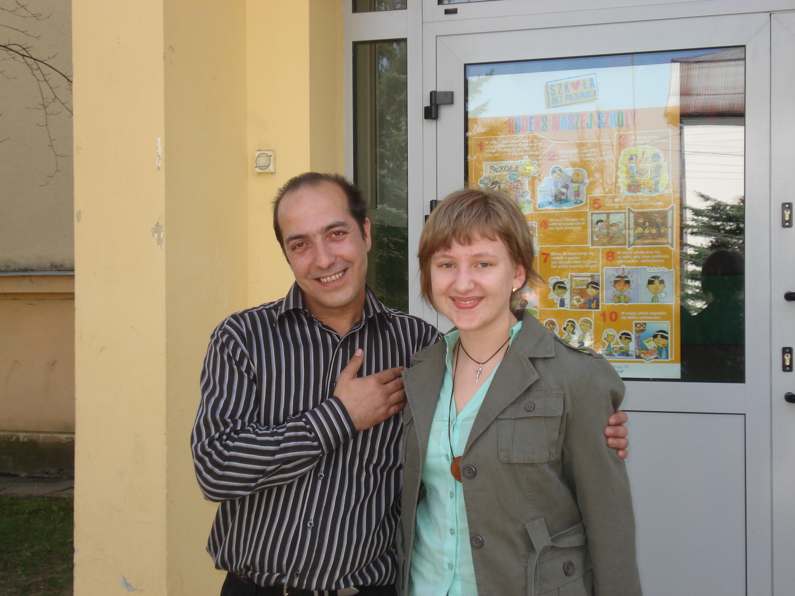

CONDUCTED BY STUDENTS: KATARZYNA MATELOWASKA AND MONIKA FRANKOWICZ
ON 23.03.2007 IN PRIMARY SCHOOL NO 6
IN KROSNO

- Do you know how many Gypsies are living in this area? Which areas are they living in?

In Krosno there are more than 100 people, but in fact there are more, but they do not reveal that they are Gypsies. They are living not only in Krosno, but also in Kopytowa (a village) and in Polanka.

- How long have you been living here? For how many generations?

Since 1804 in the area of Krosno, Sanok for many generations.

- What do the Gypsies do?

We trade, play musical instruments. It is disappearing now, but the Gypsies like music and dancing. Almost each Gypsy can play a musical instrument, they play by ear. They have it “in blood”.

- Do contemporary Gypsies travel a lot, like in the past?

They do not travel any more; everybody has their flat, place of birth, and it’s forbidden. The members of the band “Trojany” leave home once a year to keep up the tradition. Trains of Gypsy wagons go through tows and when they stop in forests, they make a bonfire, play the accordions, the guitars, they dance and sing.

- How do you feel among the Polish community? Do you feel accepted?

It’s hard. There are people who accept us and those who do not, those who believe in stereotypes, who believe we are the same as in the past in spite of the fact that we have changed, our children go to school. But some people are still prejudiced against us. Because of this it is also hard to get a job. Even if somebody is qualified, they won’t get a job because people do not pay attention to what this person is like, it’s not important that they want to learn, what matters is the colour of their skin, the fact that they are a Gypsy.

- Is it easier to integrate with the Polish community when you are in a group?

Mrs Siwak: I think so. Creating a common room in Primary School nr 6 is a good example of this. The kids are attached to my husband, to other children, they are treated in a different way by the teachers. Our children are not treated well by the teachers in all schools, but when the teachers know our culture, they have a different attitude.

- Are there many schools which the Gypsy children attend?

Yes, there are. In Krosno they attend junior high schools no 1 and 2, primary schools no 10 and 6, one secondary school. There is no problem with enrolling our children to school because they have to attend school, like other children, but there are problems in schools when our children are treated badly by teachers, other children.

- Have you got any legal problems?

We have problems with the police because they do not want to listen to us. We are never right. What we say is not important. The police have their rights, but we also have our rights.

- Do you keep up your traditions? What are your most important traditions?

According to our tradition young girls cannot wear trousers. They can until they get married. Older girls and married women do not wear short skirts or trousers; they wear long skirts, even when it is hot. People are surprised by this. When we go to swim in a river, men wear trousers or shorts covering knees, and women wear T- shirts and skirts. We just don’t show our bodies. Children do not show our bodies to us and we don’t show our bodies to them. We also have a traditional Gypsy wedding. The bride and the groom do not go to a registry office, but they are wedded by their parents. There are 15 or 16 year old married girls but their number is getting smaller, and we are still trying to keep up this tradition. Our traditions are beautiful. You would have to see them. They might seem funny to you, but to us- they are beautiful. The children are baptised in church, like other children. They also go to First Communion in church, together with other children. We don’t have our own traditions in this matter. As for getting married, there is the Gypsy wedding first, then when the people are old enough and want to get have a civil wedding, they go to the registry office.

- Are there many mixed married couples among the Gypsies?

Nowadays, there are many married couples where the girl is Polish and the boy is Gypsy and vice versa. Young people’s attitude to mixed marriages depends on how they were brought up. If parents made their child think that Gypsies are thieves, slobs, the child becomes prejudiced. If the upbringing is good, there is no problem with that. It’s mainly about the Polish nationality. There are parents who forbid their children to play with our children, grow up with them. But some do not have such prejudices and then there are these mixed marriages. There are Poles who are all right, and there are people who cannot accept this. What matters in love, not the colour of the skin. We also have “hard” traditions concerning girls. Girls do not go to discotheques, a girl stays at home until a husband takes her. Boys may go to a disco, but girls can’t. If she went to a disco, her future husband could find fault with her. If she doesn’t go, she is pure as she did not go anywhere, she is all right. There is no custom among Gypsies that a girl goes out with a boy for, for example, 5 years. A boy comes, he doesn’t know her, they get married. In mixed marriages Poles have to obey our law, accept our traditions. We have a rule that you can be contempted for some minor offences, which is a terrible thing. Then you do not contact such person, do not sit at a table, drink with him/ her. Such person is at a margin. There are scorns, light ones, for which you can be pardoned. You have to go to the King of the Gypsies, there the elders discuss it and make the decision. We have our King who settles different disputes between us.
If a girl of the Polish nationality marries our boy, she has to wear long skirts, she doesn’t take her clothes off by a river, she accepts our traditions. We have one tradition which everybody, even Poles are jealous of, our youths are different. If a young person sees a Gypsy, he/ she addresses him “uncle” even if this man is not a member of his family. People have much respect for the elderly.

- Do you feel happy here, don’t you regret coming to Poland?

We were born in Poland, we are attached to this country. Some Gypsies living in other countries also become attached to those countries. We also take over some Polish traditions, we obey the Polish law. We feel Polish because we have the Polish citizenship. However, we would feel happy if we had a job; then our children could have better education, if there were no racism in Poland. We also do not have means to bring up our children, everyone is looking for a better life.

- Can you count on the local authorities for help?

The local Social Security Department helps us, but the help isn’t the same as for the Polish families. There is a programme that helps most Gypsies. We get money from Warsaw, we have established a common room for our children at this school, but other children from the school can also come to us. We get money to send our children to summer camps, to pay for the cinema tickets, to buy school books for them. Previously we could not afford to buy school books for our children because when you do not have a job, you do not have money. It’s a big help for us. It’s also thanks to the headmistress of this school because she has written the programme, and thanks to the President of Krosno who has to transfer 20 per cent from the town budget to the sum which we get from Warsaw.

- How many Gypsy children attend this school?

At present about 14. There were more than 20 of them, but some have gone to junior high schools. The kids feel good in this school.

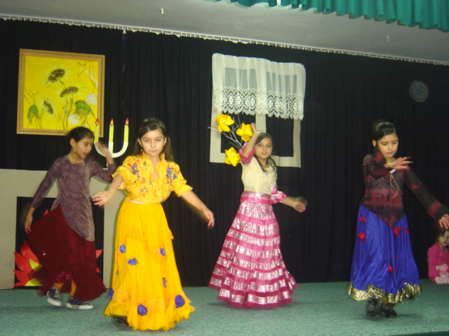

- Do you consider Poland as your motherland?

Yes, of course. We were born and brought up here, we are living and bringing our children up here. We have been living here for centuries. Our grandfathers and great grandfathers were born in Poland. Our ancestors came here from India and settled here and it stayed like that.

- Are the children in mixed families brought up in Gypsy or Polish traditions?

Rather in Gypsy traditions, but they aren’t forbidden to speak Polish. A child can, of course, have a Gypsy and a Polish grandmother. If God created man to his resemblance, I don’t understand why there is so much racism.

- Do Gypsy children have problems with integration with other children from this school?

In our (this) school this problem rather does not exist. It may be because there is this common room in our (this) school, there is the programme, and the kids are more attached.

Thank you for giving us the interview.

an interview with mr jack lala and mr ken smith – americans working at state higher vocational school
in krosno

CONDUCTED BY STUDENTS: ALEKSANDRA KIELAR AND MAGDALENA PODPORA
AND TEACHER IRENA KOLANKO ON 6.02.2007 AT PWSZ KROSNO

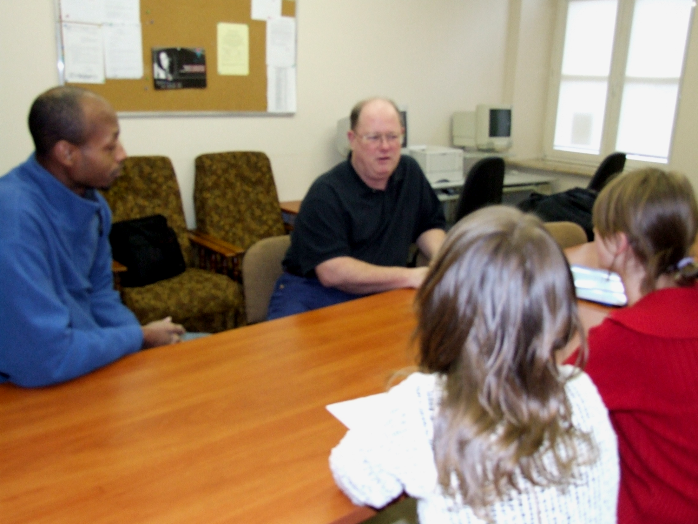

- Where are you from?

Mr Lala: I’m from Austin, Texas. Austin is the capital of Texas. When I came here I was living in Texas where I was teaching and working on my doctorate in American history at university.

2. Was it difficult for you to get the Polish visa?

Mr Lala: In my case it wasn’t difficult at all. I had a formal letter of invitation from the school inviting me to come here to teach, so I was an invited teacher, and there is a program for such people. Getting my visa was almost automatic. I had to pay for it, though. I was able to obtain visa quite easily.

3. When did you come to Poland?

Mr Lala: I came in October 2002 . I was invited for 1 year to teach and I enjoyed it so much that within 3 months of my arriving here, I asked if they would mind if I stayed, and it was quite funny because at that time my colleague, who is my boss also, he thought I meant if I would stay the whole year. I said “I’ll stay another year if you want”. He said “Sure”.

4. Why did you choose Poland not another country?

Mr Lala: As I said, I was asked. The year before I had been here to Krakow on a conference on holocaust, I’m a historian. I was asked to attend it. There I met doctor Witalisz, who is now the vice director of school here. We made contact and a year later, he contacted me and asked if I had an interest in coming here to teach. I had been teaching at Texan University for 4 years and finishing my doctoral studies, and my contract to teach had run out, so it was good time and opportunity. I said “Yes”. The first year when I came here, I was in all at what I saw in Krakow. The conference on holocaust. I enjoyed it, also because it was in such a beautiful city that I took a tour. I saw a lot of things that an average tourist doesn’t see because I was with the people who lived in Krakow. They took me round to many places, and I absolutely enjoyed the whole experience of it. I didn’t see Krosno the first year, and when I was invited to teach here, dr Witalisz kept saying “Well, this is Krakow, but a little smaller”.

5. Krosno is called “a little Krakow”. Can you see any similarities?

Mr Lala: In what it is the age. The churches that are extremely old. I’ve been to the ruins of the castle in around.
I adjusted quite easily, but because I like small places, I like small towns. I didn’t have any problems with not being in a huge place. I adjusted to Krosno very easily although I used to live in a capital city. I’ve enjoyed being here, obviously. I stayed and I’m planning to stay longer. I have enjoyed it very much.

6. Do you miss your country?

Mr Lala: I miss it all the time. You know, I don’t miss America, to me it’s not something I do. I miss my friends. I enjoy it when I go back to the US, but I like the opportunities I have here, I like the differences in the culture. And there are significant differences, some in your traditions, things that the Poles do, necessary I would not have seen them in America on a regular basis. I love the really traditional values of family that in Poland are very strong. We have them in America, but in so many different ways. America is such a diverse place. There are so many different kinds of people.
I teach American history and culture. And one of the things I have to stress to my students is that it’s very hard to say what is “America” because we are a conglomerate of any country in the world. You have to realise we opened our doors to everybody and everybody come, and they’ve all made us who we are, but that also makes us very diverse people. So how to say: I miss America, I miss lots of little things about it, but I’m happy to be here.

7. Why did you, Mr Smith, decide to come to Poland ?

Mr Smith: In America we hear a lot about France, Germany, the UK, but not very much about Poland, so I thought it is a good chance to come and see what Poland is all about. So that’s why I came to Poland.

8: How long have you been here?

Mr Smith: I came in October of last year and I plan to leave in June unless I stay longer if I’m offered the position, otherwise I’ll go back to America.

9: Do you miss your country?

Mr Smith: Not as much as Jack said, small things like a big vehicle. You have very small cars! (Mr Smith is a tall person) But I was very much amazed to hear and see so much American culture here. Music videos, television, music in general. You have McDonald’s here.

10: Have u got many friends here in Poland, Krosno?

Mr Smith: Yes I have. Being the only African American in Krosno, people want to know who I am so I have made many friends who can speak English, but if they can’t, it’s kind of hard for us to interact with one another because of the language barrier.

11: But you come from Chicago, which is called the Polish city.

Mr Smith: In Chicago there many Polish people, but they are very much americanised and so unless they told me their last name, I would never know they are Polish.

12: Have you visited your native country during your stay in Poland?

Mr Lala: I’ve been back a number of times. I was back 3 times this past year. I try to go once a year on average. I had some other things that I had to go back a little more often this past year. I like to see my friends and family so I like to go back and see them. They understand that I like it here and that I like my teaching.

13: Do you learn Polish?

Mr Smith: Yes I do, but it it’s not very good. It is a very, very hard language to learn, I feel, cause you have all these “sz”, “rz”, all those different kind of things, but I am trying to learn it every day.
Mr Lala: I would say he tries harder than I do although I’ve been here my fifth year and I don’t speak much better Polish than Ken does. I do understand much better when people are talking, but to respond- I often lack vocabulary. It is a hard language, but it is a very nice language, very melodic. When women speak it, it has a song quality.

14: Have you taken over any Polish traditions?

Mr Lala: I myself, I can’t say I’ve adopted anything in terms od Polish traditions other than I have learned to cook some Polish dishes. I’m not trying to brag, but I make an excellent pot of ”bigos”, and I have been told that by Poles. Maybe it’s my own characteristic, but I tend to eat my American type of dishes. I can find all the vegetables and spices that I need here. That was one thing that surprised me how I can find just about anything that I need. They may not be a perfect match, but they are very similar. I haven’t had the problems of having to miss things. I really don’t miss things because I can find most things here.
One thing that I have not been able to adapt to is eating cakes, small desserts after meals. Poles have lots of cakes with almost every meal. I don’t eat these things and I’m always having to say: “No, thank you- nie, dziękuję”. And they keep handing them to me. They just force them upon me. Gosh!

15: Do you like Polish cuisine?

Mr Smith: Yes, I do. ,”Pierogi”, “barszcz”, and some more that I can’t name. Some Polish names I can’t say. But I was here for Christmas Eve dinner. Twelve dishes that you have. There’s really good food there. I can’t remember what the names of those were. One was a dish of fish with rice that was kind of orange. Do you know what I am talking about? It was really good!

16: Is there something you don’t like in the Polish cuisine?

Mr Smith: Mushrooms. You put mushrooms on everything, and you put ketchup on pizza. I would never do that. In America we never put ketchup on pizza, like you do . We put ketchup on French fries. It is just the different ways people do things. Different culture in the way we do things.

17: Which American traditions would you like Poles to adopt?

Mr Lala: I am often asked that, but again, being as we so diverse, it’s hard to say what American traditions are. The mixing of things, like Thanksgiving . You have some turkey population in Poland, but you have no reason to adopt this holiday.

18: What about Halloween?

Mr Lala: Well, you celebrate it the next day on All Saints Day, but in a quite a different way. There are traditions that I don’t think are American traditions like Halloween, the trick or treating. To me, I missed the point what their origin is, what this holiday is about. We turned into kids going out in costumes and dressing up, getting candy and things like these when the origin was the respect for people who have passed away in a family, respecting the Saints, All Souls’ Day. And part of that is because, of course, America is such a diverse country in terms of its religions. We have many religions. Poland doesn’t have that. You have some religious diversity, but the majority are Catholics. It’s a very Catholic country therefore the respect for the religious traditions in terms of Catholicism points you in the direction that would not fit well in America.
But one thing I would love America to do is to adopt your respect for Christmas, the three- day tradition of Christmas, Christmas Eve dinner, Christmas Day when you are just with your family, and the second day of Christmas when you go out and see your friends. That’s very nice. We don’t have that, but again with our diversity, we have different kinds of Christmases, different holidays, so it’s not all Christmas. There are so many different denominations that we do not have Christmas celebration any more. So to import our culture upon Poland, I hope it doesn’t really happen. I used to tell my friends, I said “I came to Poland; I just hope no other Americans come”. We tend to “macdonalize” everything. Let’s leave Poland the way it is. I hope it doesn’t become macdonalized.

19: How do American people spend Christmas?

Mr Lala: We are very diverse, but the holidays at that time of year are spent very much like you do, but not the same intensity on religion. We have so much emphasis on giving presents. But this is just my opinion. I very much like the Polish Christmas.

20: Have you got a hobby?

Mr Lala: Hobbies. None really here. Reading. I’m an intense reader. I’m always on the compute, Internet all the time. History is sort of my passion, in professional and in amateur sense. I do a lot of reading. I’m doing some writing, working on some projects. I’m a bit of a film buff. I love movies. I collect movies and I use them in my classes. I actually show lots of films in my American Studies classes because by viewing film you understand America better and our people. In the past my hobby was skiing. I like sport, the American stuff football.

21: Are you treated here with respect?

Mr Lala: Very much. I don’t think that’s because of who I am, but Poles have an understanding of respect that we don’t always see in America any more. Our respect for authority has been somewhat deluded in America. We don’t have quite the same respect for authority or the things we used to have. In Poland I noticed very big respect for older people, students respect teachers. In America the situation is worse. If you were in an American school, you would be taken aback, they are a little bit too open-minded, disrespectful for authority; it is much worse in America.

22: Did you know much about Poland before you came here?

Mr Lala: I probably knew more than a typical American would because I was a historian, I had studied some of Polish history. I did some reading when I knew that I was coming here. But I did not know that much, and there are reasons for that. Most of my education in things was at that period of time when Poland was part of the Soviet Union. I’m talking of Eastern spirit. Information between the East and the West was something that was not forthcoming sometimes. Both sides lied to each other, I’m not talking about Poles, I’m talking about the system of information. There were lots of myths that were promoted and ideas put out that were not certainly true. What I knew about Poland came mainly from history books by a British historian Norman Davies and I read the book “Poland” written by an American author James Michener. I’m a Michener fan because I follow his type of writing. He makes some mistakes, but he does a very good job on establishing a story around the culture and people and geography. But that wasn’t the only thing I knew about Poland. I obviously followed the Pope, his career. I had great respect for this man. I was well aware of the Solidarity movement that had started in the 80s and I had followed it and it helped to, I think, change the impression of a lot of people of what Poland might be like somewhat of an independent country. I know what Poland was about between the wars, and I know what you have been through during World War II. But there are things that I did not know, I admit. This is my fifth year, I’m still learning things every day.

23: Where you surprised by anything when you came to Poland?

Mr Smith: I guess I was surprised by how much American culture is in Poland. I couldn’t say anything else because I didn’t know much about Poland before I came here. I heard about Lech Walesa and World War II, and the Pope so that’s all I knew. I couldn’t be surprised because I didn’t know what to expect when I came.

Mr Lala: I came fairly open-minded. I wasn’t going to try to put my own suppositions on people, I tried to learn as I was here, but I did find a few things that surprised me. This is sort of funny. In American society when you see two people holding hands, especially arm in arm all the time, it usually means that they might be a couple. When I first got here, all the women everywhere were holding hands. I thought “Why are there so many lesbians in Poland?”. I don’t mean anything negative, the intimacy, the way people hold hands, they touch, go arm in arm. I like that. We sort of don’t have that in my country any more. People are very space aware in America. When I was standing in a line for food at the market, I noticed people bumping at other people that’s not done in America, you don’t bump at people all the time because if you did, they would turn and ask “What do you want?”. And here everybody does that. Little things like that’s, they weren’t negative to me. I wasn’t used to them. I am used to them now and now I can queue with anybody.

24: How were you received by your Polish neighbours? Can you count on them?

Mr Lala: Very much. I actually rent a house here and my landlord is wonderful, he’s very helpful, even too helpful sometimes. He wants to do everything for me. And all the surrounding neighbours are very nice. Maybe because they know I’m an American. I don’t know, but people are just helpful here and that was from the very first day I was here. And I don’t think it’s because I’m an American, I just think they are nice people. Poles are used to helping each other. Like the tradition at Christmas – leaving a chair for someone who may not be as fortunate as you, and hungry. We are here to help people, something you don’t see all the time. I don’t want to say Americans don’t help people, because we do, but it’s just in a different sense. I just like it here. Something I have a great respect for.

25: Would you like to stay in Poland for good?

Mr Lala: Well, I plan on it right now, as for my teaching career. I have a full contract here for another 10 years and I plan on staying here. Perhaps when I retire, when I quit teaching maybe I’ll decide that I might go back to the US or I might go to another country to experience another culture. (He’s joking) I’m getting pretty old, I guess there are no many other cultures I can adapt to.

Mr Smith: If I stay here, I’d have to move to a bigger city. I’m from Chicago. I like that atmosphere. Maybe Krakow, Warsaw. If I find a wife, then I’ll stay. I don’t know yet. That’s kind of early. I might go to China. I have a job offered there. I haven’t made the decision yet.

26: And there’s one difficult topic we would like to talk about.
Have you come across any trappings of racism, prejudice against people of different nationality while being here?

Mr Lala: Yes, I’ve seen it occasionally. It’s usually people who are not thinking, who are in a bad mood, who have had too much to drink. When I first came here, I didn’t see it, but during the first couple of years here the Polish economy has improved significantly and with entering the EU, young people are able to travel now, to work in other places, opportunities are better-jobs are available. When I was first time here, it was tough on the labour market, people were without jobs and I was accused several times of taking people’s jobs, by Poles: “Why are you here?, you’re taking Poles job”. Once, while we were talking I said: “Please understand. I’m not taking a Polish person’s job because I’m hired as a native speaker and that’s why I’m here- as an American teacher that they wanted. I didn’t take a Pole a job. This is what the English department has to have. “ But they all did not understand it perfectly.
Other things are: Poland has its prejudices here, I understand anti-Semitism and I see it sometimes here. That’s not Polish, it’s worldwide- we see it in any places, America has its anti-Semitists. I haven’t seen the overall racism in terms of ethnicity that we have in America: white-black, white in minorities. Our history is filled with it. Ken (Mr Smith) is the only black person in Krosno and he’s treated here more like an oddity, it’s not a prejudice.

28: How do you feel being treated like an oddity?

M Smith: It’s kind of weird, people look at you all the time. It’s kind of funny, too. I feel like a movie star. I wonder what it would be like of you had more people like me here. I think it would be different.
For myself, I haven’t seen any kind of racism that occurred to me for that short time that I have been here, but I’m in a very small minority. If you had a lot of people of different colour here, I think, we could see some problem.

Mr Lala: I’m speaking about a friend of mine. There are quite a few Muslims here and one is a very good friend of mine who owns restaurant “Marhaba”. Osama feels some prejudice and racism here, but it’s more pointed towards his religion than it is towards his ethnicity, because he’s a Muslim in a Catholic country. That doesn’t always fit well. He tells me he can sense a little bit of it; and I’m speaking second – hand. Occasionally he feels a little bit of the prejudice, but he says it’s more on religious grounds than because of his race. Being an American growing up during very racist times, I grew up in the civil rights movement times, I grew up in the deep South, I was just surrounded by racism, I understood what it was. Maybe that’s why I don’t see it here because I’ve seen what real racism is. I just don’t see it here and I’m aware because I look. I’m a historian, a cultural historian and I look at culture, things. I haven’t seen it.
What I have seen is anti –Semitism. Here it’s in a little different sense than maybe when I see it in other places. I don’t know how to explain it, but the anti – Semitism in Poland is not the same variety I have seen in America or in some other places. It’s almost impossible for me to explain what I mean by that, but I just sense it differently here, and I don’t mean worse. The reasons may be deep roots of Catholicism, part is the reaction to all the horrors of World War II that was inflicted on Poland as some people say because of it’s Jewish population. I don’t know if it’s a fair evaluation, but I’ve heard it. I do a project with my students in my history class when they interview their grandparents and the people who lived here during the war and I ask them to talk about Poland before the war, if there was a Jewish community, if they had Jewish neighbours and friends and what it was like during and after the war. You would be amazed at some wonderful responses I’ve got. I learned lots of things I would have never thought. I’ve learned new things here. It’s an amazing process. I’ve been doing this for 3 years and I’m going to continue it for another 3 years, and I’ll try to put them in a book with first – hand accounts of the people who lived here.

Mr Smith: I think, for your generation (the students aged 16 ), you are very open to people who are different. I’ve noticed that here in the town. Young people are more likely to come up and talk to me, ask questions, and I think it’s maybe because of music.

30: Was it difficult for you to get used to our climate?

Mr Smith: It’s much colder here than in Illinois.

Mr Lala: I’m from Texas, which has a hotter climate. It wasn’t hard for me. I’ve been in the skiing business in the Colorado Rockies, where it is pretty cold. Here I often wear short – sleeve shirts. But once I had to shovel snow to dig my car out, and I didn’t like that.

Thank you very much for agreeing to give us the interview. It was interesting to meet you and know your views and know that you are enjoying your stay here.

Mr Lala: Most Americans that I have had to come to visit me here have enjoyed their stay. I haven’t had a person that was negative when they left.

SOCRATES COMENIUS PROJECT
AN INTERVIEW with the Armenians

1. Which country/state are you from?

- I come from Armenia and my husband too.

2.Was it difficult for you to obtain the Polish visa?

- We arrived by a voucher, then it wasn’t hard.

3. Why did you decide to come to Poland, not to another country?

- We arrived to find work.

4. How long have you been here?

- We have been living in Poland for 10 years.

5. Have you visited your native country during your stay in Poland?

- Yes, I have several times.

6. Do you miss your country? Which things do you miss most?

- I miss our sun.

7. Are there any similarities between Poland and your country?

- There are more similarities and more differences.

8. Did you know much about Poland before you came here? Did you try to learn
Polish? Are you learning it now? What is the most difficult for you?

- I knew much more about Poland than a Pole about Armenia. At the beginning
I learnt Polish. Spelling is the most difficult.

9. What were your first impressions of Poland? Were you surprised by anything?

- Polish winter surprised me.

10. Are you treated here with respect? Have you come across any trappings of
intolerance, discrimination or racism in Poland?

- We are treated with respect.

11. Was it difficult for you to get used to our climate?

- Yes, it was hard.

12. Would you like to stay in Poland for good? Why?/Why not?

- I am here with my family and we are going to stay because we have a job in
here. My children attend a school and we have our house here.

13. Have you taken over any Polish traditions?

- Yes.

14. Do you keep up your national, family traditions? What holidays/festivals do you
celebrate?

-We have the same feast, but we keep our traditions.

15. What is your hobby? Can you do it here in our town?

- I like cooking different dishes and baking cakes and Poles like it because
eastern cuisine is good. Several times we thought about opening a restaurant
with our kitchen but it is only a dream now.

16. What do you think about the Polish cuisine? What would you change in it?

- Polish kitchen is good also. Apart from potatoes, I would give more
vegetables.

17. How were you received by your Polish neighbours? Can you count on them?

- I have good neighbours, we are in amities and I can rely on their help.

18. Have you got many friends in Poland?

- We have got many friends.

SOCRATES COMENIUS PROJECT
AN INTERVIEW with the representatives of Bolivia

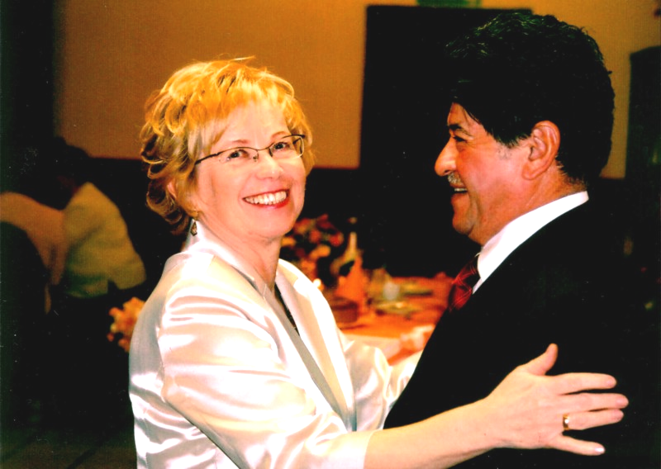

- Which country/state are you from?

- I’m from South America, and my home-town is Tariko in Bolivia.

- Was it difficult for you to obtain the Polish visa?

- I didn’t have any problems with get the visa, when I was trying to arrive
here.

- Why did you decide to come to Poland, not to another country?

- In those years socialist camp was lending scholarships for students from countries of 3rd world, I used this chance of studying, and that’s why I arrived in Cracow.

- How long have you been there?

- I’ve been living in Poland for 40 years.

- Have you visited your native country during your stay in Poland?

- Yes, I’ve visited Bolivia a few times.

- Do you miss your country? Which things do you miss most?

- I miss my people, landscapes, culture and traditions.

- Are there any similarities between Poland and your country?

- First of all, my country and Poland were aiming at one object – freedom.

- Did you know much about Poland before you came here? Did you try to learn Polish? Are you learning it now? What is the most difficult for you?

- I didn’t know a lot, but I was interested in political base of Poland. I liked the idea which led the Polish then: “for our and your freedom”. I had learn Polish to take up studies at university. I have been speaking Polish for 40 years now and I’m still learning, but I will never control the pronunciation perfectly, I will always have different accent.

- What were your first impressions of Poland? Were you surprised by anything?

- When I came here I was pleasantly surprised at Polish hospitality,
kindness and courtesy.

- Are you treated here with respect? Have you come across any trappings of intolerance, discrimination or racism in Poland?

- Yes, people treat me well, they’re rather pleasant and tolerant, but like
everywhere, there are some exceptions.

- Was it difficult for you to get used to the climate?

- Yes, I was sick a couple of times, especially in winter time. I was feeling
chilly continuously.

- Would you like to stay in Poland for good? Why?/Why not?

- I have already stayed. I got married, finished studies, received the
doctor’s degree, built my house.

- Have you taken over any Polish traditions?

- Unfortunately not, only at home we’re trying to keep culinary traditions.

- Do you keep up your national, family traditions? What holidays/festivals do you celebrate?

- Yes, because my family in Poland is catholic, we celebrate every church
holidays according to local tradition.

- What is your hobby? Can you do it here in our town?

- When I was studying I used to walk through the forest, and hunt. I like
mountains, when I was young I used to walk in the Tatra mountains. But
now with regard to my age and health I don't grow my passions. I like
gardening I’m interested in what’s going on in the world, especially in the
countries of South America, Latin America, Asia and Near East. However,
I isolated from politics in Poland. I like listening to Latin-American music
and reading Latin-American books. I’m trying to speak Spanish with my
wife and watch Spanish television. Also, I’m interested in cuisine. In
summer I like to roast beef meat called “asado” on grill with green
lettuce, spices and seasoned wine.

- What do you think about the Polish cuisine? What would you change in it?

- It’s not diversified. It’s consuming a lot of fats here. It should use less fat
and more vegetables, spicy spices, pepper and beef meat.

- How were you received by your Polish neighbors? Can you count on them?

- Probably yes, I was welcomed very good. I can count on their help. One
of my neighbors helped me when I was building my house.

- Have you got many friends in Poland?
- I have friends from time, when I was a student but I meet with them very
rarely. Now we are divided by distance and deficiency of time.

AN INTERVIEW WITH GAETANO AMBROSIO FROM ITALY
Age – 38 years

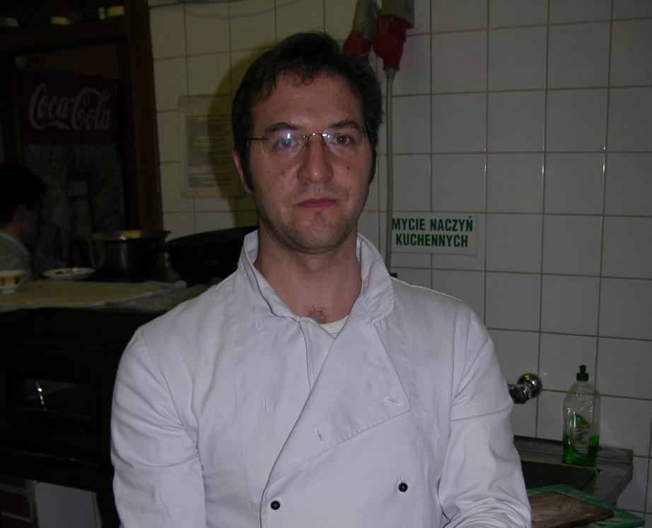

- When did you come to Poland?
The first time I visited Poland was in 1994. I liked the country already then. The thing that mostly interested me was the Polish mentality. In my opinion calmness, naturalness and silence are the most important values of this nation. From that time I visited Poland many times. I settled here in 2000.

- Why did you leave your own homeland?
The main cause was my wife and daughter. I met my wife in Italy, where we led a common business. I learned cooking Polish cuisine then. Me and my wife decided to open a Polish-Italian restaurant in Poland. From the plan to realization passed a lot of time, because we wanted to do everything precisely. Apart from the restaurant I lead a clothes shop too. Five people work in the restaurant. I make the meals myself, because I have a chef profession.

- What did you take with you from Italy?
Mainly the national cuisine. I’m trying to prepare traditional Italian dishes with precision.

- Apart from “Ambrosia,” do you have any other successes?
In the beginning of my stay in Poland I took part in a contest on a chef of an Italian restaurant, which took place in Warsaw. Despite the winning, I didn't take the job, because I couldn’t speak Polish very well and communication is very important in this kind of job. I received the position of an assistant. My biggest dream was to open an own business, so I resigned from the post. My dream came true in 2005, when I opened “Ambrosia”.

- What dreams do you still have?
I would like to speak Polish fluently and visit the country. Mostly I would like to see the Mazury (a region in north-eastern Poland) and The Baltic Sea. Also I would like to open a real restaurant – refined, exquisite and with a high class.

- How do you perceive Polish people?
Poles are opened and tolerant. They are pleasant, but sometimes I have an impression that they want me to speak fluently. Apart from that, I often watch them and their way of behavior, which is different from the Italian one. It is also true that Polish women are beautiful.

- Do you miss your homeland?
Yes, a lot. In Italy I left my family and friends. I miss those long evenings, drinking coffee with my family. I visit my country about four times a year although I have my friends from Poland and from Italy (Antonio, Huberto, Beniamino) here. I don’t want to leave Poland. I got used to living here and I like this place and the country.

- You’re Italian, but you have lived in Poland since 2002. What happened that you decided to leave your homeland?
That’s true, I’ve lived in Poland for over five years. Of course it wasn’t an easy decision, but those Polish women… (laugh). I came to Poland because of my wife and daughter. I think that nothing will change in this issue.

- When did you visit Poland for the first time?
I’m not sure, but it was probably in 1994. I don’t remember much, but this country made a big impression on me.

- What made the biggest impression on you?
Of course the beauty of this country and the cuisine…. With which my stomach had problems (laugh). The Polish people eat a lot of fat meals, meat, little fish. It differs from what we eat. I had to get used to your cuisine.

- Your favorite Polish dish?
Hm… pierogi (laugh) but I decided to make them a little bit better and I added some Italian delicacies. Instead of butter I added olive oil and parmesan cheese. I recommend!

- So similarly, the most hated?
Horseradish!

- During the stay in Poland have you met with somebody’s intolerance?
The Polish people are more opened then the foreigners. Maybe it’s a result from the fact that they often travel abroad. I’ve been accepted with kindness and I don’t really remember any upsetting situations. I employ some Polish people in my restaurant and we cooperate well. I’ve only gone mad once, when in the beginning of my stay here, some people laughed at my accent, but I got used to it.

- So if we bring the Polish language up, what makes the biggest problem for you?
Oh, yes! It’s a very difficult language. “Nożyczki” (scissors) was a word I couldn’t manage with. I remember when my mother-in-law asked me to say it still, she laughed then.

- Can you tell us about a funny situation which happened to you in Poland?
I remember when I spent my first winter in Poland. My mother-in-law washed my shirts and hanged them outside. It’s not hard to guess that they became stiff on the frost. I was convinced that she exaggerated with the starch. Everyone had a great fun of me. We laugh at that to these days.

- You have a chef profession, can you tell us something about your job?
Yes, I’m a chef. For some time I studied architecture. I lead an Italian restaurant in Krosno and I must admit that I don’t imagine my life without cooking. I love experimenting in the kitchen. I rarely use recipes, usually I do everything intuitively, with a great result I think (laugh).

- Do the Polish people like Italian cuisine?
Frequently they eat pizza and I think that this associates mostly with Italian food. But I know real gourmets of Italian cuisine. They visit me regularly.
- We’re bringing nearer the end, the last question. Do you miss your homeland?
Of course, I left my family and friend there. I have some Italian friends here in Krosno, but it’s not the same. Also I preferred the climate in my country although the climate in Poland is now almost the same as in Italy. There are also many differences between the Polish and Italian mentality. We are very spontaneous and we love to have a good time. Of course Poles also like fun, but they spend their spare time differently.

Thank you for the interview.

SOCRATES COMENIUS PROJECT
AN INTERVIEW with the German

- Which country/ state are you from?

- I come from Germany.

- Was it difficult for you to obtain the Polish visa ?

- I didn’t need a visa. Poland is a state in EU.

3. Why did you decide to come to Poland, not to another country ?

- I met the girl who is my wife now. I have come to my new family.

4. How long have you been here ?

- I have been here for two years.

5. Have you visited your native country during your stay in Poland ?

- Yes, I still visit my country.

6. Do you miss your country ? Which things do you miss most ?

- No, I don’t miss Germany. I drive there once for two weeks.

7. Are there any similarities between Poland and you country ?

- Yes, for ex the eating, food is very similar. But some things are totally different
for ex. our traditions during the Christmas or Easter I think the lifestyle is also
different because people can earn more money than in Poland, they more often
leave for holiday or other trips. We work much more and longer.

8. Did you know much about Poland before you came here ? Did you try to learn Polish ?
Are you learning it now ? What is the most difficult for you ?

- During my first visit in Poland I had no information about the country. Yes, I will
learn Polish language, but I’m not learning this now because I need a teacher.
The most difficult for me are writing and grammar.

9. What were your first impressions of Poland? Were you surprised by anything ?

- Poland is really nice. I have met very friendly people. Polish people are
hospitable. They like chatting and meeting, discussing with each other.

10. Are you treated here with respect? Have you come across any trappings of
intolerance, discrimination or racism in Poland ?

- The people are tolerant. I have no problems.

11. Was is difficult for you to get used to our climate ?

- The climate is the same as in Germany, especially in my state.

12. Would you like to stay in Poland for good ? Why ? /why not ?

- Yes of course. I would like to stay here, because I’ve got family and work in
Poland .

13. Have you taken our any Polish traditions ?

- Yes. I bake special biscuits during the advent.

14. Do you keep up national, family traditions ? What holidays/festivals do you celebrate ?

- Church’s traditions are the same. We celebrate Christmas and Easter. All Polish
traditions are celebrated by us, because I live in Poland and my wife comes from
this country.

15. What is your hobby ? Can you do it here in our town ?

- I love cycling. I ride a bicycle across the area. I like doing wooden toys e.g. cars,
planets for children. I like swimming, but I haven’t got free time. I like watching
films and going to the cinema. My favourite kinds of films are thrillers and
criminal films.

16. What do you think about Polish cuisine ? What would you change in it ?

- I like Polish cuisine, but I don’t like plums with rice and smoked food.
“Pierogi”(dumplings) are really tasty. I like eating Polish cottage cheese, too.

17. How were you received by your Polish neighbours ? Can you count on them ?

- I have a little contact with neighbours because I can’t speak Polish.

18. Have you got many friends in Poland ?

- Yes, I have many friends in Poland. I met many nice people when I started
working here and we meet very often.

Interview with mr.Pham Dinh Chien

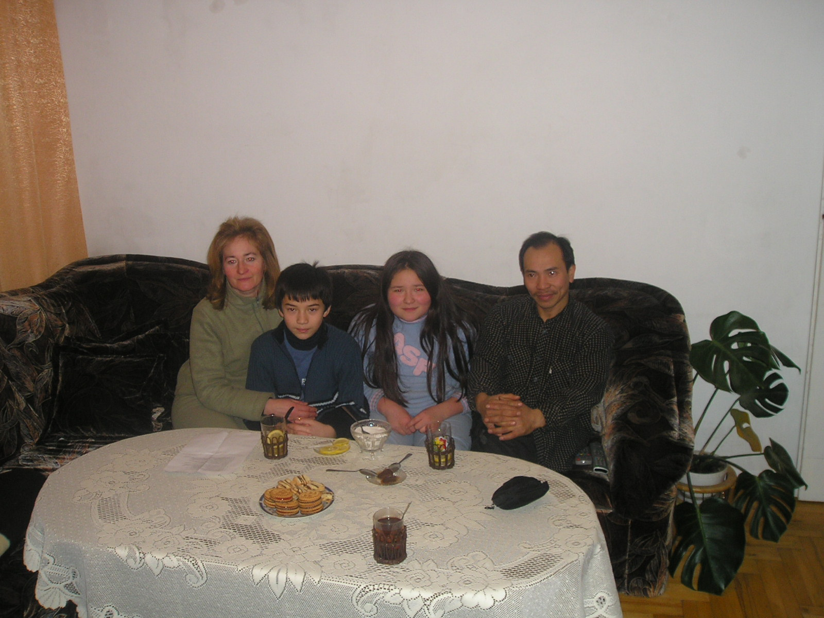

Maciek: What country are you from ?
Pham Dinh Chien: I am from Vietnam. It is an Asian country. Flight from Poland takes 16 hours with transfers in: London , Bangkok and Hanoi. I live in Hoshimina City in South Vietnam.

M: Was it hard to you to get Polish visa?
P.D.C : For me very easy. I finished studies in 1993, I met my wife in 1988 when she came for practice to Kaliningrad in Russia. After graduation we married there, so when we came to Poland I got visa based on my wedding deed and after two months I got my permanent residence card.

M: Why you decided to come to Poland?
P.D.C: Why I decided to come to Poland? hmm… It is a long story. I met Polish girl, I married her and we decided to come here. I never expected that I will come to Poland and also I didn’t expect that I will stay here for good. I’m here since 1993

M: Have you been to Vietnam since you are here ?
P.D.C: I was in my native land relatively long ago – 3 years ago. Now I don’t have time for trip there – I have duties , family etc…

M: Do you miss your native land?
P.D.C: I think that each Vietnamese miss his native land. I miss habits and friends from Vietnam. And what I miss most ? Mostly I miss bike trips with my friends to a sea cost which is about 20 km. from my city.

M: Are there many similarities between Poland and Vietnam?
P.D.C: First of all Polish and Vietnamese women have very similar features – they are very devoted to their husbands and children. And family is in first place for them. Also another similarity is that Polish and Vietnamese men love football. In Vietnam football is not high leveled but everybody loves this discipline. When I was studying on my preparing period in Russia we were watching match Poland- Brazil on world cup in Mexico till 4am and the next day we had an exam.

M: If there are similarities so maybe there are also differences between our countries?
P.D.C: It is one really big difference. It is sad but I must say it. In Poland even in our city there is home for elderly and orphanage. In Vietnam people even don’t think about giving their young or old members of family to institution like this. In my opinion it is very immoral and I am definitely against this.]

M: Did you know a lot about Poland before you came here ?
P.D.C: When I met my wife in 1988 I was coming to Poland every vacations to Rzeszow because she was studying there. But I didn’t know much about Poland. When I was coming to Rzeszow to my wife I lived with students and we were partying till morning so I didn’t have chance to get to know Poland better. When I decided to come to Poland for good I knew little bit more. During my studies I was going by ship to Szczecin and I fell in love with that beautiful city. But now I minded something… when I was 12 in Vietnamese TV there was Polish film “Sexmisja” and I fell in love in one actress, but I don’t remember her name. She was in white shorts. (Grazyna Stryjkowna – credited M.J and M.C) Then I decided that I must go to Poland in the future … (laugh)

Conclusion

Foreigners who come to Poland are received hospitably by the Polish citiziens, they don’t have problems with settling. It’s easy for them to obtain the Polish visa.
The Polish law lets them to cultivate their traditions and they take advantage of it. Immigrants come to our country because of diffrent reasons: family reasons, which are given most often, business aims (they get a job), generally they are settling in our country for good.
Nevertheless, they miss their homeland, family and friends, and that’s why they visit their homeland quite often.It was hard for them to adopt to our climate because they come from warmer parts of the world. Some of the immigrants who came to our country were interested in the Polish history, but most of them got to know it just after coming to Poland. Foreigners usually can develop their hobbies, interests, realize their passions.
Tey are interested in meeting new people in Poland.
At first they could not get used to the Polish cuisine, but with time, they changed their eating habits. After coming to Poland, most of them couldn’t speak Polish but they have been trying to learn this language, but with enormous difficulties because of pronunciation and grammar differences. Foreigners who are living in our region notice cultural differences between their and Polish customs and traditions. They were surprised by the Polish culture and by the fact that they are treated here with respect.
For them Poland is a tolerant country, open to Europe, accepting other cultures and respecting civil rights and the rights of national minorities.

