Welcome to St. John the Evangelist Parish

MASS INTENTIONS
Saturday, Jan. 13th
5:00 p.m. Logan Craney, Donald S. Lannan,
Mary Jo & Jim Bradley, Curt Elliott
Sunday, Jan. 14th
8:00 a.m. Jean Ellis
10:00 a.m. Jim Love, Jerry Hansen, Ellen Smith,
Dr. Steve Downey
Monday St. Joseph Jan. 15th
12:00 noon for the people
Tuesday, Jan. 16th
8:15 a.m. Special Intention- BS
Wednesday Jan. 17th
5:30 p.m. Katie Yarnell
Thursday, Jan. 18th
8:15 a.m. Special Intention- KI
Friday, Jan.19th
8:15 a.m. Bob Mills
Saturday, Jan. 20th
5:00 p.m. Tuffy Harding, Mary Jo & Jim Bradley, Rochelle Lents, George “Tony” Sims
Sunday, Jan. 21st
8:00 a.m. Ed & Virginia Craney
10:00 a.m. Bryan Walker (A), Bill Consley,
Terry Bowling, Pearl McCann

Ministers for Jan. 13th /14th 2018 5
SACRISTANS
5:00 p.m. Rachel Doyle
8:00 a.m. George Erler
10:00 a.m. Glenn McAtee
SERVERS:
5:00 p.m. Jamison Hennette, Cassidy Esch,
Madison Esch, Noah Esch
8:00 a.m. Jason/Craig Lubbehusen, Adie Nolley, Volunteer
10:00 a.m. Euan Graves, Nathaniel Hart, John Paul Hart, Abbi Nonte, Alex Bowling
GREETERS:
5:00 p.m. FD Joe and Vicky Doyle
SD Joyce Conlon, Barbara Stoll
8:00 a.m. FD Doug and Peg Neidigh
SD John and Diane Vaupel
10:00 a.m. FD Dan and Barbara Gregory
SD Abbie Williams, Denny Smith
LECTORS:
5:00 p.m. Pat Daugherty, Tom Walker
8:00 a.m. Tom Peter, Maureen Thomas
10:00 a.m. Rhi Graves, Lynn Bateman
EUCHARISTIC MINISTERS:
5:00 p.m. Inger Johnson, Charles and Carolyn Buxton,
Janet Matthews, Linda Wickman, Donna Ader, Volunteer
8:00 a.m. Bernie Smith, George Erler, Jerry Lubbehusen,
Peg Neidigh, Tom Peter, Jerry/Betty Huelsman
10:00 a.m. Karen McAtee, Andy Ringwald, Dayne Holder,
Gayle Strange, Peter McDowell, Greg Rasico, Vounteer

From Our Pastor
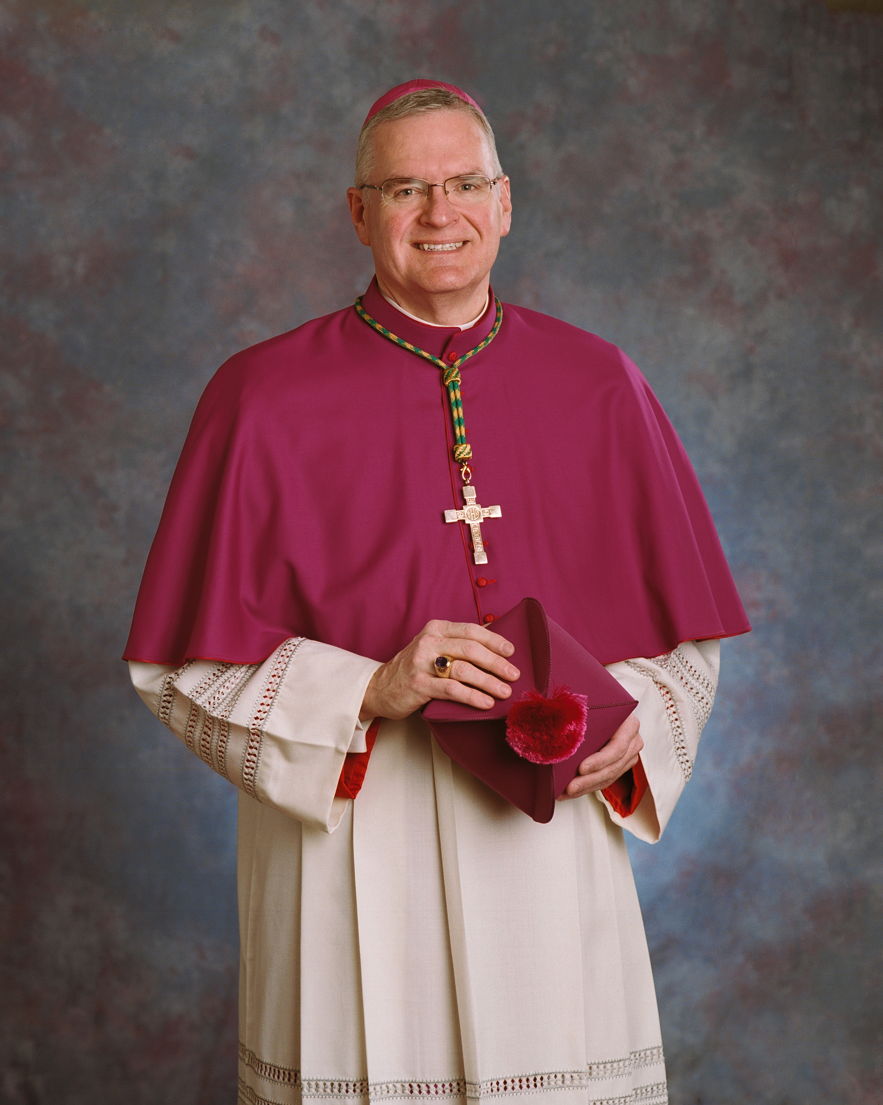
Bishop Siegel’s Episcopal Motto:
“In you Lord, I have placed my hope.”
This past Thursday we celebrated the life of Charles Ellis who was baptized and lived his early years at St. Joseph Parish in Bramble. Later, Charlie moved to northern Indiana where he reared his family. Charlie was known for his outgoing and generous personality who put others before himself. He will greatly be missed. May Charlie rest in peace. Amen
Thank you for your generous support of the Stewards of God’s Grace Capital Campaign. To date we have pledges and or cash totaling $1,012,041.76. I appreciate everyone’s cooperation and involvement. We continue to work together to make our Lord more present in our community and the diocese.
I am most thankful to Tom McAtee and his committee which consisted of: Stephanie McAtee, Skip & Cam Ackerman, Bill Boyd, Mike Staab, Ed Summers, Allen Voegerl, John Walker, and Tom Walker for taking down the decorations and storing them for next year. This group as well as Peggy Lyon, Donna Graber and Barb Boyd did a spectacular job this year with our Christmas decorations and appointments. I am most appreciative for their time, talent and generous spirit!
As we begin a new year, I am blessed to have such a loyal, dedicated, and talented staff who are a tremendous help to me as we minister to the parish.
May the Lord bless and keep you,
Father Walker.
This Week at St. John Parish .
Sunday, Jan. 14th
Confirmation- 9:45 at the Center
Liturgy of the Word- 10:00 Mass
Adult Bible Study- at 5:30 Lesson 15
Monday Jan. 15th
(S) St. Mary Eucharistic Adoration 9:00 am to 12:00
Mass at St. Joseph - 12 Noon
Quilters, 11:00 am - 3:00 pm.
Elem. Religion Classes-Classes Resume
Women’s Cursillo Grouping-5:00
Retreat Meeting-6:30
K of C 3rd degree – 7:00
Tuesday, Jan. 16th
(L)Rosary: 7:45-8:15a.m.
Wednesday, Jan. 17th
(W) St. Martin Eucharistic Adoration-3:00 pm to 6:00
Jr. /Sr. High Religion Classes-Classes Resume
Thursday, Jan. 18th
Rosary: 7:45-8:15a.m.
(L) Eucharistic Adoration after 9:00 Mass - 4:30 pm.
Youth Prayer Group-3:30 p.m.
ACCTS Meeting-6:00 Upper level of the Center
Friday, Jan. 19th
Rosary:7:45-8:15
Quilters, 11:00 am - 3:00 pm.
Epiphany Party- Gasthof 6:00(Catechists & Parish Council)
Saturday, Jan. 20th
Private Confessions -3:15 to 4:00
Sunday, Jan. 21st
Confirmation- 9:45 at the Center
Liturgy of the Word- 10:00 Mass
Adult Bible Study- at 5:30
Youth Choir Practice-6:00
Feeling depressed or let-down after the holidays? Could you benefit from having a Christian, caring person meet with you to listen to your concerns? Our Stephen Ministers are trained and ready to help you. It’s free and confidential. Contact Deacon Bob Consley at 812-295-4244 or call the parish office-812-295-2225.
Youth News with Mark Potts ss
Upcoming Events to be planned- There will be dates next week in the bulletin.
- Dinner and a movie- Feb. 5th – 6:00
- Euchre- Feb. 22nd – 6:00
- Bingo
- Prayer Group (Every Thursday at 3:30)
- Youth Activity Friday Night Feb 23

Ministers for Jan. 20th /21st 2018 5
SACRISTANS
5:00 p.m. Chuck and Carolyn Buxton
8:00 a.m. George Erler
10:00 a.m. Noel Harty
SERVERS:
5:00 p.m. Jamison Hennette, Brandon Eckerle,
Brady Lents, Alex Guinn
8:00 a.m. Matthew and Ashley Green, Wayden Wagoner,
Volunteer
10:00 a.m. Jody/Nathan Seals, Rachel Robinson, Volunteer
GREETERS:
5:00 p.m. FD Rachel Doyle
SD Sue Morrison, Judy Blackwell
8:00 a.m. FD Greg and Dottie Potts
SD Tom and Chris Peter
10:00 a.m. FD JD and Lori Flynn
SD Gayle Strange, Lonnie Hawkins
LECTORS:
5:00 p.m. Allyson Mudd, Brenda Dant
8:00 a.m. Jerry Lubbehusen, Peg Neidigh
10:00 a.m. Andy Ringwald, Kay Summers
EUCHARISTIC MINISTERS:
5:00 p.m. Elaine Wade, Diana Schutte, Pat Daugherty,
John Crays, Patrick Allbright, Tom Walker, Curt Johnson
8:00 a.m. Bruce/Lynn Hawkins, Rita Divine, Annette Taylor,
Richard Kluesner, Jan McDowell, Donna Heshelman
10:00 a.m. Tom and Stephanie McAtee, Greg and Lynn
Bateman, Brenda Mathias, Lori Flynn, Volunteer
Save the Date m
Confirmation Spectacular-Feb. 3rd from 12:00-6:00
First Saturday Marian Devotion-Feb. 3rd
Blood Drive- at St. John - Feb. 8th - 2:00 to 7:00
Marriage Enrichment Dinner-Feb. 10th from 6-8:00
2nd Grade Parent Mtg- Feb. 15th from 6:30-7:30
ACCTS Winter Banquet-Feb. 24th
Religious Education News with Paula Ringwald FAITHFORMATION pringwald@evdio.org
An adult retreat is being planned for Lent. If you would like to help with this process please come to our meeting this Monday, January 15th at 6:30 in the upper level of the Center.
Campaign Corner -Pledged $1,012,041.76 Make checks payable to Stewards of God’s Grace
Sunday Collection Jan. 6th /7th 2018 n
St. John 252 envelopes (869 families) $10,450.00
The Message is sent to every registered household in the Diocese of Evansville six times a year. Don’t forget that you can read about news and events from around the diocese all year long by subscribing to The Message! The digital edition link is delivered to your email address each week, where you can view the paper in its entirety; anywhere you can access your email ($12 per year). The print edition is delivered right to your mailbox via the US Postal Service ($24 per year). Renewing/subscribing is easy! Mail in your subscription envelope (included in your parish giving packet or within the January 26 issue). Or, visit www.themessageonline.org to subscribe by using your credit card. We thank you for your support of your diocese newspaper.

Sick List for St. John the Evangelist Parish

Helen Acton
Robert Allen
Vicky Allen
Lynette Arvin
Marilyn Arvin
Jim Bateman
Dee Bechtel
John Blanton
Charles Blessinger
Dorothy Blessinger
Claudia & Jim Bennett
Michael Bowers
Don Bowling
Barbara, Jr., Larry & Wyatt Boyd
Wanda Bradley
Avaley Braun
Chuck Bries
Laura Ann Brown
Jane Bruner
Bernice Bullock
Mary Charlene Burr
Don Cave
Roberta Cooper
Tim Consley
Jerry Craney
Wesley Crays
Linda Cresgy
Mary Jane Crew
Vic Crew
Dennis Crop
Ed David
Sr. Lorraine Devault
Joe and Vicky Doyle
Ruth Durlauf
Cindy Dwyer
Mary Jo Dyer
Debbie Dyal
Doyle Elliott
Philip Erler
Betty, John, & Mike Ervin
Jill Ernst
Jeff Farrell
Ken Fleming
Dorothy Flynn
Mary Fowler
Mary Gabbert
Anne Gebhardt
Dianna Gottwalles
Amanda and Eli Grafton
Beth Ann and Clara Grafton
Manfred Groemminger
Jeff Grube
Joan Haag
Shanna and Shirley Harding
Michael, Pat, & Roy Hawkins
Jenny Hembree
Mila Hornstein
Paul Hornstein
Nancy Hopkins
Pauline Hotz
Jane Hovis
David Johnson
Megan Johnson
Dana (Tow) Jones
JJ (Jim) Jones
Jeff & Mona Jones
Irene Kaiser
Fr. Leo
Mary Evelyn Lankford
James Lannan
Kenny Lannan
Patty Lannan
Mark Lehmkuhler
Ryan Lents
Mary Louise Lentz
Betty Lindley
Kay Love
Nancy (Miller) Marlow
Devon Marner
Margaret Mathies
Ann McAtee
Bob McGuire
Jim & Sue Morrison
Alice Myrum
Colin Nelson
Jennifer Neumann
George Nolan
Phyllis Norris
Austin O’Connor
Riley Osmon
Emil Oster
Pam Owens
Brian Padgett
Jim Pankey
Deb Parsons
Teresa Pevlor
Meg Pew
Jiggs Pieper
Georgia Anna Ragsdale
Charles Rasico
Larry Rayman
John Richardson
Roaslie Riggins
Jackie Robertson
Mary Grace Schnarr
Sarah Schoenbaechler
Edel Traut Schubert
Linda Schwager
Marie C. Seifert
Bill, Carson, Jonah, Kenley, & Terry Shaw
Eddie Sims
Mary Lou Sims
Rob Smith
Adam Sorensen
Leo Sorensen
Dale & Inez Sorrells
Margaret Spalding
Peggy Spalding
Susie Stemle
Joe Strange
Freda Stringer
Rosemary Stuckey
Bonnie and Joe Summers
Dr. Larry Sutton
Carolyn Taylor
Daniel Taylor
Tony Taylor
Maureen Thomas
Chelsea Tinkle
Kevin and Liz Tinkle
Troy Tow
Kallin Trambaugh
Karcyn Trambaugh
Frances Trout
Bill Vaughan
William Wagoner
Tom Wagner
Brittany Walker
Rita Weaver
Rob Webster
Bobbie White
Ruby Wilcoxen
Georgia Wininger
Bill Wolf
Rodney Wright

January Birthdays of St. John the Evangelist Parish

January 1:
Tracy Smith
Tenlee Mathias
Peggy Padgett
Adam Wittmer

January 2:
Stacey Bowling
Richard Colvin
Casey Hamilton
Nickolis Milligan
Kallin Trambaugh

January 3:
Jule Beltz
Virginia Cooper
Jerry Padgett
Alecia Wagner
January 4:
Darrah Holder
Trista Strange
Freda Stringer
Tylen Williams

January 5:
Brianna Eckerle
William Lannan
Bob Miller
Bruce Rahman
Sebastian Toy
Diane Vaupel

January 6:
Daniel Lents
Magdalene Mattingly
Macy McAtee
Stephanie Norris
Reuben Ritchey
Zayne Roach
Jackie Swanson
Bob Toy
Jace Toy

January 7:
Michael Gates
Mike Guy
Cheri Kebert
Richard Lemmon
Michael Strange
Brian Walker

January 8:
Delmar Mathies

January 9:
Wendy Colgaizer
Andrew Kluesner
Madonna Mathies
Nancy Meyer
Paula Ringwald

January 10:
Brooklyn Carrico
Tina Dalrymple

January 11:
Jennifer Williams

January 13:
Alice Boyd
Suzettea Jones
James Niemeyer
Mary Norris
Elaine Wade

January 14:
James Bratton
Michele Erler
Haley Ann Hager
Emily Thomas

January 15:
Grace Arvin
Linda Jones
Delores Padgett
Elijah Wininger

January 16:
Richard Asbell
Sue Carrico
Beverly Miller
Douglas Strange
January 17:
Joan Dunning
Lynn Gee
John Lents

January 18:
Sue David
Mary Lou Harding
Jessica Parker
Ashley Roach
Terry Street
Hailey Thomas

January 19:
Greg Bechtel

January 20:
Craig Burch
Brayden Horsting
Ryan Johnson
Nicholas Toy

January 21:
Donna Lottes
Kylie Murray
Miranda Rehl

January 22:
Kevin Mathies
Carol Saul

January 23:
Ada Hager
Eula Traylor
Jeff Truelove
Larry Wininger

January 24:
Agnes Cooper
Jo Ann Greenwell
Kaylin Harris
Maddie Strange
Adam Wallace

January 25:
Kevin Downey
Brenda Lythgoe

January 26:
Deborah Bledsoe
Richard Bowling
Terry Craney
Emily Johnson
Alan Toy

January 27:
James Hager
Dave Milligan
Emma Letterman
Whitney Pendleton
Jocelyn Strange

January 28:
Leela Franklin

January 29:
Cole Bartley
Lorissa Burch
Renee Burch
Sharon Fiabane
Linda Green
Brenda Jones
Marsha Street

January 30:
Lyrika Franklin Christopher Hogan
Natalie Willoughby

January 31:
Rick Bauer
Tyler Bratton
Stephanie Nolan
Jill Wininger
Ted Yarnell



