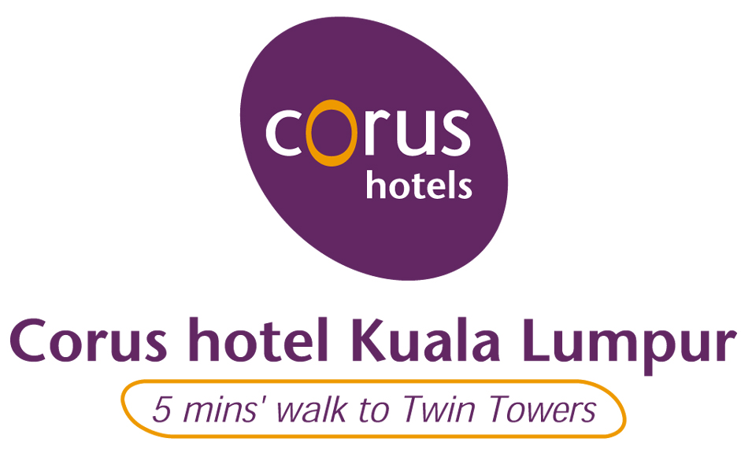
INTERNATIONAL CONFERENCE ON MEMBRANE SCIENCE & TECHNOLOGY
12 – 15 MAY 2009

HOTEL RESERVATION & CREDIT CARD AUTHORIZATION FORM
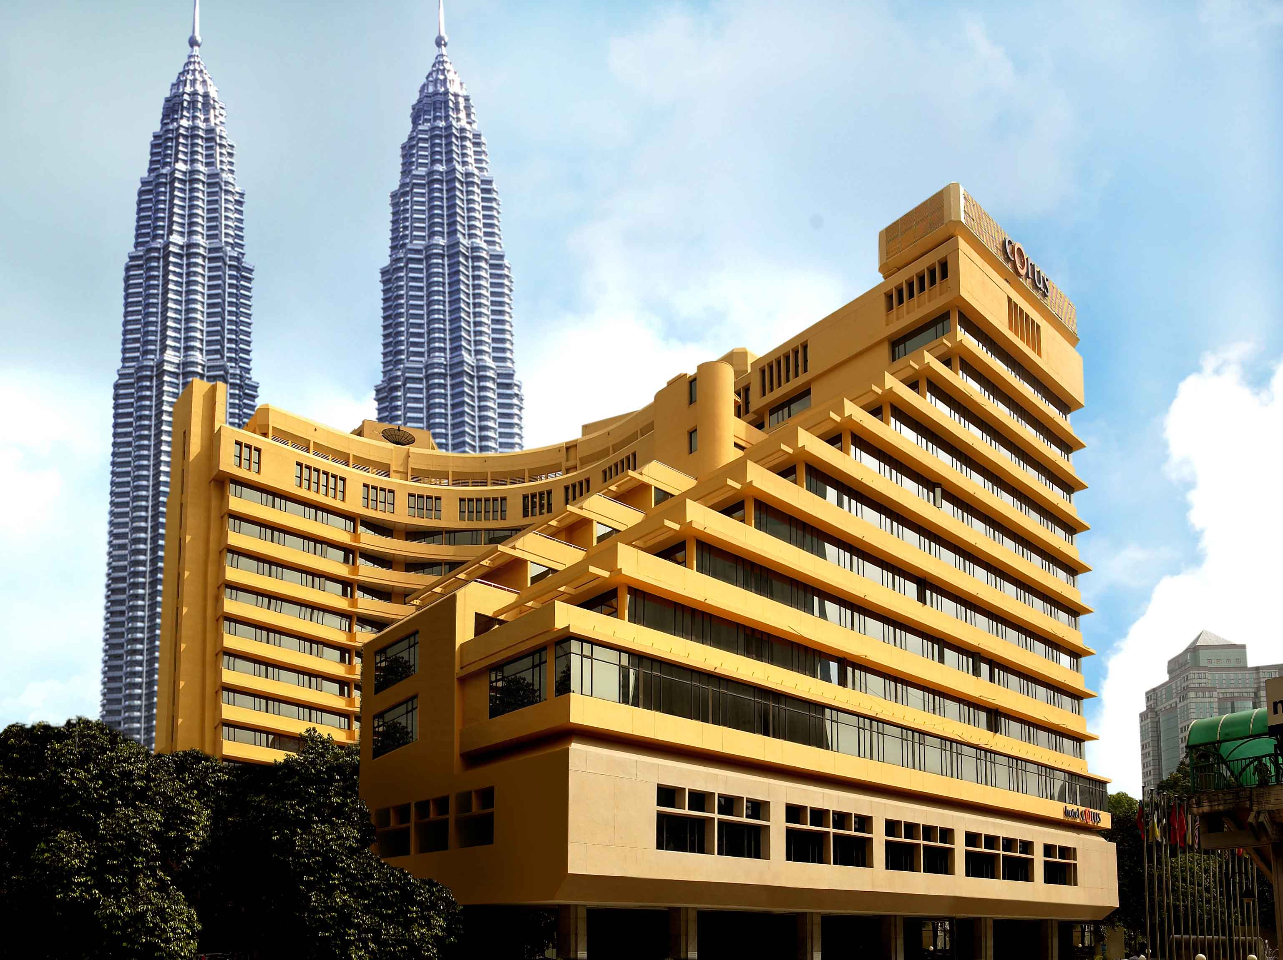  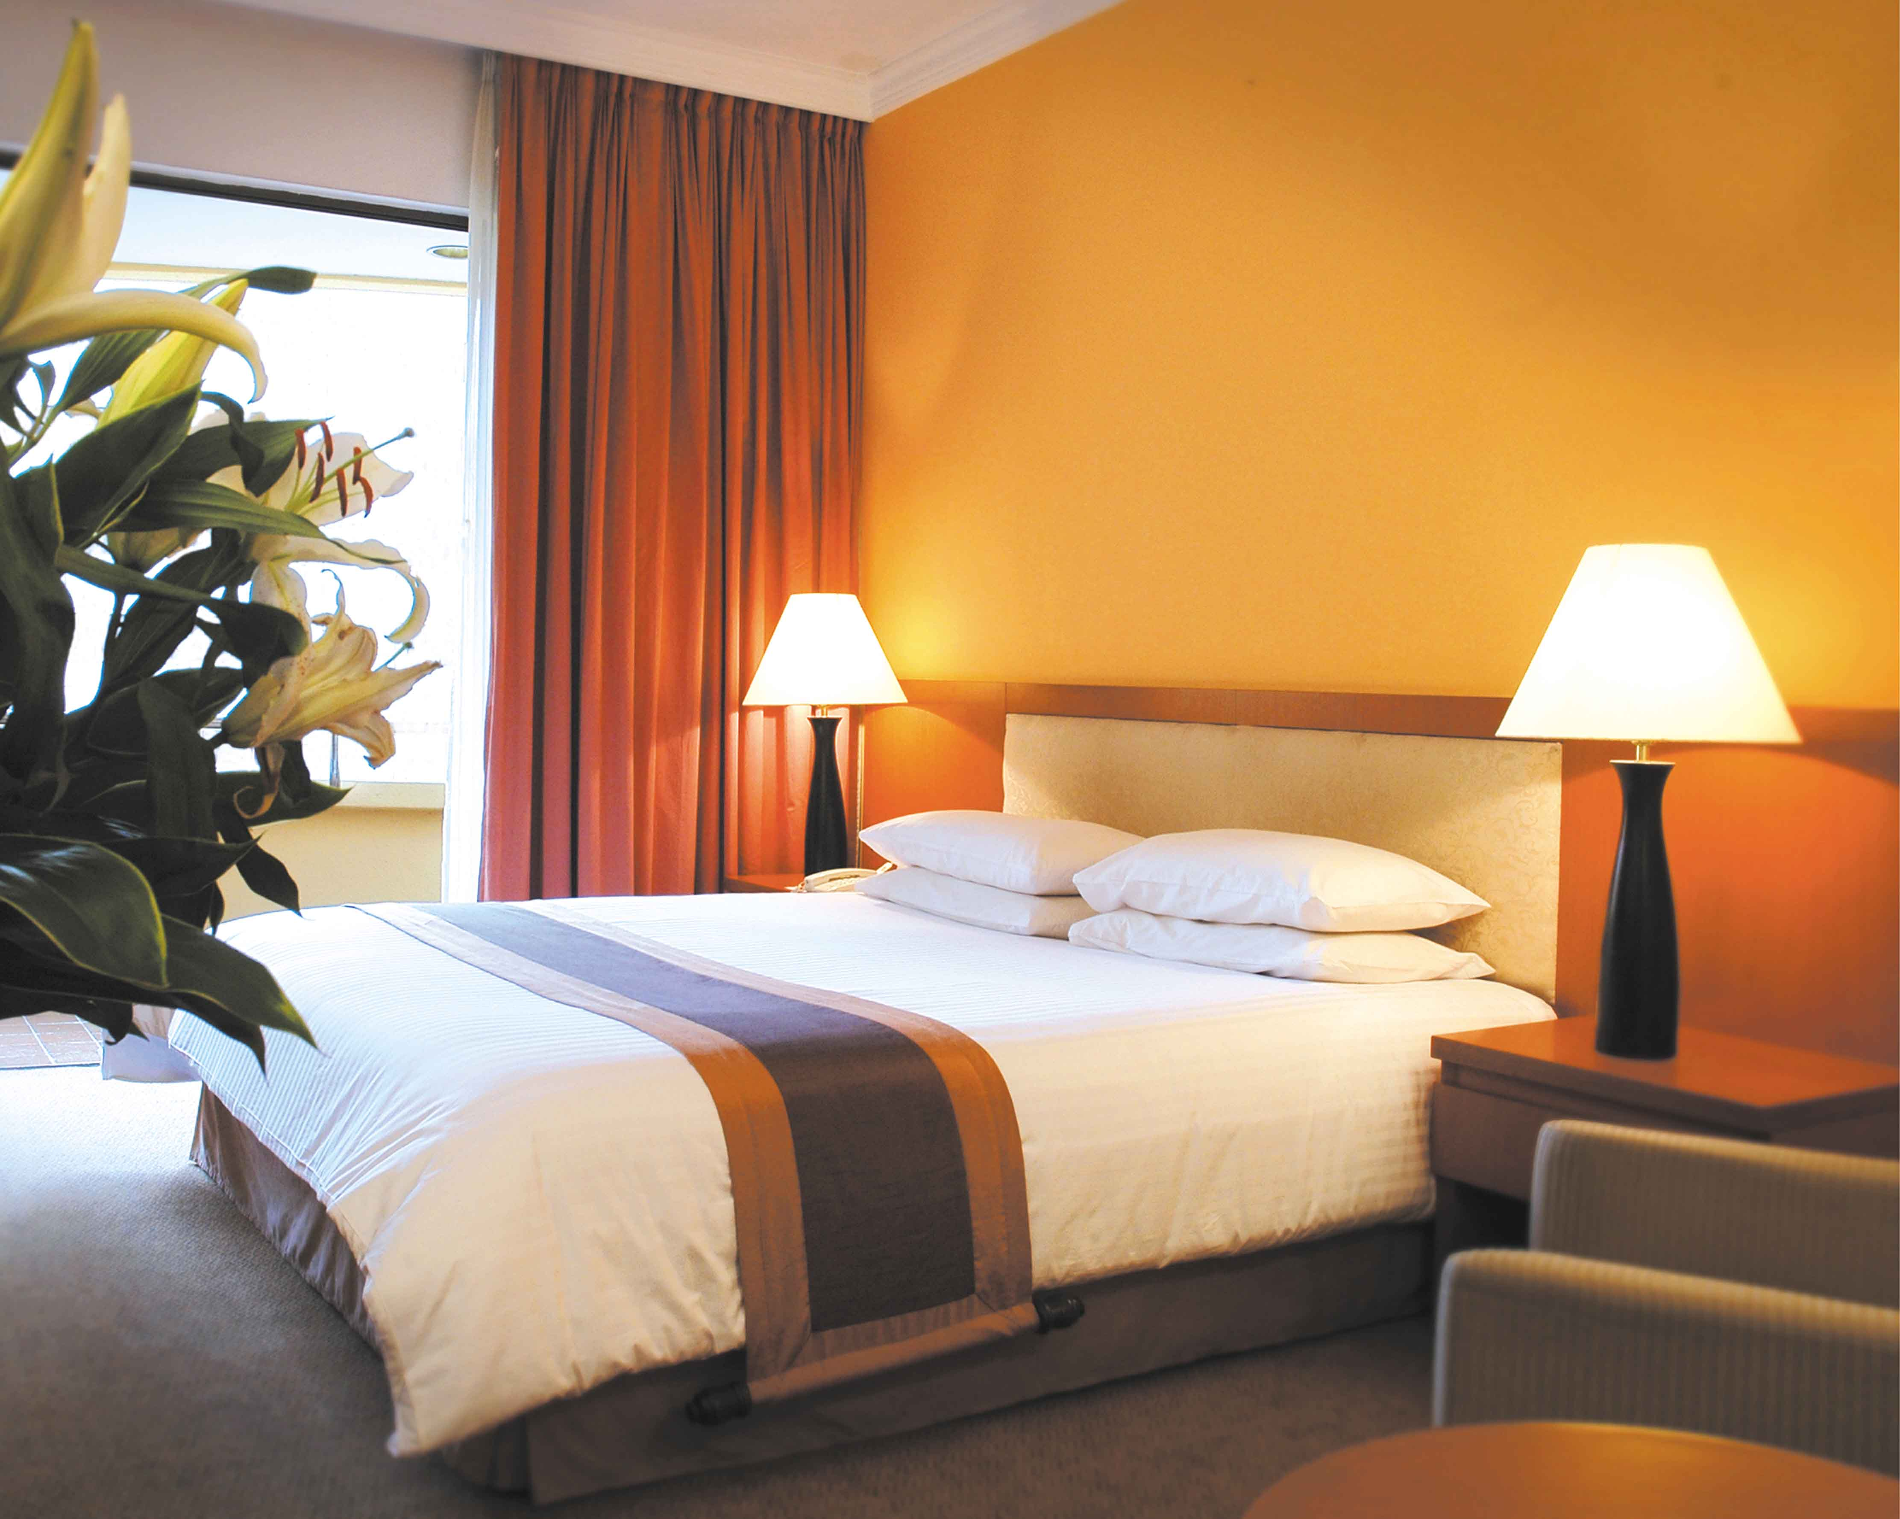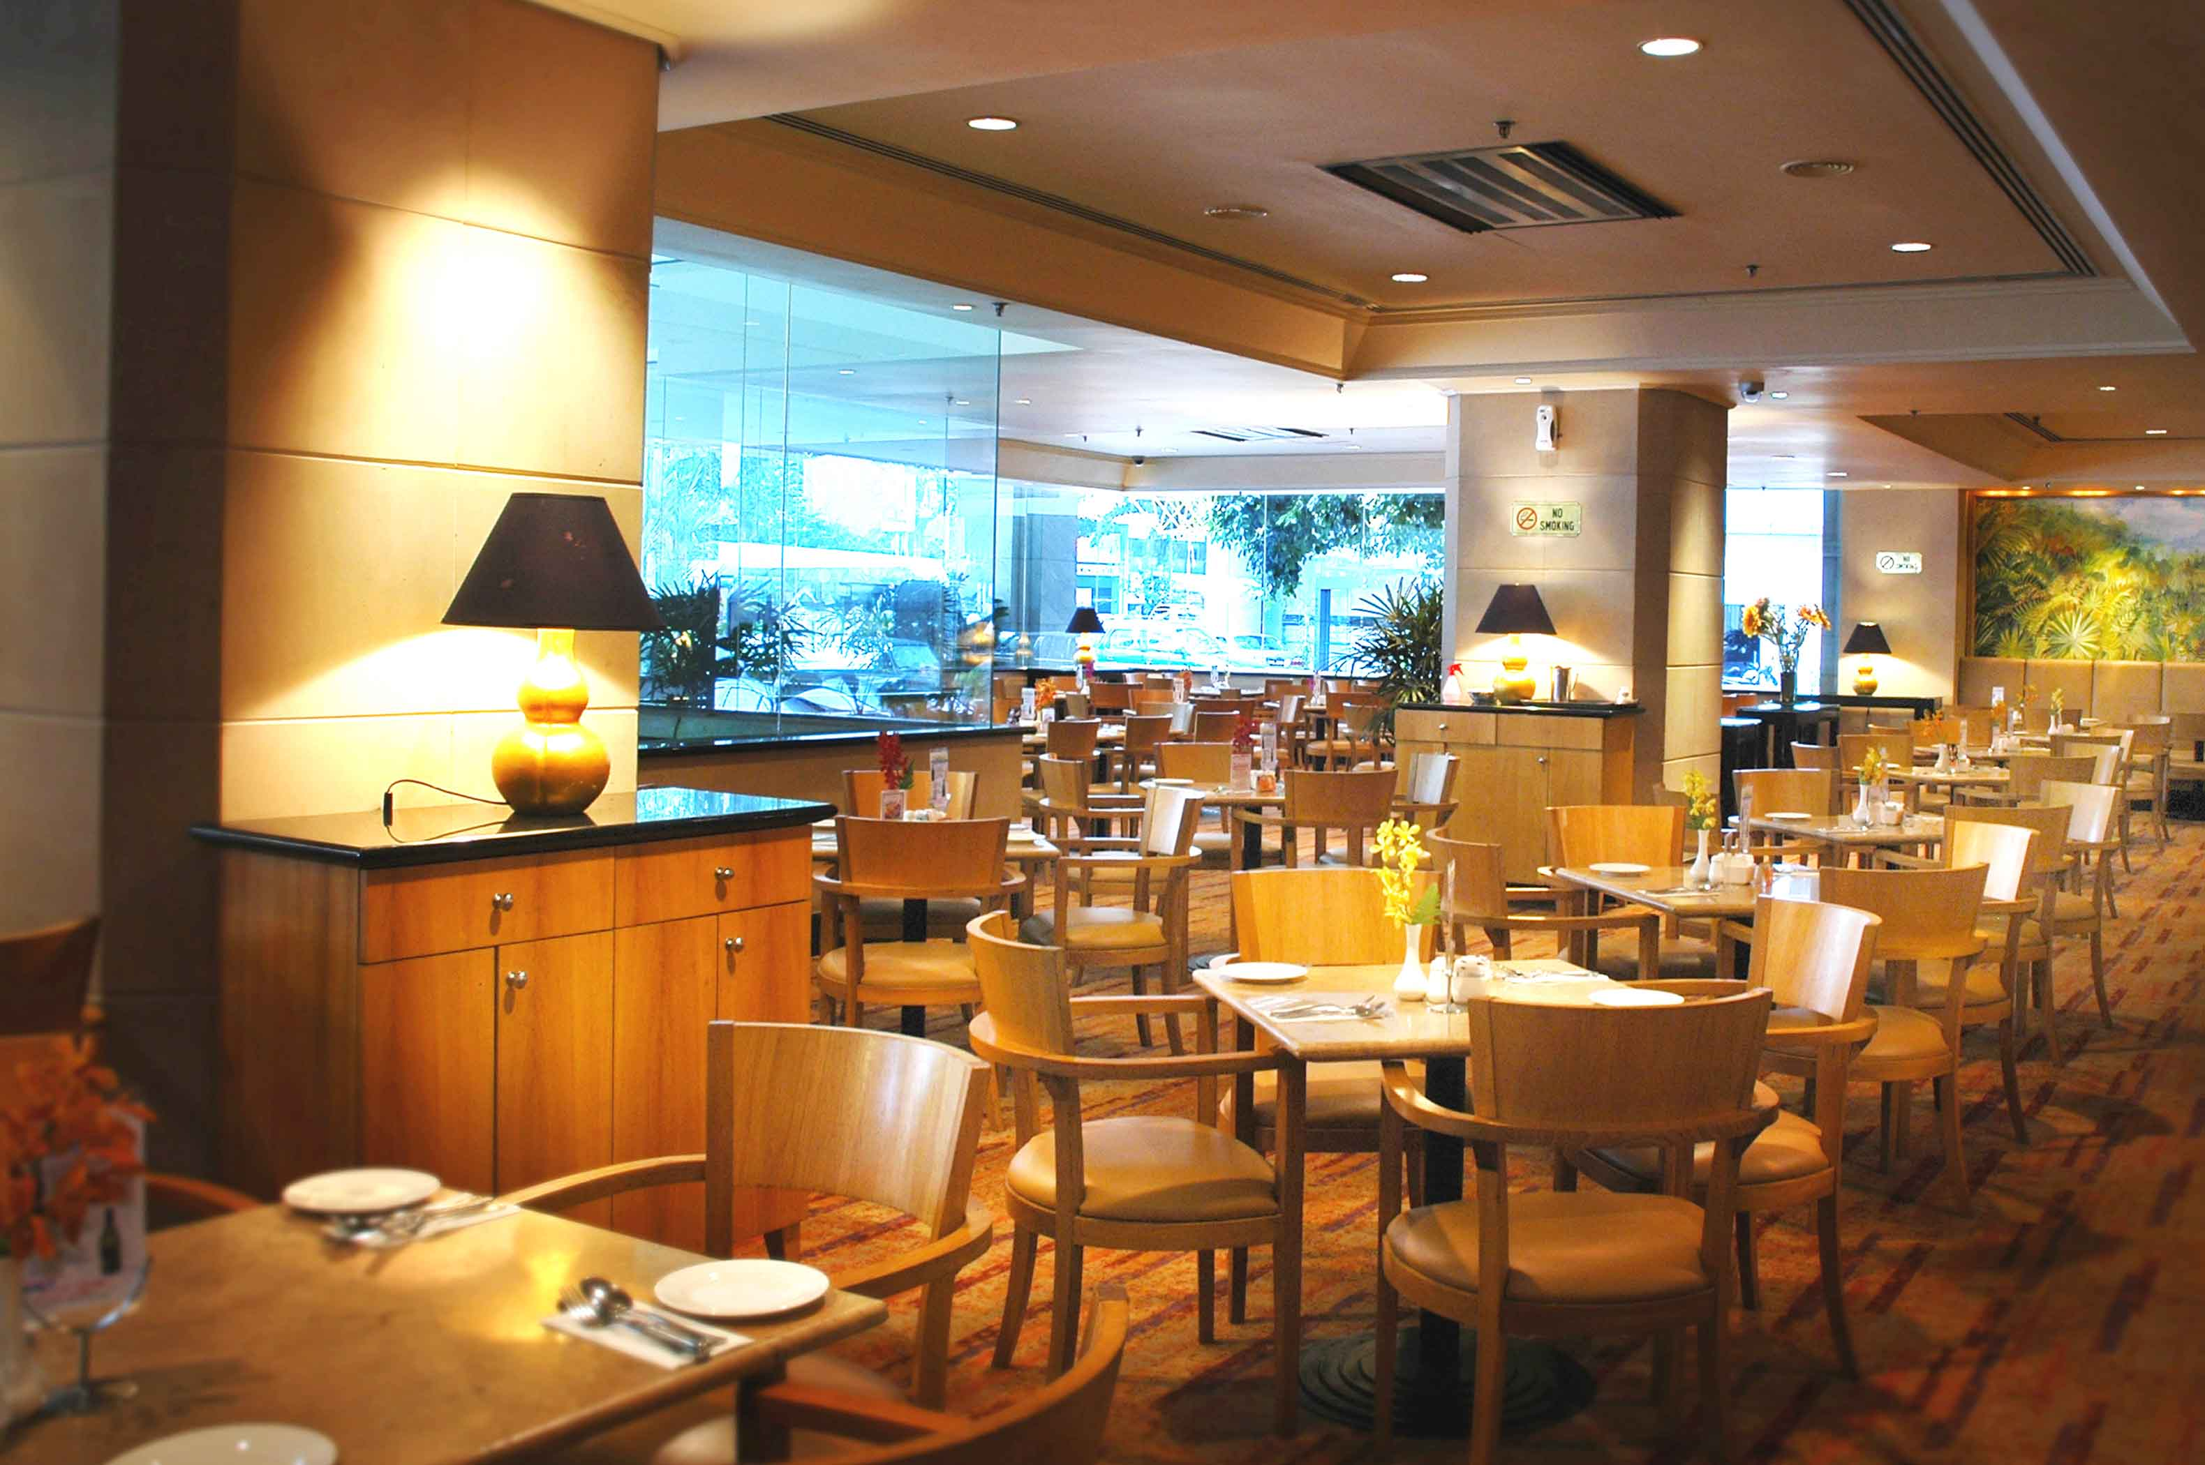 | About us  Superb location. Just 5 minutes' walk to the Petronas Twin Towers and Suria KLCC shopping mall that showcases over 500 shops. Just next door is the light rail transit (LRT) station for easy trips to the KLIA (Kuala Lumpur International Airport) via KL Sentral and many other city attractions.  What enriching feel…  Stylish comfort…of tastefully designed rooms.  Exquisite culinary experiences… at three popular restaurants.  Modern conference and function services… that create memorable events.  Pamperings of… spacious pool . relaxing lush garden . lounge . new gym . latest spa  Web : www.corushotelkl.com

Hotel | Function details | Rates | Contact Persons
CORUS  HOTEL  KUALA LUMPUR | Single Deluxe Room  Doube Deluxe Room (Twin)  Single Executive Room  Double Executive Room  Paradise Cabana (Single)  Paradise Cabana (Double) | RM 230.00++ (RM 264.50nt)  RM 250.00++ (RM 287.50nt)  RM 290.00++ (RM 333.50nt)  RM 300.00++ (RM 356.50nt)  RM 260.00++ (RM 299.00nt)  RM 280.00++ (RM 322.00nt) | SHAZLINA DATO’ HASHIM  MOBILE : + 60 12 – 913 9480  TEL : + 60 3 - 2161 8888  FAX : + 60 3 - 2162 3428  E-Mail : corporate1@corushotelkl.com
- The above room rates quoted is in Ringgit Malaysia (RM) and subject to 10% Service Charge & 5% Government Tax
- The above room rates quoted is based on Per Room Per Night basis and inclusive of Buffet Breakfasts at Dondang Sayang Restaurant.

NAME : COMPANY NAME :

ADDRESS :

Telephone No : Fax No : Email : _________________________

Arrival date: | Limousine pick-up (KLIA-Hotel) ( Y / N )  RM 160 nett (USD 55 ) per way per limo | Flight Number :  ETA :
Departure date : | Limousine send off (Hotel – KLIA) ( Y / N )  RM 160 nett (USD 55) per way per limo | Flight Number :  ETD :
- The Hotel official c/in time is from 1400 hours onwards & c/out time is before 1200 hours on the day of departure.
- In the event of any request for guaranteed early check-in before 1200 hours, a 50% surcharge will be applicable, while a full-day surcharge will be applicable for guaranteed check-in before 0900 hours.
- Late check-out will be on a request basis and subject to availability. A half-day room charge is applicable for late check-out until 1800 hours. Rooms occupied beyond 1800 hours will be charged at a full day rate.
- A one-night room charge will be imposed for any no-shows or cancellation within 07 days before the arrival date.

Credit Card Type: (please tick) Visa Master *Amex JCB Diners
* For AMEX card, please provide the 4 digit ID Number displayed at the front of the card and whereas, for the other credit card, please provide the 3 digit ID number at the back of the card.

Credit Card Nos.

Expiry Date : Credit Card ID / CVC No. :

Signature according to specimen of credit card ---------------------------------------

* Please photocopy both sides of your Credit Card and attach together with this Reservation Form for room reservation
* Room reservation request is to be sent directly to the hotel and is subject to room availability. Please fax or email this
reservation form to secure your room.
* Credit card will be used as a guaranteed & will be charge should the rooms falls below 40 rooms.

HOTEL LOCATION MAP



