
UN/CEFACT – Core Components User’s Guide

9 September 2003

Table of Contents
UN/CEFACT – Core Components User’s Guide 1
Table of Contents 2
1.0 Status of this Document 5
2.0 UN/CEFACT – Core Component User’s Guide Project Team Participants 6
2.1 Disclaimer 6
2.2 Contact Information 6
3.0 Overview 7
3.1 Introduction 7
3.2 Core Components in the Big Picture 7
3.3 Where and When May Core Components Be Used 8
4.0 Core Component Identification 9
4.1 How is Information Being Modelled in a Class Diagram? 9
4.2 Introduction to Core Components 9
4.3 Introduction to Core Component Types and Data Types 11
4.4 Introduction to Business Information Entities 13
4.5 What is ‘Context’? 14
4.5.1 Use of Context in Core Component Normalization 15
4.6 Modeling the Business Collaboration 15
4.7 Naming Rules for Core Components and Business Information Entities 19
4.7.1 Introduction 19
4.7.2 Dictionary Entry Names for Core Components (CCT, BCC, ACC and ASCC) 19
4.7.2.1 Dictionary Entry Names for Core Component Types and Data Types 19
4.7.2.2 Dictionary Entry Names for Basic Core Components 21
4.7.2.3 Dictionary Entry Names for Aggregate Core Components 22
4.7.2.4 Dictionary Entry Names for Association Core Components 22
4.7.3 Dictionary Entry Names for Business Information Entities (BBIE, ABIE, ASBIE) 23
4.7.3.1 Dictionary Entry Names for Basic Business Information Entities 23
4.7.3.2 Dictionary Entry Names for Aggregate Business Information Entities 24
4.7.3.3 Dictionary Entry Names for Association Business Information Entities 24
4.7.4 Business Terms 25
4.8 Discovery of Core Components 26
4.8.1 The Discovery Process 26
4.8.2 Detailed Core Component Identification Steps 26
4.8.2.1 Identify Detailed Information 27
4.8.2.2 Refine Business Information Entities 28
4.8.2.3 Identify and Create Core Components 30
4.8.3 Processes Applicable to Multiple Steps 33
4.8.3.1 Searching the Registry / Repository for Core Components 33
4.8.3.2 Forward/Backward Reading Guideline 35
5. Examples 36
5.1 The Boeing Company Spare Parts Procurement Example 36
5.1.1 Business Requirements View (BRV) 36
5.1.1.1 Business Process Use Case Description 36
Use Case Realisation 39
5.1.1.4 Document Content Description 40
5.1.2 Business Transaction View (BTV) 42
5.1.2.1 Business Transaction Activity Diagram 42
5.1.2.2 Object Class Diagram 43
5.1.3 Business Service View (BSV) 44
5.1.3.1 Sequence Diagram 44
5.1.3.2 Business Information Context 44
5.1.3.3 Document Class View 46
5.1.4 Completing the Core Component Model 48
5.1.4.1 Detailed Class Diagram with Core Components 59
5.1.5 Examples Using Core Components to Build Business Documents 59
5.1.5.2 The Document Type Definition (DTD) File Describes the Document Data Structure Requirements 61
5.1.5.3 The XML Schema File Describes the Document Data Structure and Data Type Requirements 62
5.1.5.4 A Browser View of the Purchase Order 64
5.1.5.5 EDIFACT Example 66
5.1.5.5.1 Introduction 66
5.1.5.5.2 Table 66
5.1.5.5.3 Segment Table 70
5.1.5.5.4 Steps 73
5.1.6 Conclusion 74
5.2 The EAN.UCC FMCG Retail Delivery Example 75
5.2.1 Business Requirements View (BRV) 75
5.2.1.1 Business Process Use Case Description 75
5.2.1.2 Business Process Activity Diagram 76
5.2.1.3 Use-case Realisation 76
5.2.1.4 Business Process Use-case Diagram 77
5.2.1.5 Requirements List 78
5.2.1.6 Business Information Objects Glossary 79
5.2.2 Business Transaction View (BTV) 80
5.2.2.1 Business Transaction Activity Diagrams 80
5.2.2.2 High-level Class Diagrams 82
5.2.2.2.1 Delivery Business Process 82
5.2.2.2.2 Despatch Advice Business Document 83
5.2.2.2.3 Receiving Advice Business Document 83
5.2.3 Business Service View (BSV) 84
5.2.3.1 Sequence Diagram 84
5.2.3.2 Context Classification Scheme 85
5.2.3.3 Detailed Class Diagram 86
5.2.3.4 Sub-set Business Document Class Diagram (detailed) 87
5.2.3.4.1 Despatch Advice Business Document (Class Diagram): 87
5.2.3.4.2 Receiving Advice Business Document (Class Diagram) 88
5.2.4 Core Component Reference Lists 89
5.2.5 Core Component Overview 91
6. Glossary 96
Appendix A 97
References 97
Copyright Statement 98

1.0 Status of this Document
This User Guide is being developed in accordance with the UN/CEFACT TMG procedures for User Guides. The Core Components Supplementary Documents Project Team has approved it for internal review.
This document contains information to guide in the interpretation or implementation of the UN/CEFACT ebXML Core Components Technical Specification.
This version: Core Components User’s Guide, Version 1.0 of 18 June 2003.

2.0 UN/CEFACT – Core Component User’s Guide Project Team Participants
We would like to recognize the following for their significant participation to the development of this document.
Project Team Leader: Fred van Blommestein Berenschot
Lead Editor: Paula Heilig Worldspan

Contributors: Mary Kay Blantz Electronic Commerce Services
Sally Chan The Boeing Company
Regenald Kramer EAN International
Boonserm Kulvatunyou NIST
Kim Lambert LMI
Melanie McCarthy General Motors
Monica Martin Sun
Sue Probert
Gunther Stuhec SAP AG
John Yunker Amazon

2.1 Disclaimer
The views and specification expressed in this document are those of the authors and are not necessarily those of their employers. The authors and their employers specifically disclaim responsibility for any problems arising from correct or incorrect implementation or use of this technical specification.

2.2 Contact Information
CCSD Chair: Fred van Blommestein, Berenschot, f.van.blommestein@berenschot.com

3.0 Overview

3.1 Introduction
This primer illustrates the discovery and implementation of Core Components by elaborating two real life examples in detail: the Boeing Part Ordering System and the EAN.UCC Delivery Process for Fast Moving Consumer Goods (FMCG).
It should be used as a supplemental document to the ebXML Core Components Technical Specification. This primer intends to explain the use of Core Components principles through actual examples.
This primer shows how the employment of the Core Components methodology may be used for analysing the needed information flows in cross-organisational processes and how it can lead to information models and communication systems that are usable internationally and cross-industry.
This primer should be read by management, responsible for the implementation of information systems. End users, information managers and IT personnel may also find the document usable.
This document must be used in conjunction with the set of UN/CEFACT ebXML specifications (see Appendix A for a list of references).

3.2 Core Components in the Big Picture
In the early days of electronic business, systems were tailored to process proprietary data between business partners; a lot of time was spent in getting the right data in and out of systems. The same data was redefined in different systems as the developer wished. This created a nightmare for system integration and maintenance to match the ever changing and growing requirements in the eBusiness environment.
Today, we have technology like XML and the Internet, which enables the exchange of business data much easier, the same data can be processed across different systems on different platforms. System interoperability is key for eBusiness success. The overhead cost of data inconsistency needs to be improved.
ebXML Core Components enable standardising data across industries. Using standardised data enables consistent data exchange from system to system and industry to industry. The time requirements for interface development are reduced. Industry can focus their time on improving business rather than worry about data flow.
By using Core Components, information is being aligned internationally and cross-industry. Meaning, names, structures and definitions of information entities are set up in a way that allows the use of it beyond the scope of the individual project defining them. Investments in such projects are lasting and secure.
Results are being stored in internationally maintained registries. No project needs to start from scratch, but instead should use the results of earlier projects in similar environments. The Core Components methods allow, support and manage functional deviations between those environments. This not only secures but also lowers the investment needed when setting up an information system across organisational borders.

3.3 Where and When May Core Components Be Used
Core Components and Business Information Entities are used whenever business processes cross-organizational borders. They define the information that is exchanged between organisations semantically and structurally. Core Components are independent of the syntax the information is cast in, they present an opportunity for information to be transmitted in a variety of formats over any type of communication network.
Many technologies exist for exchanging information between automated systems. Technologies may be embedded in integrated business information systems (like Enterprise Resource Planning packages), they may be used in specific middleware or workflow management systems or they may merely be employed to present information through human interfaces to company employees. Core Components are technology neutral. All mentioned technologies, and all usage of these technologies, may (and should) use the Core Component methodology and definitions. This way investments in information systems and in (internal) working procedures are secured, even when the technology is upgraded.
Traditionally, structured information between companies is exchanged using Electronic Data Interchange (EDI). Information that needs to be exchanged in the framework of a business process is cast in a syntax (like EDIFACT or ANSI ASC.X12), packaged in messages and transmitted using a communication network (like Internet). The information to be exchanged can and in the future should be defined using the Core Component methodology, and registered for re-use using an ebXML registry.
Using the standard eXtensible Markup Language (XML) of the World Wide Web Consortium (W3C) more advanced systems can use the same Core Component definitions. XML is more widely adopted by soft- and middleware vendors. XML can even be interpreted by browsers that are used by the general public to present information to end-users. So communication based on Core Components is not limited to application-to-application systems, but can also be used in application-to-human communication that crosses organisational borders. The illustrations in section D show how the syntax neutral core components can be used in a syntax specific format, such as XML or EDIFACT.
XML messages may also be used in information presentation (webforms-like) systems, and in webservices that are offered commercially to either application systems or human users. The information exchanged in the request for a webservice, and in the response given by the service may and should be defined according to the Core Component methodology. That ensures consistency of information semantics and structure among and between webservices and the client applications.
Summarising, Core Components are being deployed whenever information is exchanged between information systems of different organisations, regardless of the technology used.

4.0 Core Component Identification

4.1 How is Information Being Modelled in a Class Diagram?
There exist many ways to model or structure information that is being stored or exchanged. Core Components are based on Class Diagrams of the Unified Modeling Language (UML) to model information required in a business collaboration. A Class diagram shows object classes, their properties and their relationships. Object classes are the categories of the “things” that are accessed, inspected, manipulated, produced, and worked on in business operations, like products, agreements, parties and events. Object Classes can be tangible or intangible. A Person is a tangible object: “it is of flesh and blood”. An Address is an intangible object: one cannot touch an address, it only exists as a piece of information related to a location.
Class diagrams show object classes as boxes with (among other things) their names and their properties.
+Work Address
+Home Address
Person
Person ID: Identifier
First Name: Text
Last Name: Text
Address
Street: Text
City: Text
State/Province: Code

Figure 4-1 Class diagram example

In the example in figure 4-1 both Person and Address are object classes. Person has five properties: Person ID, First Name, Last Name, Work Address and Home Address. Address has three properties: Street, City and State/Province.
An Object Class can be represented as a box in which the top compartment contains the Object Class name and the bottom compartment contains the properties. The Data Type (kind of information) associated with each property is indicated next to each property separated from it by a colon.
Associations between Object Classes are indicated by drawing a line between the object classes. If the association means that one object class is the property of another object class (an address is a property of a person) an arrow point is drawn at the side of the object class that represents the property (Address).

4.2 Introduction to Core Components
Core Components (CC) are the (standardised) data elements that are used for constructing (electronic) business documents. Data is the core of any business communication. The ability to define data well is crucial to the success of electronic business.
The Core Component Technical Specification provides guidelines in identifying, defining, and naming of data elements. Core Components are in fact the generic representations of information on UML object classes. Because UML class diagrams have four categories of elements, there are four categories of core components:
- Aggregate Core Components (ACC), that represent Object Classes;
- Basic Core Components (BCC), that represent simple properties of Object Classes;
- Association Core Components (ASCC), that represent relations between Object Classes, where one Object Class is the (complex) property of another Object Class;
- Core Component Types (CCT), that define the type of information that a Basic Core Component may contain, like text, a number or a date.
Taking as an example the class diagram in figure 4-1, both Person and Address are representations of Aggregate Core Components. Person ID, First Name, Last Name, Street, City and State/Province are Basic Core Components. Work Address and Home Address are Association Core Components (see figure 4-2).
Each Aggregate Core Component, Basic Core Component and Association Core Component is given a unique name, under which the Core Component can be found in a registry or dictionary. This name is therefore called a “Dictionary Entry Name”. The Dictionary Entry Name consists in principle of three parts or “terms”: the object class term (the name of the object class), the property term (the property the core component is representing) and the representation term (the name of the data type that is derived from the core component type). The conventions for constructing the dictionary entry name are described in detail in section 4.7.
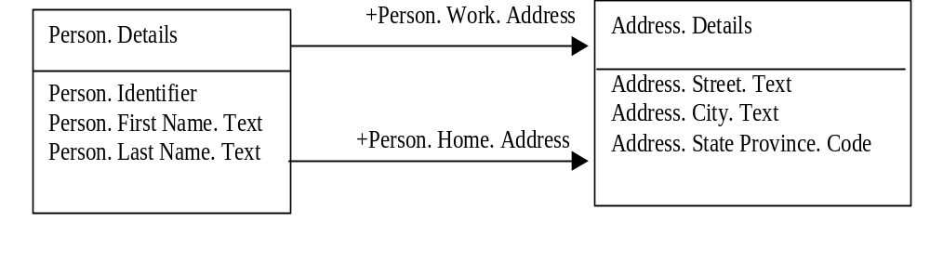
Figure 4-2 Dictionary Entry Names
Each core component is also given a definition, that describes the semantics (the meaning) of the Core Component. Other attributes of core components are a unique identifier (a unique meaningless number or string) and a number of “business terms” or synonyms. Business terms are names under which the Core Component is known in some business communities. Business terms do not need to be unique.
To understand how data is standardized to form Core Components, it is best to walk through an example. Let us consider the business term name ‘Charge Card Expiration Date’. First we analyze the data and give it a definition, then, based on the definition, we identify the data's object class, property term, and representation term as follows:
Definition: The expiration date of a payment card that is associated with an account.
Object Class: Payment Card
Property Term: Expiration Date
Representation Term: Date
The description represents the semantically unique business meaning of the core component in a complete and unambiguous way. The sentences in the description must be clear and concise.
Furthermore, the description should:
a) be unique (within any data dictionary in which it appears)
b) be stated in the singular
c) state what the concept is, not only what it is not
d) be stated as a descriptive phrase or sentence(s)
e) contain only commonly understood abbreviations
f) be expressed without embedding definitions of other data elements or underlying concepts
These rules were taken from ISO 11179-4 (Rules and guidelines for the formulation of data definitions).
The dictionary entry name is derived from the description. This means that the expressions of a dictionary entry name must be included in the description. Any abbreviations or acronyms used in the dictionary entry name must be described in the description.
After the data is analysed and classified, concatenating the Object Class, Property Term, and Representation Term can generate the Dictionary Entry Name. In the “Charge Card Expiration Date” example, the Core Component name is "Payment Card. Expiration. Date".
Payment Card

Expiration Date: Date

Figure 4-3 Class diagram

4.3 Introduction to Core Component Types and Data Types
An important element in the core component construct is the Core Component Type (CCT). Each Basic Core Component is of a Core Component Type.
Defined are ten Core Components Types. They are listed in table 4-1.
The Core Component Types come with some extra features, called supplementary components, e.g. amounts have a supplementary component that is used to define the currency identifier. So the currency is implied by the Core Component Type, and does not need to be a separate property in the Class Diagram. The table below shows the supplementary components belonging to the ten Core Component Types.

CCT | Explanation | SupplementaryComponents
Amount. Type | Monetary amounts | Amount Currency. Identifier  Amount Currency. Code List Version. Identifier
Binary Object. Type | Binary objects like pictures or sounds | Binary. Format. Text  Binary Object. Mime. Code  Binary Object. Encoding. Code  Binary Object Character set. Code  Binary Object. Uniform Resource. Identifier  Binary Object Filename. Text
Code. Type | Codes | Code List. Identifier  Code List. Agency. Identifier  Code List. Agency Name. Text  Code List. Name. Text  Code List. Version. Identifier  Code. Name. Text  Language. Identifier  Code List. Uniform Resource. Identifier  Code List Scheme. Uniform Resource. Identifier
Date Time. Type | Dates, times or combinations of date and time. | Date Time. Format. Text
Identifier. Type | Identifiers | Identification Scheme. Identifier  Identification Scheme. Name. Text  Identification Scheme Agency. Identifier  Identification Scheme. Agency Name. Text  Identification Scheme. Version. Identifier  Identification Scheme Data. Uniform Resource. Identifier  Identification Scheme. Uniform Resource. Identifier
Indicator. Type | Yes/no, on/off, present/not present kind of indication | Indicator. Format. Text
Measure. Type | All kinds of measurements | Measure Unit. Code  Measure Unit. Code List Version. Identifier
Numeric. Type | Numeric values. | Numeric. Format. Text
Quantity. Type | Countable quantities | Quantity. Unit. Code  Quantity Unit. Code List. Identifier  Quantity Unit. Code List Agency. Identifier  Quantity Unit. Code List Agency Name. Text
Text. Type | Text | Language. Identifier  Language. Locale. Identifier
Table 4-1 Core Component Types

The values of the content and/or of the supplementary components can be restricted by defining Data Types. For example the data type Country_ Code. Type is based on the Core Component Type Code. Type, but restricts the code values to country codes only. A Data Type can be used for multiple Core Components.
A Data Type defines the set of valid values that can be used for a particular Property of a BBIE or BCC. It is defined by specifying restrictions on the CCT from which the Data Type is derived. Where necessary, a Data Type restricts the set of valid values allowed by the CCT on which it is based, by imposing restrictions on the Content Component and/or Supplementary Component.
Each Data Type shall be given a Dictionary Entry Name and a Definition using the rules specified in 4.7.2.1.

4.4 Introduction to Business Information Entities
The actual information exchanged in business collaborations is not defined as Core Components, but as Business Information Entities (BIE) that reflect the business context. For each Core Component category, there is a corresponding BIE category. So there is the Aggregate Business Information Entity (ABIE) corresponding to the Aggregate Core Component (ACC), the Association Business Information Entity (ASBIE) corresponding to the Association Core Component (ASCC), and the Basic Business Information Entity (BBIE) corresponding to the Basic Core Component (BCC). Each individual Business Information Entity must be based on a corresponding Core Component.
Business Information Entities are derived from their corresponding Core Component by applying context (see Section 4.5 for contexts) to the generic (or “context free”) Core Component. The context refines the Core Component. The definition is narrowed, the number of properties may be less and the allowed values of the properties may be restricted (e.g., by means of data typing).
Business Information Entities can be identified during Business Process Modeling. If, when analyzing the business information, a Business Information Entity is found that has no corresponding Core Component, a generic Core Component must be defined.

A Business Information Entity may be distinguished from its corresponding Core Component by adding “qualifiers” to the Core Component name. Qualifiers can be added to the Object Class names and to the property terms. For the example about personal information, Business Information Entities may be specified for applications exchanging personal information of a person living in the US, using the Core Components in figure 4-2. The Agregate Core Component Person. Details, used in the context of the United States, gets the qualifier US. Therefore the Aggregate Business Information Entity is called US_ Person. Details. Figure 4-4 illustrates this example.
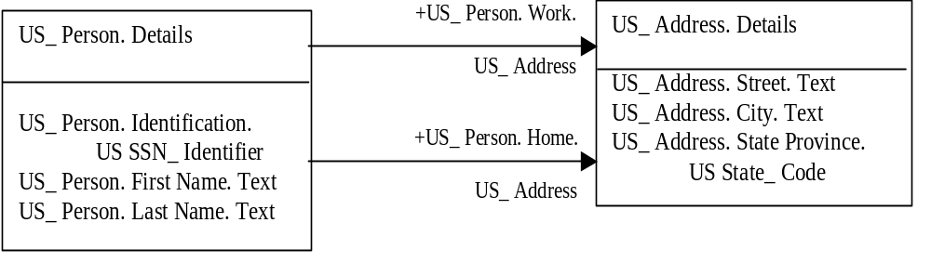
Figure 4-4 Examples of Business Information Entities

4.5 What is ‘Context’?
The concept of Core Components is based on the assumption that there exist many commonalities in the business information exchanged in different environments. Still differences exist. To manage commonalities and differences in definition and structure of business information the concept of Context was introduced.
The Context of a business relationship defines the environment in such detail, that the specific Business Information Entities can be derived from the more generic Core Components. Core Components are said to be valid in all contexts (they are context free), whereas Business Information Entities, being derived from Core Components, are context specific.
Context is defined using eight categories:
Context category | Description | Example
Business Process | The type of business process | Ordering  Delivery
Product Classification | The type of products that the collaboration is about | Parts  Consumer Goods
Industry Classification | The type of industry in which the collaboration takes place | Aerospace  Fast Moving Consumer Goods (FmCG)
Geopolitical | The location of the partners | International  Europe
Official constraints | The legislation that applies | US law  EU law
Business Process Role | The role the partners play in the process | Buyer  Seller
Supporting Role | Roles of relevant parties outside the collaboration | Shipping Agent
System Capabilities | Specific system  requirements | EAN.UCC System  SAP  Intuit
By specifying the business context of a collaboration, the exact structure of the information that is exchanged by means of Business Information Entities in business documents (or otherwise) can be derived. The context is the filter that changes Core Components into the Business Information Entities.

4.5.1 Use of Context in Core Component Normalization
Qualifiers that are used in the naming of Business Information Entities associate a context specific semantic with the Core Component. These qualifiers make up a controlled vocabulary that can have unique semantic within a specific context. For instance, "reserved" used as a qualifier has an order process context semantic, as well as a travel industry context semantic. Rigor in the construction of the controlled vocabularies for qualifiers is as important as rigor in the construction of the controlled vocabulary for core components. A qualifier should be used consistently across the library of core components. The qualifier context category, semantic, and control vocabulary source should be noted.

4.6 Modeling the Business Collaboration
The Business Information Entity and Core Component discovery process, that is described in detail in section 4.8, starts with the Class diagram that shows the Business Entities that are the subject of the business collaboration process. This high level Class diagram does contain Object Classes and only a few attributes. It defines the scope and boundaries of the information relating to the collaboration. The purpose of the high level Class Diagram is not to model the business documents. So the high level Class Diagram is a picture of the Object Classes the communication will be about. It does not model the communication itself.
At this time, the Object Classes and their associations should be taken as much as possible from the standardised and harmonised repository (if available).
The structure of the High Level Class diagram, the manner in which the Object Classes are associated with each other, is derived from the REA model. REA stands for Resource, Event, and Agent. According to the REA model, a business collaboration can be described as an Event of transferring Resources from a Trading Partner (“Agent”) to another Trading Partner, resulting in a dual Economic Event of transferring Economic Resources in the reverse direction. For example, a Supplier (Agent) transfers ownership of an Automobile (Resource) to a Customer (Agent) in return for which the Customer will provide Money (Resource) to the Supplier.
This basic REA structure is shown in Figure 4-5. The structure models the basic semantics of a business collaboration.

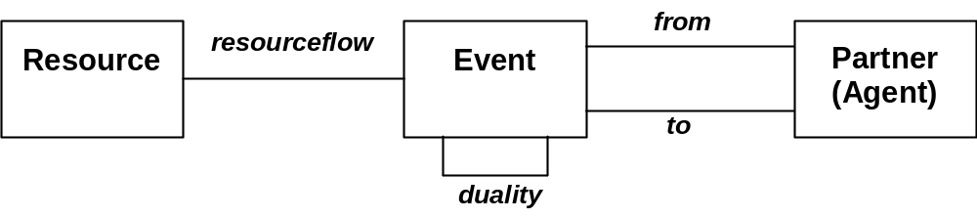
Figure 4-5 Basic REA Ontology

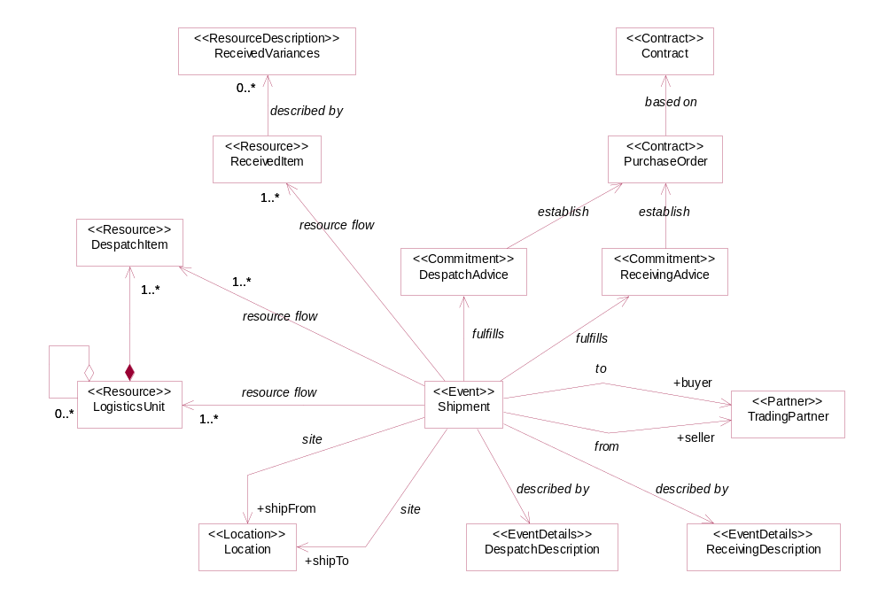
Figure 4-6 The EAN.UCC example of a high level class diagram for Goods Delivery
Steps for modelling the business collaboration include: 1) modelling a high-level class diagram capturing Object Classes in the collaboration (Figure 4-6), 2) modelling transactional class diagrams involved in the collaboration (Figure 4-7), and 3) combining transactional class diagrams to model a detail class diagram (Figure 4-8). The following paragraphs describe this further. The structure of the information to be exchanged is a subset of the structure that was modeled in the high level Class diagram. By interviewing business experts the precise meaning of the information entities is determined, including the Business Entity properties.
So for each Transaction or Document the information to be exchanged is defined in a separate detailed Class Diagram, using Business Information Entities.
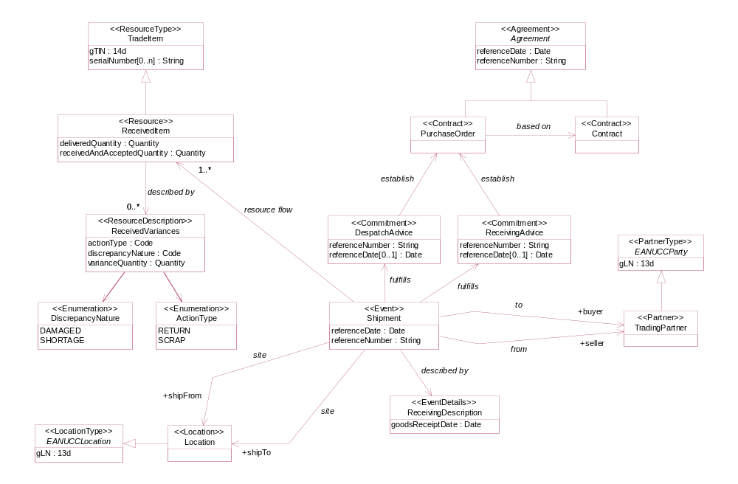
Figure 4-7 The EAN.UCC example of a transactional class diagram for Receive Advice
When the Transactional Class Diagrams are being developed, no reference should yet be made to the registry or dictionary. The actual information requirement should be modelled, not all information that possibly might be needed. The high level Class Diagram only serves to offer structure, it should not be used as an inspiration to include information in documents to be exchanged that is probably not needed.
After all Transactional Class Diagrams in the Collaboration have been modeled, the Diagrams are combined (but without the Document Object Classes) into the overall detailed Class Diagram (Figure 4-8) that contains all information that is exchanged within the collaboration, and only the information that is being exchanged. This diagram is input to the Business Information Entity and Core Component discovery process. The output of that process leads to an update of the overall detailed Class Diagram with the proper names of the Business Information Entities that were discovered.

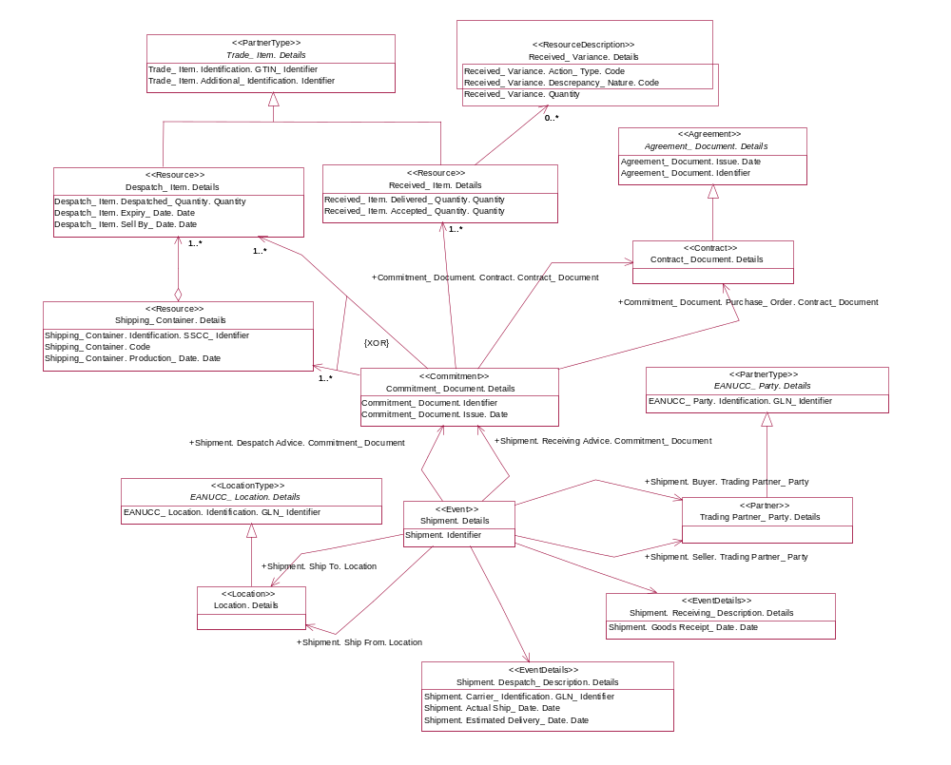
Figure 4-8 The EAN.UCC example of an overall detailed class diagram for Goods Delivery
Summarising the steps to follow when discovering Core Components:
- Determine the scope and the boundaries of the information to be exchanged in the business process
- Draw a high level Class Diagram, using the existing object class associations in the ebXML registry
- For each transaction, define a subset from the high level Class Diagram
- Investigate what detailed information needs to be exchanged in the transaction
- Look up in the registry which Core Components and Business Information Entities fulfil these information requirements
- Reuse where applicable existing Core Components and Business Information Entities.
- Define where necessary new Business Information Entities and submit them for inclusion in the registry
- Draw per transaction a detailed transactional Class Diagram
- Combine the transactional Class Diagrams into an overall detailed Class Diagram.
Discovery of Core Components is defined and expanded upon later in this document in section 4.8 and illustrated in the examples of Boeing and EAN.UCC in section 5.

4.7 Naming Rules for Core Components and Business Information Entities

4.7.1 Introduction
The names for Core Components and Business Information Entities should adhere to a set of rules. The dictionary entry name is derived from the description of the Core Component or Business Information Entity.

The dictionary entry name is unique. The dictionary entry name must be in English, preferably using the spelling in the Oxford English Dictionary. The dictionary entry names must be clear and concise, and not contain any sequences of redundant words.
The individual names of the dictionary entry names must be singular, except when the concept is specifically intended for plurals. The names of the dictionary entry names should consist of letters only. The words in the names can be verbs, nouns, or adjectives. Abbreviations and acronyms in the dictionary entry name can be used, however they must be explained in the description.
A dictionary entry name in principle consists of a number of terms, that each may consist of multiple words. Each word in a term is separated from the others by space character ( ). Each word within a term must start with an uppercase letter.

4.7.2 Dictionary Entry Names for Core Components (CCT, BCC, ACC and ASCC)
The dictionary entry name of a Core Component consists of the following terms:
Object class term –The name of an object class.
Property term – Represents the property of the object class.
Representation term – Specifies the representation type of the component.
The terms in the dictionary entry name are separated by a period (.) and a space character ( ).

4.7.2.1 Dictionary Entry Names for Core Component Types and Data Types
Each Core Component Type (CCT) has its own representation terms. The following table is a list of primary and secondary representation terms for the Core Component Types. A Core Component Type in the dictionary entry name is represented by its primary or by one of its secondary representation terms.
Core Component Type | Primary  Representation Term | Secondary  Representation Terms
Amount. Type | Amount
Binary Object. Type | Binary Object | Graphic, Picture, Sound, Video
Code. Type | Code
Date Time. Type | Date Time | Date, Time
Identifier. Type | Identifier
Indicator. Type | Indicator
Measure. Type | Measure
Numeric. Type | Numeric | Value, Rate, Percent
Quantity. Type | Quantity
Text. Type | Text | Name

The dictionary entry name of a Core Component Type consists of a primary representation term, followed by a period, a space character, and the expression Type.
Example:
Representation term: Date Time
Term: Type

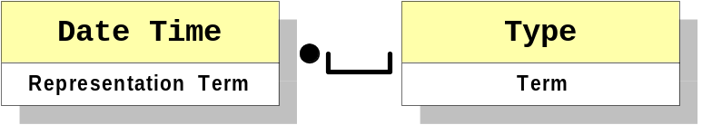

Dictionary Entry Name: Date Time. Type

More specific restrictions or distinctions for data types can be applied by adding a qualifier term to the relevant secondary or primary representation term. The dictionary entry name of the restricted data type then consists of a qualifier term, a primary or secondary representation term, and the term Type.
An underscore (_) and a space character are placed between the qualifier term and the representation term. A period (.) and a space character are placed between the representation term and the term Type.
Example:
Qualifier term: Language
Representation term: Code
Term: Type

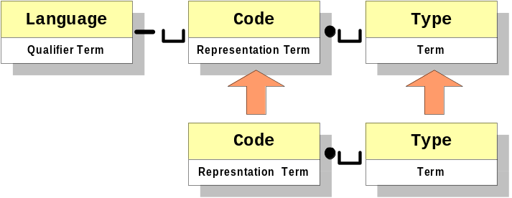
Dictionary Entry Name: Language_ Code. Type

4.7.2.2 Dictionary Entry Names for Basic Core Components
The dictionary entry name of a Basic Core Component (BCC) consists of an object class term, a property term, and a representation term.
The representation term usually consists of a primary or secondary representation term. In certain cases, data types can be used to restrict Core Component values. The representation term for a data type consists of a qualifier and the representation term of the Core Component Type the data type is based on. The qualifier in the representation term is separated from the primary or secondary representation term of the Core Component Type by an underscore and a space character.
If the dictionary entry name of a Basic Core Component consists of a representation term that is equivalent to the last word(s) of the property term, then those last words can be deleted from the property term in the dictionary entry name. This rule is called the Truncation rule.

Example:
Object class term: Goods
Property term: Delivery Date Time
Representation term: Date Time

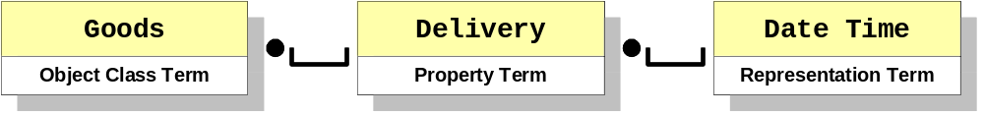
The dictionary entry name would be:
Goods. Delivery Date Time. Date Time

But becomes as a result of the truncation rule:
Goods. Delivery. Date Time

Another example of the application of the truncation rule would be:
Party. Identification. Identifier

That becomes:
Party. Identifier

4.7.2.3 Dictionary Entry Names for Aggregate Core Components
The Aggregate Core Components (ACC) consist only of an object class term and a representation term.
The expression Details is used as the representation term.
Example:
Object class term: Address
Representation term: Details
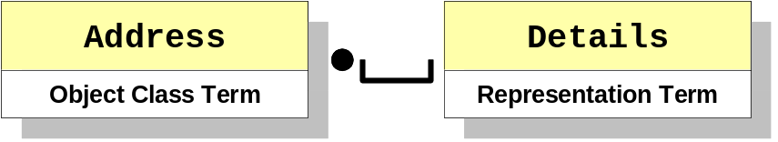
Dictionary Entry Name: Address. Details

4.7.2.4 Dictionary Entry Names for Association Core Components
Dictionary entry names for Association Core Components (ASCC) consist of the following:
- Object class term of the Aggregate Core Component that contains the Association Core Component
- Property term that represents the property of the Association Core Component
- Another object class term of the Aggregate Core Component that describes the structure of the Association Core Component.
The Truncation rule of dictionary entry names of Basic Core Components is also valid for Association Core Component’s.
Example:
Object class term: Person
Property term: Residence
Object class term: Address

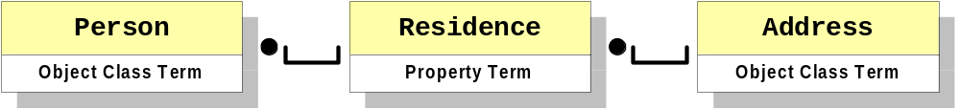
Dictionary Entry Name: Person. Residence. Address

4.7.3 Dictionary Entry Names for Business Information Entities (BBIE, ABIE, ASBIE)
The dictionary entry name for Business Information Enities also consists of an object class term, a property term, and a representation term, but in addition may contain qualifier terms that qualify the object class term or the property term to define the Business Information Entity in a specific business context.
The qualifier term is placed before the object class term or property term. An underscore (_) and a space character ( ) separate the qualifier term from the object class term or property term.
Multiple qualifier terms can be placed before an object class term or property term. Each qualifier term is separated by an underscore and a space character.
A different sequence of qualifier terms does not make the dictionary entry name unique. For example Stored_ Partial_ Goods. Details and Partial_ Stored_ Goods. Details consist of the same qualifier terms, but in a different order. The two expressions do have different semantics, but that does not make them unique.

4.7.3.1 Dictionary Entry Names for Basic Business Information Entities
The dictionary entry name of a Basic Business Information Entity (BBIE) consists of an object class term and its qualifier terms, a property term and its qualifier terms, and finally the Data Type qualifier and the appropriate representation term. The truncation rule applies, but may not be used when either the property term or the representation term is qualified.
The representation term represents the data type of the Basic Business Information Entity. This data type may be further restricted and qualified. For the representation term the same rules apply as for Basic Core Components.
Example:
Qualifier term: Partial
Object class term: Cost
Qualifier term: Period
Property term: Total Amount
Representation term: Amount

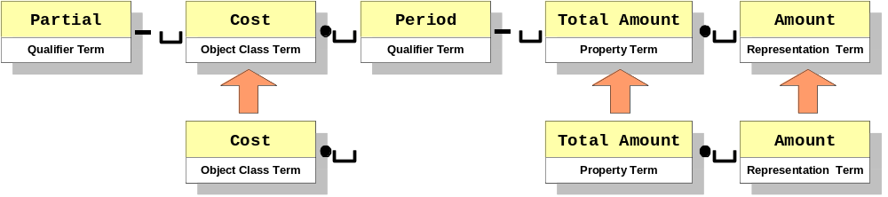
Dictionary Entry Name:
Partial_ Cost. Period_ Total Amount. Amount

An example of a BBIE in which the representation term is qualified with a Data Type qualifier is:
Despatch_ Shipment Information. Carrier_ Identification. GLN_ Identifier

4.7.3.2 Dictionary Entry Names for Aggregate Business Information Entities
The dictionary entry name of an Aggregate Business Information Entity (ABIE) consists of an object class term and its qualifier terms and the appropriate representation term, which is indicated by Details.
The object class term and representation term are copied exactly from the corresponding Aggregate Core Component, on which the Aggregate Business Information Entity is based.
Example:
Qualifier term: Temporary
Object class term: Address
Representation term: Details

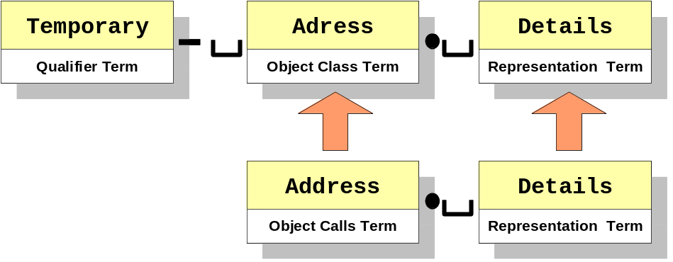
Dictionary Entry Name: Temporary_ Address. Details

4.7.3.3 Dictionary Entry Names for Association Business Information Entities
The dictionary entry name of an Association Business Information Entity (ASBIE) consists of the following:
- Object class term and its qualifier terms
- Property term and its qualifier terms
- Another object class term of the Aggregate Business Information Entity that describes the structure
Association Business Information Entities are always based on Association Core Components.
The object class term, the property term, and the second object class term and representation term are copied exactly from the corresponding Association Core Component, on which the Association Business Information Entity is based.
The dictionary entry name has the following structure:
Qualifier term: Important
Object class term: Person
Qualifier term: Temporary
Property term: Residence
Object class term: Address

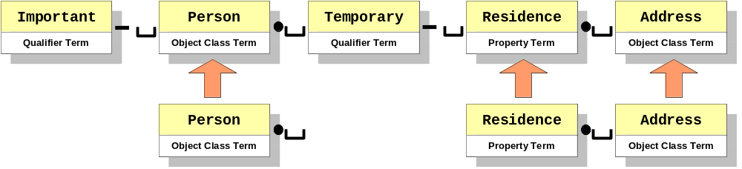

Dictionary Entry Name:
Important_ Person. Temporary_ Residence. Address

4.7.4 Business Terms
A business term represents a synonym of a Core Component or Business Information Entity. Various business terms can exist for different Core Components and Business Information Entities. The business term can be the preferred everyday business or industry term. A Core Component can contain multiple business terms.
The business terms need not to be based on any naming rule.

4.8 Discovery of Core Components
Discovery and design are a series of steps that utilize the business process definitions and result in standard business documents. The Core Components Technical Specification (CCTS) outlines the discovery and design process at a high-level. This description is supplemented and expanded upon in this primer, with inputs from the Core Components Supplementary Documents (CCSD) team and other business process experts and users.

4.8.1 The Discovery Process
A business process should be modeled using a standard approach, the UN/CEFACT Modeling Methodology (UMM), with one of the results being a class diagram. The class diagram shows the business information and inter-relationships.

The high-level steps from business process to Core Component discovery are:
- Determine the scope and the boundaries of the information to be exchanged in the business process
- Draw a high level Class Diagram, using the existing object class associations in the ebXML registry
- For each transaction, define a subset from the high level Class Diagram
- Investigate what detailed information needs to be exchanged in the transaction
- Look in the registry for Core Components and Business Information Entities which fulfil these information requirements
- Reuse where applicable existing Core Components and Business Information Entities.
- Define where necessary new Business Information Entities and Core Components and submit them for inclusion in the registry
- Draw per transaction a detailed transactional Class Diagram
- Combine the transactional Class Diagrams into an overall detailed Class Diagram.
An explanation of steps 1-3 can be found in sections 4.1 and 4.6. The search of the registry/repository (4.8.3.1) is a process that may be re-used throughout these detailed steps for discovery of each element.

Detailed Core Component Identification Steps
This section explains in detail the steps that should be taken in core component discovery and development. The steps outlined are graphically represented in process flow diagrams. Template examples of the resulting Business Information Entities and Core Components in a spreadsheet are also included to show the progress in executing the process steps. Additional details are defined to assist in this process where appropriate.
The Business Information Entities and Core Components that result from this process can be documented in a spreadsheet prior to submission to the registration and harmonisation process. It is recommended that a spreadsheet with the columns shown in the template examples be used to capture the data during the discovery process to ensure that all data needed is completed. The process steps are described in a logical manner, although it is recognized that the step order can depend on the business information compiled, library availability, and other business needs. The basic steps are:
- Identify detailed information
- Identify Business Information Entities
- Identify Core Components

4.8.2.1 Identify Detailed Information
The first step is to investigate and compile the relevant business information in the context of the business process. Analyze each piece of data to determine if it is a Basic Business Information Entity (BBIE), Aggregate Business Information Entity (ABIE) or Association Business Information Entity (ASBIE).

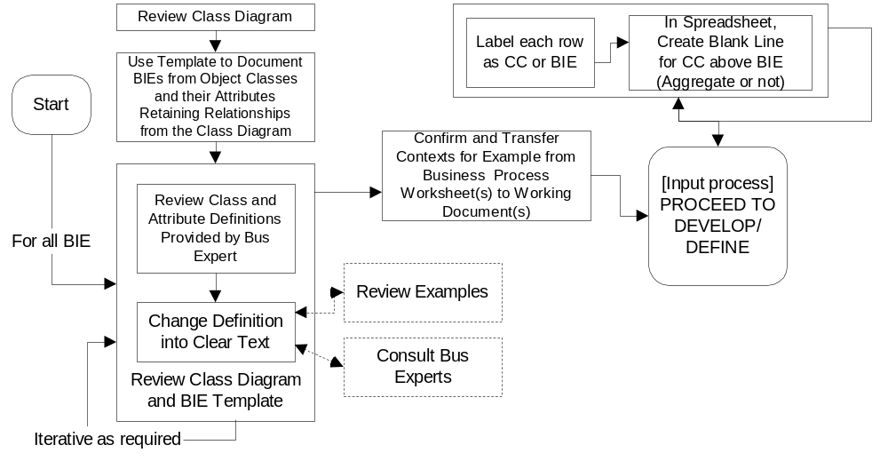
Figure 4-8 Review Class Diagram to Identify Detailed Information

The template below (Table 4-2) provides an example of a Basic Business Information Entity, an Aggregate Business Information Entity, and an Association Business Information Entity that were identified during the review of the following part of the class diagram.

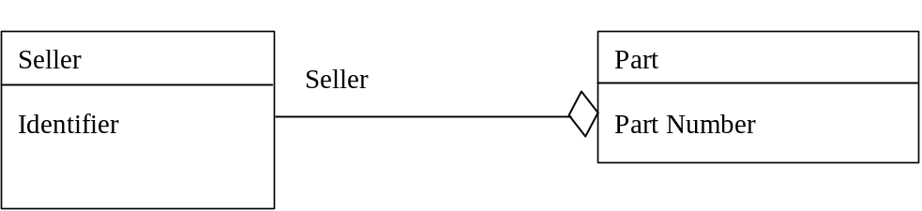

Business Term | Object Class Qualifier | Object Class | Property Term Qualifier | Property Term | Data Type  Qualifier | Representation Term | Dictionary Entry Name | ACC/BCC/ABIE/BBIE/ASBIE/ASCC | Semantic Description | Comments
Part |  |  |  |  |  |  |  | ABIE | A subject part, assembly, kit or material.
Part Number |  |  |  |  |  |  |  | BBIE | The manufacturer’s, supplier’s or industry standard identity for the subject part, assembly, kit or material.
Seller |  |  |  |  |  |  |  | ASBIE | The seller of the part.
Seller |  |  |  |  |  |  |  | ABIE | Party selling spare parts to a buyer.

Table 4-2

4.8.2.2 Refine Business Information Entities
Once the detailed information has been collected in the spreadsheet, the next step is to refine the definition and name of each BIE and to discover or define the CC’s on which to base the BIE. The diagram below shows the process for completing this step.

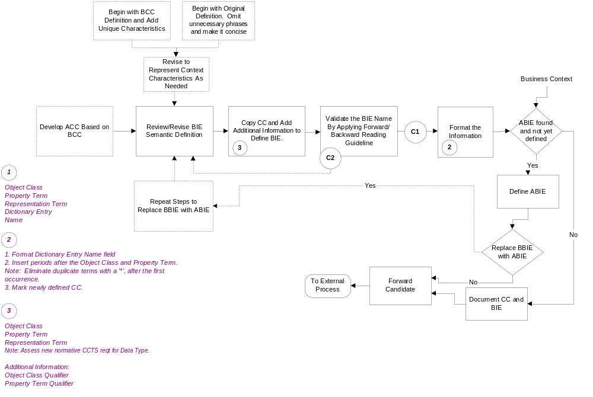
Note: References are given to other diagrams in this section, with following alphabetical keys:
A: Create CC or BIE.
B: Use the Forward-Backward Reading Guideline (entry).
C1: Exit the guideline successfully.
C2: Exit the guideline and rework the CC or BIE in order to apply the guideline again.
Figure 4-9 Refine BIE’s and define CC’s
This process primarily involves reviewing and revising the definitions of each BIE to ensure that it has a unique semantic business meaning and that the context characteristics are clear. Whenever possible the applicable Core Component Technical Specification defined context parameters should be documented. The qualifier used in naming a BIE associates a context semantic to a Core Component to create the BIE. If a CC exists on which to base the BIE, one approach to defining the BIE is to start with the CC definition and add any unique characteristics. The other approach is to take the extensive definition of the BIE (business term) and delete phrases/terms that are not meaningful.

Once the definition is completed, then the name is created. Some helpful hints in completing the spreadsheet for either an ABIE or a BBIE or an ASBIE:

- If a CC has been found on which to base the BIE, then in a blank row above the BIE, copy the Object Class and Representation Term of the CC into the appropriate columns. If a BBIE, then also copy the Property Term.
- When naming an ASBIE the Object Class, Property Term and Representation Term should be consistent with the ABIE on which it is based.
- Add any appropriate qualifiers for the Object Class and Property Term.
- If an ABIE, then concatenate Object Class Qualifier(s), Object Class, and Representation Term.
- If a BBIE or ASBIE, then concatenate Object Class Qualifier(s), Object Class, Property Term Qualifier(s), and Representation Term.
- An underscore followed by a space should be inserted between a qualifier and the term. The Object Class and Property Term are followed by a period and a space.
- Eliminate duplicate terms per the truncation rule in 4.7.2.2.
- The name may then be validated by applying the Forward/Backward Reading Guideline (see 4.8.3.2)

The template (Table 4-3) below shows BIE’s that have been properly defined and named.

Business Term | Object Class Qualifier | Object Class | Property Term Qualifier | Property Term | Data Type  Qualifier | Representation Term | Dictionary Entry Name | ACC/BCC/ABIE/BBIE/ASBIE/ASCC | Semantic Description | Comments
Part | Spare Part | Item |  |  |  | Details | Spare Part_ Item. Details | ABIE | A subject part, assembly, kit or material.
Part Number | Spare Part | Item | Manufacturer | Identification |  | Identifier | Spare Part_ Item. Manufacturer_ Identification. Identifier | BBIE | Revise – The manufacturers identification of a spare part item | Was: The manufacturer’s, supplier’s or industry standard identity for the subject part, assembly, kit or material
Seller | Spare Part | Item | Spare Part | Seller | Spare Part | Seller | Spare Part_ Item. Spare Part_ Seller. Spare Part_ Seller | ASBIE | The seller of the part.
Seller | Spare Part | Seller |  |  |  | Details | Spare Part_ Seller. Details | ABIE | Party selling spare parts to a buyer. | MerchandiseSeller_Party. Details

Table 4-3

4.8.2.3 Identify and Create Core Components
If no existing CC’s were found during the initial search of the registry/repository, then new CC’s need to be created for the BIE’s that were defined. The diagram below identifies the steps that should be taken for Basic Core Components (BCC), Aggregate Core Components (ACC), and Association Core Components (ASCC).

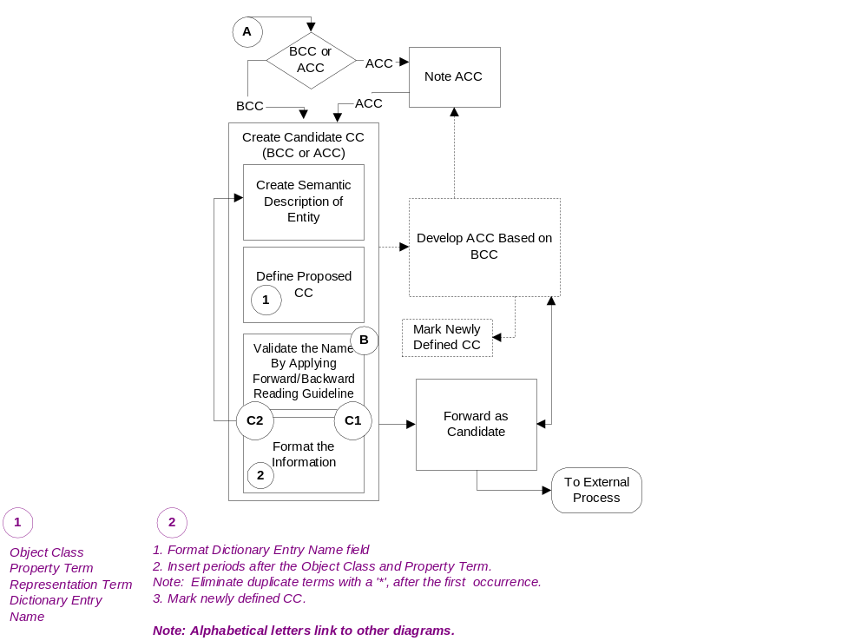
Note: References are given to other diagrams in this section, with following alphabetical keys:
A: Create CC or BIE.
B: Use the Forward-Backward Reading Guideline (entry).
C1: Exit the guideline successfully.
C2: Exit the guideline and rework the CC or BIE in order to apply the guideline again.
Figure 4-10: Create CC’s

The process of creating and naming CC’s is similar to that of a BIE except that the goal is to define reusable CC’s that can then be used to create additional BIE’s by applying context.

The definition should be developed first and then the name is extracted from the definition. Some helpful hints in completing the spreadsheet for either an ACC or a BCC or an ASCC:
- After filling in the definition in the spreadsheet, then add the Object Class, Property Term and Representation Term for a BCC and an ASCC.
- If an ACC, then only the Object Class and Representation Term columns are completed.
- Concatenate the Object Class, Property Term (for BCC’s and ASCC’s) and Representation Term to form the Dictionary Entry Name. A period and a space should be inserted between each of the terms.
- Eliminate duplicate terms per the Truncation rule in 4.7.2.2.
- The name may then be validated by applying the Forward/Backward Reading Guideline (see 4.8.3.2)

The template (Table 4-4) below gives examples of new CC’s.

Business Term | Object Class Qualifier | Object Class | Property Term Qualifier |  | Property Term | Data Type  Qualifier | Representation Term | Dictionary Entry Name | ACC/BCC/ABIE/BBIE/ASBIE/ASCC | Semantic Description | Comments
Part |  | Item |  |  |  |  | Details | Item. Details | ACC | An item of merchandise
Part | Spare Part | Item |  |  |  |  | Details | Spare Part_ Item. Details | ABIE | A subject part, assembly, kit or material.
Item |  | Item |  |  | Identification* |  | Identifier | Item. Identifier | BCC | The manufacturers identification of an item
Part Number | Spare Part | Item |  | Manufacturer | Identification |  | Identifier | Spare Part_ Item. Manufacturer_ Identification. Identifier | BBIE | Revise – The manufacturers identification of a spare part item | Was: The manufacturer’s, supplier’s or industry standard identity for the subject part, assembly, kit or material
Part Number | Spare Part | Item |  | Manufacturer | Identification |  | Identifier | Spare Part_ Item. Manufacturer_ Identification. Identifier | BBIE | Revise – The manufacturers identification of a spare part item | Was: The manufacturer’s, supplier’s or industry standard identity for the subject part, assembly, kit or material
Seller |  | Item |  |  | Seller |  | Seller | Item. Seller | ASCC | The seller of the item.
Seller | Spare Part | Item | Spare Part |  | Seller | Spare Part | Seller | Spare Part_ Item. Spare Part_ Seller. Spare Part_ Seller | ASBIE | The seller of the part.
Seller |  | Seller |  |  |  |  | Details | Seller. Details | ACC | Party selling merchandise to a buyer.
Seller | Spare Part | Seller |  |  |  |  | Details | Spare Part_ Seller. Details | ABIE | Party selling spare parts to a buyer. | MerchandiseSeller_Party. Details
Table 4-4

4.8.3 Processes Applicable to Multiple Steps

4.8.3.1 Searching the Registry / Repository for Core Components
In step 5 the registry is searched on the Aggregate Business Information Entity/Aggregate Core Component level. Searching starts once the relevant business information has been compiled.

- Searching on ABIE level:
- Search the registry for an appropriate ABIE.
- If an ABIE is found that fully meets requirements, register re-use.
- If a similar ABIE is found that could meet the requirements with modification, prepare a change request to submit to the harmonization and approval process.
- If no ABIE is found, search for an ACC that meets the business needs.
- If an ACC is found that fully meets requirements, register its re-use and create an ABIE.
- If similar ACC is found that could meet the requirements with modification, prepare a change request to submit to the harmonization and approval process.
- If no ACC is found, define and submit an ACC and ABIE that meet the business needs.
- Suggestion - in searching the repository:
- Compare the Object Classes of the Class Diagram with the Object Class terms.
- Compare the Properties identified in the Class Diagram with known property terms of BBIE’s, BCC’s, ASBIE’s and ASCC’s.

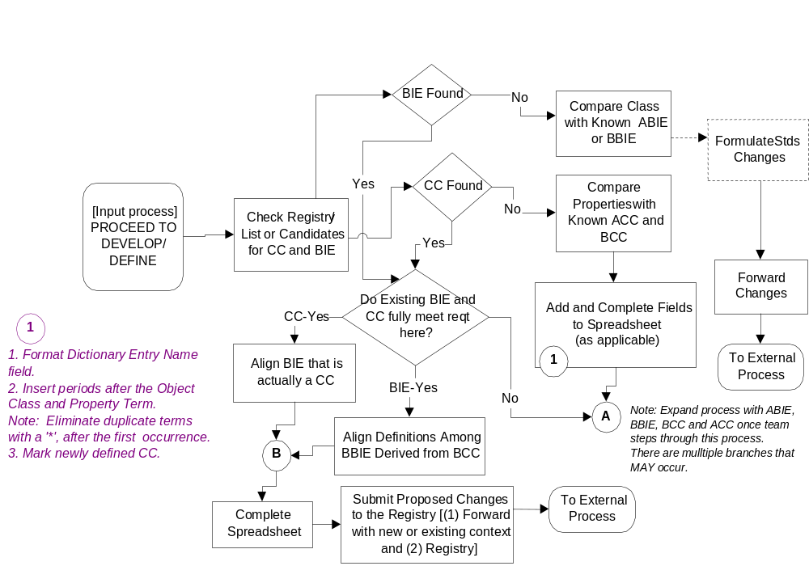
Note: References are given to other diagrams in this section, with following alphabetical keys:
A: Create CC or BIE.
B: Use the Forward-Backward Reading Guideline (entry).
C1: Exit the guideline successfully.
C2: Exit the guideline and rework the CC or BIE in order to apply the guideline again.
Figure 4-11 Searching the Registry/Repository

Following the search and discovery process, submissions should be prepared for the harmonization and approval process.

4.8.3.2 Forward/Backward Reading Guideline
This guideline should be used to validate the name of each CC and BIE.

Name
Place "of" or "for"
between each term
Read Name from
Right to Left
Make Sense
Yes
Return to
candidate
process
Progres
s to Next
Step
No
B
C2
C1
Backward
Forward
Example
•
Element Name: Financial transaction type code
•
Code for the type of financial transaction
Dictionary Name
Read "Dictionary
Name" is
"Definition."
Make Sense
Yes
Forward and
Backward
Complete
Complete
Requires
Rework
No
Yes
No
Note: References are given to other diagrams in this section, with following alphabetical keys:
A: Create CC or BIE.
B: Use the Forward-Backward Reading Guideline (entry).
C1: Exit the guideline successfully
C2: Exit the guideline and rework the CC or BIE in order to apply the guideline again.
Figure 4-12 Forward/Backward Reading Guideline

Examples
This primer contains two implementation examples of the Core Components Technical Specification. These examples show how the guidelines and steps, as elaborated in the previous chapters of this primer, may be applied in real business situations.

The two examples have been prepared by two independent teams. One example was prepared by a team from Boeing company, the other by a team of EAN International / Uniform Code Council. As the teams operated separately from each other, the approach taken differs somewhat and the outcomes are different.

The examples are only meant as illustration. The resulting Business Information Entities and Core Components have not been harmonised. The approaches were the interpretation of the respective teams, and are not normative in any way.

5.1 The Boeing Company Spare Parts Procurement Example
The Boeing Spare Parts Procurement example is an implementation of the UN/CEFACT Core Components Technical Specification. Traditionally, the airline industry has used the Air Transport Association (ATA) standard in Electronic Interchange format to describe this business process. In order to capture the business and data requirements of this process for the purpose of discovering the core components, the UN/CEFACT Modeling Methodology (UMM) was used.

The original Boeing example contains a number of use cases and the documents (BDV, BRV, and BTV) to support the different use case processes, but for the purpose of inclusion of an example in the Primer, only the Place Order Process is shown. The Activity Diagram in 5.1.1.2 shows the other use case activities and how the Place Order relates to the other activities. The Sequence Diagram for the procurement activities is also shown in 5.1.2.

5.1.1 Business Requirements View (BRV)

5.1.1.1 Business Process Use Case Description
One of these worksheets is filled out for each detail business process.
Form: Business Process Use Case
Form Id | Procure Spare parts
Business Process Name | [Provide a name for the business process. This should be a name identified on the form “Identify Business Process” and on a “Describe Process Area” form. If you are starting with this form, you may wish to refer to the ebXML Catalog of Business Processes that provides a normative list of business processes.]  Spare parts Ordering on-line.
Form Id
Identifier
Description | [A set of simple sentences that state the actions performed as part of the use case. Include references to use cases at extension points.]  - Parts Ordering System has identified that required spare parts should be ordered from the Order Management System.  - Order Management System evaluates the order information and either acknowledges the order or rejects the order.  - Order Management System notifies Parts Ordering System when the part is shipped by the supplier.
Actors | [List the actors involved in the use case.]  - Parts Ordering System  - Order Management System
Performance Goals | [A specification of the metrics relevant to the use case and a definition of their goals. Non-functional requirements may be a source of performance goals. For each performance goal, provide a name of the performance goal and a brief description of the performance goal.]  Completed the spare parts purchase order transaction.
Preconditions | [Preconditions are constraints that must be satisfied starting the use case.]  Customer identifies a need for a spare part. Parts Ordering System is the system for placing an order to procure this part. The Order Management System has links to the suppliers of this spare part.
Begins When | [Describe the initial event from the actor that starts a use case.]  Parts Ordering System submits a spare parts purchase order transaction to the Order Management System.
Ends When | [Describe the condition or event that causes normal completion of the use case.]  Order Management System sends a final shipped transaction to Parts Ordering System
Exceptions | [List all exception conditions that will cause the use case to terminate before its normal completion.]  none
Postconditions | [Post-conditions are states that must be satisfied ending the use case.]  Parts Ordering System received shipment notification from Order Management System.
Traceability | [These are the requirements covered (as shown in Annex 4, Use Case Specification Template, in the UMM).] PRD-SC-6.5.4 (meaning requirement 6.5.4 of the Product Requirements Document for the Supply Chain project).  Reference to the source requirements documents from Parts Ordering System
Supporting Business Collaborations and Business Processes | [List the business collaborations and business processes that support (are part of) this use case.]  TBD

5.1.1.2 Business Process Activity Diagram
Figure 5-1 Business Process Activity Diagram
<<BusinessCollaborationTask>>
Place Order
Order

[Change Pending]
<<BusinessCollaborationTask>>
Change Order
Order

[Revision Pending]
Order

[Invalid]
<<BusinessCollaborationTask>>
Notify Of Delivery
<<BusinessCollaborationTask>>
Notify Of Revision
<<BusinessCollaborationTask>>
Reject Order
<<BusinessCollaborationTask>>
Revise Order
<<BusinessCollaborationTask>>
Notify Of Change
Order

[Valid]
Order

[Valid]
Order

[Valid]

Business Collaboraton Protocol
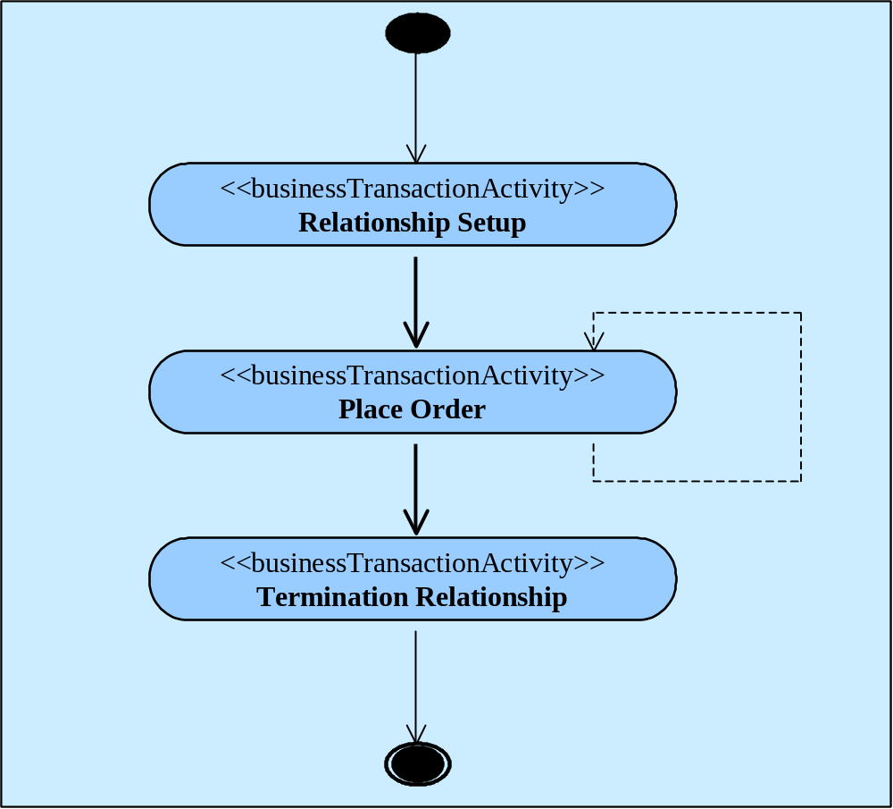
Figure 5-2 Business Collaboration Protoco

Document Content Description
The Content Description worksheet captures the initial business data. The worksheet template below shows sample data entered. The complete business data supporting the class diagram can be found in Boeing CC Discovery Work Sheets V1.1 .

Describe each element or group of elements in the document. Logically related elements can be placed in separate forms (For example, a document may have logically three parts, a header, body, and summary. The body may have further logical partitioning.). Possible values for Occurs include: 1 (one instance), 0..1 (zero on one instance), 0..* (zero or more instances), 1..* (one or more instances), or n..m (n to m instances where n is less than m). Information “looping” is specified through appropriate occurs values. Possible values for Data Type include primitive data types – such as integer, string, date-type – or a Form Id of another Content Description Form. Referencing another Content Description Form Id represents information hierarchy and nesting. If you happen to know the name of a reusable component from a domain library or the Catalogue of Core Components, then you MAY reference it. The Semantic Description SHALL be stated in business terms and SHALL be unambiguous.
Form Content Description
Content Description Name | Purchase Order - Spec2000 EDI (S1BOOKED)
Form Id
Element/Component Name | Occurs | Data Type | Field Width | Semantic Description | Notes
Command Code | 1 | String | 8 | Command Code identifies the specific type of telecommunication message or supplemental information used in (1) updating on-line files, (2) initiating procurement and quotation actions, and (3) transmitting inquiry, response and advisory messages.
Part Number | 1 | String | 1..15 | Part Number is the manufacturer's, supplier's or industry standard identity for the subject part, assembly, kit or material.
Unit Price Amount | 1 | Float | 1..13 | Unit Price Amount is the sell price for one unit of the subject part conforming to the Currency Code, Unit of Measure, and when applicable, Price Break Quantity range.
Specified Shipping Method | 0..1 | String | 3 | Specified Shipping Method Code specifies the method to be used for transporting a given shipment from the supplier's facility plus the method for paying the transportation costs.

5.1.2 Business Transaction View (BTV)

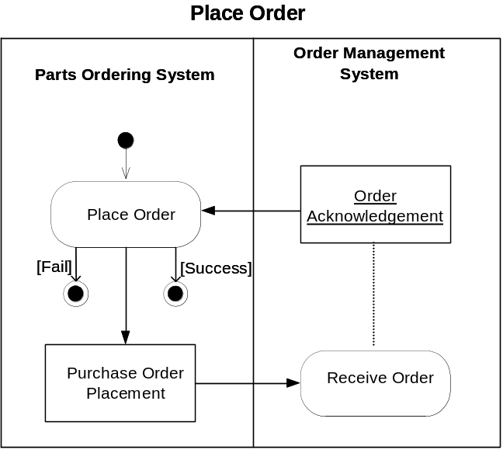
Business Transaction Activity Diagram

Figure 5-3 Business Transaction View of Place Order

Object Class Diagram
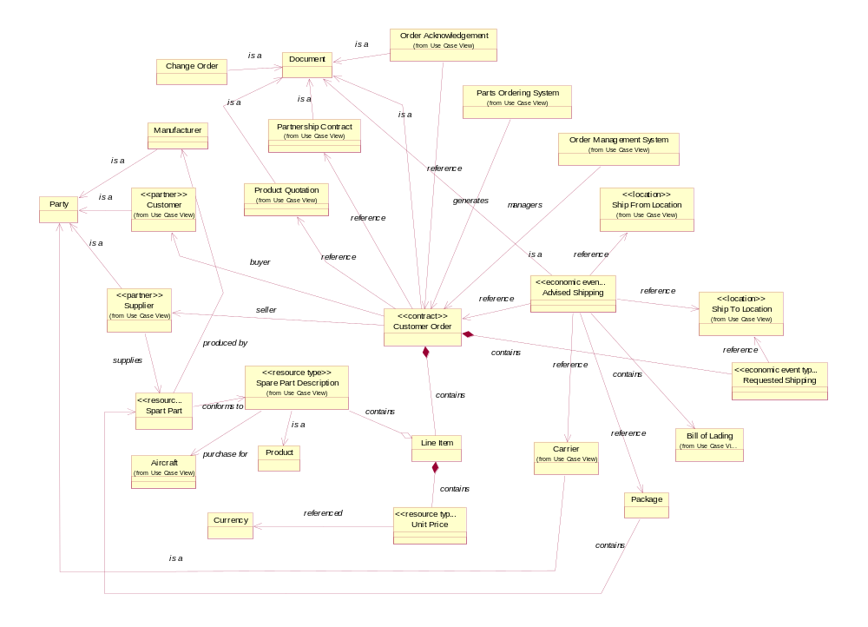
Figure 5-4 Object Class Diagram

5.1.3 Business Service View (BSV)

5.1.3.1 Sequence Diagram
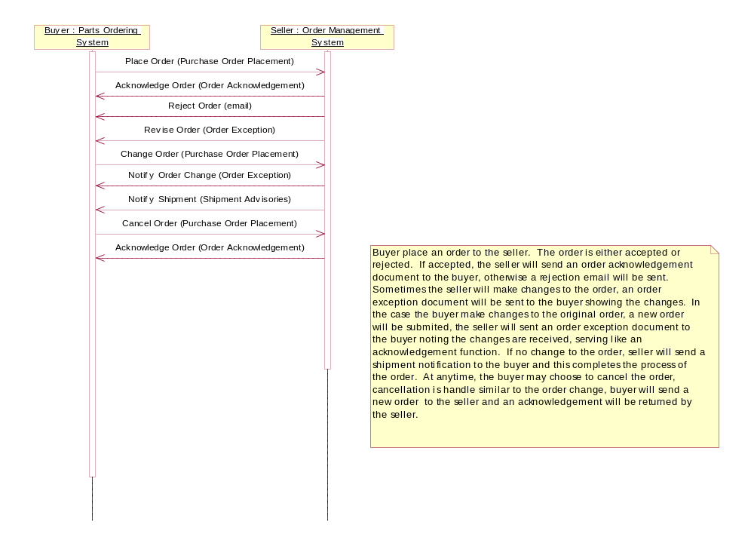
Figure 5-5 Sequence Diagram

5.1.3.2 Business Information Context
The Business Information Context form is provided as convenience for aggregating contextual values that affect the analysis of business information. It is intended that this information be obtained from other forms. For example, Industry Segment is specified in the Business Reference Model form. If there is no value for an entry, enter NOT APPLICABLE or NONE which ever is appropriate.

Form: Business Information Context
Business Information Context Name | [Provide a name for the business information context. Typically this is the name of the associated business transaction. However, it may be appropriate to name it after the name of the associated business collaboration, or higher-level business process construct.]
Form Id:
Business Process | Spare Parts Order Fulfillment.
Product Classification | Aircraft Spare Parts
Industry Classification | Aerospace Manufacturing Procurement
Geo-Political | International
Official Constraints | Air Transport Association, Federal Aviation Administration
Business Process Role | Purchaser and Manufacturer of Aircraft Spare Parts
Supporting Role | Carrier
System Capabilities | Spare Parts Procurement System

Document Class View
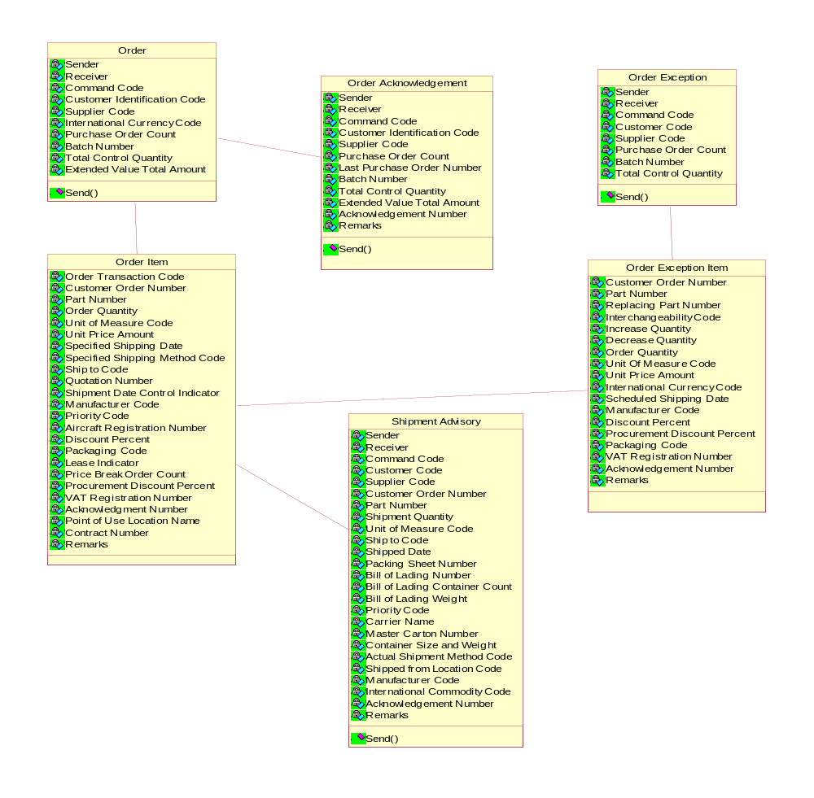
Figure 5-6 Document Class View

5.1.4 Completing the Core Component Model
Apply the core component identification process for each of the business term on the spreadsheet. The following tables show the results of the data analysis. It is important to note that data that is outside of the business process boundary is discarded (i.e. command code)
Business Term | Object Class Qualifier | Object Class. | Property Term Qualifier | Property Term. | Data Type Qualifier | Representation Term | Dictionary Entry Name | BCC/ACC/BBIE/ABIE/ ASCC/ASBIE | Semantic Description | Comments
Command Code |  |  |  |  |  |  |  |  | Command Code identifies the specific type of telecommunication message or supplemental information used in (1) updating on-line files, (2) initiating procurement and quotation actions, and (3) transmitting inquiry, response and advisory messages. | Not PO Content Data
International Currency Code |  |  |  |  |  |  |  |  | International Currency Code specifies the national currency corresponding to the Unit Price Amount or Repair Price Amount.
Purchase Order Count |  |  |  |  |  |  |  |  | Purchase Order Count specifies the number of individual purchase orders contained in S1BOOKED. | Not PO Content Data
Batch Number |  |  |  |  |  |  |  |  | Batch Number identifies a transmission grouping of part orders (S1BOOKED). | Not PO Content Data
Total Control Quantity |  |  |  |  |  |  |  |  | Total Control Quantity is the sum of all Order Quantities in an S1Booked order transmission. | - Not PO Content Data  Not use
Extended Value Total Amount |  |  |  |  |  |  |  |  | Extended Value Total Amount is a transmission control for the S1Booked Command and computed by summing the products of Unit Price Amount times Order Quantity subtracting the discount (DIS) or procurement discount percentage (PDP) for each order transaction within a given S1BOOKED Command. | - Not PO Content Data  Not use
Order Transaction Code |  |  |  |  |  |  |  |  | Order Transaction Code specifies the type, category and condition of a customer purchase order (S1BOOKED transactions) | See TNC file. Not useful as aggregate data.
 |  | Document |  |  |  | Details | Document. Details | ACC | The details of a document
 |  | Document |  | Processing |  | Code | Document. Processing. Code | BCC | The code specifying the document processing type
Type of Order | Purchase Order | Document |  | Processing |  | Code | Purchase Order_ Document. Processing. Code | BBIE | The code specifying the order processing type
 |  | Document |  | Type |  | Code | Document. Type. Code | BCC | The code specifying the type of a document
Category of Order | Purchase Order | Document |  | Type |  | Code | Purchase Order_ Document. Type. Code | BBIE | The code specifying the type of order
 |  | Document |  | Purpose |  | Code | Document. Purpose. Code | BCC | The code specifying the document purpose
Condition of Order | Purchase Order | Document |  | Purpose |  | Code | Purchase Order_ Document. Purpose. Code | BBIE | The code specifying the order purpose
Contract Number | Purchase order | Document | Sales contract | Identification |  | Identifier | Purchase Order_ Document. Sales Contract_ Identification. Identifier | BBIE | - revise - an identifier of a sales contract between parties  original - Contract Number is a reference number mutually agreed upon between the supplier and customer that represent a Special Business Agreement. | A reference number refers to a sales contract between parties.
Quotation Number | Purchase order | Document | Supplier Quotation | Identification |  | Identifier | Purchase Order_ Document. Supplier Quotation_ Identification. Identifier | BBIE | - revise - The identification assigned by the supplier to a quotation  original - Quotation Number is the identity assigned by the supplier to his quotation of price and Lead Time for the subject part. | Price and Lead Time for the subject part.
Customer Order Number | Purchase Order | Document | Customer | Identification |  | Identifier | Purchase Order_ Document. Customer_ Identfication. Identifier | BBIE | - revise - The identification assigned by the customer to an order  original - Customer Order Number is the customer's identity number assigned to a specific order for a given part or a specific order for repair/overhaul services for a given part.
 | Purchase Order | Document |  | Customer | Customer | Party | Purchase Order_ Document . Customer. Customer_ Party | ASBIE
 | Purchase Order | Document |  | Contract | Contract | Document | Purchase Order_ Docment. Contract. Contract_Document | ASBIE
 | Purchase Order | Document |  | Quote | Quotation | Document | Purchase Order_ Document. Quote. Quotation_ Document | ASBIE
 |  | Item |  |  |  | Details | Item. Details | ACC | The details of a spare part
 |  | Item |  | Leasing |  | Indicator | Item. Leasing. Indicator | BCC | An indicator specifying if an item is for leasing
 | Spare Part | Item |  | Manufacturer | Manufacturer | Party | Spare Part_ Item. Manufacturer. Manufacturer_ Party | ASBIE
 | Spare Part | Item |  | Aircraft | Aircraft | Equipment | Spare Part_ Item. Aircraft. Aircraft_Equipment | ASBIE
Part Number | Spare Part | Item | Manufacturer | Identification |  | Identifier | Spare Part_ Item. Manufacturer_ Identification. Identifier | BBIE | - revise - The manufacturer's identification of a spare part item  original - Part Number is the manufacturer's supplier's or industry standard identity for the subject part, assembly, kit or material. Part Number when linked with its Manufacturer Code provides a unique identity for the given item. (note: serial number will be used in the future to replace mfg. code to give uniqueness to the part number) | Part Number when linked with its Manufacturer Code provides a unique identity for the given item.
Lease Indicator | Ordered | Item | Onward | Leasing |  | Indicator | Ordered_ Item. Onward_ Leasing. Indicator | BBIE | - revise - An indicator specifying if an item is ordered for onward leasing  Original - Lease Indicator denotes that subject order is placed for lease of the referenced part number. | - Example from ATA:  - Yes or No code to indicate part is bought for lease or not.  The lease indicator on the PO signifies that the part ordered is designated for a lease project or lease inventory.
 |  | Line item |  |  |  | Details | Line Item. Details | ACC | The details of a line item | line item needs to be in the control vocabulary that represents a logical grouping of information such as part number, quantity, price, etc.
Order Quantity |  | Line item |  | Ordered quantity* |  | Quantity | Line Item. Ordered.  Quantity | BBIE | - revise - The quantity ordered of a line item  original - Order Quantity is the quantity (conforming to the Unit of Measure) originally ordered by the customer or subsequently revised for the specified Customer Order Number, Part Number, Specified Shipping Date and Ship To Code.
 |  | Line Item |  | Purchase Order | Purchase Order | Document | Line Item. Purchase Order. Purchase Order_ Document | ASBIE
 |  | Base charge price |  | Quantity* |  | Quantity | Base Charge Price. Quantity | BCC | The base quantity of the charge / price unit amount | please consider dictionary name: Unit Price. Base. Quantity
Unit of Measure Code |  | Base charge price |  | Quantity* |  | Quantity | Base Charge Price. Quantity | BBIE | - revise - The base quantity of the unit price  original - Unit of Measure Code specifies the type of count, measurement, container or form of the subject part and correlates to the Unit Price Amount.
 |  | Unit charge price |  | Amount* |  | Amount | Unit Charge Price. Amount | BCC | The charge/price amount per unit. | unit price needs to be defined in the control vocabulary or in an aggregate
Unit Price Amount |  | Unit charge price |  | Amount* |  | Amount | Unit Charge Price. Amount | BBIE | - revise - The charge/price amount per unit.  original - Unit Price Amount is the sell price for one unit of the subject part conforming to the Currency Code, Unit of Measure, and when applicable, Price Break Quantity range.
 |  | Transport |  | Method |  | Code | Transport. Method. Code | BCC | The method of transport used for the conveyance of goods or person | Harmonisation please consider the difference between transportation method and transportation mode
Specified Shipping Method |  | Transport |  | Method |  | Code | Transport. Method. Code | BBIE | - revise - The method of transport used for the conveyance of goods or person  original - Specified Shipping Method Code specifies the method to be used for transporting a given shipment from the supplier's facility plus the method for paying the transportation costs. | First 2 characters identify method of shipment. Last character identifies payment method.
 |  | Transport |  | Timeframe |  | Indicator | Transport. Timeframe. Indicator | BCC | The indicator that specifies a timeframe in relation to the transport date
Shipment Date Control Indicator |  | Transport | Not before fifteen days | Timeframe |  | Indicator | Transport. Not Before Fifteen Days_ Timeframe. Indicator | BBIE | - revise - The indicator that specifies that an item cannot be transported earlier than fifteen days before the transport date  original - Shipment Date Control Indicator specifies that subject order is not to be shipped earlier than fifteen days prior to customer's Specified Shipping Date.
 |  | Payment |  | Method |  | Code | Payment. Method. Code | BCC | The code specifying how payment is made
 | Transport | Payment |  | Method |  | Code | Transport_ Payment. Method. Code | BBIE | - revise - The code specifying how payment is made for transport costs  original - Specified Shipping Method Code specifies the method to be used for transporting a given shipment from the supplier's facility plus the method for paying the transportation costs.
 |  | Processing |  | Priority |  | Code | Processing. Priority. Code | BCC | The code specifying the priority of a process
Priority Code | Purchase Order | Processing | Response | Priority |  | Code | Purchase  Order_ Processing.  Response_ Priority. Code | BBIE | - revise - The code specifying the priority of the response to the order  original - Priority Code is a precedence rating (assigned by the customer) designation the urgency for processing and responding to the subject quotation or purchase order.
 |  | Equipment |  | Identification* |  | Identifier | Equipment. Identifier | BCC | The identification of a unit of an equipment
Aircraft Registration Number | Aircraft | Equipment | Aviation Authority  Assigned | Identification |  | Identifier | Aircraft_ Equipment. Aviation Authority Assigned_ Identification. Identifier | BBIE | - revise - The registration identifier assigned to each individual aircraft by the applicable aviation authority.  original - Aircraft Registration Number is the registration identity assigned to each individual aircraft by the cognizant national authority.
Discount Percent |  |  |  |  |  |  |  |  | Discount Percent specifies the trade discount applicable to Unit Price Amount. | See Procurement Discount Percent
 |  | Packaging |  | Instruction |  | Code | Packaging. Instruction. Code | BCC | A code providing a packaging instruction | Packaging is the process of putting the material around the item
Packaging Code | Aircraft part | Packaging |  | Instruction |  | Code | Aircraft Part_ Packaging. Instruction. Code | BBIE | - revise - A code specifying a packaging instruction for an aircraft part  original- Packaging Code specifies the type of container, packaging requirements or material handling devices to be used when shipping subject parts per specified Customer Order Number. | - Example from ATA:  - Reference to ATA SPEC300, Packaging Code defines packing condition, material, and container for shipping aircraft part. Specific condition for aircraft regulation on packaging condition so part will not bend or contaminated, i.e. "2" = part container is also build when the part is build.  Could have more than one BCC
 |  | Packaging |  | Spart Part | Spare Part | Item | Packaging. Spare Part. Spare Part_ Item | ASBIE
 |  | Unit Price |  |  |  | Details | Unit Price. Details | ACC, ABIE | The details of unit price
 |  | Unit price discount |  | Base quantity* |  | Quantity | Unit Price Discount. Base. Quantity | BCC | The base quantity when calculating a unit price discount
Price Break Order Count |  | Unit price discount | Order | Base quantity |  | Quantity | Unit Price Discount. Order_ Base Quantity. Quantity | BBIE | - revise - number of individual purchase orders to be considered when calculating an item price discount  original - Price Break Order Count specifies the number of individual purchase orders for a common part number within a group of orders which are to be combined for an applicable quantity price break. | Not aircraft Industry specific. For evaluation of price vs quantity. What is more economical. Buy 3 will get a discount verses buy 2 at regular price.
 |  | Unit price discount |  | Percent* |  | Percent | Unit Price Discount. Percent | BCC | The percentage of a unit price discount.
Procurement Discount Percent |  | Unit price discount |  | Percent* |  | Percent | Unit Price Discount. Percent | BBIE | - revise - The percentage of a unit price discount.  original - Procurement Discount Percent specifies the trade discount percent (to two decimal places) applicable to the Unit Price Amount and Repair Price Amount. The associated price break information is discounted also.
 |  | Unit Price |  | Line Item |  | Line Item | Unit Price. Line Item. Line Item. | ASBIE
 |  | Organization |  | Tax identification* |  | Identifier | Organisation. Tax. Identifier | BCC | The registered national tax identification of an organisation. | - CCC harmonisation - is this a party or an organisation,  Should it be an identification or a registration? Organisation.tax registration.identifier
VAT Registration Number | Customer | Organisation | VAT | Tax identification |  | Identifier | Customer_ Organisation. VAT_ Tax Identification. Identifier | BBIE | - revise - The Value Added Tax (VAT) registration number of the Customer  Original - VAT Registration Number is the tax registration number of the Customer | European tax apply to import and export comply at placing an order
 |  | Transaction |  | Reference |  | Identifier | Transaction. Reference. Identifier | BCC | An identifier to enable reference to a transaction | Note: Obtain BP definition of the word 'transaction'
Acknowledgment Number |  | Transaction |  | Reference |  | Identifier | Transaction. Reference. Identifier | BBIE | - revise - an identifier that is sent in a message to ensure transaction traceability.  original - acknowledgement Number is a value associated with a particular command, sent to ensure traceability. | Unique number generated when creating a PO, for tracking.
 |  | Location |  | Identification |  | Code | Location. Identification. Code | BCC | the identifier of a location | Based on CCSD discussion on Code vs Identifier, we recommend this should be location. Identifier.
Point of Use Location Name | Receiving Storage | Location |  | Identification |  | Code | Receiving Storage_ Location. Identification. Code | BBIE | - revise - an identifier of the receiving location for storage  original - Point of Use Location Name identifies specific stocking/binning location in a user's facility. | - Define 'stocking/binning'  ATA definition - Location for placing the inventory in a warehouse, the place is called a bin.
 |  | Location |  | Identification* |  | Identifier | Location. Identifier | BCC | The identification of a location | suggested revision to 000061 location identification code, should be an identifier not code
Ship to Code | Shipment destination | Location |  | Identification* |  | Identifier | Shipment Destination_ Location. Identifier | BBIE | - revise - The identifier of the shipment destination location  original - Ship To Code identifies the shipment destination address including required marks and information that must be displayed on shipping containers. Ship To Code may also convey applicability or exclusion of specific taxes or charges relating to the shipment destination.
 |  | Information |  | Text* |  | Text | Information. Text | BCC | A text providing information
Remarks Text | Miscellaneous | Information |  | Text* |  | Text | Miscellaneous_ Information. Text | BBIE | - revise - A text providing miscellaneous information  original - Remarks Text provides miscellaneous information not otherwise provided for by dedicated Text Element Identifiers (TEI's) in variable record systems.
 |  | Party |  |  |  | Details | Party. Details | ACC | Details of an individual, a group or a body having a role in a business function.
Manufacturer Code | Manufacturer | Party |  | Identification* |  | Identifier | Manufacturer_ Party. Identifier | BBIE | - revise - The identification of the manufacturer of an item  original - Manufacturer Code identifies the manufacturer, government agency or other organization controlling the design and the part number assignment of the subject part. | ATA definition - Manufacturer is the creator of the part, and the assigner of the part number. Manufacturer code is not part of the part number, although it might be.
Supplier Code | Vendor | Party |  | Identification* |  | Identifier | Vendor_ Party. Identifier | BBIE | - revise - The identifier of the vendor  original - Supplier Code identifies the originator of Procurement Data and a source of supply for the subject part in Procurement Planning, Provisioning V File and Delivery configuration Data application. | - Note: Supplier usually refers to parties who supply data information, "Vendor" is used by ATA for supplier who supplies products like spare parts. Distributor vs supplier. Airlines can be a supplier if they want to sell parts, they will have a supplier code, and parts has airline's part number.  ATA suggest using Vendor Party. Identifier
Customer Identification Code | Customer | Party |  | Identification* |  | Identifier | Customer_ Party. Identifier | BBIE | - revise - The identifier of the buyer of goods and services.  Original - Customer Identification Code identifies the airline customer plus the office and or individual receiving or transmitting S1BOOKED and several other transactions. | - First 2 characters identify an airline. Last character is for product identification.  Harmonization of synonyms (Customer/Buyer)
 | Vendor | Party |  | Spare Part | Spare Part | Item | Vendor_ Party. Spare Part. Spare Part_ Item | ASBIE
Currency |  |  |  |  |  |  |  |  | Currency of the associated amount | does not stand alone, rather it is the CCT aligned with an amount
 |  | Package |  |  |  | Details | Package. Details | ACC, ABIE | The details of a package
 |  | Package |  | Spart Part | Spare Part | Item | Package. Spare Part. Spare Part_ Item | ASBIE
 |  | Ship to Location |  |  |  | Details | Ship to Location. Details | ACC, ABIE | The details of ship to location
 |  | Shipping |  |  |  | Details | Shipping. Details | ACC | The details of shipping
 |  | Shipping |  | Date* |  | Date | Shipping. Date | BCC | a date when the shipping from a facility takes place
Specified Shipping Date | Customer required | Shipping |  | Date* |  | Date | Customer Required Shipping. Date | BBIE | - revise - The date the customer requires material to be shipped from the supplier's facility  original - Specified Shipping Date is the date the customer requires material to be shipped from the supplier's facility for a given purchase order.
 | Customer Required | Shipping |  | Purchase Order | Purchase Order | Document | Customer Requied_ Shipping. Purchase Order. Purchase Order_ Document | ASBIE
 | Customer Required | Shipping |  | Ship to Location | Shipment Destination | Location | Customer Required_ Shipping. Ship to Location. Shipment Destination_ Location | ASBIE
 | Advised | Shipping |  |  |  | Details | Advised_ Shipping. Details | ABIE | The details of advised shipping
 | Advised | Shipping |  | Purchase Order | Purchase Order | Document | Advised_ Shipping. Purchase Order. Purchase Order_ Document | ASBIE
 | Advised | Shipping |  | Purchase Order | Purchase Order | Document | Advised_ Shipping. Purchase Order. Purchase Order_ Document | ASBIE
 | Advised | Shipping |  | Ship to Location | Shipment | Location | Advised _ Shipping. Ship to Location. Shipment_ Location | ASBIE
 | Adviced | Shipping |  | Package |  | Package | Adviced_ Shipping. Package. Package | ASBIE
 | Requested | Shipping |  |  |  | Details | Requested_ Shipping. Details | ABIE | The details of requested shipping
 | Customer Required | Shipping |  | Ship to Location | Shipment Destination | Location | Customer Required_ Shipping. Ship to Location. Shipment Destination_ Location | ASBIE

5.1.4.1 Detailed Class Diagram with Core Components
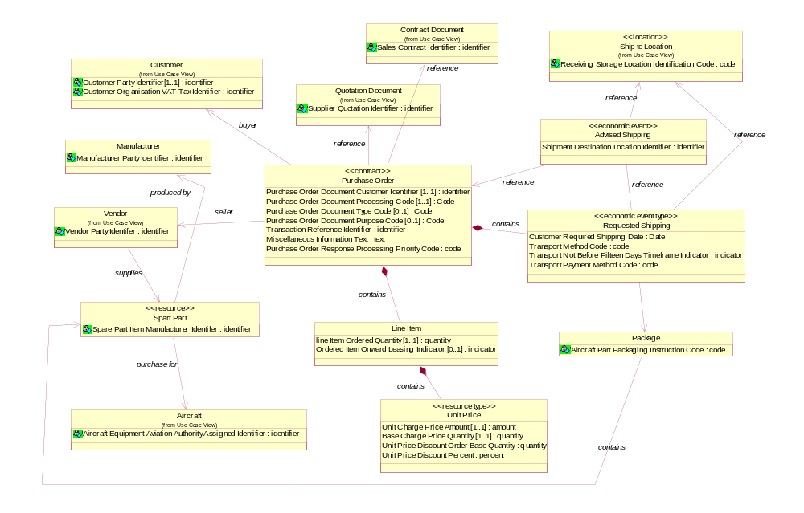
Figure 5-7 Detailed Class Diagram
The Purchase Order Class Diagram is now updated to show the names of the BIE’s that were discovered.

5.1.5 Examples Using Core Components to Build Business Documents
Examples of applying the same Core Components on an ATA Purchase Order Placement document and an EDIFACT document is shown below.

5.1.5.1 Example of an ATA Purchase Order Placement Document

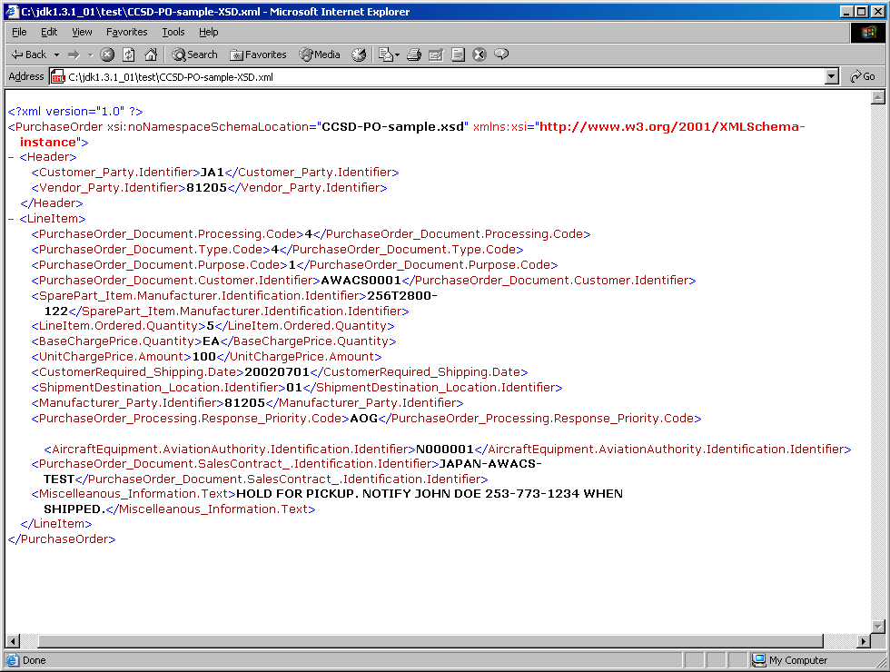
Figure 5-8 ATA Purchase Order Placement document
This example shows the use of Core Components as XML metadata tag.

5.1.5.2 The Document Type Definition (DTD) File Describes the Document Data Structure Requirements
<!ELEMENT BaseChargePrice.Quantity (#PCDATA)>
<!ELEMENT Customer_Party.Identifier ( #PCDATA ) >
<!ELEMENT CustomerRequired_Shipping.Date ( #PCDATA ) >
<!ELEMENT Header ( Customer_Party.Identifier, Vendor_Party.Identifier ) >
<!ELEMENT LineItem ( PurchaseOrder_Document.Processing.Code,
PurchaseOrder_Document.Type.Code,
PurchaseOrder_Document.Purpose.Code,
PurchaseOrder_Document.Customer.Identifier,
SparePart_Item.Manufacturer.Identification.Identifier, LineItem.Ordered.Quantity,
BaseChargePrice.Quantity, UnitChargePrice.Amount,
CustomerRequired_Shipping.Date, ShipmentDestination_Location.Identifier,
Manufacturer_Party.Identifier,
PurchaseOrder_Processing.Response_Priority.Code,
AircraftEquipment.AircraftAuthority Identification.Identifier,
PurchaseOrder_Document.SalesContract_.Identification.Identifier,
Miscelleanous_Information.Text ) >
<!ELEMENT LineItem.Ordered.Quantity ( #PCDATA ) >
<!ELEMENT Manufacturer_Party.Identifier ( #PCDATA ) >
<!ELEMENT Miscelleanous_Information.Text ( #PCDATA ) >
<!ELEMENT PurchaseOrder_Document.Customer.Identifier ( #PCDATA ) >
<!ELEMENT PurchaseOrder_Document.Processing.Code ( #PCDATA ) >
<!ELEMENT PurchaseOrder_Document.Purpose.Code ( #PCDATA ) >
<!ELEMENT PurchaseOrder_Document.Type.Code ( #PCDATA ) >
<!ELEMENT PurchaseOrder_Processing.Response_Priority.Code ( #PCDATA) >
<!ELEMENT PurchaseOrder ( Header, LineItem ) >
<!ELEMENT PurchaseOrder_Document.SalesContract_Identifier.Identifier ( #PCDATA) >
<!ELEMENT ShipmentDestination_Location.Identifier ( #PCDATA ) >
<!ELEMENT SparePart_Item.Manufacturer.Identification.Identifier ( #PCDATA ) >
<!ELEMENT Transaction.Reference.Identifier ( #PCDATA ) >
<!ELEMENT UnitChargePrice.Amount ( #PCDATA ) >
<!ELEMENT Vendor_Party.Identifier ( #PCDATA ) >

5.1.5.3 The XML Schema File Describes the Document Data Structure and Data Type Requirements
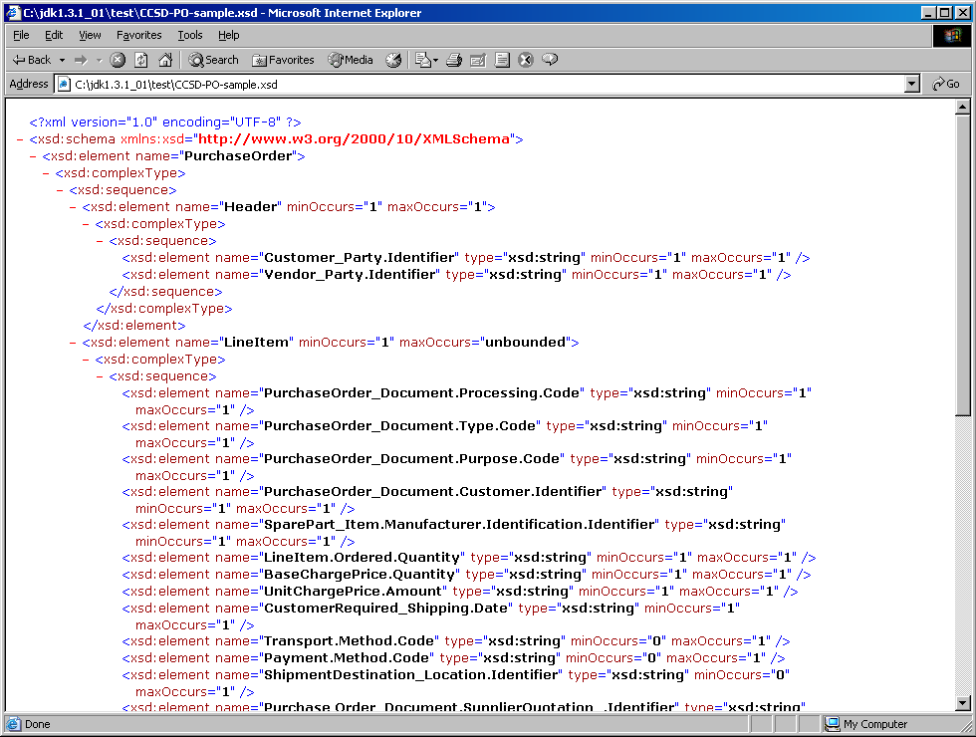
Figure 5-9 XML Schema (1)
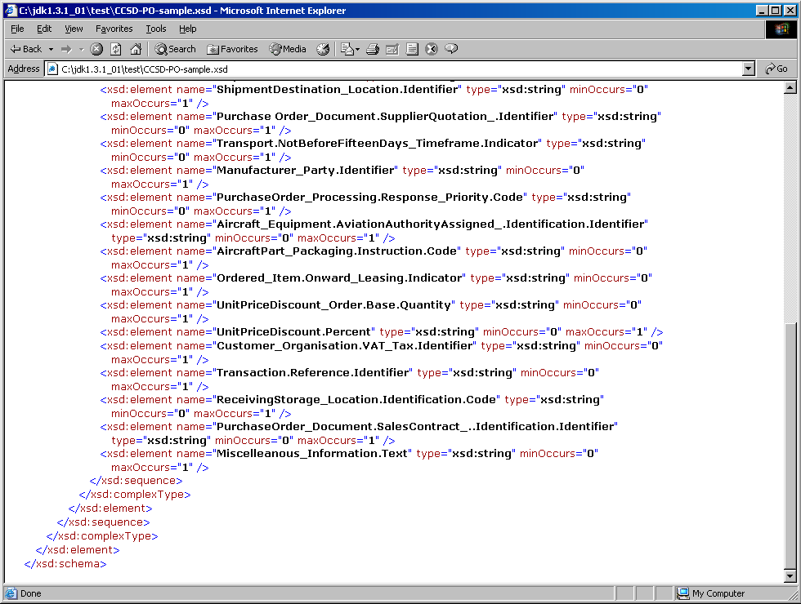
Figure 5-10 XML Schema (2)

5.1.5.4 A Browser View of the Purchase Order
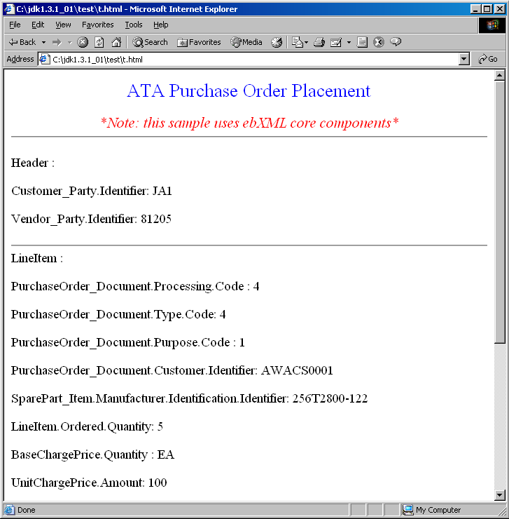
Figure 5-11 Browser view (1)

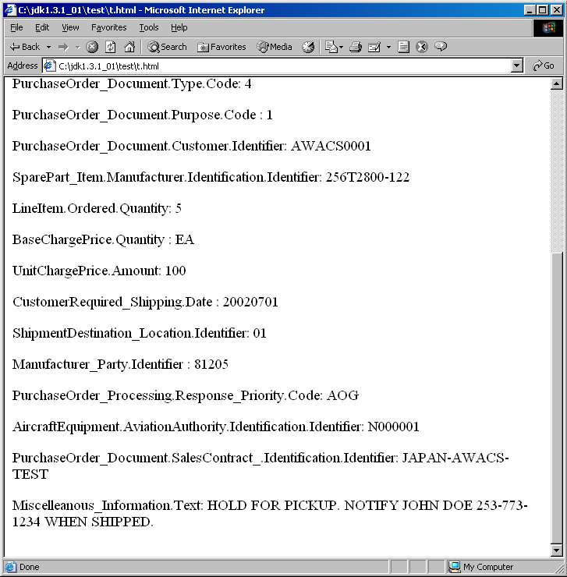
Figure 5-12 Browser view (2)

5.1.5.5 EDIFACT Example

5.1.5.5.1 Introduction
The CCSD project identified the Business Information Entities that are to be exchanged in the Aerospace Parts Order Document. As an example, in this document a rendering of that order document in the EDIFACT syntax has been performed.

Rendering in EDIFACT is a manual process, as long as no cross-reference mapping is available between the semantics of EDIFACT segments, elements and codes and BIE’s that have been discovered through the process as defined in the Core Components Technical Specification. Still the rendering has been performed as an activity as straightforward as possible. The BIE definitions should contain sufficient information so that it should not be necessary to go back to the business experts.

This has been achieved for approximately 90% of the BIE’s. The remaining 10% uncertainty has been worded in remarks, that may be used to improve the discovery process in general or to clarify the way the process should be carried out.

5.1.5.5.2 Table
The following table shows the mapping of the BIE’s to EDIFACT qualified segments and elements. The BIE’s are mapped to the segments and elements present in the EDIFACT ORDERS message, as the functional definition of that message (“A message specifying details for goods or services ordered under conditions agreed between the seller and the buyer.”) matches the description of the document as it is used in the Aerospace industry.

Most BIE’s have been mapped to data elements present in qualified segments. The “EDIFACT name” column in such case lists both the name of the qualified segment and the data element.

Most data in electronic messages is coded. The code values have not been discovered in the CCTS process. When the code values, used in this specific context, are not present in EDIFACT code lists, either they should be requested to be added, or a private code list (identified in the message) should be used.

Dictionary Entry Name | BCC/BBIE | Semantic Description | EDIFACT Segment-Qualifier | EDIFACT element | EDIFACT name
 | ABIE??? | Order Transaction Code specifies the type, category and condition of a customer purchase order (S1BOOKED transactions) | UNH | 0065 | Message Type = ORDERS
Purchase Order_ Document. Processing. Code | BBIE | The code specifying the order processing type | ? | ? | Remark: Definition is not clear enough without examples. May be placed in envelope (UNB/UNH), in BGM or in GIS.
Purchase Order_ Document. Type. Code | BBIE | The code specifying the type of order | BGM | 1001 | Document name code
Purchase Order_ Document. Purpose. Code | BBIE | The code specifying the order purpose | BGM | 1225 | Message function code
Purchase Order_ Document. Sales Contract_ Identification. Identifier | BBIE | An identifier of a sales contract between parties | RFF-CT | 1154 | Contract number
Purchase Order_ Document. Supplier Quotation_ Identification. Identifier | BBIE | The identification assigned by the supplier to a quotation | RFF-AGG | 1154 | Offer number
Purchase Order_ Document. Customer_ Identification. Identifier | BBIE | The identification assigned by the customer to an order | BGM | 1004 | Document Identifier

Spare Part_ Item. Manufacturer_ Identification. Identifier | BBIE | The manufacturer's identification of a spare part item | LIN-BZ | 7140 | Item identifier  Original equipment number  Remark:  Qualifier = 7143
Line Item. Ordered. Quantity | BBIE | The quantity ordered of a line item | QTY-21 | 6060 | Ordered quantity
Base Charge Price. Quantity | BBIE | The base quantity of the charge / price unit amount | PRI-CAL | 5284 | Unit price basis value
 | Supp. Component | The base quantity of the unit price | PRI-CAL | 6411 | Measurement unit code  Remark: In CC-spec defined as supplementory component. In EDIFACT separate element.
Unit Charge Price. Amount | BBIE | The charge/price amount per unit. | PRI-CAL | 5118 | Price amount
Customer Required Shipping. Date | BBIE | The date the customer requires material to be shipped from the supplier's facility | DTM-10 | 2380 | Shipment date/time, requested
Transport. Method. Code | BBIE | The method of transport used for the conveyance of goods or person | TDT | 8067 | Transport mode name code.  Remark: only the 10 UN/ECE Rec.19 codes are allowed here. Probably more options are needed, indicating the transport service requested rather than the mode.
Payment. Method. Code | BBIE | The code specifying how payment is made for transport costs | TOD-5 | 4215 | Transport charges payment method code
Shipment Destination_ Location. Identifier | BBIE | The identifier of the shipment destination location | NAD-ST | 3039 | Ship to party identifier
Transport. Not Before Fifteen Days Timeframe. Indicator | BBIE | The indicator that specifies that an item cannot be transported earlier than fifteen days before the transport date | SCC-1 | 4493 | Firm Delivery instruction code
Purchase Order_ Processing. Response_ Priority. Code | BBIE | The code specifing the priority of the response to the order | GIS | 7365 | Processing indicator description code  Remark: This segment will be removed effective with directory D.02B.  The GIS segment is only present on detail level
Aircraft_ Equipment. Aviation Authority Assigned_ Identification. Identifier | BBIE | The registration identifier assigned to each individual aircraft by the applicable aviation authority. | GIR-? | 7402 | Related identification number, object identifier  Remark: New code to be requested for 7297:Set type code qualifier  E.g.: "Target equipment"
Aircraft Part_ Packaging. Instruction. Code | BBIE | A code specifying a packaging instruction for an aircraft part | PAC | 7073  7065 | Packaging terms and conditions code  Package type description code
Ordered_ Item. Onward_ Leasing. Indicator | BBIE | An indicator specifying if an item is ordered for onward leasing | ALI | 4183 | Special condition code  Remark: If code 104: Rental does not apply, a new code must be requested (e.g. "Item is ordered for onward leasing")
Unit Price Discount. Order_ Base. Quantity. Quantity | BBIE | Number of individual purchase orders to be considered when calculating an item price discount | ALC-H  QTY-398 | 6060 | Line item allowance  Maximum number of purchase orders allowed
Unit Price Discount. Percent | BBIE | The percentage of a unit price discount. | ALC-H  PCD-1 | 5482 | Line item allowance
Customer_ Organisation. VAT_ Tax Identification. Identifier | BBIE | The Value Added Tax (VAT) registration number of the Customer | NAD-OY  RFF-VA | 1154 | Ordering customer  VAT registration number
Transaction. Reference. Identifier | BBIE | An identifier that is sent in a message to ensure transaction traceability. | RFF-AIH | 1154 | Common transaction reference number
Receiving Storage_ Location. Identification. Code | BBIE | An identifier of the receiving location for storage | NAD-ST  LOC-88 | 3225 | Ship to party identifier  Place of receipt
Miscellaneous_ Information. Text | BBIE | A text providing miscellaneous information | FTX-AAJ | 4440 | General information
Manufacturer_ Party. Identifier | BBIE | The identification of the manufacturer of an item | NAD-MF | 3039 | Manufacturer of goods
Vendor_ Party. Identifier | BBIE | The identifier of the vendor | NAD-VN | 3039 | Vendor
Customer_ Party. Identifier | BBIE | The identifier of the buyer of goods and services. | NAD-OY | 3039 | Ordering customer
 | Supp. Component | Currency of the associated amount | CUX-2 | 6345 | Reference currency  Remark: In CC spec this is a supplementory component, belonging to an Amount. Type. In EDIFACT the CUX segment may be placed in the header of the message as default currency, but also in CUX segments under the applicable segments that carry the amounts.

5.1.5.5.3 Segment Table
In the following table the BIE’s have been mapped to the EDIFACT ORDERS message.

Pos Tag Name S R

HEADER SECTION

0010 UNH Message header M 1
0065 = “ORDERS”

0020 BGM Beginning of message M 1
1001 = Purchase Order_ Document. Type. Code
1004 = Purchase Order_ Document. Customer_
Identification. Identifier
1225 = Purchase Order_ Document. Purpose. Code

0030 DTM Date/time/period M 1
2005 = 10 Shipment date/time, requested
2380 = Customer Required Shipping. Date

0070 FTX Free text C 99
4451 = AAI General information
4440 = Miscellaneous_ Information. Text

0090 ----- Segment group 1 ------------------ C 3-----|
0100 RFF Reference C 1 |
1153 = CT Contract number |
1154 = Purchase Order_ Document. Sales Contract_ |
Identification. Identifier |
|
0100 RFF Reference C 1 |
1153 = AGG Offer number |
1154 = Purchase Order_ Document. Supplier |
Quotation_Identification. Identifier |
|
0100 RFF Reference C 1 |
1153 = AIH Common transaction reference number |
1154 = Transaction. Reference. Identifier --------|

0120 ----- Segment group 2 ------------------ C 4-----|
0130 NAD Name and address C 1 |
3035 = OY Ordering customer |
0160 ----- Segment group 3 ------------------ C 1----||
0170 RFF Reference M 1 ||
1153 = VA VAT registration number ||
1154 = Customer_ Organisation. VAT_ Tax || Identification. Identifier ---------------||
|
0130 NAD Name and address C 1 |
3035 = ST Ship to party |
3039 = Shipment Destination_ Location. Identifier |
|
0140 LOC Place/location identification C 1 |
3227 = 88 Place of receipt |
3225 = Receiving Storage_ Location. |
Identification. Code |
|
0130 NAD Name and address C 1 |
3035 = MF Manufacturer of goods |
3039 = Spare Part_ Item. Manufacturer_ |
Identification. Identifier |
|
0130 NAD Name and address M 1 |
3035 = VN Vendor |
3039 = Vendor_ Party. Identifier -----------------|

0410 ----- Segment group 10 ------------------ C 1-----|
0420 TDT Details of transport M 1 |
8051 = 20 Main-carriage transport |
8067 = Transport. Method. Code -------------------|

0460 ----- Segment group 12 ------------------ C 1-----|
0470 TOD Terms of delivery or transport M 1 |
4055 = 5 Transport charges payment method code |
4215 = Payment. Method. Code ---------------------|

0490 ----- Segment group 13 ------------------ C 1-----|
0500 PAC Package M 1 |
7073 = Aircraft Part_ Packaging. Instruction. Code|
(conditions) |
7065 = Aircraft Part_ Packaging. Instruction. Code|
(description)------------------------------|

0620 ----- Segment group 16 ------------------ C 1-----|
0630 SCC Scheduling conditions M 1 |
4017 = 1 Firm delivery instruction code |
4493 = Delivery instruction code |
(= ? Transport. Not Before Fifteen Days Timeframe. |
Indicator) ----------------------------|

DETAIL SECTION

1030 ----- Segment group 28 ------------------ M 1-----|
1040 LIN Line item M 1 |
7140 = Spare Part_ Item. Manufacturer_ |
Identification. Identifier |
7143 = BZ Original equipment number |
(= Original equipment number allocated |
to spare parts by the manufacturer.) |
|
1080 QTY Quantity M 1 |
6063 = 21 Ordered quantity |
6060 = Line Item. Ordered. Quantity |
|
1100 ALI Additional information C 1 |
4183 = 10 Ordered_ Item. Onward_ Leasing. |
Indicator |
|
1130 X GIS General indicator C 1 |
7365 = ? Order_ Processing. Response_ Priority. |
Code |
|
1150 GIR Related identification numbers C 1 |
7297 = ? Target equipment |
7402 = Aircraft_ Equipment. Aviation Authority |
Assigned_ Identification. Identifier |
|
1320------------ Segment group 32 ------------------ M 1----||
1330 PRI Price details M 1 ||
5125 = CAL Calculation price ||
5118 = Unit Charge Price. Amount ||
5284 = Base Charge Price. Quantity ||
6411 = Measurement Unit. Code ||
||
1340 CUX Currencies M 1 ||
6347 = 2 Reference currency ||
6345 = Currency identification code---------------||
|
1780 ----- Segment group 43 ------------------ C 1----||
1790 ALC Allowance or charge M 1 ||
5463 = H Line item allowance ||
||
1820 ----- Segment group 44 ------------------ C 1---|||
1830 QTY Quantity M 1 |||
6063 = 398 Maximum number of purchase orders |||
allowed |||
6060 = Unit Price Discount. Order_ Base. |||
Quantity. Quantity ----------------------|||
||
1850 ----- Segment group 45 ------------------ C 1---|||
1860 PCD Percentage details M 1 |||
5245 = 1 Allowance |||
5482 = Unit Price Discount. Percent ------------|||

SUMMARY SECTION

2330 UNS Section control M 1
2400 UNT Message trailer M 1

5.1.5.5.4 Steps
Steps that were followed to render the Spare Parts Order Message in the EDIFACT syntax:

- Compare the functional definition of the document with the definitions of EDIFACT messages. If a definition matches or matches satisfactory, take the message as a basis and request extension of the EDIFACT functional definition with the missing functions. Otherwise, request a new message.
- For each assembly construct and ABIE, find a segment of which the definition matches, possibly at a more generic level of abstraction. If no segment matches, request a new (generic) segment.
- If the segment found is qualified, look in the segment’s qualifier code list for a qualifier that matches the specific definition of the ABIE. If none is found, request a new one. If the definition of an existing qualifier may be slightly adapted, request a change.
- Check the structure of the segment. In many cases the structure will not match the structure of the ABIE. Assess whether the BBIE’s contained in the ABIE can be accommodated by using in a segment group, and by finding segments for each (cluster of) BBIE(‘s). If the element and sub-element structure of the segment match the BBIE structure, and if the definitions also match, use the elements. Request changes and additions to the segment structure where appropriate.
- In matching BBIE’s and elements, do not forget to assess the supplementory components as well. They may need to be represented by separate elements or even by separate segments.

Note that these steps and the resulting EDIFACT message is only an example to illustrate that Core Components may be used to define messages in various syntaxes. They are by no means normative. UN/CEFACT may later publish real guidelines and rules on how EDIFACT rendering of Core Components should take place.

5.1.6 Conclusion
In this example, we did a walk thru of identifying Core Components from business terms based on the CC Technical Specification V1.9. When the CC is initially identified, it does not contain any business context or syntax, therefore it can map to any industry’s business data.

In the Boeing example, the CC is mapped to the ATA standard. The EDIFACT example in 5.1.5.5 demonstrates how the same CC can be mapped to another message standard format. The mapping demonstrates that different industries using different terms to represent the same idea make business communication and data integration difficult. Core Components can be used/reused for the same data terms/concept defined in different industries.

Using CC’s to define business documents or system data improves the overall business process, the data is thus understood by more people in the supply chain, which can result in more business opportunities.

5.2 The EAN.UCC FMCG Retail Delivery Example
Currently, there are no standard global eBusiness models and message sets that cover the Delivery business process in the FMCG Retail business area. In order to improve efficiency and business information interoperability for the FMCG Retail delivery process and to support syntax neutral eBusiness solutions, the business process was modeled using UML. As a result of the creation of the detailed class diagram, Core Components were discovered using the Core Components Technical Specification.

5.2.1 Business Requirements View (BRV)

5.2.1.1 Business Process Use Case Description

Use Case Name | Delivery
Traceability ID | BP2.Delivery-DUDE1
Actors | Buyer, Seller, ShipTo, ShipFrom and Carrier
Use Case Description | The seller needs to supply specified goods as per the accepted order to the buyer at a given location and date/time.
Preconditions | Order has been accepted and goods/documentation have been prepared for despatch.  One order relates to one delivery.  Goods are available to fulfil the order.  Location and date/time for delivery are known to the Carrier and Seller.  Seller has prepared goods for delivery.  Carrier collects goods for delivery.
Postconditions | Buyer/ShipTo – Accepts the delivery  Carrier – Has delivered the goods and notified the seller of the delivery acceptance by the Buyer  Buyer/ShipTo – Has verified goods delivered against the order  Buyer/ShipTo - Has informed the seller what materials were received / not received against the original order and what materials were accepted / not accepted  Seller - Is ready to prepare the invoice for the buyer
Main Scenario | Begins when, Seller creates despatch advice  Seller advises ShipTo party of the despatch of goods  Buyer receives despatch of goods notification  Carrier delivers goods to specified location on specified date/time  Buyer/ShipTo receives and accepts goods  Buyer/ShipTo verifies delivery against despatch advice  Carrier informs the Seller that the goods have been delivered  Ends when, Buyer/ShipTo has informed the seller what materials were received / not received against the original order and what materials were accepted / not accepted
Alternative  Scenarios | N/A
Special Requirements
Extension Points
Requirements covered | Req# 1 - 17

5.2.1.2 Business Process Activity Diagram
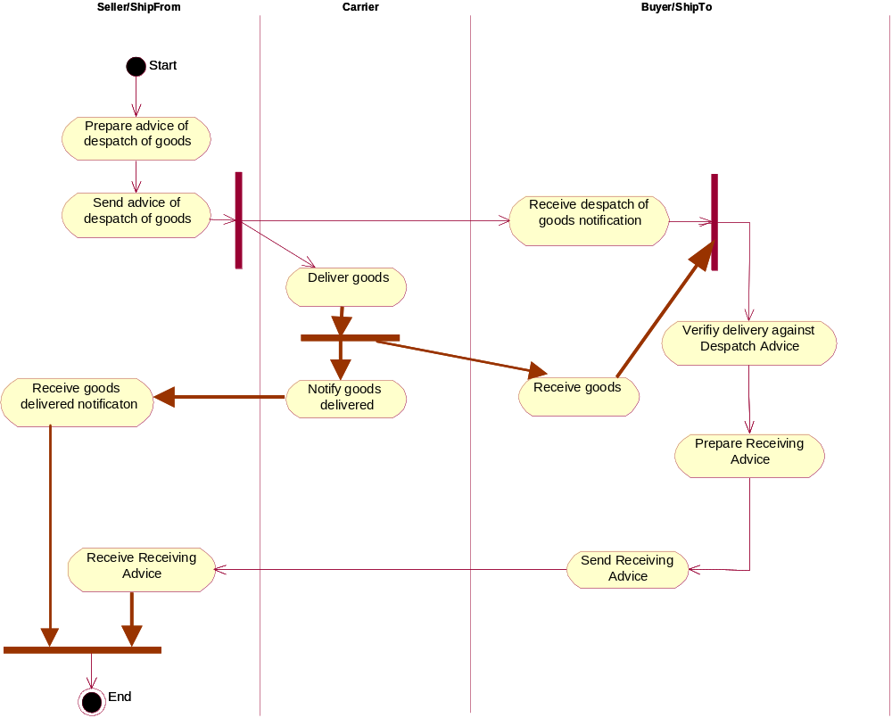
Figure 5-13 Activity Diagram

5.2.1.3 Use-case Realisation

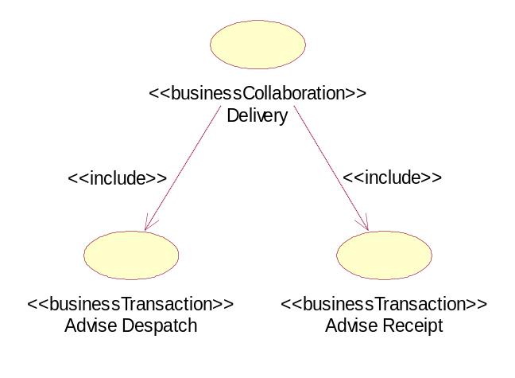
Figure 5-14 FMCGDelivery-BC2.Delivery
In the activity diagram each time control is handed from one actor to another some kind of collaborative activity takes place. The Business Collaboration depicted above does describe the Business Transactions that will be developed in order to support these collaborative activities.

Note: It does not contain all required Business Transactions. For example the transactions between Carrier and Seller are not included in the business model.

5.2.1.4 Business Process Use-case Diagram
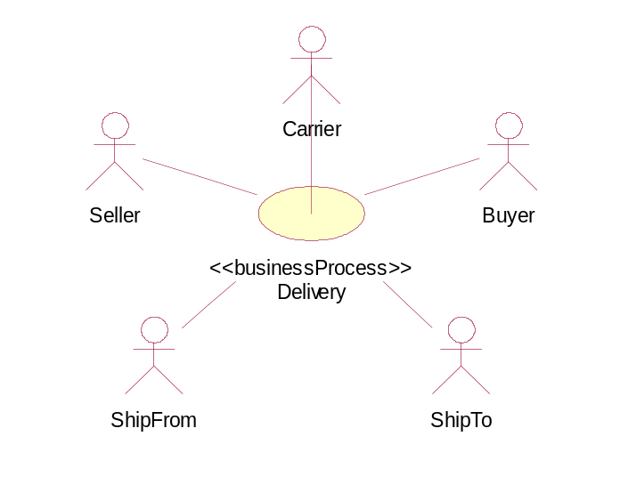
Figure 5-15 Use Case

5.2.1.5 Requirements List

Req. # | Statement | Source | Date | Status
1 | The seller MUST send a despatch advice for each shipment. | Example | 11/7/2002 | To be included in MIG
2 | The seller MUST send the despatch advise prior to delivery of the goods on the Ship-to location. | Example | 11/7/2002 | Included in activity diagram.
3 | The despatch advise MUST contain a identifier that is unique for the seller. | Example | 11/7/2002 | Included in detailed class diagram, in Document class.
4 | Each party MUST be identified using a GLN. | Example | 11/7/2002 | Included in detailed class diagram.
5 | A despatch advise advice MAY reference a maximum of one order. | Example | 11/7/2002 | Included in detailed class diagram
6 | A despatch advise advice MAY reference a maximum of one contract. | Example | 11/7/2002 | Included in detailed class diagram
7 | Each despatch advise MUST indicate the date or datetime of its issue. | Example | 11/7/2002 | Included in detailed class diagram
8 | The despatch advice MUST indicate the buyer and seller, and SHALL indicate the ship-to and/or ship-from where these differ from the buyer and / or seller. | Example | 11/7/2002 | Included in detailed class diagram, also to be included in MIG.
9 | The despatch advise MAY indicate the carrier. | Example | 11/7/2002 | Add further explanation. Already included in detailed class diagram.
10 | A despatch advise advice CAN reference a maximum of one delivery note. | Example | 11/7/2002 | Included in detailed class diagram
11 | A despatch advise advice CAN reference a maximum of one consignment number. | Example | 11/7/2002 | Included in detailed class diagram
12 | Parties agree to use only ISO pallets. | Example | 11/7/2002 | Requirement needs to be refined. Included in detailed class diagram
13 | Parties agree to use only cartons. | Example | 11/7/2002 | Requirement needs to be refined.
14 | Each logistic unit MUST be identified using an SSCC. | Example | 11/7/2002 | Included in detailed class diagram
15 | Each item MUST be identified using a GTIN. | Example | 11/7/2002 | Included in detailed class diagram
16 | The despatch advice SHOULD enable a hierarchical description of the shipment, starting with the pallet level and ending with the item level. | Example | 11/7/2002 | Included in detailed class diagram
17 | The despatch advice MUST indicate the items and quantities that have been shipped. Optionally the expiry date and sell by date MAY be included. | Example | 11/7/2002 | Included in detailed class diagram

5.2.1.6 Business Information Objects Glossary
(This section details the initial BIOs, which meet the requirements specified by the use case)
(Record the business information objects in the glossary below)
Business Term | GDD key | UID ebXML | Dictionary Entry Name | Definition | Remarks
Buyer | 00000001 | 999960 | Buyer Party. Details | Trading partner to which merchandise is sold.
Seller | 00000002 | 999959 | Seller Party. Details | Trading partner selling merchandise to a buyer.
Carrier | 00000003 | 999956 | Carrier Party. Details | Third party undertaking or arranging transport of goods between named points.
Ship To | 00000004 | 999957 | Receiver Party. Details | Identification of the location to where goods will be or have been shipped.
Ship From | 00000005 | 999958 | Ship From Party. Details | Identification of the location from where goods will be or have been shipped.
Purchase Order | 00000006 | 999999 | Related Purchase. Details | Document/message by means of which a buyer initiates a transaction with a seller involving the supply of goods or services as specified, according to conditions set out in an offer, or otherwise known to the buyer
Delivery Note |  |  |  | Paper document attached to a consignment informing the receiving party about contents of this consignment.
Logistics Unit |  |  |  | An item of any composition established for transport and/or storage that needs to be managed through the supply chain.
Despatch Advice |  |  |  | Document/message by means of which the supplier or consignor informs the buyer or consignee about the despatch of goods.
Receiving Advice |  |  |  | Message addressing the business needs related to the goods receipt or advising discrepancies between despatched or ordered/planned goods.
Consignment |  |  |  | Consignment is a logical grouping of goods (one or more physical entities) that has been consigned to a freight forwarder and is intended to be transported as a whole.
Shipment |  |  |  | Shipment is the event that moves the goods between trading partners.
Contract |  |  |  | Formal agreement between two or more parties. (Definition still to be approved)
Despatch Item |  |  |  | The individual despatched item.
Trade Item |  |  |  | Any item (product or service) upon which there is a need to retrieve pre-defined information and that may be priced, or ordered, or invoiced at any point in any supply chain.
Party |  |  |  | Organisation or entity within an organisation playing a specific role in a business process. (Definition still to be approved)

5.2.2 Business Transaction View (BTV)

5.2.2.1 Business Transaction Activity Diagrams
A business transaction activity is a business collaboration protocol activity that executes a specified business transaction. A business transaction is a set of business information and business signal exchanges between two business partners that must occur in an agreed format, sequence and time period.

NOTIFICATION PATTERN FOR ADVISE DESPATCH
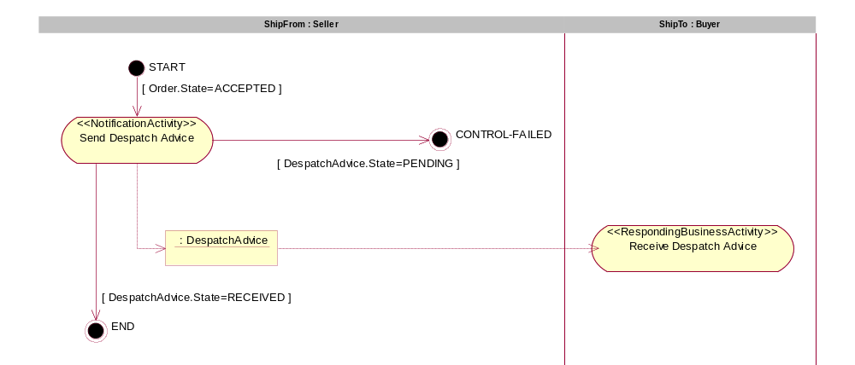
Figure 5-16

NOTIFICATION PATTERN FOR ADVISE RECEIPT
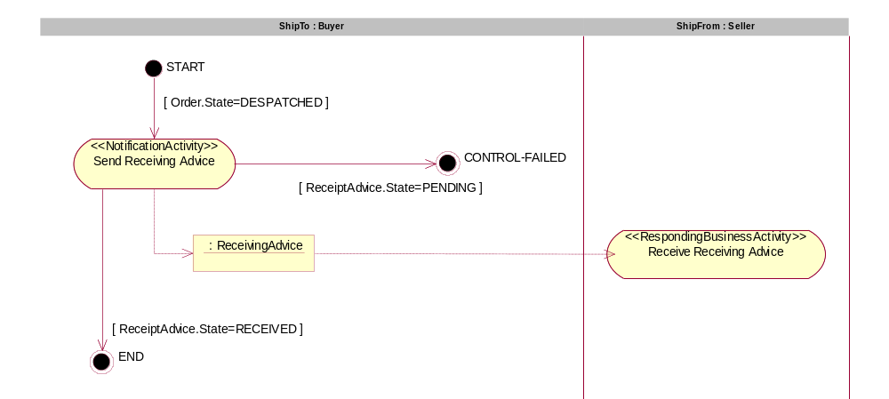
Figure 5-17

5.2.2.2 High-level Class Diagrams
Business information objects from the glossary (see 5.2.1.5) are used to create the high-level class diagram. Business information objects contained in the GDD are also used to discover candidates for classes and attributes in the high-level class diagram.

5.2.2.2.1 Delivery Business Process
Figure 5-18

5.2.2.2.2 Despatch Advice Business Document
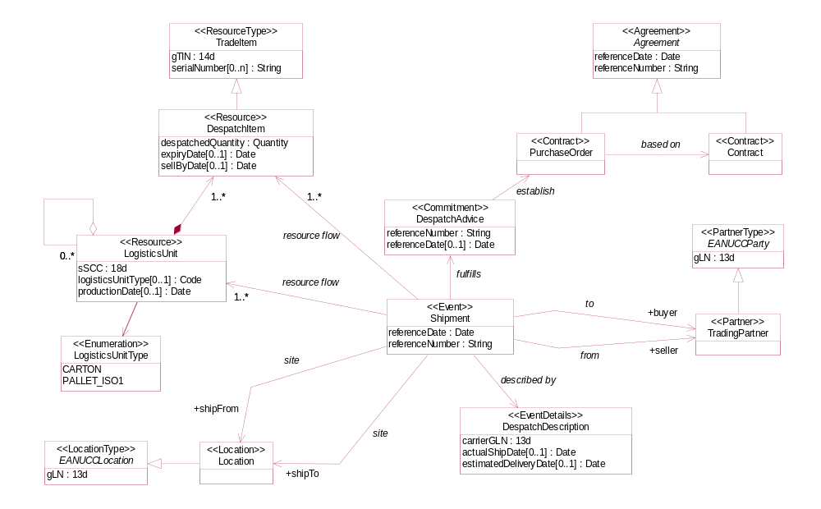
Figure 5-19

5.2.2.2.3 Receiving Advice Business Document
Figure 5-19

5.2.3 Business Service View (BSV)

5.2.3.1 Sequence Diagram
A service interaction is a mutually binding interaction between an initiating service and a responding service.

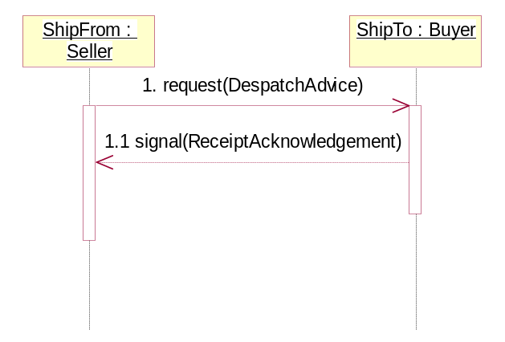

Figure 5-20 BC2.Delivery-BT1.AdviseDespatch-SI1.AdviseDespatch

Note: Service-to-Service interaction pattern E is used to design SI1.AdviseDespatch
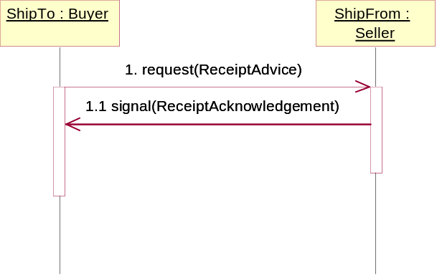

Figure 5-21 BC2.Delivery-BT1.AdviseDespatch-SI2.AdviseReceipt
Note: Service-to-Service interaction pattern E is used to design SI2.AdviseReceipt

5.2.3.2 Context Classification Scheme
This is the final scheme to specify the values of the 8 context categories of the business process.

Context Categories | Values
Business Process | Delivery
Product Classification | Consumer Goods, Trade Items
Industry Classification | FMCG Retail
Geopolitical | Global
Official Constraint | None
Business Process Role | In All Contexts
Supporting Role | In All Contexts
System Capabilities | EAN.UCC System

5.2.3.3 Detailed Class Diagram
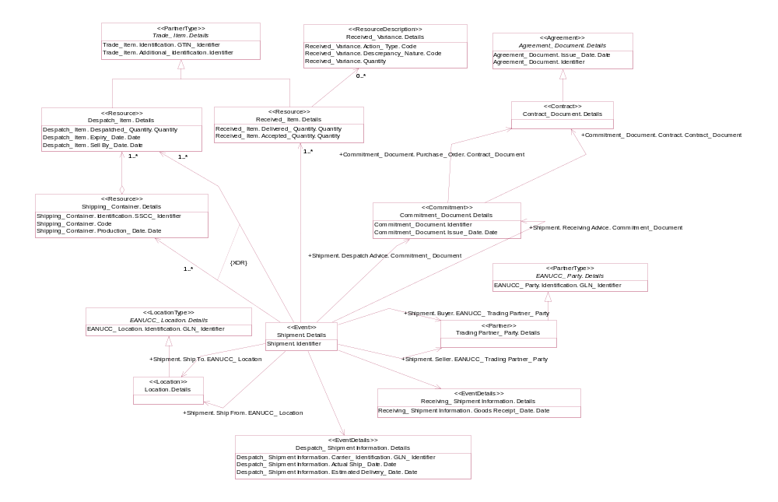
Figure 5-22 Detailed Class Diagram

5.2.3.4 Sub-set Business Document Class Diagram (detailed)
The detailed class diagram from the BSV (see 5.2.3.3) is used as a base to create the subset class diagram for each business document)

5.2.3.4.1 Despatch Advice Business Document (Class Diagram):
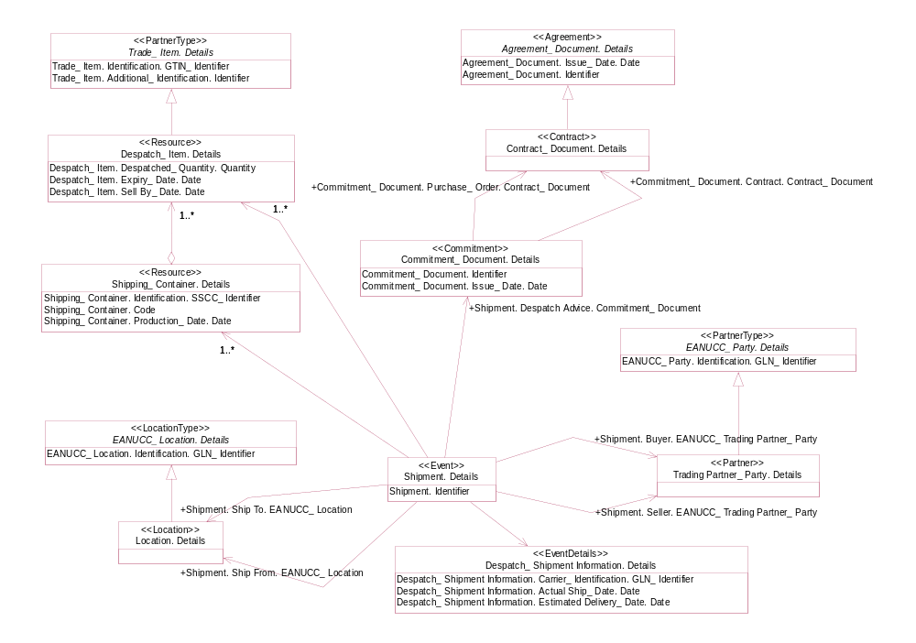
Figure 5-23 Document Class Diagram

5.2.3.4.2 Receiving Advice Business Document (Class Diagram)
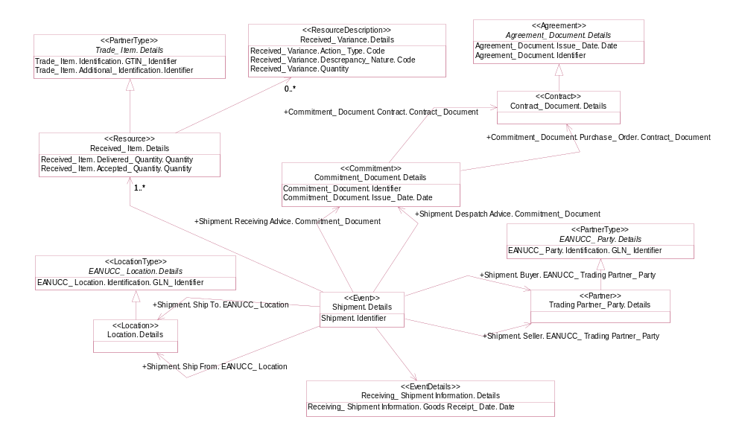
Figure 5-24 Document Class Diagram

5.2.4 Core Component Reference Lists
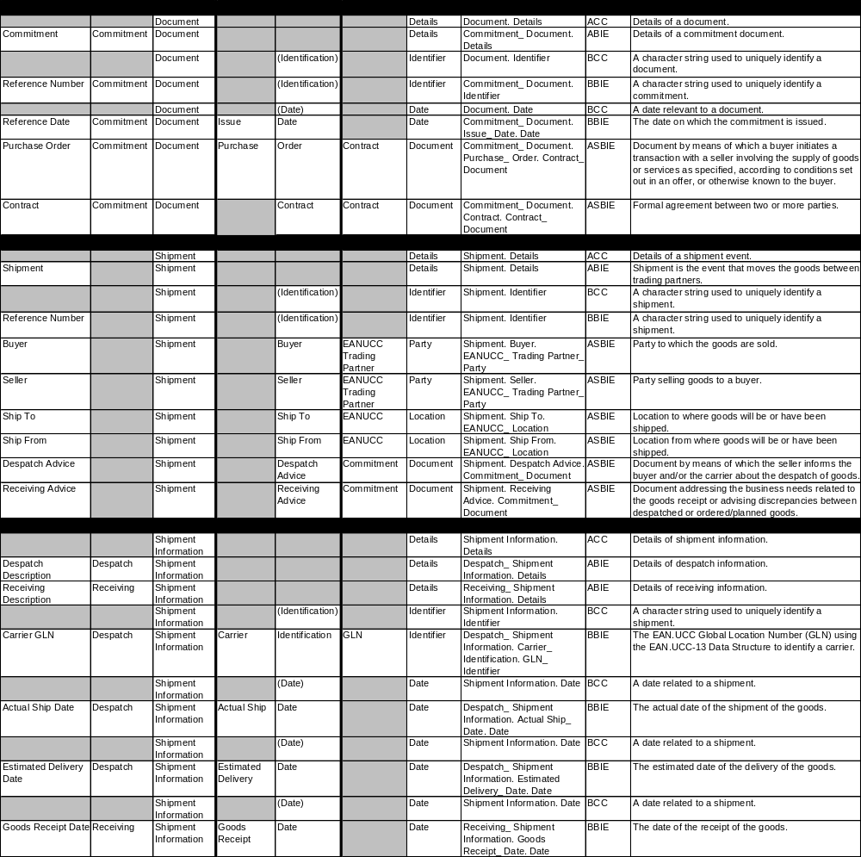

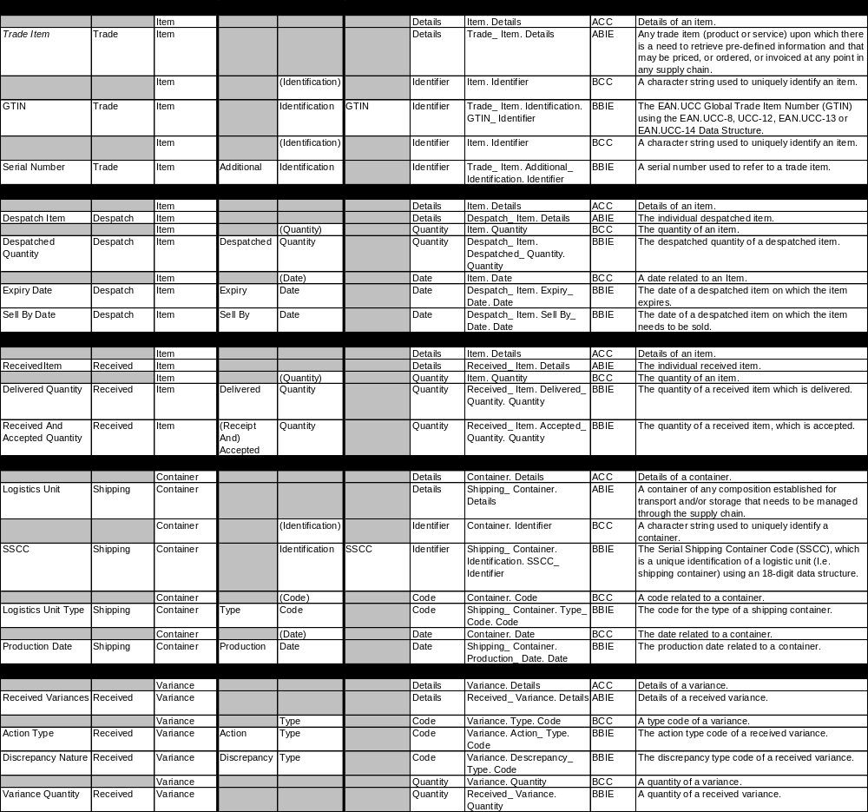

5.2.5 Core Component Overview
The Core Component overview provides a graphical presentation of the structure of the ABIE’s and their associated BBIE’s and ASBIE’s. It also shows on which CC’s the BIE’s are based.
Figure 5-25
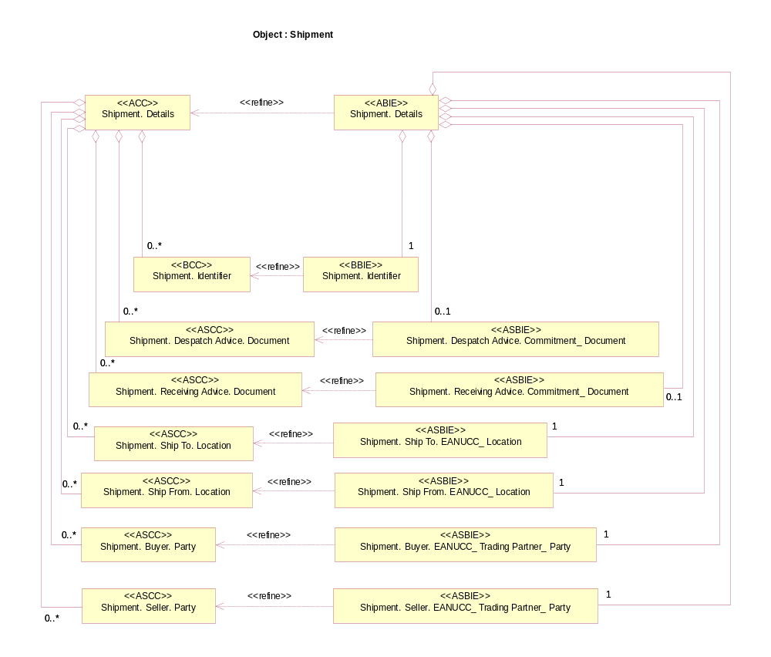
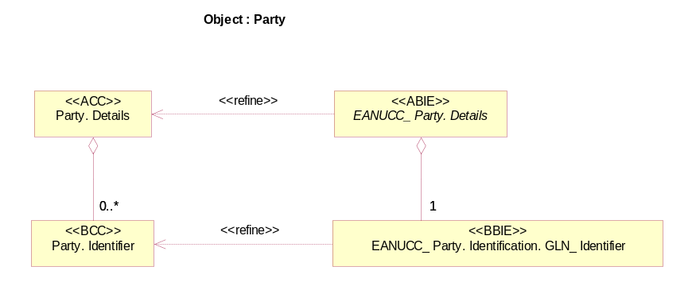
Figure 5-26
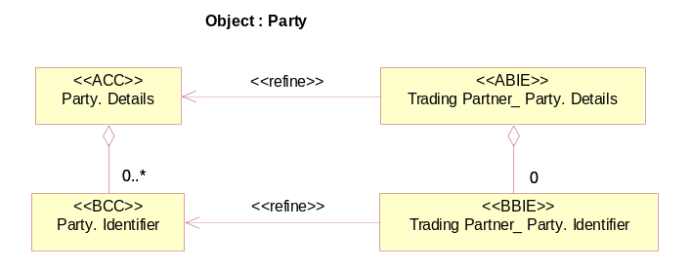
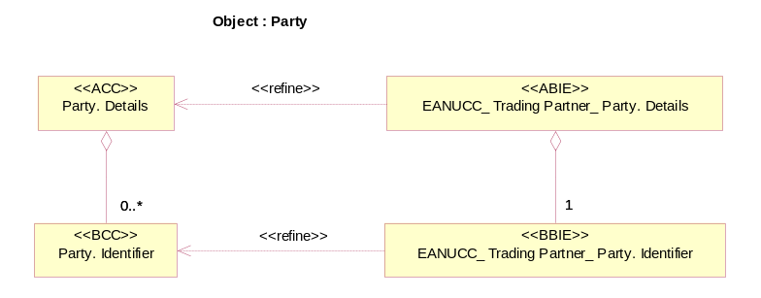
Figure 5-27
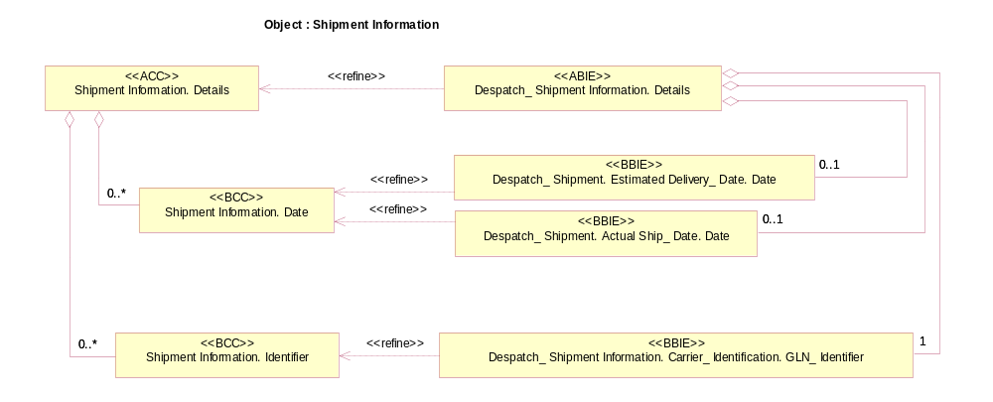
Figure 5-28
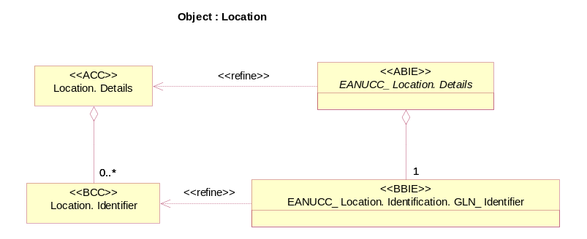
Figure 5-29
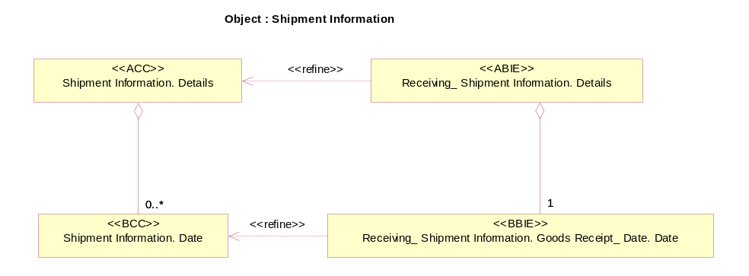
Figure 5-30
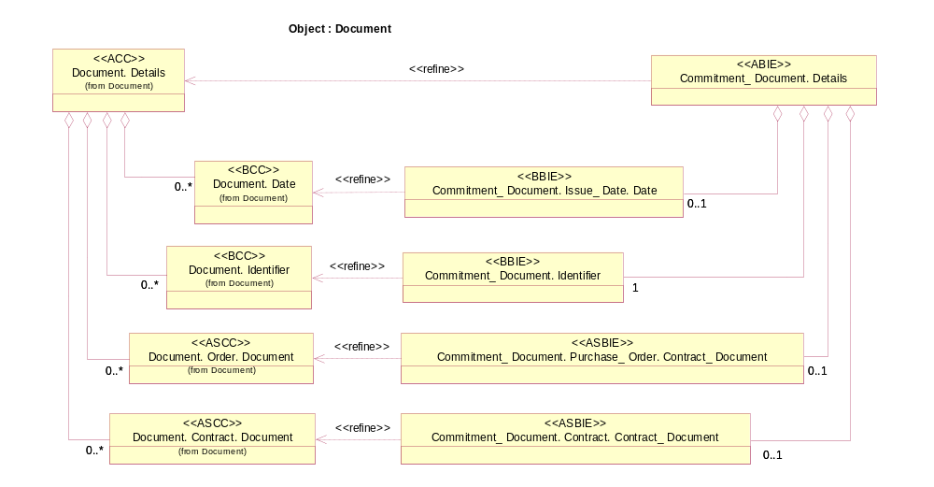
Figure 5-31
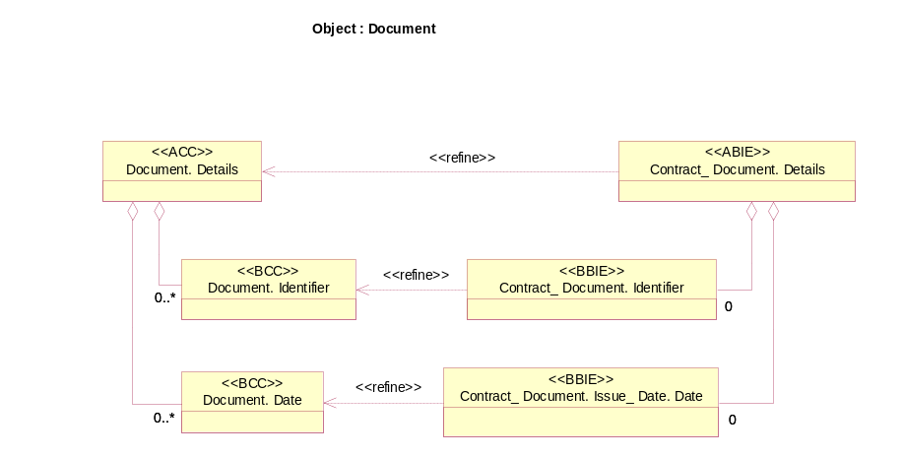
Figure 5-32
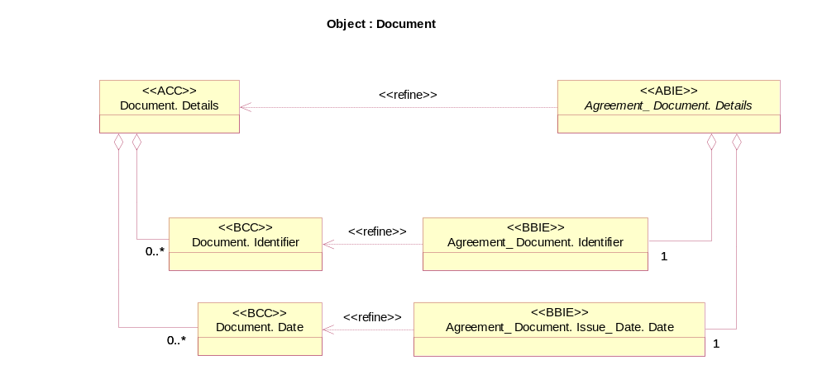
Figure 5-32
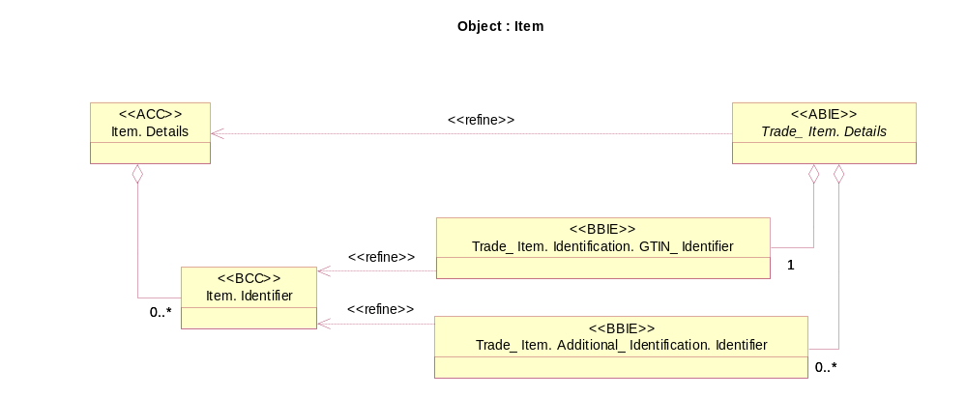
Figure 5-33
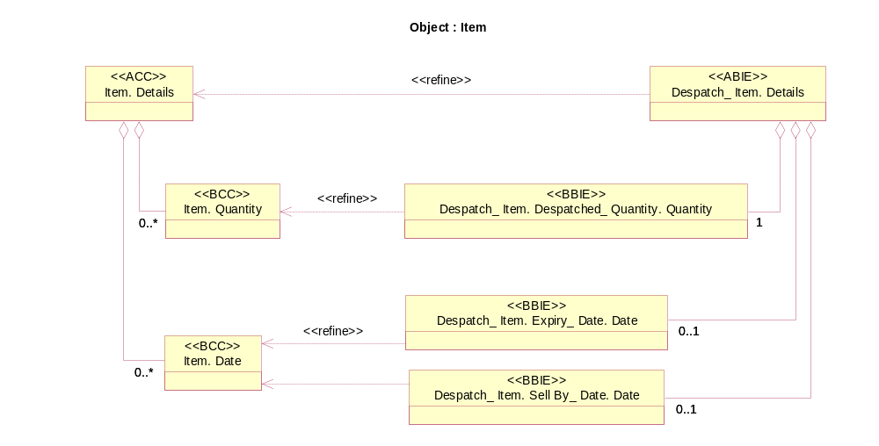
Figure 5-34
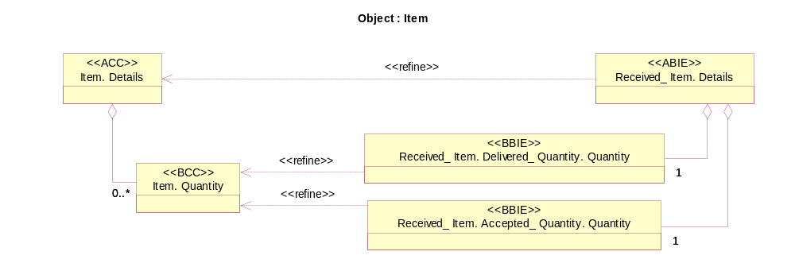
Figure 5-35
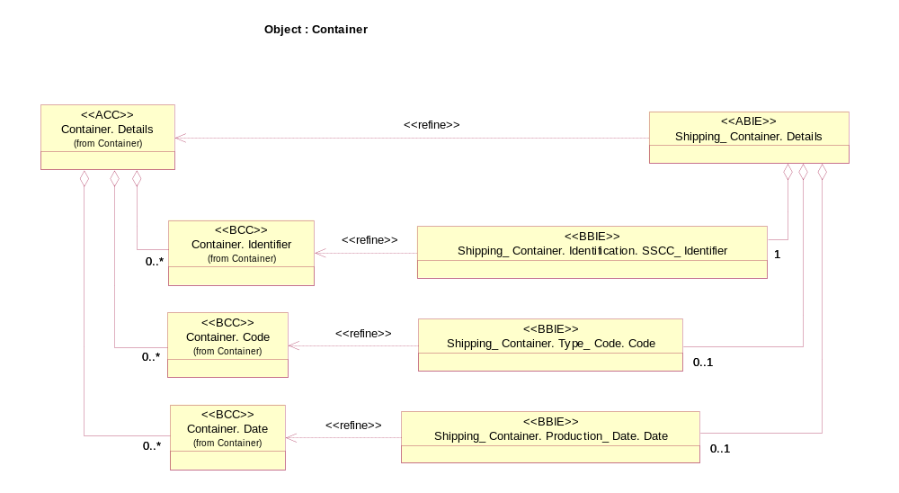
Figure 5-36
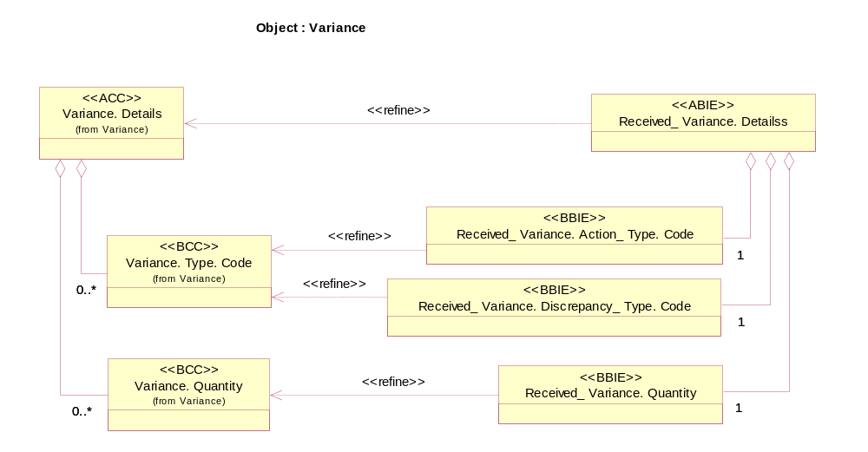
Figure 5-37

6. Glossary
ABIE Aggregate Business Information Entity
ACC Aggregate Core Component
ANSI American National Standards Institute
ASBIE Association Business Entity
ASC Accredited Standards Committee
ATA Air Transport Association
BBIE Basic Business Information Entity
BCC Basic Core Component
CC Core Component
CCSD Core Component Supplemental Document
CCTS Core Component Technical Specification
EbXML Electronic Business Extensive Markup Language
EDI Electronic Data Interchange
UMM UN/CEFACT Modeling Methodology
UN/CEFACT United Nations Centre for Trade Facilitation and Electronic Business
OASIS Organization for the Advancement of Structured Information Standards
XML Extensive Markup Language

Appendix A

References
. UN/CEFACT – ebXML Core Components Technical Specification, Release 1.90
. UN/CEFACT' s Modelling Methodology, Draft CEFACT/TMWG/N090R10
. UN/CEFACT – e-Business Architecture Technical Specification – Revision 0.83
. UN/CEFACT – e-Business Glossary Working Draft Revision 0.53
. ebXML Business Process Specification Schema v1.05
. OASIS/ebXML Registry Information Model v2.0
. OASIS/ebXML Registry Services Specification v2.0
. ebXML Requirements Specification v1.06
. OASIS/ebXML Collaboration-Protocol Profile and Agreement Specification v2.0
. OASIS/ebXML Message Service Specification v2.0
. ebXML Technical Report, Business Process and Business Information Analysis
Overview v1.0
. ebXML Business Process Analysis Worksheets & Guidelines v1.0
. ebXML Technical Report, E-Commerce Patterns v1.0
. ebXML Technical Report, Catalog of Common Business Processes v1.0
. ebXML Technical Report, Core Component Dictionary v1.04
. ebXML Technical Report, Core Component Structure v1.04
. UN/CEFACT e-Business Architecture Technical Specification Revision 0.83
. Information Technology - Metadata registries: Framework for the Specification and
Standardization of Data Elements, International Standardization Organization, ISO
11179-1
. Information Technology - Metadata registries: Classification of Concepts for the
Identification of Domains, International Standardization Organization,
ISO 11179-2
. Information Technology - Metadata registries: Registry Metamodel, International
Standardization Organization, ISO 11179-3
. Information Technology - Metadata registries: Rules and Guidelines for the
Formulation of Data Definitions, International Standardization Organization, ISO
11179-4
. Information Technology - Metadata registries: Naming and Identification Principles
for Data Elements, International Standardization Organization, ISO 11179-5
. Information Technology - Metadata registries: Framework for the Specification and
Standardization of Data Elements, International Standardization Organization, ISO
11179-6

Copyright Statement
Copyright © UN/CEFACT 2002. All Rights Reserved.
This document and translations of it may be copied and furnished to others, and derivative works that comment on or otherwise explain it or assist in its implementation may be prepared, copied, published and distributed, in whole or in part, without restriction of any kind, provided that the above copyright notice and this paragraph are included on all such copies and derivative works. However, this document itself may not be modified in any way, such as by removing the copyright notice or references to UN/CEFACT except as required to translate it into languages other than English.
The limited permissions granted above are perpetual and will not be revoked by UN/CEFACT or its successors or assigns.
This document and the information contained herein is provided on an "AS IS" basis and UN/CEFACT DISCLAIMS ALL WARRANTIES, EXPRESS OR IMPLIED, INCLUDING BUT NOT LIMITED TO ANY WARRANTY THAT THE USE OF THE INFORMATION HEREIN WILL NOT INFRINGE ANY RIGHTS OR ANY IMPLIED WARRANTIES OF MERCHANTABILITY OR FITNESS FOR A PARTICULAR PURPOSE.

Revisions:
1. Changed notation on Figure 4-1
2. Changed notation on figure on line 717
3. Changed title of 5.1.1.3 and Figure 5-2 to Business Collaboration Protocol and ‘business
CollaborationActivity’ in picture to ‘businessTransactionActivity’
4. In Figure 5-3 deleted horizontal swim-lane, underlined name of object, changed object flow
line to a dash, added [] to guard assumptions
5. Corrected figure 4-12 to change ‘No’ arrows from ‘Make Sense’ got to ‘Rework’ box
6. Change ‘basis’ to ‘basic’ in several places

