

LABORATORY CENTRIFUGE
LISTON C 2201 | LISTON C 2202 | LISTON C 2203 | LISTON C 2204 CLASSIC

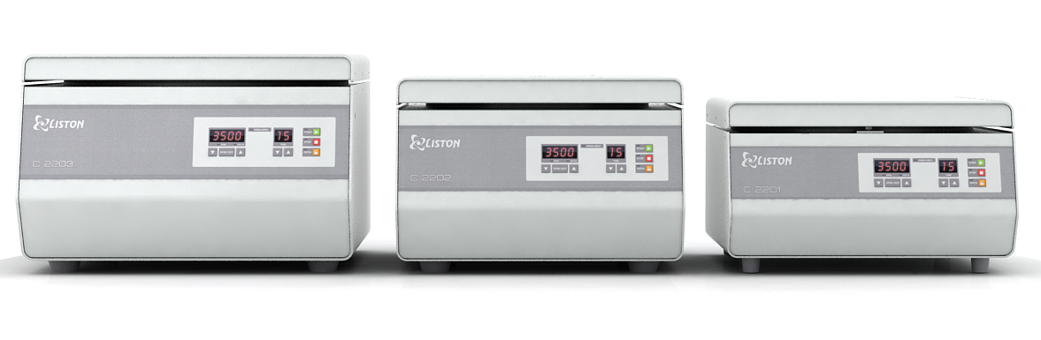

OPERATING MANUAL
- Safety
The following symbol mean:

CAUTION: Read these operating instructions fully before use and follow them unconditionally! Instructions are relevant to safety precautions.

General safety:
- Use only as specified in the operating instructions provided
- The centrifuge should not be used if it has encountered a physical shock or has been dropped
- The centrifuge should not be moved or knocked while in operation
- The centrifuge must be stored and transported according to the package labels
- After transport or storage allow the centrifuge to warm up and dry out (2 hrs) before connecting to the power source
- Centrifuge is designed for indoor use only
- Do not operate centrifuge in environments with aggressive or explosive chemical mixtures
- Do not make modifications to the design of the centrifuge
- Use only original accessories and parts (rotors, adapters, etc.), provided by Liston, LLC or its representatives
Electrical safety:
- Connect only to the power source with a voltage and power frequency corresponding to that one on the serial number label (ID-plate)
- Ensure that the switch and/or plug are easily accessible during use
- Do not plug the centrifuge into the power source without grounding
- Before moving the centrifuge turn it off and disconnect from the power source
- It is user’s responsibility to avoid any liquid getting spilt inside the centrifuge (including the slot(s) for the cover bracket insertion )

Biological safety:
- Without bioseal the centrifuge is not biosafety system and cannot be used for centrifuging of hazardous materials
- It is user’s responsibility to carry out appropriate cleaning and decontamination procedures if hazardous material is spilt on or inside the centrifuge
Operation safety:
- Do not start the centrifuge before unscrewing transportation screws
- Do not centrifuge flammable or chemically vigorously reactive materials
- Rotors must always be properly secured. The centrifuge may only be operated with the rotor firmly tightened.
- Do not use rotors or accessories with visible signs of corrosion or mechanical damage. Check them regularly.
- The rotor may only be loaded symmetrically. Even if not all of the adapters are filled with sample tubes, all of them must be installed into the rotor. Opposing tubes should be of the same type and filled equally (in order to avoid uncontrolled vibrations, the difference in weight of opposing adapters filled with tubes should not exceed 2 grams)
- Do not load the rotor with the volume of centrifugation material over values specified for the rotor
- Do not centrifuge tubes, that are not intended for centrifugation
- Prior to centrifugation, the tubes should be visually inspected for material damage. Damaged tubes must not be centrifuged, due to the possibility of damage to the centrifuge and accessories
- Seal the tube lid down tight before centrifuging. The lids of unclosed tubes may rip off during centrifugation and damage the centrifuge
- The material being centrifuged must not exceed a density of 2.0 g/cm³ at maximum rotation speed

- General information
  - Laboratory centrifuges
Liston C 2201
Liston C 2202
Liston C 2203
Liston C 2204 Classic (hereinafter referred to as the centrifuge)
are bench-top centrifuges with a speed and features depending on the model (see Specifications), and designed for the separation of heterogeneous liquid systems up to 2 g/cm³ in density in the field of centrifugal forces.
  - Centrifuge is intended for use by trained professionals in the practice of routine laboratory diagnostics, training and research in various types of medical, biochemical, industrial labs.
  - Before using the centrifuge for the first time, please read the operating manual
- Getting started
  - Unpacking
- Carefully remove the centrifuge in a plastic bag from the box and retain the packaging for future shipment or storage of the centrifuge
- Remove the plastic bag
- Remove from the inner chamber the set of spare parts and accessories
- Unscrew and remove transport screws labeled with tags in the bottom of the centrifuge, gently tilting the centrifuge to the one side with lid closed. Retain them for future transportation
- Carry out an external examination of the centrifuge
- Check the delivery package according to paragraph #5 of this operating manual
  - Set Up
- Place the centrifuge on a solid, flat and clean surface. Make sure that it stands steady, without swinging
- To ensure the that the ventilation of the device is not impaired, a fundamental clearance of 150 mm to the back wall must be maintained
- In accordance with the EN 61010-2-020 standard the safety area of 300 mm around the centrifuge must be maintained.
- Wait for 2 hours before connecting to the power source if the centrifuge was exposed to subzero temperature conditions
- Check serial number label (ID-plate) for voltage and power frequency and make sure that they are compatible with your power source
- Connect the centrifuge to the power source
- If your centrifuge has factory-installed rotor - manually check that it rotates freely in a clockwise direction
- If the rotor needs to be installed on your centrifuge see the next paragraph
  - Rotor installation (replacement)
- Check the rotor and adapters for any signs of wear and corrosion and replace if necessary.
- Hold the rotor with both hands and accurately install it on the motor shaft. Make sure, that rotor is parallel to the horizontal axis of the centrifuge (perpendicular to the motor shaft)
- If rotor and centrifuge is equipped with optical speed sensor (Liston C 2204 Classic) - make sure that both of two square-shaped metal plates (optical sensor interrupters), located at the bottom of the rotor rotate freely through the optical speed sensor (U shaped black plastic detail, located on the motor cover) - correct plates by applying gentle pressure on them if needed.
- Hold the rotor with one hand and tighten the brass screw-nut with wrench # 17 in counterclockwise direction
- Install all adapters that fit to the rotor (12,20, 4 – depending on rotor)
- Install tubes into the respective rotors according to figs. #1 and #2
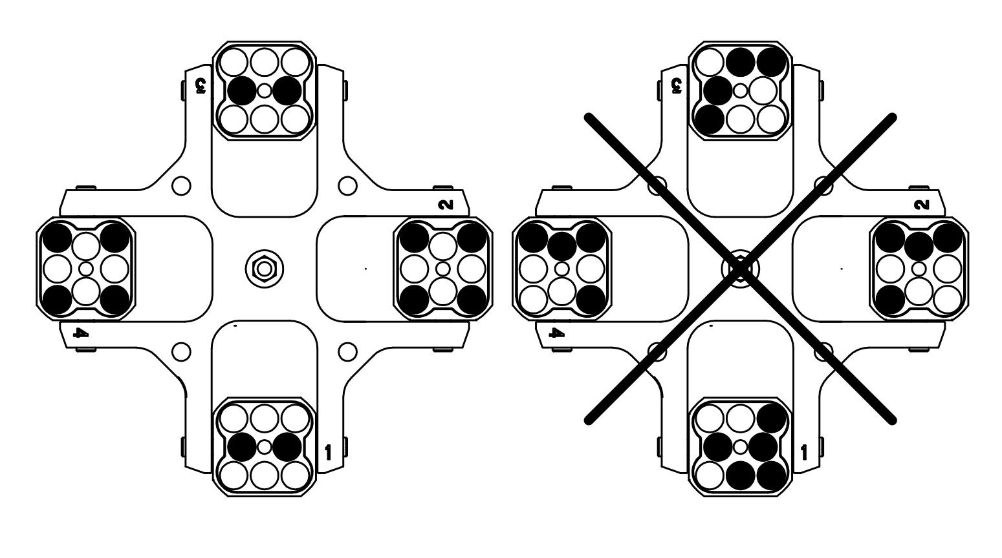
Fig.1 CRS 490 or CRS 4180 rotors loading scheme

Fig.2 CRA 1215 CRA 2015 or CRA 2415 rotors loading scheme

Operation

Recommendations during operation
- Check rotor, adapters and power cord for any signs of wear and corrosion and replace if needed
- Load rotors with even number of tubes, arranged symmetrically and evenly filled (see paragraph 3 of this operating manual)
- Make sure that rotor is fixed securely. Stop the operation immediately with STOP button if any unusual noise occurs during acceleration
- Make sure, that you use tubes that are intended for centrifugation.
- Set centrifugation speed accordingly to tube manufacturer specification. Do not exceed those specified speeds under any circumstances
- Switch the centrifuge on by toggling on/off switch, located at the right part of the back side of the centrifuge (for Liston C 2201, Liston C 2202 and Liston C 2203) or at the front panel (for Liston C 2204 Classic) to ON position

  - Centrifuge design

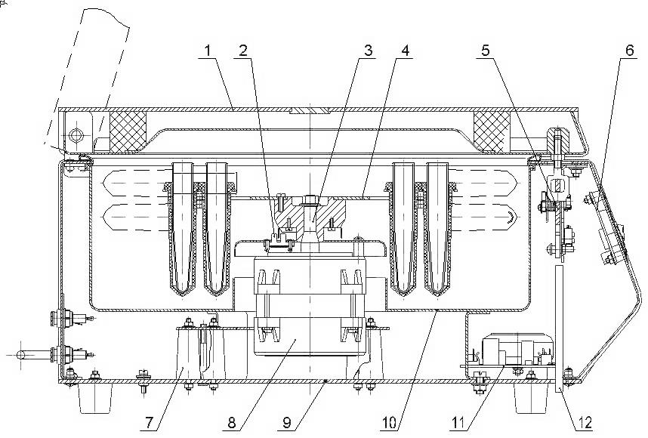
Fig. #3 Design of the Liston C 2201, Liston C 2202, Liston C 2203 centrifuges (the view of structural components are conditional, without centrifuge features):
1 – Cover
2 – RPM sensor
3 – Motor shaft
4 – Rotor
5 – Electromagnetic lock
6 – Indication and control PCB
7 – Shock absorber
8 – Electric motor
9 – Base (housing)
10 – Chamber
11 – Power PCB
12 – Emergency cover opening pusher

The design of the Liston C 2204 Classic centrifuge differs from that shown in Fig. # 3 by the absence of the electromagnetic lock Pos. 5, power PCB Pos. 11, and emergency cover opening pusher Pos. 12.

Operating centrifuges Liston C 2201, Liston C 2202, Liston C 2203
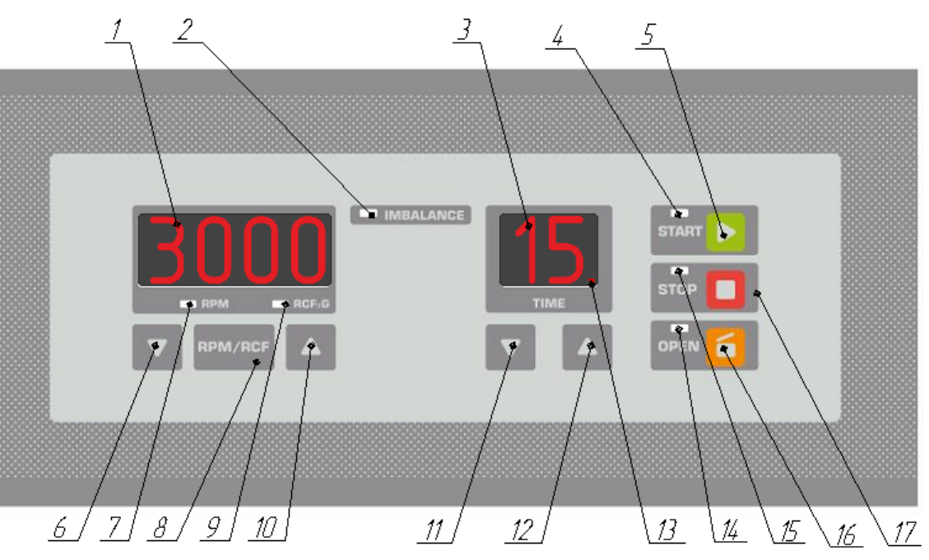
Fig. # 4 Front panel of Liston C 2201, Liston C 2202, Liston C 2203 centrifuges :
1 – Speed indicator
2 – IMBALANCE sensor indicator
3 – Centrifugation time indicator (min.)
4 –Centrifuge rotation indicator
5 –START button
6 –▼ Button for speed reduction
7 –RPM mode indication
8 –RPM / RCF mode selector
9 –RCF mode indication
10 –▲ Button for speed increase
11 –▼ button for operation time reduction
12 –▲ Button for operation time increase
13 – Direct time of centrifugation indicator (continuous mode)
14 –Open cover indication
15 – STOP mode indication
16 – OPEN button
17 – STOP button

After switching Liston C 2201, Liston C 2202, Liston C 2203 centrifuges – speed indicator (pos. 1 fig. #4), time indicator (pos. 3fig. #4) and STOP mode indicator (pos. 14fig. #4) will lit.
To open cover in initial state – press OPEN button (pos. 16 fig. #4). The cover will be opened and appropriate indicator (pos. 14 fig. #4) will be lit. If you need to open the lid without power or in case of emergency use the pusher located on the bottom of the centrifuge (pos. 12 fig. #3)
To set centrifugation speed - select the speed regulation mode by pressing RPM/RCF mode selector (pos. 8 fig. #4). Selected mode will be shown respectively with RPM (pos. 7 fig. #4) or RCF (pos. 9 fig. #4) mode indicators. Set speed in selected mode by pressing speed increasing or speed reduction buttons (pos. 6 and pos. 10 fig. #4). If speed buttons are held pressed for 2.5 seconds, the values will be changed faster
To set centrifugation time use decrease time and increase time buttons (pos. 11 and pos. 12 fig. #4 respectively). The time is set in minutes and indicated on centrifugation time indicator (pos. 3 fig. #4). If time buttons are held pressed for 2.5 seconds the values will be changed faster
To close centrifuge apply pressure on the top of the cover above the bracket(s) until the “click” sound. After proper closing of the centrifuge OPEN indicator will go off.
To start the process of centrifugation press START button (pos.5 fig. #4). The STOP indicator (pos.15 fig. #4) will go off and START indicator (pos. 4 fig. #4) will be lit. The rotor will start rotating and reach the set speed smoothly. At the same time the digital speed indicator displays the current speed, and the time indicator displays the time remaining till the drive shutdown
NOTE: Some speed change (+/- 200 RPM) after centrifuge will reach desired speed will be shown on the speed indicator (pos.1 fig. #4) – this is NORMAL (Changes occur due to the speed control system)
During the centrifugation process the electromagnetic lock will be interlocked to avoid the cover to be opened while the rotor is moving.
When the centrifugation time has lapsed, the motor starts decelerating smoothly until it stops. During the deceleration, the STOP indicator (Pos. 15 fig. #4) will blink, and when the rotor has stopped completely, the interruptible buzzer will sound three times, the cover will open, the STOP indicator will be lit permanently, and the digital indicators will display the previous operation mode. Centrifuges Liston C 2201, Liston C 2202 and Liston C 2203 can be operated in continuous mode – to do this – set time to 0 and press START button (pos.5 fig. #4). Centrifuge will be operating until the STOP button (pos.17 fig. #4) will be pressed or until the operation time will reach 100 min. If the centrifuge is working in continuous mode the direct time indicator (pos.13 fig.#4) is lit.
In the case of the activation of emergency braking when exceeding the set vibration threshold (rotor imbalance), the IMBALANCE (Pos. 2 fig. #4) and STOP indicators will blink and the interruptible buzzer will sound three times, and the STOP indicator will be lit permanently. The centrifuge will not open automatically in this case. To open the centrifuge press OPEN button (pos.16 fig. #4). Before restarting centrifuge check the load of the rotor accordingly to paragraph #3.3
For emergency lid opening (or opening without power) use the pusher, located on the bottom side of the centrifuge (pos. 12 fig#3)

  - Operating centrifuge Liston C 2204 Classic

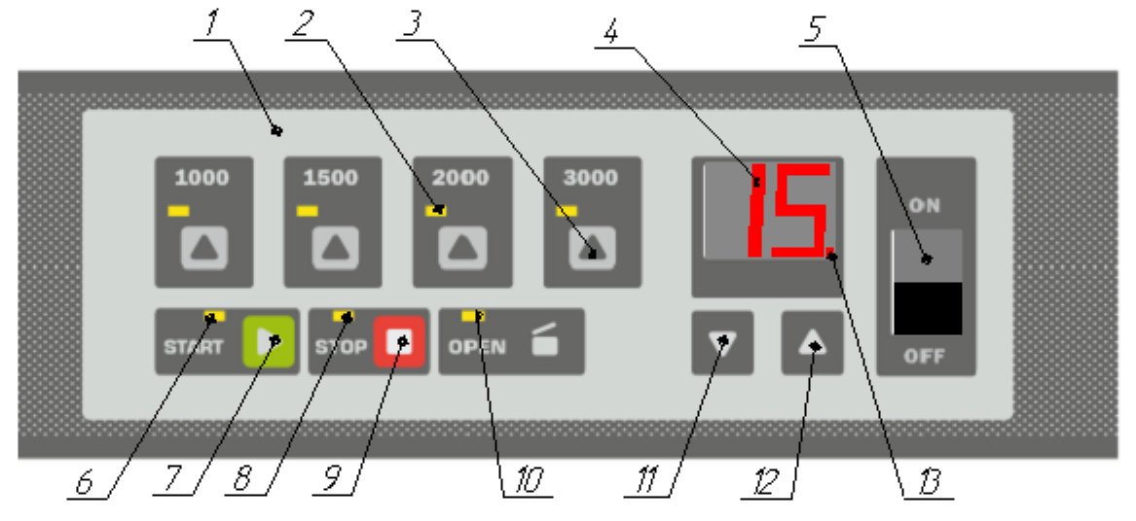
Fig.#5 Front panel of Liston C 2204 Classic centrifuge:
1– Indication / control panel
2– Selected SPEED indicator
3– SPEED selection button
4 – Centrifugation time indicator (min.)
5 – Power ON / OFF button
6 – Centrifuge rotation indicator
7 - START button
8 - STOP mode indication
9 – STOP button
10 - Open cover indication
11 - ▼ button for operation time reduction
12 –▲ Button for operation time increase
13 - Direct time of centrifugation indicator (continuous mode)

After switching centrifuge Liston C 2204 Classic ON the STOP mode indicator (pos.8 Fig #5) and the centrifugation time indicator (pos.4 Fig#5) will lit.
Liston C 2204 Classic centrifuge is opened manually. Safety system of the Liston C 2204 Classic centrifuge ensures interlocking the motor start with the cover opened and automatically switches the motor OFF when the cover is opened.
Do not put your hands into the centrifuge inner chamber after opening the centrifuge before the full stop of the rotor.
Load the centrifuge accordingly to procedures, described in paragraphs #3.3 and #4.1 of this operating manual.
Close the lid, by pressing it above the locking mechanism until you hear “click” sound.
To select the speed of centrifugation press one of the buttons with desired speed (1000, 1500, 2000, 3000 RPM) and an appropriate speed indicator (depending on selection) will be lit.
To set centrifugation time - use decrease time and increase time buttons (pos. 11 and pos. 12 fig. #5 respectively). The time is set in minutes and indicated on centrifugation time indicator (pos. 4 fig. #5). If time buttons are held pressed for 2.5 seconds, the values will be changed faster
Press the START button to begin centrifugation. START indicator will be lit
When the centrifugation time has lapsed, the motor starts decelerating smoothly until it stops
Centrifuge Liston C 2204 Classic can be operated in continuous mode – to do this – set time to 0 and press START button (pos.7 fig. #5). Centrifuge will be operating until the STOP button (pos.9 fig. #5) will be pressed or until the operation time will reach 100 min. If the centrifuge is working in continuous mode the direct time indicator (pos.13 fig. #5)
During the deceleration, the STOP indicator (Pos. 8 fig. #5) will blink, and when the rotor speed will be below 50 RPM, the interruptible buzzer will sound three times and the STOP indicator will be lit permanently.
- Delivery set
Part/Centrifuge | Liston C 2201 | Liston C 2202 | Liston C 2203 | Liston C 2204 Classic
Rotor CRA 1215 | * |  |  | *
Rotor CRA 2015 | *
Rotor CRS 490 |  | *
Rotor CRS 4180 |  |  | *
Adapters set | * | * | * | *
Fuse set | * | * | * | *
Documentation set | * | * | * | *
Note that centrifuges that have more than one compatible rotor are delivered with only one of the rotors (depending on your choice), other rotors are available optionally. Type of adapters and quantity of them depends on the rotor type and your choice described in the table below
Adapter (type, quantity)/Rotor | CRA 1215 | CRA 2015 | CRS 490 | CRS 4180
CAA 15.1.-24.18.120 | 15 | 25 | - | -
CAS 90.2.-8.13.100 |  |  | 4
CAS 90.2.-6.16.110 |  |  | 4
CAS 90.2.-6.17.110 |  |  | 4
CAS 180.3.-12.17.110 |  |  |  | 4
CAS 180.3.-14.13.100 |  |  |  | 4
CAS 180.3.-12.16.110 |  |  |  | 4
Note that only one type of adapters for every type of rotor is included into the delivery set. Other types of adapters are available optionally.

- Problems and remedies
Problem, problem symptoms and features | Possible cause | Remedy
1 The motor does not start with pressing the START button, the OPEN indicator is lit | The cover is not closed tightly | Close the cover tightly
2 The centrifuge does not operate (the rotor does not run) | 1 No power in the power supply circuit  2 The fuse is blown | 1 Check for the power in the power supply circuit  2 Replace the fuse
3 When accelerating, the imbalance sensor is activated, the rotor stops | Masses in the test tubes are not balanced | Balance the masses in the test tubes

- Guarantee and service
  - When used accordingly to operating manual this product has limited warranty for TWO YEARS.
Guarantee, mentioned above is limited for the adapters for 6 months.
  - Service & Maintenance of the centrifuges should be performed only by qualified personnel. There are no user-serviceable parts inside the unit. For service and maintenance contact your dealer
  - Cleaning and disinfection. Cleaning liquids that do not contain organic solvents, alkali or acid can be used for device cleaning. It is recommended to perform disinfection after operation session by cleaning the parts inside the centrifuge chamber. Rotors and other accessories are not autoclavable.
Centrifuge serial number____________________________
Date of manufacturing _______________________________
Quality control signature ____________________________
Stamp

- Attestation of Conformity

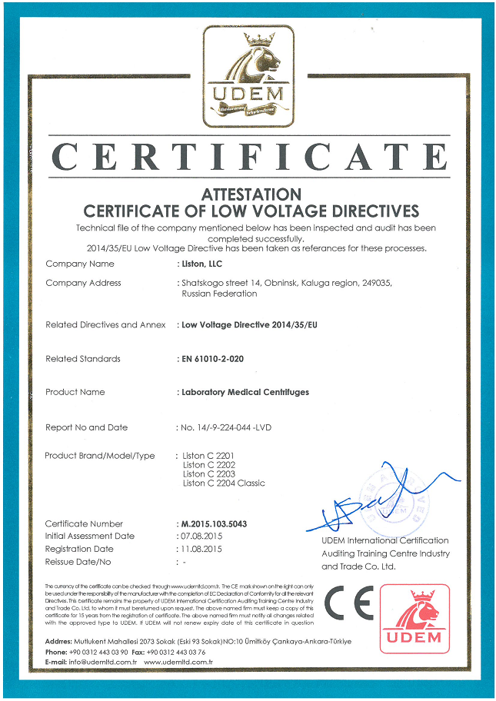
Liston, LLC
249037 Shatskogo str. 14, Obninsk, Kaluga region, Russian Federation
+7 484 399 07 06
market@listonlab.ru
www.liston.ru

