
Memo
FNSBSD
MailCenter
To: Anyone that prepares Certified Mail
From: Dave Parsons, Mailroom clerk
mailroom_adc X484
Date: 7/29/2026
Re: Certified Mail

Certified Mail should be properly prepared to avoid delays
Recently, a great quantity of mail needing to be sent Certified has reached the Mail Center prepared incorrectly. At the Postal Service, Certified mail is processed by machine along with regular mail. Incorrectly prepared Certified mail is rejected by the machine and must be processed by hand. This can cause delays up to and including sending it back. In some cases, the white portion of the certified label does not bear the originators location and cannot be returned. Without the white portion you have no proof of mailing. Some senders are not filling out the return address on the green Return Receipts. Without the return address the Postal Service cannot send the card back to you.

Use the correct forms
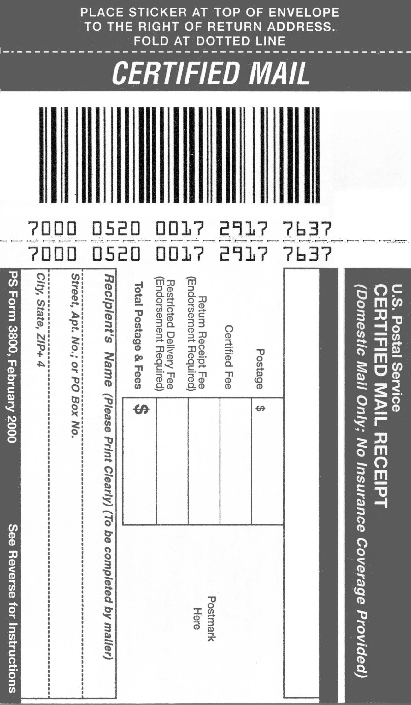
Certified Mail requires PS Form 3800. These forms are designed to be read by machines and have built-in features to assure accuracy. An area to one side of the bar code is treated with a special dye to show that this is an official document.
The receipt portion requires the name and address of the recipient, not the sender.
The lower portion is your proof of mailing. It will receive a round stamp from a Postal Service official before it is returned to you. You should identify your school or department or your school and your name.
Forms printed before February 2000 should not be used. If you have old forms, throw them away. If you need current forms I have them here or you can get them from any Post Office at no charge.

Place the label properly
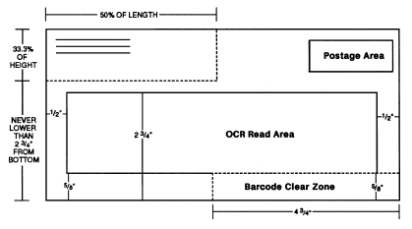
In accordance with S912.23 of the Domestic Mail Manual: “Certified mail must bear a barcoded green Form 3800. The label part of the form must be placed above the delivery address and to the right of the return address, or to the left of the delivery address on parcels.”
Keep Clear
Your letter should look like this
The top of the label folds over the top of the envelope at the dotted line. There needs to be at least 3 ½ inches of clear space from the right edge of the letter. This is the postage area. If the label is placed in the postage area the meter will print postage on the bar code, rendering it unreadable, which may delay delivery. Please place the label as close to the return address as you possibly can.

If a Return Receipt is required
Many who send Certified mail also require a Return Receipt (the green card). PS Form 3811 is a form that requires a signature from the person that accepts the mail. Affix the card to the back of envelopes or to the front of packages, if there is space. Do not cover the address with the card.
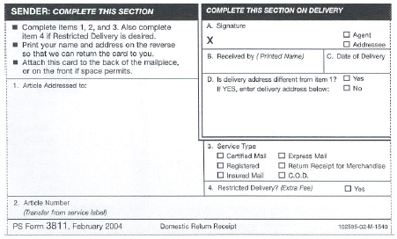
To properly fill out form 3811, you should print the recipient’s address in Box 1 (a label will work fine).
Indicate the Service Type. You only need to check “Certified Mail”. You do not need to check “Return Receipt for Merchandise” (separate service, separate form).
Fill in the Article Number in Box 2. This is the 20 digit number that appears below the bar code on the certified label. Current Certified labels have a separate gummed strip that can be applied in this box so that you don’t have to write the number yourself. This is a valuable cross-reference for Certified mail. Be sure to put your return address on the other side of the card (a label or rubber stamp works fine here). Without the return address, the Postal Service cannot return the receipt to you.
If you want to be certain that the intended recipient receives your letter, you can check “Yes” in Box 4 for “Restricted Delivery”. When this box is checked, the mail carrier will only allow the addressee to sign for the letter. There is an additional fee of $3.50 for this service, so only check this box if you need this service.

Certified Mail can be labor intensive
Currently, when you need to send mail Certified you must complete and attach the forms yourself. The cost of a typical Certified letter weighing one ounce or less is $3.24 ($.44 + 2.80 Certified Fee). Many customers also request a return receipt for notification that the mail was delivered. This costs an additional $2.30. Total postage is now $5.54. After the letter receives postage it must be taken to the Post Office by one of the warehouse drivers to get the receipt stamped. They bring the receipt back to the Mail Center and I send it to you.
E-Certified Mail can be easier and cheaper
The difference between regular Certified Mail and e-Certified Mail is that the tracking number is sent directly from our DM1000 Mailing System. You will get an email from the Postal Service when the letter is delivered or if it is returned. If you required a return receipt it will also be emailed to you when the letter is delivered. The electronic return receipt fee is $1.10 compared to $2.30 for the paper return receipt. You will not have to fill out the Certified receipt or the return receipt.
How can I take advantage of e-Certified Mail?
E-Certified Mail requires a special barcode label. If you only send Certified mail occasionally you only need to put a “sticky note” on your letter or package with the word “e-Certified” clearly written on it, along with your email address. If you frequently send Certified mail I can provide you with labels in packs of 50, as many as you require.
Can I still use regular Certified?
Yes. You will need to fill out and properly attach all labels.
Does e-Certified Mail provide legal “proof of mailing?”
Our DM1000 Mailing Machine prints a manifest of all e-Certified mail. Instead of stamping individual receipts, the Postal employee needs to stamp (and sign) only one sheet for the entire mailing. The manifests will be retained at the MailCenter until they are no longer viable as court documents.
What about the signature?
The electronic return receipt will either be a scan of the actual document signed by the recipient or it will be a signature electronically captured similar to electronically signing for a credit card transaction.

If you have further questions, please contact the MailCenter.

Dave Parsons
FNSBSD Mail Center X484
mailroom_adc@northstar.k12.ak.us
Skype: fnsbsdmailcenter

