Tables
Chapter
10
Visual EstiTrack’s fully integrated table structures provide the core configurations of your business.

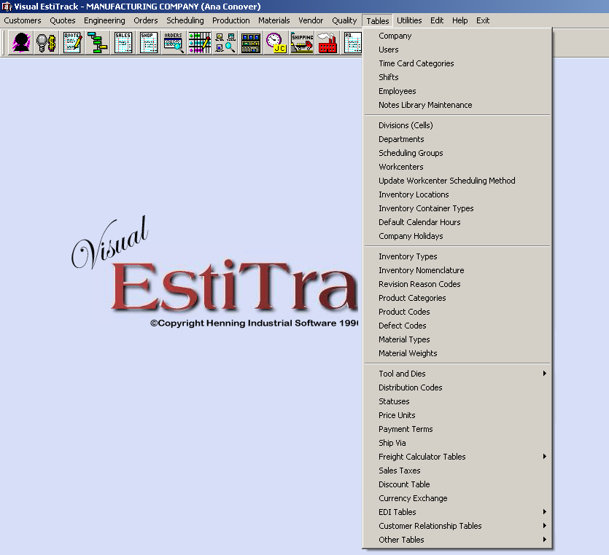

CHAPTER 10 - TABLES

TABLES DROP DOWN MENU OPTIONS

Company Table Users Table Employees Table Divisions Table Departments Table
Scheduling Groups Table Workcenters Table Inventory Locations Table Inventory Box Types Table
Default Calendar Hours (Scheduling) Company Holidays (Scheduling) Inventory Types Table

Product Codes Table (G/L Account Numbers)
Defect Codes Table (Used in Job Card Maintenance) Material Types Table (Inventory)

Material Weights Table (Used in Quoting and Inventory)
Machining Categories Table (Used in Speeds & Feeds Calculator / Quoting & Shop Order) Tool Material Types Table ((Used in Speeds & Feeds Calculator / Quoting & Shop Order) Chip Calculator Shapes Table (Used in Quotation Maintenance)
Distribution Codes (Payables G/L Account Number + One-Time Charges Option) Statuses Table (Open, Closed, Void, etc.)
Price Units Table (Price per Piece, Price per 1000, etc.) Payment Terms Table (Net 30 Days, etc.)

Ship Via Table (UPS, Truck, etc.)

Sales Taxes Table (Multiple Sales Taxes Available)

COMPANY TABLE

Purpose
The Company Table provides users with a central area to define company standard defaults and settings that will customize the software to the special needs and preferences of your company. Defaulted text, data graphical information will be used throughout the system. Settings made in the Company Table (via checkboxes and drop down selections will dictate specific behaviors of the software package. Please review the options below prior to setting up your system.

General Tab

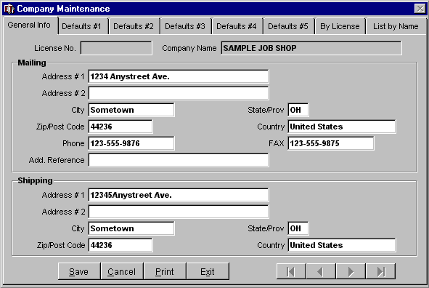

LICENSE NO. AND COMPANY NAME
Automatically populated from the initial installation of the software package.

Mailing
ADDRESS #1, #2
The Company’s post office box or street mailing address. Two lines are available.

Field Length 35 Characters, each line

Required YES

CITY
The Company’s mailing city. Field Length 15 Characters Required YES STATE/PROV.
The Company’s mailing state or province location.
Field Length 3 Characters Required YES ZIP/POST CODE
The Company’s mailing zip code or postal code location.
Field Length 10 Characters Required YES COUNTRY
The Company’s mailing country location.

Field Length 20 Characters

Required YES

PHONE
The Company’s telephone number including area code.

Field Length 14 Characters

Required YES

FAX
The Company’s facsimile number. Field Length 14 Characters Required YES

ADD. REFERENCE
Field Length 35 Characters

Required YES

Shipping
ADDRESS #1, #2
The street address of the Company’s shipping location. Two lines are available.

Field Length 35 Characters, each line

Required YES

CITY
The city of the Company’s shipping location.
Field Length 15 Characters Required YES STATE/PROV.
The state or province of the Company’s shipping location.
Field Length 3 Characters Required YES ZIP/POST CODE
The zip or postal code of the Company’s shipping location.
Field Length 10 Characters Required YES COUNTRY
The country of the Company’s shipping location.

Field Length 20 Characters

Required YES

Defaults #1 tab

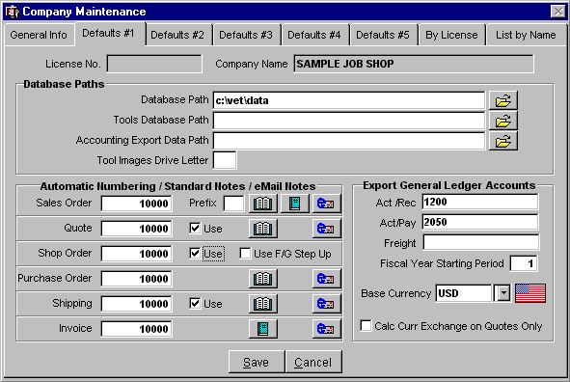

Database Paths
DATABASE PATH
Define the path to the (Server) Main Visual EstiTrack Data i.e. C:\VET\DATA or F:\VET\DATA, where
F is the drive letter of the Server.
Multiple paths can be defined as follows: C:\VET\DATA; F:\VET\DATA; D:\VET\DATA
Using the multiple database path option eliminates the need to define the Database Path in each individual User’s Table thus allowing any User to access the system from all computers.

Field Length 80 Characters

Required YES

TOOLS DATABASE PATH
Define path to The Cutting Edge Tool Catalog, if applicable. Interface no longer supported by
Henning Industrial Software. Field Length 80 Characters Required NO

ACCOUNTING EXPORT DATA PATH
Define the path for accounting interface export files. See Export documentation for details.

Field Length 80 Characters

Required Required ONLY if Using Accounting Interface.

TOOL IMAGES DRIVE LETTER
Define the drive where your tool images are stored i.e. [C:]

Field Length 1 Character

Required NO

Automatic Numbering / Standard Notes / email Notes

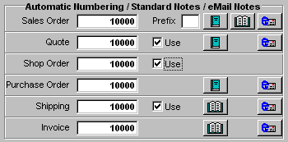

AUTOMATIC NUMBERING
When setting up Visual EstiTrack™ you will need to decide on the number that you want your records to start at for Sales Order / Quote / Shop Order / Purchase Order / Shipping / Invoice. It is recommended that the system be set up to automatically step up one number when you add a new record to Quote / Shop Order / Shipping. To do this, left-mouse click on the <Use> box in next to the number field. This check mark indicates that the step-up numbers have been activated.

Field Length 5 Characters

Required NO

PREFIX
Located next to the Sales Order numbering field, it is used to add a Prefix to a Sales Order number if requested by your customers for scanning purposes.

Field Length 2 Characters

Required NO

STANDARD NOTES
This is used to add a note that will appear on all printed Sales Orders. The closed book icon indicates that there are no notes. To add or read a note, left mouse click on the book icon. This memo field has no practical length limit.

Required NO

PROFORMA INVOICE NOTES
Double-click on this Notes icon to create a standard note that will be included with each Proforma invoice. Proforma invoices are may be created from within Sales Order Maintenance.

Required NO

Export General Ledger Accounts

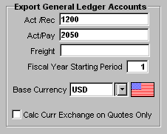

ACCOUNTS RECEIVABLE/ ACCOUNTS PAYABLE/ FREIGHT
Define Exact Number as in your Accounting Program

Field Length 20 Characters

Required Required ONLY if Using Accounting Interface

FISCAL YEAR STARTING PERIOD
Fiscal Year Starting MONTH (Not Year) for the company. E.g. January is 1, December is 12. Used in
Customer Sales & Vendor Purchases. Defaults to (1) One.

Field Length 2 Numbers

Required YES

CALC CURR EXCHANGE ON QUOTES ONLY
Click this checkbox to only apply currency exchange rates in the Quoting module. The exchange rate will be 1:1 in the Sales Order and the Invoice.

Required NO

Defaults #2 Tab

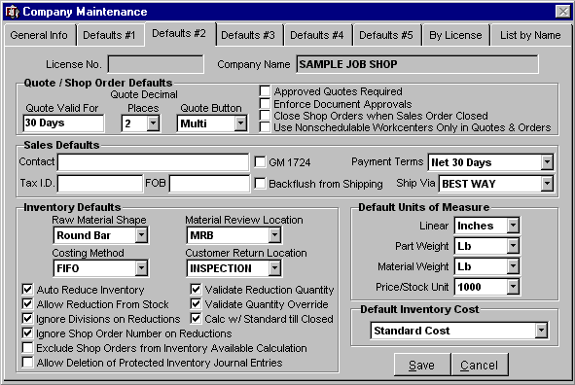

Quote / Shop Order Defaults
QUOTE VALID FOR
This information will print on your Customer Price Quotation Report in the bottom left hand corner. Enter number of days, weeks, months, etc. (i.e., 30 Days).

Field Length 10 Characters

Required NO

QUOTE DECIMAL PLACES
Select 0, 2, 3, or 4 from the drop-down options attached to the field hand corner. Quote amounts will be rounded to the selected decimal place.

Field Length 1 Character

Required NO

APPROVED QUOTES REQUIRED FOR ORDERS
This is a security check to make sure that no one enters an Order based on a Quote without it first being approved. Quote Status must be “Approve” to create an Order if check box is activated.

Required NO

ENFORCE DOCUMENT APPROVALS
Click this checkbox to prevent a quotation from being saved without the proper document approval.

Required NO

CLOSE SHOP ORDERS WHEN SALES ORDER CLOSED
Activate this checkbox to automatically close shop orders when the originating sales order is closed.

Required NO

USE NONSCHEDULABLE WORKCENTERS ONLY IN QUOTES
Activate check box to use nonschedulable workcenters when creating Quotation.

Required NO Sales Defaults CONTACT
Person in your company to be contacted by your customers & suppliers. This will auto-populate into
Quotations, Purchase Orders, etc Field Length 20 Characters Required NO

TAX ID
Enter your company’s Tax I. D. here. It automatically prints on Invoices. To be used by Canadian
Customers ONLY. This feature is not needed in the U.S.
Canadian Customers: Use DacEasy Invoice Format when printing Invoices. This will print your tax I. D. in the center of the bottom of the page of your invoice.

Field Length 15 Characters

Required Required ONLY if company is located in Canada.

FOB
Company's Freight On Board location for shipping, typically entered as City, State. This will auto- populate into Quotations. This is a time saving feature.

Field Length 15 Characters

Required NO

GM 1724
Click this button to allow printing of the GM 1724 bar-coded label from the Sales Order Line Item
Detail screen.

Required NO

BACKFLUSH FROM SHIPPING
Click this button to allow the shipping of a Finished Good Inventory item to automatically reduce the amount of that Finished Good, as well as the appropriate amounts of subassemblies. It is necessary for the Finished Good item to have a Product Structure (BOM) and a Sales Order allocation record.

Required NO

PAYMENT TERMS
Default Payment terms for your Company. Select from the drop-down options attached to the field. This will auto-populate into Purchase Order Maintenance. Payment Terms Table is located in the Tables drop down menu.

Required NO

SHIP VIA
Carrier that will be used by your suppliers to ship materials to you. Select from the drop-down options attached to the field. This will auto-populate into Purchase Orders. This is a time saving feature. Payment Terms Table is located in the Tables drop down menu.

Required NO

Inventory Defaults

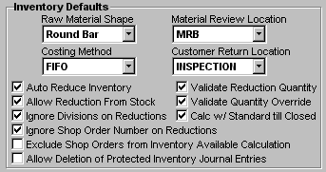

RAW MATERIAL SHAPE
This is used to select the most common material used by your company. This can be over-ridden at anytime. This is a time saving feature!
Raw Material Shape is selected from the drop-down options attached to this field.

Required NO

COSTING METHOD
Costing method is selected from the drop-down options attached to this field.
FIFO (First In First Out)
Inventory Journal & cost tiers will be available for use.
LIFO (Last In First Out)
Inventory Journal & cost tiers will be available for use.
Average
Inventory Journal & cost tiers will NOT be available for use.
Standard
Inventory Journal & cost tiers will NOT be available for use.

Required YES

MATERIAL REVIEW LOCATION
Inventory Location for material to be reviewed. Used in Job Card Maintenance – Review Quantity Field. If a default location is specified, the system will automatically move the Review Quantity to this location. Location is selected from the drop-down options attached to this field. This is a time saving feature.

Required NO

CUSTOMER RETURN LOCATION
Inventory Location that is updated when a customer returns product and items are qualified as returned in Receiving Maintenance or Invoice Maintenance If a default location is specified, the system will automatically move the Returned Quantity to this location. Location is selected from the drop-down options attached to this field. This is a time saving feature.

Required NO

AUTO REDUCE INVENTORY - RECOMMENDED
Activate this checkbox to auto-calculate raw material usage in Job Card Maintenance & Remote Time
Entry, Job Information. When you have the following conditions met:
1) Raw Material is defined in the shop order and the raw material is available
2) Allocation Records have been created to define the rate of consumption of the raw material either from
a. Quote b. BOM
c. Manually entered values
3) This check box is on
The system will automatically reduce inventory based on the number of parts produced as entered on the Job Card screen. This will also work for WIP if the Default Inventory entries have been made on the Operation screen in the Shop Order.

Required NO

ALLOW REDUCTION FROM STOCK - RECOMMENDED
Inventory Lots can either be associated with a specific Shop Order or considered general stock that has no Shop Order associated with it. The system first looks for a lot with the same Shop Order to pull from. If that is not found, then this option kicks in. If you have this checked, it will use the LIFO/FIFO rules to pull from the appropriate Stock lot for that raw material. This is helpful if you want to control the materials that go in and out of each Shop Order so you know the specific metallurgy etc. Leave it off if you want each shop order to have specific lots assigned to them for processing.

Required YES – Must activate check box if NOT defining Shop Order Numbers for Material.

IGNORE DIVISIONS ON REDUCTIONS - RECOMMENDED
Activating this checkbox will allow the system to reduce inventory regardless of which Company
Division it is attached to.

Required NO

VALIDATE REDUCTION QUANTITY - RECOMMENDED
If checkbox is activated, system will NOT allow shipment if Shipment Quantity is more than the
Quantity Ordered.

Required NO

VALIDATE QUANTITY OVERRIDE - RECOMMENDED
If checkbox is activated, the system will ask if you wish to overship on the ordered quantity. Use with
Validate Reduction Quantity Check Box

Required NO

CALC W/STANDARD TILL CLOSED - RECOMMENDED
Activate this checkbox to value Finished Goods and WIP inventory lots using the item’s Standard Cost, defined within Inventory Maintenance, until the Shop Order is closed. Upon closing the order, the accumulated actual cost from the order will be used to value the inventory lot.

Required NO

IGNORE SHOP ORDER NUMBER ON REDUCTIONS
Activating this checkbox will allow the system to reduce inventory regardless of which Shop Order number it is attached to.

Required NO

EXCLUDE SHOP ORDERS FROM INVENTORY AVAILABLE CALCULATION
Activating this checkbox will cause the system to disregard from its count, any inventory that has been reserved for a Shop Order.

Required NO

ALLOW DELETION OF PROTECTED INVENTORY JOURNAL ENTRIES
If an Inventory Journal entry has been created automatically by the system, it is protected. In order to delete the entry, it is necessary to delete the source of the entry first. For example, if raw material is consumed through a Job Card, thus creating a “Used in Production” journal entry, the Job Card must first be deleted before the corresponding journal entry may be deleted. Activate this checkbox to bypass this safeguard and allow deletion of the journal entry from within the Inventory Journal. Deleting a journal entry in this fashion will NOT affect the source of the entry.

Required NO

Default Units of Measure

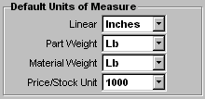

LINEAR / PART WEIGHT / MATERIAL WEIGHT / PRICE PER STOCK UNIT
Select the appropriate units from the drop-down options attached to each field. These will auto- populate the chosen Units of Measure into Quotation Maintenance. This is a time saving feature. NOTE: Price per Stock Unit may be user defined in the Price Units Table.

Required NO

Default Inventory Cost

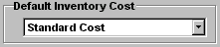

The User may choose between Standard, Average or Last and the appropriate value will then be defaulted into the Material Item Definition screen within the Quoting module.

Note ~ Right-click within the field to clear the contents. If the field is blank, then no cost will be defaulted into the Material Item Definition screen.

Defaults #3 Tab

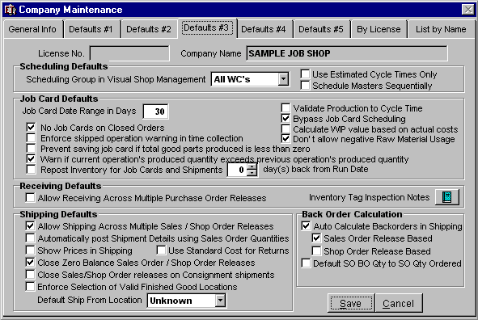

Scheduling Defaults
SCHEDULING GROUP IN VISUAL SHOP MANAGEMENT
Select from the drop-down options attached to the field. If defined, the default-scheduling group will be shown upon entering Visual Shop Management. Used as a filter in Visual Shop Management.

Required NO

USE ESTIMATED CYCLE TIMES ONLY
Activate if you ALWAYS schedule based on Net Estimated Cycle times rather than actual cycle times. Actual time is calculated when a Job Card is added. Once selected, scheduling based on Net Estimated Cycle times CANNOT be overridden.

Required NO

SCHEDULE MASTERS SEQUENTIALLY
Masters are special operation types that have one or more true operations associated with it. By default, if you have one or more masters with associated operations in a shop order they are scheduled in parallel. This overrides the behavior and schedules them sequentially (one after the other).

Required NO

Job Card Defaults

JOB CARD DATE RANGE IN DAYS FIELD – RECOMMENDED 30 DAYS
Number of days before or after the present day for which the user is allowed to enter Job Cards against. Used in Job Card Maintenance.
Example:
If “30” is entered, then the user may enter job cards for days within 30 days before or after the present date. This helps to eliminate incorrect dates (i.e., wrong year) from being entered.

Required NO

NO JOB CARDS ON CLOSED ORDERS - RECOMMENDED
Activating checkbox disallows job cards to be created for Shop Orders that have been closed.

Required NO

ENFORCE SKIPPED OPERATION WARNING/OVERRIDE IN TIME COLLECTION
Activating this checkbox will cause a warning window to pop-up, stating that no parts have been produced for a previous operation and will not let the employee proceed unless an override password is provided.

Required NO

PREVENT SAVING JOB CARD IF TOTAL GOOD PARTS PRODUCED ARE LESS THAN ZERO
Activating this checkbox will cause a warning window to pop-up stating that the total good parts produced are less than zero. The user will be prevented from saving the job card.

Required NO

WARN IF CURRENT OPERATION’S PRODUCED QUANTITY EXCEEDS PREVIOUS
OPERATION’S PRODUCED QUANTITY - RECOMMENDED
Activating this checkbox will cause a warning window to pop-up stating that the current operation’s production exceeds previous operation’s production. NOTE: The user will still be able to save the job card.

Required NO

REPOST INVENTORY FOR JOB CARDS AND SHIPMENTS __ DAY(S) BACK FROM RUN DATE
Activating this checkbox allows the system to repost production and shipping records, in sequential order, for the specified number of days. It is recommended that this option be used when job cards and shipments that affect inventory may be posted out of sequence, resulting in inventory quantity errors (i.e. parts are shipped prior to posting the job card that produces them).

Required NO

Note ~ This feature was used heavily prior to Negative Inventory Lots being incorporated into the software.
It is unnecessary to use this feature beyond revision 5.79.

VALIDATE PRODUCTION TO CYCLE TIME
Activating checkbox will prevent Actual Gross Pieces Per Hour derived from the Job Card information from exceeding the Estimated Gross Pieces per Hour defined within the Shop Order Maintenance - Operations Tab.

Required NO

BYPASS JOB CARD SCHEDULING OPTION - RECOMMENDED
Activate this option to speed up the Job Card Entry “Save” function. This will bypass re-scheduling all machines at the “Save” Job Card function and re-schedule the one machine only.

Required NO

CALCULATE WIP VALUE BASED ON ACTUAL COSTS
Click this checkbox to value the individual lots of WIP-type inventory items using the actual costs from the Shop Order that created these lots.

Required NO

DON’T ALLOW NEGATIVE RAW MATERIAL USAGE
Click this checkbox to cause an alert to pop up indicating that no raw material is currently available to satisfy the immediate demand. The User may override the alert and create a negative lot at this point.

Required NO

Shipping Defaults
ALLOW SHIPPING ACROSS MULTIPLE SALES / SHOP RELEASES - RECOMMENDED
Activating checkbox applies shipment quantity towards ALL “Open” releases.
Example:
Shipment Quantity is 150 pcs.
The order quantity for release #1 is 100 pieces.
The system will apply 100 pieces towards Release #1 and 50 pieces towards Release #2. Over-shipment will be applied towards last open release.
If the checkbox is left unchecked, then the system will apply the shipment quantity towards first
“Open” release ONLY.

Required NO

AUTOMATICALLY POST SHIPMENT DETAILS USING SALES ORDER QUANTITIES
Click this checkbox to cause the system to automatically populate fields in the Shipping Item Detail with information from the Sales Order.

Required NO

SHOW PRICES IN SHIPPING
Click this checkbox to cause product prices to appear on the Packing List.

Required NO

USE STANDARD COST FOR RETURNS
Clicking this checkbox will cause the system to use the Standard Cost instead of the Average Cost for an Inventory item being returned.

Required NO

CLOSE ZERO BALANCE SALES ORDER / SHOP ORDER RELEASES - RECOMMENDED
Activating this option will result in the status of individual Sales Order or Shop Order releases automatically changing to “closed” once the balance of the release has been shipped.

Required NO

CLOSE SALES/SHOP ORDER RELEASES ON CONSIGNMENT SHIPMENTS
Click this checkbox to cause the system to automatically close the appropriate Sales Order or Shop
Order releases for Shipments of type – Consignment.

Required NO

ENFORCE SELECTION OF VALID FINISHED GOOD LOCATIONS
Click this checkbox to restrict the User from choosing “Ship From” locations in the Shipping Item
Detail that do not allow shipping. Required NO

DEFAULT SHIP FROM LOCATION
Choose a location from the drop-down listing as your company’s default “Ship From” location. This will appear in the Shipping Item Detail.

Required NO

Back Order Calculation
AUTO-CALCULATE BACKORDERS IN SHIPPING – RECOMMENDED
Activating this option allows a backorder quantity to be auto-populated into the Back Ordered field of
Shipping Maintenance once a Current Qty Shipping has been entered.

Required NO

Sales Order Released Based – Recommended
If checked, the calculated backorder quantity will be determined from the quantities within the Sales Order releases.
Required NO

Shop Order Release Based
If checked, the calculated backorder quantity will be determined from the quantities within the Shop Order releases, unless there are related Sales Order releases. In which case, the Sales Order release quantities will take precedence.
Required NO

Default SO BO Qty to SO Qty Ordered
Activate this option to force the Back Ordered quantity within the Sales Order Detail – Update Mode screen to reflect the Quantity Ordered.

Required NO

Defaults #4 Tab

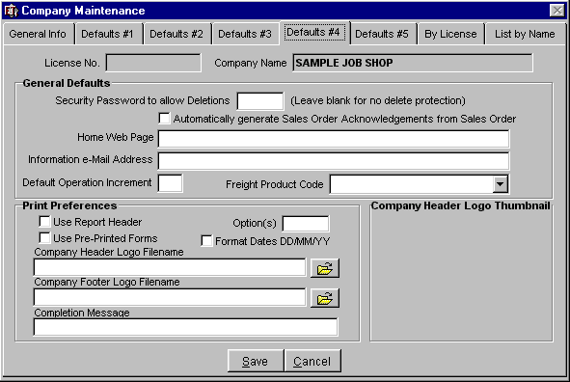

General Defaults
SECURITY PASSWORD TO ALLOW DELETIONS
Enter a password if you want only selected personnel to have access to delete records. Leave blank if delete protection is not wanted.

Required NO

AUTOMATICALLY GENERATE SALES ORDER ACKNOWLEDGEMENTS FROM SALES ORDER
Activate this checkbox to automatically prompt with Report Criteria for Sales Order Acknowledgment upon saving a Sales Order.

Required NO

HOME WEB PAGE
The following two fields are used only in our WEBTRACK software (which is in the process of being re-engineered.)

Required NO

INFORMATION E-MAIL ADDRESS
The following two fields are used only in our WEBTRACK software (which is in the process of being re-engineered.)

Required NO

DEFAULT OPERATION INCREMENT
The user may define a default increment for operation numbers in Quotes and Shop Orders. If left blank, the default increment is 1.

Required NO

FREIGHT PRODUCT CODE – RECOMMENDED, “FREIGHT”
Set the default freight product code that will be used to track and report freight transactions. NOTE: Product codes are defined in the Product Codes table.

Required NO Print Preferences USE REPORT HEADER
Activate this checkbox to print your Company Name, Address, and Phone/Fax in upper left corner of reports.

USE PRE-PRINTED FORMS
This will NOT print graphics.
(If you change your checkbox and then print an Invoice, you will see the difference.)

NOTE: Both boxes (Use Report Header & Use Pre-Printed Forms) Checked at the same time will print Company Name, address, and phone/fax in the upper left corner & will Not Print Graphics.

OPTION(S)
Custom Reports Option: For information on custom reports, please contact Henning Industrial
Software, Inc. at 330-650-4212 or 330-650-1713.

Required NO

COMPANY LOGO FILENAME
Define the path to where your Company logo is stored, i.e. C:\LOGO.BMP
Suggestion: If using peer-to-peer networking, place Company logo file on each workstation’s
\VETUSER subdirectory. E.g.: C:\VETUSER\LOGO.BMP

Required NO

COMPANY FOOTER LOGO FILENAME
Define the path to where your Company footer logo is stored, i.e. C:\FOOTLOGO.BMP
Suggestion: If using peer-to-peer networking, place Company logo file on each workstation’s
\VETUSER subdirectory. E.g.: C:\VETUSER\FOOTLOGO.BMP

Required NO

Defaults #5 Tab

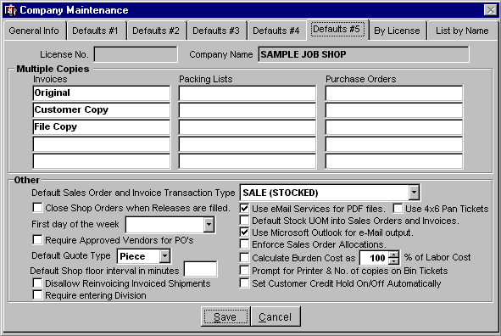

MULTIPLE COPIES
In the tradition of carbon copies, up to five copies may be specified for Invoices, Packing Lists, and Purchase Orders. Enter the recipient in the blank spaces provided to automatically generate the appropriate copies upon printing the document. If the fields are left blank, no additional copies will be printed.

Required NO

DEFAULT SALES ORDER AND INVOICE TRANSACTION TYPE – RECOMMENDED, SA
Select a default transaction type from the drop-down list attached to the field. If no transaction type is defined then the system will default to the first transaction type in the list.

Required NO

CLOSE SHOP ORDERS WHEN RELEASES ARE FILLED
Activate this checkbox to automatically close a given Shop Order when all of its individual releases have been shipped and satisfied.

Required NO

FIRST DAY OF THE WEEK
Specify the first day of the work week.

Required NO

REQUIRE APPROVED VENDORS FOR PO’S
Activate this checkbox to allow only Vendors that have a status of “Approved” to be used when creating a Purchase Order. Vendor status is set within Vendor Maintenance.

Required NO

DEFAULT QUOTE TYPE – RECOMMENDED, PIECE
EstiTrack supports job estimating for lot-based jobs as well as jobs valued per-piece of finished product

Required NO

DEFAULT SHOP FLOOR INTERVAL IN MINUTES
Select the time interval, in minutes, in which the Shop Floor will automatically refresh its data. If left blank, the interval will default to 5 minutes.

Field Length 3 Characters

Required NO

DISALLOW REINVOICING INVOICED SHIPMENTS
Activate this checkbox to prevent the user from invoicing a shipment that has already been invoiced.

Required NO

REQUIRE ENTERING DIVISION
Click this checkbox to require the entering of a Division on the Quote.

Required NO

USE EMAIL SERVICES FOR PDF FILES - RECOMMENDED
This option evokes the email screen after a PDF file has been created from selecting to email a report
(e.g., Sales Order Acknowledgement).

Required NO

DEFAULT STOCK UOM INTO SALES ORDERS AND INVOICES
This causes the system to default an inventory items stock uom into a sales order or invoice line item when a inventory number is entered. Otherwise, the unit type is “1”.

Required NO

USE 4 X 6 PAN TICKETS
Click this checkbox to use 4” x 6” pan tickets instead of 4” x 8”.

Required NO

USE MICROSOFT OUTLOOK FOR E-MAIL OUTPUT
This tells the system to use OUTLOOK code to send email from VET.

Required NO

ENFORCE SALES ORDER ALLOCATIONS
When checked - upon opening a Sales Order line item and then saving, the system will prompt the user with a message: "You may have changed line items that effects the allocation of materials. Do you want to allocate now?" The user is also provided with Yes/No buttons to select allocation option.

Required NO

CALCULATE BURDEN COST AS __% OF LABOR COST
Activate this checkbox to calculate the Burden costs associated with an operation as a predefined percentage of the corresponding Labor costs. This option bypasses the hourly burden rates that have been defined within the individual Workcenter.

Field Range 0 to 999

Required NO

PROMPT FOR PRINTER & NO. OF COPIES ON BIN TICKETS
Activate this checkbox to prompt the user, when printing Bin Tickets, to choose which printer to output to and how many copies of the ticket to print. When printing is initiated from the Remote Time Entry module, prior to creating and saving a Job Card, the ticket will not have a barcode in its header or quantities defined in any of the available production fields.

Required NO

SET CUSTOMER CREDIT HOLD ON/OFF AUTOMATICALLY
Click this checkbox to allow the system to place the Customer on Credit Hold based on the Credit
Limit defined within Customer Maintenance and the payments received.

Required NO

By License / List By Name tab

BY LICENSE TAB / LIST BY NAME TAB
Search list by License number or Company Name. This is useful for multiple Company accounts.

USERS TABLE • USER INFORMATION TAB

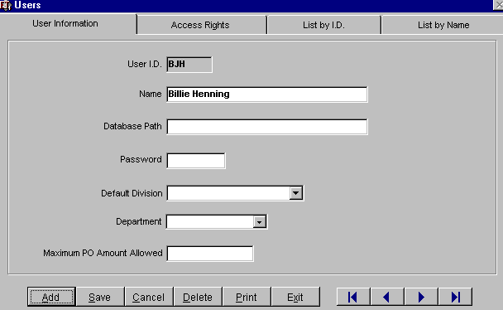

USER I.D.
Define Unique Characters to identify a User for Entry into Visual EstiTrack. Field Length 5 Characters

Required YES

USER NAME

Define User Name

Field Length 30 Characters

Required YES

DATABASE PATH
Define drive & path to the Main System (server) Data i.e. c:\vet\data or F:\vet\data (Not required if the Database Path is the same as the Company Table Database Path)

Required NO / Not required if the Database Path is the same as the Company Table Database
Path

USERS TABLE • USER INFORMATION TAB

PASSWORD

Define unique password

Field Length 5 Characters

Required YES

DEFAULT DIVISION

Select Division User works out of. Used in Visual Shop Management Only as a filter.

DEPARTMENT

Select Department user works in. Used in Visual Shop Management Only as a filter

Required NO

MAXIMUM P.O. AMOUNT ALLOWED
Define the maximum dollar amount the User is authorized to create in Purchase Order Maintenance. i.e., 10000.00

Required NO

USERS TABLE • ACCESS RIGHTS TAB

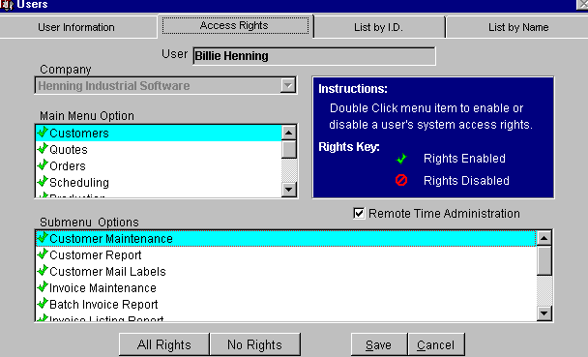

ACCESS RIGHTS MAIN MENU OPTION

Double Click & Highlight the Modules for Access
This will automatically define all submenu options for each Main Menu Option. Required YES

ACCESS RIGHTS SUBMENU OPTIONS
Double Click to Check or Un-check Rights. Required YES

ALL RIGHTS BUTTON

This will Auto-Populate all Main Menu & Submenu Options

NO RIGHTS BUTTON

This will delete all access.

LIST BY I.D./NAME SEARCH TAB

Search to update records

Highlight Name/I.D.

Click <Update Selected Item> or Double Click User

EMPLOYEES TABLE • DATA TAB

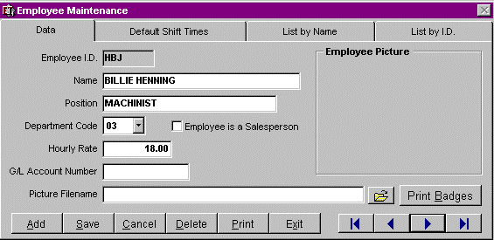

EMPLOYEE I.D.
Click <Add> button to create new Employee to tables. Define unique characters identifying the employee for Job Cards & Time Cards.

Field Length 5 Characters

Required YES

EMPLOYEE NAME

Define Employee Name

Field Length 20 Characters

Required YES

POSITION

Define Employee Position

Field Length 20

Required NO

DEPARTMENT CODE

Used in Visual EstiTrack Production Reports and also select Payroll Software Systems

Field Length 2 Characters

Required NO

EMPLOYEE IS A SALESPERSON - CHECK BOX

This will add Employee to Salesperson Pick Lists in Quotation Maintenance, Customer Maintenance
& Shop Order Maintenance. Enter this information even if Sales person is not an employee.

HOURLY RATE
Define Employee Hourly Rate Required for Work In Process Calculations. Employee Hourly Rate is captured in Job Card
Maintenance & Remote Time Entry Job Card entry.

Required NO

G/L ACCOUNT
NUMBER
Define Exact Payroll General Ledger Account Number if using Payroll Accounting Interface. Field Length 10
Characters

Required NO

PICTURE FILENAME

Scan Employee photo & save as BMP file / type File name (data path) / Not Required Do not save in
VET Subdirectory (This takes up too much memory.) i.e. C:\emp\blh.bmp

PRINT BADGES BUTTON

This will print
Employee badge with bar-coded employee name and picture.

PRINT BUTTON

Click the Print button at the bottom of the screen to print an Employee Listing Report. (This will print all employees)
Activate the “Include Bar Codes” check box to print barcode Identification Cards.

EMPLOYEE TABLE • DEFAULT SHIFT TIMES TAB

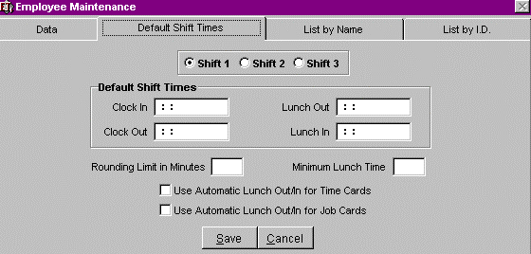

SHIFT

Select correct shift per employee. Used to determine Automatic Rounding Minutes and Lunch
Deductions. Required NO

CLOCK IN/OUT, LUNCH IN/OUT

Define Shift Time, System automatically defaults to Company Default Shift Time. Not necessary at
Employee level, unless different from Company Default Time

Required NO

ROUNDING LIMIT IN MINUTES

Define minutes to Round Clock In/Out & Lunch In/Out, Example: If Joe clocks in 15 minutes early at
5:15 every day but does not start work until 5:30, enter 15 in the field and the Remote Time Entry will automatically round his Clock In time to 5:30. System automatically defaults to Company Default Rounding Limit. Not necessary at Employee level, unless different from Company Default Time Required NO

MINIMUM LUNCH TIME
Define minutes for LunchTime, System automatically defaults to Company Default Shift Time. Not necessary at Employee level, unless different from Company Default Time

Required NO

EMPLOYEE TABLE • DEFAULT SHIFT TIMES TAB

USE AUTOMATIC LUNCH OUT/IN FOR TIME CARDS

Yes / No
Check box will automatically clock employee Out/In from time card. Time Saver. Required NO

USE AUTOMATIC LUNCH OUT/IN FOR JOB CARDS
Yes – Check box to activate.

Check box will automatically clock employee Out/In from Job Card. Time Saver.
No – Check box NOT activated. The system will not automatically deduct time for Lunch. Required NO

LIST BY I.D./NAME SEARCH

Search to update records, Highlight Name/I.D. click <Update Selected Item> or Double Click
Name/I.D.

DIVISION TABLE • DATA TAB

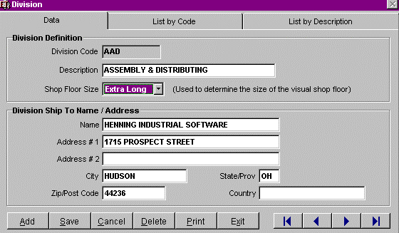

DIVISION TABLE PURPOSE
The purpose for Division is to allow large companies to maintain the same database for multiple divisions.
Note ~ If you are using Divisions then you must define the Division in each Shop Order, Sales Order, Shipping, and Inventory Locations.

DIVISION DEFINITION

DIVISION CODE
Define Company Division unique Code. Required YES

DESCRIPTION
Define Company Division Description if applicable. Required YES

SHOP FLOOR SIZE
Used to determine the size of the Visual Shop Floor. (Visual Shop Management) Required YES

DIVISION TABLE • DATA TAB

DIVISION SHIP TO NAME / ADDRESS

Define Division Ship to Name / Address

Used in Purchase Order Maintenance. This will override Company Ship To Address defined in
Company Table. Required NO

NAME
Define Division Company Name Field Length 30 Characters Required YES

ADDRESS # 1
Define Street or PO Box Address Field Length 35 Characters Required YES

ADDRESS # 2
Define Street or PO Box Address Field Length 35 Characters Required NO

CITY
City location of division company. Required YES

DIVISION TABLE • DATA TAB

STATE / PROV
State or Province location of division company. Required YES

ZIP / POSTCODE
Zip Code or Postal Code for division company. Field Length 10 Characters

Required YES

COUNTRY
Country location of division company. Required NO

LIST BY CODE / DESCRIPTION SEARCH TAB

Search to update records, Highlight Code or Description. click <Update Selected Item> or Double
Click Code or Description.

DEPARTMENTS TABLE • DETAIL TAB

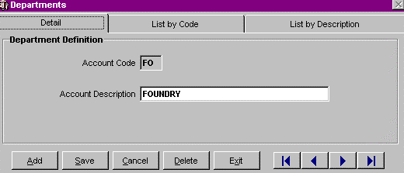

Departments are NOT required but are used in filtering Visual Shop Floor for viewing.

ACCOUNT CODE

Define Department Code. Used in Workcenters Table and Employee Table.

ACCOUNT DESCRIPTION

Define Department Description

LIST BY CODE / DESCRIPTION SEARCH TAB

Search to update records, Highlight Code or Description. Click <Update Selected Item> or Double
Click Code or Description.

SCHEDULING GROUPS TABLE • DATA TAB

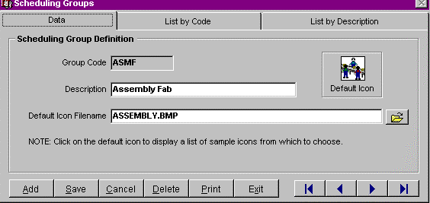

GROUP CODE

Define a unique character Scheduling Group Code. Must Define for Automatic Priority
Scheduling to work. Used in Drag & Drop Scheduling as a filter Only. Field Length 10 Characters (Alpha/Numeric Only)

Required YES

DESCRIPTION
Define a unique character Scheduling Group Code. Must Define for Automatic Priority Scheduling to work. Used in Drag & Drop Scheduling as a filter Only. (Drop down list)

Field Length 30 Characters

Required YES

DEFAULT ICON FILENAME
Click on the default icon to bring up a selection of soft cut icons that may be used. Field Length 30 Characters

Required NO

LIST BY CODE/DESCRIPTION TAB

This is used as a search to update, Click <Add> button to Add a Scheduling Group Record

WORKCENTERS TABLE • DATA TAB

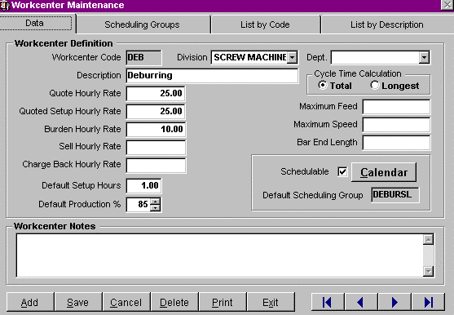

WORKCENTER CODE FIELD
MUST Define Unique characters for each Machine/Workcenter, Used in Quotation Maintenance & Operation Scheduling
Field Length 5 Characters (Alpha/Numeric Only) Required YES

DIVISION FIELD
Define division Workcenter is located. Used in Visual Shop Management Only. Field Length 20 Characters

Required Yes

DEPT. FIELD
Define the department the Workcenter is located in. Field Length 20 Characters

Required NO

DESCRIPTION FIELD
Define Workcenter Description Field Length 20 Characters Required Yes

WORKCENTERS TABLE • DATA TAB

QUOTE HOURLY RATE FIELD

Define the anticipated direct labor hourly rate plus the burden rate per hour for production.
Quote Hourly Rate will auto-populate in Quotation Maintenance and Shop Order Maintenance when the Workcenter is defined for quoting and/or defining operations.

Field Length 5 Characters

Required NO
Note ~ This should not include markup for quoting purposes. Markup can be defined in the Final
Worksheet of Quotation Maintenance.

If you prefer to markup the Quote Hourly Rate field then do not use the markup in the Final Worksheet of
Quotation Maintenance.

QUOTE SET-UP HOURLY RATE FIELD

Define the anticipated direct labor hourly rate plus the burden rate per hour for set up of the
Workcenter if applicable.
Quote Setup Hourly Rate will auto-populate in Quotation Maintenance and Shop Order Maintenance when the Workcenter is defined for quoting and/or defining operations.

Field Length 5 Characters

Required NO

Note ~ This should not include markup for quoting purposes. Markup can be defined in the Final
Worksheet of Quotation Maintenance.

If you prefer to markup the Quote Hourly Rate field then do not use the markup in the Final
Worksheet of Quotation Maintenance.

WORKCENTERS TABLE• DATA TAB

BURDEN HOURLY RATE FIELD

The burden cost per hour should not include direct Labor Costs.

This burden rate will be used in Work In Process by Multiplying the Employee Labor Hours with the
Burden Hourly Rate to determine the Burden Costs for Work In Process. If you base your Burden Rate on labor cost percentage - Leave Blank Field Length 5 Characters

Required NO

MAXIMUM FEED FIELD
Inches per Minute a cutting tool can advance. Required for Speeds & Feeds Add-On Only.

Field Length 9
Characters

Required NO

MAXIMUM SPEED
FIELD
Revolutions per Minute per cutting tool. Required for Speeds & Feeds Add-On Only.

Field Length 9
Characters

Required NO

BAR END LENGTH FIELD
Define Bar End Length for this Workcenter. This field will auto-populate in Quotation Maintenance but can be overridden at anytime.

Required NO

WORKCENTERS TABLE • DATA TAB

CYCLE TIME CALCULATIONS
Check the box to define which Tooling Cycle Time to use in scheduling. Required YES

TOTAL TOOL CYCLE
Total = Total of all cycle times. Uses the Total Cycle Times of All Tools defined in Tooling in
Shop Order
Maintenance

LONGEST TOOLING
CYCLE TIME
Longest = longest operation cycle time.
(Generally used for screw machines.)
Uses the Longest Cycle Times of All Tools defined in Tooling in Shop Order Maintenance

DEFAULT PRODUCTION %

Define default Net Production percentage.
Used in Quotation Maintenance & Shop Order Maintenance, System Defaults to 100%, Define the rate of machine performance. i.e. 90%

Field Length 3 Characters

Required NO

DEFAULT SET-UP HOURS

Define the Average Number of Set-Up hours per machine. If defined it will Auto-Populate in
Quotation Maintenance & Shop Order Maintenance per machine defined. Field Length 4 Characters

Required NO

WORKCENTERS TABLE • DATA TAB

SCHEDULABLE CHECK BOX
Activated check box allows the Workcenter to be scheduled. Used in Automatic Priority Scheduling and Drag & Drop Scheduling. The system Defaults to Yes
If check box is NOT activated the system will NOT allow the Workcenter to be scheduled.
Required YES – If scheduling Workcenter.

CALENDAR BUTTON
Click button to view Machine Load Hours Calendar, Editing allowed, Add/Update Max Load Hours - Highlight and edit Max Load Hours per Day, Suggestion: If adding Load Hours go to Utilities / Default Calendar Hours you can add hours in a few steps
for all machines. View Daily Load Hours Gantt Chart - Double Click on the Date Field

WORKCENTERS TABLE • SCHEDULING GROUPS TAB

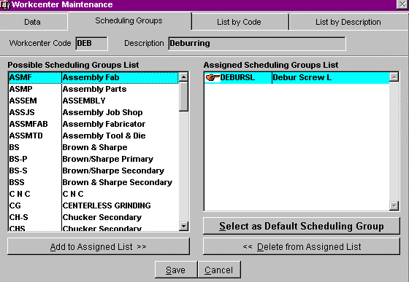

POSSIBLE SCHEDULING GROUPS LIST
Define Scheduling Group per Machine. Multiple Groups is allowed for filtering purposes. Scheduling Group is Required for ALL Workcenters if using Automatic Priority Scheduling. Highlight Scheduling Group from the left side "Possible Scheduling Groups List"

Click <Add to Assigned List> button
Highlight Default Scheduling Group desired and Click “Select as Default Scheduling Group” button. Required YES if you are using Automatic or Drag & Drop Scheduling.

ASSIGNED SCHEDULING GROUPS LIST

Will now appear on the right side "Assigned Scheduling Groups List"

ADD TO ASSIGNED LIST

Will now appear on the right side "Assigned Scheduling Groups List"

DELETE FROM ASSIGNED LIST
This will delete from the assigned list. List by Code/Description Tab

This is used as a search to update, Click <Add> button to Add a Scheduling Group Record

INVENTORY LOCATIONS TABLE • DATA TAB

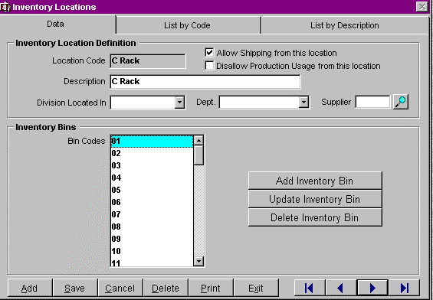

INVENTORY LOCATION DEFINITION

LOCATION CODE

Unique Code for Inventory Location

Required Yes

DESCRIPTION

Description of Inventory Location

Required Yes

DIVISION LOCATED IN

Define Division this Inventory location is located in. Used in Inventory Reports, Shipment
Maintenance, Job Card Maintenance and Receiving Maintenance.
If you define the Division in the Inventory Location, you will be REQUIRED to use the same Division in Quotes, Shop Orders, Sales Orders, Shipping Maintenance and Invoicing.

Required NO

DISALLOW PRODUCTION FROM THIS LOCATION

Generally used in Work In Process Inventory Type.

INVENTORY LOCATIONS TABLE • DATA TAB

ALLOW SHIPPING FROM THIS LOCATION

Yes – If check box is activated Shipping will be allowed from Inventory Location defined.

No – If check box is NOT activated Shipping will NOT be allowed from Inventory Location defined.

DEPT.
Define Department this Inventory Location is located in.

Required NO

SUPPLIER FIELD
Define the Supplier/Vendor Code to create a Supplier Location in Visual Shop Management ONLY.

INVENTORY BINS
Define Inventory Bins if applicable.

Required NO

BIN CODES

Define Bin Codes if applicable.

ADD INVENTORY BIN BUTTON
Used to add an Inventory Bin. First enter a New Location Code, then a description of the location, the division location, and then the department and activate the rights to ship from this location or make sure there is not a check mark in this field if you will not be shipping from this location.

DELETE INVENTORY BIN BUTTON
Left mouse click to highlight the bin you wish to delete. The system will prompt you to do you wish to delete this bin. If you select yes the information will be removed from the system all information will be lost and can not be recovered.

UPDATE INVENTORY BIN BUTTON
This option will bring up the Inventory Location Bin Screen. You may change on add information to the criteria on Code, Description or Location.

INVENTORY LOCATION BIN ADD OR UPDATE MODE

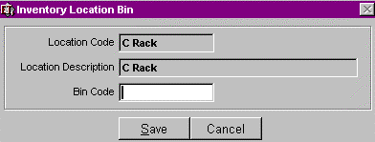

LOCATION CODE / INVENTORY BIN LOCATION

Define Unique Characters to identify the Location of the Inventory Bin.

LOCATION DESCRIPTION / INVENTORY BIN LOCATION

Description of Inventory bin location.

BIN CODE / INVENTORY BIN LOCATION

Unique Code to define Bin

INVENTORY BOX TYPE TABLE • DATA TAB

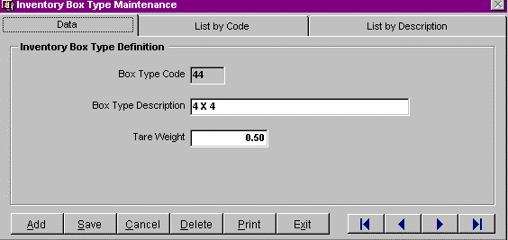

INVENTORY BOX TYPE DEFINITION

Define Inventory Box Type.

BOX TYPE CODE

Unique characters defining Inventory Box Type Code.

BOX TYPE DESCRIPTION

Define Box Description.

TARE WEIGHT

Define Tare Weight. To be used in Inventory Maintenance and tied to Shipment Maintenance.

LIST BY CODE/DESCRIPTION SEARCH TAB

This is used as a search to update, Click <Add> button to Add a New Inventory Box Type

DEFAULT CALENDAR HOURS TABLE

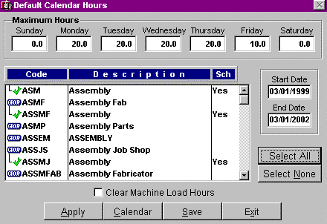

MAXIMUM HOURS
Machine Hours - Define Machine Hours Available per day (Monday - Sunday), This will auto-populate the complete Months & Years Selected, Used in Automatic Priority Scheduling and Drag & Drop Scheduling.

Required YES

START DATE / END DATE FIELD

Define Month, Day & Year to set up Calendar, Used in Scheduling

Required YES

SCREEN DISPLAY

Machine Code Description of Machine and authorization for scheduling machine

TO SCHEDULE MACHINE

Double Click on each machine to apply Load Hours (a check mark will appear to the left), Click
<Apply> button

CLEAR MACHINE LOAD HOURS BUTTON

Select Machine & Define Date Range to then select Apply button to affect desired changes.

DEFAULT CALENDAR HOURS TABLE

APPLY BUTTON
Apply button is used to apply changes to schedule calendar.

CALENDAR BUTTON
View Machine Load Hours Calendar, Highlight Machine to view, Click <Calendar> button to view Machine Load Hours Calendar

COMPANY HOLIDAY TABLE • DATA TAB

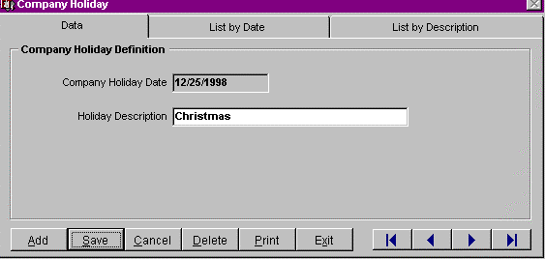

COMPANY HOLIDAY DEFINITION

COMPANY HOLIDAY DATE

Define exact Holiday Month, Day & Year, Define Company shut down time as holidays also. Used in
Automatic Priority Scheduling

Required YES

HOLIDAY DESCRIPTION

Define Holiday name, Used in Automatic Priority Scheduling

Field Length 10 Characters

Required YES

LIST BY DATE / DESCRIPTION SEARCH TAB

This is used as a search.

INVENTORY TYPES TABLE • DATA TAB

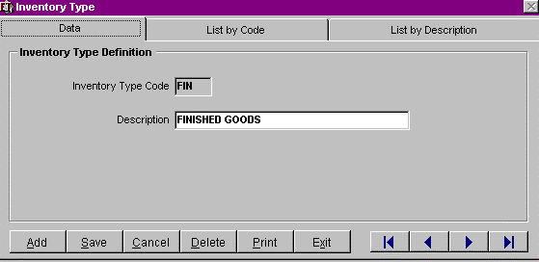

INVENTORY TYPE DEFINITION

INVENTORY TYPE CODE

Define unique characters Code
Field Length 3 Characters (Alpha/Numeric Only) Required YES

DESCRIPTION
Define Inventory Type Description Field Length 20 Characters Required YES

PRODUCT CODES TABLE

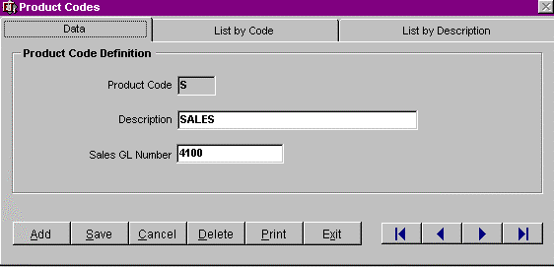

DATA TAB

PRODUCT CODE DEFINITION

PRODUCT CODE
Define unique characters Product Code. Describes products invoiced to help organize product sales for further breakdowns. Used in: Shop Order Maintenance & Invoice Maintenance

Field Length 1 Character

Required YES

DESCRIPTION
Define Product Code Description. Describes products invoiced to help organize Product Sales for further breakdowns. Used in: Shop Order Maintenance & Invoice Maintenance

Field Length 20 Characters

Required YES

G/L ACCOUNT

Define General Ledger Account Number Associated with Product Code, Used for Accounting
Interfaces Only.

Field Length 20 Characters

Required NO

DEFECT CODES TABLE • DATA TAB

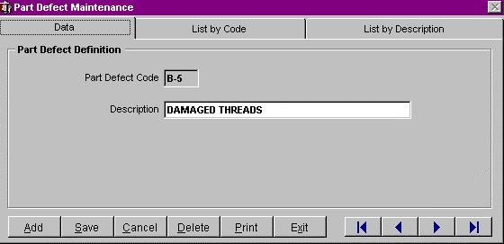

PART DEFECT DEFINITION

PART DEFECT CODE

Define Unique Characters to identify Part Defect. Used in Job Card Maintenance and Remote Time
Entry. Time Saver!

Field Length 6 Characters

Required YES

DESCRIPTION

Define a description to identify the Part Defect. Used in Job Card Maintenance and Remote Time
Entry. Time Saver!

Field Length 6 Characters

Required YES

MATERIAL TYPES TABLE • DATA TAB

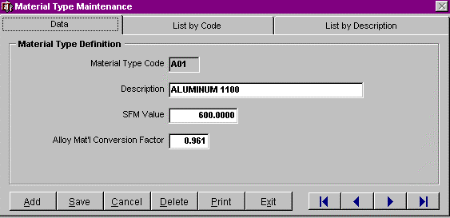

MATERIAL TYPE DEFINITION

MATERIAL TYPE CODE
Define unique characters Material Type Code, Define Material Prefix followed by 2 numbers. i.e. A02 = Aluminum 2011, B25 = Brass 360 1/2 Hard
Use Prefixes as follows: A - Aluminum

B - Copper / Brass

S - Steel

T - Tubing
These prefixes are pre-defined within Material Weight Table to determine Weight/Foot. Must be properly defined to calculate Raw Material weights in Quotation Maintenance.

Field Length 3 Characters

Required YES

DESCRIPTION
Define Material Type Description. Field Length 30 Characters Required YES

SFM VALUE
Define Surface Feet per Minute Value for each material defined. Brass, Aluminum, Steel, Tubing are pre-defined. Used in Speeds & Feeds Add-On Only.

Field Length 9 characters

Required NO

MATERIAL TYPES TABLE • DATA TAB

ALLOY MATERIAL CONVERSION FACTOR
Brass, Aluminum, Steel & Tubing are Pre-defined, Used to convert standard weight per foot to a weight appropriate for the Material Type. Use 1.00 if a material does not have a conversion factor. Required YES

LIST BY CODE / LIST BY DESCRIPTION

This is used as a search to update records.

MATERIAL WEIGHT TABLE • DATA TAB

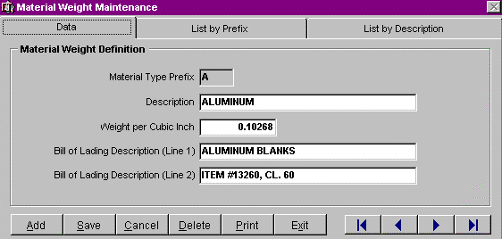

MATERIAL WEIGHT DEFINITION

MATERIAL TYPE PREFIX
Use the prefix that was predefined in Material Type Code, i.e. A02 = Aluminum 2011, B25 = Brass 360 1/2 Hard

Use Prefixes as follows:

A - Aluminum

B - Copper / Brass

S - Steel

T - Tubing
These prefixes are pre-defined defined within Material Weight Table to determine Weight/Foot. Field Length 1 Characters

Required YES

DESCRIPTION
Define Material Type Description. Field Length 30 Characters Required YES

WEIGHT PER CUBIC INCH

Define Weight per cubic inch.

MATERIAL WEIGHT TABLE • DATA TAB

BILL OF LADING DESCRIPTION (LINE 1)

Define Bill of Lading Description. i.e., ALUMINUM BLANKS

BILL OF LADING DESCRIPTION (LINE 2)

Define Bill of Lading Description Line 2. i.e., ITEM #13260, CL. 60

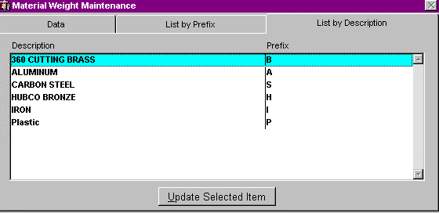

LIST BY PREFIX/DESCRIPTION SEARCH TAB

This is used as a search to update, Click <Add> button to Add a Material Weight Definition.

MACHINING CATEGORIES TABLE • DATA TAB

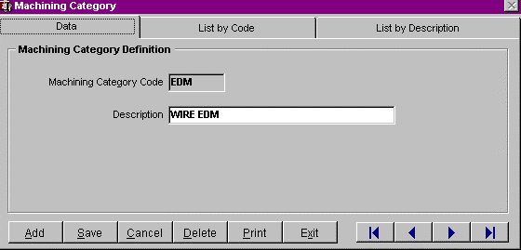

MACHINING CATEGORY DEFINITION

MACHINING CATEGORY CODE
Define Machining Category Code. i.e., DRILL Required YES

DESCRIPTION
Define Machining Category Description. i.e., DRILLING Field Length 30 Characters

Required YES

LIST BY CODE / DESCRIPTION SEARCH TAB
This is used as a search to update, Click <Add> button to Add a Material Weight Definition.

TOOL MATERIAL TYPE TABLE • DATA TAB

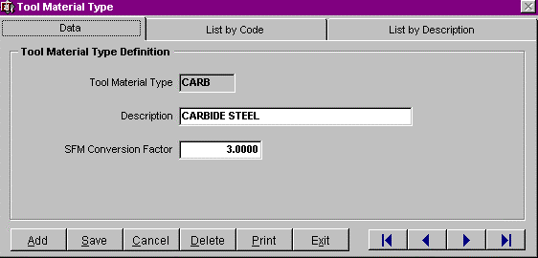

TOOL MATERIAL TYPE DEFINITION

TOOL MATERIAL TYPE
Define Tool Material Type Code. i.e., CARB Required YES

DESCRIPTION
Define Tool Material Type Description. i.e., CARBIDE STEEL Field Length 30 Characters

Required YES

SFM CONVERSION FACTOR

Define Surface Feet per Minute per Tool Material Type, Used to adjust the Base High Speed Steel
Tools SFM Value for Actual Tool Material Type used. Field Length 12 Characters

Required YES

LIST BY CODE /
DESCRIPTION SEARCH TAB
This is used as a search to update, Click <Add> button to Add a Material Weight Definition.

TOOLS TABLE • DATA TAB

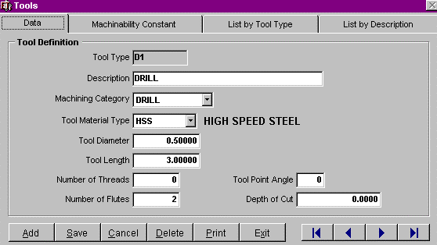

TOOLS TABLE PURPOSE

Used to maintain Tool Library for Speeds & Feeds Ad-On. Tools Table will be used in Tool Crib
Management when available.

TOOL TYPE

Define Tool Type with Unique Characters

Field Length 6 Characters

Required YES

DESCRIPTION

Define Tool Type
Description

Field Length 25
Characters

Required
YES

MACHINING CATEGORY

Define Machining Category, Drop Down List from Machining Category Table

Field Length 5 Characters

Required NO

TOOLS TABLE • DATA TAB

TOOL MATERIAL TYPE
Define Tool Material Type. Select from drop down menu from Tool Material Type Table. Field Length 5
Characters

Required NO

TOOL DIAMETER
Define Tool Cutting Edge Diameter Field Length 12 Characters Required NO

TOOL LENGTH
Define Tool Length to measure offsets

Field Length 12 Characters

Required NO

NUMBER OF THREADS

Define Number of Threads per
Tool

Field Length 8 Characters

Required NO

NUMBER OF FLUTES

Define Number of Flutes (cutting edges) per Tool

Field Length 8 Characters

Required NO

TOOL POINT ANGLE

Define the Angle of the Tool Cutting Edge, Used for Reference Only

Field Length 3 Characters

Required NO

DEPTH OF CUT

Define the Depth of Cut tool can make, Used for Reference Only

Field Length 16 Characters

Required NO

TOOLS TABLE • MACHINABILITY CONSTANT TAB

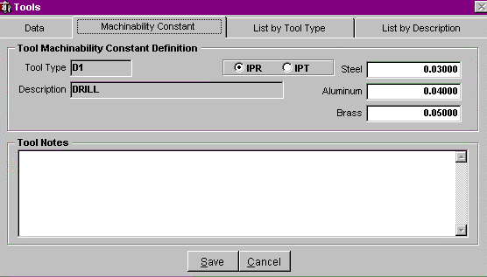

TOOL MACHINABILITY CONSTANT DEFINITION

TOOL TYPE
Define Tool Type with Unique Characters, automatically displayed from the data tab. Field Length 6 Characters

Required YES

DESCRIPTION

Define Tool Type Description, automatically displayed from the data tab.

Field Length 25 Characters

Required YES

IPR / IPT

Select which tool type the IPT (Inches per Tooth) or IPR (Inches per Revolution) for Each Material
Type field. Steel: Aluminum: Brass:

TOOL NOTES
Open Notes field. Required NO

LIST BY TOOL TYPE / DESCRIPTION SEARCH TAB

This is used as a search to update, Click <Add> button to Add a Tool Definition.

CHIP CALCULATOR SHAPES TABLE • DATA TAB

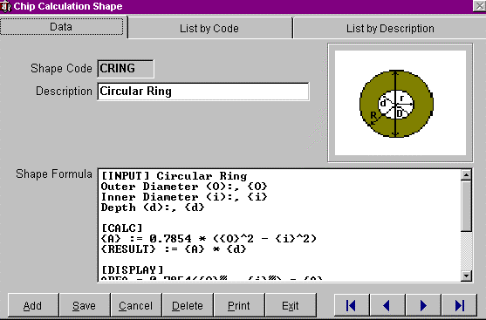

SHAPES CODE

Define Unique Characters identifying the shape of the Chip Calculation. Most are Pre-defined within
Table.

Field Length 6 Characters

Required YES

DESCRIPTION

Define description of Chip Calculator Shape Code

Field Length 30 Characters

Required YES

SHAPE FORMULA

To define your own formula, please call Henning Industrial Software for Support. 330.650.4212

Required YES

DISTRIBUTION CODES TABLE • DATA TAB

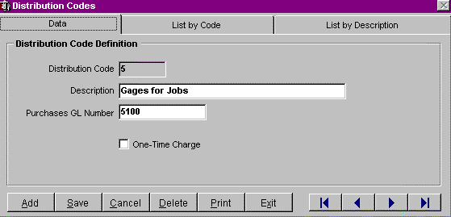

DISTRIBUTION CODES

Used to Distribute Costs from Purchase Orders. Most are Pre-defined in the Distribution Codes
Table. Reports can be printed based on Distribution Codes

Field Length 1 Character

Required YES

DISTRIBUTION DESCRIPTION
Define Distribution Code Description Filed Length 20 Characters Required YES

G/L ACCOUNT

Define General Ledger Account Number Associated with Distribution Codes. Used in Accounting
Software Interface Only

Field Length 10 Characters

Required YES if using Accounting Interface.

ONE-TIME CHARGE
Select if this item is an automatic charge to the customer if selected. Money Saver! When Invoice is created, the system will look for this Distribution Code and ask…

“Do you wish to invoice all uninvoiced one-time charges?” Yes/No

Required NO

STATUSES TABLE • DATA TAB

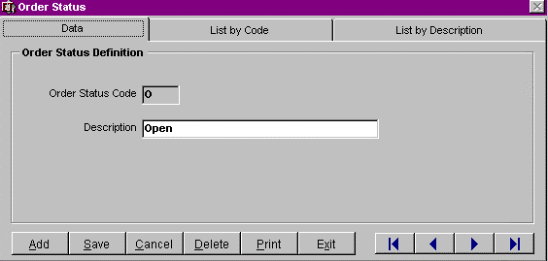

ORDER STATUS DEFINITION
Used for All Statuses (will be changing name to Status), User Defined, Open, Pending, Closed predefined. Used in Search Criteria and Automatic Priority Scheduling. e.g. Closed Shop Order Status will not appear in Automatic Priority Scheduling

ORDER STATUS CODE
Define Unique Character, Open, Pending, Closed are predefined for you. Filed Length 1 Character

Required YES

STATUS DESCRIPTION
Define Status Code Definition. Field Length 10 Characters Required YES

LIST BY CODE /
DESCRIPTION SEARCH
TAB
This is used as a search to update, Click <Add> button to Add a Distribution Code Definition.

PRICE UNITS TABLE • DATA TAB

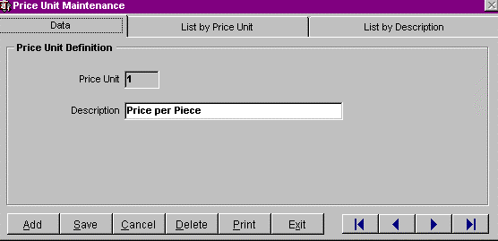

PRICE UNIT DEFINITION

User Defined i.e., Price per 1, Price per 100, Price per 1000, Price per 5000

PRICE UNIT CODE FIELD

Define Price Unit Code, User Defined i.e. 1, 100, 1000, 5000

Field Length 4 Characters

Required YES

PRICE UNIT DESCRIPTION FIELD

Define Price Unit Description per Code, i.e., Price per 1, Price per 100, Price per 1000

Field Length 20 Characters

Required YES

LIST BY PRICE UNIT /
DESCRIPTION SEARCH
TAB
This is used as a search to update, Click <Add> button to Add a Price Unit Code Definition.

PAYMENT TERMS TABLE • DETAIL TAB

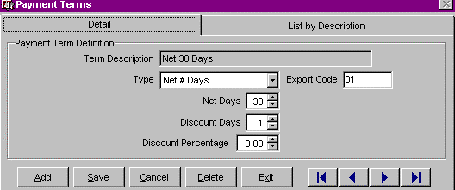

PAYMENT TERM DEFINITION

TERM DEFINITION

Define Payment Term Definition. i.e., NET 30 DAYS

TYPE

Define Type. i.e., NET # DAYS

DISCOUNT DAYS

Define Discount number of days.

Required YES

DISCOUNT PERCENTAGE

Define Discount
Percentage.

EXPORT CODE
Define Export Code if using QuickBooks Pro Accounting Interface.

LIST BY
DESCRIPTION
SEARCH TAB

This is used as a search to update, Click <Add> button to Add a Payment Code Definition.

SHIP VIA TABLE • DETAIL TAB

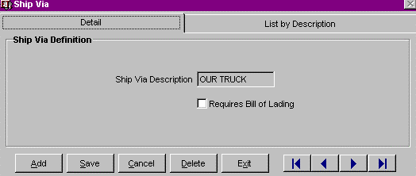

SHIP VIA DEFINITION

SHIP VIA DESCRIPTION

User Defined i.e., Price per 1, Price per 100, Price per 1000, Price per 5000

REQUIRES BILL OF LADING

Define Price Unit Code, User Defined i.e. 1, 100, 1000, 5000

Field Length 4 Characters

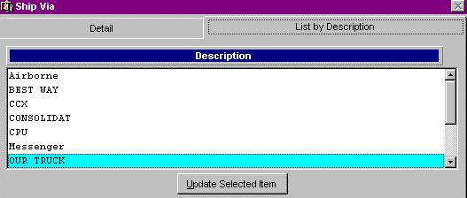

LIST BY DESCRIPTION SEARCH TAB

This is used as a search to update, Click <Add> button to Add a Ship Via Definition.

Purpose

SALES TAXES TABLE

To maintain sales tax information for items sold and purchased by your company. This information is used in Accounts Receivable or Accounts Payable to track accrued sales tax information. Contact you accountant or tax advisor to determine if this option is required to be maintained by your company.

Menu Selection
1. Click on the Tables menu.
2. Select Sales Taxes from the drop down menu.

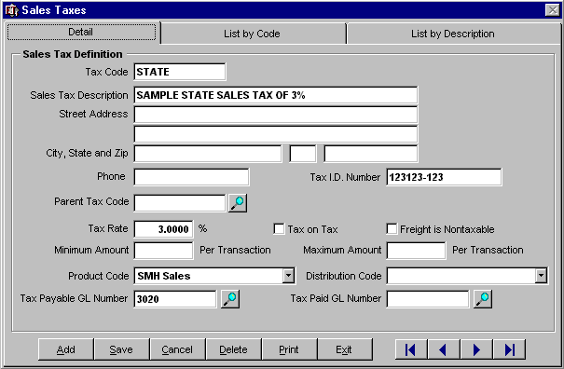

Adding Sales Taxes

ƒ Left-click on the ADD button on the Detail Tab.

ƒ Enter you company’s Sales Tax Identification number.

ƒ Enter a unique Tax Code. This code is for use internally within EstiTrack™ and Visual
Books™.

 Enter the Sales Tax Description. Example: “Ohio State Tax”.

 Enter the Address information related to payment for this state.

ƒ Define the Product Code by left clicking on the drop down menu arrow located to the right of the Product Code box. The categories within this menu have been defined in prior setup

procedures. If the Sales Tax has not been defined as a Product Code, SAVE this record. Then modify the Product Code table to include the Sales Tax. Return to the Sales Tax table and the new Product Code will be visible from the drop down choices.

ƒ The appropriate Tax Payable GL number for the chosen Product Code should be entered next. In a future revision, the appropriate account number will be defaulted into this field.

ƒ Left-click on the SAVE button to save the record.

Parent Tax Code

It is now possible to associate a Sales Tax with a Parent Tax. For example, the County Tax would list the appropriate State Tax as the Parent Tax code.

Updating Sales Taxes

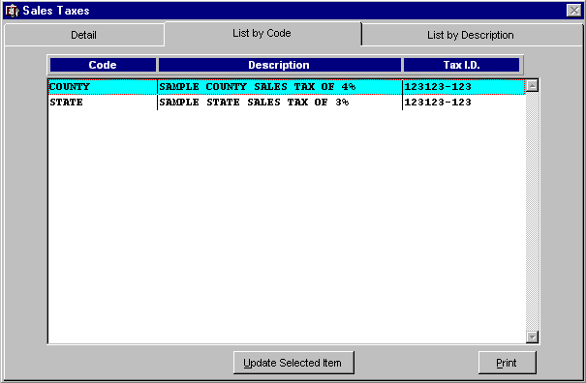

ƒ Locate the Sales Tax you want to update by scrolling through the records with the VCR buttons located at the bottom, right of the Detail Tab or use the “List by Code” or “List by Description” tabs and select the record that you wish to update.

ƒ Highlight it in the list box and choose “Update Selected Item” or double-click the left mouse button over the selection.

ƒ The Detail Tab of the selected record will be shown.

ƒ Make the necessary changes to the record.

ƒ Left-click on the SAVE button.

Deleting Sales Taxes

ƒ Left-click on the DELETE button on the Detail Tab.

ƒ The following message will appear:

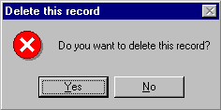

ƒ If you click the YES button, the record will be deleted.

Sales Tax Table

Sales Taxes within VET have been converted to a hierarchal structuring. The system is capable of supporting many taxes simultaneously.
The hierarchy of taxes is ADDITIVE. State Tax

+ County Tax

+ City Tax = Sales Tax

Each tax record may be given a unique code and refer back to a Parent Tax.

“Tax ID” has been renamed to “Tax Code” within the Sales Tax Table

Checkbox: Freight not Taxable

Click on this checkbox to prevent the freight charges from being taxed. This checkbox controls tax on freight. If the checkbox is left blank, then the freight tax may be controlled at the Sales Order/Invoice level.

Batch Invoice Report / Sales Order Acknowledgement Report:

Checkbox: Show Sales Tax Detail – Now breaks Sales Tax down by its hierarchy.

Customer Maintenance:

General Tab

Sales Tax 1, Sales Tax 2 have been changed from a “Combo box”, with a pull down menu of available options, to an explicit entry field with an attached Search engine.

Checkbox: Tax Exempt No. – If Customer is exempt, then click on checkbox and input the appropriate Tax Exempt Number into the provided space.

Shipping Address Tab

Sales Tax may be entered here as an override to the information in the General Tab for each
Customer Shipping Address.

Sales Order Maintenance and Invoice Maintenance

“Tax” Button

Click on the Tax button to view the customer’s Tax information defaulted in from Customer
Maintenance. This information may be overwritten within this screen.

Within the Tax button, the User may click on the Tax Exempt No. checkbox. This will cause the
Sales Order to be Tax Exempt.

Sales Order - Line Item Detail

The checkbox that read Tax Exempt now reads Non-Taxable, indicating that although this Customer does not enjoy a Tax Exempt status, this particular line item is Non-Taxable.

Sales Order - Line Item Detail / Invoice – Line Item Detail

Classification of “N”, for Non-Taxable, available in addition to “T” (Taxable) and “E” (Exempt)

Product Code Table:

Product Codes may now be designated as “Non-Taxable”

