Chapter 8A
Vendor Management
Chapter 8A Vendor Management 1
Vendor Management 2
Vendor Mainteinance 3
Retrieving an Existing Vendor 4
Quick Search 4
Deleting an Existing Vendor 5
Adding a New Vendor to the System 6
Vendor Maintenance – Address Tab 7
Vendor Maintenance – General Tab 11
Vendor Maintenance – Accounting Tab 14
Vendor Maintenance – Material Pricing 17
Vendor Default Pricing Maintenance 19
Adding a New Cost Quantity 21
Vendor Maintenance – Purchasing 22
Vendor Maintenance – Contacts 24
Adding a New Vendor Contact 26
Contact Maintenance 26
Call Specifications Tab 29
Position Tab 31
Mail Specs Tab 32
Employment Specifications Tab 33
Personal Tab 34
Emergency Tab 35
Notes Tab 36
Vendor Maintenance – Transactions 37
Vendor Maintenance – List by Code Tab 39
Vendor Maintenance – List by Name 40
Vendor Monitoring 41
Vendor Invoice Maintenance 42
Vendor Invoice/Bill Maintenance – General Tab 43
Vendor Invoice/Bill Maintenance – Line Items Tab 46
Distribution Detail Form 47
Retrieving Receipts 49
Vendor Invoice/Bill Maintenance –Transactions Tab 51
Customer / Vendor Types 52
Vendor Reports 53

Chapter
8a

Vendor Management

Visual EstiTrack’s Vendor Management Subsystem maintains and monitors Vendor activity while maintaining full data integrity with all Visual EstiTrack subsystems.

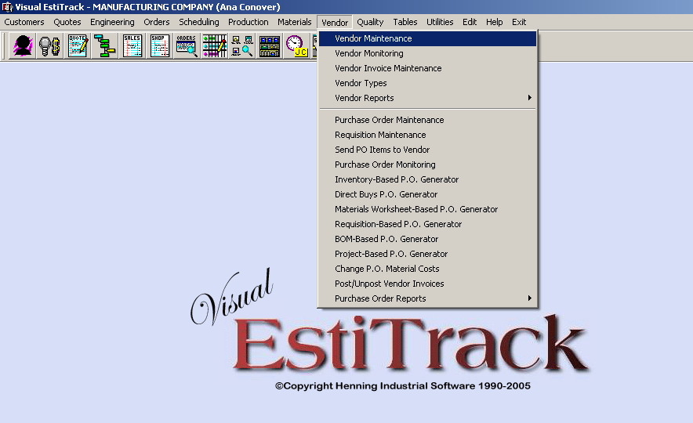
Figure 8a.1 Visual EstiTrack’s Vendor Management Menu

Vendor Mainteinance
Visual EstiTrack’s Vendor Maintenance subsystem is used to manage key Vendor definitions and configurations such as contacts, addresses, approval statuses, and credit accounts and limits. The Vendor subsystem is delineated by nine tabulations. Each tab is further outlined in the chapter below.

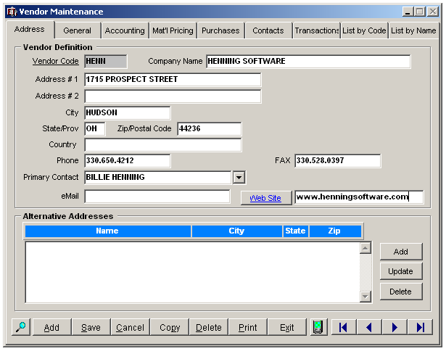
Figure 8a.2 Vendor Maintenance

Menu Selection
- Left click on the eighth menu heading labeled “Vendors”
- Select “Vendor Maintenance” from the drop down list.
Shortcut:  Quickly enter this module by left clicking on the displayed “Vendor Maintenance” icon on the toolbar.

Security
The system administrator controls access to this menu item via User access Rights (see User Table). Careful consideration should be given regarding who is authorized to manage this menu option.

Retrieving an Existing Vendor
- The pushbutton located at the bottom left corner of figure 8a.2 can be used to recall previously captured Vendors. Once activated, the Supplier Search Criteria form is retrieved and can be used to locate existing vendors. The Supplier Search Criteria form is displayed below.
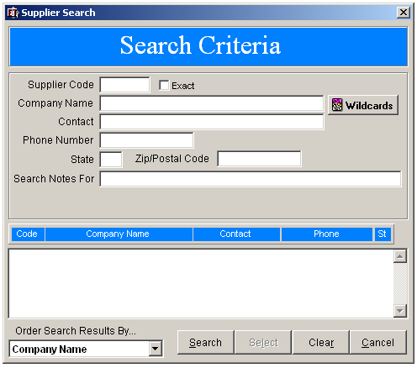
Figure 8a.3 Supplier Search Criteria form
- The fields displayed above can be used to filter the captured vendors. Partial words can also be used during the search process. Search results will be displayed on the bottom half of the screen.

- The results are automatically ordered by the Company Name. The user can change the order of the search results by using the “Order Search Results By” dropdown menu located on the bottom of the form.

- Once a sales order is selected, double click on the entry to retrieve the order into the Vendor Maintenance form.

Quick Search
Alternatively, the Quick Search is available when the user wishes to directly access a known Vendor Code.
- Activate a Right Click on the search key located on the bottom left corner of the Vendor Maintenance form.
- The Quick Search pop-up is retrieved for Vendor Code entry.
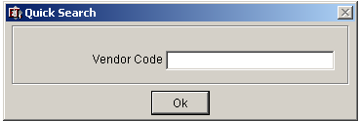

Deleting an Existing Vendor
- To remove a vendor from the system, retrieve the vendor into the Vendor Maintenance form.
- Once the data is displayed, activate the DELETE pushbutton displayed on the button of the screen to retrieve the Delete this Record pop-up displayed in the figure below.
- After the delete validation is confirmed, the record is permanently removed from the system.
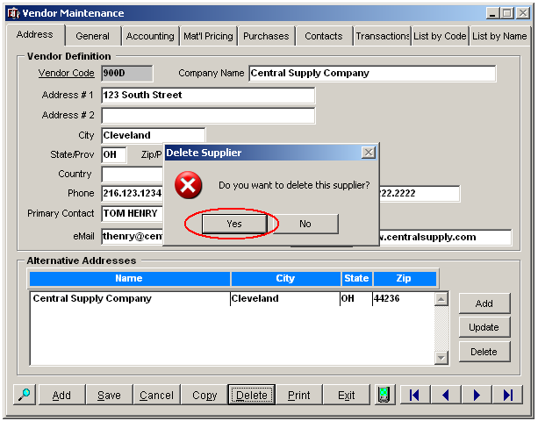
Figure 8a.4 Vendor Maintenance

Note:
Do NOT delete a record that is or has been used in other areas of the system, such as Purchase Order Maintenance.
If a Vendor/Supplier is no longer being used, the preferred method for deactivating the Vendor is to change its associated “Status” field rather than deleting the record.

Adding a New Vendor to the System
To add a new Vendor to the system;
- Retrieve the Vendor Maintenance subsystem from either the icon or via the menu bar
- Activate the ADD pushbutton located at the bottom of the form
- The Address Tab displayed in the figure below is refreshed for new Vendor entry.

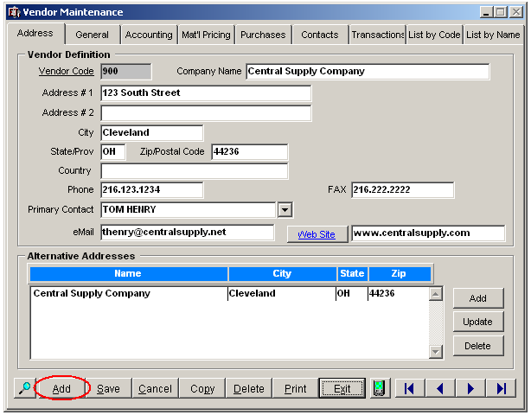
Figure 8a.5 Adding a New Vendor to the system
Vendor Maintenance – Address Tab
The Vendor Maintenance – Address tab has two distinct functions. The first key function is to maintain vendor addresses, numbers, email accounts and website. Alternate shipping addresses may also be added and maintained within the “Alternative Addresses” section of the figure shown below.
The Address tab is also used as the primary means to create new Vendors and remove unwanted vendors from the system. Additional information regarding the fields and parameters included in the form is provided in the corresponding Address Tab table below.

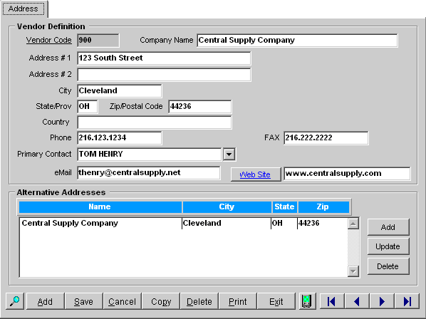
Figure 8a.6 Vendor Maintenance – Address Tab

Vendor → Address Tab
Field |  | Required | Field Type | Description
Vendor Definition
Vendor Code |  | YES | ALPHANUMERIC | Enter in a Vendor Code used to identify the Vendor. The character size of the vendor code may be no longer than 6 digits.
Company Name |  | NO | TEXT | Enter in the Vendor Company name as it will be printed on purchase orders.
Address |  | NO | TEXT | Enter in the vendor post office box or street mailing address location. This address will be printed on the Purchase Orders and Invoices. Two lines are available.
City |  | NO | TEXT | Enter in the vendor's mailing city, as it is to be printed on the Purchase Orders and Invoices.
State/Province |  | NO | TEXT | Enter in the vendor's mailing state or province location as it is to be printed on the Purchase Orders and Invoices.
Zip/Postal Code |  | NO | NUMBER | Enter in the vendor's mailing zip code or postal code location as it is to be printed on the Purchase Orders and Invoices.
Country |  | NO | TEXT | Enter in the vendor's mailing country location as it is to be printed on the Purchase Orders and Invoices.
Phone |  | NO | NUMBER | Enter in the vendor’s telephone number of the contact, including area code.
Fax |  | NO | NUMBER | Enter in the vendor’s tax number.
Primary Contact |  | NO | TEXT | Enter in the name of the vendor’s primary contact.
Email |  | NO | TEXT | Enter in the primary contact’s email address.
Web Site |  | NO | TEXT | Enter in the vendor’s web site. The website maybe directly accessed by activating the attached identifier/pushbutton.
Alternative Address
Add |  | N/A | PUSHBUTTON | Activate pushbutton to add a new vendor shipping address to the system. The Shipping Address - Add Mode pop-up is retrieved for further entry.
Update |  | N/A | PUSHBUTTON | Activate pushbutton to edit the highlighted vendor shipping address. The Shipping Address – Update Mode pop-up is retrieved for further entry.
Delete |  | N/A | PUSHBUTTON | Activate pushbutton to remove the highlighted vendor shipping address from the system. The record is permanently removed from the system when the delete validation is confirmed.
---
Search |  | N/A | PUSHBUTTON | Left Click: Left click on the pushbutton to retrieve the Supplier Search form for vendor retrieval.  Right Click: Right click on the pushbutton to retrieve the Vendor quick search pop-up. Vendor information can be quickly retrieved by entering the vendor code directly into the field.
Add |  | N/A | PUSHBUTTON | Activate pushbutton to add a new vendor to the system. The “Vendor Maintenance – Address tab” is refreshed for new vendor entry.
Save |  | N/A | PUSHBUTTON | Activate pushbutton to save any changes to the form.
Cancel |  | N/A | PUSHBUTTON | Activate pushbutton to cancel any changes to the form.
Copy |  | N/A | PUSHBUTTON | Activate pushbutton to add a new vendor to the system as a copy of an existing vendor record. The Vendor Copy pop-up is retrieved for new Vendor Code entry.
Delete |  | N/A | PUSHBUTTON | Activate pushbutton to remove the retrieved vendor from the system. If the supplier does not have any existing transactions, the record is permanently removed from the system once the delete validation is confirmed.
Print |  | N/A | PUSHBUTTON | Activate pushbutton to print the “Vendors” report. The report contains the code, name, and additional key contact information.
Exit |  | N/A | PUSHBUTTON | Activate pushbutton to return to the main Visual EstiTrack menu system.
 | Interface to Palm Based Operating System | N/A | PUSHBUTTON | Activate pushbutton to initiate communication between Visual EstiTrack and the palm based operating system.
 | Scroll to First | N/A | PUSHBUTTON | Scrolls to first record.
 | Scroll Back | N/A | PUSHBUTTON | Scrolls back one record.
 | Scroll Forward | N/A | PUSHBUTTON | Scrolls forward one record.
 | Scroll to Last | N/A | PUSHBUTTON | Scrolls to last record.

Vendor Maintenance – General Tab
The Vendor Maintenance General tab is used to configure key vendor purchasing information as well as identify the sales taxes applied to the vendor’s goods. The form is broken down into four sections that are further described in the corresponding table below.

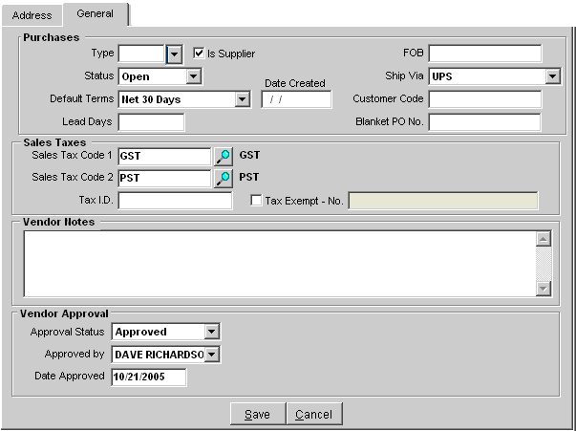
Figure 8a.7 Vendor Maintenance – General Tab

Vendor → General Tab
Field | Required | Field Type | Description
Purchases
Type | NO | DROPDOWN | Select the Vendor type from the dropdown list. Vendor types are maintained in the vendor table:  VENDORS → VENDOR TYPES
Is Supplier | NO | CHECKBOX | In Progress…
Status | YES | DROPDOWN | Select the Vendor Account status from the dropdown list.
Default Terms | NO | DROPDOWN | Select the default payment terms from the dropdown list.
Date Created | YES | DATE | Enter the current date the vendor is captured into the system. The Visual EstiTrack TM interactive calendar is available for date selection.
Lead Days | NO | NUMBER | Enter the number of lead days it takes for the vendor to actually provide the parts or service.  Lead days are also be maintained at Inventory Maintenance level. By adding an entry to this field, all items captured in the Inventory Maintenance subsystem for this vendor can be automatically updated with the entered value.  This entry is taken into consideration during the scheduling process.
FOB | NO | ALPHANUMERIC | Enter Freight On Board point for this vendor.
Ship Via | NO | DROPDOWN | Enter in the preferred standard shipping means.
Customer Code | NO | TEXT | If the Vendor is also a customer, enter in the corresponding customer code.
Blanket PO Number | NO | ALPHANUMERIC | Enter a blanket (open) P.O. number used for this vendor.
Sales Tax
Sales Tax Code 1 | NO | DROPDOWN | Define the Tax % that you are required to pay for taxable items if applicable. This will be used in Purchase Order Maintenance when a tax line item is added.
Sales Tax Code 2 | NO | DROPDOWN | Define a second tax code if applicable.
Tax ID | NO | ALPHANUMERIC | Enter your vendor’s tax ID number for this ship-to location.
Tax Exempt | NO | CHECKBOX | Activate checkbox if the Vendor is tax exempt.
Tax Exempt | NO | ALPHANUMERIC | Enter in the vendor’s tax exemption number (if they ARE tax-exempt only).
Vendor Notes
Text Box | NO | TEXT | A free form text box available for any additional vendor related notes.
Vendor Approval
Approval Status | YES | DROPDOWN | Select the approval status applied to the vendor from the dropdown list.
Approved By | NO | DROPDOWN | Select the name of the employee who defined the vendor’s approval status.
Date Approved | NO | DATE | Enter in the date of vendor approval. The Visual EstiTrack interactive calendar is available for date selection.
---
Save | N/A | PUSHBUTTON | Saves any changes made to the form.
Cancel | N/A | PUSHBUTTON | Cancels any changes made to the form.

Vendor Maintenance – Accounting Tab
The Vendor Maintenance – Accounting Tab is used to define default account settings for the vendor. Default Invoice General Ledger Accounts maybe also maintained within the form. Additional information regarding the fields and parameters included are provided in the corresponding table below.

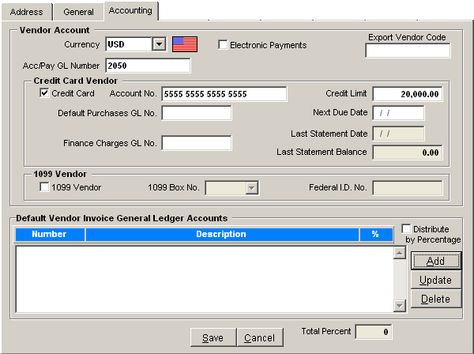
Figure 8a.8 Vendor Management – Accounting

Vendor → Accounting Tab
Field | Required | Field Type | Description
Vendor Account
Currency | YES | DROPDOWN | Select the default currency used with the vendor from the dropdown list. Currency exchange rates are maintained in the table: TABLES → CURRENCY EXCHANGE
Accounts Payable GL Number | NO | ALPHANUMERIC | Enter in the vendor’s accounts payable GL number.
Electronic Payments | NO | CHECKBOX | Activate checkbox if electronic payments are used for this Vendor.
Export Vendor Codes | NO | ALPHANUMERIC | Enter in the interface to the third party accounting software used to export the accounting data.
Credit Card Vendor
Credit Card | NO | CHECKBOX | Activate checkbox if the Vendor is a credit card vendor.
Account Number | NO | NUMBER | In progress…
Default Purchases GL Number | NO | ALPHANUMERIC | Enter in the default purchasing general ledger number if applicable.
Finance Charge GL Number | NO | ALPHANUMERIC | Enter in the default Finance charge general ledger number if applicable.
Credit Limit | NO | NUMBER | In progress…
Next Due Date | NO | DATE | Enter in the next payment due date.
1099 Vendor
1099 Vendor | NO | CHECKBOX | Activate checkbox if the vendor is a 1099 vendor. Once activated, the two associated fields below are available for entry.
1099 Box Number | NO | DROPDOWN | Select the 1099 box number from the dropdown menu.
Federal I.D. Number | NO | ALPHANUMERIC | Enter in the corresponding Federal I.D. number.
Default Vendor Invoice General Ledger Accounts |  |  | This section provides the user the ability to capture multiple Vendor Invoice G/L Accounts.
Distribute by Percentage | NO | CHECKBOX | Activate checkbox to distribute the associated costs to the various accounts by percentage.
Add | N/.A | PUSHBUTTON | Activate checkbox to add a new general ledger account its associated percentage.
Update | N/.A | PUSHBUTTON | Activate checkbox to update the highlighted G/L account/percentage defined.
Delete | N/.A | PUSHBUTTON | Activate checkbox to delete the highlighted G/L account/percentage defined.
Save | N/.A | PUSHBUTTON | Saves any changes made to the form.
Cancel | N/.A | PUSHBUTTON | Cancels any changes made to the form.

Vendor Maintenance – Material Pricing
The Material Pricing tab is divided into two main functions. The first function available is to track a list of materials purchased from the vendor and their default costs for a defined quantity range. This information is maintained within the “Default Material Pricing” display box shown in the figure below.
The second main function of the form is to identify the standard weekly delivery days applied by the vendor. Additional information regarding the fields and functions included in the form is provided in the corresponding table below.

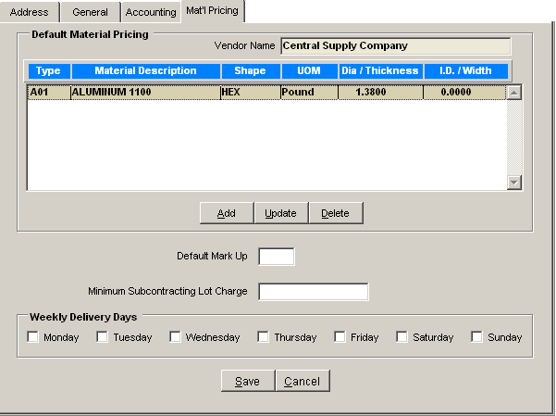
Figure 8a.9 Vendor Maintenance – Material Pricing

Vendor → Material Pricing Tab
Field | Required | Field Type | Description
Default Material Pricing
Vendor Name | N/A | DISPLAY | Displays the name of the selected vendor.
Add | N/A | PUSHBUTTON | Activate pushbutton to add a new material pricing to the list. The Vendor Default Pricing Maintenance form is retrieved for entry. Additional information regarding the function of the form is provided in the chapter below.
Update | N/A | PUSHBUTTON | Activate pushbutton to update the highlighted material. The Vendor Default Pricing Maintenance form is retrieved for further update. Additional information regarding the function of the form is provided in the chapter below.
Delete | N/A | PUSHBUTTON | Activate pushbutton to remove the highlighted record form the system. After the delete validation is confirmed, the record is permanently removed form the system.
---
Default Markup | NO | PERCENTAGE | Enter the default markup for the material purchased from the vendor. This markup is used during the quoting process.
Minimum Subcontracting Lot Charge | NO | NUMBER | Enter in the vendor defined minimum subcontracting lot charge.
Weekly Delivery Days | NO | CHECKBOX | Select the vendor delivery days of the week.
Save | N/A | PUSHBUTTON | Saves any changes made to the form.
Cancel | N/A | PUSHBUTTON | Cancels any changes made to the form.

Vendor Default Pricing Maintenance
The Vendor Default Pricing Maintenance form shown in the figure below is used to add pricing for materials supplied by the vendor. The form is accessed when a user “Adds or Updates” a material within the “Default Material Pricing” section of the “Material Pricing Tab”.

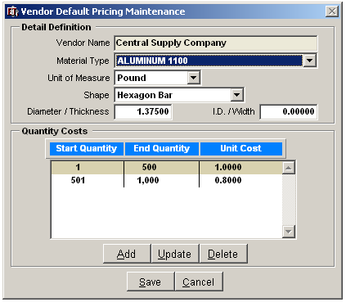
Figure 8a.10 Vendor Default Pricing Maintenance

Vendor → Material Pricing Tab → Vendor Default Pricing Maintenance
Field | Required | Field Type | Description
Vendor Name | N/A | DISPLAY | Displays the name of the selected vendor.
Material Type | NO | DROPDOWN | Select the material type from the dropdown list. Material Types are maintained in the table:  TABLES → MATERIAL TYPES.
Unit of Measure | NO | DROPDOWN | Select the material’s unit of measure from the dropdown list.
Shape | NO | DROPDOWN | Select the shape of the material from the dropdown list.
Diameter/Thickness | NO | NUMBER | If applicable, enter in the Diameter or Thickness of the material supplied by the vendor.
I.D./Width | NO | NUMBER | If applicable, enter in the Internal Diameter or Width of material supplied by the vendor.
Quantity Costs
Add | N/A | PUSHBUTTON | Activate pushbutton to add a new quantity range and cost for the material supplied by the vendor. The Vendor Default Pricing Quantity Cost pop-up is retrieved for cost entry.
Update | N/A | PUSHBUTTON | Activate pushbutton to update the highlighted cost/quantity range. The Vendor Default Pricing Quantity Cost pop-up is retrieved for update.
Delete | N/A | PUSHBUTTON | Activate pushbutton to remove the highlighted cost/quantity range from the associated material. The record is permanently removed from the system after the delete validation is confirmed.
---
Save | N/A | PUSHBUTTON | Saves any changes made to the form.
Cancel | N/A | PUSHBUTTON | Cancels any changes made to the form.

Adding a New Cost Quantity

The following steps are used when adding a new cost quantity range for the defined vendor material.
- Activate the ADD pushbutton within the Vendor Default Pricing Maintenance form to retrieve the
Vendor Default Pricing Quantity Cost pop-up displayed in the figure below.
- Enter in the “Start Quantity” – the beginning quantity range quoted by the Vendor.
- Enter in the “End Quantity” – the end quantity range quoted by the Vendor
- Enter in the “Unit Cost” of the material quoted by the Vendor.
- SAVE any changes made to the form.

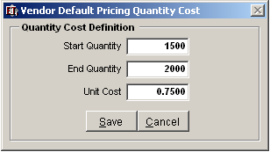
Figure 8a.11 Vendor Default Pricing Quantity Cost

Vendor Maintenance – Purchasing
The “Purchasing” Tab shown below provides the user a quick overview of the amount of purchases made with the vendor for the selected fiscal year. The sum of the purchases made is broken down by month and is also calculated per fiscal quarter.

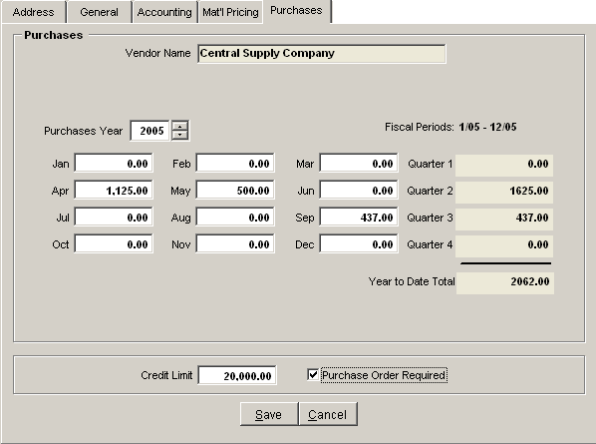
Figure 8a.12 Vendor Maintenance – Purchasing Tab

Vendor → Purchases
Field | Required | Field Type | Description
Purchases
Vendor Name | N/A | DISPLAY | Displays the name of the selected vendor.
Purchases Year | YES | SCROLL | Select the fiscal period year to review the purchases made within the calendar year.
Months | NO | CURRENCY | Displays the total cost of the purchases made for the given month. This field maybe overridden if necessary.
Credit Limit | NO | CURRENCY | Enter in the established credit limit set by the vendor.
Purchase Order Required | NO | CHECKBOX | Activate checkbox if a purchase order is required by the vendor.
Save | N/A | PUSHBUTTON | Saves any changes made to the form.
Cancel | N/A | PUSHBUTTON | Cancels any changes made to the form.

Vendor Maintenance – Contacts
The Contact tab is used to store multiple contacts associated with one specific vendor. This tab lists all key company personnel along with titles, job functions, departments and personal information within one central location.

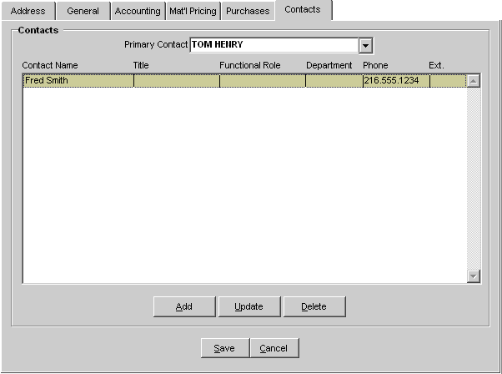
Figure 8a.13 Vendor Maintenance – Contacts

Vendor → Contacts
Field | Required | Field Type | Description
Contacts
Primary Contact | NO | DROPDOWN | Select a primary contact from dropdown list or enter in a new primary into the field. Once entered, a SAVE will capture it into the system.
Add | N/A | PUSHBUTTON | Activate pushbutton to add a new contact into the system. The Contact Maintenance subsystem is retrieved for further entry.
Update | N/A | PUSHBUTTON | Activate pushbutton to update the highlighted contact. The Contact Maintenance subsystem is retrieved for further update.
Delete | N/A | PUSHBUTTON | Activate pushbutton to remove the highlighted contact from the list. The record is permanently removed from the system after the delete validation is confirmed.
Save | N/A | PUSHBUTTON | Saves any changes made to the form.
Cancel | N/A | PUSHBUTTON | Cancels any changes made to the form.

Adding a New Vendor Contact
- Activate the add pushbutton within the Contact Tab screen to retrieve the Contact Maintenance Entry subsystem. Once activated, the Contact Maintenance subsystem is retrieved displaying the first of seven tabs used to capture all contact information.

Contact Maintenance
The Contact Maintenance subsystem captures the contact’s name and phone number as well as a group of tabs detailing specific contact information.
The Contact screen is broken down into three sections that are displayed below. The first section (section 1 of figure 8a.14) maintains the contact name and all contact numbers. This information remains static throughout the contact subsystem.
The tabulated group (section 2 of figure 8a.14), captures helpful details regarding the customer contact. The details are grouped into seven tabulations which are outlined individually below.
Section 3 of figure 8a.14, is also present throughout all contact tabulations. It holds the standard SAVE, CANCEL, EXIT pushbuttons as well as the ability to print/display the Contact Detail Report.
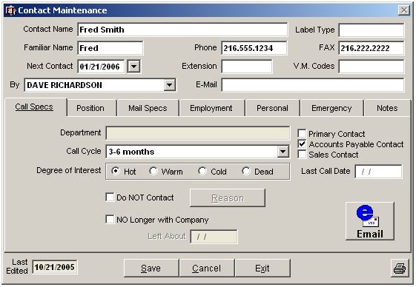
Figure 8a.14 Vendor Contact Maintenance
Section 1 
Section 2 
Section 3 

Sect. 1 
Vendor → Contacts → Contact Maintenance
Field | Required | Field Type | Description
Contact Name | YES | ALPHANUMERIC | Name of contact to be captured. This field is required before any other fields or tabs can be entered.
Label Type | NO | ALPHANUMERIC | User defined field. User can identify a label type (example – “C” for Christmas Cards) that can be used during printing label retrieval.
Familiar Name | NO | ALPHANUMERIC | First name, nickname or any name used to address this individual on a personal basis. For example, the contact’s name may be “James”, but everyone refers to him as “Jimmy”.
Phone Number | NO | ALPHANUMERIC | Telephone number of the contact, including area code. Although this field is automatically populated from the Address Tab, the phone number maybe edited and saved.
Fax | NO | ALPHANUMERIC | Fax number of the contact, including area code. Although this field is automatically populated from the Address Tab, the phone number maybe edited and saved.
Next Contact | NO | DROPDOWN | Next follow-up contact date. A user can either select a contact date interval from the dropdown list or has the option to double-click the date field in order to access an interactive pop-up calendar.
Extension | NO | ALPHANUMERIC | Telephone extension at which the contact may be reached (if applicable).
V.M. Codes | NO | ALPHANUMERIC | Enter any special voice mail or intercom codes necessary to reach contact (if applicable).
By | No | DROPDOWN | Select the salesperson handling this account from the drop down menu. Sales Representatives are identified in the Employees Table by checking the box that indicates, “Employee is a Salesperson”.
Email | NO | ALPHANUMERIC | Enter the email address for the current contact.
Call Specs | N/A | SUB-TAB | Call Specs tab is used to capture contact specifications such as calling cycle and degree of interest.
Position | N/A | SUB-TAB | Positions tab is used to capture the contact’s position within the customer’s organization.
Mail Specs | N/A | SUB-TAB | Mailing specifications of customer contact.
Employment | N/A | SUB-TAB | Employment history of customer contact.
Personal | N/A | SUB-TAB | Personal information regarding contact such as age, children, interests, etc.
Emergency | N/A | SUB-TAB | Emergency contact information for customer contact.
Notes | N/A | SUB-TAB | Any additional notes regarding customer contact.
Last Edited | N/A | DATE | Displays the date any contact information was last edited.
Save | N/A | PUSHBUTTON | Saves all entries entered into the system.
Cancel | N/A | PUSHBUTTON | Cancels any changes made to the system.
Exit | N/A | PUSHBUTTON | Exit’s the Contact Maintenance subsystem.
Contact Detail Report | N/A | PUSHBUTTON | A report can be generated using all of the data entered into each of the contact maintenance tabs. The user can select the tabs to include into the report. See below for further report details.

Call Specifications Tab
The call specification’s tab is the first of the seven tabs supporting the contact maintenance subsystem. It is most often used for marketing and is extremely beneficial to the sales department. This tab can be viewed in figure 8a.14 “Vendor Contact Maintenance”. The following fields are captured in the Call Specification Tab:

Vendor → Contacts → Contact Maintenance → Call Specifications Tab
Field | Required | Field Type | Description
Department | NO | DISPLAY | This field reflects the department information from the “Position” tab, and cannot be edited at this location. Example: Purchasing, Accounting, and Engineering. Reference field only.
Call Cycle | NO | DROPDOWN | Select the time interval between Sales/Support calls to this contact from the pull down menu. There are reports available to pull by this information. These intervals are for reference only.
Degree of Interest | NO | RADIO BUTTONS | Select between “Hot”, “Warm”, “Cold”, or “Dead”. These radio buttons are for reference only.
Primary Contact | NO | CHECKBOX | Primary contact for all correspondence. Checking this box indicates that this person is the Primary Contact for this customer. Remember the primary contact will print on invoices, purchase orders, etc.
Accounts Payable Contact | NO | CHECKBOX | Establishes contact as the Accounts Payable contact. Checking this box automatically includes the contact name on all customer invoices.
Sales Contact | NO | CHECKBOX | Establishes contact as a sales contact.
Last Call Date | NO | DATE | Enter in the date the vendor was last contacted. The Visual EstiTrack interactive calendar is available for easy date selection.
Do Not Contact | NO | CHECKBOX | Activate checkbox to indicate that this contact is NOT to be called. Clicking this checkbox will activate the “Reason” memo field.
Reason | NO | PUSHBUTTON | Double left mouse click on the button to enter information (reason for NOT contacting the individual) into the “Do not Contact” notes field.  Enter reason not to call on this customer contact into this memo field. These memo fields do not have any practical length restriction. Text can be entered in this area or user can click on the “Notes Library” icon (bottom left) where prewritten notes (from the Notes Library) can be inserted.
No Longer with Company | NO | CHECKBOX | Activate checkbox to indicate that this contact is no longer with the company. You may want to leave this contact information for future reference. Clicking this checkbox will activate the “Left About” date field.
Left About | NO | DATE | This field will activate if checkbox above is checked. Enter date manually or double click for calendar pop up, and select date from calendar.
Email | NO | PUSHBUTTON | Clicking on this button will allow an email to be sent to the contact via Microsoft Outlook or Outlook Express.

Position Tab
The Position’s tab captures the contact’s position within the customer’s organization. The fields and parameters included in the form are outlined in the corresponding table below.
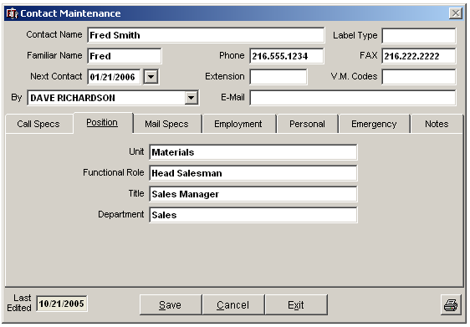
Figure 8a.15 Vendor Contact Maintenance – Positions tab

Vendor → Contacts → Contact Maintenance → Positions Tab
Field | Required | Field Type  Length | Description
Unit | NO | ALPHANUMERIC | Enter organizational unit to which the contact belongs, or other unit information.
 | N | X
Functional Role | NO | ALPHANUMERIC | Contact’s role within vendor’s organization.
 | N | X
Title | NO | ALPHANUMERIC | Enter contact’s official title within their organization, e.g., Sales Manager.
 | N | X
Department | NO | ALPHANUMERIC | Enter contact’s specific department within their organization, e.g., Commercial Application Group
 | N | X

Mail Specs Tab
The purpose of the “Mail Specs” tab is to secure a mailing address to the established contact. The fields will automatically be populated from both the Vendor Maintenance – Address Tab and Positions Tab. All the information in this screen can be overwritten and updated with any changes.
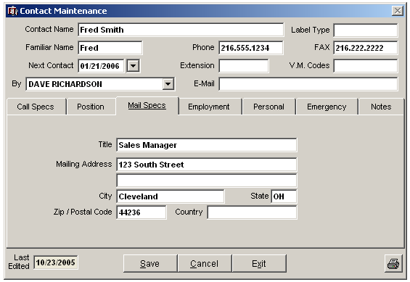
Figure 8a.16 Vendor Contact Maintenance – Mail Specifications tab

Vendor → Contacts → Contact Maintenance → Mail Specifications Tab
Field | Required | Field Type | Description
Title | NO | ALPHANUMERIC | Contact’s official title within their organization, e.g., Purchasing Manager.
Mailing Address | YES | ALPHANUMERIC | The vendor’s post office box or street mailing address location.
City | YES | ALPHANUMERIC | The vendor's mailing city.
State | NO | ALPHANUMERIC | The vendor’s mailing state or province location.
Zip/Postal Code | NO | ALPHANUMERIC | The vendor's mailing zip code or postal code location.
Country | NO | ALPHANUMERIC | The vendor's mailing country location.

Employment Specifications Tab
The Employment tab captures the contact’s information prior to their new role within the vendor’s organization.

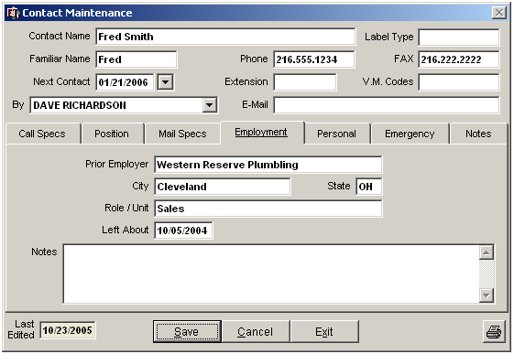
Figure 8a.17 Vendor Contact Maintenance – Employment Tabulation

Vendor → Contacts → Contact Maintenance → Employment Tab
Field | Required | Field Type | Description
Prior Employer | NO | ALPHANUMERIC | Enter prior employer information if relevant to contact.
City | NO | ALPHANUMERIC | Enter the city in which previous employer is located.
State | NO | ALPHANUMERIC | Enter the 2 digit state code where the prior employer is located.
Role/Unit | NO | ALPHANUMERIC | Enter the role or unit information applicable to this contact at previous employment.
Left About | NO | DATE | Enter the date that the contact left previous employer.
Notes | NO | ALPHANUMERIC | Additional Notes regarding prior employer. Scroll through the notes added by left mouse clicking on the up or down arrows located on the right side of the Notes page.

Personal Tab
The personal tab is used to capture contact’s personal information. The corresponding fields and descriptions are outlined in the figure and table listed below.

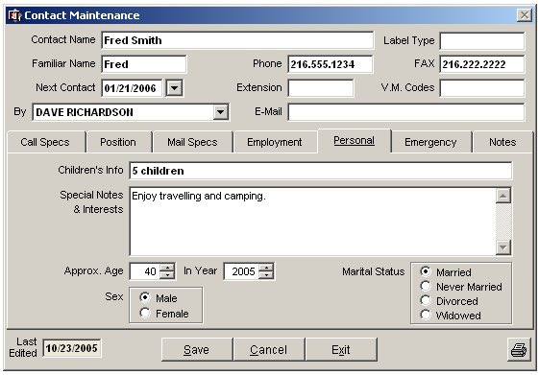
Figure 8a.18 Vendor Contact Maintenance – Personal Tab

Vendor → Contacts → Contact Maintenance → Personal Tab
Field | Required | Field Type | Description
Children’s Info | NO | ALPHANUMERIC | Complete with known information.
Special Notes and Interest | NO | TEXT | Complete with additional information such as hobbies.
Approximate Age | NO | NUMBER | Enter approximate age of contact or use up / down arrows to scroll up or down through numbers.
In Year | NO | DATE | Enter the year the contact’s approximate age number was entered or use up/down arrows to scroll up or down through numbers.
Marital Status | NO | RADIOBUTTON | Select marital status by left clicking on appropriate circle to the left of the description or by left clicking on the description.
Sex | NO | RADIOBUTTON | Select male or female by left clicking on appropriate circle to the left of the description or by left clicking on the description.
 | N | X

Emergency Tab
When information is provided, the emergency tab is used to capture the contact’s emergency information. The corresponding fields are outlined in the figure and table listed below.

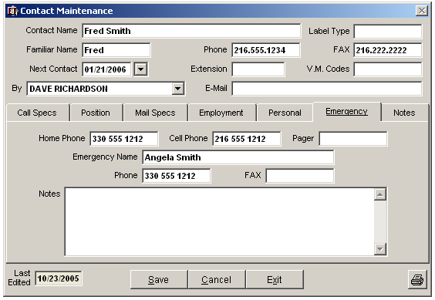
Figure 8a.19 Vendor Contact Maintenance – Emergency Tab

Vendor → Contacts → Contact Maintenance → Emergency Tab
Field | Required | Field Type | Description
Home Phone | NO | ALPHANUMERIC | Contact home phone number.
Cell Phone | NO | ALPHANUMERIC | Contact cell phone number.
Pager | NO | ALPHANUMERIC | Contact pager number.
Emergency Name | NO | ALPHANUMERIC | Name of emergency contact.
Phone | NO | ALPHANUMERIC | Phone number of emergency contact
Fax | NO | ALPHANUMERIC | Fax number of emergency contact.
Notes | NO | TEXT | Any additional relevant notes pertaining to emergency contact.

Notes Tab
The Notes tab can be used to store any additional contact information.

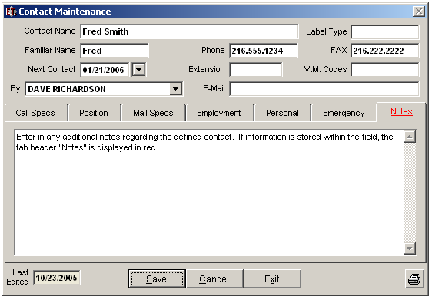
Figure 8a.20 Vendor Contact Maintenance – Notes Tab

Vendor Maintenance – Transactions
A history of vendor transactions can be reviewed within the Vendor Maintenance – Transactions tab. The

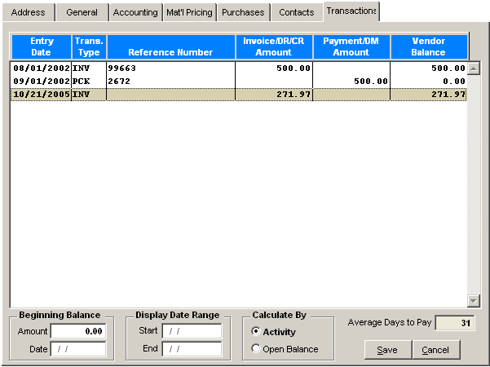
Figure 8a.21 Vendor Maintenance – Transactions

Vendor → Transactions
Field |  | Required | Field Type | Description
Beginning Balance
Amount |  | NO | NUMBER | A beginning balance maybe entered for the vendor. The transaction type “BB” identifies the transaction as a “Beginning Balance”.
Date |  | NO | DATE | Enter the beginning balance entry date. The Visual EstiTrack interactive calendar is available for date selection.
Display Date Range
Start |  | NO | DATE | Enter in the start date range.
End |  | NO | DATE | Enter in the end date range.
Calculate By |  | NO | RADIOBUTTON | Select the type of transactions to view. The user may select to view all activity or only the opening balance.
 | Activity | NO | RADIOBUTTON
 | Open Balance | NO | RADIOBUTTON
Average Days to Pay |  | N/A | DISPLAY | The system calculates the average days it took the company to pay the vendor.
Save |  | N/A | PUSHBUTTON | Saves any changes made to the form.
Cancel |  | N/A | PUSHBUTTON | Cancels any changes made to the form.

Vendor Maintenance – List by Code Tab
All of the vendors captured in the system maybe viewed and selected according to the vendor code. The vendors are displayed in alphabetical vendor code order. A vendor maybe selected for update by highlighting the desired vendor and activating the UPDATE SELECTED ITEM pushbutton shown in the figure below.

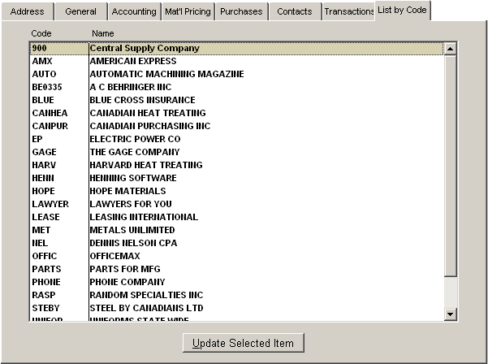
Figure 8a.22 Vendor Maintenance – List by Code Tab

Vendor Maintenance – List by Name
All of the vendors captured in the system maybe viewed and selected according to the vendor name. The vendors are displayed in alphabetical vendor name order. A vendor maybe selected for update by highlighting the desired vendor and activating the UPDATE SELECTED ITEM pushbutton shown in the figure below.

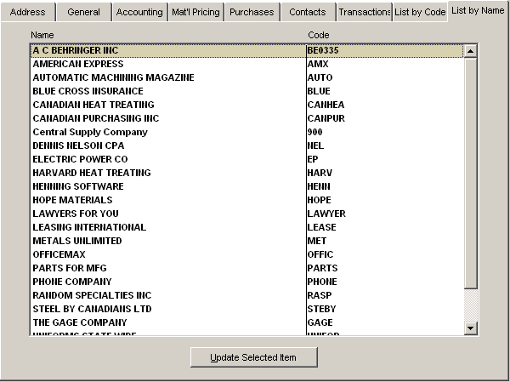
Figure 8a.23 List by Name

Vendor Monitoring
The Vendor Monitoring form provides the user a quick overview of the Vendor contact, address and key configurations. The form has read-only access and therefore cannot be edited by the user.
Once the form is accessed, the system retrieves the Supplier Search Criteria form for quick Vendor selection.

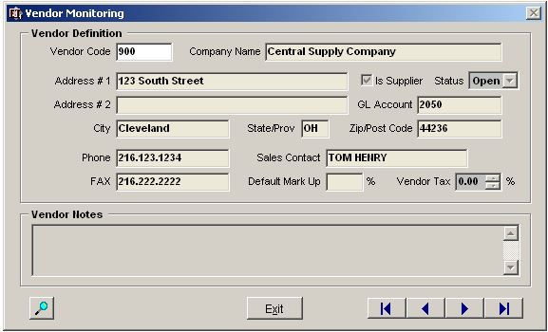
Figure 8a.24 Vendor Monitoring

Menu Selection
- Left click on the eighth menu heading labeled “Vendors”
- Select “Vendor Maintenance” from the drop down list.

Shortcut: Quickly enter this module by right clicking on the displayed “Vendor Maintenance” icon on the toolbar.


Security
The system administrator controls access to this menu item via User access Rights (see User Table). Careful consideration should be given regarding who is authorized to manage this menu option.

Vendor Invoice Maintenance
Vendor Invoice/Bill Maintenance subsystem is designed to tie Purchase Order Receipts to your Vendor’s Invoice. You will then be able to POST/UNPOST these Vendor Invoice totals to the Purchases Tab of the Vendor Maintenance subsystem previously outlined in the Vendor Maintenance – Purchasing chapter section above.
The Vendor Invoice/Bill Maintenance subsystem is delineated into three tabulations. The “General” tab displays the primary Vendor Invoice and contact information. The “Line Item” tab displays the items supplied and billed by the Vendor. The “Transactions” tab displays all transactions including Debit Memos, Payments and balances. Each of these tabulations is further individually described in the chapter below.

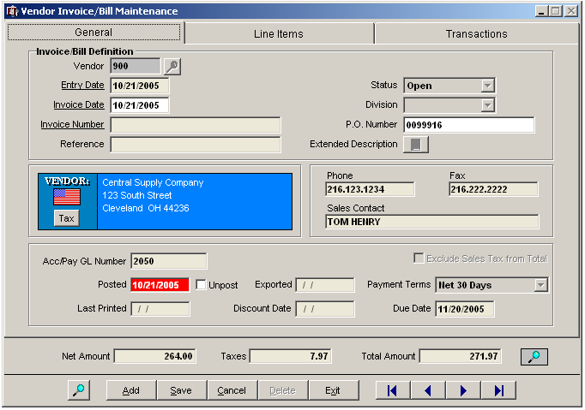
Figure 8a.25 Vendor Invoice/Bill Maintenance
Section 1 
Section 2 

Menu Selection
- Left click on the eighth menu heading labeled “Vendors”
- Select “Vendor Invoice Maintenance” from the drop down list.

Security
The system administrator controls access to this menu item via User access Rights (see User Table). Careful consideration should be given regarding who is authorized to manage this menu option.

Vendor Invoice/Bill Maintenance – General Tab
The Vendor Invoice/Bill Maintenance – General tab displays the primary Vendor Invoice and contact information. The associated fields and attributes regarding the content of the General Tab as well as the base Vendor Invoice/Bill fields are further outlined in the table below.

Vendor → Vendor Invoice/Bill Maintenance → General Tab
Field |  | Required | Field Type | Description
Invoice Bill Definition
Vendor Code |  | YES | ALPHANUMERIC | Enter in the Vendor Code. The Search key is available for quick vendor selection.  The Vendor window including contacts and phone numbers is automatically updated when the vendor code is entered into the field.
Entry Date |  | NO | DATE | The current date is automatically populated into the field and can be overridden at any time. The Visual EstiTrack Interactive Calendar is available for date selection.
Invoice Date |  | NO | DATE | Enter in the Invoice Date. The Visual EstiTrack Interactive Calendar is available for date selection.
Invoice Number |  | NO | ALPHANUMERIC | Enter in the Invoice Number from your Vendor’s Invoice.
Reference |  | NO | ALPHANUMERIC | Enter in the reference number or description if available.
Status |  | YES | DROPDOWN | Select the invoice status from the dropdown menu. The status is automatically populated as “Open.”
Division |  | NO | DROPDOWN | Enter in the company division code if applicable.
P.O. Number |  | NO | ALPHANUMERIC | Enter in the purchase order number associated with the invoice.
 | Extended Description | N/A | PUSHBUTTON | Activate pushbutton to retrieve an “Extended Descriptions” text box used to capture any additional information regarding the invoice.
---
Tax |  | N/A | PUSHBUTTON | Activate pushbutton to retrieve the Sales Tax Information pop-up displaying the defined Sales Tax Codes applied by the vendor.  The Sales Tax settings maybe overridden within the form.
Accounts Payable/  General Ledger Number |  | NO | ALPHANUMERIC | The accounts payable/general ledger field is used in conjunction with Visual Books. TM  If Visual Books TM is not being used, the field should be left blank.
Posted |  | N/A | DISPLAY | The Posted field is updated with the date the Post routine was run against the record.
Post/Unpost |  | NO | CHECKBOX | The function of the checkbox changes according to whether or not the record was posted in the system.  Post: The Post checkbox is activated designates that the invoice was not yet in the system.  Unpost: After the Post routine was activated, the unpost checkbox is available to the user. Activate the Unpost checkbox if available and go to the Post/Unpost Vendor Invoices to unpost the vendor invoice.  The unpost checkbox is made unavailable if there are “Transactions” (payments) against the vendor invoice. This can only be viewed in the “transactions” tab within Vendor Invoice Maintenance for Visual Books TM users only.
Last Printed |  | N/A | DISPLAY | The last printed field is auto populated when the print command is selected.
Exported |  | N/A | DISPLAY | The field is auto-populated with the date the vendor invoice was exported to the third party accounting package. This field is only populated when a third party accounting package is used.
Discount Date |  | NO | DATE | In Progress…
Exclude Sales Tax from Total |  | NO | CHECKBOX | Activate the checkbox to exclude the Sales Tax from the total.
Payment Terms |  | YES | DROPDOWN | The payment terms is automatically populated with the default defined within vendor maintenance.
Due Date |  | NO | DATE | The system automatically inserts the calculated due date based on the payment terms assigned.
Section 2 of Figure 8a.25
Search Key |  | N/A | PUSHBUTTON | Activate pushbutton to retrieve the Vendor Invoice Search Criteria form. The Quick search is also available to retrieve a known invoice number.
Add |  | N/A | PUSHBUTTON | Activate pushbutton to add a new vendor invoice to the system.
Save |  | N/A | PUSHBUTTON | Activate pushbutton to save any changes made to the form.
Cancel |  | N/A | PUSHBUTTON | Activate pushbutton to cancel any changes made to the form.
Delete |  | N/A | PUSHBUTTON | Activate pushbutton to delete the current record. The record can only be removed from the system if there are no transactions against the Vendor invoice.
Exit |  | N/A | PUSHBUTTON | Activate pushbutton to return back to the main Visual EstiTrack menu system.
 | Scroll to First | N/A | PUSHBUTTON | Scrolls to first record.
 | Scroll Back | N/A | PUSHBUTTON | Scrolls back one record.
 | Scroll Forward | N/A | PUSHBUTTON | Scrolls forward one record.
 | Scroll to Last | N/A | PUSHBUTTON | Scrolls to last record.

Vendor Invoice/Bill Maintenance – Line Items Tab
The “Line Item” tab displays the items supplied and billed by the Vendor. The Line Item tab provides the user the ability to both manually add vendor Line Item receipts or automatically to retrieve receipts from PO line items. Additional detail and instruction regarding the functions available within the form are further provided in the chapter below.

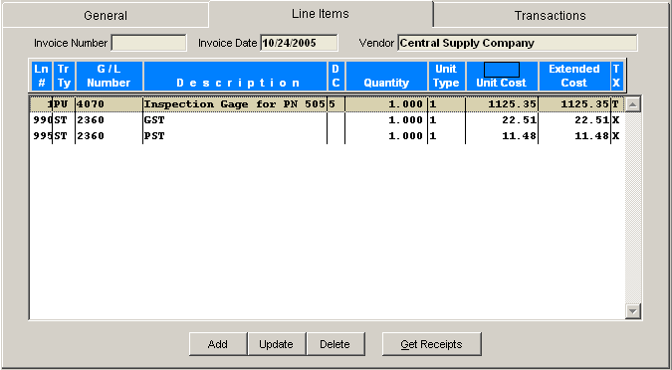
Figure 8a.26 Vendor Invoice/Bill Maintenance – Line Items Tab

Vendor → Vendor Invoice/Bill Maintenance → Line Items Tab
Field | Required | Field Type | Description
Add | N/A | PUSHBUTTON | Activate pushbutton to manually add a Vendor Invoice Line item. The Distribution Detail form is retrieved for line item entry. Additional information regarding the procedure and form is available in the section below.
Update | N/A | PUSHBUTTON | Activate pushbutton to edit the highlighted line item. The Distribution Detail form is retrieved with the selected information for update.
Delete | N/A | PUSHBUTTON | Activate pushbutton to delete the highlighted line item from the system. After the delete validation is confirmed, the record is permanently removed from the system.
Get Receipts | N/A | PUSHBUTTON | Activate pushbutton to automatically retrieve the Select PO Line Items Receipt form used to select the line item to apply towards the Vendor Invoice. Additional information regarding the procedure and the form are further provided in the chapter below.

Distribution Detail Form
The Distribution Detail form is used when either editing an existing Vendor Invoice Line item or to manually add a Vendor Invoice Line item. It is retrieved when a user ADDs a new Invoice Line item within the Line Item tab of the Vendor Invoice/Bill Maintenance subsystem. It is also retrieved when a user UPDATEs an existing line item. Additional information regarding the included fields are provided the corresponding table below.

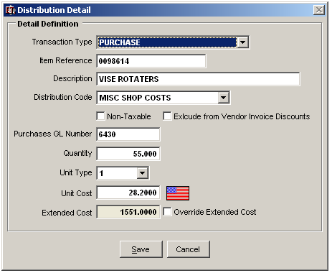
Figure 8a.27 Distribution Detail

Vendor → Vendor Invoice/Bill Maintenance → Line Items Tab → Distribution Detail
Field | Required | Field Type | Description
Transaction Type | N/A | DROPDOWN | Select the type of transaction from the dropdown menu.
Item Reference | NO | ALPHANUMERIC | Enter in the item reference number. This number usually reflects the Purchase Order Number.
Description | NO | TEXT | Enter in the description of the invoiced item.
Distribution Code | NO | DROPDOWN | Select the distribution code from the dropdown list.
Non-Taxable | NO | CHECKBOX | Activate checkbox if the invoiced item is non-taxable.
Exclude from Vendor Invoice Discounts | NO | CHECKBOX | Activate checkbox if the item should be excluded from any defined Vendor Invoice Discounts.
Purchases GL Number | NO | ALPHANUMERIC | In Progress…
Quantity | NO | NUMBER | Enter in the Quantity purchased/received from the vendor.
Unit Type | NO | DROPDOWN | Select the unit type from the dropdown menu.
Unit Cost | NO | NUMBER | Enter in the unit cost from the dropdown menu. The attached currency flag can be used to invoke the currency exchange manager.
Extended Cost | NO | DISPLAY | Displays the calculated extended cost of the invoiced line item.
Override Extended Cost | NO | CHECKBOX | Activate checkbox to override the calculated extended cost. The “Extended Cost” field is automatically made available for update.
Save | N/A | PUSHBUTTON | Saves any changes made to the form.
Cancel | N/A | PUSHBUTTON | Cancels any changes made to the form.

Retrieving Receipts
The Select PO Line Items Receipts form displayed in the figure below, lists all receipts for the given Vendor that were retrieved from the Vendor Maintenance subsystem. The form below can be used to apply the selected receipt line item toward the vendor invoice.
The Select PO Line Items Receipts form shown below is broken down into two sections. Section one of figure 8a.28 displays the purchase order number while section two lists all of the included line items included in the selected PO.

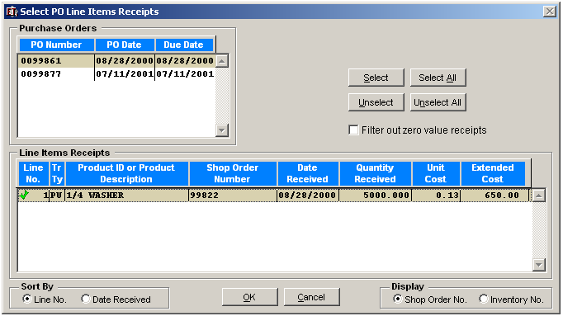
Figure 8a.28 Retrieving Receipts via the Select PO Line Items Receipts form.
Section 1 
Section 2 

Vendor → Vendor Invoice/Bill Maintenance → Line Items Tab → Select PO Line Items Receipts
Field | Required | Field Type | Description
Select | N/A | PUSHBUTTON | Activate the Select pushbutton to apply the Vendor Invoice to the highlighted PO and PO line item.  Note: A symbol indicates that the selected PO line item will be applied when the OK pushbutton is activated.
Unselect | N/A | PUSHBUTTON | Activate the pushbutton to remove the highlighted PO line item from the Vendor Invoice prior to selecting the OK pushbutton.  Note: The symbol is removed from the item and is replaced by the symbol.
Select All | N/A | PUSHBUTTON | Activate pushbutton to apply all of the PO line items to the Vendor Invoice.
Unselect All | N/A | PUSHBUTTON | Activate pushbutton to remove all line items from application to the Vendor Invoice. All line items will be indicated as “not selected” with the symbol.
Filter out zero value receipts | NO | CHECKBOX | In progress…
Sort By | NO | RADIOBUTTON | The PO line items maybe sorted according to one of the following radio buttons:
Sort By | NO | RADIOBUTTON |  | PO Line Number
Sort By | NO | RADIOBUTTON |  | Date Received
OK | N/A | PUSHBUTTON | Activate pushbutton to complete the PO line item selection process. The line items indicated with the symbol will be applied to the Vendor Invoice.
Cancel | N/A | PUSHBUTTON | Activate pushbutton to cancel any changes made to the form.
Display | NO | RADIOBUTTON | Both the Shop Order and Inventory Number are available for display in the Line Item Receipts section of the form. The user may choose to view either one by activating the appropriate radio button.

Vendor Invoice/Bill Maintenance –Transactions Tab
The Transactions Tab of the Vendor Invoice/Bill Maintenance subsystem provides the user a list of all transactions including Debit Memos, Payments and balances.
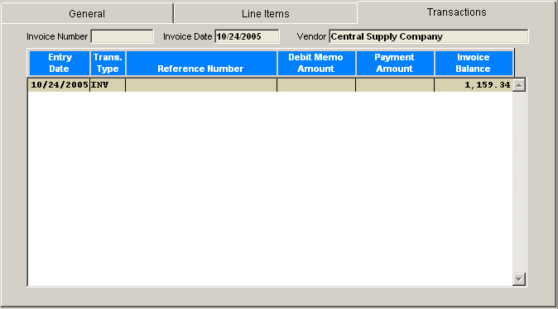
Figure 8a.29 Vendor Invoice/Bill Maintenance – Transactions Tab

Note:
Transactions will only be included in the form if Visual Books TM is used in conjunction with
Visual EstiTrack TM

Customer / Vendor Types
Customer and Vendor types used by the company can be captured and maintained within the table accessed by the form below.
The Data Tab provides the user means to add new Vendor Types and maintain existing entries. The List by Code and List by Descriptions tabs both allow the user to view the entire lists of captured Vendor types sorted by either their code or description.
Vendor types that are further applied to Vendors maybe represented by a distinct Color selected via the
CHANGE COLOR pushbutton displayed in the figure below. Vendor Types are assigned to the Vendor in the General Tab of the Vendor Maintenance subsystem. The Vendor code is then further represented throughout the Visual EstiTrack TM software with the associated Vendor Advisory Color.

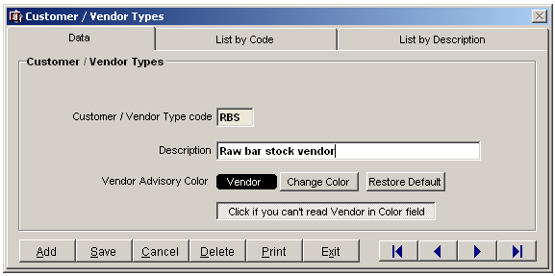
Figure 8a.30 Customer/Vendor Types

Menu Selection
- Left click on the eighth menu heading labeled “Vendors”
- Select “Vendor Types” from the drop down list.

Security
The system administrator controls access to this menu item via User access Rights (see User Table). Careful consideration should be given regarding who is authorized to manage this menu option.

Vendor Reports

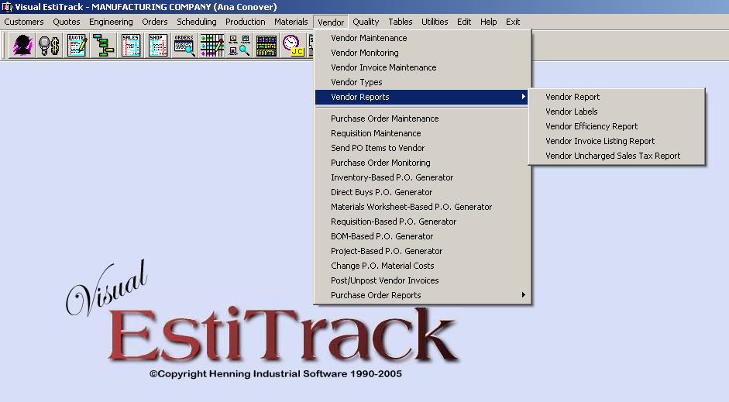
Figure 8a.31 Vendor Reports

Menu Selection
- Left click on the eighth menu heading labeled “Vendors”
- Select “Vendor Reports” from the drop down list.

Security
The system administrator controls access to this menu item via User access Rights (see User Table). Careful consideration should be given regarding who is authorized to manage this menu option.

Report
- Vendor Report
- Vendor Labels
- Vendor Efficiency Report
- Vendor Invoice Listing Report
- Vendor Uncharged Sales Tax Report

