CHAPTER 1
B2C: Making Your Own
E-Commerce Site,
Step by Step
This chapter presents basic techniques for creating e-commerce sites. The first part of the chapter introduces the terminology and some basic facts concerning e-commerce. The second part explains how to create an e-commerce site using Yahoo! Store, which is one of the easiest ways to step into this field. The third part concerns ecBuilder, which is a powerful software package for creating e-commerce sites. After that, Secure Socket Layer (SSL) is explained, followed by the most advanced issue: Microsoft Site Server Commerce Edition. The latter one is the software package for creating the most advanced solutions. Final part of this chapter concerns the E-xact Online Payment System, and is intended to present practical sides of implementation of online payment processing.

Introduction to E-commerce
E-business is the major innovation in modern business. Computer-driven economy is one of the most promising research areas today, and not without the reason. Today, the most important way of doing e-business is over the Internet. Since the Internet is now available in millions of homes, it allows producers to refer directly to their customers, virtually without mediators. Such possibility brings three major benefits to the producers: shorter path to the final customer, lower management costs, and lower overall cost of their goods.
Old kinds of e-business systems are either canceled or modified so they can work over the Internet. In the next two years one percent of World Trade will go over the Internet. This may seem quite a small part, but one should have in mind the exponential nature of the Internet growth − similar growth may be expected for e-business applications too.
E-business solutions today are accomplished using modern techniques such as: World Wide Web (WWW), intranet, extranet, Virtual Private Network (VPN), Secure Socket Layer (SSL) encryption, etc. These issues are technically and structurally well established today, and are growing in their importance very fast.
Business over the Internet is opening the whole new world of opportunities:
- Better communication inside company (intranet)
- Geographically distributed companies
- Business has became transparent (VPN)
- Collaboration with distributors and suppliers based on scheduling
- Forecasting, and just-in-time due to the information technology involved
- Replenishment of supplies (extranet)
- Telecommuting (employee can do his/her job from home providing less expenses).
The most interesting part of e-business over the Internet (also called I-business) is e-commerce over the Internet (I-commerce). In fact, e-commerce is just a part of e-business. For instance, it does not incorporate medium- and long-term planning, business-to-business solutions, and some other advanced issues. But, on the other hand, e-commerce utilizes lower-level issues those are crucial for any commercial application. For instance, e-commerce includes online payment systems, secure transactions, etc. Precisely, e-commerce is a starting point to the e-business.
Over 170,000,000 people were using the Internet on the regular basis at the beginning of the year 2000, and they all can be potential customers with only a few limitations. For instance, not all of the Internet users can possess a credit card or have access to some other payment method. However, limitations of this sort are dropping, and more and more people are every day capable to commit payments over the Internet.
Also, the number of the Internet users doubles every three years. This makes Internet the most sophisticated business challenge for the companies today. There is virtually no limitation for any company to fit into the e-commerce pattern, and it is only up to the creativity and capabilities of the company managers.
These are the basic issues of importance in building an e-commerce site:
- Creating a Web Store site
- Obtaining a digital certificate
- Obtaining a shopping cart software
- Credit card and electronic cash matters
- Marketing and planning.
Each of these steps will be briefly discussed in the following sections.

The First Step − Web Store
The most important issue for E-commerce is Web store. That is the place where one can exhibit and sell goods to the Internet users. It is much less expensive to keep a Web store, than to keep the real one − there is no physical room to rent; there is no salesperson to be paid; no power, public utility or cleaning expenses; no tax payment, etc.
One also should not worry if the store is in a good location for customers. In fact, "good location", in the means of the Internet, is interpreted in quite a different manner: attractive URL, as many as possible links to your store, attractive visual look of the store, etc.
Probably the most important matter concerning Web store is the fact that it works non-stop, 24 hours per day, 7 day per week, 365/366 days per year. Another crucial advance is the possibility for customers all over the planet to access your store and purchase goods without any differences, except those concerning tax or shipping.
The Internet is a giant market where the company can sell goods to anyone, anywhere, and at any time. The number of countries that had been marginalized by their geographical position take extremely active interest in e-commerce today. With e-commerce those countries can move to the center of the virtual geography. This brings us just a step away from the most advanced issues of e-business − internationally distributed business. It is not hard to imagine the benefits of this concept. It is even easier to take a look at the existing solutions in this area, which become more and more numerous every day.
With your own Web store hundreds of millions of people are just one click away from your business. But, in order to create a new Web store, some important conditions must be met. Let us take a closer look at these conditions:
- Getting an Internet Merchant Bank Account − that account enables credit card transactions over the Internet, which will be the basic payment method (and most often the only one) at the Web store once it is created.
- Web hosting − getting WWW space at some Internet Service Provider, in order to set and host the store upon that space.
- Obtaining a Digital Certificate − it is hard to emphasize enough the importance of transaction security; Digital Certificates are offering unified techniques for security maintenance; among other features, Digital Certificate provides its owner with initial keys for encryption, which is the basic condition for secure transaction processing.
- Finding a Provider of Online Transactions − that is the mediator between the customer and merchant's bank.
- Developing or purchasing a shopping cart software − getting hold of the Web store infrastructure, e.g. software shelves.
In order to be able to accept credit cards over the Internet, the company must apply to the bank for an Internet Merchant Bank Account. Depending on which country it is situated in, and what bank the company cooperates with, this can be relatively easy or somewhat difficult task.
In the US, this topic is a fairly simple one. Many banks offer the Internet Merchant Accounts, and most Online Transaction Providers will support them with no further complications. The standardization in this area is advancing rapidly, and it should be expected the Internet Merchant Accounting to become quite a usual matter, just like traditional accounting. Until then, companies should depend on actual regularities in their particular countries.
Majority of Online Transaction Providers today are located in the US. They are restricted in their ability to interact with banks outside their own country with a number of regulations. This leaves international merchants without much choice. In order to overwhelm these difficulties, an international merchant sited outside the US has to find a way to: (1) get US merchant account, (2) find a local Online Transaction Provider, or (3) utilize one of the few companies that services the international market.
Many banks outside the US have very restrictive policies regarding the Internet accounts. However, Internet accounting is quite profitable for banks, so the situation is improving in this area. Most Online Transaction Providers are willing to offer help to the companies to prevail these restrictions.
EU has recently adopted a recommendation aimed at making e-commerce easier. Its efforts are today mostly directed to issues like liberal domain assignments, int'l Internet banking, etc.
Once the basic difficulties have been resolved, the regular merchant account setup period should be obeyed: this period takes up to a month, and after that the account will be created. If the company already possesses a merchant bank account, it will probably also need to upgrade it to an Internet account. Ensure that your bank accepts the Internet merchant accounts and has credit card processors that can connect to FDC, Paymentech, or CyberCash (alternative payment methods). Your account must be able to handle 'Card Not Present' transactions. This is a very important issue.
Web hosting is also a very important step in the entire process. This is how you gain presence on the Internet in the first place. It is important that the Web hosting company is capable of providing you with appropriate quality of service that you need to maintain your Web store.
It is always good to spend some time when choosing a Web hosting company. Reputable provider can guarantee quality of service which is quite important. These are few practical issues concerning Web hosting those should be taken care of:
- Upload stream should be as fast as possible, since a lot of uploading will be done during the store maintenance
- Good technical support by the Internet Service Provider, since your store will be working around the clock
- Fast server-side connection to the Internet, especially if you are planning high hit rate; throughput of your server should be proportional to number of customers, or otherwise it will seem slow to the customers
- Staff that is knowledgeable about e-commerce
- Compatibility with major e-commerce providers
- Classified statistics of access to your Web site

Obtaining a Digital Certificate
A digital certificate (SSL Server Certificate) enables SSL on the Web server. SSL protects communications, so you can take credit card orders securely. It ensures that hackers cannot eavesdrop on you. Running business over the Internet is quite a delicate matter today. In the surrounding full of hackers, security becomes the issue of top importance.
Any e-commerce company will require you to have SSL before you can use their services. In other words, even if you wanted, you cannot create e-commerce site without SSL. For most people obtaining a digital certificate is not a problem. For a minimal fee, one can usually use the certificate owned by the Web hosting company where his page resides. However, one can obtain his own digital certificate by applying to one of the companies registered to issue digital certificates.
The same stands for companies, too. Companies should get and use their own digital certificates for credit card or sensitive data processing. A certificate costs about $150.00 per year. Two major companies registered to authorize digital certificates are:
- Verisign (http://www.verisign.com/)
- Thawte (http://www.thawte.com/)
All information needed to purchase a digital certificate can be obtained on Web sites of these two companies.
Before starting looking for an Internet Service Provider, you should stop for a moment and consider what are your exact needs. These are some questions that should be taken into account before selecting:
- How many transactions are expected to be completed in a month?
- How many products are to be put on the Web site, and what are their space requirements?
- How complex does the software need to be?
- How much is the company willing to spend for this service?
Selecting an appropriate provider means selecting the best price/performance ratio.
There are a lot of Online Transaction Providers today. They offer all kinds of packages with different capabilities and for different prices. The company should decide on a specific package that fits all the needs. This is perhaps the most important aspect in creating an e-commerce Web site. For instance, small business usually does not demand some advanced functions such as: international tax calculation, complicated or long-distance shipping, etc. In such a case, simpler software packages can be used, thus saving both on software cost and site building. However, if medium or large business is at stake, small software packages often cannot fulfill all the demands sufficiently. This leads to more complicated and certainly more expensive solutions.

Shopping Cart Software
Shopping cart software is the most popular and the most widely used concept of Web store architecture. There are many other types of software that can be used in the store, such as catalog software or a flat order form. The shopping cart software is however quite usual method today, and many tools offer high final performance.
Creating can be very complicated without proper tools. This also means that it can be very expensive. Many Online Transaction Providers will have shopping cart software offered along with their service, but it can often be too expensive. Another possibility is a package that offers shopping cart software as a rental included in the monthly service charge, or one that offers a simple flat order form under similar conditions. Purchasing of good tools may be the best solution. Tools that will be presented in this appendix (Yahoo! Store, ecBuilder, and Microsoft SSCE) are all offering appropriate solutions.

Credit Cards and Electronic Cash
The most widely used way of purchasing over the Internet is credit card. The consumer surfs the Internet to the merchants Web site, where he/she decides to buy something. The consumer is then moved to the online transaction server, which ensures security. Transaction (credit card billing) is passed through private gateway to a CC Processing Network, where it is completed (or denied).
Electronic cash is a counter pair to the credit card. It is the informational equivalent of physical banknotes and coins, and is perfect for so-called micro payments (such as paying $0.10 for the one-time use of software or $0.19 for reading a literary essay). Electronic cash can offer such benefits as: (1) anonymity to the buyer, (2) global acceptance. However, credit cards are still dominant, and remain be so in the years that follow.

Marketing and Planning
When the Web store is ready for customers, marketing site becomes very important. These are some Web marketing guidelines:
- Submit your site to as many search engines as possible.
- Try finding Web sites with similar themes (but not the same, of course), and make deals to create reciprocal links.
- Create an advertising banners and purchase space from popular Web sites to display them.
- Put your URL in the signature file of your email and the header of all business correspondence.
- Word of mouth (spread by e-mail) is very powerful on the Internet; tell all of your friends about your page.
- Avoid spamming − it is a sure way to get a very bad reputation.
- Investigate the Web sites that are possible rivals and formulate a strategy for competing against them; do not forget to learn from your rivals as well.
- If you anticipate a lot of growth in the amount of orders coming through your site figure out how you are going to cope with the increased load before you get swamped.

Yahoo! Store
Yahoo! Store is a powerful tool for building e-commerce sites. It can be accessed on the Internet address http://store.yahoo.com/.
Basic advantages of Yahoo! Store over other e-commerce site building methods are:
- Low cost for small stores, thus highly applicable to small business solutions.
- Intuitive interface, which is very easy to use.
- Results are visible immediately; also, the site looks after the publishing exactly the same as it looks during the creation, which makes the use of Yahoo! Store easier.
- Powerful support provided by Yahoo! on a number of topics concerning e-commerce and e-Business, such as fax and e-mail services.
- Basic disadvantages of Yahoo! Store are obvious:
- User cannot create original look of the e-commerce site; sites on Yahoo! Store look similar to each other, no matter what effort was taken for visual design, just because their structure is forced to be the same; only some graphical elements and their arrangements on the screen may be partially different
- Company still needs its own server in order to use the most advanced capabilities of Yahoo! Store, such as custom functions for tax and shipment calculation
- If company owns a server (virtual or real), it can use other tools (such as ecBuilder) to create a more flexible e-commerce site at virtually the same price
- Yahoo! Store certainly cannot fulfill all e-commerce and e-Business demands asked for by bigger companies.
Prior to creating the Web store on Yahoo! Store, an ID should be acquired. Yahoo! Store IDs are maintained on the level of Yahoo!, and not on the level of Yahoo! Store. Once the ID is obtained, user can access all Yahoo! services from the same account. User can obtain Yahoo! ID by registering at http://www.yahoo.com/ or at http://store.yahoo.com/, or at virtually any other page within the yahoo.com domain. This ID offers pass to Yahoo! services like: mail at mail.yahoo.com, e-commerce at store.yahoo.com, etc. If you are already using some of Yahoo! services, you do not need to register again; just use the same ID to create the store.
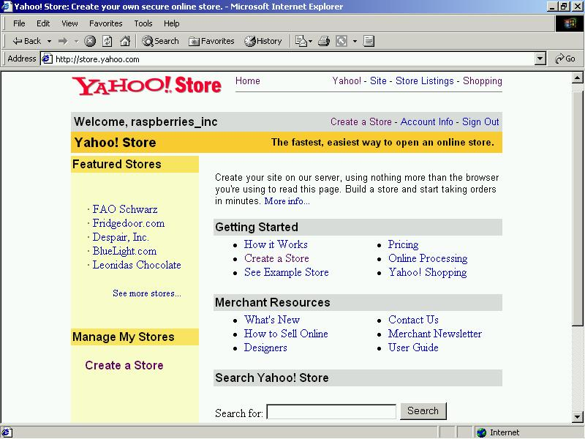
Figure 3.1 The Yahoo! Store welcoming screen.
This page contains links to several useful services,
and also a link to the page where a new store can be created
Once logged on, the welcoming screen will be shown (see Figure 3.1). You may take a look at some featured stores by clicking on appropriate links, or you can take a search in order to find some specific store by using the Search field at the page bottom. There are also some useful links on this page. For instance, you may click to the User Guide link in order to access the official guide for Yahoo! Store. There are some other useful texts in the Merchant Resources section. The section reading Manage My Stores is the section for managers. Since no store is created yet, the only link in this section is Create a Store, which is the same link as the one in the Getting Started section. If some store was created, its name would be visible in the manager's section instead of the Create a Store link.
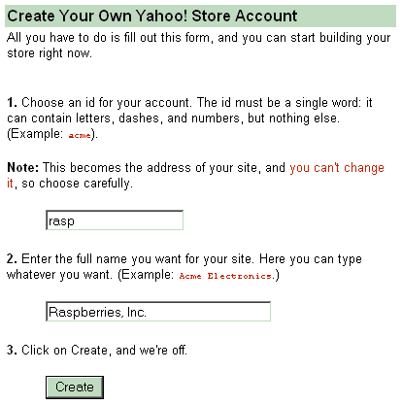
Figure 3.2 The first step in creating a store −
creating a Yahoo! Store account

Creating a New Store
The first step in creating your own store is to click on the Create a Store link. This action leads to the store editor. But, prior to that, an intermediate page is loaded, asking the store account to be created (see Figure 3.2). In order to create a store, the user is prompted for:
- ID of the site − this field also contributes to the address of the site; complete address of your store after publishing will be http://store.yahoo.com/<id>/, where <id> is the ID typed by the user. It should be clear that once entered, the ID cannot be changed later since it is a part of the WWW address, as well: user must be very careful when selecting this item. It also has to be checked whether the specified ID is already in use: if so, another ID should be entered.
- Name of the site − this field serves as the name of the company. Whatever is written as name, it will be shown at the top of the front page of the site, as will be presented later.
In the remaining of this section, using of the Yahoo! Store interface will be presented through one simple example. Suppose at this moment that we are featuring a company named Raspberries, Inc., which offers ecological fruits: raspberries, blackberries, and strawberries. Each fruit is offered in a number of forms: fresh, frozen, juice, etc. First we want to create the store for our company: we may type rasp in the ID field, and Raspberries, Inc. in the name field. This means that our WWW address will be: http://store.yahoo.com/rasp/, and heading on our front page will read Raspberries, Inc.
After clicking at the Create button, a screen with instructions will be shown. There you will find some important information about your future store, such as:
- The account just created is temporal; transforming this account into real one will be presented later.
- This temporal store will be treated for ten days, and after that it will be automatically deleted. (Whenever manager logs onto Yahoo! Store, current day countdown will be shown, just as a reminder of the store deletion if account is not transformed in time.)
- During the test period of ten days, the site will be fully operational, except that orders from customers will be scrambled; it means that the temporal account cannot be used to make profit until it is converted into the real account (e.g., the submitted credit card number will not be visible to the store owner).
- Each store consists of three types of pages:
- Front page − the first page of the site; there can be only one front page, as expected.
- Section pages − each section presents a separate set of items for sale, showing only the most necessary properties of each item: such as price, thumbnail picture of an item and unique item code.
- Item pages − each item is represented on a separate page, containing all important data: price, design, size, quantity, etc. Just as section pages are showing only the basic information about each item, each item page is supposed to provide the customer with the full information about one item (i.e. product).
Front page contains links to section pages, and each section page contains links to item pages (pages of items contained in that section). However, one section can contain one or more subordinate sections. In that case, links to those sections will be present on the section page as well. In order to access one item, user should click on the link on the front page that leads to the appropriate section page that contains that item. After that, user should click to the picture or name of the item, which will lead him to the item page designated for that item. Item can be ordered only at the item page, but its price can be seen both on the section and item pages.
Items can be put directly onto the front page, without creating sections at all. This option is preferable when only a few items are offered. Of course, it is an imaginable situation in which items are put on the front page along with links to the sections. Special case of this concept is the situation when manager wants to put some item both in some section and on the front page. In that case, such item is called a special, and a procedure to create it will be presented later.
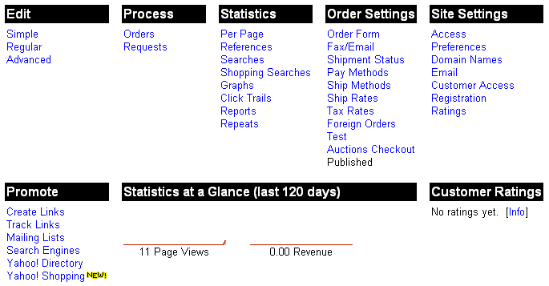
Figure 3.3 "The Yahoo! Store Switchboard" − the starting page for
any activity; there is a number of links on this page,
each one leading to the appropriate utility
After signing with Yahoo!, a screen with options will be shown (see Figure 3.3). This is, in fact, the key page for all manager's activities. In order to reach this page, manager should log onto Yahoo! Store, and in the manager's section click at the name of the store. The Options page consists of eight sections, each one leading to vital managing activities:
- Edit − this section is used when manager wants to create or update the store; each of three links (Simple, Regular, Advanced) leads to the appropriate store editor; or, as implied by their names, they differ in the number of features available to the manager; store editors will be explained in detail in the text to follow.
- Process − this section leads to order/request processing pages; each customer can order some items, request catalogue, etc. Store owner should then process all those requests, and they can be accessed through this section.
- Statistics − these links lead to different statistics useful to the store owner; some of the statistics are quite interesting, such as Click Trails, which offers the manager access to the information about customers' jumping from page to page within the site.
- Order Settings − through these links, manager can set important information about orders: whether and how they should be sent to the store owner by fax or e-mail; payment methods can be set up here; shipment and taxing rates can also be set up; methods for setting up international orders are also available in this section, along with the page for store testing.
- Site Settings − this section is used to set up some general, but important information about the Web site: its preferences and the domain, e-mail, etc.
- Promote − this section contains links related to marketing; last two links: Yahoo! Directory and Yahoo! Shopping are in respect with two global Yahoo! activities − promotion is much easier at Yahoo! Store, because Yahoo! possesses the complete marketing system.
- Statistics at a Glance − few simple statistics those can give the manager quick view the store activities.
- Customer Ratings − the last, but not the least important section, since ratings given by the customers can often be effectively used to promote your store.
At this moment, we are interested in the Edit section, which allows us to edit the store. Three options in this column represent three types of interface:
- Simple Interface − shows only the necessary options for store building; it is recommended to start store editing with this interface, and then to switch to one of the two advanced interfaces in order to set up the details.
- Regular Interface − shows some additional options in respect with simple interface; those options allow the manager to create more sophisticated visual look of the store, but the site functionality is still bounded in the front-section-item page triangle.
- Advanced Interface − shows the complete Yahoo! Store functionality; its use is recommended to experienced programmers only, since misuse of some options can cause damage to the site.
The three options differ in the amount of tools available for store editing. Only the last option allows links to other sites for extra functions such as advanced tax and shipment calculation. For details on this topic, refer to official Yahoo! Store manual available at WWW address http://store.yahoo.com/man.html.
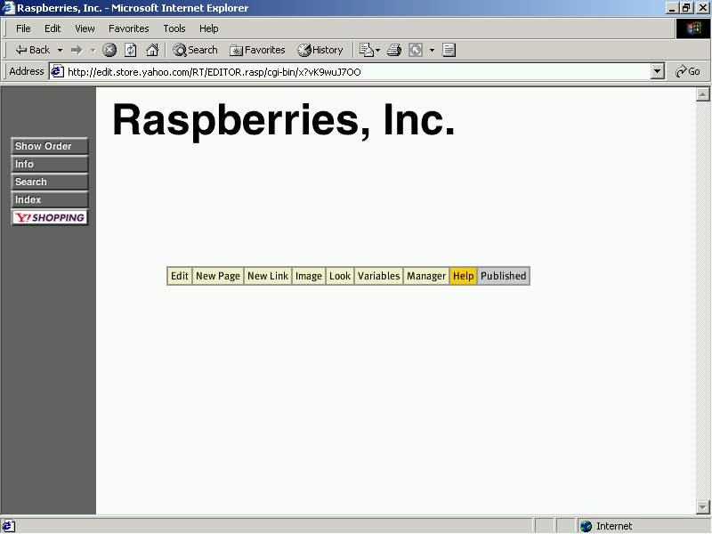Figure 3.4 An empty store: the only elements at the beginning of
the store creating are caption, left margin with buttons,
and menu bar at the bottom

Front Page
Further text will present features available through the simple interface. In order to step into the simple interface, manager should click onto the link Simple in the Edit section. After stepping into the simple interface, an empty front page will be shown. However, there are three elements shown even at the empty store (see Figure 3.4):
- Store name (Raspberries, Inc.) − this name was entered once the store was created.
- Column of buttons on the left margin − these buttons will stand there on all pages, both in the editor and on the real site on Web.
- Menu bar − a line with dozen of options at the center of the screen; this menu is carrying options for store editing, and is not visible for the customers; it exists only during the editing.
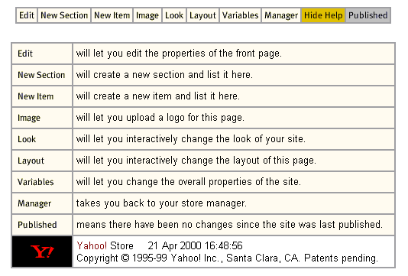
Figure 3.5 Online help is available at the Simple Interface by default;
to hide help, click Hide Help on the menu bar
Also, online help will be available at the beginning (Figure 3.5). This help is shown by default at the Simple Interface, and hidden by default at Regular and Advanced Interface. It contains short explanation for each menu bar option. To hide the help, click to Hide Help button. Otherwise, if help is hidden, this button will read Show Help, and clicking onto it will cause help to be shown. The menu bar is context-sensitive, meaning that it will look somewhat different in different situations. It can ask some time for user to accustom, and if so, it is recommended to leave online help visible for a while.
Menu bar contains, among others, two buttons with obvious functions: New Section and New Item. Adding any element to the store is quite straight-forward. These are typical steps in adding an element:
- step to the page where adding should be committed
- on the menu bar, click an appropriate option
- this leads user to the form containing all the necessary fields concerning the particular action
- after the form is closed, other options on the menu bar may be used to enhance the object of interest
A few examples of this procedure will be presented in this section. Before that, a question may be asked: why is the caption written in Arial boldface font, or why are exactly those five push buttons shown on the left margin. All these properties of the front page are set to default, and can be changed by clicking, for instance, on Variables menu option. All these details can be changed to meet user's special demands.
Note the grayed button reading Published on the menu bar (Figure 3.5). When a button is unavailable, its face is grayed. Published button shows that our store is currently published, i.e. accessible on the Web. If something is changed, on the store, this button will read Publish. By clicking onto that option, the store will become available on the address: http://store.yahoo.com/rasp, as said before.

Variables
The first button on the menu bar is Edit − this option exists on all pages. It allows the user to edit the current page, in this case the front page. In fact, it is used to change some general aspects of the page on which it is applied. If user clicks the Edit button at the front page, another page with properties of the front page will load (see Figure 3.6). These properties are referred as Variables. All relevant details concerning the look of the store are described with number of variables. For instance, fonts, text colors, buttons on the margin, etc. are all described with appropriate variables. The site creation activity boils down to the changing of the values of relevant Variables!
Variable names are self-explanatory. For instance:
- Page-title represents the title of the HTML page
- Page-elements is the list of elements that should be shown on the front page
- Image field allows us to upload an image, which will substitute the name of the company
- Image-format shows three possible positions of the image: left, banner, and unconstrained
- Buttons field is also a list, containing names of the buttons that should be shown on the left margin of each page
- Message contains text that should be written under the store title, etc.
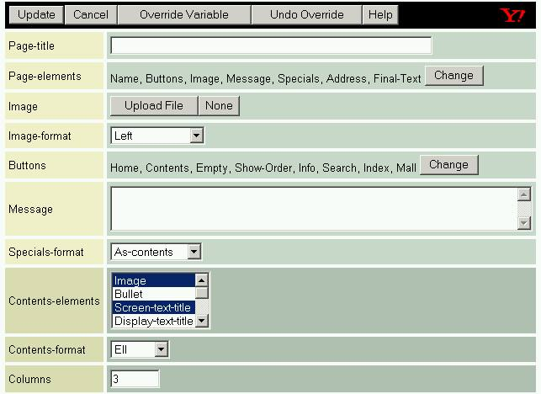
Figure 3.6 Form with variables of the front page;
this form shows as a result of clicking onto the Edit button
Each row on Figure 3.6 contains one variable. In the left-hand cell, there is the name of the variable. In the right-hand cell, there are controls that provide means of changing the particular variable. For instance, for the Page-title variable, there is an edit box on the right, allowing the user to type the title. For Message variable, there is, however, a multiline edit control, so user can write several paragraphs if needed. For some variables, there is just a Change button on the right. After the user clicks onto the Change button, another form will be loaded providing the methods for changing the variable of interest. For instance, if user clicks onto the Change button at the Background-color variable, a form with colors will be shown allowing the user to pick up the wanted color. Another example can be found on Figure 3.6 for the Image variable. There are two buttons next to it: Upload File which allows user to upload an image for the company logo, and another one reading None, which sets front page to have company name written as plain text (Figure 3.4) and not as a logo.
For instance, we may enter Page-title to be: "Green food from Serbia." If no title is entered, store name is used instead (in our example store, that will be Raspberries, Inc.). Variable Message may be assumed as company motto, e.g. "Our fruit knows of no chemistry". We also may upload a title image by pressing the Upload File button at the row for Image variable. If this image is loaded, it will be used instead of the store title, i.e. instead of Raspberries, Inc. Note that page loading time will be longer when the uploaded image is bigger. It is highly recommended to upload images smaller than 20kB, in order to keep high performance.
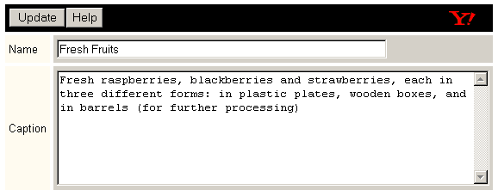
Figure 3.7 An example of section creation: after clicking to
the New Section button, the form is loaded
prompting for necessary information about the section;
section is created after clicking to the Update button on the form
In order to create a section, user should click onto the New Section button on the menu bar. Then, the form will be loaded, prompting for name and caption of the new section. To finish section creating, click the Update button on the form (Figure 3.7). Sections can be created on the front page, as well as inside other sections. This can lead to quite complicated site structures for large stores.
In the same manner, user can create as many sections as needed. After each section is created, appropriate section page will be loaded, allowing the user to edit its contents. One can return to the front page from any other page, by clicking onto the Home button at the left margin.
After creating the sections, we may take a look on the principles how to set up the general look of the front page and section pages. The simplest way to start setting up a look is to click the Look button on the menu bar. After that, another line with buttons will be shown below the menu bar, containing a dozen of general templates. Each template represents one predefined page look, and can be activated by simple click onto its name. You may feel free to experiment with different styles, in order to find the one which best fits with your store style. Figure 3.8 shows an example: look named Soft was selected, and colors and fonts on the front page have changed. Once the Look menu bar is shown, it can be hidden by clicking onto the Hide button on the right end of the menu bar.
It is important to understand that all pages (front page, and all section and item pages) will share the same graphical properties: same colors, fonts, dimensions of active parts of the screen, etc. It is highly recommended that all pages on the site have the same general visual properties, in order to set an impression of stability and consistency to the customer. However, experienced designer may intentionally set some page or group of pages in a different style, in order to leave some special impression to the visitor.
Figure 3.8 shows one interesting detail. Menu on the left margin now contains three additional buttons, each of them leading to one of the sections created in the meanwhile. These buttons will be present on the margin, on all the pages inside the store, both during the editing and later on the Web, after the store is published.
Once the general look of the store pages is selected, some details can be changed manually. Complete look and structure of each page is described through its variables. Variables are in fact properties of the page, and can be viewed by clicking onto the Variables button at the menu bar. We have already seen a number of variables on Figure 3.6. Note that the form was shown after clicking to the Edit button, and not the Variables button as stated in this paragraph. Indeed, variables can be reached in several ways. But, only after clicking at the Variables button, table containing all the variables will be shown. All other techniques, such as clicking at the Edit button, are showing only a subset of all variables: only the variables concerning the current action will be shown. For instance, after clicking at the Edit button, variables like Page-title or Image are shown, i.e. variables that closely relate to the front page.
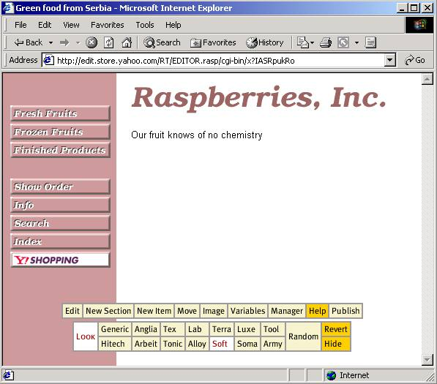
Figure 3.8 Selecting the general look of the page:
click onto the Look button at the menu bar,
and then click onto one of fourteen templates to activate it
Variable identifiers are mostly self-explaining, so the use of the Variables section should be quite simple. For instance, there are variables Button-font-size, Title, Email, Page-width, etc. with obvious meanings. Whenever the form with all or some of the variables is shown, it has the very same structure. It is a table with two columns: the left-hand column contains the name of the variable, and the right-hand column shows controls that can be used to change or discard the current variable value.
Figure 3.9 shows some of the variables for the front page. Note that the value of the Background-color variable is changed from white to pink, by clicking onto the Select button, next to the variable name. If some variables are changed, button Update should be clicked on in order to send the changes to the site. If user changes his mind, and wishes to discard the just made (but not sent) changes, he should click onto the Cancel button. After the Update button is pressed, our front page will have a pink background, since the value of the Background-color was changed. In the same manner, other properties of the page could be changed. For instance, a user can change the color and the font for the store caption.
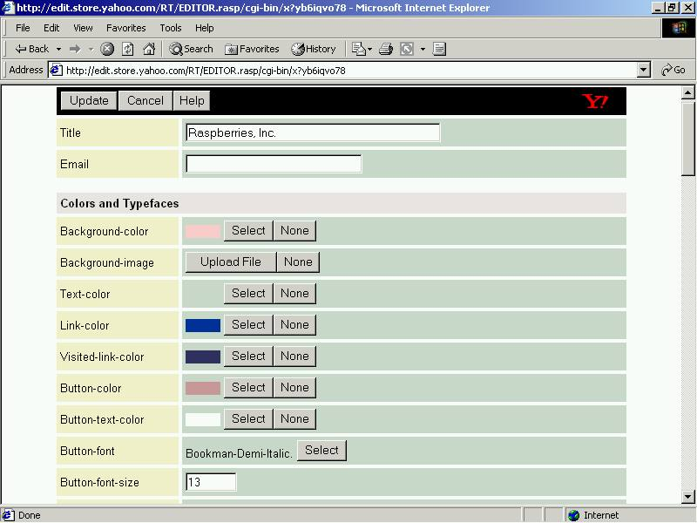
Figure 3.9 Form containing all the variables available from
the front page; next to each variable, there are appropriate
controls (buttons, edit boxes, drop-lists etc.)
that allow the user to change the value of variable in that row
It is interesting to explain how exactly the fonts are working at the Yahoo! Store. The problem is quite simple: if customer's computer does not have the appropriate font installed, some specific text will be shown using a default font, such as Arial. This problem is solved in a fairly simple way: Yahoo! Store offers the list of several dozens of fonts, and the manager has to pick up one of them when trying to change some variable value (e.g. Button-font variable). Then, a snapshot of the text written with that font is created, and that picture is pasted at the page on the appropriate place. In this manner, each customer will see the text looking exactly the same as the manager saw it. This technique allows manager to use sometimes even exotic fonts but, on the other hand, decreases the site performance, since there is yet another picture to be loaded now.
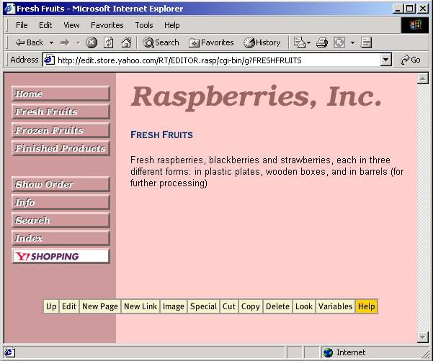
Figure 3.10 The look of the Fresh Fruits section page after
background color was changed on the front page;
variable values are common for all pages:
variable value change made on one page influences all
the other pages as well
Once the variable is changed at the front page, or at any other page, all pages will have the new variable value as well. For instance, all section and item pages will have pink background once the background for the front page is changed. Figure 3.10 shows Fresh Fruits section with the pink background. Note that the menu bar is somewhat different on Fresh Fruits section page from the one on the front page. Since menu bars are context-sensitive, tiny differences will arise on different pages. Note once again the buttons on the left margin: in contrast to the front page (Figure 3.8), the Home button is available. As said before, this button leads directly to the front page, whatever the current page is. Section buttons are still there, as they are on all the pages.
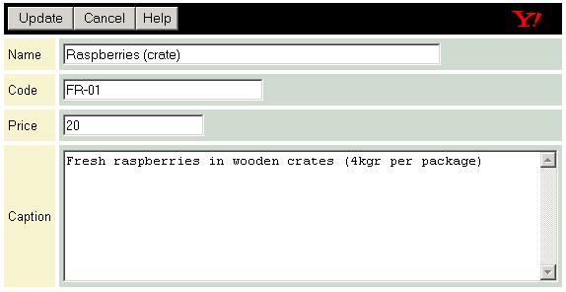
Figure 3.11 Adding a new item: only a few properties
of the item are prompted during the item creation;
all other information about the item should be set later
through the changing of appropriate variables

Adding Items
Now, one might try to add items to the sections. Menu bar on section pages contains the New Item option. After clicking to the New Item option, an appropriate form will be loaded. Four properties of the new item are asked for: name, caption, code (this is internal code of the item), and price in US Dollars (see Figure 3.11). After clicking to the Update button, a new item page will be created, and a link to it will be added to the Fresh Fruits section. As usual, if user changes mind and wishes not to create a new item page, there is the Cancel button available for that purpose.
After a new item is created, the appropriate item page will be shown, allowing the user to set up all the details about the item. For instance, an image for that item may be uploaded. In order to do that, user should click onto the Image option on the menu bar. Another form will be loaded as a result, and the user will be prompted to browse his computer for the image he wants to upload. Note that Yahoo! Store does not provide any image library, so when selecting an image, you are on your own. The browsing and uploading processes depends on the browser used. There may happen that some specific browser does not provide possibility to upload a file. If this is the case with your browser, either you should change the browser, or update it to the later version.
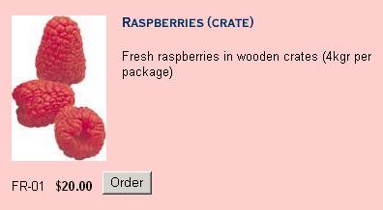
Figure 3.12 Look of a specific item on the item page;
note the elements describing the item: name, caption, image,
code, and price; there is the Order button available on the item page
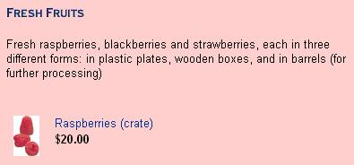
Figure 3.13 Look of the central part of the section page
containing one item; note that only name, image, and price
are available for the item; the Order button is missing,
as well: items can be ordered from their item pages only
After an image is uploaded, it will be shown both on the item page (Figure 3.12) and on the section page (Figure 3.13). Note that item image is shown in full size on the item page, and as a thumbnail at the section page. Also, there is an Order button at the item page. The Order button provides customer the possibility to order some amount of the item. Order button is available on the item page only. This means that an item cannot be ordered from the section page or from the front page.
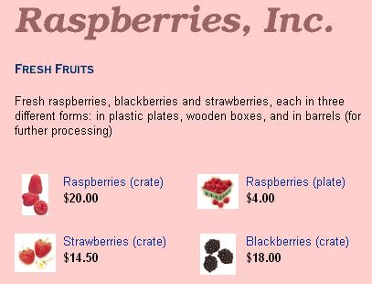
Figure 3.14 The look of the finished section page;
items are ordered in a grid, and each item
is represented by a thumbnail of its picture
In the same manner, user can add other items to the Fresh Fruits page. Figure 3.14 shows a possible look of the Fresh Fruits page after four items were added. By clicking either on the name or on the image of any item, the appropriate item page will be loaded: then, the customer can order the wanted amount of the product. Note several details concerning the organization of the section page shown on Figure 3.14:
- Items are ordered in a grid; the number of the columns of this grid is determined by the variable values;
- Each thumbnail has dimensions also defined by the variable values.
These and other properties can easily be changed to meet designer's demands.

Variable Overriding
Now, you may try to edit variables on the Fresh Fruits page. By clicking the Variables option at the menu bar, the list of variables will be loaded. The user may try, for instance, to change the Background-color variable again, and choose some other color, hoping that the Fresh Fruits page will be in a different color after that. New color will be set for the Fresh Fruits section page indeed, but all the other pages will be changed having the new background color, as well. This is, however, not what we had on mind. In fact, we wanted to change the background color for Fresh Fruits section only, and leave all other pages with the pink background. Well, this task cannot be performed on Simple Interface: Regular or Advanced Interface has to be used.
In order to use Regular Interface, user should logon again, by typing URL http://store.yahoo.com/ at the browser again. If needed, user will be prompted for username and password, but probably will not be needed. User's (or company's) personal page should be loaded, offering user to manage the existing stores. After clicking to the name of the appropriate store at the manager part of the screen, the introductory manager page will be loaded (Figure 3.3). As mentioned earlier, this page is the starting point for all sorts of activities. Among other things, type of the interface can be selected here. In order to select Regular Interface, user should click onto the Regular link in the Edit part. Link reading Advanced in the Edit part invokes the Advanced Interface.
Figure 3.15 Menu bar for the Regular Interface;
note that this menu carries somewhat more options;
also note the small triangle at the right hand end of the bar −
clicking to this triangle leads to the Advanced Interface
Figure 3.15 shows what the menu bar looks like at the front page when Regular Interface is invoked. At the first glance, everything is the same as it was at the Simple Interface, except that menu bar carries somewhat more options. Also, notice a small triangle at the end of the menu bar. By clicking at this triangle, the interface will be upgraded to Advanced. On the other side, at the Advanced interface, the same triangle will exist, but its top will be turned to the left, and it will be used to downgrade to Regular Interface. Note that from Simple Interface user cannot step to the Regular or Advanced Interface in other way but through another logon. The same stands for downgrading Regular or Advanced Interface to the Simple Interface. However, changing from Regular to Advanced Interface and vice versa is done via red arrow, which is much easier. One may look at this as an inconvenience, but it may be considered just as a protection from beginner-level users: Regular and Advanced Interface both carry some powerful options; those options can be used to launch the quality of the store, but also a damage can be done to the store if those options are used inappropriately.
Although the variable values are common for all pages, Yahoo! Store provides one powerful technique called variable overriding. This technique, originating in object-oriented programming, is managed on Yahoo! Store in a fairly simple way. If some variable is overridden at some page, another instance of the variable is created, and assigned to that page. Now, all the changes of that variable makes influence only to its own page, and all the other pages stay intact. Variable overriding is quite a simple technique, and user can create interesting effects on the site using it.
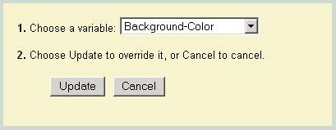
Figure 3.16 Overriding a variable: the drop list contains
all the variables on which the overriding can be applied
at the particular situation
This is how the overriding is really performed. Whenever user clicks to Edit of Variables option at the menu bar, a form showing values of some or all the variables is loaded. At the header of this table, there is a line with accessory buttons, such as Update, Cancel, or Help, and these buttons will always be present. However, when clicking to the Edit option, another button will be present at the form, reading Override Variable. Clicking to this button leads to another form, which provides user with a list of variables on which the overriding can be applied (Figure 3.16). After some variable is overridden, its name will be shown at the bottom of the variables list for its page. For instance, Figure 3.17 shows an example in which variable Background-color is overridden and its value is set to orange. After applying this change to the site, only the page for which the overriding was performed will have an orange background; all the other pages will have a pink background as before.
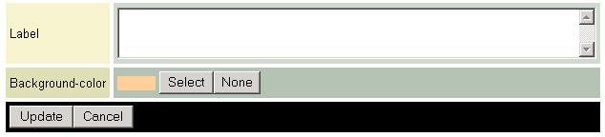
Figure 3.17 Overridden variables are shown at the very bottom of the variables list (Background-color variable in this example)
One of many useful concepts at Yahoo! Store is undoing. User may often come into position to change the mind about some matter. Yahoo! Store provides buttons and options for undoing virtually every action. As well, the variable overriding can be undone if needed. User should just click onto the Edit button, stepping into the form when the overriding was performed, and click onto the Undo Override button. After that, user is prompted to select one of the previously overridden variables, in order to remove it from that list. Of course, the Undo Override button exists at the form only if there is at least one variable on which the overriding was performed before.

Special Items
It often happens that the merchant wants to set some item to be a special offer. It may be a seasonal item, an item frequently wanted by the customers, or just a representative item that merchant wants to emphasize. Yahoo! Store provides a solution for such situations: an item which is to be special, will be shown both inside its section page, and on the front page. In order to set an item to be special, user should go to the appropriate item page and click onto Special button at the menu bar. After that, an item will be marked as special, and that button will read Not Special. That button is now used to set some item not to be special any more. Note that once the item is set special, it is not the same as if another item with same the information is created onto the front page. In fact, when an item is special, just another link is created at the front page, pointing to the existing item page. Now, if user changes something at that item page, changes will be visible both from the section page and from the front page. Figure 3.18 shows the visual look of the front page when one item is set to be special.

Figure 3.18 The look of the front page
when a special item is present
There is another option somewhat similar to the previous one. In some cases, it seems appropriate to offer some accessories along with some offered item. For instance, if you are selling an ice cream, you may offer spare plastic spoons along with it. In many cases, this can be a useful option, because customer can order a product and an accessory at the same page, without jumping around the store in the long quest for, say, plastic spoons. Accessories are added at the item pages. On the menu bar there is a New Accessory option, which allows user to add an accessory just as simple as the item was added to the section page. Figure 3.19 shows the visual look of the item page when an accessory is added. Note that accessory is shown below the item, thumbnail is smaller, and caption is condensed compared to the item.
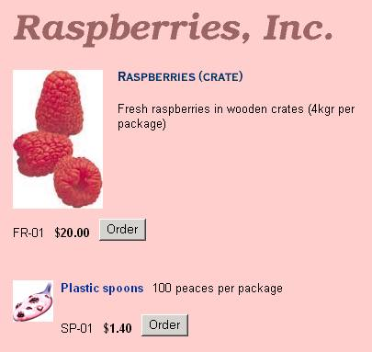
Figure 3.19 The visual look of the item page
when an accessory is present

Internal Clipboard
Another useful concept of Yahoo! Store is internal clipboard. Suppose there is a need to move or to copy some contents (item or section, for instance) from one place to another. Internal clipboard can be used for that purpose. Without this option, one would have to delete the contents and then to create a new one (identical) elsewhere, manually (which is certainly painful).
There are three possible actions when working with clipboard:
- Copy − Copies the page onto the clipboard; original object is left intact; this action is performed by clicking onto the Copy button at the menu bar;
- Cut − Copies the page onto clipboard, but also deletes the original object; this action is performed by clicking onto the Cut button at the menu bar;
- Paste − Copies the object from the clipboard to the current position; there is no button for this purpose − instead, the current contents of the clipboard are shown below the menu bar (see Figure 3.20 for the example).
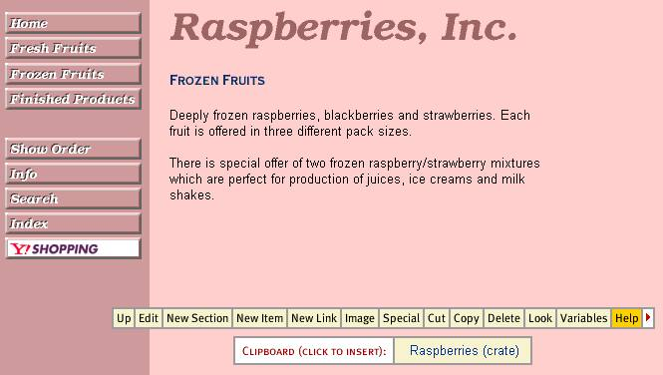
Figure 3.20 The look of some page when clipboard is not empty;
the contents of the clipboard is shown below the menu bar user can paste an item by clicking onto the white (left-hand) cell in the table
Content of the clipboard is being cleared each time user logs off from Yahoo! Store. If some item is cut, but not pasted onto some other place, it will be irretrievably lost after user logs off. Contents of the clipboard (if the clipboard is not empty) is visible underneath the menu bar (Figure 3.20). In the right-hand field, there is a caption of the object, and on the left-hand field there is a link to the paste command.

Publishing the Store
In the end, when the store is finished, it should be published. Publishing can be performed from the front page, by clicking onto the Publish button at the menu bar. The updated store will be immediately visible at the address specified by the ID of the store (http://store.yahoo.com/
rasp/ at our example).
Remember that Yahoo! offers a ten-day trial period, and the store will be automatically deleted after that period expires. In order to keep the store, merchant should convert the temporal account into the real one. This can be performed by stepping to the store introductory page (Figure 3.3) and clicking onto the link reading Open your account, situated at the bottom of the screen. Yahoo! will lead the user through the rest of the registration process. One advice: Do not wait until the tenth day to create your account. Web services are not reliable enough yet, and one may be quite disappointed if getting into position to create the complete store all over again!
One of the important topics of Yahoo! Store is the pricing. Stores are valued by their size, i.e. by the number of items offered. There are three categories:
- Small store − with up to 50 items; it costs $100 per month;
- Medium store − with up to 1000 items; it costs $300 per month;
- Large store − with more than 1000 items; it costs $300 per month for the first 1000 items, and additional $100 per month for each additional 1000 items; for instance, a store with 2300 items would cost $500 per month.
The pricing is subject to change by Yahoo!.

The ecBuilder
This section presents ecBuilder, a powerful software package coming from MultiActive Software, Inc. It is designed for step-by-step creation of fully functional e-Business solutions from scratch. It provides means of creating small and medium business sites. The interface is very intuitive and provides a quick learning curve. User does not have to bother himself asking questions "how does this or that work." Instead, the software hides the theoretical background from the user, and provides him with number of tools and techniques for solving even the toughest practical problems. The price of this package is 495$ (on January 1st, 2000), and there are no additional hardware or software demands.
What is needed to start your own e-business using ecBuilder is a registered version of ecBuilder and Web presence. All information needed on how to acquire and register the software can be found at http://www.ecbuilder.com. In order to accept credit cards online, merchant must already posses a merchant status account with a credit card company or at least an Internet merchant bank account.
Merchant must also be able to process the credit card transactions. It means that merchant needs a third-party payment processor, and also a digital signature certificate.

Introduction to ecBuilder
As said before, ecBuilder is designed for small to medium sized businesses. It requires only the basic HTML and Web design knowledge from the user, and provides all the necessary elements every e-business site must have. Elements such as shopping basket, subtotal calculator, and others are performed through embedded Java Script (needs no direct access to user memory or hard disk), and Cookie technologies. Java Script does not need (neither provide) direct access to memory or disk at the user's computer. On the other side, Cookies are used to memorize a data structure on user's hard disk.
All data related to the shopping basket are stored with the user, and not at the server. In fact, SSCE provides both options: to maintain the shopping basket on at the user, or at the server. The first option is easier to develop, but the latter one provides bore reliability. However, ecBuilder provides only the first option.
Security issues are provided via a special ecBuilder's server named ecPlace. It is a server, independent from merchant's site and merchant's ISP; the ecPlace is maintained by MultiActive, Inc. as well as the ecBuilder. Merchant should not worry about installing and maintaining the ecPlace: it is already done in background. The ecPlace provides one more interesting feature: once the store is published, its URL will appear at the ecPlace's list of featured business Web sites, thus providing a free commercial for the merchant. This list can be accessed at http://www.ecplace.com.
Another piece of software that comes along with ecBuilder is ecOrderDesk. Its purpose is to process orders, to help books keeping, and to maintain a POS terminal.

Payment processing
ecBuilder provides full support for online credit card processing. Credit card paying process is security sensitive, as said in previous text. The merchant takes care of delivering the bought goods, while ecPlace takes care of the credit card payment processing.
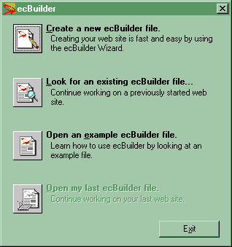
Figure 3.21 Beginning to work with ecBuilder:
opening or creating the ecBuilder file
ecBuilder provides a built-in wizard for generating boiler-plate HTML (the HTML skeleton) and Java Script code for your e-business site. There are dozens of built-in templates for the user to choose from. In fact, the only way to create an e-business site using ecBuilder is to use the Wizard. But, before user starts using Wizard, he should make a choice which option of the Wizard will be used. Wizard offers to the user to select which one among the ecBuilder files should be open: (1) create a new file, (2) look for an existing file, (3) open an example file or (4) open the last edited file (see Figure 3.21).

The ecBuilder Wizard

Step one: Site Structure.
The first step in the Wizard concerns the site structure. The ecBuilder will generate several HTML pages, and will hyperlink them correctly. At this step, user should select which additional pages the site should contain. These are the offered choices: (1) content pages, (2) products or services catalog, (3) feedback form and (4) contact information page (see Figure 3.22). For each page selected, the user is prompted to enter the appropriate page caption.
Basically, user should include each of these four page types, as they are all required if there is intention to create a serious store. Number of the steps the Wizard guides the user may vary depending on which pages user checked to be generated. Another option is set at this step: the user is prompted whether the address and phone number should be shown at the site or not. There is a check box at the bottom of the screen (Figure 3.22) serving this purpose.
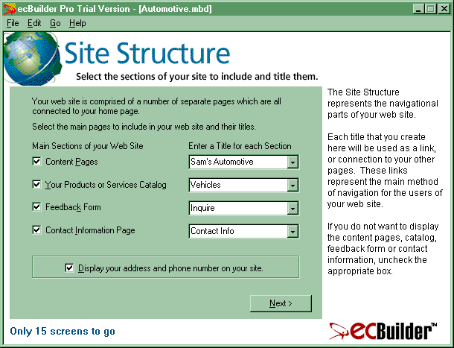
Figure 3.22 The first step in ecBuilder Wizard: selecting the site structure; along with each page user wants to add to the site,
the appropriate caption should be entered

Step two: Company Address.
Figure 3.23 shows the second step of the Wizard. In this step, user is prompted to fill more detailed information about the company: its physical and the Internet address. Fields marked with asterisk ("*") are required, and user must enter them in order to proceed to the next step. These fields are: full company name, the primary company address, city and country names. Other fields are optional, but useful. All information about the company those can be presented at the site, should be presented, because each new contact information brings additional possibilities to make contact to the customer.
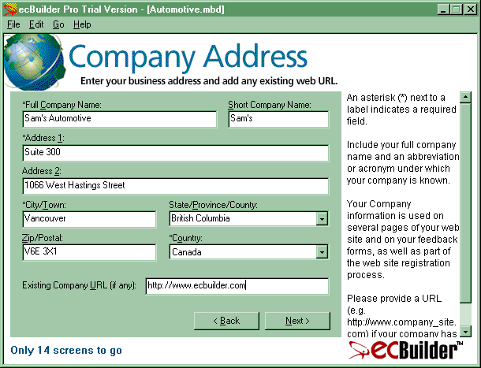
Figure 3.23 The second step in ecBuilder Wizard:
selecting the Web and physical address of the company

Step three: Site Builder Profile.
The third step of the Wizard is quite an interesting one (see Figure 3.24). In fact, the person who is building the e-business site is prompted to enter the information about himself. The wizard alone gives some information about why this step is important (see the right margin of the Wizard screen at Figure 3.24).
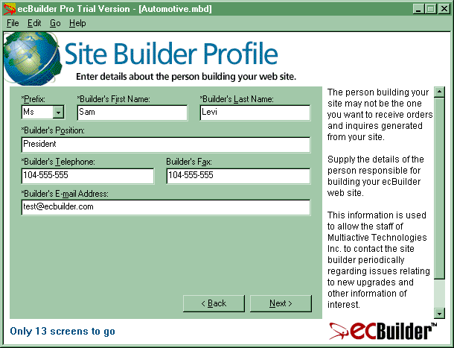
Figure 3.24 The third step of the Wizard:
selecting the site builder's profile
The site builder person may be a person inside or outside the merchant company. Whichever of these stands at the particular case, such person is qualified for creating and maintaining the site. This contact information should provide the way to send messages to that person concerning the technical side of the site. Note that if the site builder is outside the merchant's company, he keeps full author rights concerning the site structure, presentation of the contents, etc. Naturally the merchant keeps rights to use the site on the market.
Information about the site builder is useful for the MultiActive, Inc. too. Having this contact in hand, they may use it to present new updates and other features to the site building person, sending in that way their marketing notes to the very best recipient. As before, some fields on the form are required (and marked with asterisk). These are: the prefix (e.g. Mr.), first name, last name, position in the company, phone number and e-mail address. The only optional field is fax number.

Step four: Contact Person Profile.
The next step in the Wizard prompts the user to enter information about the contact person (see Figure 3.25 for the example). Such person is responsible to handle orders and inquiries sent to the merchant company. If it is the case that this person is the same as site building person (set at the previous step), just check the option at the top of the screen (Figure 3.25). If this contact name should be shown at the Contact Information page, user should check the appropriate option at the bottom of the screen.
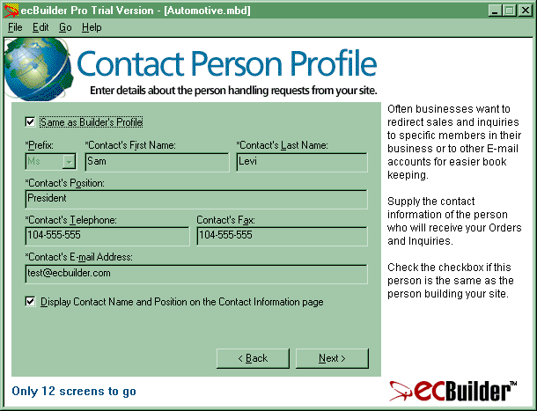
Figure 3.25 Step four of the Wizard:
setting up information about the contact person

Step five: Business Classification.
The next, fifth step, prompts user for general categorization of the business (see Figure 3.26). Two kinds of information are asked: business category, and a keyword. There may be up to 15 categories and up to 30 keywords selected for the site. These references are used to classify the site at http://www.ecplace.com, and it is of the best interest for the merchant to fill this form wisely. Note that business category can be only selected from the list provided by ecBuilder, but keywords can be entered arbitrarily. These keywords will also be submitted to the search engines for the indexing purposes. It is hard to emphasize enough at this place how much the smart keyword selection can add to the business.
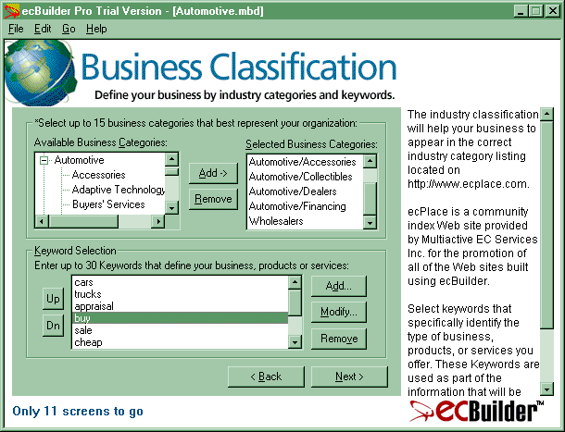
Figure 3.26 The fifth step of the Wizard:
setting up business classification

Step six: Company Identity.
Next step prompts user to select elements describing the identity of the company (Figure 3.27). Those are: company slogan, logo graphic and brief description of the company. The slogan is a sentence that will be the first sentence the customer sees once when accessed the merchant's e-business site. This sentence should hence be very carefully selected, since it is intended the customer to recognize the store according to its slogan.
The logo graphic is a picture in .GIF or .JPG format, and this picture will be visible throughout the site. In order to keep high performance, make sure that this picture is not greater than 20-30 kB at most. Otherwise, loading time may significantly rise, making bad taste to the customer.
Company description is the only required field on this form. It should be at least a sentence, and at most few paragraphs describing the merchant company, its domain, potentials, its mission, etc. Company description will be later passed to the search engines as a site summary: it will appear as a short description of the site, once the site is listed at the result list on the particular search engine.
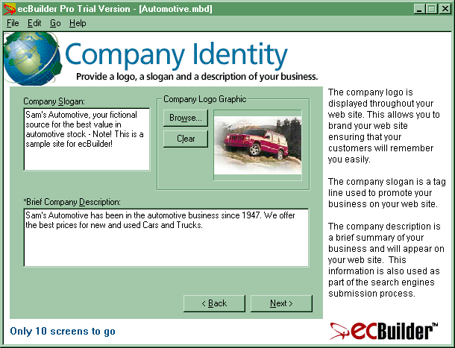
Figure 3.27 The sixth step of the Wizard:
selecting the identity of the company

Step seven: Web Site Content.
The next step provides user with possibility to precise physical content of the site (Figure 3.28). By checking the "Content Pages" check box at the Step One (Figure 3.22), user cause ecBuilder to generate a page with the default title "background". A link to that page can be found on the main page of the site. This "background" page contains up to 100 links to other pages of user's choice. Also, the default contents of this page will be generated by ecBuilder.
By using Add, Modify and Remove buttons, it is possible to create very complicated and original structure of the site. If a headline is provided for some particular content, it will be added as a link, and the content will be created as a separate HTML page. Otherwise, if headline is not provided, the content will be incorporated into the current HTML page as its part. User can use this step of the Wizard to add anything found relevant to the merchant or the site in general. This is one of few concepts at ecBuilder where user can create virtually anything, bounded only with user's creativity.

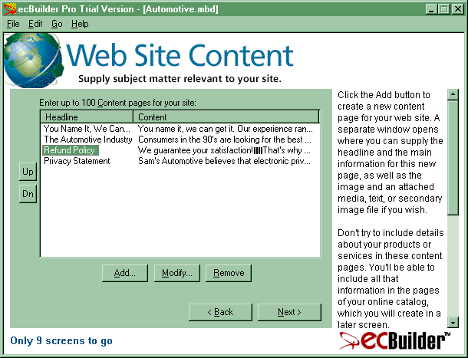
Figure 3.28 The step seven of the Wizard: selecting content of the site

Step eight: Payment Methods.
Figure 3.29 presents the eighth step of the Wizard. Here, the user is prompted to set up payment methods. These are generally divided into credit cards, and others (e.g. check, money order etc.). There is a list of featured credit card companies, and user may select the wanted ones. Also, user is capable to define new credit card name and to add it to the list. At this step it is also possible to set the currency for the prices on the site. By default, US Dollar is used.
As stated several times before, to accept online payments, merchant must have an appropriate merchant account either at credit card companies, or at the bank, or both. This question is of general nature and does not depend on ecBuilder or any other site-building tool possibly used. ecBuilder provides only an interface for online transaction processing, and this interface is being set up at this step of the Wizard.
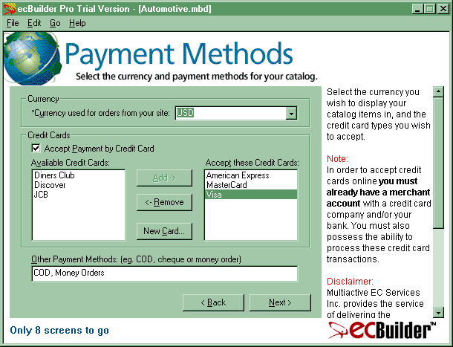
Figure 3.29 Step eight of the Wizard: selecting payment methods;
there is possibility to use credit cards as well as
some other typical payment methods

Step nine: Online Payment Processing.
At the step nine, online processing method should be set (see Figure 3.30). User is prompted to select the third-party online transaction processing (OTP) company that is intended to be used. Up to this moment, ecBuilder supports only E-xact and InternetSecure transaction processing companies.
From this point of view, ecPlace is nothing else but a software that serves as an interface to the OTP. Once the merchant obtained a merchant account, another separate account has to be obtained as well, at one of the supported OTP companies. Refer to http://www.ecbuilder.com/client/
merchantacccount for additional information on how to obtain an account with the OTP company. The OTP company furthermore serves to the merchant as a transaction gateway provider (TGP).
After user selects an OTP company from the drop list (Figure 3.30), it is possible to set additional information as ID, password, etc. depending on the OTP company. This can be accomplished by pressing onto the Settings button, and the following the instructions. If merchant haven't applied to any transaction processing company, but wants to create a beta version of the site, the field [NONE] should be selected at the field for OTP company name. That will allow the user to proceed creating the site, but such a site will not be applicable until this field is set appropriately. In order to set up the OTP company, user should return to this step later.
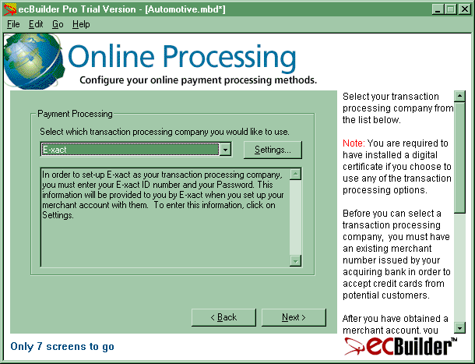
Figure 3.30 Step nine of the Wizard:
configuring payment processing method

Step ten: Catalog.
This step may loosely be called the Wizard inside the Wizard, coming from its complexity. At this step user is prompted for information about the catalog (Figure 3.31). Catalog is defined as a set of items, services or goods the merchant is offering for sale on the site. In the left pane of the splash screen shown on Figure 3.31 there is a box containing Catalog Sections. For each section selected, right pane of the form contains items inside it. Once the site is finished, sections will appear as links on the "Catalog" page, which is generated automatically. Items will appear as links, each on the corresponding section page. Note that "Catalog" page will not be created, neither this Wizard step will be invoked, if option "Your Products or Services Catalog" was not checked at the first step of the Wizard (Figure 3.22).

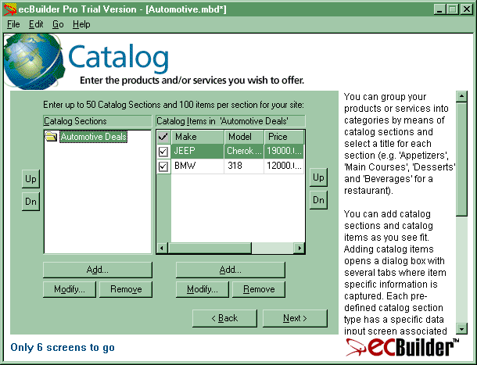
Figure 3.31 Step ten of the Wizard: setting up an online catalog
Each item page may contain arbitrary information about the item. It will also contain an interface that allows customer to invoke several actions concerning that item. For instance, user can add the item to the Shopping Basket, buy the item right away, make inquiries about the item, etc. Options those should be available to the user can be set by clicking onto Modify buttons at the Catalog Sections and Catalog Items panes.
By clicking the Modify button at the Catalog Section pane, the form shown on Figure 3.32 will be shown. This dialog is used to precise the general look of the catalog. First, Business Template should be selected from the offered list. There is a number of Business Templates offered, each applicable to some specific business. Depending on which template is selected, Web page layout may differ, as well as the choices user may make in the next steps and in the dialog boxes.
Along with the Business Template, several additional fields are provided: title of the section, discount rate with the discount description, general description for the catalog and an image. All fields except catalog title are optional. If discount rate (and possibly its description) is set, it will be applied to all the items. If this does not satisfy, separate discounts can be defined for particular items later. In such case, discount fields should be left empty. Text written at the Description for Catalog field will be shown on the Web page just below the section title: it is good place to put an adequate marketing note. Catalog section image will be situated at the left side from the title at the section Web page. Finally, user may check the Show preview images option, thus providing thumbnail images of the items to be shown on the Catalog index page.
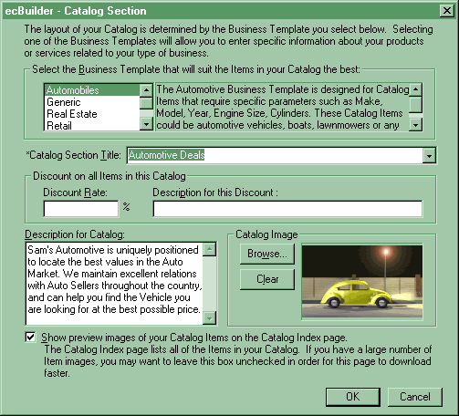
Figure 3.32 Selecting the Catalog layout;
several templates are offered providing quick results
When some item is added to the Catalog Items list (Figure 3.31), user may press the Modify button in order to set precise information about that item. At that case, another dialog will be shown, looking similar to the one presented on Figure 3.33. This dialog brings six tabs, named: Main, Features/Keywords, Details, Image/Media, Price Info and Tax/Shipping, respectively. The meanings of these sections are obvious, and we will only take a brief look at some of them.
Figure 3.33 shows Main tab of the dialog. Note that this dialog is created on Automotive Business Template. Having this on mind, it is clear why fields like Make, Model, Year, etc. are offered. If some other template was selected, some other fields would be offered. Note that there is another Description field at this dialog. This description will be shown at the item page.
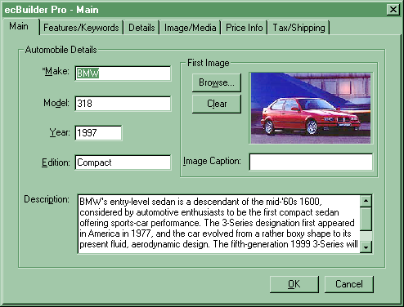
Figure 3.33 Catalog Item dialog box: this dialog contains dozens of options concerning visual look, pricing, taxing and other information about the particular item
Figure 3.34 shows the second tab of the Catalog Item dialog box. This tab allows the user to enter up to 20 features and options for the item, and up to 10 keywords. These keywords will be submitted to the search engines once the page is registered on them.
Figure 3.35 shows the Details tab of the dialog. This tab is yet another dialog that strongly depends on the Business Template selected earlier. For instance, fields as Body Style, Number of Doors or Cylinders may be shown only for the vehicles. If some other Business Template, such as Real Estate was selected, adequate fields might be expected.

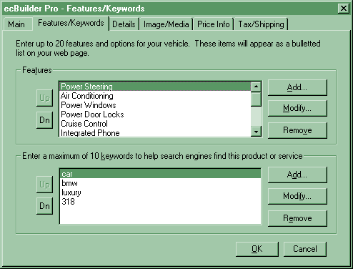
Figure 3.34 Second tab of the Catalog Item dialog box
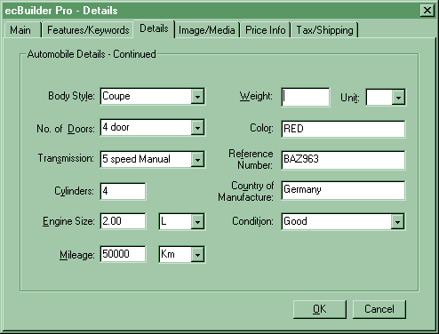
Figure 3.35 Details tab of the Catalog Item dialog
Figure 3.36 shows next tab named Image/Media. This tab is quite abstract, and does not depend on the Business Template selected. At this place, user may select the second image for the item, along with the appropriate image caption. Also, a media file may be selected (audio/video file), together with the appropriate note.
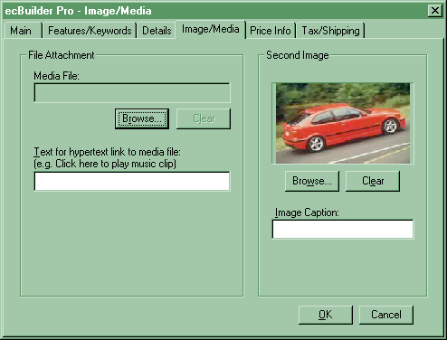
Figure 3.36 Image/Media tab of the Catalog Item page
Figure 3.37 shows another tab of the dialog that is independent on Business Template in hand. Note that several major scenarios for creating the price may be used. But, one may reproach to the creators of ecBuilder for not putting even more options since this part is essential for the merchant.
Figure 3.38 shows the final tab at the Catalog Item dialog. This tab is used to set taxing and shipment options for the current item. Unlikely the pricing tab, this one contains somewhat more options, providing both home and international taxing and shipping.

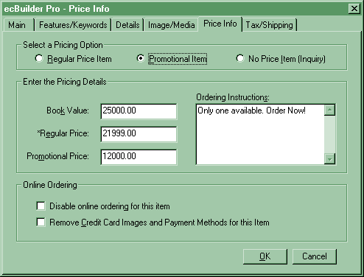
Figure 3.37 Price Info tab on the Catalog Item dialog
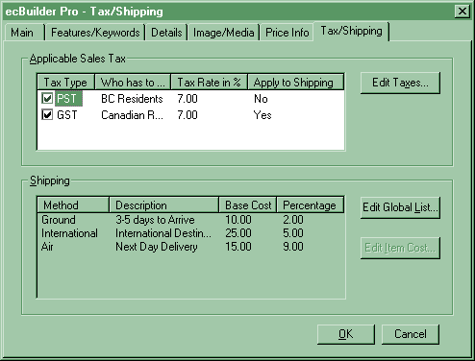
Figure 3.38 Tax and Shipping tab of the Catalog Item dialog

Step eleven: Advertising and Statistics.
This step, presented on Figure 3.39, gives the user three options to select: (1) top page banner, (2) bottom page banner and (3) hit counter. Banners are used primarily for link exchange between sites of similar interest in order to boost up hit rates. Link exchange (especially through banners) brings the merchant additional cash source (pay per click-through banners, for example). On the other hand, many companies are paying for banner clicking (1 cent/click is the order of magnitude). This is not much an income, but may give a boost to the advertising side of the business.
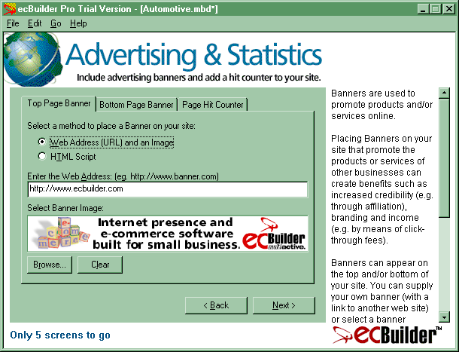
Figure 3.39 Step eleven of the Wizard:
setting up advertising and statistics
Hit counters are used for tracking visitor statistics for the site. This option can be useful when planning the future market strategy. However, many companies, especially bigger ones, avoid to set visible hit counters on the site. They rather prefer setting the hidden counter, which may be analyze number of visitors, without giving the customers that information.
Banners (either top or bottom) can be put to the site in one of two ways: (1) user selects the banner image and the appropriate URL, or (2) user may cut and paste the already generated HTML code provided from some other site, possibly the one where the banner will point to. The latter option is applicable, for instance, when user decides to enlist with some banner exchanging service. Such service will provide the user with the appropriate HTML code that should be installed to the site.
One example of the banner exchange service is LinkExchange. This service is intended to perform business-to-business advertising options. All relevant information about it may be found at http://www.linkexchange.com.
Hit counter is installed by pasting appropriate code into the text box. Counter code may be generated for you by some of the free counter services offered, or it may be your ISP's default counter code. In the latter case, you should obtain the appropriate HTML code from your ISP's support service. There are counter providers, which provide the tracking services for free. One of the best known is TheCounter at http://www.thecounter.com.
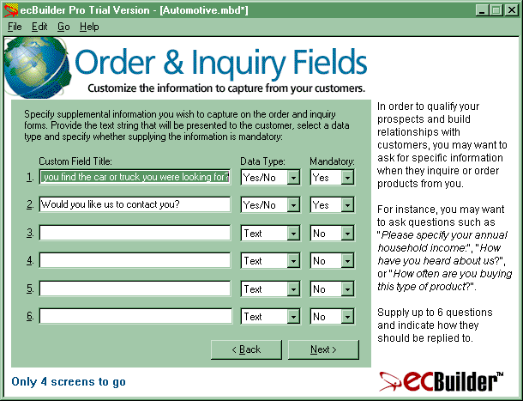
Figure 3.40 Step twelve of the Wizard:
setting up order and inquiry information

Step twelve: Order and Inquiry Fields.
Order and Inquiry Fields are supplemental information which merchant may want to hear from the customers (Figure 3.40). These questions may look like: "How often do you buy on-line?", "How did you hear about our store?", etc. These pieces of information are usually intended for market surveys and market analysis, which in turn should be used to improve the way the site and business work. Using the form shown on Figure 3.40 should be quite simple. Note that only six fields may be created.

Step thirteen: Site Design and Preview.
This is the final step concerning site editing (see Figure 3.41). At this step, user is prompted to select one of general look templates. Each template defines different arrangement of the elements on the page, as well as the color scheme of the site. There is also an option to download a template. After setting these few pieces of information, ecBuilder will be able to create the site. But, before that, use can take a look at the site by pressing the Preview button.
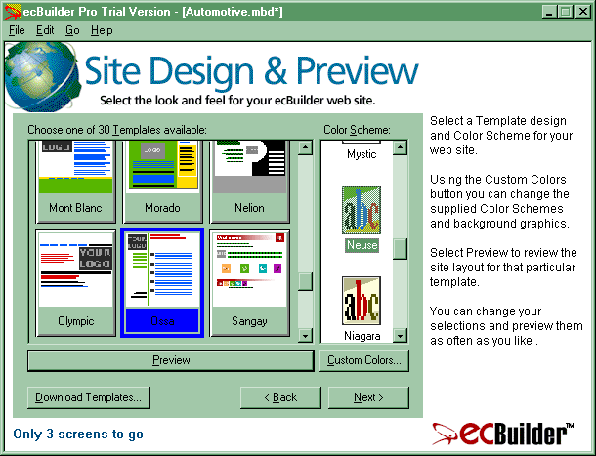
Figure 3.41 Step thirteen of the Wizard:
setting up final details on site design
The site that will be presented to the user in the preview mode will be in fact fully functional site with all the links and page elements. The site previewing process is performed via ecBuilder's browser, but user may also select some other browser as Netscape or Internet Explorer. If not satisfied, user may always return to this step and change the template or color scheme by the will. Figure 3.42 shows one possible look of the site that was created throughout this section. Note all the elements: title, brief description, top page banner, address, phone, contact information, etc.
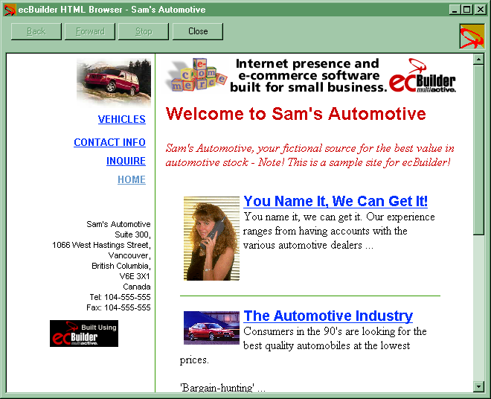
Figure 3.42 One possible look of the finished site;
the site is being previewed in the ecBuilder's
built-in HTML browser

Step fourteen: Security Options.
As stated earlier in this appendix, security is a crucial question when running an e-commerce or e-business site. This, fifteenth step provides user an option for setting the way in which security will be established (Figure 3.43). By clicking onto the Security Configuration button, user is brought to the dialog shown on Figure 3.44.
It is required to have a digital certificate if merchant chooses to use any of the payment gateway options. Digital certificate can be obtained by pressing the Get a New Digital ID button. Once obtained, Digital ID can be used by clicking onto Use digital-based security check box. After that, instructions will lead the user through the rest of the process. Basically, merchant just gets the Digital ID and then passes it to the ISP. The ID is then used for SSL transfers related to the merchant's site without further merchant's interference.
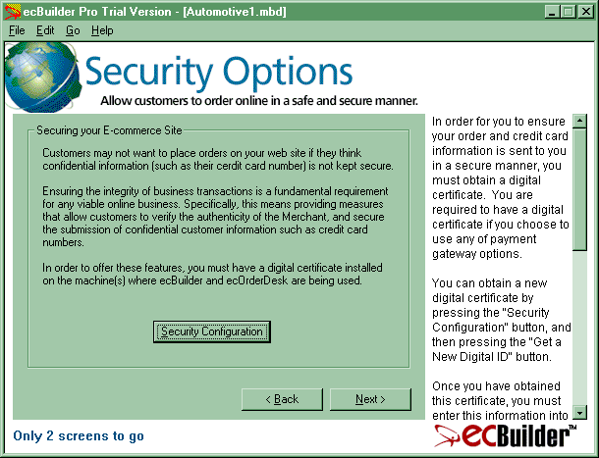
Figure 3.43 Step fourteen: setting up security information
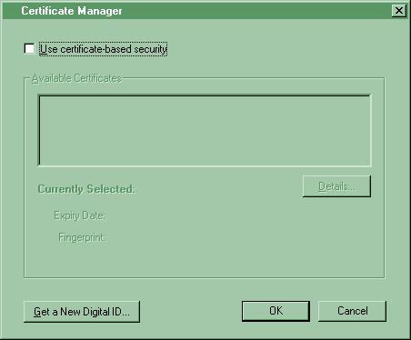
Figure 3.44 Managing a Digital ID; if one is not obtained yet,
it can be accomplished by pressing the Get a New Digital ID button

Step fifteen: Search Engines.
This is the final step in site creating process. At this step, user is prompted on what search engines or ISP partner servers the site should be submitted (Figure 3.45). At this version, only eight search engines are supported by ecBuilder. We can suppose that this list will grow in the future. Note that brief descriptions and keywords which were entered in the first steps of the Wizard will be used as an accompanying information about the site when applying to the search engines.
If user is not satisfied with this service, it is possible to use independent services for site submission to the search engines. One of the most popular services of this kind is Submit-It, and can be located at http://www.submit-it.com. For a small fee, they will submit the site to hundreds of search engines.
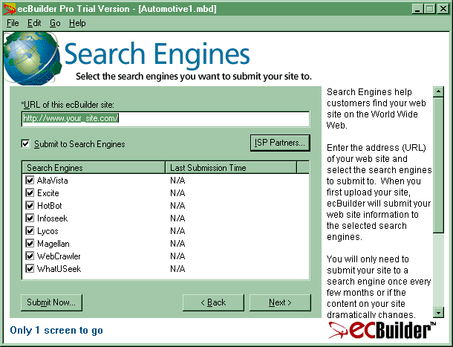
Figure 3.45 Step fifteen of the Wizard:
submitting the newly created site to the search engines

Step sixteen: Upload Your Site.
This is the final step, which offers the user to upload the site to the previously rented Web space (see Figure 3.46). There is another option to save the site to the hard disk, instead of to FTP it to the ISP. If user wishes to upload the site to the Internet server, it will be accomplished by clicking onto "FTP to your existing ISP" radio button, and then pressing to the Submit button. After that, user should just follow the instructions. Figure 3.47 shows information asked by ecBuilder when its FTP upload service is used.
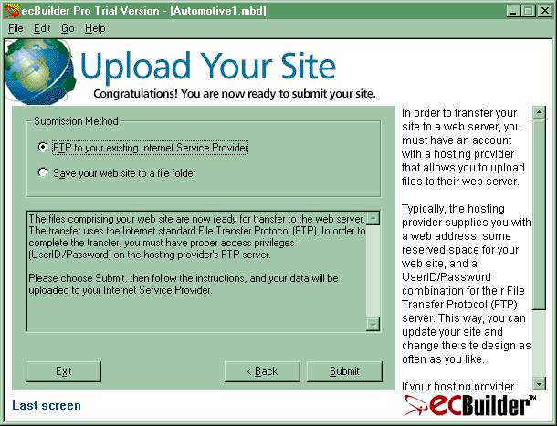
Figure 3.46 Final step: publishing the site;
everything that was set in the previous steps
will now be uploaded to the appropriate Web space
If otherwise user selects to save the site to the hard disk, the uploading will have to be performed manually to the ISP by using any FTP client.

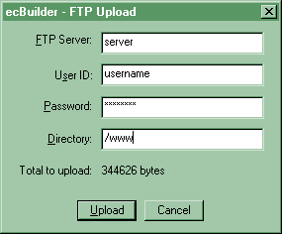
Figure 3.47 Using a built-in FTP upload service

ecBuilder Menu Bar Commands
There is a large number of menu bar commands available from ecBuilder. There are four basic menus: File, Edit, Go, and Help. Most of the options in the File menu are usual, as in most of the programs today. Some options in the File menu present shortcuts for the options of the Wizard.
The only option on File menu that deserves further explanation here is the Catalog Import and Export option (see Figure 3.48). This option allows user to import the item list directly from a .CSV (Comma Separated Values) file. In the file, offered items should be separated by commas. This is a very useful option if user plans to sell hundreds of types of items. Entering these items manually is a painstaking job, which also produces lots of mistakes. If merchant wants to sell many items, those items might already be available at some database. Exporting the database to a .CSV file should be an easy task. The easiest way should be importing your database to Excel, and then exporting it from Excel to the .CSV format. For instance, one file exported in such manner might contain lines like these:
apples, $4, yellow
apples, $3, green
oranges, $5, red
In ecBuilder, when user selects a .CSV file from which the list of items should be imported, ecBuilder will prompt for the Business Type that best matches the data model in the external file (e.g., type, price, description, as specified above), and the section in the catalog to which the data should be imported. Also, the data may be appended to the existing list, or may substitute it. After setting all the information, user will be faced the datasheet view of the selected .CSV file, and will be asked to specify the meaning of each column (Figure 3.50). Typically, user will select the most suitable Business Type option (Figure 3.48), and then fine-tune it manually (Figure 3.49). Also, user will be prompted whether this importing scheme should be saved for further use, which may prove as a very useful option.
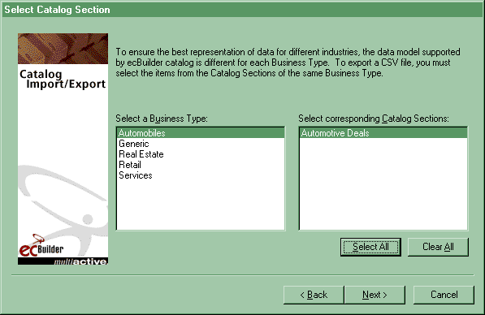
Figure 3.48 Importing a catalog; if items are already present
in some database, exporting the database to the ecBuilder
is the easiest way to create the catalog
The Edit menu provides user with two important options: to set up Tax Types and Shipping Methods (these options are in fact shortcuts to the same options in step ten of the Wizard). The Go menu lists all sixteen steps of the Wizard, allowing user to jump directly to any step wanted. The Help Menu provides help on ecBuilder's user interface and functionality, as expected.
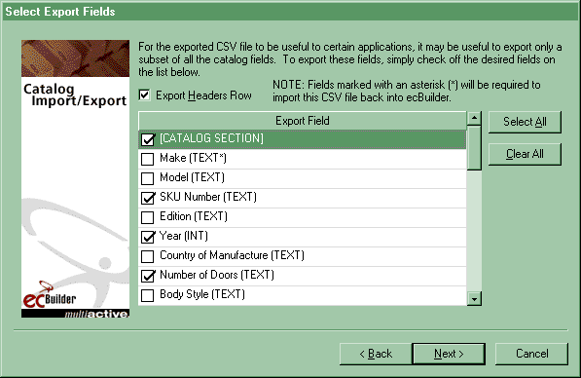
Figure 3.49 Eliminating not-needed columns from the .CSV file
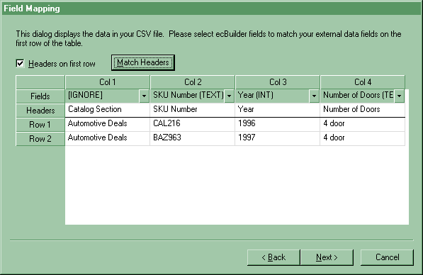
Figure 3.50 Datasheet view of the .CSV file,
just prepared to be imported as a catalog

The ecOrderDesk
The ecOrderDesk application allows user to track and manage the orders received from the ecBuilder Web site. Customers can complete an online form on the site in order to inquire about some specific products and services, or to order something from the site. The data from that form, such as name, address, credit card numbers and so on, are encrypted, compressed, encoded, and sent to the merchant as an e-mail attachment.
Once these orders or inquiries are received, merchant can decode and process them using the ecOrderDesk. The same application can be used to manage orders and inquiries that come to by telephone, mail, or other methods. The ecOrderDesk allows merchant to track the status of inquiries and orders: whether the customers have received a response, had their order been shipped, etc.
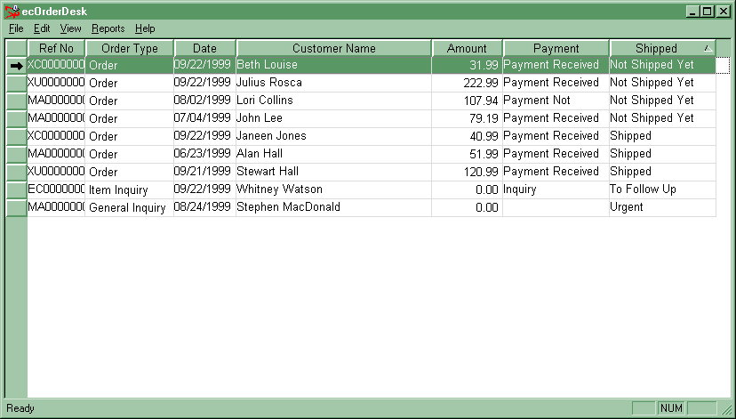
Figure 3.51 The datasheet view of the purchasing workflow
The application also allows a merchant to mark specific orders or inquiries as urgent, to ignore inquiries without deleting them, to track shipping and payment status for customers' orders, etc. ecOrderDesk also lets one to export order and inquiry data for use with the company's accounting, report-creation, order fulfillment, or contact management programs in a simple manner.
ecOrderDesk supports three types of records: orders (O), item inquiries (II), and general inquiries (GI). Order is an actual purchase request by a shopper from the Web site. It can include one or more catalog items. Item inquiry is a request for information about a specific catalogue item by a shopper from the Web site. Item inquiry is not actually a purchase request, but ecOrderDesk allows it to be converted to an order. General inquiry is a request for general information, concerning the company or anything else, but not concerning some particular product or service. In fact, general inquiry is not linked to any specific catalog item.
The email attachment specifying the contents of a shopping cart is an encrypted file. Importing that file into ecOrderDesk is done either by double-clicking on the attachment file in the e-mail message and opening it in the ecOrderDesk, or by saving the attachment to the local hard disk and later opening from the ecOrderDesk by selecting Import option at the File menu. The attachment file will be in the MultiActive ecOrderDesk .MEC format.
All three types of records (O, II, or GI) can be inserted and modified manually. Records are rich with details about order or inquiry. Sorting records is possible by any column, as usual in applications of this type. Records could be edited, deleted, filtered, sorted, etc. A selective report for printing also exists. The ecOrderDesk provides methods to export records in three distinct file types: .MEC (ecOrderDesk format), .MEL (MultiActive Maximizer format), or .CSV (Comma Separated Values, recognized by Excel, Lotus 1-2-3, etc.).
As a conclusion, we may say that ecBuilder is a powerful and a very cost-effective tool. The amount of time and other resources user invests in mastering the more advanced technologies (such as Microsoft Site Server, etc.) greatly surpasses the time and resources needed to learn and use ecBuilder. The ecBuilder also provides basically all the functionality one needs for and from an e-business site, with very few drawbacks. Having in mind all this, as well as the relative small price of this package, ecBuilder is probably the best choice for small and medium businesses, in fact, for all except the smallest and the biggest e-business companies.

Secure Socket Layer (SSL)
One of the most widely accepted ways of protection of sensitive data while transferring from the customer to the server on which the store is situated is SSL (Secure Socket Layer), originating from Netscape Communications. Private user data along with information that can be abused, such as credit card numbers or users' account numbers, must be protected during the transfer from the user to the merchant. In fact, the security should be attained as it is at the physical transactions in which the shopper gives the credit card directly to the merchant, i.e. without a third-party interference during the interaction among the customer and the merchant. During e-commerce transaction, when customer enters his credit card number along with other data at the appropriate place on the merchant's site (i.e., at the purchase form), and then clicks onto the appropriate button, those data are being sent to the merchant's server for the processing. This means that information is being sent using an HTTP POST message which is being sent to the server inside TCP/IP packages. If someone from aside would try to access those packages (intercept them) during their propagation through the network, he would be (if data are not protected) in position to extract private information fairly easily.
The basic idea behind the SSL protocol application is to insert a new level between HTTP and TCP communication software levels, which would encrypt the data in such a way that the decryption would be possible only for the authorized receiver. This means, if for instance client sends encrypted data to a server, that server is the only one in possession of the key for data decryption. In order to make this principle functional, both client and server must be SSL enabled, i.e. they must possess Secure Socket Layer between application and transport layers of their respective network softwares.

The Architecture of SSL
Secure Socket Layer consists of at least two layers, and those are: (1) SSL Handshake Protocol, and (2) SSL Record Protocol. While the secure connection is being established between the client and the server, SSL Handshake Protocol provides an agreement during which the secret data needed for information encryption and decryption keys calculation, as well as for signature calculation, are to be determined. These secret data provide authentication of the encrypted information packages those were sent. Authentication is performed in the way that certain algorithm is applied (formulas incorporating hash functions), and so MAC (Message Authentication Code) is calculated in the manner that depends on the package contents, its length, and special secret data exchanged while the handshake was performed. After that, MAC is encrypted along with the data, and eventually sent. At the receiving end, data are decrypted, MAC is independently calculated and compared to the one found inside the package. If the two differ, it means that the package received was possibly changed by some third-party interceptor. All the possible errors because of the network imperfectness and other technical reasons are being removed by the communication software levels below the SSL. This means that SSL involves a level of protection during the transfer from the intentional data change from the third party, which is, certainly, not acceptable in e-commerce transactions. Data packages are usually encrypted using the well-known DES (Data Encryption Standard) symmetrical algorithm. The term symmetrical algorithm itself means that both encryption and decryption are performed using the same key which has to be known to both client and server, and still unknown for any third party.

RSA Algorithm
During the handshake process, non-symmetrical algorithms have to be used, just the RSA is. This algorithm is based on the concept of one secret key and a public key corresponding to it. This means, if secure data are to be sent to someone, they are being encrypted using public key that belongs to the receiving side. Note that public key can be freely transmitted along the network. After that, such encrypted data are being sent to the receiving side, where they are decrypted using a secret key. If data are intercepted, they cannot be decrypted without the secret key even if the public key is known to the interceptor. Inside e-commerce transaction, the assumption is made that the server is certified, i.e. the merchant possesses the certificate from the known trusting institution which is authorized to issue the certificates. Inside the certificate, along with digital signature and other authenticity confirmations, there is also the system of RSA keys. These keys will be used by the server within the handshake negotiations with the client. The only problem is that American regulations ban the export of encrypting system with keys longer than specified number of bits, which leaves the data sometimes vulnerable to attacks of brute-force type.

The Simplified Handshake Protocol
This section describes a simplified model of the handshake protocol, in which the assumption is being made that the authentication is requested only from the server. In the general case, it is possible to request the authentication from the client, too. The communication during the handshake is performed by sending the following messages:
- The client sends a clientHello message, which contains, among other things, a randomly generated 28-byte-long field clientHello.random. Inside the message, there is a list of supported encryption algorithms and possible data compression algorithms (SSL layer may optionally compress the data before the encryption). The list is sorted in some manner depending on the client. The more reliable algorithm will be higher in the list.
- As a response to the clientHello message, the server sends the serverHello message containing independent randomly generated 28-byte-long information serverHello.random, and the communication algorithm selected among those received from the client (the first algorithm from the head of the list that is acceptable for the server is selected).
- Server sends its certificate to the client. Certificate format is standardized (e.g., x.509.v3). This standard specification is outside the scope of this appendix, and will not be elaborated further. Within this message, there is only the public key which is, after this message is received, known to the client, too. Generally speaking, there are certificates that are used just as a signature, i.e. they do not contain RSA keys. If such a certificate is sent, another message should be sent afterwards. Otherwise, another message is not needed.
- Server sends serverKeyExchange message which contains a temporarily generated public key. It should be clear that secret key stands only at the server's possession.
- Client randomly generates the piece of information referred to as preMasterSecret, 48 bytes in length, and then using the RSA algorithm encrypts it using the received public key, producing encryptedPreMasterSecret, and then sends it to the server inside the message clientKeyExchange. The server receives this message and then decrypts the preMasterSecret using its secret key. Since now both client and server have preMasterSecret in their possession, they are calculating a 48 bytes long value referred to as masterSecret, which is the final purpose of this handshake routine.
The following is the algorithm for masterSecret calculation:
masterSecret = MD5[pre_master_secret +
SHA(‘A’ + pre_master_secret + ClientHello.random + ServerHello.random)] +
MD5[pre_master_secret +
SHA(‘BB’ + pre_master_secret + ClientHello.random + ServerHello.random)] +
MD5[pre_master_secret +
SHA(‘CCC’ + pre_master_secret + ClientHello.random + ServerHello.random)];
The MD5 and SHA are secure hash functions. The MD5 is the secure hash function that converts an arbitrarily long data array into the fixed length result. The SHA is with the function like MD5, but with 20-bytes-long result.
After this, both client and the server are sending messages named Finished, containing the following data:
struct {
opaque md5_hash[16];
opaque sha_hash[20];
} Finished;
md5_hash = MD5(master_secret + pad2 + MD5(
handshake_messages + Sender + master_secret + pad1));
sha_hash = SHA(master_secret + pad2 + SHA(handshake_messages + Sender + master_secret + pad1));
Previously sent messages, as well as the maasterSecret, are figurating as parameters to these formulas. This is the protection from the attack that changes the messages during the handshake negotiation. If the intruder changes some message on its way from the client to the server (client has calculated the parameters using messages already sent), then these values will differ from the same values calculated by the server (server has calculated these values using the previously received messages as parameters). The intruder cannot calculate these values and further change the Finished message according to changes made to previous messages − this would be the typical procedure when there is an intention from the intruder to make an influence concerning the choice of the encryption algorithm, in order to make client and server to select the least secure one. The fact why this cannot be accomplished lays in the secrecy of the masterSecret value, which is based on methods previously described.

The SSL Record Layer
After the handshake has been successfully performed, the SSL Record Layer at the server and at the client are independently calculating the identical encryption keys and MAC. The first to calculate is:
keyBlock = MD5[master_secret + SHA(‘A’ + master_secret + ServerHello.random + ClientHello.random)] +
MD5[master_secret + SHA(‘BB’ + master_secret + ServerHello.random + ClientHello.random)] +
MD5[master_secret + SHA(‘CCC’ + master_secret + ServerHello.random + ClientHello.random)] +
[... ];
By the special selecting method for parts of this value and by calculation, the following final cryptographic elements are acquired:
- clientWriteKey − the key that is used by the client for the encryption of data sent to the server;
- serverWriteKey − the key that is used by the server for the encryption of data sent to the client;
- clientWriteMACSecret − the secret data for authentication of the packages sent by the client;
- serverWriteMACSecret − the secret data for authentication of the packages sent by the server.
After this, SSL Record Layer (e.g., at the client) mandatory compresses each data package, and than appends clientWriteMACSecret to it, and then all that encrypts using clientWriteKey.
Once the server receives the data, it first decrypts them using clientWriteKey (symmetrical compression), then compares the received clientWriteMACSecret with the previously calculated one, and if everything is correct, decompresses the data and finally sends them to the application level of its network software (the level above the SSL).

Microsoft Site Server Commerce Edition
The basic concepts and tools inside Microsoft Site Server Commerce Edition 3.0 package are:
- Site Builder Wizard with several finished sites provided as examples. This part of the package removes the complexity of HTML writing, scripts, and database schemes. It is simple, provides the step-by-step (wizard) approach, and drastically decreases the time needed to finish a project.
- Dynamic Merchandising is the support for the easy real-time product and prices catalog administration from any standard Web browser, using Promotion Wizard. Inside this part of the package, there are intelligent cross-sell systems for dynamical generation of the offer specific for the single shopper to whom the catalog is being presented, based on tracking the shopping history of that particular person and current contents of its shopping basket.
- Order Processing Pipeline (OPP) is the concept that serves all the operations in the background, as collecting the information needed for the product catalog, prices forming, tax calculation, etc. It can be integrated with the existing systems (databases) and provides means of expanding its possibilities by entering new components either programmed, or bought from independent software companies. OPP is the fundamental concept that stands behind the design and the work of e-commerce sites created using SSCE package.
- Commerce Interchange Pipeline (CIP) is the concept intended for the so-called business-to-business (B2B) e-business applications, which means the implementation of possibilities for the companies to exchange information as well as to perform different kinds of business transactions among each other through internal or existing EDI (Electronic Data Interchange) systems. CIP will not be further presented here, since such effort would get us far beyond the scope of this appendix.
- Integration with Microsoft Transaction Server (MTS). The MTS is a software package that provides an integrity of database operations by introducing the transactions system. Integration with MTS provides the Site Server Commerce Edition applications with a much higher degree of reliability in business transactions.
- Dynamical catalog creation using the ASP server side script.
- Rich Object Model which comes inside SSCE provides a wide range of operations concerning processing the information about products, shoppers, and orders.
- The package supports database schemes independence, and provides integration of existing informational systems with e-commerce and e-business applications. The package also possesses a built-in support for Microsoft Wallet, which is an alternative to the SSL security system − Microsoft Wallet is far less popular than SSL, but provides the security level nothing less than with SSL.
- Industry-standard security is the concept that means secure surrounding for the shoppers, partners and site administrators, using integrated HTTP authentication as well as the real-time credit card authorization under secure protocols such as SSL and SET (Secure Electronic Transaction).
- Commerce Server Software Developer's Kit (SDK) is a set of APIs for expanding the functions of Order Processing Pipeline and of Commerce Interchange Pipeline.
- Membership Server provides software infrastructure for efficient control of secure accessing to the Web sites and their contents. Authentication can be based on the cookie technology, HTML forms, challenge/response systems, and certificates.
- Direct Mailer is a simple tool for creating the personalized TDEM (Target Directed e-mail Marketing) campaigns based on shopper profiles and their affinities.
- SSCE tools for the analyzing are creating the reports needed to analyze the customers traffic on the site. These tools are classifying and integrating information about profiles and behavior of the customers. These tools are also supporting report generating based on log files of Web server. In this sense, there are 28 log file formats supported from Windows NT, Unix, and Macintosh operating systems.

Site Server Advances
As said before, Microsoft Site Server Commerce Edition 3.0 simplifies the Internet presentation creating through providing an e-commerce Web-oriented programs with extended set of tools and features. Besides, along with SSCE there come several completely finished sites that can be used as templates or models for new e-commerce stores. The SSCE Site Wizard is generating the whole site (in the closer sense − visual presentation − the storefront) with default support for collecting the data about customers and orders, for storing the gathered information into the order or bill bases, and the order processing base. Along with extensions as components for tax calculation, payments, shipment, etc. provide site setting up together with all basic e-commerce functions.
But, to set up one such site, much less expensive packages than SSCE can be used. What really makes this tool different are sophisticated solutions that provide integration with the existing information system and databases, as well as the performing of highly specific tasks.
Generally speaking, SSCE is based on three key technologies: ASP, COM (Component Object Model) objects, and OPP (for business-to-consumer sites − B2C; for business-to-business sites, it is Commerce Interchange Pipeline as a solution, but as said, it will not be discussed here). Most of the pages on one SSCE Web site are ASP pages with the server side script that manipulates the set of COM objects, usually most of them coming from the SSCE package. Software uses these objects to collect information from the customer, to find and/or save information by using the ODBC/DAO queries and to process the tasks through the OPP.
Table 3.1 Brief descriptions of usual pipeline stages
Pipeline Stage | Description
Product Info | Collects information about the products shown at the catalog pages
Merchant Info | Adds information about the merchant into the OrderForm
Shopper Info | Adds information about the shopper into the OrderForm
Order Initialization | Sets initial data about the order to the OrderForm, and checks whether the OrderForm contains the unique code of the order (ID)
Order Check | Checks whether OrderForm contains required data, e.g. that at least one product is ordered
Item Price | Determines the starting price of the product (before adding discounts)
Item Adjust Price | Adds eventual discounts (sales, promotional prices, etc.)
Order Adjust Price | Accounts possible changes on the level of the whole order (e.g. if the amount of some merchandise is above some prespecified amount, and thus deserves a discount, or another product is given for free, etc.)
Order Subtotal | Calculates the total price at the order level, but before tax and shipment is added
Shipping | Calculates price of the shipment of the all products from the order
Handling | Calculates additional expenses concerning possible special package an related topics
Tax | Calculates separate tax values for each product in the order, as well as the total tax for the whole order
continued…
…continued
Order Total | Forms the final price of the order, when everything from the rows above is added to the final price
Inventory | Checks whether all the products ordered are available at the stock
Purchase Check | Checks the address and customer's credit card information
Payment | Payment transactions are performed at this stage
Accept | This stage finishes the buying process; it can, for instance, generate a shipping request, save data about the order, etc.

The OPP Concept
The OPP imitates interaction between the customer and the merchant in a typical physical store. The OPP, as implied by its name, uses the pipeline principle. In fact, OPP is the group name for three types of pipeline that are going to be closely described in the further text. Each pipeline consists of discrete sections called pipeline stages, which are being executed in a precisely defined order. In each stage of such process, there are components (COM objects) that are performing the specified task. All the needed data are sent through the pipeline using the concept of the OrderForm object. The OrderForm is also a COM object in its nature, and it is maintained by the SSCE in order to keep and consistently process all relevant information about the customer, the merchandize he wants to purchase, shopping details, etc. Each of these stages will be presented in detail later.
The SSCE organizes information about the pipeline configurations in .PCF files. These files are created using the Commerce Server Pipeline editor. The .PCF file contains specification of all needed pipeline stages and components that will be started at each stage separately. In fact, exactly that objects are performing the processing at the stage where they are situated. The SSCE provides three prototypes (templates) that can be used with the pipeline editor for attaining the .PCF files. Prototypes can be found in files with the .PCT extension. These are the common PCT files:
- product.pct − this prototype is used to create .PCF files for pipelines that calculate the price and discounts for separate products. Such pipeline shows information about the products and their prices at the product.asp page. The resulting .PCF file can contain the following stages: Product Info, Shopper Info, Item Price, Item Adjust Price, and Inventory.
- plan.pct − this pipeline type calculates the total price of the order. This includes calculation of totals with all discounts, tax, shipping, and other expenses. This .PCF is then used to create the report for the customer, based on which the customer eventually decides whether to start to payment process or not. The pipeline consists of these stages: Product Info, Merchant Info, Shopper Info, Order Initialization, Order Check, Item Price, Item Adjust Price, Order Adjust Price, Order Subtotal, Shipping, Tax, Order Total, and Inventory.
- purchase.pct − this one creates .PCF files with COM components that check the important information about payment processing, they commit payment transactions and write down the reports about the orders into the appropriate databases. Optionally, all the information from the OrderForm may be collected in the databases, too. This kind of pipeline usually accepts OrderForm from the Plan pipeline through which the OrderForm has previously passed. In fact, this pipeline only completes the payment process that was started in the Plan pipeline. This pipeline type usually contains these stages: Purchase Check, Payment, and Accept.

Pipeline Editor
Figure 3.52 shows Plan pipeline prototype as shown in the Commerce Server Pipeline Editor. Pipeline is shown as a vertical pipe divided into sections, where each section represents a separate stage. Each horizontal valve represents an OPP COM object (component) responsible for processing the OrderForm information.
This piece of software allows adding, deleting, and configuring the OPP COM objects in each pipeline stage. It also allows creating the new pipeline stages and deleting the existing ones. In each stage, there can exist one or more objects. If stage does not contain any object, the software skips that stage during the pipeline execution. Within the SSCE package, there are OPP COM objects that can be used to form the pipeline. It is also possible to purchase from the other software companies the components designed for some specific problems. The last option is to create needed components independently.
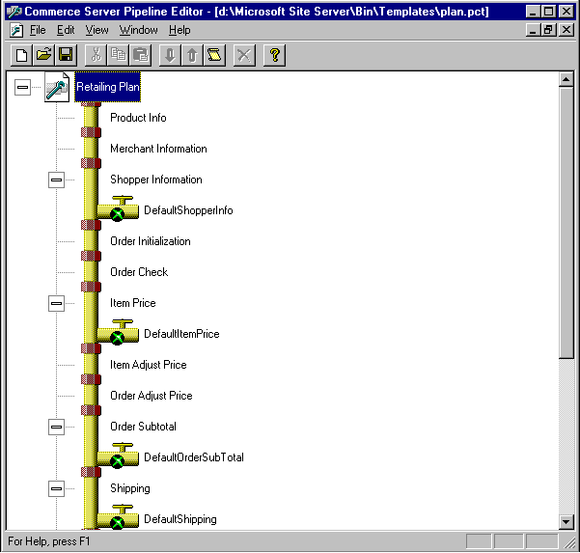
Figure 3.52 Plan pipeline prototype
viewed from the Pipeline Editor

Starting the Pipeline
In order to start an OPP pipeline, the Pipeline script should be used to create the PipeContext object. The system initializes this object with information needed to the OPP. After this, either Commerce.MtsPipeline or Commerce.MtsTxPipeline object should be created inside the Microsoft Transaction Server. The MTS provides the integrity to the data accessed in the concurrent surroundings, as ASP applications are. Usually the merchant commits Purchase pipeline using the MTSTxPipeline object. After the pipeline object has been instantiated, the wanted .PCT file is loaded by calling the LoadPipe method. The pipeline is finally invoked by calling the Execute method.

OrderForm Object
The OrderForm object is a so-called dictionary object. This object type is interesting for it provides dynamic adding of name/value pairs. Name/value pairs are data containing the reference and the value, just as any other object property. The only difference is that name/value pairs can be dynamically added to the object by a simple assignment:
object.name_of_name/value_pair = value_of_name/value_pair
If the object did not posses the property with the specified name, the appropriate one will be created, and the following value will be assigned to it. If the property already exists, whether it is a simple property or a name/value pair, its value will be set accordingly. In the following text, terms field and property will be used interchangeably, both referring to the value member of the object.
The OrderForm object is a dictionary object consisted of the collection of items, orders, and other dictionary objects, the one for each member of the Items collection. It also contains properties that carry information about the shopper, the bill and products shipping place, customer's credit card information and other needed data. There are also collections for possible errors, which are used by the components to notify the pipeline about the certain problems during the pipeline execution − based on these data, the pipeline makes a decision whether to continue the execution to the next stage, or to stop the execution and send the error message to the ASP application. For each item in the order (item is presented by the name and the quantity of specific product), there is a dictionary object containing all the fields for the most of the information needed. There are also properties added to this object for some additional pieces of information.
The typical example is a Product Info stage which usually contains the component that executes the database query for the specific item. For instance, this query might look as:
SELECT *
FROM <product>
WHERE SKU=OrderForm.Item[1].SKU.
where SKU is the unique product code. Now, for each column of the returned recordset, the property is created and the value from the corresponding column is assigned to it. The object is being instantiated in a standard ASP (VBScript) manner:
Set OrderForm = Server.CreateObject("Commerce.OrderForm")
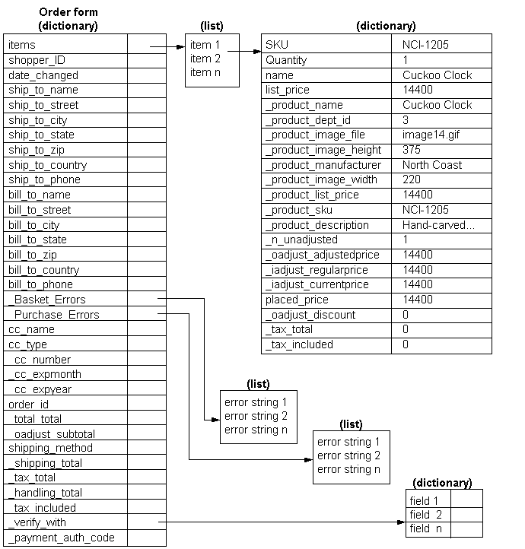
Figure 3.53 Graphical representation of the OrderForm object
Figure 3.53 graphically presents the structure of OrderForm object, showing all its properties.

Pipeline Types and Their Stages
As said before, the pipeline (in the SSCE terminology) is in fact a set of COM objects, each of them implementing some specific interface and being executed in some specific order. These objects are grouped in the pipeline stages. Each stage represents logical macro-step of the pipeline and usually contains functionality for checking whether its main purpose has been carried out without errors or not.

Product Pipeline
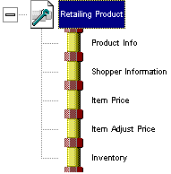
Figure 3.54 Product pipeline: typical set of stages
The aim of the Product pipeline is to collect information about the products and to show them on the product.asp page. These are the detailed explanations for the stages presented in Figure 3.54:
- Product Info − this stage is used to accumulate information from the database, concerning the products listed in the OrderForm object. The minimum activity the component is expected to perform is to sweep through the Items collection and copy all the information from the database for each item into the OrderForm. Additional components of this stage may calculate or copy some additional information about some Items: for instance, product weight as a base for further price calculation. At the end of the stage, the observation is made in order to determine whether all the needed information about the products are written into the OrderForm.
- Shopper Information − this stage can be used to write the information about the customer (potential buyer). This is useful if the database is made containing data about the customers, in order to manage more advanced concepts, as discounts for some customer target groups, etc. It is important to say that this stage can be mandatory discarded. In that case, nothing will be checked at the stage end.
- Item Price − the purpose of this stage is to determine the actual price (base price, without any additional expenses or discounts), for each product item inside the OrderForm object. This value is then assigned to the _iadjust_regularprice property in the dictionary of each item. At the end of this stage, the check is made if the _iadjust_regularprice value is set for each item.
- Item Adjust Price − this stage is used to calculate the price when all the discounts are added. The adjusted price is then written into the _iadjust_currentprice field. At the end of the pipeline, the check is made to determine if all the _iadjust_currentprice fields are set for each item.
- Inventory − this is the last stage, and is used to check if there are enough copies of the product on the stock. If the product is available in the specified amount of copies, the appropriate _inventory_backorder is set. There is no check to perform at the end of this stage.
There are situations in which this pipeline is not used to process the order. In such situations, the OrderForm does not contain ordered items at all. For instance, if one wants to collect the information about some products, it is just enough to create the new OrderForm object, put those products as some fictive orders, and then pass the OrderForm object through the Product pipeline.

Plan pipeline
Figure 3.55 shows the visual look of the Plan pipeline. It shows that the Product pipeline is just a subset of the Plan pipeline. The Plan pipeline is used to determine the complete price of the order, including shopping and taxing fees. This pipeline is typically used on two places in the program: to show the total price of the shopping basket, and on the payment page for which it is calculating the total price of the order (in fact, some kind of the bill is presented to the customer).
These are the detailed explanations for the stages not explained before:
- Merchant Information − it is used to set the information about the merchant. This stage is optional, and nothing is checked at its ending.
- Order Initialization − this stage is initializing information about the order, by checking whether the correct amount of the product is set for each item (Item[n].Quantity). At the end of this stage, the embedded checking system performs some tasks, such as setting the order ID if not already set, creating the _oadjust_adjustedprice for each item with taking into account the amount of products in the item, deleting some properties those should be reset each time this pipeline is started, etc.
- Order Check − verifies that the order can be processed. This stage generates the error at the ending, if order contains no items. The aim of each component in this stage should be either further to check the validity of the order (by some specified criteria), or to allow the detection and correction of the problems responsible for the order processing disruption.
- Order Adjust Price − this stage should set the _oadjust_adjustedprice property for each item, by calculating some specific discounts on the level of the whole order. For instance, if order value goes over some amount, then some special discount can be added.
- Order Subtotal − this stage calculates the value of the whole order (before tax and shipment are added). This subtotal is then assigned to _oadjust_subtotal property. This value is usually determined by simple summation of all _oadjust_adjustedprice properties. The reason why this summation is performed at this stage, and not in some later stage, lies in the fact that the integral sum will be used in the following stages, for instance for tax calculation (that operation does not depend only on separate item costs, but on their total, too). This sum will also be shown as the price of the whole shopping basket, because the customer still has not decided to buy it, and additional data about the customer, as address, are not known yet. This means that tax and shipment fees cannot be calculated yet, but customer still needs to be informed about the raw price of the complete order.

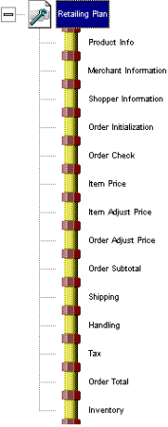
Figure 3.55 The structure of the Plan Pipeline
- Shipping − this stage determines the shipping cost which is to be incorporated to the final cost. The shipping cost is assigned to the _shipping_total property. At the end of the stage, it check is made on whether this property is set or not. If not, an error is generated.
- Handling − like the Shipping, this stage determines the packing and handling expenses, which are to be added to the final cost of the order.
- Tax − this is the final stage before the total cost calculation. At this stage, the tax is calculated and assigned to _tax_total property. Note that some parts of the tax can be calculated in previous stages, in some specific occasions. The already calculated tax is then assigned to the _tax_included property. Also, although it will not be checked for correctness, the separate taxes can be calculated and stored in the OrderForm object for each particular item. This should be done for possible reuse of the information from the OrderForm object in the book-keeping process later.
- Order Total − in this stage, the final price of the order is calculated, usually by summing the tax, shipping, handling and subtotal values already contained in the OrderForm object. The final sum is then assigned to the _total_total property of the OrderForm object. This field is checked at the end of the stage.

Purchase Pipeline
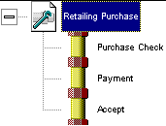
Figure 3.56 The Purchase pipeline
The goal of this pipeline is to use an instance of OrderForm that has already passed (successfully) through the Plan pipeline, and then to finish the purchase by handling the required financial transactions.
As shown on the Figure 3.56, the purchase pipeline consists of only three stages:
- Purchase Check − this stage can be used to verify that OrderForm is ready for payment procession. This can be the check that OrderForm has really passed through the Plan pipeline, meaning that _total_total property is correctly assigned, and that all the needed data concerning the payment are available. None of the system checks is performed at the end of this stage.
- Payment − at this stage, the payment transactions are performed. The goal is either to accept or discard the payment by the credit card authorization, checking the customer's account total, contacting the Transaction Gateway Provider, etc. At the end of the stage, system checks whether the _payment_auth_code property is correctly assigned. This property not only that represents the identification code of the transaction, but it also represents the acknowledgement that transaction has been completed correctly.
- Accept − this is the final stage, and it is responsible for activities those should be performed after the purchasing is done. Such activities are, for instance, inventory update, recording information about the order, e-mailing the acknowledgement to the customer (so-called electronic bill), etc. This is the optional stage, and it does not contain any checking at the end. It should be noted that there exists a mechanism for order information preservation, which can be used by simple saving the data contained in OrderForm object directly to the database. During this operation, the properties having their name beginning with an underscore (for instance, _total_total) are not recorded to the database.

The OPP COM Components Included Into the SSCE Package
This section will give the brief comment on several OPP COM components that are delivered along with the SSCE software package.

Scriptor Component
The Scriptor component is the only general-purpose component that is presented in this section: it is not intended to any particular stage of any pipeline. This is the generic component that can be used to execute the script compatible with the Windows Scripting Host Interface. Typical examples of such scripts are VBScript, JavaScript, PerlScript, etc. This practically means that inside the script there exists a COM interface, which allows the use of all registered COM components on the server by simple instantiation inside the script.
The COM object becomes the OPP COM object once it implements the COM interfaces needed for the interaction with the pipeline. These object can be created with standard tools like Visual C++ and Visual Basic, or by using the SSCE Scriptor component. In the latter case, we are speaking about the already finished OPP object with the only function to be able to execute the script program code. With the Scriptor component at hand, it is possible to create the OPP COM objects able to execute some specific processing on the OrderForm object, or to execute some particular demands in the background of the main processing, supposing that such demands cannot be covered by the standard components.
Typical order of actions would be to start with create the page using Site Foundation Wizard and Store Builder Wizard, which are both incorporated into the SSCE package. Then, using the Pipeline Editor, an OPP Scriptor component can be added into the purchase.pcf that is created by the Site Builder Wizard. The script itself can be kept internally inside the .PCF file, or externally at the separate file. If the internal version is selected, the Pipeline Editor opens the text editor that is to be used to enter the script. Three methods are already defined in such a script: MSCSExecute, MSCSOpen and MSCSClose.
The MSCSOpen method contains the main code, and that code is responsible for performing the core functionality of the component. As it is the main program module, it must be present in the script. MSCSOpen method is being executed after the object is created, and it represents a kind of constructor. Accordingly, that method is being used to initialize the component. MSCSClose method is invoked once the component destruction should be performed. It corresponds to the destructor in common object-oriented languages. Among other actions, the MSCSClose method is responsible for closing the connection with the database.

QueryProdInfoADO Component for the Product Information Stage
This component is the only built-in component intended for use in the Product Information stage. For each item from the OrderForm it performs a separate query on the products database. Some additional information concerning this component are coming forth.
- ConnectionString − specifies the ODBC connection string used to access the database. If this string is not provided, it is read from the pipeline context.
- Query − the SQL query text, which is to be invoked for each item separately.
- ParameterList − contains the comma delimited parameters list, intended to be sent to the query.
The pipeline context is the set of objects and properties accessible to the pipeline components. If Query property contains only one word, then it is assumed to be the pointer to the query inside the QueryMap object. The QueryMap object is used exclusively as query container. It is typically defined in the defined in the global.asa file, in order to be accessible to the ASP application. With no regard whether the query is defined directly or through the QueryMap object, it is possible to insert parameters from the Parameter List into it.
As an example, consider the following query:
SELECT *
FROM Product
WHERE SKU = '?'
AND Name LIKE '%?%'
with the ParameterList equal to 'Item.SKU,Item.Name'.
For each product (item), once the query is invoked, the two question marks will be changed with the current product's ID and its corresponding name, as specified with the parameter list. As a result of this query execution, the component puts the datum from each column (the Product table attribute) into the OrderForm object into the properties named _product_ColumnName. For instance, if some column from the Product table is titled Price, then QueryProductInfoADO creates the _product_price property. That property is assigns the value from the corresponding column of the query result. It is important to say that only the first row values from the resulting table are assigned. Other rows, if exist, are ignored. In the regular queries, as the one in the previous example, only one row is returned.

DefaultShopperInfo Component for the Shopper Information Stage
This component copies the data from the Shopper dictionary object of the pipeline context into the OrderForm object. The component writes values _shopper_* into the OrderForm, and reads Shopper values from the pipeline context. It means that it creates the properties of OrderForm, each carrying the name and the value identical with the property of the Shopper object. However, this object will usually be empty, because it is hard for the merchant to keep the actual data about customers on the site. Otherwise, an appropriate mechanism should be provided, as customer registration before the buying, or when arriving at the site.

Order Initialization Stage
This stage contains no built-in components defined in previously discussed sense. However, the Plan pipeline automatically creates an instance of RequiredOrderInit component. That component is part of the logic used to perform the check at the end of the component. Among other, the following checking actions are performed:
- If OrderForm.order_ID is equal to NULL, another (unique) order identifier is created
- Sets to NULL the following values in the OrderForm: _total_total, _oadjust_adjustedprice, _oadjust_subtotal, _shipping_total, _tax_total, _handling_total, _tax_included and _payment_auth_code. This provides the order resetting before entering into the pipeline. This is important because most of the components are assigning the value to the property only if the property is not previously set.

Order Check Stage
The Order Check stage is in somewhat similar situation as the Order Initialization stage. In this case, the checking is performed by the RequiredOrderCheck component. That component simply checks if there is at least one item in the OrderForm collection. If the collection is empty, it adds a message to the _purchase_errors collection of the OrderForm object, thus indicating an error. This error typically leads to the pipeline halt.

DefaultItemPrice Component for the Price Stage
Components of the Price stage are responsible for setting up the values Item._iadjust_regularprice for each separate item contained in the order. The only built-in component intended to be used in this stage is the DefaultItemPrice. It simply copies the value of Item._product_list_price property into the Item._iadjust_regularprice property. It should be clear that the pipeline was supposed to create somehow the appropriate value for the Item._product_list_price. This property should be created in the Product Info stage. This further means that, if this component is to be used to create the price, the product information table which is read in the Product Info stage must contain the list_price column. Of course, all this can be avoided by writing the new component (for instance, the Scriptor component), which would be used to extract the product prices and to copy them into the Item._iadjust_regularprice.

Item Adjust Price Stage
This stage is used to balance the price in such a way that price reflects the existence of some special offers and selling conditions. The result is then assigned to the Item._iadjust_currentprice property. The SSCE package contains two built-in components for this stage:
- SaleAdjust component − it performs the check whether the product is offered on the sale, and according to the answer, adjusts the price. This component compares the current date with the period between the dates assigned to the Item._product_sale_start and Item._product_sale_end properties, and if it stands in between, the Item._product_sale_price is copied to the Item._iadjust_currentprice property. It comes out that the QueryProductInfoADO creates three fields for columns from the products table: sale_start, sale_end, and sale_price.
- ItemPromo component − this is somewhat more complicated version of the previous component, with the difference that needed values are not taken from the database, but are expected to be found in the component's properties. These are the properties:
- StartDate − the date on which the sale begins.
- EndDate − the date when the sale ends.
- ConditionOrderKey − the property that ConditionOperator is invoked on.
- ConditionOperator − the operator that is used to determine what items are on sale, and which are not.
- ConditionValue − the value that is compared with ConditionOrderKey.
- DiscountType − describes which kind of the discount is at hand: the fixed, or relative to the price (percentage).
- DiscountValue − the integer value representing the value of the discount; this value is interpreted with regard to DiscountType value.
The ItemPromo component first performs the check whether the Item._iadjust_currentprice probably already set by some other component. If true, nothing is done further. Otherwise, the following actions are performed. First, it is determined whether the current date is inside the interval bounded with StartDate and EndDate properties. If this is correct, then it is checked if the ConditionOrderKey and ConditionValue stand in respect with the ConditionOperator. The latter test needs one example:
ConditionOrderKey = SKU
ConditionOperator = '='
ConditionValue = 123
In this example, the test looks like: SKU = 123. Now this relation is tested on correctness.
If both conditions are met, the discount is applied. As said before, the DiscountValue is an integral value that can be treated as an absolute discount, or the percentage of the price, depending on DiscountType property.

Order Adjust Stage
The only built-in component that supports this stage is the DBOrderPromoADO component. This component is supposed to extract all the information about possibly existing promotions those should be taken into account at the actual stage. The data are extracted by invoking the appropriate queries to the database, and data are supposed to contain the instructions under what conditions the discount is to be applied. They also describe in what mean the discount is applied.

Order Subtotal Stage
This component calculates the up-to-now known order amount, and assigns it to the OrderForm._oadjust_subtotal property. The only component that SSCE introduces for this stage is the DefaultOrderSubTotal. This component simply adds all the Item._oadjust_adjustedprice values and assigns the sum to the OrderForm._oadjust_subtotal. There is usually no need to add other components to this stage, unless some other specific calculation is intended to be performed.

The Shipping Stage
The total shipping cost that is calculated by this stage components is assigned to the OrderForm._shipping_total field. SSCE comes with several components designed to be used in this stage. The simplest one is the DefaultShipping component: it just assigns zero to the shipping cost and is used, as expected, in those relatively rare cases when shipping is not added to the price. Typical example of such situation is selling the software that is offered for downloading from the merchant's site.
The merchant can offer several shipping methods to the customer. These methods usually differ in cost and time required to transport the goods. The customer selects the preferred option at the same page at which the shipping address is entered. The shipping type should be assigned to the OrderForm.shipping_method property. This value will then be used by the Shipping stage components (except the DefaultShipping, of course), while trying to calculate the final shipping cost.

FixedShipping Component
This component adds the fixed cost to the order, depending on the shipping method. There are several properties contained in this component:
- ApplyWhen − specifies the which method should be assigned to the shipping_method field in order this component to calculate the shipping cost for the current order. There are three possible values for this field: (1) if "Always" is set, the shipping cost is added even if the method is not set; (2) if "Has any value" is set, then the cost is assigned only if the shipping_method differs from NULL: it is not important what method is selected, while the one is selected; (3) if the field contains "Equal to method", then the shipping cost is added only if the Method field equals to the shipping_method field.
- Method − this property specifies the shipping method that is to be compared to the OrderForm.shipping_method. Note that comparison is case sensitive.
- Cost − the shipping cost that should be added, measured in hundreds of the base money unit. Only integral values are allowed.
The FixedShipping component needs only shipping_method field from OrderForm to be functional. If successful, it writes the _shipping_total value to the OrderForm. The component needs no values from the pipeline context to be functional.
To simplify the matter, this component simply takes a look for which shipping methods it is intended, and if the method specified by the customer is met, its appropriate cost is added. Otherwise, shipping cost is left to previous value. If some other shipping method assumes some other fixed cost to be added, user should only add another FixedShipping component after the previous one, setting up additional shipping method details through it. In that case, the first component will simply pass through the data, making no change in the shipping cost. Another component will then realize that the method is set to its excepted value, and will apply the second shipping cost.

LinearShipping Component
This component calculates the shipping cost by multiplying the given fixed value with one or more values taken from OrderForm. There are several properties contained in this component:
- ApplyWhen − together with the Method field, this field specifies for which shipping methods the component should be used. The details are the same as for FixedShipping component.
- Method − the shipping method, as in FixedShipping component.
- Rate − the base part (percent) of the shipping cost that should be multiplied with parameter pointed in the BasisItemKey field.
- BasisItemKey − contains the OrderForm field which is used to multiply the Rate value. There are four possible formats for this field:
- Order.fieldname − for instance Order._oadjust_subtotal; this is the simplest format, when one plain field is used to multiply the Rate
- Sum.fieldname − means that all values of the field specified with fieldname from the OrderForm should be summed, and then used to multiply; for instance, Sum.Quantity returns total number of products ordered (not items)
- Sumq.fieldname − performs similar to Sum, except the value of the fieldname is first multiplied with the appropriate Quantity field, and just after that the summation is performed
- Count − returns the total number of product types in the order.
This component uses the _shipping_total field to store the final value of its calculation. On the other side, the component needs no additional data from the pipeline context to be functional.
The Linear Shipping component is mostly often used in three separate scenarios:
- If one needs to calculate the cost based on the percent of the total order cost; in that case, Order._oadjust_subtotal should be assigned to the BasisItemKey
- If the total shipping cost is to be calculated based on the total number of products ordered; in that case, Sum.Quantity should be assigned to the BasisItemKey
- If the shipping cost should be calculated depending on the product weight; in such case Sumq.Weight should be used. This certainly assumes that OrderForm contains the Item.weight field created in the previous pipeline stages.

TableShippingADO Component
The third and the last built-in component for the Shipping stage is the TableShippingADO component. It is intended to be used for shipping cost calculation based on data contained in the database. The base idea behind this component is to form the table in the database specifying the shipping cost different circumstances. For instance, such table can contain the shipping cost for each shipping method and weight range of the whole order. This component performs the calculation depending on the table format defined by the user, and appropriately constructed queries. Such combination provides the user with a powerful tool for cost calculation in very broad sense.
For example, assume that the following Microsoft SQL server script is executed:
CREATE TABLE dbo.healthy_shipping_costs (
shipping_method varchar (20) NOT NULL ,
min_weight float NOT NULL ,
max_weight float NOT NULL ,
cost int NOT NULL
PRIMARY KEY
(shipping_method,min_weight,max_weight)
)
The following query may be used to calculate the shipping cost:
SELECT cost
FROM healthy_shipping_costs
WHERE min_weight <= ?
AND max_weight > ?
AND shipping_method = ?

Handling Stage
Components in this stage are used to calculate the handling cost. This cost is usually concerned with activities as product packing, eventual preparing in a gift manner, etc. Components are quite similar to ones presented in the Shipping stage, even they are based on the OrderForm.shipping_method field, and have similar names. All the components are writing the final value to the OrderForm.handling_total field. These are the built-in component intended for use in this stage:
- DefaultHandling − sets the handling_total field to zero, and is used when no handling expenses exist.
- FixedHandling − performs exactly the same as FixedShipping.
- LinearHandling − equivalent component to the LinearShipping.
- TableHandlingADO − calculates the handling expenses based on data extracted from the appropriate database table; the whole matter is practically the same as for TableShippingADO component.

Tax Stage
As previously stated, this stage is used to calculate all taxing expenses that should be added to the order cost. Tax calculation may sometimes be quite mysterious matter, and components provided with the SSCE package probably will not be enough in many occasions. The built-in components are capable of tax calculation according to American, Japanese, partially Canadian and European Union laws. To calculate tax in other countries, if the underlying codes are not adequate to ones in the countries listed above, the custom components should be written. One should be aware that this task must be performed with utmost care. It is important to note one interesting phenomenon today: many countries today are still not capable to resolve the problems that occur when customer is outside the boundaries of merchant's country. In such cases, tax expenses for the export are not paid at all! This also means that tax will be calculated for local customers only. According to these paradox cases, there is a paradox component named DefaultTax, that simply assigns zero to the OrderForm._tax_total field.
In the following text, a SimpleVATTax component will be presented. This component applies the VAT tax that is regulated in the European Union countries. It is assumed that OrderForm.ship_to_country field contains ISO code for the country that shipment is sent to (this is the three-character code, e.g. USA).
These are the properties of the SimpleVATTax component:
- ApplyWhen − determines the condition under which the VAT tax will be applied. If set to "Always", the tax will always be calculated. If set to "Has any value", the tax is added only if ship_to_country is not set to NULL. If set to "Equal to country", then the tax is added only if ship_to_country field equals to Country field.
- Country − the string containing the country name; this name is compared to the OrderForm.ship_to_country if Apply field is set to "Equal to country", in order to determine whether the tax is applicable to the specified destination.
It is important to say that tax is calculated on item level. This leads to the conclusion that tax is item-specific. The Item.RateItemKey field contains the tax rate for the corresponding product type. These values should be created in one of previous pipeline stages. In the general case, there can be some specific tax expense assigned to the OrderForm._tax_included field. For that purpose, custom components must be written, because the built-in ones are just setting this property to zero.
The SimpleVATTax component introduces one difficulty concerning that fact that this tax may sometimes be applied even to other countries inside the EU, but outside the merchant's country. This problem is typically overcome by setting the ship_to_country to EU.
Just to show how sometimes tax calculation may be difficult, remind the cases when tax is calculated for shipping and handling expenses as well. This task cannot be performed by the built-in components, and if such case occurs, the custom component must be written.

Order Total Stage
The only built-in component intended for use in the Order Total stage is DefaultTotal component. As expected, this component simply sums the subtotal, shipping, handling and tax stage results, and assigns the sum to the OrderForm._total_total property.

Inventory Stage
Components belonging to this stage are used to determine whether the products from the order exist in ordered amount at the stock. There are two built-in components: LocalInventory and FlagInventory. The first one compares Quantity field of each item with the field Item._product_local_inventory that is assumed to contain the available amount of the corresponding item. This field is typically initialized in the Product Info stage, as usual with the fields of similar purpose. If ordered quantity is greater available on the stock, the difference is copied into the Item._inventory_backorder and possibly invokes the pipeline halt to inform the customer about the problem. The DisallowBackorder property of LocalInventory component determines whether the pipeline should stall if the supply shortage is detected or not.
The LocalInventory component performs the check on the stock on the product level (SKU). This means that if more than one item contains the same product, these quantities are summed prior to the supply inquiry.
The FlagInventory component, unlike to the previous one, performs the check on the item level, making no quantity summation, even if several items correspond to the same product. In this case, the available quantity should be present in the Item._product_in_stock property. As like as in the LocalInventory, the DisallowBackorder determines whether the pipeline execution should be halted if supply shortage is present or not.

Purchase Check Stage
This stage checks whether everything is ready to perform the payment or not. The only component available in SSCE for this stage is ValidateCCNumber. It checks if the credit card expiration date is equal or beyond the current date. Then, the credit card number is approved through the algorithm for determining the principal possibility that such a card exists. The real existence of the credit card and the underlying account is approved along with the payment in the following stage. If the check fails on either condition, the ValidateCCNumber component halts the pipeline and sets the error into the OrderForm._purchase_errors object.

Payment Stage
Inside this stage, the pipeline components should verify that the user-provided data are sufficient for the purchase to commit. After that, components are involved with the money transactions. In order to do all this, the Transaction Gateway Provider services are expected. The SSCE contains no component for this task: the specific components appropriate for the chosen Transaction Gateway Provider (TGP) should be used instead. Some TGPs offer, as a part of their overall service, the SSCE components that perform all needed tasks concerning payment processing. Other possibility is to write the custom component (e.g. the Scriptor component) that will use the specific methods to access the particular TGP. Yet another possibility is to instantiate the E-xact component into the Scriptor component that is then used as a specific translator between the OPP and the E-xact component's interface. At the end of the stage, the underlying logic performs the check on OrderForm._payment_auth_code: this value must be set in order to proceed.
If the credit cards are processed manually by the merchant, then the Payment stage may contain DefaultPayment built-in component that sets OrderForm._payment_auth_code to "FAITH". This approach is strongly not recommended for obvious reasons.

Accept Stage
This is the final stage, and it embeds the operations that should be performed after the purchase is committed. For instance, stock information should be updated, some information may be sent to partner companies, such as suppliers, etc. The SSCE brings several components designed for this stage. As an example, only SQLItemADO and SaveReceipt components will be presented.
The SQLItemADO component is used to update the stock database. The three parameters of this component are important:
- ConnectionString − it is used to create the connection to the database. If this string is empty, the pipeline context is consulted for the connection information.
- QuerySQL − the query that should be invoked for each separate item from the order. This can either be the complete query, or just a reference to the query contained in the QueryMap object.
- ParameterList − the list of parameters, used as in the previous text (e.g. in the QueryProdInfoADO).
For each order item, the component invokes the marked query. For example, one query capable of setting up stock information may be:
UPDATE prod_table
SET inventory_field = inventory_field  ?
WHERE SKU = ?
provided the ParameterList equals to 'Item.Quantity,Item.SKU'
The SaveReceipt component stores the data about the order (for the book keeping purposes) into the database. Generally speaking, this can be performed within the ASP script once the pipeline finishes. But, there is no reason not to use this component for the same goal. The SaveReceipt is using the ReceiptStorage object from the pipeline context. That object contains information needed for the database update, and is used to write down all the information from the OrderForm into the database. By setting the NoSaveKeyPrefix field from the OrderForm, it is possible to mark some items from the order not to be saved to the database. For instance, if this field contains string _cc_, then all the information concerning the credit cards will not be saved.

Site Builder Wizard
The easiest way to build your site is using Site Builder Wizard. It hides the complexity of the building process from the designer. The architecture of the Store Builder Wizard is composed of the following:
- A wizard, whitch processes input and helps you create a store. You only need to fulfill required fields and choose between offered options.
- A Store Configuration File (SCF), whitch is generated by the wizard. It contains information concerning configurations and customizations for a web store.
- The metafiles, tha translate the SCF file into an actual store. Metafiles are store-page templates and database templates. [UsingWiz]
The process of creating a store with the Site Builder Wizard will be shown on the example of a bookstore.
The foundation is created first and it defines some of the necessary structure of the store. The foundation alone is a functional store after you run the Store Builder Wizard. A foundation consists of:
- A set of directories for storing ASP files and assets for a store
- A set of IIS Web server virtual-directory aliases for a store
- A data source name (DSN) for database access from your store pages
- The user and administrator accounts for the new store
The Store Foundation Wizard generates a store foundation. [BuildProcess]
To create the foundation of your store follow the next steps:
- Right click on your web server’s icon and select New, Commerce Site Foundation. Select a Web Site page appears, as shown on the Figure 3.57. This example uses the default web site. Select the Default Web Site and click Next. Or you can create a new web site.
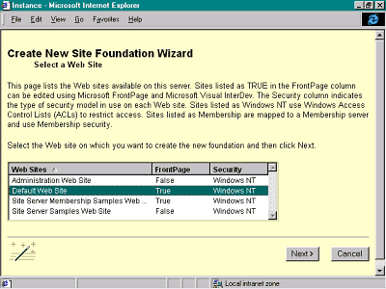
Figure 3.57 Site Builder Wizard’s main page

- In the appropriate fields enter a name and a short name for the video store, such as Bookstore. The display name (“Bookstore”) is displayed on the pages of the store. The short name ("Bstore") is used to create the IIS virtual directories and a directory for the store, and for naming database tables. The wizard adds the name you enter in the short name field to the table name. For example, the new basket table is named Bstore_basket.
- You ca take the default directory location, or enter a new location, for the new store. For example, we enter c:\InetPub\wwwroot\ Bstore.
- If you have decided to create a new web sitem, choose New Web Site as shown on the Figure 3.59.
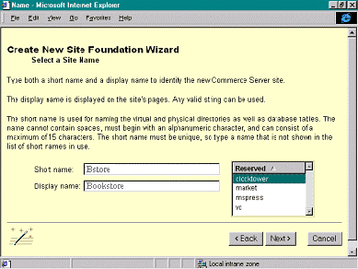
Figure 3.58 Entering a name and a short name
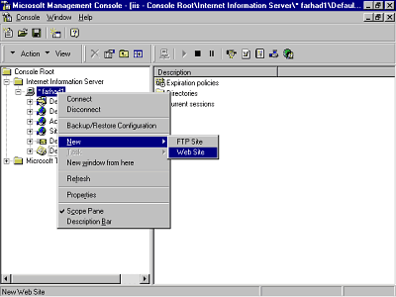
Figure 3.59 Creating a New Web Site

- Now you set properties of your web site, by entering basic information about your new site such as name, directory path, and IP address and port .
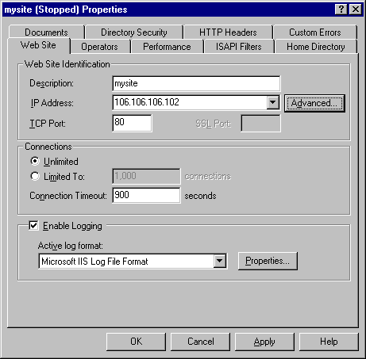
Figure 3.60 Setting the properties for your New Web Site
- Now you choose a database driver for your store based on the database you want to use. The choices include Access, Oracle, and SQL Server. You can include other options by adding an ODBC driver for the database you would like to use. For this example, specify a SQL Server database server.
- In the next step, select the (database connectivity method ) ODBC data source name (DSN) to be used for the store or create a new ODBC data Source Name for this new store. For example the SS3 DSN is entred. The DSN is used by the store pages to refer to your data store by handle. In this example the database is installed on the same machine. Enter your database administrator name and password, as shown in the Figure 3.62.
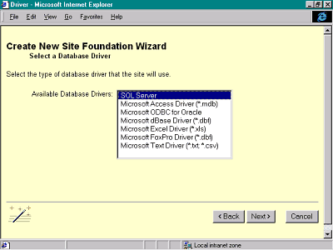
Figure 3.61 Select ODBC driver
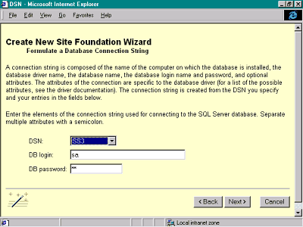
Figure 3.62 Select the DSN
- You can use an existing account for administering your store or create a new account name and password. Creating a new account (local to this server) is preferred for better security of your site.
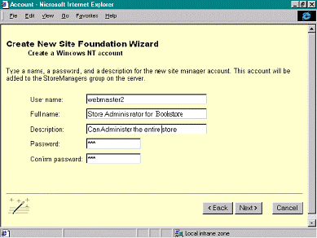
Figure 3.63 Create a new, local account
- Click Finish and you have built the foundation of your store called: Bookstore. [Video]
- When confirmed with successful creation of the store, click on the link on the confirmation page to link to the manager’s page and complete the store. After that the welcome page for the Commerce Site Builder Wizard will appear. Now select Create a custom site and click Next.
- In this step you are prompt to enter the store’s basic information, such as name and address, as shown in Figure 3.64. For this example, we chose Booksore as a Site Name. Here you enter a description of your store, and then the address, telephone, fax, and e-mail information.
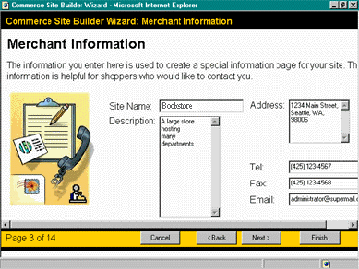
Figure 3.64 Merchant Information page

- On the next page of the wizard you will complete the Merchant Information. Select the locale for the store. With the locale information, the Store Builder Wizard configures the new store to calculate taxes, display currency, time, and address information in the proper format.
- In this step enter the store’s basic style information. These options allow you to change the look of the store. For example, the navigation bar for your store pages might be oriented either horizontally (across the top of each page) or vertically (on the side of each page). For this example, choose Horizontal. For Font, select Browser Default. For Background color, choose white. Finally for the Add to Basket button, choose the solid blue style. Check the Use Logo box to include a logo on each store page.
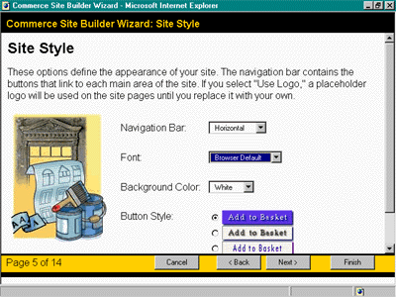
Figure 3.65 Store’s style basic information
- Next, select the type(s) of built-in promotions you want your store to offer. The two choices in this example are Price promotions and Cross-sell promotions. Building the promotional engine into a store is a good idea, even though you might not offer promotions immediately. This simply includes the functionality in your base store that otherwise would have to be added manually. From the management screens of the store, you can later enable or disable promotions for a given product or offering. In this example, include both.
- In the next step, enter your store’s basic features, such as registration requirements and search capabilities. In this example, require registration for the store entry page and enable product search capabilities to make locating products and services easier.
- Select the department type. Selecting Simple(Single level) will result in a flat hierarchy. For more sophisticated use, such as for malls and multi-tiered departments, select Variable Depth (Multilevel). Choose this latter option and check the Enabled check box to enable the Product Searching option of the wizard.
- Enter product attributes of the store. These options determine the type of product attributes this site will support. Static product attributes are defined once in the Wizard and apply to all products in the site. They cannot be modified by the store manager. Dynamic product attributes are defined later, when products are entered into the site. They can be defined on a per product basis, and they do not need to be the same for each product. There are two types of dynamic attributes: single valued and multi-valued. Single valued attributes have a single value per product. For example, Product A has an attribute called "Manufacturer" with one value: XYZ Corp. Similarly, the attribute called "Country of Origin" has one value: U.S. Multi-valued attributes have more than one value per product. For example, Product A has an attribute called "Size" that has three values: Small, Medium, and Large. Similarly, Product A has an attribute called "Color" that has four values: Red, Blue, Yellow and Green. In the 3.0 release, a site can have an unlimited number of single-valued attributes and up to five multi-valued attributes per product. Majority of products you may wish to include in your store yield themselves more naturally to a static presentation. Choose Static for this option. Add Manufacturer as a custom attribute to the list of attributes the wizard suggests as an example of customizing the product database.
The power of the wizard is that in addition to being able to change the product page, custom database columns are also automatically added to the stores schema when an additional attribute is inserted from this page. Your intermediate trial stores are easily removed using the Administrator’s pages.
Bookstore manager wished to have visitors register on entry to the store. Check the appropriate box. Check Product Searching Enabled box so books may be searched by name or title.
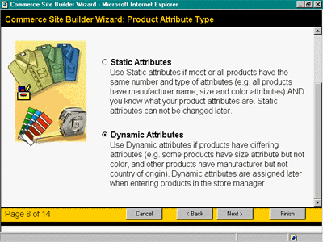
Figure 3.66 Product attributes
Figure 3.67 Shipping and Handling
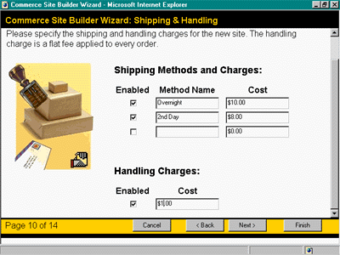
- In the next step, you add shipping methods and charges.
- In the next step, you configure tax rates for the store.You can build a tax component, purchase an existing one from vendors, or simply integrate this step into your existing order management processes, automated (batch or online) or manual
- Suppose this store accepts Visa by convention. Select the type of credit cards accepted in this pane.
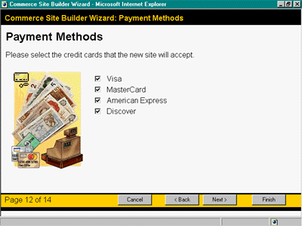
Figure 3.68 Payment Methods
- Next you should specify to retain order history for customer service down the line. This makes customer service and order tracking easier. However, it also adds to the database resources used. Click Finish to generate the video store.
At any time before clicking the Finish button, you can go back through the forms and change any options previously selected. After you have entered all options, you have to complete a final page similar to a checklist, summarizing the steps the Store Builder Wizard will perform. Depending on features and selections, clicking the Finish button creates the following:
Figure 3.69 the look of the Bookstore Site
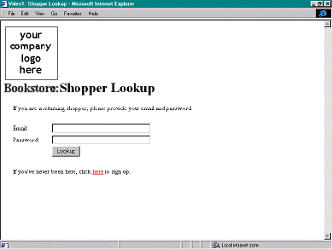
[BuildStore]

- All store pages and files
- Definition of the store’s database schema
- Definition of the store’s Order Processing Pipeline
- Sample site data including loading the data directly into the database
You can run the Store Builder Wizard repeatedly using different options each time to vary store features. When you achieve the appropriate store configuration, you use HTML editors or other tools to customize the look of the store pages. The wizard is not designed to modify existing production stores because it overwrites the original store files, including any editing or design changes made after you last used the wizard.
The Store Builder Wizard is an ASP-based application, which you can access from a Web browser over the Internet or over an Intranet. [UsingWiz]
At this point the store administrator can begin entering the store’s inventory, department, products and services. The designer can begin to add a logo and design elements. The developer can add additional functionality, customize the store, and develop assets, audio, and video functionality.
[BuildStore]

1.6 Microsoft Commerce Server 2000
Microsoft Commerce Server 2000 builds on the Site Server 3.0 Commerce Edition, improving some issues, like tighter integration among the key systems, reduced development time, and greater business functionality. [Comparison]
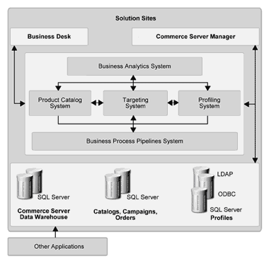
Figure 3.70 Commerce Server architecture
Commerce Server is comprised of five systems: the Business Analytics System, the Product Catalog System, the Targeting System, the Profiling System, and the Business Process Pipelines System.
Commerce Server is designed to operate together with other Microsoft .NET Enterprise Servers. [Overview]

Business Analytics

This system includes:
Business Data Warehouse is a data warehouse based on SQL Server, that incorporates all site data (and also other data) in a centralized repository.
Business Data Mining provides system-driven analysis of business data to help identify new customer segments, and recommend content.
Segment Viewer gives business managers a view of identified customer segments for advanced targeting.
Predictor uses historical site data to answer questions such as what products or content to recommend to users.
Business Desk provides managers browser-based, remote access to their business at any time and from any location.This enables them to analyze data, make decisions, and take action immediately to increase site effectiveness. For exmple, they can update catalogs, target content to users, profile users and organizations, and analyze site usage and productivity.

Product Catalog System
It is based on Microsoft SQL Server, and it is new to this code base. This system enables creating catalogs and importing and exporting from existing data sources. The Commerce Server Data Warehouse, for example, uses SQL Server Data Transformation Services (DTS) to transform data stored in SQL Server databases to the format used by Commerce Server resources. You can use the Product Catalog system to build custom catalogs with special pricing for groups of users.

Targeting System
This system is used for creating of a single definition for each Web-based or component-based application that lists the contents, components, and configuration settings. It helps simplify management and deployment tasks.
The Targeting system enables one-to-one marketing,
It includes:
Content Selection Framework, a sophisticated content scoring framework for managing complex content selection decisions.
Campaign Manager, a management tool, fully-integrated with the Targeting, Data Warehouse, and Business Analytics Systems, enabling business managers to create, analyze, and manage personalized and targeted discounts, direct marketing, related-sell, and advertising campaigns.
Direct Mailer, a built-in, fast, and scalable service, whitch enables personalized, targeted direct marketing, tracking and reporting.
List Manager, for creating and managing lists of users.
Expressions, conditions evaluated against profiles. This helps managers create explicit business rules to target content (such as ads, information, discounts, and direct mail) to specific users.

Profile System
This system enables flexibility of your site. If your data resides in different places across the site or in external systems, it can be easily mapped directly into your profile design.. Profiles can be established for any business entity, not just users, but also for requisitions, organizations, orders, and addresses. These profiles can then be incorporated as standard formats into user profiles or organization profiles.
In addition, profile system establishes secure authentication of site users to ensure they have access only to authorized areas of your site. It also enables you to serve users custom content (such as special pricing or products) based on the user's profile.

Business Process Pipeline System
Commerce Server includes in the pipelines also advertising, content selection, direct mail, discounting, and more [Comparison]
The Order Processing Pipeline is implemented using three separate pipelines—Basket, Total, and Checkout. There is also a separate checkout process for online gift certificates, implemented with a GiftCertificates pipeline. [CaseStudy]
The SSCE Commerce Interchange Pipeline was replaced by Microsoft BizTalk™ Server 2000. BizTalk Server provides the infrastructure and tools to enable e-commerce business communities. The foundation of BizTalk Server is its rules-based business document routing, transformation, and tracking infrastructure. This infrastructure enables companies to integrate, manage, and automate business processes by exchanging business documents (for example, purchase orders, or invoices) among applications within or across organizational boundaries. [Comparison]

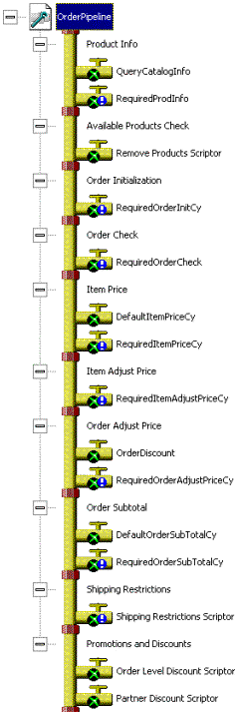
Figure 3.71 Basket Pipeline
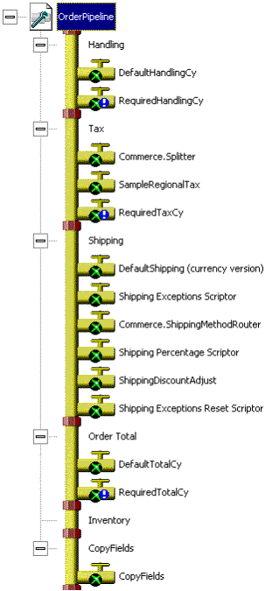
3.72 Total Pipeline
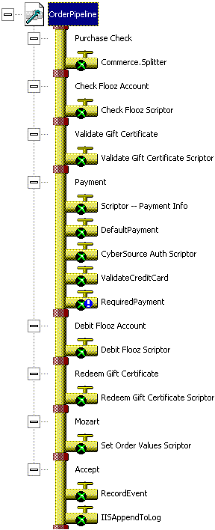
Figure 3.73 Checkout Pipeline

Solution Sites
The Commerce Server Solution Sites provide a set of Commerce Server features for building e-commerce sites. You can use the Solution Sites as a starting point for developing your own Web site, and just add functionality that is specific to your business.
Commerce Server includes the following Solution Sites:
- Blank. You can use the Blank Solution Site as a starting point for building your own custom site. It includes all of the Commerce Server resources. The Blank site is included in the Commerce Server box.
- Retail. You can use the Retail Solution Site as a starting point for building a business-to-consumer site. It includes functionality for personalization, merchandising, catalog search, customer service, and business analytics. It also includes the Customer Service, which enables users to manage their own profile information and to view their order status. The Retail site is available from http://www.microsoft.com/commerceserver/solutionsites.
- Supplier. You can use the Supplier Solution Site as a starting point for building a business-to-business site. The Supplier site is available from http://www.microsoft.com/commerceserver/solutionsites.
[Overview]

The Automatic Credit Card Payment Within the ASP Applications
Of all the available technologies for creating the e-commerce pages, ASP (Active Server Pages) of the Microsoft Corp. is the most popular one. One possible way to achieve the credit card payment is to use the ActiveX COM objects provided by the E-xact Transacions Ltd., and also the services provided by the same company. In fact, the E-xact serves as a Transaction Gateway Provider in this case. All the important details about the whole system can be found on the E-xact's official site at www.E-xact.com. In general, five institutions must be involved if one wants to process transactions in this way:
- The customer possesses a credit card;
- Merchant is present with an e-commerce site;
- Transaction Gateway Provider is present;
- Merchant possesses an account at a bank, with the permission to accept credit card payments;
- There is an institution that has provided the customer with the credit card account, which is capable to authorize the credit cards and transactions.
These are the steps needed to perform, in order to commit the payment transaction:
- Customer selects the wanted goods at the merchant's site: the list of selected products or services is usually contained in the virtual shopping basket;
- Then, the customer steps to the secured (SSL) page, filling the personal data, shipping address, as well as the data concerning the credit card payment;
- After all the data are set, they are sent to the merchant's server;
- Using some specific software, usually provided by the same company that serves as the Transaction Gateway Provider (TGP), the merchant sends those data to the TGP;
- TGP then commits the credit card transaction, performs the credit card authorization (by checking the number and available money at the account);
- If all the checks ended well, the money transfer is performed

The Component Installation Process
The E-xact component provides the ActiveX COM object that is used on the merchant's server, by the merchant's e-commerce software. By the nature of this object, it can be applied only to the servers and platforms where it can be registered, and with server-side technologies in which it can be instantiated and used. At this point, we primarily have in mind the Microsoft Internet Information Server and ASP. The file name containing the ocx control is ExactAX1.ocx, and it can be downloaded along with the documentation from the www.e-xact.com.
In order to register this component at the NT server with IIS, one should follow these steps. Copy the ExactAX1.ocx file into the directory:
<local_drive>:\<winNT_folder>\system32\inetsrv\components
Then, at the command prompt, type:
regsvr32 ExactAX1.ocx
The regsvr.exe file comes along with the rest of the package (the component and the documentation).

Using the Component
Before the component is referenced, it should be instantiated in the code in the usual ASP manner. For instance, the following code may be used:
SET exactAuth = Server.CreateObject
("ExactAX1.preauthorization98x")
The basic idea behind this is to set the properties of the component to the appropriate values, and then just to call the method that starts the transaction. These are the most important properties of the component:
- amount − the amount of the transaction, expressed in American dollars.
- ccnum − the customer's credit card number; only VISA, MASTER CARD and AMERICAN EXPRESS are supported at this moment
- cardholder − the name of the credit card owner
- ddmhip − IP address that belongs to the TGP server the component communicates with; the IP address of the E-xact server is currently 204.239.214.212, and this is the default value of this property
- ddmhpord − the port of the TGP server; the default property value is 2609. Unlike the previous property, this default value points to the testing port: the E-xact services can be tested using this port number. Without the registration, this port can be used to send the authorization request and to commit the transaction. The system will act as if the full service was invoked, with only difference that no real money transfer will be performed. After the registration at the E-xact is finished, the port number should be replaced with 2610, and the full functionality will be achieved. Together with the rest of the package, the two inexistent credit card numbers will be received, and these numbers can be used to test the system.
- expiry − the expiration date of the credit card, in the format mmyy, where mm stands for the two-digit month number, and yy stands for the two-digit year number; two final digits of the year are used, for instance 0200 stands for the February, 2000.
- merchant − the 13-digit number that identifies the merchant account at the underlying bank
- merchantaddress − the physical address of the merchant
- merchantname − the merchant's name/title
- merchantcity − the city where the merchant is situated
- merchantemail − the e-mail address of the merchant
- password − the password that is required to invoke the transaction. For the testing transactions, use "test1" value for this property. Once the component is registered with the E-xact, the password will be received.
- terminal − the eight-digit number that identifies the "terminal"; this plays the merchant's user-name in respect with the E-xact servers and the password provided with the previous property. During the testing period, this property should be set to 66001047
- transactiontype − there are four transaction types available: Purchase, Refund, PreAuthorisationPurchase and PreAuthorisation-
PurchaseCompletion. This property shows which one type is engaged.
Purchase is the typical transaction that was presented at the beginning of this section. This transaction is applicable if the sold goods are of such nature that they can be taken by the customer immediately (for instance, to download the software, different services, etc.). After the authorization, the money is immediately being transferred to the merchant's account. This procedure is usually referred to as the immediate capture of transaction, for obvious reasons.
PreAuthorisationPurchase performs the authorization with checking whether the customer owns enough money at the account. If the money is present, it is temporarily locked, but not transferred to the merchant's account. This technique is typically used when the bought goods are to be transported to the customer.
PreAuthorisationPurchaseCompletion kind of transaction is invoked once the customer has received the bought items. At that moment, the locked funds are transferred from the customer's to the merchant's account. It should be clear that within the PreAuthorisationPurchaseCompletion it must exist the information which PreAuthorisationPurchase transaction it refers to, i.e. which transaction should be completed. To solve this problem, the autnum component property is read from the PreAuthorisationPurchase, and that very same value is assigned to the same component property, just before the PreAuthorisationPurchaseCompletion transaction is invoked.
Refund transaction returns the money from the merchant's to the customer's account.
Each transaction is invoked by call to the sendToServer method. Prior to that, all the needed properties must be set appropriately. The component contains additional functions that are used to control the transaction processing, and to return the bank's response in the form of the bill for the customer. The following VBScript example demonstrates the matters explained so far. The first part of the example is an HTML code that presents the form needed to enter the data about the transaction. The HTML code contains the brief explanations that are not a part of the code body.
<html>
<head>
<title>E-xact Transaction Terminal</title>
</head>
<form action="process.asp" method="post">
<table valign = "TOP" border="1" cellPadding="3" cellSpacing="0" width="450">
<tr>
<td colSpan="2">
E-xact Transaction Terminal
</td>
</tr>
<tr>
<td width="35%">
Transaction Type:
</td>
<td>
<select name="cc_transType">
<option value="Purchase" selected>Purchase
<option value="Refund">Refund
<option value="PreAuthorizedPurchase">Pre-Authorization
<option value="PreAuthorizedPurchaseCompletion">
Pre-Authorization Completion
</select>
</td>
</tr>

<tr>
<td>
Card Holder's Name:
</td>
<td>
<input name="cc_name" size="40">
</td>
</tr>

<tr>
<td>
Card Number:
</td>
<td>
<input name="cc_number" maxLength="16" size="16" >
</td>
</tr>
<tr>
<td>
Card Expiry Date:
</td>
<td>
<select name="cc_expMonth">
<option VALUE="01" selected>Jan
<option VALUE="02">Feb
<option VALUE="03">Mar
<option VALUE="04">Apr
<option VALUE="05">May
<option VALUE="06">June
<option VALUE="07">July
<option VALUE="08">Aug
<option VALUE="09">Sep
<option VALUE="10">Oct
<option VALUE="11">Nov
<option VALUE="12">Dec
</select>
&nbsp;

<select name="cc_expYear">
<option VALUE="98" selected>1998
<option value="99">1999
<option value="00">2000
<option value="01">2001
<option value="02">2002
<option value="03">2003
</select>
</td>

</tr>
<tr>
<td>
Amount (in cents):
</td>

<td>
<input name="cc_amount" maxLength="16" size="12">
</td>
</tr>
<tr>
<td>
Authorization Number:
</td>
<td>
<input name="cc_auth_number" maxLength="16" size="16"><BR>
Only used for Pre-Authorization Completions
</td>
</tr>
<tr>
<td colspan="2" align="middle">
<input type="submit" value="Send transaction">
</td>
</tr>
</table>
</form>
</body>
</html>
Figure 3.74 shows the visual look of the table created with this HTML code.
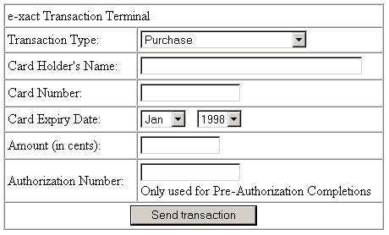
Figure 3.74 The table that is created with the HTML sample code
The following is the simplified process.asp file: only the elements needed to complete the example are shown.
<%
function ProcessTransaction()
dim approved
' Component instantiation
Set exactAuth = Server.CreateObject("exactax1.Preauthorization98x")
' Filling in the properties concerning the E-xact server connection
' The information about merchant is filled as well
exactAuth.ddmhip = "204.239.214.212"
exactAuth.ddmhPort = "2609"
timeOut = 30000
exactAuth.interval_time = cStr(timeOut)
exactAuth.merchant = "0030100941021"
exactAuth.terminal = "66001047"
exactAuth.password = "test1"
exactAuth.merchantname = "Delta memory distribution"
exactAuth.merchantcity = "Belgrade"
exactAuth.merchantaddress = "Tolstojeva 14"
exactAuth.merchantprovince = "Serbia"
exactAuth.merchantpostal = "11000"
exactAuth.merchantemail = "support@delta.co.yu"
' The credit card information is taken from the HTML form
exactAuth.ccnum = request("cc_number")
exactAuth.cardholder = request("cc_name")
exactAuth.expiry = request("cc_expMonth") & request("cc_expYear")
' The transaction value and type are set

exactAuth.amount = request("cc_amount")
exactAuth.transactiontype = TRIM(request("cc_transType"))
if TRIM(request("cc_transType"))
="PreAuthorizedPurchaseCompletion" then
exactAuth.authNum = TRIM(request("cc_auth_number"))
end if
' Checking whether the previous transaction has ended
' (the code may be executed concurrently)
AuthBool = TRUE
OKtoSendNext = FALSE
OKtoSendNext = exactAuth.maysendnext
' The waiting and sending example follows
' it is assumed that previous transaction has ended however
OKtimeout = DateAdd("s", 5, now)
do while OKtoSendNext=FALSE AND now <= OKtimeout
OKtoSendNext =exactAuth.maysendnext
Loop
if OKtoSendNext=TRUE then exactAuth.sendtoserver
' Waiting the transaction finish, and that will happen
' once the exact.insending returns FALSE
INtimeout = DateAdd("s", 30, now)
do while AuthBool AND now <= INtimeout
AuthBool = exactAuth.insending
loop
' If the timeout period has expired, and the transaction did not commit
' the customer should be noted about the error
if AuthBool then
ProcessTransaction = "<font color='red'><B>
Transaction timed out. Error: InSending</B></font>"
exactAuth.socketconnected = FALSE
exit function
end if
' In the case the transaction commits
' the transaction code should be taken
MyAuthCode = exactAuth.authnum
' The following code checks if the transaction has finished successfuly
approved = 0
if exactAuth.ddmhresp = "00" then
if int(exactAuth.RBRespCode)<50 then
'transaction approved
approved = 1
else
'transaction denied
approved = 0
end if
ctr = exactAuth.ctr
elseif exactAuth.ddmhresp = "" then
ProcessTransaction = "<font color='red'><B>
Transaction Not Completed</B></font>"
exactAuth.socketconnected = FALSE
exit function
else
ProcessTransaction = "<font color='red'><B>
Transaction Not Completed</B></font>"
exactAuth.socketconnected = FALSE
exit function
end if
exactAuth.socketconnected = FALSE
ProcessTransaction = ctr
end function
%>
The part of the code that performs checks if the transaction was finished successfully works in two steps. First, it checks the exactAuth.ddmhresp that is expected to return 00 as a sign that no error happened. If this condition is met, the exactAuth.RBRespCode is checked: if the returned value is less than 50, it is the sign that transaction has been approved; otherwise the transaction was rejected during the authorization phase.
At the very end of the code, it should disconnect and return the Customer Transaction Record. The record holds information about the transaction: those data are received from the bank.
Finally, the piece of the code is presented, which calls the ProcessTransaction function presented above, and shows the report as a conveniently formatted HTML code. The Customer Transaction Record can be easily transformed to the HTML by simple changing each carriage return sign with the <BR> tag.
<html>
<head>
<title>E-xact Transaction Terminal</title>
</head>
<table valign = "TOP" align="center” border="1"
cellPadding="3" cellSpacing="0" width="450">
<tr>
<td>
<b>E-xact Transaction Terminal</b></font>
</td>

</tr>
<tr>
<td>
<b>Customer Transaction Record (CTR)</font></b>
</td>
</tr>
<tr>
<td>
<%
ProcessCode = ProcessTransaction()
Response.write replace(ProcessCode,CHR(13), "<BR>")
%>
</td>
</tr>
</table>
</body>
</html>

Conclusion
Considering the constant growth of the usage of the Internet, it is logical to assume that in the future, a large percent of world wide business will be e-Business. It will enable all geographical regions to participate equally, offer a big variety of products and disable monopoly.
There are a lot of tools for making an e-Commerce site, and they all vary in their price, complexity and the variety of options they offer. In time, the tools that are being developed are offering more chance for better presenting of the products, marketing, contact with the customers.
The biggest problem is the security issues. Most security measures, as shown in this chapter, are very reliable, but there is still doubt among the customers.

Problems
- The advantages and disadvantages of e-Business in compare to classical business
- Overcoming the difficulties of starting a web store outside USA
- The options that can not be realized with Yahoo! Store
- Problems with using Yahoo! Store in countries outside USA
- The advantages of ec-Builder over Yahoo! Store
- Security issues in ec-Builder
- The question of secure transition with SSL
- The optimized usage of different options in Microsoft Site Server Commerce Edition 3,0
- Complexity versus simplicity in different tools for e-Business sites

References
[UsingWiz] | “Using the Site Server Wizard,”  (http://www.siteserver101.com/book/chapter2/  overview3a.asp), December 15, 2001
[BuildProcess] | “Commerce Server Build Process”, (http://www.siteserver101.com/book/chapter2/  overview3.asp), December 17, 2001
[Video] | “Building your Video Store”, (http://www.siteserver101.com/book/chapter12/  yoursite3.asp), December 17, 2001
[BuildStore] | “Building a Store Foundation”, (http://www.siteserver101.com/book/chapter2/  overview3b.asp), December 17, 2001
[Comparison] | “A Comparison of Microsoft Commerce Server 2000 and Site Server 3.0 Commerce Edition”, (http://www.microsoft.com/commerceserver/techinfo/ CS_compare.doc), September 2000
[Overview] | “Commerce Server 2000 Resource Kit -- Ch. 1, Overview and Scenarios”, (http://www.microsoft.com/technet/treeview/default.asp?  url=/technet/prodtechnol/comm/default.asp), December 20, 2001
[CaseStudy] | “Case Study -- Starbucks Technical Deployment Guide”, (http://www.microsoft.com/technet/treeview/default.asp?  url=/technet/prodtechnol/comm/default.asp), December 20, 2001

Prepared by: Zoran Horvat (zoranh@eunet.yu), Marjan Mihanovic (marjanm@eunet.yu), Miodrag Stefanovic (mik@eunet.yu), Dusan Dingarac (dingo@galeb.etf.bg.ac.yu), Ivana Vujovic (ile@eunet.yu), and Veljko Milutinovic (vm.etf.bg.ac.yu)

